Report ITU-R RS.2489-0
(09/2021)
Technical and operational characteristics
of ground-based passive sensors operating in the 51-58 GHz frequency range

RS Series
Remote sensing systems

Foreword
The role of the Radiocommunication Sector is to ensure the rational, equitable, efficient and economical use of the radio-frequency spectrum by all radiocommunication services, including satellite services, and carry out studies without limit of frequency range on the basis of which Recommendations are adopted.
The regulatory and policy functions of the Radiocommunication Sector are performed by World and Regional Radiocommunication Conferences and Radiocommunication Assemblies supported by Study Groups.

Policy on Intellectual Property Right (IPR)
ITU-R policy on IPR is described in the Common Patent Policy for ITU-T/ITU-R/ISO/IEC referenced in Resolution ITU-R 1. Forms to be used for the submission of patent statements and licensing declarations by patent holders are available from http://www.itu.int/ITU-R/go/patents/en where the Guidelines for Implementation of the Common Patent Policy for ITU-T/ITU-R/ISO/IEC and the ITU-R patent information database can also be found.

Series of ITU-R Reports
(Also available online at http://www.itu.int/publ/R-REP/en)
Series | Title
BO | Satellite delivery
BR | Recording for production, archival and play-out; film for television
BS | Broadcasting service (sound)
BT | Broadcasting service (television)
F | Fixed service
M | Mobile, radiodetermination, amateur and related satellite services
P | Radiowave propagation
RA | Radio astronomy
RS | Remote sensing systems
S | Fixed-satellite service
SA | Space applications and meteorology
SF | Frequency sharing and coordination between fixed-satellite and fixed service systems
SM | Spectrum management

Note: This ITU-R Report was approved in English by the Study Group under the procedure detailed in Resolution ITU-R 1.

Electronic Publication
Geneva, 2021
© ITU 2021
All rights reserved. No part of this publication may be reproduced, by any means whatsoever, without written permission of ITU.

REPORT ITU-R RS.2489-0
Technical and operational characteristics of ground-based passive sensors operating in the 51-58 GHz frequency range
(2021)

1 Introduction
This Report provides technical and operational characteristics of ground-based passive radiometers in the range 51-58 GHz, used for observations of the temperature of the atmosphere. The use of these radiometers supports meteorological applications and study of the temperature of the atmosphere, including the context of the climate change. Ground-based radiometers could be used for local atmosphere observations or in the framework of worldwide observational networks.
Microwave radiometers are very sensitive receivers designed to measure thermal electromagnetic radiation emitted by atmospheric gases. They are usually equipped with multiple receiving channels in order to derive the characteristic emission spectrum of the atmosphere.

2 Meteorology/climatology usages
Microwave radiometers are utilized in a variety of environmental and engineering applications, including weather forecasting and nowcasting, climate monitoring, radio astronomy and radio propagation studies.
Worldwide vertical profiles of atmospheric temperature are provided by several types of satellites (polar-orbiting satellites equipped with microwave sounding instruments) but meteorologists making detailed local forecasts or scientists investigating the planetary boundary layer have requirements for atmospheric sounding with better vertical resolution than can be provided by the satellite radiometers. This higher resolution information can be provided by using an upward-looking passive remote sensor, with a radiometer mounted at the Earth’s surface.
Passive microwave radiometry is a tool of fundamental importance for the Earth observation and radiometers are designed to receive and measure natural emissions produced by the Earth’s surface and its atmosphere. Ground-based radiometers are well suited to measure temperature profiles in the lower part of the atmosphere: the troposphere.
Microwave sensors can provide an almost all-weather capability due to higher transmission through clouds at microwave than at visible or infrared wavelengths. This all-weather capability has considerable interest for the Earth observation because more than 60% of the Earth’s surface is usually covered with clouds. In addition to this all-weather capability, passive microwave measurements can also be taken at any time of day as they are not reliant on daylight. Passive microwave sensing is an important tool widely used for meteorological, climatological, and environmental monitoring and survey (operational and scientific applications), for which reliable repetitive global coverage is essential.
Commercial ground radiometers are now available for meteorological operational applications.

2.1 Frequency aspects
A selection of channels in the oxygen band between 50 GHz and 58 GHz are used to produce a measurement of temperature structure. This Report focuses only on these bands.
It is worth mentioning that other channels, for example between 22 GHz and 28 GHz are used to provide information on the variation of water vapour in the vertical profile. A window observation in the region of 30 GHz is also used for cloud identification. Those are being addressed in another ITU-R Report.
Figure 1 shows the down-welling thermal emission of the atmosphere expressed in term of brightness temperature, as seen by a sensor deployed at sea level (blue) and at 4.5 km altitude (red). The position of the single oxygen emission lines, forming the absorption complex around 60 GHz, are visible in the red curve, together with the positions of the radiometer channels and their bandwidths. Given the increasing opacity of the atmosphere going toward the centre of the absorption complex, the radiation reaching the sensor in different channels is emitted by shallower atmospheric layers. The channel at 58 GHz receive radiation from a 500 m-thick layer while the channel at 52 GHz has contributions from the whole troposphere, hence the different brightness temperatures. A proper algorithm can then reconstruct the atmospheric temperature profile using the measurements of the various channels.
Figure 1
Simulated spectrum for ground-based radiometer between 50 and 60 GHz
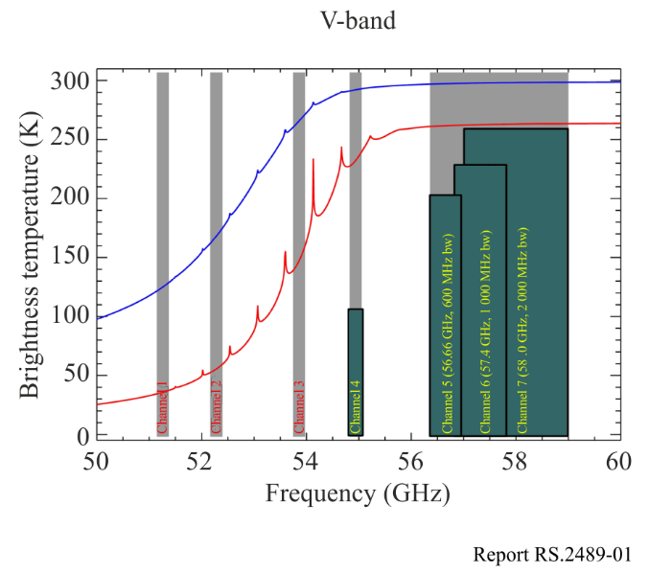
Note to Fig. 1 : The blue line is used for a sensor at sea level, and the red line for a sensor at 4.5 km of altitude. The channels measured by the instruments are marked in grey
Although the channels for ground based remote sensing of temperature are in a similar region to passive satellite remote sensing, they are not identical to those used by satellites. At some frequencies, satellite remote sensing can safely share with terrestrial services, but ground-based radiometers may need protection in order to be effective. The number of ground-based radiometers in operation is still small, but if current developments are successful, larger numbers may be deployed in the future.

2.2 Typical characteristics
Table 1 below shows some typical characteristics of commercial ground-based passive radiometers deployed in the frequency range 51-58 GHz. Scientific radiometers could have less system temperature in case of cooled receiving system.
The sensitivity of these radiometers is dependent of the operational integration time. The typical integration time is two seconds. To specify the interference threshold level, the error rate compared to sensitivity has also to be defined.
TABLE 1
Typical characteristics of ground-based passive radiometers
Platform type (airborne, ship borne, ground) | Ground
Channel center frequencies | 51.26 GHz, 52.28 GHz, 53.86 GHz, 54.94 GHz, 56.66 GHz, 57.3 GHz, 58.0 GHz
Antenna type (reflector, phased array, slotted array, etc.) | Corrugated feedhorn + reflector
Antenna diagram | Gaussian beam
Antenna sidelobe level (dB) | < −30
Antenna main beam gain (dBi) | 40
Antenna height (m) | 1.2
Receiver noise figure (dB) | 2.5
System noise temperature (°K) | 600
Receiver RF 3 dB bandwidth (MHz) | 600-2 000
Geographical distribution | Worldwide
Fraction of time in use (%) | 100
Integration time (s) | 2

2.3 Worldwide deployments
At that time, around 140 ground-based passive radiometers are deployed in the frequency range 51-58 GHz on a worldwide basis.
Figure 2 shows the location of these systems.
FIGURE 2
Location of ground-based passive radiometers in the 51-58 GHz
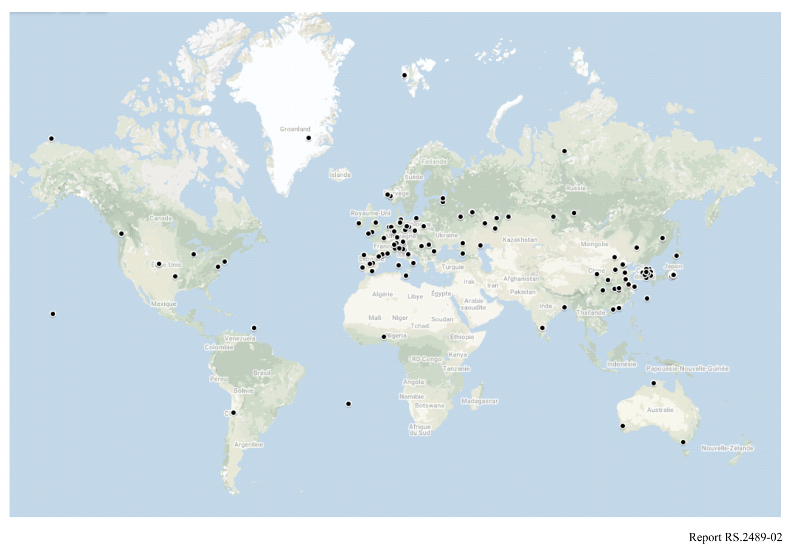

3 Summary
There is an interest in ground-based passive radiometers in the range 51-58 GHz, used by meteorological, climate change, satellite communication and astronomy communities. This Report presents the usage of such systems in particular regarding the need to obtain better vertical resolution for atmospheric temperature profile near the ground in order to provide more detailed local forecasts.
Characteristics of ground-based passive radiometers operating in the frequency range 51-58 GHz have been developed.

In meteorology, the planetary boundary layer (PBL), also known as the atmospheric boundary layer (ABL), is the lowest part of the atmosphere. Its behaviour is directly influenced by its contact with a planetary surface.

