Report ITU-R RS.2489-1
(03/2025)
RS Series: Remote sensing systems
Technical and operational characteristics of ground-based passive radiometers for meteorological and climatology applications operating in the 22-32 GHz and 51-58 GHz frequency ranges

Foreword
The role of the Radiocommunication Sector is to ensure the rational, equitable, efficient and economical use of the radio-frequency spectrum by all radiocommunication services, including satellite services, and carry out studies without limit of frequency range on the basis of which Recommendations are adopted.
The regulatory and policy functions of the Radiocommunication Sector are performed by World and Regional Radiocommunication Conferences and Radiocommunication Assemblies supported by Study Groups.

Policy on Intellectual Property Right (IPR)
ITU-R policy on IPR is described in the Common Patent Policy for ITU-T/ITU-R/ISO/IEC referenced in Resolution ITU-R 1. Forms to be used for the submission of patent statements and licensing declarations by patent holders are available from https://www.itu.int/ITU-R/go/patents/en where the Guidelines for Implementation of the Common Patent Policy for ITU-T/ITU-R/ISO/IEC and the ITU-R patent information database can also be found.

Series of ITU-R Reports
(Also available online at https://www.itu.int/publ/R-REP/en)
Series | Title
BO | Satellite delivery
BR | Recording for production, archival and play-out; film for television
BS | Broadcasting service (sound)
BT | Broadcasting service (television)
F | Fixed service
M | Mobile, radiodetermination, amateur and related satellite services
P | Radiowave propagation
RA | Radio astronomy
RS | Remote sensing systems
S | Fixed-satellite service
SA | Space applications and meteorology
SF | Frequency sharing and coordination between fixed-satellite and fixed service systems
SM | Spectrum management
TF | Time signals and frequency standards emissions

Note: This ITU-R Report was approved in English by the Study Group under the procedure detailed in Resolution ITU-R 1.

Electronic Publication
Geneva, 2025
© ITU 2025
All rights reserved. No part of this publication may be reproduced, by any means whatsoever, without written permission of ITU.

REPORT ITU-R RS.2489-1
Technical and operational characteristics of ground-based passive radiometers for meteorological and climatology applications operating in the 22-32 GHz
and 51-58 GHz frequency ranges
(2021-2025)
Keywords
Ground-based passive radiometers, meteorology, climatology

TABLE OF CONTENTS
Page

1 Introduction 2
2 Meteorology/climatology usages 2
2.1 Frequency aspects 3
2.2 Typical characteristics 4
2.3 Worldwide deployments for meteorological radiometers 5
3 Summary 6
Annex – Examples of ground-based passive radiometers for meteorological and climatology applications used in certain countries 6
1 ITU Region 1 6
2 ITU Region 2 6

1 Introduction
This Report provides technical and operational characteristics of ground-based passive microwave radiometers around the 22-32 GHz and 51-58 GHz ranges, used for observations of the atmosphere. The use of these radiometers supports meteorological applications and research by providing measurements of the profile of temperature in the lowest several kilometres of the atmosphere, integrated water vapor, and integrated cloud liquid water. Ground-based radiometers are also used for local atmosphere observations, for weather situational awareness, emergency management, and/or in the framework of worldwide observational networks. The collected data can serve additional purposes, such as correcting measurements of cosmic signals with respect to foreground attenuation and phase delays caused by Earth’s atmosphere in the radio astronomy and geodesy (Geodetic VLBI).
Microwave radiometers are very sensitive receivers designed to measure thermal electromagnetic radiation emitted by atmospheric gases. They are usually equipped with multiple receiving channels in order to derive the characteristic emission spectrum of the atmosphere.
It has to be noted that in some cases these ground based sensors are operating on an opportunistic basis and outside frequency bands allocated to passive operations, taking into account that such measurements are bound to physical facts (i.e. water vapour absorption lines), and without any protection.
The Annex includes examples of how these systems are used in certain countries, reflecting their usage of the band in these regions. However, these examples do not imply any required action by other ITU Member States and are provided for informational purposes only.

2 Meteorology/climatology usages
Microwave radiometers are utilized in a variety of environmental and engineering applications, including weather forecasting and nowcasting, climate monitoring and radio astronomy.
Worldwide vertical profiles of atmospheric temperature are provided by several types of satellites (polar-orbiting satellites equipped with microwave sounding instruments) but meteorologists making detailed local forecasts or scientists investigating the planetary boundary layer have the requirements for atmospheric sounding with better vertical resolution than can be provided by the satellite radiometers. This higher resolution information can be provided by using an upward-looking passive remote sensor, with a radiometer mounted at the Earth’s surface. Also, the coincident measurements of integrated water vapor and cloud liquid water are critical observations to a range of research and operational applications.
Passive microwave radiometry is a tool of fundamental importance for the Earth observation and radiometers are designed to receive and measure natural emissions produced by the Earth’s surface and its atmosphere. Ground-based radiometers are well suited to measure temperature profiles in the lower part of the atmosphere, humidity and temperature profiles in the troposphere of the earth, as well as integrated quantities like the integrated water vapour (IWV) and liquid water content of clouds (LWP).
Microwave sensors can provide an almost all-weather capability due to higher transmission through clouds at microwave than at visible or infrared wavelengths; only at moderate to high rain rates are the observations from ground-based microwave radiometers negatively impacted. The near all-weather capability has considerable interest for the Earth observation because more than 60% of the Earth’s surface is usually covered with clouds. In addition to this capability, passive microwave measurements can also be taken at any time of day as they are not reliant on daylight. Passive microwave sensing is an important tool widely used for meteorological, climatological, and environmental monitoring and survey (operational and scientific applications), for which reliable repetitive global coverage is essential.
Ground-based radiometers are currently available for meteorological operational applications.

2.1 Frequency aspects
A selection of channels between:
– 22 GHz and 28 GHz are used to provide information on the variation of water vapour in the vertical profile, a window observation around the region of 30 GHz is also used for integrated cloud liquid water observations;
– 50 GHz and 58 GHz are used to produce a measurement of temperature structure.
Figure 1 shows the down-welling thermal emission of the atmosphere expressed in term of brightness temperature, as seen by a sensor deployed at sea level (blue) and at 4.5 km altitude (red). The oxygen emission lines that form the absorption complex around 60 GHz, some of which are visible in the red curve, together with the positions and bandwidths of the channels of an idealized radiometer. Given the increasing opacity of the atmosphere going toward the centre of the absorption complex at 60 GHz, the radiation reaching the sensor in different channels is emitted by shallower atmospheric layers. The channel at 58 GHz receives radiation from an approximately 500 m-thick layer while the channel at 52 GHz has contributions from the whole troposphere, hence the different brightness temperatures. A proper retrieval algorithm can then reconstruct the atmospheric temperature profile using the measurements of the various channels.
Figure 1
Simulated spectrum for ground-based radiometer between 50 and 60 GHz
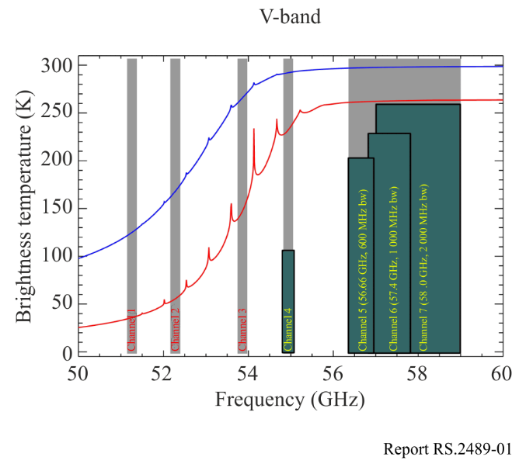
Note to Fig. 1: The blue line is used for a sensor at sea level, and the red line for a sensor at 4.5 km of altitude. The channels measured by the instruments are marked in grey.
Figure 2 shows the sensitivity of millimetre and sub-millimetre waves to atmospheric temperature and water vapour variations between 1 and 275 GHz. The 22 GHz water vapour and 60 GHz oxygen resonance spectral lines are visible in the Figure as well.
Figure 2
Atmospheric opacity in frequency range 1-275 GHz
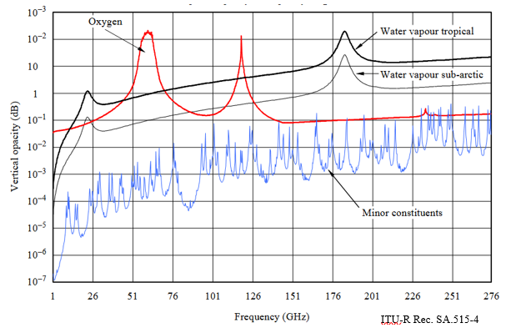
Although the channels for ground based passive radiometer are in the same spectral region to passive satellite remote sensing, they are not identical frequencies to those used by satellites. At some frequencies, satellite remote sensing can safely share with terrestrial services, but ground-based radiometers may need protection in order to be effective. The number of ground-based radiometers in operation is still small, but if current developments are successful, larger numbers may be deployed in the future.

2.2 Typical characteristics
Table 1 below shows some typical characteristics of ground-based passive radiometers deployed around the frequency ranges 22-32 GHz and 51-58 GHz. Radiometers for climatology and other scientific applications could have less system noise temperature in case of cooled receiving system.
The sensitivity of these radiometers is done by the radiometric equation and dependent on the system noise temperature, the integration time and the integrated bandwidth. The typical operational integration time for measurements is two seconds. For calibration of the radiometer, the integration time may be different and has to be defined. To specify the interference threshold level, the error rate compared to sensitivity has also to be defined.
TABLE 1
Typical characteristics of ground-based passive radiometers
 | Channel centre frequencies |  | 22.24 GHz, 23.04 GHz, 23.84 GHz, 25.44 GHz, 26.24 GHz, 27.84 GHz, 31.4 GHz |  | 51.26 GHz, 52.28 GHz, 53.86 GHz, 54.94 GHz, 56.66 GHz, 57.3 GHz, 58.0 GHz
 | Antenna type (reflector, phased array, slotted array, etc.) |  | Corrugated feedhorn + reflector |  | Corrugated feedhorn + reflector
 | Antenna diagram |  | Gaussian beam |  | Gaussian beam
 | Antenna sidelobe level (dB) |  | < −30 |  | < −30
 | Antenna main beam gain (dBi) |  | 33 |  | 40
TABLE 1 (end)
Antenna height (m) |  | 1.2 |  | 1.2
Receiver noise figure (dB) |  | 2 |  | 2.5
System noise temperature (°K) |  | < 400 |  | 600
Receiver RF 3 dB bandwidth (MHz) |  | 230 |  | 600-2 000
Geographical distribution |  | Worldwide |  | Worldwide
Fraction of time in use (%) |  | 100 |  | 100
Measurement integration time (s) |  | 2 |  | 2

2.3 Worldwide deployments for meteorological radiometers
Currently, it is estimated that more than 200 ground-based passive radiometers are deployed around the frequency ranges 22-32 GHz and 51-58 GHz on a worldwide basis.
Figure 3 shows the location of these systems.
FIGURE 3
Location of ground-based passive radiometers in the 22-32 GHz and 51-58 GHz ranges
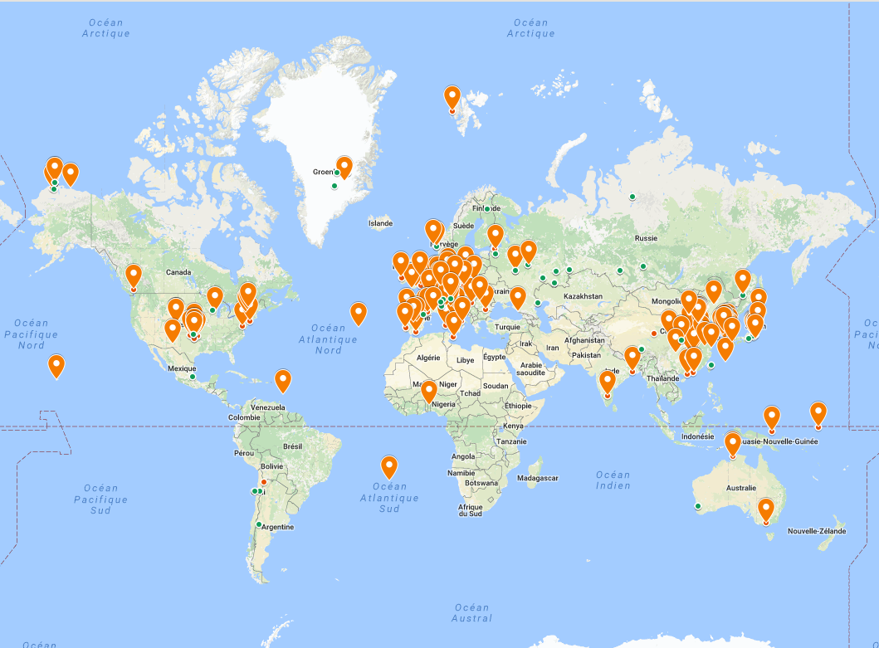

3 Summary
There is an interest in ground-based passive radiometers around the 22-32 GHz and 51-58 GHz ranges to provide data that may be used by meteorological, climatology, and astronomy communities. This Report presents the usage of such systems in particular regarding the need to obtain better vertical resolution for atmospheric temperature profile near the ground in order to provide more detailed local forecasts.
Characteristics of ground-based passive radiometers for meteorological and climatology applications operating around the frequency ranges 22-32 GHz and 51-58 GHz have been developed.

Annex
Examples of ground-based passive radiometers for meteorological and climatology applications used in certain countries

1 ITU Region 1
In Switzerland, ground-based passive sensors, and specifically microwave radiometers, are an important component of the EMER-Met (Emergency-Response Meteorology) system. This system monitors the atmosphere with wind profiler radars and microwave radiometers to measure the temperature and humidity profiles from the ground up to an altitude of several kilometres. These local observation data are integrated in real time into a high-resolution numerical weather prediction model for the provision of emergency management in the case of nuclear accidents in Switzerland and neighbouring countries.
Three sites are currently in operation: Payerne in the southwest, Schaffhausen in the north-east and Grenchen in the centre of the Swiss Plateau. The EMER-Met system has been operational since 2010 and it shows an availability rate of over 95%. This system, that relies on microwave radiometers, is essential in Switzerland for strategic decision-making in the event of a nuclear accident.

2 ITU Region 2
In the United States of America, a 2009 National Research Council recommendation included deployment of ground-based microwave radiometers at approximately 400 sites as a high infrastructure priority to continually monitor lower tropospheric conditions and fill many of the critical gaps in the national observing system. Currently, the New York State Mesonet (NYSM) Profiler Network is operating 17 profiler sites across the state as a national testbed to facilitate research and evaluation of ground-based passive sensors and their applications. Additionally, it is estimated that there are 50 or more microwave radiometers in use by various organizations to support meteorological applications and research in the United States of America.

In meteorology, the planetary boundary layer (PBL), also known as the atmospheric boundary layer (ABL), is the lowest part of the atmosphere. Its behaviour is directly influenced by its contact with a planetary surface.

