Report ITU-R RS.2431-0
(09/2018)
Technical and operational characteristics of EESS (passive) systems in the frequency range 275-450 GHz

RS Series
Remote sensing systems

Foreword
The role of the Radiocommunication Sector is to ensure the rational, equitable, efficient and economical use of the radio-frequency spectrum by all radiocommunication services, including satellite services, and carry out studies without limit of frequency range on the basis of which Recommendations are adopted.
The regulatory and policy functions of the Radiocommunication Sector are performed by World and Regional Radiocommunication Conferences and Radiocommunication Assemblies supported by Study Groups.

Policy on Intellectual Property Right (IPR)
ITU-R policy on IPR is described in the Common Patent Policy for ITU-T/ITU-R/ISO/IEC referenced in Annex 1 of Resolution ITU-R 1. Forms to be used for the submission of patent statements and licensing declarations by patent holders are available from http://www.itu.int/ITU-R/go/patents/en where the Guidelines for Implementation of the Common Patent Policy for ITU-T/ITU-R/ISO/IEC and the ITU-R patent information database can also be found.

Series of ITU-R Reports
(Also available online at http://www.itu.int/publ/R-REP/en)
Series | Title
BO | Satellite delivery
BR | Recording for production, archival and play-out; film for television
BS | Broadcasting service (sound)
BT | Broadcasting service (television)
F | Fixed service
M | Mobile, radiodetermination, amateur and related satellite services
P | Radiowave propagation
RA | Radio astronomy
RS | Remote sensing systems
S | Fixed-satellite service
SA | Space applications and meteorology
SF | Frequency sharing and coordination between fixed-satellite and fixed service systems
SM | Spectrum management

Note: This ITU-R Report was approved in English by the Study Group under the procedure detailed in Resolution ITU-R 1.

Electronic Publication
Geneva, 2018
© ITU 2018
All rights reserved. No part of this publication may be reproduced, by any means whatsoever, without written permission of ITU.

REPORT ITU-R RS.2431-0
Technical and operational characteristics of EESS (passive) systems in the frequency range 275-450 GHz
(2018)
TABLE OF CONTENTS
Page
1 Introduction 2
2 Scope 2
3 Related ITU-R Recommendations and Reports 2
4 List of acronyms and abbreviations 3
5 Primary EESS (passive) measurement classes in the range 275-450 GHz 4
5.1 Meteorology/climatology 4
5.2 Atmospheric chemistry 5
6 EESS (passive) systems in the frequency range 275-450 GHz 11
6.1 Remote Sensor-1: Ice Cloud Imager (ICI) 12
6.2 Remote Sensor-2: Tropospheric Water and Cloud ICE (TWICE) 14
6.3 Remote Sensor-3: Sub-MilliMeter Ice Cloud sensor (SMM) 16
6.4 Remote Sensor-4: Millimeter-Wave Limb sounder (STEAMR) 18
6.5 Remote Sensor-5: Geosynchronous Microwave sensor (GEM) 20
6.6 Remote Sensor-6: GEO Atmospheric Sounding (GOMAS) 22
6.7 Remote Sensor-7: Compact, Adaptable Microwave Limb Sounder (CAMLS) 24
6.8 Remote Sensor-8: FY-4MS Geostationary Microwave Sounder (GMS) 24
6.9 Remote Sensor-9: Limb sounder MASTER 26
7 Characteristics of EESS (passive) systems to be considered in sharing
studies in the frequency range 275-450 GHz 28
8 References 29
Annex 1 30
Annex 2 31

1 Introduction
The agenda item 1.15 of the WRC-19 resolves to consider the identification of frequency bands for the use of land-mobile and fixed services applications operating in the frequency range 275-450 GHz. Within this frequency range there are a number of bands which by RR No. 5.565 have been identified for use by administrations for passive services, such as the radio astronomy service, the Earth exploration-satellite service EESS (passive) and the space research service SRS (passive). RR No. 5.565 states that the use of the range above 275 GHz by the passive services does not preclude use of this range by active services.
Preparation for WRC-19 AI 1.15 requires conducting sharing and compatibility studies between the land-mobile, fixed and passive services in the frequency range 275-450 GHz while maintaining protection of the passive services identified in RR No. 5.565.
As far as EESS (passive) is concerned, the sharing and compatibility studies need to address the following frequency bands within the frequency range 275-450 GHz:
– 275-286 GHz
– 296-306 GHz
– 313-356 GHz
– 361-365 GHz
– 369-392 GHz
– 397-399 GHz
– 409-411 GHz
– 416-434 GHz
– 439-467 GHz

2 Scope
This Report provides the technical and operational characteristics of Earth Observation (passive) sensors in the frequency range 275-450 GHz to be used for sharing and compatibility studies between EESS (passive) remote sensing, and land-mobile and fixed services applications.

3 Related ITU-R Recommendations and Reports
– Recommendation ITU-R RS.2017 – Performance and interference criteria for satellite passive remote sensing.
– Recommendation ITU-R RS.515 – Frequency bands and bandwidths used for satellite passive sensing.
– Report ITU-R RS.2194 – Passive bands of scientific interest to EESS/SRS from 275 to 3 000 GHz.
For convenience, Table 1 provides an extract of Recommendation ITU-R RS.2017 summarizing the interference protection criteria for EESS (passive) sensors in the frequency range 275-450 GHz.
TABLE 1
Extract of Rec. ITU-R RS.2017 showing the interference criteria for satellite passive remote sensing in the frequency range 275-450 GHz
Frequency band(s)  (GHz) | Reference bandwidth (MHz) | Maximum interference level  (dBW) | Percentage of area or time permissible interference level may be exceeded ⁽¹⁾ (%) | Scan mode  (N, C, L)⁽²⁾
275-285.4 | 3 | −194 | 1 | L
296-306 | 200/3⁽³⁾ | −160/−194⁽³⁾ | 0.01/1⁽³⁾ | N, L
313.5-355.6 | 200/3⁽³⁾ | −158/−194⁽³⁾ | 0.01/1⁽³⁾ | N, C, L
361.2-365 | 200/3⁽³⁾ | −158/−194⁽³⁾ | 0.01/1⁽³⁾ | N, L
369.2-391.2 | 200/3⁽³⁾ | −158/−194⁽³⁾ | 0.01/1⁽³⁾ | N, L
397.2-399.2 | 200/3⁽³⁾ | −158/−194⁽³⁾ | 0.01/1⁽³⁾ | N, L
409-411 | 3 | −194 | 1 | L
416-433.46 | 200/3⁽³⁾ | −157/−194⁽³⁾ | 0.01/1⁽³⁾ | N, L
439.1-466.3 | 200/3⁽³⁾ | −157/−194⁽³⁾ | 0.01/1⁽³⁾ | N, C, L
⁽¹⁾ For a 0.01% level, the measurement area is a square on the Earth of 2 000 000 km², unless otherwise justified; for a 0.1% level, the measurement area is a square on the Earth of 10 000 000 km² unless otherwise justified; for a 1% level, the measurement time is 24 h, unless otherwise justified.
⁽²⁾ N: Nadir. L: Limb, C: Conical.
⁽³⁾ First number for nadir or conical scanning modes and second number for microwave limb sounding applications.

4 List of acronyms and abbreviations
BW Bandwidth
C Conical scanning
EE Earth explorer
EESS Earth exploration satellite service
GSO Geostationary-satellite orbit
HPBW Half power beam width
IR Infra-red
LEO Low earth orbit
N Nadir scanning
L Limb scanning
OZA Observation zenith angle
SSO Sun-synchronous orbit
UT/LS Upper troposphere / lower stratosphere

5 Primary EESS (passive) measurement classes in the range 275-450 GHz
There are two primary EESS measurement “classes” for passive sensors operating in the 275-450 GHz, namely meteorology/climatology and atmospheric chemistry:
– The meteorology/climatology measurements mainly focus around the water vapour and oxygen resonance lines and the associated windows to retrieve necessary physical parameters, such as humidity, pressure, cloud ice and temperature.
When operating below 600 GHz, the meteorology/climatology measurements are typically performed using vertical nadir sounders or conical scanning radiometers.
– The atmospheric chemistry sensing measurements focus in the many smaller spectral lines of the various atmospheric chemical species, and are mostly performed using limb sounding across the whole frequency range.

5.1 Meteorology/climatology
Figure 1 shows the sensitivity of millimetre and sub-millimetre frequencies to atmospheric temperature and water vapour variations between 2 and 1 000 GHz. The water vapour and oxygen resonance spectral lines are indicated in the Figure as well. The Figure shows the increasing atmospheric attenuation at higher frequencies and the sizable variability of the attenuation due to water vapour:
– Frequencies below 200 GHz are the most suitable for vertical nadir measurements of the lower layers of the atmosphere.
– Frequencies between 200 and 600 GHz are better suited for vertical nadir measurements of the higher layers of the atmosphere.
– Above 600 GHz the oxygen lines are only visible over regions with very dry atmosphere. Measurements at these frequencies are therefore typically from limb sounders and, in any case, exclusively for the top atmospheric layers.
The retrieval of atmospheric properties (e.g. ice cloud content, ice cloud altitude, rain rate, rain profiles, etc.) requires the use of simultaneous multiple frequency observations for better accuracy. Some important considerations among these bands:
– Frequencies around the water vapour resonance at 325 and 380 GHz and oxygen at 424 and 487 GHz are unique in their opacity and high enough in frequency to permit practical antennae to be used at geosynchronous altitudes, yet low enough in frequency for current technology solutions to allow for practical, sensitive instrumentation.
– Use of the 380 GHz water vapour band helps avoid false alarms over super-dry air masses. Adding channels in the 380 GHz band to operational polar-orbiting satellites allows for the retrieval of precipitation over snow-covered mountains and plains and in the driest polar areas where even the typically opaque 183 GHz channels become transparent. The only remedy to this transparency is a more opaque water vapour band and 380 GHz is the only suitable choice.
– Cloud ice and water vapour are two components of the hydrological cycle in the upper troposphere, and both are currently poorly measured. A number of missions have been proposed to measure cloud ice water path, ice particle size and cloud altitude. Currently, these measurements will focus on the 183 GHz, 243 GHz, 325 GHz, 340 GHz, 380 GHz, 425 GHz, 448 GHz, 664 GHz and 874 GHz bands. The vertical water vapour and oxygen sounding measurements are typically performed using a set of channels, composed of so-called “wings” and associated “windows”.
– The vertical sounding measurements along the “wings” of the resonance curve under investigation are performed in frequency slots (with a given bandwidth BW) at symmetrical distance (Offset) from the central resonance frequency. This allows characterizing the resonance curve slope at the various atmospheric heights which in turn allows observing the water vapour and oxygen vertical profiles. The required total frequency band can be defined as the maximum bandwidth (BW) plus twice the maximum offset, centred on the resonance frequency.
Figure 1
The sensitivity of millimetre and sub-millimetre frequencies to atmospheric
temperature and water vapour variations [1]
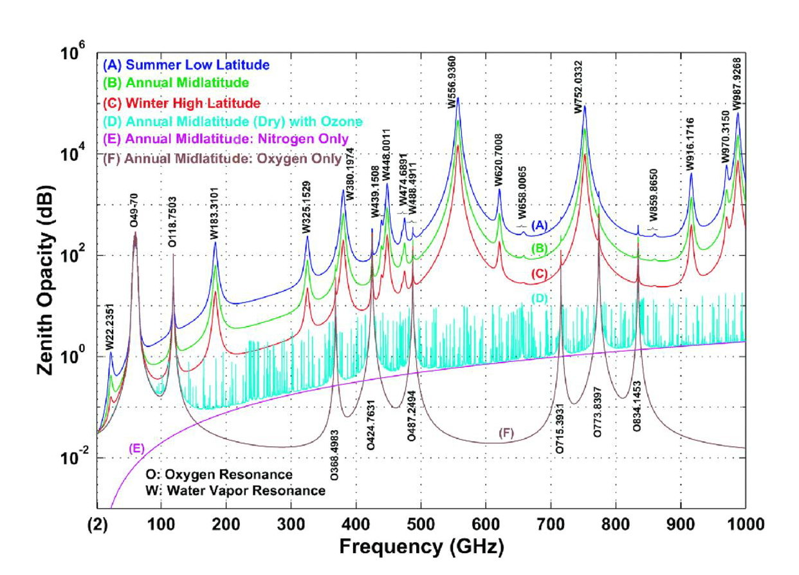

5.2 Atmospheric chemistry
Atmospheric attenuation occurs among many atmospheric layers of varying temperature. The temperature values can be sensed at different heights or distances along the path by selecting frequencies near the edges of the opaque regions with different attenuations, which provide different weighting functions or multipliers of the atmospheric temperature at a given point. Atmospheric chemistry measurements are typically made with limb sounders, scanning the atmosphere layers at the horizon as viewed from the satellite orbital position. These measurements relate to the spectral lines of a large number of chemical species in the atmosphere. Limb sounding is more sensitive and allows for better vertical resolution than nadir sounding. Sub-millimetre frequencies, from about 500 GHz and higher, allow sounding down to the lower stratosphere. Millimetre frequencies, notably between 180 and 360 GHz, allow sounding to even lower altitudes, i.e. to the upper troposphere (Recommendation ITU-R RS.515).
A number of different frequencies are typically chosen to provide a reasonable set of weighting functions for atmospheric temperature, water vapour, ozone, chlorine oxide, nitrous oxide and carbon monoxide profile measurements. The minimum bandwidth required for measurements of atmospheric spectral lines is proportional to the frequency of the spectral line (i.e. a measurement around 600 GHz requires more bandwidth than what is required for a measurement at 300 GHz). This is essentially due to the fact that the sensor filtering capability corresponds to a certain percentage absolute value of the frequency.
As a first order approximation, this implies a bandwidth requirement of about 1 GHz on both sides of the spectral line for measurements up to 500 GHz, while 2 GHz on both sides of the spectral line is needed for measurements between 500 and 1 000 GHz.

5.3 EESS (passive) scanning modes
There are two types of sounding modes and three types of scanning modes used by passive sensors in NGSO orbits. Additionally, there are two scanning modes used in geostationary orbit.
The NGSO sounding modes provide profiles of atmospheric constituents from one fixed orientation relative to the satellite. Figure 2 provides a depiction of the NGSO sounding modes which are:
– Limb sounding modes, which observe the atmosphere at a tangential angle to the Earth’s surface. The field of view terminates in space rather than at the surface of the Earth. However, some limb sounding radiometers also perform elevation scanning of the Earth’s limb in order to cover the whole vertical range and improve the vertical resolution.
– Nadir sounding modes, which provide atmospheric soundings or views of the Earth’s surface at angles of nearly perpendicular incidence to the Earth’s surface.
Figure 2
NGSO sounding modes
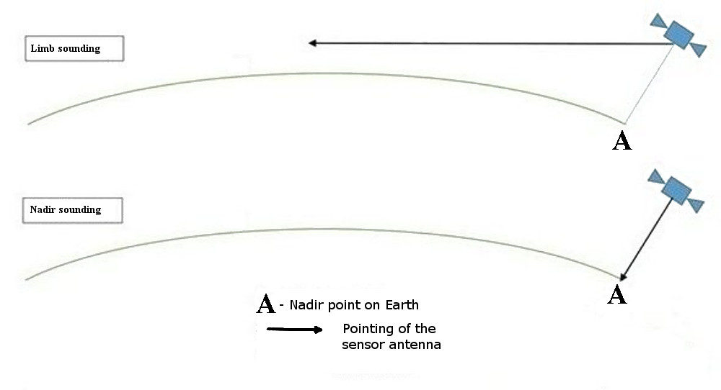
The NGSO scanning modes view the Earth from various angles and cover a range of terrestrial locations from a single satellite location. The three NGSO scanning modes are:
– conical scanning modes, which view the Earth’s surface by rotating the antenna at an offset angle from the nadir direction;
– cross track scanning modes, which provide measurements in swaths perpendicular to the track of the satellite. These swaths may provide scanning in one direction or in a back-and-forth direction (whisk-broom scan) for which the raw zig-zag pattern must be eliminated; and
– push-broom scanning modes, which utilize multiple sensors to observe the Earth in multiple parallel along-track swaths.
A schematic of the three types of NGSO scanning modes is presented in Fig. 3.
Figure 3
NGSO Scanning Modes
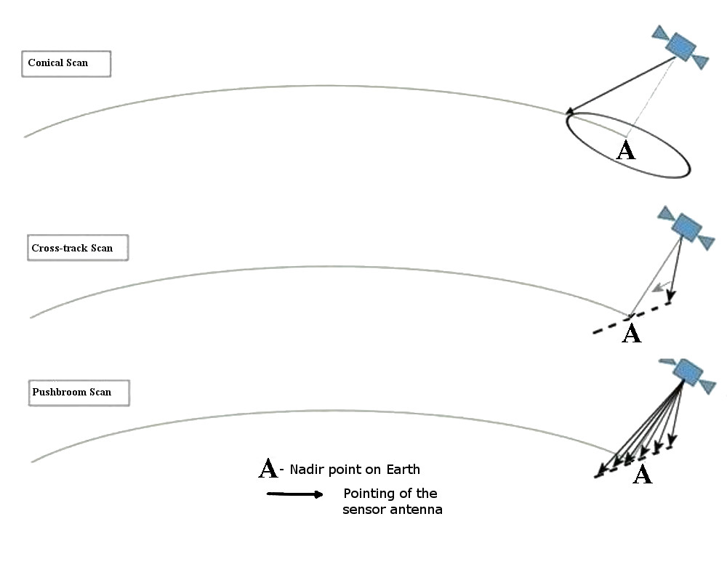
In a geostationary orbit, the orbital path of the instrument does not provide the movement in the second dimension required to perform a scan of an area. Therefore the two-dimensional scanning mechanism must be built into the instrument hardware. Examples of this type of scanning mode is depicted in Fig. 4.
Figure 4
GSO Scanning Mode
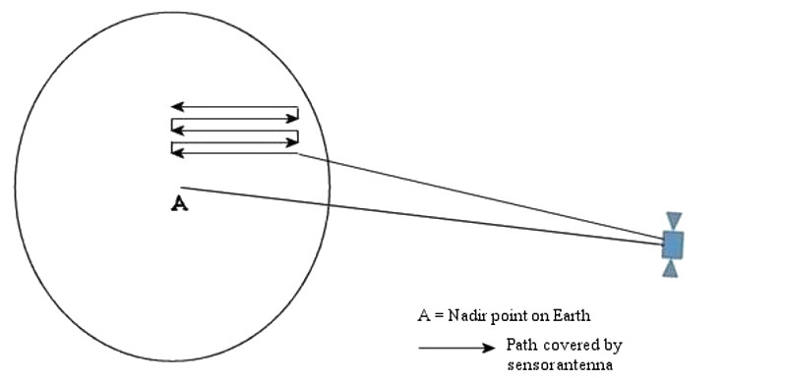
Raster Scan
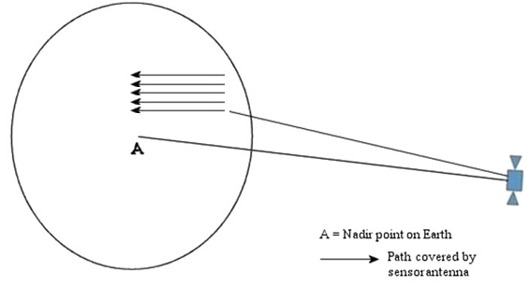
Raster Scan
The type of scanning strategy employed by the sensor will have impact in the analysis of the frequency sharing scenario.

5.3.1 Conical scanning radiometers
Many passive microwave sensors designed for imaging the Earth surface features use a conical scan configuration turning around the nadir direction because it is important, for the interpretation of surface measurements, to maintain a constant ground incidence angle along the entire scan-lines.
A conical scan configuration produces measurement footprints that are constant in size and, since the polarization characteristics of the signal have a dependence on ground incident angle, a constant ground incidence angle removes the variation of return polarization from the gathered data. Conical scanning antennas gather information over wide areas as shown in Fig. 5. Scans are typically performed by rotating the antenna at an offset angle from the nadir direction.
FIGURE 5
Geometry of conical scan passive microwave radiometers (Rec. ITU-R RS.1861)

5.3.2 Cross-track scanning
Scanning radiometric measurements gather information over wide areas which are used in creating virtual maps of the parameter being measured. Scanning measurements are also typically performed at multiple frequencies and polarizations.
Scans are typically performed in a cross-track pattern across the surface of the Earth as shown in Fig. 6. Cross-track scanning may be performed by physically rotating a reflector 360 degrees. As the reflector is directed away from the surface of the Earth, sensor channels remain operating for calibration purposes, as shown in Fig. 7. An alternate approach is to swing the sensor back and forth, never looking away from the surface. This alternate motion would produce a zig-zag pattern of coverage measurements which must be removed, usually by a mechanism within the instrument.
FIGURE 6
Typical cross-track Earth scanning pattern (Rec. ITU-R RS.1861)
FIGURE 7
Typical sensing scanning pattern over 360 degrees (Rec. ITU-R RS.1861)

5.3.3 Push-broom scanning
A “push-broom” (along track) sensor consists of a line of sensors arranged perpendicular to the flight direction of the spacecraft, as illustrated in Fig. 8. Different areas of the surface of the Earth are detected as the spacecraft flies forward. The push-broom sensor is a purely static instrument with no moving parts. The major feature of the push-broom sensor is that all resolution elements in a scan line are acquired simultaneously, and not sequentially as with mechanically scanned sensors, enabling this type of sensor to significantly increase the achievable radiometric resolution.
FIGURE 8
Typical push-broom radiometer configuration

5.3.4 Raster scanning
Raster scanning modes sweep horizontally left-to-right at a steady rate, then blanks and rapidly moves back to the left (or down), where it turns back on and sweeps out the next line, as shown in Fig. 3. During this time, the vertical position is also steadily increasing (downward). GSO raster scanning radiometers can provide temperature and humidity profiles, cloud ice/liquid water columnar amount and gross profile, precipitation rate (particularly in cyclone or convection) with very high temporal resolution.

5.3.5 Wide strip and thin circle combined scanning
GSO radiometers also focus on rapidly changing weather phenomenon observation. It needs to use real aperture design to ensure the calibration accuracy and the observation reality of dynamic targets. The wide strip and thin circle combined scanning radiometer, as illustrated in Fig. 9, can realize calibration in every one second and scan on stable satellite platform in GSO. This scan mode combines the general scan (wide strip) of satellite and detail local scan (thin circle) of sensor. Accompanied with satellite the sensor makes east-west recycling movement and steps forward line by line along south-direction, forming the general scan in two dimensional stripes, as shown in Fig. 9 with the red line. At the same time, the sensor makes its footprint move as a circle, in which total 110-degrees angle range are used for observation, forming the detail local scan to meet the requirements of region coverage and time resolution, as shown in Fig. 9 with the black line. One footprint movement step of the general scan and one circle of the detail local scan spend the same time.
FIGURE 9
Typical wide strip and thin circle combined scanning configuration

6 EESS (passive) systems in the frequency range 275-450 GHz
A number of bands between 275 and 450 GHz are identified in Recommendation ITU-R RS.2194 that are of scientific interest for studies of meteorology/climatology and atmospheric chemistry. The relevant bands between 275 and 450 GHz, along with key characteristics of those bands, are listed in Annex 2.
Table 2 provides an overview of different remote passive sensing instruments, the type of measurements obtained, and the missions that they are incorporated into. A summary Table with the main characteristics of these systems is presented in Annex 1.
TABLE 2
Instruments with radiometric channels between 275 and 450 GHz
Instrument | Short description and main objective | Mission/Sponsor
Remote Sensor-1  (ICI) | Ice Cloud Imager (ICI): Conical scanning radiometer.  Main objective: cloud ice retrieval, with emphasis on cirrus clouds, and water vapour profile measurement capability Submillimetre wave sensor with channels from 183 to 664 GHz | Instrument selected for MetOp Second Generation –B (EUMETSAT).  Under development.  Operational system for 2020 – 2040
Remote Sensor-2  (TWICE) | Tropospheric Water and Cloud ICE (TWICE): Conical scanning radiometer.  Main objective: Water vapour and ice clouds in upper troposphere, and study of circulation models for climate modelling | On-going development for CubeSat deployment.  NASA
Remote Sensor-3  (SMM) | Passive submillimetre wave (SMM) ice cloud radiometer.  Main objective: measurement of ice clouds, namely cloud ice mass, particle size, and mean cloud altitude. | Completed feasibility study.  Preparation for mission proposal was supported by JAXA.
Remote Sensor-4  (STEAMR) | STEAMR Millimetre wave multi-beam Limb sounder  Main objective: 3D limb sounding with embedded  cloud imaging capability | One of the payloads of PREMIER for an Earth Explorer Core Mission
Remote Sensor-5  (GEM) | Geosynchronous Microwave (GEM) sensor  Main objective: Temperature and moisture profiling from the lower stratosphere down to ~2-5 km altitude. | Sensor on GOES-class satellites
Remote Sensor-6  (GOMAS) | Geostationary Observatory for Microwave Atmospheric Sounding (GOMAS).  Main objective: Temperature and moisture profiles, cloud ice/liquid water gross profile. | Earth Explorer Opportunity Mission
Remote Sensor-7  (CAMLS) | Compact Adaptable Microwave Limb Sounder (CAMLS)  Main objective: understanding the composition and structure of UT/LS. | On-going development for next generation of microwave Limb Sounders.  NASA
Remote Sensor-8  (GMS) | Geostationary Microwave Sounder (GMS) | Chinese FY-4 microwave satellite
Remote Sensor-9  (MASTER) | MASTER- Millimetre wave multi-beam Limb sounder  Main objective: 3D limb sounding | Earth Explorer Core Mission

6.1 Remote Sensor-1: Ice Cloud Imager (ICI)
In order to obtain global coverage observation data for Earth atmospheric weather forecasting, ESA & EUMETSAT are jointly planning the next generation of weather satellite series: Meteorological Operational Satellite-Second Generation (MetOp-SG). MetOp-SG consists of two series of satellites (termed Satellite A and Satellite B series), with three satellites in each series (3+3 configuration). A total of ten different instruments will be flown onboard the two series of satellites. The Ice Cloud Imager (ICI) instrument is a millimetre and sub-millimetre wave conically scanning radiometer, providing brightness temperature measurements in a total number of 13 channels ranging from 183 GHz up to 664 GHz. ICI is designed to monitor the exchange mechanisms in Earth's upper troposphere and lower stratosphere, and will focus, in particular, on the remote sensing of high altitude ice clouds. This will be accomplished using several double sideband heterodyne receiver channels centred at 183 GHz, 243 GHz, 325 GHz, 448 GHz and 664 GHz, with two window channels (243 GHz and 664 GHz) which will be measured at both V and H polarizations. The use of channels around weak absorption lines (i.e. 325.15 GHz and 448 GHz) allows performing cloud slicing.
The ICI instrument is composed of a rotating part that includes the main antenna, the feed assembly and the receiver electronics, and a fixed part that contains the hot calibration target, the reflector for viewing the cold sky and the electronics for the instrument control and interface with the platform. Between the fixed and the rotating part is the scan mechanism. ICI is a conical scanner with a constant observation zenith angle (OZA) at 53° ± 2°. ICI provides footprints of 15 km at all channels.
The antenna is based on single offset reflector geometry and the feed cluster has 7 horns distributed in two rows. ICI obtains measurements from the upper and lower sidebands for each channel over an azimuth scan angle range of ±65 degrees around the nadir for scene view. The ICI rotates at uniform speed. Channels at 243 GHz and 664 GHz are measured at V and H polarizations, while all other channels are measured in V polarization only. Contrary to traditional conical scanners, ICI will be mounted on the nadir side of the spacecraft [2], [3].
TABLE 3
Main technical and operational characteristics of Remote Sensor-1 (ICI)
Type of mission | Payload on Metop-SG. Operational mission. In orbit from 2023 up to the 2040
Type of orbit | SSO LEO
Altitude | 817 km
Inclination | 98.7 degrees
Scanning geometry (N, C, L) | Conical scanning. Scan rate: ~ 27 scan/min = ~ 16 km/scan.  Scan angle over ±65 degrees. See Fig. 10
Observation zenith angle (OZA) | 53 degrees ± 2 degrees
Channels centre frequency | 183.31 GHz, 243.2 GHz, 325.15 GHz, 448 GHz & 664 GHz
Channels bandwidth | See Table 4
Antenna peak gain | 55 dBi, Beam efficiency > 95%
Antenna 3 dB beamwidth | Consistent with an antenna diameter of ~ 0.5 m
Footprint area | Projected footprint of 16 km for all channels (Oval shape, can be approximated to circle 16 km diameter)
Coverage | Global coverage once/day

TABLE 4
Channel specifications for Remote Sensor-1 (ICI)
Channel No | Frequency f_{o}±Δf (GHz) (*) | Bandwidth (MHz) (**) | Polarization | Utilization
ICI-1 | 183.31±7.0 | 2 × 2 000 | V | Water vapour profile and snowfall
ICI-2 | 183.31±3.4 | 2 × 1 500 | V | Water vapour profile and snowfall
ICI-3 | 183.31±2.0 | 2 × 1 500 | V | Water vapour profile and snowfall
ICI-4 | 243.2±2.5 | 2 × 3 000 | V, H | Quasi-window, cloud ice retrieval, cirrus clouds
ICI-5 | 325.15±9.5 | 2 × 3 000 | V | Cloud ice effective radius

TABLE 4 (end)
Channel No | Frequency f_{o}±Δf (GHz) (*) | Bandwidth (MHz) (**) | Polarization | Utilization
ICI-6 | 325.15±3.5 | 2 × 2 400 | V
ICI-7 | 325.15±1.5 | 2 × 1 600 | V
ICI-8 | 448±7.2 | 2 × 3 000 | V | Cloud ice water path and cirrus
ICI-9 | 448±3.0 | 2 × 2 000 | V | Cloud ice water path and cirrus
ICI-10 | 448±1.4 | 2 × 1 200 | V | Cloud ice water path and cirrus
ICI-11 | 664±4.2 | 2 × 5 000 | V, H | Quasi-window, cirrus clouds, cloud ice water path
(*) For each ICI channel, measurements are performed at both sides of the centre frequency (f_{o} + Δf and f_{o} - Δf)
(**) Total bandwidth per channel, considering both sides around the centre frequency f_{o}.

Figure 10
Scanning geometry and measurement/calibration sectors [2]
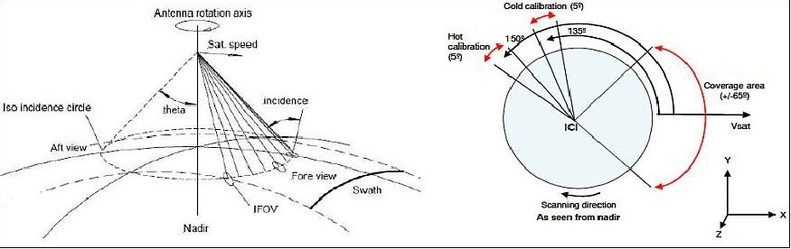

6.2 Remote Sensor-2: Tropospheric Water and Cloud ICE (TWICE)
The Tropospheric Water and Cloud ICE (TWICE) radiometer instrument is currently under development. TWICE is designed with size, mass, power consumption and downlink data rate compatible with deployment aboard a 6U-Class nanosatellite.
The TWICE instrument will perform conical scanning of the atmosphere at an incidence angle near 53 degrees as well as two-point integrated ambient and cold-sky calibration once each scan, i.e. once per second. The TWICE instrument will provide 15 radiometer channels, including window frequencies near 240, 310 and 670 GHz to perform ice particle sizing and determine total ice water content, as well as four sounding channels each near 118 GHz for temperature sounding and near 183 GHz and 380 GHz for water vapour sounding during nearly all weather conditions. This will prove particularly useful for measurements in the upper troposphere in the presence of ice clouds. The TWICE instrument has three direct-detection receivers, with dual-polarization capability at the 670 GHz. Ice particle size and total ice water content will be retrieved from measured antenna temperatures at these frequencies [4], [5].
TABLE 5
Main technical and operational characteristics of Remote Sensor-2 (TWICE)
Type of mission | 6U-Class nanosatellite
Type of orbit | SSO LEO
Altitude | 400 km
Inclination | High inclination
Scanning geometry (N, C, L) | Conical scanning. See Fig. 11  Total scan angle 130 degrees (Earth view)
Observation Zenith Angle (OZA) | 53 degrees
Channels centre frequency | Sounding: 118 GHz (4 channels), 183 GHz (4 channels) and 380 GHz (4 channels)  Window channels: 240 GHz (1 channel), 310 GHz (1 channel) and 670 GHz (2 channels)
Channels bandwidth | See Table 6
Antenna peak gain | 46-48 dBi
Antenna 3 dB beamwidth | At 310 GHz: 0.64 degrees HPBW  At 380 GHz: 0.56 degrees HPBW
Footprint area | At 310 GHz: 6.5 km (cross-track) and 9.9 km (along-track)  At 380 GHz: 5.8 km (cross-track) and 8.7 km (along-track)  Swath width = 749 km  See Fig. 12
Coverage | Nearly global coverage once/day

Figure 11
TWICE Scanning and calibration strategy [5]
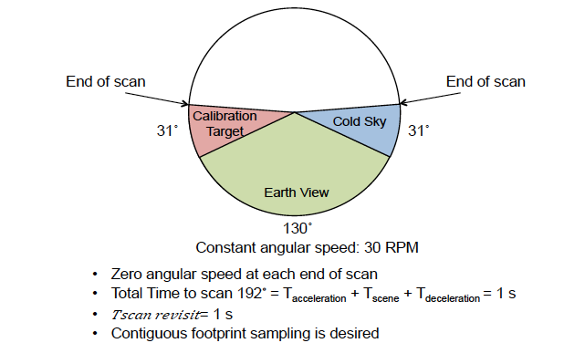
Figure 12
TWICE Surface Footprint for 400 km orbit [5]
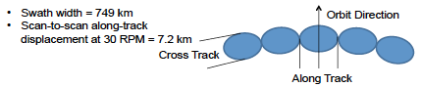
TABLE 6
Channel specifications for Remote Sensor-2 (TWICE)
Channel | Frequency f_{o}±Δf (GHz) (*) | Bandwidth  (GHz) | Polarization | Utilization
1 | 118.75 ± 1.1 | 2 × 0.4 = 0.8 | linear | Water vapour retrievals
2 | 118.75 ± 1.5 | 2 × 0.4 = 0.8 | linear | Water vapour retrievals
3 | 118.75 ± 2.1 | 2 × 0.8 = 1.6 | linear | Water vapour retrievals
4 | 118.75 ± 5.0 | 2 × 2.0 = 4.0 | linear | Water vapour retrievals
5 | 183.31 ±1.0 | 2 × 0.5 = 1.0 | linear | Water vapour profile in the troposphere and UTLS
6 | 183.31 ± 3.0 | 2 × 1.0 = 2.0 | linear | Water vapour profile in the troposphere and UTLS
7 | 183.31 ± 6.6 | 2 × 1.5 = 3.0 | linear | Water vapour profile in the troposphere and UTLS
8 | 243.20 ± 2.5 | 2 × 3.0 = 6 | linear | Ice particle sizing and total ice water content
9 | 310.00 ± 2.5 | 2 × 5.0 = 10 | linear | Ice particle sizing and total ice water content
10 | 380.20 ± .75 | 2 × 0.7 = 1.4 | linear | Water vapour sounding and ice clouds
11 | 380.20 ±1.80 | 2 × 1.0 = 2.0 | linear | Water vapour sounding and ice clouds
12 | 380.20 ± 3.35 | 2 × 1.7 = 3.4 | linear | Water vapour sounding and ice clouds
13 | 380.20 ± 6.20 | 2 × 3.6 = 7.2 | linear | Water vapour sounding and ice clouds
14 | 664.00 ±4.20 | 2 × 4.0 = 8.0 | H,V | Ice particle sizing and total ice water content

6.3 Remote Sensor-3: Sub-MilliMeter Ice Cloud sensor (SMM)
The sub-millimetre (SMM) ice cloud remote sensor targets global coverage measurements of important micro- and macrophysical properties for all types of ice clouds, namely cloud ice mass, particle size, and mean cloud altitude. These parameters have not been measured with sufficient coverage and accuracy by other sensor types including active instruments.
One of the key issues in SMM ice cloud remote sensing is to solve the trade-offs between spatial resolution, coverage, and sensor sensitivity in a satisfactory manner. Ice cloud sensing requires a spatial resolution in the order of cloud characteristic sizes, i.e. a few kilometres or better. With currently used single field-of-view scanning receivers, wide coverage of 1 000 km or more requires fast scanning when improvement of spatial resolution is targeted. Fast scanning on the other hand decreases signal integration time, increases signal noise, and decreases sensor sensitivity. To improve or solve these issues, this concept applies receiver arrays for SMM imaging.
Covering a wider area in a “single shot” observation this setup allows for slower scanning of an equivalent area compared to conventional single field-of-view receivers. Hence, sensitivity of the observation is improved. In turn, when keeping sensor sensitivity constant a finer spatial resolution can be realized.
The sensor has two observation frequencies: around the 325 GHz water vapour line and in the 660 GHz window region. Beside technological reasons, these spectral positions have been chosen because they exhibit similar clear-sky atmospheric opacities. That means, observed brightness temperatures are nearly identical for clear-sky conditions, and deviations in the signals can be attributed solely to clouds. The 325 GHz channels will be more sensitive to large particle fractions, while the high frequency channel senses smaller particles. Table 7 provides preliminary characteristics for the SMM Ice cloud remote sensor and Fig. 13 illustrates the concept of the receiver array. The channel specifications are presented in Table 8 [6].
TABLE 7
Main technical and operational characteristics of Remote Sensor-3 (SMM)
Type of mission | Proposed, preferably in line with other instruments
Type of orbit | SSO LEO
Altitude | 600 to 800 km
Inclination | High inclination
Scanning geometry (N, C, L) | Conical or across track scan scanning. See Fig. 6.3-1
Observation Zenith Angle (OZA) | Dependent on final design configuration.
Channels centre frequency | 325 GHz (H₂O-line) + 660 GHz (window)  (possibly H/V polarizations for window receiver)
Channels bandwidth | See Table 8
Footprint area | 5 km²
Coverage | Global

TABLE 8
Channel specifications for Remote Sensor-3 (SMM)
Channel No. | Centre frequency (GHz) | Polarization | Utilization
SMM-1 | 325 | Single pol | (H2O-line)  Ice clouds mass, ice particle sizing, mean cloud altitude
SMM-2 | 325 | Single pol
SMM-3 | 325 | Single pol
SMM-4 | 325 | Single pol
SMM-5 | 660 | V, H | (Window)  Ice particle sizing (for smaller ice particles) and total ice water content

FIGURE 13
Illustration of the SMM receiver array concept
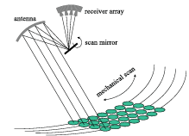

6.4 Remote Sensor-4: Millimetre-Wave Limb sounder (STEAMR)
STEAMR is one of the payloads of PREMIER, which was proposed to ESA as an Earth Explorer Core mission. The main objective of PREMIER is to measure vertical volume mixing profiles of atmospheric constituents in the mid/upper troposphere and the lower stratosphere (UT-LS), and their variation over time. The mission concept is based on a payload with three complement instrument functions: Millimetre-Wave Limb Sounder (known as STEAMR), IR limb sounder (IRLS) and IR limb cloud imager (IRCI).
The mission concept considers PREMIER flying in a tandem formation looking backwards to METOP’s swath and therefore PREMIER data would need to be temporally co-registered at the tangent point with METOP data at nadir. The geometry of the METOP and PREMIER orbits is shown in Fig. 14 [7], [8].
FIGURE 14
Geometry of METOP and PREMIER orbits
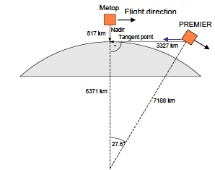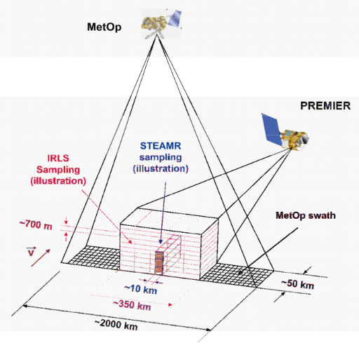
STEAMR is a multi-beam limb sounder operating in the 310-360 GHz range, using an 8-beam array of receivers to improve sensitivity and instrument data retrieval. The main objective of STEAMR is to provide vertically (1-2 km) and horizontally (30-50 km) information on the distribution of UT-LS constituents such as water vapour, ozone and carbon monoxide on the global scale.
The quasi-optical system consists of one primary reflector of 1.6 × 0.8 m with an offset Gregorian sub reflector. Three mirrors link the beam from the sub reflector to the focal plane unit, accommodating 8 receiver front-ends in an array configuration [9].
STEAMR observation principles require the highest altitude resolution at the lower end of the atmospheric altitudes observed. The STEAMR measurement concept is based on multi-beam limb sounding in the orbital plane using Schottky-diode heterodyne receivers. The instrument limb view follows a staring concept, observing simultaneously an altitude range of 22 km with 14 beams spaced vertically: every 1.5 km in the lowest 12 km and every 2 km in the highest 10 km as shown in Fig. 15 [8]. Two polarisations are used. There is no need to scan the limb mechanically or by spacecraft manoeuvring. Instead, the spacecraft antenna pointing follows the tropopause altitude.
FIGURE 15
STEAMR limb imaging principles
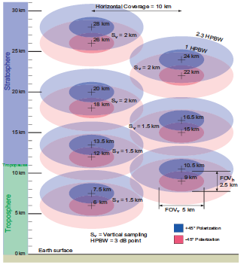

TABLE 9
Main technical and operational characteristics of Remote Sensor-4 (STEAMR)
Type of mission | Satellite in tandem formation with Metop.
Type of orbit | SSO LEO
Altitude | 817 km
Inclination | 98.7 degrees
Scanning geometry (N, C, L) | Limb sounder. See Fig. 14
Observation Zenith Angle (OZA) | Not applicable
Channels centre frequency | Spectral instrument (continuous measurement over large bandwidth
Channels bandwidth | Lower side band: 313.5-325.5 GHz  Upper side band: 343.6-355.6 GHz  (12 GHz for each spectral sideband)
Antenna peak gain | Reflector antenna 1.6 m × 0.8 m; Gain = 70 dBi  First side lobe < –35 dB
Footprint area | FOVh = 5 km, FOVv = 2.5 km  See limb imaging schematic in Fig. 15
Coverage | Global

6.5 Remote Sensor-5: Geosynchronous Microwave sensor (GEM)
The Geosynchronous Microwave (GEM) sensor was proposed to be flown on a GSO satellite. The technical and operational characteristics of the sensor were defined. The GEM observation principle is based on the use of three absorption bands of oxygen (54, 118 and 425 GHz) and two bands of water vapour (183 and 340/380 GHz). A series of narrow-bandwidth channels implemented within these bands for a total of 37 channels would provide temperature and moisture profiling capability from the lower stratosphere down to ~2-5 km altitude. Owing to the wide frequency range spanned by the five GEM bands, each of these bands is differently affected by liquid and ice water amount and drop size (see Fig. 16). These additional observable degrees of freedom provide information on cloud and precipitation type and amount.
FIGURE 16
GEM vertical response
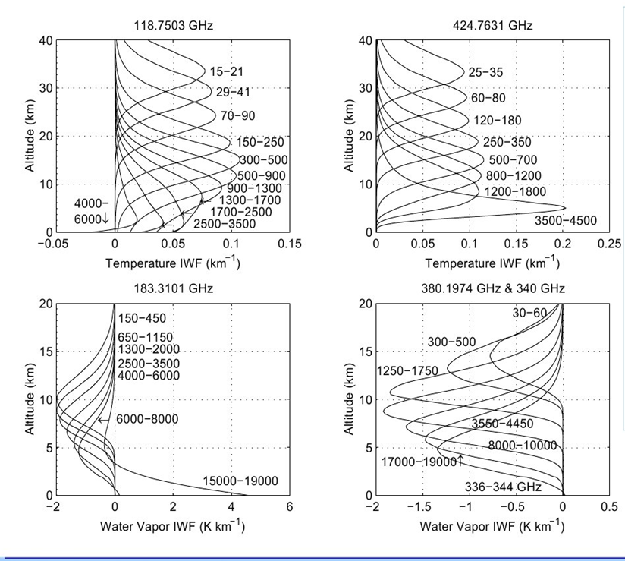
The baseline GEM concept uses a 2-metre Cassegrain antenna with a dual-stage scanning system. The dual-stage system consists of a slow momentum-compensated azimuth mechanism and fast nodding/morphing subreflector scanning system to provide both wide-area synoptic coverage and fast regional coverage with adaptive scan capabilities. Oversampling and super-resolution techniques are expected to improve GEM spatial resolutions by an additional ~20-30% for high-interest events such as hurricanes or localized mesoscale convection. Further reductions in the ∆T_{rms} are achievable via additional downsampling and/or time averaging. Regional scanning covering a 1 500 × 1 500 kilometres square is expected to take 12-15 minutes, while scanning the entire continental United States, an area 3 000 × 5 000 kilometres, is estimated to take 90 minutes.
TABLE 10
GEM Instantaneous FOV per channel
Band  (GHz) | 3 dB IFOV  (km)
50-56 | 138.6
118.75 | 60.2
183.31 | 41.9
380.153 | 20.5
424.763 | 16.4
Thermal and inertial deformations are monitored by a series of sensors on the antenna structure. Phase errors caused by such deformations will be actively compensated using a nodding/morphing sub-reflector with approximately five degrees of freedom. The sub-reflector also provides for high rate beam scanning over a limited range. Larger movements to change the observation sector are performed by momentum-compensated elevation and azimuth motors, although the possibility of using the satellite attitude control system in combination, or as an alternative, is also considered. A single feed horn path is baselined so as to provide hardware co-alignment of all feeds for the five bands. The baseline receiver uses a quasi-optical multiplexer and includes five individual radiometer modules, one for each band [10].

6.6 Remote Sensor-6: GEO Atmospheric Sounding (GOMAS)
The Geostationary Observatory for Microwave Atmospheric Sounding (GOMAS) mission was proposed to ESA as an Earth Explorer Opportunity Mission. GOMAS and GEM mission concepts are similar, although adapted to different platforms and with differences in the frequency bands selected. The instrument is intended to be flown on a dedicated satellite.
The objective is to explore the capabilities of very high frequency microwaves and sub-millimetre waves to provide observations, at 15-min intervals, of:
– Nearly-all-weather temperature and humidity profiles.
– Cloud ice/liquid water, columnar amount and gross profile.
– Precipitation rate (particularly within convection).
Considerations for the frequency selection:
– For O₂, above the 54 GHz band, the desirable temperature sounding bands are at 118 GHz and 425 GHz.
– For H₂O, above the band at 183 GHz, there are several others, the first at 325 GHz, then at 380 GHz and higher.
The choice of bands for GOMAS is 54 GHz, 118 GHz, 183 GHz, 380 GHz and 425 GHz. GOMAS has 40 channels distributed over these five frequency bands.
The GOMAS concept is based on a 3-m antenna diameter. The problem of sensitivity is solved by limiting the scanned area of the Earth's disk. Within the current technological state-of-art it is not possible to scan the full Earth disk in the required short time at the required resolution. A compromise is achieved by scanning a sector of about 1/12 of the disk (250 × 500 pixels) with an integration time of ~6 ms per pixel (see Fig. 17). The scanning mechanism may be driven with different speeds and over areas of different sizes. The reference sector of 1/12 of the disk can be selected everywhere within the disk of the Earth so as to track events of particular interest. In addition, during the satellite lifetime the longitude of geostationary position can be shifted so as to allow observation over the American continents to the Indian Ocean, following seasonal events [11].
FIGURE 17
GEM/GOMAS reference coverage and illustration of the micro-scan concept
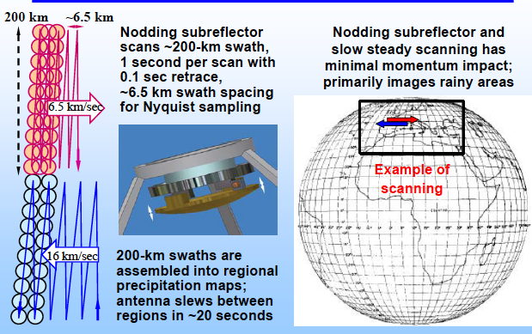
(Source: Application of a CubeSat based passive microwave constellation to operational meteorology, by Prof A.J. Gasiewski, Eumetsat seminar, 2016).
TABLE 11
Main technical and operational characteristics of Remote Sensor-6 (GOMAS)
Type of mission | The instrument is intended to be flown on a dedicated satellite  Proposed to ESA as an Earth Explorer Opportunity Mission.
Type of orbit | Geostationary
Altitude | 35,786 km
Inclination | Not applicable
Scanning geometry (N, C, L) | The scanned area can be moved within the Earth disk, and the longitude of geostationary position can be shifted during the satellite lifetime.
Channels centre frequency | 54 GHz, 118 GHz, 183 GHz, 380 GHz and 425 GHz
Channels bandwidth | See Table 12
Footprint area | IFOV at s.s.p:  12 km @ 380 GHz, and 10 km @ 425 GHz
Coverage | 1/12 of the earth disk can be scanned at any one time. Global with repositioning of GEO location and selection of scan area.

TABLE 12
Channel specifications for Remote Sensor-6 (GOMAS) within the 275-450 GHz range
Channel No. | Frequency  (GHz) | Bandwidth (GHz) | Utilization
GOMAS-1 | 380.17 ± 0.3 | 0.3 | Water
GOMAS-2 | 380.17 ± 0.9 | 0.5 | Water
GOMAS-3 | 380.17 ± 1.65 | 0.7 | Water
GOMAS-4 | 380.17 ± 3 | 1 | Water
GOMAS-5 | 380.17 ± 5 | 2 | Water
GOMAS-6 | 380.17 ± 7 | 2 | Water
GOMAS-7 | 380.17 ± 17 | 4 | Water
GOMAS-8 | 424.76 ± 0.15 | 0.06 | Oxygen
GOMAS-9 | 424.76 ± 0.3 | 0.1 | Oxygen
GOMAS-10 | 424.76 ± 0.6 | 0.2 | Oxygen
GOMAS-11 | 424.76 ± 1 | 0.4 | Oxygen
GOMAS-12 | 424.76 ± 1.5 | 0.6 | Oxygen
GOMAS-13 | 424.76 ± 4 | 1 | Oxygen

6.7 Remote Sensor-7: Compact, Adaptable Microwave Limb Sounder (CAMLS)
The CAMLS family of instruments makes measurements needed to address key outstanding issues associated with the composition and structure of Earth’s upper troposphere and lower stratosphere UT/LS (i.e. 10-20 km altitude region) [12].
TABLE 13
Main technical and operational characteristics of Remote Sensor-7 (CAMLS)
Type of orbit | LEO
Altitude | Not available
Inclination | Not available
Scanning geometry (N, C, L) | Limb sounder
Observation Zenith Angle (OZA) | Not applicable
Channels centre frequency | 340 GHz
Channels bandwidth | Two wideband 8 000 MHz channel digital polyphase spectrometers, sideband separation in the digital domain
Footprint area | 50 km along track for continuity  50 km × 50 km 2D scan for Scanning Microwave Limb Sounding (SMLS) design.

6.8 Remote Sensor-8: Geostationary Microwave Sounder (GMS)
A geostationary microwave sounder (GMS) onboard a Chinese second generation geostationary meteorological satellite – FengYun-4 microwave satellite (FY-4MS) is being developed, which will be launched after 2021. The GMS has several channels operated in the range 275-450 GHz. The GMS will focus on rapidly changing weather phenomenon observation. It uses real aperture design to ensure the calibration accuracy and the observation reality of dynamic targets. The GMS adopts wide strip and thin circle combined scanning mode. It can scan 7.2 × 7.2° area in 90 minutes, which consists of 8 scan strip, i.e. each strip is 0.9 × 2°. The speed of the detail local scan formed thin circles is 25.75 rpm and the circle diameter is 1.1°. Table 14 summarizes the parameters of the GMS sensor.
TABLE 14
Main technical and operational characteristics of GMS
Type of mission | Payload on FY-4 MS. Operational mission after 2021.
Type of orbit | Geostationary
Altitude | 35 800 km
Inclination | Not applicable
Scanning geometry (N, C, L) | Wide strip and thin circle combined scan.
Observation Zenith Angle (OZA) | Not applicable
Channels centre frequency | 338 GHz, 380 GHz and 425 GHz
Channels bandwidth | See Table 15
Antenna peak gain | 76.5 dBi
Antenna 3 dB beamwidth | 0.027°
Footprint area | 16 km
Coverage | Any 7.2°×7.2° area within the earth disk

TABLE 15
Channel specifications for Remote Sensor-8 (GMS) within the 275-450 GHz range
Channel No. | Frequency  (GHz) | Bandwidth  (MHz) | Polarization | Utilization
1 | 338 | 4 000 | V | Window
2 | 380.197 ± 18.0 | 4 000 | H | Water vapour
3 | 380.197 ± 9.0 | 4 000 | H | Water vapour
4 | 380.197 ± 4.0 | 1 800 | H | Water vapour
5 | 380.197 ± 1.5 | 1 000 | H | Water vapour
6 | 380.197 ± 0.4 | 400 | H | Water vapour
7 | 380.197 ± 0.045 | 60 | H | Water vapour
8 | 424.763±4.0 | 2 000 | H | Oxygen
9 | 424.763±1.5 | 1 200 | H | Oxygen
10 | 424.763±1.0 | 800 | H | Oxygen
11 | 424.763±0.6 | 400 | H | Oxygen
12 | 424.763±0.3 | 200 | H | Oxygen
13 | 424.763±0.15 | 120 | H | Oxygen
14 | 424.763±0.07 | 40 | H | Oxygen
15 | 424.763±0.03 | 40 | H | Oxygen

6.9 Remote Sensor-9: Limb sounder MASTER
The Millimetre-wave Acquisitions for Stratosphere/Troposphere Exchange Research instrument (MASTER) is a limb-viewing emission-sensing spectrometer with three millimetre wave and a sub-millimetre wave channel. MASTER was one of the payloads of ACECHEM, a mission proposed to ESA as Earth Explorer Core mission.
The objectives of ACECHEM are to measure and understand the human impact on the chemistry and composition of the lower and middle atmosphere, and to investigate the interactions between atmospheric chemistry, atmospheric composition and climate. This demands the simultaneous and accurate observation of numerous species in the upper troposphere and lower stratosphere, globally and with high vertical resolution. A multi-instrument payload is required to meet the objectives of ACECHEM, including an mm-wave limb sounder called MASTER with four bands in the 296-505 GHz range.
MASTER is designed to make high sensitivity measurements with good vertical resolution (2 km) and frequent along-orbit track sampling. The wavelength range chosen makes it much less sensitive to cloud and aerosol than instruments that target shorter wavelengths. The frequency range selected for MASTER requires the application of the super-heterodyne principle to down-convert the received radiation for further spectral analysis. The proposed instrument concept is a single side-band design. Sampling of the same atmospheric volume as observed by MetOp is achieved by flying the ACECHEM satellite carrying the MASTER instrument in formation with MetOp. The ACECHEM satellite would fly ahead of MetOp and its instruments would look backwards.
The MASTER antenna (offset Cassegrain type) is shared by all five receivers. The vertical and horizontal directivity requirements lead to a system with a large elliptical main reflector of 1 × 2 m. Elevation scanning of the Earth's limb in the standard tangent-height range is achieved by a combination of manoeuvring the complete satellite to the three atmospheric domains indicated in Fig. 18 and moving the main reflector at a constant speed to cover the vertical range of a given domain [13], [14], [15].
FIGURE 18
MASTER observation geometry, showing the standard and extended scan ranges achieved by the platform [14]
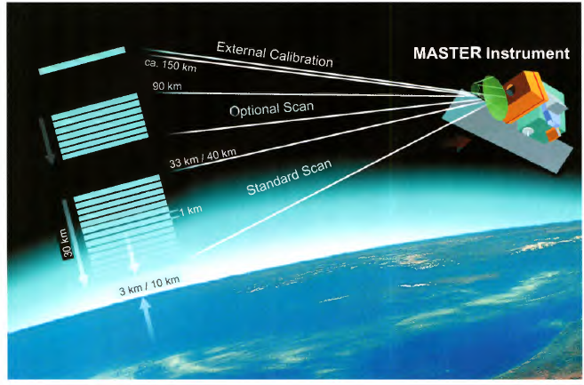
TABLE 16
Main technical and operational characteristics of Remote Sensor-9 (MASTER)
Type of mission | Proposed to ESA as an Earth Explorer Core Mission.
Type of orbit | SSO LEO
Altitude | 817 km
Inclination | 98.7 degrees
Scanning geometry (N, C, L) | Limb sounder. A vertical profile is measured every 15 s by scanning the instrument's antenna over a tangent height range of 30 km; varying from 33 km down to 3 km at the poles, to 40 km down to I0 km in the tropics.
Observation Zenith Angle (OZA) | Not applicable
Channels centre frequency | (A) 299.75 GHz, (B) 320.0 GHz, (C) 345.6 GHz,  (D) 501.5 GHz and (E) 625.25 GHz
Channels bandwidth | (A) 11.5 GHz, (B) 9.0 GHz, (C) 6.5 GHz,  (D) 9.0 GHz, (E) 2.5 GHz
Antenna peak gain | Offset Cassegrain reflector (1 m × 2 m)
Footprint area (IFOV) | (A), (B), (C) 2.3 km × 4.6 km,  (D), (E) 1.6 km × 3.3 km

7 Characteristics of EESS (passive) systems to be considered in sharing studies in the frequency range 275-450 GHz
The following Table provides a band-by-band summary of EESS (passive) systems to be considered in sharing studies in the frequency range 275-450 GHz. The detailed characteristics of these EESS (passive) systems have been presented in previous sections and have been summarised in Annex 1.
TABLE 17
Mapping criteria for satellite passive remote sensing in the frequency range 275-450 GHz
Frequency band(s)  (GHz) | Scan mode
Frequency band(s)  (GHz) | Scanning  (Nadir, Conical, Push-Broom, Cross Track, Raster) | Limb
275-286 | --------- | Consider characteristics similar to STEAMR (Note)
296-306 | Consider characteristics similar to ICI (Note) | MASTER (SSO LEO orbit, § 6.9)
313-356 | ICI (SSO LEO orbit, § 6.1)  SSM (SSO LEO orbit, § 6.3)  GEM (GSO orbit, § 6.5)  GMS (GSO orbit, § 6.8) | STEAMR (SSO LEO orbit, § 6.4)  CAMLS (SSO LEO orbit, § 6.7)  MASTER (SSO LEO orbit, § 6.9)
361-365 | Consider characteristics similar to ICI (Note)  GMS (GSO orbit, § 6.8) | Consider characteristics similar to STEAMR (Note)
369-392 | TWICE (SSO LEO orbit, § 6.2)  GEM (GSO orbit, § 6.5)  GOMAS (GSO orbit, § 6.6)  GMS (GSO orbit, § 6.8) | Consider characteristics similar to STEAMR (Note)
397-399 | Consider characteristics similar to ICI (Note)  GMS (GSO orbit, § 6.8) | Consider characteristics similar to STEAMR (Note)
409-411 | --------- | Consider characteristics similar to STEAMR (Note)
416-434 | GOMAS (GSO orbit, § 6.6)  GMS (GSO orbit, § 6.8) | Consider characteristics similar to STEAMR (Note)
439-467 | ICI (SSO LEO orbit, § 6.1) | Consider characteristics similar to STEAMR (Note)

NOTE – For the bands for which current operating or planned systems are not available characteristics based on systems in other bands should be used.

It should be noted that the current reference EESS (passive) antenna pattern as given in Recommendation ITU-R RS.1813 is valid in the 1.4 to 100 GHz range. However, for the time being, it is recommended that the pattern in Recommendation ITU-R RS.1813 be used in the 275-450 GHz range.

8 References
[1] Nadir sensitivity of millimeter and sub-millimeter frequencies to clear air temperature and water vapour variations. M. Klein, A.J. Gasiewski. Journal of Geophysical Research. Vol 105. No. D13, pages 17481-17511, July 2000.
[2] Ice Cloud Imager Instrument for MetOp Second Generation. V. Kangas, S D’Addio, U.Klein. Microrad 2014.
[3] Millimeter & sub-millimeter wave radiometer instruments for the next generation of polar orbiting meteorological satellites – MetOp-SG. B. Thomas, M Brandt, A. Walber. International Conference IRMMW-THz 2014.
[4] Tropospheric Water and Cloud ICE (TWICE) Millimeter and Submillimeter-wave Radiometer Instrument for 6U-Class Nanosatellites. Steven C. Reising1, Pekka Kangaslahti (JPL). IEEE 2016.
[5] TWICE Instrument Development for CubeSat Deployment. Reising et al., A7P5 ESTF 2015, Pasadena, CA USA
[6] Sub-Millimeter Wave Radiometer for Observation of Cloud Ice – A Proposal for Japanese Mission. Jana Mendroka, Dong L. Wub, JPL. Proc. of SPIE Vol. 7474 74740T-1. 2009. http://www.sat.ltu.se/members/mendrok/publications/mendrok09_sub-millimeter_spie.pdf.
[7] RADIOMETER instruments for space applications. A Emrich, U Frisk, International Conference IRMMW-THz 2014.
[8] Candidate Earth Explorer Core Mission – Report for Mission Selection: PREMIER. ESA SP-1324/3, European Space Agency, Noordwijk, The Netherlands.
[9] PREMIER’s imaging IR limb sounder. Phase A results. 2008.
[10] Microwave Sensing from Geostationary Orbit, GOES User Conference II, A. Gasieski et al., October 1-3, 2002, Boulder Colorado. https://www.goes-r.gov/downloads/GOES%20Users'%20Conference%20II/Gasiewski/GEM%20GOES%20User%20Conf%20Oct%202002.pdf.
[11] GOMAS Geostationary Observatory for Microwave Atmospheric Sounding. International TO VS Study Conference, Lorne, Australia, 27 February – 5 March 2002.
[12] CAMLS: Developing the core systems for next-generation of microwave limb sounders. N Livesey et al. California Institute of Technology. ESTF 2015 and ESTF 2016.
[13] The new candidates for ESA Earth Explorer Core missions, ESA/ESTEC, Earth Observation Programmes 2001.
[14] ACECHEM Reports for Assessment of Earth Explorers. SP-1257. 2001. ESA.
[15] Information content on hydrometeors from millimeter and sub-millimeter wavelengths. Birman C., Mahfouf J.F., Milz M., Mendrok J., Buehler A and Brath M. Tellus: Dynamic Meteo and Oceanopraphy. http://dx.doi.org/10.1080/16000870.2016.1271562.

Annex 1
Summary of technical characteristics of EESS (passive) systems in 275-450 GHz frequency range
Instrument | ICI | TWICE | SMM | STEAMR | GOMAS | GEM | CAMLS | MASTER | GMS
Type of Orbit | SSO LEO | SSO LEO | SSO LEO | SSO LEO | GSO | GSO | LEO | SSO LEO | GSO
Altitude (km) | 817 | 400 | not available | 817 | 35 684 | 35 684 | not available | 817 | 35 684
Inclination (degrees) | 98.7 | High inclination | High inclination | 98.7 | 0 | 0 | not available | 98.7 | 0
Scanning mode | Conical  (Fig. 10) | Conical  (Fig. 11) | Conical or cross track (Fig. 13) | Limb  (Fig. 15) | Conical  (Fig. 17) | Conical | Limb | Limb | wide strip and thin circle combined scan (Fig. 9)
Observation Zenith Angle (OZA) (degrees) for conical scan, or  Min. pointing altitude (km), for limb scan | Conical:  53 ± 2 | Conical:  53 | not available | Limb:  6 | not available | not available | Limb:  10 | Limb:  3 | N/A
RF Centre Frequency (GHz) | 325.15  448 | 310  380.2 | 325 | 319.5  349.6 | 380.197  424.763 | 380.197  425.763 | 340 | 299.75  320.0  345.6 | 338  380.197  424.763
RF Bandwidth  (GHz) | 3.2 – 6  2.4 – 6  (Table 4) | 10  7.2 | not available | 12  12 | 0.3 – 4  0.06 – 1  (Table 12) | 0.05-18 (LSB) | 16 | 11.5  9.0  6.5 | 0.03-8  0.01-1
Antenna type | Offset reflector, multiple feeds | Broadband multi-flare horns | not available | Reflector antenna | Filled aperture scanning | Filled aperture scanning | not available | Elliptical Offset  reflector | Reflector Antenna
Antenna Peak Gain (dBi) | 55 | 46-48 (TBC) | not available | 70 | not available | not available | not available | not available | 76
Antenna Diameter (m) | ~ 0.5 | not available | not available | not available | 3 | 2 | not available | 1 × 2 | 3
Antenna Beamwidth (degrees) | not available | 0.64º  0.56º | not available | See Fig. 15 | 0.019º  0.017º | 0.029º  0.026º | not available | not available | 0.027°
FOV (km)  Footprint area (km²) | 16  Area ≈ 200 km²  (Table 3) | FOV: 6.5 × 9.9  Area ≈ 50 km²  FOV: 5.8 × 8.7  Area ≈ 40 km²  (Fig. 6.2-2) | not available | N/A  (See Fig. 15) | IFOV: 12  Area ≈ 110 km²  IFOV: 10  Area ≈ 75 km² | FOV: 20.5  Area ≈ 330 km²  FOV: 16.4  Area ≈ 210 km² | N/A  (See Table 13) | N/A  (See Table 17) | IFOV: 16

Annex 2
Passive bands of scientific interest for EESS between 275 and 475 GHz
(Table in Report ITU-R RS.2194 revised the column with existing/planned instruments)
Frequency band(s)  (GHz) | Total bandwidth required  (MHz) | Spectral line(s)  (GHz) | Measurement |  |  | Typical scan mode | Existing or planned instrument(s) | Supporting information
Frequency band(s)  (GHz) | Total bandwidth required  (MHz) | Spectral line(s)  (GHz) | Meteorology – Climatology | Window (GHz) | Chemistry | Typical scan mode | Existing or planned instrument(s) | Supporting information
275-285.4 | 10 400 | 276.33 (N₂O), 278.6 (ClO) |  | 276.4-285.4 | N₂O, ClO | Limb |  | Chemistry (275-279.6),  Window (276.4-285.4)
296-306 | 10 000 | Window for 325.1, 298.5 (HNO₃), 300.22 (HOCl), 301.44 (N₂O), 303.57 (O₃), 304.5 (O¹⁷O), 305.2 (HNO₃) | Wing channel for temperature sounding | 296-306 | OXYGEN, N₂O, O₃ , O¹⁷O, HNO₃, HOCl | Nadir, Limb | MASTER | Window (296-306),  Chemistry (298-306)
313.5-355.6 | 42 100 | 313.8 (HDO), 315.8, 346.9, 344.5, 352.9 (ClO),  318.8, 345.8, 344.5 (HNO₃), 321.15, 325.15 (H₂O),  321, 345.5, 352.3, 352.6, 352.8 (O₃), 322.8, 343.4 (HOCl), 345.0, 345.4 (CH₃Cl), 345.0 (O¹⁸O), 345.8 (CO), 346 (BrO), 349.4 (CH₃CN), 351.67 (N₂O), 354.5 (HCN) | Water vapour profiling, cloud, Wing channel for temperature sounding | 339.5-348.5 | H₂O, CH₃Cl, HDO, ClO,  O₃, HNO₃, HOCl, CO, O¹⁸O, HCN, CH₃CN, N₂O, BrO | Nadir, Conical, Limb | STEAMR, MASTER, CLOUDICE, ICI, GOMAS, GEM, SSM, CAML | Water vapour line at 325.15 (314.15-336.15, BW: 3 GHz, max. offset: 9.5 GHz),  Cloud Measurements (331.65-337.65, 314.14-348, 339-348, 314.14-317.15, 320.45-324.45, 325.8-329.85, 336-344, 339-348), CLOUDICE (314.15-336.15),  ICI (313.95-336.35),  Window (339.5-348.5),  GEM Chemistry (342-346), STEAMR Chemistry (310.15-359.85)
361.2-365 | 3 800 | 364.32 (O₃) | Wing channel for water vapour profiling |  | O₃ | Nadir, Limb | GOMAS | GOMAS Water vapour (361-363),  Chemistry (363-365)
369.2-391.2 | 22 000 | 380.2 (H₂O) | WATER VAPOUR PROFILING |  |  | Nadir, Limb | GEM, GOMAS. TWICE | Water vapour line (369.2-391.2, BW: 3 GHz, max. offset: 9.5 GHz), GEM Water vapour sounding (379-381),  Water vapour profiling (371-389), Polar-orbiting and GSO satellites (FY4) for precipitation over snow-covered mountains and plains (near 380)  GOMAS (370.2-390.2)
397.2-399.2 | 2 000 |  | WATER VAPOUR PROFILING |  |  |  | GOMAS | GOMAS (397.2-399.2)
409-411 | 2 000 |  | Temperature sounding |  |  | Limb
416-433.46 | 17 460 | 424.7 (O₂) | OXYGEN, Temperature profiling |  |  | Nadir, Limb | GEM, GOMAS | Oxygen line (416.06-433.46, BW: 3 GHz, max. offset: 7.2 GHz),  GEM Oxygen (416-433)  GOMAS (420.26-428.76)
439.1-466.3 | 27 200 | 442 (HNO₃), 443.1, 448 (H₂O), 443.2 (O₃) | WATER VAPOUR PROFILING, CLOUD | 458.5-466.3 | O₃, HNO₃, N₂O, CO | Nadir, Limb, Conical | ICI, CLOUDICE | Water line (439.3-456.7, BW: 3 GHz, max. offset: 7.2 GHz), Cloud measurements (452.2-458.2, 444-447.2, 448.8-452, 459-466), CLOUDICE (439.3-456.7),  ICI (439.1-456.9),  Chemistry (442-444),  Window (458.5-466.64)

_________________

