|  |
| --- |
| **Report ITU-R RS.2310-1**  **(04/2017)** |
| **Worst-case interference levels from mainlobe-to-mainlobe antenna coupling of systems operating in the radiolocation service into active sensor receivers operating in the Earth exploration-satellite service (active) in the 35.5-36.0 GHz band** |
| **RS Series**  **Remote sensing systems** |

Foreword

The role of the Radiocommunication Sector is to ensure the rational, equitable, efficient and economical use of the radio-frequency spectrum by all radiocommunication services, including satellite services, and carry out studies without limit of frequency range on the basis of which Recommendations are adopted.

The regulatory and policy functions of the Radiocommunication Sector are performed by World and Regional Radiocommunication Conferences and Radiocommunication Assemblies supported by Study Groups.

# Policy on Intellectual Property Right (IPR)

ITU-R policy on IPR is described in the Common Patent Policy for ITU-T/ITU-R/ISO/IEC referenced in Annex 1 of Resolution ITU-R 1. Forms to be used for the submission of patent statements and licensing declarations by patent holders are available from <http://www.itu.int/ITU-R/go/patents/en> where the Guidelines for Implementation of the Common Patent Policy for ITU‑T/ITU‑R/ISO/IEC and the ITU-R patent information database can also be found.

|  |  |
| --- | --- |
| Series of ITU-R Reports  (Also available online at <http://www.itu.int/publ/R-REP/en>) | |
| **Series** | Title |
| **BO** | Satellite delivery |
| **BR** | Recording for production, archival and play-out; film for television |
| **BS** | Broadcasting service (sound) |
| **BT** | Broadcasting service (television) |
| **F** | Fixed service |
| **M** | Mobile, radiodetermination, amateur and related satellite services |
| **P** | Radiowave propagation |
| **RA** | Radio astronomy |
| **RS** | **Remote sensing systems** |
| **S** | Fixed-satellite service |
| **SA** | Space applications and meteorology |
| **SF** | Frequency sharing and coordination between fixed-satellite and fixed service systems |
| **SM** | Spectrum management |

|  |
| --- |
|  |

|  |
| --- |
| ***Note****: This ITU-R Report was approved in English by the Study Group under the procedure detailed in Resolution ITU-R 1.* |

*Electronic Publication*

Geneva, 2017

© ITU 2017

All rights reserved. No part of this publication may be reproduced, by any means whatsoever, without written permission of ITU.

REPORT ITU-R RS.2310-1

Worst-case interference levels from mainlobe-to-mainlobe antenna coupling of systems operating in the radiolocation service into active sensor receivers operating in the Earth exploration-satellite service (active)  
in the 35.5-36.0 GHz band

(2014-2017)

# 1 Introduction

This Report presents the worst-case interference levels from antenna mainlobe-to-mainlobe coupling of radiolocation service (RLS) systems into the Earth exploration-satellite service (EESS) (active) receivers in the 35.5‑36.0 GHz band using both one-pass simulation and dynamic analyses. The characteristics of two typical spaceborne active sensors operating in the EESS (active) and of two typical RLS systems, are presented. The potential worst-case interference from mainlobe coupling into the EESS (active) receiver from the RLS systems is analysed.

The 35.5-36.0 GHz band is allocated on a primary status to both spaceborne active sensors in the EESS (active) and RLS systems.

This Report focuses on two types of altimeters, one being a pure nadir altimeter operating on the whole 500 MHz EESS (active) allocation, and another being an interferometric synthetic aperture radar (SAR) within a 200 MHz bandwidth.

# 2 Technical characteristics of a 35.5-36.0 GHz pure nadir altimeter

The following table shows the characteristics of the AltiKa altimeter currently in operation within the band 35.5-36.0 GHz.

TABLE 1

AltiKa characteristics

|  |  |
| --- | --- |
|  | AltiKa |
| Antenna gain (dBi) | 50 |
| –3 dB aperture angle | 0.6° |
| Bandwidth | 35.75 GHz ±250 MHz |
| Interference criterion (Recommendation ITU-R RS.1166-4) | –119 dB(W/450 MHz) |
| Availability | 99% of all locations |
| Altitude (km) /inclination | 800 98.55° inclination |

# 3 Technical characteristics of 35.5-36.0 GHz interferometric SAR

The postulated interferometric synthetic aperture radar (InSAR) is an active sensor with sufficient capability for Earth science, commercial and civil applications. The resolution of a 200 MHz bandwidth signal at 3 degrees look angle is about 3.25 m with 4 looks.

The InSAR operates in the 35.5-36.0 GHz band, and its primary objective would be to make interferometric measurements of the Earth’s surface using single pass interferometry measurements from two antennas on the single satellite.

The Ka-band InSAR will orbit the Earth at an altitude of 890.6 km in a near circular orbit with an inclination of 77.6 degrees. The repeat period is 20.87 days. Each interferometer antennas look off from nadir at 0.7 degrees in near range (NR) and at 4.3 degrees in far range (FR). There is also a nadir looking altimeter with a nadir swath between the interferometer swaths.

The Ka-band InSAR transmits linear FM pulses with 200 MHz bandwidth centered at 35.7 GHz with a pulse repetition rate approximately at 4 400 Hz per antenna. The signal is horizontally and vertically polarized at both transmission and reception. The significant parameters for the InSAR are given in Table 2.

The InSAR uses two reflect array antennas. Each of the 3.8 m × 0.17 m reflect array antennas has about 49.29 dBi gain. The antenna beamwidth is 2.9 degrees in elevation and 0.13 degrees in azimuth. The antenna gain patterns in elevation and azimuth are shown in Figs 2a and 2b, respectively.

Figure 1

Illustration of 35.5-36.0 GHz InSAR illumination geometry (200 MHz bandwidth)

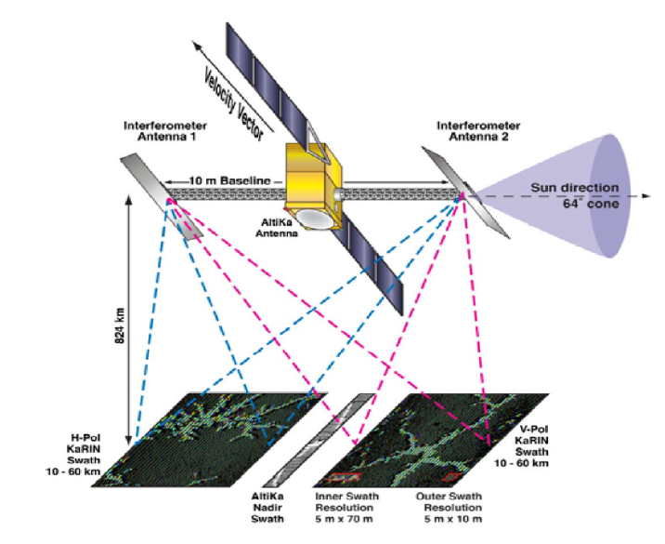

Figure 2

Ka-band InSAR antenna elevation and azimuth gain pattern in band 35.5-36.0 GHz   
(a) Elevation pattern from –10 degrees to +10 degrees, (b) Azimuth pattern from –1 degree to +1 degree  
(Calculated pattern in blue, equation fit in red)

|  |  |
| --- | --- |
| **(a) Antenna elevation gain pattern** | **(b) Antenna azimuth gain pattern** |
|  |  |

TABLE 2

35.5-36.0 GHz in SAR interferometric synthetic aperture radar characteristics

|  |  |
| --- | --- |
| Parameter | Value |
| Altitude | 890.6 km |
| Inclination | 77.6 degrees |
| Repeat cycle | 20.87 days |
| RF centre frequency | 35.7 GHz |
| Peak RF output power | 300 W |
| Pulse modulation | Linear FM chirp |
| Pulse –3 dB bandwidth | 200 MHz |
| Pulse duration | 18 μs |
| Pulse repetition rate per antenna | 4 400 Hz |
| Duty cycle | 15.8% |
| Antenna type | Reflect array 3.8 m × 0.17 m |
| Antenna gain | 49.29 dBi |
| Antenna orientation | 0.7 degrees (NR) and 4.3 degrees (FR) from nadir |
| Antenna beamwidth | 2.9 degrees × 0.13 degrees |
| Antenna polarization | Linear horizontal/vertical |
| System noise temperature | 438 K |

# 4 Potential interference to EESS (active) from the radiolocation service

## 4.1 Characteristics of radars operating in the radiolocation service

### 4.1.1 Radars listed in Recommendation ITU-R M.1640

[Recommendation ITU-R M.1640](http://www.itu.int/rec/R-REC-M.1640/en) – Characteristics of, and protection criteria for sharing studies for radars operating in the radiodetermination service in the frequency band 33.4-36 GHz, shows the characteristics of five terrestrial radars operating in the 33.4-36 GHz band. The Metric radar with 135 kW transmit peak power is the highest power radar given in Table 1 of the Annex to the Recommendation.

TABLE 3

Characteristics of terrestrial radars in the radiolocation service at 35 GHz

|  |  |  |  |  |  |
| --- | --- | --- | --- | --- | --- |
| Parameter | Imaging | Imaging | Metric | Metric | Seeker |
| Sensor type | Passive | Active | Active | Active | Active |
| Modulation | – | Pulse | Pulse | Pulse | Linear FM |
| Compression ratio | – | – | – | – | 200 |
| Pulse width | – | 0.05 | 0.25 | 0.05 | 10 |
| Tx peak power (kW) | – | 0.5 | 135 | 1 | 0.001 |
| PRF (kHz) | – | 30 | 1 | 50 | 10 |
| RF bandwidth (MHz) | – | 80 | 10 | 101 | 12 |
| Antenna gain (dBi) | 35 | 30 | 52 | 51 | 28.7 |
| Beamwidth (degrees) | 0.5 × 3.0 | 0.75 × 10 | 0.25 × 0.25 | 0.5 × 0.5 | 4.4 × 4.4 |
| Rx IF bandwidth (GHz) | 2 | 0.040 | 0.006 | 0.185 | 0.100 |
| Noise temperature (K) | 850 | – | – | – | – |
| Noise figure (dB) | – | 4.5 | 10 | 10 | 5 |
| Rx sensitivity (dBm) | – | –81 | –95 | –78 | –93 |
| Tuning | Fixed | Fixed | Fixed | Frequency hop | Fixed |
| NOTE – PRF = pulse repetition frequency. | | | | | |

Typical terrestrial tracking radars cover elevation angles from 0 degree to 90 degrees during the track, and can have mainlobe-to-mainlobe coupling in elevation.

Recommendation ITU-R RS.1628 – Feasibility of sharing in the band 35.5-36.0 GHz between the Earth exploration-satellite service (active) and space research service (active), and other services allocated in this band, which was drafted for the preparation of WRC-03 (sharing conditions between Radiolocation and EESS (active) in 35.5-36.0 GHz), clearly shows that sharing is feasible between radiolocation and EESS (active). The main two findings are the following:

–that in order to ensure compatibility between radiolocation service and EESS (active) and SRS (active), the mean pfd at the Earthʼs surface from the spaceborne active sensor generated at any angle greater than 0.8º from the beam centre should not exceed −73.3 dB(W/m2) in the band 35.5-36.0 GHz (see RR **5.549A**);

–that, according to Annex 1 of Recommendation ITU-R RS.1628, the cumulative density functions (CDFs) of the interference levels into each of seven types of spaceborne active sensors caused by radiolocation devices do not exceed –120 dBW.

The second finding is based on simulations based on worst cases, such as the Metric 1 radar station having a maximum elevation angle of 45°. Table 3 shows the list of radar devices as given at the 7‑8R in 1996. The e.i.r.p. of the Metric 1 radars equals 103.3 dBW. This Table is also in full accordance with Recommendation ITU-R M.1640.

However, it appears that the Metric 1 radar antennas are capable of being directed at elevation angles as high as zenith. This information is in contradiction with the hypothesis performed during the WRC study cycle 2000-2003. Therefore, the corresponding levels of interference that may experience AltiKa caused by a Metric 1 radar looking at nadir or angles higher than 70°, are not acceptable since it may cause malfunction of the EESS (active) receiver. This situation arises when the Metric 1 radar tracks AltiKa (in that case, elevation angles up to 90° may occur and therefore main beam to main beam coupling).

### 4.1.2 MMW Radar

There is a more powerful radar operating in the 35.5-36.0 GHz frequency band known as the Millimeter-wave radar (MMW) with characteristics as shown in Table 4. The MMW has 120 kW transmit peak power and 70.0 dBi antenna gain, giving an e.i.r.p. of 120.8 dBW, compared to the Metric radar’s e.i.r.p. of 103.3 dBW.

TABLE 4

Characteristics of the MMW at 35 GHz

|  |  |
| --- | --- |
| Parameter | Metric |
| Sensor type | Active |
| Modulation | Pulse |
| Compression ratio | – |
| Pulse width (µs) | 50 |
| Tx peak power (kW) | 120 |
| PRF (kHz) | 2 |
| RF bandwidth (MHz) | 6, 12, 500, 1 000, 2 000 |
| Antenna gain (dBi) | 70.0 |
| Beamwidth (degrees) | 0.0435 × 0.0435 |
| Rx IF bandwidth (GHz) | 2 |
| NOTE – PRF = pulse repetition frequency. | |

One objective of the MMW is space object tracking whereby it can cover elevation angles from 0 degree to 90 degrees during the track, and can have mainlobe-to-mainlobe coupling in elevation.

It is to be noted that for the wideband mode with 2 GHz bandwidth, the corresponding e.i.r.p. within the band 35.5-36 GHz equals 114.3 dBW, since the EESS(active) allocation equals 500 MHz and the RF bandwidth of the MMW radar in the wideband mode equals 2 GHz.

## 4.2 Compatibility between EESS (active) InSAR and radiolocation

### 4.2.1 Static analysis: one pass simulation

#### 4.2.1.1 Simulation using the Metric radar

For the EESS (active) spaceborne Ka-band InSAR, it has a look angle, that angle between nadir and the beam centre, of 0.7 degree (NR) and 4.3 degrees (FR). The Ka-band InSAR sensor beams which point near nadir move past the terrestrial systems as the spacecraft proceeds in its orbit. For a sensor azimuth beamwidth of 0.13 degrees, the beam scans past the terrestrial system in about 0.2 second. The InSAR looks down to the side of the nadir track at a fixed look angle.

Recommendation ITU-R F.1245 – Mathematical model of average and related radiation patterns for line-of-sight point-to-point radio-relay system antennas for use in certain coordination studies and interference assessment in the frequency range from 1 GHz to about 70 GHz, gives the antenna gain equations for the 35 GHz antenna pattern.

Figure 3

Ka-band terrestrial antenna elevation and azimuth gain pattern in band 35 GHz   
(a) Elevation pattern from –5 degrees to +5 degrees, (b) Azimuth pattern from –90 degrees to +90 degrees   
(Calculated pattern in blue, equation fit in red)

|  |  |
| --- | --- |
| **(a) Antenna elevation gain pattern** | **(b) Antenna azimuth gain pattern** |
|  |  |

In Figs 4 and 5 below, the single pass simulation of the InSAR over 800 seconds, 20 seconds and 0.2 second shows the received power into the Ka-band InSAR peaks above +0 dBm in the middle of the pass. The InSAR receiver must be protected up to +0 dBm, or +6 dBm if a 6 dB margin is imposed. The duration of the radio-frequency interference (RFI) above –10 dBm is about 20 milliseconds and above 0 dBm is about 5 milliseconds.

FIGURE 4

Single pass simulation of received power in 35.5-36.0 GHz InSAR from terrestrial Metric radar   
(a) 800 seconds in orbit (b) 2 seconds in middle of orbit

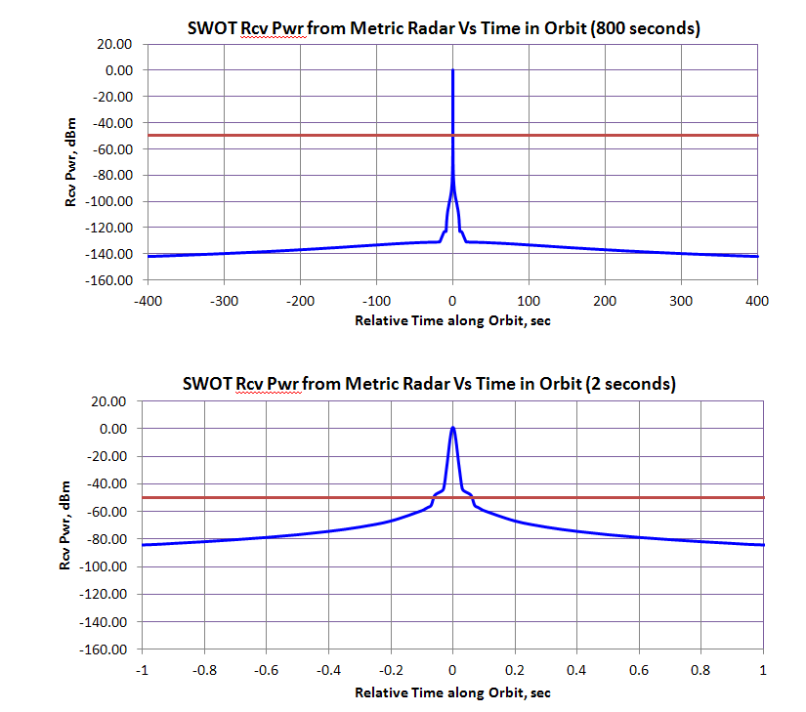

FIGURE 5

(a) Single pass simulation of received power in 35.5-36.0 GHz InSAR from terrestrial Metric radar   
over 0.2 seconds in middle of orbit (b) duration of RFI level above threshold

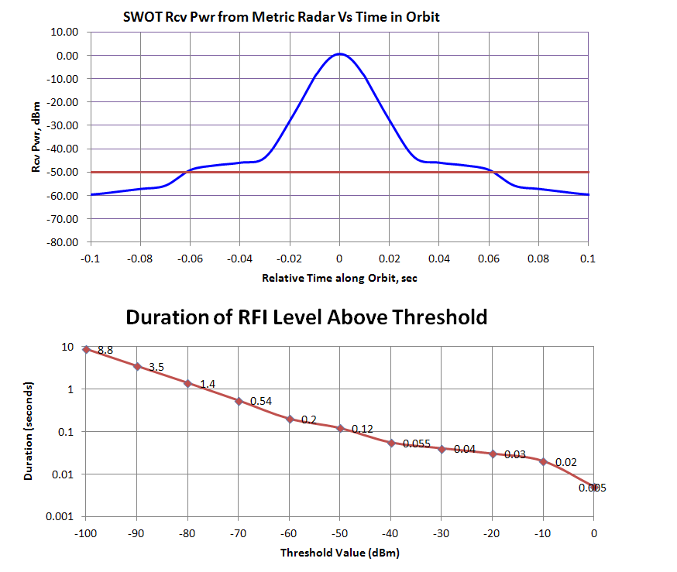

#### 4.2.1.2 Simulation using the MMW

The MMW antenna is a 13.7 m diameter parabolic dish with 70.0 dBi gain at 35.0 GHz and 0.0435 degree beamwidth. For this simulation, the InSAR antenna gain is assumed to be slightly reduced, at 48.5 dBi. The MMW is assumed to be tracking the InSAR over the single pass.

In Fig. 6 below, the single pass simulation of the RFI from the MMW into the InSAR over 800 seconds, 10 seconds and 2 seconds shows the received power into the Ka-band InSAR peaks to about +16.8 dBm in the middle of the pass. The InSAR receiver must be protected up to +16.8 dBm, or +22.8 dBm if a 6 dB margin is imposed. The duration of the radio-frequency interference (RFI) above –10 dBm is about 1.2 seconds.

FIGURE 6

Single pass simulation of received power in 35.5-36.0 GHz InSAR from the MMW   
(a) 800 seconds in orbit (b) 10 seconds in middle of orbit (c) 2 seconds in middle of orbit

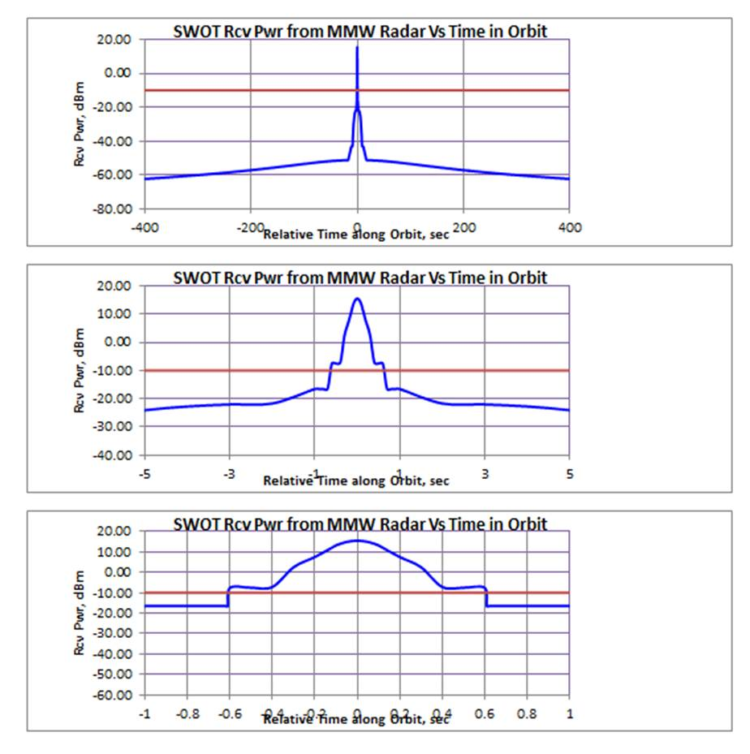

**(c) 2 seconds in orbit**

**(b) 10 seconds in orbit**

**(a) 800 seconds in orbit**

### 4.2.2 Dynamic analysis

Several dynamic simulations were performed to look at the temporal aspects of the RFI levels from the terrestrial radars into the EESS (active) receivers.

In simulations for dynamic analysis 1, for simplicity, the terrestrial radar was assumed to be pointed at zenith and the EESS (active) receive antenna pattern in elevation was a composite of the pair of interferometric SAR antenna patterns on each side of nadir and the nadir looking altimeter antenna pattern. This would represent the situation of where the highest probability of main beam to main beam interaction between the radar and the spacecraft exist.

In simulations for dynamic analysis 2, terrestrial radars were spaced by about 500 km separation over the world land masses, and the terrestrial radars were assumed to track the spacecraft. Although the tracking of the EESS (active) spacecraft by all of the radars is not a realistic scenario, the simulation provides the means for identifying situations where coupling between the radar and the EESS (active) receive beam could produce a situation where harm to the RF front-end of the EESS (active) spacecraft could occur. The EESS (active) receive antenna patterns were assumed to be a pair of separate antenna beams on each side of nadir for a total of four antenna beams.

#### 4.2.2.1 Dynamic analysis 1

##### 4.2.2.1.1 EESS (active) receive antenna patterns

The combined antenna pattern in elevation of the two interferometric SAR beams on each side of nadir and the nadir looking altimeter beam is shown in Fig. 7(a). The combined antenna pattern in azimuth is shown in Fig. 7(b).

FIGURE 7

Combined antenna patterns of EESS (active) system in elevation and azimuth

|  |  |
| --- | --- |
| **(a) Combined elevation pattern** | **(b) Combined azimuth pattern** |
| Matlab SWOT Elev | Matlab SWOT Az |

##### 4.2.2.1.2 Terrestrial radar characteristics

The terrestrial radar was modeled to be pointed in a fixed zenith-looking position. Its characteristics were assumed to be those of the “Metric radar” in Table 2. The peak transmit power is 135 kW, the peak antenna gain is 52 dBi, and the frequency is 35.7 GHz. The antenna patterns were modeled as in Recommendation ITU-R F.1245-2 for a 1.4 m dish antenna with 52 dBi gain.

##### 4.2.2.1.3 Orbit simulations

The EESS (active) orbit was assumed to have a sun synchronous orbit at 824 km altitude, and 98.7 degrees inclination with a repeat orbit of 16 days. The STK simulation had a 10 millisecond time tic with the EESS (active) initial orbit assumed flying over the Metric radar as worst case. Figure 8 shows the peak received worst case interference power into the EESS (active) receiver.

FIGURE 8

Metric radar RFI Level into EESS (active) receiver (worst case)

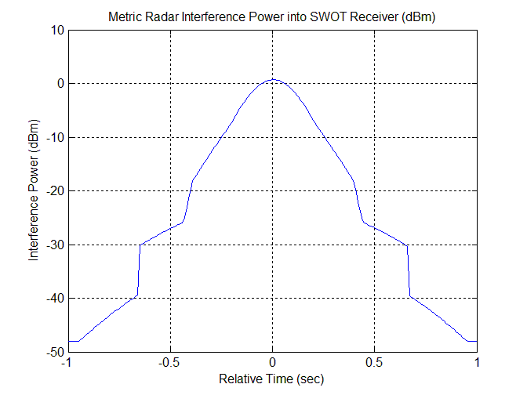

In Fig. 8, the absolute worst-case peak interference power is +0.67 dBm. The duration for the   
–3 dB power points is 0.24 seconds and the duration of the –10 dB power points is 0.5 seconds.

#### 4.2.2.2 Dynamic analysis 2

##### 4.2.2.2.1 EESS (active) receive antenna patterns

The antenna pattern in elevation of the four interferometric SAR beams, two on each side of nadir, and the nadir looking altimeter beam are as shown previously in Fig. 2. There are four beams since the InSAR alternatively transmits on different sides of nadir and receives on both sides of nadir, both co-nadir and cross-nadir beams.

##### 4.2.2.2.2 Terrestrial radar characteristics

The terrestrial radars were modeled to be tracking the spacecraft whenever a direct line-of-sight between the radar and spacecraft was possible. Its characteristics were assumed to be those of the “Metric radar” in Table 2. The peak transmit power is 135 kW, the peak antenna gain is 52 dBi, and the frequency is 35.7 GHz. The antenna patterns are as shown in Fig. 3 for a 1.4 m dish antenna with 52 dBi gain.

The terrestrial radars were spaced about 500 km apart worldwide on the land masses as shown in Fig. 9.

FIGURE 9

Worldwide distribution of terrestrial tracking radars

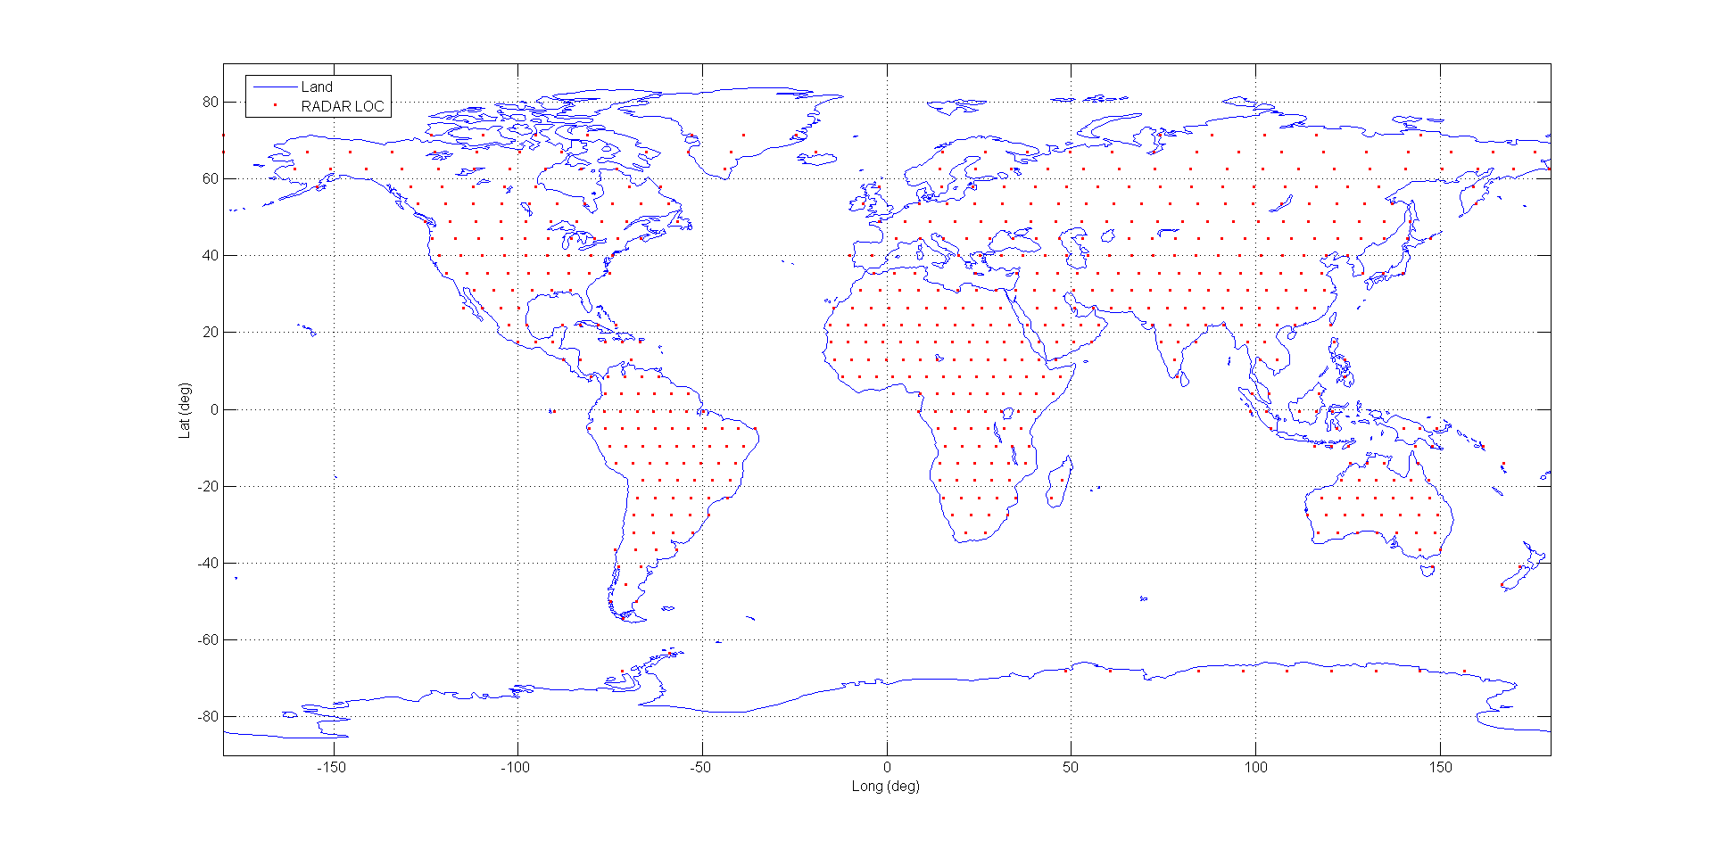

-150 -100 -50 0 50 100 150

Longitude (deg)

80

60

40

20

0

-20

-40

-60

-80

Latitude (deg)

##### 4.2.2.2.3 Orbit simulations

The EESS (active) orbit was assumed to have a sun synchronous orbit at 824 km altitude, and 98.7 degrees inclination with a repeat orbit of 16 days. The 30 day simulation had a one second time tic with the EESS (active) initial orbit assumed directly over the Metric radar as worst case. Figure 10 shows the complementary CDF of the peak received interference power into the EESS (active) four receiver channels. There is one receiver channel for each of the four receive antenna beams. The peak received RFI level as shown in Fig. 10 is about +1 dBm.

FIGURE 10

1-CDF of RFI into four EESS (active) receiver channels from terrestrial radars

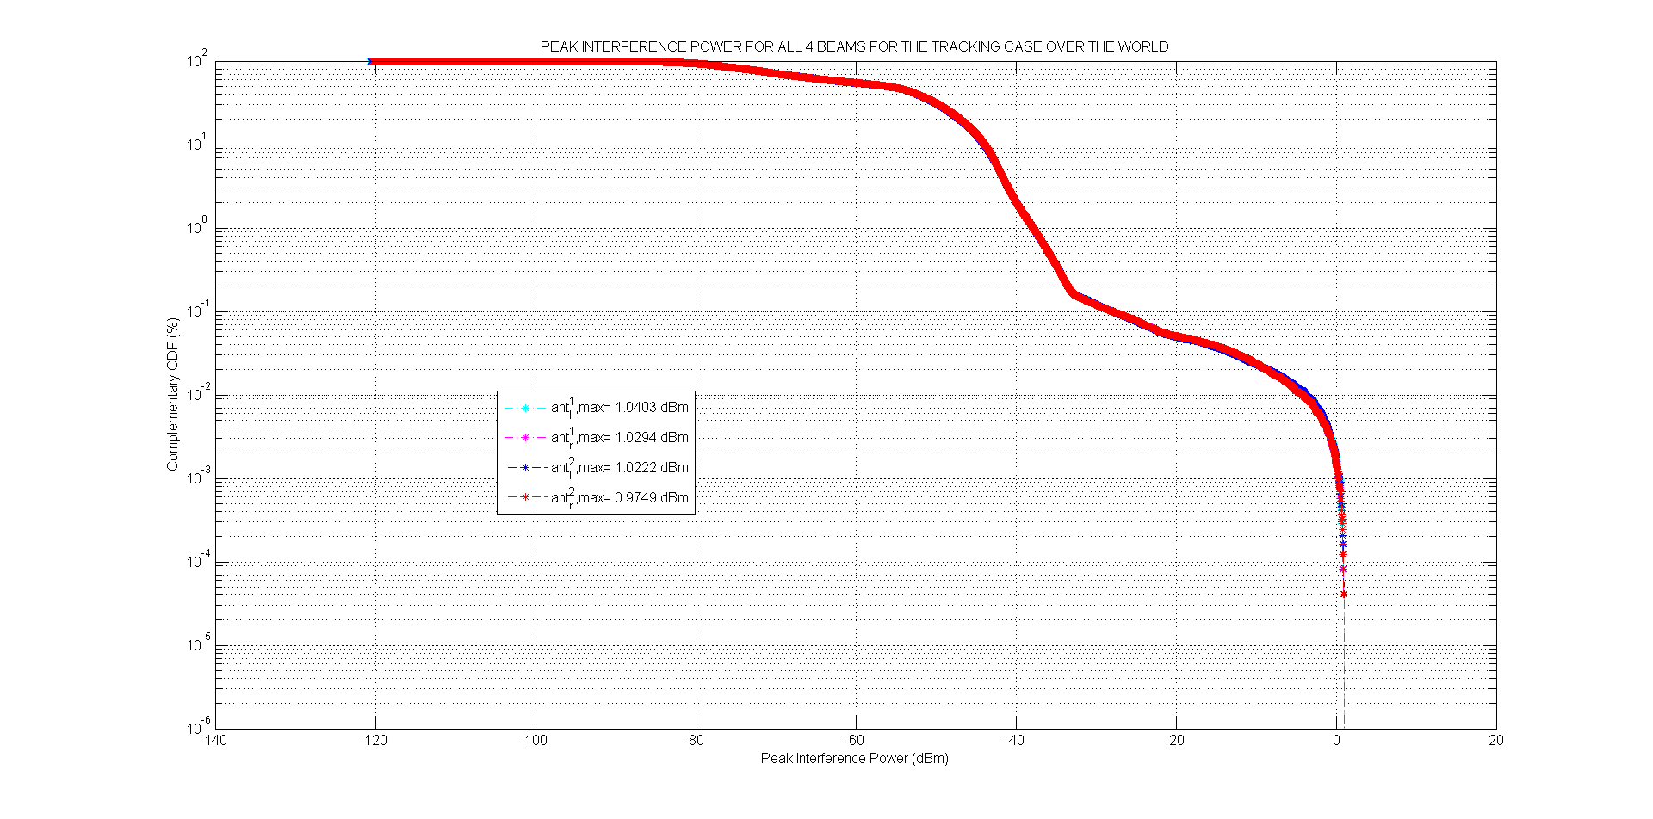

-140 -120 -100 -80 -60 -40 -20 0 20

Peak Interference Power (dBm)

Peak Interference Power for All 4 Beams for the Tracking Case Over the World

Complementary CDF (%)

102

101

100

10-1

10-2

10-3

10-4

10-5

10-6

10-7

## 4.3 Compatibility between EESS (active) AltiKa and radiolocation

### 4.3.1 Static analysis for Metric 1 radar

The worst situation arises when main beam to main beam coupling occurs: this case is considered as the worst track mode. Other track modes are also considered at elevation angles of 85°, 70° and 45°. The maximum power level that the AltiKa receiver can tolerate without any damage within the band 35.5-36.0 GHz equals –80 dBW.

|  |  |  |
| --- | --- | --- |
| Frequency | 35.8 | GHz |
| Wavelength | 0.01 | m |
| Altitude of the satellite | 800 | km |
| Satellite nadir angle | 90 | degrees |
| Maximum interference level | –119.0 | dBW/450 MHz |

AltiKa: altimeter in Ka-band

|  |  |  |  |  |  |
| --- | --- | --- | --- | --- | --- |
| Parameter | Elevation angle of the Metric 1 radar | Metric 1 radar at 90° | Metric 1 radar at 85° | Metric 1 radar at 70° | Metric 1 radar at 45° |
| e.i.r.p. of a radiolocation device Metric 1 in the direction of the AltiKa altimeter | dBW | 103.30 | 64.30 | 51.30 | 41.30 |
| Half geocentric angle | degrees | 0.00 | 0.56 | 2.31 | 6.08 |
| Distance METRIC radar – Satellite receiver | km | 800.00 | 803 | 845 | 1074 |
| Space attenuation | dB | 181.54 | 181.57 | 182.02 | 184.10 |
| AltiKa Satellite antenna gain | dBi | 50.00 | 50.00 | 50.00 | 50.00 |
| Received power at the AltiKa sensor | dBW | −28.24 | −67.27 | −80.71 | −92.80 |

In order to be consistent with the dynamic simulations as in Recommendation ITU-R RS.1628, it is considered that the Metric 1 antenna gain has a –10 dBi gain floor.

The maximum amount of interference for a single radar that may experience AltiKa equals   
–28 dBW, which is well above the –80 dBW maximum level, resulting into a 50 dB increase power that may be detrimental to the EESS (active) instrument.

On the other side, it appears that if the elevation angle is up to 70°, the interference level experienced by AltiKa caused by Metric 1 is acceptable.

### 4.3.2 Dynamic analysis for Metric 1 and MMW radars

**4.3.2.1 Compatibility between AltiKa and Metric 1**

A dynamic analysis has been performed in order to know the rate of occurrence of these kinds of extreme events. The main hypothesis is that the antenna of the Metric 1 radar, which is modeled below, constantly tracks the AltiKa satellite, without any restriction concerning the elevation angle.

FIGURE 11

Antenna pattern of the Metric 1 radar

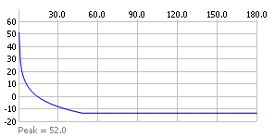

The power at antenna port equals 135 kW or 51.3 dBW for a bandwidth of 10 MHz.

The antenna pattern of the AltiKa radar receiver is modeled below.

FIGURE 12

Antenna pattern of the AltiKa radar receiver

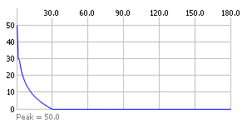

A dynamic analysis has been conducted using the following positions of the Metric 1 terrestrial radars, which corresponds to a moderate scenario of deployment of 20 radar tracking stations.

FIGURE 13

Positions of the Metric 1 terrestrial radars

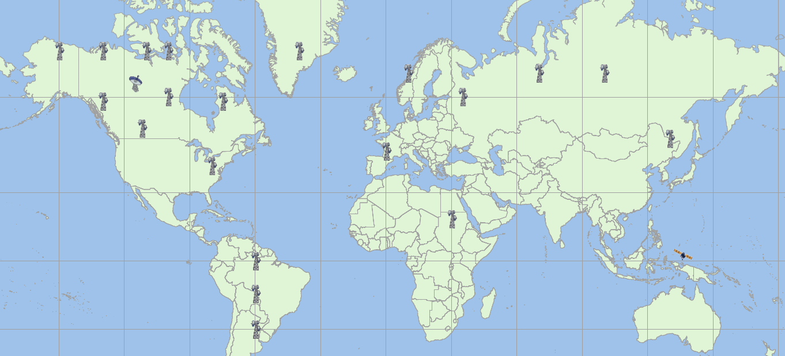

The cumulative received power valid for the whole world is shown in Fig. 14, highlighting the fact that each Metric 1 radar tracks the AltiKa satellite.

FIGURE 14

Cumulative density power valid for the whole world



Figure 14 shows that the maximum received power equals –33 dBW, well above the –80 dBW, which is the maximum of power that the receiver can tolerate without any damage. Due to the positions of the radars that are constantly tracking the AltiKa satellite, the satellite can experience interference (above the threshold of –119 dBW) during a time up to 59 consecutive minutes. It can also be noted that the satellite can experience destructive interference (above the destructive threshold of –80 dBW) during a time up to 9 consecutive minutes. During that time, there is a big risk that the receiver of the altimeter can be simply burnt out.

Figure 15 shows in more detail the statistics of the received power by the Altika receiver corresponding to an area of 12.5 million of km2 on the ground: this Figure shows the evolution of the power as received by the AltiKa receiver when the distance on the ground between the nadir sub‑satellite point and the position of a given station does not exceed a distance of 2 000 km. The position of the station equals (63N, –115W). The positions of the radars which are in operation close to this station are: (69N, –130W), (69N, –110W), (60N, –100W) and (59N, –130W).

FIGURE 15

Cumulative density power corresponding to an area of 12.5 million of km2   
around the position of a given station



It is shown that when the AltiKa satellite is flying over a given area and when the corresponding Metric 1 radars are tracking the satellite, the received interference on board the satellite is almost always higher than –80 dBW, which is actually a serious concern of damage of the AltiKa receiver.

#### 4.3.2.2 Compatibility between AltiKa and MMW

The antenna pattern of the AltiKa radar is the same as in Fig. 12. The following Fig.16 shows the MMW antenna pattern.

FIGURE 16

Antenna pattern of the MMW radar

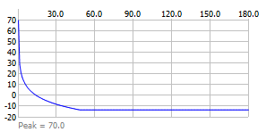

A dynamic analysis has been conducted using the following positions of the MMW terrestrial radars, which corresponds to a moderate scenario of deployment of 20 radar tracking stations. The deployment used for this analysis is the same as in shown in Fig. 13.

The cumulative received power valid for the whole world is shown in Fig. 17, highlighting the fact that each MMW radar tracks the AltiKa satellite.

FIGURE 17

Cumulative density power valid for the whole world



Figure 17 shows that the maximum received power equals –19 dBW, well above the –80 dBW, which is the maximum of power that the receiver can tolerate without any damage. Due to the positions of the radars that are constantly tracking the AltiKa satellite, the satellite can experience interference (above the threshold of –119 dBW) during a time up to 59 consecutive minutes. The simulations have shown that there is a big risk that the receiver of the altimeter can be simply burnt out, since the interference power can remain above the destructive threshold of -80 dBW up to 10 minutes.

Figure 18 shows in more detail the statistics of the received power by the Altika receiver corresponding to an area of 12.5 million of km2 on the ground: this Figure shows the evolution of the power as received by the AltiKa receiver when the distance on the ground between the nadir sub‑satellite point and the position of a given station does not exceed a distance of 2 000 km. The position of the station equals (63N, –115W). The positions of the radars which are in operation close to this station are: (69N, –130W), (69N, –110W), (60N, –100W) and (59N, –130W).

FIGURE 18

Cumulative density power corresponding to an area of 12.5 million of km2   
around the position of a given station



It is shown that when the AltiKa satellite is flying over a given area and when the corresponding MMW radars are tracking the satellite, the received interference on board the satellite is almost always higher than –80 dBW, which is actually a serious concern of damage of the AltiKa receiver.

# 5 Summary

For the spaceborne InSAR, these analyses herein provide designers of EESS (active) systems with worst-case, mainlobe antenna coupling levels, against which the receiver must be protected. The InSAR altimeter is expected to operate in the 35.5-36.0 GHz band within a bandwidth of 200 MHz. Preliminary static and dynamic analysis show that the received power from the Metric radar into the InSAR peaks at about +0.6 dBm in the middle of the pass. Therefore, the InSAR receiver should be protected from the Metric radar up to +0.6 dBm with no margin or up to +6.6 dBm if a 6 dB margin is imposed. Preliminary static analysis shows that the received power from the MMW into the InSAR peaks at about +16.8 dBm in the middle of the pass. Therefore, the InSAR receiver should be protected from the MMW up to +16.8 dBm with no margin or up to +22.8 dBm if a 6 dB margin is imposed.

For the one pass static simulation with the three separate EESS (active) antenna beams and the Metric radar used as a space object tracking terrestrial radar, the duration of the RFI above –10 dBm is about 20 milliseconds and above 0 dBm, the duration is about 5 milliseconds. For the dynamic simulation with the combined elevation antenna pattern and zenith looking terrestrial radar, the duration of the RFI above –10 dBm is 0.5 second and above –3 dBm, the duration is 0.24 second.

A conservative estimate of duration would be the greater duration of the static and dynamic analyses, or 0.5 second above –10 dBm and 0.24 second above –3 dBm.

For the one pass static simulation with the two separate EESS (active) antenna beams and the MMW used as a space object tracking terrestrial radar, the duration of the RFI above –10 dBm is about 1.2 seconds, This MMW is a singular radar at one location; whereas, the Metric radar is a typical representative tracking radar which can be assumed to be distributed around the globe for simulation purposes.

For the pure nadir altimeter, static analysis has examined, worst-case RFI situations, mainly where antenna mainlobe-to-mainlobe coupling cases occur. A dynamic analysis has confirmed these concerns of significant high power levels that could seriously damage the receiver of the altimetry satellite. According to a moderate scenario of deployment of radar tracking stations, the pure nadir altimeter can experience RFI that could be damaging (during a time up to 10 consecutive minutes) and could lead to the burnout of the receiver.

Taking into account those results for the pure nadir altimeter, it is necessary to coordinate the pure nadir altimeter operations with Metric 1 and MMW radars in track modes for Earth Observation satellites operating in the frequency band 35.5-36.0 GHz.