Report ITU-R RA.2567-0
(03/2026)
RA Series: Radio astronomy
Methods to address the determination of the coordination area around existing Radio Astronomy Service stations from IMT stations in the frequency band 6 650-6 675.2 MHz

Foreword
The role of the Radiocommunication Sector is to ensure the rational, equitable, efficient and economical use of the radio-frequency spectrum by all radiocommunication services, including satellite services, and carry out studies without limit of frequency range on the basis of which Recommendations are adopted.
The regulatory and policy functions of the Radiocommunication Sector are performed by World and Regional Radiocommunication Conferences and Radiocommunication Assemblies supported by Study Groups.

Policy on Intellectual Property Right (IPR)
ITU-R policy on IPR is described in the Common Patent Policy for ITU-T/ITU-R/ISO/IEC referenced in Resolution ITU-R 1. Forms to be used for the submission of patent statements and licensing declarations by patent holders are available from https://www.itu.int/ITU-R/go/patents/en where the Guidelines for Implementation of the Common Patent Policy for ITU-T/ITU-R/ISO/IEC and the ITU-R patent information database can also be found.

Series of ITU-R Reports
(Also available online at https://www.itu.int/publ/R-REP/en)
Series | Title
BO | Satellite delivery
BR | Recording for production, archival and play-out; film for television
BS | Broadcasting service (sound)
BT | Broadcasting service (television)
F | Fixed service
M | Mobile, radiodetermination, amateur and related satellite services
P | Radio-wave propagation
RA | Radio astronomy
RS | Remote sensing systems
S | Fixed-satellite service
SA | Space applications and meteorology
SF | Frequency sharing and coordination between fixed-satellite and fixed service systems
SM | Spectrum management
TF | Time signals and frequency standards emissions

Note: This ITU-R Report was approved in English by the Study Group under the procedure detailed in Resolution ITU-R 1.

Electronic Publication
Geneva, 2026
© ITU 2026
All rights reserved. No part of this publication may be reproduced, by any means whatsoever, without written permission of ITU.

REPORT ITU-R RA.2567-0
Methods to address the determination of the coordination area around existing Radio Astronomy Service stations from IMT stations in the frequency band 6 650-6 675.2 MHz
(2026)
TABLE OF CONTENTS
Page

1 Introduction 2
2 RAS systems 2
2.1 RAS parameters 3
2.2 RAS protection criteria 3
3 IMT systems 4
4 Propagation model and clutter loss model and polarization loss 6
4.1 Basic propagation loss for terrestrial paths 6
4.2 Clutter loss 7
4.3 Polarization loss 7
5 Possible scenarios 7
5.1 Single entry scenarios 7
5.2 Aggregation scenarios 8
5.3 Mixed scenarios 8
6 Calculation of received power level at RAS receiver and coordination area 9
7 Summary 10
Annex 1 – An example of calculation of coordination areas 11
A1.1 Number of IMT Urban BS at 6 GHz considered in the study 13
A1.2 IMT parameters 13
A1.3 RAS parameters and protection criteria 14
A1.4 Propagation modelling 14
A1.5 Results from sharing studies 15
Annex 2 – Example studies for generic and site-specific cases 16
A2.1 IMT-2020 parameters 16
A2.2 RAS parameters 18
A2.3 Simulation methodology of aggregate interference 18
A2.4 Propagation model 21
A2.5 Generic case study 22
A2.6 Sensitivity analysis study 25
A2.7 Site specific study 27
A2.8 Summary 29
Annex 3 – Proposals on example studies 30
A3.1 Introduction 30
A3.2 Additional study parameters 30
A3.3 Generic compatibility studies 34
A3.4 Site-specific studies 41
A3.5 Possible mitigation measures 43

1 Introduction
This Report provides the methods for determining the coordination area around existing Radio Astronomy Service (RAS) stations from IMT stations in the frequency band 6 650-6 675.2 MHz.
This Report starts with the descriptions and parameters of RAS systems (§ 2) and International Mobile Telecommunications (IMT) systems (§ 3), followed by the propagation loss and clutter loss and other loss the transmitted power from IMT station experiences towards a RAS station (§ 4). Section 5 presents possible scenarios for calculation of the coordination area including single entry scenarios, aggregation scenarios and mixed scenarios, while § 6 develops the methodology for calculating a coordination area using a Monte-Carlo simulation for generic study. Annexes to this Report provide example implementations of the calculation methodology in the Report.

2 RAS systems
Radio astronomy uses parts of the 6 425-7 125 MHz spectrum for observations of the methanol spectral line in the band 6 650.0-6 675.2 MHz, which is addressed in the ITU-R Radio Regulations (RR) footnote No. 5.149. The 6.6685192 GHz methanol (CH₃OH) maser line is essential to study the formation of massive stars. Radio telescopes have been deployed on a global basis, which are equipped with state-of-the-art receivers to perform measurements of this spectral line and a fair share of the total observing time is invested, both with single dishes but also with telescope networks, including VLBI.

2.1 RAS parameters
The parameters to be used in calculation of the coordination area include the antenna pattern and antenna height above the ground of RAS receiver.
Example values of parameters for a generic RAS station are listed in Table 1. However, for coordination of an actual site, the site-specific values for these parameters should be, e.g. the height above ground of the focal point. The antenna pattern for the RAS can be obtained from Recommendation ITU-R SA.509 or ITU-R RA.1631, but in many cases involving terrestrial sources of interference a flat level of 0 dBi is used for reasons outlined in Recommendation ITU-R RA.769.
TABLE 1
Example RAS parameters
Parameter | Value
Frequency range | 6 650-6 675.2 MHz
Channel bandwidth | 50 kHz
Antenna height | 50 m
Antenna pattern | An isotropic antenna with a gain of 0 dBi
Noise temperature | 10 K
Antenna temperature ⁽¹⁾ | 12 K
⁽¹⁾ Contributions from ground and atmosphere, cosmic microwave background, and galactic background.

The location of RAS station should also be provided in order to take into account the surrounding terrain for calculation of the propagation loss.

2.2 RAS protection criteria
The RAS band 6 650-6 675.2 MHz is used for spectroscopic observations of the methanol molecule, VLBI and Pulsar observations, but primarily used for spectral line measurements of the methanol molecule.
Radio Regulations No. 5.149 refers to RAS usage in the frequency band 6 650-6 675.2 MHz; However, this frequency band is not allocated to RAS.
Recommendation ITU-R RA.769 recommends “2) that administrations should afford all practicable protection to the frequencies and sites used by radio astronomers in their own and neighbouring countries and when planning global systems, taking due account of the levels of interference given in Annex 1”.
Although there is no interference threshold level entry for this band in the tables of Recommendation ITU-R RA.769, the threshold levels for the RAS allocated bands centred at 4 830 or 4 995 MHz as the closest available in Table 2 and 3 in Recommendation ITU-R RA.769 could be considered in studies, which are summarized as in Table 2.
TABLE 2
Threshold levels that could be considered in this study
Observation type | Threshold interference level  (dB(W/m² ⋅ Hz))
Spectral-line observation | −230
VLBI observation | −200

Recommendation ITU-R RA.1513, which defines levels of data loss to radio astronomy observations and percentage-of-time criteria resulting from degradation by interference for frequency bands allocated to the radio astronomy service on a primary basis, provides with 2% data loss to the RAS due to interference by all stations of one service. This percentage of data loss is not directly translated to a percentage of instances (e.g. time) considered in a Monte Carlo simulation. Since 6 650-6 675.2 MHz is not allocated to radio astronomy, Recommendation ITU-R RA.1513 does not strictly apply. However, in order to calculate coordination areas, Recommendation ITU-R RA.1513 could still be considered in studies with appropriate consideration of how the data loss percentage is translated to a Monte Carlo simulation.
Alternatively, less strict protection criteria and data loss metrics could be considered by the relevant administrations, which would accordingly lead to smaller coordination areas.

3 IMT systems
IMT technical parameters will vary depending on the local circumstances. However, in the following example parameters as in Table 3 are provided, which may be useful for the purpose of generic calculations. These parameters are based on those provided by ITU-R Working Party (WP) 5D for studies of the band 6 425-7 125 MHz under WRC-23 agenda item 1.2 as in Annex 4.4 to Document 5D/716. The typical deployment densities are defined as a function of the deployment environment of the IMT base station (BS) and user equipment (UE). The BSs are usually not operating at 100% of their capacity. In the calculations, a network loading factor of 20% could be assumed. The time division duplex (TDD) activity factors could be assumed as 75% for BSs and 25% for UE. Antenna pattern parameters were introduced in Annex 4.4 to Document 5D/716 referring to Recommendation ITU-R M.2101. Specific information about a potential total integrated gain correction was not provided during the study cycle 2019-2023. Uniform distribution for UE sampling within IMT BS cell was used in studies of 6 425-7 125 MHz under WRC-23 agenda item 1.2 and the minimum BS-UE distance is calculated based on the Down-Tilt for each scenario. The “below rooftop” parameter is provided for IMT BS deployments to describe the environment surrounding the BS. The above/below rooftop ratio in this table should not be interpreted as indicating whether or not additional clutter loss model should be applied. Depending on the sharing scenarios, relevant propagation models related to clutter loss should be used accordingly. In addition, for IMT AAS systems operating within the frequency band 6 425-7 125 MHz in adjacent channels to the RAS band (6 650-6 675.2 MHz), the operating band unwanted emissions (OBUE) are contained in the draft new Recommendation ITU-R M.[IMT-2020.UNWANT.BS] “Unwanted emission characteristics of base stations using the terrestrial radio interface of IMT-2020” (see Document 5/85(Rev.1). It should be noted that IMT beamforming is fully correlated within the entire 6 425-7 125 MHz frequency band. In the band 6 425-7 125 MHz, contiguous coverage is not expected in this frequency range in rural areas, and any such base stations that may exist in small numbers will be isolated installations at specific locations.
TABLE 3
Example IMT parameters for base stations and user equipment in the band 6 425-7 025 MHz
Parameters | IMT Base station | IMT User equipment
Band parameters
Frequency | 6.65 GHz | 6.65 GHz
Carrier bandwidth | 100 MHz | 100 MHz
Antenna parameters (Recommendation ITU-R M.2101-0)
Antenna pattern | Suburban  8 × 16 × 2 Array elements (H+V)  Beamwidth H/V = 90°/65°  G_{elem} = 6.4 dBi  30 dB f/b ratio  Spacing H/V = 0.5/0.7  Urban  8 × 16 × 2 Array elements (H+V)  Beamwidth H/V = 90°/90°  G_{elem} = 5.5 dBi  30 dB f/b ratio  Spacing H/V = 0.5/0.5 | −4 dBi (avg. isotropic)  Single-element
Antenna polarization | Linear/±45° | N/A
Down-Tilt | 6° (Suburban)  10° (urban) | N/A
Antenna height | 20 m (Suburban)  18 m (Urban) | 1.5 m
Below rooftop base station antenna deployment | 15% (Suburban)  65% (Urban) | N/A
Emitted powers
Ptx | 22 dBm per element | 23 dBm
Spectral mask (relative to total conducted power of carrier) | −50.1 dBc/MHz (adjacent) | −30 dBc/MHz (adjacent)
Ohmic losses (included in G_{elem}) | 2 dB | 2 dB
Other losses | N/A | 4 dB (body loss)
Conducted spectral power density  (Total array, without gain) | 26 dBm/MHz (in-band)  −4 dBm/MHz (adjacent) | 3 dBm/MHz (in-band)  −7 dBm/MHz (adjacent)
Power into RAS frequency band (Spectroscopy channel width: 50 kHz) | 13 dBm (in-band)  −17 dBm (adjacent) | −10 dBm (in-band)  −20 dBm (adjacent)
UE power control parameters | N/A | PCMAX = 23 dBm  P0 PUSCH = −95.5 dBm  α = 0.8
Network loading factor | 20% | N/A
TDD activity factor | 75% | 25%
TABLE 3 (end)
Parameters | IMT Base station | IMT User equipment
Deployment
Rb (housing ratio) | 2%
Ra (ratio of hotspot area to housing area) | 5% (Suburban)  10% (Urban)
Deployment density in hotspot area (number of sectors; 3 sectors per BS position) | 2.4 km^{–2} (Suburban)  10 km^{–2} (Urban) | 3 UEs per BS sector
Fraction of indoor devices | N/A | 70% (Suburban)  70% (Urban)
Distribution of user equipment (relative to base station)
BS cell radii (ISD) | 0.6 km (Suburban)  0.3 km (Urban)
Distance distribution | Polar Uniform (104.9, 600) (Suburban)  Polar Uniform (35, 300) (Urban)
Angular distribution | Uniform (−60°, +60°)

4 Propagation model and clutter loss model and polarization loss
The signal propagating from the IMT base stations to RAS station is subject to the following propagation losses/attenuations:
• Free space loss
• Atmospheric loss
• Diffraction loss due to the surrounding terrain
• Clutter loss
• Polarization loss.

4.1 Basic propagation loss for terrestrial paths
The recommended method to determine the path propagation loss between the IMT equipment and the RAS station is provided in Recommendation ITU-R P.452 or Recommendation ITU-R P.2001. Topographic information, i.e. terrain height data, should be incorporated, as it has a significant effect on the diffraction loss. The calculation of propagation loss according to the models in these Recommendations requires a specific terrain profile to be used for Monte Carlo simulations by running the model repeatedly on real (but random) paths of a fixed length. Such paths should be chosen by using a terrain database for a region representative of the environment of interest (for example, by choosing a specific city to represent an urban area or choosing a specific mountain range to represent a mountainous area). Within this region, for each path a random starting point is generated, and the end point is calculated at a random azimuth, using the path length of interest. The propagation analysis is then performed on each path, and the Monte Carlo approach is used to derive the statistics of the loss for this path length. This can then be repeated for other path lengths. For generic studies or in absence of real terrain data, the models could be used with flat terrain, but it is emphasized that this will lead to an overestimation of coordination distances. It is noted that Recommendation ITU-R P.452 or ITU-R P.2001 refers to Recommendation ITU-R P.676 for calculation of atmospheric losses. If available, atmospheric/weather data may be taken into account for more precise estimates of the atmospheric attenuation.
The application of the propagation models in Recommendations ITU-R P.452 and ITU-R P.2001 requires the choice of a so-called time percentage parameter, Tpc. The retrieved path propagation losses, L, are to be understood as cumulative distributions, i.e. for a certain input value of the Tpc, the returned loss value, L, means that in Tpc percent of the time, the actual propagation losses will be higher than L. When performing aggregation (Monte Carlo) simulations, different approaches for setting Tpc parameters were discussed, i.e. fixed Tpc with 2% referring to data loss criterion, fixed Tpc with 50% referring to annual-average weather condition, a random value (uniform distribution) for each distinct simulation run but keeping the value for p fixed for all BS and UE in an individual simulation run. Different approaches for setting Tpc parameter is one of the key factors that will result in a difference in terms of coordination distance as seen in the example studies in Annexes. No agreement was made on Tpc setting in this Report and the three assumptions mentioned above should be regarded as informationally only and other possible assumptions are not excluded.

4.2 Clutter loss
For the IMT base stations deployed in urban and suburban scenarios, Recommendation ITU-R P.2108 § 3.2 (terrestrial paths) provides a statistical clutter loss model. As RAS antenna heights are usually very high, the Recommendation ITU-R P.2108 model should be used with a single-end point clutter model, i.e. for the IMT equipment only. If BS antenna heights are well above the clutter heights along the propagation path towards RAS station, the model will not necessarily be applicable. A thorough analysis is beyond the scope of this Report. Administrations may need to investigate the situation around RAS stations in their countries in more detail. In case IMT base station deployed in rural scenario, Recommendation ITU-R P.2108 § 3.2 (terrestrial paths) does not apply.

4.3 Polarization loss
The polarization loss will be specific to the loss caused by the polarization mismatch. IMT base station is using linear ±45 degrees dual polarization. RAS station is usually using dual polarization. Appropriate polarization loss within 0 to 3 dB range may be considered for existing relevant RAS stations.

5 Possible scenarios

5.1 Single entry scenarios
Single entry scenarios, in which the compatibility between a single IMT transmitter (base station or user terminal) and the RAS station is studied, can be useful for quick assessments of a situation. While in practice, the total (aggregated) effect of a whole cell-phone network is usually of higher interest, experience shows that single-entry results can provide a reasonable first estimate for the required coordination distances. However, even if worst-case conditions are assumed (e.g. flat terrain conditions without clutter and maximum antenna gains), the aggregate scenario may still yield somewhat larger coordination distances, depending on the deployment numbers and other factors.
Single-entry calculations are usually laid out as worst-case scenarios. For example, even if a site-specific case is under study, where terrain and clutter information is available, one may still need to assess the path attenuation also for the no-clutter case. In practice, there may always be a particular transmitter location that is not fully affected by clutter. Likewise, the maximum transmitter antenna gain should be adopted.

5.1.1 Generic (flat-terrain) calculation
In absence of any further information on the terrain properties or clutter types along the propagation path between the transmitter and receiver, a flat terrain (zero profile heights) could be assumed. It is noted that in some propagation models flat-terrain conditions do not necessarily lead to the lowest possible path attenuation. Such calculations should usually only be employed if no specific RAS site is studied or if the terrain does not matter for any other reason.

5.1.2 Considering terrain, clutter and other constraints
For site-specific studies, terrain height profiles, clutter information and other relevant environmental or physical conditions should be obtained from an appropriate database. Such analyses are often conducted for a specific link (when a certain transmitter is to be constructed) or for an area surrounding an RAS station (e.g. to define coordination zones). In the first case, the exact clutter and maximum expected antenna gain towards an RAS station may be known and should hence be considered. In the second case, clutter data bases will only provide a statistical result, which is why it is necessary to conduct an analysis, at least for reference, assuming zero clutter losses. This is important because in some locations, the expected type of clutter may deviate from the actual one.

5.2 Aggregation scenarios
Aggregation scenarios, where the total received power from all IMT transmitters entering an RAS station receiver is calculated, should be performed by default. Here it is important, that a realistic estimate of the number of deployed IMT transmitters is fed into the simulations, as this number has immediate influence on the results. Likewise, all potentially mitigating factors need to be considered properly. For example, terrain and clutter can effectively shield many transmitter locations and will significantly reduce the overall received power. In addition, if beamforming antennas are used, the fact that the beams typically point towards the ground (in the sector in front of the antenna) will usually reduce the interference probability. However, as antenna side-lobes play a role for active array antenna systems, the dynamic beam pointing must be carefully considered, which usually requires information about the deployment distribution of user equipment as base station beams are formed into the direction of the user terminals. More information on this is available in Report ITU-R RA.2552-0 Annex 1, which also describes a mathematical framework that could be used for the calculation of effective antenna gains of AAS in a dynamic environment, as well as tools for location sampling of base stations and user equipment, while some mmWave parameters used in Report ITU-R RA.2552-0 Annex 1 may not apply to the frequency band 6 650-6 675.2 MHz.

5.2.1 Generic studies (in absence of terrain profiles and other information)
As for the single-entry case, generic studies can be useful for information. They allow to draw some conclusions if no particular site is investigated. Unlike for the single-entry case, clutter should be taken into account owing to the statistical nature of aggregation calculations. As such studies usually assume a mixture of urban, suburban, and sometimes rural deployment, typical clutter properties for such areas may be considered. One example would be to use the Recommendation ITU-R P.2108 clutter model for urban and suburban areas.

5.2.2 Simulation of actual deployments
The most realistic estimate of the expected received power at the RAS station will be gained, if the exact location of the transmitters, the according terrain heights, clutter information and so on, are fed into the calculations. However, as compatibility calculations are usually made well before such specifics are known, this study case is probably very rare.

5.3 Mixed scenarios
Instead of assuming flat-terrain and no clutter losses in the generic scenarios, it would in principle also be possible to derive prototypical terrain height profiles and clutter zones from a variety of real-world cases. This would allow to overcome some of the issues that propagation models have with flat-terrain. However, this approach is beyond the scope of this Report.

6 Calculation of received power level at RAS receiver and coordination area
The generic methodology for calculating a coordination area using a Monte-Carlo simulation consists of the following steps. The aim is to calculate the aggregate interference from IMT network at a RAS station receiver and compare it with the RAS protection criteria. If the threshold levels are exceeded, a minimal coordination distance can be derived.
Step 1: Determine the parameters as shown in §§ 2 and 3.
Step 2a (if RAS station surrounded by IMT network): place RAS station, IMT base stations and user equipment within the simulation area, following typical deployment numbers and distributions, except in an area of (initial) radius r around the RAS station. The simulation area must be large enough such that the resulting distribution functions (of received power) converge.
Step 2b (if RAS at some distance of an IMT network): place the IMT base stations and user equipment at an initial distance of the RAS receiver.
Step 3: Run a Monte Carlo simulation to calculate the aggregated power from IMT base stations in the simulation area received at the RAS earth station, as shown in formulas below.
Step 4: Compare the aggregated interference with the protection criterion of the RAS station, as shown in § 2. If the criterion is exceeded, continue with Step 5, otherwise the coordination distance is found.
Step 5a (if RAS station surrounded by IMT network): Increase the radius r around the RAS station, i.e. remove contributions from devices within the area defined by r. Continue with Step 3.
Step 5b (if RAS at some distance of an IMT network): Increase the distance between the RAS station and the IMT network. Continue with Step 3.
The above procedure should be repeated a number of times to determine (statistically stable) coordination distances and possibly typical scatter of the results.
Single-entry scenarios are in principle treated in the same manner, with the only difference that only a single IMT base station is considered.
If possible site-specific information should be used in single-entry and aggregation scenarios.
As IMT network is deployed on a large scale, it is often necessary to assess the impact of large portions of a network. In such cases, not only the technical parameters of individual terminals and base stations play a role, but also the deployment properties of the networks itself. Owing to the beamforming capabilities of modern IMT equipment, the link budget of each connection, between base station and user terminals, can be optimized in real-time, which also means that power control algorithms are viable that help to reduce the overall energy consumption. More information on this is provided in Recommendation ITU-R M.2101.
The transmitted power towards an RAS station (or to the local horizon in direction of an RAS station for trans-horizon paths) is subject to path propagation and clutter losses.
The interference from each IMT transmitter in the simulation experienced at RAS station is to be calculated in dB domain as follow:
$I_{n}={PSD}_{TX}+G_{TX}-L_{clutter}-L_{prop}-L_{pol}+G_{RAS}$
where:
$I_{n}$ (dBm/MHz) Single entry interference power from the n^{th} BS/UE
${PSD}_{TX}$ (dBm/MHz) Power spectral density of the n^{th} BS/UE
$G_{TX}$ (dB) Antenna gain of the n^{th} BS/UE in the direction of RAS station
$L_{clutter}$ (dB) Clutter loss affecting from the n^{th} BS/UE
$L_{prop}$ (dB) Propagation loss between the n^{th} BS/UE and the RAS station
$L_{pol}$ (dB) Polarisation loss
$G_{RAS}$ (dB) RAS station receiver antenna gain in the direction of the n^{th} BS/UE.
The values in the formula above are dependent on various angles between IMT transmitters and RAS receiver.
The aggregate interference I from IMT BSs and UEs experienced at the RAS station is to be calculated in linear domain as follows:
$I={+ F_{UE TDD} \sum_{n=1}^{N_{UE}}{I_{n} }+F}_{BS TDD} \sum_{n=1}^{N_{BS}}{I_{n }}$
where:
N_{BS} / N_{UE} : Total number of IMT BSs and UEs in the simulation area with consideration of network loading factor
F_{BS_TDD} / F_{UE_TDD} : IMT BS and UE TDD activity factor.

7 Summary
This Report provides a possible methodology that may be used for determining the coordination area around existing RAS stations from IMT stations in the frequency band 6 650-6 675.2 MHz. It is noted that, where appropriate, alternative methodologies may be used to calculate coordination areas on a case-by-case basis, taking into account all relevant information available. Annexes to this Report provide example implementations of the calculation methodology in the Report.
List of acronyms and abbreviations
AAS Advanced antenna system
BS Base station
IMT International Mobile Telecommunications
RAS Radio astronomy service
TDD Time-division duplexing
UE User equipment
VLBI Very long baseline interferometry.
Related ITU-R Recommendations
Recommendation ITU-R M.2101 – Modelling and simulation of IMT networks and systems for use in sharing and compatibility studies
Recommendation ITU-R P.452 – Prediction procedure for the evaluation of interference between stations on the surface of the Earth at frequencies above about 100 MHz
Recommendation ITU-R P.676 – Attenuation by atmospheric gases and related effects
Recommendation ITU-R P.2108 – Prediction of clutter loss
Recommendation ITU-R RA.769 – Protection criteria used for radio astronomical measurements
Recommendation ITU-R RA.1513 – Levels of data loss to radio astronomy observations and percentage-of-time criteria resulting from degradation by interference for frequency bands allocated to the radio astronomy service on a primary basis based on the epfd concept
Recommendation ITU-R RA.1631 – Reference radio astronomy antenna pattern to be used for compatibility analyses between non-GSO systems and radio astronomy service stations
Recommendations ITU-R SA.509 – Space research earth station and radio astronomy reference antenna radiation pattern for use in interference calculations, including coordination procedures, for frequencies less than 30 GHz.

Annex 1
An example of calculation of coordination areas
It presents an example for calculating the coordination areas around the RAS station using the method defined in this Report. The topographic information, i.e. terrain height data, is not considered in this study.
Step 1 – Generate RAS station, IMT base stations and user equipment.
The IMT network will be generated as a cluster consisting of 19 sites * 3 sector IMT base stations (see Fig. A1-1 (right)).
Clusters of IMT networks are generated within the ring area uniformly.
The range of the distance D between RAS to the IMT network would be $D_{p}$ ≤ D ≤$R_{s}$, where $D_{p}$ is the coordination distance, and $R_{s}$ is the radius of the simulated area.
Figure a1-1
Illustration of the scenario (left). Single IMT network is depicted on the right figure
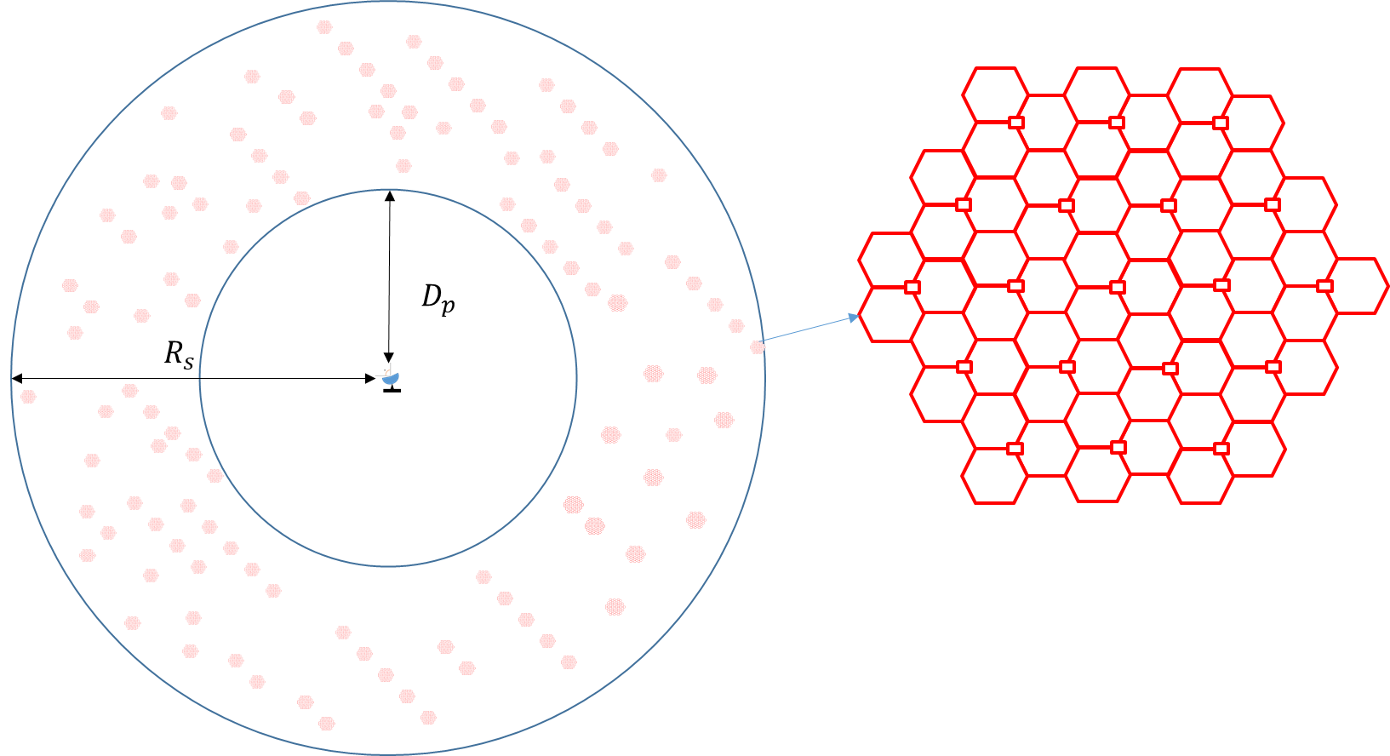
Step 2 – Calculate cluster number in the simulation area
$Cluster number of urban = \frac{cell number of urban, N_{BS,u}}{site num×cell num per site}$
$$N_{BS,u}=D*A= {(ρ}_{u} R_{a,u} R_{b}) A$$
where the subscript “u” refers to urban and suburban values, and
$D$ : density of simultaneously transmitting BS cells in km^{–2}
$A$ : simulation area in km²
$ρ$ : BS cell deployment density in km^{–2}
$R_{b}$ : ratio (< 1) of built-up areas to total area of region under study
$R_{a}$ : ratio (< 1) coverage areas to areas of cities/built-up areas/districts.
Step 3 – Model IMT BSs, as well as user equipment in each sector of each BS for the purpose of modelling BS beamforming.
– According to the ITU-R terminology, an IMT BS means one sector in a three-sector cell (see Fig. A1-2).
– Each IMT BS in a cluster is given a random horizontal orientation based on a uniform distribution (0 to 360°). This is because the orientation of BSs is a function of local coverage planning, and is independent of the orientation of the RAS station.
– Each IMT BS in a cluster forms beams towards UEs which are modelled randomly located within the BS’s coverage area with a uniform distribution.
Figure a1-2
IMT BS illustration according to the ITU-R terminology
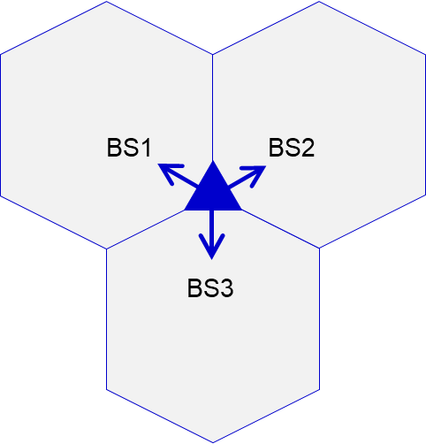 | 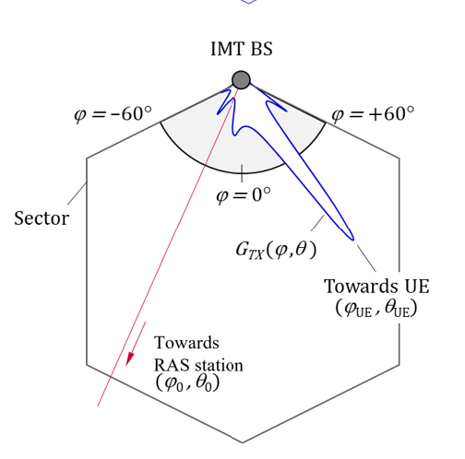
Step 4 – Calculate the interference from each IMT BS in the simulation area (see illustration of different angles on Fig. A1-2 (right)):
$I_{n}=\frac{G_{Tx}(θ_{0},φ_{0 }; θ_{UE},φ_{UE}){ G}_{Rx}\left(ψ_{0}\right)}{L_{clut}\left(θ_{0}\right) L_{prop} L_{pol}} {PSD}_{TX}=G_{n} {PSD}_{TX} (mW/MHz\text{)}$
where:
$I_{n}$ : Single entry interference power from the n^{th} BS in mW/MHz
${PSD}_{TX}$ : Total radiated power (TRP) spectral density of the BS in mW/MHz
$θ_{0},φ_{0 }$ : Elevation and azimuth angles between RAS station and BS
$θ_{UE},φ_{UE}$ : Elevation and azimuth angles of UE when viewed from the BS
$G_{Tx}(θ_{0},φ_{0 })$ : Antenna gain of the BS in the direction of the RAS station
$L_{clut}(θ_{0})$ : Clutter loss from the BS to RAS station
$L_{prop}$ : Propagation loss from the BS to the RAS station
$L_{pol}$ : Polarization loss
$ψ_{0}$ : Angle of the BS with respect to the RAS station receiver’s boresight
$G_{Rx}(ψ_{0})$ : RAS station receiver antenna gain in the direction of the BS.
Step 5 – Calculate the statistical distribution of the aggregate interference I from IMT Base Stations experienced at the RAS station:
$I=F_{TDD} \sum_{n=1}^{N_{BS}}{I_{n}}$
where:
N_{BS} : Total number of IMT base stations in the simulation area
F_{TDD} : IMT BS TDD activity factor of 75%.
This aggregate interference is compared with target threshold level of interference for the protection of the RAS receiver and then derive the coordination distance.

A1.1 Number of IMT Urban BS at 6 GHz considered in the study
Note: According to ITU-R terminology “1 BS” = 1 sector in 3-sector cell.
According to the methodology for calculating the number of BSs in a relatively large area as agreed by WP 5D in Annex 4.4 to Document 5D/716, the number of IMT BSs per 100 MHz channel in the 6 GHz band can be written as:
$N_{BS,u}=\left(ρ_{u}R_{a,u}R_{b}\right)A=DA$
where:
$D$ : density of simultaneously transmitting BS cells in km^{–2}
$A$ : area of interest in km² (i.e. larger than 200 000 km²)
$ρ$ : base station deployment density in km^{–2}
$R_{b}$ : ratio of built areas to total area of region in study
$R_{a}$ : ratio of coverage areas to areas of cities/built areas/districts
and “u” refer to urban values.
The ring area size of 360 000 km² is simulated.
TABLE A1-1
The values of $R_{a}$ and $R_{b}$ used in this Report
 | Macro
$$R_{a},u$$ | 10% Urban (area > 200 000 km²)
$$R_{b}$$ | 2% (200 000-1 000 000 km²)

A1.2 IMT parameters
Table A1-2 summarizes IMT system parameters for urban IMT BS used in this study, which align with those in § 3.
TABLE A1-2
IMT parameters used in this coexistence study
Parameter | Parameter value
Network topology | Aggregate case: clusters of IMT networks (57 BSs) are generated within the ring area uniformly
coordination distances | Considered from centre IMT network
Network loading factor | 20% ⁽¹⁾
Polarization loss | 3 dB ⁽²⁾
TABLE A1-2 (end)
Parameter | Parameter value
IMT BS antenna pattern | 8 × 16 × 2 Array elements (H+V)  Beamwidth H/V = 90°/90°  G_{elem} = 5.5 dBi  30 dB f/b ratio  Spacing H/V = 0.5/0.5
IMT Tx power | 26 dBm/MHz
IMT BS height | 18 m (urban)
Number of UE per BS | 3 UEs per BS (uniform distribution)
⁽¹⁾ Network loading factor was assumed as 20% in the ring area larger than 50 km².
⁽²⁾ The IMT base station antenna is the ±45° cross-polar, but polarization of a signal received by RAS station antenna can be different, and it would not fully match with that of IMT antenna with high probability, so a polarization loss of $L_{pol}$ = 3 dB was implied.

A1.3 RAS parameters and protection criteria
Table A1-3 summarizes RAS parameters and protection criterion used in this study, which align with those in § 2.
TABLE A1-3
RAS parameters used in this study
 | Parameter considered in the study
Antenna pattern | An isotropic antenna with a gain of 0 dBi
Antenna height | 50 m
Location | 51°N,16° E
RAS protection criteria | −218.1 dB(W/50 kHz) not exceeded by 2% of time

A1.4 Propagation modelling
The analysis in this Report is based on Recommendation ITU-R P.2001, and 50% time percentage is assumed. According to Recommendation ITU-R P.2001, Tpc (time percentage) for the following sub-models are statistically-independent and randomly-generated in the range 0-100%. The path loss with 50% time percentage matches the path loss median value if we use a random time percentage uniformly distributed within 0-100% and randomized at each simulated event. So, 50% time percentage for the Recommendation ITU-R P.2001 is an accurate assumption for statistical simulations considering long-term interference.
Propagation model | Recommendation ITU-R P.2001-4 (longitude 16 degrees; latitude 51 degrees); time percentage: 50%
Figure A1-3
Propagation model
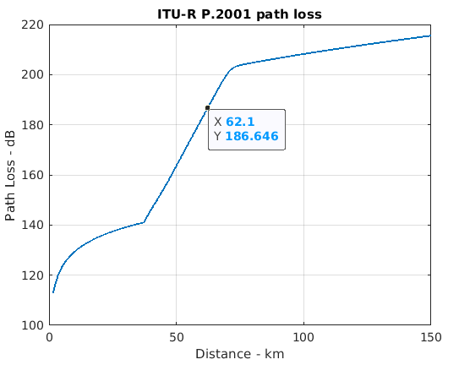
This study uses Recommendation ITU-R P.2108 § 3.2 clutter loss model for terrestrial paths in this analysis.
In order to define propagation conditions, line-of-sight (LOS) or non-line-of-sight (NLOS) concept is used in this paper in order to decide whether clutter loss to be applied or not in Urban scenario. There is a number of LoS/NLoS models in ITU, 3GPP, e.g. Report ITU-R M.2412, 3GPP TR38.901 and WINNER2, demonstrating that for transmitter and receiver heights up to 20 m, there is a very high probability of NLoS condition at distances beyond 1.5 km.
With considerations above clutter loss model is applied to all IMT BSs in this study.
TABLE A1-4
Propagation modelling summary
Clutter loss model | Section 3.2 of Recommendation ITU-R P.2108-1
Clutter loss model | 0~100% uniform random value for percentage of locations in Recommendation ITU-R P. 2108-1
Clutter loss model | Apply clutter loss model of the entire location distribution for all IMT urban BSs
Clutter loss model | No clutter model applied for RAS

A1.5 Results from sharing studies
The aggregated interference level from the IMT urban Macro BSs is calculated using the parameters and models described in the previous sections of the document, the corresponding CDF curves are shown in Fig. A1-4.
Figure A1-4
CDF curve for in-band scenario
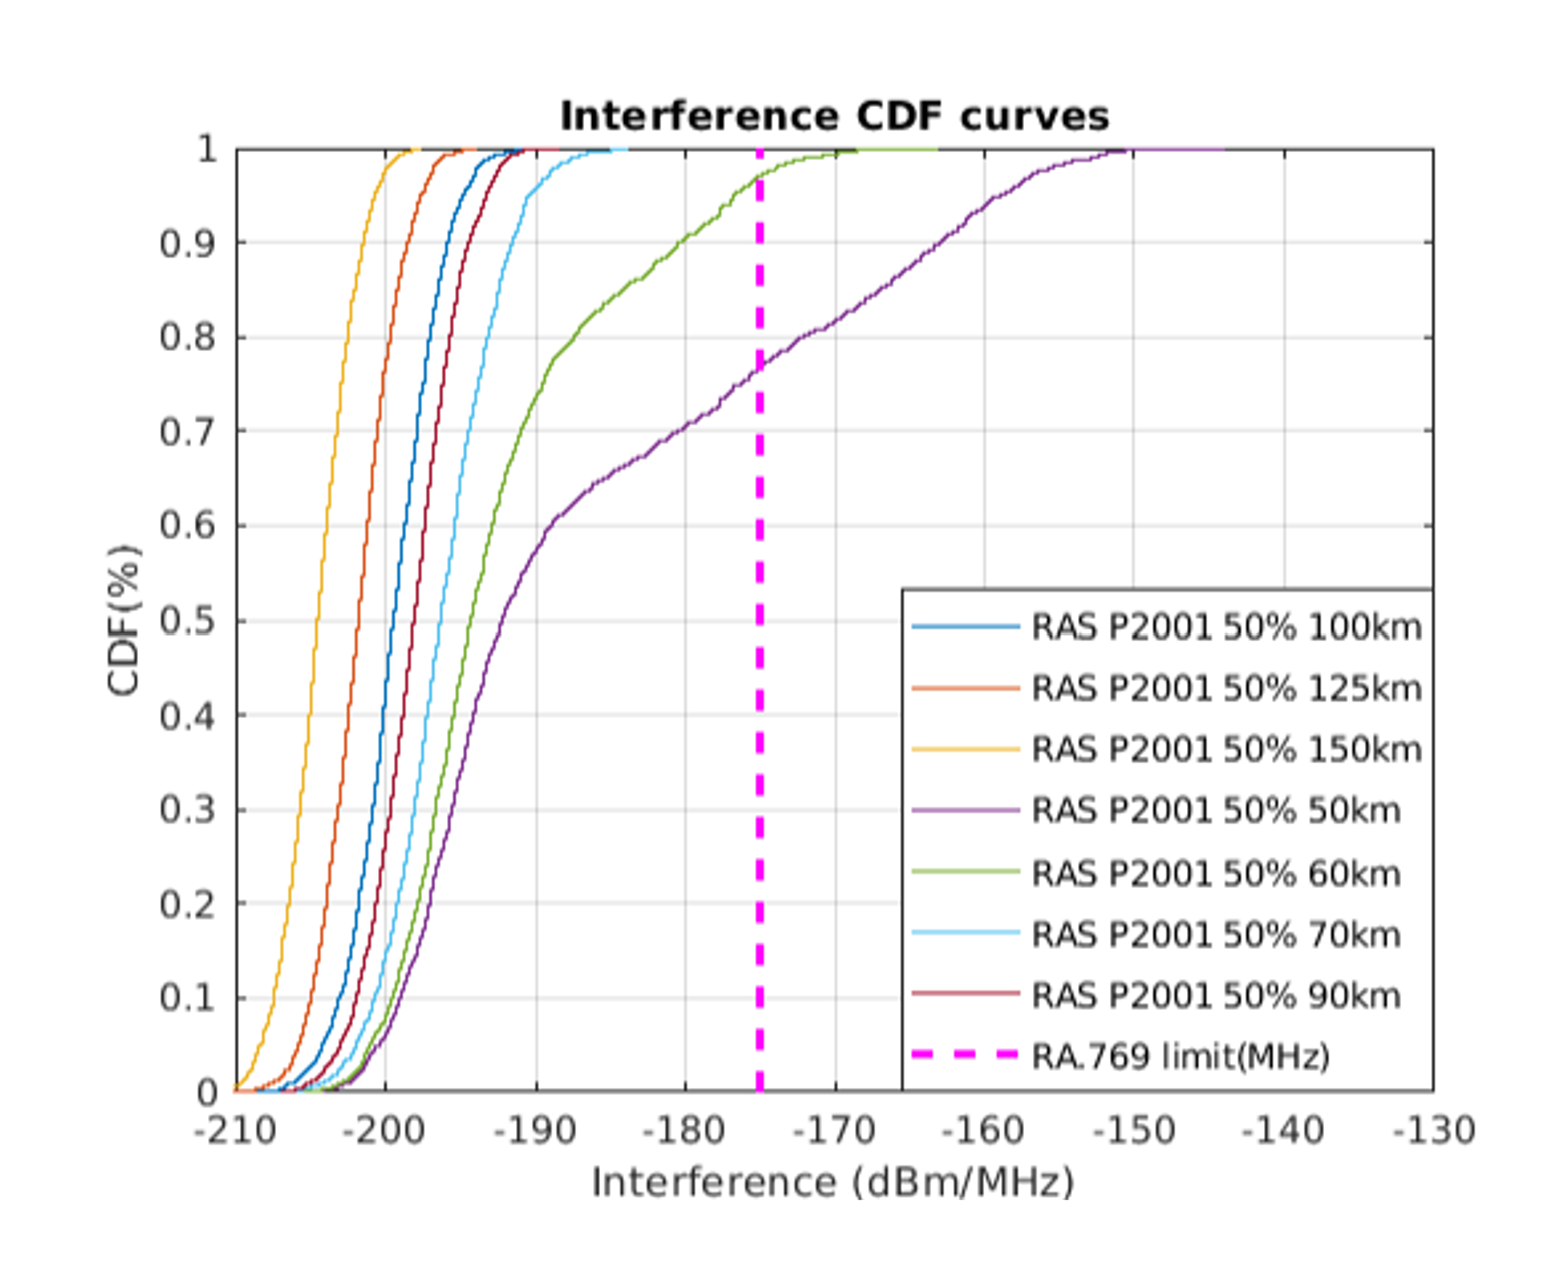
The minimum coordination distance required to ensure coexistence between RAS spectral line measurements and urban IMT macro base stations (in-band scenario) is obtained by comparing the interference levels at the RAS station receiver for the different coordination distances with the RAS protection criteria (−218.1 dB(W/50 kHz) which is equivalent to −175.1 dBm/MHz, at 98th percentile of CDF curve for the protection of the RAS receiver).
Therefore, based on this analysis the minimum coordination distance required to ensure protection for the RAS stations from the aggregated interference from the surrounding IMT urban macro cellular network is 62 km.

Annex 2
Example studies for generic and site-specific cases
It presents an example for calculating the coordination areas around the RAS station to protect RAS from aggregate interference of IMT with urban deployment using the dynamic Monte Carlo simulation method defined in this report. It also analysed single-entry interference for site-specific scenario from BS with suburban/rural deployment to RAS station for sensitivity case. It is noted that IMT base stations in rural areas may not be typical for 6 425-7 125 MHz frequency band, it is not expected to be deployed contiguously and any such base stations that may exist in small numbers will be isolated installations at specific locations.

A2.1 IMT-2020 parameters
Parameters of IMT-2020 are provided in Table A2-1, these parameters were approved by the WP 5D and can be also found in Annex 4.4 to Document 5D/716.
TABLE A2-1
IMT technical parameters for base stations and user equipment in the band 6 425-7 025 MHz
Parameters | IMT Base station | IMT User equipment
Band parameters
Frequency | 6.65 GHz | 6.65 GHz
Carrier bandwidth | 100 MHz | 100 MHz
Antenna parameters (Recommendation ITU-R M.2101-0)
Antenna pattern | Rural¹/suburban  8 × 16 × 2 Array elements (H+V)  Beamwidth H/V = 90°/65°  G_{elem} = 6.4 dBi  30 dB f/b ratio  Spacing H/V = 0.5/0.7  Urban  8 × 16 × 2 Array elements (H+V)  Beamwidth H/V = 90°/90°  G_{elem} = 5.5 dBi  30 dB f/b ratio  Spacing H/V = 0.5/0.5 | −4 dBi (avg. isotropic)  Single-element
Down-Tilt | 6° (Sub/Rural)  10° (Urban) | N/A
Antenna height | 25 m ⁽¹⁾ (Rural)  20 m (Suburban)  18 m (Urban) | 1.5 m
Emitted powers
Ptx | 22 dBm per element | 23 dBm
Spectral mask (relative to total conducted power of carrier) | −50.1 dBc/MHz (adjacent) | −30 dBc/MHz (adjacent)
Ohmic losses (included in G_{elem}) | 2 dB | 2 dB
Other losses | N/A | 4 dB (body loss)
Conducted spectral power density  (Total array, without gain) | 26 dBm/MHz (in-band)  −4 dBm/MHz (adjacent) | 3 dBm/MHz (in-band)  −7 dBm/MHz (adjacent)
Power into RAS frequency band (Spectroscopy channel width: 50 kHz) | 13 dBm (in-band)  −17 dBm (adjacent) | −10 dBm (in-band)  −20 dBm (adjacent)
UE power control parameters | N/A | PCMAX = 23 dBm  P0 PUSCH = −95.5 dBm  α = 0.8
Network loading factor | 20% | N/A
TDD activity factor | 75% | 25%

TABLE A2-1 (end)
Parameters | IMT Base station | IMT User equipment
Deployment
Rb (housing ratio) | 2%
Ra (ratio of hotspot area to housing area) | 10%¹ (Rural)  5% (Suburban)  10% (Urban)
Deployment density in hotspot area (number of sectors; 3 sectors per BS position) | 0.006 km⁻² (Rural)  2.4 km⁻² (Suburban)  10 km⁻² (Urban) | 3 UEs per BS sector
Number of indoor devices | N/A | 50%¹ (Rural)  70% (Suburban)  70% (Urban)
Distribution of user equipment (relative to base station)
BS cell radius | 1.2 km¹ (Rural)  0.6 km (Suburban)  0.3 km (Urban)
Angular distribution | Uniform (–60°, +60°
⁽¹⁾ Rural parameters were mostly undefined for the IMT band 6 425-7 025 MHz in Document 5D/716 (Annex 4.4) it is also noted that rural deployment is not expected to be common for that band and will be mostly rare isolated installations.

A2.2 RAS parameters
The study takes into account spectral line observations to take into account the most stringent protection criterion. It should be noted that for VLBI interferometers, protection criterion is less stringent.
Parameter | Value
Frequency range | 6 650-6 675.2 MHz
Channel | 50 kHz
Antenna height | 50 m
Antenna pattern | An isotropic antenna with a gain of 0 dBi
Noise temperature | 10 K
RAS protection criteria | 218.1 dB(W/50 kHz) at 98th percentile for the protection of the RAS receiver

The protection criterion for RAS is based on Recommendation ITU-R RA.769, at the same time it should be noted that for this particular band there is actually no protection criterion, so the recommendation is used as the closest available value.

A2.3 Simulation methodology of aggregate interference
Generic study that estimates aggregate interference employs Monte-Carlo simulation analysis where at each step IMT base stations are generated around the victim receiver as the 19 trisector BS clusters, so total number of sectors per each cluster is 57. In order to calculate the number of clusters, R_{a} R_{b} approach should be used.
Based on the methodology developed by WP 5D, the number of IMT BSs per 100 MHz channel in the 6 GHz band can be calculated using the follow equation:
$N_{BS,total}=\left(ρ_{u}R_{a,u}R_{b}\right)A$
where:
$ρ_{u}$ : Base station deployment density in km²
$R_{a}$ : Ratio of coverage areas to areas of cities/built areas/districts
$R_{b}$ : Ratio of built areas to total area of region in study
$S_{area}$ : Studied area expressed on km².
In this study for R_{a} 10% value was used and for R_{b} 2% value was used. Total area size was 360 000 km². The was divided into ring layers, the first layer was the required coordination distance, whereas the second layer was the simulation area where. The circle layer approach is presented in Fig. A2-1.
Figure a2-1
Methodology of simulation the interference from IMT to RAS
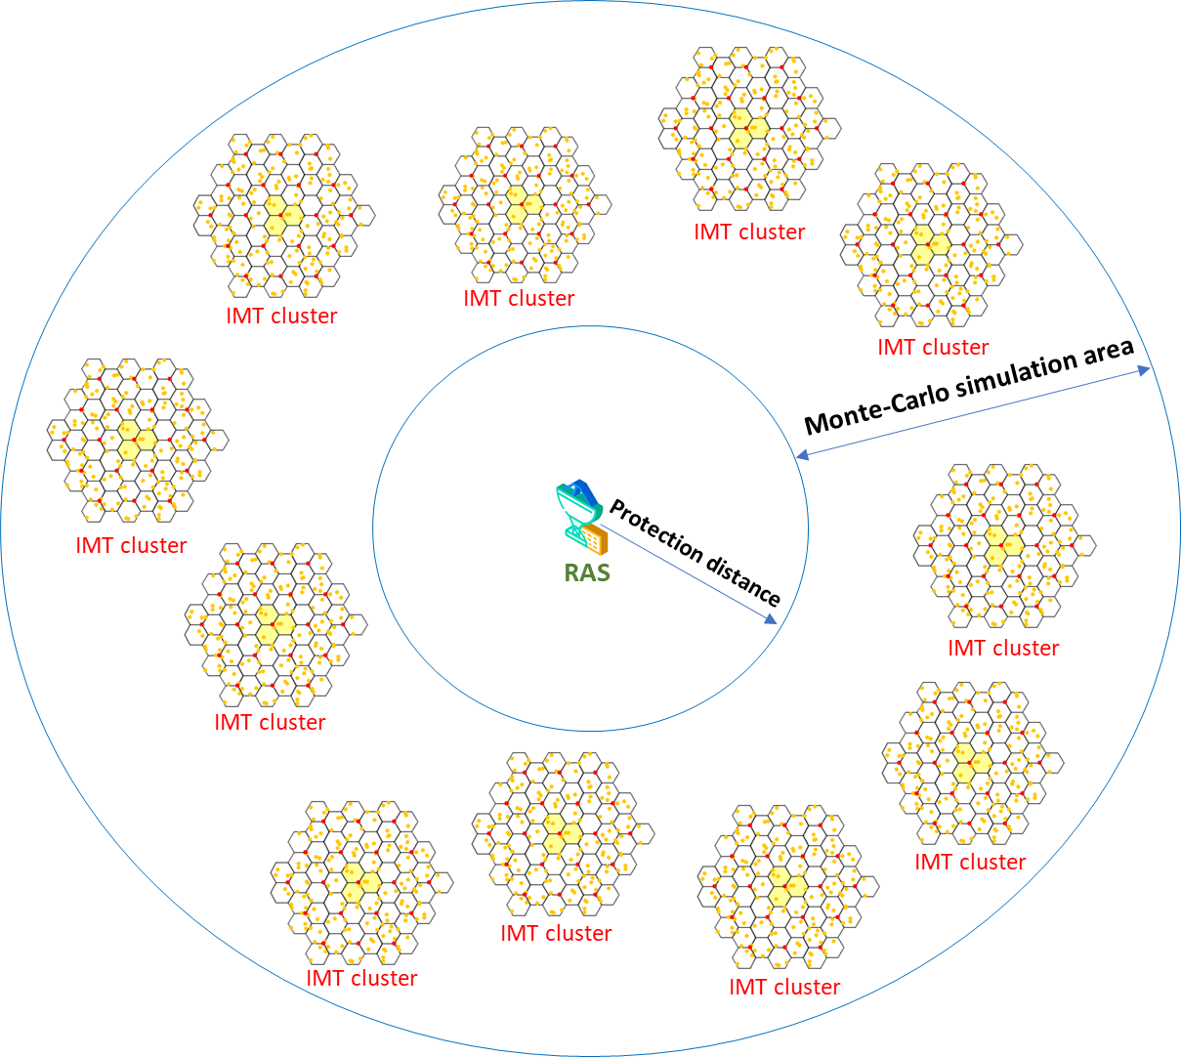
To estimate the number of simultaneously transmitting BS, TDD activity factors and network loading factor should be taken into account. For the wide studying areas network loading factor is 20%, thus total number of simultaneously transmitting IMT clusters can be expressed below:
$N_{clusters}=\frac{\left(ρ_{u}R_{a,u}R_{b}\right){S_{area}A}_{TDD}A_{loading}}{57}$
At each simulation step the antenna of the BS is electronically steered depending on the user’s position, an example of electronic antenna steering based on Recommendation ITU-R P.2101 presented in Fig. A2-2.
Figure a2-2
Base station antenna array pattern for different beam steering angles
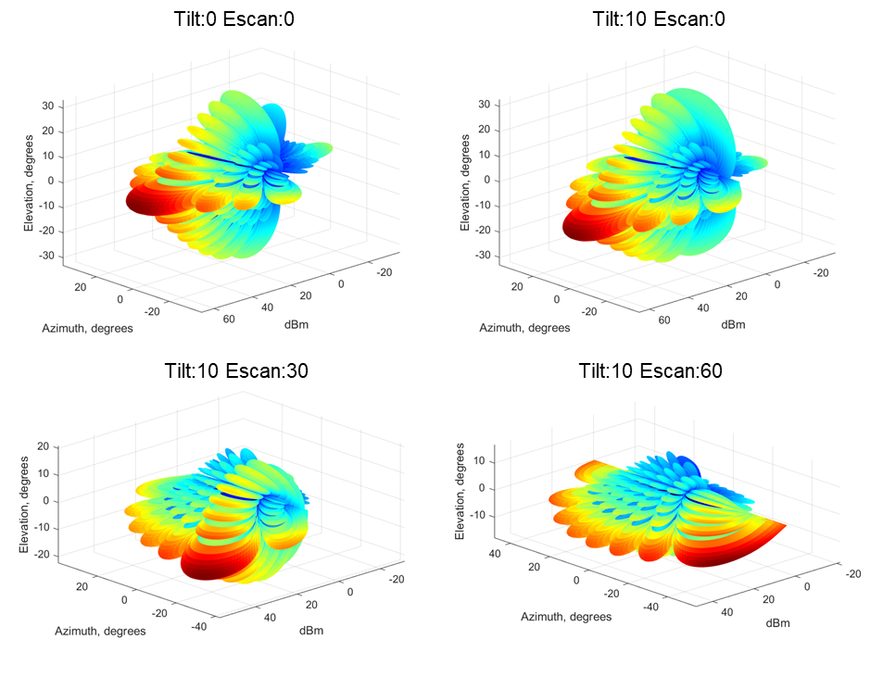
The BS beamforming precoding is used and multiple spatially directive signals are transmitted simultaneously. In simulations, the emission consisted of three directive beams pointing to every user in each sector; the output power of the beam was evenly split to each user as shown in Fig. A2-3.
Figure a2-3
Beam distribution used in simulations and gain pattern of each beam
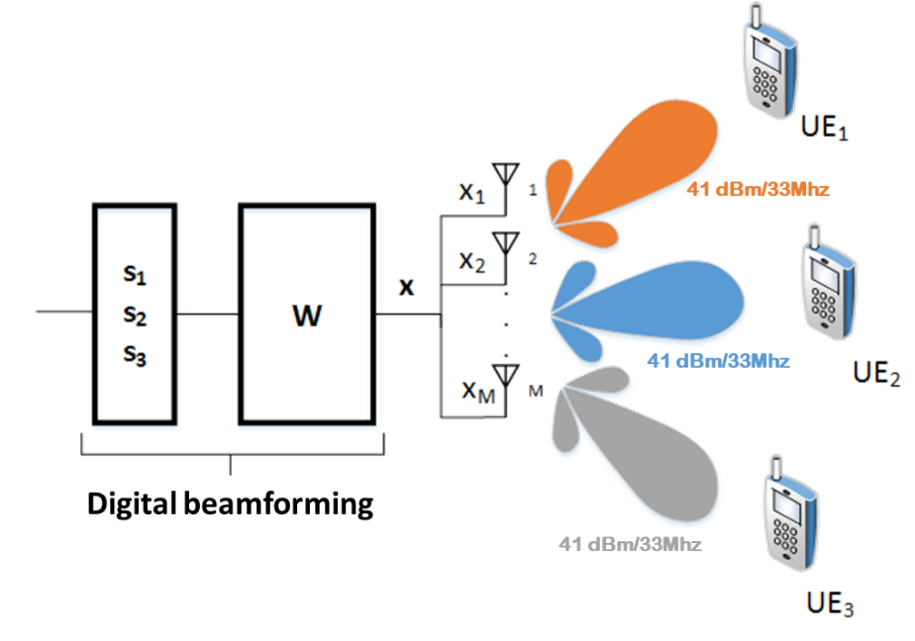
The value 41 dBm/33 MHz was obtained using the following expression:
$P_{33MHz}=22+10\log\left(8 ×16 ×2\right)-10log⁡(3)$

A2.4 Propagation model
To calculate propagation losses the model based on Recommendation ITU-R P.2001 is used. This Recommendation was among those that were allowed to be used for 6 GHz band by WP 3K/3L. This Recommendation describes a radio-wave propagation method for terrestrial paths. It has a wide range of applicability in frequency, distance, and percentage time. In particular, it predicts both fading and enhancements of signal level. It is thus particularly suitable for Monte-Carlo simulations. For Monte-Carlo simulations random percentage of time for each interfering base station should be used, given that essentially it corresponds the average, 50% value has been used.
For IMT with urban deployment, clutter should be used. The clutter losses can be calculated using the propagation model based on Recommendation ITU-R P.2108. Random percentage of locations is used. Figure A2-4 provides propagation losses of Recommendation ITU-R P.2001 for 50% of time without clutter (blue curve) and propagation losses taking into account clutter losses (red dots).
The clutter is applied for all transmitting BS given that their height is 18 m and most of the urban building height is from 20 to 30 m, therefore the probability that the path between the transmitting BS and RAS station will be covered by clutter is very high. Additionally, it should be noted that most of the WP 5D studies under WRC-23 agenda item 1.2 during the WRC-23 study cycles applied clutter for 100% base stations.
Figure a2-4
Propagation losses of Recommendation ITU-R P.2001 with 50% percentage of time with and without clutter losses
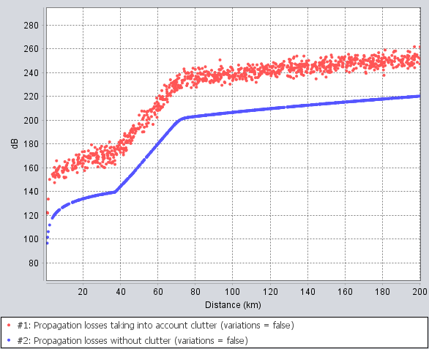

A2.5 Generic case study
The study employed Monte-Carlo simulation, at each step the location of each use within the cell was randomly distributed according to the uniform distribution. The interference at each step can be calculated using the following expression:
$I=P_{tx}+G_{tx}\left(θ,φ\right)+G_{rx}\left(θ,φ\right)-L_{2001}-L_{clutter}-L_{pol}$
where:
$P_{tx}$ : Output power of the BS in dBW
$G_{tx}(θ,φ)$ : Antenna gain of the BS towards the RAS station in dBi
$G_{rx}(θ,φ)$ : Antenna gain of the RAS towards the BS in dBi
$L_{2001}$: Propagation losses based on Recommendation ITU-R P.2001
$L_{clutter}$ : clutter losses based on Recommendation ITU-R P.2108 in dB
$L_{pol}$ : Polarization difference losses in dB.
Figure A2-5 shows the simulation example of interference from IMT to RAS in the frequency band 6 650-6 675 MHz using Monte-Carlo approach.
Figure a2-5
Propagation losses of Recommendation ITU-R P.2001 with 50% percentage of time with and without clutter losses
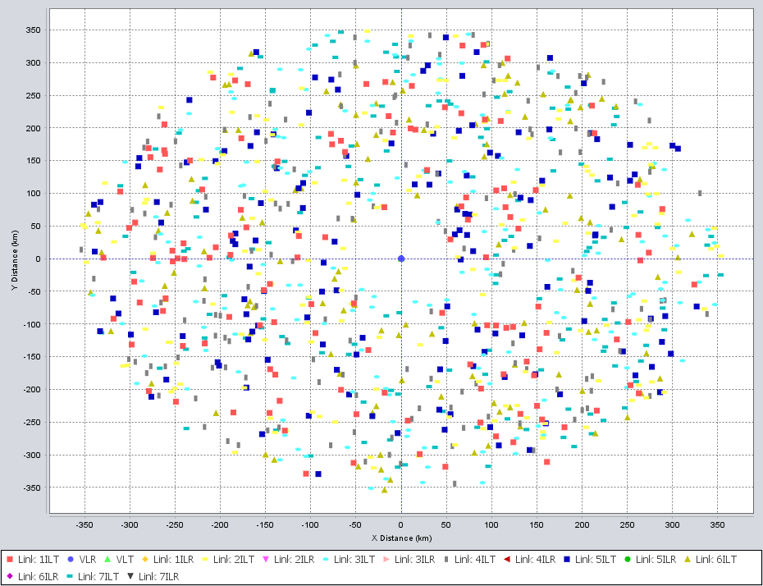
The obtained during the simulation interference values were used to generate CDF distributions, first the collected data after simulation comprised into the probability distribution function (PDF).
The PDF can be integrated into the CDF using:
$CDF(X)=\int_{-∞}^{X}{PDF(x)dx}$
The PDF and CDF data can be generated using the quantized data of the calculated values as histogram H (i) where I = {0 …. n} and each value i can be mapped to a data value x using:
$x(i)={xBinSize}_{min}$
The bin relating to data value x is then:
$i(x)=Round\left[\frac{x-x_{min}}{x_{BinSize}}\right]$
The probability density histograms for each coordination distance that was analysed (50 km, 60 km, 70 km and 100 km) are provided in Fig. A2-6.
Figure a2-6
Interference levels from IMT-2020 to RAS for different coordination distances
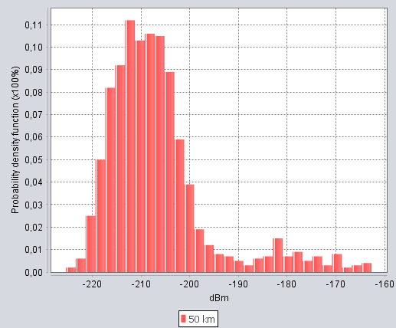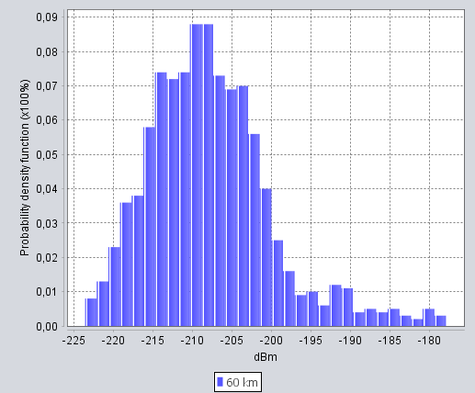
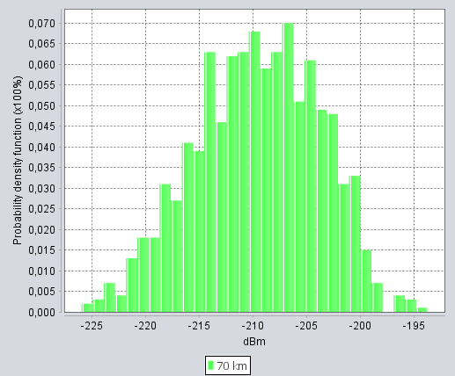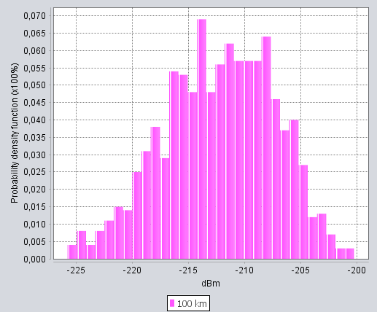
Then the CDF can be generated from the histogram as a percentage using:
$CDF(X)=100\frac{\sum_{i=0}^{i(X)}{H(i)}}{\sum_{i=0}^{i(n)}{H(i)}}$
Figure A2-7 shows the cumulative distribution function curves for each simulated coordination distance. The red curve represents the CDF for a 50 km coordination distance, the blue curve for a 60 km coordination distance, the green curve for a 70 km coordination distance, and the purple curve for a 100 km coordination distance.
Figure a2-7
Interference levels from IMT-2020 to RAS for different coordination distances
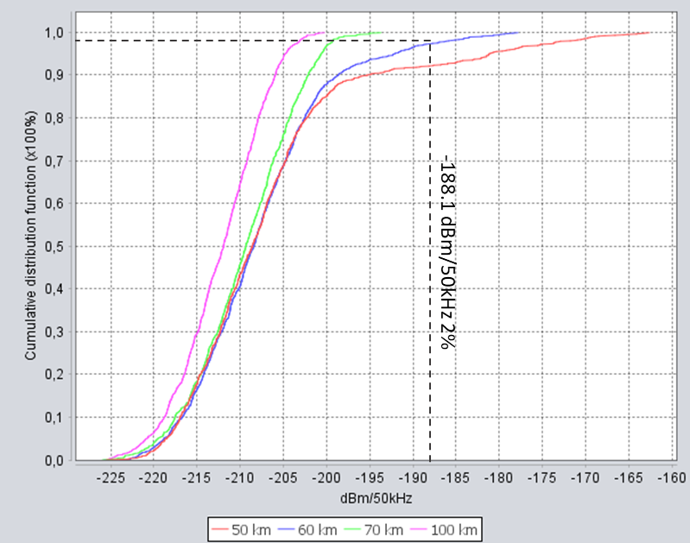
As may be seen from the curves the minimum coordination distance that allows to protect RAS from aggregate interference of IMT with urban deployment is 60 km.

A2.6 Sensitivity analysis study
Resolution 220 (WRC-23) has adopted expected e.i.r.p. mask to ensure protection for the FSS (Earth-to-space). This mask is based on the simulation studies of the WRC-23 cycle.
Averaging over beamforming directions for a given vertical angle θ₀ and horizontal angle φ₀: for an AAS base station within a given horizontal and vertical steering range, a sufficient sampling of N beamforming directions (α_{n}, β_{n}) n = 1 ... N is necessary to allow an accurate averaging of the expected e.i.r.p.
The beamforming directions (α_{n}, β_{n}) have a uniform statistical angular distribution within the steering range of the IMT base station. In other words:
$P_{1}(θ_{0},φ_{0})=\sum_{n=1}^{N}{w_{n}P(θ_{0}},φ_{0};α_{n},β_{n})$
where w_{n} refers to the weight for the nth beamforming direction, i.e. the fraction of the steering range represented by the n^{th} beamforming direction. For example, w_{n} = 1/N in the case that N uniform equispaced beams are assumed in the azimuth and elevation, respectively, and where each beam covers an equal range of angles.
The set of base station configurations over which the base station complies with the limits on expected e.i.r.p. (for example, power of steering range as one of the parameters) shall be declared and the BS shall be used within one of these configurations.
The set of e.i.r.p. values used to calculate the expected e.i.r.p. for each vertical angle range shall be a mathematical summation of both polarization states of the IMT base station antenna with no polarization discrimination. The applied mask is presented in Table A2-2.
TABLE A2-2
IMT technical parameters for base stations and user equipment in the band 6 425-7 025 MHz
Vertical angle range | Expected e.i.r.p.  (dBm/MHz)
0º ≤ θ < 5º | 27
5º ≤ θ < 10º | 23
10º ≤ θ < 15º | 19
15º ≤ θ < 20º | 18
20º ≤ θ < 30º | 16
30º ≤ θ < 60º | 15
60º ≤ θ < 90º | 15
Notes to Table A2-2:
NOTE 1: The expected e.i.r.p. is defined as the average value of the e.i.r.p., with the averaging being performed:
– over horizontal angles from −180° to +180°, with the IMT base station beamforming in a specific direction within its horizontal and vertical steering range,
– over different beamforming directions within the IMT base station horizontal and vertical steering range, and
– over the specified vertical angle range θL ≤ θ < θH.
NOTE 2: An IMT base station shall comply with the specified limits on expected e.i.r.p. spectral density for all mechanical tilts with which it can be deployed, taking into account considering m).
NOTE 3: See the Annex to Resolution 220 (WRC-23) for additional details on how the expected e.i.r.p. can be calculated for this frequency band.

Given that the interference from BS to RAS will come at the angles slightly above the horizon, this mask can be also adopted to estimate the aggregate interference from IMT to RAS. Figure A2-8 shows interference levels from IMT to RAS when applied expected EIRP mask for different coordination distances.
Figure a2-8
Interference levels from IMT-2020 to RAS for different coordination distances when applying the expected EIRP mask
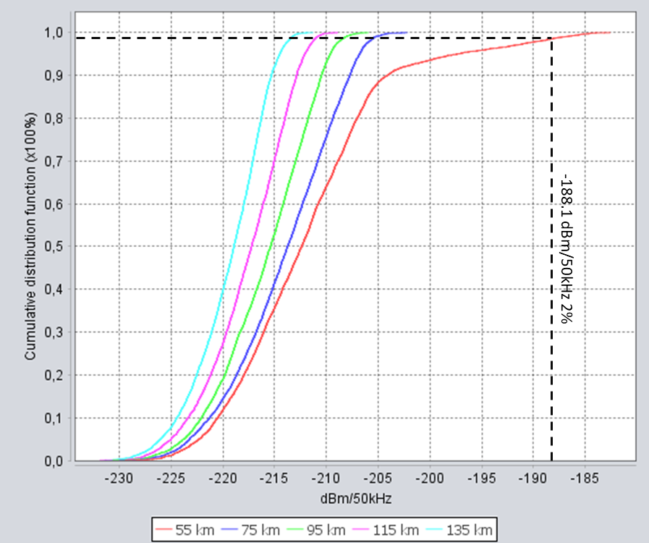
As may be seen from the obtained figures, the required coordination distance to protect RAS from IMT in urban deployment is 55 km.

A2.7 Site specific study
For this type of the study single-entry interference has been analysed. The BS with suburban/rural deployment has been considered, the clutter has not been applied in the scenario. Propagation mode based on the Recommendation ITU-R P.2001 was used. SRTM terrain was used to take into account the terrain losses. The single-entry interference was calculated using the following expression:
$I=P_{tx}+G_{tx}(θ,φ)+G_{rx}(θ,φ)--L_{2001}-10\log{(\frac{1}{A_{TDD}})}-10\log{(\frac{1}{A_{loading}})}-L_{pol}$
where:
$P_{tx}$ : output power of the BS in dBW
$G_{tx}(θ,φ)$ : antenna gain of the BS towards the RAS station in dBi
$G_{rx}(θ,φ)$ : antenna gain of the RAS towards the BS in dBi
$L_{2001}$ : propagation losses based on the Recommendation ITU-R P.2001
$A_{TDD}$ : TDD activity factor, equals 0.75
$A_{Loading}$ : network loading factor, equals 0.5
$L_{pol}$ : polarization difference losses in dB.
It should be noted that in this study polarization loss was assumed 0 dB since there was no information on polarization type the RAS stations could be used. In this example site-specific study, Badary RAS station was considered. The Badary Radio Astronomical Observatory is situated in the Burytia Republic (East Siberia) about 130 km east of Baikal Lake. This example represents a good case since Badary station located not far from the Russian-Mongolian border thus effectively representing possible cross-border example scenario.
Interference levels for in-band and adjacent band scenarios are presented in Fig. A2-9.
Figure a2-9
Single-entry interference to Badary station for the in-band and adjacent band scenarios
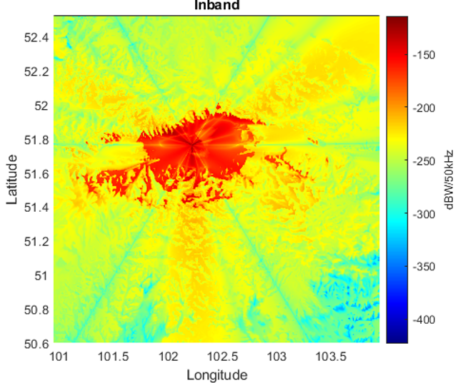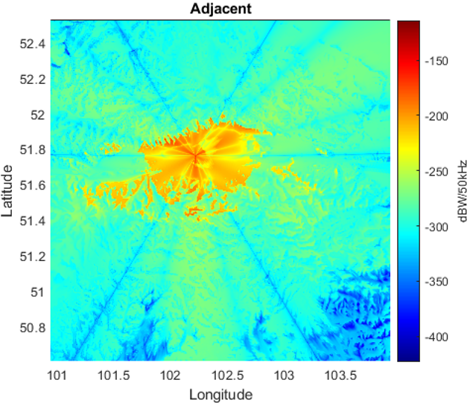
Based on the interference levels, protection contours according to the −218.1 dBW/50 kHz can be built. Figure A2-10 shows protection contours on the SRTM map for the in-band interference scenario (red lines), for adjacent channel interference (blue lines).
Figure a2-10
Protection contours for Badary RAS station for the in-band and adjacent domain scenarios
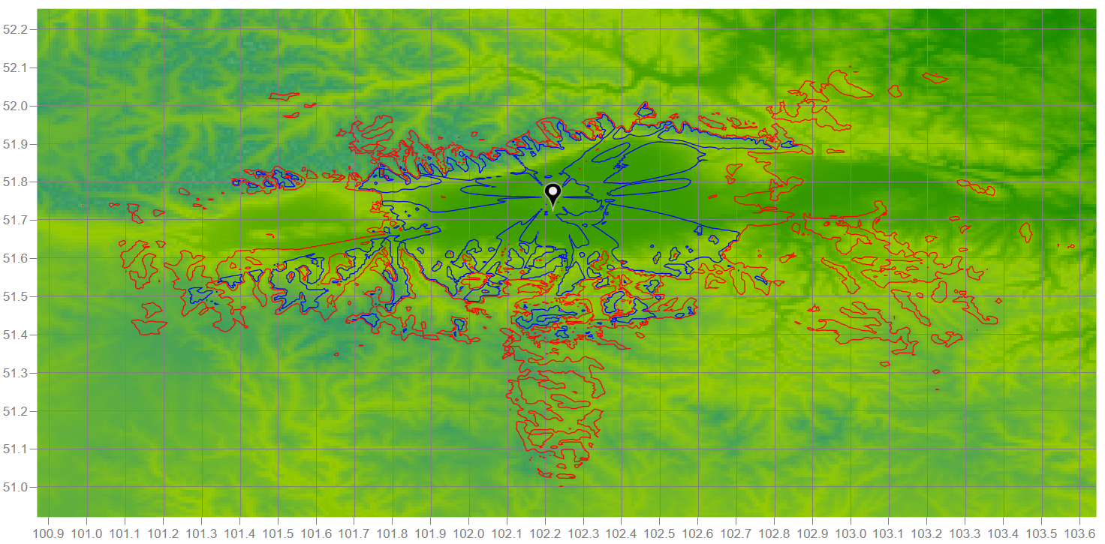
As may be noted, when taking into account terrain shielding, the interference to RAS can be mitigated quite significantly. It should be noted that in case the interfering BS would be shieled by the clutter, the contours would be even smaller; however, to address the worst case, this example did not take into account clutter losses.
Figure A2-11 presents protection contours on the Google maps layer where red lines are the contours for the in-band interference scenario, green lines are the contours for the adjacent channel interference scenario. On this Figure, distance rings are also added to see the coordination distances between BS and RAS that would be required for the site-specific case.
Figure a2-11
Protection contours for Badary RAS station for the in-band and adjacent domain scenarios
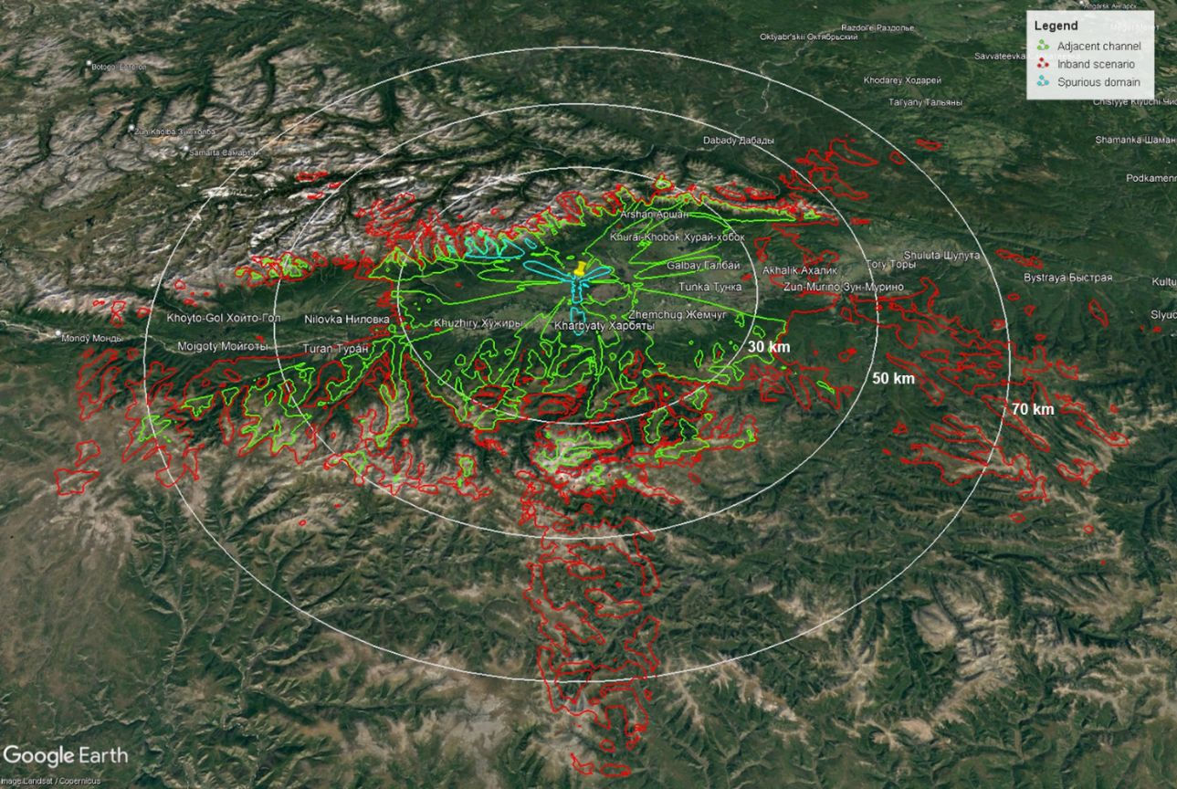
As may be seen from the obtained results, for the case of in-band interference the coordination distance would vary from 30 to 80 km, for the adjacent channel scenario it would vary from 10 to 50 km.

A2.8 Summary
When deploying IMT-2020 in the 6 650-6 675 MHz frequency band, the coordination distances will be largely depended on the deployment scenario of IMT and site-specific environment. For urban deployment, the coordination distance should be 60 km, at the same time when applying the mask that was adopted in WRC-23 for IMT BS, the coordination distance needs to be 55 km. For site-specific scenario when IMT has suburban or rural deployment, depending on the terrain environment, the coordination distance should be from 30 to 70 km, and can be reduced to 10 to 30 km for adjacent channel case.

Annex 3
Proposals on example studies

A3.1 Introduction
This Annex contains a sensitivity study related to the sharing and compatibility between stations of the terrestrial component of International Mobile Telecommunication (IMT) in the band 6 425-7 125 MHz and RAS in the band 6 650-6 675.2 MHz, which includes sharing and adjacent band scenarios.
Section A3.2 contains the additional technical parameters for the studies, in case these were not already defined in §§ 2 and 3. Sections A3.3 and A3.4 present generic and site-specific calculations, respectively. In the former case, both single-entry and aggregate scenarios are investigated, while in the latter case only single-entry computations are performed. This is owing to the fact that at the time of writing, no site-specific information on the deployment of IMT equipment in the 6 GHz band was available. Section A3.5 lists several possible mitigation measures, which could help to reduce the size of coordination zones and minimum coordination distances. A summary is contained in § A3.4.1.3.
Rural BS is also simulated in the study but IMT base stations in rural areas may not be typical for this 6 425-7 125 MHz frequency band, it is not expected to be deployed contiguously and any such base stations that may exist in small numbers will be isolated installations at specific locations.

A3.2 Additional study parameters
The IMT technical parameters used for this study are adopted in §§ 2 and 3 of this Report. Some additional parameters used in the sensitivity study in this Annex are provided in Table A3-1. The most noteworthy differences are:
– the study is considering a low number of rural BS; and
– adjacent and spurious domain cases are included, which require the specification BS antenna beamforming efficiencies for these domains.
Antenna pattern parameters for rural BS were assumed to be identical to suburban BS.
TABLE A3-1
Additional IMT technical parameters for base stations and
user equipment in the band 6 425-7 025 MHz
Parameters | IMT Base station | IMT User equipment
Antenna parameters (Recommendation ITU-R M.2101-0)
Beamforming efficiency² | ρ = 1.00 (in-band)  ρ = 0.95 (adjacent)  ρ = 0.80 (spurious) | N/A
Down-Tilt | 6° (Rural) | N/A
Antenna height | 25 m¹ (Rural) | 1.5 m
Fraction of below-rooftop installations | 0% (Rural) | N/A

TABLE A3-1 (end)
Parameters | IMT Base station | IMT User equipment
Deployment
Ra (ratio of hotspot area to housing area) | 10%¹ (Rural)
Deployment density in hotspot area (number of sectors; 3 sectors per BS position) | 0.006 km⁻² (Rural) | 3 UEs per BS sector
Fraction of indoor devices | N/A | 50%¹ (Rural)  70% (Suburban)  70% (Urban)
Distribution of user equipment (relative to base station)
BS cell radii (ISD) | 0.9 km¹ (Rural)
Distance distribution⁴ | Rayleigh (0, 300) (Rural)
¹ Rural parameters were mostly undefined for the IMT band 6 425-7 025 MHz in Document 5D/716 (Annex 4.4).
² Composite antenna pattern (beamforming) efficiency is still significant in adjacent and (near) spurious domain; see 3GPP TR 37.840 (Table 5.4.4.2-3). However, the values that are used for ρ in this study where not specified in Document 5D/716 (Annex 4.4).

A3.2.1 Base stations
The base stations utilize arrays of antenna elements (with two polarizations). For frequencies in the 6 425-7 025 MHz range, each of the 8 × 12 elements (for each polarization) has a conducted power of Ptx = 22 dBm / 100 MHz and phases can be fully controlled for each element.
For the out-of-band case, the considered RAS frequency band can either be in the adjacent or spurious domain with respect to the MS frequency band. The typical out-of-band conducted powers of IMT-2020 devices in the investigated frequency range are summarized in Document 5D/716 (Annex 4.4) and references therein. The parameters are included in Table A3-1 for convenience. It is noted that the Ohmic losses (2 dB), which usually need to be considered when determining the radiated power from the conducted power, are already included in the element gain, G_{e}. The spurious emission (conducted) in the RAS frequency band is −30 dBm/MHz, while in the adjacent band it is −4 dBm/MHz.
For the compatibility calculations the composite antenna pattern introduced in Recommendation ITU-R M.2101 is to be used, which depends on the position of the formed beam. Figure A3-1 shows the pattern for the 6 425-7 025 MHz band for a number of different beam steering angles. In practice, the beam-forming will still be more or less effective even in the adjacent and spurious domains. To account for this, 3GPP TR 37.840 (Table 5.4.4.2-3) introduces a parameter, ρ, which can be used to control the beamforming efficiency. For in-band cases, it should be set to One, while numbers smaller than One make the beamforming less effective. Values that should be used in studies were not specified, which is why some (reasonable) numbers have been assumed, here.
For BS, different antenna heights have to be considered, depending on the environment (rural, urban or suburban). To improve the gain after beamforming, the arrays are furthermore mechanically down-tilted with respect to the horizon. A fraction of BS antennas is assumed to be installed below the rooftops of houses. This has impact on the clutter loss; see below.
Figure A3-1
Composite BS antenna pattern (urban) for different beam steering angles
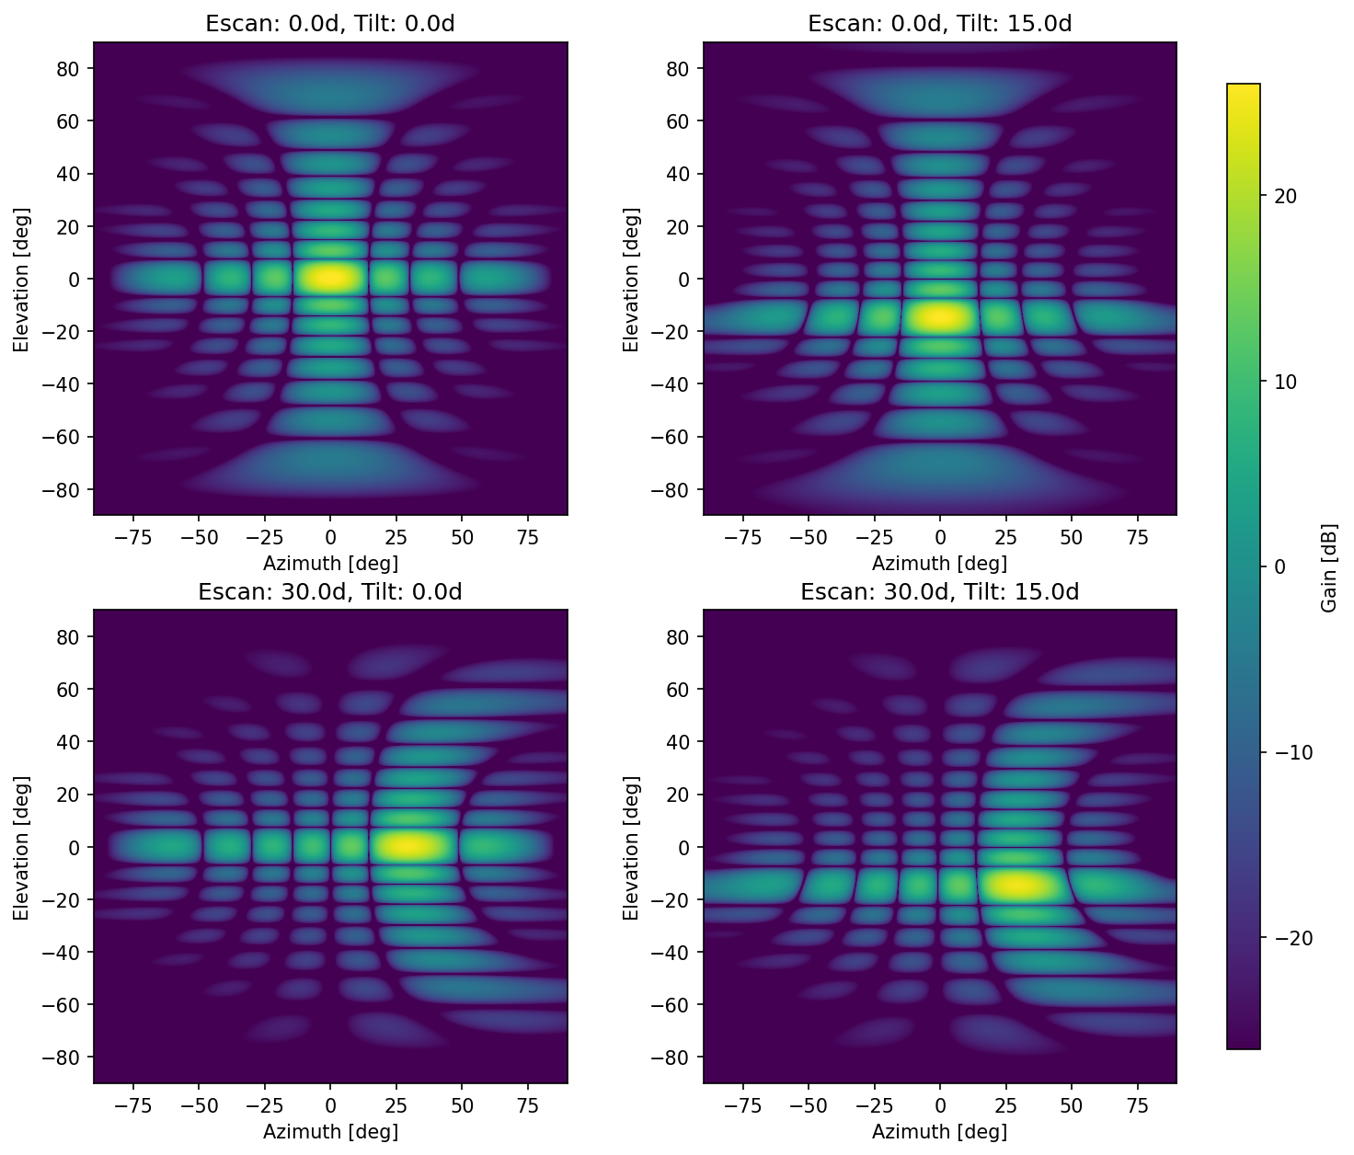

A3.2.2 User equipment
Different to the base stations, the UE does not feature AAS. For the compatibility studies, on average −4 dBi antenna gain is assumed (i.e. quasi-isotropic), with a conducted power of 23 dBm / 100 MHz. As for the base stations, conducted power levels for the adjacent and spurious domain are included in Table A3-1. Additionally, 4 dB body absorption loss must be applied.
A significant fraction of UE devices is assumed to be indoor. In the subsequent calculations, the fraction of UE, which is indoor, has been neglected from the contribution to the total aggregated received power at the RAS receiver.
UE devices feature a power control mechanism; see 3GPP TR 38.901, Table 7.4.1-1. The better the link budget the less UE power is used for transmissions. The power control parameters are also included in Table A3-1.

A3.2.3 Propagation and clutter models
For the generic compatibility study performed in this Report, a flat terrain (i.e. zero terrain heights, zero effective clutter heights) is assumed, while for site-specific scenarios real terrain heights and clutter heights were retrieved from public data bases. The propagation model according to Recommendation ITU-R P.452-18 is used. For BS, where AAS are in use, the position of the formed beam changes the effective gain towards the RAS station. For single-entry (worst-case) studies, the parameter p (or Tpc, the “time-percentage”), as defined in Recommendation ITU-R P.452-18, was assumed not to be exceeded for 2% of the time, following recommends 2 of Recommendation ITU-R RA.1513. For aggregation studies a random value is drawn (uniform distribution) for each distinct simulation run, but keeping the value for p fixed for all BS and UE in an individual simulation run. This is based on the assumption that the radio weather will be more or less constant within the small observing time range of 2 000 s and over a rather local area around the RAS site.
For the deployment of IMT equipment around RAS stations, case studies for individual RAS stations may be required, which can only be performed using detailed and specific information about actual deployment of BS around a RAS station.
For the prediction of clutter loss Recommendation ITU-R P.2108 (§ 3.2) was used. This model depends only on frequency, distance and the location percentage, p_{L}. The latter quantity is to be understood as the percentage of emitters (spread across an urban or suburban zone) producing the lowest clutter loss. For example, if p_{L} is 2%, the value $L_{cl}$ returned by the method indicates that for 2% of all cases the clutter loss will be lower than $L_{cl}$.
At 6.65 GHz and for distances larger than 5 km, clutter loss values for p_{L} = 2% are about 19 dB and about 31 dB for p_{L}=50%, respectively, whereas Recommendation ITU-R P.452 predicts up to 20 dB clutter attenuation. In the case of aggregate emissions, an integration of received powers over a sufficiently large area will be performed. Therefore, by assigning random (uniformly distributed) p_{L} values, ranging from 0% to 100%, to each BS and UE device, the expectation value of the clutter loss distribution can be computed. For distances larger than 5 km this is about 27 dB at 6.65 GHz. It is noted that for single-entry (worst-case) calculations, no clutter loss should be assumed, as there is always a non-negligible chance for the transmitter to be unaffected by clutter.
Furthermore, only a fraction of BS antenna installations is expected to be below the roof-tops of housings. All other BS locations will not be subject to relevant clutter loss. In particular, for rural locations, all BS will be at significantly larger heights than the typical roof heights. While Recommendation ITU-R P.2108 (§ 3.2) must only be used for urban and suburban areas, it is here also applied to UE in rural areas, as the UE are at low heights of 1.5 m.
Typical atmospheric conditions (temperature: 20 °C, pressure: 1 013 mbar) were assumed. For IMT equipment, the path attenuation is dependent on the associated zone (urban/suburban/rural), as the typical antenna height is different. The resulting path attenuation values are displayed in Fig. A3-2 for UE and BS, respectively. The curves for urban, suburban and rural are almost identical owing to the very similar antenna heights in all three cases, which is why only the results for the rural case are displayed.
For Monte Carlo type simulations (i.e. aggregation studies), it is important that the variable distributions are used and combined throughout the calculation and only in the final step, when looking at the posterior distribution any data loss criteria (2% for RAS) are applied.
Figure A3-2
Path attenuation for BS and UE in the 6 425-7 025 MHz band as a function of distance to the RAS station obtained using Recommendation ITU-R P.452-18
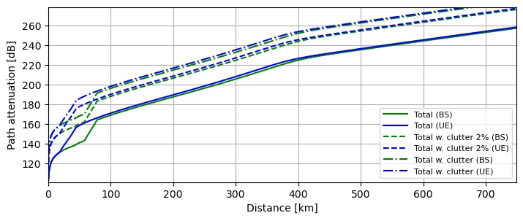

A3.3 Generic compatibility studies
For the single-interferer case the situation of a BS or UE device pointing directly towards the RAS station is of main concern. As a fair fraction of the BS is installed above roof-tops, it must be assumed that in the worst case, no additional clutter loss would apply. That no clutter loss is experienced is potentially also true for UE, although this is somewhat less likely to occur than for BS. Nevertheless, for the sake of comparison also the results under different assumptions for the clutter loss are provided here as well.

A3.3.1 Worst-case single interferer scenario
In the case of base stations, the down-tilt of the transmitting antenna arrays has to be accounted for (between 3° and 10° depending on the frequency band and environmental zone). Using the given antenna patterns (see, e.g., Fig. A3-1), the gain towards the RAS station was calculated under the assumption that the beam is steered towards the RAS receiver or – for trans-horizontal propagation paths – towards the local horizon as seen from the BS. In combination with the total power transmitted into the RAS frequency band and the total path attenuation, the power received at the RAS station can be determined. The results are visualized in Figs A3-3 to A3-5 for the different cases (in-band sharing, adjacent band operation and spurious domain).
The horizontal dashed red line indicates the Recommendation ITU-R RA.769 power threshold level for detrimental interference. The interception of the received power plots with the dashed red line therefore defines the radius of the coordination zone that would be necessary to protect the RAS station. The required coordination distances depend on the frequency, the environmental zone and the assumed clutter loss, but exceed 250 km in all cases and even exceed 400 km in some cases for the in-band sharing and are up to about 250/100 km for adjacent/spurious band operation, respectively.
The results for UE are also included in Figs A3-3 to A3-5. Here, the necessary coordination zone sizes are up to 75 km (in-band sharing) and about 50/25 km (adjacent/spurious), respectively.
Figure A3-3
Single-interferer worst-case scenario (in-band sharing) in the 6 425-7 025 MHz band
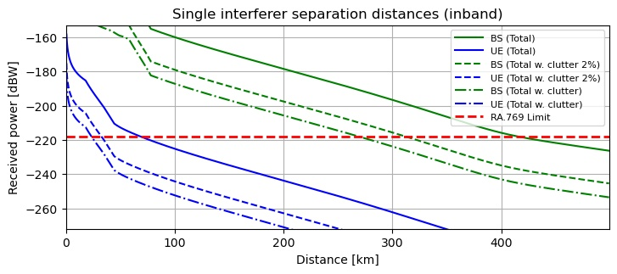
Figure A3-4
Single-interferer worst-case scenario (adjacent band operation) in the 6 425-7 025 MHz band
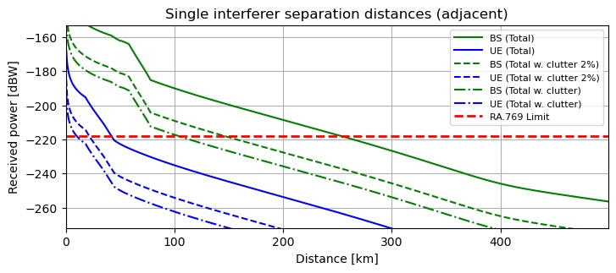
Figure A3-5
Single-interferer worst-case scenario (RAS in spurious domain of IMT) in the 6 425-7 025 MHz band
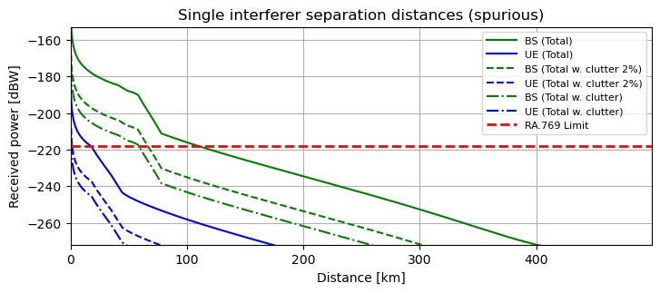

A3.3.2 Aggregated scenario
Not only the single-interferer scenario has to be considered for a compatibility study, but also the aggregated power scenario, which considers the impact of the accumulated emitted power of all IMT devices around an RAS station. Here a Monte Carlo simulation is used to infer the total aggregated power of an ensemble of BS and UE devices, which are located randomly in a box of sufficient size, adhering to the given distribution functions describing the typical deployment of devices.

A3.3.2.1 Deployment of IMT equipment
In Recommendation ITU-R M.2101 several possible deployment topologies for IMT networks are discussed, such as hexagonal or Manhattan-style grid layouts. Typical deployment number densities and other technical parameters are provided in Document 5D/716 (Annex 4.4).
In the particular case that is analysed here, the network topology can be neglected because one needs to average over a very large region. Then, the aggregated power at the RAS station will be completely determined by the average deployment densities defined in Document 5D/716 (Annex 4.4) (per zone type: urban, suburban and rural).
Following Document 5D/716 (Annex 4.4), it is assumed that parameter R_{b} = 5% (percentage of the considered area which has housing), and that R_{a} = 60%, 30%, and 10% for rural, suburban, and urban areas, respectively. For urban zones, 10 BS sectors per square kilometre are expected, with three sectors per BS position, i.e. the number of BS is 10/3 km⁻². For rural and suburban zones, the BS (sector) density is lower with 0.006 and 2.4 km⁻². In all zones, it is expected that each BS sector will serve three UEs (simultaneously).
In practice, urban and suburban areas in a region are often clustered. Since no distribution functions for the BS and UE device locations to be used in generic studies were specified so far, a uniform distribution is used here as a reference. Nevertheless, to analyse the impact of clustering effects, the following simple algorithm could be used to produce a typical distribution of urban and sub-urban zones in a densely populated environment such as Central Europe.
First, a rectangular grid of 600 km × 600 km with cells of size 2 km × 2 km is produced. For each cell a random number is drawn from a normal distribution. The uniform-density generation of urban and suburban cells is possible by computing appropriate percentiles: all cells with a random value above $(100\%-{(R}_{a}^{urban}+ R_{a}^{suburban})R_{b})$ are classified as suburban, while cells with random values above $(100\%-R_{a}^{urban}R_{b})$ are classified as urban. The result of this is visualised in Fig. A3-6 (left panel). For the central 100 km × 100 km of the simulated box. To achieve a clustering effect, a correlation length between adjacent pixels has to be introduced. This is possible by smoothing the original grid of random numbers with a blurring filter, e.g. a Gaussian filter. To achieve a realistic effect, three different kernel scales, σ_{k}, and relative amplitudes were used simultaneously: σ_{k} =2 km, 5 km and 15 km with relative amplitudes of 30%, 30% and 40%. Calculating distribution percentiles of the smoothed random number field leads to the classification of zone types representing a clustered environment, displayed in Fig. A3-6 (right panel).
Figure A3-6
Sampling of the different zone types. Left: Uniform distribution. Right: Clustered distribution
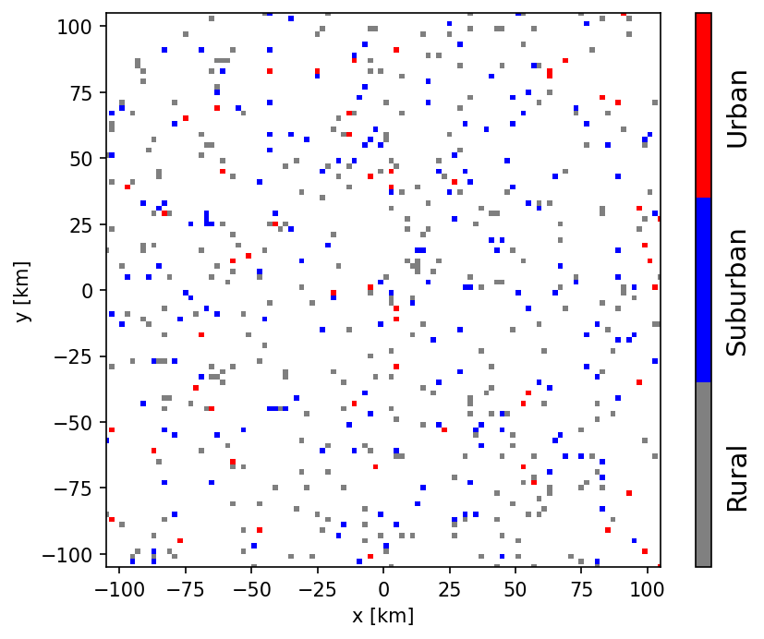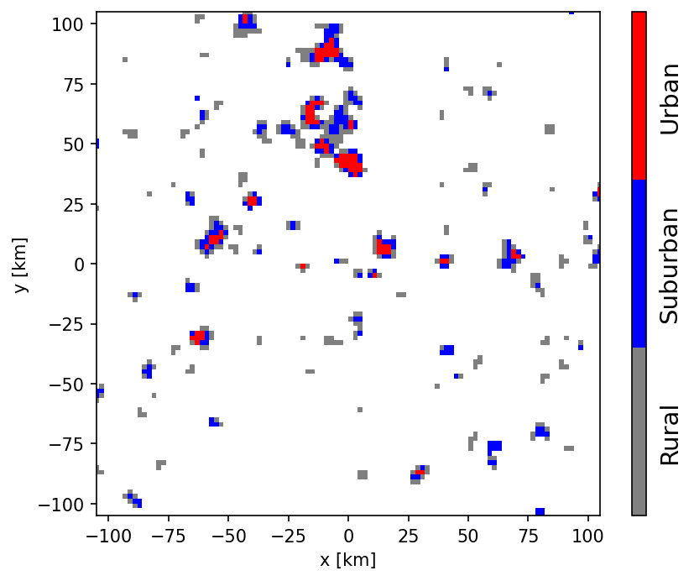
The Monte Carlo method used here to calculate the aggregate power is straightforward: BSs are randomly sampled into rural, suburban, and urban zones until the number of devices per zone leads to the specified BS number density. As an example, for a box of 1 000 km × 1 000 km this leads to 6667 BS (20 000 sectors) in urban, 800 BS (2 400 sectors) BS in suburban, and 4 BS (12 sectors) in rural zones. To each BS a random azimuthal orientation (bearing) is assigned, and it is assumed that the three sectors per BS are spaced by 120 degrees.
In each sector, three UEs are active. From the perspective of a base station sector, the UE devices are distributed in a forward cone. Here, radial and angular distribution functions are assumed as defined in § 2. The distance between BS and UE is given by a Rayleigh distribution. The angular distribution is given by a uniform distribution within ±60°. The combination of both distributions defines the desired forward cone.
UE devices can be rotated randomly, but as a constant antenna gain of −4 dBi is assumed, this has no impact on the simulations.

A3.3.2.2 Effective antenna gains and propagation losses
To infer the effective antenna gains of the BS toward the RAS station it is necessary to calculate the directions to the associated UE devices (yielding the Az_{i} and El_{i} steering direction of the beam), as well as to the RAS receiver, both in the antenna reference frame. These directions also play a role for the UE power control algorithm that is based on the coupling loss between UEs and BS. Hence, the effective gain of the BS array-antenna beams needs to be considered. As the BS (and UE) antenna frames are rotated and tilted the calculations are best performed using 3D vector algebra and appropriate rotation matrices. For determining the direction to the RAS station, it is furthermore necessary to account for the path propagation horizon angle derived from the propagation loss calculation. In Fig. A3-7, an example configuration is visualized. Stars and filled circles show positions of BS and UE respectively, whose colours indicate the resulting antenna gain (in dBi) as indicated by the colour bar shown in the Figure.
Red lines show the vectors between UEs and their BSs. Black arrows indicate the antenna frame normal vectors, while grey arrows show the direction to the RAS receiver. It is noted that only a projection onto the x-y plane is visualized, although 3D vectors are used throughout the simulation. As the length of all arrows is equal in 3D, the apparent length of the arrows in Fig. A3-7 is an indicator of their z-component.
On average, one finds that the resulting effective antenna gain towards the RAS station increases, the better the vector between UE and BS aligns (red lines) with the vector to the receiver (grey arrows). However, the orientation of the transmitting antenna arrays (black arrows) plays a role, as well, because it changes the side-lobes of the formed beam. For example, a rotation about the forward direction (defined by the antenna normal vector) will only mildly change the forward gain but can have significant impact on the gain into any other direction.
One detail which needs to be considered to calculate the BS gain for the composite-array scenario, is that one BS serves three UEs. The effective BS gain was determined by averaging over the individual gains resulting from the beam pointing to the distinct UE devices.
The propagation losses can simply be derived from the Recommendation ITU-R P.452-prediction over the distance given by the respective grid cell to the map centre (where the RAS station is situated). As discussed above, the clutter losses are calculated by assigning a random value to p_{L} (uniformly distributed over the range 0% to 100%). Likewise, the time percent parameter of Recommendation ITU-R P.452 was randomly distributed (with all-time percent values above 50% set to 50% as Recommendation ITU-R P.452 is only specified below 50%) between different simulation runs, but kept the same within a single simulation run.
Figure A3-7
Example of a BS-UE configuration (zoom-in) for the simulation
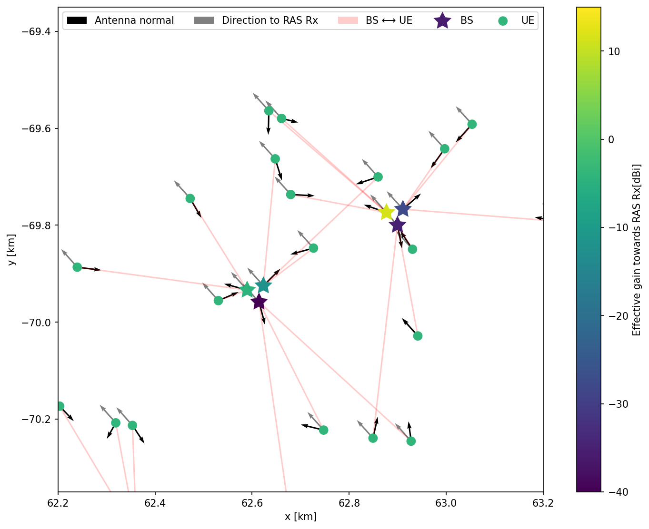

A3.3.2.3 UE power control
IMT-2020 user equipment is subject to power control. Depending on the distance of each UE device and path type (LoS, non-LoS) its output power can be increased or decreased for efficient use of power consumption. Furthermore, the number of other active devices in the vicinity plays a role in the power control algorithm, as described in Recommendation ITU-R M.2101. The path propagation loss between UE and their associated BS is calculated according to the equations given in 3GPP TR 38.901, Table 7.4.1-1 (RMa/Uma – Rural/Urban Macro scenarios). For the power control algorithm, the coupling loss has to be applied, which is the path propagation loss combined with the effective gains of the formed beams of the BS AAS. In Fig. A3-8, the effect of the power control on the UE output levels is visualised: the UE devices are coloured according to the difference (in dB) in output power after the power control algorithm was applied with respect to the nominal output power.
Figure A3-8
Effect of UE power control for the example configuration shown in Fig. A3-7.
Difference (in dB) in output power after application of the power control algorithm
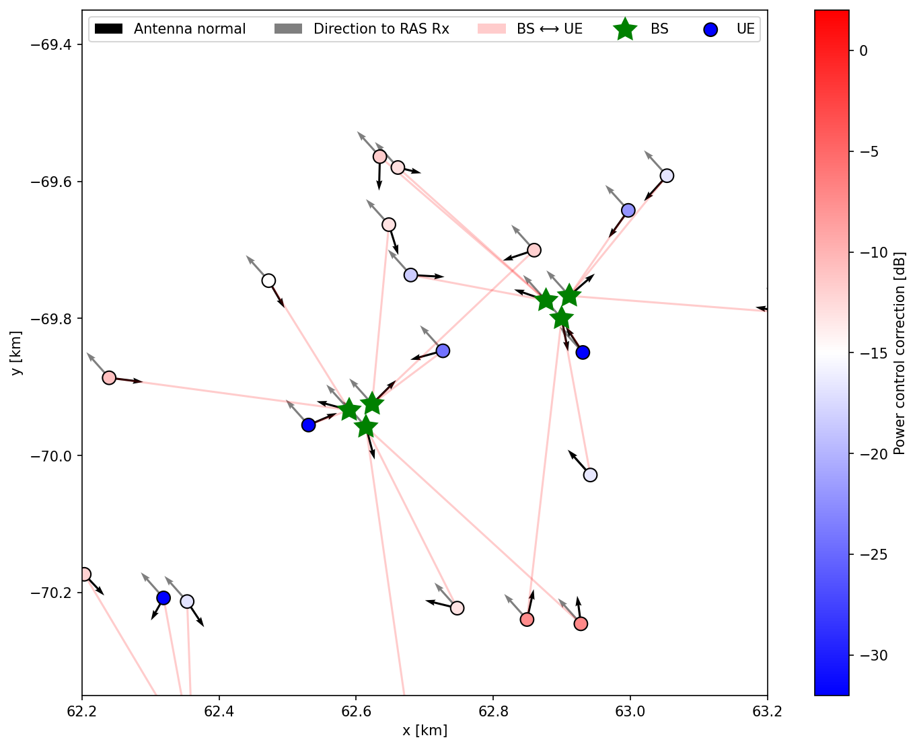

A3.3.2.4 Integrated power at the RAS receiver
Each Monte Carlo iteration (i.e. one realization of a BS+UE configuration within the box) yields a total power level received at the RAS station, which is calculated by simply aggregating all individually emitted power levels and accounting for antenna gains and propagation loss. In practice, in effectively all cases the RAS interference threshold levels are exceeded.
A minimal coordination distance can be calculated by determining the received power as a function of a coordination distance (exclusion radius) R_{i}. For each R_{i} the total contribution of devices outside a circular zone of radius R_{i} is inferred. As this is performed for each iteration, an ensemble of curves (received power as a function of coordination distance) is generated. By studying the distribution percentiles, the 50% (median) or highest 2% curve can be extracted. The latter matches the highest acceptable data loss for the RAS, following Recommendation ITU-R RA.1513. The minimal coordination distances are defined by the crossing points of the received-power curves with the threshold power level for detrimental interference given in Recommendation ITU-R RA.769.
For each of the deployment scenarios (uniform density and clustered), as well as for the adjacent, spurious, and in-band domain a Monte Carlo simulation was carried out. In Fig. A3-9, the ensemble curves and distribution percentiles are displayed for the various scenarios. The plots for the clustered deployment were omitted as they appear very similar to the uniform deployment as the relevant area in the simulations is so large that any “small-scale” structures in the deployment are marginalized. coordination.
Figure A3-9
Results for the aggregated scenario in the 6 425-7 025 MHz band (each simulation run is drawn separately, uniform deployment)
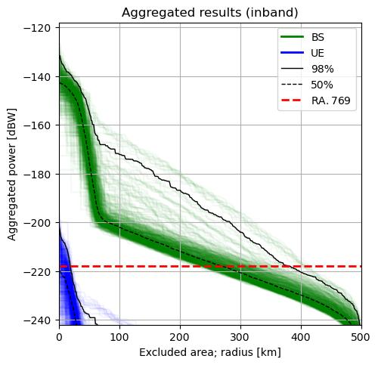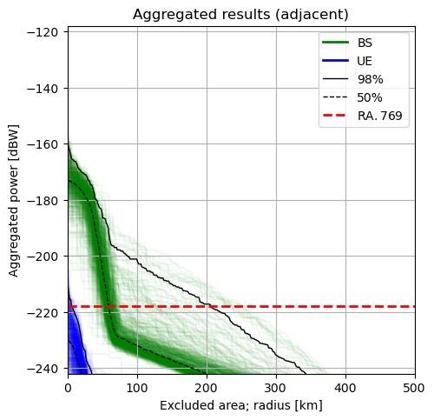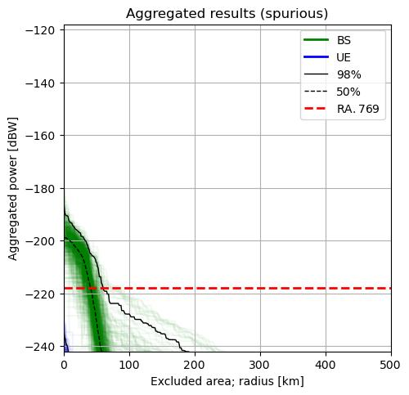

A3.3.2.5 Summary of aggregation calculations
For the in-band case, very large separation distances (about 400 km) would be necessary to protect RAS operations, while in the adjacent-band case the distances are about 200 km. Even for the spurious cases, the distances significantly exceed 50 km. The UE are completely insignificant for the total aggregated received power.

A3.4 Site-specific studies

A3.4.1 Worst-case single interferer scenario
To complement the generic (flat-terrain) sharing and compatibility studies in § A3.3, in the following site-specific single-interferer coordination distances will be derived for some real RAS sites, accounting for real terrain around the sites. The example sites are (1) the 100 m radio telescope at Effelsberg (DEU), (2) the Jodrell Bank Observatory (UK), (3) the Sardinia Radio Telescope (IT), and (4) the Yebes 40 m observatory (ESP). These sites represent only a small selection of European sites, which can observe in the 6.6 GHz band. There are, for instance, methanol observations are also being made in Latvia, Finland and Poland, and forming core research programmes for those stations. However, the chosen sites represent a sample of varying terrain conditions and thus serve as good indicators.

A3.4.1.1 Study parameters
The study parameters were provided in § 2. In contrast to the approach for aggregated calculations (compare with § A3.3.2), in those scenarios where clutter losses are included, a typical value of the Recommendation ITU-R P.2108 (their § 3.2) clutter loss model must be used. This is obtained by averaging over a uniform distribution of p_{L} values (i.e. it is the expected value of the clutter loss). This average clutter loss amounts to about 27 dB. Again, it must be noted, that the model in Recommendation ITU-R P.2108 is appropriate for urban and suburban land cover types and only if the IMT devices are below the rooftops of the housings. As in some countries, these conditions may not be fulfilled when assignments are made, the results for zero clutter loss values will also be provided for comparison.

A3.4.1.2 Singe-interferer scenario
The method to derive single-interferer coordination distances for the in-band, as well as adjacent and spurious-domain cases is the same as in § A3.3.1. The only difference is that here the actual terrain heights around the sites of interest are considered in the application of the path propagation model (Recommendation ITU-R P.452-17). The results are shown in Figs A3-10 to A3-12 and were only calculated for an antenna height of 25 m (rural). While installations in urban/suburban areas may have slightly lower antenna heights, the difference in the results is marginal. For all sites, SRTM data were used, which provide terrain height information with high spatial resolution.
Again, the assumption was made that the BS antennas are tilted down and that the beam never points above the horizon. However, this restriction does not lead to significantly reduced coordination zone sizes, which was tested by comparing the results to a case where the maximum BS antenna gain was used. Only in very mountainous terrain it can make a difference, in more open terrain, the typical horizon elevation angles are too close to zero to have an impact. For the spurious case, the difference is not notable at all.
Figure A3-10
Single-interferer coordination distances for the 100 m radio telescope at Effelsberg (Germany)
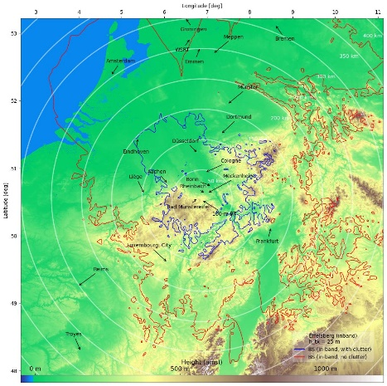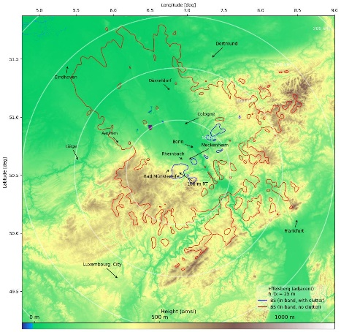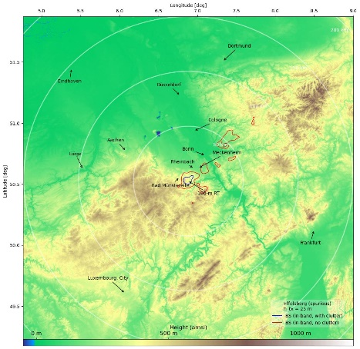
Figure A3-11
Single-interferer coordination distances for the Lovell telescope/Jodrell Bank Observatory (UK)
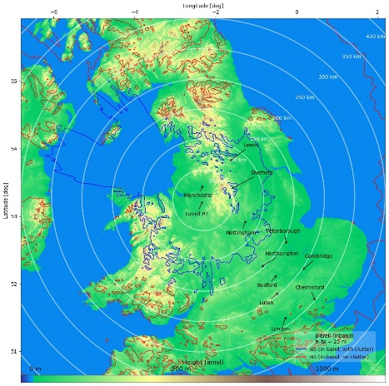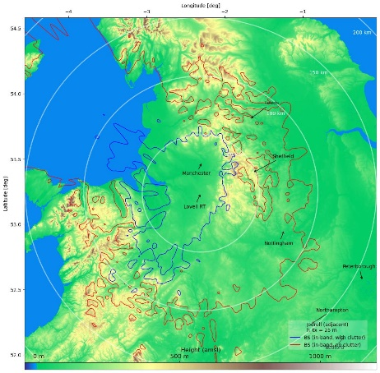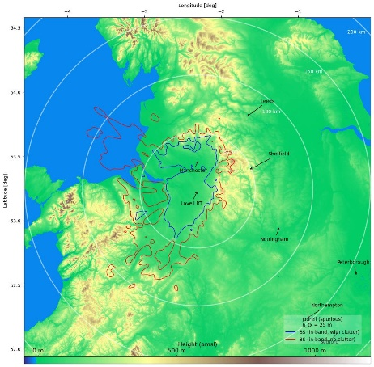
Figure A3-12
Single-interferer coordination distances for the Sardinia Radio Telescope (Italy)
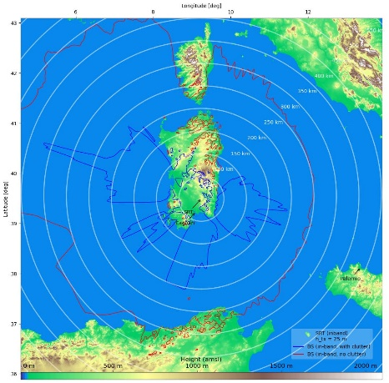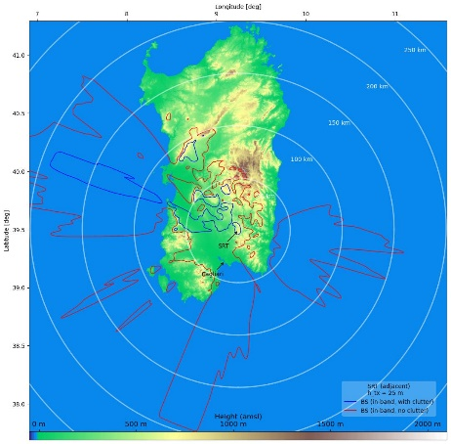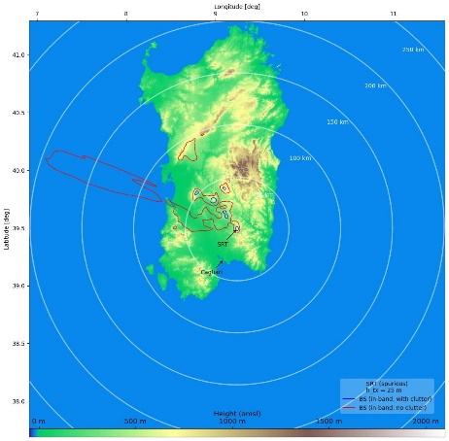
Figure A3-13
Single-interferer coordination distances for the Yebes 40-m radio telescope (Spain)
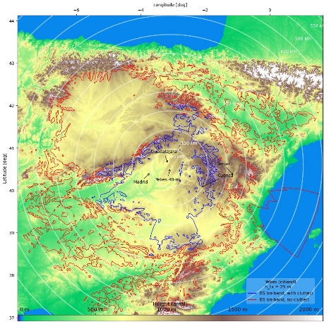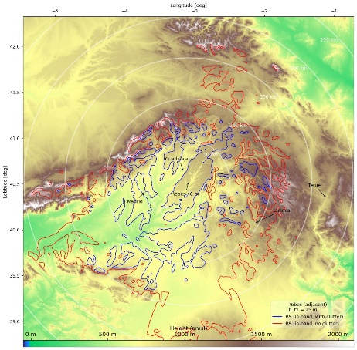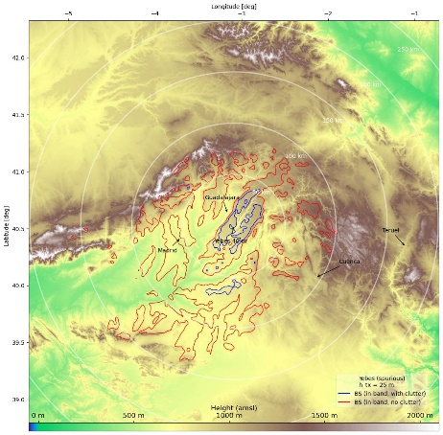

A3.4.1.3 Summary
The results derived in § A3.4.1.2 indicate that in the single-interferer worst-case scenario coordination distances of up to 200-250 km could be required in the sharing scenario, or even much more if the IMT base stations are not subject to full clutter losses (27 dB). For the adjacent and spurious domain cases, the coordination distances are still 50-100 km (with clutter). An exception is the 100-m telescope at Effelsberg in Germany, for which natural terrain shielding is somewhat more efficient at these frequencies. When clutter loss is applied, coordination distances are less than 10 km in the spurious domain case.
Given the relatively large coordination zone size – even for the spurious domain – additional mitigation measures may be considered. Some possible actions are listed in § 5.
The results demonstrate very well, how fundamental the assumed clutter losses are for the sharing and compatibility between IMT and RAS. If combined with additional mitigation measures, co-existence is well possible, but IMT base stations must not be put at elevated heights, i.e. above the local roof tops. Otherwise, IMT devices could cause interference to the RAS over significant distances. The restriction that base-station beams should never be pointed to above the horizon has little effect and cannot be considered as an important mitigation measure in many practical cases.

A3.5 Possible mitigation measures
The calculation results, especially for the aggregation scenario in § A3.3.2, indicate that coordination between IMT base stations at 6.6 GHz and RAS sites will be necessary, if protection of the radio astronomy operations in this band is desired. Several mitigation and coordination techniques exist, which will be described in the following.

A3.5.1 Choice of RAS site and suppression of telescope side lobes
Recommendation ITU-R RA.611-4 specifies “that radio astronomy observatories should continue to be placed in locations that have good natural protection from interference that may be detrimental to the RAS” and “that all practicable efforts should be made to minimize the side-lobe gains of radio astronomy antennas”. In fact, most modern RAS stations are operated in very remote places to minimize the impact of anthropogenic sources on astronomical observations. Natural terrain shielding, e.g. when the RAS site is surrounded by hills or mountains, is also a very effective tool to reduce the received power from terrestrial sources.
Radio astronomy telescope side lobes can to some extent be controlled with tapering the main dish. Here a compromise has to be found between aperture efficiency of the antenna and the reduction of near side-lobes, which would suppress some of the off-axis interference contributions.

A3.5.2 IMT site planning
The general methodology for determining the need for mitigation methods described in the main body of this Report is predicated on standardized deployment models. More site-specific deployments models, accounting for specific coverage needs for a given area, may provide both more realistic compatibility data and a means to vary parameters to resolve potential interference issues.
As explained above, the terrain and clutter around the RAS station play an important role. However, the path propagation equally depends on the situation at the transmitter, as the local terrain also provides diffraction (actually, any terrain features on the full propagation path are relevant). Unless the BSs are installed at highly elevated antenna masts, clutter loss from objects around the transmitter applies; these could include houses, trees, etc. Placing IMT equipment such that local clutter is effective in the direction of the RAS station can make a significant difference. A transmitter attached to a wall on the opposite side of a house as seen from the RAS station will contribute much less to the received power than a transmitter on the facing side.
Site-specific characteristics, such as placing BSs so that main beam illumination covers a service area while pointing away from a RAS site, transmission power levels, lower deployment densities, and taking advantage of geographic characteristics may serve as factors which individually or in combination improve compatibility.
In some cases, ensuring compatibility may require minimum coordination distances between the IMT deployment and RAS systems, regardless of other measures employed.
Terrain and clutter at any point in the propagation path from transmitter to receiver are relevant, and impact received signal through diffraction. Thus, clutter loss near transmitter, receiver, and at any point in between is relevant. IMT site planning such that clutter loss is increased toward nearby RAS sites may improve compatibility.
To demonstrate the effectiveness of this approach, the aggregation simulations have been repeated for the case that all base stations are subject to the full clutter loss (in § A3.3.2 it was assumed that a fraction of the BS would be installed significantly above the roof-tops and thus not be affected by clutter). As Fig. A3-14 reveals, the received aggregated power levels are then at least 20 dB lower, which reduces the required minimum coordination distances accordingly.
Figure A3-14
As Fig. A3-10, but assuming that clutter attenuation applies to all base stations (BS installed below rooftops)
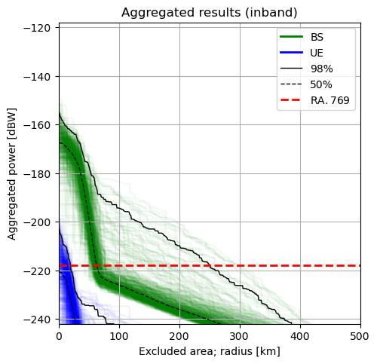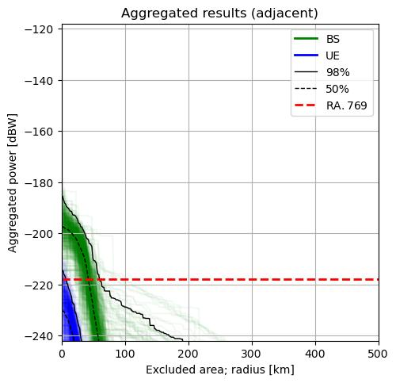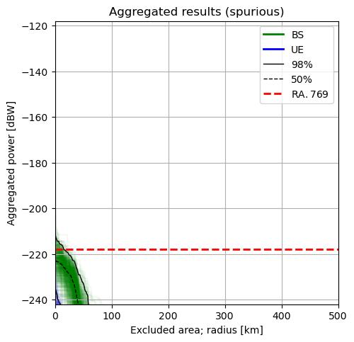
Once the baseline analysis of compatibility is conducted and a determination made that potential coordination issues may arise, a more computationally intensive further analysis accounting for more detailed modelling of a given site, including terrain, foliage, and other geographic factors, may be conducted. It may be desirable to conduct such an analysis in conjunction with the other factors detailed in this section.

A3.5.3 AAS, beamforming, and antenna orientation
Modern 5G systems often utilize active antenna systems (AAS), i.e. arrays of many antenna elements. AAS can form beams electronically, which can be steered in real time towards the required position (usually the UE). This would, in principle, also allow to program the BSs in a way such that the location of an RAS station is avoided by the BS beam and its side-lobes. In addition, the array antenna could be mounted in a way such that it has large angular coordination between its antenna normal and the location of the RAS station.
To test, how efficient beam steering could be for the reduction of interference into the RAS band, the aggregation calculations presented in § A3.3.2 have been repeated, but for various avoidance angles around the direction to the radio astronomy site. As the effect will qualitatively be the same for in- and out-of-band scenarios, only the in-band case was computed. In the simulations, the propagation path from the base stations to the RAS site is inferred. IMT base stations beams pointing within $x$ degrees around this propagation path direction were switched off, with various values for $x$ tested (1, 5, 10, 20, 30 degrees). It is noted that this is an oversimplification, as in reality the beam would be pointed elsewhere instead of switched off. Owing to the relatively large beamwidth and the high side-lobe gain of the AAS pattern, the reduction of the interference power is visible but not extremely effective, as shown in Fig. A3-15. Even if a fairly large area of 30 degrees around the propagation path direction is avoided, the net effect does not exceed 10 dB.
Figure A3-15
Results for the aggregated scenario in the 6 425-7 025 MHz band
(Effect of angular avoidance around direction to RAS site)
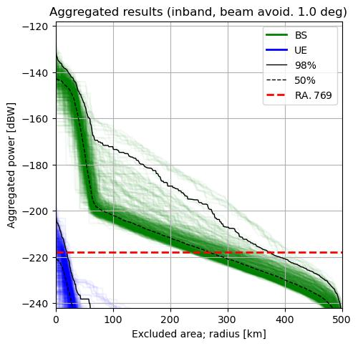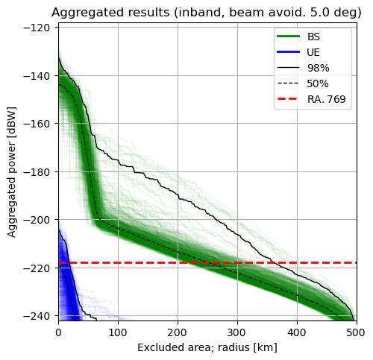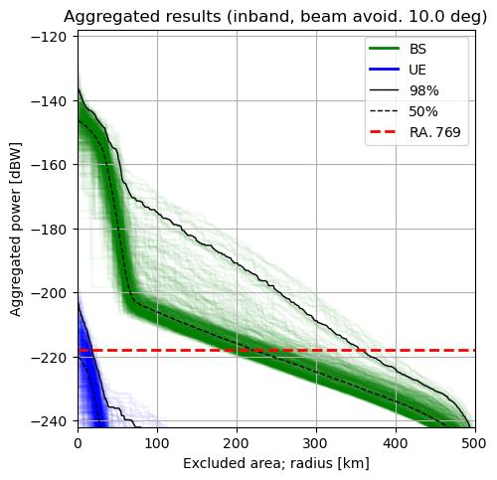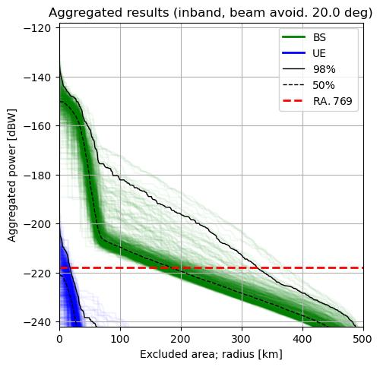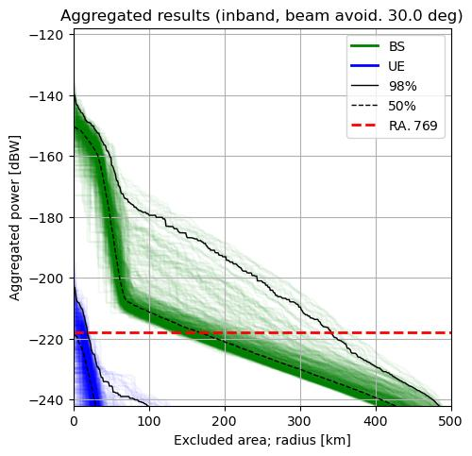

A3.5.4 Network management
As the results in § A3.3.2 indicate that the major contribution to the received power at the RAS receiver stems from base stations, another mitigation method would be to use the RAS band only for uplinks. In this case, only a relatively small area around the telescope sites would have to be coordinated to avoid user terminals in the immediate vicinity.

