Report ITU-R RA.2508-0
(10/2022)
Widely-distributed radio astronomy array systems operating above 200 GHz
RA Series
Radio astronomy

Foreword
The role of the Radiocommunication Sector is to ensure the rational, equitable, efficient and economical use of the radio-frequency spectrum by all radiocommunication services, including satellite services, and carry out studies without limit of frequency range on the basis of which Recommendations are adopted.
The regulatory and policy functions of the Radiocommunication Sector are performed by World and Regional Radiocommunication Conferences and Radiocommunication Assemblies supported by Study Groups.

Policy on Intellectual Property Right (IPR)
ITU-R policy on IPR is described in the Common Patent Policy for ITU-T/ITU-R/ISO/IEC referenced in Resolution ITU-R 1. Forms to be used for the submission of patent statements and licensing declarations by patent holders are available from http://www.itu.int/ITU-R/go/patents/en where the Guidelines for Implementation of the Common Patent Policy for ITU-T/ITU-R/ISO/IEC and the ITU-R patent information database can also be found.

Series of ITU-R Reports
(Also available online at http://www.itu.int/publ/R-REP/en)
Series | Title
BO | Satellite delivery
BR | Recording for production, archival and play-out; film for television
BS | Broadcasting service (sound)
BT | Broadcasting service (television)
F | Fixed service
M | Mobile, radiodetermination, amateur and related satellite services
P | Radiowave propagation
RA | Radio astronomy
RS | Remote sensing systems
S | Fixed-satellite service
SA | Space applications and meteorology
SF | Frequency sharing and coordination between fixed-satellite and fixed service systems
SM | Spectrum management

Note: This ITU-R Report was approved in English by the Study Group under the procedure detailed in Resolution ITU-R 1.

Electronic Publication
Geneva, 2022
© ITU 2022
All rights reserved. No part of this publication may be reproduced, by any means whatsoever, without written permission of ITU.

REPORT ITU-R RA.2508-0
Widely-distributed radio astronomy array systems operating above 200 GHz
(Questions ITU-R 226-2/7 and ITU-R 257/7)
(2022)

TABLE OF CONTENTS
Page
1 Introduction 3
2 Radio telescopes as interferometers 3
3 Technical characteristics 6
3.1 Frequency bands: 230 and 345 GHz 6
3.2 Correlation methods and postprocessing 8
3.3 Radio frequency interference excision 8
3.4 Radio telescopes 9
4 Science results 9
5 Future directions 11
5.1 New telescope sites 11
5.2 Expanded technical capabilities 12
6 References 12
7 List of acronyms and abbreviations 13

1 Introduction
Radio telescopes are designed to detect faint, naturally occurring, cosmic emissions. Radio telescope designs range from pure dipole antennas at low frequencies to shaped, often parabolic, reflectors. Because the angular resolution in radians provided by a single telescope of diameter D is approximately 1.22 λ/D, where λ is the observing wavelength, radio telescopes require extremely large diameters to approach the spatial resolution of optical telescopes. While building a single telescope to achieve such spatial resolution is a challenge, it is possible to operate radio telescopes as an interferometer, where each telescope operates independently, and the recorded data are combined after the fact. Such distributed array telescopes can be designed specifically for such operations, such as the Very Large Array (VLA), the Australia Telescope Compact Array (ATCA) the Very Long Baseline Array (VLBA), and the Square Kilometre Array (SKA) at centimetre and millimetre wavelengths. It is also possible to combine telescopes, even telescopes designed as arrays themselves, that normally operate independently. Recently, a collaboration was formed to conduct interferometric observations of the nearest and brightest black holes using radio telescopes located around the world observing at frequencies higher than 200 GHz, resulting in unprecedented high spatial resolution images of the black hole at the centre of M87 that captured the imagination of astronomers and the general public alike in 2019. This Report describes the technical and operational characteristics of this distributed array system that is denoted as the Event Horizon Telescope (EHT) and consists of individual radio telescopes, some of which operate as arrays themselves, located in Europe, North and South America, and the South Pole.

2 Radio telescopes as interferometers
As noted above, the angular resolution in radians provided by a single telescope of diameter D is approximately λ/D, where λ is the observing wavelength. Smaller values correspond to finer angular resolution. An interferometer works analogously in that each pair of telescopes, known as a baseline, provides a portion of an effective aperture of a much larger telescope. The fringe spacing of a baseline is λ/B, where B is the length of the baseline (i.e. distance between the two telescopes) projected onto the plane perpendicular to the line of sight to the observed source (see Fig. 1). The part of the aperture covered by the baseline is often referred to as its (u,v) coverage, where u and v refer to the east and north components of the projected baseline length in units of wavelengths, respectively. The instantaneous (u,v) coverage of a single baseline is a point (and a conjugate point that provides no additional information), but the coverage of a baseline tracking a source over finite time is an arc in the (u,v) plane because the rotation of the Earth changes the projection of the baseline onto the plane perpendicular to the line of sight to the observed source (see Fig. 2).
An interferometric baseline acts as a spatial filter. Although it provides an angular resolution approximately equal to its fringe spacing, a baseline is insensitive to source structures that are larger than this angular size. Thus, a single baseline provides only a small portion of the possible aperture, which is insufficient to image arbitrary source structures. As a result, interferometric arrays consist of a larger number of telescopes such that the baselines span a wide range of lengths and orientations. An interferometer with N telescopes simultaneously observing a source provides N(N-1)/2 independent baselines. The locations of the telescopes are generally chosen to provide suitably even coverage in the (u,v) plane, given constraints on topography and expected atmospheric conditions.
FIGURE 1
Each telescope of an interferometric baseline senses the signal from a distant source, such as a quasar
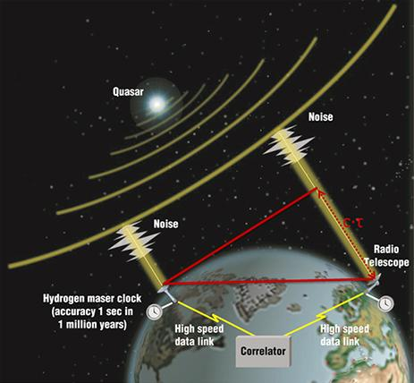
Note to Fig. 1: The signal at one telescope is delayed relative to the other due to the different path lengths. This delay, which is predictable from the coordinates of the source, the locations of the telescopes, and the time of observation, is removed at the correlator. Due to the very high data rate of the EHT and the inaccessibility of several of its telescopes, data are recorded onto modules of hard drives and physically transported to the correlator.
FIGURE 2
The baseline coverage of the EHT on M87 in 2017
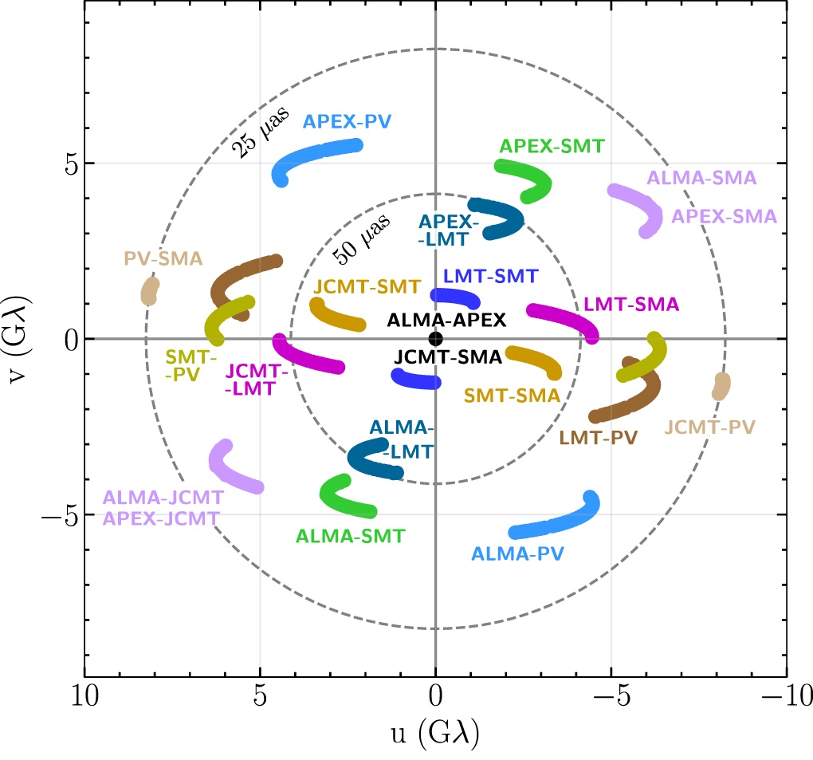
Note to Fig. 2: Each pair of telescopes instantaneously provides data at one point in the (u,v) plane, where u and v correspond to the projected baseline length in the direction of the source east and north, respectively, in units of the observing wavelength, λ. As the Earth rotates, the projection of the baseline changes, and the baseline sweeps out a portion of an ellipse in the (u,v) plane. Longer baselines provide finer angular resolution; the projected baseline length between the IRAM 30 m telescope on Pico Veleta (PV) in Spain and the observatories on Mauna Kea in Hawaii (SMA and JCMT) is approximately 10 000 km, or 8 billion wavelengths (λ ≈ 1.3 mm for 230 GHz), which corresponds to an angular resolution of 25 microarcseconds. Shorter baselines are critical too; the more that the (u,v) plane is filled, the higher the fidelity of the resulting image will be. [3]

3 Technical characteristics
This section summarizes the technical and operational characteristics of the radio astronomy facilities that comprise the Event Horizon Telescope (EHT).

3.1 Frequency bands: 230 and 345 GHz
The two primary targets of the EHT, Sagittarius A* (Sgr A*) and M87, are the two black holes whose relativistic shadow subtends the largest angular size as viewed from the Earth. In both cases, the angular size is small, ranging from an observed size of 42 microarcseconds (μas) for M87 to a predicted size of just over 50 μas for Sgr A*. These sizes are achievable with intercontinental very long baseline interferometry (VLBI) at ~230 GHz. The longest baselines in the EHT provide a fringe spacing slightly smaller than 25 μas. Modern imaging techniques are able to produce images that are super-resolved (i.e. sharper than the fringe spacing) by a factor of 2 to 3, with decreasing confidence in reconstructed features as the super-resolution factor increases.
Another important factor in the selection of observing frequency is provided by optical depth considerations. The synchrotron emission from the hot plasma surrounding a supermassive black hole is optically thick at low frequencies. As M87 is viewed at increasing frequencies from 1-86 GHz, the apparent size of the emission scales as approximately λ. Even at 86 GHz, which is the highest frequency at which VLBI is routinely done, excluding the EHT, the synchrotron emission from the jet in front of M87 is optically thick enough to prevent detection of the shadow region. At 230 GHz, the emission is optically thin enough to allow observations down to the shadow. At higher observing frequencies, the asymmetric crescent of emission is predicted to sharpen even further, with a decrease in total flux density.
The frequency dependence for Sgr A* is even more severe. Interstellar electrons along the line of sight to Sgr A* (through the plane of the Milky Way) produce severe scatter broadening of the source that scales as λ². The scattering is dominant below 86 GHz and is still significant, though smaller than the source structure, at 230 GHz.
The Event Horizon Telescope observes fixed tunings in two frequency bands, as outlined in Marrone et al. (2014). The 230 GHz (1.3 mm) tuning setup uses a first local oscillator (LO1) at 221.1 GHz and an intermediate frequency (IF) of 5-9 GHz relative to LO1, for net sky frequency (RF) coverage of 212.1-216.1 GHz (LSB) and 226.1-230.1 GHz (USB). Most receivers are tunable, but some telescopes use a receiver with a fixed-tuned LO1. The 345 GHz (0.87 mm) tuning setup uses an LO1 of 342.6 GHz and an IF of 4-8 GHz, for net sky frequency coverage of 334.6-338.6 GHz (LSB) and 346.6-350.6 GHz (USB). The sky frequencies were chosen to be near the region of maximum transmission in the 230 GHz and 345 GHz atmospheric windows. (Note: Report ITU-R RA.2189-1 has plots of atmospheric attenuation above 275 GHz.) Due to increased atmospheric absorption at low altitude, there are no plans to equip the Kitt Peak 12m telescope with a 345 GHz receiver. The IF ranges were chosen to overlap the IF ranges of the receivers on the ALMA array, which is the most sensitive element in the EHT.
The specific frequency ranges were selected to exclude the ¹²C¹⁶O lines at rest frequencies of 230.538 GHz and 345.796 GHz and the ¹³C¹⁶O lines at 220.399 GHz and 330.588 GHz. In an early experiment, the 230.538 GHz line produced detectable absorption toward one of the key EHT targets, the Galactic centre black hole Sagittarius A*. Absorption toward the Galactic centre can be observed at frequencies corresponding to a Doppler shift of ±300 km s⁻¹ of the line centre (a shift of approximately 0.1% of the rest frequency). The 230 GHz frequency range was also chosen to overlap the v = 1 line of ²⁸Si¹⁶O at 215.596 GHz, which is expected to be a spectral line of astronomical interest when spectral-line VLBI observing is offered.
ALMA, NOEMA, and SMA consist of multiple telescopes whose signals are sampled and summed using custom equipment. The single-dish observatories use a block downconverter with an LO2 of 7 GHz (for 230 GHz signals) or 6 GHz (for 345 GHz signals) to convert each of the two IF sidebands (LSB and USB) into two 0-2 GHz bands. These four 0-2 GHz bands are Nyquist-sampled at 2 bits with Reconfigurable Open-Architecture Computing Hardware 2 (ROACH2) digital backends. The sampled data are recorded by Mark6 recorders, which fan each 16 Gb s⁻¹ data stream (2 Nyquist × 2 bits/sample × 2 polarizations × 2 GHz) onto four modules containing a total of 32 hard drives. These modules are then shipped to the correlator centres (MIT Haystack Observatory in Westford, Massachusetts and the Max-Planck-Institut für Radioastronomie in Bonn, Germany) for correlation.
Almost all elements of the EHT observe both left and right (L, R) circular polarizations. The circular polarization is generally preferred in astronomical VLBI because measuring linear polarization in the circular polarization basis does not impose very strict requirements on the accurate measurement of total intensity (as is required in the linear polarization basis). An important exception is that ALMA observes both linear polarizations (X, Y). Since it is not feasible to retrofit all 66 ALMA antennas with a removable quarter-wave plate system to be inserted only for Band 6 (230 GHz) VLBI observing, the ALMA Phasing System records the phased sum in each of the X and Y linear polarizations, and linear-to-circular conversion is done after correlation using special software.

3.2 Correlation methods and postprocessing
The recorded data constitute a time stream of voltage samples at each telescope. The correlator aligns the data stream from each telescope to compensate for the changing geometric delay illustrated in Fig. 1 and performs a cross-multiply operation and a Fourier transform operation to change the basis of the output data from the time domain to the frequency domain. Although these steps can in principle be done in either order, performing the Fourier transform operation first results in an algorithm that is more scalable for parallel processing. The DiFX correlation algorithm that the EHT uses is one such algorithm.
Each of MIT Haystack Observatory and the Max-Planck-Institut für Radioastronomie (MPIfR) has a cluster consisting of a Mark6 playback unit for each of the telescopes in the field, more than 1 000 processing nodes, and very fast (100 Gb/s) network infrastructure to allow for rapid transport of data between the Mark6 playback units and the processing nodes. Correlation is split across the two correlation centres by frequency band, since data collected at one frequency do not cross-correlate with data at another frequency. The correlator requires as input a complete description of the setup of the experiment (frequencies, telescope locations, scan times, etc.) as well as clock rates and offsets measured by comparing a 1 pulse per second (PPS) tick from the hydrogen maser that provides the timing and frequency standard at each telescope against the 1 PPS tick from the Global Positioning System (GPS). The desired time cadence (a.k.a. accumulation period) and frequency width (spectral channelization) of the output are also provided as inputs to the correlator. The resulting output is a set of visibilities consisting of a complex number (amplitude and phase) and data weight for each baseline in each spectral channel at each accumulation period, along with metadata.
Data are correlated in their native polarization bases: linear for ALMA and circular for all other stations. A post-correlation processing step, known as PolConvert, is required to convert from the {X,Y} × {L,R} basis into the {L,R} × {L,R} basis on baselines to ALMA.
After correlation and PolConvert, the data are ready for calibration. Calibration involves multiple steps correcting for multiple effects, including small delays and delay-rates that are residual to the model used at correlation, the complex bandpass response of each telescope, the rapidly changing phase introduced by the Earth’s atmosphere, the variable opacity of the atmosphere, and the variable telescope gain response due to elevation and pointing errors, among others. According to the van Cittert–Zernike theorem, the calibrated set of visibilities V(u,v) constitute a set of data points corresponding to Fourier components of the image I(l,m) of the source:
$$V\left(u,v\right)=\iint{I(l,m)}e^{-2πi(ul+vm)} dl dm$$
where l and m are direction cosines in the image domain. The source image is then produced either by gridding, discrete Fourier transforming, and deconvolution (the CLEAN method and its variants) or by modern regularized maximum likelihood methods that forward-solve the image in the visibility data domain, without the need for deconvolution.

3.3 Radio frequency interference excision
As listed in Recommendation ITU-R RA.769-2, the harmful levels of interference for a continuum observation with an individual radio telescope near 230 GHz is −218 dBW/(m² ‧ Hz). However, as also noted in Recommendation ITU-R RA.769-2, the tolerable interference level for distributed arrays is determined by the requirement that the power level of the interfering signal should be no more than 1% of the receiver noise power. Thus, provided that radio frequency interference (RFI) is not so strong as to cause loss of sensitivity due to increasing the system temperature of individual telescopes, narrowband RFI can be excised after correlation. Cross-correlation of RFI at sites that are far from one another is suppressed by the natural fringe rotation that is applied at the correlator to compensate for the changing delay to astronomical sources. Cross-correlation at sites that are nearby or co-located (such as the JCMT and SMA on Mauna Kea or APEX and ALMA at the Llano de Chajnantor site in Chile) is more problematic, since the natural fringe rate is much lower on very short baselines.
While the observations are conducted at 230 and 345 GHz, it is also important to note that down converting may result in RFI at lower frequencies being mixed into the recorded data. Thus, radio frequency interference must be monitored and mitigated not only in the frequency bands of the observations, but also at lower frequencies as well.
Narrowband RFI is typically excised after correlation. Spectral channels containing RFI are flagged and discarded in post-processing. In the limit that the flagged channels correspond to a small fraction (𝜀) of the observed bandwidth, the loss in signal-to-noise ratio is approximately 𝜀/2. Further procedures to mitigate RFI can be developed as needed, but methods that require data excision all result in lower signal-to-noise ratios and the potential loss of (u,v) coverage for the flagged baselines.

3.4 Radio telescopes
The Event Horizon Telescope consists of the majority of radio astronomy facilities currently in operation that are capable of observing at frequencies above 200 GHz. The locations of these radio telescopes are listed in Table 1.
TABLE 1
Radio astronomy facilities participating in VLBI above 200 GHz via the EHT
Facility | Location | Latitude  (degree N) | Longitude  (degree E) | Altitude  (m)
Arizona Radio Observatory Kitt Peak 12 m Telescope (ARO KP12m) | Arizona, USA | 32.0 | −111.6 | 1 895
Arizona Radio Observatory Submillimeter Telescope (ARO SMT) | Arizona, USA | 32.7 | −109.9 | 3 160
Atacama Large Millimeter/submillimeter Array (ALMA) | Chile | −23.0 | −67.8 | 5 075
Atacama Pathfinder Experiment (APEX) | Chile | −23.0 | −67.8 | 5 105
Greenland Telescope (GLT) | Greenland | 76.5 | −68.7 | 90
IRAM 30-meter (PV) | Spain | 37.1 | −3.4 | 2 920
James Clerk Maxwell Telescope (JCMT) | Hawaii, USA | 19.8 | −155.5 | 4 120
Large Millimeter Telescope (LMT) | Mexico | 19.0 | −97.3 | 4 595
Northern Extended Millimeter Array (NOEMA) | France | 44.6 | 5.9 | 2 620
Submillimeter Array (SMA) | Hawaii, USA | 19.8 | −155.5 | 4 115
South Pole Telescope (SPT) | Antarctica | −90.0 | 0 | 2 815

4 Science results
Creating images from sparsely sampled (u,v) data poses several computational and scientific challenges. The EHT images of M87 shown in Fig. 3 are among the most vetted interferometric images ever published and highlight the sensitivity and spatial resolution achievable with widely-distributed arrays of radio telescopes located across the globe. The first science results on M87 from the EHT were published in 2019, with subsequent analysis of linearly polarized emission published in 2021. First results on Sgr A* followed in 2022. These results were widely distributed and appeared on the front pages of numerous newspapers and captured the imagination of scientists and the general public.
FIGURE 3
First images of M87 from the Event Horizon Telescope
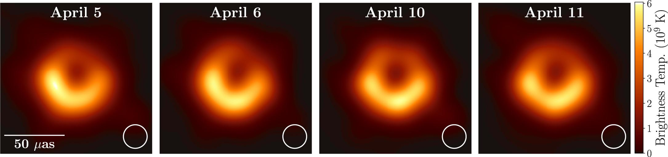
Note to Fig. 3: The asymmetric ring of emission is consistent with relativistic predictions from an optically thin plasma orbiting a black hole with a mass of approximately 6.5 billion times that of the sun [2], [4].
For the giant elliptical galaxy M87, the primary result was the detection of a ring of emission with a diameter of 42 ± 3 μas around the black hole in the centre of the galaxy [2]. The size of the ring indicates that the mass of the central black hole is (6.5 ± 0.7) × 10⁹ solar masses, consistent with prior estimates of the black hole mass derived from stellar dynamics (e.g. [6]).
In 2022, the EHT published the first images of the emission around Sagittarius A*, the supermassive black hole in the centre of our Galaxy (EHTC 2022). As shown in Fig. 4, the emission shows a ringlike morphology, similar to M87, with a ring diameter of 51.8 ± 2.3 μas, as expected for a ~4 × 10⁶ M☉ black hole in the centre of the Milky Way. The fact that these two black holes of vastly different sizes look the same is an exciting finding. It is another confirmation of Einstein’s theory of general relativity, as general relativity predicts that all black holes look and behave the same, regardless of their mass.
The Event Horizon Telescope has demonstrated the capabilities of widely-distributed arrays of radio telescopes operating above 200 GHz to create extremely high spatial resolution images of astronomical objects. However, the sparse arrays used present considerable challenges in image reconstruction and the astronomical community continues to study the impact on the fidelity of the images. The addition of more telescopes and improved equipment installed on these telescopes will yield even more robust image fidelity in the future.
FIGURE 4
First image of Sagittarius A* from the Event Horizon Telescope
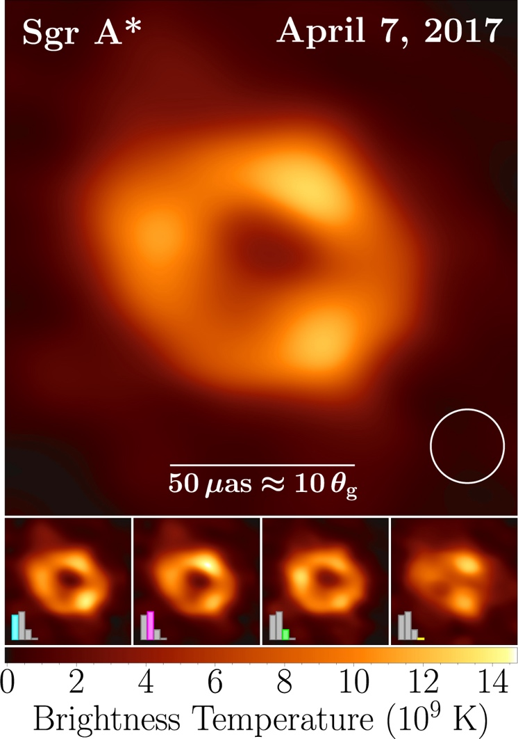
Note to Fig. 4: The size of the average image of Sgr A* on 7 April 2017 (top) is consistent with mass and distance measurements obtained from tracking stellar orbits in the Galactic Centre region at near infrared wavelengths (e.g. [1], [7]). Individual images cluster into four different groups differing in their recovered morphology around the ring (left three panels at bottom), with a small cluster of images that are not ringlike (bottom right); these differences likely point to rapidly changing structures within the emission that cannot be confidently recovered with the limited (u,v) coverage of the 2017 data. The diameter of the ring matches expectations based on the known mass and distance of Sgr A*. [5]

5 Future directions
The addition of new telescope sites and expanded technical capabilities will enable high spatial resolution observations with greater sensitivity and image fidelity in the future.

5.1 New telescope sites
The Greenland Telescope (GLT) is currently sited at Thule Air Base at sea level on the northwest coast of Greenland, where the telescope has been tested and operated. The plan is to transport the telescope to Summit Station on the Greenland ice sheet, where the higher elevation (3 200 m) is more conducive to observing at 345 GHz and higher frequencies.
A 10-m telescope formerly used in the Combined Array for Research in Millimetre-wave Astronomy (CARMA) is being relocated to the Owens Valley Radio Observatory (OVRO) and outfitted with new electronics to participate in the EHT. Construction is expected to be complete in 2023. Due to the lower elevation of the OVRO site (1200 m), it is not anticipated that a 345 GHz receiver will be added to the telescope.
The Haystack 37-m telescope is located near sea level in Westford, Massachusetts. A funded study is currently underway to design a 230 GHz receiver and upgrade the signal chain. While VLBI tests with the existing 86 GHz receiver are expected to occur soon, first light with a new 230 GHz receiver is more likely to occur in the 2025-2026 timeframe.
There is also a funded study in the US to design a next-generation EHT system and identify six to ten additional sites where new EHT telescopes can be located. As this study is still underway as of October 2022, the locations of the new telescope sites have not yet been decided.

5.2 Expanded technical capabilities
The next expansion of bandwidth (mid-2020s) is expected to double the current bandwidth, receiving 16 GHz of signal in each of two orthogonal polarizations. Given typical IF power levels, it is likely that an IF frequency range of 4-12 GHz will be chosen, observing both upper and lower sidebands. This may necessitate shifting LO1 frequencies in order to avoid strong absorption lines at RF.
A funded study in the US is producing a prototype simultaneous dual-band (230 and 345 GHz) receiver for the Large Millimetre Telescope (LMT). The aim is to replicate the receiver design for other observatories, producing an array that can observe in the 230 GHz and 345 GHz bands simultaneously. Multi-frequency observations are necessary to produce maps of the Faraday rotation, improving the ability to measure magnetic fields in active galactic nuclei sources. Simultaneous multi-frequency observing will also significantly improve sensitivity at 345 GHz via transfer of lower-frequency phase information due to tropospheric fluctuations. Additional drivers for multi-frequency observing capability include spectral-index mapping and mitigation of interstellar scattering toward Sgr A*.

6 References
[1] Do, T., Aurelien, H., Ghez, A., et al. (2019), “Relativistic redshift of the star S0-2 orbiting the Galactic Center supermassive black hole”, Science, 365, 664
[2] Event Horizon Telescope Collaboration (2019a), “First M87 Event Horizon Telescope Results. I. The Shadow of the Supermassive Black Hole”, Astrophysical J. Lett., 875, L1
[3] Event Horizon Telescope Collaboration (2019b), “First M87 Event Horizon Telescope Results. III. Data Processing and Calibration”, Astrophysical J. Lett., 875, L3
[4] Event Horizon Telescope Collaboration (2019c), “First M87 Event Horizon Telescope Results. IV. Imaging the Central Supermassive Black Hole”, Astrophysical J. Lett., 875, L4
[5] Event Horizon Telescope Collaboration (2022), “First Sagittarius A* Event Horizon Telescope Results. I. The Shadow of the Supermassive Black Hole in the Center of the Milky Way”, Astrophysical J. Lett., 930, L12
[6] Gebhardt, K., Adams, J., Richstone, D., et al. (2011), “The Black Hole Mass in M87 from Gemini/NIFS Adaptive Optics Observations”, Astrophysical J., 729, 119
[7] GRAVITY Collaboration (2022), “Mass distribution in the Galactic Center based on interferometric astrometry of multiple stellar orbits”, Astronomy & Astrophysics, 657, L12
[8] Marrone, D.P., Tilanus, R.P.J., and Doeleman, S.S. (2014), “LO Frequency for future EHT mmVLBI”, EHT Memo 2014-ETWG-01,
https://eventhorizontelescope.org/files/eht/files/EHT_memo_Marrone_2014-ETWG-01.pdf

7 List of acronyms and abbreviations
ALMA Atacama large millimeter/submillimeter array
APEX Atacama pathfinder experiment
ARO KP12m Arizona radio observatory kitt peak 12 m telescope
ARO SMT Arizona radio observatory submillimeter telescope
ATCA Australia telescope compact array
CARMA Combined array for research in millimeter-wave astronomy
EHT Event horizon telescope
EHTC Event horizon telescope collaboration
GLT Greenland telescope
GPS Global positioning system
IF Intermediate frequency
IRAM Institut de radioastronomie millimétrique
JCMT James Clerk Maxwell Telescope (JCMT)
LMT Large millimeter telescope
LO1 Local oscillator 1
LO2 Local oscillator 2
LSB Lower sideband
M87 Messier 87
MIT Haystack Massachusetts Institute of Technology Haystack Observatory
MPIfR Max-Planck-Institut für Radioastronomie
NOEMA Northern extended millimeter array
OVRO Owens valley radio observatory
PPS pulse per second
PV Pico Veleta, Spain
RF Radio frequency
RFI Radio frequency interference
ROACH2 Reconfigurable open-architecture computing hardware 2
Sgr A* Sagittarius A*
SKA Square kilometre array
SMA Submillimetre array
SPT South pole telescope
USB Upper sideband
VLA Very large array
VLBA Very long baseline array
VLBI Very long baseline interferometry

Source: NASA Space Geodesy website, https://space-geodesy.nasa.gov/techniques/VLBI.html

