Report ITU-R RA.2457-0
(06/2019)
Coexistence between the radio astronomy service and radiolocation service applications in the frequency band
76-81 GHz

RA Series
Radio astronomy

Foreword
The role of the Radiocommunication Sector is to ensure the rational, equitable, efficient and economical use of the radio-frequency spectrum by all radiocommunication services, including satellite services, and carry out studies without limit of frequency range on the basis of which Recommendations are adopted.
The regulatory and policy functions of the Radiocommunication Sector are performed by World and Regional Radiocommunication Conferences and Radiocommunication Assemblies supported by Study Groups.

Policy on Intellectual Property Right (IPR)
ITU-R policy on IPR is described in the Common Patent Policy for ITU-T/ITU-R/ISO/IEC referenced in Resolution ITU-R 1. Forms to be used for the submission of patent statements and licensing declarations by patent holders are available from http://www.itu.int/ITU-R/go/patents/en where the Guidelines for Implementation of the Common Patent Policy for ITU-T/ITU-R/ISO/IEC and the ITU-R patent information database can also be found.

Series of ITU-R Reports
(Also available online at http://www.itu.int/publ/R-REP/en)
Series | Title
BO | Satellite delivery
BR | Recording for production, archival and play-out; film for television
BS | Broadcasting service (sound)
BT | Broadcasting service (television)
F | Fixed service
M | Mobile, radiodetermination, amateur and related satellite services
P | Radiowave propagation
RA | Radio astronomy
RS | Remote sensing systems
S | Fixed-satellite service
SA | Space applications and meteorology
SF | Frequency sharing and coordination between fixed-satellite and fixed service systems
SM | Spectrum management

Note: This ITU-R Report was approved in English by the Study Group under the procedure detailed in Resolution ITU-R 1.

Electronic Publication
Geneva, 2019
© ITU 2019
All rights reserved. No part of this publication may be reproduced, by any means whatsoever, without written permission of ITU.

REPORT ITU-R RA.2457-0
Coexistence between the radio astronomy service and radiolocation service applications in the frequency band 76-81 GHz
(2019)
Scope
Sharing and compatibility study results between the radio astronomy observations and automotive radars in the frequency range between 76 and 81 GHz are summarized in this Report. Study cases in this Report found that, depending on terrain, separation distances up to 100 km would be needed for such coexistence. Administrations may refer to this Report towards establishing national regulatory measures.

TABLE OF CONTENTS
Page
1 Introduction 3
2 Characteristics of radiolocation applications operating in the frequency band 76-81 GHz 4
3 Characteristics and protection criteria for radio astronomy observations between 76-81 GHz 4
4 Status on coexistence between radio astronomy and automotive radars operating between 76-81 GHz 7
4.1 ITU-R and CEPT relevant documents 7
4.2 A Simple Study Result without Considering Terrain Information 8
4.3 Estimation of Coordination Zone Size for the ARO 12 m telescope at Kitt Peak, Arizona 9
5 Single entry studies on coexistence between radio astronomy and automotive radars operating between 76-81 GHz, taking into account terrain information 10
5.1 Radiocommunication service allocations 10
5.2 Radio astronomy protection criteria 11
5.3 Propagation model 11
5.4 Terrain model 11
5.5 Automotive radar characteristics 12
5.6 Study Results 12
Page
6 Regulatory responses of individual administrations 16
6.1 Spain 16
6.2 United States of America 19
7 Summary 21
Annex 1 22
Annex 2 – List of radio astronomy service station sites in the world capable of using the 76-81 GHz band 23
Annex 3 – Measurement results at the Arizona Radio Observatory (ARO), Kitt Peak, USA 28
1 Introduction 28
2 Beamwidth of the receiver feed 30
3 Receiver and system noise temperatures 30
4 Beam polarizations 31
5 Measurements of the radar at 1.7 km 31
6 Measurement of the radar e.i.r.p. at 27 km 33
7 Summary of results 35
8 Comparison with Recommendation ITU-R RA.769 37
8.1 Spectral line threshold 37
8.2 Continuum threshold 38
9 Estimated errors 39
10 Conclusions 40

1 Introduction
Portions of the entire 76-81 GHz band are allocated to the radio astronomy service (RAS) either on a primary or a secondary basis, and radio observatories that observe in this part of the spectrum have previously enjoyed mostly interference-free operations owing to the slight use of the band by active services. The automotive industry has been developing vehicular radar systems for improving traffic safety that operate throughout this band. Under WRC-15 agenda item 1.18, the World Radiocommunication Conference 2015 (WRC-15) made a primary allocation to the radiolocation service for automotive applications in the frequency band 77.5-78.0 GHz.
In parallel to the technical and operational considerations under agenda item 1.18 of WRC-15, radio astronomers in the world had serious concern on the potential interference caused by automotive radars, because there are numerous important spectral lines in the frequency range above 71 GHz, which are used in studying the Universe. The concern was shared with the whole astronomy community in the world. Thus, the International Astronomical Union (IAU) adopted in 2015 Resolution B4 (see Annex 1) for expressing its concern to the possible interference by the automobile radars to radio astronomical observations between 76 and 81 GHz. The IAU Resolution was submitted as a contribution to ITU-R in order to resolve agenda item 1.18 of WRC-15.
WRC-15 also adopted Resolution 759 (WRC-15) which invites the ITU-R to perform studies to assist administrations in ensuring compatibility between the radio astronomy service and radiolocation service applications in the frequency band 76-81 GHz, and develop ITU-R Recommendations and Reports, as appropriate.
Thus, Working Party (WP) 7D decided to set up a correspondence group (Coexistence RAS-VRad) with the following Terms of Reference:
1 to perform sharing and compatibility studies to assist administrations in ensuring compatibility between applications of the radio astronomy service and radiolocation service applications in the frequency band 76-81 GHz, taking into account those already completed in Report ITU-R M.2322; and
2 to develop ITU-R Recommendations and Reports, as appropriate.
There is a single study on the compatibility between the RAS and automobile radars operating between 77.5 and 78 GHz (section 6.3.4 of Report ITU-R M.2322). However, no studies were performed in the ITU-R which address the compatibility of services in the frequency bands 76-77.5 and 79-81 GHz, where the RAS has primary allocations.
Indeed, as stated in section 4.1.2.1.1 of the CPM text for WRC-2000, where the present allocations were established in these bands:
“Active terrestrial services allocated above 71 GHz include the FS, MS, AS, RLS, RNS and BS. No sharing studies between the RAS and these services have been performed yet within the ITU, because few or no parameters are available to characterize the services with which sharing needs to be assessed in this spectral region…”
In this regard, ITU-R needs to revisit the sharing and compatibility studies between the RAS and the automobile radars for the assessment of their possibility to coexist.
This Report contains the results of such studies, including information on measurements and national regulatory measures that may be useful in ensuring the sharing and compatibility between the radio astronomy service and vehicular radars in the 76-81 GHz band.

2 Characteristics of radiolocation applications operating in the frequency band 76-81 GHz
The technical and operational characteristics of radiolocation applications operating in the frequency band 76-81 GHz, used in ITU-R studies prior to WRC-15 (Report ITU-R M.2322), are found in Recommendation ITU-R M.2057 and summarized in Table 1, whose contents were taken from this Recommendation.
EIRP limits that have been adopted by some administrations in the band 76-81 GHz are around 50-55 dBm as shown in Table 2. These limits are 20 dB higher those corresponding for emissions in Recommendation ITU-R M.2057 for the band 77-81 GHz.

3 Characteristics and protection criteria for radio astronomy observations between 76-81 GHz
The radio astronomy service has frequency allocations in the bands 76-78 and 79-81 GHz on a primary basis and in the band 78-79 GHz on a secondary basis, where RR footnote No. 5.149 applies. These bands are used simultaneously for both continuum and spectral line observations. The interference threshold levels detrimental to the RAS are given in Recommendation ITU-R RA.769 as −129 dB(W/m²) and −228 dB(W/m²/Hz) for continuum observations, and −148 dB(W/m²) and −208 dB(W/m²/Hz) for spectral line observations.
The band 76-81 GHz is used for radio astronomy observations worldwide; Annex 2 contains a list of RAS stations that use, or will potentially use, the 76-81 GHz band. There are many spectral lines in the 76-81 GHz band that are being observed at RAS stations. Although only five of these were listed in ECC Report 222 as an example, more than 6 000 are registered in the Splatalogue spectral line database, which is used by radio astronomers worldwide.

TABLE 1
Automotive radar characteristics in the frequency band 76-81 GHz from Rec. ITU-R M.2057
Parameter | Radar A⁽¹⁾  Automotive radar  For front applications e.g. for adaptive cruise control | Radar B  Automotive high-resolution radar  For front applications | Radar C  Automotive high-resolution radar  For corner applications | Radar D  Automotive  high-resolution radar | Radar E  Automotive  high-resolution radar  Very short range applications (e.g. parking-aid, collision avoidance at very low speed)
Sub-band used (GHz) | 76-77 | 77-81 | 77-81 | 77-81 | 77-81
Typical operating range (m) | Up to 250 | Up to 100 | Up to 100 | Up to 100 | Up to 50
Range resolution (cm) | 75 | 7.5 | 7.5 | 7.5 | 7.5
Typical emission type | FMCW, Fast-FMCW | FMCW, Fast-FMCW | FMCW, Fast-FMCW | FMCW | FMCW, Fast-FMCW
Max necessary bandwidth (GHz) | 1 | 4 | 4 | 4 | 4
Chirp bandwidth (GHz) | 1 | 2-4 | 2-4 | 2-4 | 2
Typical sweep time (μs) | 10 000-40 000 for FMCW  10-40 for fast-FMCW | 10 000-40 000 for FMCW  10-40 for fast-FMCW | 10 000-40 000 for FMCW  10-40 for fast-FMCW | 2 000-20 000 for FMCW | 10 000-40 000 for FMCW  10-40 for fast-FMCW
Maximum e.i.r.p. (dBm) | 55 | 33 | 33 | 45 | 33
Maximum transmit power to antenna (dBm) | 10 | 10 | 10 | 10 | 10
Max power density of unwanted emissions (dBm/MHz) | 0 (73.5-76 GHz and  77-79.5 GHz)  –30 otherwise | –30 | –30 | –13⁽²⁾ | –30
Receiver IF bandwidth  (–3 dB) (MHz) | 0.5-1 | 10 | 10 | 10 | 10
Receiver IF bandwidth  (–20 dB) (MHz) | 0.5-20 | 15 | 15 | 15 | 15
TABLE 1 (end)
Parameter | Radar A⁽¹⁾  Automotive radar  For front applications for e.g. for adaptive cruise control | Radar B  Automotive high-resolution radar  For front applications | Radar C  Automotive high-resolution radar  For corner applications | Radar D  Automotive  high-resolution radar | Radar E  Automotive  high-resolution radar  Very short range applications (e.g. parking-aid, collision avoidance at very low speed)
Receiver sensitivity (dBm)⁽³⁾ | –115 | –120 | –120 | –120 | –120
Receiver noise figure (dB) | 15 | 12 | 12 | 12 | 12
Equivalent noise bandwidth (kHz) | 25 | 16 | 16 | 16 | 16
Antenna main beam gain (dBi) | Typical 30,  Maximum 45 | TX: 23  RX: 16 | TX: 23  RX: 13 | TX: 35 max.  RX: 35 max | TX: 23  RX: 13
Antenna height (m) | 0.3-1 above road | 0.3-1 above road | 0.3-1 above road | 0.3-1 above road | 0.3-1 above road
Antenna azimuth scan angle (degrees) | TX/RX: ±15 | TX: ±22.5  RX: ±25 | TX: ±23  RX: ±30 | TX: ±30  RX: ±30 | TX: ±50  RX: ±50
Antenna elevation HPBW (degrees) | TX/RX: ±3 | TX/RX: ±5.5 | TX/RX: ± 5.5 | TX/RX: ± 5.5 | TX/RX: ± 5.5
⁽¹⁾ Radar type A is related to Recommendation ITU-R M.1452.
⁽²⁾ Maximum power density of unwanted emission is specified at antenna input terminal.
⁽³⁾ The receiver sensitivity is determined using the equivalent noise bandwidth.

TABLE 2
Automotive radar e.i.r.p. adopted by administrations
Administration | Band  (GHz) | Input power  (dBm) | e.i.r.p.  (dBm) | Spurious  (dBm) | Reference
USA | 76-81 | – | 55 | 28.3 f < 200 GHz⁽¹⁾  30.5 f > 200 GHz⁽¹⁾ | FCC 17-94⁽²⁾
Chile | 76-77 | 10 | 50 |  | Rec. ITU-R M.1452
Chile | 77-81 | 10 | 55 |  | Rec. ITU-R M.1452
Australia | 77-81 | – | 33 | –30/MHz | ETSI EN 302 264
CEPT,  South Africa | 77-81 | – | 50-55 | –30/MHz | CEPT/ECC  ERC Rec. 70-03
China | 76-77 | – | 55 | –20/MHz | SRRC[2005]423⁽³⁾
Japan | 76-77  77-81 | 10  10 | 50  45 | –10/MHz  –10/MHz OOB  –30/MHz spurious | MIC, Radio Equipment Rule, Article 49-14 ⁽⁴⁾
Korea | 76-77 | 10 | 55 | –26/MHz | Notice of MSIFP 2016-125
Notes:
⁽¹⁾ 600 pW/cm² measured at 3m for f < 200 GHz, 1 000 pW/cm² at 3m for f > 200 GHz.
⁽²⁾ https://apps.fcc.gov/edocs_public/attachmatch/FCC-17-94A1.pdf
⁽³⁾ State Radio Administration Rules of the Peoples’ Republic of China, Notice No. 423 [2005].
⁽⁴⁾ http://elaws.e-gov.go.jp/search/elawsSearch/elaws_search/lsg0500/detail?lawId=325M50080000018#1336

4 Status on coexistence between radio astronomy and automotive radars operating between 76-81 GHz

4.1 ITU-R and CEPT relevant documents
Generic sharing studies of RAS observations and automotive radars operating in the frequency band 77.5-78 GHz together with a case study for the Plateau de Bure RAS station in France are presented in Report ITU-R M.2322.
The impact on radio astronomy observations of surveillance radar equipment operating in the 76 to 79 GHz range for helicopter applications has been studied by CEPT.

4.2 A Simple Study Result without Considering Terrain Information

4.2.1 Methodology
The interference threshold levels detrimental to radio astronomy observations are listed in section 3. There are two observation modes, continuum (broadband) and spectral line (narrow-band). The spectral power flux density was converted into a power flux density of -197.4 dBm/MHz for comparison with the values of the transmitters of the automotive radars shown in § 2.
The following assumptions were adopted:
1 Free space propagation loss (Recommendation ITU-R P. 525) and without regard of horizon limits;
2 Loss due to atmospheric water vapour (Recommendation ITU-R P. 676) with a water vapour density of 4.1 g/m³ at 15ºC;
3 Knife edge diffraction loss (Recommendation ITU-R P.526) with an obstacle height of 100 m located in the middle between the automobile radar and the radio astronomy station.
Separation distances for a single radar transmitter with the highest antenna gains of automobile radars (Radars A and D), which correspond to the worst-case scenario, were calculated. Line-of-sight (LoS) and non-line-of-sight (NLoS) cases were considered. The obtained separation distances together with values used in the calculations are summarized in Table 3. It is noted that Report ITU-R M.2322 used a higher attenuation coefficient of 0.358 dB/km than 0.15 dB/km used in this Report (see Table 3).

4.2.2 Results
Under the assumptions used, separation distances for the LoS cases in a single-interferer scenario are much larger than 100 km. This means that automobile radar transmitters should not operate within visual range from an RAS station operating in the frequency range 76-81 GHz. For the NLoS cases, the separation distances are much smaller, around 14 km, for Radars B, C and E, whereas they are larger than 50 km for Radars A and C, in which case it would be necessary to apply e.i.r.p. limitations.
If there is terrain shielding between an RAS station and an automobile radar, the separation distance would be greatly reduced. More detailed studies taking into account terrain profile and other propagation model can be found in Section 5 below.
For multiple entry cases, it would be necessary to conduct Monte Carlo simulations on a case-by-case basis by taking into account terrain, road distribution, radar density, and so on.

TABLE 3
Calculated worst-case separation distances between ras stations and
automotive radars in the frequency band 76-81 GHz
Tx parameter |  | Radar A⁽¹⁾ | Radar B |  | Radar C |  | Radar D |  | Radar E
Frequency range (GHz) |  | 76-77 | 77-81 |  | 77-81 |  | 77-81 |  | 77-81
Max necessary bandwidth (GHz) |  | 1 | 4 |  | 4 |  | 4 |  | 4
Maximum e.i.r.p. (dBm) |  | 55 | 33 |  | 33 |  | 45 |  | 33
Maximum Tx power to antenna (dBm) |  | 10 | 10 |  | 10 |  | 10 |  | 10
Antenna main beam gain (dBi) |  | 45 | 23 |  | 23 |  | 35 |  | 23
Power flux density (dBm/MHz) |  | 25 | –3 |  | –3 |  | 9 |  | –3
 | Rx Parameter | Radio astronomy stations
 | Antenna gain (dBi) | 0 |  | 0 |  | 0 |  | 0 |  | 0
 | Interference threshold (dBm/MHz) | –197.4 |  | –197.4 |  | –197.4 |  | –197.4 |  | –197.4
 | Required attenuation (dB) | 222.4 |  | 194.4 |  | 194.4 |  | 206.4 |  | 194.4
 |  | Separation distances for single entry cases
 | LoS separation distance (km) | 291.6 |  | 136.0 |  | 136.0 |  | 193.0 |  | 136.0
 | Free space loss (dB) | 179.4 |  | 173.0 |  | 173.0 |  | 176.1 |  | 173.0
 | Loss due to atmospheric gas (dB)⁽²⁾ | 43.0 |  | 21.4 |  | 21.4 |  | 30.3 |  | 21.4
 | Total loss (dB) | 222.4 |  | 194.4 |  | 194.4 |  | 206.4 |  | 194.4
 | NLoS separation distance (km) | 139.5 |  | 14.3 |  | 14.3 |  | 53.7 |  | 14.3
 | Free space loss (dB) | 173.0 |  | 153.5 |  | 153.5 |  | 165.0 |  | 153.5
 | Loss due to atmospheric gas (dB)⁽²⁾ | 20.6 |  | 2.2 |  | 2.2 |  | 8.4 |  | 2.2
 | Knife edge loss (dB)⁽³⁾ | 28.8 |  | 38.7 |  | 38.7 |  | 33.0 |  | 38.7
 | Total loss (dB) | 222.4 |  | 194.4 |  | 194.4 |  | 206.4 |  | 194.4
⁽¹⁾ Radar type A is related to Recommendation ITU-R M.1452.
⁽²⁾ The absorption coefficient of 0.15 dB/km (water vapour density of 4.1 g/m³ at 15 ºC) was assumed.
⁽³⁾ An obstacle in the middle between the Tx and Rx, with a height of 100 m, was assumed.

4.3 Estimation of Coordination Zone Size for the ARO 12 m telescope at Kitt Peak, Arizona
Measurements performed using the University of Arizona’s 12-metre telescope located at Kitt Peak examined the impact that automotive radar emissions would have on radio astronomy installations. The test procedures and measurement results are contained in Annex 3 and are also available as NRAO Green Bank Electronics Division Technical Note #219.
The report concluded that, for a single radar in a single vehicle, a zone of avoidance of 30 to 40 km from a radio observatory would be needed, in order to keep interference from a single vehicle below the threshold defined in Recommendation ITU-R RA.769. For four similar radars on a single vehicle, also taking into account atmospheric attenuation of 0.15 dB/km, the corresponding radius of avoidance zone would increase, becoming 45 to 60 km. For more than one vehicle, aggregate interference would have to be calculated.
The Kitt Peak test confirmed the specified e.i.r.p. 9-11 dBm of the radar devices under test, which were mounted ad hoc on a truck bumper and were not part of an actual radar-equipped vehicle. The report discussed factors that might mitigate interference from an actual radar-equipped vehicle, including losses when the radar was mounted behind a vehicle bumper. The bumper loss is irrelevant because e.i.r.p. is specified, which already takes bumper loss into account. Subsequent to the test, when the operational car radar characteristics in Table 1 were given for use in compatibility studies under agenda item 1.18 (WRC-15), it could be seen that the devices under test at Kitt Peak were only the radar input power sources, and that much higher transmitted e.i.r.p. would result from the presence of an electrically-steered high gain antenna in the bumper of a radar-equipped vehicle.
The separation distances calculated in the Kitt Peak report must underestimate the required separation distances for 76-81 GHz radar-equipped vehicles in line of sight conditions.
The Kitt Peak study acknowledged that factors such as terrain shielding, orientation of the automotive radar transmitter antenna with respect to the observatory and aggregate interference from many vehicles were not considered.

5 Single entry studies on coexistence between radio astronomy and automotive radars operating between 76-81 GHz, taking into account terrain information
Considering the current in-band sharing situation between the radio astronomy and radiolocation services, administrations need information and assistance for implementing national mitigation measures to protect their radio astronomy stations from interference caused by such radar applications. This section provides existing case studies for RAS stations capable of operating in the frequency band 76-81 GHz.

5.1 Radiocommunication service allocations
The RAS and the radiolocation service under which automotive radars operate have allocations in the whole range frequency from 76 GHz to 81 GHz. The RAS has primary allocations in bands 76-77.5 and 79-81 GHz. The radiolocation service has primary allocation in band 76-81 GHz. Independently of the status of the allocation, the protection criteria for the RAS in the subsequent studies is based on Recommendation ITU-R RA.769-2.

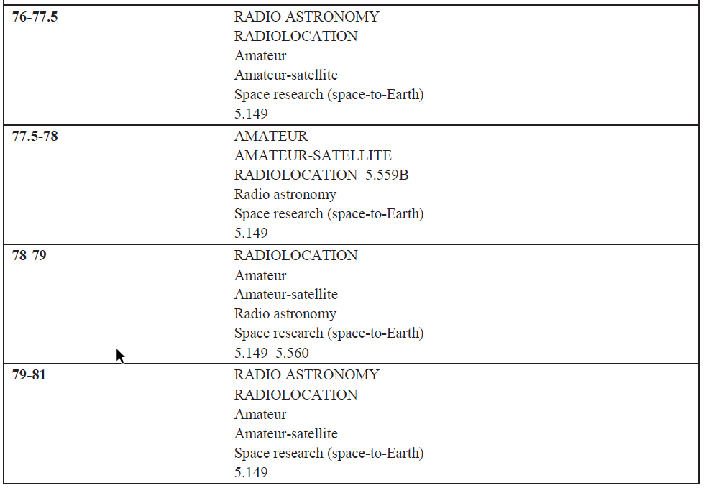

5.2 Radio astronomy protection criteria
The interference threshold levels detrimental to radio astronomy observations are listed in § 3 and further developed here below to consider the radar operational bandwidth. There are two observation modes, continuum (broadband) and spectral line (narrow-band).
A single radar transmitter with the highest antenna gains of automobile radars (Radars A and D), which correspond to the worst-case scenario were considered. In this study, the protection criteria for the continuum observation mode only was used.

5.3 Propagation model
For sharing between stations on the earth surface, Recommendation ITU-R P.452 is applied. It is noted that the Recommendation states that it is applicable up to 50 GHz. Nevertheless, ITU-R propagation experts consider that it can be used for frequencies up to 100 GHz.
Regarding the gas attenuation, an absorption coefficient of 0.15 dB/km (water vapour density of 4.1 g/m³ at 15 ºC) was assumed.

5.4 Terrain model
Locations of radio astronomy stations are chosen in remote or high elevation sites. Therefore, at least a terrain model should be considered while performing sharing studies.
The propagation model used for obtaining the minimum propagation loss is that described in Recommendation ITU-R P.452-16 associated to a percentage of time of 2% and a terrain model issued from SRTM data with 1 arcsecond accuracy. The simulation neglects the clutter attenuation and the polarization loss.

5.5 Automotive radar characteristics
To assess the worst-case situation, the simulation was run using the maximum e.i.r.p. level of the automotive radar, which does not represent the continuous emissions from the radar but allows to illustrate the impact on the RAS site during worst-case situations of emission.
This assumption implies also that the radar antenna pattern is neglected in both, azimuth and elevation planes. Indeed, the worst-case scenario simulated assumes that the road plane is such that the radar antenna is directly pointing towards the radio astronomy station in azimuth and elevation. It should be noted that automotive radars have, by design, a very narrow beamwidth in the elevation plane, not more than +/-5.5° as mentioned in Table 2.1.
According to Table 1, the antenna height of the automotive radar used in the simulation is 70 cm above road.

5.6 Study Results
This study presents the results for the two radio astronomy stations in France performing measurements in the frequency band 76-81 GHz band, considering a single emitter.

5.6.1 Plateau de Bure station
The station site is located on a plateau in the French Alps at an altitude of 2 550 m. This radio astronomy station is an interferometer composed of 12 antenna spread over several kilometers and currently performing observations in the frequency 76 -81 GHz. For the study only one location antenna point was considered as the virtual phase center position of the interferometer.
Frequency band 76 – 77 GHz
Type A radar is the only one from the five radars described in Recommendation ITU-R M.2057 that applies to this frequency band. The simulation was run using the maximum e.i.r.p. level equal to 55 dBm and the radar operational bandwidth is 1 GHz at 70 cm from the ground.
The colored areas represent the locations in which a radar operating at maximum power (55 dBm) and pointing directly in azimuth and elevation towards the radio astronomy station would exceed the protection radio astronomy criteria for continuum observation, which is the most stringent in this band, as discussed in § 5.2. The color code represents the amount of dB exceeding the radio astronomy input power limit. No clutter losses were considered.

Figure 2
Regions from which the RAS protection criterion would be exceeded with e.i.r.p.=55 dBm
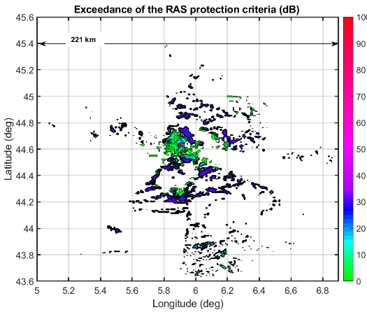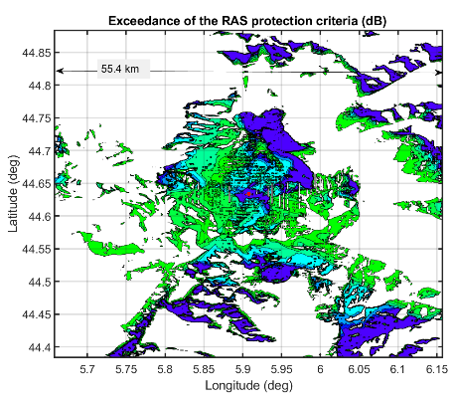
When overlapping the figure on the terrain model map, it can be seen that the results are strongly dependent on the surrounding terrain as shown in Fig. 3. These results confirm the findings from Report ITU-R M.2322 that concluded that the shape and dimension of the area from which an automotive radar could create detrimental interference to a RAS station largely depends on the terrain surrounding the RAS site.
For the case of the site of Bure, the single-entry study, considering one location of RAS antenna on the plateau, up to 110 kilometres separation distance in limited azimuths could be necessary. In this direction, among the areas in which the radar may affect the radio telescope, there are some towns and parts of highway roads. However, no clutter losses were introduced in order to take into consideration the diffraction of radar emission by building in towns.
Figure 3
Regions from which the RAS protection criterion would be exceeded (Type A radar)
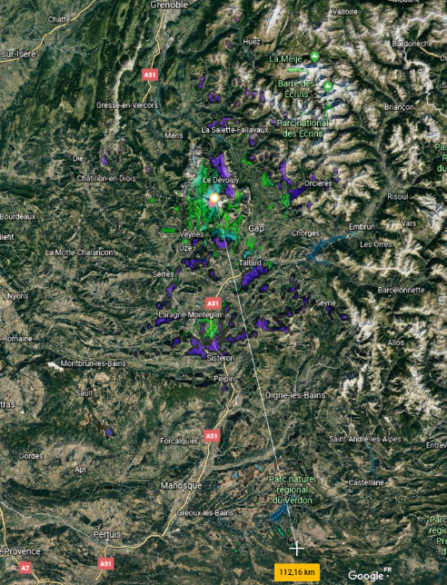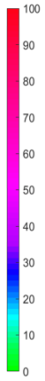
Frequency band 77-81 GHz
The other four radar types described in Recommendation ITU-R M.2057 present maximum e.i.r.p. level of 33 dBm and 45 dBm, which is 22 dB and 10 dB lower than Type A radar. The operational bandwidth of these radars, referred to as B, C, D and E is 4 GHz. For this frequency band, the study considers radar D, which is the one with the highest maximum e.i.r.p. level. The results are presented in the same way as for the frequency band 76-77 GHz.
In this case, considering again one radar presenting a maximum emission and one antenna position for the telescope, the impacted area is more limited that in the previous case. The distance in particular azimuths is up to 90 km but impacts are limited to height elevation peaks where cars are not expected outside ski station. This limited impact is due to the reduction in the maximum power and to the slight increase in the attenuation loss. Nevertheless, it is still the terrain profile surrounding the RAS station that strongly limits the impact from which an automotive radar could cause detrimental interference to the observations. Clutter attenuation such as from vegetation was not considered.

Figure 4
Regions from which the RAS protection criterion would be exceeded by (Type D radar)
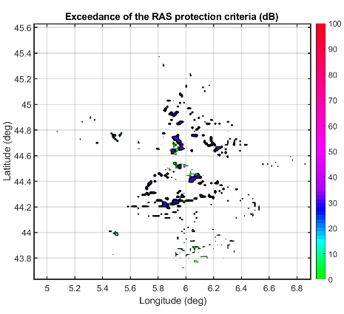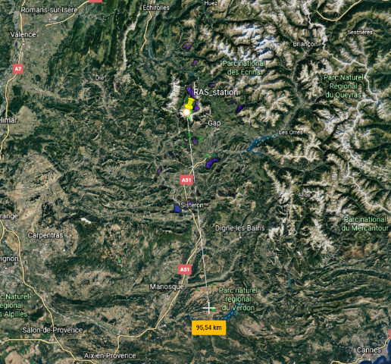

5.6.2 Maïdo station
Although this station is not currently performing observations in the 76-81 GHz band, it could be the case in future. This station is located in the French island of La Réunion at around 2 150 m at the following coordinates: 21.0796°S, 55.3841°E. The hypotheses and methodology for this site is identical to the Plateau de Bure study case. Considering the terrain profile, the situation is quite different from the Bure site as in this case the major part of the west area between the Maïdo site and the sea cost included almost all towns and road located inside, are in direct line of sight.
Frequency band 76-77 GHz
Like in the previous case, the results for this frequency range are obtained using Type A radar characteristics. Figure 5 illustrates the regions from which radio astronomy observations carried on from Maïdo station in the 76-77 GHz frequency band would be impacted by automotive radars of Type A. The dramatic landscape of the Reunion Island strongly conditions the results.
Figure 5
Regions from which the Maïdo station would be impacted by radar Type A at maximum e.i.r.p.
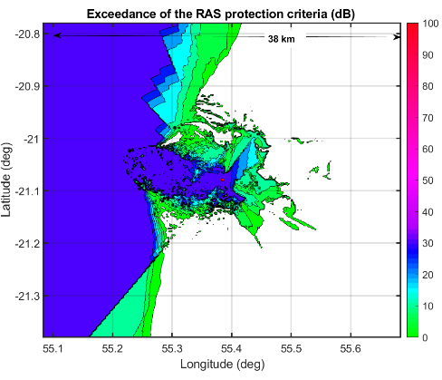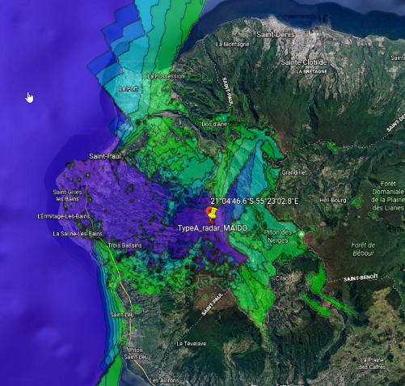
Frequency band 77-81 GHz
The results for this frequency range are obtained using Type D radar characteristics. Figure 6 illustrates the regions from which radio astronomy observations carried on from Maïdo station would be impacted by automotive radars of Type A.
Figure 6
Regions from which the Maïdo station would be impacted by radar Type D at maximum e.i.r.p.
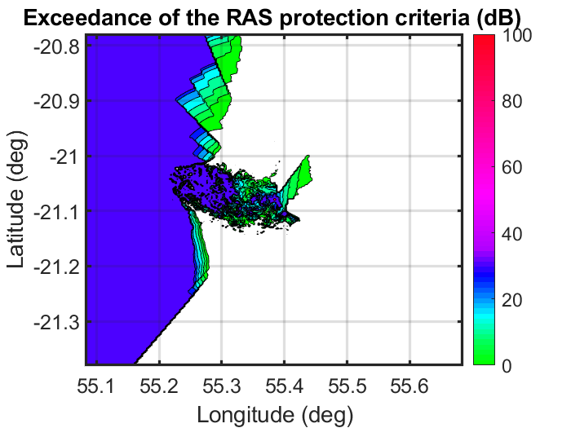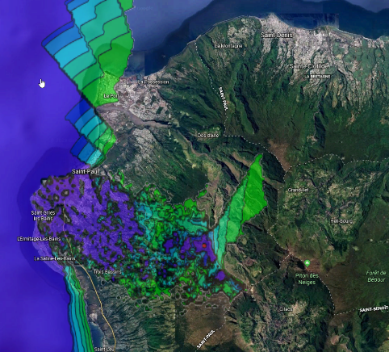

6 Regulatory responses of individual administrations

6.1 Spain
The Instituto de Radioastronomía Milimétrica (IRAM), in collaboration with the (Spanish) National Geographic Institute (NGI), operates a 30 m radio telescope (the IRAM 30 m telescope) at Pico Veleta near Granada, The telescope operates in the frequency range 70-275 GHz. For further information, see http://www.iram.es/. The telescope is located in the midst of a large ski resort, and visible from the city of Granada as well as the nearby ski resort base camp.
Figure 7
Location of the IRAM 30 m telescope in the Sierra Nevada near Granada, Spain, shown on a relief map
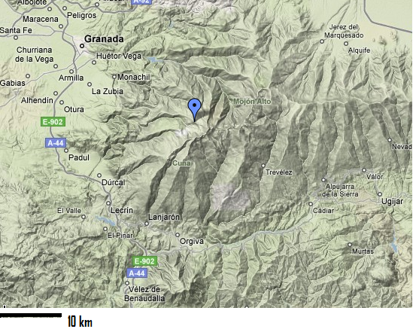

6.1.1 Specific protections
The Spanish National State Secretariat for Telecommunications and the Information Society, in its Order 1679 of June 18, 2009, “In order to ensure the efficient reception of signals from outer space and to provide protection of the instrument from radio interference”, established various limitations on nearby property rights and electromagnetic emissions. The limitations created by Order 1679 may be summarized as follows:

i) Geographic reference point of the IRAM 30 m telescope for establishing the limitations
This are defined by WGS coordinates: N 37º 03’ 58”; W 03º 23’ 34”; 2904.0 m

ii) Limitations on property rights
The proprietors or occupants under any title of any of the lots adjacent to the observatory shall be inhibited from building or modifying buildings not in accordance with the limitations and bounds established in the present resolution.
Within a radius of 1 000 m from the radio astronomy station, no construction should appear above an elevation of 3 degrees as viewed by the telescope.
The minimum separation between an industrial facility, high voltage power line or railway, and any of the receiving antennas of the observatory will be 1 000 m.
To determine the minimum distance from the observatory at which radio transmitters may be located, taking into account that the station operates at frequencies above 3 000 MHz, the limitations set out in Table 4 shall apply.
TABLE 4
Range of frequencies (f)  (MHz) | Interfering service | Apparent radiated power of the transmitter in the direction of the station to be protected  (kW) | Maximum distance limitation that may be applied between the transmitting antenna and the station to be protected (km) | Maximum distance limitation and radio electric conditions (CRE)* that may be demanded (km)
f > 3 000 | Radiolocation  Space Research (Earth-to-space) | 0.001 < P ≤ 1 | 1
f > 3 000 | Radiolocation  Space Research (Earth-to-space) | 1< P ≤ 10 | 2
f > 3 000 | Radiolocation  Space Research (Earth-to-space) | P > 10 | 5
f > 3 000 | Other services | 0.001 < P ≤ 0.01 | 0.6 | 02, and CRE
f > 3 000 | Other services | 0.01 < P | 1
* The radio electric conditions that may be demanded (CRE) will be understood, in accordance with those established in Royal Decree 1066/2001, of 28 September.

iii) Limitations on the intensity of the electric field
To protect the frequency bands used by the observatory which are allocated to the Radio Astronomy Service on a primary basis in the National Table of Allocations in force, the intensity of the electric field in the above referenced bands will be limited to the values from Table 5, when measured at the observatory, independently of where the transmitter is located.
TABLE 5
Frequency band | pfd  (dB(W/m²)) | Equivalent intensity of the  electric field  (dB(μV/m))
76-77.5 GHz  79-86 GHz  86-94 GHz  94.1-116 GHz  130-134 GHz  136-158.5 GHz  164-167 GHz  182-185 GHz  200-231.5 GHz  241-248 GHz  250-275 GHz | –130  –129  –125  –124  –124  –124  –123  –121  –119  –118  –117 | 15.8  16.8  20.8  21.8  21.8  21.8  22.8  24.8  26.8  27.8  28.8

For all other frequencies, the intensity of the electric field shall be limited to +88 dB(μV/m) (−57 dB(W/m²)) , also measured at the site of the radio astronomy station.

iv) Radio coordination zone
Prior to assigning frequencies to radiocommunication stations with an apparent radiated power that exceeds 25 Watts in the direction of the observatory, within a 10 km radius of the same, studies will be carried out to determine that the intensity of the electric field at the reference point of the Observatory shall not exceed the appropriate values given in iii). A theoretical model will be employed to calculate the electric field intensity, and the radiation pattern of the station and the terrain attenuation will also be taken into account.
Should the theoretical calculations result in an electric field intensity in excess of the limits stipulated in section b, electric field intensity measurements may be carried out at observatory using trial signals, and in collaboration with observatory and State Secretariat for Telecommunications and the Information Society staff. Under no event will the outcome of such measurements exempt the definitive transmitter of the obligation to comply with the limits given in iii) above.

v) Supervision and control
The State Secretariat for Telecommunications and the Information Society will exercise the functions attributed to it in order to conduct inspections on compliance with the limitations and bounds established.

vi) Appeals
A brief period (one-two months) was granted after publication of the decree, during which appeals or lawsuits against the decree could be filed.

6.2 United States of America
On July 13, 2017, the United States expanded the spectrum available for vehicular radars in the USA from 76-77 GHz to the entire 76-81 GHz band, while transitioning radars out of the 24 GHz band. This is consistent with the spectrum available internationally to vehicular radars, avoiding the need to customize them in vehicles intended for different markets. The new rules also permits the use of this band for unlicensed fixed and mobile radars at airports that are used for applications such as the detection of debris on runways that could harm aircraft on take-off and landing.
Licensed radar applications operating in portions of the 76-81 GHz band do so under the radiolocation service (RLS) allocations in the United States, where the band is also allocated to the RAS. RAS installations typically have been sited in remote locations to minimize background radio noise as well as the risk of harmful interference from active services.
Previously, the 76-77.5 GHz and 78-81 GHz bands had been allocated in the United States to the RAS on a primary basis; while the 77.5-78 GHz band has been allocated to the RAS on a secondary basis. The United States decided to support unlicensed vehicular radar use across a full five gigahertz block of millimetre-wave spectrum, and to add a primary RLS allocation in the half gigahertz of spectrum (i.e. 77.5-78 GHz) that previously had no RLS allocation. The United States found that maintaining the secondary RAS allocation in a portion of the band would suggest a distinction between RAS use of the 76-77.5 GHz/78-81 GHz bands and the 77.5-78 GHz band that does not exist. Given the introduction of a primary RLS allocation in the band, the inconsistent status afforded to the RAS – and any potential confusion it might cause – was particularly relevant. Furthermore, in the event that there were to be harmful interference between vehicular radars and RAS, it would be difficult to determine whether the radars were operating in the portion of the band where RAS had primary or secondary rights. By making both services co-primary throughout the band, the United States sought to provide domestic regulatory consistency between the services and eliminate the potential problem, in the event of harmful interference, of determining protection rights in favour of addressing and mitigating the interference concern.
The idea of a mechanism for vehicular radars that would automatically turn off the radars in the pre-coordinated vicinity of RAS observatories, to prevent vehicular radars from interfering with RAS operations, was questioned in terms of the practicality of a manual or automatic on/off switch and the definition of coordination zones for vehicular radars, especially given the size and scope of the automotive fleet in the United States, as compared to the 12 RAS facilities that operate in the 76-81 GHz band. It was also observed that the RAS sites in question are located in controlled areas where they may have the ability to restrict unauthorized vehicles or otherwise take preventative measures that are far more economical and sensible than requiring shut-off features for every vehicle equipped with these radars. The United States, therefore, declined to adopt a requirement for an automatic or manual on/off switch and coordination zones for vehicular radars.
Table 6 is a summary of the current U.S. allocations in the 76-81 GHz band, upon adoption of this Order.
TABLE 6
Resultant U.S. Allocations in the Frequency Range 76-81 GHz
(Services the names of which are printed in “capitals” are primary services;
services printed in “normal characters” are secondary services)
76-77 GHz | RADIOLOCATION  RADIO ASTRONOMY  Amateur  Space research (space-to-Earth)
77-81 GHz | RADIOLOCATION  RADIO ASTRONOMY  Amateur  Amateur-satellite  Space research (space-to-Earth)

In the case of the airborne use of aircraft-or helicopter mounted radars, the United States did not permit operations while airborne, based on their potential for interference with RAS operations. The United States found that an automatic shut-off mechanism offers the best assurance that parties will comply with the ground-based use restriction of aircraft-mounted radars, and that it is both feasible and desirable to deploy this feature. Hence, the United States requires that aircraft-mounted radars include an automatic mechanism that discontinues all 76-81 GHz radar functions while an aircraft is airborne.

6.2.1 Technical rules
The United States has adopted average (50 dBm) and peak (55 dBm) e.i.r.p. emissions limits for radar applications in the entire 76-81 GHz band. The technical rules for the newly expanded radar band mirror those previously provided, including unwanted emissions limits such that the power flux of radiated emissions outside the 76-81 GHz band may not exceed 600 pW/cm² at a distance of 3 meters from the exterior surface of the radiating structure for radiated emissions in the range 40-200 GHz, or 1 000 pW/cm² at frequencies above 200 GHz. All standards are based on measurements employing a power averaging detector with a 1 MHz Resolution Bandwidth.
The new radar rules do not establish distinct spectrum blocks in the 76-81 GHz band for particular radar applications such as LRR and SRR, or FOD detection and aircraft-mounted radars.

7 Summary
This Report provides sharing and compatibility study results between the radio astronomy service and radiolocation service (automobile radar applications) in the frequency range 76-81 GHz.
The case studies in the Report found the separation distances between a RAS station and a single automotive radar to be up to the order of 100 km. It has also been found that the separation distances strongly depend on the features of the terrain surrounding the RAS site, and local atmospheric characteristics. Indeed, this Report also shows that, if a RAS station is protected by mountains, the separation distance is greatly reduced. Thus, a zone around a RAS station, from which there might be impact from the automotive radars, should be analysed on a case by case basis and may have an irregular shape.
The impact of multiple interferers was not studied in this Report at this stage. Such analysis would require the consideration of the car radar density in road and towns with power aggregation taking into account the particularities of radar transmissions such as modulation type, duty cycle, lack of synchronization between different transmitters, and random orientation of the antennas with respect to the RAS station.
As shown in some compatibility studies, to address the areas of concerns around RAS stations observing in the frequency band 76-81 GHz, administrations operating RAS stations may introduce national regulatory measures to ensure coexistence between the two services. This Report provides examples of regulatory measures adopted by administrations operating RAS stations in its territory. Some administrations have already introduced such measures. Other administrations may refer to this Report towards establishing coexistence between the RAS and automobile radars, when operating or planning to operate RAS stations performing observations in the frequency band 76-81 GHz.

Annex 1
RESOLUTION B4
Protection of radio astronomy observations in the frequency range 76-81 GHz from interference caused by automobile radars
Proposed by IAU Commission 40 (Radio Astronomy)
The XXIX General Assembly of the International Astronomical Union,
recognizing
1 that the International Astronomical Union is a Sector Member of the Radiocommunication Sector of the International Telecommunication Union (ITU-R);
2 that radio astronomy observations are protected in their allocated bands from interference caused by active radio services by national regulations based on the Radio Regulations (RR) adopted by the International Telecommunication Union (ITU);
3 that the frequency ranges 76-77.5 GHz and 79-81 GHz are allocated to the radio astronomy service on a primary basis (Article 5 of the RR);
4 that Article 29.9 of the RR states that “In providing protection from interference to the radio astronomy service on a permanent or temporary basis, administrations shall use appropriate means such as geographical separation, site shielding, antenna directivity and the use of time-sharing and the minimum practicable transmitter power”,
considering
1 that radio astronomy observations consist of the reception of extremely weak signals from cosmic sources;
2 that radio astronomy receivers have exceptionally high sensitivity, which results in high susceptibility to interference caused by man-made radio signals;
3 that radio frequencies are a limited resource that should be shared;
4 that automobile manufacturers intend to utilize millimeter-wave radars operating in the frequency range 76-81 GHz for a number of purposes, that include the increasing of safety in driving;
5 that agenda item 1.18 of World Radiocommunication Conference 2015 (WRC-15) of the ITU calls for consideration of allocating the frequency range 77.5-78 GHz to radar applications worldwide, and that this allocation is expected to be applied worldwide in conjunction with existing allocations to radar applications in the frequency range 76-81 GHz;
6 that the ITU has not identified measures to protect radio astronomy observations in the frequency range 76-81 GHz from interference caused by automobile radars,
resolves
1 to request that WRC-15 take all possible steps to protect radio astronomy observations in the range 76-81 GHz from interference caused by automobile radars;
2 to express the view that the most effective protection of radio astronomy observations would be through geographical separation;
3 to send a copy of this Resolution to administrations that operate or host radio astronomy observations in the frequency range 76-81 GHz, and where automobile radars are operating or plan to operate in the same frequency range;
4 to encourage astronomers, particularly those in countries that fall under resolves 3, to work proactively in protecting radio astronomy observations in the frequency range 76-81 GHz.

Annex 2
List of radio astronomy service station sites in the world capable
of using the 76-81 GHz band
NOTE 1 – Where the Rx height above terrain is not specified, a good estimate is to take it equal to the diameter of the antenna.
NOTE 2 – Administrations applying the Tables below should consult with relevant observatories for the current status of operations.
TABLE 7
List of radio astronomy service station sites in the world capable of using the 76-81 GHz band
ITU-R Region 1
Observatory name (Administration) | Longitude (E), Latitude (N), Elevation  (m AMSL) | Minimum elevation  (degrees) | Rx height above terrain  (m) | Geographical characteristics
Plateau de Bure,  12 × 15 m Array, IRAM, France ⁽¹⁾ | 05º54’28.5”  44º 38’ 02”  2553 |  | 15 | Isolated high mountaintop in line-of-sight to various public facilities
Maido (la Réunion)  Horns 0.25 × 0.36 m  0.70 × 0.48 m  France ⁽¹⁾ ⁽²⁾ | 55°23’01”  –21°04’46”  2 200 |  |  | Mountain top
Effelsberg, 100 m, Germany | 06º53’00”  50º31’32”  369 | 8 |  | Broad flat plain exposed to nearby roads
Pico de Veleta, 30 m  IRAM, Spain ⁽¹⁾ | –03º23’34”  37º03’58”  2850 | 0 | 31 | Mountainside overlooking nearby ski resort, line of sight to city of Granada
Yebes 40 m  Yebes 14 m  Spain | –03º05’22”  40º31’27”  981 | 0  4 |  | Broad flat plain exposed to roads

TABLE 7 (end)
Observatory name (Administration) | Longitude (E), Latitude (N), Elevation  (m AMSL) | Minimum elevation  (degrees) | Rx height above terrain  (m) | Geographical characteristics
Sardinia Radio Telescope 64 m, Sardinia, Italy | 09º14’40”  39º29’34”  600 | 5 |  | High exposed plain
Onsala 25 m  Onsala 20 m  Sweden | 11º55’04”  57º23’35”  18 | 6  7 |  | Waterside, forested, relatively isolated, Gotheborg 40 km N
Metsahovi 14 m  Finland | 24º23’37”  60º13’04"  80 | 0
Noto 32 m  Italy | 14°59’20.51”  36°52’33.78”  90 | 5 |  | Flat exposed plain.  VLBI
Zelenchukskaya  RT-32 32 m  Russia⁽²⁾ | 41°33’52.6”  43°47’16.2”  970 | –5 | 35 | The Republic of Karachay-Cherkessia  (Kavkaz region of the  Russian Federation)
Zelenchukskaya  RATAN-600  576 m  Russia⁽²⁾ | 41°35’12.06”  43°49’34.2”  970 | 3 | 2 | The Republic of Karachay-Cherkessia  (Kavkaz region of the  Russian Federation)
Badary RTF-32 32 m  Russia⁽²⁾ | 102°14’04.95”  51°46’11.6”  832 | –5 | 35 | The Republic of Buryatia,  (the southern part of  Eastern Siberia)
Badary SSRT-256  256 mirror 2.5 m  Russia⁽²⁾ | 102°13’16”  51°45’27”  832 | 25 | 2 | The Republic of Buryatia,  (the southern part of  Eastern Siberia)
Pushino RT-22 FIAN  22 m  Russia⁽²⁾ | 37°37’57”  54°49’22”  200 | 6 | 30 | Moscow region of the  Russian Federation
Svetloe RTF-32 32 m  Russia⁽²⁾ | 29°46’54”  60°31’56”  80 | –5 | 35 | Leningrad region of the  Russian Federation
Kaljazin RT-64 64 m  Russia⁽²⁾ | 37°54’01”  57°13’23”  195 | 0 | 60 | Tver region of the  Russian Federation
⁽¹⁾ These telescopes also observe at higher frequency bands that are harmonically related to the radar frequency.
⁽²⁾ Not using this band at present

ITU-R Region 2
Observatory name (Administration) | Longitude (E), Latitude (N), Elevation  (m AMSL) | Minimum elevation  (degrees) | Rx height above terrain  (m) | Geographical characteristics
Robert C Byrd 100 m Green Bank Telescope, W. VA, USA | –79º50’22”  38º25’58”  807 | 5 | 140 | Flat open space ringed by forest and hills; adjacent roads
VLBA-Brewster, WA (25 m), USA | –119º40’41”  48º07’52”  250 | 2.25 | 29 | Broad, flat river valley, < 1 km from state highway US97. VLBI.
VLBA-Fort Davis, TX, USA | –103º56’41”  30º38’06”  1606 | 2.25 | 29 | Broad, flat open high plain. 3 km from highway TX118. VLBI
VLBA-Hancock, NH, USA | –71º59’12”  42º56’01”  296 | 2.25 | 29 | Sea level in the woods, 1.5-3.0 km from multiple state and federal highways. VLBI
VLBA-Kitt Peak, AZ, USA | –111º36’45”  31º57’23”  1902 | 2.25 | 29 | High mountainside, on AZ386, 6.5 km from highway AZ86. Phoenix in line-of-sight. VLBI
VLBA-Los Alamos, NM, USA | –106º14’44”  35º46’31”  1962 | 2.25 | 29 | On a high cliff-side,  1 km from highway NM4. Exposed to Santa Fe 21 km away. VLBI
VLBA- Mauna Kea, HI, USA | –155º27’19”  19º48’05”  3763 | 2.25 | 29 | High mountainside, 3 666 m above sea level. 9.6 km from highway HI200. VLBI
VLBA-North Liberty, IA, USA | –91º34’27”  41º46’17”  222 | 2.25 | 29 | In the woods just off of a busy local highway. Numerous small towns within 15 km. VLBI
VLBA-Owens Valley, CA, USA | –118º16’37”  37º13’54”  1196 | 2.25 | 29 | Broad open plain, 5 km from highway US395. VLBI.
Owens Valley Radio Observatory / CRAL | –118º16’56”  37º14’02”  1222 |  |  | Broad open plain, 5 km from highway US395.
VLBA-Pie Town, NM,  USA | –108º07’09”  34º18’04”  2365 | 2.25 | 29 | High mountain, exposed, just off highway US60. VLBI
ARO Kitt Peak 12 m, AZ, USA ⁽¹⁾ | –111º36’45”  31º57’23”  1914 |  | 12 | Mountainside, exposed to south and west but hidden from Tucson
Haystack Observatory 37 m Westford, MA,  USA | –71º29’19”  42º37’23”  131 | 5 |  | Broad flat open area at ambient elevation

ITU-R Region 2 (end)
Observatory name (Administration) | Longitude (E), Latitude (N), Elevation  (m AMSL) | Minimum elevation  (degrees) | Rx height above terrain  (m) | Geographical characteristics
LMT 50 m Sierra Negra, Puebla  Mexico ⁽¹⁾ | –97º18’48”  18º59’06”  4580 |  | 51 | Mountain top in line of sight to numerous towns and 15 km from Mexico City-Puebla-Veracruz highway
ALMA, Chajnantor, Chile ⁽¹⁾ | –67º45’18”  –23º01’22”  5059 |  |  | Broad flat high plain ringed by mountains, accessible by road
NANTEN2 4 m, Pampa La Bola. Chile | –67º42’08”  –22º17’47”  4800 |  |  | Broad flat high plain accessible by public road
ARO SMT 10 m, Mt. Graham, AZ,  USA ⁽²⁾ | –109º53’31”  32º42’05”  3186 |  | 10 | Remote forested mountaintop. Operates only above 100 GHz.
JCMT 15 m, SMA 6x6 m, CSO 12 m, Mauna Kea, HI,  USA | –155º28’30”  19º49’18”  4092 |  |  | Isolated very high mountaintop.
⁽¹⁾ These telescopes also observe at higher frequency bands that are harmonically related to the radar frequency.
⁽²⁾ These telescopes only observe at higher frequency bands that are harmonically related to the radar frequency.

ITU-R Region 3
Observatory Name (Administration) | Longitude (E), Latitude (N), elevation  (m AMSL) | Minimum elevation  (degree) | Rx height above terrain  (m) | Geographical characteristics
Mopra 22 m, Australia | 149º05’58”  –31º16’04” | 12 |  | Hilltop ringed by mountains
ATCA 6 x 22 m, Australia | 149º32’56”  –30º59’52” | 12 |  | Broad flat plain
Delingha 13.7 m, China | 97º33.6’  37º22.4’  3 200 | 5 |  | Flat plain
Tianma 65 m, China | 121º9.8’  31º05.2’  6 | 5 |  | Flat plain
QTT 110 m, China | 89º40.9’  43º36.0’  1 759 | 5 |  | Plain ringed by mountains
RRI 10.4 m, India | 77º38’  12º58’
Nobeyama 45 m, Japan | 138º28’21”  35º56’40” | 12 | 47 | Broad plain at an altitude of 1,350 m ringed by mountains
VERA-Mizusawa 20 m, Japan | 141º07’57”  39º08’01” | 3 | 22 | VLBI  Broad plain open in north and south and shielded in east and west with a long range of mountains at both sides in 15 km
VERA-Iriki 20 m,  Japan | 130º26’24”  31º44’52” | 3 | 22 | VLBI  Narrow plain surrounded by mountains
VERA-Ogasawara 20 m, Japan | 142º13’00”  27º05’31” | 3 | 22 | VLBI  Located in an isolated island about 900 km away from the mainland Japan
VERA-Ishigakijima 20 m, Japan | 124º10’16”  24º24’44” | 3 | 22 | VLBI  Located in an island in which it stands 8 km away from the populated district and is at the edge of mountains in north
Taejon 13.7 m, Korea | 127º22’18”  36º23’54” | 5 | 10.6 | Broad flat plain exposed to nearby roads
Seoul 6 m, Korea | 126º57’19”  37º27’15” | 5 | 4.5 | Steep Slope
KVN-Yonsei 20 m, Korea | 126º56’35”  37º33’44” | 5 | 15.6 | Gentle slope.  Single Dish and VLBI
KVN-Ulsan 20 m, Korea | 129º15’04”  35º32’33” | 5 | 15.6 | Steep slope.  Single Dish and VLBI
KVN-Tamna 20 m, Korea | 126º27’43”  33º17’18” | 5 | 15.6 | Gentle slope.  Single Dish and VLBI

Annex 3
Measurement results at the Arizona Radio Observatory (ARO), Kitt Peak, USA
Members of the radio astronomy community and the automotive radar industry jointly performed tests of the emissions of car radar units at the University of Arizona’s 12 Metre (12-M) Telescope, located at Kitt Peak, Arizona, USA in October 2010. The test procedures and measurement results are available as NRAO Green Bank Electronics Division Technical Note #219.

1 Introduction
In an effort to understand the impact that such systems may have on radio astronomy installations, measurements of the emissions of representative radar units were made at the University of Arizona’s 12 Meter (12-M) Telescope located at Kitt Peak, Arizona in October, 2011.
Emissions of two different automotive radars, manufactured by Robert Bosch GmbH and by Continental Corporation were measured. These units were mounted temporarily on the vehicle; in production, they are expected to be placed within a vehicle’s bumper. The transmitters were first located at a nearby car park 1.7 km distant, and secondly at a site 26.9 km away at Sells, AZ. The 12-M telescope receiver was tuned to a centre frequency of 79 GHz (Continental radar) or 77.8 GHz (Bosch radar). The car radars were used in an FMCW mode, in which the CW signal is swept at a constant rate from 77.03 to 78.58 GHz, a total bandwidth of 1 550 MHz (Bosch radar) or from 78.93 to 79.1 GHz, a total bandwidth of 170 MHz (Continental radar).
The received signal was observed using the standard radio astronomical filter bank spectrometer covering a 500 MHz band centred at the radar’s mid frequency, with 2 MHz resolution. In normal operation the 12-M Telescope uses a Cassegrain optics system. However, for this test we used the 12-M Telescope receiver and horn feed, but the beam of the feed was redirected from the subreflector by mounting a plane mirror in front of it. The main reflector of the 12-M Telescope thus did not play any part in these tests. With this arrangement the 12-M dish mount was used to point the beam of the telescope feed at the radar to achieve a “line of sight” path from the radar to the telescope receiver. Figure 8 shows the arrangement; a photograph of the plane reflecting mirror in front of the subreflector is shown in Fig. 9. The redirected beam is offset by approximately 43.4 degrees in azimuth and 80 degrees in elevation away from the normal 12-M antenna pointing direction.
Figure 8
The normal secondary focus receiver and Cassegrain feed is used independently of the main 12-M reflector.
An inclined plane reflector is placed in front of the subreflector, redirecting the beam from the
receiver to the ground, rather than utilizing the main dish surface
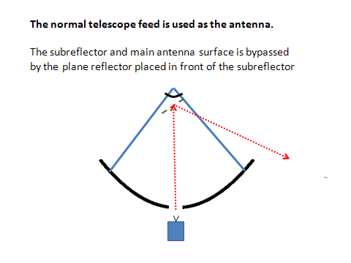
FIGURE 9
The inclined plane reflector in front of the subreflector redirects the signal received from
the radar transmitter directly into the receiver, eliminating the use of the main antenna
reflector. In the configuration shown, the signal is being received from the ground
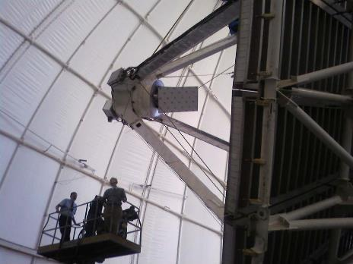

figure 9
The 3-inch diameter window in the receiver Dewar is positioned immediately above the feed horn and SIS (superconductor-insulator-superconductor) mixer of the receiver used for these measurements. The signal is normally focused by the main
12-m diameter reflector onto the subreflector and then into the receiver. For these measurements, the signal from
the radar is received directly, without utilizing the subreflector or the main 12-m antenna reflector at all
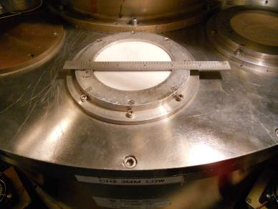
The window above the SIS (superconductor-insulator-superconductor) mixer receiver in its Dewar is shown in Fig. 9. The receiver itself is cooled to 4 K.
More details of the telescope’s receiver optics can be found in the references below by Payne et al.

2 Beamwidth of the receiver feed
The beamwidth of the 12-M receiver feed was measured in a separate test in which the radar was located 1.7 km away in the parking lot of the 90” Steward Telescope (NB this is not a public parking area). With this line of sight path the radar signal was strong enough to easily determine the beamwidth in the vertical and horizontal directions by scanning the receiver beam across the radar source. The beamwidth was symmetrical in the vertical and horizontal directions with full-width half power of 3.1 ± 0.1 degrees. Assuming a Gaussian beam this beamwidth corresponds to a gain of 35.8 ± 0.2 dBi.
The main beam gain of a 12-M antenna, such as the mm-wave radio telescope at Kitt Peak, is about 78 dBi at 79 GHz, so the feed antenna used for these measurements is equivalent to a –42 dB sidelobe of such an antenna.

3 Receiver and system noise temperatures
The receiver noise temperature was calculated from the “Y factor” measurement using liquid nitrogen cooled absorber “cold” load (80 K) and an absorber vane at ambient temperature (301 K). The receiver noise temperatures were determined to be 75 K and 108 K respectively for the vertical (channel 1) and horizontal (channel 2) polarization channels of the receiver.
For tests of the radar the system temperatures were assumed to be equal to the receiver noise plus the ambient temperature (301 K) since the beam was always filled by the ground and atmospheric radiation when pointing at the radar; atmospheric attenuation over the 26.9 km path was some 4 dB, so atmosphere alone would have contributed some 180 K to the total receiver system noise over that path. We assume ground temperature and the atmospheric temperature over this near-horizontal path both equal to the ambient temperature.
A check of the receiving system was made by observing the Sun at an elevation of 10 degrees. This was the highest elevation at which the offset beam could be pointed and was reached with the 12-M dish mount pointed at the zenith. The “vane” calibrated temperatures measured on the sun were 167 K and 170 K respectively for the 2 channels. These values are close to the expected value of 168 K above the atmosphere derived from the radio flux density of 10 150.10⁻²²W/m²/Hz at 79 GHz (see Benz, reference below). To first order the vane calibration measurement corrects for the attenuation of the atmosphere, so this is excellent agreement. These solar observations are completely consistent with the measured receiver temperatures and the feed antenna gain.

4 Beam polarizations
The receiver consists of two independent channels, sensitive to orthogonal linear polarizations. The two polarizations are split via a grid of parallel fine wires, which transmits one polarization and reflects the other. Allowing for the orientation of the plane mirror in front of the subreflector, one of these channels is sensitive only to vertical linear polarization, the other to horizontal. Tests of the polarization were made with the radar at 1.7 km. With the radar transmitting its normal vertical polarization mode, the signal was very strong in channel 1 and at least 30 dB weaker in channel 2. When the radar was physically rotated by 90 degrees the signal appeared in channel 2 and was more than 30 dB down in channel 1.

5 Measurements of the radar at 1.7 km
Figures 10 and 11 show the signals received from, respectively, the Continental radar with a nominal 200-MHz bandwidth, and the Bosch radar with a nominal 1 550 MHz bandwidth.
In Fig. 10, the emission shows two distinct features:
a) a plateau of emission approximately 170 MHz wide; and
b) a spike of emission at the high frequency end of the overall emission.
In both Figures, the vertical axis is in units of antenna temperature, ultimately calibrated against the hot (ambient) and cold (liquid nitrogen) loads that had previously been measured in front of the receiver. For reference, 1 000 K of antenna temperature, with a receiver antenna of gain 35.8 dBi, corresponds to an spfd (spectral power flux density) at the receiver of –115.0 dBW/m²/MHz.
From Fig. 10, the plateau of emission is 968 K, corresponding to an spfd at the receiver of -115.1 dBW/m²/MHz. Integrating over the 170 MHz of emission, this becomes a power flux density (pfd) of –92.8 dBW/m² at the receiver. Allowing for a free space path and an atmospheric attenuation of 0.3 dB, this corresponds to a total emitted power (e.i.r.p.) at the transmitter, just within the plateau of emission, of +13.0 dBm. Expressing this as a spectral e.i.r.p. at the sensor, this is -9.3 dBm/MHz. This is in excellent agreement with the –9 dBm/MHz measured by the sensor manufacturer, and which represents the maximum power allowed by the European Norm EN 302 264.
The spike of emission in Fig. 10 has a peak brightness temperature of 5 982 K, as measured in a 2-MHz filter channel. Excluding the plateau of emission, that corresponds to a received spfd of -107.2 dBW/m²/MHz. This spike of emission is only visible in this pre-series sensor and would be removed for the production version of the sensor. It is not considered further here.
FIGURE 10
The received signal from the Continental radar, with a nominal 200 MHz bandwidth,
at a distance of 1.7 km
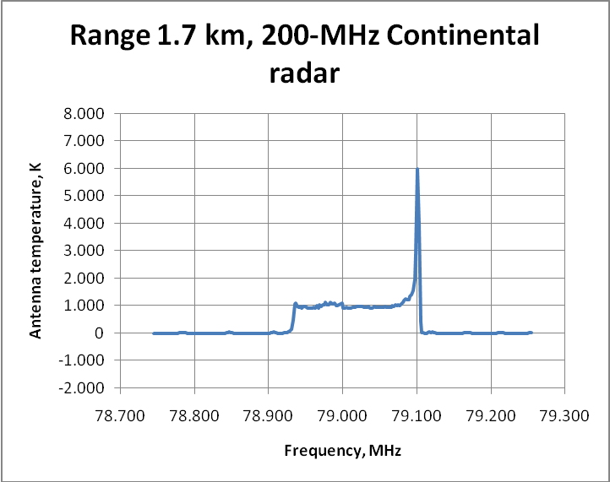
Away from the main emission of the transmitter, say ±150 MHz in Fig. 10, there is some residual response, but at a much lower amplitude of about 11 K. This is some 27 dB down on the peak emission of 5 892 K. The theoretical rms receiver noise fluctuations for this observation are only ~0.084 K.
FIGURE 11
The signal received from the 1.7 km distant Bosch wideband radar, centred on 77.8 GHz. Although the transmitted signal is nominally 1 550 MHz wide, the receiver only sees the central 512 MHz of that band
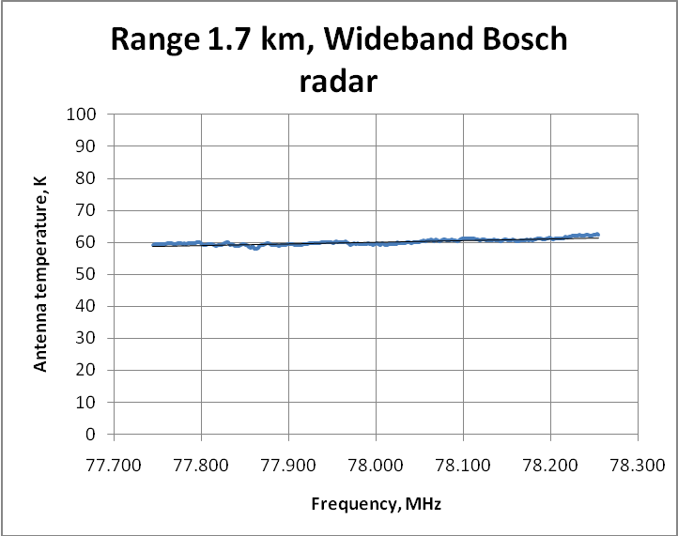
In Fig. 11, showing the Bosch radar, the central 512 MHz of emission centred at 77.8 GHz, has a mean brightness temperature of 60.1 K. The corresponding spfd of this at the receiver is -127.2 dBW/m²/MHz, with a received pfd (assuming 1 550 MHz emission bandwidth) of -95.3 dBW/m². Again, allowing for the inverse square path loss and 0.3 dB of atmospheric attenuation that corresponds to an effective isotropic radiated power (e.i.r.p.) of 13.7 dBm at the transmitter.

6 Measurement of the radar e.i.r.p. at 27 km
The primary tests of the radar were made by driving to the seldom used airport at Sells, AZ., which is 26.9 km away and is in clear view of the 12-M telescope. The receiver beam was pointed at this location using angles computed from the GPS- determined locations of the radar at Sells and the 12-M telescope. After clearly detecting the radar in the spectrum of channel 1 the beam position was checked and found to be very close to the peak which was reached with a very small adjustment in elevation. The observed spectra are plotted in Figs 12 and 13 in units of degrees Kelvin of antenna temperature. Each spectrum is the difference of the spectra taken for 30 seconds with the radar turned on followed by 30 seconds with the radar emission suppressed by covering its antenna with layers of absorber. This sequence may be repeated and the results averaged, in order to improve signal-to-noise ratio. The peak in the spectrum at 79.1 GHz, as already seen with the measurements at 1.7 km, is due to an initial low scan rate of the FMCW and is not expected in normal automobile radar operation. As before, the e.i.r.p. can be estimated from the integrated power over the 170 MHz width of the FMCW after correcting for the free space and atmospheric path loss and receiver antenna gain.
FIGURE 12
At a range of 26.9 km, this is the emission seen from the Continental 200-MHz radar, with the vehicle stationary. The average plateau of emission has a brightness of 0.68 K, while the high frequency spike is 3.08 K. The noise
in the spectrum on either side of the emission is 0.038 K, close to the theoretical receiver noise of 0.036 K
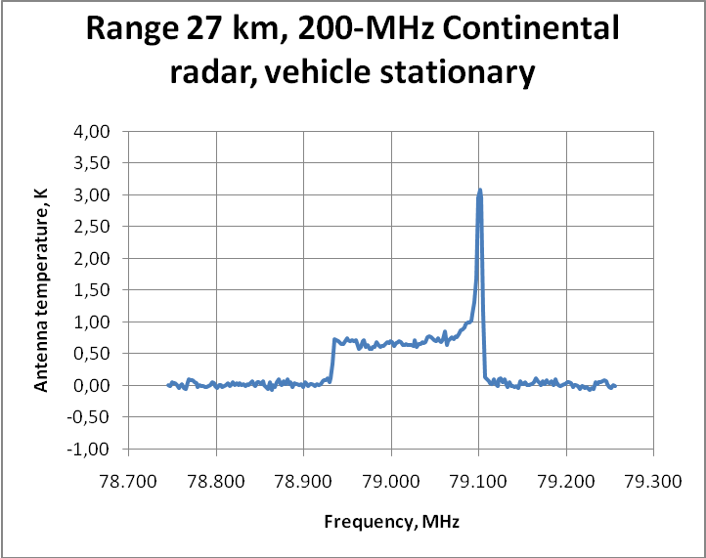
Figure 12, with the vehicle at 26.9 km and stationary, the received spfd of the plateau of emission is -146.7 dBW/m²/Hz; the spike of emission is some 6.6 dB stronger. The received pfd of the plateau is –124.4 dBW/m². Allowing 99.6 dB for the free space path loss and 4 dB for atmospheric attenuation, the estimated e.i.r.p. of the plateau of emission is 9.2 dBm.
From Fig. 13, with the vehicle in motion, the observed spfd of the plateau is –144.7 dBW/m²/Hz, with the spike stronger by a similar factor. The received pfd of the plateau is –122.4 dBW/m², with an estimated e.i.r.p. for the plateau component of 11.2 dBm. While in motion, the antenna remained in an orientation facing the distant receiver. The received signal was averaged over 30 seconds.
figure 13
At a range of 26.9 km, the emission from the Continental 200 MHz radar, with the vehicle in motion. The plateau of emission has a brightness of 1.07 K, and the high frequency spike 6.4 K. The receiver noise
on either side of the emission is 0.053 K, very close to the theoretical receiver noise of 0.049 K
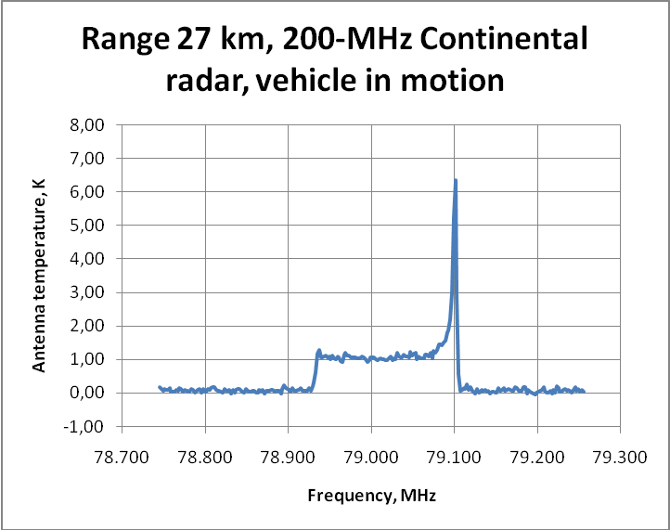
Figure 14 shows the observed emission from the 800-MHz Continental radar, with the vehicle in motion. The mean brightness of the observed emission at the range of 26.9 km is 0.41 K, although only the central 500 MHz of the 800-MHz spectrum are seen in the receiver. This corresponds to an observed spfd at the receiver of –148.8 dBW/m²/MHz, with a pfd of –119.8 dBW/m². With the free space loss and 4 dB of atmospheric attenuation, this corresponds to an e.i.r.p. of 9.2 dBm.
FIGURE 14
Range 26.9 km, observed emission from the Continental 800-MHz radar, with the vehicle in motion.
The plateau of emission has a brightness of 0.41 K, although only the central 500 MHz
of the 800 MHz emission spectrum are observed
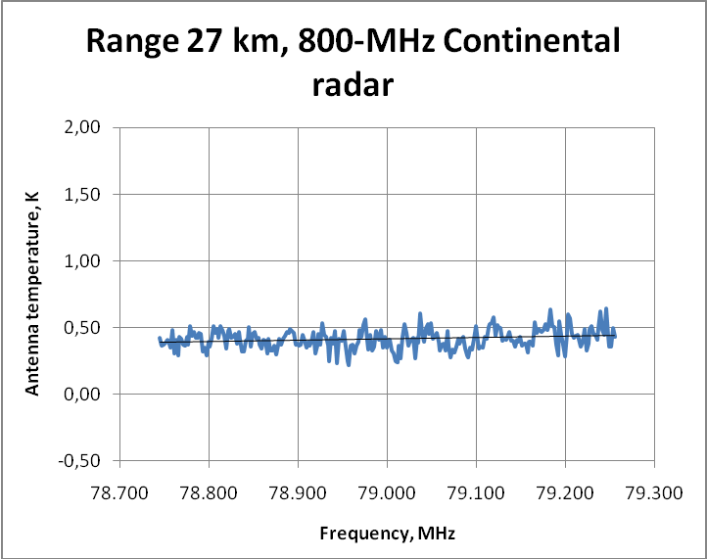

7 Summary of results
TABLE 8
Summary of measurements
Figure | Radar | Tb  peak  (K) | Tb  plateau  (K) | Prx  (dBm) | Meas.  range  (km) | Free  space loss (dB) | Atm.  Atten  (dB) | Pfd (dBW/m²) | Spfd (dBW/m²/MHz) | e.i.r.p.  (dBm) | Avoidance zone radius (km)
10 | Cont.200  Stationary | 5 982 | 968 | –86.4 | 1.7 | 135.0 | 0.3 | –92.8 | –115.1 | 13.0 | 39
11 | Bosch.WB  Stationary | – | 60.1 | –88.9 | 1.7 | 135.0 | 0.3 | –95.3 | –127.2 | 10.5 | 15
12 | Cont.200  Stationary | 3.08 | 0.68 | –118.0 | 26.9 | 159.0 | 4.0 | –124.4 | –146.7 | 9.2 | 30
13 | Cont.200  In motion | 6.36 | 1.07 | –116.0 | 26.9 | 159.0 | 4.0 | –122.4 | –144.7 | 11.2 | 34
14 | Cont.WB  In motion | – | 0.41 | –113.4 | 26.9 | 159.0 | 4.0 | –119.8 | –148.9 | 13.7 | 25
– | RA.769  1 MHz by spectral line threshold | – | – |  | – | – | – | – | –148 | – | –

Note to Table 8 – The following concern the column heads:
Figure: The Figure number in this Report, from which the data in each row of the Table were derived.
Radar: A description of the specific automotive radar. “Cont.” means the radar provided by the Continental Corporation, and “Bosch” by Robert Bosch GmbH. “200” means a nominal bandwidth of 200 MHz (in fact 170 MHz) and “WB” means the wideband radar with a nominal bandwidth of 800 MHz (Continental) or 1 550 MHz (Bosch).
Tb(peak): The antenna temperature in degrees K measured for the peak of emission found at 79.1 GHz, as seen within a 2-MHz filter channel. This is for reference, but is not used in the subsequent calculations.
Tb(plateau): The antenna temperature in degrees K measured for the plateau of emission, excluding any isolated peaks, as seen within 2-MHz filter channels. The remaining columns in this table are based on this plateau of emission, not on the stronger peak at 79.1 GHz.
Prx: The power received, dBm. Calculated from Tb plateau .k. B, with k Boltzman’s constant = 1.38.10⁻²³(J/K), and B the bandwidth in Hz. For “Cont 200” the bandwidth is 170 MHz, for Bosch WB 1 550 MHz, and for Cont.WB 800 MHz.
Meas. Range: The line-of-sight distance, in km, between the automotive radar and the receiver used for these measurements.
Free space loss: This is the attenuation introduced by the free-space Range (km) given in the adjacent column, for isotropic transmit and receive antennas. This is calculated from 20.log(4.π.d/λ), with d the distance in meters and λ the wavelength in meters, and does not include atmospheric attenuation.
Atm. Atten: This is the computed additional attenuation introduced by the atmosphere at this frequency, for the corresponding line-of-sight distance given in the “Range” column. A value of 0.15 dB/km is taken.
Pfd: This is the power flux density, integrated over the assumed transmitter bandwidth, of the total emission from the respective radar, at the receiver. Units dBW/m². This includes only the plateau of emission, not any isolated spikes within the spectrum. The receiver antenna gain of 35.8 dBi is taken into account in this calculation.
Spfd: The spectral power flux density at the receiver, in units of dBW/m2/MHz. This is derived from the previous column using (where possible) the measured bandwidth of emission, or by an assumed transmitter bandwidth.
The last line of the Table gives the threshold spfd for interference taken from Table 2 of Recommendation ITU-R RA.769-2, converting from “per Hz” into “per MHz” units.
e.i.r.p.: The derived effective isotropic radiated power (e.i.r.p.) at the transmitter, based on the received pfd shown in a previous column. Units of dBm. This is calculated from
e.i.r.p. = power_received + path loss + atmos.loss – recv_ant_gain, with
power_received from column 5 of this table,
path_loss from column 7,
atmos.loss from column 8,
and with recv_ant_gain = 35.8 dBi.
Avoidance zone radius: Obtained by scaling the 1.7-km or the 26.9-km measurements to give the minimum distance from the radio telescope that would be necessary for a single transmitter, mounted on a single vehicle, to give a level of interference at or below the threshold specified in Recommendation ITU-R RA.769, which is defined for a 0 dBi receiving antenna gain. In calculating the avoidance zone radius, an atmospheric attenuation of 0.15 dB/km has been added to the normal free space inverse square distance path loss. This distance is then calculated from the difference between the observed spfd (column 10, Table 8) and the Recommendation ITU-R RA.769 value for spfd (last row, column 10), with the corresponding distance corresponding to this differential loss taken from Fig. 15.
This is included purely for illustrative purposes. For multiple transmitters on a given vehicle, and for more than one vehicle in view of the telescope, the avoidance zone radius would be correspondingly increased. Mitigation factors such as any terrain shielding, orientation of the transmitter antenna with respect to the observatory, or attenuation of the transmitter if mounted behind the vehicle bumper have not been taken into account, and would tend to reduce the avoidance radius.
Figure 15
The extra propagation loss vs. distance, compared to a distance of 1.7 km (left) or 26.9 km (right),
including both inverse square of distance free space loss and 0.15 dB/km of atmospheric attenuation
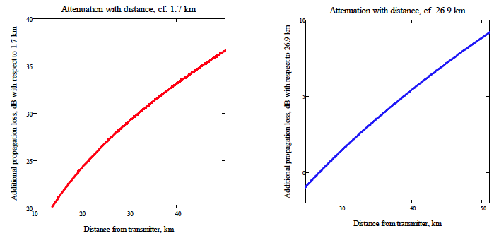

8 Comparison with Recommendation ITU-R RA.769
The measured values of Table 8 above can be compared to the threshold interference levels defined in Recommendation ITU-R RA.769. That Recommendation contains separate recommendations for the case of broadband interference (Table 1 of Recommendation ITU-R RA.769, “continuum”), or for narrow-band (Table 2 of Recommendation ITU-R RA.769, “spectral line”) interference. In the current context, allowing for the dilution of the 170-MHz or 1 550-MHz bandwidth of the interfering transmitter signal over the 8 GHz receiver bandwidth as defined in Recommendation ITU-R RA.769, the different interference thresholds are within a few dB of each other.

8.1 Spectral line threshold
First we consider the spectral line case. Table 2 of Recommendation ITU-R RA.769-2 gives a threshold level of interference detrimental to radio astronomy spectral-line observations in this frequency band of -208 dBW/m2/Hz, equivalent to –148 dBW/m²/MHz. As seen in Table 8 above, by chance most of the measurements described here give an spfd at a distance of 26.9 km within a few dB of this limit. The rightmost column of Table 8 above gives the necessary avoidance zone radius in order that the corresponding transmitter measured here does not produce an interference level at the radiotelescope in excess of the spectral line threshold defined in Recommendation ITU-R RA.769. Note this is purely for illustrative purposes, and applies to a single transmitter on a single vehicle.

8.2 Continuum threshold
The corresponding continuum spfd threshold interference level, taken from Recommendation ITU-R RA.769-2 Table 1, is –228 dBW/m²/Hz, equivalent to –168 dBW/m²/MHz. This is 20 dB more stringent than the spectral line case discussed above. However, the interfering emission in this case must be averaged over 8 GHz. For example, if emission from a single Continental 170-MHz bandwidth radar were diluted over 8 GHz, the average spfd per MHz would be reduced by 8 000/170 = 16.7 dB, which by chance is close to the 20 dB greater stringency of continuum interference threshold.
Note that, if there are several transmitters on a given vehicle on different frequencies, then although the spectral line threshold spfd (in any 1 MHz band) may remain unchanged, nevertheless the average spfd within an 8-GHz band, as defined by the Recommendation ITU-R RA.769 continuum threshold, would increase correspondingly. Table 9 summarizes the comparison between our measurements and the threshold for interference to continuum observations defined in Recommendation ITU-R RA.769-2.
TABLE 9
Comparison of the measurements with the spfd threshold of interference for continuum
observations, as defined in Table 1 of Recommendation ITU-R RA.769-2
Figure | Radar | Tb plateau (K) | Meas. range (km) | Atm. Atten (dB) | Transmitted bandwidth (MHz) | Spfd, diluted over  8 GHz band  (dBW/m²/MHz) | Avoidance zone radius  (km)
10 | Cont.200  Stationary | 968 | 1.7 | 0.3 | 170 | –131.8 | 48
11 | Bosch.WB  Stationary | 60.1 | 1.7 | 0.3 | 1 550 | –134.3 | 41
12 | Cont.200  Stationary | 0.68 | 26.9 | 4.0 | 170 | –163.4 | 38
13 | Cont.200  In motion | 1.07 | 26.9 | 4.0 | 170 | –161.4 | 43
14 | Cont.WB  In motion | 0.41 | 26.9 | 4.0 | 800 | –158.9 | 51
– | RA.769  8 GHz by continuum  threshold | – | – | – |  | –168 | –

Note to Table 8 – The following concern the Table heads:
Figure: The Figure number in this Report, from which the data in each row of the table were derived. Same as Table 8.
Radar: A description of the specific automotive radar. “Cont.” means the radar provided by the Continental Corporation, and “Bosch” by Robert Bosch GmbH. “200” means a nominal bandwidth of 200 MHz (in fact 170 MHz) and “WB” means the wideband radar with a nominal bandwidth of 800 MHz (Continental) or 1 550 MHz (Bosch). Same as Table 8.
Tb(plateau): The antenna temperature in degrees K measured for the plateau of emission, excluding any isolated peaks, as seen within 2-MHz filter channels. The remaining columns in this Table are based on this plateau of emission, not on the stronger peak at 79.1 GHz. Same as Table 8.
Meas. Range km: The line-of-sight distance, in km, between the automotive radar and the receiver used for these measurements. Same as Table 8.
Atm. Atten dB: This is the computed additional attenuation introduced by the atmosphere at this frequency, for the corresponding line-of-sight distance given in the “Range” column. A value of 0.15 dB/km is taken. Same as Table 8.
Transmitted bandwidth: This is the actual bandwidth occupied by the emissions from each transmitter. For multiple transmitters on different frequencies, this figure would have to be correspondingly increased.
Spfd, diluted over 8 GHz band: This is derived from the column Spfd in Table 8, but allowing for the dilution of the transmitted signal over the 8 GHz receiving band defined by Recommendation ITU-R RA.769. An amount 10.log(B/8000) is added to the values tabulated under Spfd in Table 8, with B corresponding to the bandwidth of the radar emission in MHz, given in column 6. The last row in this table contains the spfd threshold of –228 dBW/m2/Hz taken from Table 2 of Recommendation ITU-R RA.769-2, equivalent to 168 dBW/m2/MHz.
Avoidance Zone radius: Exactly as in Table 8, but for the Recommendation ITU-R RA.769 continuum threshold. This distance is calculated from the difference between the observed spfd given in column 7, Spfd diluted over 8 GHz, and the Recommendation ITU-R RA.769 value for continuum spfd threshold (last row, column 7), with the distances corresponding to this differential loss derived as before from Fig. 15.
As with Table 8, this is included purely for illustrative purposes. For multiple transmitters on a given vehicle, and for more than one vehicle in view of the telescope, the avoidance zone radius would be correspondingly increased. Mitigation factors such as any terrain shielding, orientation of the transmitter antenna with respect to the observatory, or attenuation of the transmitter if mounted behind the vehicle bumper have not been taken into account, and would tend to reduce the avoidance radius.

9 Estimated errors
Most of the received spectra were taken with the radar at a height of 1.6 m at a fixed location. Tests made with the vehicle moving over a paved surface in Sells resulted in an increase in signal strength of about 2 dB. This change was most likely the result of a change in the ground reflection which interferes with the signal via the direct path. For example, a ground reflection coefficient magnitude of 0.3 (–10 dB) results in a variation of about ± 2 dB depending on the reflection phase, which depends on the height of the radar and the elevation angle of the line of sight to the receiver.
Uncertainty in the atmospheric attenuation is another source of error. The 225 GHz “tipper” radiometer at the 12-M telescope was used to derive a zenith precipitable water vapour content of 4.3 mm, which corresponds to 11% relative humidity at 300 K. Using the curves of Shambayati the attenuation at 79 GHz is estimated to be 0.1 dB/km for the water vapour and 0.04 dB/km for the dry atmosphere for a total of 4 dB for the 26.9 km path. The uncertainty in this estimate is about ± 1 dB. Using the Recommendation ITU-R P.620, for a high dry site the total atmospheric attenuation would be about 0.135 dB/km, in good agreement with Shambavati. Another estimate was obtained by measuring the contribution of the atmosphere to the receiver noise. At an elevation of 3 degrees the atmosphere contributed 100 K which corresponds to 4.8 dB of attenuation. If we assume a scale height for the water of 2 km then the path length at 3 degrees is 38 km, so that the loss for a horizontal path of 26.9 km is estimated by this alternate method to be 3.5 dB.
The estimates of e.i.r.p. made at different distances are in quite good agreement. With the vehicle stationary, the estimated e.i.r.p. from 26.9 km of the plateau of emission from the Continental, 200-MHz radar is 9.2 dBm; however, the comparison with results when the vehicle were in motion suggest that this value may be artificially low, presumably because of ground reflections. With the vehicle in motion at 27 km, 11.2 dBm was derived (see Figs 12 and 13). At 1.7 km, the corresponding estimate (Fig. 10) is 13.0 dBm, some 1.8 dB greater. This difference of 1.8 dB might be attributable to an underestimate of atmospheric attenuation over the 27 km path, to different reflections from the road and nearby terrain, or to differences in orientation of the transmitter antenna with respect to the receiver at Kitt Peak. The elevation angle towards the Kitt Peak receiver from the 1.7 km distant site was approximately -6 degrees, while from the Sells airport was approximately +10 degrees. The spfd derived here from the measurements at a distance of 1.7 km of the Continental (170 MHz) radar was –9.3 dBm/MHz, while the manufacturer measured -9.0 dBm/MHz. Considering the possible sources of error, the agreement with the manufacturer’s data, and between the different measurements at different distances reported here, is considered to be very good.

10 Conclusions
The tests were performed with short range radar systems mounted outside the vehicle frame, operated at distances of 1.7 km and 26.9 km from the ARO 12 Meter Telescope. The tests demonstrated that these radars would have a significant impact on radio astronomy observations in the 77 to 81 GHz band. A zone of avoidance of about 30 to 40 km around the telescope would be needed in order to keep interference from a single vehicle below the threshold defined in Recommendation ITU-R RA.769-2. Recommendation ITU-R RA.1272-1 specifically recommends that such zones be established around mm-wave astronomical observatories, following the procedure outlined in Recommendation ITU-R RA.1031-2.
The units tested at Kitt Peak in October 2010 had e.i.r.p. of 9-11 dBm, 20-30 dB below the 77-81 GHz automotive radar characteristics subsequently published in Recommendation ITU-R M.2057 and reproduced in Table 1 of this Report, or 45 dB below the e.i.r.p. subsequently allowed on vehicles operating in the vicinity of Kitt Peak across the 76-81 GHz band (Table 2 of this Report).

References
[1] "Millimeter and Submillimeter Wavelength Radio Astronomy", John M. Payne, Proceedings of the IEEE, Vol. 77, No. 7, July 1989, pp 993 – 1017.
[2] See Fig 2 in: "A New Generation of SIS Receivers for Millimeter-Wave Radio Astronomy", John M. Payne, James W. Lamb, Jackie G. Cochran, and NancyJane Bailey, Member, IEEE, Proceedings of the IEEE, Vol. 82, No. 5, May 1994, pp 811 – 823.
[3] Shambayati, S., 2008: Atmosphere Attenuation and Noise Temperature at microwave frequencies, Chapter 6 in “Low-Noise Systems in the Deep Space Network”, by MacGregor S. Reid. Editor, John Wiley and Sons, Hoboken, New Jersey.
[4] Recommendation ITU-R P.620-6 – Propagation data required for the evaluation of coordination distances in the frequency range 100 MHz to 105 GHz
[5] Recommendation ITU-R RA.769-2 – Protection criteria used for radio astronomical measurements
[6] Recommendation ITU-R RA.1272-1 – Protection of Radio Astronomy Measurements above 60 GHz from Ground Based Interference
[7] Recommendation ITU-R RA.1031-2 – Protection of the Radio Astronomy Service in Frequency Bands shared with Other Services
[8] A.O. Benz, Quiet and slowly variable radio emissions from the sun. Landolt-Börnstein LB VI/4B 4.1.2.8 (2009).

https://www.iau.org/static/resolutions/IAU2015_English.pdf
http://www.cv.nrao.edu/php/splat/.
ECC Report 222: http://www.erodocdb.dk/doks/relation.aspx?docid=2530.
http://www.gb.nrao.edu/electronics/edtn/edtn219.pdf
https://www.fcc.gov/document/fcc-unlocks-new-airwaves-vehicular-radar-use-0.
There are 12 RAS facilities in the United States that currently observe in the 76-81 GHz band: the Arizona Radio Observatory, with facilities on Kitt Peak, and the National Radio Astronomy Observatory at Green Bank, West Virginia, as well as the ten VLBA stations.
http://www.gb.nrao.edu/electronics/edtn/edtn219.pdf.

