Report ITU-R M.2564-0
(11/2025)
M Series: Mobile, radiodetermination, amateur
and related satellite services
Studies regarding protection of radionavigation-satellite service receiving earth stations operating in the frequency bands 1 164-1 215 MHz, 1 215-1 300 MHz and 1 559-1 610 MHz from spurious emissions of IMT stations in the frequency bands below 3 GHz

Foreword
The role of the Radiocommunication Sector is to ensure the rational, equitable, efficient and economical use of the radio-frequency spectrum by all radiocommunication services, including satellite services, and carry out studies without limit of frequency range on the basis of which Recommendations are adopted.
The regulatory and policy functions of the Radiocommunication Sector are performed by World and Regional Radiocommunication Conferences and Radiocommunication Assemblies supported by Study Groups.

Policy on Intellectual Property Right (IPR)
ITU-R policy on IPR is described in the Common Patent Policy for ITU-T/ITU-R/ISO/IEC referenced in Resolution ITU-R 1. Forms to be used for the submission of patent statements and licensing declarations by patent holders are available from https://www.itu.int/ITU-R/go/patents/en where the Guidelines for Implementation of the Common Patent Policy for ITU-T/ITU-R/ISO/IEC and the ITU-R patent information database can also be found.

Series of ITU-R Reports
(Also available online at https://www.itu.int/publ/R-REP/en)
Series | Title
BO | Satellite delivery
BR | Recording for production, archival and play-out; film for television
BS | Broadcasting service (sound)
BT | Broadcasting service (television)
F | Fixed service
M | Mobile, radiodetermination, amateur and related satellite services
P | Radio-wave propagation
RA | Radio astronomy
RS | Remote sensing systems
S | Fixed-satellite service
SA | Space applications and meteorology
SF | Frequency sharing and coordination between fixed-satellite and fixed service systems
SM | Spectrum management
TF | Time signals and frequency standards emissions

Note: This ITU-R Report was approved in English by the Study Group under the procedure detailed in Resolution ITU-R 1.

Electronic Publication
Geneva, 2026
© ITU 2026
All rights reserved. No part of this publication may be reproduced, by any means whatsoever, without written permission of ITU.

REPORT ITU-R M.2564-0
Studies regarding protection of radionavigation-satellite service receiving earth stations operating in the frequency bands 1 164-1 215 MHz, 1 215-1 300 MHz and 1 559-1 610 MHz from spurious emissions of IMT stations in the frequency bands below 3 GHz
(Question ITU-R 217-2/4)
(2025)
TABLE OF CONTENTS
Page
1 Introduction 2
2 Glossary of abbreviations 3
3 Related Recommendations and Reports 3
4 Initial data 4
4.1 Unwanted emission limits for IMT systems in the range below 3 GHz 4
4.2 Protection criteria for RNSS receiving earth stations 5
4.3 Analysis of frequency arrangements for IMT systems in terms of the potential impact on the RNSS receiving stations 12
5 Typical impact scenarios of spurious emissions from IMT stations on the RNSS receiving stations frequency bands 23
6 Estimation of interference from spurious emissions created by IMT stations to RNSS receiving earth stations operating in the frequency bands 1 164-1 215 MHz, 1 215‑1 300 MHz and 1 559-1 610 MHz 24
6.1 Theoretical estimations 24
6.2 Experimental estimations of a sample IMT modem 29
7 Summary 32

1 Introduction
By the decisions of World Radiocommunication Conferences 2012 and 2015, the frequency bands 694-790 MHz, 790-862 MHz and 1 427-1 518 MHz were identified for International Mobile Telecommunication (IMT) on a global or regional basis. Also, in some countries the band 470-694 MHz was identified for IMT in accordance with relevant footnotes of the Radio Regulations (RR).
At the same time, global and regional satellite systems in the radionavigation-satellite service (RNSS) operate in the frequency bands below 3 GHz, subject to RR No. 4.10 to ensure freedom from harmful interference in the frequency bands 1 164-1 215 MHz, 1 215-1 300 MHz and 1 559-1 610 MHz for the reliable operation of the RNSS.
The frequency bands identified for IMT do not overlap by their main emissions with these RNSS frequency bands. However, unwanted emissions from IMT transmitters, including out-of-band and spurious emissions, can impact RNSS receiving earth stations operating in the frequency bands 1 164-1 215 MHz, 1 215-1 300 MHz and 1 559-1 610 MHz.
In the RNSS frequency band 1 559-1 610 MHz, impact of the second harmonic emissions of IMT stations that use the frequency bands 694-790 MHz and 790-862 MHz is possible, as well as impact of spurious emissions of IMT stations that use the frequency band 1 427-1 518 MHz (see Fig. 1).
Figure 1
Potential interference from IMT transmitters to RNSS receivers operating in the frequency band 1 559-1 610 MHz
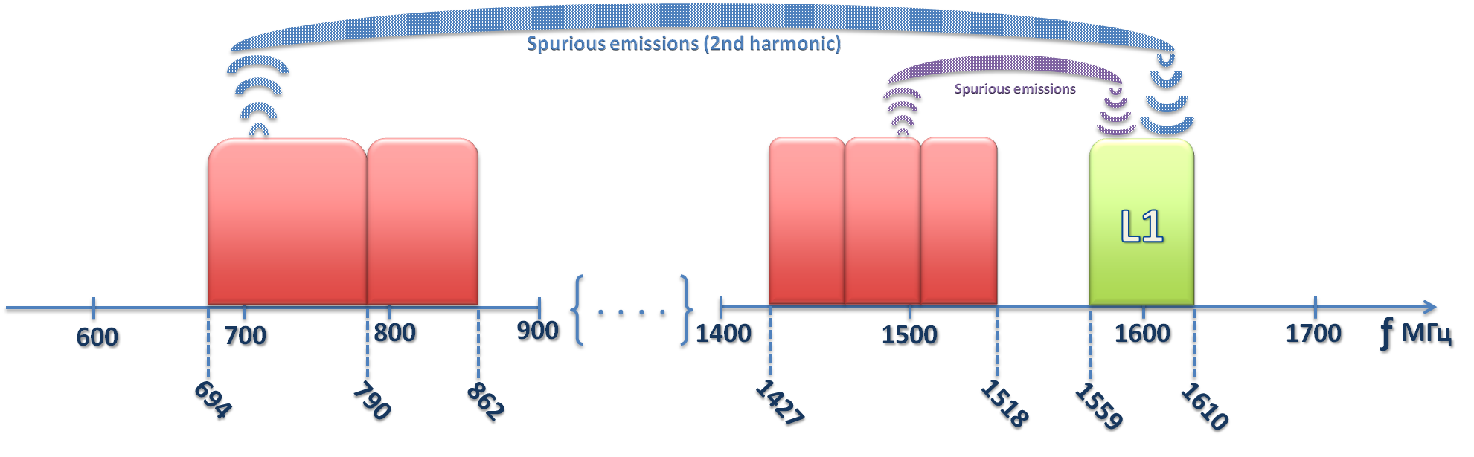
Potential impact to the RNSS frequency bands 1 164-1 215 MHz and 1 215-1 300 MHz could be produced by the second harmonic emissions of IMT stations operating in the frequency band 470-694 MHz and by spurious emissions of IMT stations operating in the frequency band 1 427-1 518 MHz (see Fig. 2).
Figure 2
Potential interference from IMT transmitters to RNSS receivers operating in the frequency range 1 164-1 300 MHz
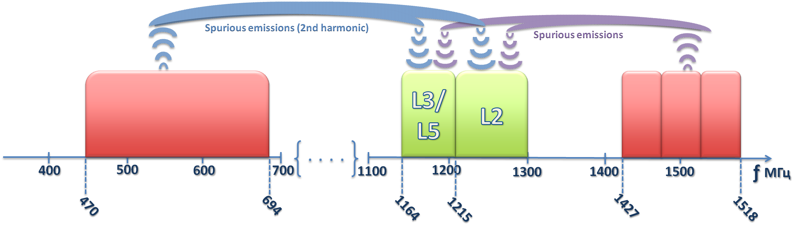
Results of the technical studies of potential spurious emissions from IMT stations to RNSS receiving earth stations operating in the frequency bands 1 164-1 300 MHz and 1 559-1 610 MHz are provided below. These studies were conducted for theoretical (specified in Recommendations ITU-R M.2070 and ITU-R M.2071) and for estimated levels of spurious emissions caused by a sample legacy IMT devices. However, it should be noted that out-of-band emissions from IMT equipment could also be of concern if IMT were to operate in frequency bands near (i.e. within 250% of the necessary bandwidth of the IMT) to those used by RNSS. Since IMT out-of-band emissions are higher than the assumed IMT spurious emissions, the results shown in § 6.1 would need to be revised (additional separation and/or attenuation required) if out-of-band emissions are considered.
The issue of protection of receiving earth stations in the radionavigation-satellite service operating in the frequency bands 1 164-1 215 MHz, 1 215-1 300 MHz and 1 559-1 610 MHz from spurious emissions of IMT stations in the frequency range below 3 GHz is global because both RNSS systems and IMT systems are worldwide and their usage is ubiquitous. The relevance of this issue increases dramatically, taking into account the general trend of “penetration” of technologies, as well as the users’ “mobility” for both the RNSS receiving equipment and the IMT systems transmitting equipment.

2 Glossary of abbreviations
IMT International mobile telecommunications
RNSS Radionavigation-satellite service

3 Related Recommendations and Reports
Recommendation ITU-R SM.329 – Unwanted emissions in the spurious domain
Recommendation ITU-R Р.525 – Calculation of free-space attenuation
Recommendation ITU-R M.1036 – Frequency arrangements for implementation of the terrestrial component of International Mobile Telecommunications (IMT) in the bands identified for IMT in the Radio Regulations (RR)
Recommendation ITU-R SM.1541 – Unwanted emissions in the out-of-band domain
Recommendation ITU-R M.1902 – Characteristics and protection criteria for receiving earth stations in the radionavigation-satellite service (space-to-Earth) operating in the band 1 215-1 300 MHz
Recommendation ITU-R M.1903 – Characteristics and protection criteria for receiving earth stations in the radionavigation-satellite service (space-to-Earth) and receivers in the aeronautical radionavigation service operating in the band 1 559-1 610 MHz
Recommendation ITU R M.1905 – Characteristics and protection criteria for receiving earth stations in the radionavigation-satellite service (space-to-Earth) operating in the band 1 164-1 215 MHz
Recommendation ITU-R M.2070 – Generic unwanted emission characteristics of base stations using the terrestrial radio interfaces of IMT-Advanced
Recommendation ITU-R M.2071 – Generic unwanted emission characteristics of mobile stations using the terrestrial radio interfaces of IMT-Advanced
Report ITU-R M.2458 – Radionavigation-satellite service applications in the 1 164-1 215 MHz, 1 215‑1 300 MHz and 1 559-1 610 MHz frequency bands

4 Initial data

4.1 Unwanted emission limits for IMT systems in the range below 3 GHz
The unwanted emission limits for mobile stations of IMT systems are established in Recommendations ITU-R M.2071 and ITU-R M.2070 for IMT base stations. Subject to these Recommendations for IMT systems operating in the frequency bands below 3 GHz, the unified limit of spurious emissions for IMT mobile and base stations as well is defined: −30 dBm/MHz (−60 dBW/MHz) (see Fig. 3). As these are the only formal, internationally recognized limits, the spurious emission levels of IMT stations provided in those Recommendations are used in the RNSS theoretical studies below. Measurements were also conducted to determine spurious levels of actual IMT equipment in relation to the levels contained in those Recommendations.
In spite of the fact that the spurious emission limits are defined as identical for IMT mobile and base stations, the interference from only IMT mobile stations are considered as this interference scenario is more likely and difficult to control.
Figure 3
Spurious emission limits for IMT systems below 3 GHz
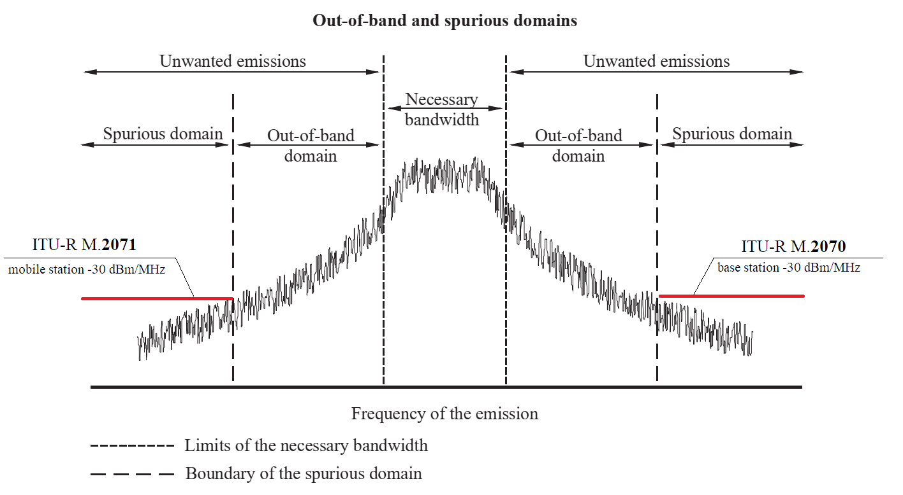
Finally, though these studies indicated potential interference into RNSS receiving earth stations, it should also be recognized that a number of administrations impose more stringent unwanted emission limits on IMT in order to protect RNSS, thereby reducing the risk of harmful interference. For example, some administrations have imposed license requirements that restrict unwanted emissions in the 1 559-1 610 MHz band for some mobile stations to levels of −95 dBW/MHz. Taking this into account, these studies should be used to assist administrations which may need detailed technical and regulatory information regarding the protection of RNSS.

4.2 Protection criteria for RNSS receiving earth stations
Protection criteria for RNSS receiving earth stations in the frequency ranges L1 (the frequency band 1 559-1 610 MHz), L2 (the frequency band 1 215-1 300 MHz) and L3/L5 (the frequency band 1 164‑1 215 MHz) are provided in Recommendations ITU-R M.1902, ITU-R M.1903 and ITU-R M.1905 in Tables 1, 2 and 3.

TABLE 1
General technical characteristics and protection criteria for RNSS receivers (space-to-Earth) operating in the frequency band 1 164-1 215 MHz (Table 1 of Recommendation ITU-R M.1905-1)

 | 1 | 2 |  | 3 |  |  | 4 |  |  | 5
Parameter | Air-navigation receiver No. 1 | Aeronautical navigation receiver No. 2 |  | High-precision receivers |  |  | Indoor positioning receivers |  |  | General purpose receivers
Signal frequency range (MHz) | 1 176.45 ± 12 | 1 204.704 + 0.423K ± 4.095, where K = −7, …, + 12  (Note 6) | 1 202.025 ± 10.25 | 1 176.45 ± 12 | 1 204.704 + 0.423K ± 4.095, where K = −7, …, + 12 | 1 202.025 ± 10.25 | 1 176.45 ± 12 | 1 204.704 + 0.423K ± 4.095, where K = −7, …, +12 | 1 202.025 ± 10.25 | 1 207.14 ± 12  1 176.45 ± 12 | 1 204.704 + 0.423K ± 4.095, where K = −7, …, +12 | 1 202.025 ± 10.25
Maximum receiver antenna gain in upper hemisphere (dBi) | +6 (circular)  (Note 1) | 7 (circular)  (Note 5) |  | 3 (circular) |  |  | 3 |  |  | 3
Tracking mode threshold power density level of aggregate wideband interference at the passive antenna output (dB(W/MHz)) | −144.8  (Notes 2, 3) | −140  (Note 7) |  | −147.4 |  |  | −150 |  |  | −140
Acquisition mode threshold power density level of aggregate wideband interference at the passive antenna output (dB(W/MHz)) | −148.7  (Notes 2, 4) | −146  (Note 7) |  | −147.4 |  |  | −156 |  |  | −146

Notes to Table 1:
Note 1 − The maximum upper hemisphere receiver RHCP antenna gain applies for an elevation angle of 90 degrees with respect to the antenna horizontal plane.
Note 2 − When used in the Rec. ITU-R M.1318-1 interference evaluation model, the threshold value is inserted in Line (a) and 6 dB (the safety margin, as described in Annex 1) is inserted in Line (b) of the evaluation template.
Note 3 − The continuous RFI threshold value applies to airborne receiver operations above 6 096 m (20 000 feet) altitude above MSL. The tracking mode values for airborne operations below 610 m (2 000 feet) altitude above ground level are −143.0 dBW (narrow-band) and −133.0 dB (W/MHz) (wideband).
Note 4 − The continuous RFI threshold value applies to airborne receiver operations above 6 096 m (20 000 feet) altitude above MSL. The acquisition mode values for airborne operations below 610 m (2 000 feet) altitude above ground level are −143.1 dBW (narrow-band) and −133.1 dB (W/MHz) (wideband).
Note 5 − The input saturation level is for power in the 20 MHz pre-correlator bandwidth.
Note 6 − This receiver type operates on several carrier frequencies simultaneously. The carrier frequencies are defined by fc (MHz) = 1 204.704 + 0.423K, where K = −7 to +12 (RNSS signals).
Note 7 − This threshold should account for all aggregate interference. The threshold value does not include any safety margin. For FDMA or CDMA (carrier frequency 1 202.025 MHz) signal processing, narrow-band continuous interference is considered to have a bandwidth less than 1 kHz. Wideband continuous interference is considered to have a bandwidth greater than 500 kHz. Thresholds for interference bandwidths between 1 kHz and 500 kHz may require further study.

TABLE 2
General technical characteristics and protection criteria for RNSS receivers (space-to-Earth) operating in the frequency band 1 215-1 300 MHz (Table 1 of Recommendation ITU-R M.1902-2)
 | 1 | 2 | 3 | 3a | 3b | 4 |  | 5 |  |  |  | 6
Parameter | SBAS ground reference receiver* | High-precision semi-codeless receiver* | High-precision receiver using L2C* | High-precision receiver using B3 and B3A | High-accuracy and authentication receiver using E6-BC/L6 | Air-navigation receiver  (Note 10) |  | Indoor positioning |  |  |  | General purpose
Signal frequency range (MHz) | 1 227.6 ± 15.345 | 1 227.6 ± 15.345 | 1 227.6 ± 15.345 | 1 268.52 ± 12 | 1 278.75 ± 21 | 1 246 + 0.4375K ± 5.11,  where K = −7, …, +6 | 1 248.06 ± 7.7 | 1 227.6 ± 12 | 1 246 + 0.4375K ± 5.11, where K = −7, …, +6 | 1 248,06 ± 7.7 | 1 268.52 ± 12 | 1 227.6 ± 12 | 1 246 + 0.4375K ± 5.11, where K = −7, …, +6 | 1 248.06 ± 7.7 | 1 268.52 ± 12
Maximum receiver antenna gain in upper hemisphere (dBi) | −2.0  circular  (Note 3) | 3.0  circular | 3.0  circular | 3.0  circular | 3.0  circular | 7  circular  (Note 5) |  | 6 |  |  | 3 | 6 |  |  | 3
Tracking mode threshold power density level of aggregate wideband interference at the passive antenna output (dB(W/MHz)) | −147.5  (P(Y))  (Note 1) | −147.4  (P(Y))  (Note 1) | −147.4  (P(Y))  (Note 1) | −147.4  (Note 2) | −140  (Note 6) | −140 |  | −150 |  |  | −145  (Note 2) | −139  (Note 1) |  |  | −140  (Note 2)
Acquisition mode threshold power density level of aggregate wideband interference at the passive antenna output (dB(W/MHz)) | −147.4  (Note 4) | −147.4  (Note 5) | −147.4  (Note 1) | −147.4  (Note 2) | −147.4  (Note 7) | −146 |  | −156 |  |  | −151  (Note 2) | −145  (Note 1) |  |  | −146  (Note 2)

Notes to Table 2:
* These table columns cover characteristics and thresholds for receivers that operate in the band 1 559-1 610 MHz. (CDMA receivers of this type operate with the signals described in Annex 2 to Recommendation ITU-R М.1787.) For characteristics and thresholds for receivers that also acquire and track RNSS signals in the 1 215-1 300 MHz and/or 1 164-1 215 MHz bands, refer also to Recommendations ITU-R M.1903 and/or ITU-R M.1905.
Note 1 – For P(Y) signal processing, including that using semi-codeless techniques, narrow-band interference is considered to have less than a 100 kHz bandwidth and wideband interference has greater than a 1 MHz bandwidth. For L2C signal processing, narrow-band interference is considered to have less than a 1 kHz bandwidth and wideband interference has greater than a 1 MHz bandwidth. For FDMA and CDMA (carrier frequency 1 248.06 MHz) signals processing, narrow-band continuous interference is considered to have less than a 1 kHz bandwidth, and wideband continuous interference is considered to have greater than a 500 kHz bandwidth. Thresholds for interference bandwidths between 100 kHz (for P(Y)) or 1 kHz (for L2C and FDMA/CDMA (carrier frequency 1 248.06 MHz)) to 1 MHz (or for FDMA to 500 kHz) are undefined and may require further study.
Note 2 – Narrow-band continuous interference is considered to have a bandwidth less than 700 Hz. Wideband continuous interference is considered to have a bandwidth greater than 1 MHz. Thresholds for interference bandwidths between 700 Hz and 1 MHz may require further study.
Note 3 – The listed maximum upper hemisphere gain value applies for 30 degrees elevation (i.e. maximum expected RFI arrival angle). The listed maximum lower hemisphere gain value applies for 5 degrees elevation.
Note 4 – Signal acquisition is performed using the L1 C/A signal. See the appropriate acquisition threshold row in Rec. ITU-R M.1903 Annex 2, Table 2-2, “SBAS Ground Reference Receiver” column.
Note 5 – Minimum receiver antenna gain at 5 degrees elevation angle is −5.5 dBiс.
Note 6 – Narrow-band continuous interference is considered to have a bandwidth less than 128 kHz. Wideband continuous interference is considered to have a bandwidth greater than 1 MHz. Thresholds for interference with a bandwidth between 128 kHz and 1 MHz may require further study.
Note 7 – For E6-BC, signal acquisition is performed using the E1-BC signal. See the appropriate acquisition threshold row in Rec. ITU-R M.1903 Annex 2, Table 2-2, “High-precision” column. For L6 signal, some receivers perform signal acquisition using the signals in L1 band and other receivers are expected to have 6 dB smaller threshold for the acquisition mode than for the tracking mode.

TABLE 3
General technical characteristics and protection criteria for RNSS receivers (space-to-Earth) operating in the frequency band 1 559-1 610 MHz (Table 2 of Recommendation ITU-R M.1903-1)
 | 1 | 2 | 3 | 4 | 5 | 6 |  | 7 | 8 |  |  | 9 | 10 |  |  | 11
Parameter | SBAS  Category I  Type 1 | SBAS  Category I  Type 2 | GBAS  Category  II/III  Type 1 | GBAS  Category  II/III  Type 2 | SBAS ground reference receiver* | Air-navigation precision approach receiver |  | A-RNSS | General-purpose No. 1 |  |  | General-purpose No. 2 | Indoor  positioning |  |  | High-precision* (Note 11)
Signal frequency range (MHz) | 1 575.42 ± 15.345 | 1 602 + 0.5625K ± 5.11, where  K = −7, …, +6  and  1 602 + 0.5625N ± 0.511, where  N = +7, …, +12 (Note 8) | 1 575.42 ± 15.345 | 1 602 + 0.5625K ± 5.11,  where K = −7, …, +6  and  1 602 + 0.5625N ± 0.511, where  N = −12, …, −8 (Note 11) | 1 575.42 ± 15.345 | 1 602 + 0.5625K ± 5.11,  where K = −7, …, +6 (Note 13) | 1600.995 ± 7.7 | 1 575.42 ± 15.345 | 1 575.42 ± 12 | 1 602 + 0.5625K ± 5.11,  where K = −7, …, +6 | 1600.995 ± 7.7 | 1 561.098  ± 2.046  1 589.742  ± 2.046 | 1 575.42 ± 12 | 1 602 + 0.5625K ± 5.11,  where K = −7, …, +6 | 1 600.995 ± 7.7 | 1 575.42 ± 15.345 | 1 602 + 0.5625K ± 5.11,  where K = −7, …, +6 | 1 600.995 ± 7.7
Maximum receiver antenna gain in upper hemisphere (dBi) | +3.0 (circular)  (Note 5) | +7  (circular)  (Note 9) | +3.0 (circular)  (Note 5) | +7 (circular)  (Notes  9 and 12) | −2.0 (circular)  (Note 6) | +7  (circular)  (Note 9) |  | 0.0 | 6 |  |  | 3 | 6 |  |  | +3.0
Tracking mode threshold power density level of aggregate wideband interference at the passive antenna output (dB(W/MHz)) | −140.5  (Notes  1 and 2) | −140  (Notes  3 and 10) | −140.5  (Notes  1 and 2) | −140  (Notes  3 and 10) | −146.0  (Note 7) | −140  (Notes  3 and 10) |  | −146.9  (Note 2) | −136  (Note 2, CDMA) (Note 3, FDMA and CDMA (carrier frequency 1 600.995 MHz)) |  |  | −140  (Note 4) | −142  (Note 2, CDMA) (Note 3, FDMA and CDMA (carrier frequency  1 600.995 MHz)) |  |  | −147.4  (Notes 2 and 3)
Acquisition mode threshold power density level of aggregate wideband interference at the passive antenna output (dB(W/MHz)) | −146.5 | −146 | −146.5 | −146 | −147.4 | −146 |  | −146.9 | −142 |  |  | −146 | −148 |  |  | −147.4  (Notes 2 and 3)

Notes to Table 3:
* These table columns cover characteristics and thresholds for receivers that operate in the band 1 559-1 610 MHz. (CDMA receivers of this type operate with the signals described in Annex 2 to Recommendation ITU-R М.1787.) For characteristics and thresholds for receivers that also acquire and track RNSS signals in the 1 215-1 300 MHz and/or 1 164-1 215 MHz bands, refer also to Recommendations ITU-R M.1903 and/or ITU-R M.1905.
Note 1 – When used in the Rec. ITU-R M.1318-1 interference evaluation model, the threshold value is inserted in Line (a) and 6 dB (the safety margin) is inserted in Line (b) of the evaluation template.
Note 2 – Narrow-band continuous interference is considered to have a bandwidth less than 700 Hz. Wideband continuous interference is considered to have a bandwidth greater than 1 MHz. Thresholds for interference bandwidths between 700 Hz and 1 MHz. These values are for L1 C/A code and not intended for use in environments with significant pulsed interference.
Note 3 – For FDMA and CDMA (carrier frequency 1 600.995 MHz) signal processing, narrow-band continuous interference is considered to have a bandwidth less than 1 kHz. Wideband continuous interference is considered to have a bandwidth greater than 500 kHz.
Note 4 – Narrow-band continuous interference is considered to have a bandwidth less than 700 Hz. Wideband continuous interference is considered to have a bandwidth greater than 1 MHz.
Note 5 – The maximum upper hemisphere receiver RHCP antenna gain applies for an elevation angle of 75 degrees or more with respect to the antenna horizontal plane.
Note 6 – The listed maximum upper hemisphere gain value applies for 30 degrees elevation (maximum expected RFI arrival angle). The listed maximum lower hemisphere gain value applies for 5 degrees elevation.
Note 7 – The tracking values apply to the L1 SBAS signal. Tracking thresholds are based upon FAA Specification FAA-E-2892B, Modification No. 0012. The acquisition values apply to the L1 C/A signal with an I/N of −6 dB. Continuous interference bandwidth limits for narrow-band and wideband thresholds are 700 Hz (max.) and 1 MHz (min.), respectively. Thresholds for interference bandwidths between these limits are not specified and may require further study.
Note 8 – This receiver type operates on several carrier frequencies simultaneously. The carrier frequencies are defined by fc (MHz) = 1 602 + 0.5625K, where
K = −7, ..., +6 (RNSS signals) and fc (MHz) = 1 602 + 0.5625N, where N = +7, ..., +12 (SBAS signals).
Note 9 – Minimum receiver antenna gain at 5 degrees elevation angle is −5.5 dBic.
Note 10 – This threshold should account for all aggregate interference. The threshold value does not include any safety margin.
Note 11 – This receiver type operates on several carrier frequencies simultaneously. The carrier frequencies are defined by fc (MHz) = 1 602 + 0.5625K, K = −7, ..., +6 (RNSS signals) and fc (MHz) = 1 602 + 0.5625N, where N = −12, ..., −8 (ARNS signals).
Note 12 – Minimum receiver antenna gain at 5 degrees elevation angle is −21 dBi (ARNS signals).
Note 13 – This receiver type operates on several carrier frequencies simultaneously. The carrier frequencies are defined by fc (MHz) = 1 602 + 0.5625K, where
K = −7 to +6. Navigation receivers manufactured before 2006 can operate with navigation signals having carrier frequency numbers (К) −7 to +12.

4.3 Analysis of frequency arrangements for IMT systems in terms of the potential impact on the RNSS receiving stations
Currently, section 3 of Recommendation ITU-R M.1036 contains the following frequency arrangements in 610-960 MHz band for IMT systems:
Table 4
Frequency arrangements in the band 610-960 MHz for IMT systems from Recommendation ITU-R M.1036
Frequency arrangements | Paired arrangements |  |  |  | Un-paired arrangements  (e.g. for TDD)  (MHz)
Frequency arrangements | Mobile station  transmitter  (MHz) | Centre gap  (MHz) | Base station  transmitter  (MHz) | Duplex separation  (MHz) | Un-paired arrangements  (e.g. for TDD)  (MHz)
A1 | 824-849 | 20 | 869-894 | 45 | None
A2 | 880-915 | 10 | 925-960 | 45 | None
A3 | 832-862 | 11 | 791-821 | 41 | None
A4 | 698-716  776-793 | 12  13 | 728-746  746-763 | 30  30 | 716-728
A5 | 703-748 | 10 | 758-803 | 55 | None
A6 | None | None | None |  | 698-806
A7 | 703-733 | 25 | 758-788 | 55 | None
A8 | 698-703 | 50 | 753-758 | 55 | None
A9 | 733-736 | 52 | 788-791 | 55 | None
A10 | External | – | 738-758 | – | None
A11 (harmonized with A7 and A10) | 703-733  External | 25  – | 758-788  738-758 | 55  – | None
A12 | 663-698 | 11 | 617-652 | 46 | None
A13 | 663-703 | 11 | 612-652 | 51 | None

Analysis of the IMT systems frequency arrangements for which bands of the radio navigation satellite service fall into the spurious emissions of the second harmonic is presented in Table 5.

Table 5
An analysis of the IMT systems frequency arrangements for which bands of the radionavigation satellite service fall into the spurious emissions of the second harmonic is presented from Recommendation ITU-R M.1036
Frequency arrangements | Paired arrangements |  |  |  | Un-paired arrangements  (e.g. for TDD)  (MHz) | Frequencies of spurious emissions of the IMT systems second harmonic that fall into the frequency bands of RNSS systems  (MHz)
Frequency arrangements | Mobile station  transmitter  (MHz) | Centre gap  (MHz) | Base station  transmitter  (MHz) | Duplex separation  (MHz) | Un-paired arrangements  (e.g. for TDD)  (MHz) | 1 164-1 215 | 1 215-1 300 | 1 559-1 610
A1 | 824-849 | 20 | 869-894 | 45 | None | – | – | –
A2 | 880-915 | 10 | 925-960 | 45 | None | – | – | –
A3 | 832-862 | 11 | 791-821 | 41 | None | – | – | 1 582-1 610
A4 | 698-716  776-793 | 12  13 | 728-746  746-763 | 30  30 | 716-728 | – | – | 1 559-1 586
A5 | 703-748 | 10 | 758-803 | 55 | None | – | – | 1 559-1 606
A6 | None | None | None |  | 698-806 | – | – | 1 559-1 610
A7 | 703-733 | 25 | 758-788 | 55 | None | – | – | 1 559-1 576
A8 | 698-703 | 50 | 753-758 | 55 | None | – | – | –
A9 | 733-736 | 52 | 788-791 | 55 | None | – | – | 1 576-1 582
A10 | External | – | 738-758 | – | None | – | – | –
A11 (harmonized with A7 and A10) | 703-733  External | 25  – | 758-788  738-758 | 55  – | None | – | – | 1 559-1 576
A12 | 663-698 | 11 | 617-652 | 46 | None | – | 1 234-1 300 | –
A13 | 663-703 | 11 | 612-652 | 51 | None | – | 1 224-1 300 | –
Note to Table 5: The shadowed frequencies correspond to the IMT systems frequency bands which, by their second-harmonic spurious emissions, do not fall into the frequency bands of RNSS systems. The non-shadowed frecuencies correspond to the IMT systems frequency bands which, by their second-harmonic spurious emissions, fall into the frequency bands of RNSS systems.

Based on the analysis presented above, it can be concluded that currently only four frequency arrangements out of 13 do not fall into the RNSS frequency bands with their second-harmonic spurious emissions (frequency arrangements A1, A2, A8, A10). The remaining nine frequency arrangements with their second-harmonic spurious emissions fall into the RNSS frequency bands, while the seven frequency arrangements with their second-harmonic spurious emissions fall within the 1 559-1 610 MHz frequency band (frequency arrangements A3, A4, A5, A6, A7, A9 and A11) and the two frequency arrangement with their second-harmonic spurious emissions fall within the 1 215-1 300 MHz frequency band (frequency arrangement A12 and A13).
It should also be noted that only two frequency arrangements (frequency arrangements A4 and A6) produce spurious emissions by the IMT user equipment out of nine frequency arrangements which fall into the RNSS frequency bands with their spurious emissions of the second harmonic.
Thus, it can be stated that currently the frequency arrangements, which fall into the frequency bands of the RNSS systems by their second-harmonic spurious emissions, affect only the RNSS frequency band 1 559-1 610 MHz.
Based on the ITU BR satellite services database (06.08.2024), summarized information on the affected RNSS satellite systems and networks is presented below for each frequency arrangement of IMT systems (frequency arrangements A3, A4, A5, A6, A7, A9, A11, A12, A13), which by its second-harmonic spurious emissions falls into the RNSS frequency bands (see Figs 4 to 9).
FIGURE 4
Information on RNSS satellite systems and networks in the frequency band 1 582-1 610 MHz affected by the IMT A3 frequency arrangement
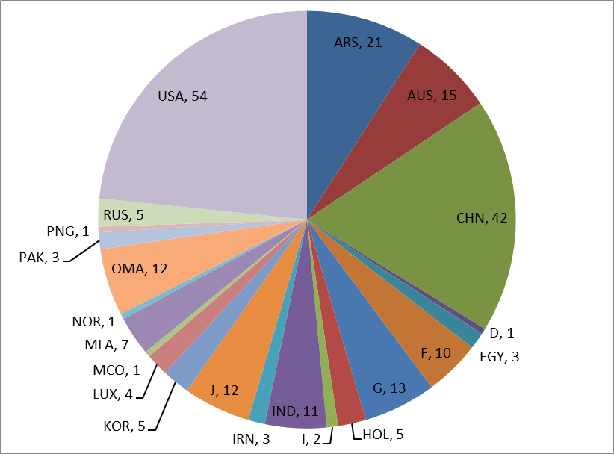
FIGURE 5
RNSS satellite systems and networks that was brought into use in the frequency band 1 582-1 610 MHz
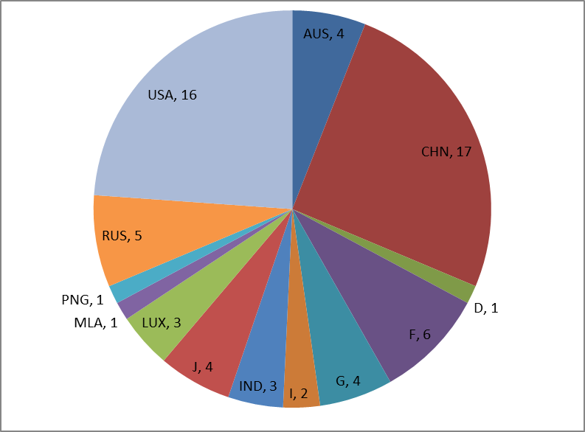
Note to Fig. 5: ARS – Saudi Arabia (Kingdom); AUS – Australia; CHN – China (People’s Republic); D – Germany (Federal Republic); EGY – Egypt; F – France; G – United Kingdom of Great Britain and Northern Ireland; HOL – the Netherlands (Kingdom); I – Italy; IND – India (Republic); IRN – Iran (Islamic Republic of); J – Japan; KOR – Korea (Republic); LUX – Luxembourg; MCO – Monaco (Principality of); MLA – Malaysia; NOR – Norway; OMA – Oman (Sultanate of); PAK – Pakistan (Islamic Republic of); PNG – Papua New Guinea; RUS – Russian Federation; USA – United States of America.
Analysis of the data presented in Figs 4 and 5 shows that 231 RNSS satellite networks from 22 administrations can be affected by the IMT A3 frequency arrangement. At the same time, 67 out of 231 RNSS satellite networks confirmed the date of bringing into use.
FIGURE 6
Information on RNSS satellite systems and networks in the frequency band 1 559-1 586 MHz, 1 559-1 576 MHz,
1 559-1 576 MHz affected by the IMT A4, A7 and A11 frequency arrangements respectively
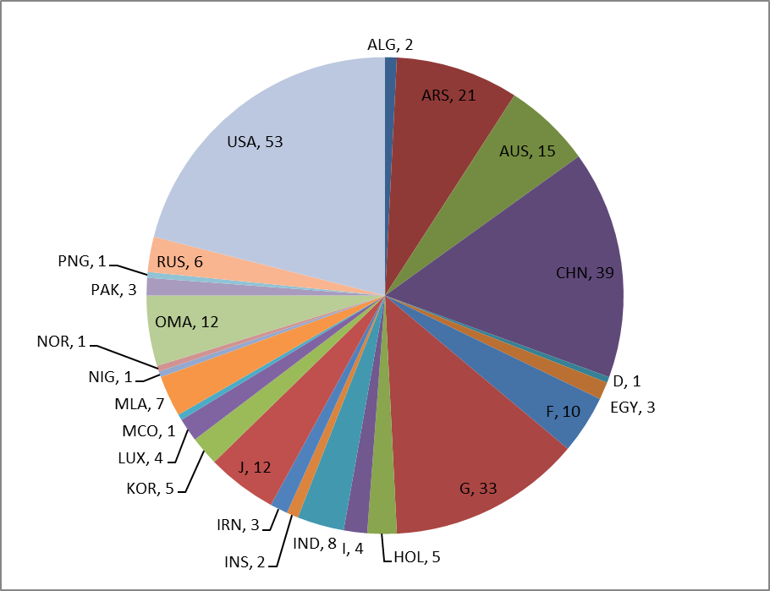
FIGURE 7
RNSS satellite systems and networks that was brought into use in the frequency band 1 559-1 586 MHz
and 1 559-1 576 MHz
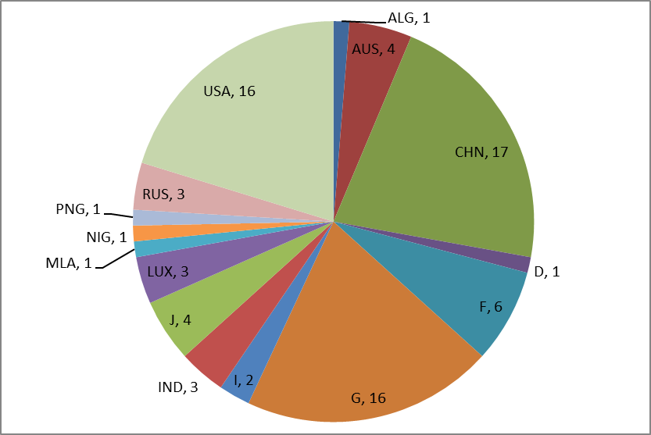
Note to Figs 6 and 7: ALG – Algerian People’s Democratic Republic; ARS – Saudi Arabia (Kingdom); AUS – Australia; CHN – China (People’s Republic); D – Germany (Federal Republic); EGY – Egypt; F – France; G – United Kingdom of Great Britain and Northern Ireland; HOL – the Netherlands (Kingdom); I – Italy; IND – India (Republic); INS – Indonesia (Republic of); IRN – Iran (Islamic Republic of); J – Japan; KOR – Korea (Republic); LUX – Luxembourg; MCO – Monaco (Principality of); MLA – Malaysia; NIG – Nigeria (Federal Republic); NOR – Norway; OMA – Oman (Sultanate of); PAK – Pakistan (Islamic Republic of); PNG – Papua New Guinea; RUS – Russian Federation; USA – United States of America.
Analysis of the data presented in Figs 6 and 7 shows that 252 RNSS satellite networks from 25 administrations can be affected by the IMT A4, А7 and А11 frequency arrangements. At the same time, 79 out of 252 RNSS satellite networks confirmed the date of bringing into use.
FIGURE 8
Information on RNSS satellite systems and networks in the frequency band 1 559-1 606 MHz and
1 559-1 610 MHz affected by the IMT A5 and A6 frequency arrangements respectively
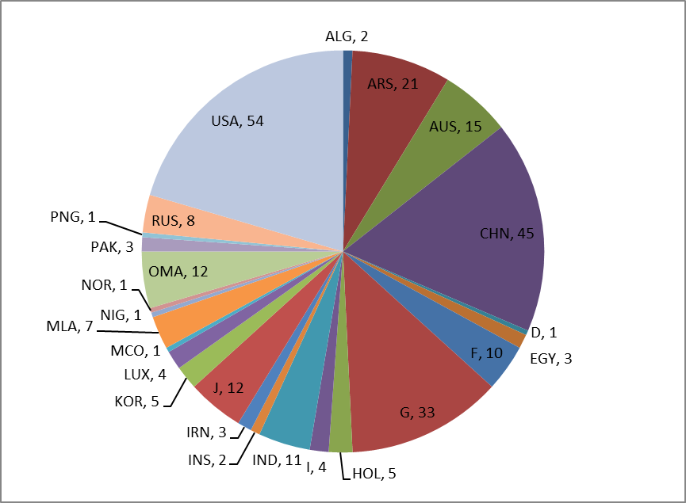
FIGURE 9
RNSS satellite systems and networks that was brought into use in the frequency band
1 559-1 606 MHz and 1 559-1 610 MHz
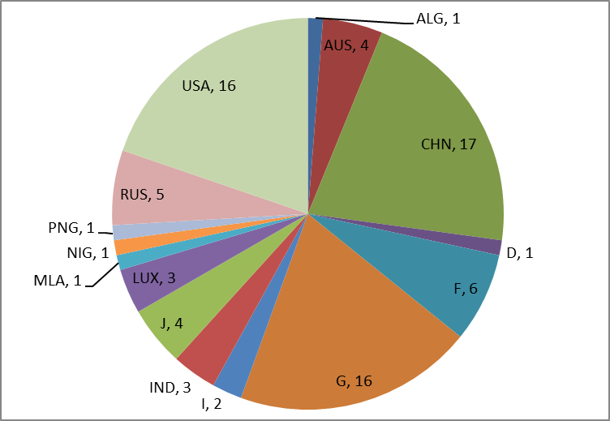
Note to Figs 8 and 9: ALG – Algerian People’s Democratic Republic; ARS – Saudi Arabia (Kingdom); AUS – Australia; CHN – China (People’s Republic); D – Germany (Federal Republic); EGY – Egypt; F – France; G – United Kingdom of Great Britain and Northern Ireland; HOL – the Netherlands (Kingdom); I – Italy; IND – India (Republic); INS – Indonesia (Republic of); IRN – Iran (Islamic Republic of); J – Japan; KOR – Korea (Republic); LUX – Luxembourg; MCO – Monaco (Principality of); MLA – Malaysia; NIG – Nigeria (Federal Republic); NOR – Norway; OMA – Oman (Sultanate of); PAK – Pakistan (Islamic Republic of); PNG – Papua New Guinea; RUS – Russian Federation; USA – United States of America.
Analysis of the data presented in Figs 8 and 9 shows that 264 RNSS satellite networks from 25 administrations can be affected by the IMT A5 and А6 frequency arrangements. At the same time, 81 out of 264 RNSS satellite networks confirmed the date of bringing into use.
FIGURE 10
Information on RNSS satellite systems and networks in the frequency band 1 576-1 582 MHz affected
by the IMT A9 frequency arrangement
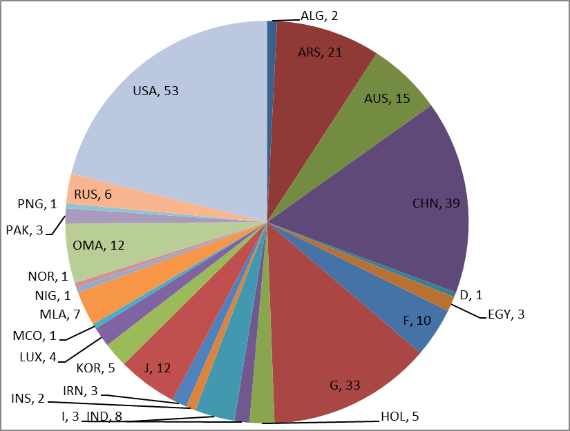
FIGURE 11
RNSS satellite systems and networks that was brought into use in the frequency band 1 576-1 582 MHz
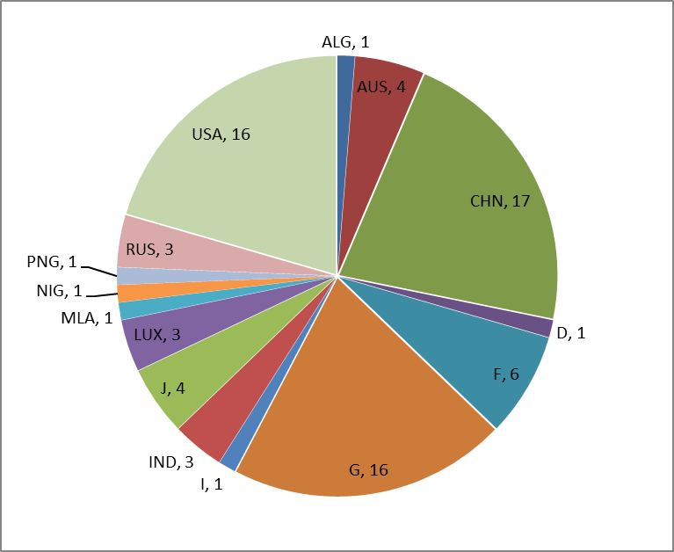
Note to Figs 10 and 11: ALG – Algerian People’s Democratic Republic; ARS – Saudi Arabia (Kingdom); AUS – Australia; CHN – China (People’s Republic); D – Germany (Federal Republic); EGY – Egypt; F – France; G – United Kingdom of Great Britain and Northern Ireland; HOL – the Netherlands (Kingdom); I – Italy; IND – India (Republic); INS – Indonesia (Republic of); IRN – Iran (Islamic Republic of); J – Japan; KOR – Korea (Republic); LUX – Luxembourg; MCO – Monaco (Principality of); MLA – Malaysia; NIG – Nigeria (Federal Republic); NOR – Norway; OMA – Oman (Sultanate of); PAK – Pakistan (Islamic Republic of); PNG – Papua New Guinea; RUS – Russian Federation; USA – United States of America.
Analysis of the data presented in Figs 10 and 11 shows that 251 RNSS satellite networks from 25 administrations can be affected by the IMT А9 frequency arrangement. At the same time, 78 out of 251 RNSS satellite networks confirmed the date of bringing into use.
FIGURE 12
Information on RNSS satellite systems and networks in the frequency band 1 234-1 300 MHz affected
by the IMT A12 frequency arrangement
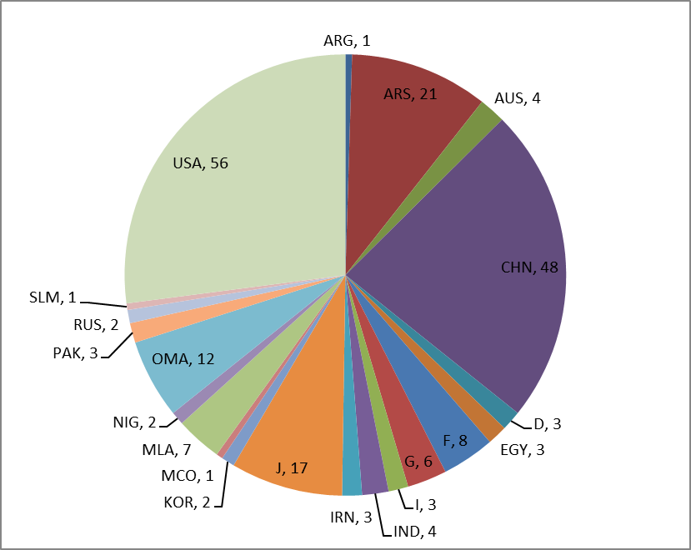
FIGURE 13
RNSS satellite systems and networks that was brought into use in the frequency band 1 234-1 300 MHz
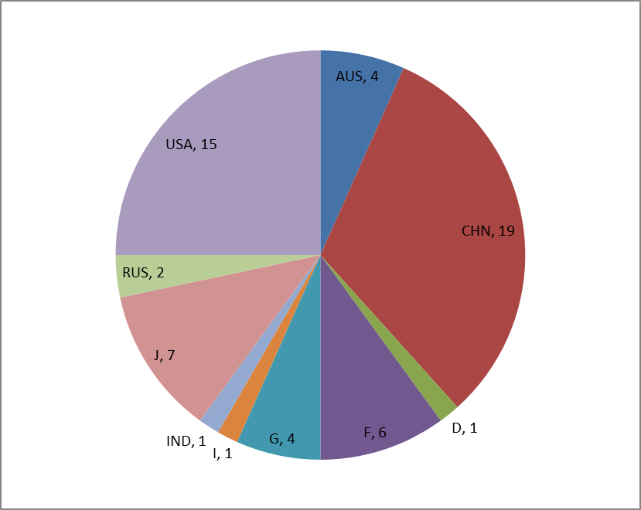
Note to Figs 12 and 13: ARG – Argentina; ARS – Saudi Arabia (Kingdom); AUS – Australia; CHN – China (People’s Republic); D – Germany (Federal Republic); EGY – Egypt; F – France; G – United Kingdom of Great Britain and Northern Ireland; I – Italy; IRN – Iran (Islamic Republic of); J – Japan; KOR – Korea (Republic); MCO – Monaco (Principality of); MLA – Malaysia; NIG – Nigeria (Federal Republic); OMA – Oman (Sultanate of); PAK – Pakistan (Islamic Republic of); RUS – Russian Federation; SLM – Solomon Islands; USA – United States of America.
Analysis of the data presented in Figs 12 and 13 shows that 207 RNSS satellite networks from 21 administrations can be affected by the IMT А12 frequency arrangement. At the same time, 60 out of 207 RNSS satellite networks confirmed the date of bringing into use.
FIGURE 14
Information on RNSS satellite systems and networks in the frequency band 1 224-1 300 MHz affected
by the IMT A13 frequency arrangement
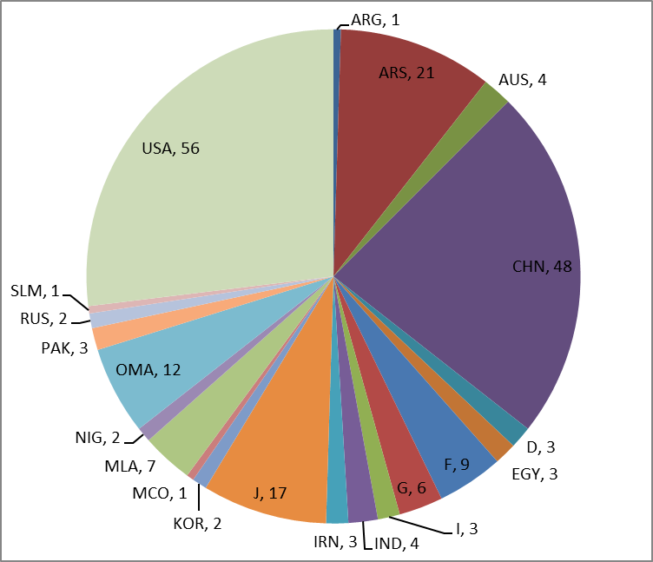
FIGURE 15
RNSS satellite systems and networks that was brought into use in the frequency band 1 224-1 300 MHz
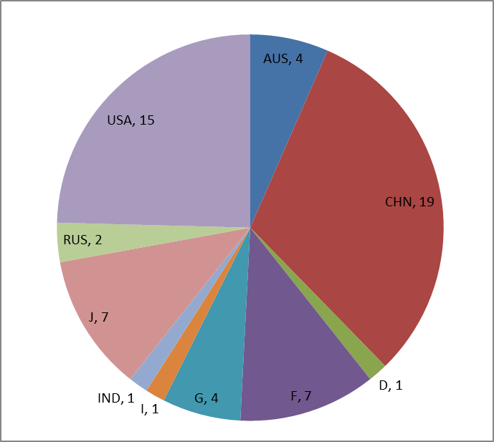
Note to Figs 14 and 15: ARG – Argentina; ARS – Saudi Arabia (Kingdom); AUS – Australia; CHN – China (People’s Republic); D – Germany (Federal Republic); EGY – Egypt; F – France; G – United Kingdom of Great Britain and Northern Ireland; I – Italy; IND – India; IRN – Iran (Islamic Republic of); J – Japan; KOR – Korea (Republic); MCO – Monaco (Principality of); MLA – Malaysia; NIG – Nigeria (Federal Republic); OMA – Oman (Sultanate of); PAK – Pakistan (Islamic Republic of); RUS – Russian Federation; SLM – Solomon Islands; USA – United States of America.
Analysis of the data presented in Figs 14 and 15 shows that 208 RNSS satellite networks from 21 administrations can be affected by the IMT А13 frequency arrangement. At the same time, 61 out of 208 RNSS satellite networks confirmed the date of bringing into use.
It should be noted that today the radionavigation satellite service is widely used for many applications such as construction, agriculture, autonomous transport, unmanned aircraft systems. And for a number of these applications the issue of ensuring safety of human life is the highest priority. More information regarding that issue could be found in Report ITU-R M.2458.
In addition, satellite navigation technologies and IMT systems are one of the main elements in the construction of intelligent transport systems, smart cities, etc. Thus, effective global development and adoption of new services can be possible only by ensuring smooth operation of IMT systems and satellite navigation systems since the symbiosis of navigation technologies and IMT provides this basis.
In this regard, in order to further protect RNSS, administrations could consider some ways to mitigate the possible influence of the spurious emissions of the second harmonic from IMT systems that may impact RNSS systems operating in the frequency bands 1 164-1 215 MHz, 1 215-1 300 MHz and 1 559-1 610 MHz.
As an example, administrations may implement techniques (e.g. frequency channels adjustment) to reduce IMT emissions into the frequency bands that have second harmonics affecting RNSS systems. Another example could be to filter the transmitting equipment of IMT base stations to reduce the second harmonic emissions. There could also be other ways for Administrations to protect RNSS receivers from spurious emissions of IMT transmitters.

5 Typical impact scenarios of spurious emissions from IMT stations on the RNSS receiving stations frequency bands
There are two general possible cases of the influence of IMT stations spurious emissions in the frequency bands 1 164-1 215 MHz, 1 215-1 300 MHz and 1 559-1 610 MHz, in which the receiving stations of the radionavigation satellite service operates: the potential impact of IMT base station, which by the spurious emissions fall in the frequency bands 1 164-1 215 MHz, 1215-1 300 MHz, 1 559-1 610 MHz and the potential impact of IMT user terminal, which by the spurious emissions fall in the frequency bands 1 164-1 215 MHz, 1 215-1 300 MHz, and 1 559-1 610 MHz.
From a technical point of view, it is also necessary to take into account that the antennas used in navigation equipment are, in most cases, omnidirectional, and therefore it is necessary to decide whether it is needed to take into account the aggregate or single interference when analysing the impact from IMT systems.

6 Estimation of interference from spurious emissions created by IMT stations to RNSS receiving earth stations operating in the frequency bands 1 164-1 215 MHz, 1 215‑1 300 MHz and 1 559-1 610 MHz

6.1 Theoretical estimations
Theoretical interference estimations are made for the levels of IMT stations spurious emissions (established in ITU-R Recommendations). At the same time, it was defined both the required level of attenuation of spurious emissions of IMT stations or separation distance between IMT transmitter and RNSS receiving earth stations that provide the required protection for RNSS receiver.
The propagation model specified in Recommendation ITU-R Р.525 is used as the most suitable model for the potential separation distances.
The threshold power density levels of aggregate wideband interference in tracking and acquisition modes are used as the protection criteria for a certain RNSS receiver.
It is considered the worst case when the additional attenuations of RNSS receiver antenna gain and IMT transmitter towards each other are not applied. In practice such scenario is quite realistic taking into account the low antenna discrimination and also possible random location and direction of user antennas in the RNSS and IMT systems. In this case the required spurious emission power attenuation ΔP of IMT stations for RNSS receiver protection criterion is calculated by the following equation:
$∆P=P_{lim}-\left(P_{out}+G_{max}\right)$
where:
ΔP : required attenuation of IMT stations spurious emissions (dB)
P_{lim} : RNSS receiver protection criteria (dB(W/MHz)
G_{max} : maximum antenna gain of RNSS receiver (dBi)
P_{out} : IMT station spurious emission level (dB(W/MHz).
Using the propagation model in accordance with Recommendation ITU-R Р.525 the separation distances of transmitting and receiving systems can be calculated by the following equation:
$L_{bf}=20\log{(\frac{4 π d}{λ})}$
where:
L_{bf} : free-space basic transmission loss (dB)
d : distance (m)
λ : wavelength (m).
The equation can also be written in the following way:
$L_{bf}=32.4+20\log{f}+20\log{d}$
where:
f : frequency (MHz)
d : distance (km).
Set equal ΔP to L_{bf} , express d by the following:
$d={(10)}^{\frac{P_{lim}-(P_{out}+G_{max}) -32.4-20∙\log{f} }{20}}$
The estimation results of IMT station spurious emissions impact to different RNSS receivers in navigation signal tracking and acquisition modes are shown in Tables 6, 7 and 8. For indoor RNSS receivers the interference from user IMT station located in the same building is considered.

Table 6
Estimation results of IMT stations (mobile/base) spurious emissions impact to RNSS systems in the frequency band 1 164-1 215 MHz
 | 1 | 2 | 3 | 4 | 5
Parameter | Air-navigation receiver No. 1 | Aeronautical navigation receiver No. 2 | High-precision receivers | Indoor positioning receivers | General purpose receivers
Maximum receiver antenna gain in upper hemisphere (dBi) | 3 | 7 | 3 | 3 | 3
Spurious emissions level (dB(W/MHz)) | −60 | −60 | −60 | −60 | −60
Interference power at the receiver antenna output (dB(W/MHz)) | −57 | −53 | −57 | −57 | −57
Tracking mode threshold power density level of aggregate wideband interference at the passive antenna output (dB(W/MHz)) | −144.8 | −140 | −147.4 | −150 | −140
Required attenuation (dB) | 87.8 | 87 | 90.4 | 93 | 83
Separation distance (m) | 498 | 444 | 672 | 906 | 287
Acquisition mode threshold power density level of aggregate wideband interference at the passive antenna output (dB(W/MHz)) | −148.7 | −146 | −147.4 | −156 | −146
Required attenuation (dB) | 91.7 | 93 | 90.4 | 99 | 89
Separation distance (m) | 780 | 885 | 672 | 1808 | 572

Table 7
Estimation results of spurious emissions impact from IMT stations (mobile/base) to RNSS receivers in the frequency band 1 215-1 300 MHz
 | 1 | 2 | 3 | 3a | 3b | 4 | 5 |  | 6
Parameter | SBAS ground reference receiver* | High-precision semi-codeless receiver* | High-precision receiver using L2C* | High-precision receiver using B3 and B3A | High-accuracy and authentication receiver using  E6-BC/L6 | Air-navigation receiver | Indoor positioning |  | General purpose
Maximum receiver antenna gain in upper hemisphere (dBi) | −2.0 | 3.0 | 3.0 | 3.0 | 3.0 | 7 | 6 | 3 | 6 | 3
Spurious emissions level (dB(W/MHz)) | −60 | −60 | −60 | −60 | −60 | −60 | −60 |  | −60
Interference power at the receiver antenna output (dB(W/MHz)) | −62 | −57 | −57 | −57 | −57 | −53 | −54 | −57 | −54 | −57
Tracking mode threshold power density level of aggregate wideband interference at the passive antenna output (dB(W/MHz)) | −147.5 | −147.4 | −147.4 | −147.4 | −140 | −140 | −150 | −145 | −139 | −140
Required attenuation (dB) | 85.5 | 90.4 | 90.4 | 90.4 | 83 | 87 | 96 | 88 | 85 | 83
Separation distance (m) | 366 | 644 | 644 | 644 | 271 | 429 | 1227 | 482 | 346 | 271
Acquisition mode threshold power density level of aggregate wideband interference at the passive antenna output (dB(W/MHz)) | −147.4 | −147.4 | −147.4 | −147.4 | −147.4 | −146 | −156 | −151 | −145 | −146
Required attenuation (dB) | 85.4 | 90.4 | 90.4 | 90.4 | 90.4 | 93 | 102 | 94 | 91 | 89
Separation distance (m) | 362 | 644 | 644 | 644 | 644 | 856 | 2448 | 962 | 690 | 541

Table 8
Estimation results of spurious emissions impact from IMT stations (mobile/base) to RNSS receivers in the frequency band 1 559-1 610 MHz
 | 1 | 2 | 3 | 4 | 5 | 6 | 7 | 8 | 9 | 10 | 11
Parameter | SBAS  Category I  Type 1 | SBAS  Category I  Type 2 | GBAS  Category II/III  Type 1 | GBAS  Category II/III  Type 2 | SBAS ground reference receiver* | Air-navigation precision approach receiver | A-RNSS | General-purpose No. 1 | General-purpose No. 2 | Indoor positioning | High-precision
Maximum receiver antenna gain in upper hemisphere (dBi) | +3.0 | +7 | +3.0 | +7 | −2.0 | +7 | 0.0 | 6 | 3 | 6 | +3.0
Spurious emissions level (dB(W/MHz)) | −60 | −60 | −60 | −60 | −60 | −60 | −60 | −60 | −60 | −60 | −60
Interference power at the receiver antenna output (dB(W/MHz)) | −57 | −53 | −57 | −53 | −62 | −53 | −60 | −54 | −57 | −54 | −57
Tracking mode threshold power density level of aggregate wideband interference at the passive antenna output (dB(W/MHz)) | −140.5 | −140 | −140.5 | −140 | −146.0 | −140 | −146.9 | −136 | −140 | −142 | −147.4
Required attenuation (dB) | 83.5 | 87 | 83.5 | 87 | 84 | 87 | 86.9 | 82 | 83 | 88 | 90.4
Separation distance (m) | 227 | 334 | 227 | 334 | 240 | 334 | 335 | 191 | 216 | 381 | 502

Table 8 (end)
 | 1 | 2 | 3 | 4 | 5 | 6 | 7 | 8 | 9 | 10 | 11
Parameter | SBAS  Category I  Type 1 | SBAS  Category I  Type 2 | GBAS  Category II/III  Type 1 | GBAS  Category II/III  Type 2 | SBAS ground reference receiver* | Air-navigation precision approach receiver | A-RNSS | General-purpose No. 1 | General-purpose No. 2 | Indoor positioning | High-precision
Acquisition mode threshold power density level of aggregate wideband interference at the passive antenna output (dB(W/MHz)) | −146.5 | −146 | −146.5 | −146 | −147.4 | −146 | −146.9 | −142 | −146 | −148 | −147.4
Required attenuation (dB) | 89.5 | 93 | 89.5 | 93 | 85.4 | 93 | 86.9 | 88 | 89 | 94 | 90.4
Separation distance (m) | 452 | 666 | 452 | 666 | 282 | 666 | 335 | 381 | 431 | 759 | 502

The theoretical estimation results show that the required attenuation of spurious emissions from mobile/base stations is from 67 dB to 102 dB. These attenuation values correspond to the separation distances from 42 m to 2 446 m.

6.2 Experimental estimations of a sample IMT modem
The experimental interference estimations are conducted for actual (experimental measurements) spurious emissions of IMT stations. Corresponding measurements with the sample legacy IMT equipment were performed.
Further (also as in theoretical estimations) the impact of actual spurious emission level from IMT stations to different RNSS receivers is estimated and the required attenuation level of spurious emissions or the required separation distance between IMT transmitter and RNSS receiver are defined.
The spurious emissions from IMT stations in the frequency bands 1 164-1 215 MHz, 1 215-1 300 MHz and 1 559-1 610 MHz can be produced by the second harmonic frequency of IMT equipment operating in the frequency band 470-862 MHz (see Figs 1 and 2).
In order to minimize potential negative impact to the currently operating RNSS equipment, spurious emissions of the second harmonic of the sample legacy IMT user equipment were measured for LTE modem operating in the frequency band 854.5-862 MHz (the second harmonic frequency 1 709‑1 724 MHz). The results are applicable for certain IMT user equipment operating in the frequency bands 470-862 MHz. It should be noted that the sample IMT modem equipment used in these studies is not representative of all IMT stations and further theoretical analysis using more representative IMT equipment may be needed.
The following equipment is used in the experiments:
– Spectrum analyser ANRITSU MS2720Т;
– R&S HL040 antenna;
– HF calibrated cable set;
– LTE modem: HUAWEI LTE USB 822FT.
The spurious emission level (second harmonic) of LTE modem is conducted subject to the scheme shown in Fig. 16. The modem is adjusted to transmit information in the frequency range of 800 MHz (the operating frequency band 854.5-862 MHz).
Figure 16
Setup for spurious emissions measurements
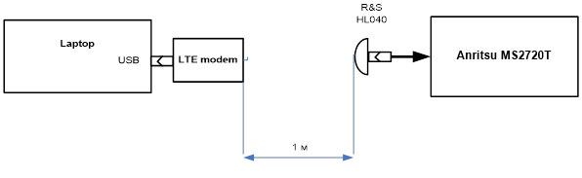
Spectrograms of main and second harmonic emissions shown in Figs 17 and 18 respectively.
Figure 17
Spectrogram of LTE modem main emission in the frequency band 854.5-862 MHz
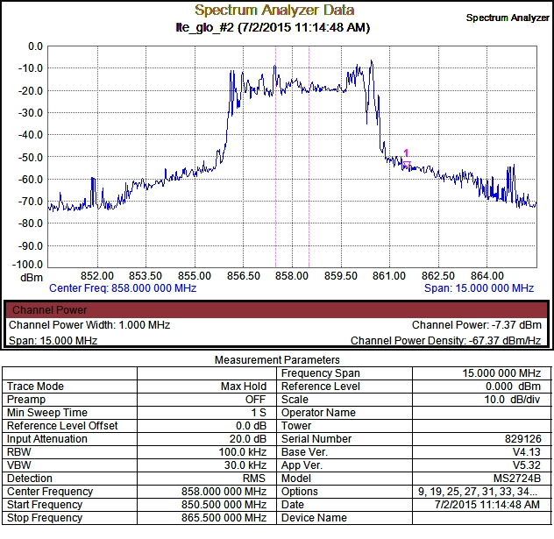
Figure 18
Spectrogram of LTE modem spurious emissions on second harmonic
(854.5-862 MHz – operating frequency band, 1 709-1 724 MHz – second harmonic)
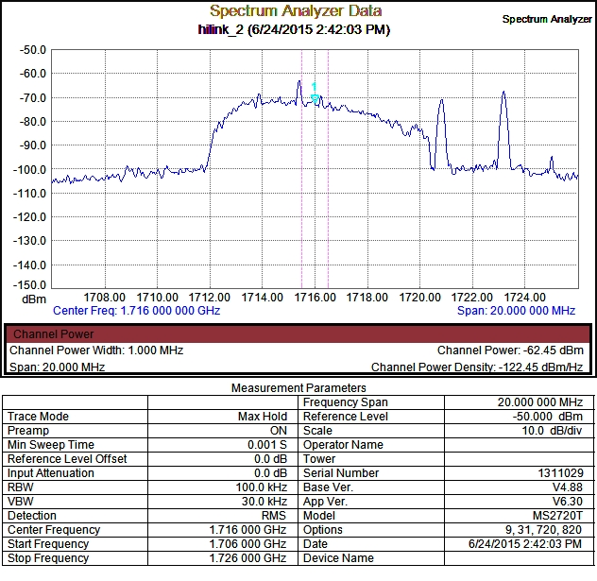
To define the emission power level at the modem output the following equation is used:
$P_{out}=P_{m}-G+N+L$
where:
Р_{m} : measured emission level in the frequency band 1 MHz, dBm/MHz
G : antenna gain, dB
N : cable loss, dB
L : free-space path loss at the distance of 1 m, dB.
The following equation is used to calculate L:
$L=20\log{D}+20\log{F}+32.4$
where:
D: distance, km
F: frequency, MHz.
The measurement results of the main emission power and second harmonic emission power at the modem output are shown in Table 9.
Table 9
Measurement results
Parameter | Main emission | Second harmonic frequency emissions
F (MHz) | 858 | 1716
Р_{m} (dBm/MHz) | −7.37 | −62.45
G (dB) | 7.8 | 7.5
N (dB) | 1.2 | 1.5
L (dB) | 31.2 | 37.14
Р_{out} (dBm/MHz) | 17.23 | −31.31
Р_{out} (dBW/MHz) | −12.77 | −61.31

Results show that the measured spurious emissions level of the tested equipment (−61.31 dBW/MHz) conforms to the spurious emissions level applicable to IMT stations established in current ITU-R Recommendations (−60 dBW/MHz) with little margin. It is noted that the measurements have been made for a limited set of conditions (both environmentally and configured parameters) and on a very limited number of equipment samples and types. In addition, it must be remembered that since IMT out-of-band emissions are higher than the assumed IMT spurious emissions, the results shown in § 6.1 would need to be revised (additional separation and/or attenuation required) if IMT were authorized to operate in frequency bands near (i.e. within 250% of the necessary bandwidth of the IMT) to those used by RNSS.

7 Summary
This Report presents the results of a technical studies of the impact of potential interference from IMT spurious emissions to RNSS receiving earth stations operating in the frequency bands 1 164‑1 300 MHz and 1 559-1 610 MHz. These studies were conducted for theoretical (see § 6.1) and for estimated levels of spurious emissions caused by the sample legacy IMT equipment (see § 6.2).
The analysis showed that out of 13 frequency arrangements, four frequency arrangements do not fall into the RNSS frequency bands with their second harmonic spurious emissions (A1, A2, A8, A10 frequency arrangements). The remaining nine frequency arrangements with their second harmonic spurious emissions fall into the RNSS frequency bands, while seven frequency arrangements with second harmonic spurious emissions fall into the frequency band 1 559-1 610 MHz (A3, A4, A5, A6, A7, A9 and A11 frequency arrangements) and two into the frequency band 1 215-1 300 MHz (A12 and A13 frequency arrangements). It should also be noted that out of nine frequency arrangements that fall into the RNSS frequency bands with their second harmonic spurious emissions, only two frequency arrangements (A4 and A6 frequency arrangements) may cause spurious emissions by IMT user terminals.
In this regard, in order to further protect RNSS, Administrations could consider some ways to mitigate the possible influence of the spurious emissions of the second harmonic from IMT systems that may impact RNSS systems operating in the frequency bands 1 164-1 215 MHz, 1 215-1 300 MHz and 1 559-1 610 MHz.
As an example, administrations may implement techniques (e.g. frequency channels adjustment) to reduce IMT emissions into the frequency bands that have second harmonics affecting RNSS systems. Another example could be to filter the transmitting equipment of IMT base stations to reduce the second harmonic emissions. There could also be other ways for administrations to protect RNSS receivers from spurious emissions of IMT transmitters.

