Report ITU-R M.2562-0
(12/2025)
M Series: Mobile, radiodetermination, amateur
and related satellite services
Sharing and compatibility studies between foreign object debris detection system and other services in the frequency ranges 92-100 GHz

Foreword
The role of the Radiocommunication Sector is to ensure the rational, equitable, efficient and economical use of the radio-frequency spectrum by all radiocommunication services, including satellite services, and carry out studies without limit of frequency range on the basis of which Recommendations are adopted.
The regulatory and policy functions of the Radiocommunication Sector are performed by World and Regional Radiocommunication Conferences and Radiocommunication Assemblies supported by Study Groups.

Policy on Intellectual Property Right (IPR)
ITU-R policy on IPR is described in the Common Patent Policy for ITU-T/ITU-R/ISO/IEC referenced in Resolution ITU-R 1. Forms to be used for the submission of patent statements and licensing declarations by patent holders are available from https://www.itu.int/ITU-R/go/patents/en where the Guidelines for Implementation of the Common Patent Policy for ITU-T/ITU-R/ISO/IEC and the ITU-R patent information database can also be found.

Series of ITU-R Reports
(Also available online at https://www.itu.int/publ/R-REP/en)
Series | Title
BO | Satellite delivery
BR | Recording for production, archival and play-out; film for television
BS | Broadcasting service (sound)
BT | Broadcasting service (television)
F | Fixed service
M | Mobile, radiodetermination, amateur and related satellite services
P | Radio-wave propagation
RA | Radio astronomy
RS | Remote sensing systems
S | Fixed-satellite service
SA | Space applications and meteorology
SF | Frequency sharing and coordination between fixed-satellite and fixed service systems
SM | Spectrum management
TF | Time signals and frequency standards emissions

Note: This ITU-R Report was approved in English by the Study Group under the procedure detailed in Resolution ITU-R 1.

Electronic Publication
Geneva, 2025
© ITU 2025
All rights reserved. No part of this publication may be reproduced, by any means whatsoever, without written permission of ITU.

REPORT ITU-R M.2562-0
Sharing and compatibility studies between foreign object debris detection system and other services in the frequency ranges 92-100 GHz
(Question ITU-R 260/5)
(2025)
TABLE OF CONTENTS
Page
1 Introduction 3
2 Foreign object debris detection system characteristics 3
3 Technical characteristics of incumbent services 6
3.1 Earth exploration-satellite service (active) spaceborne cloud profile radars 6
3.2 Earth exploration-satellite service (passive) spaceborne radiometers 8
4 Performance criteria of Earth exploration-satellite service (active) and
Earth exploration-satellite service (passive) 8
5 Interference criteria 9
6 Deployment scenarios of foreign object debris detection system 9
7 Sharing and compatibility studies 11
7.1 In-band emissions of foreign object debris detection systems into Earth
exploration-satellite service (active) 11
7.2 Compatibility studies for Earth exploration-satellite service (active) 11
7.3 Out-of-Band emissions of foreign object debris detection systems into
Earth exploration-satellite service (passive) 11
7.4 Compatibility studies for Earth exploration-satellite service (passive) 11
8 Summary 12
Annex 1 - Interference analysis for Earth exploration-satellite service (active) 12
A1-1 Interference from foreign object debris detection systems into Earth
exploration-satellite service (active) 12
A1-1.1 Static analysis based on interference with specific geometric scenarios 12
A1-1.2 Dynamic analysis based on interference observed with spacecraft
orbit simulation 20
A1-2 Summary of result 29
Annex 2 - Interference analysis for Earth exploration-satellite service (passive) 29
A2-1 Interference from foreign object debris detection systems into Earth
exploration-satellite service (passive) 29
A2-1.1Static analysis based on interference with specific geometric scenarios 29
A2-1.2 Dynamic analysis based on interference observed with spacecraft orbit simulation 36
A2-2 Summary of results 40

Scope
This Report provides results of sharing and compatibility studies between foreign object debris (FOD) detection system operating in the frequency range 92-100 GHz and EESS (active) and EESS (passive) operating in these or adjacent bands, in particular interference from FOD to EESS (active) and EESS (passive). The results of analyses contained within this Report are limited to FOD detection system and deployment described herein. Additional deployments of this system or new systems will require further studies for sharing and compatibility.
Keywords
Radar, technical and operational characteristics, airport runway
List of Abbreviations/Glossary
CCDF Complementary cumulative distribution function
CPR Cloud profile radar
EESS Earth exploration-satellite service
FMCW Frequency-modulated continuous wave
FOD Foreign object debris
FODDS FOD detection system
OOB Out-of-band
Related ITU-R Recommendations and Reports
Recommendation ITU-R F.699 – Reference radiation patterns for fixed wireless system antennas for use in coordination studies and interference assessment in the frequency range from 100 MHz to 86 GHz
Recommendation ITU-R RS.1166 – Performance and interference criteria for active spaceborne sensors
Recommendation ITU-R RS.1861 – Typical technical and operational characteristics of Earth exploration-satellite service (passive) systems using allocations between 1.4 and 275 GHz
Recommendation ITU-R RS.2017 – Performance and interference criteria for satellite passive remote sensing
Recommendation ITU-R RS.2105 – Typical technical and operational characteristics of Earth exploration-satellite service (active) systems using allocations between 40 MHz and 238 GHz
Recommendation ITU-R M.2162 – Technical and operational characteristics of radiolocation systems operating in the frequency range 92-100 GHz and radionavigation systems operating in the frequency range 95-100 GHz
Report ITU-R M.2501 – Technical and operational characteristics of the foreign object debris detection system operating in the frequency range 92-100 GHz

1 Introduction
The range resolution of a radar is dependent on the pulse repetition frequency or the bandwidth of radar signals. To achieve a range resolution of less than a few centimetres, radar bandwidths in the order of GHz are required. Since the band 92-100 GHz is allocated for radiolocation services on a primary basis, the bandwidth of 8 GHz can provide the high range resolution around 2 cm. The technical and operational characteristics foreign object debris (FOD) detection systems (FODDSs) to utilise such broad bandwidth for airport safety operation are provided by Report ITU-R M.[FOD 92-100 GHZ]. However, FODDSs should be deployed to protect a number of incumbent services operating in the band 92-100 GHz and the adjacent bands.
The 94.0-94.1 GHz band is allocated to the Earth exploration-satellite service (EESS) (active) on a primary basis for spaceborne active sensors, such as cloud profile radars (CPRs). Herein are presented technical characteristics of two typical EESS (active) cloud profile radar systems operating in the frequency band 94.0-94.1 GHz and technical characteristics for typical FODDSs proposed for the frequency range 92-100 GHz. Performance criteria and interference criteria for active spaceborne cloud profile radar operating in the frequency band 94.0-94.1 GHz are provided. Preliminary calculations are made of the attenuation required of the FODDSs in-band emission levels in order for those emissions to be below the EESS (active) interference protection criteria level of the most susceptible CPR.
The 86-92 GHz band is allocated to EESS (passive) on a primary basis for EESS (passive) spaceborne passive sensors, such as radiometers. Herein are presented technical characteristics of one typical EESS (passive) radiometer system operating in the frequency band 86-92 GHz and technical characteristics for typical FODDSs proposed for the frequency range 92-100 GHz. Performance criteria and interference criteria for passive spaceborne radiometers operating in the frequency band 86-92 GHz are provided. Preliminary calculations are made of the attenuation required of the FODDSs out-of-band (OOB) emission levels in order for those emissions to be below the EESS (passive) interference protection criteria level of the most susceptible radiometer.

2 Foreign object debris detection system characteristics
The characteristics of the FOD detection systems provided in Recommendation ITU-R M.2162 are shown in Table 1 and the measured spectrum are shown in Fig. 2.
Recommendation ITU-R F.699 was selected among several antenna reference models. The reason is that its frequency range is close to the frequency range 92-100 GHz, and also a revision of the frequency range above 86 GHz is currently under discussion. The similarity between the antenna pattern for the actual FODDS and the ITU-R F.699 antenna model is another reason for the selection. Figure 3 shows one example of the measured antenna pattern of the cassegrain antenna at 96 GHz.
Table 1
Technical and operational characteristics of FODDS operating
in the frequency range 92-100 GHz
Parameters | Values
Frequency range (GHz) | 92-100
Channel plan | See Fig. 1 from Rec. ITU-R M.2162
Channel bandwidth (GHz) | 0.58-7.98
Output power (mW) | 50-200
Spectrum envelope | See Fig. 2
Sweep frequency (kHz) | 1.250
Antenna type | Cassegrain
Antenna gain (dBi) | 44
Antenna pattern | Rec. ITU-R F.699
Antenna height (m) | 0.1-8
Full width at half maximum (degrees) | Elevation: 1.0, Azimuth: 1.0
Antenna rotation speed (rpm) | 15
Detection distance (m) | 200-500
Antenna elevation angle (degrees) | ±1.8
Radiated rotation angle (degrees) | ±60
Radar cross section (dB/m²) | −20
Out-of-band emission (dBm/MHz) | ‒50 Channel Plan A, B, C  ‒47 Channel Plan D, E
Emission bandwidth (−3 dB) (MHz) | 1 (see Fig. 2 (b))
Emission bandwidth (−20 dB) (MHz) | 3.5 (see Fig. 2 (b))
Adjacent channel leakage ratio (dBc) | < −70
Receiver noise figure (dB) | 10
Maximum number of FOD radars per 4-km runway | 480 for low power FODDS (~50 mW)  48 for high power FODDS (200 mW)  (see Fig. 5)
Estimated maximum number of FOD radar at airports | 120 (see Table 4)
I/N protection criteria (dB) | −6

FIGURE 1
Channel plan for FODDS operating in the frequency range 92-100 GHz
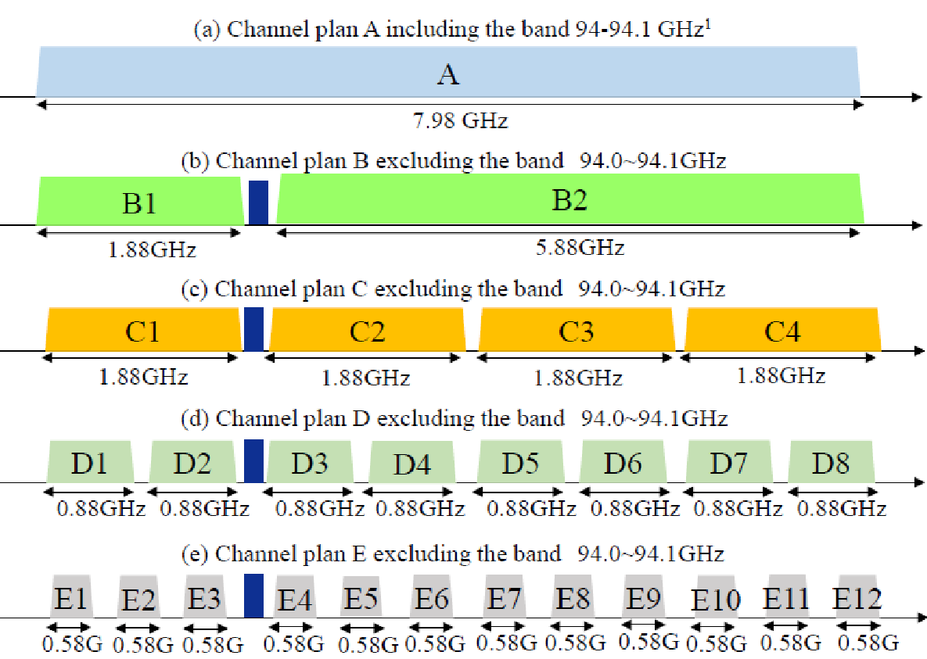
¹ This channel plan will be used if mitigation techniques are available to resolve the coexistence issues with EESS (active).
Figure 2
Measure spectrum of FODDS (a) Spectrum envelope of frequency modulated carrier wave signal in the frequency band 92--97 GHz
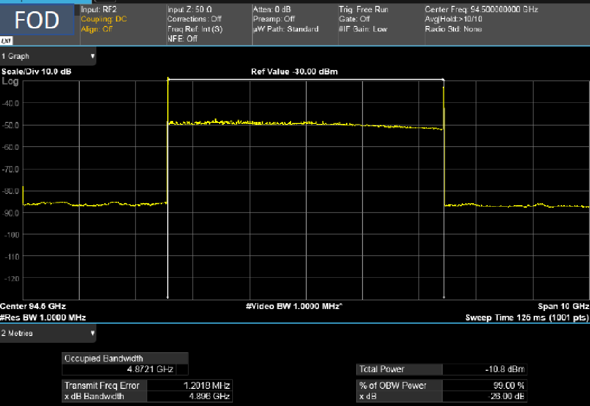
(b) Adjacent channel leakage ratio at an offset frequency of 10 MHz
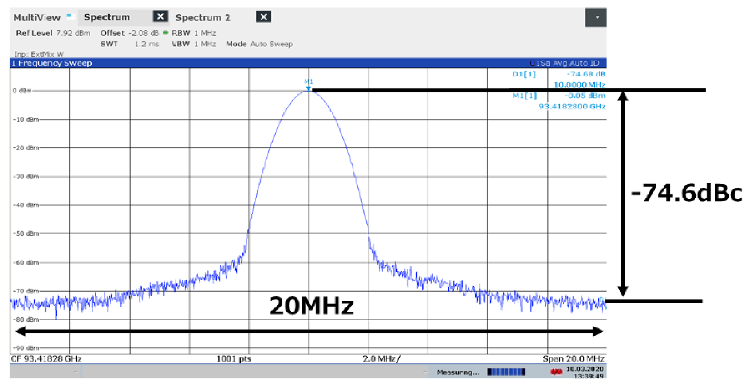
Figure 3
Example of measured antenna radiation pattern at 96-GHz whose antenna gain is 44 dBi
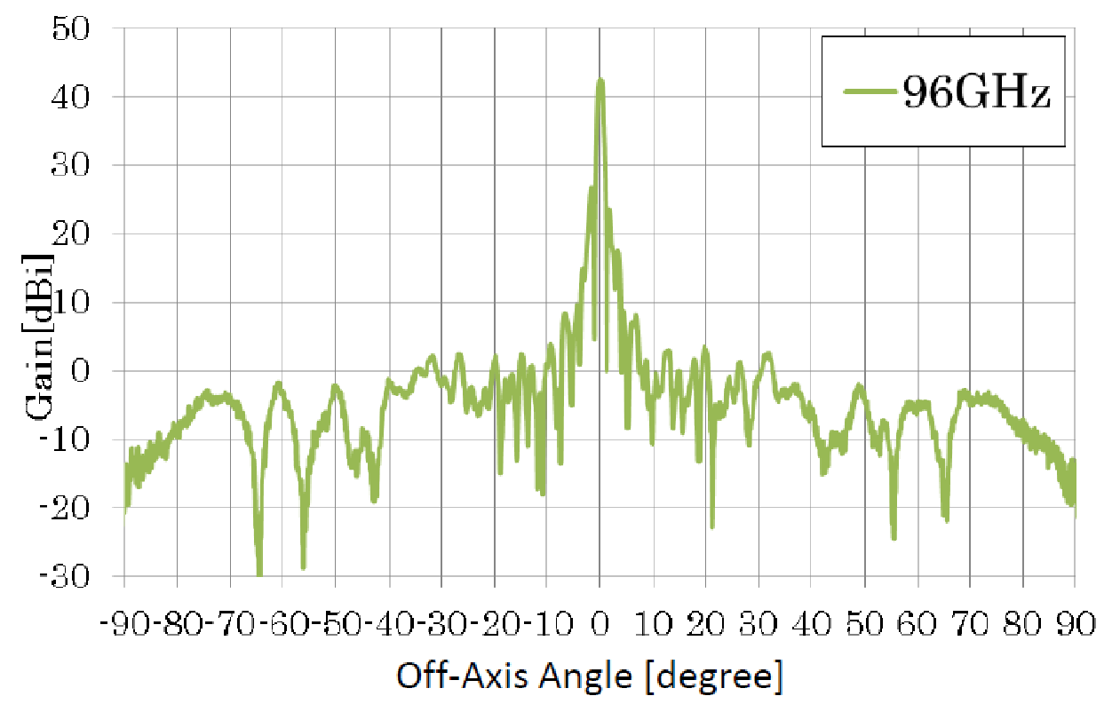

3 Technical characteristics of incumbent services

3.1 Earth exploration-satellite service (active) spaceborne cloud profile radars
Technical characteristics of CPRs in the frequency band of 94.0-94.1 GHz are provided in Recommendation ITU-R RS.2105. The technical characteristics for two CPR systems CPR-L1 and CPR-L2 are presented below in Table 2.
Table 2
Characteristics of Earth exploration-satellite service (active) missions
in the frequency band 94-94.1 GHz
Parameter | CPR-L1 | CPR-L2
Sensor type | Cloud profiling radar | Cloud profiling radar
Type of orbit | Sun synchronous orbit | Sun synchronous orbit
Altitude (km) | 705 | 393
Inclination (degree) | 98.2 | 97
Ascending node LST | 13:30 | 2:00
Repeat period, days | 16 | 25
Antenna type | Parabolic reflector to offset cassegrain antenna | Parabolic reflector
Antenna diameter (m) | 1.85-2.5 | 2.5
Antenna (transmit and receive) peak gain (dBi) | 63.1-65.2 | 66
Polarization | Linear | LHC, RHC
Incidence angle at Earth (degree) | 0 | 0
Azimuth scan rate (rpm) | 0 | 0
Antenna beam look angle (degree) | 0 | 0
Antenna beam azimuth angle (degree) | 0 | 0
Antenna elevation. beamwidth (degree) | 0.12 | 0.095
Antenna azimuth. beamwidth (degree) | 0.12 | 0.095
Beamwidth (degree) | 0.095-0.108 | 0.095
RF centre frequency (MHz) | 94.050 | 94.050
RF bandwidth (MHz) | 0.36 | 7
Transmit peak power (W) | 1 000 | 2 200
Transmit average power (W) | 21.31 | 44
Pulse width (msec) | 3.33 | 3.3
PRF (Hz) | 4 300 | 1 800-7 500
Chirp rate (MHz/μsec) | N/A ⁽¹⁾ | 2.1
Transmit duty cycle (%) | 1.33 | 2.0
Minimum sensitivity (dBZ) | −30 to −35 | −30 to −35
Horizontal resolution | 0.7-1.9 km | 800 m
Vertical resolution (m) | 250-500 | 500
Doppler range (m/s) | ±10 | ±10
Doppler accuracy (m/s) | 1 | 1
System noise figure (dB) | 7 | 7
⁽¹⁾ The sensor uses an unmodulated pulse.

3.2 Earth exploration-satellite service (passive) spaceborne radiometers
Technical characteristics of spaceborne radiometers in the frequency band of 86-92 GHz are provided in Recommendation ITU-R RS.1861. The technical characteristics for spaceborne radiometer systems L8, L12 and L17 are presented in Table 3.
Table 3
Characteristics of EESS (passive) missions in the frequency band 86-92 GHz
Parameter | L8 | L12 | L17
Sensor type | Conical scan radiometer | Conical scan radiometer | Conical scan radiometer
Type of orbit | SSO | Sun asynchronous tilted orbit | SSO
Altitude (km) | 700 | 407 | 665.96
Inclination (degree) | 98.2 | 50 | 98.06
Repeat period | 16 |  | 3
Antenna type | Parabolic reflector antenna
Antenna diameter (m) | 2.0 | 1.1 | 2.0
Antenna (receive) peak gain (dBi) | 62.4 | 58 | 62.4
Polarization | Linear H, V | H, V | H, V
Incidence angle at Earth (degree) | 55 | 53 | 55
Azimuth scan rate (rpm) | 40 | 30 | 40
Antenna beam look angle (degree) | 47.5 | 48.6 | 47.7
Antenna beam azimuth angle (degree) | 0 to 360 | 0 to 360 | 0 to 360
Antenna elevation beamwidth (degree) | 0.15 | 0.4 | 0.15
Antenna azimuth beamwidth (degree) | 0.15 | 0.4 | 0.15
Beamwidth (degree) | 0.15 | 0.4 | 0.15
RF centre frequency (GHz) | 89.0 | 89.0 | 89.0
RF bandwidth (MHz) | 3 000 | 3 000 | 3 000
Horizontal resolution (km) | 2.9 | 8.7 | 3
Vertical resolution (km) | 5.1 | 7.5 | 5

4 Performance criteria of EESS (active) and EESS (passive)
Performance requirements for spaceborne active sensors in the EESS (active) are provided by Recommendation ITU-R RS.1166-5. The performance criteria for the EESS (active) cloud profile radars specifies measurements of a minimum reflectivity of −35 dBZ ±10%, I/N no greater than −10 dB and random data availability criteria of at least 95%.
Performance requirements for spaceborne passive sensors in the EESS (passive) are provided by Recommendation ITU-R RS.2017. The performance criteria for the EESS (passive) radiometers specifies a temperature differential, ΔT_{e} of 0.05 K and data availability criteria of at least 99.99%.

5 Interference criteria
EESS (active) and EESS (passive)
Interference requirements for spaceborne active sensors in the EESS (active) are given in Recommendation ITU-R RS.1166-5. The interference threshold criteria for the EESS (active) CPR in the frequency band 94.0-94.1 GHz is –160 dBW over 300 kHz. The availability criteria is 99%.
Interference requirements for spaceborne passive sensors in the EESS (passive) are given in Recommendation ITU-R RS.2017. The interference threshold criteria for the EESS (passive) radiometer in the 86-92 GHz frequency band is −169 dBW over 100 MHz with a percentage of area permissible interference level may be exceeded of 0.01%. For a 0.01% level, the measurement area is a square on the Earth of 2 000 000 km², unless otherwise justified.

6 Deployment scenarios of FOD detection system
Figure 4 shows the location of major airports in Japan where FOD detection systems may be implemented in the future. The number of FOD implemented in runway is estimated using Fig. 5. The important parameter of the deployment scenario is the separation distance of FOD radars which is 200 m. If the runway length is 4 000 m, the number of FOD radars becomes 48, as shown in Fig. 5. FOD radars are deployed at each side of runway. Table 4 summarizes the estimated number of FOD radars which will be implemented in major airports. Those numbers of FOD radars should be taken into account when interference from FOD radars is studied.
Figure 4
Foreign object debris detection systems planned to operate in the airports
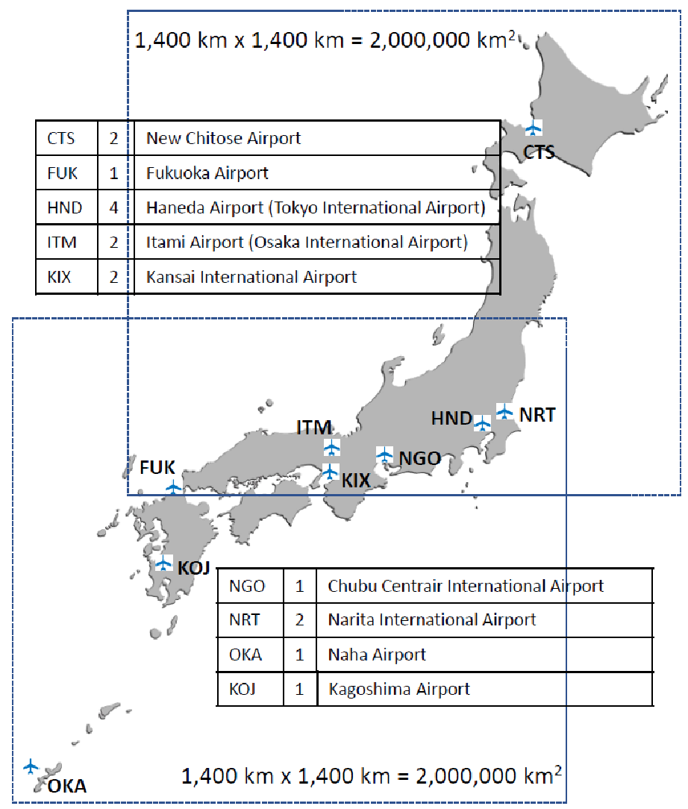
Figure 5
Basic concept of implementation of foreign object debris radars in 4-km runway
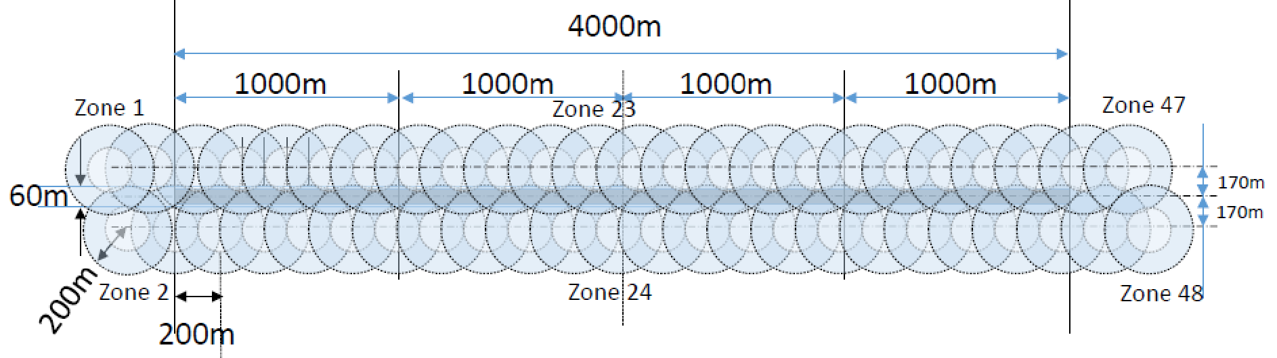
TABLE 4
Estimated number of foreign object debris radars in each airport
Airport | Number of runway | Runway length  (m) |  | Estimated number of FOD radars
CTS ⁽¹⁾ | 2 | 3 000, 3 000 |  | 68
FUK ⁽²⁾ | 1 | 2 800 |  | 17
HND ⁽³⁾ | 4 | 2 500, 2 500, 3 000, 3 360 |  | 120
ITM ⁽⁴⁾ | 2 | 1 828, 3 000 |  | 52
KIX ⁽⁵⁾ | 2 | 3 500, 4 000 |  | 84
KOJ ⁽⁶⁾ | 1 | 3 000 |  | 32
NGO ⁽⁷⁾ | 1 | 3 500 |  | 36
NRT ⁽⁸⁾ | 2 | 2 500, 4 000 |  | 74
OKA ⁽⁹⁾ | 1 | 3 000 |  | 32
⁽¹⁾ New Chitose Airport  ⁽²⁾ Fukuoka Airport  ⁽³⁾ Tokyo International Airport (Haneda)  ⁽⁴⁾ Osaka International Airport - Itami Airport  ⁽⁵⁾ Kansai International Airport |  |  | ⁽⁶⁾ Kagoshima Airport  ⁽⁷⁾ Chubu Centrair International Airport  ⁽⁸⁾ Narita International Airport  ⁽⁹⁾ Naha Airport

7 Sharing and compatibility studies

7.1 In-band emissions of FODDS into EESS (active)
FOD detection systems are proposed to operate in the frequency band 92-100 GHz. The frequency band 94.0-94.1 GHz, which is allocated to the EESS (active) CPR, would be in-band with the FOD detection frequency band 92-100 GHz. The maximum in-band emissions occur when the FOD frequency modulated carrier wave (FMCW) signal spectrum is positioned over the spectrum of the EESS (active) band (see Channel plan A in Fig. 1).

7.2 Compatibility studies for EESS (active)
The study results are included in Annex 1. Section A1-1.1 contains the static analysis and § A1-1.2 contains the dynamic analysis.

7.3 Out-of-band emissions of FODDSs into EESS (passive)
FODDSs are proposed to operate in the frequency range 92-100 GHz. The 86-92 GHz band, which is allocated to the EESS (passive) spaceborne radiometer, would be OOB with respect to the FOD detection frequency range 92-100 GHz. The maximum OOB emissions occur when the FOD FMCW signal spectrum is positioned near the spectrum edge of the EESS (passive) band just above 92 GHz.

7.4 Compatibility studies for Earth exploration-satellite service (passive)
The study results are included in Annex 2. Section A2-1.1 contains the static analysis and § A2-1.2 contains the dynamic analysis.

8 Summary
Results of the static calculations show for the three different geometrical interaction scenarios described involving antenna beam coupling between FOD systems and cloud profile radars as well as spaceborne radiometers. The RFI levels at CPR are highest for the geometrical situation of coupling between the nadir-looking CPR antenna and the sidelobes of the FOD detection system antenna. The RFI levels at the radiometer meter are highest for the geometrical situation of coupling between the mainlobe of the radiometers L-8, L-12 and L-17 antennas and the sidelobe of the FOD detection system antenna. The out-of-band emission level of FODDS antenna should be further improved to decrease the RFI level at both CPR and radiometer antennas. Additionally, a result of the dynamic calculation shows that there is no expectation of interference from FODDSs exceeding the protection limits of EESS (passive). If further studies are proposed in future meetings, this Report should be revised accordingly.

Annex 1
Interference analysis for Earth exploration-satellite service (active)

A1-1 Interference from FODDSs into EESS (active)

A1-1.1 Static analysis based on interference with specific geometric scenarios
At least three different geometrical scenarios have to be considered in assessing the potential for interference from FOD detection systems into EESS active systems. The first is coupling of the antenna mainlobe of a nadir-looking EESS (active) satellite with the sidelobes of the FODDS antenna. The second geometrical scenario is when coupling occurs between the sidelobes of both the EESS active sensor antenna and the FODDS antenna; and the third, and worst case, geometrical scenario is when coupling occurs between the mainbeam of the FOD detection system antenna and the EESS active sensor antenna sidelobes at a time when the EESS active satellite is on the horizon with respect to the FODDS.
The peak interfering signal power level, I (dBW), received by a spaceborne radar from a terrestrial source is calculated from:
$I=10\log{P_{t}}+G_{t}+G_{r}-\left(32.44+20\log\left(fR\right)\right)-L_{a}-{FDR}_{IF}+CAF$ (A1-1)
where:
Pt : peak terrestrial source transmitter power (W)
Gt : terrestrial source antenna gain towards spaceborne sensor (dBi)
Gr : spaceborne radar antenna gain towards terrestrial source (dBi)
f : frequency (MHz)
R : slant range between spaceborne sensor and terrestrial source (km)
L_{a} : attenuation due to atmospheric absorption (dB)
FDR_{IF} : frequency-dependent rejection produced by the receiver IF selectivity curve on an unwanted transmitter emission spectra (dB)
CAF : channel aggregation factor (dB).
Attenuation due to atmospheric absorption, L_{a}, is dependent upon the path length to the satellite through the Earth’s atmosphere, and hence upon the elevation angle from the terrestrial source to the satellite. Potentially other propagation mechanism may or may not be relevant for three geometric scenarios La is calculated using Recommendations ITU-R P.676 and ITU-R P.835. FDR_{IF} is not included in the following tables of calculation of the interference levels and margins because sufficient information is not provided in Recommendations ITU-R RS.1861 and ITU-R RS.2105.
Table A1-1 summarizes technical and operational parameters to be used for three geometric scenarios between FOD radar and CPR L-1 and CPR L-2. The antenna gains of FOD radar and EESS active sensor are calculated using Recommendations ITU-R F.699 and ITU-R RS.1813, respectively. The channel aggregation factor is introduced for calculation to consider out-of-band emissions from neighbouring channels. The out-of-band emission of −47 dBm/MHz fell within one channel of CPR L-1 and CPR L-2 sensors which is worse than −50 dBm/MHz is used for compatibility studies. Although the number of FOD radars varies in relation to the size of the airport, the number of FOD radars in the CPR L-1 and CPR L-2 footprints recommended to use is 120 which gives the maximum density of FOD radars provided in Table 4 in the main body of this Report.
Table A1-1
Technical and operational parameters to be used for three geometric scenarios between FOD radar and CPR L-1 and CPR L-2
Parameter | Geometric scenario 1:  the mainlobe of the CPR points at the FOD radar |  | Geometric scenario 2:  the CPR is at 45 degrees elevation from the FOD radar |  | Geometric scenario 3:  the mainlobe of the FOD radar points at the CPR
 | CPR L-1 | CPR L-2 | CPR L-1 | CPR L-2 | CPR L-1 | CPR L-2
Transmit power of FOD radar (mW) | 200 | 200 | 200 | 200 | 200 | 200
Out-of-band emission level (dBm/MHz) | −47 | −47 | −47 | −47 | −47 | −47
Antenna gain of FOD radar (dBi) | −16.85 | −16.85 | −9.3 | −9.3 | 44 | 44
Elevation angle from the FOD radar to EESS active sensor (degree) | 90 | 90 | 45 | 45 | 0 | 0
Antenna gain of EESS active sensor (dBi) | 65.2 | 66 | −21.4 | −22 | −26.6 | −27.4
Elevation angle to FOD radar (degree) | 0 | 0 | 39.6 | 41.8 | 64.2 | 70.4
Distance between FOD radar and EESS active sensor (km) | 705 | 393 | 952 | 540 | 3079 | 2270
Atmospheric loss (L_{a}) at 94 GHz (dB) | −0.82 | −0.82 | −1.165 | −1.163 | −66.92 | −64.74
RF bandwidth of EESS active sensor (MHz) | 0.36 | 7 | 0.36 | 7 | 0.36 | 7
Channel aggregation factor (dB) | 3 | 3 | 3 | 3 | 3 | 3
Number of FOD radars in beam | < 120 | < 120 | < 120 | < 120 | < 120 | < 120

The interference due to CPR antenna mainlobe coupling with the FOD detection system antenna sidelobes allows for the highest value of RFI levels of these three geometrical scenarios. For CPR L-1 and CPR L-2, the CPR L-1 system was found to be more sensitive to interference due to its narrower receiver bandwidth of 300 kHz. For geometric scenario 1 for coupling between the CPR L-1 mainlobe and the FOD radar sidelobes (elevation angle at 90°), preliminary calculations of two cases examined are provided in Table A1-2 which indicates the amount of attenuation such as 23.88 dB needed to apply to in-band FOD detection systems emissions in order that they meet the EESS (active) interference protection criteria for CPR L-1. However, preliminary calculations on out-of-band emissions of FOD radars in the frequency range 94.0-94.1 GHz indicate EESS (active) protection criteria are met with margin of 47.56 dB.
For geometric scenario 2 for coupling between the CPR L-1 sidelobes and the FOD detection sidelobes (elevation angle at 45°), preliminary calculations of two cases examined are provided in Table A1-3 which indicates the EESS (active) interference protection criteria for CPR L-1 are met with margins of 58.12 dB and 129.56 dB for in-band and out-of-band emissions of FOD radars, respectively.
For geometric scenario 3 for coupling between the CPR L-1 sidelobes and the FOD radar mainlobe (elevation angle at 0°), preliminary calculations of two cases examined are provided in Table A1-4 which indicates the EESS (active) interference protection criteria for CPR L-1 are met with margins of 88.98 dB and 157.42 dB for in-band and out-of-band emissions of FOD radars, respectively.
For EESS (active) systems, when initially considering three different geometrical interaction scenarios between FODDSs and CPR L-1, the RFI levels at the CPR are highest for the geometrical situation of coupling between the nadir-looking CPR antenna coupling and the sidelobes of the FODDS antenna. The RFI levels by in-band FOD radar emission for this first scenario is higher than those of the second and third geometrical scenarios which examine coupling between the sidelobes of both the CPR antenna and the FODDS. It could be concluded that EESS (active) interference protection criteria are met for the second and third geometric scenarios. For the first geometric scenarios, in-band emission of FOD radars cause interference to EESS (active) missions in the frequency band 94-94.1 GHz, while out-of-band emissions of FOD radars do not. Therefore, it could be recommended not to use “Channel plan A” described in Fig. 1 in the main body of this Report.

Table A1-2
Interference into CPR-L1
First geometric scenario: cloud profile radar mainlobe to FOD sidelobe
Calculation of received power when the CPR is at 90 degrees elevation
 | Cloud profile radar-L1
 | Value | dB
 | Value | In-band | Out-of-band
Transmit power (W) | 0.2 | −6.99
Out-of-band emission (dBm/MHz) | −47 |  | −47
Gain transmit antenna (dBi) |  | −16.85 | −16.85
e.i.r.p. (dBW) |  | −23.84 | −98.28
Gain receive antenna (dBi) |  | 65.20 | 65.20
1/R² (km) | 705 | −56.96 | −56.96
1/f² (MHz) | 94 050 | −99.47 | −99.47
Path loss (dB) |  | −188.87 | −188.87
Atmospheric loss (dB) |  | −0.82 | −0.82
No. of FODs in beam | 120 | 20.79 | 20.79
Channel aggregation factor (dB) |  | 0 | 3
Interference power (dBW) |  | −127.54 | −198.98
K | 1.38E-23 | −228.60 | −228.60
Temperature (K) | 290 | 24.62 | 24.62
EESS bandwidth (Hz) | 0.36×10⁶ | 55.56 | 55.56
EESS noise figure (dB) |  | 7.00 | 7.00
Noise power (dBW) |  | −141.42 | −141.42
I/N (dB) |  | 13.88 | −57.56
I/N criteria (dB) |  | −10.00 | −10.00
Margin (attenuation) (dB) |  | −23.88 | 47.56

Table A1-3
Interference into CPR-L1
Second geometric scenario: cloud profile radar sidelobe to FOD sidelobe
Calculation of received power when the CPR is at 45 degrees elevation
 | Cloud profile radar-L1
 | Value | dB
 | Value | In-band | Out-of-band
Transmit power (W) | 0.2 | −6.99
Out-of-band emission (dBm/MHz) | ‒47 |  | −47
Gain transmit antenna (dBi) |  | ‒9.3 | ‒9.3
e.i.r.p. (dBW) |  | −16.29 | ‒90.73
Gain receive antenna (dBi) |  | −21.4 | −21.4
1/R² (km) | 952 | −59.57 | −59.57
1/f² (MHz) | 94 050 | −99.47 | −99.47
Path loss (dB) |  | −191.48 | −191.48
Atmospheric loss (dB) |  | −1.165 | −1.165
No. of FODs in beam | 120 | 20.79 | 20.79
Channel aggregation factor (dB) |  |  | 3
Interference power (dBW) |  | −209.55 | ‒280.98
K | 1.38E-23 | −228.60 | −228.60
Temperature (K) | 290 | 24.62 | 24.62
EESS bandwidth (Hz) | 0.36×10⁶ | 55.56 | 55.56
EESS noise figure (dB) |  | 7.00 | 7
Noise power (dBW) |  | −141.421 | ‒141.42
I/N (dB) |  | −68.12 | ‒139.56
I/N criteria (dB) |  | ‒10 | ‒10
Margin (attenuation) (dB) |  | 58.12 | 129.56

Table A1-4
Interference into CPR-L1
Third geometric scenario: cloud profile radar sidelobe to FOD mainlobe
Calculation of received power when the CPR is at 0 degrees elevation
 | Cloud profile radar-L1
 | Value | dB
 | Value | In-band | Out-of-band
Transmit power (W) | 0.2 | −6.99
Out-of-band emission (dBm/MHz) | ‒47 |  | ‒47
Gain transmit antenna (dBi) |  | 44.00 | 44.00
e.i.r.p. (dBW) |  |  | ‒37.43
Gain receive antenna (dBi) |  | −26.6 | −26.6
1/R² (km) | 3 079 | −69.77 | −69.76
1/f² (MHz) | 94 050 | −99.47 | −99.47
Path loss (dB) |  | −201.68 | −201.68
Atmospheric loss (dB) |  | −66.92 | −66.92
No. of FODs in beam | 120 | 20.79 | 20.79
Channel aggregation factor (dB) |  |  | 3
Interference power (dBW) |  | −237.4 | ‒308.84
K | 1.38E-23 | −228.60 | −228.60
Temperature (K) | 290 | 24.62 | 24.62
EESS bandwidth (Hz) | 0.36×10⁶ | 55.56 | 55.56
EESS noise figure (dB) |  | 7.00 | 7.00
Noise power (dBW) |  | −141.42 | ‒141.42
I/N (dB) |  | −95.98 | ‒167.42
I/N criteria (dB) |  | −10.00 | ‒10.00
Margin (attenuation) (dB) |  | 85.98 | 157.42

Tables A1-5, A1-6 and A1-7 also show the results for CPR L-2 that could be concluded that EESS (active) interference protection criteria are met for the second and third geometric scenarios. For the first geometric scenarios, in-band emission of FOD radars cause interference to EESS (active) missions in the frequency band 94-94.1 GHz, while out-of-band emissions of FOD radars do not. Therefore, it could be recommended not to use “Channel plan A” described in Fig. 1 in the main body of this report.
Table A1-5
Interference into CPR-L2
First geometric scenario: cloud profile radar mainlobe to FOD sidelobe
Calculation of received power when the CPR is at 90 degrees elevation
 | Cloud profile radar-L2
 | Value | dB
 | Value | In-band | Out-of-band
Transmit power (W) | 0.2 | −6.99
Out-of-band emission (dBm/MHz) | −47 |  | −47
Gain transmit antenna (dBi) |  | −16.85 | −16.85
e.i.r.p. (dBW) |  | −23.84 | −85.4
Gain receive antenna (dBi) |  | 66 | 66
1/R² (km) | 393 | −51.89 | −51.89
1/f² (MHz) | 94 050 | −99.47 | −99.47
Path loss (dB) |  | −183.8 | −183.8
Atmospheric loss (dB) |  | −0.82 | −0.82
No. of FODs in beam | 120 | 20.79 | 20.79
Channel aggregation factor (dB) |  | 0 | 3
Interference power (dBW) |  | −121.67 | −180.23
K | 1.38E-23 | −228.60 | −228.60
Temperature (K) | 290 | 24.62 | 24.62
EESS bandwidth (Hz) | 7×10⁶ | 68.45 | 68.45
EESS noise figure (dB) |  | 7.00 | 7.00
Noise power (dBW) |  | −128.53 | −128.53
I/N (dB) |  | 6.86 | −51.70
I/N criteria (dB) |  | −10.00 | −10.00
Margin (attenuation) (dB) |  | −16.86 | 41.70

Table A1-6
Interference into CPR-L2
Second geometric scenario: cloud profile radar sidelobe to FOD sidelobe
Calculation of received power when the CPR is at 45 degrees elevation
 | Cloud profile radar-L2
 | Value | dB
 | Value | In-band | Out-of-band
Transmit power (W) | 0.2 | −6.99
Out-of-band emission (dBm/MHz) | −47 |  | −47
Gain transmit antenna (dBi) |  | −9.3 | −9.3
e.i.r.p. (dBW) |  | −16.29 | −77.85
Gain receive antenna (dBi) |  | -22 | -22
1/R² (km) | 540 | −54.64 | −54.64
1/f² (MHz) | 94 050 | −99.47 | −99.47
Path loss (dB) |  | −186.55 | −186.55
Atmospheric loss (dB) |  | −1.163 | −1.163
No. of FODs in beam | 120 | 20.79 | 20.79
Channel aggregation factor (dB) |  | 0 | 3
Interference power (dBW) |  | −205.25 | −263.81
K | 1.38E-23 | −228.60 | −228.60
Temperature (K) | 290 | 24.62 | 24.62
EESS bandwidth (Hz) | 7×10⁶ | 68.45 | 68.45
EESS noise figure (dB) |  | 7.00 | 7.00
Noise power (dBW) |  | −128.53 | −128.53
I/N (dB) |  | -76.73 | −135.29
I/N criteria (dB) |  | −10.00 | −10.00
Margin (attenuation) (dB) |  | 66.73 | 125.29

Table A1-7
Interference into CPR-L2
Third geometric scenario: cloud profile radar sidelobe to FOD mainlobe
Calculation of received power when the CPR is at 0 degrees elevation
 | Cloud profile radar-L2
 | Value | dB
 | Value | In-band | Out-of-band
Transmit power (W) | 0.2 | −6.99
Out-of-band emission (dBm/MHz) | −47 |  | −47
Gain transmit antenna (dBi) |  | 44 | 44
e.i.r.p. (dBW) |  | 37.01 | −24.55
Gain receive antenna (dBi) |  | −27.47 | −27.47
1/R² (km) | 2270 | −67.12 | −67.12
1/f² (MHz) | 94 050 | −99.47 | −99.47
Path loss (dB) |  | −199.03 | −199.03
Atmospheric loss (dB) |  | −64.74 | −64.74
No. of FODs in beam | 120 | 20.79 | 20.79
Channel aggregation factor (dB) |  | 0 | 3
Interference power (dBW) |  | −233.67 | −292.0
K | 1.38E-23 | −228.60 | −228.60
Temperature (K) | 290 | 24.62 | 24.62
EESS bandwidth (Hz) | 7×10⁶ | 68.45 | 68.45
EESS noise figure (dB) |  | 7.00 | 7.00
Noise power (dBW) |  | −128.53 | −128.53
I/N (dB) |  | −105.14 | −163.47
I/N criteria (dB) |  | −10.00 | −10.00
Margin (attenuation) (dB) |  | 95.14 | 153.47

A1-1.2 Dynamic analysis based on interference observed with spacecraft orbit simulation
To obtain a more realistic assessment of the interference expected to be observed from FODDSs into EESS active systems, an analysis was conducted in which the orbits of the EESS spacecraft under investigation (i.e. CPR-L1 and CPR-L2 described in Table 2) will be dynamically simulated. This approach corresponds to the EESS ITU-R Recommendations and is the only type of analysis where conclusions can be drawn.
Based on time series values for the peak interfering signal power level, complementary cumulative distribution function (CCDF) curves were generated in order to assess the percentage of time for which violations of the limit specified in Recommendation ITU-R RS.1166-4 occurred. From Recommendation ITU-R RS.1166-4, the interference criteria for a cloud profiling type radar, under conditions of systematic interference source, is I/N of −10 dB with a data availability of 99% of time.

A1-1.2.1 Deployment of foreign object debris detection systems
In anticipation of a worldwide rollout of FODDS at airports, networks of FODDS were assumed to be present at locations throughout the world. The FODDSs will be assumed to be deployed along the runways of the airports that are classified as medium or large hubs. Medium airports are defined as ones that have .25% to 1% of total passenger boarding annually. Large hubs are defined as one with greater than 1% of total annual passenger boarding annually. This criterion results in deployment at 6 432 runways globally. Figure A1-1 shows the deployment of the global FODDS. Figure A1-2 shows a zoomed in version of the Chicago, USA area airports to show some detail how the FODDS were placed alongside the runways.
The analysis will consider two types of deployments. The first scenario will be higher power FOD radars with a low density at an airfield and the FODDS will have a down tilt focused on the runways. The FODDS were placed every 500 metres along the runways, and this would result in a total of 29 994 FODDS. This scenario considered ICAO Standards for FOD detection.
The second scenario is envisioned as a possible alternative deployment where a deployment under scenario 1 is difficult due to physical or other constraints at some locations. It will consider small lower power FODs radars placed uniformly alongside the runways and it will have a higher density and an up-tilt so to be able measure the maximum distance of the runway. The FODDS were placed every 20 metres along the runways, and this would result in a total of 670 554 FODDS. Figure A1-1 shows the proposed global deployment. This analysis could also serve as a sensitivity analysis to assess a higher number of radars operating at lower powers. The assumed operating parameters are the same as the parameters of the radars in scenario 1, other than the operating power.
Figure A1-1
Assumed global deployment of foreign object debris detection systems (scenario 1)
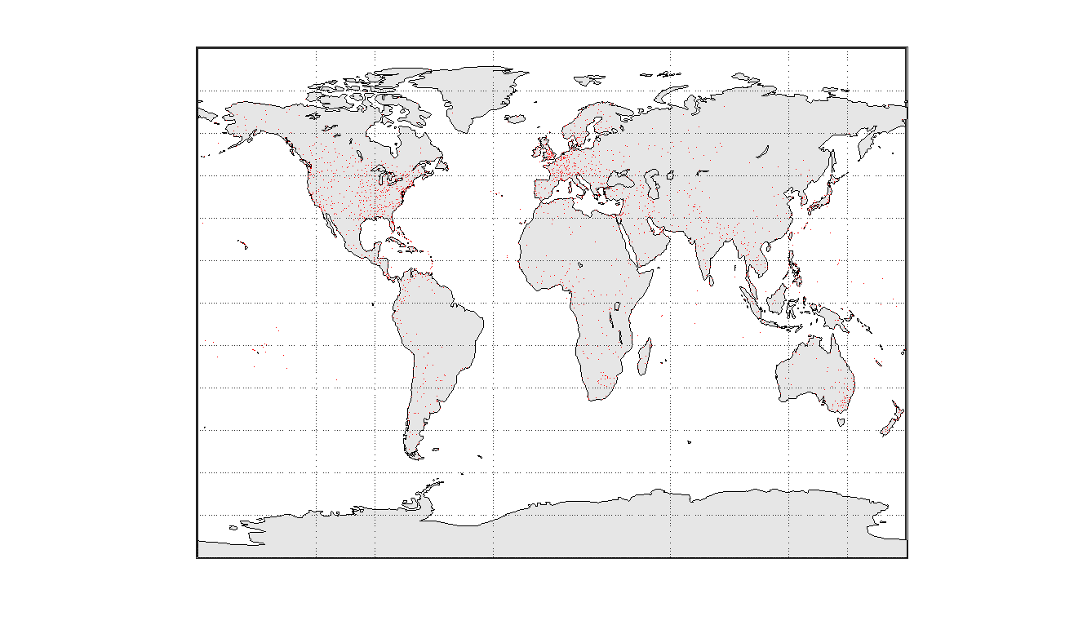
Figure A1-2 shows deployment over airports in the Chicago, USA area under the 500 m separation of scenario 1.
Figure A1-2
Assumed FODDS deployment over Chicago airport (scenario 1)
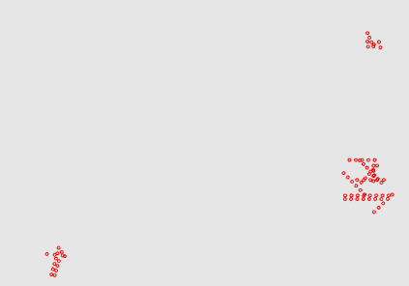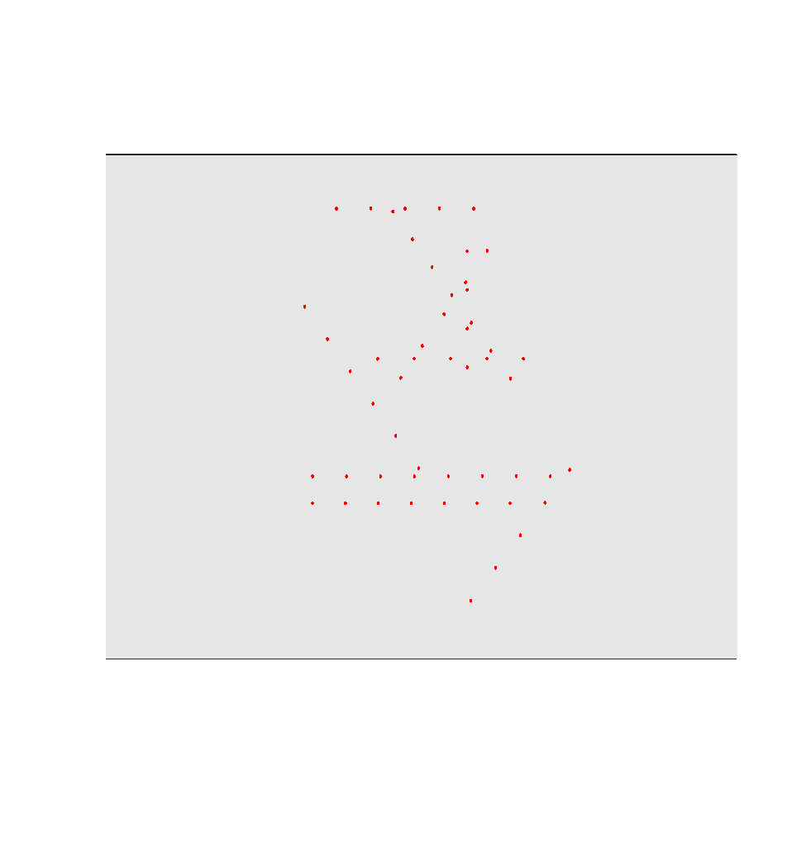
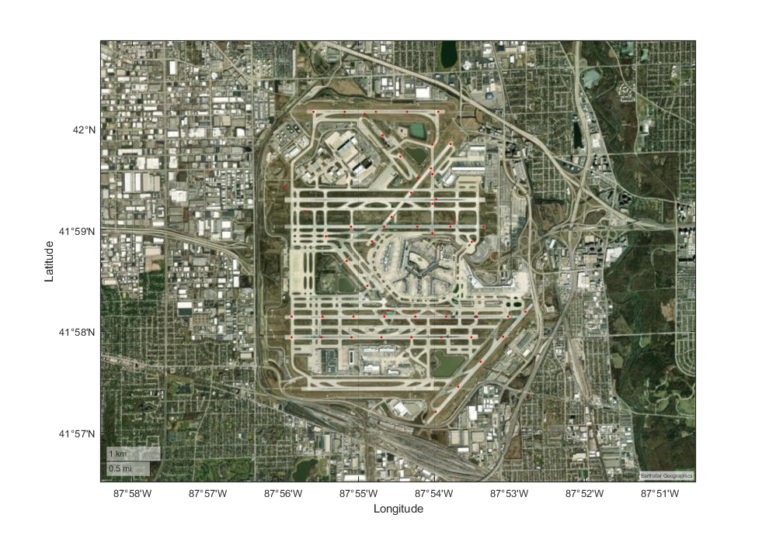
Figure A1-3 shows deployment over airports in the Chicago, USA area under the 20 m separation of scenario 2.
Figure A1-3
Assumed FODDS deployment over Chicago airport (scenario 2)
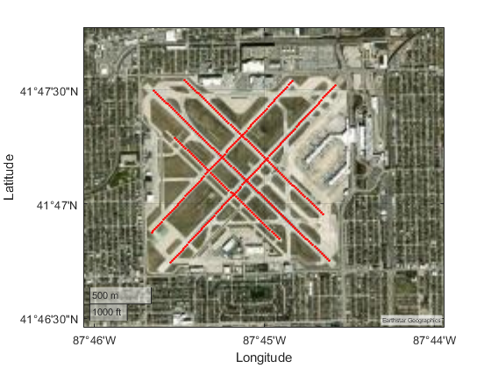

A1-1.2.2 Characteristics of FODDSs
The description of the FOD detection networks, including the parameters used for this analysis, is given in Table A1-8 and Table A1-9. The received interference will be calculated based on the aggregate power received by all FOD radars within a possible line of sight mask. In this study, system refers to the individual RF element, and network refers to coverage of the systems over an application area i.e. airport collection of multiple runways.
Table A1-8
Assumed scenario 1 characteristics of FODDS networks
Parameter | Value
Carrier frequency of each FOD radar (GHz) | 94.050
Modulation bandwidth (MHz) | 1.2
Transmit power of each FOD radar (mW) | 200
Elevation angle (degree) | −1.8
Spacing (m) | 500
Azimuth scan (degree) | ±60
Scan rate (RPM) | 15
Transmit height (m) | 8

Table A1-9
Assumed scenario 2 characteristics of FODDS networks
Parameter | Value
Carrier frequency of each FOD radar (GHz) | 94.050
Transmit power of each FOD radar (mW) | 50
Elevation angle (degree) | +1.8
Spacing (m) | 20
Azimuth | Fixed runway heading
Transmit height (cm) | 10

The FODDS antenna radiation pattern at 96 GHz was used to construct an empirical function, shown in Fig. A1-4, for the transmit antenna gain $G_{TX}$ (in dBi) as a function of the off-axis angle $α$ (in degrees) used in this analysis.
Figure A1-4
Empirical FODDS antenna radiation pattern used for dynamic radio frequency interference analysis (assumed to also apply at 94.05 GHz)
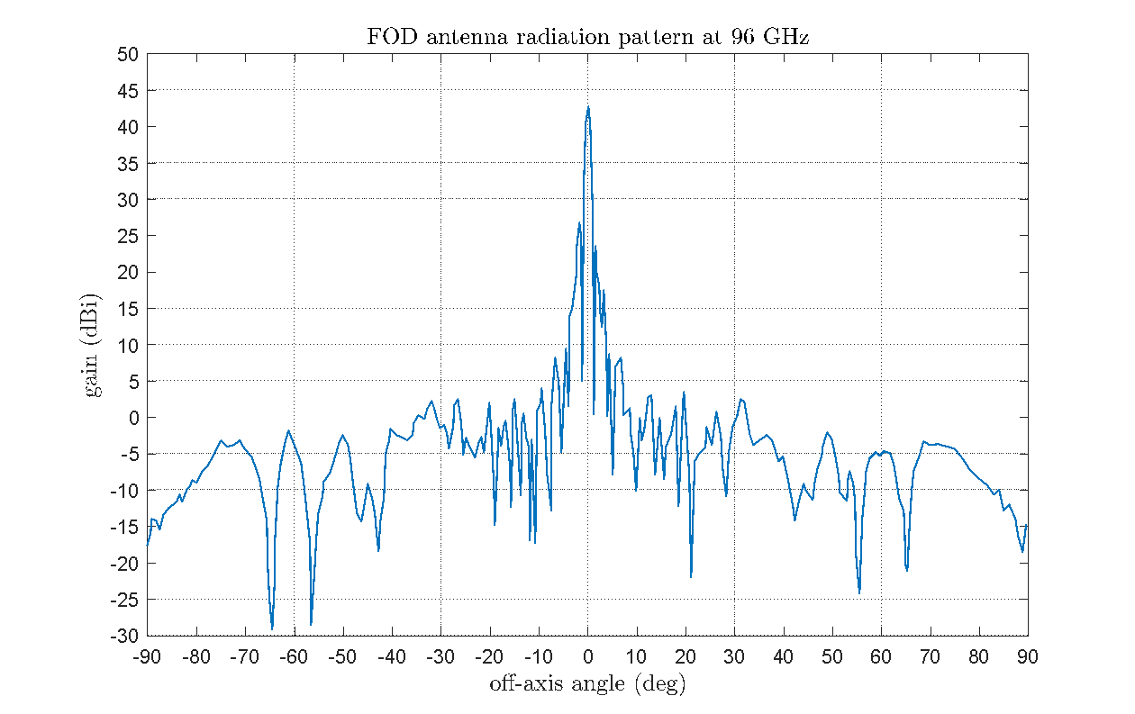

A1-1.2.3 Characteristics of EESS (active) system

A1-1.2.3.1 EESS (active) orbital characteristics
Table A1-10 shows EESS satellite orbit parameters used by CloudSat.
Table A1-10
EESS (active) satellite orbit parameters
Parameter | Value
Altitude (mean) (km) | 705
Inclination (degree) | 98.2

A1-1.2.3.2 EESS (active) technical and operational characteristics
Table A.1-11 summarizes the EESS parameters.
Table A.1-11
EESS (active) technical and operational characteristics
Parameter | Value
Maximum gain (dBi) | 65.2
Bandwidth (MHz) | 0.36
Antenna pattern | Figs A1-5, A1-6
Temperature (K) | 290
Noise figure (dB) | 7
Noise power (dBW) | −141.42
Scan type | Fixed
Pointing | Nadir

Figure A1-5
EESS (active) antenna pattern normalized to 0 dB
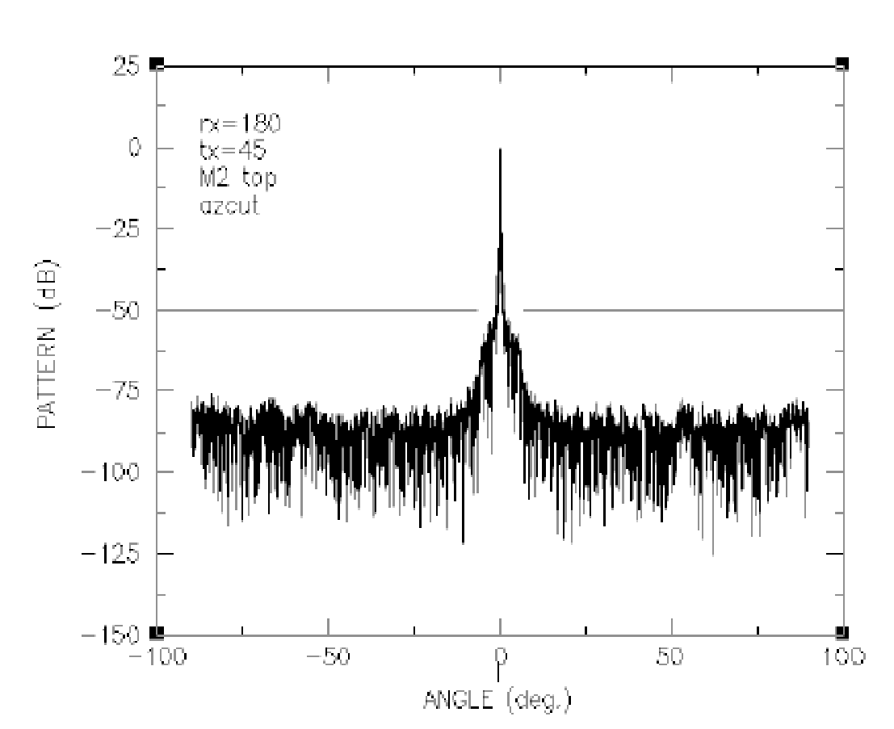
Figure A1-6
EESS (active) small angle antenna pattern normalized to 0 dB
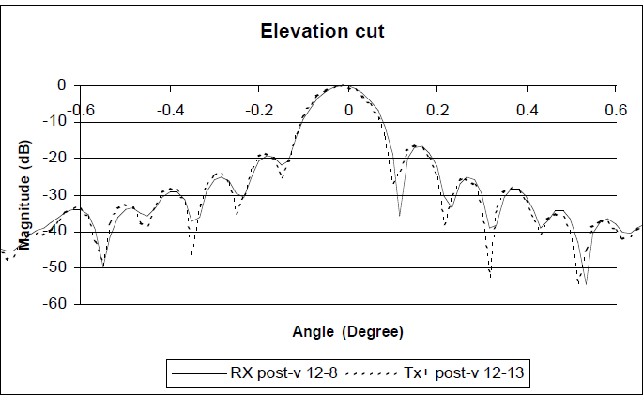

A1-1.2.3.3 Sensor area of interest test cases
A single test case was explored which was a global area of interest. Consequently, all visible Earth ground area within the sensor field of view is considered.

A1-1.2.4 Simulation parameters and results
The peak interfering signal power level, I/N (dB), received by a spaceborne radar from a terrestrial source is calculated from equation (A1-3):
$I=10\log{P_{t}}+G_{t}+G_{r}-\left(32.44+20\log\left(fR\right)\right)-L_{a}-{FDR}_{IF}-X_{r}$ (A1-2)
$T=T_{b}\left({10}^{{NF}/{10}}-1\right)$ (K)
$N=10\log{(T b BW)}$ (dBW)
$I/N=I-N$ (dB) (A1-3)
where:
Pt : peak terrestrial source transmitter power (W)
Gt : terrestrial source antenna gain towards spaceborne sensor (dBi)
Gr : spaceborne radar antenna gain towards terrestrial source (dBi)
f : frequency (MHz)
R : slant range between spaceborne sensor and terrestrial source (km)
L_{a} : attenuation due to atmospheric absorption (dB)
FDR_{IF} : frequency-dependent rejection produced by the receiver IF selectivity curve on an unwanted transmitter emission spectra (dB)
X_{r} : losses due to polarization mismatch (dB)
T_{b} : noise temperature w/o noise figure (K)
NF : noise figure (dB)
b : Boltzman constant 1.38 × 10⁻²³ (K)
BW : bandwidth of receiver (Hz)
N : Noise power with noise figure (dBW).

A1-1.2.4.1 General simulation parameters
Table A1-12 gives the relevant aspects of the simulation.
Table A1-12
General simulation parameters
Parameter | Value
Duration (days) | 1
Time step (s) | 0.1
Atmospheric losses | P.676
Polarization losses (dB) | 3

A1-1.2.4.2 Simulation results

A1-1.2.4.2.1 Scenario 1
The following CCDF curve shows the statistical distribution of interference to noise (I/N dB) levels experienced by the active sensor during the simulation for scenario 1.
Figure A1-7
Complementary cumulative distribution function curves of aggregated radio frequency interference scenario 1
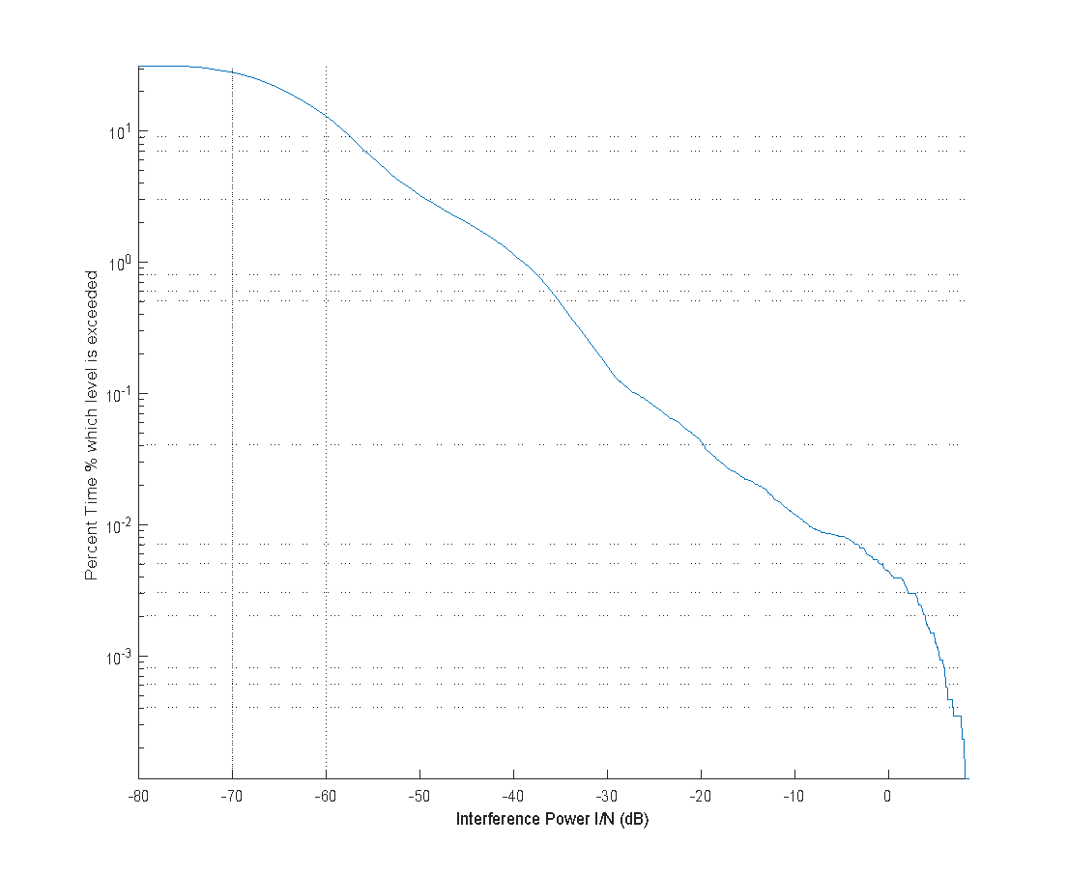
NOTE – Dashed line indicates −10 dB I/N threshold used by Recommendation ITU-R RS.1166-4.
The following RFI impact map indicates FOD radar sources that contributed more to interference levels over time for scenario 1.
Figure A1-8
Impact map of radio frequency interference (I/N dB) scenario 1
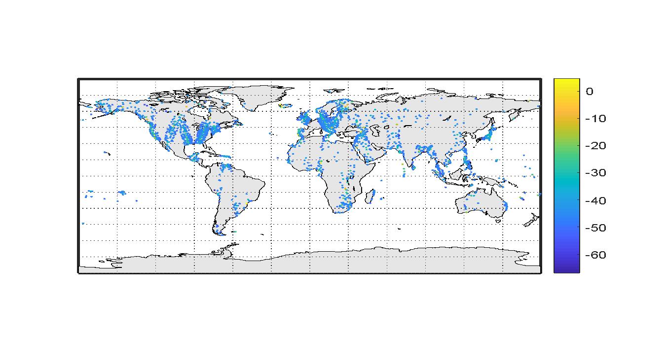

A1-1.2.4.2.2 Scenario 2
The following CCDF curve shows the statistical distribution of interference to noise (I/N dB) levels experienced by the active sensor during the simulation for scenario 2.
Figure A1-9
Complementary cumulative distribution function curves of aggregated radio frequency interference scenario 2
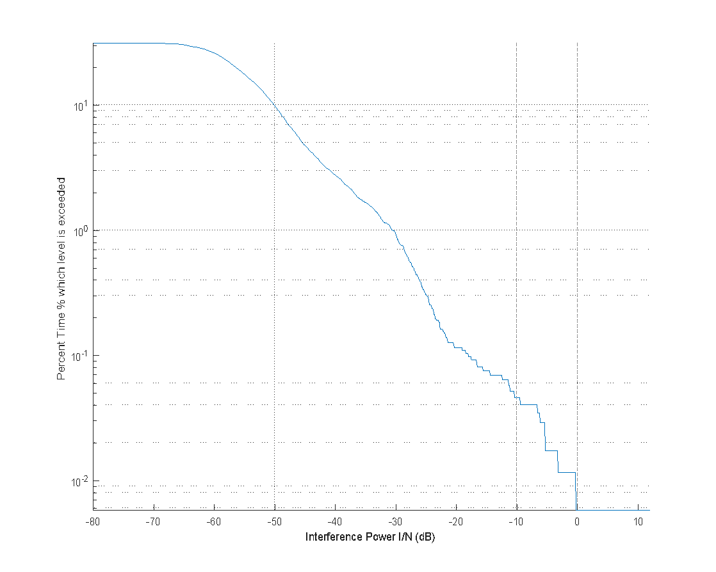
NOTE – Dashed line indicates −10 dB I/N threshold used by Recommendation ITU-R RS.1166-4.
The following RFI impact map indicates FOD radar sources that contributed more to interference levels over time for scenario 2.
Figure A1-10
Impact map of radio frequency interference (I/N dB) scenario 2
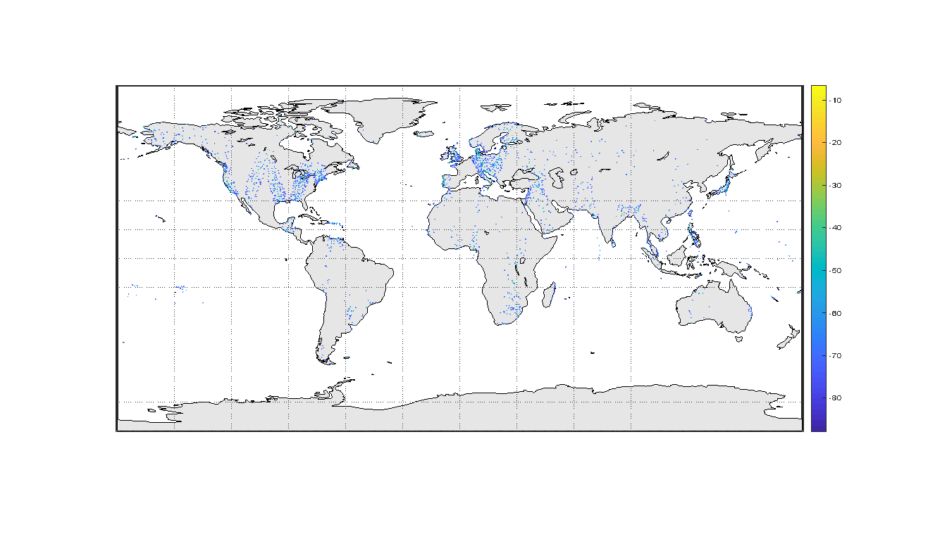

A1-2 Summary of result
As a result of studying the interference cases outlined above, there is no expectation of interference from FODDSs exceeding the protection limits of EESS (active). The worst-case results, co-frequency FOD with 100% duty cycle, between the two cases of deployment studied show a margin of at least 20 dB for 1% of time. There are only minor differences between the two deployment scenarios. The deployment on large airport runways dominates the anticipated interference, as large airport runways are most likely to have the highest number of FODDSs in the main beam of an EESS (active) sensor. Further studies are needed to evaluate if other geographic areas are identified for deployment of FODDSs adjacent to the EESS active band.

Annex 2
Interference analysis for Earth exploration-satellite service (passive)

A2-1 Interference from FODDSs into EESS (passive)

A2-1.1 Static analysis based on interference with specific geometric scenarios
At least three different geometrical scenarios have to be considered in assessing the potential for interference from FODDS into EESS passive systems. The first geometrical scenario is coupling of the antenna mainlobe of a nadir-looking EESS (passive) satellite with the sidelobes of the FODDS antenna. The second geometrical scenario is when coupling occurs between the sidelobes of both the EESS passive sensor antenna and the FODDS antenna; and the third geometrical scenario is when coupling occurs between the mainbeam of the FODDS antenna and the EESS passive sensor antenna sidelobes at a time when the EESS passive satellite is on the horizon with respect to the FODDS.
The peak interfering signal power level, I (dBW), received by a spaceborne radiometer from a terrestrial source is calculated from:
$I=10\log{P_{t}}+G_{t}+G_{r}-\left(32.44+20\log\left(fR\right)\right)-L_{a}-{FDR}_{IF}+CAF$ (A2-1)
where:
Pt : peak terrestrial source transmitter power (W)
Gt : terrestrial source antenna gain towards spaceborne sensor (dBi)
Gr : spaceborne radar antenna gain towards terrestrial source (dBi)
f : frequency (MHz)
R : slant range between spaceborne sensor and terrestrial source (km)
L_{a} : attenuation due to atmospheric absorption (dB)
FDR_{IF} : frequency-dependent rejection produced by the receiver IF selectivity curve on an unwanted transmitter emission spectra (dB)
CAF : Channel aggregation factor (dB).
Attenuation due to atmospheric absorption, L_{a}, is dependent upon the path length to the satellite through the Earth’s atmosphere, and hence upon the elevation angle from the terrestrial source to the satellite. Potentially other propagation mechanism may or may not be relevant for three geometric scenarios L_{a} is calculated using Recommendations ITU-R P.676 and ITU-R P.835. FDR_{IF} is not included in the following tables of calculation of the interference levels and margins because sufficient information is not provided in Recommendations ITU-R RS.1861 and ITU-R RS.2105.
Table A2-1 summarizes technical and operational parameters to be used for three geometric scenarios between FOD radar and radiometer L-8. The antenna gains of FOD radar and EESS passive sensor are calculated using Recommendations ITU-R F.699 and ITU-R RS.1813, respectively. The channel aggregation factor is introduced for calculation to consider out-of-band emissions from neighbouring channels. The out-of-band emission of −47 dBm/MHz fell within one channel of L-8 sensor which is worse than −50 dBm/MHz is used for compatibility studies. Although the number of FOD radars varies in relation to the size of the airport, the number of FOD radars in the L-8 footprint recommended to use is 120 which gives the maximum density of FOD radars provided in Table 4 in the main body of this report.
Table A2-1
Technical and operational parameters to be used for three geometric scenarios between FOD radar and radiometer L-8
Parameter | Geometric scenario 1: the mainlobe of the radiometer points at the FOD radar | Geometric scenario 2: shortest distance between radiometer and FOD radar | Geometric scenario 3: the mainlobe of the FOD radar points at the radiometer
Transmit power of FOD radar (mW) | 200 | 200 | 200
Out-of-band emission level (dBm/MHz) | −47 | −47 | −47
Antenna gain of FOD radar (dBi) | −7.1 | −16.8 | 44
Elevation angle to EESS passive sensor (degree) | 36.8 | 90 | 0
Antenna gain of EESS passive sensor (dBi) | 62.4 | −22.9 | −11.6
Elevation angle to FOD radar (degree) | 0 | 47.5 | 16.8
Distance between FOD radar and EESS passive sensor (km) | 1 123.6 | 700 | 3 069
Atmospheric loss (L_{a}) at 92 GHz (dB) | −1.41 | −0.81 | −64.9
Channel bandwidth of EESS passive sensor (MHz) | 3 000 | 3 000 | 3 000
Channel aggregation factor (dB) | 3 | 3 | 3
Number of FOD radars in beam | < 120 | < 120 | < 120

The interference due to spaceborne antenna mainlobe coupling with the FODDS antenna sidelobes allows for the highest value of RFI levels of these three geometrical scenarios. For geometric scenario 1, the coupling between the radiometer L-8 mainlobe and FOD sidelobe in the frequency below 92 GHz is calculated using the out-of-band emission from FOD radar fallen in the channel of L-8 sensor. The FOD radar sidelobes is given by elevation angle at 35° + 1.8° (down tilt) = 36.8°. Preliminary calculation is provided in Table A2-2 which indicates the amount of attenuation needed to apply to OOB FOD detection systems emissions in order that they meet the EESS (passive) interference protection criteria for radiometer L-8.
For geometric scenario 2 for coupling between the radiometer L-8 sidelobes and the FOD sidelobes (elevation angle at 90°) in the frequency below 92 GHz, preliminary calculation using the out-of-band emission from FOD radar fallen in the channel of L-8 sensor is provided in Table A2-3 which indicates the EESS (passive) interference criteria are met with margin of 78.57 dB.
For geometric scenario 3 for coupling between the radiometer L-8 sidelobes (off-axis angle at 64.3°) and the FOD radar mainlobe (elevation angle at 0°) in the frequency below 92 GHz, preliminary calculation using the out-of-band emission from FOD radar fallen in the channel of L-8 sensor is provided in Table A2-4 which indicates the EESS (passive) interference protection criteria for radiometer L-8 are met with margin of 83.4.
For EESS (passive) systems, when initially considering three different geometrical interaction scenarios between FODDSs and radiometer L-8, the RFI levels at the radiometer L-8 are highest for the geometrical situation of coupling between the main-beam of the radiometer L-8 and the sidelobes of the FODDS antenna. The RFI levels are much lower than for this first scenario when considering the second geometrical scenario which examines coupling between the sidelobes of both the radiometer L-8 antenna and the FODDS antenna. The third geometrical scenario is coupling between the main-beam of the FODDS antenna and the radiometer L-8 antenna sidelobes with the radiometer L-8 satellite on the horizon with respect to the FODDS. The RFI levels in this third scenario are also much lower than for the first scenario. It could be concluded that EESS (passive) interference protection criteria are met for the second and third geometric scenarios. For the first geometric scenarios, further improvement of OOB emission of FOD radar is required.
Table A2-2
Interference into L-8
First geometric scenario: L-8 mainlobe to FOD sidelobe
Calculation of received power when L-8 points at the FOD radar
 | Radiometer L-8
 | Value | dB
Out-of-band emission (dBm/MHz) | −47 | −47
Receiver channel bandwidth (MHz) | 3 000 | 34.77
Gain transmit antenna (dBi) |  | −7.1
e.i.r.p. (dBW) |  | −49.33
Gain receive antenna (dBi) |  | 62.40
1/R² (km) | 1 123.6 | −61.01
1/f² (MHz) | 92 000 | −99.28
Path loss (dB) |  | −192.72
Atmospheric loss (dB) |  | −1.41
Number of FODs in beam | 120 | 20.79
Channel aggregation factor (dB) |  | 3
Interference power (dBW) |  | −157.28
Interference power criteria (dBW) |  | −169.00
Margin (dB) |  | −11.72

Table A2-3
Interference into L-8
Second geometric scenario: L-8 sidelobe to FOD sidelobe
Calculation of received power when L-8 points at 90 degrees elevation
 | L-8
 | Value | dB
Out-of-band emission (dBm/MHz) | ‒47 | ‒47
Receiver channel bandwidth (MHz) | 3 000 | 34.77
Gain transmit antenna (dBi) |  | −16.8
e.i.r.p. (dBW) |  | −59.03
Gain receive antenna (dBi) |  | −22.9

Table A2-3 (end)
Calculation of received power when L-8 points at 90 degrees elevation
 | L-8
 | Value | dB
1/R² (km) | 700 | −56.90
1/f² (MHz) | 92 000 | −99.28
Path loss (dB) |  | −188.62
Atmospheric loss (dB) |  | −0.81
Number of FODs in beam | 120 | 20.79
Channel aggregation factor (dB) |  | 3
Interference power (dBW) |  | −247.57
Interference power criteria (dBW) |  | −169.00
Margin (dB) |  | 78.57

Table A2-4
Interference into L-8
Third geometric scenario: L-8 sidelobe to FOD mainlobe
Calculation of received power when L-8 points at 0 degree elevation
 | L-8
 | Value | dB
Out-of-band emission (dBm/MHz) | −47 | −47
Receiver channel bandwidth (MHz) | 3 000 | 34.77
Gain transmit antenna (dBi) |  | 44.00
e.i.r.p. (dBW) |  | 1.77
Gain receive antenna (dBi) |  | −11.6
1/R² (km) | 3 069 | −69.74
1/f² (MHz) | 92 000 | −99.28
Path loss (dB) |  | −201.46
Atmospheric loss (dB) |  | −64.9
Number of FODs in beam | 120 | 20.79
Channel aggregation factor (dB) |  | 3
Interference power (dBW) |  | −252.4
Interference power criteria (dBW) |  | −169.00
Margin (dB) |  | 83.4

Table A2-5 summarizes technical and operational parameters to be used for three geometric scenarios between FOD radar and radiometer L-12 and L-17. The antenna gains of FOD radar and EESS passive sensor are calculated using Recommendations ITU-R F.699 and ITU-R RS.1813, respectively. The channel aggregation factor is introduced for calculation to consider out-of-band emissions from neighbouring channels. The out-of-band emission of −47 dBm/MHz fell within one channel of L-12 and L-17 sensors which is worse than −50 dBm/MHz is used for compatibility studies. Although the number of FOD radars varies in relation to the size of the airport, the number of FOD radars in the L-12 and L-17 footprints recommended to use is 120 which gives the maximum density of FOD radars provided in Table 4 in the main body of this Report.
Table A2-5
Technical and operational parameters to be used for three geometric scenarios between FOD radar and radiometer L-12 and L-17
Parameter | Geometric scenario 1: the mainlobe of the radiometer points at the FOD radar |  | Geometric scenario 2: shortest distance between radiometer and FOD radar |  | Geometric scenario 3: the mainlobe of the FOD radar points at the radiometer
 | L-12 | L-17 | L-12 | L-17 | L-12 | L-17
Transmit power of FOD radar (mW) | 200 | 200 | 200 | 200 | 200 | 200
Out-of-band emission level (dBm/MHz) | −47 | −47 | −47 | −47 | −47 | −47
Antenna gain of FOD radar (dBi) | −7.7 | −7.1 | −16.8 | −16.8 | 44 | 44
Elevation angle to EESS passive sensor (degree) | 36.8 | 36.8 | 90 | 90 | 0 | 0
Antenna gain of EESS passive sensor (dBi) | 58 | 62.4 | −21.8 | −22.9 | −12.9 | −11.81
Elevation angle to FOD radar (degree) | 0 | 0 | 48.6 | 47.7 | 21.4 | 17.2
Altitude (km) | 407 | 665.96 | 407 | 665.96 | 407 | 665.96
Distance between FOD radar and EESS passive sensor (km) | 649.3 | 1082.5 | 407 | 665.96 | 2317.5 | 2989.8
Atmospheric loss (L_{a}) at 92 GHz (dB) | −1.35 | −1.43 | −0.8 | −0.81 | −64.8 | −64.9
Channel bandwidth of EESS passive sensor (MHz) | 3 000 | 3 000 | 3 000 | 3 000 | 3 000 | 3 000
Channel aggregation factor (dB) | 3 | 3 | 3 | 3 | 3 | 3
Number of FOD radars in beam | < 120 | < 120 | < 120 | < 120 | < 120 | < 120

Tables A2-6, A2-7 and A2-8 show the results for the radiometers L-12 and L-17 that the RFI levels at the radiometer L-12 and L-17 are highest for the first geometric situation of coupling between the main-beam of the radiometers L-12 and L-17 and the sidelobes of the FODDS antenna. The RFI levels in the second and third geometric scenarios are much lower than for the first scenario. It could be concluded that EESS (passive) interference protection criteria are met for the second and third geometric scenarios. For the first geometric scenarios, further improvement of OOB emission of FOD radar is required.
Table A2-6
Interference into L-12 and L-17
First geometric scenario: L-12 and L-17 mainlobe to FOD sidelobe
Calculation of received power when L-12 and L-17 point at the FOD radars | Radiometer L-12 |  | Radiometer L-17
 | Value | dB | Value | dB
Out-of-band emission (dBm/MHz) | −47 | −47 | −47 | −47
Receiver channel bandwidth (MHz) | 3 000 | 34.77 | 3 000 | 34.77
Gain transmit antenna (dBi) |  | −7.1 |  | −7.1
e.i.r.p. (dBW) |  | −49.33 |  | −49.33
Gain receive antenna (dBi) |  | 58 |  | 62.4
1/R² (km) | 649.3 | −56.25 | 1082.5 | −60.69
1/f² (MHz) | 92 000 | −99.28 | 92 000 | −99.28
Path loss (dB) |  | −187.97 |  | −192.41
Atmospheric loss (dB) |  | −1.35 |  | −1.43
No. of FODs in beam | 20 | 20.79 | 20 | 20.79
Channel aggregation factor (dB) |  | 3 |  | 3
Interference power (dBW) |  | −156.86 |  | −156.98
Interference power criteria (dBW) |  | −169.00 |  | −169.00
Margin (dB) |  | −12.14 |  | −12.02

Table A2-7
Interference into L-12 and L-17
Second geometric scenario: L-12 and L-17 sidelobe to FOD sidelobe
Calculation of received power when L-12 and L-17 are at 90 degrees elevation | Radiometer L-12 |  | Radiometer L-17
 | Value | dB | Value | dB
Out-of-band emission (dBm/MHz) | −47 | −47 | −47 | −47
Receiver channel bandwidth (MHz) | 3 000 | 34.77 | 3 000 | 34.77
Gain transmit antenna (dBi) |  | −16.8 |  | −16.8
e.i.r.p. (dBW) |  | −59.03 |  | −59.03
Gain receive antenna (dBi) |  | −21.8 |  | −22.9
1/R² (km) | 407 | −52.19 | 665.96 | −56.47
1/f² (MHz) | 92 000 | −99.28 | 92 000 | −99.28
Path loss (dB) |  | −183.91 |  | −188.19
Atmospheric loss (dB) |  | −0.8 |  | −0.81
No. of FODs in beam | 20 | 20.79 | 20 | 20.79

Table A2-7 (end)
Calculation of received power when L-12 and L-17 are at 90 degrees elevation | Radiometer L-12 |  | Radiometer L-17
 | Value | dB | Value | dB
Channel aggregation factor (dB) |  | 3 |  | 3
Interference power (dBW) |  | −241.75 |  | −247.14
Interference power criteria (dBW) |  | −169.00 |  | −169.00
Margin (dB) |  | 72.75 |  | 78.14

Table A2-8
Interference into L-12 and L-17
Third geometric scenario: L-12 and L-17 sidelobe to FOD mainlobe
Calculation of received power when L-12 and L-17 are at 0 degree elevation | Radiometer L-12 |  | Radiometer L-17
 | Value | dB | Value | dB
Out-of-band emission (dBm/MHz) | −47 | −47 | −47 | −47
Receiver channel bandwidth (MHz) | 3 000 | 34.77 | 3 000 | 34.77
Gain transmit antenna (dBi) |  | 44 |  | 44
e.i.r.p. (dBW) |  | 1.77 |  | 1.77
Gain receive antenna (dBi) |  | −10.2 |  | −11.50
1/R² (km) | 2317.5 | −67.3 | 2989.8 | −69.51
1/f² (MHz) | 92 000 | −99.28 | 92 000 | −99.28
Path loss (dB) |  | −199.02 |  | −201.23
Atmospheric loss (dB) |  | −64.8 |  | −64.9
No. of FODs in beam | 20 | 20.79 | 20 | 20.79
Channel aggregation factor (dB) |  | 3 |  | 3
Interference power (dBW) |  | −248.46 |  | ‒252.07
Interference power criteria (dBW) |  | −169.00 |  | −169.00
Margin (dB) |  | 79.46 |  | 83.07

A2-1.2 Dynamic analysis based on interference observed with spacecraft orbit simulation
The analysis will be conducted in which the orbit of the EESS (passive) spacecraft under investigation is dynamically simulated, retaining only the data points when the EESS (passive) sensor antenna boresight points within a defined measurement area of interest, as defined in Recommendation ITU-R RS.2017. Calculations will be performed to determine the potential interference from each of the FOD detection radars into the EESS (passive) sensors under study and will consider the aggregate effect from multiple FOD transmitters. The simulation will propagate the satellite based on its orbital parameters, and the simulation step size is selected to be an irrational number to ensure that the beam dynamics of the passive sensor do not exhibit periodic behaviour. At each simulation step, a snapshot of the interference scenario will be generated where the directional vectors from each FOD source to the EESS (passive) sensor will be computed along with the gain of the transmit and receive antennas using their respective antenna patterns.
The interfering signal power level,$I_{i,n}$ (dBW/100 MHz), received by a spaceborne radiometer at the $n^{th}$ simulation step from the $i^{th}$ terrestrial source is calculated from:
$I_{i,n[dBW/100 MHz]}={ P}_{TX i,n}+G_{TX i,n}+{ G}_{RX i,n}-{ L}_{FSPL i,n}-L_{Misc i,n}$ (A2-2)
where:
${ P}_{TX i,n}$: peak terrestrial source transmitter out-of-band emission power (dBW/100 MHz)
$G_{TX i,n}$: terrestrial source antenna gain towards spaceborne sensor (dBi)
$G_{RX i,n}$: spaceborne radar antenna gain towards terrestrial source (dBi)
$L_{FSPL i,n}$: free space path loss (dB)
$L_{Misc i,n}$: other losses considered (dB).
The aggregate interference at the $n^{th}$ simulation step,${ AggI}_{n}$ (dBW/100 Hz), is calculated by the linear summation of the received interference from all $i$transmitting, terrestrial sources within line of sight of spaceborne radiometer under consideration:
${AggI}_{n[dBW/100 MHz]}=\left(\sum_{i}{I_{i,n[W/100 MHz]}}\right)$ (A2-3)
Using the resulting data containing received interfering power levels, CCDF curves will be generated to assess interference observed over the MAI.

A2-1.2.1 Deployment of FODDS
This analysis considers a deployment of FODDSs over Japan. The FODDSs have a down tilt focused on the runways. The FODDSs are placed every 200 meters along the runways. In the case where the runway was not a multiple of 200 m, a ceiling function was used to ensure that the entire runway surface would be covered for detection of foreign objects. Two FOD deployment scenarios are considered, over large airports as well as large plus medium airports. Large airports are land airports with scheduled major airline service with millions of passengers/year, or a major military base. Medium airports are land airports with scheduled regional airline service, or regular general aviation or military traffic. Although Fig. 4 shows the possible Japanese Airport which may implement FOD detection systems in the future, more than 100 airports including large and medium airports are operated in Japan. In this section, FOD detection system implemented in large and medium airports are considered, taking into account the distribution of FOD deployment system at those airports. The resulting FOD deployment considers 350 FOD systems placed over 13 large airports with 23 runways and 1472 FOD systems placed over 106 large plus medium airports with 130 runways. The FOD deployment is illustrated in Fig. A2-1.
FIGURE A2-1
FOD deployment over Japan (X=large airports, O=large and medium airports)
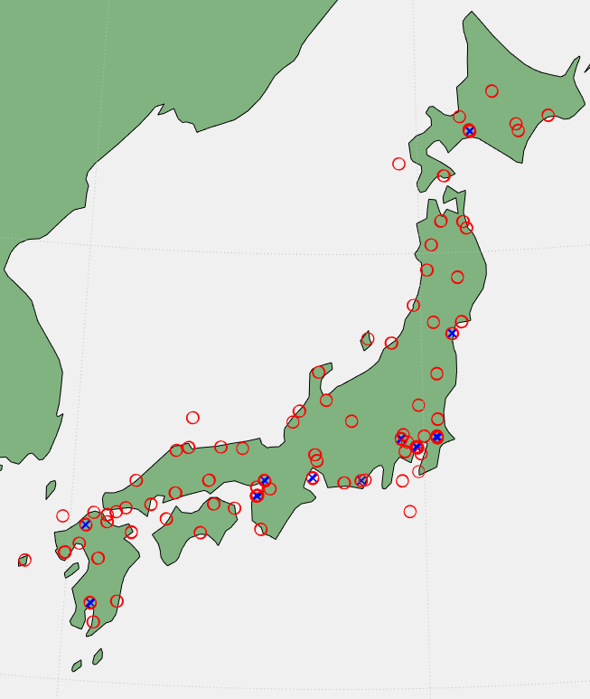

A2-1.2.2 Characteristics of foreign object debris detection systems
The parameters of the FODDSs used for this initial analysis are summarized in Table A2-9, with parameters taken from Table 1. The received interference is calculated based on the aggregate power received by all FODDSs. The analysis uses the FOD out-of-band power within the frequency band 86-92 GHz used for EESS (passive). As a conservative, worst-case assumption, the out-of-band power in this analysis is assumed to remain constant across the 100 MHz bandwidth considered for EESS (passive) protection. Additionally, the analysis considers all FOD systems to be operating on the same channel with 100% duty cycle.
TABLE A2-9
Characteristics of foreign object debris detection system networks
Parameter | Value
Maximum out-of-band emission power (dBm/MHz) | −50
Antenna gain (dBi) | 44
Antenna pattern | F.699-8
Antenna height (m) | 7
Scan rate (RPM) | 15
Antenna elevation angle (degree) | −1.8
Radiated rotation angle (azimuth scan) (degree) | ±60
Spacing (m) | 200

A2-1.2.3 Characteristics of EESS (passive) system
Relevant information on typical technical and operational characteristics of systems operating in the EESS (passive) systems using allocations between 1.4 GHz and 275 GHz can be found in Recommendation ITU-R RS.1861-1, All NGSO sensors operating between 86-92 GHz are examined in this study. The EESS sensors under study were considered to have infinite out-of-band attenuation and zero in-band attenuation in this analysis.
Recommendation ITU-R RS.2017-0 contains the performance and interference criteria for satellite passive remote sensing. The following limits should hold for frequency band 86-92 GHz.
• Maximum interference level: −169 dBW/100 MHz.
• Percentage of area or time permissible interference level may be exceeded: 0.01%. The area analyzed should be 2 000 000 km².

A2-1.2.3.1 EESS (passive) sensor area of interest test cases
As described in § A2-1.2.1, this study will focus on the airports inside of Japan. Table A2-10 defines the corners of the measurement area of interest.
TABLE A2-10
Corner Coordinates for measurement area of interest
- | Latitude, °N | Longitude, °E
Point 1 | 47 | 137
Point 2 | 41 | 148
Point 3 | 29 | 134
Point 4 | 36 | 123

A2-1.2.4 Simulation parameters and results

A2-1.2.4.1 General simulation parameters
Table A2-11 gives the relevant aspects of the simulation.
TABLE A2-11
General simulation parameters
Parameter | Value
Duration (days) | 20
Time step (s) | π/100
Atmospheric losses | P.676
Polarization losses (dB) | 3

A2-1.2.4.2 Simulation results
The results of FOD interference from large airports into EESS (passive) are shown in Fig. A2-12. The results of FOD interference from large plus medium airports into EESS (passive) are shown in Fig. A2-13.
FIGURE A2-12
Interference from FODDSs at large airports into EESS (passive)
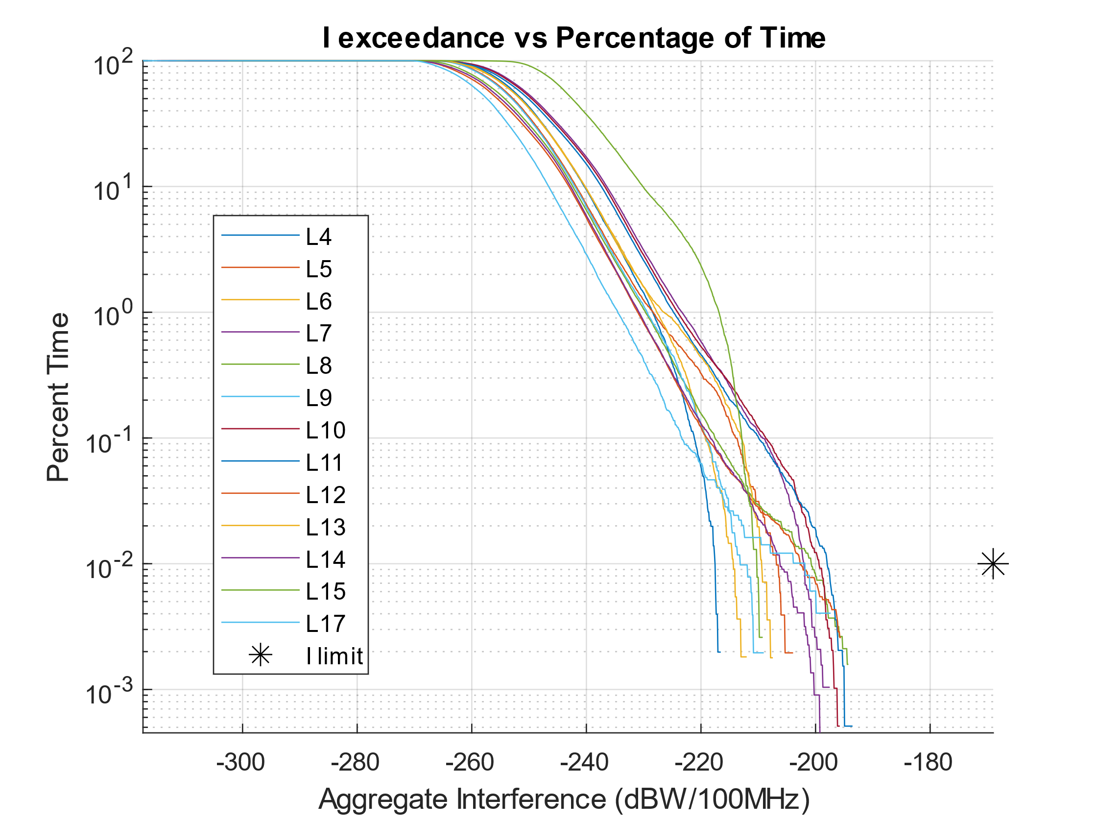
FIGURE A2-13
Interference from FODDSs at large plus medium airports into EESS (passive)
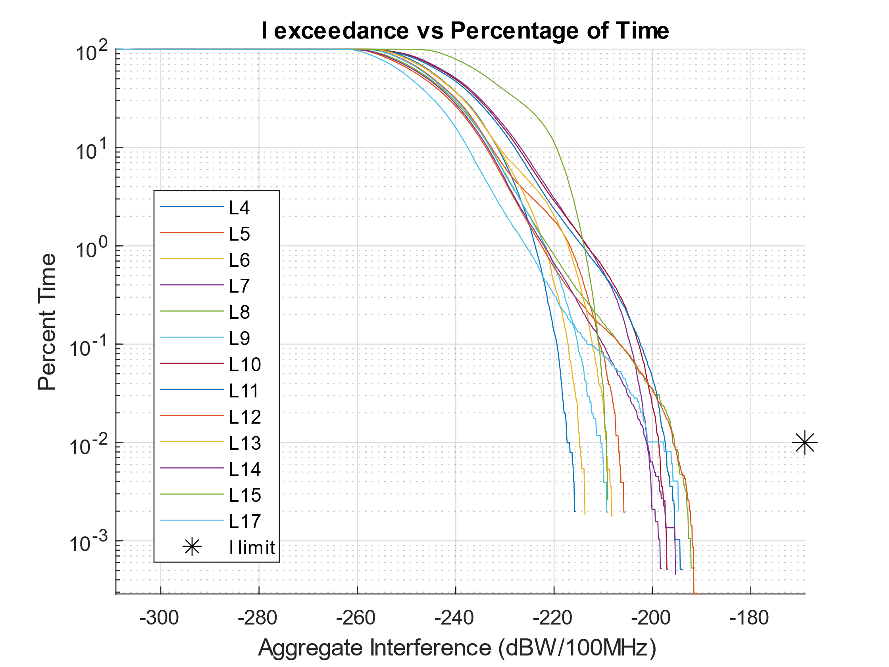

A2-2 Summary of results
As a result of studying the interference cases outlined above, there is no expectation of interference from FODDSs exceeding the protection limits of EESS (passive). The worst-case results, co-frequency FOD with 100% duty cycle, between the two cases of deployment studied show a margin of at least 26.54 dB for 0.01% of time. There are only minor differences between the two deployment scenarios. The deployment on large airport runways dominates the anticipated interference, as large airport runways are most likely to have the highest number of FODDSs in the main beam of an EESS (passive) sensor. Conical sensors, specifically sensors L8, L10, L11, and L12, display the highest susceptibility to interference from FODDSs. Further studies are needed to evaluate if other geographic areas are identified for deployment of FODDSs adjacent to the EESS passive band.

