Report ITU-R M.2560-0
(12/2025)
M Series: Mobile, radiodetermination, amateur
and related satellite services
Guidance for national and bilateral coordination of stations in the fixed service with IMT stations in the frequency band 6 425-7 125 MHz

Foreword
The role of the Radiocommunication Sector is to ensure the rational, equitable, efficient and economical use of the radio-frequency spectrum by all radiocommunication services, including satellite services, and carry out studies without limit of frequency range on the basis of which Recommendations are adopted.
The regulatory and policy functions of the Radiocommunication Sector are performed by World and Regional Radiocommunication Conferences and Radiocommunication Assemblies supported by Study Groups.

Policy on Intellectual Property Right (IPR)
ITU-R policy on IPR is described in the Common Patent Policy for ITU-T/ITU-R/ISO/IEC referenced in Resolution ITU-R 1. Forms to be used for the submission of patent statements and licensing declarations by patent holders are available from https://www.itu.int/ITU-R/go/patents/en where the Guidelines for Implementation of the Common Patent Policy for ITU-T/ITU-R/ISO/IEC and the ITU-R patent information database can also be found.

Series of ITU-R Reports
(Also available online at https://www.itu.int/publ/R-REP/en)
Series | Title
BO | Satellite delivery
BR | Recording for production, archival and play-out; film for television
BS | Broadcasting service (sound)
BT | Broadcasting service (television)
F | Fixed service
M | Mobile, radiodetermination, amateur and related satellite services
P | Radio-wave propagation
RA | Radio astronomy
RS | Remote sensing systems
S | Fixed-satellite service
SA | Space applications and meteorology
SF | Frequency sharing and coordination between fixed-satellite and fixed service systems
SM | Spectrum management
TF | Time signals and frequency standards emissions

Note: This ITU-R Report was approved in English by the Study Group under the procedure detailed in Resolution ITU-R 1.

Electronic Publication
Geneva, 2025
© ITU 2025
All rights reserved. No part of this publication may be reproduced, by any means whatsoever, without written permission of ITU.

REPORT ITU-R M.2560-0
Guidance for national and bilateral coordination of stations in the fixed service with IMT stations in the frequency band 6 425-7 125 MHz
(2025)
TABLE OF CONTENTS
Page
1 Introduction 2
2 Methodology for calculating coordination distance 3
2.1 Characteristics of systems 3
2.2 Propagation and clutter loss models 5
2.3 Method for calculation of coordination area around FS station 6
2.4 Method for calculation of coordination area around IMT stations 9
3 Possible approaches for coordination between IMT and FS 11
3.1 Possible separation approach between IMT and FS 11
3.2 Examples of mitigation techniques and other considerations 14
3.3 Migration of FS links 15
4 Summary 15
Annex – Examples of calculating coordination area based on the methodology in § 2.4 15

Related ITU-R Recommendations, Reports and Handbooks
Recommendation ITU-R F.384 – Radio-frequency channel arrangements for medium- and high- capacity digital fixed wireless systems operating in the 6 425-7 125 MHz band
Recommendation ITU-R P.452 – Prediction procedure for the evaluation of interference between stations on the surface of the Earth at frequencies above about 100 MHz
Recommendation ITU-R P.676 – Attenuation by atmospheric gases and related effects
Recommendation ITU-R F.758 – System parameters and considerations in the development of criteria for sharing or compatibility between digital fixed wireless systems in the fixed service and systems in other services and other sources of interference
Recommendation ITU-R F.1245 – Mathematical model of average and related radiation patterns for point-to-point fixed wireless system antennas for use in interference assessment in the frequency range from 1 GHz to 86 GHz
Recommendation ITU-R SM.1541 – Unwanted emissions in the out-of-band domain
Recommendation ITU-R F.1566 – Performance limits for maintenance of digital fixed wireless systems operating in plesiochronous and synchronous digital hierarchy-based international paths and sections
Recommendation ITU-R M.2101 – Modelling and simulation of IMT networks and systems for use in sharing and compatibility studies
Recommendation ITU-R P.2108 – Prediction of clutter loss
List of acronyms and abbreviations
AAS Advanced antenna system
ACIR Adjacent channel interference ratio
ACLR Adjacent channel leakage ratio
ACS Adjacent channel selectivity
AWGN Additive white gaussian noise
BS Base station
C/I Carrier to interference ratio
F/B Front-to-back ratio
FS Fixed service
HARQ Hybrid Automatic Repeat reQuest
I/N Interference to noise ratio
IMT International Mobile Telecommunications
MLC Minimum coupling loss
NLoS Non-line-of-sight
SINR Signal-to-interference-plus-noise ratio
TDD Time-division duplexing

1 Introduction
The studies undertaken under WRC-23 agenda item 1.2 revealed that co-channel coexistence between IMT and the fixed service in the frequency band 6 425-7 125 MHz can be achieved but would require site-by-site coordination if IMT and fixed service (FS) are deployed in the same or in adjacent geographical areas. This coordination is crucial to mitigate potential interference issues.
WRC-23 agenda item 1.2 resulted in a Conference decision to identify the frequency band 6 425-7 125 MHz for IMT in Region 1 and some additional countries. Resolution 220 (WRC-23) invites ITU-R “to update existing ITU-R Recommendations/Reports or develop new ITU-R Recommendations/Reports, as appropriate, to provide information and assistance to the administrations concerned on possible coordination of stations in the fixed service with IMT stations in the frequency band 6 425-7 125 MHz”.
This Report is intended to provide guidance on the methodology for calculating coordination distance and possible approaches for the coordination between IMT and FS in the frequency band 6 425-7 125 MHz at a national or bilateral level. This Report is not meant to repeat the sharing and compatibility studies undertaken during the WRC-23 cycle.

2 Methodology for calculating coordination distance

2.1 Characteristics of systems

2.1.1 Fixed service system parameters and deployment scenarios
The FS systems operating within the frequency band 6 425-7 125 MHz are deployed in rural and urban (including sub-urban) areas. The exact deployment scenarios vary country by country.
The FS parameters to be used in the calculation of coordination distances include:
– Antenna pattern
– Antenna height
– Antenna gain
– Link length
– TX output power
– Feeder/multiplexer loss
– Receiver noise figure.
The values of these parameters in rural and urban deployments will normally be different, e.g. FS height and FS link length. Furthermore, fixed link deployments vary from country to country and are based on many national considerations including applications being supported by fixed links. Values for parameters for different links also vary from each other. Therefore, specific parameters will need to be taken into account, on a site by site, case-by-case basis. Notwithstanding, examples of typical values which may be applicable to some countries/regions are provided in Table 1.
table 1
Typical values of parameters for fixed service for simulation
System parameters | Rural area |  | Urban area
 | Example 1 | Example 2 | Example 3 | Example 4
Modulation | 64-QAM | 64-QAM | 64-QAM | 64-QAM
Channel spacing and receiver noise bandwidth (MHz) | 40 | 40 | 40 | 40
TX output power (dBW) | 3 | 3 | 3 | 3
Feeder/multiplexer loss (dB) | 1.8 | 1.8 | 1 | 1.8
Antenna gain (dBi) | 38 | 39.5 | 36 | 38
Antenna pattern | Rec. ITU-R F.1245 for the aggregated case
Antenna height (m) | 60 | 60 | 20 | 60
Link length (km) | 38 | 38 | 10 | 35

2.1.2 Protection criterion for FS systems
The following long-term interference-to-noise protection criterion for FS systems is to be used in studies (Recommendation ITU-R F.758-8):
I/N = −10 dB to not be exceeded for more than 20% of time
The above equates to 0.5 dB degradation in fade margin and 10% degradation in error performance objectives for the fixed service for the band under consideration in this Report (see Table 2 in Annex 1 to Recommendation ITU-R F.758-8).

2.1.3 IMT system parameters and deployment scenarios
Calculations of interference between IMT and FS, including coordination distance, may take into account the specific characteristics of IMT base stations, if available and where applicable on a case-by-case basis. Otherwise, example technical characteristics of IMT system for operation in the frequency band 6 425-7 125 MHz, as in Table 2, may be used for a general analysis.
table 2
Simulation parameters of IMT-2020
System parameters | Macro suburban | Macro urban
Common parameters
Frequency band (MHz) | 6 425-7 125 | 6 425-7 125
TDD/FDD | TDD | TDD
Network loading factor | 50% | 50%
TDD activity factor | 75% | 75%
User equipment density for terminals that are transmitting simultaneously | 3 UEs per sector | 3 UEs per sector
UE distribution | Uniform distribution in the hexagon area | Uniform distribution in the hexagon area
Typical channel bandwidth (MHz) | 100 | 100
Deployment related parameters
BS Antenna height (m) | 20 | 18
UE Antenna height (m) | 1.5 | 1.5
Cell radius (m) | 600 | 300
Sectorization | 3 sectors | 3 sectors
Base station maximum coverage angle in the horizontal plane (degrees) | ±60 | ±60
Base station vertical coverage range (degrees) | 90-100 | 90-120
Mechanical downtilt (degrees) | 6 | 10
Base station antenna characteristics
Antenna pattern | Refer to Rec. ITU-R M.2101 Annex 1, section 5
Element gain (dBi) | 6.4 | 5.5
Horizontal/vertical 3 dB beamwidth of single element (degree) | 90° for H  65° for V | 90° for H  90° for V
Horizontal/vertical front-to-back ratio (dB) | 30 for both H/V | 30 for both H/V
Antenna polarization | Linear ±45° | Linear ±45°
table 2 (end)
System parameters | Macro suburban | Macro urban
Antenna array configuration (Row × Column) | 16 × 8 elements | 16 × 8 elements
Horizontal/Vertical radiating element spacing | 0.5 of wavelength for H  0.7 of wavelength for V | 0.5 of wavelength for H  0.5 of wavelength for V
Array Ohmic loss (dB) | 2 | 2
Conducted power (before Ohmic loss) per antenna element (dBm) | 22 | 22
Noise figure (dB) | 6 | 6
ACS | 42 | 42
Blocking response level | In-band blocking level: −43 dBm Out-of-band blocking level: −15 dBm | In-band blocking level: −43 dBm Out-of-band blocking level: −15 dBm
User equipment characteristics
Antenna pattern | Omnidirectional
Typical antenna gain for user terminals (dBi) | −4 | −4
Body loss (dB) | 4 | 4
Maximum user terminal output power (dBm) | 23 | 23
Power control model | Rec. ITU-R P.2101 | Rec. ITU-R P.2101

2.1.4 Protection criterion for IMT systems
Typically, IMT employs protection criterion (irrespective of the number of cells and independent of the number of interferers) which is based on the interference-to-noise ratio. This criterion has been developed without considering any percentage of time related to it. When interfered by the other primary service the protection criterion I/N = −6 dB.

2.2 Propagation and clutter loss models
The signal propagating from the IMT base stations to FS station is subject to the following propagation losses/attenuations:
– Free space loss
– Diffraction loss due to the surrounding terrain
– Atmospheric absorption
– Rain fade
– Clutter loss
– Polarization loss
– Multipath fading.

2.2.1 Basic propagation loss for terrestrial paths
The recommended method to determine the path propagation loss between the IMT equipment and the FS station is provided in Recommendation ITU-R P.452 or Recommendation ITU-R P.2001. Topographic information, i.e. terrain height data, should be incorporated as it could have a significant effect on the diffraction loss.
The calculation of propagation loss according to the models in these Recommendations requires a specific terrain profile but may be suitable for Monte Carlo simulations by running the model repeatedly on real (but random) paths of a fixed length. Such paths may be chosen by using a terrain database for a region representative of the environment of interest (for example, by choosing a specific city to represent an urban area or choosing a specific mountain range to represent a mountainous area). Within this region, for each path a random starting point is generated, and the end point is calculated at a random azimuth, using the path length of interest. The propagation analysis is then performed on each path, and the Monte Carlo approach is used to derive the statistics of the loss for this path length. This can then be repeated for other path lengths.
It is noted that Recommendation ITU-R P.452 or ITU-R P.2001 refer to Recommendation ITU-R P.676 for calculation of atmospheric losses. If available, atmospheric/weather data may be taken into account for more precise estimates of the atmospheric attenuation.

2.2.2 Clutter loss
Recommendation ITU-R P.2108 in § 3.2 (terrestrial paths) provides a statistical clutter loss model. In an aggregation calculation (Monte Carlo simulation) for each IMT BS station, a randomly chosen $p_{L}$ value (uniformly distributed between 0 and 100%) may be used.

2.2.3 Polarisation loss
The polarization loss will be specific to the loss caused by the polarization mismatch, between the transmitting and receiving antennas. A polarization loss of 3 dB should be considered since FS antenna are generally vertically or horizontally polarised and IMT BS antenna have generally ±45° polarization.

2.3 Method for calculation of coordination area around FS station

2.3.1 Monte Carlo methodology
The generic methodology for calculating a coordination area using Monte Carlo simulation is set out in the following steps. The methodology calculates the aggregate interference from IMT base stations at a FS station receiver and then derive the coordination distance. This is repeated at different azimuth angles around the FS receiver.
Step 1
Determine the parameters and generate FS station, IMT base stations and user equipment. Generate IMT base stations and user equipment in a simulation area e.g. Hexagon grid with 57 sectors (see Fig. 1). Modelling of network load for determination of the active BSs can be found in Recommendation ITU-R M.2101. Another possibility is, for each of the BS in the simulation area, to assign it as active or not, with a probability given by the network loading factor (see Table 2). The FS station receiver is located at a distance from IMT network.
Figure 1
Illustration of possible locations of FS stations and IMT base stations
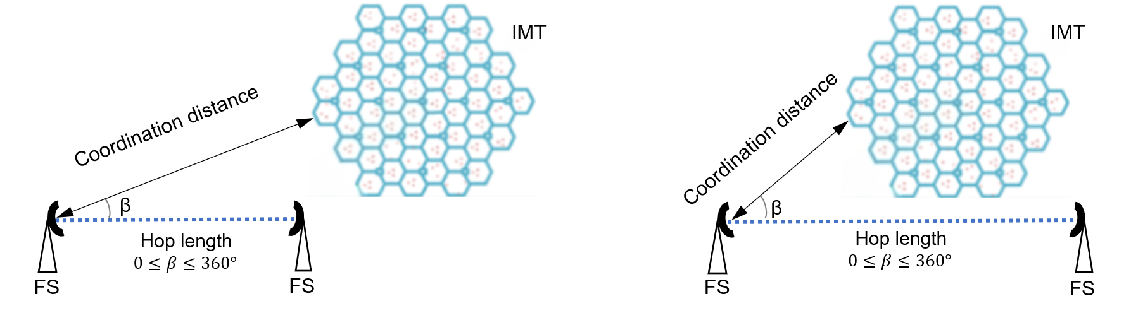
Step 2
Locate the IMT network at an initial distance d of the FS receiver. This initial distance could be 1 km for co-channel calculation and 250 m for adjacent channel calculation. Run a Monte Carlo simulation to calculate a Cumulative Distribution Function of the aggregated interference, I, from IMT base stations using the procedure in § 2.3.1. Compare the aggregated interference with the protection criterion of the FS station receiver. If the criterion is not exceeded, then the coordination distance is found. Otherwise repeat with the IMT network separated further away, until the criterion is not exceeded.
Step 3
Repeat the process at a different azimuth angle β (between the FS pointing direction and the IMT network) until the 360 degrees arc is completed.
Co-channel calculation
Modelling of the IMT network is performed according to Recommendation ITU-R M.2101. The interference power from one BS is calculated as:
$I_{BS}={PSD}_{TX}+{G(θ)}_{TX}-{L(θ)}_{clutter}-L_{prop}-L_{pol}+{G\left(ψ\right)}_{Fs}$ dBm/MHz (1)
where:
$I_{BS}$: single entry interference power from a BS (dBm/MHz)
${PSD}_{TX}$: power spectral density of the i^{th} BS (dBm/MHz)
${G(θ)}_{TX}$: antenna gain of the i^{th} BS in the direction of fixed service (dBi)
${L(θ)}_{clutter}$: clutter loss from the BS location to fixed service (dB)
$L_{prop}$: propagation loss according to Recommendation ITU-R P.2001 or ITU-R P.452 (dB)
$L_{pol}$: polarisation loss (3 dB)
${G(ψ)}_{FS}$: FS antenna receiving gain towards the direction of the i^{th} BS (dBi).
The aggregate interference towards the FS station is calculated by summing up contributions from 57 sectors deployed within the simulation area as shown in equation (2).
$I_{BS_total}= 10\log_{10}\left(\sum_{i}{10^{\frac{I_{BS}\left(i\right)}{10}}}\right)$ dBm/MHz (2)
where:
$I_{BS(i)}$: interference from i^{th} IMT base stations, dBm/MHz
$I_{BS_total}$: aggregate interference power density from IMT base stations, dBm/MHz.
Application of TDD activity factor
In a TDD network, the BS transmits for a fraction of the time and the UEs transmit for the rest of the time, using the same channel. The TDD activity factor is the fraction of IMT sub-frames that are used for downlink transmissions in the IMT system (see Table 2).
Typically, IMT TDD networks are expected to be synchronised within an area. This means that all BSs in the network are transmitting during the same downlink timeslots and receiving from the UEs during the same uplink timeslots. This is in order to prevent BS to BS inter-cell interference.
The fact that IMT networks are TDD and synchronised is considered as follows in the Monte Carlo simulation: denoting $\text{P}{\text{r}}_{\text{BS_TDD}}$ the TDD activity factor (in %), then the BSs transmit at $\text{P}{\text{r}}_{\text{BS_TDD}}$ % of the Monte Carlo snapshots and UEs transmit at ($\text{100}-\text{P}{\text{r}}_{\text{BS_TDD}})$% of the snapshots. In practice, in the context of the methodology in this section where only BS interference to FS is considered, this means that at ($\text{100}-\text{P}{\text{r}}_{\text{BS_TDD}})$% of the snapshots the $I_{BS_total}$ is null.
If the BSs in the study are considered not synchronized, then the TDD activity factor can be taken into account by subtracting $10\log_{10}\left(\text{P}{\text{r}}_{\text{BS_TDD}}\right)$ from $I_{BS_total}$ in equation (2).
Then aggregate IMT BSs interference over the noise of FS receiver is calculated and compared with the protection criterion specified in § 2.1.2.
Adjacent channel calculation
The generic methodology for calculating the adjacent channel case using Monte Carlo simulation is the same as for the co-channel case, but the power spectral density of the individual IMT BS must be corrected to the out-of-block power for the frequency offset range. The out-of-block power spectral density can be derived from the spectral mask.

2.3.2 Minimum coupling loss (MCL) analysis
The minimum coupling loss (MCL) method includes the calculation of interference from a single IMT base station to a FS receiver. It represents the worst-case scenario and it normally estimates the highest level of interference that could occur by determining the minimum possible path loss between the interferer transmitter and the victim receiver that guarantees the protection of the victim receiver. In order to evaluate the coordination area around the FS station, the MCL methodology does not take into account any specific information about the interfering IMT BS – neither its location nor its technical or deployment parameters – apart from the transmit power, antenna gain and the antenna height.
Figure 2 shows typical example scenario of the interference from IMT to FS in the 6 425-7 125 MHz and required components to conduct MCL calculations.
FIGURE 2
Coexistence scenario between IMT BS transmitter and the FS receiver
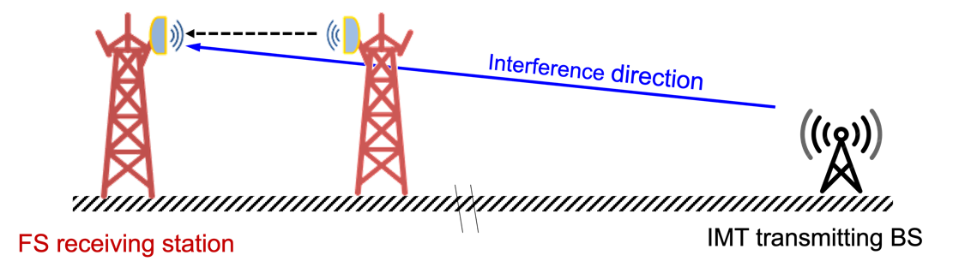
The assessment of the interference from IMT BSs into FS P-P receivers, based on the Minimum Coupling Loss approach (MCL), takes into account I/N protection criterion:
$I/N(d,θ_{1},φ_{1},θ_{2},φ_{2})=P_{tx}+G_{tx}\left(θ_{1},φ_{1}\right)+G_{rx}\left(θ_{2},φ_{2}\right)-PL(d)-N$ (3)
where:
P_{tx}: transmitted power (dBm) of the interfering IMT BS
G_{tx}(θ₁, φ₁): gain (dBi) of the IMT BS interfering antenna the direction of victim system (θ₁, φ₁)
G_{rx}(θ₂, φ₂): gain (dBi) of the FS victim antenna in the direction of the interfering system (θ₂, φ₂)
PL(d): path loss attenuation (dB) due to the propagation along distance d (km)
d: distance between the interfering system (IMT BS) and the victim system (FS receiver)
N: noise level (dBm) of the victim FS receiver.
The MCL methodology can also be used to evaluate the coexistence conditions, inside the coordination area, between a specific interfering IMT BS and a victim FS receiver.

2.4 Method for calculation of coordination area around IMT stations

2.4.1 Minimum coupling loss analysis
MCL analysis normally assesses the worst-case scenario by determining the minimum possible path loss between a transmitter and a receiver, thereby estimating the highest level of interference that could occur. This method is particularly useful in spectrum management, where it is essential to ensure that different systems can coexist without causing harmful interference to each other. Figure 3 shows typical example scenario of the interference from FS to IMT in the 6 425-7 125 MHz and required components to conduct MCL calculations.
FIGURE 3
Typical scenario of FS station interference to IMT BS station
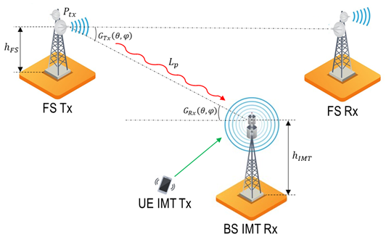
The interference level from FS station to the IMT station may be expressed with the following equation:
$I=P_{tx}+G_{tx}\left(θ,φ\right)+G_{rx}\left(θ,φ\right)-L_{prop}-L_{clutter}-L_{pol}$ (4)
where:
$P_{tx}$: output power of the FS, in dBW
$G_{tx}(θ,φ)$: antenna gain of the FS towards the IMT station, in dBi
$G_{rx}(θ,φ)$: antenna gain of the IMT station towards the FS station, in dBi
$L_{prop}$: propagation losses based on Recommendation ITU-R P.2001 or Recommendation ITU-R P.452
$L_{clutter}$: clutter losses based on Recommendation ITU-R P.2108, in dB
$L_{pol}$: polarization difference losses, in dB.
Adjacent band considerations
In order to calculate adjacent channel interference, adjacent channel selectivity (ACS) of IMT stations and adjacent channel leakage ratio (ACLR) of FS need to be used. ACS of the IMT station is provided in Table 2, whereas the ACLR of FS can be obtained from spectrum emission masks. Here, the ratio of the total interference between adjacent channels is given by the adjacent channel interference ratio (ACIR), hence, the following:
$ACIR=10\log\left(\frac{1}{\frac{1}{10^(ACS/10)} + \frac{1}{10^(ACLR/10)}}\right)$ (5)
where:
ACS: adjacent channel selectivity in dB
ACLR: adjacent channel leakage ratio in dB.
Note that in this expression ACLR needs to be provided as a single value, however in many cases ACLR provided as a spectrum emission mask, in that case, the following expression should be used:
$FDR\left(∆f\right)=\frac{\int_{0}^{∞}{P\left(f\right)df}}{\int_{0}^{∞}{P(f){\left|H(f+∆f)\right|}^{2}df}}$ (6)
where:
FDR(Δf): frequency dependant rejection
P(f): power spectral density of the interfering signal equivalent intermediate frequency in W/Hz
H(f): frequency response of the receiver, depending on Δf = ft − fr (MHz), where ft is interferer tuned frequency and fr is receiver tuned frequency.
Thus, adjacent channel interference can be calculated using the following expression:
$I=P_{tx}+G_{tx}\left(θ,φ\right)+G_{rx}\left(θ,φ\right)-L_{prop}-L_{clutter}-L_{pol}- FDR(∆f)$ (7)

2.4.2 Site-specific studies
Site specific studies may include terrain around the protected IMT station, including its topography. For site-specific studies area analysis approach may be used to estimate the protection area around the particular IMT station. Area analysis typically involves a victim or interfering station being positioned at each of a set of points within an area and at each location undertaking a static analysis. Any of the values derived in the calculations at that point can then be shown graphically either through the use of colour-coded pixels (blocks) or by drawing coordination distance lines based on the I/N protection criterion.

3 Possible approaches for coordination between IMT and FS
This section provides some possible approaches for coordination between IMT and FS systems for the purpose of providing information and assistance to administrations concerned on possible coordination of stations in the fixed service with IMT stations in the frequency band 6 425-7 125 MHz. These possible approaches are not exhaustive and may not be universally applicable in all countries and it is subject to each country to determine the most suitable coordination strategy based on its specific needs and circumstances. Consequently, the approaches outlined in this section should be regarded as informational only and do not oblige any country to adopt or implement any of them.

3.1 Possible separation approach between IMT and FS
The following approaches, or a combination of these approaches, could be considered to manage co-channel or adjacent channel coexistence between IMT and FS:
– Separation in geography/space.
– Separation in frequency.
– Angular discrimination.

3.1.1 Separation in geography/space
A method for calculation of coordination distances for specific actual FS sites can be found in § 2.3. The procedure provides an area around the actual site where IMT BS should not be deployed, to avoid interference to the FS receiver. Figure 4 provides an example of what such an area looks like for an actual FS station in South Africa.
Figure 4
Coordination area for a FS site in the suburbs of Durban, South Africa
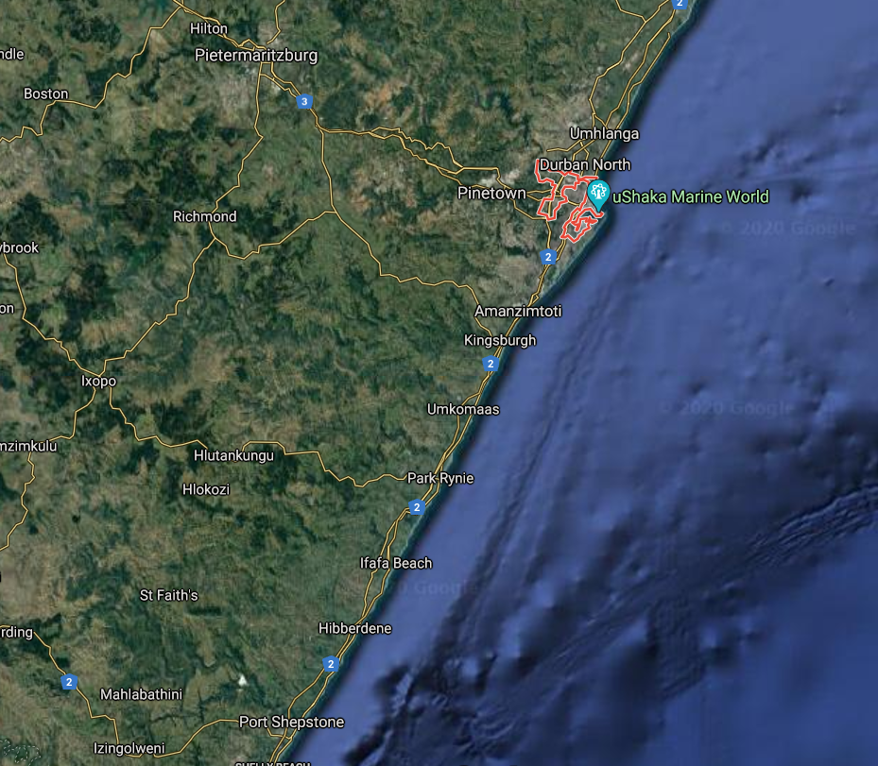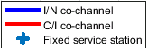
This approach can be time consuming if there are many FS stations in the areas where IMT will be deployed. However, IMT is expected to be deployed in urban and suburban areas, and administrations may decide that the FS in those areas get migrated to a different band. In that case, it may be possible to simplify the coordination procedure with the establishment of IMT areas, where IMT BS can be deployed and FS stations are migrated, and FS areas, where FS stations remain. The calculation would then be conducted only for those FS stations in the proximity of the IMT areas.

3.1.2 Separation in frequency
Recommendation ITU-R F.384-11 contains channel plans for the FS in the 6 425-7 125 MHz frequency band (U6 GHz band). Typical plans use channelisation of 16 channels (8 forward and 8 return) of 40 MHz and 32 channels (16 forward and 16 return) of 20 MHz. This is shown in Fig. 5.
Figure 5
Typical channel arrangements in 6 425-7 125 MHz (Recommendation ITU-R F.384-11)
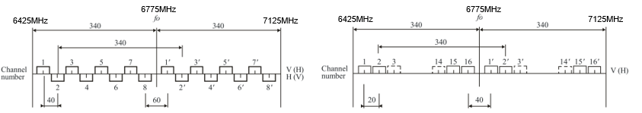
Depending on national planning approaches, not all channels may be used in one of the directions of a fixed link. This is because of the planning of a FS network to avoid inter site interference, and because of the self-interference between the transmitter and receiver at the site. This means that there may be opportunities for use of the unused spectrum by IMT.
Figure 6 shows a simple diagram of a fixed link with go and return directions, and the coordination areas around each of the receivers. With 4+0 or 8+0 configuration, IMT could theoretically use part of the band as follows:
Figure 6
Diagram of a bidirectional fixed link and the coordination areas for each site
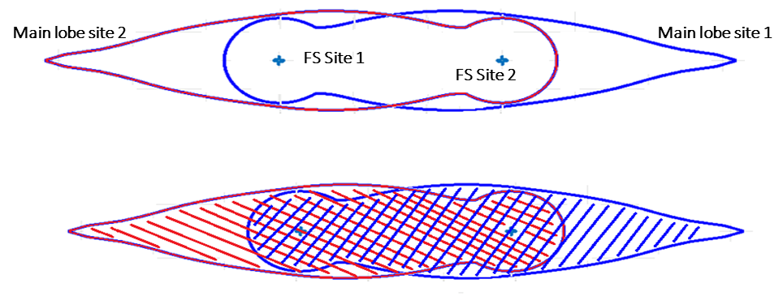
This is an idealised scenario with one link only, in practice there may be other links using other channels at the same sites or in the same area and hence there will be other coordination areas that overlap with these. Therefore, overall availability of spectrum will depend on density of utilisation of the fixed link channels and below are examples for the above idealised scenario.
8+0 with 40 MHz Channel Spacing (CS) (worst case)
– 1/2 of U6 GHz band (6 775-7 125 MHz) could be used by IMT in blue only area.
– 1/2 of U6 GHz band (6 425-6 775 MHz) could be used by IMT in red only area.
– No U6 GHz band could be used by IMT in the red and blue overlapping area.
4+0 with 40 MHz CS
– 3/4 of U6 GHz band could be used by IMT in blue only area.
– 3/4 of U6 GHz band could be used by IMT in red only area.
– 1/2 of U6 GHz band could be used by IMT in the red and blue overlapping area.
4+0 with 20 MHz CS
– 7/8 of U6 GHz band could be used by IMT in blue only area.
– 7/8 of U6 GHz band could be used by IMT in red only area.
– 3/4 of U6 GHz band could be used by IMT in the red and blue overlapping area.
The assessment above is theoretical and would need to be adjusted to account for the fact that the IMT BS out of band emissions would also cause interference to the FS receiver in adjacent channels. However, the resulting coordination areas for adjacent channel interference will be significantly smaller in comparison to the co-channel case.

3.1.3 Angular discrimination
Angular discrimination techniques, such as precise antenna positioning, IMT sectorization effectively reduce interference. Both FS and IMT systems utilize antennas with narrow beamwidths and high gain to focus energy where needed.
Recommendation ITU-R F.1245 recommends the FS antenna pattern, and the exact antenna pattern for different antenna gains (dBi) as shown in Fig. 7. Outside the main beam of the FS antenna, the necessary separation reduces drastically, which can be seen in Fig. 4 and Fig. 6 as well.
Figure 7
Recommendation ITU-R F.1245 antenna pattern
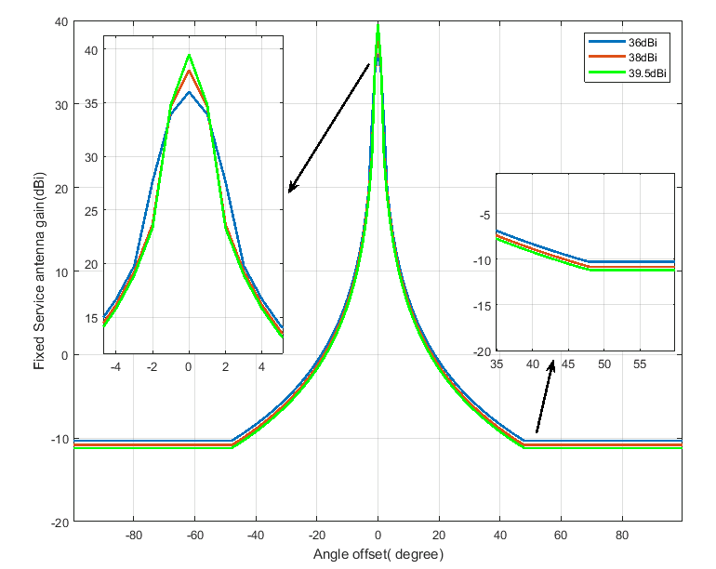

3.1.4 Combination of the above
By strategically combining geographical separation, frequency separation, and angular discrimination techniques, risk of interference can be minimized and potential increasing spectrum sharing.
The most efficient combination of approaches depends on the area considered, FS link density and national needs.
Whereas the sections above discuss approaches to ensure protection of FS stations from IMT stations, similar approaches apply for the protection of IMT stations from FS stations.

3.2 Examples of mitigation techniques and other considerations
The following techniques and other considerations, or a combination of which, could be considered to further reduce the separation required between IMT and FS.

3.2.1 Examples techniques applicable to fixed service
Adding an antenna shroud to the antenna of the FS receiver can improve isolation by:
– around 15 dB at azimuth angles from around 20 to 85 degrees
– around 7 dB in the Front-to-Back (F/B) ratio.
These gains could further reduce the coordination distance at side lobe and backside of FS stations. Figure 8 shows an FS antenna with and without a shroud.
Figure 8
FS antenna without shroud and with shroud
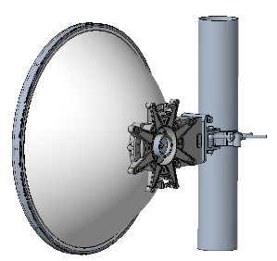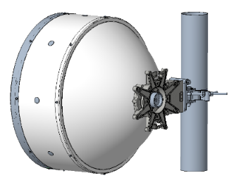

3.2.2 Examples of mitigation techniques applicable for IMT
Techniques that can potentially be adopted by IMT systems to reduce the interference at the FS receiver includes the following:
– Careful choice of the IMT site locations
– Reduction of antenna height
– Reduction of transmitter power
– Increased antenna tilt
– Ensuring Non-Line-of-Sight (NLoS) propagation between IMT and FS stations.

3.2.3 Other considerations
Administrations may want to consider that, when considering protection of specific sites, some of the actual operational parameters for the specific site may allow for improved coexistence conditions. Some examples are given as below.
Use of actual antenna characteristics
A more realistic modelling of this parameter in the calculations will reduce the coordination distance at the backside of FS stations. The antenna pattern modelled according to Recommendation ITU-R F.1245 result in a Front-to-Back (F/B) ratio of around 50 dB. However, measurement of this parameter in commercial antennas gives a value that can be several dBs better.
Use of I/N protection criterion for FS stations greater than −10 dB
Recommendation ITU-R F.758 recommends use of I/N of −10 dB not to be exceeded for more than 20% of time as protection criterion for FS stations for sharing between FS and IMT stations.
It is recognised that other protection criterion may be considered or used at national or in bilateral discussions.
Use of C/I protection criterion for FS stations
Recommendation ITU-R F.758 recommends use of I/N of −10 dB not to be exceeded for more than 20% of time as protection criterion for FS stations for sharing between FS and IMT stations.
For coordination of actual specific sites, a C/I criterion could also be considered if parameters for the sites (in particular C/I) are available. Indeed, C/I criteria would be unique to each FS link and would depend on many local deployment considerations and variations (e.g. type of radio modulation, availability, fading). Additionally, FS links are generally designed with appropriate degradation margins rather than interference considerations. For these reasons, there are no C/I criterion (including exceedance time percentage) for FS links in the ITU-R Recommendations and Reports. When using the C/I protection criterion for site specific coordination, the level should be specified based on the actual parameters of the site.

3.3 Migration of FS links
Clearance of FS deployments where IMT systems will be deployed, with FS either migrated to other FS bands or replaced by fibre, is a possible measure depending on national situations, the locations and density of FS deployments in the band. It requires national administrations to identify FS migration policies (e.g. assignment of new spectrum in alternative bands).
Clearance requires that operators of FS networks replace FS equipment and re-plan their FS network. The FS migration will need time, mainly in countries with many fixed links (in the areas earmarked for IMT). A phased migration might be advisable. The locations where IMT is most likely to be used first, such as busy urban centres, could be scheduled for earlier clearance. Other locations, such as suburban neighbourhoods, could be given a longer period for clearance.
Migration strategies should be considered together with the coexistence methodologies. In areas outside of urban and suburban centres, coexistence following the approach in § 3 may be possible, and hence clearance may not be necessary.

4 Summary
This Report provides the methodology for calculating coordination distance and possible approaches for the coordination between IMT and FS in the frequency band 6 425-7 125 MHz. It serves as a resource for administrations and stakeholders seeking to introduce IMT in the 6 425-7 125 MHz frequency band while safeguarding existing FS operations.

Annex
Examples of calculating coordination area based on
the methodology in § 2.4
In this example coordination areas around hypothetical IMT base station is calculated when interfered by the main lobe, side lobe and back lobe of the FS station.
The following assumptions are made in the analysis.
table 3
Assumptions of the example analysis of determining coordination area around IMT BS
Assumption | Value
IMT deployment type | Suburban/Rural
FS antenna height | 60 m
IMT BS azimuth | The azimuth always aligns with location of the FS
Percentage of time for Rec. ITU-R P.2001 | 50%
Clutter | No clutter applied
Polarization loss | 3 dB
I/N protection criterion | −6 dB

Propagation losses can be calculated using Recommendation ITU-R P.2001. Given that the beam position of an IMT base station (BS) varies depending on the User Equipment (UE) location, a random percentage of time may be used for accurate modelling. However, this requires Monte Carlo analysis. For more common static analyses, typically used in coordination, a 50%-time probability can be applied, as it yields results nearly equivalent to using a random percentage.
It is important to note that in some scenarios, clutter losses may also be included in the model. Clutter losses are generally not applied to the transmitting fixed service (FS) station, as FS links are designed to ensure an unobstructed Fresnel zone between transmitting and receiving stations. However, clutter losses may be relevant for the victim IMT station. In such cases, Recommendation ITU-R P.2108 can be used, with a 50% location probability applied to account for these losses.
Figure 9 illustrates the I/N levels around the IMT base station for main lobe interference. Figure 10 depicts the coordination areas for main lobe interference (red coordination distance), side lobe interference (green coordination distance), and back lobe interference (pink coordination distance). As shown, the coordination distance for main lobe interference varies significantly, ranging from 15 to 75 km in certain areas. For side lobe interference, the coordination distance spans from 5 to 25 km, while for back lobe interference, the coordination area is typically less than 3-4 km.
It is important to note that for cross-border interference, acceptable distances can extend up to 38 km, even in worst-case scenarios, given that this aligns with the typical link length of fixed service (FS) systems operating in the 6 425-7 125 MHz frequency band. Additionally, the likelihood of an FS station being directly aligned with the IMT base station is very low. Further mitigation could also occur if the IMT base station is shielded by environmental clutter.
FIGURE 9
I/N levels around IMT station when interfered by the main lobe of the FS station
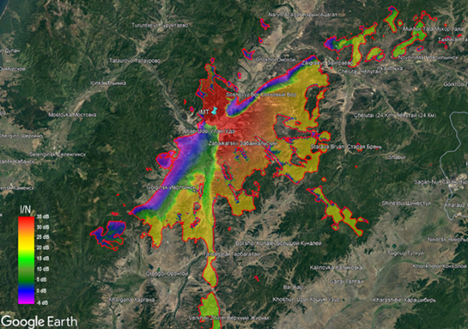
FIGURE 10
Coordination areas around IMT BS when interfered by the FS main lobe (red), side lobe (green) and back lobe (pink)
