Report ITU-R M.2559-0
(12/2025)
M Series: Mobile, radiodetermination, amateur
and related satellite services
Mitigation of interference due to tropospheric ducting effect within an International Mobile Telecommunications network

Foreword
The role of the Radiocommunication Sector is to ensure the rational, equitable, efficient and economical use of the radio-frequency spectrum by all radiocommunication services, including satellite services, and carry out studies without limit of frequency range on the basis of which Recommendations are adopted.
The regulatory and policy functions of the Radiocommunication Sector are performed by World and Regional Radiocommunication Conferences and Radiocommunication Assemblies supported by Study Groups.

Policy on Intellectual Property Right (IPR)
ITU-R policy on IPR is described in the Common Patent Policy for ITU-T/ITU-R/ISO/IEC referenced in Resolution ITU-R 1. Forms to be used for the submission of patent statements and licensing declarations by patent holders are available from https://www.itu.int/ITU-R/go/patents/en where the Guidelines for Implementation of the Common Patent Policy for ITU-T/ITU-R/ISO/IEC and the ITU-R patent information database can also be found.

Series of ITU-R Reports
(Also available online at https://www.itu.int/publ/R-REP/en)
Series | Title
BO | Satellite delivery
BR | Recording for production, archival and play-out; film for television
BS | Broadcasting service (sound)
BT | Broadcasting service (television)
F | Fixed service
M | Mobile, radiodetermination, amateur and related satellite services
P | Radio-wave propagation
RA | Radio astronomy
RS | Remote sensing systems
S | Fixed-satellite service
SA | Space applications and meteorology
SF | Frequency sharing and coordination between fixed-satellite and fixed service systems
SM | Spectrum management
TF | Time signals and frequency standards emissions

Note: This ITU-R Report was approved in English by the Study Group under the procedure detailed in Resolution ITU-R 1.

Electronic Publication
Geneva, 2025
© ITU 2025
All rights reserved. No part of this publication may be reproduced, by any means whatsoever, without written permission of ITU.

REPORT ITU-R M.2559-0
Mitigation of interference due to tropospheric ducting effect within an International Mobile Telecommunications network
(2025)
TABLE OF CONTENTS
Page

1 Background 2
2 Definitions 3
3 Abbreviations/Glossary 4
4 References 5
5 Identification of interference causes and optimisation plan 5
6 Optimization at the interferer side 6
6.1 Remote interference management (RIM) data analysis 6
6.2 The optimization of Top interferer 7
6.3 The selection of Top interferer 9
6.4 Increase GP of Top interferers 9
6.5 Reduce transmit power of Top interferers 9
6.6 Adjustment of the Top interferers’ antenna 9
6.7 Turn off some DL transmit symbols of Top interferers 9
6.8 Performance evaluation indicators for optimization effectiveness 9
7 Optimization at the interfered side 9
7.1 Identification of interfered cells 10
7.2 Ensure the performance of UL 10
7.3 Traffic offload between multi-frequency networks 10
7.4 Increase GP of Top interfered cell 11
7.5 Performance evaluation indicators for optimization effectiveness 11
8 Future considerations 11

1 Background
This Report describes a process for identifying the interference causes due to tropospheric propagation and possible optimization solutions within an International Mobile Telecommunications (IMT) network.
The tropospheric ducting phenomenon occurring under specific atmospheric conditions, creates a duct within the troposphere that facilitates the abnormal propagation of radio waves. Tropospheric ducting can significantly impact IMT network performance, due to the use of higher frequencies and Time Division Duplexing (TDD) making it more susceptible to ducting, potentially causing severe degradation of IMT base stations performance. Under certain weather conditions, the tropospheric duct phenomenon may happen: the base station (BS) signal can propagate in a higher refractive index layer and may experience less attenuation. In a TDD IMT network, this extended propagation delay can cause performance degradation, as the downlink signals from an interferer BS can arrive at a distant interfered BS with a delay exceeding the guard period (GP) designed to separate downlink transmission and uplink reception. This results in severe interference on the interfered base station’s uplink reception, potentially disrupting communications over tens or even hundreds of kilometres. The key minimum requirements for IMT-2020 radio interface(s) are detailed in Report ITU-R M.2410.
Figure 1
Tropospheric duct propagation phenomenon
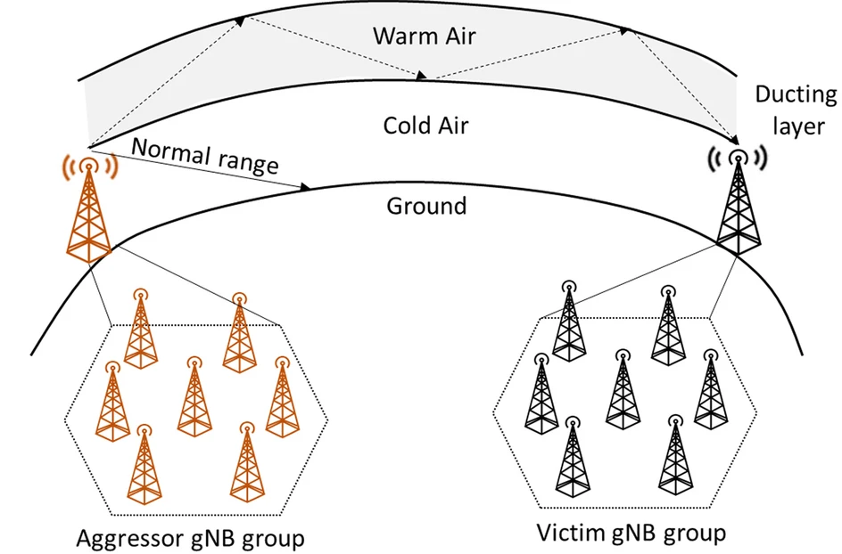
Figure 2
The proportion of the propagation delay goes beyond the guard period
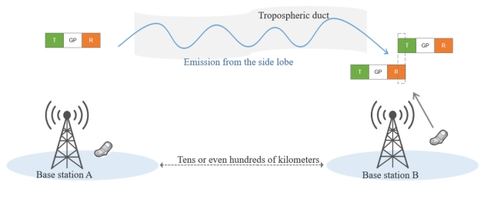
In IMT networks, such kinds of distanced disturbance have been observed, and with the continuous expansion of the network such long-distance interference increases, posing a significant challenge to network operators. While the issue is particularly pronounced in TDD networks due to the shared use of frequencies for uplink (UL) and downlink (DL); even FDD networks are not immune. In coastal areas, where atmospheric conditions are conducive to ducting and in border region, FDD base stations may experience interference from distant transmitters located in neighbouring countries or across bodies of water.
This necessitates a comprehensive understanding of tropospheric ducting and the implementation of effective solutions to mitigate such issues, providing approaches to address unintentional remote and random disturbance.

2 Definitions
Distributed nodes: Distributed nodes gather parameter and real-time interference data from local base stations, analyse inter-area interference paths, and report key findings to the central network controller.
Guard period (GP): The guard period is the time interval within a Time Division Duplex (TDD) communication system when the BS switches from the transmitting function to the receiving function. It is mainly used to avoid UL signal suffering the interference from the DL signal. When tropospheric ducting exists, the duration of GP becomes crucial in determining the minimum separation distance required between base stations to avoid interference. However, increasing the guard period may impact overall system efficiency.
Network centre control node: The data aggregation centre of distributed nodes, with the functions of aggregating and analysing interference data and issuing adjustment instructions.
Network performance assurance mechanism: Through the collaboration between central control nodes and distributed nodes within the network, beneficial measures are applied to all base stations affected by the tropospheric ducting phenomenon to ensure network performance.
Reference signal (RS): The signal, which is transmitted by an interfered base station, includes the identification of the base station, is characterized by the transmission frequency, transmission frame number and selected random sequence. When the interferer receives the signal, the identification of the interfered base station can be known (via the unique code assigned to each cell site or tower, to distinguish it from others within the network), and the mutual interference relationship is established.
Surface ducting: The most important short-term propagation mechanism that can cause interference over water and in land areas and can give rise to high signal levels over long distances (more than 500 km over the sea). Such signals can exceed the equivalent “free-space” level under certain conditions; see Recommendation ITU-R P.452.
Timing advance (TA): The control of the UL transmission timing of individual User Equipment (UE). It helps to ensure that UL transmissions from all UE are synchronized when received by the base station. See https://www.nrexplained.com/ta
Top interferer: The base stations that interfere the most interfered base stations and cause the most serious interference when tropospheric ducting exists.
QRxLevMin: The minimum receiver access level of the cell.
Troposphere: The troposphere is the lowest layer of Earth’s atmosphere, extending from the surface up to an average height of about 13 kilometres (8 miles). Nearly all-weather phenomena occur within the troposphere, like clouds, rain, snow, storms, and all the other dynamic atmospheric events that shape our climate. The troposphere contains about 75-80% of the atmosphere’s total mass and almost all of its water vapor.

3 Abbreviations/Glossary
BS Base station
DL Down link
FDD Frequency division duplex
gNB Next generation node B
GP Guard period
IMT International Mobile Telecommunications
KPI Key performance indicator
NR New radio
OFDM Orthogonal frequency division multiplexing
RIM Remote interference management
RRC Radio resource control
RS Reference signal
SCS Sub carrier spacing
SSF Special SubFrame
TA Timing advance
TDD Time division duplex
UE User equipment
UL Up link

4 References
Related ITU Resolution, Recommendations and Report and other
Resolution ITU-R 56 – Naming for International Mobile Telecommunications.
Recommendation ITU-R P.452 – Prediction procedure for the evaluation of interference between stations on the surface of the Earth at frequencies above about 0.1 GHz
Recommendation ITU-R M.2150 – Detailed specifications of the terrestrial radio interfaces of International Mobile Telecommunications-2020 (IMT-2020).
Report ITU-R M.2410 – Minimum requirements related to technical performance for IMT-2020 radio interface(s).
3GPP TR 38.866 – Study on remote interference management for NR.

5 Identification of interference causes and optimisation plan
When one or a number of base stations are interfered, the first action is to identify the interference causes. The interference due to tropospheric ducting propagation can be assessed by analysing the ducting interference characteristics as described in the: 3GPP TR 38.866:
Presence time (duration):
The particularity of remote interference is never infinite (intermittent) and has a duration of appearance compared to the normal interference which is always active and present.
– The duration of remote interference depends on ducting situation based on the weather conditions (several minutes to several hours before it disappears).
Ducting interference range (distance from the interferer):
– Distance between interfering and interfered cells can be estimated by the number of interfered UL symbols immediately after: GP.
– Larger is distance between interfering and interfered base station, higher is number of DL symbols subject to interference.
In a TDD network, the remote interference due to tropospheric ducting propagation will be present if the propagation delay is greater than the GP of the frame in TDD system.
Time domain and power level:
– Remote interference impacts UL symbols closest to GP by higher interference than UL symbols in a normal subframe (full UL), that means there is a delta power difference between UL symbols interfered (top versus bottom of slot).
– Remote interference shows downhill shape in time domain and symbol level, as shown in Fig. 3.
– The interference power at interfered base station side is important and can be 20~30 dB higher than UL interference level in a normal situation. This value can be used as the detection threshold for indicating appearance of ducting interference.
Figure 3
Duct propagation interference power level
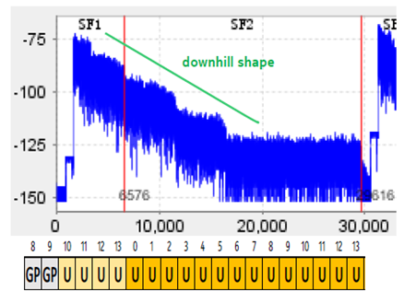
Once tropospheric ducting propagation was identified as the interference cause, the proper optimization plan has to be set up to solve the problem.
To ensure optimal IMT network performance in the presence of tropospheric ducting, a multi-pronged approach is necessary. To address the interference issues with IMT BSs caused by tropospheric ducting, with the help of RS sequences, IMT base station can detect and locate the tropospheric ducting interference and adjust manually or automatically, which BS will handover the UE.
In practical applications, the remote interference management function of IMT systems may attenuate the tropospheric ducting interference, but it still needs to be further adjusted by engineering optimization. To further address the interference with IMT BSs caused by these effects, a coordinated optimization mechanism between interfering and interfered base stations needs to be developed to mitigate the impact of such unintentional interference on the network.
A performance assurance mechanism may balance between interfering and interfered BSs, achieving the optimization results with minimal resource loss.
Before the tropospheric ducting effects subside, the mechanism can effectively address the problem where BSs immediately become interferer again after optimization adjustments.

6 Optimization at the interferer side
Measurement and optimization of interferer may reduce interference from IMT BSs (caused by tropospheric ducting effects) in the interferer side, and reduce impact, by using some means, for example, measuring precisely the interferer signal, selecting the method to implement the optimization, etc. BSs can employ various techniques, such as targeted optimization strategies, to minimize their impact on the IMT network.
The following subsections describe a mitigation technique/methodology focusing on IMT-2020 3GPP 5G-RIT; see 3GPP TR 38.866.

6.1 Remote interference management (RIM) data analysis
According to RIM in IMT, a RS sequence, containing the gNB information of a IMT BS, can be sent when the BS is suspected of being impacted by the interference under tropospheric ducting effects. According to the reciprocity of the channel, the interferer BS can decode the gNB information of the victim BS after receiving the RS sequence, identify the affected BS, and locate the interference pathway.
The RS sequence detection can be extracted from the BS, mainly including the detection of the interfered BS identification, cell identification, interference source identification, interference power and other information. The BS can extract key information from the detected RS sequence, mainly including the detection of the interfered BS identification, cell identification, interference source identification, interference power and other information. An example is shown in the following table:
Table 2
RS sequence detection result
Name | Sample Data
Year | 2021
Month | 6
Day | 6
Hour | 23
Minute | 51
gNodeB ID (interfered) | 10 500 353
CellID | 1
Received power density | −108 dBm/360 kHz
gNodeB ID (interfere) | 160 405

In order to efficiently solve the interference effect due to ducting propagation in a IMT network with different vendors it is important to ensure consistent parameter configuration and compatible RIM optimisation features between vendors.

6.2 Optimization of Top interferer
Specific network performance assurance mechanism can be used for the selected BSs which are most needed to be optimized, including the increase of the GP, reducing the transmit power and adjusting the antenna tilt.
Currently, in most cases, each zone is independently optimizing its own IMT networks. However, they often fail to address cross-zonal interference caused by tropospheric ducting, as there is cross-zonal interference caused by tropospheric duct effects, where a BS in one zone can influence a station in another zone (distance between zones can be several hundreds of kilometres). To address this problem, it is important to implement an automatic optimization scheme that encourages cooperation among interferers in the same zone or in different zones, to ensure the optimal network performance. The diagram below illustrates this process.
Figure 4
Tropospheric ducting interference interferer BS collaborative optimization and performance assurance measures flow chart
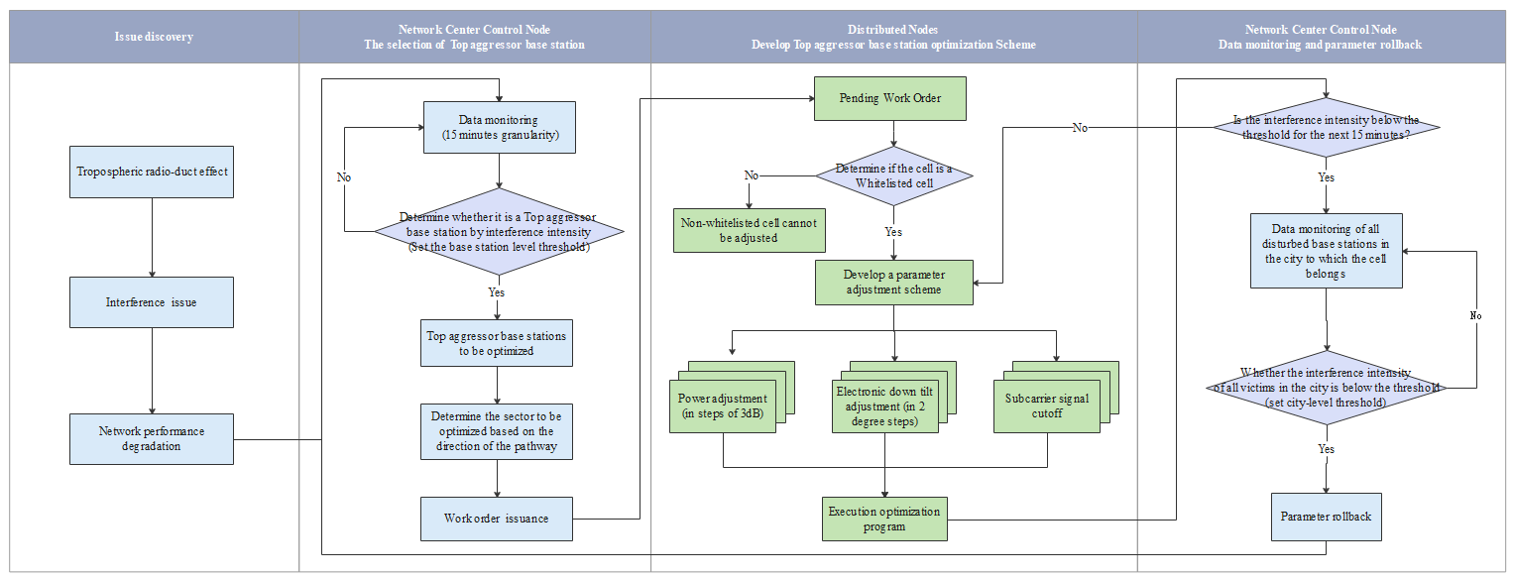
1) Selection of Top interferer BSs
Based on the key interference data fed back from the distributed nodes, the network centre control node consolidates and calculates according to the interference-level, the frequency and power to select the interferers, identifies and prioritizes the most impactful interferer (Top interferer) BSs i.e. which frequently and severely interfere others.
Based on the key interference data fed back from the distributed nodes, the network centre control node aggregates and analyses it according to interference-levels, frequency and power to identify the Top interferers, i.e. which frequently and severely interfere others.
2) Setup and maintenance of clean-list for cell
Cells eligible for optimization through parameter adjustments will be added to a clean-list. The current transmission power and tilt angle ranges for each BS are determined by updating clean-list information. Only cells on the clean-list are eligible for parameter optimization adjustments.
3) Optimization plan creation and implementation
If a Top interferer is on the clean-list, the current parameter settings and adjustable ranges are obtained. Its power value and tilt angle are adjusted by using a set step, or turn off some DL symbols.
4) Parameter monitoring
Measurements to identify the interfering TDD network are challenging.
It is a crucial step in resolving interference caused by Top interferers. Once the transmission power and tilt angle of the interferers have been adjusted, each step is carefully monitored. If the interference persists, the parameters are modified and tested again until a resolution is found.
This real-time monitoring process not only resolves the interference but also determines whether the parameter rollback process should be initiated, to avoid repetitive adjustments. By closely monitoring the parameters and their effects, troubleshoot can be swiftly and effectively solved, leading to optimal performance and results.
5) Parameter rollback
When the influence of the monitored interference effect disappears, the parameters of the affected individuals revert back to their original state.

6.3 Selection of Top interferer
From collaborative optimization of interferer perspective, through a performance assurance mechanism, the detection results of RS sequences and engineering parameter data from IMT BSs in various regions are gathered and analysed. According to the localization threshold, the interferers which are most needed to be optimized will be selected. Then, targeted improvements are made to enhance overall network performance.

6.4 Increase GP of Top interferers
When the special subframe configuration of the Top interferer site is 6:4:4, the length of the GP is 4 OFDM symbols, and the guard distance is about 42.84 km. Increase the GP (Each additional symbol of the GP can extend the protection distance by about 10.71 km) can effectively avoid the interference to BSs which in the protection distance extension area.

6.5 Reduce transmit power of Top interferers
To mitigate the impact of interferer BSs on the electromagnetic compatibility characteristics of other BSs, their transmission power may be reduced, through performance assurance mechanisms, thereby reducing the emission power portion entering the tropospheric ducting.

6.6 Adjustment of the Top interferers’ antenna
To minimize tropospheric ducting interference from top interferers, the tilt angle of their antennas can be adjusted through performance assurance measures, to reduce the transmitted power portion propagated through the ducting. It can be also considered replacing an antenna with better sidelobe suppression (in elevation and azimuth).

6.7 Turn off some DL transmit symbols of Top interferers
When the interference under tropospheric ducting effects occurs, according to the distance and direction of the interference path, some DL symbols (Physical Downlink Shared Channel (PDSCH) in special slot and DL slot of the Top interferer) to be shut down is determined by the performance assurance mechanism, and the adjustment instructions are issued by the network centre control node and executed by the distributed nodes, thus expanding the protection distance, avoiding or mitigating interference.

6.8 Performance evaluation indicators for optimization effectiveness
After implementing the above optimization methods, the objectives should include reducing the proportion of interfering cells, improving wireless connection rate, reducing wireless connection failure rate and/or datarate loss, and increasing performance metrics.
It should be pointed out that the described optimisation actions in this section allow to improve the network performance at the interfered BSs side, but there is some degree of negative impact on the coverage and capacity of the interferer BSs.

7 Optimization at the interfered side
From the perspective of the interfered BS, tropospheric ducting interference can be avoided by means of tropospheric ducting interference identification, UL anti-interference ability enhancement, and traffic offload from multi-layer networks to reduce the impact on users’ perception.
Figure 5 illustrates the process of optimisation at the interfered side.
Figure 5
Tropospheric ducting interference in interfered cells optimization flow chart
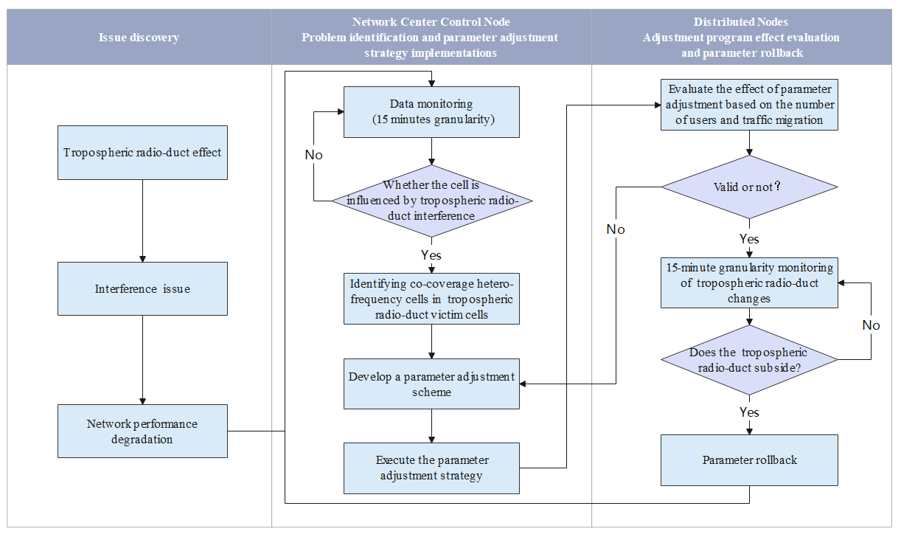

7.1 Identification of interfered cells
With RS detection data, it is possible to judge whether the cell is influenced by tropospheric ducting, identify the interfered cells, and then through the performance assurance mechanism to determine to implement interference mitigation solutions or traffic offloading.
To identify interfered cells affected by the tropospheric ducting effect, the successful reception is tracked of RS and measuring the interference power of a BS during a specified time period.

7.2 Ensure the performance of UL
When the main Key Performance Indicator (KPI) such as cell call success rate, dropped call rate, and UL data rate are impacted by the tropospheric ducting effect, the affected cell is designated as an interfered cell requiring optimisation.

7.3 Traffic offload between multi-frequency networks
As the FDD IMT network uses different frequencies for the UL and DL, FDD cells do experience less interreference to wireless BSs caused by tropospheric ducting effects. Therefore, in the event of this interference, the data traffic can be offloaded to FDD cells, as illustrated in Fig. 6. The traffic offload can be activated through parameter setting, including, increasing QRxLevMin of TDD cells (minimum access level of the cell, in dBm), and increasing the Cell Individual Offset between TDD cells and co-coverage FDD cells. This strategy allows the traffic offloading from TDD to FDD and avoids user poor perception on the network QoS.
Figure 6
Schematic diagram of co-located TDD and FDD cells
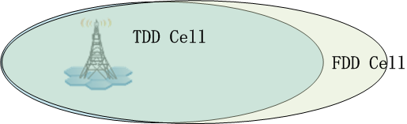

7.4 Increase GP of Top interfered cell
When the special subframe configuration of the IMT Top interfered site is 6:4:4, the length of the GP is 4 OFDM symbols, and the guard distance is about 42.84 km. Increase the GP (each additional symbol of the GP can extend the protection distance by about 10.71 km) can effectively avoid the interference to BSs which in the protection distance extension area, but this solution can affect temporarily and slightly the cell UL throughput in Up Link (UL).

7.5 Performance evaluation indicators for optimization effectiveness
After implementing the above optimization methods, improvements should be achieved in performance indicators such as wireless connection success rate or handover success rate. Network KPI monitoring and several other network performance indicators such as I/N, UL interference level, Block Error Rate (BLER), Physical Resource Block (PRB) usage can also be monitored and measured.

8 Future considerations
The current interference mitigation action is taken after the occurrence of tropospheric duct effects, with adjustments made through performance assurance mechanisms. In the future, it is expected that artificial intelligence and big data analysis will provide prediction algorithms and dynamic remote interference management solutions.
By integrating these future perspectives, future IMT systems can be designed for enhanced resilience against tropospheric challenges, ensuring reliable and high-quality communication services.
Further consideration is needed when managing RIM solutions for networks in different countries, such as differences in Public Land Mobile Network and physical cell identification, and possible variations in the frame structures. Between neighbouring countries, an exchange of mobile network parameters is essential for finding appropriate solutions to solve the cross-border interference problems due to tropospheric propagation.

Recommendation ITU-R P.452 is referred in RR No. 5.530A.

