|  |
| --- |
| **Report ITU-R M.2441-0**  **(11/2018)** |
| **Emerging usage of the terrestrial component of International Mobile Telecommunication (IMT)** |
| **M Series**  **Mobile, radiodetermination, amateur**  **and related satellite services** |

Foreword

The role of the Radiocommunication Sector is to ensure the rational, equitable, efficient and economical use of the radio-frequency spectrum by all radiocommunication services, including satellite services, and carry out studies without limit of frequency range on the basis of which Recommendations are adopted.

The regulatory and policy functions of the Radiocommunication Sector are performed by World and Regional Radiocommunication Conferences and Radiocommunication Assemblies supported by Study Groups.

# Policy on Intellectual Property Right (IPR)

ITU-R policy on IPR is described in the Common Patent Policy for ITU-T/ITU-R/ISO/IEC referenced in Resolution ITU-R 1. Forms to be used for the submission of patent statements and licensing declarations by patent holders are available from <http://www.itu.int/ITU-R/go/patents/en> where the Guidelines for Implementation of the Common Patent Policy for ITU‑T/ITU‑R/ISO/IEC and the ITU-R patent information database can also be found.

|  |  |
| --- | --- |
| Series of ITU-R Reports  (Also available online at <http://www.itu.int/publ/R-REP/en>) | |
| **Series** | Title |
| **BO** | Satellite delivery |
| **BR** | Recording for production, archival and play-out; film for television |
| **BS** | Broadcasting service (sound) |
| **BT** | Broadcasting service (television) |
| **F** | Fixed service |
| **M** | Mobile, radiodetermination, amateur and related satellite services |
| **P** | Radiowave propagation |
| **RA** | Radio astronomy |
| **RS** | Remote sensing systems |
| **S** | Fixed-satellite service |
| **SA** | Space applications and meteorology |
| **SF** | Frequency sharing and coordination between fixed-satellite and fixed service systems |
| **SM** | Spectrum management |

|  |
| --- |
|  |

|  |
| --- |
| ***Note****: This ITU-R Report was approved in English by the Study Group under the procedure detailed in Resolution ITU-R 1.* |

*Electronic Publication*

Geneva, 2019

© ITU 2019

All rights reserved. No part of this publication may be reproduced, by any means whatsoever, without written permission of ITU.

REPORT ITU-R M.2441-0[1]*

Emerging usage of the terrestrial component of International Mobile Telecommunication (IMT)

(2018)

TABLE OF CONTENTS

Page

1 Introduction 2

2 Relevant ITU-R Recommendations and Reports 3

3 Acronyms 3

4 Capabilities of IMT technologies 4

4.1 Higher throughput 5

4.2 Quality of service 5

4.3 Use of spectrum 6

4.4 Energy efficiency 6

4.5 Mobility Management 7

4.6 Coverage 7

4.7 Security Aspects of IMT systems 7

4.8 Position 8

4.9 Clock Synchronization 8

4.10 Technology aspects for use cases 9

5 Use cases or applications 11

5.1 Machine-Type Communication (MTC) (also known as Machine-to-Machine (M2M) in some jurisdictions) 11

5.2 Broadband Public Protection and Disaster Relief (PPDR) 11

5.3 Transportation applications 11

5.4 Utilities 17

5.5 Industrial automation 20

5.6 Remote control 32

5.7 Surveying and inspection 36

5.8 Healthcare 37

5.9 Sustainability/Environmental 39

5.10 Smart city 40

5.11 Wearables 42

5.12 Smart homes 43

5.13 Agriculture 44

5.14 Media and Entertainment 46

5.15 Enhanced personal experiences 46

5.16 Commercial Airspace Unmanned Aerial Systems (UAS) applications 47

6 Summary 49

Scope

This Report is a compilation document on existing and new usage of International Mobile Telecommunication (IMT) in specific applications. Further, it introduces potential new emerging applications of IMT in areas beyond traditional voice, data and entertainment type communications. It is provided as a reference document on these important uses of IMT, as envisaged in the vision for IMT-2020.

# 1 Introduction

The original goal of IMT was to provide access to a wide range of telecommunication services supported by fixed and mobile telecommunication networks. This has been outlined in a number of ITU-R Recommendations, starting with ITU-R [M.687](http://www.itu.int/rec/R-REC-M.687/en) and elaborated in others over the years, including the “vision” Recommendations ITU-R [M.1645](http://www.itu.int/rec/R-REC-M.1645/en) and ITU-R [M.2083](http://www.itu.int/rec/R-REC-M.2083/en). The capabilities of IMT technologies are also applicable to specific industrial applications in a wide-range of closed environments. Some of these IMT applications have already been investigated (e.g. Report ITU-R M.2291 on Public Protection and Disaster Relief and Report ITU-R M.2373 on audio-visual applications). It is useful to cover these specific industrial applications of IMT in a Report.

This Report provides information on the usage of IMT systems for emerging use cases or applications such as Intelligent Transport Systems (ITS), railways or high speed train communications, industrial automation, remote control, etc. as well as references to relevant Recommendations and Reports where they exist on established use cases. This Report does not preclude the development of new use cases or applications that exist or appear in future IMT technology development and deployment or other applications that can be provided by the satellite component of IMT or other systems.

It is to be noted that some topics in this Report are also covered by current activities of ITU-R therefore, elements of these topics may be updated over time and potentially be introduced into future revisions to this Report.

# 2 Relevant ITU-R Recommendations and Reports

Recommendation [ITU-R M.687](http://www.itu.int/rec/R-REC-M.687/en) – International Mobile Telecommunications-2000 (IMT-2000)

Recommendation [ITU-R M.1457](http://www.itu.int/rec/R-REC-M.1457/en) – Detailed specifications of the terrestrial radio interfaces of International Mobile Telecommunications-2000 (IMT-2000)

Recommendation [ITU-R M.1645](https://www.itu.int/rec/R-REC-M.1645/en) – Framework and overall objectives of the future development of IMT‑2000 and systems beyond IMT-2000

Recommendation [ITU-R M.2012](http://www.itu.int/rec/R-REC-M.2012/en) – Detailed specifications of the terrestrial radio interfaces of International Mobile Telecommunications Advanced (IMT-Advanced)

Recommendation [ITU-R M.2083](http://www.itu.int/rec/R-REC-M.2083/en) – IMT Vision – Framework and overall objectives of the future development of IMT for 2020 and beyond

Report [ITU-R M.2134](https://www.itu.int/pub/R-REP-M.2134) – Requirements related to technical performance for IMT-Advanced radio interface(s)

[Report ITU-R M.2291](http://www.itu.int/pub/R-REP-M.2291) – The use of International Mobile Telecommunications for broadband public protection and disaster relief applications

Report [ITU-R M.2320](https://www.itu.int/pub/R-REP-M.2320) – Future technology trends of terrestrial IMT systems

Report [ITU-R M.2370](https://www.itu.int/pub/R-REP-M.2370) – IMT Traffic estimates for the years 2020 and 2030

Report [ITU-R M.2373](http://www.itu.int/pub/R-REP-M.2373) – Audio-visual capabilities and applications supported by terrestrial IMT systems.

# 3 Acronyms

ADS Automated driving system

AGV Automated guided vehicles

AR Augmented reality

BLISKs Bladed disks

C2C Control to control

DDT Dynamic driving task

E2E End to End

EMBB Enhanced mobile broadband

Gbit/s Gigabit per second

GPS Global Positioning System

HD High definition

IMT International Mobile Telecommunications

IP Internet Protocol

IoT Internet of Things

ITS Intelligent transport systems

LTE Long-term evolution

Mbit/s Megabit per second

ms millisecond

MTC Machine-type communications

NR New radio

PFS Precision farming systems

PPDR Public protection and disaster relief

QoS Quality of service

RAN Radio access network

RLAN Radio local area network

RAT Radio access technology

SAE Society of automotive engineers

SLA Service level agreement

Tbit/s Terrabit per second

TTI Transmission time interval

UAS Unmanned aerial systems

UE User equipment

URLLC Ultra-reliable low latency communications

V2I Vehicle to infrastructure

V2P Vehicle to Pedestrians

V2V Vehicle to Vehicle

V2X Vehicle-to-X (vehicle/infrastructure/pedestrian)

WSN Wireless Sensor Network

# 4 Capabilities of IMT technologies

The development of International Mobile Telecommunication (IMT) systems foresees new capabilities that go far beyond those of IMT-2000 and IMT-Advanced, whose radio characteristics are described in Recommendation [ITU-R M.1457](http://www.itu.int/rec/R-REC-M.1457/en) and Recommendation [ITU-R M.2012](http://www.itu.int/rec/R-REC-M.2012/en) respectively.

The capabilities of IMT-2020 technologies are different from those of IMT-2000 and IMT‑Advanced as indicated in Fig. 1.

Figure 1

Enhancement of key capabilities from IMT-Advanced to IMT-2020

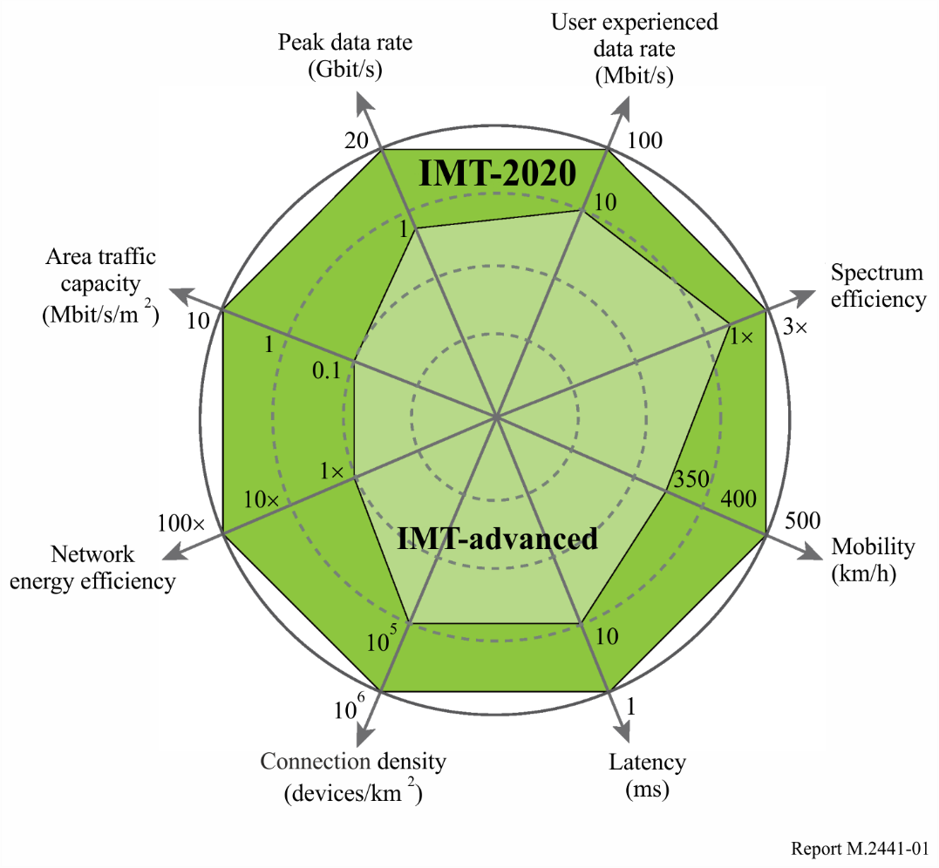

The reference values for IMT-Advanced shown in the above Figure for the peak data rate, mobility, spectrum efficiency and latency are extracted from Report ITU-R M.2134-0. The Report was published in 2008 and was used for the evaluation of IMT-Advanced candidate radio interfaces described in Recommendation ITU-R M.2012.

## 4.1 Higher throughput

IMT-2020 is expected to provide a user experience matching, as far as possible, that of fixed networks. The enhancement will be realized by increased peak and user experienced data rates, enhanced spectrum efficiency, reduced latency and enhanced mobility support. As indicated in Fig. 1 above, the “user experienced data rate” is expected to be 100 Mbit/s compared to 10 Mbit/s for IMT-Advanced.

## 4.2 Quality of service

Small-cell deployment can improve the Quality of Service (QoS) of users by decreasing the number of users in a cell and user experience can be enhanced.

People expect the experience of instantaneous connectivity wherein applications need to exhibit “flash” behaviour without waiting times: a single click and the response is perceived as instantaneous. Reliability relates to the capability to provide a given service with a very high level of availability. The low latency and high reliability communication that supports “flash” behaviour thus becomes an enabler for the future development of new applications (e.g. in health, safety, office, entertainment, etc.). As indicated by Figure 3 of Recommendation ITU-R M.2083, the “latency” of IMT-2020 is expected to be 1 millisecond (ms) compared to that of IMT‑Advanced of 10 ms.

Enhanced mobile cloud services, real-time traffic control optimization, emergency and disaster response, smart grid, e-health or efficient industrial communications are examples of where low latency and high reliability can improve quality of life.

## 4.3 Use of spectrum

Licensed Spectrum

Licensed spectrum allows for exclusive, and in some cases shared, use of particular frequencies or channels in particular locations. Licensed spectrum can facilitate the support of a wide range of applications, including mission-critical applications, with regulatory protection from harmful interference.

Licensed shared spectrum

Licensed shared spectrum includes licenses for exclusive use which could be granted for a limited geographical area, e.g. a harbour or a factory, or during certain time periods. Such sharing may be based for example on commercial leasing agreement between a license holder and the party wishing to use the spectrum in the limited geographical area or time, or on Licensed Shared Access[2] concept.

License-exempt spectrum

In spectrum that is designated as license-exempt, users can operate without a license but must use certified radio equipment and must comply with the technical requirements approved in each administration. Users of the license-exempt bands do not have exclusive use of the spectrum and are subject to interference, which may be more appropriate for non-critical applications.

Efficient use of radio resources

Flexible spectrum usage, joint management of multiple radio access technologies (RATs) and flexible uplink/downlink resource allocation in IMT can provide technical solutions to address the growing traffic demand in the future and may allow more efficient use of radio resources.

Bandwidths to support the different usage scenarios

Bandwidths to support the different usage scenarios in section 4 of Recommendation ITU-R M.2083 (e.g. enhanced mobile broadband, ultra-reliable and low-latency communications, and massive machine type communications) would vary. Wideband contiguous spectrum above 6 GHz may facilitate those scenarios requiring several hundred MHz up to at least 1 GHz.

## 4.4 Energy efficiency

Energy efficiency has two aspects as described in Recommendation ITU-R M.2083:

− on the network side, energy efficiency refers to the quantity of information bits transmitted to/received from users, per unit of energy consumption of the radio access network (RAN) (in bit/Joule);

− on the device side, energy efficiency refers to quantity of information bits per unit of energy consumption of the communication module (in bit/Joule).

The network energy efficiency of IMT-2020 is expected to be 100 times greater than IMT‑Advanced as indicated in Fig. 3 of Recommendation ITU-R M.2083.

## 4.5 Mobility Management

High mobility

IMT-2020 can support mobility of 500 km/h compared to that of 350 km/h in IMT-Advanced as indicated in Fig. 3 of Recommendation ITU-R M.2083.

IMT-2020 is also expected to enable high mobility up to 500 km/h with acceptable QoS: this is envisioned specifically for high speed trains.

A connected society in the years beyond 2020 will need to accommodate a similar user experience for end-users on the move and when they are static e.g. at home or in the office. To offer the “best experience” to highly mobile users and communicating machine devices, robust and reliable connectivity solutions are needed as well as the ability to efficiently maintain service quality with mobility.

Maintaining high quality at high mobility will enable successful deployment of applications on user equipment located within a moving platform such as cars or high-speed trains which are being deployed in several countries. Connectivity on mobile platforms may be provided via IMT, Radio Local Area Network (RLAN) or another network on that platform using suitable backhaul.

For the wide area coverage case, seamless coverage and medium to high mobility are desired, with much improved user data rates compared to existing data rates. However, the data rate requirement for this case may be relaxed compared to the hotspot case.

Lower mobility

In small cells, higher-order modulation and modifications to the reference-signal structure with reduced overhead may provide performance enhancements due to lower mobility in small cell deployments and potentially higher signal-to interference ratios compared to the wide area coverage case.

For the hotspot case (i.e. for an area with high user density), very high traffic capacity is needed while the requirement for mobility is low so the user data rate may be higher than that of wide area coverage.

## 4.6 Coverage

For wide area coverage cases (e.g. in urban and suburban areas), a user experienced data rate of 100 Mbit/s is expected to be enabled. In hotspot cases, the user experienced data rate is expected to reach higher values (e.g. 1 Gbit/s indoor).

## 4.7 Security Aspects of IMT systems

The security schemes deployed in IMT systems are configured to be compliant with local lawful interception laws and regulations.

These security mechanisms provide the following capabilities:

− End user privacy to prevent unauthorized user tracking;

− End user authentication and access authorization;

− Confidentiality and integrity protection of user’s dedicated signalling;

− Confidentiality and integrity protection of user’s traffic data;

− Protection of network against hacking, fraud and attacks (passive, protocol aware jamming, man in the middle, replay and denial of service).

## 4.8 Position

With the fast development of Internet of Things (IoT) technology, location -based service continues to play an important role in mobile communication applications. Location-related applications have significant development potential. With the generalization of “smart city”, the structure of buildings has become complex. Therefore, both mass material resources management and location applications inside the office building will face challenges. Positioning can help expand the commercial market and offer more services to end users.

There are some examples to show the capacity of positioning in industrial applications. For example, in an underground parking scenario in which people need to find a parking location quickly, positioning can indicate the quantity of available carports and their locations to the driver. This application could also provide location assistance to find the car when a locating tag is set on the car. All these can obviously increase the travel efficiency. Moreover, with intelligent logistics for example, the position of cargo could be provided with high accuracy and low latency to enhance delivery efficiency. An additional example is a “smart factory” building: applying indoor positioning can facilitate collection of information on workers’ attendance, labour hours and work movements. For warehouse management, the amount of cargo and the cargo movements can be provided in real time with indoor positioning.

The technical and operational aspects of positioning to be considered include coverage, accuracy, mobility, and cost, etc. In terms of coverage, next generation positioning technology can achieve seamless positioning which means a high-accuracy position could be obtained not only in open outdoor cases, but also in urban canyon and indoor scenarios[3]. To realize this goal, a carrier-class oriented solution is needed, providing the basic available positioning technology that is similar to satellite positioning in indoor and urban canyons. Also, carrier-class positioning technology is able to provide greater coverage distance with fewer positioning base stations, and there is no capacity limit on the number of positioning terminal. As to accuracy generally, next generation high accuracy positioning based on IMT-2020 technology is envisaged to achieve a level of accuracy of around 1 metre[4] in most parts of the service area, including indoor, outdoor and urban environments. For high speed scenarios, the positioning may need more accuracy (e.g. equal or less than 1 meter with 10-15 ms delay for mobility of 200 km/h). Considering other general issues such as cost, next generation positioning technology may need to use a small number of base stations and simple deployments[5].

## 4.9 Clock Synchronization

For many of use cases, such as medical care, smart grids, and robots, there is a need to ensure that the user equipment clocks are synchronized with the network. The local time of the clock of each user equipment (UE) must be synchronized. For example, in medical applications, a time stamp (e.g. 1 ms accuracy level) can help to determine if there are any problems with the patient and where the problems are[6]. In the multi-robot cooperation case of motion control, where a group of robots collaborate to conduct an action, for example, symmetrical welding of a car body to minimize deformation, isochronous operation is required (e.g. 1 microsecond accuracy level of clock synchronization) between all cooperative robots to ensure the assembling[7].

Figure 2

Multiple wearable UEs

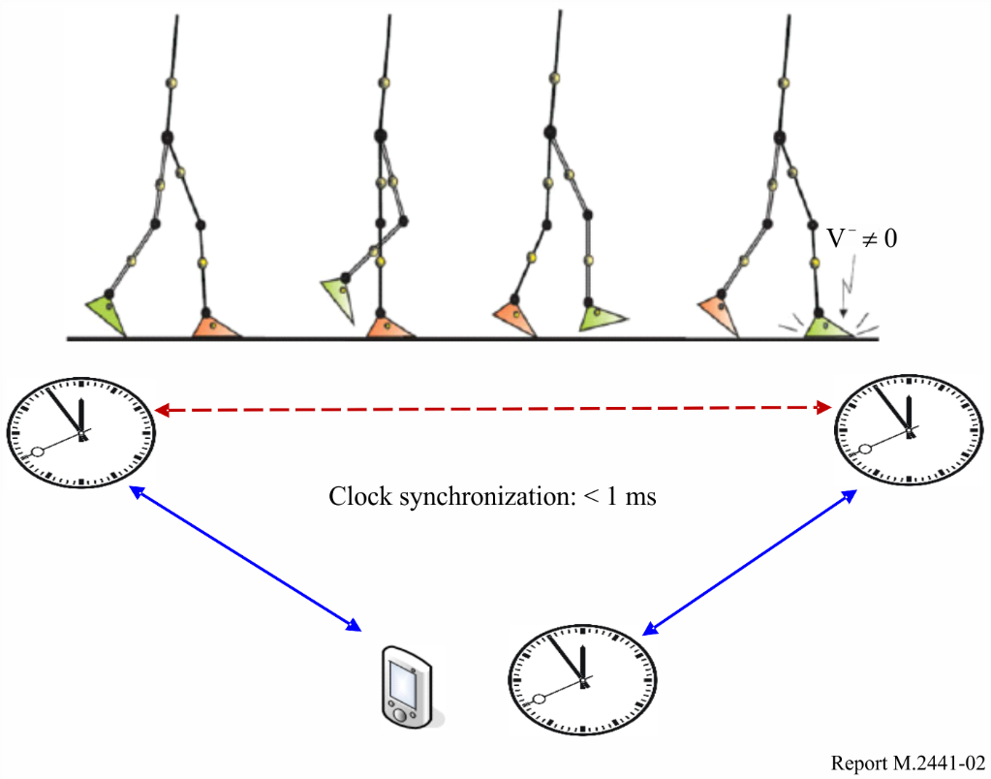

Figure 3

Multi-robot cooperation

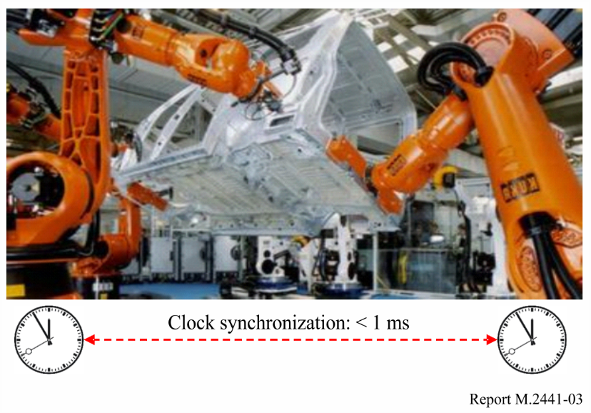

## 4.10 Technology aspects for use cases

IMT-2020 innovations related to media delivery, and core, radio-access and transport networks are expected to provide the technology needed for remote operation and other industrial mission-critical cases. To deliver an acceptable level of service experience for industrial remote operation, a number of performance requirements need to be set: minimum bitrate, maximum latency, and a permitted level of packet loss. By deploying service specific optimizations relating to scheduling, the requirements of several remote use cases may be met by modern IMT-Advanced based cellular systems. As IMT-Advanced continues to be enhanced with improvements such as latency reductions, it is expected to become ever more applicable for industrial applications.

However, some demanding use cases – such as the operation of fast-moving machine parts or scenarios that require accurate real-time control – place such stringent requirements on connectivity that they cannot be met by existing cellular solutions. But some technologies are being developed with these requirements in mind in order to provide the performance capabilities necessary for demanding industrial use cases.

Some of the main innovation areas for the IMT-Advanced evolution include: latency reduction, support for license-assisted access and operation in unlicensed spectrum, new use cases, massive machine-type communication, and massive MIMO (known as full-dimension MIMO in 3GPP).

To support the requirements of the whole coverage area for high-load situations, special design characteristics need to be taken into consideration. The challenge arises when connections are congested or suffer from low data rate, causing the transfer rate over the radio link to drop temporarily below the code rate of the video stream. When this occurs, queuing delays follow, which in turn degrade user experience.

Low latency and high reliability are two key design criteria for potential new-radio interfaces in IMT-2020. To attain the levels of performance required for latency and reliability, a number of air interface design characteristics, like short radio frames and new coding schemes, will come into play.

To achieve low latency in the system, the time it takes to transmit a control command over the radio interface needs to be minimized. In IMT-2020, the time to transmit a single packet over the air – the Transmission Time Interval (TTI) – is expected to be a fraction of the TTI in IMT-Advanced. The TTI in IMT-Advanced is defined as 1 ms, whereas NR will be designed to deliver TTIs in the order of one or a few hundred microseconds[8]. Such low-order TTIs will enable short transmission times for short packages and facilitate retransmission without exceeding the latency bound.

The radio receiver needs to be able to decode received messages quickly. High-performance forward error correcting codes, such as turbo codes traditionally used for mobile broadband, are not optimal for transmission of short messages with high reliability requirements. Therefore, special forward error correcting codes such as convolutional codes are envisioned for latency-critical applications[9].

A highly reliable radio link is needed to avoid transmission errors and time-consuming retransmissions. The level of reliability needed can be achieved with high diversity order of the communication through antenna or frequency diversity, which improves the probability of signal detection and correct reception of the transmitted radio signals.

Messages need to be transmitted over the communication link without scheduling delays. To minimize delays, service-aware scheduling algorithms can be applied to prioritize critical remote applications over other less critical communication.

# 5 Use cases or applications

## 5.1 Machine-Type Communication (MTC) (also known as Machine-to-Machine (M2M) in some jurisdictions)

Machine-Type Communications, including the Internet of Things (IoT), is quickly emerging as a very significant agent of transformation as it blends the physical and digital worlds; indeed, billions of connected devices are forecasted by the year 2021[10].. For service providers, this represents an opportunity for increased revenues while for networked industrial applications, this represents more efficient operations.

MTC cuts across many industrial use cases so various applications in the sections below may also represent use cases of MTC.

## 5.2 Broadband Public Protection and Disaster Relief (PPDR)

The use of IMT for broadband public protection and disaster relief (PPDR) applications is covered in detail in [Report ITU-R M.2291](http://www.itu.int/pub/R-REP-M.2291) with descriptions of the current and possible future use of IMT, including the use of long term evolution (LTE)[11] to support broadband PPDR communications as outlined in relevant ITU-R Resolutions, Recommendations and Reports. Report ITU-R M.2291 further provides examples for deploying IMT for PPDR radio communications, case studies, and scenarios of IMT systems to support broadband PPDR applications such as data and video.

## 5.3 Transportation applications

### 5.3.1 Intelligent Transport Systems (ITS)

Intelligent Transport Systems (ITS) applications are typically classified into three groups: road safety applications, traffic control and infotainment. Road safety applications aim at protecting the road users (pedestrians), the driver and the vehicle itself. Examples of such applications include cooperative active safety systems to warn drivers about dangerous situations and intervene through automatic braking or steering to avoid accidents, cooperative driving applications, such as platooning, to reduce accidents and increase road safety and traffic efficiency. In addition, communications between vehicles and vulnerable road users (pedestrians, cyclists) through their mobile devices will be an important key element to improve traffic safety and to avoid accidents.

Due to their critical nature, the road safety related applications have very strict requirements on latency, reliability and availability as they rely on timely and reliable exchange of information between vehicle to vehicle (V2V), between vehicles and pedestrians (V2P) and between vehicles and infrastructure such as roadside units (V2I). V2V, V2I and V2P collectively are commonly referred to as vehicle to X (V2X) which raise distinct challenges to the traditional wireless communication system. With some further advanced V2X services envisaged by the automotive industry, such as vehicle platooning, sensor data sharing and remote driving, it is expected to impact ultra-low latency, ultra-high reliability, extended coverage and higher data rate[12].

Increasingly, most vehicles are equipped with a multi-faceted infotainment system that delivers navigation, music, phone calls, and more, at the touch of a screen, turn of a knob, or buttons on the steering wheel, and some even with voice commands. They also use a touch screen so, in a way, they are very similar to smartphones. In fact, smartphones may be emulated on the dashboard of the cars. Many of these vehicles can use IMT to provide this service. With IMT Broadcast, users can also watch TV shows and downstream services including movies, news, weather, and sports.

IMT technologies are envisaged to provide communications to different ITS application through the LTE-based V2X feature[13]. In order to increase the reliability and availability with reduced latency, the safety related information should be able to be transmitted on a highly reliable direct link between the terminals that equipped with ITS applications. The LTE-based V2X system could provide two communication interfaces to support the strict transmissions for ITS application: direct communication interface between vehicle to vehicle (also referred to as sidelink, see § 4.3.1.1) and the cellular-based communication interface[14] (both of the unicast and broadcast are supported). This gives the flexibility to select a suitable transmission path based on the services and wireless environment. Furthermore, from the resource allocation perspective, a combination of the centralized and distributed resource allocation mechanism is supported to benefit to enable V2X services. The LTE-based V2X covers both the operating scenario where the carrier(s) is dedicated to LTE-based V2X services (subject to regional regulation and operator policy including the possibility of being shared by multiple operators) and the operating scenario where the carrier(s) uses licensed spectrum for normal LTE operation. LTE-V2X is expected to provide an evolution path to NR V2X.

#### 5.3.1.1 Automotive direct communication over sidelink

Many future automotive applications require vehicles to share data with other vehicles in their vicinity, which calls for a method for direct communication often referred to as sidelink. Examples include sharing of sensor data, cooperative functions, and other functionalities which increases the comfort and efficiency of automated driving. The sidelink has capabilities for broadcast, multicast, and unicast transmission.

The sidelink works in two modes:

– Sidelink out-of-coverage mode which does not depend on radio-resource management by a third party, such as a network operator. This allows for functionalities to work independently of network coverage.

– Sidelink managed mode which uses central radio resource management.

Further, sidelink anticipates the implementation of QoS concepts to facilitate certain performance requirements. These include, but are not limited to, guaranteed latency and reliability and guaranteed data rate.

– for Ultra Reliable Low Latency Communications (URLLC) sidelink Out of Coverage usage scenario;

– for URLLC sidelink managed mode usage scenario.

#### 5.3.1.2 Cooperative driving support

Cooperative driving anticipates a permanent support of transmitting and receiving messages with typical payloads for each vehicle in all operational scenarios (under loaded conditions).

– C-V2X[15] sidelink out of coverage.

– C-V2X managed mode.

In the context of IMT-2020, the C-V2X sidelinks covering URLLC services are equivalent to the IMT‑2020 URLLC definition.

Cooperative Awareness Messages or Decentralized Environmental Notification Messages in Europe or Basic Safety Messages (BSM) in the USA have typical payload. Note that Cooperative Awareness Messages and Decentralized Environmental Notification Messages are not only for communication between cars: there are use cases that include road side stations and even backend servers. In addition, there are more message types called SPaT (Signal Phase and Timing) and TOPO (typically for the topology of crossings including number of lanes, and allowance for left/right turn etc.).

The use cases behind this are numerous including the following examples:

– Cooperative driving;

– Intersection assistance;

– Information about traffic flow and density for traffic centres;

– Information about the state of traffic lights for red light alert, remaining red time and green wave advisory;

– Detection and information about wrong way drivers at road side;

– Information about local danger warnings (accidents, construction sites, etc.) to and from traffic centres;

– Infrastructure-based intersection assistant (e.g. information about topology and pedestrians is sent from infrastructure to cars).

#### 5.3.1.3 Automated driving

Automated driving system (ADS), enhanced mobile cloud services, and real-time traffic control optimization are examples of cases in which low latency and high reliability can improve quality of life.

It should be noted that the Society of Automotive Engineers (SAE) international’s standards taxonomy and definitions for Terms Related to On-Road Motor Vehicle Automated Driving Systems[16] provides a taxonomy for motor vehicle in which automated driving systems perform part or all of the dynamic driving task (DDT) on a sustained basis and range in level from no driving automation (level 0) to full driving automation (level 5). In SAE level 0 (no automation) to 2 (partial automation) a human driver monitors the driving environment while in SAE level 3 (conditional automation) to 5 (full automation) an automated driving system monitors the driving environment.

It should also be noted that in accordance with SAE international’s definition, active safety systems, (such as electronic stability control and automated emergency braking), and certain types of driver assistance systems (such as lane keeping assistance) are excluded from the scope of this driving automation taxonomy because they do not perform part or all of the DDT on a sustained basis and, rather, merely provide momentary intervention during potentially hazardous situations. Due to the momentary nature of the actions of active safety systems, their intervention does not change or eliminate the role of the driver in performing part or all of the DDT, and thus are not considered to be driving automation.

It should, however, be noted that crash avoidance features, including intervention-type active safety systems, may be included in vehicles equipped with driving automation systems at any level. For ADS-equipped vehicles (i.e. SAE levels 3-5) that perform the complete DDT, crash avoidance capability is part of ADS functionality.

In the future, an increasing number of all cars may be connected to a network. Even automated driving at lower SAE levels will benefit from being connected to a network which will allows for navigation systems (software and firmware) to be dynamically updated and maintenance to be updated with data about the car itself. Automated systems in the middle SAE levels, since they sometimes require the car to drive autonomously, may use connectivity as a support in order to understand local road information quickly. The decision in the car can be supported by connectivity to the cloud. Therefore, the data needs to be quickly transmitted between the car and the cloud, meaning the IMT-2020 feature of low latency will be an important factor. In the end, however, any delay in the connection between the base station and the car may not be a concern, since the connection between the data centre where information will be processed and the car is expected to be an end to end delay guaranteed network.

#### 5.3.1.4 Collision avoidance

This system provides vehicle collision avoidance at intersections with bad visibility. To monitor cars, bicycles, and people that are entering an intersection in real time, video cameras are placed at the intersection, and image processes are carried out with a low-latency application server which is placed at a base band unit. When intersection ingresses are detected, a detection result is created, considering an alarm and a video, which is transmitted to automobiles through low-latency IMT‑2020 networks. The automobiles that received the detection result automatically slow down while the alarm and video is displayed on monitors. This system also predicts intersection ingresses by gathering traffic information from neighbouring intersections.

#### 5.3.1.5 Technical performance for safety related Cooperative-ITS

##### 5.3.1.5.1 Automotive Direct Communication over user plane sidelink latency

In addition, latency should be considered in combination with reliability, vehicle speed, communication, traffic load and packet size: these parameters should not be considered separately.

The communication latency from mobile station (vehicle, pedestrian, road side unit) to another mobile station (vehicle, pedestrian, road side unit) from the radio protocol layer 2/3 Service Data Unit ingress point to the radio protocol layer 2/3 Service Data Unit egress point of the radio interface.

The performance of sidelink transmission latency should satisfy service performance, with certain conditions for both Out of Coverage and managed mode scenarios.

##### 5.3.1.5.2 Automotive direct communication over sidelink reliability

The end-to-end reliability for a sidelink communication from a mobile station (vehicle, pedestrian, road side unit) to another mobile station (vehicle, pedestrian, road side unit) is the success probability of transmitting a layer 2/3 packet within a maximum time, which is the time it takes to deliver a small data packet from the radio protocol layer 2/3 Service Data Unit ingress point to the radio protocol layer 2/3 Service Data Unit egress point of the radio interface at a certain channel quality.

The sidelink reliability should satisfy service performance with certain conditions for both Out of Coverage and managed mode scenarios.

### 5.3.2 Railways or High Speed Train Communication

High Speed Train Communication covers two main applications: broadband connectivity to the passengers as well as closed circuit television (CCTV) operations and train control operations.

The broadband connectivity application focuses on providing amenities or entertainment for passengers. In the case of longer distance train trips, consumers may watch full movies or tourists could watch streaming video of sight-seeing such as views from a various angles that can be selected by each tourist. In another case of a train providing access to a football stadium, fans on board the train can share information and experiences with other fans by using their smartphone. In the case of such a train transporting around one thousand passengers, an IMT-2020 system needs to support high data rate transmission so that many users on board the train can simultaneously watch high definition video and/or exchange a large amount of data. In the case of the rush hour commute in the metropolitan area of one country with many subway trains per hour in many directions, these railway passengers traveling through a terminal station generate a large amount of communication traffic. As an example, the largest terminal station in one country’s metropolitan area has eleven railway lines and a train of each line arrives every two minutes during peak rush hour. Assuming 90% of the “accumulating passengers”[17] use cellular terminals, the number of cellular terminals exceeds 25,900.

Another example[18] considers the area around the station as 200 metres by 500 metres, the density of cellular terminals as 259,000 UE/km2, and assuming user data rate in the year of 2020 as 20 Mbit/s, the communication traffic per km2 reaches 5.18 Tbit/s/ km2.

Even though the data rates, latency and reliability requirements are not very stringent, the use case for trains could become challenging in mobility requirement due to the high-speed of the trains, which can reach up to 500 km/h.

In addition, the CCTV application enables also different CCTV functionality, such as live view of CCTV as well as CCTV offloading (i.e. transfer of CCTV archives from the train to the ground). The increasing number of cameras on the train combined with very high camera resolution generate excessive amount of data. Due to up to 31 days’ retention time, there must be efficient high-capacity link between train and stations.

The train control application focuses on train operations, control and diagnostics which require robust and reliable communication. Trains operate under the condition that they are able to have real-time communication with train control, signalling zones, stations as well as among railcars and trackside equipment. Train operations do not require high data rates but reliability requirements are very stringent. As stated above, higher data rates are required when transferring large multimedia databases from the ground to the train and offloading the recorded CCTV content from the train to the ground at the station/depot. The railways industry has been using wireless systems for operational applications for many years. Many long distance and high-speed trains deploy GSM-R and TETRA networks both for operational voice communications between train drivers and train controllers as well as to carry train signalling and control information. However, IMT provides high speed, high security and high-bandwidth capacity that allow it to carry voice and data for train control and on-board video surveillance on a single IP network. The low latency and high bandwidth of IMT-2020 allows for support of mission critical, secure and time-sensitive applications for a future train control system. To enhance safety, today’s trains need on-board real time video surveillance to monitor and assess any critical or abnormal situation inside the engine and the coaches, alongside the track or on platforms.

With the advances in IMT technologies[19], it is possible to provide wide ranges of communication service for train passengers as well as enhanced train operations controls.

Figure 4

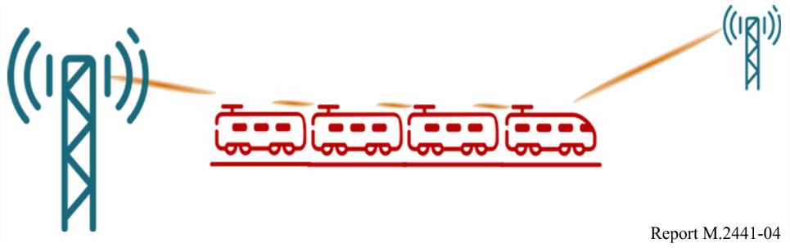

### 5.3.3 Bus/Fleet traffic management

The user scenarios that provide comfortable experiences through advanced methods of transportation include services that assist drivers to provide comfortable rides by avoiding traffic jams or other obstacles, and computer-aided management of crowds during popular events.

#### 5.3.3.1 Location-based services for traffic management

Both the private and public sectors are developing services that use Global Positioning System (GPS) and digital maps. These services are expected to continue to develop and evolve to use high‑speed mobile and cloud-based services enabled by IMT-2020. In the future, it will not only be people using electronic maps, but also self-driving vehicles that will be able to function when high-speed data transmission allows for real-time information updates. When this becomes a reality, digital maps will be able to be dynamically updated, including information on traffic jams and road construction. The low latency of IMT-2020 will enable these maps to be dynamically updated in real-time.

Municipalities also need hazard maps that can be updated in real-time for use in times of disasters or evacuations. IMT-2020 can also assist in creating maps that can change in real-time in response to disaster information, similar the dynamic maps self-driving vehicles will use.

Another example is the connected bus stop[20] – a concept that incorporates IMT and RLAN small cell technology. Apart from the usual consumer uses for mobile broadband, the connected bus stop can support functionality that is particularly useful for commuters. This could include screens that display real-time information about bus movements and touch-screens that provide access to interactive maps, local news, tourist information and advertising. In addition, a CCTV camera, panic button and push-to-talk functionality could be incorporated to increase security and make it easy for commuters to contact emergency services or the police. This is illustrated in Fig. 5.

Figure 5

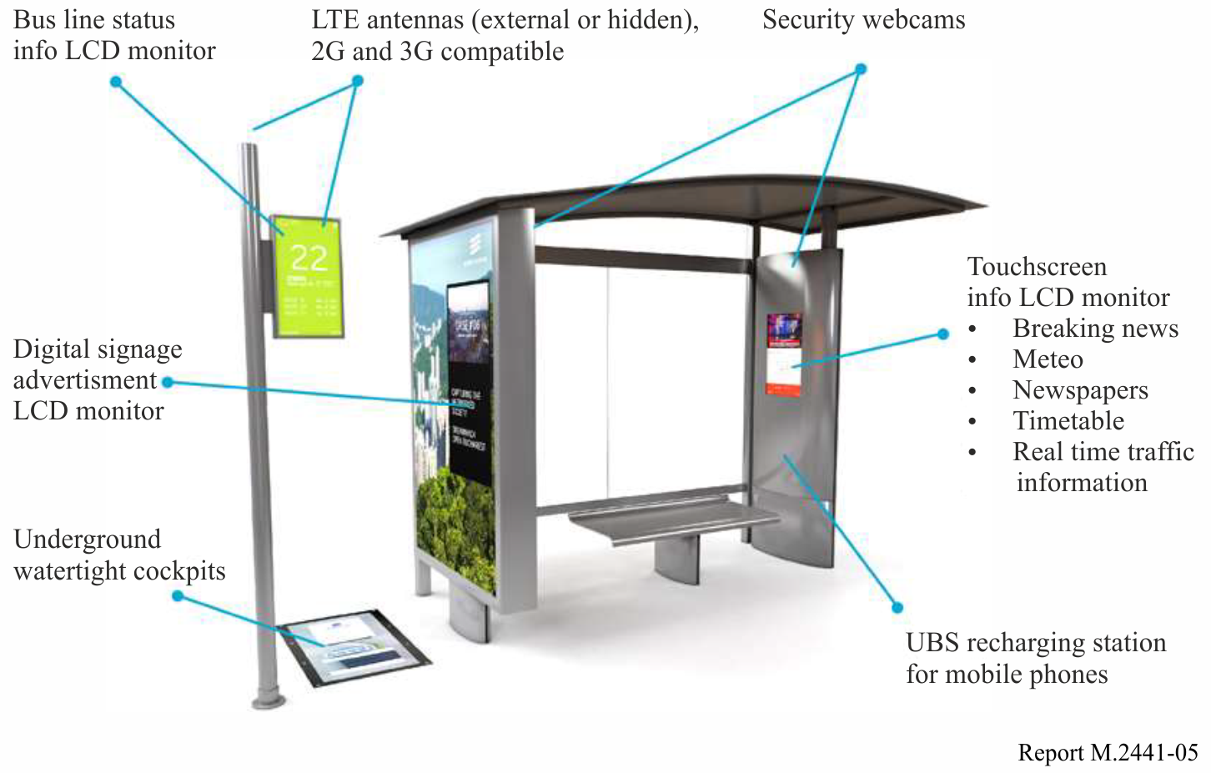

## 5.4 Utilities

### 5.4.1 Smart Grids

Smart grids will provide the information overlay and control infrastructure, creating an integrated communication and sensing network. The smart grid enabled distribution network provides both the utility and the customer with increased control over the use of electricity, water and gas. Furthermore, the network enables utility distribution grids to operate more efficiently than ever before[21].

Smart grids envisage ubiquitous connectivity across all parts of utility network distribution grids from sources of the supply grid, through network management centres to individual premises and appliances. Smart grid will require enormous 2-way data flows and complex connectivity which will be on a par with the internet. More information on the communication flows envisaged over the electricity supply grid is available in the ITU Technical Paper “Applications of ITU-T G.9960, ITU‑T G.9961 transceivers for Smart Grid applications: Advanced metering infrastructure, energy management in the home and electric vehicles” [22].

#### 5.4.1.1 Smart Grid requirements

In Smart Grids, there are many communication use cases, with varying requirements for latency, reliability, packet size and cycle times. Some use cases could have a high number of connected devices, while others have more stringent requirements on latency and reliability.

One survey of communication requirements for the smart power grid[23] shows the different communication use cases and their respective requirements on latency and reliability. Reliability requirements range from 99 to 99.99 percent. Some of the identified applications are Advanced Metering Infrastructure (AMI), Electric Transportation of a large number of electric vehicles, Distributed Energy Resources and storage applications for renewable energy sources, Distribution Grid Management, etc. For the application areas described above, the reliability requirements can be met by the current and future development of IMT technologies.

Cellular networks (i.e. GSM/EDGE, WCDMA/HSPA and LTE) have evolved from providing telephony services to supporting a wide range of data applications, with in-built security and Quality of Service support. In recent 3GPP releases, standardization enhancements for MTC have also been introduced, including support for congestion control, improved device battery life, ultra-low complexity devices, support for a massive number of devices and improved indoor coverage. Smart meters are available with individual monitoring and control functions using 3GPP technologies.[24]

3GPP has a variety of wireless standards that are applicable to first mile applications for power grid management systems. Recent releases of the 3GPP standards have introduced enhancements for MTC e.g.:

Release 10:

– Delay tolerant access establishment (UMTS, HSPA+, LTE);

– Extended access barring (GSM/EDGE).

Release 11:

– Extended access barring (UMTS, HSPA+, LTE).

Release 12:

– UE power saving mode (GSM/EDGE, UMTS, HSPA+, LTE);

– Low complexity UE category (LTE).

Release 13:

– Extended Discontinous Reception (GSM/EDGE, UMTS, HSPA+, LTE);

– Extended Coverage GSM Internet of Things (EC-GSM-IoT) (GSM/EDGE);

– LTE Physical Layer Enhancements for MTC (eMTC) (LTE);

– Narrow band Internet of Things (NB-IoT)[25].

### 5.4.2 Water management

Wireless communication is becoming an essential tool in managing the water quality and the environment surrounding the catchment area. In Africa, a telemetry project is aimed at investigating the atmospheric deposition of nutrients into the African Great Lakes, and how mobile phones can be used to support environmental protection. These lakes support the fishery and agricultural industries in the surround areas and are critical components of the economy and development of countries in the area. Wireless monitoring is helping improve the water quality. Wireless networks are also being used to educate the people living around these lakes on pollution and land use. At present these wireless networks are using basic GSM systems but with IMT there will be opportunities to further improve monitoring systems.

Water authorities in another country are investigating how IMT-2020 systems can be used for water management. In urban areas, wireless sensor networks (WSN) offer the promise to have a significant impact on a broad range of applications related to environmental monitoring and water safety. The convergence of the internet, telecommunications, and advancement in information technologies with techniques for miniaturization now provides vast opportunities for the application of low-cost wireless monitoring solutions for water management as well as for sewers.

With respect to sustainable water management systems, one of the most pressing issues is the efficient use of water – increasingly a scarce resource. Water shortages[26], leaks associated with aging infrastructure[27], inefficient irrigation systems[28] as well as industrial uses, which if not properly mitigated can create pollution in waterways. Thoughtful application of sensors and advanced metering can address several of these issues – sensors can serve as infrastructure monitors reporting leaks and managing water in real time. For example, one parks service installed a smart city system ‘to remotely monitor water consumption, detect leaks and share information with colleagues at other parks and facilities. The parks department estimates a 20 percent reduction in water use annually with a savings of some $860,000 per year.”[29], [30]

In another example, sensors are being utilized for applications such as managing water leaks and for water conservation. Sensors can help in identifying and managing leaks in water lines. Some studies have estimated that some communities “can be losing as much as 30 percent of their product along the way to leaks in the distribution system.”[31] To help with this, sensors and advanced metering infrastructure can be installed in treatment plants and underground pipes and help alert managers when leaks take place and identify how much water is being lost before it reaches the end-user. Smart meters allow people to know how they are using water and where they might be able to economize given their usage levels. In one area, for example, “metering, when coupled with effective pricing structures, reduces water use by 15 percent to 20 percent.”[32],[33]

Wireless networks already provide the following functions, but with IMT there are possibilities to do more:

– Improve monitoring and control of water flow over extended distances;

– Improve operator safety and efficiency by eliminating the need to travel to remote site locations for readings;

– With wireless radios, allow for any type of network topology, can self-heal, and provide reliability as well as capacity for future expansion.

Water authorities are already using wireless solutions for a variety of applications:

– Pump station control;

– Water quality monitoring;

– Dam gauging and gate control;

– Leakage detection in water distribution networks;

– Early flood-warning systems;

– Valve and flow meter stations;

– Rainfall and runoff monitoring;

– Tank level monitoring;

– Camera surveillance; and

– Irrigation monitoring and control.

## 5.5 Industrial automation

### 5.5.1 Motion control

Motion control is among the most challenging and demanding closed-loop control applications in industrial applications. A motion control system is responsible for controlling moving and/or rotating parts of machines in a well-defined manner, for example in printing machines, machine tools or packaging machines. Due to the movements/rotations of components, wireless communications based on IMT-2020 systems constitutes a promising approach. On the one hand, this is because with wirelessly connected devices, slip rings, cable carriers, etc. – which are typically used for these applications today―can be avoided, thus reducing abrasion, maintenance effort and costs. On the other hand, this is because machines and production lines may be built with less restrictions, allowing for novel (and potentially much more compact and modular) setups.

A schematic representation of a motion control system is depicted in Fig. 6. A motion controller periodically sends desired set points to one or several actuators (e.g. a linear actuator or a servo drive) which thereupon perform a corresponding action on one or several processes (in this case usually a movement or rotation of a certain component). At the same time, sensors determine the current state of the process(es) (in this case the current position and/or rotation of one or multiple components) and send the actual values back to the motion controller. This is done in a strictly cyclic and deterministic manner, such that during one communication cycle time *T*cycle the motion controller sends updated set points to all actuators, and all sensors send their actual values back to the motion controller. Nowadays, typically Industrial Ethernet technologies are used for motion control systems. In general, lower cycle times allow for faster and more accurate movements/rotations.

Figure 6

Schematic representation of a motion control system

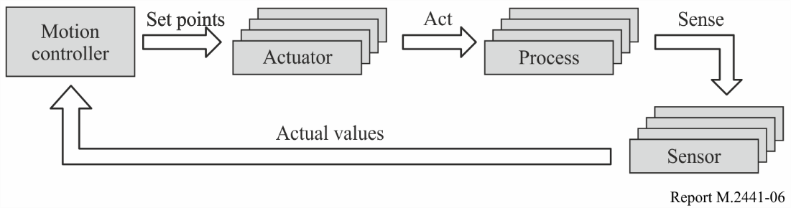

While it might be possible to move away from the strictly cyclic communication pattern for motion control systems in the long-term, it is hard to do so in the short-term since the whole ecosystem (tools, machines, communication technologies, servo drives, etc.) is based on the cyclic communication paradigm. In order to support a seamless migration path, the IMT-2020 system therefore should support such a highly deterministic cyclic data communication service.

Furthermore, there are many scenarios where some devices (e.g. sensors or actuators) are added / activated or removed / deactivated while the overall control system keeps on running. In order to support such cases, hot-plugging support is required without any (observable) impact on the rest of the system. 3GPP requirements for this application are available in TR 22.804 v16.1.0.

One case study[34] has looked specifically at the manufacture of bladed disks (BLISKs), which are important components of turbines such as aircraft jet engines. Consisting of a rotor disk and multiple blades around its edge, BLISKs are one of the most demanding metal processing applications. The rework rate of BLISKs today is approximately 25 percent, meaning that one in every four BLISKs needs to be reworked. With the introduction of wireless communications-enabled automation, the rework rate can be decreased from 25 to 15 percent and this is a conservative assessment.

While the BLISKs case is an extreme example, similar challenges exist within the manufacturing industry as a whole; vibration and “chatter” during milling is a very common problem. There are approximately 5 million industrial sites in Europe alone, compared with a total of 4 million mobile base stations in the world (<https://rod.eionet.europa.eu/obligations/721>): equipping each industrial site with mobile communications opens up large opportunities for wireless operators to expand their business.

### 5.5.2 Motion control – transmission of non-real-time data

In this use case, some additional non-real-time data are transmitted from the motion controller to one or several nodes (see Fig. 6). This is done in parallel to the regular cyclic data transmission service as described in § 5.5.1 above. Examples for this non-real-time data are software/firmware updates or maintenance information. 3GPP requirements for this application are available in TR 22.804 v16.1.0.

### 5.5.3 Motion control - seamless integration with Industrial Ethernet

In this use case, not all sensors and actuators in a motion control system are connected using an IMT‑2020 system. Instead, a single motion control system could integrate components of a wire‑bound Industrial Ethernet system and components of an IMT-2020 system. Therefore the IMT‑2020 system must support the seamless integration and interplay with Industrial Ethernet. 3GPP requirements for this application are available in TR 22.804 v16.1.0.

Figure 7

Example for an industrial Ethernet network including IMT-2020 links for motion control

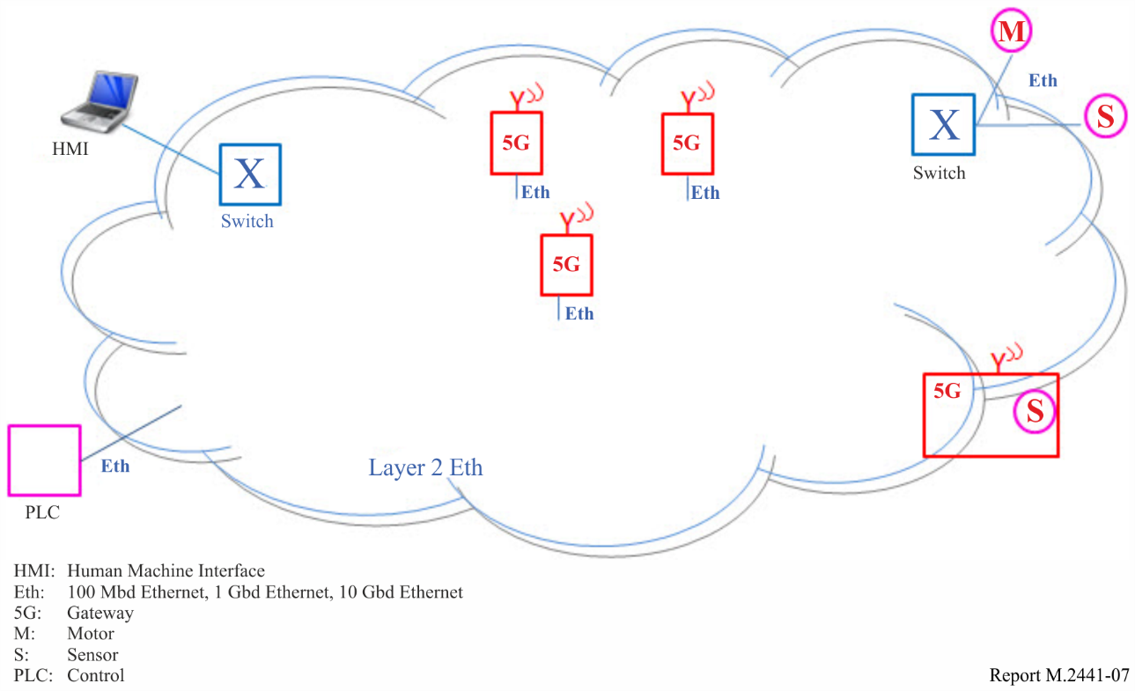

### 5.5.4 Control-to-control communication (motion subsystems)

Control-to-control (C2C) communication, i.e. the communication between different industrial controllers (e.g. programmable logic controllers or motion controllers) is already used today for a number of different use cases, such as the following ones:

– Large machines (e.g. newspaper printing machines), where several controls are used to cluster machine functions, which need to communicate with each other. These controls typically need to be synchronised and exchange real-time data.

– Individual machines that are used for fulfilling a common task (e.g. machines in an assembly line) often need to communicate, for example for controlling and coordinating the handover of work pieces from one machine to another.

Typically, a C2C network has no fixed configuration of certain controls that need to be present. The control nodes present in the network often vary with the status of machines and the manufacturing plant as a whole. Therefore, hot-plugging support for different control nodes is important and often used.

Protocols that are used for C2C communications today include Industrial Ethernet standards.

With the introduction of industrial IoT scenarios, the amount of data being exchanged is assumed to rise significantly. In this respect, wireless communication using an IMT-2020 system may pave the way for highly modular and flexible production modules that efficiently and flexibly interact with each other.

The main focus is on control-to-control communication between different motion (control) subsystems, as outlined in § 5.5.1. An exemplary application for that are large printing machines, where it is not possible or desired to control all actuators and sensors by one motion controller only. Such C2C systems typically have the most demanding requirements on the underlying connectivity infrastructure. For other C2C applications, the corresponding requirements (e.g. in terms of clock synchronicity) become often more relaxed. 3GPP requirements for this application are available in TR 22.804 v16.1.0.

### 5.5.5 Mobile control panels with safety functions

Control panels are crucial devices for the interaction between people and production machinery as well as for the interaction with moving devices. These panels are mainly used for configuring, monitoring, debugging, controlling and maintaining machines, robots, cranes or complete production lines. In addition to that, control panels are typically equipped with an emergency stop button and an enabling device, which an operator can use in case of a safety event in order to avoid damage to humans or machinery. When the emergency stop button is pushed, the controlled equipment immediately has to come to a safe stationary position. Likewise, if a machine, robot, etc. is operated in the so-called special ‘enabling device mode’, the operator has to manually keep the enabling device switch in a special stationary position. If the operator pushes this switch too much or releases it, the controlled equipment immediately has to come to a safe stationary position as well. This way, it can be ensured that the hand(s) of the operator are on the panel (and not under a moulding press, for example) and that the operator does – for instance – not suffer from any electric shock or the like. A common use case for this ‘enabling device mode’ is the installation, testing or maintenance of a machine, during which other safety mechanisms (such as a safety fence) have to be deactivated.

Due to the criticality of these safety functions, safety control panels currently have mostly a wire-bound connection to the equipment they control. In consequence, there tend to be many such panels for the many machines and production units that typically can be found in a factory. With an ultra-reliable low-latency wireless link, it would be possible to connect such mobile control panels with safety functions wirelessly. This would lead to a higher usability and would allow for the flexible and easy re-use of panels for controlling different machines.

One way to realise the safety functions is to make use of a special safety protocol in conjunction with the "black channel" principle[35]. These safety protocols can ensure a certain safety level as specified[36] with no or only minor requirements on the communication channel between the mobile control panel and the controlled equipment. To this end, a strictly cyclic data communication service is required between both ends. If the connectivity is interrupted, an emergency stop is triggered, even if no real safety event has occurred. That means the mobile control panel and the safety controller (e.g. a safety programmable logic controller (PLC)) it is attached to cyclically exchange messages and the machine stops if either the connection is lost or if the exchanged messages explicitly indicate that a safety event has been triggered (e.g. that the emergency stop button has been pushed). Thus, guaranteeing the required safety level is not difficult, but achieving at the same time a high availability of the controlled equipment/production machinery is. To that end, an ultra-reliable ultra-low-latency link is required.

The cycle times for the safety traffic always depend on the process/machinery/equipment whose safety has to be ensured. For a fast-moving robot, for example, the cycle times are lower than for a slowly moving linear actuator. 3GPP requirements for this application are available in TR 22.804 v16.1.0.

### 5.5.6 Mobile robots

Mobile robots and mobile platforms, such as automated guided vehicles (AGV), have numerous applications in industrial and intra-logistics environments and will play an increasingly important role in the “Factory of the Future”. A mobile robot essentially is a programmable machine able to execute multiple operations, following programmed paths to fulfil a large variety of tasks. This means, a mobile robot is able to perform activities like assistance in work steps and transport of goods, materials and other objects and can have a large amount of mobility within the industrial environment. Mobile robot systems are characterised by a maximum flexibility in mobility relative to the environment, with a certain level of autonomy and perception ability, i.e. they can sense and react with their environment. AGVs are a sub-group of mobile robots. AGVs are automatically steered and are driverless vehicles used to move materials efficiently in a restricted facility. Mobile robots and AGVs are monitored and controlled from a guidance control system. Radio controlled guidance control is necessary to get an up-to-date process information to avoid collisions between mobile robots, to assign driving jobs to the mobile robots and manage the traffic of mobile robots. The mobile robots are track-guided by the infrastructure with markers or wires in the floor or guided by own surround sensors, like cameras or laser scanners, for instance.

Mobile robot systems are sophisticated machines that represent a complete material handling solution and which are installed in a wide range of applications and environments. A detailed overview of the state of the art of AGV systems with modern areas of applications, AGV categories and AGV technologies is given in IEC 62443-3-2.[37]

The key aspects of mobile robots and AGV systems include:

– processes for handling goods and materials, especially incoming and outgoing goods, in warehousing and commissioning, in transportation as well as transfer and provision of goods;

– followed by information flows, namely the communication of inventory and movement reports, the outstanding order situation, throughput times and availability forecasts, presenting data to support tracking, monitoring and if needed to make decisions on measures to be taken, as well as the selection and implementation of means of data transfer;

– the use of means of transportation (cranes, lifters, conveyors, industrial trucks, etc.), as well as monitoring and control elements (sensory and actuating equipment); and

– the use of techniques (for active/passive security, data management, goods and wares recognition/identification, image processing, goods transfer, namely provision, sorting commissioning, palletising, packaging).

Mobile robot systems can be divided in operation in indoor, outdoor and both indoor and outdoor areas. These environmental conditions have an impact on the requirements of the communication system, e.g. the handover process, to guarantee the required cycle times. 3GPP requirements for this application are available in TR 22.804 v16.1.0.

### 5.5.7 Massive wireless sensor networks

Sensor networks aim at monitoring the state or behaviour of a particular environment. In the context of the “Factory of the Future”, WSN are targeting the monitoring of a process and the corresponding parameters in an industrial environment. This environment is typically monitored using various types of sensors such as microphones, CO2 sensors, pressure sensors, humidity sensors, and thermometers. In particular, these sensors usually form a distributed monitoring system. The monitored data, from such a system, is used to detect anomalies in the data, i.e. by leveraging machine learning algorithms. These algorithms usually require a training phase before a trained machine learning algorithm can later work on a subset of the available measured data. However, the training as well as the analysis of the data may be realised in a centralised or distributed manner.

The placement of the monitoring function can be dynamic and thus, may vary over time to enable dynamic up- and down-scaling of computing resources. In particular, the placement may also be constrained by the available WSN hardware. Given rather simple sensing devices, the functionality needs to be placed into a centralised computing infrastructure such as a mobile data or data centre cloud. Alternately, functionality may be placed inside the sensor network, i.e. the sensing devices, with additional external computational resources. The computation is referred to as fog computing, multi-access edge computing (MEC), and cloud computing (see Fig. 8), when sensor devices and gateways, gateways and edge cloud, and edge cloud and data centre resources are involved, respectively. A more local approach, e.g. fog computing or multi-access edge computing, is preferred over a more centralised approach in order to keep sensitive data in a fabrication site and keep the automated process independent of an internet connection.

Figure 8

High level component view of a scalable massive sensor network

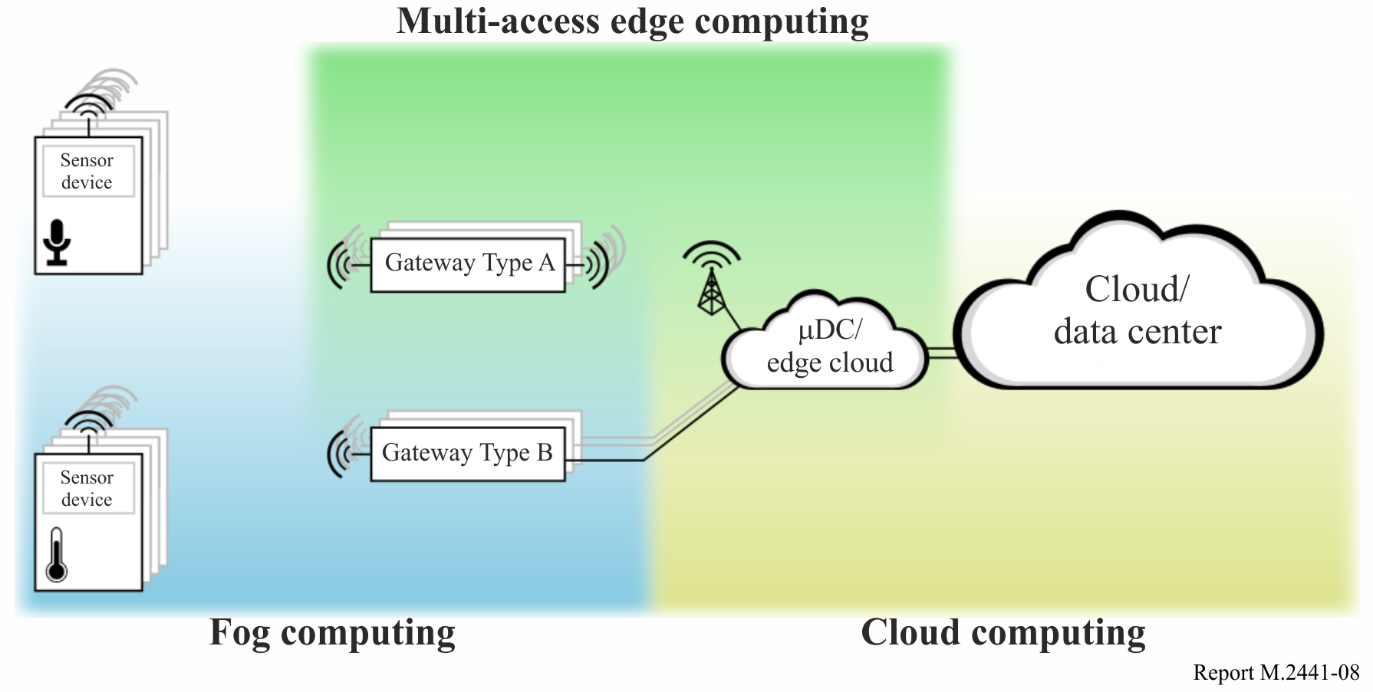

Note to Fig. 8: – It may comprise a set of heterogeneous measurement-units, wirelessly connected to gateways, which in turn are connected to a computing infrastructure such as a micro data centre (µDC). Other setups that contain grouped sensor devices are possible and may assist in reducing load on central instances.

Sensor networks facilitate the complex task of monitoring an industrial environment to detect malfunctioning and broken elements in the surrounding environment. An appropriate detection approach along with a classification of the anomaly can help choosing a countermeasure or proper action to take in case of predictive maintenance. Such actions can aid in improving the safety by automatically triggering a machine’s emergency stop in case of the detection of a critical problem. At the same time, production efficiency can be increased as machines can continue running in case the detected problem is not safety relevant and only disrupts service of some elements.

Measuring the environment and propagating events may be realised in different scenarios. In the simplest scenario, which is the least scalable, the sensors propagate each newly measured value without any pre-processing, i.e. in a solely proactive scenario. A more advanced approach is to solely react to the environmental changes to reduce traffic, e.g. by only propagating events under certain circumstances whenever a value exceeds a certain threshold[38]. In such a case, each sensor keeps measuring data but only propagates it whenever it detects a relevant change in the environment. Depending on the hardware, the sensing device may also be able to pause any active handling (i.e. polling data from sensor) as long as the given threshold is not exceeded, e.g. by receiving an interrupt when the sensor itself measures a sudden significant change of the environment. Usually, active handling in such a case is triggered by a call back from the sensor or a (remote) control unit. This optimisation enhances the sensing devices durability by reducing its power consumption. The power consumption reduction is an important task in WSNs since sensors are often just equipped with a battery. Thus, the power consumption reduction has gained a significant momentum in the WSN research. Moreover, a lot of effort is put on specifying new messaging protocols to reduce overhead of messaging protocols while still maintaining a high reliability and low latency[39]. Additionally, the reduction of message generation, e.g. by analysing measurements in local groups has thoroughly been investigated.

The traffic patterns generated by the sensor network vary with the type of measurement and the aforementioned setup. Traffic patterns may arise in the form of self-similar and/or periodic patterns, i.e. the latter is usually the case in proactive setups. Moreover, low-bandwidth and high-bandwidth streams might be transmitted. Depending on the computational resources of the gateway(s), some pre-processing of the sensor data may reduce the network load, and with that, the uplink requirements.

Figure 9

Sensor devices in star topology are connected to a local gateway (i.e. small cell),   
which provides connectivity to a base station

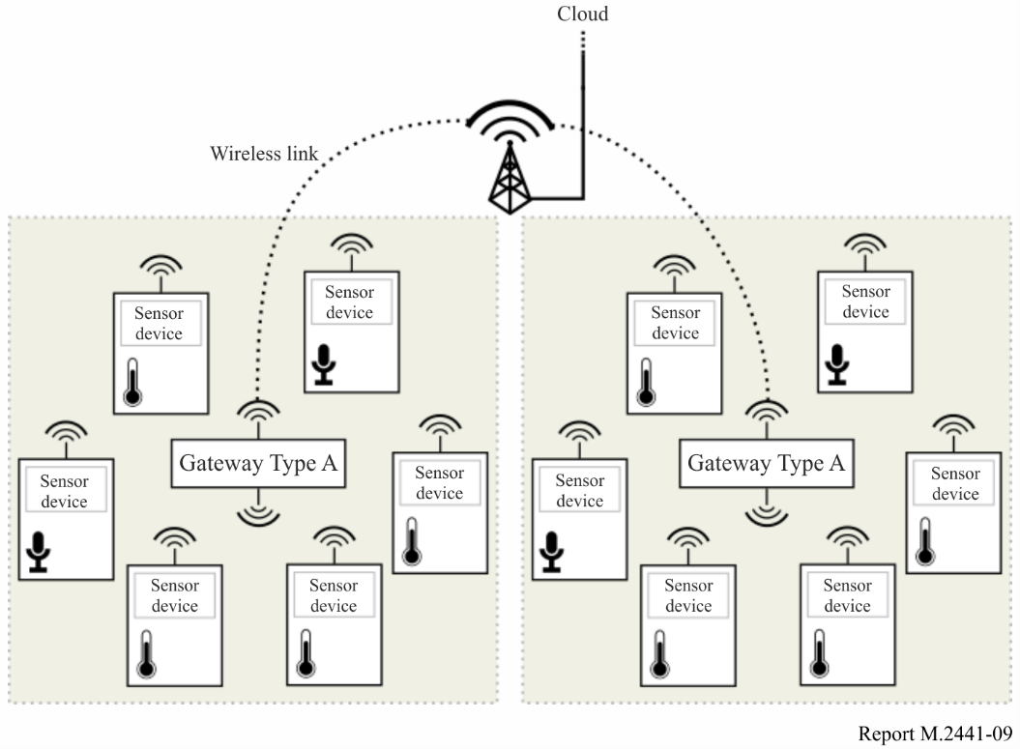

Figure 9 depicts a massive sensor network deployment. A number of sensor devices are connected to a local gateway (small cell) which connects to a base station at the edge to the cloud network. Hence, the local gateway aggregates and forwards monitoring data. Also, while aggregating, the local gateway may pre-process the incoming data to reduce traffic load to the cloud and computational resource requirements on the cloud. A local gateway needs to dynamically handle the attachment requests and detachment events of sensor devices without disruption of the monitoring service.

Figure 10

Sensor devices in a mesh topology realising multi-hop connectivity to gateway (via edge devices)

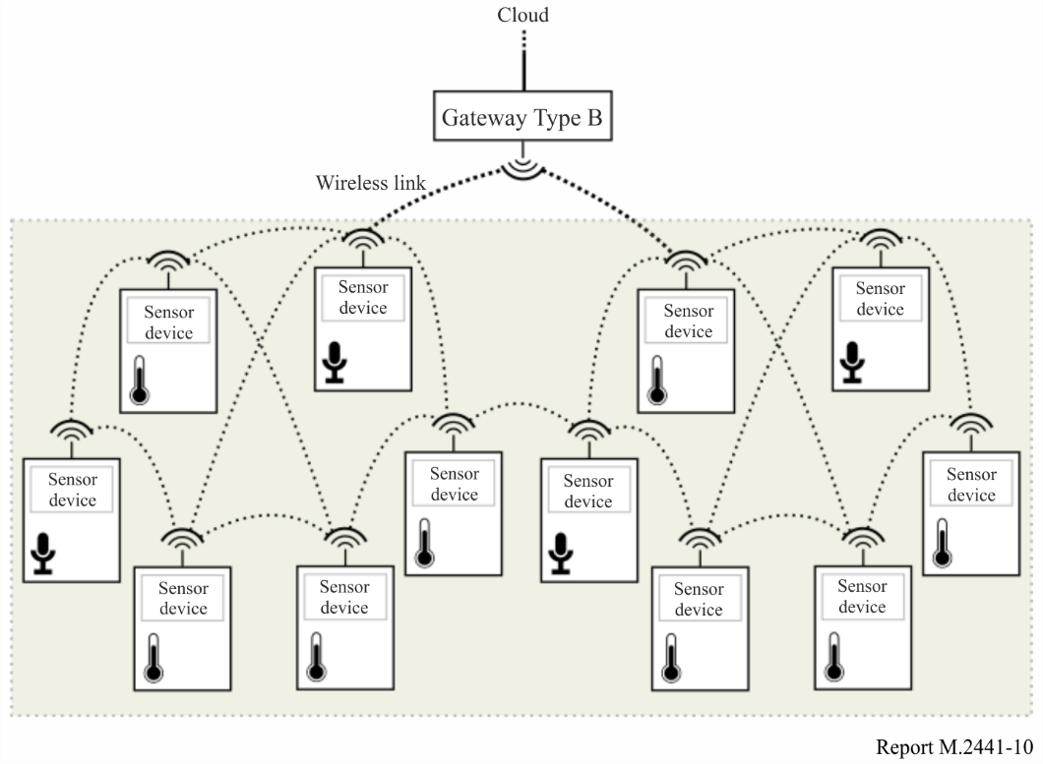

Another topology for a massive sensor network is shown in Fig. 10. Here, a set of sensor nodes is directly interconnected as a mesh, where one sensor nodes provides an uplink to the serving gateway (small cell). This reduces the number of locally deployed cells. In such a topology, the sensor nodes may communicate just locally to reduce the load on more central instances such as gateways and cloud resources.

In both topologies, star and mesh, a sensor node needs to perform a proper bootstrapping to connect to the network. It needs to be able to attach itself to the network automatically by attaching itself to a local cell or neighbouring mesh devices. Additionally, time synchronisation of sensor nodes, base stations, and gateways can enhance and ease monitoring. Time synchronisation in a massive sensor network may be realised in local groups, using the gateways or base stations. However, the bootstrapping of sensor nodes and the time synchronisation is not part of this Report. 3GPP requirements for this application are available in TR 22.804 v16.1.0.

**5.5.8 Remote access and maintenance**

Remote Access and Maintenance is a key motivation for looking beyond conventionally wired device networks in automation. Typical industrial networks are isolated from the internet and often based on very specific protocols. In such industrial networks (peer-to-peer communication links between just two devices, fieldbus with multiple devices and controllers, LAN or RLANs), remote access is often possible already today, but requires gateway functionality at any transition of the automation pyramid between bus systems, as shown in Fig. 11. Mapping of data formats, addresses, coding, units, and status is required for remote access to device data going down the automation pyramid, which comes along with a substantial engineering effort. This data mapping implemented in the gateway(s) is quite static and is not suitable for a flexible access on event-based conditionsrather than a permanent connection and data exchange, e.g. reading the device revision in case of a diagnostic event.

Figure 11

Remote access to field devices in existing systems through controllers   
via gateways at each transition point of the automation pyramid

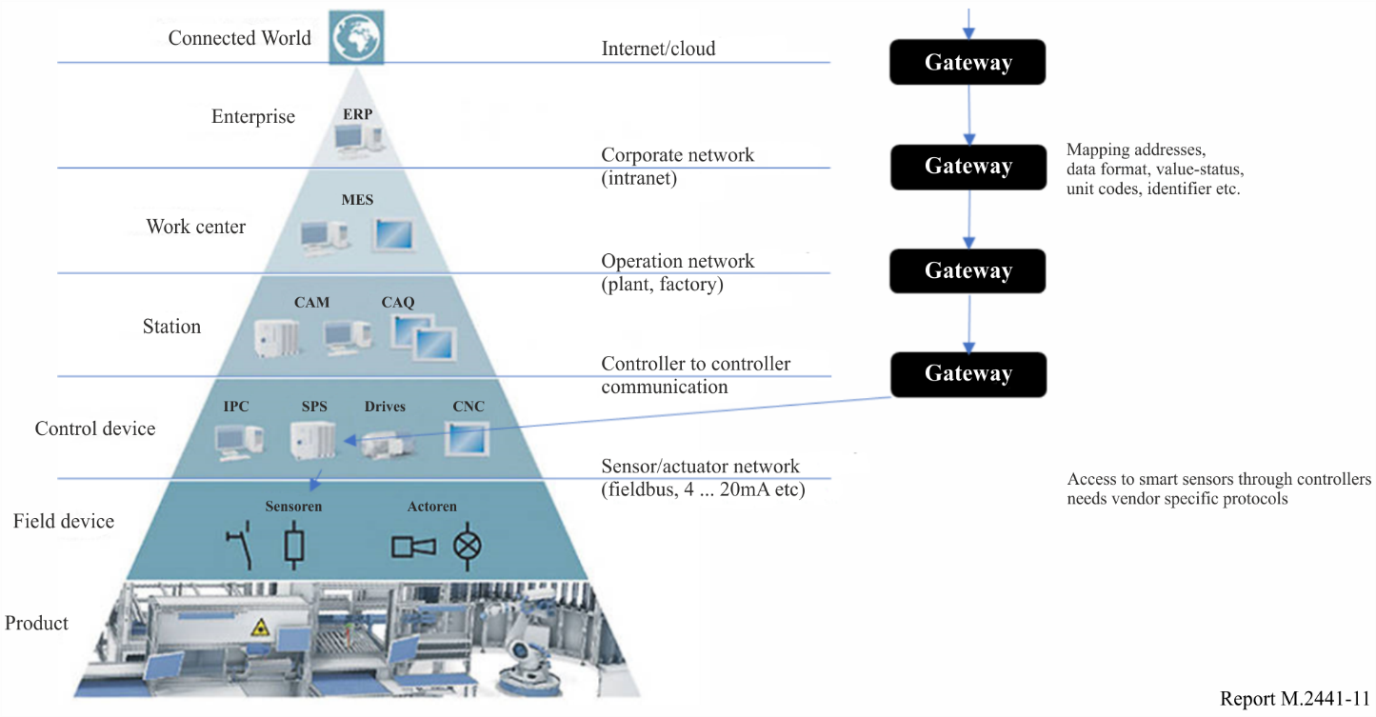

Remote Access and Maintenance scenarios apply to:

– Devices which already have a “cyclic” connection through a communication service for transmitting data regularly. This ad-hoc communication might be requested by the same end device and just runs in parallel from time to time.

– Devices which act almost autonomously, i.e. they have local computing power to run algorithms like measurement and data analytics, but they do not have a regular, cyclic connected communication service.

– Devices which have local personnel to interact with, such as a machine or even a car. A remote connection could be requested during a service case or if the local operator needs remote assistance.

– Devices which sleep most of the time and which should be woken up by establishing a connection via a dedicated wireless network.

A special sub-set of remote accesses is when the partner is a mobile device (geographically) near the device instead of a service far away from the device. The device might not differentiate if it is accessed remotely or “locally” via the IMT-2020 network. Use cases described here would be the same from the device’s point of view. A remote user would expect to parse a list with devices and have them organised in trees. A local operator has the intention to "talk with the device in front of her/him" instead of walking through a list of 10 000 devices installed at this plant. There should be means to automatically discover which IMT-2020 devices belonging to a certain group (e.g. all IMT-2020 devices installed in a process plant) are in the immediate vicinity of a local operator and to provide the user with a list of all those IMT-2020 devices.

Another use case is the inventory of devices and periodic readouts of configuration data, event logs, revision data, and predictive maintenance information. This is often called “asset management”, and tools for collecting and displaying data from many connected devices are called "asset monitors". Such a system may work autonomously (set of configured periodical checks) or it is interacting with a user (“show me status of this device”). A remote diagnostic system might be connected to many or all devices of a certain plant or location. A remote diagnostic system might be connected to many or all devices the operator is responsible for. A remote diagnostic system could also run as a device vendor’s service to maintain all devices independent of the device owner (plant, location).

There exist many protocols for reading and writing data to smart devices. Some of these protocols are standardised and many others proprietary. Assuming an Internet Protocol (IP)-capability of an IMT-2020 system, it should be possible to either use:

– Standardised IP-based protocols.

– Pack non-IP-based protocols into IP-frames in a proprietary way. This can be inside standardised protocols such as http (port 80) or proprietary IP-based protocols (device specific ports).

– Proprietary IP-based protocols (device specific ports).

Communicated data could be of any kind from single bytes, longer telegrams of a few kilobytes to continuous streams. Volume applications are expected with power and memory limited devices. The full range from power-optimised applications on the one end to high performance real-time data on the other end should be covered.

Remote access to a device may happen at any time (in case the user does authorise). So the remote access shall be non-reactive to other communication in the IMT-2020 network and operation and performance to other devices. Remote access should have impact only on the contacted device. Prioritised traffic mechanisms may solve the problem to not violate configured real-time conditions when upgrading a firmware of a device in the same network. The trigger to remotely access a device may come from the device itself, based on a certain event or condition. In this case, a device initiates a connection to another (known) device and submits data which alerts a service to read / write specific data from / to that device.

A major concern associated with remote access and maintenance is the potential vulnerability of devices in terms of cyber security. Most classical wired communication protocols do not consider any cyber security relevant scenarios. Physical access to devices and networks is almost restricted to skilled and authorised personnel. Furthermore, protocols are not widely used so the knowledge is kept to a limited community of specialists.

Users might want to block a device for any remote access, others might restrict access to only read data or just parts of data, such as operating hour meter, but no configuration data. Some restriction levels might be specific to the device and as such not standardised. Those restrictions should be fully transparent to the lower communication layers (IMT-2020 in this case). A basic set of restriction levels are expected from IMT-2020, (e.g. an adoption of existing mobile communication standards).

Electronic industrial devices do have a typical life cycle between 5 and 25 years. Customers expect old devices to remain accessible during this time with (at least) the same functionality that was provided when they were installed. Installations in process industry and factory automation are continuously extended and changed, so new devices are operated in parallel to old ones. 3GPP requirements for this application are available in TR 22.804 v16.1.0.

### 5.5.9 Augmented reality

It is envisioned that in future smart factories and production facilities, people will continue to play an important and substantial role. However, due to the envisaged high flexibility and versatility of the “Factories of the Future”, shop floor workers should be optimally supported in getting quickly prepared for new tasks and activities and in ensuring smooth operations in an efficient and ergonomic manner. To this end, augmented reality (AR) may play a crucial role, for example for the following applications:

– Monitoring of processes and production flows.

– Step-by-step instructions for specific tasks, for example in manual assembly workplaces.

– Ad-hoc support from a remote expert, for example for maintenance or service tasks.

In this respect, head-mounted AR devices are especially attractive since they allow for a maximum degree of ergonomics, flexibility and mobility and leave the hands of workers free for other tasks. However, if such AR devices are worn for a longer period of time (e.g. one work shift), these devices have to be lightweight and highly energy-efficient and they should not become very warm. A very promising approach therefore is to offload complex (video) processing tasks to the network (e.g. an edge cloud) and to reduce the AR device essentially to a connected camera and display. This has the additional benefit that the AR application may have easy access to different context information (e.g. information about the environment, production machinery, the current link state, etc.) if executed in the network. A possible processing chain for such a setup is depicted in Fig. 12.

Figure 12

Possible processing chain for an augmented reality  
system with offloaded tracking and rendering

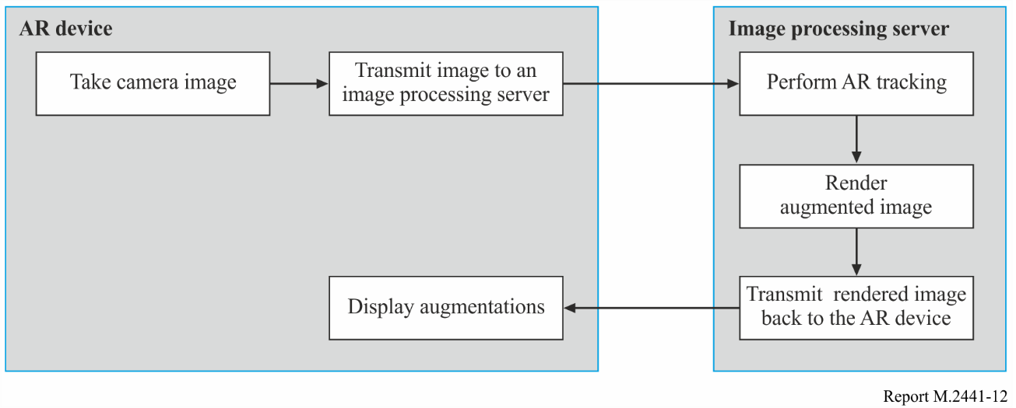

Here, the AR tracking algorithm determines the current viewpoint of the AR device and places the desired augmentations at the right positions in the current image. One of the main challenges with such a setup is that the displayed augmentations have to timely follow any movements of the camera in the AR device (which may be caused by any movements of the person wearing the AR device) since otherwise the AR user may experience nausea after some time and reasonable usage would not be possible. Therefore, compression of the video stream from the AR device to the image processing server and back should also be avoided if possible in order to reduce the overall processing latency and requirements. 3GPP requirements for this application are available in TR 22.804 v16.1.0.

### 5.5.10 Process automation – closed-loop control

In this use case, several sensors are installed in a plant and each sensor performs continuous measurements. The measurement data are transported to a controller, which takes decision to set actuators. The latency and determinism in this use case are crucial. 3GPP requirements for this application are available in TR 22.804 v16.1.0.

### 5.5.11 Process automation – process monitoring

Several sensors are installed in the plant to give insight into process or environmental conditions or inventory of material. The data are transported to displays for observation and/or to databases for registration and trending. 3GPP requirements for this application are available in TR 22.804 v16.1.0.

### 5.5.12 Process automation – plant asset management

To keep a plant running, it is essential that the assets, such as pumps, valves, heaters, instruments, etc., are maintained. Timely recognition of any degradation and continuous self-diagnosis of components are used to support and plan maintenance. Remote software updates enhance and adapt the components to changing conditions and advances in technology. 3GPP requirements for this application are available in TR 22.804 v16.1.0.

### 5.5.13 Flexible, modular assembly area

In the future, static sequential production systems in factories will increasingly be replaced by novel, modular production systems offering high production flexibility and versatility. The concept of modular production systems encompasses a large number of increasingly mobile production assets, for which powerful wireless communication and localisation services are required. These assets do not only include autonomous devices such as automated guided vehicles, but also production-assistance devices such as mobile control and monitoring devices and augmented-reality goggles.

This use case should consider the following:

– Ultra-reliable wireless communication for a variety communication services adhering to negotiated and guaranteed QoS parameters.

– Communication bursts when several parallel actions occur (e.g. parallel actions supported by real-time video assistance).

– High density of mobile assets.

– The wireless network configuration should change when the layout of the assembly area is altered. The network configuration change is carried out by the production staff, supported by self-optimising algorithms. In some cases this only involves the wireless modems. In other cases, wireless access points might have to be relocated, or more base stations might have to be added to the wireless network.

– Network maintenance and communication service assurance:

• monitoring the production environment and processes related to communication: detect potential communication bottlenecks in the production area;

• diagnosis of network errors, faults, underperformance, etc.; contains recommendations in regards to fulfilling the requested QoS.

3GPP requirements for this application are available in TR 22.804 v16.1.0.

### 5.5.14 “Plug and produce” for field devices

This use case covers the realisation of plug-and-produce for intelligent field devices that utilise wireless communication services.

“Plug and produce” addresses the automated integration and configuration of a (new) field device into an existing production system. The plug-and-produce use case is applicable to discrete manufacturing as well as continuous and batch processing. The goal of plug and produce is to increase the flexibility and adaptability of production systems and to speed up the commissioning process of field devices by reducing manual overhead. The field device in question may be an individual sensor or actuator, or a more complex production unit.

One of the aspects to consider when allowing this kind of dynamic integration of field devices into a production system is to ensure that the automation system always complies with the automation system security requirements. This requires controls to provide access to a production system only to authenticated, authorised field devices. For unconstrained field devices, the plug-and-produce integration of field devices within a production system can be protected through appropriate application layer security mechanisms. In those cases, network security and security of the production system can be handled rather independently. However, some field devices are constrained (for instance battery-driven field devices), and some real-time automation applications might run in an (edge) cloud environment that do not allow for application layer security mechanisms. As “over the top security” is not possible here, the security of the production system has to rely on the security of the wireless system. As a rule of thumb, factory operators strive to offer security already at the network layer. Also, in many cases, the factory operator also manages the communication network, and in that role she is interested in securing the network itself. There is thus a strong interest in securing wired and wireless communication in factories including potential private IMT-2020 networks.

Such field devices often offer more than one communication port (e.g. IEEE 802.11 RLAN and IEEE 802.3 Ethernet), and that some field devices may support only some communication technologies (e.g. only IMT-2020 or only RLAN). So, the wireless communication system has to be integrated in a production system using heterogeneous communication technologies. It is also noteworthy that factory operators prefer a unified authentication of field devices, i.e. that the same communication authentication credential can be used with different communication technologies and ports. After being connected and being discovered by the production system, the field device automatically obtains the configuration required to participate in the production process.

This use case should consider the following:

– Network access authentication for field devices in networks with credentials provided by the manufacturer and not the network operator.

– Backward compatibility of future releases to the authentication framework in place.

– Support of different types of authentication credentials depending on the credentials available in a specific industrial site/application.

– Automation system functions Manufacturing Execution System to control network access properties in private networks, e.g. limiting the range of network addresses accessible to a plug-and-produce field device.

– Integration of communication links within a local automation network zone, i.e. enforcement of network isolation for private networks.

3GPP requirements for this application are available in TR 22.804 v16.1.0.

## 5.6 Remote control

Remote control robots will have great potential in many fields and provide commercial and societal profits. Construction and maintenance in dangerous areas, repair work in damaged nuclear or chemical plants, off-shore construction tasks are examples of such areas where the use of robots is very relevant. A prerequisite for the use of robots is a remote-control with real-time capability, high reliability and availability.

Depending on the type of applications, response times of less than a few milliseconds might be needed (e.g. for visual-haptic feedback). Some typical mobile robot applications are remote measurement, remote surgery and remote control in underground mining. Examples of specific applications are described in the following subsections.

For remote operation solutions to function effectively, sensory information like sounds and images needs to be transferred to the tele-operator from the equipment being controlled and its surroundings. Ensuring that audio and visual feeds are sent with minimal distortion enables the tele-operator to gain a good understanding of the remote environment, which leads to improved productivity and safety.

Remote operations would become even more efficient and intuitive if sensory data additional to the basic audio and visual information were included in the solution. Just as manual operations rely heavily on the human ability to balance and touch things, remote operation applications – whether industrial, medical, or recreational – can benefit greatly from the incorporation of this type of sensory information.

The addition of touch and balance to the operator feed can be achieved by the use of haptic interaction and force feedback. The ability for the operator to actually feel the vibrations when an object like an excavator bucket hits the ground, or to sense when a robot arm touches its target is highly valuable in terms of productivity, cost, and safety.

Additional sensors and technologies, like gyros, accelerometers, radars, lasers, lidars (Light Detection and Ranging), and thermal and infrared sensors can be used to gain more information from the remote site and provide enhanced control at the operator end.

The negative effects of bad media quality, or an imperfect representation of the remote equipment and its surrounding environment, can be alleviated to some degree through training. Before full productivity can be achieved, operators require training and experience of operating equipment remotely – even if they have previously operated the same or similar equipment on-site.

Remote operation is not a one-size-fits-all solution. Owing to the range of equipment and the many potential scenarios in which remote applications apply, the array of use cases that could benefit from remote operation is extensive. An extra level of variation arises from the need to weave environmental parameters – such as rain, snow, dust, dirt, vibrations, and visibility – into system design. For example, remotely operating a dumper that moves cargo loads in and out of a mine is fundamentally different from performing surgery using a remote-controlled precision robot. But even less obviously contrasting examples, like operating a dumper in differing visibility conditions, can present significant challenges for the technical solution.

### 5.6.1 Communication links

Securing a high-quality communication link between the control station and the machines being operated is key to accurate and effective remote operation. Existing solutions tend to use cable or RLAN to implement the last hop of this link. Cable provides low latency and high reliability, but it is costly to install and modify – which is significant when machines are constantly being moved from one site to another, such as in construction. RLAN is a low-cost alternative that provides a certain degree of mobility – within the coverage area of the RLAN network. Both solutions require dedicated on-site installation and a connection to the control centre over the public internet or through a leased fixed-line connection.

To provide remote operation solutions with connectivity, standardized cellular systems offer a number of benefits. First, using an operator-managed cellular network eliminates the need to install on-site infrastructure. Second, cellular networks can offer widespread coverage and mobility solutions that can provide connectivity to mobile machinery and devices. Furthermore, as they use licensed frequency bands, cellular links are highly reliable, and the required level of security can be guaranteed. However, the requirements set by some use cases cannot easily be met by existing communication technologies.

A simple, quick and flexible on-site installation process is a basic requirement for many remote operation applications. Machines might be portable or driverless and may be required at different locations during the same working day. Job sites can be temporary and may grow, and their communication needs may change over time – which tends to be the case in construction and mining. For such environments, wireless solutions are preferable as they offer the desired level of flexibility and ease of installation, they can support equipment that is on the move, and do not require any cables.

For the most part, industrial companies expect global communications to be delivered with end‑to‑end (e2e) Service Level Agreements (SLAs), which they can handle themselves to some degree. Providing e2e SLAs, however, presents a challenge given that the system may span multiple public operator networks and even infrastructure owned by the enterprise itself.

High-definition video is a fundamental element of remote operation solutions. To deliver heavy video streams requires connection links with high minimum bitrates, especially when applications require high-resolution images, fast frame rates, stereoscopic video, immersive video, or multiple viewpoints (several camera feeds). Low media quality severely degrades the user experience, which inevitably leads to a drop in productivity. The exact bandwidth requirements are, however, highly dependent on the use case. Like most real-time applications, remote operation requires connection links with low latency and low jitter characteristics. To operate equipment (like an excavator or a robot) efficiently on a remote basis, the time lapse between the instant an operator sends a control instruction to the moment the equipment’s reaction is sensed by the operator must be as short as possible.

The toughest latency requirements occur in applications that include haptic interaction. A typical haptic control loop in a remote operation application requires latency to be below 10 ms [40], and in some cases, the round trip time should not exceed a few milliseconds. To put this figure into perspective, current IMT-Advanced networks have an average latency of 30 ms, which in some cases can rise to 100 ms or more if packets are delayed.

Some degree of toleration to packet loss in remote operation applications is expected. However, packet loss may result in lost or delayed control commands, which can cause machinery to stop, can be costly, and can cause damage to equipment or even injury to personnel. Thus, to guarantee the continuous and safe operation of machinery, the communication link and the entire solution need to be highly reliable.

System outages or hijacked equipment resulting from a cyber-attack or other security intrusion can have severe consequences. Personnel safety is jeopardized, business continuity can be affected, and expensive equipment may be damaged. Thus, security is a key consideration when designing any remote operation system.

Proper audio and video feed synchronization is critical to provide the operator with a clear understanding of what is happening at the remote location. The synchronization requirements for remote operation solutions that incorporate haptic interaction and force feedback are much stronger than for a videoconference, for example. Without proper synchronization, the operator might receive confusing and contradictory messages, which has negative impact on user experience.

Mechanisms need to be in place to ensure that equipment can be stopped automatically in abnormal situations like a machine malfunction, a collision, or the presence of unauthorized personnel. Tele-operated equipment may require additional sensors and functionality to detect potential risks and enable safe remote fault handling and recovery.

The communication requirements for remote operation can be summarized as follows:

– ease of deployment;

– minimum bitrate;

– low latency;

– reliability;

– security;

– emergency handling and recovery.

Examples of remote operation and control applications exist everywhere, but the benefits that can be gained in mining and construction are easier to realize than in some other use cases. Increased productivity, access to specialized expertise, improved safety and wellbeing, and reduced exposure to hazardous chemicals are just some of the gains that remote operation can bring. If configured appropriately, today’s IMT networks can support some industrial applications, but the needs of other, more demanding, use cases can only partly be met by existing communication solutions. Future IMT-2020 systems are, however, being developed to meet challenging requirements like low latency, high reliability, global coverage, and a high degree of deployment flexibility – the key drivers supporting innovative business models.

### 5.6.2 Mining

The modern mine is crowded with vehicles and machines performing a variety of tasks, both on the surface and underground: trucks, drills, trains, wheel loaders, and robots designed for specific tasks are all typical examples. Mines are high-risk environments, and the ability to move people and equipment from one place to another is key, given that certain areas can take a considerable amount of time to reach[41].

The ability to move driverless equipment into place quickly, say following a blast, is a potential time-saver when people are not permitted into the area until fumes have cleared. Benefits like this, combined with the fact that mines are typically found in remote locations, have led the mining industry to become an early adopter and developer of remote machine operation.

### 5.6.3 Construction site

The incentives for construction use cases to implement remote operations are similar to those that apply in mining. In both cases, heavy machinery is required, such as excavators, wheel loaders, compactors, and haulers – all of which can be worked remotely to advantage. Unlike mining, machinery used in construction moves from one site to the next, which requires a more flexible operating solution that can function without the need for fixed on-site infrastructure.

Research addressing remote operations for the construction application was demonstrated at MWC in 2015[42]. The trials leading up to the demo aimed to determine the network requirements like latency and throughput, as well as the performance needs for the audio and video equipment – with a view to ensuring that IMT-2020 will meet the specifications.

### 5.6.4 Harbours

Large cargo ships can carry over 16,000 containers. Loading and unloading is a time-consuming process often requiring a number of cranes working simultaneously for many hours at a time. Traditionally, each operator sits on-site in the control cabin of the crane, high above ground. Cranes need to be operated with speed, precision, and consistency. With smart cranes and remote operation, safety and productivity levels can be increased, while operator stress levels can be reduced. The comfort of the control room offers many benefits in terms of wellbeing, as it:

– saves the time spent accessing a crane’s control cabin;

– provides a favourable job environment with improved ergonomics;

– reduces exposure to adverse weather conditions;

– improves the security and safety of personnel;

– personnel can help each other in solving issues;

– easy to get monitoring information for various purposes.

Solutions to remotely operate cranes from a control room in the harbour, where the operator’s work is facilitated by a video feed from the crane[43]. Traffic is highly asymmetric, consisting of large amount of video data in the uplink whereas the downlink is used for control and safety data. Latency time and variations in the latency are critical. The needed location information accuracy varies from 1 cm in automatic control of the crane, to 10 m in locating the machine in port terminal. The container's position information needs 1 meter accuracy. Centralization is the natural next step in the development of this solution, enabling multiple cranes situated at different sites to be operated from the same station.

The container port area should be considered as a very challenging radio wave propagation environment, because the presence of many steel containers can cause very strong multipath effect while the time-varying container arrangement in stacks of different height changes the path loss value over time.

## 5.7 Surveying and inspection

Drones, robots, and vehicles that are remotely operated are suitable for applications like land and sea inspection, where the safety issues arising from the distances covered, adverse weather conditions, and hazardous terrain can be costly to address. Remote operations work well for these types of monitoring applications, and are ideal for observing industrial and construction sites in out-of-the way places, or large indoor venues and warehouse environments.

Video streams and other sensor data are fed back to the operator, enabling appropriate action to be taken. By combining remote inspection with remote manipulation, the level of automation can be raised. For example, a remotely operated robot in a data centre can rapidly swap out a malfunctioning server, or respond to other types of hardware failures[44].

### 5.7.1 Oil and gas

The oil and gas industry operates in environments that are harsh – both for people and equipment. Inspection, servicing, and operation of equipment as well as monitoring of leaks are just some of the routine applications. Remote operation is highly applicable to these use cases, but to fully reap the potential benefits, equipment must remain functional without the need for regular on-site maintenance. One of the main benefits of remote operation is a reduction in the need for people to work in challenging environments, and frequent maintenance visits would negate this benefit.[45]

### 5.7.2 Electricity

Applications in electricity networks can be divided into three main categories: monitoring, controlling, and protection applications. The protection applications put the highest constraints for the communication network, which currently use a wired connection due to very stringent requirements on the communication reliability and low latency. One example of such protection application is line differential protection, in which current vectors are measured from both ends of the feeder and transmitted to the other end of the feeder for determining differential current value. In this application, symmetrical communication line operates over long distances. Monitoring and controlling applications are not as time critical and they can be performed wirelessly with current technology.

## 5.8 Healthcare

Healthcare is a rapidly expanding field that is using wireless networks. IMT-2020 technology has great potential to improve the quality of healthcare. Presently, there are simple applications such as reminding patients to take their medications. With the advent of smartphones there are now more sophisticated health applications. Medical devices are now integrating wireless into their products. For example, blood pressure and heart rate can now be transmitted to a remote medical practitioner.

Looking forward, IMT-2020 advances in URLLC, massive MTC and enhanced mobile broadband (eMBB), have potential to impact health care service delivery across multiple applications. While mission-critical medical functions, such as remote surgery, require high reliability and availability with latency intervals that are down to a few milliseconds; monitoring devices and wearable medical equipment will require long battery life comparatively low data rate transmission. Enhanced mobile broadband applications, such as high-resolution imaging and video conferencing have potential to be used for diagnostic purposes. IMT2020 may enable these requirements and bring consistent, reliable user experiences to improve medical care[46].

Health care application requirements may include the following:

– Health applications have a variety of not only throughput requirements, but also latency and reliability considerations.

– The lower the latency requirements of a specific health application, the larger the bandwidth needed to send a given amount of data. This becomes an important consideration for applications such as remote surgery.

– Health applications often need ultra-reliable connections, which can include a combination of ultra-robust connections (heavy coding and retransmissions) with high throughput/low latency requirements. This also will require large bandwidths.

– A given application’s range and coverage requirements should be considered as well as bandwidth needs of the specific application.

– Range and coverage requirements also depend on deployment scenarios – e.g. monitoring healthcare in rural clinics could require long range communications (i.e. low frequencies) to enable e-health services for vulnerable communities

### 5.8.1 Remote surgery

The use of teleoperation technology is emerging in the field of medicine. It enables surgeons to perform critical specialized medical procedures remotely – allowing their vital expertise to be applied globally. While this application area is still in its infancy, it is likely to become more widespread as the technology becomes more advanced.

If we consider a scenario where a patient is staying in a hospital of rural area with poor medical facilities, and a doctor of a general hospital in a big city operates surgery of this patient, there exist systems, that transmit 3D video capturing the surgical site in real-time, and various medical data, and a surgery robot in the operating table of the hospital in a remote place. A remote surgery system in the general hospital receives such data and shows them to the doctor, and the doctor controls the robot based on this data and delivers control information of the surgery robot, thus the surgery robot performs the desired motion accordingly.

In order to facilitate a situation in which the surgeon does not feel any latency in remote control, much shorter latency than IMT-2000 and IMT-Advanced is required. For example, when a person (controller) changes the location of a robot arm, it is necessary that he/she feels as if he/she was standing there and moving the arm by himself/herself. However, the current IMT-2000 and IMT‑Advanced networks do not meet this requirement. Thus, IMT-2020 network technology with ultra-low latency is needed.

Video and sensing data from a robot should also be realistic as the same to what a person actually sees. Transmission speed of networks for higher definition video from a robot needs to be supported. Recognition technology using five-sense sensors as well as high definition 3D or hologram, and cloud computing technology can be used for robot services. When multiple robots perform joint work and their data is delivered to one controller, the requirement for broadband services becomes more significant.

Malfunction of robots is directly related with a life of human as well as work process. Thus, higher level of network reliability needs to be secured. Also, in order to keep failure rate below six-sigma, high-reliable transmission of sensing and control data through a network is one of key requirements.[47]

### 5.8.2 Clinical Wearables

Clinical wearables and remote sensors as well as many other devices that monitor and electronically transmit medical data such as vital signs, physical activity, personal safety, and medication adherence. As an example, the Michael J. Fox Foundation has pioneered work on devices that track the tremors associated with Parkinson’s disease.[48] Rather than relying on patients’ self-reporting of the number and duration of tremors and how they have varied over time, doctors are deploying wearable motion sensors that provide reliable data in real time for many different aspects of the disease. This level of data is unprecedented and the ability to analyse it and identify patterns will help in determining things like whether symptoms are deteriorating and the possible causes of deterioration. Information regarding whether a particular kind of medication is helping patients or not and how that medication is being affected by the data points the devices are monitoring such as food intake, exercise, and the like, will also allow for novel applications.[49]

### 5.8.3 Mobile Health Applications

There are already thousands of medical apps available for smartphones, in what has been referred to as AppPharmacy. The trend is growing rapidly and existing apps can be used, for example, for the viewing, registration, fusion, and/or display for diagnosis of medical images. Other applications include use of the phone’s camera to analyse the absorption of red and infrared light by blood in the fingertip giving continuous access to heart rate and blood oxygen saturation level; immunization schedules; screening tools for jaundice by combining a smartphone app with a colour calibration card and cloud-powered analytics. Medicine is now going beyond the smartphone into smart consumer products. IoT is driving a new world of connected healthcare. The availability of this continuous digital data is transformative, not just for the single consumer, but for humanity[50].

In one particular study by Stanford University scientists it was found that smartwatches can detect the earliest symptoms of a cold, Lyme disease or diabetes, hinting at the potential of the technology for improving people’s health and well-being[51].

Case Study:[52]

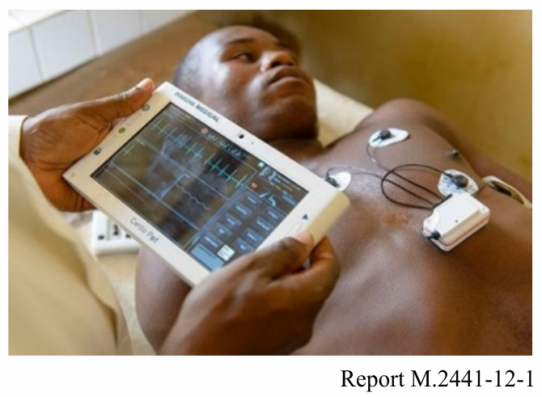

In Africa for example, an engineer developed a new device called a Cardio-Pad. This device allows village doctors who have no access to sophisticated equipment to take a quick scan of a patient’s heart function and send it wirelessly to a specialist, who can provide an analysis in 20 minutes. This condition frequently goes undetected until the advanced stages due to the lack of properly equipped medical facilities especially in rural areas. With IMT, there will be the capability to do further analysis allowing local doctors to do more under the supervision of a specialist.

At present, in developed countries, surgeons are using robots to perform surgery in some instances. Research is now occurring on how to use these capabilities remotely. With IMT-2020’s low latency there is the opportunity to manipulate the robots remotely. This will improve healthcare in remote and rural areas. For example, surgeons will be able to perform an angioplasty remotely, which involves temporarily inserting and inflating a tiny balloon in an artery that is clogged to help widen the artery.

## 5.9 Sustainability/Environmental

The unique features of IMT-2020, such asURLLC, eMBB, and massive MTC have particular relevance for resource management and sustainability. In parallel, advancements in connectivity and network infrastructure will allow for the deployment of potentially billions of sensors[53] and other IoT devices which – despite smaller form factors – will be able to perform heavy computational tasks, leveraging multiple access edge computing and other innovations for processing power.

Sensors can also aid in implementation of precision agriculture (see § 5.13), aiding farmers in making real time data backed decisions for irrigation methods as well as water management (see § 5.4.2).

Energy efficiency is defined as the number of bits that can be transmitted per Joule of energy, where the energy is computed over the whole network, including potentially legacy cellular technologies, radio access and core networks and data centres. Energy efficiency is a key factor to minimize the total cost of ownership as well as the environmental footprint of networks and must be a central design principle/key performance indicator of IMT-2020 networks.

Specific use cases, such as in the case of natural disasters will require extremely efficient network deployments. Survivors should be able to signal their location/presence so that they can be found quickly. Efficient network and user terminal energy consumptions are critical in emergency cases. Several days of operation should be supported.[54] Other non-emergency use cases, such as in the case of agricultural sensors require wide area, low power devices which result in extremely long battery life (i.e. approximately 10 years) [55].

## 5.10 Smart city

Cities are growing at a rapid rate and smart infrastructure investments will prepare urban communities for the challenges ahead. To accelerate the planning and adoption of innovative urban infrastructure, many governments have launched Smart Cities Challenges to develop Smart Cities Plans together with local government, citizens, businesses and civil society[56]. A number of Smart Sustainable City Cases have been reported[57].

These initiatives will improve the quality of life for urban residents, through better city planning and implementation of clean, digitally connected technology including greener buildings, smart roads and energy systems, and advanced digital connectivity for homes and businesses.

Although there are a wide variety of smart city applications, below are a few general considerations for smart city implementations:

– Standard interconnectivity interfaces for devices and/or applications from third parties who have interactions with cities[58].

– The need for adaptive radio protocols to opportunistically route messages adapting to the dynamic application requirements (i.e. energy usage, expected quality of service, etc.) which may be enabled through features such as Software Defined Radio.

– Ability to switch dynamically between radio interfaces based on application throughput requirements.

– Dynamic fair scheduling of resources to enable city stakeholders to deploy applications in a multi-tenancy fashion over heterogeneous sensor and processing nodes across a city leveraging edge computing infrastructure as appropriate

– Coverage: Some smart city applications, e.g. industrial IOT applications, require a wide coverage area, whereas smart home applications, for example, require a small coverage area. A large coverage can be provided by use of multi-hopping, or can be achieved by longer range transmissions[59]. Longer range may also require devices that support low power and or longer battery life.

– Scalability: The ability of an access technology to scale to a large number of nodes with high efficiency is another determining factor for its applicability for a particular smart city application[60]. The deployment model a particular city selects is also a factor that may impact scalability.

– Power: IoT sensors need low power operation and a multi-year-long battery life. There are other IoT devices, for example in industrial applications, which are ac-powered and there are different devices with different battery life expectancies in between. A related parameter to power is the form factor; the form factor of a battery powered device determines the type and size of battery it contains and hence how low power the operation of the device needs to be. Other related parameters impacting power requirements are required throughput and traffic patterns, communication range, as well as the determinism of access[61].

– Throughput and data traffic patterns - While sensors typically use very low throughput to transmit collected data at low frequencies, e.g. reporting measured temperature every hour, other IoT devices (e.g. surveillance cameras) use higher throughputs for long durations of time. There are actuators that typically only receive data and there are sensors which only report data, and there are many different types of devices that both transmit and receive on a regular basis. [62]

– Determinism: Mission critical applications need determinism to be provided by the access technologies. While unlicensed technologies in general do not provide guaranteed timely access to the wireless medium, in special scenarios, for example in an isolated industrial field, determinism can be achieved especially for short-range and high bandwidth communication technologies. [63]

## 5.11 Wearables

Extension of current wearables may utilize wide area radios and cloud connectivity to provide non-real-time services. Tracking and sensor data as of typical data sources at user equipment. Firmware Over-The-Air (FOTA), commands, and assistance data are a possible data types in downlink.

Emergency responders use a number of wearable devices to stream video, access information and collaborate in real time. Officers’ safety is increased with automatic health and status monitoring. With the advent of IMT-2020, emergency responders and fire response personnel will have a number of connected devices on their person and will benefit from being connected as shown in Fig. 13 below.

Figure 13

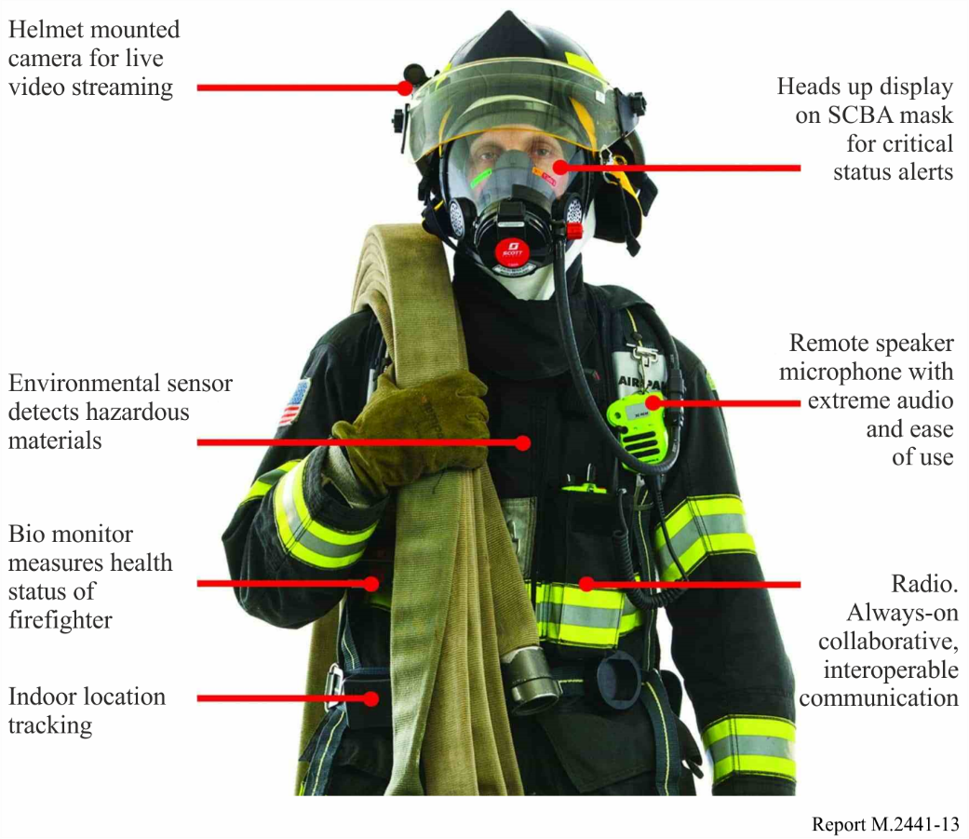

These connected devices could include:

– 360 degrees Body Worn Cameras;

– Augmented Reality visual display;

– Multi-stream Audio Communication;

– Virtual Partner;

– Biometrics;

– Gun Holster sensor;

– Integrated Power Management, etc.

A significant number of such connected devices are expected to use IMT-2020.

## 5.12 Smart homes

Smart Homes have been defined as the technological enrichment of the living environment in order to offer support to inhabitants and improve their quality of life[64]. Analysts predict that by 2020, the global market for smart home technology will reach USD 100 billion dollars with more than 50 connected devices in the average home.[65] Advancements in IMT-2020 network connectivity and new radio solutions will allow interoperable smart home devices to connect rapidly and securely to content and services stored at the edge of the cloud, delivering home security, automation and high‑quality video and entertainment services. The advancements around massive machine type communications is rapidly enabling the proliferation of connected devices, appliances, and things. This proliferation, augmented by technologies such as virtual and augmented reality, audio and video analytics, voice recognition and artificial intelligence, can enable a number of applications in the smart home[66].

Generally Smart Homes may include:

– Throughput and latency to support both mMTC applications (i.e. connected appliances) as well as applications requiring enhanced mobile broadband (i.e. high definition video streaming for entertainment/gaming). Smart homes should also have the ability to communicate via IP.

– Context awareness - Smart homes should be able to not only react to changes in the environment, but also perform AI-based reasoning and data analytics to take into account the preferences of the user inhabiting the smart home[67].

– Physical device and network security in the home, including hardware, software, communications, data handling and user experiences – essentially end-to-end data and device protection[68].

– Other requirements may include: Sensory and movement recognition, device data collection and management, natural language, speech, and computer vision.

Smart Home Application Examples:

– Vacation Mode – Smart home automation can manage different modes of use. The simple vacation mode voice command could automatically set the thermostat, lock doors, and windows activate the security system, close the blinds and adjust lights.

– Cognitive Assistance: Smart home keeps track of important items and can confirm that family documents, prescription medicines, and mobile devices are safely packed for the family and ready to go for an upcoming trip.

– Dashboard – dashboard view on mobile devices allows family to check on home at any time and view detailed data at a glance.

– Anomaly Detection – while family is away, sensors detect a leak from the water heater. They are able to immediately schedule a plumber through a trusted app and confirm the repair.

– Physical Access – the security system recognizes the neighbour who has come to water the plants and automatically lets her in. It can also verify the arrival of the plumber, grant him access and monitor his location and activities while he’s in the house.

– Dynamic Reminders and contextual response – from a central family calendar, the home can adjust assistance to match changes. For example, a delayed flight can be tracked, enabling the home to automatically compensate with changes such as rescheduling airport pickup.

– Voice controlled lighting, speakers, and security. Voice can also be used for complex scene creation programming. For example, a user stating: “Let’s watch a movie’ triggers TV to turn on, the lights to dim and the shades to close.

## 5.13 Agriculture

New generation smart agriculture by using micro robots:

This usage scenario shows an IMT-2020 application to smart agriculture by using IMT-2020’s capability of low power consumption, enabling extremely longer time duration of data communication with extremely long life of battery.

Applications of sensor networks, big data analysis, low latency feedback for prompt actuation will develop new uses for robots, drones, instruments and machinery.

Automated/autonomous driving/operations of agricultural machines, e.g. tractors and harvesting machines:

– Remote control of agricultural machines, such as tractors. Remote control of tractors, soil cultivators, planters and/or harvesting machines without on-board operations/controls. The machines can be controlled both in close proximity of several tens of meters to as far away as several hundred kilometres.

– Remote monitoring and control by human, compared with fully autonomous driving of agricultural machines, requires low-latency or no codec, i.e. no information source coding. Therefore, large data rate requirements for transmitting monitoring video becomes necessary. Coding schemes, such as HEVC (high efficiency video coding), cannot be used due to its large coding latency.

– Remote control or autonomous driving of agricultural machines means an on-board human driver/operator is no longer required. This allows for high speed operation/driving of agricultural machines, as no human operator/drivers are onboard, removing the need of low speed, rapid operation/driving of agricultural machines will reduce the overall operating/driving time while working. In this case, communication latency should be as low as possible.

IT agriculture:

– Agriculture work does not always require low latency. The ability to sustain massive connections, however, would be required. The machinery at a typical agricultural operation might include a water pump that would provide water to agricultural fields, a drainage water pump, an on/off machine of sprinkling water machine, an electric fan to prevent frost for farm products. Overall, there would be many devices that could be connected to a network.

– IT-led agriculture would require a periodical data collection system to collect small size data from water temperature sensors, anemometers, air temperature sensors, humidity sensors, daylight sensors, and soil humidity sensors.

– Big data collected from sensors could then be shared by a regional entity such as regional Agricultural cooperatives.

– Big data could also be processed at the point where the data is gathered and merged, e.g. averaging the data, eliminating abnormal values. Big data collected from the fields could also be used and shared by a local agricultural experimental centres for species breeding.

Currently in agricultural use cases, which is driven mostly by manual labour, ICT has been used to mainly expand the number of sales channels. In addition to keeping track to this data for planting, this information can be used when selling products, thereby adding more value to the crops.

Agriculture is rapidly adopting technology as it evolves from being entrenched in tradition to rapidly embracing change. New technology is [automating laborious tasks](http://readwrite.com/2016/04/04/iot-makes-smart-wine-agriculture-if4/) and [providing farmers and growers with greater knowledge and insight](http://readwrite.com/2016/06/07/can-arables-iot-device-end-world-hunger-vl1/) into their crops. As technology evolves, so do the needs of the farmers.

Farmers, with the aid of smartphones, are adopting IoT technology to get accurate information about the weather and growing conditions, soil quality and moisture and other information that previously was unavailable or difficult to attain in real time. These advances are giving rise to precision farming systems (PFS), which use sensor data to measure crop yields, moisture levels, and terrain topography to enable the targeted application of fertilizer, which increases yields while reducing costs, and is more sustainable. Other PFSs can steer tractors using GPS data to cover a field more precisely and efficiently than a human driver could.[69]

Agriculture equipment manufacturers have also created connected platforms and vehicles along with a suite of start-ups intent on modernizing farming through increased technological insight. These platforms include an acoustic rain gauge that measures more than 40 observation streams including rain, hail, canopy leaf area, crop water demand, environmental stresses, microclimate, and even air pollution. It is always on and always connected (built-in Bluetooth, Wi-Fi, and cellular).

These applications have built in security, flexibility (an API to plug the data into existing platforms), and control (farmers can choose how/when/what data to share); and with these applications, farmers are able to manage the response of crops to the weather and processors can predict future yield so they can make marketing decisions.[70] Applications leveraging big data analytics are also helping to transform agriculture; with the advances from IMT-2020, it is expected that this transformation could greatly enhance food production.

IMT-2020 based applications for plant farming include the following: sensor-based crop and soil monitoring, fertilizer/water management, environmental management (to control leaching of pesticides into surrounding soils/water bodies/drinking supplies), drone-based monitoring/imagery and precision viticulture (optimizing vineyard yield/performance). Examples of livestock farming applications include: electronic identification, automated livestock administration applications, reproduction optimization applications, feed formulation applications, and quality management applications.

General requirements[71] for monitoring of farm conditions such as soil, water level, livestock and actuation of machinery (e.g. sprinklers, feeding) may include:

– Latency on the order of seconds to minutes;

– Non-critical reliability;

– Device density of approximately 104 / km2;

– Agricultural deployments including sensors to monitor crops, livestock, soil conditions, etc. that measure multiple variables may require requisite capacity to support massive agricultural deployments.

– Multiyear battery life for wireless sensors.

– Systems may support mobility from stationary to pedestrian speeds.

– Interworking and roaming may not be necessary for fixed sensors.

– Promote interoperability of sensor and transmission technologies by harmonizing communication protocols[72].

## 5.14 Media and Entertainment

Report ITU-R M.2373 – Audio-visual capabilities and applications supported by terrestrial IMT systems, covers the use of IMT for distribution of audio-visual content and in audio-visual content production. Emerging technologies such as augmented and virtual reality are examined, as are support for High Definition and Ultra High Definition television. Some forecasts estimate that by 2021, 82% of all internet traffic will be video.[73] The Report provides further information on user requirements and trends for audio-visual services and applications, convergence between broadcasting and mobile services, relevant use cases for audio-visual distribution over IMT, requirements for audio-visual content production, the key characteristics of IMT for audio-visual services and applications, and emerging transmission technologies for broadcasting/multicasting in IMT-2020.

## 5.15 Enhanced personal experiences

### 5.15.1 Social media

The internet traffic has increased with the dramatic rise of the use of smartphones, especially among young people. These devices allow people to be connected to the internet 24 hours a day with something they hold in their hands. Delivering video and images to smartphones has contributed to the increase of internet traffic, just as it did with PCs. The emergence of reasonable flat-rate internet connection services has led to rich content, such as video, which has led to further and further increase of internet traffic. The rise of time enjoying social media has also led to an increase of internet traffic[74].

Smartphones have become indispensable for young people and have been being used by those in their teens and twenties to strengthen their relationships with each other through the social media. These generation will bring this communication style with them as they enter the workforce by the 2030s. IMT-2020, which is being introduced in 2020 and beyond, will be fully implemented by that time, meaning most people will have an IMT-2020 compatible devices in their possession. The capabilities of IMT-2020 may make these services more attractive to this generation, which are one of the main users of these services[75].

The main use of smartphones today is the exchange of real-time information between people through social networking services, becoming a tool that supports human communication. Smartphones themselves are used more by women than men and have become indispensable devices for women and young people today. Women are more likely than men to create their own content, for example taking and posting photos, on social media. They are more inclined to share them with only their friends on social media sites, or with only their family and close friends on social media site that is one of the most popular real time messaging service in some countries. It can be said that these women using smartphones to stay connected to many different online communities are at the forefront of a new way of building human relations.

### 5.15.2 Outdoor activities and games

Each person with unique and/or advanced experiences may enjoy leisure time such as watching sports games in stadium, playing games and going for travels. It ranges from enhanced real experiences to fully virtualized experiences with the linkage of IoT applications. Ultra-high definition moving pictures and high fidelity sounds, requiring high speed data, are likely to be extensively utilized. As network and sensor technology advances, the expansion of IoT worldwide also facilitates changes in services via ICT such as entertainment.

Passengers in car with entertainment such as films for the users to be able to enjoy during their trips on the expressway. A car moving on an expressway will be provided with IMT-2020 handover services for the delivery of 4K movies.

In addition, outdoor real time gaming created by a virtually real visual sphere may be a usage scenario in the future.

## 5.16 Commercial Airspace Unmanned Aerial Systems (UAS) applications

UAS is moving into fast lane with accelerated involvements across use cases. Major trends in multi-directional UAS applications include intelligent flight, broadband transmission, and diversified functions, leading towards the internet of UASs. Four capabilities are essential to support the diverse UAS-related applications: HD image/video transmission, remote and real-time control, high-precision positioning, and seamless coverage. Civilian UASs mainly find applications in consumer uses and industrial uses such as entertainment, inspection, agriculture, logistics, monitoring, and rescue. There are basically two kinds of data types in the UAS applications: one is the flight command and control data of the UAS platform, including telemetry, waypoint update for autonomous UAS operation, real time piloting, identity, flight authorization, navigation database update, etc.; these applications are of a safety-of-flight nature and should be performed in accordance with requisite civil aviation regulations. The other is the application data or UAS payload applications, including video, images, other sensors data, etc. This payload transmission can be supported by IMT technologies. In order to provide high-definition (HD) real-time video transmission, mobile network should be able to provide high uplink data rate for UASs. For example, nominal data rate is mainly determined by the video codec scheme, frame size, bit depth, etc. With 1080P (1920x1080 pixels) video transmission, the typical data rate is on the level of several Mbit/s. With the increased demand of higher resolution video, such as 4K/8K HD video, higher data rate with tens of even hundreds of Mbps may be needed.

– *Entertainment*: The applications of UAS in entertainment include live broadcast of large-scale events (e.g. sport events and music concerts), film-making, ad-shooting, etc.

– *Inspection*: UASs are more and more widely used in the field of infrastructure inspection with the advantages of low cost, high flexibility, high security, less-affected by natural environment and better visual perspective.

– *Agriculture*: UASs can help increase production based on the spraying of agricultural chemicals and mapping of farmland information.

– *Logistics:* UASs for logistics and distribution can save time, reduce cost, and save manpower.

– *Public Protection and Disaster Relief (PPDR) Monitoring and Rescue***:** UASs can be used for PPDR and emergency rescue based on the flexibility and low risk.

# 6 Summary

IMT technologies may be utilized by a wide range of industrial applications in various environments. In addition to summarizing some of the technical capabilities of IMT technologies, this Report also provides information on how IMT systems may support emerging use cases or applications including industrial automation, remote control for mining or inspection, healthcare, agriculture, and transportation.

1. * One Administration expressed reservations about the use of the wording “industry sector” used throughout the text of this Report. An editorial revision has been carried out after the closing of the Working Party (WP) 5D meeting in order to take into account the comment raised by that Administration.
2. European Commission, RSPG Opinion on Licensed Shared Access, RSPG13-538, 2013.
3. For reference: 3GPP TR 37.857: Study on indoor positioning enhancements for UTRA and LTE.
4. For reference: 3GPP TR22.862: Feasibility Study on New Services and Markets Technology Enablers for Critical Communications.
5. For reference: 3GPP TR38.913: Study on Scenarios and Requirements for Next Generation Access Technologies.
6. WWRF VIP Working Group.
7. 3GPP TS 22.261 Service requirements for the IMT-2020 system.
8. Ericsson, “5G Radio Access for Ultra-Reliable and Low- Latency Communications”, Ericsson Research Blog, May 2015; available: <https://www.ericsson.com/research-blog/5g/5g-radio-access-for-ultra-reliable-and-low-latency-communications/>.
9. Ericsson, “5G Radio Access for Ultra-Reliable and Low- Latency Communications”, Ericsson Research Blog, May 2015; available: <https://www.ericsson.com/research-blog/5g/5g-radio-access-for-ultra-reliable-and-low-latency-communications/>.
10. 28 billion connected devices are forecasted by the year 2021 (Ref. [Ericsson Mobility Report](http://www.ericsson.com/mobility-report), 2016.
11. LTE and LTE-Advanced also known as Evolved Universal Terrestrial Radio Access Network (E‑UTRAN) is an IMT terrestrial radio interface in Recommendation ITU-R M.1457, §§ 5.1 and 5.3 and Recommendation ITU-R M.2012, Annex 1.
12. For example, see 3GPP TS 22.185 V14.1.0 and TR 22.886.
13. 3GPP TR 36.885 Study on LTE-based V2X.
14. Cellular V2X (C-V2X) includes both cellular and short range communication and its IMT-2020 evolutions called NR.
15. Cellular V2X (C-V2X) includes both cellular and short range communication and its 5G evolutions called NR.
16. <https://www.sae.org/misc/pdfs/automated_driving.pdf>.
17. “Accumulating passengers” consist of (1) passengers getting on/off, (2) passengers staying on the train, and (3) people coming into/going off the station.
18. <http://5gmf.jp/wp/wp-content/uploads/2016/09/5GMF_WP101_All.pdf>, p.61.
19. 3GPP TR 38.913 Study on Scenarios and Requirements for Next Generation Access Technologies.
20. <https://www.ericsson.com/spotlight/services/connected-bus-stop-for-a-better-commuter-experience/>.
21. Report ITU-R SM.2351-1 “Smart Grid Utility Management Systems”.
22. <http://www.itu.int/publ/T-TUT-HOME-2010/en>.
23. U.S. Department of Energy, “[Communications Requirements of Smart Grid Technologies](http://energy.gov/gc/downloads/communications-requirements-smart-grid-technologies)”, 5 October 2010.
24. Report ITU-R SM.2351-0 “Smart Grid Utility Management Systems”.
25. *Ibid*.
26. Phillip Tracy, “How the Iot Applies to Water Management,” Industrial IoT5G, 11 August 2016.
27. *Ibid.*
28. U.S. Department of Agriculture Economic Research Service, “Irrigation & Water Use”, June 15, 2016.
29. Miami-Dade Country Fact Sheet, “Smarter Water Management: Parks, Recreation and Open Spaces,” undated.
30. <https://www.brookings.edu/wp-content/uploads/2016/11/gs_20161201_smartcities_paper.pdf>
31. Angela Godwin, “Advanced Metering Infrastructure: Drivers and Benefits in the Water Industry,” Water World, undated.
32. Pacific Institute, “Metering in California,” September, 2014.
33. <https://www.brookings.edu/wp-content/uploads/2016/11/gs_20161201_smartcities_paper.pdf>.
34. “Bringing 5G business value to industry”, An Ericsson Consumer & IndustryLab Insight Report, April 2018. Available: <https://www.ericsson.com/en/trends-and-insights/consumerlab/consumer-insights/reports/5g-business-value-to-industry-blisk>.
35. IEC 61508: “Functional safety of electrical/electronic/programmable electronic safety-related systems”, 2010.
36. IEC 62061: “Safety of machinery – Functional safety of safety-related electrical, electronic and programmable electronic control systems” (IEC 62061:2005 + A1:2012).
37. IEC 62443-3-2: “Security for industrial automation and control systems – Part 3-2: Security risk assessment and system design”, in progress.
38. A. Manjeshwar and D.P. Agrawal, “TEEN: a routing protocol for enhanced efficiency in wireless sensor networks”, In Proceedings 15th International Parallel and Distributed Processing Symposium. IPDPS 2001. IEEE Comput. Soc. <https://doi.org/10.1109/ipdps.2001.925197>.
39. M. A. Mahmood, W. K. G. Seah, and I. Welch, I., “Reliability in wireless sensor networks: A survey and challenges ahead.” Computer Networks, 79, 166–187, 2015. <https://doi.org/10.1016/j.comnet.2014.12.016>.
40. ITU-T, “The Tactile Internet” Technology Watch Report, August 2014; available: <http://ow.ly/Ubmow>.
41. Ericsson and ABB, “Industrial Remote Operation: 5G rises to the challenge”, Ericsson Technology Review, Vol. 92, No. 9, 2015; available: <https://www.ericsson.com/research-blog/5g/5g-radio-access-for-ultra-reliable-and-low-latency-communications/>.
42. Ericsson, Mobile World Congress (MWC) demo, “Why do we need 5G?” 2015  
     <https://www.ericsson.com/news/150303-why-do-we-need-5g_244069647_c>.
43. ABB, “Bigger ships, taller cranes, better crane control”, Press release, 2013; available: <http://www.abb.com/cawp/seitp202/2743e1e32c585504c1257b7f00419f8c.aspx>.
44. ABB, “Remote inspection and intervention” ABB Review, Issue 2, 2011; available: <https://library.e.abb.com/public/46a3a908e1a647f3c125795800580caf/50-55%202m155_ENG_72dpi.pdf>.
45. Ericsson, “5G Radio Access for Ultra-Reliable and Low- Latency Communications”, Ericsson Research Blog, May 2015; available: <https://www.ericsson.com/research-blog/5g/5g-radio-access-for-ultra-reliable-and-low-latency-communications/>.
46. <https://www.brookings.edu/wp-content/uploads/2016/07/5G-Health-Internet-of-Things_West.pdf>.
47. <http://kani.or.kr/5g/whitepaper/5G%20Service%20Roadmap%202022.pdf>.
48. <https://www.michaeljfox.org/foundation/publication-detail.html?id=597&category=7>.
49. <https://www.brookings.edu/wp-content/uploads/2016/07/5G-Health-Internet-of-Things_West.pdf>
50. Vish Nandlall, “BYOD: Bring Your Own...Doctor?” Available: <https://www.linkedin.com/pulse/byod-bring-your-owndoctor-vish-nandlall> (retrieved 16/01/2017).
51. Tereza Pultarova, “Smartwatches can spot disease onset”. Available: <https://eandt.theiet.org/content/articles/2017/01/smartwatches-can-spot-disease-onset/> (retrieved 16/01/2017).
52. Source: 27 May 2016, Tereza Pultarova , E&T Magazine.
53. Dave Evans, Cisco: [“The Internet of Things How the Next Evolution of the Internet Is Changing Everything”](https://www.cisco.com/web/about/ac79/docs/innov/IoT_IBSG_0411FINAL.pdf).
54. 3GPP TR 22.891 “3rd Generation Partnership Project; Technical Specification Group Services and System Aspects; Feasibility Study on New Services and Markets Technology Enablers; Stage 1.” <https://portal.3gpp.org/desktopmodules/Specifications/SpecificationDetails.aspx?specificationId=2897>
55. <https://www.gsma.com/iot/wp-content/uploads/2016/03/Mobile-IoT-Low-Power-Wide-Area-Connectivity-GSMA-Industry-Paper.pdf>.
56. ITU-T, Smart Sustainable Cities, [http://www.itu.int/en/ITU-T/ssc](http://www.itu.int/en/ITU-T/ssc/).
57. <https://www.ericsson.com/industries/smart-sustainable-cities/cases>.
58. Connected City Advisory Board: Connected City Blueprint: <http://www.wballiance.com/wp-content/uploads/2016/12/Connected-City-Blueprint-V1.pdf>.
59. *Ibid.*
60. *Ibid.*
61. *Ibid.*
62. *Ibid.*
63. *Ibid.*
64. [“Smart Home and Smart City Solutions enabled by 5G, IoT, AAI, and CoT Services”](http://ieeexplore.ieee.org/stamp/stamp.jsp?arnumber=7019822).
65. [Markets and Markets Smart Home Market – Global Forecast to 2022, May 2016.](http://www.marketsandmarkets.com/PressReleases/global-smart-homes-market.asp)
66. Smart Home Business Brief: <http://www.intel.com/content/www/us/en/smart-home/connected-home/smart-home-business-brief.html>.
67. [*Ibid.*](http://ieeexplore.ieee.org/stamp/stamp.jsp?arnumber=7019822)
68. *Ibid.*
69. Franziska Kreische, Angela Ulrich, Kathleen Ziemann (German Federal Ministry for Economic Cooperation and Development, <https://10innovations.alumniportal.com/internet-of-things/iot-in-agriculture-increasing-smallholder-productivity.html>.
70. <http://readwrite.com/2016/12/31/2016-year-review-agtech-il4/?utm_campaign=coschedule&utm_source=twitter&utm_medium=RWW&utm_content=5>.
71. NGMN Perspectives on Vertical Industries and Implications for 5G: <https://www.ngmn.org/publications/all-downloads/article/ngmn-perspectives-on-vertical-industries-and-implications-for-5g.html>.
72. USAID Sensors4Ag Key Findings.
73. Cisco’s VNI Global Fixed and Mobile Internet Traffic, <https://www.cisco.com/c/en/us/solutions/service-provider/visual-networking-index-vni/index.html>.
74. <http://5gmf.jp/wp/wp-ontent/uploads/2016/09/5GMF_WP101_All.pdf>, p8.
75. <http://5gmf.jp/wp/wp-ontent/uploads/2016/09/5GMF_WP101_All.pdf>, p 10.