|  |
| --- |
| **Report ITU-R M.2440-0**  **(10/2018)** |
| **The use of the terrestrial component of International Mobile Telecommunications for narrowband and broadband machine-type communications** |
| **M Series**  **Mobile, radiodetermination, amateur**  **and related satellite services** |

Foreword

The role of the Radiocommunication Sector is to ensure the rational, equitable, efficient and economical use of the radio-frequency spectrum by all radiocommunication services, including satellite services, and carry out studies without limit of frequency range on the basis of which Recommendations are adopted.

The regulatory and policy functions of the Radiocommunication Sector are performed by World and Regional Radiocommunication Conferences and Radiocommunication Assemblies supported by Study Groups.

# Policy on Intellectual Property Right (IPR)

ITU-R policy on IPR is described in the Common Patent Policy for ITU-T/ITU-R/ISO/IEC referenced in Resolution ITU-R 1. Forms to be used for the submission of patent statements and licensing declarations by patent holders are available from <http://www.itu.int/ITU-R/go/patents/en> where the Guidelines for Implementation of the Common Patent Policy for ITU‑T/ITU‑R/ISO/IEC and the ITU-R patent information database can also be found.

|  |  |
| --- | --- |
| Series of ITU-R Reports  (Also available online at <http://www.itu.int/publ/R-REP/en>) | |
| **Series** | Title |
| **BO** | Satellite delivery |
| **BR** | Recording for production, archival and play-out; film for television |
| **BS** | Broadcasting service (sound) |
| **BT** | Broadcasting service (television) |
| **F** | Fixed service |
| **M** | Mobile, radiodetermination, amateur and related satellite services |
| **P** | Radiowave propagation |
| **RA** | Radio astronomy |
| **RS** | Remote sensing systems |
| **S** | Fixed-satellite service |
| **SA** | Space applications and meteorology |
| **SF** | Frequency sharing and coordination between fixed-satellite and fixed service systems |
| **SM** | Spectrum management |

|  |
| --- |
|  |

|  |
| --- |
| ***Note****: This ITU-R Report was approved in English by the Study Group under the procedure detailed in Resolution ITU-R 1.* |

*Electronic Publication*

Geneva, 2018

© ITU 2018

All rights reserved. No part of this publication may be reproduced, by any means whatsoever, without written permission of ITU.

REPORT ITU-R M.2440-0

The use of the terrestrial component of International Mobile Telecommunications for narrowband and broadband machine-type communications

(2018)

TABLE OF CONTENTS

Page

1 Introduction 1

2 Scope 2

3 Relevant ITU-R Recommendations and Reports 3

4 Statistics and forecasts 3

5 Technical and operational aspects of terrestrial IMT-based radio networks and systems to support narrowband and broadband MTC 4

5.1 Technical aspects 4

5.2 Operational aspects 6

6 Spectrum considerations 7

7 Summary 8

# 1 Introduction

Machine-type communications (MTC)[1] are entering our daily lives and offer the potential to help enable a more convenient and intelligent experience in a hyper-connected world. The deployment of MTC infrastructure networks is expanding rapidly. These networks are being deployed to support consumer, industrial and government applications with a variety of services. MTC may need to support a large number of devices, wide area and deep indoor coverage, low power consumption, low cost and various data rates. MTC is a subject of high interest for the information and communication technology industry and other industries, as well as end users, regulators and other sectors that can potentially benefit from this emerging communications technology. Terrestrial International Mobile Telecommunications (IMT) infrastructure networks play a role in supporting MTC applications.

Globally, the importance of developing reliable and cost effective MTC solutions for various industries is increasing on a daily basis. Examples of these solutions include smart energy management, agriculture, water management, waste management, health, transportation and utilities that may have a direct impact on social and economic development.

MTC has wide range of narrowband and broadband applications based on each use case. Some use cases of broadband MTC include sensors (including health monitoring as an example), actuators and cameras with a wide range of characteristics and demands. Several use cases for MTC require a narrowband connection as well as wide coverage area and low power consumption. Some of the MTC features are summarized in the following Fig. 1.

Figure 1

Example of some IoT /MTC features

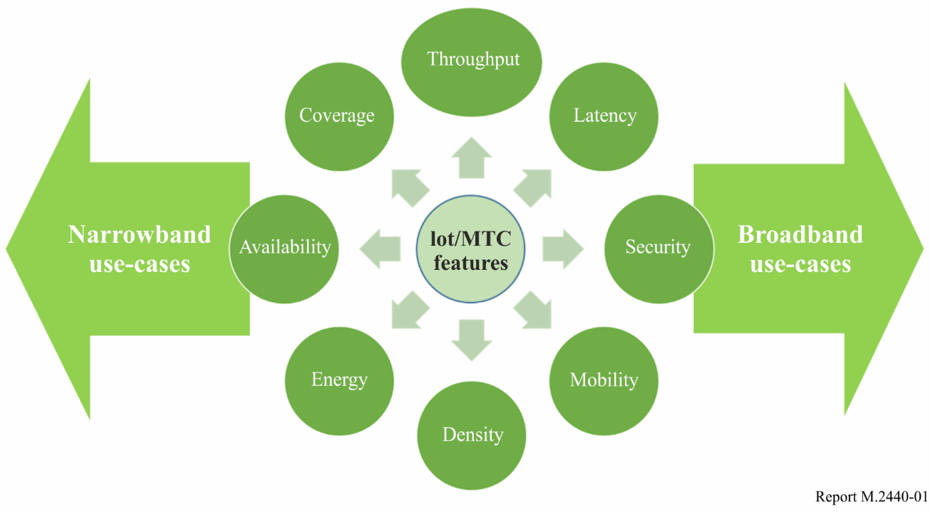

Some use cases requiring broadband MTC (e.g. live streaming of high definition video, etc.) can be met by utilizing the frequencies identified for current IMT-Advanced and future IMT‑2020 systems.

The spectrum harmonization for IMT systems, including those used to support MTC applications, have advantages such as:

– Efficient usage of spectrum;

– Fast ecosystem development and deployment;

– Providing economies of scale benefits to manufacturers and consumers;

– Reasonable equipment costs for consumers, in particular for the narrowband-IoT/MTC;

– Facilitating the development of equipment and interoperability with existing and planned IMT networks in a timely and cost effective manner.

The existing frequency bands already identified for IMT and frequency bands under study towards IMT identification may be utilized for narrowband and broadband MTC.

The harmonised use of existing spectrum identified for IMT systems provides economies of scale to facilitate the deployment of IMT-based MTC ecosystems. Such harmonized use of spectrum to facilitate narrowband MTC ecosystems may include the use of the same IMT frequency arrangements within a certain region or number of Administrations based on their needs.

# 2 Scope

This Report addresses the technical and operational aspects of terrestrial IMT-based radio networks and systems supporting MTC applications, as well as spectrum needed, including possible harmonized use of spectrum to support the implementation of narrowband and broadband MTC infrastructure and devices.

# 3 Relevant ITU-R Recommendations and Reports

Recommendation [ITU-R M.1036](https://www.itu.int/rec/R-REC-M.1036/en) – Frequency arrangements for implementation of the terrestrial component of International Mobile Telecommunications (IMT) in the bands identified for IMT in the Radio Regulations (RR)

Recommendation [ITU-R M.1457](https://www.itu.int/rec/R-REC-M.1457/en) – Detailed specifications of the terrestrial radio interfaces of International Mobile Telecommunications-2000 (IMT-2000)

Recommendation [ITU-R M.2012](http://www.itu.int/rec/R-REC-M.2012/en) – Detailed specifications of the terrestrial radio interfaces of International Mobile Telecommunications Advanced (IMT‑Advanced)

Recommendation [ITU-R M.2083](http://www.itu.int/rec/R-REC-M.2083/en) – IMT Vision – Framework and overall objectives of the future development of IMT for 2020 and beyond

Report [ITU-R M.2410](https://www.itu.int/pub/R-REP-M.2410-2017) – Minimum requirements related to technical performance for IMT‑2020 radio interface(s)

Report [ITU-R M.2134](http://www.itu.int/pub/R-REP-M.2134) – Requirements related to technical performance for IMT‑Advanced radio interface(s)

Report [ITU-R M.2320](http://www.itu.int/pub/R-REP-M.2320) – Future technology trends of terrestrial IMT systems.

# 4 Statistics and forecasts

It is estimated that the number of IMT MTC connections is around 750 million in 2017 and it is forecasted to be around 3 500 million by 2023 (see Fig. 2).

Figure 2

IMT MTC connections  
Cellular IoT connections per region (billions)

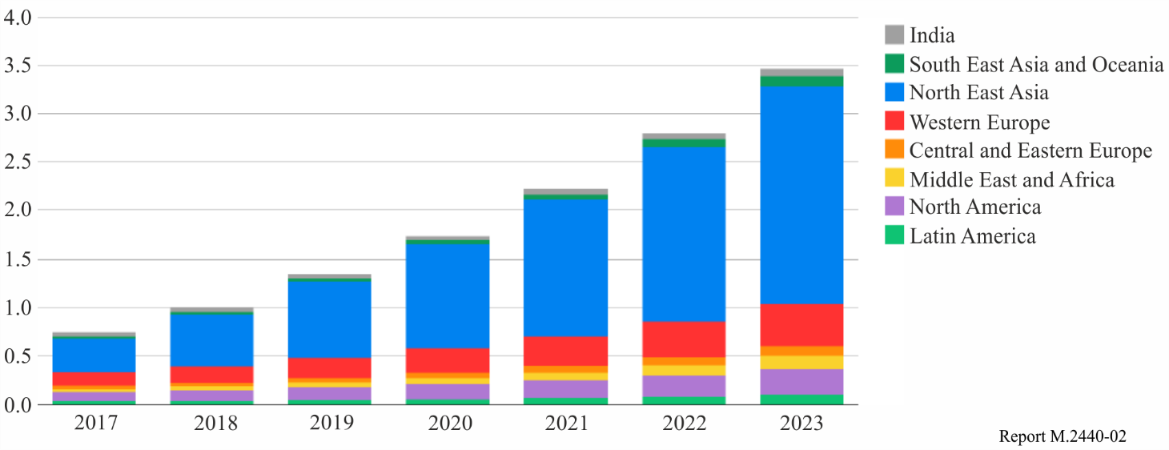

Source: *"The Ericsson Mobility Report",* [*https://www.ericsson.com/en/mobility-report*](https://www.ericsson.com/en/mobility-report)

The increase in the number of connections related to IMT MTC is associated with growing demand for connecting various industries and use cases. The proliferation of MTC devices is supported by:

– sensors and actuators to monitor and control the surrounding environment;

– communication technologies capable of low consumption power and wide area coverage;

– technologies for big data/cloud computing to analyse a big volume of data;

– evolution of software and hardware for relevant technologies.

# 5 Technical and operational aspects of terrestrial IMT-based radio networks and systems to support narrowband and broadband MTC

## 5.1 Technical aspects

Three MTC technologies operating within IMT networks are EC-GSM-IoT, LTE MTC/eMTC and NB‑IoT. While EC‑GSM-IoT is based on legacy GSM technology, which is described in ‘TDMA SC’ of Recommendation ITU-R M.1457, LTE MTC/eMTC and NB-IoT are developed based on LTE technology

Some of the following features of IMT-based narrowband and broadband technologies have been addressed for MTC through the descriptions in Recommendation ITU-R M.2012[2]:

– Low mobility;

– Time controlled;

– Small data transmissions;

– Infrequent mobile terminated;

– MTC monitoring;

– Secure connection;

– Group based MTC features (group based policies, group based addressing).

As described in Recommendation ITU-R M.2083, the support of massive MTC (mMTC) and Ultra Reliable Low Latency Communications (URLLC) are some of the usage scenarios of IMT-2020. Technical specifications are also being developed for URLLC which will support some MTC use cases.

New Radio (NR) is being developed within 3GPP as a candidate technology to meet the IMT-2020 requirements and will include specifications to satisfy various IMT-based MTC broadband and narrowband requirements and use cases.

In terms of URLLC use cases, coverage, mobility, radio link features, etc., related to providing low latency and/or high reliability are considered. Ongoing standardization work has considered the possibility of enabling both the high reliability and the continuous and ubiquitous coverage in urban areas, with capabilities for very high connection density of mMTC devices of 1 million devices per km2 as defined in section 4.8 “Connection density” of Report ITU‑R M.2410.

### 5.1.1 Technical aspects of IMT systems for broadband MTC

Existing IMT technologies support a wide range of broadband MTC applications. Data rates in the order of tens of Mbit/s for MTC have been addressed in Recommendation ITU-R M.1457 and technology has been further developed to support hundreds of Mbit/s as addressed in Recommendation ITU-R M.2012.

The utilization of current and future broadband IMT-based MTC will be essential to enable the infrastructure development of IoT and smart cities and to satisfy broadband MTC requirement of certain verticals. Some use cases are:

– Smart wearables (eHealth): smart wearables include various types of devices and sensors, some of which can be integrated into people’s clothing. These sensors can measure different environmental and health parameters related to people. The number of devices as well as high data rate in some cases can be important challenges.

– Mobile video surveillance: mobile video surveillance is growing rapidly such as in houses, special events, aircrafts, drones, vehicles, etc. These applications require highly reliable and secure connections with high data rates.

– Real-time communications: this classification covers several use cases associated with real-time interactions such as autonomous driving, remote computing and gaming, etc. These use cases require high throughput, high reliability, mobility, etc.

### 5.1.2 Technical aspects of IMT systems for narrowband MTC

The development of IMT-based narrowband MTC technologies plays an important role in supporting MTC development, including the rollout of large forecasted number of connections.

IMT technologies for narrowband MTC, included in Recommendations ITU-R M.2012, support low data rate such as a few hundreds of kbit/s in MTC.

Some of the characteristics supported by IMT-based narrowband MTC include:

– Delay tolerant access establishment;

– Extended access barring;

– User Equipment (UE) Power Saving Mode (PSM) to improve power consumption;

– Low complexity UE category in modem implementation;

– Extended Discontinuous Reception (eDRX) for power saving.

#### 5.1.2.1 Narrowband IoT (NB-IoT)

Narrowband IoT technology, addressed in Recommendation ITU-R M.2012, is developed for the IoT applications with features such as low throughput, long battery life, wide area and deep indoor coverage. This technology complements the family of IMT systems to satisfy the rapidly growing demands for various MTC capabilities and use cases. This technology utilizes blocks of 200 kHz as frequency channel bandwidth, corresponding to 180 kHz Tx/Rx bandwidth, and provides peak data rates of 250 kbit/s (20 kbit/s for 15 kHz single tone operation) with the ability to support a large number of connected devices per channel and improved coverage in comparison with conventional LTE coverage. It can be deployed in existing LTE networks.

NB-IoT can be implemented in three operational modes:

– In-band Mode: In this mode, one or more LTE Physical Resource Blocks (PRBs) are reserved for NB‑IoT within an LTE channel. This mode can enable the spectrum resources to be used efficiently for NB-IoT services based on demand from mobile users.

– Channel Edge Mode: In this mode[3], NB-IoT is deployed using some of the LTE channel elements which are not used for data transmission, but at the edge of the LTE channel, noting that such use does not affect LTE operation.

– Channel mode. In this mode, NB-IoT can be deployed utilising a standalone channel within IMT spectrum.

The following are some of the expected performance objectives are considered in the development of narrowband MTC (NB-IoT) technology:

– Improved indoor coverage.

– Support for a large number of devices.

– Improved power efficiency.

For further information, refer to Recommendation ITU-R M.2012.

#### 5.1.2.2 Enhanced MTC

Enhanced MTC (known as LTE‑eMTC) has been introduced in Recommendation ITU‑R M.2012. LTE-eMTC uses a 1.4 MHz channel bandwidth, providing peak data rates of 1 Mbit/s. LTE-eMTC supports services that are sensitive to latency (e.g. voice capable wearable devices and health monitoring devices). It can be deployed in existing LTE networks.

The following are some of the performance objectives which are considered for Enhanced-MTC;

– Improved power efficiency.

– Extended coverage.

For further information, refer to Recommendation ITU-R M.2012.

#### 5.1.2.3 Extended Coverage GSM IoT

Extended Coverage GSM IoT (EC-GSM-IoT) has also been standardized and is based on the enhanced General Packet Radio Service (eGPRS) technology platform so that it can be deployed conveniently via software upgrade of existing GSM networks. This technology uses a 200 kHz GSM channel and provides peak data rates of up to 240 kbit/s in downlink and uplink.

## 5.2 Operational aspects

From an operational perspective, different MTC use cases can utilize various capabilities of IMT and non‑IMT systems, for example for low data rate, low power and wide area applications as shown in Fig. 3 below. The following IMT capabilities can be considered for different use cases, an example of which is indicated in Fig. 3 and described below:

– Broadband MTC is used in applications requiring high data rates and/or sensitive to latency;

– LTE-eMTC technology is used in applications requiring data rates up to 1 Mbit/s and/or sensitive to latency;

– NB-IoT realizes transmission rates of tens to hundreds of kbits/s for latency tolerant applications.

Figure 3

Example of MTC technologies and application fields

# 

# 6 Spectrum considerations

IMT based narrowband and broadband MTC applications and devices can be used within a range of frequency bands used for IMT including those already identified for IMT and possible new candidate frequency bands under study for future identification with respect to IMT-2020.

The existing frequency arrangements for IMT, detailed in Recommendation ITU-R M.1036, help enable a wide range of MTC applications and devices.

Spectrum below 1 GHz which is used for IMT, including the associated frequency arrangements as detailed in Recommendation ITU-R M.1036, helps enable narrowband MTC applications and devices such as those requiring wide area coverage and improved indoor penetration.

Spectrum between 1 to 6 GHz offers more bandwidth (including support for broadband MTC), higher connection density and adequate coverage to support IMT-based MTC applications, as relevant.

Table 1 below provides possible examples for guidance and consideration by administrations and industry. Table 1 does not represent a complete exhaustive list of all potential arrangements that could be considered for the deployment of MTC. See Recommendation ITU‑R M.1036 for additional guidance on frequency bands identified for IMT that could be used for MTC.

TABLE 1

Possible examples of frequency bands that could be considered for use by MTC

| Frequency band | | Notes |
| --- | --- | --- |
| Mobile station transmitter | Base station transmitter |
| 452.5-457.5 MHz | 462.5-467.5 MHz | This corresponds to arrangement D14 in Rec. ITU-R M.1036. IMT based MTC networks are operating or planned to operate within these bands in certain countries |
| 703-748 MHz | 758-803 MHz | This corresponds to arrangement A5 in Rec. ITU-R M.1036. IMT based MTC networks are operating or planned to operate within these bands in certain countries. |
| 733-736 MHz | 788-791 MHz | This corresponds to arrangement A9 in Rec. ITU-R M.1036 which is aligned and part of A5 arrangement in Rec. ITU-R M.1036. In Region 1 certain countries are considering this frequency band as a potential option for harmonised use for IMT based narrowband MTC networks deployment. |
| 824-849 MHz | 869-894 MHz | This corresponds to arrangement A1 in Rec. ITU-R M.1036. IMT based MTC networks are operating or planned to operate within these bands in certain countries. |
| 880-915 MHz | 925-960 MHz | This corresponds to arrangement A2 in Rec. ITU-R M.1036. IMT based MTC networks are operating or planned within these bands in certain countries. |
| 832-862 MHz | 791-821 MHz | This corresponds to arrangement A3 in Rec. ITU-R M.1036. IMT based MTC networks are operating or planned to operate within these bands in certain countries. |
| 1 710-1 785 MHz | 1 805-1 880 MHz | This corresponds to arrangement B2 in Rec. ITU-R M.1036. IMT based MTC networks are operating or planned to operate within these bands in certain countries. |
| 1 920-1 980 MHz | 2 110-2 170 MHz | This corresponds to arrangement B1 in Rec. ITU-R M.1036. IMT based MTC networks are operating or planned to operate within these bands in certain countries. |
| NOTE: This Table provides possible examples for consideration by administrations and industry. This Table does not represent a complete exhaustive list of all potential arrangements that could be considered for the deployment of MTC. See Recommendation ITU-R M.1036 for additional guidance on frequency bands identified for IMT that could be used for both narrowband and broadband MTC. It may be noted that MTC devices used in one country or region may not be authorised to operate in other countries or regions[4]. | | |

# 7 Summary

This Report presents technical and operational aspects including the potential harmonized spectrum usage to support the implementation of narrowband and broadband MTC infrastructures.

Analysis of the spectrum use for terrestrial IMT-based narrowband and broadband MTC shows that the current identification of spectrum for IMT can be used for various MTC applications.

Possible example(s) of the potential harmonized use of frequency arrangements for IMT‑based MTC, based on IMT frequency arrangements provided by Recommendation ITU-R M.1036, can be found in Table 1.

Abbreviations / Glossary

3GPP Third Generation Partnership Project

DL Downlink

EC-GSM-IoT Extended Coverage GSM for Internet-of-Things

eGPRS enhanced General packet radio service

eMTC enhanced Machine-type communications

FDD Frequency division duplex

GPRS General packet radio service

GSM Global system for mobile communications

HD-FDD Half-duplex FDD

IMT International mobile telecommunications

IoT Internet-of-Things

LTE Long term evolution

M2M Machine-to-machine

MCL Maximum coupling loss

mMTC massive machine-type communications

MTC Machine-type communications

NB-IoT Narrowband internet-of-things

NR New radio

PRB LTE physical resource block

TDD Time division duplex

UE User equipment

UL Uplink

URLLC Ultra-reliable low latency communications

1. MTC is also known as machine-to-machine (M2M) or Internet of Things (IoT), and these terms are used interchangeably in this Report. This Report addresses terrestrial IMT-based MTC.
2. For full details see Recommendation ITU-R M.2012-3, § 1.2.2.2.48.
3. This mode of LTE operation, known as ‘guard band mode’ in 3GPP, is internal within the IMT system itself and is not related to any guard bands with adjacent services.
4. In certain cases, the operation of IMT-based Narrowband MTC with respect to the concerned administrations may be used under a non-interference and non-protection basis, where required.