Report ITU-R M.2436-0
(11/2018)
The global aeronautical distress
and safety system

M Series
Mobile, radiodetermination, amateur
and related satellite services

Foreword
The role of the Radiocommunication Sector is to ensure the rational, equitable, efficient and economical use of the radio-frequency spectrum by all radiocommunication services, including satellite services, and carry out studies without limit of frequency range on the basis of which Recommendations are adopted.
The regulatory and policy functions of the Radiocommunication Sector are performed by World and Regional Radiocommunication Conferences and Radiocommunication Assemblies supported by Study Groups.

Policy on Intellectual Property Right (IPR)
ITU-R policy on IPR is described in the Common Patent Policy for ITU-T/ITU-R/ISO/IEC referenced in Resolution ITU-R 1. Forms to be used for the submission of patent statements and licensing declarations by patent holders are available from http://www.itu.int/ITU-R/go/patents/en where the Guidelines for Implementation of the Common Patent Policy for ITU-T/ITU-R/ISO/IEC and the ITU-R patent information database can also be found.

Series of ITU-R Reports
(Also available online at http://www.itu.int/publ/R-REP/en)
Series | Title
BO | Satellite delivery
BR | Recording for production, archival and play-out; film for television
BS | Broadcasting service (sound)
BT | Broadcasting service (television)
F | Fixed service
M | Mobile, radiodetermination, amateur and related satellite services
P | Radiowave propagation
RA | Radio astronomy
RS | Remote sensing systems
S | Fixed-satellite service
SA | Space applications and meteorology
SF | Frequency sharing and coordination between fixed-satellite and fixed service systems
SM | Spectrum management

Note: This ITU-R Report was approved in English by the Study Group under the procedure detailed in Resolution ITU-R 1.

Electronic Publication
Geneva, 2018
© ITU 2018
All rights reserved. No part of this publication may be reproduced, by any means whatsoever, without written permission of ITU.

REPORT ITU-R M.2436-0
The global aeronautical distress and safety system
(2018)
Scope
This Report provides consideration on the concept of operations on global aeronautical distress and safety system as defined in version 6.0 and approved by Air Navigation Commission of International Civil Aviation Organization.
Keywords
Aviation, aeronautical, distress
Abbreviations/glossary
AHWG Ad‐hoc working group
ConOps Concept of operations
GADSS Global aeronautical distress and safety system
ICAO International Civil Aviation Organization
SAR Search and rescue
WRC World Radiocommunication Conference

1 Background
The International Civil Aviation Organization (ICAO) held a special meeting on global flight tracking of Aircraft in Montreal, May 2014 and formed two groups to address the near-term priority to track airline flights, regardless of their global location or destination. Those groups were: an ICAO ad hoc working group (AHWG) to develop a concept of operations (ConOps) to support future development of a global aeronautical distress and safety system (GADSS), and an industry led group under the ICAO framework called the aircraft tracking task force to identify near term capabilities for normal flight tracking using existing technologies.
The AHWG developed the initial ConOps for the GADSS, which was endorsed by States at a high-level safety conference in February 2015. The ConOps was further updated by the AHWG in 2015 to reflect the outcomes of the ICAO Council approval to develop new standards and recommended practices in the relation to the GADSS concept.
ITU Plenipotentiary Conference at Busan in October-November 2014, decided through Resolution 185, to instruct WRC-15, pursuant to No. 119 of the ITU Convention, to include in its agenda, as a matter of urgency, the consideration of global flight tracking, including, if appropriate, and consistent with ITU practices, various aspects of the matter, taking into account ITU-R studies.
WRC 15 agreed on:
– Resolution 425 (WRC-15) to facilitate the global flight tracking;
– Resolution 426 (WRC-15) for a new agenda item on global aeronautical distress and safety system.
Version 6.0 of the ConOps describes the following functions:
– Aircraft tracking
Typically uses existing technologies to assist in the timely identification and location of aircraft. Provides an automated reporting function every 15 mins or less. Aircraft tracking may be accomplished by multiple different systems over the duration of a flight.
– Autonomous distress tracking
An automated method of position reporting at intervals of one minute or less to support search and rescue (SAR), triggered by indications that an aircraft is in distress which may result in an accident. Distress tracking aims to establish the location of a potential accident site within a 6 nautical mile (11.1 km) radius.
– Post flight localization and recovery
A combination of both the immediate need to locate and rescue possible survivors after an air accident using emergency location beacons and other methods to an accuracy of <1 nautical mile (<1.85 km), and the timely collection of aircraft components and data that will assist in the accident investigation.
– Procedures and information management
The method of data collection and notification of flight tracking data to the relevant SAR, and rescue coordination centres.
The ConOps is the guidelines for the development of ICAO performance-based standards, outlining specific technical and operational requirements that an aircraft must meet. It does not identify specific systems proposed to contribute to GADSS. ICAO intends to use systems operating under appropriate existing allocations in accordance with the provisions of the RR, including the use of emergency position-indicating radio beacons operating in the frequency band 406-406.1 MHz.

2 Extracts from ICAO concept of operations of the GADSS relative to frequency spectrum regulation

2.1 Introduction on GADSS concept of operations
The effectiveness of the current alerting of search and rescue services will be increased by addressing a number of key improvement areas, and by developing and implementing a globally integrated system, the GADSS, which addresses all phases of flight under all circumstances including distress.
Responding to the requirements and objectives, the GADSS ConOps specifies the high-level functions needed, with a description of users and usages of aircraft position information, in all airspaces, during all phases of flight, both normal and distress flight conditions including the timely and accurate location of an aircraft accident site and recovery of flight data.
Objectives of the GADSS are:
– Ensure timely detection of aircraft in distress
• To timely initiate SAR actions
– Ensure tracking of aircraft in distress and timely and accurate location of end of flight
• To accurately direct SAR actions
– Enable efficient and effective SAR operations
– Ensure timely retrieval of Flight Recorder Data
Figure 1 below gives an overview of the concept, identifying the following GADSS functions:
– Aircraft tracking function;
– Autonomous distress tracking function;
– Post flight localization and recovery function; and
– GADSS information management and procedures.
FIGURE 1
Main functions of GADSS
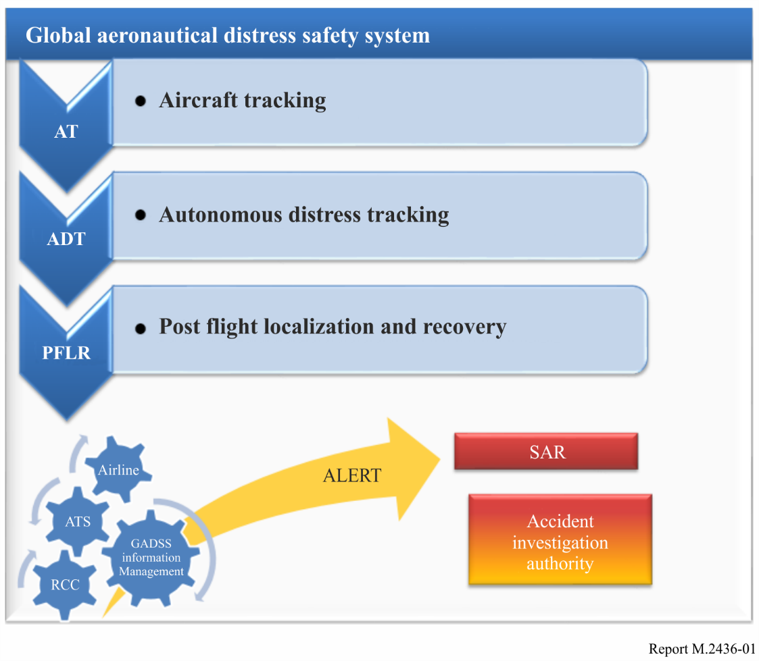

2.2 Frequency spectrum considerations
To ensure global interoperability and lawful operation of radio equipment on‐board aircraft, the equipment will conform to agreed performance standards, will operate in correct frequency bands, must be licensed by appropriate authorities, and be operated by licensed personnel if appropriate.

3 Spectrum needs for the introduction and use of the GADSS
Studies within ICAO in preparation for WRC-19 have determined that the GADSS requirements can be satisfied using existing systems operating within existing aeronautical frequency allocations and distress spectrum (e.g. 406.1 MHz).

“Global Aeronautical Distress and Safety System (GADSS) – Concept of Operations”, Version 6.0, International Civil Aviation Organization, 6 July 2017.

