|  |
| --- |
| **Report ITU-R M.2322-0**  **(11/2014)** |
| **Systems characteristics and compatibility of automotive radars operating**  **in the frequency band 77.5 78 GHz for sharing studies** |
| **M Series**  **Mobile, radiodetermination, amateur**  **and related satellite services** |

Foreword

The role of the Radiocommunication Sector is to ensure the rational, equitable, efficient and economical use of the radio-frequency spectrum by all radiocommunication services, including satellite services, and carry out studies without limit of frequency range on the basis of which Recommendations are adopted.

The regulatory and policy functions of the Radiocommunication Sector are performed by World and Regional Radiocommunication Conferences and Radiocommunication Assemblies supported by Study Groups.

# Policy on Intellectual Property Right (IPR)

ITU-R policy on IPR is described in the Common Patent Policy for ITU-T/ITU-R/ISO/IEC referenced in Annex 1 of Resolution ITU-R 1. Forms to be used for the submission of patent statements and licensing declarations by patent holders are available from <http://www.itu.int/ITU-R/go/patents/en> where the Guidelines for Implementation of the Common Patent Policy for ITU‑T/ITU‑R/ISO/IEC and the ITU-R patent information database can also be found.

|  |  |
| --- | --- |
| Series of ITU-R Reports  (Also available online at <http://www.itu.int/publ/R-REP/en>) | |
| **Series** | Title |
| **BO** | Satellite delivery |
| **BR** | Recording for production, archival and play-out; film for television |
| **BS** | Broadcasting service (sound) |
| **BT** | Broadcasting service (television) |
| **F** | Fixed service |
| **M** | Mobile, radiodetermination, amateur and related satellite services |
| **P** | Radiowave propagation |
| **RA** | Radio astronomy |
| **RS** | Remote sensing systems |
| **S** | Fixed-satellite service |
| **SA** | Space applications and meteorology |
| **SF** | Frequency sharing and coordination between fixed-satellite and fixed service systems |
| **SM** | Spectrum management |

|  |
| --- |
|  |

|  |
| --- |
| ***Note****: This ITU-R Report was approved in English by the Study Group under the procedure detailed in Resolution ITU-R 1.* |

*Electronic Publication*

Geneva, 2015

© ITU 2015

All rights reserved. No part of this publication may be reproduced, by any means whatsoever, without written permission of ITU.

REPORT ITU-R M.2322-0

Systems characteristics and compatibility of automotive radars operating  
in the frequency band 77.5‑78 GHz for sharing studies

(2014)

TABLE OF CONTENTS

Page

1 Introduction 3

2 Regulatory information 3

3 Characteristics of systems operating in the frequency band 77.5‑78 GHz 4

3.1 System characteristics of amateur service stations 4

3.2 System characteristics of amateur satellite service stations 4

3.3 Characteristics of radio astronomy stations 5

3.4 System characteristics of space research service stations 5

4 Systems characteristics of automotive radars 5

5 Basic equations for automotive radar power 5

5.1 Choice of the propagation model 6

5.2 Atmospheric attenuation 7

6 Sharing Studies between automotive radar and the systems of the services having allocation in the frequency band 77.5-78 GHz 9

6.1 Sharing studies with the amateur and amateur-satellite services 10

6.2 Sharing studies with space research (space-to-Earth) service 24

6.3 Sharing studies with radio astronomy service 24

7 Compatibility studies in the adjacent frequency bands 76-77.5 and 78‑81 GHz 34

8 Conclusions 34

Annex A – Automotive radar characteristics 35

Annex B – Atmospheric attenuation of radio waves 37

Page

Annex C – Required output power of automotive radar versus detection distance 41

1 Required output power of automotive radar in the rain conditions 41

2 Required detection distance for useful breaking 47

2.1 Scenarios to be considered 47

2.2 Required detection distance for Case A (car to car) 47

2.3 Required detection distance for Case B (car to pedestrian) 48

Annex D – List of radio astronomy service station sites in the world that use or will potentially use the 78 GHz frequency band 51

# 1 Introduction

WRC-15 agenda item 1.18 calls for consideration of a primary allocation to the radiolocation service for automotive radar applications in the frequency band 77.5-78.0 GHz in accordance with Resolution **654 (WRC-12)**.

Resolution **654 (WRC-12)** invites ITU-R to conduct, as a matter of urgency, and in time for consideration by WRC-15, the appropriate, technical, operational and regulatory studies, including:

i) sharing studies and regulatory solutions to consider a primary allocation to the radiolocation service in the frequency band 77.5-78 GHz, taking into account incumbent services and existing uses of the frequency band;

ii) compatibility studies in the frequency band 77.5-78 GHz with services operating in the adjacent frequency bands 76-77.5 and 78-81 GHz;

iii) spectrum requirements, operational characteristics and evaluation of ITS safety-related applications that would benefit from global or regional harmonization.

This Report is focused on points i) and ii), that is, sharing and compatibility studies to be carried out in co-channel and adjacent frequency bands.

# 2 Regulatory information

Table of Frequency Allocations

Table 1 below is an extract of RR (Edition 2012) Article **5** in the frequency band 76-81 GHz and the related footnotes.

TABLE 1

Existing allocations in the frequency band 76-81 GHz

76-81 GHz

|  |  |  |
| --- | --- | --- |
| Allocation to services | | |
| Region 1 | Region 2 | Region 3 |
| … | | |
| 76-77.5 RADIO ASTRONOMY  RADIOLOCATION  Amateur  Amateur-satellite  Space research (space-to-Earth)  5.149 | | |
| 77.5-78 AMATEUR  AMATEUR-SATELLITE  Radio astronomy  Space research (space-to-Earth)  5.149 | | |
| 78-79 RADIOLOCATION  Amateur  Amateur-satellite  Radio astronomy  Space research (space-to-Earth)  5.149 5.560 | | |
| 79-81 RADIO ASTRONOMY  RADIOLOCATION  Amateur  Amateur-satellite  Space research (space-to-Earth)  5.149 | | |

5.149 In making assignments to stations of other services to which the band 76-86 GHz (see *Editor's Note below*) are allocated, administrations are urged to take all practicable steps to protect the radio astronomy service from harmful interference. Emissions from spaceborne or airborne stations can be particularly serious sources of interference to the radio astronomy service (see Nos. **4.5** and **4.6** and Article **29**).     (WRC‑07)

5.560 In the band 78-79 GHz radars located on space stations may be operated on a primary basis in the Earth exploration-satellite service and in the space research service.

*Editor Note*: Footnote **5.149** refers to several frequency bands, not reported in this text, among which there is the band 76-86 GHz.

# 3 Characteristics of systems operating in the frequency band 77.5‑78 GHz

## 3.1 System characteristics of amateur service stations

System characteristics of amateur service stations, used in the studies, presented in this Report, are described in § 6.1.1.

## 3.2 System characteristics of amateur satellite service stations

System characteristics of amateur satellite service stations, used in the studies, presented in this Report, are given in Recommendation ITU-R M.1732.

## 3.3 Characteristics of radio astronomy stations

The following ITU-R Recommendations provide characteristics of radio astronomy stations and were taken into account in sharing studies:

ITU-R RA.769 Protection criteria used for radio astronomical measurements

ITU-R RA.1031 Protection of the radio astronomy service in frequency bands shared with other services

ITU-R RA.1272 Protection of radio astronomy measurements above 60 GHz from ground based interference.

The protection criteria described in Recommendation ITU-R RA.769 are referred to a gain of 0 dBi in all cases, thereby eliminating dependencies on such properties of individual telescopes as their size and instantaneous orientation.

## 3.4 System characteristics of space research service stations

No space research service (SRS) (space-to-Earth) systems have been identified to date in the frequency range 76 GHz to 81 GHz[1]. Therefore no characteristics have been supplied for space research stations.

# 4 Systems characteristics of automotive radars

New Recommendation ITU-R М.2057 - Systems characteristics of automotive radars operating in the frequency band 76-81 GHz for intelligent transport systems applications, was published in February 2014.

In Table 1 of Recommendation. ITU-R M.2057, shown in Annex A, the parameters of automotive radar type B are given, that should provide a target detection distance up to 100 m. The Table specifies the following parameters of the radar:

– Receiver sensitivity, –120 dBm.

– Antenna gain in the transmit mode, 23 dB.

– Antenna gain in the receive mode, 16 dB.

– Maximum power at the transmitter output, 10 dBm.

These values are used for calculation of target detection distance of automotive radars.

# 5 Basic equations for automotive radar power

In the radiolocation theory, necessary radar power stems from achievable distance for target detection. Generally, detection distance, *D*0, is determined by the well-known formula (free space):

 , (m); (1)

where:

*Pt* : transmitter power (W)

*GAtx* : antenna gain in transmit mode

*GArx* : antenna gain in receive mode

σ*tg* : effective target area, equal to 1 m2

λ : wave-length, equal to 3.859 × 10-3 m

*Pr min* : receiver sensitivity (W).

Taking into account attenuation, *Latm*, of radio waves in the Earth atmosphere, target detection distance, *Datm*, will be determined by the formula:

, (m) (2)

where:

*Latm* : attenuation of radio waves in the Earth’s atmosphere (dB);

*Datm* : target detection distance in the Earth’s atmosphere.

Note that *Latm*depends on *Datm*and (4) is a formal expression only. The value of *Datm* must be determined by numerical iteration when atmospheric attenuation is important.

The effective target area depends on the type of target that the radar should be able to detect.

If the target is a car, σ*tg* can be assumed equal to 1 m2. However, short range radar (SRR) are conceived and installed not only for detecting cars, but also to avoid collision with pedestrians. In the case of a pedestrian target, the effective target area is significantly lower. Practical measurements[2] indicated an average value for a target pedestrian, and this value is equal 0.0316 m2.

## 5.1 Choice of the propagation model

Following issues are considered in this section:

– Determination of the rain rate for calculating rain attenuation and subsequently the required transmit power of the radar. It is argued that the rain rate should be 5-30 mm/h, however it is not necessarily representative of all geographical locations. Based on data from Recommendation ITU-R P.837-6, it is proposed to adopt the range 5-50 mm/h.

– Considering that SRR will be required to be able to detect also pedestrians, this particular case is added and the required power is calculated also for this case.

The yearly probability distribution of rain rate (mm/h) varies with the geographical location. In principle, considering that the allocation sought under WRC-15 agenda item 1.18 is a worldwide allocation, it is sensible to evaluate the required power for a range of rain rates representative of all possible geographical locations. Guidance can be found in Recommendation ITU-R P.837-6 (on the ITU web page of Study Group 3 a software code can be found that implements the Recommendation). Figure 1 below represents the rain rate probability distribution, according to Recommendation ITU-R P.837-6, for some cities of the world.

Figure 1

Rain rate probability distribution, Recommendation ITU-R P.837-6

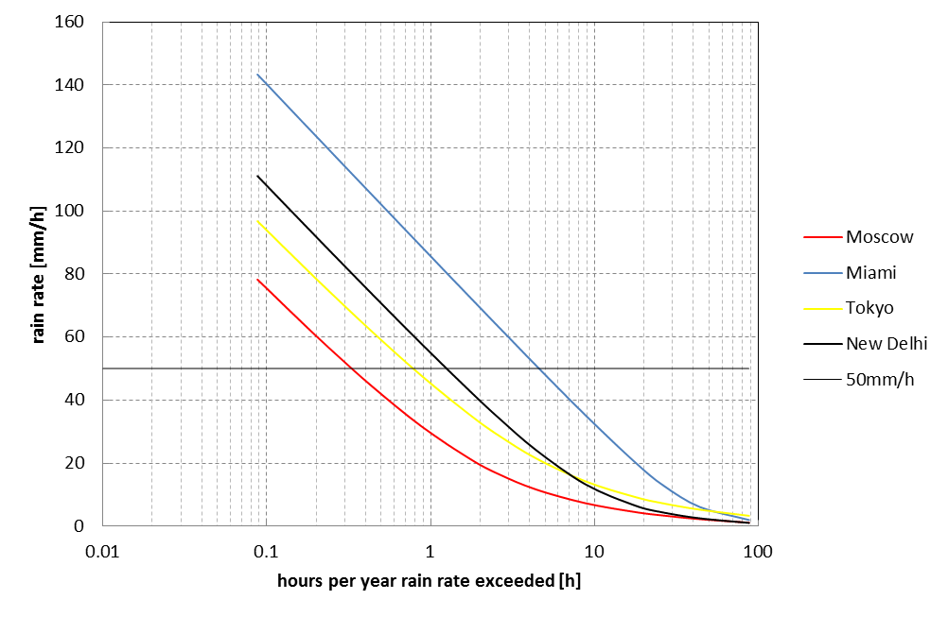

As can be seen, for a given time percentage, the rain rate varies widely and the choice 5-50 mm/h seems a fairly representative range.

## 5.2 Atmospheric attenuation

### 5.2.1 Atmospheric attenuation in wet air at standard pressure

Attenuation of radio waves in the Earth atmosphere generally consists of attenuation in atmospheric gases (oxygen and water vapour) and attenuation in fog or rain. The analysis shows, that the greatest contribution to the attenuation of radio waves is due to atmospheric gases and rain. Therefore, to estimate detection distance, attenuation of radio waves in atmosphere, *Latm*, needs to be determined. This attenuation is defined by the formula:

$L_{atm}=2×D_{atm}×(γ_{g}+γ_{R})$ (dB), (3)

where:

γ*g* : specific attenuation due to atmospheric gases (dB/km)

γ*R* : specific attenuation due to rain (dB/km)

*Datm* : target detection distance in the Earth’s atmosphere.

The calculations of specific attenuations γ*g* and γ*R*are detailed in Annex A.

In order to determine the relationship between the detection distance of the automotive radar and the power using equation (3), calculations for various rain intensities from 5 mm/h to 50 mm/h have been carried out.

Table 2 shows results of calculation of specific attenuation of radio waves in the atmosphere both for horizontal and vertical polarization for rain intensities from 0 mm/h to 50 mm/h in steps of 5 mm/h.

TABLE 2

|  |  |  |  |  |  |  |  |  |  |  |  |  |
| --- | --- | --- | --- | --- | --- | --- | --- | --- | --- | --- | --- | --- |
| Rain intensity, R | mm/h | 0 | 5 | 10 | 15 | 20 | 25 | 30 | 35 | 40 | 45 | 50 |
| Specific rain attenuation for horizontal polarization $,{ γ}_{R_{H}}$ | dB/km | 0 | 3.982 | 5.925 | 8.296 | 10.108 | 11.794 | 13.387 | 14.53 | 15.988 | 17.395 | 18.757 |
| Total specific attenuation of radio waves by Earth atmosphere for horizontal polarization, ${ γ}_{{atm}_{H}}$ | dB/km | 0.358 | 4.62 | 6.563 | 9.02 | 10.746 | 12.432 | 14.025 | 15.168 | 16.626 | 18.033 | 19.395 |
| Specific rain attenuation for vertical polarization, ${ γ}_{R_{V}}$ | dB/km | 0 | 3.547 | 5.785 | 7.703 | 9.438 | 11.048 | 12.566 | 14.01 | 15.395 | 16.73 | 18.022 |
| Total specific attenuation of radio waves by Earth atmosphere for vertical polarization, ${ γ}_{{atm}_{V}}$ | dB/km | 0.358 | 4.185 | 6.423 | 8.341 | 10.076 | 11.686 | 13.204 | 14.649 | 16.034 | 17.369 | 18.640 |

NOTE – γ*atm*= γ*g* + γ*R* – final specific attenuation of radio waves by Earth’s atmosphere.

### 5.2.2 Atmospheric attenuation in dry air at higher elevations applicable to studies of sharing with operations of the radio astronomy service

In contrast to typical driving conditions at sea level in inclement weather as noted in § 5.2.1 and Table 2, mm-wave radio astronomy observations are conducted at remote sites that have been chosen to reduce the atmospheric opacity. Moreover, radio astronomy service (RAS) observations at mm-wave frequencies are not conducted in inclement weather. For these reasons the atmospheric attenuation applicable to sharing studies with the RAS is much smaller than, for instance, the values of approximately 6 dB/km given in Table 2 for a rain intensity of 10 mm/h.

Figure 5 in Annex 2 of Recommendation ITU-R P.676-9 suggests values of 0.36 dB/km and 0.07 dB/km for the atmospheric attenuation at 78 GHz due to wet and dry air (respectively) but the wet-air value pertains to a water vapour density of 7.5 g/m³ which is characteristic of coastal areas and considerably worse than would be found in the vicinity of a mm-wave observatory. Conversely, the dry-air value is uncharacteristically small except perhaps under the very best conditions at the very best sites, e.g. at the South Pole, in the Atacama or on Mauna Kea.

Annexes 1 and 2 of Recommendation ITU-R P.676-9 contain expressions for the attenuation due to dry air and water vapour absorption. For water vapour densities of 2-3 g/m³ that are appropriate to mm‑wave observing sites the calculated attenuation is 0.135 dB/km – 0.168 dB/km. Therefore a value 0.15 dB/km seems appropriate for sharing and compatibility studies with the RAS in the 76‑81 GHz band. This value is also consistent with the work of Shambayati (2008)[3].

Thus for a typical interferer at a distance of 10 km, the atmospheric attenuation will be of order 1.5 dB, amounting to a reduction in the incident radiation of only 31%. Although atmospheric attenuation must not be neglected, it does not, by itself, provide the required protection against interference to RAS operations in the 76-81 GHz band.

Figures 1 and 2 of Recommendation ITU-R P.676-9 straightforwardly demonstrate the enormous disparities in atmospheric attenuation that exist between wet and dry air at various altitudes.

SRR signals will propagate much further in an environment with an atmospheric attenuation of 0.15 dB/km than, say, one where the attenuation is 6 dB/km. Such a diminution in atmospheric attenuation in principle affords the compensating ability to turn down the radar power while maintaining its effectiveness. Over a detection distance of 0.3 km with a round-trip distance of 0.6 km, this simple example indicates approximately a 3.6 dB (2 x 0.3 km x 6 dB/km) stronger return signal. This does not compensate for the increased propagation of the SRR signals at long distances near radio astronomy sites where the attenuation over tens of km is reduced by many tens of 10 dB compared to the more typical situation described in § 5.1.

# 6 Sharing Studies between automotive radar and the systems of the services having allocation in the frequency band 77.5-78 GHz

There are four incumbent services to consider in the sharing studies: amateur and amateur-satellite (primary), space research (space-to-Earth) and radio astronomy (secondary).

## 6.1 Sharing studies with the amateur and amateur-satellite services

### 6.1.1 Characteristics of the amateur service systems

Table 3 below summarizes the technical parameters of amateur receivers, which are used for the sharing studies between the automotive radar and amateur service systems[4].

TABLE 3

Technical parameters of amateur receivers

|  |  |  |  |  |  |
| --- | --- | --- | --- | --- | --- |
| Parameter | Units | Value | | | |
| Mode of operation |  | Morse telegraphy | Single sideband telephony | FM telephony | Multimedia (Data, TV) |
| Frequency band | MHz | 77 500-78 000 | 77 500-78 000 | 77 500-78 000 | 77 500-78 000 |
| Necessary bandwidth and class of emission (emission designator) |  | 150HA1A | 2K70J3E | 11K0F3E, 16K0F3E, 20K0F3E | 10M5F7W |
| Transmitter power | dBW | -30 – -17 | -30 – -17 | -30 – -17 | -30 – -17 |
| Feeder loss | dB | 1 | 1 | 1 | 1 |
| Transmitting antenna gain | dBi | 42 | 42 | 42 | 42 |
| Typical e.i.r.p. | dBW | 11-24 | 11-24 | 11-24 | 11-24 |
| Antenna polarization |  | Horizontal | Horizontal | Vertical | Vertical |
| Receiver IF bandwidth | kHz | 0.4 | 2.7 | 9, 15 | 10 500 |
| Receiver noise figure (assumes use of low noise preamplifier) | dB | 3-7 | 3-7 | 3-7 | 3-7 |

In general, at these frequencies, it is common practise for the amateur station to use the same antenna for transmitting and receiving. In order to simulate the diagram of the antenna used by the amateur receiver, Recommendation ITU-R F.1245 was used. Figure 2 below shows the antenna diagram, as a function of the off-axis angle, for an antenna with circular symmetry and a maximum gain of 42 dBi (frequency 78 GHz). The ratio *D/*λ is determined from *Gmax* using the formula that links *D/*λand *Gmax* given in Recommendation ITU-R F.699.

Figure 2

Radiation diagram of the amateur receiving antenna



### 6.1.2 Characteristics of the amateur satellite service systems

Currently no in-orbit use of the 77.5‑78 GHz frequency band is identified in the amateur-satellite service[5]. However this should not preclude future usage, including current plans for transmission beacons on-board amateur satellites for attitude determination and atmospheric propagation research for reception by amateur ground stations. Therefore, the technical characteristics given in Recommendation ITU-R M.1732 - Characteristics of systems operating in the amateur and amateur‑satellite services for use in sharing studies, can be used in the sharing studies. Table 4 below, taken from Table 6 in Recommendation ITU-R M.1732, summarizes these technical parameters which are used for the sharing studies between the automotive radar and amateur satellite service systems.

TABLE 4

Characteristics of amateur~~-~~satellite systems in the space-to-Earth direction

|  |  |  |  |  |  |  |  |
| --- | --- | --- | --- | --- | --- | --- | --- |
| Mode of operation | Units | CW Morse, 10‑50 Bd | | | SSB voice, digital voice, FM voice, data | | |
| Frequency band(1) | MHz | 28 | 144-5 850 | 10 450- 24 050 | 28 | 144-5 850 | 10 450- 24 050 |
| Necessary bandwidth and class of emission (emission designator) |  | 150HA1A 150HJ2A | 150HA1A 150HJ2A | 150HA1A 150HJ2A | 2K70J3E 2K70J2E 16K0F3E | 2K70J3E 16K0F3E 44K2F1D 88K3F1D | 2K70J3E 16K0F3E 44K2F1D 88K3F1D |
| Transmitter power (2) | dBW | 10 | 10 | 10 | 10 | 10 | 0-10 |
| Feeder loss | dB | 0.2-1 | 0.2-1 | 0.2-1 | 0.2-1 | 0.2-1 | 0.2-1 |
| Transmitting antenna gain | dBi | 0 | 0-6 | 0-6 | 0 | 0 | 0-6 |
| Typical e.i.r.p. | dBW | 9 | 9-15 | 9-15 | 9 | 9-15 | 9-15 |
| Antenna polarization |  | Horizontal, vertical, RHCP, LHCP | Horizontal, vertical, RHCP, LHCP | Horizontal, vertical, RHCP, LHCP | Horizontal, vertical, RHCP, LHCP | Horizontal, vertical, RHCP, LHCP | Horizontal, vertical, RHCP, LHCP |
| Receiver IF bandwidth | kHz | 0.4 | 0.4 | 0.4 | 2.7, 16 | 2.7, 16, 50, 100 | 2.7, 16, 50, 100 |
| Receiver noise figure (3) | dB | 3-10 | 1-3 | 1-7 | 3-10 | 1-3 | 1-7 |
| (1) Amateur bands within the frequency ranges shown conform to RR Article **5**.  (2) While total transmitter power of 20 dBW is assumed, 10 dBW is used as power is shared among signals in passband.  (3) Receiver noise figures for bands above 50 MHz assume the use of low-noise preamplifiers. | | | | | | | |

### 

### 6.1.3 Sharing studies

Two different methodologies were used in the sharing studies between automotive radar and amateur service systems. These two studies and the results are given below:

a) Geometric analysis methodology

This study covers only the sharing between automotive radars and amateur service stations.

Characteristics of the automotive radars were taken from Table 1 of Recommendation ITU-R M.2057 which is given in Annex A. Radar A was used in this study.

The antenna diagram of the radiolocation service systems is not provided in Recommendation ITU‑R M.2057. Therefore, in order to simulate the diagram of the antenna used by the radar, Recommendation ITU-R F.1245 was used. Figure 2 of Recommendation ITU-R F.1245 shows the antenna diagram, as a function of the off-axis angle, for an antenna with circular symmetry and a maximum gain of 30 dBi (frequency 78 GHz). The ratio *D/*λ is determined from *Gmax* using the formula that links *D/*λand *Gmax* given in Recommendation ITU-R F.699. Figure 3 below shows the antenna diagram of the automotive radar.

Figure 3

Antenna diagram adopted for the automotive radar



Interference from automotive radar Type A:

It is considered that a FMCW/fast-FMCW radar for automotive applications sweeps a band of typically 1 GHz. Therefore, it is assumed that during an entire sweep time only a portion of the radiated energy will fall in the band of the amateur receiver, whose receiving band is much smaller than 1 GHz.

Table 5 shows the power attenuation for various bandwidths of the amateur receiver related to the radar sweep bandwidth.

TABLE 5

Attenuation due to receiver bandwidth

|  |  |  |  |
| --- | --- | --- | --- |
| Type of the AS link | A: Receiver Bw (kHz) | B: Radar sweep bandwidth (GHz) | C: Attenuation  10log10(A/B) (dB) |
| Morse telegraphy | 0.4 | 1 | –63 |
| Single sideband telephony | 2.7 | 1 | –55.6 |
| FM telephony | 9.15 | 1 | –50.3 |
| Multimedia (Data, TV) | 10 500 | 1 | –19.7 |

The formula for determining the interference at the receiver is the following:

$$I={eirp}_{V}+G_{A}+FSL+C$$

where:

*I*: interference at the amateur receiver

*eirpv*: equivalent isotropic radiated power in the direction of the amateur receiver

*GA*: antenna gain of the amateur receiver in the direction of the automotive radar

*FSL*: free space propagation loss

*C*: attenuation in Table 5.

Sharing scenarios and studies

Concerning the deployment scenarios of the amateur service systems, an indication can be found in ECC Report 56. The report indicates that“antennas are in general mounted on masts as high as practical, high buildings, hills or mountaintops in order to obtain the least obstruction towards the horizon in order to make long distance contacts possible”.

Two scenarios are therefore considered. In the first scenario (mountain top) it is considered that the amateur receiver is installed on top of a mountain and in the second scenario (building top) it is considered that the amateur receiver is installed on top of a building.

Scenario 1: Mountain top

The first scenario is depicted in Fig. 4 below. The amateur receiver is operated on top of a mountain with a height of 1 500 m.

Figure 4

Description of the mountain top scenario

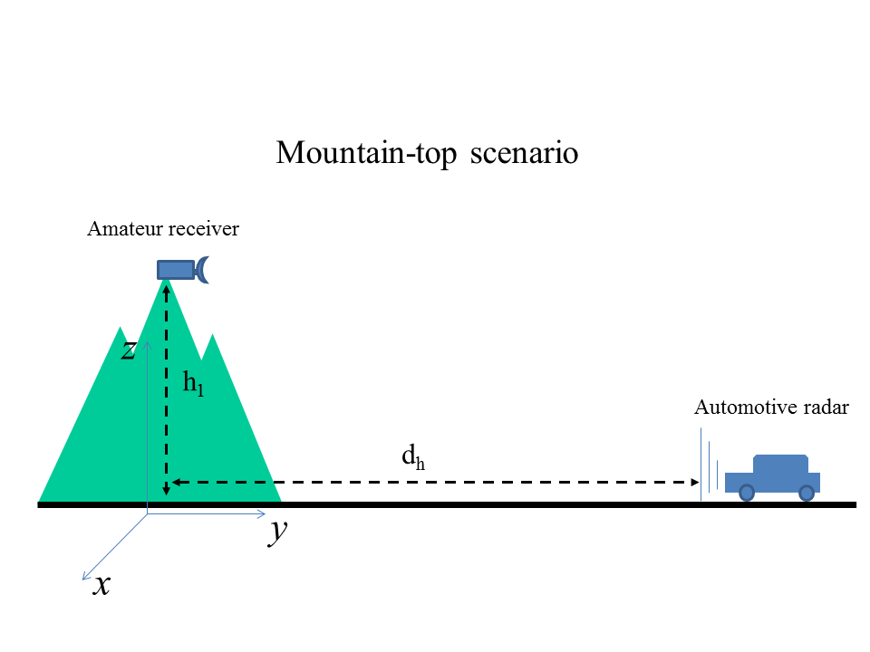

With reference to Fig. 4:

*• h1*: is fixed, equal to 1 500 m.

*• dh*: variable from 0 to 30 000 m.

*•* Automotive radar: see Table 1 of Recommendation ITU-R M.2057.

*•* The azimuth of the automotive radar coincides with the direction of the mountain, while its elevation is zero.

*•* The azimuth is variable, but its elevation is fixed and coincides with the horizon.

With respect to the coordinate system in Fig. 4:

*•* The automotive receiver is located at (0,0*,h*1). Its antenna pointing is defined by a vector laying in the plan (*x,y,*0).

*•* The car is moving along the line defined by the coordinates (0*,dh,*0), where *dh* is variable. The car is moving toward decreasing *dh..*

*•* The scanning of the automotive radar in the horizontal plane is neglected and the assumption is made that the beam is permanently pointed in the *–y* direction.

Figure 5 shows the values of *I/N*, the off-pointing angles and the antenna gains for the following case:

*•* Type of amateur link: Multimedia/TV. This type of link is the most susceptible link to the radar interference because it has the largest bandwidth and therefore has the lowest attenuation as given in Table 4.

*•* Pointing of the amateur receiver: In the direction *y* with reference to Fig. 4. This corresponds to the worst case.

Figure 5



As it can be seen from Fig. 5, the value of *I/N*=-6 dB is never exceeded and there is a margin of at least 15 dB for accommodating the aggregated interference from multiple interferers.

Figure 6 shows the same values for the case when the amateur receiver is pointed in the direction defined by the vector (1,1,0). This means an azimuth that forms an angle of 45° with the orientation of the road.

Figure 6



As can be seen, de-pointing by 45° of the amateur receiver antenna from the worst case direction gives a ratio *I/N* that never exceeds the value of about –40 dB. Considering that a sufficient protection criterion could be *I/N* = *–*6 dB, this leaves a sufficient margin for accommodating the aggregated effect of a large number of multiple automotive radars.

The conclusion is that the operation of the amateur service in the mountain top scenario is not expected to be significantly constrained by the radiolocation service.

Scenario 2: Building top

The building top scenario is depicted in Fig. 7. In this scenario the radio amateur receiver is installed on the roof of a building, with a height of 30 m. The building is located near a road.

In this scenario, with reference to Fig. 7:

*•* The car moves on a road defined by the coordinates (*x,dh,*0). *x* is a variable that defines the position of the car on the road (thus varying in time) and *dh*is a parameter that defines the distance of the road from the building (thus *dh* is constant in time, but may vary from one scenario to another).

*•* The amateur receiver is located on the top of the building at a height of *h1*=30 m. Its position is defined by (0,0,*h1*).

*•* The amateur receiver antenna is pointed toward the horizon, with zero elevation and thus the direction of a vector in the plan *x,y*. Different azimuth of the antenna are considered in the analysis.

*•* The radar of the car performs a scanning in the horizontal plane. In principle the scan has an aperture in the horizontal plane of ±15° only. However, it is considered that the car can have several radars, some on its sides for side impact detection and mitigation. Therefore, the crude assumption is made that the radar has azimuth always pointed toward the direction of the amateur receivers (while his elevation remain constant and equal to 0).

Figure 7

Description of the building top scenario

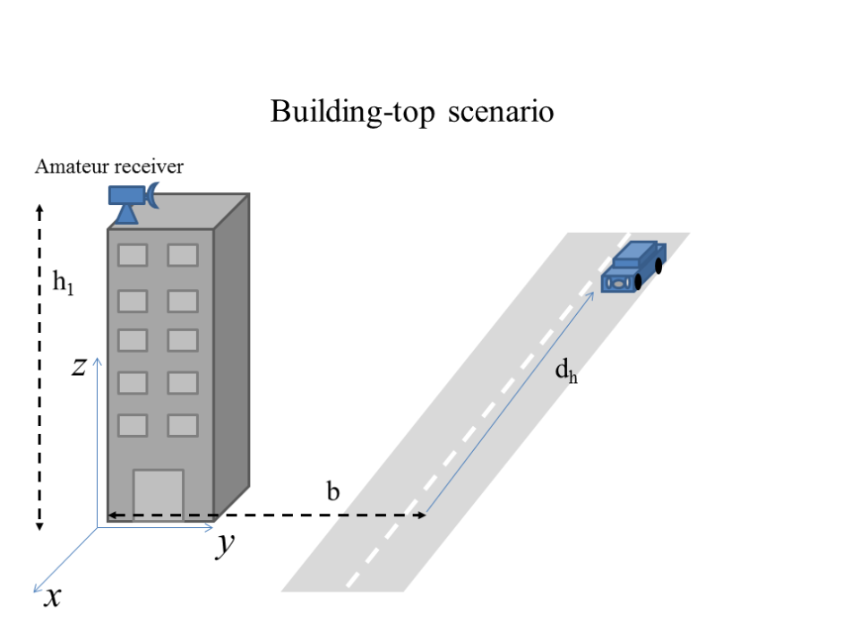

Figure 8 shows the values of *I/N*, the off-pointing angles and the antenna gains for the following case:

*•* Type of amateur link: Multimedia/TV. This type of link is the most susceptible link to the radar interference because it has the largest bandwidth and therefore the lowest attenuation as given in Table 5;

*•* Pointing of the amateur receiver: In the direction –*x* with reference to Fig. 8;

*•* Distance *b* between the building and the road: 10 metres.

Figure 8



Figure 8 shows the same values for the case when the amateur receiver is pointed in the direction defined by the vector (1,1,0). This means an azimuth that forms an angle of 45° with the orientation of the road.

Figure 9



As can be seen from Fig. 9, provided that a sufficient de-pointing of the amateur antenna is adopted (in Fig. 9, the angle is 45° between the azimuth of the antenna and the direction of the street), the ratio *I/N* never exceeds –7 dB. This leaves a margin to accommodate several interfering devices.

The conclusion from Figs 8 and 9 is that, with a careful choice of the building where the amateur receiver has to be installed, it is still possible to operate the radio amateur stations.

Conclusions

The conclusions of this study are:

*•* The operation of the amateur service in the mountain top scenario is not expected to be significantly constrained by the radiolocation service.

*•* With a careful choice of the building where the amateur receiver has to be installed, it is still possible to operate the radio amateur stations.

The study indicates that the allocation of the band 77.5-78 GHz to the radiolocation service is not expected to impose severe constraints on the radio amateur service.

b) Minimum coupling loss methodology

In order to determine the minimum interference distances between the automotive radar and amateur systems, minimum coupling loss (MCL) methodology was used.

This study covers sharing between automotive radars and amateur service stations as well as sharing between automotive radars and amateur satellite stations.

For the purpose of this study, the interference probability from the automotive radars to amateur and amateur satellite stations, operating line of sight, was taken as the worst case scenario, however a more realistic approach of considering sidelobe response was used in the calculations.

Principle of minimum coupling loss analysis

The method of the study is based on the deterministic link budget analysis. The generated result is isolation in dB, which is converted into a physical interference distance if a free space path loss formula is used. A single interferer, transmitting at a fixed maximum power, is considered.

The following equation can be used to calculate the co-channel interference power from automotive radar to the amateur or amateur satellite station.

$$P_{RX}=P_{TX}-{FL}_{TX}+G_{TX}-PL+G_{RX}-{FL}_{RX}-BCF$$

where:

*PRX* : Interference power at the victim receiver

*PTX* : Transmitter power of the automotive radar

*FLTX* : Feeder loss of the automotive radar

*GTX* : Transmitter antenna gain in the direction of the receiver

*PL* : Path loss

*GRX* : Receiver antenna gain in the direction of the transmitter

*FLRX* : Feeder loss of the amateur or amateur satellite station

*BCF* : Bandwidth Correction Factor. In this study the *PRX* the “Interference power at the victim receiver” is taken to be 6 dB below the “victim receiver thermal noise” level.

The gain of the transmitter antenna, *GTX,* is taken into account by using equivalent isotropic radiated power and the receiver antenna gain, *GRX,* is taken to be 0 dBi which is an estimate of the sidelobe response of the amateur receiver antenna. This is done as it provides a reasonable estimate of the spatial average gain of the victim receiver antenna over all possible transmission paths. The worst case scenario is when the transmitter antenna is pointing directly at the receiver antenna and as the probability of this is low due to the narrow beam widths of both the receiver and transmitter, using 0 dBi as the receiver antenna gain gives a more realistic estimate of interference potential.

Interference scenarios considered for the minimum coupling loss calculations

Following four scenarios were used for the calculations with MCL methodology as the representatives of amateur and amateur satellite systems.

Scenario 1: Interference from automotive radar to amateur FM telephony system

The result of the MCL calculations for the case of amateur FM telephony system, supposed to be operated in the 77.5-78.0 GHz band is given in Table 6 below:

TABLE 6

Automotive radar to amateur FM telephony system interference distance

|  |  |  |
| --- | --- | --- |
| Parameter, unit | Units | Value |
| Victim receiver bandwidth | kHz | 20 |
| Victim receiver antenna gain | dBi | 0 |
| Operating frequency | MHz | 77 750 |
| N, victim receiver thermal noise | dBm | –125.82 |
| Interferer's EIRP | dBm | 33 |
| Interferer's BW | kHz | 4 000 000 |
| BW correction factor | dB | –53.0 |
| I/N objective | dB | –6 |
| Minimum path loss | dB | 111.81 |
| **Interference distance FSL model** | km | **0.12** |

Scenario 2: Interference from automotive radar to amateur multimedia system

The result of the MCL calculations for the case of amateur multimedia system, supposed to be operated in the 77.5-78.0 GHz band is given in Table 7 below:

TABLE 7

Automotive radar to amateur multimedia system interference distance

|  |  |  |
| --- | --- | --- |
| Parameter, unit | Units | Value |
| Receiver bandwidth | kHz | 10 500 |
| Receiver antenna gain | dBi | 0 |
| Operating frequency | MHz | 77 750 |
| N, receiver thermal noise | dBm | –98.62 |
| Interferer's EIRP | dBm | 33 |
| Interferer's BW | kHz | 4 000 000 |
| BW correction factor | dB | –25.8 |
| I/N objective | dB | –6 |
| Minimum path loss | dB | 111.81 |
| **Interference distance FSL model** | **km** | **0.12** |

Scenario 3: Interference from automotive radar to amateur satellite digital voice system

The result of the MCL calculations for the case of amateur satellite digital voice system, supposed to be operated in the 77.5-78.0 GHz band is given in Table 8 below:

TABLE 8

Automotive radar to amateur satellite digital voice system interference distance

|  |  |  |
| --- | --- | --- |
| Parameter, unit | Units | Value |
| Receiver bandwidth | kHz | 88 |
| Receiver antenna gain | dBi | 0 |
| Operating frequency | MHz | 77 750 |
| N, receiver thermal noise | dBm | –120.39 |
| Interferer's EIRP | dBm | 33 |
| Interferer's BW | kHz | 4 000 000 |
| BW correction factor | dB | –46.6 |
| I/N objective | dB | –6 |
| Minimum path loss | dB | 112.81 |
| **Interference distance FSL model** | **km** | **0.13** |

Scenario 4: Interference from automotive radar to amateur satellite CW Morse system

The result of the MCL calculations for the case of amateur satellite CW Morse system, supposed to be operated in the 77.5-78.0 GHz band is given in Table 9 below:

TABLE 9

Automotive radar to amateur satellite CW Morse system interference distance

|  |  |  |
| --- | --- | --- |
| Parameter, unit | Units | Value |
| Receiver bandwidth | kHz | 0.15 |
| Receiver antenna gain | dBi | 0 |
| Operating frequency | MHz | 77 750 |
| N, receiver thermal noise | dBm | –150.07 |
| Interferer's EIRP | dBm | 33 |
| Interferer's BW | kHz | 4 000 000 |
| BW correction factor | dB | –74.3 |
| *I*/*N* objective, dB | dB | –6 |
| Minimum path loss, dB | dB | 114.81 |
| **Interference distance FSL model, km** | **km** | **0.17** |

Conclusions for the minimum coupling loss calculations

It can be seen from the above calculations that the distances over which interference could be expected are small and are all less than 200 metres for the scenarios considered. It should be kept in mind that:

1. The MCL calculations consider the a spatial average scenarios, the worst case scenario where the transmitter and receiver are directly facing each other will result in large protection distances, however the probability of this is very small.
2. No mitigation has been used in these calculations.
3. Direct line of site was used between the interferer and the victim without considering any terrain parameters (buildings, trees, hills etc.) which will considerably attenuate the signal.

In the light of the calculations given above, it can be concluded that the interference probability from automotive radars to amateur or amateur satellite stations is very low.

## 6.2 Sharing studies with space research (space-to-Earth) service

As indicated in § 3.4, no SRS (space‑to-Earth) systems have been identified to date in the frequency range 76 GHz to 81 GHz”. Therefore, no sharing study was performed between the automotive radars and space research service for the purpose of WRC-15 agenda item 1.18.

## 6.3 Sharing studies with radio astronomy service

### 6.3.1 Sharing criteria and available Reports

Report ITU-R SM.2057 and ECC Report 56 considered sharing studies between automotive short range devices and RAS. These existing Reports conclude that the coexistence of automotive SRR with –3 dBm/MHz e.i.r.p. and RAS stations is feasible provided that mitigation techniques (such as e.i.r.p. limitations) or protection distances from RAS station are applied.

It is also important to understand how the aggregation effect has been assessed in those studies. In a rural environment, vegetation and/or terrain model will suppress the interference for most (or all) interferers in regions of high ambient atmospheric attenuation, but shielding by vegetation is minimal or absent in the vicinity of the arid high elevation sites at which some RAS operations occur. In addition, car shielding needs to be taken into account when considering a high density of cars. However, the density of cars in the immediate vicinity of radio astronomy stations is small. Therefore WP 5B would need to check, and maybe update, the studies between SRR at 79 GHz and RAS presented in Report ITU-R SM.2057.

To achieve this, some information about RAS stations and 79 GHz SRR is required:

– As far as SRRs are concerned, Annex 1 provides some regulatory and technical information about 79 GHz SRR deployed in Europe.

– Concerning RAS, the protection criteria detailed in Recommendation ITU-R RA.769 are derived as follows:

– 89 GHz is the nearest frequency listed in Table 1 for continuum observations, with a maximum surface pfd threshold level of –228 dBW/m2/Hz, corresponding to a pfd threshold level of –288 dBW/Hz.

– 88.6 GHz is the nearest frequency listed in Table 2 for spectral line observations, with a maximum surface pfd threshold level of –208 dBW/m2/Hz, corresponding to a pfd threshold level of –268 dBW/Hz.

These interference levels are based on noise fluctuations corresponding to astronomical observations integrated over 2 000 s.

It must be underlined that Recommendation ITU-R RA.1031 invites to “perform the calculation over several periods of time in order to verify that the percentage of observations lost is lower than the criterion of 2% given in Recommendation ITU-R RA.1513”.

Therefore it is understood that the interference pfd threshold levels above can be exceeded, but not more than 40 s over 2 000 s; or – in the case of Monte Carlo simulations – with a probability of lower than 2%.

Some administrations have concluded that the possibility of interference to RAS from automotive radars is sufficiently low and that the propagation characteristics of the band, translate in practice to a minimal interference potential to RAS operations. However, in some parts of the world, mitigation measures, such as proper power emission limits, might be needed to avoid potential interference to the radio astronomy service; some administrations permit the operation of automotive radars with specified emission power limits.

### 6.3.2 Choice of the propagation model for sharing studies with the radio astronomy service

From a general point of view, in the choice of a propagation model, the problem can be simplified by distinguishing two different cases:

– A propagation model intended for system design and performance evaluation. Such a model needs to take into account propagation impairments that can hinder the system performance. For example, rain attenuation, atmospheric absorption and reflection from ground can be considered.

– A propagation model intended for interference calculations and sharing studies. This model will rather pay attention to signal enhancement at low percentages of time (especially for sharing with the RAS).

In the case of sharing studies between SRR and RAS, clearly the second case applies.

It is worth noting that, for sharing studies between automotive SRR and RAS in the 78 GHz, Report ITU‑R SM.2057 used Recommendation ITU-R P.452. However, the following facts are highlighted:

– Recommendation ITU-R P.452 is in principle validated up to 50 GHz, see paragraph 1 of Annex 1: “The prediction procedure is appropriate to radio stations operating in the frequency range of about 0.7 GHz to 50 GHz”.

– The minimum resolution for the antenna height from Recommendation ITU-R P.452 is 1 m. So it is sensible to assume that the Recommendation will underestimate the propagation loss for radars mounted close to the earth surface at an average height of 30 cm above ground level.

Moreover, in Report ITU-R SM.2057, shielding from terrain and additional losses due to terrain clutter (e.g. vegetation) are not taken into consideration, while it is clear that they will play an important role in reducing the distance at which interference will occur in wet climates. For instance, one can consider Recommendation ITU-R P.833-7 to see that in the millimetre wave zone, the average specific attenuation for propagation through vegetation has the magnitude of several dB per metre. However, radio astronomical observations at mm-wavelengths are often conducted in arid landscapes, often at very high elevation, where vegetation and clutter range from sparse to non-existent.

If we consider Recommendation ITU-R P.620-6, we find that (rearranging equation (49) in the Recommendation), the propagation model for the calculation of coordination distances around base stations can be written as:

 (4)

Where FSL is the free space loss,  is the gas absorption, is the loss due to site shielding and the term  models signal enhancements for low percentages of time.

Figure 10 shows *E*(*p*1,*d*).

Figure 10

Signal enhancements at low percentages of time

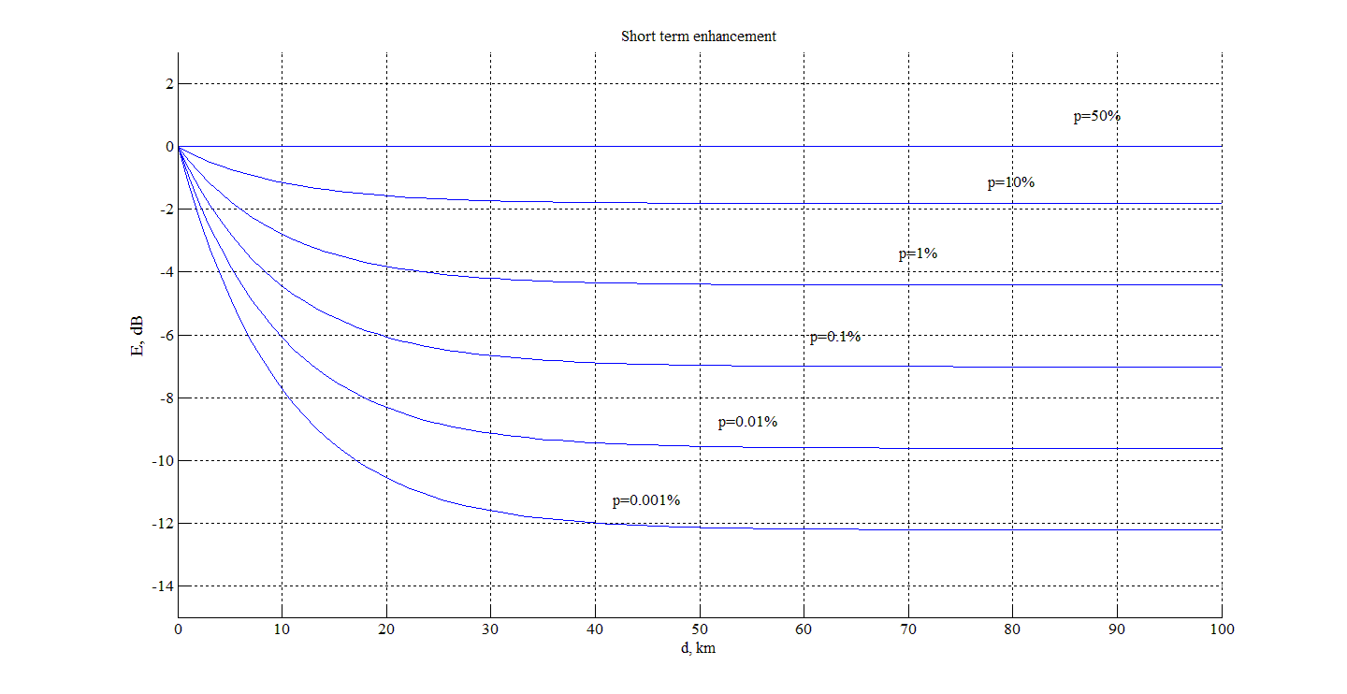

To overcome the limitations discussed above, it is proposed to take the model suggested by Recommendation ITU-R P.620, but modifying in the following way:

– The term Ah in equation (1) above is substituted by the term *Ad*, where *Ad* represents the diffraction loss as calculated by Recommendation ITU-R P.526-12. The rationale for this change in the propagation model is that the term Ah in Recommendation ITU‑R P.620-6 is only valid in the particular case of shielding artefacts around the RAS station but not generally applicable for all type of obstacles (in particular not for terrain obstacles like hills or even mountains). The advantage of using Recommendation ITU‑R P.526-12 instead is that this recommendation presents an algorithm valid for diffraction loss for a generic path.

With the discussion described above, the propagation model proposed for coordination studies with the RAS is given in equation 5:

$${L\left(p_{1}\right)=γ}_{gm }d+FSL+2.6\left[1-exp\left(\frac{-d}{10}\right)\right]log\left(\frac{p1}{50}\right)+Ad$$

(5)

It is important to highlight the importance of considering diffraction in the propagation model for the following reasons:

– In the millimetre-wave range, the shadow zone is very small compared to lower frequencies and obstacles along the path in practice cause a significant loss.

– Radars will be normally mounted at 30 to 50 cm above the ground level. It is therefore very likely that the area in line of sight with the RAS system will be limited by the obstacles in the proximity of the vehicle or by surrounding terrain relief when the radars are used in crowded areas, or in wetter climates or near sea level. For instance, in the millimetre wave region absorption by vegetation is important, when vegetation is abundant, and a small wood will likely act mostly as a diffracting obstacle. In other words, terrain clutter (vegetation, micro-scale terrain irregularities and human artefacts like fences) will contribute to reduce the actual interference potential of SRR toward RAS station sites when it actually exists.

### 6.3.3 List of radio astronomy service station sites in the world that use or will potentially use the 78 GHz frequency band

Annex D lists the coordinates of radio astronomy stations using or potentially using the 77.5‑78 GHz band that is proposed for a new primary allocation to the radiolocation service for automotive radar under WRC 15 agenda item 1.18. It also provides a brief description of the local geography for each site.

### 6.3.4 Sharing studies

#### 6.3.4.1 Theoretical assessment of the necessary separation distance between radio astronomy service systems and automotive radars

With the input parameters given in Table 10, a calculation was carried out for the necessary separation distances to protect RAS systems as a function of the density of transmitting automotive radars.

TABLE 10

Input parameters

|  |  |  |  |
| --- | --- | --- | --- |
| Parameter | Units | Value | Source |
| Frequency | GHz | 77.75 |  |
| SRR RF emission bandwidth | GHz | Max 4 | Recommendation ITU-R M.2057 |
| SRR maximum e.i.r.p | dBm | 33  (over entire bandwidth) | Recommendation ITU-R M.2057 |
| Height of SRR | m | 0.5 |  |
| Maximum permissible spectral power flux density of RAS | dBW/Hz | –288  (continuum observations) | Recommendation ITU-R RA.769 |
| Height of RAS telescope | m | 25 |  |
| Attenuation of radio waves in atmosphere | dB/km | 0.358 | Annex |
| Maximum distance for calculations | km | 500 | Recommendation ITU-R P.620 |

The number of rings taken into account in the calculation is determined by using the relevant algorithm from Recommendation ITU-R P.620, and covers an area with a radius of up to the minimum separation distance + 500 km.

The propagation model is based on Recommendations ITU-R P.526 and ITU-R P.620, in which diffraction loss of smooth spherical earth and attenuation of radio waves in atmosphere are considered. Other factors such as terrain shielding and car shielding are not considered.

The provision in Recommendation ITU-R RA.1513 to “perform the calculation over several periods of time in order to verify that the percentage of observations lost is lower than the criterion of 2%” was not considered. Scenarios for the sharing studies are given in Fig. 11.

FIGURE 11

Scenarios for sharing studies

radio astronomy

observatory

max 500km

separation

distance

The results of the calculations are given in Figs 12 and 13 (logarithmic protection distance).

FIGURE 12

Separation distances necessary to protect radio astronomy systems vs. density  
of transmitting automotive radars

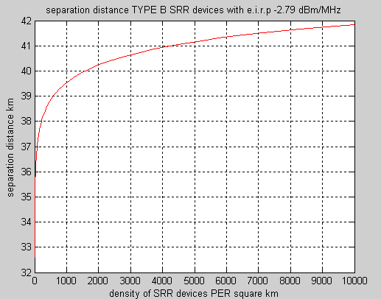

FIGURE 13

Separation distances necessary to protect radio astronomy systems vs. density  
of transmitting automotive radars

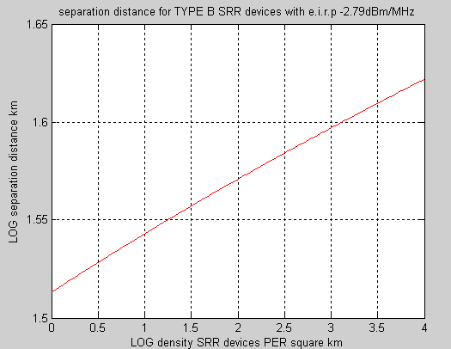

The study result is similar with that of Report ITU-R SM.2057: to avoid potential harmful interference from automotive radar devices, appropriate separation distance from RAS should be determined. If no mitigation techniques are applied (such as terrain shielding and e.i.r.p. limitations, etc.), the required separation distance between the automotive radar and RAS might be not less than 30 km, under visual range conditions.

Mitigation factors, mentioned above, but not considered in the calculations, would reduce the distance.

#### 6.3.4.2 Kitt Peak measurements

Measurements performed using the University of Arizona’s 12 metre telescope located at Kitt Peak examined the impact that automotive radar emissions would have on radio astronomy installations. The test procedures and measurement results are available as NRAO Green Bank Electronics Division Technical Note #219[6].

Emissions of two different automotive radars mounted outside the vehicle body were measured in the adjacent 77‑80 GHz band. The measurements determined that the radars under test were operating with e.i.r.p. of 9 – 11 dBm. This is 23 dB below the maximum operating e.i.r.p. specified in Recommendation ITU-R M.2057, corresponding to measurements on the radar input power source directly.

The measurements of the emissions from a single automotive radar system at two distances (1.7 km and 26.9 km from the radio astronomy installation) demonstrated that the received signal level at the radio astronomy installation exceeded the protection criteria indicated in Recommendation   
ITU-R RA.769 when referred to 0 dBi gain of the 12 m antenna. The study concluded that, in the absence of other factors, compliance with the threshold levels in Recommendation ITU-R RA.769 would require coordination distances of 30-40 km, like those described in § 6.3.4.1 here. Recommendation ITU-R RA.1272-1 specifically recommends that such zones be established around mm-wave astronomical observatories, following the procedure outlined in Recommendation   
ITU-R RA.1031‑2.

The Kitt Peak study acknowledged that factors such as terrain shielding, orientation of the automotive radar transmitter antenna with respect to the observatory, and attenuation of the automotive radar transmitter if mounted behind the vehicle bumper were not taken into account and would tend to reduce the potential for interference. The ability of such factors to mitigate interference to the radio astronomy station should be considered in light of the 23 dB margin of the test conditions that is now apparent since publication of Recommendation ITU-R M.2057.

#### 6.3.4.3 Plateau de Bure case study

A preliminary assessment was made of the coordination area around the site Plateau de Bure (other sites still need to be analysed).

In analysis, the following assumptions were made:

The propagation area was calculated using the following criteria:

– The interference threshold level (one single interferer) was set to –228.6 dBW/m2/Hz, as prescribed by Recommendation ITU-R RA.769.

– An interfering transmitter with a e.i.r.p. density of –9 dBm/MHz was considered. Its height above ground level was assumed to be 1 m. This is clearly a conservative assumption, considering that the SRR would normally be mounted in the bumper of a car, with an average height above the ground of 30-50 cm.

– The antenna pattern of the interfering transmitter is considered as follows: the e.i.r.p. is –9 dBm/MHz for all azimuths and all elevations below 45°. For other directions the e.i.r.p is reduced by 40 dB.

– Polarisation mismatch between interfering transmitter and RAS site was neglected.

– The propagation model is the one described in the above paragraph, with the following conservative simplifications:

− Gas attenuation is neglected.

− The term E (scintillations) is considered constant equal to 22 dB, for all distances.

– The propagation model is applied to a digital terrain model with resolution 50 m.

– The terrain profile takes as input by the propagation model is extracted from a digital elevation model (50 m resolution) and from a raster file that from each terrain pixel specifies the ground occupancy and clutter height. The propagation model, when diffraction is considered, takes into account the clutter height also.

Figures 15 and 16 represent the area around the site Plateau de Bure (Fig. 14 indicates the coordination area over a geographic map, while Fig. 15 depicts it over the digital terrain model). The meaning of the area is the following:

– Pixels in red represent locations such that if a single SRR transmitted from them, under the assumptions exposed above, the power received at the RAS site would exceed the value of –228.6 dBW/m2/Hz. It has to be noted that in order to generate harmful interference as per Recommendation ITU-R F.749, the radar should remain in a red location for at least 2 000 seconds (33 minutes).

– Pixels marked in yellow are locations such that a single interference alone would not be sufficient to exceed the threshold level of –228.6 dBW/m2/Hz, but would be within a 10 dB range from it. The yellow boundary zone can be regarded as an estimate of the dependence of the area on the imprecision of the propagation model.

Figure 14

Coordination area for the Plateau de Bure (one interferer). Distance between two radii: 30 km

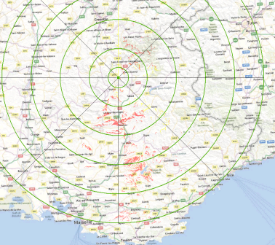

Figure 15

Coordination area for the Plateau de Bure (one interferer). Distance between two radii: 30 km

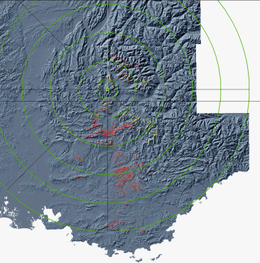

As it can be seen from Figs 15 and 16, the distance around the RAS site heavily depends on the terrain shape. In the case of Plateau de Bure, the red area almost always covers mountains’ tops or areas normally inaccessible to vehicles (see also below).

In order to appreciate the impact of multiple interferes on area, Fig. 15 adds in blue to the previous coverage yellow and red areas for which interference would be less than the threshold but within a 40 dB range. In other words, up to 10 000 transmitters would be acceptable, provided that they all operated outside the coloured areas in Fig. 17 (blue or red or yellow). The estimate is conservative because in reality the majority of the radars will not experience signal enhancements due to scintillations at the same time so most of them will contribute less to the aggregated effect. As it can be seen, the extension of the blue area is not significant. This is basically due to the fact that at 78 GHz diffraction is very effective in stopping the signal and the shadow region is reduced. In other words, for RAS sites that are well shielded by terrain, the effect of multiple interferers should not dramatically change the area with respect to one single transmitter.

Figure 16

Coordination area for the Plateau de Bure (one interferer). Distance between two radii: 30 km

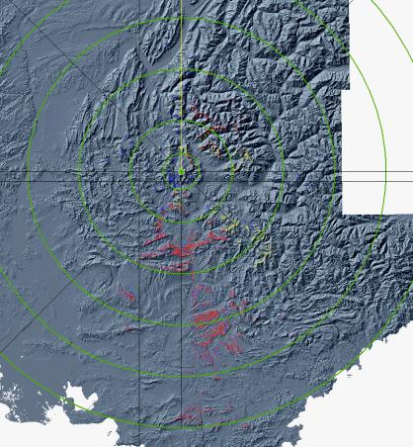

Blue areas, with respect to the previous Figures, indicate the zone that would generate interference within 40 dB from the limit.

Close inspection of the coordination area reveals that it overlaps some zone where cars can be located (an urban area and a route). See Fig. 17 for a detailed view of such area.

Figure 17

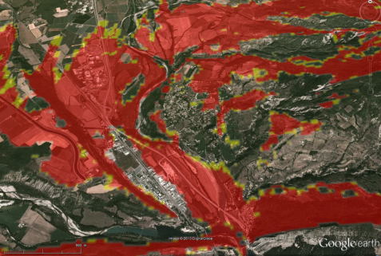

For the areas indicated in the Figure above, a more detailed analysis needs to be performed, taking into account density of vehicles, and possibly mitigation measures will have to be adopted (like adding shielding artefacts or vegetation on the road side, or via a specific shielding of the RAS site in the direction of the concerned area, or imposing a quiet zone to SRR triggered by a GPS fix).

In conclusion, this preliminary assessment of the sharing issues between SRR and RAS in the 78 GHz band, performed for the Pic du Bure case study, indicates that:

– The shape and dimension of the coordination area largely depends on the features of terrain surrounding the RAS site. In principle terrain shape and terrain occupation should be considered.

– Choice of the location may greatly improve the protection of systems operating in the RAS.

– Areas of concern remain and will have to be further analysed and dealt with by administrations.

– Provided that RAS sites are at emplacements well shielded by terrain relief, the magnitude of the interference issue is manageable.

### 6.3.5 Conclusion of sharing studies with the radio astronomy stations

Some administrations have concluded that the possibility of interference to RAS from automotive radars is sufficiently low and that the propagation characteristics of the band, translate in practice to a minimal interference potential to RAS operations. However, in some parts of the world, mitigation measures such as proper power emission limits might be needed to avoid potential interference to the radio astronomy service; some administrations permit the operation of automotive radars with specified emission power limits.

In general, the following conclusions can be drawn:

– The shape and dimension of the coordination area largely depends on the features of terrain surrounding the RAS site. In principle terrain shape and terrain occupation should be considered.

– Choice of the location may greatly improve the protection of systems operating in the RAS.

– Provided that RAS sites are adequately shielded by terrain relief, the magnitude of the interference issue is manageable.

– Areas of concern remain and will have to be further analysed and dealt with by administrations.

It is hoped that the radio astronomy community and the automotive radar manufacturers will continue their cooperative efforts to examine and implement mitigation techniques that can be employed to address potential interference concerns. Based on the above, potential cases of interference would be expected to be localized and could best be resolved by the administrations.

# 7 Compatibility studies in the adjacent frequency bands 76-77.5 and 78‑81 GHz

In the 76-77.5 and 78-81 GHz frequency bands, there is already a primary allocation to Radiolocation service. The studies performed up to now concluded that coexistence in the co channel case with the incumbent services is already possible. Therefore, there is no need to consider compatibility in an adjacent band scenario.

# 8 Conclusions

Theoretical studies and observations indicated that the required separation distance between automotive radars and incumbent services could range from less than 1 km to up to 42+km, depending on the interference scenario and deployment environment. These results were based on worst-case assumptions and did not take into account the effects of terrain shielding, terrain occupation and the implementation of mitigation techniques to reduce the possibility of interference to incumbent services. When these factors are taken into account, the possibility of co-channel interference to incumbent services from automotive radars is sufficiently low and manageable. Therefore, it can be concluded that in the 77.5-78 GHz band, sharing is feasible between automotive radars and incumbent services.

It is expected that any potential cases of interference between automotive radars and incumbent services could be addressed by mitigation factors such as terrain shielding, emission power limits and quiet zones. Some areas of concern remain and may need to be further analysed and dealt with by administrations. It is anticipated that the radio astronomers, radio amateurs and the automotive radar manufacturers will continue their cooperative effort to examine and implement mitigation techniques that can be employed to address potential interference concerns.

Annex A  
  
Automotive radar characteristics

TABLE 1

Automotive radar characteristics in the frequency band 76-81 GHz

|  |  |  |  |  |  |  |
| --- | --- | --- | --- | --- | --- | --- |
| Parameter | Units | Radar A(1)  Automotive radar  For front applications for e.g. for adaptive cruise control | Radar B  Automotive high-resolution radar  For front applications | Radar C  Automotive high-resolution radar  For corner applications | Radar D  Automotive  high-resolution radar | Radar E  Automotive  high-resolution radar  Very short range applications  (e.g. parking-aid, collision avoidance at very low speed) |
| Sub-band used | GHz | 76-77 | 77-81 | 77-81 | 77-81 | 77-81 |
| Typical operating range | m | Up to 250 | Up to 100 | Up to 100 | Up to 100 | Up to 50 |
| Range resolution | cm | 75 | 7.5 | 7.5 | 7.5 | 7.5 |
| Typical emission type |  | FMCW, Fast‑FMCW | FMCW, Fast‑FMCW | FMCW, Fast‑FMCW | FMCW | FMCW, Fast‑FMCW |
| Max necessary bandwidth | GHz | 1 | 4 | 4 | 4 | 4 |
| Chirp bandwidth | GHz | 1 | 2-4 | 2-4 | 2-4 | 2 |
| Typical sweep time | μs | 10 000-40 000 for FMCW  10-40 for fast‑FMCW | 10 000-40 000 for FMCW  10-40 for fast‑FMCW | 10 000-40 000 for FMCW  10-40 for fast‑FMCW | 2 000-20 000 for FMCW | 10 000-40 000 for FMCW  10-40 for fast‑FMCW |
| Maximum e.i.r.p. | dBm | 55 | 33 | 33 | 45 | 33 |
| Maximum transmit power to antenna | dBm | 10 | 10 | 10 | 10 | 10 |
| Max power density of unwanted emissions | dBm/MHz | 0 (73.5‑76 GHz and 77‑79.5 GHz)  –30 otherwise | –30 | –30 | –13(2) | –30 |
| Receiver IF bandwidth  (–3 dB) | MHz | 0.5-1 | 10 | 10 | 10 | 10 |
| Receiver IF bandwidth  (–20 dB) | MHz | 0.5-20 | 15 | 15 | 15 | 15 |

TABLE 1 (*end*)

|  |  |  |  |  |  |  |
| --- | --- | --- | --- | --- | --- | --- |
| Parameter | Units | Radar A(1)  Automotive radar  For front applications for e.g. for adaptive cruise control | Radar B  Automotive high-resolution radar  For front applications | Radar C  Automotive high-resolution radar  For corner applications | Radar D  Automotive  high-resolution radar | Radar E  Automotive  high-resolution radar  Very short range applications (e.g. parking-aid, collision avoidance at very low speed) |
| Receiver sensitivity (3) | dBm | –115 | –120 | –120 | –120 | –120 |
| Receiver noise figure | dB | 15 | 12 | 12 | 12 | 12 |
| Equivalent noise bandwidth | kHz | 25 | 16 | 16 | 16 | 16 |
| Antenna main beam gain | dBi | Typical 30, Maximum 45 | TX: 23  RX: 16 | TX: 23  RX: 13 | TX: 35 max.  RX: 35 max | TX: 23  RX: 13 |
| Antenna height | m | 0.3-1 above road | 0.3-1 above road | 0.3-1 above road | 0.3-1 above road | 0.3-1 above road |
| Antenna azimuth scan angle | degrees | TX/RX: ±15 | TX: ±22.5  RX: ±25 | TX: ±23  RX: ±30 | TX: ±30  RX: ±30 | TX: ±50  RX: ±50 |
| Antenna elevation HPBW | degrees | TX/RX: ±3 | TX/RX: ±5.5 | TX/RX: ± 5.5 | TX/RX: ± 5.5 | TX/RX: ± 5.5 |
| (1) Radar type A is related to Recommendation ITU-R M.1452.  (2) Maximum power density of unwanted emission is specified at antenna input terminal.  (3) The receiver sensitivity is determined using the equivalent noise bandwidth. | | | | | | |

Annex B  
  
Atmospheric attenuation of radio waves

Attenuation of radio waves by the Earth’s atmosphere generally consists of attenuation by atmospheric gases (oxygen and water vapour) and by fog or rain. The analysis shows, that the greatest contribution to the attenuation of radio waves by the Earth’s atmosphere is due to atmospheric gases and rain. Therefore, to estimate the target detection distance, *Datm*, attenuation of radio waves by the atmosphere, *Latm*, has to be determined. This attenuation can be defined by the following formula:

 (dB); (6)

where:

γg : specific attenuation due to atmospheric gases (dB/km)

γR : specific attenuation due to rain (dB/km)

*Datm* : target detection distance considering attenuation of radio waves in the Earth atmosphere.

Using equation (6), the target detection distance can be defined as follows:

, (m), (7)

Equation (7) is transcendental. Applying the logarithm to both parts of this equation, we can derive:

 (8)

Thus, to determine the target detection distance taking into account the atmospheric attenuation, it is necessary to know the specific attenuation. Now, let us estimate (γ*g*+ γ*R*) for radio frequency 77.75 GHz and typical atmospheric conditions:

– pressure, *Patm* = 1013 hPa;

– temperature, *Tatm* = 150C;

– water vapour density, ρ = 7.5 g/m3 at calculation γ*g* – attenuation of radio waves in atmospheric gases and ρ = 12.8 g/m3 at calculation γ*R* – attenuation of radio waves in the conditions of a rain with intensity from 5 to 50 mm/h;

− rain intensity, *R* = 5; 10; 15; 20; 25, 30 and 50 mm/h.

Specific attenuation of radio waves in atmospheric gases is calculated using methodology of Recommendation ITU-R P.676-6 - Attenuation by atmospheric gases. According to this technique, specific attenuation of radio waves in atmospheric gases at frequency 77.75 GHz is defined by the following formula:

 , (9)

where:

γО – specific attenuation in oxygen, dB/km, and  – specific attenuation in water vapour (dB/km).

In its turn, specific attenuation in oxygen, γО, is defined by the formula:



, (10)

where the coefficients in the formula (10) can be found from the equations:

*rp* = *Patm/*1013; (11а)

*rt* = 288/(273+Tatm); (11b)

; (11с)

; (11d)

; (11е)

. (11f)

Substituting typical atmospheric parameters in the equations (11а) and (11b) and using equations (11с) to (11f) and (6), we can find specific attenuation of radio waves in the oxygen at frequency 77.75 GHz, that is γ*О* = 0.072 dB/km.

Specific attenuation in water vapour,, is defined by the formula:



where the coefficients in equation (12) can be found from the equations:

; (13a)

. (13b)

Substituting typical atmospheric parameters in the equations (13а) and (13b) and using equation (12), we can find specific attenuation of radio waves in water vapours at frequency 77.75 GHz, that is  = 0.566 dB/km. Then taking into account the formula (9), specific attenuation of radio waves in atmospheric gases at frequency 77.75 GHz will be equal:

, dB/km. (14)

Specific attenuation of radio waves in rain is calculated using methodology of Recommendation ITU‑R P.838-3 - Specific attenuation model for rain for use in prediction methods. According to this technique, specific attenuation of radio waves in rain at frequency 77.75 GHz is defined by the following formula:

, (15)

where the coefficients *K* and α are functions of frequency and polarization of radio waves. For frequency 77.75 GHz the coefficients are:

– for horizontal polarization: *KH* = 1.1395 and α*H* = 0.716;

– for vertical polarization: *KV* = 1.1385 and α*V* = 0.706.

In order to determine the relationship between specific rain attenuation and rain intensity, calculations were carried out for various rain intensities from 5 to 30 mm/h using equation (15). For middle geographical latitudes of Russian territory these rain intensities correspond to the percentage of time for the worst month of a year from 1% to 0,042%, as it is shown in Table 1. Table 1 also shows calculation results for specific attenuation of radio waves with horizontal and vertical polarizations, $γ_{R_{H}}, γ_{R_{V}},$ for each rain intensity. Also this Table shows the calculation results of the final specific attenuation by the Earth’s atmosphere with horizontal and vertical polarizations (dB/km).

TABLE 1

|  |  |  |  |  |  |  |  |  |
| --- | --- | --- | --- | --- | --- | --- | --- | --- |
| Rain intensity, R, | 5 | 10 | 15 | 20 | 25 | 30 | 50 | mm/h |
| Specific rain attenuation for horizontal polarization $,{ γ}_{R_{H}}$ | 3.982 | 5.925 | 8.296 | 10.108 | 11.794 | 13.387 | 18.757 | dB/km |
| Specific attenuation of radio waves by Earth atmosphere for horizontal polarization, ${ γ}_{{atm}_{H}}$ | 4.62 | 6.563 | 9.02 | 10.746 | 12.432 | 14.025 | 19.395 | dB/km |
| Specific rain attenuation for vertical polarization, ${γ }_{R_{V}}$ | 3.547 | 5.785 | 7.703 | 9.438 | 11.048 | 12.566 | 18.022 | dB/km |
| Specific attenuation of radio waves by Earth atmosphere for vertical polarization, ${ γ}_{{atm}_{V}}$ | 4.185 | 6.423 | 8.341 | 10.076 | 11.686 | 13.204 | 18.660 | dB/km |

Annex C  
  
Required output power of automotive radar versus detection distance

# 1 Required output power of automotive radar in the rain conditions

On the basis of the computed final specific attenuation for horizontal polarization, the detection distance, *Datm*, for automotive radar was calculated by formula (2), taking into account attenuation by the Earth’s atmosphere for conditions without a rain and for various rain intensities from 0 ‑ 50 mm/h. Power parameters of automotive radar type B from Recommendation ITU-R М.2057 - Systems characteristics of automotive radars operating in the frequency band 76-81 GHz for intelligent transport systems applications, were thus used:

– receiver sensitivity *Pr min*= 10-15 W (minus 120 dBm);

– antenna gain in a transmit mode, *GAtx* ≈ 200 (23 dBi);

– antenna gain in a receive mode, *GArx* ≈ 40 (16 dBi).

During the calculations the detection distance in free space,D0, was assumed in the range from 10 up to 280 m for a “car” target and from 5 up to 90 m – for a “pedestrian” target. After that, the product of the specific attenuation by the detection distance in free space was calculated, making it possible to derive the ratio *Datm*/*D0*from Fig. 18 (calculated by the equation (8) in Annex B) and then calculate the detection distance taking into account attenuation by the Earth’s atmosphere. In the final part of the calculations the necessary transmitter power of the automotive radar, *Pt atm*, was determined using the formula:

 (W) (16)

In the calculations using equation (16), “car” target scattering cross-section was assumed to be 1 m2, and “pedestrian” target scattering cross-section 0.0316 m2.

Such power of the radar transmitter will provide appropriate detection distance in free space and smaller distance in the Earth’s atmosphere.

The calculation results using equation (16) for “car” and “pedestrian” targets are presented in Tables 1 and 2 and also as curves of detection distances versus transmitter power for free space and for the Earth’s atmosphere with various rain intensities are plotted in Figs 19 and 20, respectively.

figure 18

Datm/D0 vs. (γatm × D0)



TABLE 1

Summary of calculations for “car” target

|  |  |  |  |  |  |  |  |
| --- | --- | --- | --- | --- | --- | --- | --- |
| Requirements transmitter power of the radar type B  *Pt* (W) | Detection distance (free space), *D0* (m) | Detection distance for “car” target (Earth atmosphere)  *Datm**car* (m) | | | | | |
| R = 0 (mm/h) | R = 5 (mm/h) | R = 10 (mm/h) | R = 15 (mm/h) | R = 20 (mm/h) | R = 25 (mm/h) |
| 1.678×10-7 | 10 | 10 | 9.95 | 9.93 | 9.90 | 9.88 | 9.86 |
| 2.685×10-6 | 20 | 20 | 19.80 | 19.70 | 19.62 | 19.54 | 19.46 |
| 1.359×10-5 | 30 | 30 | 29.58 | 29.34 | 29.13 | 28.98 | 28.80 |
| 4.296×10-5 | 40 | 40 | 39.20 | 38.84 | 38.52 | 38.20 | 37.96 |
| 1.049×10-4 | 50 | 50 | 48.80 | 48.20 | 47.70 | 47.25 | 46.85 |
| 2.175×10-4 | 60 | 60 | 58.26 | 57.42 | 56.76 | 56.10 | 55.56 |
| 4.029×10-4 | 70 | 70 | 67.69 | 66.57 | 65.59 | 64.75 | 64.05 |
| 6.873×10-4 | 80 | 80 | 77.04 | 75.60 | 74.40 | 73.28 | 72.32 |
| 1.101×10-3 | 90 | 90 | 86.31 | 84.42 | 82.89 | 81.63 | 80.46 |
| 1.678×10-3 | 100 | 100 | 95.40 | 93.20 | 91.40 | 89.80 | 88.40 |
| 2.457×10-3 | 110 | 110 | 104.61 | 101.86 | 99.66 | 97.79 | 96.25 |
| 3.479×10-3 | 120 | 120 | 113.64 | 110.40 | 107.88 | 105.72 | 103.92 |
| 4.792×10-3 | 130 | 130 | 122.59 | 118.82 | 115.96 | 113.49 | 111.41 |
| 6.446×10-3 | 140 | 140 | 131.32 | 127.12 | 123.90 | 121.10 | 118.72 |
| 8.495×10-3 | 150 | 150 | 140.10 | 135.45 | 131.70 | 128.70 | 125.85 |
| 0.011 | 160 | 160 | 148.64 | 143.52 | 139.36 | 136.00 | 132.96 |
| 0.014 | 170 | 170 | 157.42 | 151.64 | 147.05 | 143.31 | 139.91 |
| 0.018 | 180 | 180 | 165.96 | 159.48 | 154.44 | 150.30 | 146.70 |
| 0.022 | 190 | 190 | 174.42 | 167.39 | 161.88 | 157.51 | 153.52 |
| 0.027 | 200 | 200 | 182.80 | 175.20 | 169.20 | 164.40 | 160.20 |
| 0.033 | 210 | 210 | 191.31 | 182.91 | 176.40 | 171.15 | 166.53 |
| 0.039 | 220 | 220 | 199.54 | 190.52 | 183.48 | 177.98 | 172.92 |
| 0.047 | 230 | 230 | 207.69 | 198.03 | 190.67 | 184.46 | 179.40 |
| 0.056 | 240 | 240 | 216.00 | 205.44 | 197.52 | 191.04 | 185.52 |
| 0.066 | 250 | 250 | 224.00 | 212.75 | 204.25 | 197.50 | 191.50 |
| 0.077 | 260 | 260 | 232.18 | 220.22 | 211.12 | 203.84 | 197.60 |
| 0.089 | 270 | 270 | 240.03 | 227.34 | 217.89 | 210.06 | 203.58 |
| 0.103 | 280 | 280 | 248.08 | 234.36 | 224.28 | 216.16 | 209.44 |

TABLE 1 (*end*)

|  |  |  |  |  |  |  |
| --- | --- | --- | --- | --- | --- | --- |
| Requirements transmitter power of the radar type B  *Pt* (W) | Detection distance (free space), *D0* (m) | Detection distance for “car” target (Earth atmosphere) *Datm car* (m) | | | | |
| R = 30  (mm/h) | R = 35  (mm/h) | R = 40  (mm/h) | R = 45  (mm/h) | R = 50  (mm/h) |
| 1.678×10-7 | 10 | 9.85 | 9.83 | 9.81 | 9.80 | 9.78 |
| 2.685×10-6 | 20 | 19.40 | 19.34 | 19.28 | 19.22 | 19.16 |
| 1.359×10-5 | 30 | 28.68 | 28.53 | 28.41 | 28.29 | 28.17 |
| 4.296×10-5 | 40 | 37.68 | 37.48 | 37.24 | 37.04 | 36.84 |
| 1.049×10-4 | 50 | 46.45 | 46.15 | 45.80 | 45.50 | 45.20 |
| 2.175×10-4 | 60 | 55.02 | 54.54 | 54.12 | 53.64 | 53.28 |
| 4.029×10-4 | 70 | 63.35 | 62.72 | 62.16 | 61.60 | 61.04 |
| 6.873×10-4 | 80 | 71.52 | 70.72 | 70.00 | 69.28 | 68.64 |
| 1.101×10-3 | 90 | 79.47 | 78.48 | 77.58 | 76.77 | 75.96 |
| 1.678×10-3 | 100 | 87.20 | 86.00 | 85.00 | 84.00 | 83.10 |
| 2.457×10-3 | 110 | 94.82 | 93.39 | 92.18 | 91.08 | 89.98 |
| 3.479×10-3 | 120 | 102.24 | 100.68 | 99.24 | 97.92 | 96.72 |
| 4.792×10-3 | 130 | 109.46 | 107.64 | 106.08 | 104.65 | 103.22 |
| 6.446×10-3 | 140 | 116.62 | 114.52 | 112.84 | 111.16 | 109.62 |
| 8.495×10-3 | 150 | 123.45 | 121.35 | 119.40 | 117.45 | 115.80 |
| 0.011 | 160 | 130.40 | 128.00 | 125.76 | 123.68 | 121.92 |
| 0.014 | 170 | 137.02 | 134.47 | 132.09 | 129.88 | 127.84 |
| 0.018 | 180 | 143.64 | 140.76 | 138.06 | 135.72 | 133.56 |
| 0.022 | 190 | 150.10 | 147.06 | 144.21 | 141.55 | 139.27 |
| 0.027 | 200 | 156.40 | 153.00 | 150.00 | 147.20 | 144.80 |
| 0.033 | 210 | 162.54 | 158.97 | 155.82 | 152.88 | 150.15 |
| 0.039 | 220 | 168.74 | 165.00 | 161.48 | 158.40 | 155.54 |
| 0.047 | 230 | 174.80 | 170.66 | 166.98 | 163.76 | 160.54 |
| 0.056 | 240 | 180.72 | 176.40 | 172.56 | 168.96 | 165.84 |
| 0.066 | 250 | 186.50 | 182.00 | 177.75 | 174.00 | 170.75 |
| 0.077 | 260 | 192.14 | 187.46 | 183.04 | 179.14 | 175.50 |
| 0.089 | 270 | 197.91 | 192.78 | 188.19 | 184.14 | 180.36 |
| 0.103 | 280 | 203.28 | 197.96 | 193.48 | 189.00 | 185.08 |

TABLE 2

Summary of calculations for “pedestrian” target

|  |  |  |  |  |  |  |  |  |  |  |  |  |
| --- | --- | --- | --- | --- | --- | --- | --- | --- | --- | --- | --- | --- |
| Requirements transmitter power of the radar type B  Pt , W | Detection distance (free space), D0 , m | Detection distance for “pedestrian” target (Earth atmosphere) *Datm ped* (m) | | | | | | | | | | |
| R= 0 mm/h | R= 5 mm/h | R= 10 mm/h | R= 15 mm/h | R= 20 mm/h | R= 25 mm/h | R= 30 mm/h | R= 35 mm/h | R= 40 mm/h | R= 45 mm/h | R= 50 mm/h |
| 3.319×10-7 | 5 | 5 | 4.99 | 4.98 | 4.98 | 4.97 | 4.97 | 4.96 | 4.96 | 4.96 | 4.95 | 4.95 |
| 5.31×10-6 | 10 | 10 | 9.95 | 9.93 | 9.90 | 9.88 | 9.86 | 9.85 | 9.83 | 9.81 | 9.80 | 9.78 |
| 2.688×10-5 | 15 | 15 | 14.9 | 14.84 | 14.79 | 14.73 | 14.70 | 14.66 | 14.63 | 14.58 | 14.55 | 14.52 |
| 8.496×10-5 | 20 | 20 | 19.80 | 19.70 | 19.62 | 19.54 | 19.46 | 19.40 | 19.34 | 19.28 | 19.22 | 19.16 |
| 2.074×10-4 | 25 | 25 | 24.70 | 24.55 | 24.40 | 24.28 | 24.18 | 24.08 | 23.98 | 23.88 | 23.80 | 23.70 |
| 4.301×10-4 | 30 | 30 | 29.55 | 29.34 | 29.13 | 28.98 | 28.83 | 28.68 | 28.53 | 28.41 | 28.29 | 28.17 |
| 7.968×10-4 | 35 | 35 | 34.41 | 34.13 | 33.85 | 33.64 | 33.43 | 33.22 | 33.04 | 32.87 | 32.69 | 32.55 |
| 1.359×10-3 | 40 | 40 | 39.24 | 38.84 | 38.52 | 38.20 | 37.96 | 37.68 | 37.48 | 37.24 | 37.04 | 36.84 |
| 2.177×10-3 | 45 | 45 | 44.06 | 43.56 | 43.11 | 42.75 | 42.44 | 42.12 | 41.81 | 41.58 | 41.31 | 41.04 |
| 3.319×10-3 | 50 | 50 | 48.80 | 48.20 | 47.70 | 47.25 | 46.85 | 46.45 | 46.15 | 45.80 | 45.50 | 45.20 |
| 4.859×10-3 | 55 | 55 | 53.57 | 52.86 | 52.25 | 51.70 | 51.21 | 50.77 | 50.38 | 50 | 49.61 | 49.28 |
| 6.882×10-3 | 60 | 60 | 58.32 | 57.42 | 56.76 | 56.10 | 55.56 | 55.02 | 54.54 | 54.12 | 53.64 | 53.28 |
| 9.479×10-3 | 65 | 65 | 63.05 | 62.01 | 61.17 | 60.45 | 59.80 | 59.22 | 58.7 | 58.18 | 57.66 | 57.20 |
| 0.013 | 70 | 70 | 67.69 | 66.57 | 65.59 | 64.82 | 64.05 | 63.35 | 62.72 | 62.16 | 61.60 | 61.04 |
| 0.017 | 75 | 75 | 72.38 | 71.10 | 69.98 | 69.08 | 68.25 | 67.43 | 66.75 | 66.08 | 65.48 | 64.88 |
| 0.022 | 80 | 80 | 77.04 | 75.52 | 74.32 | 73.28 | 72.32 | 71.52 | 70.72 | 70.00 | 69.28 | 68.64 |
| 0.028 | 85 | 85 | 81.69 | 79.99 | 78.63 | 77.52 | 76.42 | 75.48 | 74.63 | 73.78 | 73.02 | 72.34 |
| 0.035 | 90 | 90 | 86.31 | 84.42 | 82.98 | 81.63 | 80.46 | 79.47 | 78.48 | 77.58 | 76.77 | 75.96 |

FIGURE 19

“Car” target D0 and Datm vs. Pt for various rain intensities R



FIGURE 20

“Pedestrian” target D0 and Datm vs Pt for various rain intensities R



From Table 1 and Fig. 19 we can derive that for “car” target detection distance of 100 m in free‑space with the automotive radar type B, the required transmitter power shall be approximately 1.7 mW or 2.3 dBm. The target detection distance in the Earth’s atmosphere is limited to 95.4 m with rain intensity of 5 mm/h and to 83.1 m with rain intensity of 50 mm/h. Similarly, from Table 2 and Fig. 20 we can derive that for “pedestrian” target detection distance of 60 m in free space with the automotive radar type B, the required transmitter power shall be approximately 6.9 mW or 8.4 dBm. In this case, the target detection distance in the Earth’s atmosphere is limited to 58.3 m with rain intensity of 5 mm/h and to 50 m with rain intensity of 50 mm/h.

# 2 Required detection distance for useful breaking

## 2.1 Scenarios to be considered

It is necessary to distinguish between two cases:

– The radar is used to detect a car (Case A).

– The radar is used to detect a pedestrian (Case B).

In general, the two cases differ for a set of parameters:

– Case A (car to car): the most critical case is identified for the following scenario: the radar is mounted on a car speeding at 110 km/h (for instance on a highway), when rain is falling at 50 mm/h and the target to be detected is another car, placed along the direction of the motion. The effective target area is 1 m2. The required sensing distance is the distance that allows the driver to stop the car, avoiding collision with the other car.

– Case B (car to pedestrian): the most critical case is identified for the following scenario: the radar is mounted on a car, in a suburban environment, when rain is falling at 50 mm/h. In this case, the speed of the car is less than the previous case and it is assumed to be max 60 km/h.

## 2.2 Required detection distance for Case A (car to car)

To determine the necessary obstacle detection distance, Dmax V, we calculated maximum distance that the vehicle passes from the moment of obstacle detection by the driver until full stop. This distance can be determined from the formula:

, m; (17)

where:

VV1 : vehicle speed, m/s, assumed 30.6 m/s (110 km/h); for car target

tdr : driver response time, 1s

tV : vehicle brake system response time, 1s

VV2 : vehicle speed when the brakes applied (km/h)

kr : tire grip coefficient. It equals 0.4 for rain condition. This coefficient depends on rain intensity, and could be obtained from Table 3.

Substituting input data into equation (17), we obtain the maximum distance that a vehicle will travel from the moment of obstacle detection by the driver until full stop with various rain intensities. These distances are also given in Table 3. In most critical conditions (such as rain intensity of 50 mm/h) this distance equals approximately 180 m for “car” target.

## 2.3 Required detection distance for Case B (car to pedestrian)

In the case when the radar is intended for detection of the pedestrian, following changes in equation (17) have been made:

*VV*1 – vehicle speed is equal 16.7 m/s, that corresponds to speed *Vv*2, equal 60 km/h.

Substituting in equation (17) necessary initial data, we can calculate the maximum distance which is passed by the car from the moment of detection by the driver of an obstacle to a full stop of the car for case B.

Results of calculation of the maximum distance that vehicle will travel in Case B are given in Table 3. In most critical conditions (such as rain intensity of 50 mm/h) this distance equals approximately 68.8 m for “pedestrian” target.

TABLE 3

|  |  |  |  |  |  |  |  |  |  |  |  |  |
| --- | --- | --- | --- | --- | --- | --- | --- | --- | --- | --- | --- | --- |
| Rain intensity, *R*, | mm/h | 0 | 5 | 10 | 15 | 20 | 25 | 30 | 35 | 40 | 45 | 50 |
| Tire grip coefficient, *kr* | – | 0.75 | 0.53 | 0.468 | 0.436 | 0.422 | 0.415 | 0.408 | 0.404 | 0.403 | 0.402 | 0.4 |
| “Car” target detection distance in the Earth’s atmosphere, *Datm car* ,  for a radar type B | m | 153.1 | 145.3 | 140.4 | 136.2 | 133.1 | 129.9 | 127.5 | 125.3 | 123.3 | 121.2 | 119.6 |
| Maximum distance travelled by vehicle until full stop *Dmax* V, with initial speed of 110 km/h | m | 125 | 151 | 163 | 170 | 174 | 176 | 178 | 179 | 163 | 179.5 | 180 |
| “Pedestrian” target detection distance in the Earth’s atmosphere, *Datm ped* , for a radar type B | m | 65.1 | 63.4 | 62.6 | 61.8 | 61.1 | 60.4 | 59.8 | 59.3 | 58.8 | 58.3 | 57.8 |
| Maximum distance travelled by vehicle until full stop *Dmax V*, with initial speed of 60 km/h | m | 52.4 | 60.1 | 63.7 | 65.9 | 67 | 67.6 | 68.2 | 68.4 | 68.6 | 68.7 | 68.8 |

Calculation results of “car” and “pedestrian” target detection distance for automotive radar type B in Earth’s atmosphere are also presented in Table 3. Besides, these results are presented in Figs 21 and 22, respectively.

From Table 3 and Figs 21 and 22 it can be seen that automotive radar type B can ensure required detection distance only in clear atmosphere or in low rain intensity: for “car” target in rain intensity below 5 mm/h and for “pedestrian” target in rain intensity below 10 mm/h.

FIGURE 21

“Car” target detection distance Datm car for automotive radar type B and maximum   
distance travelled by car until full stop Dmax V car versus rain intensity



FIGURE 22

“Pedestrian” target detection distance Datm ped for automotive radar type B and maximum   
distance travelled by car until full stop Dmax V ped versus rain intensity



The required automotive radar transmitter power was calculated to achieve the detection distance of 180 m in Earth’s atmosphere for “car” target and 68.8 m for “pedestrian” target. Results of the calculation are presented in Table 4.

TABLE 4

Required automotive radar transmitter power for various rain intensities

|  |  |  |  |  |  |  |  |  |  |  |  |  |
| --- | --- | --- | --- | --- | --- | --- | --- | --- | --- | --- | --- | --- |
| Rain intensity, *R*, | mm/h | 0 | 5 | 10 | 15 | 20 | 25 | 30 | 35 | 40 | 45 | 50 |
| Required power for “car” target detection distance of 180 m, *Preq* | W | 0.018 | 0.025 | 0.03 | 0.036 | 0.042 | 0.048 | 0.055 | 0.062 | 0.07 | 0.079 | 0.088 |
| dBm | 12.55 | 13.98 | 14.77 | 15.56 | 16.23 | 16.81 | 17.4 | 17.92 | 18.45 | 18.98 | 19.44 |
| Required power for “pedestrian” target detection distance of 68.8 m, *Preq* | W | 0.012 | 0.0138 | 0.0147 | 0.0157 | 0.0165 | 0.0175 | 0.0185 | 0.0193 | 0.020 | 0.021 | 0.022 |
| dBm | 10.79 | 11.4 | 11.67 | 11.96 | 12.17 | 12.43 | 12.67 | 12.86 | 13.01 | 13.22 | 13.42 |

Annex D  
  
List of radio astronomy service station sites in the world that use or will potentially use the 78 GHz frequency band

NOTE **–** Where the Rx height above terrain is not specified, a good estimate is to take it equal to the diameter of the antenna.

ITU-R Region 1

|  |  |  |  |  |
| --- | --- | --- | --- | --- |
| Observatory name (Administration) | Longitude (E), Latitude (N), Elevation (m AMSL) | Minimum elevation  (degrees) | Rx height above terrain  (m) | Geographical characteristics |
| Bordeaux 2.5 m France | –00o31’37”  44o50’10”  73 | 0 |  |  |
| Plateau de Bure,  12 × 15 m Array, IRAM, France (1) | 05o54’28.5”  44o 38’ 02”  2250 | 0 | 15 | Isolated high mountaintop in line-of-sight to various public facilities |
| Maido (la Réunion)  Horns 0.25 × 0.36 m  0.70 × 0.48 m  France | 55°23’01”  –21°04’46”  2200 |  |  | Mountain top |
| Effelsberg, 100 m, Germany | 06o53’00”  50o31’32”  369 | 7 |  | Broad flat plain exposed to nearby roads |
| Pico de Veleta, 30 m  IRAM, Spain (1) | –03o23’34”  37o03’58”  2850 | 0 | 31 | Mountainside overlooking nearby ski resort, line of sight to city of Granada |
| Yebes 40 m  Yebes 14 m  Spain | –03o05’22”  40o31’27”  981 | 0  4 |  | Broad flat plain exposed to roads |
| Sardinia Radio Telescope 64 m, Sardinia, Italy | 09o14’40”  39o29’50”  650 | 5 |  | High exposed plain |
| Onsala 25 m  Onsala 20 m  Sweden | 11o55’35”  57o23’45”  10 | 0  3 |  | Waterside, forested, relatively isolated, Gotheborg 40 km N |
| Metsahovi 14 m  Finland | 24o23’37”  60o13’04"  61 | 0 |  |  |
| Noto 32 m  Italy | 14°59’20.51”  [36°52’33.78”](http://toolserver.org/%7Egeohack/geohack.php?pagename=Noto_Radio_Observatory&params=36_52_33.78_N_14_59_20.51_E_) | 5 |  | Flat exposed plain.  VLBI |

ITU-R Region 1 (*end*)

|  |  |  |  |  |
| --- | --- | --- | --- | --- |
| Observatory name (Administration) | Longitude (E), Latitude (N), Elevation (m AMSL) | Minimum elevation  (degrees) | Rx height above terrain  (m) | Geographical characteristics |
| Cambridge 32 m  UK | 0°2’13.4”  52°10’1.2” | 2.5 |  | Flat terrain. |
| Zelenchuk RT-32 32 m  Russia | 41°33′52.6′′  43°47′16.2′′  1175 | 0 | 35 | The Republic of Karachay-Cherkessia  (Kavkaz region of the  Russian Federation) |
| Zelenchuk RATAN-600  576 m  Russia | 41°35′12.06′′  43°49′34.2′′  970 | 0 | 2 | The Republic of Karachay-Cherkessia  (Kavkaz region of the  Russian Federation) |
| Badary RTF-32 32 m  Russia | 102°14′04.95′′  51°46′11.6′′  813 | 0 | 35 | The Republic of Buryatia,  (the southern part of  Eastern Siberia) |
| Badary SSRT-256  256 mirror 2,5 m  Russia | 102°13′08′′  51°45′33′′  813 | 0 | 2 | The Republic of Buryatia,  (the southern part of  Eastern Siberia) |
| Pushino RT-22 FIAN  22 m  Russia | 37°37′57′′  54°49′22′′  200 | 5 | 30 | Moscow region of the  Russian Federation |
| Svetloe RTF-32 32 m  Russia | 29°46′54′′  60°31′56′′  86 | 0 | 35 | Leningrad region of the  Russian Federation |
| Kaljazin RT-64 64 m  Russia | 37°54′01′′  57°13′23′′  178 | 0 | 60 | Tver region of the  Russian Federation |

(1) These telescopes also observe at higher frequency bands that are harmonically related to the radar frequency.

ITU-R Region 2

|  |  |  |  |  |
| --- | --- | --- | --- | --- |
| Observatory name (Administration) | Longitude (E), Latitude (N), Elevation  (m AMSL) | Minimum elevation  (degrees) | Rx height above terrain  (m) | Geographical characteristics |
| Robert C Byrd 100 m Green Bank Telescope, W. VA, USA | –79.839411  38.432842 | 5 | 140 | Flat open space ringed by forest and hills; adjacent roads |
| VLBA-Brewster, WA (25 m), USA | –119.68333  48.131111 | 2.25 | 29 | Broad, flat river valley,  < 1 km from state highway US97. VLBI. |
| VLBA-Fort Davis, TX, USA | –103.94472  30.635000 | 2.25 | 29 | Broad, flat open high plain. 3 km from highway TX118. VLBI |
| VLBA-Hancock, NH, USA | –71.986666  42.933611 | 2.25 | 29 | Sea level in the woods, 1.5-3.0 km from multiple state and federal highways. VLBI |
| VLBA-Kitt Peak, AZ, USA | –111.61250  31.956389 | 2.25 | 29 | High mountainside, on AZ386, 6.5 km from highway AZ86. Phoenix in line-of-sight. VLBI |
| VLBA-Los Alamos, NM, USA | –106.24556  35.775278 | 2.25 | 29 | On a high cliff-side, 1 km from highway NM4. Exposed to Santa Fe 21 km away. VLBI |
| VLBA- Mauna Kea, HI, USA | –155.45528  19.801389 | 2.25 | 29 | High mountainside, 3 666 m above sea level. 9.6 km from highway HI200. VLBI |
| VLBA-North Liberty, IA, USA | –91.574166  41.771389 | 2.25 | 29 | In the woods just off of a busy local highway. Numerous small towns within 15 km. VLBI |
| VLBA-Owens Valley, CA, USA | –118.27694  37.231667 | 2.25 | 29 | Broad open plain, 5 km from highway US395. VLBI. |
| VLBA-Pie Town, NM, USA | –108.11917  34.301111 | 2.25 | 29 | High mountain, exposed, just off highway US60. VLBI |
| ARO Kitt Peak 12 m, AZ, USA (1) | –111.61250  31.956388 |  | 12 | Mountainside, exposed to south and west but hidden from Tucson |
| CARMA Array, Cedar Flat, CA, USA (1) | –118.14174  37.280416 |  |  | Mountaintop straddling public road |

ITU-R Region 2 (*end*)

|  |  |  |  |  |
| --- | --- | --- | --- | --- |
| Observatory name (Administration) | Longitude (E), Latitude (N), Elevation  (m AMSL) | Minimum elevation  (degrees) | Rx height above terrain  (m) | Geographical characteristics |
| Haystack Observatory 37 m Westford, MA, USA | –71.488611  42.623056 | 5 |  | Broad flat open area at ambient elevation |
| LMT 50 m Sierra Negra, Puebla Mexico (1) | –97.313333  18.985000 |  | 51 | At 4 660 m in line of sight to numerous towns and 15 km from Mexico City-Puebla-Veracruz highway |
| ALMA, Chajnantor, Chile (1) | –67.754928  –23.022911 |  |  | Broad flat high plain ringed by mountains, accessible by road |
| NANTEN2 4 m, Pampa La Bola. Chile | –67.702222  –22.296306 |  |  | Broad flat high plain accessible by public road |
| ARO SMT 10 m, Mt. Graham, AZ,  USA (2) | –109.89201  32.701303 |  | 10 | Remote forested mountaintop. Operates only above 100 GHz. |
| JCMT 15 m, SMA 6x6 m, CSO 12 m, Mauna Kea, HI,  USA (2) | –155.47500  19.821667 |  |  | Isolated very high mountaintop.  Operates only above 100 GHz. |

(1) These telescopes also observe at higher frequency bands that are harmonically related to the radar frequency.

(2) These telescopes only observe at higher frequency bands that are harmonically related to the radar frequency.

ITU-R Region 3

|  |  |  |  |  |
| --- | --- | --- | --- | --- |
| Observatory Name (Administration) | Longitude (E), Latitude (N), elevation (m AMSL) | Minimum elevation  (degs) | Rx height above terrain  (m) | Geographical characteristics |
| Mopra 22 m, Australia | 149º05’58”  –31º16’04” | 12 |  | Hilltop ringed by mountains |
| ATCA 6 x 22 m, Australia | 149º32’56”  –30º59’52” | 12 |  | Broad flat plain |
| Delingha 13.7 m, China | 97º33.6’  37º22.4’  3 200 | 5 |  | Flat plain |
| Sheshan 65 m, China | 121º9.8’  31º05.2’  6 | 5 |  | Flat plain |
| Qitai 110, China | 89º40.9’  43º36.0’  1 759 | 5 |  | Plain ringed by mountains |

ITU-R Region 3 (*end*)

|  |  |  |  |  |
| --- | --- | --- | --- | --- |
| Observatory Name (Administration) | Longitude (E), Latitude (N), elevation (m AMSL) | Minimum elevation  (degs) | Rx height above terrain  (m) | Geographical characteristics |
| RRI 10.4 m, India | 77º38’  12º58’ |  |  |  |
| Nobeyama 45 m, Japan | 138º28’21”  35º56’40” | 12 | 47 | Broad plain at an altitude of 1.350 m ringed by mountains |
| Kagoshima 6 m, Japan | 130º30’26”  31º27’51” | 4 | 10 | Facing a main road and a sea shore in 1 km in west and backed onto mountains and the sea beyond |
| VERA-Mizusawa 20 m, Japan | 141º07’57”  39º08’01” | 3 | 22 | VLBI  Broad plain open in north and south and shielded in east and west with a long range of mountains at both sides in 15 km |
| VERA-Iriki 20 m, Japan | 130º26’24”  31º44’52” | 3 | 22 | VLBI  Narrow plain surrounded by mountains |
| VERA-Ogasawara 20 m, Japan | 142º13’00”  27º05’31” | 3 | 22 | VLBI  Located in an isolated island about 900 km away from the mainland Japan |
| VERA-Ishigakijima 20 m, Japan | 124º10’16”  24º24’44” | 3 | 22 | VLBI  Located in an island in which it stands 8 km away from the populated district and is at the edge of mountains in north |
| Taejon 13.7 m, Korea | 127º22’18”  36º23’54” | 5 | 10.6 | Broad flat plain exposed to nearby roads |
| Seoul 6 m, Korea | 126º57’19”  37º27’15” | 5 | 4.5 | Steep Slope |
| KVN-Yonsei 20 m, Korea | 126º56’35”  37º33’44” | 5 | 15.6 | Gentle slope.  Single Dish and VLBI |
| KVN-Ulsan 20 m, Korea | 129º15’04”  35º32’33” | 5 | 15.6 | Steep slope.  Single Dish and VLBI |
| KVN-Tamna 20 m, Korea | 126º27’43”  33º17’18” | 5 | 15.6 | Gentle slope.  Single Dish and VLBI |

_____________

1. Document 5B/089 (Study cycle 2012-2015).
2. See the JRC report available at <http://publications.jrc.ec.europa.eu/repository/bitstream/111111111/27421/1/lbna25762enn.pdf>
3. Shambayati, S., 2008: Atmosphere Attenuation and Noise Temperature at microwave frequencies, Chapter 6 in “Low-Noise Systems in the Deep Space Network”, by MacGregor S. Reid. Editor, John Wiley and Sons, Hoboken, New Jersey.
4. Document 5B/157 (Study cycle 2012-2015).
5. Document 5B/157 (Study cycle 2012-2015).
6. <http://www.gb.nrao.edu/electronics/edtn/edtn219.pdf>.