|  |
| --- |
| **Report ITU-R M.2287-0**  **(12/2013)** |
| **Automatic identification system  VHF data link loading** |
| **M Series**  **Mobile, radiodetermination, amateur**  **and related satellite services** |

Foreword

The role of the Radiocommunication Sector is to ensure the rational, equitable, efficient and economical use of the radio-frequency spectrum by all radiocommunication services, including satellite services, and carry out studies without limit of frequency range on the basis of which Recommendations are adopted.

The regulatory and policy functions of the Radiocommunication Sector are performed by World and Regional Radiocommunication Conferences and Radiocommunication Assemblies supported by Study Groups.

# Policy on Intellectual Property Right (IPR)

ITU-R policy on IPR is described in the Common Patent Policy for ITU-T/ITU-R/ISO/IEC referenced in Annex 1 of Resolution ITU-R 1. Forms to be used for the submission of patent statements and licensing declarations by patent holders are available from <http://www.itu.int/ITU-R/go/patents/en> where the Guidelines for Implementation of the Common Patent Policy for ITU‑T/ITU‑R/ISO/IEC and the ITU-R patent information database can also be found.

|  |  |
| --- | --- |
| Series of ITU-R Reports  (Also available online at <http://www.itu.int/publ/R-REP/en>) | |
| **Series** | Title |
| **BO** | Satellite delivery |
| **BR** | Recording for production, archival and play-out; film for television |
| **BS** | Broadcasting service (sound) |
| **BT** | Broadcasting service (television) |
| **F** | Fixed service |
| **M** | Mobile, radiodetermination, amateur and related satellite services |
| **P** | Radiowave propagation |
| **RA** | Radio astronomy |
| **RS** | Remote sensing systems |
| **S** | Fixed-satellite service |
| **SA** | Space applications and meteorology |
| **SF** | Frequency sharing and coordination between fixed-satellite and fixed service systems |
| **SM** | Spectrum management |

|  |
| --- |
|  |

|  |
| --- |
| ***Note****: This ITU-R Report was approved in English by the Study Group under the procedure detailed in Resolution ITU-R 1.* |

*Electronic Publication*

Geneva, 2014

© ITU 2014

All rights reserved. No part of this publication may be reproduced, by any means whatsoever, without written permission of ITU.

REPORT ITU-R M.2287-0

Automatic identification system VHF data link loading

(2013)

# 1 Introduction

The purpose of this Report is:

– to provide an assessment of automatic identification system (AIS) VHF data link (VDL) loading in an example high vessel traffic area;

– to identify how AIS VDL loading affects the various functions of the AIS;

– to support WRC-15 agenda item 1.16 studies on additional AIS channels to support AIS applications and to mitigate AIS VDL loading; and

– to consider an example AIS implementation using two additional channels for AIS applications that would also provide sufficient capacity for the future of AIS.

# 2 WRC-15 agenda item 1.16

WRC-15 agenda item 1.16 “to consider regulatory provisions and spectrum allocations to enable possible new AIS technology applications and possible new applications to improve maritime radiocommunication in accordance with Resolution **360** **(WRC-12)**” addresses the excess AIS VDL loading problem and its potential solution, i.e. that the prospective addition of channels could provide a means to support AIS applications such that the harmful effects of excess AIS VDL loading for both the present and the future are mitigated.

# 3 Background

AIS is a maritime communication and safety of navigation system operating in the VHF frequency band and is used for vessel collision avoidance as well as the delivery of information about specific details of the vessel. Further, consequential to the introduction of the AIS-search and rescue transmitter (AIS-SART) for search and rescue operations, the AIS channels were added to Appendix **15** of the Radio Regulations.

With increasing demand for maritime VHF data communications, AIS has become heavily used for maritime safety, maritime situational awareness and port security. As a result, overloading of AIS 1 and AIS 2 has created a need for additional AIS channels. International Maritime Organization (IMO) Resolution MSC 74(69) required that AIS,

“…improve the safety of navigation by assisting in the efficient navigation of ships, protection of the environment, and operation of vessel traffic services (VTS), by satisfying the following functional requirements:

1) in a ship-to-ship mode for collision avoidance;

2) as a means for littoral States to obtain information about a ship and its cargo;

3) as a VTS tool, i.e. ship-to-shore (traffic management)”.

The International Association of Marine Aids to Navigation and Lighthouse Authorities (IALA) has advised in its maritime radio communication plan that additional AIS channels are required for ship-to-ship and ship‑to-shore maritime safety information and general data communications (i.e. area warnings, meteorological and hydrographic data, channel management of AIS, future   
VHF digital data channels, and ship-shore data exchange).

Although satellite detection of AIS on AIS 1 and AIS 2 was proven to be possible, its effectiveness was determined to be unacceptably limited where VDL loading is high. The need for a separate dedicated service on separate dedicated channels was confirmed by WRC-12 and two additional channels were designated. While this new designation solves the problem for satellite detection, AIS VDL loading remains a serious issue to an increasing degree in many parts of the world due to the proliferation of AIS applications, message types, services and equipment types plus the unanticipated increase in user volume.

IMO also recently expressed its concerns on this subject in Resolution MSC.347(91) (adopted on 30 November 2012) “Recommendation for the Protection of the AIS VDL”. To solve this problem and protect the integrity of the AIS VDL, AIS subject matter experts in IALA are considering an approach in which application specific messages (ASM) would be moved to two additional AIS channels. WRC-12 acknowledged this concept in its revision of Appendix **18** and provided four candidate channels on an experimental basis for this evaluation.

# 4 Effects on safety and the exchange of information

The harmful effects of AIS VDL loading and its degradation to “maritime radiocommunication”, as stated in WRC-15 agenda item 1.16 are described in IALA Recommendation A-124 – “Automatic Identification System (AIS) Shore Station and Networking Aspect relating to the AIS Service”, which states that when AIS VDL loading exceeds 50%:

– safety (the reduced ability of the shipborne AIS to find free slots) is impaired; and

– information exchange (the reduced ability of the AIS shore infrastructure to exchange information with the shipborne AIS) as required by IMO is impaired.

# 5 Requirements for the exchange of information

In addition to safety requirements, requirements for the exchange of information with an AIS shore infrastructure can be determined from the IMO AIS regulations and performance standards shown below, and including, as noted in § 3, IMO’s concern for the protection of the integrity of the AIS VDL to ensure that these requirements are met. The technical standard for AIS, Recommendation ITU-R M.1371, addresses the AIS shore infrastructure elements of AIS base stations, AIS aids to navigation and AIS repeaters, all of which have accompanying IEC performance standards and the AIS infrastructure standard, IALA Recommendation A-124 (ref. section 4).

IMO’s SOLAS Convention, as revised, Regulation 19, § 2.4.5, states with regard to the purpose of the AIS:

“AIS shall

1 provide automatically to appropriate equipped shore stations, other ships and aircraft information, including ship’s identity, type, position, course, speed, navigational status and other safety-related information;

2 receive automatically such information from similarly fitted ships;

3 monitor and track ships; and

4 exchange data with shore-based facilities.”

In addition, the IMO performance standards for the AIS state:

“1.2 The AIS should improve the safety of navigation by assisting in the efficient navigation of ships, protection of the environment, and operation of Vessel Traffic Services (VTS), by satisfying the following functional requirements:

1 in a ship-to-ship mode for collision avoidance;

2 as a means for littoral States to obtain information about a ship and its cargo; and

3 as a VTS tool, i.e. ship-to-shore (traffic management).

1.3 The AIS should be capable of providing to ships and to competent authorities, information from the ship, automatically and with the required accuracy and frequency, to facilitate accurate tracking. Transmission of the data should be with the minimum involvement of ship’s personnel and with a high level of availability.

1.4 The installation, in addition to meeting the requirements of the Radio Regulations, applicable ITU-R Recommendations and the general requirements as set out in Resolution A.694(17), should comply with the following performance standards. ”

# 6 Application of additional channels to mitigate excess automatic identification system VHF data link loading

Since safety and the exchange of information are the two main requirements of AIS which must be accommodated and protected, and since the current arrangement results in an unacceptable failure to meet these requirements in critical areas of high vessel traffic where these requirements are most needed, it is essential that:

– the Appendix **18** channels identified for additional AIS technology applications, e.g. ASM be designated for this purpose;

– the AIS utilizes the additional channels in a new arrangement that will ensure that the requirements of safety and exchange of information are satisfied; and

– the resulting arrangement will protect the integrity of the AIS VDL and is sufficient to accommodate the expected future growth.

# 7 Considerations for the utilization of additional channels

The new arrangement noted in § 6 should consider technical advances, administrative realities and constraints, including, but not limited to the following:

– there will be a need for a transition period and to ensure backwards compatibility during this period;

– there is strong motivation to minimize equipment and installation costs;

– there are technical advances that can provide significantly improved spectrum efficiency, e.g. advanced modulation waveforms (ref. En 300392-2 v3.2.1, Sec. 5, 76.8 kbps) which achieve an 8X increase in data rate per channel;

– the prospective expanded multi-channel arrangement may provide a means to separate the requirements of safety and the exchange of information on different channels with different communications protocols;

– the various AIS message types have different priorities, purposes and communication access schemes;

– there have been technical advances, e.g. software defined radios, that can provide highly complex multi-channel multi-function digital functionality in a very small physical size and at very low cost.

Monitoring of the VDL loading by three countries is provided in Annexes 1 to 3.

These annexes show that the 50% loading is almost reached or even excided. In addition, a preliminary study conducted in China in the middle of 2012 showed the occupancy rate of AIS 1 and AIS 2 frequencies was in average about 30% in some of the high traffic area such as Shanghai port and Bohai Bay. In rush hours, the occupancy might reach up to 40%. These data indicate the necessity of additional channels for the AIS.

Annex 1  
  
Situation of the VHF data link loading in USA

# 1 Introduction

The critical 50% threshold has already been exceeded in some areas of the world where vessel traffic is high, for example, the Northern Gulf of Mexico in the United States of America, as shown in Table 1. There is also a problem of accurately measuring AIS VDL loading, as shown in Table 2, which shows that the indicated loading value of 64% shown in Table 1, based on AIS messages received, is artificially low (presumably because of AIS slot reuse), and must actually be, based on AIS self-organized time division multiple access (SOTDMA) structured behaviour, as high as 133%. This also shows that information exchange between vessels and the AIS infrastructure is highly impaired, due to a significant loss (133%-64% = 69%) of information. This loading problem, as bad as it already is, is increasing as more vessels are being fitted, more types of devices containing AIS are introduced, and more AIS applications and ASM are implemented.

TABLE 1

VDL loading analysis[1]  
  
United States nationwide automatic identification system, Liverpool site,   
Northern Gulf of Mexico

|  |  |  |  |
| --- | --- | --- | --- |
| Site: Liverpool-1680 | | 18 Dec. 2012 (24hours) | |
| Observed VDL content | Total messages | Total slots used | Total VDL load (%) | Type 1 VDL load (%) | Type 1 < 0.5 VDL load (%) |  |
| **AIS “A”** | **1,929,553** | **2,078,421** | **64.15** | **49.0** | **29.7** |  |
| **AIS “B”** | **1,966,550** | **2,109,737** | **65.12** | **50.0** | **30.4** |  |
| **Total** | **3,896,103** | **4,188,158** | **64.63** | **49.5** | **30.1** |  |
| **Message type (comm state)** | **AIS “A” Channel** | **AIS “B”Channel** | | | **Total (both channels)** | |
| **Messages** | **Vessels** | **Messages** | **Vessels** | **Messages** | **Vessels** |
| **1 - Class A position report (SOTDMA)** | **1,586,142** | **2,059** | **1,618,620** | **2,049** | **3,204,762** | **2,201** |

TABLE 1 (*end*)

|  |  |  |  |  |  |  |
| --- | --- | --- | --- | --- | --- | --- |
| Site: Liverpool-1680 | | 18 Dec. 2012 (24hours) | |  | | |
| Observed VDL content | Total messages | Total slots used | Total VDL load (%) | Type 1 VDL load (%) | Type 1 < 0.5 VDL load (%) |  |
| 1 - SOG = 0.0 | 695,262 | 1,430 | 710,974 | 1,408 | 1,406,236 | 1,513 |
| 1 - SOG = 0.1 | 215,381 | 1,187 | 219,702 | 1,180 | 435,083 | 1,282 |
| 1 - SOG = 0.2 | 27,284 | 930 | 27,795 | 949 | 55,079 | 1,043 |
| 1 - SOG = 0.3 | 14,528 | 843 | 14,980 | 820 | 29,508 | 934 |
| 1 - SOG = 0.4 | 11,032 | 777 | 11,336 | 787 | 22,368 | 896 |
| 1 - SOG >= 0.5 | 617,645 | 1,535 | 628,707 | 1,543 | 1,246,352 | 1,658 |
| 1 - SOG not available | 5,010 | NA | 5,126 | NA | 10,136 | NA |
| **2 - Class A assigned position report (SOTDMA)** | **3** | **3** | **3** | **3** | **6** | **6** |
| **3 - Class A special position report (ITDMA)** | **96,223** | **1,299** | **98,859** | **1,325** | **195,082** | **1,468** |
| **4 - Base station report (SOTDMA)** | **21,567** | **16** | **24,035** | **16** | **45,602** | **20** |
| **5 - Class A static / voyage data (none)** | **148,867** | **1,366** | **143,182** | **1,342** | **292,049** | **1,508** |
| **6 - Addressed Binary (none)** | **16** | **8** | **10** | **7** | **26** | **11** |
| **7 - Acknowledge 6 reception (none)** | **7** | **6** | **6** | **6** | **13** | **12** |
| **8 - Binary broadcast (none)** | **22,340** | **30** | **26,382** | **25** | **48,722** | **31** |
| **9 - SAR Aircraft position (ITDMA/SOTDMA)** | **718** | **7** | **574** | **4** | **1,292** | **8** |
| **10 - Request UTC / date (none)** | **19** | **7** | **12** | **4** | **31** | **10** |
| **11 - UTC / date response (SOTDMA)** | **19** | **12** | **26** | **14** | **45** | **20** |
| **12 - Addressed text (none)** | **2** | **2** | **4** | **4** | **6** | **6** |
| **13 - Acknowledge addressed text (none)** | **10** | **9** | **8** | **8** | **18** | **17** |
| **14 - Text broadcast (none)** | **5** | **5** | **4** | **4** | **9** | **9** |
| **15 - Message request (none)** | **19,016** | **20** | **15,383** | **19** | **34,399** | **25** |
| **16 - Command report behavior (none)** | **1** | **1** | **0** | **0** | **1** | **1** |
| **17 - DGNSS broadcast (none)** | **3** | **3** | **1** | **1** | **4** | **4** |
| **18 - Class B position report (ITDMA/SOTDMA)** | **5,642** | **65** | **5,382** | **65** | **11,024** | **68** |
| **19 - Class B Position & static data (none)** | **1** | **1** | **5** | **5** | **6** | **6** |
| **20 - Command FATDMA slot reservations (none)** | **24,146** | **15** | **29,234** | **11** | **53,380** | **16** |
| **21 - AtoN position & status (none)** | **54** | **7** | **54** | **9** | **108** | **12** |
| **22 - Command AIS channel & mode (none)** | **4** | **4** | **6** | **6** | **10** | **10** |
| **23 - Command AIS unit’s behavior (none)** | **3** | **3** | **5** | **5** | **8** | **8** |
| **24 - Additional AIS unit information (none)** | **4,675** | **68** | **4,679** | **63** | **9,354** | **69** |
| **25 - One slot binary data (none)** | **68** | **8** | **74** | **12** | **142** | **19** |
| **26 - Scheduled binary data (ITDMA/SOTDMA)** | **2** | **2** | **2** | **2** | **4** | **4** |

TABLE 2

Estimated actual VHF data link loading from Table 1[2]

|  |  |
| --- | --- |
| Estimated loading of VDL (average over 24 hours) | |
| Day | 18 Dec. 2012 |
| Total type 1 messages >= 0.5 knot received | 1,238,283 |
| Estimated total type 1 messages >= 0.5 knot | 2,556,678 |
| Percentage of Est. total type 1 >= 0.5 knot received | 48.43% |
| Total received slots – all messages | 4,188,158 |
| Estimated total of all message slots broadcast | 8,647,273 |
| Percentage of VDL slots received over day | 64.63% |
| Estimated 24-hour average loading of VDL | 133.45% |

Annex 2  
  
Situation of the VHF data link loading in Japan

# 1 Introduction

The Japan coast guard (JCG) operates AIS shore base stations for the safety of navigation around Japan and one of the capabilities of the AIS shore base stations is to monitor the slot usage of AIS 1 and AIS 2 frequencies. In 2008, for the preparation of AIS-SART introduction, the JCG carried out a survey on AIS use in Tokyo Wan area, the busiest sea area in Japan. Figure 1 shows the slot map captured at the survey. The slot map indicates 27.4% of slot usage at the morning rush of Tokyo Wan area.

FIGURE 1

Slot map of Kannonsaki automatic identification system shore base station at 0741 hours on 5 August 2008

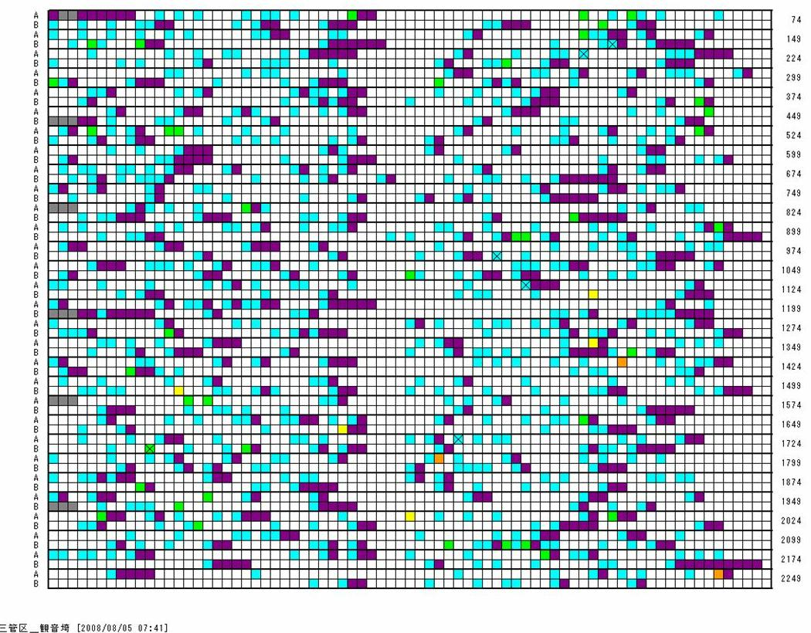

Slot usage rate: 27.4%

Slot identification rate: 61.2%

Unknown

Reserved by

shore base station

Grade A

Grade B

Grade C

Grade D

Grade E

Collision

Static message

Four years later, in 2012, the JCG carried out another survey for the preparation for establishment of AIS aids to navigation station and monitored the slot usage of Tokyo Wan area again. Figure 2 shows the slot graph captured at the second survey. The peak of slot usage occurred between 06:34 and 07:34, and reached 38%.

FIGURE 2

Slot graph of Kannonsaki automatic identification system shore base station on 25 July 2012

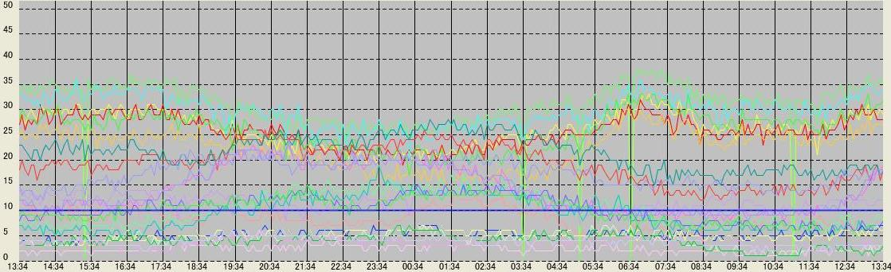

Traffic

(%)



Time

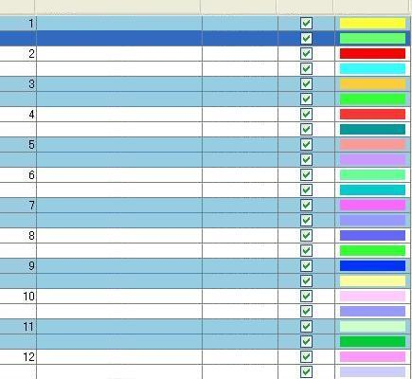

Kannnonsaki

Hommoku

Urayasu

Izuoshima

Nojimasaki

Katsuura

Irosaki

Inubosaki

Kinkan

Isosaki

Shioyasaki

Ryuosaki

Ch A

Ch A

Ch A

Ch A

Ch A

Ch A

Ch A

Ch A

Ch A

Ch A

Ch A

Ch A

Ch B

Ch B

Ch B

Ch B

Ch B

Ch B

Ch B

Ch B

Ch B

Ch B

Ch B

Ch B

Station Name

No

Channel

Display

Color

The two Figures clearly indicate that the AIS slot usage rapidly increased more than 10% in four years in Tokyo Wan area. It is supposed that one of the causes of this increase is the increase of class B AIS although class B AIS is not widely used by Japanese ships including fishing boats and pleasure crafts.

The JCG is now encouraging the use of class B AIS, especially for the safety navigation of fishing boats and pleasure crafts. However, this encouragement will burden more load to VDL of AIS. According to the IALA Recommendation A-124 Appendix **18** “VDL Loading Management”, when the VDL exceeds 50% loading of its nominally available slot capacity during the last 4 minutes on both channels, it may have an impact on the mobile AIS station’s ability to find free slots available for transmission.

# 2 Conclusion

From the above-mentioned discussion, there is a clear need for additional channels for AIS in order to improve the safety of navigation around Japan.

Annex 3  
  
Situation of the VHF data link loading in Korea

# 1 Introduction

The Ministry of Oceans and Fisheries has deployed and operates shore infrastructure including   
38 AIS base stations for navigation safety and collision avoidance in the Republic of Korean territorial waters.

In January 2013, the measurements of the channel loading of AIS VDL were carried out in the main ports area in the Republic of Korea. As a result of initial survey, the peak value of AIS VDL loading in Busan area is about 40%. Figure 3 shows AIS VDL loading data of AIS shore base station in Busan. Busan is the busiest port in Korea due to growing vessel traffic. In a certain time of Busan area, there were 550 AIS targets acquired at AIS base station as shown in Fig. 4.   
This amount of AIS VDL loading can be expected to increase as being used more type of AIS devices, for example, AIS aids to navigation and man overboard which are currently available in commercial market.

FIGURE 3

AIS VDL loading data of AIS shore base station in Busan at 1630 hours on 28 January 2013

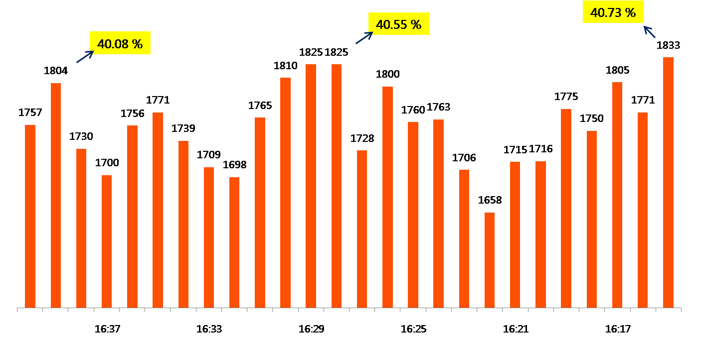

FIGURE 4

Image for monitoring automatic identification system shore base station in Busan at 1630 hours on 28 January 2013

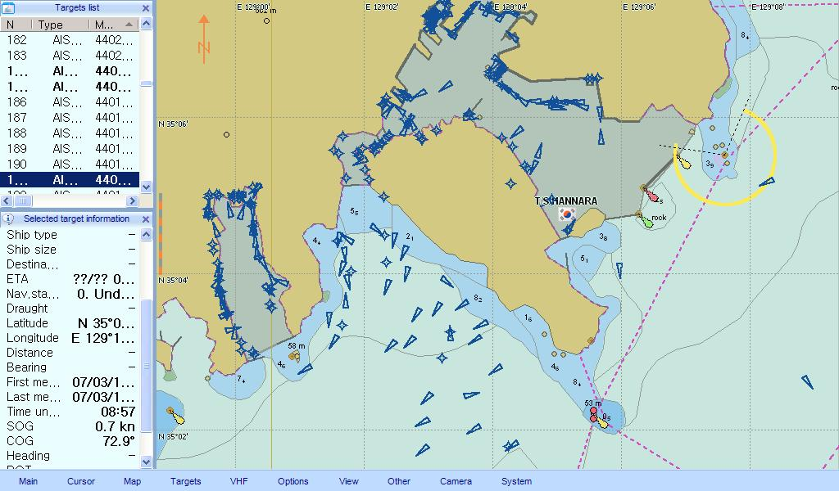

# 2 Candidate for additional frequency for the automatic identification system

Candidate for additional frequency for the AIS should consider the following aspects:

− to protect the integrity of the AIS VDL for its original purpose of navigation safety and collision avoidance;

− to accommodate the expected future AIS VDL loading;

− to minimize installation costs and transition period;

− to ensure backwards compatibility for an existing AIS.

Based on the WRC-12 results, it might be considered that the channel 2027 and 2028 are candidates for AIS additional frequencies.

Example of existing and new automatic identification system frequencies (MHz)

|  |  |  |  |
| --- | --- | --- | --- |
| 2027 | AIS 1 | 2028 | AIS 2 |
| 161.950 | 161.975 | 162.000 | 162.025 |
| NEW AIS 1 |  | NEW AIS 2 |  |

______________

1. This data and analysis is courtesy of the US Coast Guard Research and Development Center.
2. This data and analysis is courtesy of the US Coast Guard Research and Development Center.