Report ITU-R M.2244
(11/2011)
Isolation between antennas of IMT base stations in the land mobile service

M Series
Mobile, radiodetermination, amateur
and related satellite services

Foreword
The role of the Radiocommunication Sector is to ensure the rational, equitable, efficient and economical use of the radio-frequency spectrum by all radiocommunication services, including satellite services, and carry out studies without limit of frequency range on the basis of which Recommendations are adopted.
The regulatory and policy functions of the Radiocommunication Sector are performed by World and Regional Radiocommunication Conferences and Radiocommunication Assemblies supported by Study Groups.

Policy on Intellectual Property Right (IPR)
ITU-R policy on IPR is described in the Common Patent Policy for ITU-T/ITU-R/ISO/IEC referenced in Annex 1 of Resolution ITU-R 1. Forms to be used for the submission of patent statements and licensing declarations by patent holders are available from http://www.itu.int/ITU-R/go/patents/en where the Guidelines for Implementation of the Common Patent Policy for ITU-T/ITU-R/ISO/IEC and the ITU-R patent information database can also be found.

Series of ITU-R Reports
(Also available online at http://www.itu.int/publ/R-REP/en)
Series | Title
BO | Satellite delivery
BR | Recording for production, archival and play-out; film for television
BS | Broadcasting service (sound)
BT | Broadcasting service (television)
F | Fixed service
M | Mobile, radiodetermination, amateur and related satellite services
P | Radiowave propagation
RA | Radio astronomy
RS | Remote sensing systems
S | Fixed-satellite service
SA | Space applications and meteorology
SF | Frequency sharing and coordination between fixed-satellite and fixed service systems
SM | Spectrum management

Note: This ITU-R Report was approved in English by the Study Group under the procedure detailed in Resolution ITU-R 1.

Electronic Publication
Geneva, 2012
© ITU 2012
All rights reserved. No part of this publication may be reproduced, by any means whatsoever, without written permission of ITU.

REPORT ITU-R M.2244
Isolation between antennas of IMT base stations in the land mobile service

TABLE OF CONTENTS
Page
1 Introduction 3
2 Scope 3
3 Related Reports and Recommendations in ITU-R 3
4 Definitions 4
5 Typical antenna configuration cases 5
5.1 Antenna isolation of space separated antennas 5
5.2 Antenna isolation of multi-band antennas 5
6 Basic analytical methods for determining antenna isolation 5
6.1 Horizontal space isolation calculation 6
6.2 Vertical space isolation calculation 9
6.3 Slant space isolation calculation 10
6.4 Simulation evaluation of analytical formulas 11
7 Additional considerations for antenna isolation 13
7.1 Influence of objects near the antenna 13
7.2 Frequency dependency 15
7.3 Polarization 17
7.4 Multiple interfering antennas 17
8 Antenna isolation measurements 18
8.1 Measurement methodology 18
8.2 Measurement results 19
9 Spurious emissions, blocking and intermodulation interference effects 40
9.1 Spurious emission interference isolation analysis 40
9.2 Blocking interference isolation analysis 41
9.3 Intermodulation interference isolation analysis 41
Page
9.4 Isolation methodology 41
10 Summary and conclusions 41
Annex 1 – Isolation calculation examples 42
1 Interference technical specifications 42
2 The isolation requirements for System A 42
2.1 The spurious emission isolation requirements for System A 42
2.2 The blocking isolation requirements for System A 43
2.3 The intermodulation isolation requirements for System A 43
2.4 Isolation requirements for System A 43
2.5 Conclusion 44
Annex 2 – Simulation analysis of analytical methods for antenna isolation 44
1 Models for antenna isolation 44
2 Method for analysis 45
3 Results 47
4 Conclusions 50
Annex 3 – Influence of objects near the antenna 50
1 Example of a conductor mast’s influence on the isolation between two half-wave dipole antennas 50
1.1 A scenario of two antennas sharing a conductor mast 50
1.2 The results’ reference value for real directional BS antenna 52
Annex 4 – Theoretical derivation of the equation for vertical separation 53
1 Theoretical derivation for the formula of vertical isolation between two small dipoles 53
2 Theoretical derivation for the formula of vertical isolation between two half-wave dipoles 55
Annex 5 – Spurious emissions, blocking and intermodulation interference effects 59
1 Spurious emission interference isolation analysis 59
2 Blocking interference isolation analysis 60
3 Intermodulation interference isolation analysis 60
Page
Annex 6 Glossary 61

1 Introduction
In this Report the isolation between co-located antennas and antennas in close proximity of IMT base stations in the land mobile service is investigated. The key benefits of having co-located antennas are as follows:
– encouraging equitable reasonable competition;
– reducing the number of steel towers or masts, mitigating the shortage of suitable sites;
– reducing network building expense;
– reducing visual impact.
One must, however, also ensure that the interference between different systems is kept within acceptable levels. An important consideration when base station antennas share the same tower, rooftop, or other antenna sites, and are consequently separated by small distances, is thus the degree of isolation that can be obtained between the ports of two antennas. One of the main techniques to mitigate interference between radio systems is providing sufficient physical separation and proper orientation between antennas. This method has the attractive property of reducing all types of interference. Determining sufficient physical separation is however non-trivial, as the isolation is highly sensitive to antenna choice, heights, azimuths, downtilts and the sectorization angles.

2 Scope
This Report contains methods to estimate the required isolation between IMT base station antennas in the land mobile service that are co-located or located in close proximity and possible antenna orientations to achieve the required isolation. It presents analytical methods and measured isolation values for horizontal, vertical and slant separation of antennas. Furthermore, information is given regarding how to use this isolation in a base station to base station interference analysis.

3 Related Reports and Recommendations in ITU-R
Recommendation ITU-R M.1073 – Digital cellular land mobile telecommunication systems.
Recommendation ITU-R M.1457 – Detailed specifications of the radio interfaces of International Mobile Telecommunications-2000 (IMT-2000).
Recommendation ITU-R M.1580 – Generic unwanted emission characteristics of base stations using the terrestrial radio interfaces of IMT-2000.
Recommendation ITU-R M.1581 – Generic unwanted emission characteristics of mobile stations using the terrestrial radio interfaces of IMT-2000.
Recommendation ITU-R M.1823 – Technical and operational characteristics of digital cellular land mobile systems for use in sharing studies.
Report ITU-R M.2030 – Coexistence between IMT-2000 time division duplex and frequency division duplex terrestrial radio interface technologies around 2 600 MHz operating in adjacent bands and in the same geographical area.
Report ITU-R M.2039 – Characteristics of terrestrial IMT-2000 systems for frequency sharing/interference analyses.
Report ITU-R M.2045 – Mitigating techniques to address coexistence between IMT-2000 time division duplex and frequency division duplex radio interface technologies within the frequency range 2 500-2 690 MHz operating in adjacent bands and in the same geographical area.
Report ITU-R M.2135 – Guidelines for evaluation of radio interface technologies for IMT-Advanced.
Report ITU-R M.2141 – Study of the isolation between VHF land mobile radio antennas in close proximity.
Recommendation ITU-R SM.1134-1 – Intermodulation interference calculations in the land-mobile service.

4 Definitions
Co-location refers to antennas that are deployed on the same mast. For the purpose of this Report, antennas which are located in close proximity to one another (for example, antennas located on the rooftop of the same building but are installed on separate masts) are considered to be co-located due to the negligible geographic separation between the antennas.
Figure 1 below shows the basic radio parts of the interferer and the victim systems, including the interferer transmitter, aerial feeder, transmitting antenna, and the victim antenna, aerial feeder, receiver, that must be incorporated in a mathematical model.
Figure 1
Basic radio part of the interferer and interfered with systems

The interference signal of the interfering system passes through the aerial feeder, is radiated from the interferer antenna, and is propagated through the air and is received by the interfered with receiver through the antenna and its aerial feeder.
Antenna isolation is defined as the loss between points A and B, the two antenna ports, as shown in Fig. 1. The main parameters affecting the isolation are the separation distance and the wavelength. Antenna-to-antenna isolation is normally expressed in terms of dB of attenuation. Antenna isolation is often called antenna coupling loss, or antenna decoupling.
It is important to distinguish antenna isolation from another frequently used concept, minimum coupling loss (MCL), often used in base station-to-base station interference analysis due to its simplicity. The MCL is defined as the loss between interfering BS Tx port (antenna connector) and the interfered with BS Rx port (antenna connector), as shown in Fig. 1. The relationship between MCL and antenna isolation can be thus written as:
MCL = feeder_loss_1 + antenna isolation + feeder_loss_2 (1)

5 Typical antenna configuration cases
In mobile network deployment, both multi-band antennas and space separated single band antennas are used depending on the radio site configuration. The isolation between antennas in a multi-band antenna configuration is provided by the manufacturer and cannot be adjusted during installation. It is thus not considered in the sections on analytical methods or measurements, where the focus is on isolation obtainable by variable space separation.

5.1 Antenna isolation of space separated antennas
In practice, single band antennas (vertical polarized antenna and cross polarized antenna) are frequently used in mobile network deployments. Careful consideration of antenna isolation is necessary for co-located base stations to avoid excessive interference.

5.2 Antenna isolation of multi-band antennas
Figure 2 below shows an example of a cross-polar tri-band antenna (900 MHz, 1 800 MHz, and 2 GHz) with 6 ports. The multi-band antenna technical characteristics provided by the antenna manufacturer include two antenna isolation parameters: intra-band inter-port isolation and inter-band isolation. The typical intra-band inter-port and inter-band isolation is approximately 30 dB. In the technical specification of IMT-2000 CDMA DS, an assumption of MCL = 30 dB is used in the co-location requirement specification, see e.g. § 6.6.3.4 in [1].
Figure 2
Illustration of a cross-polar tri-band antenna

6 Basic analytical methods for determining antenna isolation
The amount of isolation that can be achieved between antennas depends on several factors, such as the physical separation distance between the antennas, polarization, radiation pattern of the antennas and whether the antennas are within the main beam of each other, and the conducting properties of the antenna tower. This isolation can most accurately be determined through on-site measurements. However, such measurement campaigns may be too costly and time-consuming. As an alternative, different methods of analytical modelling is proposed in this section.
Nevertheless, it should be noted that the empirical or semi-empirical equations found in literature for calculating antenna isolation, like those presented below, can provide a quick estimate of the antenna isolation but must also be used with caution, as a number of different factors, including those listed above, may substantially influence the required isolation.
This section provides information that may be helpful for obtaining estimates of the isolation between co-located base station antennas or between closely spaced base station antennas operating at the same frequency with the same polarization, and where it is assumed that influence from objects near the antennas can be disregarded. For this case, antenna isolation is primarily a function of the wavelength, antenna types (omni vs directional), antenna characteristics (downtilt, gain, radiation patterns, etc.) and relative spatial configurations.

6.1 Horizontal space isolation calculation
Figure 3
Horizontal isolation
The horizontal free space antenna isolation for a scenario as described in Fig. 3 can be computed by the following equation:
I_{H}[dB] = 22 + 20lg (d_{h}/λ) – (G_{Tx} + G_{Rx}) – (SL(ρ)_{Tx} + SL(θ)_{Rx}) (2)
Where the space distance d_{h} between two antennas satisfies the following approximate far-field condition (see [2]):
d_{h} ≥ 2D²/ λ
Note that the accuracy of this approximation decreases with decreasing antenna gain.
The parameters involved are defined as follows:
D[m]: the maximum dimension of the largest of the transmitter or receiver antennas
I_{H}[dB]: isolation between horizontally separated transmitter and receiver antennas
d_{h} [m]: the horizontal distance from the centre of interferer antenna to that of the interfered with receiver antenna
λ[m]: the wavelength of the interfered with system frequency band
G_{Tx}[dBi]: maximum gain of the transmitter antenna with respect to an isotropic antenna (dBi)
G_{Rx}[dBi]: maximum gain of the receiver antenna with respect to an isotropic antenna (dBi)
SL(ρ)_{Tx}[dB]: gain of the side-lobe with respect to the main-lobe of the transmitter antenna (negative value), see Fig. 4
SL(θ)_{Rx}[dB]: gain of the side-lobe with respect to the main-lobe of the receiver antenna (negative value), see Fig. 4.
Figure 4
Influence of antenna azimuthal angle
Equation (2) can be deduced from the Friis formula [2], which gives the following relation (in the linear domain) between the received (P_{Rx}) and transmitted power (P_{Tx}) for line-of-sight conditions:
P_{Rx}/P_{Tx} = (G_{Tx} * SL(ρ)_{Tx})(G_{Rx} * SL(θ)_{Rx})(λ/4π dh)² (3)
By introducing the isolation IF = P_{Tx}/P_{Rx} and converting the Friis formula to dB scale, we get equation (2) above. The Friis formula, and thus equation (2) above, does not only apply to horizontal separation between antennas, but to any arbitrary separation. Furthermore, it can be used with arbitrarily rotated antennas, as indicated by the inclusion of the maximum and side-lobe antenna gains in the equation. Consequently, the equation can incorporate effects from both antenna tilt and variations in azimuthal angle.
A simplified version of the equation above, applicable to dipole antennas and thus excluding the terms G_{Tx}, G_{Rx,} SL(ρ)_{Tx} or SL(θ)_{Rx}, can be found in Recommendation ITU-R SM.337-6 [3]. For that particular scenario, it is proposed that the separation should be at least 10λ for the equation to be valid.
Using equation (2), Table 1 provides estimates of the horizontal separation distances that are needed to obtain 30, 45 or 60 dB isolation for 2 base station antennas operating at the frequencies indicated.
These frequencies were taken as representative of downlink frequencies used in IMT system deployments currently in operation or planned for the 450-470 MHz, 698-960 MHz, 1 710-1 980 MHz, 2 110-2 200 MHz and the 2 500-2 690 MHz IMT bands. The calculations performed assumed both antennas were at the same height (i.e. mounted on the same platform or mounted on platforms of identical height). It is clear that the requirements on physical separation are sensitive to the antenna gain in the direction of the other antenna as well as the frequency used.
TABLE 1
Horizontal separation distances (metres) to obtain 30, 45 and 60 dB antenna isolation

 |  | Separation distance for 0 dB gain in the direction of the other antenna |  |  | Separation distance for −5 dB gain in the direction of the other antenna
 |  | Required antenna isolation (m) |  |  | Required antenna isolation (m)
Frequency (MHz) | Wavelength (m) | 30 dB | 45 dB | 60 dB | 30 dB | 45 dB | 60 dB
465 | 0.645 | 1.62 | 9.11 | 51.25 | 0.51 | 2.88 | 16.21
725 | 0.414 | 1.04 | 5.84 | 32.87 | 0.33 | 1.85 | 10.39
810 | 0.370 | 0.93 | 5.23 | 29.42 | 0.29 | 1.65 | 9.30
880 | 0.341 | 0.86 | 4.82 | 27.08 | 0.27 | 1.52 | 8.56
940 | 0.319 | 0.80 | 4.51 | 25.35 | 0.25 | 1.43 | 8.02
1 840 | 0.163 | 0.41 | 2.30 | 12.95 | 0.13 | 0.73 | 4.10
1 960 | 0.153 | 0.38 | 2.16 | 12.16 | 0.12 | 0.68 | 3.84
2 160 | 0.139 | 0.35 | 1.96 | 11.03 | 0.11 | 0.62 | 3.49
2 655 | 0.113 | 0.28 | 1.60 | 8.98 | 0.09 | 0.50 | 2.84

6.2 Vertical space isolation calculation
Figure 5
Vertical isolation
Vertical isolation can be computed by the following equation, based on the work in [4]:
I_{v}[dB] = 28 + 40*lg(d_{v}/λ) (4)
The equation is applicable for vertical dipoles, and when d_{v} is greater than 10*λ. For a derivation of this formula, see Annex 4.
Note that equation (4) does not require any information regarding the antenna gains in the direction of the other antenna. It is based on the assumption of having perfectly oriented antennas in the sense of showing pattern nulls to each other. For such a case with perfectly oriented antennas, only field components decreasing like 1/r² and hence power density decreasing like 1/r⁴ will contribute. These field components are near-field components of any direction, even radial components may contribute. For large distances the isolation will be very high. In particular, equation (4) applies to vertically separated short dipoles for such a scenario.
It is important to note that it may be very difficult to guarantee that the prerequisites for equation (4) holds in reality, see further Fig. 7 below. For a scenario where these requirements do not hold, i.e. where the antenna orientation accuracy does not guarantee antenna pattern nulls in the required direction, the Friis formula still applies, see equation (3) above. This formula allows the antenna gains in the relevant directions to be taken into account. Taking antenna mounting imperfections into account these gain values should be chosen conservatively.
Where:
I_{v}[dB]: isolation between vertically separated transmitter and receiver antennas
d_{v}[m]: the vertical distance from the interferer antenna to the interfered with receiver antenna, measured from radiation centre-to-radiation centre
λ [m]: the wavelength of the interfered with system frequency band.
Using equation (4), Table 2 provides estimates of the vertical separation distances that are needed to obtain 30, 45 or 60 dB isolation for 2 base station antennas operating at the frequencies indicated. These frequencies were taken as representative of downlink frequencies used in IMT system deployments currently in operation or planned for the 450-470 MHz, 698-960 MHz, 1 710-1 980 MHz, 2 110-2 200 MHz and the 2 500-2 690 MHz IMT bands. The calculations were performed under the assumption that both antennas were mounted on the same tower.
TABLE 2
Vertical separation distances (metres) to obtain 30, 45 and 60 dB antenna isolation
 |  | Required antenna isolation (m)
Frequency (MHz) | Wavelength (m) | 30 dB | 45 dB | 60 dB
465 | 0.645 | 0.72 | 1.72 | 4.07
725 | 0.414 | 0.46 | 1.10 | 2.61
810 | 0.370 | 0.42 | 0.99 | 2.34
880 | 0.341 | 0.38 | 0.91 | 2.15
940 | 0.319 | 0.36 | 0.85 | 2.01
1 840 | 0.163 | 0.18 | 0.43 | 1.03
1 960 | 0.153 | 0.17 | 0.41 | 0.97
2 160 | 0.139 | 0.16 | 0.37 | 0.88
2 655 | 0.113 | 0.13 | 0.30 | 0.71

6.3 Slant space isolation calculation
Figure 6
Slant isolation
Slant isolation can be computed by the following equation:
I_{s}[dB] = (I_{v} – I_{h}) * (α/90°) + I_{h} (5)
Where:
I_{s}[dB]: when antennas slantingly configured, the isolation between the transmitter antenna and receiver antenna
I_{h}[dB]: when antennas horizontally configured, the isolation between the transmitter antenna and receiver antenna
I_{v}[dB]: when antennas vertically configured, the isolation between the transmitter antenna and receiver antenna
α[°]: the vertical angle between the transmitter antenna and receiver antenna.
Equation (5) is the linear interpolation of the equations for horizontal and vertical separation. It should be noted that the actual slant isolation is dependent on factors such as actual shape and taper of the antenna beams and that the linear interpolation might not provide a realistic estimation of the isolation. Note also the uncertainty regarding the factor representing the vertical isolation if equation (4) is used, as noted above.
The equation is applicable when d_{h} ≥ 2D²/ λ and d_{v} >10*λ, as for the horizontal and vertical cases. In Recommendation ITU-R SM.337 [3], it is proposed to use 10λ as the required horizontal separation for the equation to be valid.
It should be noted that Friis’ formula can be applied for this case as an alternative methodology.

6.4 Simulation evaluation of analytical formulas
The accuracy of different analytical methods have been compared to the results from simulations of antenna isolation, and are presented in Fig. 7 below. Antenna separation is here measured from centre to centre. The details of the methodology are described in Annex 2.
FIGURE 7
Simulation results for isolation between dipole antennas
In Fig. 7, the different simulated antennas are denoted as follows: short dipoles are denoted “short”, half-wave dipoles “λ/2” and the dipole array “array”. Results for horizontal (H)/vertical (V) separation are depicted using solid/dashed lines, respectively. The “array” values are most relevant, as they represent the behaviour of a sector antenna. The far-field distance 2D²/λ = 82 m for the dipole array is depicted with a red dot-dashed vertical line. This fairly large far-field distance is the result of the low frequency employed, 300 MHz.
The value 0.086 dBi employed in one of the Friis calculation corresponds to the antenna gain looking sideways (azimuth = 90°), a horizontal separation, and −4.4 dBi corresponds to looking upwards and downwards, a vertical separation. 1.76 dBi corresponds to a short dipole, and 2.15 corresponds to a half-wave dipole.
From the results in Fig. 7, it is manifest that the most realistic antenna, the dipole array, follows the radial behaviour of the Friis formula for vertical separation. For small separations, where near-field effects influence the results, the Friis formula will in some cases under-estimate and in other cases over-estimate the isolation. Formula (4) for vertical separation substantially exaggerates the isolation for the dipole array representing the sector antenna.
It should be noted that in practice, antenna isolation in excess of 80-90 dB is very difficult to achieve due to secondary phenomena like reflections and scattering from the surrounding environment, mechanical or electrical antenna downtilt, misalignments, etc.

7 Additional considerations for antenna isolation

7.1 Influence of objects near the antenna
The environment around the interfering and interfered antennas will influence the isolation between them. Examples of objects that may affect this isolation are walls and base station masts. This section thus focuses on the single tube tower’s influence on isolation, using simulations based on the Method of Moments, a standard method in the area of computational electromagnetics. Additional details and other examples can be found in Annex 3.
Base station antenna masts are generally made of metal, and may thus reflect electromagnetic waves. The structure of masts can somewhat simplistically be divided into two kinds, either a framework of angle iron or a closed metal tube mast (sometimes referred to as single-tube tower), as illustrated in Figs 8 and 9. Given the different characteristics of these masts, it is reasonable to assume that they will affect the antenna isolation differently. Indeed, simulations for 900 MHz, 1 800 MHz and 2 100 MHz show that for a framework of angle iron with cross-section edges length of about 1 m and a distance between dipole and a framework of angle iron axis of more than 2.5 m, the influence of the angle iron on the isolation is quite small.
For a closed metal tube mast with radius about 0.35 m and a distance between dipole and the mast axis of about 1.8 m, simulations for 900 MHz, 1 800 MHz and 2 100 MHz show that the influence of the mast on the isolation is quite small. In the simulations the angle between the two antennas is set to 60°, 120° and 180°. The results indicate that when the angle between the antennas is 60° or 120°, the isolation decreases by no more than 3 dB. For a scenario where a mast is directly in-between two antennas (angle is 180°), isolation may increase substantially, sometimes more than 10 dB.
Based on these results, one may draw the conclusion that for the case of directional antennas, which are frequently used in the land mobile service, the characteristics of the side lobes of such antennas (schematically described in Fig. 10) may influence the antenna isolation. As shown in Fig. 10, it may be difficult to estimate in detail the influence of an object such as a mast on antenna isolation. The antenna gain in the direction of the other antenna may be different from towards the object, possibly resulting in reflections, and may cause higher interference power at the affected antenna. For a scenario where a mast is directly in-between two antennas, isolation may increase substantially, as the mast may block the radio wave propagation.

Figure 8  BS mast: Framework of angle iron | Figure 9  BS mast: Single-tube tower
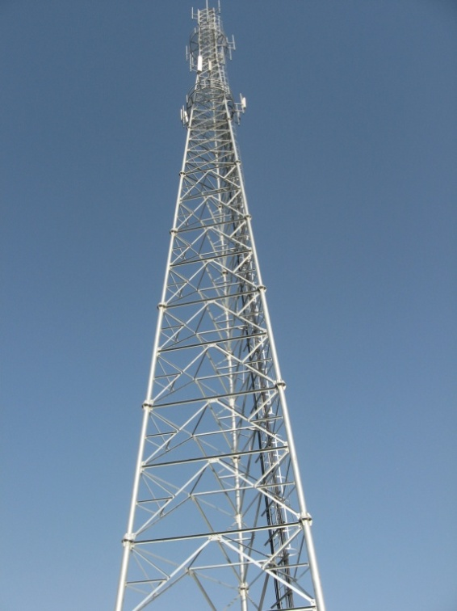 | 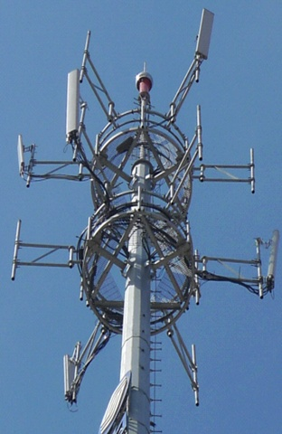
Figure 10
Antenna patterns of two antennas sharing a metal mast, reflections cause more receiving power of antenna R

7.2 Frequency dependency
An antenna is a radiating device. The technical characteristics of any given antenna usually contains the frequency range, antenna radiation patterns (horizontal and vertical), VSWR, gain, etc. An important observation is that these characteristics may be frequency dependent.
For the specified frequency range, the antenna radiation patterns, gains, and other characteristics are optimum. Outside the specified frequency range, however, the radiation patterns, the antenna gains, and VSWR are usually worse than those provided in the technical profile. It is consequently necessary to take this frequency dependency into account if the two antennas in question have different operating frequency bands.
Antenna isolation is a function of the antenna radiation patterns, gains, and propagation losses between the two antennas in close proximity.
For a given frequency band, all of these parameters are almost constant or similar and so the antenna isolation is not considered as frequency dependent in a specific frequency band. But between two antennas with different operating frequency bands, the inter-band antenna isolation is frequency dependent due to the difference in propagation loss and antenna characteristics in the different frequency bands.
The MCL interference calculation between BSs for a given frequency band can be calculated from the following expression (in linear units),
I_total = TxP/ACIR/MCL (6)
where
I_total is the total received interference
TxP is the transmit power of the interfering BS.
1/ACIR = 1/ACLR + 1/ACS (7)
MCL = Feeder_Loss_1 * Antenna Isolation * Feeder_Loss_2 (8)
In the case where the interfering BS and interfered wtih BS are operating in two different frequency bands (Band_1 and Band_2, respectively) or have a significant frequency separation, the antenna gain, radiation pattern, and propagation loss can be very different in the frequency Bands 1 and 2, as shown in Fig. 11. The ACLR from the Band_1 BS to the Band_2 BS is calculated with the spurious emission levels defined in the Band_1 BS specifications, and the ACS of the interfered with BS in the Band_2 is derived with the blocking level of the Band_2 BS specifications.
Figure 11
Inter-band interference analysis scenario

The total received interference level, I_total, in linear unit can be expressed as:
I_total = I₁ + I₂ = TxP/ACLR/MCL₁ + TxP/ACS/MCL₂ (9)
If an effective MCL (MCL_{e}) is defined as:
I_total = TxP/ACIR/MCL_{e} (10)
From (10) and (11), we obtain:
(11)
where:
TxP is the transmit power of the interfering BS.
MCL₁=Antenna Isolation(Band_1 Band_1) * Feeder_Loss_1* Feeder_Loss_2 (12)
MCL₂=Antenna Isolation(Band_2 Band_2) * Feeder_Loss_1* Feeder_Loss_2 (13)
It should be noted that:
− Antenna isolation (Band_1 Band_1) refers to measuring the antenna isolation at a specific frequency within the frequency band of Band_1; and
− Antenna isolation (Band_2 Band_2) refers to measuring the antenna isolation at a specific frequency within the frequency band of Band_2.
It can be seen from equations (12) and (13) that the antenna isolations between the Band_1 antenna and the Band_2 antenna should be measured at a frequency in Band_1, as well as at a frequency in Band_2. These two antenna isolations are usually different, as described in § 8.

7.3 Polarization
The analytical formulas in § 6 assume that transmitter and receiver antennas have the same polarization. In the case where polarizations differ, antenna isolation will increase. The magnitude of this polarization discrimination depends on the polarizations of the transmitter and receiver antennas. See § 8 for measurements on additional isolation due to differences in polarization of transmitting and receiving antennas.

7.4 Multiple interfering antennas
In a scenario with base stations that are co-located, there may be multiple systems, and each system may have multiple antennas. It may thus be necessary to consider interference from multiple antennas.
Figure 12 below shows the beam pattern of multiple antennas sharing the same tower and mast. There are 4 systems on the 3 platforms of the mast, each system equipped with 3 antennas. There are 2 systems on the bottom platform, and one on each of the upper two platforms.
By accumulating interference from all interfering antennas, the total interference power received by each antenna of the different systems can be calculated. The antenna installation as a whole can then be determined as acceptable or not.
Figure 12
Beam patterns of a multi-system and multi-antenna scenario using a communal mast

8 Antenna isolation measurements

8.1 Measurement methodology
The antenna isolation between spatially separated antennas is usually modelled based on measurements. Antenna isolation measurements require careful planning and preparation which, furthermore, requires a special measurement environment and test bed. An antenna isolation measurement configuration is illustrated in Fig. 13, where two spatially separated antennas (antenna 1 and antenna 2) are connected to a network analyser. A signal at a desired frequency is generated by the network analyser and sent to the input of antenna 1, the output of the signal at antenna 2 is measured and recorded by the network analyser. With calibrated connection cables, by taking into account the cable loss, the difference of signal power level at the antenna 2 output and that at the antenna 1 input is taken as antenna isolation.
Figure 13
Antenna isolation measurement configuration between two spatially separated antennas
Based on the description of antenna isolation frequency dependency, two different scenarios can be distinguished when measuring antenna isolation:
1) Antenna isolation between antennas in the same frequency band
When two antennas have the same operation frequency band, the centre frequency of the band is used in the measurement, and so the antenna isolation is measured at this single frequency point.
2) Antenna isolation between antennas in different frequency bands
When considering the measurement of antenna isolation between two antennas operation in two different frequency bands, Band_1 and Band_2, there are, in practice, three measurement configurations between the Band_1 antenna and the Band_2 antenna, as summarized in Table 3.
TABLE 3
Measurement configurations to measure isolation between two antennas
operating in two different frequency bands
Configuration No. | Tx signal frequency at Band_1 antenna | Rx signal frequency at  Band_2 antenna | Antenna isolation
1 | Band_1 | Band_1 | Antenna isolation  (Band_1 Band_1)
2 | Band_2 | Band_2 | Antenna isolation  (Band_2 Band_2)
3 | Scanning the frequencies in Band_1 & Band_2 | Scanning the frequencies in Band_1 & in Band_2 | Minimum antenna isolation (Iso_min)

Where,
− Antenna Isolation (Band_1 Band_1) refers to measuring the antenna isolation at a specific frequency within the frequency band of Band_1.
− Antenna Isolation (Band_2 Band_2) refers to measuring the antenna isolation at a specific frequency within the frequency band of Band_2.

8.2 Measurement results
The results from four different antenna isolation measurement campaigns are presented below, and are compared to the analytical results in § 6. Note also that measurements carried out for the VHF band in Report ITU-R M.2141 [5] and thus, are not presented in this Report.

8.2.1 Co-located base station antennas in the band 2 500-2 690 MHz
This section presents the results of a practical measurement campaign of antenna isolation in the case that two base station antennas are co-located and operating in the frequency range 2 500-2 690 MHz. The basic characteristics of the commercially available antenna used for the measurement campaign are described in Table 4.
TABLE 4
Basic antenna characteristics
Parameter | Value
Operating frequency | 2.6 GHz
Antenna gain | 17.5 dBi
Antenna beamwidth | 65°

Several antenna configurations were considered for the measurement including horizontal separation, vertical separation and a mix of both. Additionally, in these basic scenarios, measurements have been taken whilst varying the boresight direction of the two antennas and the down tilt angle by electrical tilt.
The isolation scenarios for the measurement campaign are summarized as follows:
1) horizontal separation, boresight direction variation and electrical tilt;
2) vertical separation, boresight direction variation and electrical tilt;
3) combination of horizontal and vertical separation.

8.2.1.1 Isolation with horizontal separation
Antenna isolation for horizontal separation was measured for different horizontal distances between the two antennas, different angles of down tilt, and different boresight angle directions. In addition, polarization has been considered as illustrated in Fig. 14.
Figure 14
Antenna polarizations
Two antennas are horizontally installed at the same height of each pole. The isolation is measured while increasing the horizontal separations, measured centre-to-centre, between the two antennas as illustrated in Fig. 15. Figure 16 shows the results.
FIGURE 15
Antenna configuration for the horizontal separation(s)
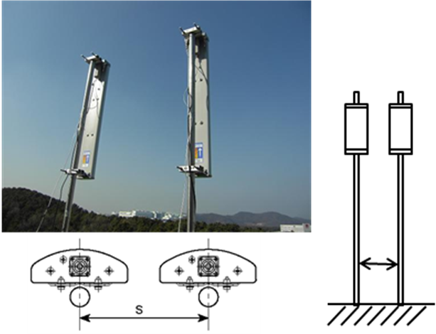

Figure 16
Antenna isolation vs. horizontal spacing
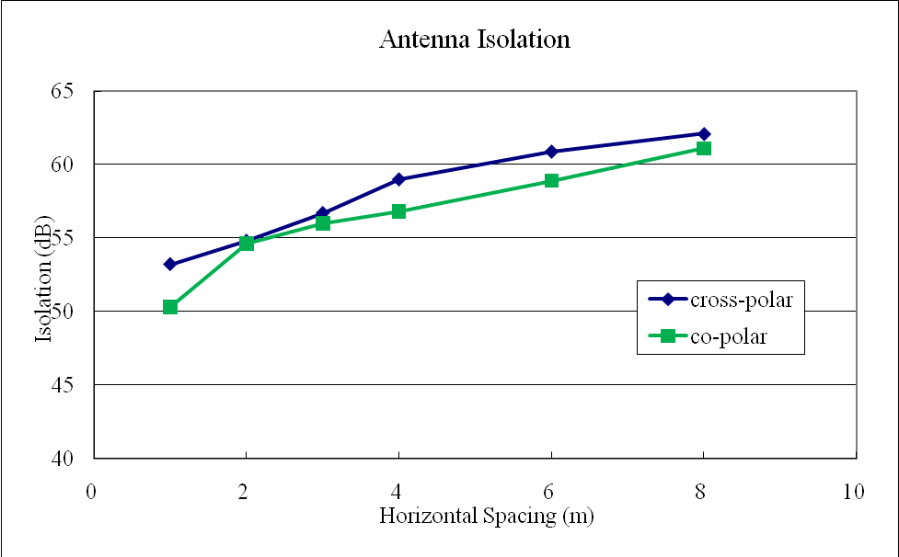
The measured isolation ranges from 50 dB to 63 dB depending on separation distance and polarization. For the results in Fig. 16, each antenna is facing the same direction. However, further measurements showed that a change of boresight direction of one antenna with respect to the other, can significantly influence the isolation.
Figure 17 shows the antenna configuration for measuring the antenna isolation whilst varying the relative boresight angle. The two antennas are horizontally installed with 3 m separation between the poles. As the boresight angle of one antenna against the other antenna increases from −45° to 45°, the isolation was measured. The results are shown in Fig. 18. Cross polar operation was employed.
Figure 17
Antenna configuration for varying the relative boresight angle
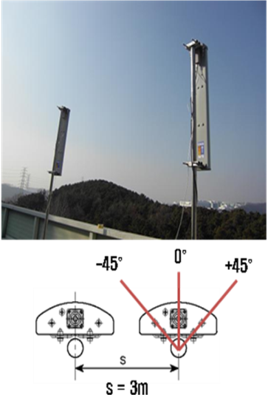
Figure 18
Boresight angle vs. antenna isolation
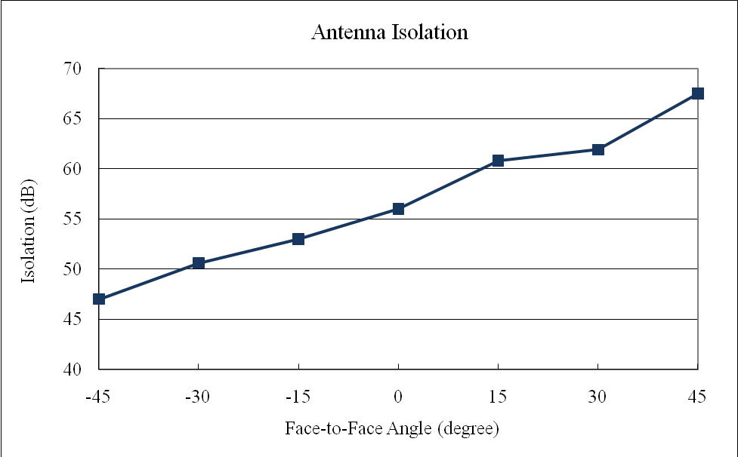

The results in Fig. 18 show that positive rotation of the relative boresight angle direction can improve the isolation by approximately 20 dB as the antenna boresight directions diverge. Electrical tilting of the antenna pattern also significantly improves isolation.
Figure 19 shows the antenna configuration with the two antennas horizontally located 3 m apart. The down-tilt of the two antennas is increased from 0° to 8° simultaneously and the isolation is measured. The results are shown in Fig. 20. Cross polar operation is employed.
Figure 19
Antenna configuration for down-tilt measurements
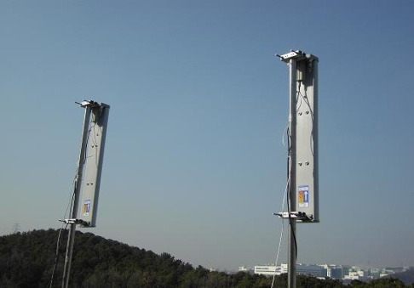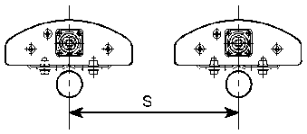
Figure 20
Electrical down-tilt vs. antenna isolation
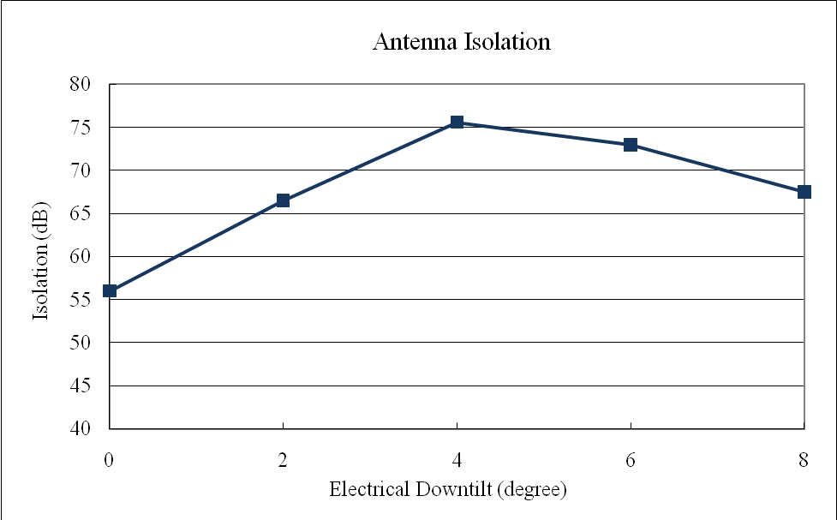

Figure 20 shows that isolation can be improved by 20 dB, and provides an antenna isolation of 76 dB, with 4° of down-tilt and horizontal separation of 3 m.

8.2.1.2 Isolation with vertical separation
Vertical separation can also be employed to isolate two antennas in a co-site situation. The basic configuration is depicted in Fig. 21. The spatial separation is measured edge-to-edge. Antenna isolation for a range of vertical separation distances was measured with different vertical distances between the two antennas. In addition the effect of the angle of down tilt and relative boresight angle direction are investigated. Cross polar operation was employed in all these scenarios.
To measure the isolation against vertical separation, the antenna configuration is illustrated in Fig. 21. Two antennas were installed on the same pole and as the vertical distance between the two antennas increased from 0 to 1 m, the isolation was measured. The results are shown in Fig. 22.
Figure 21
Antenna configuration for vertical separation
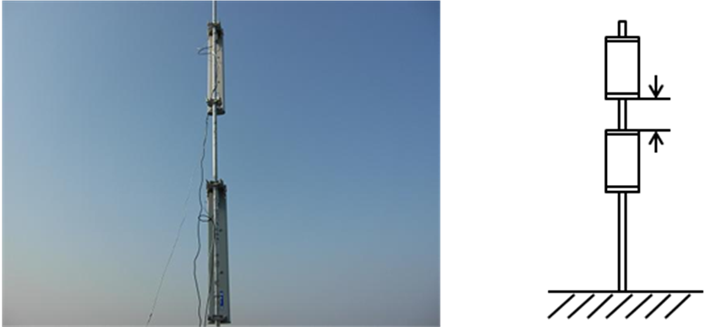
Figure 22
Vertical isolation vs. vertical spacing
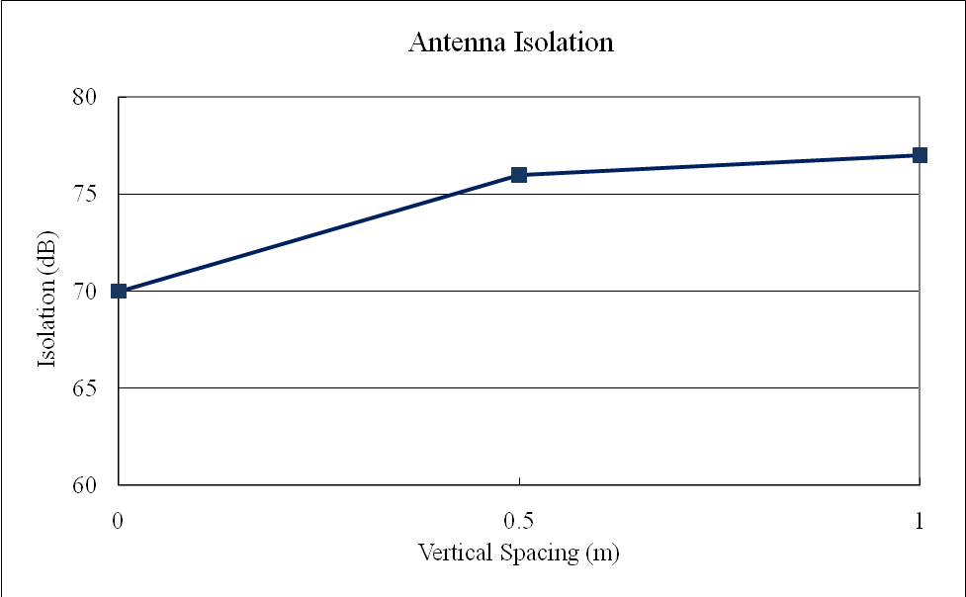

Figure 22 shows the measurement results as the vertical separation distance between the two antennas is increased. The measurement results show that simple vertical separation can achieve isolation of more than 70 dB. It can be observed that vertical separation appears to be more effective in isolating antennas than horizontal separation.
For testing the impact of down-tilt with vertically separated antennas, two antennas were installed on the same pole with the same varying electrical down-tilt and separated by 0.5 m as illustrated in Fig. 23. The measurement results are shown in Fig. 24.
FIGURE 23
Antenna configuration for down-tilt in vertically separated antennas
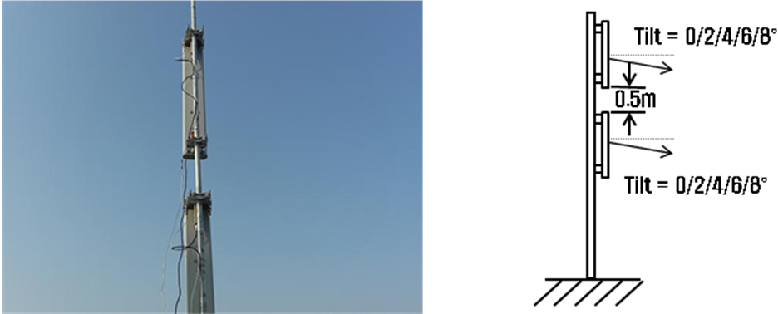
Figure 24
Electrical down-tilt vs. antenna isolation
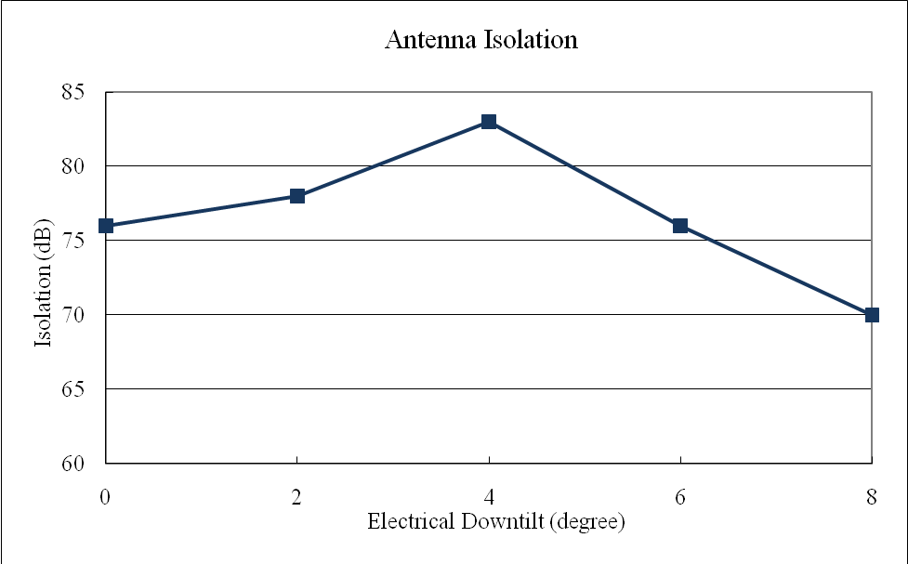

The measurement results in Fig. 24 show that as for the horizontal separation case, electrical down-tilt can improve antenna isolation at some settings. In this example, the down-tilt of 4° maximized the isolation by 7 dB at around 83 dB.
To measure the effect of the relative boresight directions in vertically separated antennas the antenna configuration Fig. 25 was used. The direction of one antenna is fixed whilst the other antenna is rotated from 0° (both antennas pointing in the same direction) to 180° relative to the fixed antenna. The isolation measurement results are shown in Fig. 26.
Figure 25
Antenna configuration for varying the relative boresight
in vertically separated antennas
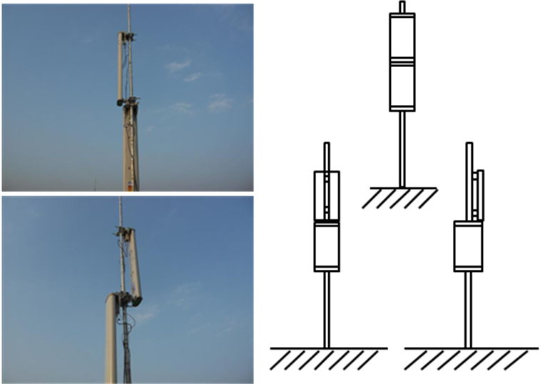
Figure 26
Vertical angle vs. antenna isolation
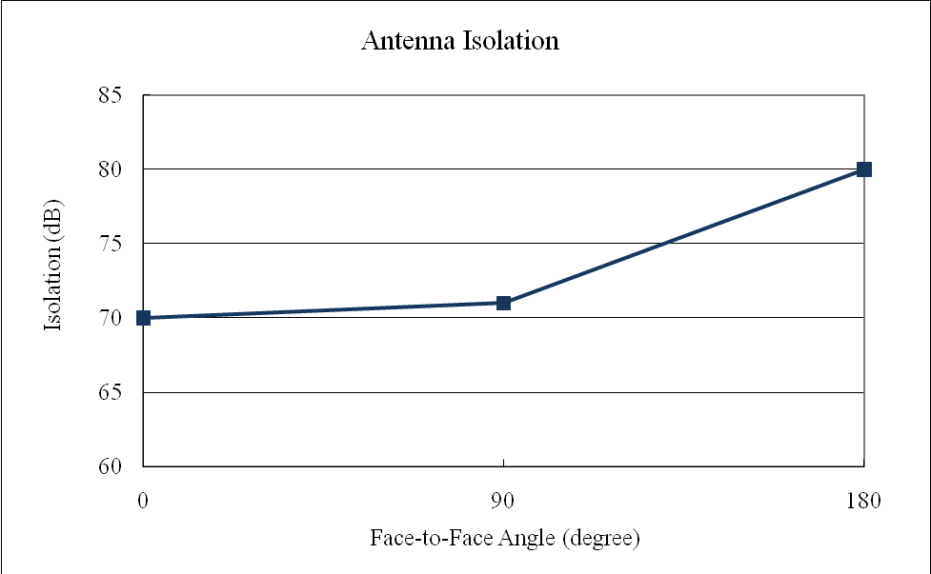

Figure 26 shows the improvement in isolation by increasing the antenna angle. Rotation of the boresight angle is less effective below 90° and rotation of the boresight angle up to 180° only increased the measured isolation by 10 dB.

8.2.1.3 Horizontal and vertical separation
A combination of horizontal and vertical separation is another option to be taken into account. Two antennas were installed at different heights on separate poles as illustrated in Fig. 27. Since Fig. 22 suggests limited improvement in isolation above 1 m vertical separation, this was fixed whilst the horizontal separation was varied for the measurement process. Figure 28 shows the results of the isolation measurements.
FIGURE 27
Antenna configuration for horizontal and vertical separation
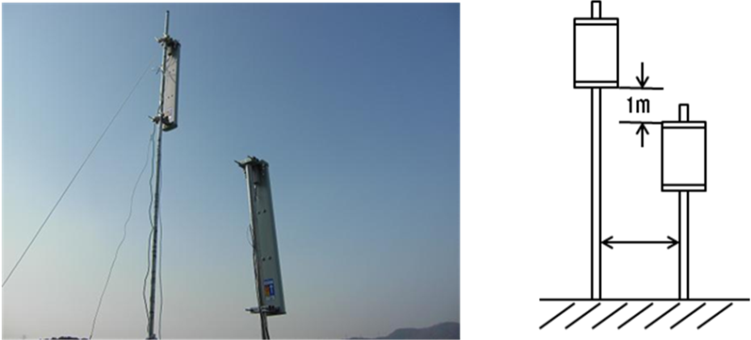
Figure 28
Horizontal & vertical spacing vs. antenna isolation
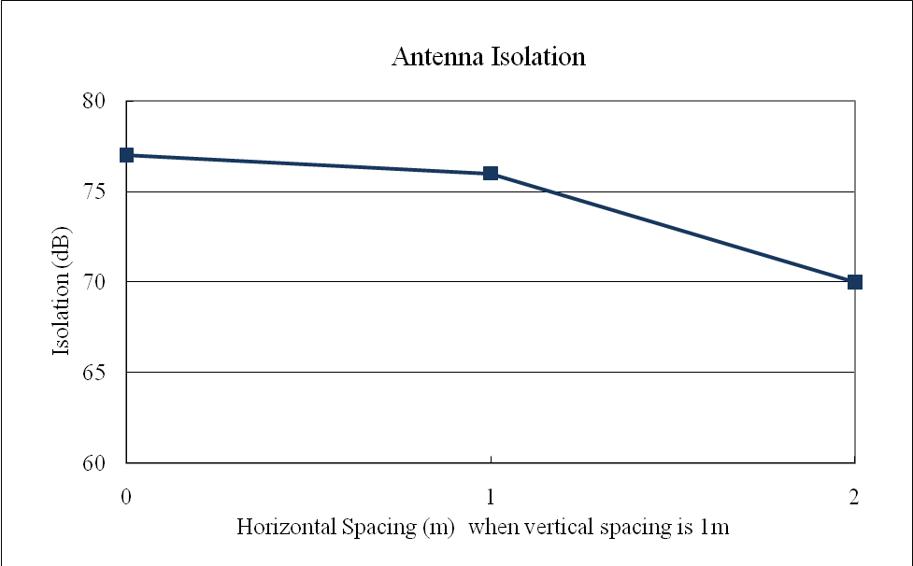
The isolation according to increasing horizontal separation with fixed 1 m vertical separation is shown at Fig. 28. Interestingly, the isolation for the mixed horizontal and vertical separation is decreasing with the increase in horizontal separation distance. But this is still better than that in the case of simple horizontal isolation. Therefore, mixed horizontal and vertical separation may be more effective where use of same antenna pole for both BS antennas is not possible.

8.2.1.4 Result summary
The measured isolation for all the antenna configurations considered is summarized in Table 5.
If isolation with only the horizontal antenna configuration is considered, then a maximum of 76 dB isolation was measured with 3 m separation and 4° of electrical down-tilt. On the other hand, with vertically separated antennas, a maximum of 83 dB isolation was measured with 0.5 m separation and 4° of electrical down-tilt. However, the practical configuration may depend upon the environment of the base station antenna installation, as well as the required isolation for protecting the system performance.
TABLE 5
Summary of antenna configuration and measured isolation
Antenna configuration | Measured isolation
Horizontal separation 3 m/8 m | 56 dB/61 dB
Horizontal separation 3 m with 0°/+15°boresight angle rotation | 56 dB/60 dB
Horizontal separation 3 m with 0°/4°electrical down-tilt | 56 dB/76 dB
Vertical separation 0 m | 70 dB
Vertical separation 1 m with different antenna pole (horizontal separation 1 m) | 76 dB
Vertical separation 0.5 m with 0°/4°electrical down-tilt | 76 dB/83 dB

These results may be compared to those obtained from the analytical formula in § 6. For 2 665 MHz the necessary horizontal separation to obtain 60 dB isolation is 9.0 or 2.85 m, depending on the antenna gain in the direction of the other antenna, which is not in contradiction with the results above. The analytical results for 2 665 MHz and a vertical edge-to-edge separation of 0.71 m is an isolation of 60 dB, somewhat lower than the measured results.

8.2.2 Measurements of horizontal separation in the 900, 1800 and 2 GHz bands
Measurements of isolation due to horizontal separation of mono-band antennas have been carried out for 900, 1 800 and 2 000 MHz with antenna characteristics as defined in Table 6. The results are presented in Table 7, where the separation distance between the antennas is expressed as edge-to-edge.
TABLE 6
Specifications for measured antennas
Frequency (MHz) | Antenna gain  (dBi) | Polarization | Horizontal opening (°) | Vertical opening (°)
900 | 16 | Cross-polarized | 65 | 8
1 800 | 17 | Cross-polarized | 65 | 6
2 000 | 18 | Cross-polarized | 65 | 6

TABLE 7
Measured antenna isolation (in dB) with horizontal separation
Dh (m) | 900 MHz | 1 800 MHz | 2 GHz
0,5 | 35 | 43 | 47
1 | 38 | 45 | 51
2 | 44 | 49 | 56
3 | 46 | 53 | 62

The typical 900 MHz panel antenna (16 dBi gain) length is about 1.8 m, and 2 GHz band antenna (18 dBi) is about 1.2 m, the analytical formula described in § 6 is for far-field distance >=2D²/λ, for the horizontal separation distance between 0.5 and 3 m, it is in near-field domain, the analytical formula given in § 6 is not valid for near-field domain, so it is difficult to compare the analytical results with the measurement presented in Table 7.

8.2.3 Measurements of vertical isolation on a real base station tower

8.2.3.1 Introduction
Experiments were carried out in Tangshan city, in the Hebei Province of China in July, 2010. The environment is plain suburban. The temperature was 24ºC, and the relative humidity was 55%. The major equipment used in the experiment are listed below:
1) Two ± 45° polarized antennas with frequency range 820-960 MHz, and length of 0.75 m;
2) Two vertical polarized antennas with frequency range 820-960 MHz, and length of 0.69 m;
3) Portable vector network analyser with output power set to 6 dBm;
4) Laser range finder, meter stick, coaxial cables, adapters, etc.

8.2.3.2 Experimental scenario
The measurement was done in a real single-tube antenna tower with the following characteristics:
• height = 45 m
• diameter = 0.7 m
• height of platform for operators and instruments = 35 m
• platform structure (circular steel cage), with radius = 3.6 m
• the vertical isolation between the two BS antennas was measured in 890 MHz and 830 MHz.
Figure 29 shows the set-up of the experiment.
Figure 29
Set-up of the experiment

In the experiment, the pole was connected to platform and the antennas were installed on the pole, the pole can move. So we set two scenarios: A, Antenna close to platform edge; B, antenna away from platform about 1.2 m, as shown in Fig. 30.
Figure 30
Antenna pole close to the platform and away from the platform

According to different polarization combinations, four experiments items were designed:
1) Vertical polarization vs. vertical polarization;
2) Vertical polarization vs. 45° polarization;
3) In-phase 45° polarization;
4) Orthogonal 45°polarization,
as shown in Fig. 31.
Generally speaking, polarization is defined with respect to a reference plane – which is formed by the plane containing the direction of propagation of the electromagnetic (e.m.) wave and the normal to the surface (on which the e.m. wave impinges). In the case of dipole antennas, the reference plane is formed by the plane containing the antenna axis and the direction of propagation of the e.m. wave. However, some textbooks go a step further and use the earth’s surface directly as the reference plane. This Report employs the same simplification and assumes that polarization can be defined with respect to the earth’s surface, If the antenna axis is parallel to the earth’s surface, then the polarization is deemed horizontal, while if the axis is perpendicular to the earth’s surface, the polarization is vertical. This simplification and consequent definition of polarization are both depicted in Fig. 31.
Figure 31
Items of different polarization and downtilt combinations, as seen from the side

The following Fig. 32 is a photo of the experiment:
figure 32
Worker is installing an antenna
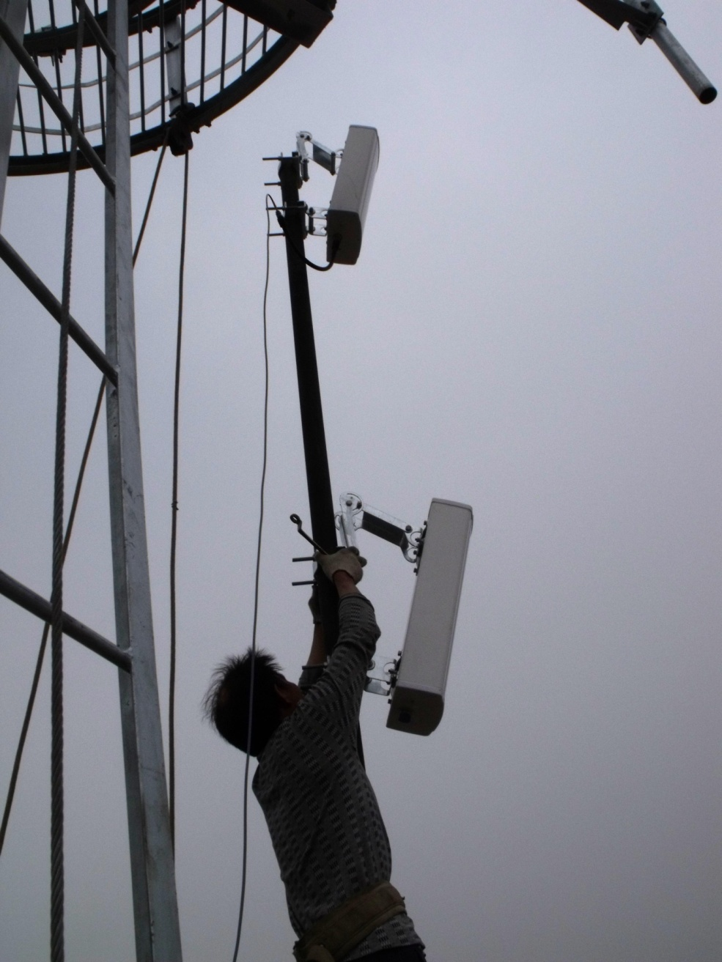

8.2.3.3 Measurement results
The following tables show measurement results. Readings 1 and 2 correspond to measurements of the same scenario, but at different points in time.

TABLE 8
Vertical isolation of item 1 (Vertical polarization ~ Vertical polarization)
Sequence | Frequency (MHz) | Edge distance (m) | Reading 1 (dB) | Reading 2 (dB) | Scenario
1 | 890 | 0.21 | 47.22 | – | Close
1 | 890 | 0.21 | 46.24 | – | Away
2 | 890 | 1.32 | 59.92 | 60.42 | Close
2 | 890 | 1.32 | 60.15 | 61.00 | Away
3 | 890 | 2.38 | 54.65 | 55.67 | Close
3 | 890 | 2.38 | 61.26 | 60.86 | Away
4 | 890 | 3.77 | – | – | Close
4 | 890 | 3.77 | 64.68 | 64.46 | Away

TABLE 9
Vertical isolation of item 2（vertical polarization ~ 45° polarization）
Sequence | Frequency (MHz) | Edge distance (m) | Reading 1 (dB) | Reading 2 (dB) | Scenario
1 | 890 | 0.30 | 55.33 | – | Close
1 | 890 | 0.30 | 57.14 | – | Away
2 | 890 | 3.50 | 69.20 | 70.07 | Close
2 | 890 | 3.50 | 71.50 | – | Away
3 | 830 | 3.50 | 60.77 | – | Away

TABLE 10
Vertical isolation of item 3 (In phase 45° polarization)
Sequence | Frequency (MHz) | Edge distance (m) | Reading 1 (dB) | Scenario
1 | 890 | 0.19 | 44.76 | Close
1 | 890 | 0.19 | 55.06 | Away
2 | 830 | 0.19 | 52.71 | Close
2 | 830 | 0.19 | 58.28 | Away
3 | 890 | 3.62 | 61.27 | Close
3 | 890 | 3.62 | 66.73 | Away

TABLE 11
Vertical isolation of item 4（Orthogonal 45° polarization）
Sequence | Frequency (MHz) | Edge distance (m) | Reading 1 (dB) | Scenario
1 | 830 | 0.19 | 54.76 | Close
1 | 830 | 0.19 | 58.08 | Away
2 | 890 | 3.62 | 68.89 | Close
2 | 890 | 3.62 | 73.52 | Away

In the study, we can find that in many cases, vertical isolation of “scenario A: close” is less than that of "scenario B: away from platform". One reason can be analysed using ray tracing method. As shown in Fig. 33, there is a metal structure near two vertical isolated antenna, in addition to the vertical coupling (corresponding to the vertical isolation), there is also lateral reflection – reception between the two antennas (as the Line 1 and Line 2 in Fig. 33 indicate), which means an increase of energy coupling and isolation reduction. Therefore, the results of “scenario B: away from platform” is more nearly to “pure vertical isolation”. But the measurement results of “scenario A: close” is also valuable, because in the actual antenna installation, sometimes the antenna is close to metal platform.
Figure 33
The energy transfers near metal structure: Vertical coupling and lateral reflection – reception
For some measurement cases, there is good agreement with the analytical results obtained from equation (4), for instance in the case of separation no more than 1.5 m and when both antennas have vertical polarization. For instance, this equations gives a required vertical separation distance of 2.16 metres to obtain 60 dB isolation for 880 MHz with the same polarization of transmitter and receiver. The corresponding result from these measurements is for 890 MHz between 1.3 and slightly more than 2 m. Note, however, that for some cases, the differences between the formula and the measured isolation may be up to 15 dB. See further Figs 34 and 35 for a comparison between some of the measurement results and what is predicted by the equations of § 6.
figure 34
Vertical isolation (Vertical polarization ~ Vertical polarization)
figure 35
Vertical isolation (In phase 45° polarization)
Different polarization of transmitter and receiver increases isolation as expected. The decrease in antenna isolation with the antennas nearer the mast is also as expected; where the presence of an antenna mast, causing reflections, decreases the isolation compared to a free space scenario.

8.2.4 Inter-band antenna isolation measurement results
Antenna isolation (coupling loss) between two dipole antennas has been measured in the laboratory at three frequencies: 900 MHz, 2 000 MHz, and 2 600 MHz. The dipole antennas used in the measurement were specially designed antennas for laboratory measurement. For 900 MHz measurement, two 900 MHz dipole antennas are used. For 2 GHz and 2.6 GHz measurements, two wideband dipole antennas covering both 2 GHz and 2.6 GHz frequency bands are used. The antenna characteristics are summarized in Table 12.
TABLE 12
Antenna size and gain at different frequency bands
Frequency | 900 MHz | 2 GHz | 2.6 GHz
Antenna length | 18.5 cm | 7 cm | 7 cm
Maximum gain | 2.25 | 1.92 | 2.1

The measured antenna isolation (coupling loss) at three frequencies for different horizontal separation and vertical separation distances are respectively plotted in Figs 36 and 37. It can be seen that antenna isolation is frequency dependent. The antenna isolation is greater for higher frequencies.
Figure 36
Antenna isolation as function of horizontal separation distance (Edge to edge)
Figure 37
Antenna isolation as function of vertical separation distance (Edge to edge)

It should be noted that the antenna isolation at 2 GHz and 2.6 GHz bands has been measured using the same type of wideband dipole antennas. The antenna gain and radiation patterns in these two bands are very similar. The difference of antenna isolation mainly comes from the near-field propagation loss difference at different frequencies and coupling effect of the two near-by dipole antennas.
The measured antenna isolation as function of horizontal separation distance presented in Fig. 36 is compared with the analytical calculation by using the equation provided in § 6, for the small dipole antenna, the far-field condition 2D²/λ= 0.2 m for 900 MHz band (0.06 m and 0.08 m for 2 GHz and 2.6 GHz bands respectively), it is met at horizontal separation distance of 20 cm for 900 MHz band (6 cm and 8 cm for 2 GHz and 2.6 GHz band, respectively). The comparisons between measurements and analytical calculations for the three frequencies of 900 MHz, 2 000 MHz, and 2 600 MHz, are plotted in Fig. 38.
Figure 38
Comparison between measurements and analytical calculations (horizontal separation)

It can be seen that the analytical calculations are quite in line with the measurements, especially for the horizontal separation distance ≥20 cm for 900 MHz band, which is the far-field condition. For 2.6 GHz, the calculation and measurements match also quite well, in particular for the horizontal separation distance ≥6 cm.
The measured dipole antenna isolation with vertical separation presented in Fig. 37 is also compared with the analytical calculations based on the formula in § 6. The comparison curves for the three frequencies of 900 MHz, 2 000 MHz, and 2 600 MHz are plotted in Fig. 39.
The comparison curves in Fig. 40 show that the calculated antenna isolations are about 2 to 3 dB higher compared to the measured antenna isolations at vertical separation, they have the similar behaviour as function of vertical separation distance.
Figure 39
Comparison between measurements and analytical calculations (vertical separation)

Some antenna isolation measurement data between 900/1 800 MHz band antenna and 2 GHz band antenna at the frequency of 2 GHz are plotted in Fig. 40. The 900 MHz band antenna, 1 800 MHz band antenna, and 2 GHz band antenna have the same characteristics: x-polar antenna with maximum gain of 17 dBi, 65° horizontal opening, etc.
Figure 40
Antenna isolation as function of horizontal separation distance (Edge to edge)

It is interesting to see that the antenna isolation between 900 MHz band antenna and 2 GHz band antenna is about 10 dB greater than that between 1 800 MHz band antenna and 2 GHz band antenna. Since both measurements have been done at the same frequency 2 GHz, this difference comes mainly from the antenna characteristics (gain, radiation patterns) of 900 MHz band antenna and 1 800 MHz band antenna at the frequency of 2 GHz.
9 Spurious emissions, blocking and intermodulation interference effects
As wireless communication systems develop, different mobile systems coexist, such as GSM, TD-SCDMA, WCDMA and cdma2000 and so on. But the suitable sites to build the tower are limited. In some cases, it may then be beneficial for operators to share the towers to mount their base station antennas. When engineers configure the antennas, they need to adjust the distance between several antennas that share the tower. They not only need the method to get actual antenna isolation, but also the method to get the antenna isolation requirements. For further details see Annex 5.

9.1 Spurious emission interference isolation analysis
When the transmitter noise floor or spurious emission signal falls in the frequency band of the interfered with system receiver, it will be interfered. For BS-to-BS interference, taking the protection margin into consideration, the isolation of spurious emission is the following:
I_{spurious} = P_{emission} – K_{BW} – L_{Tx} – L_{Rx} – M_{Rx} (14)
where:
I_{spurious} [dB]: spurious emission isolation between the interferer and the interfered
P_{emission} [dBm]: the spurious emission specification of the interferer transmitter in the frequency band of the interfered with system in the specified measurement bandwidth
BW_{Tx} [kHz]: measurement bandwidth of the interferer system
BW_{Rx} [kHz]: channel bandwidth of the interfered with system
L_{Tx} [dB]: aerial feeder loss of the interferer system
L_{Rx} [dB]: aerial feeder loss of the interfered with system
M_{Rx} [dB]: the interference value to the interfered with system under certain protection ratio
K_{BW} [dB]: bandwidth conversion factor
K_{BW}= 10*log(BW_{Tx}/ BW_{Rx})
M_{Rx}Value:
• when the worsening ratio is 0.4 dB, M_{Rx} interference value is 10 dB lower than the noise floor of the interfered with receiver;
• when the worsening ratio is 0.8 dB, M_{Rx} interference value is 7 dB lower than the noise floor of the interfered with receiver;
The noise floor of the system is equal to:
N_{Noise} = −174 + NF +10*log(Receiver_BW) (15)
where:
N_{Noise} [dBm]: noise floor of the interfered with system
NF[dB]: noise figure of the interfered with system
BW[Hz]: the channel bandwidth of the interfered with system.

9.2 Blocking interference isolation analysis
The isolation of blocking interference is the following:
I_{Blocking} = P_{Tx} – L_{Tx} – L_{Rx} – P_{Blocking} (16)
The detail information about parameters in equation (16) is in Annex 5.

9.3 Intermodulation interference isolation analysis
Before the analysis of intermodulation interference isolation, the probability of occurrence of odd and low-level intermodulation interference, that influences the performance of the interfered with system, due to more than two high-level unwanted signals, should be analysed beforehand.
The isolation of intermodulation interference is the following:
I _{intermodulation} = P_{intermodulation} – N_{Rx} – 10*log(BW_{Tx} / BW_{Rx}) (17)
The detail information about parameters in equation (17) is in Annex 5.

9.4 Isolation methodology
When several different radio systems are co-located, the antenna isolation concept can be brought into consideration in the calculation of interference between them, such as the isolations of horizontal (HI), vertical (VI) and slant (SI) antenna configurations. When space is available, the space distance between antennas should be large enough to guarantee sufficient isolation and more protection ratio against the interference. When antenna space isolation is not enough to meet the requirement, external band-pass filter could be adopted to mitigate the interference.

10 Summary and conclusions
This Report provides information regarding isolation between IMT base station antennas in the land mobile service, that are co-located or located in close proximity. Analytical methods are provided for horizontal, vertical and slant space isolation. The analytical equation for horizontal separation antenna isolation is valid only for far-field domain (d_{h}>=2D²/λ). The sensitivity to antenna orientation for the vertical isolation case is demonstrated by calculations. Simulations also demonstrate that influence of nearby objects, such as the antenna mast, may cause reflections which affect the antenna isolation. A multi-antenna scenario is studied and conclusions are drawn regarding the feasibility of such a deployment.
Measurement methodology for antenna isolation is described both for antennas using the same frequency band and for different bands. Measurement results are provided for some typical deployment scenarios; horizontal, vertical and slant separation. In addition, antenna isolations for some cases with antenna down tilt and variations in the relative boresight angle have been measured. Measurements have been carried out for horizontal, vertical and slant scenarios for the operating frequency 2.6 GHz, see Table 5, for horizontal separation for the frequencies 900, 1 800 and 2 000 MHz, see Table 7, for vertical separation in the 800 MHz range, and for inter-band antenna isolation.
Two major conclusions can be drawn based on the results from the analytical results and the measurements. Firstly, considerable isolation between co-located antennas can be obtained by horizontal, vertical or slant separation, and the application of tilt and/or relative boresight rotation. For the 2.6 GHz set of measurements, the isolation for a horizontal separation of 3 m varies between 56 and 76 dB, depending on tilt and boresight, and for a vertical separation of 0.5 m between 76 and 83 dB depending on whether tilt is used or not. The second set of measurements shows that for lower frequencies the isolation decreases, for instance it was measured to be 46 dB for 900 MHz at 3 m horizontal separation (no tilt or boresight rotation). The measurements in the 800 MHz range of vertical separation provide 45 – 75 dB isolation depending on physical separation, 0.2 m – 3.6 m, and polarization. Measurements also verify the need for taking into account frequency dependent characteristics of the two antennas, as the influence on isolation may be significant.
Secondly, it is clear from the measurements and the theoretical analysis that the obtained isolation values are sensitive to frequency, antenna tilt, antenna boresight, details of the antenna diagram and the structure of the antenna mast. In particular, the theoretical analysis shows the sensitivity of isolation values in relation to the vertical antenna diagram. Care must thus be taken when applying analytical methods or basic measurement results to estimate obtainable isolation values for a particular deployment.

Annex 1
Isolation calculation examples
In the following requirements, the aerial feeder loss is not considered, for specific circumstance, antenna isolation can be gotten by subtracting the aerial loss of the receiver system from the following results. Furthermore, the filter that undoubtedly mitigates the interference should be analysed if is exists, and the extra mitigation ratio introduced by the filter subtracted from the following isolation requirements gives the real isolation.

1 Interference technical specifications
TABLE 13
Interference technical specifications
The interfered with system | The interfering system | Spurious emission specifications | Blocking specifications | Intermodulation specifications
System A | System B | −67 dBm/100 kHz | −13 dBm | −43 dBm
System A | System C | −98 dBm/100 kHz | 8 dBm | −43 dBm

NOTE – The frequency bands of System A and C are around 900 MHz, and that of System B is around 2 GHz.

2 The isolation requirements for System A

2.1 The spurious emission isolation requirements for System A
The isolation requirements for System A are listed below.

TABLE 14
The spurious emission isolation requirements for System A
Other systems | The spurious emission requirements of other systems in A frequency band | System A receiver sensitivity | System A base station receiver noise floor | the interference value to System A under 1dB worsening ratio | Isolation requirements
System B | −98 dBm/100 kHz | −104 dBm | −113 dBm/  200 kHz | −119 dBm/  200 kHz | 24 dB
System C | −67 dBm/100 kHz | −104 dBm | −113 dBm/  200 kHz | −119 dBm/  200 kHz | 55 dB

2.2 The blocking isolation requirements for System A
The blocking isolation requirements for System A is listed below.
TABLE 15
The blocking isolation requirements for System A
Other systems | The supposed channel power of other systems (dBm) | System A base station blocking requirements (dBm) | Isolation requirements (dB)
System B | 42 | 8 | 34
System C | 49 | −13 | 62

2.3 The intermodulation isolation requirements for System A
In practice, the intermodulation is not considered here.

2.4 Isolation requirements for System A
TABLE 16
Isolation requirements for System A
Other systems | Isolation requirements (dB)
System B | 34
System C | 62

TABLE 17
Vertical isolation calculation
Vertical distance/m | Vertical isolation (dB)
Vertical distance/m | System B | System C
1 | 61 | 47
2 | 73 | 59
2.5 | 77 | 63
3 | 80 | 66
3.5 | 82 | 69
4 | 85 | 71
5 | 89 | 75

2.5 Conclusion
Considering Tables 16 and 17, we can get the minimum acceptable vertical distance.

Annex 2
Simulation analysis of analytical methods for antenna isolation
This Annex contains an analysis of the relationships between the Friis formula and the other analytical methods for calculating antenna isolation presented in this Report.

1 Models for antenna isolation
The Friis formula [2] gives the following relation between the received (P_{r}) and transmitted power (P_{t}):
P_{r}/P_{t} = G_{t}G_{r} (λ/4πr)² (18)
Here G_{r} and G_{t} are the receive antenna and transmit antenna gains, respectively, and r is the distance between the antennas. Note that the Friis formula is derived using line-of-sight conditions. In normal usage the receive and transmit antennas are directed towards each other which implies the usage of peak gain figures. However, it can be used with arbitrarily rotated antennas by using the gain figures in the line-of-sight direction to the other antenna.
By introducing the isolation:
I_{F} = P_{t}/P_{r} (19)
and converting (18) to dB scale we get:
I_{F} = 22 + 20 log(r/ λ) – (G_{t} + G_{r}) (20)
When two antennas are placed in such a way that they show pattern nulls to each other, the situation is slightly more complicated. In such a situation, the isolation will depend on two mechanisms:
1) If the antennas are perfectly oriented, only field components decaying like 1/r² and hence power density decaying like 1/r⁴ will contribute. These field components are near-field components of any direction, even radial components may contribute. For large distances, the isolation will be very high. For vertically separated short dipoles, the isolation becomes
I_{null} = 28 + 40 log(r) (21)
2) If the antenna orientation accuracy is finite, which is most likely, the Friis formula applies for far-field distances
r ≥ 2D²/ λ (22)
and with a gain level corresponding to a representative value near the pattern nulls.
In the context of dipole antennas, (20) is referred to as horizontal isolation, and (21) is called vertical isolation. In the combined case of both horizontal and vertical separation, it has been proposed to use I = I_{F} + I_{null} or various combinations of I_{F} and I_{null}.

2 Method for analysis
To verify the use of the Friis formula (18), calculations have been carried out using the method in [5], pp. 416-422, which provides of coupling between arbitrary arrays of electric and magnetic dipoles. Here, short electric dipoles (G = 1.76 dBi), half-wave electric dipoles (G = 2.15 dBi) and an array of electric and magnetic antennas (G = 17.3 dBi) have been used. The array is designed to mimic the pattern of a typical sector antenna. The antenna array and the resulting pattern are depicted in Figs 41 and 42. The array of dipoles is made of pairs of electric and magnetic (loop) dipoles, also called Huygens sources. The spacing between the elements is 0.8 λ vertically and 0.4 λ horizontally. The electric dipoles have length 0.45 λ and the loop radius is 1/4 of the dipole length, i.e. 0:45 λ/4. For simplicity, the frequency used is 300 MHz, i.e. λ = 1 m.
FIGURE 41
Figure 42
The gain of the dipole array for use in the Friis formula (1) is 0.086 dBi looking sideways (θ,φ) = (90°, ±90°) and –4.4 dBi looking upwards and downwards, i.e. θ = 0 or 180°. The values of these directions have been indicated in the figure.

3 Results
The results from the calculations are compared with (20) and (21) in Figs 43 and 44. The coupling is calculated using the Induced EMF method, see [6], pp. 416-422. Figure 43 is based on measuring the separation from the centre of one antenna to the centre of the other, whereas Fig. 44 uses antenna edge to antenna edge distance.
FIGURE 43
Comparison between calculated isolation and models
Short dipoles are denoted “short”, half-wave dipoles “λ = 2” and the dipole array depicted in Figs 41 and 42 is denoted “array”. Results for horizontal (H)/vertical (V) separation are depicted using solid/dashed lines, respectively. The “array” values are most relevant, as they represent the behaviour of a sector antenna. The far-field distance 2D²/λ = 82 m for the dipole array is depicted with a red dot-dashed vertical line. The value 0.086 dBi employed in one of the Friis calculation corresponds to the antenna gain looking sideways (azimuth = 90°), a horizontal separation, and –4.4 dBi corresponds to looking upwards and downwards, a vertical separation. The value 1.76 dBi corresponds to a short dipole, and 2.15 dBi corresponds to a half-wave dipole.
FIGURE 44
Comparison between calculated isolation and models
Short dipoles are denoted “short”, half-wave dipoles “λ=2” and the dipole array depicted in Figs 41 and 42 is denoted “array”. Results for horizontal (H)/vertical (V) separation are depicted using solid/dashed lines, respectively. The “array” values are most relevant, as they represent the behaviour of a sector antenna. The far-field distance 2D²/λ = 82 m for the dipole array is depicted with a red dot-dashed vertical line. The value 0.086 dBi employed in one of the Friis calculation corresponds to the antenna gain looking sideways (azimuth = 90°), a horizontal separation,
and –4.4 dBi corresponds to looking upwards and downwards, a vertical separation. The value 1.7 dBi corresponds to a short dipole, and 2.15 dBi corresponds to a half-wave dipole.
From the results in Fig. 43, it is manifest that the most realistic antenna, the dipole array, follows the radial behaviour of the Friis formula for vertical separation. In all cases, where antennas are not oriented to mutually show pattern nulls, the Friis formula applies for large enough separations (22). For small separations, the Friis formula will in some cases under-estimate and in other cases over-estimate the isolation. Note that the Friis formula applies when using the correct gain figures with respect to angle of departure and arrival. In the case of horizontally separated dipole arrays:
G_{r} = G(90,–90) = Gt = G(90,90) = 0.086 dBi, (23)
and in the case of vertically separated dipole arrays
G_{r} = G(180,φ) = Gt = G(0,φ) = –4.4 dBi. (24)
Although the agreement between the Friis formula and the calculated values are good for the short antenna, there are large differences for the more realistic sector antenna (“array”). This indicates the sensitivity in the vertical direction, and that equation (21) may overestimate the isolation. Moreover, in reality one must take into account the limited pointing accuracy of mounted antennas. An alternative is to use the Friis formula and a representative gain value from an angular region around the pattern nulls.

4 Conclusions
1) The Friis formula can be used to calculate isolation for any relative position and orientation of two antennas;
2) Taking antenna mounting imperfections into account the gain values should be chosen conservatively;
3) If the antennas are located and oriented such that they are in the sidelobe region of each other, the peak gain level in the sidelobe regions can be used. A conservative approximation of the isolation is then
I_{F} = 22 + 20 log(r/ λ) – (G_{t,SL} + G_{r,SL}) (25)
Here G_{x,SL} = G_{x,PEAK}+ SLL is the peak gain in the sidelobe region.

Annex 3
Influence of objects near the antenna

1 Example of a conductor mast’s influence on the isolation between two half-wave dipole antennas
Base station antenna masts are generally made of metal, that may reflect electromagnetic waves. The structure of masts can somewhat simplistically be divided into two kinds, either a framework of angle iron, see Fig. 8, § 7.1, or a closed metal tube mast (sometimes referred to as single-tube tower), see Fig. 9, § 7.1. Given the different characteristics of these masts, it is reasonable to assume that they will affect the antenna isolation differently. Indeed, simulations for 900 MHz, 1 800 MHz and 2 100 MHz shows that a mast according to Fig. 8 with cross-section edges’ length of about 1 m and distance between dipole and mast axis is more than 2.5 m, the influence of the mast on the isolation is quite small. The rest this section thus focuses on the single-tube tower’s influence on isolation, using simulations based on the Method of Moments, a standard method in the area of computational electromagnetics.

1.1 A scenario of two antennas sharing a conductor mast
As shown in Fig. 45, the simulations consider a mast that is a metal cylinder of height H. Transmitting and receiving antennas are half-wave dipole antennas, mounted parallel to the cylinder axis. The dipole antenna centre and the cylinder axis centre are in the same horizontal plane. Figure 46 shows a cross-section diagram of the masts and the antennas. It is assumed that the radius of the mast at the height of the antennas is R_{m} = 0.35 m, while the distance of the antennas from the cylinder axis is R_{a} = 1.8 m. The angle between the two antennas is α.

Figure 45  Two antennas sharing a mast | Figure 46  Cross-section diagram of Fig. 45
The contribution has established a simulation model based on MoM, and there are some specific settings notes:
1) Simulation frequency is 900 MHz, 1 800 MHz and 2 100 MHz.
2) Real mast may be as high as 40 m, simulation model of such length requires enormous computation. However, for a simulation model of this scenario, a length of H=0.8 m~1.2 m is enough.
3) α has been set to 60°, 120° and 180°. In calculation, the antenna port impedance is matching half-wave dipole input impedance. In free space, this will eliminate reflection at the antenna port, but if there is a metal reflector around the antenna, the "antenna-reflector" constitutes a new radiation system so radiation impedance will change, thus the original port impedance no longer match it, so the return loss () on input port may increase.
4) The metal antenna is set as an infinitely thin perfect conductor. The metal mast is assumed to be a perfect conductor.
5) In the MoM model, the edge length is set to 0.15 λ.
Tables 18 and 19 show the main results of the simulation.

TABLE 18
Simulation result at 900 MHz
Parameter [α] | 60° | 120° | 180°
Isolation in free space I_{F} (dB) | 32.39 | 37.16 | 38.41
Isolation in Fig. 45 scenario I_{M} (dB) | 31.60 | 35.44 | 55.93
Variation of isolation(dB) | −0.79 | −1.72 | 17.52
Return loss in Fig. 1 scenario (dB) | −21.92 | −21.97 | −22.00

TABLE 19
Simulation result at 1 800 MHz
Parameter [α] | 60° | 120° | 180°
Isolation in free space I_{F} (dB) | 38.41 | 43.18 | 44.43
Isolation in Fig. 45 scenario I_{M} (dB) | 37.01 | 42.90 | 56.36
Variation of isolation(dB) | −1.41 | −0.28 | 11.93
Return loss in Fig. 1 scenario (dB) | −22.50 | −22.49 | −22.48

TABLE 20
Simulation result at 2 100 MHz
Parameter [α] | 60° | 120° | 180°
Isolation in free space I_{F} (dB) | 39.75 | 44.52 | 45.77
Isolation in Fig. 45 scenario I_{M} (dB) | 37.16 | 42.01 | 55.36
Variation of isolation(dB) | −2.59 | −2.52 | 9.59
Return loss in Fig. 1 scenario(dB) | −22.79 | −22.79 | −22.79

1.2 The results’ reference value for real directional BS antenna
For the case with directional antennas, frequently used in the land mobile service, it is necessary to consider the characteristics of the side lobes of such antennas, schematically described in Fig. 47, as in the type of deployment considered here the isolation will mainly result from them.
As suggested in Fig. 47, it will be more difficult to estimate the influence on antenna isolation of an object such as a mast, as the antenna gain in direction of the other antenna involved and that towards the object, possibly resulting in reflections, may be very different.
Figure 47
Antenna patterns of two antennas sharing a metal mast

Annex 4
Theoretical derivation of the equation for vertical separation
Sections 1 and 2 provide derivations for equation (27) describing vertical isolation between two antennas. Section 1 is for small dipoles, whereas § 2 applies to half-wave dipoles. Throughout the calculations, the angles are measured in radians.

1 Theoretical derivation for the formula of vertical isolation between two small dipoles
The length of small dipole is much smaller than the wavelength λ. As shown in Fig. 48, transmitting antenna and receiving antenna are both small dipoles whose length is l, and source current of transmitting antenna is I. In spherical coordinates, in the distance of d from transmitting antenna, electric field E_{r} can be expressed as equation (26) [1]:
Figure 48
Two vertical small dipoles

(26)
As Fig. 45 shows，θ in equation (26) is 0, when the distance d > 10 λ, high level minimum related to can be ignored, then equation (26) can be simplified as equation (27):
d > 10 λ (27)
In equation (27), ε is the dielectric constant in vacuum. Take and (where c is light speed in vacuum) into equation (27), then equation (28) can be obtained:
(28)

Where wave impedance η₀ = 120 π, and peak radiated power P_{T} of a small dipole is:
(29)
Then, the receiving antenna will be analysed. As electric field E_{r} is parallel to the receiving antenna, so there is no polarization mismatch. According to the theory of receiving antenna [2][3], when small dipole is motivated by external electric field, induction electromotive force will be generated in the receiving port. As the effective receiving area of short dipoles is 3λ²/8π [4], then according to receiving power formula of small dipole which is motivated by the plane electromagnetic wave, the received power P_{R} can expressed as equation (30):
(30)

Take of equation (28) into equation (30), we get:
(31)
Take η₀ = 120 π into equation (31), we get the vertical isolation I_{v}:
(32)

Convert equation (32) to dB format, we get the following equation (33):
(33)

2 Theoretical derivation for the formula of vertical isolation between two half-wave dipoles
References [5] [6] [7] have given mutual impedance formula between two half-wave dipoles whose length is λ/2. As shown in Fig. 49, the length of two half-wave dipoles is L = λ/2, the edge distance is s and central distance is d. Propagation constant is β = 2π/λ. In order to facilitate follow-up derivation, this contribution introduces several intermediate variables, and there are slight differences with references.
Figure 49
Two vertical half wave dipoles
(34)
(35)
(36)
(37)
(38)
(39)
(40)
Mutual impedance can be expressed by equations (34) ~ (40) [5] [6] [7]. Si(x) and Ci(x) in equations (35) and (36) are sine integral function and cosine integral function respectively, when x >> 1 there are following properties:
(41)
(42)
Set p > 10 (i.e. d > 10 λ), then 4π (p–0.5) > 119 >> 1, then equations (41) and (42) can be used for simplification. And when p > 10 there are:
(43)
Take equations (41) ~ (43) into equations (27) ~ (29) for simplification, we get:
(44)
Similarly, equation (45) is available:
(45)
As p >10, high level minimum related to in equation (44) can be ignored, and then equation (44) can be simplified as:
(46)
Take equations (43) and (46) into equation (29), we get:
(47)
Take equations (45)~(47) into equations (30)~(31) for simplification, and as p > 10, keep variable related to and ignore high level minimum related to , we get:
(48)
(49)
Take equations (48) and (49) into equation (32), equation (50) can be obtained:
(50)
Equation (50) is an elegant expression. It has been known that self-impedance of half-wave dipole is Z₁₁ = 73 + j42.5, According to relationship between the S parameter and impedance matrix of two port microwave network [8], the following equation (51) can be obtained:
(51)
When p > 10, so:
(52)
Convert equation (52) to dB format, we get the following equation (53):
(53)
In order to verify the derivation, we use approximate formula (53) and precise calculation method based on equations (34)~(40) and equation (51) to calculate the vertical isolation, then compare the results. As shown in Fig. 50, results from both methods are very consistent.
Figure 50
Comparison of precise calculation method and approximate formula (53)
For the case of small dipole antenna, I_{v}(dB) = 28+40lg(d/λ) has been proven. And for the half-wave dipole that is I_{v}(dB) = 30.5 + 40lg(d/λ).The constants 28 and 30.5 are only with slight difference. A unified formula is necessary in engineering applications; we choose the smaller constant 28, which leads to a small isolation estimation, which will be more adequate to estimate the interference.
Measurement of vertical isolation in real steel tower shows that some other factors will also impact the vertical isolation of antennas. For instance, if antenna approach steel tower, the isolation is likely to decrease 2~4 dB, so it is necessary to take a more secure isolation estimation.
References for Annex 4
[1] JIN Au Kong [2000], Electromagnetic Wave Theory, Wiley-Interscience.
[2] SU C C. A rigorous derivation of the relation between the effective area and the directive gain and its extension to lossy antennas [J]. IEEE Trans Antennas Propagat, 2001, 49(3): 413-418.
[3] SU C C. [2003] On the equivalent generator voltage and generator internal impedance for receiving antennas [J]. IEEE Trans Antennas Propagat, 51(2): 279-285.
[4] FRIIS, H. T. [1946], A Note on a Simple Transmission Formula, Proc. IRE, 34:254, May. (Effective areas of transmitting and receiving antennas.).
[5] KRAUS & MARHEFKA [2002], Antennas for all applications, McGraw-Hill.
[6] KOSMO J. AFFANASIEV [1946], Simplifications in the Consideration of Mutual Effects Between Half-Wave Dipoles in Collinear and Parallel Orientations. Proceedings of the I.R.E. and Waves and Electrons, pp 635-638, September.
[7] COX, C. R. [1947], Mutual Impedance between Vertical Antennas of Unequal Heights, Proc. IRE, 35:1367, November.
[8] POZAR, David M. [2004], Microwave Engineering, 3rd Edition. Wiley. February.

Annex 5
Spurious emissions, blocking and intermodulation interference effects

1 Spurious emission interference isolation analysis
When the transmitter noise floor or spurious emission signal falls in the frequency band of the interfered system receiver, it may experience interference. For BS-to-BS interference, filtering or linearization or both can be used to reduce the unwanted emissions from one BS to another thus reducing the interference at the interfered with BS. In a similar manner, receiver filtering may reduce the interference to the interfered with BS. When the overall interference is reduced, BSs could operate closer to each other, or allow higher Tx power or both while maintaining a desired interference level.
Taking the protection margin into consideration, the isolation of spurious emission is the following:
I_{spurious} = P_{emission} – K_{BW} – L_{Tx} – L_{Rx} – M_{Rx} (54)
where:
I_{spurious} [dB]: spurious emission isolation between the interferer and the interfered
P_{emission} [dBm]: the spurious emission specification of the interferer transmitter in the frequency band of the interfered with system in the specified measurement bandwidth
BW_{Tx} [kHz]: measurement bandwidth of the interferer system
BW_{Rx} [kHz]: channel bandwidth of the interfered with system
L_{Tx} [dB]: aerial feeder loss of the interferer system
L_{Rx} [dB]: aerial feeder loss of the interfered with system
M_{Rx} [dB]: the interference value to the interfered with system under certain protection ratio
K_{BW} [dB]: bandwidth conversion factor
K_{BW}= 10*log(BW_{Tx}/BW_{Rx})
M_{Rx}Value:
– when the worsening ratio is 0.1 dB, M_{Rx} interference value is 16 dB lower than the noise floor of the interfered with receiver;
– when the worsening ratio is 0.2 dB, M_{Rx} interference value is 13 dB lower than the noise floor of the interfered with receiver;
– when the worsening ratio is 0.4 dB, M_{Rx} interference value is 10 dB lower than the noise floor of the interfered with receiver;
– when the worsening ratio is 0.8 dB, M_{Rx} interference value is 7 dB lower than the noise floor of the interfered with receiver;
– when the worsening ratio is 1 dB, M_{Rx} interference value is 6 dB lower than the noise floor of the interfered with receiver.
The noise floor of the system is equal to:
N_{Noise}= −174 + NF +10*log(Receiver_BW) (55)
where:
N_{Noise} [dBm]: the noise floor of the interfered with system
NF[dB]: the noise figure of the interfered with system
Receive_BW[Hz]: the channel bandwidth of the interfered with system.

2 Blocking interference isolation analysis
The isolation of blocking interference is the following:
I_{Blocking} = P_{Tx} – L_{Tx} – L_{Rx} – P_{Blocking} (56)
where:
I_{Blocking} [dB]: blocking interference isolation between the interferer and the interfered
P_{Tx}[dBm]: the transmitted power of the interferer system
L_{Tx} [dB]: aerial feeder loss of the interferer system
L_{Rx} [dB]: aerial feeder loss of the interfered with system
P_{Blocking} [dBm]: blocking interference specification of the interfered.
It should be pointed out that in some system specifications, e.g. 3GPP, the in-band and out-of-band blocking levels are specified at 6 dB desensitisation test condition, those blocking levels should be converted into the blocking levels at 1 dB desensitisation, if it is the required receiver protection ratio, P_{Blocking} should be the blocking level after conversion.

3 Intermodulation interference isolation analysis
Before the analysis of intermodulation interference isolation, the probability of occurrence of odd and low-level intermodulation interference, that influences the performance of the interfered with system, due to more than two high-level unwanted signals, should be analysed beforehand.
The isolation of intermodulation interference is the following:
I _{intermodulation} = P_{intermodulation} – N_{Rx} – 10*log(BW_{Tx} / BW_{Rx}) (57)
where:
P_{intermodulation} [dBm]: intermodulation interference power in the frequency band of the interfered with receiver
BW_{Tx} [kHz]: measurement bandwidth of the interferer system
BW_{Rx} [kHz]: channel bandwidth of the interfered with system
N_{Rx}[dBm]: the tolerable interference power to the interfered.

Annex 6
Glossary
ACIR Adjacent channel interference ratio
ACLR Adjacent channel leakage ratio
ACS Adjacent channel selectivity
BS Base station
IMT International Mobile Telecommunications
MCL Minimum coupling loss
MoM Method of moments
VSWR Voltage standing wave ratio
References
[1] 3GPP TS 25.104 – Technical Specification Group Radio Access Network; Base Station (BS) radio transmission and reception (FDD).
[2] FRIIS, H. T. [1946], Proc. IRE, Vol. 34, p. 254.
[3] Recommendation ITU-R SM.337-6 – Frequency and distance separations.
[4] AFFANASIEV, K. J. [1946], Simplifications in the consideration of mutual effects between half-wave dipoles in collinear and parallel orientations, Proc. IRE Wave Sept.
[5] Report ITU-R M.2141 – Study of the isolation between VHF land mobile radio antennas in close proximity.
[6] BALANIS, C. A. [1997], Antenna Theory: Analysis and Design – 2nd ed. John Wiley & Sons, Inc..

______________

WG ST4 of CCSA (China Communications Standards Association), has produced a relevant recommendation/report on antennas isolation, Technical requirements for co-location and sharing of the telecommunication infrastructure: Part 1: communication steel tower and mast, which also contains this formula for antenna isolation.
The antenna model used for the test is AM-X-WM-17-65-00T-RB.
The contribution that antenna isolation can bring to the overall inter-base station isolation is examined further in WiMAX Forum Whitepaper “Managing TDD-FDD interference between co-sited base stations deployed in adjacent frequency blocks”.

