|  |
| --- |
| **Report ITU-R M.2242**  **(11/2011)** |
| **Cognitive radio systems specific for International Mobile Telecommunications systems** |
| **M Series**  **Mobile, radiodetermination, amateur**  **and related satellite services** |

Foreword

The role of the Radiocommunication Sector is to ensure the rational, equitable, efficient and economical use of the radio-frequency spectrum by all radiocommunication services, including satellite services, and carry out studies without limit of frequency range on the basis of which Recommendations are adopted.

The regulatory and policy functions of the Radiocommunication Sector are performed by World and Regional Radiocommunication Conferences and Radiocommunication Assemblies supported by Study Groups.

# Policy on Intellectual Property Right (IPR)

ITU-R policy on IPR is described in the Common Patent Policy for ITU-T/ITU-R/ISO/IEC referenced in Annex 1 of Resolution ITU-R 1. Forms to be used for the submission of patent statements and licensing declarations by patent holders are available from <http://www.itu.int/ITU-R/go/patents/en> where the Guidelines for Implementation of the Common Patent Policy for ITU‑T/ITU‑R/ISO/IEC and the ITU-R patent information database can also be found.

|  |  |
| --- | --- |
| Series of ITU-R Reports  (Also available online at <http://www.itu.int/publ/R-REP/en>) | |
| **Series** | Title |
| **BO** | Satellite delivery |
| **BR** | Recording for production, archival and play-out; film for television |
| **BS** | Broadcasting service (sound) |
| **BT** | Broadcasting service (television) |
| **F** | Fixed service |
| **M** | Mobile, radiodetermination, amateur and related satellite services |
| **P** | Radiowave propagation |
| **RA** | Radio astronomy |
| **RS** | Remote sensing systems |
| **S** | Fixed-satellite service |
| **SA** | Space applications and meteorology |
| **SF** | Frequency sharing and coordination between fixed-satellite and fixed service systems |
| **SM** | Spectrum management |

|  |
| --- |
|  |

|  |
| --- |
| ***Note****: This ITU-R Report was approved in English by the Study Group under the procedure detailed in Resolution ITU-R 1.* |

*Electronic Publication*

Geneva, 2011

© ITU 2011

All rights reserved. No part of this publication may be reproduced, by any means whatsoever, without written permission of ITU.

REPORT ITU-R M.2242

Cognitive Radio Systems specific for International Mobile  
Telecommunications systems

(2011)

CONTENTS

Page

1 Scope 3

2 Introduction 3

3 Definitions, abbreviations and related documents 3

3.1 Definitions 3

3.2 Abbreviations 4

3.3 Related documents 4

4 Scenarios of cognitive radio systems specific for IMT systems 4

4.1 Update of a network for optimized radio resource usage 5

4.2 Upgrade of an existing radio interface or a network with a new radio interface 6

4.3 In-band coverage/capacity improvement by relays 8

4.4 Self-configuration and self-optimization of femtocells 9

4.5 Multi-modes coexistence and simultaneous transmission 10

4.6 Possible other deployment scenarios 10

5 Determination of the IMT spectrum usage 10

5.1 Measurement collection system for determination of spectrum state 10

5.2 Additional methods for determination of spectrum state 12

5.3 Spectrum quality evaluation 12

5.4 Spectrum balancing 12

6 Description and impacts of cognitive radio systems specific for IMT systems 13

6.1 CRS approaches applicable to IMT 13

6.2 Cognitive networks for IMT systems 14

Page

6.3 Additional aspects and technical challenges of CRS technology in IMT networks 15

6.4 Spectrum refarming in IMT networks 15

6.5 Intra-operator based radio resource optimization 16

7 Performance of IMT systems with CRS capability 16

7.1 Potential benefits of using CRS technology in IMT systems 16

7.1.1 Overall spectrum efficiency and capacity improvement 16

7.1.2 Radio resources utilization flexibility 16

7.1.3 Interference Mitigation 17

7.2 Potential implications of using CRS technology in IMT systems 17

7.2.1 Signalling overhead in CRS 17

7.2.2 Increase of the system complexity 17

7.2.3 Increase of the control/user plane latency 17

7.3 Key performance indicators for CRS technology in IMT systems 17

8 Conclusions 18

Annex A – A methodology to calculate theoretical capacity of IMT system with CRS capability 18

1 Assumed spectrum sharing scenario and sharing method 18

2 Capacity analysis of IMT-CRS using the same spectrum with IMT‑MCS 21

2.1 Average cell capacity for given transmit power, Ptx 21

2.2 Capacity of IMT-CRS 22

3 Examples of numerical calculations 23

Annex B – Scenarios illustrating potential efficiency gains through cognitive radio technology 26

# **1 Scope**

This document addresses aspects of cognitive radio systems specific to International Mobile Telecommunications (IMT) systems. It includes results of studies to determine the impact of adding cognitive radio capabilities to existing IMT systems, and analyses the benefits, challenges and impacts of CRSs in IMT, including a description of how the systems would be used in IMT system deployments and their possible impact on the use of IMT spectrum.

Particular attention needs to be given to the potential applications and their impact on spectrum use. Technical aspects related to the band usage, will be addressed on a case-by-case basis.

# **2 Introduction**

Cognitive radio systems (CRS)s are emerging and present the potential to address the challenge of spectrum scarcity. Though their development is still at an early stage, CRSs could be of interest for addressing specific applications and uses. It is expected that CRSs could improve the efficiency of the spectrum use. It is important to note that any IMT system using a CRS must operate in accordance with the Radio Regulations, local and regional administration rules governing the use of a particular band.

As noted, this report is for CRS technology as specifically applicable to IMT systems. A more general treatment of CRS in the land mobile radio service, excluding IMT, may be found in Report ITU-R M.2225 – Introduction to cognitive radio systems in the land mobile service*.*

# **3 Definitions, abbreviations and related documents**

## 3.1 **Definitions**

The definitions for software-defined radio (SDR) and cognitive radio system (CRS) have been developed within ITU-R. These definitions are contained in Report ITU-R SM.2152 and read as follows:

**Software-defined radio (SDR):** A radio transmitter and/or receiver employing a technology that allows the RF operating parameters including, but not limited to, frequency range, modulation type, or output power to be set or altered by software, excluding changes to operating parameters which occur during the normal pre-installed and predetermined operation of a radio according to a system specification or standard.

**Cognitive radio system (CRS):** A radio system employing technology that allows the system to obtain knowledge of its operational and geographical environment, established policies and its internal state; to dynamically and autonomously adjust its operational parameters and protocols according to its obtained knowledge in order to achieve predefined objectives; and to learn from the results obtained.

**IMT:** Is the root name that encompasses both IMT-2000 and IMT-Advanced collectively. The ITU Radiocommunication Assembly (RA-07) approved by the Resolution ITU-R 56, that:

1) the term “IMT-2000” encompasses also its enhancements and future developments;

2) the term “IMT-Advanced” be applied to those systems, system components, and related aspects that include new radio interface(s) that support the new capabilities of systems beyond IMT-2000; and

3) the term “IMT” be the root name that encompasses both IMT-2000 and IMT-Advanced collectively.

## **3.2 Abbreviations**

SDR: Software-defined radio

APIs: Application programming interfaces

BS: Base station

CPC: Cognitive pilot channel

CRS: Cognitive radio system

GUIs: Graphical user interfaces

IMT: International Mobile Telecommunications

MCD: Measurement capable devices

MNO: Mobile network operator

O&M: Operation and maintenance

QoS: Quality-of-service

RAT: Radio access technology

REM: Radio environment map

SBS: Spectrum balancing strategies

SNR: Signal to noise ratio

## **3.3 Related documents**

Report ITU-R SM.2152: Definitions of software-defined radio (SDR) and cognitive radio system (CRS).

Report ITU-R M.2225: Introduction to cognitive radio systems in the land mobile service.

Recommendation ITU-R M.1457: Detailed specifications of the terrestrial radio interfaces of International Mobile Telecommunications-2000 (IMT-2000).

Recommendation ITU-R M.1645: Framework and overall objectives of the future development of IMT‑2000 and systems beyond IMT-2000.

Resolution ITU-R 56: Naming for International Mobile Telecommunications.

# **4 Scenarios of cognitive radio systems specific for IMT systems**

This section addresses possible scenarios and highlights the potential benefits of cognitive radio systems in IMT operations. The extent to which the following deployment scenarios will be implemented is dependent upon compliance with national, regional and international Radio Regulations.

It is understood that there are various CRS deployment scenarios possible for IMT systems. Nevertheless, given that IMT systems are deployed in a harmonized, global and regulated spectrum environment, the introduction of CRS capabilities and their applicability to IMT systems should be carefully evaluated. Principles considered essential for the introduction of CRSs in IMT include:

− an IMT system employing CRS technology should still meet the minimum requirements for IMT systems;

− that the existing IMT systems will not suffer from harmful interference and quality-of-service (QoS) degradation as a result of the introduction of CRS technology;

The specific case of intra-operator scenarios currently seems to be the ideal candidate to take the full benefit from some CRS capabilities in a harmonised, global and regulated IMT spectrum environment. It means an improvement in the spectrum usage efficiency by accessing spectrum resources from one IMT system for other IMT systems inside the domain of a single operator.

The intra-operator scenarios involve cases where an operator who is the exclusive owner of the spectrum may use cognitive radio features to better manage its heterogeneous radio access networks.

One cognitive feature is that geo-localized field measurements performed by IMT devices can be used to satisfy operator objectives following network decisions to improve radio resource usage.

Radio environment maps (REMs) are an example of a way to implement this principle.

The following scenarios address the possible use of CRSs when the spectrum resources are assigned to and managed by a single operator.

## **4.1 Update of a network for optimized radio resource usage**

An operator, operating IMT systems within its assigned spectrum resource, could manage its radio resources in a more efficient way to address the traffic load of different services on a specified radio access technology (RAT).

A CRS management entity could give the operators operating IMT systems the means for managing, in a more efficient way, the radio resources and optimizing the network performances in terms of QoS (e.g. reduction of radio access blocking percentages, low latency, redistribution of resources among different RATs and/or minimization of interference problems on mobile terminals) within its own licensed frequency bands to handle the following example cases:

− the traffic of different applications on a specified RAT may change from one area to the other depending on the time of day. For example, in some areas with high traffic – typically in the hot spots – cells may be congested (high blocking percentages and/or high latency) while surrounding cells are less loaded or characterized by low blocking percentages and/or low latency;

− the traffic of different applications on each deployed RAT– in case of deployment of two or more RATs – in the same area may be differently distributed in time and space with respect to the ones of the other deployed RATs;

− it could happen that in a certain area IMT devices may experience interference problems (both intra system and/or inter system) which will be reported to the network.

Furthermore, an operator could have an opportunity to perform flexible redistribution of resources among different RATs within the operator's own licensed frequency bands to maximize the overall traffic by an optimum use of spatial and temporal variations of the demand. Therefore, an operator optimizes the utilization and management of its spectrum resources in an autonomous and flexible manner based on measurements.

Another way to perform efficient radio resources utilization in accordance with the traffic demand is to use intelligent mobility mechanisms. The combined knowledge of the radio environment with geo-location information could also be used to take optimal handover decisions for intra-RAT or inter-RAT which, in both cases could involve intra or inter-frequency handovers.

In most cellular systems, handovers are “mobile-assisted”. It means that IMT devices provide the serving base station (BS) with measurements of the signal strength from neighbouring BSs operating on the same RAT. Based on these measurements, the network decides whether to perform the handover or not. It requires the IMT device to maintain a list of valid neighbouring intra-RAT BSs, thus it has to monitor periodically neighbouring signals which consumes resources.

With the introduction of cognitive features the network could evaluate handover possibilities for its MSs (IMT devices) e.g., on the basis of geo-localized information. There is also possibility to enhance the performance of inter-RAT and inter-frequency (vertical) handovers in multi-frequency and multi-technology RAN environments. Near real time reporting on availability of frequencies/technologies, with corresponding location information is reported by IMT devices to update the REMs. REM[1] is a cognitive tool for storing environmental information that can be used to enhance radio resource management in cognitive networks. It contains measurements by IMT devices, combined with geo-location information and reported to a central entity of the network. This entity is responsible for building a complete map by interpolating the reported geo-localized measurements so that the entire map can be exploited for radio resource optimization purposes. Note that the purpose of interpolating the reported measurements is to have predicted values at locations where there are no reported measurements.

The network may use such geo-localized coverage information to optimize the handover decision.

## **4.2 Upgrade of an existing radio interface or a network with a new radio interface**

An operator, within its own licensed frequency bands, could simultaneously operate multiple different technologies. An operator of one RAT, operated under licensed regime, could decide to deploy a second/new RAT in the same frequency band in accordance with the national regulatory regime. The newest technology will replace the first one at one point in time to provide all mobile services to its customers. During some transition period the legacy mobile devices, that only have access to the first technology, coexist with multi-mode mobile devices accessing both technologies. It is obvious, that there should not be constraints for the customers nor capacity/throughputs bottlenecks.

This phased resource reallocations within the same frequency band could be allowed by reconfigurable base stations (RBSs) provided that appropriate mechanisms are implemented to manage the radio resources[2]. To guarantee QoS, reconfigurable elements are needed to introduce flexibility at the base stations. Furthermore, there is a requirement for adaptability of mobile devices. The activation/deactivation of first/new RATs resources should match to local cell load variations. The deployment roadmap of the new RAT would be progressive in terms of geographic coverage.

In this context, as depicted Figure A below, a radio equipment may evaluate available RATs and may perform the communication by aggregating the bandwidth allocated to each RAT. If this scenario becomes possible, CRS technology would allow optimisation of frequency band usage in the IMT system.

Figure A

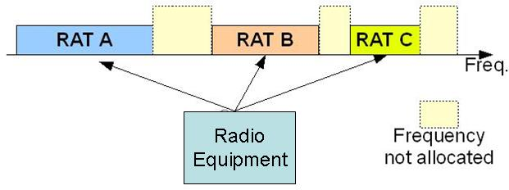

From the definition, the CRS may offer improved efficiency to the overall spectrum use and provide additional flexibilities, allowing the network to determine what combination of RAT and available spectrum is required for best connectivity and then adapt the radio according to its internal state, external environmental conditions and established policies.

Introduction of CRS could allow more dynamic spectrum management and more flexible spectrum usage inside the domain of a single operator, noting that CRS technology for IMT is still at the stage of research activity and a number of technical and operational challenges are still to be addressed. As an illustration (see Figure B), an example of an operator who already owns a network and operates in its assigned spectrum could be given. Taking into consideration the non‑uniform nature of radiocommunication needs within a given area, an operator having more than one radio access network in this geographical area, based on different radio technologies could dynamically adapt to traffic variations and jointly manage the deployed resources, such as GSM and IMT, in its assigned spectrum, in order to adapt the configuration of the networks to maximize the overall network capacity, e.g. by adopting reconfigurable radio base stations and related cognitive management entities.

This case could be expanded when an operator decides to deploy another radio network based on a new generation radio interface technology in another assigned spectrum band covering the same geographical area.

Figure B

Scenario of CRS in intra-operator



## **4.3 In-band coverage/capacity improvement by relays**

The use of relays – that use the radio access spectrum for backhauling and forwarding packets from the Base Stations to IMT devices and the reciprocal path – is one of the features included in the IMT-Advanced technologies. The deployment of relays in terms of transmitting power, antenna parameters, etc. could be a solution to solve an operator’s capacity/coverage problems.

CRSs may detect and locate the situations that require coverage and capacity improvements. Furthermore CRSs may identify the available resources to configure and optimize the above mentioned relay solution. Indeed, an operator may have to handle areas with high channel impairments and areas with high traffic demand for short periods:

− some areas that suffer from high shadowing receive the serving signal with strength much lower than what the initial planning forecasted. This is commonly referred to as a “dead zone” or a “coverage hole”. Possible causes are a hilly terrain or buildings of great dimensions. In these areas, the service quality could be significantly impacted. However, depending on the size of a coverage hole and traffic needs, the deployment of a new base station may not be the best solution;

− some areas might have a significantly high traffic demand for short periods, which necessitates a provision of capacity increase in order not to cause a notable degradation in the planned service quality.

A possible tool to alleviate such problems could be the deployment of relays whose parameters could be optimized using REMs.

FIGURE C

Relay scenario

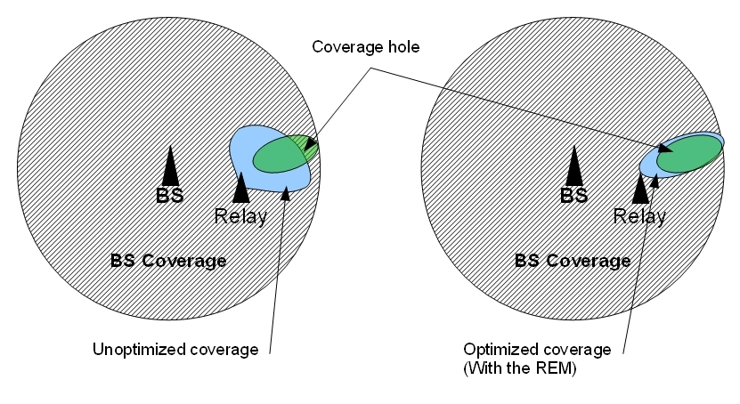

Figure C above provides an example of a relay-based solution for coverage improvement. This figure depicts a situation where the green area requires better coverage due to propagation issues or more capacity due to traffic issues. The left-hand sub-figure highlights the weakness of a static design solution: the transmission power of the relay is not optimally adjusted to cover the intended zone. The blue area that is due to the overshoot in relay coverage causes high interference, degrading the QoS for the users in the vicinity. Besides, the relay coverage does not completely cover the intended zone, leaving the initial problem partially unsolved. On the right-hand side, we can see the solution tailored with REM. The transmission power of the relay is optimally configured; its coverage matching the green area.

REM helps resolve coverage and capacity problems by supplying geo-localized information on the coverage/capacity indicators. As a remedy, it provides a means to dynamically adjust the transmit power of the relay transmitters (i.e. relay auto-configuration). Indeed, relays should be agile enough in configuration of modifications (power adjustment, beam forming capability, etc.) so relays can perform better.

## **4.4 Self-configuration and self-optimization of femtocells**

Initial dimensioning and planning of the femtocell network by an operator is quite a big challenge since it is difficult to evaluate how many femtocells will be deployed and where backhauling is provided by the landline internet access of the customer (ADSL, fiber, etc.) and radio access is achieved by the RAT that defines the femtocell (IMT or IMT‑Advanced). To achieve easy installation of femtocells they must be plug-and-play type devices, since there may be no initial network planning process in the femtocells.

Femtocells, being plug-and-play type devices, are assumed to be autonomous in specific operations as long as they are used in the operators licensed frequency bands. This includes specifications for transmission parameter settings (RF and antenna parameters, power levels, etc.), neighbour identification list, admission/congestion control parameter adjustment and mobility management of open access femtocells[3] (femto-femto as well as femto-macro mobility).

Furthermore, for closed access femtocell[4] deployments, interference mitigation with neighbouring femtocells is a challenging issue. Likewise, when femtocells are deployed in the same frequency band as the macro cells of the same RAT, efficient interference mitigation techniques are needed to prevent QoS degradation. Systems involving femtocells are expected to be highly dynamic thus issues like self-configuration, self-optimization are of primary importance.

## **4.5 Multi-modes coexistence and simultaneous transmission**

This scenario includes multi-modes coexistence within the same and different frequency bands. In order to achieve multi-modes coexistence and avoid harmful interference among the different RATs, it could be possible to use the different frequency bands or reuse the same frequency bands with an optimum transmission power and acceptable separated distance which are obtained or decided by the use of CRSs.

In multi-modes simultaneous transmission, the radio equipment (both base stations and terminals) should be reconfigurable, supporting operation in different modes among multiple radio interfaces and transmitting data by using multiple radio interfaces.

## **4.6 Possible other deployment scenarios**

In addition to the case of intra-operator use, other possible CRS deployment scenarios, may involve agreement between different operators in accordance with radio regulations. The challenges identified in this Report are valid for any scenario; however they might be more critical in other scenarios involving multiple operators and it could even be necessary to address additional issues.

# **5 Determination of the IMT spectrum usage**

## **5.1 Measurement collection system for determination of spectrum state**

It is under consideration that a RAT agnostic measurement system, referred to as the REM, may come along with the future terrestrial radiocommunication systems implementing cognitive radio concepts in order to facilitate the collection, storage and processing of the radio environment measurements. The REM is expected to be part of the operator domain in order to query the network infrastructure and related user equipment. The communication between the REM and this equipment, as shown in Figure D below, is reliant on standardized interfaces and protocols.

FIGURE D

Measurement collection system

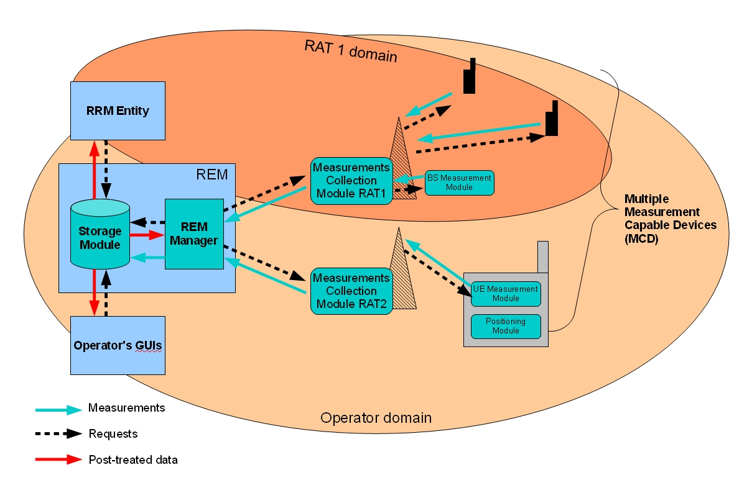

In Figure D the REM manager is responsible for the processing tasks. The manager has two main roles:

− it fuses and interpolates radio measurements when necessary;

− it updates the content of storage module by generating measurement requests based on available post-treated data.

The storage module would typically be a database with standardized interfaces and data model, enabling probes from e.g. a wide range of operation and maintenance (O&M) and RRM tools.

The measurements collection modules are located in the radio network and play the role of common application programming interfaces (APIs) for the various RATs. It relays measurement requests to and gathers measurements and information from the measurement capable devices (MCDs) which include base stations and user equipment.

MCDs provide dynamic geo-located measurements on request, collected from every RAT domain that are stored and treated in the REM entity which encompasses REM management and storage modules. The post-treated REM data then feed the RRM entities for radio resources optimization purposes. Thus, the REM as a technology agnostic tool, encompassing any compliant reconfigurable radio access technology, allowing implementation of powerful cross-technology optimization algorithms, provides a synthesized view of the networks for monitoring purposes through dedicated graphical user interfaces (GUIs).

## **5.2 Additional methods for determination of spectrum state**

Spectrum state determination can be divided into two distinct tasks namely measurement and updating:

− determination of the state of a specific RAT on a given frequency band[5] related to the radio environment; this involves identifying distinct spectral states having different spectral characteristics using measurements and,

− improve the knowledge about the inherent characteristics and parameters of a RAT[6]; this implies recognition of the particular RAT based on measurements.

If these tasks are to be accomplished by using only the measurement data, then advanced statistical learning (supervised classification, feature extraction and selection) techniques can be used. Otherwise, solutions like cognitive pilot channel (CPC) can be proposed.

The purpose of these tasks is to gain information on the wireless environment for constructing efficient operator policies and decisions for increased spectrum efficiency and enhanced QoS.

## **5.3 Spectrum quality evaluation**

Spectrum quality is a relative qualitative measurement of the available spectrum which is based on the spectrum state information mentioned above. Parameters such as bandwidth, duration of availability and existing interference levels are used in order to be able to evaluate the spectrum quality. On-going research activities are investigating possible techniques for determination of both spectrum state and spectrum quality evaluation, such as spectrum sensing, using a database approach and using a cognitive pilot channel, among others. Various combinations of these techniques are also being investigated. Combining calculated information and internal state, network capacity and link quality on the available spectrum can be estimated, which could support decision making for spectrum usage.

## **5.4 Spectrum balancing**

Spectrum can be utilised according to spectrum quality in the following ways.

According to spectrum state and quality information, decision making mechanisms calculate and select the spectrum and operational parameters which are satisfied for CRS requirements. When spectrum state and quality change, CRS makes a decision to adjust its operational parameters, e.g. operation frequency and transmitted power.

Spectrum can be selected based on:

• Capacity and degree of utilisation.

• Type of application.

− Different types of applications may have different requirements for spectrum quality.

• Priority of application.

− Applications of different priorities may be provided with spectrum of varying quality.

Another approach is for an operator to implement dynamic spectrum balancing in its licensed frequencies based upon its unique business and technical algorithms. An example is shown in Figure E by which, spectrum balancing strategies (SBS) are applied to facilitate CRS operations in the operator’s licensed spectrum. Considering traffic imbalance and variations, some RATs may have unoccupied carriers within a given geographical area and time. SBS implies an operator has developed a control entity, which could be a physical entity or logical entity, in its network for controlling various RATs and BSs. By SBS processing, the unoccupied carrier can be cognitively configured and used by the other RATs to increase the network capacity. Radio environment information is collected for the SBS from BSs and then SBS generates configuration decisions after analysis based on network information and traffic prediction so that SBS can finally adjust the parameters of BSs. Here, network information may contain geography information, coverage area and other information of BSs in the network.

Figure E

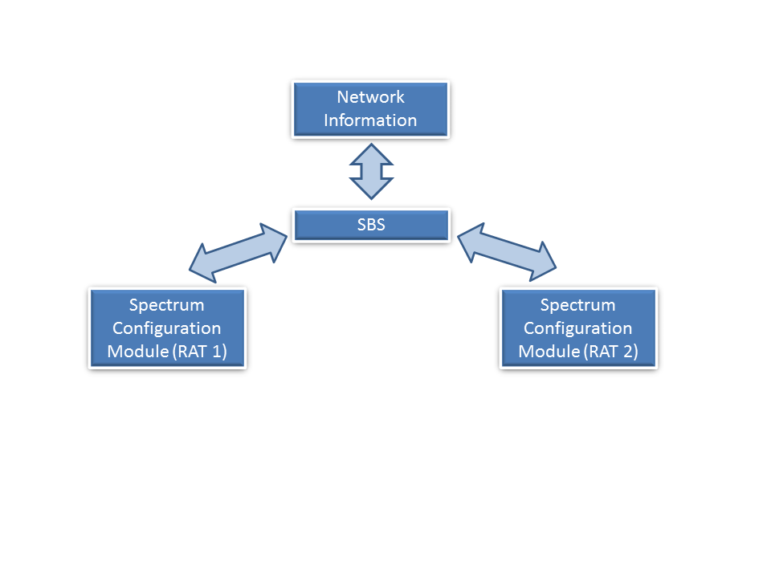Spectrum balancing strategies framework for dynamic network   
configuration in an intra-operator environment

# **6 Description and impacts of cognitive radio systems specific for IMT systems**

The CRS paradigm involves a set of new principles to increase the efficiency of the IMT RAT. Applying those principles impacts the current IMT networks and gives rise to specific technical challenges. The notion of QoS, in particular, is important to IMT systems; therefore, it is supposed that the introduction of CRS will not have a detrimental effect on the QoS for IMT systems.

## **6.1 CRS approaches applicable to IMT**

This section concentrates on the definition of cognitive principles and technology enablers currently under study and then lists possible impacts of applying them to IMT systems.

The cognitive concept relies on the following resources:

• capability to obtain knowledge of the radio operational environment such as the geographical environment, the internal states and the frequency band assignations;

• determining established policies and devices internal state: full control of the operators’ policies and rules to manage the use of bands identified for IMT;

• dynamic and autonomous adjustment of operational parameters and protocols (including a switch of the implemented RAT) based on predefined objectives provided by an IMT network operator relative to its own network deployment;

• dynamic adjustment of users device’s operational parameters and protocols (including a switch of the implemented RAT);

• learning from the results obtained which is one of technical aspects of the CRS definition.

Some considerations for introducing cognitive radio to IMT systems include the following:

• consequences of CRS functionality on co-existence;

• consequences of CRS functionality on roaming;

• support of CRS specific network functions:

− Sensing.

− Geo-location database.

− Emission limits.

− Initial access (RAT selection and reselection).

− Positioning.

− Frequency mobility when a CRS changes its operating frequency.

The cognitive concept aims at accomplishing most of the radio functions by using software instead of hardware (for example through the use of SDR technology). This provides more flexibility and allows both the BSs and user devices to modify their operating parameters as well as to select the RAT and frequency band in which they operate.

## **6.2 Cognitive networks for IMT systems**

A cognitive network is a network that could dynamically adapt its parameters, functions and resources on the basis of the knowledge of its environment and established policies. The cognitive network general concept fully applies to the intra-operator scenario for a CRS as described in Section 4.

In principle, a cognitive radio network includes the following functionalities and entities:

• cognitive network management;

• reconfigurable base stations;

• reconfigurable user devices.

In addition other functionalities or entities may be included such as radio environment database.

The cognitive network management functionality over-spans different radio interface technologies, managing and controlling the nodes inside the network, with the goal to self-adapt towards an optimal mix of radio interface technologies and frequency bands. This functionality could act on the basis of some input parameters, such as resource availability, traffic demand, user device capabilities (supported radio interface technologies, frequency bands, etc.), and bearer services requests among others. The reconfigurable base stations and reconfigurable user devices are part of the cognitive network. The resources of a reconfigurable base station could be dynamically reconfigured in order to be used with different radio interface technologies, frequencies, channels, etc., and could support multi-radio interface operation with dynamic load-management. The software and/or hardware of a reconfigurable user device could be dynamically reconfigured, making it able to operate on different radio interface technologies, frequencies, etc. The reconfiguration of reconfigurable base stations and user devices is managed and controlled by the cognitive network management functionality.

Hence the heterogeneous nature of a cognitive network creates the need for a standardised cross‑technology language used for:

• data collection;

• reconfiguration control.

The availability of reconfigurable nodes in the networks in conjunction with cognitive network management functionalities could give the network operator the means for managing, in a globally efficient way, its overall radio and hardware resources, with the aim to adapt the network itself to the dynamic variations of the traffic offered to the deployed RATs.

## **6.3 Additional aspects and technical challenges of CRS technology in IMT networks**

The implementation of CRS technology in IMT networks will progress stepwise due to a number of technical challenges coupled with the current state of the technology. In addition, the implementation of CRS technology in IMT networks may introduce specific and unique challenges of technical or operational nature.

A list of such challenges related to the introduction of CRS technology inside IMT systems could include, for example:

• interference management: so the existing radio systems users do not suffer harmful interference due to any CRS operation;

• QoS: the current QoS level of existing radio systems users should be guaranteed in case of any CRS operation;

• reliability: the CRS operations should be entirely reliable for the users and all the involved nodes in the system(s);

• mobility: a full seamless connection experience should still be guaranteed to users in case of any CRS operation;

• timing: the CRS operations should be executed and signalled to all the affected users and nodes in a timely manner;

• security: the existing radio systems should have a sufficient degree of protection against malicious behavior which may arise due to any CRS operation and in particular to guarantee that user devices will not bypass network policies.

Additional study/research is needed to further investigate the concept of CRS technology, including CRS architecture; operational techniques; QoS and mobility issues. Furthermore, CRS specific certification aspects may be addressed by industry.

## **6.4 Spectrum refarming in IMT networks**

CRS could be of particular interest in a situation of spectrum refarming by an operator within its own licensed frequency bands. Indeed, in the context of technology evolution and periodical emergence of new families of standards, due to the large amount of legacy equipment and the corresponding investments, a transition period taking into account the traffic constraints and user expectations is required. The smooth refarming managed by a single operator could be facilitated by CRS.

## **6.5 Intra-operator based radio resource optimization**

A number of mobile communication RAT standards have been adopted by markets over the world. Some of them are widely adopted IMT systems. Mobile network operators (MNO) need to build, optimize and maintain their communication networks, upgrade to new/advanced technology standards. Sometimes they operate multiple communication networks of different standards, especially during network migration period. As a matter of fact, many MNOs run multiple IMT systems in same geographic area and same time period, on different spectrum bands. Therefore, an operator today must be able to manage such a heterogeneous radio environment that is characterized by its multiple services, different network architectures, various multiple access techniques and multiple frequency bands. Cognitive radio could facilitate intra-operator simultaneous multiple frequency usage to balance the load of the different networks that represent different technologies and different generations. Spectrum aggregation also can increase the utilization of the scarce resources available. Furthermore, the traffic variations in space/time could be managed in a dynamic manner, which could lead to optimal use of the composite capacity of the frequency bands.

The continuing growth of mobile radio systems is driving the demand for more efficient use of spectrum. In this case, CRS technology could provide MNOs an opportunity to maximize the utilization of the radio resources they are authorized to use.

Scenarios illustrating potential efficiency gains and load balancing through cognitive radio technology are found in Annex B.

# **7 Performance of IMT systems with CRS capability**

This section addresses the issues related to the potential benefits, and key performance indicators of using CRS technology in IMT systems.

## **7.1 Potential benefits of using CRS technology in IMT systems**

This section addresses potential benefits which could be experienced by IMT systems through the use of CRS technology.

### **7.1.1 Overall spectrum efficiency and capacity improvement**

A CRS could monitor the time and space variation of the radio environment, and allow the network to reuse selectively available frequencies. By this way, the overall spectrum efficiency can be improved. Considering that more of the available spectrum could be used and higher efficiency may be reached within the existing radio environment, thus system capacity may be enhanced accordingly. Annex A of this Report shows an example of a methodology that can be used to calculate the theoretical capacity of IMT systems with CRS capability.

### **7.1.2 Radio resources utilization flexibility**

CRS technology may bring more flexibility in frequency use to the operation of IMT systems. Cognitive capability allows IMT systems to optimize parameters, such as bandwidth, operation frequency and transmission power. This flexibility may help IMT systems intelligently adjust their network to satisfy dynamic capacity requirement. Agile use of radio parameters also helps to implement self-configuration and self-optimization networks.

### **7.1.3 Interference mitigation**

Interference is a significant problem in radio communication networks, impacting bit error rate (BER) and packet loss ratio. Considering intelligent selection of the frequency, IMT systems employing CRS technology could choose available spectrum with a lower interference level. Furthermore, with dynamic spectrum allocation strategy and adaptive transmission power control methods, the system interference level or link interference could be mitigated.

## **7.2 Potential implications of using CRS technology in IMT systems**

This section addresses potential implications to IMT systems arising from the use of CRS technology.

### **7.2.1 Signalling overhead in CRS**

CRS feature support may result in an increase in signalling overhead.

### **7.2.2 Increase of the system complexity**

The cognitive function may increase the complexity not only for system components (such as core network, BSs) but also user devices. Within the CRS, the architecture, interface, protocol, network entities, software, and working mode may need to be adaptive.

### **7.2.3 Increase of the control/user plane latency**

For the system with cognitive capabilities, more interactive processes may be needed; this may cause control/user plane latency.

## **7.3 Key performance indicators for CRS technology in IMT systems**

Cognitive radio is designed to be aware of and sensitive to the changes in its surrounding radio environment, which makes techniques for spectrum quality assessment among the important requirements for the realization of cognitive radio networks. Currently there are a number of techniques being investigated to satisfy this requirement, such as spectrum sensing, database approach, cognitive pilot channel, etc., and some possible combinations of these techniques. With specific reference to spectrum sensing, some spectrum sensing methods are possible, including matched filter detection, energy detection, and feature detection. These existing quality assessment methods differ in their sensing performances. These methods or combination thereof could be implemented by taking various circumstances into consideration. Therefore, in order to weigh the performance of different methods, such as, but not limited to, the unique key performance indicators for spectrum knowledge, overall system performance, decision making, and user experience of CRS technology in IMT systems may need to be defined.

With specific reference to overall system performance aspect, the advantages and implications brought to IMT systems by CRS technology can be uniquely expressed as some parameters, such as channel set up and release duration, signalling load, cell average throughput, overall network capacity and reliability.

# **8 Conclusions**

In conclusion, an IMT network operator centric, intra operator, approach to integrate CRS features in the IMT network is the preferred scenario; however, it is of major importance to ensure that the existing radio systems will not suffer from either harmful interference or QoS degradation as a result of the introduction of CRS technology.

In this context, introduction of CRS in the IMT systems may allow more dynamic and flexible radio resources management and optimization. It should be noted that CRS technology for IMT systems is still in a research stage and a number of technical and operational challenges remain to support its implementation.

Annex A  
  
A methodology to calculate theoretical capacity of  
IMT system with CRS capability

This Annex shows a methodology to calculate the theoretical capacity achieved by an IMT system with CRS capability (denoted as IMT-CRS hereafter), when the IMT-CRS system and an existing IMT system share the same spectrum. The analysis is performed under the assumption that the spectrum sharing mechanism works ideally using some CRS capability, i.e., the IMT system with CRS capability does not give harmful interference to the existing IMT system. The existing IMT system is assumed to be a macro cellular system (denoted as IMT-MCS hereafter), while the IMT‑CRS system is newly deployed in an indoor or outdoor environment in the same geographical area.

Furthermore, interference between IMT-CRS base stations is not taken into consideration in the analysis. This situation would be valid if the number of deployed IMT-CRS base stations is small, where its deployment is conducted in a controlled manner by the same operator deploying the existing IMT system.

# 1 Assumed spectrum sharing scenario and sharing method

In the analysis the scenario shown in Figure 1 is assumed, where the IMT-MCS and IMT-CRS system share the same spectrum band in the same geographical area. Only the downlink transmission of the IMT-CRS system is analysed and both the IMT-MCS and IMT-CRS system are assumed to use frequency division duplex (FDD) mode. In order to protect the existing system, mobile stations in the IMT-MCS must not be subjected to harmful interference. However, IMT-MCS base stations will be interference sources to the IMT-CRS system.

In addition,

− Interference between IMT-CRS base stations is not taken into consideration. This assumption is valid if IMT-CRS base station deployment density is not high.

Figure 1

Sharing mechanism

(NOTE – Only downlink scenario is considered)



In the study, the following two sharing methods are considered as CRS capabilities for the IMT system in the downlink (see Figure 1).

− Listen Before Talk (LBT) method: This method allows an IMT-CRS base station to transmit signals only if the transmitted signal imposes no harmful interference on IMT‑MCS mobile stations. In other words, the IMT-CRS base station senses the signal level from IMT-MCS mobile stations and if the observed signal level is below a predetermined threshold, the IMT-CRS base station transmits signals; otherwise it refrains from sending signals.

− Adaptive Transmit Power Control (ATPC) method: This method allows an IMT-CRS base station to send signals with the transmit power, *Pallow,crs*, that does not give harmful interference to any of the IMT-MCS mobile stations, i.e., interference to all IMT-MCS mobile stations must be less than *Iallow,mcs*(dBm/Hz). This method needs to estimate propagation path loss between the IMT-CRS base station and the nearest IMT-MCS mobile station.

In the ATPC method, in order to obtain *Pallow,crs*, the path loss *Lpath* (dB) between an IMT-CRS base station and an IMT-MCS mobile station needs to be estimated by observing uplink signals from the IMT-MCS mobile stations at the IMT-CRS base station. For example:

*Lpath* (dB) = *Rcrs,bs* – (*Ptx,mcs,ms* + *Gmcs,ms* + *Gcrs,bs*),

where:

*Rcrs,bs* (dBm): received signal power from the IMT-MCS mobile station

*Ptx,mcs,ms*: transmit power of the IMT-MCS mobile station

*Gmcs,ms* (dBi): antenna gains of the IMT-MCS mobile station

*Gcrs,bs* (dBi): antenna gain of the IMT-CRS base station.

Here, *Ptx,mcs,ms* and *Gmcs,ms* is assumed to be known at the IMT-CRS BS. Moreover, in order to calculate *Pallow,crs*, allowable interference level at the IMT-MCS base station *Iallow,mcs* is known at the IMT-CRS base station,

*Pallow,crs* (dBm) = *Gcrs,bs* – *Lpath* + *Gmcs,ms* + *Iallow,mcs* + *BWcrs*,

where *BWcrs* (dBHz) is the occupied bandwidth of the IMT-CRS system.

Figure 2

IMT-CRS stations: indoor and outdoor scenarios

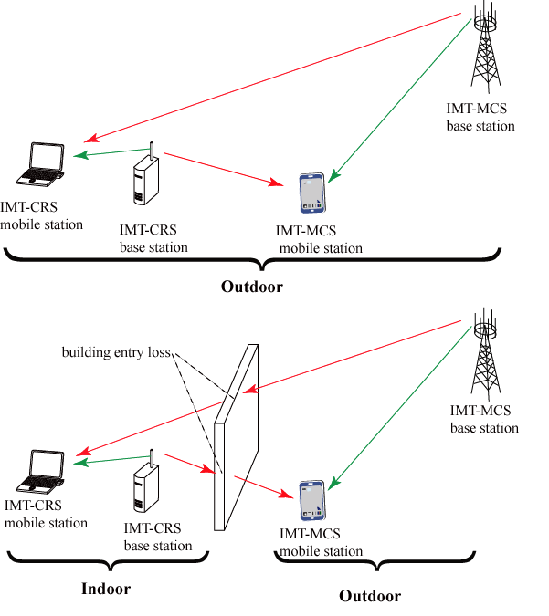

Two scenarios for IMT-CRS deployment (i.e., indoor and outdoor environment) are considered. Meanwhile, IMT-MCS stations reside outside the buildings. When the IMT-CRS stations are used within the indoor environment, penetration loss due to the building outer wall is taken into consideration for the following two paths (see Figure 2):

− paths between an IMT-CRS base station and an IMT-MCS mobile station;

− paths between an IMT-MCS base station and an IMT-CRS mobile station.

# 2 Capacity analysis of IMT-CRS using the same spectrum with IMT‑MCS

Achievable capacity of IMT-CRS is analysed when IMT-CRS and IMT-MCS share the same spectrum in the same geographical area.

## 2.1 Average cell capacity for given transmit power, *Ptx*

The average cell capacity for given transmit power, *Ptx*, over area A is obtained by

,

where:

*Z*(*Ptx*): signal to interference and noise ratio (SINR)

SA: cell area

*vsf* : shadowing factor

*psh*(*vsf*, *msh*): probability density function (PDF) of *vsf* with variance 2.

The equation *psh*(*vsf* , *msh,c*) is expressed as

,

where *msh,c* is determined using the following equation so as not to change the mean path losses by introducing the shadowing effects.



*Z*(*Ptx*), which is denoted *Z* by omitting *Ptx* below, is calculated as

,

where:

*PIN* (dBm): interference plus noise power density at an IMT-CRS mobile station

*Gcrs,ms* (dBi): antenna gain of the IMT-CRS mobile station.

*PIN* is calculated from thermal noise density *Nthermal* (dBm/Hz) and the noise figure *NF* (dB) and interfering signal power density *PI* (dBm/Hz).

.

Moreover, *PI* is obtained as the total signal power from all IMT-MCS mobile stations so *PI* becomes

,

where:

*SMCS,BS*: set of IMT-MCS base stations

*Lpath,i* : path loss between the *i*-th IMT‑MCS base station and the IMT-CRS mobile station

*Gmcs,bs*: antenna gain of an IMT‑MCS base station

*BWmcs*: system bandwidth of IMT-MCS.

In order to derive closed form equations, the interference level at an IMT-CRS mobile station is approximated as that of its serving IMT-CRS base station.

Last, the relation between capacity *C*(*Z*) (bps/Hz) and SINR *Z* is given by

*C*(*Z*)= min(*Cmax*, log2(1+ *Z*/*Ccmp*)),

where *Ccmp* is a compensation factor that depends on system capabilities, and *Cmax* is the maximum achievable capacity. *Cmax* is determined by the system parameters including modulation and coding sets and the effective ratio of radio resources available for data symbols.

## 2.2 Capacity of IMT-CRS

In the spectrum sharing scenario, the received interference power at the IMT-MCS mobile stations should be below the acceptable interference level *Iallow,mcs* (dBm/Hz):

*Iallow,mcs* > *Ptx,crs* – *BWcrs* + *Gcrs,bs* – *Lpath* + *Gmcs,ms*,

where *Ptx,crs* (dBm) is the transmit power of the IMT-CRS base station. The condition described in the above equation determines distance *dia*, the minimum distance not to cause harmful interference to the IMT-MCS stations. Path loss is modelled as:

*Lpath* =  log10(*d*) + ,

where *d* is the distance between the IMT-CRS base station and the IMT-CRS mobile station. If the path passes through a wall between indoor and outdoor sites, additional penetration loss *Lpath* is considered.  and * *are constants that depend on the radio channel conditions including frequency and antenna heights. Based on the above assumptions, *dia* becomes:



where:

 = *Gcrs,bs* + *Gmcs,ms* – *BWcrs* - *Iallow,mcs*

Here the effects of shadowing and multipath fading are omitted in determining *dia*.

If IMT-MCS mobile stations are assumed to be distributed uniformly over the area, the number of IMT-MCS mobile stations in the area experiencing interference by the IMT-CRS base station, *Nmcs,ms* is:

*Nmcs,ms* = *mcs,ms*  (*dia*2 − (*hcrs,bs - hcrs,ms*) 2)

where

*hcrs,bs*: antenna height of the IMT-CRS base station

*hcrs,ms* : antenna height of the IMT-CRS mobile station

*mcs,ms*: density of the IMT-MCS mobile stations whose packets are in the queue of the downlink scheduler.

From *Nmcs,ms*, it is possible to obtain the probability that the IMT-CRS base station can transmit signal with power *Ptx,crs*.

,

where *pactive,mcs* is the probability that the IMT-MCS mobile station is active.

1) LBT method

Using the above equations, the cell-averaged capacity in the LBT method is given as follows:

*Ccell, LBT*(*Ptx,crs*) (bps/Hz) = *Ccell* (*Ptx,crs*) *Ftxp*(*Ptx,crs*).

2) ATPC method

Using the above equations, the cell-averaged capacity in the ATPC method is given as follows:

,

where

*Ptx,crs,max* (dBm): maximum transmit power of the IMT-CRS base station

*ftxp*(*Ptx,crs*): probability that the IMT-CRS base station transmits at *Ptx,crs* with the ATPC method, which is obtained by differentiating *Ftxp*(*Ptx,crs*) as follows:

.

# 3 Examples of numerical calculations

Tables 1 and 2 show the parameters used in the numerical calculations and the applied propagation models, respectively. Basically the parameters match the values summarized in Report ITU-R M.2039. A 19-cell structure with the frequency reuse factor of one is assumed for the deployment of IMT-MCS base stations and an IMT-CRS base station is located at the center of each cell (see Figure 3). In calculating the capacity, only a single triangle area in the cell area is considered, when the symmetrical feature is taken into consideration. As for the protection criteria of mobiles stations in IMT-MCS, it is considered that the interference limit is the noise level minus *MIN* (dB) = −6 (dB). Omni-directional antennas are assumed for all stations in the IMT-CRS system and IMT-MCS.

Figure 3

Cell structure of IMT-MCS

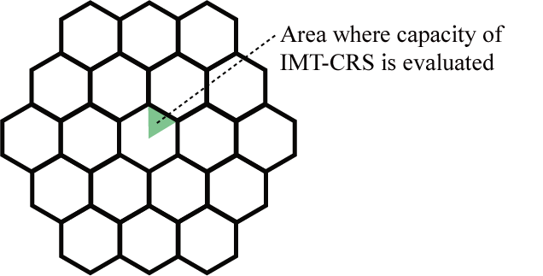

TABLE 1

Assumed parameters

|  |  |
| --- | --- |
| Common parameters | |
| Frequency (GHz) | 2 |
| *Nthermal* (dBm/Hz) | –174 |
| ⬧ (dB) | 4 |
| *Ccomp* (dB) | 8 |
| *Cmax* (bps/Hz) | 7 |
| *Lwall* (dB) | 10 |
| *MIN* (dB) | –10 |
| IMT-MCS parameters | |
| *Ptx,mcs,bs* (dBm) | 43 |
| *BWmcs* (MHz) | 20 |
| *Gmcs,bs* (dB) | 17 |
| *Gmcs,ms* (dB) | 0 |
| *NF* (dB) | 6 |
| Mobile station antenna height (m) | 1.5 |
| Base station antenna height (m) | 30 |
| Pactive,mcs (m) | 0.1 |
| Cell radius (m) | 500 |
| IMT-CRS parameters | |
| *Ptx,crs,max* (dBm) | 20 |
| *BWcrs* (MHz) | 20 |
| *Gcrs,bs* (dB) | 5 |
| *Gcrs,ms* (dB) | 0 |
| *NF* (dB) | 6 |
| Mobile station antenna height (m) | 1.5 |
| Base station antenna height (outdoor) (m) | 10 |
| Base station antenna height (indoor) (m) | 3 |
| cell radius (m) | 30 |

TABLE 2

Applied propagation models

|  |  |
| --- | --- |
| Path | Model |
| Between IMT-MCS base station and mobile station | COST-231 EXTENDED HATA |
| Between IMT-CRS base station and mobile station | (Indoor cases) Report ITU-R M.2135, Indoor hotspot, NLOS |
| (Outdoor cases) Report ITU-R M.2135, Micro-urban, Hexagonal cell layout |

Figure 4 shows an example of cell-averaged capacity in an IMT-CRS base station when the IMT‑CRS system and IMT-MCS system share the same spectrum in the same geographical area. In the figure, the capacity (vertical axis) is normalized by that achieved in the highest capacity scenario, which is achieved in the ATPC method for the active IMT-MCS mobile stations’ density *mcs,ms* of 0.5 x 10–4 (terminals/m2) in the indoor scenario.

FigURE 4

Downlink cell-averaged capacity in an IMT-CRS base station versus  
the active mobile stations’ density in IMT-MCS

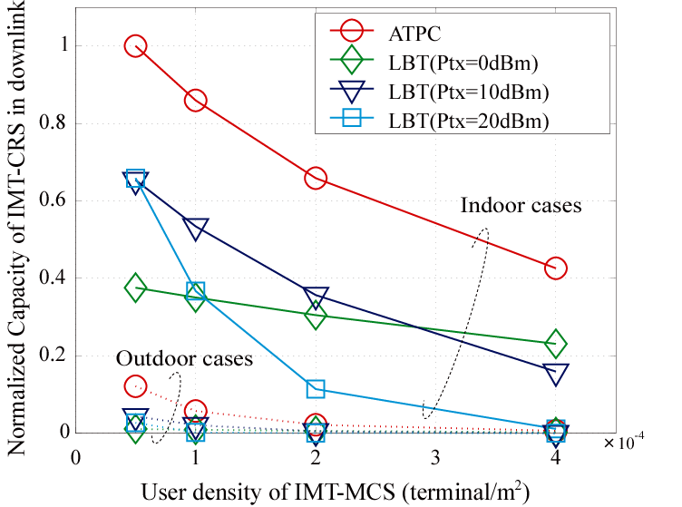

The following observations are drawn from Figure 4:

− the ATPC method offers higher capacity than the LBT method;

− the IMT-CRS base station achieves higher capacity in the indoor deployment scenario than in the outdoor deployment scenario;

− the capacity of the IMT-CRS base station decreases as the density of active IMT-MCS mobile stations is increased, and the reduction in capacity is more significant in the outdoor deployment scenario than in the indoor deployment scenario.

It should be noted that the achievable capacity in an IMT-CRS base station depends on propagation environment, cell radii of IMT-MCS and IMT-CRS base stations, and other relevant parameters.

Reference

(1) H. Fujii and H. Yoshino, "Spectrum Sharing by Adaptive Transmit Power Control for Low Priority Systems and Achievable Capacity", IEICE Trans. on Commun., Vol. E92‑B, no. 8, pp. 2588-2576, Aug. 2009.

Annex B  
  
Scenarios illustrating potential efficiency gains   
through cognitive radio technology

In this calculation the resource needed for each call is assumed to be one channel. It is assumed that there are two different groups of spectrums available. Each spectrum group has 18 channels. It is also assumed that the performance criterion is not to exceed 1% probability of blocking. Here, the unit of “call” is equivalent to “Erlang”.

***Scenario 1:***

Two groups of spectrum that are completely partitioned. Each spectrum group is assumed to support 10 identical calls at 1% probability of blocking.

|  |  |  |  |
| --- | --- | --- | --- |
| Spectrum are not shared: each group is fully utilized | | | Spectrum are pooled |
| Group 1 | Group 2 | Group 1 + Group 2 | Group 1 + Group 2 |
| 10 calls | 10 calls | 20 calls | 25 calls |
| 18 channels | 18 channels | 36 channels | 36 channels |
| Utilization = 55% | Utilization = 55% | Utilization = 55% | Utilization = 69% |

***Scenario 2:***

Two groups of spectrum that are completely partitioned. It is assumed that the first group is not fully utilized, where the number of calls serviced is = 2 calls; and group 2 is overloaded (more than 10 calls) which resulted in unacceptable probability of blocking (higher than 1%).

Each group is assumed to support 10 identical calls at 1% probability of blocking.

|  |  |  |  |
| --- | --- | --- | --- |
| Resources are not shared: Group 1 is not fully utilized | | | Resources are pooled |
| Group 1 | Group 2 | Group 1 + Group 2 | Group 1 + Group 2 |
| 2 calls | 10 calls | 12 calls | Can support up to 25 calls (2 calls from group 1 and 23 calls from the overloaded group 2) |
| 18 channels | 18 channels | 36 channels | 36 channels |
| Utilization = 11% | Utilization = 55% | Utilization = 33% | Utilization = 69% |

1. ICT-248351 FARAMIR, “Flexible and Spectrum Aware Radio Access through Measurements and Modelling in Cognitive Radio Systems”, D2.2 “Scenario Definitions”, August 2010.
2. Draft ETSI TR 103 063 “Reconfigurable Radio Systems (RRS). Use Cases definition for Reconfigurable Radio Systems operating in IMT bands and GSM bands”, April 2011.
3. 3GPP TS 36.300 “3rd Generation Partnership Project; Technical Specification Group Radio Access Network; Evolved Universal Terrestrial Radio Access (E-UTRA) and Evolved Universal Terrestrial Radio Access Network (E-UTRAN); Overall description; Stage 2 (Rel. 10)”.
4. 3GPP TS 25.367 “3rd Generation Partnership Project; Technical Specification Group Radio Access Network; Mobility procedures for Home Node B (HNB); Overall description; Stage 2 (Release 10)”.
5. L. Gueguen, B. Sayrac, "Automatic Determination of Spectral States for Cognitive Radio," *IEEE GLOBECOM 2008*.
6. L. Gueguen, B. Sayrac, "Radio access technology recognition by classification of low temporal resolution power spectrum measurements," *Wiley Journal on Wireless Communications and Mobile Computing*, 10(8), pp.1033-1044.