Report ITU-R F.2558-0
(12/2025)
F Series: Fixed service
Studies on unwanted emission levels outside the allocated bands for fixed service systems operating in frequency bands from 94.1 GHz to 174.8 GHz for the protection of Earth exploration-satellite service (passive) operating in adjacent bands where footnote No. 5.340 of the Radio Regulations applies

Foreword
The role of the Radiocommunication Sector is to ensure the rational, equitable, efficient and economical use of the radio-frequency spectrum by all radiocommunication services, including satellite services, and carry out studies without limit of frequency range on the basis of which Recommendations are adopted.
The regulatory and policy functions of the Radiocommunication Sector are performed by World and Regional Radiocommunication Conferences and Radiocommunication Assemblies supported by Study Groups.

Policy on Intellectual Property Right (IPR)
ITU-R policy on IPR is described in the Common Patent Policy for ITU-T/ITU-R/ISO/IEC referenced in Resolution ITU-R 1. Forms to be used for the submission of patent statements and licensing declarations by patent holders are available from https://www.itu.int/ITU-R/go/patents/en where the Guidelines for Implementation of the Common Patent Policy for ITU-T/ITU-R/ISO/IEC and the ITU-R patent information database can also be found.

Series of ITU-R Reports
(Also available online at https://www.itu.int/publ/R-REP/en)
Series | Title
BO | Satellite delivery
BR | Recording for production, archival and play-out; film for television
BS | Broadcasting service (sound)
BT | Broadcasting service (television)
F | Fixed service
M | Mobile, radiodetermination, amateur and related satellite services
P | Radio-wave propagation
RA | Radio astronomy
RS | Remote sensing systems
S | Fixed-satellite service
SA | Space applications and meteorology
SF | Frequency sharing and coordination between fixed-satellite and fixed service systems
SM | Spectrum management
TF | Time signals and frequency standards emissions

Note: This ITU-R Report was approved in English by the Study Group under the procedure detailed in Resolution ITU-R 1.

Electronic Publication
Geneva, 2025
© ITU 2025
All rights reserved. No part of this publication may be reproduced, by any means whatsoever, without written permission of ITU.

REPORT ITU-R F.2558-0
Studies on unwanted emission levels outside the allocated bands for fixed service systems operating in frequency bands from 94.1 GHz to 174.8 GHz for the protection of Earth exploration-satellite service (passive) operating in adjacent bands where footnote No. 5.340
of the Radio Regulations applies
(Question ITU-R 252/5)
(2025)
TABLE OF CONTENTS
Page
1 Introduction 2
2 Abbreviations/Glossary 2
3 Related ITU documents 3
4 Summary 3
5 Annexes 6
Annex 1 – Detailed summary of studies 6
Annex 2 – Study 1 – Technical analysis for FS unwanted emission limits based on extrapolation of existing studies 10
1 Density of fixed service links 10
2 Elevation of fixed service links 11
3 Antenna pattern of fixed service systems 12
4 Unwanted emissions of fixed service systems 12
5 EESS (passive) protection criteria 13
6 Propagation characteristics 14
7 Results 16
Annex 3 – Analysis of fixed service links densities in the various fixed service bands from 94.1 GHz to 174.8 GHz 18
1 Summary of analysis 18
2 Description of methodology used for the FS density estimation tool 22
Annex 4 – Study 2 – Detailed Monte Carlo Study for FS Unwanted Emission Limits 24
1 Fixed service characteristics 24
1.1 Density of fixed service links 24
1.2 Elevation angle of fixed service links 25
1.3 Antenna pattern of fixed service 26
1.4 Other fixed service parameters 26
2 Atmospheric propagation characteristics 26
3 EESS (passive) characteristics and protection criteria 26
4 Dynamic analysis 27
4.1 Results of dynamic analysis for the band 114.25-116 GHz 28
4.2 Results of dynamic analysis for the band 148.5-151.5 GHz 30
4.3 Results of dynamic analysis for the band 164-167 GHz 31
5 Static analysis 33
5.1 Results of static analysis for the band 114.25-116 GHz 34
5.2 Results of static analysis for the band 148.5-151.5 GHz 36
5.3 Results of static analysis for the band 164-167 GHz 38
6 Conclusion 40

1 Introduction
This Report provides studies on emission levels outside the allocated bands for fixed service (FS) systems operation in the bands from 94.1 GHz to 174.8 GHz for the protection of Earth exploration satellite service (EESS) (passive) operating in adjacent bands where Radio Regulations (RR) No. 5.340 applies. ITU RR No. 5.340 prohibits all emissions, inter alia, in the frequency bands 86-92 GHz, 100-102 GHz, 109.5-111.8 GHz, 114.25-116 GHz, 148.5-151.5 GHz and 164-167 GHz. These studies are summarised in Annex 1.
It is noted that since the frequency bands 100-102 GHz and 109.5-111.8 GHz are only used by limb sounding applications of EESS (passive) systems, according to Recommendation ITU-R RS.2017. It is believed that they may coexist with adjacent frequency band FS systems operating in the frequency bands 94.1-100 GHz and 102-109.9 GHz which follow the unwanted emission levels provided in Recommendation ITU-R SM.1541. While studies on those bands are not contained in this Report, a more detailed technical study may be conducted to determine more specific unwanted emission limits needed to protect limb sounding applications in these bands, if appropriate.

2 Abbreviations/Glossary
EESS Earth exploration satellite service
FS Fixed service

3 Related ITU documents
Resolution 750 (Rev.WRC-19)
Recommendations ITU-R SM.1541 – Unwanted emissions in the out-of-band domain
Recommendation ITU-R RS.1861 – Typical technical and operational characteristics of Earth exploration-satellite service (passive) systems using allocations between 1.4 and 275 GHz
Recommendation ITU-R RS.2017 – Performance and interference criteria for satellite passive remote sensing
Report ITU-R F.2239 – Coexistence between fixed service operating in 71-76 GHz, 81-86 GHz and 92-94 GHz bands and passive services
NOTE – In every case the latest edition of the Recommendation/Reports in force should be used.

4 Summary
For the Monte-Carlo study in Annex 4, the following distributions of FS antenna elevation angles have been considered as appropriates cases (baseline) to consider a reasonable representation of practical deployments with a conservative view towards ensuring protection of EESS:
– Case 1: Random uniform distribution between −10° and 10°.
– Case 2: Random gaussian distribution with a mean of 0° and standard deviation of 4.92°, with 0.39% of FS sites having a random uniform distribution of antenna elevation angles between 20° to 30°.
Additional sensitivity analysis (cases 3 to 6 in Table 1) examined the impact of different distributions of FS antenna elevation angles presenting a portion of links with higher elevation angles (mostly derived from Report ITU-R F.2239). These analyses show that the distribution of FS antenna elevation angles has significant impact on the protection of EESS (passive) from the fixed service in an adjacent band. Indeed, at higher elevation angles above 30°, the FS antenna main beam (even in small numbers over the measurement area) has the potential to be close or even within the EESS (passive) main lobe and, hence produces much higher level of interference (e.g. 5-10 dB more restrictive compared the baseline results).
TABLE 1
High FS Link Elevation Scenarios for Sensitivity Analysis
 | Case 3 | Case 4 | Case 5 | Case 6
High elevation links | 0.39% of links with elevation angles between 20° and 45° | 0.39% of links with elevation angles between 20° and 90°  (see Report ITU-R F.2239) | 0.5% of links with elevation angles between 30° and 45°  (see Report ITU-R F.2239) | 2% of links with elevation angles between 20° and 65°  (see Report ITU-R F.2239)

Taking into account these cases of FS elevation angle scenarios studied, the unwanted emission levels provided by taking the results of the case 1 and 2 FS elevation scenarios, as provided in Table 2, could be sufficient to ensure the protection of the EESS (passive).This conclusion assumes that FS links are operating at elevation angles near the horizon in their vast majority, with outlier cases (i.e. less than 100 out of 25 000) limited to elevation angles between 20 and 30 degrees. This assumption may be consistent with currently projected FS characteristics in the frequency range 92-174.8 GHz, taking into account public data available today on operations in the bands 71-76 GHz and 81-86 GHz. In case FS deployments with outlier cases having elevation angles above 30 degrees might be envisaged (or not controlled), more stringent limits than those shown in Table 2 would be necessary to ensure EESS (passive) protection. In such cases, the masks provided in Table 5 might be relevant.
TABLE 2
Summary baseline results for cases 1 and 2 of FS elevation angles in Study 2 (FS unwanted emission levels to protect EESS (passive))
FS band  (GHz) | EESS band  (GHz) | Unwanted emission levels
111.8-114.25 | 114.25-116 | −30.4 − 14(f − 114.25) dBW/100 MHz  −44.4 dBW/100 MHz | for 114.3 ≤ f ≤ 115.25 GHz  for 115.25 ≤ f ≤ 116 GHz
141-148.5 | 148.5-151.5 | −22.7 − 14(f − 148.5) dBW/100 MHz  −36.7 dBW/100 MHz | for 148.55 ≤ f ≤ 149.5 GHz  for 149.5 ≤ f ≤ 151.45 GHz
151.5-164 | 148.5-151.5 | −36.7 dBW/100 MHz  −22.7 − 14(151.5 − f) dBW/100 MHz | for 148.55 ≤ f ≤ 150.5 GHz  for 150.5 ≤ f ≤ 151.45 GHz
151.5-164 | 164-167 | −28.1 − 14(f − 164) dBW/100 MHz  −42.1 dBW/100 MHz | for 164.05 ≤ f ≤ 165 GHz  for 165 ≤ f ≤ 166.95 GHz
167-174.8 | 164-167 | −42.1dBW/100 MHz  −28.1 − 14(167 − f) dBW/100 MHz | for 164.05 ≤ f ≤ 166 GHz  for 166 ≤ f ≤ 166.95 GHz

Table 2 describes FS unwanted emission masks, according to formulas, where f is the centre frequency of the 100 MHz reference bandwidth expressed in GHz, that provide an operational interference level that is equivalent to the interference caused by the flat emission limits identified in the respective study. Utilizing such a decaying emission mask better meets the needs of FS operation at the band edge compared to a flat limit.
It should be noted that the analyses conducted in this Report are based on parameters of fixed service links that represent the best knowledge and expertise at current time. They may change in the future as systems are designed/deployed, including assumptions on the density and elevation distribution of fixed service links, antenna performance (side lobe levels) or possible mitigation factors that could realistically be implemented to limit the impact into adjacent passive service operations.
Figures 1, 2 and 3 provide a graphical representation of the unwanted emission levels shown in Table 2. It should be noted that lower and the higher 100 MHz reference bandwidth slots are intended to be centred at 50 MHz inside the EESS band edges.
FIGURE 1
Unwanted emissions from FS operating in 111.8-114.25 GHz to protect EESS (passive) in the band 114.25-116 GHz (from Table 2)
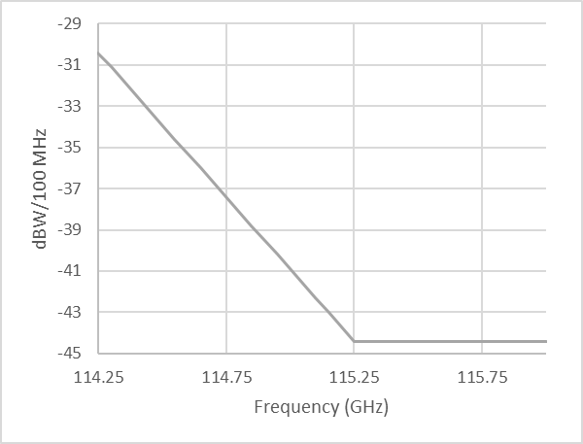
FIGURE 2
Unwanted emissions from FS to protect EESS (passive) in the band 148.5-151.5 GHz (from Table 2)
a) from FS operating in 141-148.5 GHz b) from FS operating in 151.5-164 GHz
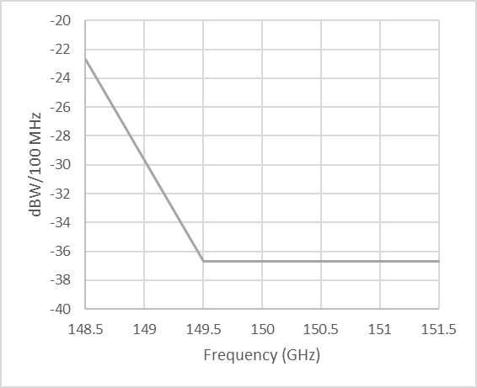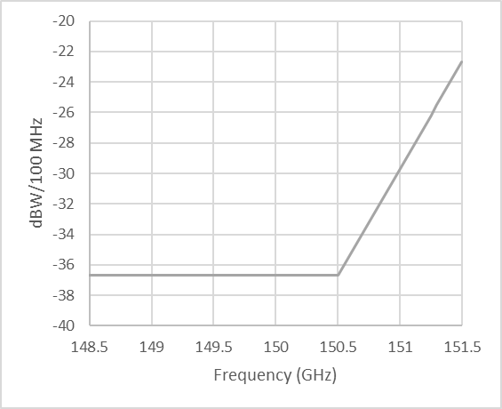
FIGURE 3
Unwanted emissions from FS to protect EESS (passive) in the band 164-167 GHz (from Table 2)
a) from FS operating in 151.5-164 GHz b) from FS operating in 167-174.8 GHz
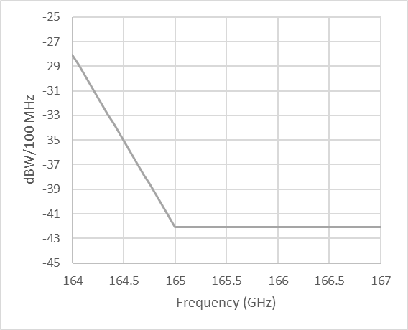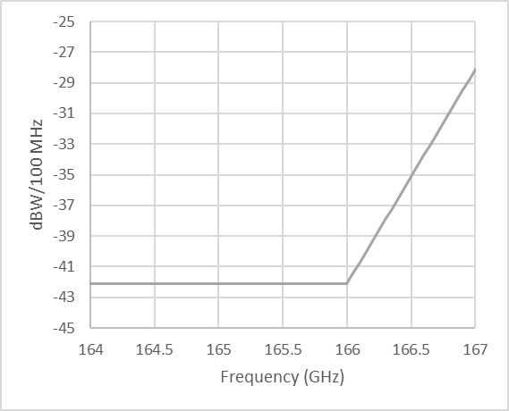

5 Annexes
Annex 1: Detailed summary of studies
Annex 2: Study 1 – Technical analysis for FS unwanted emission limits based on extrapolation of existing studies
Annex 3: Analysis of FS links densities in the various FS bands from 94.1 GHz to 174.8 GHz
Annex 4: Study 2 – Detailed Monte Carlo study for FS unwanted emission limits

Annex 1
Detailed summary of studies
Two independent studies were conducted to assess interference from FS transmitters operating in bands adjacent to frequency bands 114.25-116 GHz, 148.5-151.5 GHz and 164-167 GHz, where footnote RR No. 5.340 applies.
EESS (passive) systems in frequency bands 100-102 GHz and 109.5-111.8 GHz are only used for limb sounding applications, according to Recommendation ITU-R RS.2017. As specified in Note 2 of Table 2 within Recommendation ITU-R RS.2017, limb scan modes view the atmosphere “on edge” and terminate in space rather than at the surface, and accordingly are weighted zero at the surface and maximum at the tangent point height. As the EESS antenna main beam is not directed towards the Earth, main beam to main beam coupling between EESS (passive) systems and FS systems is not expected. It is believed that EESS (passive) systems can coexist with adjacent band FS systems which follow the unwanted emission levels provided in Recommendation ITU-R SM.1541.
The studies determine limits of unwanted emissions at the antenna port of FS transmitters, falling into the aforementioned bands. Tables 3, 4 and 5 describe FS unwanted emission masks, according to the following formulas, where f is the centre frequency of the 100 MHz reference bandwidth expressed in GHz, that provide an operational interference level that is equivalent to the interference caused by the flat emission limits identified in the respective studies. Utilizing such a decaying emission mask better meets the needs of FS operation at the band edge compared to a flat limit (similarly to what was agreed to ensure protection of EESS (passive) in the band 86-92 GHz from FS, as described in Report ITU-R F.2239 and Resolution 750 (Rev.WRC-19).
Study 1 (presented in Annex 2) extrapolates the FS unwanted emission levels developed in Report ITU-R F.2239 for the band 86-92 GHz, accounting for variation from frequency dependent parameters including:
– Density of fixed service links
– Elevation angle of fixed service links, using the same elevation cases as in Report ITU-R F.2239:
1) 0.39% of links with elevation angles between 20° and 90°.
2) 0.1 to 0.5% of links with elevation between 30° and 45°.
3) ±30° (normally distributed).
4) 2% of links with elevation angles between 20° and 65°.
– Antenna pattern of fixed service systems
– Unwanted emissions of fixed service systems
– EESS (passive) protection criteria
– Atmospheric propagation characteristics
– Bandwidth of frequency bands allocated to EESS (passive).
TABLE 3
Summary results of Study 1 (FS unwanted emission levels to protect EESS (passive))
FS band  (GHz) | EESS band  (GHz) | Unwanted emission levels
111.8-114.25 | 114.25-116 | −40.1 − 14(f − 114.25) dBW/100 MHz  −54.1 dBW/100 MHz | for 114.3 ≤ f ≤ 115.25 GHz  for 115.25 ≤ f ≤ 116 GHz
141-148.5 | 148.5-151.5 | −35.7 − 14(f − 148.5) dBW/100 MHz  −49.7 dBW/100 MHz | for 148.55 ≤ f ≤ 149.5 GHz  for 149.5 ≤ f ≤ 151.45 GHz
151.5-164 | 148.5-151.5 | −49.7 dBW/100 MHz  −35.7 − 14 (151.5 − f) dBW/100 MHz | for 148.55 ≤ f ≤ 150.5 GHz  for 150.5 ≤ f ≤ 151.45 GHz
151.5-164 | 164-167 | −34.4 − 14 (f − 164) dBW/100 MHz  −48.4 dBW/100 MHz | for 164.05 ≤ f ≤ 165 GHz  for 165 ≤ f ≤ 166.95 GHz
167-174.8 | 164-167 | −48.4 dBW/100 MHz  −34.4 − 14 (167 − f) dBW/100 MHz | for 164.05 ≤ f ≤ 166 GHz  for 166 ≤ f ≤ 166.95 GHz

Study 2 (presented in Annex 4) performs Monte-Carlo studies that simulate possible deployment scenarios of fixed service and EESS (passive) parameters to determine appropriate FS unwanted emission levels that ensure protection of EESS (passive) in the frequency bands 114.25-116 GHz, 148.5-151.5 GHz and 164-167 GHz.
Study 2 considers six random distributions for FS antenna elevation angles, referred to as cases 1 to 6. Table 4 describes the FS unwanted emission mask resulting from the following FS elevation cases 1 and 2 only (see below), which are considered as baseline FS deployment scenarios:
– Case 1: Random uniform distribution between −10° and 10°.
– Case 2: Random gaussian distribution with a mean of 0° and standard deviation of 4.92°, with 0.39% of FS sites having a random uniform distribution of antenna elevation angles between 20° to 30°.
TABLE 4
Summary results for cases 1-2 of FS elevation angles in Study 2 (FS unwanted emission levels to protect EESS (passive))
FS band  (GHz) | EESS band  (GHz) | Unwanted emission levels
111.8-114.25 | 114.25-116 | −30.4 − 14(f − 114.25) dBW/100 MHz  −44.4 dBW/100 MHz | for 114.3 ≤ f ≤ 115.25 GHz  for 115.25 ≤ f ≤ 116 GHz
141-148.5 | 148.5-151.5 | −22.7 − 14(f − 148.5) dBW/100 MHz  −36.7 dBW/100 MHz | for 148.55 ≤ f ≤ 149.5 GHz  for 149.5 ≤ f ≤ 151.45 GHz
151.5-164 | 148.5-151.5 | −36.7 dBW/100 MHz  −22.7 − 14 (151.5 − f) dBW/100 MHz | for 148.55 ≤ f ≤ 150.5 GHz  for 150.5 ≤ f ≤ 151.45 GHz
151.5-164 | 164-167 | −28.1 − 14 (f − 164) dBW/100 MHz  −42.1 dBW/100 MHz | for 164.05 ≤ f ≤ 165 GHz  for 165 ≤ f ≤ 166.95 GHz
167-174.8 | 164-167 | −42.1 dBW/100 MHz  −28.1 − 14 (167 − f) dBW/100 MHz | for 164.05 ≤ f ≤ 166 GHz  for 166 ≤ f ≤ 166.95 GHz

FS deployment scenarios with higher elevation angles have been considered in cases 3 to 6 in sensitivity analysis resulting in more stringent FS unwanted emission levels required to protect EESS (passive) operating in adjacent bands. These cases, described in the list below, were based on variations of the cases considered in Report ITU-R F.2239. Table 5 describes the FS unwanted emission mask resulting from FS elevation cases 1, 2 and 3.
– Case 3: Random gaussian distribution with a mean of 0° and standard deviation of 4.92°, with 0.39% of FS sites having a random uniform distribution of antenna elevation angles between 20° to 45°.
– Case 4: Random gaussian distribution with a mean of 0° and standard deviation of 4.92°, with 0.39% of FS sites having a random uniform distribution of antenna elevation angles between 20° to 90°.
– Case 5: Random gaussian distribution with a mean of 0° and standard deviation of 4.92°, with 0.5% of FS sites having a random uniform distribution of antenna elevation angles between 30° to 45°.
– Case 6: Random gaussian distribution with a mean of 0° and standard deviation of 4.92°, with 2% of FS sites having a random uniform distribution of antenna elevation angles between 20° to 65°.
TABLE 5
Summary results for higher FS elevation angle scenarios Cases 1, 2 and 3 in Study 2 (FS unwanted emission levels to protect EESS (passive))
FS band  (GHz) | EESS band  (GHz) | Unwanted emission levels
111.8-114.25 | 114.25-116 | −38 − 14(f − 114.25) dBW/100 MHz  −52 dBW/100 MHz | for 114.3 ≤ f ≤ 115.25 GHz  for 115.25 ≤ f ≤ 116 GHz
141-148.5 | 148.5-151.5 | −32 − 14(f − 148.5) dBW/100 MHz  −46 dBW/100 MHz | for 148.55 ≤ f ≤ 149.5 GHz  for 149.5 ≤ f ≤ 151.45 GHz
151.5-164 | 148.5-151.5 | −46 dBW/100 MHz  −32 − 14 (151.5 − f) dBW/100 MHz | for 148.55 ≤ f ≤ 150.5 GHz  for 150.5 ≤ f ≤ 151.45 GHz
151.5-164 | 164-167 | −32.8 − 14 (f − 164) dBW/100 MHz  −46.8 dBW/100 MHz | for 164.05 ≤ f ≤ 165 GHz  for 165 ≤ f ≤ 166.95 GHz
167-174.8 | 164-167 | −46.8 dBW/100 MHz  −32.8 − 14 (167 − f) dBW/100 MHz | for 164.05 ≤ f ≤ 166 GHz  for 166 ≤ f ≤ 166.95 GHz

Figure 4 provides a comparison of the masks in Tables 3, 4 and 5 for the EESS (passive) band 114.25-116 GHz. It should be noted that lower and the higher 100 MHz reference bandwidth slots are intended to be centred at 50 MHz inside the EESS band edges.
FIGURE 4
Comparison of masks for the band 114.25-116 GHz
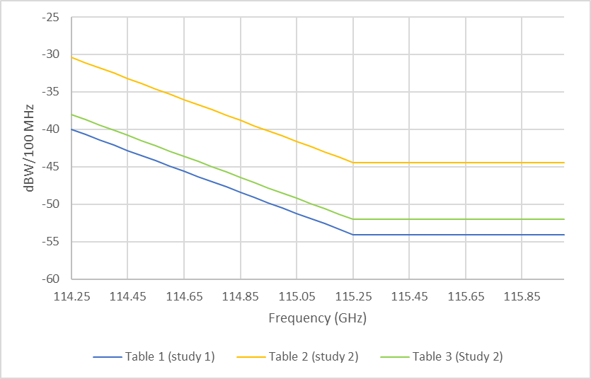

Annex 2
Study 1 – Technical analysis for FS unwanted emission limits based on extrapolation of existing studies
This Annex provides a comparative analysis to support the determination of relevant FS unwanted emission limits to ensure protection of EESS (passive) in the bands 114.25-116 GHz, 148.5-151.5 GHz and 164-167 GHz.
The approach taken to determine FS unwanted emission limits within 94.1-174.8 GHz to protect EESS (passive) in adjacent bands is based on an extrapolation of the studies completed for the band 86-92 GHz in Report ITU-R F.2239. The Report ITU-R F.2239 methodology, described in § 2 of Annex 3 to this Report, was used to establish density of fixed service links for the various sub-bands within 94.1-174.8 GHz. Thereafter, using the FS unwanted emission limit in 86-92 GHz as a reference level, FS unwanted emission limit for each of the sub-bands were determined by taking into consideration variation from all frequency dependent parameters between 86-92 GHz and each of the FS sub-bands within 94.1 and 174.8 GHz. Finally, difference of bandwidth between EESS (passive) in 86-92 GHz and the various relevant EESS (passive) bands within 94.1-174.8 GHz was considered to develop the dynamic mask to protect EESS (passive) from FS operation in adjacent bands (see § 7 of this Annex for more details).
To this respect, the following parameters and assumptions need to be considered:
– Density of fixed service links
– Elevation angle of fixed service links
– Antenna pattern of fixed service systems
– Unwanted emissions of fixed service systems
– EESS (passive) protection criteria
– Atmospheric propagation characteristics
– Bandwidth of frequency bands allocated to EESS (passive).

1 Density of fixed service links
It is recognized that the density of FS links is an important factor in assisting to determine appropriate RF unwanted emissions limit to adequately protect EESS (passive) in adjacent bands. This means that the conditions of protection of EESS (passive) are derived mostly from urban/suburban areas presenting a relatively high number of FS links, as depicted in Report ITU-R F.2239 for the band 86-92 GHz.
In principle, FS hop lengths decreases with frequency, due to the increased attenuation (free space and atmospheric), hence leading to a potential increase of the FS station density in W and D bands comparted to E-band.
Annex 3 provides the detailed analysis supporting the FS links densities in the bands 111.8-114.25 GHz, 141-148.5 GHz, 151.5-164 GHz and 167-174.8 GHz which were considered in this technical analysis.
However, the following three points should also be noted in addition to the assumption that higher bands will have proportionally more deployments due to the shorter link length, when determining appropriate FS density in W and D bands:
– First, the deployment FS density in practice would not just be tied to differences in propagation losses, but rather more to the density of other service stations for which the FS would be providing backhaul/fronthaul connectivity.
– Secondly, it is expected that in many cases, FS link distances would be maximized in these bands by sacrificing link availability targets. For example, some deployments could follow the distances of E band (71-86 GHz) links by operating multi-band links, providing supplemental capacity but with a lower availability for this added capacity; this approach could tend to reduce the FS density.
– Finally, it should be noted that the dB increase in interference level caused by the FS should be carefully considered, since it assumes that all FS emission waves arrive at the EESS antenna perfectly in phase. This could be a conservative assumption, especially if a very large number of FS stations are the main interferers in terms of relative power.

2 Elevation of fixed service links
Together with the density of fixed service stations found within the EESS (passive) footprint, the distribution of their elevation has also an important impact on the protection of EESS (passive) from fixed service in adjacent band.
Indeed, at high elevation, FS antennas main beam have the potential to be close or even within the EESS (passive) main lobe and hence producing much higher interference.
With the increase in frequency, as mentioned above, the FS link hop length is likely to decrease. With shorter links in urban area, the distribution of their elevation will obviously tend to depict a certain increase in elevation.
It is not proposed at this stage to quantify in detail such increase and their corresponding impact but at least to consider the issue as a potential aggravating factor.
To this respect, it is interesting to point to Report ITU-R F.2239 in which different FS elevation distributions were considered. Table 6 reproduces the Table in § 3.5.2 of the cited Report).
TABLE 6
Distributions of high elevation angle of fixed service links
 | Study 1 (Annex A) | Study 1 (Annex A1) | Study 2 (Annex B) | Study 3 (Annex C)
High elevation links | 0.39% of links with elevation higher than 20° | 0.1 to 0.5% of links with elevation between 30° and 45° | ±30° (normally distributed) | Less than 2% of links with elevation between 20° and 65°

Although presenting a relatively small difference (less than 2%) in the proportion of FS links with high elevation (above 20°), these corresponding studies depicted quite different interference calculations results.
In particular, one can mention the following finding of study A (§ 2.3 of the cited Report):
“From the simulations, the required level to protect passive sensors from FS links deployed below elevation angles of 20° is an unwanted emission power level of −42 dBW/100 MHz at the antenna port of the FS station. The required level to protect passive sensors from 1% high elevation FS links in hot spots and 0.24% in rural areas is −50 dBW/100 MHz at the antenna port of the FS station.”
This shows that even with a limited difference of 1% high elevation FS links (20°), the end result can be up to 8 dB on the interference to EESS (passive).
Since the publication of Report ITU-R F.2239, FS links in E-band have been widely deployed. Experience due to the extensive deployment in many countries has shown that antenna elevation angles have been quite small. As an example, for over 1 640 links in the one administration’s licensing database, the 5:95 percentile statistical distribution shows about a −3°:+3°, with only 1 link above 20° (at 25.11°), which represents 0.06% and no links with elevation of 30° or above. This confirms that the assumptions regarding elevation angle made in Report ITU-R F.2239 were more than sufficient to ensure appropriate EESS protection (i.e. 1% FS links high antenna elevation in hot spots and 0.24% in rural areas).
It is understood that FS links in W and D bands are expected to be shorter in length, leading to a certain increase in antenna elevation angle compared to E-band. Although no data is available to quantify this increase, it can be assumed that by doubling the frequency (174.8 GHz versus 86 GHz), the anticipated percentage of antenna elevation links would not increase more than by doubling as well for the upper limit and likely less for lower frequencies. Therefore, based on experienced gained in the E-band, it is expected that antenna elevation of FS links in W and D bands will fulfil the condition of no more than 1% FS links high antenna elevation in hot spots and 0.24% in rural areas by complying with FS unwanted emission limit and no dB factor is added in this technical analysis to consider the potential impact of antenna elevation angle.

3 Antenna pattern of fixed service systems
Recommendation ITU-R F.1245 is the antenna radiation pattern to be used for aggregated interference cases. Since there is no available model beyond 86 GHz, it is currently the best available radiation pattern for such an investigation. The studies conducted in Report ITU-R F.2239 (see Annex 2) used the antenna pattern provided in Recommendation ITU-R F.1245-1. At the time when these studies were conducted, the Recommendation did not apply in the 86-92 GHz range, but the antenna pattern was assumed to be applicable.
Since then, this Recommendation has been revised to be applicable up to 86 GHz, with a new antenna pattern in the 70-86 GHz range which provides a sidelobe suppression improvement of up to 10 dBs. It should be noted however that sidelobe suppression improvement has minimal benefit, as the higher interference to EESS (passive) systems is when FS antenna main lobe is close or even within the EESS (passive) antenna main lobe, as indicated in § 2 above.
It should also be noted that the currently in force Recommendation ITU-R F.1245 does not yet cover the frequency range 94.1-174.8 GHz. Nevertheless, it does represent the most suitable available radiation pattern for such investigation and therefore the antenna pattern in Recommendation ITU-R F.1245 has been used in the technical analysis to develop FS unwanted emission limit for W band and D band.
In conclusion, no dB factor is added in this technical analysis to consider the potential impact of antenna pattern differences in the W and D bands versus the 86-92 GHz range, since the impact on EESS compatibility is expected to be dominated by FS emissions near its main lobe.

4 Unwanted emissions of fixed service systems
The FS unwanted limits in the band 86-92 GHz are based on spreading the effective total power of −50 dBW/100 MHz into a 6 GHz bandwidth by allowing more power in the first 1 GHz near the 86 GHz edge and less away from it. The initial FS unwanted limits into W/D bands have been considered to follow the exact same levels, although the possible issue is that the bandwidths of EESS spectrum are not 6 GHz in most of those cases. The difference in EESS (passive) in sub-bands within 94.1-174.8 GHz compared to the EESS (passive) in 86-92 GHz has been taken into account as shown in Table 7.

5 EESS (passive) protection criteria
Recommendation ITU-R RS.2017 is the reference for EESS (passive) protection criteria. An extract of Table 2 (Interference criteria for satellite passive remote sensing up to 1 000 GHz) of this Recommendation is shown in Table 7, providing the protection criteria for each of the seven EESS (passive) bands requiring protection from proposed fixed service in the band 94.1-174.8 GHz, as well as the protection criteria for the band 86-92 GHz to be used as reference.
TABLE 7
Extract of Table 2 “Interference criteria for satellite passive remote sensing up to 1 000 GHz” from Recommendation ITU-R RS-2017 (showing only relevant rows)
Frequency band(s)  (GHz) | Reference bandwidth (MHz) | Maximum interference level  (dBW) | Percentage of area or time permissible interference level may be exceeded⁽¹⁾  (%) | Scan mode  (N, C, L)⁽²⁾
86-92 | 100 | −169 | 0.01 | N, C
114.25-116 | 10 | −189 | 1 | L^{(*)}
115.25-122.25 | 200/10⁽³⁾ | −166/−189⁽³⁾ | 0.01/1⁽³⁾ | N, L
148.5-151.5 | 500/10⁽³⁾ | −159/−189⁽³⁾ | 0.01/1⁽³⁾ | N, L
164-167 | 200/10⁽³⁾ | −163/−189⁽³⁾ | 0.01/1⁽³⁾ | N, C, L
174.8-191.8 | 200/10⁽³⁾ | −163/−189⁽³⁾ | 0.01/1⁽³⁾ | N, C, L
^{(*)} Although the band 114.25-116 GHz is indicating only the limb sounding mode in Recommendation ITU-R RS.2017 (published in August 2012), Recommendation ITU-R RS.1861 published in December 2021) confirmed that it is also used for the nadir and conical modes.

Table 8 converts the protection criteria of Table 7 into a common reference bandwidth of 100 MHz to simplify the comparison.
TABLE 8
Protection criteria for the six EESS (passive) bands requiring protection from proposed fixed service in 94.1-174.8 GHz (expressed in same reference bandwidth)
Frequency Band  (GHz) | P100 MHz  (dBW/100 MHz) | PREF  (dBW) | BWREF  (MHz) | SCAN MODE
86-92 | −169 |  |  | N, C
114.25-116 | −179 | −189 | 10 | L^{(*)}
115.25-122.25 | −169.01 | −166 | 200 | N
148.5-151.5 | −165.99 | −159 | 500 | N
164-167 | −166.01 | −163 | 200 | N, C
174.8-191.8 | −166.01 | −163 | 200 | N, C
^{(*)} Although the band 114.25-116 GHz is indicating only the limb sounding mode in Recommendation ITU-R RS.2017 (published in August 2012), Recommendation ITU-R RS.1861 (published in December 2021) confirmed that it is also used for the nadir and conical modes.
It should also be noted that not all EESS (passive) bands have the same scan mode. When considering only Nadir/Conical scan instruments (removing Limb sounding scan), Table 9 provides the remaining protection criteria normalised to similar reference bandwidth of 100 MHz.
TABLE 9
Protection criteria for remaining EESS (passive) sensors
Frequency band(s)  (GHz) | Reference bandwidth  (MHz) | Maximum interference level  (dBW) | Equivalent maximum interference level  (dBW) in 100 MHz
86-92 | 100 | −169 | −169
114.25-116 | 100 | −169 | −169
115.25-122.25 | 200 | −166 | −169
148.5-151.5 | 500 | −159 | −166
164-167 | 200 | −163 | −166

This shows that for the bands 114.25-116 and 115-25-122.25 GHz the protection criteria is equivalent to the band 86-92 GHz whereas for the bands 148.5-151.5 GHz and 164-167 GHz, it is higher by 3 dB.
It was confirmed that the band 114.25-115.25 GHz is currently used by both conical-scan and nadir-scan passive sensors, as evidenced by the channel centre frequencies and bandwidths provided in Recommendation ITU-R RS.1861. Although the protection criteria in the band 114.25-115.25 GHz, as contained within Recommendation ITU-R RS.2017, is only provided for limb-sounding passive sensors, it is proposed to apply in 114.25-115.25 GHz the interference protection criteria from the neighbouring passive band 115.25-122.25 GHz, which is a maximum interference level of −166 dBW per 200 MHz with an allowable area or time exceedance of 0.01%.

6 Propagation characteristics
Considering that the path between fixed links and EESS (passive) is assumed to be unobstructed line of-sight, the two dominant propagation mechanisms are free-space basic transmission loss and gaseous attenuation.
The relevant ITU-R Recommendations for these propagation mechanisms are:
– Recommendation ITU-R P.525 – Calculation of free-space attenuation; can be used to calculate the free-space basic transmission loss.
– Recommendation ITU-R P.676 – Attenuation by atmospheric gases and related effects; can be used to calculate the gaseous attenuation.
– Recommendation ITU-R P.835 – Reference atmospheres; provides the mean annual global reference atmosphere, five seasonal reference atmospheres, measured atmospheric profiles, and atmospheric profiles from numerical weather prediction reanalysis. The mean annual global reference atmosphere assumes an exponential water vapor profile, which is easily adjusted as a function of location and time percentage.
– Recommendation ITU-R P.836 – Water vapour: surface density and total columnar content; gives the global variation of water vapour density exceeded for different time percentages.
Earth-space (slant) paths
The worldwide gaseous attenuation for Earth-space (slant) paths can be predicted using Annex 1 or Annex 2 to Recommendation ITU-R P.676.
Annex 1: Equation (13) of Annex 1 predicts the slant path gaseous attenuation for a given atmospheric profile (pressure, temperature, and water vapour density vs. height) at any elevation angle for frequencies between 1 GHz and 1 000 GHz. If local profile data is not available, the pressure and temperature profiles can be obtained from the mean annual global reference atmosphere in § 1 of Recommendation ITU-R P.835. The water vapour density profile should assume an exponential atmosphere per § 1.2 of Recommendation ITU-R P.836 with the surface water vapour density obtained either from local data or from Recommendation ITU-R P.836 for the location and probability of interest.
Annex 2: Equation (41) of Annex 2 provides an approximate estimate of the slant path gaseous attenuation at any location on the surface of the Earth and elevation angles of 5° and above for frequencies between 1 GHz and 350 GHz; however, for frequencies within 0.5 GHz of the spectroscopic line centres shown in Tables 1 and 2, Annex 1 should be used. The surface pressure and temperature at the location of interest can be obtained from either local data or the mean annual global reference atmosphere in § 1 of Recommendation ITU-R P.835. The integrated water vapour content at the location and probability of interest are available from Annex 2 to Recommendation ITU-R P.836.
Terrestrial paths
The worldwide gaseous attenuation for terrestrial paths can be predicted using Annex 1 to Recommendation ITU-R P.676. Equation (29) of Annex 1 predicts the terrestrial attenuation for a given surface pressure, surface temperature, surface water vapour density, and path length for frequencies between 1 GHz and 1 000 GHz. The surface pressure and temperature at the altitude of interest can be obtained from either local data or the mean annual global reference atmosphere in § 1 of Recommendation ITU-R P.835. The surface water vapour density at the location and probability of interest can be obtained from Annex 1 to Recommendation ITU-R P.836.
The relevant atmospheric attenuations are given by the model described in Recommendation ITU-R P.676.
When considering EESS (passive), studies in Report ITU-R F.2239 were mainly performed with two nadir scan instruments (AMSU-A and MHS) and 1 conical scan (sensor 1 – CMIS).
The representative elevation angles at ground for these three instruments are:
– 34.6° for CMIS
– 90° and 32.4° for AMSU-A
– 90° and 30.8° for MHS.
Table 10 provides the corresponding attenuation for these elevation angles at the different frequencies (typical atmosphere, ro = 7.5, pressure = 1 013, temperature = 15°).
TABLE 10
Atmospheric Attenuation
EESS (passive)
Elevation Angle (degrees) | Atmospheric Attenuation (dB)
Elevation Angle (degrees) | 86 GHz (low ref. case) | 92 GHz (high ref. case) | 114.25 GHz | 116 GHz | 148.5 GHz | 151.5 GHz | 164 GHz | 167 GHz
30.8 | 1.49 | 1.58 | 4.05 | 6.88 | 4.02 | 4.28 | 6.33 | 7.42
32.4 | 1.43 | 1.51 | 3.87 | 6.57 | 3.84 | 4.09 | 6.05 | 7.09
34.6 | 1.34 | 1.42 | 3.65 | 6.2 | 3.62 | 3.86 | 5.71 | 6.69
90 | 0.76 | 0.81 | 2.07 | 3.52 | 2.06 | 2.19 | 3.24 | 3.8

Considering the low reference case (i.e. 86 GHz) and the intermediate elevation angle (32.4°), one can simplify these elements by providing rounded values of attenuation differences, as in Table 11.
TABLE 11
Attenuation differences
Frequency  (GHz) | 86  (low ref. case) | 114.25 | 116 | 148.5 | 151.5 | 164 | 167
32.4° elevation | 0 | 2.4 | 5.1 | 2.4 | 2.7 | 4.6 | 5.7
90° elevation | 0 | 1.3 | 2.8 | 1.3 | 1.4 | 2.5 | 3.0

7 Results
In Table 12, the FS unwanted emission mask limit for 86 GHz, obtained from Report ITU-R F.2239, is adjusted for the frequency range 94.1-174.8 GHz based on the corresponding FS link density values, propagation effects and the protection criteria for different EESS (passive) sub-bands as described in the sections above.
TABLE 12
Proposed FS unwanted emission limit
EESS (passive) band  (GHz) | 86-92  (N, C) | 114.25-116  (N) ⁽¹⁾ | 148.5-151.5  (N) | 164-167  (N, C) | 164-167  (N, C) | 174.8-191.8  (N, C)
FS frequency (GHz) | 86 | 114.25 | 148.5 | 164 | 167 | 174.8
EESS (passive) protection criterion (dBW/100 MHz) | −169 | −169 | −166 | −166 | −166 | −166
(A) Impact of difference in FS link density (dB) | – | −1.20 | −1.52 | −1.76 | −1.81 | v1.99
(B) Impact of difference in free space loss (dB) | – | 2.54 | 4.74 | 5.14 | 5.60 | 6.16
(C) Impact of difference in EESS (passive) protection criterion (dB) | – | – | 3 | 3 | 3 | 3
(D) Impact of difference in atmospheric attenuation (dB) | – | 1.3 | 1.3 | 2.5 | 3 | 3.6
FS unwanted emission limit (dBW/100 MHz) (−50+A+B+C+D) | −50 | −47.36 | −42.48 | −41.12 | −40.21 | −39.23
Corresponding min/max values of equivalent unwanted emission limit based on a dynamic mask (dBW/100 MHz) | −55.0 / −41.7 | −54.1 / −40.8 | −49.7 / −36.4 | −48.4 / −35.1 | −48.4 / −35.1 | −41.7 / −28.4
⁽¹⁾ While Recommendation ITU-R RS.2017 only provides protection criteria for limb sounders in the frequency band 114.25-116 GHz, EESS-(passive) systems are also using this frequency range for nadir and conical scan applications as confirmed in § 6.14 of Recommendation ITU-R RS.1861. To ensure protection of EESS (passive) in this frequency range, it has been decided to use the protection criteria of −166 dBW/200 MHz for nadir and conical scan applications in 115.25-122.25 GHz found in Table 8.

The values in Table 12 were developed as follows:
– The unwanted emission limits of −50 dBW/100 MHz for protection of EESS (passive) in the frequency range 86-92 GHz from FS at 86 GHz, as per Report ITU-R F.2239, has been used as the basis to project the values for higher frequencies.
– Projection was performed considering:
• The peak FS link density at each frequency as reported in Table 18. The difference (A) is determined as −10 log (D₂ / D₁).
• The free space loss at the relevant frequency in each EESS (passive) band. The difference (B) is determined as 20 log (F₂ / F₁).
• The protection criterion for each EESS (passive) band as specified in Recommendation ITU-R RS.2017.
• The atmospheric attenuation at the relevant frequency in each EESS (passive) band. The difference (D) is determined as per Recommendation ITU-R P.676-13.
• The atmospheric attenuation and free space loss factors were determined for a worst-case scenario corresponding to a propagation path where the EESS (passive) satellite is located directly at nadir (i.e. 90 degrees and 850 km altitude).
In the last row, the dynamic FS unwanted emission mask is determined such that the operational interference is equivalent to that caused by the FS unwanted emission limit in the row above. These limits have been determined following the same approach used for the band 86-92 GHz in Report ITU-R F.2239, applying a slope for the first 1 GHz followed by a constant FS unwanted emission limit. The total operational interference from this dynamic mask is calculated using numerical integration over the width of the EESS (passive) band, whether below and/or above the FS band as appropriate. It should also be noted that the difference in EESS (passive) sub-bands’ bandwidth within 94.1-174.8 GHz compared to 6 GHz bandwidth of EESS (passive) in 86-92 GHz has been taken into account in the last row.

Annex 3
Analysis of fixed service links densities in the various fixed service bands from 94.1 GHz to 174.8 GHz

1 Summary of analysis
This analysis highlights the need to validate whether the FS link density for the W/D bands differs from the one specified for the E-band in Report ITU-R F.2239, in order to estimate the FS operational parameters for FS in W/D bands.
In order to achieve the above, this analysis is proposing to reuse the approach described in Annex A2 to Report ITU-R F.2239 in order to determine an appropriate FS link density level. A new tool was developed following the methodology contained in Annex A2 (see § 2 below for a detailed description of the methodology used).
Briefly, the tool simulates random possible FS deployments in urban hotspots by continuously adding new FS links within a confined region until X consecutive failures are encountered. A failure occurs when the new FS link cannot be added due to a violation of the interference criterion.
The first step to confirm the tool’s validity was to ensure it produced the same FS link density results as in Report ITU-R F.2239 for the E-band (71-76/81-86 GHz). To perform this validation, the same assumptions as in Report ITU-R F.2239 were used in Annex A2 as shown in Table 13.
TABLE 13
Assumptions from Report ITU-R F.2239
Assumption | Value
Number of consecutive failures (X) | 20
Only one direction of the link is tested | N/A
Frequency | 86 GHz
Maximum antenna gain | 55 dBi
Antenna pattern | Rec. ITU-R F.1245-1
Noise level | −114 dBW in 250 MHz
Hop length | 50 m – 2.5 km
Minimum FS antenna height | 20 m (20 m + random value from 0 to 80 m)
Radius of the tested area ($d$) | 5 km
Pe | 9 dBm in 250 MHz
Sensitivity | −90 dBm in 250 MHz
Availability | 99.99%
Interference criterion | 3 dB i.e. I equals to N (Note 3)
NOTE 1: Pe has been assumed to be “Power emitted” and considered as transmitter output power.
NOTE 2: Rain Fading and Oxygen Absorption were considered.
NOTE 3: An interference criterion of 3 dB contradicts the statement that “I equals to N”. In this study, it is assumed that there was a typographic error in Report ITU-R F.2239, and that an I/N criterion of 0 dB was used in that Report to calculate the FS deployment density.

The intention was to obtain the same results as in Report ITU-R F.2239 shown in Table 14.
TABLE 14
FS link density results from Report ITU-R F.2239
Total number of stations | Total number of stations in d + d_{max} | Total number of stations  in d | Total number of Rx at 86 GHz stations in d | Density of stations in d + d_{max} | Density of stations  in d | Density of Rx at 86 GHz stations in d
50 | 46 | 23 | 11 | 0.2603 | 0.2928 | 0.1401
104 | 97 | 45 | 23 | 0.5489 | 0.573 | 0.2928
162 | 152 | 64 | 33 | 0.8601 | 0.8149 | 0.4202
76 | 67 | 27 | 13 | 0.3791 | 0.3438 | 0.1655
84 | 77 | 36 | 19 | 0.4357 | 0.4584 | 0.2419
206 | 193 | 93 | 43 | 1.0922 | 1.1841 | 0.5475
156 | 149 | 79 | 39 | 0.8432 | 1.0059 | 0.4966
140 | 132 | 63 | 30 | 0.747 | 0.8021 | 0.382
108 | 100 | 38 | 20 | 0.5659 | 0.4838 | 0.2546
48 | 46 | 24 | 13 | 0.2603 | 0.3056 | 0.1655
In going through the validation process, it was not possible to obtain the same results. During investigation, two issues were uncovered.
The first issue found was that a minimum transmitter output power level was not specified. In the absence of such a minimum Tx power level, shorter FS links would have low transmit power levels which cannot be achieved by commercially available fixed service transmitters. Due to the generation of such unrealistic low power FS links, the estimated FS density can be significantly higher. Therefore, the minimum transmitter output power level is a key parameter, since it controls the effective power levels for shorter links, and thus the resulting interference levels. Based on FS system deployments in the E-band within one administration’s licensing database, it was found that the achievable transmitter output power range is 27 dB. Therefore, considering a maximum transmitter output power level of +9 dBm in 250 MHz defined in the assumptions, a minimum transmitter output power level of −18 dBm in 250 MHz was specified in the tool.
Secondly, it is worth considering that a receiver sensitivity of −90 dBm in 250 MHz is lower than the thermal noise level of −84 dBm in 250 MHz, also specified in the assumptions (−114 dBW in 250 MHz). Therefore, it would make more sense considering −84 dBm in 250 MHz as the minimal theoretical worst case receiver sensitivity (this is considered worst case because a lower sensitivity value requires a lower transmitter output power level, and thus allows a higher density of FS links).
By adding a minimum transmitter output power level of −18 dBm and correcting the receiver sensitivity to −84 dBm in 250 MHz, the same peak FS density of 0.5 links/km² was obtained. The detailed results for 10 random samples out of the 100 runs conducted with the developed tool are provided in Table 15. The final list of assumptions proposed to be used for estimating FS link density in the W/D bands are provided in Table 17.
TABLE 15
Results (10 randomly selected sample runs out of 100)
Total number of stations | Total number of stations in d+d_{max} | Total number of stations in d | Total number of Rx at 86 GHz stations in d | Density of Rx at 86 GHz stations in d (per km²)
120 | 120 | 63 | 32 | 0.41
188 | 188 | 77 | 39 | 0.5
72 | 71 | 31 | 15 | 0.19
116 | 114 | 50 | 25 | 0.32
120 | 119 | 48 | 23 | 0.29
134 | 134 | 56 | 28 | 0.36
162 | 161 | 78 | 39 | 0.5
126 | 126 | 48 | 24 | 0.31
156 | 155 | 61 | 30 | 0.38
80 | 80 | 21 | 10 | 0.13

Table 16 provides various statistics of the simulation results as provided in Annex A2 of Report ITU-R F.2239 and the simulation results obtained from the developed FS density tool. It should be noted that the primary interest lies in the peak FS link density. Also, note that Annex A2 to Report ITU-R F.2239 only provided the results of 10 runs while the statistics for the results of the developed FS density tool are calculated over 100 runs.
TABLE 16
Comparison of results from Report ITU-R F.2239 and the developed tool
 | Average FS link density | Peak FS link density | Standard deviation of FS link density
ITU-R F.2239 | 0.31/km² | 0.54/km² | 0.14/km²
Developed tool | 0.32/km² | 0.53/km² | 0.11/km²

TABLE 17
Final assumptions for FS density estimation tool in the frequency band 71-86 GHz
Assumption | Value
Number of consecutive failures (X) | 20
Only one direction of the link is tested | N/A
Frequency | 86 GHz
Maximum antenna gain | 55 dBi
Antenna pattern | Recommendation ITU-R F.1245-3 (Note 1, Note 3)
Noise level | −84 dBm in 250 MHz
Hop length ($d_{min}$ − $d_{max}$) | 50 m − 2.5 km
Minimum FS antenna height | 20-100 m (Uniform Distribution)
Radius of the tested area ($d$) | 5 km
Min. Tx Power (Pe_{min}) | −18 dBm in 250 MHz
Max. Tx Power (Pe_{max}) | 9 dBm in 250 MHz
Sensitivity | −84 dBm in 250 MHz
Availability | 99.99%
Interference criterion | 0 dB (I equals N)
Considering rain fading and oxygen absorption | ITU-R P.530, ITU-R P.676, ITU-R P.837, ITU-R P.838 (Zone “K”)
NOTE 1: It should be noted that the tool that was developed using the currently in force Recommendation ITU-R F.1245. However, it was validated that using either ITU-R F.1245-1 or ITU-R F.1245-3 had no significant impact on the FS density results.
NOTE 2: The parameters different from Table 13 are identified in bold font.
NOTE 3: Recommendation ITU-R F.1245 is the antenna radiation pattern to be used for aggregated interference cases, as noted in the working document towards a preliminary draft new Recommendation ITU-R F.[EESS-PROTECTION]. Since there is no available model beyond 86 GHz, it is currently the best available radiation pattern for such an investigation. This is also consistent with the FS density estimation in Annex 2 to Report ITU-R F.2239.

Following the validation process, the tool was used to estimate the FS link density in the various sub-bands within the frequency range 92-174.8 GHz, in which FS systems plan to operate. All the same assumptions for input technical parameters to the FS link density tool used in the 86 GHz band (reported in Table 17) were used to calculate the results within 92-174.8 GHz.
TABLE 18
Calculated peak FS link density results in W/D bands from use of the FS link density tool
 | FS frequency (GHz)
 | 86 | 114.25 | 148.5 | 151.5 | 164 | 167 | 174.8
Peak FS density (links/km²) | 0.5 | 0.66 | 0.71 | 0.72 | 0.75 | 0.76 | 0.79

It should be noted that in Table 18, the estimated peak FS link density increases with frequency. The frequencies used for analysis in Table 18 correspond to the edges of FS allocated bands which are adjacent to an EESS (passive) band where footnote RR No. 5.340 applies, which are:
– 114.25-116 GHz, 148.5-151.5 GHz, and 164-167 GHz;
– the frequency range 174.8-191.8 GHz has been added for completeness.
It should be noted that the EESS (passive) bands 100-102 GHz and 109.5-111.8 GHz are not considered in this study since they correspond with bands where only limb sounders operate.
Using the FS link density values from Table 18, an estimation of an FS unwanted emission level was developed for each the EESS (passive) bands within the frequency range 94.1-174.8 GHz.
In Report ITU-R F.2239, the unwanted emission level for protection of EESS (passive) is determined by simulating an area of 2 000 000 km², including 20 hot spots representing urban areas where the FS link density is same as the peak determined by the FS link density tool.

2 Description of methodology used for the FS density estimation tool
The following methodology was implemented for this study and is the same as the one provided in Annex A2 to Report ITU-R F.2239.
Step 1: A first station (S1) is set up in an area of a radius: d + d_{max} where d_{max} is the maximum length of the FS link. Then, another station (S2) is associated to this station. It is set up in a radius of d_{max} centred around the first station (see Fig. 5).
Figure 5
First link
The power at the receiver is assumed to be 3 dB above the sensitivity, and the power at the Tx is calculated accounting for oxygen absorption (see Recommendation ITU-R P.676) and rain fading (see Recommendation ITU-R P.530). It should be mentioned that this methodology considers free-space propagation losses and does not account for topography and shielding in urban and suburban areas (which may lead to higher densities in those areas). It must be noted that the tool is based on former versions of Recommendations ITU-R P.837 and ITU-R P.838 (zone “K” is assumed in the simulations).
Step 2: Step 1 is repeated to set up new links (see Fig. 6).
Each time a link is set up, the tool calculates the interference from the new transmitter on all the existing receivers at the considered frequency accounting for oxygen absorption.
Figure 6
Interference from the new transmitter at each existing receiver
Then, the aggregate interference is calculated.
Step 3−Each time a link is set up, the tool calculates the interference from the existing transmitters on the new receiver at the considered frequency accounting for oxygen absorption (see Fig. 7).
Figure 7
Interference from each existing transmitter to the new receivers
Then, the aggregate interference is calculated.
Step 4: The aggregate interference at the existing and at the new receiver is compared with a threshold. If the threshold is met, the link is accepted, and the tool will try to set up an additional new link. If the threshold is not met, the new link is rejected, and the tool will test another link. If the tool is not able to set up a new link after X consecutive failures, it is considered that the maximum density is achieved.

Annex 4
Study 2 – Detailed Monte Carlo Study for FS Unwanted Emission Limits
This Annex presents Monte Carlo studies that simulate a large number of possible deployment scenarios based on relevant values of fixed service and EESS (passive) parameters to determine appropriate FS unwanted emission levels that ensure protection of EESS (passive) in the frequency bands 114.25-116 GHz, 148.5-151.5 GHz and 164-167 GHz.

1 Fixed service characteristics

1.1 Density of fixed service links
There are two parameters to consider on this topic: the value(s) of FS link density representative for a dense urban area and the ratio of FS links within urban areas to that outside of urban areas. First, it is proposed to use the values in Table 18 for the FS links’ density in urban areas for the various EESS (passive) bands. Secondly, the density of FS links outside urban areas, following the approach developed in Report ITU-R F.2239, is determined to be 8.3 times lower than the FS link density in urban areas.
TABLE 19
Calculated FS link density in W/D bands
FS density | FS frequency  (GHz)
FS density | 86 | 114.25 | 148.5 | 151.5 | 164 | 167 | 174.8
In urban areas (links/km²) | 0.5 | 0.66 | 0.71 | 0.72 | 0.75 | 0.76 | 0.79
Outside urban areas (links/km²) | 0.060 | 0.079 | 0.086 | 0.087 | 0.090 | 0.092 | 0.095

1.2 Elevation angle of fixed service links
Together with the density of fixed service stations found within the EESS (passive) footprint, the distribution of their elevation has also an important impact on the protection of EESS (passive) from the fixed service in an adjacent band.
Since there is no deployment data available at this time for FS antenna elevation angles within the frequency range 92-174.8 GHz, available information for FS antenna elevation angles in 71-86 GHz has been considered as a reference point to determine appropriate values for 92-174.8 GHz. As per Recommendation ITU-R F.2086, deployment information provided by administrations reflect that FS links deployed in 71-76 GHz and 81-86 GHz have an antenna elevation of no more than 2.5 degrees above the horizon in 95% of cases.
In this study, the following distributions of FS antenna elevation angles have been considered as appropriates cases to consider a reasonable representation of practical deployments with a conservative view towards ensuring protection of EESS:
– Case 1: Random uniform distribution between −10° and 10°.
– Case 2: Random gaussian distribution with a mean of 0° and standard deviation of 4.92°, with 0.39% of FS sites having a random uniform distribution of antenna elevation angles between 20° to 30°.
In both cases above, it should be noted that, assuming a bi-directional FS link, the transmitter for one direction would have the opposite elevation angle to the transmitter for the other direction.
In addition, FS elevation is one of the most important parameter for determining the compatibility with EESS (passive) operations, as shown in Report ITU-R F.2239. Indeed, at high elevation, FS antennas main beam have the potential to be close or even within the EESS (passive) main lobe and, hence producing much higher level of interference. Therefore, a sensitivity analysis has been performed by including the following additional FS deployment scenarios:
TABLE 20
High FS link elevation scenarios for sensitivity analysis
 | Case 3 | Case 4 | Case 5 | Case 6
High elevation links | 0.39% of links with elevation angles between 20° and 45° | 0.39% of links with elevation angles between 20° and 90°  (see Report ITU-R F.2239) | 0.5% of links with elevation angles between 30° and 45°  (see Report ITU-R F.2239) | 2% of links with elevation angles between 20° and 65°  (see Report ITU-R F.2239)

1.3 Antenna pattern of fixed service
Recommendation ITU-R F.1245 is the antenna radiation pattern to be used for aggregated interference cases. Although this recommendation does not cover up to 174.8 GHz, the antenna pattern for the range 70-86 GHz from this Recommendation currently represents the best available estimation and has been used in this study.

1.4 Other fixed service parameters
Other fixed service parameters for the study include the reference transmitter unwanted emission power level, the losses between the transmitter and the antenna (i.e. feeder losses) and the antenna gain.
TABLE 21
FS parameters for dynamic simulation
Fixed service parameter | Value
Feeder losses | 0 dB
Maximum antenna gain | 55 dBi
Reference FS unwanted emission power level | −28 dBW/MHz

2 Atmospheric propagation characteristics
Considering that the path between fixed links and EESS (passive) is assumed to be unobstructed line-of-sight, the two dominant propagation mechanisms are free-space basic transmission loss and gaseous attenuation. Therefore, the method described in Recommendation ITU-R P.525 is used to calculate the free-space basic transmission loss and the method described in Recommendation ITU-R P.676 is used to calculate the gaseous attenuation.

3 EESS (passive) characteristics and protection criteria
The values specified in Table 7 have been used as the EESS (passive) protection criteria for this study. This is also consistent with Recommendation ITU-R RS.2017.
Tables 22 to 24 describe the parameters for various EESS (passive) sensors considered in this study. The sensors selected for the study form a representative subset of the systems that use Conical and Nadir scan modes, as described in Recommendation ITU-R RS.1861-1.
TABLE 22
EESS (passive) Parameters for the band 114.25-116 GHz
EESS system | M2 | M3 | M6 | GSO-M1
Centre frequency (GHz) | 115.55 ⁽¹⁾ | 115.55 ⁽¹⁾ | 115.55 ⁽¹⁾ | 115.55 ⁽¹⁾
Orbit altitude (km) | 407 | 836 | 830 | 35 800
Nadir angle (degree) | 46.1 | 42.6 | 44.8 | 0
Slant path distance (km) | 609 | 1 207 | 1 257 | 35 800
Free space losses (dB) | 189.4 | 195.3 | 195.7 | 224.8
Elevation at ground (degree) | 40 | 40 | 37.2 | 90
Atmospheric losses (dB) | 4.6 | 4.6 | 4.89 | 2.96
TABLE 22 (end)
EESS system | M2 | M3 | M6 | GSO-M1
Antenna gain (dBi) | 60.5 | 60.5 | 55.5 | 70.5
IFOV (km²) | 17 | 67 | 68 | 1 104
⁽¹⁾ Centre of the lowest channel.

TABLE 23
EESS (passive) parameters for the band 148.5-151.5 GHz
EESS system | N1 (nadir) | N1 (outer)
Centre frequency (GHz) | 150 ⁽¹⁾ | 150 ⁽¹⁾
Orbit altitude (km) | 705 | 705
Nadir angle (degree) | 0 | 48.95
Slant path distance (km) | 705 | 1 166
Free space losses (dB) | 192.9 | 197.3
Elevation at ground (degree) | 90 | 33.1
Atmospheric losses (dB) | 2.1 | 3.9
Antenna gain (dBi) | 45 | 45
IFOV (km²) | 144 | 721
⁽¹⁾ Centre of the lowest channel.

TABLE 24
EESS (passive) parameters for the band 164-167 GHz
EESS system | P3 | P4 | P10 | GSO-P1
Centre frequency (GHz) | 164.75 ⁽¹⁾ | 164.75 | 164.75 | 164.75
Orbit altitude (km) | 830 | 407 | 666 | 35800
Nadir angle (degree) | 53.3 | 48.6 | 45.5 | 0.0
Slant path distance (km) | 1610 | 643 | 1008 | 35800
Free space losses (dB) | 200.9 | 192.9 | 196.9 | 227.9
Elevation at ground (degree) | 25.0 | 37.1 | 38.0 | 90.0
Atmospheric losses (dB) | 7.9 | 5.57 | 5.46 | 3.36
Antenna gain (dBi) | 62.6 | 60.6 | 57.2 | 72.1
IFOV (km²) | 28 | 20 | 28 | 531
⁽¹⁾ Centre of the lowest channel.

4 Dynamic analysis
A dynamic analysis has been conducted where the impact of an assumed distribution of FS stations over a portion of North America within a reference area of 2 000 000 km² has been considered. The EESS (passive) sensor propagates on its orbit and calculates aggregate interference at each time step of 100 ms, over a total period of ten days. Population density has been used as the trigger to distinguish urban and non-urban areas as follows:
TABLE 25
Criteria for differentiation of urban and non-urban areas for dynamic analysis
Population density (D) | Designation
D > 2 000 inhabitants per km² | Urban
100 inhabitants per km² > D > 2 000 inhabitants per km² | Other than urban
D < 100 inhabitants per km² | No FS deployment

Once designated, FS stations are deployed in each region as per the applicable density level identified in Table 19. A publicly available population database was used to determine the population density over the area of study (https://earthdata.nasa.gov/data/catalog/sedac-ciesin-sedac-gpwv3-popdens-3.00). Figure 8 shows the FS deployment, consisting of more than 50 000 FS stations within the reference area.
Figure 8
Simulated FS deployment in the reference area for dynamic analysis
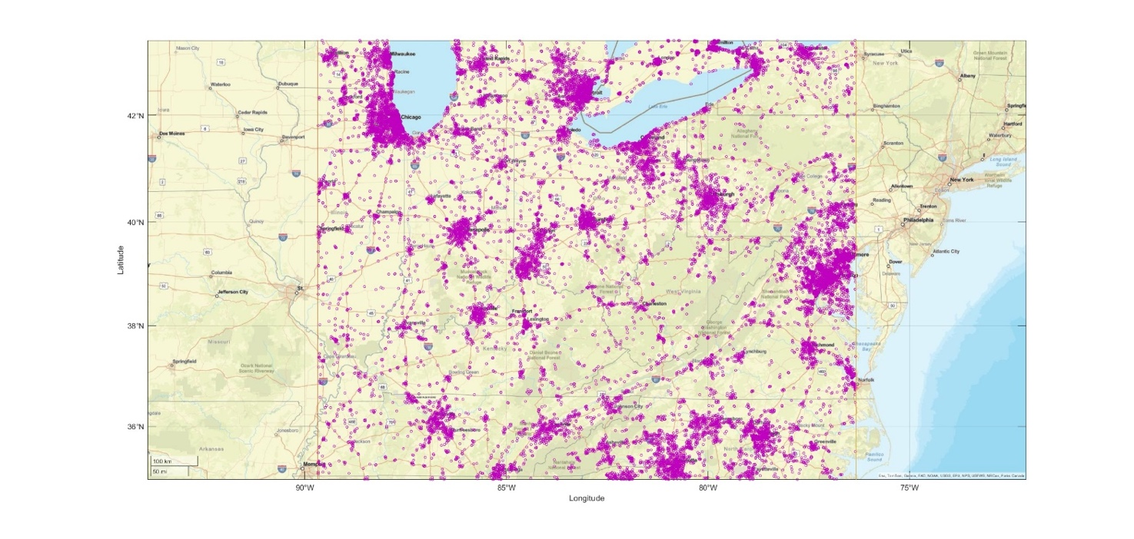

4.1 Results of dynamic analysis for the band 114.25-116 GHz
Figures 9 to 11 depict the aggregate interference levels obtained from the dynamic analysis for the band 114.25-116 GHz for a reference FS unwanted emission power level of −28 dBW/MHz (i.e. −5 dBW/200 MHz).
Figure 9
Interference statistics for M2 sensor from dynamic analysis
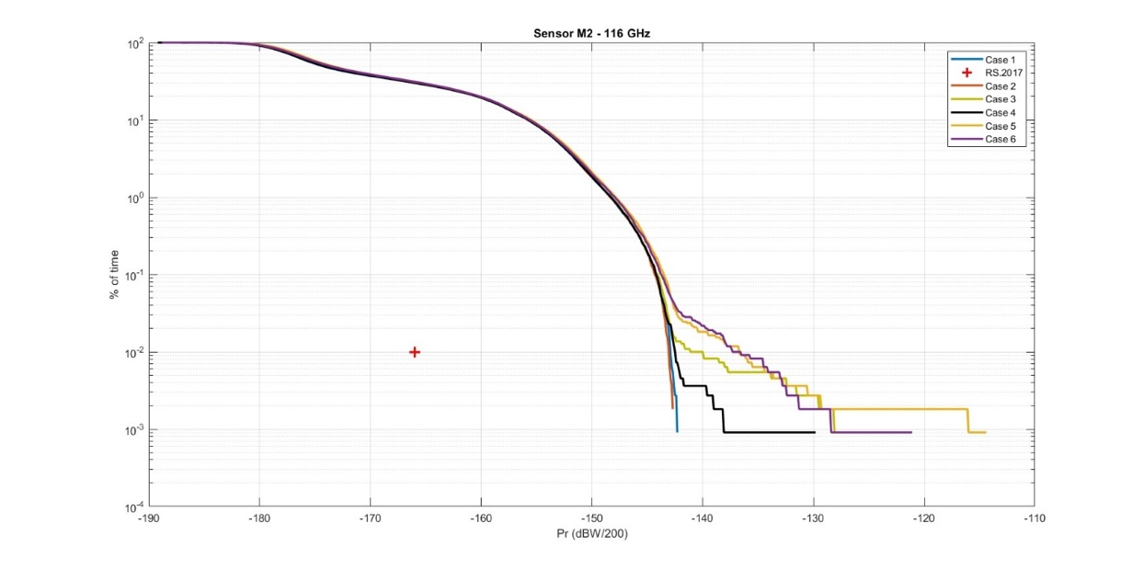
Figure 10
Interference statistics for M3 sensor from dynamic analysis
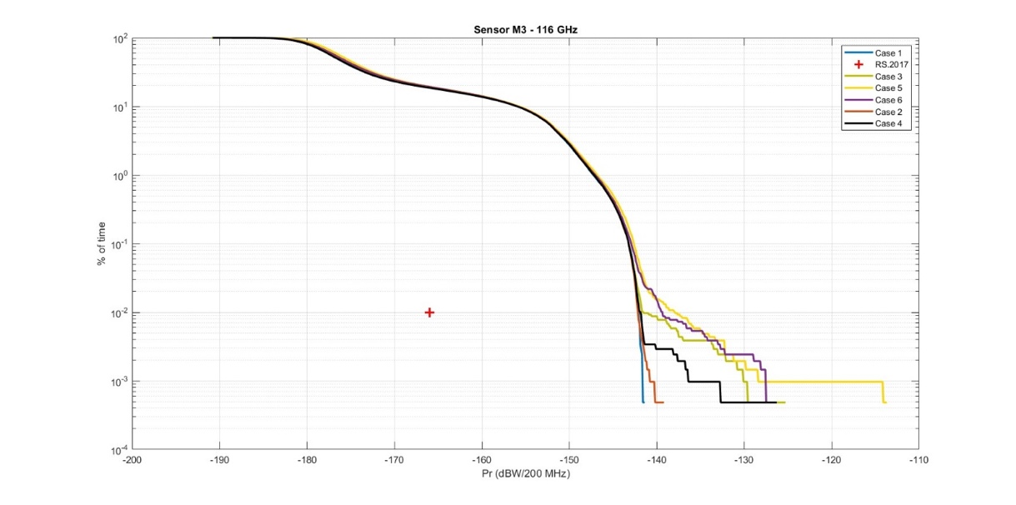
Figure 11
Interference statistics for M6 sensor from dynamic analysis
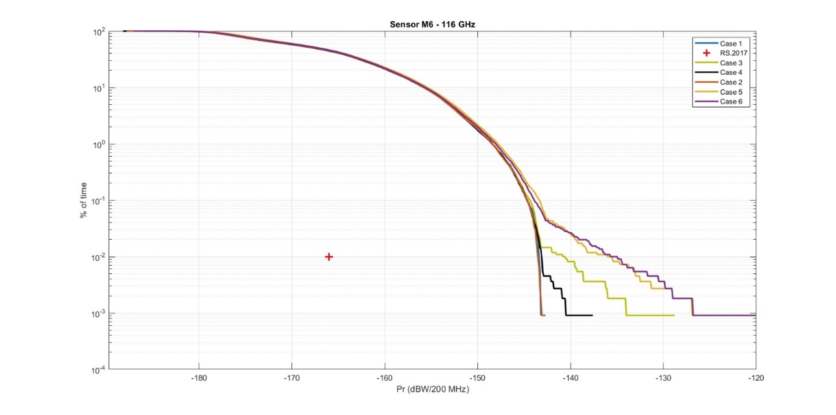
Based on these results, following FS unwanted emission levels are necessary to ensure protection of EESS (passive) sensors.
TABLE 26
Summary of results of dynamic analysis for the band 114.25-116 GHz
EESS (passive) sensor | Unwanted emission level (dBW/200 MHz)
EESS (passive) sensor | Case 1 | Case 2 | Case 3 | Case 4 | Case 5 | Case 6
M2 | −31.9 | −31.8 | −32.4 | −32.1 | −36 | −34.6
M3 | −31.1 | −30.9 | −34 | −31.5 | −37.3 | −37.4
M6 | −30.5 | −30.4 | −33.1 | −30.8 | −37.9 | −38.2

The results of dynamic analysis provide an unwanted emission level of −34.9 dBW/100 MHz to protect EESS (passive) for baseline cases (1 and 2), and a limit of −41.2 dBW/100 MHz in the sensitivity cases (3 to 6). in the band 114.25-116 GHz.

4.2 Results of dynamic analysis for the band 148.5-151.5 GHz
Figure 12 depicts the aggregate interference levels obtained from the dynamic analysis for the band 148.5-151.5 GHz for a reference FS unwanted emission power level of −28 dBW/MHz (i.e. −1 dBW/500 MHz).
Figure 12
Interference statistics for N1 sensor from dynamic analysis
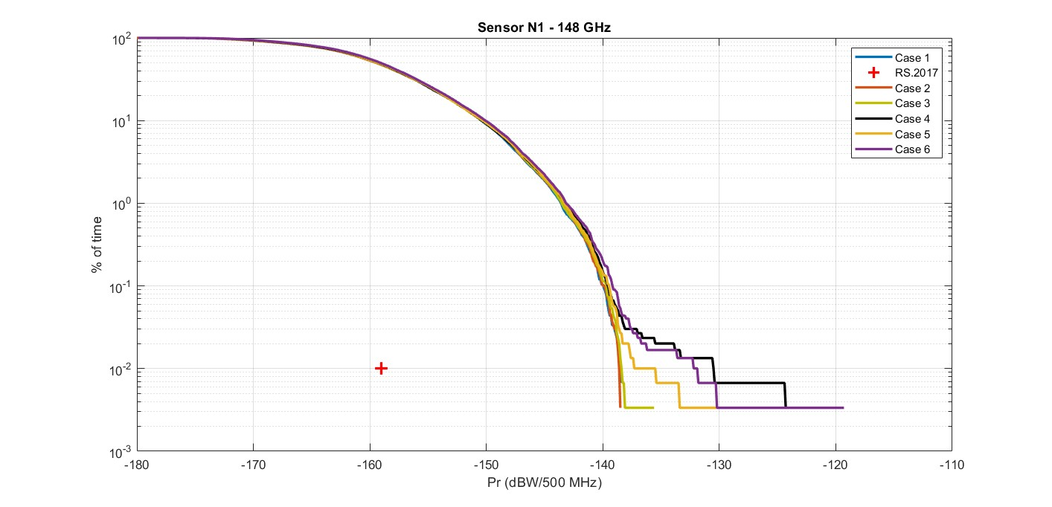
Based on these results, following FS unwanted emission levels are necessary to ensure protection of EESS (passive) sensors.
TABLE 27
Summary of results of dynamic analysis for the band 148.5-151.5 GHz
EESS (passive) sensor | Unwanted emission level (dBW/500 MHz)
EESS (passive) sensor | Case 1 | Case 2 | Case 3 | Case 4 | Case 5 | Case 6
N1 | −21.4 | −21.4 | −21.6 | −29.5 | −24.5 | −28.1

The results of dynamic analysis provide an unwanted emission level of −28.4 dBW/100 MHz to protect EESS (passive) for baseline cases (1 and 2), and a limit of −36.5 dBW/100 MHz in the sensitivity cases (3 to 6). in the band 148.5-151.5 GHz.

4.3 Results of dynamic analysis for the band 164-167 GHz
Figures 13 to 15 depict the aggregate interference levels obtained from the dynamic analysis for the band 164-167 GHz for a reference FS unwanted emission power level of −28 dBW/MHz (i.e. −5 dBW/200 MHz).
Figure 13
Interference statistics for P3 sensor from dynamic analysis
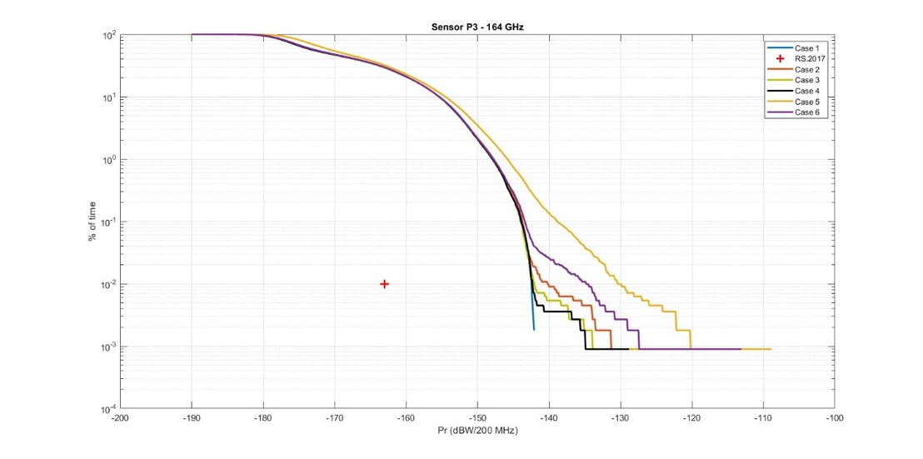
Figure 14
Interference statistics for P4 sensor from dynamic analysis
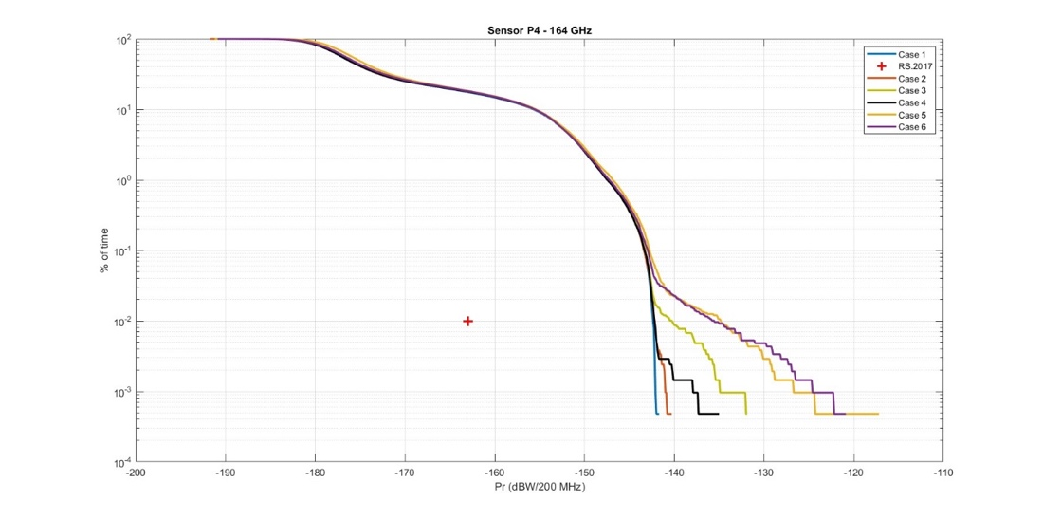
Figure 15
Interference statistics for P10 sensor from dynamic analysis
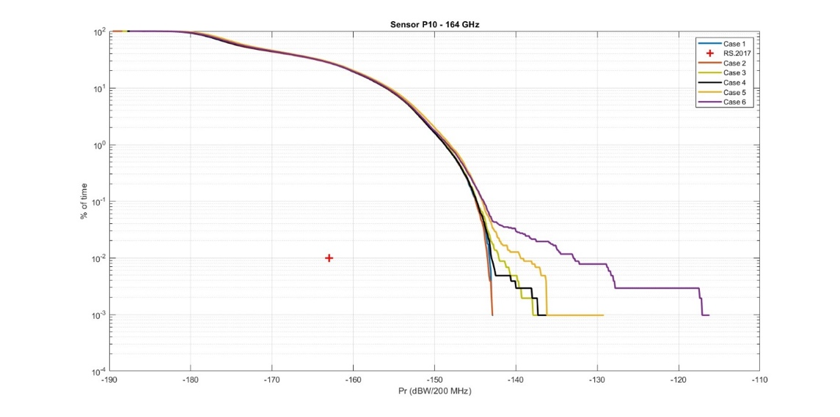
Based on these results, following FS unwanted emission levels are necessary to ensure protection of EESS (passive) sensors.
TABLE 28
Summary of results of dynamic analysis for the band 164-167 GHz
EESS (passive) sensor | Unwanted emission level (dBW/200 MHz)
EESS (passive) sensor | Case 1 | Case 2 | Case 3 | Case 4 | Case 5 | Case 6
P3 | −25.5 | −27.7 | −25.9 | −25.6 | −37.5 | −33.1
P4 | −25.6 | −25.8 | −27.7 | −25.7 | −33.1 | −32.4
P10 | −24.7 | −24.4 | −25.8 | −24.9 | −28.5 | −35

The results of dynamic analysis provide an unwanted emission level of −30.7 dBW/100 MHz to protect EESS (passive) for baseline cases (1 and 2), and a limit of −40.5 dBW/100 MHz in the sensitivity cases (3 to 6). in the band 164-167 GHz.

5 Static analysis
In this method, the FS links are deployed in an area corresponding to the size of the EESS (passive) IFOV (footprint), provided for the various EESS (passive) sensors in Tables 22 to 24. 2 000 independent Monte Carlo runs simulate different random FS deployment scenarios within this area in accordance with FS deployment characteristics described in § 1 of this Annex. Note that the location in orbit and the pointing angle of the EESS (passive) is fixed for this analysis.
According to the EESS (passive) protection criteria, interference limits may be exceeded for 0.01% of time or area, over a measurement area of 2 000 000 km². This corresponds to a maximum area of 200 km² where unwanted emission limits may be exceeded. For the static simulation, while EESS (passive) sensor is stationary, each Monte-Carlo run represents a possible FS deployment in a measurement area (equivalent to a new EESS (passive) sensor position in the dynamic simulation) where aggregate interference is measured. To meet the EESS (passive) protection criteria, total measurement areas (Monte-Carlo runs) where aggregate interference exceeds the unwanted emission limit must not exceed 200 km².
Taking the example of the M6 EESS (passive) sensor, with an IFOV of 68 km², there may be up to two runs out of 2000 simulated FS deployment scenarios (equivalent to a region of 136 km²) where interference exceeds unwanted emission limits of the EESS (passive) protection criteria. A third such run where interference exceeds the limits shall take the corresponding total measurement region (212 km²) beyond the EESS (passive) protection criteria. Similarly, for the M2 EESS (passive) sensor, with an IFOV of 17 km², 11 runs (187 km²) of the 2 000 may exceed the unwanted emission limits.

5.1 Results of static analysis for the band 114.25-116 GHz
Figures 16 to 19 depict the amount by which aggregate interference levels exceed the EESS (passive) protection criteria in the static analysis for the band 114.25-116 GHz for a reference FS unwanted emission power level of −28 dBW/MHz (i.e. −5 dBW/200 MHz).
Figure 16
Interference statistics for M2 sensor from static analysis

Figure 17
Interference statistics for M3 sensor from static analysis

Figure 18
Interference statistics for M6 sensor from static analysis

Figure 19
Interference statistics for GSO-M1 sensor from static analysis

Based on these results, following FS unwanted emission levels are necessary to ensure protection of EESS (passive) sensors.
TABLE 29
Summary of results of static analysis for the band 114.25-116 GHz
EESS (passive) sensor | Unwanted emission level (dBW/200 MHz)
EESS (passive) sensor | Case 1 | Case 2 | Case 3 | Case 4 | Case 5 | Case 6
M2 | −33.3 | −34.1 | −34.7 | −34.2 | −37.7 | −36.1
M3 | −33.5 | −34.7 | −42.3 | −36.4 | −45.6 | −45.3
M6 | −28.1 | −29.9 | −32.6 | −32.2 | −36.4 | −39.0
GSO-M1 | −27.4 | −27.4 | −27.4 | −63.7 | −27.4 | −27.5

The results of static analysis provide an unwanted emission level of −37.7 dBW/100 MHz to protect EESS (passive) for baseline cases (1 and 2), and a limit of −48.6 dBW/100 MHz in the sensitivity cases (3 to 6). in the band 114.25-116 GHz.

5.2 Results of static analysis for the band 148.5-151.5 GHz
Figures 20 and 21 depict the amount by which aggregate interference levels exceed the EESS (passive) protection criteria in the static analysis for the band 148.5-151.5 GHz for a reference FS unwanted emission power level of −28 dBW/MHz (i.e. −1 dBW/500 MHz).
Figure 20
Interference statistics for N1 (nadir) sensor from static analysis
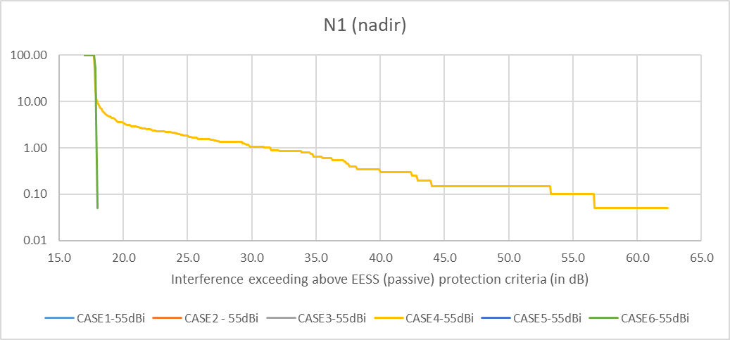
Figure 21
Interference statistics for N1 (outer) sensor from static analysis
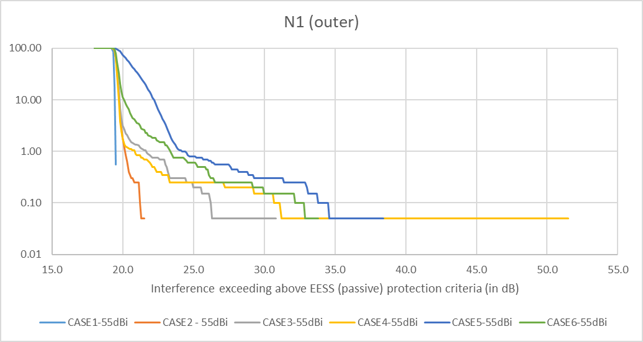
Based on these results, following FS unwanted emission levels are necessary to ensure protection of EESS (passive) sensors.
Table 30
Summary of results of static analysis for the band 148.5-151.5 GHz
EESS (passive) sensor | Unwanted emission level (dBW/500 MHz)
EESS (passive) sensor | Case 1 | Case 2 | Case 3 | Case 4 | Case 5 | Case 6
N1 (nadir) | −18.7 | −18.7 | −18.7 | −57.6 | −18.7 | −19.0
N1 (outer) | −20.5 | −22.5 | −31.8 | −52.5 | −39.4 | −34.8

The results of static analysis provide an unwanted emission level of −29.5 dBW/100 MHz to protect EESS (passive) for baseline cases (1 and 2), and a limit of −64.6 dBW/100 MHz in the sensitivity cases (3 to 6). in the band 148.5-151.5 GHz.

5.3 Results of static analysis for the band 164-167 GHz
Figures 22 to 25 depict the amount by which aggregate interference levels exceed the EESS (passive) protection criteria in the static analysis for the band 164-167 GHz for a reference FS unwanted emission power level of −28 dBW/MHz (i.e. −5 dBW/200 MHz).
Figure 22
Interference statistics for P3 sensor from static analysis

Figure 23
Interference statistics for P4 sensor from static analysis

Figure 24
Interference statistics for P10 sensor from static analysis

Figure 25
Interference statistics for GSO-P1 sensor from static analysis
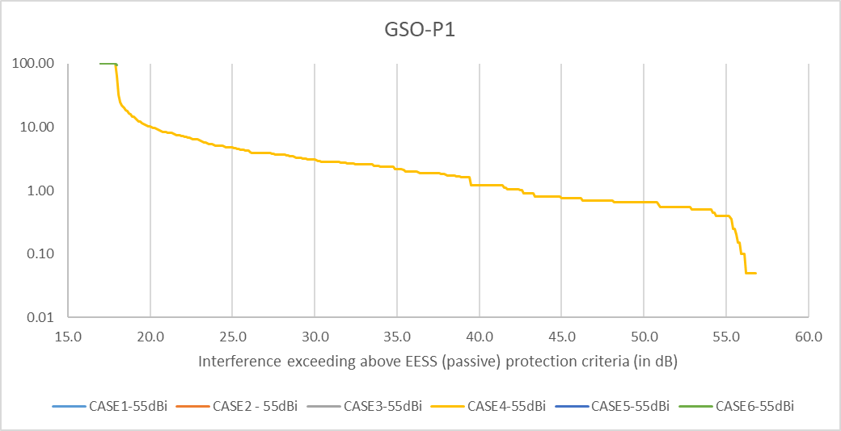
Based on these results, following FS unwanted emission levels are necessary to ensure protection of EESS (passive) sensors.
Table 31
Summary of results of static analysis for the band 164-167 GHz
EESS (passive) sensor | Unwanted emission level (dBW/200 MHz)
EESS (passive) sensor | Case 1 | Case 2 | Case 3 | Case 4 | Case 5 | Case 6
P3 | −26.1 | −31.9 | −31.2 | −31.6 | −42.4 | −31.0
P4 | −30.6 | −31.8 | −32.5 | −31.7 | −36.6 | −36.2
P10 | −24.8 | −25.8 | −27.6 | −25.6 | −31.3 | −32.0
GSO-P1 | −22.9 | −22.9 | −22.9 | −22.9 | −22.9 | −23.0

The results of static analysis provide an unwanted emission level of −34.9 dBW/100 MHz to protect EESS (passive) for baseline cases (1 and 2), and a limit of −45.4 dBW/100 MHz in the sensitivity cases (3 to 6). in the band 164-167 GHz.

6 Conclusion
Tables 32 to 34 summarise the results of dynamic and static studies related to the protection of EESS (passive) systems operating in the bands 114.25-116 GHz, 148.5-151.5 GHz and 164-167 GHz.
The following points should be noted:
– The worst case among the results for FS elevation cases 1 and 2 represents the baseline for a single FS unwanted emission level for the frequency band.
– The results for FS elevation cases 3 to 6 may be further considered if additional margin is deemed necessary to account for the impact of high elevation angles.
– Results for case 4 may include outliers (particularly for the GSO-M1 sensor) due the presence of a hypothetical FS link with 90° elevation and are hence not considered as representative.
– Results for cases 5 and 6 may include outliers due to the presence of hypothetical FS links with a higher proportion of high elevation links and are hence not considered as representative. These cases were mainly studied for the purposes of a sensitivity analysis to see the impact of higher elevation angles.
Table 32
Unwanted emission levels for the band 114.25-116 GHz (summary of results)
EESS (passive) sensor | Unwanted emission level (dBW/200 MHz)
EESS (passive) sensor | Case 1 | Case 2 | Case 3 | Case 4 | Case 5 | Case 6
M2 (static) | −33.3 | −34.1 | −34.7 | −34.2 | −37.7 | −36.1
M2 (dynamic) | −31.9 | −31.8 | −32.4 | −32.1 | −36 | −34.6
M3 (static) | −33.5 | −34.7 | −42.3 | −36.4 | −45.6 | −45.3
M3 (dynamic) | −31.1 | −30.9 | −34 | −31.5 | −37.3 | −37.4
M6 (static) | −28.1 | −29.9 | −32.6 | −32.2 | −36.4 | −39.0
M6 (dynamic) | −30.5 | −30.4 | −33.1 | −30.8 | −37.9 | −38.2
GSO-M1 (static) | −27.4 | −27.4 | −27.4 | −63.7 | −27.4 | −27.5
Table 33
Unwanted emission levels for the band 148.5-151.5 GHz (summary of results)
EESS (passive) sensor | Unwanted emission level (dBW/500 MHz)
EESS (passive) sensor | Case 1 | Case 2 | Case 3 | Case 4 | Case 5 | Case 6
N1 (nadir) | −18.7 | −18.7 | −18.7 | −57.6 | −18.7 | −19.0
N1 (outer) | −20.5 | −22.5 | −31.8 | −52.5 | −39.4 | −34.8
N1 (dynamic) | −21.4 | −21.4 | −21.6 | −29.5 | −24.5 | −28.1
Table 34
Unwanted emission levels for the band 164-167 GHz (summary of results)
EESS (passive) sensor | Unwanted emission level (dBW/200 MHz)
EESS (passive) sensor | Case 1 | Case 2 | Case 3 | Case 4 | Case 5 | Case 6
P3 (static) | −26.1 | −31.9 | −31.2 | −31.6 | −42.4 | −31.0
P3 (dynamic) | −25.5 | −27.7 | −25.9 | −25.6 | −37.5 | −33.1
P4 (static) | −30.6 | −31.8 | −32.5 | −31.7 | −36.6 | −36.2
P4 (dynamic) | −25.6 | −25.8 | −27.7 | −25.7 | −33.1 | −32.4
P10 (static) | −24.8 | −25.8 | −27.6 | −25.6 | −31.3 | −32.0
P10 (dynamic) | −24.7 | −24.4 | −25.8 | −24.9 | −28.5 | −35
GSO-P1 (static) | −22.9 | −22.9 | −22.9 | −22.9 | −22.9 | −23.0

The mean annual reference atmosphere is referenced to mean sea level. If the location of interest is at a different altitude relative to mean sea level, the pressure and temperature profiles should be adjusted accordingly.
The protection criteria values have been converted to a common reference bandwidth of 100 MHz for simpler comparison.
This is “Table 4 Results of simulations” in Annex 2 of Report ITU-R F.2239.
The FS link densities were determined by taking into account propagation conditions associated with the frequency specified in each column.

