Report ITU-R F.2439-0
(11/2018)
Deployment and technical characteristics of broadband high altitude platform stations in the fixed service in the frequency bands 6 440-6 520 MHz, 21.4-22.0 GHz, 24.25-27.5 GHz, 27.9-28.2 GHz, 31.0-31.3 GHz, 38.0-39.5 GHz, 47.2-47.5 GHz and 47.9-48.2 GHz used
in sharing and compatibility studies

F Series
Fixed service

Foreword
The role of the Radiocommunication Sector is to ensure the rational, equitable, efficient and economical use of the radio-frequency spectrum by all radiocommunication services, including satellite services, and carry out studies without limit of frequency range on the basis of which Recommendations are adopted.
The regulatory and policy functions of the Radiocommunication Sector are performed by World and Regional Radiocommunication Conferences and Radiocommunication Assemblies supported by Study Groups.

Policy on Intellectual Property Right (IPR)
ITU-R policy on IPR is described in the Common Patent Policy for ITU-T/ITU-R/ISO/IEC referenced in Resolution ITU-R 1. Forms to be used for the submission of patent statements and licensing declarations by patent holders are available from http://www.itu.int/ITU-R/go/patents/en where the Guidelines for Implementation of the Common Patent Policy for ITU-T/ITU-R/ISO/IEC and the ITU-R patent information database can also be found.

Series of ITU-R Reports
(Also available online at http://www.itu.int/publ/R-REP/en)
Series | Title
BO | Satellite delivery
BR | Recording for production, archival and play-out; film for television
BS | Broadcasting service (sound)
BT | Broadcasting service (television)
F | Fixed service
M | Mobile, radiodetermination, amateur and related satellite services
P | Radiowave propagation
RA | Radio astronomy
RS | Remote sensing systems
S | Fixed-satellite service
SA | Space applications and meteorology
SF | Frequency sharing and coordination between fixed-satellite and fixed service systems
SM | Spectrum management

Note: This ITU-R Report was approved in English by the Study Group under the procedure detailed in Resolution ITU-R 1.

Electronic Publication
Geneva, 2018
© ITU 2018
All rights reserved. No part of this publication may be reproduced, by any means whatsoever, without written permission of ITU.

REPORT ITU-R F.2439-0
Deployment and technical characteristics of broadband high altitude platform stations in the fixed service in the frequency bands 6 440-6 520 MHz, 21.4-22.0 GHz, 24.25-27.5 GHz, 27.9-28.2 GHz, 31.0-31.3 GHz, 38.0-39.5 GHz, 47.2-47.5 GHz and 47.9-48.2 GHz used in sharing and compatibility studies
(2018)

1 Introduction
This Report provides deployment and technical characteristics for the fixed service using high altitude platform stations (HAPS) in the frequency bands: 6 440-6 520 MHz, 21.4-22.0 GHz, 24.25-27.5 GHz, 27.9-28.2 GHz, 31.0-31.3 GHz, 38.0-39.5 GHz, 47.2-47.5 GHz and 47.9-48.2 GHz, in accordance with Resolution 160 (WRC-15). It provides information on broadband HAPS links used in sharing and compatibility studies in the frequency bands listed above, and in adjacent bands.
This Report includes the HAPS systems characteristics in the bands 6 440-6 520 MHz, 21.4-22.0 GHz, 24.25-27.5 GHz, 27.9-28.2 GHz, 31.0-31.3 GHz, 38.0-39.5 GHz, 47.2-47.5 GHz and 47.9-48.2 GHz that are used in the sharing and compatibility studies under WRC-19 agenda item 1.14.

2 Glossary
CPE Customer premises equipment
DL Down link
e.i.r.p. Equivalent isotopically radiated power
G/T Figure of merit
GW Gateway
HAPS High altitude platform station
LHCP Left hand circular polarisation
Ptx Transmit power
RHCP Right hand circular polarisation
RF Radio frequency
Tx Transmitter
UL Up link

3 Deployment and system characteristics of HAPS systems
This section outlines the deployment scenarios for HAPS. It also identifies a number of different HAPS systems.
HAPS typically consist of an aerial platform that flies over a pre-defined footprint in order to provide communication services to users located within the given circular radius of the nominal nadir platform point as illustrated in Fig. 1 below. The HAPS communicates with a set of fixed CPEs or Gateway stations on the ground located within the service area.
Figure 1
HAP System Service Area
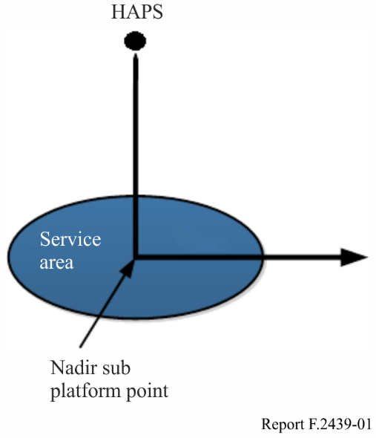
HAPS utilizes one or more gateway connections (feeder links) from a number of locations within the platform service area.

4 Platform geometry
Each platform has the ability to provide coverage within a radius R_{user} from the nadir sub-platform point as illustrated in Fig. 1. This typically corresponds to a large area. For example, at a 20 km altitude, a platform can cover up to 50 km radius, assuming user terminal elevation angles > 20 degrees in the coverage area and under certain circumstances up to 200 km radius with terminal elevation angles greater than 5 degrees.
Once in position, the HAPS will remain within a cylindrical volume. The HAPS may change altitudes over time, bounded by an upper and lower limit, as defined in RR No. 1.66A. This flight path typically remains constrained to a volume that can be represented using a cylinder as illustrated in Fig. 2. The cylinder’s radius, R_{HAP} is the maximum distance from the nominal centre that the platform will fly while providing service. A_{min} is the platform’s minimum altitude and A_{max} is the platform’s maximum altitude.
Figure 2
HAPS volume of movement
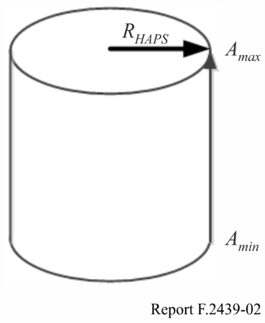
The design of the cylinder (see Fig. 2) together with the specified positions of the FS terminal in the service area define the variation in the geometry of the FS links. This provides the basis for related studies.
A generalisation of the platform geometric characteristics is provided in Table 1.
TABLE 1
Example platform geometric characteristics
Parameters | Values
Platform service radius R_{user} | 20 km to 50 km
Minimum platform altitude A_{min} | 20 km
Maximum platform altitude A_{max} | 26 km
Maximum platform flight radius R_{hap} | 1 to 5 km

Specific parameters for different systems are outlined in § 6.

5 Illustrations of HAPS broadband systems
A systems level diagram, Fig. 3 below, is provided to illustrate the connectivity between HAPS and fixed service stations on the Earth, which together deliver broadband access.
Figure 3
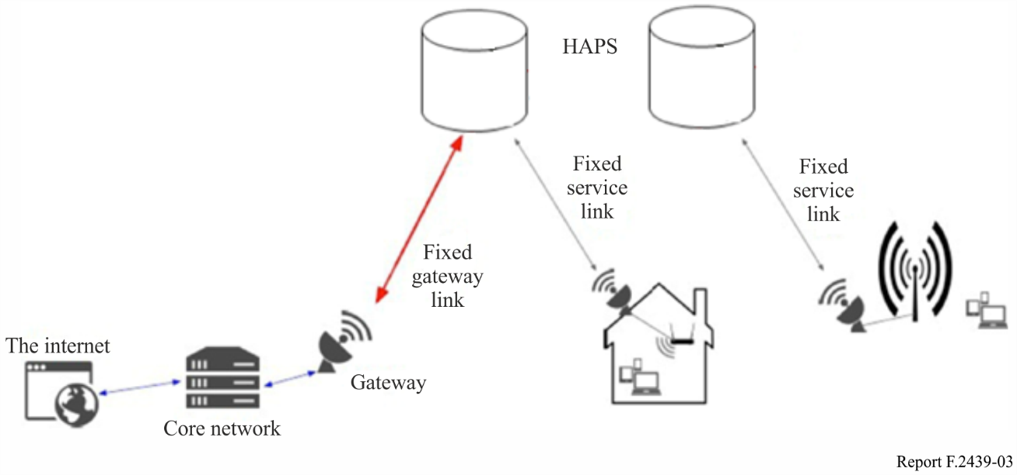
HAPS will provide the intermediate radiocommunication infrastructure that connects smaller networks (whose CPEs will be the points of entry) with the gateways which are located on the backbone.
Figure 4 provides an example outline of how services may be provided to customer premises equipment (CPE). The HAPS “Customer Premises Equipment” (CPE) is understood to be equipment for ground-based fixed links which communicate with the HAPS and redistribute their connectivity to end users by other wired or wireless means (e.g. International Mobile Telecommunications (IMT), 5.8 GHz Wireless Access Systems including radio local area networks (WAS/RLAN), etc.).
Figure 4
Example CPE beam gateway beam and HAPS coverage
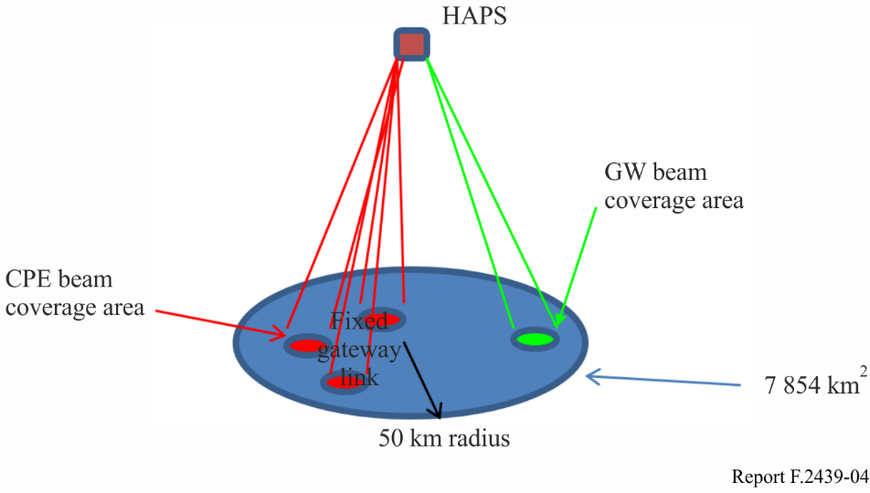
By means of adaptive antenna array (AAA) or active electronically scanned array (AESA) antenna technologies (see Annex 2), HAPS have the ability to form beams dynamically.
As far as AESA are concerned, receiver and transmitter beams can be controlled individually and may re-use the same frequencies. The panel element patches are assumed to provide 6 dBi gain each. In order to yield more gains, the number of elements may be adjusted accordingly. Two kinds of AESA systems are illustrated in this Report, i.e. four-facet panel and five-facet panel system, respectively.
In a four-facet panel AESA system, the HAPS AESA system is composed of a tilted four-facet panel configuration with four beams per facet as shown in Fig. 5.
Figure 5
Example for HAPS AESA frontend
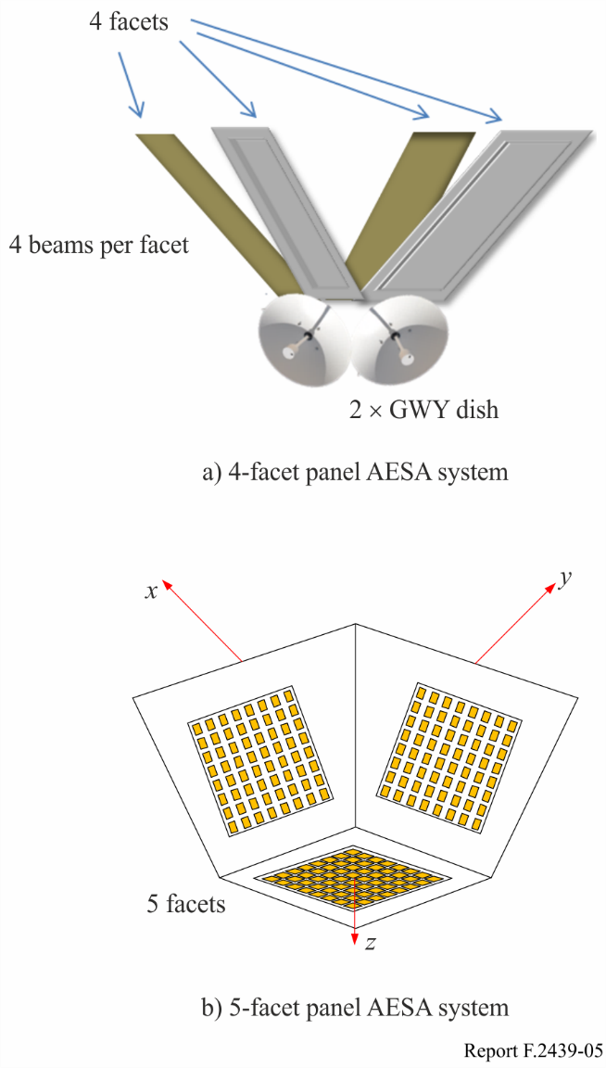
An alternative is a five- facet panel AESA system which has a bottom facet in addition to the tilted four-facet panel. The tilted four-facet panel could provide coverage to those links with antenna elevation angle from 22 to 65 degrees, and the rest of the links are covered by the bottom facet. Each facet consists of several sub-arrays, more specifically, 4~8 beams per facet, assuming that the beams can sweep dynamically over the intended coverage region. For example, when a 12 ×12 antenna array is employed for each facet, the AESA system may provide up to 24 dBi array gain with four beams of each facet.

6 Various systems characteristics
Characteristics for different systems have been proposed in Table 2 below. Full technical characteristics for each of these systems are outlined in Annex 1. A representative system will be used for purposes of sharing and compatibility studies in applicable frequency bands.
TABLE 2
 | System 1 | System 2 | System 4a | System 4b | System 5 | System 6⁽¹⁾
Frequency bands (GHz) | 6.44-6.52  27.9-28.2  31.0-31.06 | 21.4-22.0  24.25-25.5  27-27.5  27.9-28.2  31.0-31.3  38.0-39.5  47.2-47.5  47.9-48.2 | 27.9-28.2  31-31.3  38-39.5 | 27.9-28.2  31-31.3  38-39.5 | 27.9-28.2  31.0-31.3  38.0-39.5 | 21.4-22.0  24.25-27.5  27.9-28.2  31.0-31.3  38.0-39.5  47.2-47.5  47.9-48.2
Platform service radius (km) | 30 (CPE beam)  20 (GW beams) | 50 (CPE beam)  30 (GW beam) | 50 | 50 | 50 | 50
GW No. of beams | 2 | 2 | 2 | 2 | 2~4⁽²⁾ | 1
CPE No. of beams | 16 | 16 | 16 | 67 | 20~40⁽²⁾ | 4
CPE density | 1 per beam in co-frequency | 1 per beam in co-frequency | 1 per beam | 189 per beam⁽³⁾ | 1 per beam | 4 per beam in co-frequency
Deployment environment (urban, etc.) | All | All | All | All | Rural and remote areas | Suburban and rural areas
⁽¹⁾ System 3 was merged with System 6.
⁽²⁾ For System 5, the multi-beam HAPS is intended to cover different deployment scenarios, i.e. from low population density scenarios (<10 people per km²) to high population density scenarios (>60 people per km²). An antenna array system, which may consist of several sub-arrays and is able to form multiple beams simultaneously, is assumed to be deployed on the HAPS. The beam number of the antenna array system is assumed to be adjustable.
⁽³⁾ 189 users/beam is the maximum number of CPEs per beam. Around 2.6% is the percentage of simultaneous active transmitting users per beam.

7 HAPS protection criteria
The HAPS protection criteria as used in the sharing studies under WRC-19 agenda item 1.14 are as follows:
• I/N = −10 dB should not be exceeded for more than 20% of the time;
• I/N = +10 dB should not be exceeded for more than 0.01% of the time.

Annex 1
Technical characteristics

6 400-6 520 MHz
HAPS --> GW (DL)
 | System 1
Frequency (GHz) | 6 440-6 520 MHz
Signal bandwidth (5% roll-off) (MHz) | 50
No. of beams | 1
No of co-frequency beams | 1
Coverage radius/beam | −3 dB beamwidth
Polarization | RHCP/LHCP
Maximum platform Tx Gain (per beam) (dBi) | 18.4
Platform Antenna Pattern | Recommendation ITU-R F.1245
Maximum platform e.i.r.p. per beam (dBW) | −6 (−9 per polarisation)
Maximum platform e.i.r.p. spectral density (dB(W/ MHz)) | −23 (−26 per polarisation)
Nominal e.i.r.p. spectral density per beam (dB(W/MHz))⁽¹⁾ | −23 (−26 per polarisation)
GW antenna pattern | Recommendation ITU-R F.1245
GW antenna height above ground (m) | 1-10
GW antenna gain (dBi) | 28.8
System noise temp (K) | 500
GW G/T (dB/K) | 1.81
⁽¹⁾ This corresponds to the maximum power at which the system operates under clear sky conditions for the link between the HAPS and the GW &/or CPE.

21.4-22 GHz to be considered for Region 2 only (Res. 160 (WRC-15))
GW --> HAPS (UL)
 | System 6⁽¹⁾
Frequency (GHz) | 21.4-22
Signal bandwidth (MHz) | 571.4 (5% roll-off)
No. of beams | 1
No of co-frequency beams | 1
Coverage radius/beam (degrees) | −3 dB beamwidth
Polarization | RHCP/LHCP
GW antenna diameter (m) | 2
GW antenna pattern | Rec. ITU-R F.1245
GW antenna gain (dBi) | 51.4
GW antenna height above ground (m) | 10
GW Tx power (W) | 39.8
Maximum GW e.i.r.p. (dBW) | 65.9
Maximum GW e.i.r.p. spectral density (dB(W/MHz)) | 38.3
Unwanted emissions mask | ⁽²⁾
Platform antenna | Multi-band reflector
Platform antenna pattern | Rec. ITU-R F.1245
Platform antenna diameter (m) | 0.2
Platform Rx gain (dBi) | 31.4
System noise temperature (K) | 600
Platform G/T (dB/K) | 3.62
⁽¹⁾ Note that in system 6, the 21.4-22 GHz CPE uplink is not planned to be used for all implementations.
⁽²⁾ Examples include emission masks, IEEE 802.11 ad, DVB-s2x, etc.

HAPS --> GW (DL)
 | System 6 | System 2
Frequency (GHz) | 21.4-22 | 21.4-22
Occupied bandwidth (MHz) | 341 | 480 per beam
No. of beams | 1 | 2
No of co-frequency beams | 1 | 1
Coverage radius/beam | −3 dB beamwidth | −3 dB beamwidth
Polarisation | RHCP/LHCP | RHCP/LHCP
Platform Tx gain (per beam) (dBi) | 32.6 | 34.3
Platform Antenna Pattern | Rec. ITU-R F.1245 | Rec. ITU R F.1245
Platform antenna diameter (m) | 0.2 | 0.3
Maximum platform e.i.r.p. per beam (dBW) | 29.3 | 21.3 (18.3 per polarisation)
Maximum platform e.i.r.p. spectral density (dB(W/ MHz)) | 4.0 | −5.5 (−8.5 per polarisation)
Power control range (dB) ⁽¹⁾ |  | ≤ 14.4
Nominal e.i.r.p. spectral density per beam (dB(W/MHz)) ⁽²⁾ |  | −19.9 (−22.9 per polarization)
Unwanted emissions mask | ⁽³⁾ | Rec. ITU-R SM.1541
GW antenna diameter (m) | 2 | 2
GW antenna pattern | Rec. ITU-R F.1245 | Rec. ITU-R F.1245
GW antenna height above ground (m) | 10 | 1-10
GW antenna gain (dBi) | 51.4 | 51
System noise temp | 350 | …
GW G/T (dB/K) | 27.9 | 26.2
⁽¹⁾ This corresponds to the system capacity to operate within a range of e.i.r.p..
⁽²⁾ This corresponds to the maximum power at which the system operates under clear sky conditions for the link between the HAPS and the GW &/or CPE.
⁽³⁾ Examples include emission masks, IEEE 802.11 ad, DVB-s2x, etc.

CPE --> HAPS (UL)
 | System 6 ⁽¹⁾
Frequency (GHz) | 21.4-22
Signal bandwidth (MHz) | 117
No. of beams | 4
No of co-frequency beams | 4
Coverage radius/beam (degree) | −3 dB beamwidth
Polarisation | RHCP/LHCP
CPE antenna diameter (m) | 0.35 | 0.6 | 1.2
CPE antenna pattern | Rec. ITU-R F.1245
CPE antenna gain (dBi) | 35.6 | 40.2 | 46.3
CPE antenna height above ground (m) | 10
Maximum CPE e.i.r.p. (dBW) | 33.2 | 37.9 | 43.9
Maximum CPE e.i.r.p. spectral density (dB(W/ MHz)) | 12.5 | 17.2 | 23.2
Unwanted emissions mask | ⁽²⁾
Platform Rx gain (dBi) | 28.1 | 28.1 | 28.1
Platform antenna pattern | Rec. ITU-R F.1891
System noise temperature (K) | 600
Platform G/T (dB/K) | 0.3 | 0.3 | 0.3
⁽¹⁾ Note that in system 6, the 21.4-22 GHz GW uplink is not planned to be used for all implementations.
⁽²⁾ Examples include emission masks, IEEE 802.11 ad, DVB-s2x, etc.

HAPS --> CPE (DL)
 | System 6 |  |  | System 2
Frequency (GHz) | 21.4-22 |  |  | 21.4-22
Occupied bandwidth (MHz) | 600 |  |  | 95 per beam
No. of beams | 4 |  |  | 16
No of co-frequency beams | 4 |  |  | 4
Coverage radius/beam | −3 dB beamwidth |  |  | −3 dB beamwidth
Polarization | RHCP/LHCP |  |  | RHCP/LHCP
Platform Tx gain (dBi) | 28.1 |  |  | 29
Platform antenna pattern | Rec. ITU-R F.1891 |  |  | Annex 2
Platform antenna diameter | N/A |  |  | N/A
Maximum platform e.i.r.p. (dBW) | 32.2 |  |  | 22 (19 per polarisation)
Maximum platform e.i.r.p. spectral density (dB(W/ MHz)) | 4.4 |  |  | 2.2 (−0.8 per polarisation)
Power control range (dB) ⁽¹⁾ | … |  |  | ≤ 10.7
Nominal e.i.r.p. spectral density per beam (dB(W/MHz)) ⁽²⁾ | … |  |  | −8.5 (−11.5 per polarization)
Unwanted emissions mask | ⁽³⁾ |  |  | Rec. ITU-R SM.1541
CPE antenna diameter (m) | 0.35 | 0.6 | 1.2 | 1
CPE antenna pattern | Rec. ITU-R F.1245 |  |  | Rec. ITU-R F.1245
CPE antenna gain (dBi) | 35.6 | 40.2 | 46.3 | 44.8
CPE antenna height above ground (m) | 10 |  |  | 1-10
System noise temperature (K) | 350
CPE G/T (dB/K) | 12.1 | 16.7 | 22.8 | 20.2
⁽¹⁾ This corresponds to the system capacity to operate within a range of e.i.r.p..
⁽²⁾ This corresponds to the maximum power at which the system operates under clear sky conditions for the link between the HAPS and the GW &/or CPE.
⁽³⁾ Examples include emission masks, IEEE 802.11 ad, DVB-s2x, etc.

26 GHz to be considered for Region 2 only (Resolution 160 (WRC-15))
GW --> HAPS (UL)
 | System 6
Frequency (GHz) | 24.25-27.5
Signal bandwidth (MHz) | 623 ⁽¹⁾
No. of beams | 1
No of co-frequency beams | 1
Coverage radius/beam (degrees) | 3.4
Polarization | RHCP/LHCP
GW antenna diameter (m) | 2
GW antenna pattern | Rec.ITU-R F.1245
GW antenna gain (dBi) | 53.3
GW antenna height above ground (m) | 10
Maximum GW Tx power (W) | 1.04
Maximum GW e.i.r.p. (dBW) | 52 ⁽²⁾
Maximum GW e.i.r.p. spectral density (dB(W/ MHz)) | 24
Power control range (dB) ⁽⁴⁾ | 16
Nominal e.i.r.p. spectral density per beam (dB(W/ MHz)) ⁽⁵⁾ | 8
Unwanted emissions mask | ⁽³⁾
Platform antenna | Multi-band reflector
Platform antenna pattern | Rec. ITU-R F.1245
Platform Rx gain (dBi) | 33
System noise temperature (K) | 600
Platform G/T (dB/K) | 0.3
⁽¹⁾ To comply with the e.i.r.p. limits in RR No. 21.3 of Article 21.
⁽²⁾ Feeder loss of 1.5 dB was considered.
⁽³⁾ Examples include emission masks, IEEE 802.11 ad, DVB-s2x, etc.
⁽⁴⁾ This corresponds to the system capacity to operate within a range of e.i.r.p.
⁽⁵⁾ This corresponds to the maximum power at which the system operates under clear sky conditions for the link between the HAPS and the GW &/or CPE.

CPE --> HAPS (UL)
 | System 6 |  |  | System 2
Frequency (GHz) | 24.25-27.5 |  |  | 25.25-25.5
Signal bandwidth (MHz) | 117 |  |  | 60 per beam
No. of beams | 4 |  |  | 16
No of co-frequency beams | 4 |  |  | 4
Coverage radius/beam (degrees) | 3.4 |  |  | −3 dB beamwidth
Polarisation | RHCP/LHCP |  |  | RHCP/LHCP
CPE antenna diameter (m) | 0.35 | 0.6 | 1.2 | 1
CPE antenna pattern | Rec. ITU-R F.1245 |  |  | Rec. ITU-R F.1245
CPE antenna gain (dBi) | 37.5 | 42.2 | 48.2 | 45.5
CPE antenna height above ground (m) | 10 |  |  | 1-10
Maximum CPE e.i.r.p. (dBW) | 33.2 | 37.9 | 43.9 | 35.5 (32.5 per polarisation)
Maximum CPE e.i.r.p. spectral density (dB(W/MHz)) | 12.5 | 17.2 | 23.2 | 17.8 (14.8 per polarisation)
Power control range (dB) ⁽²⁾ | ≤ 10.8 |  |  | ≤ 10.8
Nominal e.i.r.p. spectral density per beam (dB(W/MHz)) ⁽³⁾ | 1.7 | 6.4 | 12.4 | 7 (4 per polarisation)
Unwanted emissions mask | ⁽¹⁾ |  |  | Rec. ITU-R SM.1541
Platform Rx gain (dBi) | 28.1 | 28.1 | 28.1 | 29
Platform antenna pattern | Rec. ITU-R F.1891 |  |  | Annex 2
System noise temperature (K) | 600 |  |  | …
Platform G/T (dB/K) | 0.3 | 0.3 | 0.3 | 4.2
⁽¹⁾ Examples include emission masks, IEEE 802.11 ad, DVB-s2x, etc.
⁽²⁾ This corresponds to the system capacity to operate within a range of e.i.r.p.
⁽³⁾ This corresponds to the maximum power at which the system operates under clear sky conditions for the link between the HAPS and the GW &/or CPE.

HAPS --> CPE (DL)
 | System 6 |  |  | System 2
Frequency (GHz) | 24.25-27.5 |  |  | 24.25-25.25 and 27-27.5
Occupied bandwidth (MHz) | 938 |  |  | 225 per beams
No. of beams | 4 |  |  | 16
No of co-frequency beams | 4 |  |  | 4
Coverage radius/beam (degrees) | 3.4 |  |  | −3 dB beamwidth
Polarization | RHCP/LHCP | RHCP/LHCP | RHCP/LHCP | RHCP/LHCP
Platform Tx Gain (dBi) | 28.1 | 28.1 | 28.1 | 29
Platform antenna pattern | Rec. ITU-R F.1891 |  |  | Annex 2
Platform antenna diameter (m) | N/A |  |  | N/A
Maximum platform e.i.r.p. per beam (dBW) | 34.1 | 34.1 | 34.1 | 25 (22 per polarisation)
Maximum platform e.i.r.p. spectral density  (dB(W/MHz)) | 4.4 | 4.4 | 4.4 | 1.48 (−1.52 per polarisation)
Power control range (dB) ⁽²⁾ | ≤ 10.8 |  |  | ≤ 10.8
Unwanted emissions mask | ⁽¹⁾ |  |  | Rec. ITU-R SM.1541
CPE antenna diameter (m) | 0.35 | 0.6 | 1.2 | 1
CPE antenna pattern | Rec. ITU-R F.1245 |  |  | Rec. ITU-R F.1245
CPE antenna gain (dBi) | 37.5 | 42.2 | 48.2 | 45.5
CPE antenna height above ground (m) | 10 |  |  | 1-10
System noise temperature (K) | 350 |  |  | 290
CPE G/T (dB/K) | 12.1 | 16.7 | 22.8 | 20.9
⁽¹⁾ Examples include emission masks, IEEE 802.11 ad, DVB-s2x, etc.
⁽²⁾ This corresponds to the system capacity to operate within a range of e.i.r.p.
⁽³⁾ This corresponds to the maximum power at which the system operates under clear sky conditions for the link between the HAPS and the GW &/or CPE.

28 GHz is defined as fixed downlink for countries outside Region 2 (RR No. 5.537A)

HAPS --> GW (DL)
 | System 1 | System 5 | System 4a | System 4b
Frequency (GHz) | 27.9-28.2 | 27.9-28.2 | 27.9-28.2 | 27.9-28.2
Signal bandwidth (MHz) | 60 | 300 | 300 per beam | 300 per beam
No. of beams | 1 | 2 | 2 | 2
No of co-frequency beams | 1 | 2 | 1 | 1
Coverage radius/beam (degrees) | −3 dB beamwidth | −3 dB beamwidth | −3 dB beamwidth | −3 dB beamwidth
Polarization | RHCP/LHCP | RHCP/LHCP | RHCP/LHCP | RHCP/LHCP
Maximum platform Tx gain (per beam) (dBi) | 33.5 | 35.3 | 35.5 | 35.5
Platform antenna pattern | Rec. ITU-R F.1245 | Rec. ITU-R F.1245 | Rec. ITU-R F.1245 | Rec. ITU-R F.1245
Platform antenna diameter (m) | N/A | 0.3 | N/A | N/A
Maximum platform e.i.r.p. per beam (dBW) | 29.5 (26.5 per polarisation) | 23.3 | 19.7 | 19.7
Maximum platform e.i.r.p. spectral density (dB(W/MHz)) | 11.7 (8.7 per polarisation) | −1.47 | −5 | −5
Power control range (dB) ⁽¹⁾ | 35 | … | 9 | 9
Nominal e.i.r.p. spectral density per beam (dB(W/MHz)) ⁽²⁾ | −23.3 (−26.3 per polarisation) | … | −14  per polarization | −14  per polarization
GW antenna diameter (m) | N/A | 2 | 2.4 | 2.4
GW antenna pattern | Rec. ITU-R F.1245 | Rec. ITU-R F.1245 | Rec. ITU-R S.580-6 | Rec. ITU-R S.580-6
GW antenna gain (dBi) | 47.5 | 52.2 | 54.6 | 54.6
GW antenna height above ground (m) | 1-10 | 2 | … | …
System noise temp (K) | 500 | 550 | 200 | 200
GW G/T (dB/K) | 20.5 | 24.8 | 31.6 | 31.6
⁽¹⁾ This corresponds to the system capacity to operate within a range of e.i.r.p.
⁽²⁾ This corresponds to the maximum power at which the system operates under clear sky conditions for the link between the HAPS and the GW &/or CPE.

HAPS --> CPE (DL)
 | System 6 |  | System 1 | System 2 | System 5
Frequency (GHz) | 27.9-28.2 |  | 27.9-28.2 | 27.9-28.2 | 27.9-28.2
Signal bandwidth (5% roll-off) (MHz) | 285.7 | 285.7 | 3.75 per beam | 75 per beam | 75 per per beam
No. of beams | 4 |  | 16 | 16 | 20
No of co-frequency beams | 4 |  | 4 | 4 | 5
Coverage radius/beam (degrees) | −3 dB beamwidth |  | −3 dB beamwidth | −3 dB beamwidth | −3 dB beamwidth
Polarization | RHCP/LHCP | RHCP/LHCP | RHCP/LHCP | RHCP/LHCP | RHCP/LHCP
Platform Tx gain (dBi) | 28.1 | 28.1 | 29 | 29 | 24
Platform Antenna Pattern | Rec. ITU-R F.1891 | Rec. ITU-R F.1891 | Annex 2 | Annex 2 | Annex 2
Maximum platform Tx power (W) | 1.3 | 1.3 | N/A | 0.5 | 1 (per beam)
Maximum platform e.i.r.p. per beam (dBW) | 27.6 | 27.6 | 3 (0 per polarisation) | 22 (19 per polarisation) | 24
Maximum platform e.i.r.p. spectral density (dB(W/MHz)) | 3.0 | 3.0 | −2.8 (−5.8 per polarisation) | 3.3 (0.3 per polarisation) | 5.25
Power control range (dB) ⁽²⁾ | ≤ 12.1 |  | ≤ 15 | ≤ 12.1 | …
Nominal e.i.r.p. spectral density per beam (dB(W/MHz)) ⁽³⁾ | −9.1 |  | −17.8 (−20.8 per polarisation) | −8.8 (−11.8 per polarisation) | …
Unwanted Emissions Mask | ⁽¹⁾ |  | N/A | Rec. ITU-R SM.1541 | N/A
CPE antenna diameter (m) | 0.35 | 1.2 | N/A | 1 | 1.2 | 0.6 | 0.3
CPE antenna pattern | Rec. ITU-R F.1245 | Rec. ITU-R F.1245 | Rec. ITU-R F.1245 | Rec. ITU-R F.1245 | Rec. ITU-R F.1245
CPE antenna gain (dBi) | 37.7 | 48.4 | 41.5 | 47 | 47.5 | 41.5 | 36.8
CPE antenna height above ground (m) | 10 |  | 1-10 | 1-10 | 1-10
System noise temp (K) | 350 |  | 500 | 290 | 550
CPE G/T (dB/K) | 12.3 | 23 | 14.51 | 22.1 | 20.1 | 14.1 | 9.4
⁽¹⁾ Examples include emission masks, IEEE 802.11 ad, DVB-s2x, etc.
⁽²⁾ This corresponds to the system capacity to operate within a range of e.i.r.p.
⁽³⁾ This corresponds to the maximum power at which the system operates under clear sky conditions for the link between the HAPS and the GW &/or CPE.

31 GHz is defined as fixed uplink in countries outside Region 2 (RR No. 5.543A)
GW -> HAPS (UL)
 | System 1 | System 5
Frequency (GHz) | 31-31.06 | 31-31.3
Signal bandwidth (MHz) | 60 | 300
No. of beams | 1 | 2
No of co-frequency beams | 1 | 2
Coverage radius/beam (degreees) | −3 dB beamwidth | −3 dB beamwidth
Polarization | RHCP/LHCP | RHCP/LHCP
GW antenna diameter (m) | N/A | 2
GW antenna pattern | Rec. ITU-R F.1245 | Rec. ITU-R F.1245
GW antenna gain (dBi) | 53 | 53
GW antenna height above ground (m) | 1-10 | 1-10
Maximum GW Tx power (W) | N/A | 5
Maximum GW e.i.r.p. (dBW) | 54 (51 per polarisation) | 58
Maximum GW e.i.r.p. spectral density (dB(W/MHz)) | 36.2 (33.2 per polarisation) | 33.2
Power control range (dB) ⁽¹⁾ | 30 | …
Nominal e.i.r.p. spectral density per beam (dB(W/MHz)) ⁽²⁾ | 6.2 (3.2 per polarisation) | …
Platform antenna | Dish | Multi-band reflector
Platform antenna pattern | Rec. ITU-R F.1245 | Rec. ITU-R F.1245
Platform antenna diameter (m) | N/A | 0.3
Platform Rx gain (dBi) | 34.4 | 35.3
System noise temperature (K) | 700 | 800
Platform G/T (dB/K) | 5.95 | 6.3
⁽¹⁾ This corresponds to the system capacity to operate within a range of e.i.r.p.
⁽²⁾ This corresponds to the maximum power at which the system operates under clear sky conditions for the link between the HAPS and the GW &/or CPE.

HAPS --> GW (DL)
 | System 6 | System 2
Frequency (GHz) | 31-31.3 | 31-31.3
Signal bandwidth (MHz) | 285.7 (5% roll-off) | 160 per beam
No. of beams | 1 | 2
No of co-frequency beams | 1 | 1
Coverage radius/beam | −3 dB beamwidth | −3 dB beamwidth
Polarization | RHCP/LHCP | RHCP/ LHCP
Platform Tx gain (dBi) | 34.1 | 37.2
Platform antenna pattern | Rec. ITU-R F.1245 | Rec. ITU-R F.1245
Platform antenna diameter | 0.2 | 0.3
Maximum platform e.i.r.p. per beam (dBW) | 27.6 | 23.2 (20.2 per polarisation)
Maximum platform e.i.r.p. spectral density (dB(W/MHz)) | 3.0 | 1.16 (−1.84 per polarisation)
Power control range (dB) ⁽²⁾ | ≤ 26 | 20
Nominal e.i.r.p. spectral density per beam (dB(W/MHz)) ⁽³⁾ | −23 | −18.84 (−21.84 per polarisation)
Unwanted emissions mask | ⁽¹⁾ | Rec. ITU-R SM.1541
GW antenna diameter (m) | 2 | 2
GW antenna pattern | Rec. ITU-R F.1245 | Rec. ITU-R F.1245
GW antenna gain (dBi) | 54.5 | 53
GW antenna height above ground (m) | 10 | 1-10
System noise temp (K) | 350 | 300
GW G/T (dB/K) | 28.1 | 28
⁽¹⁾ Examples include emission masks, IEEE 802.11 ad, DVB-s2x, etc.
⁽²⁾ This corresponds to the system capacity to operate within a range of e.i.r.p..
⁽³⁾ This corresponds to the maximum power at which the system operates under clear sky conditions for the link between the HAPS and the GW &/or CPE.

CPE -> HAPS (UL)
 | System 1 | System 5
Frequency (GHz) | 31-31.06 | 31-31.3
Signal bandwidth (MHz) | 3.75 per beam | 9.4 per beam
No. of beams | 16 | 20
No of co-frequency beams | 4 | 5
Coverage radius/beam | −3 dB beamwidth | −3 dB beamwidth
Polarization | RHCP/LHCP | RHCP/LHCP
CPE antenna diameter (m) | N/A | 1.2 | 0.6 | 0.3
CPE antenna pattern | Rec. ITU-R F.1245 | Rec. ITU-R F.1245
CPE antenna gain (dBi) | 48 | 47.5 | 41.5 | 36.8
CPE antenna height above ground (m) | 1-10 | 1-10
Maximum CPE Tx power (W) | … | 2
Maximum CPE e.i.r.p. (dBW) | 26 (23 per polarisation) | 46.5 | 40.5 | 35.8
CPE density (/km²) | 1 co-frequency per beam | …
Maximum CPE e.i.r.p. spectral density (dB(W/MHz)) | 20.3 (17.3 per polarisation) | 26.75 | 20.75 | 16.05
Power control range (dB) ⁽¹⁾ | 20 | …
Nominal e.i.r.p. spectral density beam (dB(W/MHz)) ⁽²⁾ | 0.3 (−2.7 per polarisation) | …
Platform Tx gain (dBi) | 29 | 24.7
Platform antenna pattern | Annex 2 | Annex 2
System noise temp (K) | 700 | 800
Platform G/T (dB/K) | 0.54 | –4.3
⁽¹⁾ This corresponds to the system capacity to operate within a range of e.i.r.p.
⁽²⁾ This corresponds to the maximum power at which the system operates under clear sky conditions for the link between the HAPS and the GW &/or CPE.

HAPS --> CPE (DL)
 | System 6 |  | System 4a | System 4b
Frequency (GHz) | 31-31.3 |  | 31-31.3 | 31-31.3
Signal bandwidth (MHz) | 285.7 |  | 150 per beam | 100 per beam
No. of beams | 4 |  | 16 | 67
No of co-frequency beams | 4 |  | 4 | 17
Coverage radius/beam | −3 dB beamwidth |  | −3 dB beamwidth | −3 dB beamwidth
Polarization | RHCP/LHCP |  | RHCP/LHCP | RHCP/LHCP
Platform Tx gain (dBi) | 28.1 |  | 34 | 18 to 25.5
Platform antenna pattern | Rec. ITU-R F.1891 |  | Rec. ITU-R F.1245 | Rec. ITU-R F.1245
Platform Tx power (W) | 1.3 |  | … | …
Maximum platform e.i.r.p. per beam (dBW) | 27.6 |  | 22.7 | 21
Maximum platform e.i.r.p. spectral density (dB(W/ MHz)) | 3.0 |  | 1 | 1
Power control range (dB) ⁽²⁾ | ≤ 12.1 |  | 14 | 13
Nominal e.i.r.p. spectral density per beam (dB(W/MHz)) ⁽³⁾ | −9.1 |  | −13 per polarization | −12 per polarization
Unwanted emissions mask | ⁽¹⁾ |  | … | …
CPE antenna diameter (m) | 0.35 | 1.2 | 1 | 0.74 | 0.3
CPE antenna pattern | Rec. ITU-R F.1245 |  | Rec. ITU-R S.580-6 | Rec. ITU-R S.580-6
CPE antenna gain (dBi) | 38.6 | 49.3 | 47.9 | 45.3 | 37.7
CPE antenna height above ground (m) | 10 |  | … | …
System noise temperature (K) | 350 |  | 200 | 200 | 200
CPE G/T (dB/K) | 12.3 | 23 | 24.5 | 22.3 | 14.5
⁽¹⁾ Examples include emission masks, IEEE 802.11 ad, DVB-s2x, etc.
⁽²⁾ This corresponds to the system capacity to operate within a range of e.i.r.p.
⁽³⁾ This corresponds to the maximum power at which the system operates under clear sky conditions for the link between the HAPS and the GW &/or CPE.

38-39.5 GHz to be considered on global level (Res.160 (WRC-15))
GW --> HAPS (UL)
 | System 6 | System 2 | System 5 | System 4a | System 4b
Frequency (GHz) | 38-39.5 | 38-39.5 | 38-39.5 | 38-39.5 | 38-39.5
Signal bandwidth (MHz) | 1 428.6 | 1 500 per polarisation/per beam | 1 500 | 1 110 per beam | 1 425 per beam
No. of beams | 1 | 2 | 2 | 2 | 2
No of co-frequency beams | 1 | 1 | 2 | 1 | 1
Coverage radius/beam (degrees) | 1.3 | −3 dB beamwidth | −3 dB beamwidth | −3 dB beamwidth | −3 dB beamwidth
Polarization | RHCP/LHCP | RHCP/LHCP | RHCP/LHCP | RHCP/LHCP | RHCP/LHCP
GW antenna diameter (m) | 2 | 2 | 2 | 2.4 | 2.4
GW antenna pattern | Rec. ITU-R F.1245 | Rec. ITU-R F.1245 | Rec. ITU-R F.1245 | Rec. ITU-R S.580-6 | Rec. ITU-R S.580-6
GW antenna gain (dBi) | 56.5 | 55 | 55.2 | 57.4 | 57.4
GW antenna height above ground (m) |  | 1-10 | 1-10 | … | …
Maximum GW Tx power (W) | 9 | 5 per polarization | −5 | … | …
Maximum GW e.i.r.p. (dBW) | 64.5 | 65 (62 per polarisation) | 50.2 | 56.4 | 57.5
Maximum GW e.i.r.p. spectral density (dB(W/MHz)) | 33.0 | 33.2 (30.2 per polarisation) | 18.44 | 26 | 26
Power control range (dB) ⁽²⁾ |  | ≤ 35 | … | 15 | 15
Nominal e.i.r.p. spectral density per beam (dB(W/MHz)) ⁽³⁾ |  | −1.8 (−4.8 per polarisation) | … | 11 per polarization | 11per polarization
Unwanted emissions mask | ⁽¹⁾ | … | … | … | …
Platform antenna | Multi-band reflector | Dish | Multi-band reflector | … | …
Platform antenna pattern | Rec. ITU-R F.1245 | Rec. ITU R S.1245 | Rec. ITU-R F.1245 | Rec. ITU-R F.1245 | Rec. ITU-R F.1245
Platform antenna diameter | 0.2 | 0.3 | 0.3 | N/A | N/A
Platform Rx gain (dBi) | 35.3 | 39.3 | 37.9 | 38.2 | 38.2
System noise temperature (K) | 600 | 300 | 800 | 590 | 590
Platform G/T (dB/K) | 7.56 | 14.2 | 8.9 | 10.5 | 10.5
⁽¹⁾ Examples include emission masks, IEEE 802.11 ad, DVB-s2x, etc.
⁽²⁾ This corresponds to the system capacity to operate within a range of e.i.r.p.
⁽³⁾ This corresponds to the maximum power at which the system operates under clear sky conditions for the link between the HAPS and the GW &/or CPE.

HAPS --> GW (DL)
 | System 5
Frequency (GHz) | 38-39.5
Signal bandwidth (MHz) | 1 500
No. of beams | 2
No of co-frequency beams | 2
Coverage radius/beam (degrees) | −3 dB beamwidth
Polarization | RHCP/LHCP
Platform Tx gain (per beam) (dBi) | 37.9
Platform antenna pattern | Rec. ITU-R F.1245
Maximum platform e.i.r.p. per beam (dBW) | 27.9
Maximum platform e.i.r.p. spectral density (dB(W/MHz)) | −3.86
GW antenna diameter | 2
GW antenna pattern | Rec. ITU-R F.1245
GW antenna gain (dBi) | 55.1
System noise temperature (K) | 550
GW G/T (dB/K) | 27.7

CPE --> HAPS (UL)
 | System 6 |  | System 2 | System 5 |  |  | System 4a | System 4b
Frequency (GHz) | 38-39.5 |  | 38-39.5 | 38-39.5 |  |  | 38-39.5 | 38-39.5
Signal bandwidth (MHz) | 117 |  | 26 per beam & per polarization | 250 |  |  | 105 per beam | 30 per beam
No. of beams | 4 |  | 16 | 30 |  |  | 16 | 67
No of co-frequency beams | 4 |  | 4 | 5 |  |  | 4 | 17
Coverage radius/beam (degrees) | 3.4 |  | −3 dB beamwidth | −3 dB beamwidth |  |  | −3 dB beamwidth | −3 dB beamwidth
Polarization | RHCP/LHCP |  | RHCP/LHCP | RHCP/LHCP |  |  | RHCP/LHCP | RHCP/LHCP
CPE antenna diameter (m) | 0.35 | 1.2 | 1 | 0.35 | 0.6 | 1.2 | 1 | 0.74 | 0.3
CPE antenna pattern | Rec. ITU-R F.1245 |  | Rec. ITU-R F.1245 | Rec. ITU-R F.1245 |  |  | Rec. ITU-R S.580-6 | Rec. ITU-R S.580-6
CPE antenna gain (dBi) | 40.6 | 51.4 | 49 | 40.2 | 44.9 | 50.9 | 49.8 | 47.2 | 39.3
CPE antenna height above ground (m) | 10 |  | 1-10 | 1-10 |  |  | … | …
Maximum CPE e.i.r.p. (dBW) | 40.3 | 51.0 | 49 (46 per polarisation) | 44.2 | 48.9 | 54.9 | 50.2 | 43 | 35
CPE density (/km²) | … |  | 1 co-frequency per beam | … |  |  | 1 co-frequency per beam | 1 co-frequency per beam
Maximum CPE e.i.r.p. spectral density (dB(W/MHz)) | 19.6 | 30.3 | 33.5 (31.5 per polarisation) | 20.2 | 24.9 | 30.9 | 30 | 35.5 | 26.5
Power control range (dB) ⁽²⁾ | ≤ 25.3 |  | 25.3 | … |  |  | 15 | 16 | 12
Nominal e.i.r.p. spectral density per beam (dB(W/MHz)) ⁽³⁾ | −5.7 | 5 | 9.2 (6.2 per polarisation) | … |  |  | 15 | 19.5 | 14.5
Unwanted emissions mask | ⁽¹⁾ |  | Rec. ITU-R SM.1541 | … |  |  | … | …
Platform Rx gain (dBi) | 28.1 | 28.1 | 29 | 24.8 |  |  | 37.3 | 18 to 25.5
Platform antenna pattern | Rec. ITU-R F.1891 |  | Annex 2 | Annex 2 |  |  | Rec. ITU-R F.1245 | Rec. ITU-R F.1245
System noise temperature (K) | 600 |  | 300 | 800 |  |  | 540 | 500
Platform G/T (dB/K) | 0.3 | 0.3 | 4.2 | −4.2 |  |  | 10 | −1.5
⁽¹⁾ Examples include emission masks, IEEE 802.11 ad, DVB-s2x, etc.
⁽²⁾ This corresponds to the system capacity to operate within a range of e.i.r.p.
⁽³⁾ This corresponds to the maximum power at which the system operates under clear sky conditions for the link between the HAPS and the GW &/or CPE.

HAPS --> CPE (DL)
 | System 5 |  |  | System 4a
Frequency (GHz) | 38-39.5 |  |  | 38-39.5
Signal bandwidth (MHz) | 250 |  |  | 100 per beam
No. of beams | 30 |  |  | 16
No of co-frequency beams | 5 |  |  | 4
Coverage radius/beam (degrees) | −3 dB beamwidth |  |  | −3 dB beamwidth
Polarization | RHCP/LHCP |  |  | RHCP/LHCP
Platform Tx gain (dBi) | 24.8 |  |  | 37
Platform antenna pattern | Annex 2 |  |  | Rec. ITU-R F.1245
Maximum platform e.i.r.p. per beam (dBW) | 26.8 |  |  | 22
Maximum platform e.i.r.p. spectral density  (dB(W/MHz)) | 2.82 |  |  | 2
Power control range (dB) ⁽¹⁾ | … |  |  | 14
Nominal e.i.r.p. spectral density per beam (dB(W/MHz)) ⁽²⁾ | … |  |  | −12
CPE antenna diameter (m) | 0.35 | 0.6 | 1.2 | 1
CPE antenna pattern | Rec. ITU-R F.1245 |  |  | Rec. ITU-R S.580-6
CPE antenna gain (dBi) | 40.2 | 44.9 | 50.9 | 49.8
System noise temperature (K) | 550 |  |  | 200
CPE G/T (dB/K) | 12.8 | 17.5 | 23.5 | 27.3
⁽¹⁾ This corresponds to the system capacity to operate within a range of e.i.r.p.
⁽²⁾ This corresponds to the maximum power at which the system operates under clear sky conditions for the link between the HAPS and the GW &/or CPE.

47/48 GHz is defined for global level (RR No. 5.552A)
GW --> HAPS (UL)
 | System 6 |  | System 2
Frequency (GHz) | 47.2-47.5 | 47.9-48.2 | 47.2-47.5  47.9-48.2
 | When both are used in combination
Signal bandwidth (5% roll-off) (MHz) | 285.7 | 285.7 | 300 per beam & per polarization
No. of beams | 1 |  | 2
No of co-frequency beams | 1 |  | 1
Coverage radius/beam (degrees) | 1.1 | 1.1 | −3 dB beamwidth
Polarization | RHCP/LHCP | RHCP/LHCP | RHCP/ LHCP
GW antenna diameter (m) | 2 | 2 | 2
GW antenna pattern | ITU RR Res. 122, resolve 3 | ITU RR Res. 122, resolve 3 | ITU RR Res. 122, resolve 3
GW antenna gain (dBi) | 58.1 | 58.2 | 57
GW antenna height above ground (m) | 10 |  | 1-10
Maximum GW Tx power (W) | 10 (7 per polarisation) | 10 (7 per polarisation) | 10 (7 per polarisation)
Maximum GW e.i.r.p. (dBW) | 68.1 | 68.2 | 67 (64 per polarization)
Maximum GW e.i.r.p. spectral density (dB(W/MHz)) | 42.2 (39.2 per polarisation) | 42.2 (39.2 per polarisation) | 42.2 (39.2 per polarisation)
Power control range (dB) ⁽²⁾ | ≤ 44.4 |  | ≤ 44.4
Nominal e.i.r.p. spectral density per beam (dB(W/MHz)) ⁽³⁾ | −2.2 | −2.2 | −2.2 (−5.2 per polarisation)
Unwanted emissions mask | ⁽¹⁾ |  | Rec. ITU-R SM.1541
Platform antenna | Multi-band Dish | Multi-band Dish | Multi-band Dish
Platform antenna pattern | Rec. ITU-R F.1245 | Rec. ITU-R F.1245 | Rec. ITU-R F.1245
Platform antenna diameter (m) | 0.2 | 0.2 | 0.3
Platform Rx gain (dBi) | 36 | 36.1 | 40.5
System noise temperature (K) | 600 |  | 300
Platform G/T (dB/K) | 8.19 | 8.32 | 15.7
⁽¹⁾ Examples include emission masks, IEEE 802.11 ad, DVB-s2x, etc.
⁽²⁾ This corresponds to the system capacity to operate within a range of e.i.r.p.
⁽³⁾ This corresponds to the maximum power at which the system operates under clear sky conditions for the link between the HAPS and the GW &/or CPE.

Annex 2

1 Antenna characteristics (HAPS system 2 CPE beam)
The antenna characteristics outlined below are applicable where directed by the Table in Annex 1 above (HAPS system 2 antenna characteristics CPE beam).
The beamforming antenna is based on an antenna array and consists of a number of identical radiating elements located in the yz-plane with a fixed separation distance (e.g. λ/2), all elements having identical radiation patterns and “pointing” (having maximum directivity) along the x-axis. Total antenna gain is the sum (logarithmic scale) of the array gain and the element gain.
The θ and ϕ definition is based on the coordinate system are illustrated in Fig. 6 below.
Figure 6
Antenna model geometry
θ: elevation, range from 0 to 180 degree
ϕ: Azimuth, range from -180 to 180 degree
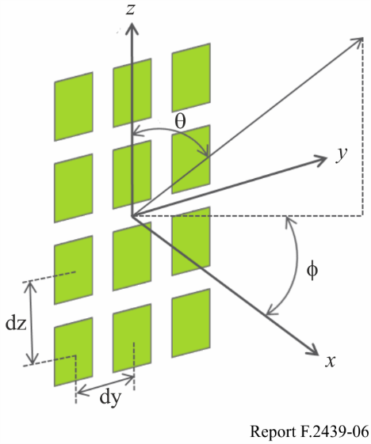
The radiation elements are placed uniformly along the vertical z-axis in the Cartesian coordinate system. The x-y plane denotes the horizontal plane. The elevation angle of the signal direction is denoted as θ (defined between 0° and 180°, with 90° representing perpendicular angle to the array antenna aperture). The azimuth angle is denoted as ϕ (defined between −180° and 180°).
The system will actively control all individual signals being fed to individual antenna elements in the antenna array in order to shape and direct the antenna emission diagram to a wanted shape, e.g. a narrow beam towards a user. It creates a correlated wanted emission from the antenna. The unwanted signal, caused by transmitter OOB modulation, intermodulation products and spurious emission components will not experience the same correlated situation from the antenna and will have a different emission pattern. A non-correlated antenna system has an antenna emission pattern similar to a single antenna element as outlined in Table 3.

1.1 Single element pattern
TABLE 3
Element pattern for antenna array model
Horizontal Radiation Pattern | $$A_{E,H}\left(φ\right)=-min\left[12{\left(\frac{φ}{φ_{3dB}}\right)}^{2},A_{m}\right]dB$$
Horizontal 3dB bandwidth of single element/deg ($φ_{3dB}$) | 80
Front-to-back ratio: A_{m} and SLAv | 30
Vertical Radiation Pattern | $$A_{E,V}\left(φ\right)=-min\left[12{\left(\frac{θ-90}{θ_{3dB}}\right)}^{2},{SLA}_{V}\right]dB$$
Vertical 3dB beamwidth of single element/deg ($θ_{3dB}$) | 65
Single element pattern | $$A_{E}\left(φ,θ\right)=G_{E,max}-min\left\{-\left[A_{E,H}\left(φ\right)+A_{E,V}\left(θ\right)\right],A_{m}\right\}$$
Element Gain (dBi), GE,max | 6

1.2 Composite antenna pattern
Table 4 illustrates the derivation of the composite antenna pattern, $A_{A}\left(θ,φ\right)$. $A_{A}\left(θ,φ\right)$ is the resulting beamforming antenna pattern from logarithmic sum of the array gain, $10\log_{10}\left({\left|\sum_{m=1}^{N_{H}}{\sum_{n=1}^{N_{V}}{W_{i,n,m}.V_{n,m}}}\right|}^{2}\right)$, and the element gain $A_{E}\left(θ,φ\right)$. The composite pattern for the antenna should be used where the array serves one or more CPEs with one or more beams, with each beam indicated by the parameter i.
TABLE 4
Composite antenna pattern for AESA beam forming
Configuration | Multiple columns (NV × NH elements)
Composite array radiation pattern in dB $A_{A}\left(θ,φ\right)$ | For beam i:  $$A_{A,Beami}\left(θ,φ\right)=A_{E}\left(θ,φ\right)+10\log_{10}\left({\left|\sum_{m=1}^{N_{H}}{\sum_{n=1}^{N_{V}}{W_{i,n,m}.V_{n,m}}}\right|}^{2}\right)$$  the super position vector is given by:  $V_{n,m}=exp\left(i.2π\left(\left(n-1\right).\frac{d_{v}}{λ}.\cos\left(θ\right)+\left(m-1\right).\frac{d_{H}}{λ}.\sin\left(θ\right).\sin\left(φ\right)\right)\right)$,  n=1,2,...N_{V}; m=1,2,...N_{H};  the weighting is given by:  $$W_{i,n,m}=\frac{1}{\sqrt{N_{H}N_{V}}}exp\left(i.2π\left(\left(n-1\right).\frac{d_{v}}{λ}.\sin\left(θ_{i,etilt}\right)-\left(m-1\right).\frac{d_{H}}{λ}.\cos\left(θ_{i,etilt}\right).\cos\left(φ_{i,escan}\right)\right)\right)$$
TABLE 4 (end)
Configuration | Multiple columns (NV × NH elements)
Antenna array configuration (Row × Column) | HAPS AESA10x20
Horizontal radiating element spacing d/lambda | 0.5
Vertical radiating element spacing d/λ | 0.5
There is need to introduce a normalization factor to the calculation of the antenna directivity in each direction in order to ensure that the total array directivity is equal to 0 dB.
The expression for the composite array radiation pattern:
$${\check{G}}_{dB}\left(θ,φ\right)=A_{E dB}\left(θ,φ\right)+10\log_{10} \left\{1+ρ\left[{\left|\sum_{m=1}^{N_{H}}{\sum_{n=1}^{N_{V}}{w_{m,n}\left(θ,φ,φscan,etilt\right)v_{m,n}(θ,φ,φscan,etilt)}}\right|}^{2}-1\right]\right\}$$
where:
v_{m},_{n} called the ‘super position vector’ can be understood as the steering vector giving the phase shift due to array placement
w_{m,n} depicts the weighting factor, is a function of the antenna beam pointing angles φ-scan and the electrical tilt and aims at tuning side lobe levels.
This actual array gain that has to be performed in any sharing studies should be normalised as follows:
$D\left(θ,φ,φscan,etilt\right)={\frac{\check{G}\left(θ,φ,φscan,etilt\right)}{\frac{1}{4π}\int_{0}^{2π}{\int_{0}^{π}{\check{G}\left(θ,φ,φscan,etilt\right)\sin\left(θ\right)dθdφ}}}}_{}$
to ensure that the total radiated power equal $P_{Tx}$ where $P_{Tx}$ is the conducted power input to the array system. Consequently, this contribution accounts this normalization factor in the computation of the HAPS station antenna gain (HAPSCPE). Figure 7 provides the normalization faction versus azimuth and elevation electronical tilts.
Figure 7
Normalization factor
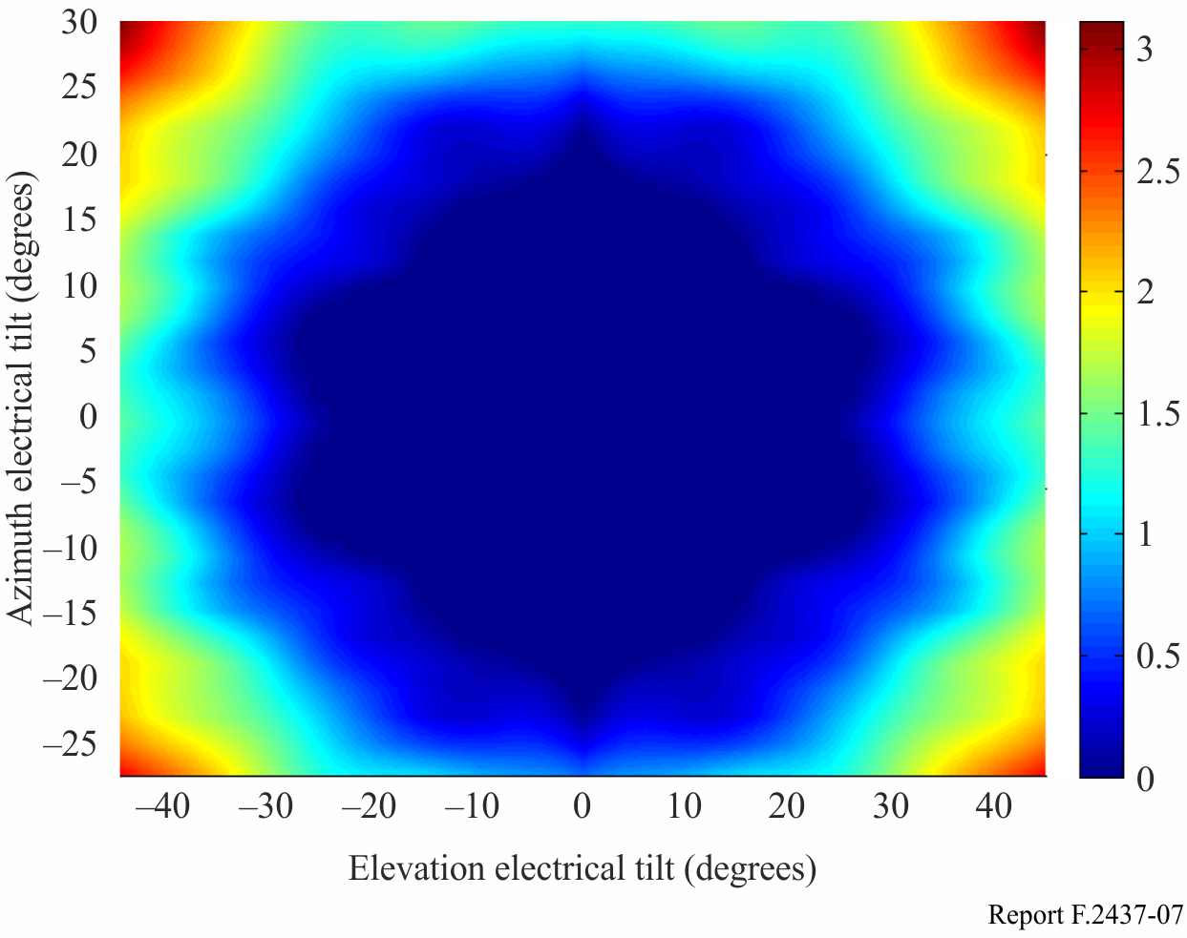
Figure 8 below, presents the HAPS antenna patterns for a down tilt of 60 degrees, an electronic elevation tilt of respectively 30 degrees and -30 degrees (edge of the HAPS coverage area) and finally an electronic azimuth tilt of 0 degrees.
Figure 8
HAPS antenna patterns for a mechanical down tilt of 60°
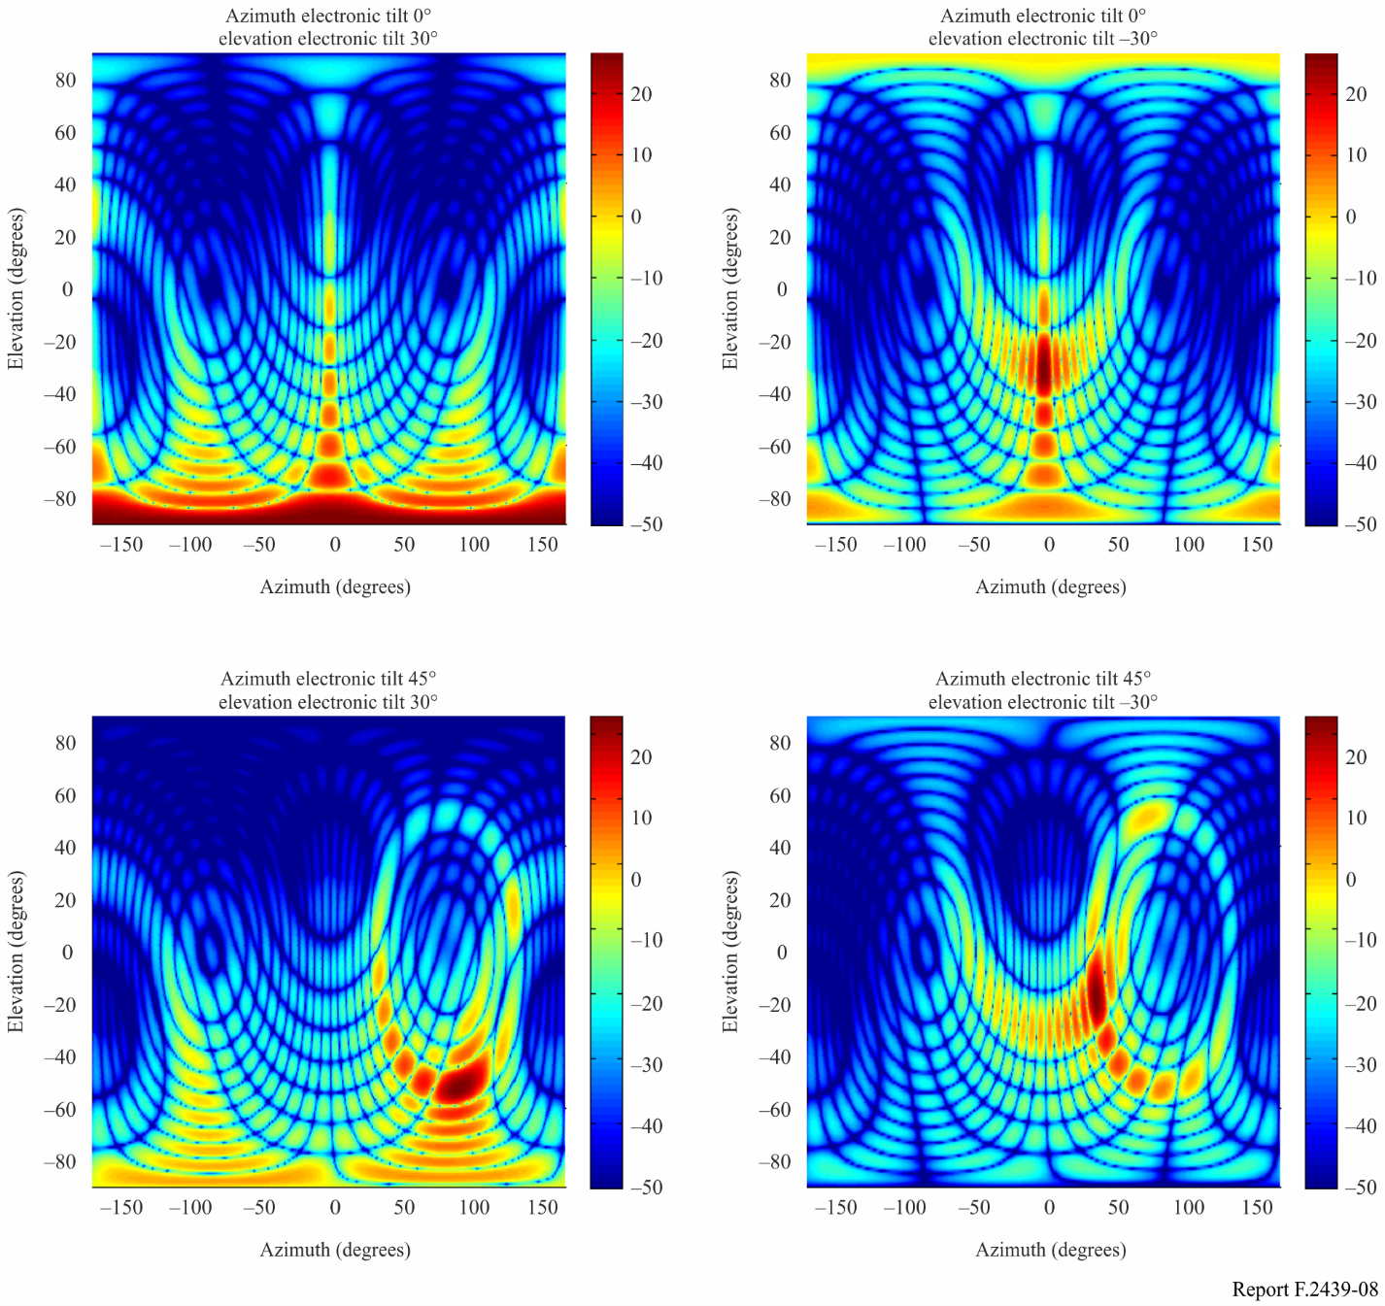

2 HAPS Antenna characteristics (HAPS System 5 CPE beam)
The HAPS antenna characteristics outlined below are applicable where directed by the Table in Annex 1 above (HAPS System 5 antenna characteristics CPE beam).
Figure 9 shows the antenna characteristics of the 5-facet panel AESA system, which is deployed on HAPS for HAPS <-> CPE link.
Figure 9
AESA antenna pattern
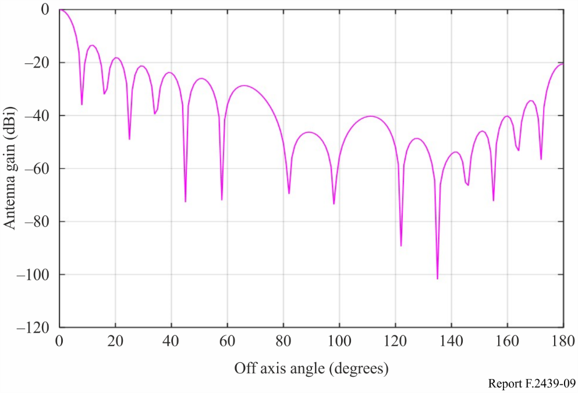
Both azimuth electronic tilt and elevation electronic tilt are 0 degree in the Figure.
The −3 dB beam width is about 7 degrees, and the antenna gain of 1st side lobe is 13 dB lower than that of the main lobe.

Annex 3
Example of link budget in 28/31 GHz band
Link budget of System 5
Option | 1 |  |  |  | 2 |  |  |  | 3
 | CPEs→GWs |  | GWs→CPEs |  | CPEs→GWs |  | GWs→CPEs |  | CPEs→GWs |  | GWs→CPEs
 | UL | DL | UL | DL | UL | DL | UL | DL | UL | DL | UL | DL
Frequency (GHz) | 31 | 28 | 31 | 28 | 31 | 28 | 31 | 28 | 31 | 28 | 31 | 28
Bandwidth (MHz) | 9.4 | 35 | 247 | 65.6 | 9.4 | 35 | 247 | 65.6 | 9.4 | 35 | 247 | 65.6
Tx power (dBW) | –2 | –12 | 5 | 4 | –2 | –12 | 5 | 4 | –2 | –12 | 5 | 4
Tx antenna gain (dBi) | 36.8 | 35.3 | 53 | 24 | 41.5 | 35.3 | 53 | 24 | 47.5 | 35.3 | 53 | 24
Nominal e.i.r.p. (dBW) | 34.8 | 23.3 | 58 | 28 | 39.5 | 23.3 | 58 | 28 | 45.5 | 23.3 | 58 | 28
Slant range* (km) | 56.4 | 56.4 | 56.4 | 56.4 | 56.4 | 56.4 | 56.4 | 56.4 | 56.4 | 56.4 | 56.4 | 56.4
Free space path loss (dB) | 157.30 | 156.42 | 157.30 | 156.42 | 157.30 | 156.42 | 157.30 | 156.42 | 157.30 | 156.42 | 157.30 | 156.42
Rain attenuation (dB) | 12 | 12 | 12 | 12 | 12 | 12 | 12 | 12 | 12 | 12 | 12 | 12
Receiver noise temperature (K) | 800 | 550 | 800 | 550 | 800 | 550 | 800 | 550 | 800 | 550 | 800 | 550
Receiver G/T (dB/K) | –4.3 | 24.8 | 6.3 | 9.4 | –4.3 | 24.8 | 6.3 | 14.1 | –4.3 | 24.8 | 6.3 | 20.1
RX and TX losses (dB) | 2.0 | 2.0 | 2.0 | 2.0 | 2.0 | 2.0 | 2.0 | 2.0 | 2.0 | 2.0 | 2.0 | 2.0
Rx antenna gain | 24.7 | 52.2 | 35.3 | 36.8 | 24.7 | 52.2 | 35.3 | 41.5 | 24.7 | 52.2 | 35.3 | 47.5
Boltzmann’s constant (dB(W/K*Hz)) | –228.6 | –228.6 | –228.6 | –228.6 | –228.6 | –228.6 | –228.6 | –228.6 | –228.6 | –228.6 | –228.6 | –228.6
Required C/(N+I) (dB) | 14.5 | 19.0 | 19.0 | 14.5 | 19.0 | 19.0 | 19.0 | 19.0 | 19 | 19.0 | 19.0 | 19.0
C/N UP (dB) | 18.04 |  | 37.64 |  | 22.74 |  | 37.64 |  | 28.74 |  | 37.64
C/N down (dB) |  | 30.84 |  | 17.41 |  | 30.84 |  | 22.11 |  | 30.84 |  | 28.11
Margin (dB) | 3.54 | 11.84 | 18.64 | 2.91 | 3.74 | 11.84 | 18.64 | 3.11 | 9.74 | 11.84 | 18.64 | 9.11
* Note: investigation are ongoing to see if this slant range could be extended for gateways.

Annex 4
Automatic Transmitting Power Control
This Annex aims at providing explanation on the Automatic Transmit Power Control (ATPC) that is used to compensate the rain attenuation and how it is used in the sharing studies under WRC-19 agenda item 1.14.
ATPC is a method to allow the emitter to compensate the attenuation due to rainy weather conditions.

1 Definition
EIRP_{nominal}: Maximum e.i.r.p. at which the HAPS system operates under clear sky condition
EIRP_{max}: Maximum e.i.r.p. that will never be exceeded
ATPC: Automatic transmit power control is the increase of the EIRP to compensate the rain attenuation
ATPC_{max}: Maximum ATPC that will never be exceeded
$${EIRP}_{max}={EIRP}_{nominal}+{ATPC}_{max}$$

2 Clear sky condition
The clear sky conditions can be defined by the percentage of an average year when the rain attenuations can be considered negligible. Recommendation ITU-R P.618-12 provides the estimated attenuation to be exceeded for a percentage of an average year p in the range 0.001% to 5%. Figure 10 provides the rain attenuations for p = 5% of the time and for an elevation angle of 21 degrees corresponding to the HAPS edge of coverage.
For p = 20%, the attenuation should be lower than the above results and can be considered negligible. Therefore, for p = 20% the conditions should be very close to the clear sky conditions.
Figure 10
Rain attenuation using Recommendation ITU-R P.618-12
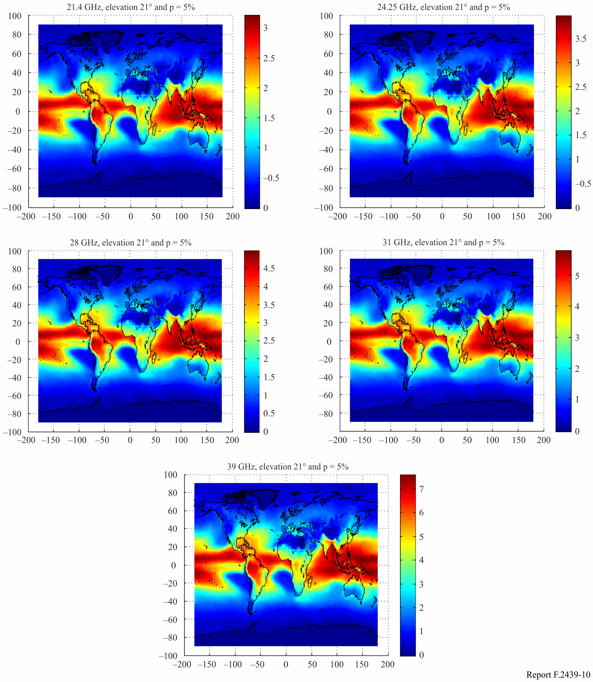

3 Elements to illustrate ATPC cumulative distribution function (CDF) over an average year
A HAPS or a HAPS ground station will transmit a nominal e.i.r.p. under clear sky condition.
During raining conditions, those stations will increase their transmit e.i.r.p. to compensate the rain attenuation. Three areas of the rain attenuation CDF can be defined:
– the clear sky condition area: raining attenuation close to 0 dB for p = 100% to p = 20%;
– the raining condition area: raining attenuation within the range of Recommendation ITU-R P.618-12 (p = 5% to p = 0.001%);
– the raining condition area outside the range of Recommendation ITU-R P.618-12; (p = 20% to p = 5%): for this area there is no ITU-R Recommendation and it is proposed to interpolate Recommendation ITU-R P.618-12.
During raining conditions, HAPS stations will limit the increase of their transmit EIRP to a maximum value EIRPmax which is the nominal e.i.r.p. plus the maximum ATPC. This maximum ATPC value is often linked to the required link availability.
$$EIRP={min⁡(EIRP}_{nominal}+ATPC,{EIRP}_{nominal}+{ATPC}_{max})$$
Figure 11 is a representation of the above.
Figure 11
Link between weather, raining attenuation and EIRP level
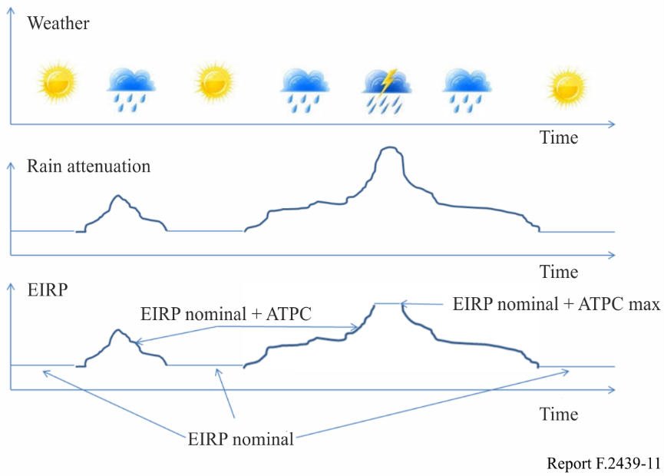
Figure 12 provides an example of the rain attenuation CDF and the ATPC level CDF when the HAPS station is located at longitude 0 degree and latitude 10 degrees, the elevation angle is 21 degrees (edge of the HAPS coverage), a maximum ATPC of 10.8 dB and the frequency at 24.25 GHz. The same computation can be performed when the HAPS beam is not pointing toward the HAPS edge of coverage. In this case the rain attenuation CDF will be lower.
Figure 12
Rain attenuation CDF and ATPC CDF
