Report ITU-R F.2107-2
(11/2011)
Characteristics and applications of fixed wireless systems operating in frequency ranges between 57 GHz and 134 GHz

F Series
Fixed service

Foreword
The role of the Radiocommunication Sector is to ensure the rational, equitable, efficient and economical use of the radio-frequency spectrum by all radiocommunication services, including satellite services, and carry out studies without limit of frequency range on the basis of which Recommendations are adopted.
The regulatory and policy functions of the Radiocommunication Sector are performed by World and Regional Radiocommunication Conferences and Radiocommunication Assemblies supported by Study Groups.

Policy on Intellectual Property Right (IPR)
ITU-R policy on IPR is described in the Common Patent Policy for ITU-T/ITU-R/ISO/IEC referenced in Annex 1 of Resolution ITU-R 1. Forms to be used for the submission of patent statements and licensing declarations by patent holders are available from http://www.itu.int/ITU-R/go/patents/en where the Guidelines for Implementation of the Common Patent Policy for ITU-T/ITU-R/ISO/IEC and the ITU-R patent information database can also be found.

Series of ITU-R Reports
(Also available online at http://www.itu.int/publ/R-REP/en)
Series | Title
BO | Satellite delivery
BR | Recording for production, archival and play-out; film for television
BS | Broadcasting service (sound)
BT | Broadcasting service (television)
F | Fixed service
M | Mobile, radiodetermination, amateur and related satellite services
P | Radiowave propagation
RA | Radio astronomy
RS | Remote sensing systems
S | Fixed-satellite service
SA | Space applications and meteorology
SF | Frequency sharing and coordination between fixed-satellite and fixed service systems
SM | Spectrum management

Note: This ITU-R Report was approved in English by the Study Group under the procedure detailed
in Resolution ITU-R 1.

Electronic Publication
Geneva, 2010
© ITU 2010
All rights reserved. No part of this publication may be reproduced, by any means whatsoever, without written permission of ITU.

REPORT ITU-R F.2107-2
Characteristics and applications of fixed wireless systems operating in frequency ranges between 57 GHz and 134 GHz

(2007-2009-2011)

Scope
This Report contains propagation aspects, system design parameters, possible applications and other technical/operational characteristics, which are required for the implementation of fixed wireless systems in frequency ranges between 57 and 134 GHz. The applications include specific examples of outdoor and/or indoor wireless connections taking advantage of these frequency bands. It is intended that future versions of this Report would be needed.
Vocabulary
VCWL: Vertically-connected wireless link
A wireless link providing a short vertical connection within a building, e.g. between the rooftop and the balconies.
Ortho-mode transducers: A waveguide component that is designed to separate and to combine orthogonal polarizations.

Abbreviations
ARO Availability ratio objective
ARQ Automatic repeat request
A/D Analog/Digital
BBER Background block error ratio
BER Bit error ratio
BPSK Binary phase shift keying
BSTV Broadcasting-satellite television
DTTV Digital terrestrial television
D/A Digital/Analog
EPO Error performance objective
ESR Errored second ratio
FEC Forward error correction
FPU Filed pick-up unit
FWA Fixed wireless access
HD-SDI High-definition serial digital interface
HDTV High definition television
HEMT High electron mobility transistor
HRP Hypothetical reference path
HRX Hypothetical reference connection
IF Intermediate frequency
IP Internet protocol
MHEMT Metamorphic high electron mobility transistor
MMIC Microwave monolithic integrated circuit
MMW Millimeter wave
MRC Maximum ratio combining
LAN Local area network
LoS Line-of-sight
OC-192 Optical carrier-192
OFDM Orthogonal frequency division multiplexing
OI Outage intensity
PCMCIA Personal computer memory card international association
PDA Personal digital assistant
PRBS Pseudorandom bit sequence
QAM Quadrature amplitude modulation
QPSK Quatenary phase-shift keying
RF Radio frequency
SD Spatial diversity
SESR Severely errored second ratio
VCO Voltage controlled oscillator
VCWL Vertically connected wireless link
WLAN Wireless local area network
WPAN Wireless personal area network
3DTV Three-dimensional television
10GbE 10 Gigabit Ethernet
References
ITU-R Recommendations and Reports
Recommendation ITU-R F.1497: Radio-frequency channel arrangements for fixed wireless systems operating in the band 55.78-59 GHz
Recommendation ITU-R F.1668: Error performance objectives for real digital fixed wireless links used in 27 500 km hypothetical reference paths and connections
Recommendation ITU-R F.1703: Availability objectives for real digital fixed wireless links used in 27 500 km hypothetical reference paths and connections
Recommendation ITU-R F.1704: Characteristics of multipoint-to-multipoint fixed wireless systems with mesh network topology operating in frequency bands above about 17 GHz
Recommendation ITU-R P.530: Propagation data and prediction methods required for the design of terrestrial line-of-sight systems
Recommendation ITU-R P.676: Attenuation by atmospheric gases
Recommendation ITU-R P.833: Attenuation in vegetation
Recommendation ITU-R P.837: Characteristics of precipitation for propagation modelling
Recommendation ITU-R P.838: Specific attenuation model for rain for use in prediction methods
Recommendation ITU-R P.840: Attenuation due to clouds and fog
Recommendation ITU-R P.1238: Propagation data and prediction methods for the planning of indoor radiocommunication systems and radio local area networks in the frequency range 900 MHz to 100 GHz
Recommendation ITU-R P.1410: Propagation data and prediction methods required for the design of terrestrial broadband radio access systems operating in a frequency range from 3 to 60 GHz
Recommendation ITU-R P.1411: Propagation data and prediction methods for the planning of short-range outdoor radiocommunication systems and radio local area networks in the frequency range 300 MHz to 100 GHz
Report ITU-R F.2047: Technology developments and application trends in the fixed service
Recommendation ITU-T G.826: End-to-end error performance parameters and objectives for international, constant bit-rate digital paths and connections
Recommendation ITU-T G.828: Error performance parameters and objectives for international, constant bit-rate synchronous digital paths
Recommendation ITU-R F.2006: Radio-frequency channel arrangements for fixed wireless systems operating in the 71-76 and 81-86 GHz bands
Recommendation ITU-R F.2004: Radio-frequency channel arrangements for fixed service systems operating in the 92-95 GHz range.

1 Introduction
In recent years, the interest in frequency ranges between 57 and 134 GHz range for wireless communication applications has increased significantly. The main reason for this interest is the potential for wide bandwidth implementations which meet the growing requirement [Correia and Prasad, 1997] for high data rate applications in the range of hundreds of Mbit/s, including last-mile connectivity. Various short distance link configurations may be expected in these bands, including high-density applications.
In Canada, the band 57-64 GHz is available for licence-exempt applications. In the United States of America, the 60 GHz (57-64 GHz), 70 GHz (71-76 GHz), 80 GHz (81-86 GHz) and 95 GHz (92-95 GHz) bands are available for broadband wireless applications. In Japan, wireless personal area network (WPAN) systems are being implemented in the 60 GHz range for short-range, high speed multimedia data services to terminals located in rooms or office space, and the feasibility experiments of 10 Gbit/s wireless links were conducted in the 120 GHz band (116.5-133.5 GHz). The Administration of Japan, recognizing that many parts of this frequency range are not allocated to the fixed service in the Radio Regulations, has licensed use of the band for this experiment only on condition that the experimental FS stations shall not cause any interference beyond the permissible level to other stations operating in accordance with the national/international regulations, in particular passive services. In Europe, several bands above 57 GHz are currently being considered for fixed wireless systems. In the United Kingdom, the 57-64 GHz band is available for licence-exempt FS point-to-point applications and the 64-66 GHz, 71-76 GHz and 81-86 GHz bands are also available for point to point FS applications under a simple regulatory process.

2 Propagation characteristics and considerations in the 60/70/80/95/120 GHz bands
Free-space loss is proportional to the square of the operating frequency; therefore, the free-space loss in the 60/70/80/95/120 GHz bands is much higher than the losses in the 2.4 GHz or 5 GHz bands available in many administrations for WLAN operations.
The free-space loss PL_{FS} (dB) at a reference distance d₀ (m) is given by:
(1)
where λ is the wavelength (m). The average path loss over a distance d (m) can be determined using the following path loss exponent model based on Recommendation ITU-R P.675 (ex-CCIR):
(2)
where:
the average path loss (dB) at a particular distance d
n: the path loss exponent that characterizes how fast the path loss increases with transmit and receive antenna separation. Fig. 1 shows the simulated results of the received signal level (dBm) as a function of the distance from the transmit antenna. The simulated results are provided for the 2.4/5.5/60/70/80/95/120 GHz bands. In this simulation, it is assumed the transmit power P_{t} is 10 dBm, the transmit and receive antenna gains (G_{t} and G_{r}) are unity, n is 2.1, and the oxygen absorption is 15 dB/km for the 60 GHz band and zero otherwise.
Figure 1
Received power (dBm) vs. distance (km)
From Fig. 1, the path loss at 60 GHz is much higher than the losses at other frequency bands because of the oxygen absorption, which is detrimental to signal propagation. In an outdoor environment, the gaseous absorption attenuates the transmitted signal (~10 to 15 dB/km) in addition to free-space loss. Notwithstanding the above, the oxygen absorption loss can be compensated for by the use of high-gain directive antennas. As well, it can also prove attractive for short-range communications as it further attenuates harmful interference such as co-channel interference in wireless cell-based systems, which combined with low transmit powers in the 60 GHz band (~10 mW) can increase frequency reuse from cell to cell.
For the 70/80/95/120 GHz bands, the gaseous absorption is negligible. Fig. 2 shows the attenuation (dB/km) vs the frequency (GHz) due to the gasses and hydrometeors for radio transmission through the atmosphere. The figure indicates that rain has the greatest impact on transmitted signals in the 60/70/80/95/120 GHz bands.
Figure 2
Attenuation due to gasses and hydrometeors for transmission
through the atmosphere
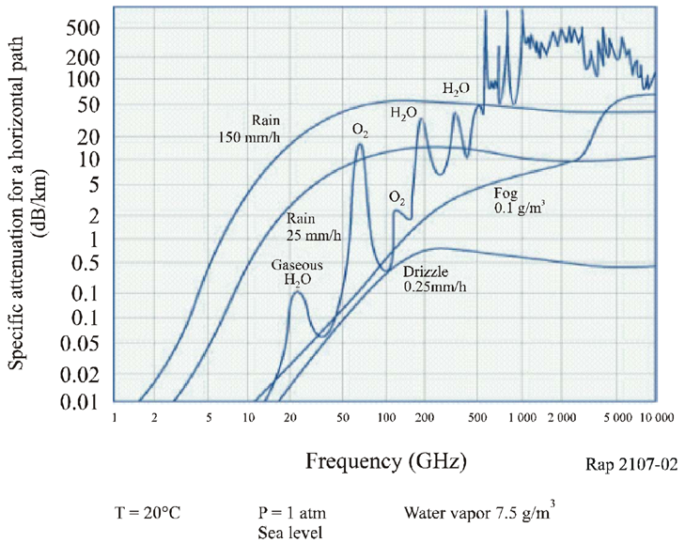
Therefore, enhancement of RF devices and techniques in these frequency bands would improve the availability of these networks under rainy conditions.
For indoor applications, transmitted signals in the 60/70/80/95/120 GHz bands are significantly attenuated by surrounding objects and inner walls and can result in a substantial drop in the received signal level.
Additionally, measured values of RF signal material attenuation have been published in [Rappaport, 2002]. The following results of minimum and maximum attenuation (57-95 GHz) through various materials have been interpolated from these findings:
– Fibreglass insulation: ~3-3.5 dB
– Dry paper-towel: ~3-3.5 dB
– Asphalt shingle: ~3.5-4 dB
– Drywall: ~3.5-6.5 dB
– Glass: ~4.5-7 dB
– Wet paper-towel: ~5-7 dB
– 19 mm pine board: ~8-11 dB
– 19 mm plywood: ~7-11 dB
– Clay brick: 10-23 dB
– Painted 2 × 8 (5 cm × 20 cm) board: ~20-35 dB.
There are also various ITU-R Recommendations that are useful in dealing with propagation issues at these frequencies (see References).
Other factors such as delay spread and Doppler may also need to be taken into consideration. The delay spread is caused by reflections and scattering and will depend on the size of the room and the nature of the walls and objects in it. In a typical office (nomadic) environment, the reflected signals may cause delay spread of the order of few tens of nanoseconds at 58 GHz [Smulders and Wagemans, 1992] and subsequence intersymbol interference, depending on the symbol duration. This effect can be minimized by using directive antennas, which in turn complicate other aspects such as broader coverage.
Experimental results of vertical propagation characteristics in the 60 GHz band are given later in Appendix 1.

3 System design considerations for the 60/70/80/95/120 GHz bands
In addition to the propagation medium, the performance of a wireless communication system also strongly depends on the hardware specifications of the transmitter, the receiver, and the antenna subsystems. Design parameters such as amplifier linearity, output power, noise figure, mixer conversion loss, oscillator phase noise, antenna gain, and antenna beamwidth influence the entire system performance. In the millimetre-wave (mm-wave) bands, choosing the parameters mentioned-above is a challenging task because of their inter-dependencies. Trade-offs and compromises must be made to ensure a realistic design. Furthermore, the cost of the RF subsystems depends on the volumes of production. As the volume increases, the cost per subsystem decreases. Therefore, for the 60/70/80/95/120 GHz systems to be competitive with systems operating at lower frequencies, the volume of the deployed systems needs to be very high.

3.1 Multiplexing and modulation schemes
One of the efficient schemes for transmission in the 60/70/80/95/120 GHz bands is the orthogonal frequency division multiplex (OFDM) scheme [Heiskala and Terry, 2002], which enhances the system’s spectrum efficiency and makes the propagation channel robust against large delay spread. In the case of OFDM systems, the phase noise of the local oscillators in the link’s transceivers is very critical and could impair the orthogonality of OFDM transmission.
For 60/70/80/95/120 GHz systems, the carrier frequency is obtained by multiplying the frequency of the reference local oscillator whereby the phase noise at these frequencies would be higher than in 2.4 GHz and 5.5 GHz systems. The increase in the system’s phase noise leads to BER performance degradation, particularly when OFDM is used with higher order modulation techniques such as 16-QAM and 64-QAM [Heiskala and Terry, 2002]. Therefore, the phase noise of the local oscillators for these mm-wave systems is a design challenge and requires design attention.
The use of adaptive modulation makes the adaptation of a user’s data rate as a function of the channel conditions (average SINR, BER, etc.) possible [Nanda et al., 2000 and Lin et al., 1984]. Efficient adaptive modulation schemes must incorporate both robust transmission modes with low modulation efficiency such as BPSK or QPSK and high data rate modes with high modulation efficiency such as 64-QAM or 256-QAM. Typically, the use of adaptive modulation yields substantial improvement in data rate in comparison with non-adaptive systems, which uses a conservative modulation mode to guarantee a given BER performance at worst conditions at the expense of data rate.

3.2 Countermeasures to improve propagation environments
In point-to-multipoint wireless links, broader antenna beams (even omnidirectional antennas) can be used at both the transmitter and the receiver, which incurs frequency-selective fading due to delay spread and broadband transmission. Frequency-selective fading is typically mitigated through the use of an equalizer, but the complexity of the equalizer quickly grows as a function of data rate.
In a typical indoor environment, obstructions of human movement, walls, floors and ceilings resulting in radio path blockage will cause the received signal level to fluctuate significantly. This challenge should be met to realize wireless local area networks (WLAN) or wireless personal area networks (WPAN) using the 60/70/80/95/120 GHz bands. An acknowledgment and retransmission algorithm is implemented between the transmitter and the receiver using the automatic repeat request (ARQ) protocol [Nanda et al., 2000 and Proakis, 1989]. ARQ removes packet errors at the cost of only moderate additional transmission latency. Assuming that adequate antenna spacing is achievable, spatial diversity (SD) is also an efficient scheme to mitigate an unexpected obstacle to a LoS path by making multiple wireless links between the transmitter with multiples antennas and the receiver (transmit diversity) or between the transmitter and the receiver with multiples antennas (receive diversity). The basic idea of SD is that multiple links are much less likely to be obstructed simultaneously than a single links. In case of receive diversity, the received signals are combined by maximal ratio combining (MRC) rule or the best quality signal is selected among the received signals [Proakis, 1989]. Space-time block coding is a particularly attractive approach to realize transmits diversity without requiring channel knowledge at the transmitter [Gesbert et al., 2002 and Alamouti, 1998].

3.3 Consideration on radio frequency arrangements
In the lower frequency bands below 57 GHz, there are many F-Series Recommendations dealing with preferred RF channel/block arrangements. When the frequency bands are used for license-exempt FS or licensed FS to operate under a light touch regulatory process, administrations may determine preferred RF arrangements as required, taking into account general guidance in relevant ITU-R Recommendations, e.g. Recommendations ITU-R F.746, ITU-R F.1401 and ITU-R F.1519. It should also be noted that for the band 57-59 GHz, Recommendation ITU-R F.1497 (Annex 2) provides example RF channel arrangements with channel separations of 50 MHz or 100 MHz.
Furthermore, for the bands 71-76/81-86 GHz and 92-95 GHz, example RF channel and block arrangements are provided in the draft new Recommendations ITU-R F.2006 and ITU-R F.2004, respectively.

3.4 Performance and availability aspects
Performance and availability objectives for fixed wireless links used for a part of the access network portion of the 27 500 km hypothetical reference paths and connections (HRP or HRC) may be derived from the objectives given in the following Recommendations:
– for error performance objectives (EPO), Recommendation ITU-R F.1668;
– for availability ratio (AR) and outage intensity (OI) objectives, Recommendation ITU-R F.1703.
The objectives specified for the access portion are provided in Tables 1 and 2.
TABLE 1
EPOs for fixed wireless links forming all of the access network section
of the national portion of the HRP and HRC according
to ITU-T Recommendation G.826
Rate  (Mbit/s) | <Primary rate | 1.5 to 5 | >5 to 15 | >15 to 55 | >55 to 160 | >160 to 400
ESR | 0.04 C | 0.04 C | 0.05 C | 0.075 C | 0.16 C | Not applicable
SESR | 0.002 C | 0.002 C | 0.002 C | 0.002 C | 0.002 C | 0.002 C
BBER | Not applicable | 2 C × 10^{–4} | 2 C × 10^{–4} | 2 C × 10^{–4} | 2 C × 10^{–4} | 1 C × 10^{–4}
NOTE 1 – There is another set of the EPO for systems conveying synchronous digital path based on
Recommendation ITU-T G.828.
NOTE 2 – The value of C has provisionally been agreed to be in the range of 0.075 to 0.085 (7.5% to 8.5%).

TABLE 2
Availability, ratio and outage intensity objectives for links forming access
portion of a national portion of constant bit-rate digital path element
Availability ratio objective | Outage intensity objective
1 – 5 × 10^{–4} | 100
NOTE 1 – Outage intensity is defined by reciprocal of meantime between outage.

These Recommendations specify error performance/availability objectives for fixed wireless links forming all of the access network section of the national portion of the HRP and HRC, and do not provide a further subdivision principle for real wireless links forming only a part of the access section. Therefore, it is referred to system operators or designers, within the recommended specifications, how to determine the objectives of real fixed wireless links applied to parts of access network to the end users.
It is generally understood that in high frequency bands rainfall or atmospheric absorption is a dominant degradation factor and that the availability objective is more important for the link design. For systems designed separately from the HRP (or HRC), EPO or ARO may be determined, within the national standard, if there is any, taking into account the following factors:
– the nature of the conveyed signal (voice, video, message, data);
– users’ requirement (real time or non real time, interactive or one-way);
– the environment for the deployment (availability of clear-sky, line-of-sight condition);
– the trade off between required performance and equipment cost.
In design of these systems, the EPO/ARO may be specified flexibly focusing on the most important one among the above factors. To achieve this, an accumulation of the propagation data in wide range of the frequency band will be required.

4 Advantages and disadvantage of the 60/70/80/95/120 GHz bands
The advantages of using the 60/70/80/95/120 GHz bands include:
– frequency reuse in dense areas with reduced potential for undesired interference;
– use of smaller size antennas (antenna gains are proportional to the antenna dimension
and the wavelength);
- small size radio equipment as to provide nomadic applications;
- narrow antenna beamwidths (antenna beamwidth is inversely proportional to the operating frequency) which reduce interference and increase frequency reuse;
- potential frequency sharing feasibility with other radio services;
– support for high capacity transmission due to their wider usable bandwidth (Shannon’s Law).
The following example demonstrates the increase in system capacity [Haroun et al., 2004] due to the wide bandwidth for 60 GHz and 2.4 GHz systems (C = bandwidth × log₂(1 + SNR_{linear})):
– for 60 GHz system with bandwidth of 4 GHz and SNR = 18 dB, the capacity, C is:
C = 4 × 10⁹ × log₂ (1 + 63.1) = 24 Gbit/s
– for 2.4 GHz system with bandwidth of 5 MHz, SNR = 18 dB, the capacity, C is:
C = 5 × 10⁶ × log₂ (1 + 63.1) = 30 Mbit/s
From the above example, the 60/70/80/95/120 GHz bands are ideal choices for high-data-rate short-haul links, but further studies are needed to investigate all the system design challenges.
The disadvantages of these bands include:
– signal obstruction by an object or persons;
– oxygen absorption in the 60 GHz range;
– susceptibility to outage in heavy rain and snow-fall regions;
– unsuitable for long-haul transmission.

5 Technology developments
The very high operating frequencies in the 60/70/80/95/120 GHz bands permit the design of small size high gain antennas with directive beams. Therefore, for communication devices in close proximity, practical antennas could be designed to form small mesh radio networks with minimum interference.
For example, one company developed broadband antennas for applications up to 100 GHz. The large bandwidths that are expected in these systems require state-of-the-art microwave monolithic integrated circuit (MMIC) technology. High performance medium-power amplifiers and low-noise amplifiers using metamorphic high electron mobility transistors (MHEMT) and GaAs based high electron mobility transistors (HEMT) for the 95 GHz band were reported. Other amplifiers operating in the 60/70/80/95/120 GHz bands [Samoska, 2004, Morf et al., 1999 and Li et al., 2003, Kosugi et al., 2006] were also reported. Multipurpose voltage control oscillators (VCOs) with wide tuning ranges and oscillation frequencies up to 74 GHz were reported by researchers [Li et al., 2003]. Systems in the 70/80/95 GHz bands are now also reported and available. Off-the-shelf circuit-blocks which support 60 GHz applications are now available. These blocks include low noise amplifiers, power amplifiers, multipliers and switches.
In addition to the above-mentioned circuit and block level development, above 57 GHz systems are now available where one manufacturer introduced a new high-capacity wireless system which combines free space optical (FSO) equipment with 60 GHz mm-wave technology. The new solution is expected to provide near error-free communications (up to 1.5 Gbit/s) and 99.999% availability over 1 km. Another company introduced an ultra-high capacity system which operates in the 60 GHz band and it is a full rate Gigabit Ethernet (1.25 Gbit/s). Yet another introduced a high capacity point-to-point radio link that operates in the 60 GHz band. This particular solution is designed for use in metropolitan areas and other situations where a fibre optic link is not practical to implement. As well as 60 GHz systems for communications in the range of 1 km, another company introduced a 70 GHz point-to-point system providing near error-free communications up to 1.25 Gbit/s over the effective range of 2~5 km. In addition to the above, systems are being developed that could enable access for customers in remote locations, urban areas and metropolitan areas, and facilitate high-speed services such as movies on demand with successful experiments reported in transmitting video and teleconferencing information over separate channels at 71-72.75 GHz and 73-74.75 GHz. It is important to note that devices for the 70/80/95/120 GHz bands are only produced in small quantities at present and are therefore costly. Forthcoming technologies could reach the goal of transmitting data rates up to and greater than 10 Gbits/s.

6 Standards activity
The IEEE is presently investigating the use of a millimetre-wave-based physical layer within the Wireless Personal Area Network (WPAN) Standard. Systems and devices will operate over very short distances in the 57-64 GHz band and support the following anticipated high data rate applications:
– very high-speed internet access;
– real time streaming;
– HDTV, home theatre, video-on-demand;
– intra-vehicle communications;
– sports/apartment complex communications;
– wireless data bus for cable replacement.

Reference lists a minimum bit rate of 622 Mbits/s at a three-metre distance, non-delay to low delay transmission and a personal digital assistant (PDA)/Personal Computer Memory Card International Association (PCMCIA) form factor as the most important system requirements. For point-to-point applications, bit rates of at least 1 Gbit/s at more than 20 m and 2 Gbits/s at more than 10 m are required.

7 Possible applications in the 60/70/80/95/120 GHz bands
Examples of outdoor/indoor applications that could benefit from the 60/70/80/95/120 GHz bands:
– wireless local area networks (WLANs) and wireless personal area networks (WPANs);
– microcellular and frequency reuse architecture, e.g. fixed links for mobile infrastructure;
– high resolution nomadic multimedia services;
– wireless video distribution systems;
– wireless communications serving underground tunnels and large convention halls;
– wireless links with data rates up to and greater than 10 Gbit/s.

7.1 Indoor deployment
A scenario for a home environment application where consumer electronics are controlled and operated is shown Fig. 3. In this scenario the 60 GHz band was chosen as an example.
Figure 3
Example of a 60 GHz system for home environment
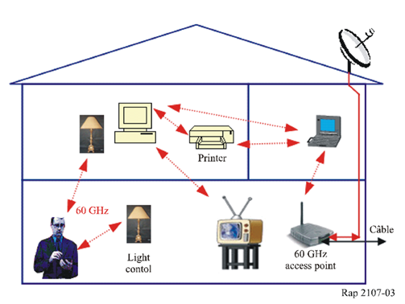
Millimetre wave link in the 60 GHz band can be applied also to another indoor wireless connection as shown in Fig. 4. The standard operational parameters of this application are given in Table 3, which are adopted taking into account residential environments in Japan.
TABLE 3
Operational environment of the indoor wireless connection in Fig. 4
Link distance | Around 10 m
Height of the transmitter (Tx) | Around 2 m
Height of receiver (Rx) | Around 1 m
Communication mode | Point-to-point or point-to-multipoint⁽¹⁾
⁽¹⁾ For a point-to-multipoint application, the antenna gain is several dB smaller than the value in Table 4.

FIGURE 4
Application of the 60 GHz wireless link to indoor connection


7.2 Outdoor deployment

7.2.1 Campus network application
Fig. 5 shows another application that can be used on campuses where wired network solutions become too costly.
Figure 5
60/70/80/95 GHz bands for campus network applications

7.2.2 Vertically connected wireless link
60 GHz millimetre-wave (MMW) band (59-66 GHz) is used for licence-exempt fixed and mobile wireless systems under certain technical requirements, the outline of which is shown in Table 4. Within this band, various kinds of wireless data transmission are expected to develop without licence.
Vertically-connected wireless link (VCWL) systems are proposed as a reliable and economical means for wireless transmission of communication channels and video signals within individual buildings. Fig. 6 shows a concept of a system using VCWL. This system links the rooftop unit to individual units set up on balconies. Communication signals, provided from other networks such as existing wireless LAN (Ethernet signals) or satellite media, are input into the transmitter (Tx) located on the rooftop unit of the building. They are then up-converted to the 60 GHz band and transmitted over the air to the receivers (Rx) set up on the balconies. The Rx in each unit receives the millimetre wave signals, down-converts them to IF signals, and inputs them into the modem. Since this system does not need any wired connections, such as coaxial cables or optical fibres, it will provide an inexpensive solution to the reception problems encountered by individual apartment unit dwellers.
TABLE 4
Current standards adopted in Japan
Unlicensed band | 59-66 GHz
Transmit power (at the antenna input) | ≤ 10 mW  (+ 50%, –70%)
Antenna gain | ≤ 47 dBi
Permitted value of the occupied frequency bandwidth | ≤ 2.5 GHz

Figure 6
System using vertically-connected wireless link (VCWL)

7.3 Example of radio-frequency spectrum arrangement in the 59-66 GHz range
Within the range 59-66 GHz, three radio-frequency (RF) channels are available for applications discussed in § 7.2. Each RF channel has 2 130 MHz bandwidth as shown in Table 5 to transmit video signals provided from satellite systems or other media.
Fig. 7 illustrates several types of the video signal spectrum arrangements within an RF channel.
TABLE 5
Example of the radio-frequency spectrum arrangement
 | Available frequency range | Bandwidth
RF channel No. 1 | 59.48-61.61 GHz | 2 130 MHz
RF channel No. 2 | 61.67-63.80 GHz | 2 130 MHz
RF channel No. 3 | 63.86-65.99 GHz | 2 130 MHz

FIGURE 7
Baseband signal arrangement examples for the 60 GHz wireless link

7.4 Application of 10 Gbit/s wireless link
Fig. 8 shows possible applications of 10 Gbit/s wireless links. One application is fixed wireless access (FWA) for 10 Gigabit Ethernet (10GbE). It is difficult to install fibre networks across rivers and main roads because of the construction works involved and the need for authorization. FWA is cheaper and quicker to install than a fibre network, so it can be used to extend a fibre network to the next building across main roads, and for backhaul with a low cost and a short installation time.
A 10 Gbit/s wireless link can be used for temporary gigabit access because it can be set up quickly and inexpensively. For example, it is a key component in disaster-recovery plans for emergencies when fibre networks fail in a disaster. Furthermore, it can transmit the huge volume of data needed for moving pictures, such as digital cinema or high-definition movies for remote medical treatment. The data rate of 4K digital cinema is 6 Gbit/s, and the wireless data transmission of 4K digital cinema enables public viewing of the digital cinema at various events.

The most promising application for 10 Gbit/s wireless links is multiplexed wireless transmission of uncompressed high-definition television (HDTV) signals (high-definition serial digital interface signals: HD-SDI signals) whose data rate is 1.5 Gbit/s. For wireless transmission of broadcast materials, a microwave field pick-up unit (FPU) is commonly used. The data rate of the state-of-the-art FPU is insufficient for transmitting HD-SDI signals. Therefore, current microwave wireless communication systems must compress the HD-SDI signal. This compression causes a time delay. The 10 Gbit/s wireless link enables transmission of 6-channel multiplexed HD-SDI signals without compression and delay. Relay broadcasting using the 10 Gbit/s wireless link is schematically shown in Fig. 8. The HD-SDI signals are gathered and multiplexed at the outside broadcast vans and transmitted to the relay point building in which broadband fibres are installed and are transmitted to the TV stations through optical fibres.
In order to realize 10 Gbit/s data transmission by using the 57 GHz to 134 GHz frequency range, consideration of the available bandwidth and the level of available modulation scheme is necessary to achieve a balance between the technical challenges and an early introduction of these systems into these bands. QPSK modulation and demodulation with a data rate of 10 Gbit/s have already been achieved using the frequency range of 123 GHz to 133 GHz [Takahashi et al., 2010], and the present technology trend indicates that high-level modulation, such as 16QAM, is expected to be achieved in the near future for bands around 60/70/80 GHz and in the next 5-10 years for bands above 80 GHz. This is due to the recent progress in semiconductor millimetre-wave monolithic integration circuits.
Figure 8
Application examples of 10 Gbit/s wireless link
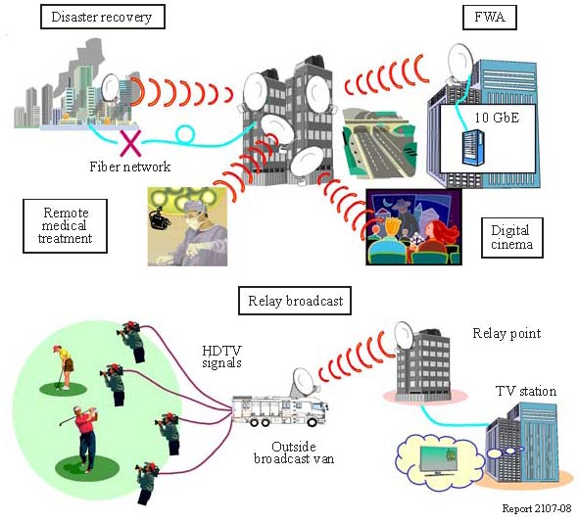
Example specifications and the first experimental results of the above systems using low efficiency modulation are provided in Appendix 2.

8 Summary
The main reason for the growing interest in the utilization of the 57 to 134 GHz frequency range is because of their wide bandwidth capability that supports the potential for high data rates in the Gbit/s range. Wireless solutions in the 60/70/80/95 GHz bands are presently available but the system cost is not yet competitive with lower frequency technologies. Design challenges at these frequencies still exist. For 60/70/80/95/120 GHz band range systems to be competitive with those at lower frequencies, the volume of deployed systems needs to be very high.
Nevertheless, one of the main advantages of the 57 to 134 GHz range is the frequency reuse in dense areas with limited potential for harmful interference. This is most evident in the 60 GHz band where high losses due to oxygen absorption add additional attenuation to RF signals and thereby mitigate interference to a greater extent. Conversely, this increased attenuation in the 60 GHz band is also a disadvantage because it limits the range of communication.
Further studies are required to determine capabilities and limits of the transmitters, receivers, and antennas and other technical elements including modulation/bandwidth requirements in particular to achieve data rates higher than 10 Gbit/s at these millimetre-wave bands.

References
ALAMOUTI, S.M. [October 1998] A simple transmit diversity technique for wireless communications. IEEE J. Select Areas Commun., Vol. 16, p. 1451-1458.
CORREIA, L.M. and PRASAD, R. [January 1997] An Overview of Wireless Broadband Communication. IEEE Comm. Magazine, p. 28-33.
GESBERT, D., HAUMONTE, L., BOLCSKEI, H., KRISHNAMOORTHY, R. and PAULRAJ, A.J. [April 2002] Technologies and performance for non-line-of-sight broadband wireless access networks. IEEE Comm. Magazine, Vol. 40, 4, p. 86-95.
HAROUN, I., KENNY, T. and HAFEZ, R. [August 2004] Ultra-wideband as a short-range ultra-high-speed wireless communications technology. RF Design Magazine.
HEISKALA, J. and TERRY, J. [2002] OFDM Wireless LANs: A Theoretical and Practical Guide. SAMS Publishing.
KOSUGI, T. et al. [November 2006] 120 GHz Tx/Rx waveguide Modules for 10 Gbit/s Wireless Link System. IEEE CSIC Symp. Dig., pp. 25-28.
LI, H. et al. [October 2003] Wide-Band VCOs in SiGe Production Technology Operating up to 70 GHz band. IEEE Microwave and Wireless Components Letters, Vol. 13, 10.
LIN, S., COSTELLO Jr., D.J. and MILLER, M.J. [December 1984] Automatic-repeat-request error control schemes. IEEE Comm. Magazine, Vol. 22, 12, p. 5-16.
MORF, T. et al. [December 1999] 98 GHz InP/InGaAs HBT Amplifiers with 26 dB gain. IEEE MTT, Vol. 9, 12.
NANDA, S., BALACHANDRAN, K. and KUMAR, S. [January 2000] Adaptation Techniques in Wireless Packet Data Services. IEEE Comm. Magazine, Vol. 38, 1, p. 54-64.
PROAKIS, J.G. [1989] Digital Communications. New York: McGraw-Hill.
RAPPAPORT, T.S. [2002] Wireless Communications: Principles and Practice. 2nd Ed. Englewood Cliffs, NJ: Prentice-Hall.
SAMOSKA, L. [February 2004] A 20 mW, 150 GHz InP HEMT MMIC Power Amplifier Module. IEEE Microwave and Wireless Components Letters, Vol. 14, 2.
SMULDERS, P.F.M. and WAGEMANS, A.G. [June 1992] Wideband indoor radio propagation measurements at 58 GHz. Electron. Lett., Vol. 28, p. 1270-1272.
TAKAHASHI, H., KOSUGI, T., HIRATA, A., MURATA, K., and KUKUTSU, N. (May 2010), 10 Gbit/s QPSK modulator and demodulator for a 120-GHz-band wireless link. 2010 IEEE MTT-S International Microwave Symposium Digest, p. 632-635.
Bibliography

MORGAN, M. and WEINREB, S. A W-band monolithic medium power amplifiers. Dept. of Elect. Eng. California Institute of Tech., Pasadena, CA. 91109, United States of America.

Appendix 1
Technical details and propagation measurements for
vertically connected wireless link

1 Introduction
High-speed video transmission can easily be adapted to VCWL. A large demand exists for functional video transmission systems. According to an investigation conducted by the Ministry of Internal affairs, and Communications of Japan, about 900 000 households were unable to receive satellite video services such as digital broadcasting provided by broadcasting satellite (BS) and communications satellite (CS). This can be attributed to trees or other buildings that partially or wholly interrupt the satellite beam path, or location of the individual units that face away from the satellite coordinates. Setting up coaxial cables is expensive. For broadband transmission in the 60 GHz band, Association of Radio Industries and Businesses (ARIB) standard T-69 [Arib, 2001] defines some examples for possible frequency arrangements.

2 Radio equipment outline
One organization developed a prototype of the VCWL system. The experimental parameters are given in Table 6 and the developed Tx and Rx are shown in Fig. 9. The shapes of Tx and Rx are the same. The IF signal is input into the Tx and then converted into a 60 GHz band using a 59.010 GHz local oscillator.
An outdoor transmission experiment was conducted by using the BS video signals (8-carrier signals containing 4 analogue-FM as well as 4 8-PSK having 86.58 Mbit/s/carrier) and it was confirmed that 60 m transmission is possible for digital video signals with a total air bit rate of 346.32 Mbit/s.

TABLE 6
Experiment parameters
RF frequency (RF) | 60.045-60.345 GHz
Local oscillator (Lo) | 59.010 GHz
IF frequency (IF) | 1.035-1.335 GHz
Transmit power (at the antenna input) | 10 mW
Antenna gain | 23 dBi (Tx, Rx)
Size of Tx (or Rx) | 11 cm (as diameter of the shape)
Weight of Tx (or Rx) | 600 g (including metal fittings)

Figure 9
Transmitter (left) and receiver (right)

3 Propagation measurements for vertically connected wireless link
The vertical propagation characteristics in the 60 GHz band is required for designing a VCWL. There are some problems that must be overcome for realizing the VCWL, i.e., when the Rx antenna in the VCWL system points to the upper direction, snow may lie on the Rx and affect the received level. We measured the vertical propagation characteristics over the VCWL as well as effect of snow on the Rx antenna in the 60 GHz band [Kanazawa and Ogawa, 2004].
A vector network analyser system is used for the measurement. Table 7 shows the measurement parameters. For calibration, we first measured the delay profile in a static environment when the distance between the transmitter and receiver antennas is 1 m. All measurement delay profiles are calibrated from this data. In order to calculate the delay spread, Recommendation ITU-R P.1411 could be referred to, where the cut off level is defined as noise level plus 10 dB. The noise level is calculated as the median value of the noise region.

TABLE 7
Measurement parameters
Frequency | 61.5-63.5 GHz
Transmission power | 2 dBm
Polarization⁽¹⁾ | Vertical/horizontal/circular
Antenna gain (3 dB beam width) | 22 dBi (15º)/15 dBi (30º)⁽²⁾
Number of averaged data for one measurement | 32
⁽¹⁾ Polarization is defined regarding wall of the building.
⁽²⁾ Measurement-purpose antennas, not antennas in Table 6, are used for both Tx and Rx antennas.

The measurements are performed at the apartments. The coordinates are defined by horizontal distance (X), (Y), and vertical distance (Z). The Z is measured as a distance from the ground. Fig. 10 shows appearance of both apartments A and B. Apartment A is made of reinforced-concrete, and is a five-storied building. The handrail is made of concrete and is 1.4 m high. Also apartment B is made of concrete, and is a seven-storied building. The handrail is made of aluminium lattice and is 1.20 m in height. The measurement conditions are shown in Table 8.
FIGURE 10
Appearance of apartment A and B
TABLE 8
Measurement conditions
 |  | Distance characteristics in vertical direction | Effect of snow on the Rx antenna
Building |  | Apartment A (Fig. 10a) | Apartment B (Fig. 10b)
Antenna position (m)⁽¹⁾ | Tx antenna | 5th Fl. (Y=0.3; Z=13.7) | 6th Fl. (Y=0.65; Z=14.6)
Antenna position (m)⁽¹⁾ | Rx antenna | 4th Fl. (Y=0.15, 0.3, Z=10.7)  3rd Fl. (Y=0.15, 0.3, Z=7.95)  2nd Fl. (Y=0.15, 0.3; Z=5.15)  1st Fl. (Y=0.15, 0.3; Z=1.75) | 3rd Fl. (Y=0.3; Z=6.35)
Polarization |  | Vertical/Horizontal/Circular | Vertical
Antenna beam width |  | 15° | 15°
⁽¹⁾ The antenna horizontal positions (X-axis) are constant (X = 0) for all the cases.

The measurements of distance characteristics in vertical directions are performed under the conditions that the Rx antenna is on the 1st to 4th floors with the Tx antenna set on the 5th floor handrail at apartment A. The Rx antenna is just under the Tx antenna. The depth of Tx antenna is 0.3 m, and the depth of Rx antenna is changed to 0.15 and 0.30 m.
When the depth of Rx antenna was 0.15 m, we observed that the propagation for vertical directions was almost approximated by the free space path loss equation. On the other hand, when Rx antenna was 0.3 m, we observed a large deterioration in the received level at 2nd floor as shown in Fig. 11. As for the delay spread, the maximum value of 2.8 ns was observed at this position. This means that a multipath signal interferes with the direct signal at this point.
To investigate this condition theoretically, it is assumed that two-ray path interference between the direct signal and the reflection on the wall, and that the value for complex permittivity of concrete is 6.50-j0.43 based on Recommendation ITU-R P.1238.
Fig. 11 shows the measurement and calculated results. The measured value for deterioration on the 2nd floor was almost same to that calculated theoretically for two-ray path interference. This means that multipaths were mainly caused by wall.
FIGURE 11
Received level characteristics (Tx: Y = 0.3 m, Rx: Y = 0.3 m)
The measurements regarding effect of snow on the receiver in vertical directions were performed over one week in winter, at apartment B. The temperature was below 0° C throughout the day. In the experiment, we used covers on each Tx and Rx antenna for waterproofing.
To investigate the effect of snow depth on the Rx antenna, snow was put on the antenna’s cover. And depth of snow changed from 0 to 25 cm in 5 cm steps. 5 cm deep snow corresponds to a volume of 500 cc, the weight of which was about 60 g. The density of the snow was 0.12 g/cc. The measurements were repeated 15 times.
Fig. 12 shows attenuation characteristics due to snow. Here, the attenuation is based on the received level with no snow on receiver antenna. The characteristics vary widely because the permeation through the snow and the reflection on the snow vary according to the snow’s condition. However, it is confirmed that the received level tends to have a large attenuation with increased snow depth. The relationship between the snow depth and median attenuation value is approximated by the following linear approximation: y1 = 0.85x1 – 0.95, where x1 is the snow depth (cm) and y1 is the relative attenuation (dB).
The calculated delay spread was also large, in line with the snow depth. Observed maximum delay spread was 3.9 ns. It was caused by the reduction of the direct signal level, although the level of reflection and diffractions signals tended to be constant.
FIGURE 12
Relation between the received level attenuation and
snow depth on the Rx antenna

Appendix 2
Example specifications and experimental results of 10 Gbit/s
wireless link in 116.5-133.5 GHz band

1 Introduction
Demand for 10 Gigabit-class wireless communications is increasing year by year. In the field of telecommunications, the leading edge in the local area network (LAN) market is moving from Fast Ethernet to Gigabit Ethernet. Commercial 10 Gigabit Ethernet (10GbE) service has already started, and the 10 Gigabit Ethernet market is now growing as well. In the field of broadcasting, TV programme production with the HDTV standard is spreading. The data rate of uncompressed HDTV signals (HD-SDI signal) is 1.5 Gbit/s. Moreover, research and development of a next-generation television system called ultra high definition television (UHDTV) are under way. The data rate of the UHDTV amounts to tens of Gbit/s. To catch up with the speed-up of telecommunications and broadcasts, wireless systems with a data rate of over 10 Gbit/s are required. However, no commercial wireless system meets these requirements. One of the promising ways to meet the demand for 10 Gigabit-class wireless links is to use mm-wave signal at a frequency of over 100 GHz.
One organization has developed a wireless link using the 116.5-133.5 GHz band that has a maximum data rate of over 10 Gbit/s. It should be stressed that most of this frequency range is not allocated to the fixed service and therefore, the organization had obtained experimental radio station licences from the Japanese Ministry of Internal Affairs and Communications and conducted various trial experiments provided that the experimental FS stations shall not cause any interference beyond the permissible level to other stations operating in accordance with the national/international regulations, in particular passive services. The wireless link yielded the error-free transmission of 10 Gb E signal, optical carrier-192 (OC-192) signal, and 6 channel multiplexed uncompressed HDTV signal. The wireless link was used for the transmission of broadcast materials for TV programme productions. The success using over 100 GHz band millimetre-waves that are unexplored frequency region in the field of industry has open a prospect for ultra-high-speed wireless communication system with a rate of over 10 Gbit/s in the near future.

2 Radio equipment outline
The specifications of the 120 GHz band wireless link are shown in Table 8. The developed radio equipment is shown in Fig. 13. The radio equipment has three data interfaces. One is for electrical signals at a data rate of from 1 to 11.1 Gbit/s. The second is for optical signal at a data rate of 9.95 to 11.1 Gbit/s. The 120 GHz band wireless link uses the parameters given in Table 9 in order to transmit the maximum rate of 10 Gbit/s data. The frequency range used for 120 GHz band wireless link for 11.1 Gbit/s data transmission is from 116.5 GHz to 133.5 GHz. In the Radio Regulations, the entire parts of this frequency range are not allocated to the FS. Therefore, the use of these ranges is only for an experimental purpose. The optical signal interface corresponds to 10GbE standard and OC-192 standard with and without forward error correction (FEC). The last interface is the electrical interface for HD-SDI signals.
The radio equipment is designed to be usable for the transmission of uncompressed HDTV materials in live broadcasts of TV programmes. The wireless link system is composed of two parts; the head, which generates radio-frequency (RF) signals, and the controller which supplies data signals, control signals, and electric power to the head (Fig. 14). The head and the controller are connected by camera cables that contain two data signal lines, two control signal lines, and power supply lines. We can remotely control and monitor the head with the controller set at a distance of up to 1 km from the head. The use of monolithic microwave integrated circuits (MMICs) makes the equipment compact (W190 × D380 × H130 mm), light (7.3 kg), and low cost, and provides low power consumption (< 100 W), which enables battery operation. The equipment can be operated as easily as the conventional field pick-up units (FPUs) that TV stations use for wireless transmission of HDTV signals for TV programme productions.
The radio equipment is a unidirectional system. Cross-polarization duplex technologies can make the 120 GHz band wireless link bidirectional without increasing the bandwidth, and ortho-mode transducers with a sufficient isolation characteristics for bidirectional transmission using cross-polarization duplex have been already developed [Takeuchi et al., 2010].
As far as these field experiments are concerned, the wireless link system uses simple ASK modulation, and the bandwidth necessary for 10 Gbit/s data transmission is about 17 GHz. In order to narrow the bandwidth, the development of more efficient modulation, such as QPSK and 16QAM, is now being pursued. QPSK transmitter and receiver modules that can transmit 10 Gbit/s data using frequencies from 123 GHz to 133 GHz have been reported. These developments enable such a system to operate within a much smaller bandwidth.
In order to achieve more efficient modulation, development of wireless circuit technologies, such as high-speed digital circuits, A/D and D/A convertors for generating high-level modulation IF signals are required.

TABLE 9
Example specifications of the 120 GHz band wireless link
Bandwidth | 3 GHz (123.5-126.5 GHz: HD-SDI transmission)  17 GHz (116.5-133.5 GHz:10 Gbit/s data transmission)
Modulation | ASK
Output power | 40 mW
Detection | Envelope detection
Receiver sensitivity  (BER< 10⁻¹²) | −40 dBm (without FEC)  −46 dBm (with FEC)
Power consumption | 100 W
Weight | 7.3 kg
Size | W190 × D380 × H130 mm
Antenna | Cassegrain antenna (450 mm diameter)
Antenna gain | 48.6 dBi
Antenna beamwidth | 0.4º (@ 3 dB)
Input signal interface | Electrical signal: 1 to 11.1 Gbit/s  Optical signal: 9.95～11.1 Gbit/s  (OC-192, 10GbE with and w/o FEC)  HD-SDI signal: 1.5 Gbit/s, 50i/60i (NTSC/PAL)
Figure 13
Photograph of the wireless equipment
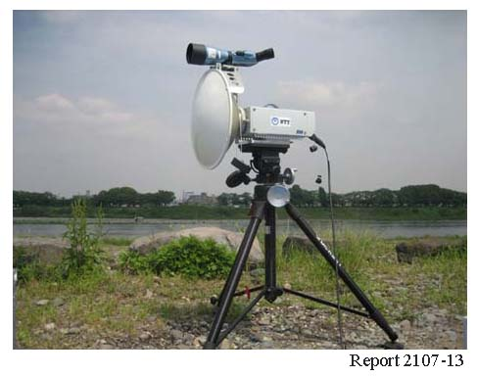

Figure 14
Composition of the 120 GHz band radio equipment

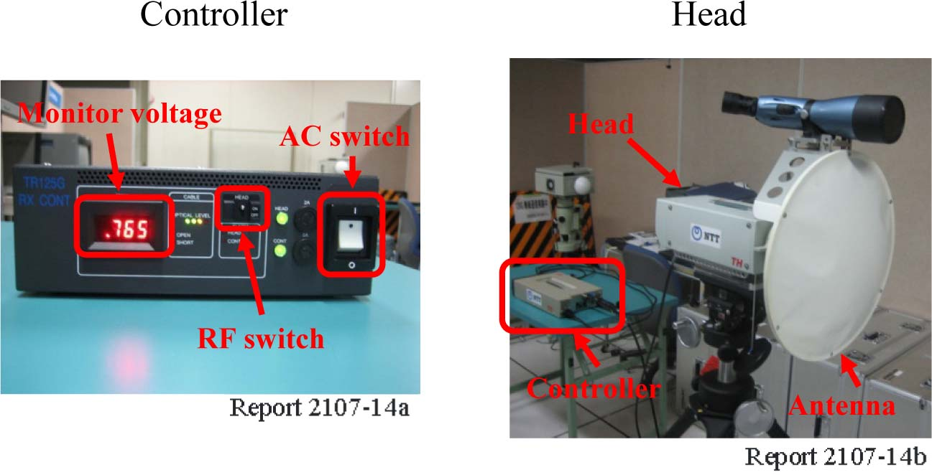

3 Transmission characteristics`

3.1 Transmission experiments using vertical-polarized millimetre-waves
Outdoor experiments were conducted using 10.3 Gbit/s pseudorandom bit sequence (PRBS) data and 6-channel multiplexed uncompressed high-definition television (HDTV) signals (1.5 Gbit/s), and error-free transmission (bit error rate (BER) < 10⁻¹²) over a distance of 5.8 km was obtained. Fig. 15 shows the received power dependence of BER. A BER below 10⁻¹² was obtained with a received power of over −40 dBm. The received power necessary for BER below 10⁻¹² becomes −46 dBm by the use of FEC (Reed-Solomon (255,239) coding).
Fig. 16 shows the received power fluctuation of the wireless link over a distance of 1 km. The received power fluctuation was below 1 dB for 20 hours. These results indicate that the output power fluctuation and the divergence of the antenna axis are small.

Outdoor experiments were conducted using 10.3 Gbit/s pseudorandom bit sequence (PRBS) data, and error-free transmission (bit error rate (BER) < 10⁻¹²) over a distance of 1.3 km was obtained. Fig. 15 shows the received power dependence of BER. A BER below 10⁻¹² was obtained with a received power of over −38 dBm. The received power necessary for BER below 10⁻¹² becomes −45 dBm by the use of FEC (Reed-Solomon (255,239) coding). The maximum transmission distance estimated from the output power, antenna gain, and minimum received power for error-free transmission is about 3.0 km.
Fig. 16 shows the received power fluctuation of the wireless link over a distance of 1 km. The received power fluctuation was below 1 dB for 20 h. These results indicate that the output power fluctuation and the divergence of the antenna axis are small.
Figure 15
Received power dependence of BER
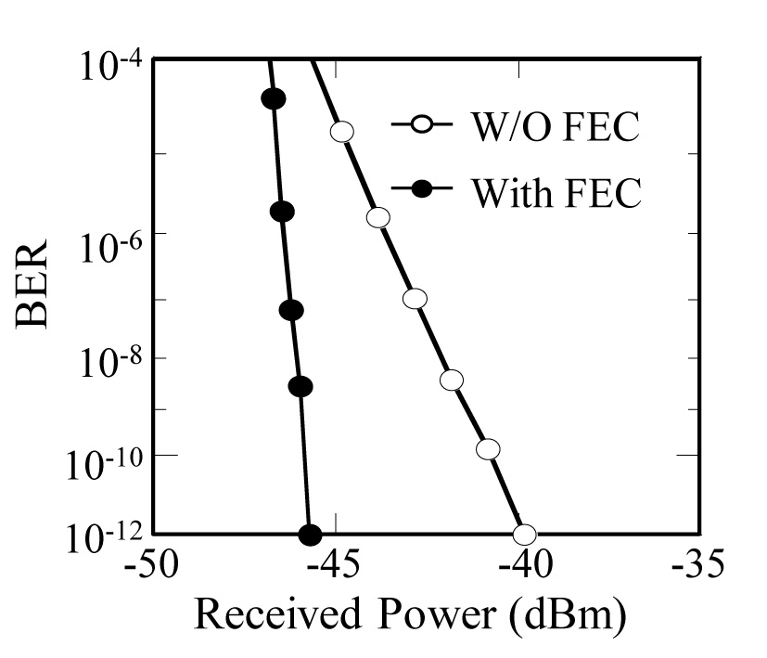
Figure 16
Received power fluctuation of the wireless link.
Transmission distance is 1 km
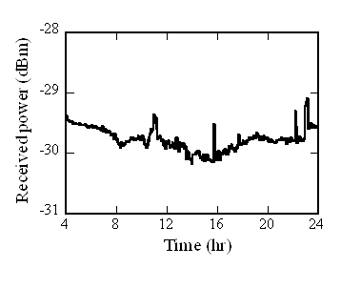
To clarify the dependence of transmission characteristics on weather conditions, long-term transmission experiments have now been conducted using 120 GHz band radio equipment designed for long-term outdoor experiment. The transmitter and receiver are set on a roof, and the distance between the transmitter and receiver is 400 m. The received power, rain intensity, wind speed, temperature, and BER are automatically recorded in a computer.
Fig. 17 shows the rain intensity dependence of the measured attenuation factor. The measurement was done from March to December in 2008 in the Atsugi area, Japan.
The theoretical value for a specific attenuation factor γ (dB/km) with respect to rain rate R (mm/h) is calculated by:
γ = kR^{α}
where:
k = 1.4911
α = 0.6609)
(k and α are referred from Recommendation ITU-R P.838.)
The theoretical value agrees well with the measurement result in the range from 10 to 80 mm/h. The rain attenuation factor obtained by the measurement is about 9, 17 and 23 dB/km when the rain rate is 20, 40 and 60 mm/h, respectively. When rain rate is low, the effect of the wet radome losses cannot be negligible because path losses are relatively small, which causes the discrepancy between the models and measurement results. In the high rain rate region, the quantity of measurement data is too small to compare with the statistical models.
Figure 17
Rain intensity dependence of the attenuation factor

3.2 Transmission experiments using cross-polarization waves
A 20 Gbit/s duplex data transmission experiment over 120-GHz-band wireless links using vertical and horizontal polarization waves was conducted at Yokosuka, Japan, in October 2010.
The 120 GHz band wireless link system uses high-gain antennas, and high-frequency millimetre-wave signals travel straight. The interference between the 120 GHz band wireless links is expected to be small, and the use of cross-polarization duplex and FEC technology can make the interference smaller.
The 1 km long transmission experiments showed that the parallel wireless links can transmit 10 Gbit/s data with a BER of 10⁻¹² by using cross-polarization duplex and FEC technology. One of the wireless links used vertical-polarized and the other one used horizontal-polarized millimetre-waves. The two wireless link equipments are set with a space of 0.8 m, and 450 mm diameter Cassegarain antennas with a cross-polarization discrimination of about 20 dB were used (Fig. 18). The FEC equipment employs concatenated RS (Reed-Solomon) codes (encoding gain of about 6 dB was used) [Okabe et al., 2010].
FIGURE 18
Photograph of the transmission experiments using parallel wireless links
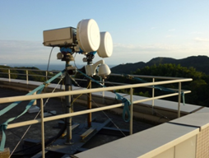

4 Multiplexed uncompressed HDTV signal transmission
One of the most promising applications of the 120 GHz band wireless link is multiplexed wireless transmission of uncompressed HD-SDI signals. Multiplexed wireless transmission of uncompressed HD-SDI signals was achieved by multiplexing them over Internet Protocol (IP) networks. A schematic of the multiplexed wireless transmission system is shown in Fig. 19. The multiplexing HD-SDI signals were conducted by an IP multiplexer. The IP multiplexer converts six HD-SDI video streams to IP packets, then multiplex these packets via a 10GbE network interface. The 10Gb E signals were transmitted over the 120 GHz band wireless link. In the receiver, an IP demultiplexer outputs six reconfigured video streams. Six-channel multiplexed uncompressed HD SDI signals were transmitted over a distance of 1 km by using the 120 GHz band wireless link. This multiplexed wireless transmission system was used for the transmission of three-dimensional television (3DTV) signals and 4K (4 096 × 2 048) resolution digital cinema signals.
Figure 19
Schematic of 6-channel multiplexed wireless transmission of uncompressed
HD-SDI signal over the 120 GHz band wireless link

References

Takeuchi, J. et al. (December 2010) 10-Gbit/s Bi-directional and 20-Gbit/s Uni-directional Data Transmission over a 120-GHz-Band Wireless Link using a Finline Ortho-mode Transducer. 2010 Asia-Pacific Microwave Conference, Dig., pp. 195-198.
Okabe, S. et al., (January 2010) 10-Gbps forward error correction system for 120-GHz-band wireless transmission, 2010 IEEE Radio and Wireless Symposium, pp. 472-475.

Appendix 3
Technical characteristics and deployment scenarios
for FS in the bands 71-86 GHz

The typical technical and operational characteristics and deployment practices of wireless solutions operating in some administrations in the 71-76 GHz and 81-86 GHz have been identified and summarized below.

1 Technical characteristics
TABLE 10
System-wide
Frequency band (GHz) | 71-76/81-86
Type of emission | Digital
Modulation type | BPSK, QPSK, DQPSK
Type of operation | Full duplex point-to-point
Allocated bandwidth upstream + downstream (GHz) | 1.25 + 1.25 = 2.5 (typical), 5 + 5 = 10 (max)
Capacity (Gbps) | 1.25
Transmitter
Output power (dBm) | 17-20
e.i.r.p. (dBm) | 70 (typical), 75 (max for sharing studies) 85 (absolute max)
Coverage radius (km) | 1.6-12 *
Antenna
Antenna type | Parabolic
Antenna gain (dBi)/beamwidth (degrees) **  60 cm  45 cm  30 cm | 50/0.4  46.5/0.6  43.5/0.9
Antenna height relative to ground level (m) | Up to 60
Antenna polarization | Vertical or horizontal (field selectable)

TABLE 10 (end)
Receiver
Noise figure (dB) | ≤ 11
Sensitivity at 10⁻⁶ BER (dBm) | –61.5 ***
* The maximum coverage radius of 12 km is achieved under ideal operating conditions.
** For antenna gains less than 50 dBi, the EIRP must be reduced by 2 dB for every 1 dB reduction in gain below 50 dBi.
*** Data sheets of existing receivers specify a sensitivity (BER=10−6) ranging from –62 dBm to −57 dBm. The sensitivity (BER = 10−6) of –61.5 dBm is derived by using the theoretical S/N (BER = 10-6) values provided in Recommendation ITU-R F.1101 with the coding gain and implementation losses assumed mutually compensating.

2 Deployment scenarios
The extremely large bandwidth that is available in these bands (5 GHz, full duplex) allows for very high capacity data distribution. Links in these bands are normally operated for very short hop point-to-point links (typically less than 10 km).
At this frequency range, very high gain and high directivity are possible from small antennas (also known as “pencil beams”). This allows the deployment of many links in a given area with little chance of mutual interference.
Commercial deployments of 70/80 GHz technology include, but are not limited to, the following applications:
– Fibre extensions and replacements (Fig. 20).
– Alternative network access - backup to fibre (Fig. 21).
– Gigabit wireless LANs and private networks (Fig. 22).
– Machine to machine connectivity for storage area networks (Fig. 23).
– Wireless access backhaul for dense urban networks, such as IMT or IMT-Advanced (Fig. 24).
– IP and SONET backhaul.
– Redundancy, portability and security, including network recovery.
– Video relay of uncompressed high definition television programming.

Figure 20  Typical deployment | Figure 21  Network recovery
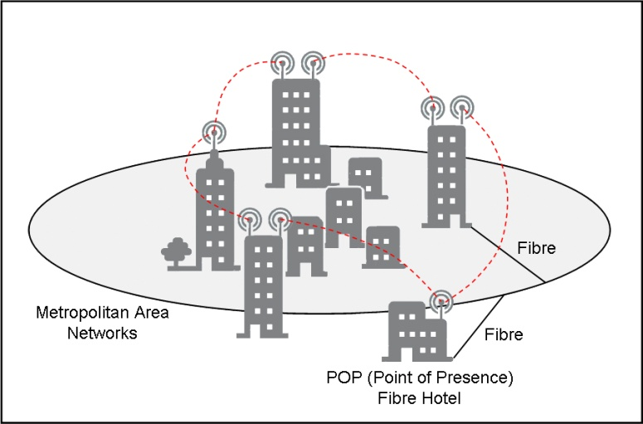 | 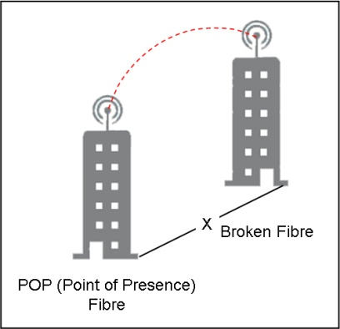

Figure 22  Campus LAN | Figure 23  Storage access
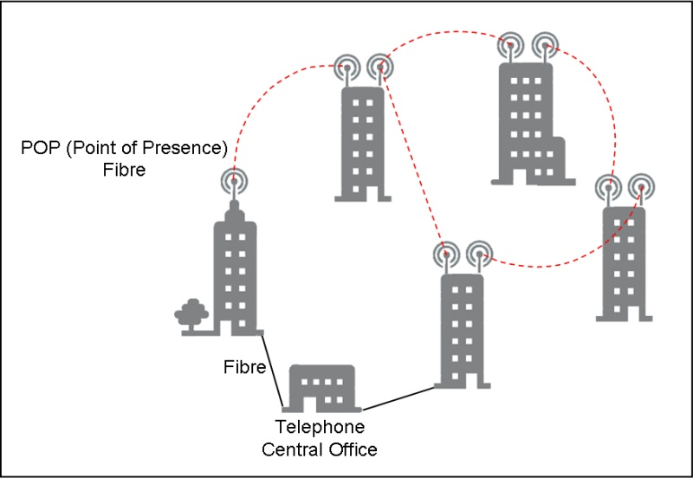 | 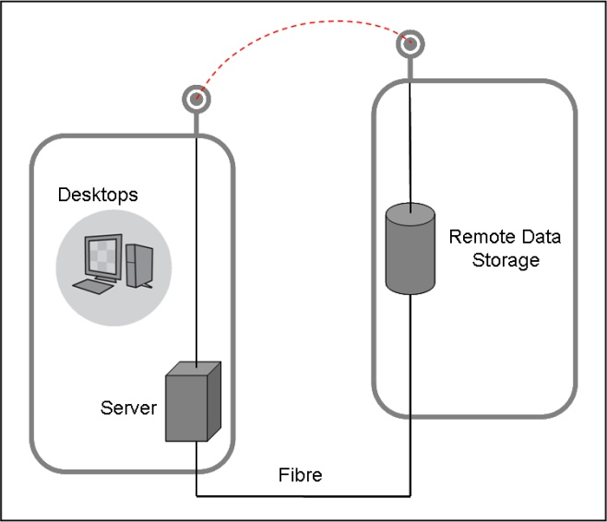
Figure 24
Wireless backhaul
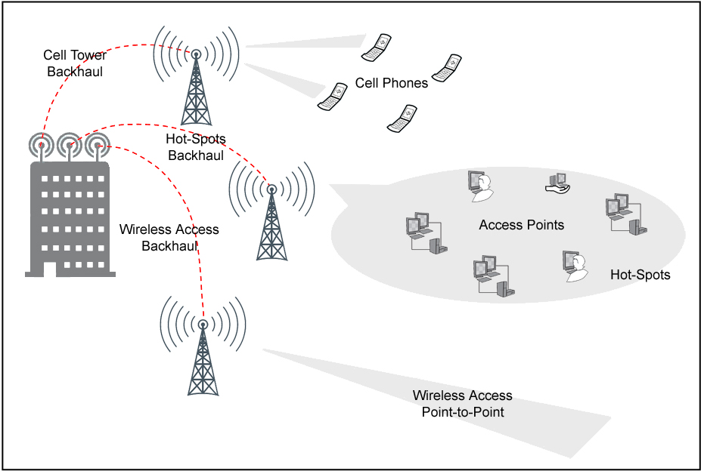
Deployment of ring and mesh topologies improve service availability and capacity and ease migration between circuit and packet applications. At present only a fraction of cell sites are typically served with microwave (6-38 GHz) backhaul while the remaining sites are connected with wireline infrastructure. A typical architecture for microwave backhaul is a branching tree structure, with approximately five hops between the most distant cell sites and the core fibre network (Fig. 25).

Figure 25
Typical microwave backhaul networks
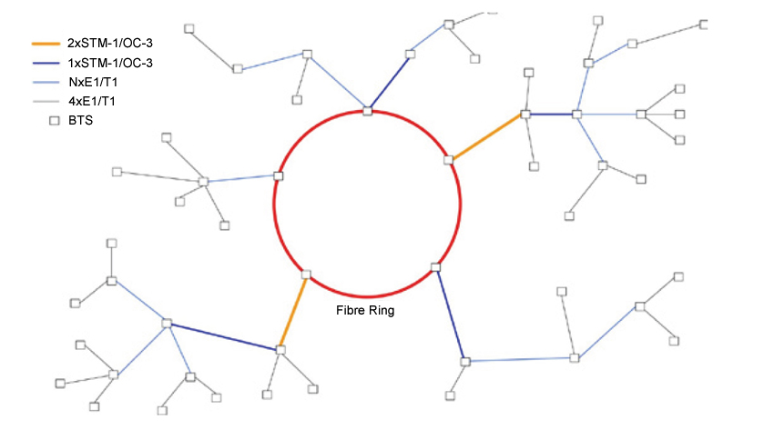
A backhaul network such as the example shown in Fig. 25 would typically use a number of different frequency bands depending on the needed capacity and range. The 70 and 80 GHz bands are most useful for short links needing a high capacity. This would most typically be the case closest to the network core.

3 Antenna patterns
Systems in the 70 and 80 GHz bands typically use high performance 30 cm and 60 cm parabolic dish antennas. These antennas are usually integrated with the outdoor unit to avoid transmission lines losses and simplify installation. It is important to note that antenna performance in these bands is very sensitive to manufacturing tolerances and small variations can result in large differences in antenna pattern.
Since the gain of an antenna increases with frequency, large gains may be achieved from relatively small antennas at these frequencies. Fig. 26 shows the variation in gain for a 30 cm parabolic antenna with frequency. Furthermore, the highly directional nature and narrow beamwidth of
a 70/80 GHz antenna allows for lower antenna heights without risk of multipath fading due to ground reflections. This result in simpler antenna mounting structures for 70/80 GHz systems and systems can be constructed on smaller areas of land and along existing rights of-way such as pipelines, railroad tracks and roads.
Figure 26
The effect of frequency on antenna gain for a 30 cm parabolic antenna

Table 11 shows a regulatory mask used by some administrations for antennas in the 70 and 80 GHz bands.
NOTE – This is not a real antenna pattern but a regulatory mask adopted by these administrations. Further work is required to establish real antenna patterns in these and other bands above 71 GHz.
Table 11
Antenna mask used in some administrations (30 cm parabolic antenna)
Frequency (GHz) | Maximum beamwidth to 3 dB (°) | Minimum antenna gain (dBi) | Minimum radiation suppression to angle in degrees  from centre-line of main beam (dB)
Frequency (GHz) | Maximum beamwidth to 3 dB (°) | Minimum antenna gain (dBi) | 5°-10° | 10°-15° | 15°-20° | 20°-30° | 30°-100° | 100°-140° | 140°-180°
71-76  (co-polar)* | 1.2 | 43 | 35 | 40 | 45 | 50 | 50 | 55 | 55
71-76  (cross-polar)* | 1.2 | 43 | 45 | 50 | 50 | 55 | 55 | 55 | 55
81-86  (co-polar)* | 1.2 | 43 | 35 | 40 | 45 | 50 | 50 | 55 | 55
81-86  (cross-polar)* | 1.2 | 43 | 45 | 50 | 50 | 55 | 55 | 55 | 55
92-95 | 0.6 | 50 | 36 | 40 | 45 | 50 | 55 | 55 | 55
* Antenna gain less than 50 dBi (but greater than or equal to 43 dBi) is permitted only with a proportional reduction in maximum authorized e.i.r.p. in a ratio of 2 dB of power per 1 dB of gain, so that the maximum allowable e.i.r.p. (in dBW) for antennas of less than 50 dBi gain becomes +55 – 2(50 – G), where G is the antenna gain in dBi. In addition, antennas in these bands must meet two additional standards for minimum radiation suppression: At angles between 1.2 and 5 degrees from the centreline of the main beam, co-polar discrimination must be G – 28, where G is the antenna gain in dBi; and at angles of less than 5 degrees from the centre line of main beam, cross-polar discrimination must be at least 25 dB.

______________

ThinKom Solutions Inc., 3825 Del Amo Blvd., Torrance, CA, 90503, United States of America.
Millimeterwellen-ICs und Module, Franunhofer IAF 2001, p. 26.
ElvaLink LCC, 5900 Harper Rd# 102 Solon, OH 44139-1866, United States of America.
http://www.airfiber.com.
http://www.connectronics.com/ceragon.
http://www.ydi.com.
http://www.comotech.com.
http://www.gigabeam.com.
FCC 02-180, WT Docket No. 02-146, June 28, 2002.
IEEE P802.15 WPAN Document IEEE P802.15.SG3c Call for Applications, July 12, 2004.
IEEE P802.15 WPAN Document Draft SG3c System Requirements Outline, January 25, 2005.
Characteristics may be subject to change.
The maximum 85 dBm corresponds to the Radio Regulation generic limit for all terrestrial emissions and adopted by some administrations for offering the wider flexibility to the market; however, it is considered taking into account the future evolution of present equipment and antenna technology, such a limit would hardly ever be reached. Therefore sharing studies should refer to the proposed 75 dBm.
These are often Cassegrain antennas designs. The Cassegrain antenna is a double reflector using a parabolic contour for the main dish and a hyperbolic contour for the sub dish. The main advantages of Cassegrain antenna are a reduction in the axial dimensions of the antenna and a greater flexibility in the design of the feed system.

