Report ITU-R BT.2575-0
(10/2026)
BT Series: Broadcasting service (television)
Television reference test patterns

Foreword
The role of the Radiocommunication Sector is to ensure the rational, equitable, efficient and economical use of the radio-frequency spectrum by all radiocommunication services, including satellite services, and carry out studies without limit of frequency range on the basis of which Recommendations are adopted.
The regulatory and policy functions of the Radiocommunication Sector are performed by World and Regional Radiocommunication Conferences and Radiocommunication Assemblies supported by Study Groups.

Policy on Intellectual Property Right (IPR)
ITU-R policy on IPR is described in the Common Patent Policy for ITU-T/ITU-R/ISO/IEC referenced in Resolution ITU-R 1. Forms to be used for the submission of patent statements and licensing declarations by patent holders are available from https://www.itu.int/ITU-R/go/patents/en where the Guidelines for Implementation of the Common Patent Policy for ITU-T/ITU-R/ISO/IEC and the ITU-R patent information database can also be found.

Series of ITU-R Reports
(Also available online at https://www.itu.int/publ/R-REP/en)
Series | Title
BO | Satellite delivery
BR | Recording for production, archival and play-out; film for television
BS | Broadcasting service (sound)
BT | Broadcasting service (television)
F | Fixed service
M | Mobile, radiodetermination, amateur and related satellite services
P | Radiowave propagation
RA | Radio astronomy
RS | Remote sensing systems
S | Fixed-satellite service
SA | Space applications and meteorology
SF | Frequency sharing and coordination between fixed-satellite and fixed service systems
SM | Spectrum management
TF | Time signals and frequency standards emissions

Note: This ITU-R Report was approved in English by the Study Group under the procedure detailed in Resolution ITU-R 1.

Electronic Publication
Geneva, 2026
© ITU 2026
All rights reserved. No part of this publication may be reproduced, by any means whatsoever, without written permission of ITU.

REPORT ITU-R BT.2575-0∗
Television reference test patterns
(Question ITU-R 44-4/6)
(2026)
TABLE OF CONTENTS
Page
1 Introduction 1
2 Specific-purpose test patterns, their elements and applications 2
2.1 Geometric characteristics assessment 2
2.2 Frequency domain assessment 3
2.3 Linearity assessment 5
2.4 Multi-link SDI Cable swap check 6
2.5 Display-related assessment 7
2.6 Colour assessment 9
2.7 Audio-related assessment 10
2.8 Pathological pattern 11
2.9 Opacity checker 11
3 Multi-purpose test patterns and applications 12
3.1 UHDTV HDR Composite test pattern 12
3.2 Colour bars 20
3.3 Moving colour bars 20
3.4 Colour bars with audio channel ID 21

1 Introduction
Test patterns have two main use cases:
1) System acceptance and “deep” maintenance – needed for installation of new systems and maintenance of existing systems. Multiple signals are needed to de-bug and stress test systems that will be used for multiple programmes and long-term inter-location connectivity. Significant time and engineering expertise is needed in this use-case.
2) Day-to-day operational use – needed to establish the overall suitability of a link and/or system for a single event or programme. Used by operations (not engineering) where time limits are tight and level of expertise is biased toward identification of issues and not necessarily the resolution of the issue identified as being at fault.
Many types of test patterns are used throughout the broadcast production chain to identify faults and analyse system characteristics. These patterns are typically fed into systems, and their output signals are evaluated using displays, waveform monitors, and other measurement tools.
This Report describes various television test patterns, their applications, and composite test patterns.

2 Specific-purpose test patterns, their elements and applications

2.1 Geometric characteristics assessment

2.1.1 Cross-hatch
Cross-hatch pattern consists of evenly spaced horizontal and vertical white lines over a uniform grey background as shown in Fig. 1. It is primarily used to evaluate geometric distortion, scanning linearity, and convergence in television display systems. Misalignments or warping of the grid indicate issues in the display geometry or deflection system.
In television display systems with deflection circuits, nonlinearities in the deflection characteristics cause white lines to appear as barrel distortion or pincushion distortion. In projectors, nonlinearities in the optical system cause white lines to appear as barrel distortion or pincushion distortion. Convergence misalignment appears as colouration such as red or blue tints along the edges of white lines, occurring most frequently at the screen’s periphery. When dot patterns are included, they are used to evaluate convergence on monitors or projectors.
FIGURE 1
Cross-hatch
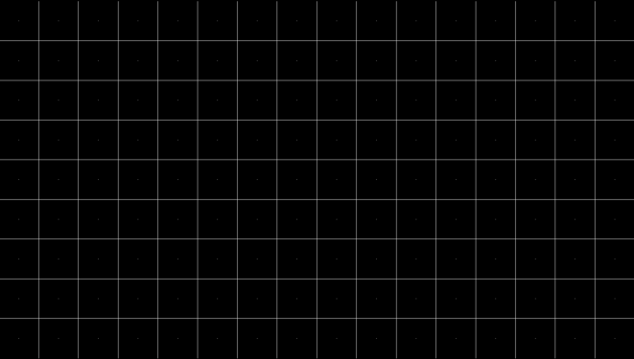

2.1.2 Circle
A perfect circle, typically with a diameter equal to the height of the active image area as shown in Fig. 2 is used to assess aspect ratio accuracy, geometric distortion, and scanning linearity. Any deformation (e.g. oval shape) indicates non-uniform scaling or distortion in the display system.
FIGURE 2
Circle


2.2 Frequency domain assessment

2.2.1 Luminance multiburst
Luminance multiburst pattern contains multiple vertical bars of increasing spatial frequency as shown in Fig. 3. It is used to evaluate the luminance frequency response and passband performance of the luminance channel. For digital video signals, the frequency response characteristics of digital signal processing in each device can be evaluated. When these passband performance and frequency response characteristics are not flat, the burst amplitude varies at each frequency.
Loss of detail or contrast in higher frequency bursts indicates limited resolution or filtering effects.
FIGURE 3
Horizontal luminance multiburst
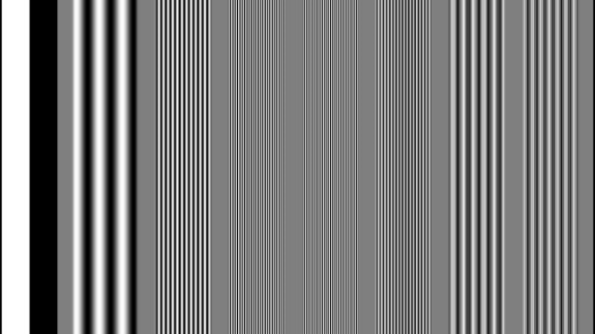

2.2.2 Chroma multiburst
Similar to the luminance multiburst pattern, this applies to colour difference signal as shown in Fig. 4. It is used to assess the frequency response of the chroma channels (Cb and Cr). It helps identify chroma bandwidth limitations, colour smearing, and filtering artifacts.
FIGURE 4
Horizontal chroma multiburst
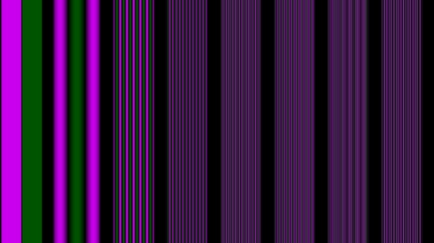

2.2.3 Circular Zone Plate (CZP)
Circular Zone Plate as shown in Fig. 5 is used to evaluate spatial frequency response, aliasing, moiré effects in image processing in video equipment and monitors. It consists of concentric circles of various frequencies. Arbitrary spatial frequencies in all directions can be evaluated. When this test pattern is displayed through a video device, artifacts such as false concentric circles may appear due to the system spatial frequency transfer characteristics. This allows for a visual evaluation of these characteristics.
FIGURE 5
Circular zone plate (luminance channel)
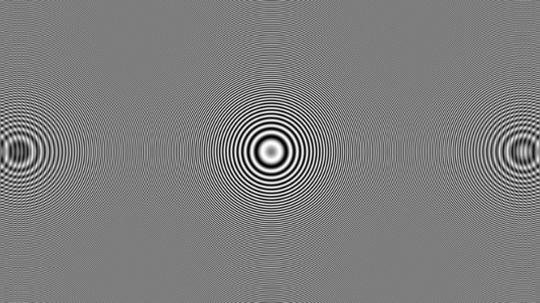

2.2.4 Horizontal resolution wedges
Horizontal resolution wedges feature converging lines where the horizontal frequency increases along the vertical axis as shown in Fig. 6. It is used to determine the maximum reproducible horizontal resolution of the system prior to the onset of aliasing or blurring.
When assessing the television monitors with the pixel structures such as LCDs using this test pattern, it may be difficult to distinguish the maximum resolution subjectively due to aliasing.
Using the line select function on the waveform monitor allows for quantitative evaluation of the passband performance of each device’s video signal processing.
FIGURE 6
Horizontal resolution wedges
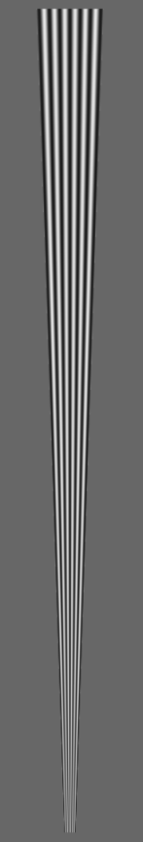

2.2.5 Vertical resolution wedges
Vertical resolution wedges feature converging lines where the vertical frequency increases along the horizontal axis as shown in Fig. 7. It is used to evaluate the vertical resolution limits of the system and reveal interlacing artifacts.
Similar to the horizontal resolution wedge, using the line select function on the waveform monitor allows for quantitative evaluation of the passband performance of each device’s video signal processing.
FIGURE 7
Vertical resolution wedges

2.3 Linearity assessment

2.3.1 Luminance steps (grey scale)
Luminance steps (grey scale) consist of a series of discrete grey levels ranging from black to white as shown in Fig. 8. Each grey scale level increases or decreases monotonically, ideally with uniform increments. It is used to evaluate luminance channel linearity, gamma response, and white balance. In television display systems, the neutrality of each grey tone indicates the accuracy of white balance and R, G, B gamma tracking. If any deviation occurs, a colour cast is observed on the grey tones.
FIGURE 8
Luminance steps


2.3.2 Luminance ramp
Luminance ramp consists of a continuous gradient transitioning from black to white or from white to black as shown in Fig. 9. It is used to assess luminance linearity, dynamic range, signal-to-noise ratio, and white balance. Banding or uneven transitions may indicate quantization issues or poor gamma correction. These artifacts are observed as vertical stripes on the television monitor. Neutral grey indicates the accuracy of white balance and R, G, B gamma tracking. If any deviation occurs, coloured vertical stripes are observed. Using a waveform monitor to check luminance level transitions allows verification that unintended gamma (Log) conversion has not occurred. In digital signal processing, if specific bits are stuck as either 0 or 1, the pattern is observed as staircase-like waveforms with varying step sizes depending on the bit position.
FIGURE 9
Luminance ramp


2.4 Multi-link SDI Cable swap check

2.4.1 “米” pattern
A cross-like pattern resembling the Chinese character “米” (rice) as shown in Fig. 10 is used in Multi-link 2SI SDI systems to verify that all four SDI links are correctly connected and synchronized. Misalignment indicates cabling or signal routing issues.
FIGURE 10
Cross-like pattern, “米” pattern


2.4.2 Cyclone pattern
The Cyclone pattern as shown in Fig. 11 is designed for UHDTV production and used in Quad Link (4-link) 2SI SDI systems to verify that all four SDI links are correctly connected and synchronised. It is a spiral-shaped pattern composed of a 2-pixel structure, measuring 20 pixels horizontally and 18 pixels vertically. This pattern is tiled across the image in a total of 1 440 blocks, arranged as 48 blocks horizontally and 30 blocks vertically. Visual misalignment or breakup of the spiral shape indicates cabling errors (swapped links) or signal routing issues.
FIGURE 11
Cyclone pattern specified in ARIB STD-B66
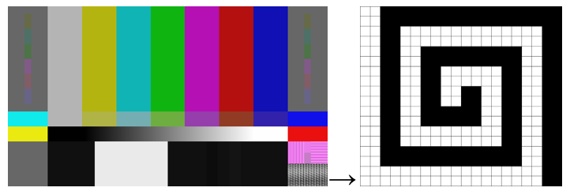

2.5 Display-related assessment

2.5.1 PLUGE (Picture Line-Up Generation Equipment)
PLUGE consists of the central higher-level patch representing the nominal peak level of the video signal, narrow horizontal stripes placed on the left-hand side, and two coarse stripes placed on the right-hand side, as shown in Fig. 12. The stripes consist of three near-black levels: below black, black, and above black. It is used to set and verify black level (brightness) and contrast settings, and to ensure the luminance signal is correctly clipped and displayed.
PLUGE signal specifications for SDTV, HDTV and UHDTV including HDR-TV are defined in Recommendation ITU-R BT.814.
FIGURE 12
PLUGE

2.5.2 Overscan markers
Overscan markers as shown in Fig. 13 are used to define the boundaries of the safe viewing area on a display. Overscan markers help content creators ensure that critical visual elements (like text or graphics) remain within the visible area on all types of displays.
The safe viewing area is specified in Recommendation ITU-R BT.1848 to ensure the visibility of critical picture elements of television programmes, such as text, graphics, or logos, on the majority of home television receivers.
Additional regional guidelines have been established by various standardization bodies to reflect local broadcasting practices.
To comply with these standards during programme production, overscan marker patterns are commonly used by overlaying them on production images.
In the production of computer graphics or on-screen text, customised versions of this pattern are often used. These may include additional markers indicating the boundaries of advertiser captions, logo areas, or other on-screen overlays, allowing operators to confirm layout consistency during production.
FIGURE 13
Overscan markers
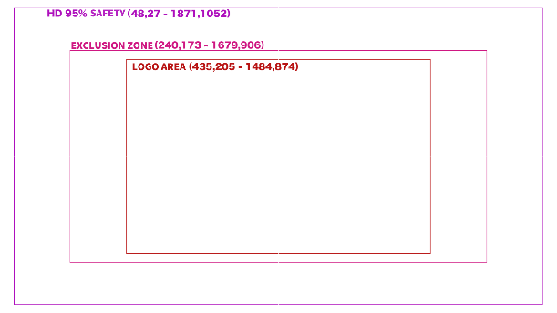

2.6 Colour assessment

2.6.1 Colour chart
Colour chart comprises several patches representing typical tones, such as natural materials and skin colours as shown in Fig. 14. It serves as a reference standard for achieving precise colour reproduction in imaging workflows, including video and image processing.
It is used for the calibration and colour profiling of cameras and display systems. The patches enable the assessment of white balance and skin tone fidelity in captured imagery, facilitating adjustments to chromatic balance, hue accuracy, and overall colourimetric consistency.
SMPTE ST 303M is available for a standard colour chart.
FIGURE 14
Colour chart

2.6.2 Colour ramps
Colour ramps present a continuous gradient of a single colour (red, green or blue) or a combination as shown in Fig. 15. It is used to evaluate nonlinear distortion in individual colour channels and to verify chroma scaling and colour blending accuracy.
FIGURE 15
Colour ramps
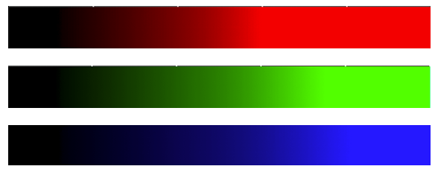

2.6.3 Skin colours
Skin colour pattern consists of patches of typical skin tones as shown in Fig. 16. It is used to evaluate flesh tone accuracy and to adjust colour balance and hue for natural-looking human skin reproduction.
FIGURE 16
Skin colours
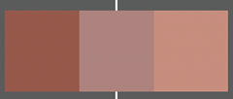

2.7 Audio-related assessment

2.7.1 Lip-sync checker
Lip-sync checker consists of synchronized visual cues (e.g. flashing box or mouth movement) and audio tones as shown in Fig. 17. It is used to verify audio-video synchronization (lip-sync) in broadcast and playback systems.
FIGURE 17
Lip-sync checker
There is another type of lip-sync checker given in EBU Tech 3305, as shown in Fig. 18. The upper part of this pattern consists of colour bars and a linear ramp. A 50% grey signal centred on the white-yellow transition is inserted. A reserved area centred on the red bar is provided for visual information, e.g. source identification, time code.
The lower part of this test pattern consists of two side-by-side black bars, whose horizontal width oscillates at a defined frequency. When they overlap in the centre of the image, a white bar appears for the duration of one frame only. The appearance of the white bar is accompanied by a synchronised sound burst of equal duration and a frequency of 1 kHz.
By transmitting this test pattern through the broadcast equipment, it is possible to evaluate the time difference between the video and audio signals. The delay setting of equipment is adjusted on the receiving side so that the transition points of the video and audio signals occur at the same time.
FIGURE 18
EBU Tech 3305 Lip-sync checker
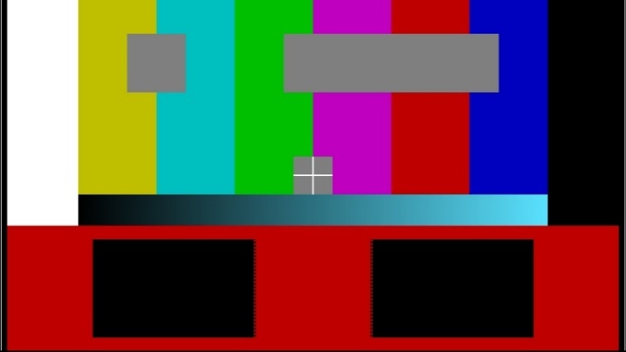

2.7.2 Audio mapping check
Audio mapping check consists of visual audio channel indicators marked with audio signal as shown in Fig. 19. It is used to check audio channel mapping, etc. As shown in the Figure, this is a test image made for a 5.1-channel system. The visual shows that the centre channel is active, and if the system is functioning properly, a test audio sound should be heard from the centre channel.
FIGURE 19
Audio mapping check
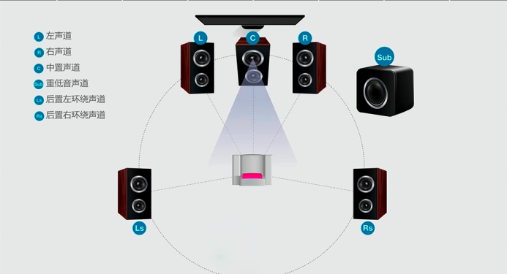

2.8 Pathological pattern
Pathological pattern as shown in Fig. 20 is used for stress testing to evaluate the margin and reliability of systems interconnected with digital video equipment via SDI signals.
In SDI, video data is serialised using NRZI (Non-Return-to-Zero Inverted) encoding. Under normal video conditions, the scrambler ensures that logic “1” s and “0” s appear in a random distribution, resulting in a stable eye pattern.
When a pathological pattern is applied, it generates extremely unbalanced bit sequences (such as long runs of 0 s or 1 s) that place maximum stress on the system. This allows engineers to test the performance limits of components such as the PLL (Phase-Locked Loop) and equaliser, and to detect jitter, bit errors, clock recovery issues and cable quality problems.
FIGURE 20
Pathological pattern (SDI checkfield)


2.9 Opacity checker
Opacity checker consists of elements with varying levels of transparency as shown in Fig. 21. It is used to evaluate the handling of alpha channels and blending accuracy in compositing and overlay systems.
When operating graphic overlay systems, external key signals are typically used. This pattern also includes elements for verifying alignment between FILL and KEY signals, as well as checking the linearity of the KEY signal.
In Fig. 21, the left side represents the FILL signal, and the right side represents the KEY signal.
FIGURE 21
Opacity checker (FILL) and Opacity checker (KEY)
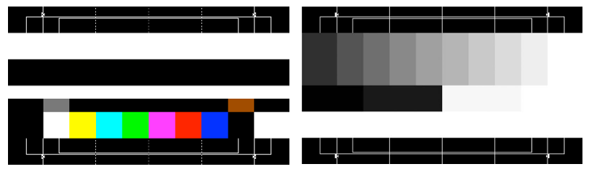

3 Multi-purpose test patterns and applications

3.1 UHDTV HDR Composite test pattern

3.1.1 Composite test patterns
The pattern described in this section is intended for use with Recommendation ITU-R BT.2100 ultra-high-definition HDR television. The EOTF used is HLG as described in Recommendation ITU-R BT.2100.
The reference test pattern has several purposes:
– quality control of chroma and luminance through the production chain;
– checking and adjusting the chroma and luminance alignment of broadcast equipment, particularly video monitors;
– general testing of equipment for video production, emission and presentation;
– checking for audio-video synchronization;
– checking for correct connection of audio channels and correct audio levels;
– checking for correct connection of 4 × 12G SDI or 4 × 3G SDI link.
The parameters of the test patterns refer to the following standards:
Recommendation ITU-R BT.709 – Parameter values for the HDTV standards for production and international programme exchange
Recommendation ITU-R BT.2020 – Parameter values for ultra-high definition television systems for production and international programme exchange
Recommendation ITU-R BT.2100 – Image parameter values for high dynamic range television for use in production and international programme exchange
Recommendation ITU-R BT.2111 – Specification of colour bar test pattern for high dynamic range television systems.
The samples of the 4K (3 840 × 2 160) UHDTV HDR test pattern are shown in Figs 22 and 23. The samples of the 8K (7 680 × 4 320) UHDTV HDR test pattern are shown in Figs 24 and 25.
figure 22
4K UHDTV HDR test pattern
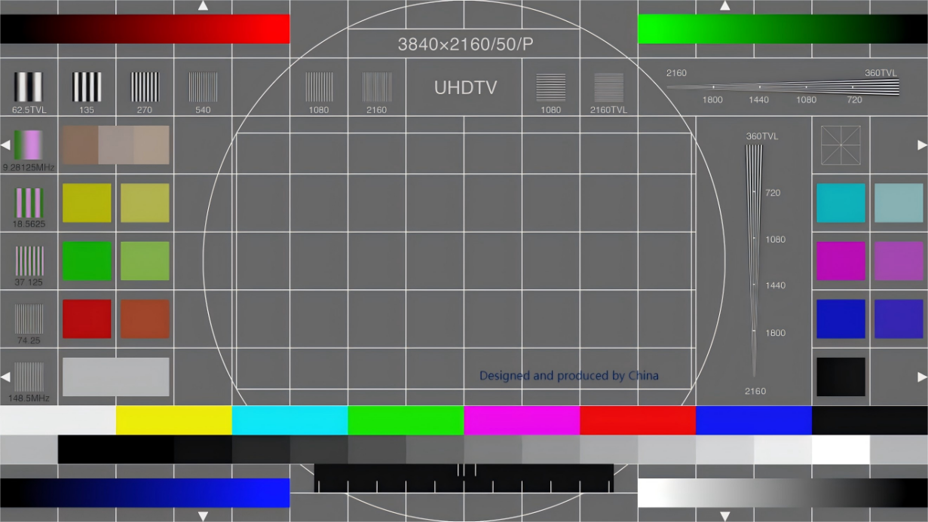
figure 23
4K UHDTV HDR test pattern
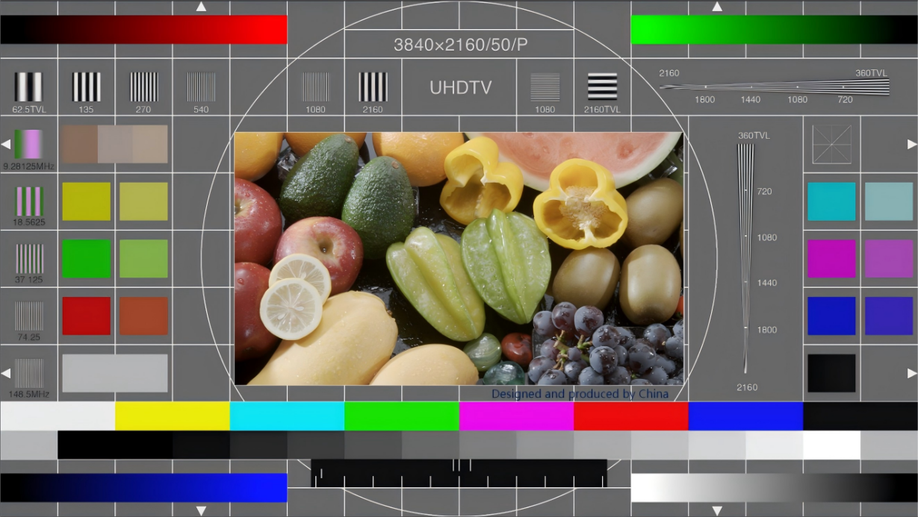
Figure 24
8K UHDTV HDR test pattern
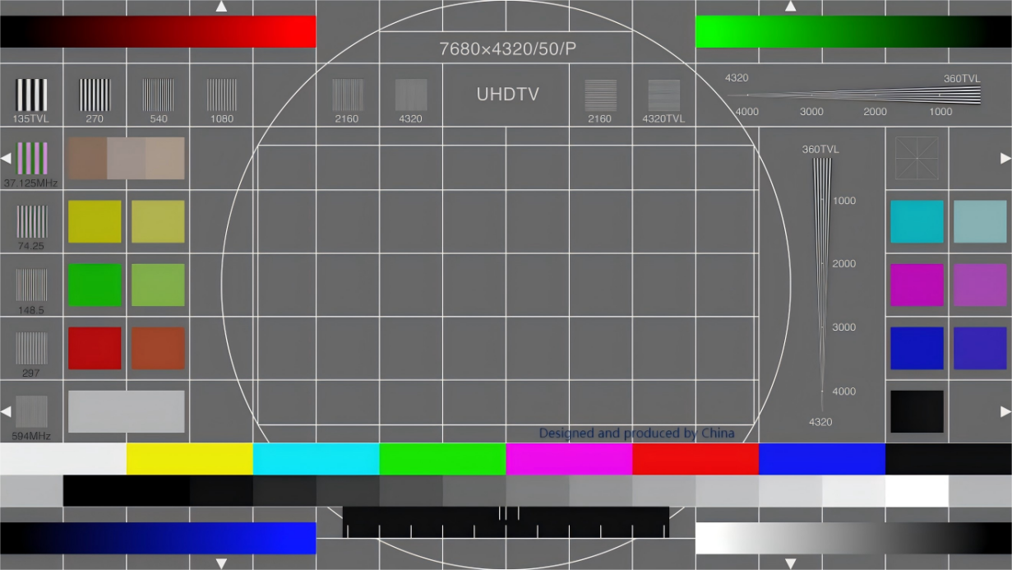
Figure 25
8K UHDTV HDR test pattern
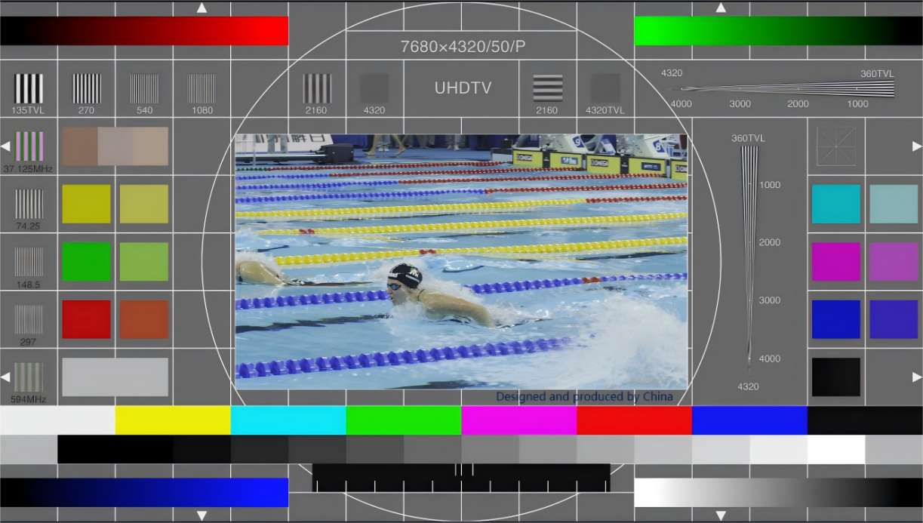
Table 1 provides the parameter values for both test pattern options with further explanation given in § 3.1.2
TABLE 1
Signals of test pattern
No. | Signal | Position
1 | Grey background grid | Background of the active image
2 | Circle | The centre position of the active image
3 | Luminance multiburst | Columns 1, 2, 3, 4, 6, 7, 10, 11 – Row 2
4 | Chroma multiburst | Column 1 – Rows 3, 4, 5, 6, 7
5 | Horizontal resolution wedges | Columns 13, 14 – Rows 3, 4, 5, 6, 7
6 | Vertical resolution wedges | Columns 12, 13, 14, 15, 16 – Row 2
7 | Luminance steps | Columns 2, 3, 4, 5, 6, 7, 8, 9, 10, 11, 12, 13, 14, 15 – Lower half of Row 8
8 | Luminance ramp | Columns 12, 13, 14, 15, 16 – Row 9
9 | Red colour ramp | Columns 1, 2, 3, 4, 5 – Row 1
10 | Green colour ramp | Columns 12, 13, 14, 15, 16 – Row 1
11 | Blue colour ramp | Columns 1, 2, 3, 4, 5 – Row 9
12 | 100% HLG colour bar | Columns 1, 2, 3, 4, 5, 6, 7, 8, 9, 10, 11, 12, 13, 14, 15, 16 – Upper half of Row 8
13 | 75% HLG BT.2100 white | Columns 2, 3 – Row 7
14 | 75% HLG BT.2100 yellow colour | Column 2 and Row 4
15 | 75% HLG BT.2100 Cyan colour | Column 15 and Row 4
16 | 75% HLG BT.2100 Green colour | Column 2 and Row 5
17 | 75% HLG BT.2100 Magenta colour | Column 15 and Row 5
18 | 75% HLG BT.2100 Red colour | Column 2 and Row 6
19 | 75% HLG BT.2100 Blue colour | Column 15 and Row 6
20 | 75% HLG BT.709 yellow colour | Column 3 and Row 4
21 | 75% HLG BT.709 Cyan colour | Column 16 and Row 4
22 | 75% HLG BT.709 Green colour | Column 3 and Row 5
23 | 75% HLG BT.709 Magenta colour | Column 16 and Row 5
24 | 75% HLG BT.709 red colour | Column 3 and Row 6
25 | 75% HLG BT.709 blue colour | Column 16 and Row 6
26 | Skin tones | Columns 2, 3 and Row 3
27 | Three black levels | Column 15 and Row 7
28 | Multi-link SDI Cable swap check | Column 15 and Row 3
29 | Audio-video synchronization check | Columns 6, 7, 8, 9, 10, 11 – Upper half of Row 9
30 | Active image border check signal | Columns 1, 16 – Rows 3, 7 horizontal markers  Columns 4, 13 – Rows 1, 9 vertical markers
31 | User-definable areas | Columns 7, 8, 9, 10 – Lower half Row 1;  Columns 8, 9 and Row 2
32 | Channel identification signal and test sequences | Columns 5, 6, 7, 8, 9, 10, 11, 12 – Rows 3, 4, 5, 6, 7

3.1.2 Signals and usage
No. 1: The background is composed of 100% HLG white lines over a 40% HLG grey background. The white lines form a grid of eight equally spaced and horizontal 15 equally spaced vertical lines, dividing the entire active image area into 9 horizontal and 16 vertical segments. The width of white lines are four pixels in the 4K test pattern and eight pixels in the 8K test pattern. The background and grid are used to evaluate the geometric distortion and scanning nonlinear distortion of ultra-high-definition television display systems.
No. 2: The diameter of the centre circle is the height of the active image. The luminance level and line width are the same as the given in No. 1 above. The circle is used to check the geometric distortion and scanning nonlinear distortion of ultra-high-definition television display systems.
No. 3: The sine signal frequencies are:
– for the 4K test pattern: 9.28125 MHz, 18.5625 MHz, 37.125 MHz, 74.25 MHz, 148.5 MHz, 297 MHz; and
– for the 8K test pattern: 37.125 MHz, 74.25 MHz, 148.5 MHz, 297 MHz, 594 MHz, 1 188 MHz.
The luminance levels of the luminance multiburst signal are:
– 0% HLG for the black part; and
– 100% HLG for the white part.
The multiburst is used to observe and evaluate the video frequency response of ultra-high-definition television systems or equipment.
No. 4: The sine signal frequencies are:
– for the 4K test pattern Cb and Cr are 9.28125 MHz, 18.5625 MHz, 37.125 MHz, 74.25 MHz, 148.5 MHz respectively; and
– for the 8K test pattern, Cb and Cr are 37.125 MHz, 74.25 MHz, 148.5 MHz, 297 MHz, 594 MHz respectively.
The luminance levels of the black and white signals are as given in No. 3 above.
The sine signal section is used to observe and evaluate the chroma channel video frequency response of ultra-high-definition television systems.
No. 5: The horizontal resolution wedges:
– for the 4K test pattern, the frequency of the sine signal from the top to the bottom of the wedge is: 49.5 MHz to 297 MHz, which is equivalent to a horizontal resolution of 360 TV lines (TVL) to 2 160 TV lines (TVL) and the size varies from 13 pixels at the narrow end to 79 pixels at the wide end;
– for the 8K test pattern, the frequency of the sine signal from the top to the bottom of the wedge is: 99 MHz to 1 188 MHz, which is equivalent to a horizontal resolution of 360 TV lines (TVL) to 4 320 TV lines (TVL) and the size varies from 13 pixels at the narrow end to 158 pixels at the wide end.
The luminance levels of the black and white signals are as given in No. 3 above.
The horizontal wedges are used to observe and evaluate the horizontal resolution of ultra-high-definition television systems.
No. 6: The vertical resolution wedges:
– for the 4K test pattern the frequency of the sine signal from the right to the left of the wedge is: 49.5 MHz to 297 MHz, which is equivalent to a vertical resolution of 360 TV lines (TVL) to 2160 TV lines (TVL) and the size varies from 13 pixels at the narrow end to 79 pixels at the wide end;
– for the 8K test pattern the frequency of the sine signal from the right to the left of the wedge is: 99 MHz to 1188 MHz, which is equivalent to a vertical resolution of 360 TV lines (TVL) to 4320 TV lines (TVL) and the size varies from 13 pixels at the narrow end to 158 pixels at the wide end.
The luminance levels of the black and white signals are as given in No. 3 above.
The vertical wedges are used to observe and evaluate the horizontal resolution of ultra-high-definition television systems.
No. 7: The brightness levels of the luminance steps are −7%, −7%, 0%, 10%, 20%, 30%, 40%, 50%, 60%, 70%, 80%, 90%, 100%, and 109% of 100% HLG.
The luminance steps are used to evaluate the nonlinear distortion of the luminance channel of ultra-high-definition television systems. The luminance steps signal can also check whether the white balance of the display device is correct.
No. 8: The brightness of the luminance ramp varies from −7% ~ 109% HLG.
The luminance ramp is used to evaluate and measure the nonlinear distortion of the luminance channel of ultra-high-definition television systems, image luminance levels and signal-to-noise ratio, as well as whether the white balance of ultra-high-definition television receivers and display devices is good.
No. 9: The Red ramp signal level is −7% ~ 109% HLG.
The red ramp is used to evaluate and measure the nonlinear distortion of R channel, image R chroma scale level of ultra-high-definition television systems.
No. 10: The Green ramp signal level is −7% ~ 109% HLG.
The green ramp is used to evaluate and measure the nonlinear distortion of G channel, image G chroma scale level of ultra-high-definition television systems.
No. 11: The Blue ramp signal level is −7% ~ 109% HLG.
The blue ramp is used to evaluate and measure the nonlinear distortion of B channel, image B chroma scale level of ultra-high-definition television systems.
No. 12: The details of the 100% HLG narrow colour bars are given in Table 2.
TABLE 2
Signal level for 100% HLG colour bars narrow range (10 bits)
 | White | Yellow | Cyan | Green | Magenta | Red | Blue | Black
R | 940 | 940 | 64 | 64 | 940 | 940 | 64 | 64
G | 940 | 940 | 940 | 940 | 64 | 64 | 64 | 64
B | 940 | 64 | 940 | 64 | 940 | 64 | 940 | 64

The colour bars are used to evaluate and measure whether the colour reproduction of ultra-high-definition television systems is correct, and to adjust the “hue” and “colour saturation” of ultra-high-definition television receivers and display devices.
Nos. 13-19: The 75% HLG narrow range colour bar signal levels are shown in Table 3.
TABLE 3
Signal level for 75% HLG colour bars narrow range (10 bits)
 | White | Yellow | Cyan | Green | Magenta | Red | Blue
R | 721 | 721 | 64 | 64 | 721 | 721 | 64
G | 721 | 721 | 721 | 721 | 64 | 64 | 64
B | 721 | 64 | 721 | 64 | 721 | 64 | 721

Nos. 20-25: The 75% Recommendation ITU-R BT.709 colour gamut colour block signal levels are shown in Table 4.
TABLE 4
Signal level for 75% BT.709 HLG colour bars narrow range (10 bits)
 | Yellow | Cyan | Green | Magenta | Red | Blue
R | 713 | 538 | 512 | 651 | 639 | 227
G | 719 | 709 | 707 | 286 | 269 | 147
B | 316 | 718 | 296 | 705 | 164 | 702

It is used to observe and evaluate the colour reproduction performance and reproduction effect of ultra-high-definition television systems.
No. 26: There are darker skin tones, mid skin tone and light skin tone. The R, G and B values (10 bits) are shown in Table 5.
TABLE 5
Signal level for skin tones (10 bits)
 | Dark | Medium | Light
R | 536 | 630 | 677
G | 435 | 575 | 613
B | 362 | 548 | 551

It is used to evaluate the skin tone reproduction ability of ultra-high-definition television systems and to adjust the skin tone reproduction effect of television receivers or displays.
No. 27: The luminance levels of the three black blocks are −2% HLG, 0% HLG, and 2% HLG.
The black blocks are used to evaluate whether the ultra-black signal of the luminance channel of the ultra-high-definition television system is transmitted and displayed correctly, and can also check whether the white balance of the display device is correct.
No. 28: It is a multi-link SDI cable swap check pattern, looks like Chinese text “米” (rice). The width of the line is 1 pixel, and the signal level is 100% HLG.
This pattern is used to check if cables of the links in the 4-link 2SI SDI signal are correct.
No. 29: The audio-video synchronization check area is divided into three vertically:
– The upper third is composed of three white bar time marks of +20 ms (sound ahead of image), 0 ms and −40 ms (image ahead of sound), which serve as a reminder of the qualified scale range of audio and video synchronization.
– The middle third is a horizontally moving white bar that crosses from left to right once per second. When the white bar passes the centre point (0 ms mark), a sound synchronization mark signal appears.
– The lower third is composed of 11 white bar time marks at intervals of 100 ms.
The background area is 0% HLG, and the white bar is 100% HLG.
The width of the white bar signal in the 4K test pattern is four pixels and eight pixels in the 8K test pattern.
The audio is a continuous single audio sinusoidal signal.
For a 5.1 surround sound system, the frequencies are: 392 Hz for the left channel, 493.9 Hz for the centre channel, 587.3 Hz for the right channel, 784 Hz for the left surround channel, 987.8 Hz for the right surround channel, and 40 Hz for the low-frequency effect channel.
For a two-channel system, the frequencies are: 392 Hz for the left channel and 587.3 Hz for the right channel.
The sound signal level is the calibration level −20 dBFS, where the right channel signal is combined with the image signal and is muted once per second, the muting time is 25 ms, and the audio-visual synchronization point is at the middle of the muting period.
The combination of video and audio is used to evaluate whether the audio and video synchronization of ultra-high-definition television systems.
No. 30: The edge of image markers consists of white isosceles triangles at the four edges of the active image. There are two triangles at each edge
For 4K, the active image markers are located on the four edges of the test pattern, with two white isosceles triangles on each edge. The height of the isosceles triangle is 42 pixels, the length of the base is 44 pixels, and the signal level is 100% HLG white:
– The vertices of the two isosceles triangles on the upper border overlap with the first vertical line/840th horizontal pixel and the 2 998th horizontal pixel respectively.
– The vertices of the two isosceles triangles on the lower border overlap with the 2 160th vertical line/840th horizontal pixel and the 2 998th horizontal pixel respectively.
– The vertices of the two isosceles triangles on the left border overlap with the 600th vertical line and the 1 558th vertical line/the first horizontal pixel respectively.
– The vertices of the two isosceles triangles on the right border overlap with the 600th vertical line and the 1 558th vertical line/the 3 840th horizontal pixel respectively.
For the 8K the active image markers are located on the four edges of the test pattern, with two white isosceles triangles on each edge. The height of the isosceles triangle is 84 pixels, the base length is 88 pixels, and the signal level is 100% HLG:
– The vertices of the two isosceles triangles in the upper border overlap with the first vertical line/1 680th horizontal pixel and the 5 996th horizontal pixel respectively.
– The vertices of the two isosceles triangles in the lower border overlap with the 4 320th vertical line/1 680th horizontal pixel and the 5 996th horizontal pixel respectively.
– The vertices of the two isosceles triangles in the left border overlap with the 1 200th vertical line and the 3 116th vertical line/the first horizontal pixel respectively.
– The vertices of the two isosceles triangles in the right border overlap with the 1 200th vertical line and the 3 116th vertical line/the 7 680th horizontal pixel respectively.
No. 31: The text is user-definable to identify the transmission channel or signal source.
No. 32: The channel identification signal consists of an image prompt and a sound prompt in the corresponding channel. The test image sequence is a high-quality moving image with the characteristics of complex and fast motion, rich details and colours and fast scene switching.
The channel identification signal can be used to check whether the audio signal channel of the multi-channel system matches the actual playback system channel. The test image sequence is mainly used to evaluate the subjective and objective image quality of the system.

3.2 Colour bars
The colour bar test pattern is used to verify colour reproduction, hue, saturation, and decoder alignment. It also serves as a reference for display calibration. Several types of colour bar test patterns are defined depending on regional requirements.
Recommendation ITU-R BT.2111 specifies colour bars test pattern for HDR-TV, which includes 75% HLG, 100% HLG, BT.709 colour bars, Ramp, Staircase, Black Signal, and Grey bars, as shown in Fig. 26.
FIGURE 26
Recommendation ITU-R BT.2111 colour bars
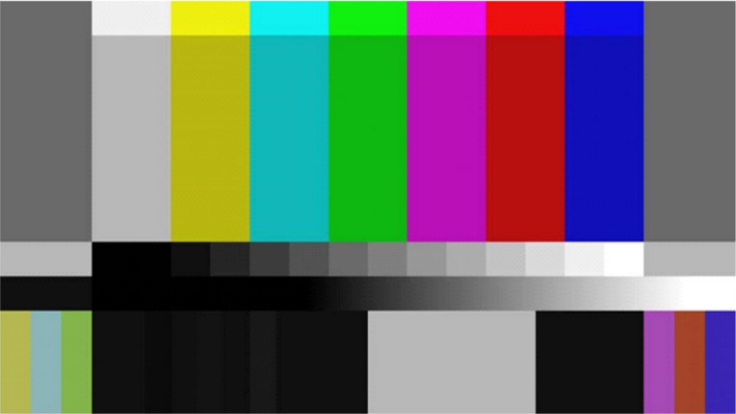

3.3 Moving colour bars
Conventional colour bars are static images and therefore unsuitable for verifying system response to motion or checking frame synchronisation.
In addition, when monitoring through a transmission path, a frozen image cannot be detected if equipment malfunctions (since the source itself is static).
The moving colour bars pattern introduces motion by shifting the bars both vertically and horizontally at a constant speed, enabling the following checks:
– Synchronisation stability: Verify frame drops or synchronisation errors using the moving pattern.
– Delay measurement: Compare the position of the moving bars between input and output to measure latency.
– Monitor response characteristics: Observe after-images or frame interpolation behaviour in moving colour areas.
Figure 27 illustrates an example of the pattern, showing colour bars moving diagonally from the lower left to the upper right of the screen.
FIGURE 27
Moving colour bars
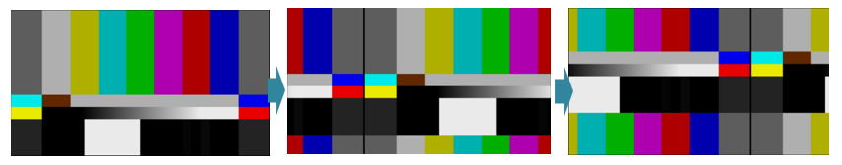

3.4 Colour bars with audio channel ID
For signal verification through transmission lines or system paths, it is common practice to use colour bars in combination with a single-tone audio signal.
To confirm each audio channel individually, distinct tones (e.g. differing frequencies or pulse patterns) are assigned to each channel.
In addition, it is common to display an on-screen overlay indicating which channel is active, providing both an audible and visual reference for channel identification.
Figure 28 illustrates an example for an eight-channel audio configuration. The sequence cycles through time-divided segments where all channels are output first, followed by each individual channel in turn, and finally all channels again. The channel ID appears as an overlay whenever the corresponding audio channel is active. The left side of the Figure shows the pattern when all channels are active, and the right side shows the pattern when only channel 3 is active.
FIGURE 28
Colour bars with audio channel ID
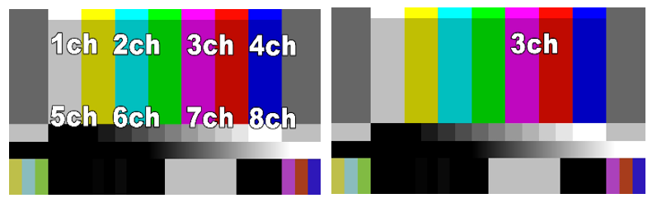

∗ This Report should be brought to the attention of IEC TC100.
These test patterns are explained in detail in China’s GY/T 413-2024 standard. The pattern can be obtained by contacting zhangqian@abp2003.cn.
To prevent the risk of screen burn-in, it is recommended that the test pattern not be displayed on screen for too long, based on the specific characteristics of the display.
Values of Tables 2 to 4 are defined in Recommendation ITU-R BT.2111-2.

