Report ITU-R BT.2568-0
(03/2026)
BT Series: Broadcasting service (television)
Application-oriented television broadcasting

Foreword
The role of the Radiocommunication Sector is to ensure the rational, equitable, efficient and economical use of the radio-frequency spectrum by all radiocommunication services, including satellite services, and carry out studies without limit of frequency range on the basis of which Recommendations are adopted.
The regulatory and policy functions of the Radiocommunication Sector are performed by World and Regional Radiocommunication Conferences and Radiocommunication Assemblies supported by Study Groups.

Policy on Intellectual Property Right (IPR)
ITU-R policy on IPR is described in the Common Patent Policy for ITU-T/ITU-R/ISO/IEC referenced in Resolution ITU-R 1. Forms to be used for the submission of patent statements and licensing declarations by patent holders are available from https://www.itu.int/ITU-R/go/patents/en where the Guidelines for Implementation of the Common Patent Policy for ITU-T/ITU-R/ISO/IEC and the ITU-R patent information database can also be found.

Series of ITU-R Reports
(Also available online at https://www.itu.int/publ/R-REP/en)
Series | Title
BO | Satellite delivery
BR | Recording for production, archival and play-out; film for television
BS | Broadcasting service (sound)
BT | Broadcasting service (television)
F | Fixed service
M | Mobile, radiodetermination, amateur and related satellite services
P | Radio-wave propagation
RA | Radio astronomy
RS | Remote sensing systems
S | Fixed-satellite service
SA | Space applications and meteorology
SF | Frequency sharing and coordination between fixed-satellite and fixed service systems
SM | Spectrum management
TF | Time signals and frequency standards emissions

Note: This ITU-R Report was approved in English by the Study Group under the procedure detailed in Resolution ITU-R 1.

Electronic Publication
Geneva, 2026
© ITU 2026
All rights reserved. No part of this publication may be reproduced, by any means whatsoever, without written permission of ITU.

REPORT ITU-R BT.2568-0
Application-oriented television broadcasting
(2026)
TABLE OF CONTENTS
Page

1 Introduction 1
2 Abbreviations 2
3 Application-oriented television broadcasting 3
3.1 General requirements considered 4
3.2 Easy access to TV content 6
4 General architecture, components and sample UI designs 6
4.1 Application Catalogue 9
4.1.1 Bootstrap Applications 10
4.1.2 Electronic Programming Guide (EPG) 12
4.1.3 Electronic Content Guide (ECG) 14
4.1.4 Profile Manager 15
4.1.5 Privacy Manager 16
4.1.6 Access Panel 17
4.2 Persistent Media Player 17
4.3 Audience Measurement Manager 18
5 Example of an application-oriented television broadcasting system 21
6 References 21

1 Introduction
Next-generation television is gearing up to introduce innovative use cases, shedding light on the crucial role of multimedia applications in broadcasting services. Through these TV applications, broadcasters and their partners can capitalize on highly anticipated innovations, including personalized TV experiences, targeted advertising and programming, content recommendation, seamless over-the-air (OTA)/over-the top (OTT) switching, immersive content provisioning, enhanced accessibility, sensory effects rendering, novel interaction modalities, enhanced emergency alerting capabilities, among other envisioned use cases.
Therefore, multimedia TV applications are expected to evolve from their weary status as merely an accessory for broadcasters to become the focal point of all TV content control and consumption. This shift towards “application-oriented television broadcasting” is crucial for enabling the proactive management of viewer profiles throughout their entire content consumption journey, shaping this journey into a personalized, immersive, engaging experience. It can also be employed to make content delivery methods completely transparent to the viewers, facilitating seamless integration with broadband content and services. Furthermore, it goes beyond this by concealing the traditional concept of TV channels. Overall, this approach aligns with the widespread app-based user experience provided by smart devices.
Historically, application coding specifications for terrestrial digital TV have been centred on middleware standardization, focusing primarily on backend processes, execution environments and their application programming interfaces (APIs) necessary for applications to function. However, to meet the distinct needs of an application-oriented TV, it is imperative to evolve from a middleware specification to a comprehensive software platform specification. A platform specification expands this focus to include both backend infrastructure and front-end components and graphical interfaces, creating a more cohesive and integrated system.
This platform approach encompasses critical components such as broadcast service navigation and selection, viewer profile management, and content search and retrieval. These elements are essential for providing a seamless and intuitive viewer experience. By incorporating these components into a unified platform, next-generation TV can position applications as central elements in the viewer’s journey.

2 Abbreviations
ABNT Associação Brasileira de Normas Técnicas (Brazilian technical standards association)
AMM Audience measurement manager
API Application programming interface
DSM-CC Digital storage media – Command and control
DTV Digital television
DVB Digital video broadcasting
ECG Electronic content guide
EPG Electronic programming guide
HTML Hypertext markup language
IPTV Internet protocol television
NCL Nested context language
OTA Over the air
OTT Over the top
PII Personally identifiable information
SI Service Information
UI User interface
URL Uniform resource locator
VOD Video on demand
VR Virtual reality

3 Application-oriented television broadcasting
Application-oriented television broadcasting can be perceived as a paradigm shift, where the entry point for TV content consumption shifts from a broadcaster’s channel selection to the selection of a broadcaster’s application. This implies that, from the outset of a TV viewer’s journey, an application may proactively manage viewer profiles (with their consent), which is a crucial aspect for delivering personalized and engaging TV experiences that broadcasters can leverage. While numerous advantages are envisioned for this new paradigm, several concerns may arise regarding the potential risk of compromising some of the existing fair, convenient, and well-established broadcasting experiences. This section is dedicated to describing the application-oriented television broadcasting paradigm and outlining the requirements considered to ensure its new benefits, as well as the preservation and evolution of the best qualities of current broadcasting services.
As a comprehensive software platform, an application-oriented TV needs to establish specific requirements and functionalities to facilitate a seamless and comprehensible journey for viewers, ensuring uniform behaviour across various implementations. This holistic approach not only supports the technical execution of applications but also significantly enhances how viewers discover, interact with, and personalize their TV content.
In considering the transition to an application-oriented TV platform, it is essential to evaluate the potential benefits and the challenges it may present. The following list outlines the key benefits and considerations associated with this paradigm shift:
Benefits
– Enhanced personalization: Applications can proactively manage viewer profiles (with their agreement) from the outset, enabling the delivery of personalized, immersive, and engaging TV experiences.
– Seamless integration: The software platform allows seamless integration with broadband content and services, providing a unified viewer experience.
– Support for multiple technologies: The application-oriented TV platform can support legacy and emerging broadcast technologies, ensuring smooth transitions and backward compatibility.
– Transparency in content delivery: Content delivery methods are made completely transparent to viewers, simplifying their experience.
– Flexibility and scalability: As a thorough software platform, it can be updated and scaled, accommodating new features, services, and technologies.
– Standardization and interoperability: Establishing common standards and protocols ensures consistent behaviour across different implementations and enhances interoperability.
– Regulatory management: The ability to conceal the traditional concept of TV channels and their assigned numbers and frequencies facilitates future technology transition deployment and regulation.
Considerations
– Complexity of implementation: Transitioning to a software platform may introduce complexities in development, conformance, system performance, quality of experience and robustness.
– Privacy and awareness: Managing viewer profiles and ensuring personalized experiences requires robust mechanisms for obtaining and maintaining viewer awareness and protecting privacy.
– Regulatory compliance: Complying with varying regulations across different coverage areas, regions, and delivery methods (OTA/OTT) may require significant effort and adjustment to ensure adherence to diverse legal frameworks.
To ensure the successful implementation and operation of the application-oriented TV platform, it is essential to establish clear and comprehensive functional and non-functional requirements. These requirements will serve as a foundation for developing, deploying, and maintaining the application-oriented TV platform, ensuring that it meets the expectations of viewers, broadcasters, and other stakeholders. The functional requirements outline the features and capabilities that the software platform is required to possess, while the non-functional requirements address performance, reliability, and other quality attributes crucial for delivering a seamless and engaging viewer experience.

3.1 General requirements considered
The functional requirements for the application-oriented TV platform specify the essential features and capabilities that the system is required to provide to support an application-oriented approach. Clearly defining these requirements ensures that the software platform meets the diverse needs of broadcasters and delivers a consistent and high-quality viewing experience. Below are the general functional requirements (GFRs) considered for the application-oriented TV platform.
– GFR-01: The application-oriented TV platform is required to support mechanisms for the discovery of broadcast services, where discovered services are identified as applications that are automatically instantiated on the software platform based on the metadata received during the over-the-air signal scan or rescan process. These initial applications are referred to as Bootstrap Applications.
NOTE – This Report assumes that broadcast services are announced via terrestrial broadcast transmission and may be delivered through terrestrial broadcast and/or via the Internet. A single broadcast transmission may announce multiple broadcast services.
– GFR-02: The application-oriented TV platform is required to support application-oriented mechanisms for the navigation and selection of broadcast services through an Application Catalogue dedicated to listing broadcast services exclusively, each one identified as a Bootstrap Application.
– GFR-03: The application-oriented TV platform is required to support mechanisms for discovering broadcast content based on the content metadata provided by the broadcast services.
NOTE – This Report assumes that broadcast content includes linear and non-linear accessible, immersive, interactive, multimedia/mulsemedia/VR content and may be announced and delivered through terrestrial broadcast and via the Internet.
– GFR-04: The application-oriented TV platform is required to support the discovery, navigation, selection, and execution of broadcasters’ additional applications written in standardized programming languages like HTML5, NCL etc. These additional applications are referred to as Broadcaster Applications and deliver enhanced experiences such as personalised recommendations, targeted advertisements, and more.
– GFR-05: The application-oriented TV platform is required to support application-oriented mechanisms for the aggregation of broadcast content from different broadcast services, where aggregated content is individually associated with its respective Bootstrap or Broadcaster Application.
– GFR-06: The application-oriented TV platform is required to support application-oriented mechanisms for the navigation, search, and selection of aggregated broadcast content, such as the Electronic Programming Guide (EPG) and the Electronic Content Guide (ECG), where retrieved content is clearly associated with its respective Bootstrap or Broadcaster Application. Selecting the content launches the corresponding application for presentation.
– GFR-07: The application-oriented TV platform is required to support application-oriented mechanisms for the playback of broadcast content. Broadcaster Applications are required to be able to handle all media content by fully controlling the Persistent Media Player and other media players. The persistent media player is required to continue playing the current content across application switches, allowing the newly launched application to either continue with the current content or define new content to be played.
– GFR-08: The application-oriented TV platform is required to support application-oriented mechanisms for managing viewer profiles, so viewers do not need to create new profiles from scratch for every discovered service of interest. With the viewer’s agreement, Broadcaster Applications may extend these profiles. Broadcaster-specific data in viewer profiles is required to be kept inaccessible to other broadcasters.
– GFR-09: The application-oriented TV platform is required to support application-oriented mechanisms for the management of viewer privacy, where every broadcaster that engages in processing personal data is required to announce a machine-readable privacy record request. This request serves as the basis for rendering privacy management graphical interfaces.
– GFR-10: The application-oriented TV platform may support a standardized remote API server such as ATSC 3.0 WebSocket interface and TV 3.0 WebServices. If present, this server is required to be continuously active.
– GFR-11: The application-oriented TV platform is required to support application-oriented mechanisms for integration with companion devices. Authorized client applications running on companion devices are able to request pairing for: (i) controlling the application-oriented TV platform, (ii) presenting broadcast content, (iii) controlling a Broadcaster Application, and (iv) being controlled by a Broadcaster Application.
– GFR-12: The application-oriented TV platform is required to support interoperability with existing broadcast standards and technologies to ensure a smooth transition. Legacy broadcast services are required to be equally accessible as Bootstrap Applications, serving at least as an entry point for these services.
– GFR-13: The application-oriented TV platform is required to support mechanisms for data analytics and reporting, allowing broadcasters and their associated third parties to collect and analyse viewer engagement metrics and content performance, ensuring data-driven decision-making under the auspices of GFR-09.
Non-functional requirements specify the qualities and attributes necessary for the effective and efficient operation of the application-oriented platform. These requirements focus on performance, reliability, security, usability, and other critical factors that contribute to the overall viewer experience and system integrity. Below are the general non-functional requirements (GNFRs) considered for the application-oriented TV platform.
– GNFR-01: The application-oriented TV platform should be accessible in a harmonized and prominent manner with unique visual identification in the main graphical interface (also known as the home screen) of the receiver device.
– GNFR-02: The application-oriented TV platform should be exclusively dedicated to content and applications signalled by free-to-air terrestrial broadcast services.
– GNFR-03: The application-oriented TV platform should include robust testing and validation mechanisms to ensure compatibility and performance across different hardware and software environments.
– GNFR-04: The application-oriented TV platform should ensure data privacy and protection in compliance with relevant regulations and standards.
– GNFR-05: The application-oriented TV platform should support rapid switching between different Broadcaster Applications within the same broadcast service context.

3.2 Easy access to TV content
This section enumerates the easy access functional requirements (EAFRs) and easy access non-functional requirements (EANFRs) considered to guarantee easy access to television content, given the current difficulties and inconsistent identification of broadcasting services in different TV devices.
– EAFR-01: The application-oriented TV platform is required to be accessible through a standardized icon permanently and prominently visible on the receiver’s home screen.
– EAFR-02: The application-oriented TV platform is required to be accessible through a direct access key (single touch) with a standardized icon on the receiver remote control.
– EAFR-03: The application-oriented TV platform is required to adhere to accessibility standards, including compatibility with assistive technologies, to ensure usability by viewers with disabilities.
– EAFR-04: The application-oriented TV platform is required to list exclusively Bootstrap Applications announced by over-the-air broadcast services to ensure that only broadcast-related content is available.
– EAFR-05: When an application-oriented TV receiver is first switched on (‘out-of-the-box experience’), it is required to initiate the process of scanning the electromagnetic spectrum using its indoor or outdoor antenna to retrieve the metadata of the broadcasting services and instantiate the corresponding Bootstrap Applications in the Application Catalogue. This allows free access to the content of the broadcasters that operate in the location where the receiver is installed. This stage should take place in the background without interfering with or blocking the viewer and should not disturb or interrupt the sequence of settings for the first use of the receiver.
– EAFR-06: The application-oriented TV platform is required to support dynamic updates, enabled by automatic or manual signal rescanning, to reflect new Bootstrap Applications over time. Automatic signal rescanning should occur daily when the receiver is in standby mode.
– EANFR-01: The application-oriented TV platform should support rapid switching between different Bootstrap Applications (zapping between different broadcast services).

4 General architecture, components and sample UI designs
This section describes the general architecture for application-oriented television broadcasting in a technology-agnostic way. This approach becomes versatile and adaptable for potential adoption across both existing and future broadcasting systems. As an inclusive framework, the paradigm may be adapted to specific technological constraints, offering a conceptual foundation that can be integrated into diverse broadcasting environments.
The general architecture encompasses all the modules and components necessary to implement the functionalities outlined in the list of general requirements (§ 4.1), as well as the specific requirements defined in the subsequent sections. Figure 1 illustrates the application-oriented TV platform’s general architecture. Its components are briefly described as follows.
Figure 1
Application-oriented TV Platform General Architecture
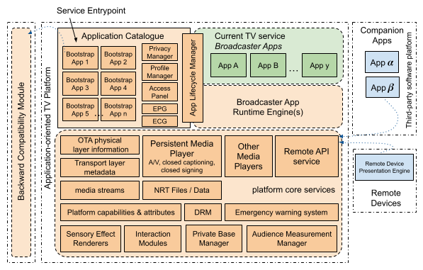
In the following subsections, each relevant architecture component is explained with the help of sample UI designs for better understanding.
The Application Catalogue is the primary interface for viewers to browse and access broadcast services. It exclusively lists Bootstrap Applications announced by terrestrial broadcast services, ensuring that only broadcast-related content is available. This catalogue provides a centralized location where viewers can identify available broadcasters, explore their content offerings, and manage their interactions with various services. The Application Catalogue is the dedicated TV-exclusive section within a device, designed to display all Bootstrap Applications instantiated following a signal scan or rescan process. Additionally, it offers access to other software platform modules, such as the Electronic Programming Guide (EPG) and the Electronic Content Guide (ECG). Given the substantial amount of application and content metadata gathered by the Application Catalogue, specific implementations may incorporate search functions to enhance the viewer’s ability to find desired content and services efficiently. The catalogue also includes features for managing viewer profiles, allowing viewers to customize their settings and preferences for a personalized viewing experience.
Bootstrap Applications are the initial applications instantiated on the Application Catalogue, as announced and parameterized by terrestrial broadcast services’ transport layer metadata. These applications are the entry points for viewers to access the broadcaster’s content ecosystem, starting with their linear service. To eliminate the additional time that would be required for downloading applications during signal scanning, the Bootstrap Application is automatically instantiated for each identified service. The Bootstrap Application acts as the fundamental interface for a specific TV service, launching when the viewer selects the corresponding icon on the Application Catalogue or when service switching (zapping) occurs. Due to the need for rapid switching performance, Bootstrap Applications are designed to be straightforward. They typically manage a concise set of broadcaster/content metadata and control the Persistent Player for presenting the selected OTA (Over-The-Air) or OTT (Over-The-Top) service/content. In the event of Broadcaster Application malfunctioning, the Application Lifecycle Manager can relaunch the relevant Bootstrap Application to maintain service continuity.
Broadcaster Applications are additional apps delivered over-the-air (OTA) or via the Internet to provide enhanced experiences. While the Bootstrap Application offers essential functionality for simplicity and performance, additional functionalities are needed for delivering comprehensive, personalized experiences. Therefore, broadcasters develop additional applications to provide viewers with enhanced features such as personalized recommendations, targeted advertisements, and more. Each broadcaster may develop multiple applications that can be automatically switched based on viewer behaviour or made available for explicit selection by the viewer. These additional applications enable broadcasters to offer engaging content, ensuring that the application-oriented TV platform delivers a modern and versatile viewing experience.
The Application Lifecycle Manager oversees the entire lifecycle of Bootstrap and Broadcaster Applications within the application-oriented TV platform, as well as the software platform’s other components. This includes application instantiation or installation, updating, activation, launching, monitoring, pausing, ending, removing, and releasing resources. It is designed to handle the unique demands of managing fast-switching applications, ensuring that transitions between applications are smooth and responsive. In the event of a Broadcaster Application malfunctioning, the Application Lifecycle Manager employs a fail-safe mechanism, terminating the misbehaving application and relaunching the Bootstrap Application corresponding to the current TV service.
The Broadcaster Application Runtime Engines include presentation engines, browsers, interpreters, and virtual machines that support the standardized programming language and APIs for Broadcaster Application development as specified for the TV system. The standardized APIs, the definition of expected engine behaviours and formal conformance testing procedures ensure that Broadcaster Applications can be executed efficiently and consistently across different devices.
The Access Panel is a component of the Application Catalogue that enables viewer access to essential services of the receiver platform before or during the playback of both over-the-air and over-the-top broadcaster content or, outside of this context, during the execution of a Broadcaster Application. In the context where the viewer is executing a Bootstrap or Broadcaster Application, the Access Panel can be evoked by the viewer and may overlay graphical elements of the Bootstrap Application or Broadcaster Application. The Access Panel is activated via the receiver’s remote control direct access key and offers quick access to essential components, such as the EPG, ECG and search, as well as to the Broadcaster Applications list. It can also dynamically adapt to the content being played, clearly indicating available settings, such as audio selection and accessibility options.
The Platform Core Services contain all the components that are shared by the Application Catalogue and the Broadcaster Application Runtime Engines, including, in particular, the Persistent Media Player and the Remote API Service.
The Persistent Media Player is a core component of the application-oriented TV platform that handles the continuous playback of media content across different applications and services. It ensures the continuous presentation of selected content during application switches, meeting the requirements for managing all media content from the broadcaster and facilitating rapid application switching. Consequently, the player’s lifecycle is not tied to a specific application, allowing applications to freely modify the player state and its media source. The Persistent Media Player supports both OTA and OTT content, providing flexibility in content delivery. It integrates with the Bootstrap and Broadcaster Applications to manage and present selected content, maintaining stability and performance throughout the viewing session.
The Remote API Service component provides APIs for accessing application-oriented TV platform information, resources and features from any application, both on the receiver and other devices within the home environment. This service adopts a decoupled approach, enhancing flexibility and interoperability across various devices and applications. By utilizing the Remote API Service, some Broadcaster Application Runtime Engines that could be directly integrated with TV core services can avoid incorporating new TV-specific APIs into their standardized base API.
Companion Applications run on third-party software platforms on the same device as the application-oriented TV platform or on different devices within the home environment. These applications use the Remote API Service to interact with the application-oriented TV platform components, Broadcaster Applications, broadcaster content, data, and metadata. Companion Applications enhance the viewing experience by providing additional functionalities and interactive features. They are typically subject to access authorization processes, which are confirmed by both the viewer and the broadcaster to ensure secure and controlled access.
In the application-oriented TV platform context, Remote Devices are those connected to the same local network as the application-oriented TV receiver (such as smartphones and head-mounted displays, among others) and registered with the Remote API Service as a device capable of executing part of a Broadcaster Application using a remote device presentation engine.
The Backward Compatibility Module provides the required support for the technologies needed for executing Bootstrap Applications and Broadcaster Applications corresponding to legacy broadcast services.

4.1 Application Catalogue
The Application Catalogue serves as the primary interface for viewers to browse and access broadcast services. It streamlines the viewer’s experience by consolidating all available broadcast services into a single, user-friendly interface. This interface should be designed to be intuitive, ensuring that viewers can easily navigate through various Bootstrap Applications and application-oriented TV platform components without confusion or difficulty. Figure 2 depicts a sample wireframe user interface for the Application Catalogue.
Figure 2
Application Catalogue – wireframe UI sample
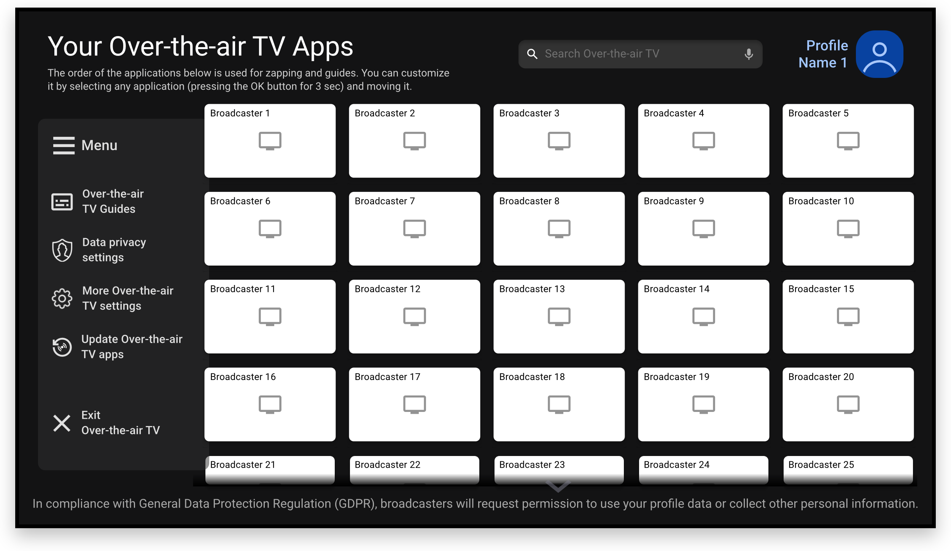
The catalogue exclusively lists Bootstrap Applications announced by terrestrial broadcast services, ensuring that only broadcast-related content is available. Accessed through a standardized icon on the receiver’s home screen or using the receiver’s remote control direct access key, the catalogue offers personalized application ordering based on the viewer’s preferences. Information such as the Bootstrap Application name and icon is provided for each entry, making it easy for viewers to identify their preferred broadcast service at a glance.
The Application Catalogue is designed to display all Bootstrap Applications instantiated following a signal scan or rescan process. This means that after a signal scan, all detected Bootstrap Applications are automatically added to the catalogue, ensuring that viewers can access the available broadcast services in their area. Dynamic updates, enabled by manual and automatic signal rescanning, ensure the catalogue reflects new Bootstrap Applications over time, allowing viewers to have up-to-date access to broadcast services.
Additionally, the catalogue offers access to relevant application-oriented TV platform components, such as the EPG and the ECG. Given the substantial amount of application and content metadata gathered by the Application Catalogue, specific implementations may incorporate search functions to enhance the viewer’s ability to find desired content and services. These search functions can filter and sort content based on various criteria, making it easier for viewers to locate specific programs or services.
The catalogue also includes a module for managing viewer profiles, allowing users to customize their settings and preferences for a personalized viewing experience. Viewers can set up profiles with preferences for language, accessibility, parental control and more.

4.1.1 Bootstrap Applications
Bootstrap Applications are the initial applications instantiated on the Application Catalogue, as announced and parameterized by terrestrial broadcast services through the corresponding transport layer metadata. A Bootstrap Application is the entry point for viewers to access the corresponding broadcaster’s content ecosystem, typically starting with their linear service by default.
To eliminate the additional time required for downloading applications during signal scanning, a Bootstrap Application is automatically instantiated from a template application for each identified broadcast service. This process ensures that all discovered broadcasters have similar initial applications, providing viewers with immediate access to basic broadcast services.
Therefore, a Bootstrap Application acts as the fundamental interface for a specific broadcaster. Due to the need for rapid switching performance, a Bootstrap Application is designed to be straightforward. It typically manages a concise set of broadcaster and content metadata, including essential information about the broadcast service and the current content.
Executing a Bootstrap Application establishes the current broadcast service context and instructs the Persistent Media Player to begin playing the selected OTA or OTT content. Initially, the Bootstrap Application may resize the Persistent Media Player screen area (keeping the aspect ratio), creating space for its graphical interface. This interface prominently features basic broadcast service information, including the logo, name, and slogan, as specified in its manifest file. Additionally, the interface presents content details such as the title, schedule (for linear services), description, genre, and content advisory rating of the currently playing content. If the Bootstrap Application resizes the Persistent Media Player screen area, after some seconds of inactivity, it expands back to full screen to enhance the viewing experience. If the viewer interacts with the “OK”, “BACK”, or “INFO” remote control functions, the initial interface layout reappears without the some-second timer, allowing the viewer to select the full-screen option at their convenience. This design ensures viewers can switch between detailed information and a clean full-screen experience. Figure 3 illustrates a sample wireframe graphical interface for a Bootstrap Application controlling the Persistent Media Player.
Figure 3
Bootstrap Application controlling the Persistent Media Player – wireframe UI sample
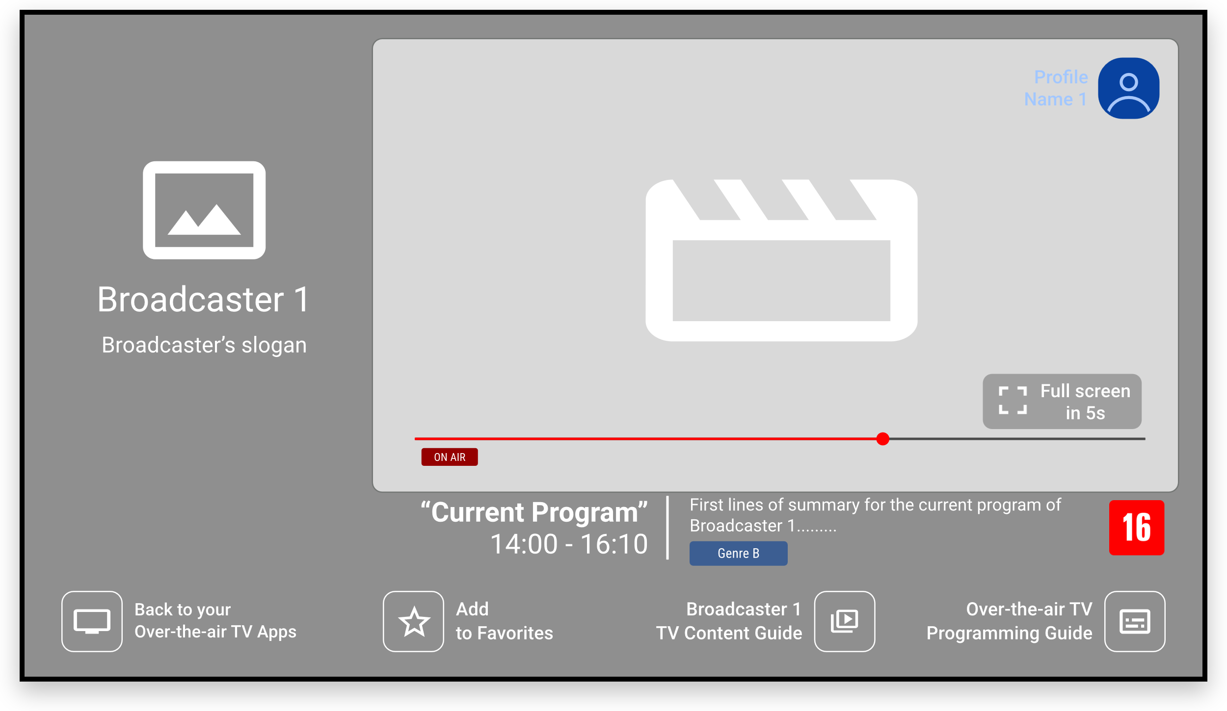
The Bootstrap Application is primarily launched when the viewer selects the corresponding broadcaster icon in the Application Catalogue or when service switching (zapping) occurs. In both scenarios, the Bootstrap Application is initiated by defaulting the content source for the Persistent Player to the main linear service as signalled by transport-layer metadata. In case of service unavailability, the first functional fallback linear service URL listed in its manifest file is used.
Additionally, the Bootstrap Application can be parameterized to present on-demand content on the Persistent Media Player when launched from other application-oriented TV platform components. This includes scenarios such as selections from the EPG, ECG, or search results within the Application Catalogue.
The simplicity of Bootstrap Applications not only ensures quick loading times but also reduces the risk of errors and delays. This streamlined design provides a robust implementation that the Application Lifecycle Manager uses as part of a fail-safe mechanism. In case of any Broadcaster Application malfunction, the Lifecycle Manager can quickly relaunch the Bootstrap Application to maintain service continuity and ensure a seamless viewing experience.

4.1.1.1 Legacy broadcasting system support
In receivers that support both application-oriented TV broadcasting and earlier digital broadcasting standards, Bootstrap Applications harmonize the viewer experience across different technologies. While the primary function of Bootstrap Applications is to serve as the entry point for accessing next-generation TV content ecosystems, they are also designed to support legacy broadcasting services.
When a legacy TV service is detected during a scan/rescan process, the Bootstrap Application is instantiated to ensure that the viewer has a consistent interface similar to that used for next-generation TV services. This interface includes basic broadcaster information, such as the logo, name and slogan, alongside content details like the title, schedule, description, genre and content advisory rating. By presenting this information in a standardized format, the Bootstrap Application maintains a unified viewing experience regardless of the underlying broadcast technology.
A key aspect of this support is that legacy digital TV signals carry the minimal information required for receivers to instantiate a Bootstrap Application automatically. The essential data within the legacy TV signal enables the receiver to identify the service and instantiate the corresponding Bootstrap Application, which then manages the playback of the main audio and video streams through the Persistent Media Player. Initially, the manifest file for the Bootstrap Application can be automatically created using this minimal broadcaster metadata provided by the legacy TV signal. However, this manifest can later be replaced by a more comprehensive manifest file provided by the legacy TV broadcaster. This updated manifest, if transmitted, is required to be named and placed in a standardized way in the legacy service information metadata (e.g. DVB-SI) or datacasting service (e.g. DSM-CC carousel).
However, it is important to note that the functionality of Bootstrap Applications is tailored to the capabilities of the respective broadcasting standard. For legacy TV services, the Bootstrap Application focuses on delivering essential features without incorporating advanced application-oriented functionalities such as privacy management, analytics data collection, broadband signalling, or OTT content.
The integration of Bootstrap Applications for both application-oriented TV broadcasting and earlier digital broadcasting standards allows viewers to seamlessly switch between next-generation TV and legacy services, using a common Application Catalogue and service-zapping functionality. By supporting legacy broadcasting through Bootstrap Applications, the application-oriented TV platform provides a harmonized entry point for all digital television services. This not only simplifies the viewer experience but also enhances the overall functionality of receivers, allowing them to serve as a versatile solution for current and future broadcasting technologies.

4.1.2 Electronic Programming Guide (EPG)
The EPG is a familiar user interface found in existing broadcasting systems, presenting OTA programming metadata in a timeline format. With the integration of OTA and OTT services in next-generation television, certain programmes listed in an EPG might already be accessible on the broadcaster’s OTT service. Consequently, the conventional linearity of OTA service can be disrupted, leading to non-linear experiences via OTT, which are explored and made accessible through an enhanced EPG. This subsection explores the new possibilities of an EPG in an application-oriented television broadcasting with seamless OTA/OTT integration.
The EPG component of the application-oriented TV platform functions as a metadata aggregation interface, providing streamlined access to both linear and on-demand programming for broadcast services. Unlike conventional guides, this EPG consolidates past, current, and future broadcast schedules from multiple broadcasters, enabling viewers to navigate and select from a comprehensive range of content, including previously transmitted programmes.
Structured around each broadcast service’s linear timeline, the EPG supports flexible viewing options. Broadcasters can designate non-live programmes as available on demand via the Internet, allowing viewers to access content outside of the traditional broadcast schedule. This integration of on-demand capabilities transforms the EPG into a versatile content aggregation interface, accommodating both real-time and time-shifted viewing.
The EPG includes essential features such as programme descriptions, scheduling information, and content metadata. Additionally, it supports content search functionality and category filtering tools, facilitating efficient access to both live and on-demand content across the application-oriented TV platform.
The application-oriented TV platform EPG provides two distinct user interfaces, defined in this subsection, to support navigation through linear schedules and on-demand options.
The Simple View offers an overview of available broadcasters, displaying basic details about the previous, current, and next programmes. This initial view allows for quick access to immediate programming information; navigation beyond the upcoming or previous programme transitions viewers to the Extended View for a more detailed exploration. Figure 4 illustrates a sample wireframe graphical interface for the EPG Simple View.
Figure 4
EPG Simple View– wireframe UI sample
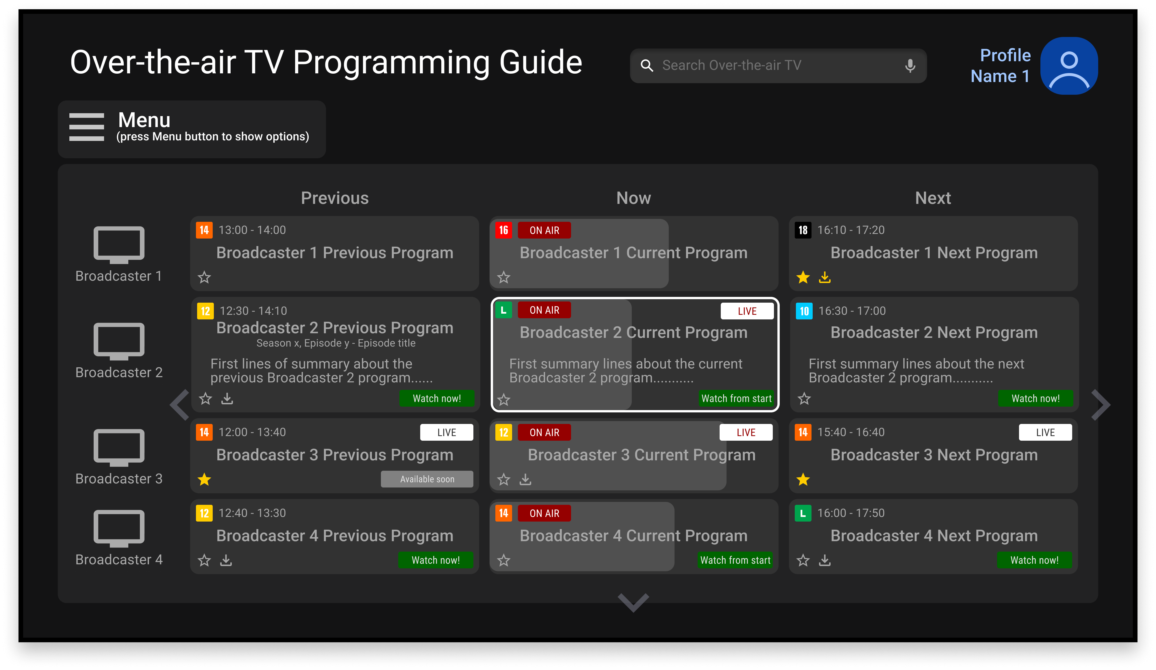
In the Extended View, programmes are displayed on a timeline aligned by their start and end times, with each entry proportionally sized according to its duration. A vertical line represents the current time, providing real-time context within the timeline. Figure 5 illustrates a sample wireframe graphical interface for the EPG Extended View.
Figure 5
EPG Extended View– wireframe UI sample
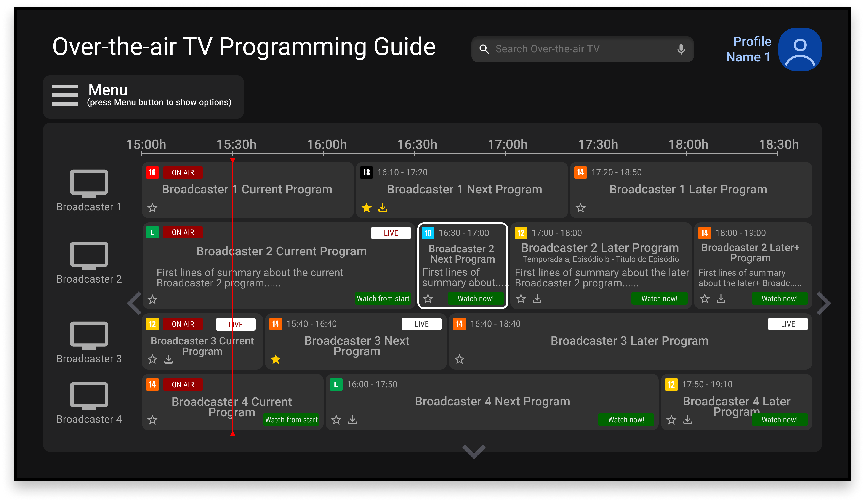
Both interfaces present standardized information for each programme entry, including title, start time, end time, and relevant labels for efficient content identification. Visual or text elements should indicate whether the programmes are currently on-air, if they are, were or will be live, if they are available to watch from the start or if they can be watched now regardless of their scheduled broadcast time.
When a viewer selects a programme that is on-air, the EPG provides direct access to the corresponding linear service for immediate viewing, without additional steps. When a viewer selects a programme which is not on-air, the EPG displays an intermediate view containing detailed information about the programme, such as title, start and end times, genre, and summary. This view also includes interactive options based on the programme’s availability, such as “Watch Now” for on-demand access or “Set a Reminder” for future broadcasts. If available, the EPG should also display metadata on additional features, including content accessibility, VR content, and sensory effects, ensuring viewers have comprehensive information about the programme’s capabilities.
To provide access to an on-air programme, the EPG shall initiate the Bootstrap Application for the corresponding broadcast service.
To provide access to an on-demand programme, depending on the provided URL, the EPG can:
– initiate the Bootstrap Application for the corresponding broadcast service passing the programme’s URL as the parameter, if the URL points directly to the corresponding media; or
– if the URL contains a deep link to a Broadcaster Application, the application-oriented TV platform shall establish the corresponding broadcast service context without opening the Bootstrap Application, load and start the target Broadcaster Application passing the URL as a parameter.

4.1.3 Electronic Content Guide (ECG)
The ECG is a recognizable user interface commonly seen in current IPTV services, used to display a content catalogue available in Video-on-Demand (VoD) services, characterized by its non-linear nature. With the advancements in next-generation broadcasting, broadcasters can announce content availability in both OTA and OTT services. This allows for the dynamic construction of a content catalogue through an ECG module. This subsection explores the potential of such a scenario.
The ECG component of the application-oriented TV platform functions as a content aggregation interface, offering access to all on-demand programming announced by broadcast services. In contrast to the EPG, which incorporates both linear and on-demand schedules, the ECG is exclusively dedicated to aggregating on-demand content from multiple broadcast services. This structure enables viewers to explore a comprehensive range of programmes that extend beyond the constraints of the traditional broadcast schedule.
The ECG organizes content through multiple user interfaces, each designed to enhance navigation and discovery based on different content segmentation criteria. In its Default View, on-demand content is segmented by broadcast service, with each broadcast service displayed in a dedicated row. Within these rows, content titles are represented by cover art that includes a genre indication, allowing viewers to quickly identify the type of content available from each broadcaster’s on-demand catalogue. Figure 6 illustrates a sample wireframe graphical interface for the ECG Default View.
Figure 6
ECG Default View– wireframe UI sample
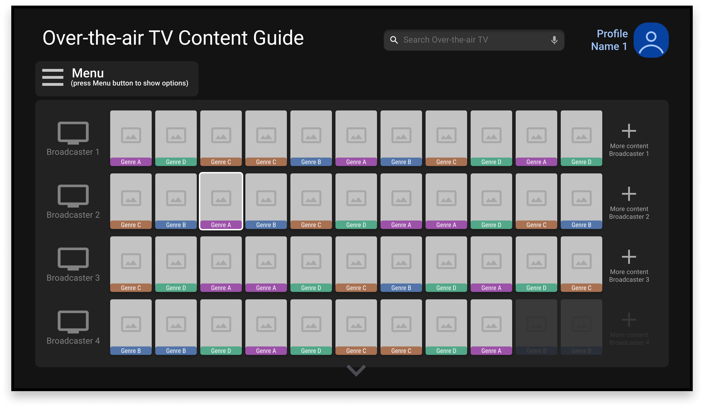
Additionally, the ECG provides a Broadcast Service View, which organizes content by genre within a specific broadcast service context. In this view, each row corresponds to a specific genre. This structure facilitates genre-based content discovery, allowing viewers to explore on-demand programming that aligns with their interests.
When a viewer selects a title, the ECG presents an Intermediate View containing detailed information about the selected content. This Intermediate View includes metadata such as title, description, cover art, genre, and broadcast service. It also provides interactive options, such as “Watch Now”. By selecting “Watch Now”, the viewer can immediately initiate playback of the chosen content. Figure 7 illustrates a sample wireframe graphical interface for the ECG Intermediate View.
Figure 7
ECG Intermediate View– wireframe UI sample
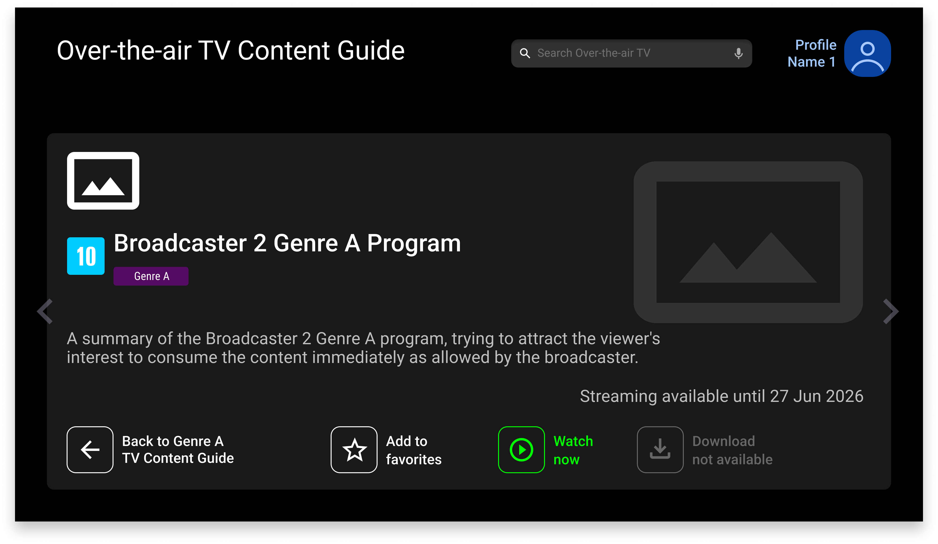
To provide access to an on-demand programme, depending on the provided URL, the ECG can:
– initiate the Bootstrap Application for the corresponding broadcast service, passing the programme’s URL as the parameter, if the URL points directly to the corresponding media; or
– if the URL contains a deep link to a Broadcaster Application, the application-oriented TV platform shall establish the corresponding broadcast service context without opening the Bootstrap Application, load and start the target Broadcaster Application passing the URL as a parameter.

4.1.4 Profile Manager
In the context of application-oriented television broadcasting, the activation of viewer profiles can commence from the application catalogue user interface. This enables viewers to create their profiles once on a specific device, with the flexibility to use this profile across multiple broadcasters at their discretion. If desired, broadcasters can link a viewer profile to a user profile existent on their OTT service. While a broadcaster can add or redefine data within a viewer profile, access to data added by other broadcasters is forbidden. This subsection describes the specifics of viewer profiles for application-oriented television broadcasting.
The Profile Manager is responsible for keeping TV viewer profile data and managing access to it. A TV viewer profile is characterized by a set of attributes that allow a personalized experience for that viewer. Device manufacturers (or application-oriented TV platform developers) and broadcasters can use those attributes to provide personalized experiences to the viewer. In this context, a set of attributes is proposed, organized in a three-level hierarchy, as shown in Fig. 8.
Figure 8
Hierarchical organization of TV viewer profile attributes
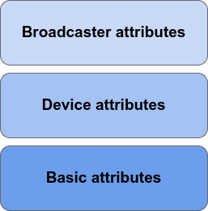
The basic attributes of a TV viewer profile are the standardized attributes, which can be accessed by the device manufacturer and the broadcast service enabled by the viewer. Viewers can enter these attributes when registering their profile and update them whenever desired through the application-oriented TV platform. The device manufacturer (or application-oriented TV platform developer), in turn, can specify a set of additional attributes and also manage their access. This management shall include the possibility of allowing or denying access to such attributes. Device attributes can be customized by the viewer in their profile and can be useful for personalizing their experience. Finally, each broadcast service can also specify its additional broadcaster attributes and manage their access. The broadcaster attributes are stored within the corresponding broadcast service context locally in the application-oriented TV platform receiver and can only be accessed from within that broadcast service context.
A TV viewer’s basic or device attribute may have its content redefined in the broadcast service context of a broadcaster. So, TV viewers’ attribute values can be customized for each broadcast service in a different way if desired.

4.1.5 Privacy Manager
The Privacy Manager integrates and extends the standardized consent records and consent receipts as described in ISO/IEC 27560 [10], also allowing the attribution of other legal bases for processing purposes. In the application-oriented TV platform, privacy records serve as documented evidence of a viewer's decision to allow or deny the processing of their personally identifiable information (PII), while privacy receipts provide viewers with a clear, verifiable record of their choices. This dual approach not only aligns with global privacy regulations but also builds trust with viewers by giving them control over their data and ensuring their informed privacy settings.
A privacy record documents a viewer's decision on whether to allow their PII to be processed by broadcasting services. Broadcast services include a privacy record request in their transmission, formatted similarly to a privacy record but without the viewer's choices. Upon receiving a new or modified request, the application-oriented TV platform automatically renders a privacy notice user interface based on the proposed PII processing specified in the request. Through this UI, viewers make their choices, and upon submission, the broadcaster receives a completed privacy record while the viewer receives a privacy receipt.
Prior to requesting or generating any privacy records, the broadcaster shall identify the information to be maintained in the privacy record based on the requirements of its organizational processes, practices, and legal compliance. This information shall then be used to define the schema of the privacy record, including pre-populating fields such as the broadcast service’s information and adding additional fields as necessary.

4.1.6 Access Panel
The Access Panel is a core component of the application-oriented TV platform that provides the viewer with access to essential services of the receiver during the playback of both OTA and OTT broadcaster content or, outside of this context, during the execution of a Broadcaster Application.
The Access Panel is activated by the receiver’s remote control direct access key when a Bootstrap Application or Broadcaster Application is in use. This allows users to quickly access platform-wide settings and features without interrupting video playback. If the receiver’s remote control direct access key is activated again while the Access Panel is open, the viewer is taken back to the Application Catalogue. When the Persistent Media Player is active, the Access Panel may dynamically adapt its own interface to the content being played, visually indicating which settings and services are available based on the specific characteristics of the current OTA or OTT content. For example, the Access Panel should only allow subtitles activation or audio selection if those features are supported by the current content.
If no interaction occurs some seconds after being activated, the Access Panel automatically hides, but can be summoned again by activating the receiver’s remote control direct access key. The Access Panel should provide shortcuts to other core application-oriented TV platform components, such as the EPG, ECG and search, as well as to the list of Broadcaster Applications related to the current broadcast service context. The list of available Broadcaster Applications is obtained from the Application Lifecycle Manager.
The Access Panel should also be able to call up configuration interfaces from both the receiver’s proprietary platform and the application-oriented TV platform. For example, through the Access Panel, viewers can access a simple audio selection provided by the application-oriented TV platform or more advanced immersive audio settings managed by the receiver’s proprietary platform.
The Access Panel should operate consistently across all applications within the application-oriented TV platform, ensuring that viewers have uninterrupted access to essential platform services. Figure 9 depicts a sample wireframe user interface listing the available Broadcaster Applications for the current service.
Figure 9
Access Panel – wireframe UI sample
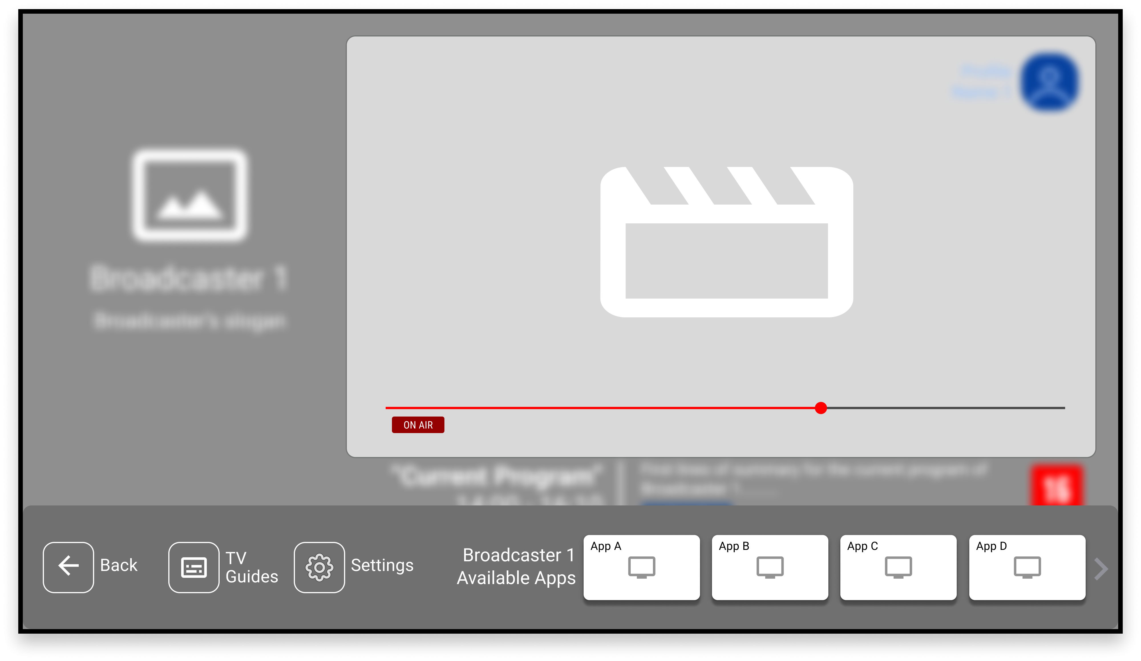

4.2 Persistent Media Player
The Persistent Media Player is a core component of the application-oriented TV platform, responsible for managing the seamless and uninterrupted playback of broadcasters’ media content even during transitions between different applications within the same broadcast service context.
The Persistent Media Player is architecturally designed so that its lifecycle is not tied to any specific application. This design allows the player’s state and media source to be retained when switching from one application to another, thereby preserving the continuity of the viewing experience. The active application may modify the media source or alter the player’s state in response to viewer interaction or automatically, depending on the application’s functionality. For example, when a viewer transitions from a broadcaster’s Bootstrap Application to a Broadcaster Application, the Persistent Media Player seamlessly continues playing the current content, even as the controlling application and user interface change. Should the Broadcaster Application offer alternative or additional content, the application may instruct the Persistent Media Player to update the media source accordingly. The Persistent Media Player is depicted in Fig. 2, where a Bootstrap Application controls its behaviour.
The Persistent Media Player is designed to support OTA and OTT content, allowing broadcasters to deliver their content from multiple sources. Whether content is broadcast via OTA signals or streamed over the internet through OTT services, the Persistent Media Player ensures that transitions between these different delivery modes are executed smoothly and transparently to the viewer.
Additionally, the Persistent Media Player is engineered to accommodate a standardized range of media formats and streaming protocols, making it adaptable to the evolving requirements of broadcasters. It supports simultaneous playback of audio, video, closed captioning, and closed signing streams. The application-oriented TV platform also provides APIs for controlling all the features of the Persistent Media Player, such as setting the position and size of video and sign language windows, altering playback state (including current play time), updating the media source, delivering playback and stream events, and configuring dynamic content insertion.

4.3 Audience Measurement Manager
The Audience Measurement Manager (AMM) enables broadcasters to initiate and terminate data collection without the need to embed specific triggers or cookies in their applications and content. This is achieved by delegating the responsibility of data collection to the application-oriented TV platform upon request. The AMM autonomously gathers the data, compiles it into a standardized report, and subsequently delivers this information.
With viewer awareness, the AMM allows for capturing comprehensive behavioural data across all application-oriented TV platform content and applications. The use of the audience measurement data collection API is contingent on the viewer's prior agreement. The collected data shall be securely stored and transmitted within a context exclusively linked to the broadcast service and content where the data collection was initiated.
In addition to the primary function of collecting audience measurement data, which enables broadcasters to analyse the data and make informed decisions, the scope extends to include third parties, with proper clarification of data use policies and viewer agreement. Therefore, mechanisms are implemented to ensure data authenticity, to allow any authorized party to verify the integrity and origin of the collected data.
Audience measurement data collection is organized in sessions. There are two ways of initiating audience measurement data collection sessions. Bootstrap Applications can initiate those sessions based on their metadata. Additionally, Broadcaster Applications can interact with the Remote API Service to initiate those sessions. The AMM is responsible for managing these sessions, with the following behaviours:
– Bootstrap Applications and Broadcaster Applications are not directly involved in data collection, as the AMM handles the process. A session is created when triggered by the application.
– Data collection sessions remain active when switching between Broadcaster Applications within the same broadcast service context, ensuring the continuity of data collection without interruption.
– Each data collection session is uniquely identified, enabling session status monitoring and linking to a specific data collection context.
– If a disruption occurs in the data collection context – such as service zapping, changes in the active viewer profile, receiver power interruption, or the use of the receiver for other purposes – the active session automatically transitions to a paused state.
– When the original data collection context is restored, the session resumes and continues from its paused state.
– Each session is assigned a validity period, after which data collection ends, and the report is delivered to the broadcaster. The delivery process is secured by the AMM to ensure the data’s source and integrity.
– Progressive delivery of collected data is supported through checkpoints that allow for partial report submissions during a session, without waiting for the session’s validity period to end.
The audience measurement data collection context is uniquely identified by the pair broadcast service and viewer profile. This context captures the environment at the time of the session’s initiation, confirming that collection was triggered by a specific broadcaster and authorized by a particular viewer. Any modification in the current broadcast service or viewer profile signifies a disruption in the collection context, leading to the automatic pause of a possibly active session.
The variety of changes in the collection context, potential errors, and different stages that the collection process undergoes are defined as a state machine for a given audience data collection session. With a session identifier, Broadcaster Applications can at any time query or modify the current state of the session. The state machine governing an audience measurement data collection session is illustrated in Fig. 10.
Figure 10
State machine for an audience measurement data collection session
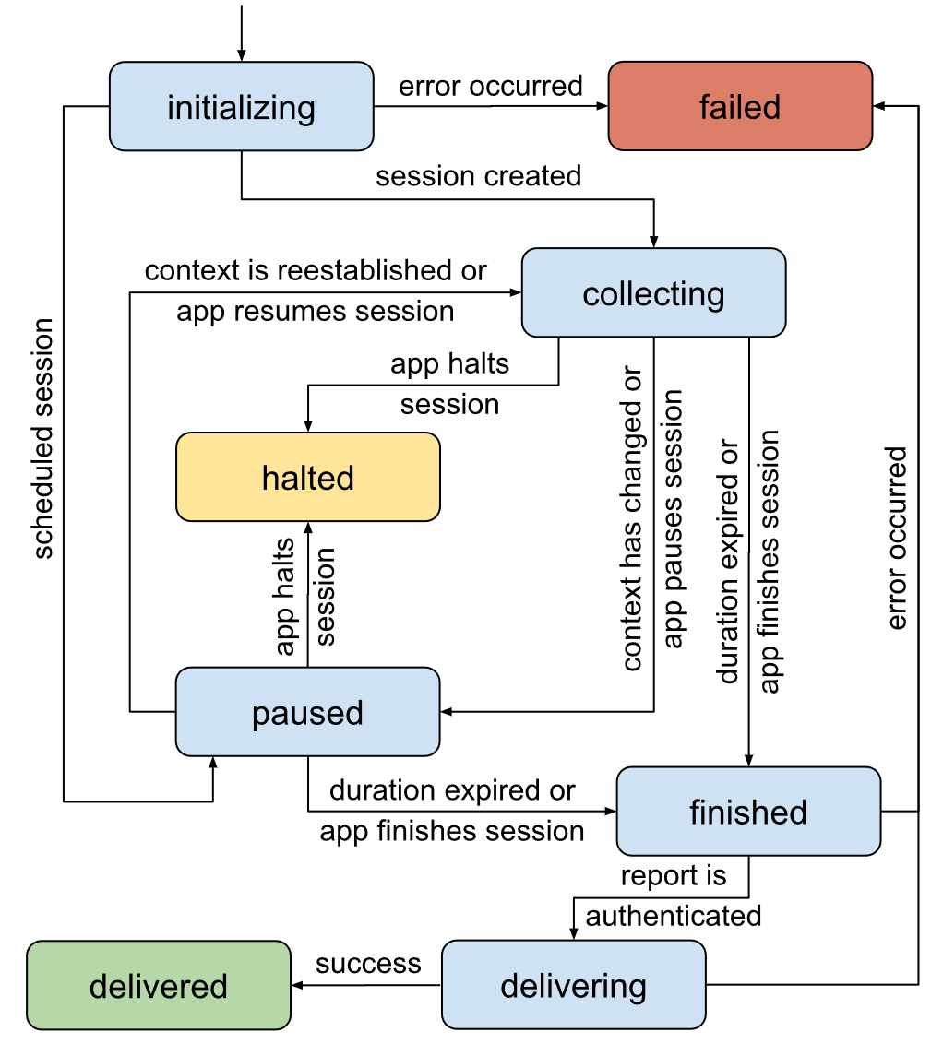
A brief description of the state machine follows:
– Initializing: The process begins when requested by a Bootstrap Application or when the Remote API Service receives a request from a Broadcaster Application to start an audience measurement data collection session. The context for the session to be created is defined by the pair that identifies the requesting broadcast service and the active viewer profile. In this state, the AMM shall validate the request parameters, verify resource availability for creating the session, and the viewer’s agreement. Three outcomes are possible:
• Error in the request: Incorrect or inconsistent parameters, lack of resources, or viewer dissent triggers the 'error' transition.
• Scheduled request: If the request specifies a future collection, it initiates the 'scheduled session' transition, and the current collection is placed in a ‘paused’ state until the scheduled date and time.
• Immediate collection: If immediate data collection is requested, the state switches to ‘collecting.’
– Collecting: In this state, interactive and/or personalized behavioural data related to media and application consumption is actively collected, temporarily stored, and protected in the receiver for eventual delivery to the broadcaster. From this state, three possible transitions can occur:
• End of data collection: The data collection concludes either because the duration specified by the broadcaster has expired (“duration expired”) or the Broadcaster Application directs termination of the collection (“app finishes the session”). Both scenarios lead to a transition to the ‘finished’ state.
• Change in context or pause requested: If there is a change in any of the contexts defining the collection ("context has changed") or if the Broadcaster Application requests a pause (“app pauses the session”), the session moves to the 'paused' state.
• Interruption by Broadcaster Application: Should the Broadcaster Application interrupt the session ("app halts the session"), this prompts a transition to the ‘halted’ state.
– Paused: In this state, data collection is temporarily suspended due to previously mentioned circumstances, yet it remains poised for resumption, interruption, or conclusion. From here, three transitions can occur:
• Interruption by Broadcaster Application: If a Broadcaster Application interrupts the session, this generates a transition to the ‘halted’ state (“app halts the session”).
• Resumption of collection: The collection can resume if the original context is re-established (“context is reestablished”), the Broadcaster Application requests a resumption (“app resumes the session”), or the previously scheduled start time for the collection is reached. In any of these cases, the session transitions back to the ‘collecting’ state.
• End of data collection: The collection concludes either when the period specified by the broadcaster expires (“duration expired”) or if the Broadcaster Application signals that the collection should be terminated (“app finishes the session”). Both scenarios lead to a transition to the ‘finished' state’.
– Halted: This state indicates that the data collection has been aborted following a directive from the Broadcaster Application. Consequently, the data collected thus far is discarded, and no delivery is made to the broadcaster. As a final state, the AMM retains only the session identifier, its current state, and the identifiers of the collection context. These details are persisted for some minutes.
– Finished: This state signifies the conclusion of the data collection period, either due to a directive from the Broadcaster Application or the expiration of the requested duration. In this state, the AMM also ensures the authenticity and integrity of the data collected, employing digital signatures retrieved from a service provided by a common agreement between the broadcaster and third parties. This state can result in one of two outcomes:
• Successful authentication: If the authentication is successful, the session transitions to the 'delivering' state, confirming the successful data authentication.
• Authentication failure: If the digital signature retrieval service at the specified URL is repeatedly unavailable or fails to properly respond to the retrieval attempts, and the maximum number of attempts is exhausted, an ‘error’ transition occurs, leading to the ‘failed’ state.
– Delivering: This state represents the AMM effort to deliver the data collected during the session, which is temporarily stored in the receiver. The delivery attempt is made to the URLs specified by the broadcaster when the data collection session was initially requested. The process follows specific rules that define the number of delivery attempts and the interval between them. This stage can result in one of two outcomes:
• Successful delivery: If the delivery is successful, the session transitions to the ‘delivered’ state, confirming the successful transfer of data.
• Delivery failure: If the service at the specified URLs is repeatedly unavailable or fails to properly respond to the delivery attempts, and the maximum number of delivery attempts is exhausted, an ‘error’ transition occurs, leading to the ‘failed’ state.
– Delivered: This state indicates that both the collection and delivery procedures have been successfully completed. At this stage, the data collected during the session is discarded, and the procedure is considered terminated. As a final state, the AMM retains only the session identifier, its state, and the identifiers of the collection context. These details are persisted for some minutes.
– Failed: This state is triggered by an error during session creation – such as incorrect or inconsistent parameters, lack of available resources, or viewer dissent – or by the inability to deliver the collected data after all planned attempts. In this scenario, any audience measurement data already collected is discarded. As a final state, the application-oriented TV platform retains only the session identifier, its state, the identification of the collection context, and details of the error. These elements are persisted for some minutes.

5 Example of an application-oriented television broadcasting system
One example of a system that adopts the application-oriented television broadcasting paradigm is TV 3.0, which is a Digital Terrestrial Television system defined in the suite of standards ABNT NBR 25601 [1] to ABNT NBR 25609 [9], also known as DTV+. More specifically, the aspects related to the application-oriented television broadcasting paradigm can be found in ABNT NBR 25608 (TV 3.0 – Application coding) [8].

6 References
[1] ABNT NBR 25601:2025 – TV 3.0 – Physical layer – https://www.abntcatalogo.com.br/pnm.aspx?Q=TlJMbnRvMWR1RUpMUkYySW03RlJTaTJFV3g4VXFUYmJ6SGwwWFhwaEhwdz0=
[2] ABNT NBR 25602:2025 – TV 3.0 – Transport layer – https://www.abntcatalogo.com.br/pnm.aspx?Q=MHpHdVFBN2tjUk1STVM2WDFZQ3ppeXQ2S1daYTdOaFZmMjZmTTRFd0JwST0=
[3] ABNT NBR 25603:2025 – TV 3.0 – Video coding – https://www.abntcatalogo.com.br/pnm.aspx?Q=WTRSby9iUDRnQkFZQlhpVjZYZncyaGd6Nm91KzNxbXhRNDN6ZEQwWXZ5TT0=
[4] ABNT NBR 25604:2025 – TV 3.0 – Audio coding – https://www.abntcatalogo.com.br/pnm.aspx?Q=SDR1VUl6Nk11UTVoTE54dGhwUXZyQWhKN0F3K3Z5dkZZWndaL0VCU3FZaz0=
[5] ABNT NBR 25605:2025 – TV 3.0 – Closed Captioning – https://www.abntcatalogo.com.br/pnm.aspx?Q=NDFmZHlBS2FUMEI1OWUxWS8yZWZjeWk3Qkp2cURoamJWandneUVRR1N5OD0=
[6] ABNT NBR 25606:2025 – TV 3.0 – Closed Signing – https://www.abntcatalogo.com.br/pnm.aspx?Q=MHNpdEFFN2s4WG9ZbElkemVmQWh0LzBjZFNVVHQzZWJNRXVMYjVyZXJ0VT0=
[7] ABNT NBR 25607:2025 – TV 3.0 – Emergency alert system – https://www.abntcatalogo.com.br/pnm.aspx?Q=YTk0Szc5d0FoOHRTdDJDTFp2MWR0aWk2andtOFp5NDQzZmNHdVl6WC9EUT0=
[8] ABNT NBR 25608:2025 – TV 3.0 – Application coding – https://www.abntcatalogo.com.br/pnm.aspx?Q=QnpKWHV3SE5aUWphVFhwRTFsWW9pZnFaakFJcG9TVERWZEZQeXZhUEtkVT0=
[9] ABNT NBR 25609:2025 – TV 3.0 – Receivers – https://www.abntcatalogo.com.br/pnm.aspx?Q=UlplSER6aWxHNGpHcjVrTFdTWFR2OU02Ny83enlhbkQwZDZZeS85b3NXUT0=
[10] ISO/IEC 27560 – Privacy technologies – Consent record information structure
NOTE – The most up-to-date references [1]-[9] are available in: https://forumsbtvd.org.br/tv-3-0-technical-standards-guides/

