Report ITU-R BT.2545-0
(11/2024)
BT Series: Broadcasting service (television)
Inter-tower communications network for terrestrial broadcasting and datacasting systems

Foreword
The role of the Radiocommunication Sector is to ensure the rational, equitable, efficient and economical use of the radio-frequency spectrum by all radiocommunication services, including satellite services, and carry out studies without limit of frequency range on the basis of which Recommendations are adopted.
The regulatory and policy functions of the Radiocommunication Sector are performed by World and Regional Radiocommunication Conferences and Radiocommunication Assemblies supported by Study Groups.

Policy on Intellectual Property Right (IPR)
ITU-R policy on IPR is described in the Common Patent Policy for ITU-T/ITU-R/ISO/IEC referenced in Resolution ITU-R 1. Forms to be used for the submission of patent statements and licensing declarations by patent holders are available from https://www.itu.int/ITU-R/go/patents/en where the Guidelines for Implementation of the Common Patent Policy for ITU-T/ITU-R/ISO/IEC and the ITU-R patent information database can also be found.

Series of ITU-R Reports
(Also available online at https://www.itu.int/publ/R-REP/en)
Series | Title
BO | Satellite delivery
BR | Recording for production, archival and play-out; film for television
BS | Broadcasting service (sound)
BT | Broadcasting service (television)
F | Fixed service
M | Mobile, radiodetermination, amateur and related satellite services
P | Radiowave propagation
RA | Radio astronomy
RS | Remote sensing systems
S | Fixed-satellite service
SA | Space applications and meteorology
SF | Frequency sharing and coordination between fixed-satellite and fixed service systems
SM | Spectrum management
TF | Time signals and frequency standards emissions

Note: This ITU-R Report was approved in English by the Study Group under the procedure detailed in Resolution ITU-R 1.

Electronic Publication
Geneva, 2025
© ITU 2025
All rights reserved. No part of this publication may be reproduced, by any means whatsoever, without written permission of ITU.

REPORT ITU-R BT.2545-0
Inter-tower communications network for terrestrial broadcasting
and datacasting systems
(2024)
TABLE OF CONTENTS
Pages
Policy on Intellectual Property Right (IPR) ii
1 Scope 3
2 Introduction 4
3 Inter-Tower Communications Network (ITCN) 5
4 LDM in ITCN 6
5 State of the art of existing inter-tower communications link 7
6 ITCN application scenarios 8
6.1 SFN with ITCN 9
6.2 SFNs with ITCN interconnection 10
6.3 Coordinated ITCN 11
7 ITCN technical challenges and realization solutions 14
7.1 Transmitter timing control for SFN operation 16
7.2 Loopback signal isolation (SI) 17
7.3 Self-interference cancellation in in-band full-duplex communications 18
7.4 Relay station Rx dynamic range requirement 23
7.5 Field tests in Ottawa/Gatineau area (Canada) 25
8 ITCN and backhaul signal structures 27
8.1 Signal structures analysis 28
8.1.1 SISO signal structure: a realistic scenario 28
8.1.2 MIMO signal structure: a realistic scenario 30
8.2 Co-channel interference study 32
8.2.1 LDM signal structure co-channel interference analysis 33
8.2.2 TDM signal structure co-channel interference analysis 35
8.2.3 LDM-LDM vs LDM-TDM signal structures 36
8.3 Summary 36
9 ITCN network node integrating with BCN and other technologies 37
9.1 DTV network evolution: legacy and future networks 37
9.1.1 Legacy DTV networks 37
9.1.2 Broadband mobile access networks as a reference architecture 38
9.1.3 The need of a specific broadcast core network 38
9.2 Future DTV networks: transmitter network (access network) and broadcast core network 39
9.3 Broadcast Node (bcNode) 40
9.4 Summary 41
10 Conclusion 41

List of acronyms
5GC 5G Core
ACI Adjacent channel interference
ALP ATSC Link-layer Protocol
BCN Broadcast core network
bcNB broadcast Node B
CL Core layer
DVB-I Digital video broadcasting-Internet
EL Enhanced layer
FBS Fixed broadcast service
FDM Frequency division multiplexing
FWS Forward signal
gNB Next generation node B
IAB Integrated access and Backhaul
IBFD In-band full-duplex
ICT Information and communications technology
IDL In-band distribution link
ITCN Inter-tower communications network
ISSC Interactive successive signal cancellation
LBS Loopback signal
LDM Layered division multiplexing
LDPC Low-density parity-check
LOS Line-of-sight
LTE-A Long-term evolution Advanced
MBCS Multicast/broadcast communications system
MBS Mobile broadcast service
MMT MPEG media transport
NFV Network function virtualization
NOM Non-orthogonal multiplexing
NRT Non-real time
NUC Non-uniform constellation
NU-QAM Non-uniform quadrature amplitude modulation
OFDM Orthogonal frequency division multiplexing
OM Orthogonal multiplexing
P-NOM Power-based non-orthogonal multiplexing
RAN Radio access network
RN Relay node
ROUTE Real-time object delivery over unidirectional transport
SBA Service based architecture
SFN Single frequency network
SIC Self interference cancellation
SMF Session management function
SSC Successive signal cancellation
STL Studio-to-transmitter link
STLTP STL transport protocol
TDM Time division multiplexing
TS Transmitter station
UPF User plane function

1 Scope
The Inter-tower communications network (ITCN) is a novel concept to implement an embedded data network with bi-directional tower-to-tower communications in existing terrestrial broadcasting systems, which enables spectral and cost-efficient solutions for broadcasters to deliver new business cases including datacasting, broadcast internet, network cue and control and local TV content, and to stay competitive against other media platforms. The ITCN is also considered an essential technology for developing the new Broadcast Core Network (BCN) to enable interconnection with 5G and future broadband systems.
This Report introduces the concept of ITCN, which is to connect all broadcast transmission towers to form an IP-based wireless communications network using a channel from the terrestrial broadcast service frequency bands and co-existing with existing broadcast service applications. Various ITCN use cases, providing a spectrum-efficient solution to connect all broadcast towers relying on the single frequency network (SFN) or non-SFN to form an IP network, are illustrated.
The layered division multiplexing (LDM), which can achieve higher cumulative transmission capacity when delivering multiple services with different quality requirements, being the supporting technology to ITCN, is then referred to. Existing inter-tower communications technologies (both wired and wireless) are recalled. ITCN application scenarios, including concepts of SFN with ITCN, coordinated ITCN and others, are depicted. ITCN technical challenges and realization solutions are addressed in detail, including transmitter timing control, signal isolation, and self-interference cancellation in in-band full-duplex communications, as well as field test validation and verification. ITCN and backhaul signal structures in various combinations of multiplexing schemes are considered, which are important factors in increasing the data throughput and improving spectrum efficiency, considering backward compatibility with the legacy broadcast services and receivers. Study shows that hybrid broadcast SFN overlay with ITCN/inband distribution link (IDL) data network using LDM might be the optimal solution considering backward compatibility, data capacity, and co-channel interference. ITCN network nodes integrating with BCN and other technologies are investigated, comprising legacy and future networks comparison, design consideration of the broadcast node, and access network/broadcast core network integration.
The ITCN has drawn broad interest from industry and is being considered by the ATSC TV broadcast standard. It is currently being implemented by the ATSC Implementation Team 5 (IT-5), with members from major equipment manufacturers, broadcasters and research institutions.

2 Introduction
The Information and Communications Technology (ICT) industries are converging to an Internet Protocol (IP) based ecosystem to migrate to a connected world of digital economy. The terrestrial broadcast industry is also following the trend. Some good examples are ATSC 3.0 Broadcast Core Network (BCN) [1] [2] and Digital Video Broadcasting-Internet (DVB-I) [3] projects, which aim to connect all broadcast facilities and user devices. In June 2022, Innovation, Science and Economic Development (ISED) Canada published the Broadcasting Circular No. 22 (BC-22) [5] to facilitate the application process for applicants seeking to experiment ATSC 3.0 broadcast and non-broadcast services. One of the use cases is to connect all broadcast transmission towers to form a wireless ITCN [4] using a channel from the terrestrial broadcast service frequency bands (e.g. UHF band) and co‑existing with existing broadcast service applications.
As part of the terrestrial broadcasting and datacasting system, the ITCN provides a spectrum-efficient solution to connect all broadcast towers relying on the single frequency network (SFN) or non-SFN in order to form an IP network for various usages such as datacasting, network control and SFN signal distribution. The ITCN offers a scalable and configurable network solution embedded in a terrestrial broadcasting system, which becomes independent from any non-broadcasting telecommunications infrastructure. The described technology partially relies on the infrastructure of the underlying broadcast network, using the allocated service frequency bands without requiring additional frequency bands.

3 Inter-Tower Communications Network (ITCN)
As shown in Fig. 1, the ITCN supports the broadcast node B (bcNB), similar to the next generation node B (gNB) in the 5G wireless communications network, allowing broadcast facilities and user equipment (UE) to connect with the ATSC 3.0 BCN. The ITCN provides full-duplex transmission among SFN [6] and/or non-SFN transmitters, aiming at enriched data services including IoT, emergency warning, connected car, and other localized data services. Each tower can broadcast localized content, i.e. different SFN towers can emit different contents that operate like 4G/5G. The coordinated ITCN concept is also introduced, which applies to multiple operators sharing the same SFN or multiple SFNs coordination. The ITCN can be used to monitor broadcast facility operation, support local advertisement, local datacasting, and emergency alert, to provide program distribution to SFN and/or non-SFN transmitting towers. This will reduce the terrestrial broadcasting system operating costs, and connecting and inter-networking with other ICT systems (e.g. BCN, Cloud, 5G Core (5GC)). There will be no impact, i.e. it is fully backward compatible with legacy broadcast receivers. The ITCN is an IP-based wireless network embedded in the terrestrial broadcasting system that is independent of any telecommunications infrastructure.
Figure 1
A full-duplex broadcasting system with BCN and ITCN
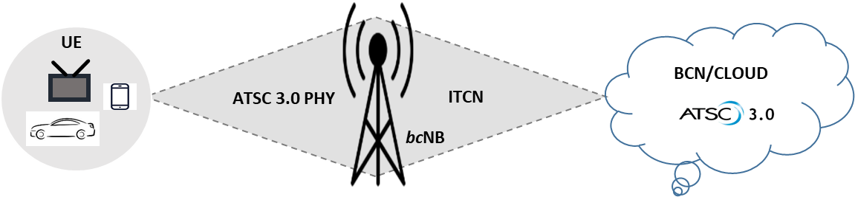
Figure 2 illustrates the ITCN between two SFN broadcast towers. The IDL signal along with IoT and control signals are transmitted from the left tower to the right tower, and vice versa. This is assuming the SFN broadcast towers are much higher in altitude than the typical 10 m consumer reception antenna and that there are line-of-sight (LOS) paths among SFN towers. In this scenario, due to all transmissions being carried out on the same frequency, a series of technical issues need consideration, including transmitter timing control for SFN operation, loopback signal isolation and cancellation, and relay station receiver (Rx) dynamic range assessment [7].
Figure 2
In-band two-way communications between towers
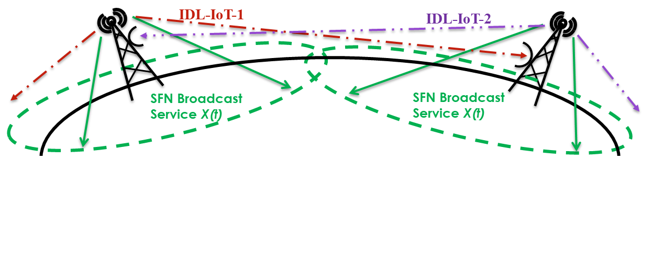
The network scalability and configurability supported by the ITCN are shown in Fig. 3. This is an example of three ATSC 3.0 SFNs interconnected through ITCN. Each SFN is composed of a group of relay towers. The SFNs are working generally independently, e.g. serving different geographical areas, and can operate on different frequencies. There may be inter-SFN ITCN connections to link the SFN networks, which could be between two main transmitters or between two towers of different layers or scales. All main transmitters and SFN towers can be connected via multi-hop transmission. The network topology is reconfigurable and scalable, i.e. if one tower fails the data can still be re‑routed to reach all other remaining towers.
Figure 3
Scalable and reconfigurable multi-hop SFNs interconnected with ITCN
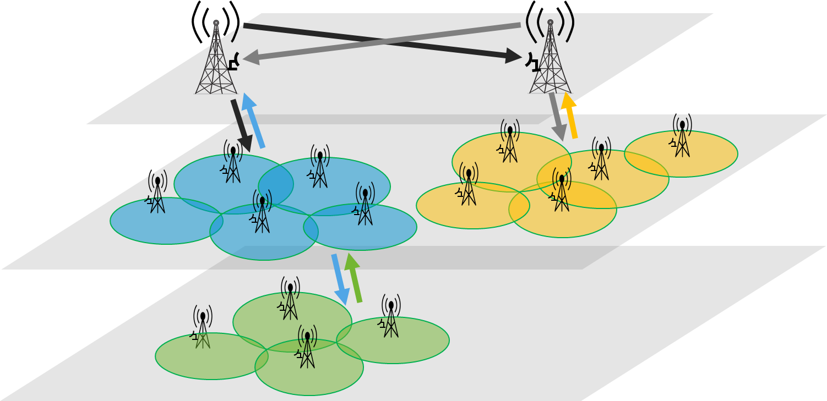
In an ITCN supported terrestrial broadcasting and datacasting system, the data and network traffic can be multiplexed with broadcast services using Time /Frequency /Layered Division Multiplexing (TDM/FDM/LDM) [8]. Full-duplex communications [9] can be used to increase spectrum efficiency, where transmission and reception occur on the same RF band for spectrum reuse and sharing. Antenna diversity technologies, such as MIMO and antenna array, as well as advanced high order Non‑Uniform Constellation (NUC) modulations [10] [11] and new error correction codes [12] [13] can also greatly increase spectrum efficiency.

4 LDM in ITCN
Traditional TDM and FDM are Orthogonal Multiplexing (OM) technology schemes, where different signals or services can be independently received by time or frequency separation. There is also a set of Non-Orthogonal Multiplexing (NOM) schemes, where different signals and services are not mutually independent. Layered Division Multiplexing (LDM) is a Power-Based NOM (P-NOM), where different signals or services are multiplexed by power difference. Figure 4 presents a two-layer LDM, where the upper layer (UL or L1) and lower layer (LL or L2) transmit different signals or services. The UL and LL are separated by a power injection level difference of 6 dB (≈4 times power difference). This means that the UL takes 80% of the total transmission power (4/(4+1)), while the LL takes 20% of the total power (1/(4+1)). The UL has more power, is usually more robust, and has a lower SNR threshold. Therefore, the UL can be used to carry mobile or handheld services. The LL has lower power allocation, which requires a higher SNR to operate. It can be used for fixed and high data rate services using a high-gain directional receiving antenna.
LDM can achieve higher cumulative transmission capacity when delivering multiple services with different quality requirements. A typical application scenario is to simultaneously deliver time and frequency synchronized UL and LL signals super-imposed within the same frequency band. On the receiving end, if the SNR is high, there should be easy decoding of the UL signal. The decoded UL signal is re-modulated to the original signal form and feedback subtracts itself from the received LDM signal. This is called Successive Signal Cancellation (SSC). After SSC, the UL is eliminated from the received signal, and only the LL signal is present, this LL signal can be decoded. It can be seen that this is a two-stage decoding process. Decoding the UL first, subtracting it from the received signal, and then decoding the LL. It introduces a delay to decode the LL signal, in exchange for better system performance. The study also shows that LDM can have much higher spectrum efficiency because both UL and LL signals are transmitted 100% of the time over 100% of the spectrum, while the traditional TDM and FDM only use part of the frequency or time resources.
FIGURE 4
A diagram illustrating a signal model of a two-layer LDM system
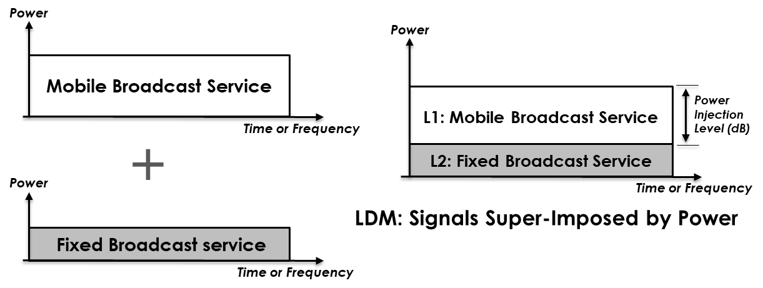
The layered structure is very flexible in the delivery of combined mobile, fixed, backhaul IDL, ITCN and datacasting services in two-layer LDM systems. There are three different services using LDM in the ITCN application scenarios:
– SFN or non-SFN broadcasting services to mobile/fixed terminals using LDM.
– ITCN: two-way communications among towers, and LDM datacasting in each tower coverage area. Each tower can transmit different data. Inter-tower networking can operate as an SFN or as a non-SFN multi-frequency network. ITCN could be used, for example, for datacasting.
– SFN backhaul link (i.e. IDL): one-way communications, high data rate, and high SNR for spectrum efficiency.
These three services can be TDM, FDM or LDM multiplexed depending on application scenarios for efficient use of spectrum.

5 State of the art of existing inter-tower communications link
Single frequency network (SFN) provides an effective spectrum-saving solution in broadcasting system design and implementation [14]. In a terrestrial broadcasting system, to connect all broadcast towers relying on the SFN via backhaul links, existing implementation solutions include fiber or dedicated microwave links [14] [15]. Basically, the broadcast gateway is responsible for sending distribution data to each transmitter via those backhaul links. In ATSC 3.0, this communication process is defined as studio-to-transmitter links (STLs). The distribution data for each transmitter includes both the broadcast service data and specific control signalling that configures the time and frequency offsets for signal emission. All these implementations are one-way downlink, out-of-band solutions. Fiber links are not always available for locations to deploy SFN transmitters, and even if they are available, the rental cost of a fiber link can be expensive. Similarly, dedicated microwave links can also be expensive to install. In addition, with the current trend of allocating more spectrum for consumer broadband systems, the microwave spectrum becomes less available for distribution data transmission. Therefore, using either of these conventional backhaul methods could introduce significant costs from both initial installation and monthly operation which would, for SFNs, be multiplied by a large number of low-power transmitters. To overcome the above drawbacks and further increase spectrum efficiency, a wireless in-band backhaul technology was proposed for the next-generation TV broadcasting with SFN [16], where the distribution data is wirelessly delivered among SFN transmitters from the main transmitter while sharing the same TV band with the broadcast services. The distribution signal is multiplexed with the service signal in the same ATSC 3.0 waveform. LDM technology is proposed to achieve more efficient transmission of the distribution signal.
3GPP adopted the integrated access and backhaul (IAB) technology starting from 4G Long Term Evolution Advanced (LTE-A) system to implement low-cost backhaul links to relay nodes (RNs) [17]. The backhaul transmission can operate in either in-band or out-of-band modes. In in‑band mode, the backhaul transmission and service transmission share the same spectrum; while in out‑of‑band mode, the backhaul data is transmitted using a separate spectrum. It has been noted that the in‑band mode can be more attractive since there is no need to apply for dedicated backhaul channels.
However, it also means that the service throughput will be reduced to accommodate the backhaul transmission. The RNs could operate in either half-duplex mode or full-duplex mode. In half-duplex mode, at any given time, an RN either receives the backhaul signal or transmits the service signal; while in full-duplex mode, the RN performs these two operations simultaneously. The in-band full‑duplex (IBFD) mode offers a throughput advantage over the half-duplex mode. However, the full-duplex mode creates a self-interference issue that requires careful design and advanced signal processing algorithms to obtain good backhaul signal detection. This results in increased implementation complexity. Up until now, all the IBFD IAB solutions adopted by LTE use orthogonal multiplexing (OM) methods, such as TDM and FDM to combine the service and backhaul data within the same channel [18]. With the explosive increase in demands for data throughput on the limited wireless spectrum, significant studies in IBFD technologies are being carried out in various wireless communications systems. In [19], the effects of IBFD transmission on system performance in various networks such as bidirectional, relay, and cellular topology networks are investigated. The quantification of the amount of self-interference cancellation (SIC) required for different access schemes of an IBFD from the first generation to the candidate fifth generation of mobile cellular systems is studied in [20]. More recently, wireless backhaul with IBFD has been examined for 3GPP IAB for 5G NR with the benefit of significant infrastructure cost reduction [21] [22] [23]. Self‑interference reduction and system-level downlink throughput performance have been evaluated and IBFD IAB was confirmed to be a promising framework for 5G NR [21]. The performance of IAB networks in both dense and suburban areas in 5G networks was investigated, and the robustness of IAB networks to weather and various deployment conditions was studied [22]. In [23], the IBFD for small cell 5G systems was considered. Indoor 5G scenarios were evaluated, targeting mobile broadband and ultra-reliable communication use cases.

6 ITCN application scenarios
The ITCN provides a scalable and configurable network solution embedded in a broadcast system, which becomes independent from any non-broadcasting telecommunication infrastructure. It partially relies on the infrastructure of the underlying broadcast/multicast network, using the allocated broadcast service radio frequency channels without requiring additional frequency bands or a separate frequency band. It implements full duplex transmission among SFN transmitters, providing enriched data services including IoT, emergency warning, connected car and other localized data services. This section presents some exemplar ITCN application scenarios.

6.1 SFN with ITCN
Given ATSC 3.0 as a system example, a simple SFN with ITCN using bi-directional ITCN signals is illustrated in Fig. 5. The ITCN can also support local datacasting. The operation of the in-band backhaul is defined in [4], [24], or the backhaul may be provided via an STL link in some implementations. In the meantime, Tx-A can transmit ITCN signals to Tx-B and vice versa, e.g. through LOS paths, which are multiplexed with conventional broadcast/multicast services signals, e.g. TV broadcast, and in-band backhaul signals, using TDM, FDM and/or LDM. Each SFN tower can emit different ITCN data, transmitting different ITCN signals on the same frequency band. Different types of services can be embedded in ITCN signals and can be received within each tower’s broadcast coverage area. These can include broadcast network cue and control data for network operation and monitoring, which are not intended for consumer services. ITCN data can also include consumer or professional service data, such as IoT, emergency warnings, software download, connected cars, and other localized data services or advertisement. The combination of TDM+LDM, or FDM+LDM, different modulation/coding, and reception conditions can provide tiered services for different robustness, data rates and reception conditions (see example in § 7 on ITCN signal structure.
Different reception antennas might be used for over-the-air (OTA) ITCN signal reception to limit the co-channel interference from undesired transmission towers during the inter-tower communications signal transmission. Some towers can operate as SFN with main transmitters, if desired. In some scenarios, an ITCN can also connect transmission towers that are not part of the SFN, but nearby towers transmitting on a different radio frequency. This scenario makes signal reception easier since there is no loopback signal (co-channel interference) cancellation needed as for SFN towers. The ITCN is an embedded network in the broadcast infrastructure, and can operate independently from any other telecommunications infrastructure.
FIGURE 5
A schematic diagram of SFN with ITCN
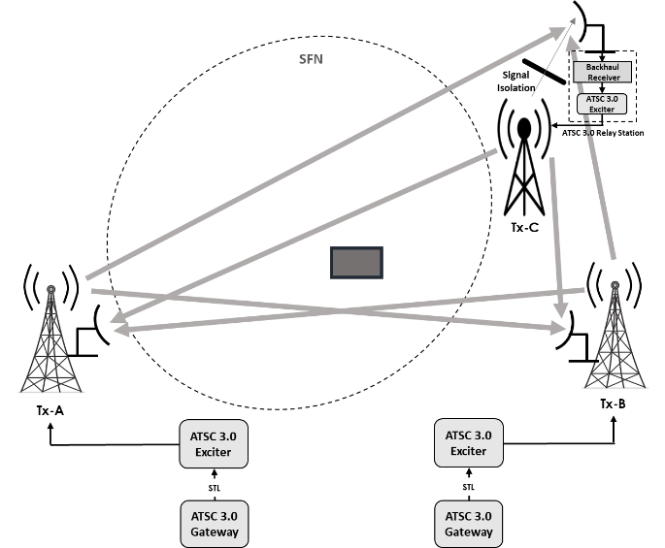
Most of the datacasting content/information is non-real-time (NRT), which may be desirable to have a data server at each participating tower to store the datacasting content/information and broadcast out locally, e.g. as data-carousel. The timing and content can be controlled by an ITCN administrator via an ITCN server. This approach can also reduce the data rate requirement on the ITCN.
For the Tx-A to receive the ITCN data from Tx-B, since the receiving antenna may be very close to its broadcast transmission antenna, sufficient signal isolation may be needed to prevent the Tx-A transmission signal, also called the loopback signal, from interfering with the ITCN signal emitted from Tx-B [24].

6.2 SFNs with ITCN interconnection
An example of two SFNs interconnected with ITCN is shown in Fig. 6. In this example, each SFN (circled separately) is composed of three relay stations, and the two SFNs are operating independently, e.g. serving different geographical areas, and may be operating on different RF frequencies. All the towers in the Tx-A SFN are connected in a star type of configuration [25]. The Tx-B SFN uses a ring topology. There are inter-SFN ITCN connections to link the two SFN networks, which could be between two main transmitters or between two relay stations. All main transmitters (i.e. Tx-A and Tx-B) and relay transmitters can be connected via multi-hop transmission. The network topology is reconfigurable and scalable, if one tower fails the data can be re-routed to reach all towers.
ITCN services using the same frequency band can be established among the towers in each SFN. To limit the co-channel interference during the ITCN transmission period, different reception antennas may be used for over-the-air ITCN signal reception from different adjacent transmission towers. In this example, the ITCN transmission connections between Tx-A and Tx-B might be on different transmission frequencies. Tx-A and Tx-B may each combine an in-band transmission with out-of-band reception when communicating with each other.
Each transmitter site can also have a local server that may store data for control and local datacasting. All relay transmitters can be provided with in-band backhaul or other backhaul methods, but the ITCN remains the same.
FIGURE 6
A schematic diagram illustrating two interconnected SFNs with ITCN
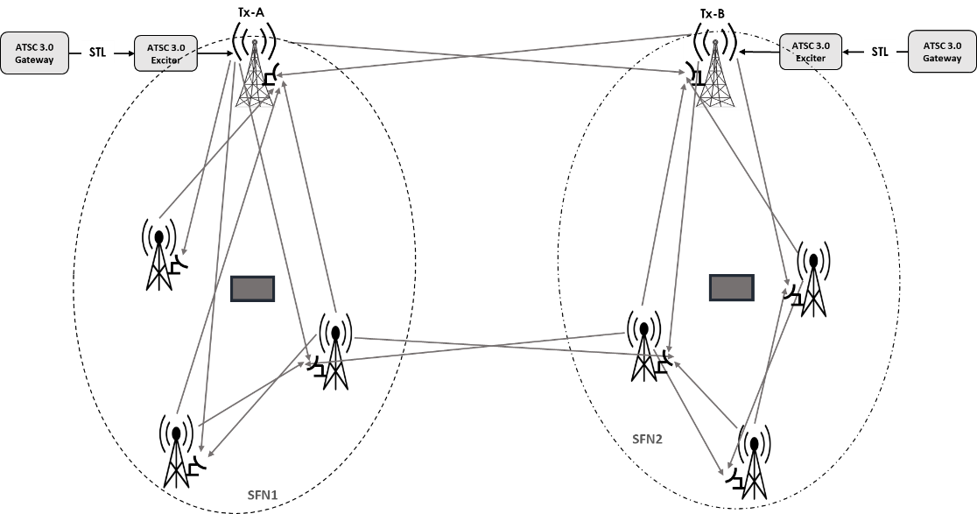

6.3 Coordinated ITCN
For a single broadcast operator, the in-band ITCN solution could be used where the ITCN links share the same TV channel with the broadcast services. This enables each broadcast operator to implement its own ITCN within its own channel(s), even with a single TV channel. However, for in-band solutions, the remote SFN transmitters may be affected by the loopback signal, which is the leakage signal from the broadcast transmission antenna into the ITCN receive antenna since the broadcast transmission signal may be continuously present in the time domain. With the high capacity offered by the next generation broadcasting systems, multiple broadcast operators can multiplex their programs in fewer channels. Furthermore, shared SFN infrastructure may be more feasible for different operators in the same area.
An alternative solution is to implement a combined ITCN using a separate RF TV channel for multiple broadcast operators. Each operator shares the ITCN capacity by TDM and/or FDM. In this case, time or frequency division duplex modes could be used for the bi-directional transmissions, which removes loopback signals. For the full-duplex transmission mode, highly directional antennas could be used for ITCN links that can significantly reduce the loopback signal power, potentially removing the requirement for loopback signal cancellation.
An example of the coordinated ITCN with two operators sharing the same SFN infrastructure is shown in Fig. 7.
FIGURE 7
Coordinated ITCN with two broadcast operators sharing the same SFN transmitters
A second example of the coordinated ITCN solutions with two operators having separate SFN infrastructures is shown in Fig. 8. In this case, the ITCN links for the two broadcasters from remote SFN transmitters (Tx-B and Tx-D) to the anchor transmitter Tx-A need to be time and frequency locked. This can be achieved by using GPS time reference to control the transmission timing at Tx-B and Tx-D, which was already implemented in SFN transmitters.
Figure 9 illustrates a multicast/broadcast communications system (MBCS) example including local ITCN data servers at each participating transmitter station (TS). One or several ITCN data servers may include ITCN data storage for storing various types of data that may be transmitted to users in the TS broadcast area and another TS for re-transmitting. The stored data may include datacasting data, local advertisement, ITCN data such as ITCN broadcast signal backhaul among towers, local IoT data to consumers, and others. The ITCN data server may be configured to implement datacasting and/or a data carousel. Datacasting examples may include datacasting different software upgrades, local emergency alerts, weather updates, local news, etc. It takes advantage of the broadcast system’s one-to-many distribution capacity. NRT data, which may include TV programme-related data and other data, e.g. for datacasting services which is not TV programme-related.
FIGURE 8
Coordinated ITCN with two broadcast operators with separate SFN transmitters
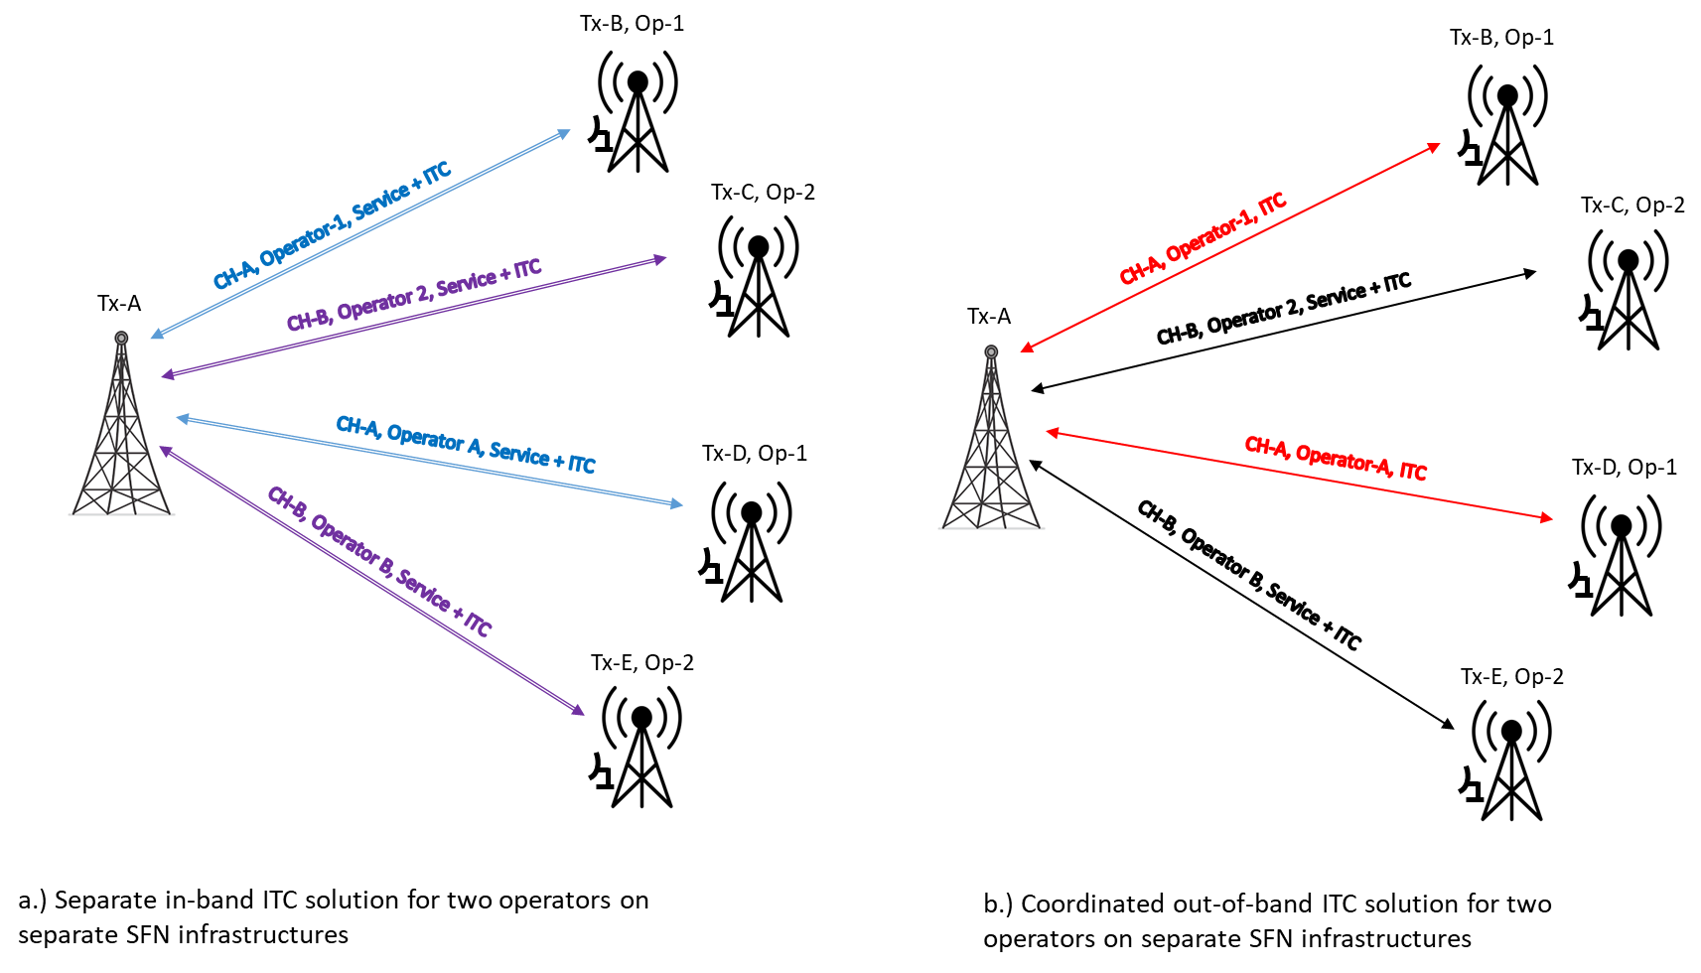
In some scenarios, TS participating in an ITCN network may coordinate their operations to conduct datacasting at a certain time frame. Different towers can emit different data content at the same time in an SFN environment. Towers that are not operating in an SFN may also be connected by ITCN to other towers for performing control, monitoring, diagnosis, and data backhaul functions. An ITCN network may be reconfigurable and scalable to extend the network or re-route ITCN data, if some network nodes/towers are out of service. Broadcasters may also coordinate to use a dedicated broadcast RF channel for ITCN only (without simulcasting conventional broadcast service). For example, after midnight or in the early morning, when traditional broadcast programs are not broadcasting (after-hour period), the entire RF channel can be used for data communication and distribution. Participating broadcasters can share the network resource of the ITCN, for example using network slicing. Large and scalable inter-connected ITCN/SFN and MFN form the integrated inter-tower wireless communications network, which is part of the broadcast core network [1] for future broadcast internet applications.
FIGURE 9
Block diagram of a next generation TV station headend with MBCS containing an integrated ITCN data server
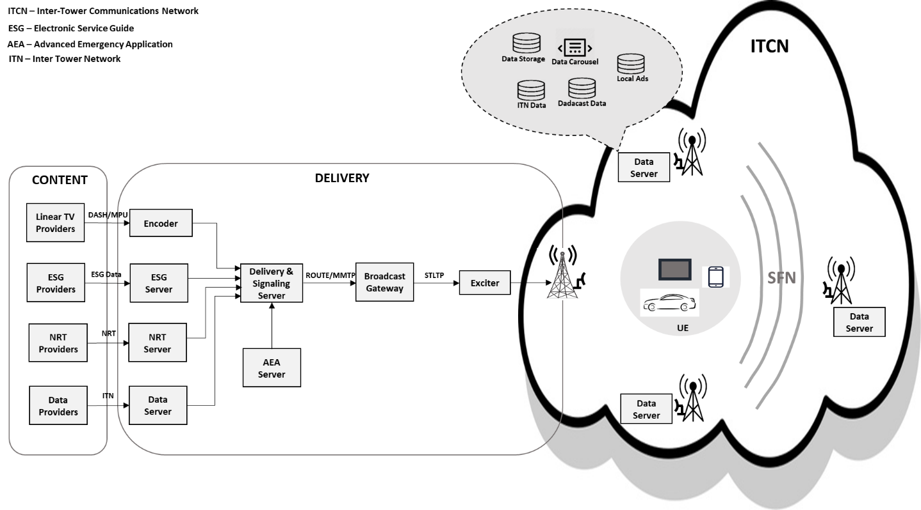

7 ITCN technical challenges and realization solutions
A single frequency network (SFN) provides an effective spectrum-saving solution in broadcasting system design and implementation. It has been shown as an effective deployment solution to achieve good mobile broadcast service distribution [17]. To deploy an SFN, a capable, scalable, and cost-effective studio-to-transmitter link (STL) solution plays a significant role in the real success of the new system. An effective alternative is to use in-band backhaul, also known as in-band distribution link (IDL) technologies, which transmit the STL data via wireless links from the broadcast gateway to the SFN transmitters using the same spectrum as the broadcast services. Two-way IDLs among broadcast transmitters achieve an ITCN.
An approach for providing data delivery for SFN operations using IDL has been proposed [16]. The basic concept, as shown in Fig. 10, the main transmitter, Tx-A, an existing high-power transmitter, having a dedicated STL connection to the broadcast gateway (BGW). Tx-A receives the STL data for each new secondary SFN-Tx (Tx-B/C/D) and modulates it onto part of the broadcast signal for over-the-air transmission. This yields an in-band solution because the STL data distribution shares the same spectrum as the broadcast services. LDM is used to combine STL Transport Protocol (STLTP) data and broadcast-service data within one RF TV channel. In this case, the main transmitter, Tx-A, transmits a two-layer LDM signal wherein the Core Layer (CL) delivers robust mobile services and part of the Enhanced Layer (EL) capacity delivers STLTP data for the other SFN-Tx’s. At each secondary SFN-Tx, an SFN relay receiver (RL-Rx) is implemented to decode the STLTP data from the received EL signal. The decoded STLTP data then is fed to an Exciter to generate the SFN broadcast-service signal for emission.
Figure 10
Using LDM to implement IDLs
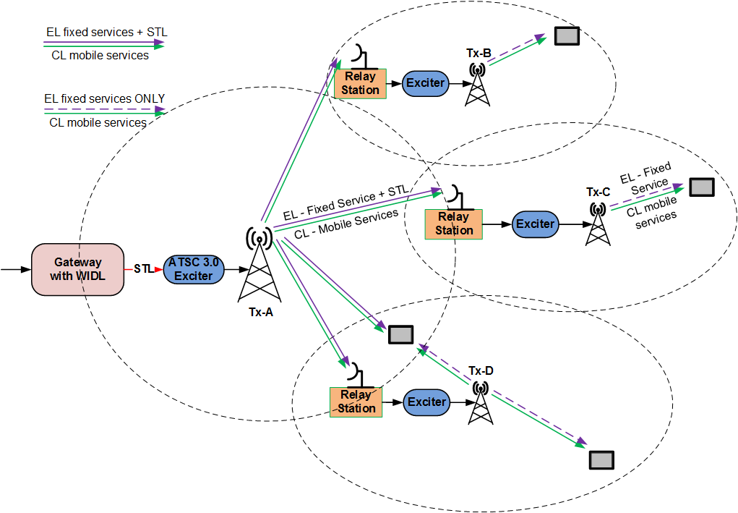
The proposed STL is fully backward compatible and has no impact on existing services for consumer receivers. Figure 11 shows a block diagram of the STL signal detection at a secondary SFN receiver/transmitter R-Tx. The received signal from the A-Tx contains both the SFN service component (mobile broadcast service (MBS) + fixed broadcast service (FBS)) and the STL component. This signal is referred to as forward signal (FWS). At the R-Tx, the SFN relay receiver RS-Rx decodes the STL data, from which the SFN service signal is generated and fed into the Exciter for emission. To achieve a high SNR condition for STL data detection, a powerful directional antenna is usually installed at the RS-Rx.
Figure 11 also depicts a design challenge at the RS-Rx for STL detection. The RS-Rx receiver collects not only the FWS from the A-Tx, but also the emission signal from the R-Tx transmission antenna, which is called loopback signal (LBS). Since the RS-Rx receive antenna and the R-Tx transmission antenna are usually installed on the same tower and both at high elevations, they are closely located. This results in a very high loopback signal power received at the RS-Rx receive antenna.
Figure 11
Backhaul signal detection at RS-Rx
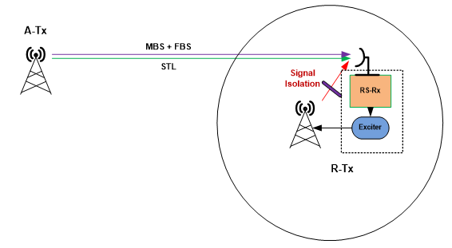
In Fig. 12, structures of the FWS and loopback signals received at the RS-Rx antenna are illustrated for an ATSC 3.0 SFN system with IDL using STL-TDM. In the forward signal (FWS), mobile broadcast service (MBS) and fixed broadcast service (FBS) are delivered in a two-layer LDM configuration in a specific time slot, while the STL data for both services are delivered in a different time slot.
During the time slot allocated for broadcast services, the LBS is the same as the FWS, because A-Tx and R-Tx deliver synchronized SFN services. However, during STL time slot, the FWS and LBS are different. Therefore, the LBS becomes a strong interference to the STL detection at the RS-Rx. This interference is also called self-interference in the in-band full-duplex relay for LTE/5G [19].
Figure 12
Signal model at RS-Rx; (a) FWS; (b) LBS
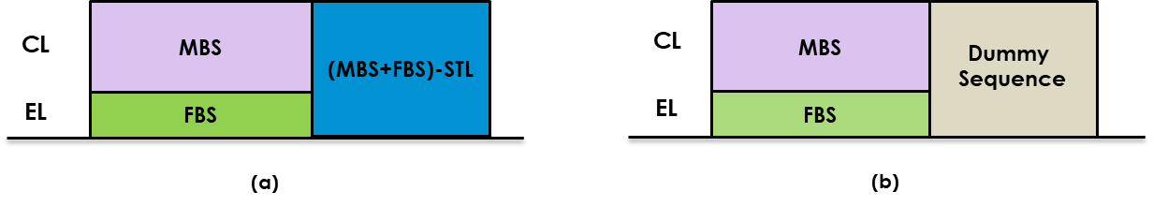
The IDL/ITCN implementation needs the following considerations: transmitter timing control for SFN operation, loopback signal isolation, loopback signal cancellation, and relay station receiving dynamic range requirement.

7.1 Transmitter timing control for SFN operation
In an SFN as shown in Fig. 10, all the transmitters need to deliver the same service signal and the emission from different transmitters needs to be time-synchronized. When using IDL, this requires that the STL data embedded in the A-Tx transmission signal has a time advance compared to the service data. This time advance is needed for the R-Tx to receive and decode the STL signal, and to generate the service signal for re-emission. Therefore, a timing control mechanism needs to be designed to synchronize the relative timing between the STL data and the service data to align the operations of the different transmitters.
The simple timing control for SFN is illustrated in Fig. 13 and explained as follows:
– In the transmission signal from the nth hop from A-Tx, the STL data, X(t−nT), is transmitted with a time advance of nT compared to the service data, X(t).
– The loopback signal X(t−nT+T) at the R-Tx is relatively much higher in signal strength than STL signal X(t−nT).
– The SFN time synchronized signal of X(t−nT+T) over X(t−nT) is more like a two-layer LDM signal.
– Since X(t−nT+T) is a known signal at the IDL reception site, it can be successively cancelled out to retrieve the IDL signal.
In typical service scenarios, a time-advance T of one DTV frame duration is sufficient for SFN operation.
Figure 13
SFN timing control
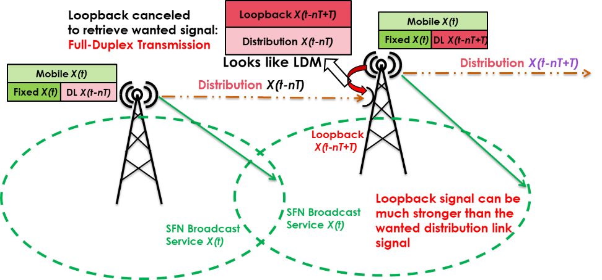

7.2 Loopback signal isolation (SI)
The objective of the SI is to minimize the LBS power arriving at the RS-Rx receive antenna. This can be achieved by several approaches:
1) Increasing the antenna spacing:
At the destination, both the RS-Rx receive antenna and the R-Tx transmit antenna are installed on the same tower at high elevations. The loopback signal propagation channel between these two antennas is a LOS channel. The distance between them is at most a few hundred meters. For this distance, the propagation loss could be well modelled as free space path loss (FSPL), which is calculated as:
$FSPL\left(dB\right)=20\log\left(d\right)+20\log{(}f)+32.44$
where:
d : distance (in km)
f : frequency (in MHz).
Therefore, an antenna distance of 100 m gives an LBS power of 20 dB lower than that from a distance of 10 m.
Recent research on signal isolation characterization of ITCN [26] shows that the overall signal isolation increases when the distance between transmission and reception antennas increases. In addition, the signal isolation increase follows a pseudo-logarithmic trend since the most significant differences are located in the low antenna distance values. For example, increasing by 5 m the antenna distance from 3 to 8 m provides around 10 dB of signal isolation gain, while 5 m difference between 8 to 13 m increases the isolation performance by around 4 dB. Therefore, the results indicate that it is highly recommended to provide a minimum antenna separation of 10 m to obtain significant signal isolation values to implement IDL/ITCN applications.
2) Signal blocking:
A metal shielding could be installed above the RS-Rx receive antenna, as shown in Fig. 14. This is especially useful for some antennas with small form factors, such as panel antennas. In [27], a metal mesh installed on top of a panel antenna is shown to be effective to block the loopback signal.
Figure 14
Loopback signal blockage at R-Tx
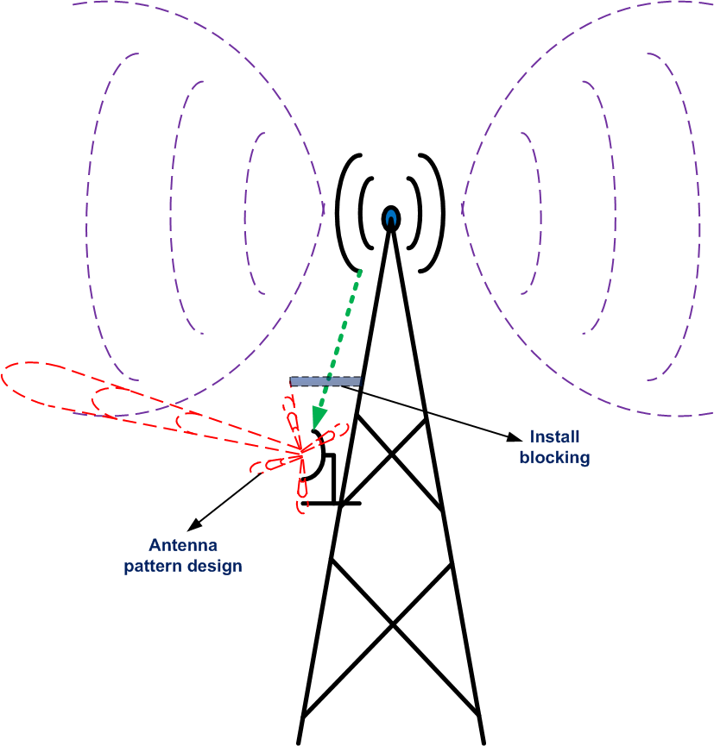
3) Receive antenna directivity:
Modern antenna design could be applied on the receive antenna to have a null towards the transmission antenna, further reducing the LBS power. However, this may require the installation of multiple antenna elements and more engineering effort and larger space on the tower.
The loopback signal isolation values are measured during various field trials in real ITCN transmission scenarios [26]. The results show that the total signal isolation varies depending on the transmission/reception configuration between 70 to 90 dB.

7.3 Self-interference cancellation in in-band full-duplex communications
Some detailed analysis of self-interference cancellation is presented in [28]. To cancel the loopback signal, the RS-Rx first needs to estimate the loopback channel and its channel response. To reduce the amount of radio resource required for STL data delivery, it is desirable to use high-throughput signal configuration for the STL signal, i.e. high-order modulation, high coding rate, MIMO. This requires high SNR to decode and puts a high requirement on the loopback channel estimation accuracy.
Because the RS-Rx knows exactly what signal is being transmitted during the STL time slot, as shown in Fig. 12, the loopback channel can be estimated using decision-directed channel estimation (DD‑CE) algorithms.
To perform DD-CE, the frequency-domain (FD) least square (LS) channel estimation is first obtained as:
where:
Y_{RL}(k) : received signal at RS-Rx
X_{LB}(k) : LBS symbol in the kth subchannel
H_{LB}(k) : channel response of the forward and loopback channel
X_{STL}(k)*H_{FWS}(k) : received forward signal from A-Tx
N₀(k) : thermal noise.
It should be noted that in the above channel estimation, the FWS appears as part of the noise; such noise effect is called “intrinsic noise”.
A two-dimensional filtering (2D-Filt) could be used to enhance the channel estimation accuracy. A frequency-domain filter (FD-Filt) is first applied to the LS estimates,
where Ψ_{F} could be a minimum mean square error (MMSE) filter [29], a singular value decomposition (SVD)-based filter [30], a discret Fourier transform (DFT)-filter [31], a Wiener filter, or simply a smooth windowing function.
A time-domain (TD) filter is subsequently applied to further improve the accuracy of the channel estimate:
where Ψ_{T} is usually implemented using a Wiener filter or a smooth windowing function.
Computer simulations were conducted to evaluate the achievable LBS cancellation performance, assuming a low-complexity DD-CE with 2D-Filt, which consists of an FD Wiener filter followed by a TD average windowing.
Since the STL receive antenna and the R-Tx transmit antenna are installed on the same tower and are closely located, the loopback channel could be well approximated as a LOS channel. However, for cases where there are some obstacles surrounding the R-Tx tower, the channel could be modelled as a multipath channel with a very short delay spread. Therefore, two-channel models are tested in simulations, a typical LOS channel and a rare multipath channel, which is modelled as a typical urban (TU) channel [32] with a mean delay spread (DS) of 0.1 μs and a maximum DS of 0.7 μs.
An ATSC 3.0 system with 16k transmission mode is used in simulations. It is assumed that the forward signal has an SNR of 25 dB at the RS-Rx receiver. Four loopback signal (LBS)/forward signal (FWS) power ratios, [0 10 20 30] dB, are tested to evaluate the LBS cancellation performance under a wide range of operational conditions. Since the power ratio is for LBS after the signal isolation, a 30 dB LBS/FWS power ratio is a rather worst-case scenario.
Figure 15 shows the LBS cancellation performance for a LOS channel. For LOS channel, the Wiener filter in the frequency domain becomes an averaging window, where a window size of 500 taps is used. In the time domain, an average window of 40 taps is used. The upper subplot shows the MSE of the channel estimation after the 2D-Filt, while the lower subplot shows the SNR of the STL signal after the LBS cancellation.
For LOS channels, for all LBS/FWS power ratios, using this simple 2D channel estimator could achieve a residual loopback signal power of more than 40 dB lower than the FWS signal. Considering the required SNR for high-throughput STL signal detection from the FWS being from 25 to 30 dB, this LBS cancellation performance is more than sufficient.
Figure 16 shows the LBS cancellation performance in a more challenging short TU channel, which could serve as a worse-case scenario. Due to the frequency selectivity, a Wiener filter of 50 taps is used in the frequency domain and a large time-domain windowing of 100 taps is used.
Figure 15
LBS cancellation performance, LOS channel
Figure 16
LBS cancellation performance, short TU channel
Even for this multipath channel, for all scenarios, the loopback signal cancellation can reduce the LBS signal power to 30 dB lower than the FWS signal, which is still enough for STL detection requiring an SNR of 25 dB.
It needs to be pointed out that the loopback signal only impacts the backhaul signal reception. It has absolutely no impact on the broadcast service reception by the consumer receivers. The backhaul signals are simply ignored by the consumer receivers.
To achieve higher combined STL and broadcast-service throughput, LDM is used to combine STLTP data and broadcast-service data within one RF TV channel. In this case, the main transmitter, Tx-A, transmits a two-layer LDM signal wherein the Core Layer (CL) delivers robust mobile services and part of the Enhanced Layer (EL) capacity delivers STLTP data for the other SFN-Tx’s.
Implementation challenges of ITCN/IDL in broadcasting applications include the following:
– Tx nonlinear distortion due to high transmission power.
– Low frequency and low antenna directivity cause large signal multipath delay spread. With SFN, an even larger delay spread is created.
– High-order modulations (1 024QAM or 4 096QAM for high ITCN/IDL data rate) require highly accurate self-interference cancellation to achieve high SNR.
– High accuracy remote channel estimation scheme is required in the SFN environment.
The remaining of this sub-section describes recent new technologies developed to address these challenges.
A frequency-domain RF self-interference cancellation (RF-SIC) approach has been proposed in [33] which has the unique capability of cancelling self-interference with a large delay spread. A schematic illustration of an IBFD transceiver with two different kinds of RF reference signal (RFRS) for a single-input single-output (SISO) system is shown in Fig. 17, where the main receive antenna Rx receives the desired signals from the remote transmitter and the self-interference signals from the co-located transmit antenna Tx. Separating the Rx and Tx antennas can effectively reduce the SI power. Such practice is suitable for wireless backhaul with less real estate constraint, especially for broadcasting systems, where the transmit antenna is mounted at the top of a high tower. The direct RFRS (D-RFRS) is obtained by tapping at the transmitter antenna waveguide and fed to the receiver through cable. Since D-RFRS and SI signals share the same RF chain, they both have the same nonlinear distortion and adjacent channel interference (ACI) from the co-located transmitter. This D-RFRS is modelled as the transmitted signal attenuated by a single tap of fixed gain and delay. A separated antenna RS-Rx is used to receive the signal transmitted from the co-located transmit antenna Tx to provide a reference signal to the receiver, this reference signal is called over-the-air RF reference signal (OTA-RFRS). The RS-Rx antenna is placed close to the Rx antenna and can be realized with an antenna array with beamforming to the co-located Tx. OTA-RFRS and SI signals share the same transmitter chain and similar surrounding propagation environment. Therefore, OTA‑RFRS and SI signals have the same nonlinear distortion and ACI from both the co-located transmitter and neighbour transmitters.
The detailed block diagram of the frequency-domain RF-SIC of Fig. 17 is illustrated in Fig. 18. After (Fast Fourier Transform (FFT) on the received signals and the RFRS, the least square (LS) estimates are used to obtain the filter weights. A DFT windowing is then applied to these LS estimates of the filter weights to reduce the weight error. The resulting filter weights are then applied to the reference signals before being subtracted from the received signals. Finally, for non-Orthogonal frequency division multiplexing (non-OFDM) systems, the error signals are converted back to the time domain by IFFT for further processing, while for OFDM systems, the error signals can be passed through directly for further processing.
Figure 17
ITCN/IDL receiver for a SISO system with interference cancellation.
Either D-RFRS or OTA-RFRS is used for RF-SIC
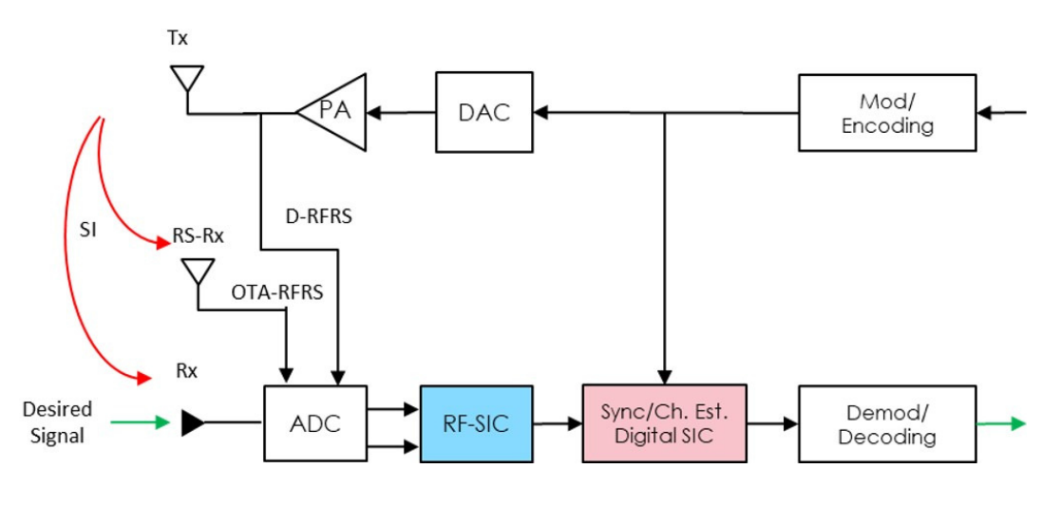
Figure 18
Block diagram of frequency-domain RF-SIC (expansion of the RF-SIC in Fig. 8)
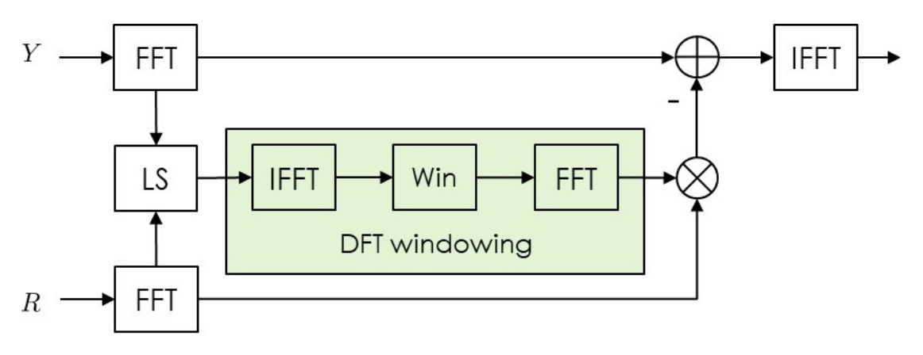
The RF-SIC is advantageous compared to other RF feedback SIC techniques, as it does not require a dedicated training phase/training sequence to estimate the filter weights or SI channel gains, it has the capability of tracking the self-interference channel variation since the filter weights are updated in a block-by-block fashion. Very importantly, by utilizing an RF reference signal to perform SI cancellation, the RF-SIC has the inherent capability to cancel the SI with transmitter nonlinear distortion. The drawback of this approach is the presence of the signal of interest (SOI) becoming an “intrinsic noise” in the filter weight estimation which limits the SI cancellation capability.
To overcome the existence of “intrinsic noise” in [33], a novel interactive successive signal cancellation (ISSC) scheme for ITCN/IDL interference mitigation was proposed in [34] to achieve improved SIC performance. The core idea of this novel ISSC scheme is to use the FW channel estimation and the demodulated/decoded FWS to reduce the “intrinsic noise” in the RF-SIC stage, which will consequently lead to improved SIC cancellation. The improved SIC cancellation will further lead to more accurate FW channel estimation and FWS demodulation/decoding. This process can be iteratively performed until the desirable bit error rate (BER) or the preset iteration number is achieved, as illustrated in Fig. 19. The simulation showed that combining with the SFN channel adapted multi-band window and 2D estimation, the proposed iterative successive signal cancellation scheme can effectively suppress the self-interference to the receiver noise floor, therefore achieving the required SINR for ITCN/IDL signal detection for very high spectral efficiency. The capability and the effectiveness of this ISSC on cancelling the SI with strong transmitter nonlinear distortion were demonstrated in [37].
Figure 19
ISSC flow chart
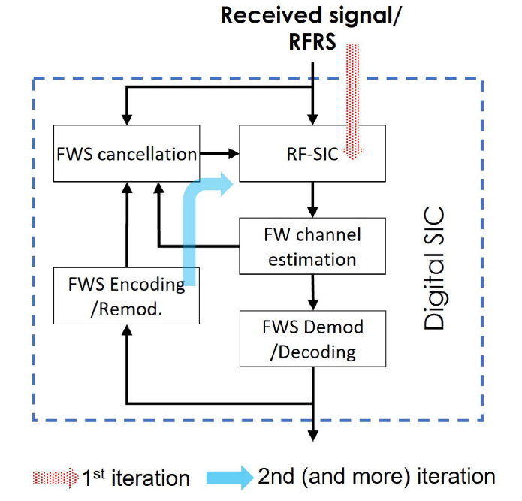
It is desirable to integrate multi-input multi-output (MIMO) into ITCN/IDL transmission to increase the throughput and reduce the portion of spectrum occupation by ITCN/IDL. However, due to the backward compatibility constraint, conventional symmetrical MIMO techniques cannot be applied directly to the existing broadcast infrastructure without affecting legacy receivers. The practical implementation of a non-symmetrical MIMO for ITCN/IDL while maintaining backward compatibility is considered in [35]. In addition to the existing broadcasting antenna, the non-symmetrical MIMO comprises an additional low-power RF feeder cable and one or more highly directional antennas to achieve low-cost MIMO implementation for high throughput data distribution and inter-tower communications. For the MIMO receiver to receive the ITCN/IDL signal in the most spectral-efficient in-band full-duplex operation mode, self-interference cancellation was analyzed to warrant successful detection of the ITCN/IDL signal [35]. The MIMO receiver antennas for ITCN/IDL signal can be installed separately from the transmit antenna at the broadcasting tower with a distance of 10 to 40 m, which attenuates the SI signal significantly. A frequency domain RF-SIC with the unique capability of handling very long delay spread was designed which is suitable for broadcasting systems [33]. A multi-stage SIC with RF-SIC and digital (baseband) SIC is illustrated in Fig. 20.
Figure 20
MIMO transceiver block diagram with multi-stage SIC
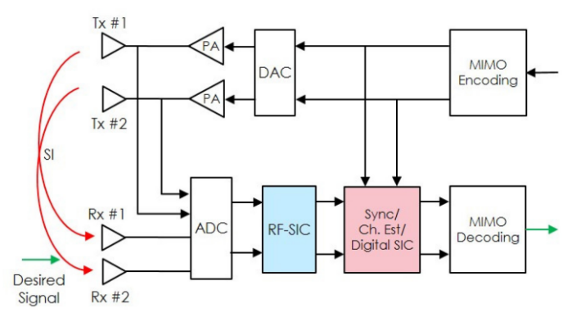
In conclusion, by combining antenna separation, signal blocking and iterative RF-SIC, the nonlinearly distorted SI signal can be effectively reduced to the receiver noise floor to enable high order modulation, e.g. 1 024 QAM, in delivering ITCN/IDL signal with high data rate.

7.4 Relay station Rx dynamic range requirement
The previous analysis assumes that the RS-Rx has sufficient dynamic range to receive a signal consisting of both the FWS and the LBS. When the power of LBS is much higher than that of FWS, the required dynamic range is also increased.
The dynamic range requirement of the RS-Rx is illustrated in Fig. 21. Assuming the LBS is α dB higher than the FWS and the required SNR to decode the STL signal is β dB, the dynamic range of the RS-Rx, κ, should be larger than α + β.
For example, for an LBS/FWS power ratio of 30 dB and a required SNR of 25 dB for STL detection, the receiver needs to have a dynamic range of at least 55 to 60 dB. While this is not impossible, it could be challenging to implement.
Figure 21
RS-Rx dynamic range requirement
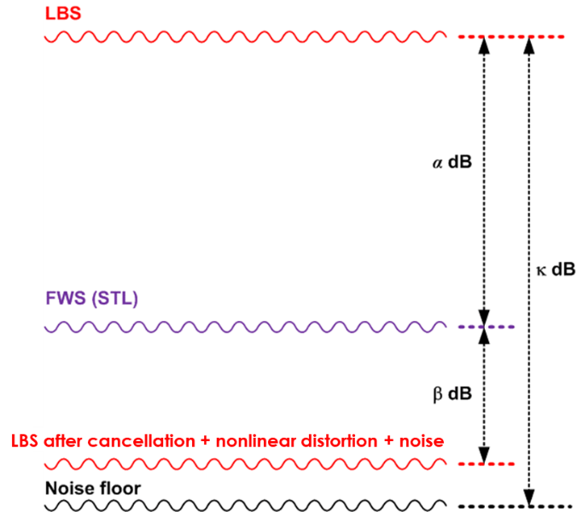
To reduce the dynamic range requirement, the LBS power level needs to be reduced. This can be achieved by designing a more effective signal isolation module using the technologies mentioned in § 6.2. If an advanced SI module could lower the LBS power by 15 dB, the required receiver dynamic range becomes 45 dB for the above example. This could be achievable for professional equipment.
A second solution to lower the LBS power at the receiver tuner input is to implement an analog LBS signal cancellation module, as proposed for on-channel repeaters (OCR) in [36]. The proposed method can reduce the LBS signal strength by up to 50 dB, at additional complexity costs.
It should be pointed out that for most multi-cell deployment scenarios, the emission power from the R-Tx is much lower than the A-Tx. With a good SI mechanism, an LBS/FWS power ratio of 30 dB is highly unlikely to occur. A reasonable range is from 0 to 15 dB.
An exemplar theoretical calculation of IDL Rx receiving signal strength as a function of Tx emission power and Tx-Rx propagation distance is illustrated in Fig. 22(a). In the calculation, the free space path loss model at a frequency of 470 MHz is used. Tx emission powers of 40~70 dBm are considered. Similarly, loopback Rx power strength as a function of Tx emission power and Tx-Rx propagation distance is depicted in Fig. 22(b), where the same frequency of 470 MHz is assumed. At the RS Rx, pattern discrimination of 20 dB between Rx-Tx antennas is taken into consideration.
As an example, from Fig. 22, at IDL Tx emission power of 50 dBm and Tx-Rx distance of 5 000 m, the Rx power strength is at –30 dBm. Assuming the same loopback Rx signal strength with the same Tx emission power, the Tx-Rx distance of 50 m is obtained. This gives an idea of the required separation distance between transmitting and receiving antennas for the loopback signals which can guarantee a fully functioning system when IDL and loopback power strengths are equal. If a loopback signal cancelation capability of 25 dB can be reached (which is feasible according to the previous analysis), the Tx-Rx separation at the loopback side of less than 10 m can be achieved.
Figure 22
IDL power strength (a) vs loopback power strength (b)
(a) (b)

7.5 Field tests in Ottawa/Gatineau area (Canada)
A measurement campaign was carried out in the Ottawa area to evaluate the feasibility of implementing IDL in an ATSC 3.0 SFN using an existing DTV tower as A-Tx. The DTV tower is a 229-meter tower located on top of a mountain in Camp Fortune (Chelsea, Quebec) with a sea level of 360 meters. Six DTV channels are evaluated, for which the parameters are listed in Table 1.
The measurement campaign is conducted in two steps. In the first step, the received signal power is measured at different locations around Ottawa area. The locations are carefully chosen to maximize LOS paths, locations on the high ground (top of local hills, etc.) or locations without surrounding reflective obstacles. This is to ensure the configuration is as close as possible to the actual tower-to-tower propagation. The locations of the Camp Fortune tower and measurement points are shown in Fig. 23, where the purple point on the North is the Camp Fortune tower.
TABLE 1
DTV channels for measurement
Channel | Channel number | Fc ⁽¹⁾  (MHz) | H_{Tx} ⁽²⁾  (m) | Tx ERP  (dBm)
Global Toronto | 14 | 473 | 169.1 | 81.6
TVO | 24 | 533 | 130.9 | 79.8
CBC Ottawa | 25 | 539 | 197.8 | 84.9
Tele-Quebec | 30 | 569 | 141.3 | 84.8
Radio Canada | 33 | 587 | 197.8 | 83.8
V-Tele | 34 | 593 | 141.3 | 74.8
⁽¹⁾ Fc is the centre frequency.
⁽²⁾ H_{Tx} is the height of the antenna relative to the bottom of the tower.

Next, the loopback power levels for different TV stations are measured at the bottom of the transmission tower. The loopback power levels could be scaled to calculate the actual loopback power level as:
$$P_{LB}\left(d_{1}\right)=P_{LB}\left(d_{0}\right)+20\log_{10}\left(\frac{d_{0}}{d_{1}}\right)$$
where d₀ is the height of the transmission antenna, and d₁ is the distance of the RS-Rx antenna to the R-Tx transmission antenna, assuming d₁ is at least 10 m.
Figure 23
Measurement campaign map in Ottawa (Canada)
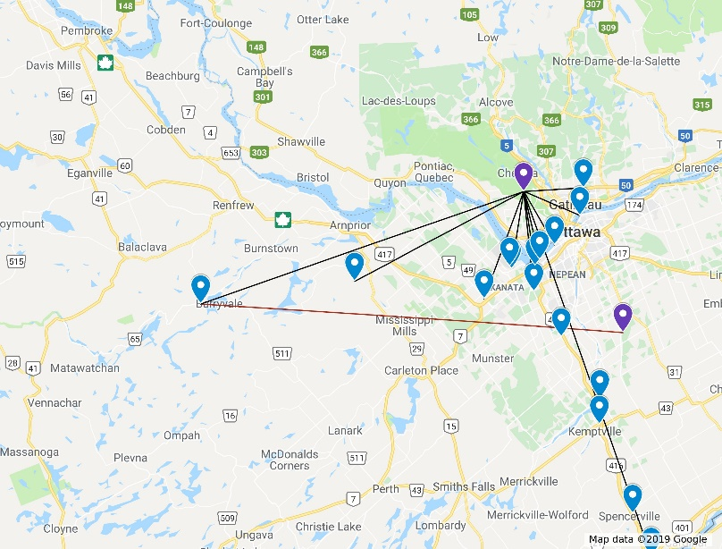
Based on the measurement of received signal power and the LBS power estimation, the power ratio of PLBS/PFWS for different channels at different locations is calculated and plotted in Fig. 24, for an R-Tx emission power of 70 dBm and a Tx-Rx antenna distance of 30 m.
It is shown that, even for a distance close to 100 km, the LBS over FWS power ratio is always less than 30 dB. From Fig. 25, it is clearly shown that a low-complexity LBS cancellation module could achieve a residual LBS signal (after cancellation) 30 dB lower than the FWS signal.
This case study shows that the IDL could be realized at all testing points, even those with elevations lower than 10 m. The actual implementation with a high tower should have much better performance.
Figure 24
Received FWS signal power
Figure 25
PLBS/PFWS power ratio

8 ITCN and backhaul signal structures
This section presents the ITCN signal structures using the different combinations of multiplexing schemes, TDM/FDM, and Layered Division Multiplexing (LDM) [39]. The data capacity is analysed for mobile and fixed broadcasting services, as well as datacasting, inter-tower communication, and in-band distribution link (IDL). MIMO is investigated for ITCN and IDL to increase the data throughput to improve spectrum efficiency. Backward compatibility with the legacy broadcast services and receivers is also considered. A hybrid broadcast SFN overlay with ITCN/IDL data network using LDM might be the best solution considering backward compatibility, data capacity, and co-channel interference.

8.1 Signal structures analysis
This sub-section studies the ITCN/IDL system signal structures based on the ATSC 3.0 standards [4] [40] [41] [42]. It presents a comprehensive analysis of various signal structures using TDM/FDM and LDM to multiplex broadcast, datacast, and ITCN/IDL services.
Some exemplar signal structures of TDM/LDM in ITCN applications are illustrated in Fig. 26. The FDM/LDM application scenarios follow the same structural concept. Figure 26(a) shows ITCN and datacasting TDM with LDM of L1 (i.e. UL) and L2 (i.e. LL) data. Figure 26(b) shows LDM of two ITCNs TDM with LDM of L1 and L2. Figure 26(c) depicts ITCN TDM with LDM of mobile broadcast services (MBS) and fixed broadcast service (FBS)/in-band backhaul. Figure 26(d) illustrates the TDM of three services, including LDM of mobile broadcast service (MBS)/FBS, ITND, and in-band backhaul (i.e. IDL). Figure 26(e) shows LDM of L1 (which is composed of MBS and ITCN) and L2 (which is composed of FBS and in-band backhaul data). Figure 26(f) depicts TDM of two LDM services, one MBS with two TDMed ITCNs, another FBS with in-band backhaul.
FIGURE 26
Examples of two-layer LDM signal structures for delivering mobile, fixed, backhaul and ITCN services
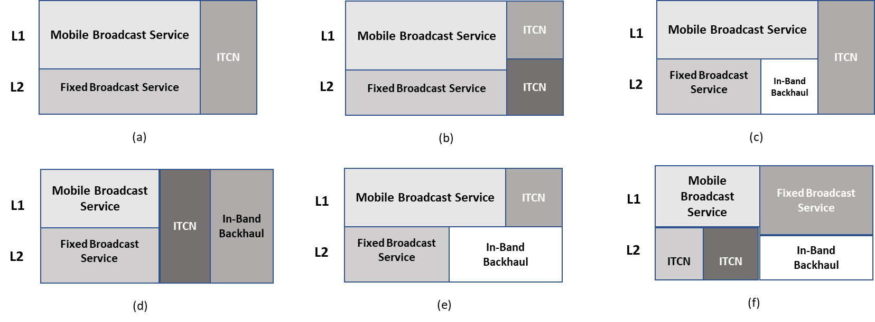
In the system design, using antenna diversity allows communication with different towers (possibly at reduced SNR or data rate due to co-channel interference). ITCN services can run on multi-frequency towers, and under this circumstance, no signal cancellation is required, the system may be much simplified and with reduced system delay.
In the following of this sub-section, channel capacity and resource allocation are investigated and optimized to improve spectrum efficiency. Realistic scenarios, SISO and MIMO ITCN/IDL integrations, are introduced. Although the ATSC 3.0 standard is used as an example, other terrestrial TV standards can also be used while maintaining backward compatibility with legacy TV receivers.

8.1.1 SISO signal structure: a realistic scenario
Figure 27 presents two signal structures designed for the ATSC 3.0 transmission standard using SISO. The ATSC 3.0 physical layer parameters (modulation, channel coding, frame structure, and physical layer pipe) are used as an example to calculate the data rate and required SNR for each service in a 6 MHz radio-frequency (RF) channel [40] [41]. In Fig. 27(a), LDM-TDM means that mobile broadcast service and fixed broadcast service are multiplexed as the core layer (CL) and enhanced layer (EL) in LDM, while TDM is implemented to multiplex broadcast services and data services. In Fig. 27(b), LDM-LDM indicates that LDM is implemented to multiplex broadcast services and data services. In this latter scenario, the signal SNR level is referenced to the total signal power in all LDM layers [40].
There are five different services in the ITCN/IDL system. The mobile services, fixed broadcast services, IDL service, ITCN network, and ITCN data services.
For reliable service quality, the AWGN SNR for a mobile broadcasting service should be around 5 dB [11]. The fixed broadcast service AWGN SNR should be around 15 dB [43] [11].
The IDL distributes the broadcast service data (mobile and fixed services) to the SFN transmitters. The IDL data capacity should be higher than that of the combined data rates of mobile and fixed broadcast services. The terrestrial broadcast system is usually operating in a High Power High Tower (HPHT) environment [44]. The power is high, and the RF frequency is low (UHF band vs GHz band for 4G/5G systems) so the antenna discrimination is low, as well as the transmitter-receiver antenna isolation. Therefore, the full-duplex transmission requires a successive signal cancellation range of over 60 dB [38]. A high dynamic range, low noise floor RF tuner is required. The IDL is between broadcast towers, which have a line-of-sight propagation path and good reception signal strength, e.g. around −50 dBm. Considering signal cancellation complexity, Tx-Rx antenna isolation, and RF tuner performance, the required AWGN SNR for IDL service should be around 27 dB [4] [38].
FIGURE 27
ITCN/IDL Signal Structures (SISO)
(a) LDM-TDM structure | (b) LDM-LDM structure
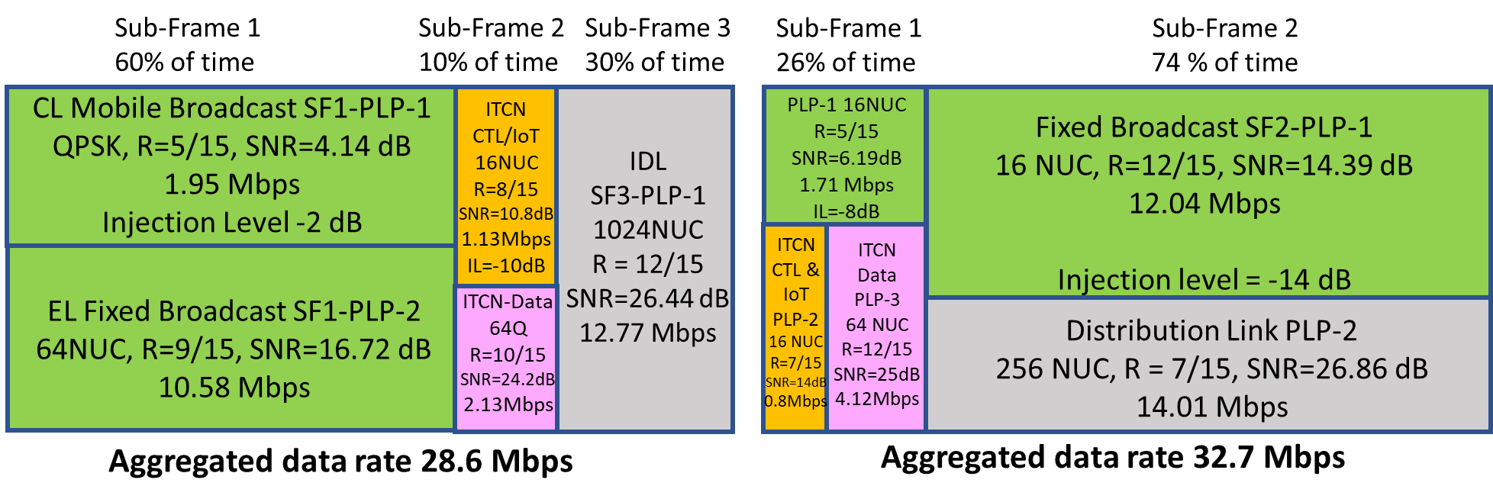
ITCN allows for two-tier data services. The ITCN network data, referred to as ITCN-N, is transmitted among broadcast towers, operating similarly to IDL with a determined LOS path. The ITCN-N data can have relatively high SNR, say around IDL SNR of 24 dB (27 dB − 3 dB), for robustness and high data throughput. The other service is a robust data link, ITCN-C/D, which provides network control (CTL), and datacasting applications to user terminals. For good service quality, the ITCN-C/D SNR should be more robust than that of the fixed broadcast service. The ITCN-C/D SNR of 10 to 12 dB is recommended [42].
Both signal structures in Fig. 11 are backward compatible with the legacy ATSC 3.0 broadcast services. There is no impact on the legacy ATSC 3.0 TV receiver.
It should be pointed out that, in Fig. 27, the LDM-LDM structure has a higher aggregated data rate than that of the LDM-TDM approach (32.7 Mbit/s vs 28.7 Mbit/s). In the LDM-TDM structure, Fig. 27(a), the broadcast services occupy 60% of the transmission time while the sub-frame 1’s highest SNR is only 16.7 dB for the LDM lower layer. Low SNR indicates low spectrum efficiency for 60% of the transmission time. On the other hand, for the LDM-LDM approach, 90% of the time, the signal SNR is higher than 25 dB, which has a much higher spectrum efficiency than that of the LDM-TDM. One possible solution to improve the LDM-TDM structure spectrum efficiency is to add a 3rd LDM layer below broadcast services [7], i.e. below the sub-frame 1 in Fig. 27(a). However, ATSC 3.0 only adopted a two-layer LDM. This could be realized in a future extension of the ATSC 3.0 standard.
The LDM-LDM approach, Fig. 27(b), represents a hybrid broadcast SFN overlay with the ITCN/IDL data network using LDM. This signal structure can also be used for other non-ATSC terrestrial broadcast systems, where the ITCN/IDL could be injected below the legacy broadcast services to maintain backward compatibility for the legacy TV receivers. LDM-LDM structure also achieves better co-channel interference performance, which will be discussed in the next sub-section.

8.1.2 MIMO signal structure: a realistic scenario
Figure 28 presents two signal structures using MIMO on the IDL to improve the spectrum efficiency. To maintain backward compatibility, broadcast services must be transmitted as SISO for legacy TV receivers.
For the LDM-TDM signal structure, Fig. 28(a), dual-polarized MIMO is implemented on the IDL (sub-frame 3), which is TDM-ed with other services. The MIMO can improve the spectrum efficiency by 80+% because the signal can be transmitted on the two polarized channels [45]. Two orthogonal sets of OFDM pilot carriers are needed for the synchronization and channel estimation for the two channels, which slightly reduces the total data rate. Since the MIMO increases the spectrum efficiency, the time resource allocated to the IDL can be reduced from 30% to 20%, as illustrated in sub-frame 3 of Fig. 27(a) vs Fig. 28(a). The 10% spectrum saving can be re-located to broadcast services to increase the data capacity from 60% to 70% of time resource, as shown in sub-frame 1 of Fig. 27(a) vs Fig. 82(b). This is the incentive to implement MIMO technology.
For the LDM-LDM signal structure, Fig. 28(b), dual-polarized MIMO is implemented on the IDL, i.e. sub-frame 2 lower layer, or enhanced layer (EL), which is LDM-ed with the fixed broadcast service on LDM upper layer, or core layer (CL). This means that, for the two polarized MIMO signals, their LDM CLs are transmitting identical broadcast signals, while the ELs are transmitting the dual‑polarized MIMO signals [46]. This will enable backward compatibility with the legacy TV receivers which are designed to receive TV signals only. The legacy TV receivers can ignore the ITCN/IDL networking and data services.
FIGURE 28
ITCN/IDL Signal Structures (MIMO)
(a) LDM-TDM structure | (b) LDM-LDM structure
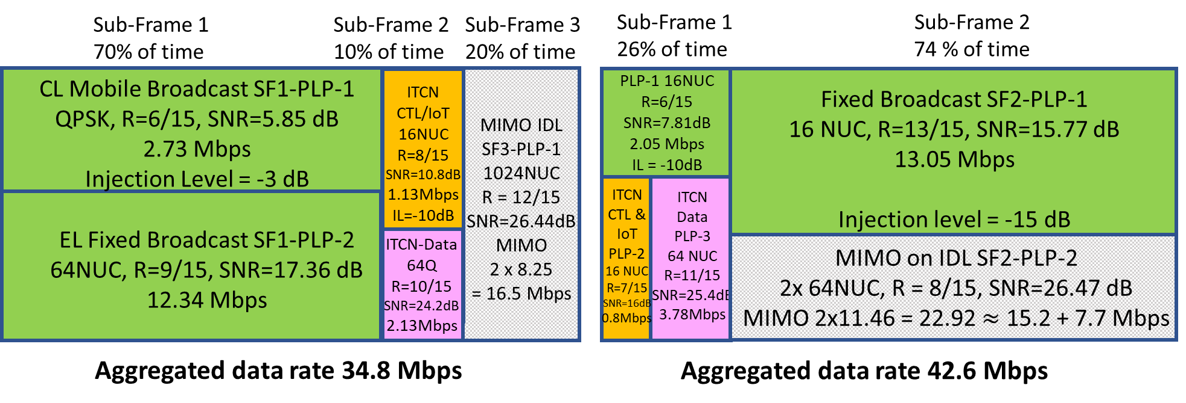
MIMO can achieve a much higher data capacity for IDL, which can be used to improve the IDL EL transmission system SNR by reducing the modulation order and/or increasing the coding robustness. Therefore, less transmission power is required for the IDL, i.e. more transmission power can be allocated to the broadcast service to increase the data throughput. Comparing sub-frame 2 in Fig. 27(b) with Fig. 28(b), the LDM injection level is increased from 14 dB to 15 dB. This indicates more power is allocated to the CL broadcast service. The data rate is, therefore, increased from 12 Mbit/s to 13 Mbit/s with the same time allocation (16NUC with code of 12/15 vs 13/15, where NUC stands for non-uniform constellation). It should be pointed out that the ATSC 3.0 PHY standard [41] restricts the LDM CL modulations to QPSK and 16NUC. No higher-order modulation is allowed. This limits the highest modulation parameters to 16NUC and 13/15 code.
In the ATSC 3.0 PHY standard [41], there is another restriction related to LDM and MIMO. The LDM is the baseline technology, while the MIMO is optional technology, which is not implemented in the TV receivers. The current ATSC 3.0 PHY indicates that LDM and MIMO cannot co-exist in the TV receiver. However, based on the above-described design of the LDM-MIMO ITCN/IDL system, there is no impact on the legacy ATSC 3.0 TV reception of broadcast signals.
MIMO is not deployed in today’s terrestrial broadcast system. To implement MIMO, there will be a major upgrade to the broadcast RF transmission chain to install a second RF cable/waveguide on the broadcast tower. However, since the newly added second polarized MIMO ITCN/IDL signal is designed for inter-tower communications, where high-gain directional transmission and receiving antennas can be used to reduce the emission power requirement. The second RF cable/waveguide can have a much lower power rating (about 10 dB lower), in comparison to the original RF installation. The capital cost to upgrade the RF facility is high. But the data capacity increase is significant. From Table 2, it can be seen that a MIMO gain of 30% data capacity can be achieved.
TABLE 2
Aggregated Data Rate Comparison: SISO vs MIMO and LDM-TDM vs LDM-LDM
Data rate | LDM-TDM | LDM-LDM | LDM vs TDM gain
SISO | 28.7 Mbit/s | 32.7 Mbit/s | 4.0 Mbit/s or 14%
MIMO | 35.8 Mbit/s | 42.6 Mbit/s | 6.8 Mbit/s or 18%
MIMO gain | 7.1 Mbit/s or 25% | 9.9 Mbit/s or 30%

Table 3 lists the data rates and SNRs for all services, signal structures and SISO/MIMO modes.
It should be pointed out that MIMO can also apply to the ITCN-N data, which can further increase the aggregated data rates. The implementation is the same as the LDM-LDM MIMO for IDL.
TABLE 3
Broadcast and IDL/ITCN Data Rates and SNR (AWGN Channel)
Service | Signal structure | Fixed broadcast (Mbit/s) | Mobile broadcast (Mbit/s) | IDL + Data  (Mbit/s) | ITCN-C/D CTL and data (Mbit/s) | ITCN-N network data (Mbit/s) | Aggregated data rate (Mbit/s)
SISO | LDM-TDM | 10.58 | 1.95 | 12.53+0.24=12.77 | 1.13 | 2.13 | 28.7
SISO | LDM-LDM | 12.05 | 1.71 | 13.76+0.25=14.01 | 0.80 | 4.12 | 32.7
MIMO | LDM-TDM | 12.34 | 2.73 | 15.1+1.4=16.5 | 1.13 | 2.13 | 35.8
MIMO | LDM-LDM | 13.05 | 2.05 | 15.2+7.7=22.9 | 0.80 | 3.78 | 42.6
TABLE 3 (end)
Service | Signal structure | Fixed broadcast SNR  (dB) | Mobile broadcast SNR  (dB) | IDL + Data SNR (dB) | ITCN-C/D CTL and data SNR (dB) | ITCN-N network data SNR (dB) | Aggregated data rate (Mbit/s)
SISO | LDM-TDM | 16.72 | 4.14 | 26.44 | 10.84 | 24.21 | 28.7
SISO | LDM-LDM | 14.39 | 6.19 | 26.85 | 14.53 | 24.93 | 32.7
MIMO | LDM-TDM | 17.36 | 5.85 | 26.44 | 10.84 | 24.21 | 25.8
MIMO | LDM-LDM | 15.77 | 7.81 | 26.47 | 16.34 | 25.41 | 42.6

8.2 Co-channel interference study
With the ever-increasing spectrum congestion, all wireless networks are co-channel interference limited, rather than noise limited. This sub-section analyses the co-channel interference among SFN transmission towers of the IDL system. LDM-LDM vs LDM-TDM system co-channel interference performance is investigated. It can be demonstrated that the LDM-LDM system offers superior performance over the LDM-TDM system.
Figure 29 presents an example of a hybrid SFN-IDL/ITCN network with seven transmitters in a one‑hub and two rings network topology. All transmitters emit the same broadcast service signal forming an SFN. Meanwhile, different transmitters can emit different IDL/ITCN signals, which will generate co-channel interference. Both SFN broadcast service signals and IDL/ITCN signals are emitted from omnidirectional broadcast antennas (worst-case scenario). In Fig. 29, Tx1 is the hub transmitter. The first hop to three “red” Tx2x transmitters and the second hop to three “green” Tx3x transmitters. Tx21 receives desired IDL signal from Tx1, while there are co-channel interferences from two nearby transmitters Tx31 and Tx32. The IDL requires high SNR to achieve high spectrum efficiency transmission, which is the most vulnerable to co-channel interference. Highly directional receiving antennas are used to reduce co-channel interference. Since Tx32 distances to Tx21 is much longer than that of Tx31 to Tx21, for simplicity, the co-channel interference from Tx31 is the major focus.
FIGURE 29
An SFN-IDL/ITCN network with seven transmitters
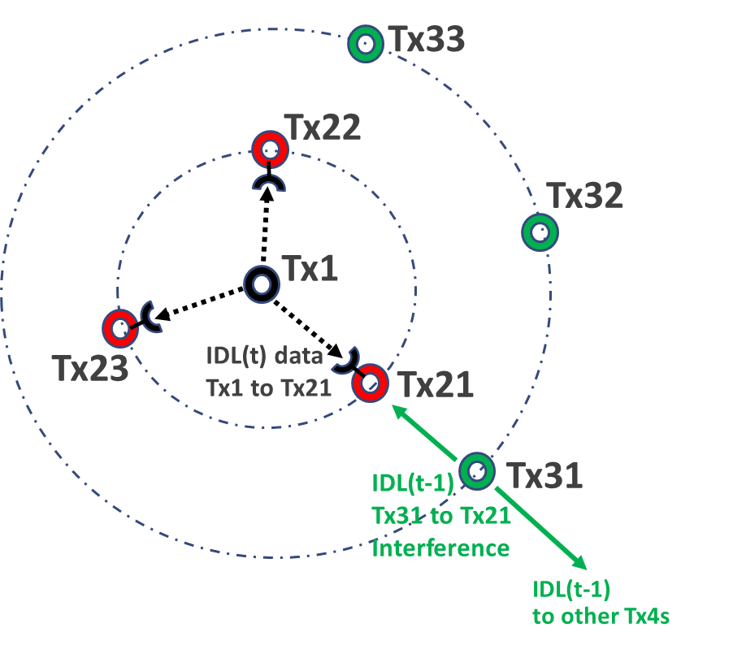

8.2.1 LDM signal structure co-channel interference analysis
The LDM-LDM structure in Fig. 27(b) has an advantage in the SFN environment, where the CL signal from all transmitters operates as an SFN. In an SFN environment, there is no co-channel interference among different transmitters since all transmitters emit identical signals. These identical emissions create multipath distortions. In contrast, co-channel interferences occur among transmitters that carry different IDL data on the EL. They will interfere with the desired EL IDL signal reception.
Figure 30 illustrates the LDM system signal reception under a co-channel interference condition. The two LDM signal structures on the left indicate the desired signal from Tx1 (top-left signal structure) and the interference signal from Tx3 (bottom-left). The CL of both transmitter signals carries identical SFN broadcast service signals, while their ELs transmit different IDL/ITCN signals. For each LDM signal, the EL injection level is 14 dB below the CL power level or 14.17 dB below the total signal power. The total signal power is the CL power and EL power-by-power combination. The −14 dB injection level is 0.17 dB higher than the CL power level. In Fig. 30, this total signal power is referenced as the 0 dB point in the subsequent calculation. Assuming Tx1(P), Tx1(CL), and Tx1(EL) represent the total transmission power of the Tx1 transmitter, Tx1 CL power, and Tx1 EL power, respectively.
Tx1(P) = Tx1(CL) + Tx1(EL) = 0 dB reference point (1)
Tx1(CL) = –0.17 dB (2)
Tx1(CL)-Tx1(EL) = 14 dB (3)
Tx1(EL) = –14.17 dB (4)
FIGURE 30
LDM-IDL Co-Channel Interference under hybrid SFN-IDL/ITCN Overlay Network Environment
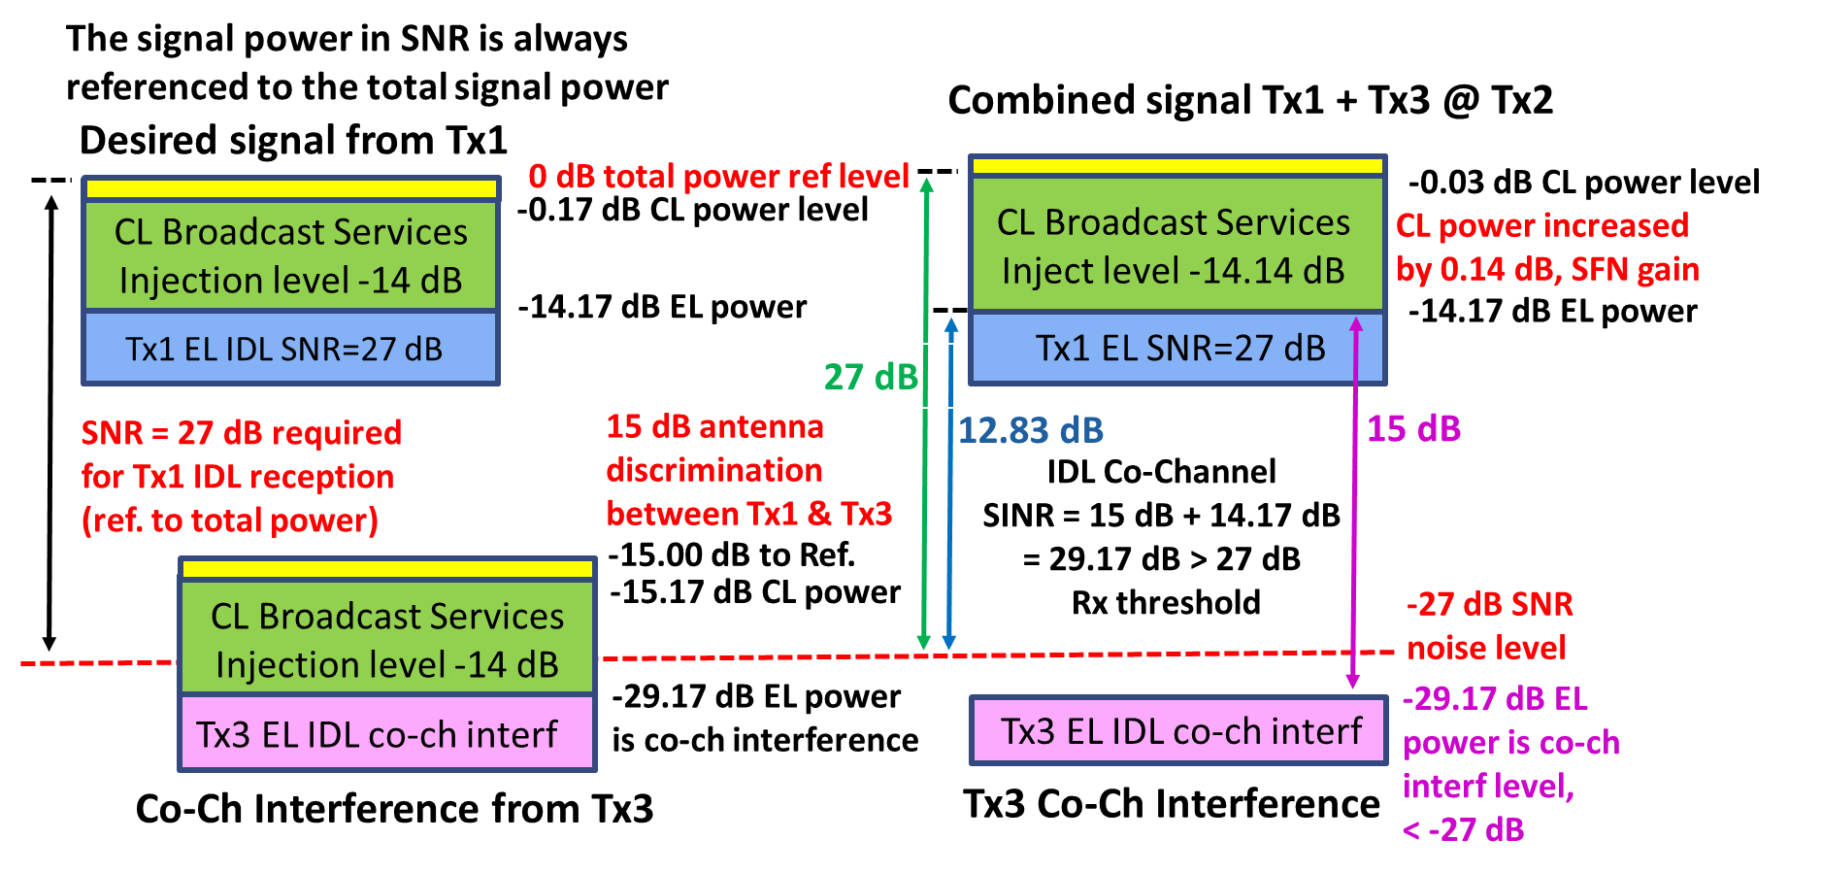
For the interference signal from Tx3, assuming the Tx1 receiving antenna provides a 15 dB front-to‑back ratio, the co-channel interference from Tx3 will be 15 dB below the Tx1 signal, or at the −15 dB point below the Tx1 total signal power.
Tx1(P) – Tx3(P) = Tx1(CL) – Tx3(CL) = Tx1(EL) – Tx3(EL) = 15 dB (5)
Tx3(P) = Tx3(CL) + Tx3(EL) = −15 dB (6)
Tx3(CL) = −15.17 dB (7)
Tx3(CL) – Tx3(EL) = 14 dB (8)
Tx3(EL) = −29.17 dB (9)
However, from Fig. 27(b) the EL signal requires an SNR of about 27 dB to achieve successful EL signal reception (note the signal power in SNR is always referenced to the total signal power [41]). This SNR requirement of 27 dB is more stringent than that of the 15 dB co-channel interference from Tx3. It has been found that one of the advantages of the broadcast SFN overlaying ITCN data network using LDM is that it creates less co-channel interference among different SFN/ITCN transmitters which emit ITCN/IDL signal on the EL.
The right-side diagrams of Fig. 30 present how the system can successfully receive the Tx1 IDL/ITCN signal on the EL. Since both Tx1 and Tx3 CL carry the same SFN broadcast service signal, the two signals are likely to arrive at the receiving antenna with a time difference, which results in a multipath delay spread. It is reasonable to assume the two identical signals with a time offset will be combined by power addition. This is demonstrated in Fig. 30 top-right signal structure, where the Tx1 CL and the Tx3 CL, 15 dB below the Tx1 CL, are power combined in the LDM receiver front-end, resulting in a total CL signal power gain of +0.03 dB. This is the so-called SFN gain [47] [48], which can improve the CL signal reception margin. The received signal
Tx1(P) + Tx3(P) = Tx1(CL) + Tx3(CL) + Tx1(EL) + Tx3(EL) (10)
where Tx1(CL) and Tx3(CL) are the same SFN signal with different arrival times and Tx3(CL) is 15 dB below the Tx1(CL) power level. Therefore,
Tx1(P) + Tx3(P) = (Tx1(CL) + 0.03 dB (SFN gain)) + Tx1(EL) + Tx3(EL) (11)
In the LDM receiver, the CL signal and the SFN gain will be cancelled out in the LDM’s reception process. The remaining signals are:
Tx1(EL) + Tx3(EL) (12)
where Tx1(EL) is the desired signal and Tx3(EL) is the co-channel interference signal. Figure 30 bottom-right signal structure shows the Tx3 EL signal, which remains at a 29.17 dB level (14.17 dB + 15 dB) and is equivalent to the LDM injection level (see equations (4), (5), and (9)). This interference level is lower than the Tx1 EL SNR requirement of 27 dB. The EL signal reception should be successful.
Another way to understand the interference calculation is that the real co-channel interference in Fig. 30 comes from the Tx3 EL signal. The identical CL signals from Tx1 and Tx3 do not cause co-channel interference. They are combined in the LDM receiver front-end and the combined signal is cancelled out in the LDM decoding’s Successive Signal Cancellation (SSC) process [39]. The EL reception SNR requirement of 27 dB is referenced to the total signal power, which is 14.17 dB above the Tx1 EL signal power. The required SNR for EL reception referenced to EL signal power is 12.83 dB (27 dB – 14.17 dB). As mentioned above, the Tx3 co-channel interference is 15 dB below the Tx1 signal, due to receiving antenna discrimination. This means the Tx3 EL co-channel interference is −2.17 dB (12.83 dB – 15 dB) below the SNR threshold. The signal reception should be successful.
It should be pointed out that the above example assumed an omnidirectional broadcast transmission antenna. If a directional transmission antenna can be used in the SFN transmitters where the transmitter signal can be pointed outward (Fig. 30), the co-channel interference signal level can be further reduced to improve the IDL/ITCN signal reception. Another issue is that the LDM decoding SSC process must achieve a cancellation residual signal level that is much lower than the SNR of 27 dB required for EL signal decoding. This should not be a problem for a UHF-band fixed reception environment. Very accurate channel estimation can be achieved [11] [39]. IDL/ITCN receiver is not a consumer product. A high-quality RF tuner and 12+ bits quantization can be implemented in a professional receiver. The above analysis is focused on IDL signal reception. The ITCN (ITCN-C/D and ITCN-N) data reception should be easier than that of IDL, since they require lower SNR.

8.2.2 TDM signal structure co-channel interference analysis
Figure 31 presents TDM system co-channel interference analysis. The related signal structure is in Fig. 27(a). The broadcast service signal and the IDL/ITCN signals are TDM-ed. All broadcast signals from all SFN transmitters form an SFN in the time period of Sub-Frame 1. As long as the SFN signal delay spread is less than that of the OFDM system cyclic prefix (CP), the SFN signal should have no impact on the TDM-ed IDL/ITCN signals. The broadcast signals and IDL/ITC signals are transmitted in different sub-frames [6], separated by CP.
In Fig. 31, as described in § 6.2.1, the desired IDL/ITCN signal from Tx1 is 15 dB above the co-channel interference from Tx3, while the desired signal receiving threshold is a SNR of 27 dB, which is much higher than the co-channel interference of 15 dB. The IDL/ITCN signal cannot be successfully decoded. However, the interfering signal from the Tx3 might be delivered to Tx3 from the Tx2 as an IDL signal in the previous time frame [24]. The signal cancellation technique could be implemented to regenerate the interference signal from the stored data, and use it to cancel or reduce the received interference signal to a tolerable level. As demonstrated in Fig. 31, if the co-channel interference from Tx3 can be reduced by 12+ dB, the desired signal from Tx1 can be successfully decoded. However, this process is very complicated and needs precise signal synchronization and regeneration on the proper frequency band. It also introduces more processing delay. It should be pointed out that this signal cancellation technique can also be implemented for LDM signal reception.
FIGURE 31
TDM-IDL co-channel interference analysis (interference cancellation required)
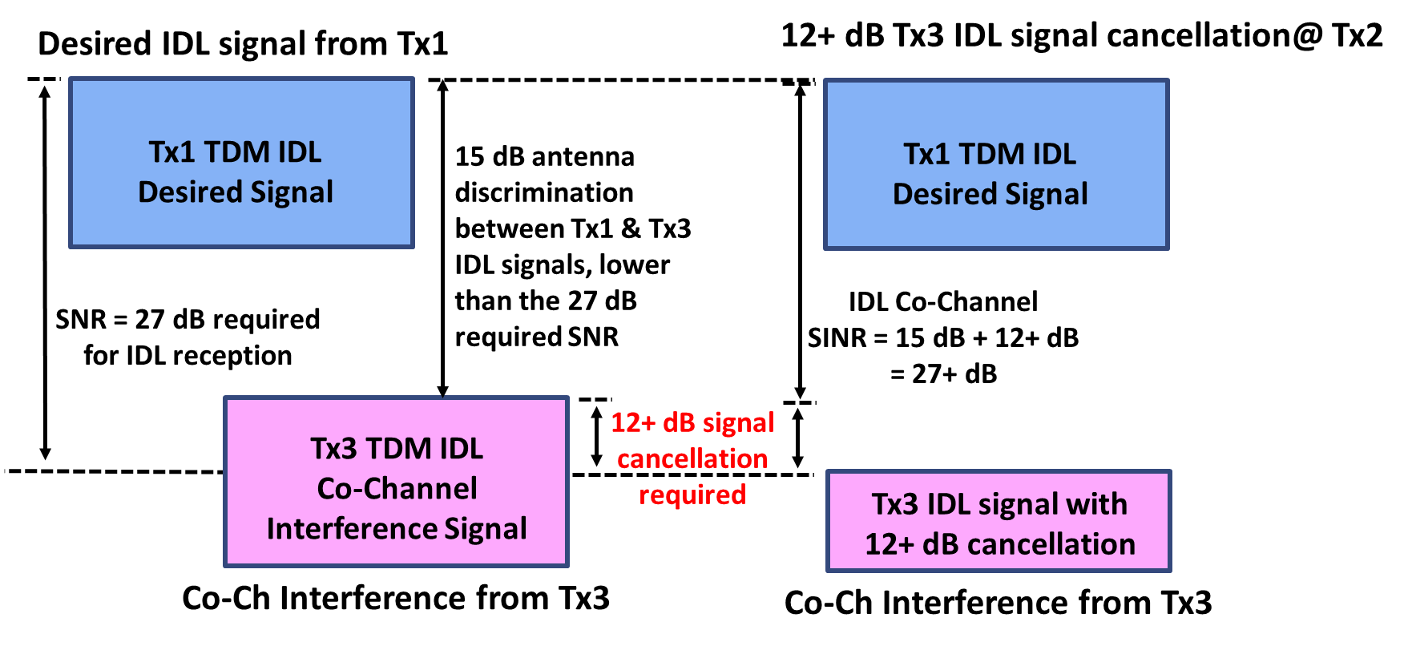

8.2.3 LDM-LDM vs LDM-TDM signal structures
The LDM-LDM structure works better under a multi-transmitter networking environment (multi-hop) because it is more robust to the co-channel interferences from other SFN Tx towers.
The LDM-TDM structure works with a limited number of transmitters. Otherwise, a very complicated signal cancellation scheme needs to be implemented to cancel the interfering IDL signal. This IDL signal was likely transmitted from the reception site in the previous IDL time frame, so it could be stored and used for interference cancellation.
As discussed in § 8.2.1, co-channel interference in the LDM-LDM case is between the two desired and interfering EL signals. The EL signal is 14 dB below the CL signal power, i.e. only 3% of the CL power. This means the EL transmission power is much smaller than the CL or total signal power. Lower transmission power means a smaller interference area. This low power transmission of the IDL signal is the key reason that the LDM-LDM approach leads to reduced co-channel interference. Meanwhile, the CLs from all IDL/ITCN towers form an SFN. There is no co-channel interference, rather it generates an SFN gain [47] [48].
It can be seen that in the LDM-LDM structure, the broadcast SFN and the IDL/ITCN form an overlay hybrid network. This structure can also be used in 6G broadband wireless systems to combine the broadcast service with the unicast service in one RF channel for more efficient use of the spectrum.

8.3 Summary
This section investigated ITCN/IDL signal structure and co-channel interference scenarios. A hybrid broadcast SFN overlay with ITCN/IDL data network using LDM might be the best solution considering backward compatibility, data capacity, and co-channel interference. The legacy terrestrial broadcast services can be transmitted on the CLs, while ITCN/IDL data are allocated on newly added ELs. Legacy TV receivers can receive legacy broadcast TV services with full backward compatibility This broadcast service and data network overlay system, based on Power-domain Non-Orthogonal Multiplexing (P-NOM or LDM), can also enable the convergence of the broadcast and broadband wireless services in future wireless systems.

9 ITCN network node integrating with BCN and other technologies

9.1 DTV network evolution: legacy and future networks
The limitations of current DTT network architectures (flexibility, modularity, amongst others) have been identified by relevant broadcast industry stakeholders. The current architectural design lacks flexibility and modularity to incorporate new services; the closeness and tightness of its workflow make it very hard to expose its functionalities to third parties; and the lack of a superior management entity hinders its integration with other technologies, such as 5G.
Work is already ongoing towards this direction in some ITU-R regions. ATSC already identified the architectural design during the standardization of ATSC 3.0 and is currently working on the technical details of a Broadcast Core Network as part of the ATSC 3.0 standard portfolio.

9.1.1 Legacy DTV networks
The ITU Handbook on DTT [49] describes a system architecture based on a downlink-only, one-to-many media transmission path that has prevailed based on the same paradigm with little variations up to our days. The classical architecture of any DTT standard transmission part can be divided into four subsystems (Broadcast Center, Transport, RAN, and Reception/Display), as represented at the top of Fig. 32.
FIGURE 32
Legacy DTT and today’s broadband mobile architectures
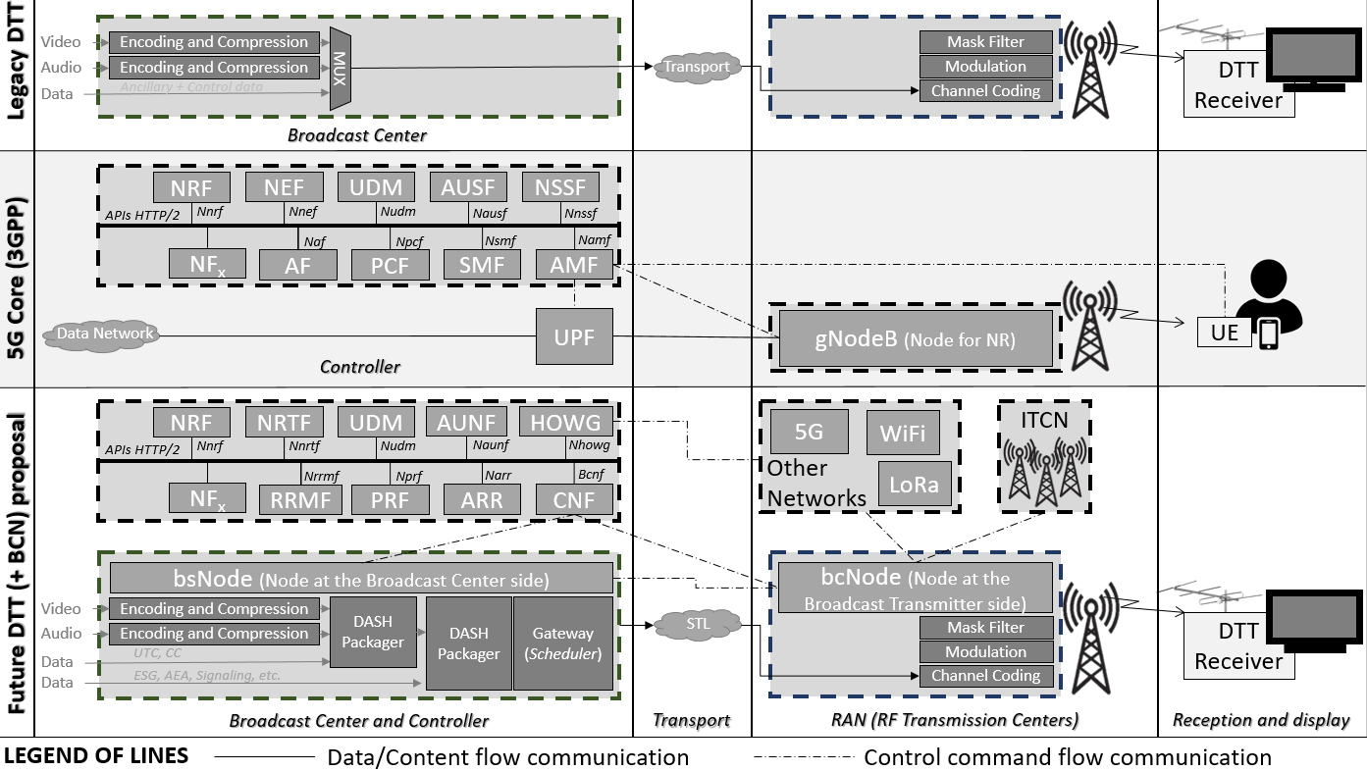
Content creation is carried out (or assembled) at the Broadcast Center, where raw video compression and application-level error protection are completed. The Service Multiplex (MUX) and Transport, assembles the digital data stream into information packets with univocal identification and eventually multiplexes the video, audio, and ancillary data into a single stream. Then, the transport subsystem routes this resultant stream to each RAN tower. The RF transmission stage transforms the channel-coded digital data stream information into a modulated signal ready for broadcasting. Finally, DTT receivers tune, process, and display the content.
However, even after the significant evolution of the physical layer (Low-Density Parity-Check (LDPC), Non-Uniform Quadrature Amplitude Modulation (NU-QAM), Layer Division Multiplexing (LDM), Combined Interleaving) in the RF Transmission Center side, transport (e.g. ROUTE, MMT) in the Broadcast Center side, and link layer protocols development (e.g. ATSC Link-Layer Protocol (ALP), GSE), the data distribution architecture has not undertaken any substantial changes. Consequently, the main blocks described in Fig. 32 (top row) can still be easily identified in any widely spread DTT standard (1st and second-generation systems, namely DVB-T, DVB-T2, ATSC 1.0, ATSC 3.0, DTMB-A, or ISDB-T). So, even if the latest DTT standards are among the most spectrally efficient systems, their rigid network architecture refrains them from being part of the current use case and services.

9.1.2 Broadband mobile access networks as a reference architecture
3GPP Release 15 (Rel-15) described the 5G Service-Based Architecture (SBA) for the first time. A set of specifications drove this approach. First, modularity should support various communication scenarios and pose different network needs. Modularity turned out to be one of the critical drivers of the network slicing concept, a 5G flagship. Secondly, openness should support new services exposing network capabilities to broadcast operator's services and third-party applications. Third, extensibility will facilitate the interaction between different services and should remain guaranteed without introducing a new reference point and the corresponding message flows. Lastly, it should support separate Control and User planes, allowing for independent evolution of core network (5GC) and RANs through Network Function Virtualization (NFV). NFV also contributes to improved scalability, flexibility, and cost-effective service provisioning [51].
Following those requirements, the main difference between 5GC and previous network architectures was the usage of service-based interactions between Network Functions (NFs) instead of the traditional "nodes" or "network elements" connected by interfaces. Each NF offers one or more services to other NFs relying on the widely used "Hypertext Transfer Protocol (HTTP) Representational State Transfer (REST) paradigm" as a communication method. Fig. 32 (central row) contains a typical representation of a 5G SBA, including a selection of the main NFs and associated interfaces with the gNodeB (Radio Access Technology (RAT) for 5G). Recently, 3GPP presented the enhanced Service Based Architecture (eSBA), which improved flexible deployments of Session Management Function (SMF) and User Plane Functions (UPF), added support for commercial services using location-based service architecture enabled RAN Self-Organizing Networks, and provided Dual Connectivity and Carrier Aggregation enhancements [50].

9.1.3 The need of a specific broadcast core network
Applying directly the 5GC architecture, protocols and network functions is the immediate solution available. Unfortunately, 5GC directly to the DTT ecosystem is not feasible for the current broadcast infrastructure and service peculiarities. First, the Free-to-Air (FTA) use case is the pivoting point of the whole system, and its relevance will remain for some years. The receiver should be able to decode the media signal without any Subscriber Identity Module (SIM) card or associated pre-paid service. In addition, there is no direct support for an uplink channel, and IP connectivity cannot be taken for granted in all parts of the world. Lastly, the regulations of the infrastructures and the frequency planning are also different for the DTT systems.
The current architectural approach of 5G has some limitations to be directly applied to ATSC and other broadcast access networks. One of the most remarkable is related to the user plane in the ATSC infrastructure, which differs significantly from the one existing in 5G. Moreover, the approach taken in 5G has also shown some weaknesses, as identified in the literature. The first limitation is the diversification of communication requirements that are increasingly diversified due to the increase in the types of applications, and they do not fit easily in a landscape defined by a few global use cases. Second, the communication-centric design and network operation did not consider the design beyond communication functionalities to support the needs of other vertical applications, such as smart manufacturing, which requires tight geographical positioning and user coordination. Third, the 5G network design considers Artificial Intelligence (AI) an independent tool and does not enable extracting descriptive knowledge of the data. Therefore, if we look to the future 6G service requirements, radio access and core networks should significantly improve flexibility, scalability, and programmability. Even if the overall architecture is the same and the general purpose of some NFs is similar, the particularities of the DTT networks require the definition of a specific BCN. In consequence, there should be NFs whose instances should be adapted to the requirements of DTT networks.
Moreover, the particularities of a DTT transmitter station require a new intelligent node referred as to Broadcast Node (bcNode). This entity is an upgrade of a traditional broadcast facility that encompasses capabilities conceptually associated with a gNodeB. Likewise, a bcNode is included at the studio to interface between the production workflow and the BCN.

9.2 Future DTV networks: transmitter network (access network) and broadcast core network
Adopting a BCN has a profound impact on the architecture of DTT, transforming it into a network-based system. As depicted in Fig. 33, a hierarchical architecture can be considered a feasible alternative to exploit the potentialities of the BCN. This approach introduces a segmentation strategy wherein a regional BCN has the capability to deploy one or multiple centralized/virtualized/open (C/V/O) transmission facilities.
FIGURE 33
(Broadcast) Radio access network and broadcast core network: hierarchical BCN distribution
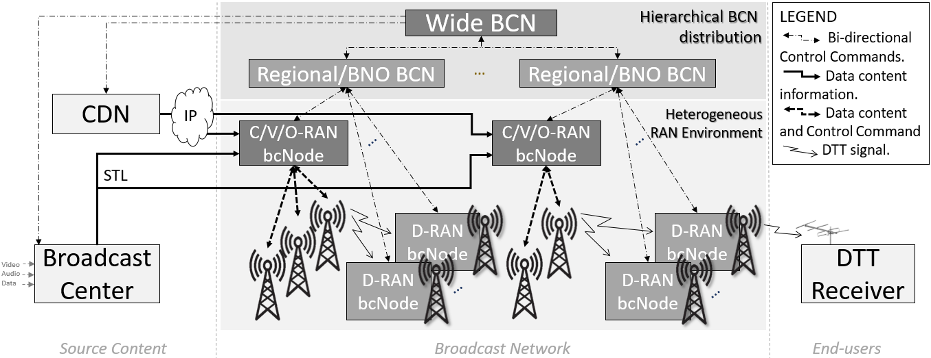
These evolved transmission facilities, called bcNodes, possess high-throughput internet connections and access to the Broadcast Centre content via the Studio-to-Transmitter Link (STL). They can also be primary transmitters in the ITCN.
Conversely, lower-level ITCN secondary transmitters will invariably require D-RAN architecture due to poor-throughput or non-existent internet connections. Due to their geographical locations, they lack direct access to the content from the Broadcast Center and must receive the content from the contribution link, which is delivered by another transmission tower. This way, the broadcaster could avoid deploying the expensive fiber of microwave links for some network transmitters.
The O-RAN choice in the primary transmitters would be beneficial to minimize costs and open up the acquisition of RAN modules without depending on the same manufacturer. O-RAN is the most cost-efficient alternative to propose the DTT RAN design. This will also facilitate that each BNO can select its architecture to deploy. However, for BNOs that do not want to have open APIs, V-RAN would still be the option to choose. Given the current limited connectivity conditions prevalent in many broadcasting transmission towers, it is not feasible to establish a network of primary transmitters with high-speed and low-latency connectivity based on an O-RAN approach. Therefore, as an initial step, an architecture similar the one depicted in Fig. 33 could be feasible but with a limited migration towards a D-RAN architecture for all the transmission facilities. The concept of bcNode will serve as a fundamental pillar around which the proposed changes will evolve. Eventually, this architecture will lay the foundations for future virtualized proposals.

9.3 Broadcast Node (bcNode)
To fully leverage the capabilities of the evolved RAN architecture in Fig. 34, the bcNode is designed as a plug-and-play module that can be seamlessly integrated into existing transmission facilities with minimal changes to the current architecture. The functional blocks of the bcNode are illustrated in Fig. 33. The various functions involved in data and interface management are categorized into four main blocks based on their characteristics.
FIGURE 34
Broadcast node (bcNODE): interfaces and basic functions
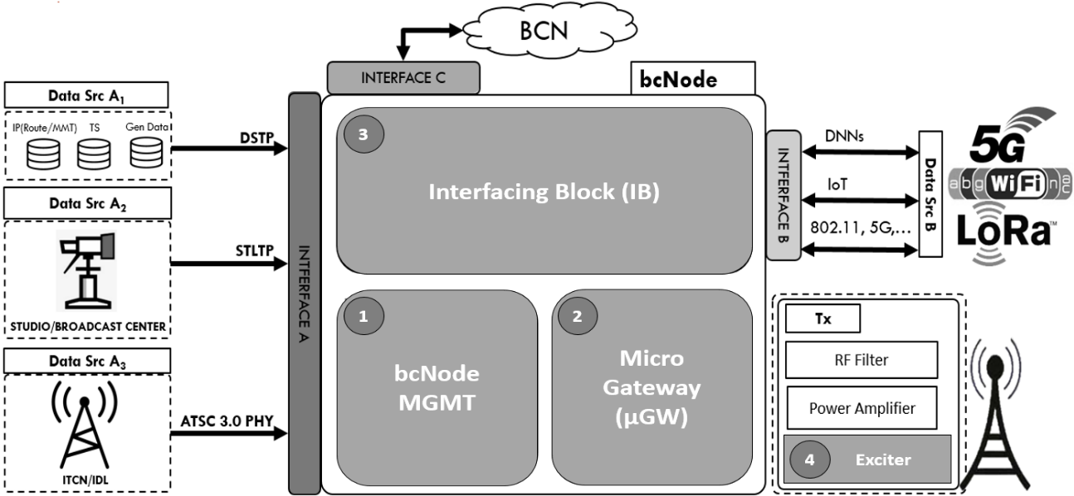
The RAN interfaces with different entities, including source content providers (Interface A), other radio access technologies (Interface B), and the BCN itself (Interface C). Interface A is responsible for ingesting data provided by the BNO either from the Broadcast Center using the Studio to Transmitter Link Transport Protocol (STLTP) or from a Content Delivery Network over the Data Source Transport Protocol (DSTP). These are the classical data entry points for TV linear content. Additionally, the bcNode can receive the contribution link from another bcNode embedded in the DTT Physical Layer.
To enhance the flexibility and scalability of the bcNode, it should be capable of ingesting data content from other platforms or networks and injecting it into the DTT signal. Possible candidates for connection through this interface include Internet of Things (IoT) networks, local networks based on IEEE 802.11, or 4G and 5G 3GPP networks. Finally, Interface C facilitates the connections between the bcNode and the BCN, the overseeing entity managing a group of bcNodes.
In addition, the bcNode should incorporate a Micro-Gateway (μGW) to extract the different sources obtained by the interfacing block and organize them according to the predefined frame configuration set by the network operator. This part shall include the transcoding capability required to access the different content formats and re-encode them into a format allowed by the DTT standards. For instance, in the ATSC 3.0 case, the bcNode should guarantee that all the content aggregated to the scheduler component is encoded in a DASH/ROUTE format. Depending on the hardware capabilities of the transmission facilities, certain bcNodes may have limited transcoding capabilities restricted to predefined protocols. This block facilitates harmonization with other networks and enhances system flexibility by expanding the range of ingestion sources through a single software upgrade. In this manner, the μGW functions as a repackager and scheduler.
The exciter is connected to the power amplifier at the transmitter facility's edge. The exciter performs modulation, encoding, and other essential functions to ensure spectrum efficiency in traditional DTT systems. While these functions remain intact, the exciter should also allow configuration by an external entity. It is anticipated that in the short to medium term, Broadcast network operators will continue to utilize current facilities, which rely heavily on dedicated hardware to process the physical layer waveform generator.
Eventually, all the processing described above will be managed by the bcNode management entity. Its primary functions include establishing communication with the BCN to process HTTP2 REST commands for service configuration, controlling the data flow between components No. 2, No. 3, and No. 4, and providing an entry point for the BNO to monitor and control the transmission facility. For example, the management entity (MGMT) would select the sub-modules within each bcNode block necessary to process the data and encapsulate it into Physical Layer Pipe (PLP) frames defined by an external entity such as the BCN Operator or System Manager. This management function forms the core of the bcNode.

9.4 Summary
This section has introduced the potential evolution of current digital terrestrial television networks. The current rigid architecture encompassing creation-distribution-transmission may be transformed into a more sophisticated combination of Access and Core Networks. There are many advantages from this new architecture, similar to broadband mobile networks, that include convergence with other networks, advanced services, new uplink choices enabled by complementary networks and better control of the services delivered to different audiences. The bcNode is a fundamental cornerstone of this paradigm, furnishing the DTT transmitter centre with content management capacities and interfacing capabilities within the ITCN network and with other networks such as 5G and IoT.

10 Conclusion
This Report introduced the concept of ITCN, which is to connect all broadcast transmission towers to form an IP-based wireless communications network using a channel from the terrestrial broadcast service frequency bands and co-existing with existing broadcast service applications. Various ITCN use cases, providing a spectrum-efficient solution to connect all broadcast towers relying on the SFN or non-SFN to form an IP network, were illustrated. The LDM, which can achieve higher cumulative transmission capacity when delivering multiple services with different quality requirements, being the supporting technology to ITCN, was then referred to. Existing inter-tower communications technologies (both wired and wireless) were recalled. ITCN application scenarios, including concepts of SFN with ITCN, coordinated ITCN, etc., were depicted. ITCN technical challenges and realization solutions were addressed in detail, including transmitter timing control, signal isolation, and self-interference cancellation in in-band full-duplex communications, as well as field test validation and verification. ITCN and backhaul signal structures in various combinations of multiplexing schemes were considered, which are important factors in increasing the data throughput and improving spectrum efficiency, considering backward compatibility with the legacy broadcast services and receivers. Study shows that hybrid broadcast SFN overlay with ITCN/IDL data network using LDM might be the optimal solution considering backward compatibility, data capacity, and co-channel interference. ITCN network nodes integrating with BCN and other technologies were investigated, comprising legacy and future networks comparison, design consideration of the broadcast node, and access network/broadcast core network integration.
Although major applicable scenarios in this Report are with ATSC 3.0, the ITCN-related technologies are standard agnostic and can be applied to all sorts of terrestrial broadcasting and communications systems requiring in-band full-duplex communication technologies. Continuous work on ITCN development will include AI involvement in the self-interference cancellation and antenna design, and flexible convergence with other networks including 3GPP, Wi-Fi and others.

References

[1] J. Montalban, R. Cabrera, E. Iradier, P. Angueira, Y. Wu, L. Zhang, W. Li, Z. Hong, “Broadcast Core‑Network: Converging Broadcasting With the Connected World”, IEEE Transactions on Broadcasting, Vol. 67, No. 3, pp. 558-569, September 2021.
[2] ITU-R Working Party 6B (SWG 1) Document, “Core Network for Broadcast Services”, Working document towards a preliminary draft new Report ITU-R BT.[IP-BCN], 28 September 2022.
[3] ETSI TS 103 770 v1.1.1, “Digital Video Broadcasting (DVB): Service Discovery and Programme Metadate for DVB-I”, November 2020.
[4] W. Li, L. Zhang, Y. Wu, Z. Hong, S. Laflèche, S-I. Park, S. Kown, S. Ahn, Namho Hur, E. Iradier, I. Bilbao, J. Montalbán, and P. Angueira, “Integrated Inter-Tower Wireless Communications Network for Terrestrial Broadcasting and Multicasting Systems”, IEEE Transactions on Broadcasting, Vol. 67, No. 3, pp. 570-581, September 2021.
[5] ISED Document, “BC-22 − Requirements for the Experimental Operation of ATSC 3.0 in TV Bands”, Broadcasting Circular No. 22, Issue 1, June 2022 (https://www.ic.gc.ca/eic/site/smt-gst.nsf/eng/sf11788.html)
[6] A. Mattsson, “Single Frequency Networks in DTV”, IEEE Transactions on Broadcasting, Vol. 51, No. 4, pp. 413-422, December 2005.
[7] W. Li, L. Zhang, Y. Wu, S. Park, N. Hur, J. Lee, “LDM in Wireless In-Band Distribution Link and In-Band Inter-Tower Communication Networks for Backhaul, IoT and Datacasting”, in Proceedings of IEEE International Symposium on Broadband Multimedia Systems and Broadcasting 2020 (BMSB2020), 27-29 October 2020, Paris, France.
[8] L. Zhang et al., “Layered-Division-Multiplexing for High Spectrum Efficiency and Service Flexibility in Next Generation ATSC 3.0 Broadcast System”, IEEE Wireless Communications, Vol. 26, No. 2, pp. 116-123, April 2019.
[9] C. Hoymann, W. Chen, J. Montojo, A. Golitschek, C. Koutsimanis and X. Shen, “Relaying operation in 3GPP LTE: Challenges and solutions”, IEEE Communications Magazine, Vol. 50, No. 2, pp. 156‑162, February 2012.
[10] N. S. Loghin et al., “Non-Uniform Constellations for ATSC 3.0”, IEEE Transactions on Broadcasting, Vol. 62, No. 1, pp. 197-203, March 2016.
[11] S-I Park et al., “Performance Analysis of All Modulation and Code Combinations in ATSC 3.0 Physical Layer Protocol”, IEEE Transactions on Broadcasting, Vol. 65, No. 2, pp. 197-210, June 2019.
[12] K-J. Kim et al., “Low-Density Parity-Check Codes for ATSC 3.0”, IEEE Transactions on Broadcasting, Vol. 62, No. 1, pp. 189-196, March 2016.
[13] S. Ahn et al., “Mobile Performance Evaluation of ATSC 3.0 Physical Layer Modulation and Code Combination under TU-6 Channel”, IEEE Transactions on Broadcasting, Vol. 66, No. 4, pp. 751‑769, December 2020.
[14] ITU-R BT.2386-3, Digital terrestrial broadcasting: Design and implementation of single frequency networks, BT Series, Broadcasting service (television), October 2020.
[15] A/324, ATSC Standard: Scheduler / Studio to Transmitter Link, Doc. A324: 2023-03, 28 March 2023.
[16] L. Zhang, et.al., “Using Layered Division Multiplexing for Wireless In-Band Distribution Links in Next Generation Broadcast Systems”, IEEE Transactions on Broadcasting, Vol. 67, No. 1, pp. 68-82, March 2021.
[17] “Further advancements for E-UTRA, physical layer aspects, V1.5.1”, 3GPP, Sophia Antipolis, France, Rep. TR-36.814, Dec. 2009.
[18] C. Hoymann, W. Chen, J. Montojo, A. Golitschek, C. Koutsimanis, and X. Shen, “Relaying operation in 3GPP LTE: Challenges and solutions”, IEEE Commu. Mag., vol. 50, no. 2, pp. 156-162, Feb. 2012.
[19] D. Kim, H. Lee, and D. Hong, “A survey of in-band full-duplex transmission: From the perspective of PHY and MAC layers”, IEEE Commun. Surveys Tuts., vol. 17, no. 4, pp. 2017-2046, 4th quart., 2015.
[20] C. D. Nwankwo, L. Zhang, A. Quddus, M. A. Imran, and R. Tafazolli, “A survey of self-interference management techniques for single frequency full duplex systems”, IEEE Access, vol. 6, pp. 30242‑30268, 2018.
[21] G. Y. Suk, S.-M. Kim, J. Kwak, S. Hur, E. Kim, and C.-B. Chae, “Full duplex integrated access and backhaul for 5G NR: Analyses and prototype measurements”, 2020, arXiv:2007.03272.
[22] C. Madapatha et al., “On integrated access and backhaul networks: Current status and potentials”, IEEE Open J. Commun. Soc., vol. 1, pp. 1374-1389, 2020.
[23] R.-A. Pitaval, O. Tirkkonen, R. Wichman, K. Pajukoski, E. Lahetkangas, and E. Tiirola, “Full-duplex self-backhauling for small-cell 5G networks”, IEEE Wireless Commun., vol. 22, no. 5, pp. 83-89, Oct. 2015.
[24] L. Zhang et al., “Using Layered Division Multiplexing for Wireless In-Band Distribution Links in Next Generation Broadcast Systems”, IEEE Transactions on Broadcasting, vol. 67, no. 1, Mar. 2021.
[25] Grant, T. J., ed. Network Topology in Command and Control. Advances in Information Security, Privacy, and Ethics. IGI Global. pp. xvii, 228, 250. ISBN 9781466660595, 2014.
[26] E. Iradier, I. Bilbao, M. Fernandez, J. Montalban, Z. Hong, W. Li, and Y. Wu, “Signal Isolation Characterization of ITCN In-Band Full-Duplex Communications”, IEEE Transactions on Broadcasting, vol. 69, no. 2, pp. 569-578 June 2023.
[27] Advanced Television Systems Committee, ATSC Recommended Practice: Design Of Multiple Transmitter Networks (A/111:2009), Sept. 2009.
[28] Y. Wu, L. Zhang, W. Li, S. Laflèche, S. I. Park, J. Lee, H. Kim, N. Hur, S. Weiss, E. Iradier, P. Angueira, J. Montalban, “ATSC 3.0 Backward Compatible SFN In-Band Distribution Link and In‑Band Inter-Tower Wireless Network for Backhaul, IoT and Datacasting”, Proceedings of NAB 2020, May 2020.
[29] J.-J. van de Beek, O. Edfors, M. Sandell, S. K. Wilson, and P. O. Borjesson, “On channel estimation in OFDM systems”, in VTC’95, vol. 2, July 1995, pp. 715-719.
[30] O. Edfors, M. Sandell, J.-J. van de Beek, S. K. Wilson, and P. O. Borjesson, “OFDM Channel Estimation by Singular Value Decomposition”, IEEE Trans. Commun., vol. 46, no. 7, pp. 931-939, July, 1998.
[31] L. Zhang, et. Al., “DFT-Windowing Based Channel Estimation in Coherent OFDM Systems”, in VTC’09, Sept. 2009.
[32] COST 207 Report, Digital land mobile Radio Communications, Commission of European Communities, Directorate General, Telecommunications, Information Industries and Innovation, Luxembourg, 1989.
[33] Z. Hong, L. Zhang, W. Li, Y. Wu, Z. Zhu, S.-I. Park, S. Kown, S. Ahn, N. Hur, E. Iradier, J. Montalban, and P. Angueira, “Frequency-Domain RF Self-Interference Cancellation for In-Band Full-Duplex Communications”, IEEE Transactions on Wireless Communications, vol. 22, no. 4, pp. 2352-2363, April 2023.
[34] Z. Hong, L. Zhang, W. Li, Y. Wu, Z. Zhu, S.-I. Park, S. Kown, S. Ahn, N. Hur, E. Iradier, J. Montalban, and P. Angueira, “In-Band Full-Duplex Communications in ATSC 3.0 Single Frequency Network”, IEEE Transactions on Broadcasting, vol. 69 No. 2, pp 560-568, June 2023.
[35] Z. Hong, L. Zhang, W. Li, Y. Wu, Z. Zhu, S.-I. Park, S. Kown, S. Ahn, N. Hur, E. Iradier, J. Montalban, and P. Angueira, “Implementation of Wireless Backhaul and Inter-Tower Communications with MIMO in ATSC 3.0”, IEEE Transactions on Broadcasting, vol. 69 No. 2, pp 579-588, June 2023.
[36] S. W. Kim, Y. T Lee, S. I. Park, H. M. Eum, J. H. Seo, and H. M. Kim, “Equalization Digital On-Channel Repeater in the Single Frequency Network”, IEEE Trans. Broadcasting, vol. 52, no. 2, pp. 137-146, June 2006.
[37] Z. Hong, L. Zhang, W. Li, Y. Wu, Z. Zhu, S.-I. Park, S. Kown, S. Ahn, N. Hur, E. Iradier, J. Montalban, and P. Angueira, “Iterative successive nonlinear self-interference cancellation for in-band full-duplex communications”, IEEE Transactions on Broadcasting, doi: 10.1109/TBC.2023.3291136.
[38] Z. Hong, L. Zhang, W. Li, Y. Wu, Z. Zhu, S. I. Park, S. Ahn, S. Kwon, N. Hur, E. Iradier, J. Montalban, and P. Angueira, “Frequency Domain RF Self-Interference Cancellation for In-Band Full-Duplex Communications”, IEEE Trans. Wireless Communications, Oct. 2022. Early acc. https://doi.org/10.1109/TWC.2022.3211196.
[39] L. Zhang, Y. Wu, W. Li, X. Wang, S. Park, H. Kim, J. Lee, P. Angueira, and J. Montalban, “Layer-Division-Multiplexing: Theory and Practice”, IEEE Trans. Broadcast., vol. 62, no.1, pp. 216-232, Mar. 2016.
[40] ATSC Standard, Doc. A/321, “System Discovery and Signaling”, Mar. 31, 2022.
[41] ATSC Standard, Doc. A/322, “Physical Layer Protocol”, Mar. 31, 2022.
[42] L. Liu, Y. Xu, Y. Wu, Y. Huang, D. He, and W. Zhang “Hybrid-Mux Signal Structure and Resource Allocation for In-band Distribution Link and ITND Transmission in SFN Environment”, IEEE Trans. Broadcast., vol. 69, no.2, part II, June 2023.
[43] Y. Wu, P. Bouchard, B. Caron, D. Tyrie, and R. Trenholm, “Canadian digital terrestrial television system technical parameters”, IEEE Trans. Broadcast., vol.45, no. 4, pp. 355-364, Dec. 1999.
[44] S. Ahn, J. Kim, S-K Ahn, S. Kwon, S. Jeon, D. Gomez, P. Angueira, D. He, C. Akamine, M. Ek, S. Simha, M. Aitken, Z. Hong, Y. Wu, S-I Park, “Characterization and Modeling of UHF Wireless Channel in Terrestrial SFN Environments: Urban Fading Profiles”, IEEE Trans. Broadcasting, vol. 68, no.4, Dec. 2022. DOI: 10.1109/TBC.2022.3210382.
[45] D. Gómez-Barquero, D. Vargas, M. Fuentes, P. Klenner, S. Moon, J. Choi, D. Schneider, and K. Murayama, “MIMO for ATSC 3.0”, IEEE Trans. Broadcast., vol. 62, no. 1, pp. 298-305, March 2016.
[46] Z. Hong, L. Zhang, Y. Wu, W. Li, S. Park, S. Ahn, S. Kwon, N. Hur, E. Iradier, J. Montalban, and P. Angueira, “MIMO Integration for Wireless Backhaul and Inter-Tower Communications in ATSC 3.0”, Proceedings of IEEE Int’l Symp. on Broadband Multimedia Systems and Broadcasting 2022 (BMSB2022), June 15-17, 2022, Bilbao, Spain.
[47] C. Li, S. Telemi, X. Zhang, R. Brugger, I. Angulo, and P. Angueira, “Planning Large Single Frequency Networks for DVB-T2”, in IEEE Transactions on Broadcasting, vol. 61, no. 3, pp. 376‑387, Sept. 2015. DOI: 10.1109/TBC.2015.2419179.
[48] D. Plets, W. Joseph, P. Angueira, J. A. Jose Antonio Arenas, L. Verloock and L. Martens, “On the Methodology for Calculating SFN Gain in Digital Broadcast Systems”, in IEEE Transactions on Broadcasting, vol. 56, no. 3, pp. 331-339, Sept. 2010. doi: 10.1109/TBC.2010.2051176.
[49] ITU-R Handbook on digital terrestrial television broadcasting networks and systems implementation. International Telecommunication Union − Radiocommunication Sector (ITU-R). Geneva, 2021.
[50] R. Mijumbi, J. Serrat, J. -L. Gorricho, N. Bouten, F. De Turck and R. Boutaba, “Network Function Virtualization: State-of-the-Art and Research Challenges”, in IEEE Communications Surveys & Tutorials, vol. 18, no. 1, pp. 236-262, Firstquarter 2016,
[51] O. Caicedo et al., “Series Editorial: Network Softwarization and Management”, IEEE Communications Magazine, vol. 60, no. 2, pp. 11-11, 2022.

It should be noted that the ITCN concept presented in this Report can also be used with other broadcasting systems than ATSC3.0.

