Report ITU-R BT.2539-0
(03/2024)
BT Series: Broadcasting service (television)
Use of cloud computing for programme production

Foreword
The role of the Radiocommunication Sector is to ensure the rational, equitable, efficient and economical use of the radio-frequency spectrum by all radiocommunication services, including satellite services, and carry out studies without limit of frequency range on the basis of which Recommendations are adopted.
The regulatory and policy functions of the Radiocommunication Sector are performed by World and Regional Radiocommunication Conferences and Radiocommunication Assemblies supported by Study Groups.

Policy on Intellectual Property Right (IPR)
ITU-R policy on IPR is described in the Common Patent Policy for ITU-T/ITU-R/ISO/IEC referenced in Resolution ITU-R 1. Forms to be used for the submission of patent statements and licensing declarations by patent holders are available from http://www.itu.int/ITU-R/go/patents/en where the Guidelines for Implementation of the Common Patent Policy for ITU-T/ITU-R/ISO/IEC and the ITU-R patent information database can also be found.

Series of ITU-R Reports
(Also available online at https://www.itu.int/publ/R-REP/en)
Series | Title
BO | Satellite delivery
BR | Recording for production, archival and play-out; film for television
BS | Broadcasting service (sound)
BT | Broadcasting service (television)
F | Fixed service
M | Mobile, radiodetermination, amateur and related satellite services
P | Radiowave propagation
RA | Radio astronomy
RS | Remote sensing systems
S | Fixed-satellite service
SA | Space applications and meteorology
SF | Frequency sharing and coordination between fixed-satellite and fixed service systems
SM | Spectrum management
TF | Time signals and frequency standards emissions

Note: This ITU-R Report was approved in English by the Study Group under the procedure detailed in Resolution ITU-R 1.

Electronic Publication
Geneva, 2024
© ITU 2024
All rights reserved. No part of this publication may be reproduced, by any means whatsoever, without written permission of ITU.

REPORT ITU-R BT.2539-0
Use of cloud computing for programme production
(2024)
TABLE OF CONTENTS
Page

1 Introduction 2
2 Overview of cloud computing 2
2.1 Architecture model of cloud computing 2
2.2 Concept of availability in cloud computing 3
3 Use of cloud computing for programme production 4
3.1 Benefits of using cloud computing 4
3.2 Broadcast system built on cloud computing 5
4 Security 7
5 Conclusion 8
References 8
Annex 1 – Use cases of cloud computing for programme production 8
A1.1 Production system on cloud computing 8
A1.2 Live production on cloud computing 11
A1.3 Cloud-based live productions and distributions 12

1 Introduction
Cloud computing technologies are continuously evolving to improve the performance and functionality of information communication technologies (ICTs). Applications of cloud computing are now being extended from high-performance computing and the substitution of on-premises infrastructures, such as virtual servers, scalable storage, and databases to more complex media processes to enable efficient workflow of broadcasting operations. Over-the-top (OTT) service operators have been deploying their service infrastructures on cloud platforms that feature multiple media-related capabilities.

2 Overview of cloud computing

2.1 Architecture model of cloud computing
Cloud computing provides resources for computing, storage, databases, and applications. These resources are scalable and flexible for respectively assigning and combining components and functions. Figure 1 shows a basic architecture of cloud computing and three major service models, namely, infrastructure as a service (IaaS), platform as a service (PaaS), and software as a service (SaaS), which are defined in Recommendation ITU-T Y.3500 [1][2].
There are three different types of deployment to meet system requirements: private cloud, public cloud, and hybrid cloud. A private cloud system is deployed on an infrastructure owned by a user company and managed by the same company. This type of system is designed for strict information security or privacy. A public cloud system is operated by commercial cloud vendors. A hybrid cloud system is deployed on mixed infrastructures consisting of both private and public cloud systems.
FIGURE 1
Cloud computing architecture model
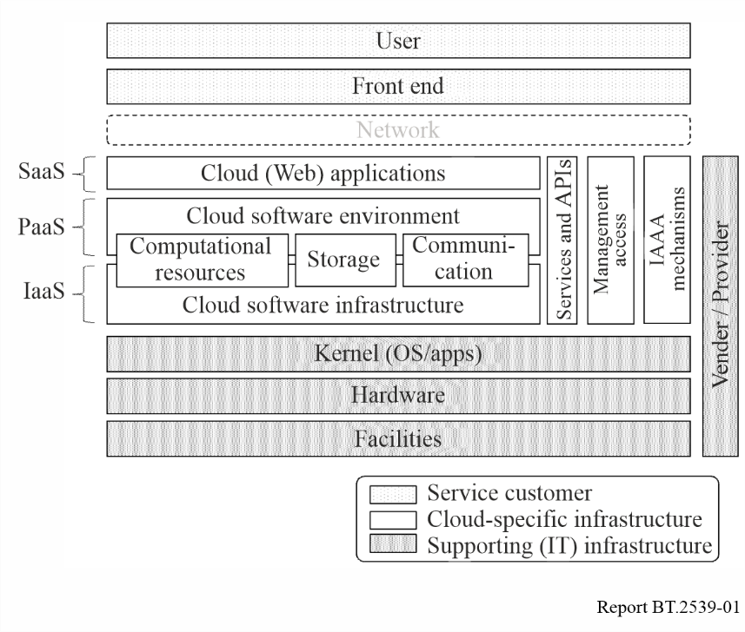
Cloud computing systems can be described on the basis of workflows and applications. Figure 2 shows an example of a system description, where the various elements of functions, instances, components, and applications are provided as SaaS, PaaS, or IaaS on the cloud.
FIGURE 2
Example of system diagram of programme production on cloud computing
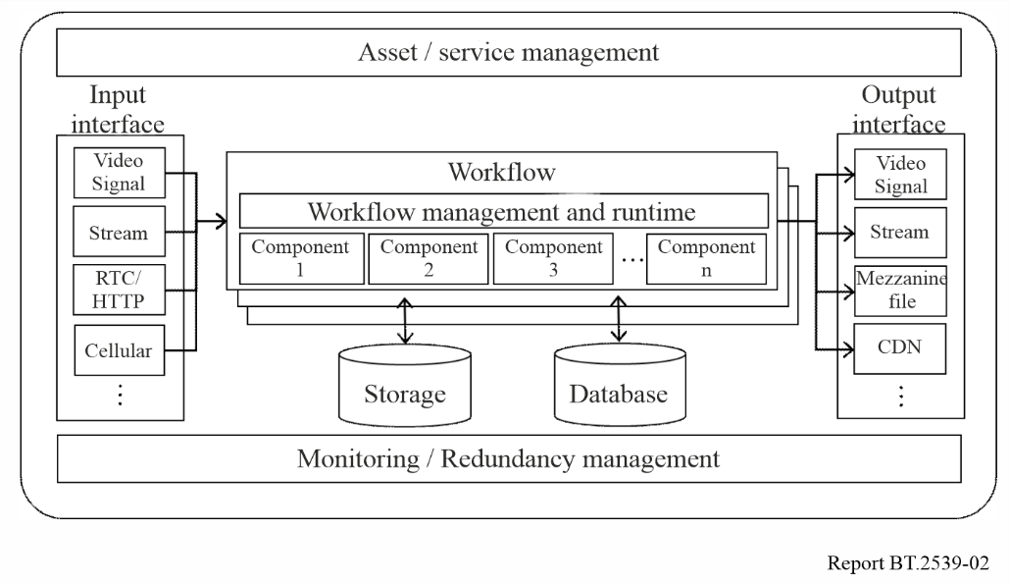

2.2 Concept of availability in cloud computing
In conventional on-premises broadcasting infrastructures, reliability and availability are guaranteed by duplicated or multiple backup systems. The concept of reliability and availability in cloud computing, which is designed as a distributed system, is different from those in conventional infrastructures.
Cloud service providers declare a guaranteed percentage of availability for specific units such as regions, data centres, and system units in a Service Level Agreement (SLA). Normally, the larger the scale of a unit, the higher its availability. For example, take a certain cloud computing vendor that shows the availability percentages of 99.95% for regions, 99.5% for data centres, and 95% for components. The SLA percentages defined for each item can only be ensured if the system is configured and deployed correctly; otherwise, a single point of failure may cause service degradation. Figure 3 shows an example of different availability models, in which availability zones are different between two deployment examples. In this case, deployment example A can provide higher availability in the unit of regions.
FIgure 3
Example of deployment and different availabilities
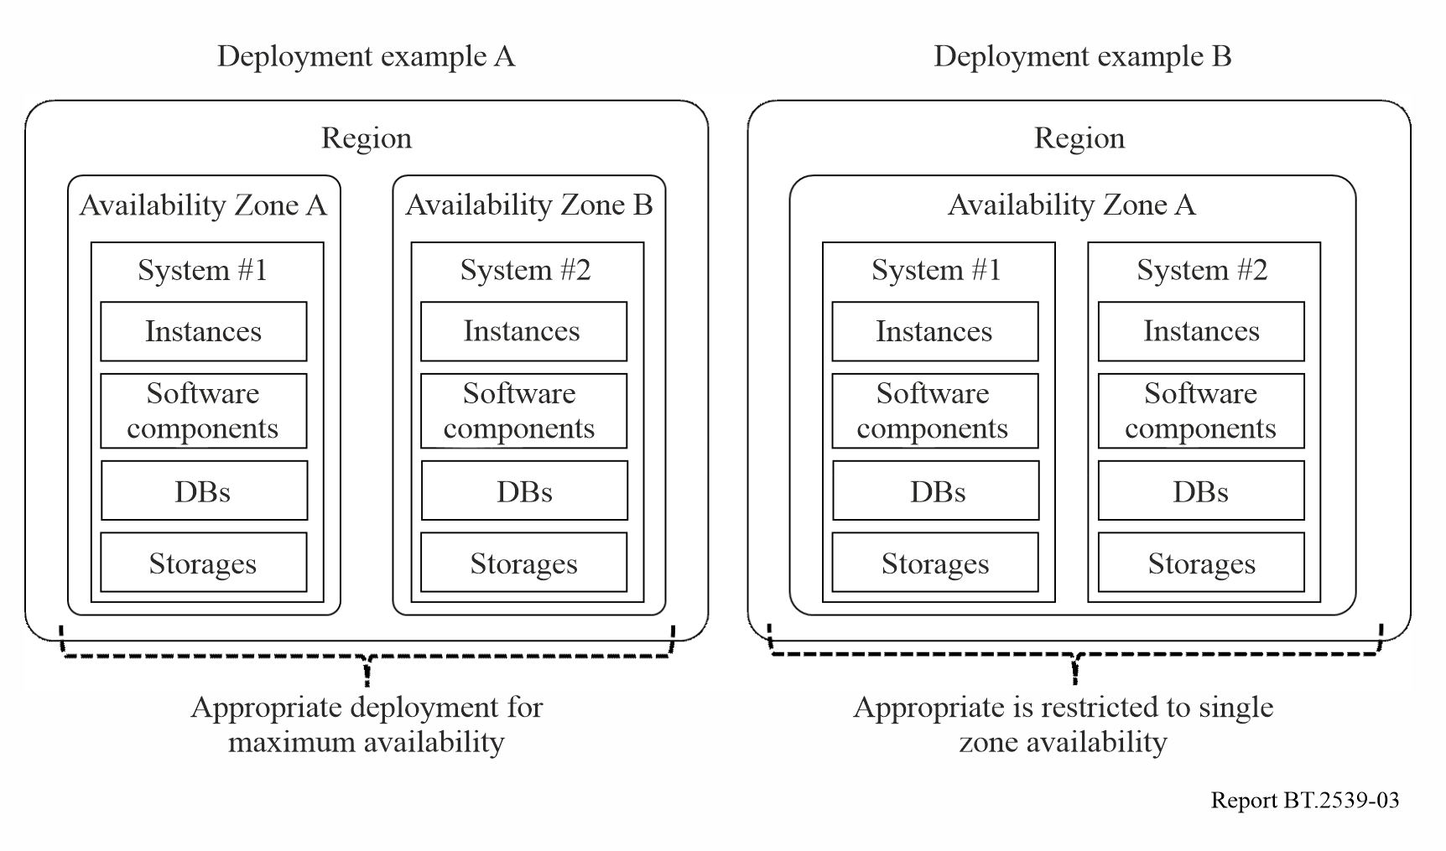

3 Use of cloud computing for programme production

3.1 Benefits of using cloud computing
In recent years, with the major changes in work styles partly triggered by the COVID-19 pandemic, the use of cloud computing in the broadcast industry has been gradually increasing.
Using cloud computing for programme production has the following benefits.
– Simplicity of system construction
By using cloud computing, one no longer needs to prepare hardware equipment for programme production, such as video switchers, audio mixers, graphics servers, media storage, and encoders. Moreover, a system can be constructed anywhere within or outside the broadcast station, as long as the network with the cloud is available. This will reduce the time and cost required for building systems.
– Flexibility and scalability
Cloud computing allows for a flexible system architecture to meet the required scale of the system for programme production, as it provides on-demand access to the resources needed. Additionally, even if the load increases beyond what was expected at the time of system design, flexible scaling is possible by increasing the number of virtual machines.
– Remote production
In cloud-based programme production, equipment other than capture devices such as cameras and microphones can be built in the form of software on the cloud. This eliminates the need to install a broadcast van or major equipment at the venue, making it possible to conduct remote production with minimal equipment and staff.
A remote production centre can be built anywhere within or outside the broadcast station as long as the network with the cloud is available.
– Collaboration
In a cloud computing environment, members of a programme production team can access the cloud individually and simultaneously to perform their tasks, such as uploading materials and editing and previewing content, regardless of location or time. In addition, with the use of communication tools, team members can work together, making it easier to collaborate without the need to gather in a studio or an editing room. This is expected to improve programme production efficiency.
– Business continuity
Cloud computing allows for the construction of systems with physically distributed data centres by dividing regions or availability zones. Backup systems can also be easily built using replication functions. Even if one data centre is damaged, operations can be continued using systems built in other data centres.
– Utilization of the latest technology
The latest technologies can be adopted for cloud computing. Cloud-based data analytics collects, stores, analyses, and visualises data in the cloud. Cloud-based AI provides a variety of services as SaaS, such as automatic editing of highlight scenes and removal of copyrighted background music from content, in addition to core functionalities such as image recognition, natural language processing, and machine learning.

3.2 Broadcast system built on cloud computing

3.2.1 Overview
Figure 4 shows an example of a system overview for live programme production, content editing, media asset management, and programme playout and broadcasting built on the cloud. It is also possible to build only some of the systems or only the backup system on the cloud.
FIGURE 4
Example of cloud-based broadcast system overview
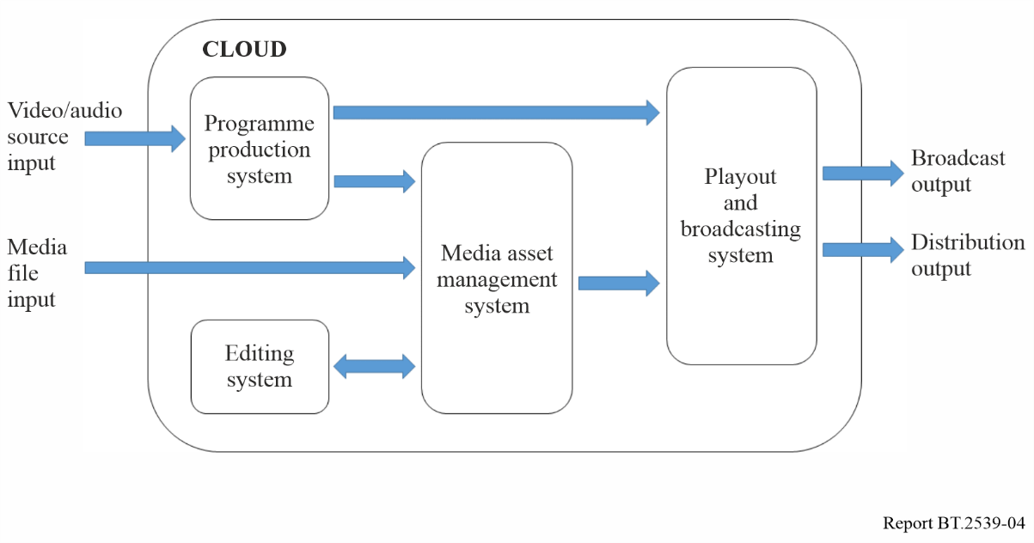

3.2.2 System for cloud-based live programme production
In a cloud-based system, live production is performed by transmitting video and audio from capture devices such as cameras and microphones to the cloud and remotely operating software-based video switchers, audio mixers, and graphics servers that are installed on virtual machines in the cloud (see Fig. 5).
Video switchers and audio mixers are operated via the GUI of a remotely connected PC. Some applications also provide switching panels and mixing consoles so that operations can be performed in a way that is similar to those performed when using on-premises equipment.
The quality of the network and transmission protocol of the signal transmission path from the relay site to the cloud can have significant impacts on the transmission bandwidth, transmission delay, and error rate, which all affect the quality of programmes. Therefore, it is important to carefully choose these factors.
FIGURE 5
Example of system for cloud-based live programme production
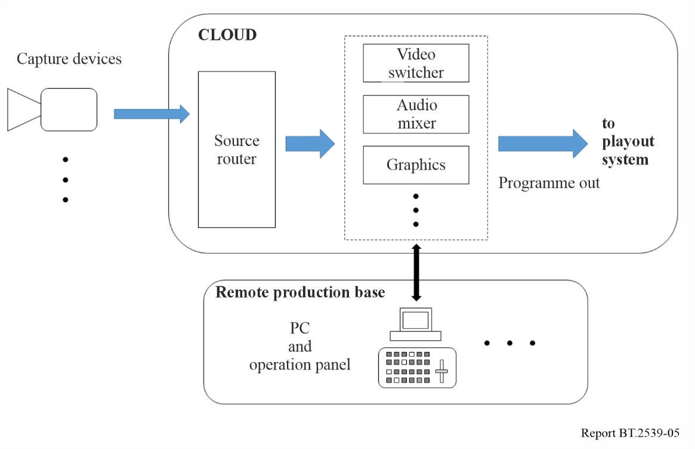

3.2.3 System for cloud-based content editing
In a cloud-based system, content is edited by remotely operating the editing software installed on a virtual machine in the cloud using materials uploaded to the cloud storage. Virtual Desktop Infrastructure (VDI) is often used as an interface for remote connection, allowing editors to operate in a way that is similar to an on-premises environment with high-speed screen transfer (see Fig. 6).
Editors can work from anywhere, without having to bring materials to the editing studio. Moreover, they can work safely on the cloud without having to worry about the security of the materials.
In addition, the materials and programmes produced, as described in the previous section, can often be stored directly in the cloud storage service, making it easy to integrate with cloud editing.
FIGURE 6
Example of system for cloud-based content editing
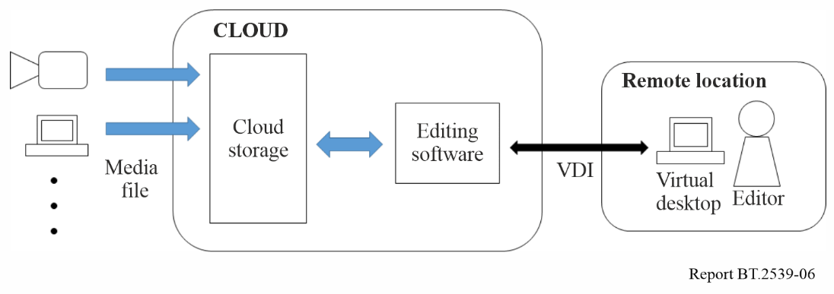

3.2.4 System for cloud-based media asset management
By storing and managing materials and content in cloud storage, one can easily adapt to the growing number of content and distribution platforms. Public cloud storage generally offers multiple service classes with different usage fees depending on several factors such as availability, latency at the time of access, and retrieval frequency. It is necessary to select an appropriate service class for the purpose.
In addition, by using AI services provided by the cloud, it is possible to automatically perform tasks such as adding metadata that identify people, places, and objects, translating audio and subtitles for localization, and resizing images.

3.2.5 System for cloud-based programme playout and broadcasting
In a cloud-based system, programmes are processed in the cloud on virtual machines that are equipped with software-based switchers, encoders, and multiplexers. The processed signals are then transmitted to the transmission facility via the broadcast station. Signals and fault detection alarms at each processing point are monitored remotely from the broadcast station (see Fig. 7).
Building a backup system for the critical broadcasting infrastructure in a different region or availability zone is an effective solution in the case of a disaster.
FIGURE 7
Example of system for cloud-based programme playout and broadcasting
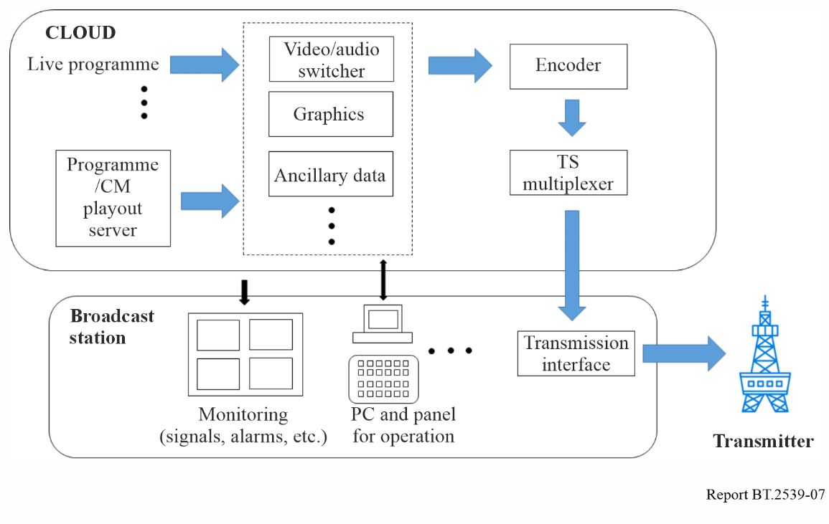

4 Security
Cloud computing requires different security policies from normal on-premises facilities. Generally, in cloud computing services, a service provider usually has the latest security procedures in place at all times, thus users need not be aware of vulnerabilities in hardware, operating systems, and key software components. In contrast, access rights must be strictly defined when using the cloud.
Information leaks, data loss, cyberattacks, unauthorised access, and account hijacking are the major security threats in cloud computing. To counter these threats, multiple approaches need to be considered during the process of adopting cloud computing, including infrastructure, virtual infrastructure, service infrastructure, integrated management environments, data management, data classification, user/identity management, and employee training.
While a cloud service provider is responsible for the security of cloud computing environments, it should be ensured that there are no discrepancies between the security policy of the cloud service provider and the security governance of the user.
In general, there are four aspects of cloud security governance.
– Controls over cloud services availability, fault management, and resilience
– Continuity of services, terms and conditions, and quality provided by cloud service providers
– Lifecycle management of data on cloud services, including storage, replication, backup, and restoration of user data
– Controls over cross-border data transfers between countries with different legal systems when servers are remotely distributed.
Some cloud services are built on private cloud services provided by third-party cloud service providers, or on multiple clouds. It is important to clarify service dependencies and relationships among the clouds during system integration and operation.
Recommendation ITU-T X.1601 – Security framework for cloud computing, provides guidelines for a comprehensive review of security threats and possible solutions. For detailed and specific information, refer to the document and its associated documents.

5 Conclusion
Cloud computing has significant positive impacts on the programme production workflow, primarily because it makes the workflow more efficient and reduces the time required for programme production. Numerous services and applications provided by cloud computing vendors can make production workflow even more efficient and endued with added value.

References
[1] B. Grobauer, T. Walloschek, and E. Stocker, “Understanding Cloud Computing Vulnerabilities”, IEEE Security & Privacy, Volume: 9, Issue: 2, March-April 2011, pp. 50-57.
[2] Recommendation ITU-T Y.3500 “Information technology – Cloud computing –Overview and vocabulary”.
[3] Recommendation ITU-T X.1601 “Security framework for cloud computing”.

Annex 1
Use cases of cloud computing for programme production

A1.1 Production system on cloud computing
Cloud computing improves the convenience and efficiency of programme production. The following is a use case of cloud-based tools for programme production.

A1.1.1 Cloud-based uploading tool
Nippon TV, a commercial broadcaster in Japan, has developed a cloud-based tool that uploads video from outside venues to a non-linear editing system in the broadcasting centre. The uploading tool is built on a public cloud without the assistance of any dedicated software. The uploading tool has been used for news gathering and sports broadcasting.
A) News gathering
Reporters upload video and metadata using the uploading tool from a web-browser on their PC or mobile phone. Security Assertion Markup Language (SAML) is adopted for authentication, which allows users to access the cloud storage without a login process to improve user access and strengthen security. Not only reporters but also end-users can upload video easily through one-time QR code.
B) Sports broadcasting
Figure A1-1 shows the uploading workflow in sports broadcasting.
Programme materials shot at the venue are stored in a local server installed in the OB truck and also uploaded to a public cloud. Operators select clips from the uploaded materials, add metadata, and transfer the clips to the editing centre. The uploading system is also used to send highlights to the news editor during broadcasting.
Automatic synchronization of stored materials on the local server and on the cloud for distribution enables immediate supply of the contents for distribution.
FIGURE A1-1
Uploading workflow in sports broadcasting
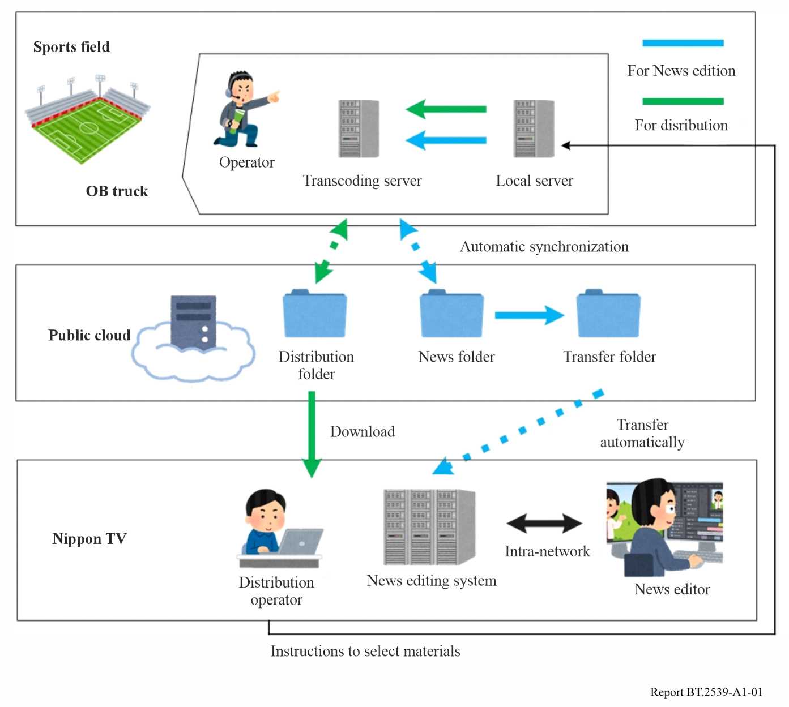

A1.1.2 Cloud-based distribution and recording system
High availability is one of the key features of public cloud services and is an important factor for building systems that can operate even in the event of a natural disaster.
Tokyo Broadcasting System Television, a commercial broadcaster in Japan, has built a cloud-based distribution and recording system for live camera images from its affiliated stations nationwide as shown in Fig. A1-2.
The system was developed to meet the following requirements:
– business continuity plan (BCP) in preparation for a case when the main broadcasting centre is severely damaged due to natural disaster;
– scalability that allows handling of an increasing number of live cameras;
– flexibility to expand functions;
– stability of the system;
– freedom from reliance on dedicated operation terminals.
Affiliated broadcast stations upload live camera images to be recorded in cloud storage. Every station has access to uploaded images from all the stations even when the main broadcasting centre is damaged. All live camera images can be monitored all at once on a web browser as shown in Fig. A1-3. Operators can intuitively perform editing of the recorded images.
The main role of this system is to play out live images and play back recorded images in the event of a disaster for use in news programmes. For example, when an earthquake early warning is issued, the live images near the epicentre are highlighted on the GUI, and the relevant video clips from recorded images are automatically created.
FIGURE A1-2
Cloud-based distribution and recording system for live camera images
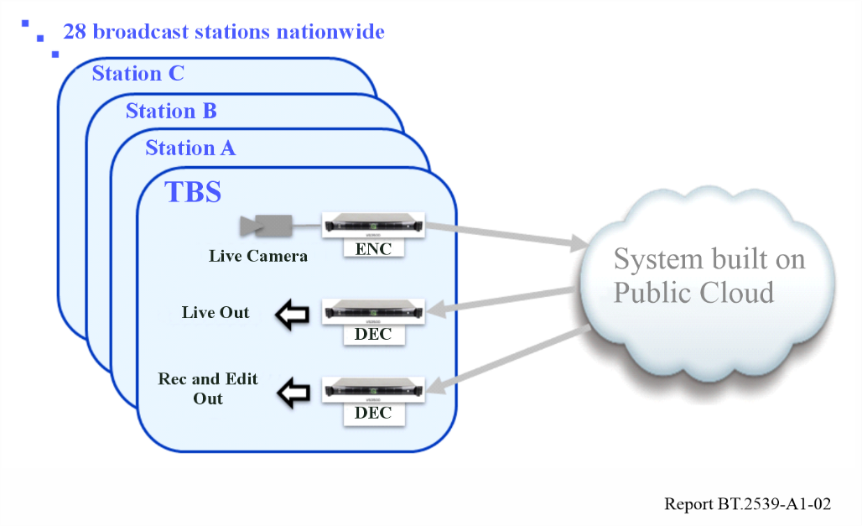
FIGURE A1-3
GUI image on web browser
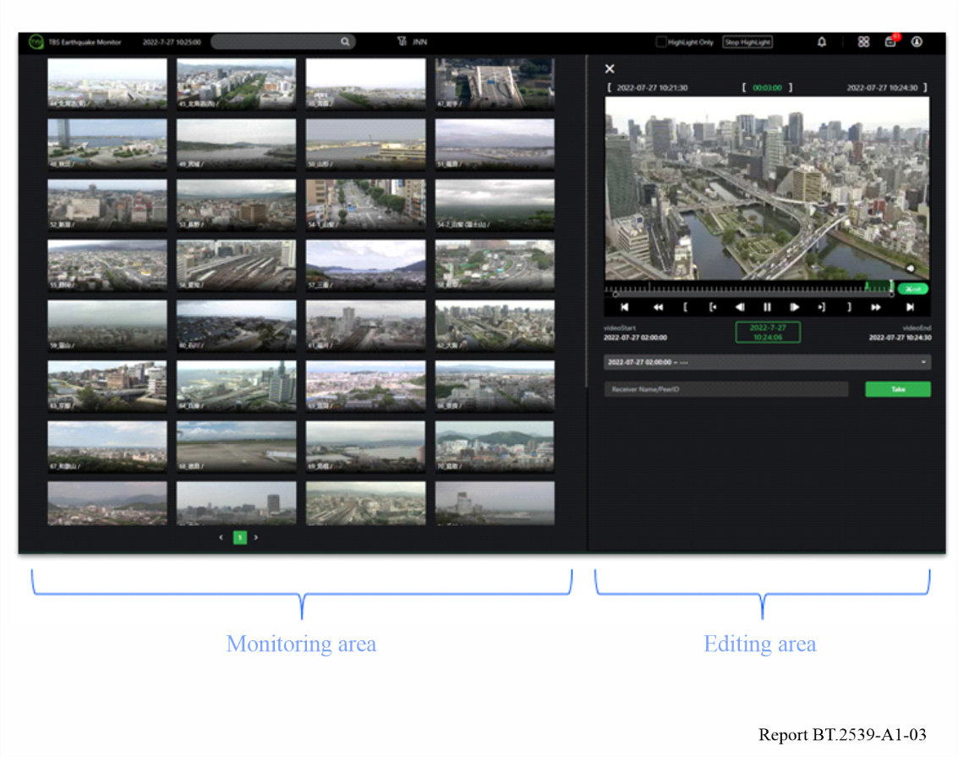

A1.2 Live production on cloud computing
While the modern equipment and technologies used in programme production are highly matured to guarantee stability and functionality, those on cloud computing are still under development. Cloud computing may be more suitable than conventional equipment in the following cases:
– to cover one-off events in a timely manner with little investment;
– to ensure inter-regional redundancy and site diversity; and
– to eliminate special constraints of on-premises systems.
5G technologies are widely spreading for commercial use and are expected to provide ubiquitous, broadband, reliable, and low-latency connection. These features are also useful for services ancillary to programme making (SAP).
The combination of cloud computing and 5G technologies will enable the production of outside broadcasting with mobility and flexibility.

A1.2.1 Cloud-based news gathering
Fuji Television, a commercial broadcaster in Japan, introduced the concept of “cloud-based news gathering (CNG)” as a framework for workflow innovation brought about by cloud computing in the contribution, distribution, production, and delivery of news programmes. As a proof of this concept, a programme production trial was carried out in 2021 to confirm the following items:
– redundancy of contribution feed;
– feeding and controlling from multiple remote sites;
– use of extensive transfer protocols;
– distribution to OTT platforms.
Figure A1-4 shows the setup of this experiment, where contribution, production, and distribution systems are deployed on a private cloud platform. Several software components have been implemented for input functions to handle the signals in multiple protocols, a video switcher, an audio mixer, a superimposer, and an output feeder to stream a completed programme.
Figure A1-4
Setup of production trial of cloud-based news gathering
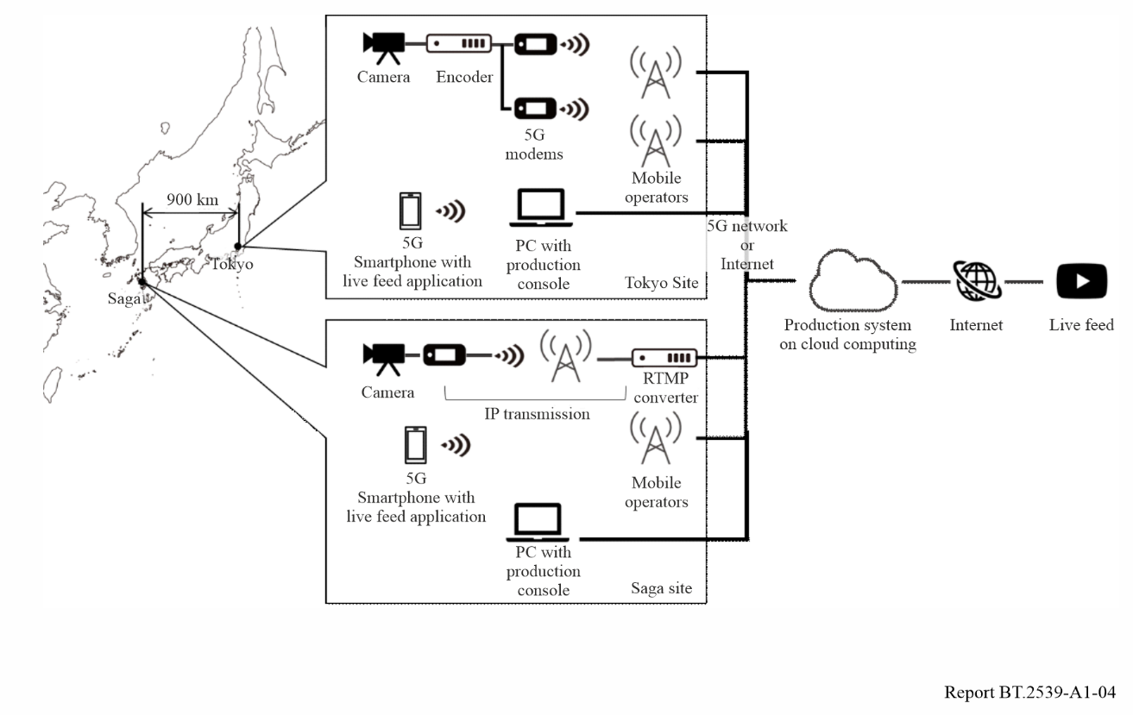
Two scenes of this trial are provided in Fig. A1-5, where the left shows the location of camera shooting and the right shows a production operation using a laptop PC with console software.
figure A1-5
Production site of cloud-based news gathering trial
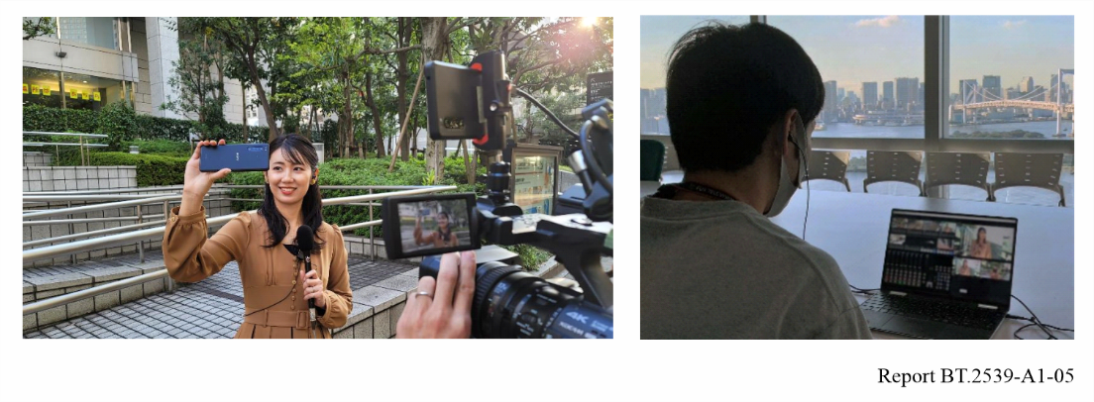
The following items have been confirmed through this trial:
– the input function can select and change over to the right signal feed fed simultaneously in multiple routes on the basis of quality parameters;
– live video streams between Tokyo and Saga (about 900 km apart) can be fed and controlled from both sites;
– multiple protocols including the Real Time Messaging Protocol (RTMP), Secure Reliable Transport (SRT), and various vendor-specific protocols were successfully used;
– the system can feed programme outputs to a live streaming service (YouTube Live) platform.

A1.3 Cloud-based live productions and distributions
TV Asahi, a commercial broadcaster in Japan, is working with ABEMA NEWS, an OTT distribution service provider, on Cloud Live Production (CLP) for live programme production that uses applications on cloud platforms to improve operational efficiency and promote its operational shift to teleworking. CLP-based systems have been introduced for daily programme productions and distributions to make the systems scalable and location-independent.
In OTT distribution, it is common to have one live programme simulcasted to various OTT platforms. However, in many cases the same contents are not distributed simply due to the difference of distribution starting times and restrictions of content rights. Some parts of the programme content thus need to be replaced with specific images or different camera feeds. This operation is carried out by a different operator from the main programme production. For this operation, a software-based system was developed on the cloud platform. It can be controlled on PCs or smartphones from any location far from a venue of the main programme production. A software-based switcher has also been built on a general operating system with a GPU instance of the cloud service (Fig. A1-6). The Secure Reliable Transport (SRT) protocol for video transmission provides strong error corrections. Network Device Interface High Efficiency (NDI|HX) is supported to enable PTZ camera control from remote locations. Control panel applications are available on web browsers. The location-independent feature also allows outsourcing of the operation even in remote locations. Its operation has been delegated to staff in Okinawa, which is 1 600 km away from the studio in Tokyo.
Figure A1-6
Basic system configuration on the cloud
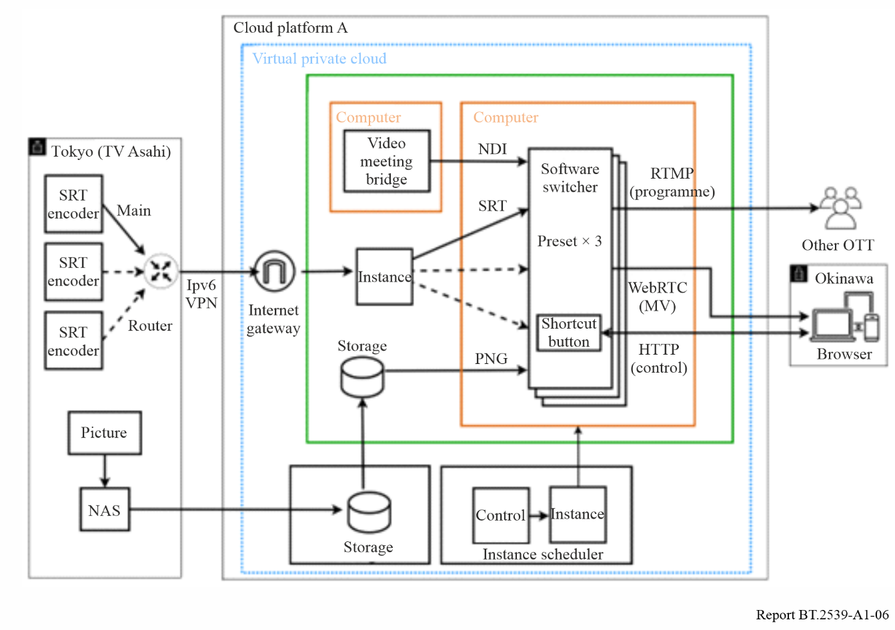
In order to improve system availability, dual systems have been built on two different availability zones or two different cloud platforms to provide redundancy, as shown in Fig. A1-7.
Figure A1-7
Basic configuration of multi-cloud platform
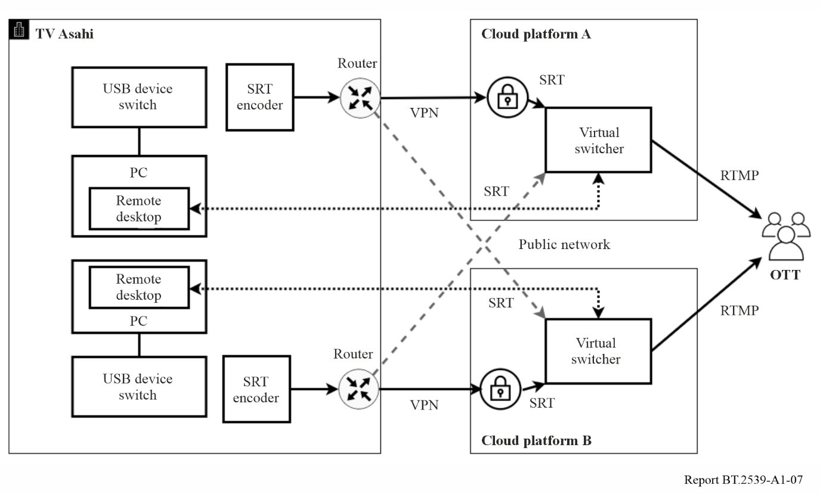
The following issues need to be addressed in the future:
– time synchronisation function for video and audio;
– redundancy of the switching function between clouds;
– handling procedure against breakdowns of network connected to the cloud.

Reports ITU-R BS/BT.2522 – A framework for the future of broadcasting, and ITU-R BS/BT.2524 – A framework for the future of broadcast production, provide high level overviews of the operational use of cloud services in programme production.

