Report ITU-R BT.2539-1
(09/2025)
BT Series: Broadcasting service (television)
Use of cloud computing for programme production

Foreword
The role of the Radiocommunication Sector is to ensure the rational, equitable, efficient and economical use of the radio-frequency spectrum by all radiocommunication services, including satellite services, and carry out studies without limit of frequency range on the basis of which Recommendations are adopted.
The regulatory and policy functions of the Radiocommunication Sector are performed by World and Regional Radiocommunication Conferences and Radiocommunication Assemblies supported by Study Groups.

Policy on Intellectual Property Right (IPR)
ITU-R policy on IPR is described in the Common Patent Policy for ITU-T/ITU-R/ISO/IEC referenced in Resolution ITU-R 1. Forms to be used for the submission of patent statements and licensing declarations by patent holders are available from https://www.itu.int/ITU-R/go/patents/en where the Guidelines for Implementation of the Common Patent Policy for ITU-T/ITU-R/ISO/IEC and the ITU-R patent information database can also be found.

Series of ITU-R Reports
(Also available online at https://www.itu.int/publ/R-REP/en)
Series | Title
BO | Satellite delivery
BR | Recording for production, archival and play-out; film for television
BS | Broadcasting service (sound)
BT | Broadcasting service (television)
F | Fixed service
M | Mobile, radiodetermination, amateur and related satellite services
P | Radio-wave propagation
RA | Radio astronomy
RS | Remote sensing systems
S | Fixed-satellite service
SA | Space applications and meteorology
SF | Frequency sharing and coordination between fixed-satellite and fixed service systems
SM | Spectrum management
TF | Time signals and frequency standards emissions

Note: This ITU-R Report was approved in English by the Study Group under the procedure detailed in Resolution ITU-R 1.

Electronic Publication
Geneva, 2025
© ITU 2025
All rights reserved. No part of this publication may be reproduced, by any means whatsoever, without written permission of ITU.

REPORT ITU-R BT.2539-1
Use of cloud computing for programme production
(2024-2025)
TABLE OF CONTENTS
Page

1 Introduction 2
2 Overview of cloud computing 2
2.1 Architecture model of cloud computing 2
2.2 Concept of availability in cloud computing 3
2.3 Cloud-Edge-Terminal (CET) platform architecture 4
3 Use of cloud computing for programme production 6
3.1 Benefits of using cloud computing 6
3.2 Broadcast system built on cloud computing 7
3.3 Production service provided by CET platform 9
4 Security 13
5 Conclusion 14
References 14
Annex 1 – Use cases of cloud computing for programme production 14
A1.1 Production system on cloud computing 14
A1.2 Live production on cloud computing 18
A1.3 Cloud-based live productions and distributions 20
Annex 2 – Omnimedia content production platform based on Cloud-Edge-Terminal (CET) architecture 21
A2.1 Overview 21
A2.2 CMG Media Cloud platform application cases 22

1 Introduction
Cloud computing technologies are continuously evolving to improve the performance and functionality of information communication technologies (ICTs). Applications of cloud computing are now being extended from high-performance computing and the substitution of on-premises infrastructures, such as virtual servers, scalable storage, and databases to more complex media processes to enable efficient workflow of broadcasting operations. Over-the-top (OTT) service operators have been deploying their service infrastructures on cloud platforms that feature multiple media-related capabilities.

2 Overview of cloud computing

2.1 Architecture model of cloud computing
Cloud computing provides resources for computing, storage, databases, and applications. These resources are scalable and flexible for respectively assigning and combining components and functions. Figure 1 shows a basic architecture of cloud computing and three major service models, namely, infrastructure as a service (IaaS), platform as a service (PaaS), and software as a service (SaaS), which are defined in Recommendation ITU-T Y.3500 [1] [2].
There are three different types of deployment to meet system requirements: private cloud, public cloud, and hybrid cloud. A private cloud system is deployed on an infrastructure owned by a user company and managed by the same company. This type of system is designed for strict information security or privacy. A public cloud system is operated by commercial cloud vendors. A hybrid cloud system is deployed on mixed infrastructures consisting of both private and public cloud systems.
FIGURE 1
Cloud computing architecture model
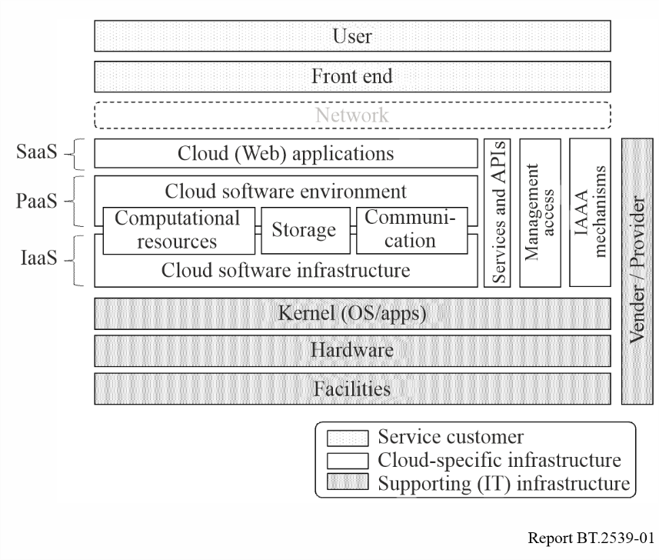
Cloud computing systems can be described on the basis of workflows and applications. Figure 2 shows an example of a system description, where the various elements of functions, instances, components, and applications are provided as SaaS, PaaS, or IaaS on the cloud.
FIGURE 2
Example of system diagram of programme production on cloud computing
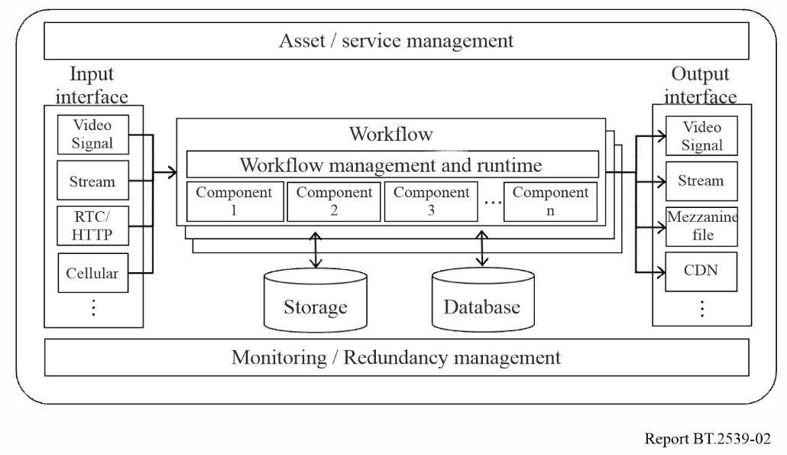

2.2 Concept of availability in cloud computing
In conventional on-premises broadcasting infrastructures, reliability and availability are guaranteed by duplicated or multiple backup systems. The concept of reliability and availability in cloud computing, which is designed as a distributed system, is different from those in conventional infrastructures.
Cloud service providers declare a guaranteed percentage of availability for specific units such as regions, data centres, and system units in a Service Level Agreement (SLA). Normally, the larger the scale of a unit, the higher its availability. For example, take a certain cloud computing vendor that shows the availability percentages of 99.95% for regions, 99.5% for data centres, and 95% for components. The SLA percentages defined for each item can only be ensured if the system is configured and deployed correctly; otherwise, a single point of failure may cause service degradation. Figure 3 shows an example of different availability models, in which availability zones are different between two deployment examples. In this case, deployment example A can provide higher availability in the unit of regions.
FIgure 3
Example of deployment and different availabilities
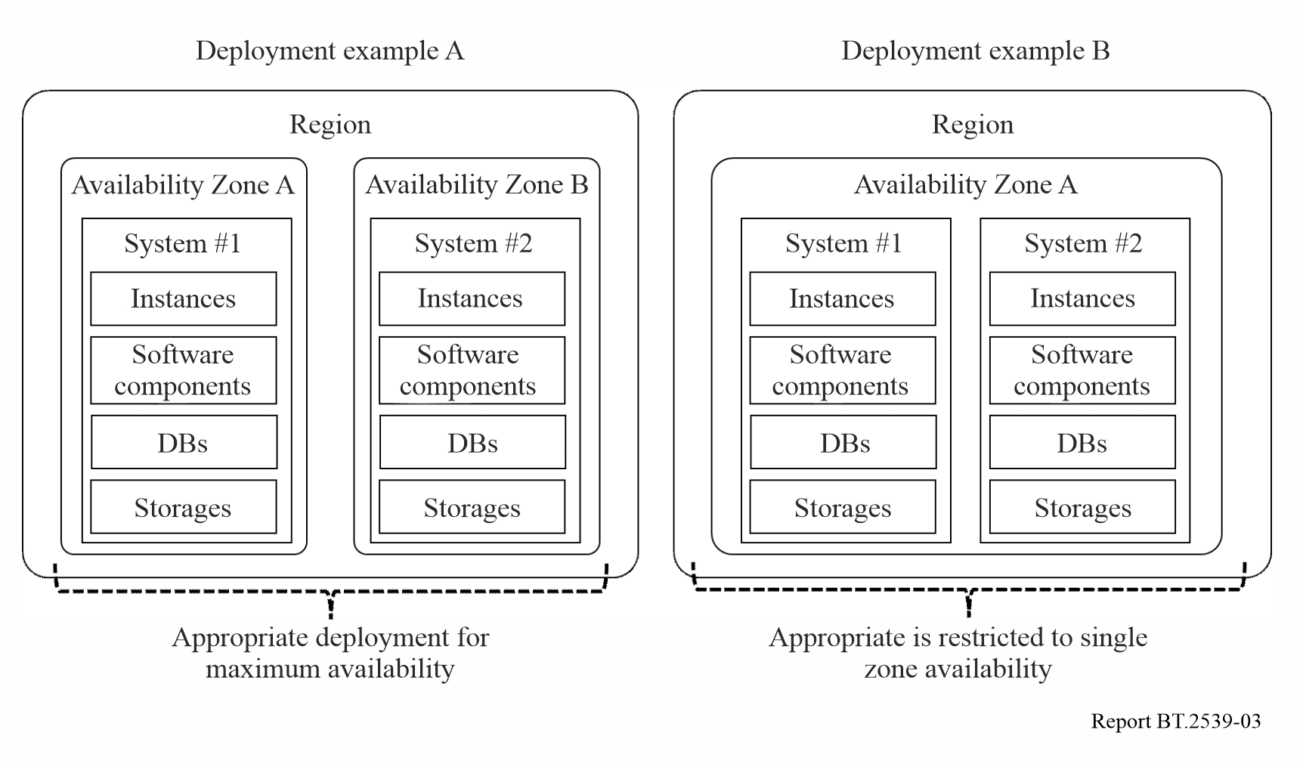

2.3 Cloud-Edge-Terminal (CET) platform architecture
With the continuous advancement of IT in the media industry, cloud platforms have become an important infrastructure supporting omnimedia production. Media content production, represented by 4K/8K ultra-high-definition (UHD), requires high computing power, high bandwidth and low latency. Its massive data volume also creates efficiency issues in data interaction between the “cloud” and the “edge”.
The maturity of technologies such as 5G Mobile Edge Computing (MEC) and Software-Defined Wide Area Network (SD-WAN) has gradually enabled the industrial application of edge computing. This application scenario, which deploys computing power at edge nodes and shifts service production to edge areas, is particularly suitable for the production of 4K/8K UHD media content. By leveraging the CET architecture, it is possible to build a production platform that serves a wider range of users, offering enhanced capabilities across multiple dimensions, as shown in Fig. 4.
Figure 4
CET platform architecture
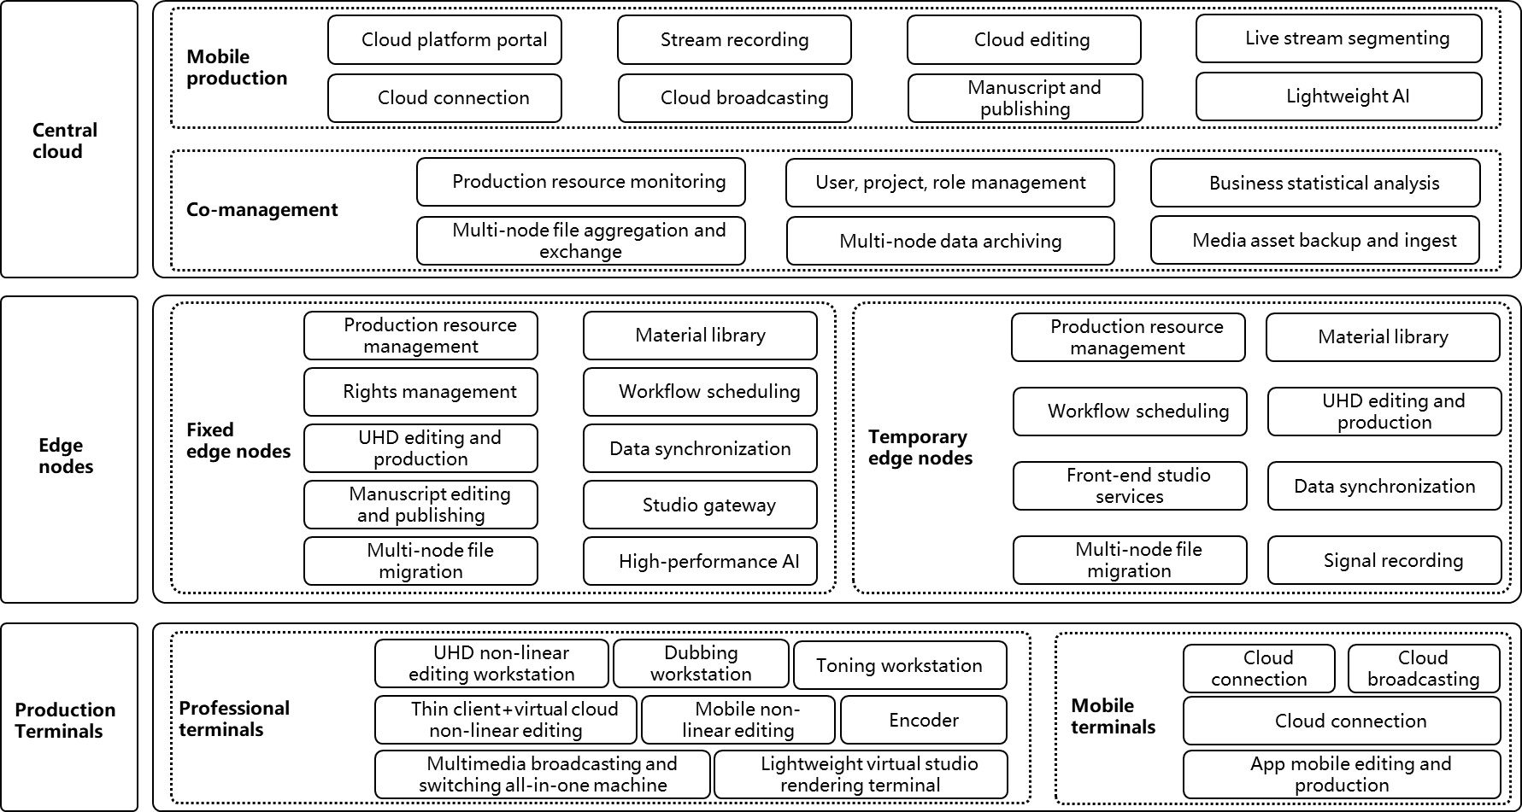

2.3.1 Definition
The CET platform architecture consists of three layers: the central cloud, edge nodes and the production terminal. It supports users in meeting the production demands of various scenarios, such as professional production and mobile production.
Central cloud
The central cloud is the most critical component of the cloud-edge-terminal architecture. It provides unified user management, resource monitoring, data file interaction, and other essential services, facilitating resource aggregation and cross-regional collaborative management across the platform. The central cloud can also offer a variety of cloud-based production services and tools, supporting lightweight production workflows. In terms of deployment, the central cloud can be deployed in public cloud, private cloud, or hybrid cloud modes according to functional requirements.
Edge nodes
Edge nodes are a critical component of the platform, and they are categorized into fixed and temporary types based on different service. needs. Fixed edge nodes primarily provide technical services to media organizations’ headquarters, while temporary edge nodes offer short-term technical support for large events such as sports competitions. Edge nodes can be deployed using 5G edge computing or private cloud methods, providing unified support for high computing power, large bandwidth, and low latency services to support various production tasks.
Production terminals
The production terminal devices encompass a wide range of types, including specialized production terminals, laptops, office computers, smartphones, tablets and more. These devices support both independent production by a single device and collaborative production through a production area composed of multiple devices. The production terminal can connect to the central cloud or edge nodes via dedicated lines, 5G networks, or even the internet, depending on the specific production needs of different scenarios.

2.3.2 Cloud-edge coordination
Based on cloud computing technology, the CET platform introduces edge nodes, building cloud-based resources and service capabilities at the edge to achieve complementary collaboration with the central cloud.
Resource collaboration
The central cloud serves as the hub for resource exchange, facilitating the aggregation, transmission, and intelligent analysis of media content. Through flexible media data and metadata management strategies between the central cloud and edge nodes, resource interoperability is achieved.
Service collaboration
Edge nodes support local content production, while the central cloud is responsible for unified distribution, archiving, and publishing. It manages the scheduling of production processes, including the preparation for broadcast and permanent storage of HD/UHD TV programmes and high-value content.

3 Use of cloud computing for programme production

3.1 Benefits of using cloud computing
In recent years, with the major changes in work styles partly triggered by the COVID-19 pandemic, the use of cloud computing in the broadcast industry has been gradually increasing.
Using cloud computing for programme production has the following benefits.
– Simplicity of system construction
By using cloud computing, one no longer needs to prepare hardware equipment for programme production, such as video switchers, audio mixers, graphics servers, media storage, and encoders. Moreover, a system can be constructed anywhere within or outside the broadcast station, as long as the network with the cloud is available. This will reduce the time and cost required for building systems.
– Flexibility and scalability
Cloud computing allows for a flexible system architecture to meet the required scale of the system for programme production, as it provides on-demand access to the resources needed. Additionally, even if the load increases beyond what was expected at the time of system design, flexible scaling is possible by increasing the number of virtual machines.
– Remote production
In cloud-based programme production, equipment other than capture devices such as cameras and microphones can be built in the form of software on the cloud. This eliminates the need to install a broadcast van or major equipment at the venue, making it possible to conduct remote production with minimal equipment and staff.
A remote production centre can be built anywhere within or outside the broadcast station as long as the network with the cloud is available.
– Collaboration
In a cloud computing environment, members of a programme production team can access the cloud individually and simultaneously to perform their tasks, such as uploading materials and editing and previewing content, regardless of location or time. In addition, with the use of communication tools, team members can work together, making it easier to collaborate without the need to gather in a studio or an editing room. This is expected to improve programme production efficiency.
– Business continuity
Cloud computing allows for the construction of systems with physically distributed data centres by dividing regions or availability zones. Backup systems can also be easily built using replication functions. Even if one data centre is damaged, operations can be continued using systems built in other data centres.
– Utilization of the latest technology
The latest technologies can be adopted for cloud computing. Cloud-based data analytics collects, stores, analyses, and visualises data in the cloud. Cloud-based AI provides a variety of services as SaaS, such as automatic editing of highlight scenes and removal of copyrighted background music from content, in addition to core functionalities such as image recognition, natural language processing, and machine learning.

3.2 Broadcast system built on cloud computing

3.2.1 Overview
Figure 5 shows an example of a system overview for live programme production, content editing, media asset management, and programme playout and broadcasting built on the cloud. It is also possible to build only some of the systems or only the backup system on the cloud.
FIGURE 5
Example of cloud-based broadcast system overview
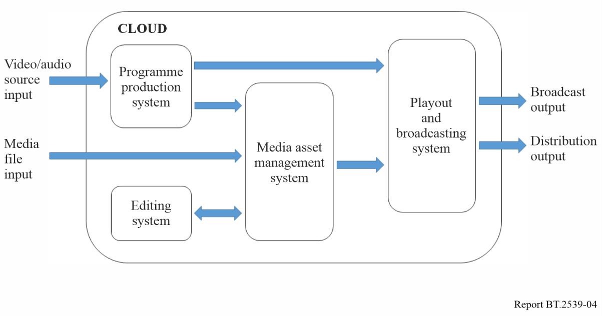

3.2.2 System for cloud-based live programme production
In a cloud-based system, live production is performed by transmitting video and audio from capture devices such as cameras and microphones to the cloud and remotely operating software-based video switchers, audio mixers, and graphics servers that are installed on virtual machines in the cloud (see Fig. 6).
Video switchers and audio mixers are operated via the GUI of a remotely connected PC. Some applications also provide switching panels and mixing consoles so that operations can be performed in a way that is similar to those performed when using on-premises equipment.
The quality of the network and transmission protocol of the signal transmission path from the relay site to the cloud can have significant impacts on the transmission bandwidth, transmission delay, and error rate, which all affect the quality of programmes. Therefore, it is important to carefully choose these factors.
FIGURE 6
Example of system for cloud-based live programme production
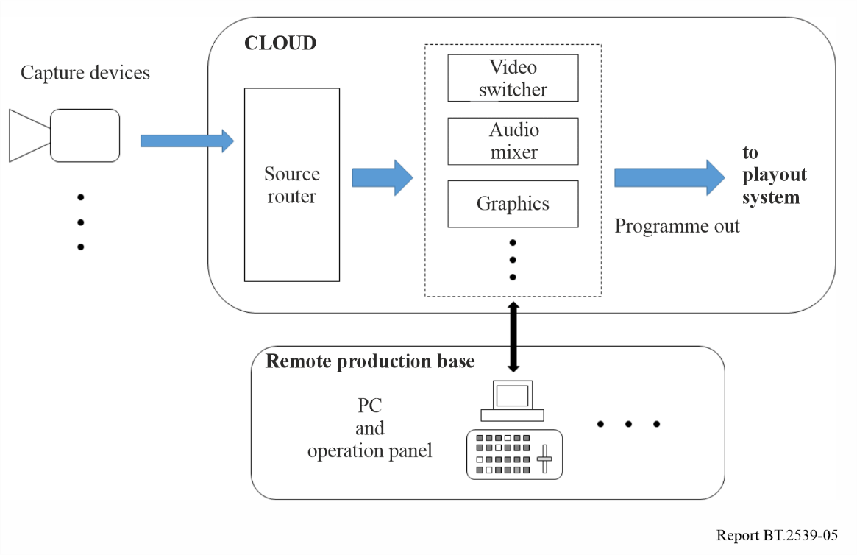

3.2.3 System for cloud-based content editing
In a cloud-based system, content is edited by remotely operating the editing software installed on a virtual machine in the cloud using materials uploaded to the cloud storage. Virtual Desktop Infrastructure (VDI) is often used as an interface for remote connection, allowing editors to operate in a way that is similar to an on-premises environment with high-speed screen transfer (see Fig. 7).
Editors can work from anywhere, without having to bring materials to the editing studio. Moreover, they can work safely on the cloud without having to worry about the security of the materials.
In addition, the materials and programmes produced, as described in the previous section, can often be stored directly in the cloud storage service, making it easy to integrate with cloud editing.
FIGURE 7
Example of system for cloud-based content editing
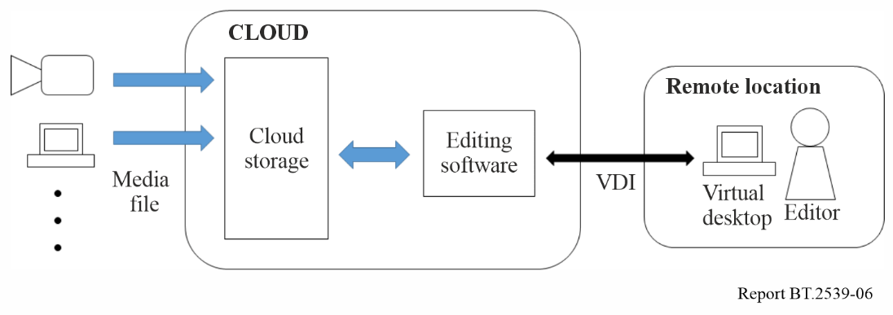

3.2.4 System for cloud-based media asset management
By storing and managing materials and content in cloud storage, one can easily adapt to the growing number of content and distribution platforms. Public cloud storage generally offers multiple service classes with different usage fees depending on several factors such as availability, latency at the time of access, and retrieval frequency. It is necessary to select an appropriate service class for the purpose.
In addition, by using AI services provided by the cloud, it is possible to automatically perform tasks such as adding metadata that identify people, places, and objects, translating audio and subtitles for localization, and resizing images.

3.2.5 System for cloud-based programme playout and broadcasting
In a cloud-based system, programmes are processed in the cloud on virtual machines that are equipped with software-based switchers, encoders, and multiplexers. The processed signals are then transmitted to the transmission facility via the broadcast station. Signals and fault detection alarms at each processing point are monitored remotely from the broadcast station (see Fig. 8).
Building a backup system for the critical broadcasting infrastructure in a different region or availability zone is an effective solution in the case of a disaster.
FIGURE 8
Example of system for cloud-based programme playout and broadcasting
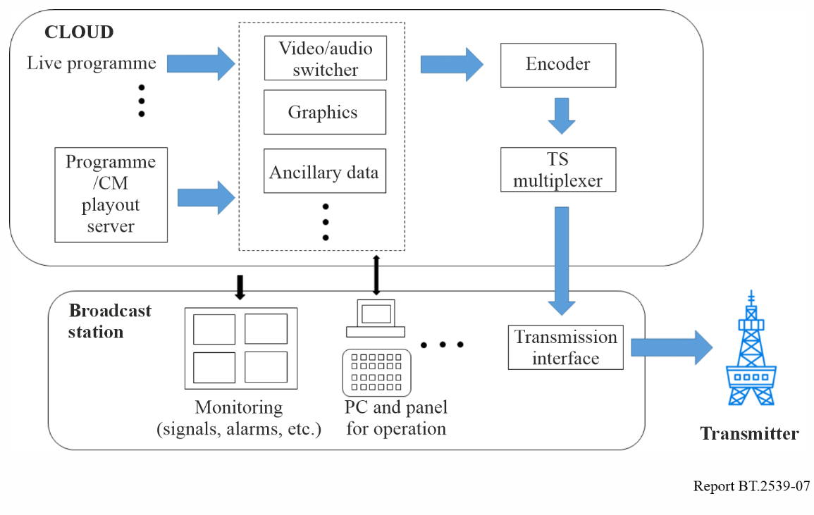

3.3 Production service provided by CET platform
The CET platform architecture provides users with a collaborative production model that spans across regions, devices, and networks. Leveraging the centralized management capabilities of the central cloud, it aggregates resource information from various edge nodes and utilizes flexible scheduling logic to enable fast sharing and transmission of content, thus meeting the needs of users in diverse collaborative production scenarios.

3.3.1 Material sharing and interaction across edge nodes
Between multiple edge node production areas, material sharing and interaction across domains and production areas can be realized based on service requirements, as shown in Fig. 9. Edge node production areas can initiate content archiving and program preparation workflows through the central cloud. Users can trigger content sharing and interaction workflows between different edge node production areas via the central cloud, enabling cross-domain data sharing across multiple nodes.
Figure 9
Material sharing and interaction process across edge nodes
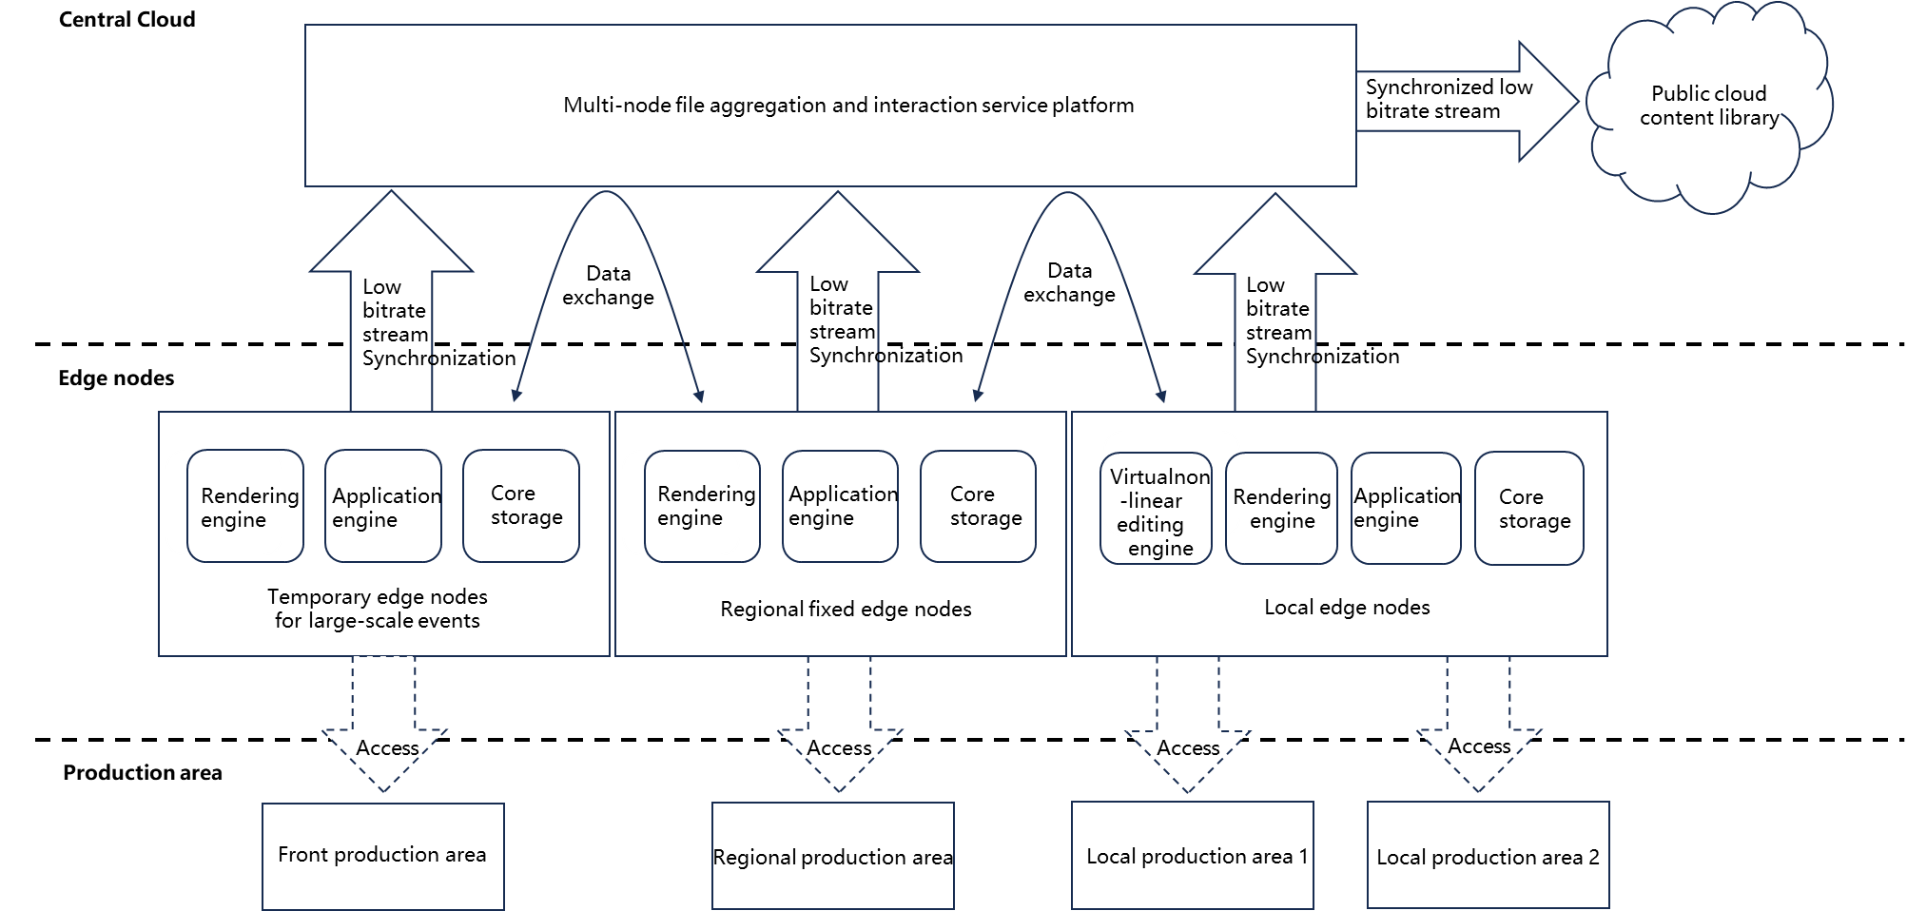
Program delivery process
Once the finished program is produced in the edge node production area, it establishes a delivery service relationship with the broadcasting system. The programme’s metadata and audio-visual data are transmitted back to the central cloud. After being received by the central cloud’s unified process engine, the delivery process is initiated.
Material archiving process
Materials from the edge node production area are archived through the central cloud’s archiving service, establishing a service relationship with the media asset management system. The material’s metadata and audio-visual data are sent back to the central cloud. After being received by the central cloud’s unified process engine, the archiving process is initiated.
Cross-edge node material interaction process
Users in the edge node production area synchronize proxy bitrate files and mobile production release files of their materials to the central cloud. Users can browse materials within their permission scope in the central cloud’s unified resource library and share these materials with users in other production areas. The central cloud initiates the interaction process to enable material sharing among various edge node production areas.

3.3.2 Cross-domain collaborative production
Users in internet-covered regions can access the central cloud through technologies such as 5G, with proxy bitrate technology supporting HD/UHD content production. Users in production areas can access the resource library of edge nodes through thin terminals and utilize various virtualization editing services deployed at the edge nodes for ultra-high-definition programme production, as shown in Fig. 10.
Figure 10
Cross-domain collaborative production
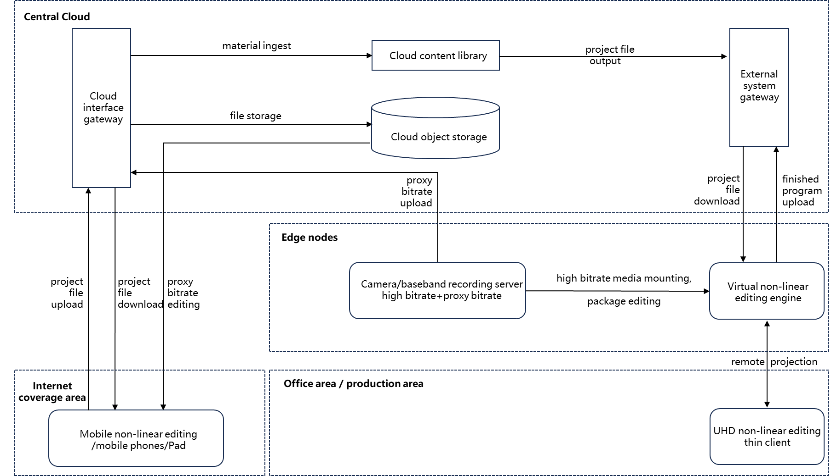
Transfer high-bitrate files of on-site footage/materials to the edge nodes and upload the proxy bitrate files to the central cloud. Use mobile production terminals to select and perform rough edits on proxy bitrate materials, then upload the rough-edited timeline project files to the central cloud. The central cloud synchronizes the timeline project files to the edge nodes. The edge nodes retrieve the timeline project files, import them, apply the high-bitrate files, and perform fine editing to complete the program production.

3.3.3 HD/UHD program production
At the edge node side, heavy tasks requiring high computational power, high bandwidth, and low latency can be addressed locally. The CET platform enhances system scalability through microservice containerization and integrates the entire acquisition, editing, and broadcasting workflow, thereby improving production and broadcasting efficiency. The process is illustrated in Fig. 11.
Figure 11
HD/UHD program production
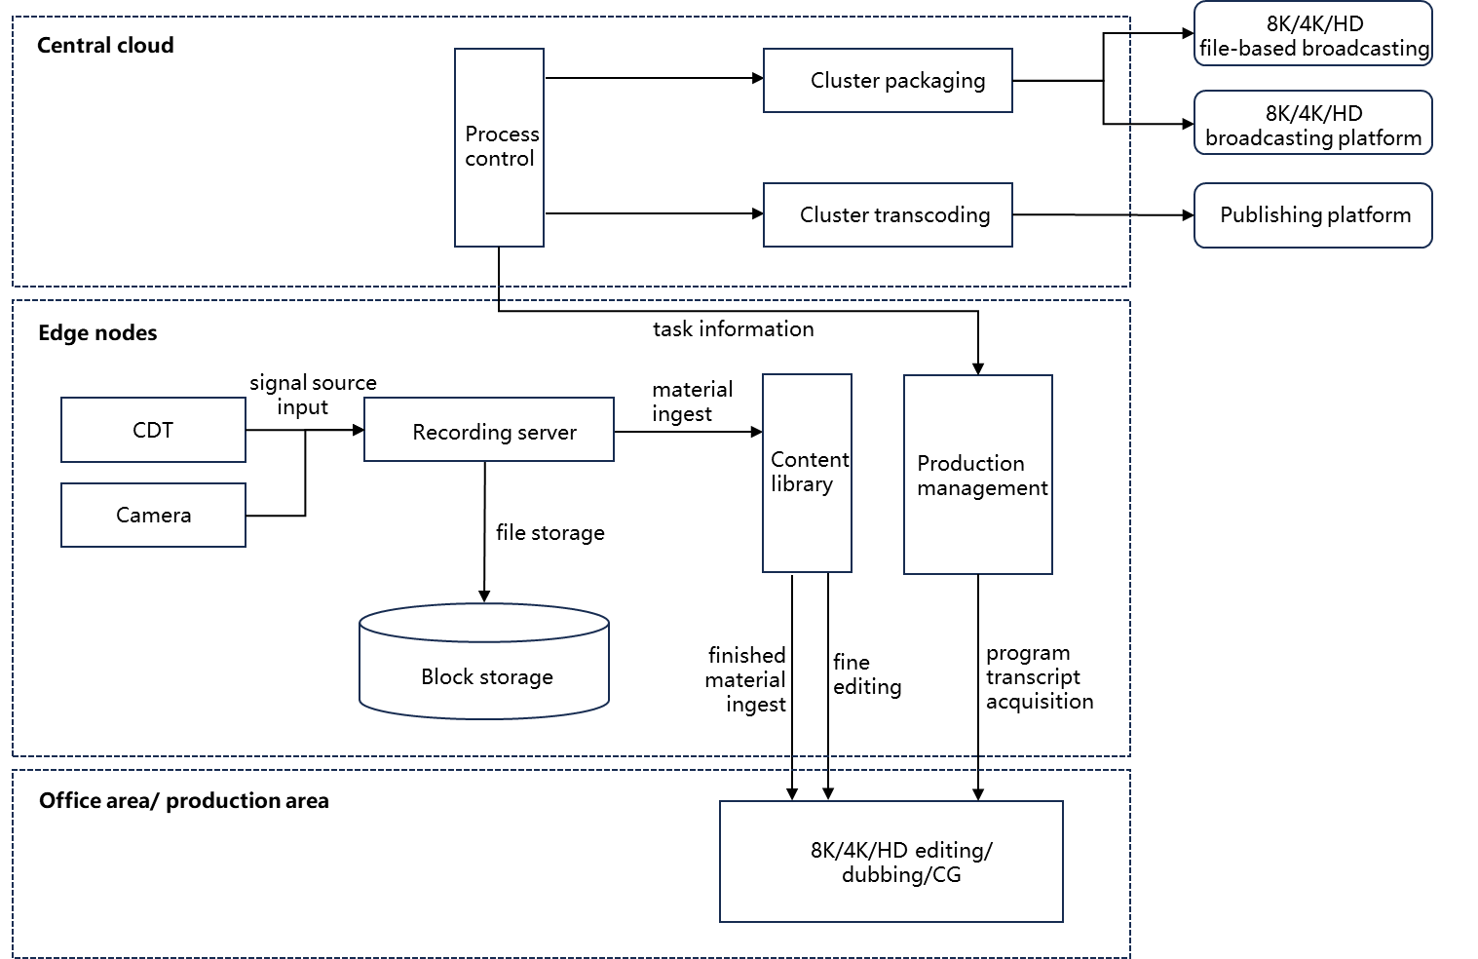
Signal recording
The system employs a highly integrated approach for recording, supporting the capture of both baseband and IP signals. For HD content, DNxHD encoding is used; for 4K content, XAVC; and for 8K content, JPEG-XS. Additionally, proxy bitrate videos are generated simultaneously during the recording process to facilitate collaborative production.
Programme production
The system supports a range of functions including uploading HD/UHD materials, editing, dubbing, packaging, colour grading, compositing, and review. The efficiency of program production is enhanced through the use of distributed clusters for packaging.
Program broadcasting
The system enables finished programs to be broadcast on HD/UHD television channels and also supports the production and release of new media content for mobile platforms. This ensures compatibility and effective dissemination of content across both large and small screens.

3.3.4 AI-based media production services
Combining full media production services with AI-assisted technologies, this approach leverages specialized algorithms such as facial recognition, speech recognition, OCR, and scene transition detection. By integrating these algorithms with a range of tools available on the platform, it offers advanced, intelligent media production capabilities. The process is depicted in Fig. 12.
Figure 12
AI-based media production
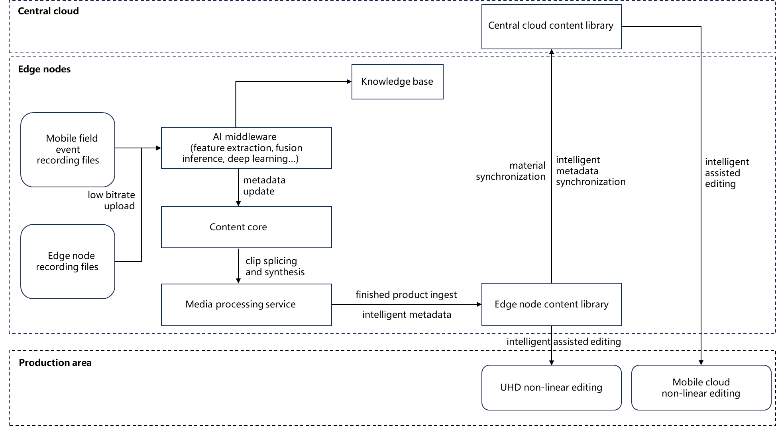
Analysis and recognition
This involves real-time intelligent analysis of audio-visual signals or files to extract features and add specific labels. Capabilities include facial recognition, object recognition, scene recognition, character recognition, and speech recognition.
On-demand inference
Using predefined rules and specific labels, the system performs inference to generate various material segments that meet the specified criteria, such as character segments, effective shot segments and scene segments.
Intelligent production assistance
The inferred material segments are intelligently combined using optimization algorithms to assist users in achieving efficient and rapid program editing and production.

4 Security
Cloud computing requires different security policies from normal on-premises facilities. Generally, in cloud computing services, a service provider usually has the latest security procedures in place at all times, thus users need not be aware of vulnerabilities in hardware, operating systems, and key software components. In contrast, access rights must be strictly defined when using the cloud.
Information leaks, data loss, cyberattacks, unauthorised access, and account hijacking are the major security threats in cloud computing. To counter these threats, multiple approaches need to be considered during the process of adopting cloud computing, including infrastructure, virtual infrastructure, service infrastructure, integrated management environments, data management, data classification, user/identity management, and employee training.
While a cloud service provider is responsible for the security of cloud computing environments, it should be ensured that there are no discrepancies between the security policy of the cloud service provider and the security governance of the user.
In general, there are four aspects of cloud security governance.
– Controls over cloud services availability, fault management, and resilience
– Continuity of services, terms and conditions, and quality provided by cloud service providers
– Lifecycle management of data on cloud services, including storage, replication, backup, and restoration of user data
– Controls over cross-border data transfers between countries with different legal systems when servers are remotely distributed.
Some cloud services are built on private cloud services provided by third-party cloud service providers, or on multiple clouds. It is important to clarify service dependencies and relationships among the clouds during system integration and operation.
Recommendation ITU-T X.1601 – Security framework for cloud computing [3], provides guidelines for a comprehensive review of security threats and possible solutions. For detailed and specific information, refer to the document and its associated documents.

5 Conclusion
Cloud computing has significant positive impacts on the programme production workflow, primarily because it makes the workflow more efficient and reduces the time required for programme production. Numerous services and applications provided by cloud computing vendors can make production workflow even more efficient and endued with added value.

References
[1] B. Grobauer, T. Walloschek, and E. Stocker, “Understanding Cloud Computing Vulnerabilities”, IEEE Security & Privacy, Volume: 9, Issue: 2, March-April 2011, pp. 50-57.
[2] Recommendation ITU-T Y.3500 “Information technology – Cloud computing –Overview and vocabulary”.
[3] Recommendation ITU-T X.1601 “Security framework for cloud computing”.

Annex 1
Use cases of cloud computing for programme production

A1.1 Production system on cloud computing
Cloud computing improves the convenience and efficiency of programme production. The following is a use case of cloud-based tools for programme production.

A1.1.1 Cloud-based uploading tool
Nippon TV, a commercial broadcaster in Japan, has developed a cloud-based tool that uploads video from outside venues to a non-linear editing system in the broadcasting centre. The uploading tool is built on a public cloud without the assistance of any dedicated software. The uploading tool has been used for news gathering and sports broadcasting.
A) News gathering
Reporters upload video and metadata using the uploading tool from a web-browser on their PC or mobile phone. Security Assertion Markup Language (SAML) is adopted for authentication, which allows users to access the cloud storage without a login process to improve user access and strengthen security. Not only reporters but also end-users can upload video easily through one-time QR code.
B) Sports broadcasting
Figure A1-1 shows the uploading workflow in sports broadcasting.
Programme materials shot at the venue are stored in a local server installed in the OB truck and also uploaded to a public cloud. Operators select clips from the uploaded materials, add metadata, and transfer the clips to the editing centre. The uploading system is also used to send highlights to the news editor during broadcasting.
Automatic synchronization of stored materials on the local server and on the cloud for distribution enables immediate supply of the contents for distribution.
FIGURE A1-1
Uploading workflow in sports broadcasting
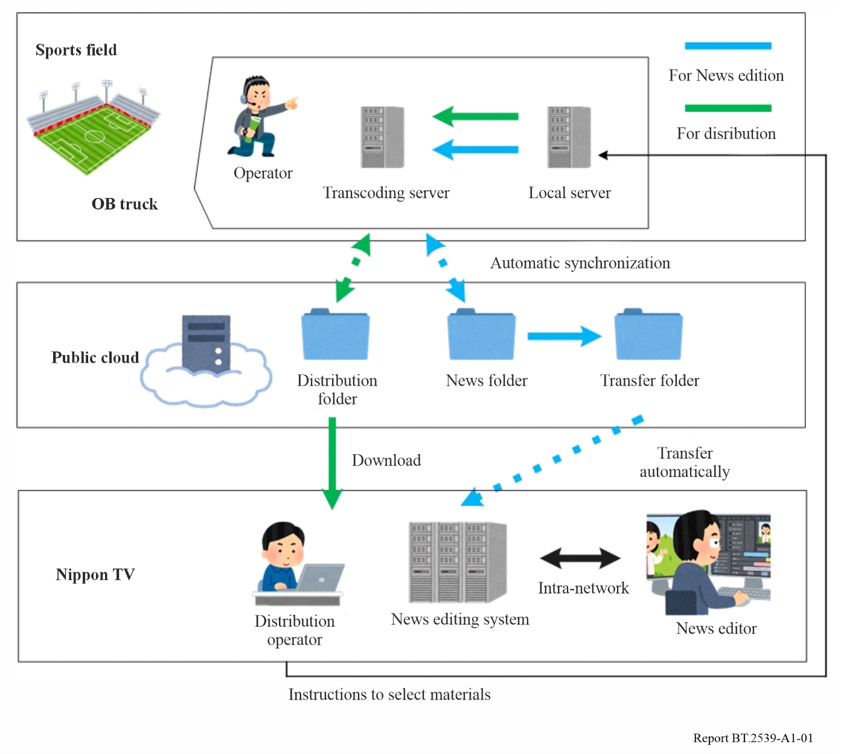

A1.1.2 Cloud-based distribution and recording system
High availability is one of the key features of public cloud services and is an important factor for building systems that can operate even in the event of a natural disaster.
Tokyo Broadcasting System Television, a commercial broadcaster in Japan, has built a cloud-based distribution and recording system for live camera images from its affiliated stations nationwide as shown in Fig. A1-2.
The system was developed to meet the following requirements:
– business continuity plan (BCP) in preparation for a case when the main broadcasting centre is severely damaged due to natural disaster;
– scalability that allows handling of an increasing number of live cameras;
– flexibility to expand functions;
– stability of the system;
– freedom from reliance on dedicated operation terminals.
Affiliated broadcast stations upload live camera images to be recorded in cloud storage. Every station has access to uploaded images from all the stations even when the main broadcasting centre is damaged. All live camera images can be monitored all at once on a web browser as shown in Fig. A1-3. Operators can intuitively perform editing of the recorded images.
The main role of this system is to play out live images and play back recorded images in the event of a disaster for use in news programmes. For example, when an earthquake early warning is issued, the live images near the epicentre are highlighted on the GUI, and the relevant video clips from recorded images are automatically created.
FIGURE A1-2
Cloud-based distribution and recording system for live camera images
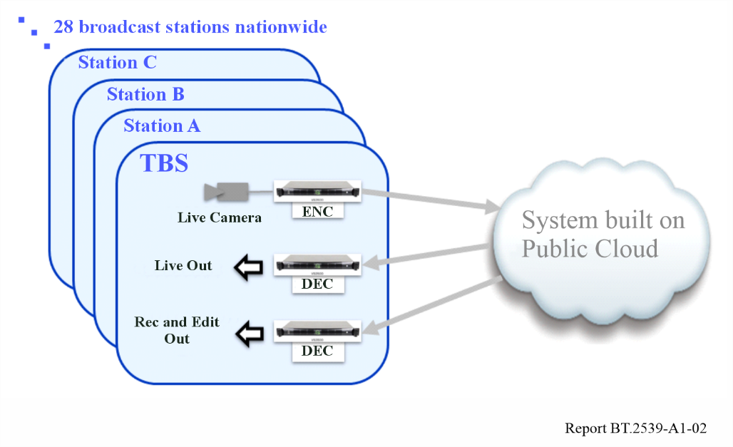
FIGURE A1-3
GUI image on web browser
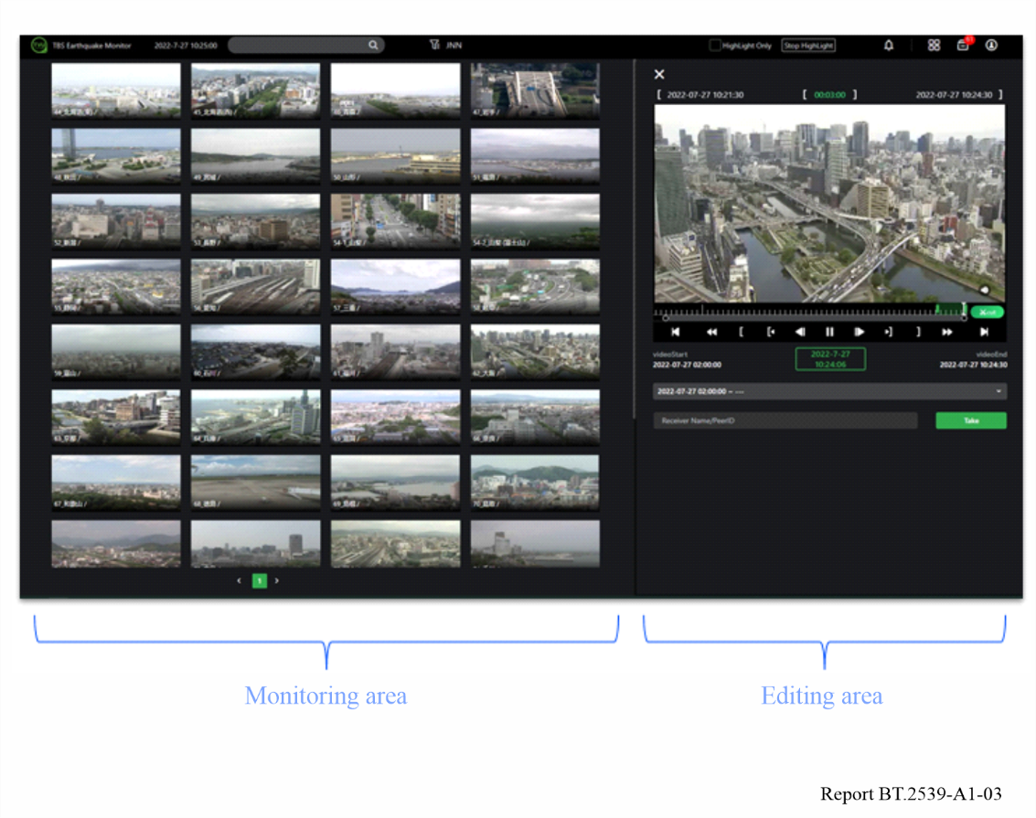

A1.2 Live production on cloud computing
While the modern equipment and technologies used in programme production are highly matured to guarantee stability and functionality, those on cloud computing are still under development. Cloud computing may be more suitable than conventional equipment in the following cases:
– to cover one-off events in a timely manner with little investment;
– to ensure inter-regional redundancy and site diversity; and
– to eliminate special constraints of on-premises systems.
5G technologies are widely spreading for commercial use and are expected to provide ubiquitous, broadband, reliable, and low-latency connection. These features are also useful for services ancillary to programme making (SAP).
The combination of cloud computing and 5G technologies will enable the production of outside broadcasting with mobility and flexibility.

A1.2.1 Cloud-based news gathering
Fuji Television, a commercial broadcaster in Japan, introduced the concept of “cloud-based news gathering (CNG)” as a framework for workflow innovation brought about by cloud computing in the contribution, distribution, production, and delivery of news programmes. As a proof of this concept, a programme production trial was carried out in 2021 to confirm the following items:
– redundancy of contribution feed;
– feeding and controlling from multiple remote sites;
– use of extensive transfer protocols;
– distribution to OTT platforms.
Figure A1-4 shows the setup of this experiment, where contribution, production, and distribution systems are deployed on a private cloud platform. Several software components have been implemented for input functions to handle the signals in multiple protocols, a video switcher, an audio mixer, a superimposer, and an output feeder to stream a completed programme.
Figure A1-4
Setup of production trial of cloud-based news gathering
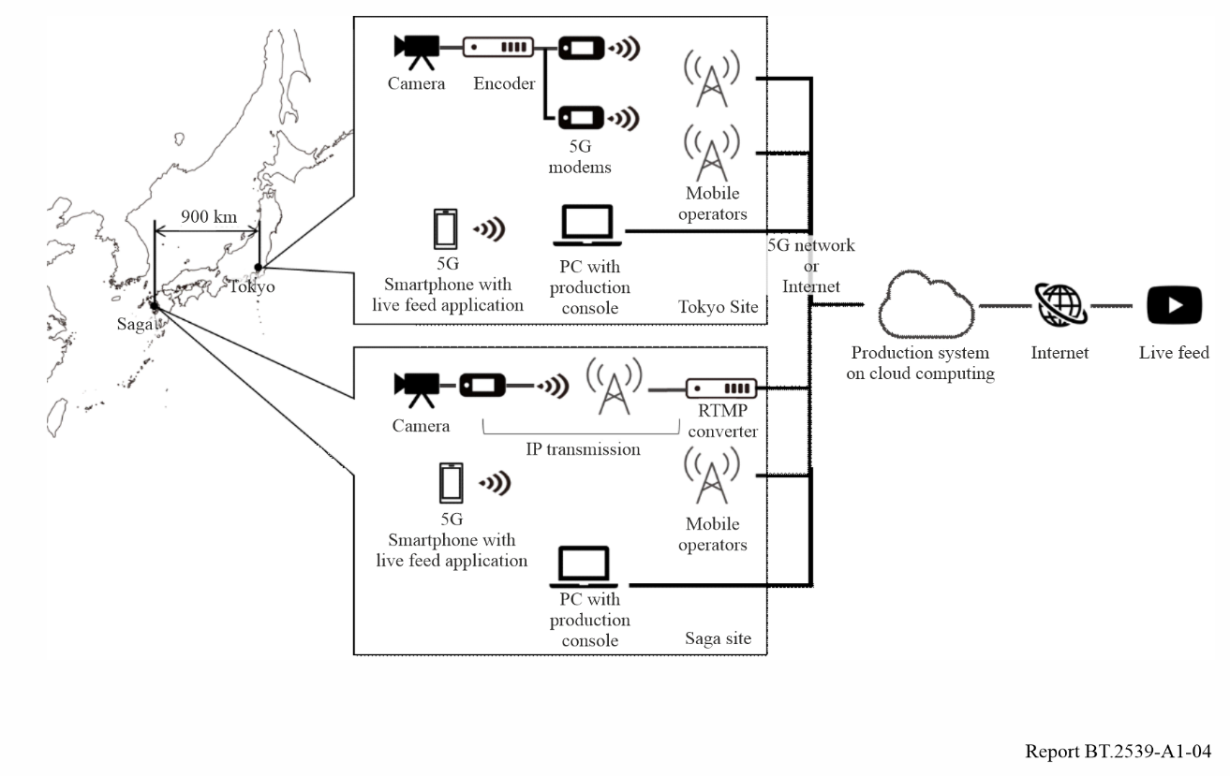
Two scenes of this trial are provided in Fig. A1-5, where the left shows the location of camera shooting and the right shows a production operation using a laptop PC with console software.
figure A1-5
Production site of cloud-based news gathering trial
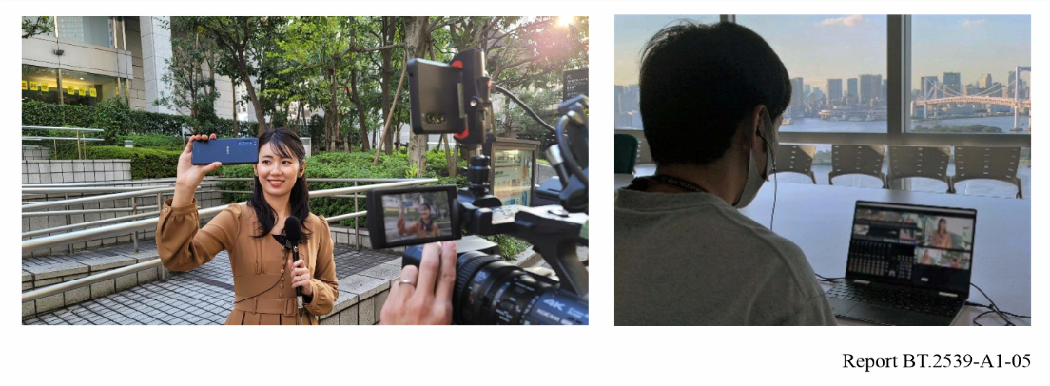
The following items have been confirmed through this trial:
– the input function can select and change over to the right signal feed fed simultaneously in multiple routes on the basis of quality parameters;
– live video streams between Tokyo and Saga (about 900 km apart) can be fed and controlled from both sites;
– multiple protocols including the Real Time Messaging Protocol (RTMP), Secure Reliable Transport (SRT), and various vendor-specific protocols were successfully used;
– the system can feed programme outputs to a live streaming service (YouTube Live) platform.

A1.3 Cloud-based live productions and distributions
TV Asahi, a commercial broadcaster in Japan, is working with ABEMA NEWS, an OTT distribution service provider, on Cloud Live Production (CLP) for live programme production that uses applications on cloud platforms to improve operational efficiency and promote its operational shift to teleworking. CLP-based systems have been introduced for daily programme productions and distributions to make the systems scalable and location-independent.
In OTT distribution, it is common to have one live programme simulcasted to various OTT platforms. However, in many cases the same contents are not distributed simply due to the difference of distribution starting times and restrictions of content rights. Some parts of the programme content thus need to be replaced with specific images or different camera feeds. This operation is carried out by a different operator from the main programme production. For this operation, a software-based system was developed on the cloud platform. It can be controlled on PCs or smartphones from any location far from a venue of the main programme production. A software-based switcher has also been built on a general operating system with a GPU instance of the cloud service (Fig. A1-6). The Secure Reliable Transport (SRT) protocol for video transmission provides strong error corrections. Network Device Interface High Efficiency (NDI|HX) is supported to enable PTZ camera control from remote locations. Control panel applications are available on web browsers. The location-independent feature also allows outsourcing of the operation even in remote locations. Its operation has been delegated to staff in Okinawa, which is 1 600 km away from the studio in Tokyo.
Figure A1-6
Basic system configuration on the cloud
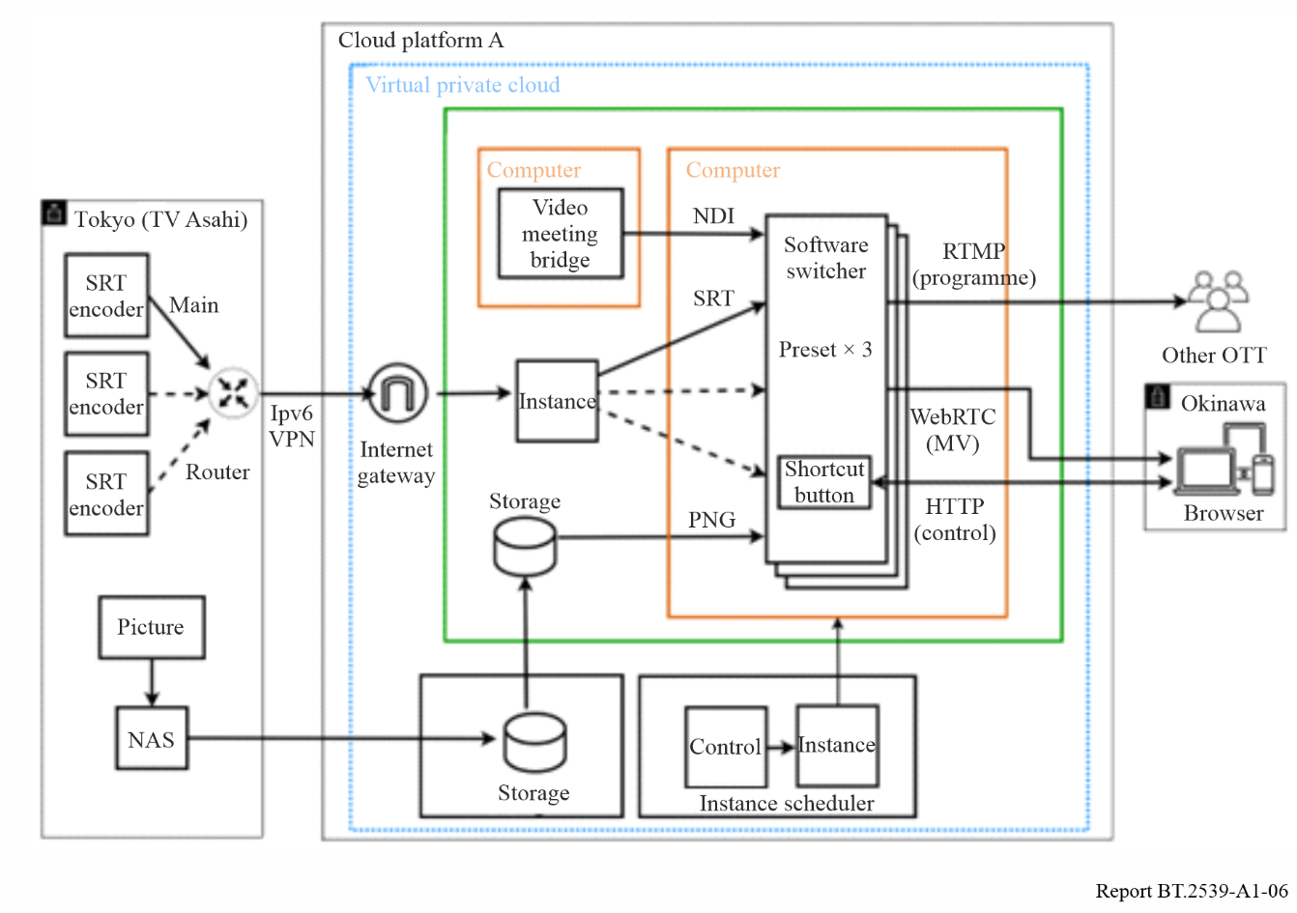
In order to improve system availability, dual systems have been built on two different availability zones or two different cloud platforms to provide redundancy, as shown in Fig. A1-7.
Figure A1-7
Basic configuration of multi-cloud platform
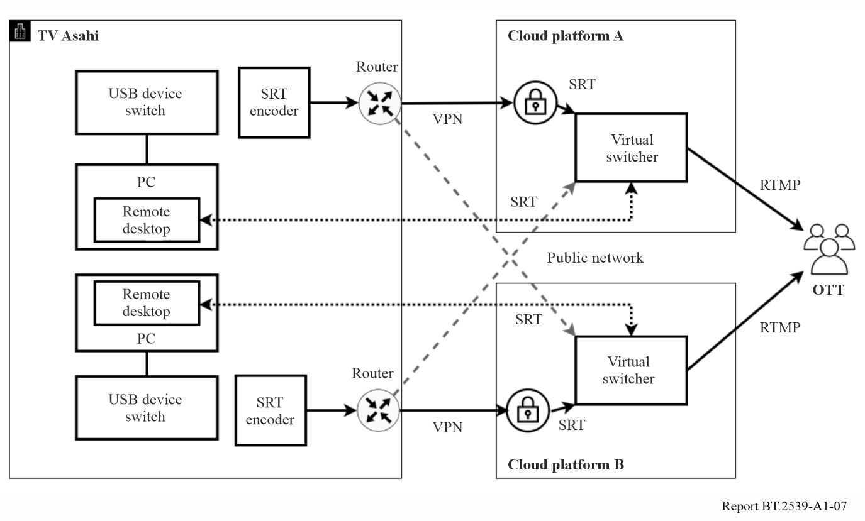
The following issues need to be addressed in the future:
– time synchronisation function for video and audio;
– redundancy of the switching function between clouds;
– handling procedure against breakdowns of network connected to the cloud.

Annex 2
Omnimedia content production platform based on
Cloud-Edge-Terminal (CET) architecture

A2.1 Overview
In 2021, the China Media Group (CMG) launched the CMG Media Cloud platform based on the cloud-edge-terminal (CET) architecture, consisting of three levels: central cloud, edge nodes, and production terminals. By coordinating resources, data, and service between the central cloud and edge nodes, it forms a cross-regional support system for omnimedia content production. Users can access it anytime and anywhere through 5G and other mobile communication means and utilize lightweight mobile terminals to achieve easy mobile omnimedia content production. Since its launch, the CMG Media Cloud platform has supported the daily production of the headquarters and various domestic branches of the group and has been applied to events such as the 2022 Beijing Winter Olympics, the 2023 Chengdu Summer World University Games and the 2023 Hangzhou Asian Games.

A2.2 CMG Media Cloud platform application cases
The CMG Media Cloud platform’s central cloud node adopts a hybrid cloud deployment model. On the public cloud side, it deploys a range of lightweight cloud service tools, including cloud resource libraries, cloud recording, cloud live streaming, cloud connectivity, cloud files, and BS editing tools, to support users’ new media production operations. The private cloud hosts a unified resource aggregation platform and a unified distribution platform, serving domain-wide resource sharing, scheduling, and professional HD/UHD television program distribution management services. A dedicated line connects the public and private clouds, ensuring secure, reliable, and high-quality interaction and synchronization. Based on service needs, China Media Group has established a fixed-type node – Guanghua Road Edge Node – at its Beijing headquarters and a fixed-type node – local station edge nodes – in all 34 provinces of China. To support on-site production for large events, CMG builds temporary edge nodes at event venues, providing technical services during the event period.

A2.2.1 Fixed edge node applications
In the CMG Media Cloud platform, the largest fixed-type edge node is the Guanghua Road Edge Node. This edge node relies on the core computing power and storage resources of the station’s data center to comprehensively support the HD/UHD and audio broadcasting program production for CMG’s Beijing headquarters across its four office areas. According to the technical deployment principles of “network interconnection, data interoperability, system expansion, and standardization”, local stations build fixed-type hybrid cloud architecture edge nodes and gradually invest in production resources based on the actual service needs. The infrastructure and service content of the fixed-type edge nodes at each local station are essentially consistent with those of the Guanghua Road Edge Node, while services can be flexibly configured according to the specific service requirements of each local station.
1) Collaborative production across multiple working areas in headquarters in Beijing
CMG has established a comprehensive media collaborative production system based on the CET architecture. This system integrates the “Central Cloud + Guanghua Road Edge Node” to support cloud-based content production across CMG’s four office locations at the Beijing headquarters (Guanghua Road Office Area, Fuxing Road Office Area, Fuxingmen Office Area, and Lugu Office Area). The platform architecture is depicted in Fig. A2-1. These office locations share CET media production resources based on access permissions, providing collaborative media production capabilities for daily operations across CMG’s television channels, radio frequencies, and new media platforms.
Figure A2-1
CMG Media Cloud supporting collaborative production across multiple offices
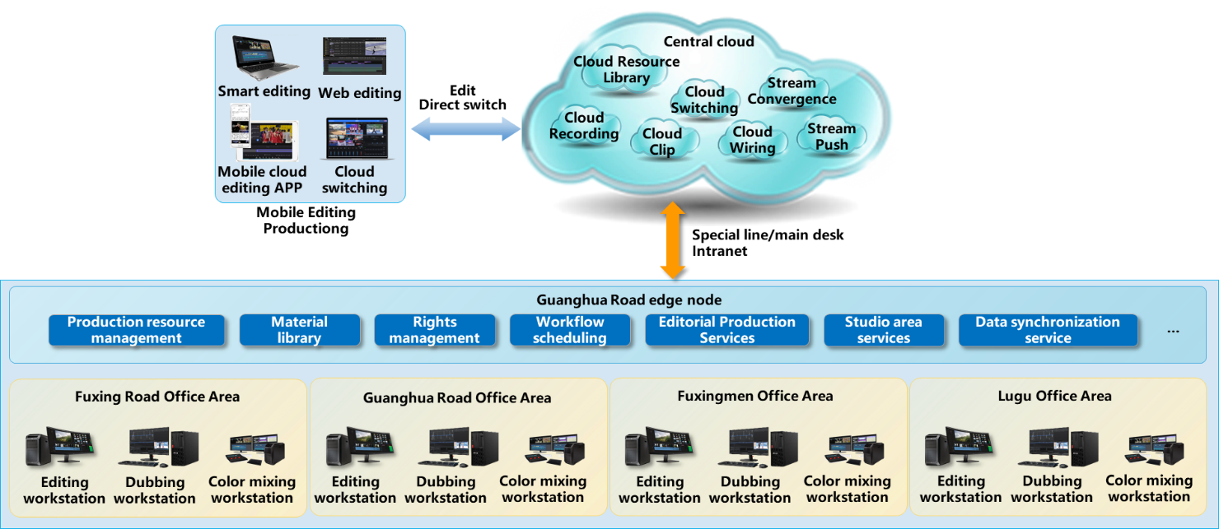
The Guanghua Road office area of CMG leverages the centralized backend and computing resources deployed at the Guanghua Road edge node to support the full-media production and broadcasting operations. By flexibly configuring foundational resources and production toolsets, it meets the daily program production requirements of areas such as the Sports Production Zone and the Chinese Global Program Center, as well as the program production demands during major sporting events. The integrated HD/UHD production capabilities provide immersive sports programming to CCTV5 Sports Channel, CCTV5+ Event Channel, CCTV16 Olympic Channel, CCTV8K Ultra HD Channel, CCTV Video, and the CCTV Sports App. The mobile cloud-based broadcasting tools enable sports event reporters to move from fixed workstations to event sites, allow live reporting personnel to quickly seize trending events and start live broadcasts, and ensure that editors and journalists can swiftly produce and release content anytime and anywhere.
The Fuxingmen office area of CMG is gradually transitioning towards a cloud-based production model as a frequency representative. “China’s Voice” successfully utilizes the cloud capabilities of its central platform to conduct live interactive broadcasts, with low-latency cloud connections providing a more authentic conversational experience for both viewers and listeners. Through the use of CMG Media Cloud and large-scale AI applications, including speech-to-text transcription, audio editing from text, and speech-to-text comparison, the platform supports the daily production needs of multiple programs, reduces human resource input for basic tasks, and enhances production efficiency. The Ethnic Language Production Center at the Fuxingmen office area is equipped with various cloud-based production tools and AI applications tailored to ethnic languages. Utilizing the shared capabilities of the central cloud, it facilitates the rapid translation of large-scale sports events and daily new media content, and supports multi-platform publishing. CMG Media Cloud “audio program transmission tool” is now deployed in program production studios across seven cities – Xiamen, Meizhou, Guangzhou, Chengdu, Lhasa, Xining, and Urumqi – achieving full coverage of the Ethnic Language Program Center. This forms a secure, reliable, and stable cloud-based audio program production and broadcasting workflow.
The Lugu office area of CMG has designed a cloud-based “one-stop” production process based on an integrated full-media collaborative production and broadcasting system. The CMG Media Cloud provides translation production capabilities such as “task flow” management, collaborative editing, and AI-generated timestamp matching for scripts, based on the work structure of the Film and Television Translation Center in Lugu. By designating personnel for specific production stages, the system links program staff with language experts, enabling a fully collaborative, streamlined translation process. This significantly improves translation efficiency and quality. At the same time, the CMG Media Cloud offers multilingual subtitling transcription services for the daily production of programs from the Asia-Africa Center and the Europe and Latin America Language Program Center at Lugu. This allows production staff to independently edit subtitled translations, reducing the dependency between production personnel and directors, and making the workflow more flexible. Currently, this system supports 17 languages, including Japanese, Bengali, Turkish, Portuguese, Czech, Greek, Hungarian, Serbian, Croatian, Polish, and others.
The platform supports approximately 23 hours of daily broadcast time across television channels, 14 hours of daily broadcast time across radio frequencies, 60 daily posts on new media platforms, and 4 daily live streams on new media platforms with a total duration of approximately six hours. AI services perform an average of 2.32 million characters of intelligent translation per month, as well as approximately 300 hours of intelligent transcription.
2) Collaborative production across multiple CMG branch units
The CMG Media Cloud platform will provide an integrated cross-regional media production system for CMG’s regional headquarters nationwide. Edge nodes in key areas will selectively replicate the central cloud architecture and basic configurations according to their scale and service needs and will facilitate content and data sharing with the central cloud. These regional edge nodes can access materials from the central cloud and archive content from the edge nodes to the CMG media asset system through the CET media content production platform, thereby enriching CMG’s material resource pool. Leveraging the advantages of CMG Media Cloud and combining its cloud services capabilities, along with box-mounted, lightweight, and mobile broadcasting equipment, CMG provides tailored lightweight production solutions and full-process technical support for regional stations, optimizing equipment utilization and maximizing the mobility and integrated broadcasting capabilities of box-mounted solutions. At the same time, key technologies such as multi-terminal cloud-based collaborative production and mobile integrated media live broadcasting are applied to the construction plans for regional stations. Through lightweight media cloud production applications and AI-assisted tools, CMG has already provided technical support for the daily production and special event coverage of regional stations in Jiangsu, Jiangxi, Shandong, Qinghai, Tianjin, Gansu, and other regions. The regional headquarters production areas generate an average of 100 posts per month on the platform and host 8 integrated media live streams. The structure of the regional headquarters is illustrated in Fig. A2-2.
Figure A2-2
CMG Media Cloud supporting collaborative production across multiple CMG branch units
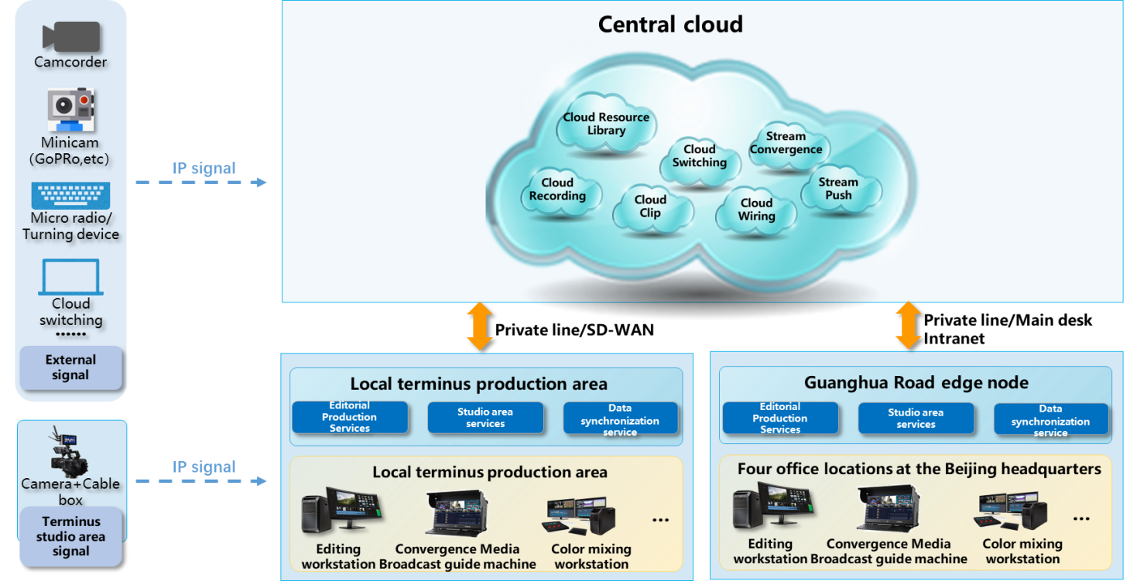

A2.2.2 Temporary edge node applications
The temporary large-scale event production system is characterized by short operational durations, large production volumes, and complex cross-domain interactions. To address these challenges, CMG adopts a cloud-edge-terminal technology framework, establishing temporary edge nodes for large-scale events that provide elastic scaling of production resources and localized access to production tools. Following an integrated cloud-network design approach, this system is designed to support a mobile-first, cross-domain collaborative full-media production and broadcasting solution for sports event broadcasts and large-scale comprehensive activities. The application and practical implementation of the cloud-edge-terminal architecture in temporary large-scale events are explored.
1) 2023 Hangzhou Asian Games
During the 2023 Hangzhou Asian Games, the CMG Media Cloud platform utilized temporary edge nodes to offer a range of services including ultra-high-definition 4K/8K event signal acquisition and production, studio-based file-based broadcasting, mobile production capabilities, integrated media live streaming, and real-time monitoring of live streaming signals. This setup enabled comprehensive media production coverage at the event site, supporting CMG’s production needs for live broadcasting. The architecture is illustrated in Fig. A2-3. Additionally, the temporary edge nodes leveraged the advantages of the CET architecture to facilitate local content production. They transmitted event content back to the central cloud, overcoming geographical limitations and enabling collaborative content production across multiple channels and frequencies at CMG’s Beijing headquarters. This supported CMG’s extensive and multidimensional broadcasting of major events. During the Asian Games, over 5 000 hours of public signal recording were completed, along with 339 hours of integrated media live streaming and recorded programming, 191 hours of channel broadcasts, and 123 hours of event programming transmitted from edge nodes to the central cloud.
Figure A2-3
CMG Media Cloud supporting the 2023 Hangzhou Asian Games
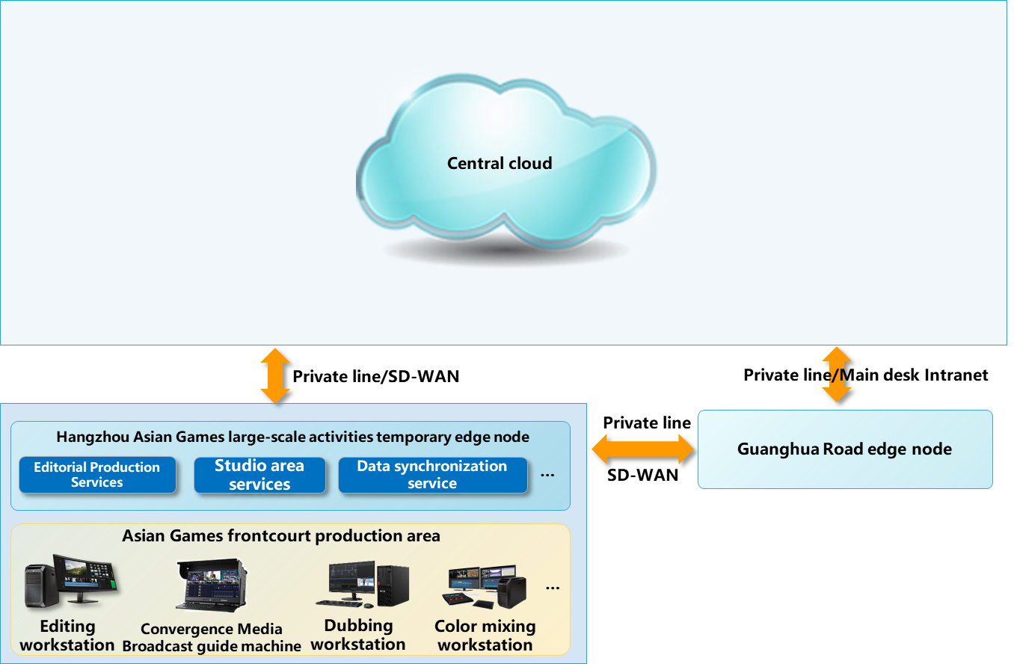
2) Cloud-based co-production for remote broadcast and outside studios
Relying on the CMG Media Cloud platform and combining 5G network/SD-WAN and other transmission technologies, CMG efficiently combines the off-stage studio production system, OB production system, and on-stage production area through a file interaction gateway, forming a new model of all-media collaborative production involving OB vans, external and internal studios, and in-house production areas. The system structure is shown in Fig. A2-4. Based on the architecture of CET omnimedia content production platform, it can achieve real-time cloud uploading of live/recorded live set highlights, camera unilateral included material, and PGM included material files, and users can use various types of editing tools of CET all-media content production platform to quickly carry out the production and release of new media programs; at the same time, users can access the cloud to proxy code rate material for production, which corresponds to the edge of the return of high-code material nodes and then complete the set in the production area for in-depth packaging and production to improve program production efficiency.
In practical applications, the broadcast vehicle file exchange gateway serves as a key device that integrates with the broadcast vehicle production system or the EFP production system, forming a mobile temporary edge node. Through the cloud-based transmission capabilities of the file exchange gateway, it connects the production and signal generation systems, enabling the transfer of high and low bitrate video files produced by the production systems to the CMG Media Cloud. This forms a cloud-based collaborative production model. This model was deployed during the 2022 CMG Mid-Autumn Festival Gala, accelerating the production and creation of multiple program versions for new media, HD, 4K, and 8K formats. Additionally, it has been used for cloud-based production in support of short video production for 22 major events, including the Chengdu FISU World University Games, the 14th National Winter Games, the 2024 Thomas and Uber Cup, and the 2024 FINA Diving World Cup, improving the content output efficiency for new media platforms.
Figure A2-4
CMG Media Cloud supporting the cloud-based co-production for remote broadcast and outside studios
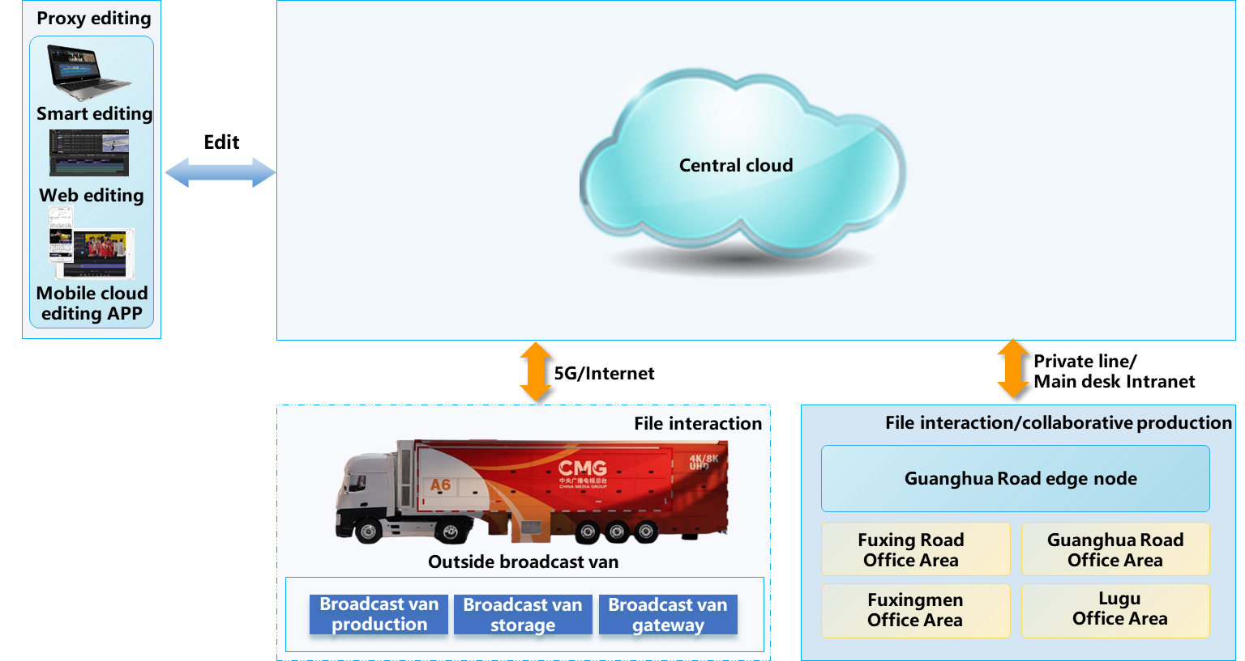

Reports ITU-R BS/BT.2522 – A framework for the future of broadcasting, and ITU-R BS/BT.2524 – A framework for the future of broadcast production, provide high level overviews of the operational use of cloud services in programme production.
“Omnimedia” refers to the concept of various media types, including linear/nonlinear TV, radio, on-demand video, live streaming for APP in mobile phone, etc.

