Report ITU-R BT.2524-0
(09/2023)
BT Series: Broadcasting service (television)
A framework for future of broadcast production

Foreword
The role of the Radiocommunication Sector is to ensure the rational, equitable, efficient and economical use of the radio-frequency spectrum by all radiocommunication services, including satellite services, and carry out studies without limit of frequency range on the basis of which Recommendations are adopted.
The regulatory and policy functions of the Radiocommunication Sector are performed by World and Regional Radiocommunication Conferences and Radiocommunication Assemblies supported by Study Groups.

Policy on Intellectual Property Right (IPR)
ITU-R policy on IPR is described in the Common Patent Policy for ITU-T/ITU-R/ISO/IEC referenced in Resolution ITU-R 1. Forms to be used for the submission of patent statements and licensing declarations by patent holders are available from http://www.itu.int/ITU-R/go/patents/en where the Guidelines for Implementation of the Common Patent Policy for ITU-T/ITU-R/ISO/IEC and the ITU-R patent information database can also be found.

Series of ITU-R Reports
(Also available online at https://www.itu.int/publ/R-REP/en)
Series | Title
BO | Satellite delivery
BR | Recording for production, archival and play-out; film for television
BS | Broadcasting service (sound)
BT | Broadcasting service (television)
F | Fixed service
M | Mobile, radiodetermination, amateur and related satellite services
P | Radiowave propagation
RA | Radio astronomy
RS | Remote sensing systems
S | Fixed-satellite service
SA | Space applications and meteorology
SF | Frequency sharing and coordination between fixed-satellite and fixed service systems
SM | Spectrum management
TF | Time signals and frequency standards emissions

Note: This ITU-R Report was approved in English by the Study Group under the procedure detailed in Resolution ITU-R 1.

Electronic Publication
Geneva, 2023
© ITU 2023
All rights reserved. No part of this publication may be reproduced, by any means whatsoever, without written permission of ITU.

REPORT ITU-R BT.2524-0
A framework for future of broadcast production
(2023)
Summary
The rapid advances in programme making technologies combined with the diversification of content delivery options and the drive to create a connect world, is changing the expectations and preferences of users and consumers of media. Today audience expectations are reshaping the traditional idea of broadcasting as it merges with gaming, streaming and content-based services available through Internet connected and smart devices that can be used in any location.
This Report expands the production trends in Report ITU-R BS/BT.2522 and focuses on the development of radio, television, audio and video programme making technologies that influence the development of a framework for future programme production.
Abbreviations/Glossary
3D Three-dimensional
6DoF Six degrees of freedom
AI Artificial Intelligence
AISM Advanced immersive sensory media
APIs Application programme interfaces
AR Augmented reality
AWS Amazon web services
CDN Content delivery network
DNS Domain name servers
DTT Digital terrestrial television
DTTB Digital terrestrial television broadcasting
EAD Enhanced audio description
ELSA Ethical legal and social aspects
ELSI Ethical, legal and social implications
GenAI Generative Artificial Intelligence
GPT Generative pre-trained transformer
GUI Graphical user interface
HD High definition
HDR High dynamic range
HMD Head-mounted display
HOA Higher-order ambisonics
IBB Integrated broadcast-broadband
IoT Internet of Things
IP Internet Protocol
IPR Intellectual Property Rights
IPTC International Press Telecommunications Council
MADI Multichannel audio digital interface
ML Machine learning
MPEG Moving Picture Experts Group
MR Mixed reality
MXF Material eXchange format
NFTs Non-fungible tokens
OBM Object-based media
OTT Over-the-top
PMSE Programme-making and special events
PoP Point of Presence
QoE Quality of Experience
QoS Quality of Service
SaaS Software as a Service
SAB Services ancillary to broadcasting
SAP Services ancillary to programme-making
SD Standard definition
UHD Ultra-high definition
UHDTV Ultra-high definition television
VOD Video-on-demand
VPN Virtual private network
VR Virtual reality
XML eXtensible Markup Language
XR eXtended reality
Related ITU-R Recommendations and Reports
Many of the technology trends discussed in this Report are based on work currently under way in ITU-R Study Group 6. Information about recent implementation, research and some of the early use-case examples, is available in the following ITU-R Recommendations, Reports and Opinions.
Recommendation ITU-R BS.2143 – Transport method for non-Pulse-Code Modulation audio signals and data over digital audio interfaces for programme production and exchange
Recommendation ITU-R BS.2051 – Advanced sound system for programme production
Recommendation ITU-R BS.2076 – Audio Definition Model
Recommendation ITU-R BS.2125 – A serial representation of the Audio Definition Model
Recommendation ITU-R BS.2127 – Audio Definition Model renderer for advanced sound systems
Recommendation ITU-R BT.2020 – Parameter values for ultra-high-definition television systems for production and international programme exchange
Recommendation ITU-R BT.2100 – Image parameter values for high dynamic range television for use in production and international programme exchange
Recommendation ITU-R BT.2123 – Video parameter values for advanced immersive audio-visual systems for production and international programme exchange in broadcasting
Recommendation ITU-R BT.2153 – The use of componentized workflows for the exchange of non-live television programmes
Recommendation ITU-R BT.2154 – High-level system architecture for immersive video for presentation on various types of display devices
Report ITU-R BT.2207 – Accessibility to broadcasting services for persons with disabilities
Report ITU-R BS.2388 – Usage Guidelines for the Audio Definition Model and Multichannel Audio Files
Report ITU-R BT.2400 – Usage scenarios, requirements and technical elements of a global platform for the broadcasting service
Report ITU-R BT.2420 – Collection of usage scenarios and current statuses of advanced immersive audio-visual (AIAV) systems
Report ITU-R BT.2447 – Artificial intelligence systems for programme production and exchange
Report ITU-R BT.2448 – Technical realisation of signing in digital television
Report ITU-R BS.2493 – Practical implementation of broadcast systems using audio codecs for ITU advanced sound systems
Report ITU-R BT.2506 – Requirements for spatial characteristics of an ideal head-mounted display for immersive video
Report ITU-R BT.2521 – Practical examples of actions to realize energy aware broadcasting
Report ITU-R BS/BT.2522 – A framework for the future of broadcasting
Opinion ITU-R 104 – Advice for sustainability strategies incorporating carbon offsetting policies

TABLE OF CONTENTS
Page
1 Introduction 5
1.1 Production is changing 5
1.2 The media supply chain 6
1.3 Creating a framework 8
2 Future production trends 9
2.1 Flexible production workflows 9
2.2 Non-live content workflow evolution 9
2.3 Concerns over cloud-based workflows 11
2.4 Radio live content workflow evolution 11
2.5 Television live content workflow evolution 14
3 Cloud ready 18
3.1 Workflow as a service 18
4 Complex Media Creation 21
4.1 Object Based Media 21
4.2 Objects and content creation 22
4.3 Benefits of media as objects 23
4.4 Componentized content creation 24
5 Artificial intelligence and machine learning driven automation 26
5.1 Generative AI 26
5.2 AI used for sport content 27
5.3 AI in the news environment 27
5.4 AI for fake and hate detection 28
5.5 AI for synthetic media 28
5.6 AI for accessible media 29
5.7 Ethical, Legal and Social Issues of AI in broadcasting 29
6 Virtual programme production 30
6.1 The Evolution of Virtual Studio Sets 30
6.2 Remote performance 31
7 Immersive, interactive and accessible media. 32
7.1 Volumetric video capture 32
7.2 Light Field 33
8 Data Flow 33
8.1 Scene Descriptive Data Flow 34
8.2 Content adaptation 34
8.3 New Production Tools 36
8.4 Data across the production chain 38
9 Sustainable production 38
9.1 Carbon action plan 39
10 Conclusion 39

1 Introduction
Never before has broadcasting played such an important role in all of our lives, providing News, Entertainment and Education during a time when so much of the social interaction we always took for granted, was so radically curtailed. The COVID-19 pandemic significantly underscored humanity's growing reliance on broadcasting systems for business continuity, education, healthcare and other essential services for daily life. These roles and features also contribute to the United Nations Sustainable Development Goals.
Future media and broadcasting businesses will include the environments of gaming, social media, autonomous transport, Internet of Things (IoT) and many others, which can influence, compliment or compete with traditional media for the time and interest of the audience. Figure 1 gives an overview of the key trends that are emerging, driven by rapidly changing connected technologies and the growing number of connected consumers.
Figure 1
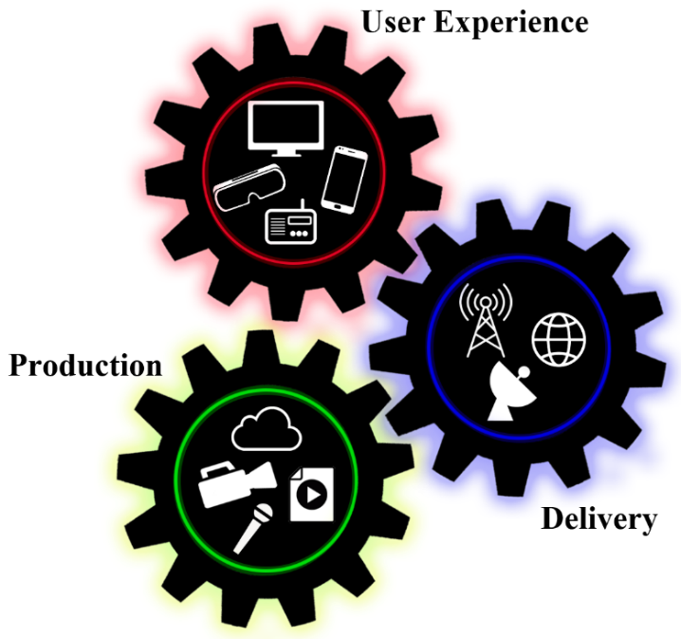
Key trend areas
Personalized, accessible,
immersive experience
Adaptable, de-centralized
cloud-based, automated
Any device, any time,
any platform

1.1 Production is changing
Technical innovation goes hand-in-hand with production innovation. Developments in programme production technology enable content creation processing that has the potential to meet the needs of both the current and the future user experience in a multiformat world.
As users expect to have content available at any time on any of their devices, delivery systems will need to become more intelligent. Web browser and business software already offer seamless hand-off between devices although not necessarily between different vendor applications or hardware platforms. It is essential to provide the user with “any content on any device via any platform” (e.g. fixed TV or radio receivers, portable devices), with the content they want. Content should be made to be adaptable to the specific capabilities of the device being used (e.g. accessibility options, immersive experiences), and enable seamless hand-off between devices both in the home and when traveling.
The only constant in production technology is change. Future media production will require a range of new tools and working practices to produce content that exploits the options for new or expanded services. Broadcasting organizations need to weigh up the benefits, practicality, and economic implications of each service option.
– The growing use of the Cloud and IP based services for production, distribution and delivery often rely on third-party or outsourced facilities will require reinforcement of security and access measures.
– Production and delivery environments will call for steps to improve sustainability.
– There is a growing global awareness of the need to add measures that aid those who need options to assist accessing media. The ability for users to personalize media services to an ever-greater extent will assist accessibility.
Content is delivered to the end-user through multiple distribution options which often require different technical formats, editorial versions and to platforms that offer different levels of user selectable services. Radio and television content is often co-produced by multiple organizations which adds complexity to workflows for live programmes, recorded studio or outside broadcast programmes and non-live packaged programmes. Broadcast content creators are very aware they compete with many other entertainment and information-based services (gaming, social media, consumer generated content, etc.) and are learning that a single fixed version of a programme is no longer commercially viable.

1.2 The media supply chain
Supply chain principles and practices have been applied to many manufacturing, retail and logistics industries for some time where supply chain management looks holistically at the end-to-end process from a supplier through all processes to the consumer.

1.2.1 Supply chain overview
From a supply chain point of view (example given in Fig. 2), media production and delivery can be treated in the same way as any other manufacturing industry, but traditionally it has been difficult to define how supply chain principles could be applied to broadcasting. The impact of direct-to-consumer delivery and the realization by broadcasters that a single version of a programme is no longer commercially viable, has changed the way content is created, processed and delivered making supply chain management critical to the future of the industry.
FIGURE 2
Media supply chain example
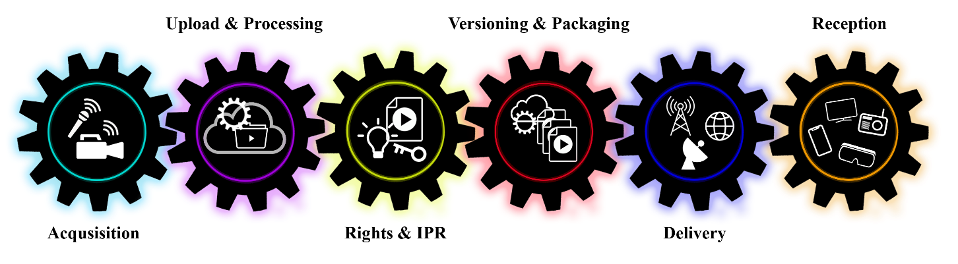
Just as the transition from physical linear media (film and tape) changes production workflows, the move from hardware to software-based processing is creating a more commoditized production process that includes direct to consumer, packages media, international exchange and traditional linear distribution.
A fully digitized media supply chain enables the implementation of an app-based approach where systems can be activated and optimized (spun-up) for specific programmes or pop-up channels or events, then closed (spun-down) when not needed.

1.2.2 Blockchain
Blockchain is about business transactions enabled through encrypted digital networks and therefore sit within the media supply chain. The reason blockchain has become interesting to broadcasters is that there is very little difference between digital media transactions and any other type of business product transaction.
Blockchain systems provide trust and, more importantly, transparency between authorized users. Early use of Blockchain in content production primarily focused on e-commerce activities and licencing.
While production and programme making technologies continue to rapidly evolve, the ownership of content has remained virtually unchanged. The evolution of Blockchain and Non-fungible tokens (NFTs) is beginning to change this. NFTs are already being used for media related merchandizing ranging from t-shirts to micro-funding schemes for production to ownership of “original” media asset.
NFTs are built on blockchain technologies that allow the sale and transferral of the ownership of assets between parties. Blockchain uses a distributed ledger that allows the owner to set rules around what happens when the item is then resold, enabling the long-term re-selling and re-licensing options that previously have only been accessible to large organisations that can buy the rights to content for whole territories. Blockchain is enabling users to share content, pay the transit costs and pay a contribution towards the NFT. All of this is based on a notion of having Blockchain at the heart of future media supply chain. Companies are already using live streaming blockchain apps to manage access and streaming for major sporting and music events.
Blockchain and NFTs use in the transactional process of access to content is relatively clear but the use for the actual processing of digital content assets is initially harder to envisage. As content production moves from physical infrastructures to “software as a service” modes, blockchain will become integrated into the asset workflow by, for example, limiting the ability to share protected content to authorised users and enabling or preventing specific processes based on creative intent or rights management.
It is very important for broadcasters to understand the Blockchain concept and consider the possible impact on new media processes.

1.3 Creating a framework
Future media experiences will be based on broadcasting technology development trends enabling more and more options for personalizing the media experience, including using voice activation, digital assistants, and haptic interaction. Looking forward, a user will want to store personal settings and be able to hand them off to different devices either by choice or allow them to be triggered automatically by the local environment, specific user needs or suggestions from the broadcaster or content creator.
Programme makers will always consider the Impact of their content on the intended audience, the Cost of creating that impact and the Usability of the processes needed to make and exchange the content. Figure 3 can be applied to any content production process, from major studios (movies, international episodic, major documentaries, etc.) to content created using consumer devices for sharing through traditional broadcasting or direct to social media applications.
Figure 3
Content production and innovation relationships
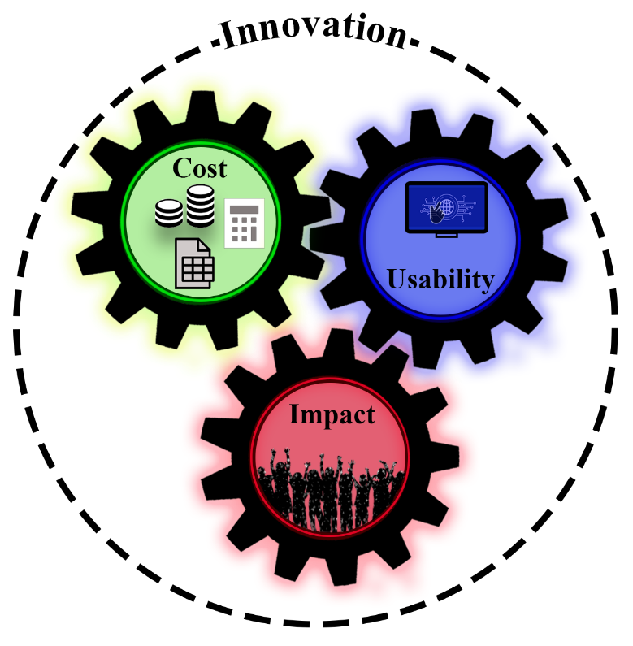
Future media services will be available on a wider range of end user equipment - not just traditional TV sets, tablets and smartphones. The range of delivery platforms will remain (terrestrial broadcasting, satellite broadcasting, cable television, IPTV, Wired and Wireless Internet) but each platform will vary in how it is able to deliver these new kinds of services. The new 5G and beyond 5G mobile broadband systems will play a significant role in providing media services. An attractive option enabled by the common IP nature of these distribution and new platforms will be to combine broadband services with broadcast services as a means of creating increasingly flexible and robust networks.

2 Future production trends
A future media production framework will be very wide ranging encompassing many different new technologies and production-based ideas. These can be grouped into three production trends: Flexible Workflows, Complex Radio and Television Media Creation, and Data Driven Production.
Many of the ideas that contribute to the future of production are already in the early stages of study in Study Group 6. Reports ITU-R BT.2420 and ITU-R BT.2447 give examples of work being carried out on advance immersive sensory media and artificial intelligence used in production. Reports ITU-R BS.2493 and ITU-R BS.2388 look at the continuing developments of advances sound systems through the audio definition model. This section will explore a framework for future radio and television production through these trends, taking into account the continued move to diversify and virtualize content creation that were accelerated by the restrictions during 2020 and 2021. At the same time, programme makers are looking at user trends to create content that merges gaming techniques and user interaction.

2.1 Flexible production workflows
Restrictions during 2020 and 2021 demonstrated that fixed hardware-based infrastructure was no longer essential or flexible enough. The key to future programme making can be simply defined by the term workflow flexibility, underpinned by flexible technology solutions.
A multi-format production environment will be required to provide sufficient technical, and editorial flexibility, to have sufficient quality headroom required for different delivery platforms and has the potential to meet the quality expectations of both current and future audiences.
New technologies continue to increase the flexibility of production processing which in turn allows programme makers to innovate, experiment and try-out new ideas, while at the same time improving efficiency.
A key indicator of how production and content creation processing has continued to develop can be seen through the evolution of production workflows. To give context to how broadcast radio and television production workflows and operational areas are evolving, it is worth spending time to look and compare traditional linear content workflows using ‘physical’ media for versioning and delivery compared to a more recent file and cloud-based media workflows.

2.2 Non-live content workflow evolution
Television tape-based workflows now look very inefficient. Figure 4 demonstrates how much time and resource was wasted simply transferring content between different video tape formats, usually from different manufacturers, or between different video standards (NTSC <> PAL, 525 <> 625, etc.).
Figure 4
Physical media tape-based format transfer workflow
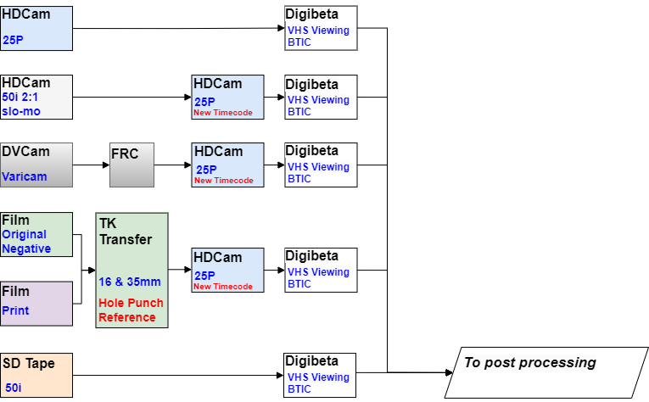
Figure 5 continues the workflow through post-production to the creation of the exchange versions where the different versions are created by further tape to tape copying and format conversion.
Figure 5
Physical media tape-based format post-production and versioning workflow
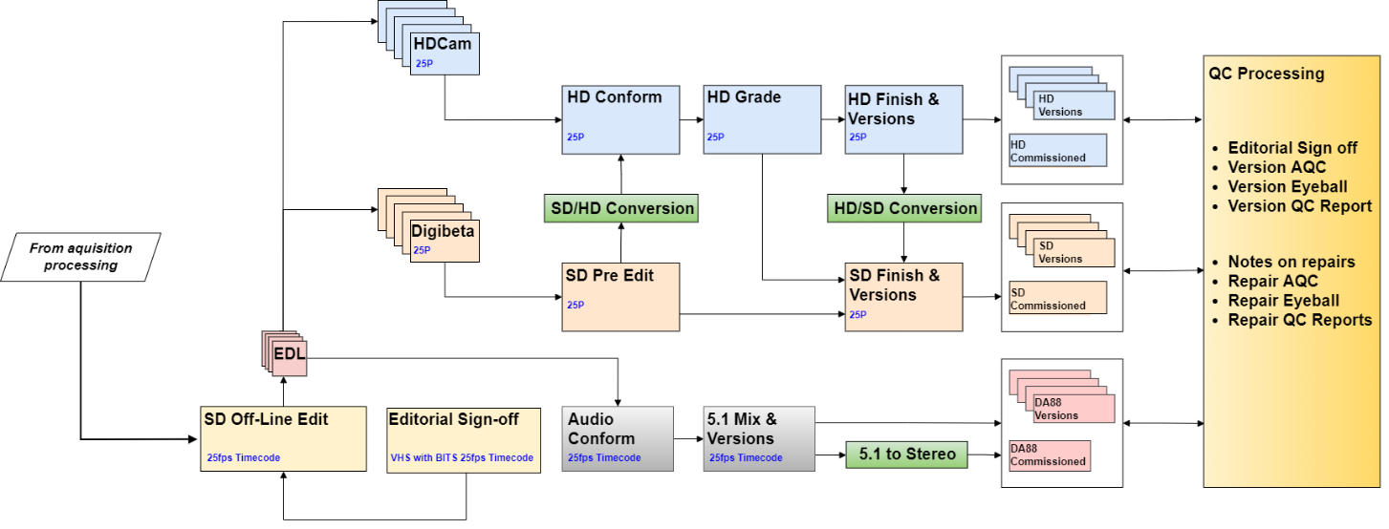
Compare the physical media workflow to a file and cloud-based workflow shown in Fig. 6.
Figure 6
File media cloud-based virtual workflow
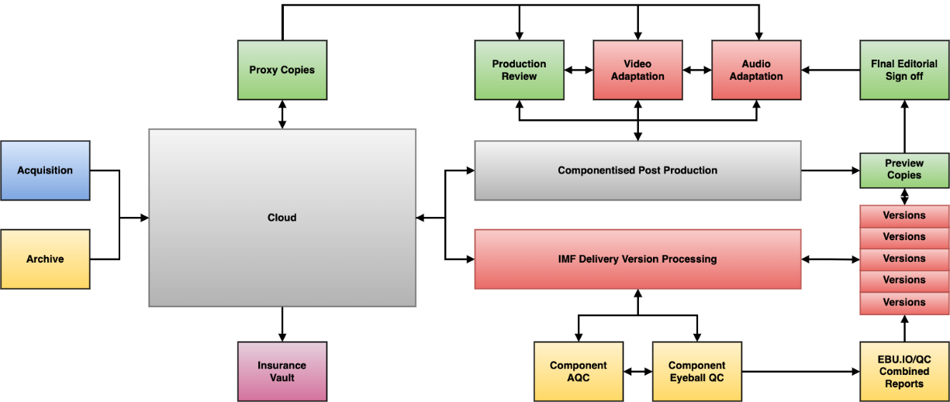
The most noticeable difference is the elimination of virtually all the high-cost, time-consuming conversions and copying processes. All the non-productive procedures up to the point of delivery, are no longer needed, and there is a more flexible approach to different formats from ingest to the export of the final versions.
The continuing move toward cloud-based workflows enables the use of local, remote and distributed production techniques and processing. These workflows are driven by data, and employ AI and ML tools that support editorial staff in a variety of tasks, including automated content creation, automated transcription, adding accessible media services and detection of fake or manipulated content.
The future will see the cloud and software processing trend continuing towards a so-called “cloud native” model, where content is uploaded once and stays in the cloud with no further download/upload actions for processing or exchange. This combined with continuing technology advances in computing power and connectivity bandwidths are narrowing the difference between live multicamera studio or outside broadcast programmes and non-live packages media content workflows.

2.3 Concerns over cloud-based workflows
Understandably, there are concerns associated with cloud-based operations for both live and non-live content. The concerns of today can either become “business as usual” tomorrow or if not resolved, render the technology unfit for purpose. Security, latency, sustainability issues and unpredictable costs will present barriers to adoption if current linear workflows are simply duplicate using “cloud” as remote disk storage. Business and IoT processing and application can provide solutions to media processing by acknowledging that audio and video are just large data streams or files.

2.4 Radio live content workflow evolution
There has been much discussion about the difficulty and ability of live content to use cloud and software-based services, however the progress in radio broadcasting production is often overlooked.
Radio production can often benefit from technology developments before television services are able to use them practically. This happened in the early 2000’s when radio production pioneered the end-to-end digital chain. The infrastructure however was not radically different to the analogue predecessor. Figure 7 gives a high-level overview of a traditional radio studio where the audio mixing desk is usually the centre of the infrastructure and supported by a control room. The control room infrastructure is usually local to the studio either attached to or in the same building complex.
Figure 7
Traditional radio studio overview
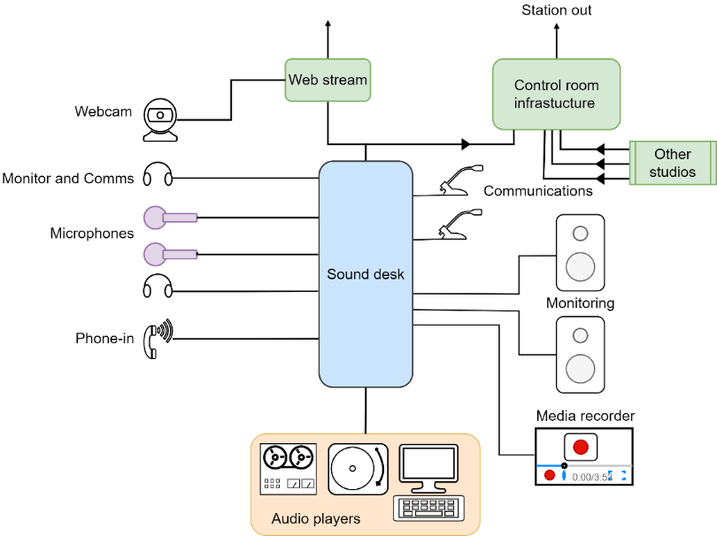

2.4.1 The software radio studio
Future radio broadcasting will look radically different. Many projects were initiated to use then new techniques to share and virtualize radio infrastructure. An example is the BBC’s Virtual Local Radio (ViLoR) project which virtualized the 34 local radio stations rationalizing infrastructure, improving resilience and increasing the quality of each local service.
Figure 8 shows how much was changed in the operational studio area. There is virtually no traditional broadcast equipment or signal processing besides microphones and monitoring.
Figure 8
Virtual radio studio operational area
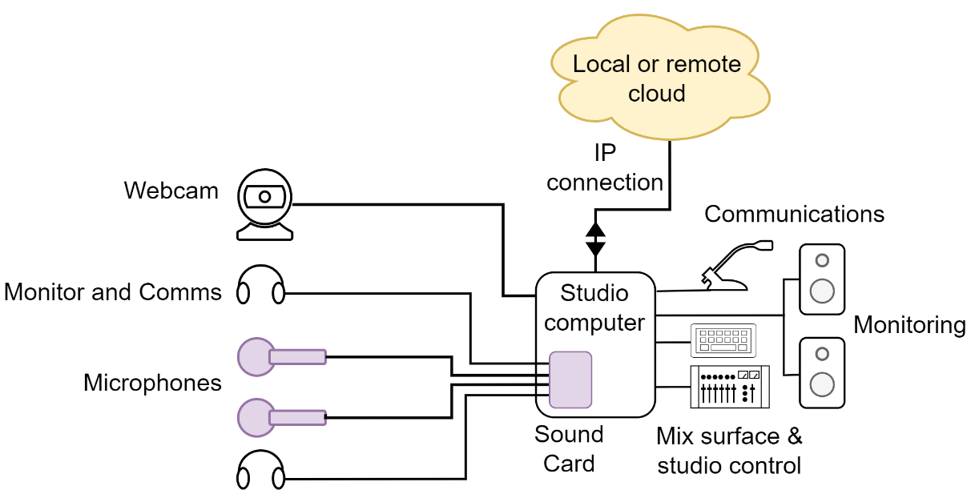
The cloud infrastructure can be local or remote and shared with other studio operational areas. Figure 9 gives a high-level overview of the processing functions in a cloud-based radio studio’s virtual cloud-based control room. The virtualized system’s flexibility allows any studio operational area to be connected to any control room processing service.
Figure 9
Virtual cloud-based radio control room
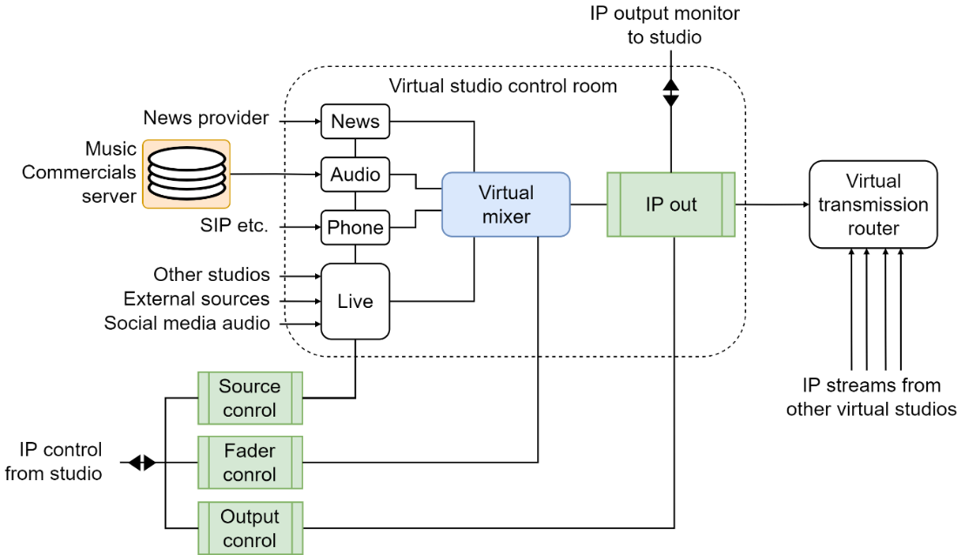
What is clear is that the process of radio virtualization will continue using more and more commodity-based infrastructure, allowing broadcasters to provide more local, national and international radio services, which can be targeted at specific audiences. Remote production technology also enables more direct engagement with communities through the increasing use of pop-up studios at local events and by directly connecting communities both nationally and internationally.,

2.5 Television live content workflow evolution
For some time, television studios and especially outside broadcast workflows have been slowly changing mainly driven by personnel, travel and rig/de-rig time and cost. Although IP based infrastructure offers the potential for a more radical development, the ‘game-changer’ arrived in early 2020 when traditional studio production was not possible due to lockdowns.
The reluctance of many live television content programme makers to change to remote and distributive workflows was overcome when the only way to make content was through remote and cloud-based television production systems.
As with radio, at high level, live digital studio or outside broadcast (including when used for multi-camera recorded content) workflows appear virtually unchanged from analogue days. There are still traditional job roles and processing stages. Serial digital interface (SDI) studio workflows may have become more efficient and more resilient than their predecessor analogue workflows but overall, they are very similar. It should be noted though, that significant workflow effort is required to maintain audio to video synchronization due to the inherent difference in processing delay through the signal chains.
Figure 10 is an overview of a traditional SDI television studio. Here, the vision mixer/switcher and the audio desk are primarily the centre of the video and audio workflows which are supported by the rest of the studio signal processing infrastructure. It is also usual for the communications system (open/switched talkback, etc.) to be part of a studio’s audio infrastructure and operations.
Figure 10
Traditional television studio overview
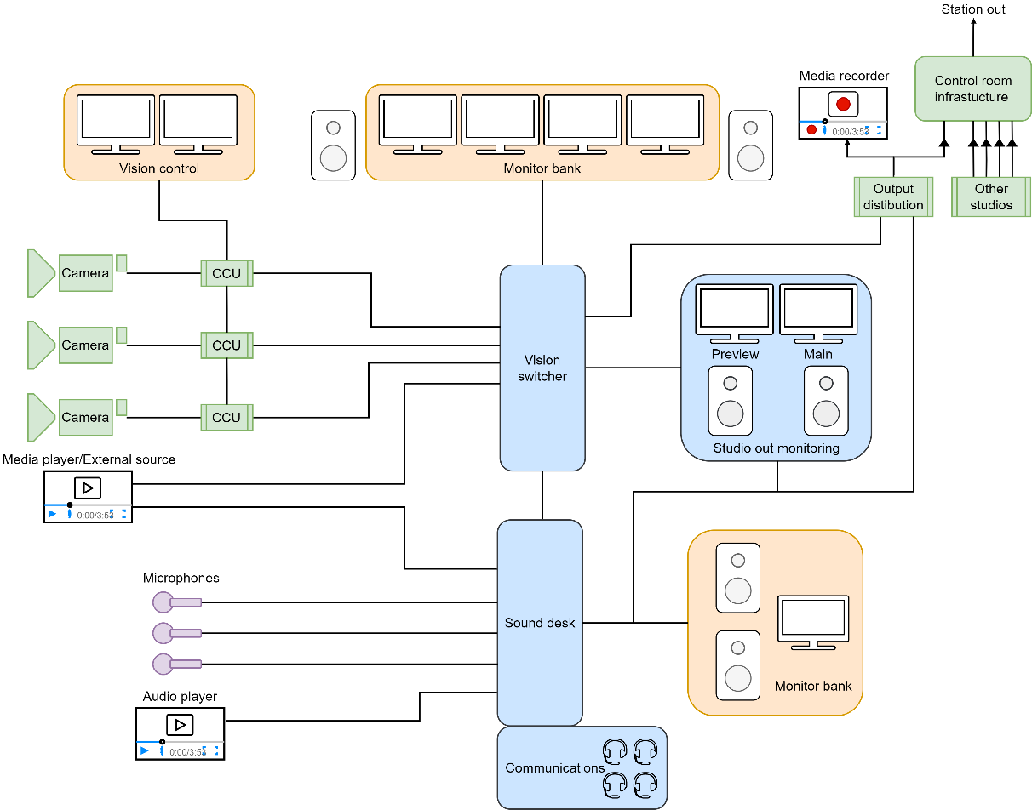

2.5.1 The software television studio
To efficiently use local infrastructure within a studio or event location, the processing of audio, video and control data into transport-steams will need to be carried out as close to the source as possible, preferably in the camera or microphone or of a multichannel audio digital interface (MADI) stream if used, as shown in Fig. 11. These data-streams can then be uploaded to cloud services through single or bonded multiple data transfer channels.
Figure 11
Operational cloud-based live production overview
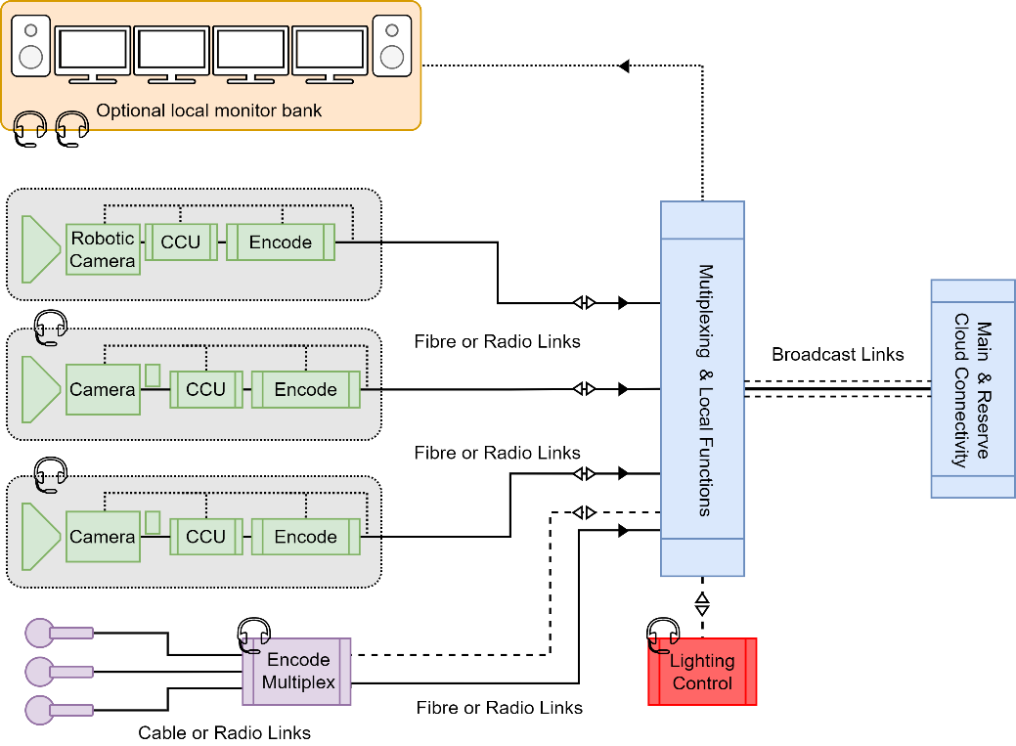
The programme production control area is undergoing the greatest change. Future connectivity from the location or studio floor operational areas will consist primarily of media and control data-streams and return monitoring signals. Although some form of traditional physical configuration will still be desirable for some users, it will no longer be the only option available to programme makers.
The use of Software as a Service (SaaS) type workflows is already significantly reducing the complexity, rig and de-rig costs required for remote locations and for in-house studio floor areas. It can also decouple the operational control functions areas from the studio floor allowing any control room area to operate with any floor space in any building or any remote event location.
Figure 12
Production cloud based live TV applications
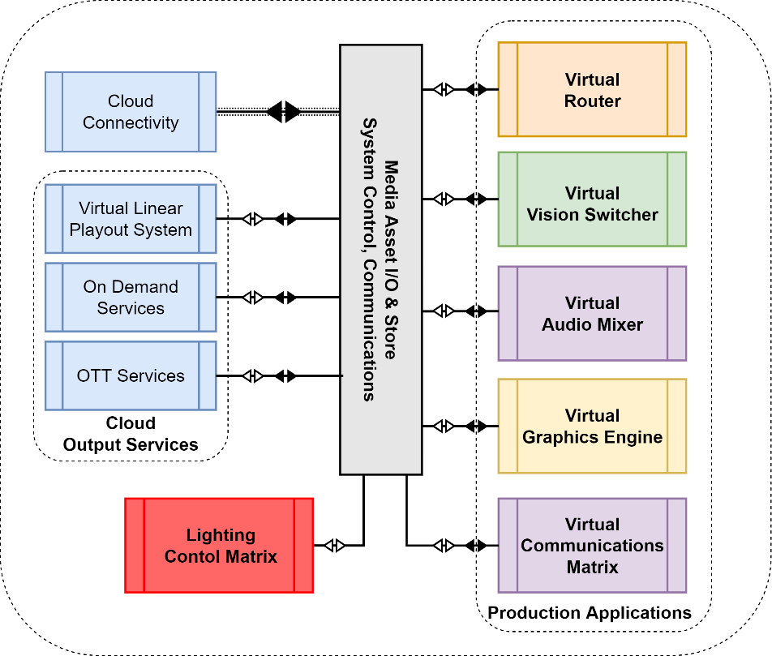
The control surfaces for software and cloud-based infrastructures will only need to send data instructions to the cloud applications which process the media. This allows the operational users to be in any location using a mix of physical data control surfaces or purely software control applications.
Figure 12 provides a high-level overview of the broadcast signal and data applications located in a cloud service used by a programme. Control can be by any Internet capable device such as the pad-based application shown in Fig. 13, which only requires a reasonably good Internet connection.
Figure 13
Virtual studio control application
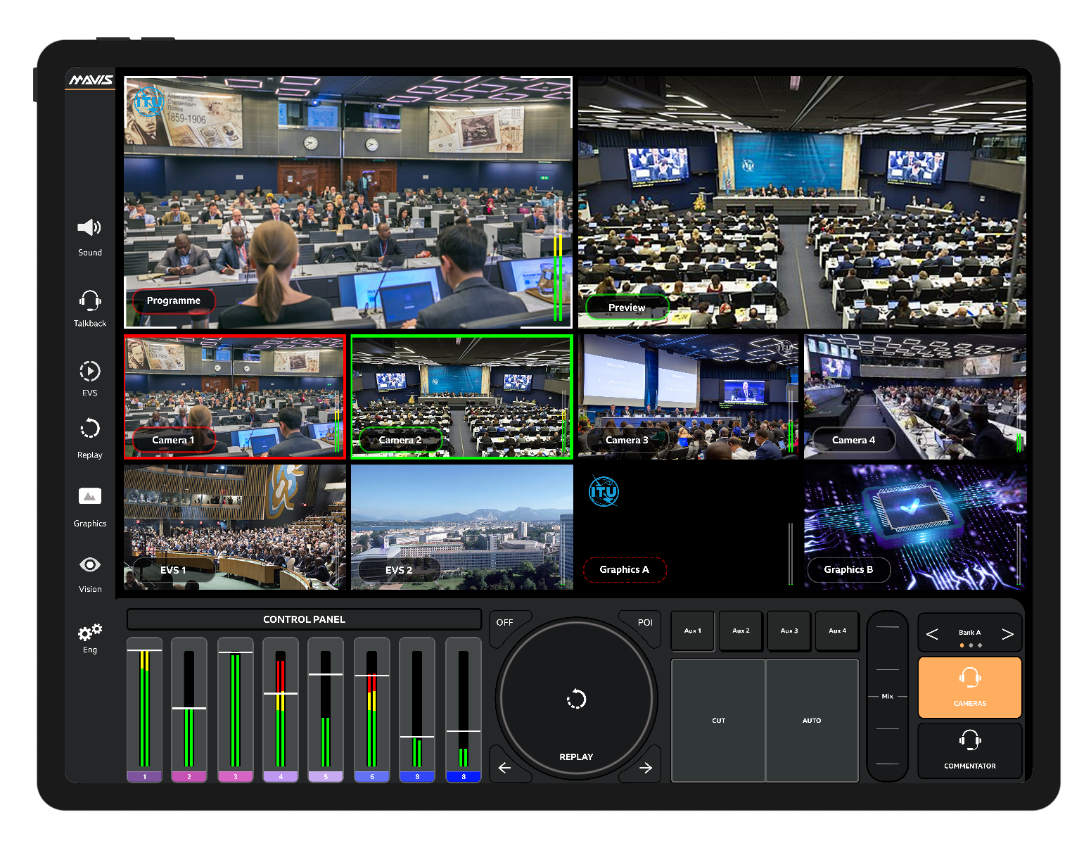

3 Cloud ready
Services will not depend on specific instances of an underlying resource (e.g. a particular virtual machine, or a particular IP address), but will use abstraction and encapsulation principles such as load balancing, object-based storage, Application Programme Interfaces (APIs) and Domain Name Servers (DNS) to provide parallel, scalable and resilient subsystems. The use of serverless computing has the potential to provide API functionality without the need to manage any underlying infrastructure.
Inhouse, distributed and remote production infrastructures will to a large extent continue to adapt information technology processes and functionalities. Broadcasters have begun to use IP technologies in production centres which, although the primary enabler of change, is only the starting point for future cloud-based live and non-live production workflows.

3.1 Workflow as a service
In all production workflows (e.g. for live, TV, radio and sound studio, outside broadcast, packaged media), the programme production process continues to move away from fixed process-based hardware to ‘software as a service’ where the programme maker or broadcaster can elect to use an on-demand service or a continuing contract or a fixed term lease option to access programme making applications.
Moving away from the traditional infrastructure model allows the move away from multi-year capital expenditure models to operational and application segment financial planning, reducing or even removing the need for large upfront capital expenditure.

3.1.1 Data driven workflows
The goal of a data driven workflow is to minimize the need to copy, move or transfer media files while maximising the flexibility and efficiency of production processing. To achieve an efficient workflow, rich content data in a standardized form is essential. This data can describe the parameters or permissions of the original source media (e.g. camera, microphone, location, take, licence, originator) and describe processing required or carried out during the media’s progress through the workflow and on to the end user (in the form of rights or permissions, additional information, etc. (See § 7.)
Data driven workflows enable broadcasters to continuously adapt content to deliver a high Quality of Service (QoS) targeted at emerging devices while continuing to provide traditional services that fulfil their commercial or public service remit.
The growth of smart Internet connected devices needs to be served by data driven object-based content from production through to the consumer, enabling a high degree of personalized media which can be automatically adapted for different platforms and for linear and on demand services.
It will also be necessary to respond to the need and demand for the enhancement of video and audio with the expansion of conventional 2D screens and conventional multichannel audio to a greater space of expression.

3.1.2 Data driven cloud processing
Efficient and flexible production workflow systems are critical for the automatic adaptation of content to be targeted at multiple devices. Figure 14 is an overview of how production business, rights and content creation systems are integrated into a cloud-based data driven workflow, giving content owners and broadcaster control of each aspect of the production chain.
Figure 14
Cloud processing overview
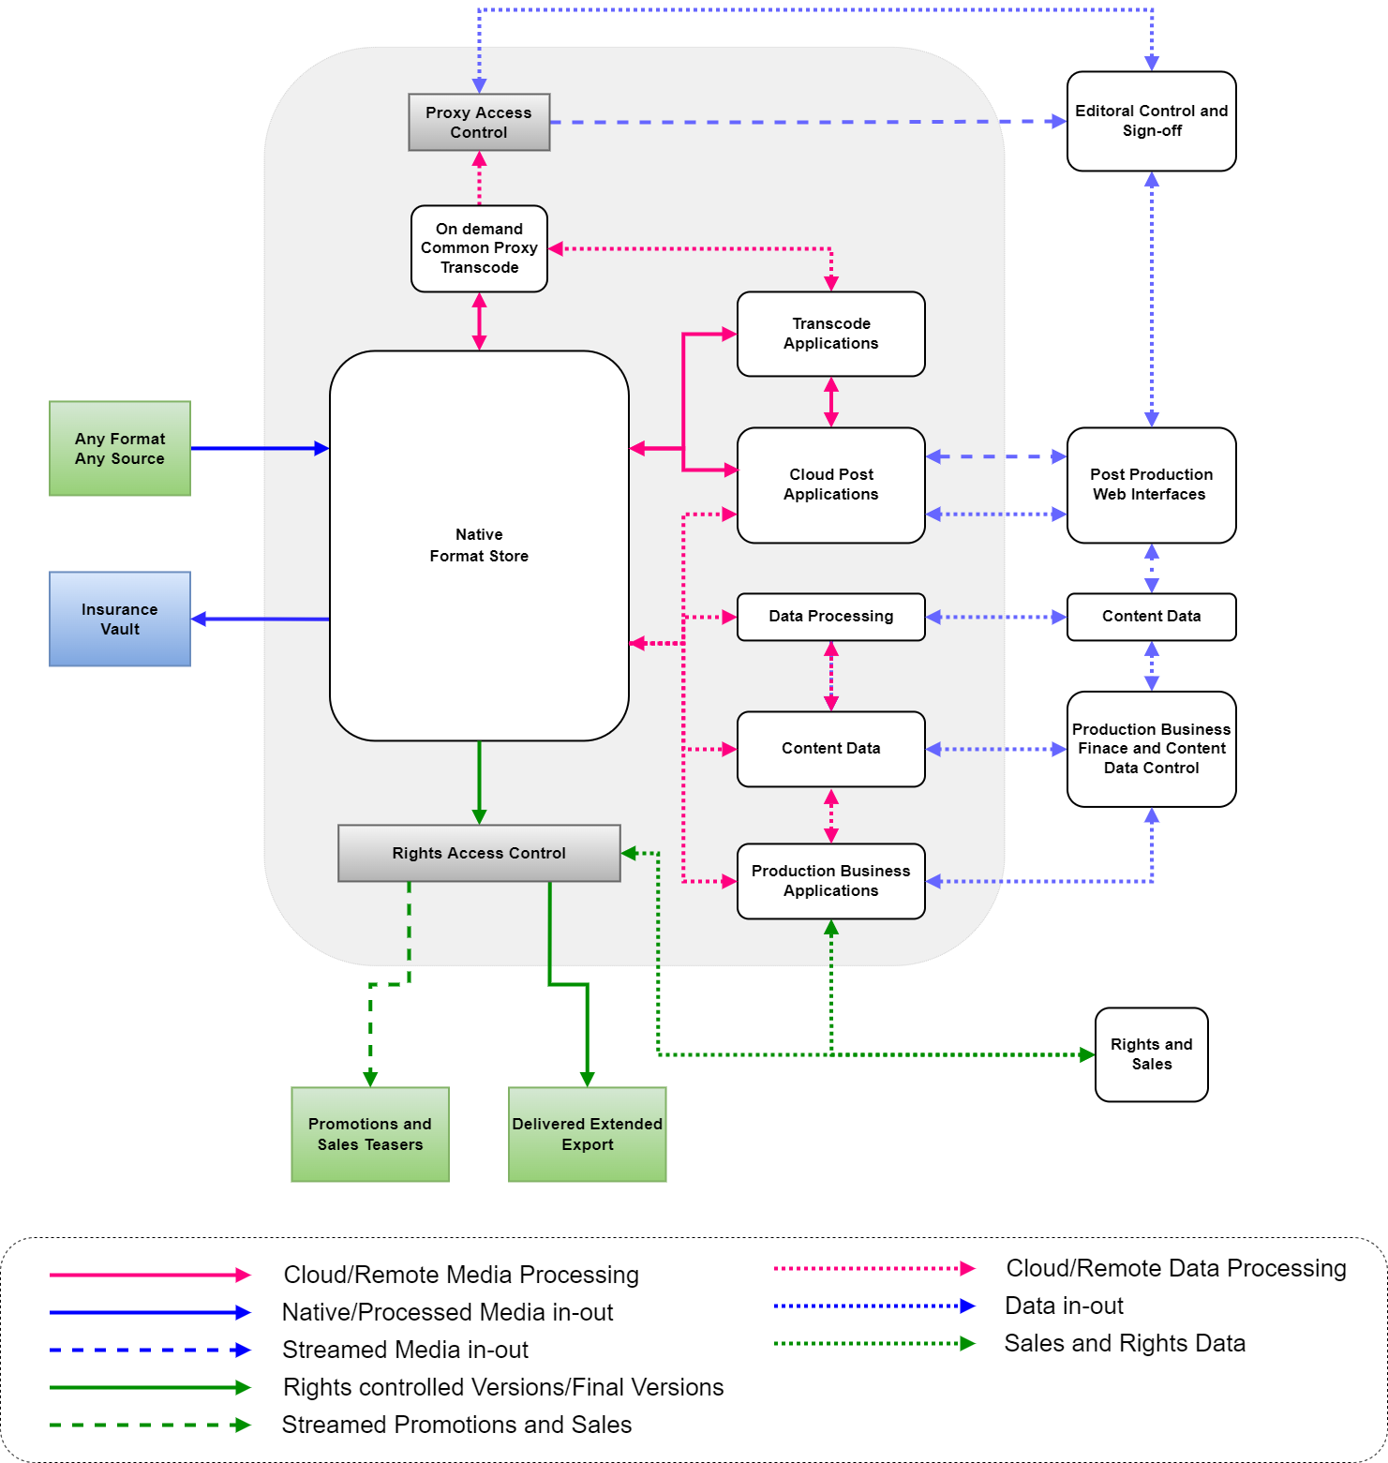

3.1.3 Cloud security
The merging of production and broadcaster business systems with content creation systems and cloud service providers is a new area of concern for security policies and practices. Many companies offer guidance and proprietary architecture for cloud-based production security.
A report by MovieLabs, The evolution of production security, suggests that “cybersecurity threats will become more difficult to detect as AI becomes a widely available tool for attackers”. The report goes on to define two security impact areas.
The first is protection from malicious and unauthorized activity, which is the primary goal of information security. The second is protection of the integrity of data, workflows, applications and processes, which suggests three principles for applying security protocols to production media workflows:
– security centred on workflows, rather than the infrastructure they run on;
– security centred on assets, rather than their storage and transport;
– that the integrity of assets, processes, and workflows is protected.
It is not just what and where security protocols are applied, it is also the case that programme makers are often frustrated by too rigid security protocols especially during the research phase of production and again when working with companies outside their own organization. Media security architecture needs to acknowledge that there is a wide variety of applications and operations that are required during content production. This makes it vital that applied security protocols allow programme makers to easily move content through the approved workflows that may involve internal departments as well as multiple external organizations. Protocols such as zero-trust architecture are useful when targeted at content workflows. A zero-trust approach assumes that any connection is a potential threat and instead of taking snapshots as users connect and then persisting any permissions applied, zero-trust will continuously evaluate and confirm the validity of the user, the user’s device and the network or service attached.

4 Complex media creation
As workflows become more flexible, they also become capable of processing more complex media. The way media is captured, post produced and prepared for delivery is also rapidly changing. Technology developments, especially the real-time processing of images and audio in any three-dimensional space and the production of interactive immersive experiences, have opened opportunities for programme makers to explore and try new ideas and storytelling techniques. To achieve this, the content itself will be captured, processed and stored as discrete objects, only merging into a single entity at the point of delivery or even in the user device.

4.1 Object-based media
In a report on object-based media (OBM) the UK’s Communications and Media Regulator states that:
“Object-based media describes any approach to producing, distributing and/or consuming media content that uses separate digital media assets, known as ‘objects’.”
As the benefits are multi-faceted, broadcasters and operators need to make a complex internal business case for a shift towards objects. OBM is already showing benefits in broadcasting where it is used to:
– create a wide variety of objects that augment the core content through social media platforms;
– create branching narrative objects in interactive content;
– target advertising.

4.2 Objects and content creation
Object-based media allows content itself to be made, packaged and presented in different ways. To better understand this concept, OBM can be summarized into three primary types as illustrated in Fig. 15. Although there are various terms used, the concept can be labelled as layers (or tracks), chunks and transmedia.
Figure 15
Overview of object media types
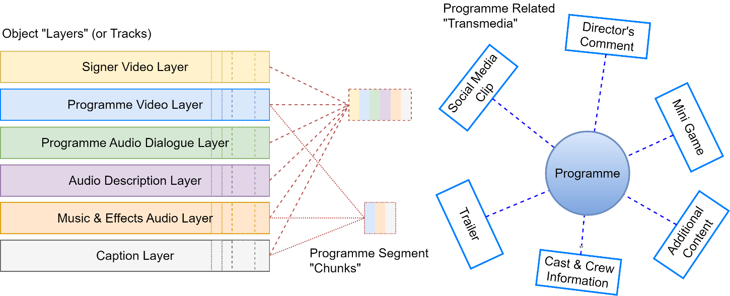

4.2.1 Layers
Layers (sometimes referred to as “tracks”) can be considered as objects that are intended to be used together with or instead of, other objects at a moment in the content timeline.
Examples include:
– a complete version of a programme;
– captions and subtitles (including audio captions);
– audio description;
– signing;
– director’s commentary;
– alternative graphics, commentaries;
– alternative languages;
– separated audio or video (e.g. to change dialogue loudness for better clarity).
Objects of this type are combined in groups to create alternative or augmented experiences. These objects are co-timed and synchronised to be meaningful.

4.2.2 Chunks
Chunks (sometimes called “clips”) are discrete sections that can be consumed alone. Chunks can be sections of a programme or specially made content, designed to be used alone. Programme makers are already going through archives and creating short form ‘snackable’ content created from snippets of archive material and putting them out on major social media channels.
Examples include:
– a single News item from a programme;
– individual boxing rounds;
– short self-contained items from a radio or TV programme;
– opening or closing credits;
– short sections of several archived programmes on a theme.
Manipulating these chunks gives consumers and producers more flexibility in terms of what audiences consume, allowing the production of:
– different programme lengths for different production or consumer requirements (e.g. from episode highlights to full episode);
– branching interactive narrative that allows audiences to make choices that affect narrative outcomes;
– media tailored to the individual by creating new content packages from an extensive list of content (e.g. personalised news package for people who opt out of celebrity news);
– targeting advertising at specific consumers with specific advertisement clips;
– incidents in a sporting event, e.g. goals, penalties, home runs;
– clips for thoughts or to stimulate social media discussion.
Audiences are already clipping, re-tweeting, personalizing and distributing elements and clips from content on social media, usually in a homemade way on their mobile devices – operators and broadcasters can be unsure how to react to this but will need to consider providing richer data to make sharing and tagging easier for audiences, or by restricting object and data distribution to avoid inappropriate clipping and editing by consumers.

4.2.3 Transmedia
Transmedia consists of sections of related media that are independent and not a direct part of a programme. They are and will be accessed separately to add to or complement the overall experience.
Examples of these objects include:
– bumpers, trailers, making-of documentaries, outtakes;
– links to media and information databases (e.g. Wikipedia/IMDb entries);
– cast and crew interviews, location information;
– reviews, social media pages, blog posts;
– programme related gaming or competitions.
Transmedia can easily extend to related content such as a radio drama version, toys, merchandise, magazines and spin-offs.

4.3 Benefits of media as objects
All these object types already exist but are very rarely arranged, ordered, tagged and searched as a true object-based media database.
To realize the potential of object-based media, it is important that a set of standardized rules are developed. The rules will be required to define how the data needed to describe how an object is packaged and adapted by the applications used to process and present the content to the end user.

4.3.1 Accessibility benefits of media as objects
Using object-based media provides new opportunities to respond creatively to new forms of accessibility. In addition to signing, captioning and audio description, new accessibility features will become viable such as enhanced audio description (EAD).
This can add a new dimension to a traditional audio description offering a new audio description approach to the narrative. Ideas include first person narration from the perspective of a particular character and the sound bed manipulated with sound effects and spatialization to provide a better sense of location and facilitate a more compelling experience for blind and partially sighted audience members. Research already shows this provides a more enjoyable and informative experience than audio description today.
More research is needed in consultation with accessibility groups to incorporate user driven options suitable for any need. Ideas for future accessibility object options could include:
– haptic representation of music and other audio-based effects;
– tactile representation of visual objects;
– personalization of signers (gender, ethnicity, etc.);
– choice of verbatim, simplified, rich, etc. captioning;
– personalization of text-to-speech and other audio descriptive functions.

4.4 Componentized content creation
As content is produced for multiple territories, additional versions will be required to comply with different regulatory and rights requirements. Different platforms require technical variants in addition to the editorial versions in order to accommodate a variety of display formats and capabilities (screen size and shape, device audio or immersive audio reproduction, display colour and dynamic range capability, stereo, surround or immersive audio, etc.).
Making multiple versions of programmes results in multiple copies of segments of the content, which is wasteful, environmentally undesirable and requires complex post-production if changes are required to content that is used in many or even all versions of the programme.
To satisfy the need to reduce the storage and transfer requirements, new techniques are needed to handle content as the complexity and number of versions continue to increase.

4.4.1 Objects as components
A traditional versioning process will create a full-length file for each version of a programme. Much of the content will be identical in each of these versions, which is an unnecessary and inefficient use of local and cloud storage and requires excessive and unnecessary quality control (QC), file transfer, compliance checks and repeated processing. One method of managing this is to consider each object required in a version as a component that can exist in any number of individual versions without duplication.
Componentized content creation targets:
– internal and business-to-business media exchange;
– content with multiple audio, video and data components;
– access service provision in multiple languages;
– descriptive static and dynamic process and users targeted data streams;
– creation of multiple editorial versions from a common set of essence and data files;
– delivery of content in phases, without the need to repeat delivery of the entire content;
– identifier-rich metadata for ‘robust’ automation and auditing.
Currently componentized content workflows maintain flexibility up to the point of content exchange. From this point onward in the chain, individual single version files need to be made for linear-channel play out, on-demand services and OTT or other distribution versions.
New distribution options will be needed to enable components to be taken all the way from the content owner to the user. Doing this will allow a high level of control by:
– the user to select the options and version of the content they want;
– the broadcaster to enable or disable options based on subscription level or regional regulation or to include child protection measures.
Control data packaged with the components will be able to automate versioning, packaging and the options to be delivered with the content for user personalization.

4.4.2 Automating versioning workflows
The automation of production content workflows has traditionally been constrained because programmes were made and delivered on linear physical media formats (film and tape). The move to file did increase some areas of production automation but versioning and content exchange automation was again constrained due to the programmes being exported as flattened files.
Componentized workflows will become more attractive to an increasing number of content producers because:
– The creation of different versions of the same content for online services is increasing for national broadcasters (e.g. different online version for mobile watching, in signage applications in public transport, etc.). This fits the overall trend towards a more ‘object-based’ production and delivery chain.
– Content creators are already using ‘higher quality’ production technologies than are needed for current delivery platforms in order to future proof media. Componentized content can be used with existing media libraries and workflows as well as object or fully componentized systems.
The combination of data and essence in workflows will enable a high degree of automated processing and on-demand versioning. This minimizes the need for multiple transcoding and re-encoding processes and maximise storage and transport efficiency.

4.4.3 Rendering
At some point in the media supply chain, objects and components will be reproduced on a device through a rendering process. The term is not new in the post-production, visual effects and games industries where the purpose of the renderer is to assemble all the elements into the flattened final consumable content version. Gaming has already demonstrated that high quality audio and video objects can be rendered in real-time on consumer-based devices. Applying this technology to live broadcast object-based media is not an unrealistic ideal.
Componentized object-based media will have multiple elements that need to be consolidated by the renderer. In essence, the process combines some or all the objects available using the accompanying data. At the point of rendering, data describing the media and data required to process the version are vital to how the user device will reproduce the content and the options available for personalization based on user need, device capability and the surrounding environment at the time.
It is important to maintain as much flexibility as possible to the point of reproduction and, ideally, rendering will occur in the reproduction device itself. To do this, a two-way data exchange will be needed so only the elements required by the user will be sent and allow the distributor to comply with territorial regulations, subscription level and user profile.
A more flexible approach to standards (see § 8.4.1) will be needed to maintain interoperability between the content owner, the distributor infrastructure and the user device while maintaining the creative intent through personalization variations based on a user’s situation.
Environmental option examples include:
– size or type of device or screen;
– number and position of speakers;
– use of headphones;
– ability to display UI or graphics;
– control of navigation and reproduction parameters.
User-based options examples include:
– closed captioning choice;
– dialogue enhancement;
– signing;
– audio description;
– language preference;
– territorial and age restrictions.

5 Artificial intelligence and machine learning driven automation
It is important to see how artificial intelligence (AI) and machine learning (ML) technology used in content creation is rapidly evolving. As an example, in 2016 the IBM’s Watson AI system was used in the production process for a trailer for the movie “Morgan”. The system was trained by analysing multiple movies and trailers from the same genre before the whole movie was presented to the system.
IBM reports that “…from the 90-minute movie, our system provided our filmmaker a total of six minutes of footage. From the moment our system watched “Morgan” for the first time to the moment our filmmaker finished the final editing, the entire process took about 24 hours. Reducing the time of a process from weeks to hours…”
Since then, AI/ML systems have continued to learn and are now starting to analyse live sporting events to automatically create highlights packages based on user criteria (e.g. highlights of a player, a team, a season).

5.1 Generative AI
In the context of the future of broadcast production, Generative AI (GenAI) may be used to deal with text, audio, video, three dimensional (3D) space modelling and virtually any area of media production. Effectively, GenAI systems learn from existing media and data, and use the learning to create new content. One of the more well-known GenAI applications is ChatGPT. GenAI applications have already been used in producing scripts and script ideas, generating lyrics and music and adapting linear storylines into branching interactive content.
Current early examples of how AI systems are already changing the way content is being made show how rapidly this technology is changing the programme production. The potential ethical, legal and social implications of the use of AI systems in broadcasting are discussed in § 5.7.

5.2 AI used for sport content
As an example, European broadcaster Sky is using AI based automation to produce content enhancing sports highlights packages for multiple territories using services like these for rapid time to market as shown in Fig. 16. Processing includes:
– ingest of mezzanine grade streams to Amazon web services (AWS) for cloud processing and analysis;
– localization using territory specific streams targeted customer experience (commentary language).
The system uses an AWS elemental portfolio of SaaS solutions to produce video-on-demand (VOD) highlights served via API to dedicated middleware per client.
Figure 16
AI automated sports highlights
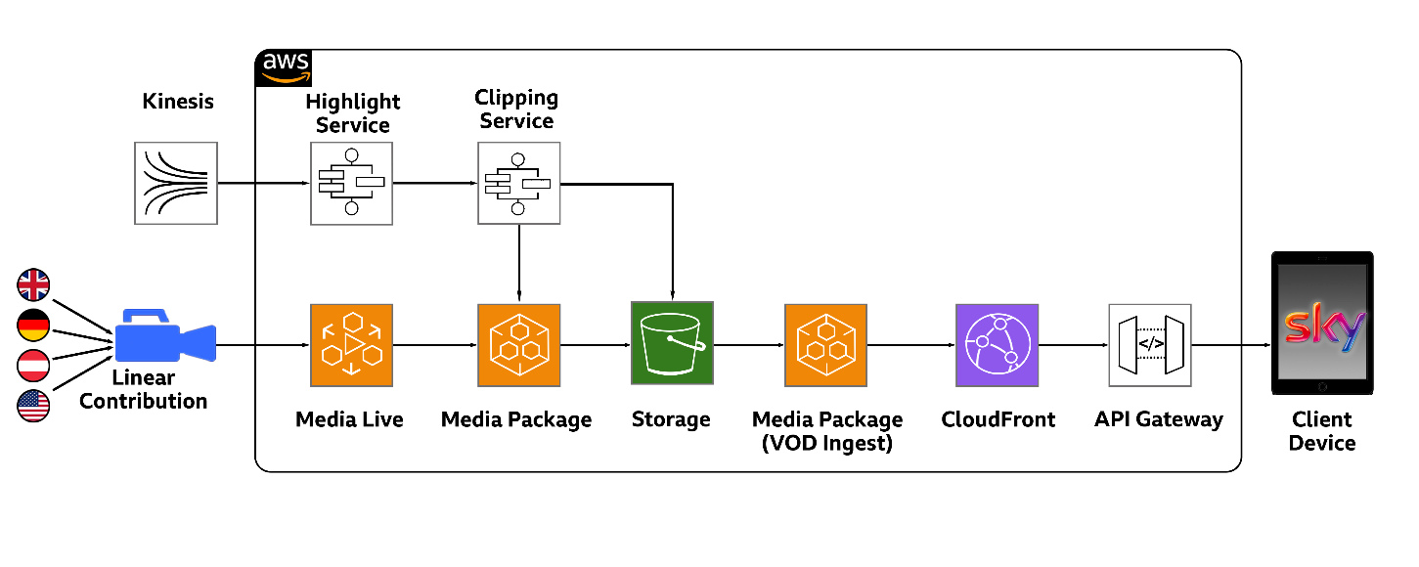

5.3 AI in the news environment
Newsroom automation systems using a range of AI/ML driven applications will become essential aids to journalists. The driver is the ability to rapidly access content and the verification of information including accurate identification of locations, events and the people involved.
Face and voice recognition algorithms crossed referenced with an organization’s archives, social media and external data services combined with experienced journalists lead to more accurate reporting and information used during interviews and analysis stories. AI/ML systems can also rapidly cross-reference themes and stories too identify emerging trends.
Most news organizations use templates for graphics, statistical analysis and on-screen text or radio data services. AI/ML can populate the data fields needed pulling the information from scripts, archives and external sources. They will also be able to highlight conflicting or mismatching data rapidly and accurately.
It is clear that in the future the use and exchange of data will be of primary concern. Speed-to-air is critical, and there are three main areas that will benefit from standardization efforts:
– Pooling: It is common for groups of news organizations to agree to pooling interviews where one journalist represents the group in order to gain access. AI driven exchange of content and associated data allows using common standards, enables each organization to get stories to air and apply house style to the content.
– In the field: Journalists need to get to breaking story location very quickly often without time to organize the logistics to identify the media and data packages they will send back. AI driven processing can send to and retrieve data from connected location devices (smartphones and pads linked to connected cameras) providing the journalist with the latest information and, more importantly, automatically identifying contributors and packaging the returned content ready to be fed into the newsroom system.
– Platform formatting: Users expect to get news from any platform, especially social media applications. The key to fast-to-air on each platform is the re-formatting of text and audiovisual clips. Again, data format standards enable AI systems to analyse content and storyline to auto-format and update each output platform.
It is inevitable that in certain areas of production the automation of the creation of derivatives and repurposing of content will become completely automated through the use of AI and ML based systems, with manual intervention occasionally.

5.4 AI for fake and hate detection
The proliferation of DeepFakes (synthetic media manipulated by deep learning algorithms) is now even deceiving human experts. Journalistic investigations complemented by AI/ML systems are beginning to detect and flag misinformation in audio, video and text content. The mining of meaningful information based on a vast amount of heterogenous data as well as its analysis and visualization is the province of AI/ML systems which will prove to be vital tools that support and allow investigative and data journalism to thrive.
AI technologies can be used to identify bias, detect “hate speech” and monitoring gender, ethnicity and religious mis- and under-representation in public media which along with breaking down language barriers, help in supporting transparency and diversity in journalism.
AI algorithms can be targeted at protection of audiences, especially young audiences from malicious digital attacks and identify the damaging trend of targeting misinformation at vulnerable groups.

5.5 AI for synthetic media
Fake media is really synthetic, the term “synthetic media” is often used to describe video or still images, speech or music and text, in any combination that is fully or partially generated by computer algorithms. Many applications used to create synthetic media need little or no knowledge of the underlying complex technologies.
Synthetic media tools can be used by programme makers and broadcasters to enable and extend content creation and storytelling options including:
– creation of digital humans, e.g. remote performers, sign language interpreters;
– creating realistic or fantasy environments for human or synthetic performers or both;
– automating animation production;
– creating alternative versions of storylines for interactive or personalized content.
Synthetic media applications and tools are becoming capable of creating complete programmes including the scripting, performers and scenery, dialogue, music, etc. that may be difficult to distinguish from traditional made content.
Synthetic media tools also make it possible to fabricate entire events or the participants in an event without consent causing harm, offence and disruption to business, economies and political situations. The ethical implications and the responsibilities of those creating or distributing synthetic media are still to be realized.

5.6 AI for accessible media
Another important application area that is beginning to benefit substantially from AI technologies during the production stage is accessibility. These technologies can dramatically raise the quality level of accessibility options and, more importantly, will enable more content to be made fully accessible to users who rely on these services. Examples of early development of AI systems for automated multilanguage captioning, audio description and signing are already being used by broadcasters to enhance content. As these systems develop there will be a growing need for interoperability between output platforms and for the exchange of content between programme makers, distributors and broadcasters.

5.7 Ethical, Legal and Social Issues of AI in broadcasting
The term ethical, legal and social implications (ELSI) sometimes known as ethical legal and social aspects (ELSA), is an approach considered when studying the impact of science and technology advances including the use of AI/ML on society and individuals. This mirrors the ethical considerations applied to or by any broadcaster, journalist or programme maker irrespective of the use of AI/ML technology.
The use of AI/ML technologies for programme making should not necessarily introduce any new areas of responsibility. Programme makers have always had to respect and protect the rights and the privacy of actors, contributors and the audience. The general ethical principles of respect for freedom of choice, protection of personal data and equality of opportunity, which apply to content creation, also apply to the use of AI/ML technologies where they are used for programme making and content distribution.
Consideration when implementing AI/ML technology should include, , :
– individual, social and environmental well-being, AI systems should contribute to, and not harm, individual, social and environmental well-being;
– transparency: the purpose, inputs and operations of AI programs should be knowable and understandable to its stakeholders;
– accountability and oversight: humans should be able to understand, supervise and control the design and operation of AI based systems, and those involved in their development or operation should take responsibility for the way that these applications function and for the resulting consequences.

6 Virtual programme production
Although virtual television programme production has been used in some form for many years, recently there have been very rapid and major advances. An article by the International Broadcast Convention (IBC) suggests that ten years of progress has happened in one.

6.1 The evolution of virtual studio sets
Virtual film and television sets for non-live content have been used for some time and more recently computing power developments have enabled the use for live productions.
Traditionally virtual studio sets have relied on the advances in green-screen technologies. These have evolved from simple static set-ups to linking multiple cameras to processing applications that can accurately track motion and framing in real-time. Data generated by the processing applications control the virtual background either live or via the data being recorded on set to be used during post-production. One of the major drawbacks of green-screen live production is the lack of tactile interaction between the performers and the virtual set. As computing power increased, hybrid sets now often seen in live Sport productions, became viable and virtual cameras which can create paths through the composite of the real and virtual imaging that would be impossible with a physical camera.
The next step is the move from green screen backdrops to very large video wall backdrop displays which provide high resolution, wide colour gamut, high dynamic range scenery. These displays walls need to produce images to a much higher quality than the target reproduction format to allow dynamic camera moves and close up shots of performers.
Figure 17
Large video wall studio
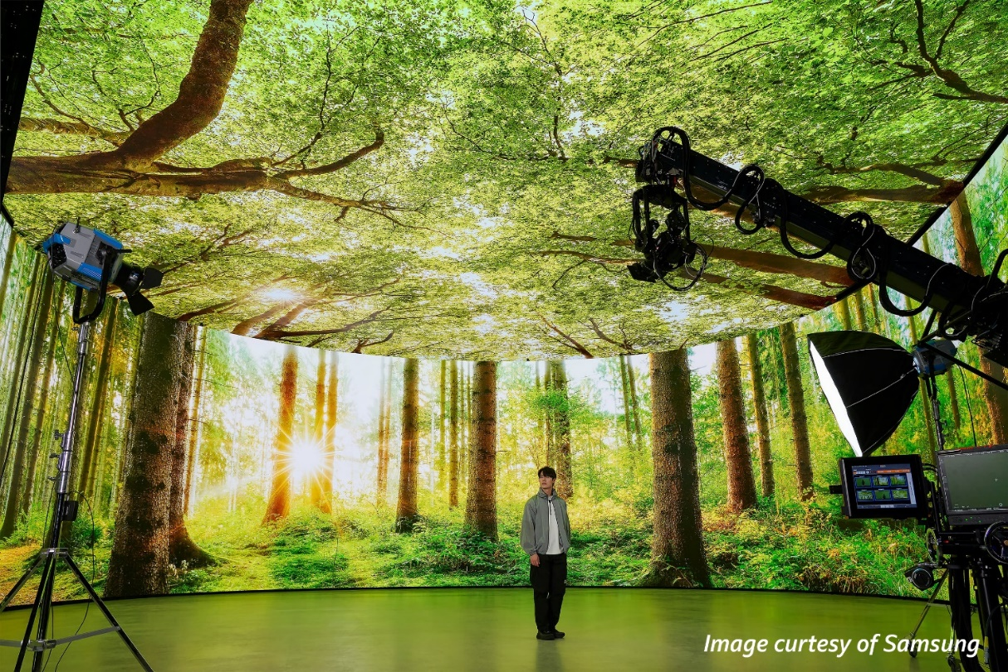
Figure 17 for example, illustrates a Samsung micro-LED installation which has an oval display 20 metres diameter by 7 metres high and a resolution of up to 30 720 (32K) by 4 320 (4K). Video wall technology will continue to develop rapidly as they are used as studio sets and in public spaces becoming ever larger. They may require content to be produced at resolutions, colour rendition and dynamic range in excess of current standards. Although many of these displays will be for bespoke or proprietary formats, they will need to be based on adaptations of new production formats and it is important that standards must be developed for interactive fully immersive content with resolutions of 32K, 64K or even beyond.

6.2 Remote performance
Another area of virtual television production taking advantage of the rapid development of motion capture techniques is the use of remote performers. Traditional motion capture required a performer to where a body suite with reflective trackable markers that can be used to animate digital characters or avatars.
A combination of gaming technologies including facial expression recognition and full body motion detection is beginning to move motion capture to a new level where body suites and green screen studios are no longer needed. Gaming engine technology is also enabling the use of consumer-based devices (cell phones, webcam, etc.) to capture the motion and the human expression parameters needed by motion capture software packages to process. Proof of concept trials, are advancing to the point where organizations should consider what standardization is needed in this new area of production.
New use-case models include:
– remote performers interacting with animated characters in real time (live animation);
– human performers driving their digital twins in artificial environments;
– human signers driving human-real avatars allowing users to choose the signer’s representation and eliminating the need for dedicated signing studios (similar to the remote captioning techniques used for broadcast, conferences and virtual meeting applications).

7 Immersive, interactive and accessible media
The same technologies that have enabled remote performance advances are also an integral part of the capture technologies needed for immersive media.
When these technologies are combined with the work on the standardization of immersive media codecs (e.g. MPEG I and others), programme makers will have access to a growing set of tools that can break down the complexity and cost of interactive and virtual content creation.
Two inter-related image capture technologies are at the heart of future developments for immersive imaging. Volumetric Capture and Light Field 3D imaging are concepts that have been known for many years, which can now be realized for real-time content creation.

7.1 Volumetric video capture
Volumetric capture (sometime called volumetric video) has many potential uses in areas such as navigation in autonomous transportation, medical imaging, motion capture and for live performance capture in any environment.
Volumetric capture is the process of capturing a physical volume that contains objects in a way that makes it appear the objects take up three-dimensional space. The objects could be a single static item, a person in action or an entire location at an event. A volumetric image allows the user to choose how to move around the captured space.
NHK (Japan) has been researching volumetric capture in their Meta Studio space where multiple cameras capture a subject’s shape, surface light-field and reflectance in addition to the movement in the 3D space (Fig. 18). This data is used in a real-time rendering process to create a digital-twin 3D model of the subject which can then be used in any real or virtual environment using virtual cameras and realistic lighting processing.
Figure 18
Volumetric capture and processing
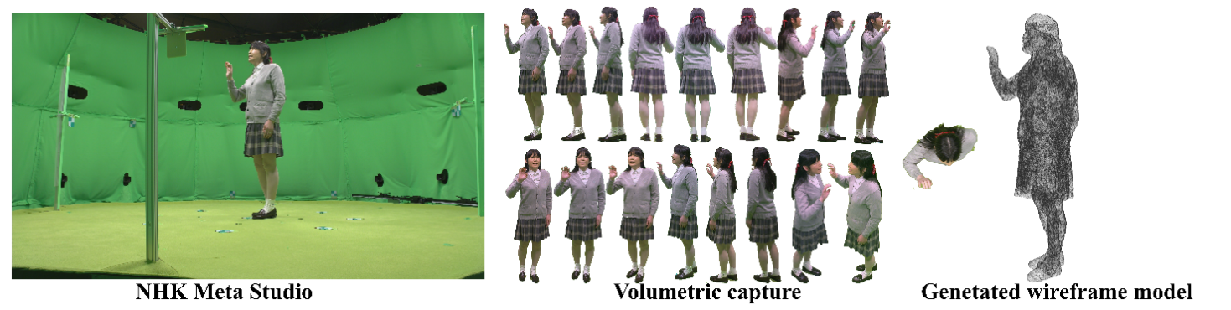
Production oriented standards are needed for the data streams required to accurately describe a scene in time and 3D space. The data specifying time-dependent position, orientation, size and other attributes of the 3D spaces being represented needs to be understood by down-stream production applications and packaged in a way consumer devices can navigate the scene in a reliable way realizing the programme maker’s creative intent. MPEG is already active in this area with standards for file formats, compression and scene descriptive data.
Along with the images, a fully realistic immersive audio environment and other sensory objects must be accurately placed relative to the user as the user moves through the virtual 3D space. To achieve this, captured data has to be passed through the post-production workflow which will create the packaged data streams required to drive the content reproduction devices and which describes the content adaption constraints for the user’s interaction.

7.2 Light field
A light field is the totality of light rays or radiance in 3D space through any position and in any direction,. Applied to image capture (still and moving images), light field cameras capture traditional images and additionally the direction and angle of all the light rays arriving at the sensor. The additional data describing where each light ray came from can be processed to create a depth map of the captured space which in turn can be used to recreate a video representation of the 3D space.
Along with the data generated by volumetric capture, the 3D space data forms part of the scene descriptive data which programme makers will need to package to realize their creative intent and to set the parameters the user can use to navigate the content. Again, MPEG is active in this area.

8 Data flow
It has become clear that data will drive future broadcast media workflows from capture to the end user. Future data flow will not be passive, nor will it be static, it will drive processing, content automation, platform and device formatting, rights, territorial and regulatory access and user personalization parameters. This means that as data flows through each process it will need to be appended, adding new data where needed during each stage of the media supply chain. Future data format and transport standards may need to incorporate or be based on Blockchain principles to maintain integrity and security of the data during its journey. Complex media production requires new data streams that identifies a user’s device capabilities then supplies the production format and user personalization options associated with the content specific to the device.

8.1 Scene descriptive data flow
A very important aspect of data for immersive, interactive and accessible media will be common standards for audio and video scene description. This is the data needed to describe and drive the narrative or the user related navigation through any scene in a programme. Figure 19 shows a potential path of the scene descriptive data that will be needed to reproduce and adapt immersive content. What is interesting for this interaction, is the ability to either send all relevant data to the user device or only send data requested by the user’s interaction with the device.
Figure 19
Scene descriptive data flow
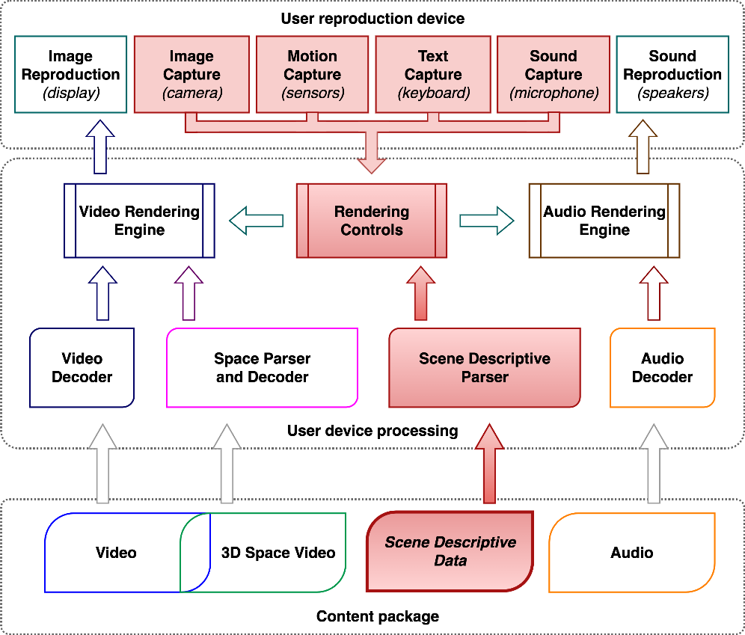
Sending all data (which would include all audio and video options too) could be a potential model for a traditional terrestrial or satellite delivery system, to present a very large audience with interactive options without the need of a return path for live content. Including a return path in the process simply increases the options available to the user in real time.

8.2 Content adaptation
Implementing these data-controlled object-based production workflows requires that clearly specified data protocols be in place and available in both cloud-based virtual tools and locally based production infrastructure tools. These protocols will be needed to automate the adaptation of the media to the platform or intended user device.
Figure 20 illustrates how a content adaptation process fits into virtual workflows adding temporal, positional, cognitive, and sensory adaptation data to media objects.
Figure 20
Content adaptation
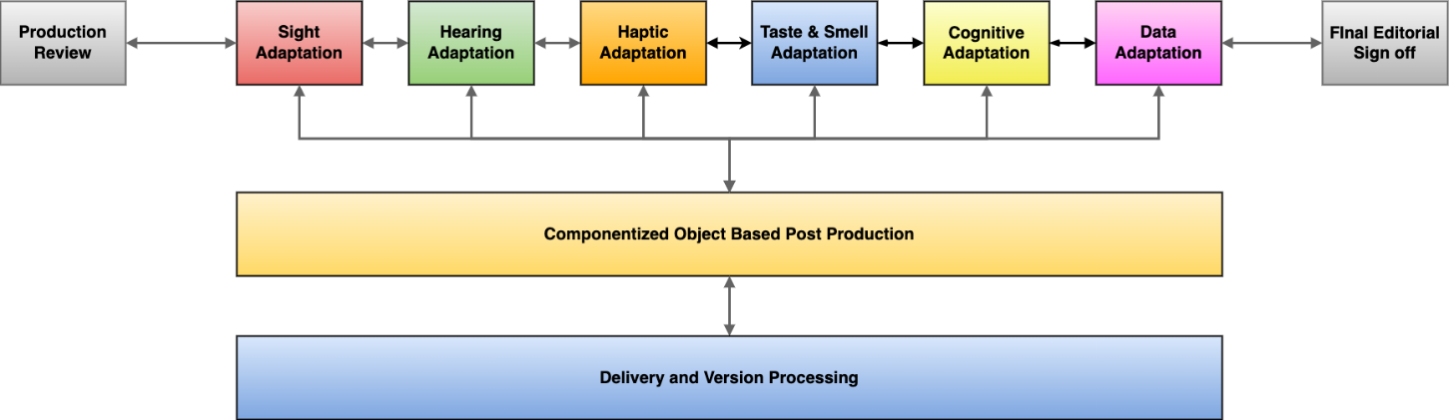

8.1.1 Accessibility adaptation
Figure 21 gives an example of the potential adaptation processes for immersive, accessible and personal media. In the example, content has options for Video Adaptation, Audio Adaptation, Sensory (Haptic and Taste/Smell) Adaptation and Cognitive Adaptation. Although the user can adjust the content to meet their specific needs, the programme maker can set the limits of the adaptation based on the capabilities of the device being used to ensure creative intent is maintained and that reproduction is not compromised or damaged due to exceeding devices specifications.
This is a simple 2D representation of potential adaptation which is not just a ‘slider’ that delivers a pre-set option. A user must be able to select both the option and the impact of the chosen option – e.g. a user chooses the option – ‘Audio Description’ then sets the impact of the option – for example ‘Audio Description level relative to the content audio’.
FIGURE 21
Personalized content adaptation
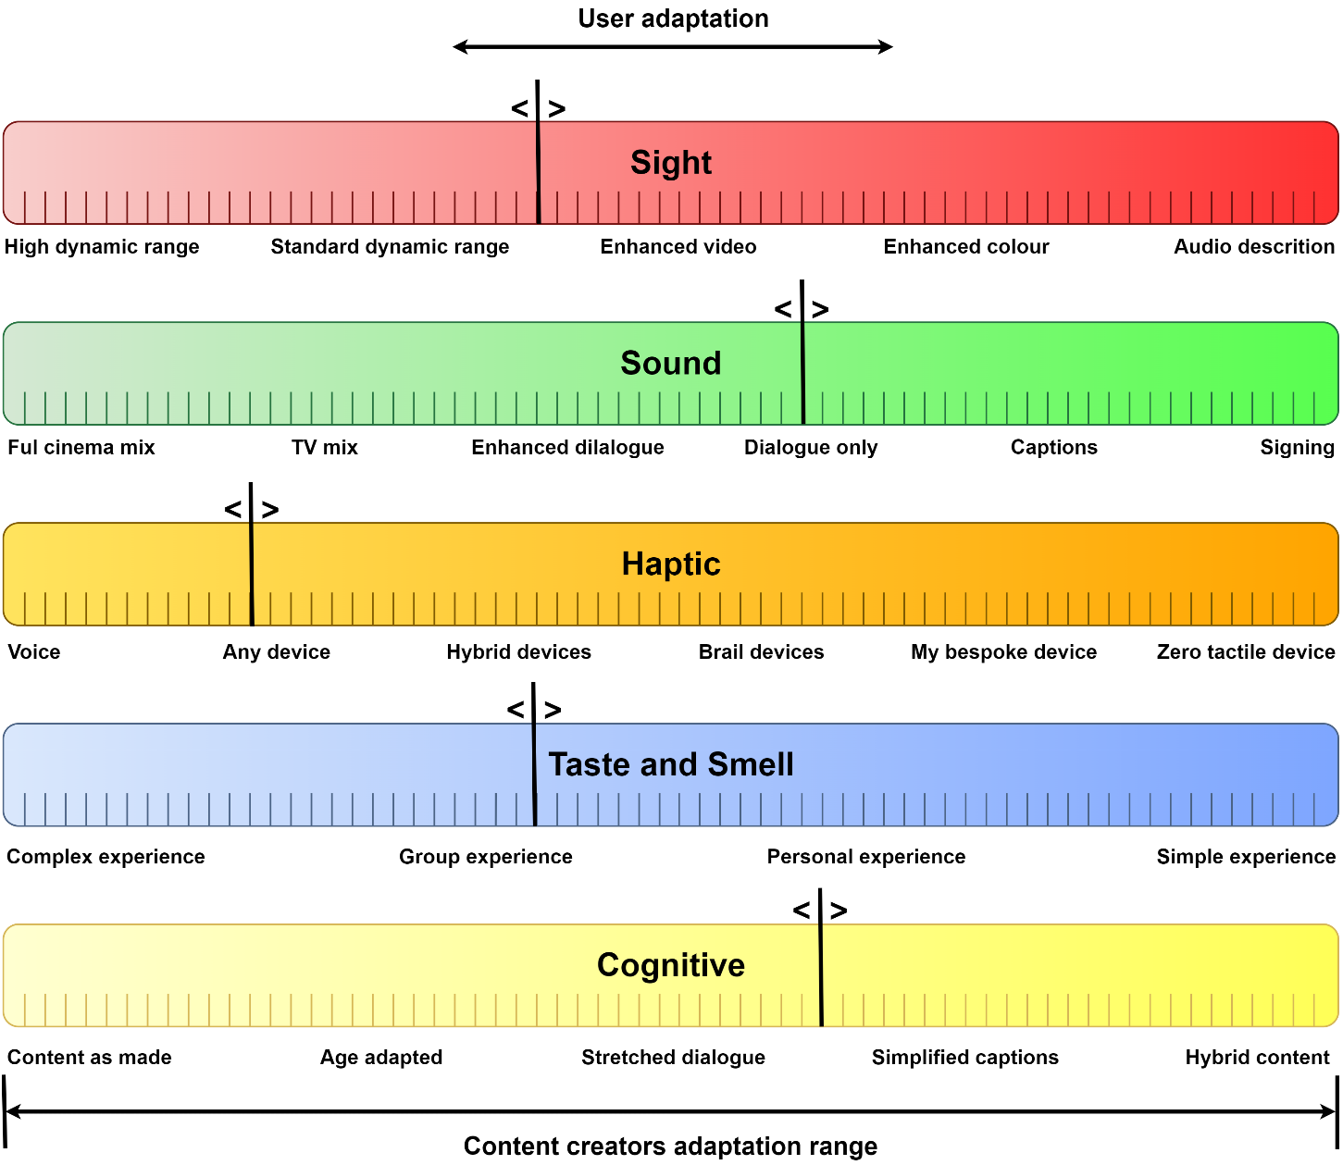

8.1.2 Cross platform adaptation
Broadcasters have been working on techniques to make content once but to deliver to many different platforms. This is usually between television and radio but increasingly adding social media platforms for text only, audio only, audio and video, video and text etc. In the future this will not just be traditional 2D or 3D but will include immersive experiences up to 6DoF. As the number and type of potential delivery platforms and target devices continues to increase, future broadcasting will depend on AI technology to automate the processing, re-formatting and packaging of content, making it ready for all the distribution chains.

8.3 New production tools
To service these new production ideas and meet the user expectations, new production tools will be needed based on:
– spatial sensing technology that will be needed for acquiring the shape and texture of objects, lighting conditions, audio properties, vital signs, etc.;
– 3D modelling and spatial processing technologies that will be needed for enabling producers to present the object images and audio fields to best effect;
– situation-understanding technology that will be needed for assisting the production flow, such as automation of shooting, switching, audio mixing, and 3D processing;
– a cross-modal production platform that provides signalling of bodily sensations in conjunction with traditional audiovisual content will be needed, so that end-user devices can exploit immersive sensations in the best way possible for their device features;
– data processing interfaces that allow programme makers to create adapt and embed the data needed to drive these features in the end user devices.
A number of production tools have been developed both by industry and by academic bodies that are designed to simplify the burden of asset creation for OBM and embed practical design principles into the process of OBM content creation.
An example of new tools for broadcasting is from the BBC’s “MakerBox” community toolset which is a collection of free user-based tools (example shown in Fig. 22). The StoryFormer tool is designed for creating flexible, responsive stories which can change dynamically in response to the viewer's input.
Figure 22
BBC StoryFormer interface
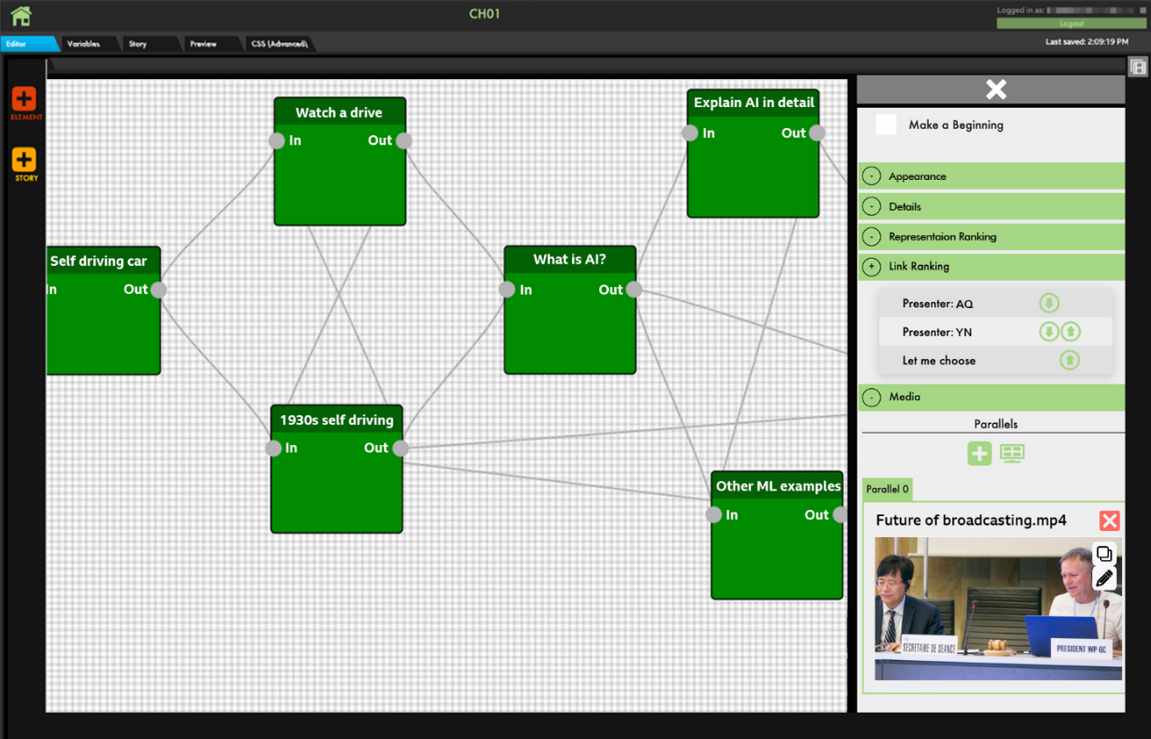
Many of the tools adhere to principles of open-source distribution and use. This indicates a recognition within industry of a need to consolidate tool chains and create working standards that allow broadcasters, independent production companies and creative organisations to speak the same language and work to the same set of standards.

8.4 Data across the production chain
The growth of data will also assist content management by making intelligent decisions to find content using specific criteria and make decisions whether to store, delete or make content instantly available. This will help reduce production costs by automated production at scale, i.e. providing more qualitative content at reduced cost. The use of unique universal identifiers for all elements of a programme will become vital.

8.4.1 Data for object-based media
The UK regulator’s object-based media report¹⁰ states that “without data, objects alone have no practical use!ˮ. Content related data is needed to place objects in time and space and to control how they are reproduced, e.g. relative volume.
Framework Standards might be a solution to rapidly advancing technology implementation. Figure 23 is a high-level overview of an idea for defining a framework standard rule set. These would be applied to formatting eXtensible Markup Language (XML) data which satisfies the requirements of static or global data and when wrapped using the Material eXchange Format (MXF), satisfy the dynamic or temporal data.
Figure 23
Framework standards rules set overview
The repositories, tools and formats needed for Framework Standards are well established. Repositories such as GitHub, Octopus Deploy and cloudsmith are in use by many developers and many broadcaster and programme makers technology teams use tools such as FFmpeg to process media at very high quality.
The International Press Telecommunications Council (IPTC) for example, has standards for the distribution of photo and video data. Framework standards can be used to apply these data standards to the live, streaming, post-production and packaging processing stages as well as formatting for the onward distribution to programme exchange and delivery to users.
It is the flexibility that make framework standards very attractive to process and system developers who will be driving future broadcasting innovation. However, to make this work the rules sets must be based on an underlying stable set of base or core standards.

9 Sustainable production
Many broadcasters and production companies believe that environmental sustainability must be embedded in the way programmes are made. In some cases, environmental messaging is embedded into the narrative of a programme itself. Programme makers and production processes will need to support the sustainability ethos of the commissioning companies, who are the production’s financial backers. As an example, the BBC’s television programme delivery requirements state:
“From January 2022 all new commissions and recommissions are required to complete albert, certification, including content from Television, the Nations, Children’s and Education, BBC Film and non-News related Sport...ˮ.
Many broadcasters already use carbon calculator tools to certify a production’s sustainability action plan. Delivering an action plan is an essential part of the commissioning process to reduce emissions and minimize power consumption and consumables (props, scenery, etc.).
Many of the processes and workflow ideas discussed in this Report can be used as part of a strategy to reduce the environmental impact of content creation by either the efficient use of shared infrastructure, reducing need for travel or eliminating duplication of assets or resources.

9.1 Carbon action plan
All broadcaster, production companies and individual productions should consider making a carbon action plan, . The action plan is a mechanism designed to help productions to understand and reduce their environmental impact. Opinion ITU-R 104 – Advice for sustainability strategies incorporating carbon offsetting policies, provides background information for broadcasters and broadcast related organizations on how carbon offsetting can be integrated into carbon action plans.
Examples of the areas that need to be assessed in any action plan include:
– use of low power lighting;
– use of facilities that source sustainable power;
– use of rechargeable, not single use batteries;
– use of sustainable material in new sets and costumes;
– use of hire and return, not buy and dispose in all purchasing plans.
There are many other production technologies that can form part of a sustainability strategy, but the key is the use of virtualized and cloud-based infrastructures described earlier. By minimizing processing and copying media files and reducing the duplication of infrastructure across an organization’s buildings estate, broadcasters and production companies become an active part in achieving net zero.

10 Conclusion
Future production methodologies and standards need to be adaptable and have a greater scope to change to match the trends discussed. Removing dedicated process hardware from broadcast infrastructure also removes the need for rigid implementation standards. Software based infrastructure and processing can be adapted simply and as often as needed but only if there are strong standards defining the data formats needed to update virtual production tools.
Complex content still needs to be simple to implement, use and control or the Cost – Usability – Impact assessment (see § 1.3) will fail to deliver any benefits.
Any framework for the future of broadcast production can only look at the way any current trends are evolving and what direction these new and emerging trends appear to be taking. Broadcasters and programme makers will look at how user trends are developing and also endeavour to excite and attract audiences to new concepts.

Note: Report ITU-R BT.2420 – Collection of usage scenarios of advanced immersive sensory media systems, has further information, explanations and early examples of many of the concepts discussed in the present Report.
The UNFCCC has commenced sustainability action through the Entertainment Industry Net Zero Accord (ENZA).
Blockchain @ Media report Deloitte –https://www2.deloitte.com/content/dam/Deloitte/tr/Documents/technology-media-telecommunications/deloitte-PoV-blockchain-media.pdf.
Direct: Fog computing at industrial level, architecture, latency, energy, and security: A review – https://www.sciencedirect.com/science/article/pii/S240584402030551X.
UNESCO: Communities through radio https://en.unesco.org/news/connecting-communities-through-radio.
Radio Active: Example community radio https://radioactive.org.uk/.
IBM: Object Storage – https://www.ibm.com/cloud/learn/object-storage.
MovieLabs The evolution of production security – https://movielabs.com/prodtech/security/Evolution-of-Production-Security-Final.pdf.
UK National Cyber Security Centre – Zero-trust architecture design principles https://www.ncsc.gov.uk/collection/zero-trust-architecture/introduction-to-zero-trust.
Ofcom: Object-based media report – https://www.ofcom.org.uk/research-and-data/technology/general/object-based-media.
López, Kearney & Hofsadter, Seeing films through sound: Sound design, spatial audio, and accessibility for visually impaired audiences (2020). https://journals.sagepub.com/doi/full/10.1177/0264619620935935 which notes the short film “Pearl” (Palumbo and Feng, 2015), that includes an EAD soundtrack by Mariana López and Gavin Kearney.
See Recommendation ITU-R BT.2153 – The use of componentized workflows for the exchange of non-live television programmes.
IBM Research Takes Watson to Hollywood with the First “Cognitive Movie Trailer” – https://www.ibm.com/blogs/think/2016/08/cognitive-movie-trailer/.
Note: Report ITU-R BT.2447 – Artificial intelligence systems for programme production and exchange has further information, explanations and early examples of many of the concepts discussed in this document.
See What is Generative AI? Artificial intelligence explains | World Economic Forum (weforum.org).
European Network of Forensic Science Institute Digital Audio Authenticity Analysis = https://enfsi.eu/wp-content/uploads/2022/12/FSA-BPM-002_BPM-for-Digital-Audio-Authenticity-Analysis.pdf.
See https://wonderdynamics.com/.
What is ELSI – https://elsi.osaka-u.ac.jp/en/what-is-elsi.
Actors: https://mediaengagement.org/research/the-ethics-of-computer-generated-actors/.
Horizon 2020: https://ec.europa.eu/info/funding-tenders/opportunities/docs/2021-2027/horizon/guidance/ethics-by-design-and-ethics-of-use-approaches-for-artificial-intelligence_he_en.pdf.
See EU Plans to Regulate AI Image Generators | PetaPixel.
See The EU's Artificial Intelligence Act, explained | World Economic Forum (weforum.org).
IBC 365 Virtual Production – Ten years of growth achieve in one article – https://www.ibc.org/features/virtual-production-ten-years-of-growth-achieved-in-one/8427.article.
Introductory guide to virtual studios (Dock10) – https://www.dock10.co.uk/televisionstudios/virtualstudios/introductory-guide-to-virtual-studios.
See: https://nantstudios.com/nantstudios-builds-groundbreaking-virtual-production-stages-in-australia-brworlds-largest-led-volume/
See Recommendation ITU-R BT.2100 – Image parameter values for high dynamic range television for use in production and international programme exchange.
Introductory guide to virtual studios (Dock10) – https://www.dock10.co.uk/televisionstudios/virtualstudios/introductory-guide-to-virtual-studios.
BBC News “Click” Motion capture rig removes the need to wear a suit – https://www.bbc.co.uk/programmes/p0bqnrw4.
Unreal Engine – MetaHumans – https://docs.metahuman.unrealengine.com/en-US/.
3D in this document refers to a three-dimensional space (3D space) in which an object appears to occupy.
Gershun A. The light field. J Math Phys. 1939;18(1–4):51–151. doi: 10.1002/sapm19391815.
National Library of Medicine: Review of light field technologies – https://www.ncbi.nlm.nih.gov/pmc/articles/PMC8642475/.
Wildmoke – Responsive Video (example of AI driven real time image reformatting) – https://www.wildmoka.com/responsive-video.
BBC Connected Studio MakerBox – https://www.bbc.co.uk/makerbox.
IPTC Digital News Enabled – https://iptc.org/.
Albert: Production Tools – https://wearealbert.org/production-handbook/production-tools/.
Albert International – https://wearealbert.org/international/.
Carbon calculator for the cultural industry; https://sustainablearts.ch/en/carbon-calculator-for-the-cultural-industry/.
Albert: Carbon Action Plan Questions – https://wearealbert.org/wp-content/uploads/2021/04/Carbon-Action-Plan-Questions.pdf.
See Report ITU-R BT.2521 – Practical examples of actions to realize energy aware broadcasting.

