Report ITU-R BT.2521-0
(03/2023)
BT Series: Broadcasting service (television)
Practical examples of actions to realize energy aware broadcasting

Foreword
The role of the Radiocommunication Sector is to ensure the rational, equitable, efficient and economical use of the radio-frequency spectrum by all radiocommunication services, including satellite services, and carry out studies without limit of frequency range on the basis of which Recommendations are adopted.
The regulatory and policy functions of the Radiocommunication Sector are performed by World and Regional Radiocommunication Conferences and Radiocommunication Assemblies supported by Study Groups.

Policy on Intellectual Property Right (IPR)
ITU-R policy on IPR is described in the Common Patent Policy for ITU-T/ITU-R/ISO/IEC referenced in Resolution ITU-R 1. Forms to be used for the submission of patent statements and licensing declarations by patent holders are available from http://www.itu.int/ITU-R/go/patents/en where the Guidelines for Implementation of the Common Patent Policy for ITU-T/ITU-R/ISO/IEC and the ITU-R patent information database can also be found.

Series of ITU-R Reports
(Also available online at https://www.itu.int/publ/R-REP/en)
Series | Title
BO | Satellite delivery
BR | Recording for production, archival and play-out; film for television
BS | Broadcasting service (sound)
BT | Broadcasting service (television)
F | Fixed service
M | Mobile, radiodetermination, amateur and related satellite services
P | Radiowave propagation
RA | Radio astronomy
RS | Remote sensing systems
S | Fixed-satellite service
SA | Space applications and meteorology
SF | Frequency sharing and coordination between fixed-satellite and fixed service systems
SM | Spectrum management
TF | Time signals and frequency standards emissions

Note: This ITU-R Report was approved in English by the Study Group under the procedure detailed in Resolution ITU-R 1.

Electronic Publication
Geneva, 2023
© ITU 2023
All rights reserved. No part of this publication may be reproduced, by any means whatsoever, without written permission of ITU.

REPORT ITU-R BT.2521-0
Practical examples of actions to realize energy aware broadcasting1
(2023)
Summary
The broadcasting, entertainment and media related industries contribute to climate change through the need to use large quantities of power (lighting, high-capacity servers, air conditioning for infrastructure and others) and should be encouraged to take action to reduce the demand for power, source essential power from non-carbon producing technologies and employ other long-term energy efficient options.
This Report is intended to assist broadcasters and broadcasting related organizations to implement sustainability strategies and assess and reduce their impact on the environment.
Keywords
Sustainability, climate change, carbon calculator, energy consumption
Abbreviations/Glossary
albert Founded in 2011, albert is an organization that supports the global Film and TV industry to reduce the environmental impacts of production and to create content that supports a vision for a sustainable future.
ARTE Association Relative à la Télévision Européenne is a European public service channel dedicated to culture. It is made up of three separate companies: the Strasbourg-based European Economic Interest Grouping ARTE, ARTE France based in Paris and ARTE Deutschland based in Baden-Baden.
ISO-50001 A voluntary standard for designing, implementing and maintaining an energy management system. ISO 50001 was developed by an ISO technical committee and published in 2011.
Scope As used in this Report, it refers to Scope 1 and 2 [1] emissions, which are owned or controlled by a company. Scope 3 [1] emissions are a consequence of the activities of the company but occur from sources not owned or controlled by it.
Introduction
The broadcasting, entertainment and media related industries contribute to climate change through the high-level usage of energy (lighting, high-capacity servers, air conditioning for infrastructure, etc.) and should be encouraged to take action to reduce the demand for energy, source essential energy from non-carbon producing technologies and employ other long-term energy efficient options.
The following three presentations describe the activities of organizations that may assist others when planning sustainability strategies.

1 Sustainability strategy2
ARTE is the public European broadcaster with headquarters in Strasbourg, France. The Strasbourg offices are located in the same neighbourhood as the European Parliament and the Council of Europe. ARTE is essentially funded by German and French license fees and accordingly programmes are mainly produced in France and in Germany, but also in cooperation with 11 European partners who are all European public service channels.
This section will introduce ARTE and discusses its sustainability strategy which has been evolving since 2011. It also highlights ARTE’s ISO 50001 certification, which was obtained in 2016.
ARTE first broadcasts were in French and German, but now it has extended its services across Europe though the internet in six languages: French, German, English, Spanish, Polish and Italian.
ARTE’s environmental strategy is based on energy reduction and cutting carbon emissions rather than offsetting the emissions. Even though ARTE has been working to reduce its carbon emissions in different areas for some time, it made an important step forward in 2021 when a comprehensive Corporate Social Responsibility (CSR) strategy was defined [5]. This included the environmental and social issues like diversity, inclusion, etc., and it is now one of the five pillars of the company’s overall strategy, a core value influencing all processes and decisions.
ARTE’s environmental objectives
The first task was to do a comprehensive carbon footprint analysis that included the Greenhouse Gas Protocols (GHG) Scopes 1, 2 and 3 [6].
ARTE established what Scopes 1 to 3 meant for them as a broadcaster:
– First, the whole activity of the Strasbourg headquarters buildings, including all services and mobility of staff had to be measured.
– Next, the whole programme acquisition and production activities were assessed. This was mainly carried out by external production companies.
– Finally, ARTE’s broadcasting activity were evaluated, including the Television broadcasting via satellite, IPTV, terrestrial as well as non-linear broadcasting on several internet platforms and our social media activities.
The resulting carbon footprint led to several recommendations to reduce energy consumption and carbon emissions. As ARTE was already ISO 50001 certified, the action plan on energy management were essentially improvements of some of the topics that were already instigated.
The result from the distribution broadcasting footprint analysis led to an important objective, which the French like to call digital sobriety! The ARTE carbon footprint analysis demonstrated that the impact of its non-linear distribution far outweighed the distribution of its live signal distribution!
ARTE’s current sustainability projects
A. Green Frame
ARTE is working toward reducing the carbon footprint of the streaming files produced and uploaded to the Content Delivery Network (CDN). Most tools seemed to only measure one part of the digital system, i.e. the client, the server or the network. ARTE was looking for a tool that provided a comprehensive end to end vision of its impact.
A proof-of-concept project with the Green Frame methodology was initiated and focused on recreating a model of the digital system in a laboratory environment. This provided valuable and reproducible key indicators that allowed the evaluation of the carbon footprint of the ARTE homepage. It also enabled observation of changes each time developers added new features. By doing this modelling, ARTE continues to learn about good and bad development practices and the impact to the carbon footprint.
B. Townhall
The second ongoing project is with the research organization Townhall. This project aims to implement a title encoding pipeline in ARTE’s existing transcoding farms with the intention of reducing data rates. ARTE has trained an artist specific content modeller using machine learning mechanisms so it is able to predict the parameters needed for transcoding the content in a more efficient way.
The title encoding pipeline will be integrated into the transcoding farm and the next logical step will be to apply it to different codec classes for different end devices. ARTE can already see its carbon footprint will be optimized using these new technical tools.
ARTE’s technical staff are closely monitoring the progress of the development of processing and coding. In their opinion, there are still important technical hurdles to overcome before the proof of concept and productive applications are in place. Nonetheless, it remains important to closely monitor progress of artificial intelligence-based video optimization and ensure creation of the highest possible quality at the lowest possible bitrates.
What next?
While ARTE is quite proactive, its footprint can be reduced further in different places and across different technical levels. ARTE realize that others can also look at optimizing systems. There is room for optimization of user devices, networks and streaming settings. ARTE is planning communication campaigns to give its audience all the information they need to make sustainable choices when using their services.
ARTE has initiated several green productions with external production companies. The year 2022 marks a transitional period with the main goal to start to inform and to motivate these companies.
ARTE has also measured a selection of its internal productions with a French carbon calculator from Eco Prod, are currently testing the albert calculator and are working with the German calculator from MFG. All these experiences will allow ARTE to define its green production requirements before the end of 2022.
The outcomes of these trials must align with the German, French and European standards. Germany already has published standards. In France, ARTE is working with other large broadcasters in a project led by the National Film Funding Institute, S.A.S. to define the French standards. The European Commission will also publish European wide standards soon which will make it much easier for ARTE as a European broadcaster working across Europe.
ISO 50001 Certification
ARTE has taken many interrelated actions to reduce the carbon emission across all buildings and in all its activities. In 2016, ARTE was the first French TV channel to be ISO 50001 certified. ISO 50001 is about measuring energy consumption, setting ambitious targets to reduce energy consumption and continuously working on an action plan.
ARTE achieved this by beginning with a careful analysis of its energy use then increasing energy efficiency on many levels. ARTE worked on raising awareness among all employees as an ongoing process. Achievements so far include a decrease in gas and electricity consumption by more than 40% between 2013 (which was the reference year of certification) and 2021.
Examples of how this reduction was achieved include:
– using the heat released by the servers to heat the building;
– replacing the entire heating and air conditioning system with energy efficient systems;
– solar films applied to glass facades, and
– continuously informing ARTE’s staff, explaining, and motivating to join this common effort.
Although this came with difficulties, ARTE has managed to switch to 100% renewable energy. A total of over 200 initiatives have been taken so far in the ongoing certification process, which requires regular external audits to check on progress.
A very important aspect is taking energy criteria into account during purchasing processes. ARTE has kick-started a large infrastructure project to renew broadcasting and production equipment and processes. ARTE has incorporated sustainability and green IP requirements into its technical specifications for this project, among others.
Other topics being addressed include broader use of waste heat, better use of server capacity, the origin of components, sustainability and sustainable product design, product lifecycle, longevity, reuse, recycling, as well as sustainable data and cloud solutions. Finally, ARTE asks its suppliers for certificates and social standards.
There are also many complementary actions ARTE has taken since the beginning of the ISO certification process. A mobility plan was started which includes removal of company cars and working instead with a car sharing company. Staff are encouraged to ride bikes to work and the company has a bike repair service, free rental bikes, etc. Before the pandemic, 40% of employees came to work every day by bike.
ARTE has also financed train tickets to encourage colleagues who live further away to not use their cars. Further, business trips and the means of transport that people are using are monitored very carefully. The company also worked with its canteen and cafeteria on sustainability, has waste management activities and having a no-plastic policy for several years now in all buildings and there is concern regarding biodiversity in its gardens and surrounding areas. ARTE participates every year in a big company challenge in the region and has proudly won first prize several times.
Last but not least, the most influential aspect towards improving the environmental impact of our industry maybe is ARTE’s programme content, which is our main responsibility as public service media. ARTE is showing a great deal of programmes on environmental issues, climate change and educational programmes on these topics.

2 Energy consumption in programme production and programme certification3

Founded in 2011, albert supports the global Film and TV industry to reduce the environmental impact of production and to create content that supports a vision for a sustainable future.
albert started ten years ago as a simple carbon calculator created by the BBC to help productions around the UK measure their environmental impact. Later the BBC gave the tool to the British Academy of Film and Television Arts (BAFTA).
albert is funded by BAFTA, independent production companies and broadcasters. The larger partners provide the main source of funding so that everyone in the industry can benefit, for example, a small independent can receive free training and tools. albert views itself as one of the leading environmental sustainability initiatives for humanity with the aim to lead the screen industries in effective collaboration for a sustainable climate.
The organization’s objectives are:
– to Inspire – empowering the industry to create content that supports a vision for a sustainable future. We want our content to help society to make the right choices in reducing the environmental impacts.
– to Eliminate – a zero carbon/zero waste production industry. This goal is truly ambitious.
albert works together with broadcasters, SVOD organizations, studios and the production community, and understands the community. Productions produce programme making data which leads to measurement and it is this that drives behaviour change. Presenter Quote- “unless you know your impact you cannot focus on the important things to reduce.”
By understanding the impact of the industry, albert creates tools, reports and content for the training they deliver globally. By understanding the barriers to the industry, albert creates solutions with their partners. The products and services albert has put together allows the partners to act very fast on the sustainability topic.
albert initiatives include:
– Free training – helps industry colleagues to live and work sustainably by providing an optimistic, science based, solution centric and enjoyable introduction to the environmental challenges we face.
– Green rider – an agreement to empower actors, directors, writers and their agents get more sustainability measures implemented on sets through their contracts.
– Creative energy – a project to help creative industries switch to a 100% renewable electricity supplier. This project creates a bucket like agreement with suppliers to help reduce green electricity costs for the creatives.
– Screen new deal – a report that sets out a roadmap for what a sustainable film industry could look like.
– Suppliers to zero – practical solutions for films and TV community to address their Scope 3 emissions within their supply chain.
– Creative offsets – a scheme to help companies off-set the carbon emissions that they cannot reduce by supporting a portfolio of high quality, impactful REDD+ emission reduction projects.
– Planet placement – is an editorial project. It is a creative guide for programme makers, providing practical tips, inspiration and ideas for putting the planet and climate change solutions into programme editorially. For example, a character’s job could be to install solar panels.
The albert carbon calculator has been in existence for ten years, which means it has data for approximately 12 000 productions. This data puts albert in a privileged position in understanding the impact of what they do for the productions.
The January 2021 major release of the albert tools updated the:
– Carbon calculator to include localized carbon factors adding 308 carbon factors related to generating electricity. For example, if there is filming in Martinique, it is possible to get data of the emissions for that particular island.
– Carbon action plan which productions use to achieve certification. By rewarding productions to take action, a sustainability strategy is created for each production.
– Reports.
– Support.
– Translations – albert is now available in 10 languages.
The impact of COVID-19 demonstrated there was a 52% reduction of CO₂/hr of output – from 9.2 tons (2019-2020) down to 4.4 tons (2020-2021). This reduction had nothing to do with producing less, but with new factors including remote production, reduction in travel and more renewables in the energy mix.
Actions – Some of the actions productions and broadcasters can take to reduce the impact of their energy use include:
– Energy generation – e.g. add solar panels to the buildings,
– Source renewable energy – e.g. it is already possible to source green energy across most of Europe.
– Avoid diesel generators – first by trying to reduce energy consumption. Use local mains supply before sourcing green generators such as electric or biofuel.
– Use LED lighting – this is one of the easiest ways to reduce the energy consumption.
In 2021, 97% of albert’s members productions used energy efficiency measures which were achieved by many switching to green energy tariffs for buildings and:
– 18% used low emission generators.
– 11% used accommodation that was on an energy efficiency tariff.
– 50% (almost) switched to low emitting or electric vehicles.
– 76% hired local suppliers to reduce the transportation required.
This is achieved by collaboration with each production company’s suppliers.

3 Energy and the carbon footprint of ICT and Entertainment and Media sectors4
This section discusses the emissions and carbon footprint of the ICT and Entertainment and Media (E&M) sectors.
In this document the classic definition of Information and Communications Technology (ICT) groups computing and telecom together. Entertainment and Media (E&M) includes electronic entertainment media, broadcasting, music, film, gaming, etc. Other electronics, such as used in the building sector, vehicles in production, industry, etc., are not included as part of the E&M sector.
Trends
There are currently two major trends that can be identified in these sectors:
1 The ability to communicate is built into entertainment.
2 ICT devices are used for consuming entertainment and media as well as, for example, smartphones having cameras, GPS, media players, and which are used for gaming.
Within the ICT and E&M sectors, the carbon and energy footprints have been studied for 10 to 20 years. Figure 1 shows the carbon footprint over time for the ICT section, the E&M sector and the print media sector.
– The footprint of the ICT sector grew rapidly between 2005 and 2010, but after that, it flattened out and has remained at about the same level since [2]. The ICT and E&M carbon footprints are expected to reduce due to the switch to renewables. After a peak in 2010, the consumption of the user device categories has started to decline thanks mainly to new display technologies.
– The emergence of smartphones reduced consumer device energy consumption as they replaced a plethora of other devices.
– Energy consumption in paper media peaked around 2007, since then less paper media was consumed worldwide due to the move to online versions.
One of the big questions over time concerns the use of data and its impact on carbon emissions. Figure 2 shows the data traffic over a ten-year period:
– between 1995 and 2000, the data increase use was 70-fold
– between 2000 and 2005 it was 15-fold
– between 2005 and 2010 it slowed to 7-fold.
While the growth rate has slowed, it still remains high:
– between 2010 and 2020 14-fold growth.
What is interesting is that the annual energy consumption and carbon footprints have stayed almost the same.
The prediction for the future is that data traffic will continue to grow exponentially. Even though the exact growth rate is difficult to predict it is unlikely to impact the energy consumption and therefore the CO₂ emissions. The switch to renewable energy sources will potentially reduce the CO₂ emissions even though the power consumption is likely to increase.
What is clear is that energy use and CO₂ emissions are not and never have been, directly proportional to the amount of data being processed. Data increase is a function of technology, first comes technology development, then the data, not the other way around! If it had been the other way around, energy and CO₂ emissions would have increased exponentially, as would the cost. An example of this is a modern laptop which can process over 100 000 times more data while requiring 1/10th the energy of an old desktop. This can be applied to modern networks and data centres too.
To understand the energy consumption and carbon footprint of networks, real and accurate measurements are a key prerequisite to lowering power emissions.
Data on production and shipment of consumer electronics devices and servers are shown in Fig. 3. For laptops and desktops, the peak occurred just after 2010, albeit with an uptake in 2020 because many companies were in need of new laptops with webcams to facilitate homeworking during the COVID-19 pandemic.
Figure 1
Carbon footprint over time
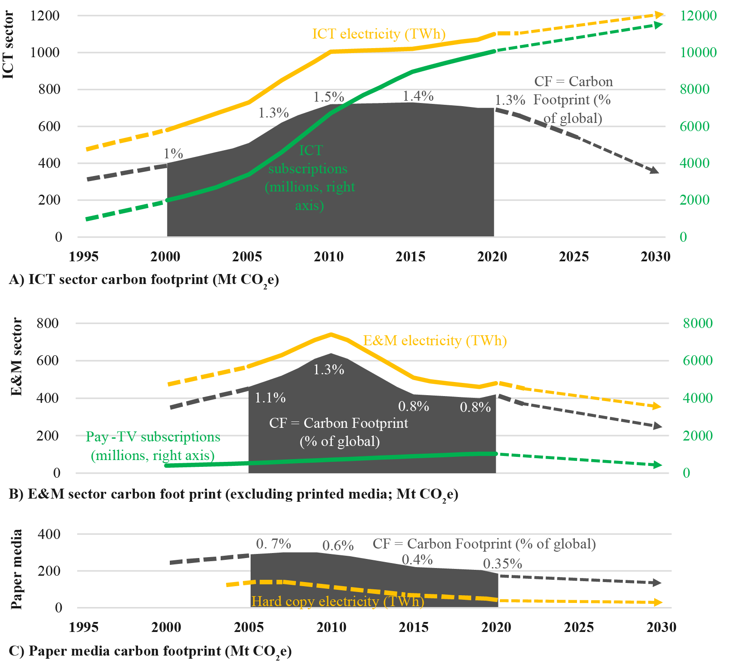
Production of TVs, TV set top boxes and gaming devices has been relatively stable over time after a peak of sales in 2010. Mobile phones including smart phones, have not seen growth in recent years and sales have even decreased.
Despite predictions that data centres would need to grow significantly, the number of new servers shipped has been stable, with growth accounted for by expansion in China.
Figure 2
Data traffic over time
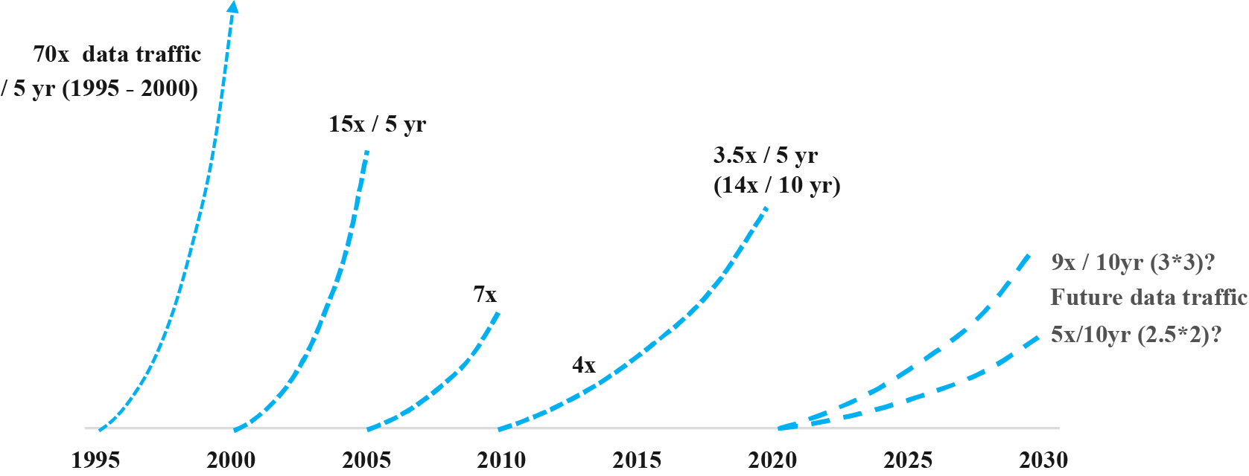
Figure 3 also shows the energy consumed by data centres based on verifiable statistics from 150 companies representing more than 90% of the world’s data processing. The combined power requirement of these companies is around 115 TWh per year. More than half of this comes from specifically purchased renewable power sources but additionally, these companies are investing in their own renewable electricity production.
Figure 3
Data on consumer electronics devices and servers
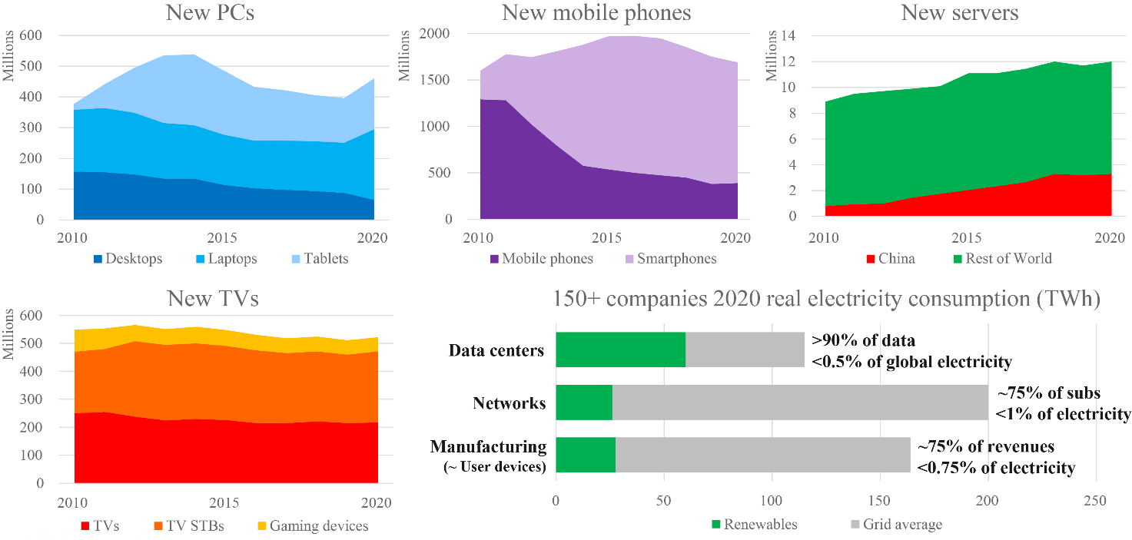
The energy used for data processing and networks represents less than half a percent of the world’s total energy consumption. Our statistics of networks covering about 75% of all the subscriptions, shows that less than 1% of electricity is consumed here.
Figure 4 shows the carbon footprints of the ICT and E&M sectors in 2020. Darker shades refer to embodied carbon (i.e. related to the production of equipment). Lighter shades refer to carbon generated during the operational use of the equipment. As can be seen, the size of the networks in the entertainment and media sector is relatively small compared to the ICT sector as a whole and the embodied carbon is less than 1 million tonnes.
Figure 4
Carbon footprints of ICT and E&M sectors in 2020
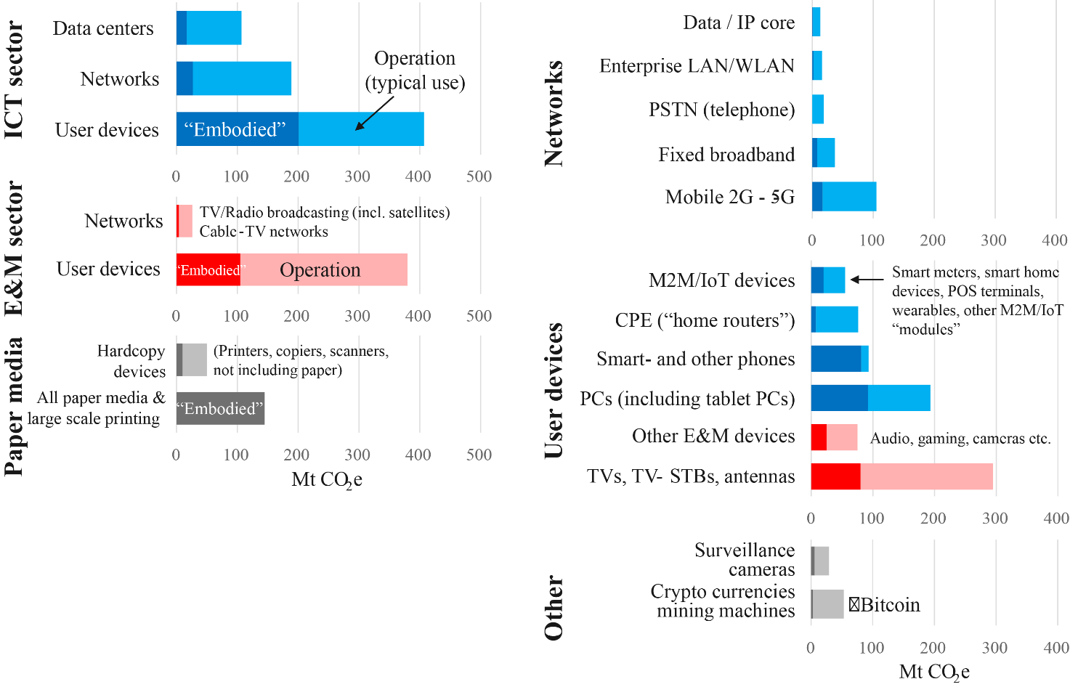
The power used by devices for transmitting5 data is shown in Fig. 5 [3]. The power used to transmit is not proportional to the amount of data sent. For example, a home router which is not transmitting any data will normally use about 10 W. The increase in power required to send data for a standard video stream adds about 0.1 W. The physical line itself does not consume much more. All routers in any network exhibit a similar behaviour.
Data centres and the content delivery network together require less than 1 W to stream a 5 Mbit/s HD video [2], as shown in Fig. 6. A typical end-to-end network (includes delivery and home networks) power requirement is about 18 W for a high-quality video stream [3]. The power consumed by user’s display devices varies from 100 W for a television6 to about 20 W for a typical laptop or under 3 W for a smartphone [3]. For 4K televisions in 2022 in default settings, the power consumption is on average 122.5 W for a 55” screen, and 145 W for a 65” screen. Similarly, in 2022, 8K televisions use much more power, on average 250 W for a 55” display and 300 W for a 65” display.
Figure 5
Power as function of data rate
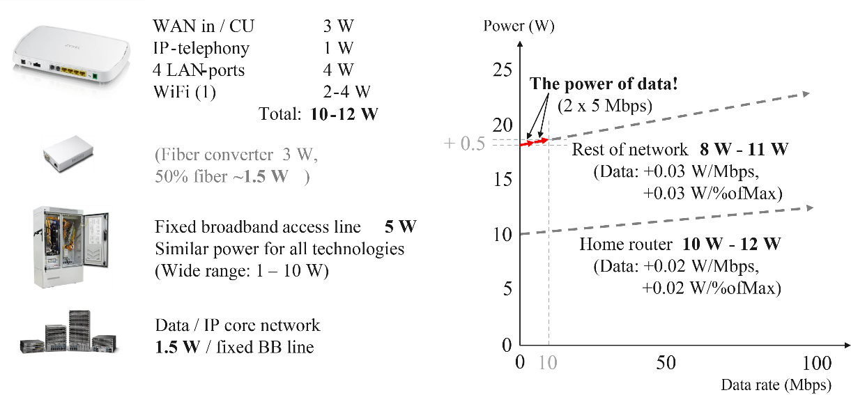
Figure 6
Total power used to stream a video
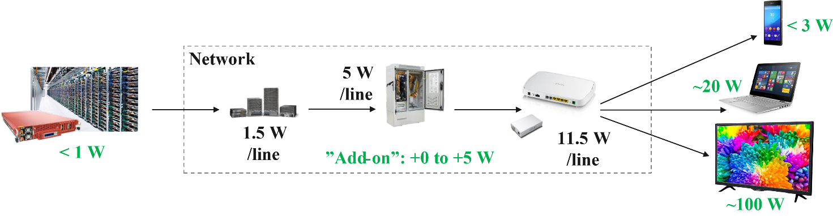
Data transmission cost is often expressed in kWh/GB. However, the actual value depends on several factors. First, due to equipment replacement, the cost per GB tends to fall [2] [4]. This means that measurements of data transmission costs made several years ago are no longer accurate. Second, using excessively large values will lead to unrealistic estimates. For example, assuming 0.4 kWh/GB, as measured for small files several years ago, would lead to a power use of 920 W to stream a high-definition video – an amount that is impossible in practice. Likewise, using the network average would lead to a consumption of 180 W for a high-definition video, which is still a factor 10 too high. Further, it was found that small files have a higher cost per GB than large files. The conclusion here is that power use needs to be measured while streaming, at the level of individual files or streams.
Video data rates depend on pixel resolution. An HD video requires around 5 Mbit/s, whereas 4K and 8K resolutions require 20-25 and 50-100 Mbit/s respectively. Using fine-grained measurements, in 2020 an HD video streamed at 5 Mbit/s (2.3 GB/h) at 18.3 W would require around 0.008 kWh/GB. A large game file download at 50 Mbit/s (23 GB/h) at less than 21 W requires less than 0.001 kWh/GB. These measurements confirm that power use of data transmission is not proportional to the amount of data.
A comparison between streaming and traditional TV is shown in Fig. 7. The average TV set top box consumes around 10 W today [2].
Figure 7
Streaming vs broadcasting
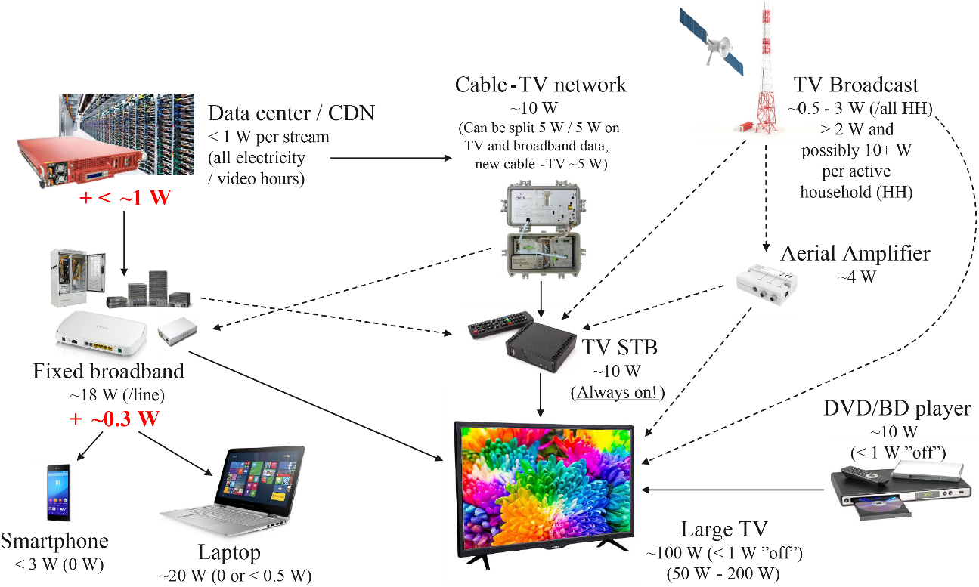
Cable TV networks consume a little more than a fixed broadband line, but this could be split, allocating one part to broadband and one part to TV. Both use the same kind of data centres and content delivery networks. As an example, TV broadcast in Sweden consumes around 5 W per active household. The only device that may consume there is an aerial amplifier that may be needed between the antenna and the TV. Further, DVD players and Blu-ray disc players each consume around 10 W when in use.
Ways to save energy could be to use fibre networks that are being constructed around the world, as that is infrastructure that is being built anyway. Further, consumers can reduce their energy consumption by watching on smaller screens such as laptop/tablet/phone screens. Finally, the use of parallel technologies for backward compatibility could be switched off, notably first-generation mobile technology. The 2G and 3G mobile networks are also likely to be switched off relatively soon.
In the future, physical media (DVDs, Blu-ray disks) will be less present. TV broadcasting is likely to stay, also because it helps to maintain national security. Mobile broadband compares relatively well, as it requires a low wattage per subscriber. However, it consumes more than, for example, fixed broadband when a video is streamed on it [3].

References
[1] Carbon Trust, “Briefing: What are Scope 3 emissions?” [Online.] Available: https://www.carbontrust.com/our-work-and-impact/guides-reports-and-tools/briefing-what-are-scope-3-emissions#:~:text=Scope%201%20covers%20direct%20emissions,in%20a%20company's%20value%20chain. [Accessed January 2023.]
[2] Carbon Trust, “Carbon Impact of Video Streaming,” 2021.
[3] J. Malmodin, “The Power Consumption of Mobile and Fixed Network Data Services –the Case of Streaming Video and Downloading Large Files,” in Electronics Goes Green 2020+, 2020.
[4] J. Aslan, K. Mayers, J. G. Koomey and C. France, “Electricity Intensity of Internet Data Transmission: Untangling the Estimates,” Journal of Industrial Ecology, vol. 22, no. 4, pp. 785-798, 2017.
[5] United Nations Industrial Development Organization (UNIDO), “What is CCR?” [Online]. Available: https://www.unido.org/our-focus/advancing-economic-competitiveness/competitive-trade-capacities-and-corporate-responsibility/corporate-social-responsibility-market-integration/what-csr. [Accessed January 2023.]
[6] Greenhous Gas Protocol, “Greenhous Gas Protocol,” [Online]. Available: https://ghgprotocol.org/sites/default/files/standards_supporting/FAQ.pdf. [Accessed January 2023.]

1 This ITU-R Report is an overview of a webinar on Energy Aware Broadcasting held on 23 March 2022 to discuss the current work being undertaken by broadcasting organizations and partners to minimize the environmental impact of content creation, exchange and delivery.
2 This section is based on a presentation made by Birgit Gabriel from ARTE.
3 This section is based on a presentation made by Roser Canela Mas from albert.
4 This section is based on a presentation made by Jens Malmodin from Ericsson.
5 For the purpose of this ITU-R Report, terms relating to the ‘transmission of data’ refer to the ITU-T definition in Recommendation ITU-T X.1040.
6 This is an average over all televisions in active use in 2020.

