Report ITU-R BT.2485-1
(03/2022)
Advanced network planning and transmission methods for enhancements
of digital terrestrial television broadcasting

BT Series
Broadcasting service
(television)

Foreword
The role of the Radiocommunication Sector is to ensure the rational, equitable, efficient and economical use of the radio-frequency spectrum by all radiocommunication services, including satellite services, and carry out studies without limit of frequency range on the basis of which Recommendations are adopted.
The regulatory and policy functions of the Radiocommunication Sector are performed by World and Regional Radiocommunication Conferences and Radiocommunication Assemblies supported by Study Groups.

Policy on Intellectual Property Right (IPR)
ITU-R policy on IPR is described in the Common Patent Policy for ITU-T/ITU-R/ISO/IEC referenced in Resolution ITU-R 1. Forms to be used for the submission of patent statements and licensing declarations by patent holders are available from http://www.itu.int/ITU-R/go/patents/en where the Guidelines for Implementation of the Common Patent Policy for ITU-T/ITU-R/ISO/IEC and the ITU-R patent information database can also be found.

Series of ITU-R Reports
(Also available online at http://www.itu.int/publ/R-REP/en)
Series | Title
BO | Satellite delivery
BR | Recording for production, archival and play-out; film for television
BS | Broadcasting service (sound)
BT | Broadcasting service (television)
F | Fixed service
M | Mobile, radiodetermination, amateur and related satellite services
P | Radiowave propagation
RA | Radio astronomy
RS | Remote sensing systems
S | Fixed-satellite service
SA | Space applications and meteorology
SF | Frequency sharing and coordination between fixed-satellite and fixed service systems
SM | Spectrum management

Note: This ITU-R Report was approved in English by the Study Group under the procedure detailed in Resolution ITU-R 1.

Electronic Publication
Geneva, 2022
© ITU 2022
All rights reserved. No part of this publication may be reproduced, by any means whatsoever, without written permission of ITU.

REPORT ITU-R BT.2485-1
Advanced network planning and transmission methods for enhancements
of digital terrestrial television broadcasting
(2021-2022)

TABLE OF CONTENTS
Page
Policy on Intellectual Property Right (IPR) ii
1 Advanced broadcast applications and formats 4
1.1 High definition television (HDTV) and ultra high definition television (UHDTV) 4
1.2 High Frame Rate television 5
1.3 High dynamic range television 5
1.4 Advanced Immersive television applications 5
1.5 Advanced Sound System (AdvSS) 6
1.6 Multiscreen and ultra-wide angle panoramic television 6
1.7 Virtual Reality (VR) 7
1.8 Augmented Reality (AR) 7
1.9 Supplementary information services 8
1.10 Additional multimedia services in the same transport stream 9
1.11 Conclusions 10
2 Advanced network planning for creation additional capacity in television broadcasting networks 11
2.1 Large-scale single frequency networks 11
2.2 Extended bandwidth broadcasting 12
2.3 Combined approach 13
2.4 Content-accumulating receivers 13
3 Advanced transmission and reception methods to increase broadcasting networks capacity 13
3.1 Separation by polarization 14
3.2 Multiple antenna systems 15
3.3 Distributed transmission 15
3.4 Orbital angular momentum (OAM) 17
Page
3.5 Non-Uniform Constellation (NUC) 17
3.6 Hierarchical transmission 19
3.7 LDPC code 20
3.8 Wideband Re-Use 1 (WiB) 21
3.9 Spectrum sharing and interference cancellation 22
3.10 HARQ error correction in hybrid broadcast-broadband system 22
3.11 Channel bonding 22
4 Test trials and research studies 24
4.1 Test data transmission system within DTTB multiplex 24
References 25

Acronyms
ADM Audio definition model
AdvSS Advanced sound system
AIAV Advanced immersive audio-visual
AR Augmented reality
ATSC Advanced Television Systems Committee
ATSC 3.0 Advanced Television Systems Committee next generation
BICM Bit-interleaved coding and modulation
C/N Carrier-to-noise ratio
CSS Cascading style sheets
DIDO Distributed input, distributed output
DTTB Digital terrestrial television broadcasting
DTV Digital television
DVB-T Digital video broadcasting – terrestrial
DVB-T2 Digital video broadcasting – terrestrial second generation
FDM Frequency division multiplexing
FEC Forward error correction
FEF Future extension frame
FFT Fast Fourier transform
HARQ Hybrid automatic repeat request
HBBTV Hybrid broadcast broadband television
HD High definition
HDR Higher dynamic range
HDTV High definition television
HFR Higher frame rate
HLG Hybrid-log gamma
HTML Hypertext markup language
IoT Internet of Things
IP Internet protocol
IPDC Internet protocol data cast
IPTV Internet protocol television
IRA Irregular repeat-accumulate
LDPC Low density parity check
LDM Layer-division multiplexing
LOS Line of sight
M2M Machine to machine
MET Multi-EDGE TYPE
MFN Multi-frequency network
MIMO Multiple input, multiple output
NUC Non uniform constellation
OAM Orbital angular momentum
PC Personal computer
PLP Physical layer pipe
PQ Perceptual quantization
QAM Quadrature amplitude modulation
QoS Quality of service
QPSK Quadrature phase-shift keying
RF Radio frequency
RoD Redundancy on demand
SD Standard definition
SDTV Standard definition television
SDR Standard dynamic range
SFN Single frequency network
SISO Single input, single output
SNR Signal-to-noise ratio
STB Set-top box
TCP-IP Transmission Control Protocol/Internet Protocol
TDM Time-division multiplexing
TS Transport stream
TV Television
UHD Ultra high definition
UHDTV Ultra high definition television
UHF Ultra high frequency
VR Virtual reality
VRTV Virtual reality television
WiB Wideband re-use 1

Introduction
To meet the increasing user requirements for quality of broadcast content and maintain the competitiveness of digital terrestrial broadcasting with respect to other platforms, a number of advanced content delivery formats and applications should be introduced in broadcasting networks. This means introduction of high-definition (HD) and ultra-high definition (UHD), high frame-rate (HFR), high dynamic range (HDR), augmented/virtual reality (AR/VR), multi-screen and ultra-wide angle television, multi-channel immersive audio providing presence effect, associated and additional content delivery and many others.
The aim of this Report is to consider a number of improved techniques of frequency planning and advanced methods of transmission for broadcasting networks to provide necessary additional data capacity to introduce new and upcoming broadcast applications, audio and picture formats using the limited number of channels within heavily occupied and extensively used radio spectrum environment.

1 Advanced broadcast applications and formats

1.1 High definition television (HDTV) and ultra high definition television (UHDTV)
Recommendation ITU-R BT.709 specified the parameters for high-definition television (HDTV). It is expected that HDTV will replace standard definition television (SDTV) as the mainstream standard for picture resolution in broadcast networks. HDTV resolution now widely supported in modern television production equipment and consumer television receivers.
Ultra-high definition television (UHDTV) provides viewers with an enhanced visual experience primarily by having a wide field of view both horizontally and vertically with appropriate screen sizes relevant to usage at home and in public places. UHDTV applications require system parameters that go beyond the levels of HDTV. Recommendation ITU-R BT.2020 provides parameters for UHDTV. Two levels of spatial resolutions are specified, 4K UHDTV (3 840×2 160) and 8K UHDTV (7 680×4 320).
Transmission of HDTV and UHDTV images requires significant increase in the data volume transferred within a broadcast channel with respect to SDTV transmission. There are various estimations of necessary data capacity, due to divergence of test methods, picture content, subjective quality requirements, equipment used in tests, etc. If the video compression (H.264/H.265) is applied, increase in the bitrate for UHDTV transmission becomes lower than relevant increase in the number of picture elements (pixels); nevertheless, it remains substantial. As a rule, transmission of HD images requires several times larger bitrate than SD transmission, and demands from 5 to 14 Mbit/c depending on a compression method, picture frame rate, content type and user tolerance to distortions of small details or fast-moving objects. Transmission of 4K UHD images typically require bitrate from 20 to 50 Mbit/c, depending on the similar conditions.

1.2 High frame rate television
High frame rate (HFR) television provides viewers with an enhanced visual experience by providing images that look more essentially and sharper when a motion in captured scene take place.
HFR television offers smoother motion with less ‘motion blur’, the effect where for example an object moving across the screen looks out of focus or blurred but becomes much sharper when static and implementation of HFR across production chain would provide a more realistic image for scenes with motion, without massive loss of details.
In addition to increased resolution, HFR options up to 120 Hz are specified in Recommendations ITU-R BT.2020 for UHDTV and ITU-R BT.2100 for HDR-TV.
Implementation of HFR for all production chain should help to provide more realistic live picture for scenes with motion, without massive loss of details. Some increase in the necessary data capacity in the broadcast channel will be a payment for it. Effect of HFR application on bitrate requirements will vary depending on dynamics, amount of motion and other characteristics of a picture. For a sport content in a high definition format (HD) the necessary addition may be up to 20%.

1.3 High dynamic range television
High Dynamic Range Television (HDR-TV) provides viewers with an enhanced visual experience by providing images that have been produced to look correct on brighter displays, that provide much brighter highlights, and that provide improved detail in dark areas.
Recommendation ITU-R BT.2100 specifies HDR-TV image parameters for use in production and international programme exchange using the Perceptual Quantization (PQ) and Hybrid Log-Gamma (HLG) methods. These define progressive image formats with spatial characteristics of 1 920 × 1 080, 3 840 × 2 160 and 7 680 × 4 320 pixels with bit depths of either 10 bits or 12 bits, and with frame frequencies ranging between 24 Hz and 120 Hz. The system colorimetry is identical to that of Recommendation ITU-R BT.2020.
HLG allows to encode in one signal both SDR and HDR images, and it is quite probably that SDR-TVs may have an opportunity to display an HDR-content after software update. HDR-video will be used not only in UHD television: HD also included in the list of supported resolutions. It is important to note what 10- or 12-bit colour depth to be used for HDR. Transmission of additional colour bits for HDR representation will definitely require some additional data capacity in TV transmission downstream. Taking into account latest developments in the field, standardization and implementation of new HDR technologies are expected to continue.

1.4 Advanced Immersive television applications
Report ITU-R BT.2420 ‒ Collection of usage scenarios and current status of advanced immersive audio-visual systems (AIAV-Systems), points out that Advanced immersive audio-visual systems allow a user to have immersive experiences with an unprecedented degree of presence. By tricking the low-level perceptual systems of the user’s brain, AIAV systems can make the user believe to be somewhere else and/or somebody else. This is achieved by (re)creating audio-visual realities and allowing the user to naturally interact with these virtual environments.
These systems rely on the combination of high resolution images, ‘3D sound’ (see § 1.5) and for interaction, minimal latency.
The success of future immersive audio-visual applications will depend on presenting each eye with sufficient resolution that the participant (more than just a viewer) can suspend disbelief and become part of a 360° experience. Recommendation ITU-R BT.2123-0 specifies spatial resolutions of 30 720 × 15 360 (30K × 15K) for 360° images.
Due to a large amount of data required, delivery of high-quality advanced immersive streams will be a challenging task for all types of telecommunication networks. Extended broadcast applications may provide such possibility with a small additional cost at broadcaster side using one of advanced ‘layered’ modulation techniques described in § 3.

1.5 Advanced Sound System (AdvSS)
The Advanced Sound System is capable of providing listeners with an immersive audio experience by reproducing sound using three-dimensional loudspeaker layouts. AdvSS can provide audio services adapted to listener’s preferences and listening environments, using an audio renderer that makes use of audio-related metadata.
Recommendation ITU-R BS.2051 specifies loudspeaker configurations supporting up to 24 loudspeakers for advanced sound production and supports channel-based, object-based or scene-based input sound signals, or a combination of them, with accompanying metadata. The number of input sound signals maybe larger than the number of reproduction audio channels or loudspeakers, in which case they are converted to reproduction loudspeaker signals based on audio-related metadata by the audio renderer.
Recommendation ITU-R BS.2127-0, specifies the reference renderer for use, including for programme exchange, with the advanced sound systems specified in Recommendation ITU-R BS.2051-2, and the XML based audio-related metadata specified by the Audio Definition Model (ADM) in Recommendation ITU-R BS.2076-1.
The audio renderer converts a set of audio signals with associated metadata to a different configuration of audio signals and metadata, based on the provided content metadata and local environmental metadata.

1.6 Multiscreen and ultra-wide angle panoramic television
Conventional TV systems designed to display with limited area-of-view. A viewer typically watches a television at the distance about two to three metres from the display. For HDTV and UHDTV home use, a large screen application normally considered to be essential. At the same time, in many cases installation of a large screen TV in particular household is not feasible due to some practical constrains or considerations. So, in many cases typical viewing distance is enough to neglect the effect of even large-size display – viewing angle is still not big enough to consider wide-angle panoramic television content application.
Both multiscreen and panoramic ultra-wide angle television aimed to provide better user experience.
Multiscreen service provides the picture for additional displays, and the content of these additional views in simplest system to be selected by production team. In more advanced systems, consumer can select the content for additional displays from wider preset of cameras, or even freely select points of view taken from larger ultra-wide angle or panoramic view. Combination of real-time choice between different points of view (for example, panoramic cameras in some locations) and field of view selection (for currently used panoramic camera) capable to give to end-user something close to ‘virtual presence’ experience.
Another way to extend user experience is the panoramic or ultra-wide-angle TV, which delivers panoramic or ultra-wide-angle image (or a set of conventional size images intended to form ultra-wide-angle picture) directly to the screen (or screens) at end-user side. One simple example of ultra-wide-angle view system is a multiscreen set using a number of adjacent displays, preferably models with curved screens and thin frames. Multi-element screen has to be of enough size and to stay in proper position for being capable to provide the aerial effect.
If user equipment supports virtual and augmented reality (VR/AR) applications, multiscreen or ultra-wide-angle panoramic TV content may also be applied for rendering VR/AR scenes in receiver.

1.7 Virtual Reality (VR)
Virtual Reality application have to handle great volume of visual information to render a three-dimensional scene what will create the effect of presence using moving portable displays or personal 3D viewing equipment what also provide control information what affect the rendered image, like a change in direction of human look, head and body movements, etc.
With respect to VR application in Broadcasting service (VRTV), most probable approach is to deliver all necessary visual information to user equipment (PC, STB, etc.) and perform required operations to render VR in user equipment. This approach overcomes latency and QoS issues relevant for conventional simulcast IP network. To achieve UHD quality when looking at particular direction, and to provide at least HD quality 2x-3x zoom, spherical panoramic image must be much larger and have better resolution than UHD TV.
VR applications also offer certain forms of interactivity, allowing the user to affect somehow the content of the displayed environment. In the simplest case, a system permits the user to be moved freely to new points of presence, becoming the witness of various events or watching the same event from different locations. Real-time interactivity requires even larger volume of data being transferred to receiver when the downlink/broadcast approach is adopted.

1.8 Augmented Reality (AR)
The term ‘augmented reality’ reflects the feature of real-time local interaction between visualized content and real environment, based on broadcasting transmission. This form of local interaction includes detection of user position, movement, gaze direction. This data is used to display the content in such a way that provides precise alignment with the surrounding visible environment. Visualization of such augmented image carried out by mobile display, is capable to precisely identify a movement and its position in space (smart phones, pads, 3D-helmets or glasses).
Example of similar system is the system of the mixed reality ‘Augmented TV’. Users can see objects and characters in TV programmes, which are falling outside the limits the TV screen when looking at the pad connected to TV service provider. The 2D-image in the TV set and the 3D-image on the pad are synchronized, reference points for alignment of the images are set up by recognition of TV picture appearing in the pad backward camera sensor, in combination with pad angle movement sensor data.
Augmented reality applications require additional information to be transmitted in broadcast channel, including information on the spatial binding of the augmented reality content, the content itself, additional data for the proper content representation (time and subject relevance, etc.). In given above example delivering image that goes beyond the margins of TV screen, it is required to transmit an additional image, which in size and quality can be comparable with or even exceed the main image. If this system is implemented by means of a TV broadcasting network, an additional extended image with reference to the coordinate system must be transmitted as part of the broadcast multiplex or in a separate channel.

1.9 Supplementary information services
A number of useful additional applications related to multicast/broadcast data transfer in the DTTB multiplex may be considered. Examples of such supplementary data broadcast include transmission of weather information, traffic data, real-time public transport schedules for display at stop points, special information for urban social and technical services including M2M data, special information for law enforcement agencies, warning messages for sound or visual public alert systems, etc.
The supplementary information broadcasting represents point-to-point and point-to-multipoint (one-to-many) data transmission services intended to deliver information to remote devices. Supplementary information broadcast system does not require bi-directional link (like in TCP-IP) for data transmission to be established.
Supplementary information services can provide a range of applications. Three types of applications can be identified:
– requiring a real-time return channel (uplink),
– allowing a non-real-time return transmission with major delay (typically non-predictable),
– not requiring return channel or uplink transmission.
For the last two options, considering low-traffic or one-to-many transmission scenarios, the multicast datagram broadcast transmission (datacast) system may have a potential to be a cost-efficient data delivery solution.
Reception of supplementary data in broadcast multiplex may be performed by fixed, mobile or portable receivers. A separate data stream may be allocated within broadcast channel to transmit data for teleinformation services (in the DVB-T2, a separate PLP with robust transmission mode and light profile may be used). Other advantages are: no need to register all devices in the telecommunication network, low cost of services, no network congestion when sending messages to a large number of users, and low energy consumption in device (only reception of some time-slots is required). The latter is very important if there is no power at the place where teleinformation receiver operates —power supply in that case may be provided using low-power sources, for example batteries or solar panels.
The benefit of using DTTB multiplex is a large coverage of existing DTTB networks (no network deployment cost) and ability to connect to the existing fixed reception antenna system (reduced user installation cost). Teleinformation device may be connected to the antennae cable in parallel to broadcast receiver using very cheap conventional 75-Ohm splitter or it may have built-in amplified pass-through to fast-up installation. In areas where the broadcast signal is strong enough, small indoor/outdoor antennas may be used to reduce the user equipment installation cost further.
DTTB-based teleinformation devices may be useful for the organization of distress and emergency warning systems, information boards, dynamically reconfigurable road signs, etc.
Examples of applications that do not require an inverse channel (uplink lines) are:
– information boards;
– speech informers and means of distress and emergency warning;
– control devices or a backup control channel for remote devices to ensure enough reliability;
– some applications of the Internet of Things;
– an additional data channel for remote devices (IoT and others) to deliver data too big for narrowband networks, for example, regular or emergency digital maps or software updates;
– industrial applications;
– targeted distribution of messages to the public;
– public or business services dealing with notifications or general public information.
For some applications, data transmission on the uplink may be postponed until it becomes possible, for example, when the subscriber will move from outside to a point within the service area of the wideband telecommunication network. An example of such applications are services that do not require the immediate reaction of the subscriber when receiving the message, in particular the delivery of various end-user notifications related to the postal, banking or government services.
The systems for the of additional data transmission in DTTB channels will be most useful in cases where rapid mass message delivery is required to recipients distributed on a large territory, not bounded by the availability and quality of mobile operatorsʼ networks in those particular locations. Such systems have the following important features:
– no additional costs are required to build and operate the existing network (no deployment cost);
– one-to-many broadcast delivery significantly saves traffic and reduces the data load in the such network;
– end-user devices can be only receivers without any transmission (saving energy, improve electromagnetic compatibility);
– no need to register each subscriber on the network: the number of devices is unlimited;
– the devices can be connected to the existing DTTB receiving antenna system available in household, which reduces the costs of their installation and maintenance.
The combination of these advantages indicates the potential market for such a technology.

1.10 Additional multimedia services in the same transport stream
In addition to the television programmes, multiplexed DTTB signal may contain extra multimedia payload, such as sound broadcasting. Additional multimedia data may be included into the dedicated programme stream (at the physical layer this means transmission within dedicated time slots, so in some DTTB systems), so specific modulation parameters may be used for this stream.
In many countries, large-scale DTTB networks are already deployed, providing coverage for the significant part of territory and relevant population. That makes it valuable to use this coverage to transmit additional sound and multimedia broadcasting. When sound and multimedia service embedded into the existing multiplex, it helps to reduce transmission cost and facilitate fast deployment. Taken into account that DTTB networks in many cases were planned for fixed reception with the aim to reduce amount of occupied RF spectrum and, thus, uses 64-QAM and 256-QAM modulation, additional of sound and multimedia streams more robust coding and modulation typically required to provide mobile and portable coverage.
One example of possible DTTB multi-service multiplex configuration given in Table 1. This example uses a multi-PLP (Physical Layer Pipe) approach as in DVB-T2 or ATSC 3.0 systems.
TABLE 1
PLP | TV channels | Sound channels
“0” | 8 | 2
“1” | 1 | 1
“2” | 1

In this example, DTTB multiplex includes three sets of television programmes accompanied by three sound radio programmes, which at present time might be received to only by a television receiver (TV or STB). Same level of modulation is used for DTTB and sound programmes.
Another example given in Table 2.
TABLE 2
PLP | Modulation | TV channels | Sound channels
“0” | 64-QAM | 8 | –
“1” | 64-QAM | 2 | –
“2” | 16-QAM | – | 3

In this example, there is a clear separation between television and sound/multimedia programmes. Television programmes are transmitted using 64-QAM PLPs, and sound/multimedia programmes using PLP with 16-QAM modulation and robust coding. This potentially could allow a portable reception using relatively simple portable receiver, not necessary a TV or STB receiver.

1.11 Conclusions
Implementation of advanced broadcast applications and new content formats in most cases will require additional data capacity in broadcast network channel. The data capacity of additional bandwidth can be up to tens of percent, and in the case of such technologies as UHDTV, VR/AR is more than 100 percent in relation to the data capacity for the original TV programme stream. This opens the issue of how it actually can be done using available means, i.e. wired, mobile, broadcast and fixed channels.
In many regions, due to economy and infrastructure limitations, penetration of ultra-broadband communication networks grows slowly and still uneven, providing coverage primarily for separate ‘islands’ with high demand, but not for all populated areas. The introduction of new applications and formats in broadcasting service will depend on the penetration of ultra-wideband, low latency, high QoS communication networks. This may significantly limit application of such services.
In particular, there are many practical reasons that delay deployment of ultra-wideband networks, wired or mobile, in rural or sparsely populated area. Thus, could new services and formats of TV broadcasting technically depend on ultra-wideband networks deployment, it may delay introduction of new services and formats of TV broadcasting in some areas for an indefinite period. This will not in any way contribute to bridging the digital divide but will further deepen it. Thus, the development of solutions that allow the introduction of new technologies for the transmission of content using mainly the infrastructure of broadcast networks is an important practical task.
The majority of broadcasting networks were created for transmission of linear TV programmes in standard or high definition format. They are not providing extra capacity for deployment of advanced broadcast applications or improved quality formats. Existing national and international frequency plans provide only a limited number of radio frequency channels. The situation is further complicated by the need for simultaneous operation of transmitters of previous and new standards (for example, H.264 standard definition TV and H.265 high definition TV) during the transition period (Simulcast), which can last for many years.
To maintain competitiveness of terrestrial television broadcasting delivery in the rapidly developing telecommunication market, further improvement of the provided broadcast services will be necessary. Therefore, it is important to study methods capable to provide additional capacity in terrestrial television broadcasting networks, both by means of new approaches in frequency planning, and through the use of advanced transmission or reception techniques.

2 Advanced network planning for creation additional capacity in television broadcasting networks
Existing digital broadcasting networks and frequency plans were developed to deliver linear content using the principle of terrestrial and frequency separation to ensure absence of interference according to a given criterion. At the same time, the lack of a radio-frequency spectrum will increasingly force broadcasters to use new approaches, such as joining zones of frequency allocations of the Geneva-06 Plan or combining separate powerful frequency assignments into long-range single-frequency networks. Other approaches may also be studied.

2.1 Large-scale single frequency networks
A large-scale single frequency network is a large area network using synchronized (synchronous network) or non-synchronized (asynchronous or mixed network) transmitting digital broadcasting stations to cover large area using the same frequency channel. The distances between transmitting stations in such a network may greatly exceed the limit distance equivalent to the maximum delay of the guard interval for selected operating mode. In the case of absence of a radio spectrum for deployment of additional digital broadcasting multiplexes, such an approach, in theory, makes it possible to provide extended service areas with the most efficient use of radio frequency resources. However, if such a network is implemented in practice, there would be some difficulties.
The problem is that not every transmission network topology is suitable for this approach. When relative delay between signals of comparable levels is exceeded, network self-interference may occur. In a large-scale single-frequency network, self-interference zones typically cannot be completely eliminated. It is only possible to plan large SFN network in such a way that single-frequency interference zones will be located in uninhabited areas or be limited by the signal attenuation due to obstacles on the ground.
At the same time, existing digital broadcasting networks in most cases were created using former infrastructure, for example analogue broadcasting sites. Thus, the topology of a digital broadcast network in many cases cannot be completely re-designed, and the possibilities for its further customization may also be limited due to the lack of infrastructure or to technical constrains.
For a large-scale SFN, delivery of local content (for example, local programmes or local insertions into national programmes) is an issue. Partially synchronized SFN approach may provide the possibility to do that. Interference from neighbouring non-synchronous stations will exist, and will affect all TV programmes in multiplex, even if the non-identical content transmitted in only one programme. Therefore, it is preferable to use separate PLP for TV programmes with local insertions or local content. That PLP may also have more robust modulation to decrease the effect of self-interference.
Another solution is to create two semi-SFN networks on two different channels that deliver the same content. Those networks may have a similar topology, but not identical parameters of transmitting stations, and are planned in such a way that the zones of self-interference will be located in different places. The use of the radio spectrum in this case is quite high and close to 1/2. The main advantage is that there is no need to set up new broadcasting sites close to or within problem areas. The disadvantage of this approach is the higher cost of signal delivery (in fact, it shall be full or partial duplication of the transmitters at the transmitting sites).
The third possible solution is the use of directed receiving antennas with improved shielding of the side and rear lobes, as well as antenna systems with active interference suppression. The problem is the production of such antennas, since any estimate of market size for such devices does not currently exist. The installation of such antennas may be too difficult for common users and require competent surveillance with the development of proper regulatory procedures.
Continuous single-frequency networks make it possible to increase the efficiency of spectrum utilization, but a number of problems arise. In the case of large-scale single-frequency networks, further studies are necessary with respect to:
– collection of statistics and national experience on the stability of subscriber receivers of various digital TV broadcasting systems to self-interference and signals with high delay;
– collection of statistics and national experience on the influence of directional selectivity of the of receiving antennas to reduce interference in single-frequency networks;
– national experience on usage of large-scale SFNs with high, low and medium power stations;
– national experience on the local content delivery in large SFNs;
– protection ratios for self-interference signals of synchronous and non-synchronous stations in SFN.

2.2 Extended bandwidth broadcasting
The capacity of the DVB- T2 and ATSC 3.0 communication channels is already close to the theoretical Shannon limit. Therefore, instead of improving digital transmission technologies in the usual ways (using higher modulation levels, for example, using QAM-2048 or even higher), another method may be considered. Existing digital transmission technologies provide high efficiency in many respects due to the use of high levels of QAM modulation. But this leads to two negative consequences.
First, it is necessary to use high-power transmitters, since the Shannon limit has revealed the exponential dependence of the required signal power to the achievable data rate in a channel of a given bandwidth. Second, the use of high-level modulation modes makes the signal sensitive to interference, and this reduces the spectrum utilization factor. For DVB-T2 networks, it is usually 1/4 to 1/7.
The main difference between the concept of broadcasting and the extended frequency band is that it is proposed to broadcast signals that are not limited to a single RF channel but occupy the whole available UHF range. The transition from modern DTV frequency plans (for example, based on the DTV compatibility criteria for high-throughput modes) to such a model can improve spectrum efficiency by 37-60% and at the same time significantly reduce transmitter power.
Within the framework of this technology, it is reported being possible to raise the spectrum utilization factor to almost 1, that is, transmit at all available frequencies, including inter-channel gaps of 0.2-0.4 MHz. It is also important that transmitters with overlapping coverage areas and operating at the same frequencies can transmit different signals. This will require the use of robust modulation modes, such as QPSK with 1/2 code rate. The C/N level required to receive such a signal is about 1 dB. And the spectrum efficiency in this mode is close to 1 bit/s × Hz. In the 224 Hz band, this will provide approximately the same data rate as five channels at 40 Mbit/s or six at a rate of 33 Mbit/s. It is predicted that, on average, the total available bandwidth in TV network may increase by one and a half times.
The disadvantage of this approach is the need to revise all international frequency plans and launch complete modernization of all broadcast networks with the installation of a large number of transmitters (but low power ones) at each radio centre. It is necessary to conduct research and field tests on experimental networks that will allow to refine the planning criteria for such networks, taking into account the low modulation levels (e.g. QPSK) reception experience in real conditions, with a high level of interference on site.

2.3 Combined approach
The most effective way may use of a combined approach based on the methods described in §§ 2.1 and 2.2, when one or another method for improving the efficiency of radio spectrum is selected taking into account local conditions, existing transmission networks topology and availability of radio channels. A study using math modelling methods can be considered that will determine the conditions for the optimal choice of a technology for planning digital broadcasting networks for a particular situation.

2.4 Content-accumulating receivers
An additional level of broadcast channel capacity optimization is content-accumulating receivers. Such a receiver constantly receives and stores received content on the internal disk. It can operate even when (from the userʼs point of view) it is ‘switched off’ – that in this case means energy-saving mode. If such a receiver is turned on, user can view both the currently transmitted content and all the previously transmitted programmes. This approach allows more efficient use of the transmission channel, since there is no binding to the time of TV programme transfer (for example, popular programmes can be transmitted even at night hours). Also, retransmission of repetitive items (for example, advertisement units and news blocks) will be no more necessary. Modern receivers may incorporate storage of enough volume to keep a large number of TV programmes and other content. To further optimize the use of space on the drive, some priority criteria for the stored content can be used, taking into account the relevance, popularity and personal preferences of the user. In addition, a number of such receivers may be connected via local network to compensate short-time loss of the signal at some receiver input replacing damaged content by one transferred from other receivers, and form higher capacity distributed storage for received broadcast content.
Content-accumulating receiver approach will not require any changes in the frequency planning or operation of TV broadcasting networks. At the same time, for the effective optimization of the content storage and easy navigation, it is necessary to have an extended metadata, which allows to effectively classify separate TV programmes and even some individual elements within them. For example, news programmes could be classified by topics, relevance, popularity, etc. Fresh stories on a topic should replace in the storage obsolete ones. Advanced metadata represents one of potential areas where development of common standards could ease up production and facilitate deployment in a large extent. Broadcast receivers wireless interlink for rural areas where local networks are not present may be another example of potential study subject in this area.
It should be mentioned also that high quality system software has a critical importance for such a receiver: it should work quickly and stable for many years and not require any user action for its maintenance. It should be useful to combine efforts of industry to develop an open software platform that, to confirm its stability, must undergo extensive testing.
The use of content accumulating receivers will provide the equivalent of multi-programme broadcasting in the conditions of insufficient radio-frequency spectrum to deploy big capacity linear broadcast networks, and simultaneously provide higher level of interactivity to the user displaying television and multimedia content.

3 Advanced transmission and reception methods to increase broadcasting networks capacity
Advanced methods of transmission and reception may provide an increase in the bandwidth of terrestrial television broadcasting channels and will not require extensive revision of existing frequency plans. At the same time, advanced transmission and reception methods in most cases may be deployed using specifically designed equipment, in some cases including development of new standards. The development of a totally new broadcasting system is a complicated and long-term task. Under the scope of this Report, it is preferable to consider advanced transmission and reception methods that may be used not only in brand new broadcast system, but also may be implemented without need to develop a whole new family of system standards.

3.1 Separation by polarization
In fixed reception broadcast networks, plain horizontal or vertical polarization is mostly often applied. Separation of vertically and horizontally polarized waves for transmission of various information within one radio frequency channel could be matter of great interest.
In accordance with Recommendation ITU-R BT.419, the polarization isolation in the UHF range vary from 9 dB (90% of locations) to 22 dB (10% of locations). When planning analogue TV broadcasting, it was proposed to use 15 dB as a representative value. That studies have been conducted to examine signals received from different transmitting stations. When signal comes from the same transmitter site, variation of polarization decoupling in antenna systems should be lower.
The Recommendation notes that in the UHF band, the use of horizontal polarization gives advantages due to the best directivity achieved in receiving antennas; this reduces the impact of reflected signals, especially in urban areas. But for digital broadcasting systems, due to the presence of a guard interval, reflected signals with small delays cause no difficulty for fixed reception in most places.
To build a multi-polarization digital broadcasting system with increased data transfer capacity, it is necessary to ensure that signal-to-noise ratio requirement for all polarized signals is met. This may be achieved by means of polarization decoupling in receiving antenna system. An example of an antenna system with an improved polarization decoupling can be a cross-polarized antenna system with active suppression of an interfering signal, in which an antenna with an opposite polarization acts as the antenna for interferer reception.
In this example, an antenna system incorporates two cross-polarized antennas. Each one of the two antennas receives both the useful signal (of its polarization) and the interfering (opposite polarization) one with a level lower by A_{p} dB, where A_{p} is the polarization decoupling of a single antenna. If, after the pre-amplification, the antenna signal B, attenuated by A_{p} dB, is subtracted from the signal received from antenna A, it is possible to provide improved signal B suppression, which in theory may reach a value of almost 2 A_{p}. Thus, if it is assumed that A_{p} is 15 dB, the total suppression A_{p}' can potentially reach up to 30 dB. In practice, the suppression will be less, but the required C/I value (which for most DVB-T2 modes, for example, is not more than 20 dB) may be provided. Connecting the outputs of two antennas to two different receivers (or to the input of one receiver through the frequency converter) will allow simultaneously reception of signals with vertical and horizontal polarization transmitted within one frequency channel. This approach itself does not require the development and standardization of new transmission systems, providing method of increasing the bandwidth of the TV broadcasting channel, theoretically up to 2x.
To ensure backward compatibility with existing TV broadcast receiving systems, an asymmetric approach for cross-polarized signals may be used. Additional cross-polarized (for example, vertical polarized) signal can be attenuated in level with respect to the original signal (of horizontal polarization) by 7-8 dB, which will ensure further reception of horizontal polarized signal by existing antennas. Protection of the new signal may be provided by using an interference-proof robust modulation mode, for example, 16-QAM or QPSK. Asymmetric approach provides smaller increase in broadcast channel capacity, but it can be used for a transitional period in existing fixed reception broadcast network.
To assess the potential for the implementation of cross-polarization separation methods, further research is necessary, primarily in following areas:
– technical parameters of antenna systems with improved polarization isolation what may be achieved by mass market devices installed in real environment;
– fixed and mobile reception parameters of propagation path de-polarization;
– values of cross-polarization decoupling, achievable in typical reception conditions;
– methods for reducing the probability of random correlation between signals of vertical and horizontal components, the necessary extent for their application.

3.2 Multiple antenna systems
In fixed and mobile radio communication, transmission methods of multiple antenna are widely used. Multiple input multiple output (MIMO) is a method that utilizes multiple transmitting and receiving antennas that use the same frequency to increase transmission capacity and/or robustness. Installing multiple antennas at the transmitter and receiver is necessary for the deployment of terrestrial broadcasting using a MIMO transmission. The pilot signal used for channel estimation needs to be denser for MIMO than for single input single output (SISO) because the multiple signal streams transmitted on the same frequency need to be separated and equalized at the receiver.
Dual-polarized MIMO transmission that utilizes two orthogonal polarized waves has been studied for its use in digital terrestrial broadcasting. Orthogonal polarizations can be achieved using a combination of horizontal and vertical polarizations or right and left circular polarizations. In general, single-polarized MIMO transmission is possible for indoor use, e.g. Wi-Fi, because the transmitted signals are received via various propagation paths resulting in a weak correlation of the transmission channels. On the other hand, in a line-of-sight (LOS), which is considered to be a typical transmission path of terrestrial broadcasting, the orthogonal polarizations achieve a better transmission with the aid of the reduced cross-talk between the two polarized signals. A practical digital terrestrial broadcasting system can only use two independent polarizations, and two polarized antennas for transmitting and receiving are feasible with respect to installation space. When using three or more polarizations, the overhead of the pilot signals for channel estimation also increases, and the gain of the transmission capacity obtained by MIMO decreases. Figure 1 shows an example of transmitting and receiving antennas using horizontally and vertically polarized waves. The transmitting and receiving antennas are a horizontal/vertical multi-stage dipole antenna and cross polarized Yagi antenna, respectively.
FigURE 1
Example of transmitting and receiving antennas
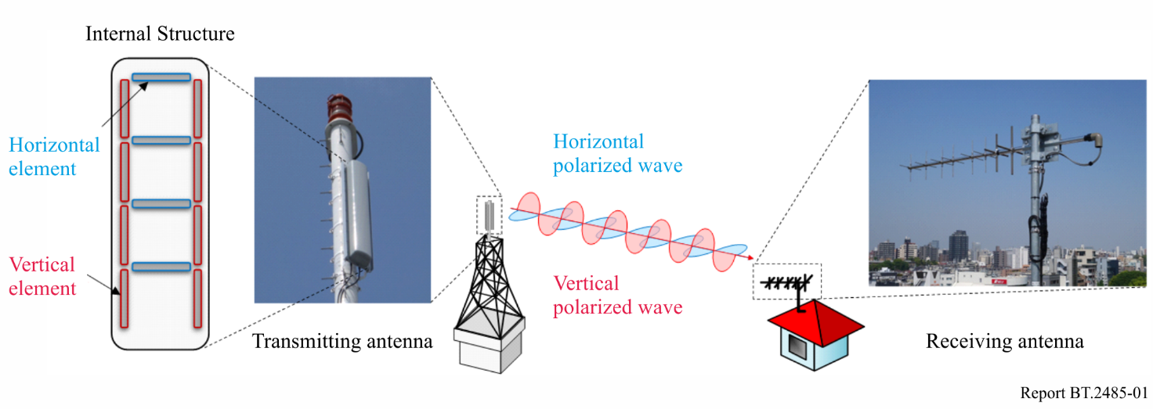

3.3 Distributed transmission
The main difference between implemented in telecommunication distributed like Distributed Input Distributed Output (DIDO) and multiple (like MIMO) antenna systems is that MIMO considers distributed antenna arrays at one telecommunication station site, and DIDO is the coordinated operation of several remote located radio communication stations in a way similar to distributed array of antennas.
In the case of TV broadcasting in UHF bands, multiple antenna systems could have large linear dimensions or use several separately standing antenna masts. Otherwise, the range of the spatial separation of signals by the receiver will be relatively small and such a system does not make much sense. In addition, MIMO operation in open spaces (direct visibility from the transmitter to the receiving point) normally less efficient. In a number of countries, studies have been carried out on the application of the distributed antenna arrays in telecommunication. Gain is primarily achieved for transmission over relatively short distances (no more than 10 km).
For distributed transmission (DIDO), spatial separation performed using a number of space-distributed receivers, if all received signals processed together in a special way. An obligatory element of the mobile or fixed communication system is a data processing centre connected to individual radio stations by ultra-wideband optical data channels with a very low latency. Transmission to the data centre and real time processing of signals from different base stations represents the most complex part in such a radio communication system.
In TV broadcasting, the receiver is only at the subscriber side and signals at transmitting stations can be formed in such a way that allow separation by the receiving system. Distributed emission requirements for purely transmitting network are much simple in comparison to mobile or fixed distributed radio communication network. In distributed broadcasting network, receiver uses a number of antenna elements, which in case of fixed reception can be installed at different points of the roof or even on different buildings (schematically such an array of vertical elements is depicted in Fig. 2).
Based on the analysis of signals from different antennas, their levels and relative delays, the receiver will be able to separate and restore several useful signals coming from different directions and transmitted at the same frequency. The result will be a multiple (several times) increase in the efficiency of the use of the radio-frequency spectrum.
FigURE 2
Distributed receiving antenna array for spatial separation of signals from several directions
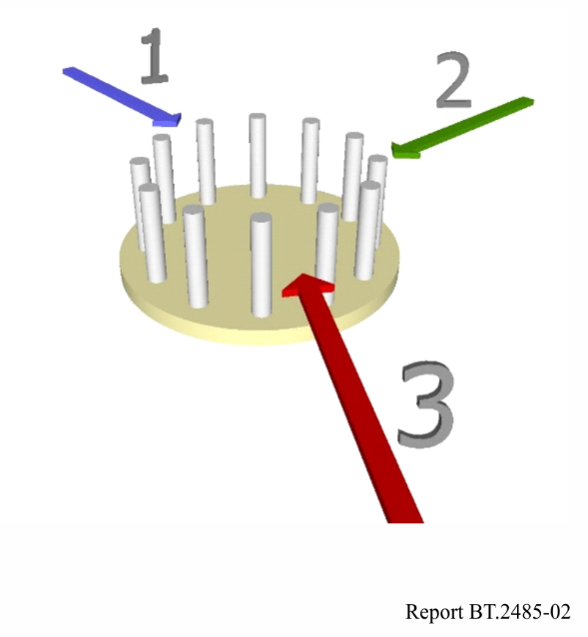
An important problem for distributed broadcasting network signals reception occurs if the receiver system is located close to one of the transmitting sites. In those conditions, signals from nearby transmitting station will suppress signals from remote ones due to a huge difference of levels and limited dynamic range of receiver input. A possible solution to this problem is the combined use of both distributed and multiple antenna systems, when multiple antenna system (like in MIMO) will serve locations near transmitting sites and distribute transmission will reach remote areas.
Methods of signals separation and technology of operation of such networks in terrestrial broadcasting have not yet been developed and require further investigation.

3.4 Orbital angular momentum (OAM)
In addition to frequency, amplitude, phase and polarization, electromagnetic wave has one more characteristic – the orbital angular momentum (OAM). It is determined, if not equal to zero, by the specific form of the wave front swirling along the propagation axis of the radio wave. By adjusting this parameter, it is possible to create a large number of channels operating on the same frequency and to separate them later in the receiver. In practice, the number of channels will not be so great due to technical limitations. It should be noted that development of antennas for the implementation of this physical principle is quite a challenge. A number of experiments have been carried out in scientific laboratories, confirming the possibility of the creation and subsequent separation of such signals by the receiver. However, the work is still at the stage of laboratory research.
To use OAM method in broadcasting, the complex task of creating non-directional antennas or antennas with a broad beam pattern for OAM radio waves should find a practice solution. In addition, signal transmission with a rotating wave front is effective only for open propagation paths, which in TV broadcasting does not always occur. For closed and semi-closed paths, the effects of depolarization greatly reduce the efficiency of OAM signal separation. Another problem is that the size of the antenna arrays for UHF frequencies can be quite large. At present, laboratory experiments are conducted at frequencies from 2 GHz and above, most often in the millimetre wave range.
Combination of OAM and spatial separation methods (like MIMO) deserves a consideration. Some studies show that implementation of OAM allows to increase the range of MIMO efficient range by tens of percent. However, given the typical size of the broadcasting zones of UHF TV stations, the limiting range at which OAM / MIMO operates efficiently in a typical antenna system configuration (up to around 10-12 km) for many sites is still not enough.
A significant number of unsolved problems with the design of antenna systems and the practical implementation of channel separation based on OAM does not allow considering this method as promising for implementation in TV broadcasting in the near future. It is possible that antenna systems for OAM for UHF broadcasting will be created, but the solution of this task may take considerable time.

3.5 Non-Uniform Constellation (NUC)
With respect to carrier modulation technology, the transmission capacity can be increased by a non-uniform constellation (NUC) that is used in the mapping process from bits to symbols. The NUCs are optimized to expand transmission capacity by increasing the bit-interleaved coded modulation (BICM) capacity at the target carrier-to-noise-ratio (C/N) threshold for each code rate of forward error correction (FEC). Figure 3 shows examples of a NUC for 16 signal points and its corresponding bit labels. Figure 3(a) shows that the symbols in the NUC targeting low C/N are condensed in each quadrant. The symbol arrangement is intended to realize a robust transmission in combination with FEC using the most significant two bits of each symbol, i.e. similarly to QPSK, even in a low C/N environment. On the other hand, the NUC for a high C/N shown in Fig. 3(b) is an arrangement that realizes a higher capacity by setting the symbols a long distance apart.
Higher order modulation can yield greater improvement in BICM capacity because the degree of freedom in optimizing the signal point arrangement is increased for higher order modulation. Two different NUC designs are possible. One is a two-dimensional (2D) NUC and the other is a one-dimensional (1D) NUC. Figure 4 shows an example of a 2D NUC (256-QAM) and an example of a 1D NUC (1024-QAM). The 2D NUC has no restrictions on the symbol arrangement and the left side of Fig. 4 shows the commonly used circular constellation. On the other hand, the 1D NUC is designed for maintaining a square shape. Therefore, a conventional demapping method for uniform constellations, such as the hard-decision method, can be applied for 1D NUC. A 2D NUC introduces higher gain in BICM capacity than a 1D NUC; however, a 2D NUC requires higher complexity at the receiver than a 1D NUC because conventional demapping methods cannot be applied. For 16-QAM, only about 0.2 dB gains in the required C/N can be expected for 2D NUCs over conventional uniform constellation while 256-QAM NUCs can exceed 1 dB gains. As for 1024 -QAM NUCs and 4096-QAM NUCs, the gain in the required C/N can exceed 1 dB for both 1D NUC and 2D NUC.
FigURE 3
Non-Uniform Constellations (16 signal points) for different C/N
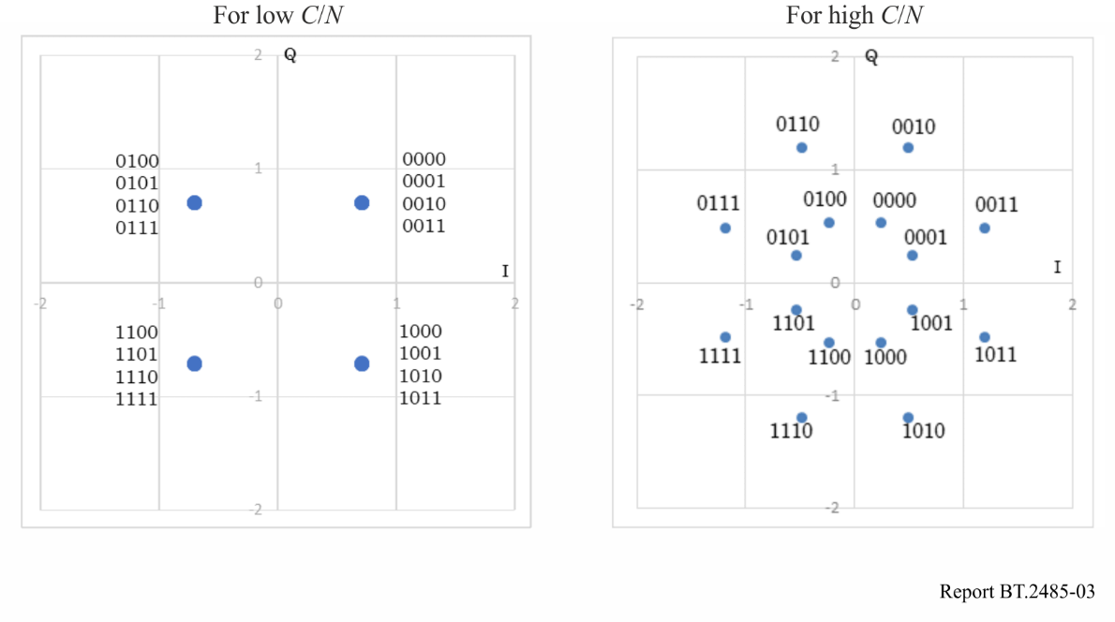
FigURE 4
2D and 1D Non-Uniform Constellation
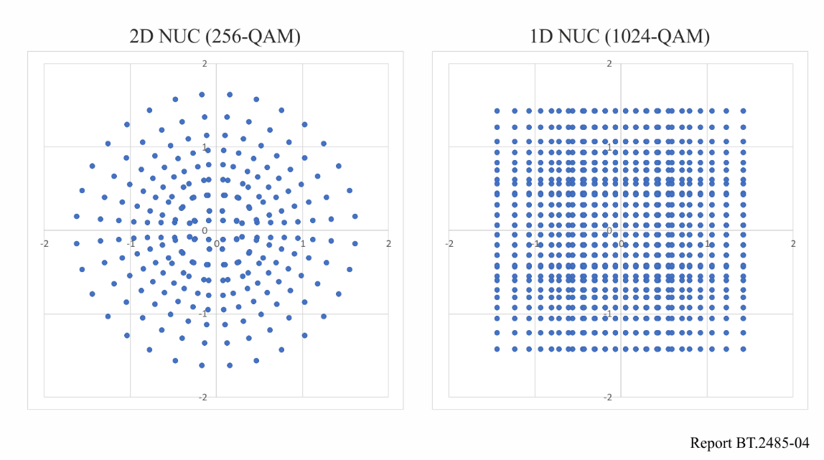

3.6 Hierarchical transmission
Hierarchical transmission technology is a transmission method that combines multiple programmes with different bit rates and required C/N onto one physical channel. This technology expands transmission capacities for several scenarios, such as mobile and fixed receptions. Three hierarchical transmission technologies – frequency division multiplexing (FDM), time division multiplexing (TDM), and layered division multiplexing (LDM) – have been adopted for the current terrestrial television broadcasting standards. FDM divides frequencies for several services. Figure 5 shows the FDM structure. In contrast, TDM divides time for several services, and LDM divides the power for each service. Figure 6 shows the TDM structure and Fig. 7 shows the LDM structure. Note that LDM can be applied with both FDM and TDM; however, Fig. 6 shows the case of basic LDM, in which the entire frequency band and all-time duration are multiplexed with LDM.
The outline of FDM, TDM, and LDM is summarized in Table 3. The optimum hierarchical transmission technology is different depending on user requirements and use cases.
FigURE 5
Frame structure of Frequency Division Multiplexing (FDM)
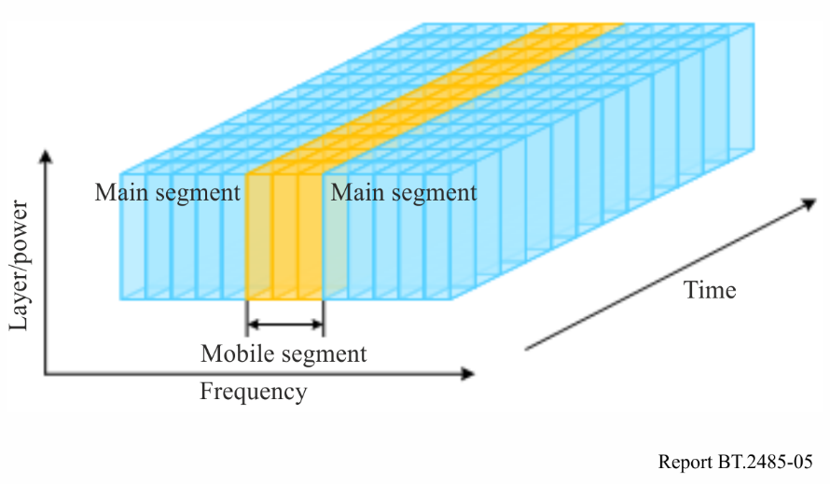
FigURE 6
Frame structure of Time Division Multiplexing (TDM)
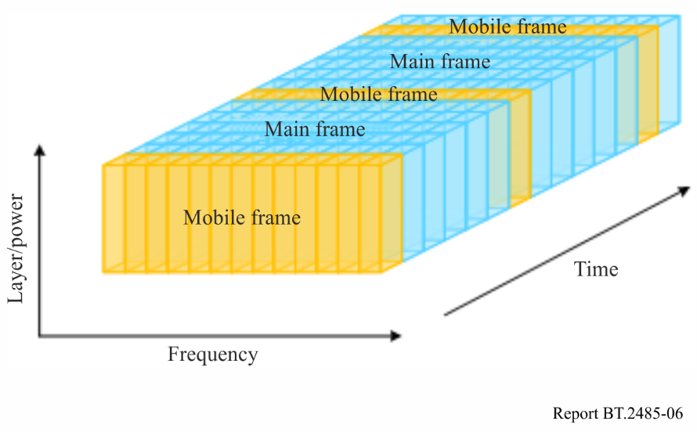
FigURE 7
Frame structure of Layer Division Multiplexing (LDM)
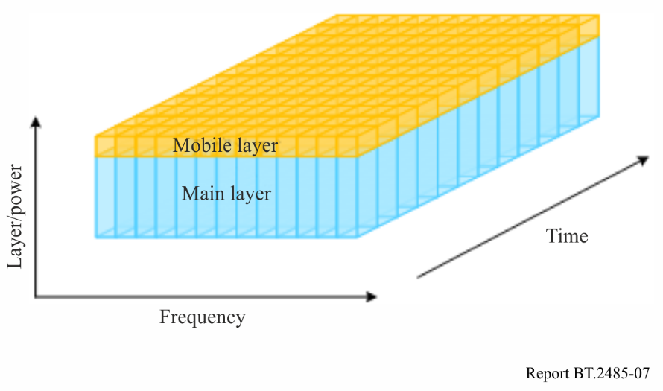
TABLE 3
Outline of hierarchical transmission technologies
Item | FDM | TDM | LDM
Assumption | Divides frequency for hierarchical transmission | Divides time for hierarchical transmission | Divides power for hierarchical transmission
Features | It is possible to configure a simplified receiver that uses a smaller FFT size with a narrow band frequency filter that passes the desired signal. | For a dedicated time partial receiver, it is possible to reduce power consumption by turning off the circuit of the receiver in the absence time of the desired signal. | Depending on the transmission parameters for mobile and main layers, it is possible to improve the performance compared to FDM or TDM.

3.7 LDPC code
A low-density parity check (LDPC) code is an advanced forward error correction (FEC) technology for correcting errors that occur in digital terrestrial television broadcasting. LDPC codes were developed in 1962 and are known to have excellent performance approaching the Shannon limit. They have been put into practical use as an FEC for digital satellite television broadcasting and have been adopted and developed not only for digital terrestrial broadcasting systems but also for mobile communication systems such as 5G.
An LDPC code having an information bit length of K and a code length of N is defined by a binary matrix H of N-K rows and N columns called a parity-check matrix. An irregular repeat-accumulate (IRA) structure and a multi-edge type (MET) structure are known as the parity-check matrix. IRA is capable of easily generating parity bits in the encoding process, and MET is superior in bit error rate performance with a low code rate compared with IRA. The structure of a parity-check matrix is selected according to code rate and the location of “1” is arranged to achieve lower bit error rate for each code rate. Figure 8 shows examples of IRA- and MET-structured parity-check matrices. Each column of matrix H corresponds to each bit constituting of a codeword, and each row corresponds to each parity bit. The tops of both matrix structures are the same; however, MET improves error correction performance by expanding the area where “1” can be randomly arranged at high density at the bottom-centre of the matrix.
FigURE 8
Parity-check matrix structure
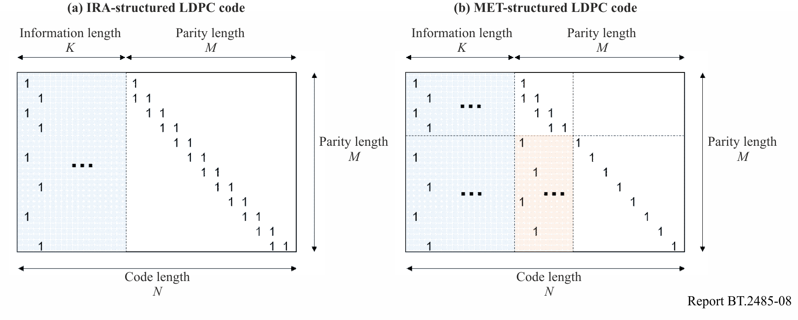

3.8 Wideband Re-Use 1 (WiB)
Wideband Re-Use 1 (WiB) is a promising approach for next generation Digital Terrestrial Television networks. The basic principles of WiB are the use of wideband RF channels, frequency re-use 1, the use of Layer Division Multiplexing and Interference Cancellation. WiB used robust modulation modes and other techniques to achieve capability to use all available frequency spectrum without any ‘white space’ at a given frequency. The price of increased robustness is a lower bitrate per one radio frequency channel. Benefits are that, the first, all frequency channels at the location may be used (re-use factor 1) and, the second, lower transmitter powers required to achieve the same coverage.
WiB application may allow an increase in spectral efficiency of around 30% to 60% compared to a conventionally planned MFN. However, it should be noted that, due to different planning approaches and propagation conditions, the potential for WiB implementation will differ from country to country. For example, WiB efficiency gain over a large area SFNs or in the mountainous areas will be much lower. Another factor influencing the potential gains of WiB is the commercial or regulatory need for regional services to be broadcasted in addition to or over national services. Subject to further study it is anticipated that national SFN networks would be even more efficient than the regional WiB scenario implementation.
The most probable WiB deployment scenario considers the mix-up of WiB and conventional DTTB networks architecture. Existing DTTB transmissions would be migrated to the new DTTB-WiB standard and be re-planned to achieve reuse factor 1 using some part of the available UHF band. In such a scenario, WiB would be deployed in a form that entirely backwards compatible with existing digital broadcasting system. This is possible if the digital broadcasting system deployed in a country includes high-robust modulation option (modulation mode with S/N close to 0 dB). That provides a seamless transition from one network design to another. Majority of existing broadcasting receivers may continue to be used by public to receive WiB services. DTTB-WiB receiver would be required only in areas of interference, introduced by the move to frequency re-use 1.
The efficiency gain of WiB implementation for typical scenario and particular national cases requires further study. At present time, there is no clear analytics model or software tool presented that can help to further examine benefits or extra costs of WiB deployment for particular local conditions.

3.9 Spectrum sharing and interference cancellation
Spectrum sharing allows to receive a number of different data streams within one frequency band at one location. To make this possible, the interference cancellation may be applied.
To explain interference cancellation technique, an example of two co-channel signals, received at one antenna simultaneously is considered. To recover the first co-channel signal, its power should be higher than the power of second co-channel signal by X dB, where X should not be lower than the value of co-channel protection ratio. The receiver can then re-construct the received first signal and subtract it from the coupled signal coming from the receiving antenna to clean up and decode the second one. This approach allows the spectrum to be used more than once in the same location, or even used more than once by same broadcasting station in one multiplex.
Could such a Layer Division Modulation (LDM) multiplex be implemented, it is possible to provide backward compatibility with former DTTB signal in the upper (most powerful) level of modulation. Other level or levels may be used for the introduction of new services, e.g. UHD TV or data transmission.
With the present state of technology, it may be difficult to provide lower LDM layers using low-robust modulation with high bit-rates. The lower layer signal has less power and more sensitive to external interference or noise. Demodulation of the lower layer may also be more difficult due to additional noise coming from first layer re-construction and subtraction process. There are no reports published yet that uncovers the technical parameters achievable in practice by mass market receiver using interference cancellation.
Since lower LDM layers are more sensitive to noise or interference, it may be feasible to consider such a technique for deployment of services less critical to coverage achieved. For example, an UHD TV may have a market demand at the limited area that much lower than the service area of the former network (upper layer). In this case, a very low additional cost for UHD implementation will be required at broadcaster side. In this scenario, due to no change in the upper layer at all, 100% backward compatibility will be granted to continue delivery of SDTV/HDTV services.

3.10 HARQ error correction in hybrid broadcast-broadband system
Future deployment of broadcast TV systems will probably be based on IP delivery of content. With such systems broadband, wired for fixed reception or cellular for mobile reception, could be used to improve the resilience of a broadcast service. Where reception of a broadcast service is subject to dropped packets, these could be requested via the broadband service. This is, in fact, an additional layer of error correction commonly used in broadcasting forward error correction (FEC), representing a hybrid automatic repeat request (HARQ) technique. This may be implemented on the basis of hybrid TV service and would require an additional short buffer at the reception side to allow time for identified lost packets to be requested and delivered without interrupting the continuity of the broadcast service.
A similar concept was trialled in Berlin in using DVB-T2. That trial using a concept called Redundancy on Demand (RoD) [1][2], monitored the received signal and requested via a broadband service, either wired or 3G, additional error correction. Reports from the trial indicated that RoD had an effect on coverage, an increase, similar to that obtained by increasing the transmitter power by 3 dB.

3.11 Channel bonding
Channel bonding technologies make use of two or more radio frequency (RF) channels to transmit data from a single Physical Layer Pipe (PLP). Channel bonding can transmit a total data rate that exceeds the capacity of a single RF channel. In addition, it can be used for frequency diversity reception using multiple RF channels. Moreover, the RF channels used in channel bonding may not necessarily be adjacent to each other. Furthermore, they may be located at any channel frequency.
Channel bonding can be categorized into two methods depending on whether or not the input data stream is split for modulation, a technique called ‘stream division’.
Figure 9 illustrates a block diagram of the channel bonding method with stream division and multiple Bit-Interleaved Coded Modulation (BICM) blocks. The stream division splits input data stream into multiple data streams before feeding it to the BICM. Each BICM block modulates the individual data stream. Next, the cell exchange block exchanges the output cells from the BICM blocks. This cell exchange may be used to increase the diversity across multiple RF channels. Thereafter, framing and interleaving blocks interleave the cells and construct the orthogonal frequency division multiplexing (OFDM) frames consisting of data cells, pilot signals and other signals, the waveform generation blocks conduct an OFDM modulation and add a guard interval. Lastly, the transmitter(s) upconverts the frequencies of the signals to those of the RF channels, and power amplifiers applies the signals to the transmitting antenna(s).
When the cell exchange is not used, a set of BICM, framing and interleaving, and waveform generation can be implemented as a basic single-input single-output (SISO) modulator.
FigURE 9
Block diagram of channel bonding with stream division
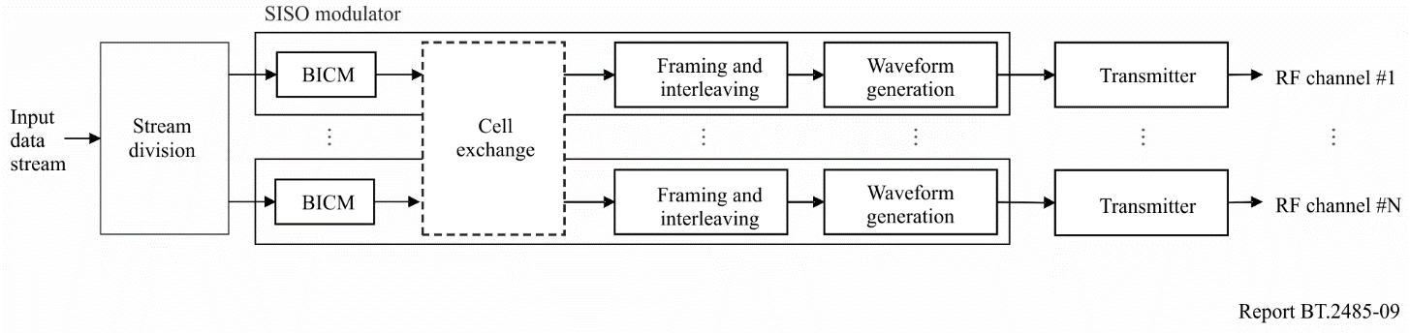
Figure 10 illustrates a block diagram of an alternative channel bonding method without stream division. This method utilizes a BICM block and cell division. The cell division splits the modulated cells into multiple RF channels; in addition, it can increase the diversity across multiple RF channels without the use of stream division.
FigURE 10
Block diagram of channel bonding without stream division
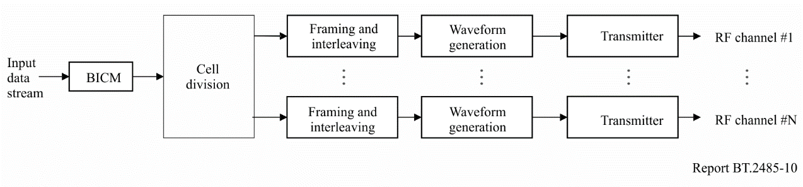
Channel bonding has been standardized as an option for ATSC 3.0 [3]. The method illustrated in Fig. 9 is described for two modes: the ‘plain mode’ without the cell exchange and the ‘SNR average mode’ with the cell exchange. The SNR average mode is intended to improve the PLP performance by increasing the diversity across multiple RF channels. The channel bonding method without stream division, illustrated in Fig. 10, provides similar effects as the SNR average mode.
Table 4 compares the features of channel bonding methods.
TABLE 4
Features of channel bonding methods
Method | With stream division  (Figure 9) |  | Without stream division  (Figure 10)
 | With cell exchange | Without cell exchange
Frequency diversity gain across multiple RF channels | Obtainable. | Not obtainable. | Obtainable.
Implementation of transmitting system | Physical layer blocks are implemented in a single modulator.  When more channels are used in the future, a new modulator will need to be implemented. | Multiple basic SISO modulators can be used.  When more channels are used in the future, basic SISO modulators will need to be added. | Physical layer blocks are implemented in a single modulator.  When more channels are used in the future, a new modulator will need to be implemented.

4 Test trials and research studies

4.1 Test data transmission system within DTTB multiplex
In the Russian Federation, experimental work carried out to create a test at a transmission system using available bit-rate capacity within DTTB multiplex.
In the Russian Federation, the federal state DTTB network using the DVB-T2 system has been built and operated. It covers about 98% of the population with its signal and represents free viewing of 20 television and three radio channels, some of which include regional content. This network consists of large area SFNs, includes a number of time zones and covers all the country regions. This DTTB network operates primarily in the UHF range.
To create a prototype of the system designed to delivery address information to a big number of recipients simultaneously through a multiplex channel based on DVB-T2 system, a test installation was established. This installation includes three factory manufactured DVB-T2 receivers, capable to support different versions of the HBB-TV specification.
At the DVB-T2 DTTB transmitter side, an available PLP, free of TV programme transmission, selected to create transport stream containing IP datacast (IPDC) carousel in which information representing a set of data in the form of HTML pages, CSS style description files and JS scripts repeatedly retransmitted after a predetermined period of time.
When receiving information from the IPDC carousel, each of the television receivers displayed the address information selected by the dedicated JS script if it contained the proper set of identifiers for relevant television receiver (version of the HBB of the TV platform, the device identifier, the TV manufacturerʼs identifier). The trial indicated that this approach is formally capable to do all things necessary for the address information display.
This approach has some advantages:
– Use of standardized commercially available receiving equipment and protocols.
– Small initial system deployment time.
At the same time, it has the following disadvantages:
– High overhead for information transfer.
– Lack of a standardized mechanism for subscriber registration, identification, data/message submission and data/message addressing.
– Lack of information security solutions.
High overhead costs for the transfer of information can be reduced in the following ways:
1 Implementation of native TS inside PLP support in mass-market DVB-T2 tuners/chipsets.
2 Development of a specific standard for data transfer via FEF.
3 Implementation of the FEF data extraction in mass-market DVB-T2 tuners/chipsets.
4 Development and standardization of the ‘light’ protocol for transmitting information (datagram sets) based on templates and methods for multiple data reuse.
It is also necessary to develop a mechanism for the message identification, data encryption and ensuring data integrity. Such a mechanism is supposed to be based on public key or other encryption technologies if they allow implementation with low hardware requirements.

References
[1] ‘Redundancy on Demand – Extending the Coverage Area of Terrestrial Broadcast via Broadband Networks’, J. Qi, J. Zollner, J. Robert, L. Stadelmeier and N. Loghin, IEEE Transactions on Broadcasting, Vol. 60, No. 2, June 2014.
[2] ‘Field Trial of a Redundancy on Demand DVB-T2 System’, F. Schreiber, J. Zollner, L. Stadelmeier, R. Burow, F. Kattanek, S. Krueger, IEEE 2016.
[3] Report ITU-R BT.2295-3 − Digital terrestrial broadcasting systems.

