|  |
| --- |
| **Report ITU-R BT.2400-2**  **(10/2018)** |
| **Usage scenarios, requirements and technical elements of a global platform  for the broadcasting service** |
| **BT Series**  **Broadcasting service**  **(television)** |

Foreword

The role of the Radiocommunication Sector is to ensure the rational, equitable, efficient and economical use of the radio‑frequency spectrum by all radiocommunication services, including satellite services, and carry out studies without limit of frequency range on the basis of which Recommendations are adopted.

The regulatory and policy functions of the Radiocommunication Sector are performed by World and Regional Radiocommunication Conferences and Radiocommunication Assemblies supported by Study Groups.

# Policy on Intellectual Property Right (IPR)

ITU-R policy on IPR is described in the Common Patent Policy for ITU-T/ITU-R/ISO/IEC referenced in Resolution ITU‑R 1. Forms to be used for the submission of patent statements and licensing declarations by patent holders are available from <http://www.itu.int/ITU-R/go/patents/en> where the Guidelines for Implementation of the Common Patent Policy for ITU‑T/ITU‑R/ISO/IEC and the ITU-R patent information database can also be found.

|  |  |
| --- | --- |
| Series of ITU-R Reports  (Also available online at <http://www.itu.int/publ/R-REP/en>) | |
| **Series** | Title |
| **BO** | Satellite delivery |
| **BR** | Recording for production, archival and play-out; film for television |
| **BS** | Broadcasting service (sound) |
| **BT** | Broadcasting service (television) |
| **F** | Fixed service |
| **M** | Mobile, radiodetermination, amateur and related satellite services |
| **P** | Radiowave propagation |
| **RA** | Radio astronomy |
| **RS** | Remote sensing systems |
| **S** | Fixed-satellite service |
| **SA** | Space applications and meteorology |
| **SF** | Frequency sharing and coordination between fixed-satellite and fixed service systems |
| **SM** | Spectrum management |

|  |
| --- |
|  |

|  |
| --- |
| ***Note****: This ITU-R Report was approved in English by the Study Group under the procedure detailed in Resolution ITU-R 1.* |

*Electronic Publication*

Geneva, 2018

© ITU 2018

All rights reserved. No part of this publication may be reproduced, by any means whatsoever, without written permission of ITU.

REPORT ITU-R BT.2400-2[1]

Usage scenarios, requirements and technical elements of a global platform[2]  
for the broadcasting service

(Question ITU-R 140/6)

(2017-2018)

# 1 Introduction

A conceptual block diagram of the global platform is shown in Fig. 1.

As shown in the left-hand box in Fig. 1, broadcasters are producing a wide range of content and services for distribution not only as traditional linear radio and television programming but also as time-shifted, on-demand, hybrid content and data services. ‘Hybrid content’ refers to content a part of which is provided over non-broadcasting networks in parallel with broadcasting platforms.

The audience has an increasing range of devices at its disposal. Typical user devices are shown in the right-hand box in Fig. 1. Television receivers for consumer use are now larger and more capable; this in turn feeds user expectations for increased picture quality and functionality.

Personal computers, smartphones and tablets are increasingly used to access media services. These devices are used either as a second screen to supplement the main television set, or as a secondary receiver or even as the main media device, in particular for out-of-the-home use.

The audience thus enjoys a wide choice of content and services, both linear and on-demand, which are increasingly available at any time and at any location. The audience increasingly expects, from a technical perspective, to be able to watch linear and non-linear broadcast content anytime, anywhere and on any audio-visual device, both stationary and in motion.

This trend is fully recognized and supported – to the extent possible – by today’s broadcasters, who naturally seek to deliver their range of content and services to all interested users on a device of their choice and in their preferred environment. This is the reason why ITU-R Study Group 6 studies a global platform, which is a delivery platform to facilitate distribution of broadcast content to end‑users with various receiving devices in multiple reception environments, implemented by using both broadcasting and non-broadcasting (e.g. broadband) technologies.

As shown in the centre box in Fig. 1, this requires the use of a number of different means of distribution, including traditional broadcasting platforms, such as terrestrial, cable and satellite, as well as broadband networks, both stationary and mobile. Although the global platform is intended to take advantage of non-broadcast networks, ITU-R SG 6 studies how the technical specifications of non-broadcast networks may be utilized in the global platform from the perspective of assembling and accessing broadcast content.

Figure 1

Conceptual block diagram of global platform

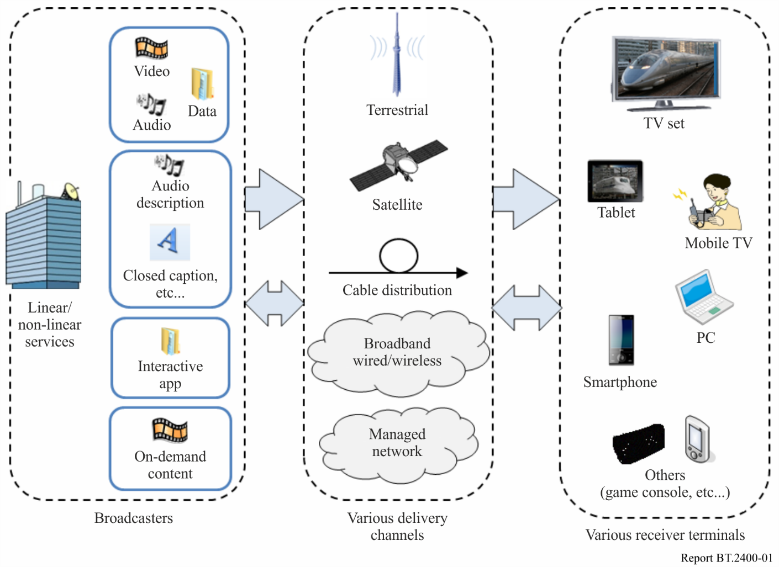

# 2 The envisioned global platform for the broadcasting service

This ITU-R Report results from initial work of ITU-R Study Group 6 on the high-level user and technical requirements and possible wrapper techniques to address a new multifunctional, Global Platform for the broadcasting service (TV, sound and multimedia).

It considers the following elements:

– Modern requirements for digital TV and multimedia broadcasting are radically different from the current ones, and traditional requirements do not reflect the latest international decisions as well as the current and future technological progress.

– Thanks to interactive “info-communication”, the users can take an active part in the way programmes are received on the base of personal preferences and convenient viewing time. These possibilities of the consumers influence television and multimedia broadcasting strategies and the associated info-communication services as never before.

– The intensive development of broadband access and the wide penetration of the Internet and its applications significantly enhance the users’ possibilities to receive and consume various types of audiovisual content.

– The development of video information systems, in addition to home and mobile reception, allows for the delivery of broadcasting to all audiences in private and public places, a variant of “always and everywhere”.

– The logical result of the considerations above is the introduction of a new integrated, multifunctional, global platform for the broadcasting service that includes all broadcasting media and means, as well as the associated info-communication services.

– There is now a demand for a new global platform for the broadcasting service and there is also a demand for a new model of the information society.

The high-level conclusions of this ITU-R Report are the following:

– Broadcasters require a new multifunctional global platform for the broadcasting service, in order to integrate modern and prospective media and means for the creation, delivery and presentation of broadcasting content with the highest possible quality through terrestrial, satellite and cable TV broadcasting as well as multimedia broadcasting in other networks: a new global platform for the broadcasting service should be conceived to respond to modern requirements for digital broadcasting, which are radically different from the traditional ones.

– Consumers require a new global platform for the broadcasting service, in order to facilitate access to the desired content in the most convenient form at any time and any place, on stationary or mobile receivers.

The new global platform would use those radiofrequency channels that are currently used for the delivery of broadcasting content, which are currently available and provide an optimal balance for the user between quality of service and cost of the service.

Specifically, the global platform would be able to serve the delivery channels below or combinations thereof:

– Terrestrial broadcasting.

– Satellite broadcasting.

– Cable television.

– Fixed broadband access.

– Mobile broadband access.

These delivery channels include IBB.

These may include linear and non-linear transmission mechanisms, such as the “pre-service push” option, e.g. transmission during the night for later selection by the end-user.

Interactivity should also be provided using user-friendly ways: through fixed and mobile networks, the reverse channel of the cable and satellite systems, etc.

# 3 Usage scenarios for the global platform

This section considers the distribution options currently available to broadcasters and identifies the distribution means that may be required in the future. It is based on studies of the BBC reflected in full detail in EBU Technical Report TR 026 – Assessment of available options for the distribution of broadcasting services – June 2014 [2].

It assumes that broadcast content encompasses the entire range of content that broadcasters offer to the audience irrespective of the technical platform across which it is distributed. (In this context, the term “broadcast service” is used to indicate broadcast content deliberately selected for that purpose).

In order to address the current and anticipated future audience behaviour, this section uses the concept of use cases. A use case is defined as a combination of a broadcast service, a user environment in which the service is used, and a user device.

Two distinct user environments are considered: a permanent one where a user spends considerable amount of time in the same place and where the vast majority of media use takes place (e.g. home or office), and a transient one (e.g. public place or when travelling) which is becoming increasingly important, in particular on portable devices.

A set of representative types of user devices has been identified without considering their respective functionalities and features in any great detail. These device categories reflect how services are consumed by the viewers and listeners and not necessarily the technical means of their delivery.

Individual use cases have been evaluated in terms of their relevance to broadcasters. In reality, different use cases coexist and are strongly influenced by their context. The following assumptions have been made:

– Linear viewing is the primary way of watching TV content and there is currently no indication that this will change in the foreseeable future.

– Time-shifted and on-demand viewing will continue to grow, but this will not significantly erode the overall amount of linear viewing.

– Migration of TV services from SDTV to HDTV will continue. More content will be offered as well, in particular with the introduction of new HDTV services.

– Ultra-HDTV will be introduced and may become the mainstream format in the medium to long-term future on all TV platforms.

– Portable and mobile devices are increasingly used to access media services. Nevertheless, most of the TV viewing will remain on the large screen.

– Majority of the TV viewing, both linear and nonlinear, will continue to occur in the home. Usage in transient environments will become increasingly significant.

– Innovative media services embrace active audience participation, in particular through social networks such as Facebook, Twitter, etc.

– Hybrid broadcast-broadband services are becoming commonplace based on broadcast platforms and fixed broadband infrastructure. In the future they may also make use of wireless broadband.

Not all identified use cases are equally relevant from a broadcaster’s perspective. The relevance is determined taking into account the current situation as well as the short to mid-term future (e.g. next 5-10 years). For instance, a use case is considered highly relevant if it is currently important or if it is foreseen to become important in the future. Elements to be considered may include the size of audience, availability of suitable devices or the programme offer.

Once a relevant use case has been identified the question becomes by which distribution options this use case can be enabled. For the purpose of analysis of distribution options only the highly relevant use cases have been considered. A distribution option refers to any technical possibility available to a broadcaster to distribute its services to the audience. This report dealt with terrestrial, satellite, cable, fixed broadband and mobile broadband as distribution options.

For every use case a set of requirements has been defined that need to be fulfilled by a viable distribution option. The requirements are service focused, i.e. defined in such a way as to ensure desired availability and quality of service. Two types of requirements have been defined:

– general requirements which are common to all use cases, and

– specific requirements for each use case.

The distribution options are assessed in terms of their ability to satisfy the requirements. The following are the main conclusions:

– The use cases that include linear services are sufficiently well served by broadcast networks except those that target portable devices such as tablets and smartphones.

– Broadband networks are not suitable to support use cases containing linear TV services because they typically provide only best-effort quality and are, in general, not able to serve large concurrent audiences. This limitation is more pronounced on mobile networks than on fixed.

– The use cases that include on-demand services are supported only by broadband networks as they provide the required return channel which is not available on broadcast networks.

– A number of use cases are supported by more than one distribution option.

– No single distribution option can support all relevant use cases. Therefore, in order to enable the whole range of relevant use cases multiple distribution options need to be employed in a complementary manner.

– Some distribution options may be able to support multiple use cases simultaneously. For example, broadband networks can be used to watch linear TV and access on-demand services at the same time. However, broadband networks may not be able to serve peak demands of all supported use cases simultaneously, even though they may in principle satisfy them individually at different times.

– Some use cases have been identified that are considered highly relevant but cannot be fully supported by any of the currently available distribution options. For these cases further technical and market developments are necessary.

The above-mentioned analysis focused on individual use cases. However, it is important to recognize that individual use cases taken in isolation do not cover all situations that occur in reality. Combinations of use cases, i.e. simultaneous use of different devices and services or consecutive use over time and space, sometimes even including a switch of device, are becoming increasingly important. This kind of user behaviour is described by the term ‘usage pattern’.

Only a brief analysis of usage patterns was performed. It revealed that most usage patterns cannot be enabled by a single distribution option. Combination or even cooperation of different options would be required.

Furthermore, this study touched upon some of the ongoing technical developments, noting that all distribution options are evolving and may in the future overcome some of their current limitations. However, it remains to be seen which of the proposed innovative technical solutions will be successful on the market. Full details of the study are given in [2].

The results of the analysis clearly indicate that there will be no ‘one-fits-all’ solution.

# 4 Broadcasters’ general requirements for a global platform

## 4.1 General requirements

General requirements address not only technical issues but also regulatory, market and business‑related aspects relevant for broadcasters and apply across all distribution options.

The general requirements are:

– Ability to provide content free-to-air (no additional cost for viewers/listeners).

– Deliver public content to the public without blocking or filtering the service offer (i.e. no gate keeping).

– Content and service integrity: No modification of the content or service by third parties. For example, TV content and additional services (e.g. subtitles, etc.) must be displayed on screen, unaltered and without unauthorised overlays.

– Broadcast content should be protected from unauthorized access.

– Quality of service (QoS) to be defined by the broadcaster, including availability of a network, robustness, up-time, and reliability.

– QoS for each user should be independent of the size of the audience.

– Geographical availability of the service (e.g. national, regional, local) is to be defined by the broadcaster.

– A distribution method needs to support an attractive breadth of programmes as offered by the broadcaster.

– Broadcast content should be given prominence and be straightforward to access.

– Low barrier for access to content and services for people with disabilities (e.g. subtitles, audio description and signing).

– Ability to reach audiences in emergency situations.

– No limitation in the number of concurrent users.

– Option for anonymous reception of free-to-air content.

## 4.2 Specific requirements

In addition, depending on the service, user device, reception environment, and distribution method, technical parameters would need to be adapted to the particular delivery mechanism. These should take account of the following requirements:

– The original quality of the broadcast content should generally be capable of being maintained irrespective of the delivery channel selection, network loading, etc.

– Latency for delivering broadcast content should be predictable and small.

– Broadcast functions in terrestrial communications networks should allow fixed and mobile reception over large service areas.

# 5 High-level end-to-end user requirements for a global platform

This section succinctly lists the main requirements with which the Global Platform should comply, in order to meet the main needs of broadcasters. The identification, development and validation of the Global Platform should be based on these end-to-end requirements.

## 5.1 Reception/consumption situation for TV/radio/data broadcast services

– Stationary (including within home-networks).

– Portable (including personal body-worn displays).

– Transient/On the move, e.g. in a vehicle (including in-car networks).

## 5.2 Terminals used

– On a conventional TV/radio set.

– On a desktop/laptop or tablet computer.

– On a smart phone.

## 5.3 Broadcast services offered as linear TV/radio/data broadcasts via broadcast networks

– As linear TV/radio/data broadcasts via broadband networks.

– On demand TV/radio/data broadcasts (normally retrieved over broadband networks).

– In hybrid form (IBB, i.e. simultaneous access over broadcast and broadband networks).

– Via pre-service push (e.g. during the night for later viewing/listening by the end‑user).

# 6 Deployment examples of global platforms

## 6.1 General

This section introduces two deployment examples of global platforms.

## 6.2 4K broadband service

SKY Perfect JSAT Corporation provides a broadband service by using fibre to the home (FTTH) in which service identical to that of satellite broadcasts, including three 4K services, is provided simultaneously. This service is intended to be received with TV sets or STBs.

All of the satellite broadcast signals are delivered over optical fibres separately from data signals delivered for Internet service by using wavelength division multiplexing (WDM) technology. This usage of WDM technology is specified in Recommendation ITU-T J.185 ‒ Transmission equipment for transferring multi-channel television signals over optical access networks by frequency modulation conversion. A video-optical network unit (V-ONU) equipped at each receiving home and apartment outputs the same signals as those received by a parabolic antenna.

This service has many advantages. Because it does not require an antenna, the quality of the broadcast service does not deteriorate even when there is rain, and the service is easily introduced in apartments in which equipping an antenna is not allowed. The broadcast signals are delivered separately from the data signals, so the quality of the broadcast service remains high even when end users use the Internet service. The high-quality 4K services can be received with several TVs and STBs simultaneously. Further, the Internet service is not affected even when a lot of broadcast programmes are being watched.

## 6.3 Internet radio services

NHK Radiru and Radiko are internet radio services in which most of the radio programmes available on AM or FM radios are provided simultaneously on the Internet. The services are intended to be received by PCs, smartphones, and similar devices.

In these services, audio signals encoded at 48 kbit/s per channel are provided with Flash and HTTP live streaming (HLS) formats though a Content Delivery Network (CDN). Any devices connected to the Internet are able to receive the services, although the reception areas are restricted to Japan. Neither time signals nor emergency warning systems are offered because the internet radio services are behind the original radio services by a few to a few tens of seconds.

An electronic programme guide (EPG) is provided on web pages and dedicated applications. End users see the information together with thumbnails about on-air programmes and then choose the programme to receive. In the services, both live radio programmes and programmes requested by end users are provided. End users can listen to a programme they missed by requesting it. The internet radio services provide convenient functions that are not provided by the original radio services.

# 7 Technical elements

In order to establish broadcasting services on the global platform, many different technical elements are required. Annex 1 of this Report contains some examples.

The second “*decides*” of Question ITU-R 140/6 describes:

What means and measures could be recommended, that would allow broadcast content to be flexibly delivered to the end-users via the widest possible range of terminal devices?

The technical elements described in Annex 1 would provide some answers to this aspect of the Question.

# 8 Related ITU texts

1) Integrated Broadcast-Broadband systems

– Recommendation ITU-R [BT.2075](https://www.itu.int/rec/R-REC-BT.2075/en) – Integrated broadcast-broadband system

– Report ITU-R [BT.2267](https://www.itu.int/pub/R-REP-BT.2267) – Integrated broadcast-broadband systems

IBB applications may work as service enablers on various kinds of terminals via various kinds of delivery networks, and seamlessly integrate the final delivery to the end users.

2) International Mobile Telecommunications (IMT) networks

– Report ITU-R [M.2373](https://www.itu.int/pub/R-REP-M.2373) – Audio-visual capabilities and applications supported by terrestrial IMT systems

Concerning delivery over IMT networks, Report ITU-R M.2373 describes the capabilities of IMT systems to deliver audio-visual services. It also examines user requirements as well as some of the requirements from the audio-visual content providers.

3) Access network transport

– <http://www.itu.int/en/ITU-T/studygroups/com15/Pages/ant.aspx>

“Access network transport standards overview” is found on the above URL. Some of the networks listed in the overview are effective means of delivery for the global platform.

# 9 Bibliography

[1] EBU Technology Fact Sheet – Public Service Media Requirements in Distribution – December 2014.

[2] EBU Technical Report TR 026 – Assessment of available options for the distribution of broadcasting services – June 2014.

Annex 1  
  
Technical elements of a global platform

# 1 Introduction

This Annex contains examples of some of the technical elements of a global platform.

# 2 Delivery of IP-based broadcasting services over broadband networks

## 2.1 Overview

Internet Protocol (IP)-based broadcasting systems such as ISDB-S3 and ATSC 3.0 have been developed. In these systems, broadcasting services are transmitted as IP packets, which are used in broadband networks. Since IP packets are a common interface between broadcast and broadband, broadcast channels can be used to deliver broadcasting services to broadband networks without making any changes to these services, such as by transcoding, replacing encryption for Conditional Access System (CAS) or Digital Rights Managements (DRM), or converting the protocol.

Figure A1 illustrates the protocols used in IP-based broadcasting and broadband. A broadcaster is able to transmit its services by using the same protocols for broadcast channels as for broadband networks. A TV set can receive these broadcast services with the same protocols even though they are transmitted along different paths.

FIGURE A1

Protocols in IP-based broadcasting and broadband

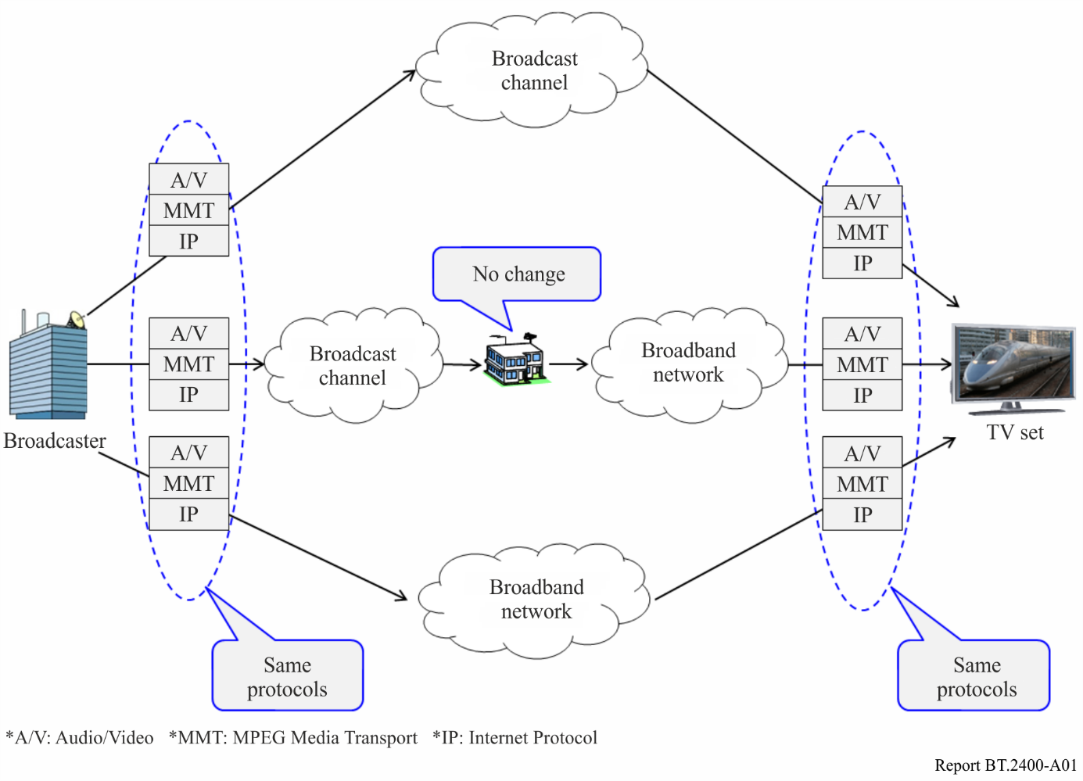

## 2.2 Differences between broadcast channels and broadband networks

The ISDB-S3 system uses MPEG Media Transport (MMT), a media transport protocol on top of IP, to transmit broadcasting services including audio, video, and other signals. In the Candidate Standard of ATSC 3.0, either MMT or DASH/ROUTE on top of IP is used to transmit broadcasting services. In any of these systems, IP packets carry the broadcasting services through the broadcast channel.

In the case of a broadcast channel, broadcast services are transmitted by multicasting UDP/IP packets to any receiver, as the channel is a unidirectional path. The broadcast channel for fixed reception provides quasi-error-free transmissions, because broadcast systems have a robust error correction mechanism in their physical layer.

In the case of broadband, both bidirectional transmission in the form of TCP/IP packets and unidirectional transmission with the form of UDP/IP packets are possible. However, packet losses could result from buffer overflows at routers on the transmission path, even if there are no packet losses over the broadband lines themselves. Re-transmission of packets with the TCP mechanism or Application Layer-Forward Error Correction (AL-FEC) in combination with UDP is often used to keep transmission quality high when packet losses occur.

## 2.3 Experiment on delivery of 8K programmes over broadcast and broadband

NHK conducted an experiment in May 2016 in order to confirm that the protocol of ISDB-S3 works through an actual broadband network without any modifications. Figure A2 shows the experimental system.

FIGURE A2

Experimental system using actual broadband network

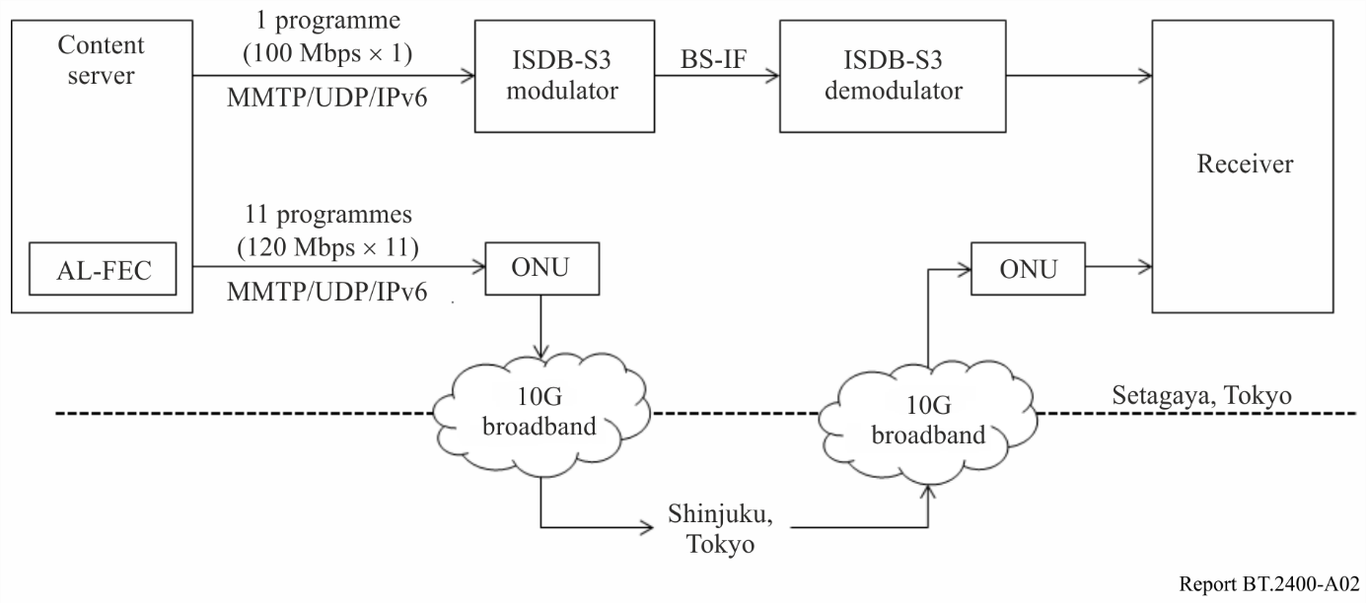

*ONU: Optical Network Unit

The content server and receiver were located in Setagaya, Tokyo in Japan. The ISDB-S3 modulator and demodulator are connected back-to-back as the broadcast channel. A 10G-EPON was used as the broadband network. The server transmitted one programme through an ISDB-S3 modulator and demodulator and eleven programmes through broadband.

Each programme consisted of encoded 8K video and two-channel audio signals. It was transmitted in real-time in accordance with their presentation time by using MMTP/UDP/IPv6 packets, whose bitrates were approximately 100 Mbit/s. Table A1 lists the signals transmitted in the experiment.

TABLE A1

Signals transmitted in experiment

|  |  |
| --- | --- |
| Item | Configuration |
| IP version | IPv6 |
| Transport protocol | MMTP/UDP |
| IP packet size | Max. 1.5 KB |
| Audio format | Two channels |
| coding | MPEG-4 AAC LC |
| Video format | 7680×4320/59.94/P |
| coding | HEVC Main 10 profile |

Eleven programmes were transmitted from the server to Shinjuku, Tokyo, about 25 km away from Setagaya, Tokyo, at which point they were returned to the receiver in Setagaya. At this time, 10‑Gbit/s services are available in limited areas of the Tokyo metropolitan region. Such service areas will spread throughout Japan in the near future.

In order to maintain error resiliency, the packet flows through broadband included repair packets generated by AL-FEC. The source packets through broadband were identical to those through the broadcast channel. The bitrate of one programme with repair packets was approximately 120 Mbit/s.

The receiver chose one of the twelve programmes from either broadcast or broadband and displayed it after extracting the AAC/HEVC streams from the received MMT packets and decoding them.

Figure A3 shows the content server and receiver. The monitor on the left shows the status of the content server that transmitted the twelve programmes in real time: one for broadcast and eleven for broadband. The monitor on the right shows the received 8K programme that a user selected.

FIGURE A3

Content server and receiver

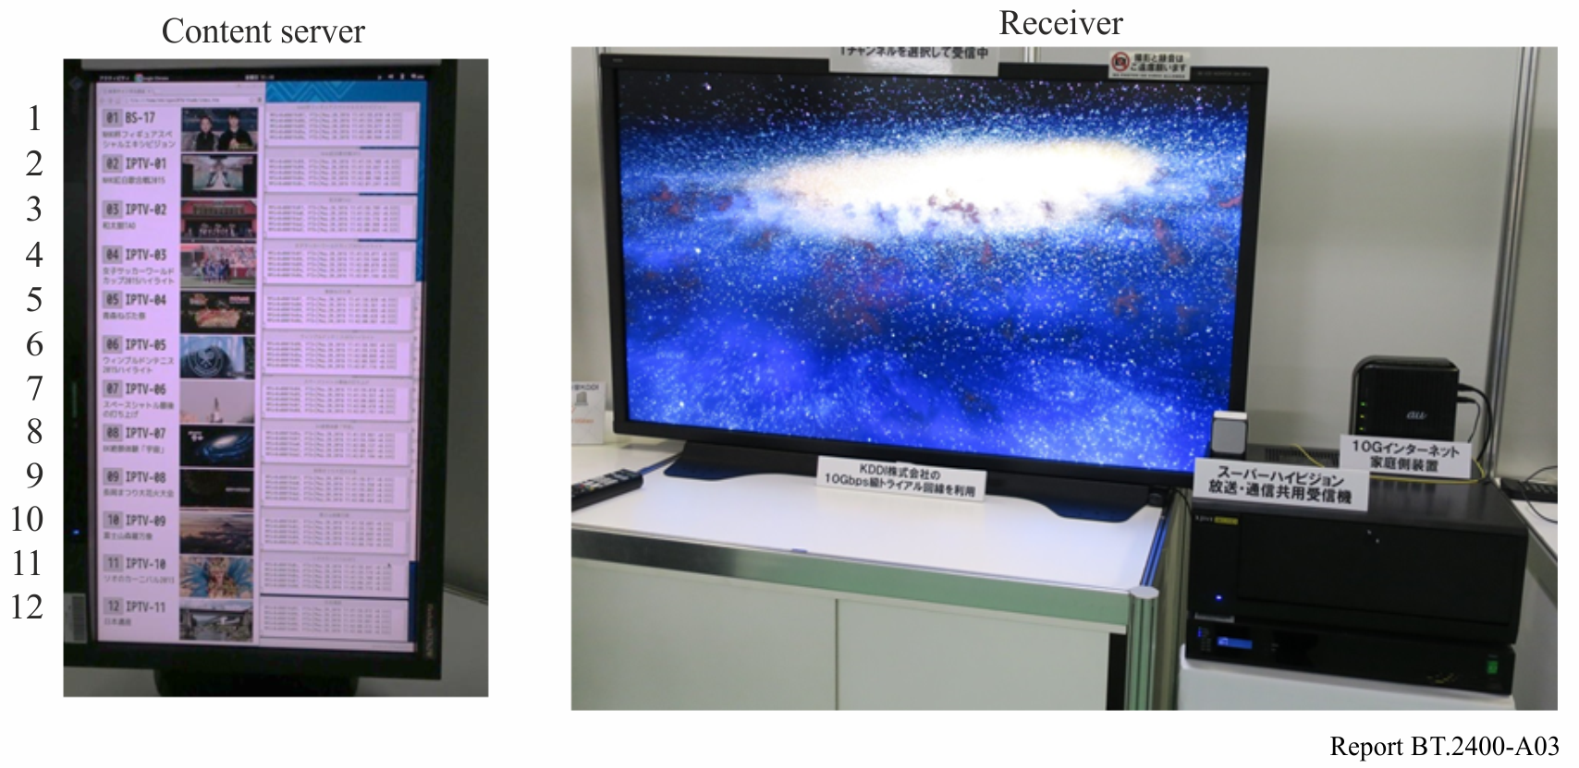

During this experiment, the receiver stably presented the 8K programme selected by the user. The user could choose the programme he wanted to watch without having to worry about its delivery path.

A receiver that did not support the AL-FEC function received IP packets including the repair packets. In this case, the receiver could ignore the repair packets and processed only the source packets. There was no packet loss during the 24-hour period in which the eleven 8K programmes were delivered.

This experiment confirmed that the protocol of ISDB-S3 on top of IP correctly worked through broadband.

## 2.4 Conclusion

This clause described an experiment on delivering 8K programmes through an actual high-speed broadband network by utilizing a media transport protocol on top of IP identical to that of an IP‑based broadcasting system, ISDB-S3. The receiver stably presented the 8K programmes during the experiment. The experimental results showed that the IP-based protocol of ISDB-S3 also worked well through a high-speed broadband network using IP.

# 3 Delivery model including a distribution status management server

## 3.1 Overview

Broadcasters have begun distributing TV programmes via Internet simulcast and video on demand (VOD) as well as broadcasting. End users watch TV programmes provided by broadcasters with various devices such as smartphones, tablets, and Integrated Broadcast and Broadband (IBB) receivers.

It is important for audiences to be able to obtain the content they desire regardless of the delivery channel. For broadcasters, it is important to provide content to audiences through inexpensive channels.

The following server and end-user device are required to achieve such content delivery:

– A server that manages the status of content distribution; that is, indication of availability on each delivery channel, and provides the status to each end-user device.

– An end-user device that decides an appropriate delivery channel for end users to obtain the desired content on the basis of the status of content distribution.

## 3.2 Importance of distribution status management server

When there is a server that manages the status of content distribution on each delivery channel, a device can obtain the desired content on an appropriate delivery channel depending on the situation. This mechanism also enables broadcasters to guide end users to broadcast channels in which the delivery cost is lower than that of broadband networks. Figure A4 illustrates the content delivery model including the server that has such functionality.

FIGURE A4

Distribution status management server and content delivery model

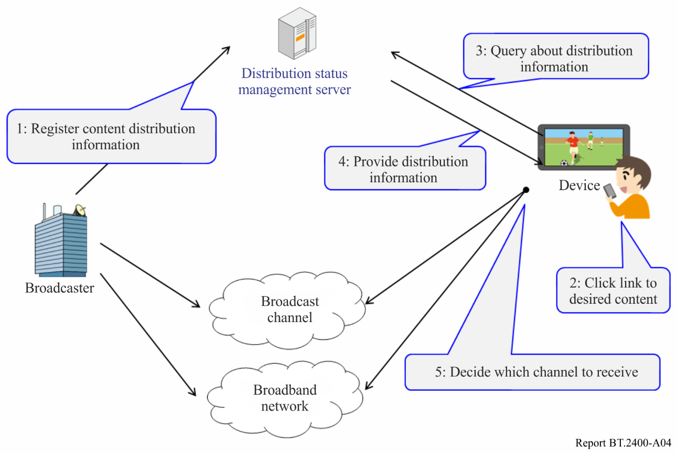

The distribution status management server stores information on how content is distributed.

Before distributing their content, broadcasters register the distribution information of the content, including broadcast channel information, Internet simulcast URLs, or VOD services URLs on the server (Step 1 in Fig. A4). Additional information such as video resolution and transmission latency from a live broadcast service, which is used to determine an appropriate distribution channel for a device, is also registered.

When an end user wants to view content, they simply click a URL link to the content (Step 2 in Fig. A4). The URL is described independently of the distribution channels.

Then, the device queries the server for the distribution information of the content (Step 3 in Fig. A4). In response to the inquiry, the server provides the device with the distribution information, including available channels, video resolution, transmission latency, and so on (Step 4 in Fig. A4).

On the basis of this information, the device decides an appropriate channel to obtain the content (Step 5 in Fig. A4); then, it presents the content. It is assumed that an appropriate channel can be determined by examining various parameters including those describing the device capabilities.

In this content delivery model, content is identified by a URL that is independent from the delivery channel. The device decides an appropriate channel from the distribution information provided by the server and dynamically resolves the link. Owing to this mechanism, end users can watch a TV programme without caring about its delivery channel.

## 3.3 Implementation and verification

To verify the content delivery model described above, NHK implemented a server, receiver, and transmitter. Figure A5 shows the implementation overview.

FIGURE A5

Implementation overview

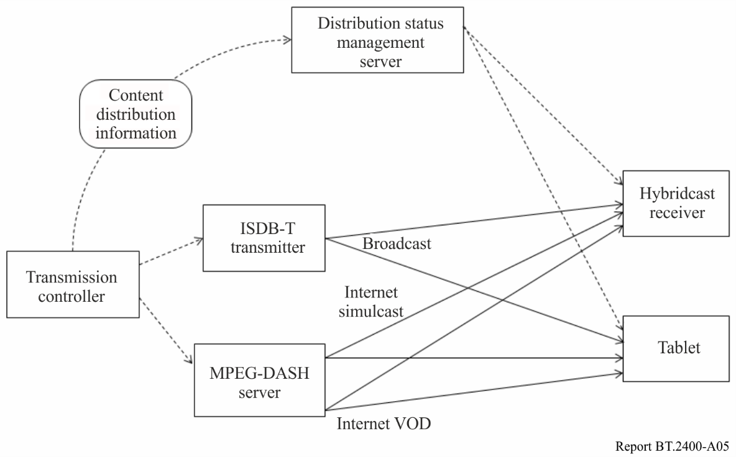

A hybridcast receiver and an Android tablet were used as the end users’ devices.

A programme was distributed from ISDB-T transmitter (through broadcast), MPEG-DASH server for live streaming (through Internet simulcast), and MPEG-DASH server for on-demand (through Internet VOD). In this implementation, the Internet VOD offered ‘start-over’ service that enabled end users to watch a programme from the beginning anytime, while it was delayed more than several minutes from real time.

The transmission controller informed the distribution status management server about the distribution status; then, the server stored them. For simplicity, each device decided an appropriate delivery channel by prioritizing real-time availability and video resolution in that order.

The verification experiment was conducted with one programme, Programme A. The distribution methods were updated every minute, and the end user clicked the link for Programme A after each update. Figure A6 illustrates the change in available distribution channels. This Figure also illustrates the channels selected by each device.

FIGURE A6

Registered schedule of each delivery channel and channel selected by each device

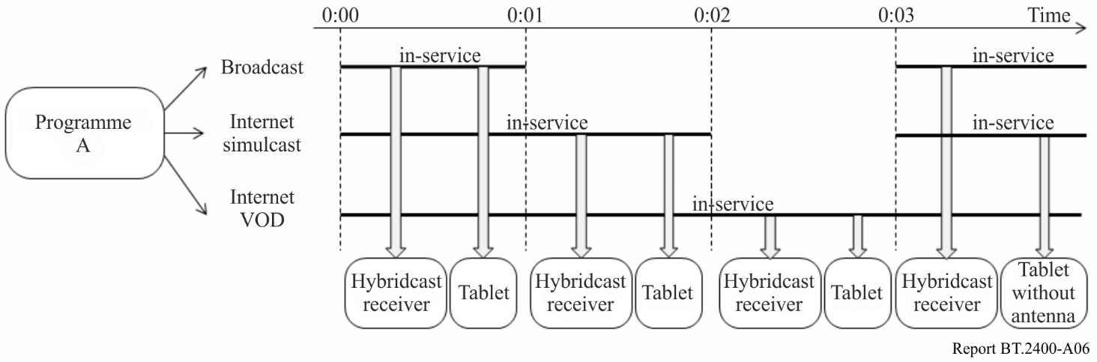

During the interval 0:00 to 0:01, Programme A was distributed via broadcast, Internet simulcast, and VOD. The devices selected broadcast to receive Programme A, since broadcast provided Programme A in real-time and at the highest resolution.

During the interval 0:01 to 0:02, the Programme A was distributed only via Internet simulcast and VOD. The devices selected Internet simulcast, since it was a real-time delivery method.

During the interval 0:02 to 0:03, the devices selected VOD, since it was the only available delivery channel to receive Programme A.

In addition, after 0:03, we unplugged the broadcast antenna cable from the tablet in order to simulate a bad receiving condition. At that time, the tablet selected Internet simulcast, since it could not receive broadcast signals.

From this experiment, it was confirmed that the devices determined an appropriate delivery channel by using the distribution status management server.

## 3.4 Measuring reception quality of broadcast and mobile broadband in the field

### 3.4.1 Measuring reception quality

To investigate the potential of using both broadcast and mobile broadband to deliver broadcast content, the reception quality was measured in actual mobile reception environments that simulated real-life situations such as walking or riding on a train or bus.

Measurements were conducted for two round-trip routes (Routes A and B) in October and November 2016, as shown in Table A2 and Fig. A7. Route A included underground sections on the way.

TABLE A2

Two routes for measuring reception quality

|  |  |
| --- | --- |
| Route A | NHK STRL – (walking) – Soshigaya Okura station – (train) – Shinjuku station (staying in neighbourhood for approx. 15 minutes) |
| Route B | NHK STRL – (bus) – Shibuya station (staying in neighbourhood for approx. 15 minutes) |

Figure A7

Two routes for measuring reception quality

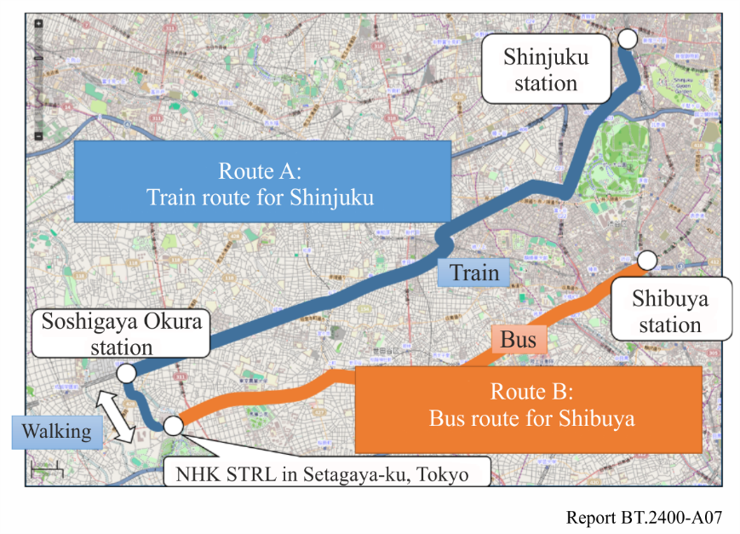

Figures A8 and A9 show the measured *C*/*N* (dB) of the broadcast signals and the throughput (Mbit/s) of the broadband on Routes A and B, respectively.

On Route A, shown in Fig. A8, the throughput of mobile broadband did not decrease even in the underground sections, although the broadcast quality deteriorated. On Route B, shown in Fig. A9, the broadcast quality remained high in the neighbourhood of Shibuya station, while the throughput of mobile broadband frequently decreased, which was supposed to be due to congestion.

Figure A8

Measured reception quality on Route A

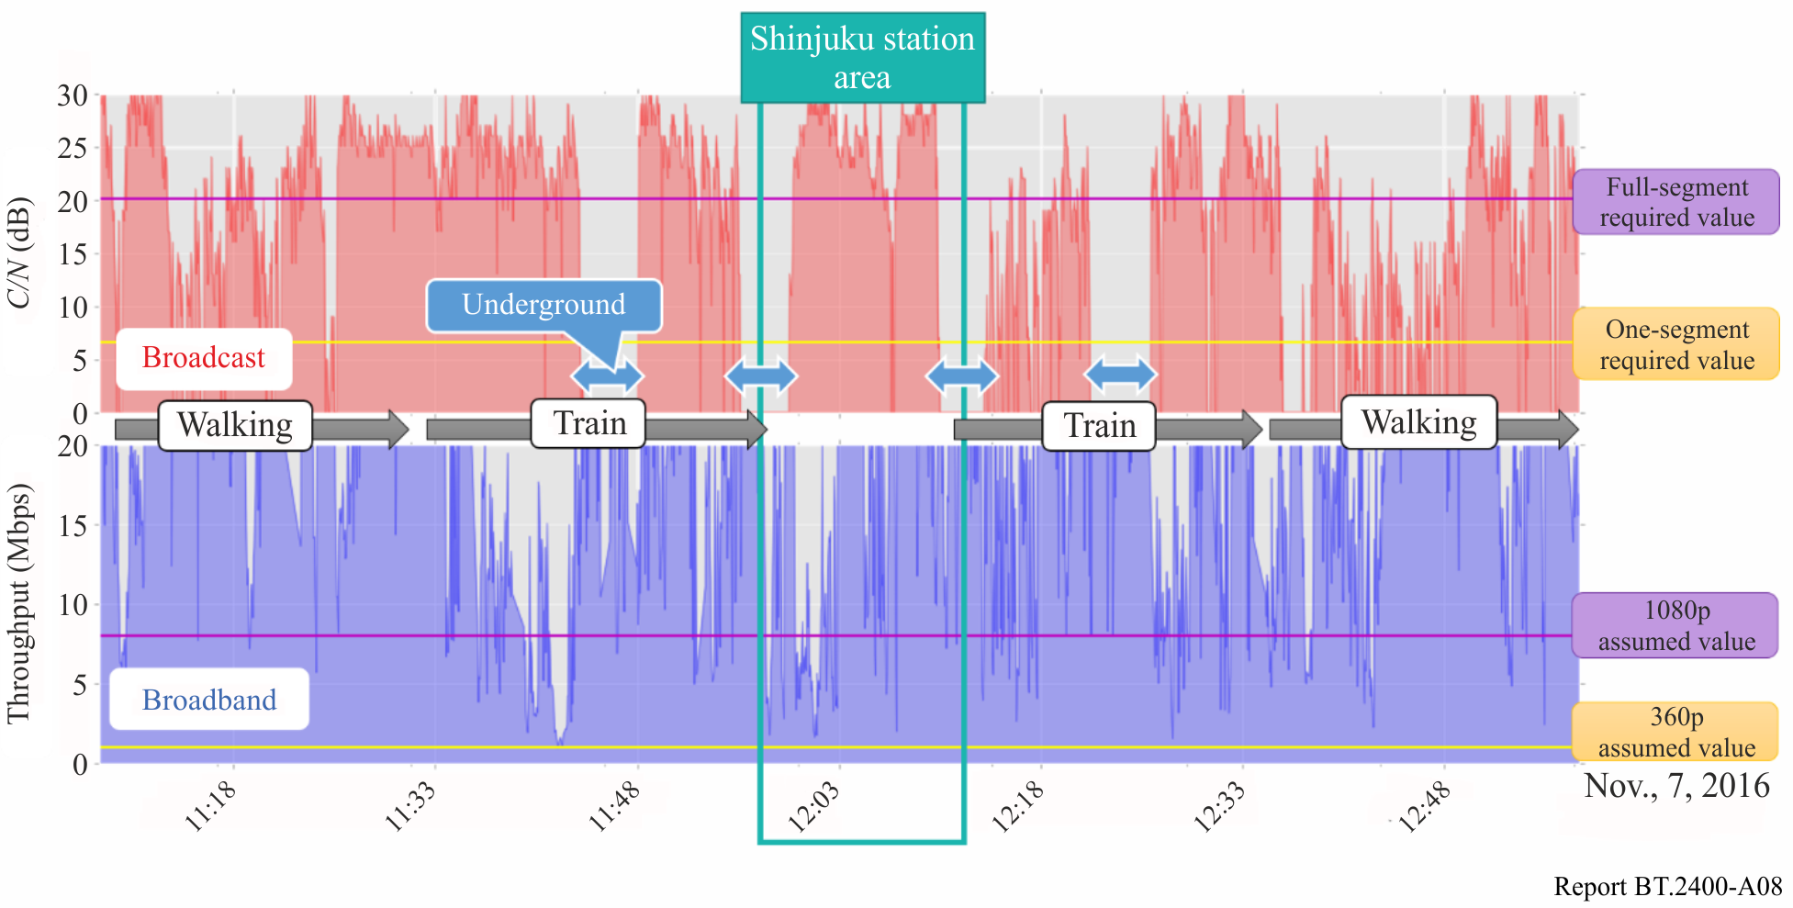

Figure A9

Measured reception quality on Route B

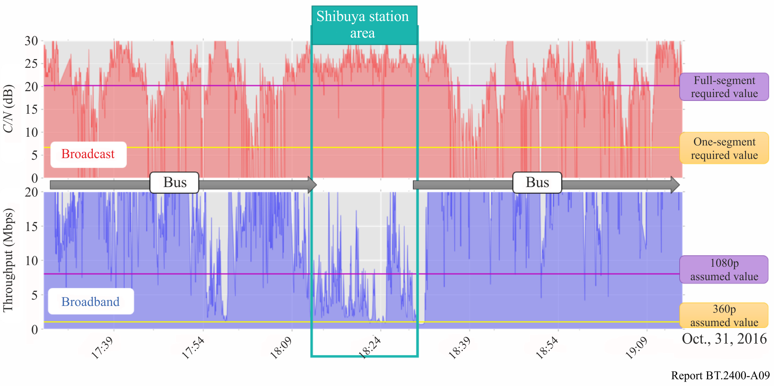

### 3.4.2 Improved service availability by combined use of broadcast and broadband

Table A3 shows the service availability for different reception scenarios, that is, broadcast only, broadband only (low or high data rate), and a combination of both, on Routes A and B.

TABLE A3

Service availability on basis of measured reception quality

|  |  |  |  |  |  |
| --- | --- | --- | --- | --- | --- |
| Reception scenario | Assumed reception condition | | Service availability | | |
| via broadcast | via broadband | Route A | Route B |
| One-segment broadcast only(1) | *C*/*N* ≥ 6.6 dB(3) | N/A | 75.0% | 92.0% |
| Full-segment broadcast only(2) | *C*/*N* ≥ 20.1 dB(3) | N/A | 50.9% | 64.3% |
| Broadband only (low data rate) | N/A | Throughput ≥ 1 Mbit/s(4) | 99.7% | 98.3% |
| Broadband only (high data rate) | N/A | Throughput ≥ 8 Mbit/s(5) | 91.7% | 82.8% |
| One-segment broadcast  and low-data-rate broadband | *C*/*N* ≥ 6.6 dB (3) | Throughput ≥ 1 Mbit/s(4) | 100.0% | 100.0% |
| Full-segment broadcast  and high-data-rate broadband | *C*/*N* ≥ 20.1 dB (3) | Throughput ≥ 8 Mbit/s(5) | 99.8% | 100.0% |
| (1) Data rate of 416.0 kbit/s for 320 × 240/15/P video encoded with ITU-T H.264|MPEG-4 AVC and stereo sound.  (2) Data rate of 18.2 Mbit/s for 1440 × 1080/59.94/I video encoded with MPEG-2 Video and 5.1-channel sound.  (3) Required C/N is defined by standard.  (4) Assuming 640 × 360/30/P video encoded with ITU-T H.264|MPEG-4 AVC.  (5) Assuming equivalent quality of full-segment. | | | | | |

The service availability was improved when the combination of broadcast and broadband was used.

### 3.4.3 Improved video quality by use of broadcast

The video quality of full-segment broadcasting is higher than that of video streaming via broadband with less than 8 Mbit/s. There were some time periods when a full-segment broadcast could be received while the throughput on broadband was less than 8 Mbit/s; they were 5.3% and 16.4% on Routes A and B, respectively. In this situation, receiving a full-segment broadcast rather than a broadband improves received video quality without decreasing service availability.

### 3.4.4 Summary of advantages of using broadcast and broadband based on measured reception quality

The measured mobile reception quality of broadcast and broadband assuming real-life situations shows that using both improves service availability and video quality.

Owing to the distribution status management server, end users are able to receive their desired content without caring about its delivery channel, as shown in Fig. A10. The distribution status management server is applicable to any broadcasting systems and any protocols over broadband networks.

Figure A10

Operation examples based on broadcast reception quality

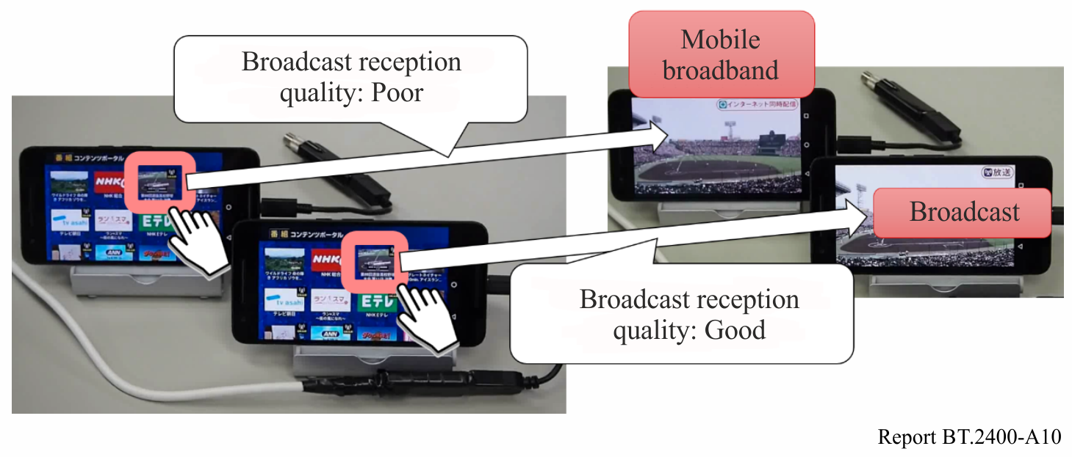

## 3.5 Conclusion

This section described a content delivery model including a distribution status management server in order to make good use of broadcast channels and broadband networks in view of the end users’ situation. The implementation confirmed the functionality of the distribution status management server.

# 4 Simultaneous delivery of broadcast content using integrated broadcast-broadband (IBB) systems

Integrated broadcast-broadband (IBB) systems enable simultaneous transmission of broadcast content, one through broadcasting networks and the other through broadband networks. Even when UHDTV programmes are not available in terrestrial or satellite broadcasting, they can be delivered through broadband networks. IBB systems can also provide VOD catch-up services. Figure A11 shows a system configuration for a multi-resolution video service by means of an IBB system.

Figure A11

System configuration for multi-resolution video service by means of IBB system

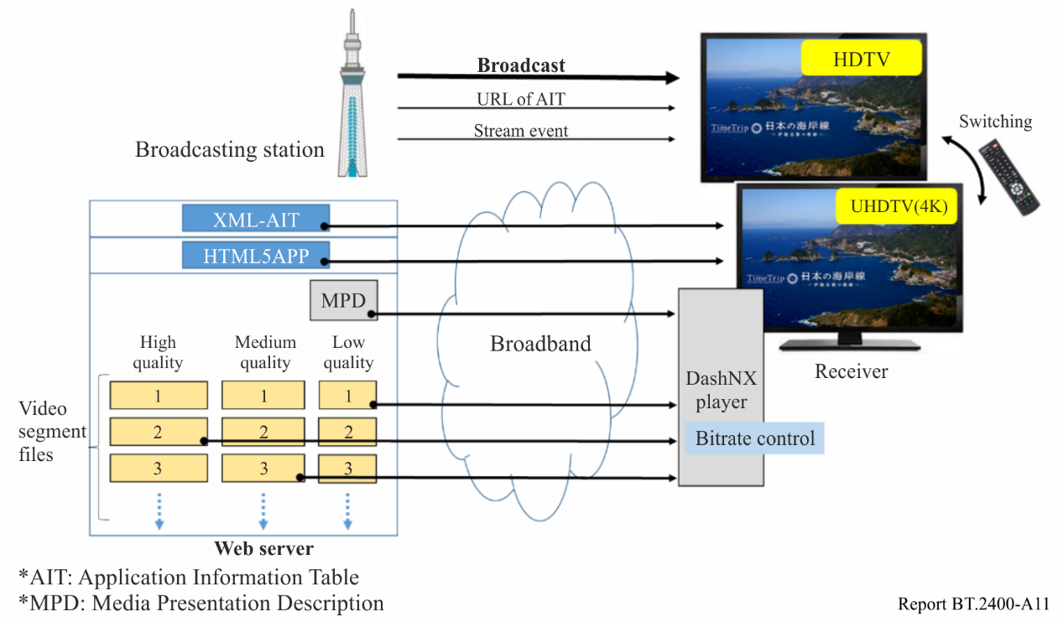

# 5 Retransmission of received broadcast content to home or private network

Broadcast content received at a home may be retransmitted to a home network or a private network at the discretion of a user so that the user can watch the content on any Internet-connected viewing devices at any location, and even at any time if a server functionality is available (Fig. A12). When broadcast content is transferred from the broadcast receiver to the network, the protocol may be converted and encryption may also be needed for content protection.

Figure A12

Retransmission of received broadcast content by the user

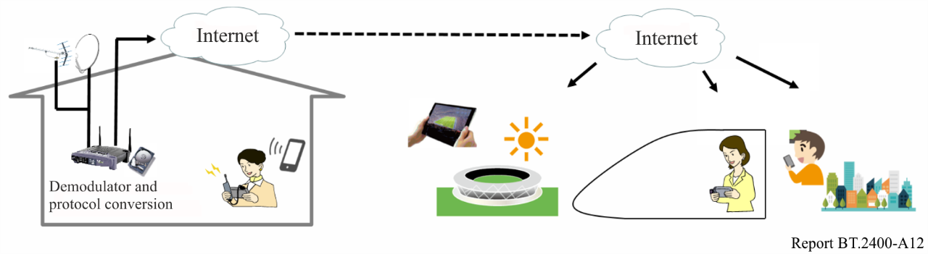

Bibliography

[1] Recommendation ITU-R [BT.2074-1](https://www.itu.int/rec/R-REC-BT.2074/en) – Service configuration, media transport protocol, and signalling information for MMT-based broadcasting systems

[2] Recommendation ITU-R [BO.2098-0](https://www.itu.int/rec/R-REC-BO.2098/en) – Transmission system for UHDTV satellite broadcasting

[3] ISO/IEC 23008-1:2017: Information technology – High efficiency coding and media delivery in heterogeneous environments – Part 1: MPEG media transport (MMT)

[4] ISO/IEC 23008-13:2017: Information technology – High efficiency coding and media delivery in heterogeneous environments – Part 13: MMT implementation guidelines

1. The Administration of United States of America does not support the approval of this Report. The Report in its current form is merely a concept paper and provides little description of a specific technical goal. In fact, the paper identifies the Global Platform as being very similar to the current broadcasting platform. The Administration of United States of America therefore does not believe it should share a place along with other technical ITU-R Reports.
2. The global platform is defined as a delivery platform to facilitate distribution of broadcast content to end-users with various receiving devices in multiple reception environments, implemented by using both broadcasting and non-broadcasting (e.g. broadband) technologies.