Report ITU-R BT.2386-6
(03/2026)
BT Series: Broadcasting service (television)
Digital terrestrial broadcasting: Design and implementation of single frequency networks

Foreword
The role of the Radiocommunication Sector is to ensure the rational, equitable, efficient and economical use of the radio-frequency spectrum by all radiocommunication services, including satellite services, and carry out studies without limit of frequency range on the basis of which Recommendations are adopted.
The regulatory and policy functions of the Radiocommunication Sector are performed by World and Regional Radiocommunication Conferences and Radiocommunication Assemblies supported by Study Groups.

Policy on Intellectual Property Right (IPR)
ITU-R policy on IPR is described in the Common Patent Policy for ITU-T/ITU-R/ISO/IEC referenced in Resolution ITU-R 1. Forms to be used for the submission of patent statements and licensing declarations by patent holders are available from https://www.itu.int/ITU-R/go/patents/en where the Guidelines for Implementation of the Common Patent Policy for ITU-T/ITU-R/ISO/IEC and the ITU-R patent information database can also be found.

Series of ITU-R Reports
(Also available online at https://www.itu.int/publ/R-REP/en)
Series | Title
BO | Satellite delivery
BR | Recording for production, archival and play-out; film for television
BS | Broadcasting service (sound)
BT | Broadcasting service (television)
F | Fixed service
M | Mobile, radiodetermination, amateur and related satellite services
P | Radio-wave propagation
RA | Radio astronomy
RS | Remote sensing systems
S | Fixed-satellite service
SA | Space applications and meteorology
SF | Frequency sharing and coordination between fixed-satellite and fixed service systems
SM | Spectrum management
TF | Time signals and frequency standards emissions

Note: This ITU-R Report was approved in English by the Study Group under the procedure detailed in Resolution ITU-R 1.

Electronic Publication
Geneva, 2026
© ITU 2026
All rights reserved. No part of this publication may be reproduced, by any means whatsoever, without written permission of ITU.

REPORT ITU-R BT.2386-6
Digital terrestrial broadcasting: Design and implementation
of single frequency networks
(2015-2017-2019-2020-2023-2024-2026)
TABLE OF CONTENTS
Page
Part 1 – Overview of single frequency networks 8
1 Definition and characteristics of single frequency networks 8
1.1 Definition of single frequency networks 8
1.2 Benefits of single frequency networks 8
1.3 Requirements and limitations of single frequency networks 9
1.4 Type of SFN 10
1.5 Consideration of network structures for SFN 10
1.6 Classification of transmitting stations 12
1.7 Spectrum utilization 12
2 Coverage criteria 12
2.1 Reception modes 12
2.2 Pixel coverage, area coverage, population coverage 13
2.3 Full area vs. partial coverage 14
3 Statistical aspects and Network Gain in SFN planning 15
3.1 Statistical Aspects of Coverage Prediction 15
3.2 Effect of OFDM Multipath Capability on Coverage Prediction 15
3.3 Network Gain 16
4 Layer definition 20
5 Broadcasters’ requirements 20
5.1 Service area requirements 20
5.2 Coverage requirements 20
5.3 Operational/Network requirements 21
6 Implementation of the transmitter network 22
6.1 Coordination 22
Page
6.2 Conformity with the Plan Entry 22
6.3 Self interference 22
6.4 Transmitter synchronisation 22
6.5 Frequency synchronisation 22
6.6 Timing synchronisation 23
6.7 Effect of synchronisation loss 23
Part 2 – SFN application and implementation of DVB-T, DVB-T2, ATSC 3.0 and DAB system 24
1 Multipath capability of DVB-T, DVB-T2, ATSC 3.0 and DAB 24
1.1 General 24
1.2 Inter-symbol interference 24
1.3 Guard interval 25
1.4 Contributing and interfering signal components with inter-symbol interference 28
2 FFT-window synchronisation 31
2.1 General 31
2.2 Synchronisation strategies 33
2.3 Strongest signal 33
2.4 First signal above a threshold level 34
2.5 Centre of gravity 35
2.6 Quasi-optimal 36
2.7 Maximum C/I 37
3 Site selection and management 37
4 Coverage and interference management 38
4.1 General 38
4.2 Wanted coverage prediction 38
4.3 Out-going interference management 39
5 Post implementation of the network 40
5.1 Network coverage and improvement 40
5.2 Network problems 40
Page
6 Impact of DVB-T parameters on SFN performance 41
6.1 Constellation 41
6.2 Code rate 41
6.3 2k/8k FFT 42
6.4 Guard interval 42
6.5 Data rate versus guard interval 44
7 Impact of ATSC 3.0 parameters on SFN performance 46
7.1 Constellation 46
7.2 Code rate 47
7.3 8k/16k/32k FFT 47
7.4 Guard interval 47
7.5 Data rate versus guard interval 48
7.6 Robust co-channel interference tolerance 49
Annex A – Empirical channel characterization and modelling of terrestrial SFN in the UHF band 50
Annex B – Transmitter identification signal and its applications 57
8 Distribution networks for SFNs 64
8.1 DVB-T Sat-fed in Italy 64
9 DVB-T case studies 68
9.1 National DVB-T SFN deployment in Italy 68
10 Overview 88
11 Spectral efficiency and spectrum consumption of DVB-T2 networks 88
11.1 Spectral efficiency and spectrum consumption 88
11.2 Spectral efficiency of DVB-T2 89
11.3 Layer spectrum efficiency of DVB-T2 90
11.4 Re-use distances for DVB-T2 networks 91
12 DVB-T2 Lite 92
13 DVB-T2 and DVB-T2 Lite case studies 92
13.1 Theoretical study on maximum achievable data rates for large DVB T2 SFN areas 92
13.2 DVB-T2 and DVB-T2 Lite: Experimental tests in Italy (Aosta Valley) 102
Page
13.3 Case study on large DVB-T2 SFN in Denmark 110
13.4 Case study on DVB-T2 service areas in Sweden 119
13.5 Practical DVB-T2 based scenarios exploring the interdependence of coverage, capacity, transmission mode and network configuration 125
13.6 Case study on DVB-T2 MFN vs. SFN in the UK 129
13.7 DVB-T/DVB-T2 planning exercise with limited spectrum resources in the UK 137
13.8 Effect of sea path propagation – An example in the United Kingdom 138
13.9 Optimisation of a DVB-T2 SFN in Malaysia 143
13.10 DVB-T2 SFNs Networks and an Extended T2-MIP: a BBC study 146
14 Impact of DAB parameters on SFN performance 150
14.1 General 150
14.2 Constellation 150
14.3 Code rate 150
14.4 FFT 150
14.5 Guard interval 151
14.6 Data rate versus guard interval 152
15 DAB case studies 152
15.1 Italy implementation 152
15.2 Static timing in the United Kingdom DAB network 162
15.3 Static timing in the Bavarian DAB+ network 163
Part 3 – SFN application and implementation of ISDB system 167
1 Principle of SFN reception 167
2 Case study for Japan 168
3 Design of SFN 170
3.1 Site location 170
3.2 Effective radiation power 170
3.3 Antenna radiation pattern 170
3.4 Transmission timing adjustment 170
3.5 Tools for network design 171
Page
Part 4 – SFN application and implementation of DTMB system 172
1 Overview 172
2 Case study for DTMB 174
2.1 Local area SFN 174
Annex A – SFN Transmitting Stations completed by the end of 2009 179
Annex B 180
Annex C 180
Annex D 181
Annex E – Location of the Digital Terrestrial Television (DTT) stations and the estimated coverage (January 2011) 182
2.2 Deployment of DTMB SFN based on satellite program distribution networks 193
2.3 Synchronization scheme of DTMB SFN using IEEE1588v2 standard and time of days 199
2.4 Large area single frequency network optimization method 209
Part 5 – SFN application and implementation of DTMB-A system 226
1 SFN Field trial for DTMB-A 226
1.1 Background 226
1.2 Field trial structurer 226
1.3 Field trial result 228
1.4 Conclusions 233

Abstract
Digital broadcasting techniques, that have been massively introduced during the last years, allow the use of single frequency networks (SFN), in which the same frequency is assigned to all transmitters in a given service area in order to broadcast the same programme.
Although the implementation of SFN permits a use of the spectrum in a more efficient way, SFNs are not the panacea for the resolution of the increasing spectrum demand. In the document, benefits and drawbacks of SFNs are analysed.
Many practical examples are described with the aim to share experiences and to give guidance in design and implementation to those have the intention to start the deployment of this kind of network.
The Report is organized in parts in order to be consulted more practically.
The document opens with a general part, which examine the concepts and the features of SFNs, common to every type of standard in use in the ITU Regions.
The remaining parts are related to the different digital transmission standards.
The present edition presents three different categories of network: the DVB and DAB family, ISDB and DTMB.
In each part, the key elements of the system are mentioned, with references to the standards or others ITU Reports, but more relevance is given to designs, implementations and case studies.
In particular, in the part related to DVB-T, T2 and DAB, propagation and scattering phenomena, optimization, timing, distribution and studies on large SFN and T2-Lite are well treated.
In the ISDB and DTMB sections, the deployment of a network is carefully described.
Acronyms
ASI Asynchronous serial interface
ATM Asynchronous transfer mode
BBFrame Base band frame
BER Bit error rate
CEPT Conférence Européenne des Administrations des Postes et Télécommunications
CEQ Cliff edge coefficient
C/N Carrier to noise ratio
CNR Carrier to noise ratio
COFDM Coded orthogonal frequency division multiplexing
DSL Dynamic label segment
DTTB Digital terrestrial television broadcasting
DTM Dual transfer mode
DTT Digital terrestrial television
EBU European broadcasting union
EMC Electromagnetic compatibility
e.r.p. Effective radiated power
ETSI European Telecommunications Standards Institute
GE06 ITU-R Conference and Agreement Geneva 2006
FEC Forward error correction
FEF Future extension frame
FFT Fast Fourier transformation
FIC Fast information channel
FM Frequency modulation
FRF Frequency reuse factor
GI Guard interval
GIF Guard interval fraction
GPS Global positioning system
HbbTV Hybrid Broadcast Broadband Television
HD High definition
HDTV High definition TV
HPHT High power high tower
ISD Inter-site distance
ISI Inter symbol interference
LCN Logical channel number
LSE Layer spectrum efficiency
MER Modulation error rate
MFN Multi frequency network
MIP Megaframe initialization packets
MPEG Moving picture experts group
OFDM Orthogonal frequency division multiplexing
PN Pseudo random noise
PSB Public service broadcasting
QAM Quadrature amplitude modulation
QEF Quasi error free
QPSK Quadrature phase shift keying
RBF Re-use blocking factor
RF Radio frequency
RSL Receiving signal level
SD Standard definition
SDH Synchronous digital hierarchy
SDTV Standard definition TV
SFN Single frequency network
SIP Session initiation protocol
TDS-OFDM Time domain synchronous orthogonal frequency division multiplexing
TII Transmitter identification information
TS Transport stream
UEP Unequal error protection
vBER Bit error rate after Viterbi decoder
VC Video codec
VHF Very high frequency
VSW Coverage probability
UHF Ultra high frequency

Part 1
Overview of single frequency networks

1 Definition and characteristics of single frequency networks
Broadcast networks provide coverage over certain geographical areas (the “coverage area”). A service area is generally a subset of the coverage area, being limited to the area within which an administration can seek protection for a service. The size of these can vary significantly – they could be as large as an entire country or as small as a single town, and in general they fall into the three main categories of national, regional and local areas. Invariably, service areas are defined by a mixture of political, editorial, economic and practical considerations.
In most cases service areas are large enough to require multiple transmitters to provide the desired coverage, and broadcast networks are normally planned to match these as closely as is practicable.

1.1 Definition of single frequency networks
Digital broadcast systems introduced the potential to use single frequency networks (SFN). An SFN is a network of transmitters, all operating on the same frequency channel and all carrying the same data. In a SFN the same frequency is assigned to all transmitters in a given network that covers all, or part of a service area. For the systems mentioned, harmful intra-SFN interference is avoided by COFDM modulation on which they are based.
SFNs have now been widely deployed, and have been in operation for many years. They require a different planning approach to Multiple Frequency Networks (MFN) in which each transmitter would be assigned a different frequency to its neighbours in order to avoid undue interference between them.
Relative to MFNs, SFNs have a number of benefits, but these are associated with some drawbacks. The most significant of these aspects are briefly discussed below.

1.2 Benefits of single frequency networks
A major advantage of using SFN is the possibility to increase the frequency efficiency. In traditional networks all the nearby stations uses different frequencies. With SFN technology it is possible to form the cluster of nearby stations using the same frequency. The maximum coverage extent for a SFN cluster depends on the parameters of the radio emission system.
In many circumstances the use of an SFN may enable a service area to be covered by a single frequency, rather than multiple frequencies.
SFN technology permits higher layer spectrum efficiency compared to traditional MFN technology. The basis for this is that network implementation with SFN cluster requires a smaller number of frequencies for a network layer compared to MFN. The number of frequencies necessary for a network layer can be significantly reduced when the SFN is used, having the asymptotic value equal to 1. The cost of the SFN functionality is that the transmission system have somewhat lower data capacity for a single RF channel. But overall, SFN techniques provide a very valuable tool to significantly increase the efficiency in frequency use.
This is a clear benefit and forms a major subject of this Report.
SFNs also introduce flexibility into network design – the ability to deploy SFNs, MFNs or a mixture of the two introduces a greater number of options for network planning, allowing the most suitable solution to be selected for the circumstances at hand.
As a result of the local ground cover variations will the signal level to vary. Typically an SFN would introduce multiple transmissions from multiple sites, meaning that many locations would often be served by more than one transmitter. The signal contribution from multiple transmitters results in signal diversity, which often improves the reception of the SFN case, especially for mobile reception without the need of any kind of handover, unlike the MFN case. The presence of several transmitters, each transmitting the same signal on the same frequency, from different directions as seen by the receiver, decreases the variability of the total signal field strength. For example, if one source is shadowed, others may be more easily receivable, and the field strength variation could thereby be reduced. Compared with an MFN, this effect reduces the overall location variation, resulting in lower field strength being required to meet a particular reception requirement.
Furthermore, receivers can make use of the power in each of the multiple signals received from the other SFN transmitters. Signals that arrive within the guard interval can be combined to increase the power of the received signal. This effect is most beneficial for Rayleigh channels whereby the increase in total received power would outweigh the effects of additional multipath which would have little detrimental impact on an already distorted signal.
These two factors are often referred to as “network gain”. The actual quantity of such “gain” varies with many factors, such as the propagation environment, the number of signals received and their relative levels. In fixed reception environments, the directivity of the receiving antenna is likely to reduce the relative levels of some signals, and the propagation channel is more Ricean. So the resultant network gain is applicable to portable and mobile reception with an omnidirectional antenna, but not applicable to fixed rooftop reception with a directional antenna.
SFNs also have the ability to make spectrum planning more effective. They enable allotment planning which can simplify the technical aspects of the frequency coordination process as the detail of the transmission network does not need to be known in advance – it can be determined later in the planning phase, or even during or after implementation. However, overall there is no reduction in network planning effort because work is simply shifted from the coordination phase to later in the network lifecycle. Although the total planning effort for MFNs and SFNs would be similar, SFNs may offer greater flexibility.
SFN allotments also allow network coverage to be progressively modified or improved by adding further transmitters without the need for re-planning frequency use or additional frequency coordination as long as the constraints of the allotment frequency plan are respected. This would make it easier to improve the coverage quality step by step, as for example when enhancing coverage from fixed rooftop reception to portable reception.

1.3 Requirements and limitations of single frequency networks
In order to operate successfully, SFNs must avoid self-interference. They achieve this by sacrificing part of the signal’s throughput to the guard interval, or cyclic prefix. Subsequently, SFNs cannot usually achieve the same throughput in an individual multiplex as would be possible in an otherwise equivalent MFN. This point is a key consideration of SFNs.
Furthermore, transmitters within an SFN cannot operate independently – the content that they transmit must be identical, and the time at which they transmit it must be precisely controlled. Signals transmitted from the stations within an SFN must:
– have precise time synchronisation (which may deliberately introduce a tightly controlled delay relative to one another);
– be coherent in frequency (within a few Hz);
– have identical and synchronised content over the entire multiplex.
These requirements introduce complexity into the network. For example, additional equipment is needed in order to ensure that the above conditions are met and maintained. Apart from increasing costs, operational complexity is also increased as precise control over transmissions needs to be maintained at all times. Although usually these additional requirements and complexities pose no significant impediment to SFN deployment, they would need to be considered increasingly carefully as the number of transmitters within an SFN increases. For example, networks involving many hundreds of sites would need to consider these factors in greater detail. These aspects are further detailed in Report ITU-R BT.2253 “GPS timing receivers for DVB-T SFN application: 10 MHz phase recovery”, that, despite the title, refers to a problem that could affect any kind of SFN.
The requirement for identical and synchronised content means that any regional or local programmes within an SFN would be transmitted over the entire area it covers. The carriage of local content within a wide area SFN could mean that it would be available in areas where it may not be heavily used. In practice it may be more efficient to limit the size of SFNs to the particular area in which the content is required.

1.4 Type of SFN
SFNs can be used in a variety of coverage situations. Most typically, they are used to cover a whole country or part of one, but can be used for smaller local areas (even at the level of just one city).
A further distinction of SFNs is given by categorising them as either open or closed:
In an open network, no measures are taken to minimize the level of radiation towards areas outside the coverage area. In the limiting case an open network can consist of only a single transmitter.
In a closed network, the level of radiation towards areas outside the coverage area is deliberately reduced without reduction of the coverage within the intended area. This can be done by using directional antennas on transmitting stations near the periphery of the coverage area.

1.5 Consideration of network structures for SFN
Open and closed configurations
In a real network, covering a large area there may be considerable distances between the transmitters. If such a network is designed as a closed network it will cause less interference at a given distance outside its coverage area than if it had been designed as an open network. The reason for this is that the level of interference is mainly determined by the radiated power from the transmitters closest to the boundary of the coverage area in the direction considered.
However, in a closed network covering a small area the radiated power from transmitters on the side of the coverage area opposite to the direction under consideration contributes relatively more to the outgoing interference level than in a closed network covering a large area. Thus the use of directional transmitting antennas on transmitters near the boundary of the coverage area consequently brings less advantage, in term of less outgoing interference, than in the case of networks covering larger areas.
It follows that for relatively large coverage areas, the separation distance between co-channel areas will generally be less for closed networks than for open ones. For smaller coverage areas the separation distance for closed networks approaches that for open networks.
Transmitting sites
Digital terrestrial broadcasting deployment can re-use existing sites, or use new sites or alternative network architectures. In turn, this will affect the choice of the selected digital terrestrial broadcasting variant and the frequency requirements.
The number of transmitter sites deployed and the separation distances between them will vary a lot from network to network, and from country to country, and will depend on the system variant, the reception mode (fixed, portable or mobile), the country size and boundary situations.
In an SFN using appropriate digital terrestrial broadcasting standards, the separation distance between transmitters influences the choice of the guard interval, which in turn limits the size of the network. The separation distance and the antenna height will also influence the effective radiated power (e.r.p.) required to provide the desired coverage.
The use of “dense networks”, a network of closely situated, low to medium power stations, can offer some advantages over networks based on high power transmitters separated by large distances.
Particularly in the case of regional SFNs, but also for national SFNs, it is possible to consider various forms of dense networks having significantly lower e.r.p. than that required by a single transmitter serving the same area. For digital terrestrial broadcasting, the concept of “distributed emission” can provide the required field strength over the entire service area by a number of low power, synchronized SFN transmitters, located on a more-or-less regular lattice, or to use on-channel repeaters receiving their signal off-air from the main transmitter, to improve the coverage of the main transmitter. In the latter case, the repeaters are synchronized in time by default, and no parallel distribution infrastructure is needed to bring the signal to them.
Furthermore, local high density SFNs could be used to supplement large SFN in areas where the coverage would otherwise be inadequate, due (for example) to the topography. Finally, they offer a reduction of the impact of co-channel interference beyond the border of the service area, by introducing a sharper field strength roll-off. This can be further improved by suitable choice of the transmitting antenna directivity.
For example, it is possible to envisage transmitter topologies in which the central part of the service area is covered by a large SFN (with high power transmitters separated by large distances), but near the edge a dense transmitter network is installed (with low e.r.p., and with low-height and directive antennas). This allows the e.r.p. to be “tailored” according to the service area contour, reducing the interference to adjacent areas and keeping the high service availability inside the wanted area.
Transmitting antenna types and radiation patterns
Transmitting antennas will have either omni-directional or directional pattern. For stations located close to the edge of an SFN coverage area, directional antennas could be used to reduce interference outside the service area, thus reducing the separation distance for the frequencies in question, and to protect the coverage areas of other existing services. This is especially true for high and medium power stations.
Beam-tilt is an efficient tool to target the radiated power of high power stations to the outer part of the coverage area and, at the same time, to reduce the interference potential at large distances and to other radio services.
Factors influencing the transmitter separation distance
There are several factors that influence the transmitter separation distance, for example radiated power, antenna height, reception mode, system variant and propagation path. It must be noted that these may be different for different networks. In SFNs, the separation between adjacent transmitters is limited by the length of the guard interval.
Factors influencing the co-channel separation distance
The separation distance between two co-channel service areas is the minimum distance needed in order to avoid undue interference to either of the two service areas.
The separation distance has a significant influence on the number of frequency blocks or channels needed to establish coverage of a larger area containing several countries or regions, each having its own programmes transmitted in one frequency block or channel.
Coverage areas served by transmitters located along the periphery and using directive antennas pointing inwards (that is, in a closed network) will result in shorter separation distances compared to equivalent coverage achieved by the use of non-directional antennas (that is, in an open network). In the case of propagation paths with a significant amount of sea, separation distances will be larger than for the case of land-only paths.

1.6 Classification of transmitting stations
Just as SFNs can be used to cover areas of different sizes, so the transmitting stations that make up an SFN can vary in e.r.p. or antenna height. Although a “classical” SFN is normally thought of a relatively homogenous network with all transmitters having the same heights and e.r.p.s, in practice, many SFNs are built using a mixture of high, medium and low power transmitters.
For example, section 1.6.17 of the Report from the First Session of the 2004/06 ITU Regional Radio Conference gave three classifications of transmitting station, with e.r.p.s ranging from over 10 kW to under 50 W.

1.7 Spectrum utilization
Flexibility in use of spectrum
SFN configuration allows a very large flexibility in the use of spectrum. For example, a network can be initially designed to provide coverage to fixed roof-level antennas, but can be developed later, without the need for additional frequencies, to provide mobile or portable services by the addition of supplementary transmitter stations.
This can be a way of spreading the cost of introducing a new digital network over a period of time. For example, if the initial investment required to provide a network which delivers indoor coverage to the whole target area is too high, an administration or network operator could chose to implement a network with a variety of reception modes, such as coverage to fixed roof-level antennas across a wide service area, with portable reception in some towns inside the service area. The fixed coverage network can then be developed to provide further indoor coverage over a period of time.
Another flexibility that SFNs bring is the freedom for a broadcasting operator to implement new stations to improve coverage within an existing network, without having to use additional spectrum.

2 Coverage criteria

2.1 Reception modes
DTT services are usually planned for three different reception modes: fixed, portable (outdoor/indoor) and mobile, with additional differentiation possible within these categories. For network planning the intended reception mode is perhaps the major planning criterion. It determines the network topology, in particular the transmitter density, and the power (or link) budget of the transmitters. A brief description of these reception modes is provided below.
Fixed antenna reception is defined as reception where a directional receiving antenna mounted at roof-level is used. In calculating the field strength required for fixed antenna reception, a receiving antenna height of 10 m above ground level is considered to be representative.
Portable reception is defined as the reception at rest (stationary reception) or at very low speed (walking speed). Although reception in this mode will, in practice, take place under a great variety of conditions (outdoor, indoor, ground floor and upper floors), it is usually characterised by two broad classes: portable outdoor and portable indoor.
A distinction is also made between portable reception with an external (dipole) antenna and an antenna integrated in a handheld device. The difference between portable reception and handheld portable reception lies in the different antenna gains which are assumed for the two reception modes.
Mobile reception is defined as the reception by a receiver in motion with an antenna situated at no less than 1.5 m above ground level. The speed of the receiver can range from walking pace to that of a car driven on a motorway. High-speed trains, buses and other vehicles could also be considered in this mode, and may be a reception target in some instances.

2.2 Pixel coverage, area coverage, population coverage
In this section, some aspects of the definition of coverage are considered. Firstly, when describing coverage, a principal distinction is to be made as to whether the intended coverage target is to be based on the area or the population served. As population is not distributed uniformly across an area there may be large differences between the covered area and the covered population for a given network. This distinction should therefore be taken into account when coverage figures are compared so that population coverage is not inadvertently compared with area coverage.
Population, while perhaps intuitively being measured in numbers of people, is often measured in households as a proxy for the number of people they contain.
The calculation of coverage, whether it be population or area based, may also be carried out in two main ways: cut-off and proportional.
For the cut-off method the entire population or area of a pixel (a small area of, e.g. 100 m × 100 m) is regarded as served if the predicted probability of coverage exceeds a specified threshold. If however, the predicted probability does not exceed the specified threshold none of the population or area are considered to be served. Typical values for this threshold range from 70% to 95% for fixed and portable reception and 99% for mobile reception. As an example, if the threshold is 70% and the predicted probability of coverage in this pixel is 84% and the population is 200 households, then the population served using a cut-off method is 200. If in the same pixel the same threshold (70%) was obtained but the predicted coverage probability was 68%, the population served with the cut-off method would be 0 households.
If the coverage assessment was area based the entire area of the pixel may be considered covered if the specified threshold was reached, and entirely uncovered if the coverage probability was lower than the threshold. The overall total coverage is determined by summing together all households, or areas where pixels are served to at least the cut-off threshold for a defined service area.
Broadcasters normally apply this method to describe area or population coverage.
The proportional method is an alternative approach. In this method the predicted probability of coverage of a pixel determines the proportion of the population in that pixel or the area of the pixel that are served. For example, where a pixel with 200 houses is served with a predicted probability of coverage of 84%, 168 households would be considered served. With this method only a proportion of the pixel is considered to be covered whereas the cut-off method would consider it entirely served if the threshold was met, but it cannot be said which part of the pixel is covered, or which is not covered. A similar approach could be applied to area where that was the metric to be used. The full coverage is then determined by summing together the proportion of each pixel, either population or area, corresponding to the coverage probability in each. While useful as an aggregate measure of coverage, because it “averages out” reception variations across many pixels, this method is not suitable to quantify coverage within any particular pixel.

2.3 Full area vs. partial coverage
A further relevant distinction when considering coverage is as to whether it is intended to cover the full area of a country or region, or only parts of it. For example it may be necessary to cover only metropolitan areas. Typically these would not be adjacent – they are usually separated by some distance. If they are separated by more than the re-use distance, then the number of required frequencies can be significantly reduced as it would be possible to re-use the same frequency for all or many of the local areas – even if different content is provided to each of these. Therefore, a partial non-contiguous coverage always has a lower spectrum requirement than full area coverage where adjacent service areas have to use different frequencies in order to avoid undue interference.
Figure P1-1a  Example of full area coverage using 7 channels | Figure P1-1b  Example of metropolitan area coverage using  3 channels
Examples are given in Figs P1-1a and P1-1b where fictional coverage scenarios for Germany are sketched. Figure P1-1a represents full area coverage and Fig. P1-1b metropolitan area coverage. A hypothetical channel assignment is indicated in the Figures with channels 1 to 7 for the full area case and channels 1 to 3 for the metropolitan case. In this example, for the case of full area coverage a higher number of channels is required in order to avoid undue interference between co-channel service areas. In the example a separation distance (re-use distance) of about 120 km is assumed.
A closely related case is the requirement to cover a full area on an incomplete basis, i.e. it may be sufficient to cover a certain, but nonetheless high percentage of the area. For example 80% or 90% area coverage may be adequate where the non-covered locations are distributed throughout the entire area and fall where no coverage is actually required. An example may be where the aim is to cover populated areas such as households, with no need to cover motorways or roads. In this case only parts of the total area would need full coverage. Relative to a full area requirement, this relaxation reduces the number of frequency channels, in particular for MFNs and also in the case of extending SFN areas.

3 Statistical aspects and Network Gain in SFN planning

3.1 Statistical Aspects of Coverage Prediction
The prediction of coverage is a crucial element in broadcast network planning. It relies – often as the only input – on field strength prediction at the envisaged locations of reception. Since field strength prediction is affected by non-complete knowledge of the propagation path, the involved clutter, etc., a statistical treatment is required. This statistical aspect is reflected by predicting a mean value of the field strength and a standard deviation which describes the location variation. Standard field strength prediction models, path-specific as well as path-general like Recommendations ITU-R P.1812 and P.1546, follow this approach.
As a consequence, an additional parameter is introduced in coverage prediction to describe the minimum requirements for reception: the minimum required location probability. In planning for DTT, often a value of 95% location probability is used.

3.2 Effect of OFDM Multipath Capability on Coverage Prediction
OFDM technology, applied by DAB, DVB-T, and other digital systems, enables a constructive use of delayed signals. This is valid for signals from one transmitter reaching the receiver with various delays due to multipath propagation, as well as for signals deriving from different transmitters, synchronized within a single frequency network. The signal delay after receiver synchronization determines the mode of signal combination, either constructive or destructive. Details are given in Part 2 of this Report.
Therefore, in an SFN many receiving locations can be covered by more than one transmitter, thus introducing a certain level of redundancy in the signal sources and improving the service availability, especially when portable reception is required. Particularly in portable reception, the field strength from a single transmitter shows statistical variations due to the presence of obstacles on the propagation path. This field strength variation can be reduced by the presence of several transmitters, located in different directions, since when one source is shadowed, others may be easily receivable.
As a result, SFN can be operated at lower power for the main transmitters, and the field strength distribution is more homogeneous as compared to MFN. The impact of these features for fixed roof-top reception may not be that prominent, but portable reception with its non-favourable receiving sites and less elaborate receiving antennas will benefit from these features to a large amount.
For planning, the constructive addition of multiple useful signals is to be taken into account in the effective field statistics. As a result, the mean value of the effective sum field strength is increased and its standard deviation is decreased.
An example for the decrease of the standard deviation is given in Fig. P1-2, representing a single frequency network with three transmitters of equal power. The standard deviation of the useful field strength is presented, based on a standard deviation for a single transmitter of 5.5 dB. In the vicinity of a transmitter the effective standard deviation remains the same as for a single transmitter because the influence of this transmitter dominates. In between the transmitters the statistical addition of fields is effective, and the standard deviation decreases.
Figure P1-2
Standard deviation in a single frequency network
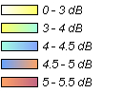
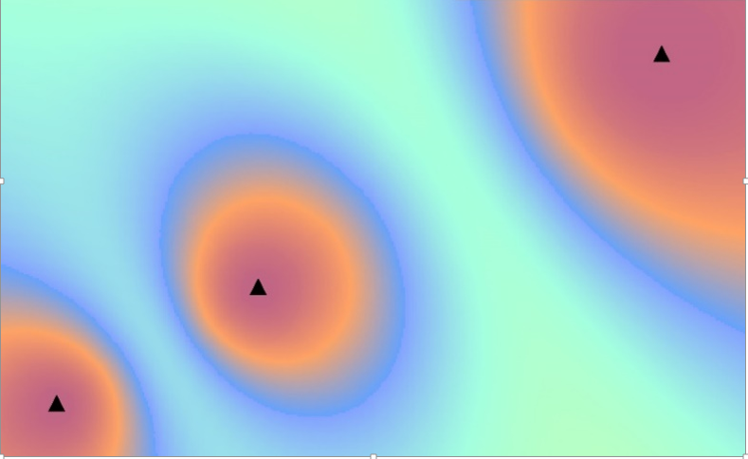

For planning and coverage prediction, a further effect has to be taken into account. A multipath environment is more difficult for reception than a single signal situation. Usually, this fact is reflected in planning by using different C/N values for the receiving system. This means that C/N values for Rayleigh channels might be more adequate for SFN coverage predictions as compared to C/N values for Rice channels being sometimes more adequate for MFN coverage predictions. This fact may reduce the beneficial effect of the constructive addition of multiple useful signals.
At least for portable and mobile reception, where a multipath environment is present in any case, the beneficial effect of the constructive addition of multiple useful signals will be more prominent.

3.3 Network Gain

3.3.1 General
The fact described in § 3.2 is known as ‘network gain’. It is a statistical aspect relevant for network planning, particularly for SFN. Taking it in account allows for a more detailed planning of transmitter sites and their power budgets. In the following the notion of ‘network gain’ is explained in more detail.
When discussing network gain it is necessary to consider a test area where two (or more) signals are present and the necessary conditions (i.e. well-defined median value with appropriate standard deviation and a log-normal distribution) apply for both (or all) wanted signals individually. In different test areas, the specifics of these conditions may well differ, and this will give rise to differing values of the network gain. Just as the median value of field strength varies throughout the test areas of a coverage area, the network gain will also vary throughout the test areas of an SFN.
Sometimes the term ‘network gain’ is used to define a single number which is applicable to the entire SFN and this can lead to confusion. To avoid this confusion, the term ‘effective network gain’ will be introduced below to refer to network gain in such a large ‘non-test area’.

3.3.2 Definitions related to network gain
In order to clarify the concept of network gain, the following set of definitions is given. In each case the network gain involved is a function of the location probability concerned: In general, the network gain for a given test area will increase as the location probability for which it is determined increases. Although not usually explicitly stated in the following, the dependence of network gain on location probability must always be kept in mind.
– The total network gain (T) refers to the total increase of received power, for a specific location probability in the reception test area as compared to the power received from one (the strongest) transmitter serving that test area for the same location probability. Actually care must be taken in using this definition. It must be recalled that, throughout the test area, the field strength due to the (strongest) transmitter itself varies. What is really meant is that over an extended, though small, test area the received power will be increased by at least the ‘total network gain’ at the specified location probability throughout the specified small test area. The example in Fig. P1-3 of may illustrate this. For a given location probability, the received power/field strength which is exceeded with this probability is smaller in the case of a single transmitter than that in the case of the SFN. The difference is the total network gain T for the considered test area.
The total network gain is sometimes considered to be composed of two contributions: a statistical part and an additive part.
– The statistical network gain (S) arises due to the purely statistical nature of the individual signals without taking into account their (potential) combination within the receiver. In determining the statistical network gain the location variation of the field strength is the dominant contributing factor: the time variation of the field strength is generally not taken into account because the time standard deviation is relatively small at the short distances involved in providing coverage.
Statistical network gain can be understood in at least two equivalent ways:
a) Area coverage: To overcome the statistical location variation in field strength, that is in order to ensure that with a single transmitter the minimum equivalent field strength value is achieved at a high percentage of a given area, it is necessary to transmit with more power. If, on the other hand, two (or more) transmitters can be used to cover the same area the percentage of coverage will also be increased without the need to increase the power. For example, if one signal covers an (overlapping) area with 60% probability and a second signal covers, independently, the same area with 55% probability, that area will be covered at {1 – (1 – 0.6) × (1 – 0.55)} = 0.82, that is 82% combined probability.
The statistical network gain, in terms of coverage probability, would be: 82% – 60% = 22%. A third signal covering the same area with 45% probability would increase the combined probability to 90.1%, and this increase of coverage probability is achieved with no increase of power (of the individual transmitters).
In situations where, in a given test area, one transmitter delivers the minimum field strength for a significantly higher percentage of locations than the other transmitters in the network (for example, sufficiently near any given transmitter) the statistical network gain will tend to zero.
b) Mobile reception: In mobile reception the field strength from a single transmitter shows statistical variations due to the continual variation of obstacles on the propagation path. This field strength variation can be reduced by the presence of several transmitters (or echoes), located in different directions, since when one source is shadowed, others may be more easily receivable.
Knowing the type of distribution and the value of the standard deviation, it is relatively easy to calculate the amount of statistical network gain to be expected.
– The additive network gain (A) is manifested as an effective increase in signal strength (or power) in a test area due to the incidence of two or more signals at the receiver antenna (i.e. the ‘additive point gain’) at each point in the test area. It is due to the ability of the receiver to add the signal powers delivered by the wanted signals (or echoes) arriving from the transmitters in the SFN and would arise even if there were no statistical variations in the propagation channel. For example, two (three, four, …) signals with the same field strength level and no relative delay arriving at a receiving antenna (located at a point) from two (three, four, …) different transmitters in the SFN would result in a 3 dB (4.8 dB, 6 dB, …) increase of useful signal strength at that point (‘additive point gain’). However, because it is not possible (or practical) to determine field strength levels at individual points, it is necessary to define additive network gain over a test area, as was done above in the definitions for the total network gain and for the statistical network gain.
But, taking into account the statistical variation of the fields, the levels of two or more fields are very rarely the same at any given point in a reception test area, even if the median values of the signals are the same in that test area. Thus it is not correct to say that the additive network gain is 3 dB (4.8 dB, 6 dB …) if the two (three, four …) median values of the contributing signals are equal. The ‘additive point gain’ at a particular location/point will depend on the relative field strengths received at the location/point which in turn are related to, but not explicitly determined by, the means and the location variations of the contributing signals. And the final distribution of the ‘additive point gains’ throughout the test area will define the additive network gain.
Because the additive network gain is connected to the ‘interaction’ of signals at a point as well as the variation statistics of the signals at the points over a test area, it is not a simple matter to calculate it directly. The additive network gain can, however, be calculated indirectly by subtracting the statistical network gain from the total network gain: A = T – S.
The effective network gain (E) is defined as follows for an SFN. An SFN coverage area consists of many test areas, each test area of which, A_{i} say, benefits from its own individual total network gain, T_{i}. Recall that this means that throughout each Area A_{i} the received power will be effectively increased by its individual total network gain T_{i}. In principle, it would be possible to reduce the powers of all the transmitters in the SFN by this amount and still maintain the same location probability in the test area as would be attained by the strongest received transmitter operating by itself (at its original power). As a result of network gain, the transmitters in an SFN can be operated at lower powers compared to those in an MFN. Moreover, the field strength distribution in the coverage area of the SFN will be more homogeneous. The temptation is to reduce the powers in an SFN by the maximum of the T_{i} for all the test areas in the SFN. But this could lead to a reduction which is too large for certain test areas. The effective network gain is that amount by which each transmitter power in an SFN may be reduced and still provide the required coverage probability throughout the SFN and, as just indicated, this may be less than the maximum T_{i}. Great care is needed to determine a suitable value for effective network gain.

3.3.3 Example of network gain
As an example, the sum distributions for three equal contributors are given in Fig. P1-3 for the entire range of location percentages 0.1% to 99.9%, indicating total, statistical, and additive network gain components.
It can be seen that:
• the additive network gain is not constant and is in fact an increasing function of the percentage location probability of interest;
• the amount of total network gain that can be achieved depends in the same way on the location percentage coverage that is being planned for;
• the overall standard deviation of the composite received signal is less than that of a single signal; hence the extra power margin needed to achieve, for example, a 95% or 99% location coverage can be reduced relative to the single transmitter case.
Figure P1-3
Sum distributions for three equal contributing signals

3.3.4 Network gain and coverage measurements in SFN
Sections 3.3.1 and 3.3.2 explain that network gain is a network planning concept. Its nature is statistical; it therefore cannot be verified by coverage measurements at single locations. These always represent the analysis of a definite, particular situation. As a consequence, strictly speaking, network gain cannot be determined by measurements.
It is however possible to determine approximately the change of coverage at the fringe of the coverage area of a single transmitter induced by the presence of other SFN transmitters. From this it can be determined how much the power of the single transmitter has to be increased in order to achieve the same coverage. This difference might be interpreted as network gain; it resembles to some extent the ‘effective network gain’, described in § 3.3.2.
Here, the possible difference in the propagation channels has to be taken in account. For the single transmitter a Rice channel may be adequate, whereas for the SFN case a more demanding Rayleigh channel may be adequate; a difference which is in particular relevant for fixed roof-top reception. This difference may reduce or even compensate the beneficial effect of network gain.

4 Layer definition
In broadcast planning, a “layer” is considered as the set of frequency channels, together with their associated service areas, which can be used to provide one full national or partial nationwide coverage for a multiplex.

5 Broadcasters’ requirements

5.1 Service area requirements
Broadcasters have different needs that effect the size of their service areas. They may include, for example:
– Commercial requirements: the service itself can contain programs intended for an entire nation, a region or a local area. Additionally it may be necessary to break down larger areas into smaller ones – for example, even when programs are national there may still be a requirement to insert local or regional advertisements.
– Demographic requirements: there may be a need to provide a service in a particular area, due to cultural and language variations, or areas of a particular group of people. Broadcasts in minority languages are an example.
– Regulatory requirements: permission by authorities and regulators may specify the area where it should be possible to receive the program(s), often these areas are defined on the basis of commercial or demographic borders (as given in the two first points).
– Social Requirements: often the regulatory requirements above will consider the social objectives of a broadcast service, particularly in the case of public service broadcasters where a key aim is to minimize the risk of social exclusion by providing easy access to high quality free-to-air coverage for all viewers, listeners or consumers of the service.
Due to its diversity, the actual size of broadcast service areas varies significantly throughout different countries. In terrestrial broadcasting a national service area may cover a whole country with a large number of transmitters, while in some countries only a few transmitters may be needed to provide national coverage. The requirement for regional and local content also varies, depending on the requirements of the country, region or area in question.
The introduction of digital broadcast systems has increased the number of transmitted programs, many of which are often delivered on a commercial basis. In several cases this has led to a greater requirement to insert local or regional advertisements and even regional radio services carried on DTT. While digital broadcast systems have allowed the introduction of wide area SFNs, they do not always suit the local circumstances.

5.2 Coverage requirements
Coverage requirements differ between countries and also depend upon broadcasters’ objectives. Furthermore the requirements may be defined by a number of different organisations including, for example, regulatory authorities and broadcasters themselves. For DTT they are often defined in terms of population coverage or household coverage rather than providing a certain degree of area coverage.
In most countries the coverage requirements are higher for public service broadcasters where they are often obliged to provide close to full population coverage. For example the PSB services in the UK have requirements to cover at least 98.5% of the population and SVT (Swedish television) has an obligation to cover more than 99.8% of the population.
The coverage obligation for commercial broadcasters may be defined by the regulatory authorities, but perhaps more commonly they are based upon market aspects. In Sweden for example the commercial broadcasters require population coverage of 98%.
In many cases it is also fairly easy to reach high population coverage when only using the main transmitters. This is due to the uneven population distribution with population concentrated in a few main cities. Providing coverage for the last few percent will generally require much more effort and will be much more expensive. Coverage requirements can therefore also be set for economic reasons.
Coverage requirements can also be influenced by the reception mode targeted by broadcasters. Some countries aim for portable indoor reception, while others aim for fixed rooftop reception.

5.3 Operational/Network requirements
The nature of broadcasting, particularly for “high-tower, high-power” (HPHT) networks where individual sites cover large numbers of people, often places very high availability targets on transmission networks. Failures in the network may cause break in services which may in turn cause a significant reduction of enjoyment for viewers or listeners with the possibility of audiences migrating to competing platforms. For commercial operators funded by advertising, a failure in the network could also lead to financial loss. In order to prevent such events, network operators and planners when designing, implementing and operating networks have to ensure that broadcasters’ required service availability can be met.
Compared with MFNs, SFN networks bring additional parameters into play when considering aspects of network reliability, both in terms of equipment and network planning.
SFNs require tight control of frequency and time; the Global Positioning System (GPS) being typically used to provide both a stable frequency and time reference against which network synchronisation can be managed. Failure of the timing in any part of the network or a drift in the frequency of a transmitter within an SFN can result in significant interference, the source of which can be difficult, and time consuming, to track down.
In a national MFN, whilst parts of an area may be subject to interference occurring due to anomalous propagation conditions, it is unlikely that all frequencies in all areas will be affected – frequency diversity in an MFN mitigates to an extent such interference and where it occurs at any given time. In a large SFN, such as a national SFN, such frequency diversity does not exist and as a consequence interference, when it occurs may affect much larger areas than would be affected in an MFN during the same propagation event. As such in SFNs, if care is not taken when planning, network coverage problems may occur. This is particularly true for networks within which propagation paths over sea or other extensive areas of water are involved (as these paths are subject to greater time variation in propagation).
As such not only does redundancy need to be factored in to key components associated with network synchronization, but network planning must factor in time variability of signals, particularly over sea paths.

6 Implementation of the transmitter network
The implementation of any particular SFN is unlikely to be identical to any other. Factors such as terrain, population distribution and coverage requirements will vary and have a significant impact on network design and implementation. The section is intended to provide some guidelines and practical advice on the design and development of a network, but it cannot be entirely comprehensive. Planners should use their own knowledge and judgement on which parts are appropriate to their needs. In particular, the section on Coordination and Conformity (§§ 6.1 and 6.2) are likely to be applicable only in some parts of the world.

6.1 Coordination
A plan for a new SFN will either be based on an existing allotment in a Plan (for example, the GE06 Plan), or represent a new requirement which will require coordination. The coordination process itself is outside the scope of this Report. Once coordination is successfully completed the transmitter network can be implemented. At this point some additional transmitter characteristics specific to SFN will need to be considered. These are the self-interference caused within the network and transmitter synchronisation.

6.2 Conformity with the Plan Entry
If the SFN is represented in a Plan by an allotment, then the assignments used to implement the allotment must be in conformity with the Plan Entry. Details on how to check conformity will normally be given in the Plan’s accompanying document (for example, the GE06 Plan is accompanied by the GE06 Agreement, which contains these details). Most usually, calculations of outgoing field strengths are made to a series of Test Points outside the allotment area. Any proposed assignments will need to generate less than an agreed level of interference at each of those Test Points to be in conformity with the Plan Entry.
Should the required transmitter network not be in conformity with the Plan Entry, further coordination with neighbouring administrations will be necessary, according to procedures in the appropriate Regional Agreement or in the Radio Regulations.

6.3 Self interference
In an SFN it is possible for signals to arrive from distant transmitters outside the guard interval. Signals outside the guard interval can cause self-interference in the network. Although it may only occur for short percentages of time it does need to be considered. Self-interference can be reduced by either advancing or delaying the launch of the service from some transmitters in relation to a fixed reference.
Signals exceeding guard interval may arrive from distant SFN sites by the abnormal propagation. Possible solutions for such cases could include assigning the other channels than the SFN, or building complementary transmitting sites.

6.4 Transmitter synchronisation
In order for an SFN to operate correctly all of the transmitters in the network need to be synchronised with one another. This requirement is true in both the frequency and time domains.

6.5 Frequency synchronisation
The frequency accuracy of the digital transmitter will normally be very stable. However in order to minimise any drift all transmitters should be locked to a reference source, for instance with GPS.

6.6 Timing synchronisation
In order to reduce intra network interference it is possible to adjust the time at which a specific signal frame is launched from each transmitter of the network, the relative transmitter timing. Optimising this delay allows the signals from both near and distant transmitters to arrive at the receiver within the guard interval, thus being constructive rather than destructive. The relative transmitter timing can be adjusted to be either in advance of or after the reference point.
However, in all cases the time of signal transmission at each transmitter of the network needs to be referenced to a time reference. Distribution of the service content also needs to be considered so that the same data frame is transmitted during the same time period, either with or without any required delay. Over a large, e.g. national, network the arrival of the content information to transmitters may vary significantly. One option is to feed the content signal directly to the network sites using satellite distribution.
In a small SFN, i.e. one that is not larger in diameter than the signal can travel in the guard interval, it should not be necessary to consider this element of network planning.
When initially designing the network configuration the planner needs to predict both the wanted coverage and the interference potential of each transmitter. These predictions should be carried out at 50% time for the wanted service and 1% time for the interferer. With the relative timing delay set to zero the coverage of the whole network can be derived. At which point the overall interference caused by each transmitter into the SFN can then be calculated.
In general it will be the highest power assignments which will cause the most interference and it is reasonable to focus on them initially. However, adjusting the timing of sites with lower e.r.p.s. can lead to significant coverage gains around the periphery of their service areas.
Transmitter that can interfere with should ideally be identified during the planning of the network. Once the destructive transmitters have been identified the network timings can be adjusted and the interference recalculated. It should be noted that the transmitter causing the greatest interference may not be the one to adjust since a change may simply cause a problem in a different part of the network. It may be a better strategy to retard the smaller site(s) so that their signals are received within the guard interval of the distant high power site.
Consideration should also be given to how receiver synchronization is implemented in the prediction models.

6.7 Effect of synchronisation loss
If a transmitter is allowed to drift out of synchronisation with the rest of the network it will become a source of interference to the coverage of the rest of the network. This will be noticeable as an area of lost coverage toward the periphery of the un-synchronised transmitter’s coverage area, a “mush” zone. As the transmitter drifts further out of synchronisation with the rest of the network the mush zone will become progressively larger. It should be noted that reception close to the drifting transmitter, where received field strengths are high, are unlikely to be affected.

Part 2
SFN application and implementation of DVB-T, DVB-T2, ATSC 3.0
and DAB system

1 Multipath capability of DVB-T, DVB-T2, ATSC 3.0 and DAB

1.1 General
In OFDM the information is carried via a large number of individual carriers in a frequency multiplex. Each carrier transports only a relatively small amount of information and high data capacities are achieved by using a large number of carriers within a frequency multiplex. The individual carriers are modulated by means of phase shift and amplitude modulation techniques. Each carrier has a fixed phase and amplitude for a certain time duration during which a small portion of the information is carried. This unit of data is called a symbol; the time it lasts is called the symbol duration. After that time period the modulation is changed and the next symbol carries the next portion of information.
A DVB-T, DVB-T2, ATSC 3.0 or DAB receiver has to cope with the adverse conditions of the broadcast transmission channel. In general, signals arriving at a receiver by different paths show different time delays which result in inter-symbol interference (ISI), a degradation in reception. An OFDM system with a multipath capability allows for the constructive combination of such signals. This is achieved by inserting a guard interval, a cyclic prolongation of the useful symbol duration of the signal. The FFT-window, i.e. the time period for the OFDM demodulation, is then positioned in such a way that a minimum of inter-symbol interference occurs.

1.2 Inter-symbol interference
In order to demodulate the signal – and looking at only one carrier – the receiver has to evaluate the symbol during the symbol duration. Three consecutive symbols in time, denoted by n − 1, n and n + 1, and the setting of the FFT-window such that symbol n is evaluated by the receiver, are shown in Fig. P2-1. No guard interval is used in this example, and the FFT-window has the same duration as the symbol.
Figure P2-1
OFDM symbol duration and FFT-window (no guard interval)
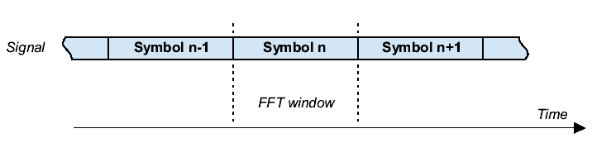
In an environment where several useful signals -either from multipath echoes or from other transmitters in an SFN- are available to the receiver, things become more complex. Usually, the signals arrive at different times at the receiver which, in the absence of a guard interval, makes correct synchronisation to all of the signals impossible. Such a situation with two signals as an example is depicted in Fig. P2-2. Synchronisation to symbol n of signal 1 leads to an overlap of the FFT-window with the preceding symbol n–1 of the delayed signal 2. Since this symbol n–1 carries different information from symbol n, the overlap acts as interference to the evaluation of symbol n. The degradation of the reception caused by this mechanism is called inter-symbol interference (ISI).
Figure P2-2
Inter-symbol interference with a delayed signal (no guard interval)
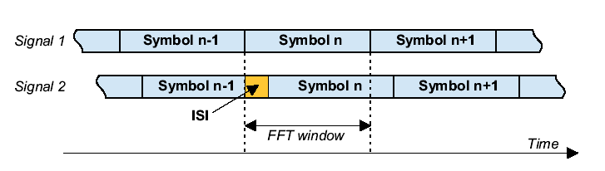

1.3 Guard interval
In order to overcome the inter-symbol interference problem in DVB-T, DVB-T2, ATSC 3.0 and DAB, part of the symbol is copied from the beginning of the symbol to the end, increasing its duration by a certain amount of time called the guard interval. This cyclic prolongation of the original symbol is shown in Fig. P2-3. The guard interval is denoted by ∆.
Figure P2-3
Increase of the symbol duration by the guard interval
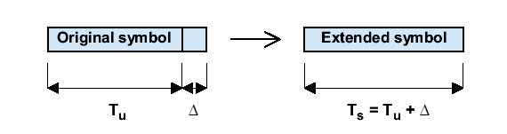
The new increased symbol duration is denoted by T_{s} and the original symbol duration is often called useful symbol duration T_{u}. The duration of the FFT-window during which the symbol is evaluated is kept at the original value T_{u}. The orthogonal relationship is kept with the original symbol duration T_{u}, not the extended T_{s}.
The improvement that is achieved by the insertion of the guard interval can be seen from Fig. P2-4 with two signals as an example. The guard interval now allows for the FFT-window to be positioned so that there is no overlap with a preceding or subsequent symbol, thus avoiding ISI.
Figure P2-4
Guard interval utilisation
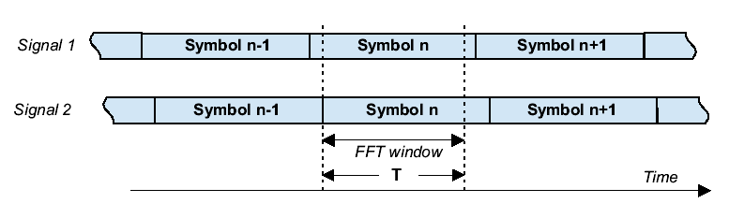
The fact that the duration of the FFT-window is now smaller than the symbol duration allows for a variety of different possible FFT-window positions for the evaluation of a symbol. This is indicated in Fig. P2-5 for the simple case of synchronisation to a single signal. Three possible FFT-window positions are indicated as examples. Here, all positions are equivalent with regard to evaluation of the symbol because all the FFT-window positions shown include samples from only one symbol.
Figure P2-5
Three possible FFT-window positions
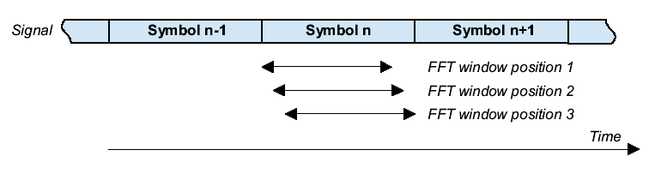
The insertion of the guard interval reduces the data capacity because not all of the symbol duration T_{s} is used for “useful” data.
In a multipath or SFN environment, where many potentially useful signals are available to the receiver, the choice of the FFT-window position becomes more complex. A number of different strategies that can be applied are discussed in the next chapter.
All signals with time delays that cannot be absorbed by the guard interval in the way described above introduce a degradation of reception, similar to that shown in Fig. P2-2. Any part of each of these received signals that falls outside the guard interval has an interfering characteristic, which will be dealt with in more detail in § 1.4.
OFDM, due to its multicarrier nature, exhibits relatively long symbols. This long symbol period already provides a certain degree of protection against inter-symbol interference caused by multipath propagation. However, as described above, this protection is greatly enhanced by use of the guard interval. The guard intervals for the 2k and 8k DVB-T systems are given in Table P2-1 below, and the guard intervals for the 8k, 16k and 32k ATSC 3.0 system payload are given in Table P2-2 below. ATSC 3.0 a priori information is signalled in the bootstrap (A/321), where the guard interval time period equals the number of samples divided by the baseband sample rate, and the baseband sample rate bsr = 384,000(N + 16), where N is the bootstrap parameter bsr_coefficient, which is 2, 5 or 8, for 6 MHz, 7 MHz, or 8 MHz, respectively.
TABLE P2-1
Guard interval durations (from ETSI EN 300 744 v1.6.1)
Mode | 8k mode |  |  |  | 2k mode
 | Guard interval
 | 1/4 | 1/8 | 1/16 | 1/32 | 1/4 | 1/8 | 1/16 | 1/32
8 MHz channel | 224 μs | 112 μs | 56 μs | 28 μs | 56 μs | 28 μs | 14 μs | 7 μs
7 MHz channel | 256 μs | 128 μs | 64 μs | 32 μs | 64 μs | 32 μs | 16 μs | 8 μs
6 MHz channel | 298.667 μs | 149.333 μs | 74.667 μs | 37.333 μs | 74.667 μs | 37.333 μs | 18.667 μs | 9.333 μs
NOTE – values in italics are approximate values.

TABLE P2-2
Guard interval durations (from ATSC A/327-2020)
Mode | 8k | 16k | 32k
 | Guard Interval, # samples
6, 7, 8 MHz channel | 192 | 192 | 192
6, 7, 8 MHz channel | 384 | 384 | 384
6, 7, 8 MHz channel | 512 | 512 | 512
6, 7, 8 MHz channel | 768 | 768 | 768
6, 7, 8 MHz channel | 1 024 | 1 024 | 1 024
6, 7, 8 MHz channel | 1 536 | 1 536 | 1 536
6, 7, 8 MHz channel | 2 048 | 2 048 | 2 048
6, 7, 8 MHz channel |  | 2 432 | 2 432
6, 7, 8 MHz channel |  | 3 072 | 3 072
6, 7, 8 MHz channel |  | 3 648 | 3 648
6, 7, 8 MHz channel |  | 4 096 | 4 096
6, 7, 8 MHz channel |  |  | 4 864

As the proportion of the symbol used to make the guard interval is increased, the transmission capacity decreases. However, if a system with a greater number of carriers were used, the symbol period would increase and therefore the same proportion of guard interval would give a greater protection in terms of absolute time. However, increasing the number of carriers has also some drawbacks:
– higher complexity (FFT performed on a higher number of samples and more memory)
– higher sensitivity to tuner phase noise.
Table P2-3 gives the absolute guard interval duration Δ, expressed in multiples of the elementary period T for each combination of FFT size and guard interval fraction for DVB-T2 system.
TABLE P2-3
Duration of the guard interval in terms of the elementary period T
(from Table 67 ETSI EN 302 755 v1.3.1)
FFT size | Guard interval fraction (∆/T_{u})
FFT size | 1/128 | 1/32 | 1/16 | 19/256 | 1/8 | 19/128 | 1/4
32K | 256T | 1 024T | 2 048T | 2 432T | 4 096T | 4 864T | NA
16K | 128T | 512T | 1 024T | 1 216T | 2 048T | 2 432T | 4 096T
8K | 64T | 256T | 512T | 608T | 1 024T | 1 216T | 2 048T
TABLE P2-3 (end)
FFT size | Guard interval fraction (∆/T_{u})
4K | NA | 128T | 256T | NA | 512T | NA | 1 024T
2K | NA | 64T | 128T | NA | 256T | NA | 512T
1K | NA | NA | 64T | NA | 128T | NA | 256T
NOTE – There are further restrictions on the combinations of FFT size and guard interval allowed for T2-Lite

The guard interval for DAB Mode I (the most suitable for terrestrial SFN in VHF band) is ¼ of the symbol period (246 μs) (see Table 38 of ETSI EN 300 401 v1.4.1).

1.4 Contributing and interfering signal components with inter-symbol interference
For network planning, the power of all the echoes received within a window of duration ∆ (guard interval width) is considered as useful, and contributes positively to the total available signal power. Outside the guard interval, a part of the echo power is associated with the same OFDM symbol as the primary signal, and which therefore contributes positively to the total useful signal power.
Another part of the echo power is associated with the previous or subsequent OFDM symbol and produces ISI, which has a similar effect to uncorrelated Gaussian noise interference. Therefore, as the echo delay is progressively increased beyond the guard interval, the useful contribution decreases and the ISI increases with a quadratic law. The echo power becomes fully interfering (i.e. it contains no useful power) when the delay is larger than or equal to one OFDM symbol.
DVB-T
Moreover, with DVB-T there is a further degradation mechanism effective: the channel estimation process in the receiver, for constellation equalisation and coherent detection, is based on a frequency domain interpolation filter, which allows recovering of the channel response from the scattered pilot carriers. The pass-band T_{p} of this filter is designed to be larger than the guard interval (∆=T_{u}/4), but, because of theoretical limitations, cannot exceed T_{u}/3 (practical figures are up to T_{p}= (7/24)T_{u} for a sophisticated receiver). The following cases can take place:
– the echo is within the guard interval ∆: its power adds to the “useful” signals;
– the echo is outside ∆, but within T_{p}: it is correctly equalised, but is split into a useful component (relevant to the actual OFDM symbol) and an interfering component (relevant to the previous OFDM symbol), as described in the formula below;
– the echo is outside T_{p}: it is to be considered as pure interference, with the same effect as an equal-power Gaussian noise.
The situation for DVB-T is depicted in Fig. P2-6.
Figure P2-6
DVB-T model – Splitting of the signal power into contributing and interfering components
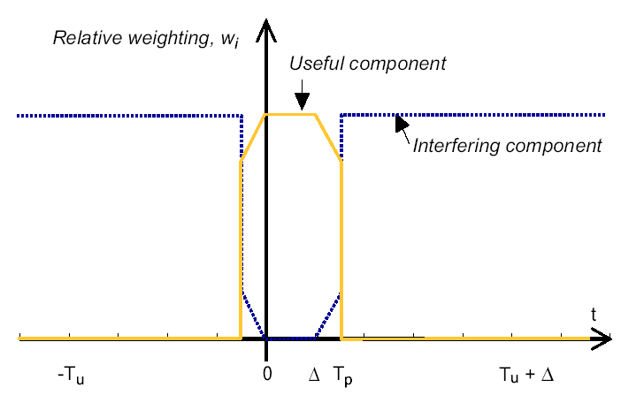
Mathematically, the rule for splitting the signal power into a useful component and an interfering component is expressed as follows:
where:
C_{i} : is the power contribution from the i-th signal at the receiver input
C : is the total power of the effective useful signal
I : is the total effective interfering power
w_{i} : is the weighting coefficient for the i-th component
T_{u} : is the useful symbol length
∆ : is the guard interval length
t : is the signal arrival time
Tp : is the interval during which signals usefully contribute.
It should be remembered that I, the total effective interfering power, is weighted by the appropriate DVB-T-to-DVB-T protection ratio when being regarded as a source of interference in a coverage calculation.
As already mentioned, a value of T_{u}/3 is regarded as a theoretical limit for T_{p}, and would require an interpolation filter with an infinite number of taps. The formula T_{p} = 7T_{u}/24 is often quoted and this gives a sensible practical limit given real filter design. At the present time, many DVB-T receivers do not even reach this performance.
DVB-T2
See the following parts of Report ITU-R BT.2254:
– Section 3.5 “DVB-T2 equalization interval (EI)”
– Section 4.2 “Degradation beyond guard interval”
– Annex 6 “Further understanding the DVB-T2 Equalization Interval”.
ATSC 3.0
See CTA CEB-32.2, Section 5.7 Multipath, for guidance regarding the maximum delay of tolerable echoes for QEF reception of ATSC 3.0.
DAB
DAB uses differential demodulation. Therefore, the restrictions arising from the interpolation filter for the channel estimation do not exist for DAB and the degradation function looks slightly different. It is depicted in Fig. P2-7.
Figure P2-7
DAB model – Splitting of the signal power into useful and interfering components
For DAB, the rule for splitting the signal power into a useful component and an interfering component is expressed as follows:
where:
C_{i} : is the power contribution from the i-th signal at the receiver input
C : is the total power of the effective useful signal
I : is the total effective interfering power
w_{i} : is the weighting coefficient for the i-th component
T_{u} : is the useful symbol length
∆ : is the guard interval length
t : is the signal arrival time.
It must be borne in mind that I, the total effective interfering power, is weighted by the established DAB-to-DAB protection ratio when being regarded as a source of interference in a coverage calculation.

2 FFT-window synchronisation

2.1 General
The synchronisation of an OFDM receiver is performed in two stages: the initial synchronisation in which the receiver is aligned with the symbol rate, and the secondary synchronisation in which the receiver positions the FFT-window to demodulate the signal.
The initial synchronisation is normally done by correlating samples taken T_{u} apart in time. When the waveform repeats, as shown in Fig. P2-8, the correlator output exceeds a threshold value. From this the receiver can detect the start of a new symbol period.
Figure P2-8
Initial Receiver Synchronisation (image courtesy of Philips Ltd)
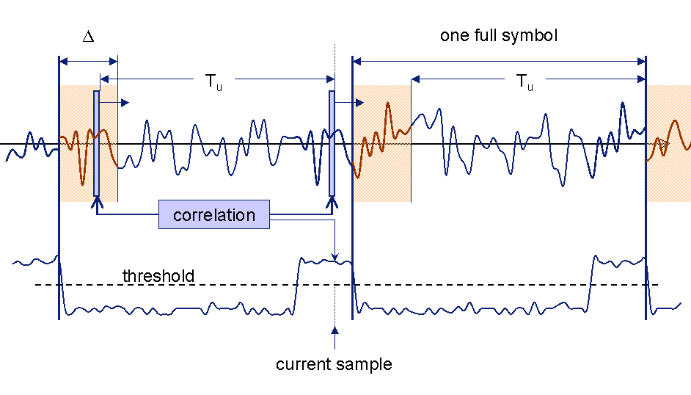
In a real multipath environment, the receiver encounters a multitude of echoes that make the second-stage synchronisation process, i.e. finding the “best” position for the FFT-window, a complex task. As a consequence, various strategies can be applied in order to optimize the receiver performance.
For coverage calculations a model is needed to describe the synchronisation performance of real receivers. A natural way to describe the reception situation in planning simulation tools would be to model real receiver behaviour. Unfortunately, the receiver FFT-window positioning is not prescribed in detail in the DVB-T, DVB-T2, DAB or ATSC 3.0 system specifications. This means that all manufacturers have their own solutions and, moreover, regard these various solutions as confidential, making a single description of receiver FFT-window positioning difficult.
A detailed consideration of the difference between direct signals and echoes is relevant at this stage. In an MFN, where each transmitter acts independently on its own frequency, the receiver may get one direct signal and a number of scattered echoes. The direct signal is not necessarily the strongest signal nor is there necessarily a direct signal at all, particularly in the case of portable or mobile reception. On the other hand, there are also cases where there is only the direct signal present. In an SFN, all transmitters in the network use the same channel. In this case, the receiver gets a number of direct signals and a number of scattered echoes.
The difference between direct signals and echoes becomes important in the computer simulation of a coverage calculation.
Most coverage prediction methods use two dimensional (2-D) prediction models taking into account only the direct path. Therefore in an MFN, the modelling of the FFT-window positioning is simple and unique since there is only one direct path present. In an SFN, receiver synchronisation modelling is no longer unique since there are usually several direct path signals present.
In some three-dimensional (3-D) prediction models a multipath propagation environment for each transmitter is considered. Therefore, the FFT-window positioning for an MFN becomes as complex as that for an SFN when 3-D prediction models are used.
A further difference arises from the fact that real receivers have to account for the time variation of the transmission channel, whereas software modelling of the receiver FFT-window positioning usually assumes a static reception situation. This, to some extent, is justified by the different time scales of successive synchronisation instants and the time variation of shadow fading in a transmission channel. But it means that a real receiver will not show exactly the same synchronisation behaviour as that described in the simple model cases below.

2.2 Synchronisation strategies
This chapter describes five different strategies for second-stage synchronisation (i.e. positioning of the FFT-window) that are commonly used in receiver modelling. Four of them are relatively simple, straightforward strategies, while the fifth is an idealised, optimal strategy.
FFT-window synchronisation is of particular importance for mobile and portable reception, when the receiver will need to be able to synchronise in a rapidly changing environment and in the presence of pre- and post-echoes.
The strategy employed by a receiver determines which peak in the time-domain impulse response of the received signal is used by the receiver uses for synchronisation, and where the receiver sets the FFT-window relative to this peak.
In a single signal environment, the synchronisation configuration is simple and clear. The principle was already explained in the previous chapter and can be seen from, e.g. Fig. P2-5. When two or more signals are involved, various approaches are possible.

2.3 Strongest signal
A natural approach for the FFT-window positioning is to synchronise to the strongest signal. In order to demonstrate the principle, a configuration with four signals is chosen as an example. Figure P2-9 shows the channel response function for the configuration, where the peaks represent a characteristic time instant of the signals, such as the start of symbol n.
Figure P2-9
Synchronisation to the strongest signal (signal 3); time-domain impulse response
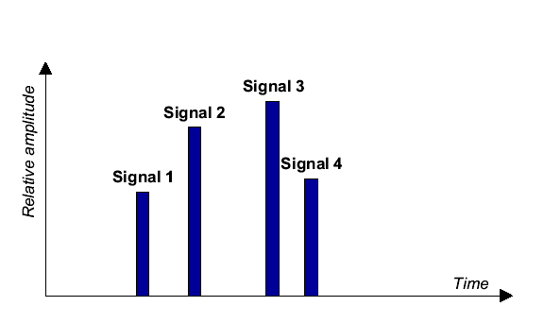
Signal 3 is the strongest signal. Accordingly, the FFT-window is synchronised to signal 3. Since relevant contributions of further signals may be found preceding signal 3 or following signal 3, it seems reasonable to locate the centre of the FFT-window at the centre of symbol n of signal 3. This is depicted in Fig. P2-10. In the example, signals 3 and 4 contribute fully to the evaluation of symbol n, whereas the FFT-window exhibits an overlap with symbol n+1 of signals 1 and 2, which results in a certain amount of ISI.
Figure P2-10
Synchronisation to the strongest signal (signal 3) FFT-window position
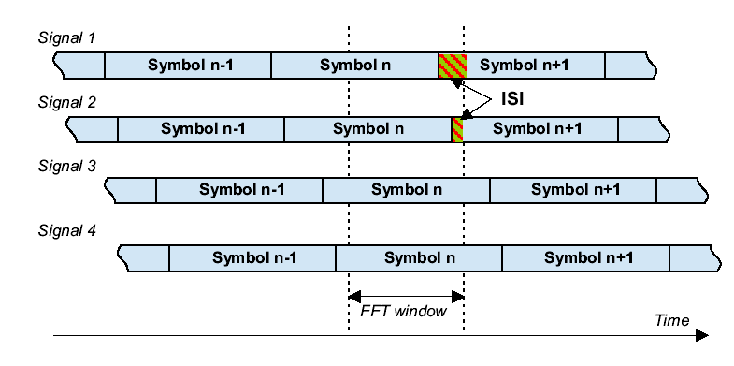
A more sophisticated synchronisation strategy based on the strongest signal approach would not be fixed to the centre of the symbol duration but would check for better positions within the symbol duration of the strongest signal, e.g. in the chosen example it would be advantageous to move the FFT-window a little bit backwards in time to avoid the small amount of ISI arising from the overlap with symbol n+1 of signal 2. Also the inter-symbol interference from signal 1 would be reduced.

2.4 First signal above a threshold level
This strategy takes the first signal of the time impulse response as a reference for the FFT-window. Normally, a minimum threshold level is necessary for a signal in order to be accepted as a trigger. Again the 4-signal configuration of the previous chapter is taken as an example. The impulse response is given in Fig. P2-11 with the threshold value indicated by a horizontal dashed line.
Figure P2-11
Synchronisation to the first signal above a threshold (signal 2); impulse response
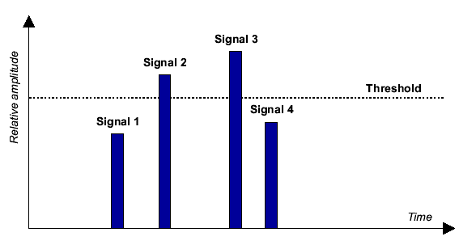
The first signal above the threshold is signal 2. It serves here as the trigger for the FFT-window. If the threshold is chosen reasonably it can be expected that there is no significant signal preceding signal 2, therefore it is logical to align the end of the FFT-window with the end of the symbol n of signal 2. This is indicated in Fig. P2-12.
Figure P2-12
Synchronisation to the first signal above a threshold (signal 2); FFT-window position
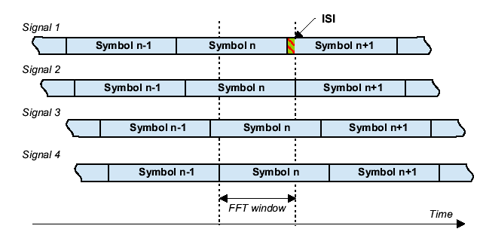
With this synchronisation strategy, in this example, signals 2, 3 and 4 contribute fully constructively, whereas signal 1 adds a certain amount of ISI.
The choice of the threshold value is a specific issue of this synchronisation strategy. It may be taken as the power corresponding to the minimum field strength or, more pragmatically, as a value, say 6 to 10 dB, below the strongest signal.

2.5 Centre of gravity
In this case the receiver looks at the impulse response, calculates the ‘centre of gravity’ of the impulse response spectrum and centres the FFT-window on that point in time:
where:
t_{c} : centre of gravity
p_{i} : power of the i-th signal of the impulse response
t_{i} : time of the i-th signal of the impulse response.
The impulse response of the chosen example with the corresponding centre of gravity indicated by a dashed line is given in Fig. P2-13.
Figure P2-13
Synchronisation to the centre of gravity (between signal 2 and 3); impulse response
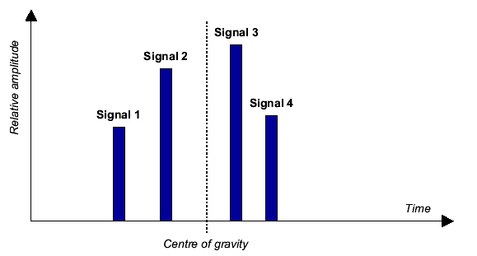
In this example, signals 2 and 3 fully contribute constructively. Signals 1 and 4 show a small amount of inter-symbol interference arising from an overlap of the FFT-window with symbol n+1 of signal 1 and with symbol n-1 of signal 4. This is depicted in Fig. P2-14.
The centre of gravity approach responds well to pre-echoes and delayed signals of similar amplitude, since it does not fix the FFT-window to a particular signal but takes into account the average behaviour of the impulse response of the transmission channel. On the other hand, it can lead to ISI in cases where other strategies may not: for example, most two-echo cases, separated by virtually the whole guard interval, would cause this strategy difficulties unless the two echoes were of equal power.
Figure P2-14
Synchronisation to the centre of gravity (between signal 2 and 3); FFT-window position
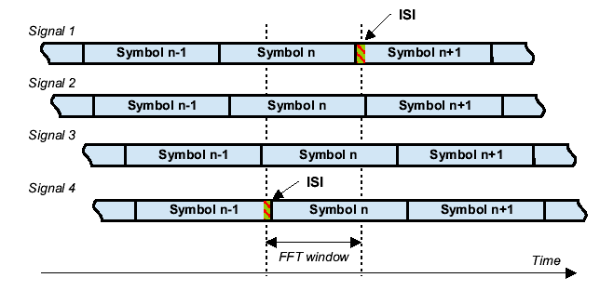

2.6 Quasi-optimal
This strategy builds on that described in the chapter “first signal above a threshold” in an attempt to approach the “Maximum C/I” described below.
The first signal of the impulse response above a minimum threshold level is taken as a reference for the FFT-window. The process is described in the flowchart below, Fig. P2-15.
Figure P2-15
Flowchart describing the Quasi-Optimal Strategy
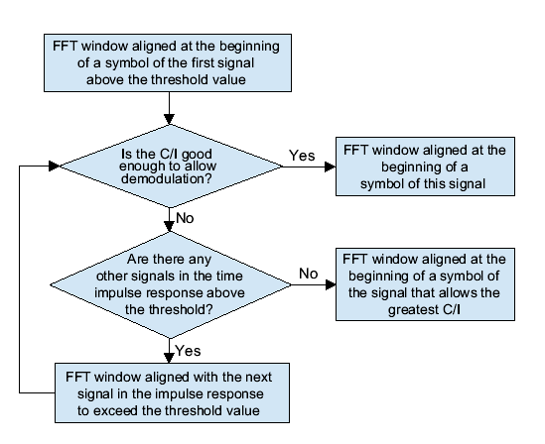

2.7 Maximum C/I
Whereas the previously discussed strategies all give means of quickly finding a good FFT-window position, an optimal choice would be a position where the effective C/I is maximised. This position, however, is not easily found and would in general take too much time to be calculated. Therefore, normally one of the above simpler strategies, or a combination of them, is applied. Such simpler approaches can be justified by the fact that the optimum C/I will often show a relatively flat maximum, i.e. errors introduced by sub-optimal synchronisation are small. But there are also difficult configurations possible, e.g. in a two-echo case, if the difference in delay is close to the guard interval, there is only one position that will result in no ISI, so the optimum here would be very sharp.
Note that the method in the previous chapter (the “Quasi-Optimal” strategy) does not attempt to find a position for the FFT-window that gives the best C/I. It merely seeks to find a position for the window at which the C/I is good enough to allow demodulation and decoding with an acceptable error rate.
Receiver manufacturers indicate that the evaluation of C/I is by no means trivial for a DVB-T receiver, and for a DVB-T mode with a large guard interval of T_{u}/4 there seem to exist theoretical limits for the evaluation of C/I which would prevent the application of a “maximum C/I” synchronisation strategy in this case.
With regard to receiver modelling in computer simulations, e.g. for coverage calculations, the detection of the maximum C/I position of the FFT-window is not a principle problem. A simple but time-consuming approach would be to scan the time period of interest with an appropriate step size, calculate the C/I for each sampling point and to use the time position with the maximum C/I as the reference.
A more sophisticated strategy to find the maximum C/I position is based on the observation that the maximum C/I is always found at a position where the FFT-window is aligned with the start or the end of one of the incoming signals for the symbol under consideration. A check of all these possible positions, which amounts to 2N evaluations of C/I for N signals, then gives the maximum C/I position. Practical experience shows that the computational effort is about twice that of the basic strategies described in the previous chapters.

3 Site selection and management
Once the planner has a definition of the service requirements the next stage is to consider what resources are available and what sort of transmission network will be required to deliver it. Chapter 1 of Part 1 gives guidance regarding some of the different types of network structures which could be implemented.
The first requirement of any terrestrial broadcast network is the sites at which it is to be implemented. Are the existing broadcast sites sufficient to facilitate the service or are others likely to be required? In some cases more sites will be needed for a digital service than for an analogue one due to the requirement to deliver services to a higher percentage of locations and the use of more difficult reception modes. When considering sites the following criteria should be considered:
– What sites are presently available?
– Existing broadcast sites used at high powers for analogue services may not be appropriate for implementing some types of SFN coverage, due to their distance from population centres and the large distances over which they can cause out-going interference.
– Are rooftop sites within towns and cities more appropriate for delivering the required coverage? Although there may be concerns over high field strengths in populated areas.
– There may be economic advantages using particular sites, for example those already used for broadcasting.
– Is aperture available at the site? If not, it may be possible to combine some services, for instance VHF FM and DAB services may be able to share aerial aperture.
– Is there an existing antenna at the site and if so, can this be shared? This may not be the case if allotments using the site have different constraints, service areas or implementation rights.
– Consideration might also be required when trying to serve population centres at the edge of an allotment, for example in coastal areas.
– It is becoming more difficult to achieve approval for the use of new sites due to the perceived EMC hazards.
Where multiple services are present in the same area some further considerations may need to be taken into account:
– Whilst adjacent channel digital services can operate in the same area, care should be taken to avoid interference between them. Interference may occur to other services around a transmitter site from which only one of the services is transmitted. In most cases this problem can be resolved by site sharing, even if the services have very different radiated powers and aerial patterns.
– Different types of network, both in terms of size of coverage (local, national, etc.) and reception mode may require significantly different transmitter network configurations. This difference may in turn lead to adjacent channel interference problems.
– If a number of different multiplexes are expected to have similar coverage areas, but have very different frequencies allocated to them, use of the same transmission parameters for each will not necessarily deliver this. To facilitate similar coverage differing radiated powers, and possibly, aerial systems may be required.
– It is likely that the interference environment of different frequencies will vary.

4 Coverage and interference management

4.1 General
In an ideal situation the planner can design a network which delivers the required coverage whilst keeping outgoing interference within the levels allowed for the coordinated allotment. However, in reality achieving an acceptable final result will often require a number of compromises, these may not all be of a technical nature.
Whilst the allotment will have been planned to have an acceptable level of in-coming interference it would be advisable to calculate what the actual level is. This will give the minimum usable field strength for the wanted service over the coverage area. This calculation may be difficult to quantify exactly especially where interference comes from unimplemented allotments.
The coverage and interference planning process normally involves a number of steps which may form an iterative loop. The main steps being the calculation of wanted coverage and out-going interference.

4.2 Wanted coverage prediction
In order to start the process a calculation of the wanted coverage should be made. Initially this should only be the coverage provided from the primary sites selected for the service, on the basis that they are likely to be the main sources of out-going interference. Account should be taken of the following factors during the prediction process:
– transmitter powers
– aerial directionality, both in azimuth and the vertical plane
– aerial height
– polarisation
– network gain
– It is applicable to SFN being received in portable and mobile reception modes where an omnidirectional antenna is used
– It is not applicable to fixed roof-top reception mode where a directional antenna is used
– the level of background interference
– the reception mode
– initial signal launch delay
When a good level of coverage is achieved from these sites, it should be proceeded to the stage described in § 4.3.

4.3 Out-going interference management

4.3.1 General
Having achieved a good level of coverage from the primary sites the next step is to make the own calculation of the level of out-going interference. There is little point spending a significant period of time producing a final network design at this stage. This is because if the out-going interference is unacceptably high the proposed network will need to be modified significantly. There are different methods of calculating the out-going interference from DAB and DVB-T/DVB-T2 allotments; these are considered in the two following sub-sections below.
If the out-going interference exceeds the required limit some steps will need to be taken to resolve the problem. Whilst the options are similar to those available for analogue systems they are detailed below.
– Reduce the radiated power at the worst sites.
– Increase directional restrictions – either in azimuth or VRP.
– Change one or more of the primary sites.
– Can other sites with more terrain shielding be used?
– Can international co-ordination be carried out to increase the allowable levels of out-going interference?
Most of these options will have an impact on the wanted coverage. As a result some amount of re-planning will be required before re-calculating the outgoing interference.
Once the levels of out-going interference and the coverage are acceptable the final network plan should be completed. Since it is expected that the rest of transmitters will be of a lower power or cause less out-going interference they should not cause any significant co-ordination problems. However, it would be advisable to re-calculate the level of the overall network before proceeding further.

4.3.2 Calculation of out-going DAB interference
For DAB out-going interference is calculated to a set of test points generated specifically for the purpose.
In the DAB case it may be possible to relax interference levels at some test points, for instance where they lie either in the sea or within your own country boundary.

4.3.3 Calculation of out-going DVB-T/DVB-T2 and ATSC 3.0 interference
In the DVB-T/DVB-T2 and ATSC 3.0 cases there is no agreed method of calculating out-going interference yet. The allowable levels of out-going interference caused by an allotment are agreed through bilateral and multilateral agreements between the administrations concerned. This means that there may be different methods of calculating the levels of interference and different field strength limits imposed.
Optimally, when signal power is distributed uniformly across transmission channels, interference management becomes primarily a matter of determination of an allowed minimum ratio of signal power to noise (and interference) power in the intended service areas. There are mainly to two types of interference cases: co-channel and adjacent channel.
Co-channel interference susceptibility is determined primarily by the characteristics of the signal to be received, with both natural and man-made interfering signals treated essentially as a noise source. Adjacent-channel interference susceptibility is determined largely by the combination of characteristics of the signal to be received and the selectivity characteristics assumed for receivers in targeted service areas. An additional characteristic that may be considered is the directivity of any antennas assumed to be used for fixed (as opposed to mobile or portable) reception.
With the required relationships of signal power levels established for the two types of cases, the various available signal characteristics, allocation, allotment, and assignment protocols can be established both within countries and between countries. Additional future complicating factors however, may be presented by an increase in the number of modulation schemes having different reception characteristics, as well as the potential development of more complex regulatory schemes to deal with the multiplicity of available modulation schemes.

5 Post implementation of the network

5.1 Network coverage and improvement
Once the network is in operation some consideration of the following might be appropriate:
– The coverage delivered by the network could be measured in order to confirm that any planned target has been achieved.
– Measurements to confirm that network self-interference is managed correctly.
– Shortfalls in predicted coverage may be filled by the addition of additional gap filling transmitters.
– Gap filling transmitters can also be built to compensate for environmental changes, such as the construction of new buildings.

5.2 Network problems
As mentioned in previous chapters, the transmitters of an SFN need to be synchronised in order to prevent self-interference. If a fault occurs it is possible for a transmitter to lose this synchronisation. The effect is that the transmitter will slowly move out of phase with the ones which surround it and become a source of destructive interference. This will result in a narrow ring of lost coverage developing around, but kilometres away from, the faulty transmitter, although users near to it are unlikely to notice a problem. In the DAB case some mobile listeners may only notice a small zone of lost coverage as they pass through it. A fault like this may take a significant time before it manifests itself, and before being identified could have an impact over a significant area. If SFN synchronization is lost, the drift rate of the previously-disciplined oscillator will cause an apparent Doppler shift that consumes a proportion of the receiver echo-correction capability. Carrier spacing, which is dependent on FFT size, will influence the ability of receivers to correct for the apparent Doppler shift.
Changes to coverage may occur due to seasonal variations, such as snow causing reflection points. Problems of this type are extremely difficult to resolve.
The implementation of a new transmitter for service operating on an adjacent channel may cause a problem to an existing service. In such cases users may lose a service for no apparent reason and receivers may still display information for services which are no longer available. This problem can be resolved through the use of a transmitter co-sited with the interferer or avoided through agreements between operators to use common sites.
DVB-T SFN

6 Impact of DVB-T parameters on SFN performance

6.1 Constellation
The DVB-T specification allows for three different phase/amplitude constellations, QPSK (4-QAM), 16-QAM and 64-QAM, in order to meet the different requirements in terms of spectral efficiency and the reliability of the broadcast service.
The choice of constellation determines the number of bits that are carried at a time on each sub-carrier; either 2 bits (QPSK), 4 bits (16-QAM) or 6 bits (64-QAM) may be carried. Moreover, the modulation has an important impact on the performance in a SFN as the choice of constellation also determines noise tolerance, with QPSK being around four to five times more tolerant than 64-QAM.
QPSK provides a low data capacity but it does provide a very rugged service. Networks using QPSK may be of particular value in urban areas for services to pedestrians and vehicles.
16-QAM provides a moderate capacity and, therefore, this variant may be of interest for providing reasonably rugged services to medium or densely populated areas.
64-QAM variant has a high data capacity but does not provide rugged services and is particularly sensitive to self-interference effects in large area SFN.

6.2 Code rate
Different code rates can be used to trade bit rate versus ruggedness, e.g. the signal strength required and interference protection required.
The code rate of 1/2 has the highest redundancy and in doing so the highest transmission safety albeit at the cost of data throughput. This mode should only be applied to channels that have a high degree of interference. The variants using code rates higher than 3/4 offer additional capacity but may be not worthwhile as the system becomes less rugged. For code rates 5/6 and 7/8 the implementation margins may also be higher than expected making those variants even less attractive. The code rate of 7/8 has the lowest redundancy but the highest throughput. As such, it should only be used for channels with low levels of interference.
In the case of mobile reception under SFN environment, since the speed of the mobile receiving terminal relative to different transmitters is often different, this will result in strong Doppler effects, which have to be dealt with by channel estimation and error correction system. A lower rate of convolutional coding like 1/2 is thus recommended for mobile implementation.

6.3 2k/8k FFT
The DVB-T standard defines two FFT modes (2k and 8k) each using different numbers of sub-carriers (2048 and 8192) to constitute the OFDM signal. This means different symbol times T_{u} = 896 µs and T_{u} = 224 µs.
The 8k FFT systems provide a higher degree of protection against inter-symbol interference caused by multipath propagation. The use of a higher number of carriers within the same bandwidth increases the symbol period (in order to preserve orthogonality) and therefore the same proportion of guard interval gives a greater protection. In the 2k FFT systems, signal delays that exceed the guard interval are very much more conspicuous due to the considerably shorter usable symbol time of 224 µs. Thus, the 2k FFT systems are not meant for large area SFN.
However, the 8k FFT mode presents a higher complexity and a higher sensitivity to tuner phase noise and may be less suitable for mobile reception. The DVB-T 2k FFT systems can withstand moving echoes up to several hundreds of Hz. Therefore, this mode is superior for mobile applications.
The working frequency of each SFN transmitter should be accurately managed and monitored. For COFDM SFN operation, the stability and the accuracy of the transmitter’s working frequency shall ensure that each sub-carrier has the same absolute frequency position in the RF channel.

6.4 Guard interval
In an SFN each transmitter is required to radiate the same OFDM symbol at the same time. This comes from the fact that echoes (natural or artificially generated by co-channel transmitters) shall be confined in the guard interval period. The OFDM receiver has to setup a time-window during which it samples the on-air OFDM signal. The objective is to synchronize this time-window with the useful period of the OFDM symbol. Accordingly, it will ignore the signal during the guard interval period where the receiver signal is made of a mixture of two or more OFDM symbols. If the transmitters deliver the same OFDM symbol at the same instant, or with a sufficiently small time delay, the differential propagation path delay to the OFDM receiver will remain inside the guard interval period. Accordingly, the sum of the received signals will be constructive because they constitute the same OFDM symbol (no inter-symbol interference).
The DVB-T specification offers a selection of system guard intervals, i.e., 1/32, 1/16, 1/8 or 1/4 times the duration of the useful symbol duration. For 8k(2k) mode, 8 MHz channel, this represents a permitted guard interval duration of 28(7) µs, 56(14) µs, 112(28) µs and 224(56) µs, respectively.
The selection of the appropriate guard interval parameter for digital terrestrial television affords resilience against delayed, interference–causing signals in television reception. Moreover, the guard interval value chosen to operate an SFN has a major implication on the topology of the SFN network: as the guard interval duration governs the maximum echoes delay admissible by the system, it governs accordingly the maximum possible distance between co-channel transmitters (producing active echoes). Some modes allow setting up large SFN networks having a great distance between high and medium power transmitters sites. Some others allow smaller service areas with a greater density of low power transmitters.
The recommendation given in the Implementation Guidelines ETSI TR 101-190 v1.3.2 for DVB-T is that guard interval selection should be based on the distance between the transmitters. The spacing between adjacent transmitters in an SFN should not be significantly greater than the propagation time permitted in the guard interval:
In a 2k-FFT – 8 MHz channel system the guard interval values are: 7 μs, 14 μs, 28 μs, 56 μs. These values translated into distance give respectively: 2.1 km, 4.2 km, 8.4 km, and 16.8 km.
In an 8k-FFT – 8 MHz channel system the guard interval values are: 28 μs, 56 μs, 112 μs, 224 μs. These values translated into distance give: 8.4 km, 16.8 km, 33.6 km, and 67.2 km (Table 5 ETSI EN 300 744 v1.6.1).
For an 8k-FFT – 8 MHz channel system and guard interval of 1/4 it means that the permissible signal delay times are outside the signal delay between adjacent transmitters, when these transmitters are situated less than 67.2 km apart.
Values for 6 and 7 MHz channel systems can be found in Tables E.2 and E.4 of ETSI EN 300 744 v1.6.1.
Studies on the maximum distance between transmitters in theoretical SFN for DVB-T and DAB systems have shown that together with the guard interval the maximum inter-transmitter distance is influenced by the system variant required and the effective radiated power of the transmitters in the network.
Figure P2-16
Dependence of the maximum distance between transmitters in a DVB-T SFN on the e.r.p. and minimum required C/N for coverage target of 100%: (a) portable outdoor reception with 95% of location probability
in Band III; (b) portable outdoor reception with 95% of location probability in Band IV
a) | b)
For a given DVB-T system variant there exists an optimal SFN size with a proper radiated power of transmitters. The influence of C/N required by DVB-T system and the e.r.p. of the transmitters (P_{Tx}) on the maximum distance between transmitters D_{max} in the SFN to reach 100% of the coverage is presented in Fig. P2-16 for different frequency bands. With an increase of C/N and at fixed power levels, D_{max} should be decreased in order to maintain self-interference free SFN coverage. Increase of D_{max} could be obtained by augmenting the power radiated by transmitters in the SFN. However, this could be done up to a certain e.r.p. value only. After this limit the self-interference effects result in a degradation of the SFN coverage. This is reflected by vertical lines in Fig. P2-16.
Because of the long guard interval (246 μs) and the relatively low required C/N (15 dB) in the case of DAB the size of the SFN is only limited by the e.r.p. of the transmitters but not by self-interference. This is demonstrated in Fig. P2-17. The maximum distance increases as the power radiated by the SFN transmitters augments. It should be also mentioned that DAB is characterised by less rapid performance degradation versus the echo delay as DVB-T.
Figure P2-17
Dependence of the distance between transmitters in a DAB SFN on the e.r.p. for a coverage target of 100%
at portable indoor reception with 95% of location probability in Band III
Transmitter spacing can be increased beyond that defined by the guard interval by varying the radiated power, transmission polarisation and the relative transmitter timing. Effective planning of the required radiated power and transmission polarisation at the secondary site(s) will optimise SFN performance and provide effective management to eliminate most potential interference problems.
There is no limit on transmitter spacing providing the secondary site has a directional antenna transmitting away from the main site utilising an appropriate delay. However, where two transmit sites are radiating towards each other careful planning is required.

6.5 Data rate versus guard interval
Because the guard interval reduces the amount of time available for data transmission, its setting has an effect on the DVB-T net deliverable bit rate. Lengthening the guard interval decreases the bit rate. The guard interval 1/32, 1/16, 1/8, 1/4 produce respectively a loss of 3.1%, 6.2%, 12.5% and 25% in the transmitted bit rate. Table P2-4 indicates the net bit rate in Mbit/s for various modulations, combinations of guard interval settings and error protection code rates. The data are given for the bandwidth of 8 MHz and 7 MHz (in brackets) (for 6 MHz channel, see Table E.3 of ETSI EN 300 744 v1.6.1).
TABLE P2-4
DVB-T net bit rate in Mbit/s; 8 MHz bandwidth (in brackets for 7 MHz bandwidth)
Modulation | Code rate | Guard interval
Modulation | Code rate | 1/4 | 1/8 | 1/16 | 1/32
QPSK | 1/2 | 4.98 (4.35) | 5.53 (4.84) | 5.85 (5.12) | 6.03 (5.28)
QPSK | 2/3 | 6.64 (5.81) | 7.37 (6.45) | 7.81 (6.83) | 8.04 (7.04)
QPSK | 3/4 | 7.46 (6.53) | 8.29 (7.26) | 8.78 (7.68) | 9.05 (7.92)
QPSK | 5/6 | 8.29 (7.26) | 9.22 (8.06) | 9.76 (8.54) | 10.05 (8.80)
QPSK | 7/8 | 8.71 (7.62) | 9.68 (8.47) | 10.25 (8.97) | 10.56 (8.80)
16-QAM | 1/2 | 9.95 (8.71) | 11.06 (9.68) | 11.71 (10.25) | 12.06 (10.56)
16-QAM | 2/3 | 13.27 (11.61) | 14.75 (12.90) | 15.61 (13.66) | 16.09 (14.08)
16-QAM | 3/4 | 14.93 (13.06) | 16.59 (14.52) | 17.56 (15.37) | 18.10 (15.83)
16-QAM | 5/6 | 16.59 (14.52) | 18.43 (16.13) | 19.52 (17.08) | 20.11 (17.59)
16-QAM | 7/8 | 17.42 (15.24) | 19.35 (16.93) | 20.49 (17.93) | 21.11 (18.47)
64-QAM | 1/2 | 14.93 (13.06) | 16.59 (14.52) | 17.56 (15.37) | 18.10 (15.83)
64-QAM | 2/3 | 19.91 (17.42) | 22.12 (19.35) | 23.42 (20.49) | 24.13 (21.11)
64-QAM | 3/4 | 22.39 (19.60) | 24.88 (21.77) | 26.35 (23.05) | 27.14 (23.75)
64-QAM | 5/6 | 24.88 (21.77) | 27.65 (24.19) | 29.35 (25.61) | 30.16 (26.39)
64-QAM | 7/8 | 26.13 (22.86) | 29.03 (25.40) | 30.74 (26.90) | 31.67 (27.71)

To maximise the net bit rate, the guard interval is often chosen as small as possible, reducing accordingly the maximum echoes delay but also the maximum distance between transmitters, thus practically disallowing in many cases to operate 2k-SFN.
Figure P2-18
Relation between C/N, Profile, net bit rate and guard interval
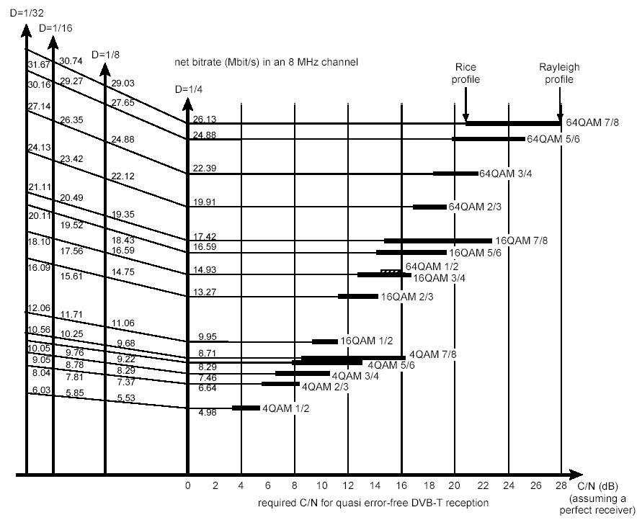
Figure P2-18 gives an overview of the relation between C/N, profile, net bit rate and guard interval for the various DVB-T configurations.

7 Impact of ATSC 3.0 parameters on SFN performance

7.1 Constellation
The ATSC 3.0 specification utilizes Non-Uniform Constellations (NUC) in all but one of its constellation types. It provides for six different phase/amplitude constellations, QPSK (4-QAM), 16-NUC, 64-NUC, 256-NUC, 1024-NUC and 4096-NUC, in order to meet different broadcast service requirements in terms of spectral efficiency and robustness. ATSC 3.0 operating points are depicted in Fig. P2-19 below.
FIGURE P2-19
ATSC 3.0 BICM operating points
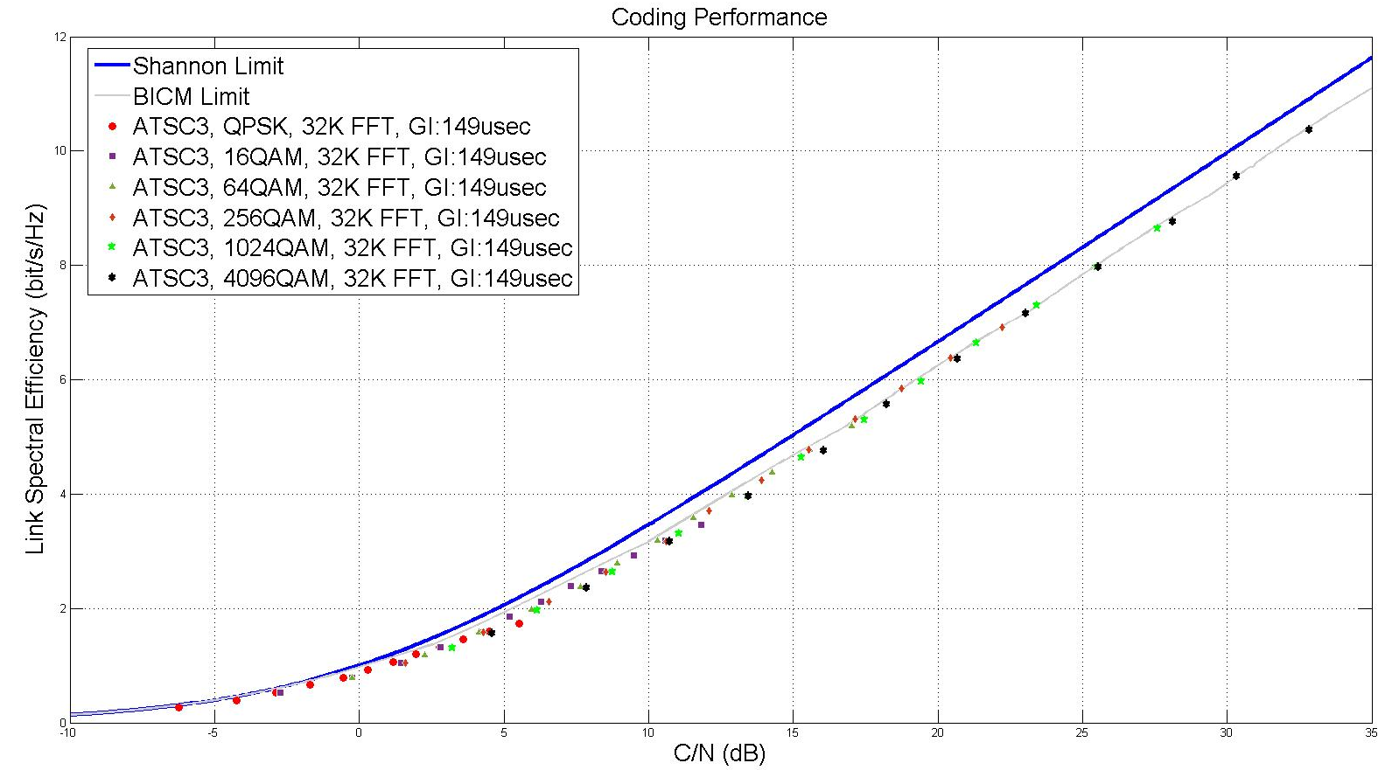

7.2 Code rate
Different code rates can be used to trade off bitrate against ruggedness, e.g. the signal strength versus error protection required. The ATSC 3.0 specification optimizes code rate and modulation type combinations to achieve maximal spectrum efficiency.
The ATSC 3.0 specification applies Low-Density Parity Check (LDPC) codes with code rates that range from 2/15 to 13/15. A code rate of 2/15 has the highest redundancy and provides the highest transmission safety at the cost of data throughput. This mode should only be applied to channels that have a high degree of channel impairment. Variants using code rates higher than 7/15 offer additional capacity but have the tradeoff of making the system less robust. A code rate of 13/15 has the lowest redundancy but the highest throughput. As such, it should only be used for channels with low levels of channel impairment.

7.3 8k/16k/32k FFT
The ATSC 3.0 standard defines three FFT modes for the payload (8k, 16k, and 32k), each using different numbers of carriers (8 192, 16 384 and 32 768) to constitute the OFDM signal. It also defines a 2k FFT for signal discovery, also called the “bootstrap” signal, which provides a priori information such as sampling rate and channel bandwidth.
The 8k FFT mode provides the highest resilience to Doppler shift, due to having the widest carrier spacing of the three FFT modes. It therefore is the preferred mode for high-speed mobile applications.
The 32k FFT mode provides a higher degree of protection against inter-symbol interference caused by multipath propagation, due to its longer symbol times.

7.4 Guard interval
The ATSC 3.0 specification offers a selection of system guard intervals, ranging from 192 to 4 864 samples. For a 6 MHz channel, this represents a permitted guard interval duration that can range from 28 μs to 704 μs. For a 7 MHz channel, the guard interval duration can range from 24 μs to 603 μs. For an 8 MHz channel, the guard interval duration can range from 21 μs to 528 μs.

7.5 Data rate versus guard interval
Because the guard interval reduces the amount of time available for data transmission, its setting has an effect on the ATSC 3.0 net deliverable bit rate. Lengthening the guard interval decreases the bit rate.
For a 32k FFT, the shortest allowed ATSC 3.0 guard interval (192 samples) produces a loss of 0.6% in the transmitted bit rate. For an 8k FFT, the longest allowed ATSC 3.0 guard interval (2048 samples) produces a loss of 25% in the transmitted bit rate.
Table P2-5 lists example net bit rates in Mbit/s for various combinations of modulation, guard interval settings and error protection code rates, in a 6-MHz channel.
TABLE P2-5
ATSC 3.0 net bit rate in Mbit/s; 6 MHz bandwidth (32K FFT, 41 payload symbols)
Modulation | Code rate | Guard interval, # samples
Modulation | Code rate | 192 (SP32_2) | 768 (SP32_2) | 2 048 (SP12_2) | 4 864 (SP6_2)
QPSK | 2/15 | 1.45 | 1.42 | 1.33 | 1.17
QPSK | 5/15 | 3.68 | 3.62 | 3.38 | 2.97
QPSK | 8/15 | 5.91 | 5.81 | 5.43 | 4.78
QPSK | 11/15 | 8.14 | 8.00 | 7.48 | 6.58
QPSK | 13/15 | 9.63 | 9.46 | 8.84 | 7.78
16-NUQAM | 2/15 | 2.90 | 2.85 | 2.67 | 2.35
16-NUQAM | 5/15 | 7.37 | 7.24 | 6.76 | 5.95
16-NUQAM | 8/15 | 11.83 | 11.62 | 10.86 | 9.56
16-NUQAM | 11/15 | 16.29 | 16.00 | 14.96 | 13.17
16-NUQAM | 13/15 | 19.27 | 18.93 | 17.69 | 15.57
64-NUQAM | 2/15 | 4.36 | 4.28 | 4.00 | 3.52
64-NUQAM | 5/15 | 11.05 | 10.86 | 10.15 | 8.93
64-NUQAM | 8/15 | 17.75 | 17.43 | 16.30 | 14.34
64-NUQAM | 11/15 | 24.44 | 24.01 | 22.44 | 19.75
64-NUQAM | 13/15 | 28.90 | 28.39 | 26.54 | 23.36
256-NUQAM | 2/15 | 5.81 | 5.71 | 5.34 | 4.70
256-NUQAM | 5/15 | 14.74 | 14.48 | 13.53 | 11.91
256-NUQAM | 8/15 | 23.66 | 23.24 | 21.73 | 19.13
256-NUQAM | 11/15 | 32.59 | 32.01 | 29.92 | 26.34
256-NUQAM | 13/15 | 38.54 | 37.86 | 35.39 | 31.15

Table P2-6 lists example net bit rates in Mbit/s for various combinations of modulation, guard interval settings and error protection code rates, in an 8 MHz channel.
TABLE P2-6
ATSC 3.0 net bit rate in Mbit/s; 8 MHz bandwidth (32K FFT, 41 payload symbols)
Modulation | Code rate | Guard intervals, # samples
Modulation | Code rate | 192 (SP32_2) | 768 (SP32_2) | 2 048 (SP12_2) | 4 864 (SP6_2)
QPSK | 2/15 | 1.935 | 1.901 | 1.778 | 1.567
QPSK | 5/15 | 4.904 | 4.817 | 4.505 | 3.97
QPSK | 8/15 | 7.872 | 7.733 | 7.233 | 6.373
QPSK | 11/15 | 10.841 | 10.649 | 9.96 | 8.776
QPSK | 13/15 | 12.82 | 12.593 | 11.779 | 10.379
16-NUQAM | 2/15 | 3.87 | 3.802 | 3.556 | 3.133
16-NUQAM | 5/15 | 9.808 | 9.634 | 9.011 | 7.94
16-NUQAM | 8/15 | 15.745 | 15.466 | 14.466 | 12.746
16-NUQAM | 11/15 | 21.682 | 21.298 | 19.921 | 17.533
16-NUQAM | 13/15 | 25.64 | 25.186 | 23.558 | 20.757
64-NUQAM | 2/15 | 5.805 | 5.702 | 5.334 | 4.7
64-NUQAM | 5/15 | 14.711 | 14.451 | 13.516 | 11.909
64-NUQAM | 8/15 | 23.617 | 23.199 | 21.699 | 19.119
64-NUQAM | 11/15 | 32.523 | 31.947 | 29.882 | 26.329
64-NUQAM | 13/15 | 38.461 | 37.779 | 35.337 | 31.136
256-NUQAM | 2/15 | 7.74 | 7.603 | 7.112 | 6.266
256-NUQAM | 5/15 | 19.615 | 19.267 | 18.022 | 15.879
256-NUQAM | 8/15 | 31.49 | 30.932 | 28.932 | 25.492
256-NUQAM | 11/15 | 43.364 | 42.596 | 39.842 | 35.105
256-NUQAM | 13/15 | 51.281 | 50.372 | 47.115 | 41.514

7.6 Robust co-channel interference tolerance
Accommodating signal overlap from adjacent markets is possible with the Co-Channel Interference Mitigation capability of ATSC 3.0. When geographically-neighbouring broadcasters use the same channel frequency with robust ModCod’s (e.g. below 0 dB S/N threshold operating point), pilot-carrier spectral energy can overlap at a receiver location. Pilot patterns are similar in the two emissions and pilot location overlap causes channel estimation errors. ATSC 3.0 offers optional centre frequency offsets of plus or minus one 8K FFT carrier spacing. With pilots at different frequencies in the two signals, there is higher probability of correct channel estimation in the channel to which a receiver is tuned. Bootstrap emission times may also be offset to avoid superposition of bootstrap signals when both broadcasters also use the same frame size.

Annex A
Empirical channel characterization and modelling of terrestrial SFN
in the UHF band

7.A.1 Overview
The second-generation DTT standards, e.g. ATSC 3.0 and DVB-T2, have been developed as supportive of SFN deployment. Historically, SFNs were first planned in European regions and were deployed on a DVB-T basis. Since the 2010s, SFN allotment has been embodied in other ITU-R regions, and macro SFNs have been built using the second generation DTT technologies.
The Republic of Korea has now deployed SFNs for the commencement of ATSC 3.0 broadcast services. Since this launch in 2017, KBS, a major broadcaster in Korea, has gradually extended the physical deployment of SFNs, starting from regional clusters in metropolitan cities. Expecting spectral efficiency, the Korean SFN deployment is planned to expand nationwide.
Noting the growing importance of SFNs and their active deployment in public networks, representative channel models have now been developed to describe multipath fading in urban SFNs. This project, whose results are reported in this Annex, was initiated to capture unique and realistic properties of physical channels in the HPHT SFN environment, which are particularly distinct from that in single-cell network configurations, e.g. MFN deployments.
As part of this project, extensive channel-sounding field measurements were conducted in the Seoul Metropolitan Area, specifically in a service area of an SFN that KBS operates. Based on the experiments conducted on UHF band channels, terrestrial SFN channels were empirically characterized, yielding the realistic models presented here.

7.A.2 Field experiment description
The field measurements took place in the Seoul Metropolitan Area, Republic of Korea. The experiments utilized the operating network of KBS, which has provided public ATSC 3.0 UHDTV services since 2017 on UHF channels 52 (701 MHz) and 56 (768 MHz). The Seoul Metropolitan SFN consisted of synchronized HPHTs whose ERPs (effective radiated powers) range up to 40 kW. The location of each tower site is shown in Fig. P2-20.
FIGURE P2-20
Geographic topology: Seoul Metropolitan SFN
To derive realistic reference models that will characterize the channel situations most frequently appearing in urban HPHT SFNs, three representative locations were chosen as reference measurement points, namely, P_{S3}, P_{S2}, and P_{S1}. Those locations were selected so that a receiver could observe three, two, and one line-of-sight (LoS) linkages from SFN towers, respectively. The channel-sounding results extracted from P_{S3}, P_{S2}, and P_{S1} were refined into S₃, S₂, and S₁ models, respectively. Fig. P2-20 identifies where the receiving locations were situated:
– P_{S3} -- 37°42' 26.52" N, 126° 45' 19.15" E
– P_{S2} -- 37° 30' 53.17" N, 126° 41' 36.26" E
– P_{S1} -- 37° 32' 54.17" N, 127° 05' 45.48" E
FIGURE P2-21
Transmission facilities for the Seoul Metropolitan SFN and the field measurement facility
As shown in Fig. P2-21, an isotropic receive antenna was utilized for measurements. By ensuring uniform angular gain, the following were achieved: i) derivation of representative and neutral reference models, ii) compatibility with both stationary and mobile environments, and iii) benefits to SFNs from 360-degree reception from arbitrary towers. The antenna gain was precisely 0 dBi and this antenna unit was mounted on a mast to facilitate measurements at variable heights within the range from 1.9 m to 9 m.
The channel-sounding experiments leveraged transmitter identification (TxID) signals embedded in the ATSC 3.0 broadcast signals. The TxID signal is defined in the ATSC 3.0 standard as a radio watermarking technology identifying each individual SFN transmitter's signals from the mixture of them.
Every involved SFN tower transmitted superposed waveforms in which the TxID signals were buried at a 9.0 dB injection level, i.e. the TxID signals were emitted at a power level 9.0 dB lower than the broadcast service signals.
Because each SFN tower transmitted a unique TxID signal, this allowed each received signal to be discerned from the ID signals of other towers. TxID signals also proved compatible with channel-sounding use, enabling simultaneous presentation of individual channel profiles originating in each tower’s emission.
This Report therefore additionally demonstrates the feasibility of TxID signals in channel-sounding applications. Generation of the TxID signal and its embedding in preamble signals are defined in the physical-layer standard of ATSC 3.0, A/322.
FIGURE P2-22
SFN channel-sounding result measured at P_{S3}
FIGURE P2-23
SFN channel-sounding result measured at P_{S2}
FIGURE P2-24
SFN channel-sounding result measured at P_{S1}
Figures P2-22, P2-23 and P2-24 show the results of channel sounding carried out at P_{S3}, P_{S2} and P_{S1}, respectively. The presented measurement results identify the power-delay profile detected at each point.

7.A.3 Channel modelling results
The measurement results were used to generate concise fading-channel models. The data gathered at P_{S3}, P_{S2} and P_{S1}, produced the S₃, S₂, and S₁ models, respectively. As mentioned, S₃, S₂ and S₁ models represent situations where three, two, and a single LoS component are observable, respectively. Every presented channel model was designed using a tapped delay line form.
Table P2-7 presents a stationary channel model S₃ Fixed fabricated from Fig. P2-22, which considers fixed receivers. The relative power and delay of each tap are extracted from the power-delay profile in Fig. P2-22. This model consists of three LoS and three non-LoS (NLoS) taps. Relative phase shifts in individual echo taps are determined by calculations using relative (incidence) delay data.
TABLE P2-7
HPHT SFN channel model profile: S₃ Fixed (3-LoS, stationary channel)
Tap index | Relative power  (Db) | Relative delay  (μs) | Type | Phase shift (rad)  (stationary)
1 | −0.96 | −26.041666667 | LoS | 5.235988
2 | −3.65 | −12.876157407 | NLoS | 4.855121
3 | 0.00 | 0.000000000 | LoS | 0.000000
4 | −6.03 | 10.995370370 | NLoS | 3.419109
5 | −13.74 | 13.165509259 | NLoS | 5.864470
6 | −0.17 | 37.471064814 | LoS | 4.683297

Table P2-8 is another version of the S₃ model, the so-called S₃ Mobile, which describes the mobile reception environment. Following the general framework, the mobile channel model is characterized by a Doppler shift profile instead of deterministic phase shifts in multipath taps. This identifies a dynamic aspect caused by the Doppler effect, in that the incident phase of each ray drifts over time.
The phase drifts in LoS taps, which are attributed to direct path propagation from transmitter towers, are characterized by pure Doppler shift. The amount of Doppler shift is expressed in a scale of maximum Doppler shift f_{d}, where the relative amount of scaling is determined by calculations using geographic data, i.e. the coordinates of transmitter towers and measurement points. The maximum Doppler shift is dependent on receiver speed v, as given by f_{d} = f_{c}·v/c, where f_{c} and c are the centre frequency of the channel and the speed of light, respectively.
The phase drifts in NLoS taps, which are attributed to reflected and scattered propagation paths, are modelled to follow the classical Jakes’ fading model whose Doppler power spectrum is defined as:

$S_{Jakes}\left(f;f_{d}\right)=\left\{\begin{matrix}\frac{1}{πf_{d}\sqrt{1 - {\left(\frac{f}{f_{d}}\right)}^{2}}} & \left|f\right|<f_{d} \\ 0 & \text{otherwise}\end{matrix}\right.$

TABLE P2-8
HPHT SFN channel model profile: S₃ Mobile (3-LoS, mobile channel)
Tap index | Relative power  (dB) | Relative delay  (μs) | Type | Doppler spectrum  (mobile)
1 | −0.96 | −26.041666667 | LoS | Pure Doppler  (0.7771f_{d} shift)
2 | −3.65 | −12.876157407 | NLoS | Classical
3 | 0.00 | 0.000000000 | LoS | Pure Doppler  (−0.3160f_{d} shift)
4 | −6.03 | 10.995370370 | NLoS | Classical
5 | −13.74 | 13.165509259 | NLoS | Classical
6 | −0.17 | 37.471064814 | LoS | Pure Doppler  (0.4312f_{d} shift)

Tables P2-9 and P2-10 show extensions of S₃ Fixed and Mobile, which additionally included several notable multipath elements visible in Fig. P2-22. The NLoS taps 2-1, 4-1 and 6-1, which share the same source with taps 2, 4 and 6, respectively, are additionally included.
TABLE P2-9
HPHT SFN channel model profile: S₃ extended (Fixed)
(3-LoS, additional multipath included)
Tap index | Relative power  (dB) | Relative delay  (μs) | Type | Phase shift [rad]  (stationary)
1 | −0.96 | −26.041666667 | LoS | 5.235988
2 | −3.65 | −12.876157407 | NLoS | 4.855121
2−1 | −9.41 | −11.140046296 | NLoS | 2.215894
3 | 0.00 | 0.000000000 | LoS | 0.000000
4 | −6.03 | 10.995370370 | NLoS | 3.419109
4−1 | −8.17 | 13.454861111 | NLoS | 3.758058
TABLE P2-9 (end)
Tap index | Relative power  (dB) | Relative delay  (μs) | Type | Phase shift [rad]  (stationary)
5 | −13.74 | 13.165509259 | NLoS | 5.864470
6 | −0.17 | 37.471064814 | LoS | 4.683297
6−1 | −1.27 | 39.496527778 | NLoS | 5.430202

TABLE P2-10
HPHT SFN channel model profile: S₃ extended (Mobile)
(3-LoS, additional multipath included)
Tap index | Relative power  (dB) | Relative delay  (μs) | Type | Doppler spectrum  (mobile)
1 | −0.96 | −26.041666667 | LoS | Pure Doppler  (0.7771f_{d} shift)
2 | −3.65 | −12.876157407 | NLoS | Classical
2−1 | −9.41 | −11.140046296 | NLoS | Classical
3 | 0.00 | 0.000000000 | LoS | Pure Doppler  (−0.3160f_{d} shift)
4 | −6.03 | 10.995370370 | NLoS | Classical
4−1 | −8.17 | 13.454861111 | NLoS | Classical
5 | −13.74 | 13.165509259 | NLoS | Classical
6 | −0.17 | 37.471064814 | LoS | Pure Doppler  (0.4312f_{d} shift)
6−1 | −1.27 | 39.496527778 | NLoS | Classical

Tables P2-11 and P2-12 show the profiles of S₂ Fixed and S₂ Mobile, the stationary and mobile versions of S₂ model. The S₂ model is designed after Fig. P2-23, consisting of two LoS and three NLoS taps.
TABLE P2-11
HPHT SFN channel model profile: S₂ Fixed (3-LoS, stationary channel)
Tap index | Relative power  (dB) | Relative delay  (μs) | Type | Phase shift [rad]  (stationary)
1 | −6.50 | −49.189814815 | NLoS | 4.855121
2 | −9.54 | −33.564814815 | LoS | 3.956079
3 | 0.00 | 0.000000000 | LoS | 0.000000
4 | −9.59 | 3.327546296 | NLoS | 3.419109
5 | −15.84 | 31.684027778 | NLoS | 5.864470

TABLE P2-12
HPHT SFN channel model profile: S₂ Mobile (2-LoS, mobile channel)
Tap index | Relative power  (dB) | Relative delay  (μs) | Type | Doppler spectrum  (mobile)
1 | −6.50 | −49.189814815 | NLoS | Classical
2 | −9.54 | −33.564814815 | LoS | Pure Doppler (−f_{d} shift)
3 | 0.00 | 0.000000000 | LoS | Pure Doppler (+f_{d} shift)
4 | −9.59 | 3.327546296 | NLoS | Classical
5 | −15.84 | 31.684027778 | NLoS | Classical

Tables P2-13 and P2-14 show the profiles of S₁ Fixed and S₁ Mobile, the stationary and mobile versions of S₁ model. The S₁ model is designed after Fig. P2-24, consisting of a single LoS and four NLoS taps.
TABLE P2-13
HPHT SFN channel model profile: S₁ Fixed (Single-LoS, stationary channel)
Tap index | Relative power  (dB) | Relative delay  (μs) | Type | Phase shift [rad]  (stationary)
1 | −9.46 | −14.612268519 | NLoS | 4.855121
2 | −7.34 | −9.403935185 | NLoS | 3.419109
3 | 0.00 | 0.000000000 | LoS | 0.000000
4 | −1.33 | 14.033564815 | NLoS | 5.864470
5 | −13.00 | 32.407407407 | NLoS | 2.215894
6 | −16.54 | 35.300925926 | NLoS | 3.758058

TABLE P2-14
HPHT SFN channel model profile: S₁ Fixed (Single-LoS, mobile channel)
Tap index | Relative power  (dB) | Relative delay  (μs) | Type | Doppler spectrum  (mobile)
1 | −9.46 | −14.612268519 | NLoS | Classical
2 | −7.34 | −9.403935185 | NLoS | Classical
3 | 0.00 | 0.000000000 | Los | Pure Doppler  (0.7f_{d} shift)
4 | −1.33 | 14.033564815 | NLoS | Classical
5 | −13.00 | 32.407407407 | NLoS | Classical
6 | −16.54 | 35.300925926 | NLoS | Classical

7.A.4 Summary
This amendment describes realistic multipath channel models used to describe channel fading in UHF terrestrial SFN environments. Korea (Republic of) has conducted extensive channel-sounding measurements in HPHT SFN in the Seoul Metropolitan Area. The field measurements have captured authentic characteristics of SFNs by gathering data from an operating ATSC 3.0 network. Leveraging the results obtained from these experiments, representative channel models, namely S₃, S₂, and S₁, have been designed to characterize urban HPHT SFN environments.
Public-domain source code of the related channel simulator is available at https://github.com/ETRI-KMOU/FadingChannelSimulator.

Annex B
Transmitter identification signal and its applications

7.B.1 Overview
In the ATSC 3.0 PHY layer standard, a transmitter identification (TxID) signal is defined to identify each ATSC 3.0 transmitter and to allow the efficient design and optimization of an SFN. The TxID signal can also be used to find the co-channel and adjacent interference signals, to assist accurate location finding calculation, and to obtain the estimated channel information for each transmitter, which can aid local service (e.g. a targeted advertisement) reception, as well as enhancing emergency alerts. SFNs are widely employed in the world, providing efficient use of spectrum and improvement of quality of service. For efficient designing, fine-tuning, and operating an SFN, it is crucial to identify each transmitter's signal and adjust its power and emission time. Since the TxID is embedded into the host ATSC 3.0 frame as a radio frequency watermark, it is transparent to legacy ATSC 3.0 receivers. TxID detection can be performed even under extremely low signal-to-noise ratio conditions and in dense SFN environments.

7.B.2 Transmitter identification signal generation
In SFN environments, when combined signals from multiple transmitters are received, it is difficult to distinguish individual transmitters among the received signals. This is because each transmitter in the same SFN transmits the same signal, so that the signals from multiple transmitters do not interfere with each other. In ATSC 3.0, unique RF watermarking patterns are inserted into each transmitter’s signal to identify individual transmitters, which allows managing and monitoring the received signals without the complication of turning on and off each transmitter.
The ATSC 3.0 TxID technology is a direct-sequence buried spread-spectrum RF watermark technology. Each transmitter has a unique Gold code sequence that identifies that specific transmitter in an SFN. The RF watermark signals are injected into the host ATSC 3.0 signal only during the first preamble symbol period. ATSC 3.0 provides several options for the injection level of the TxID signal, allowing the injection level to be chosen appropriately by broadcasters for each broadcasting environment.
Using the Gold sequence (with a length of 8 191), the TxID signal can be inserted into the first preamble symbol period regardless of preamble configuration such as the FFT size. The Gold sequence is generated by a pair of primitive polynomials, as shown in Fig. P2-25. The two shift registers are defined by the following generator polynomials, respectively:
– generator polynomial for Tier 1: x¹³ + x⁴ + x³ + x + 1;
– generator polynomial for Tier 2: x¹³ + x¹² + x¹⁰ + x⁹ + x⁷ + x⁶ + x⁵ + x + 1.
To generate the Gold sequence, each of the two shift registers shown in Fig. P2-25 is preloaded with the determined values for each frame so that the TxID signal is the same for every frame. The shift registers in Tier 1 are preloaded with a value of 1 in the x stage and 0 in all the other stages. For the shift registers in Tier 2, a 13-bit TxID address value is preloaded into the x¹³ through x stages, where the most significant bit is mapped into the x¹³ stage and the least significant bit into the x stage.
A TxID address value is uniquely assigned to each transmitter on a given RF channel so that this value can be used for controlling each individual transmitter by the ATSC 3.0 Scheduler. Note that the number of possible TxID address values being assigned to individual transmitters is 2¹³ = 8 192.
The combined output of the two shift registers is modulated by a binary phase shift keying (BPSK) modulator before injection into the host ATSC 3.0 preamble symbol. If the combined output bit is 'zero', then it is modulated as '−1'. If the combined output bit is 'one', then it is modulated as '+1'. As a result, the generated TxID signal is a BPSK-modulated signal with a length of 8 191 samples.
FIGURE P2-25
Gold sequence generator for TxID signal
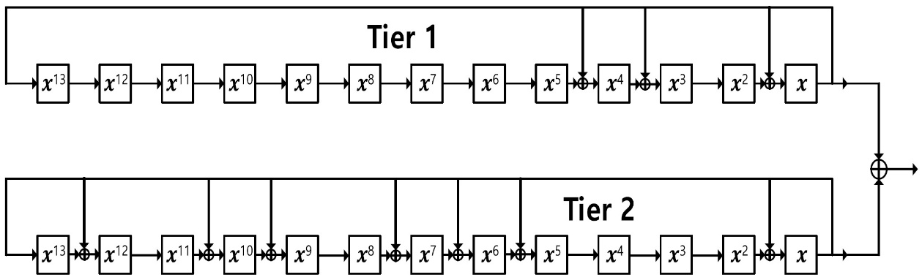
The generated TxID signal is injected into the first preamble symbol period in a time domain and transmitted simultaneously with the host ATSC 3.0 signal. To prevent performance degradation of the ATSC 3.0 payload (e.g. audio & video contents and data services), the TxID signal is injected in the preamble period, which is more robust than the data part. Broadcasters should carefully choose the injection level of the TxID in order to minimize the performance impact of the host broadcasting signals while maintaining the detection performance of the TxID signal on the receiving side, such as in measurement or monitoring equipment.
The beginning of the TxID signal is always exactly aligned with the first sample of the first preamble symbol including the symbol's guard interval (GI), as depicted in Fig. P2-26. However, since the symbol period is determined by FFT size, the TxID signal can be inserted multiple times within one preamble symbol to maximize the TxID detection capability. When an 8K FFT size is used for the preamble, the TxID having a length of 8 191 samples is injected once per ATSC 3.0 frame as depicted in Fig. P2-26(a). For the 16K FFT size, the duplicated TxID signal is additionally injected within the first preamble symbol period, as depicted in Fig. P2-26(b). Note that the duplicated TxID signal has the opposite polarity of the first TxID signal in order to average out DC components of the total TxID signal. When the 32K FFT size is used for the preamble, the TxID signal is repeated four times, as depicted in Fig. P2-26(c). In this case, the second and fourth TxID signals have opposite polarities with respect to the first and third TxID signals.
A wide range of injection levels for the TxID signal is available in ATSC 3.0, so that an operator can minimize the performance degradation of the preamble while maintaining the desired TxID detection performance. The injection level for the TxID signal can be set by the Scheduler from 9 dB to 45 dB below the level of the host preamble, with a granularity of 3 dB, and the scaled TxID signals are injected into the host ATSC 3.0 preamble immediately following the bootstrap signal.
FIGURE P2-26
TxID signal injection for various FFT sizes
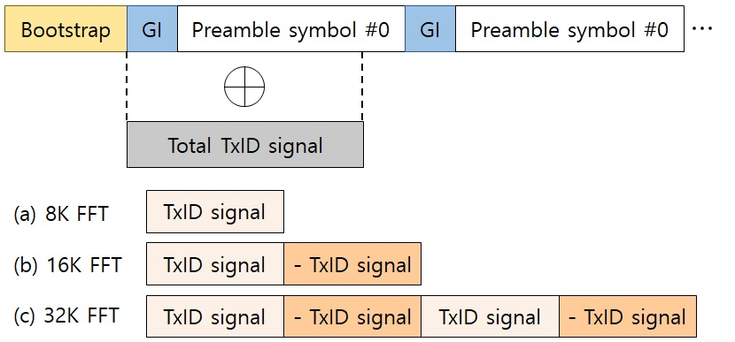

7.B.3 Transmitter identification signal detection
TxID detection can be performed by the cross-correlation method in a specially designed measurement device called a TxID analyzer. By receiving and synchronizing the ATSC 3.0 frame, the TxID analyzer can estimate the starting point of the TxID signal in the time domain. If the TxID address value is known at the TxID analyzer, TxID detection can be performed through cross-correlation between the received signal and the TxID signal generated by the TxID analyzer in the region around the expected starting point of the TxID signal corresponding to the beginning of the first preamble symbol.
TxID detection performance can be measured using an evaluation metric called the TxID signal-to-interference-plus-noise ratio (TINR). TINR is the ratio between the sum of the powers of the correlation values of the desired TxID signal and the sum of the powers of the correlation values of undesired signal, within the time window to search for the TxID signal. Note that if the TINR value is less than 10 dB, TxID detection is considered a detection failure, because the TINR is not sufficient to ensure reliable detection of the TxID signal.
Table P2-15 shows the system parameters for the laboratory and field tests. The RF centre frequency was 768 MHz, corresponding to channel 50. For a 6 MHz system bandwidth, the baseband sampling rate for generating the TxID signal was 6.912 MHz, and the occupied bandwidth for the ATSC 3.0 host signal was 5.832 MHz. When designing the SFN, the value of guard interval needs to be appropriately selected in consideration of the maximum distance between adjacent transmitters in the SFN. In this test, a 148.17 µs guard interval was used, so that the maximum distance between adjacent transmitters can be up to 44.42 km. For TxID detection at the receiving end, the TxID detection capability is not sufficient to ensure stable detection when the injection level is greater than 30 dB. Therefore, only the injection levels below 30 dB were tested, as listed in Table P2-15.
Figure P2-27 shows the measurement results of TxID detection performance according to various FFT sizes, with a commercial exciter and a TxID analyzer. As shown in the Fig. P2-27, the laboratory and field test results are generally well-aligned. When the FFT size is doubled, the length of the entire TxID signal is also doubled, so the repetition gain obtained from this becomes 3 dB, which is well shown in the measurement results. The repetition gain from increasing the FFT size is maintained even when the TxID injection level changes. In order to provide successful TxID detection in the TxID analyzer (i.e. TxID greater than 10 dB), the maximum values of injection levels were chosen up to 24, 27 and 30 dB for 8K, 16K and 32K FFT sizes, respectively.
TABLE P2-15
System parameters for various FFT sizes
RF centre frequency (MHz) | 689
Baseband sampling rate (MHz) | 6.912
Occupied bandwidth (MHz) | 5.832
FFT size | 8K, 16K, 32K
GI length (µs) | 148.15 (GI5_1024)
TxID injection level (dB) | [9 12 15 18 21 24 27 30]
Carrier-to-noise ratio (dB) | 15
Channel | AWGN (Laboratory)  AWGN-like (Field)

FIGURE P2-27
TxID signal detection performance according to injection level vs various FFT sizes
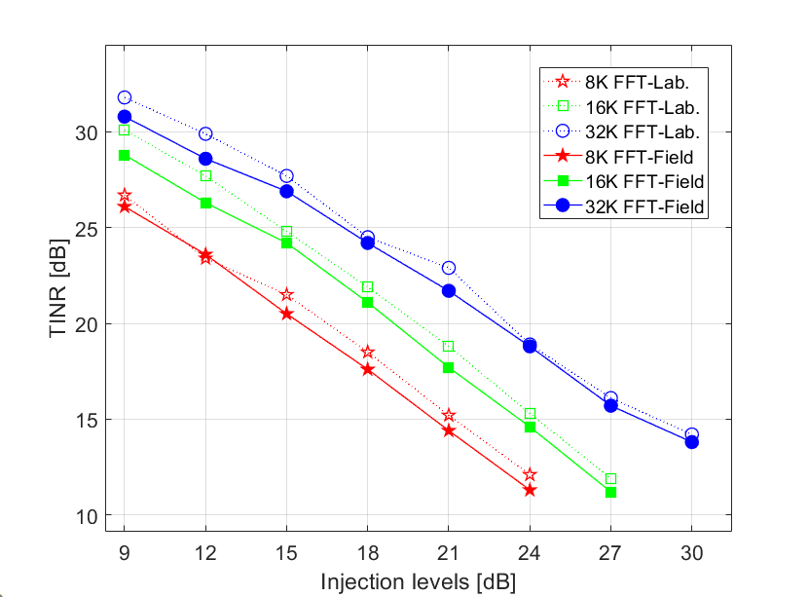
Detecting TxID signals in a multi-transmitter environment is a critical issue. Since all the host signals from multiple transmitters are identical in SFN, all host signals may be combined in a constructive manner, where each TxID is independent of each other. As a result, the effective injection level of each TxID signal is changed by combining a plurality of transmission signals. When the reception power from each transmitter is equal, the power of the combined host signal is doubled. In this case, the effective injection level of each TxID signal is 3 dB higher than the injection level assigned by the transmitter, resulting in a 3 dB performance degradation in TxID signal detection. This performance degradation is exacerbated as the number of transmission signals simultaneously received by the TxID analyzer increases.
Table P2-16 shows the system parameters for multiple-transmitter tests. For the laboratory and field tests, 6 MHz system bandwidth was considered, so that the baseband sample rate and the occupied bandwidth were 6.912 MHz and 5.832 MHz, respectively. The waveform parameters, such as the FFT size and the guard interval, were set equal to the on-air terrestrial broadcasting parameters in the Republic of Korea. The test was performed considering the maximum number of transmitters as 2. The delay among the received signals from multiple transmitters was assumed to be 7 samples, i.e. 1.0127 µs delay. The CNR for each transmission signal was assumed to be 15 dB, but the CNR at the receiving end varied depending on the number of received signals.
TABLE P2-16
System parameters for multiple-transmitter test
RF centre frequency (MHz) | 689
Baseband sampling rate (MHz) | 6.912
Occupied bandwidth (MHz) | 5.832
FFT size | 8K
GI length (µs) | 222.26 (GI6_1536)
TxID injection level (dB) | [9 12 15 18 21 24]
Number of transmitters | 1, 2
Received signal delay | 7 samples (1.0127 µs)
Carrier-to-noise ratio (dB) | 15
Channel | AWGN (Laboratory)  AWGN-like (Field)

FIGURE P2-28
TxID signal detection performance according to injection level vs number of transmitters
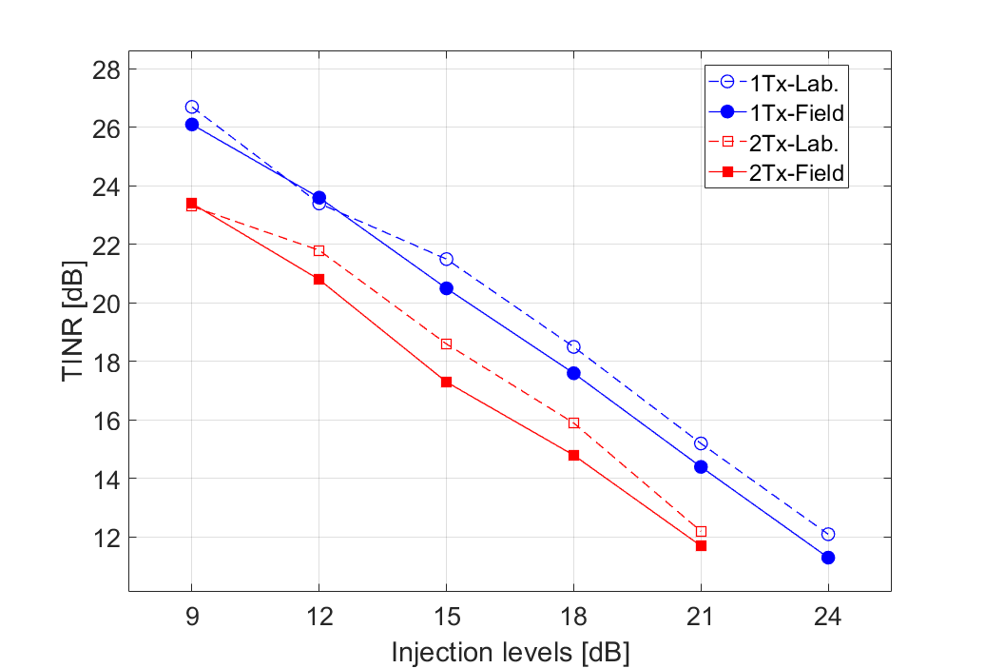
Figure P2-28 shows the results of measuring TxID detection performance in laboratory and field tests for different numbers of transmitters. The laboratory and field test results are well-aligned with each other, maintaining a performance difference of approximately 1 dB. In this Figure, it is observed that the TxID detection performance is degraded by 3 dB when the number of transmitters is doubled, when the received power from each transmitter is approximately the same. Note that the TxID detection performance may be further degraded depending on the number of transmitters or reception power imbalance.
Figure P2-29 shows one snapshot of TxID detection measured in a real field environment. This result was obtained from an operating network in the Seoul Metropolitan area, South Korea. South Korea launched SFN-based DTV services in 2017, and the SFNs are deployed on a metropolitan scale, followed by a plan to expand the SFN nationwide. The SFN of Seoul Metropolitan is currently the largest and densest DTV SFN in South Korea and consists of 10 synchronized transmitters with static inter-tower delays. The Seoul SFN consists of pure STL-connected transmitters only, without including any repeaters. Every transmitter has unique TxID signals with the same injection level of 9 dB, so that each transmitter's contribution can be measured accurately.
In the TxID detection process, advanced detection methods including frame accumulation/averaging and host preamble signal cancellation techniques were applied to provide better detection capability, especially in dense SFN scenarios. In the field test, as shown in Fig. P2-29, the TxID analyzer can detect up to six different TxID signals simultaneously, even though there exists significant pre-ghosts and long-delayed echoes. Through this field test result, it was verified that TxID signal detection is feasible even in a dense SFN environment.
FIGURE P2-29
An example of TxID detection signal in a real SFN environment
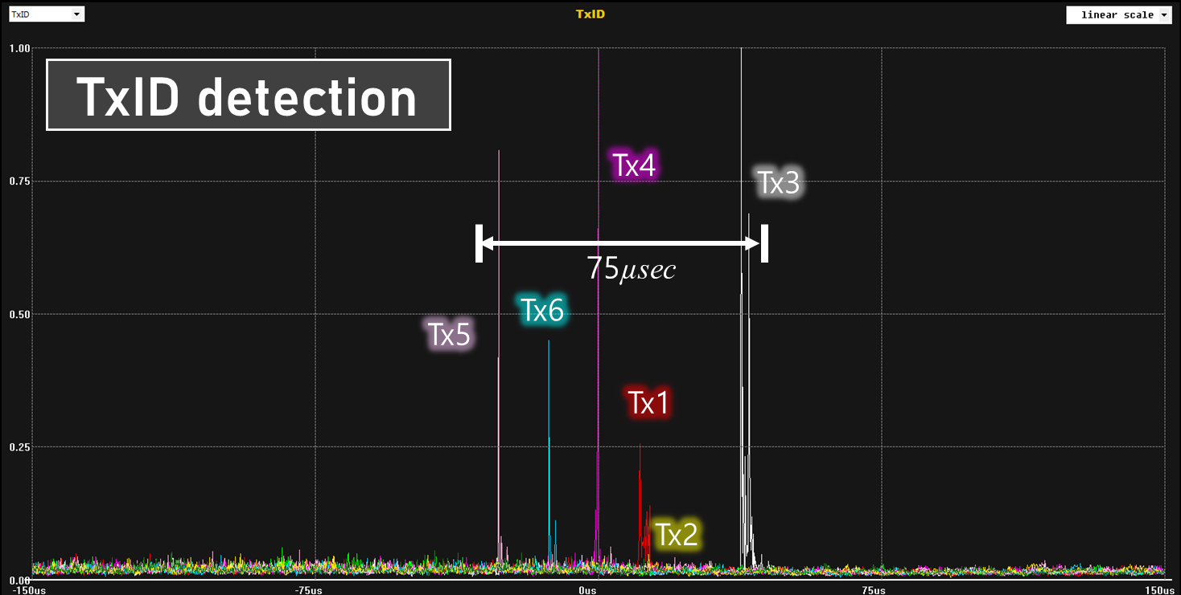

7.B.4 Other applications of the transmitter identification
While the initial focus of the transmitter identification (TxID) was on measuring and optimizing SFN performance using professional receivers, if consumer receivers are able to demodulate the TxID received with the highest power (as required for TV 3.0 receivers in ABNT NBR 25609, for example), this identification can also be used to obtain reliable and as precise as possible geolocation information (corresponding to the area where the transmitter for which the TxID is received with the highest power is the best server) directly from the over-the-air signal. This geolocation information can be used to determine whether the receiver is within the geographic target of an emergency warning message. It can also be used to provide geographically targeted content (e.g. weather forecasts, geo-targeted ads). This Report explores these use cases. It should be noted that these applications of TxID are also applicable to MFNs.

7.B.4.1 Geo-targeted emergency warnings
Although there are emergency warnings aimed at vast, continuous geographical regions, the majority of emergency warnings focus on smaller areas. The coverage of a single Digital Terrestrial Television (DTT) transmitting station can extend to a radius of tens of kilometres. When multiple stations operate together in a single-frequency network, as is often the case to reduce spectrum usage, the coverage radius can exceed one hundred kilometres. It results in a very large coverage area that is unsuitable for many emergency warning situations. Transmitting emergency warnings to large geographical areas leads to many individuals receiving alerts unnecessarily. This can cause confusion, congest evacuation routes, and desensitise the public to emergency alerts due to excessive false alarms, leaving them unprepared to respond when an alert is really important. It is, therefore, essential to limit the area of dissemination of an emergency alert as much as possible, ensuring that it remains more relevant to the affected population.
The Common Alerting Protocol (CAP 1.2), defined in Recommendation ITU-T X.1303bis, allows the authorities emitting the alerts to associate each of them with a specific geographic area, preferably using geospatial polygons or circles. If it is desirable to transmit an alert to a specific geographical area via DTT, it should be noted that DTT receivers do not normally have Global Navigation Satellite System (GNSS) reception that would provide them with precise and reliable geolocation information.
If the DTT receiver is connected to the Internet, it may use its IP address to try to determine its geolocation, but it is not precise or reliable. If it is connected directly to a mobile network (generally not the case for fixed receivers), it could try to determine its geolocation based on the position of the mobile network towers connected, which would be more precise and reliable. If it has Wi-Fi, which is often the case in DTT receivers, it could try to determine its geolocation using the Wi-Fi Positioning System. The reliability and precision tend to be higher in more developed urban areas. But all these methods rely on the Internet connection, which may not be active, especially if disrupted by an emergency situation (this issue could be mitigated by proactively caching the geolocation information on the receiver when it is connected to the Internet).
It could also use geolocation information manually set by the user (such as city or ZIP code), but the user may not input the required information or input it incorrectly. Furthermore, if the emergency warning message does not use the same type of geographically-based code set by the user, it may not be possible to determine its correspondence with geospatial polygons or circles (that may depend on a database, either stored locally or accessed over the Internet).
To address the limitations of the possible geolocation data sources mentioned above, it is possible to provide transport layer metadata in the DTT transmission, associating each TxID address to a geographic polygon that delineates the area where the corresponding transmitter is the best server. One example of such an approach can be observed in ABNT NBR 25602 (TV 3.0 – Transport layer). Such metadata enables receivers capable of retrieving the TxID address corresponding to the transmitter signal received with the highest power to obtain reliable and as precise as possible geolocation information (corresponding to the area where this transmitter is the best server) directly from the over-the-air signal regardless of Internet connectivity. Even if the receiver cannot retrieve the TxID address corresponding to the transmitter signal received with the highest power, it can still use such metadata to determine reliable, although less precise, geolocation information (corresponding to the whole coverage area of the SFN) directly from the over-the-air signal.
To further improve geolocation precision, an application-oriented TV platform (see Report ITU-R BT.2568-0 – Application-oriented television broadcasting) or Integrated Broadcast Broadband system (see Recommendation ITU-R BT.2075 – Integrated broadcast-broadband system, and Report ITU-R BT.2267 – Integrated broadcast-broadband systems) can provide an API for obtaining geolocation information from different sources, if/when available. The most reliable and accurate available source should be used if the source parameter is not provided. An example of such an approach can be observed in ABNT NBR 25608 (TV 3.0 – Application coding).

7.B.4.2 Geo-targeted content
Providing other types of geo-targeted content (e.g. weather forecasts, geo-targeted ads) would also benefit from obtaining precise and reliable geolocation information. The same geolocation sources can be considered, and the same limitations and workarounds can be taken into account. However, offering geo-targeted content, particularly when geolocation data is considered alongside other personally identifiable information related to the viewer’s profile, may necessitate extra efforts to obtain and maintain viewer consent, protect privacy, and ensure compliance with the applicable legal framework. A possible way to deal with such privacy management is described in Report ITU-R BT.2568-0 – Application-oriented television broadcasting, and ABNT NBR 25608 (TV 3.0 – Application coding).

7.B.5 Summary
SFNs can be designed efficiently using the TxID signal, which enables accurate measurement and diagnosis of the network. Utilizing information obtained from TxID signal detection, the transmission power and delay of each transmitter can be adjusted to minimize interference in SFNs. Frame accumulation/averaging or host preamble signal cancellation can be applied to detect TxID signal effectively when the injection level is low. The TxID can also be used for co-channel and adjacent-channel interference identification, geolocation, geo-targeted emergency warnings, geo-targeted content, and for individual channel estimation for each transmitter in an SFN.
Although the use case in this Annex specifically addresses an ATSC 3.0 transmission, the TxID technology could be used in other transmission systems.

8 Distribution networks for SFNs
In order to operate an SFN properly a reliable distribution network is required to provide the multiplex content to the transmitters within it. In many countries this task is performed by means of satellite distribution, but terrestrial distribution is also common, as well as IP distribution. Three examples are described in this section: the distribution network as used in Italy by Rai Way, the DVB-T signal distribution in France and the DVB-T/T2 signal distribution in Sweden.

8.1 DVB-T Sat-fed in Italy
In Italy, Rai Way broadcasts three multiplexes on behalf of Rai and eight regional multiplexes on behalf of local editors.
The first multiplex Rai is the public service multiplex with macroregional regional contents instead the others two Rai multiplexes have national content, as summarized below.
– Mux MR: macroregional
• RAI 1 HD, RAI 2 HD, RAI 3 (HD and SD, see § 8.1.10.2), RAI News 24
• ≈ 20 Mbit/s
• Coverage > 98%
– Mux A and B: national
• Thematic channels (RAI Sport, RAI Movie, RAI Scuola, etc.), Rai Radio 2 Visual, Radio Uno, Radio Due, Radio Tre, Ibrid channels (thematic Radio channels, 4K channel)
• ≈ 20 Mbit/s
• Coverage > 95%
A logical scheme representing the DVB-T distribution network is highlighted in Fig. P2-30.
Figure P2-30
DVB-T distribution network
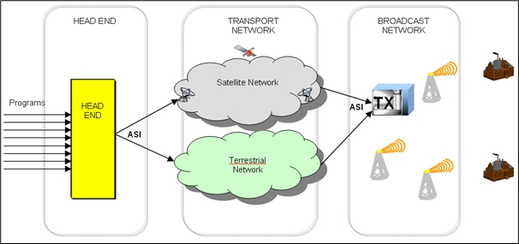
The distribution transport network uses both terrestrial and satellite systems. The terrestrial transmission network is based on radio links and Fibre leased lines from Rome to regional headquarters. This network uses Next Generation SDH technology (consisting of TS packets mapping on SDH VCs). The satellite transmission network is based on seven transponders (AB3 5°W/HB8 13°E) using the DVB-S / DVB-S2 standard.
Multiplex MR is composed by eleven different multiplexes each of them covers three different Italian regions. It requires high coverage and high priority. All multiplexes are deployed with a SFN architecture. The main distribution channel is through satellite, with radio link connecting the main sites as a backup. When the satellite transponders use frequencies in the low band (10.5-11.7 GHz) which are shared with fixed radio links, it is necessary to provide small sites also with radio links. This process, as well as the SFN, requires also a time synchronization signal which is provided via GPS.
For the multiplexes with national content the concept is similar: in the main sites, which provide about 80% of population coverage, the main transmission network is the terrestrial one and the satellite network is only used as a backup. In the smallest sites, which cover about 10% population, the only distribution network is satellite (with antenna systems typically ≥120 cm).
Figure P2-31
Terrestrial distribution network with satellite network as main
The Rai Way roadmap is currently evaluating different solutions to create new terrestrial distribution networks, as ASI radio link and IP. In particular, IP is a promising technology with high flexibility; an example is described in § 8.3.

8.2 DVB-T signal distribution in France
In France, six multiplexes are currently on air, with two additional ones being partially deployed. The first multiplex has regional content, while the remaining ones offer national programmes.
The broadcast of all the multiplexes relies on up to 1 626 sites for up to 98.5% population coverage, depending on the multiplex, with the following architecture:
– main sites all rely on satellite or terrestrial transmission links;
– secondary sites either rely on UHF or satellite transmission links (when UHF links are not possible, due for example to poor propagation conditions between the transmitting and receiving sites).
Overall, there are more than 10 000 distribution links:
– More than 3 000 links use satellite or terrestrial transmission links
– The remaining use UHF transmission links:
• 6 000 relays are on-channel repeaters (the secondary transmitters re-transmit the same channel as is distributed by the parent transmitter), either in an SFN (same content) or co-channel manner (same content or local insertion of different programs).
• Approximately 660 relays are MFN repeaters, or relays (the secondary transmitters re-transmit on a different channel to the pilot, or parent transmitter).
• The remaining relays use an MFN-SFN technique: the piloting signal is received from an MFN repeater, but the content and channel on which it is re-transmitted impose that the transmission forms part of an existing SFN on the designated channel.

8.3 Distribution of DVB-T/T2 data to the transmitters using IP in Sweden
Teracom in Sweden operates a DTT network consisting of about 54 main HPHT transmitters and about 450 smaller fill-in transmitters. Currently 7 DTT multiplexes are in operation; 5 DVB-T and 2 DVB-T2.
At the start of the DTT transmissions in 1997 (official launch 1999), using DVB-T, the distribution of the signals to the main transmitters was made using microwave links using ATM/SDH, regardless of whether they operated in an MFN or SFN. The smaller MFN fill-in transmitters were fed with an off-air signal from the main station which they transposed to a different frequency and repeated. Local re-multiplexing was used to insert local and regional content into a national or base feed that was common for all main transmitters – a single layer distribution approach. Figure P2-32 broadly shows the architecture of the ‘old’ DTT distribution network.
Figure P2-32
Old MPEG structure of DTT network
Note to Fig. P2-32: Encoding (ENC) and multiplexing is done at a national level as well as at the local sites for the local /regional content.
More recently however IP/Ethernet over DTM has been used as the primary distribution mechanism from the central head-end (see Fig. P2-33) to the main DTT transmitters. The newer DTM based distribution network is based on a two layer principle with a high capacity fibre optical core network and a mix of microwave and fibre for the distribution network from the core network to transmitter sites.
One of the main differences in the new distribution architecture (Fig. P2-33) is that all multiplexes are generated centrally at the head-end site. This covers both multiplexes that do not have local content as well as multiplexes with local content. Local content/services are sent back to the central head-end using the DTM network. The multiplex is then distributed along with all the other national and local multiplexes. For example, Multiplex 2 has national services which have approximately 30 regional news areas. At the central head-end 30 complete regional versions are created and distributed to the different regions. The local and regional multiplexes are of course only sent to the appropriate regional or local transmitters. This approach is possible since the primary distribution cost per Mbit/s is lower in the new DTM network compared to earlier. Teracom’s new primary distribution DTM based network (core network) has much higher capacity than the old ATM based network which has been replaced. The whole distribution DTM network is owned and operated by Teracom.
Figure P2-33
New structure of DTT network using IP distribution
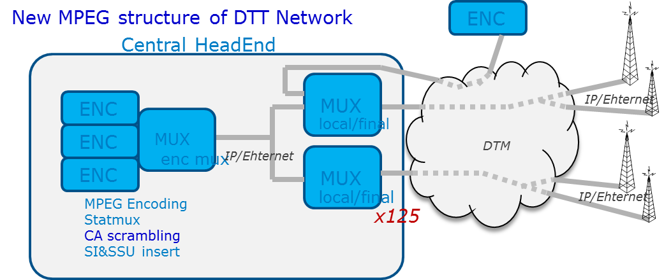
This approach with centralized systems for regional insertion etc. normally means higher cost for primary distribution, but it is well compensated for by the reduced cost for all regional systems. Additionally it makes supervision and operation much easier. With centralizing regional DTT systems (such as MPEG multiplexing, SFN adaptation and T2 gateway) it has been possible to use much more N + 1 redundancy strategies for these systems which earlier often had to use 1 + 1 redundancy. But also in a fairly large network some other advantages are: maintenance is easier, spare parts and monitoring. This has significantly reduced the cost for the regional systems.
This means that the complexity is reduced at the transmitter site allowing a reduction of the cost for maintenance as this can be done at a central location, rather than at remote transmitter sites. The connection of the transmitters is also simplified since newer transmitters are connected to the same signals, using Ethernet as the interface. (ASI interface is still however used for older legacy transmitters; this is handled via external network adaptor at the transmitter site converting IP/Ethernet signals into ASI.) Using IP/Ethernet has simplified switching when N + 1 redundancy is used by the transmitters.

9 DVB-T case studies

9.1 National DVB-T SFN deployment in Italy
The refarming of 700 MHz band in Italy began in October 2021 with the withdrawal of the coding standard MPEG-2 for the national multiplexes of Rai and the equivalent multiplexes of the private broadcasters. After that, a plan for the release of 700 MHz band based on the new National Plan of Frequencies Attribution, PNAF, was implemented region by region beginning from Sardinia in late 2021 and ending with Campania in June 2022. With the new PNAF, the national multiplexes were reduced from 20 to 12. The maximum number of multiplexes for each national network operator was fixed in three. Moreover, several regional and local multiplexes have been implemented by local network operators. One mixed VHF (7 MHz) and UHF multiplex is under consideration for the assignment to a national operator, taking into account the cap of three multiplexes for each national network operator.
Ten national UHF (8 MHz) SFN have been set up utilizing one or at most two frequencies each one and one SFN (RAI multiplex MR) was expressly designed for the public service with multiregional deployment.
Figure P2-34
Regional SFN of RAI multiplex MR
Rai Regional Multiplex – before 30 June 2022 | Rai Regional Multiplex – after 30 June 2022
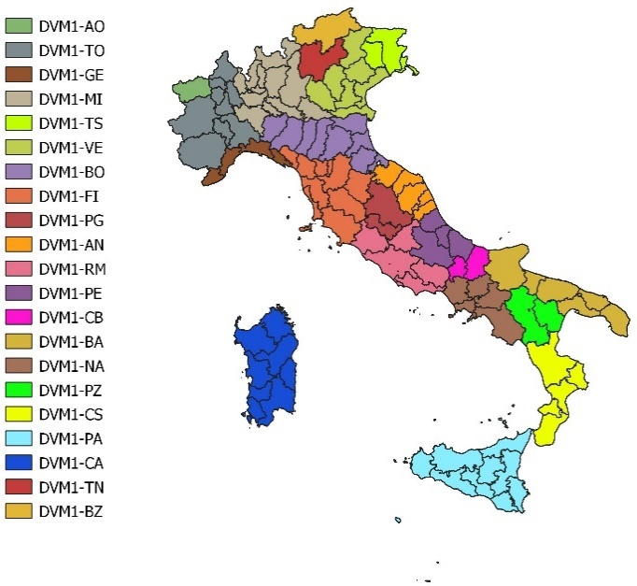 | 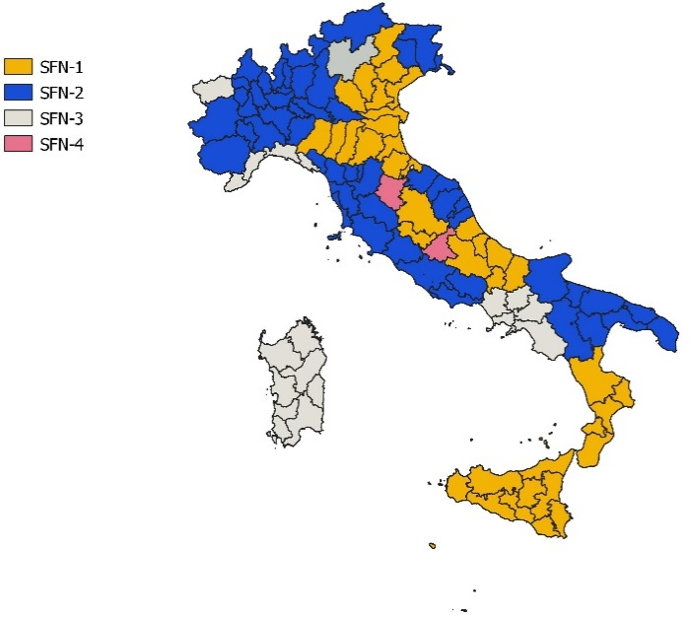
The RAI multiplex MR has been deployed using four SFNs clusters with a frequency reuse factor = 1 for each and up to three regions are covered by using the same frequency. During specific time slots in the day, each region broadcasts its own content. This means that this SFN provides a mixture of regional and national content. To overcome this trouble an application of dynamic PMT update has been implemented, and it is described in § 9.1.10.
Based on these Italians ruling, very large scale SFNs with a frequency reuse factor = 1 are now operating in Italy.
The DVB-T adopted configuration is: 8K, 64QAM, CR 2/3 (3/4 or 5/6 for private broadcasters) GI 1/4 (224 µs);
The DVB-T2 considered configurations are: 32K, 256QAM, CR 2/3 or 3/4, GI 1/8 (448 µs), PP2, extended carrier mode.

9.1.1 Example of a very large SFN: RAI multiplex A
All Rai multiplexes are deployed with large SFNs and in particular the Rai multiplex MR can be considered as a very dense SFN. Rai Way, the owner of RAI’s transmission and broadcasting network, implemented these SFNs by using around 2 023 transmitting sites for the multiplex MR, 1 096 transmitting sites for the national multiplex A and 1 017 transmitting sites for the national multiplex B.
The goal of covering more than 95% of the population with the national multiplexes and quite 99% of the population with the multiplex MR has been reached and exceeded and a good quality of service is almost everywhere guaranteed.
Figure P2-45
RAI multiplex A: transmitters and map of quality of service
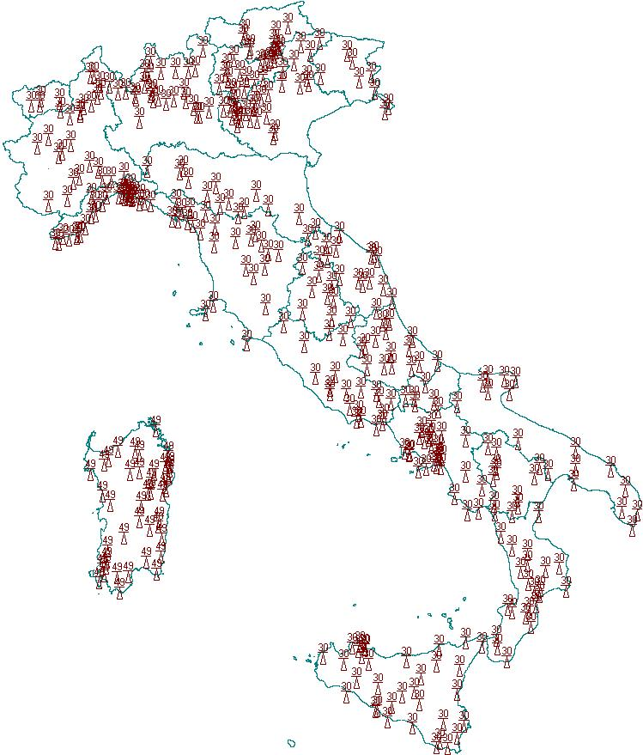 | 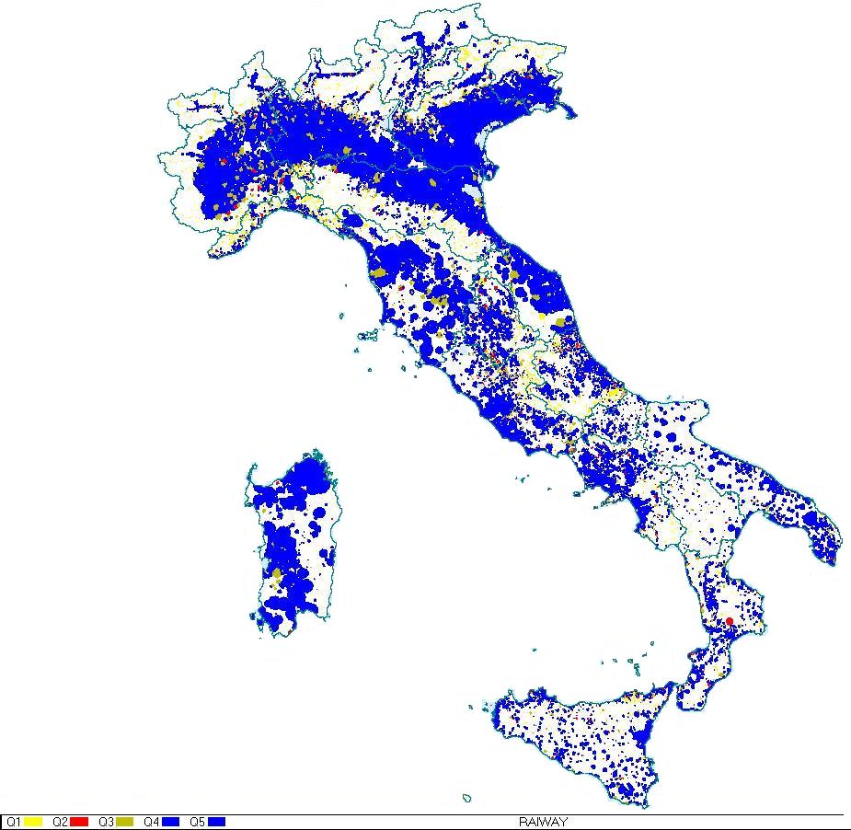
The parameters of the network are: 8K, 64QAM, guard interval ¼, code rate ⅔. The multiplex is composed by a mixed SD, HD and Hybrid TV and Radio channels.

9.1.2 Operating the network
The tuning of the network required a large amount of time, measures and studies.
Investigating the causes of very short and systematic switching on and off which affected many transmitters, often in the same instant, led to the study of the performance of GPS receivers (see Report ITU-R BT.2253).
A second class of problems seriously affecting large scale SFN with FRF = 1, is the considerable number of echoes at the user end. Two different kinds of echoes, natural and artificial, can be detected.
The first category of echoes is originated by reflections or scattering due to nearby obstacles, the second one is originated by other transmitters of the network operating on the same frequency. Propagation effects can further severely complicate reception in areas surrounded by warm sea.
Echoes may fall into the guard interval or outside it, some of them arrive in advance of the main signal, some others after it (Fig. P2-36).
Figure P2-36
Example of echo spread at the receiver end
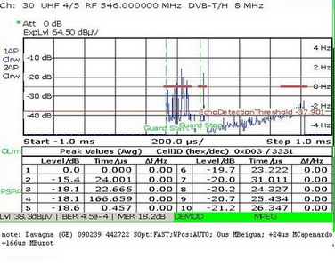
The need to accurately deploy and check the behaviour of a large SFN forced Rai Way to use transmission parameter Cell ID, Cell Identifier, to identify the transmitting site.
Rai Way is continuously using this method when performing in-field surveys and the Italian Administration has always strongly supported the use of different Cell IDs in SFN to identify transmitters.
Thanks to this use, Rai Way was able to solve bad reception problems due to propagation and to reflection.
A method of DVB-T transmitter identification has been developed. This method permits to identify all received signals from transmitters of a DVB-T SFN, at a receiving point. The full description of the method is contained in the Report ITU-R SM.2304 – Application of Technical Identification and Analysis of Specific Digital Signals.
In order to evaluate the impact of the use of different Cell Ids to end users, many surveys on receivers’ behaviour were performed. Results are shown in the embedded document “Identification of transmitters in a SFN”.

9.1.3 SFN and propagation phenomena on the warm sea
After the switch-off of all the area on the Adriatic Sea, Rai Way received many complaints because the service was not guaranteed during a few hours each day. The analysis of the problem was complex because many transmitters are operating in that region. Continuous monitoring and recording of the RF signal, MER, BER and Cell Id values permitted to discover that the transmitter that was causing the most annoying interferences on the coast was the one of Udine which is as many as 224 km away.
FIGURE P2-37
SFN transmitters insisting on Rimini area
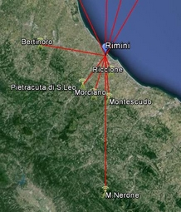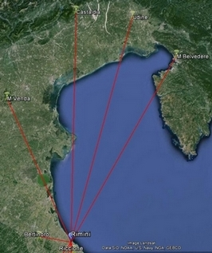
Transmitter | Distance (km) | Cell ID
M. Belvedere | 203 | 7192
Udine | 224 | 7231
Castaldia | 221 | 7307
M. Venda | 150 | 6196
Bertinoro | 30 | 8007
Pietracuta di S. Leo | 16.4 | 8802
Morciano | 18.2 | 8805
Montescudo | 19.6 | 8803
Riccione | 7.8 | 8801
M. Nerone | 59.8 | 12303

The analysis was made with an equipped vehicle placed on the coast near Rimini. A continuous monitoring with an “ad hoc” Rai Way software was performed. This software permits to register RF, MER, BER values and channel analysis parameters each minute.
A first study was executed in order to discover which transmitters was causing reception problems, keeping into account especially those transmitters which were not synchronized because very far away.
The collected measurements pointed out that Udine transmitter could be received on this part of the coast during many hours a day. A more detailed survey with the antenna in direction of Udine at 8 m height above ground was effected.
The recorded values showed that the RF levels fluctuated all day long and reached 79 dBµV/m, too (see Fig. P2-38).
Figure P2-38
Rimini registration 18 and 19 July
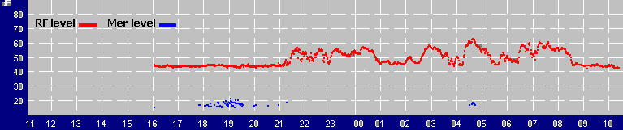
Note that during registration time, weather conditions were not particularly favourable to propagation phenomena.
Once detected that Udine signals easily arrived with significant levels, a second analysis was carried out in order to evaluate the impact of this propagation on end users.
The measurements were performed setting the antenna at 14 m height above ground towards Bertinoro which is the main transmitter of this area, simulating the typical aerial reception system of the residential buildings.
A correlation analysis was done comparing vBER values and the echoes level of all the received signal. The investigation showed that when the echo level of Udine transmitter increased, vBER decreased and overstepped the QEF threshold (see Fig. P2-39). Udine transmitter is not synchronized and has a 559 µs delay with respect to Bertinoro.
In order to solve bad reception problems, Rai Way had no other solution than to relocate the transmitter of Udine.
Figure P2-39

9.1.4 SFN and propagation phenomena on the ground
Similar propagation phenomena were detected also in other part of Italy and not originated by warm sea.
A measurement campaign was achieved in Castel San Pietro, not far from Bologna, where many people complained against bad reception during few hours a day.
This area is Monte Venda target area which is about 100 km away. Almost in the same direction there is also Col Visentin transmitter which is 200 km far away.
Figure P2-40
Monte Venda and Col Visentin position respect to Castel San Pietro – Castel San Pietro-Col Visentin profile
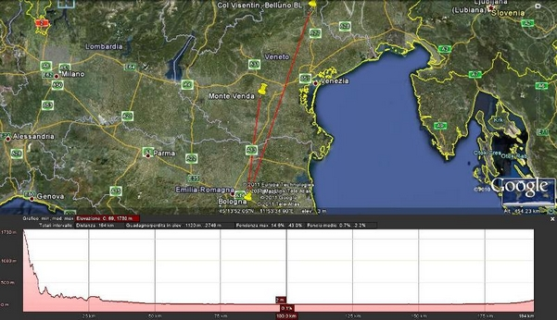
Signals coming from Col Visentin cover 200 km and therefore they are subject to propagation phenomena that can significantly vary their intensity even in the course of a single day. The path from Monte Venda extends almost in the same direction but only for half the distance (100 km): this signal can also be affected by propagation phenomena but in a different way and there is no correlation between the two. For this reason, during the day, the relationship between the level of the wanted signal and the interferer one can vary significantly.
The analysis gives evidence that, during propagation time, signals coming from Col Visentin transmitter degrades the reception quality. The following Figures, related to Monte Venda channel analysis, demonstrate the variability observed in the short period of about one hour.
Col Visentin echo has a delay of about 285 µs and appears in Fig. P2-41 also with a spurious image with a delay of −13 µs. Laboratory tests proved that spurious images of echoes appear when an echo falls outside the guard interval and its level is 21 dB or less lower than the main one.
This situation causes a serious degradation of the reception quality, which is confirmed by the bad values of MER (17.4 dB) and BER (1.4E-3).
Figure P2-41
Castel San Pietro (BO) – Monte Venda signal analysis – h 9.08
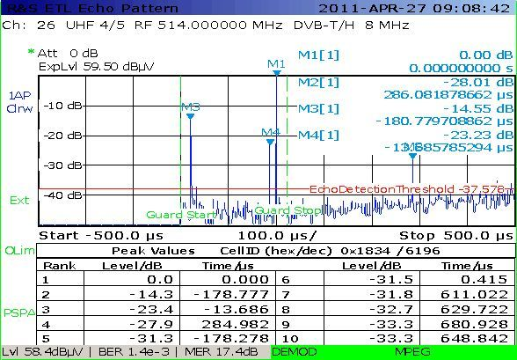
Figure P2-42 shows the same analysis repeated after 40 minutes. In the meantime the level of Col Visentin echo was decreased and better values of MER and BER were registered.
Figure P2-42
Castel San Pietro (BO) – Monte Venda signal analysis – h 9.50
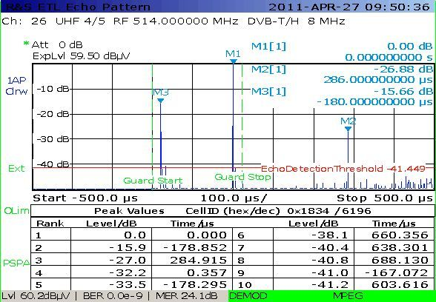
An additional test was made in order to evaluate if the degradation of signal was also due to other transmitters of SFN.
Col Visentin transmitter was switched off for a short period and an additional improvement of Monte Venda signal was observed: this confirmed that the local SFN was good optimized and only the signal of Col Visentin damaged the quality of service (see Fig. P2-43).
In order to solve this kind of problems, the radiation power of Col Visentin transmitter in this direction was reduced and the antenna tilted.
Figure P2-43
Castel San Pietro (BO) – Monte Venda signal analysis with Col Visentin switched off
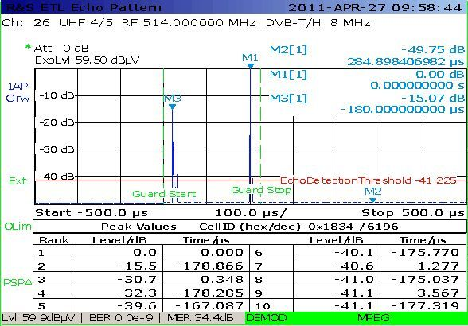

9.1.5 SFN and reflection/scattering phenomena
Another interesting study was achieved in order to optimize the SFN on Como Lake.
This lake is narrow and surrounded by mountains and reflection phenomena are very common.
The broadcasting service is granted by transmitters placed up in the mountains and directed toward the opposite side of the lake.
Figure P2-44
Como Lake overview – Detail of the northern part of the lake
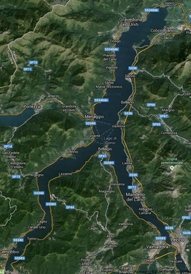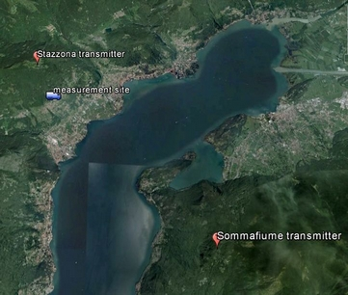
In particular, a measurement campaign was set up in the northern part of the lake, near Stazzona.
This side of the lake is Sommafiume transmitter target area and all the antenna of the buildings are pointed in that direction. In spite of the clear line of sight between transmitting and receiving antennas and the short distance between them (around 6 or 7 km), the reception quality proved to be very poor in a wide area and impossible at some points. This was mainly due to the many artificial and natural echoes.
Many of them were related to Stazzona transmitter: its signal was reflected back by the opposite side of the mountain directly or through the lake (see Fig. P2-45 – Stazzona echoes around 12 µs delay and level ≈ −26 dB).
Figure P2-45
Stazzona Channel analysis
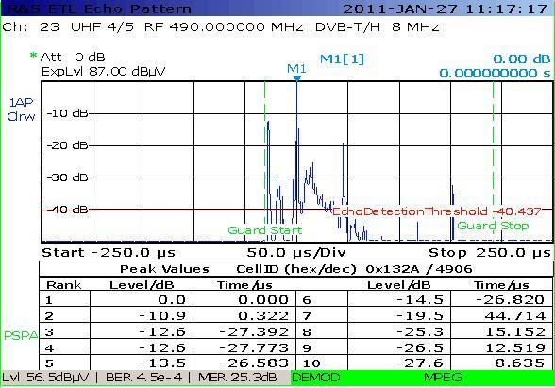
The improvement of quality of service was obtained optimizing the power of the two transmitters and the relative delays. A more detailed dissertation on this topic is presented in Report ITU-R BT.2252.

9.1.6 Optimization of SFN – DFREE experience
Besides the choice of the Guard Interval, Modulation and Code rate, there are also other technical parameters that can be used to optimise a SFN:
– static delay of each SFN transmitter;
– power of transmitters;
– antenna diagrams;
– site selection.
Parameters are listed in order of decreasing simplicity: in other words, changing a static delay is easier than changing the power of a transmitter.
For example, excluding those sites that could be critical for the SFN and replacing them with different ones always requires great efforts and large investments.

9.1.7 Parameters details
To implement large DVB-T 1-SFNs, the value 1/4 of the Guard Interval is strongly preferred. This is the maximum possible value and, with 8k carriers mode, it leads to a GI duration of 224 µs. This choice gives a penalty in terms of useful bit rate, but the gain on the reuse of frequencies always compensates this loss, because each frequency is used two, three times or even more.
The simpler action to obtain the proper SFN tuning is to modify the static delay of each transmitter of the SFN. The starting point is the static delay equal to “0” for every transmitting site. This static delay has usually a value that could be set in between ±1 ms (with steps of 1 µs) with respect to the “0” reference. In line of principle, having a “main” transmitter that is assumed with static delay “0”, all the other “minor” transmitters could have a static value that is increased in order to receive inside the GI all the contributes from different transmitters. On the contrary, near the “main” transmitter, the possible negative effect of the other transmitters (that could be outside the GI and, therefore, creating interferences) is reduced.
Decreasing the power of the transmitter of 7 dB with respect to the analogue operating value is the typical starting point to implement a DVB-T network that reuse the same site. Especially if the network is an SFN, it might be useful in some sites to modify this value (increasing or decreasing it), in order to optimize their coverage and reduce ISI.
Transmitting Antenna diagrams could be changed to improve the SFN coverage. As an example, in MFN operation, in a first direction could be useful to limit the coverage in order not to interfere another co-channel transmitter, while in a second different direction the coverage could be wider. In an SFN, it could be preferable to extend the coverage in the first direction (because the co-channel site is now part of the SFN itself) and, on the contrary, in the second direction is better to limit the coverage, to avoid “long distance contributes” that are outside the guard interval.
In a SFN the contemporary presence of many high-altitude sites that cover wide overlapping areas might create trouble to the complete coverage. In a limited number of cases, it might be the case to dismiss one of these “high altitude” sites, replacing them with one or more different sites.

9.1.8 Final technical considerations on SFN design
In a SFN it is not desirable to have strong in-homogeneities characteristics with regard to transmitter because self-interferences would then become dominant. In line of principle, for the optimisation of a large SFN it is preferable to identify a minimum number of ‘high-altitude-high-power’ transmitting sites (ideally, one for each region) that could offer large coverage and simply require the proper static delay tuning.
All the other transmitters (typically with smaller coverage) have to adopt initially a proper static delay tuning: if this is not enough, also the power or the aerials of these minor sites could be changed.
Finally, it can be considered that a DVB-T2 network could offer a larger guard interval with respect to the DVB-T, with a minimum penalty on the useful capacity.
In fact, adopting DVB-T2 32k mode, it is enough 1/16 of the useful symbol to obtain the same maximum guard interval of DVB-T (224 µs, with 8k, GI 1/4) and with 1/8 of the useful symbol it is possible to increase the GI up to 448 µs. With such a large guard interval, it’s easier to obtain a large SFN without residual ISI problems, even taking into account all the possible negative propagation effects in the worse months.

9.1.9 Examples of 1-SFN
To preserve the useful coverage of the former MFN analogue or digital network, some additional requirements and constraints on the 1-SFN were adopted (e.g. the alienation of few SFN critical sites replacing them with other additional ones, to change some transmitter aerials, re-tuning power and static delay).
Figure P2-46
DFREE at the end of the Analogue Switch Off (1-SFN) – More than 400 sites –
Useful coverage > 90% population
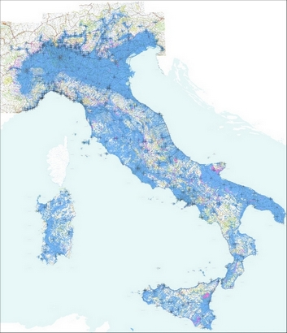
Figure P2-47 shows details of the 1-SFN in two cases: a well optimized network and at the beginning of the tuning process where all the static delays of the network are set to the value “0”.
Adopting different configuration for the 1-SFN, the indicative values for the ISI should be:
– power −7 dB, no other tuning: ISI = 10%;
– power −7 dB and static delay tuning: ISI = 3.5%;
– power and static delay tuning: ISI = 1.5%;
– sites, antenna diagrams, power and static delay tuning: ISI < 1% (see Fig. P2-47)
ISI is expressed in terms of population coverage.
Figure P2-47
Detail of the 1-SFN coverage (“site”, “power”, “diagrams” and “static delay” tuning)
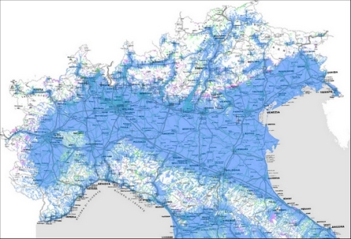

9.1.10 Special applications for SFN
Due to the shortage of multiplexes assigned to the national broadcasters and the constrain given by the implementation of the macroregional multiplex MR (multiregional coverage and locations of transmitting sites), Rai implemented some specific features able to overcome such constrains.

9.1.10.1 Logical Channel Number (LCN) management
The RAI macroregional multiplex MR contains the following programmes: Rai 1, Rai2, Rai News 24, the national Rai 3 and three regional Rai 3 programmes. The Logical Channel Number, LCN, 1 has been assigned to Rai 1; the LCN 2 has been assigned to Rai 2 and LCN 3 has been assigned to each Rai 3.
Table P2-17 identifies the planned regional triplets.
TABLE P2-17
Italian macroregional SFN
BOUQUET | Region 1 | Region 2 | Region 3 | Channel
1 | RAI 3 LOMBARDIA | RAI 3 PIEMONTE | RAI 3 EMILIA ROMAGNA (PC) | 30
2 | RAI 3 SUDTIROL | RAI 3 TRENTINO | RAI 3 ALTO ADIGE | 30-43
3 | RAI 3 LAZIO | RAI 3 ABRUZZO | RAI3 MOLISE | 37
4 | RAI 3 LAZIO | RAI 3 TOSCANA | RAI 3 UMBRIA | 30-37-45
5 | RAI 3 PUGLIA | RAI 3 BASILICATA | RAI 3 MOLISE | 30
6 | RAI 3 EMILIA ROMAGNA | RAI 3 VENETO | RAI 3 LOMBARDIA | 37
7 | RAI 3 FRIULI VG | RAI 3 BIS (TS) | RAI 3 VALLE D’AOSTA | 30-43
TABLE P2-17 (end)
8 | RAI 3 LIGURIA | RAI 3 SARDEGNA | RAI 3 TOSCANA | 43
9 | RAI 3 MARCHE | RAI 3 UMBRIA | RAI 3 ABRUZZO | 30
10 | RAI 3 CALABRIA | RAI 3 SICILIA | RAI 3 BASILICATA | 37
11 | RAI 3 CAMPANIA | RAI 3 BASILICATA | RAI 3 CALABRIA | 43

During tuning phase of the receivers, an LCN conflict appears asking the user to choose which regional programme has to be assigned to LCN 3.
The resolution of the conflict could be further complicated by the presence of the same macroregional multiplexes transmitted on different frequencies (case 2, 4 or 7 of Table P2-17) or by different macroregional multiplex on the same area (overlapping coverage areas).
The Italian Authority Autorità per le Garanzie nelle Comunicazioni (AGCOM) accepted RAI request for the assignment of specific LCNs for regional programs in the positions from 801 to 823 in addition to LCN 3 and issued a renewed LCN plan. Consequently, the user has the option to select the desired regional content on LCN 3, still being able to take advantage of the two additional regional programmes available on its territory.
Table P2-18 identifies the list of assigned LCNs.
TABLE P2-18
Italian regional LCN
LCN | Rai 3 TGR
801 | Valle D'Aosta
802 | Piemonte
803 | Liguria
804 | Lombardia
805 | Veneto
806 | Bolzano
807 | Trento
808 | Sudtirol (Regional program in German)
809 | Friuli-Venezia Giulia
810 | Furlanija Krajina (Rai 3 Bis)  (Regional program in Slovenian)
811 | Emilia-Romagna
812 | Toscana
813 | Marche
814 | Umbria
815 | Lazio
816 | Abruzzo
817 | Molise
818 | Campania
819 | Puglia
TABLE P2-18 (end)
LCN | Rai 3 TGR
820 | Basilicata
821 | Calabria
822 | Sardegna
823 | Sicilia

To verify if TV sets and decoders were able to manage the LCN conflict, RAI carried out a series of tests in collaboration with the Italian Authority Ugo Bordoni Foundation (FUB) and the receiver manufacturers on all types of receivers (Set-Top-Box and IDTV receivers) available on the reference market. Tests have been performed in particular in the case of multiple conflicts up to 6/9 simultaneous regional programmes. When necessary, upgrades of the receivers’ software were developed by manufactures. To facilitate the updating operations on the national territory, Rai has also set up and offered an OTA platform for on-air updates.
An example of LCN collision resolution is reported in Fig. P2-48.
Figure P2-48
Example of LCN collision resolution
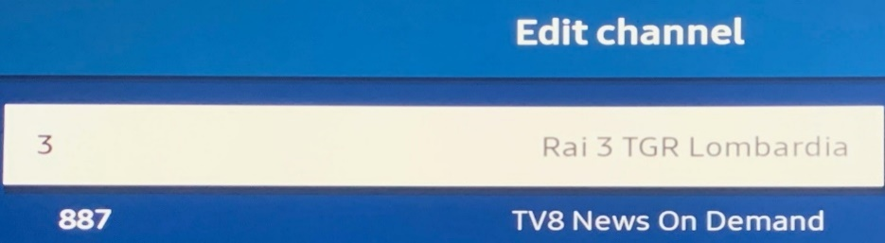
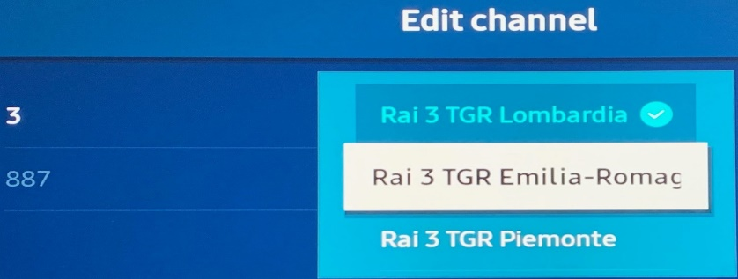


9.1.10.2 Capacity optimization through dynamic bandwidth management
The RAI macroregional multiplex MR is composed by HD and SD programmes. One hour a day, the Rai3 HD programme needs to be replaced by three different SD regional programmes. The simplest solution is to transmit three SD Rai3 programmes simultaneously for all 24 hours and the Rai3 HD programme in another multiplex, wasting capacity.
To overcome such problem, Rai studied a new solution considering the impact on the receivers, on the Head End and on the master control.
In particular, it has been verified the ability of the receivers to manage the dynamic change of the content of PMT table, the ability of the head end to reconfigure itself regardless the brand and the ability of the master control to generate and propagate the synchronization signalling.
RAI group has developed a technical solution able to meet the above constraints by adopting a new dynamic management logic of the bandwidth at the broadcast head end. Rai3 content is declared in the multiplex four time: one as HD ghost programme and three as SD regional programmes. During the periods of the regional contents’ transmission, each declared SD programme is associated to a different audio-video Programme Identifier (PID). During the rest of the day, the three regional programmes are associated to the same audio-video PID of the HD ghost programme. Thus, the capacity dedicated to Rai3 is dynamically distributed between the HD ghost and SD regional programmes. Figure P2-49 describes the new logic employed in the central head end for dynamic bandwidth management during the regional programming hours. To implement this solution, it is necessary to insert a synchronism signalling on the outgoing stream of each Rai regional headquarter. Such signalling allows, in the time slots assigned to the regional programming, to centrally manage the automatic remodulation of the capacity between the audio-video common component (HD) and the dedicated audio-video component (SD).
Figure P2-49
Dynamic management of the multiplex capacity
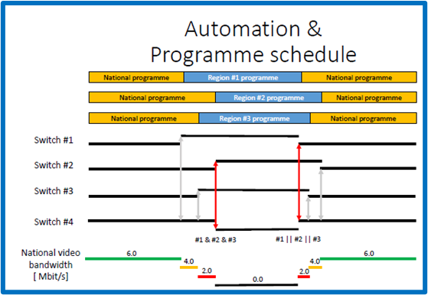
At the receiver side, activating the new Rai feature of dynamic bandwidth management, the update of the PMT table is detected by DVB-compliant receiver as a manual channel change without any fault.
This solution optimizes the available capacity of the RAI multiplex MR, transmitting a single HD Rai 3 content for about 23 hours per day and switching automatically to three SD regional programmes for the remaining time and vice-versa, with a user perception of a simple channel change, without wasting capacity with the transmission of Rai 3 HD in another multiplex.
It is important to point out that such solution is applicable regardless the adopted transmission standard, DVB-T or DVB-T2.

9.1.10.3 HbbTV applications in SFN environment
The release of 700 MHz band has reduced the maximum number of multiplexes available for each broadcaster, from five to three, and consequently the available capacity to carry the same or more contents.
Consequently, each Multiplex contains no UHDTV HEVC, few 1 080ì, some 720p and more 576ì programmes. The only way to overcome the constrains given by the limited available capacity and to provide the contents at the highest quality is to complement each non UHD or 1 080ì programmes with its hybrid version, for which specific LCNs have been assigned.
Moreover, each multiplex is deployed in 1-SFN or 2-SFN clusters with frequency reuse factor of 1, and this leads to a very dense geographical SFNs, and forces the use of the maximum guard interval (G.I. 224 µs in DVB-T and 448 µs in DVB-T2) and the higher protection code rate (C.R. 2/3). A further constrain for the macroregional multiplex is given by the requirement to use the frequencies assigned to the region for the transmitting sites placed within. In some cases, the impossibility to broadcast the right regional content to the right region arose. To overcome these constrains, Rai has developed specific solutions based on HbbTV features. Information on HbbTv features and applications can be found in Recommendation ITU-R BT.2075, Recommendation ITU-T Y.2239 and Report ITU-R BT.2267.

9.1.10.3.1 HbbTV and 4K Hybrid application
Through HbbTV hybrid application RAI made available again the entire thematic radio offer that had been suppressed in October 2021 due to lack of capacity on the Rai DTT multiplexes.
Since November 2022, during the Soccer World Cup, “Rai 4K” channel has been made available in hybrid mode on Rai digital terrestrial platform in addition to satellite platform, RAI TiVùSat.
Users who have TV sets compliant with DVB standard, 4K and HbbTV technology (HbbTV version from 2.0.1 onwards) and connected to the Internet network, can receive Rai 4K hybrid channel on the DTT platform, through the direct selection of the LCN 101 on the remote control or through HbbTV “Rai TV +” application.
Figure P2-50
4K hybrid application
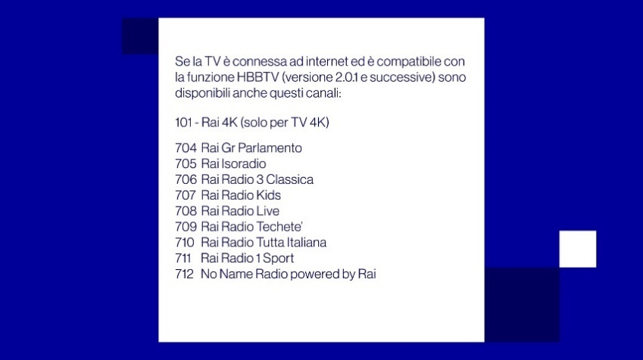
Despite the same content was available in HD format on Rai 1, which is receivable in 99% of the Italian national territory, over 100 000 families have appreciated the Soccer World Cup event in 4K format. In the occasion of the Soccer World Cup, in addition to geo-blocking, it was also necessary to apply the Digital Right Management (DRM) to the audio and video streams of the live streaming service in MPEG-DASH. The technical choice of delivering the decryption information to the receiver via the HbbTV application and not via the ‘manifest’ file has highlighted an incomplete implementation of the content protection technology by some brands of TV sets and decoders. The Rai Centre for Research, Technological Innovation and Experimentation (CRITS) has made available information useful for the identification of the malfunction causes, allowing manufacturers to prepare software updates for their products.
At the end of 2022, in Italy HbbTV compliant connected televisions can be estimated up to 16 million. This statistic is growing rapidly and certainly provides opportunities for the use of value-added interactive services.

9.1.10.3.2 Regional Exchange Action
To provide the right regional content, Rai developed a new functionality, Regional Exchange Action (REA), to be integrated into HbbTV interactive application, Rai Tv+, available from July 2021 on HbbTV receivers (version 2.0.1 or later) connected to the Internet network.
Using the REA functionality, each user could choose one of the 23 regional contents available on the RAI platforms, regardless the viewing location. In particular, if the receiver is tuned into one of the Rai 3 programmes available on DTT platform, the user, by selecting a specific icon in a banner, is linked to the interactive platform on a configuration page and the user has the possibility to select the preferred content. Whenever the regional contents start, users are also informed through a message superimposed on the video, that they could access the configuration page and to revise it, if needed.
Figure P2-51
“Now on air” section: access to the configuration page from the “Change the editor” icon

Figure P2-52
Configuration access message via green remote-control button

Once the preferred regional content has been selected on the configuration page, at the beginning of each regional content, REA functionality automatically tunes into the selected regional Rai 3 programme. There is no default regional content, and the configuration is saved in the persistent memory of the receiver.
Figure P2-53
REA function configuration page
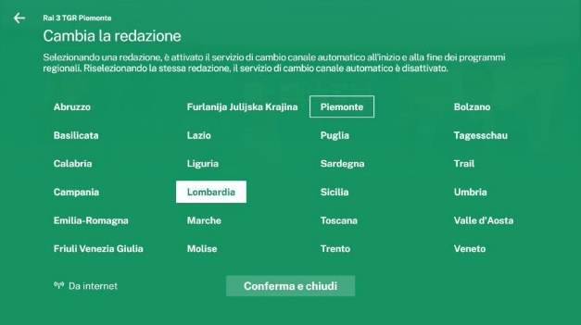
When starting the REA player, the content is received by streaming mode.
As soon as the IP trasmission has been launched, a message superimposed on the video signal indicates that it has a delay with respect to the corresponding transmission broadcast.
Figure P2-54
Broadband and broadcast delay message
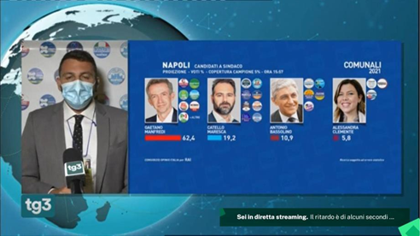
The flexible configuration of the REA function allows automatic switching from the DTT platform to the IP platform and vice-versa when a specific content cannot be received on the DTT platform.
In case the user does not have Internet access, even temporarily, the REA functionality will enable the transmission of the contents present on the DTT platform in that region.
In conclusion, in case of Smart TV connected to the Internet network and HbbTV compatible, the REA functionality integrates regional contents broadcasted on DTT with IP contents and allows the users to choose the preferred regional contents in a flexible way.
DVB-T2 SFN

10 Overview
DVB T2 has, relative to its predecessor DVB T, introduced significantly more freedom with respect to SFN planning and implementation. In particular the increased guard interval durations that DVB T2 offers allow the maximum practical size of SFN to be extended while maintaining high throughputs (or conversely the throughput of existing SFNs to be increased while maintaining coverage). The extent to which DVB T2 can be used to introduce new, or modify existing SFNs is discussed here, along with some of the practical considerations that would be involved in so doing.
In the first instance the maximum possible extent of an SFN is of interest, i.e. is there any limit to the geographical area that an SFN may cover? In principle SFN areas may be arbitrarily large, but in practice a number of technical and non-technical factors limit their useful size.
Self-interference places the main constraint on the size of an SFN. In broad terms an SFN will contain coverage holes if any two transmitters within it are separated by distances exceeding the guard interval (more exactly: the distance which the signal travels during the guard interval period). Up to a limit, it is possible to overcome this interference and regain the coverage by increasing the signal’s guard interval, or by improving its robustness. However, doing either of these will reduce the network’s throughput, and it becomes necessary to trade off coverage against throughput in order to find the most satisfactory combination of the two.
Alternatively, increasing the number of sites within the network in order to reduce the inter site distance (ISD) would overcome self-interference without reducing coverage or capacity. However, this option could be very costly, and is largely ruled out in instances where the pragmatic approach of re using existing infrastructure is opted for.
These factors combine in most practical instances to limit the extent to which SFNs are deployed.
Additional non-technical factors also limit their size editorial or commercial regions play an important role in determining their dimensions.
In order to see how these factors would affect SFNs in practice, several studies have been undertaken and few are here summarized (for the detailed description see the Annexes of the EBU document Technical Report TR 029 https://tech.ebu.ch/).

11 Spectral efficiency and spectrum consumption of DVB-T2 networks

11.1 Spectral efficiency and spectrum consumption
In this section the spectral efficiency of DVB-T2 is considered in a more theoretical light and the concept of Layer Spectrum Efficiency (LSE) is introduced. This concept is a more generalized way of assessing spectral efficiency which incorporates into a single figure the raw spectrum efficiency of a transmission system as well its re-use distance (a factor that characterizes the distance beyond which a channel may be re-used without causing undue interference; it has a major impact on the overall spectrum consumption of a transmission system). LSE is therefore more holistic than traditional measures of efficiency which are usually based on the performance of a transmission system in isolation (i.e. the performance of the air interface). LSE more clearly sets out the total amount of spectrum a system would require in order to deliver a set of services, and allows a direct comparison of one system with another while taking into account factors such as the network topology and frequency plans.
Spectrum consumption, together with cost considerations are the major aspects which determine the efficiency of a particular network topology and mode (SFN or MFN).

11.2 Spectral efficiency of DVB-T2
A basic characteristic of a radio transmission system is its spectral efficiency. This is defined as the available data rate per unit frequency, measured in bit/s/Hz. DVB-T2 is specifically designed for the terrestrial distribution of linear broadcast content, and as such it has a high spectral efficiency, in particular for fixed reception. Table P2-19 shows this by setting out the spectral efficiency of a range of DVB-T2 modes appropriate for a HTHP network topology. They have been taken from Report ITU-R BT.2254 – Frequency and network planning aspects of DVB-T2, and are here referred to as scenarios 1 through 8. These are typical modes in operation. Theoretically even higher values of the spectral efficiency are possible.
TABLE P2-19
System parameters and spectral efficiencies of several DVB T2 modes
Scenario | FFT Modulation | Code rate | GI [µs] | Data rate (Mbit/s) | C/N (dB) | Network type | Reception mode | Spectral efficiency (bit/s/Hz)
1 | 32K ext 256 QAM | 2/3 | 28 | 40.2 | 20.0 | MFN | fixed | 5.0
2 | 32K ext 256 QAM | 2/3 | 448 | 33.4 | 21.2 | Large SFN | fixed | 4.2
3 | 32k ext 256 QAM | 2/3 | 224 | 37.0 | 20.8 | Medium SFN | fixed | 4.6
4 | 16K ext 64 QAM | 2/3 | 224 | 26.2 | 17.9 | Medium SFN | portable outdoor/ mobile | 3.3
5 | 32K ext 64 QAM | 2/3 | 448 | 26.2 | 17.9 | Large SFN | portable outdoor | 3.3
6 | 16K ext 64 QAM | 1/2 | 448 | 16.9 | 15.1 | Very large SFN | portable outdoor/ mobile | 2.1
7 | 16K ext 16 QAM | 2/3 | 224 | 17.5 | 13.2 | Medium SFN | portable indoor | 2.2
8 | 16K ext 16 QAM | 1/2 | 224 | 13.1 | 9.8 | Medium SFN | (deep) portable indoor | 1.6

11.3 Layer spectrum efficiency of DVB-T2
In § 11.2, only the raw spectral efficiency of the transmission system was considered. In order to address the efficiency question more fully, the total consumption of spectrum needs to be taken into account by incorporating the frequency re-use factor.
Transmission systems, together with their associated network topology are often characterized by the minimum required number of frequency channels to cover a large area, or layer. This is called the frequency re-use figure. This number of channels has to be made available in order to cover the whole layer even if not all channels are used in all locations.
However, in order to realistically assess the spectrum consumption of a transmission system, the frequency re-use figure is a rough metric. For example, in the GE06 plan, six to seven channels are required to cover one layer in Europe. But this does not mean that all of these channels are blocked everywhere in the considered area (i.e. that they cannot be used elsewhere in the area). Trivially, one channel is blocked since it is used by the intended service. But, in general, only a fraction of this area is blocked for all the other channels. Thus, there remains a part of the area where the remaining channels may be re-used for other purposes. Therefore, a blocking factor would be a better characterization of the spectrum consumption of a transmission system with its associated network topology than the frequency re-use figure.
In the EBU Technical Review 2014 an approach is described for defining such a blocking factor. It is called the re-use blocking factor. This factor depends on the system sensitivity, the network topology, the size and shape of the service areas and to a minor extent on the frequency channel distribution of the considered frequency plan. It is thus not a fixed factor of a class of plan implementations but varies slightly from one individual implementation of a frequency plan to the other. Based on these considerations a generalization of the concept of spectral efficiency is introduced which is called Layer Spectrum Efficiency (LSE). It allows for a more holistic assessment of the spectrum needed for a particular scenario to be implemented. The findings of the EBU Technical Review 2014 are summarized here.
Basically, the LSE value is given by the ratio of Spectral Efficiency to Re use Blocking Factor (RBF):
$$LayerSpectrumEficiency=\frac{SpectralEficiency}{Re-useBlockingFactor}$$
The larger the re-use blocking factor, the smaller the layer spectrum efficiency; and the larger the spectral efficiency, the larger the layer spectrum efficiency. Since RBF is dimensionless, LSE has the same dimension as the spectral efficiency SE; bit/s/Hz.
The concept of layer spectrum efficiency has been applied to the scenarios listed in § 5.2. In order to simplify the examples, all scenarios assume full area coverage (100%).
An RBF of 7 is assumed for the MFN approach. For an SFN approach for regional service areas, which requires medium size SFNs, an RBF of 5 is used as calculated in the EBU Technical Review 2014. A less regionally oriented approach for the service area would allow for larger SFNs which may be assumed to have an RBF of 4. National service areas, which are even larger and correspond to very large SFN, show an RBF of about 2 as explained in the EBU Technical Review 2014.
Table P2-20 collects these data for the DVB-T2 based scenarios of § 10.2 and gives typical values of the resulting Layer Spectrum Efficiency in the last column.
Two clear trends can be observed. High requirements with regard to regionality (from large SFN to medium SFN to MFN, the latter allowing for the highest degree of regionality) have to be paid for by a lower layer spectrum efficiency, and also high requirements with regard to the ease of reception (from fixed to portable outdoor/mobile to portable indoor) have to be paid for by a lower spectrum layer efficiency.
TABLE P2-20
Layer spectrum efficiency of various DVB-T2 scenarios
Scenario | DVB-T2 Network Type | Reception Mode | Spectral Efficiency SE (bit/s/Hz) | Typical value of the re-use blocking factor RBF | Typical value of the layer spectrum efficiency LSE (bit/s/Hz)
1 | MFN | Fixed | 5.0 | 7 | 0.71
2 | Large SFN | Fixed | 4.2 | 4 | 1.05
3 | Medium SFN | Fixed | 4.6 | 5 | 0.93
4 | Medium SFN | Portable outdoor/mobile | 3.3 | 5 | 0.66
5 | Large SFN | Portable outdoor | 3.3 | 4 | 0.83
6 | Very large SFN | Portable outdoor/mobile | 2.1 | 2 | 1.05
7 | Medium SFN | Portable indoor | 2.2 | 5 | 0.44
8 | Large SFN | (Deep) portable indoor | 1.6 | 4 | 0.40

11.4 Re-use distances for DVB-T2 networks
In order to make an optimum use of the spectrum which is a finite natural source, it is inevitable to re-use the same frequency over different geographical areas. Each of these areas that are covered with a single frequency network is called a service area. To make the repetition of frequency channels possible, a minimum distance –the re-use distance between the co-channel service areas is vital otherwise there would be an unacceptable degradation in the operation of the co-channel systems. The re-use distance is a metric which plays an important role in the determination of spectrum consumption and is a major component in the evaluation of the re-use blocking factor.
In a study by IRT (see document EBU Technical Report TR 029 – Annex A6 https://tech.ebu.ch/), the general behaviour of a reference hexagonal network was investigated in the presence of another co channel reference network. The minimum required distance between operating co-channel service areas was also studied and the relationship between various SFN system parameters and the re-use distance has been set out.
Typical DVB-T2 network implementations have re-use distances between 80 km and 120-130 km. A remarkable dependency on the power budget of the network is to be observed. At least a 3 dB power margin above the minimum field strength is required in order to restrict the re-use distances to a reasonable value.
A further interesting finding of the study is that the typical effective antenna heights of the networks have a remarkable influence on the re-use distance. With lower effective antenna heights the re-use distances increase faster with increasing C/N values than with higher effective antenna heights.
The reason for this effect is that at larger distances (beyond the radio horizon) field strengths decrease slower with decreasing effective antenna heights than at smaller distances. Thus, with decreasing antenna heights, the margin between wanted field strengths (coming from smaller distances) and unwanted field strengths (coming from larger distances) decreases, and along with this also the achieved coverage probability. In order to compensate for this a larger re-use distance is required.
Also differences in the re-use distance regarding different reception modes are remarkable. More demanding reception modes require larger re-use distances. Table P2-21 gives an example for a particular DVB-T2 mode.
TABLE P2-21
Land path re use distances of DVB-T2 for different reception modes
64 QAM 3/5, PP1, 1/4 , 16k , data rate = 20.1 Mbit/s (95% location probability)
Fixed rooftop reception | Portable outdoor reception | Mobile outdoor reception
Re-use distance = 60 km | Re-use distance = 100 km | Re-use distance = 165 km

Moreover, the influence of the inter-site distance of the transmitters in the network on the re-use distance is investigated. As can be expected, with increasing inter-site distance the re-use distance becomes larger. However, this effect is more pronounced for portable reception than for fixed rooftop reception due to the directional character of the receiving antenna in the fixed reception case.

12 DVB-T2 Lite
In several countries, DVB-T2 networks for the delivery of SD and HD television content over terrestrial channels have already been deployed, or are planned.
Often these networks are designed for fixed reception, but there is a growing demand for linear TV viewing on portable devices, such as tablets. The increasing number of these devices is placing considerable load on mobile operators’ networks which are trying to serve their users with unicast delivery.
Broadcasting would, however, be both technically and economically better to reach large audiences during peak hours or major events. For this reason in 2011 DVB introduced T2 Lite (EN 302 755), which supports portable and mobile reception alongside a DVB-T2 service for fixed reception.
To reduce the cost of network deployment, T2 Lite can be combined together with T2 Base (i.e. DVB-T2) and deployed on the existing networks using Future Extension Frames (FEF) within the DVB-T2 standard, thus avoiding the need to build a new network dedicated exclusively to mobile services. A short description of how this could be achieved may be found in Report ITU-R BT.2254 – Frequency and network planning aspects of DVB-T2.

13 DVB-T2 and DVB-T2 Lite case studies

13.1 Theoretical study on maximum achievable data rates for large DVB T2 SFN areas
In a study by IRT, theoretical hexagonal networks have been used in conjunction with the Recommendation ITU-R P.1546 propagation model to examine the limitations and capabilities of large DVB T2 based SFNs. Two cases, a large SFN with dimensions of 360 km × 360 km and a very large SFN (720 km × 720 km), have been analysed in order to find the modes that would, for 100% area coverage, provide the maximum achievable data rate for mobile, portable and fixed reception.
In the model an inter transmitter distance of 60 km was assumed. All transmitters in the SFN are assigned the same characteristics: omnidirectional antenna, effective antenna height of 300 m and an e.r.p. of 100 kW.
Additionally the trade-off between area covered and increasing data rate is discussed. Although the large SFN is already quite extensive, due to additional interference beyond the guard interval, the introduction of further transmitters to extend the SFN size affects the performance of the network and impairs reception. This characteristic is closely related to a further trade-off between a higher data rate and a lower reception quality, which is also examined. With an increasing data rate the percentage of the covered area decreases. For instance, in the large SFN, 100% coverage with 20.1 Mbit/s for mobile reception could be achievable, whereas an increase in the data rate to 22.4 Mbit/s would cover only 52% of the area to the required location probability the rest (48%) would fall below this limit (but would still be above 95% coverage probability).
The less demanding parameters for portable reception, as compared to mobile, allow for higher data rates; for instance, for the large SFN up to 30 Mbit/s would be possible. This is a significant difference which is mainly due to the assumption of a 5 dB allowance for Doppler degradation (which may be conservative) that has been made for mobile reception.
Nevertheless it has been found that even for the large SFN, and also for the very large SFN, a guard interval of 448 µs (GI 1/4 with 16k FFT) would be required. Smaller GIs cannot fulfil the coverage requirements. Only in the case of portable reception, where the modulation is made more robust (64 QAM reduced to 16 QAM), would the smaller guard interval yield acceptable coverage.
Finally, based on a hexagonal network with the size as of 360 km × 360 km, the relationship between signal robustness and minimum required guard interval for networks with various inter site distances has been analysed. As can be expected, the required guard interval increases as the inter site distance and the C/N value increase. For example, a DVB T2 mode with a C/N of 20 dB, operated in an SFN with a typical inter site distance of 50 km requires a guard interval of at least 425 µs. For a 16k FFT there is only one such guard interval value available which is GI 1/4 (448 µs).
The results may be used as guidance in the initial stages of the network planning process when choosing a DVB T2 mode for particular coverage scenarios.

13.1.1 Introduction
The objective of this study is to analyse the capabilities of single frequency networks in DVB-T2 when there is a mission to cover a large area. This could be a state, a region or an entire country.
Planning a network requires a trade-off between the size of a coverage area and the highest achievable data rate. In other words it is not possible to cover a large SFN with the highest available data rate. This is due to the fact that deleterious delay differences of signals from different transmitters have to be compensated by a so-called guard interval. This mechanism has to be paid for by data capacity. For this reason an optimisation should be found to fulfil both requirements in the best possible way.
In this optimisation problem different degrees of freedom are available. Some of them are the inter-site distance, transmitter antenna height, effective radiated power, modulation and code rate, and guard interval among others.
In order to have a general understanding of single frequency network behaviour, first a theoretical study is presented in this Report. The purpose here is to find the best operational mode which makes the coverage of areas possible. Here these areas are a German state like Bavaria and an entire country like Germany. For both cases fixed roof-top, portable and mobile reception scenarios are analysed.

13.1.2 Planning parameters and network structure
The study of large SFN is done on a theoretical hexagon network. The network is assumed to be located on a flat surface and no topography and morphography data are used during this study. For this reason the Recommendation ITU-R P.1546 propagation model is the best choice to use.
The structure of such a network is shown in Fig. P2-55. The distance between transmitters or inter-site distance (ISD) is 60 km. This distance is chosen due to its similarity to the real world networks in Germany. The transmitter antennas have a 300 m effective antenna height and an effective radiated power of 100 kW. This high transmitter power ensures that no coverage deficiencies appear due to a lack of power. In a real network implementation the transmitter powers will be adapted and might be less than 100 kW.
As mentioned earlier the theoretical hexagon networks have to cover areas of the size of Bavaria and Germany in fixed, portable and mobile modes. For this reason the size of the network with three hexagon rings with 360 km diameter for Bavaria (“large size SFN”) and six rings with 720 km diameter for Germany (“very large size SFN”) is chosen. None of the above mentioned real areas are square-shaped; therefore the hexagon networks are chosen big enough to cover the entire area of Germany and Bavaria. Figure P2-56 shows the map of Germany with the geographical sizes.
Figure P2-55  Theoretical hexagon network (large size SFN) | Figure P2-56  Size of Germany and Bavaria
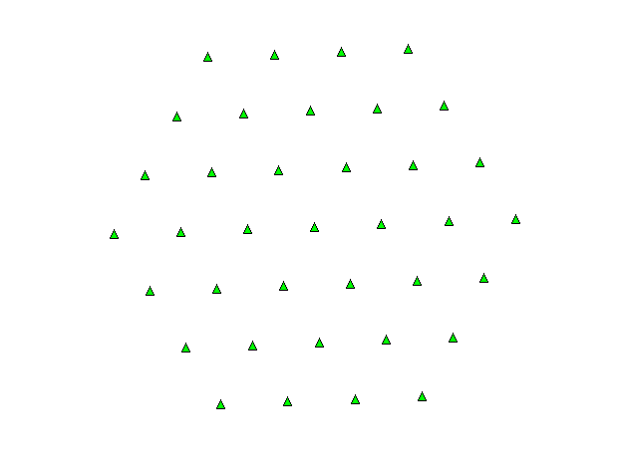 | 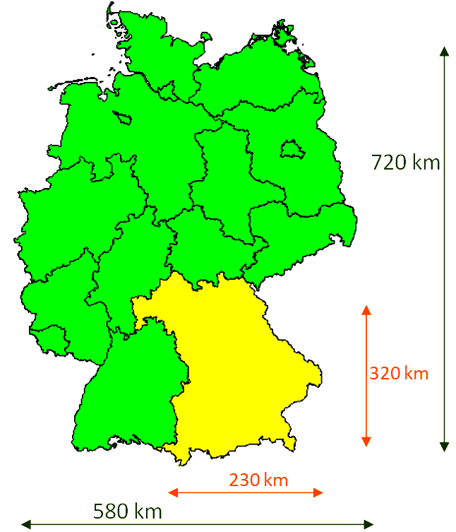
Table P2-22 gives the list of planning parameters that were applied in the simulation. They are either taken from the Report ITU-R BT.2254 on DVB-T2 planning or from the technical annex of the GE06 Agreement. For fixed reception the usual directional antenna as described in Recommendation ITU-R BT.419-3 is assumed whereas for portable and mobile reception simple non-directional TV receiving antennas are used. These are to be distinguished from built-in handheld antennas which show a worse performance. All calculations were performed in Band IV/V at channel 40. The minimum location probability for mobile reception is assume 98% (for the very large SFN) and 98.5% (for the large SFN), respectively, which differs slightly from the common value of 99%.
The reason for this is a pragmatic one: If 99% would have been applied strictly, favourable DVB-T2 variants would have failed in the optimization process only because of small potential gaps in coverage. For fixed and portable reception a minimum location probability of 95% is assumed.
TABLE P2-22
Planning parameters
 | Mobile reception | Portable outdoor reception | Fixed roof-top reception
Receiver noise figure (dB) | 7 | 7 | 7
Standard deviation of shadow fading (dB) | 5.5 | 5.5 | 5.5
Rx antenna height (m) | 1.5 | 1.5 | 10
Coverage probability (%) | 98.0 (very large SFN)  98.5 (large SFN) | 95.0 | 95.0
Feeder loss (dB) | 0 | 0 | 4
Antenna gain (dBd) | 0 | 0 | 11
Rx antenna diagram | Non-directional | Non-directional | Directional ITU-R BT.419-3-Band IV/V

13.1.3 DVB-T2 modes
A large number of DVB-T2 modes, i.e. combinations of DVB-T2 system parameters, were investigated to find optimal variants. The parameters for these and some additional other modes are summarized in Table P2-23. The table contains the data rates and the C/N values of these modes in a Rician, static Rayleigh and time-variant Rayleigh channel.
TABLE P2-23
C/N values and data rates for selected DVB-T2 variants
DVB-T2 mode  (FFT size / modulation / code rate / guard interval / pilot pattern) | C/N (dB) |  |  | Data rate  (Mbit/s)
 | Mobile  reception | Portable  reception | Fixed  reception | Data rate  (Mbit/s)
16k ext, 64-QAM-1/2, 1/4, PP1 | 20.1 | 15.1 | 13.1 | 16.8
16k ext, 64-QAM-3/5, 1/4, PP1 | 21.9 | 16.9 | 15.2 | 20.1
16k ext, 64-QAM-2/3, 1/4, PP1 | 23.3 | 18.3 | 16.5 | 22.4
16k ext, 64-QAM-3/4, 1/4, PP1 | 25.4 | 20.4 | 18.0 | 25.2
16k ext, 64-QAM-4/5, 1/4, PP1 | 27.0 | 22.0 | 19.3 | 26.9
16k ext, 256-QAM-1/2, 1/4, PP1 | 24.5 | 19.5 | 17.5 | 22.3
16k ext, 256-QAM-2/3, 1/4, PP1 | 26.7 | 21.7 | 19.6 | 26.9
16k ext, 256-QAM-2/3, 1/4, PP1 | 28.4 | 23.4 | 21.2 | 30.0
16k ext, 64-QAM-1/2 ,19/128, PP2 | 20.1 | 15.07 | 13.1 | 18.3
16k ext, 64-QAM-3/5, 19/128, PP2 | 21.9 | 16.9 | 15.2 | 22.0
16k ext, 16-QAM-3/5, 19/128, PP2 | 16.9 | 11.9 | 10.4 | 14.7
32k ext, 256-QAM-3/4, 19/256, PP2 | 30.9 | 25.9 | 23.2 | 39.2
32k ext, 256-QAM-3/4, 1/8, PP2 | 30.9 | 25.9 | 23.2 | 37.5

The static Rayleigh channel is applied for portable reception, the time-variant Rayleigh channel for mobile reception and the Rician channel for fixed reception. These values are chosen in accordance with Report ITU-R BT.2254 on DVB-T2 planning. For mobile reception an additional 5 dB is added on top of the static Rayleigh figures in order to justify the time variance and Doppler degradation of a mobile transmission channel.
The 5 dB increment for mobile reception is to be regarded as tentative. It results from measurements of consumer receivers which are not particularly designed for mobile reception; they rather are used in fixed reception environments. It is expected that in the future dedicated mobile receivers will be available which show a better performance; in particular antenna diversity should be advantageous. The results for mobile reception might therefore be regarded as conservative.

13.1.4 Maximum data rate to cover large areas with DVB-T2 theoretical SFNs for mobile, portable and fixed reception
In this section the maximum possible data rate with acceptable robustness which covers the medium and large size SFN in mobile, portable and fixed reception modes is examined. The following approach was chosen. Firstly, all locations within the SFN area have to be covered with the minimum required location probability. Among those DVB-T2 variants which fulfil this requirement the one which provides the highest data rate is chosen. Due to the high vulnerability of 32k FFT mode to Doppler degradation this mode is excluded for portable and mobile receptions. Although this fact is obvious for mobile reception, this condition is also applied to the portable reception mode in order to guarantee a certain amount of mobility in this reception mode as well.
Figure P2-57 presents a snapshot of this process. It shows a coverage plot for mobile reception of the large SFN (360 km × 360 km) for the DVB-T2 variant 16k 64-QAM-2/3-GI 1/4. The colours indicate the coverage probabilities; white: (> 98.5%), green: (95% – 98.5%), yellow: (70% – 95%), grey: (< 70%). The coverage requirement is fulfilled if the whole SFN area is white. This is not the case here. For this reason the following variant cannot be regarded as appropriate for the coverage of the large SFN for mobile reception.
In practice, there is no need to calculate the whole SFN area. The high symmetry of the network topology allows reducing the consideration to a small fraction of the entire area. Indeed, this is helpful since the computing time is quite high for such a large number of transmitters.
Figure P2-57
Coverage plot of the large hexagon SFN (360 km diameter) for mobile reception
with the DVB-T2 variant 16k 64-QAM-3/4, GI=1/4 PP1
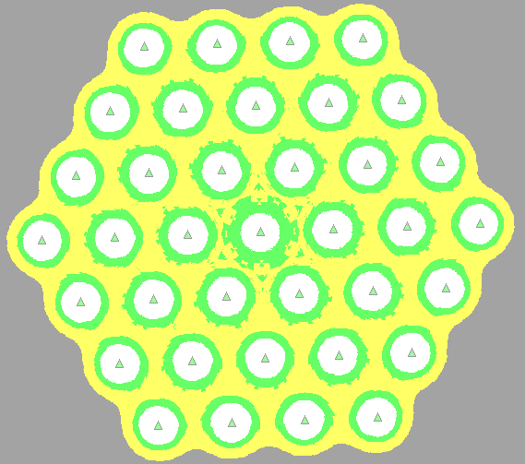
Table P2-24 gives an overview of the results. For each category of SFN and reception mode the optimum DVB-T2 variant is given which provides full area coverage, where the optimization criterion is the data rate.
TABLE P2-24
DVB-T2 modes with maximum data rate while allowing for a full SFN coverage
 | Large SFN (360 km × 360 km) | Very large SFN (720 km × 720 km)
Fixed reception | 32k-ext, 256-QAM-3/4 PP2  GI 19/256 (266 µs)  Data rate: 39.2 Mbit/s | 32k-ext, 256-QAM-3/4 PP2  GI 1/8 (448 µs)  Data rate: 37.5 Mbit/s
Portable reception | 16k-ext, 256-QAM-2/3 PP1  GI 1/4 (448 µs)  Data rate: 30.0 Mbit/s | 16k-ext, 64-QAM-3/4 PP1  GI 1/4 (448 µs)  Data rate: 25.2 Mbit/s
Mobile reception | 16k-ext, 64-QAM-3/5 PP1  GI 1/4 (448 µs)  Data rate: 20.1 Mbit/s | 16k-ext, 64-QAM-1/2 PP1  GI 1/4 (448 µs)  Data rate: 16.8 Mbit/s

The maximum data rate for the mobile reception mode is 20.1 Mbit/s for the large SFN and 16.8 Mbit/s for the very large SFN. With this data rate 100% of the areas are covered with the location probability not lower than 98%. For portable reception these figures are 30.0 Mbit/s and 25.2 Mbit/s for the large and the very large SFN, respectively. For fixed reception, 32k FFT modes with a high modulation scheme are found which provide nearly 40 Mbit/s data rate.
In the following, the focus will be on portable and mobile reception. Three findings are remarkable. Firstly, there is a large difference between the performance of portable and mobile reception modes. It was already mentioned in the previous section that the parameters of the mobile reception case may be conservative. From the other side a static Rayleigh channel might be too optimistic for a robust portable reception.
As a result, it could be concluded that the future portable and mobile DVB-T2 receivers might show a performance somewhere in between the two scenarios described above. However, as long as there are no such receivers available in the market this remains uncertain. At least our study proofs that still more investigations on this item are required.
Secondly, there is still a remarkable difference with the data rates between the large SFN and the very large SFN scenario. This is an interesting finding since it was believed that the size of a large SFN is great enough and the addition of further transmitters would not remarkably increase the deleterious effect of self-interference. The results for the very large SFN show that this is not true. Even at several hundred kilometres distance the self-interference effect is perceivable and addition of transmitters affect the results of self-interference.
Thirdly, according to the results the largest guard interval (448 µs in 16k FFT mode) is the most appropriate choice for the coverage of a large SFN. Instead a smaller guard interval could be used with a robust code rate but then the data rate will be much lower.
The DVB-T2 variants in Table P2-24 fulfil the requirement of full area coverage. Variants with higher data rate would not provide 100% coverage of the area. Such DVB-T2 modes were also investigated.
For the mobile reception case and the large SFN, Fig. P2-58 gives the percentages of covered locations ordered by their respective location probability for nine DVB-T2 variants. The two variants of Table P2-24 are also included in this Figure. 64-QAM-3/5-GI 1/4 is the best variant which fulfils the 100% coverage requirement. Other 64-QAM-GI 1/4 variants with a less robust code rate fail; however, 64-QAM-2/3-GI 1/4 with a data rate of 22.4 Mbit/s shows at least full area coverage with a location probability higher than 95%. 256-QAM-1/2-GI 1/4 gives a similar, slightly worse, result with nearly full area coverage. Variants with the smaller guard interval of 19/128 (266 µs) show a quite bad performance which emphasizes the crucial impact of the guard interval. In § 1.2 a more detailed investigation of the guard interval aspect is presented.
Figure P2-58
Percentage of covered locations in the large SFN (360 km × 360 km) for 9 DVB-T2 variants
and mobile reception ordered according to four location probability classes
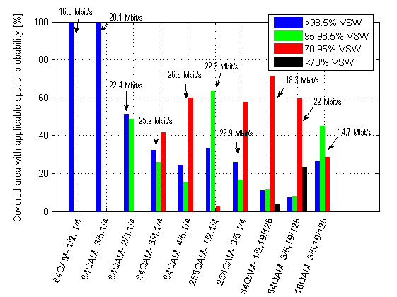
Note to Fig. P2-58: VSW is the German abbreviation for reception location probability.
Figure P2-59 shows the results for the mobile reception and very large SFN. All variants suffer from higher self-interference degradation than in the large SFN case. Now only 64-QAM-1/2-GI 1/4 fulfils the coverage requirements. 64-QAM-3/5-GI = 1/4 has at least a nearly full area coverage for 95% location probability, whereas for 64-QAM-2/3-GI = 1/4 the percentage of locations with less than 95% location probability is already nearly 20%.
Figure P2-59
Percentage of covered locations in the very large SFN (720 km × 720 km) for 9 DVB-T2 variants and mobile reception ordered according to four location probability classes
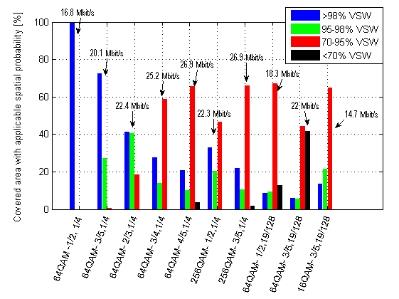
As discussed earlier in this section, the situation improves remarkably if the less demanding parameters for portable reception, as compared to mobile reception, are applied. Figure P2-60 shows the results for the same nine DVB-T2 modes for the large SFN case. Now all GI 1/4 variants fulfil the coverage requirements. The variants with the smaller guard interval of 19/128 still fail to achieve the full area coverage with 95% location probability. Only a change from 64-QAM to the more robust 16-QAM modulation provides the required coverage; however, at the price of lower data rate.
Figure P2-60
Percentage of covered locations in the large SFN (360 km × 360 km) for 9 DVB-T2 variants and portable reception
ordered according to three location probability classes
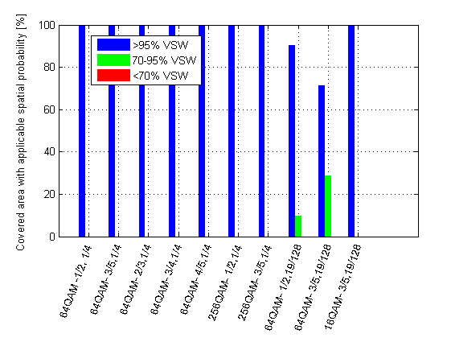
The situation for the very large SFN, depicted in Fig. P2-61, is very similar to the previous one. Again, the 64-QAM GI 19/128 variants fail; now with a higher percentage of uncovered locations. And again, the more robust 16-QAM variant fulfils the requirement.
Figure P2-61
Percentage of covered locations in the very large SFN (720 km × 720 km) for 9 DVB-T2 variants
and portable reception ordered according to three location probability classes
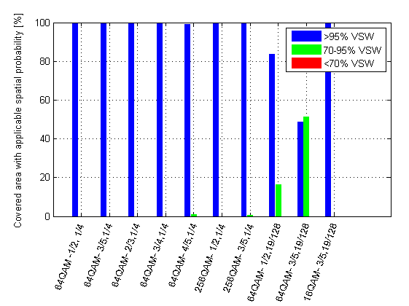
Furthermore, the influence of the inter-transmitter distance ISD on the SFN performance is shortly investigated. As an example the DVB-T2 mode with 64-QAM modulation, 3/5 code rate and 19/128 guard interval is studied for the mobile reception mode and the large SFN. Table P2-25 shows how the coverage changes if the inter-site distance decreases from 60 km to 50 km.
TABLE P2-25
The coverage for a specific DVB-T2 mode with different inter-site distances
DVB-T2 mode 64-QAM-3/5, 19/128 | > 98.5% reception location probability | 95 – 98.5% reception location probability | 70 – 95% reception location probability | < 70% reception location probability
ISD = 60 km | 7.4% | 8.1% | 59% | 23%
ISD = 50 km | 13.7% | 12.9% | 71.2% | 2.12%

As can be expected, the negative effect of self-interference reduces. In the range of >95% location probability the improvement of 5 to 6 percentage points is observed. Most prominent is the improvement with regard to the 70% level. However, the changes in the higher location probability range are not very large. The results for ISD = 60 km may therefore be regarded as representative, at least for the situation in Germany where the typical main transmitter distance is between 50 km and 60 km, sometimes even beyond that.
A further aspect has to be taken into account. The diameter of the network with ISD = 50 km is smaller which already decreases self-interference for geometrical reasons. An enlargement of the SFN to the former size of 360 km (or 400 km, to remain within the model of hexagon rings) would reduce the above improvement in performance to some extent.

13.1.5 Minimum required guard interval for various inter-site distances and C/N values
In this section the relation of guard interval, transmitter site density and robustness (C/N value) is investigated in more detail. The minimum required guard interval to cover an area with different C/N values is examined.
The area is a hexagon with a diameter of 360 km. The effective antenna height is 300 m and 50 kW is the effective radiated power. Full area coverage is required with a location probability of 98.5% for a non-directional receiving antenna at 1.5 m height. Different from the previous section the number of hexagon rings now varies for each inter-site distance in order to cover the same area within the hexagon with 360 km diameter. In only two exceptional cases of inter-site distances of 40 km and 50 km the diameter of network is 400 km.
The guard intervals are not necessarily chosen from the standard DVB-T2 modes but they are the minimum thresholds which makes the coverage within the hexagon possible. This means that the guard interval guarantees 100% coverage with the location probability higher than 98.5%. If the guard interval decreases below this threshold then coverage gaps start to appear.
At a given location, self-interference components appear as soon as the relative delay between SFN signals exceeds the guard interval length. In addition there is a small phase after guard interval, characterized by the so-called cliff-edge-coefficient (CEQ), which takes a fraction of received symbols as useful and a fraction as inter-symbol interference. Now the coverage of a location is fulfilled if the sum of field strengths of the useful part is greater than the sum of the field strengths (plus protection ratio) which causes self-interference. These are the paths which arrive after the guard interval plus CEQ time. The more transmitters fall outside the guard interval, the higher value will result from the summation of the field strengths causing self-interference.
As shown in Fig. P2-62 the guard interval increases as the inter-site distance and the C/N value increase. The Figure may be used as guidance when choosing a DVB-T2 mode for a particular coverage scenario. To give an example: A DVB-T2 mode with a C/N of 20 dB (green curve, see Table P2-23), operated in an SFN with a typical inter-site distance of 50 km requires a guard interval of at least 425 µs. For a 16k FFT there is only one such guard interval value available which is GI 1/4 (448 µs). Or, as a second example, for a DVB-T2 mode with a C/N of 18 dB and a guard interval of GI 19/128 (266 µs for 16k FFT) a typical transmitter-site distance of about 32 km is required to achieve full area coverage in a large SFN.
Figure P2-62
Relationship between inter-site distance, robustness (C/N) and minimum guard interval
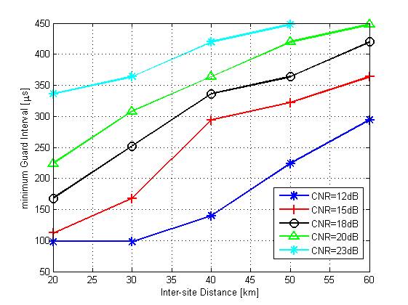

13.1.6 Summary and conclusions
Theoretical hexagon networks are used in this study to examine the restriction and capabilities of DVB-T2 large SFN. Two cases, a large SFN with a size of 360 km × 360 km and a very large SFN with a size of 720 km × 720 km, are analysed and DVB-T2 modes with the maximum achievable data rate for mobile, portable and fixed reception scenarios are identified.
Additionally the loss of coverage area vs. increasing data rate is discussed. Although the large SFN is already quite extensive, still the additional rings to extent the SFN size affect the performance of the network and impair the reception.
Next the trade-off between higher data rate and less reception quality is examined. With increasing data rate the percentage of covered area decreases. For instance, in the large SFN, 100% coverage with 20.1 Mbit/s for mobile reception could be achieved. Increasing the data rate to 22.4 Mbit/s is possible, but then only 52% of locations are covered with the required location probability (> 98.5%) whereas the rest of 48% is (only) covered with 95-98.5% probability.
The less demanding parameters for portable reception, as compared to mobile reception, allow for remarkably higher data rates; for instance, for the large SFN up to 30 Mbit/s is possible.
This is a large difference which is mainly due to the probably conservative assumptions made for the mobile reception case. As a consequence, there is a need for a more detailed determination of these parameters in order to better model mobile receivers.
Furthermore, it turns out that even for the large SFN, and also for the very large SFN, a guard interval of 448 µs (GI 1/4 for the 16k FFT mode) is required. Smaller GIs cannot fulfil the coverage requirements. Only in the case of portable reception the change to a more robust modulation (from 64-QAM to 16-QAM) allows using a smaller guard interval.
Finally, based on a hexagonal network with the size as of 360 km × 360 km, the relationship between robustness and minimum required guard interval for networks with various inter-site distances is analysed. The results may be used as guidance in the network planning process when choosing a DVB-T2 mode for particular coverage scenarios.

13.2 DVB-T2 and DVB-T2 Lite: Experimental tests in Italy (Aosta Valley)
After experimenting in the laboratory the first prototypes of DVB-T2 Lite, the RAI Research Centre in co-operation with RAI WAY and with the technical support of some Italian manufactures launched an experimental trial where HDTV services for fixed reception and T2 Lite mobile TV services are being transmitted on the same channel to demonstrate an optimal exploitation of the UHF spectrum and guaranteeing adequate transmission robustness for very different services.
The trial, based on a SFN with four transmitters in a mountainous area, allowed to validate the technical characteristics of the system, to evaluate the coverage in mobility, to check interoperability related to the implementation of a SFN using equipment from different vendors and, last but not least, to test the behaviour of receivers in the field. The experiment took place in the Aosta Valley on the UHF channel 53 using the transmitting centres of Tete de Arpy, Aosta-Gerdaz, Saint Vincent-Salirod and Col de Courtil. In a second phase, currently underway (February 2015), the network has been expanded with other transmitters.
TABLE P2-26
Aosta Valley transmitters
Transmitter | P_{out}  (W) | e.r.p._{max}  (dBk) | Polarization | Static delay  (µs) | Transmitter identifier
Tete de Arpy | 50 | –5.1 | H | 20 | 3
Aosta Gerdaz | 50 | –5.3 | H | 45 | 1
Saint Vincent – Salirod | 100 | –1.3 | H | 0 | 2
Col de Courtil | 50 | –6.9 | H | 5 | 4

Figure P2-63
Geographical context – Aosta Valley
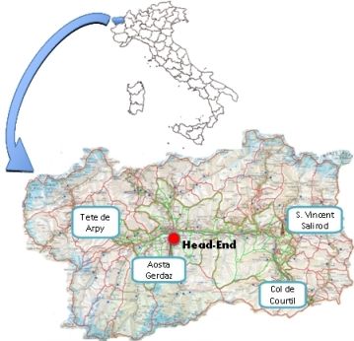
The geographical context together with the location of the transmitters and their characteristics are reported in Fig. P2-63.
The bouquet takes origin in the head-end located in the Rai's premises of Aosta and consists of three HD programs for the T2 base and of three services oriented to mobile reception for the T2 Lite. The distribution of the signal toward the transmitters is performed by SDH digital radio link.
Figure P2-64
Head End Scheme
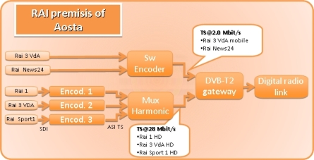
The scheme chosen for the testing involves the use of a “mixed” system: the T2 signal is split into two sub frames, one compatible with the standard T2 Base, the other T2 Lite, optimized respectively for fixed and mobile reception.
The modulation parameters adopted during the field test are the following:

DVB-T2 Base
– Constellation: 256QAM, rotated
– FEC: 3/4 – available bit rate 28.2 Mbit/s
– FFT: 32k
– Guard Interval: 1/128 (28 µs)
– Pilot pattern: PP7.

DVB-T2 Lite
– Constellation: QPSK Rotated
– Tests in three different configurations of FEC:
• ⅓ – available bit rate 1.6 Mbit/s;
• ½ – available bit rate 2.2 Mbit/s;
• ⅔ – available bit rate 3.3 Mbit/s
– FFT: 8k
– Guard Interval: 1/32 (56 µs)
– Pilot Pattern: PP4.
The transmitters have common coverage overlapping; thus, to avoid interferences beyond the guard interval in that zone (28 µs for the selected transmission mode) static delays have been added on the transmitters, as depicted in the table above.
Figure P2-65
Location probability for fixed reception
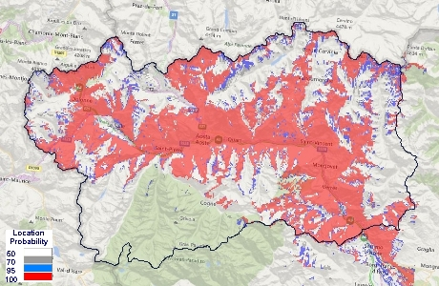

Figure P2-66
Location probability for mobile outdoor reception
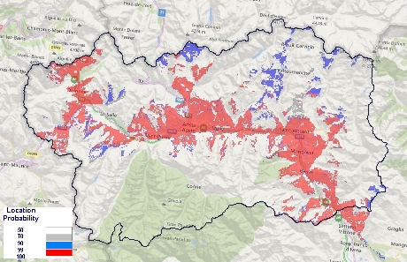
Figure P2-67
Area where the signals of the transmitters are within the GI (green) and beyond the GI (red)
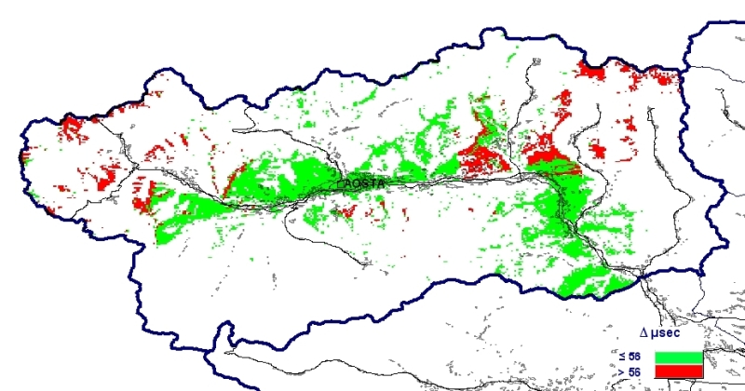

Figure P2-68
Difference in field strength between strongest signal and second strongest signal
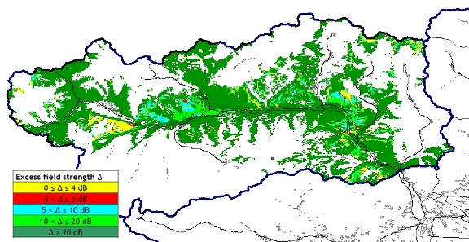
Figure P2-69
Area of the best server
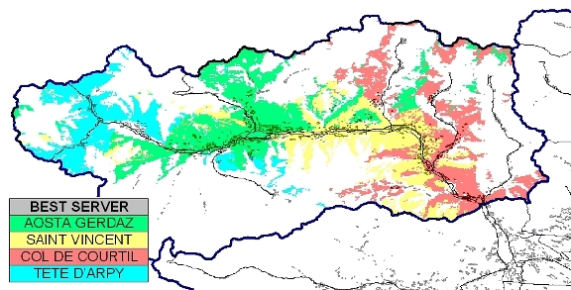
For each chosen FEC value of DVB-T2 Lite, measurements ‘on route’ were performed and more than 400 km were covered along the roads of the Aosta Valley. The results are very promising. DVB-T2 Lite allows an excellent mobile reception on cars travelling at speeds up to 130 km/h. The coverage is very good on all type of roads (motorway, main roads, secondary roads, etc.) in most of the main valley, in the urban areas (Aosta, Saint Vincent and Chatillon) and also a quite good coverage is accomplished in many secondary lateral valleys. The mobile reception availability for the Single Frequency Network is reported in Fig. P2-70.
Figure P2-70
SFN mobile reception availability (signal received, green; not received, red) – FEC 1/2
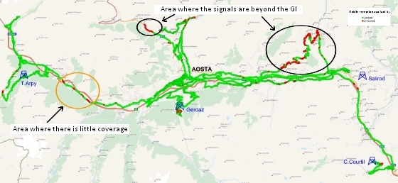
The measurement campaign pointed out three critical areas: one due to the lack of coverage (see Fig. P2-70) and the other two due to the fact that the signals of Aosta Gerdaz and Saint Vincent Salirod transmitters arrive in the area outside the Guard Interval.
A test with the PP7 profile was achieved but, with this configuration, travelling at speed of 70/80 km/h in a radial direction with respect to the transmitter, the receiver was not able to decode properly the signal.
Moreover, theoretical studies and laboratory tests show that, with PP4 profile, reception is possible even up to speeds of 250 km/h or more: therefore this system is suitable also for TV broadcasting for reception on high speed trains.
A set of fixed measurements were also performed in order to evaluate the service area of DVB-T2 Base. The measures were carried out at 15 m a.g.l. using directive yagi antenna for each transmitter and showed a high reception margin in all the predicted coverage area. The reception margin was measured by attenuating the incoming signal up to the reception threshold.
In Fig. P2-71 is reported the location of the test points together with the achieved results.
Figure P2-71
Field strength measurements – Example of measures of a single transmitter
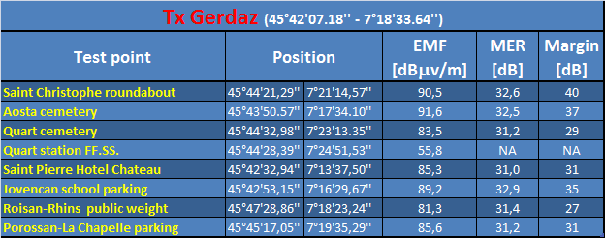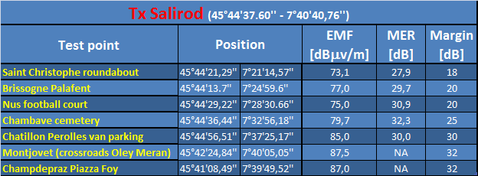
In order to validate the SFN in the service area where the signals of the transmitters are overlapped, a lot of measurements has been carried out collecting information regarding the spectrum, impulse response, constellation, MER, modulation parameters, field strength, etc.
An example of the measurements is shown in the Figures below.
Figure P2-72
Example of SFN fixed reception measurements – Spectrum
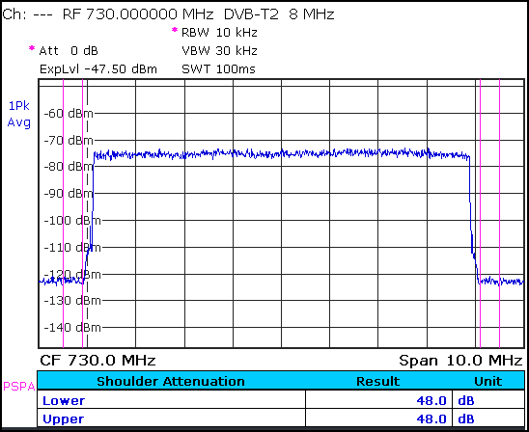
Figure P2-73
Example of SFN fixed reception measurements – Channel Impulse Response T2 base and T2 Lite
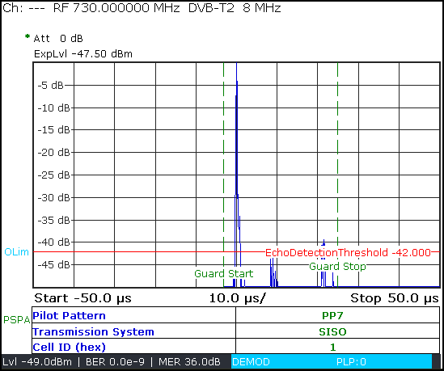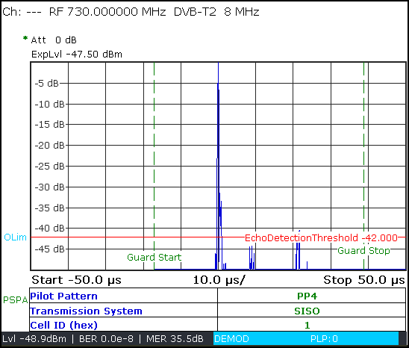
Figure P2-74
Example of SFN fixed reception measurements – Overview T2 base and T2 Lite
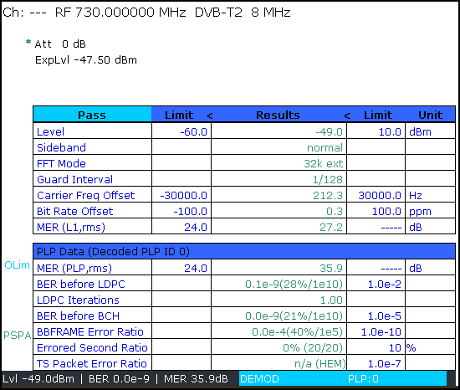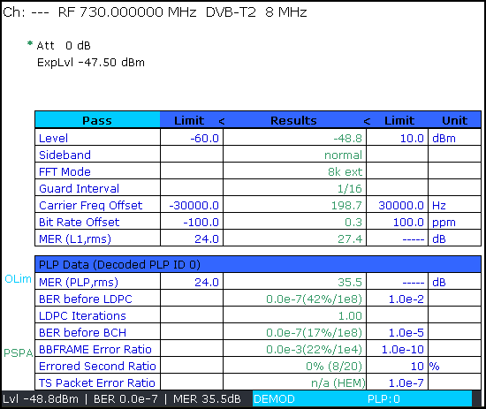
Figure P2-75
Example of SFN fixed reception measurements – Constellation T2 base and T2 Lite
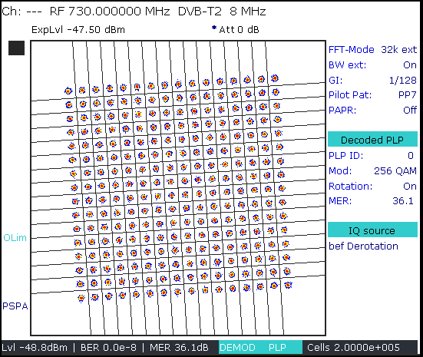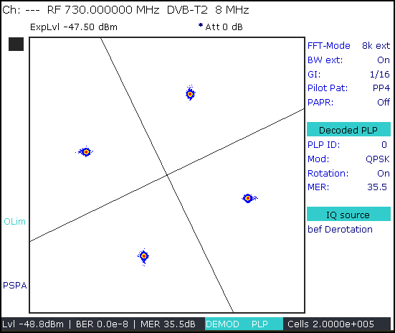
The T2 Lite signal is very robust and even in critical conditions it is possible to decode it. In Fig. P2-76, there is an example of this kind of situation.
Figure P2-76
Example of critical conditions – T2 Base overview – T2 Lite overview and constellation
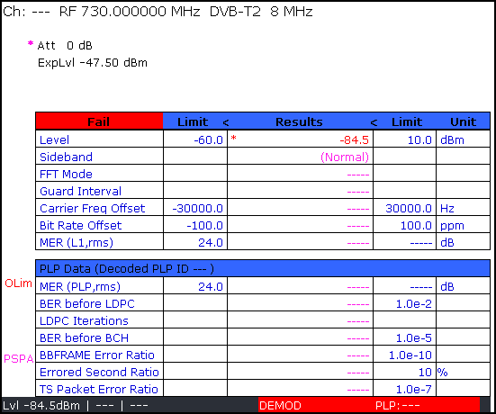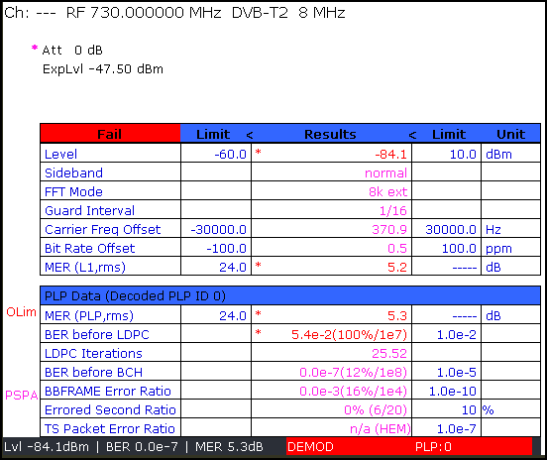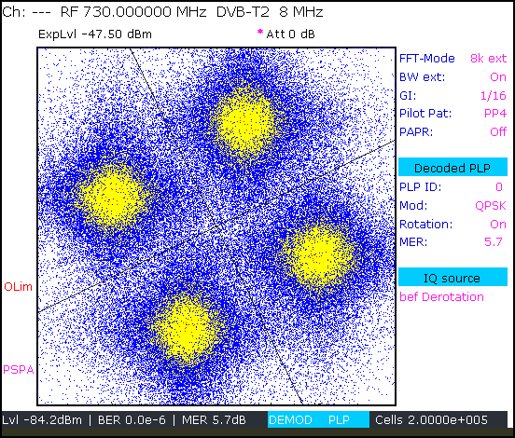
Figure P2-77
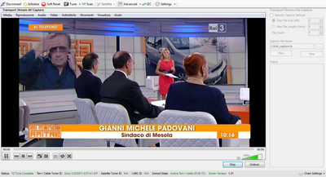

13.3 Case study on large DVB-T2 SFN in Denmark
A study by Progira and DR aimed at determining whether national SFNs could be a practical method of matching existing near-universal coverage in Denmark. The study considered coverage to directional rooftop antennas from the existing HPHT DTT network for both DVB-T and DVB-T2.
Table P2-27 shows that the current DTT network in Denmark provides near universal coverage (99.7% population) to rooftop antennas. It has some 47 transmitters (18 main stations and 29 lower power, secondary stations) configured mainly in regional SFNs of around 150 to 160 km in diameter, with the occasional MFN. The table also shows the results from coverage predictions for this network with the DVB-T and DVB-T2 modes shown, all of which are practical and could be deployed in real networks.
TABLE P2-27
National SFN coverage for various modes in Denmark
 | DVB-T  current network | DVB-T  National SFN | DVB-T2  National SFN | DVB-T2  National SFN | DVB-T2  National SFN
Mode | DVB-T  64-QAM 2/3  GI 1/4 (224 µs) | DVB-T  64-QAM 2/3  GI 1/4 (224 µs) | DVB-T2  256-QAM 3/5  GI 1/8 (448 µs) | DVB-T2  256-QAM 3/5  GI 19/128 (532 µs) | DVB-T2  64-QAM 3/5  GI 19/128 (532 µs)
C/N (dB) | 19.5 | 19.5 | 19.6 | 19.6 | 15.2
Population (%) | 99.7 | 37.0 | 97.0 | 97.1 | 99
Capacity (Mbit/s) | 19.9 | 19.9 | 29.9 | 29.4 | 21.8
The following main points were highlighted in the results:
– The maximum guard interval for DVB-T (1/4) would be too short to form a national SFN based on the current network. Widespread self-interference would limit coverage to around 37% of the population. DVB-T2 would therefore be necessary.
– A DVB-T2 based SFN with a 1/8 guard interval (448 µs) would significantly improve coverage, though a shortfall of almost 3% would remain. Despite the doubling of the guard interval, self-interference would still be the limiting factor (the C/N of this mode is similar to the current DVB-T mode, which implies the coverage loss may be attributed to the SFN)
– A further increase in the guard interval to 532 µs would only marginally improve coverage – 0.1% additional population was gained.
– Adoption of a more robust DVB-T2 mode (64-QAM 3/5) with 4.4 dB lower C/N would still not fully regain the coverage – 0.7% of the currently served population would remain without coverage – and importantly the national SFN would only increase throughput by 1.9 Mbit/s, which is not significant.
– For the cases above using DVB-T2, it is however believed that the remaining problems of SFN self-interference could be substantially resolved by introducing static time delays in combination with adjustments of antenna patterns for some of the transmitter sites.
The study made the following general points regarding SFNs:
– National SFNs may make the addition of new, low power transmitters (gap fillers) to the network easier.
– Some network gain may be realised for networks designed to provide mobile or portable reception.
– Regional and local content, an important broadcaster requirement would not be delivered efficiently in a national SFN.
– The throughput of a multiplex configured in an SFN reduces relative to MFNs. This is a direct result of increasing the guard interval to avoid self-interference. Even if it was possible, at least one additional multiplex would be required to recover the lost capacity should DVB-T based MFNs or regional SFNs be converted to national SFNs also based on DVB-T. The overall benefits of this scheme are therefore questionable.
The study incorporated a simplifying assumption that Denmark would have unrestricted use of a single frequency channel, and that it would be free from interference from other countries. In practice this may be an optimistic assumption.
It was also noted that due to the significant number of transmission paths across water (circumstances that increase the potential for self-interference) Denmark may be regarded as a challenging, but nonetheless practical case study. These considerations should be borne in mind when extrapolating the results to other areas.
The study drew the following conclusions:
National SFNs would not be a practical means of delivering near universal coverage with DVB-T due to its limited guard interval duration. DVB-T2 would provide significant improvements, as anticipated, but the study found that a national SFN based on existing network infrastructure, while maintaining sufficient capacity, would still not fully match the coverage of the current regional SFN/MFN network.
It would not be possible to efficiently deliver regional content with a national SFN. Regional SFNs would be better suited for this purpose and may overall remain the most attractive configuration for broadcasters.

13.3.1 Introduction
The following study describes a few aspects of SFN planning, in particular when extending the size of an SFN. It also discusses the possibilities to reduce the frequency usage when extending the SFN size. As an example the DTT network in Denmark is used. Currently this DTT network consists of a number of MFNs and regional SFNs using the DVB-T standard. In the examples given all the sites are assumed to be part of a “national” SFN using the DVB-T/T2 standard.
The different SFN considerations are dealt with in separate sections.
It has to be mentioned that this represents a purely theoretical study which does not take into account requirements for local or regional services. Likewise requirements from neighbouring countries are not taken into account.
This study shows that there is generally not any improvement in terms of spectrum efficiency when utilizing large national SFN implemented using DVB-T2. However, there are other benefits of the SFNs in general. One such advantage is in mobile or portable coverage, where contributions from several transmitters at each receiving location will improve and expand coverage.
SFNs also make it relatively easy to add fill-in stations on the same frequency to improve coverage, without any need for re-planning or frequency change.

13.3.2 Loss of capacity in an SFN
When introducing a DVB-T/T2 SFN there is a need to use a mode with a longer guard interval compared to the MFN case. In order to create large area SFNs using the DVB-T system the longest guard interval duration of 1/4 (224 µs for 8k mode) is often needed. For the most commonly used DVB-T mode, 64-QAM, R = 2/3, this means that the bitrate is reduced from about 24.1 Mbit/s to 19.9 Mbit/s, going from guard interval fraction 1/32 (28 µs) to 1/4 (224 µs), using the 8k mode. In this case there is a loss of capacity of 20% between the SFN and the MFN case. The result will be that if five multiplexes are required using MFNs there is a need for a 6th DVB-T multiplex to compensate for the loss of capacity due to the introduction of the SFNs.
From a spectrum efficiency point of view the use of SFNs should then reduce the overall spectrum requirements by 20% to compensate for this loss of capacity due to the longer guard interval, in order to be able to provide the same total bit rate as in the MFN case.

13.3.3 Size of SFN
SFNs require careful planning and if they are made too large in size the transmitters in the SFN will start to interfere with each other, this is called SFN self-interference. It should be pointed out that a guard interval of 224 µs would allow for SFNs with a diameter of up to about perhaps 100-150 km, depending on network topology and the terrain. Creation of really large SFNs with diameters of 150-400 km may not be possible using the DVB-T system, due to SFN self-interference.
If however DVB-T2 is used, additional guard interval options are available. It will be possible to make SFNs covering larger areas with smaller loss of capacity due to the use of the 32k or 16k modes. For example the DVB-T2 mode 32k 256-QAM R= 3/5 with guard interval fraction 1/8 with a guard interval of 448 µs, or a guard interval fraction of 19/128 with a guard interval of 532 µs.
Using one of these DVB-T2 SFN options will reduce the loss of capacity from 20% (DVB-T) to about 15% (DVB-T2 for GI fraction 19/128) or about 12% (DVB-T2- for GI fraction 1/8). The drawback of using the 32k mode is the lack of mobile reception.

13.3.4 Limitation in local/regional programming
One of the drawbacks of using large (national) SFNs is that it is not possible to introduce regional or local programmes. The programmes need to be identical for all of the transmitters in the SFN. If not, the transmitters will interfere with each other. An important strength of terrestrial transmission is the possibility to provide local or regional programmes, at least part of the time, for example during advertisement. In many countries one of the main areas of growth for terrestrial TV is considered to be in regional or local transmission, where, for example, satellite delivery has difficulty to compete.

13.3.5 Large (national) SFN, example of Denmark
In order to highlight some of the considerations related to SFN planning. A few planning examples are given below.
As an example the DR digital TV network in Denmark will be used. The network consists of 47 transmitters; 18 main transmitters and 29 smaller transmitters. Currently the network consists of mainly regional SFNs with a typical diameter of up to 150 km, and in a few cases with a diameter up to 165 km.
Figure P2-78 shows the predicted coverage using rooftop antennas when the DTT network is turned into a national SFN (except for the island of Bornholm) using DVB-T with the mode 64-QAM R=2/3 and GI=1/4 (224 µs), which results in a bit rate of 19.9 Mbit/s. It is clear that this SFN will not work. Coverage will be very limited. Only 37% of the population is served, while for the existing DVB-T network using a combination of MFN and regional SFNs, the population coverage is 99.7%. The network is too large to work well as an SFN using the DVB-T standard. Areas indicated in red in Fig. P2-79 will have limitations due to SFN self-interference.
If, however, is used the DVB-T2 standard (Fig. P2-80) with the mode 256-QAM, Code rate 3/5, GI = 1/8 (448 µs), the predicted coverage becomes much better. The estimated population coverage is about 97.0% This DVB-T2 mode has a C/N value very close to the DVB-T mode used in
Fig. P2-78 and gives a bit rate of 29.9 Mbit/s. In Fig. P2-81 the potential areas where self-interference may occur can be seen. It is clear that there are still some areas where problems may appear, even when using this very long guard interval. Subsequently, about 2.5% of population may be affected by self-interference.
Figure P2-78
DVB-T National SFN 64-QAM R = 2/3 TG 1/4 (224 µs)
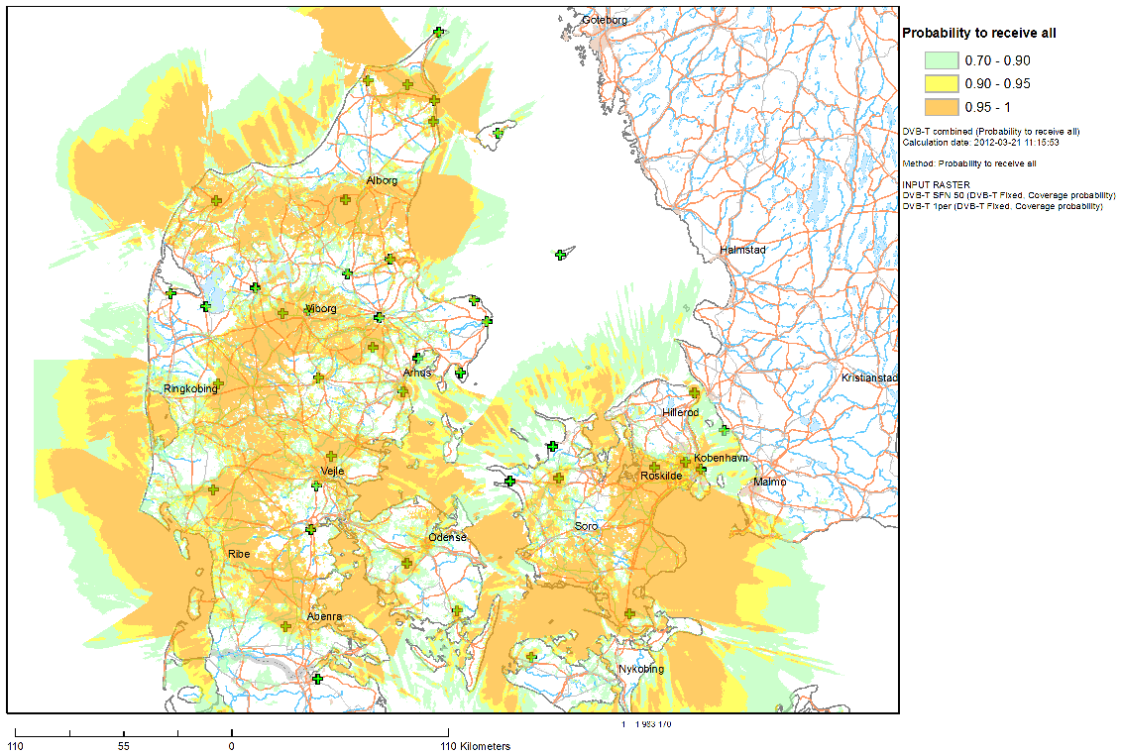
Figure P2-79
DVB-T National SFN 64-QAM R = 2/3 TG 1/4 (224 µs) Self Interference
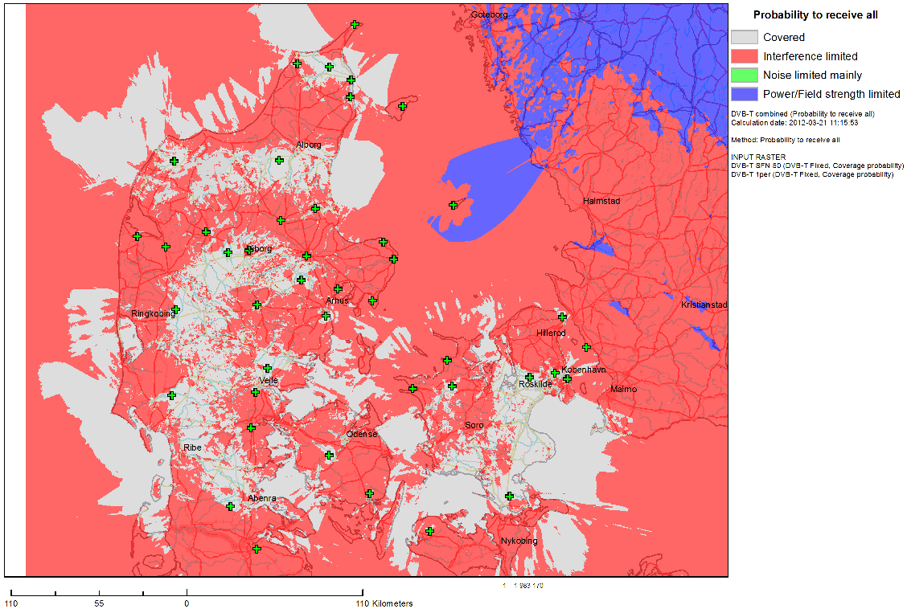
Figure P2-80
DVB-T2 National SFN 256-QAM R = 3/5 TG 1/8 (448 µs) Fixed Reception
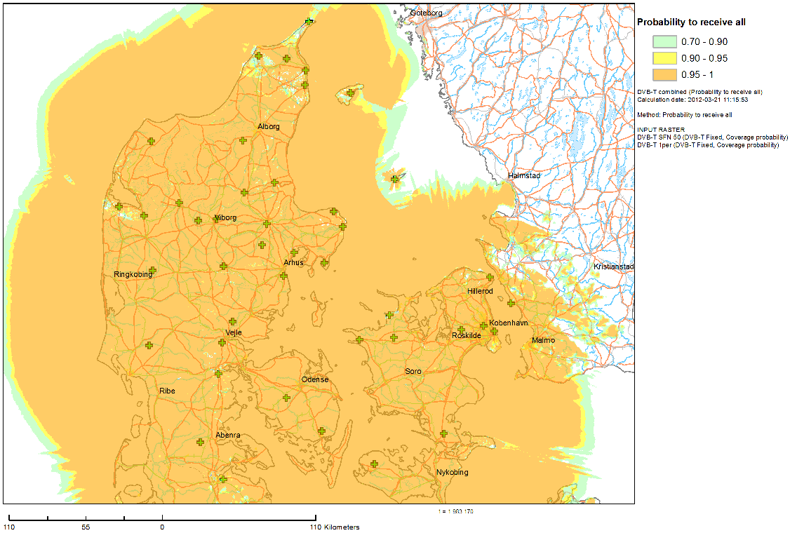
Figure P2-81
DVB-T2 National SFN 256-QAM R = 3/5 TG 1/8 (448 µs) Self Interference
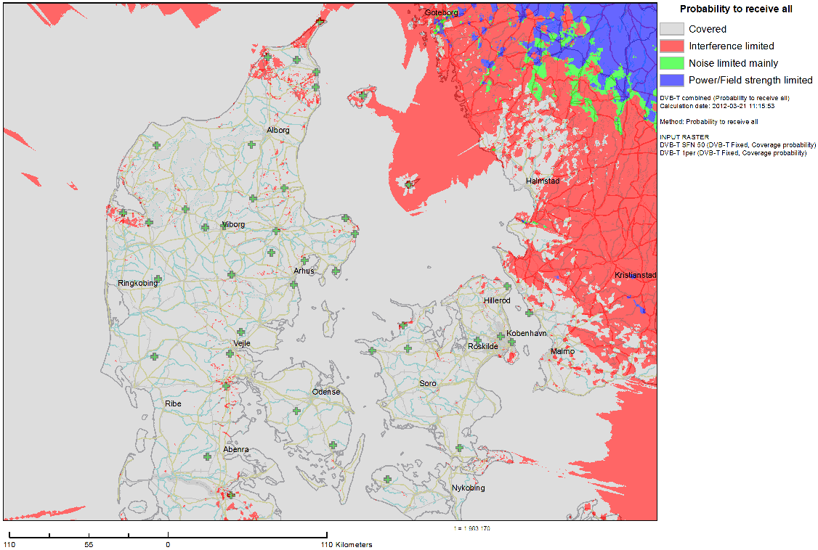
Trying to cure this self-interference problem by extending the guard interval to 19/128 (532 µs) it can be seen that the problem is only slightly smaller (Fig. P2-82). Potential self-interference areas are shown in Fig. P2-83. The population coverage is now 97.1%. Using this mode the bit rate will be about 29.4 Mbit/s.
Figure P2-82
DVB-T2 National SFN 256-QAM R = 3/5 TG 19/128 (532 µs)
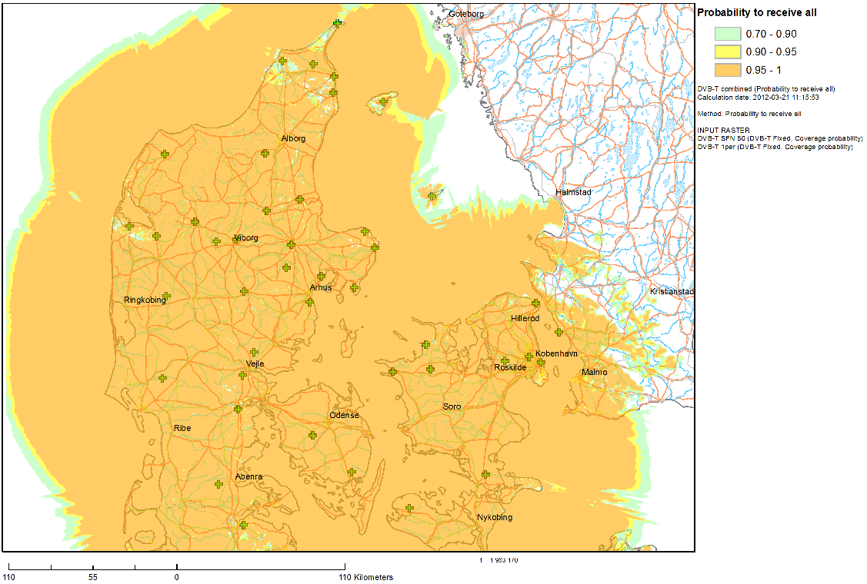
Figure P2-83
DVB-T2 National SFN 256-QAM R = 3/5 TG 19/128 (532 µs) Self Interference
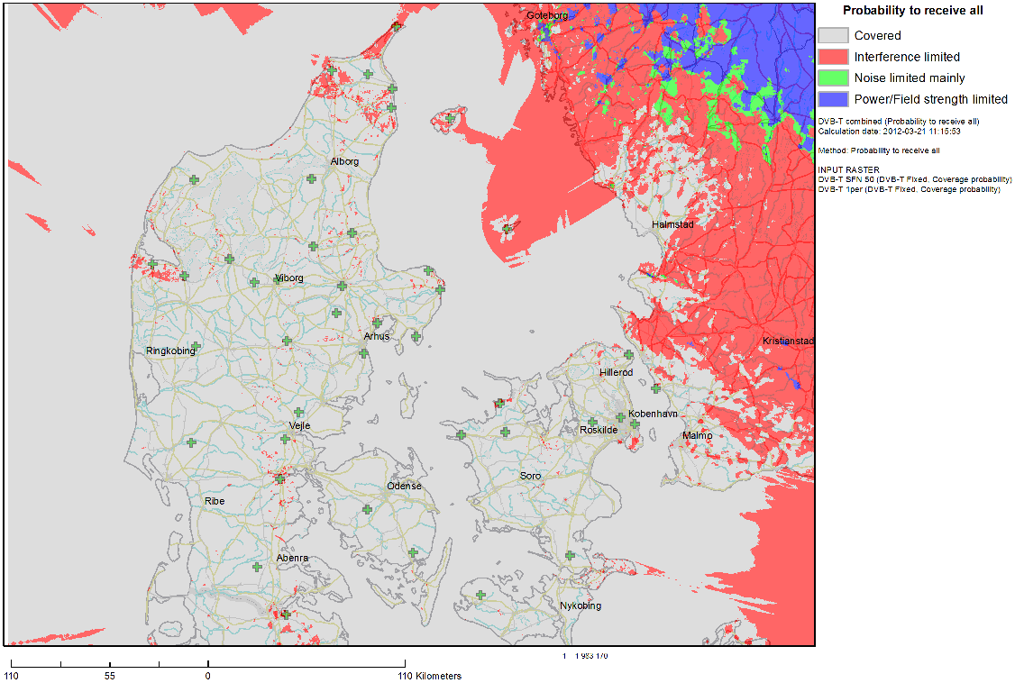
So from these simulations the conclusion drawn is that even when using DVB-T2 it may be difficult to make a very large national SFN. In the case of Denmark the situation is special since there are sea paths between the different Danish islands that will lead to good long-distance propagation (in particular) for lower percentages of time, which may create SFN self-interference from time to time. Even if extra gap-fillers might be able to fill some of the areas without coverage it is also clear that a large number of pixels suffering from self-interference are spread across the country and cannot easily be covered by extra gap fillers.
In smaller regional SFNs it is generally possible to optimize coverage by using, for example, delays on certain transmitters and directional transmitting antennas. However, in an SFN network of this size, and with this number of transmitters it is generally difficult to completely eliminate the SFN self-interference without substantial investments in additional infrastructure. The result of, for example, adding a time delay on some transmitters would be that the zones of self-interference are moved to other places instead.
One remaining possibility would be to use a more robust DVB-T2-mode; it would however result in further loss of capacity. Figure P2-84 shows the result of a simulation using the DVB-T2 mode 64-QAM R = 3/5 and GI-fraction 19/128 (532 µs). Population coverage is just below 99%, indicating that there are still some small areas where self-interference may occur (Fig. P2-85). The system variant has a C/N of about 15 dB and a capacity of 21.8 Mbit/s. In other words, this mode will more or less have the same capacity as the DVB-T network which is currently in operation. This means that capacity in each multiplex is unchanged when moving from DVB-T to DVB-T2.
Figure P2-84
T2 National SFN 64-QAM R = 3/5 TG 19/128 (532 µs)
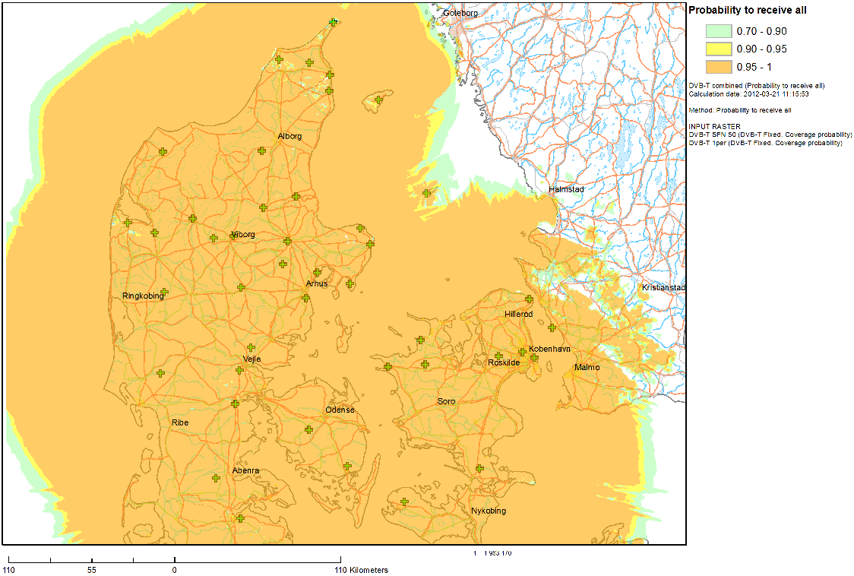
Figure P2-85
DVB-T2 National SFN 64-QAM R = 3/5 TG 19/128 (532 µs) Self Interference
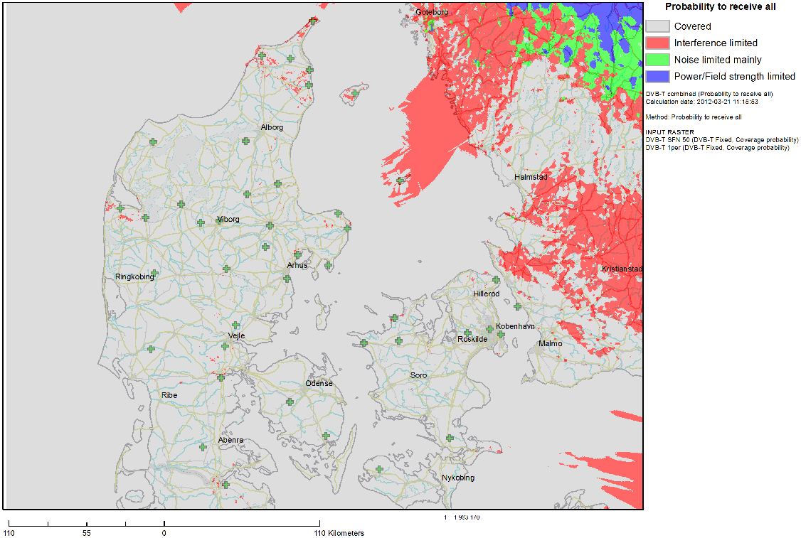

13.3.6 How do spectrum requirements change with larger SFNs?
The final question to be answered is if large area SFNs will reduce the number of frequencies needed to complete a coverage layer. There are a few studies made on this subject.
The potential improvements of using an SFN in terms of spectrum efficiency has been studied in EBU Technical Report TR 023 (https://tech.ebu.ch/) in terms of the number of frequencies needed to complete one coverage layer.
There are a few main factors which determine this, such as:
1) The outgoing interference from SFN network into other adjacent areas (SFNs); this determines the reuse distance of frequencies. It will be possible to reduce the outgoing interference from an SFN if more sites using lower power are used. This would result in a lower reuse distance, which may improve the spectrum efficiency. Extending the infrastructure will of course lead to a large increase of network cost. In such cases it is probably more efficient to use regional SFNs where the coverage area can be tailored to fit the desired geographical coverage area. It will then be easier to find a frequency that can be used on a local or regional basis.
2) The reception mode: A network designed for fixed rooftop antenna reception will need a shorter reuse distance, since the antenna directivity will reduce (discriminate) the interference. For mobile and portable reception, omnidirectional antennas are normally considered which also receive more interference.
3) The robustness of the DVB-T or T2 system variant: As seen in the given examples, a more robust mode will reduce the impact of interference, but will also of course reduce the capacity in each multiplex.
TABLE P2-28
From EBU TR 023
SFN – Fixed antenna reception, 95% locations, 100% pixels
Service area diameter | Number of channels |  |  | Equivalent number of channels
 | 64-QAM | 16-QAM | QPSK | 64-QAM | 16-QAM | QPSK
50 km | 9 | 7 | 4 | 9 | 11 | 12
150 km | 3 | 3 | 3 | 3 | 5 | 9

Table P2-28 above gives theoretical numbers on needed channel to complete one coverage layer, in the case of rooftop reception. By equivalent number of channels the capacity of the used DVB-T mode is also taken into consideration.
It can be seen the theoretically there is a need for trois RF channels in order to complete one coverage layer. These simulations are however based upon hexagon shaped areas. It is clear that countries are normally not hexagon shaped! If, for example, the national SFN in Denmark is considered, it will be clear that it will not be possible to use the same frequency in a large part of Norway, Sweden, and Germany, with additional restrictions in part of the Netherlands and Poland as well This would result in that at least 4 – 5 frequencies are needed to create one coverage layer.
If neighbouring countries have different reception mode requirements this will increase the number of frequencies required for each layer.
Comparing this spectrum efficiency it is not substantially different from the figures that would be obtained when using MFNs, for example, as seen in the United Kingdom. This example is based upon rooftop reception.

13.4 Case study on DVB-T2 service areas in Sweden
A study by Teracom compares the interference-limited population coverage in Sweden by using two different network configurations: a national SFN and a number of smaller sub-national ‘regional’ SFNs using a total of four frequency channels. In both cases DVB-T2 was used with the same transmission mode.
In the regional SFN case the maximum distance between any two of the larger stations within each SFN area was kept within the length of the guard interval. However, in some cases there were smaller stations beyond this distance.
The study focussed entirely on Sweden, with no consideration of neighbouring countries, and as such it should not be considered as a proposal but only as an example.
The main findings of the study are as follows:
Covering Sweden with regional SFNs in a four-frequency network would provide significantly higher interference-limited coverage than a national SFN.
Even if a single frequency was sufficient for Sweden in isolation, neighbouring countries would require separate frequencies of their own. Although not considered in detail, it was estimated that four frequencies might be needed over a wider area in order for other countries to achieve their coverage targets – roughly the same number as would be needed for regional SFNs.
For the same degree of interference-limited coverage, the regional SFN approach, which by virtue of having smaller regions would permit the use of higher capacity/shorter guard interval modes, could lead to a higher total capacity within a set amount of spectrum.
The regional SFN approach also provides far better – although by no means perfect – possibilities for regional programming.

13.4.1 Introduction
This section compares the interference-limited population coverage in Sweden using a national SFN (single frequency) and a number of regional SFNs (a total of four frequencies). In both cases DVB-T2 is used with the same transmission mode.
In the regional SFN case, the maximum distance between any of the larger stations within each SFN area is within the size of the guard interval. However, in some cases there are smaller stations that do not fulfil this.
The study is limited to Sweden, without any considerations of neighbouring countries.
This section should not be considered as a proposal but only as an example.

13.4.2 Parameters
The DVB-T2 transmission parameters were chosen to maximize the guard interval, while still allowing a reasonably high bit rate (36 Mbit/s). The mode used is 32k, 256-QAM, R = 3/4 with guard interval fraction 19/128, allowing a guard interval of 532 µs. This corresponds to a maximum theoretical transmitter distance of 160 km without self-interference.
The assumed infrastructure consists of the existing 54 main stations in Sweden with existing e.r.p. levels and antenna heights. Most stations have an antenna height of approximately 300 m and e.r.p. of 50 kW, although some are smaller and with lower power. In Fig. P2-86 the two types of stations are indicated with different symbols.

13.4.3 Network planning
The national SFN coverage was calculated taking into account only self-interference. It was assumed that the reuse distance was large and that the interference was negligible from the next co-channel area.
The 4-frequency network was designed with all larger stations inside the guard interval. Coverage was calculated taking into account self-interference within each area, where applicable, and co-channel interference from the stations of the closest co-channel areas.
Figure P2-86
Frequency Network in Sweden
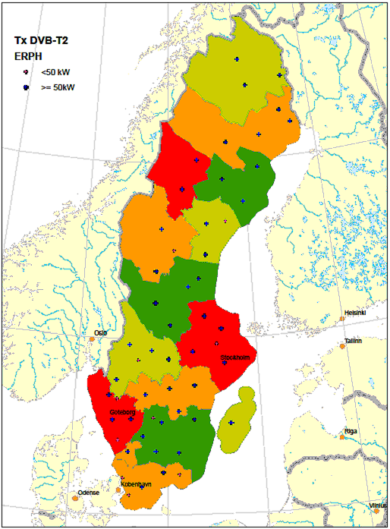

13.4.4 Population coverage calculation
The interference-limited (i.e. no noise) population coverage was calculated for fixed reception with 95% of locations and with a pixel resolution of 200 × 200 m² per pixel. The wanted field strength was calculated for 50% of time and the interference (self-interference and co-channel interference) for 1% of time in all cases.

 | National SFN | 4-frequency SFN Areas
Population coverage | 89.1% | 95.4%

Figure P2-87
National SFN frequency plan, 256-QAM R=3/4 TG=19/128 (532 µs)
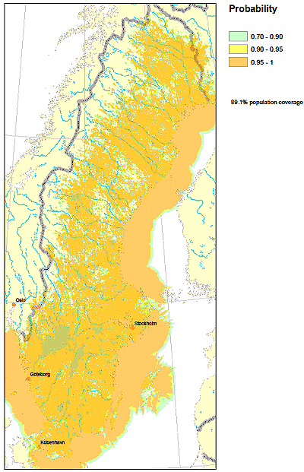
Figure P2-88
4- frequency plan, 256-QAM R=3/4 TG=19/128 (532 µs)
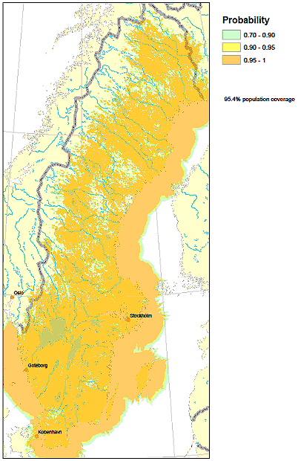
Figure P2-89
Self-interference National SFN
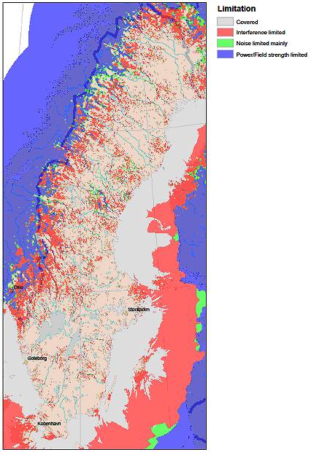

13.4.5 Discussion
From the results it is clear that the interference-limited coverage is significantly worse using a national SFN compared to regional SFNs the sizes of which roughly match the size of the guard interval, which is feasible with DVB-T2.
The explanation for this is that the closest self-interfering transmitters of the national SFN appear at a much shorter distance than the closest co-channel interfering transmitters of the regional SFN.
It is a widely held belief that the spectral efficiency increases with the size of the SFN and that large SFNs covering an entire country, like e.g. Sweden, would be more spectral efficient than using smaller SFNs.
It should however be noted that an international frequency plan of large (e.g. national) SFNs will also require a frequency reuse, which may be of the same order as that of the regional SFNs, i.e. at least four frequencies (probably some areas will need to use more).
A large SFN with signals outside guard interval is also complex to plan and may require the introduction of additional stations to compensate for coverage loss due to self-interference.
In fact, a national SFN will, for some countries, suffer from very difficult self-interference which may be difficult to cure and will also have severe limitations in regional programming, if feasible at all without excessive overhead due to simulcasting. The strongest interferers in the national SFN example network appear at distances around 200 km, i.e. just outside the guard interval and arrive from all directions.
A regional SFN with areas in the size of the chosen guard interval can in DVB-T2 be efficiently planned considering frequencies, with no or limited self-interference. Compared to the national SFN the regional SFN areas offer much better possibilities for regional programming, although still with significant limitations compared to a pure MFN (or hybrid MFN/SFN with small SFN areas such as the current DTT network in Sweden). The largest interferers in the four-frequency example are co-channel interferers at the distance of about 330 km, which can be compared with the 200 km figure for the national SFN.
To get a fair comparison between the two approaches (national and regional SFNs) the networks should in principle be expanded to include a wider area so that interference from reuse areas is accounted for properly in both cases. For the regional SFN case such a wider area should at least include neighbouring countries. It is expected that especially the regional SFN approach would suffer from more harmful interference in this case, but further studies are needed to assess the effects of this. In any case the regional SFN approach, with a 4-frequency reuse, looks promising in that it could potentially require a similar number of “global” frequencies (frequency reuse factor) while at the same time offer better interference-limited coverage and better possibilities for regional programming.
It should also be stressed that the robustness of the used mode also affects the interference-free coverage. One way to increase the interference-limited coverage of the national SFN could be to use e.g. a lower code rate. This would make reception more robust against interference, and therefore somewhat increase coverage, but would of course also reduce the capacity correspondingly. If the regional SFN approach would require slightly more frequencies for an international plan this may be compensated for by a higher capacity per multiplex, for the same interference-limited coverage in the two cases. The advantage of better possibilities for regional programming would still benefit the regional SFN case.

13.4.6 Conclusions
Covering Sweden with regional SFNs in a 4-frequency network provides significantly higher interference-limited coverage than a national SFN, although the expected number of frequencies to cover a larger area is likely to be in the same order. More studies are however needed to assess this.
For the same degree of interference-limited coverage the regional SFN approach, which reduces/avoids self-interference within each region, may use a higher capacity mode which may lead to higher total capacity with this approach within a given spectrum.
The regional SFN approach also provides far better – although by no means perfect – possibilities for regional programming.

13.5 Practical DVB-T2 based scenarios exploring the interdependence of coverage, capacity, transmission mode and network configuration
A UK based capacity study by Arqiva and the BBC was undertaken with the aim of providing high level guidance as to the throughput and population coverage that DVB-T2 could achieve with various transmission modes in combination with three broad network configurations (MFN, regional SFN and national SFN). The study also considered how the throughput and coverage would vary depending on the amount of spectrum allocated to a multiplex, or layer. In total 360 different combinations, or scenarios, were assessed including 18 different DVB-T2 modes, three different network configurations, and a spectrum allocation ranging from three to six frequency channels per multiplex.
The scope of the study was restricted to the existing HTHP network infrastructure and fixed rooftop reception. In order to simplify the work, many high-level assumptions were made (most of which are not set out in this summary), particularly about the transmissions in neighbouring countries. As some assumptions may not accurately reflect their operating conditions, or may not be practical, the results should be treated as indicative, and used to draw only high-level conclusions about what may be possible, and although it is believed that the broad conclusions of the work are fairly general, they may not be directly applicable to all countries.
The study included real terrain information, and to the extent known, existing antennas systems, transmitted powers, and geographical population distributions.
It must also be pointed out that the study does not constitute any particular proposal for a frequency plan, either within the UK, or further afield. It was simply a research exercise in order to form broad conclusions about what capacity and coverage might be achievable from different network configurations in conjunction with DVB-T2.

12.5.1 Methodology
The study sought to determine the throughput and coverage that could be obtained from a predefined number of frequency channels allocated to a single multiplex, or layer, in one of three network configurations. In total 360 scenarios were considered, each of which were themselves formed from a combination of a sub-scenario and a transmission mode, as set out in Table P2-29.
The sub-scenarios consisted of a combination of network configuration (MFN, regional SFN, or national SFN) and a number of frequency channels (3 to 6) assigned to a multiplex. For example, a full scenario may have consisted of four channels being assigned to a multiplex, or layer, configured in a regional SFN whereby a capacity of 34 Mbit/s was available. The population coverage was then calculated. Altogether these full scenarios encompass a wide range of potential network configurations and modes, giving a good indication of what might be achievable under a range of circumstances.
TABLE P2-29
Considered sub-scenarios and transmission modes in the study;
all 360 combinations were investigated
Sub-scenario | Transmission mode
Network Configuration | Constellation Code Rate
MFN | 256-QAM 2/3
MFN + Relays SFN | 256-QAM 3/5
Regional SFN | 64-QAM 5/6
Nations SFN | 64-QAM 3/4
National SFN | 64-QAM 3/5
 | 16-QAM 2/3
Frequency channels per multiplex | Guard interval (µs)
6 | 28
5 | 224
4 | 448
3

A bespoke system was created to automatically generate a frequency plan for each sub-scenario (network configuration and channel availability). It assigned to each station a frequency from the pre-determined list of those available, and assumed that the frequencies of stations in the UK and neighbouring countries could be freely changed in order to get the best overall population coverage throughout the planning area. It was further assumed that for each sub-scenario the same network configuration would be used across the entire planning area – for example, in a regional SFN scenario, all countries in the planning area were assumed to adopt regional SFNs comprising the same number of frequency channels. No changes were made to the transmitted powers, or antenna patterns of the stations in any of the scenarios.
The UK coverage for each scenario was calculated based on the existing 80 main stations in the UK and included interference from the main stations of neighbouring countries under pragmatic assumptions based on coordination agreements.

13.5.2 Results
Three charts appear below which summarise the high-level results for MFNs, regional SFNs and national SFNs. They are best described by an example in which the aim is to achieve at least 95% coverage. Figure P2-90 indicates that the 80 main stations in an MFN would require a minimum of four channels, and around 27 Mbit/s could be achieved from the network. Five channels on the other hand could achieve 34 Mbit/s, while six could achieve 40 Mbit/s. Figure P2-91 shows that a regional SFN could achieve the coverage target with three channels, but the capacity would be reduced to around 23 Mbit/s. In this configuration four channels may provide around 35 Mbit/s (more than the MFN), and whereas six channels would provide more coverage in the regional SFN than the MFN, the maximum throughput would be reduced due to the extended guard interval required in the SFN. National SFNs, as shown by Fig. P2-92 could achieve around 33 Mbit/s with four channels while reaching the coverage target.
The charts clearly show the inverse relationships between coverage and capacity – increasing one reduces the other. They also show the benefit that using more frequencies can give to both coverage and capacity – both can be increased by using more spectrum. The relationship between guard interval durations, coverage and capacity within SFNs is also highlighted. Increasing the guard interval can improve coverage, but it reduces capacity.
Figure P2-90
MFN
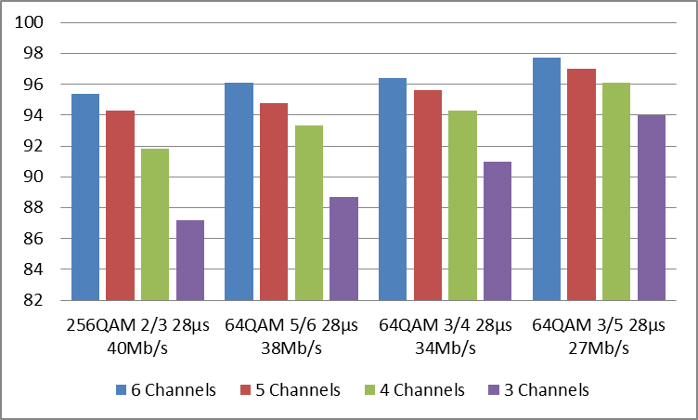
Figure P2-91
Regional SFN
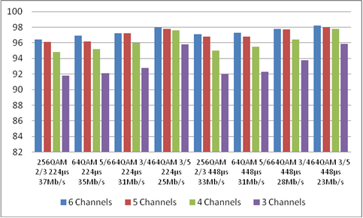
Figure P2-92
National SFN
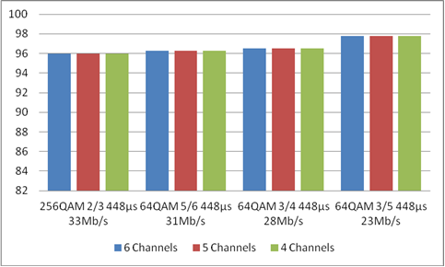

13.6 Case study on DVB-T2 MFN vs. SFN in the UK
A study by BBC incorporates and follows on from the results in § 13.5. It is intended to assess the efficiencies of national SFNs, regional SFNs and MFNs relative to one another. Two methods were used. Method 1 was based on the familiar metric of spectral efficiency measured in bits/s/Hz. Method 2 looked at efficiency in terms of the number of programmes that could be delivered per frequency channel while taking into account the effects of statistical multiplexing and MPEG compression. Both methods were based on the results from § 13.5 which determined how many frequency channels would be required to achieve various throughputs in a national network made up either MFNs, regional SFNs or national SFNs.
Method 1 showed that SFNs could be some 25% more efficient than a national MFN, and 10% more efficient than a regional SFN.
Method 2 also shows broadly similar results, though as expected there is some slight variation due to the quantising effect that the carriage of discrete numbers of programmes have on the multiplex capacity (i.e. it is only possible to carry a whole number of programmes on a multiplex – it is not for instance possible to carry half a programme). For a particular program quality this effect can lead to a greater or lesser portion of the total throughput being ‘left over’, and it is more pronounced for high quality HD programmes. Depending on the throughput of a particular multiplex, only three or four HD programmes may be able to be carried within it, which makes the quantising effect more significant. This can have the effect of reducing the efficiency of an SFN as significant ‘left over’ capacity would remain in some instances. For example it may come to pass that introducing three HD channels may nominally leave 2 Mb/s of multiplex capacity being ‘left over’ which may not be sufficient for another HD programme.
This method also relies on the subjective measure of picture quality which, at first sight, could be perceived to have the potential to change the efficiency conclusions that are drawn from the method 1 analysis. However, this study has looked at various different picture qualities, and although quality does influence the outcome to an extent, it is not sufficient to change the conclusions, except perhaps for the case of very high quality HD pictures in a lower capacity multiplex.
The main factor that influences spectral efficiency is the number of frequency channels required for the different network configurations. The results in § 13.5 were used to establish these requirements in the first instance, and they lead to the conclusions above.
A sensitivity analysis was carried out in order to determine how the results may change if additional frequency channels were needed in the various network configurations. Method 1 was used for this assessment, and it was found that should each network configuration require an additional channel, relative to an MFN, the efficiency of a national SFN would drop to approximately 20%. Another showed that that if MFNs required an additional channel while national SFNs did not, the relative efficiency of an SFN would approach 50% over an MFN.
In all cases it should be noted that the price to pay for the increased efficiency of SFNs would be restrictions on regional and local coverage.
As it would not be efficient to deliver regional content in a national SFN, regional SFNs are a good compromise between an MFN and a full national SFN. Their efficiency generally sits between the two and they would allow regionality to be maintained.

13.6.1 Introduction
A persistent question is whether an SFN is more efficient than an MFN. The usual way to respond is to compare the spectral efficiency (Mbit/s/Hz) of one network with the other. However, to do so it is necessary to determine how many frequency channels would be required for the two different network configurations, and this is usually the contentious part. Nevertheless this note attempts to answer the question by considering a range of scenarios – the typical high medium and low cases.
This note also considers the spectral efficiency in terms of programmes per multiplex in order to determine whether practical considerations such as statistical multiplexing would yield an efficiency figure that differs from the standard measure of Mbit/s/Hz.

13.6.2 Background
The Building Blocks may be used to determine the number of frequency channels that would be necessary to provide a particular coverage and capacity given various network configurations. Importantly the methodology of the Building Blocks applied equally ideal conditions for each considered case, which makes it possible to directly compare one scenario with another. Broadly, the building blocks concluded the following for DVB-T2 broadcasting networks:
– Six frequency channels would provide 98.5% coverage at 40.2 Mbit/s in an MFN.
– Five frequency channels would provide 98.5% coverage at 38 Mbit/s in a regional SFN.
– A national SFN providing 98.5% coverage would be capable of delivering up to 33 Mbit/s.
It has been assumed that the results of the building blocks for MFNs and regional SFNs could be extended over the entirety of Europe. Although it is not known whether this assumption would, in the end, prove correct, it has been assumed to be true in this note as it appears reasonable in the first instance. Similarly, although National SFNs were included in the Building Blocks the planning area under consideration was not wide enough for a useful outcome to be obtained.
For example the building blocks indicate that four frequency channels would be no more beneficial than three. Should the study have been undertaken over a wider area it is expected that more frequency channels would have been found to be necessary, as discussed below.
For an SFN the simplest assumption to make is that four-colour map theory would apply and that it would be possible to cover the entire planning area with four frequency channels. In practice it is likely at least one additional frequency channel would be required in certain ‘hot-spot’ areas, and therefore over the entire planning area. However, for the purposes of this study four has been assumed sufficient as a starting point though it is noted that SFNs may therefore be assessed favourably in this document.
As mentioned in the summary, two methods of assessing the networks’ efficiency have been adopted in this note. They are:
1) Raw payload per frequency channel (Mbit/s/frequency channel)
2) TV programmes per channel (programmes/frequency channel)
Method 1 is the usual way of assessing efficiency and is straightforward. It makes no assumptions about what services could be transmitted in the multiplex – it simply looks at the payload that would be available in equivalent SFN and MFN networks and normalises it with respect to the number of frequency channels that would be required to deliver the payload in each network configuration.
Method 2 looks at efficiency in a more practical way. It considers efficiency in terms of the number of TV programmes that might be deliverable in a multiplex before normalising the result with respect to the required frequency channels. This approach takes into account statistical multiplexing gains as they are often mentioned as an important factor in determining multiplex efficiency. However, as picture quality is subjective, precise bitrate per programme requirements cannot be determined, and guideline values must be used. To overcome the need for a subjective judgement, three picture quality cases: a high, medium and low have been considered in order to gauge how sensitive efficiency may be to particular picture quality choices. EBU Technical Report TR 015 (https://tech.ebu.ch/) has been used as the source of the guideline figures for HD and SD MPEG-4 compression.

13.6.3 Discussion

13.6.3.1 Method 1
The results of Method 1 are set out in Table P2-30 which shows a National SFN to be approximately 25% more efficient than an MFN. However, the efficiency would come at the price of regionality, which is an important factor in broadcast networks. Whether the modest efficiency gain would be worthwhile at the high cost of sacrificed regionality is therefore questionable.
To maintain regionality a regional SFN could be adopted. The Regional SFN is shown to be some 10% more efficient than the MFN and some 15% less efficient than a full national SFN. As such, it may be a suitable middle ground between the MFN and full SFN.
TABLE P2-30
DVB-T2 network efficiencies
 | MFN | Regional SFN | National SFN
Frequency channels required per multiplex | 6 | 5 | 4
Regionality enabled | Yes | Yes | No
Capacity of multiplex (Mbit/s) | 40.2 | 37 | 33.4
Spectral efficiency (Mbit/s / channel) | 6.7 | 7.4 | 8.35
Efficiency relative to an MFN | – | 10% | 25%

13.6.3.2 Method 2
The results from the assessment of method 2 are summarised separately in this section for SD and HD services as the picture quality heavily influences the number of programmes that can be delivered in a multiplex. All the per programme bitrate requirement figures for various picture qualities and stat-mux gains in this note have been obtained from EBU Technical Report TR 015 (https://tech.ebu.ch/).
SD
Table P2-31 shows the total number of SD programmes that it would be possible to carry in each network configuration assuming the application of bitrates of Table A2 in EBU Technical Report TR 015 were applied as well as the stat-muxing gains in Fig. A2 of the same document. The results for SD services closely match those of method 1 in Table P2-30 above. However, once again it should be noted that the efficiency of a national SFN would come at the expense of regionality, which may not be worthwhile.
It is worth noting that in this instance all network configurations would allow the carriage of a significant number of services. This means that for one network relative to the other there is no stat-mux gain – a saturated 26% saving is evident for each of the networks.
TABLE P2-31
Relative Efficiencies for SD
 | MFN | Regional SFN | National SFN
Frequency channels required per multiplex | 6 | 5 | 4
Regionality possible | Yes | Yes | No
Capacity of multiplex (Mbit/s) | 40.2 | 37 | 33.4
Base bitrate per SD programme | 2.65 | 2.65 | 2.65
Stat-mux gain (%) | 26 | 26 | 26
Effective bitrate per programme in stat-mux | 1.96 | 1.96 | 1.96
Potential programmes per stat-mux | 20 | 18 | 17
Unused capacity (Mbit/s) | 1.0 | 1.7 | 0.1
Total programmes per frequency channel | 3.3 | 3.6 | 4.3
Efficiency relative to an MFN | – | 8% | 28%

EBU Technical Report TR 015 (https://tech.ebu.ch/) provides only a single bitrate requirement per programme for SD services – no indication is provided regarding higher and lower quality SD services. Therefore in order to gauge the sensitivity of spectrum efficiency to picture quality the above assessment has been repeated assuming both 0.5 Mbit/s more per programme and 0.5 Mbit/s less would be required. The results are shown in Table P2-32, from which it is clear that the picture quality would have little impact on the efficiency of the network configuration.
TABLE P2-32
Sensitivity of spectrum efficiency to programme bit-rate – Standard definition
 | MFN | Regional SFN | National SFN
Efficiency relative to an MFN (3.15 Mbit/s/programme) | – | 6% | 24%
Efficiency relative to an MFN (2.15 Mbit/s/programme) | – | 10% | 20%

HD
As with SD, the number of programmes that can be transmitted in a multiplex relies on subjective assessment. However fewer HD programmes would fit into a multiplex than SD due to the higher bitrate requirement of HD services. As such the spectrum efficiency of different networks for HD transmission would become more granular and may be more sensitive to particular picture quality choice. Again, to overcome this difficulty three different picture qualities, in the form of the required bitrate per programme, have been considered. This approach will show the sensitivity of efficiency to picture quality.
Table P2-33 summarises the results of Tables P2-34 to P2-36 which provide the detailed assessment for the various picture qualities considered. In general, under this analysis, national SFNs remain more efficient than MFNs. However, in the high quality case the benefit is less clear.
TABLE P2-33
Relative efficiencies for various HD programme qualities
Programme quality | Regional SFN | National SFN
HD Programmes per Frequency Channel – High Bitrate per Programme | 20% | 13%
HD Programmes per Frequency Channel – Medium Bitrate per Programme | 20% | 20%
HD Programmes per Frequency Channel – Low Bitrate per Programme | 0% | 25%

TABLE P2-34
Relative efficiencies for HD – High bitrate per programme
 | MFN | Regional SFN | National SFN
Frequency channels required per multiplex | 6 | 5 | 4
Regionality possible | Yes | Yes | No
Capacity of multiplex (Mbit/s) | 40.2 | 37 | 33.4
Base bitrate per SD programme | 10.85 | 10.85 | 10.85
Stat-mux gain (%) | 15 | 15 | 12
Effective bitrate per programme in stat-mux | 9.22 | 9.22 | 9.55
Potential programmes per stat-mux | 4 | 4 | 3
Unused 'bitrate' (Mbit/s) | 3.3 | 0.1 | 4.8
Total programmes per frequency channel | 0.7 | 0.8 | 0.8
Efficiency relative to an MFN | – | 20% | 13%

TABLE P2-35
Relative efficiencies for HD – Medium bitrate per programme
 | MFN | Regional SFN | National SFN
Frequency channels required per multiplex | 6 | 5 | 4
Regionality possible | Yes | Yes | No
Capacity of multiplex (Mbit/s) | 40.2 | 37 | 33.4
Base bitrate per SD programme | 8.35 | 8.35 | 8.35
Stat-mux gain (%) | 17.5 | 17.5 | 15
Effective bitrate per programme in stat-mux | 6.89 | 6.89 | 7.10
Potential programmes per stat-mux | 5 | 5 | 4
Unused ʻbitrateʼ (Mbit/s) | 5.8 | 2.6 | 5.0
Total programmes per frequency channel | 0.8 | 1.0 | 1.0
Efficiency relative to an MFN | – | 20% | 20%

TABLE P2-36
Relative efficiencies for HD – Low bitrate per programme
 | MFN | Regional SFN | National SFN
Frequency channels required per multiplex | 6 | 5 | 4
Regionality possible | Yes | Yes | No
Capacity of multiplex (Mbit/s) | 40.2 | 37 | 33.4
Base bitrate per SD programme | 7.85 | 7.85 | 7.85
Stat-mux gain (%) | 19 | 17.5 | 17.5
Effective bitrate per programme in stat-mux | 6.36 | 6.48 | 6.48
Potential programmes per stat-mux | 6 | 5 | 5
Unused ʻbitrateʼ (Mbit/s) | 2.0 | 4.6 | 1.0
Total programmes per frequency channel | 1.0 | 1.0 | 1.3
Efficiency relative to an MFN | – | 0% | 25%

In some of the scenarios in Table P2-34, Table P2-35 and Table P2-36, a significant unused bitrate is evident – for example the MFN in Table P2-35 has an unused bitrate of 5.8 Mbit/s. This arises because the required bitrate per programme is not an integer divisor of total capacity. In any practical situation it is unlikely that the bitrate would be allowed to lie fallow and the base bitrate per programme would be adjusted slightly to accommodate an additional programme. Such adjustments have been made in Table P2-38 and Table P2-39 for the low and medium capacity HD cases. In these instances it was possible to reduce the required bit rate per programme by less than 0.3 Mbit/s to obtain an additional programme in some network configurations. This more pragmatic arrangement yields the summary in Table P2-37 where a national SFN is shown to be up to 25% more efficient than an MFN. It was not possible to undertake a similar adjustment for the high bitrate per programme example as the large bitrate requirements per programme would need too great an adjustment to be considered minor.
TABLE P2-37
Relative efficiencies for various HD programme qualities – Pragmatic approach
Programme quality | Regional SFN | National SFN
HD programmes per frequency channel – high bitrate per programme | 20% | 13%
HD programmes per frequency channel – medium bitrate per programme | 0% | 25%
HD programmes per frequency channel – low bitrate per programme | 20% | 25%

TABLE P2-38
Relative efficiencies for HD – Medium bitrate per programme
 | MFN | Regional SFN | National SFN
Frequency channels required per multiplex | 6 | 5 | 4
Regionality possible | Yes | Yes | No
Capacity of multiplex (Mbit/s) | 40.2 | 37 | 33.4
Base bitrate per SD programme | 8.25 | 8.1 | 8.05
Stat-mux gain (%) | 19 | 17.5 | 17.5
Effective bitrate per programme in stat-mux | 6.68 | 6.68 | 6.64
Potential programmes per stat-mux | 6 | 5 | 5
Unused ʻbitrateʼ (Mbit/s) | 0.1 | 3.6 | 0.2
Total programmes per frequency channel | 1.0 | 1.0 | 1.3
Efficiency relative to an MFN | – | 0% | 25%

TABLE P2-39
Relative efficiencies for HD – Low bitrate per programme
 | MFN | Regional SFN | National SFN
Frequency channels required per multiplex | 6 | 5 | 4
Regionality possible | Yes | Yes | No
Capacity of multiplex (Mbit/s) | 40.2 | 37 | 33.4
Base bitrate per SD programme | 7.85 | 7.6 | 7.85
Stat-mux gain (%) | 19 | 19 | 17.5
Effective bitrate per programme in stat-mux | 6.36 | 6.16 | 6.48
Potential programmes per stat-mux | 6 | 6 | 5
Unused ʻbitrateʼ (Mbit/s) | 2.0 | 0.1 | 1.0
Total programmes per frequency channel | 1.0 | 1.2 | 1.3
Efficiency relative to an MFN | – | 20% | 25%

Sensitivity to frequency channels required per multiplex
As previously stated, it is unclear whether or not four channels would be sufficient for national SFNs throughout Europe. Bearing that in mind it is informative to consider how sensitive the spectral efficiency may be to the number of required channels. Table P2-40 shows the Method 1 efficiencies recalculated should an additional channel be required for each network configuration, while Table P2-41 does the same should only the MFN and Regional SFNs require an additional channel.
Referring to Table P2-40 it is clear that the relative efficiencies of SFNs would decrease should it be found that each network configuration would require an additional channel. In this case, the efficiency of an SFN over and MFN would marginally reduce to approximately 18%. Conversely, Table P2-41 shows that the relative efficiencies of National SFNs would increase if MFNs and Regional SFNs were found to require an additional channel while four remain adequate for SFNs.
TABLE P2-40
Method 1 efficiency gains should each network configuration require
an additional frequency channel – Method 1
 | MFN | Regional SFN | National SFN
Frequency channels required per multiplex | 7 | 6 | 5
Regionality enabled | Yes | Yes | No
Capacity of multiplex (Mbit/s) | 40.2 | 37 | 33.4
Spectral efficiency (Mbit/s/channel) | 5.7 | 6.2 | 6.7
Efficiency relative to an MFN | – | 9% | 18%

TABLE P2-41
Method 1 efficiency gains should the MFN and regional SFN network configuration
require an additional frequency channel – Method 1
 | MFN | Regional SFN | National SFN
Frequency channels required per multiplex | 7 | 6 | 4
Regionality enabled | Yes | Yes | No
Capacity of multiplex (Mbit/s) | 40.2 | 37 | 33.4
Spectral efficiency (Mbit/s/channel) | 5.7 | 6.2 | 8.35
Efficiency relative to an MFN | – | 9% | 46%

13.6.4 Summary
Two different methods have been used to assess the relative efficiencies of SFNs. Method 1 is based spectral efficiency measured in Mbit/s/Hz while Method 2 looks at efficiency in terms of programmes that could be delivered per frequency channel. The Building Blocks have been used as a base to determine how many frequency channels would be required for a national network comprising of MFN, Regional SFNs and National SFNs.
Method 1 shows SFNs to be some 25% more efficient than a national MFN, and 10% more efficient than a regional SFN.
Method 2 also showed broadly similar results, though as expected there was some slight variation due to the quantising effect that discrete programme numbers have. If, however, a high quality HD programme format is chosen only three or four programmes would be possible per multiplex and the quantising effect becomes more significant which would reduce the efficiency of an SFN in which significant unused capacity would remain.
Method 2 relies on the subjective measure of picture quality which, without study, could be perceived to have the potential to change the efficiency conclusions that are drawn from the method 1 analysis. However, this study looked at various different picture qualities, and although quality influences the outcome to an extent, it is not sufficient enough to change the conclusions, except perhaps for the case of high quality HD pictures mentioned above.
The main factor that influences spectral efficiency is the number of frequency channels required for the different network configurations. As mentioned earlier the Building blocks were used to establish these requirements in the first instance. However, under less ideal circumstances than considered in the Building Blocks, additional channels may be required. To gauge the sensitivity to frequency channel requirements, two additional scenarios were investigated under Method 1. One scenario considered the relative efficiencies should each network configuration require an additional channel. This showed the relative SFN efficiency would reduce to approximately 20% over an MFN. The second showed that if MFNs required an additional channel while SFNs did not, the relative efficiency of an SFN would approach 50% over an MFN.
In all cases, it should be noted that the price to pay for the increased efficiency of SFNs would be the loss of regionality. The regional SFN may be a good trade-off between MFNs and full national SFNs as their efficiency generally sits between the MFN and SFN but would allow regionality to be maintained.

13.7 DVB-T/DVB-T2 planning exercise with limited spectrum resources in the UK
Combined, the main six UK multiplexes use 32 channels, leading to an average-per-multiplex frequency re-use pattern of 5.3. Studies by Arqiva investigated whether six channels (31 to 35 and 37), using a re-use pattern of three, would be sufficient to create two national DTT layers (layers 7 and 8) while aligning with existing editorial regions.
Under these more restrictive conditions stations were arranged so that any particular service area had an even number of neighbouring areas, as with this arrangement a three-colour map is possible (i.e. adjacent service areas would not fall co-channel). However, in order to create these conditions some transmitters in particular regions, which would normally be in MFNs, had to be re-configured into SFNs.
It was found that, compared with the main network, where the frequency re-use is higher, the three-channel network would be both coverage and capacity limited – the former being a result of the more frequent re-use pattern, while the latter was due to the increased guard interval necessary to operate some transmitters in SFNs. DVB-T2, it was noted, would offer benefits for both coverage and capacity. It would, in these circumstances, eliminate SFN self-interference, and could, through moving to a more robust mode, improve coverage by sacrificing some of the additional capacity it would introduce relative to DVB-T.
One study also considered whether a national SFN would be practical (layer 9). With DVB-T it was found that, although quasi-national coverage could be achieved, the capacity of such a network would be impractically low due to the long guard interval requirements. DVB-T2 would, however offer significant benefits to both coverage and capacity.
Table P2-42 and Table P2-43 summarise the results of the studies.
TABLE P2-42
Re-use 3 coverage
Mode |  | Capacity | Layer 7 coverage (%) | Layer 8 coverage (%)
DVB-T | 8k 64QAM 2/3 FEC 1/4 GIF | 19.9 Mb/s | 89.3 | 87.2
DVB-T2 | 32k 256QAM 2/3 FEC 1/16 GIF | 38 Mb/s | 88.1 | 85.9

TABLE P2-43
National SFN coverage
Mode |  | Capacity | Layer 9 coverage (%)
DVB-T | 8k 64QAM 2/3 FEC 1/4 GIF | 19.9 Mb/s | 84.4
DVB-T2 | 32k 256QAM 2/3 FEC 1/8 GIF | 35.8 Mb/s | 91.2

13.8 Effect of sea path propagation – An example in the United Kingdom
This paragraph summarises a United Kingdom based study concerning the optimisation of the guard interval for wide-area SFNs. In part it considers long distance interference from beyond the guard interval, over land and sea paths. Here the sea path aspect is highlighted.
The optimal guard interval can be taken as a measure of the strength of self-interference in the network. Longer guard intervals are required if the self-interfering components of the SFN signals are larger. In the study the optimum guard interval is evaluated for the whole United Kingdom as well as for its four constituent nations: Wales, Scotland, Northern Ireland and England.
The study shows that a United Kingdom-wide SFN including all four nations would, relative to an England-Scotland SFN, benefit from longer guard intervals, even though the maximum geographical extents of the network would not significantly change, the reason being that the inclusion of Wales and Northern Ireland would introduce more interference from signal paths over sea. These can be significant sources of interference that must be properly taken into account during any network design. The details of the study are described below.

13.8.1 Optimising the guard interval in a national SFN
The optimum guard interval in a national SFN will depend on a number of factors including the size of the country, the length of sea paths and any coverage obligations. The United Kingdom is a good example of a difficult country to serve with a national SFN as its width and length exceed the length of the guard interval of any of the available DVB-T2 modes, the country is surrounded by water so consideration of sea paths plays a significant part in any planning and it has coverage obligations with respect to the nations that make up the United Kingdom.
An analysis of the coverage obtained across the United Kingdom with a national Single Frequency Network (SFN) has been carried out by Arqiva. This was based on DVB-T2 as follows:
– Modulation scheme: 256-QAM.
– Mode: 32k.
– Code rate: 2/3.
Coverage predictions were run using a sequence of guard intervals to examine the effect of this on population coverage. These were in the range from 300-566 μs with an additional value of 900 μs being included as an upper bound.
Note, that the values used are not those contained in the DVB-T2 specification; thus, the results given do not necessarily demonstrate practicably achievable scenarios. Rather, the aim has been to consider the trends demonstrated. Of course, in practice, changing the guard interval can have other secondary effects. For example, with the existing DVB-T2 specification, a change in guard interval may also result in the need to change the pilot pattern. Therefore, in practice, the resulting change in data rate may not be the same as an initial calculation would suggest. However, for this study, such considerations have been put aside; any changes in bit rate are considered to be solely due to the change in the guard interval itself. For this reason, when carrying out the analysis, normalized data rate values are used.
The coverage runs were carried out using the 80 Primary Sites. This number was considered to be sufficiently high to assess the impact on coverage while being sufficiently low to carry out numerous runs within a reasonable length of time.

13.8.2 Results and analysis
Figure P2-93 shows the variation in coverage with guard interval. The population for each country is given as a fraction of the total population of that country.
N.B.: The apparent discontinuity at 566 μs is an artefact; it occurs because there are no data points to plot between 566 μs and the final point at 900 μs.
As expected, the population covered increases with increasing guard interval.
The next step in the assessment is to use the results to determine the optimum guard interval. In order to do this, the rising coverage must be compensated with the associated falling data rate. One approach to use would be to consider the product of the population served with the data rate. However, using a simple product does not allow us to take into account any specific requirements.
For example, full national coverage is expected to beat least 98.5% of the population. Therefore, a high data rate is of less interest if the population coverage is below the required threshold. Similarly, if a sufficient proportion of the population is served, improving the data rate may be considered to have priority over increasing the coverage.
Figure P2-93
Normalised relative population coverage of the United Kingdom and constituent nations, 70% locations served
To this end, a weighted product of population served and data rate was used.
The weighting has been carried out as follows:
– Define a threshold population coverage. For a full national run, this would correspond to 98.5%. However, in this example, using only the 80 Primary Sites, 97.5% was chosen; additional relay sites will result in a higher population coverage.
cf.: The 80 Primary Sites using the National Switchover Plan (the Base Configuration) results in an overall UK coverage of 95.5%.
– For population coverage which is below the threshold, use:
(Fraction of the population served) 2 × (Normalised Data Rate)
otherwise, use:
(Fraction of the population served) × (Normalised Data Rate) 2
i.e. for low population coverage, more weight is given to the population coverage while for high population coverage, more weight is given to the data rate.
Figure P2-94
Normalized coverage weighted for reduction in data capacity with increasing guard interval
(70% locations served)
The plot in Fig. P2-94 summarises the results for 70% locations after accounting for the reduction in data capacity with increasing guard interval; the plot in Fig. P2-95, relates to similar the results but for 90% locations.
Figure P2-95
Normalized coverage weighted for reduction in data capacity with increasing guard interval
(90% locations served)
Note that the numerical values on the ordinate scale are, in themselves, not relevant. What is of interest are the relative values.
Using this approach, for the United Kingdom as a whole, an optimum value for the guard interval of just over 400 μs can be observed. If the threshold population is changed to 97%, then the peak of the plot corresponds to a guard interval at just under 400 μs.
Repeating this using data for 90% locations, the curve maximum corresponds to a guard interval of around 400 μs for both 97% and 97.5% thresholds.
Thus, for the remainder of this study, SFN coverage analysis has been carried out using a guard interval of 400 μs.
Figure P2-96
Location of United Kingdom primary sites
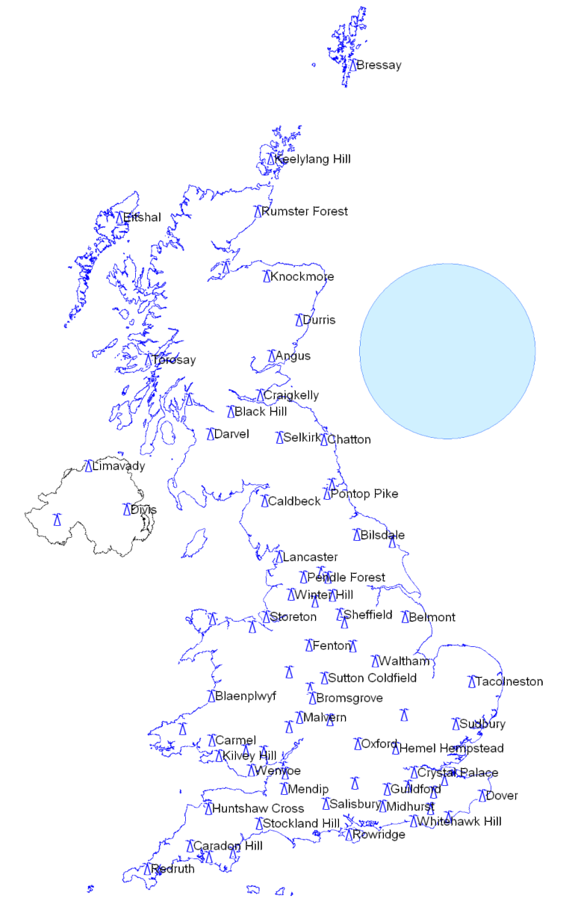
Finally, it is worth spending a little time looking at the curves for the individual nations. As expected, the path of the United Kingdom curve is dominated by the England, and to a lesser extent the Scotland curves. This is not surprising since these two countries account for over 90% of the United Kingdom’s population.
If it were to base the guard interval on the results for Wales and Northern Ireland then the curves would suggest a longer guard interval. This can be explained when the geography is considered.
For Wales and Ireland, the contribution from more distant interferers is arguably more significant owing to the higher percentage of sea path. Conversely, the reverse impact of the main station at Divis (Northern Ireland, Belfast) on these stations is lower in terms of the overall impact on coverage in England.
Figure P2-96 shows the locations of the sites. The blue circle has a radius corresponding to a delay of 400 μs.
It can be seen that paths from sites such as Caldbeck to Northern Ireland are predominantly sea paths whereas from the same site (Caldbeck) to Mainland Britain the paths are predominantly over land. Thus the interference from Caldbeck to Northern Ireland will be higher than the interference it causes in areas at a similar distance in England.

13.8.3 Summary
Figure P2-97 compares the coverage achieved by a national SFN with a guard interval of 400 µs with that achieved from the base configuration (MFN).
Figure P2-97
Coverage comparison of a national SFN versus an MFN
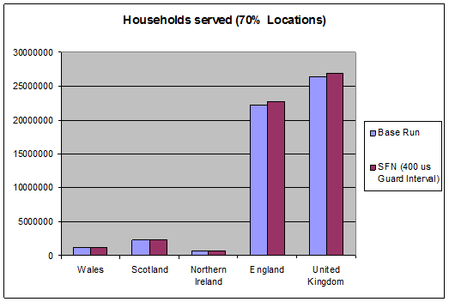
This indicates that a national SFN provides an overall United Kingdom increase in population, dominated by an increase in coverage in England. Coverage in Wales and Scotland also increased, albeit to a lesser extent while, for Northern Ireland, the population served has fallen slightly.
It should be noted that an MFN network would provide 40 Mbit/s whilst an SFN with an effective guard interval of 400 μs (actual 448 μs) would provide 33 Mbit/s.
The United Kingdom has regionality requirements for PSB services that preclude the use of national SFN.

13.9 Optimisation of a DVB-T2 SFN in Malaysia
A national DVB-T2 SFN was planned by Progira in Malaysia as part of an application to become network provider for DTT. The planning was performed for both Western and Eastern Malaysia, but only the results for West Malaysia appear in this example and it should be noted that the network has not yet been implemented. The use of national DVB-T2 SFNs was suggested since they would provide an efficient use of frequencies.
The target was to provide rooftop coverage for 98% of the population, which is equivalent to the current analogue coverage. Additionally there was a secondary requirement to provide indoor coverage in the main cities. Overall the area under consideration has as size of about 700 × 200 km².
The main planning parameters were:
– Use of DVB-T2 system variant: 256-QAM, R = 3/5, GI 1/8 or 19/128, 448 µs or 532 µs, PP2 providing about 30 Mbit/s or more.
– C/N assumed: 19.6 dB (rooftop).
– Use of existing infrastructure for analogue TV as far as possible which also meant that existing transmitting and receiving antenna would be used whenever possible.
In total about 74 transmitters were used in the planning work, assuming e.r.p.s between 1 kW and 60 kW.
Figure P2-98
Potential SFN self-interference areas in DVB-T2 SFN
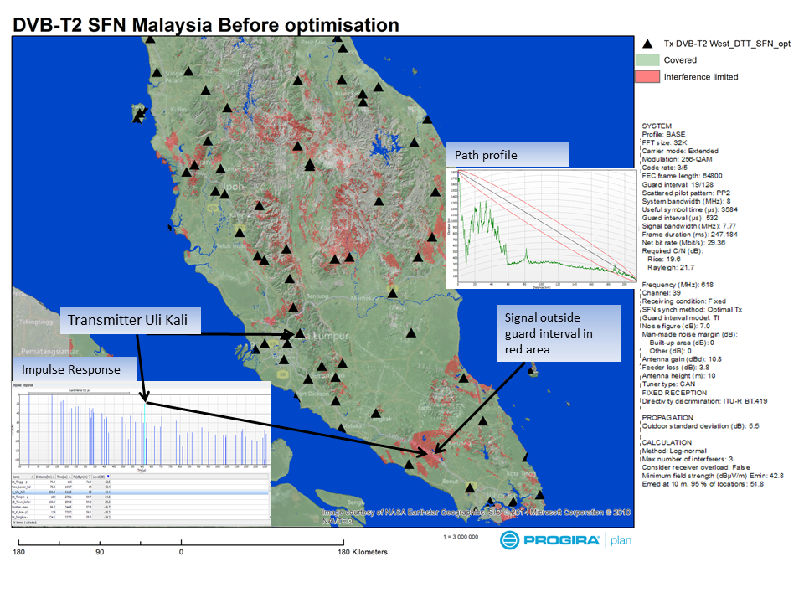
First the coverage was calculated using the nominal transmitter parameters assuming no timing offsets on the individual transmitters in the SFN. The result is given in Fig. P2-98 whereby coverage to 95% of the population was achieved, slightly below the requirement of 98%. When analysing the resulting coverage it became clear that some areas would potentially be affected by self-interference, despite the use of the long guard interval. This is shown when analysing the 1% time interfering signals where SFN self-interference areas are indicated in red in Fig. P2-98. At 50% time, this self-interference is not visible – it is only evident when propagation anomalies are considered, e.g. for 1% of time.
As seen the self-interference is scattered across the whole country but in particular it occurs in the mountains which are, with a few exceptions, not densely populated.
Figure P2-99 also shows an example of an impulse response at a point where self-interference is predicted. It can be seen that delayed signals beyond the 532 µs guard interval may occur. This may potentially happen from transmitters located in elevated positions. In this example, the transmitter Uli Kali has an effective antenna height of about 1 700 m in some directions. The path profile from the transmitter to the area where self-interference may occur is also shown in Fig. P2-99.
Figure P2-99
Resulting DVB-T2 coverage after optimization of SFN self-interference
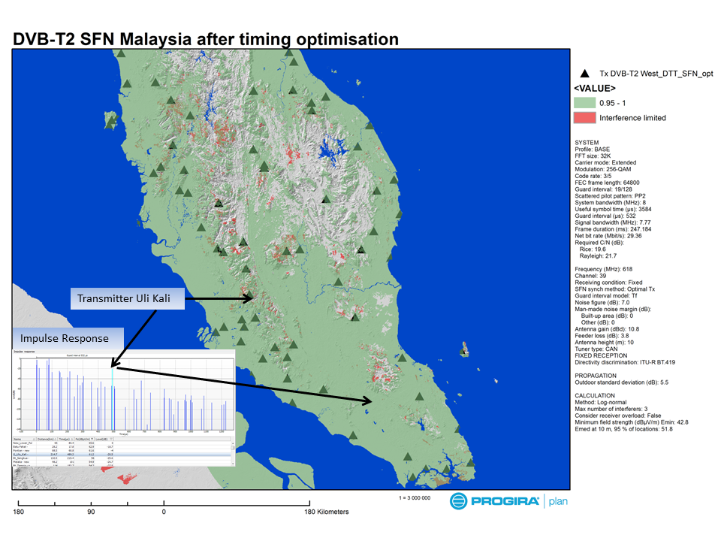
Note to Fig. P2-99: The problems with the out of guard interval signals are reduced with a combination of timing offsets and adjustments of antenna diagrams.
In order to reduce the effect of SFN self-interference, optimization was carried out with the following steps:
1) Analysis of the self-interference areas, identifying transmitters that may create out of guard interval interference.
2) Optimizing the static timing of the transmitters to minimize potential self-interference. This was carried out using a feature in the Progira Plan planning software where coverage can be optimized based upon the population.
3) Adjustments of antenna diagrams and in particular antenna tilt for a number of transmitters to further reduce potential self-interference.
4) Timing optimization in order to improve the SFN self-interference situation further.
The result of the optimization is shown in Fig. P2-99. Limited self-interference may still potentially remain in mountainous areas. However it is less significant compared to the initial case. The total population coverage is predicted to be 98.5%, which is above the requirements. The population that would potentially suffer SFN self-interference is very small.

13.10 DVB-T2 SFNs Networks and an Extended T2-MIP: a BBC study
Introduction
The ideas below emerged from a discussion regarding the UK DVB-T and T2 networks.
A typical arrangement in the current UK network is shown in the left hand picture below. A parent transmitter operating on frequency f1 feeds a number of relays which receive its signal off-air and re-transmit it on frequencies f2, f3, f4. These relays are either full regenerative repeaters (demodulation followed by re-modulation) or, typically for lower power sites, frequency transposers (which perform a frequency shift only).
One way of increasing the spectral efficiency of the network might be for these relays to all re-transmit on the same frequency (f2) in a synchronised SFN as shown in the right hand picture. In order to achieve the highest signal quality in the resulting SFN, regenerative repeaters would be preferred over transposers. However, to achieve this requires the carriage of appropriate synchronisation information in the off-air signal used by the relays.
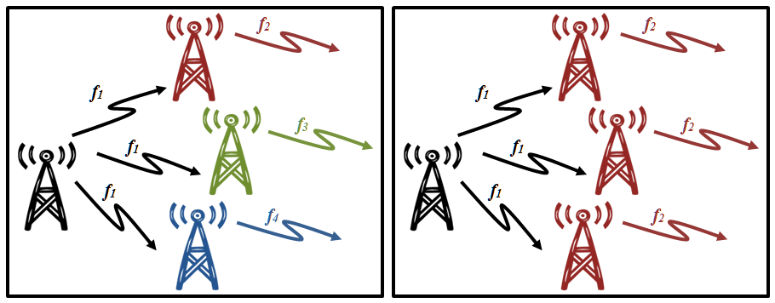
The differences between T and T2 mean that they present different challenges when deploying synchronised SFNs based on regenerative repeaters.
The differences between DVB-T and DVB-T2 SFNs
For DVB-T, there is a direct link between the mega-frame structure and the TS packets. The Transport Stream (TS) can be made into a complete and unambiguous description of the on-air signal by including Megaframe Initialization Packets ([T-]MIPs). The MIP is a TS packet that contains the timing information suitable for generating synchronised SFNs. Since this is a conventional TS packet, it is carried in the off-air signal along with the audio, video and SI. A conventional DVB-T receiver can decode the on-air signal and be connected directly to a SFN modulator to form a regenerative repeater as illustrated below.
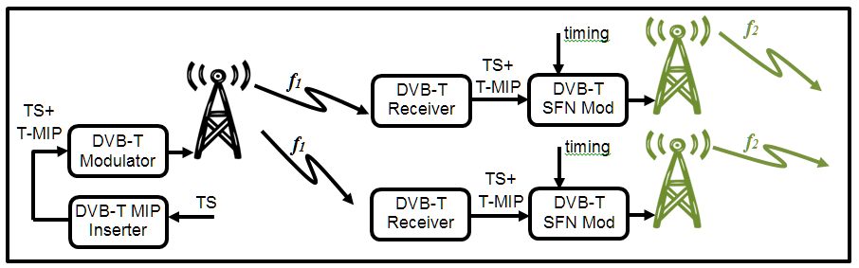
For DVB-T2, there is no longer a fixed relationship between the packetization of the TS and the frame structure of the physical layer. Therefore the TS alone is not an unambiguous representation of the off-air signal meaning that it is not, on its own, suitable for the formation of T2 synchronised SFNs.
A new entity, the T2-Gateway, is required in the network that takes at its input the audio/video transport stream and generates at its output the T2 modulator interface (T2-MI). The T2-MI provides the unambiguous representation of the on-air DVB-T2 signal as a combination of BBFrames and L1 signalling. Timing information can also be conveyed by the T2-MI and, since the T2-Gateway has carried out the framing once, this can be used to form synchronised T2 SFNs from multiple transmitters. However, the T2-MI is not carried over-air but is instead used by a modulator to generate the on-air signal.
In the current United Kingdom DTT network, the synchronised T2 SFNs make use of a T2-Gateway at a parent transmitter after the output of a proprietary SI insertion device. The T2-Gateway generates a T2 Modulator Interface (T2-MI) signal that is then line-fed to the children as illustrated below.
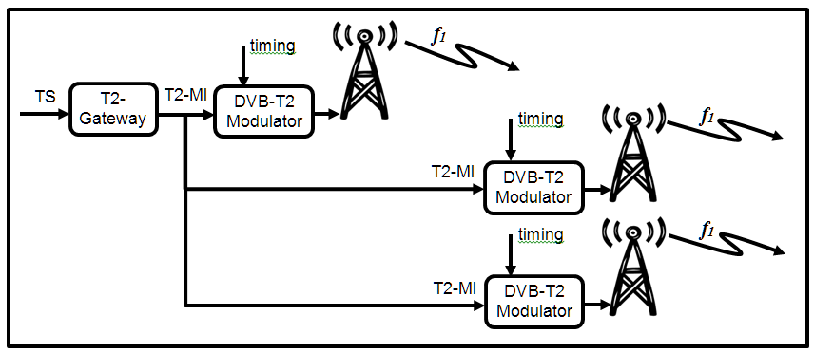
The requirement for line feeding of the transmitters means that the cost is prohibitively high for generating T2 synchronised SFNs at smaller sites. In areas where it is not economic to provide line feeds, non-synchronised transposers are currently used and the resulting mush area regarded as an acceptable compromise.
T2 has its own version of the MIP defined as the T2-MIP (the T2 Modulator Interface Packet) that allows generation of synchronised SFNs from an off-air signal. Just as for DVB-T, this is a conventional TS packet that carries timing information and is carried in the on-air signal along with the audio, video and SI. The T2-MIP indicates the timing of the start of emission of the physical layer super-frame in which the packet is carried.
However, a special receiver is required that is capable of outputting the physical layer framing of the T2 by generating T2-MI in the form of Baseband frames and the L1 signalling along with the timing information derived from the T2-MIP packet (see below).
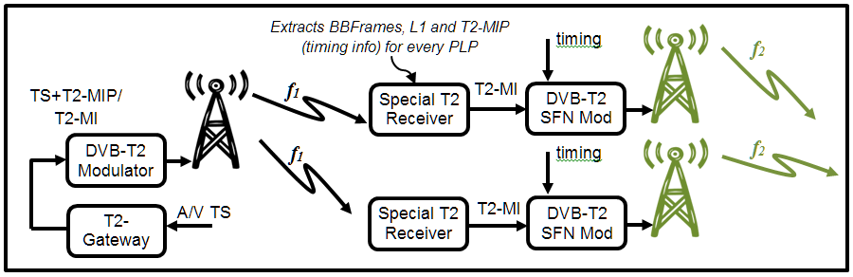
A further issue occurs when multiple PLPs are used since this special receiver also needs to be able to receive all of the PLPs whereas a conventional T2 receiver is only required to receive two PLPs simultaneously.
Up until now, the necessity to have this special receiver has meant that this setup has not been possible and it is not believed that such a device currently exists on the market.
Possible solutions
In principle, what is required is a full regenerative repeater, able to receive the T2 signal off air, extract the BBFRAMEs, L1 signalling and T2-MIP and either use these to generate T2-MI to feed a T2-MI-capable modulator, or generate the DVB-T2 signal directly.
However, such a piece of equipment is complicated and specialised, and for many applications a simpler solution may be possible.
For the simplest modes of DVB-T2 where every Baseband frame is fully allocated (as currently used in the United Kingdom), each T2 frame always contains the same number of Baseband frames and where only single PLPs are in use, the relationship between the TS packets and physical layer frames is simpler to define.
In fact, all that would be required is for the T2-MIP to be extended to signal the offset (in bits) from the start of the first BBFrame to the start of the packet. This would be a so-called extended MIP (T2-eMIP). With this packet, a conventional receiver could be used to receive the TS off-air. A separate (relatively simple) device could then use the offset and timing information contained in the T2-eMIP to re-construct the physical layer framing (BBFrames) in an unambiguous way and output a T2-MI signal suitable for use in forming a subsequent synchronised SFN.
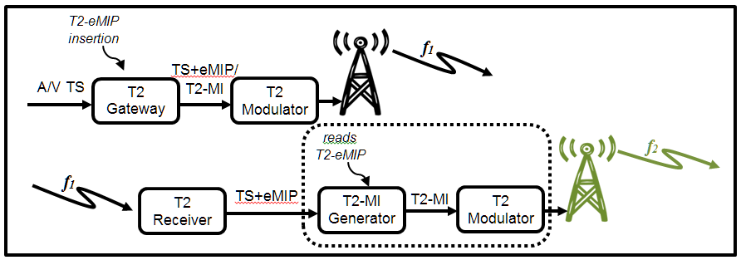
This re-construction of the T2-MI could be carried out either in software or in a relatively simple hardware.
The standalone T2-MI Generator could be fairly simple. It would not even be necessary to read the L1 information of the off-air input signal since this could be manually configured on each device in the same way that T2 modulators are currently configured in the DTT network. For a more general solution, it would be possible to include the necessary configuration information in the T2-eMIP or another packet to be defined. The most obvious way to do this would be to transmit some or all of the L1 signalling.
The T2-eMIP could be created by making use of the rfu_bytes fields defined in Annex B of ETSI TS 102 773 v1.3.1. Alternatively, a new T2-MIP could be defined using a new synchronization_id. In either case, this could be standardised through DVB/ETSI by issuing a new version of TS 102 733.
Depending on the use cases and requirements, it might be necessary or advisable to make the T2-eMIP work for a wider range of configurations.
A possible outline for the information to be carried might include:
– All the information currently in the existing T2-MIP.
– An indication of the offset in packets and bits, relative to the start of the T2-eMIP, of the first bit of the data field of the first BBFRAME of each Interleaving Frame (it might be possible to indicate only every superframe if certain other constraints are imposed, particularly regarding padding).
– A concise way of indicating the pattern of BBFrame padding.
– A method of carrying the L1 pre- and configurable L1-post signalling as needed (once per superframe should be sufficient).
– A method to carry a copy of the dynamic L1 signalling for each T2-Frame.
Consideration would be needed as to how to support multiple PLPs. One option would be to include a T2-eMIP in each PLP’s Transport Stream, possibly using a common PLP
There might be a trade-off in making the system flexible enough to meet the requirements whilst avoiding making it as complicated as the full T2-MI solution.
Conclusion
The T2-MIP can be used to re-create subsequent synchronised T2 SFNs that are re-generated from an off-air signal. However, up until now, the necessity to have a special device capable of re-uniting the TS packets with the relevant physical layer T2 frame has made this approach unattractive and there is no awareness of any commercial devices that are available to perform this function.
The T2-MIP also relies on access to separate knowledge about how the TS was mapped into BBFRAMEs and Interleaving Frames as well as about the scheduling and allocation of PLPs to the T2-frame structure.
An extension to the existing T2-MIP definition (the so-called eMIP), could offer a simpler solution for off-air regeneration of a T2 signal in an MFN. It would also allow a DVB-T2 signal to be generated deterministically from an input TS in other applications. These could potentially include local content insertion.

14 Impact of DAB parameters on SFN performance
With the term DAB is intended the reference to the EUREKA 147 system regardless the modulation adopted, MPEG-1-layer 2 (DAB) or AAC+ (DAB+).

14.1 General
Several of the conclusions drawn in the previous chapter on the impact of DVB-T parameters on SFN performance are equally valid also for the DAB case. For reasons of a balanced presentation they are partly repeated in the present chapter on DAB properties.

14.2 Constellation
All DAB modes use QPSK (4-QAM) modulation. QPSK provides a low data capacity but it does provide a very rugged service for mobile reception.

14.3 Code rate
Different code rates can be used to trade bit rate versus ruggedness, e.g. the signal strength required and interference protection required.
Five protection levels are available for audio (forward error correction (code rate) ranges from 1/3 to 3/4) and eight protection levels are available for data services through using punctured convolutional coding.
In the case of an audio signal, greater protection is given to some source-encoded bits than others, following a pre-selected pattern known as the unequal error protection (UEP) profile. The average code rate, defined as the ratio of the number of source-encoded bits to the number of encoded bits after convolutional encoding, may take a value from 1/3 (the highest protection level, giving the lowest useful data capacity) to 3/4 (the lowest protection level which provides the highest data capacity). Different average code rates can be applied to different audio sources, subject to the protection level required and the bit rate of the source-encoded data.
Because different segments of the data stream for each programme service have different protection levels and therefore require different code rates, it is not possible to precisely specify the overall code rate for each programme service or for the overall multiplex of programme services and data. The code rate thus depends slightly on the data rate used for each programme service (or data service).

14.4 FFT
The DAB system has four alternative modes which allow for the use of a wide range of transmitting frequencies up to 3 GHz. These transmission modes have been designed to cope with Doppler spread and delay spread, for mobile reception in presence of multipath (passive) echoes and active echoes created by co-channel gap-fillers or transmitters in a single frequency network.
Mode I is most suitable for a terrestrial SFN in the VHF range, because it allows the largest distances between transmitters as it has the longest guard interval.
Mode II is most suitable for local radio applications requiring one terrestrial transmitter and hybrid satellite/terrestrial transmission up to 1.5 GHz. Mode II can also be used for a small-to-medium SFN at 1.5 GHz.
Mode III is most appropriate for satellite and complementary terrestrial transmission at all frequencies up to 3 GHz. Mode III is also the preferred mode for cable transmission up to 3 GHz.
Mode IV, a new mode, bridging the gap between Modes I and II, which is also optimized for operation at 1.5 GHz has been added with key values in a binary relationship to the previously developed modes. This mode provides for a longer constructive echo delay for easier SFN implementation, while keeping the effect of the Doppler spread at high vehicle speed within reasonable bounds.
TABLE P2-44
Main characteristics for the four DAB transmission modes
 |  | Mode I | Mode IV | Mode II | Mode III
Typical use |  | Terrestrial VHF | Terrestrial urban L-band | Terrestrial L-band | Satellite L-band
Number of carriers | n | 1536 | 768 | 384 | 192
Approximate carrier spacing (kHz) | Δf | 1 | 2 | 4 | 8
Useful symbol duration (μs) | T_{U} | 1 | 500 | 250 | 125
Guard interval (μs) | Δ | 246 | 123 | 62 | 31
Total symbol duration (μs) | T_{S} = T_{U} + Δ | 1246 | 623 | 312 | 156
Max. speed (mobile) VHF  (km/h) | V_{max} | 260 / 390 | 520 / 780 | n.a. | n.a.
Max. speed (mobile) L-band (km/h) | V_{max} | 40 / 60 | 80 / 120 | 160 / 240 | 320 / 480

14.5 Guard interval
In an SFN each transmitter is required to radiate the same OFDM symbol at the same time.
This comes from the fact that echoes (natural or artificially generated by co-channel transmitters) shall be confined in the guard interval period. The OFDM receiver has to setup a time window during which it samples the on-air OFDM signal. The objective is to synchronize this time-window with the useful period of the OFDM symbol. Accordingly, it will ignore the signal during the guard interval period where the receiver signal is made of a mixture of two or more OFDM symbols. If the transmitters deliver the same OFDM symbol at the same instant, or with a sufficiently small time delay, the differential propagation path delay to the OFDM receiver will remain inside the guard interval period. Accordingly, the sum of the received signals will be constructive because they constitute the same OFDM symbol (no inter-symbol interference).
The DAB specification offers one system guard interval, i.e. 1/4 times the duration of the active symbol duration. This is shown in Table P2-44 above.
The selection of this guard interval parameter affords resilience against delayed, interference–causing signals for mobile reception. The guard interval value has a major implication on the topology of the SFN: as the guard interval duration governs the maximum echoes delay admissible by the system. It therefore governs the maximum possible distance between co-channel transmitters (producing active echoes). Mode I allows setting up large SFN networks having a great distance between transmitter sites.
For Mode I, when the transmitters are situated less than 75 km apart, the permissible signal delay times are greater than the actual signal delay between adjacent transmitters.
Transmitter spacing can be increased beyond that defined by the guard interval by varying the radiated power, transmission polarisation and the relative transmitter timing. Effective planning of the required radiated power and transmission polarisation at the secondary site(s) will optimise SFN performance and provide effective management to eliminate most potential interference problems.
There is no limit on transmitter spacing providing the secondary site has a directional antenna transmitting away from the main site utilising an appropriate delay. However, where two transmit sites are radiating towards each other careful planning is required.

14.6 Data rate versus guard interval
In each of the specified modes of DAB operation the guard interval is a set fraction, one fifth, of the overall symbol period. Whilst both the symbol period and the number of carriers transmitted vary between modes the total number of symbols over a given period is the same. As a result the transmitted data rate is only affected by a change in the error protection level used.
Table P2-45 indicates the net bitrate in Mbit/s for various error protection code rates.
TABLE P2-45
Net bit rate in Mbit/s for various error protection code rates
Protection level | Corresponding approximate code rate | Approximate bit-rate (Mbits/s)
1 | 0.34 | 0.78
2 | 0.43 | 0.99
3 | 0.50 | 1.15
4 | 0.60 | 1.38
5 | 0.75 | 1.73

15 DAB case studies

15.1 Italy implementation

15.1.1 DAB SFNs in Trentino Alto Adige region
In 2010, the Italian Administration issued a new set of laws for the digital radio choosing DAB+ as modulation technique and SFN mode for the fulfilment of the network.
Few operators were already operating DAB network in SFN mode and the widest network was the one of RAS in Alto Adige region. RAS is a regional radio television broadcaster which guarantees the public service in German for the minority community of the Alto Adige area.
In 2013 Rai Way also began to implement its national DAB+ SFN. The new network will be operating on the same block all over Italy but, at this time, the frequencies assigned to DAB have not been yet released.
The development of the new DAB+ network started from Trentino Alto Adige.
Figure P2-100
Italy and Trentino Alto Adige region
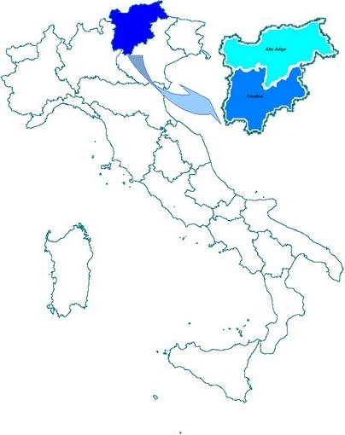
Trentino Alto Adige is a mountainous region located in northern Italy bordering Austria. In the northern part of the region, Alto Adige, there is the RAS network on 10B block shared with Rai Way; in the southern part of the region, Trentino, there is the Rai Way network on 12B block.
The RAS network is composed by twenty-seven transmitters, each one with a different identification code. As the region is not very wide (around 7 400 km²), there is no need to have different static delays.
Figure P2-101
RAS DAB SFN coverage
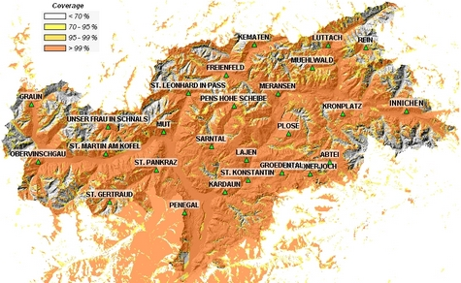
The technical information of the network is detailed in Table P2-46.
TABLE P2-46
RAS DAB SFN
Transmitter site | Altitude | Antenna height | e.r.p.  (kW) | TII-Main  0-69 | TII-SubTable 1-23 | MNSC  65535
Mut – Mutta | 1 264 | 32 | 1.0 | 1 | 1 | 101
St. Leonhard – S. Leonardo | 1 286 | 31 | 0.4 | 1 | 2 | 102
St. Pankraz – S. Pancrazio | 1 090 | 46 | 0.4 | 1 | 3 | 103
St. Gertraud – Santa Gertrude | 1 775 | 29 | 0.05 | 1 | 4 | 104
Penegal | 1 740 | 45 | 3.2 | 2 | 1 | 201
Plose – Plose | 2 023 | 22 | 1.6 | 3 | 1 | 301
Lajen – Laion | 1 142 | 58 | 0.13 | 3 | 2 | 302
Meransen – Maranza | 1 370 | 20 | 0.2 | 3 | 3 | 303
Kronplatz – Plan Corones | 2 258 | 69 | 0.5 | 4 | 1 | 401
Luttach – Lutago | 1 415 | 31 | 0.5 | 4 | 2 | 402
Innichen – San Candido | 1 690 | 46 | 0.25 | 4 | 3 | 403
Rein – Riva di Tures | 1 767 | 37 | 0.03 | 4 | 4 | 404
TABLE P2-46 (end)
Transmitter site | Altitude | Antenna height | e.r.p.  (kW) | TII-Main  0-69 | TII-SubTable 1-23 | MNSC  65535
Mühlwald – Selva dei Molini | 1 510 | 29 | 0.05 | 4 | 5 | 405
St. Konstantin – S. Costantino | 917 | 16 | 0.2 | 5 | 1 | 501
Sarntal – Sarentino | 1 242 | 27 | 0.16 | 5 | 2 | 502
Hohe Scheibe – Cima Capra | 2 556 | 15 | 0.25 | 5 | 3 | 503
Obervinschgau – Alta Val Venosta | 1 962 | 56 | 1.0 | 6 | 1 | 601
St. Martin am Kofel – S. Martino di Laces | 1 703 | 45 | 0.63 | 6 | 2 | 602
Graun – Curon Venosta | 1 515 | 41 | 0.25 | 6 | 3 | 603
Unser Frau in Schnals – Madonna di Senales | 1 872 | 12 | 0.2 | 6 | 4 | 604
Freienfeld – Campo di Trens | 1 340 | 42 | 0.5 | 7 | 1 | 701
Kematen – Caminata (Val di Vizze) | 1 810 | 59 | 0.02 | 7 | 2 | 702
Grödnerjoch – Passo Gardena | 2 280 | 16 | 0.32 | 8 | 1 | 801
Grödental – Val Gardena | 2 006 | 45 | 0.32 | 8 | 2 | 802
Abtei – Badia | 1 702 | 33 | 0.02 | 8 | 3 | 803
Paganella | 2 098 | 56 | 3.2 | 9 | 1 | 901
Kardaun – Cardano | 932 | 29 | 0.13 | Gapfiller

The multiplex contains twelve programs, some in DAB+ and some in DAB, some in Italian other in German: Rai Radio1 (DAB+, Italian); Rai Radio2 (DAB+, Italian); Rai Radio3 (DAB+, Italian); Rai Südtirol (DAB+, German); WDR KIRAKA (DAB+, Radio for children, German); Radio Swiss Classic (DAB+, German); Radio Swiss Pop (DAB+, German); Deutschlandradio Kultur (DAB+, German); RSI Rete 2 (DAB+, Italian); BR BAYERN 3 (DAB, German); BR-KLASSIK (DAB, German) and BR B5 aktuell (DAB, German).
A measurement campaign was performed in order to evaluate the quality of service for mobile reception.
The measures were achieved with an equipped vehicle with a DAB+ commercial radio and an “ad hoc” board developed in partnership with a world leader in providing electronic components and semiconductor solutions. This equipment allowed to detect the Transmitter Identification Information, TII, and to evaluate the coverage, the quality of service and the performance of the SFN.
Figure P2-102 shows the measure set up.
Figure P2-102
Measure set up
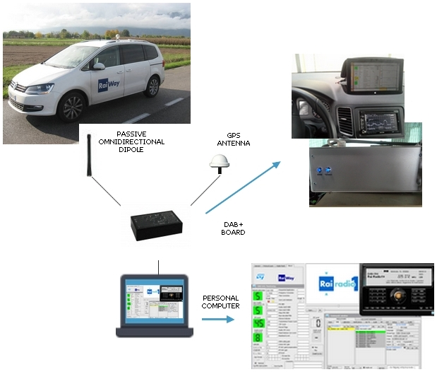
The service quality is estimated with FIC parameter in the following way:
good service FIC < 5 × 10⁻³
poor service 5 × 10⁻³ ≤ FIC < 5 × 10⁻²
no service FIC ≥ 5 × 10⁻²
In the following Figures, the results of the measurements are shown.
Figure P2-103
TII map
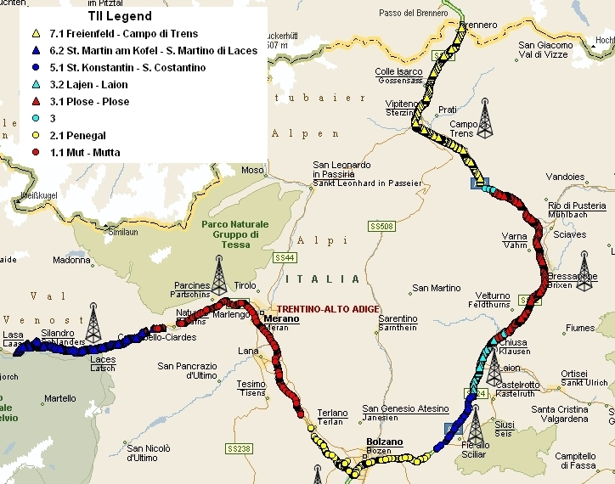
Figure P2-104
RF level map
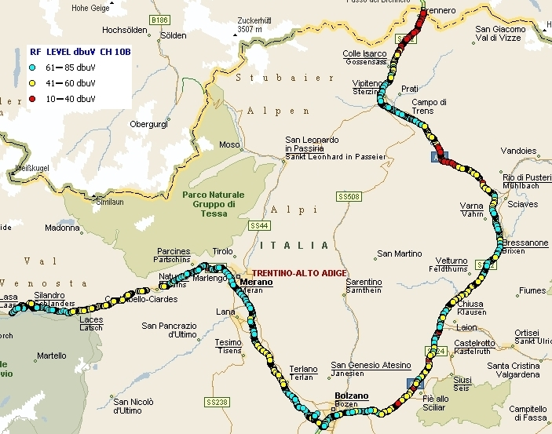
Figure P2-105
FIC BER map
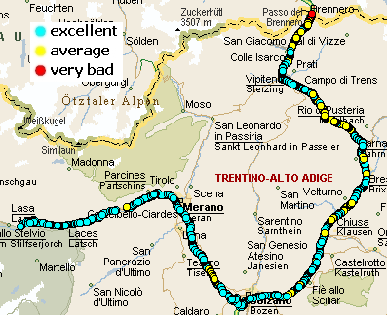
The Rai Way network of Trentino is newer and, at the moment, is composed only by four transmitters: Paganella (0.25 KW and TII 55.16); Ravina di Trento (0.15 KW and TII 4.2); Rovereto (0.50 KW and TII 4.1); Cima Penegal (0.60 KW and TII 55.11) that cover the main valley.
Figure P2-106
Rai Way DAB transmitters and coverage
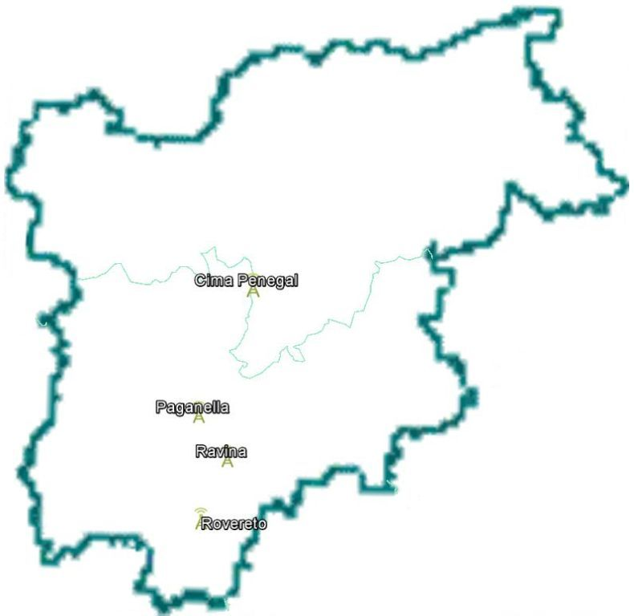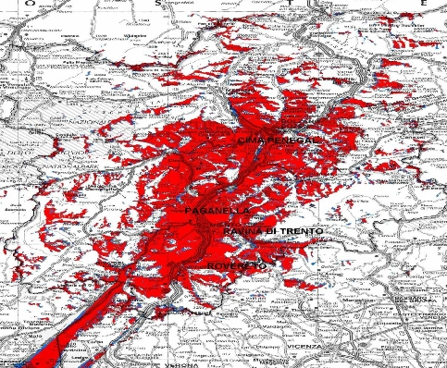
This multiplex contains only DAB+ programs: Radio1 (mostly news, national content); Radio1 TAA (regional content); Radio2 (mostly entertainment, national content); Radio2 TAA (regional content); Radio3 (mostly cultural programmes); Südtirol (regional content in German); Radio Filodiffusione 5 (classical music programmes); Radio Filodiffusione 4 (jazz and modern music programmes); GR Parlamento (news and political programmes); Isoradio (traffic information of the main roads); WebRadio6; WebRadio7 and WebRadio8. As the DAB+ technique allows to broadcast data contents, too, almost all the programmes have their own data services: Slideshow, SLS, and Dynamic Label Segment, DSL.
Figure P2-107
SLS and DSL during Italy Cycling Tour 2013
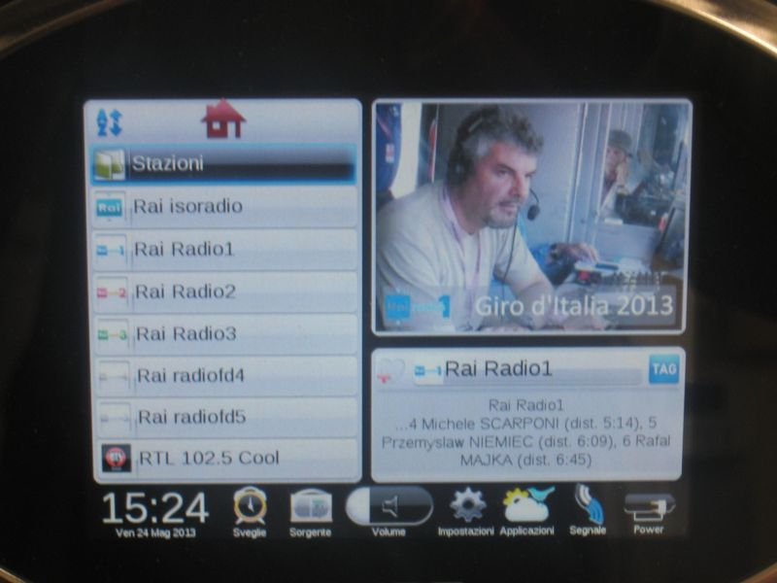

Figure P2-108
Level and FIC BER map
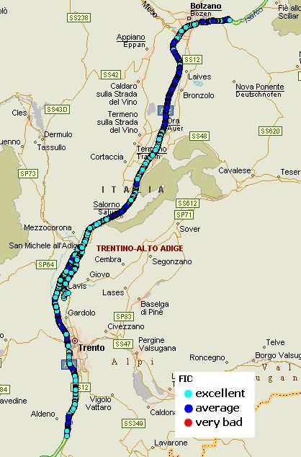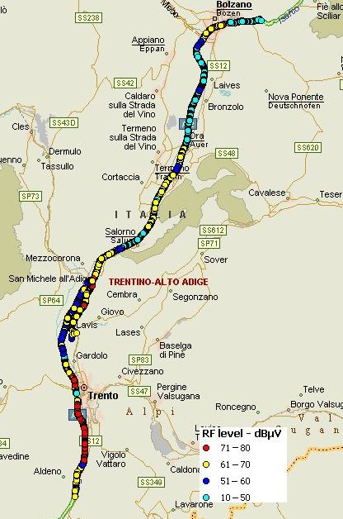
Figure P2-109
TII map
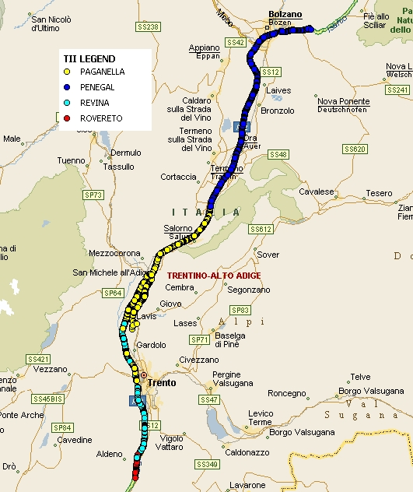

15.1.2 Tests on DAB receivers
In order to better optimize the network, tests on receivers were performed too.
Two kinds of tests were achieved: one in laboratory and the other in the service area.
Laboratory tests proved that receivers are more performing than the theory states. In fact, applying the theory, in presence of signals outside the guard interval, which for mode I is 246 μs, the protection ratio needed are:
Protection ratio  (dB) | Delay  (μs)
20 | 265
19 | 270
18 | 276
17 | 283
16 | 292
15 | 304
14 | 317
13.5 | 325
12 | 353

Laboratory tests fulfilled with five different receivers established the following values:

Protection ratio  (dB) | Delay Δ  (μs)
0 | 0 ≤ Δ ≤ 246
4 | 246 < Δ ≤ 350
13.5 | Δ < 0 ÷ Δ > 350

The results obtained in the laboratory were proved in the service area.
Tests were performed in the service area of the Monte Venda and Campalto transmitters which were operating on block 12D. Acting on the transmitters power and delay, different configuration were obtained.
The measurements were achieved in specific point and also with an equipped vehicle travelling in the city and on the highway.
Summarizing, receivers were able to demodulate properly even when the two signals had the same RF level and the delay between the two was around 350 μs. It is important to underline that receivers lost the signal when the delay was between 350 μs and 400 μs but they started to demodulate again when the delay reached 320 μs.
In Fig. P2-110 the audio quality travelling on highway is shown.
Figure P2-110
Audio quality measured travelling on highway
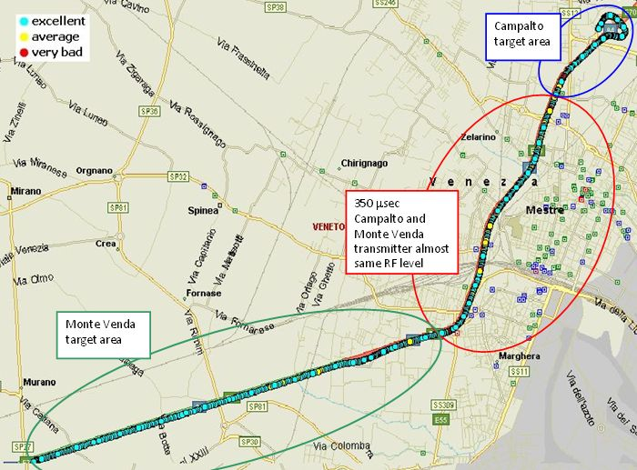

15.2 Static timing in the United Kingdom DAB network
The United Kingdom has two DAB networks which operate as national SFNs. Their predicted coverage is shown in Fig. P2-111 where the coverage of the network with optimised static timing (timed network) is compared with the coverage of the same network with all transmitters set to the same relative delay of 0 µs (untimed network) – all other parameters are identical in the two situations. Yellow shows coverage common to both the timed and untimed networks, red shows coverage only available in the untimed network while green shows coverage available only in the timed network.
It is clear that in some areas the untimed network performs better than the timed network, and vice versa. Overall, the static timing is of benefit as it improves population coverage by almost 1% and coverage to roads by some 4.7%. It is estimated that around 20 to 40 transmitters would otherwise be required to provide this coverage increase.
Figure P2-111
The benefits of static timing in the United Kingdom DAB network
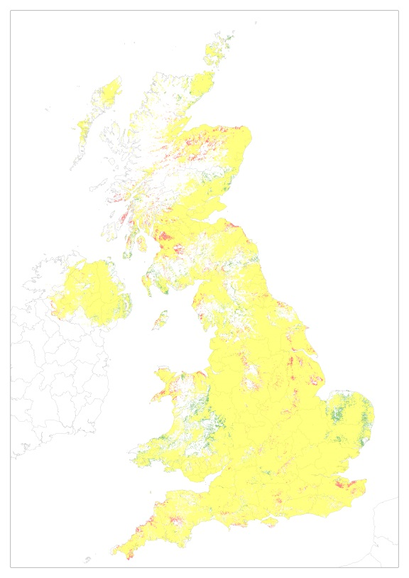
Note to Fig. P2-111: Yellow: coverage common to both the timed and untimed networks – Red: coverage only available in the untimed network – Green: coverage available only in the timed network.

15.3 Static timing in the Bavarian DAB+ network
A further example of delay time tuning is given with the DAB+ network in Bavaria at stage of implementation of 22 transmitters, where most of them have individually set transmitter offset delays in order to optimise the coverage. This measure is necessary since the transmitter characteristics with regard to distance from the next transmitter, antenna height or transmitter power, are very heterogeneous. The optimization was performed by Bayerischer Rundfunk (BR).
Figure P2-112 gives a coverage plot with the transmitter sites and transmitter powers, but without any delay time optimization. Green denotes covered locations for DAB+ mobile reception and red indicates locations where sufficient field strength is available but reception is not possible because of self-interference. The non-optimised network already has very good coverage; however there remain areas of interference, mainly in the fringes.
Figure P2-112
Coverage of the DAB+ network in Bavaria – without static delay time optimization – Transmitter sites,
transmitter e.r.p. (kW) and the initial static delay (0 µs) are indicated
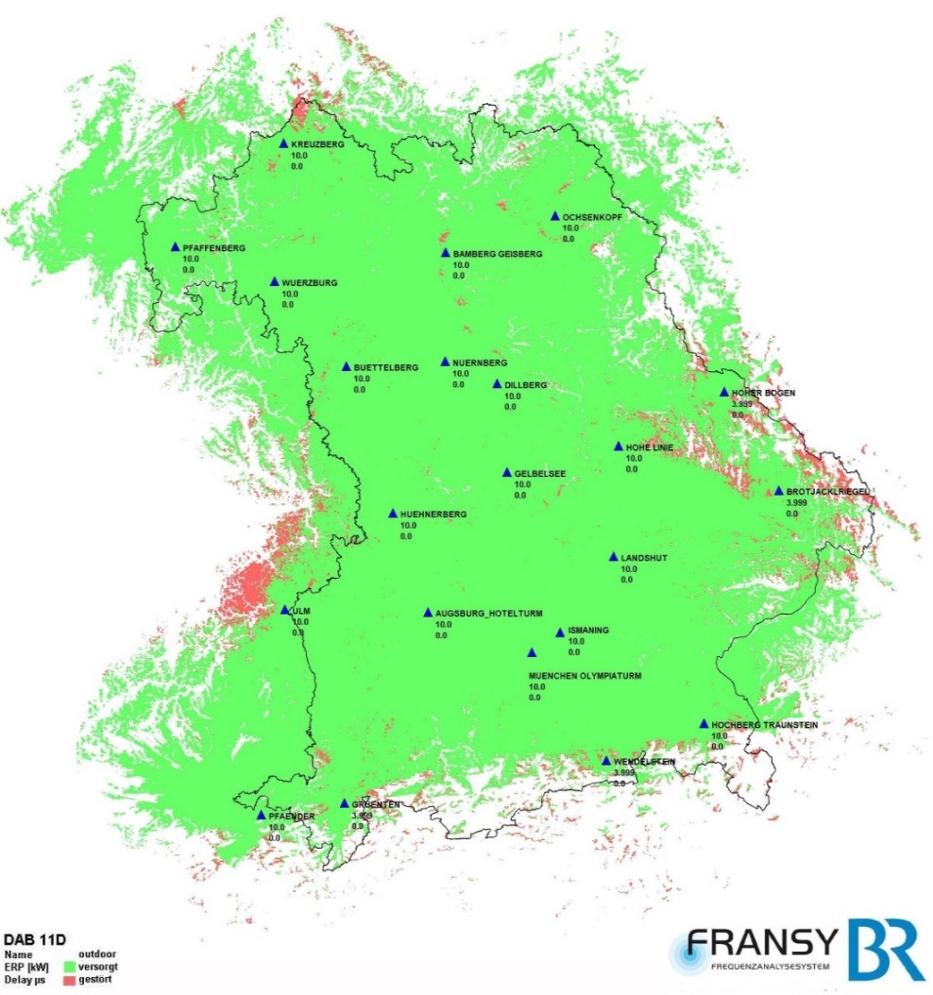
These remaining areas of interference could be reduced by a static time delay optimization, as can be seen in Fig. P2-113, where the individual delays are indicated in the coverage plot. Still there remain regions where self-interference occurs. This is due to the fact that time delay optimization may be a means to improve a self-interference situation but cannot totally eliminate it.
Figure P2-114 is a difference plot showing the areas where the delay optimization improved the situation. As compared to the total coverage area these amount to a small percentage which is due to an already well-chosen transmitter topology.
To illustrate how the delay tuning impacts the signal situation, a receiving location was chosen where the reception was improved by the optimization and the time delay spectra were calculated for the two cases – with and without delay optimization. This is shown in Fig. P2-115.
Figure P2-113
Coverage of the DAB+ network in Bavaria – with static delay time optimization – Transmitter sites,
transmitter e.r.p. (kW) and individual static delays (µs) are indicated
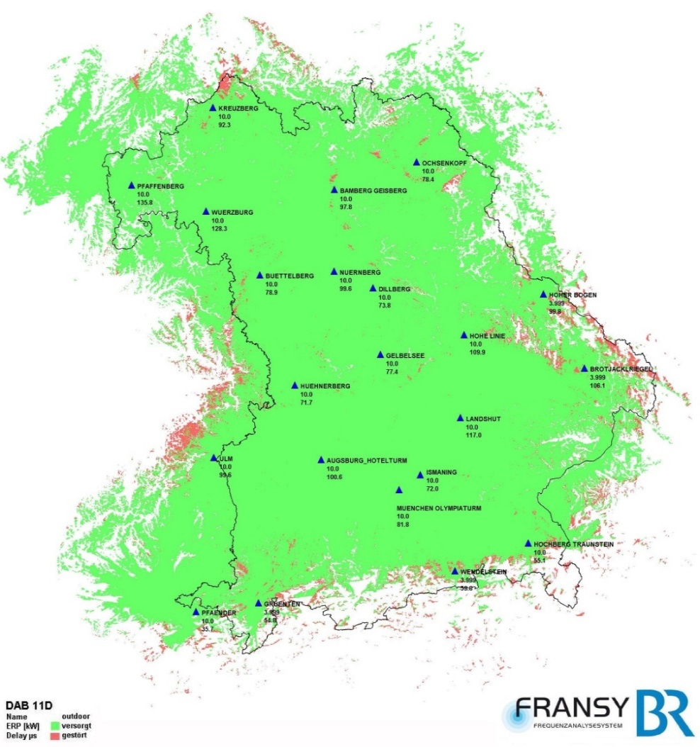
The upper delay spectrum represents the signal situation without delay optimization, the lower one with delay optimization. The cyan time region shows the signals within the guard interval. They contribute constructively to the wanted field strength which is indicated by a blue bar. Beyond the guard interval, the orange time region, the signals have both constructive as well as interfering components. The interfering components are indicated by red bars. In order to keep the two components together they are plotted in the same place on the time axis, the smaller component being put in the foreground. Thus both contributions can always be identified and are visible – apart from the case where both components are equal; then only the red interfering bar is visible.
Figure P2-114
DAB+ network in Bavaria – Difference plot – Locations where static delay time
optimization improved the coverage
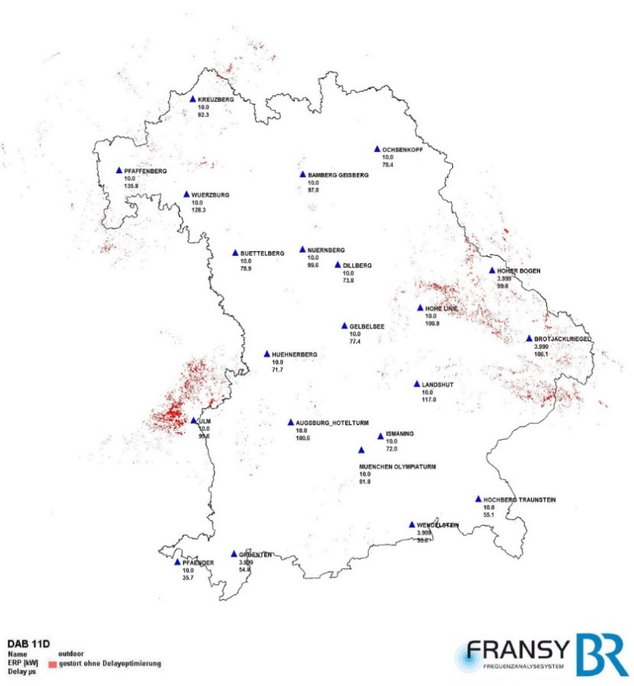
Figure P2-115
Time delay spectra at a typical self-interference situation before and after optimization
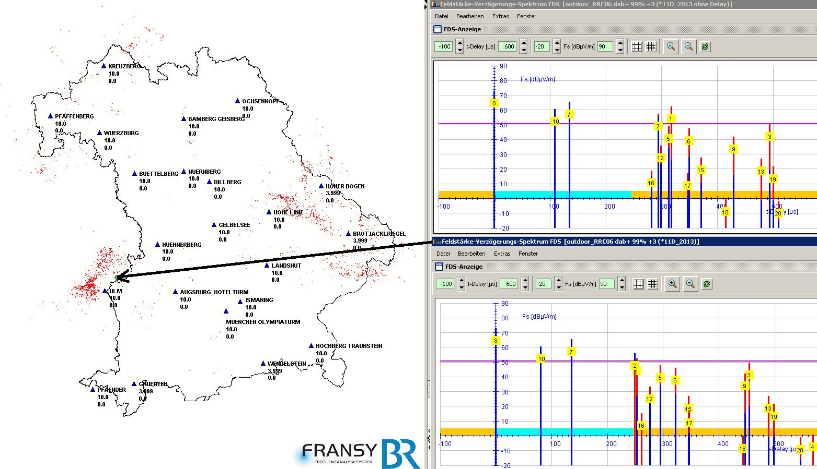

Part 3
SFN application and implementation of ISDB system

1 Principle of SFN reception
Report ITU-R BT.2209 gives the detailed theoretical considerations concerning the SFN reception conditions, as well as the required receiver characteristics. The calculation model given by the Report has been successfully applied in the design and implementation of SFNs in Japan. A summary of the model follows.
The received signal exhibits ripples in frequency response when a desired signal is received with SFN waves. In this case, bit error rates (BERs) of the OFDM carriers positioned at peaks in the frequency response improve, because the input signal levels are high for those carriers. On the other hand, BERs of the carriers positioned at dips in the frequency response worsen, because the input levels are low. The occurrence of SFN reception failure can be estimated by calculating the BERs for every carrier, and the overall figures be used to check whether the total BER is worse than the required value.
Figure P3-1 gives an example of frequency response of the received signal. Figure P3-1a is a case where the desired signal is just at the level that gives the required carrier-to-noise ratio (C/N). In this example, it is assumed that the total BER is worse than the required value, as there are many carriers where BER is worse than the reference value. If the levels of both the desired and SFN signals are increased at the same time, the number of carriers having worse BER is decreased, and the signal is correctly received, as shown in Fig. P3-1b. Thus, the required C/N (or C/N threshold) increases with the existence of SFN waves, resulting in reception failure in critical areas.
Figure P3-1
Example of received signals
The required DUR (desired-to-undesired ratio) increases with the delay difference between the main and SFN signals. Figure P3-2 (a) shows the Guard Interval Mask, which represents the relationship of allowable SFN signal levels against delays (both relative to the main signal). SFN reception failure occurs when one or more SFN signals exceed this mask. Figure P3-2 (b) shows an application of the Guard Interval Mask, where the received signals are plotted in the form of delay profile together with the Guard Interval Mask. This graph is very useful in designing and optimizing an SFN, to the extent that any transmitting station causing SFN reception failure can be easily identified, while the network can be optimized by adjusting the transmission timing delay and antenna radiation pattern of the station.
For details of the theory and calculation model on SFN reception, see Report ITU-R BT.2209.
Figure P3-2
Example of Guard Interval Mask

2 Case study for Japan
In Japan, DTTB started in 2003 using the ISDB-T system. Analogue television broadcasts ceased in 2012. Approximately 12 000 broadcasting channels are assigned to DTTB transmitting stations to cover Japan using the 470-710 MHz frequency band (channels #13 – #53). Each of the 128 television broadcasters in Japan has its own broadcasting network. The majority are prefecture-based, while there are also some regional and nationwide networks.
Figure P3-3 shows a large-scale SFN the Kinki region (outlined in yellow) for NHK Educational TV. The coloured dots in red, yellow, green, etc. depict the reception failure probabilities. The SFN covers an area of 250 km by 250 km. The blue diamonds indicate the transmitting stations of the network. There are 120 transmitting stations, 40 of which operate in the SFN. In addition, there are 69 gap-fillers for small districts and community-antenna reception systems (very small-scale cable systems) in mountainous areas. The network is reliable, even in fading or abnormal propagation conditions.
Figure P3-4 shows the reception situation when the synchronization for SFN operation is lost.
Figure P3-3
Example of SFN in Kinki Region
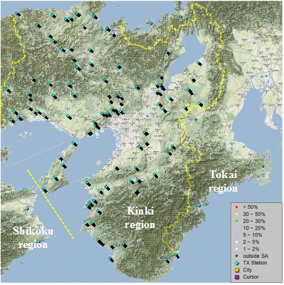
Figure P3-4
Example of SFN without synchronization
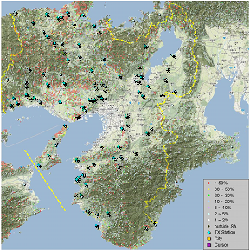
The red in Fig. P3-4 shows the places with severe reception failure when there is no synchronization. Thus, synchronization is indispensable in an SFN. When designing a network, the transmission timing adjustment, in particular, must be carefully studied and calculated, taking into account the actual propagation characteristics.

3 Design of SFN
In designing a broadcasting network, a number of technical characteristics for every transmitting station must be optimized. The major characteristics are site location, e.r.p., antenna radiation pattern, and transmission timing adjustment.

3.1 Site location
Many of the digital stations occupy the same site as the previous analogue station. This is only reasonable since:
– the analogue stations were situated at optimal locations in order to cover the service area, e.g. mountain tops or tall antenna towers in city centres;
– viewers’ reception antennas were positioned for the analogue transmitting stations; and
– most of the facilities for analogue broadcasts (e.g. the station building, antenna tower, power supply system, etc.) were able to be re-used for DTTB.
When starting to design a network, it is desirable to take into account the existing sites, using them as the transmitting stations, and calculating the coverage, interference, implementation costs, and suchlike, accordingly. New transmitting sites can be added or some of the existing sites can be removed, if necessary, for the network to achieve its objectives.

3.2 Effective radiation power
The effective radiation power (e.r.p) for DTTB stations can initially be assumed to be proportional to that of the analogue stations. The proportional value is the required field strength of digital signal to the analogue, e.g. −10 dB. The area covered by all the transmitting stations in the SFN is calculated, and the e.r.p. for each station is then adjusted to ensure coverage. Each station need not provide coverage in its particular area, because the TV receivers will receive signals from all of the stations in the SFN.

3.3 Antenna radiation pattern
Antenna radiation pattern control is one of the useful methods to avoid SFN reception failure. SFN reception failure tends to occur in limited areas where the signal emitted from a particular station exceeds the Guard Interval Mask.
In such cases, the signal of interest can be decreased by reducing the radiation power of the transmitting station. This need only be done in the direction of the relevant area in order to have the signal level below the mask, keeping the reception conditions in the other areas unchanged.

3.4 Transmission timing adjustment
Transmission timing adjustment is the most effective and important technique in the design and implementation of a network. Figure P3-5 shows the transmission timing adjustment.
Figure P3-5 shows reception failure probability in an area circled in red experiencing reception failure. The graph at the top-right shows the delay profile and corresponding Guard Interval Mask at the reception failure location, where an SFN signal exceeds the Mask.
The graph at the centre-right shows the delay profile when the transmission timing of the interested station is delayed to make the reception signal below the mask. The delay adjustment eliminates the reception failure, as shown in Fig. P3-3.
The graph at the bottom-right expresses the relationship of number of failure locations (sum of the failure probabilities over the whole area) against transmission timing. Note that in adjusting the timing of a transmitting station, the calculation of reception failure should be conducted for a wide area rather than the area of interest. This is because SFN failure may take place at locations far away from the transmitting station concerned, especially in fading or abnormal propagation conditions, which often appear in the UHF band. The delay time setting for each transmitting station in the SFN followed the maximum delay time adjustment method described in Report ITU-R BT.2294 ‒ Construction technique of DTTB relay station network for ISDB-T.
FigURE P3-5
Example of transmission timing adjustment in an SFN
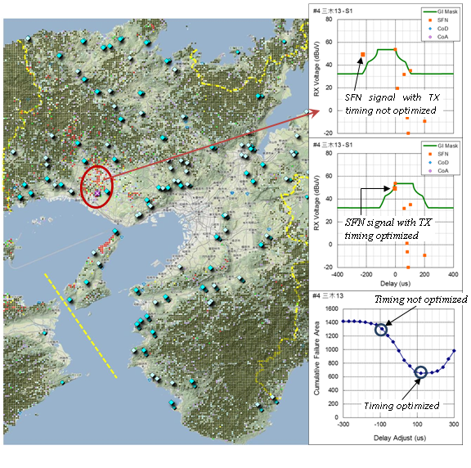

3.5 Tools for network design
The design of SFN is complicated, especially in the transmission timing adjustment. Hence it is essential to use the right calculation tools, which include:
– precise field strength calculation based on the point-to- point prediction method;
– reception voltage calculation taking into account the reception antenna characteristics, including the algorithm for pointing the antenna at the optimum direction;
– antenna radiation pattern control and transmission timing adjustment for every transmitting station;
– calculation of reception failure probability at every reception location, based on the calculation model described in Report ITU-R BT.2209; and
– on an optional level, the automatic optimization algorithm for transmission timing adjustment.
A calculation tool named “Digital Reception Simulator” was developed and successfully used in the channel planning study, as well as in designing and implementing networks.

Part 4
SFN application and implementation of DTMB system

1 Overview
Single Frequency Network refers the digital TV coverage network consist of several synchronized transmitters at different location. Each transmitter within the network transmits the same TV signal using the same frequency at the same time, to achieve more reliable coverage for the specific service area. For the DTMB-based SFN, TS from the multiplexers were firstly sent to SFN adapter to form streams that contain SIP, then delivered to transmitter via program distribution network and finally converted into radio frequency (RF) signals. The structure of DTMB-based SFN is shown in Fig. P4-1.
Figure P4-1
The structure of DTMB SFN in digital terrestrial television broadcasting
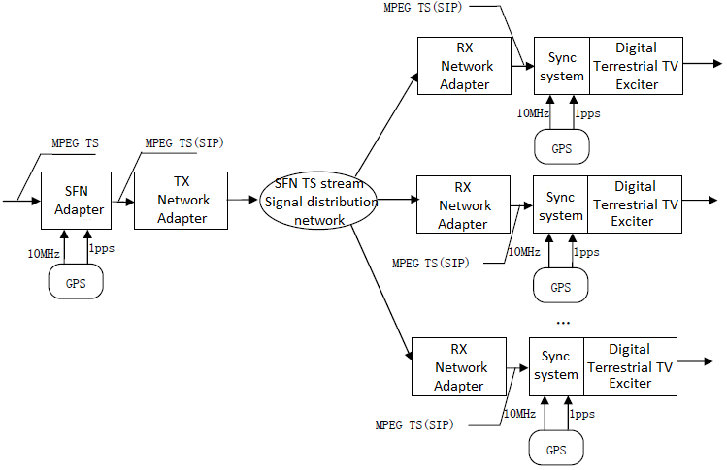
The Signal Frame is the basic element of the frame structure for DTMB system. A Signal Frame consists of two parts, Frame Header and Frame Body. Frame Header uses Pseudo-random Noise (PN) sequences which can be used for fast synchronization and accurate and highly efficient channel estimation/equalization. There are three options for the Frame Header length in dealing with multi-path interference with different multi-path delay spread, as shown in Table P4-1.
TABLE P4-1
Frame Header mode (8 MHz RF bandwidth)
Frame Header mode | Symbols in frame header | Length of frame header
Mode 1 (PN420) | 420 | 55.56 μs
Mode 2 (PN595) | 595 | 78.7 μs
Mode 3 (PN945) | 945 | 125 μs

A longer Frame Header can help deal with longer echoes, but will decrease the payload data rate of the system. In general, the longer Frame Header is suitable for large area SFN operation.
Remote control of distributed transmitters
DTMB standard supports over three hundred different operation modes or configurations of the modulator: for the SFN application scenario, it might become difficult, given these conditions, to ensure that all the modulators are coherently configured. The simplest way to deal with this problem is to remotely control these modulators from the unique broadcasting centre. Utilizing the service information data in SIP package is one example of the remote control and synchronization.
The primary distribution network (including TX and RX adapter) transports the MPEG-TS (SIP) to the digital terrestrial TV modulator from the broadcasting centre transparently. The MPEG-TS (SIP) keeps invariant for the same payload data rate of the modulator. So all the input of MPEG-TSs (SIP) to those modulators within the network are identical.
In the digital terrestrial TV modulator, SYNC system will recognize the SIP from the input MPEG-TS and provide propagation time compensation by comparing the inserted SIP with the local time reference (1 pps) and calculate the extra delay needed for SFN synchronization. In other words, all the modulators in the network will transmit Signal Frame including SIP at the time instant set in SIP after the absolute time reference (1 pps). The maximum delay spread (depending on the different time delay of the network) that SYNC system can deal with is one second. Modulators divide the input stream into data packets for modulation based on the recognized SIP. The first bit of SIP will also be the first bit of data packet so that all the modulators are bit synchronized. The operation modes of the modulators depend on the SI in the SIP (SI-SIP) so that all the modulators are working in the same mode. The working delay of the modulators should be stable.
As shown in Fig. P4-1, the SFN adapter and all the modulators need to use the 10 MHz frequency reference and 1 pulse per second (1 pps) time reference provided by GPS receiver as the absolute time reference. The network adapters especially the RX network adapters also use the GPS 10 MHz frequency reference. This will ensure all the modulators to be frequency, time and “bit” synchronized. The 10 MHz system clock is assumed to be available for all the nodes within the network.
Second-frame and Second-frame Initialization Package
In the SYNC system described above, the SFN adapter inserts a Second-frame Initialization Package (SIP) every one second. This is based on the following reasons: according to the digital terrestrial TV broadcasting system specified in DTMB, there are 8 Super Frames in one second which is called Second Frame; the number of Signal Frame in one Super Frame is always an integer regardless of the constellation mapping mode, Frame Header mode and FEC code rate. Either the number of Signal Frames or TS packages in one second is integer.
The SFN adapter inserts one SIP to the TS stream every one second aligned with 1 pps, as shown in Fig. P4-2.
Figure P4-2
Insertion of SIP
The SIP package is MPEG-2-TS package consist of 4 bytes package header and 184 bytes data, as shown in Fig. P4-3. Package header is used to identify SIP. Maximum delay time prescribes the delay time between the modulated Signal Frame including SIP and the 1 pps. Individual adjusting time prescribes the individual extra delay for each modulator in the SFN network. SI-SIP includes the SI of the operation modes for all modulators. Broadcasting addressing information is used to address the modulators in the network.
Figure P4-3
SIP structure

2 Case study for DTMB

2.1 Local area SFN

2.1.1 Deployment of DTMB in Single Frequency Network of Hong Kong
Hong Kong Special Administrative Region (HKSAR) of the People’s Republic of China has adopted DTMB for its Digital Terrestrial Television (DTT) services. The first transmitting station of the DTT SFN was launched at the end of 2007 covering about 50% of the population. As of early 2011, the DTT SFN has been extended to cover about 90% of the population with 20 transmitting stations.

2.1.1.1 Executive summary
Hong Kong Special Administrative Region (HKSAR) of the People’s Republic of China has adopted for its digital terrestrial television (DTT) services. The DTMB SFN deployment was formally launched with 50% population coverage by a single DTT transmitting station at the end of 2007 and was extended to about 90% population coverage in January 2011 by 20 DTT transmitting stations.
This subsection introduces DTMB deployment in the Single Frequency Network of Hong Kong, including assessment of DTMB, DTMB SFN design criteria, challenges to implement DTMB SFN, and update on implementation of DTMB SFN.
Most information provided in this Report is based on information available from the Office of the Telecommunications Authority website (www.ofta.gov.hk) and HKSAR government Digital TV website (www.digitaltv.gov.hk).
In selecting the DTT technical standard for HKSAR, the HKSAR Government adopted a market-led approach under which the two incumbent broadcasters proposed the preferred standard for assessment by the Telecommunications Authority (TA). The TA, taking into account the technical proposals of the incumbent broadcasters, issued the Statement setting out his views and decisions on the transmission standard and receiver specification for DTT service.

2.1.1.2 Criteria of assessment for transmission standard
In selecting the DTT technical standard for HKSAR, the TA has taken into consideration the following criteria:
a) The selected standard should facilitate the provision of sufficient channel transmission capacity (e.g. able to support SFN transmission) to meet new demand for broadcasting services during and after the simulcast period.
b) The selected standard should support mobile reception; The channel bandwidth adopted by the selected standard should be compatible with the 8 MHz channel bandwidth that is currently used in HKSAR for terrestrial television broadcasting.
c) The selected standard should preferably be widely adopted internationally. There should be a full range of consumer products such as set-top boxes and integrated television sets based on the selected standard available in the market at competitive prices.
d) It would be advantageous for the selected standard to be interoperable with other broadcasting services delivered by different transmission platforms such as satellite or cable. The commonality in the system design of the relevant broadcasting equipment and television receivers may lead to cost savings in both network rollout and network operation.

2.1.1.3 Assessment on technical performance of transmission standard
To verify the suitability of deploying the National Standard DTMB in the local environment, which is characterised by hilly terrain, high-rise buildings and tidal harbour with long waterfront, a field trial for the National Standard DTMB was conducted in HKSAR in late 2006.
The field trial covered receptions under a variety of propagation conditions, such as line-of-sight, non-line-of-sight and tidal fading. The field trial demonstrated the superiority of the National Standard over analogue transmission (PAL-I). In particular the picture and sound quality delivered by DTT signal was satisfactory under non-line-of-sight conditions using only one tenth of the transmitting power of its analogue counterpart. Satisfactory results were obtained for all the following test items:
a) Line-of-sight reception
b) Reception in hill shadow
c) Reception at roof level in building shadow
d) Reception at ground level in building shadow
e) Reception under tidal fading
f) Indoor reception
g) Standard definition television (SDTV) / HDTV reception
h) Mobile reception
i) Tests on SFN / MFN, and
j) Test on In-building Co-axial Cable Distribution System (IBCCDS).
As demonstrated in the field trial, the National Standard DTMB supports spectrum-efficient operations including SFN deployment, multi-channel programming (several programme channels carried in one frequency multiplex) and conveyance of HDTV content. Regarding the frequency characteristics, the 3 dB bandwidth of a frequency multiplex is 7.56 MHz, which fits well within the 8 MHz channel currently used for terrestrial television broadcasting in HKSAR.

2.1.1.4 DTMB technical parameters adopted in HKSAR
The specification HKTA 1108 issued by the TA covers the technical standard of DTMB receiver requirements in HKSAR. The RF Characteristic, Channel Demodulation and Decoding are shown Table P4-2.
TABLE P4-2
HKTA 1108 technical standard of DTMB receiver
Item No. | Description | Reference / Detail
2 | RF Characteristics, Channel Demodulation and Decoding
2.1 | Frequency Band | 470 MHz – 862 MHz
2.2 | Transmission channel bandwidth | 8 MHz
2.3 | Channel demodulation and decoding | Transmitted DTT signals will comply with GB 20600-2006 (‘the National Standard’) which includes some 300 combinations of options.  Mode – C = 3780  Modulation – 64QAM, 16QAM and 4QAM  Frame Header – PN 945  Code Rate – 0.4 and 0.6  Symbol Interleaving – Mode 2 i.e. B = 52 and  M = 720 symbols.  Receivers shall be capable of correctly  Interpreting the system information given in the frame body in accordance with Annex G of the National Standard.
2.4 | Channel offset | The nominal centre frequency of each channel is given by :  f_{c} = 474 + (I – 21)*8 MHz  Where I is the channel number which is an integer between 21 and 69.  The receiver shall be capable of tuning to transmissions with a channel offset  of +1/6 MHz.
2.5 | Operation in Single Frequency Network (SFN) | Receivers shall be able to operate properly in SFN environments.

2.1.1.5 Challenges to build DTMB SFN
SFN is a broadcast network where several transmitters simultaneously send the same signal over the same frequency channel. Once there is a loss of synchronization of SFN in any one of the transmitting stations, the un-synched signal becomes an interference signal, and the SFN coverage in overlapping service areas may collapse if the interference signals level exceeds the co-channel interference protection ratio. Hence, the overlapping service areas of SFN coverage should be minimized. If there are many overlapping areas, it is very difficult to add the gap filling stations which create even more overlapping areas.
In most foreign countries, the SFN transmitting stations are widely separated so that the overlapping area is relatively small comparing with the main service areas and do not create significant reception problem. Basically, in order to keep the SFN in working condition, there are two essential key elements of working criteria:
1) synchronization in transmitting frequency with identical signal of all SFN transmitting stations with the frequency precision accuracy within 1 Hz, and
2) to keep arriving time of the entire signals in the service area within the guard interval to prevent symbol errors
HKSAR topographic situation is mountainous and complicated in radio wave propagation because of densely built high rise buildings. Due to the basic considerations as mentioned above, it would be appropriate to minimize the overlapping coverage areas of the SFN transmitting stations to reduce the loss of synchronization signal. Furthermore, echo mixed with pre-echo and long post-echo would cause reception difficulty. With reference to the factors mentioned above, the DTMB SFN transmission network has been carefully designed to minimize overlapping from each DTMB SFN transmitting stations by means of tailor-made antenna radiation pattern.

2.1.1.6 Implementation Update of DTMB SFN
HKSAR adopted a phased implementation approach for DTMB. The following table shows the technical parameters of individual transmitting stations and their accumulated population coverage. The 12 stations completed by the end of 2009, and their coverage areas are set out in Annex A.
TABLE P4-3
e.r.p. of 12 DTMB SFN stations, including principal and fill-in stations
SFN Station name | Maximum e.r.p. | Polarization | Station type | Accumulated population coverage
Temple Hill | 1000 W | H | Principal station | ~ 50% of HKSAR population
Golden Hill | 320 W | H | Principal station | ~ 75% of HKSAR population by 7 stations
Kowloon Peak | 320 W | H | Principal station | ~ 75% of HKSAR population by 7 stations
Castle Peak | 320 W | H | Principal station | ~ 75% of HKSAR population by 7 stations
Cloudy Hill | 1 000 W | H | Principal station | ~ 75% of HKSAR population by 7 stations
Lamma Island | 150 W | V | Principal station | ~ 75% of HKSAR population by 7 stations
Mt. Nicholson | 10 W | V | Fill-in station | ~ 75% of HKSAR population by 7 stations
Sheung Yeung Shan | 0.6 W | V | Fill-in station | ~ 85% of HKSAR population by 12 stations
Sai Wan Shan | 10 W | H | Fill-in station | ~ 85% of HKSAR population by 12 stations
Piper’s Hill | 10 W | H | Fill-in station | ~ 85% of HKSAR population by 12 stations
Brick Hill | 10 W | H | Fill-in station | ~ 85% of HKSAR population by 12 stations
Beacon Hill | 0.2 W | H | Fill-in station | ~ 85% of HKSAR population by 12 stations

By the end of 2010, eight more DTMB SFN fill-in stations were competed. With the rollout of these fill-in stations, the coverage was extended to about 90% of the population. The e.r.p. of the 8 DTMB SFN stations is shown in Table P4-4. The covered areas of the eight fill-in stations are set out in Annex B. The locations of the 20 SFN transmitting stations are set out in Annex C.
TABLE P4-4
e.r.p. of 8 DTMB SFN fill-in stations
SFN Station name | Maximum e.r.p. | Polarization | Station type | Accumulated population coverage
Hill 374 (Yuen Long) | 5 W | V | Fill-in station | ~ 90% of HKSAR population by 20 stations
Pottinger Peak | 10 W | H | Fill-in station | ~ 90% of HKSAR population by 20 stations
Stanley | 10 W | H | Fill-in station | ~ 90% of HKSAR population by 20 stations
Cheung Chau | 2 W | V | Fill-in station | ~ 90% of HKSAR population by 20 stations
Hill 141 (Tai Lam Chung) | 0.2 W | V | Fill-in station | ~ 90% of HKSAR population by 20 stations
Tai Po Tsai | 0.5 W | V | Fill-in station | ~ 90% of HKSAR population by 20 stations
Robin’s Nest | 10 W | V | Fill-in station | ~ 90% of HKSAR population by 20 stations
Tai O | 0.7 W | V | Fill-in station | ~ 90% of HKSAR population by 20 stations

As in January 2011, there were 20 transmitting stations launched for DTMB SFN services, the location of the DTT Stations and the estimated coverage can be found in Annex E. It is planned that nine more DTMB SFN fill-in stations will be constructed by the end of 2011.

2.1.1.7 DTT take-up rate
The viewing public in HKSAR has been taking up DTT services at a steady pace. According to the latest public survey conducted in September 2010, about 61% of the families in HKSAR (representing some 1.4 million television households territory-wide) receive DTT services via set-top boxes, integrated digital TV (iDTV) sets (i.e. TV sets with built-in decoders) and computers. The details of the take-up situation from early 2008 to September 2010 with the use of set-top box, iDTV or computer are set out in Annex D.

2.1.1.8 Conclusion
During the implementation of DTMB SFN transmission network in HKSAR, invaluable experience was gained in overcoming reception problems caused by the difficult topographic situations (which is mountainous, dense built-up urban areas and tidal changes along harbour-front). Such experience would also be invaluable to the deployment of DTMB SFN in other cities.

Annex A
SFN Transmitting Stations completed by the end of 2009
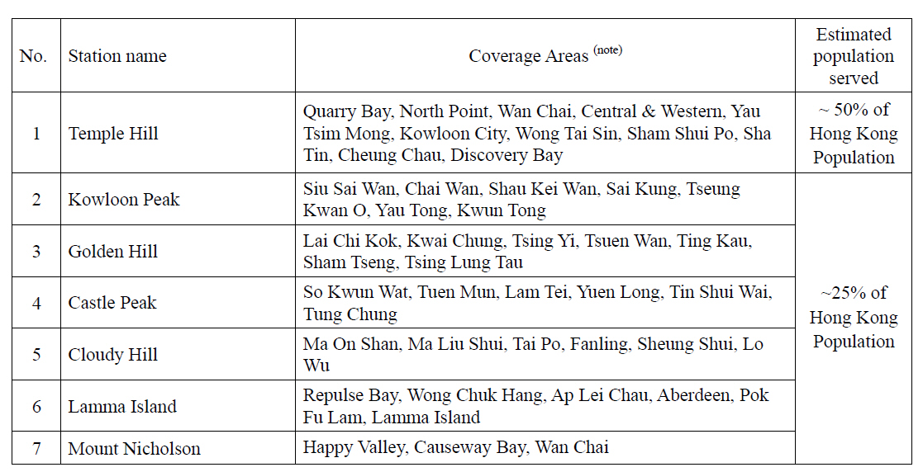

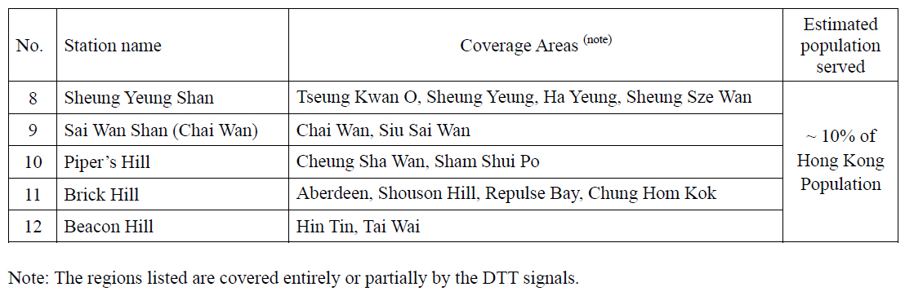

Annex B
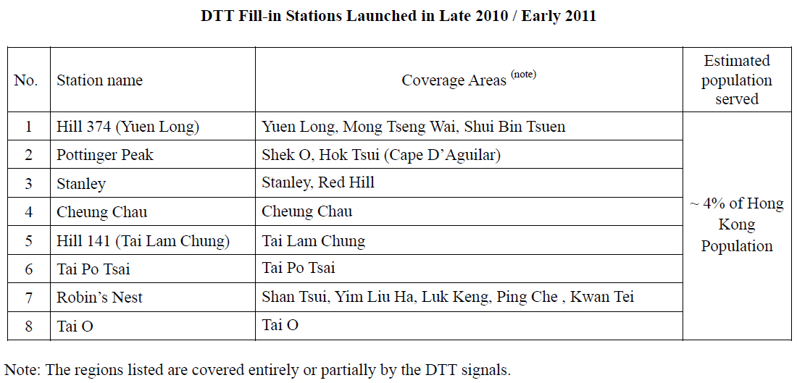

Annex C
Location of 20 DTMB SFN Stations (12 stations in pink refer to Annex A; 8 stations in yellow refer to Annex B).
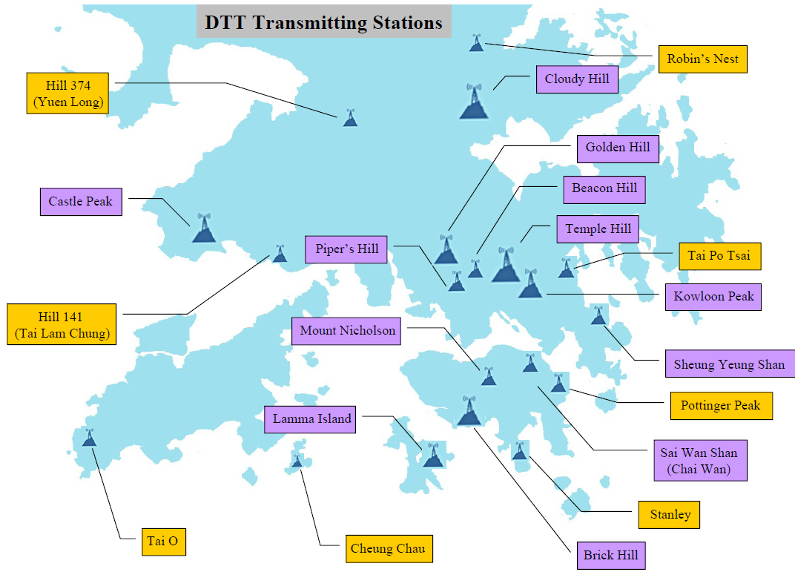

Annex D
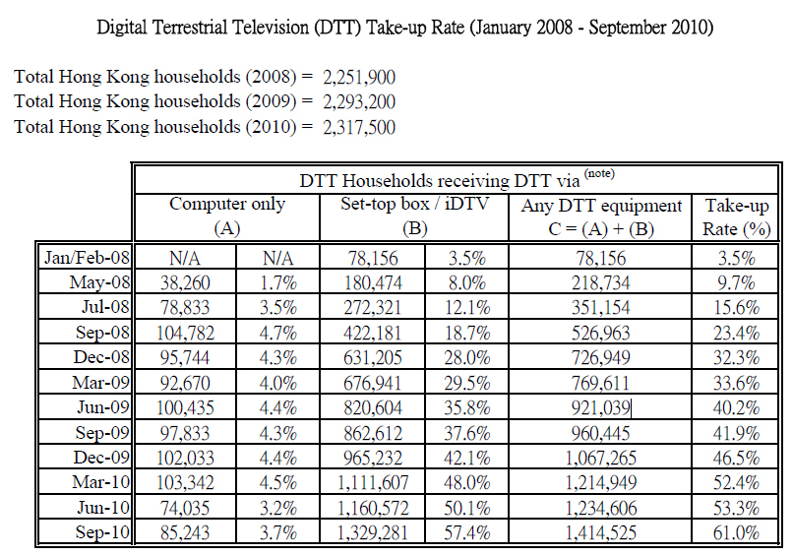
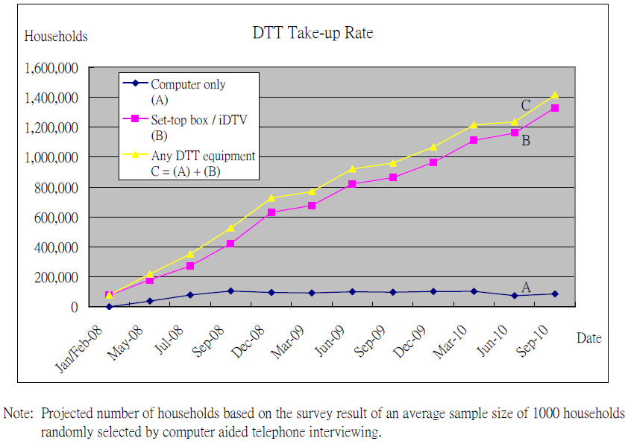

Annex E
Location of the Digital Terrestrial Television (DTT) stations
and the estimated coverage (January 2011)
There are totally 20 transmitting stations launched for DTT services, including 6 principal stations and 14 fill-in stations. The location of the transmitting stations and the map of estimated coverage and areas are illustrated by the following diagrams and tables respectively. The listed diagrams and tables are prepared for reference as rough estimation of DTT coverage. It is planned that nine more DTMB SFN fill-in stations are to be constructed by the end of 2011.
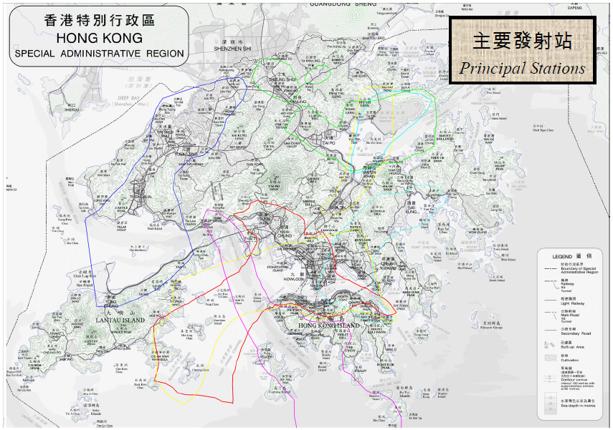
Estimated coverage shown in the above diagram is composed by the signals broadcast by the following principal transmitting stations.
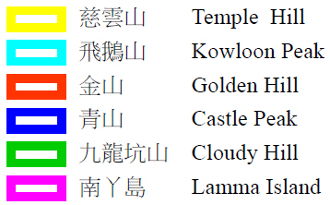
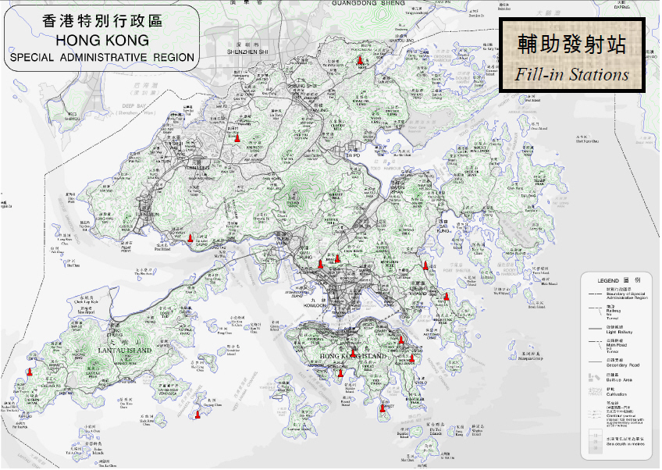
Location of fill-in stations
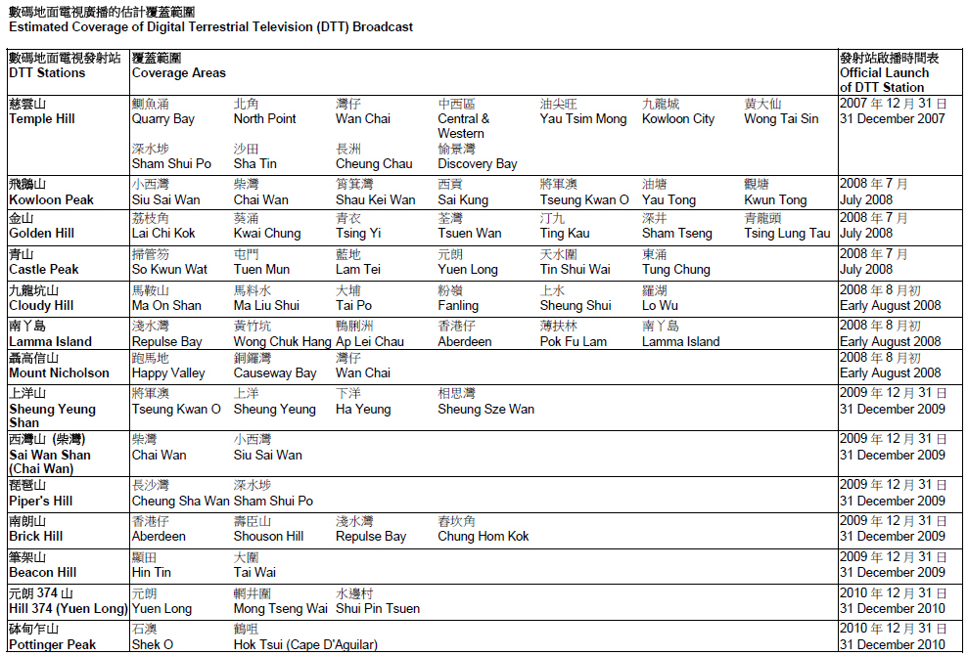
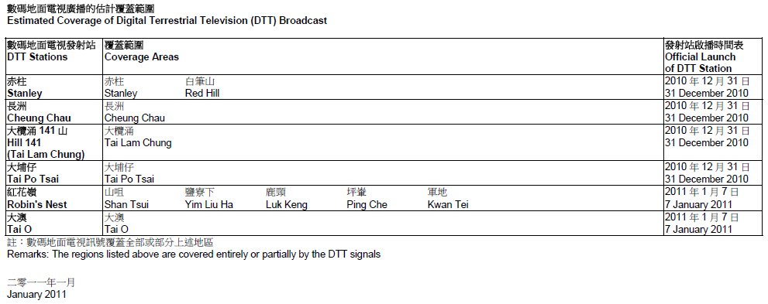

2.1.2 Deployment of DTMB SFN in Shanghai
With the release of DTMB standard, the application of terrestrial digital TV in Shanghai began to schedule in 2009.
Shanghai is the largest city in China full of high buildings and skyscrapers. Total area of whole city is about 300 square km. Only one broadcasting station cannot provide enough coverage and the SFN application of DTMB seems to be a unique solution. Besides, the wireless channel of Shanghai is very complex, especially in the overlapping area between two adjacent stations.

2.1.2.1 Executive summary
After the release of DTMB standard and the specification of DTMB receiver, some modes with good lab test results can be applied for the SFN in Shanghai. Evaluations and experiments had been carried out to promote the application. With the help of radio network planning tool, a SFN network with six stations had been successfully deployed since 2009.
This Report provides introduction of DTMB trial in Shanghai for mobile TV by the SFN Transmission Network System. Firstly, technical parameters of DTMB SFN in Shanghai are given; secondly, DTMB SFN implementation for different stages is introduced; finally, a result of technical methods suitable in the SFN is given.

2.1.2.2 Technical parameters of DTMB SFN in Shanghai
To fully utilize the analogue station infrastructure, building and steel tower, the design of DTMB SFN system in Shanghai was based on the existing station. Oriental Pearl, the main SFN station, and five other SFN stations (HongQiao, Education TV, Oriental TV, Daning and West Nanjing Road) formed the whole SFN transmission network system of DTMB.
After release of DTMB standard, some modes of DTMB had shown attractive testing results. One mode of DTMB was tried for the SFN application of DTMB in Shanghai.
Transmission parameters
Modulation of DTMB is C = 1, 4 QAM, PN = 595, Code rate 0.8 and Data rate is 10.396 Mbit/s, which is shown in Table P4-5.
TABLE P4-5
Parameters of one mode used in Shanghai
Mode | Single-Carrier mode with the number of carriers (C= 1)
Modulation | 4QAM
Frame header | PN 595
Code rate | 0.8
Symbol interleaving | Mode 2  i.e. B = 52 and M = 720 symbols

2.1.2.3 Implementation and results of DTMB SFN
The whole construction was in three stages.
Stage 1: Operated the two stations (Oriental Pearl and HongQiao) individually and got the coverage of the two stations respectively by field testing around the broadcasting station. With the help of field testing, a planning tool designed for DTMB SFN network was used to get the overlapping coverage area.
Stage 2: Some field testing for these overlapping areas were conducted with the two stations broadcasting synchronized. With the guide of lab testing results and help of planning tool, some adjustment of time delay and powers were made.
Stage 3: By extending the experience of two station SFN network and with the further help of the planning tool, the whole DTMB SFN network with six stations was successfully deployed. The testing of whole SFN network had shown a good result.
Stage 1 implementation
At the implementation of Stage 1, broadcasting signals by single station at Oriental Pearl station and HongQiao station individually to get the overlapping coverage area. The Oriental Pearl station is the highest TV tower in Shanghai and located in the eastern Shanghai, while HongQiao station is located in the western Shanghai and also plays a role in the broadcasting.
Some new platforms on the tower were setup with antenna mounting structure, which was designed to provide space for DTMB equipment accommodation, steel platform on top of building for antenna (Normal & Standby) installation. The equipments and facilities of optical fiber transmission were installed for the adaptor of SFN network, steel pole on top of the steel platform for accommodation the common GPS antenna system, which was necessary for the DTMB SFN network.
The period for Stage 1 lasted one month. The overlapping area for the two main stations was successfully figured.
DTMB coverage maps formed by Oriental Pearl station and HongQiao station individually are shown below in Figs P4-4 and P4-5. The overlapping areas were marked in Fig. P4-6 by calculating the difference of Receiving Signal Level (RSL) between the two stations.
Figure P4-4
DTMB Coverage map – only with the broadcasting of Oriental Pearl station
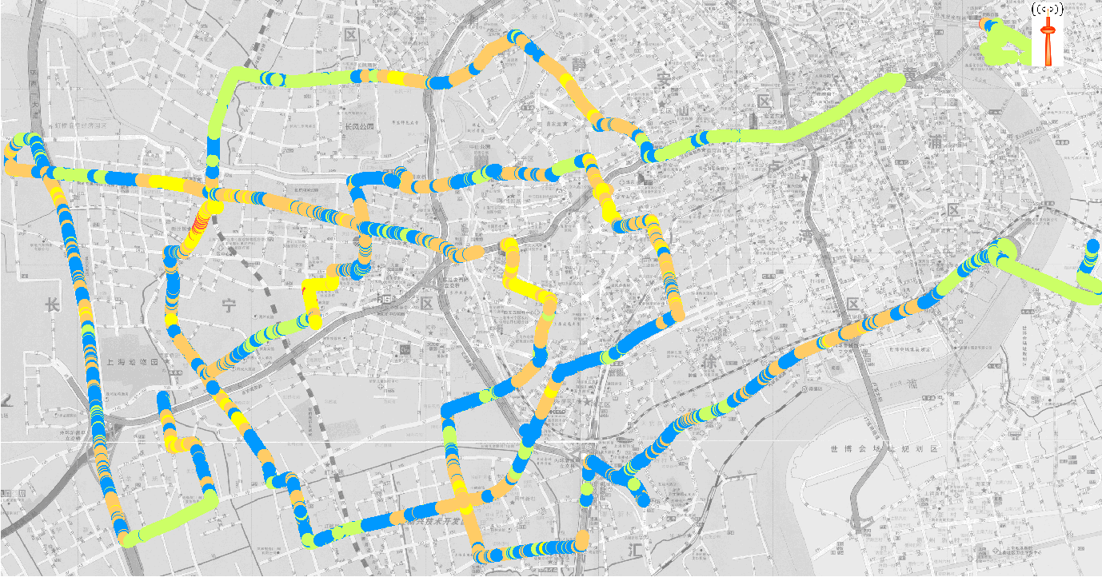
NOTE – Green is representing for the RSL from –65 dBm to –20 dBm.
Blue is from –72 to –65 dBm.
Orange is from –78 to –72 dBm.
Yellow is from –85 to –78 dBm.
Red is from –100 to –85 dBm.
Figure P4-5
DTMB Coverage Map – only with the broadcasting of HongQiao station
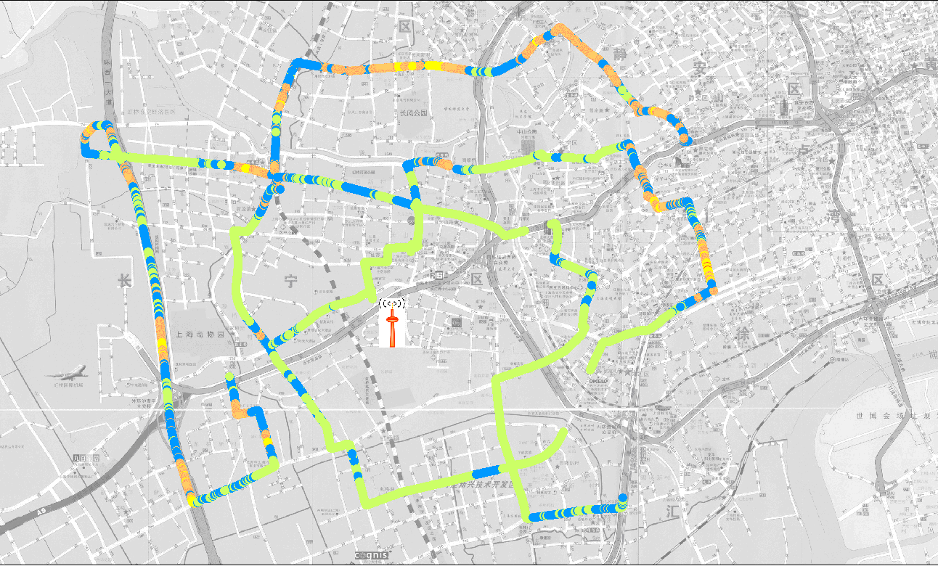
NOTE – Green is representing for the RSL from –65 to –20 dBm.
Blue is from –72 to –65 dBm.
Orange is from –78 to –72 dBm.
Yellow is from –85 to –78 dBm.
Red is from –100 to –85 dBm.

Figure P4-6
DTMB Coverage map– for the RSL difference between the two stations
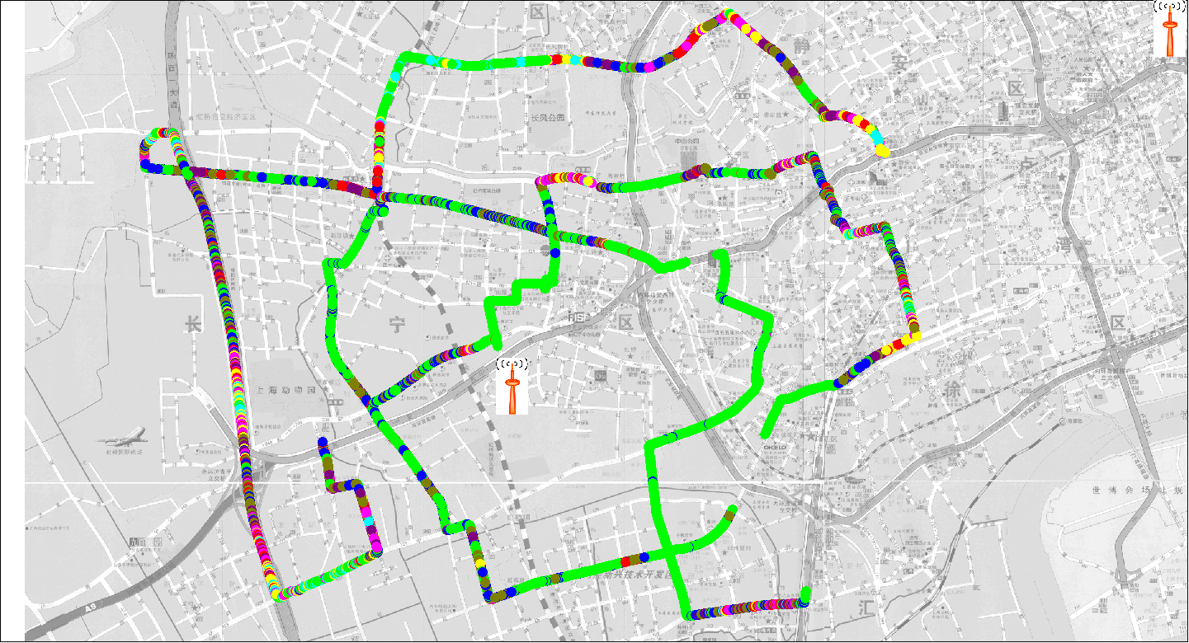
NOTE – Grass Green is representing for the RSL difference from 9 to 35 dB.
Azure is from 6 to 9 dB.
Yellow is from 3 to 6 dB.
Pink is from 1 to 3 dB.
Red is from –1 to 1 dB.
Purple is from –3 to –1 dB.
Khaki is from –6 to –3 dB.
Blue is from –9 to –6 dB.
The overlapping area is defined to be those areas where the absolute difference of RSL between two stations is less than 5 dB.
Stage 2 implementation
The SFN network of two stations must have equipment, the SFN adaptor. In Stage 2, the two stations were broadcasting synchronized. Based on the lab test report and analysis from the planning tool, some adjustments for the time delay and power of the two stations were made.
The initial transmitter parameters of the two stations are listed as below in Table P4-6.
TABLE P4-6
Initial transmitter parameters of the two stations
Transmitter Location | Power (w) | Delay (μs) | Antenna height (m)
Oriental Pearl | 1 000 | 0 | 420
HongQiao | 800 | 0 | 150

Field test examples in the overlapping area without the adjustment of time delay and power are shown below in Fig. P4-7.

Figure P4-7
DTMB Reception Performance –without the adjustment of time delay and
power for the SFN network with two stations
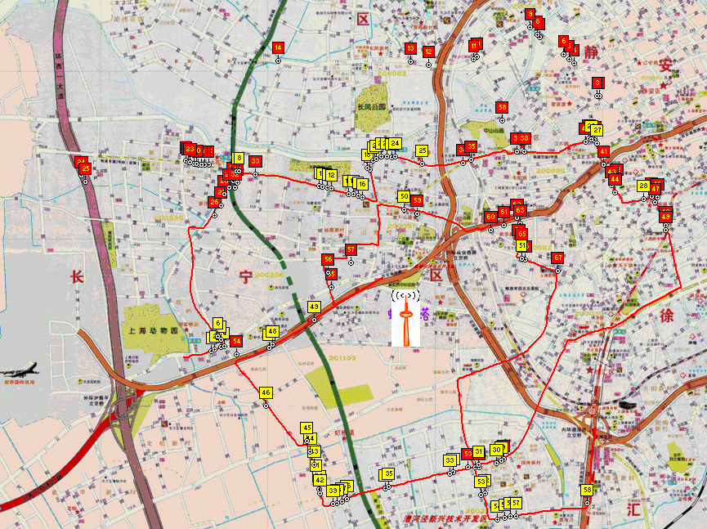
NOTE – The yellow labels indict failure reception spots in the overlapping area.
With the guide of planning tool, some adjustment of time delay and powers were made. The adjusted transmitter parameters of the two stations are listed as below in Table P4-7.
TABLE P4-7
Adjusted transmitter parameters of the two stations
Transmitter location | Power (w) | Delay (μs) | Antenna height (m)
Oriental Pearl | 1 000 | 0 | 420
HongQiao | 700 | 14 | 150

Field test examples in the overlapping area after the adjustment are shown below in Fig. P4-8.
Figure P4-8
DTMB Reception Performance – after the adjustment of time delay and
power for the SFN network with two stations
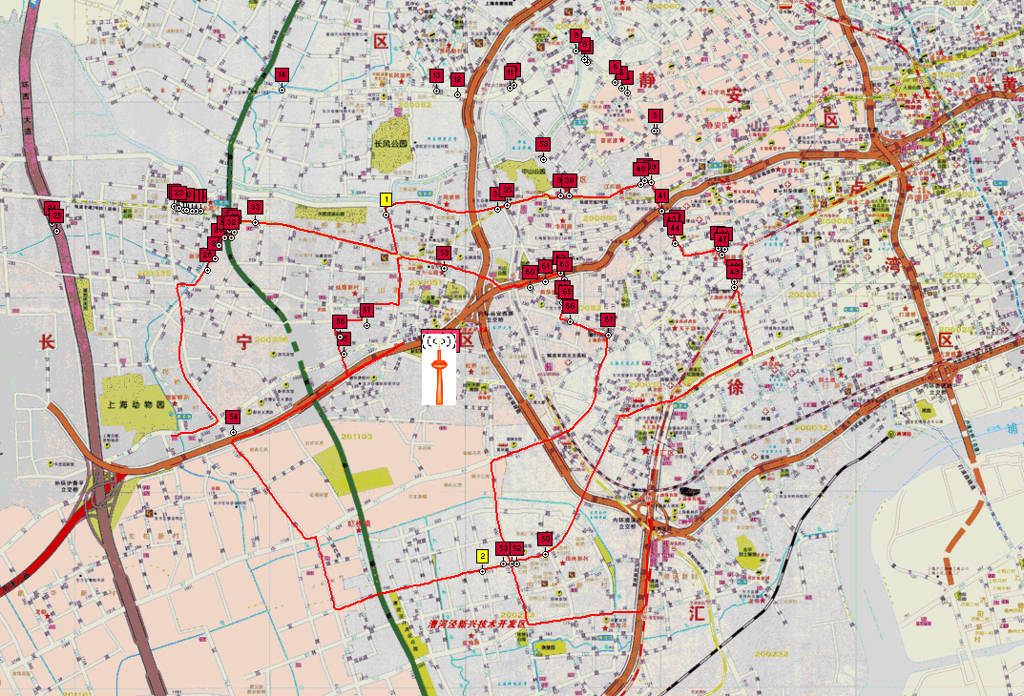
NOTE – The yellow labels indict failure reception spots in the overlapping area.
From Fig. P4-8, it is clear that the reception performance in the overlapping area had been greatly improved.
Stage 3 implementation
In Stage 3, additional four stations were deployed to cover the whole Shanghai. Information of these six stations is listed in Table P4-8, including the final adjustments of time delay and power. The location map of DTMB SFN stations is shown in Fig. P4-9. With a careful design, the SFN network of DTMB in Shanghai had achieved good coverage and reception performance, which are shown in Figs P4-10 and P4-11.
TABLE P4-8
Technical parameters of six principal stations in Stage 3
Transmitter location | Transmitter power (W) | Delay  (µs) | Antenna height (m)
Oriental Pearl | 1 000 | 0 | 420
HongQiao | 700 | 14 | 150
Oriental TV | 1 000 | 2 | 140
DaNing | 500 | 9 | 100
Education TV | 600 | 5 | 130
West Nanjing Road | 400 | 5 | 130

Figure P4-9
Location Map of DTMB SFN Stations
Figure P4-10
DTMB Coverage map – with six broadcasting stations
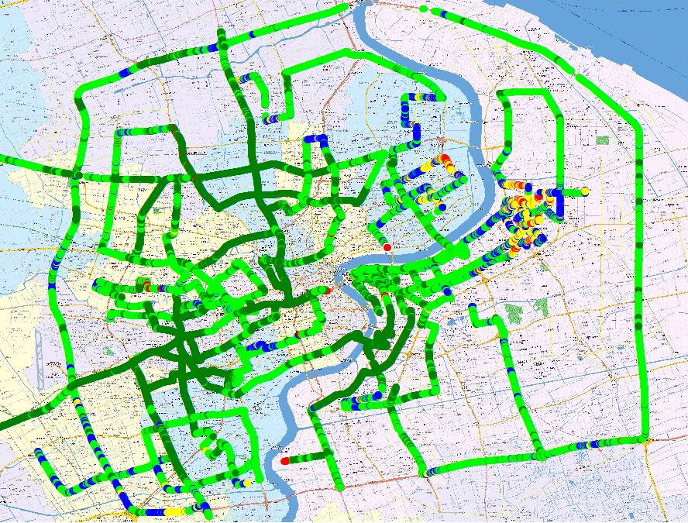
NOTE – Dark green is representing for the RSL from –60 to –20 dBm
Green is from –70 to –60 dBm
Blue is from –75 to –70 dBm
Red is from –100 to –75 dBm.

Figure P4-11
DTMB Reception Performance – with six broadcasting stations
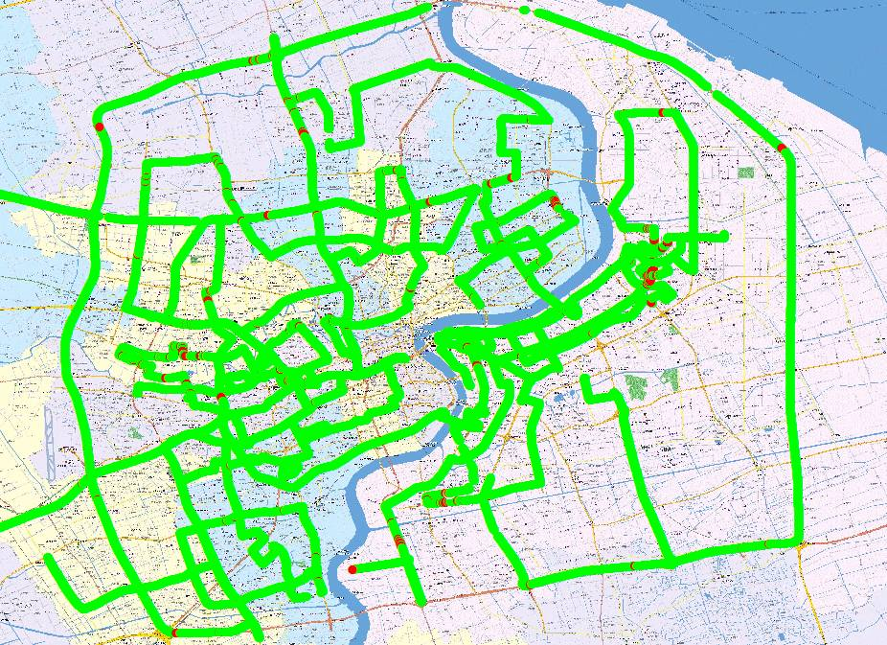
NOTE – Green is representing for the successful reception and Red is for the failure reception.

2.1.2.4 Conclusion
During the trial implementation of DTMB SFN transmission network in Shanghai, invaluable experience was gained in overcoming reception problems caused by the difficult topographic situations (which is multiple broadcasting stations and dense skyscraper area). Such experience would also be invaluable to the deployment of DTMB SFN in other cities.

2.2 Deployment of DTMB SFN based on satellite program distribution networks

2.2.1 System structure
The SFN based on satellite distribution networks consists of DTT front-end system, scrambling and encryption, SFN adapter, satellite distribution link and DTTB transmitting system. The SFN structure is illustrated in Fig. P4-12.
The DTT front-end system performs the video and audio compression coding using AVS+ and DRA standards, and generates one TS by multiplexing. Then, the TS is fed to the SFN adapter for SFN adaption after scrambling and encryption. After that, the adapted TS is transmitted to the satellite earth station for satellite distribution. The satellite receiver demodulates the received satellite signal and recovers the transmitted TS. Then, the recovered TS is transformed to the DTTB signal by DTTB transmitters.
Figure P4-12
The DTTB SFN structure based on satellite distribution networks

2.2.2 Satellite distribution networks
The satellite distribution link is comprised of signal transmission and connection system, uplink transmitting system and downlink receiving system. The signal transmission and connection system transmits the TS from the SFN adapter to the satellite earth station through DS3 signal format. The uplink transmitting system completes the satellite signal modulation, up-conversion, high power amplifying and RF output. The downlink system receives the satellite signal, demodulates, descrambles and recovers the original TS signal.
The signal transmission and connection system includes network terminal, digital optical transmission hub station, dual-route cable protection ring network, digital microwave link and transmission adapter. The DS3 signal is input to the dual-route cable protection ring through the network terminal, and then distributed to the satellite earth stations through the dual-route cable protection ring and the digital microwave link. The uplink systems at the earth stations receive the distributed DS3 signal and transmit to the satellite transponder.
The uplink system completes satellite signal modulation, up-conversion, signal amplification and RF output to the satellite transponder. At the same time, the DTTB station should have the satellite receiving antenna and satellite IRD with AVS+ decoder, after demodulation and descrambling, the TS was sent to DTTB transmitter/exciter.
The synchronization module inside the DTTB transmitter/exciter identifies the second initialization packet (SIP) embedded in the received TS and analyses the TS transmission delay. Furthermore, the transmitter will also identify the working mode from the System Information part in the SIP and adjust it operation mode. According to the local reference signal supplied by GPS or BDS timing receiver, the transmitter/exciter adjusts the transmitting time so that all the transmitters in the SFN can send the same signal at the same time.
However, the transmission data rate of the satellite modulator will be slightly higher than the data rate of the DTMB system. So additional null packets will be inserted into the adapted SFN TS by satellite modulator, which will change the original structure of the adapted SFN TS. Therefore, the DTTB modulator must distinguish the null packets inserted by satellite modulator and SFN adapter, and should eliminate the null packets inserted by satellite modulator to keep the TS same as output of SFN adapter. In addition, traditional satellite modulator will modify the PCR data in the TS. It maybe causes the out of synchronization of audio and video. So the PCR data information should be recovered by the DTTB transmitter or the satellite receiver. Furthermore, long transmission delay and jitter problems will be introduced when using satellite transmission links, further experimental verifications is needed to check the influence on SFN.
Accordingly, there are two technical difficulties that should be overcome using satellite link as the distribution network. Firstly, the satellite transmission equipment must guarantee the TS structure unchanged from the SFN adapter. Secondly, the DTTB transmitters must be able to complete the synchronization adjustment according to the synchronization reference information in the SFN adapted TS under the long transmission delay caused by satellite distribution and encrypting.

2.2.3 SFN adapter
The SFN adapter is the key equipment in the SFN. The SFN adapter have two functions, SIP packet insertion and data rate adaptation to match the payload data rate of the corresponding DTMB working mode.
According to the reference signals (10MHz clock and 1PPS signal) provided by GPS/BDS timing receiver, the SFN adapter inserts SIP packet to the TS with the period of 1 second. Because satellite distribution link is adopted, it is required that the SIP and null packets inserted by SFN adapter must have special tags in order to distinguish from the null packets involved by satellite modulator. Otherwise, it will cause the processing error at each DTTB station and make the SFN networking failure.
Consequently, the format of null packet inserted by SFN adapter needs to be modified. At the same time, special indication bytes and CRC check bytes are introduced to the padding data of the SIP.

2.2.4 Laboratory and field tests
In order to verify the feasibility and effectiveness of the proposed DTMB SFN scheme, laboratory verification and field trial was conducted based on satellite distribution networks.
1) Laboratory test results
The TS distribution link is very important for SFN networking. Besides the wireless transmission delay, additional processing delay will be introduced by the satellite modulator and demodulator in the satellite distribution link. So, the transmission characteristics and the processing delay of the satellite transmission link should be verified.
The laboratory test system diagram for the measurement of satellite transmission delay is shown in Fig. P4-13.
The delay analyser will insert special timing tag to the measured TS, and then the TS will be modulated and transmitted to the satellite. The satellite demodulator receives the forwarded signal and demodulates the TS to the delay analyser. Then, the transmission delay is calculated by comparing the timing tags between the transmitted and received TS.
The test site is selected at the satellite earth station. TS signal with 3 AVS+ HDTV programmes passing through the delay analyser, and then modulated by uplink satellite modulator. Local satellite receiver at the same earth station demodulated the signal and fed back the TS to the delay analyser.
Test results show that the satellite transmission delay is about 250 ms (248.5~249.3 ms) for different satellite receivers. The transmission jitter is also not obvious during laboratory tests. So the transmission delay of the satellite distribution link can satisfy the DTTB SFN requirement of 1 second transmission delay even taking into account different DTTB stations with different geography locations.
Figure P4-13
Transmission delay measure
Networking experiment with multiple exciters is an important verification step before SFN field trial. The diagram of test system is shown in Fig. P4-14. The receiving antenna receives the transmitted signal from satellite distribution link and sends the signal to two satellite receivers by distributor. Two satellite receivers demodulate and descramble the received signal and send the demodulated TS signal to DTTB exciters. The modulated RF signals from the DTTB exciters are combined with a power combiner. Combined signal is transmitted to digital television analyser (ETL) and DTTB set-top-box. ETL can analyse the SFN networking parameters and set-top-box can monitor the reception quality directly.
Figure P4-14
Laboratory SFN networking test
Part of the test scenarios are shown in Fig. P4-15.
Figure P4-15
Laboratory test scenarios
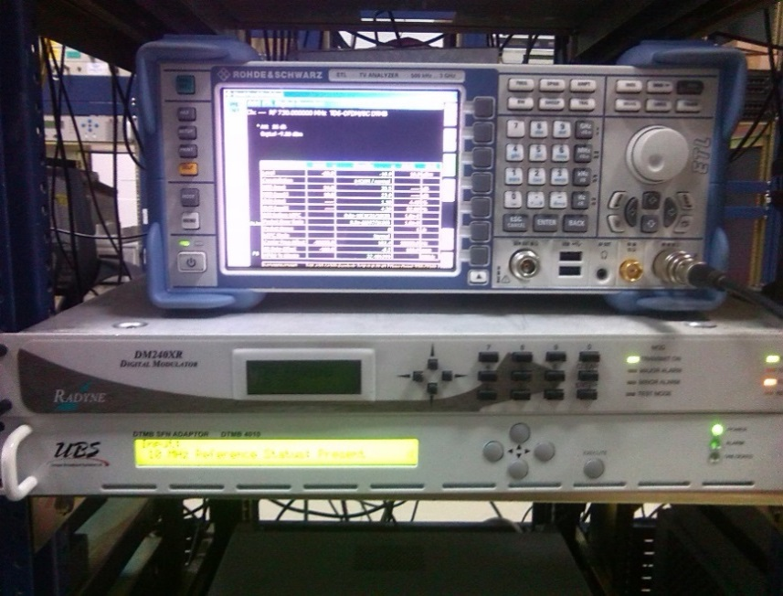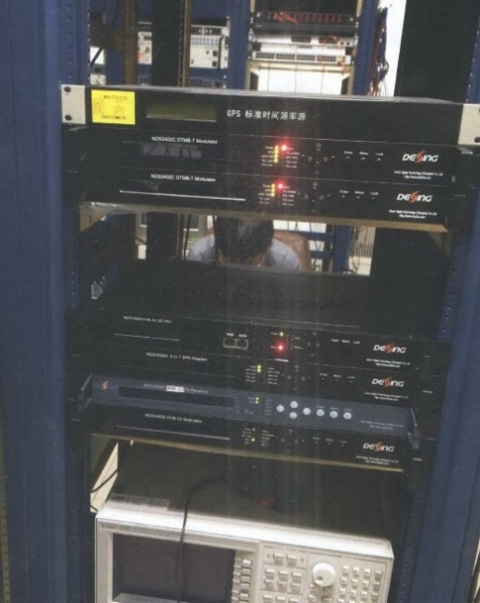
Laboratory networking test results show that the distribution network based on satellite links can support the SFN synchronizations effectively. The spectrum and corresponding time domain channel impulse response of the combined RF signal are shown in Fig. P4-16 (a) and (b) respectively. Furthermore, cross tests indicate that the SFN networking is successful using different SFN adapter and DTTB exciters of different brands. Therefore, laboratory test verified the feasibility of the proposed SFN structure using satellite distribution networks.
2) Field trial results
The field trials are performed based on laboratory tests to further validate the proposed SFN scheme with the coordination of CCTV tower, satellite earth station and CCTV.
The field trail is completely constructed according to the actual system architecture. CCTV provides one scrambled TS signal including six AVS+ programmes. The TS signal is then transmitted to the satellite earth station and passed through the SFN adapter and satellite modulator to generate the uplink satellite signal. At the DTTB station, the TS signal is recovered by satellite receiver. DTTB transmitter receives the recovered TS and converts it to DTMB RF signal. Two DTTB stations are selected, i.e. CCTV tower and one transmitting station around Beijing. Channel 32 with centre frequency of 666 MHz is used, and the transmitting power is 1KW for both stations. DTMB working mode is PN945, C=3 780 (multi-carrier mode), 16QAM and LDPC rate 0.6.
Before field trial, the coverage is calculated using frequency planning software according to the real parameters. Calculated results show that the coverage overlapping area mainly exists between the east Ring 3 and Ring 5. Therefore, the main road of east Ring 3 and Ring 5 is selected for the reception test.
Figure P4-16
Signal characteristics of the combined signal
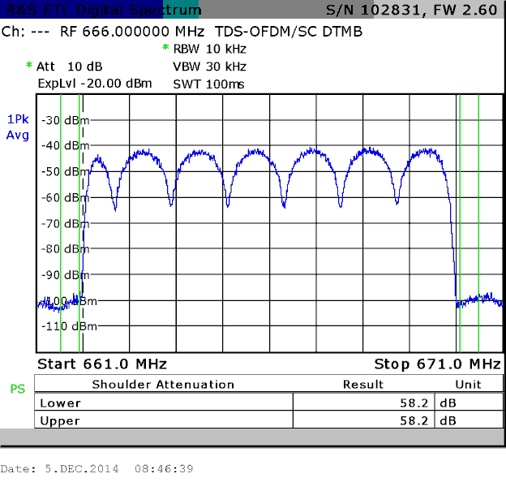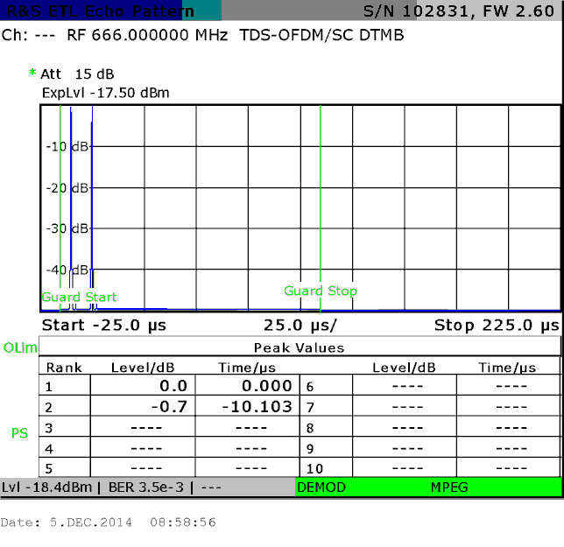
(a) spectrum (b) impulse response
The field trail results for single transmission station are shown in Fig. P4-17 (a) and (b) respectively, in which the LDPC block error rate is used to indicate the mobile reception quality. It is clear from Fig. P4-17 that there exists an obvious service blind area when using single transmission station (red section in Fig. P4-17).
Figure P4-18 illustrates the coverage test results in the case of two transmission stations working on nonsynchronous condition. It is obvious that both transmission stations generate severe interference to each other, and the coverage area is decreased evidently compared with single transmission station mode.
Under the condition of SFN mode with both transmitters synchronous to each other, the field trail results are shown in Fig. P4-19. From Fig. P4-19, it is clear that the service availability exceeds 98% when both transmitters are working synchronously to form SFN. The coverage effect is much better compared with single transmission station, which proves the feasibility and effectiveness of the satellite-based distribution link in practical application environments.
Figure P4-17
Coverage test results of single transmission station
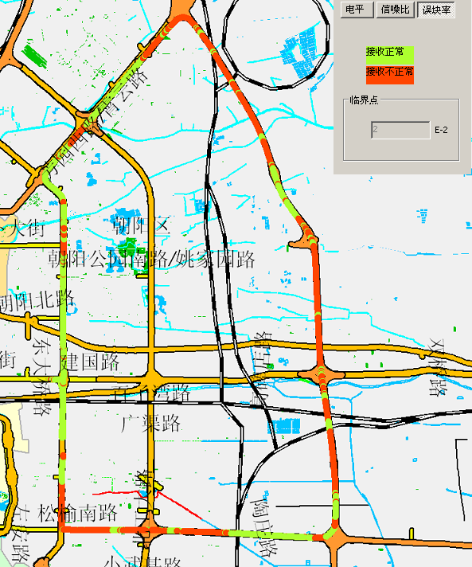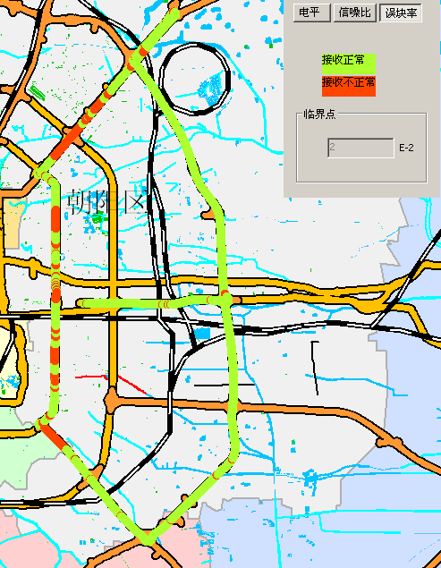
(a) CCTV tower (b) the other station
Figure P4-18
Coverage test results of nonsynchronous transmission stations
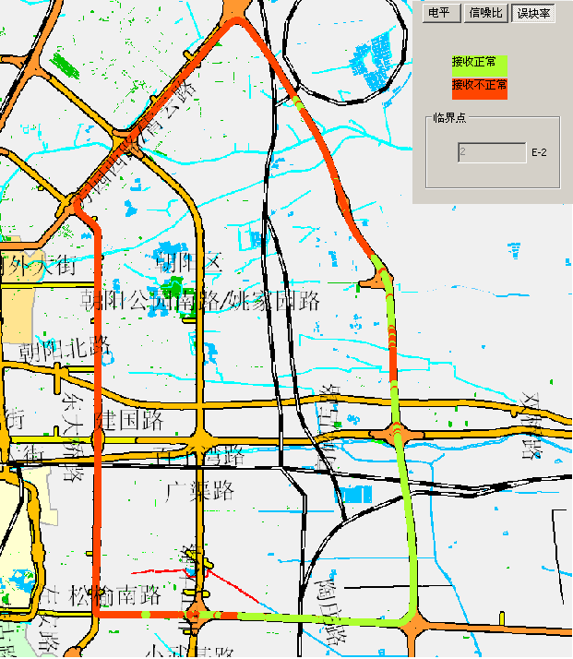
Figure P4-19
Coverage test results of SFN mode
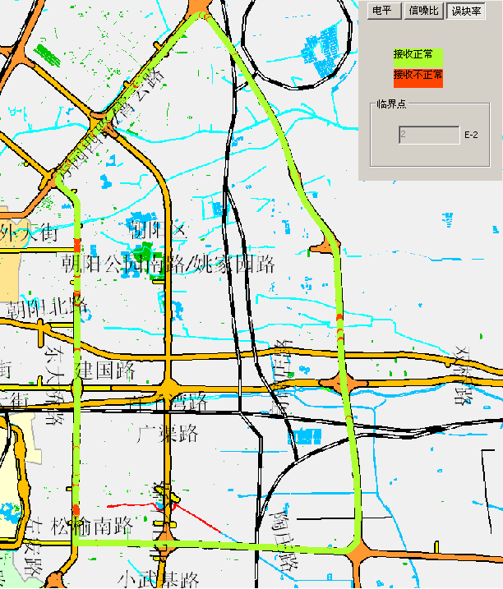

2.2.5 Conclusion
A novel DTTB SFN scheme is proposed based on satellite distribution networks. The advantages of the satellite link are fully utilized in the proposed scheme so that the program distribution network will not be affected by the regional restrictions. Therefore, it is suitable for constructing national wide or large area DTTB SFN networks. Test result indicates that the transmission delay of the satellite distribution link satisfies the SFN networking requirement. Both laboratory test and field trial show that the proposed SFN structure can support practical applications.

2.3 Synchronization scheme of DTMB SFN using IEEE1588v2 standard and time of days

2.3.1 Introduction
In Recommendation ITU-R TF.486-2, UTC frequency is proposed as reference in standard frequency and time signals emissions. This contribution proposed a feasible scheme of time and frequency synchronization based on network distribution in DTMB SFN. UTC time and frequency are used as reference clock in the proposed scheme. This method can also be used in other DTTB systems as a reference.

2.3.2 General
Single Frequency Network (SFN) transmitters simultaneously send the same signal over the same frequency channel which leads to much more efficient utilization of the radio spectrum than Multiple Frequency Network (MFN). SFN systems are capable of increasing the coverage area and allowing a higher number of TV programmes. However, multiple SFN signals would be considered as destructive multipath interference if timing and frequency synchronization exceed the tolerance of receivers, so several transmitters sending the same signal should be synchronized as precise as possible.
In present DTMB systems, synchronizing signals, 1PPS and 10 MHz reference frequency, are extracted from GPS signals and each transmitter is equipped with a GPS receiver. The high expenses and practical restrictions of setting up GPS receivers make it hard to accomplish SFN system implementation in some special areas. What’s more, present synchronizing signals do not carry the absolute time information which results in being unable to get two transmitters synchronized on condition that the deviation of propagation delays from adapter to different transmitters exceed 1 second.
In Recommendation ITU-R TF.486-2, UTC frequency is proposed as reference in standard frequency and time signals emissions. This document shows an example of utilize UTC clock in SFN system to get all related equipment synchronized.
This contribution introduces a time distribution scheme using UTC frequency and time as reference. In this method, IEEE1588v2 standard which is used for precision clock synchronization is adopted. The time information including 1PPS and time of days (TOD) is distributed by PTN equipment supporting IEEE1588v2 protocol. The deviations of 1PPS received by multiple transmitters are less than 1 µs, which can fulfill the time precision requirement of SFN system. Concerning the reference frequency, the transmitters/exciters are able to obtain reference frequency from frequency divider by making use of 1PPS signal. The use of absolute time information, TOD, makes it possible to accomplish SFN networking when propagation delays from adapter to each transmitter/exciter exceed 1 second. Laboratory test has proved that the proposed time distribution and synchronization scheme can support practical applications.

2.3.3 System structure
In this method, SFN consists of time distribution network and content distribution network. Content distribution network used for content transmission consists of content generator, SFN adapter and transmitters/exciters. Time distribution network used for synchronization among multiple transmitters consists of time server and packet transmission network (PTN) device. The system structure is illustrated in Fig. P4-20.
figure P4-20
Proposed SFN system structure

2.3.4 Time distribution network
Time distribution network is illustrated in Fig. P4-21. The original timing signals used as reference clock with high precision is obtained from a GPS or Beidou (BD) receiver called time server. The time server accepts the timing signals and adjust the output of local crystal, then provide high quality clock signal, 1PPS and absolute time information provided as time of days (TOD) in this document. After the clock in time server get disciplined by GPS, the server transmits 1PPS and TOD signals to PTN device on adapter side numbered as PTN device 1 in Fig. P4-21. The PTN device 1 encapsulates time information into PTP packet, meanwhile, 1PPS and TOD used as reference clock are transmitted to adapter. PTP packets containing time information are transmitted through fiber from adapter side PTN device to transmitter side PTN devices numbered as 2 to N in Fig. P4-21, and the PTN devices would be accurately synchronized with PTN device 1 by operating IEEE1588v2 standard. The time-synchronized PTN devices send reference clock, 1PPS and TOD, to transmitters/exciters.
IEEE 1588v2 is one type of precision time protocol (PTP) which use PTP packets to get multiple devices synchronized. In IEEE 1588v2 standard, master clock and slave clock are provided. The master clock regarded as reference exchanges PTP packets with slave clock and achieve synchronization by operating algorithm with PTP packets. A slave clock may connect with multiple high precision clock and master-slave relation may vary with time. Best Master Clock algorithm (BMCA) is used to build and manage master-slave relation. In Fig. P4-21, PTN device 1 obtain reference clock directly from Time server, so device 1 is the sole master clock in this system. Time stamps is added in physical layer, so the processing delay of operating system and protocol stack is eliminated which leads to precision synchronization. There are three types of PTP clock, Ordinary clock (OC), Boundary clock (BC) and Transparent clock (TC). OC and BC are employed in this contribution. OC, PTN device 2 to N in the proposed system, have a single PTP port in a domain and maintains the timescale used in the domain. A boundary clock, PTN device 1 in this system, has multiple PTP ports in a domain. Both OC and BC can serve as either master clock or slave clock. To make the system function well, the asymmetry of transmission path must be compensated in physical layer, so the difference of propagation delays between the path from master to slave and the return path from slave to master must be restricted in a small range.
In SFN adapter, time information, TOD, derived from time server and a preset delay are embedded in some reserved bytes in SIP packet. Transmitters/exciters would transmit the stored stream simultaneously after synchronization of emission time is completed. The synchronization scheme is illustrated in § 3 in detail. The preset delay can be set to more than 1 second in adapter which leads to being capable of dealing with the situation that the propagation delays from adapter to multiple transmitters exceed 1 second.
figure p4-21
Time distribution scheme

2.3.5 SFN adapter
The DTMB SFN adapter and transmitters/exciters can get current absolute time information and frequency reference from above-mentioned time distribution network. SFN adapter and transmitters/exciters get their frequency synchronized based on the reference frequency information provided by 1pps signal. At the adapter end, according to the 1pps signal, a new SIP packet is inserted to the TS with a period of 1 second. Two changes in the new SIP packet are made. On one hand, the new SIP packet contains TOD information, which is different from TOD information in any other SIP packets. On the other hand, the common emission delay parameter is inserted in the SIP packet, which denotes the duration between the moment when adapter inserts this SIP packet and the start moment when the TS labeled by this SIP packet is modulated and transmitted. The common emission delay must be larger than the maximum propagation delay of content distribution network, and would be limited by the cache capacity of transmitters/exciters.
TS inserted with SIP packets is distributed to multiple transmitters/exciters. After receiving SIP packet, transmitters/exciters analyse the absolute time information (TOD) and common emission delay parameter, and combine them to get the exact emission time. When the absolute time provided by the transmitters/exciters side PTN devices reaches the exact emission time, the TS content labeled by this SIP packet starts being modulated and transmitted into the RF channel.
Since the common emission delay parameter is the duration between the moment when adapter inserts the SIP packet and the starting moment when the TS labeled by this SIP packet is modulated and transmitted, the restriction of maximum propagation delay of content distribution network is released by setting the parameter larger than 1 second.
An example is illustrated in Fig. P4-22. In this example, the maximum propagation delay is 2 seconds, and the common emission delay is set to 3 seconds. The difference between the two-emission time of exciters is within 1 us, which is brought in by the deviation of 1pps signal.
figure P4-22
Synchronization scheme

2.3.6 Lab test
Laboratory test result for the proposed SFN scheme is given in this section. Figure P4-23 shows the block diagram of laboratory test.
figure P4-23
Laboratory test structure
Different propagation delays of the program distribution network are accomplished by TS delayer. The common emission delay is set to 3 seconds, and the TS delayer is set to 1.5 seconds. Additional emission time deviation can be achieved by setting specific transmitter’s parameter. Received signal after the combiner is sent to spectrum analyser. Other test targets and test mode parameters are listed in Table P4-9 and Table P4-10 respectively. Smooth video can be watched on displayer.
TABLE P4-9
Test targets
Items | Result
1PPS deviation | 260 ns
Carrier Frequency Offset | 0.5 Hz
Residual Emission Time Offset | 0.1 μs
SFN Networking | normal
TABLE P4-10
Test mode parameter
 | Frequency  (MHz) | Output power  (dBm) | Carrier mode | Mapping pattern
Mode 1 | 706 | 0 | C=3780 | 16QAM
Mode 2 | 706 | 0 | C=1 | 16QAM
 | FEC rate | Frame mode | Interleaving pattern | Payload rate (Mbit/s)
Mode 1 | 0.8 | PN420 | 720 | 21.685
Mode 2 | 0.8 | PN595 | 720 | 20.791

Firstly, the synchronization performances derived from the proposed scheme are shown in Figs P4-24 and P4-25 at different time-points.
FigURE P4-24
Comparison of 1PPS signals at the first reference time-point
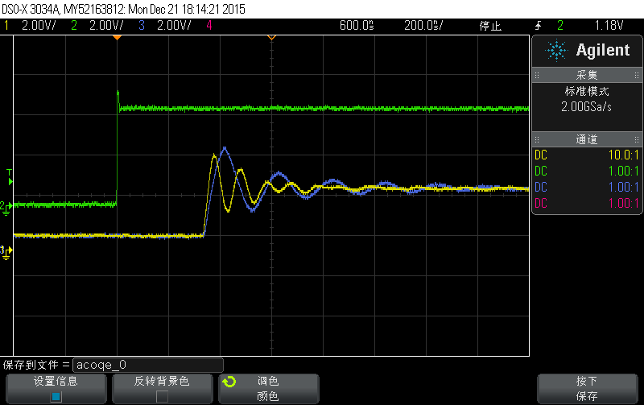
FigURE P4-25
Comparison of 1PPS signals at the second reference time-point
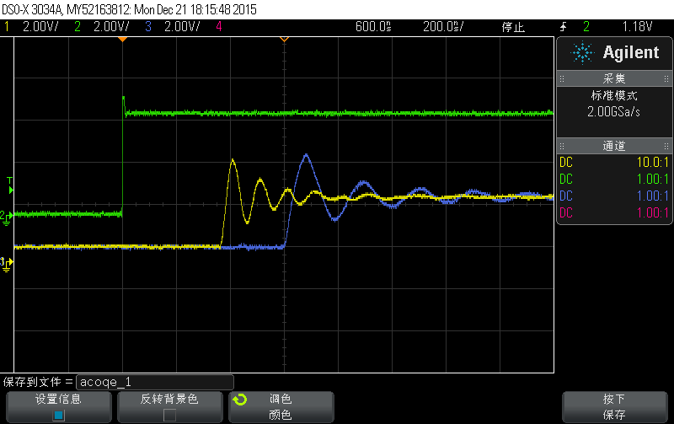
The 1PPS signal indicated by the green line is the output of the PTN device at the adaptor side. Comparatively, the signals indicated by the yellow and blue lines are obtained from the PTN devices at the exciters side. From Figs P4-24 and P4-25, the deviation of 1PPS at exciters side is 300 ns at most, which can fully meet the demand of SFN networking.
Figures P4-26 and P4-27 show the spectrum of combined signal when the emission time deviation is set to 0 and 0.6 microsecond. The spectrum shows that the SFN with proposed scheme is functioning well.
FigURE P4-26
Spectrum with zero emission time deviation
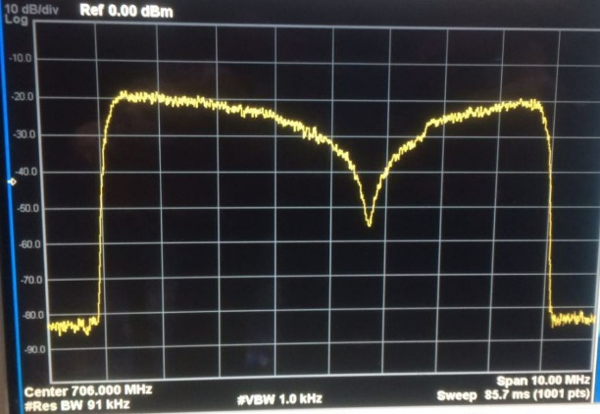
Figure P4-27
Spectrum with 0.6 microsecond emission time deviation
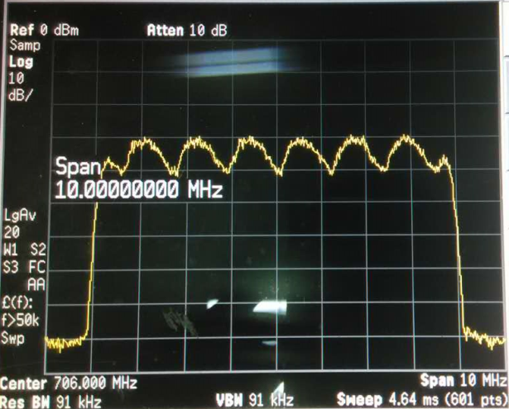

2.3.7 Field test
The field trials are performed to further validate the practicability of the proposed time distribution scheme. These trials are implemented with the coordination of Shanghai Oriental Pearl Radio & TV research and Development Co. Ltd. Figure P4-28 shows the implementation architecture of the field test.
Figure P4-28
Field test structure
There are two separate links in the proposed structure, time distribution link and content distribution link. As for the time distribution link, One of PTN devices obtains the reference time from the master clock and then distributes the time information to other PTN devices. All the PTN devices are precisely synchronized by applying IEEE1588v2 standard. As for the content distribution link, the TS streams from stream generator are put into the SFN adaptor and then distributed to each exciter in different stations. Two emission stations are selected to form the SFN network. PTN devices in the same station and different stations are both connected by optical fibre. The exciter and adaptor do not have IP mode to enable transmission through common IP network, so a pair of transition gateways are used. The signal from exciters is amplified to drive the high power tower and launched to the air. The detail information of used equipment is listed in Table P4-11.
TABLE P4-11
Test equipment list
Master clock(Keywie PTPGrand-2200) | Handheld Spectrum analyzer  (ROHDE&SCHWARZ FSH4)
3*PTN devices (ZXCTN6110) | 2*Emission Towers (Oriental Pearl TV tower)
2*Exciters (Anywave CTTB Exciter) | Gateway (Dektec DTE3100/3120)
1*adaptor (Anywave SA3000) | TS generator (Linux computer host)

In order not to impact the normal service, the central frequency is set to 514 MHz. Two DTTB stations, Chuangzhi Tiandi and Xin Jinqiao mansion, with about 10 km apart are selected to produce an overlapping area as shown in Fig. P4-29. Three reception points within the overlapping area are selected as shown in Fig. P4-29. The output powers of exciters (before amplifier) in Chuangzhi Tiandi and Xin Jinqiao mansion are −4.5dBm and −10 dBm respectively. After amplification, the transmitting powers are 200 W for both stations. The DTMB working mode is PN945, C=3780 (multi-carrier mode), 16QAM and LDPC rate 0.8. Additionally, the detail information of emission towers and reception points are listed in Tables P4-12 and P4-13.
Figure P4-29
Emission and reception map
TABLE P4-12
Emission tower parameter
Emission tower number | Antenna height | Polarization direction | Antenna  gain | Emission power | Location
1 | 120 m | horizontal | 12.65 dB | 200 W | Chuangzhi Tiandi, Yangpu district
2 | 120 m | vertical | 12.65 dB | 200 W | Xin Jinqiao Mansion, Yangpu district

TABLE P4-13
Reception point parameter
Reception Point number | Distance from  tower1 | Distance from  tower2 | Polarization direction (Reception) | Antenna gain (Reception) | Location
1 | 5.5 km | 5.3 km | Horizontal or Vertical | 5 dBi | Longchang Road &  Hejian Road, Yangpu
2 | 5.5 km | 5.2 km | Horizontal or Vertical | 5 dBi | Pingliang Road &  Liping Road, Yangpu
3 | 5.8 km | 4.8 km | Horizontal or Vertical | 5 dBi | Yangshupu Road & Neijiang Road, Yangpu

The field trial result in each reception point is shown in Table P4-14. The power spectrum in overlapping area is used to indicate the networking condition. The signal mode used in field test is different from lab test for showing significant difference in comparison results. Test results are authenticated by the Oriental Pearl Radio & TV Tower and a user test report is provided. Test results show that the proposed time distribution network can meet the requirement of SFN networking.
TABLE P4-14
Comparison of the received signals
Reception Point Number | Transmitter using UTC time synchronization | Transmitter without using UTC time synchronization
1 | 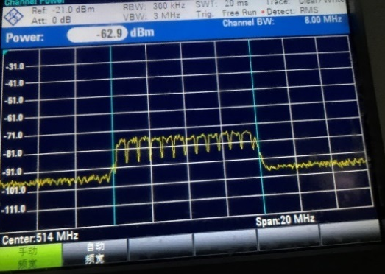 | 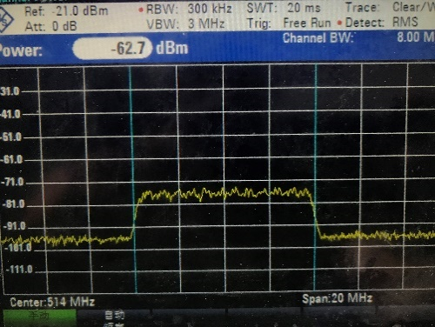

TABLE P4-14 (end)
Reception Point Number | Transmitter using UTC time synchronization | Transmitter without using UTC time synchronization
2 | 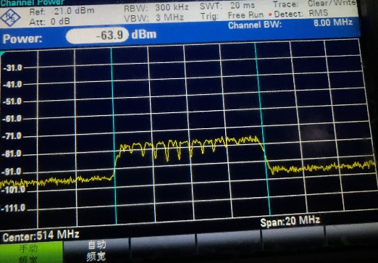 | 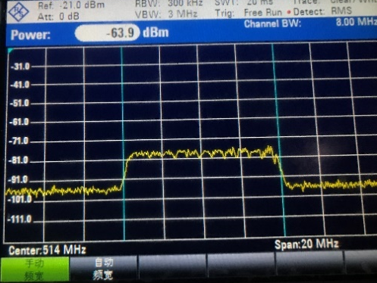
3 | 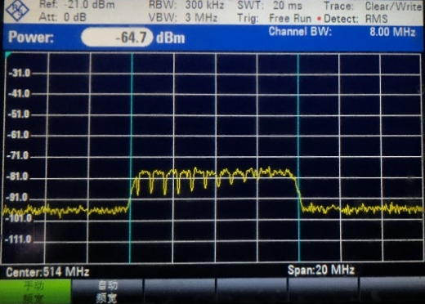 | 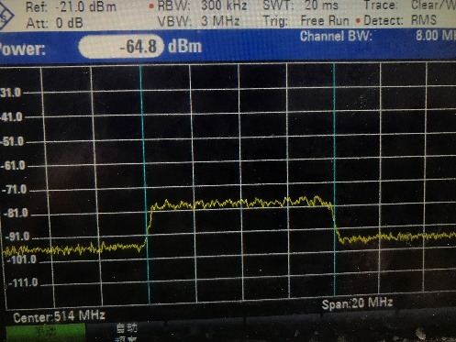

2.3.8 Conclusion
A new SFN scheme is proposed for DTMB using the UTC reference time. Since the reference UTC time is provided by PTN devices, only one GPS clock is needed in whole system theoretically. What’s more, the utilization of TOD makes for elimination of propagation delay restriction. Laboratory test results show that the proposed SFN scheme performs well when the maximum propagation delay of program distribution network exceeds 1 second, which is an abnormal scenario in the traditional DTMB SFN system. Field trials are performed to further validate the proposed synchronization scheme. Both laboratory and field test results show that the performance of the proposed networking is as good as traditional system.

2.4 Large area single frequency network optimization method

2.4.1 Overview
Due to the limitation of frequency resources and the requirement for large area coverage, it is necessary to set up a large area of single frequency network. In China, radio and TV programme wireless digital coverage project of Hunan province includes more than 100 terrestrial digital TV stations which deliver five sets of provincial TV programmes. The service used a province-wide single frequency network which operated on channel DS-19 (centre frequency 522 MHz). In order to eliminate or minimize intra-network interference and achieve the most optimal coverage effect, it is necessary to optimize the single frequency network through different technical methods in combination with the actual conditions of each station to improve the population coverage of the single frequency network.

2.4.2 Single frequency network optimization

2.4.2.1 Single frequency network optimization methodology
The traditional single frequency network optimization adopts the process of repeatedly adjusting the parameters of transmitting stations, evaluating the coverage through subjective comparison, and then selecting the most reasonable technical parameter. When the number of transmitting stations is small, with the help of professional planning software, the design of single frequency network is not difficult; however, when such design method is used to deal with complex network environment with a large number of transmitting stations, such as the design of province-wide single frequency network, the interference area of single frequency network will keep changing with the change of a single network technical parameters, it is very difficult to get a satisfactory design scheme, resulting in the calculation workload increases exponentially, and even falls into endless iterations.
In order to solve the problem of large area single frequency network optimization, the classical optimization algorithm is introduced in the optimization of Hunan Province single frequency network, which regards the optimization of single frequency network as the solution process under certain constraint relations and simplifies it mathematically as the solution to resolve space search problem under the condition of certain objective function.
The method of combining the genetic algorithm with the analysis of single frequency network changes the design methodology that it needs to repeatedly adjust the transmitting power, delay time, antenna direction diagram, etc. to get the network coverage effect and then get the relatively applicable design scheme. This method can massively improve the efficiency of single frequency network analysis and design.
The implementation flow of single frequency network optimization based on genetic algorithm was shown in Fig. P4-30.
FIGURE P4-30
Single frequency network optimization flow based on genetic algorithm
During the optimization, the coverage areas of each transmitting station of single frequency network usually overlap with nearby station, where intra-network interference may arise, and the single frequency network system needs to be optimized. When the multipath is strong in the overlapping area of single frequency network, the delay difference between multipath can be reduced; when the multipath delay is long, the strength of multipath signals can be reduced. In the process of single frequency network optimization, the coverage effect of single frequency network can be optimized by adjusting the relative delay of signals of each transmitting station and/or reducing the transmitting power of each transmitting station. The optimization can adjust the interference area of single frequency network to the smallest area or adjusting the interference area of single frequency network to the area with less population density.
Although it is possible to reduce the interference of a single frequency network by reducing the transmitting power, this actually comes at the cost of reducing the coverage of the whole network. This approach can be considered in advance during the initial planning phase of a single frequency network, but it should be used with caution during the optimization phase of a single frequency network. Adjusting the transmit delay has been considered as the main, and the most economical and convenient way in the single frequency network optimization phase.

2.4.2.2 Single frequency network interference optimization example
Chenzhou City is located in the south of Hunan Province, and the area is dominated by mountainous terrain. The city includes 12 single frequency network transmitting stations. The coverage and optimization analysis results in the area were shown in Figs P4-31 to P4-33, and the parameter configurations were shown in Table P4-15.
FIGURE P4-31
Coverage effect under the condition of no time delay adjustment
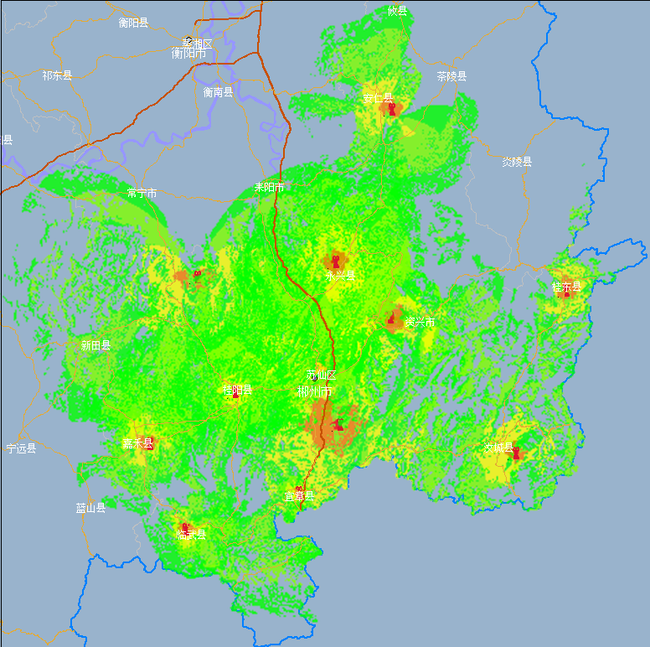
FIGURE P4-32
Interference in the network before optimization
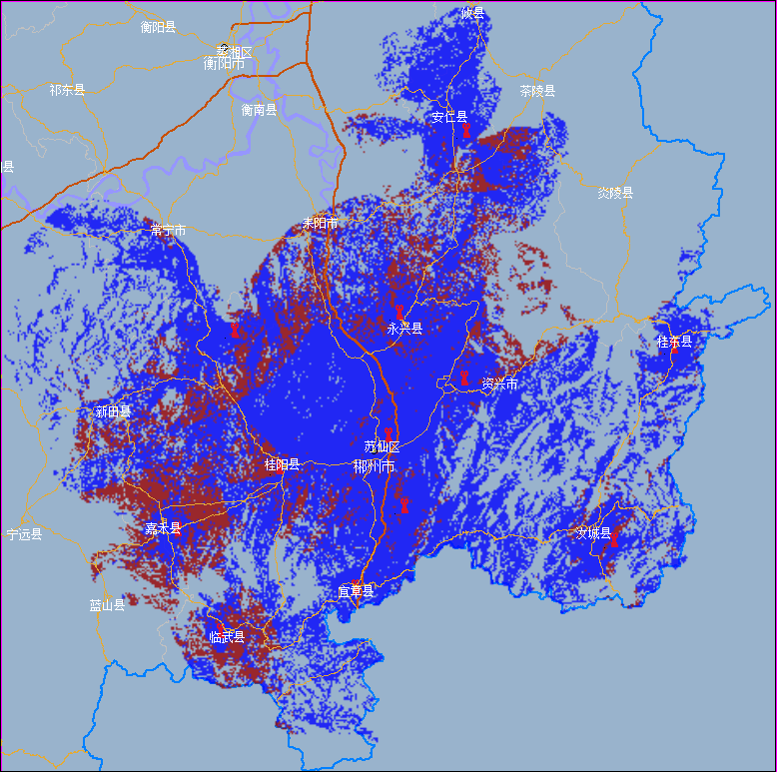
According to statistics, the ideal coverage area at this setup is 16 153.50 square kilometres, and the actual coverage area is 12 895.50 square kilometres, with an effective coverage ratio of 79.83%.
FIGURE P4-33
Interference analysis in the network after optimization
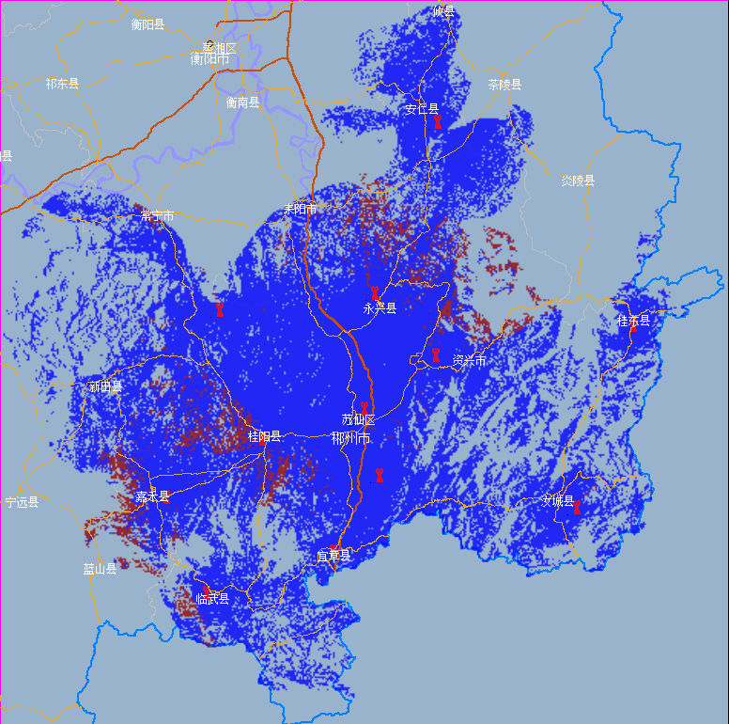
According to statistics, the ideal coverage area at this time is 16,153.50 square kilometres, and the actual coverage area increase to 15,207.75 square kilometres, with an effective coverage ratio of 94.15%.
TABLE P4-15
Optimization parameters of related stations
No. | City | Station | Power  (kW) | Delay  (μs) | Interference area
1 | ChenZhou city | Sizhoushan station | 0.3 | 140 | Sizhoushan  District
2 | ChenZhou city | Suxianling station | 1 | 72 | Sizhoushan  District
3 | ChenZhou city | Wugaishan station | 0.5 | 9 | Sizhoushan  District
4 | ChenZhou city | Zixing station | 0.3 | 58 | Sizhoushan  District
5 | ChenZhou city | Baoling station | 0.05 | 180 | Sizhoushan  District
6 | ChenZhou city | Yongxing station | 0.3 | 115 | Sizhoushan  District
7 | ChenZhou city | Yizhang station | 0.3 | 0 | Sizhoushan  District
8 | ChenZhou city | Jiahe station | 0.3 | 0 | Sizhoushan  District
9 | ChenZhou city | Linwu station | 0.3 | 0 | Sizhoushan  District
10 | ChenZhou city | Rucheng station | 0.1 | 0 | Sizhoushan  District
11 | ChenZhou city | Guidong station | 0.3 | 0 | Sizhoushan  District
12 | ChenZhou city | Anren station | 0.3 | 140 | Sizhoushan  District

2.4.3 Field trial verification
October 2021, in order to verify the results of the optimization, a comparison test between before and after optimization was conducted in the coverage area with the following details.

2.4.3.1 Testing instruments
During the test, the instruments shown in Table P4-16 were used.
TABLE P4-16
Testing instruments
No. | Equipment | Model | Note
1 | Radio and TV frequency planning optimization and coverage software | Self-developed | The software follows international and domestic broadcast TV industry standards and supports national terrestrial digital terrestrial TV (DTMB), CMMB and analog FM and TV services, with functions such as map display, coverage analysis, single frequency network analysis, interference analysis, frequency assignment, frequency coordination, network optimization, station management, etc.
TABLE P4-16 (end)
No. | Equipment | Model | Note
2 | Integrated Management System for Wireless Digital Radio and Television Network Planning, Simulation and Analysis and Network Verification | CHIRplus_  BC | The system is applied to the network planning, coverage effect, statistical calculation, compatibility analysis, border coordination, spectrum mining, etc. required for building wireless digital radio and TV coverage networks; it can support the experimental research on modern coverage networking technology, efficient frequency assignment methods for multi-frequency networks, single frequency network networking optimization, coverage network testing and verification, etc. It can support the CDR and DTMB network analysis and calculation, etc.
3 | Spectrum analyser | KEYSIGHT  N9342C | Support the test of signal spectrum and signal power.  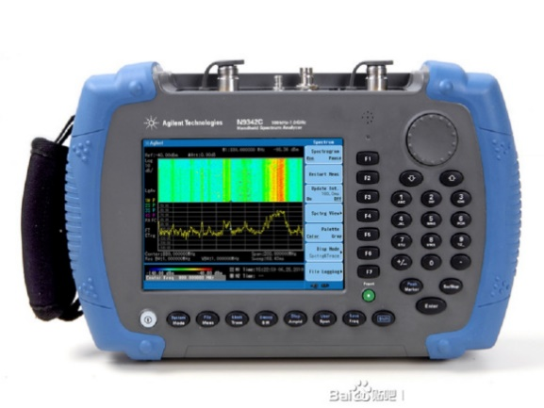
4 | Field trial tester | S7200 | Support the DTTB signal mobile reception test.  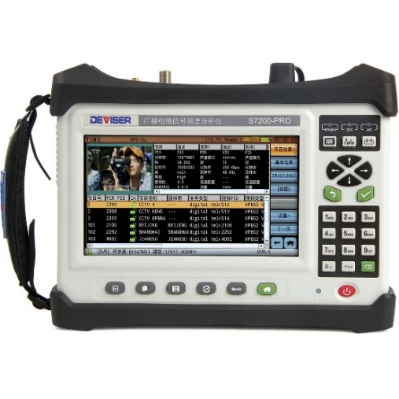
5 | TS analyser | BlueTop  BTA-P200 | Support digital radio and TV programme stream analysis.  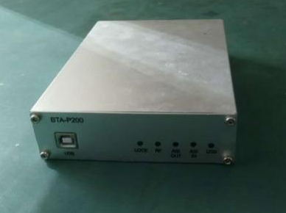
6 | Yagi antenna | RS

2.4.3.2 Test site No.1
The overview of test site No.1 is shown in Fig. P4-34, the test results after optimization are shown in Table P4-17.
TABLE P4-17
Results of Test site No. 1
No. | Test Site | Position and nearby | Test result | Direction
1 | Test site  No.1 | Roof top  Open area | Level −50.3 (dBm)  BER < 1.0E-08  C/N 32.1 (dB)  MER 22 (dB)  Reception: success | Sizhoushan
1 | Test site  No.1 | Roof top  Open area | Level −44.2 (dBm)  BER < 1.0E-08  C/N 29.6 (dB)  MER 22 (dB)  Reception: success | Baoling
1 | Test site  No.1 | Roof top  Open area | Level −52.2 (dBm)  BER < 1.0E-08  C/N 26.8 (dB)  MER 21.2 (dB)  Reception: success | Wugaishan
FIGURE P4-34
Overview of test site No. 1
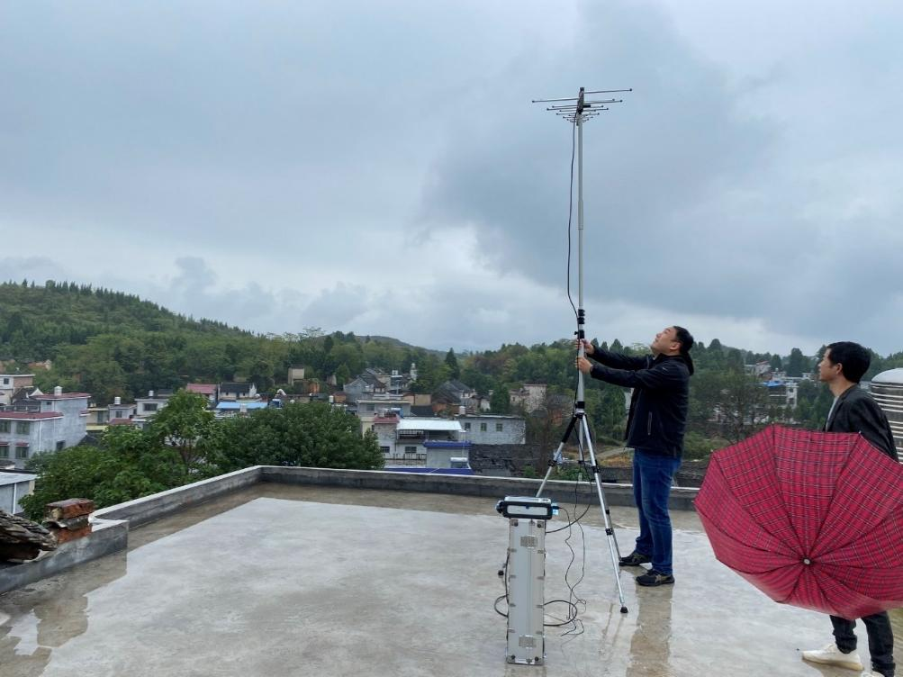
Spectrum and reception parameters before optimization are shown in Figs P4-35 to P4-38.

2.4.3.2.1 Before optimization
FIGURE P4-35
Spectrum of test site No. 1 before optimization
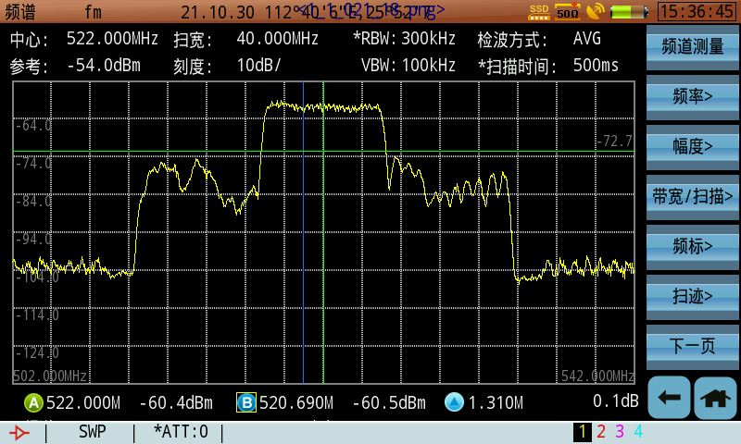
FIGURE P4-36
Reception parameters of test site No. 1 before optimization
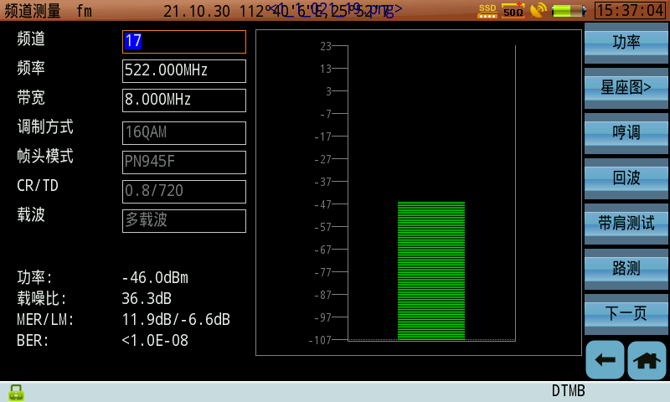
FIGURE P4-37
TS parameters of test site No. 1 before optimization
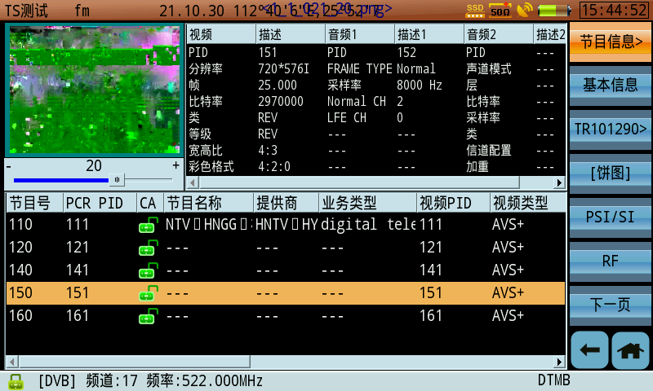
FIGURE P4-38
Multipath parameters of test site No. 1 before optimization
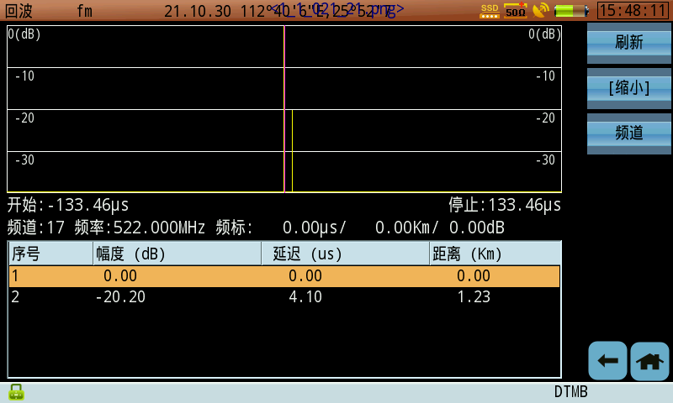
Spectrum and reception parameters after optimization are shown in Figs P4-39 to P4-42.

2.4.3.2.2 After optimization
FIGURE P4-39
Spectrum of test site No. 1 after optimization
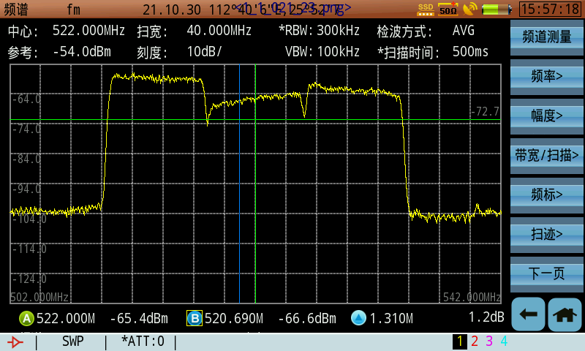
FIGURE P4-40
Reception parameters of test site No. 1 after optimization
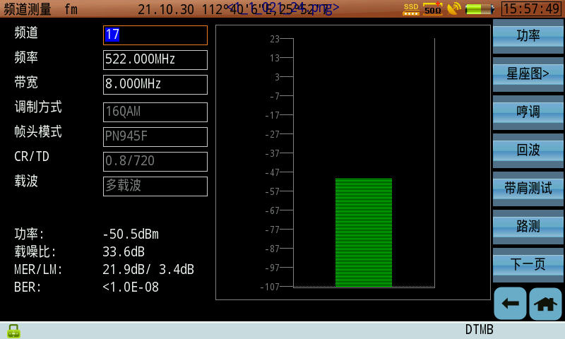
FIGURE P4-41
TS parameters of test site No. 1 after optimization
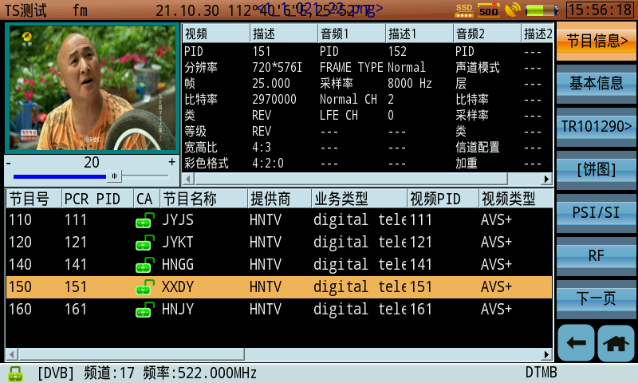
FIGURE P4-42
Multipath parameters of test site No. 1 after optimization
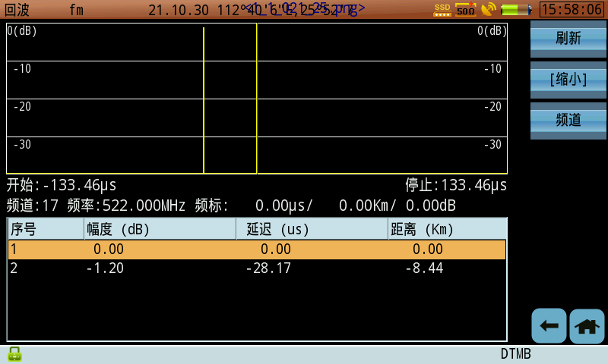

2.4.3.3 Test site No. 2
The overview of test site No. 2 is shown in Fig. P4-43, the test results after optimization are shown in Table P4-18.
TABLE P4-18
Results of Test site No. 2
No. | Test site | Position and nearby | Test result | Direction
2 | Test site  No. 2 | Farmland, open area | Level −71.3 (dBm)  Reception: success | Changning
2 | Test site  No. 2 | Farmland, open area | Level −72.6 (dBm)  Reception: success | Sizhoushan
2 | Test site  No. 2 | Farmland, open area | Level −61.8 (dBm)  Reception: success | Leiyang

FIGURE P4-43
Overview of test site No. 2
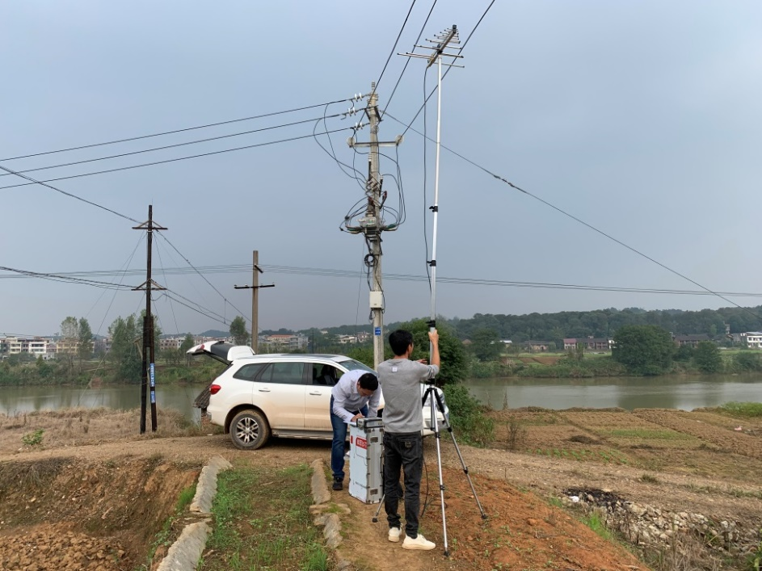
Spectrum and reception parameters before optimization and after optimization are shown in Figs P4-44 to P4-47.

2.4.3.3.1 Before optimization
FIGURE P4-44
Spectrum of test site No. 2 before optimization
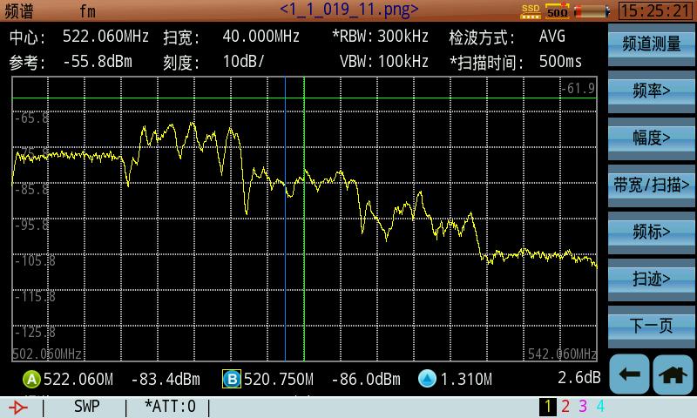
FIGURE P4-45
Reception parameters of test site No. 2 before optimization
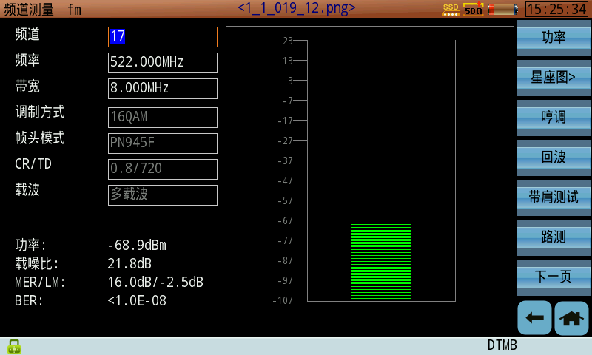
FIGURE P4-46
TS parameters of test site No. 2 before optimization
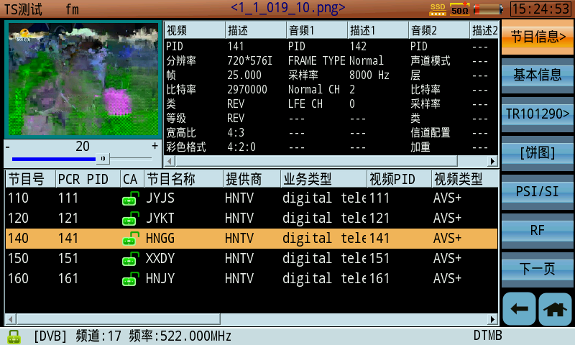
FIGURE P4-47
Multipath parameters of test site No. 2 before optimization
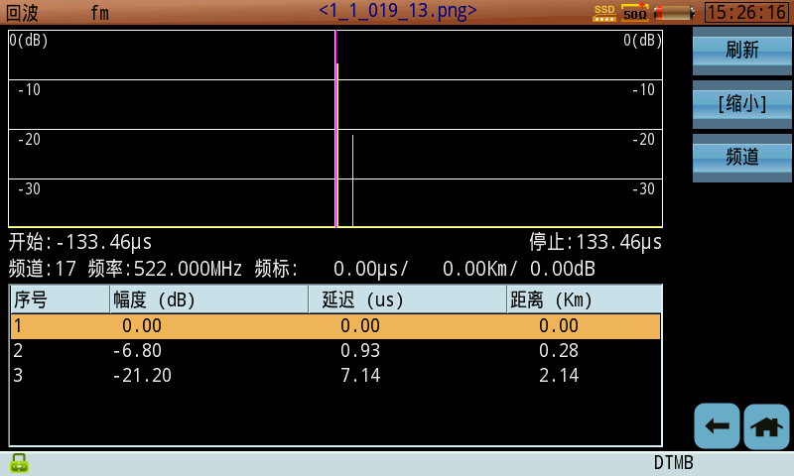

2.4.3.3.2 After optimization
Spectrum and reception parameters after optimization are shown in Figs P4-48 to P4-51.
FIGURE P4-48
Spectrum of test site No. 2 after optimization
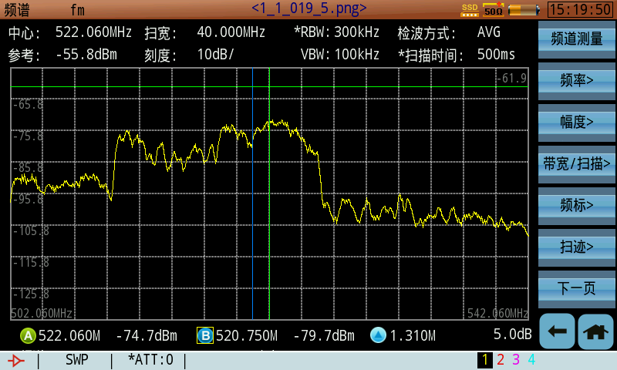
FIGURE P4-49
Reception parameters of test site No. 2 after optimization
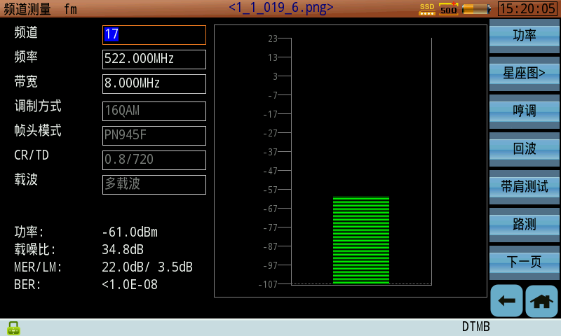
FIGURE P4-50
TS parameters of test site No. 2 after optimization
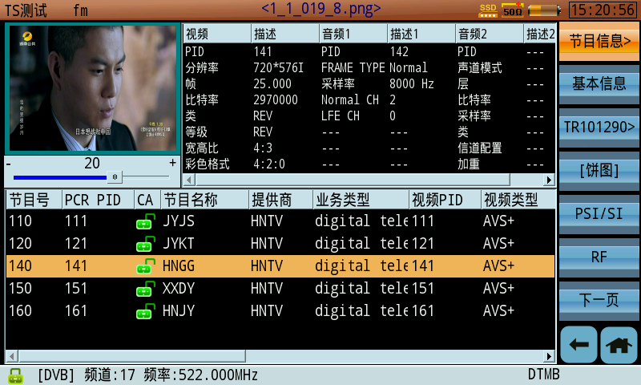
FIGURE P4-51
Multipath parameters of test site No. 2 after optimization
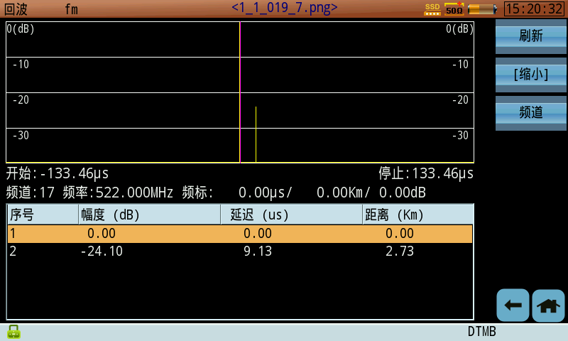

2.4.4 Conclusion
The field test shows that the genetic algorithm-based single frequency network optimization method can effectively reduce the workload and shorten the design cycle of single frequency network analysis and can be used to guide the construction and optimization of terrestrial digital television single frequency networks.
This optimization method can be applied not only to DTMB, but also to other terrestrial digital TV standards with appropriate adjustments.

Part 5
SFN application and implementation of DTMB-A system

1 SFN Field trial for DTMB-A

1.1 Background
Digital terrestrial television broadcasting (DTTB) is an important part of the broadcasting and television system. As a traditional means of television broadcasting, DTTB can meet the basic requirements of information transmission in modern information society because of its ability of simple reception and mobile reception.
In 2007, Hong Kong announced the adoption of DTMB as the DTTB transmission standard and has successfully established DTMB SFN covering the whole areas of Hong Kong. Because of the mountainous terrain, high-rise buildings, small area and high population density, DTTB is facing great challenges in Hong Kong. In order to validate the actual coverage effect of DTMB-A system (the next generation DTMB system) in Hong Kong, Tsinghua University organized the field trials by setting up a DTMB-A SFN consisting of three transmitting stations in August 2019.

1.2 Field trial structurer
In order to verify the SFN networking capability and coverage effect of DTMB-A system, Tsinghua University organized the DTMB-A SFN coverage field trial in Hong Kong at the end of August 2019.
DTMB-A exciters are set up in three different transmitting stations, Temple Hill, Golden Hill and Kowloon Peak stations, to form a SFN, as shown in Fig. P5-1. Temple Hill, as the main transmitting station, is configured with 1000W equivalent isotropically radiated power (e.i.r.p.) to cover most areas of Hong Kong island and Kowloon city, whereas both Golden Hill and Kowloon Peak Stations are with 300W e.i.r.p. to service for other major areas of Hong Kong. CH37 (602 MHz) is chosen throughout the field trials.
Apart from DTMB-A exciter, the SFN adapter and MPEG-TS player are equipped in Temple Hill station to build an SFN. The output of the TS player is processed by the SFN adapter to insert synchronization information to the TS stream. Then, the adapted TS stream is fed to Golden Hill and Kowloon Peak stations through microwave link. The GPS timing receivers are needed at every transmitting station to provide the reference clock for all the equipment including DTMB-A exciters and SFN adapter. The equipment construction of three transmitting stations and the survey car are shown in Fig. P5-2.
Figure P5-1
Locations of transmitting stations in Hong Kong
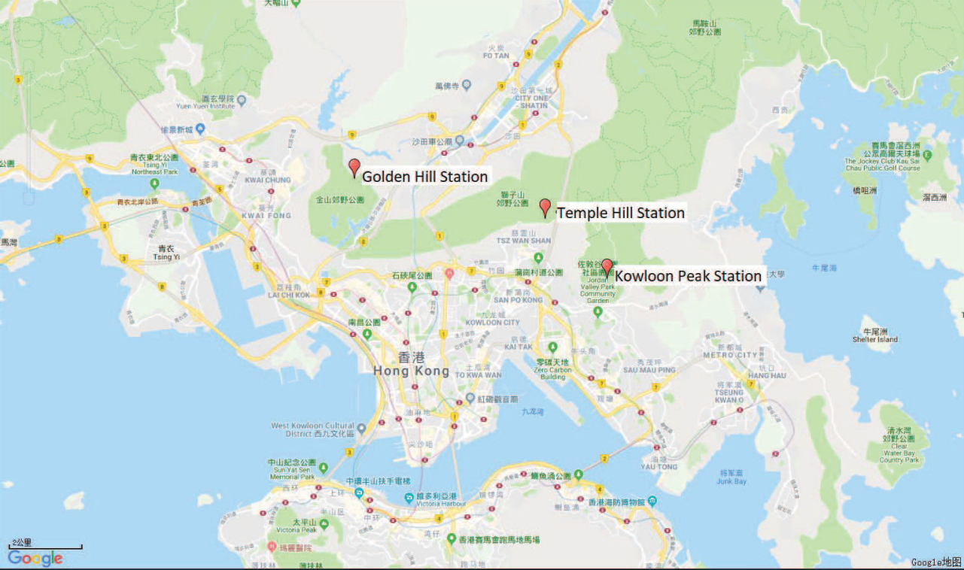
Figure P5-2
Test environment. (a) Equipment of three transmitting stations. (b) Survey car
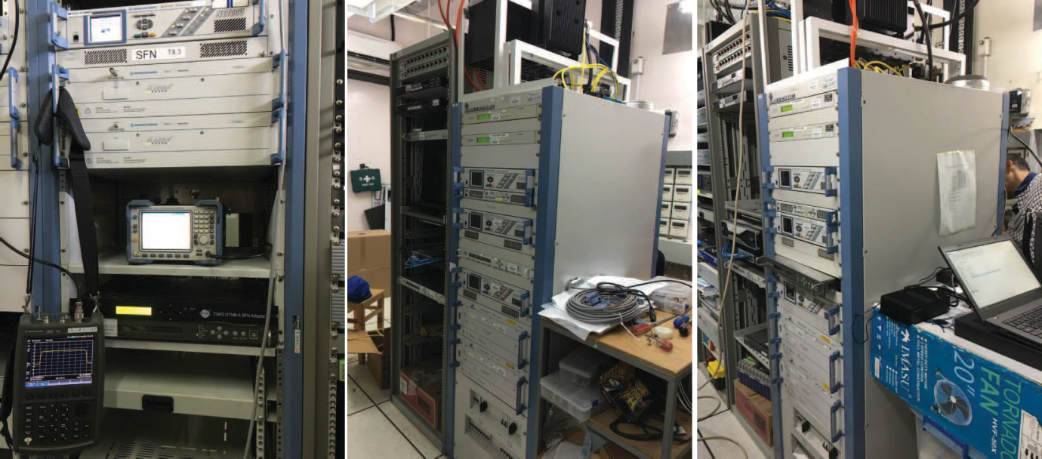
Temple Hill Station | Golden Hill Station | Kowloon Peak Station
(a)
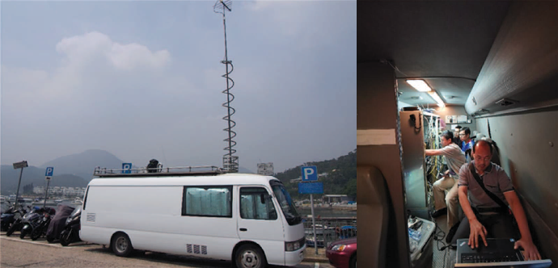
(b)
(b)

1.3 Field trial result
After completing the construction of the DTMB-A SFN, the full performance measurements are carried out at typical test points. Two main working modes are chosen for fixed and mobile receptions, respectively. The parameters of these two working modes are shown in Table P5-1.
For fixed reception mode, 4K UHDTV programme using H.265 video compression coding with the data rate of 25 Mbit/s is transmitted. While 2K HDTV programme of 6 Mbit/s with H.265 coding is selected for the mobile reception mode.
TABLE P5-1
Working modes for SFN field trial
 | Parameter | Payload Data Rate
Fixed  Reception | PNMC 1024, FFT 32768,  256APSK, LDPC 61440 2/3 | 37.89 Mbit/s
Mobile  Reception | PNMC 1024, FFT 4096,  64APSK, LDPC 61440 1/2 | 15.10 Mbit/s

After setting up the SFN, the initial testing was performed to verify the synchronization of the network at the location where the receiver can receive all the signals from three transmitters at the same time. The characteristics of the received DTMB-A signal under SFN is shown in Fig. P5-3 which is obtained from the receiver in real time. The left half of Fig. P5-3 indicates the constellation symbols after channel equalization, in which the 256APSK constellation can be seen obviously. The upper right of Fig. P5-3 illustrates the channel impulse response estimated by the receiver. It shows that there are three transmission paths corresponding to three transmitters respectively. Moreover, the corresponding channel frequency response is shown in the lower right part. The typical spectrum of the received signal is shown in Fig. P5-4.
Figure P5-3
DTMB-A signal characteristics under SFN scenario
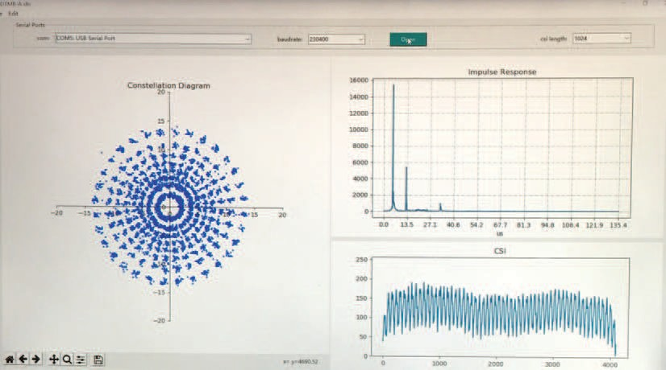
Figure P5-4
Typical spectrum of the received signal
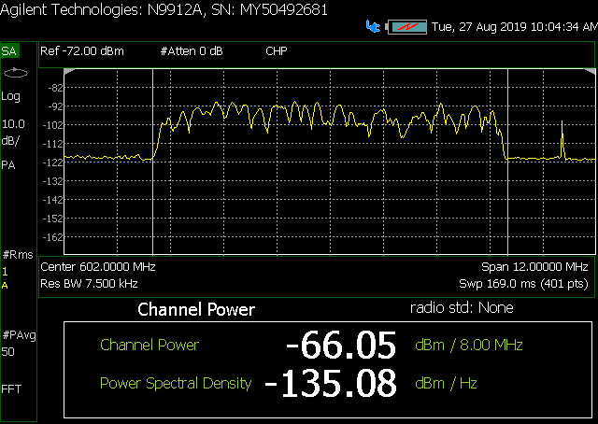
All the typical test items are performed during the field trials, including LOS and building shadow for fixed reception, mobile reception as well as tidal fading. The measurement results indicate that the DTMB-A system can support reliable coverage even under complicated reception conditions in Hong Kong. The specific test results are detailed as follows.
A Fixed reception
Fixed reception is of great importance to the coverage of DTTB signal in Hong Kong. Therefore, a large number of typical fixed reception test points were selected to assess the actual receiving quality of the DTMB-A system. The carrier- to-noise ratio (C/N) and the sensitivity (minimum receiving signal input level) are mainly focused for both LOS and building shadow conditions.
The measurement results at different test points are listed in Table P5-2, where the C/N and sensitivity are given for both LOS and building shadow. From Table P5-2, it can be seen that DTMB-A system can support very reliable signal reception, and can effectively provide 4K UHDTV video transmission in 8 MHz bandwidth, no matter in LOS or in building shadow environments.
TABLE P5-2
Measured result of fixed reception
 | Test Point | C/N  (dB) | Sensitivity  (dBm)
LOS | Shaw Movie city | 18.0 | −80.6
LOS | Sha Tin Penfold Park | 18.1 | −80.5
LOS | Kai Tak Cruise Terminal | 19.4 | −78.7
LOS | Lam Tin Station | 18.3 | −79.8
LOS | Hebe Haven Public Pier | 17.6 | −80.4
LOS | Tai Mong Tsai Road | 17.1 | −80.5
LOS | Fung Mat Road Tram Depot | 18.1 | −79.7
TABLE P5-2 (end)
 | Test Point | C/N  (dB) | Sensitivity  (dBm)
Building Shadow | Shaw Movie city | 19.1 | −79.1
Building Shadow | Cha Kwo Ling | 23.4 | −73.7
Building Shadow | Tui Min Hoi | 20.7 | −79.0
Building Shadow | Lung Mei Tsuen Road | 18.9 | −80.1
Building Shadow | Tin Sam Village | 21.2 | −76.7
Building Shadow | Mong Kok Tak Cheong Street | 22.7 | −75.6
Building Shadow | Hoi Fai Road Promenade | 23.1 | −74.9
Building Shadow | Stonecutters Island | 21.1 | −77.1

B Mobile reception
The mobile reception is also of great significance to the mobile terminals such as car or bus TV and smart phones. Therefore, the performance of mobile receptions was tested sufficiently by selecting several typical routes such as the highway in Hong Kong Island, Kowloon Island loop line and Nathan Road. The DTMB-A receiver can give a block error (BLE) signal from the LDPC decoder, and then a dedicated mobile test recorder will save all the related information to the computer in real time, including the GPS coordinates, received signal strength and BLE signal of continuous test points at one second interval. After that, offline analysis can be performed based on the recorded results.
Figures P5-5 and P5-6 show the mobile reception results of the Kowloon Island loop line and Nathan Road. Figure P5-5(a) gives the received signal strength recorded at one second interval with the range from −55 dBm to −90 dBm. Red colour represents the weakest signal strength and blue means the strongest. Figure P5-5(b) illustrates the BLE results corresponding to each signal strength point, where green is error-free and red means decoding error appears. It is clear from Fig. P5-5 that the DTMB-A receiver can recover the video programme without any bit error at most of the route, besides the location where the received signal power is around −90 dBm. The test results of other routes are also similar to that of Kowloon Island loop line. Figure P5-6(a) shows the received signal strength from −60 dBm to −78 dBm on Nathan Road. From Fig. P5-6(b), it is clear that DTMB-A can provide very reliable mobile reception on Nathan Road with good signal strength.
Figure P5-5
Mobile reception results of Kowloon Island loop line
(a) Receiving signal strength (−55 ~ −90 dBm). (b) BLE signal
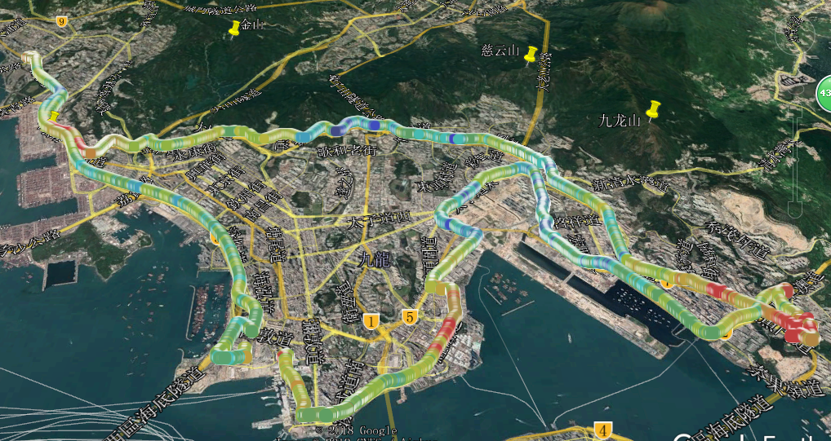
(a)
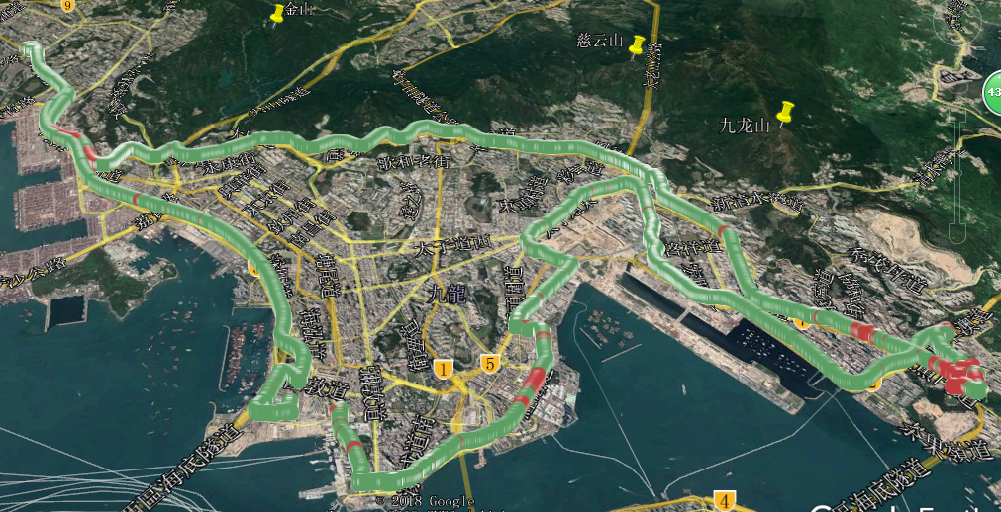
(b)
Figure P5-6
Mobile reception results of Nathan Road
(a) Receiving signal strength (−60 ~ −78 dBm). (b) BLE signal
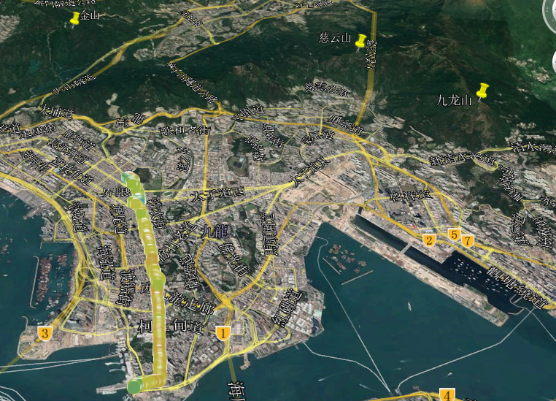
(a)
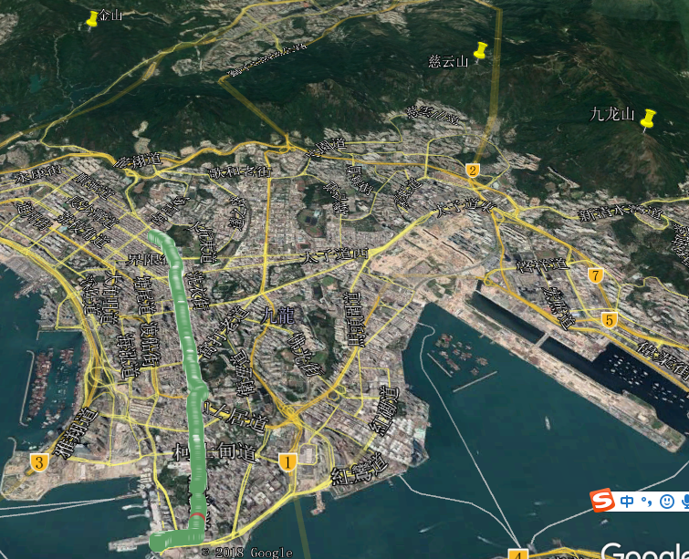
(b)

1.4 Conclusions
As the next generation of DTTB standard, DTMB-A system can provide higher spectrum efficiency, stronger reception robustness and anti-multipath capability compared with DTMB system. Therefore, DTMB-A supports a wider range of applications and can provide higher quality of services. This contribution presents the field trial results of DTMB-A system in the construction of SFN in Hong Kong. It validates that DTMB-A system can support reliable coverage for both fixed and mobile receptions under complicated conditions in Hong Kong. The SFN works very well and 4K UHDTV programmes can be transmitted reliably through DTMB-A network.

References
[1] Recommendation ITU-R BT.1306 – Error correction, data framing, modulation and emission methods for digital terrestrial television broadcasting
[2] Technical Standard for Digital Terrestrial Television Broadcasting, Statement of the Telecommunications Authority, 4 June 2007 (http://tel_archives.ofca.gov.hk/en/tas/others/ta20070604.pdf)
[3] Technical Specification for Digital Terrestrial Television Baseline Receiver Requirements, OFTA (http://tel_archives.ofca.gov.hk/en/standards/hktaspec/hkta1108.pdf)
[4] Location of the Digital Terrestrial Television (DTT) Stations and the Estimated Coverage (January 2011), OFTA http://www.digitaltv.gov.hk/general/pdf/coverage.pdf

The minimum required distance between different allotments using the same frequency is called “frequency re-use distance”.
Network gain is not restricted to SFN. Proper MFN planning should reflect the fact of multiple coverage of a location as well, although in a slightly different way.
A ‘test area’ is not ‘too large’ and not ‘too small’. Typically, it has the size of 100 m × 100 m.
In particular, the value is not generally 4.8 dB for three equal contributors.
The elementary period T is specified for each bandwidth in Table 65 of ETSI EN 302 755 v1.3.1.
For smaller guard intervals (e.g. Δ=T_{u}/8, ..., T_{u}/32), it can be assumed that the interpolator filter bandwidth remains the same as for T_{u}/4.
CTA-CEB32.2-A, “Recommended Practice for ATSC 3.0 Television Sets, Physical Layer,” March 2022.
In the ATSC Physical Layer standard A/322, the TxID injection level has a positive value by definition.
“Refarming the 700 MHz band” means the clearance of the frequency band above 694 MHz from DTT which is re-planned into 470-694 MHz band through a new national plan called PNAF (Piano Nazionale di Attribuzione Frequenze).
DFREE is an Italian national commercial broadcaster.
In a MFN network GI 1/32 is possible, therefore the “penalty” for the useful bit-rate is the difference between 1/4-1/32 of the total capacity.
A minimum step of 0.1 µs is foreseen by the DVB-T SFN specification and implemented by all transmitter manufactures. This limit value derives from the 10 MHz frequency reference. For tuning purposes, a step of 1 µs is usually adopted.
7 dB of power reduction with respect to the former analogue peak sync value is the “famous” Chester rule (Chester 1997 – CEPT Multilateral Coordination Agreement relating to Technical Criteria, Coordination Principles and Procedures for the introduction of Digital Terrestrial Television).
Minimum median field-strength = 58 dBµV/m, C/I = 27 dB, interference % time 1%.
Brugger, R., Schertz, A., “TV Distribution via Cellular Networks I: Spectrum Consumption”, EBU Tech Rev Q2/2014, Geneva, 2014.
IRT is the Research and Development Institute of ARD, ZDF, DRadio, ORF and SRG/SSR.
This mode is also used in the present network.
For illustrative purposes hypothetical regions were used with dimensions well matched to the chosen guard interval.
The study was undertaken over a limited area that did not include some well-known hotspot areas where frequency planning is particularly difficult. In these regions in particular the results from this study may need some adaption.
For the definition of nation see Annex A4.
It should be noted that in this study a different definition of spectral efficiency is used from the one applied in § 5.
Arqiva, “CH21 to CH60. Creation of Layers 7 and 8 in Released Spectrum”, Study by Arqiva, prepared for Ofcom, 2009. http://stakeholders.ofcom.org.uk/binaries/spectrum/spectrum-policy-area/projects/ddr/ch21.pdf Arqiva, “Creation of Broadcast Layers 7, 8 and 9 in 600 MHz Released Spectrum”, Study by Arqiva, prepared for Ofcom, 2011. http://stakeholders.ofcom.org.uk/binaries/spectrum/spectrum-awards/600mhz/600MHz-Band-Study.pdf – 7 March 2011.
It should be noted that the coverage calculations incorporated coordination agreements that, under different conditions might be relaxed, leading to improved coverage. More detail can be found in the reports.
For DVB-T2, 900 μs represent a guard interval of just over ¼ symbol period; it is not considered worthwhile to explore the effect of using guard intervals which are longer than this.
If the initial Guard interval is a fraction (1/Xold) and the new guard interval is a fraction (1/Xnew) then it is assumed:
The United Kingdom public sector broadcast (PSB) television network consist of 1 154 stations, 80 primary sites that serve about 95% of the population and a further 1074 relays that bring the coverage up to 98.5%.
United Kingdom coverage is based on methodology developed by the Joint Planning Project (JPP). Coverage is for 70% locations with a time availability of 99%.
The T2-MI packets are themselves carried in TS for compatibility with existing distribution networks.
Simultaneous reception of one data plus one common PLP is mandated by the T2 specification.
Mode 4 is an extension of the original ETSI standard specification to improve multipath performance of L-Band SFN in urban areas, hence the table does not follow a natural sequence.

