|  |
| --- |
| **Report ITU-R BT.2385-0**  **(07/2015)** |
| **Reducing the environmental impact of terrestrial broadcasting systems** |
| **BT Series**  **Broadcasting service**  **(television)** |

Foreword

The role of the Radiocommunication Sector is to ensure the rational, equitable, efficient and economical use of the radio-frequency spectrum by all radiocommunication services, including satellite services, and carry out studies without limit of frequency range on the basis of which Recommendations are adopted.

The regulatory and policy functions of the Radiocommunication Sector are performed by World and Regional Radiocommunication Conferences and Radiocommunication Assemblies supported by Study Groups.

# Policy on Intellectual Property Right (IPR)

ITU-R policy on IPR is described in the Common Patent Policy for ITU-T/ITU-R/ISO/IEC referenced in Annex 1 of Resolution ITU-R 1. Forms to be used for the submission of patent statements and licensing declarations by patent holders are available from <http://www.itu.int/ITU-R/go/patents/en> where the Guidelines for Implementation of the Common Patent Policy for ITU‑T/ITU‑R/ISO/IEC and the ITU-R patent information database can also be found.

|  |  |
| --- | --- |
| Series of ITU-R Reports  (Also available online at <http://www.itu.int/publ/R-REP/en>) | |
| **Series** | Title |
| **BO** | Satellite delivery |
| **BR** | Recording for production, archival and play-out; film for television |
| **BS** | Broadcasting service (sound) |
| **BT** | Broadcasting service (television) |
| **F** | Fixed service |
| **M** | Mobile, radiodetermination, amateur and related satellite services |
| **P** | Radiowave propagation |
| **RA** | Radio astronomy |
| **RS** | Remote sensing systems |
| **S** | Fixed-satellite service |
| **SA** | Space applications and meteorology |
| **SF** | Frequency sharing and coordination between fixed-satellite and fixed service systems |
| **SM** | Spectrum management |

|  |
| --- |
|  |

|  |
| --- |
| ***Note****: This ITU-R Report was approved in English by the Study Group under the procedure detailed in Resolution ITU-R 1.* |

*Electronic Publication*

Geneva, 2015

© ITU 2015

All rights reserved. No part of this publication may be reproduced, by any means whatsoever, without written permission of ITU.

REPORT ITU-R BT.2385-0

Reducing the environmental impact of terrestrial broadcasting systems

(2015)

TABLE OF CONTENTS

Page

Introduction 3

Annex 1 - Mega solar plans at high power radio transmitting station in Japan 3

1 Introduction 3

2 The list of radio transmitting stations with solar power generating facilities 4

3 Example of mega solar system at a radio transmitting station 4

3.1 Overview of the Shobu-Kuki radio transmitting station 4

3.2 Prior considerations 5

3.3 Arrangement of solar panels 8

3.4 Grounding 8

3.5 Electrical systems 10

3.6 Power generation and impact 12

4 Summary 14

Annex 2 - Evaluations of energy consumption associated with terrestrial television broadcasting 14

1 Introduction 14

2 Energy efficiency of terrestrial television broadcasting emissions 15

3 Energy required by television consumer receivers 16

4 Conclusions 17

Annex 3 - Power consumption of DVB-T broadcast networks in Germany 17

1 Introduction 17

2 Input power and radiant power of transmitters 18

3 Power consumption of an existing DVB-T network in Germany 18

4 Comparison with overall power consumption 18

Annex 4 - Wind power generation in the South Atlantic 19

1 Introduction 19

2 BBC power station 20

2.1 Overview 20

2.2 Renewable energy options 20

2.3 Wind power feasibility study 21

2.4 Wind farm implementation 25

Annex 5 - Solar powered FM broadcasting 27

1 Introduction 27

2 System design 27

3 Modelling a PV system 28

4 Routine maintenance and replacements 28

5 BBC World Service systems 28

6 Conclusions 30

# Keywords

Environmental impact, energy efficiency, terrestrial broadcasting, environment

# Introduction

The environment and climate change are global issues. ITU Plenipotentiary Resolution 182 (“The role of telecommunications/information and communication technologies in regard to climate change and the protection of the environment”), approved in Guadalajara in 2010 and revised in Busan in 2014, notes that “the development and deployment of telecommunications/ICTs has resulted in innovative outcomes, including, but not limited to, better energy management, recognition of the contribution of the entire lifecycle of telecommunications/ICTs on climate change, and the benefits that accrue from the comprehensive deployment of telecommunications/ICTs”. *Resolves* 2, 3 of Resolution 182 encourage energy efficiency and *resolves* 7 of Resolution 182, the adoption of green energy sources. The Secretary-General, in collaboration with the Directors of the three Bureaux, is also instructed to “encourage the use of renewable energy technologies and systems, and to study and disseminate best practices in the field of renewable energy”.

Resolution ITU-R 60 (Reduction of energy consumption for environmental protection and mitigating climate change by use of ICT/radiocommunication technologies and systems) resolves “that ITU R Study Groups should develop Recommendations, Reports or Handbooks on best practices in place to reduce energy consumption within ICT systems, equipment or applications operating in a radiocommunication service” and “possible development and use of radio systems or applications which can support reduction of energy consumption in non-radiocommunication sectors” (*resolves*1*)* and that “that ITU R Study Groups, when developing new ITU R Recommendations, Handbooks, or Reports or reviewing existing Recommendations or Reports, take into account, as appropriate, energy consumption as well as best practices to conserve energy” (*resolves* 2). Resolution ITU-R 60 highlights the importance of close cooperation and regular liaison between the Sectors (*resolves* 3) in order to avoid duplication, but also considers that “that the ITU T work programme developed on the basis of WTSA Resolution 73, does not contain specific studies focusing on energy consumption related to radio transmission technology or planning characteristics of radio networks” (*further considering b).*

Like all industries, the broadcasting sector has a responsibility to improve its environmental performance. The main environmental impacts of the broadcasting industry are greenhouse gas (GHG) emissions, energy use, raw material consumption and electronic waste. Studies suggest that 2% of global GHG emissions result from Information and Communication Technology (ICT)   
(~800 Mt CO2e). Television sets and related peripherals are responsible for ~1.8% of global emissions (~700 Mt CO2e)[1].

Annex 1  
  
Mega solar plans at high power radio transmitting station in Japan

# 1 Introduction

In Japan, there has been considerable interest in harnessing sustainable sources of energy since the Great East Japan Earthquake in 11 March 2011. Natural sources of energy and the environment are major issues of public concern. The broadcasters in Japan try to provide their service which is environment-friendly by suppressing an increase in energy consumption by the development and installation of broadcasting facilities with energy saving. In the case of using natural sources of energy, solar power generating facilities are installed into not only broadcasting halls, but high-power radio transmitting stations. This facility is playing its part in helping protect the environment by reducing carbon-dioxide emissions. The power purchase has been reduced by installing a solar power generating facilities.

# 2 The list of radio transmitting stations with solar power generating facilities

The solar power generating facilities were installed into the radio transmitting stations of public and private broadcasters. The list of radio transmitting stations with solar power generating facilities in Japan is shown in Table A1-1.

TABLE A1-1

Radio transmitting stations with solar power generating facilities

|  |  |  |  |  |  |
| --- | --- | --- | --- | --- | --- |
| Broadcaster | Radio transmitting station | Start date | Output power  (kW) | Annual output power (MWh) | Number of panels |
| NHK (Japan Broadcasting Corp.) | Shobu-Kuki | August 2012 | 2,000 | 2,800 | 8,124 |
| Kyushu Asahi Broadcasting Co., Ltd. | Kitakyusyu | February 2013 | 730 | 730 | 2,548 |
| Broadcasting System of San-in Inc. | Yonago | April 2013 | 1,750 | 1,840 | 700 |
| RKB Mainichi Broadcasting Corp. | Kitakyusyu | August 2013 | 900 | 890 | 3,100 |
| Yukuhasi | August 2013 | 280 | 290 | 1,180 |
| CBC Radio Co., Ltd. | Nagashima | August 2013 | 1,645 | １,684 | 6,800 |
| Yamanashi Broadcasting System Inc. | Futaba | August 2013 | 1,150 | 1,000 | 4,700 |
| Asahi Broadcasting Corp. | Takaishi | September 2013 | 1,990 | 2,800 | 10,000 |
| Mainichi Broadcasting System, Inc. | Takaishi | October 2013 | 600 | 700 | 2,884 |
| Nippon Broadcasting System, Inc. | Kisarazu | October 2013 | 1,908 | 2,102 | 7,634 |
| “RKK” Kumamoto Broadcasting Co., Ltd. | Arao | October 2013 | 890 | 950 | 3,626 |
| Yamagata Broadcasting Co., Ltd. | Numagi | October 2013 | 725 | 741 | 3,024 |

# 3 Example of mega solar system at a radio transmitting station

The following provides overall details about installation of the 2MW solar power generating facilities into the Shobu-Kuki Radio Transmitting Station, which is one of the largest radio transmitting stations in Japan. The technical problems that had been overcome for the installation of the facility and the amount of power it has produced are described in the following sections.

## 3.1 Overview of the Shobu-Kuki radio transmitting station

The Shobu-Kuki radio transmitting station broadcasts NHK’s Radio 1 service (594 kHz) at 300 kW and NHK’s Radio 2 service (693 kHz) at 500 kW. These services can reach approximately 20 million households (or some 40 percent of the total households in Japan). A height of 245 m antenna is used for NHK Radio 1, while a 215 m antenna is used for NHK Radio 2. These transmitters are solid-state digital. The facility as a whole normally consumes 1,100 kW of power. The 30 hectare site has copper wires for grounding running underneath it in radial patterns from the antenna. The grounding radials ensure the efficient radiation of the radio wave. The solar panels were established on the southern side of the site so that they would not come under the shadow of the antennas. Enough panels were installed to supply all of the facility’s power needs when the panels are operating at full capacity. There are a total of 8,120 panels, each capable of generating up to 247 W, or a total of 2 MW. They are arranged in 145 blocks or series, consisting of 14 × 4 panels, which occupy about 3 hectare of site. They generate an estimated 2,000 MWh of power per annum, achieving a 1,000 tons of reduction in carbon-dioxide emissions. The solar power generating facility was first considered in its construction in 2009, and was completed in 2012. Installation of the solar power generating facility into the Shobu-Kuki Radio Transmitting Station is summarised in the following sections.

## 3.2 Prior considerations

Solar power is looked upon a source of energy for the future. It is clean, sustainable, and does not rely on fossil fuels, but it does require space for the installation of solar panels. As the solar power generating facility was to be established at a radio transmitting station, there had to be prior consideration of the possible impact the radio wave might have on the extensive solar panels, and vice versa. Particular consideration was given to the possible effect on the grounding radials, given that the panels would have to be installed above the undergrounding radiating copper wires. Another important issue was safeguarding the transmitters from any negative impact by connecting the solar power generation facility to the existing power facilities.

### 3.2.1 Examinations with actual equipment

A system of actual, minimum-scale equipment was created to consider the possible effects that the strong field strength might have on the different components of the solar power generating facility. It consisted of a 10 kW power-conditioning subsystem (the smallest industrial version available) and a module of 9 × 200 W solar panels. The solar panels were moved within the site of the Shobu‑Kuki Radio Transmitting Station to examine the impact of the strong field strength (see Fig. A1-1). Main considerations were as follows:

− Impact on the solar panels.

− Unwanted signals in the cabling for the solar panels.

− Unwanted signals in the cabling between the solar panels and the power-conditioning subsystem (CPS).

Figure A1-1

Examinations with actual equipment

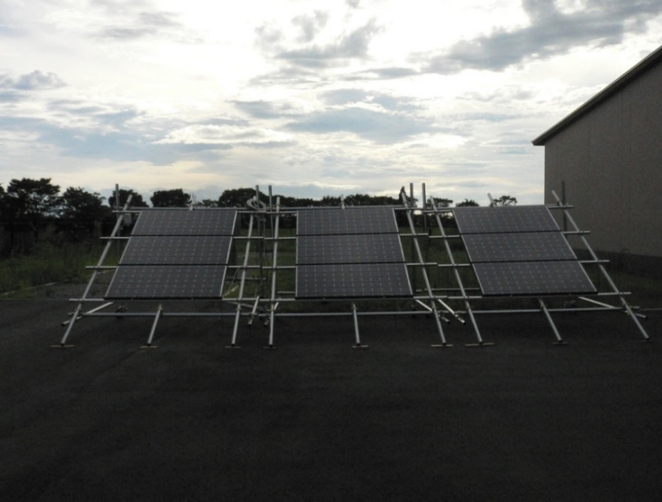

A series of tests were conducted by progressively shifting the panels into stronger field strength.   
No trouble was found to generate power even when they were positioned in strong field strength right near the antenna, and when the cables extended for a length of 200 m, the distance expected for the solar power generation system.

### 3.2.2 Electromagnetic simulations

Electromagnetic simulations were carried out with a model of the solar panels for the proposed the solar power generation system. The considerations were as follows:

• Impact on radio waves.

• Impact on the transmitters.

• Impact of unwanted signals in the solar panels.

The solar power generation system would have to be placed at the maximum possible distance from the antenna, given concerns about the possible effect the panels might have on the medium-wave signals. The amount of unwanted signals in the solar panels was smaller than that in the minimum‑scale system. Moreover, there was no effect on the directivity of the antenna and impedance. The results of the simulations are shown in Fig. A1-2.

Figure A1-2

Simulation result of electric field

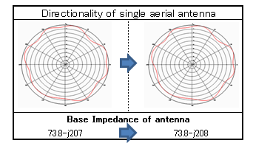

### 3.2.3 Extended test

An extended operational test in strong field strength was carried out with a 12 kW solar power generating facility, which was built by adding more solar panels to the PCS (Power Conditioning Subsystem) in the minimum-scale system. The 12 kW facility consists of 63 × 200 W panels (see Fig. A1-3). It generated power without any troubles during its test.

Figure A1-3

12 kW solar power generating facility

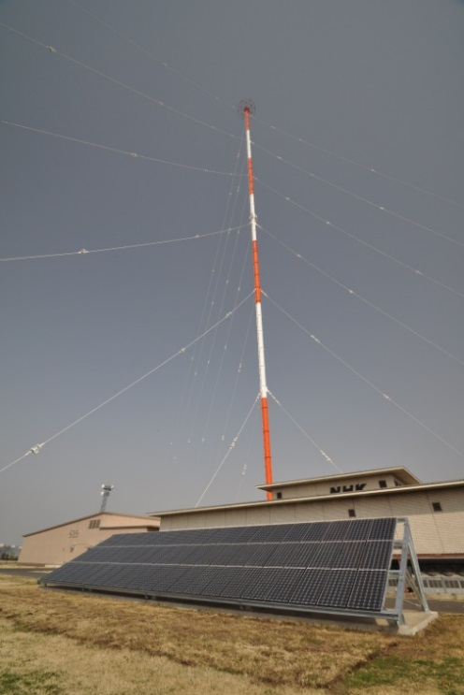

### 3.2.4 Construction test

A study of the subsurface of the proposed site of the solar power generating facility was carried out. There was also a test to consider the possible impact that the ensuing construction work might have on broadcasts. This was done by cutting a number of wires in the grounding radials. A maximum of up to 15 wires had been cut in the event the solar power generation facility had 4 power‑conditioning subsystems and extend over a quarter of the radials. A number of wires were cut during broadcast service suspension at night. The operating data from the transmitters and electromagnetic measurements revealed no impact, even when 15 wires had been cut (see Fig. A1-4 and Fig. A1-5).

Figure A1-4

Cutting points of grounding radial system

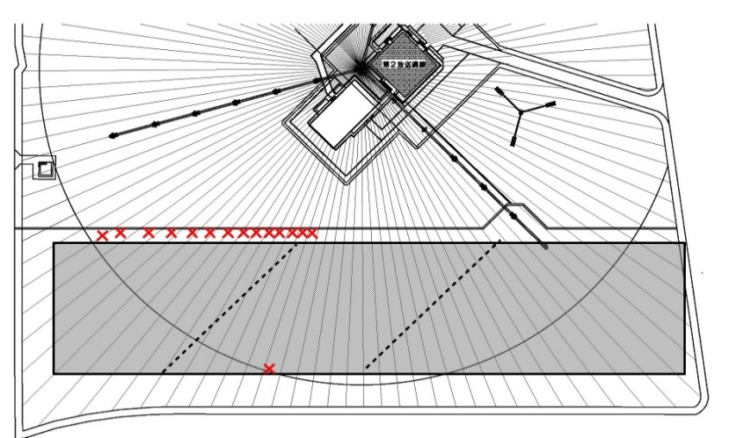

Cutting points of antenna grounding radial system

Figure A1-5

Cutting off grounding radials

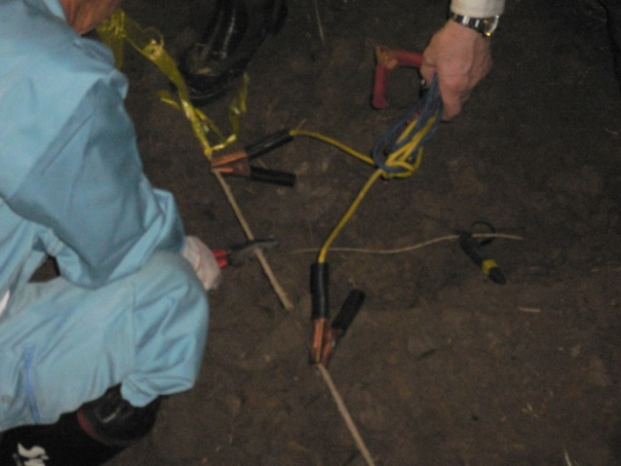

## 3.3 Arrangement of solar panels

The overall positioning of the solar panels focused on two issues: the shade coming from the tall trees abutting the southwest boundary of the site; and space required for new feeder cables. The angling and the spacing of the mounts for the solar panels are shown in Fig. A1-6.

Figure A1-6

Positioning of solar panels

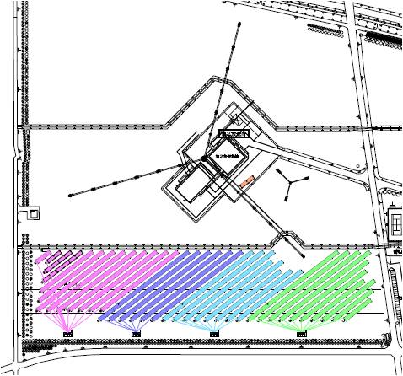

PCS-1

PCS-2

PCS-3

PCS-4

12kW

## 3.4 Grounding

### 3.4.1 Grounding radials

The wires that extend from the antennas to provide the grounding radials are situated about 40 cm below the surface. The piling and other interfering components were therefore installed beforehand to avoid them. Grounding wires in the form of twisted copper wires were laid around each mount for the solar panels, and connected to the existing grounding radials (see Fig. A1-7 and Fig. A1-8).

Figure A1-7

Grounding radials

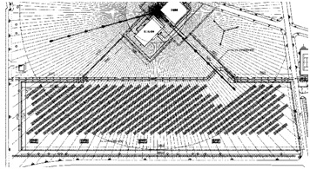

Figure A1-8

Connection to the existing grounding radials

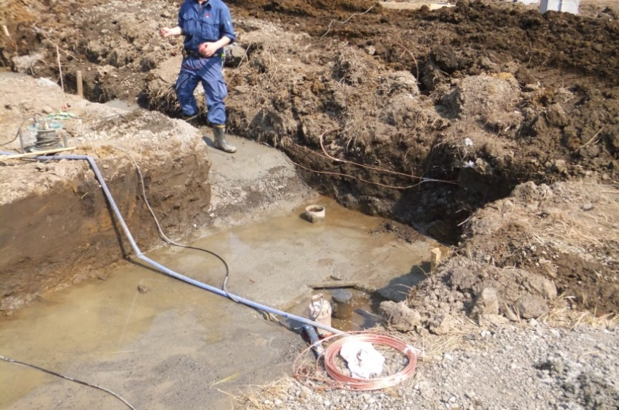

### 3.4.2 Grounding for the solar panels

Protection equipments were connected to the mounts to protect the solar panels against lightning strikes. They run from above the panels to the foundations and to the grounding wires   
(see Fig. A1-9).

Figure A1-9

Lightning protection equipment

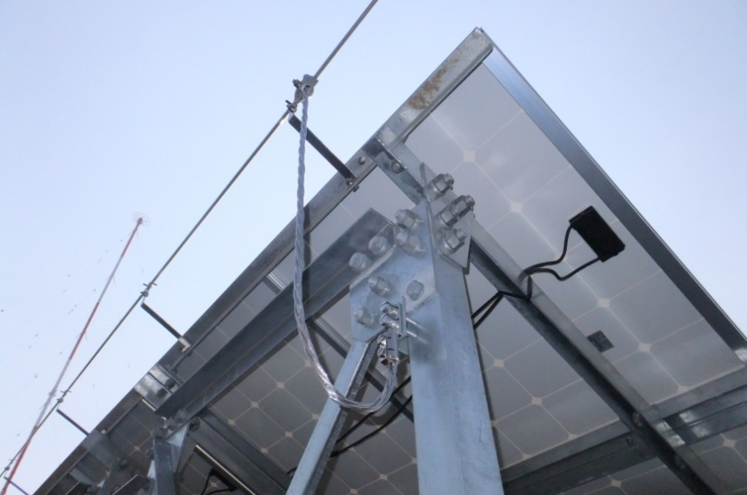

## 3.5 Electrical systems

### 3.5.1 Solar facilities

Figure A1-10 shows the electrical network for the solar power generation facility.

Figure A1-10

Connecting to the grid

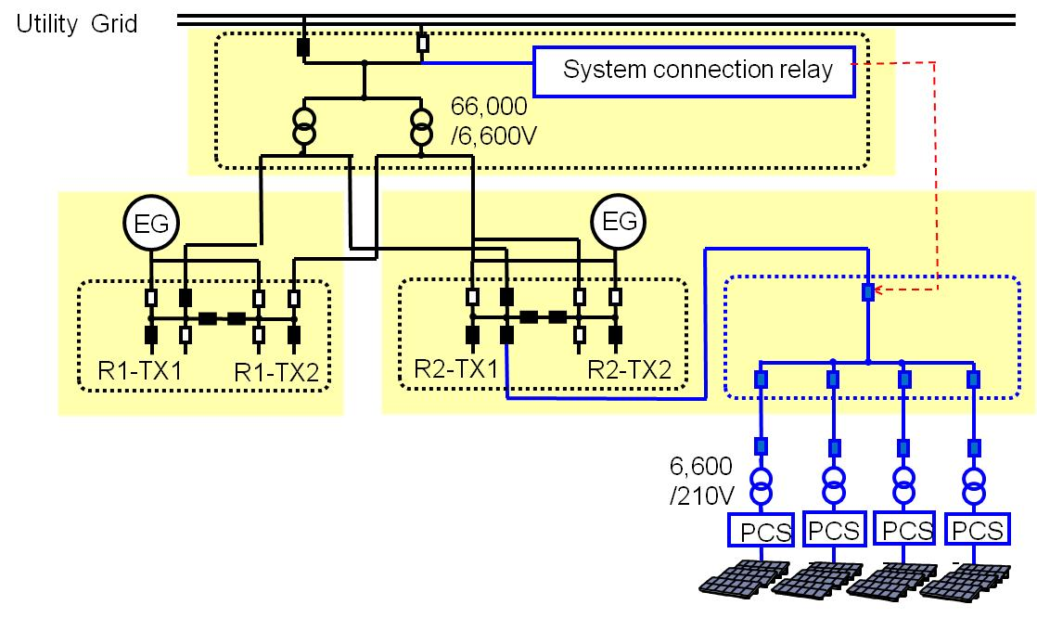

The panels near the radio transmitting station for NHK Radio 2 generate approximately DC 430 V, which is converted outside to AC 6,600 V. The current passes through the solar power sub-station inside the building for the NHK Radio 2 transmitter to an auxiliary circuit breaker, and thence to the high-voltage substation where it is connected to the mains grid. The solar panels generate enough power for the transmitters and other facilities at the Shobu-Kuki Radio Transmitting Station.   
The system is designed to backfeed any surplus to the electric power company. Shortfalls at night-time and other occasions are accommodated by purchasing power from the power company.

### 3.5.2 Solar panels

The solar panels are arranged in series of 14 panels to ensure that the 41.12 V upper limit of the open-circuit voltage comes within the 600 V input-voltage ranges of the power-converting subsystems (CPS).

PCS-1, PCS-2, and PCS-4 have 144 parallel circuits, while PCS-3 has 148.

### 3.5.3 Electrical network for the solar farm

The direct current generated by the solar panels is converted into an alternating current at the power-converting subsystems (CPS). Four CPS have been established; each can handle up to 500 kW. The voltage is raised outside to 6,600 V to accommodate loss and suchlike from the cables that extend a distance of more than 200 m to the radio transmitting station for NHK Radio 2. A circuit breaker was established at the high-voltage substation so that the solar power generating facility can be disconnected from the mains grid in the event of parallel operation. It runs to the auxiliary breaker at the radio transmitting station for NHK Radio 2. Figure A1-11 shows an outside power distributor. Table A1-2 shows the specification of each PCS:

TABLE A1-2

Specification of PCS

|  |  |
| --- | --- |
| Capacity | 500 kW |
| Rated input voltage | DC 350 V |
| Input voltage range | DC 310 – 600 V |
| Maximum power point tracking range | DC 320 – 550 V |
| Output voltage | AC 210 V |
| Conversion efficiency | 97.1%[2] |

Figure A1-11

External power panels

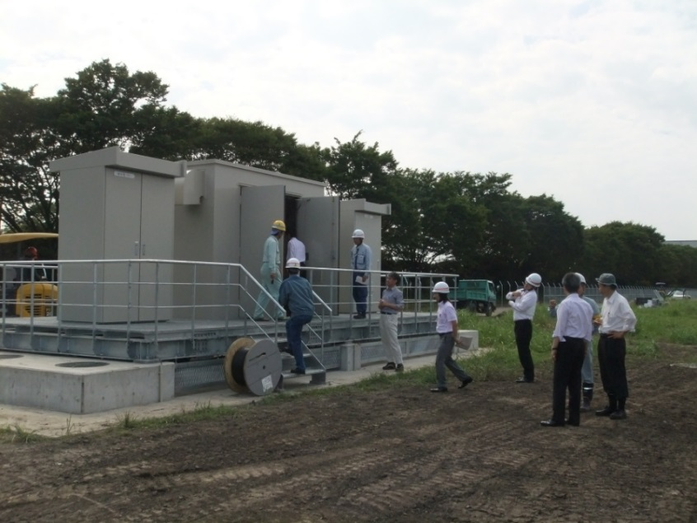

Transformer

PCS

### 3.5.4 Grid connection

In order to avoid back feeding to the commercial power grid, the solar power generating facility must be disconnected without delay if there is any earthing at the utility side. A relay for the mains grid was established in the upper part of the extra-high voltage transformer. As the transformer relies on dry compressed air for insulation, the modifications, including the airtight tests and compression, took four days. The placement of the relay is shown in Fig. A1-12.

Figure A1-12

Placement of grid connection

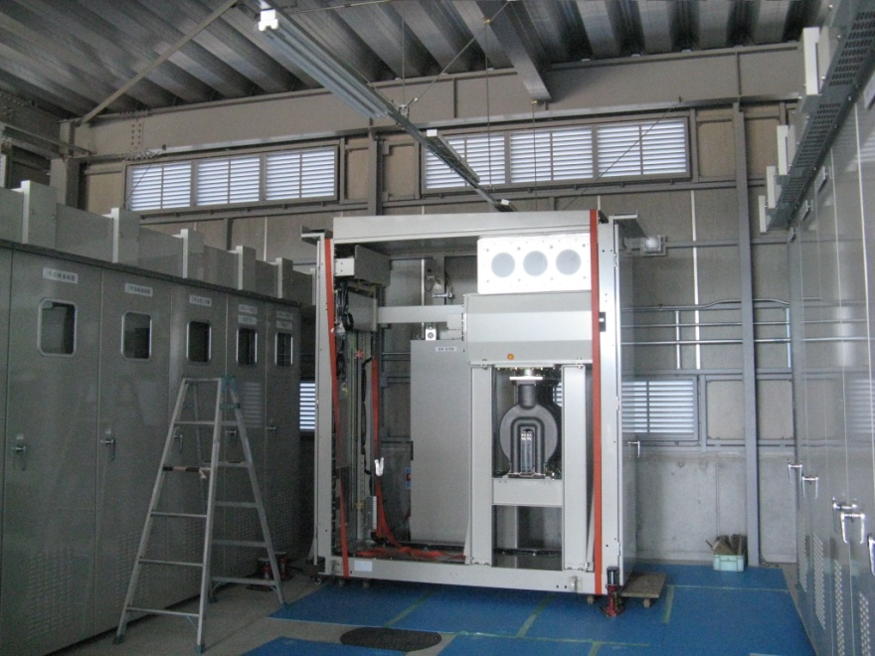

The relay was installed for backfeeds to the mains grid. It does not control the electrical networks for the transmitters and other facilities, only the breaker for the solar power generating facility.

## 3.6 Power generation and impact

One sunny day, the solar generates more power than that consumed by the Shobu-Kuki radio transmitting station; the surplus can be sold to the electric power company. The amount of power generated by the solar power generating facility is shown in Fig. A1-13 and Fig. A1-14. The broadcasts from the transmitter continue without interruption, as the electric power company can cover any momentary drop in power generation owing to cloudy skies or other factors. Sunny conditions saw the solar farm generate approximately 316,000 kWh in May 2013. Moreover, electromagnetic measurements have not revealed any major fluctuations in the directivities of the antennas, which had been major concerns (see Fig. A1-15). The facility has been generating power in a stable manner without any effect on the radio broadcasts.

Figure A1-13

Solar power generation

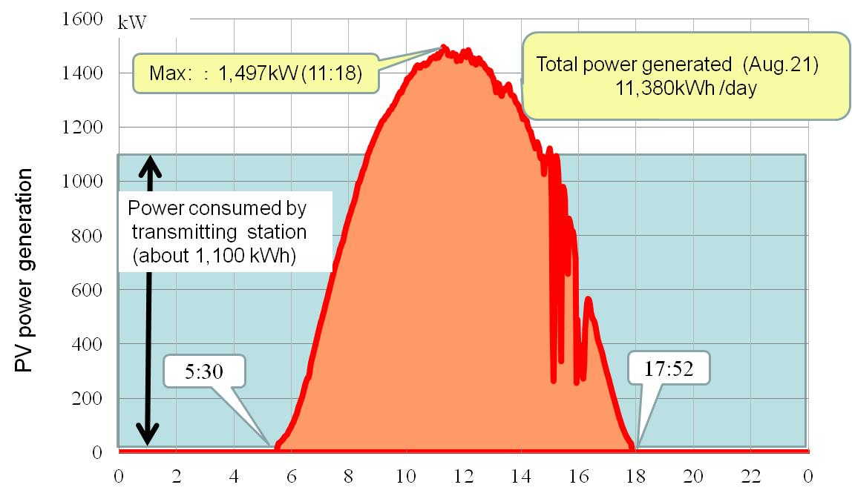

Figure A1-14

Monthly total generated powers (kWh)

(kWh)

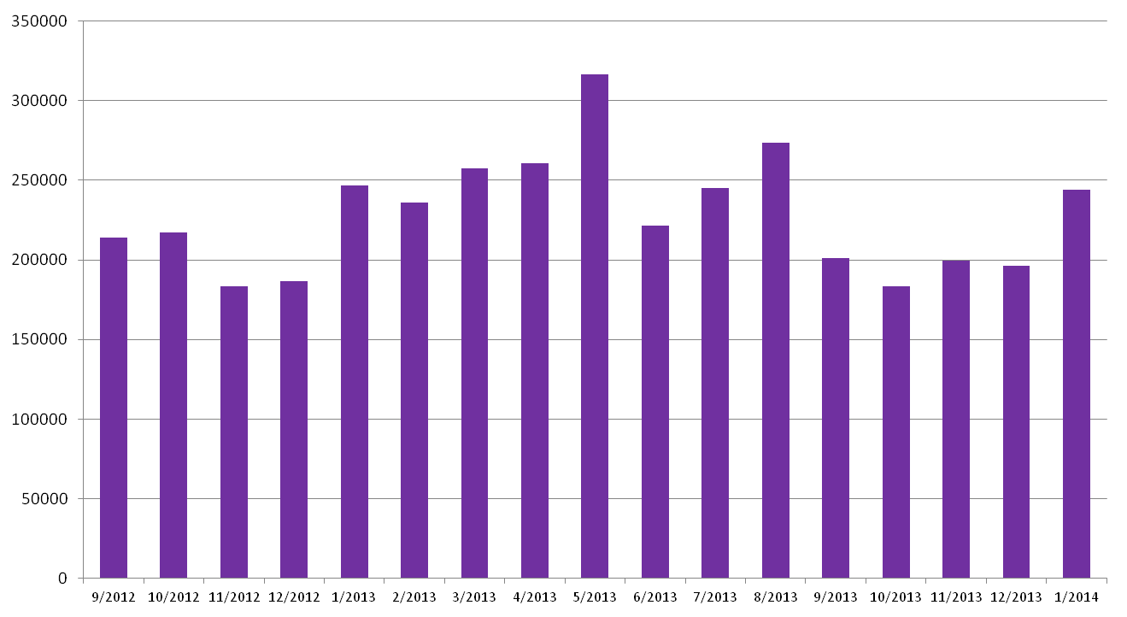

Figure A1-15

Fluctuation of field strength in measurement points

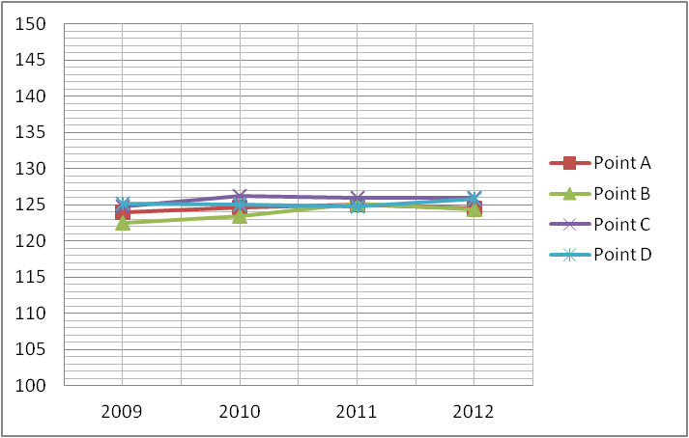

# 4 Summary

The solar power generating facilities were established at some of the radio transmitting stations in Japan. The objective was to reduce the demand for electricity during peak periods in the day and reduce carbon-dioxide emissions without any interruption of the broadcast services. This Report provides the list of radio transmitting stations with solar power generating facilities and the example of installation into the one of the largest radio transmitting stations. It also describes the simulations and examinations with actual equipment to study the possible impacts of solar system installation on radio wave and the possible impacts of broadcast signals on solar system. Based on the results of these prior considerations that showed that the mutual impacts were extremely small, the installation of the solar power generating facilities was conducted. This system has been generating environment-friendly power without any impact on the radio broadcasts.

Annex 2  
  
Evaluations of energy consumption associated with   
terrestrial television broadcasting

# 1 Introduction

Terrestrial television broadcasting is a radiocommunication service that provides information, entertainment, culture and instruction to virtually all the populations in the world, through a multiplicity of emission channels of diversified thematic vocations.

The ITU has stressed the need to establish best practices to reduce energy consumption within information and communication technology (ICT) systems, equipment or applications operating in radiocommunication services in order to reduce their impact on climate change. Mindful of this need, CBS and Rai Way, which both operate terrestrial television broadcasting services respectively in the USA and in Italy, have coordinated an inquiry to assess how efficiently they use electric energy to distribute television broadcasting programs to their audiences.

# 2 Energy efficiency of terrestrial television broadcasting emissions

The parameter chosen in this document to estimate the energy efficiency of terrestrial television broadcasting emissions is the daily energy used by a transmitter to deliver one digital television channel to each household in its service area (a channel carries a multiplex of one or more HDTV and/or SDTV program schedules).

The parameter value is computed on the following premises:

− the energy used by the broadcaster is the one required for the emission of one channel, irrespective of the number of television program schedules carried in the channel;

− the used energy, in Watt-hours is the one measured at the output of the transmitter, not the one radiated by the antenna;

− the channel is broadcast 24 hours a day: the used energy is the total daily energy;

− the potential audience is the total number of households directly served by the main transmitter;

− it is assumed that on average, each household is made up of three persons.

The approach taken in this annex correctly uses the " potential audience" as the audience parameter, rather than using a parameter derived from audience polls, since the values of audience polls depend upon the audience appreciation of the content of the programs, while the potential audience is defined as the size of the audience that a broadcast transmitter can serve, irrespective of the programme content. The parameter of potential audience is particularly appropriate for those countries in which public broadcasters are under a charter obligation to serve a given percentage of the population in a given territory, irrespective of the population density.

Tables A2-1 and A2-2 show the case studies relevant respectively to the CBS and the Rai Way operation. The rightmost column in the tables shows the electric energy, in Watt-hours, that their terrestrial television broadcast transmitters use each day to provide each household of their potential audience with the program schedules carried in one digital television emission channel.

TABLE A2-1

Case study for CBS (USA)

|  |  |  |  |  |  |
| --- | --- | --- | --- | --- | --- |
| Transmitting center | Frequency band | Type of service area | Power per channel | Potential audience | Daily energy per household |
| New York | UHF | A metropolis and a very wide area | 88 kW | 19400000 | 0.33 W-hours |
| Los Angeles | UHF | A metropolis and a very wide area | 100 kW | 17000000 | 0.42 W-hours |
| Chicago | VHF-Hi | A metropolis and a very wide area | 13 kW | 9200000 | 0.10 W-hours |
| Baltimore | VHF-Hi | Two large cities over a wide area | 27.5 kW | 2700000 | 0.73 W-hours |

TABLE A2-2

Case study for Rai Way (Italy)

|  |  |  |  |  |  |
| --- | --- | --- | --- | --- | --- |
| Transmitting center | Frequency band | Type of service area | Power per channel | Potential audience | Daily energy per household |
| Paganella (in the Alps) | VHF | A city and many villages | 0.25 kW | 175000 | 0.10 W-hours |
| Venda (the Po river valley) | VHF | Several cities and many towns | 2.5 kW | 4240000 | 0.04 W-hours |
| Eremo (the city of Turin) | UHF | A large city and its surroundings | 2.5 kW | 2075000 | 0.09 W-hours |

The Tables show that broadcasters typically use a small fraction of one (1) Watt-hour per day to deliver one terrestrial television channel to each household in their audience[3]. Furthermore, it can be expected that improvements in the energy efficiency of broadcast transmitters and in the ways broadcasting networks are managed will further reduce the energy currently used by digital terrestrial television broadcasters to deliver their program schedules to their audiences.

# 3 Energy required by television consumer receivers

The receiving devices for broadcasting are not directly under the control of the broadcast industry. The broadcasting industry will always encourage manufacturers of these devices to make them as energy efficient as possible. Reception of broadcasting is on a variety of devices ranging from laptops, tablets, portable receivers and static television receivers.

The following tables are provided for information purposes to give the necessary information on the domestic receiving end of the television broadcast service.

Table A2-3 below recalls the power consumption of typical television consumer receivers.

TABLE A2-3

Power consumption of typical television consumer receivers of various screen sizes

|  |  |  |  |  |  |  |  |
| --- | --- | --- | --- | --- | --- | --- | --- |
| Screen size of the television set | 52” | 46” | | 40” | | 32” | |
| Power used in the “bright” (“shop”) mode | 260 W | | 220 W | | 170 W | | 100 W |
| Power used in the “home” mode | 200 W | | 160 W | | 140 W | | 90 W |
| Power used in the “quick start” mode | 17 W | | | | | | |
| Power used in the “standby” mode | 0.2 W | | | | | | |

Table A2-4 gives the typical total daily energy consumption used by each household, on the assumption it watches television in the “home” mode for an average of 4 hours per day and that the television set is kept in the “quick start” mode in other hours, or in the “standby” mode, or it is switched off.

TABLE A2-4

Daily energy consumption of a typical television consumer receiver watched 4 hours per day

|  |  |  |  |  |
| --- | --- | --- | --- | --- |
| Screen size of the television set | 52” | 46” | 40” | 32” |
| Daily energy used if the TV set switches to the “quick start” mode when not in use | 1140 W-h | 980 W-h | 900 W-h | 700 W-h |
| Daily energy used if the TV set switches to the “standby” mode when not in use | 804 W-h | 644 W-h | 564 W-h | 364 W-h |
| Daily energy used if the TV set switches off when not in use | 800 W-h | 640 W-h | 560 W-h | 360 W-h |

# 4 Conclusions

The analysis shows that broadcasters typically use a small fraction of one (1) Watt-hour per day to deliver one terrestrial television channel to each household in their audience. The overall power consumption of the broadcasting chain is dominated by consumer receivers. Nevertheless, further improvements can be expected in order to further reduce the overall energy consumption.

Annex 3  
  
Power consumption of DVB-T broadcast networks in Germany

# 1 Introduction

ITU is studying how the information and communications technology (ICT) contributes to the effect of climate change and how ICT could be used to reduce this effect (ref. for example to Resolution ITU-R 60 “Reduction of energy consumption for environmental protection and mitigating climate change by use of ICT/radiocommunication technologies and systems”, which, in turn, makes reference to Resolution 182 of the ITU Plenipotentiary Conference (Guadalajara, 2010) entitled “The role of telecommunications/information and communication technologies in regard to climate change and the protection of the environment”.

The transition from analogue to digital television has led to a dramatic reduction in energy consumption needed for the terrestrial television service. On one hand, the number of transmit stations could be significantly reduced (from a few thousand to about 150 per national TV network) owing to the immunity of DVB-T and DVB-T2 to multipath propagation. Practically all fill-in stations could be shut down. On the other hand, the transmit power of a TV station could be reduced significantly due to the lower *C/(N+I*) requirements for digital modulation (from up to 500 kW ERP for one analogue TV programme to typically 34.5 kW ERP for a multiplex of four TV programmes).

The following analysis deduces the consumption of electrical energy for the total of the German DVB-T networks and puts it in relationship to the annual personal energy consumption of the DVB‑T users. The power consumption of broadcast networks is often overestimated. The conclusion, however, is that the percentage of electrical energy needed for DVB-T per user is negligible in practice.

# 2 Input power and radiant power of transmitters

The input power is used to produce a signal whose strength is called radiated power of the transmitter. The ratio between radiated power and input power is the efficiency. The radiated power can be increased by focusing the electrical energy on a certain spatial segment. The result is the effective radiated power (ERP) as product of the radiated power and the antenna gain.

Consequently, the following equation is valid:

ERP = (input power) × efficiency × (antenna gain)

Usually, only the ERP of a transmitter is made public and the input power has to be determined by backwards calculation.

# 3 Power consumption of an existing DVB-T network in Germany

As an example, an existing TV coverage in Germany is considered: four TV programmes (ZDF, 3sat, KiKa and ZDFneo) are transmitted together in a DVB-T multiplex. The network consists of 143 transmitters with an average ERP of 34.5 kW. The efficiency of today’s DVB-T transmitters is about 25%-30%. For new transmitters, it is around 30%. Prototypes of transmitters with an efficiency of 40% were already presented. The antenna gain is about 10 dB.

There is no relevant overhead to be taken into consideration to cope with potential failures of transmit equipment. Effectively, redundancy is provided by the fact that a power amplifier consists of several modules.

A failure of one of them causes only a weakening of the signal until the module is replaced. Of course, major transmission facilities include a replacement transmitter which, however, requires only a small fraction of normal input power in standby mode.

The average ERP of a transmitter of the DVB-T network mentioned above is 34.5 kW. From an antenna gain of 10 dB (including cable loss) it can be concluded that the output power of the power amplifier is one-tenth of that value (3.45 kW). For an efficiency of 30%, an electrical power of 11.5 kW is required to produce an amplifier output power of 3.45 kW. Consequently, the overall electrical power for 143 transmitters is thus 1.645 MW (= 143 × 11.5 kW). This corresponds to an annual consumption of electrical energy of the transmission network of 14.4 GWh.

# 4 Comparison with overall power consumption

There are usually six (6) DVB-T multiplexes in Germany, so the overall consumption of electrical energy of the DVB-T networks is about 86 GWh/a (= 6 × 14.4 GWh/a). However, three of these multiplexes (private stations) are restricted to urban areas. Consequently, the overall consumption of electrical energy of the DVB-T networks is less than 86 GWh/annum. But for sake of simplicity, let us assume 86 GWh/a. About 10% of the population receives TV via the DVB-T networks (primary and secondary TV receivers) corresponding to around 8 million people. Hence the electrical energy consumption of the DVB-T networks per user is 10.8 kWh/a (= 86 GWh/annum / 8 million).

Annex 4  
  
Wind power generation in the South Atlantic

# 1 Introduction

BBC World Service operates a high power AM short-wave relay station on Ascension Island in the South Atlantic Ocean. Ascension Island is part of a British Overseas Territory, together with St. Helena and Tristan da Cunha, and is geographically ideally located for short-wave coverage of Africa and South America.

The transmitting station, together with a new diesel fired power station, were opened at English Bay on the northern coast of the island in 1966, together with a village of bungalows at Two Boats to accommodate the staff.

Both the transmitting station and power station are owned by the BBC, currently operated and maintained on its behalf by Babcock International.

Today, the BBC broadcasts from Ascension to Africa in English, Hausa, and French. The site continues to be strategically important to delivering radio services to the BBC’s large short-wave audiences in Africa.

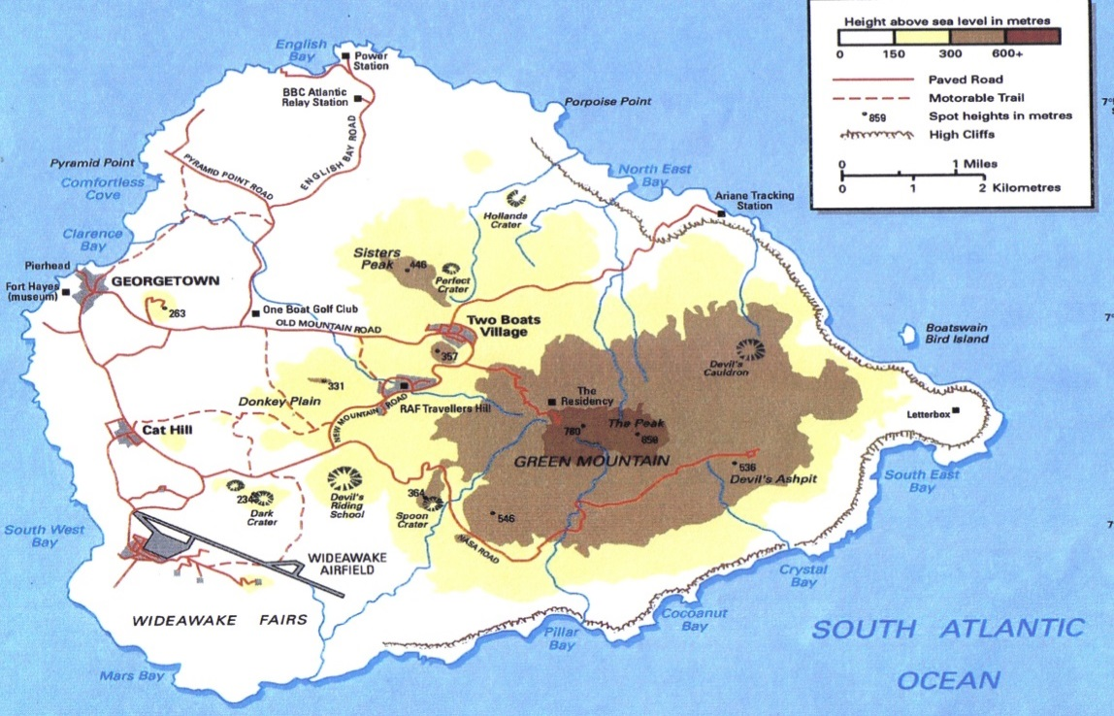

However, its disadvantages include its remoteness and the lack of any natural resources.

The major operating costs to BBC on Ascension Island are electricity costs – which is generated using diesel fired generators. In a re-engineering project that began in 2004, the BBC commenced a two-phase programme to reduce operating costs:

– replacement of ageing Marconi BD272 AM transmitters (45% efficient) with modern RIZ AMC transmitters (80% + efficient) together with a new station automation system allowing unattended operation of the transmitting station;

– an investigation into powering the transmitting station and the other British interests on the island using renewable energy sources.

This paper will describe how the BBC has brought environmental “green” benefits to this remote island, and at the same time reduced its electricity bill.

# 2 BBC power station

## 2.1 Overview

The BBC Power Station at English Bay is a diesel fired power station originally built in 1966. It supplies electricity and fresh water to all British interests on the island.

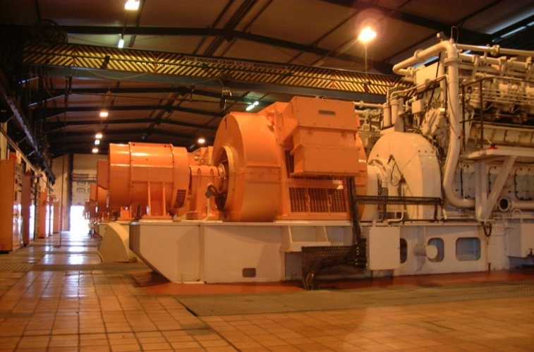

– Consists of 7, W H Allen V12 diesel generators

– Rated at 1,417 kW typically run on Ascension at 1,350 kW

– Between 2 and 3 diesels operate depending on forecasted load

– Major load is the atlantic relay transmitting station

– Supply an 11kV island network, mostly overhead transmission cable

– Compliance UK Grid code: 50 Hz

## 2.2 Renewable energy options

In 2005, the BBC commissioned work to investigate the use of renewable energy to reduce the environmental impact of our operation on the island.

Five options were initially reviewed:

– solar;

– wave/Tidal;

– geothermal;

– biomass;

– wind.

The Table below summarises the 2005 review.

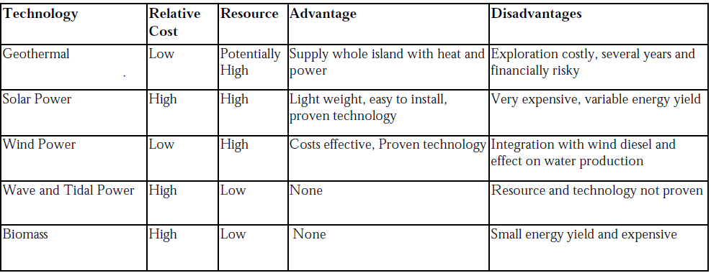

### 2.2.1 Geothermal

Given the volcanic nature of the island geothermal power was an option, and research conducted previously by US researchers had demonstrated a potential resource on the island. But costly and time consuming exploration work would need to be conducted at risk to identify the suitability of the resource. If available, the potential reward is a continuous supply of economically attractive electrical power and heat in sufficient quantity for the whole island.

### 2.2.2 Solar

Although the solar irradiance resource is likely to be high, a large quantity of photovoltaic equipment would be required, at considerable cost, just to fulfil the base load. Given the variability of solar power it is likely to create significant engineering obstacles, and given the 24/7 nature of the transmitting operation considerable additional energy storage devices would be required.

### 2.2.3 Wave and Tidal

In 2005, wave and tidal technologies were largely undeveloped, and an unproven technology is not suited for a remote island.

### 2.2.4 Biomass

Given the population of the island the biomass resource potential will not be large enough to impact on the energy requirement of the island.

### 2.2.5 Wind

Of the technologies reviewed, it was concluded that wind power was the cheapest, lowest risk exploitable renewable energy technology. The island benefits from an excellent wind regime, dominated by the consistent south-easterly trade winds. Ergo, on balance it was concluded that the installation of wind turbines was the most attractive option.

## 2.3 Wind power feasibility study

In 2006 a Feasibility study evaluated potential locations:

– consulted with local administration, environment officer, conservation department, the US Air force regarding aerodrome safeguarding, other internal and external companies / organisations;

– wind resource;

– access;

– grid connection;

– physical space;

– geology.

The chosen site was at English Bay close to the BBC Power Station. This site provided good wind resource, good grid connection, good access, suitable physical space, clear of seabird nesting grounds and acceptable geological conditions. The risk of RF interference was mitigated by choice of location of the turbines.

Chosen wind farm location

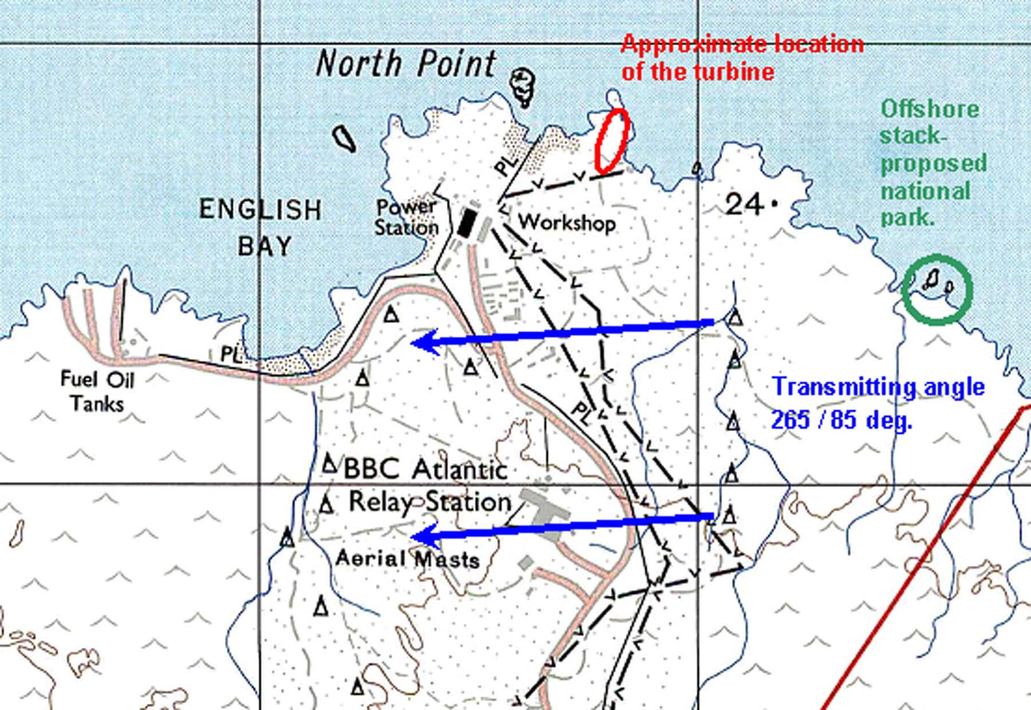

Bird nesting sites on north coast of Ascension

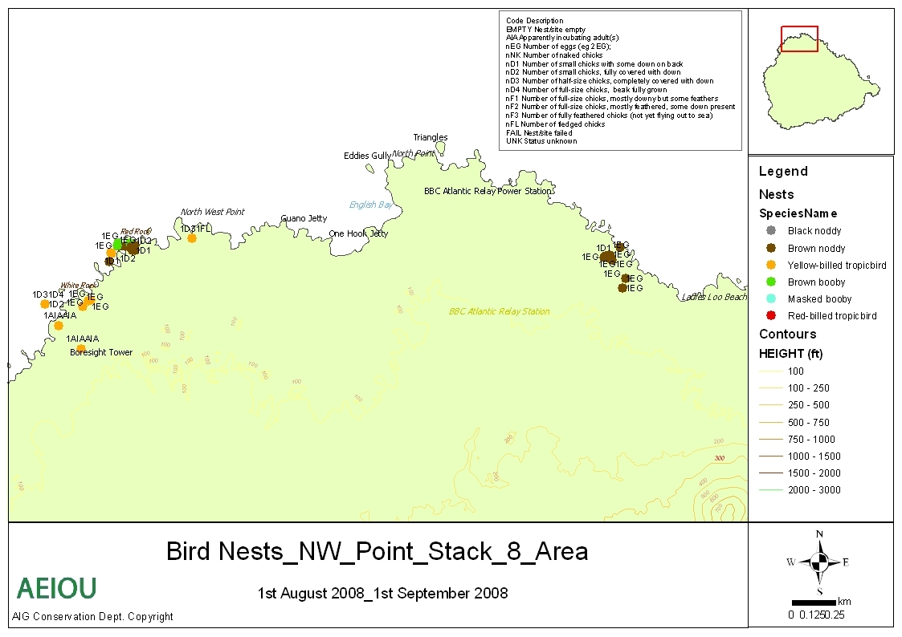

### 2.3.1 Geological Conditions at Site

On this volcanic island there was concern about ground conditions. Initial investigations were carried out at the proposed site to explore ground conditions. 3 trial pits were excavated at site, and revealed rock at variable depths < 1 m. The “rock” comprises of volcanic cobbles and boulders, silt and sand. Loose volcanic material and cobbles cover the surface, as shown below.



### 2.3.2 Wind resource monitoring

To confirm the wind resource on the site, a 50 m high wind monitoring mast was erected, equipped with anemometers and wind vanes at 30 m, 40 m and 50 m. The monitoring system was powered by Solar PV, and data retrieved from a memory card periodically. Over a 9-month period, recorded data was closely analysed and this was correlated with long term data obtained from the weather station at Ascension Airfield. The results proved that there is a relatively constant SE wind resource with very low wind shear.

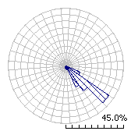

Wind Rose showing prevalent SE trade wind

Long term wind climate is 8.84 m/s @ 50 m

Long term wind climate is 8.81 m/s @ 40 m

Long term wind climate is 8.77 m/s @ 30 m

The initial design considered the use of 2 wind turbines up to 900 kW each with up to 50 m hub heights. These plans were later modified due to difficulties of offloading at Ascension and erection on site to use of 5 turbines each of 330 kWp at 36 m hub height. Calculated figures predict a wind resource capable of producing circa 5 GWh.

Offloading at Ascension Island

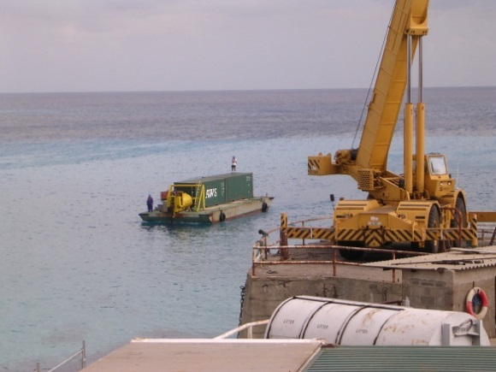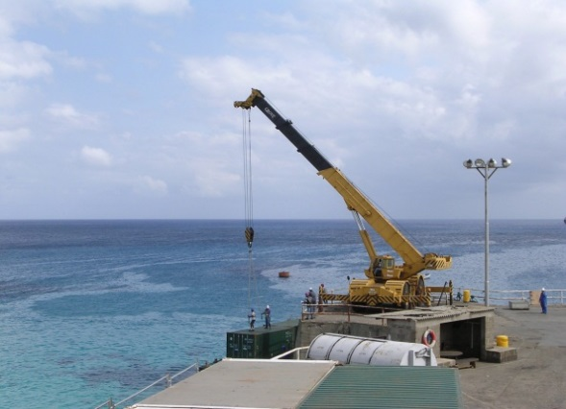

## 2.4 Wind farm implementation

BBC World Service signed a contract in 2009 with Enercon for the supply of 5 off 330 kW wind energy converters (WEC’s) to be located at English Bay adjacent to the BBC Power Station. Civil works associated with this project were carried out by Morrison Construction.

Project work was started on the island in July 2009 with project completion in April 2010.

The E 33 WEC’s are a gearbox-less variable pitch machine, ideally suited to use in the Wind Diesel Hybrid application.

WEC 1 and 2 Ascension Island

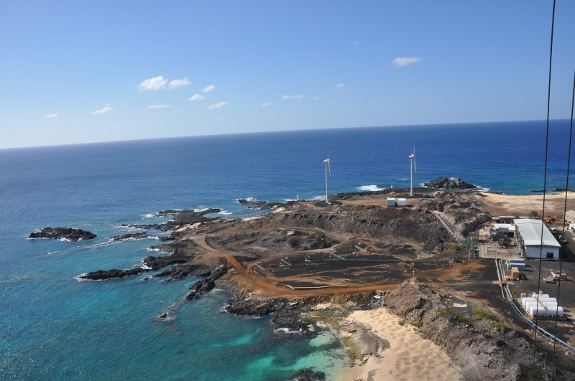

WEC 3, 4 and 5 Ascension Island

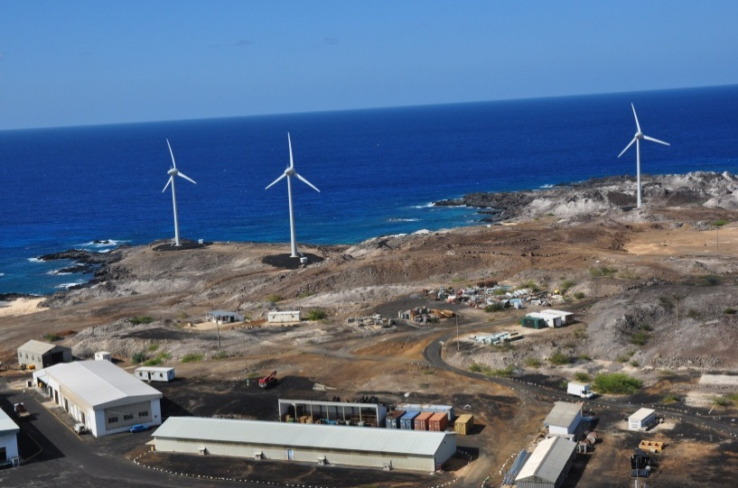

### 2.4.1 Wind farm results

|  |  |  |  |  |  |
| --- | --- | --- | --- | --- | --- |
| Year | Total wind farm output MWh | Grid penetration | Average wind speed m/s | Average availability % | Co2 offset (Tonnes) |
| 10/11 | 2,411 | N/A | N/A | 90.08 | 603 |
| 11/12 | 2,924 | 23.19% | 7.18 | 97.70 | 731 |
| 12/13 | 2,768 | 23.05% | 7.37 | 99.09 | 692 |
| 13/14 | 2,802 | 25.48% | 7.36 | 98.34 | 701 |
| 14/15 | 2,081 | 25.97% | 7.54 | 95.02 | 520 |

### 2.4.2 Pre wind farm

Peak power load

Transmitting Station: 3.2 MW - Using 6 original Marconi BD272 AM transmitters

Island Load: 1 MW

– consumed circa 6M litres diesel p.a.

– required 4 bulk storage tanks holding 10 M litres of fuel

– refueling every 18 months using floating hose to offshore tanker

### 2.4.3 Post wind farm

Peak power Load

Transmitting Station: 2.2 MW - 4 Riz AMC transmitters plus 2 Marconi BD272 AM transmitters

Island load: 1 MW

– consumed circa 3M litres diesel p.a.

– require 2 bulk storage tanks holding 6 M litres of fuel

– refueling reduced to every 24 months

Conclusions

Whilst Wind Diesel hybrid systems can deliver substantial green benefits to operators of high power short-wave broadcasting from remote islands, the challenges should not be underestimated.

The choice of wind as the renewable resource on Ascension Island was proven to be correct and has fully justified the investment. On an island with near constant wind resource this was not a difficult choice. A wind-based solution will not necessarily be correct in all locations.

As the owner of the HV grid on the island the BBC was able to re-engineer and approve the new grid design without reference to a third party “utility operator”.

The lobby from other environmental groups should not be underestimated. Considerable challenge from the island’s conservation department were faced, who were concerned with the impact of the turbines on the island’s birdlife.

In closing, a respectable 25% grid penetration is now being achieved, with a wind diesel hybrid system without energy storage. Only around half of the available wind resource from the wind farm is being utilised. In the future, given suitable battery technology, there appears to be scope to develop this solution to deliver 50% grid penetration.

Annex 5  
  
Solar powered FM broadcasting

# 1 Introduction

For local and rural VHF FM broadcasting to small communities the widest coverage area can be achieved through having the transmitting aerial as high as possible but there can be many difficulties associated with this objective.

In a city, mast and towers are often available; however this is not always economically possible or practical where the service is in a rural location with a lack of infrastructure. Transmitters can be installed on a local high building or on top of a hill but this prime position can bring complications with a lack of a public electricity supply; a diesel generator could be used but has the problem of refueling.

For locations where a public electricity supply is expensive, unreliable or would cost too much to install and maintain, the possibility of using renewable energy is attractive to provide an autonomous power supply with low routine maintenance. An off-grid photovoltaic (PV) system may be a solution to consider; PV panels convert solar energy to charge batteries and the stored energy in these batteries can be used for low power FM transmitters.

# 2 System design

The design an off-grid PV system is done in a certain order and each step often dictates the decisions made in the next step. At a high level, the steps are to determine the:

– energy consumption and consumption pattern of the load;

– size of the energy storage required;

– amount of energy that needs to be generated by the PV array.

In PV systems the design considerations include.

**Location** – Based on the location meteorological data is available for the system calculation,   
the most significant factors is the available solar radiation energy (available from NASA’s Atmospheric Science Data Centre <https://eosweb.larc.nasa.gov/cgi-bin/sse/grid.cgi>) and the daytime ambient temperature (available from a number of sources including Weather base <http://www.weatherbase.com/>.) The angle of incidence of the sunlight on the PV panel is also determined from the location and the variance of incident (and so energy conversion) over the year is also location dependent.

**System load** – this includes transmitter load, equipment such as rebroadcast or satellite receivers, system inefficiencies in the power conversion and I²R power loss in the cables. Consideration needs to be given to using equipment that will connect directly to the batteries, for example a 24V DC exciter to a 24V battery system. Efficiency of the overall system is a prime consideration.

**Days of Autonomy** – The number of days the system can operate without the battery array being   
re-charged contributes to the battery capacity required; a power saving mode to reduce or inhibit the transmitter power may reduce the number of batteries and panels needed to a more acceptable cost.

**Depth of Discharge** – The amount batteries are allowed to discharge before the broadcast system (the load) is switched off varies between different types of panels and batteries.

As the aim is to design an off-grid system, all of the energy used by the relay system must be generated by the PV array. In months of the year where there is less solar radiation available there will be less energy generated from the array. The PV system must be designed to support the relay system during the darker winter months. By tailoring the load to match the amount of available solar radiation, a smaller PV array will be able to be used, and less energy will be wasted.

When planning a PV system, it is possible to make reasonable predictions about the solar energy available, as the sun’s radiation is fairly consistent. Meteorology, however, is not. To enable the PV power system to cope with unpredictable weather, cloud cover for example, sufficient reserve must be available, data is available about the weather patterns but this is an average and short term variations will occur.

The ‘smart’ system can be used; under control of a simple timer or a single board computer (such as an Arduino based unit or Raspberry Pi) the transmitter can be switched off at times, for example overnight when there are fewer listeners or switched to a ‘low power’ mode. If a single board computer is used then other functions can be added, for example remote monitoring of the system charge and discharge and sending SMS text messages to show the state of the installation.

# 3 Modelling a PV system

System design can be aided using one of the many software tools available for analysis, planning, and economic evaluation and monitoring of PV systems. Some tools are available free of charge and can be downloaded from the internet, for example HOMER, the Hybrid Optimization Model for Electric Renewables designed by the National Renewable Energy Laboratory (NREL).   
Any modelling needs to have the variables defined and a Microsoft Excel spreadsheet can be used as a front end to the HOMER simulation software and guide the user to select system inputs and variables. The Excel spreadsheet is designed to be adaptable by the user; units such exciters, receivers etc. have their specifications in the model spreadsheet and can be selected through drop down menu selection and these can be easily updated to include new or different units.

Macros in the spreadsheet produces the input files for the simulation software defining parameters such as load, sunshine and incident angles of sunshine. The final output from the simulation software shows the appropriate photovoltaic solar power system components required to power the off-grid FM system as defined.

# 4 Routine maintenance and replacements

Like any system, PV is not completely maintenance free; the main points are:

**Batteries** – these have a limited number of charge/discharge cycles and will probably need to be replaced after about five years. Flooded batteries need to be checked regularly to make sure electrolyte levels are full; the chemical reaction releases gases, as water molecules are split into hydrogen and oxygen. This, in turn, consumes water and creates the need to replace it regularly with pure distilled water. The connections from battery to battery and to the charging and load circuits should always be kept clean and free of corrosion.

**PV Panels** – during long periods without rain the loss in energy production caused by dust over a daily period can be up to 20% though this depends on the angle of the panels.

# 5 BBC World Service systems

The BBC World Service has installed a number of solar/PV FM relay systems; the first was in Hargeisa in November 2001 and was followed by seven in Afghanistan and two in Sierra Leone. The Afghan relays are designed to provide power for two 30 W transmitters and the others for a single 30 W transmitter; the only other item of equipment for the BBC services is a satellite receiver used as part of the global programme distribution network. The systems were supplied by different UK companies and include:

**Batteries** – different types have been used; the first systems had 2 volt flooded cell batteries and the later ones 12 volt sealed batteries with a capacity between 150 and 300 amp-hour. Batteries have rigorously enforced arrangements for freight shipping which is not a problem as long as the correct documentation is available from the manufacturer.

**PV/solar panels** – panels are becoming larger, higher capacity and producing higher voltages but there are often limitations in shipping and the maximum size that can be accommodated in smaller air freight routes.

**Battery charger and inverters** – chargers need to be set to match the type of PV panel and battery used; different types of batteries need to have different charge settings.

**Transmission equipment** – transmitters provided work directly from 24V DC but the satellite receivers have to use a DC to 240V AC inverter as a DC version isn’t available.

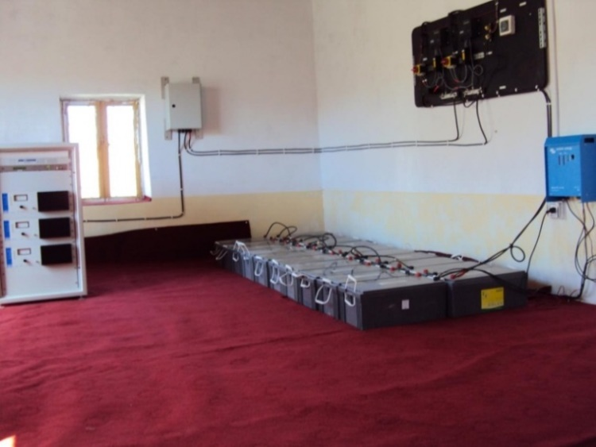

This system has two 30W transmitters and 16 deep discharge batteries. The control wiring (on the black board fixed to the wall) has been pre-wired for installation. A separate battery charger (blue wall unit) allows the batteries to be charged from a small petrol generator.

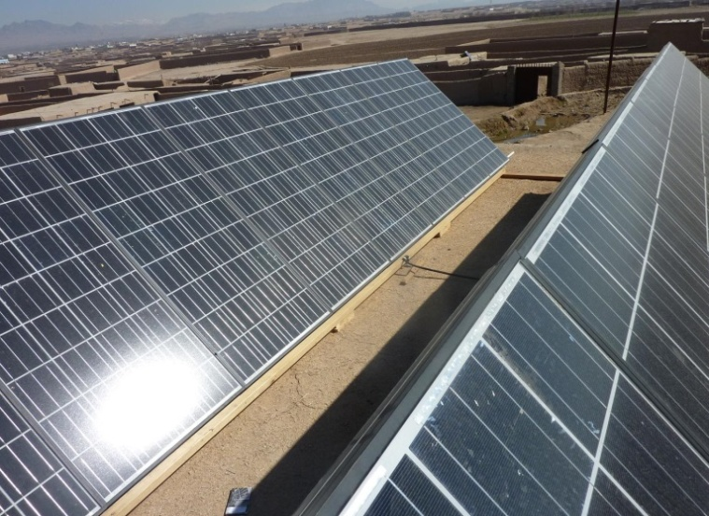

The roof mounted PV array has been spaced to prevent one set of panels being in the shadow of the other.

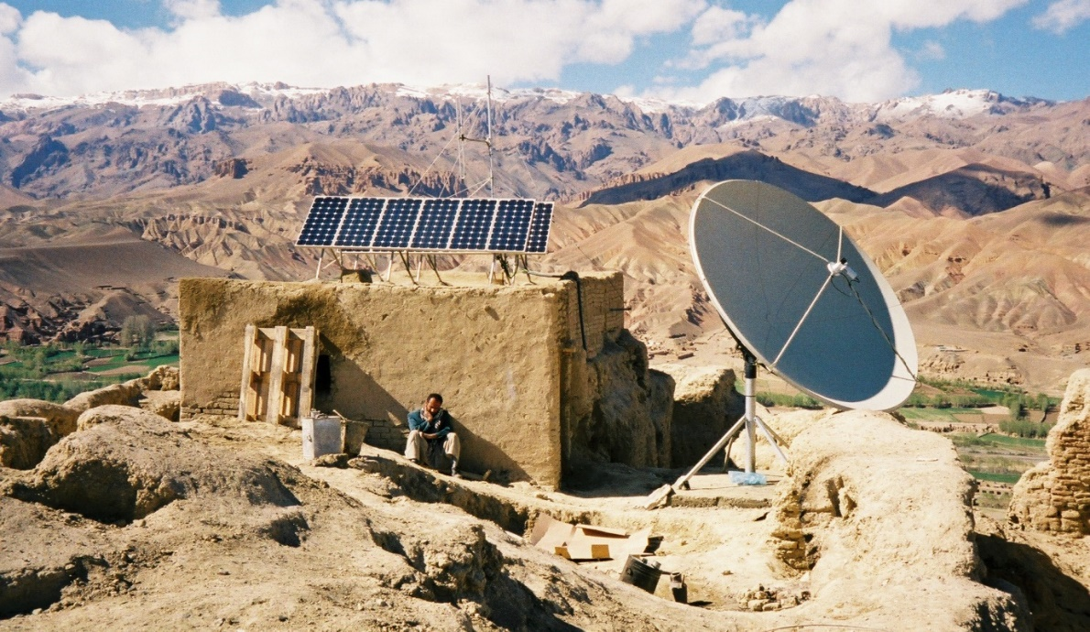

This shows a system and the rugged and remote environment in which it operates as an autonomous off-grid installation.

# 6 Conclusions

A practical installation to produce about 50W of RF power, with deep-discharge batteries for a reasonable length of autonomy, solar panels and other parts including frames for the solar panels, charge controllers and installation will cost around $ 20,000 in addition to the usual cost of installation. A connection to a public supply will (almost) always be the most effective means of powering broadcast transmitters; the supply can be for higher power services which would normally be beyond an economic value from solar or wind power.

Off-grid systems start to produce benefits and provide coverage to communities in remote locations which are beyond coverage from main broadcasting stations. In this way sustainable energy provides the means for broadcasters to reach out these communities and provide coverage that was previously not possible. An ideal solution may be difficult and expensive to implement and careful thought needs to be given to a compromise design which may not provide the same availability as a grid-connected design but that does deliver the sought after services to very remote locations; adding a small percentage of increased availability may bring a large percentage increase in costs.

______________

1. EBU Tech Fact Sheet – Sustainable Broadcasting – 17 September 2014.
2. Maximum conversion efficiency of 97.7% at 40% rated capacity.
3. It can be noted that CBS stations in the USA use a higher daily energy per household than Rai Way stations in Italy. This is not surprising since the average population density over the USA is about one sixth of the average population density over Italy (about 32 persons per square kilometer in the USA, and about 200 persons per square kilometer in Italy).