|  |
| --- |
| **Report ITU-R BT.2380-2**  **(10/2018)** |
| **Television colorimetry elements** |
| **BT Series**  **Broadcasting service**  **(television)** |

Foreword

The role of the Radiocommunication Sector is to ensure the rational, equitable, efficient and economical use of the radio-frequency spectrum by all radiocommunication services, including satellite services, and carry out studies without limit of frequency range on the basis of which Recommendations are adopted.

The regulatory and policy functions of the Radiocommunication Sector are performed by World and Regional Radiocommunication Conferences and Radiocommunication Assemblies supported by Study Groups.

# Policy on Intellectual Property Right (IPR)

ITU-R policy on IPR is described in the Common Patent Policy for ITU-T/ITU-R/ISO/IEC referenced in Resolution ITU‑R 1. Forms to be used for the submission of patent statements and licensing declarations by patent holders are available from <http://www.itu.int/ITU-R/go/patents/en> where the Guidelines for Implementation of the Common Patent Policy for ITU‑T/ITU‑R/ISO/IEC and the ITU-R patent information database can also be found.

|  |  |
| --- | --- |
| Series of ITU-R Reports  (Also available online at <http://www.itu.int/publ/R-REP/en>) | |
| **Series** | Title |
| **BO** | Satellite delivery |
| **BR** | Recording for production, archival and play-out; film for television |
| **BS** | Broadcasting service (sound) |
| **BT** | Broadcasting service (television) |
| **F** | Fixed service |
| **M** | Mobile, radiodetermination, amateur and related satellite services |
| **P** | Radiowave propagation |
| **RA** | Radio astronomy |
| **RS** | Remote sensing systems |
| **S** | Fixed-satellite service |
| **SA** | Space applications and meteorology |
| **SF** | Frequency sharing and coordination between fixed-satellite and fixed service systems |
| **SM** | Spectrum management |

|  |
| --- |
|  |

|  |
| --- |
| ***Note****: This ITU-R Report was approved in English by the Study Group under the procedure detailed in Resolution ITU-R 1.* |

*Electronic Publication*

Geneva, 2018

© ITU 2018

All rights reserved. No part of this publication may be reproduced, by any means whatsoever, without written permission of ITU.

REPORT ITU-R BT.2380-2

Television colorimetry elements

(2015-2017-2018)

Foreword

This Report covers a wide range of topics including ideal colorimetry and future predictions, and some conclusions. It should be noted that over a period of time these predictions and conclusions may have been overtaken by the passage of time, or other industry factors. Reference is also made to an ideal camera, in this context a virtual camera.

Introduction

The intent of a television system is to give to the viewer the possibility of viewing scenes from a distant time or place. It is important that it allows the maximum possible replication of the reproduced image and the original scene, now referred to as High Dynamic Range (HDR). In many instances the creative community may choose to create a certain “look” for the programme, a departure from the ideal replication.

Using digital technologies, distortion of a video signal can be insignificant, but there remains the potential sources of distortions. The display device, the emission transmission limitations are just some of the areas where signal constraints may introduce distortions.

The transmission of colour information in existing systems is based on colorimetric principles. The main contributor to improve the viewer’s experience is by controlling the viewing conditions. This task is simply impossible, only recommendations can be made. .

The accumulated knowledge of visual perception mechanisms and characteristics, including colour perception and display, serve as the basis for progress in image system fidelity.

The starting point for colorimetric calculations is the XYZ system adopted by the International Commission on Illumination (CIE) in 1931. This is a coordinate system that describes spectral colour perception using a defined colour space. As a means of specifying colorimetry, one of the drawbacks of the system is that it does not take into account adaptation and observation conditions of the human vision system. This system does not exhibit uniform ‘distances’ between the equally perceptible colour differences across the colour space.

Two systems or diagrams, each with advantages, which had uniform spacing of perceived differences, CIELUV and CIELAB systems, were adopted by the CIE in 1976. The CIELUV system uses a MacAdam uniform colour scale, using experimental data for threshold colour differences. The CIELAB system uses a cube root formula to derive colour coordinates.

CIELUV system has largely found use in television applications, and CIELAB system has largely found use for multimedia and other applications.

One of the recent achievements of colorimetric science is the development of the CIECAM02 colour appearance model, which is consistent with experimental data on colour perception. It is now recommended for colour management by the CIE. In this system, real colour perception mechanisms are taken into account, including adaptation properties.

Some modifications of CIECAM02, to enhance uniformity and to account for spatial and temporal vision effects, are described in this Report.

Television colorimetry and colorimetry of other electronic image systems are based on the use of signals that can be associated with colour space coordinates within the system and coordinate-dependent transmitted scene and reproduced images.

In the image systems used for different applications, the option of similarity of image colour obtained in shooting and in reproduction environment is essential. The International Color Consortium (ICC) has agreed general principles of colour rendering, according to which all colorimetric transformations should be realized in a single colour space, not dependent on the device types used, and in this space transformations for device matching should be applied.

Use of current colour perception models in television and related applications should form the basis for the following:

– Increasing of the colour reproduction quality by close replication of the transmitted scene visual colours and reproducible image colours.

– Further coding efficiency increase with video information compression taking into account both current colour perception models and transmitted scene types information, and also statistics of colour image composition, detail and other characteristics of transmitted scenes.

– Improvement of colour reproduction quality assessment methods by using better human colour perception considerations.

– Optimal image quality management in the broadcast production chain.

The advent of new components in television systems, and improvements in system models, may result in transformations of increasing complexity. This will become more practical with the evolution of mathematical transforms.

An important task is the achievement of backwards compatibility of new systems with former systems. It may be achieved in television and related applications when innovation is such that systems operate according to former standards but include the option of new components giving additional opportunities that are not compatible with the old systems. In some cases, the backwards compatibility may limit quality and mean that certain quality levels never become available.

At the current stage of technical progress of image systems, enhancements of the colorimetry system are already embodied in UHDTV systems, in digital cinema, and ACES large screen digital imagery systems. Improvements are towards a wider colour gamut, HDR and colour accuracy enhancement. Some new applications such as using Free Scale-Gamut (FS-Gamut) and Free Scale-Log (FS-Log) opto‑electronic transfer function are now possible along with the proposed HDR systems.

In the sections of this Report, all these aspects, particularly, technical aspects correlated with colorimetry characteristics of TV and, to some extent, with other image systems, colour rendering quality aspects and aspects associated with the state-of-the-art of colour perception models, are considered.

CHAPTER 1

General model of light-to-light television   
and related imaging systems

Current television image systems can be represented as shown in Fig. 1.1. The generic end-to-end system is shown as a serial connection of light-to-signal conversion (via the camera), the electrical transmission path, and signal-to-light conversion (via the reproducing device). Figure 1 does not take account of the artistic adjustments that are made at the camera signal output, or later in the production process.

In the electrical path of a television system, the transmitted signals are usually expressed as the ** primary signals or *Yʹ CʹR CʹB* luminance and colour difference signals. These signals can be considered as coordinates of the three-dimensional colour space of the system.

OETF (opto-electron transfer function) conversion and EOTF (electro-optical transfer function) conversion in the terminal devices may be represented as the transition from  using non‑constrainedcolour space coordinates (for example **)tothe constrained signals  (for example ** or *Yʹ CʹR CʹB*) on the transmission path, and as the transition from the signals  to  coordinates of reproduced image colour space on the receiving side, which is constrained by the characteristics of the display.

Figure 1.2 is a block diagram of a potential adaptive image system, providing colour reproduction, independent of devices used (regarding any colorimetric transformations used in them). A principal distinction of such a system compared to a non-adaptive system may be the use of a colour space in the transmitting channel that is independent of the colorimetric transformations in devices used and independent of viewing conditions.

For colour reproduction quality assessment, a uniform colour space may be used, in which visual perception of object in the image is associated with the  coordinates of this colour space at the transmitting side, and visual perception of reproduced image is associated with colour coordinates,  on the reproduction side.

 colour spaces coordinates, expressed with different degree of accuracy with respect to the human vision, may be used. Colour spaces include those developed by the CIE: CIELUV, CIELAB, and CIECAM02. As a measure of colour reproduction quality in such a case, distances in the  space may be used with appropriate conversion.

ICC has defined profiles for multimedia applications, independent of the capture and reproduction devices. For television, such approach is not in use: however, it may be desirable to develop systems independent of viewing conditions for any point of the light-to-light video chain (transmission path).

For television applications, these principles are described in [1.3] to [1.8].

Figure 1.1

Block diagram of a non-adaptive system

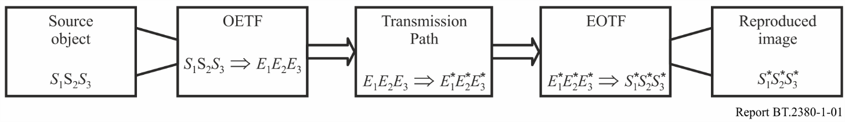

figure 1.2

Block diagram of a potential adaptive system

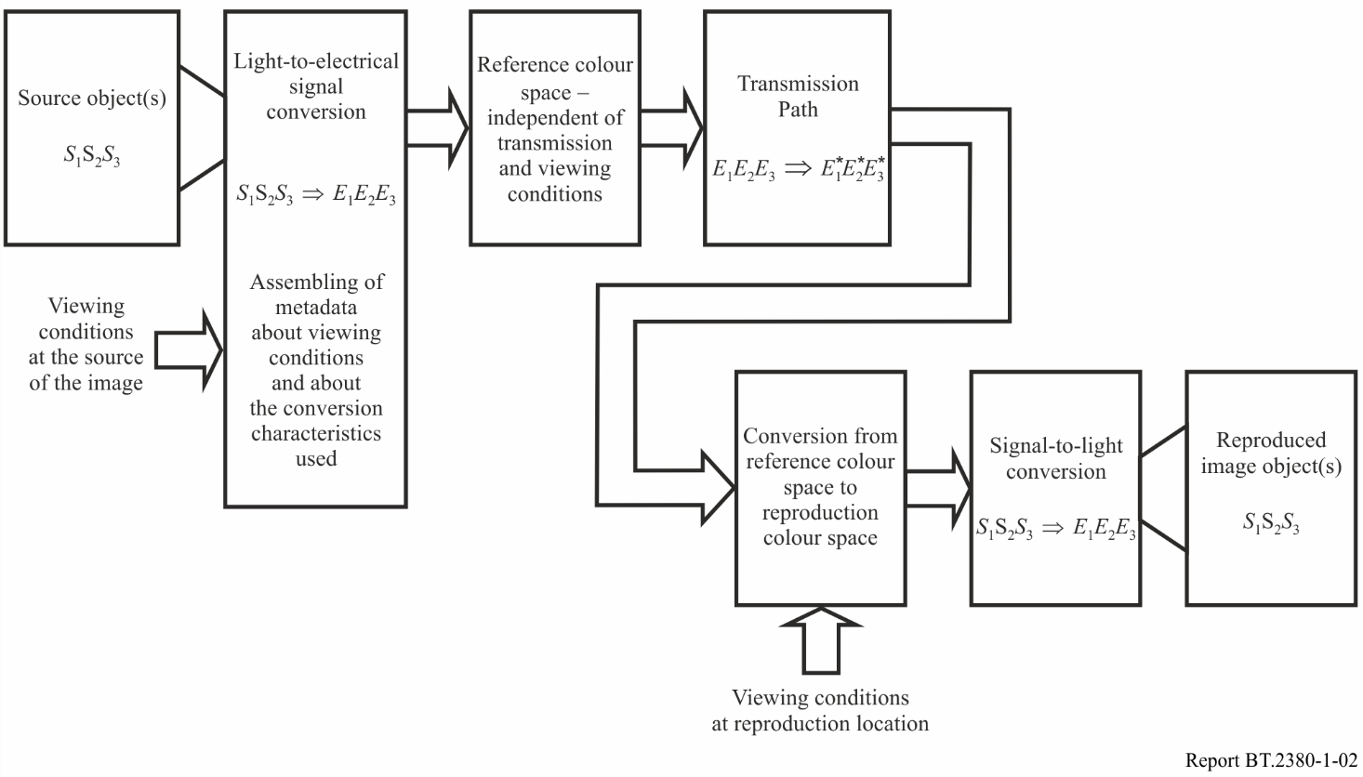

Bibliography for Chapter 1

[1.1] P. Green, L. MacDonald *Colour engineering. Achieving device independent colour*. John Wiley and Sons Ltd, 2003

[1.2] Mark D. Fairchild *Color Appearance Models, 3rd edition,* Addison-Wesley, 2013

[1.3] Gofaizen O.V. *The conception of image quality management in TV systems of future*. “Pratzi of the UNIIRT” (“Proceedings of the UNIIRT”), 1996. – № 2 (6). – С. 97

[1.4] Ukraine. *The Concept of Adaptive Colour Image Quality Control in Future TV Systems*. Doc. 11A/51, 11C/39, 06.11.96.

[1.5] Gofaizen O.V., Tepukhina A.V. *Current Level of colorimetry and the problem of colour adaptive TV and related systems development.* “Pratzi of the UNIIRT” (“Proceedings of the UNIIRT”), 1(41). – 2005

[1.6] Gofaizen O.V., Tepukhina A.V., Komarov M.M. *Colour adaptive digital TV systems of future: The principles of development and colorimetric fundamentals*. Pratzi of the UNIIRT” (“Proceedings of the UNIIRT”). – № 2(42) – 2005

[1.7] Recommendation ITU-R BT.1691-1 (2009) – Adaptive image quality control in digital television systems

[1.8] Recommendation ITU-R BT.1692-1 (2009) – Optimization of the quality of colour reproduction in digital television

CHAPTER 2

Colorimetric characteristics of television and related systems

## 2.1 Introductory note

Colorimetric characteristics have a major role in video systems characteristics; they considerably influence the overall quality of the transmitted and reproduced images. In this section information on colorimetric characteristics of television, multimedia and other related systems is summarized. The description of colour spaces for some image compression systems is also shown.

A complete colour space definition for digital video representation may include specification of the following aspects:

* The chromaticity coordinates of the source colour primaries ** and coordinates  of reference white point.
* The opto-electronic transfer characteristics of the source components (e.g. definition of ** as a function of**).
* Matrix coefficients for transformation of the *RGB* components into luma and chroma components (e.g., definition of components  and  as a function of and ).
* Definition of scaling, offsets, and quantization for digital representation.
* A gamut boundary definition specifying the range of values over which effective representations of colours can be achieved.

## 2.2 Relationship between tristimulus values in XYZ colour space and in RGB signal space

The correlations interrelating between  colour space and RGB signal space of TV system in accordance with SMPTE RP 177 [2.1] are represented in this subclause.

RGB signal space tristimulus values are normalized in such a way that reference white is   
equi-primary signal .

For transformations the  matrix of primaries chromaticity coordinates and  vector of reference white chromaticity coordinates are used.

 (2.1)

The  vector normalization corresponds to reference white assignment with a unit luminance factor.

Signal space in television is normalized to the unit range of relative luminance change that corresponds to change of  primary signal levels between the values 0 and 1. It corresponds to such  space normalization that  coordinate, characterizing the image relative luminance values, takes 0 values on black and 1 on white.

Relationship between  colour space and  signal space is carried out as

 (2.2)

where the system primaries coordinates matrix is:

 (2.3)

It is calculated with use of formula:

 (2.4)

The second row of normalized system primaries coordinates matrix represents the vector of primaries luminance factors, relative colour luminance coordinates being determined as

. (2.5)

Thus  characterize primaries relative luminance. They are also named primaries luminance factors and designated:

.

It has been noted in [2.1] that as a result of calculations with the limited number of digits (because of rounding) coefficients of the second row can turn out in the calculation of matrix, to give a sum that will differ from unity. In this case it is recommended to normalize the matrix columns so as to obtain this sum equal to unity.

The examples of colour space conversion of standard-definition television (SDTV) and HDTV signals from one colour space to another, based on formulas of direct conversion of ** signals to ** values and of inverse conversion of ** values to ** signals, are presented in the Report ITU-R BT.2250 [2.31].

## 2.3 Relationship between spectral reflectance of transmitted scene object and tristimulus values in RGB signal space

Matrix  can be used to convert the vector of colour matching functions  depending on the wavelength  of the monochromatic radiation in CIE space to the vector of  primaries colour matching functions which, assuming that as primary colours of this colour space the primaries of TV system are chosen, is the vector of spectral sensitivity characteristics  of the TV camera primary channels. If these characteristics are implemented and the spectral distribution  of the light source corresponds to the standardized for TV system, undistorted colour rendering will be ensured.

The spectral characteristics of an ideal camera may be determined using the relationships corresponding to equation (2.2):

. (2.6)

For these characteristics relative levels of  primary signals normalized to the  interval are determined by the formula:

, (2.7)

where ,  – the spectral reflectance of transmitted scene object.

The colorimetric characteristics of SDTV, HDTV and UHDTV systems in terms of CIE 1931 colorimetry in accordance with Recommendations ITU-R BT.601, ITU-R BT.709, ITU-R BT.1543, ITU-R BT.1847 and ITU-R BT.2020 (see following sub-clauses) are defined by matrixes:

* for SDTV system:

 (2.8)

* for HDTV system:

 (2.9)

* for UHDTV system:

 (2.10)

Vector of reference white D65 normalized chromaticity coordinates is:

. (2.11)

Tables E.1 to E.3 of Annex E show the values of the characteristics of ideal cameras SDTV, HDTV and UHDTV submitted in increments of 5 nm calculated according to equation (2.6).

Using these formulas and data of Tables E.1–E.3 may facilitate the implementation of further research and development in this direction. Figure 2.1 presents a comparison of characteristics of these three TV systems.

FIGURE 2.1

Comparison of the spectral sensitivity characteristics of primary signal channels of SDTV, HDTV,   
UHDTV in terms of CIE 1931colorimetry

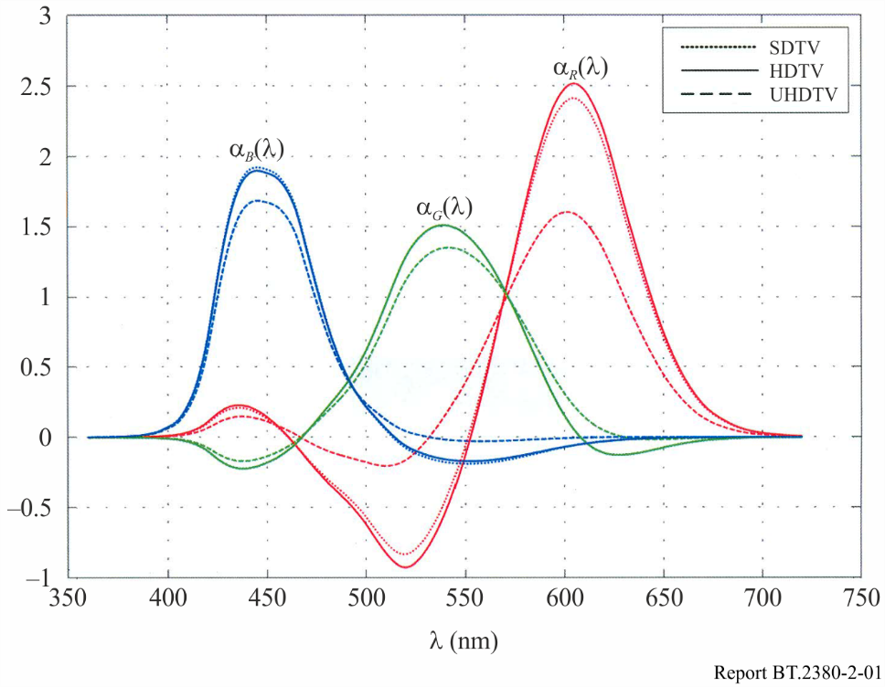

## 2.4 Comparison colour rendering of through light-to-light TV path for colorimetric parameters based on CIE-1931 and CIE-2006 colorimetry systems

There are currently two systems of colour coordinates, based on colour matching functions (CMFs) adopted by CIE, which can be used for any application including television:

* CIE 1931 [2.32];
* CIE 2006 [2.33].

CIE 2006 system is more accurately expressing the spectral characteristics of human cone vision compared to CIE 1931.

Practically, all colorimetric standards and existing colorimetric data are based on CIE 1931 system including standards for TV applications. Therefore, it is difficult to imagine that in the next few years this system will come out of use.

However, with the adoption of the CIE 2006 system and the wish to obtain more stringent colorimetric assessment and thereby make more sophisticated technical solutions, including in the field of TV applications, the transition to the use of this system can be considered as possible trend of TV colorimetry progress.

Imperfection of CIE 1931 system was found by Sony Corporation [2.34] when comparing the CRT‑based displays and OLED-panels, and it was found that there may be noticeable colour shift.

Considering the progress of TV systems, aimed to further empowering TV technology and improving the quality of the image, it is possible to predict that the transition to the CIE 2006 system will be implemented with time.

The comparison of the colour rendering of the through light-to-light path of UHDTV systems considering the spectral characteristics of the ideal camera primary channels, calculated on the basis of using CIE 1931 and CIE 2006 colorimetric systems, is presented in Annex F.

## 2.5 Colorimetric characteristics of digital standard definition and high definition television systems

Colorimetric characteristics of standard definition and high definition digital television systems are presented in Table 2.1, where:

– relative luminance levels of ** components;

– gamma-corrected signals relative levels ();

– luminance signal;

,,,  – colour-difference signals, normalized to the interval .

In Recommendation ITU-R BT.601-7 [2.4] 8-bit and 10-bit coded representation is used for digital SDTV systems and decimal values of the quantized signals are:

‒ for gamma-corrected  signals:

 (2.12)

 (2.13)

 (2.14)

TABLE 2.1

Colorimetric characteristics of standard definition and high definition digital television systems

|  |  |  |  |  |  |  |  |  |
| --- | --- | --- | --- | --- | --- | --- | --- | --- |
| System | Primaries and reference white chromaticity coordinates | | | | | Opto-electronic and electro-optic conversion characteristics | Coding equation | |
| **SDTV**  (ITU-R BT.601-7 [2.4],  item 3.6) |  | **625/50/2:1** | | |  | Opto-electronic conversion:      Electro–optic conversion: | |  |
|  | *x* | *y* |
| Red | 0.640 | 0.330 |
| Green | 0.290 | 0.600 |
| Blue | 0.150 | 0.060 |
| White D65 | 0.3127 | 0.3290 |
| **525/60/2:1** | | |
|  | *x* | *y* |  |
| Red | 0.630 | 0.340 |
| Green | 0.310 | 0.595 |
| Blue | 0.155 | 0.070 |
| White D65 | 0.3127 | 0.3290 |
|  | | |
| **HDTV 1080 lines**  (ITU-R BT.709 [2.5])  **720 lines** (ITU-R BT.1543-1 [2.6], ITU-R BT.1847-1 [2.7]) | |  |  |  | | --- | --- | --- | |  | *x* | *y* | | Red | 0.640 | 0.330 | | Green | 0.300 | 0.600 | | Blue | 0.150 | 0.060 | | White D65 | 0.3127 | 0.3290 | | | | | | Opto-electronic conversion: | |  |

‒ for luminance and colour-difference  signals:

 (2.15)

 (2.16)

 (2.17)

where *D* takes either the value 1 or 4, corresponding to 8-bit and 10-bit quantization respectively. The operator  returns the value of 0 for fractional parts in the range of 0 to 0.4999 … and +1 for fractional parts in the range 0.5 to 0.999 ..., i.e. it rounds up fractions above 0.5.

Recommendation ITU-R BT.601-7 specifies as well equations for derivation quantized luminance and colour-difference signals via quantized gamma-corrected  signals.

In Recommendations ITU-R BT.709-6 [2.5], ITU-R BT.1543-1 [2.6] and ITU-R BT.1847-1 [2.7] 8‑bit and 10‑bit coded representation is used and decimal values of the quantized signals are:

‒ for gamma-corrected  signals:

 (2.18)

 (2.19)

 (2.20)

‒ for luminance and colour difference signals:

 (2.21)

 (2.22)

 (2.23)

where *n* denotes the number of the bit length of the quantized signal.

Derivation of luminance and colour-difference signals via quantized ** signals is realised using equations:

 (2.24)

 (2.25)

 (2.26)

## 2.6 Colorimetric characteristics of ultra-high definition digital television systems

Colorimetric characteristics of ultra-high definition digital television systems are presented in Table 2.2. In Recommendation ITU-R BT.2020-1 [2.8] a newly proposed signal format for UHDTV systems is specified. For UHDTV systems 10‑bit, 12‑bit and 16‑bit coded representation may be used, and equations decimal values of the quantized signals are the same as for HDTV systems.

TABLE 2.2

Colorimetric characteristics of UHDTV systems

|  |  |  |  |  |  |  |  |
| --- | --- | --- | --- | --- | --- | --- | --- |
| System | Primaries and reference white chromaticity coordinates | | | | | Opto-electronic and electro–optic conversion characteristics | Coding equation |
| UHDTV |  |  | | |  | Opto-electronic conversion:    where *E* is voltage normalized by the reference white level and proportional to the implicit light intensity that would be detected with a reference camera colour channel *R*, *G*, *B*;  *E'* is the resulting non-linear signal.  α = 1.099 and β = 0.018 for 10-bit system α = 1.0993 and β = 0.0181 for 12-bit system | Constant luminance :    Non-constant luminance : |
|  | *x* | *y* |
| Red | 0.708 | 0.292 |
| Green | 0.170 | 0.797 |
| Blue | 0.131 | 0.046 |
| White D65 | 0.3127 | 0.3290 |
|  | | |

## 2.7 Multimedia systems colorimetric characteristics

Opto-electronic and electro-optic conversions and multimedia systems colorimetric characteristicsspecified in IEC 61966-2-1 [2.9], IEC 61966-2-2 [2.10], 61966-2-4 [2.11], and IEC 61966-2-5 [2.12], are shown in Table 2.3.

## 2.8 Colorimetric characteristics of new video applications: Digital cinema systems and LSDI systems

Technological progress has led to possibility of the practical implementation of a new level of video applications, namely, the systems of production and reproduction of scenes with a number of pixels close to 2000×4000 (4k) and 4000×8000 (8k), such as digital cinema (DC) systems [2.13–2.15], LSDI system ACES [2.16] (which can be used for different applications as well as digital cinema) that are by their functionality close to UHDTV systems [2.8].

Among digital cinema systems there are two levels of systems standardized in the world:

– DC systems, characteristics of which were specified by version 1.0 of DCI specification [2.14], which was replaced by DCI specification version 1.2 [2.15];

– DC systems, characteristics of which are specified in the SMPTE 2048-1.

In *DCI specification* [2.14] the use of CIE-31 tristimulus values *X*,*Y*,*Z* as primary colour source digital cinema signals is specified. At the output of the scene capturing system the colour capturing signals *X,Y,Z* that directly characterize tristimulus values are provided.

A more recent version of the standard for digital cinema system specifies the colour gamut that covers the entire chromaticity diagram and thus provides the possibility of free choice of reproducible colour gamut for reproduction system (*FS-Gamut*) but this feature is somewhat limited in use relative to the first version of digital cinema. Source colour primary signals used in this system are not the CIE-31 tristimulus values *X,Y,Z* and therefore there is a limited colour gamut with increasing luminance.

*SMPTE ST.2048-1* [2.13] defines 4k and 8k image formats primarily for DC content acquisition and creation. These image formats may also be used for acquisition and creation of high quality content for other DC applications. This standard specifies formats compatible with ITU-R BT.709-6 HDTV formats and formats defined with tristimulus values and reference white of Free Scale-Gamut (*FS‑Gamut*), colour primary signals transmission *Free Scale-Log* (*FS-Log)* curve and VANC (Vertical Ancillary Code) packet, which conveys the parameter values of user-defined colour space and Log curve.

Default chromaticity coordinates of the primaries and reference white for *FS-Gamut* systems are defined in the standard in compliance with Table 2.4.

*SMPTE ST.2065-2* [2.16] specifies the Academy Color Encoding Specification (ACES) which defines a digital colour image encoding appropriate for both photographed and computer-generated images.

The colour space type shall be colorimetric: additive RGB. The ACES colour space type can also be considered to be of the type input-device-dependent and as such has an associated reference image capture device (RICD). The RGB primaries chromaticity values shall be those found in Table 2.6.

TABLE 2.3

Multimedia systems colorimetric characteristics

|  |  |  |  |
| --- | --- | --- | --- |
| Colour space | Primaries and reference white chromaticity coordinates | Opto-electronic and electro-optic conversion characteristics | Coding equation |
| **sRGB**  IEC 61966-2-1 Annex F [2.9] | |  |  |  | | --- | --- | --- | |  | *x* | *y* | | Red | 0.640 | 0.330 | | Green | 0.300 | 0.600 | | Blue | 0.150 | 0.060 | | White D65 | 0.3127 | 0.3290 | | Opto-electronic conversion:    where – tristimulus values of  colour space  – colour primary coordinates of  signal space  Electro–optic conversion:    Quantized signal representation:  8-bit representation:  where | **:**    Quantized signal representation:  *n*-bit representation: |
| bg-sRGB  IEC 61966-2-1 Annex G [2.9] | |  |  |  | | --- | --- | --- | |  | *x* | *y* | | Red | 0.640 | 0.330 | | Green | 0.300 | 0.600 | | Blue | 0.150 | 0.060 | | White D65 | 0.3127 | 0.3290 | | Opto-electronic conversion:  where – tristimulus values of  colour space  – colour primary coordinates of  signal space | : |

TABLE 2.3 (*continued*)

|  |  |  |  |
| --- | --- | --- | --- |
| Colour space | Primaries and reference white chromaticity coordinates | Opto-electronic and electro-optic conversion characteristics | Coding equation |
|  |  | Electro-optic conversion:  Quantized signal representation:  16-bit representation:  where  Bit depth equals 10, 12 or 16 | Quantized signal representation: |
| scRGB IEC 61966-2-2 [2.10] | |  |  |  | | --- | --- | --- | |  | *x* | *y* | | Red | 0.640 | 0.330 | | Green | 0.300 | 0.600 | | Blue | 0.150 | 0.060 | | White D65 | 0.3127 | 0.3290 | | Opto-electronic conversion:    where – tristimulus values of  colour space  – colour primary coordinates of  signal space  Electro–optic conversion:    scRGB-nl  Quantized signal representation:  16-bit representation: | :    Quantized signal representation:  12-bit representation: |

TABLE 2.3 (*continued*)

|  |  |  |  |
| --- | --- | --- | --- |
| Colour space | Primaries and reference white chromaticity coordinates | Opto-electronic and electro-optic conversion characteristics | Coding equation |
|  |  | **scRGB-nl**  Quantized signal representation:  16-bit representation:  where    12-bit representation:  where | **Quantization relationships using scRGB**   |  |  |  |  | | --- | --- | --- | --- | | **scRGB(16)** | **scRGB** |  | **scRGB-nl** | | N/A | –0.6038 | –0.8.000 | 0 | | 0 | –0.5 | –0.7354 | 83 | | 2048 | –0.25 | –0.5371 | 337 | | 4096 | 0 | 0.0000 | 1024 | | 12288 | 1 | 1.0000 | 2304 | | 20480 | 2 | 1.3533 | 2756 | | 28672 | 3 | 1.6125 | 3088 | | 36864 | 4 | 1.8248 | 3360 | | 45056 | 5 | 2.0080 | 3594 | | 53248 | 6 | 2.1708 | 3803 | | 61440 | 7 | 2.3184 | 3992 | | 65535 | 7.4999 | 2.3876 | 4080 | | N/A | 7.5 | 2.3877 | 4080 | | N/A | 7.5913 | 2.4000 | 4096 | |
| xvYCC  IEC 61966-2-4 [2.11] | |  |  |  | | --- | --- | --- | |  | *x* | *y* | | Red | 0.640 | 0.330 | | Green | 0.300 | 0.600 | | Blue | 0.150 | 0.060 | | White D65 | 0.3127 | 0.3290 | | Opto-electronic conversion:  where – tristimulus values of  colour space  – colour primary coordinates of  signal space  Electro-optic conversion: | **:**    **:** |

TABLE 2.3 (*end*)

|  |  |  |  |  |  |
| --- | --- | --- | --- | --- | --- |
| Colour space | Primaries and reference white chromaticity coordinates | Opto-electronic and electro-optic conversion characteristics | | Coding equation | |
|  |  |  | Quantized signal representation:  n-bit representation is specified:    must be limited as follows: | |
| opYCC  IEC 61966-2-5 [2.12] | |  |  |  | | --- | --- | --- | |  | *x* | *y* | | Red | 0.640 | 0.330 | | Green | 0.210 | 0.710 | | Blue | 0.150 | 0.060 | | White D65 | 0.3127 | 0.3290 | | Opto-electronic conversion:    where – tristimulus values of  colour space  – colour primary coordinates of  signal space  Electro-optic conversion:    Quantized signal representation:  *n*-bit representation:  where | Quantized signal representation:  *n*-bit representation is specified: | |

TABLE 2.4

Specified chromaticity coordinates of DCDM and ACES systems

|  |  |  |  |
| --- | --- | --- | --- |
|  | Primaries and reference white | Chromaticity | |
| *x* | *y* |
| DC (FS-Gamut) | R () | 0.73470 | 0.26530 |
| G () | 0.14000 | 0.86000 |
| B () | 0.10000 | – 0.02985 |
| W | 0.31272 | 0.32903 |
| ACES | R | 0.73470 | 0.26530 |
| G | 0.00000 | 1.00000 |
| B | 0.00010 | – 0.07700 |
| W | 0.32168 | 0.33767 |

## 2.9 Colorimetric characteristics of new video applications: Video production systems in multimedia environment

From the point of view of colorimetric characteristics, an important characteristic of the new image applications, including digital graphics systems, digital photography, etc., used for video production, is colour gamut. Graphical information from such image systems as Adobe [2.17] and Eastman Kodak [2.18 to 2.21] with an extended range of colours, in particular, can be used as sources of video in HDTV and UHDTV programme production, in accordance with Recommendations ITU-R BT.709‑6 [2.5] and ITU-R BT.2020-1 [2.8].

In the Adobe system with an extended range of colours, and in Eastman Kodak system, the use of primary colours coordinates different from those in the TV systems, is provided. Tristimulus values of the primaries and reference white of RIMM-ROMM (Kodak), ROM (Kodak) and Wide Gamut (Adobe) systems are presented in Table 2.5.

TABLE 2.5

Chromaticity coordinates of primaries and colour gamut  
of Kodak and Adobe multimedia systems

|  |  |  |  |  |  |  |
| --- | --- | --- | --- | --- | --- | --- |
| System | *R* | | *G* | | *B* | |
| *x* | *y* | *x* | *y* | *x* | *y* |
| RIMM-ROMM | 0.7347 | 0.2653 | 0.1596 | 0.8404 | 0.0366 | 0.0001 |
| ROM | 0.8730 | 0.1440 | 0.1750 | 0.9270 | 0.0850 | 0.0001 |
| Wide Gamut | 0.7347 | 0.2653 | 0.1152 | 0.8264 | 0.1566 | 0.0177 |

In this systems all or part of colour primaries are unreal, and on the basis of this the colour gamut covers almost whole area of chromaticity diagram.

## 2.10 Characteristics of colorimetry systems for digital video coding systems

Digital video coding system colorimetric characteristics specified in MPEG-2Video[2.22]; MPEG-4 Visual [2.23]; MPEG-4/AVC [2.24]; MPEG-H HEVC [2.25] are shown in Tables 2.8, 2.9 and 2.10, which combine according data from Tables 6-7, 6-8, 6-9 from MPEG-2 Video, Tables 6-8, 6-9, 6-10 from MPEG-4 Visual, Tables E-8, E-9, E-10 from MPEG-4/AVC and Tables E-3, E-4, E-5 from MPEG-H HEVC.

Primaries chromaticity and reference white coordinates for given parameter values of colour primariesare shown it Table 2.6.

Opto-electronic conversion characteristics – transfer primaries channel characteristics for given parameter values of transfer characteristics are shown in Table 2.7. The Table specifies:

– image primaries tristimulus values, that are relative luminance levels,  image components;

*V* – relative levels of gamma-corrected signals  – image components;

 – normalized luminance signal normalized to ;

,  – colour-difference signals normalized to .

Luminance signals and colour-difference signals matrixes coefficients for given parameter values of matrix_coefficients are shown in Table 2.8 with exception of cases when matrix_coefficientsvalues are equal to 0 and 8. Value 8 in MPEG-2 Video, MPEG-4/AVC and MPEG-H HEVC corresponds to signal coding  processed by algorithms specified in these standards where  signals are in terms of . Value 0 in IEC 61966-2-2, MPEG-4/AVC and MPEG-H HEVC corresponds to  space signals  coding processed by algorithms specified in these standards.

TABLE 2.6

Colour primaries for digital video coding in MPEG-2 Video, MPEG-4 Visual, MPEG-4 AVC, and MPEG-H HEVC

|  |  |  |  |  |  |  |  |  |
| --- | --- | --- | --- | --- | --- | --- | --- | --- |
| Colour_primaries | Systems and standards | | Primaries and reference white chromaticity coordinates | | | | | |
| 0 | Forbidden (*only MPEG-2 Video and MPEG-4 Visual*) | |  | | | | | |
| Reserved (*only MPEG-4 AVC and MPEG-4 Visual*) | | For future use ITU-T/ISO/IEC | | | | | |
| 1 | Recommendation ITU-R BT.709 [2.5]  IEC 61966-2-1 [2.9] (sRGB or sYCC) (*only MPEG-4 AVC and MPEG-H HEVC*)  IEC 61966-2-4 [2.11]  SMPTE RP 177 [2.1] (1993) Annex B | |  |  | | | |  |
| Primary | | *x* | *y* |
| Red | | 0.640 | 0.330 |
| Green | | 0.300 | 0.600 |
| Blue | | 0.150 | 0.060 |
| White D65 | | 0.3127 | 0.3290 |
|  | | | |
| 2 | Unspecified | | Image characteristics are unknown or are determined by the application | | | | | |
| 3 | Reserved | | For future use by ITU-T/ISO/IEC | | | | | |
| 4 | Recommendation ITU-R BT.470 system M (*historical*)  NTSC 1953 Recommendation for transmission standards for colour television (*only MPEG-2 Video and MPEG-4 AVC and MPEG-H HEVC*)  US 47 CFR 73.682 (a) (20) [20] (*only MPEG-2 Video and  MPEG-4 AVC and MPEG-H HEVC*) | |  |  | | | |  |
| Primary | | *x* | *y* |
| Red | | 0.67 | 0.33 |
| Green | | 0.21 | 0.71 |
| Blue | | 0.14 | 0.08 |
| White C | | 0.310 | 0.316 |
|  | | | |
| 5 | Recommendation ITU-R BT.1700 [2.3] 625 PAL or 625 SECAM (*only MPEG-2 Video and MPEG-4 AVC and MPEG-H HEVC*)  Recommendation ITU-R BT.601 [2.4] 625 (*only MPEG-2 Video and MPEG-4 AVC and MPEG-H HEVC*)  Recommendation ITU-R BT.470 systems B, G (*historical*) | |  |  | | | |  |
| Primary | | *x* | *y* |
| Red | | 0.64 | 0.33 |
| Green | | 0.29 | 0.60 |
| Blue | | 0.15 | 0.06 |
| White D65 | | 0.3127 | 0.3290 |
|  | | | |
| 6 | | Recommendation ITU-R BT.1700 [2.3] NTSC (*only MPEG-2 Video and MPEG-4 AVC and MPEG-H HEVC*)  SMPTE 170M [2.2]  Recommendation ITU-R BT.601 [2.4] 525 NTSC (*only MPEG-2 Video and MPEG-4 AVC and MPEG-H HEVC*) |  |  | | | |  |
| Primary | *x* | | *y* |
| Red | 0.630 | | 0.340 |
| Green | 0.310 | | 0.595 |
| Blue | 0.155 | | 0.070 |
| White D65 | 0.3127 | | 0.3290 |

TABLE 2.6 (*continued*)

|  |  |  |  |  |  |  |  |  |  |
| --- | --- | --- | --- | --- | --- | --- | --- | --- | --- |
| Colour_primaries | Systems and standards | Primaries and reference white chromaticity coordinates | | | | | | | |
| 7 | SMPTE 240M [2.26] |  |  | | | | |  | |
| Primary | *x* | | *y* | |  | |
| Red | 0.630 | | 0.340 | |
| Green | 0.310 | | 0.595 | |
| Blue | 0.155 | | 0.070 | |
| White D65 | 0.3127 | | 0.3290 | |
|  | | | | |  | |
| 8 | Reserved (*only MPEG-2 Video*) |  | For future use by ITU-T | ISO/IEC | | | | |  | |
| Generic film (colour filters using standard illuminant C)  (*only MPEG-4 Visual, MPEG-4 AVC, and MPEG-H HEVC*) |  |  | | | | |  | |
| Primary | *x* | | *y* | |  | |
| Red | 0.681 | | 0.319 | | (Wratten 25) | |
| Green | 0.243 | | 0.692 | | (Wratten 58) | |
| Blue | 0.145 | | 0.049 | | (Wratten 47) | |
| White C | 0.310 | | 0.316 | |  | |
|  | | | | |  | |
| 9 | Reserved (*only MPEG-2 Video and MPEG-4 Visual*) |  | For future use by ITU-T | ISO/IEC | | | | |  | |
| Rec. ITU-R BT.2020 [2.8] (*only MPEG-4 AVC and  MPEG-H HEVC*)  Rec. ITU-R BT.2100 [2.35] (*only MPEG-4 AVC and  MPEG-H HEVC*) |  |  | | | | |  | |
| Primary | *x* | | | *y* |
| Red | 0.708 | | | 0.292 |
| Green | 0.170 | | | 0.797 |
| Blue | 0.131 | | | 0.046 |
| White D65 | 0.3127 | | | 0.3290 |
|  | | | | |  | |
| 10 | Reserved (only *MPEG-2 Video and MPEG-4 Visual* |  | For future use by ITU-T | ISO/IEC | | | | | |  |
| SMPTE ST 428-1 CIE 1931 XYZ) (*only MPEG-4 AVC and  MPEG-H HEVC*) | Primary | | *x* | | *y* | |
| X | | 1 | | 0 | |
| Y | | 0 | | 1 | |
| Z | | 0 | | 0 | |
| White | | 1/3 | | 1/3 | |
|  | | | | | |

TABLE 2.6 (*end*)

|  |  |  |  |  |  |  |  |  |  |
| --- | --- | --- | --- | --- | --- | --- | --- | --- | --- |
| Colour_primaries | Systems and standards | Primaries and reference white chromaticity coordinates | | | | | | | |
| 11 | Reserved *(Only* *MPEG-2 Video and MPEG-4 Visual)* |  | For future use by ISO/IEC | | | | | |  |
| SMPTE RP 431-2 (*only MPEG-4 AVC and MPEG-H HEVC*) | Primary | | *x* | | *y* | |
| Red | | 0.680 | | 0.320 | |
| Green | | 0.265 | | 0.690 | |
| Blue | | 0.150 | | 0.060 | |
| White | | 0.314 | | 0.351 | |
|  | | | | | |
| 12 | Reserved *(Only* *MPEG-2 Video and MPEG-4 Visual)* |  | For future use by ISO/IEC | | | | |  | |
| SMPTE EG 432-1 (*only MPEG-4 AVC and MPEG-H HEVC*) | Primary | *x* | | *y* | |
| Red | 0.680 | | 0.320 | |
| Green | 0.265 | | 0.690 | |
| Blue | 0.150 | | 0.060 | |
| White | 0.3127 | | 0.3290 | |
|  | | | | |
| 13-21 | Reserved | For future use by ITU‑T | ISO/IEC | | | | | | | |
| 22 | Reserved *(Only* *MPEG-2 Video and MPEG-4 Visual)* |  | For future use by ITU‑T | ISO/IEC | | | | |  | |
| EBU Tech. 3213-E | Primary | *x* | | *y* | |
| Red | 0.630 | | 0.340 | |
| Green | 0.295 | | 0.605 | |
| Blue | 0.155 | | 0.077 | |
| White | 0.3127 | | 0.3290 | |
|  | | | | |
| 23-255 | Reserved |  | For future use by ISO/IEC | | | | |  | |

TABLE 2.7

Transfer characteristics for digital video coding in MPEG-2 Video, MPEG-4 Visual, MPEG-4 AVC, MPEG HEVC 1) 2)

|  |  |  |  |
| --- | --- | --- | --- |
| transfer_characteristic | Systems and standards | Transfer characteristic | |
| 0 | Forbidden (*only* *MPEG-2 Video and MPEG-4 Visual*) |  | |
| Reserved (*only* *MPEG-4 AVC and MPEG-H HEVC*) | For future use by ITU-T | ISO/IEC | |
| 1 | Recommendation ITU-R BT.709 [2.5] | where  – colour primaries tristimulus values,   – colour primaries signals | |
| 2 | Unspecified | | Image characteristics are unknown or are determined by the application | |
| 3 | Reserved | | For future use by ITU-T | ISO/IEC | |
| 4 | Recommendation ITU-R BT.470 system M (*historical*)  Recommendation ITU-R BT.1700 [2.3] 625 PAL or 625 SECAM (*only MPEG-4 AVC and MPEG-H HEVC*)  US NTSC 1953 Recommendation for transmission standards for colour television  US 47 CFR 73.682 (a) (20) [20] | | Assumed displayed gamma 2.2 | |
| 5 | Recommendation ITU-R BT.1700 [2.3] 625 PAL or 625 SECAM (*only MPEG-2 Video and MPEG-4 Visual and MPEG-4 AVC*)  Recommendation ITU-R BT.470 systems B, G (*historical*) | | Assumed displayed gamma 2.8  *Note*. This value conflicts with Recommendation ITU-R BT.1700 (2007 revision) and accordingly to this Recommendation has to be changed to 2.2 | |
| 6 | Recommendation ITU-R BT.1700 [2.3] NTSC  SMPTE 170M [2.2]  Recommendation ITU-R BT.601 [2.4] 525 or 625 (*only MPEG-2 Video and MPEG-4 AVC and MPEG-H HEVC*)  u *AVC* | |  | |

TABLE 2.7 (*continued*)

|  |  |  |
| --- | --- | --- |
| transfer_characteristic | Systems and standards | Transfer characteristic |
| 7 | SMPTE 240M [2.26] |  |
| 8 | Linear transfer characteristic |  |
| 9 | Logarithm transfer characteristic (100:1 range) |  |
| 10 | Logarithm transfer characteristic (range) |  |
| 11 | IEC 61966-2-4 [2.11] |  |
| 12 | Extended colour gamut system *(historical)* |  |
| 13 | Reserved (*only MPEG-2 Video and MPEG-4 Visual*) | For future use by ITU-T | ISO-IEC |
| IEC 61966-2-1 (sRGB or sYCC) (*only MPEG-H HEVC*) |  |
| 14 | Reserved (*only* *MPEG-2 Video and MPEG-4 Visual*) | For future use by ITU-T | ISO-IEC |
| Rec. ITU-R BT.2020 for 10 bit system (*only MPEG-H HEVC*) |  |
| 15 | Reserved (*only* *MPEG-2 Video and MPEG-4 Visual*) | For future use by ITU-T | ISO-IEC |
| Rec. ITU-R BT.2020 for 12 bit system (*only MPEG-H HEVC*) |  |

TABLE 2.7 (*end*)

|  |  |  |
| --- | --- | --- |
| transfer_characteristic | Systems and standards | Transfer characteristic |
| 16 | Reserved (*only* *MPEG-2 Video and MPEG-4 Visual   AVC*) | For future use by ITU-T | ISO-IEC |
| SMPTE ST 2084 for 10, 12, 14 and 16 bit systems (*MPEG-4 AVC and MPEG-H HEVC)*  Rec. ITU-R BT.2100 perceptual quantization (PQ) system |  |
| 17 | Reserved (*MPEG-2 Video and MPEG-4 Visual   AVC*) | For future use by ITU-T | ISO-IEC |
| SMPTE ST 428-1 (*MPEG-4 AVC and MPEG-H HEVC)* |  |
| 18 | Reserved (*MPEG-2 Video and MPEG-4 Visual and MPEG-4 AVC)*) | For future use by ITU-T | ISO-IEC |
| ARIB STD-B67 (*MPEG-H HEVC)*  Rec. ITU-R BT.2100 Hybrid Log Gamma (*MPEG-H HEVC)* |  |
| 19-255 | Reserved | For future use by ITU-T | ISO-IEC |
| 1. For transfer_characteristic =1, 6, 11, 12, 14, 15 α=1.099 296 826 809 442...; β-0.018 053 968 510 807.... 2. For transfer_characteristic =13 α=1.055; β=0.31308 | | |

TABLE 2.8

Matrix coefficients for video coding in MPEG-2 Video, MPEG-4 Visual, MPEG-4 AVC, MPEG HEVC

|  |  |  |
| --- | --- | --- |
| matrix_coefficients | Systems and standards | Matrix |
| 0 | Forbidden (*MPEG-2 Video, MPEG-4 Visual)* |  |
| sRGB (IEC 61966-2-1) (*only MPEG-4 AVC, MPEG-H HEVC*) | Typically referred as *RGB*. Also may be used for *XYZ* |
| 1 | Recommendation ITU-R BT.709 [2.5]  IEC 61966-2-1 (sYCC) (*only MPEG-2 Video and MPEG-4 AVC and MPEG-H HEVC*)  IEC 61966-2-4 xvYCC709 [2.11] (*only MPEG-2 Video and MPEG-4 AVC and MPEG-H HEVC*)  SMPTE RP 177 Annex B [2.1] (*only MPEG-2 Video and MPEG-4 AVC and MPEG-H HEVC*) |  |
| 2 | Unspecified | Image characteristics are unknown or determined by the application |
| 3 | Reserved | For future use by ITU-T/ISO/IEC |
| 4 | US NTSC 1953 Recommendation for transmission standards for colour television (*only* *MPEG-2 Video*)  US 47 CFR 73.682 (a) (20) [20] |  |
| 5 | Recommendation ITU-R BT.1700 [2.3] 625 PAL and 625 SECAM (*only MPEG-2 Video and MPEG-4 AVC and MPEG-H HEVC*)  IEC 61966-2-4 xvYCC601 (*only* *MPEG-2 Video, MPEG-4 AVC, MPEG-4 HEVC*)  Recommendation ITU-R BT.470 systems B, G(*historical*)  Recommendation ITU-R BT.601 [2.4] 625 (*only MPEG-2 Video and MPEG-4 AVC and MPEG-H HEVC*) |  |

TABLE 2.8 (*continued*)

|  |  |  |
| --- | --- | --- |
| **matrix_coefficients** | **Systems and standards** | **Matrix** |
| 6 | Recommendation ITU-R BT.1700 [2.3] NTSC  SMPTE 170M NTSC [2.2]  Recommendation ITU-R BT.601 525 [2.4] (only MPEG-2 Video, MPEG-4 AVC, MPEG-H HEVC)) |  |
| 7 | SMPTE 240M (1999) [2.26] |  |
| 8 | (*only MPEG-2, MPEG-4 AVC, MPEG-H HEVC*) | *YCgCo*  where *Cg* and *Co* may be referred as *CB* and *CR* respectively, where  for *n* bit video  *Y*, *CB* and *CR* are related to *R*, *G* and *B* as: |
| 9 | Rec. ITU-R BT.2020 non-constant luminance system (*only MPEG-4 AVC, MPEG-H HEVC*) |  |

TABLE 2.8 (*end*)

|  |  |  |
| --- | --- | --- |
| **matrix_coefficients** | **Systems and standards** | **Matrix** |
| 10 | Rec. ITU-R BT.2020 constant luminance system (*only MPEG-4 AVC, MPEG-H HEVC*) |  |
| 11-255 |  | Reserved. For future use by ITU-T/ISO/IEC |

## 2.11 Colorimetric characteristics of professional and consumer displays

Today Flat panel displays have replaced CRT displays.

In Recommendation ITU-R BT.1728-1 [2.27] guidance on the use of flat panel displays in television production and postproduction is formulated. In the *considering* of this Recommendation, it is stated that, from the point of view of colorimetric characteristics:

– Flat panel displays present images whose rendition depends on the type of technology used in the flat panel, and often also depends on the display brand and model, even for displays that use the same flat panel technology.

– Flat panel displays may be adjusted to present images at a higher white colour temperature than the standardized one (D 6500), so that images typically appear “colder”. The image rendition of some flat panel displays depends on the viewing angle.

In Recommendation ITU-R BT.1886 [2.28] the reference electro-optical transfer function for flat panel displays used in HDTV studio production is specified. It is specified in the recommendation, that with the introduction of new display technologies which have entirely different characteristics to the CRT displays, it is optional to define the EOTF of new devices that emulate that of the CRT displays in order to maintain interoperability with achieve material.

Recommendation ITU-R BT.2022 [2.29] provides general viewing conditions for subjective assessment of quality of SDTV and HDTV television pictures on flat panel displays. These conditions reflect viewing conditions in laboratory and home environment on the screen of professional and consumer displays consequently.

EBU document TECH-3325 [2.30] provides suggested methods of measurement characteristics of professional studio monitors, particularly, such characteristics, related to colorimetry image quality:

– Achievable contrast

– Black level

– Chromaticity of the primary red (R), green (G), and blue (B) light emissions

– Colour gamut

– Colour temperature.

Bibliography for Chapter 2

[2.1] RP 177-1993 SMPTE Recommended Practice. *Derivation of Basic Television Colour Equations*

[2.2] SMPTE ST 170M-1999 SMPTE Standard for Television – *Composite Analog TV System for Video Applications*

[2.3] Recommendation ITU-R BT.1700-0 (2005) – Characteristics of composite video signals for conventional analogue television systems

[2.4] RecommendationITU-R **BT.601-7 (2011)** –Studio encoding parameters of digital television for standard 4:3 and wide screen 16:9 aspect ratios

[2.5] Recommendation ITU-R BT.709-6 (2015) – Parameter values for the HDTV standards for production and international programme exchange

[2.6] Recommendation ITU-R BT.1543-1 (2015) – 1 280 × 720, 16:9 progressively-captured image format for production and international programme exchange in the 60 Hz environment

[2.7] Recommendation ITU-R BT.1847-1 (2015) – 1 280 × 720, 16:9 progressively-captured image format for production and international programme exchange in the 50 Hz environment

[2.8] Recommendation ITU-R BT.2020-2 (2015) – **Parameter values for ultra-high definition television systems for production and international programme exchange**

[2.9] IEC 61966-2-1:1999 *Multimedia systems and equipment – Colour measurement and management – Part 2-1: Colour management – Default RGB colour space – sRGB*

[2.10] IEC 61966-2-2:2003 *Multimedia systems and equipment – Colour management and colour measurement. Part 2-2: Colour management – Extended RGB colour space – scRGB*

[2.11] IEC 61966-2-4:2006 *Multimedia systems and equipment – Colour management and colour measurement. Part 2-4: Colour management – Extended-gamut YCC colour space for video applications – xvYCC*

[2.12] IEC 61966-2-5:2007 *Multimedia systems and equipment – Colour measurement and management – Part 2-5: Colour management – Optional RGB colour space – opRGB*

[2.13] SMPTE ST 2048-1:2011 *2048×1080 and 4096×2160 Digital Cinematography Production Image Formats FS/709*

[2.14] *Digital Cinema System Specification* Version 1.0 with Errata as of 30 August 2012 Incorporated. – Approved 10 October 2012.– Digital Cinema Initiatives, LLC, Member Representatives Committee

[2.15] *Digital Cinema System Specification* Version 1.2 with Errata as of April 2016 Incorporated. –

[2.16] SMPTE ST 2065-1:2012 *Academy Color Encoding Specification (ACES)*

[2.17] *Adobe Photoshop* ® *5.0*, Adobe Systems Inc., San Jose, CA

[2.18] Eastman Kodak Company *Reference output medium metric RGB colour space (ROMM RGB) white paper*, http://www.colour.org/tc8-05

[2.19] Eastman Kodak Company *Reference input medium metric RGB colour space (RIMM RGB) white paper*, http://www.pima.net/standards/iso/tc42/wq18

[2.20] K. E. Spaulding, G. J. Woolfe, and E. J. Giorgianni *Reference input/output medium metric RGB colour encodings (RIMM/ROMM RGB)*, PICS 2000 Conf., Portland, OR, March 26-29 (2000)

[2.21] K. E. Spaulding, B. Pridham, and E. J. Giorgianni *Definition of standard reference output medium RGB colour space (ROM RGB) for best practice tone/colour processing*, Kodak Imaging Science Best Practice Document

[2.22] Recommendation ITU-T H.262:2012 | ISO/IEC 13818-2:2013 *Information technology – Generic coding of moving pictures and associated audio information: Video*

[2.23] ISO/IEC 14496-2:2004/Amd. 3:2007 *Information technology – Coding of audio-visual objects – Part 2: Visual, Amendment 3: Support for colour Spaces + Technical corrigendum 1:2008*

[2.24] Recommendation ITU-T H.264:2014 | ISO/IEC 14496-10:2012 *Information technology – Coding of audio-visual objects – Part 10: Advanced video coding*

[2.25] Recommendation ITU-T H.265:2015 | ISO/IEC 23008-2:2015 *Information technology – High efficiency coding and media delivery in heterogeneous environments – Part 2: High efficiency video coding*

[2.26] SMPTE 240M-1999 *SMPTE Standard for Television – 1125-Line High-Definition Production Systems – Signal Parameterstrueinform.ru/*

[2.27] Recommendation ITU-R BT.1728-1 (2010) – Guidance on the use of flat panel displays in television production and postproduction

[2.28] Recommendation ITU-R BT.1886-0 (2011) – Reference electro-optical transfer function for flat panel displays used in HDTV studio production

[2.29] Recommendation ITU-R BT.2022-0 (2012) – General viewing conditions for subjective assessment of quality of SDTV and HDTV television pictures on flat panel displays

[2.30] EBU TECH 3325:2008 *Methods for the Measurement of the performance of Studio Monitors*

[2.31] Report ITU-R BT.2250 (2012) – Delivery of wide colour gamut image content through SDTV and HDTV delivery systems

[2.32] CIE Proceeding 1931 Cambridge University Press. − Cambridge 1932. − P. 19

[2.33] *CIE Functions* <http://www.cvrl.org/ciepr.htm>

[2.34] *Colour Matching Between OLED and CRT* / Sony Corporation. − Tech. V. 1.0. – 2013

[2.35] Recommendation ITU-R BT.2100-0 (2016) – Image parameter values for high dynamic range television for use in production and international programme exchange

CHAPTER 3

Colour appearance models

## 3.1 General requirements for colour appearance models

As it was previously stated, the perception of colours plays a major part in overall image quality perception. R.W.G. Hunt in [3.1] has formulated six approaches to colour reproduction. Two of them seem to be suitable for implementation in TV systems:

– Equivalent colour reproduction. In this approach, the goal is achieving equality of chromaticities and absolute and relative luminances of colours of the original scene and reproduced image being viewed under different conditions.

– Preferable colour reproduction. The purpose of this approach is not achievement of strict equality of colour perception of display and standard images, but reproduction of colours in such a way that the colours of the estimated image were more pleasant for an observer, than colours of original scene.

It should be noted that reproduction of colours from memory has a substantial influence on judgments about the reproduced image; but it cannot be used as independent criterion.

Colour spaces are used for the mathematical representation of colours independently of the spectral power distribution of the optical radiation. To take account of viewing conditions (that is necessary for colour transforms and colorimetric distortion correction) various colour appearance models have been developed. The most widely used colour appearance models are CIELUV and CIELAB [3.1, 3.3–3.7].

A description of the CIE models used (i. e. CIELUV and CIELAB) is given in §§ 3.2 and 3.3, and the description of CIECAM02 model [3.2, 3.5] and its modification proposed by Luo and al. [3.8] is given in Annex A.

The results of testing published have shown that predictions obtained by using CIECAM02-based colour spaces best match all available colour appearance data and can be considered to become a base for further research work on development of TV and related video systems, and for the development of colour appearance models for image quality assessment systems, particularly colorimetric quality assessment.

The problems of TV colorimetry, the use of colour appearance models and topics for future studies are pointed out in [3.9]. Evaluation of colour rendition fidelity for systems with High Dynamic (luminance) Range (HDR), including video information systems, HDR TV systems, et al., is related with use of colour appearance models, covering a range of luminance several times larger than 1000 cd/m2, which is close to the upper end of the range of luminance, in which operates CIECAM02 model for photopic vision, as well as of luminance, at which acts mesopic and scotopic vision

## 3.2 CIELUV Model

Input data:  – CIE 1931 tristimulus values of the sample;  – CIE 1931 tristimulus values for reference white.

Stimulus lightness is defined as follows:

 (3.1)

Opponent axes:

 (3.2)

where



Chroma and hue:

 (3.3)

## 3.3 CIELAB Model

Input data: – CIE 1931 tristimulus values of the sample;  – CIE 1931 tristimulus values for reference white.

The lightness of stimulus is defined as follows:

 (3.4)

Opponent axes:

 (3.5)

where:



Chroma and hue:

 (3.6)

Bibliography for Chapter 3

[3.1] R.W.G Hunt *The reproduction of colour* – Sixth edition, Wiley-IS&T series in imaging science and technologies, 2004

[3.2] CIE Technical Report. *A colour appearance model for colour management systems*: CIECAM02. CIE 159: 2004

[3.3] G. Wyszecki, W.S. Stiles *Colour science. Concepts and methods, quantitative data and formulae* – Wiley classics library edition 2002

[3.4] Erik Reinhard, Erum Arif Khan, Ahmet Oguz Akyüz, Garret M. Johnson *Colour Imaging. Fundamentals and Applications*, A K Peters, 2008

[3.5] Mark D. Fairchild *Color Appearance Models* ‒ 3rd Edition, Wiley-IS&T series in imaging science and technologies, 2013

[3.6] ISO 11664-4:2008 (CIE S 014-4/E:2007) *Colorimetry – Part 4: CIE  colour space*

[3.7] ISO 11664-5:2008 (CIE S 014-5/E:2009) *Colorimetry – Part 5: CIE  colour space and  uniform chromaticity scale diagram*

[3.8] M. Ronnier Luo, Guihua Cui, Changjun Li *Uniform Colour Spaces based on CIECAM02 Colour Appearance Model,* Colour Research and Application, Volume 31, Issue 4, May 2005

[3.9] Gofaizen O.V., V.V. Pilyavskiy *Problem questions of TV colorimetry* / Digital Technologies, 2014. – No. 16. – P. 104–110

CHAPTER 4

Colour difference estimation

## 4.1 Introductory notes

Objective estimation of colour reproduction quality can be based on the usage of colour spaces. In such a case, the distance between the points of reference and reproduced colours in colour space can correspond to subjective colour difference. There are two possible ways [4.1], [4.2]:

1 Colour space is perceptually uniform, i.e. in that subjective colour difference corresponds to equal distance between points of colours. In such case, distance between the points of colours is estimated by Euclidian metrics, for example in CIELAB, CIELUV, CIECAM02 and ITP.

2 Colour space is non-uniform. In such case, correction of metric is required, as this was done in the set of equations for estimation colour difference based on CIELAB: CMC, CIE94, CIEDE2000 models.

Distances between points of colours in the colour spaces of CIELUV and CIELAB systems are defined respectively as:

, (4.1)

where , , , ,  conform to arithmetic difference between corresponding coordinates of reference and considered colours.

These metrics are traditional and widely used.

In 2006 a set of colour difference formulae applied to large and small colour difference was tested by Luo et al. [4.3]. CIEDE2000, BFD and CAM02-SCD have shown the best performance for assessment of small (nearly) colour differences among ten formulae tested. The CAM02-UCS and DIN99d [4.4] formulae performed slightly poorer. The metrics performed best for assessing of large (nearly) colour differences are CAM02-LCD, OSA and GLAB and (with only a slightly poorer performance) CAM02-UCS, which is based on the recently defined colour appearance model CIECAM02 and represents a good compromise for all amounts of colour differences.

When viewer adaptation is not known, as can be the case in television, it may be desirable to measure the maximum potential perceptibility of colour differences under all adaptation states. This can be done by presuming a state of viewer adaptation that is most sensitive for the colour being evaluated [4.5, 4.6]. In this case, the colour difference estimation may be calculated using ITP with the ΔEITP metric as defined in Recommendation ITU-R BT.2124-0.

CIEDE2000 metric [4.7] is presented in the following § 4.2. Details regarding the ΔEITP metric are presented in § 4.3. Other colour difference formulae mentioned above are explained in references [4.1–4.4]. They are not used in broadcasting today but may be used in future.

## 4.2 CIEDE2000

The metric based on CIELAB colour appearance model (see previous section)

 (4.2)

where:







;

and  – arithmetic mean values of  and  of two colour patches being tested;

 – arithmetic mean values of hue values  of colour patches under consideration:





The values of  are set depending on application, default values are 1.

## 4.3 Objective colour difference measurement metric ΔEITP

There are several standardized colour difference metrics (e.g. CIE94, CIEDE2000, CAM02-UCS). Each of these metrics requires a known state of viewer adaptation. ΔEITP is the first standardized colour difference metric that indicates the maximum potential perceptibility of colour differences given all adaptation states.

$∆E_{ITP}=720×\sqrt{{\left(I_{1}-I_{2}\right)}^{2}+{\left(T_{1}-T_{2}\right)}^{2}+{\left(P_{1}-P_{2}\right)}^{2}}$ (4.3)

The ΔEITP colour difference metric is applicable when the viewers’ adaptation state is unknown or assumed to be variable (as may be the case in television), or possibly different for viewers who may be looking at different areas of the image being viewed. Colour differences, once determined to be acceptable, should remain acceptable regardless of image content and viewer adaptation. Viewer adaptation state knowledge is used in the design of the metric. ΔEITP uses the highest colour sensitivity under all adaptation states. The results will be valid for the adaptation state that is most critical for the colours being compared, and thus will not under-predict colour differences. The metric can over‑predict perceptual differences for adaptation states that are less well suited for discriminating the difference between the colours being compared.

Bibliography for Chapter 4

[4.1] P. Green, L. MacDonald *Colour engineering. Achieving device independent colour*, John Wiley and Sons Ltd, 2003

[4.2] G. Wyszecki, W.S. Stiles *Colour science. Concepts and methods, quantitative data and formulae,* Wiley classics library edition 2002

[4.3] M. Ronnier Luo, Guihua Cui, Changjun Li *Uniform Colour Spaces based on CIECAM02 Colour Appearance Model,* Color Research and Application, Volume 31, Issue 4, May 2005

[4.4] DIN 6176:2001 *Colorimetric calculation of colour differences with the DIN 99 Formula* (Abstract with comments)

[4.5] E. Pieri, J. Pytlarz *Hitting the Mark A New Color Difference Metric for HDR and WCG Imagery*, SMPTE Motion Imaging Journal, 18-25, April 2018

[4.6] J. Pytlarz et al. *Objectively Evaluating High-Dynamic-Range and Wide-Color-Gamut Color Differences*, SMPTE Motion Imaging Journal, 27-32, March 2017

[4.7] ISO 11664-6:214 (CIE S 014-6/E:2013) *Colorimetry – Part 6:  colour difference formula*

CHAPTER 5

Image appearance and image difference models

## 5.1 Introductory notes

Colour appearance models account for many changes in viewing conditions, but are mainly focused on changes in the colour of the illumination, the illumination level, and surround relative luminance. Such models do not directly incorporate any of the spatial or temporal properties of human vision and the perception of images. They essentially treat each pixel of an image (and each frame of a video) as completely independent stimuli.

An image appearance model extends colour appearance models to incorporate properties of spatial and temporal vision allowing prediction of appearance in complex stimuli and the measurement of image differences.

In this section some of the image appearance models and their application to image difference assessment (and thus to image quality assessment) are shown.

System S-CIELAB is described in the following § 5.2. Further systems (iCAM and MOM), are described in Annex B. These may be relevant to television, because they do not only describe colour space but also spatio-temporal image space.

## 5.2 S-CIELAB

S-CIELAB [5.1] was designed specifically as a spatial extension of the CIELAB colour difference space. The spatial extension is essentially a vision-based pre-processing step based on traditional CIE colorimetry, and can be thought of as a spatial vision enhancement to a colour difference equation. The general flowchart is shown in Fig. 5.1

figure 5.1

Flowchart of S-CIELAB

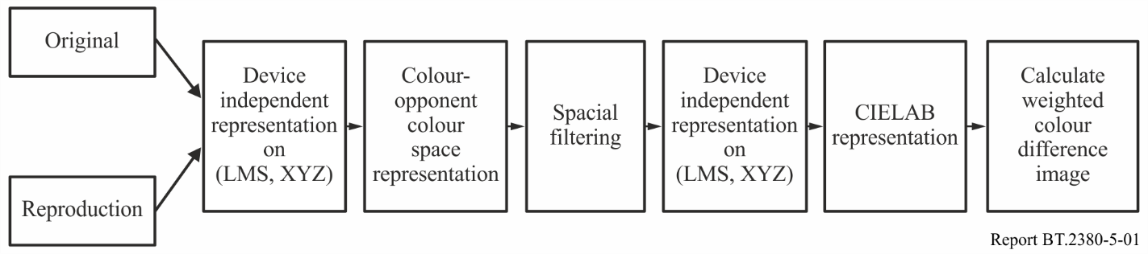

The model takes two images as an input. The first stage in the calculation is to transform the images into colour-opponent colour space *AC1C2*, representing an achromatic, a red-green and a blue‑yellow channels:



The spatial filters that approximate human CSFs are used to eliminate the information that is imperceptible to the visual system and normalize colour differences at spatial frequencies that are visible. The traditional S-CIELAB model uses two-dimensional separable convolution kernels. These kernels are unit sum kernels, in the form of a series of Gaussian functions. The unit sum was designed such that for large uniform areas S-CIELAB predictions are identical to the corresponding CIELAB predictions. The spatial form of the convolution kernels are the following:



The parameters *k* and *ki* normalize the filters such that they sum to one, thus preserving the mean colour value for uniform areas. The parameters wi and  represent the weight and the spread (in degrees of visual angle) of the Gaussian functions, respectively.

The separable nature of the kernels allows for the use of two relatively simple 1-D convolutions of the colour planes, rather than a more complex 2-D convolution.

If computationally feasible it might be desirable to perform the spatial filtering in the frequency domain, rather than the spatial domain. The characteristics of luminance and chrominance filters are the following:

TABLE 5.1

Weight and spread of Gaussian convolution kernel

|  |  |  |
| --- | --- | --- |
| Filter | Weight (*wi*) | Spread () |
| Achromatic (i=1) | 1.00327 | 0.0500 |
| Achromatic (i=2) | 0.11442 | 0.2250 |
| Achromatic (i=3) | −0.11769 | 7.0000 |
| Red-Green (i=1) | 0.61673 | 0.0685 |
| Red-Green (i=2) | 0.38328 | 0.8260 |
| Blue-Yellow (i=1) | 0.56789 | 0.0920 |
| Blue-Yellow (i=2) | 0.43212 | 0.6451 |



The parameters, *a*, *b*, and *c* can be fit to existing experimental data, if available. Alternatively values of 75, 0.2, and 0.8 for a, b, and c respectively fit reasonably well with the S-CIELAB filters.

TABLE 5.2

Parameters for chrominance CSFs

|  |  |  |
| --- | --- | --- |
| Parameter | Red-Green | Blue-Yellow |
| a1 | 109.1413 | 7.0328 |
| b1 | –0.0004 | 0.0000 |
| c1 | 3.4244 | 4.2582 |
| a2 | 93.5971 | 40.6910 |
| b2 | –0.0037 | –0.1039 |
| c2 | 2.1677 | 1.6487 |

The filtered opponent channels are then transformed back into CIE *XYZ* space as shown below:



The filtered *XYZ* pixel values for both the original and the test image are then transformed into the CIELAB space and the colour differences are determined on pixel-by-pixel basis by using colour difference formulae.

CHAPTER 6

Colour gamuts transmitted and reproduced  
by television and related systems

In this section, the evaluations of colour gamuts for SDTV, HDTV and UHDTV systems in colour spaces of XYZ and of CAM02-UCS with consideration of TV system parameters and image luminance levels are presented. CAM02-UCS is currently not used in practice in television. However, the presentation of colour gamut in uniform CAM02-UCS space provides possibility to evaluate the effect of variation of viewing conditions on colour gamut.

Presented evaluations are related to possible principles of realization extended colour gamut in accordance with Table 5 of ITU-R Report ITU-R BT.2246 [6.1] are made. More detailed information is presented in [6.12-6.14].

## 6.1 Conventional colour gamut and extended colour primaries triangle television systems

The range of the colours reproduced by conventional colour gamut SDTV and HDTV systems [6.2‑6.5] and by extended triangle UHDTV systems [6.6] are defined by the range of primaries signals variation limited by zero and unit values:



 colour gamut boundaries on  plane are presented here for systems with primaries specified in Recommendations ITU-R BT.601-7 [6.2] (SDTV), ITU-R BT.709-6 [6.3], ITU-R BT.1543-1 [6.4] and ITU-R BT.1847-1 [6.5] (HDTV) and in Recommendation ITU-R BT.2020-1 [6.6] (UHDTV).

Transferred colour gamut area in XYZ space and CAM02-UCS space for  and  is presented on Figs 6.1 to 6.6, from which it is seen, that for colorimetric parameters, specified for UHDTV system, for all luminance levels relative transferred colours area is considerably larger than SDTV and HDTV systems. It can be seen to what degree colour gamut evaluated in uniform (perceptual) colour space depends on the relative luminance *Y* of image detail*.*

|  |  |
| --- | --- |
| Figure 6.1  Colour gamuts of SDTV, HDTV and UHDTV systems for in XYZ space | Figure 6.2  Colour gamuts of SDTV, HDTV and UHDTV systems for  in CAM02-UCS space |
|  |  |

|  |  |
| --- | --- |
| Figure 6.3  Colour gamuts of SDTV, HDTV and UHDTV systems for in XYZ space | Figure 6.4  Colour gamuts of SDTV, HDTV and UHDTV systems for  in CAM02-UCS space |
|  |  |

|  |  |
| --- | --- |
| Figure 6.5  Colour gamuts of SDTV, HDTV and UHDTV systems for in XYZ space | Figure 6.6  Colour gamuts of SDTV, HDTV and UHDTV systems for  in CAM02-UCS space |
|  |  |

## 6.2 Digital cinema and LSDI applications

Evaluations of colour gamut transmitted by digital cinema (DC) systems and LSDI systems in  space with consideration of image viewing conditions

Figure 6.7 shows primaries as specified in SMPTE ST 2048-1 [6.7] with chromaticity coordinates presented in the Table 2.6 of Chapter 2. The points of the B and G primaries of the triangle are placed outside the chromaticity diagram, the point of primary R is selected so that it matches the chromaticity diagram boundary point of monochromatic red. So, the area of a primaries triangle exceeds the area of the triangle of UHDTV. Figure 6.7 also shows the projections of area boundaries of transmitted colours on CIE-31 tristimulus values plane. It is seen that for relative brightness of scene details less than 0.25, the major portion of chromaticity diagram area is transmitted.

|  |  |
| --- | --- |
| Figure 6.7  Colour gamut boundaries of DC system on the CIE‑31 chromaticity diagram plane | Figure 6.8  Colour gamut boundaries of DC system for  on the plane of |
|  |  |

Figure 6.8 presents projections of the transmitted colours area for DC system on the plane of chroma Cartesian coordinates  of  uniform colour space. The projections are presented for the relative luminance levels of 0.05, 0.25, 0.5, 0.7, 0.9 and luminance level on white of 250 cd/m2, which corresponds to the luminance of the adaptation of observer’s visual system respectively equal to 50 cd/m2.

Figure 6.9 shows primaries triangle of ACES system specified in SMPTE ST 2065-1 [6.8]. The R,G,B primaries of the ACES triangle are placed outside the chromaticity diagram. So all the chromaticity diagram is inside the triangle, and area of ACES triangle is more than area of triangles of DC- system. Figure 6.10 shows the projections of area of transmitted in ACES system chromaticities on CAM02-UCS chromaticity coordinates plane.

|  |  |
| --- | --- |
| Figure 6.9  Colour gamut boundaries for ACES system on the CIE-31 chromaticity diagram plane | Figure 6.10  Colour gamut boundaries of ACES system for  on the plane of |
|  |  |

Extended colour gamut video applications

Systems for extended colour gamut video applications such as RIMM-ROMM Eastman Kodak and Adobe are described in references [6.9] to [6.11], they have primarily been used outside the broadcasting industry.

Bibliography for Chapter 6

[6.1] Report ITU-R BT.2246-0 (2012) – The present state of ultra-high definition television

[6.2] Recommendation ITU-R BT.601**-7 (2011)** – Studio encoding parameters of digital television for standard 4:3 and wide screen 16:9 aspect ratios

[6.3] Recommendation ITU-R BT.709-5 (2002) – Parameter values for the HDTV standards for production and international programme exchange

[6.4] Recommendation ITU-R BT.1543-1 (2015) – 1 280 × 720, 16:9 progressively-captured image format for production and international programme exchange in the 60 Hz environment

[6.5] Recommendation ITU-R BT.1847-1 (2015) – 1 280 × 720, 16:9 progressively-captured image format for production and international programme exchange in the 50 Hz environment

[6.6] Recommendation ITU-R BT.2020-2 (2015) – **Parameter values for ultra-high definition television systems for production and international programme exchange**

[6.7] SMPTE ST 2048-1:2011 *2048×1080 and 4096×2160 Digital Cinematography Production Image Formats FS/709*

[6.8] SMPTE ST 2065-1:2012 *Academy Color Encoding Specification (ACES)*

[6.9] K. E. Spaulding, G. J. Woolfe, and E. J. Giorgianni*, Reference input/output medium metric RGB color encodings (RIMM/ROMM RGB)*, PICS 2000 Conf., Portland, OR, March 26–29 (2000)

[6.10] K. E. Spaulding, B. Pridham, and E. J. Giorgianni, *Definition of standard reference output medium RGB color space (ROM RGB) for best practice tone/color processing*, Kodak Imaging Science Best Practice Document

[6.11] *Adobe Photoshop* ® *5.0*, Adobe Systems Inc., San Jose, CA

[6.12] Gofaizen O.V., Pilyavskiy V.V. *Digital television systems colour gamut* / Digital technologies, 2012, No 11, P. 47-70

[6.13] Gofaizen O.V., Pilyavskiy V.V. *Colorimetric characteristics of new video applications: Digital cinema and digital television systems matching* / Digital technologies, 2012, No 1, – P. 85-99

[6.14] [Gofaizen O.V.](http://www.irbis-nbuv.gov.ua/cgi-bin/irbis_nbuv/cgiirbis_64.exe?Z21ID=&I21DBN=UJRN&P21DBN=UJRN&S21STN=1&S21REF=10&S21FMT=fullwebr&C21COM=S&S21CNR=20&S21P01=0&S21P02=0&S21P03=A=&S21COLORTERMS=1&S21STR=Gofaizen%20O$), Pilyavskiy V.V *Matching of some color spaces for use in different industries and spaces of color television systems* [/ Proceedings of ONAT](http://www.irbis-nbuv.gov.ua/cgi-bin/irbis_nbuv/cgiirbis_64.exe?Z21ID=&I21DBN=UJRN&P21DBN=UJRN&S21STN=1&S21REF=10&S21FMT=JUU_all&C21COM=S&S21CNR=20&S21P01=0&S21P02=0&S21P03=IJ=&S21COLORTERMS=1&S21STR=%D0%9670260) n.a. A.S. Popov. – 2013. – No 2. – P. 33‑40

CHAPTER 7

Possible criteria of colour reproduction  
quality evaluation

## 7.1 Approaches to evaluation

The evaluation of quality of colour reproduction should be based on:

– the model of the system, for which the evaluation is carried out, and colorimetrical transformations in it;

– viewing conditions of the original scene and displayed image;

– the criteria and procedure of evaluation, including interpretation of results.

In [7.1] six approaches have been formulated for the evaluation of colour reproduction quality.

Spectral colour reproduction

Concerning imaging systems, this approach implies equality of relative spectral power distributions of radiation entering the image capture device and radiation created by display device.

Colorimetric colour reproduction

The purpose of this approach is to achieve equality of chromaticity coordinates and relative luminances of the compared stimuli under the same viewing conditions. Thus, the subjective identity of metameric colour stimuli, i.e. stimuli which that have different spectral power distribution of radiation and the same tristimulus values, is taken into account.

Exact colour reproduction

Such approach requires equality of chromaticity coordinates, relative and absolute luminances of stimuli, being compared, and the radiations of sources of illumination and other parameters affecting the state of adaptation of the visual analyser. Such an approach is never in the real imaging systems, as usually the conditions under which the system operates imply differences of observing conditions at transmitting and receiving ends.

Equivalent colour reproduction

The goal is to achieve equality of chromaticities as well as absolute and relative luminances of colours of the original scene and the reproduced image being viewed under different conditions.

Corresponding colour reproduction

Reproduction, in which chromaticities and relative luminances of colours are such that when seen in the picture-viewing conditions, they have the same appearance as the colours in the original scene would have had if they had been illuminated to produce the same average absolute luminance level as that of the reproduction.

Preferable colour reproduction

The purpose of such an approach is not achievement of strict equality of colour perception of display and standard images, but reproduction of colours in such a way that the colours of the estimated image were more pleasant for an observer than colours of original scene. Reproduction of such ‘memory’ colours has a substantial influence on judgments about reproduced image; however, it cannot be used as independent criterion.

The quality of colour reproduction of large colour image details is most critical, as discriminability of colours increases with the increase of sizes of image details.

Colour, size, form and orientation of details, and also the adapting and masking properties of background and surround, influences the evaluation of quality of colour reproduction of medium and small image details.

## 7.2 Evaluation criteria of colour reproduction quality

Evaluation of separate colour reproduction quality

For judgments on quality of all image colour reproduction it is desirable to have the assessments of each colour change. For evaluating the quality of specific colour reproduction, large enough uniformly coloured areas of image can be used that allow local effects to be ignored, also the influence of contrast-sensitivity characteristics, descriptions, aureole effects and etc. The distance between the points of colours of original and reproduced image in colour space can serve as the criterion.

Quality evaluation of the reproduction of all varieties of colours

For practical applications, the quality evaluation of integral reproduction of all varieties of colours can be useful. Such evaluations can be made for the range of colours uniformly filling colour space. The root-mean-square, mean absolute, or maximum distance between the points of compared colours in colour space, can serve as a criterion of quality of colour reproduction.

Evaluation of quality of natural scene colour reproduction

Evaluation of the quality of natural scene colour reproduction is complicated due to the problem of choice of test materials. For this purpose, images/sequences sets can be used containing images of natural objects with large areas with a few colours, for which the evaluation of colour can be made.

Evaluation of colour reproduction quality in systems with object-oriented presentation of images

In the case of object-based scene presentation, metadata should desirably carry parameter values related to the specific object capturing, processing, transmission, etc. used. Use of object-based presentation of video information implies the possibility of differences in the conditions of capturing, production and processing of separate objects, and in the process of programme production, or some other video processing in the TV light-to-light chain. The possibility of separate object information matching should be provided by metadata, and this information should be brought to the common viewing conditions at the transmission and/or on receiving ends, and this information may be used in the process of image quality evaluation separately for different objects.

Colour reproduction is one of the colour image quality components that can substantially depend on a great number of factors, including characteristics of capture, reproduction, coding, processing, transmission and storage of video information. Thus, the basic method of quality evaluation is subjective evaluation or objective evaluation with the use of devices based on the results of experimental and theoretical research on defining the relation between subjective quality assessments by average observer in the standard viewing conditions and the objective evaluation criteria.

Colour reproduction quality, as a part of general image quality evaluation can be substantially affected by other types of distortions. In this case it can be, in a certain measure, be enhanced by using more perfect models of colour vision for ‘qualimeters’.

Such evaluation is useful to the solving many practical tasks, as it gives an objective judgment of image distortions, and the treatment by observers of concrete types of distortions taking into account their specificity.

As a criterion of colour reproduction quality evaluation, the assessments obtained for test-materials suitably chosen from a colour distortion point of view can be used.

Methods of image quality evaluation for television and multimedia applications are defined in ITU Recommendations [7.2–7.14] and IEC Standards [7.15–7.17].

## 7.3 Test materials which may be used for the evaluation of colorimetric quality of reproduced images

Recommendation ITU-R BT.1210 [7.5] – Test materials to be used in assessment of image quality, states that the evaluation of image quality can be made with test materials listed in the Report ITU-R BT.2245 [7.19]. The Report contains a list of materials, which include still images and sequences of moving images, designed for quality assessment of HDTV systems. Among these pictures, in particular, there are images with the following attributes:

– colour reproduction;

– gray scale reproduction;

– skin colour;

– contrast.

These images may be considered suitable to evaluate image colorimetric quality.

## 7.4 Optimization of colour reproduction quality for natural objects

In [7.18] the optimization model of natural image colour reproduction quality based on preferable colour reproduction approach is described. It is proposed to evaluate image quality by quality index, defined by naturalness and colourfulness indices. The naturalness index is estimated locally within the three typical of memory colours segments: “skin”, “sky” and “grass” on CIELUV chromaticity diagram.

## 7.5 Possible approach to evaluation of colour rendering fidelity of the through light-to-light digital television system video path

Colour rendering fidelity is an important image quality component in TV systems of different levels and is a part of studies in the field of development TV systems and their performance evaluation.

In Annex G the approach to the evaluation of colour rendering fidelity in television systems and in the related applications, depending on the spectral characteristics, is used. Evaluation of colour distortion in the form of colour points shifts in uniform colour space CAM02-UCS, based on the implementation of colour appearance model CIECAM02, adopted by the CIE as the most perfect model in the coming years, is provided. The evaluation of the real cameras colour rendering fidelity for Color Checker set is done, and it is shown that the “standard” SDTV camera with linear matrix compared to the ideal camera provides practically undistorted colour reproduction.

Bibliography for Chapter 7

[7.1] Robert Hunt *The Reproduction of Colour* – John Wiley and Sons Ltd, 2004

[7.2] Recommendation ITU-R BT.500-13 (2012) – Methodology for the subjective assessment of the quality of television pictures

[7.3] Recommendation ITU-R BT.710-4 (1998) – Subjective assessment methods for image quality in high-definition television

[7.4] Recommendation ITU-R BT.1129-2 (1998) – Subjective assessment of standard definition digital television (SDTV) systems

[7.5] Recommendation ITU-R BT.1210-4 (2012) – Test materials to be used in assessment of picture quality

[7.6] Recommendation ITU-R BT.1663-0 (2003) – Expert viewing methods to assess the quality of systems for the digital display of large screen digital imagery in theatres

[7.7] Recommendation ITU-R BT.1683-0 (2004) – Objective perceptual video quality measurement techniques for standard definition digital broadcast television in the presence of a full reference

[7.8] Recommendation ITU-R BT.1721-0 (2005) – Objective measurement of perceptual image quality of large screen digital imagery applications for theatrical presentation

[7.9] Recommendation ITU-R BT.2022-0 (2012) – General viewing conditions for subjective assessment of quality of SDTV and HDTV television pictures on flat panel displays

[7.10] Recommendation ITU-R BT.2035-0 (2013) – A reference viewing environment for evaluation of HDTV program material or completed programmes

[7.11] Recommendation ITU-T P.910 (2008) – Subjective video quality assessment methods for multimedia applications

[7.12] Recommendation ITU-T P.911 (1998) – Subjective audiovisual quality assessment methods for multimedia applications

[7.13] Recommendation ITU-T J.140 (1998) – Subjective picture quality assessment for digital cable television systems

[7.14] Recommendation ITU-T J.144 (2004) – Objective perceptual video quality measurement techniques for digital cable television in the presence of a full reference

[7.15] IEC 61966-3:2000 – Multimedia systems and equipment – Colour management and colour measurement. Part 3: Equipment using cathode ray tubes

[7.16] IEC 61966-4:2000 – Multimedia systems and equipment – Colour management and colour measurement. Part 4: Equipment using liquid crystal flat panels

[7.17] IEC 61966-5:2008 – Multimedia systems and equipment – Colour management and colour measurement. Part 5: Equipment using plasma display panels

[7.18] *Optimizing colour reproduction of natural images,* S.N. Yendrikhovskij, F.J.J. Blommaert, H. de Ridder, Proceedings of Sixth Colour Imaging Conference: “Colour Science, Systems and Applications”, 1998, pp. 140–145

[7.19] Report ITU-R BT.2245-1 (2014) *–* HDTV and UHDTV test materials for assessment of picture quality

CHAPTER 8

The influence of observing conditions on colour  
reproduction quality assessment

A difference between scene capturing and image displaying conditions is normal for television and related applications. The influence of image viewing conditions at the receiving end becomes apparent as the change of adaptation of the observer’s vision depending on luminance, colour, spatio-temporal and other surround factors, resulting in the potential for distortions of the perceived image colours.

In particular, the illumination conditions of the image display influence perceived image quality greatly due to the screen flare. The flare lowers perceived contrast as it increases the black level. The perceived image colours are also distorted due to the adapting white point shift. There are many works [8.1‒8.7] devoted to the influence of illumination on image quality. The CIE Committee TC8-04 “Adaptation under mixed illumination conditions” (<http://www.colour.org/tc8-04/>) deals with this problem, but research work of this committee is directed mainly on cross-media colour matching (particularly softcopy vs. hardcopy colour matching) [8.8, 8.9]. As for TV field, a method of evaluation of mixed adaptation [8.2], which allows the evaluation of the influence of daylight and interior illumination on displayed colour, can be of interest for television and related applications. A summary of this method is presented below.

The algorithm uses two basic transforms: CIECAM02-based adaptation model (equations (8.1) to (8.5)) and, strictly speaking, accounting for mixed adaptation (equations (8.6) and (8.7)).

The adaptation transform consists of the following steps:

, (8.1)

where:

; ;

 – absolute value of adapting luminance, cd/m2. If the value of adapting luminance is unknown, it is supposed to be equal to 20 % adapting white luminance;  – is the factor for evaluation of degree of observer’s adaptation to different surrounds, which equals to 1.0, 0.9 and 0.8 for average, dim and dark surround respectively.

 (8.3)

 (8.4)

 (8.5)

Mixed adaptation is evaluated as follows:

 (8.6)

where  are the cone responses of the evaluated colour when watching display in dark room, ‒ factor of mixed adaptation:

. (8.7)

The algorithm consists of the following steps:

1) Transformation from daylight condition  to interior condition  using equations (8.1) to (8.5)

2) Transformation from interior condition  to mixed adaptation conditions, using equations (8.1) to (8.5) with substitution  in equation (8.5) by  (equation (8.6)).

The results of experiments [8.2] have shown that, as the adapting luminance goes lower, the correlated colour temperature (CCT) of the adapting white approaches the display’s white point. On the contrary, when the adapting luminance increases, the CCT of the adapting white approaches the ambient light’s white point. The method considered above allows relatively exact evaluation of changes of colours under mixed adaptation conditions, and the adjustment of display settings suitable to various viewing conditions.

Bibliography for Chapter 8

[8.1] *Applying Mixed Adaptation to Various Chromatic Adaptation Transformation (CAT_ Models),* Naoya Katoh, Kiyotaka Nakabayashi, Proceedings of the Image Processing, Image Quality, Image Capture Systems Conference (PICS-01)

[8.2] *A Chromatic Adaptation Model for Mixed Adaptation Conditions,* Jin-Keun Seok, Sung-Hak Lee, In-Ho Song, Kyu-Ik Sohng, Proceedings of IPCV 2008, July 14–17

[8.3] *Effect of ambient light source for the appearance of colour image on CRT monitor*, Yong-Gi Kim, Jeong-Yeop Kim, Eui-Yoon Chunga, Yeong-Ho Ha, Proceedings of SPIE, 2001, vol. 4300

[8.4] *Effect of ambient light on colour appearance of soft copy images,* Naoya Katoh, Kiyotaka Nakabayashi, J. Electronic Imaging 7(04)

[8.5] *A bilinear model of the illuminant's effect on colour appearance in Computational Models of Visual Processing,* Brainard, D.H. and Wandell, B.A., MIT Press, 1991

[8.6] *Establishment of Display White Point Considering Adaptative Neutral Point for the Various Viewing Conditions,* Hyun-Sik Choi, Myoung-Hwa Lee, Sung-Hak Lee, Soo-Wook Jang, Eun-Su Kim, Kyu-Ik Sohng, Proceedings of IPCV 2006

[8.7] *A Perception-based Colour Space for Illumination-invariant Image Processing*– Hamilton Chong, Steven Gortler and Todd Zickler, Proceedings of ACM SIGGRAPH 2008

[8.8] *CIE TC-08 Progress Report* (Nov. 10, 2004), http://www.color.org/tc8-04/Reports/FINAL report.ppt

[8.9] *Correction to CIE TC-08 Progress Report* (July, 2004) http://www.color.org/tc8-04/ CIE162_Corr1_DRAFT1.pdf

CHAPTER 9

Possible future of TV colorimetry

The Metrics of the CAM02-UCS system, which is an addition to CIECAM02 system, depends on the human perception of the adapting luminance  and  for viewing colour objects of the transmitted scene and image of these objects, as well as on the viewing conditions  and, on the shooting side and on the reproduction side, which can vary in a wide range independently. So, in this metrics undistorted colour rendering may be formulated as such:



This means that it is possible to approach undistorted colour rendering only in systems adaptive to viewing conditions, the main principles of which are specified in Recommendations ITU-R BT.1691 [9.1] and ITU-R BT.1692 [9.2].

In the current chapter, possible principles and examples of construction of adaptive TV and related systems on the base of modern colorimetry are considered for any broadcast and related video applications, in particular for mobile television applications.

Concerning multimedia applications, a standard colour space that can serve as the base for the construction of device-independent applications are defined in the standards IEC 61966-2-1 [9.3] and IEC 61966-2-4 [9.4].

The requirements for adaptive systems for television and related applications are formulated in Recommendations ITU-R BT.1691 and BT.1692. The main idea, problem and examples of implementation of adaptive video applications are presented in Annex C.

As it was previously stated, the viewing conditions greatly influence the perception of reproduced images by display colours. This influence impacts displayed image quality for mobile and portable applications due to the smaller screen sizes and possible quick changes of luminance and colour parameters of the viewing environment (for example when changing from indoor to outdoor). During such substantial changes of brightness, colourfulness and hue of reproduced colours significant changes in perceptual colour gamut can appear. Traditional methods of colorimetry and qualimetry are not applicable under such conditions. Some examples of the implementation of adaptive TV technologies in mobile and portable applications are presented in Annex D.

Bibliography for Chapter 9

[9.1] Recommendation ITU-R BT.1691-1 (2009) – Adaptive image quality control in digital television systems

[9.2] Recommendation ITU-R BT.1692-1 (2009) – Optimization of the quality of colour reproduction in digital television

[9.3] IEC 61966-2-1:1999 – Multimedia systems and equipment – Colour measurement and management – Part 2-1: Colour management – Default RGB colour space – sRGB

[9.4] IEC 61966-2-4:2006 – Multimedia systems and equipment – Colour management and colour measurement. Part 2-4: Colour management – Extended-gamut YCC colour space for video applications – xvYCC

CHAPTER 10

The tasks for further studies

Further progress of television colorimetry could be based on more complete implementation of modern colour appearance models and more general human colour vision models.

TV Colorimetry could be developed in the direction of more complete account of the viewing conditions of images on television screens taking into account spatial, temporal and colorimetric characteristics.

In particular, the principal question is how the image viewing environment at the transmission and receiving ends, can be modelled.

As for the adaptive systems, further studies are required, directed on one hand, at the realization of models for adaptive systems and, on the other hand, on the creation of the implementable algorithms of their construction.

Commercial considerations will most likely determine the direction that future TV systems will adopt.

Annex A  
(relevant to Chapter 3)  
New colour appearance models

## A.1 CIECAM02 model

The Following equations which describe CIECAM02 transformations are based on CIE 159 Report [A.1].

Forward conversion equations

Input data:

 – CIE 1931 tristimulus values of the sample;

 – CIE 1931 tristimulus values for reference white;

,  – surround white luminance;

,  – reproduced image white luminance;

,  – adapting luminance;

if data on adapting luminance are not available it is recommended be taken to be equal to  – surround impact factor,  – chromatic induction factor,  – factor for degree of adaptation,  – relative luminance of the background. If the value of this parameter is unavailable it can be adopted to be equal to 

If data on,  and  are unavailable they can be chosen as follows.

Viewing conditions and related appropriate parameters of the model

|  |  |  |  |
| --- | --- | --- | --- |
| **Viewing condition** |  |  |  |
| Average surround | 0.69 | 1.0 | 1.0 |
| Dim surround | 0.59 | 0.9 | 0.9 |
| Dark surround | 0.525 | 0.8 | 0.8 |

Surround type may be defined via such a relationship as: . The value  corresponds to dark surround,  to dim one and  to average one.

The cone responses are:

 (A.1)

where

 (A.2)

The degree of viewer’s adaptation:

 (A.3)

The adaptation transform is:

 (A.4)



The transformation to Hunt-Pointer-Estevez cone responses is conducted as follows:

 (A.5)

where:



The nonlinear response compression transform is:

 (A.6)

If any of values of  are negative, then their absolute values are used and then the corresponding quotient term in Equations (A.6) must be multiplied by a negative 1 before adding the value 0.1.

Opponent axes:

 (A.7)

Hue angle:

 (A.8)

 (A.9)

Eccentricity factor:

 (A.10)

Colour quadrature  may be obtained via linear interpolation method:

 (A.11)

using the values of unique hues shown in Table below. Here  if, and  else wise.

Unique hue data for the calculation of hue quadrature

|  |  |  |  |  |  |
| --- | --- | --- | --- | --- | --- |
|  | **Red** | **Yellow** | **Green** | **Blue** | **Red** |
|  | 1 | 2 | 3 | 4 | 5 |
|  | 20.14 | 90.00 | 164.25 | 237.53 | 380.14 |
|  | 0.8 | 0.7 | 1.0 | 1.2 | 0.8 |
|  | 0.0 | 100.0 | 200.0 | 300.0 | 400.0 |

The achromatic response is:

 (A.12)

The lightness is:

 (A.13)

The brightness is:

 (A.14)

The chroma is:

 (A.15)

where:



The colorfulness is:

 (A.16)

The saturation is:

. (A.17)

CIECAM02 includes three attributes in relation to the chromatic content: chroma (*C*), colourfulness (*M*) and saturation (*s*). These attributes together with lightness (*J*) and hue angle (*h*) can form three colour spaces , where:

|  |  |  |
| --- | --- | --- |
|  |  |  |
|  |  |  |

## A.2 Modification of CIECAM02 by Luo et al.

All the colorimetric assessments based on CIECAM02 are usually expressed in  or  spaces. As it was shown [A.2], usage of  ‒ space gives more accurate predictions of colour appearance. The following modifications of this space for large (CAM02-LCD), small (CAM02-SCD) and both small and large (CAM02-UCS) colour differences were proposed:

 (A.18)

 (A.19)

The coefficients for each version of UCS based upon CIECAM02 are the following:

|  |  |  |  |
| --- | --- | --- | --- |
| Version of space | CAM02-LCD | CAM02-SCD | CAM02-UCS |
|  | 0.77 | 1.24 | 1.00 |
|  | 0.007 | 0.007 | 0.007 |
|  | 0.0053 | 0.0363 | 0.0228 |

As follows from published results of studies [A.2], the estimations obtained with the use of these modifications show the best correlation with all available data on colour appearance and can be considered as basis for the further studies directed to the progress of television and related video applications, and to the progress of colour appearance models for their use as part of the systems of image quality evaluation, in particular, evaluation of colorimetric quality.

The results of testing published to date have shown that predictions obtained by using CIECAM02‑based colour spaces best match all available colour appearance data and can be considered to become a possible base for further research work on development of TV and related video systems, and on the development of colour appearance models for implementation as the part of image quality assessment systems, particularly colorimetric quality assessment.

CAM02-UCS () chromaticity diagram

CAM02-UCS (**) chromaticity diagram [A.3] is presented in Figs A.1 and A.2. The Figures demonstrate the dependence of colour appearance on adaptation level *LA* and relative luminance level *Y* in Luo et al. colour space.

Figure A.1

Chromaticity diagram CAM02-UCS (*a'M*, *b'M*), *YW*=100, *Y*=10

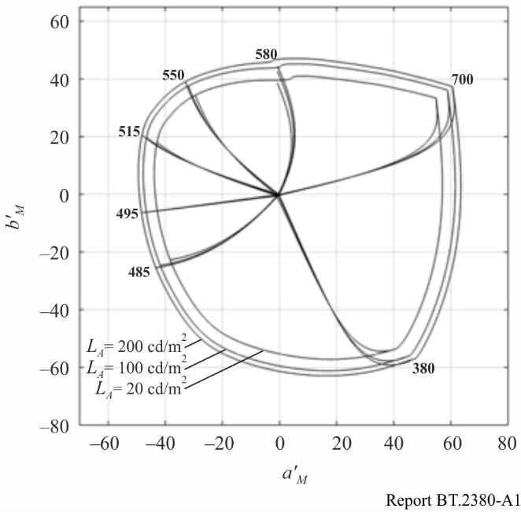

The Figures demonstrate change of colour appearance depending on the surround illumination (dark, dim, average) and adapting lightness of  for given stimulus luminance relative values Y. As follows from figures, the change of surround may substantially influence on colour appearance. This is clear from the dependence of the projection of the chromaticity diagram on the plane of coordinates **, and this influence shows up in to the largest degree at large stimulus luminance levels, and the change of both colourfulness and perceived hue  can take place.

These changes of colour appearance can be critical for video applications in that viewing conditions substantially differ on transmitting and receiving ends, which results in impairments of colour rendition.

It is possible to give more complete quantitative evaluation of possible colour appearancechanges with change of adapting luminance and surround, by an evaluation of the change of chromaticity coordinates in CAM02-UCS space as distance  between points on the plane of coordinates  for different combinations of adapting luminance  and of surround for the compared stimuli.

Figure A.2

Chromaticity diagram CAM02-UCS (*a'M*, *b'M*)  
*LA*=20 cd/m2, *YW*=100, *Y*=20

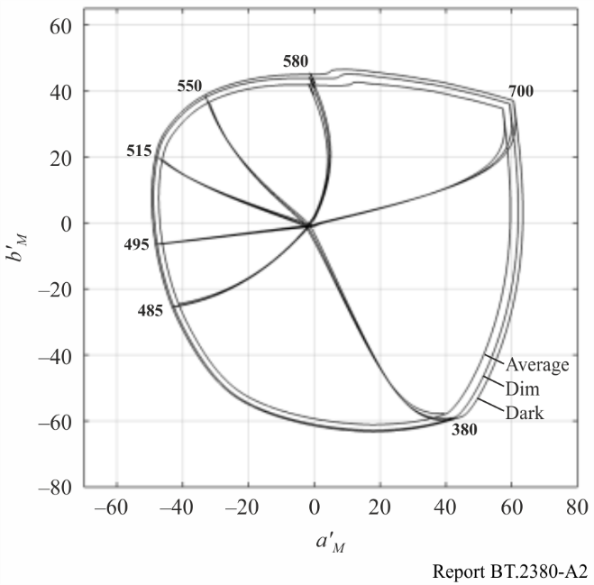

The dependence of perceived colours on  may be shown with use the criterion:



where , ,  ‒ differences of coordinates of colour space , ,  for adapting luminance levels  and .

The values of  are shown in the Table A.1. Data, presented on Table A.1 and on Fig. A.2, are comparable with this evaluation. A comparison of evaluations confirms that conditions of independently changing surround of image and adapting luminance at the transmitting side and on a receiving side can result in distortions of colour rendition from a level unnoticeable or barely noticeable to the level of unacceptable impairment of image colorimetric quality.

TABLE A.1

Values of distance  between position of points of monochromatic colours of chromaticity diagram for combined adapting luminance and surround for stimulus luminance, equal 10 cd/m2

|  |  |  |  |  |  |  |  |
| --- | --- | --- | --- | --- | --- | --- | --- |
| Conditions of viewing (adapting luminance  and surround) on capturing and reproduction ends |  | | | | | | |
| 380 | 485 | 495 | 515 | 550 | 580 | 700 |
| – average  – dim | 12.39 | 8.51 | 8.4 | 8.51 | 8.53 | 8.59 | 9.55 |
| – average  – dark | 18.16 | 13.18 | 13.01 | 13.07 | 13.02 | 13.02 | 13.89 |
| – average  – dim | 9.34 | 9.12 | 9.01 | 9.15 | 9.03 | 8.63 | 9.12 |

TABLE A.2

Correlation of distance  and colour rendition impairment

|  |  |
| --- | --- |
| , CIE units | Image impairment evaluation |
| 3 | Unnoticeable |
| 5 | Barely noticeable |
| 10 | Bad |
| 15 | Imperceptible |

Figure A.3

Occurrence of image impairment in dependence of colour deflection levels 

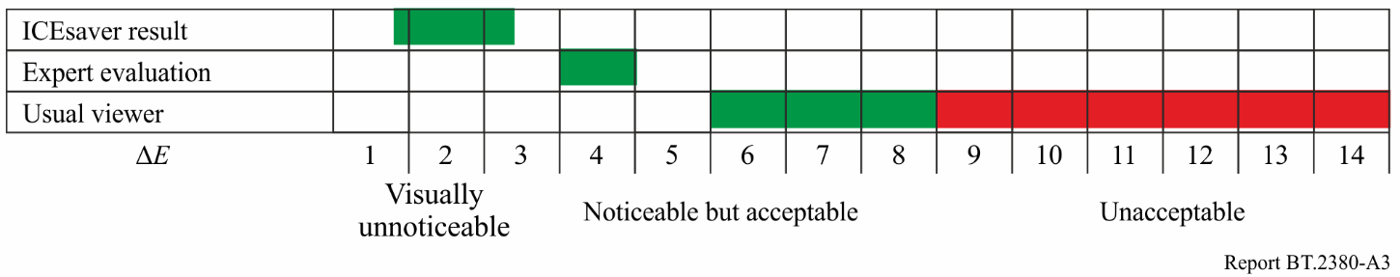

## A.3 High-Luminance Colour Appearance Model

High dynamic range imaging systems (HDR-TV) have become more widely used. Evaluation of HDR-systems colorimetry is a complex task as the existing colour appearance models are based on relatively low-luminance experimental data. For instance, the LUTCHI colour appearance data were obtained for luminances up to 690  (except the small amount of data obtained at 1 000 and 1 280 ). CIECAM02 colour appearance model specifically was developed based on this data and it is not intended to operate in very high-luminance domain. In addition, the majority of tone‑mapping operators (the transforms necessary for perceptually correct reproduction of HDR‑content on low-dynamic range displays) compress luminance range only, without dealing with the colorimetric parameters of images, thus resulting in colorimetric distortions. Thus there is a necessity to create universal colour appearance model that can be applied to high-luminance stimuli. The ref. [A.4] is devoted to one of such kind of model. As the model is still under development, and its formulation in [A.4] has some ambiguities, we give its description an introduction.

The testing of this model has shown that the accuracy of its predictions at low and average luminance levels is close to CIECAM02 (it is not surprising as this model was created based on CIECAM02 and partially on LUTCHI data); and at high luminance levels (up to 16680 ) its performance exceeds CIECAM02.

The model consists of three main components: chromatic adaptation, cone responses, and cortex responses for each perceptual colour attributes. It aims to accurately predict lightness, colourfulness and hue, including the Hunt effect, the Stevens effect, and simultaneous contrast. Additional correlates of brightness, chroma, and saturation will be derived as well.

As the focus of experiments [A.4] was not on chromatic adaptation, CIECAT02 chromatic adaptation transform [A.1] that has been shown to work well was adopted.

To evaluate cone responses tristimulus values are first transformed into LMS cone space using the Hunt-Pointer-Estévez (HPE) transform [A.1]. The cones’ absolute responses are modelled as following:

 (A.20)

where  is adaptation level value in . The adaptation level should ideally be the average luminance of the 10° viewing field. The parameter  is derived experimentally, .

The cone response then is converted into an achromatic signal A by averaging the contribution of each type of cone:

 (A.21)

The lightness is derived by:

 (A.22)

with



The values of the parameters are derived from experimental data, yielding , , , . It is interesting to note that  may yield values below zero, in which case it should be clamped. This corresponds to the case where the observer cannot distinguish dark colours from even darker colours anymore.

As the perceived lightness values vary significantly with different media, the media-dependent lightness value is expressed as:

 (A.23)

where the parameter *E* is different for each medium. A value of  corresponds to a high-luminance LCD display, transparent advertising media yield, CRT displays are**, and reflective paper is . These parameters were derived from the LUTCHI data set.

The brightness is defined as:

 (A.24)

The parameter  is derived from experimental data, .

Preliminary red-green and yellow-blue opponent dimensions are calculated using:

 (A.25)

Chroma is calculated as:

 (A.26)

where:

, .

Colourfulness is defined as:

 (A.27)

where  is reference white luminance,, .

The other remaining quantity is saturation, which by definition is the colourfulness relative to its own brightness:

 (A.28)

The hue angle is computed by:

 (A.29)

Bibliography for Annex A

[A.1] CIE Technical Report. *A colour appearance model for colour management systems: CIECAM02*. CIE 159: 2004

[A.2] M. Ronnier Luo, Guihua Cui, Changjun Li *Uniform Colour Spaces based on CIECAM02 Colour Appearance Model* – Colour Research and Application, Volume 31, Issue 4, May 2005

[A.3] Gofaizen O.V., Pilyavskiy V.V. *TV image colour appearance characteristics: Perception adaptive properties*/Digital Technologies, 2011, No. 10, Pp. 86‒105

[A.4] Min H. Kim Tim Weyrich Jan Kautz ‒ *Modelling Human Colour Perception under Extended Luminance Levels* ‒ Proceedings of ACM SIGGRAPH, 2009

Annex B  
(relevant to Chapter 5)  
Image appearance models iCAM and MOM

## B.1 iCAM

The iCAM image appearance model is a refinement of the CIECAM02 colour appearance model [B.1 – B.3]. It omits the sigmoidal compression found in CIECAM02 but adds spatially variant processing in the form of two separate Gaussian-blurred images that may be viewed as adaptation levels. Like most colour appearance models, the model can be applied in the forward direction and in the reverse direction. A flowchart of iCAM image appearance model is shown in Fig. B.1.

As input, the model requires colorimetrically characterized data for the image (or scene) and surrounding in absolute luminance units. The image is specified in terms of relative CIE *XYZ* tristimulus values. The adapting stimulus is a low-pass filtered version of the CIE *XYZ* image that is also tagged with absolute luminance information necessary to predict the degree of chromatic adaptation. The absolute luminances *Y* of the image data are also used as a second low pass image to control various luminance-dependent aspects of the model intended to predict the Hunt effect [B.4] (increase in perceived colourfulness with luminance) and the Stevens effect (increase in perceived image contrast with luminance) [B.5].

Finally, a low-pass, luminance *Y* image of significantly greater spatial extent is used to control the prediction of image contrast that is established to be a function of the relative luminance of the surrounding conditions (Bartleson and Breneman equations). The specific low-pass filters used for the adapting images depend on viewing distance and application.

The first stage of the model is to account for chromatic adaptation. The chromatic adaptation transform embedded in CIECAM02 has been adopted in iCAM since it was well researched and established to have excellent performance with all available visual data.



The amount of adaption is determined by parameter *D*. The *D*-factor can set manually in a range from 0 (no adaptation) to 1 (complete adaptation) or evaluated depending on adapting luminance as expressed below:



The adapting white point for each pixel *W(x, y)* is derived from the *XYZ* image by applying a low pass filter with a kernel a quarter the size of the image. This may be applied to each colour channel independently for chromatic adaptation, or on the *Y* channel only for achromatic adaptation. This low-pass filtered image is then also converted with the *MCAT02* matrix.

Finally, the D65 white point (95.05, 100.0, 108.88) is also converted to sharpened cone responses. The subsequent von Kries adaptation transform is given by the following.



This transform effectively divides the image by a filtered version of the image.

Figure B.1

Flowchart of iCAM image appearance model

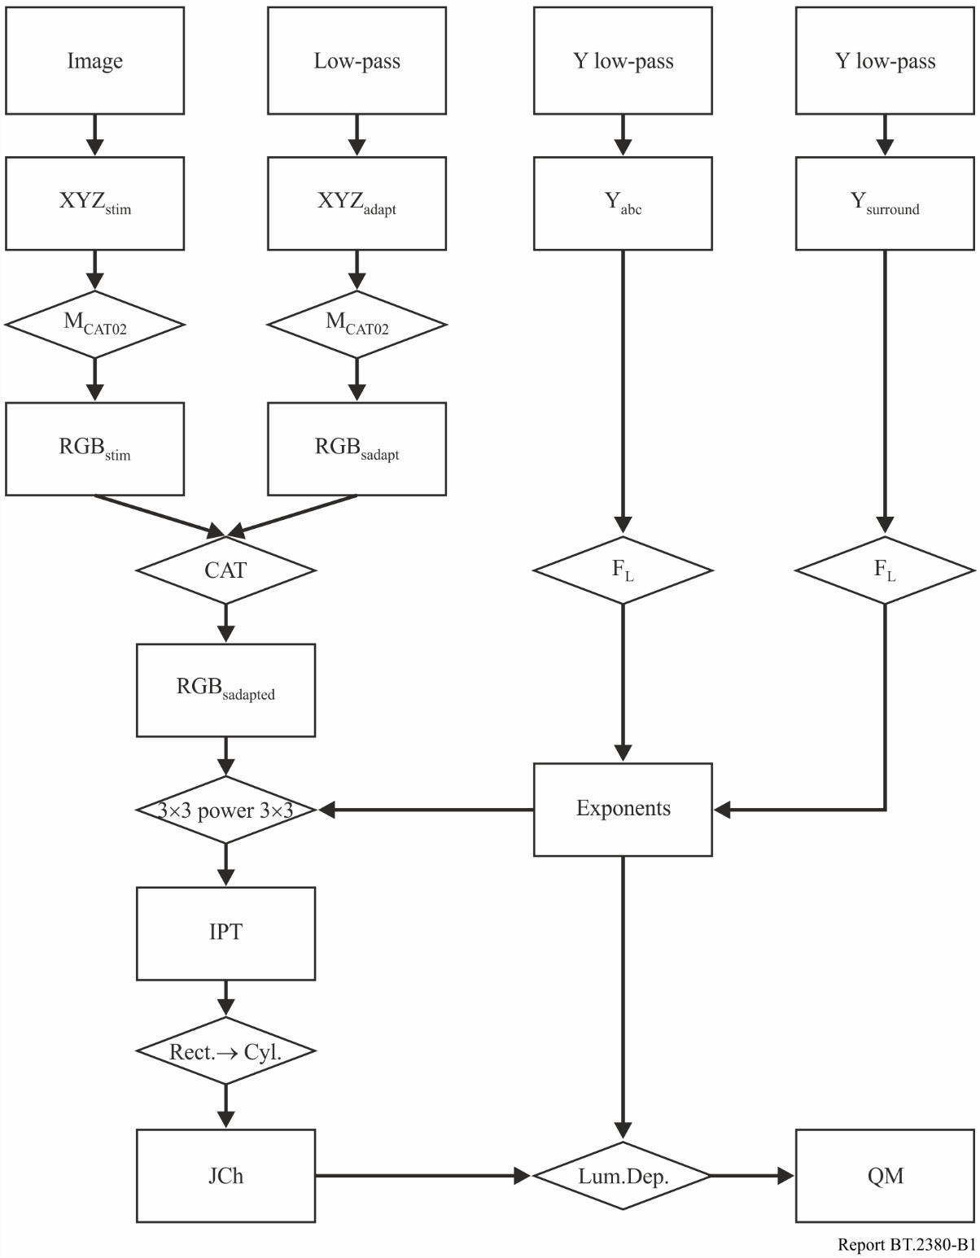

The next stage of the model is to convert from *RGB* signals to opponent-colour signals that are necessary for constructing a uniform perceptual colour space and correlates of various appearance attributes. The colour space chosen was the *IPT* space that has relatively simple formulation and specifically has a hue angle component with good prediction of constant perceived hue (important in gamut-mapping applications).

The conversion includes such steps:



The exponential function that compresses the range of luminances is given by the following.



The exponent is modified on a per-pixel basis by *FL*, which is a function of a spatially varying surround map derived from the luminance channel (*Y* channel) of the input image. The surround map *S(x, y)* is a low-pass filtered version of this channel with a Gaussian filter kernel size of one‑third the size of the image. The function *FL* is then given by the following.



The image is then transformed into *IPT* space:



Once the *IPT* coordinates are computed for the image data, a transformation from rectangular to cylindrical coordinates is applied to obtain image-wise predictors of lightness *J*, chroma *C*, and hue angle *h:*



For image-difference and image-quality predictions, it is also necessary to apply spatial filtering to the image data. The spatial pre-processing serves to eliminate information that is imperceptible to the visual system and normalize colour differences at spatial frequencies that are visible. Since the human contrast sensitivity functions vary for luminance (band-pass with sensitivity to high frequencies) and chromatic (low-pass) information, it is appropriate to apply these filters in an opponent space. Two approaches to use iCAM framework to evaluate image difference are described below.

In image quality applications of iCAM, spatial filtering can be applied in the *IPT* space [B.3]. Since it is appropriate to apply spatial filters in a linear signal space, they are applied in a linear version of *IPT* prior to conversion into the non-linear version of *IPT* for appearance predictions (see Fig. B.2).

However, spatial filtering strongly "blurs" the elements of the image, which is undesirable in cases where viewers watch it closer than the recommended viewing distance.

Example contrast sensitivity functions, used to define spatial filters for image difference computations are given below for the luminance *I* channel and for the chrominance *P* and *T* channels.



The parameters *a*, *b*, and *c* are set to 75, 0.2, and 0.8 respectively for the luminance CSF, applied to the *I* channel. The spatial frequency *f* is defined in terms of cycles per degree of visual angle (cpd). For the red-green chromatic CSF, applied to the *P* dimension, the parameters (*a*1, *b*1, *c*1, *a*2, *b*2, *c*2) are set to (109.14, 0.00038, 3.424, 93.60, 0.00367, 2.168). For the blue–yellow chromatic CSF, applied to the *T* dimension, they are set to (7.033, 0.000004, 4.258, 40.69, 0.10391, 1.6487).

The second approach [B.1] to use iCAM framework for image difference assessment (see Fig. B.3) resembles the one used in S-CIELAB. The spatial filtering, allowing for spatial frequency adaptation, is used at the pre-processing stage. Spatial filtering is performed in an orthogonal colour space :



The CSF (Contrast Sensitivity Function) used to define spatial filters for image difference computations are given below for the luminance and chromatic channel and chromatic channels



The parameters *a*, *b*, and *c* are set to 75, 0.2, and 0.8 respectively for the luminance CSF. The spatial frequency *f* is defined in terms of cycles per degree of visual angle (cpd).

For the red-green chromatic CSF, applied to the C1 dimension, the parameters (*a1*, *b1*, *c1*, *a2*, *b2*, *c2*) are set to (91.228, 0.0003, 2.803, 74.907, 0.0038, 2.601). For the blue-yellow chromatic CSF, applied to the *C2* dimension, they are set to (5.623, 0.00001, 3.4066, 41.9363, 0.083, 1.3684).

Figure B.2

Implementation of iCAM for image difference and image quality metrics



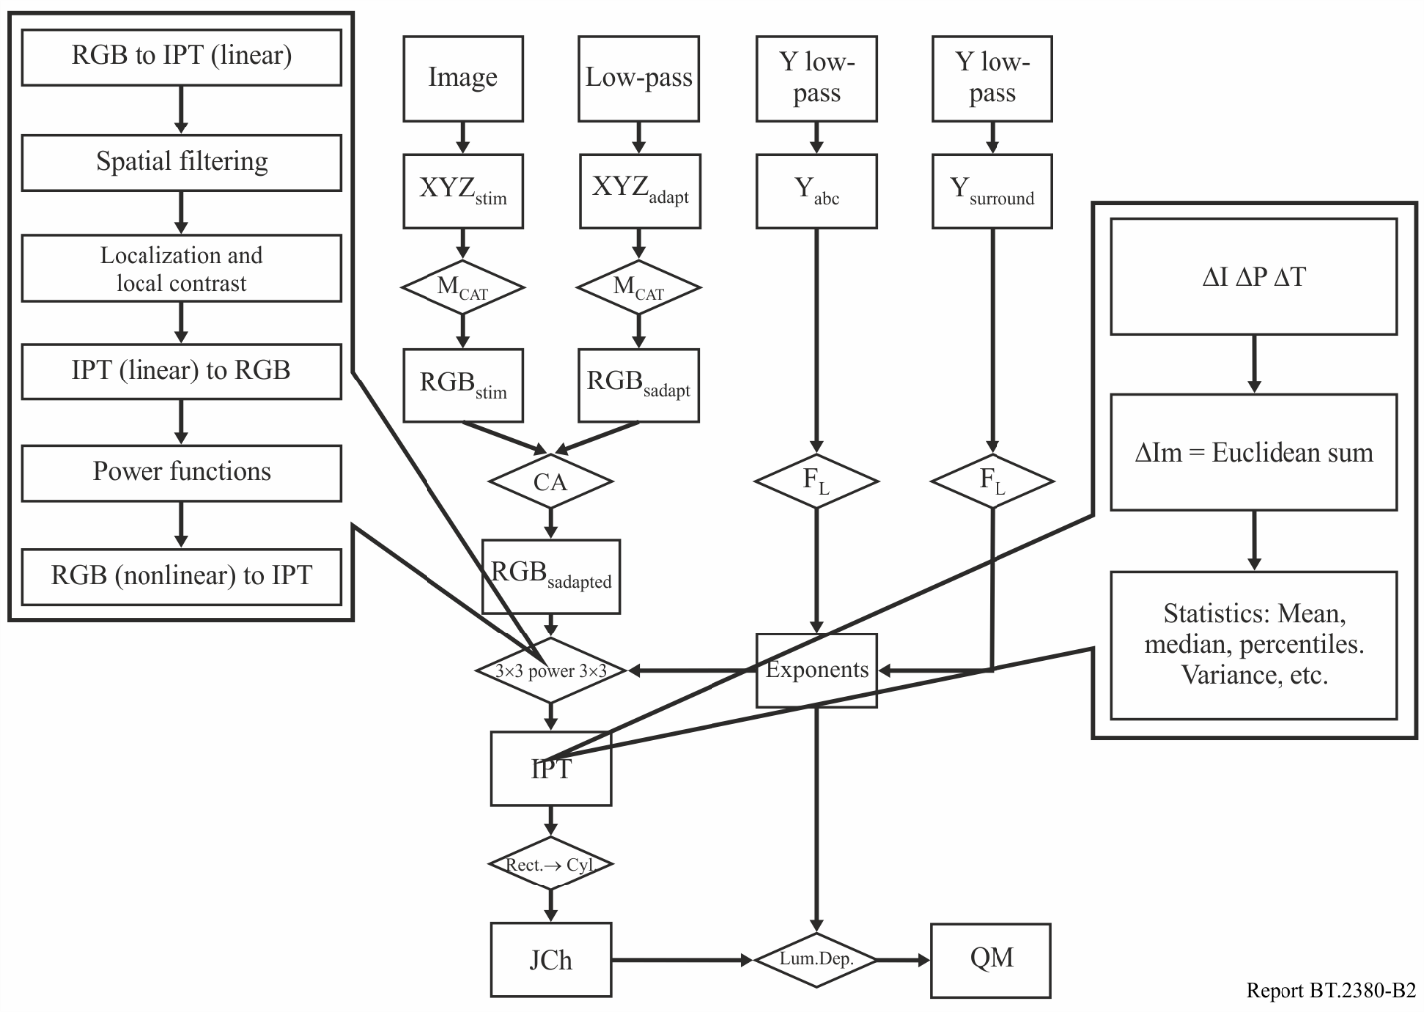

The entire filtering process, for the luminance channel, is shown below.



A spatial adaptation mechanism can be described as:

For the red–green chromatic CSF, applied to the C1 dimension, the parameters (*a1*, *b1*, *c1*, *a2*, *b2*, *c2*) are set to (91.228, 0.0003, 2.803, 74.907, 0.0038, 2.601). For the blue – yellow chromatic CSF, applied to the *C2* dimension, they are set to (5.623, 0.00001, 3.4066, 41.9363, 0.083, 1.3684).

The entire filtering process, for the luminance channel, is shown below.

figure B.3

Implementation of iCAM for image difference and image quality metrics

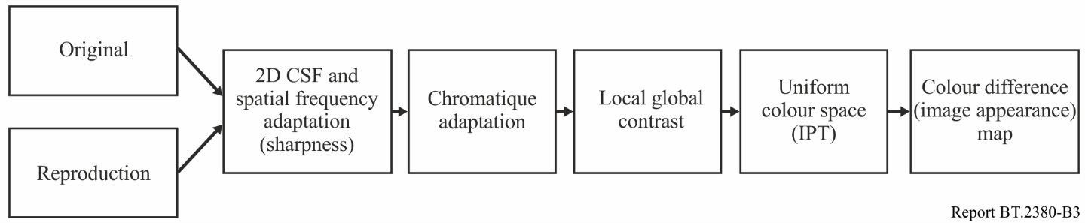

A spatial adaptation mechanism can be described as:



The scaling function, , converts the frequency representation into absolute units of contrast at each spatial frequency. The *D* factor is similar to the degree of chromatic adaptation factor found in CIECAM02. Spatial frequency adaptation is important when calculating image differences between images that may have regular periodic patterns, such as a stochastic halftone pattern, or a jpeg-compressed image that has an 8-pixel blocking pattern. The regular period of these patterns actually reduces the visual sensitivity to the pattern itself and makes it less visible. Another potential benefit of spatial frequency adaptation is the ability to predict visual masking without the need for multiscale approaches. If a masking frequency is present in an image, the CSF for that particular frequency region (depending on the extent of the blur) will become less sensitive.

To calculate appearance difference the filtered images are then processed using the general iCAM framework discussed above. This results in two pixel-by-pixel colour appearance maps. These colour appearance maps are in a uniform colour space and as such can be used to calculate perceived colour differences through simple subtraction.

Often the differences must be characterized by one number. This is done mainly on the basis of statistical data on the colour differences, such as the mean, standard deviation and higher confidence intervals (e.g. 95 %). Total  Euclidean difference in the *IPT* space is defined as:



Coefficients 100 and 150 are used to match the range of differences with a range of CIELAB.

## B.2 MOM

The Multiscale Observer Model is designed to be a complete model of spatial vision and colour appearance [B.2]. It is capable of taking into account a wide range of visual phenomena, including high-dynamic range, tone-mapping, chromatic adaptation, luminance adaptation, spreading, and crispening.

The first step in the forward model is to account for light scatter in the ocular media, followed by spectral sampling to model photoreceptor output. This yields four images representing the rods and the L, M, and S cones. These four images are then each spatially decomposed into seven-level Gaussian pyramids and subsequently converted into four six-level difference-of-Gaussian (DoG) stacks that represent band pass behaviour as seen in the human visual system. DoGs are computed by subtracting adjacent images in the pyramid.

The next step consists of a gain control system applied to each of the DoGs in each of the four channels. The shape of the gain control function resembles TVI curves such that the results of this step may be viewed as adapted contrast pyramidal images.

The cone signals are then converted into a colour opponent scheme that contains separate luminance, red-green, and yellow-blue colour channels. The rod image is retained separately.

Contrast transducer functions that model human contrast sensitivity are then applied. A colour appearance map is formed next, which is the basis for the computation of the aforementioned appearance correlates.

To obtain DoGs, the model calls for low-pass filtered copies with spatial frequencies of 0.5, 1, 2, 4, 8, and 16 cycles per degree (cpd). The model expects input to be specified in LMS cone coordinates and *R* rod coordinates. Stack of six DoG images that represent adapted contrast at six spatial scales is defined as following:



where *s* denotes the level of filtering,

 ‒ the coordinates of filtered images.

*G*– compressive function applied in all stages of the Multiscale observer model is given by the following gain control.



The low-pass image at level *s* = 7 is retained and will form the basis for image reconstruction. In the final step of the forward model, pixels in this low pass image are adapted to a linear combination of themselves and the mean value of the low-pass image, as follows:



The amount of dynamic range reduction is determined by user parameter *A* in these equations, which takes a value between 0 and 1.

To obtain the perception correlates and to prepare the image for the display, the inverse model is to be applied.

In the first step of the inverse model, the mean white point of the target display device needs to be determined. A gain control factor is determined, and the low-pass image is adapted once more, but now for the mean display white point as follows.



The stack of DoGs is then added to the adapted low-pass image one scale at a time, starting with *s*= 6 and followed by *s* = 5, 4, *. . .*, 0, as follows.



The reconstruction of a displayable image proceeds by successively adding bandpass images back to the low-pass image. These bandpass images by default receive equal weight. It may be beneficial to weight bandpass images such that higher spatial frequencies contribute more to the final result. Although the original Multiscale observer model does not feature such a weighting scheme, we have found that contrast in the final result may be improved if higher frequencies are given a larger weight. The scale factor *k* used for these images relates to the index number *s* of the bandpass pyramid in the following manner.



The constant *g* is a user parameter, which we vary between 1 and 5. A larger value for *g* produces more contrast in the tone-mapped image, but if this value is chosen too large the residual halos present in the image are emphasized.

Finally, the result is converted to XYZ and then to RGB, where gamma correction is applied.

The computational complexity of this operator remains high, and we would only recommend this model for images with an extreme dynamic range. If the amount of compression required for a particular image is less, simpler models likely suffice. The model can be simplified, by computing three colour channels.

Bibliography for Annex B

[B.1] J. Shanda, “*Colorimetry. Understanding the CIE System*”, WILEY-INTERSCIENCE, 2007

[B.2] E. Reinhard, G. Ward, S. Pattanail, P. Devebec “*High Dynamic Range Imaging. Acquisition, Display and Image-Based Lighting*”, the Morgan-Kaufmann Series in Computer Graphics and Geometric Modelling, Elsevier, 2005

[B.3] Mark D. Fairchild “*Color Appearance Models*” ‒ Second Edition, Wiley-IS&T series in imaging science and technologies, 2005

[B.4] J.C. Stevens and S.S. Stevens, *Brightness functions: Effects of adaptation*, J. Opt. Soc. Am. 53, 375-385 (1963).

[B.5] R.W.G. Hunt, *Measuring Color*, 3rd Ed., Fountain Press, England (1998)

Annex C  
(relevant to Chapter 9)  
Problems and example of adaptive TV technologies implementation

This Annex considers possible future systems which adapt themselves to the viewing environment.

## C.1 The problems of adaptive systems realization and implementation

The peculiarity of construction of adaptive systems is that to provide the perceptual realism of transmitted scenes in television, it is necessary to provide for the corresponding variation of viewing conditions at the receiving end.

From a point of view of technical realization of adaptive principles in systems of different levels, the problem is to define standard colour space which may be constructed to be adaptive to different television scene types; this is the principle difference to existing multimedia applications. Perhaps, there will be some colour spaces, being chosen depending on information transmitted in digital flow. It should be the subject of further studies.

One of the problems is to obtain information on viewing conditions at the receiving end. The conditions can be complicated, so characterization based on relative white luminance only is a very limited criterion. There is not enough information available to make further enhancements yet. It should be also the subject of further studies.

There are also difficulties with the determination of the viewing conditions at the receiving side, as knowledge about light and colour adaptation is limited.

There is still the possibility of using CIECAM02 colour appearance model for adapting TV system to adapting luminance and background luminance, but these parameters describe the perception conditions only partially.

Still, the use of such possibility as realization of standard colour space on the basis of modern colour appearance model like CIECAM02 can allow creation TV systems with correct colorimetry.

## C.2 An example of adaptive technology implementation

In [C.1] the description of the Java applications compensating influence of illumination of displayed image colours implemented on MHP-platform for set-top boxes is presented. The applications described in [C.1] perform the illumination compensation based on the limited set of viewing conditions which user can choose from. In a more advanced version of application user can set luminance and colour temperature of illumination source and gamma-value of halftone reproduction curve. The transition to target viewing conditions is performed on the basis of CIECAM02 colour appearance model using 3D colour look-up tables. The authors of [C.1] noted the suitability of use of Java program language to integrate the applications with MHP platform and expressed the opinion that it is very promising approach for developing adaptive image quality control applications for TV set-top boxes.

Bibliography for Annex C

[C.1] *Natural Color Reproduction of an Image with Highlights by Vector Transformation and Non-linear Mapping,* Kyeong-Man Kim, Jeong-Yeop Kim, Hee-Soo Kim and Yeong-Ho Ha, Journal of Imaging Science and Technology, Volume 45, Number 2, 2001, pp. 100‒106

Annex D  
(relevant to Chapter 9)  
Mobile applications

As it was previously stated, the viewing conditions influence the perception of reproduced by display colours greatly. This influence is most noticeable for mobile and portable applications, due to the smaller screen sizes and possible quick changes of luminance and colour parameters of the viewing environment (for example when changing from indoor to outdoor). During substantial distortions of brightness, colourfulness and hue of reproduced colours changes in perceptual colour gamut can appear. Traditional methods of colorimetry and qualimetry are not applicable under such conditions. This section is devoted to the problems of mobile applications colorimetry and to the compensation of influence of viewing conditions.

## D.1 CIECAM02 for mobile applications

In [D.1] the applicability of CIECAM02 colour appearance model for evaluation of colorimetry of mobile applications was tested. The experiments were conducted for three types of displays: 2' mobile phone display, 4' PDA display and 7' LCD display for four types of surround: dark, dim, average and bright. Bright surround corresponds to surround ratio value >1. Testing has shown that CIECAM02 performance for mobile applications is insufficient, especially for bright surround (that is expected as CIECAM02 was developed for dark, dim and average surrounds only). Each of the surround type is characterized by a fixed value set of parameters   and. To raise the accuracy of predictions, the following continuous functions of dependence of these parameters on surround were proposed in [D.1]:

 (D.1)

The testing has shown that using of these functions improves the model performance.

## D.2 Illumination-adaptive colour reproduction system for mobile displays

In [D.2] a method of compensation of influence of illumination on appearance of colours reproduced by mobile display is described. The method consists of the following steps:

The lux sensor is built into a mobile phone to detect ambient light intensity. According to the measured intensity level, the amount of flare, expressed as the CIE *XYZ* values, are calculated. Then, for the luminance component, lightness enhancement is implemented by establishing a linear relationship between the luminance values and the cone response values to obtain perceived tone reproduction, where the cone response values corresponding to the luminance value are simply calculated from the lightness adaptation model. Then the chroma compensation is done by adding the chroma values reduced by the flare to those of original image, yielding a colourful image. Since this kind of serial-based procedure is not appropriate for real-time processing, a look-up table representing daylight intensity is designed based on the sampled RGB data.

In the CIE 122-1996, flare is defined as the portion of the ambient light reflected from the display panel and is added to the colours produced by the mobile LCD:

 (D.2)

, (D.3)

where *R* is the reflection ratio of the display screen (between 0.5 % and 2 % for mobile LCD) and   
() is the chromaticity of the ambient light; *M* is the intensity of the ambient light (lux) taken from the lux-sensor.

Lightness enhancement is carried out by the following procedure. An input *RGB* value is converted into a *XYZ* value by using piecewise linear interpolation. Lightness enhancement is executed only for the luminance component of the *XYZ* value, while the remainder of the components are left intact. First, the flare is added with an input luminance value, which is then mapped to a cone response by using the lightness adaptation model.

 (D.4)

 (D.5)

where  and ** are the luminance values of the input image and flare, respectively.

*σ* is the half-saturation parameter (i.e. the value that causes half of the system's response, ) and *n* is a sensitivity constant. To compute *σ* the following empirical relationship can be used [D.3]:

 (D.6)

Where *α* is 0.69 and *σ* is the value between 5.83 and 2.0 , depending on what receptor (cone or rod) is considered [D.3] ‒ ambient intensity (in ).

The corresponding luminance () for the cone response () is found through linearization of the input luminance () to establish a linear relation between input luminance and cone response for the lightness enhancement. Linearized cone response can be acquired by exchanging the cone response with the input luminance using piecewise linear interpolation. The sampled input luminance values  are transformed to a cone response value  using equation (D.5). These cone response values are normalized to an amount of one and are stored in one-dimensional (1D) look-up table (LUT). For an arbitrary input luminance value, piecewise linear interpolation is applied to the 1D LUT, thus creating the output cone response curve.

Then, inverse cone response curve is simply obtained by switching the cone response value with the luminance value stored in 1D LUT. Therefore, a new input value  for the inverse cone response can be calculated as follows:

 (D.7)

Finally, the corresponding luminance  for the input value  can be obtained by applying the piecewise linear interpolation to the 1D LUT. This value is then combined with the intact colour components and is transformed into the CIELCH colour space for the subsequent application of the chroma compensation.

To compensate the chroma, the chroma difference between two types of environment, i.e., darkroom and outdoors, is added to the CIELCH (in [D.2] the CIELAB colour space was used) value acquired from lightness enhancement. However, since the chroma difference depends on the hue value, chroma compensation should be applied considering each chroma value individually.

 (D.8)

 (D.9)

where *C* and  are the chroma values from darkroom and outdoor environment respectively. The compensated chroma is adjusted according to the enhancement parameter α to prevent the compensated chroma value falling outside the colour gamut boundary.

 (D.10)

where β is the compression starting point parameter and  is the gamut boundary calculated by using the method developed by Braun and Fairchild [D.4]. This method uses gridding and interpolation to arrive at a data structure consisting of a uniform grid in terms of lightness and hue, and it stores the gamut’s most extreme chroma values for each of the grid points. The boundary value has 101 and 360 levels for each grid points. If the input chroma value is inside , the chroma difference is added to the input chroma value without compression. Otherwise, compression compensation is executed by using the compression starting point parameter , which can be set flexibly values of 1.0, 1.5, and 2.0. If β is over 2.0, chroma compensation is not effective through the experiment, while a clipping artefact is generated if the value is less than 1.0 [D.2]. Finally, the 3D RGB lookup table should be composed for real-time processing.

The results of experiments [D.2] have shown quite good performance of the lightness enhancement and chroma compensation algorithm for mobile LCD, thus reproducing more colourful and brighter images in the outdoor environment. Furthermore, the authors of the algorithms expect that they can be applied to other portable devices.

## D.3 Image Colour-Quality Modelling for Mobile LCDs

This clause describes the development of an image colour quality model based on individual physical image statistical measures for mobile liquid crystal displays [D.5].

In this model only colour attributes were considered and the accumulated mean opinion score (MOS) values of image quality from the previous study were used to develop an image colour‑quality model based on image statistical measures such as memory colour reproduction, mean chroma and 95th percentile lightness. The spatial attributes were left for future research.

The model uses the similarity of the colour considered compared to its memory prototype as quality criterion. It is comprised of three parts: quantifying memory colour, chroma, and lightness. It is capable of predicting the quality of individual images in respect of colour variation. Each of the attributes affecting image quality was modelled separately and all three were combined into a single image colour-quality model. The concept of region of interest (ROI) was adopted at this point. Basically, it is assumed that when the ratio of reproduced colours in an ROI that are similar to its memory prototype is higher, the image should exhibit higher image quality.

The internal memory prototype can be defined in terms of a colour centre and a tolerance. The colour centre is the mean colour coordinates of a certain memory colour and the tolerance is a level of acceptable colour difference unit from this colour centre. The scene-dependency effect in image quality judgment can be compensated by those two factors.

The concept of region of interest (ROI) was adopted at this point. It is assumed that when the ratio of reproduced colours in an ROI that are similar to its memory prototype is higher, the image should exhibit higher image quality. To highlight the ROI (e.g. face, foliage, sky etc.) the masking can be applied.

The model calculation of the memory colour reproduction ratio (MCRR) is defined as the ratio of reproduced colours in a particular ROI, of which colour difference from its colour centre is less than the given tolerance, as shown in equation below.

 (D.11)

where *X* and *Y* are the numbers of horizontal and vertical pixels in the image considered and  is a binary number at each pixel in an input image, i.e. 1: within tolerance or 0: out of tolerance. The total number of pixels categorized into the ROI is *m*.

The colourfulness model  is based on summation of mean and standard deviation of saturation in CIELAB space:

 (D.12)

 (D.13)

 (D.14)

where *X* and *Y* are the numbers of horizontal and vertical pixels in the image considered. *L\**, *a\**, *b\** represent the CIELAB coordinates for each pixel of the image and *σ* is the standard deviation of  for the pixels in image.

For predicting lightness influence on image quality, the 95th percentile *L\** was proposed as it has shown the highest correlation with MOS for image tested.

The colour image quality model can be derived by combining the three main effects [D.5] (memory colour reproduction ratio in a region of interest, mean chroma and 95th percentile lightness) with the following manner:

 (D.15)

where *M* is Ln(*MCCR*), *C* is  and *L* is 95th percentile lightness *L*.*

The coefficients for the metric are listed below:

|  |  |
| --- | --- |
| Coefficients | Value |
| *a* | 8.85 |
| *b* | –0.47 |
| *c* | –9.37 |
| *d* | –0.63 |
| *e* | –10.04 |
| *f* | 0.62 |
| *g* | 0.84 |
| *h* | 11.57 |

As it was shown in [D.5] the model is capable of appraising a single image with a good correlation without the presence of an original image. It is also important that subjective image quality was linked to objective values such as image statistical characteristics.

Bibliography for Annex D

[D.1] *Applying CIECAM02 for Mobile Display Viewing Conditions* ‒ YungKyung Park, ChangJun Li, M. R. Luo, Youngshin Kwak, Du-Sik Park, and Changyeong Kim, 15th Color Imaging Conference Final Programme and Proceedings

[D.2] *Illumination-Level Adaptive Color Reproduction Method with Lightness Adaptation and Flare Compensation for Mobile Display,* Myong-Young Lee, Chang-Hwan Son, Jong-Man Kim, Journal of Imaging Science and Technology 51(1): 44‒52, 2007

[D.3] *A local model of eye adaptation for high dynamic range images,* P. Ledda, L. P. Santos, A. Chalmers, Proceedings of the 3rd International Conference on Computer Graphics, Virtual Reality, Visualization and Interaction in Africa, 2004, pp. 151–160

[D.4] *Techniques for gamut surface definition and visualization,* G. J. Braun, M. D. Fairchild, Proceedings of IS&T/SID 5th Color Imaging Conference(IS&T, Springfield, VA, 1997) pp. 147–152

[D.5] *Image Color-Quality Modelling for Mobile LCDs,* Youn Jin Kim, Jangjin Yoo, M. Ronnier Luo, Peter Rhodes, Vien Cheung, Stephen Westland, Wonhee Choe, Seongdeok Lee and Changyeong Kim, 14th Color Imaging Conference Final Programme and Proceedings, pp. 159‑164

Annex E  
(relevant to § 2.2)  
The values of spectral sensitivity characteristics of   
primary channels of TV cameras

TABLE E.1

The values of spectral sensitivity characteristics of primary channels of SDTV camera  
ideal in terms of CIE 1931 colorimetry

|  |  |  |  |  |  |  |  |  |
| --- | --- | --- | --- | --- | --- | --- | --- | --- |
|  |  |  |  |  |  |  |  |  |
| 360 | 0.00010 | –0.00001 | 0.00065 |  | 545 | –0.27042 | 1.49093 | –0.18555 |
| 365 | 0.00018 | –0.00017 | 0.00117 |  | 550 | –0.06270 | 1.44673 | –0.18887 |
| 370 | 0.00032 | –0.00030 | 0.00210 |  | 555 | 0.17246 | 1.37990 | –0.18790 |
| 375 | 0.00058 | –0.00053 | 0.00377 |  | 560 | 0.43288 | 1.29053 | –0.18314 |
| 380 | 0.00106 | –0.00098 | 0.00698 |  | 565 | 0.71330 | 1.17840 | –0.17493 |
| 385 | 0.00174 | –0.00161 | 0.01141 |  | 570 | 1.00708 | 1.04734 | –0.16385 |
| 390 | 0.00329 | –0.00305 | 0.02169 |  | 575 | 1.30451 | 0.90074 | –0.15035 |
| 395 | 0.00590 | –0.00550 | 0.03918 |  | 580 | 1.59392 | 0.74404 | –0.13511 |
| 400 | 0.01100 | –0.01031 | 0.07341 |  | 585 | 1.85971 | 0.58290 | –0.11886 |
| 405 | 0.01771 | –0.01670 | 0.11924 |  | 590 | 2.08860 | 0.42541 | –0.10238 |
| 410 | 0.03291 | –0.03128 | 0.22440 |  | 595 | 2.26831 | 0.27945 | –0.08621 |
| 415 | 0.05809 | –0.05572 | 0.40172 |  | 600 | 2.37429 | 0.15423 | –0.07144 |
| 420 | 0.09888 | –0.09592 | 0.69840 |  | 605 | 2.41299 | 0.04988 | –0.05809 |
| 425 | 0.15334 | –0.15129 | 1.12374 |  | 610 | 2.37028 | –0.02814 | –0.04669 |
| 430 | 0.19422 | –0.19583 | 1.49794 |  | 615 | 2.25978 | –0.08185 | –0.03701 |
| 435 | 0.21060 | –0.21936 | 1.75352 |  | 620 | 2.08651 | –0.11342 | –0.02899 |
| 440 | 0.20356 | –0.22182 | 1.88613 |  | 625 | 1.85448 | –0.12610 | –0.02235 |
| 445 | 0.17650 | –0.20738 | 1.92256 |  | 630 | 1.59863 | –0.12551 | –0.01698 |
| 450 | 0.13374 | –0.18093 | 1.90866 |  | 635 | 1.35765 | –0.11815 | –0.01284 |
| 455 | 0.07952 | –0.14638 | 1.87524 |  | 640 | 1.12822 | –0.10583 | –0.00962 |
| 460 | 0.01297 | –0.09993 | 1.79053 |  | 645 | 0.91268 | –0.09044 | –0.00713 |
| 465 | –0.06087 | –0.04124 | 1.63380 |  | 650 | 0.71937 | –0.07405 | –0.00524 |
| 470 | –0.14100 | 0.03483 | 1.36904 |  | 655 | 0.55625 | –0.05889 | –0.00383 |
| 475 | –0.21735 | 0.11680 | 1.09776 |  | 660 | 0.42015 | –0.04539 | –0.00277 |
| 480 | –0.28755 | 0.20188 | 0.84379 |  | 665 | 0.30916 | –0.03384 | –0.00198 |
| 485 | –0.35158 | 0.28704 | 0.62397 |  | 670 | 0.22314 | –0.02468 | –0.00139 |
| 490 | –0.41314 | 0.37854 | 0.45189 |  | 675 | 0.16250 | –0.01812 | –0.00099 |
| 495 | –0.48341 | 0.48555 | 0.31953 |  | 680 | 0.11958 | –0.01344 | –0.00072 |
| 500 | –0.56448 | 0.61249 | 0.21722 |  | 685 | 0.08417 | –0.00953 | –0.00049 |
| 505 | –0.66119 | 0.77057 | 0.13394 |  | 690 | 0.05809 | –0.00660 | –0.00034 |
| 510 | –0.74766 | 0.94117 | 0.05467 |  | 695 | 0.04054 | –0.00462 | –0.00023 |
| 515 | –0.81147 | 1.11740 | –0.01776 |  | 700 | 0.02908 | –0.00331 | –0.00017 |
| 520 | –0.83272 | 1.27386 | –0.07450 |  | 705 | 0.02076 | –0.00237 | –0.00012 |
| 525 | –0.79673 | 1.38416 | –0.11284 |  | 710 | 0.01482 | –0.00169 | –0.00001 |
| 530 | –0.71418 | 1.45842 | –0.14092 |  | 715 | 0.01052 | –0.00120 | –0.00006 |
| 535 | –0.59739 | 1.49866 | –0.16210 |  | 720 | 0.00742 | –0.00085 | –0.00004 |
| 540 | –0.44935 | 1.50904 | –0.17687 |  |  |  |  |  |

TABLE E.2

The values of spectral sensitivity characteristics of primary channels of HDTV cameras  
ideal in terms of CIE 1931 colorimetry

|  |  |  |  |  |  |  |  |  |
| --- | --- | --- | --- | --- | --- | --- | --- | --- |
|  |  |  |  |  |  |  |  |  |
| 360 | 0.00011 | –0.00009 | 0.00064 |  | 545 | –0.34800 | 1.49093 | –0.16579 |
| 365 | 0.00020 | –0.00017 | 0.00115 |  | 550 | –0.12918 | 1.44673 | –0.16959 |
| 370 | 0.00035 | –0.0003 | 0.00207 |  | 555 | 0.11928 | 1.37990 | –0.16941 |
| 375 | 0.00063 | –0.00053 | 0.00372 |  | 560 | 0.39511 | 1.29053 | –0.16576 |
| 380 | 0.00115 | –0.00098 | 0.00688 |  | 565 | 0.69282 | 1.17840 | –0.15897 |
| 385 | 0.00188 | –0.00161 | 0.01126 |  | 570 | 1.00530 | 1.04734 | –0.14957 |
| 390 | 0.00357 | –0.00305 | 0.02140 |  | 575 | 1.32229 | 0.90074 | –0.13795 |
| 395 | 0.00640 | –0.00550 | 0.03865 |  | 580 | 1.63135 | 0.74404 | –0.12474 |
| 400 | 0.01193 | –0.01031 | 0.07243 |  | 585 | 1.91594 | 0.58290 | –0.11059 |
| 405 | 0.01922 | –0.01670 | 0.11763 |  | 590 | 2.16186 | 0.42541 | –0.09615 |
| 410 | 0.03574 | –0.03128 | 0.22139 |  | 595 | 2.35590 | 0.27945 | –0.08190 |
| 415 | 0.06311 | –0.05572 | 0.39632 |  | 600 | 2.47207 | 0.15423 | –0.06877 |
| 420 | 0.10746 | –0.09592 | 0.68904 |  | 605 | 2.51707 | 0.04988 | –0.05681 |
| 425 | 0.16675 | –0.15129 | 1.10870 |  | 610 | 2.47592 | –0.02814 | –0.04647 |
| 430 | 0.21140 | –0.19583 | 1.48000 |  | 615 | 2.36291 | –0.08185 | –0.03754 |
| 435 | 0.22954 | –0.21936 | 1.73026 |  | 620 | 2.18340 | –0.11342 | –0.02998 |
| 440 | 0.22230 | –0.22182 | 1.86127 |  | 625 | 1.94171 | –0.1261 | –0.02357 |
| 445 | 0.19341 | –0.20738 | 1.89744 |  | 630 | 1.67456 | –0.12551 | –0.01826 |
| 450 | 0.14760 | –0.18093 | 1.88402 |  | 635 | 1.42265 | –0.11815 | –0.01409 |
| 455 | 0.08947 | –0.14637 | 1.85140 |  | 640 | 1.18257 | –0.10583 | –0.01076 |
| 460 | 0.01795 | –0.09993 | 1.76823 |  | 645 | 0.95687 | –0.09044 | –0.00811 |
| 465 | –0.06173 | –0.04124 | 1.61405 |  | 650 | 0.75431 | –0.07405 | –0.00605 |
| 470 | –0.14875 | 0.03483 | 1.35330 |  | 655 | 0.58335 | –0.05889 | –0.00448 |
| 475 | –0.23207 | 0.11680 | 1.08619 |  | 660 | 0.44065 | –0.04539 | –0.00327 |
| 480 | –0.30911 | 0.20188 | 0.83622 |  | 665 | 0.32426 | –0.03384 | –0.00235 |
| 485 | –0.37971 | 0.28704 | 0.61999 |  | 670 | 0.23406 | –0.02468 | –0.00167 |
| 490 | –0.44801 | 0.37854 | 0.45103 |  | 675 | 0.17045 | –0.01812 | –0.00119 |
| 495 | –0.52608 | 0.48555 | 0.32149 |  | 680 | 0.12544 | –0.01344 | –0.00087 |
| 500 | –0.61632 | 0.61249 | 0.22188 |  | 685 | 0.08830 | –0.00953 | –0.00060 |
| 505 | –0.72425 | 0.77057 | 0.14144 |  | 690 | 0.06094 | –0.00660 | –0.00041 |
| 510 | –0.82204 | 0.94117 | 0.06513 |  | 695 | 0.04253 | –0.00462 | –0.00029 |
| 515 | –0.89642 | 1.11740 | –0.00438 |  | 700 | 0.03050 | –0.00331 | –0.00020 |
| 520 | –0.9255 | 1.27386 | –0.05860 |  | 705 | 0.02178 | –0.00237 | –0.00015 |
| 525 | –0.89279 | 1.38416 | –0.09519 |  | 710 | 0.01555 | –0.00169 | –0.00010 |
| 530 | –0.80987 | 1.45842 | –0.12206 |  | 715 | 0.01103 | –0.00120 | –0.00007 |
| 535 | –0.68971 | 1.49866 | –0.14251 |  | 720 | 0.00778 | –0.00085 | –0.00002 |

TABLE E.3

The values of spectral sensitivity characteristics of primary channels of UHDTV cameras  
ideal in terms of CIE 1931 colorimetry

|  |  |  |  |  |  |  |  |  |
| --- | --- | --- | --- | --- | --- | --- | --- | --- |
|  |  |  |  |  |  |  |  |  |
| 360 | 0.00011 | –0.00009 | 0.00064 |  | 545 | –0.34800 | 1.49093 | –0.16579 |
| 365 | 0.00020 | –0.00017 | 0.00115 |  | 550 | –0.12918 | 1.44673 | –0.16959 |
| 370 | 0.00035 | –0.0003 | 0.00207 |  | 555 | 0.11928 | 1.37990 | –0.16941 |
| 375 | 0.00063 | –0.00053 | 0.00372 |  | 560 | 0.39511 | 1.29053 | –0.16576 |
| 380 | 0.00115 | –0.00098 | 0.00688 |  | 565 | 0.69282 | 1.17840 | –0.15897 |
| 385 | 0.00188 | –0.00161 | 0.01126 |  | 570 | 1.00530 | 1.04734 | –0.14957 |
| 390 | 0.00357 | –0.00305 | 0.02140 |  | 575 | 1.32229 | 0.90074 | –0.13795 |
| 395 | 0.00640 | –0.00550 | 0.03865 |  | 580 | 1.63135 | 0.74404 | –0.12474 |
| 400 | 0.01193 | –0.01031 | 0.07243 |  | 585 | 1.91594 | 0.58290 | –0.11059 |
| 405 | 0.01922 | –0.01670 | 0.11763 |  | 590 | 2.16186 | 0.42541 | –0.09615 |
| 410 | 0.03574 | –0.03128 | 0.22139 |  | 595 | 2.35590 | 0.27945 | –0.08190 |
| 415 | 0.06311 | –0.05572 | 0.39632 |  | 600 | 2.47207 | 0.15423 | –0.06877 |
| 420 | 0.10746 | –0.09592 | 0.68904 |  | 605 | 2.51707 | 0.04988 | –0.05681 |
| 425 | 0.16675 | –0.15129 | 1.10870 |  | 610 | 2.47592 | –0.02814 | –0.04647 |
| 430 | 0.21140 | –0.19583 | 1.48000 |  | 615 | 2.36291 | –0.08185 | –0.03754 |
| 435 | 0.22954 | –0.21936 | 1.73026 |  | 620 | 2.18340 | –0.11342 | –0.02998 |
| 440 | 0.22230 | –0.22182 | 1.86127 |  | 625 | 1.94171 | –0.1261 | –0.02357 |
| 445 | 0.19341 | –0.20738 | 1.89744 |  | 630 | 1.67456 | –0.12551 | –0.01826 |
| 450 | 0.14760 | –0.18093 | 1.88402 |  | 635 | 1.42265 | –0.11815 | –0.01409 |
| 455 | 0.08947 | –0.14637 | 1.85140 |  | 640 | 1.18257 | –0.10583 | –0.01076 |
| 460 | 0.01795 | –0.09993 | 1.76823 |  | 645 | 0.95687 | –0.09044 | –0.00811 |
| 465 | –0.06173 | –0.04124 | 1.61405 |  | 650 | 0.75431 | –0.07405 | –0.00605 |
| 470 | –0.14875 | 0.03483 | 1.35330 |  | 655 | 0.58335 | –0.05889 | –0.00448 |
| 475 | –0.23207 | 0.11680 | 1.08619 |  | 660 | 0.44065 | –0.04539 | –0.00327 |
| 480 | –0.30911 | 0.20188 | 0.83622 |  | 665 | 0.32426 | –0.03384 | –0.00235 |
| 485 | –0.37971 | 0.28704 | 0.61999 |  | 670 | 0.23406 | –0.02468 | –0.00167 |
| 490 | –0.44801 | 0.37854 | 0.45103 |  | 675 | 0.17045 | –0.01812 | –0.00119 |
| 495 | –0.52608 | 0.48555 | 0.32149 |  | 680 | 0.12544 | –0.01344 | –0.00087 |
| 500 | –0.61632 | 0.61249 | 0.22188 |  | 685 | 0.08830 | –0.00953 | –0.00060 |
| 505 | –0.72425 | 0.77057 | 0.14144 |  | 690 | 0.06094 | –0.00660 | –0.00041 |
| 510 | –0.82204 | 0.94117 | 0.06513 |  | 695 | 0.04253 | –0.00462 | –0.00029 |
| 515 | –0.89642 | 1.11740 | –0.00438 |  | 700 | 0.03050 | –0.00331 | –0.00020 |
| 520 | –0.9255 | 1.27386 | –0.05860 |  | 705 | 0.02178 | –0.00237 | –0.00015 |
| 525 | –0.89279 | 1.38416 | –0.09519 |  | 710 | 0.01555 | –0.00169 | –0.00010 |
| 530 | –0.80987 | 1.45842 | –0.12206 |  | 715 | 0.01103 | –0.00120 | –0.00007 |
| 535 | –0.68971 | 1.49866 | –0.14251 |  | 720 | 0.00778 | –0.00085 | –0.00002 |
| 540 | –0.53561 | 1.50904 | –0.15698 |  |  |  |  |  |

Annex F  
(relevant to § 2.2)  
Comparison colour rendering of through light-to-light TV path for colorimetric parameters based on CIE-1931 and CIE-2006 colorimetry systems

## F.1 Introduction

The formulas for calculation colorimetric characteristics of through TV path, namely characteristics of ideal TV cameras, are presented in § 2.2.

Annex 3 to ITU-R WP 6C Chairman Report [F.1] contains colorimetric system of UHDTV system in terms of the CIE 2006 colorimetry. This colorimetric system corresponds to the matrix of chromaticity coordinates of primaries:



and vector of normalized coordinates of reference white colour:

.

## F.2 Spectral characteristics of the ideal UHDTV camera in terms of CIE 1931 and CIE 2006 colorimetry

The values of corresponding spectral characteristics of UHDTV camera primary channels sensitivity, that correspond to CIE 1931 colorimetry, are presented in Annex E.

The values of corresponding spectral characteristics  of R,G,B primary channels of UHDTV camera (λ – light wavelength) that correspond to CIE 2006 colorimetry, are shown below in Table F.1 and in Figure F.1.

TABLE F.1

The values of spectral sensitivity characteristics of primary channels of UHDTV camera  
ideal in terms of CIE 2006 colorimetry

|  |  |  |  |  |  |  |  |  |
| --- | --- | --- | --- | --- | --- | --- | --- | --- |
|  |  |  |  |  |  |  |  |  |
| 360 | 0,00000 | 0,00000 | 0,00000 |  | 545 | 0.27434 | 1.42935 | –0.04471 |
| 365 | 0,00000 | 0,00000 | 0,00000 |  | 550 | 0.39092 | 1.39079 | –0.04559 |
| 370 | 0,00000 | 0,00000 | 0,00000 |  | 555 | 0.52278 | 1.34990 | –0.04556 |
| 375 | 0,00000 | –0,00001 | 0,00009 |  | 560 | 0.67124 | 1.28097 | –0.04398 |
| 380 | 0,00002 | –0,00005 | 0,00056 |  | 565 | 0.82618 | 1.20311 | –0.04175 |
| 385 | 0,00020 | –0,00027 | 0,00178 |  | 570 | 0.99686 | 1.10180 | –0.03849 |
| 390 | 0.00209 | –0.00271 | 0.01788 |  | 575 | 1.16159 | 0.98127 | –0.03442 |
| 395 | 0.00518 | –0.00671 | 0.04462 |  | 580 | 1.31488 | 0.84157 | –0.02959 |
| 400 | 0.01206 | –0.01595 | 0.10611 |  | 585 | 1.47983 | 0.71012 | –0.02501 |
| 405 | 0.02546 | –0.03472 | 0.22937 |  | 590 | 1.59944 | 0.58347 | –0.02058 |
| 410 | 0.04737 | –0.06619 | 0.43646 |  | 595 | 1.67997 | 0.45813 | –0.01617 |
| 415 | 0.07443 | –0.10787 | 0.71434 |  | 600 | 1.71703 | 0.34305 | –0.01211 |
| 420 | 0.10169 | –0.15200 | 1.01820 |  | 605 | 1.71409 | 0.24192 | –0.00854 |
| 425 | 0.11938 | –0.18410 | 1.26314 |  | 610 | 1.65303 | 0.16019 | –0.00566 |
| 430 | 0.13384 | –0.21215 | 1.50276 |  | 615 | 1.54761 | 0.09759 | –0.00345 |
| 435 | 0.13897 | –0.22708 | 1.69150 |  | 620 | 1.41293 | 0.05120 | –0.00181 |
| 440 | 0.14078 | –0.23650 | 1.85476 |  | 625 | 1.26325 | 0.01852 | –0.00066 |
| 445 | 0.12676 | –0.21930 | 1.85507 |  | 630 | 1.07877 | –0.00018 | 0.00000 |
| 450 | 0.10655 | –0.18969 | 1.78672 |  | 635 | 0.89896 | –0.01075 | 0.00038 |
| 455 | 0.07722 | –0.14035 | 1.60770 |  | 640 | 0.74068 | –0.01647 | 0.00058 |
| 460 | 0.04607 | –0.08770 | 1.46882 |  | 645 | 0.60312 | –0.01894 | 0.00067 |
| 465 | 0.01372 | –0.02818 | 1.37647 |  | 650 | 0.47071 | –0.01706 | 0.00060 |
| 470 | –0.02590 | 0.05043 | 1.20245 |  | 655 | 0.35804 | –0.01449 | 0.00051 |
| 475 | –0.06613 | 0.13866 | 0.95722 |  | 660 | 0.26870 | –0.01195 | 0.00042 |
| 480 | –0.10161 | 0.22648 | 0.71921 |  | 665 | 0.19897 | –0.00948 | 0.00033 |
| 485 | –0.12967 | 0.30813 | 0.52999 |  | 670 | 0.14529 | –0.00721 | 0.00025 |
| 490 | –0.15041 | 0.38698 | 0.38103 |  | 675 | 0.10460 | –0.00533 | 0.00018 |
| 495 | –0.16957 | 0.48300 | 0.28197 |  | 680 | 0.07423 | –0.00386 | 0.00013 |
| 500 | –0.18535 | 0.59951 | 0.20763 |  | 685 | 0.05189 | –0.00273 | 0.00000 |
| 505 | –0.19899 | 0.73959 | 0.13943 |  | 690 | 0.03566 | –0.00189 | 0.00000 |
| 510 | –0.20190 | 0.89453 | 0.08164 |  | 695 | 0.02483 | –0.00132 | 0.00000 |
| 515 | –0.18513 | 1.04997 | 0.04258 |  | 700 | 0.01729 | –0.00092 | 0.00000 |
| 520 | –0.15395 | 1.19378 | 0.01214 |  | 705 | 0.01199 | –0.00064 | 0.00000 |
| 525 | –0.09782 | 1.29270 | –0.00964 |  | 710 | 0.00822 | –0.00044 | 0.00000 |
| 530 | –0.02442 | 1.36179 | –0.02474 |  | 715 | 0.00562 | –0.00030 | 0.00000 |
| 535 | 0.05961 | 1.40452 | –0.03465 |  | 720 | 0.00388 | –0.00020 | 0.00000 |
| 540 | 0.16214 | 1.43529 | –0.04134 |  |  |  |  |  |

FIGURE F.1

The spectral sensitivity characteristics of primary channels of UHDTV camera  
ideal in terms of CIE 2006 colorimetry

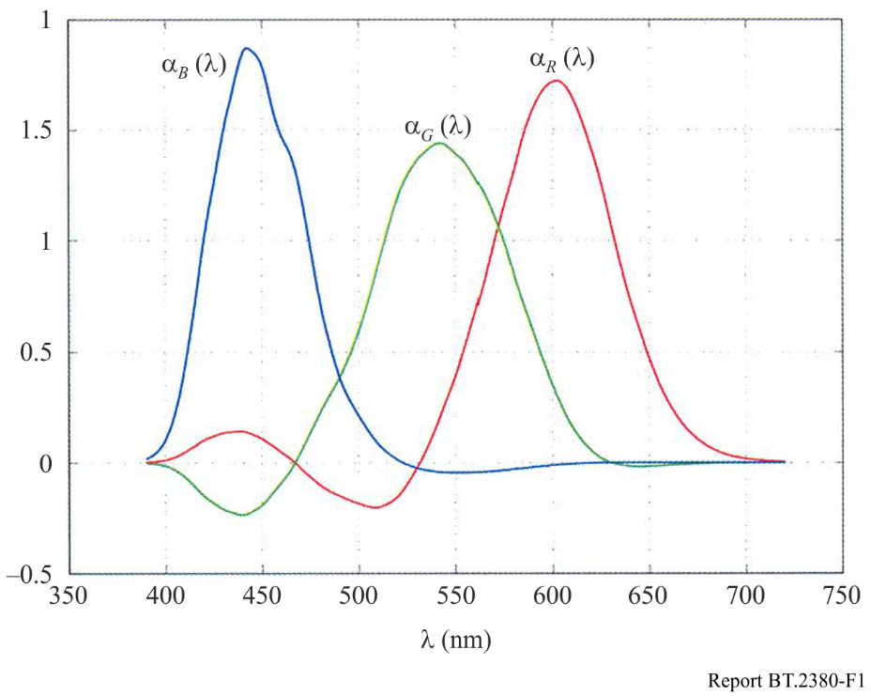

## F.3 Evaluation of colour distortion due to difference of view on the characteristics of the ideal UHDTV camera in terms of CIE 1931 and CIE 2006 colorimetry

Figure F.2 presents a comparison of the spectral sensitivity characteristics of primary colour channels of UHDTV camera due to difference of view on the characteristics of the ideal UHDTV camera in terms of CIE 1931 and CIE 2006 colorimetry.

FIGURE F.2

Comparison of the spectral sensitivity characteristics of primary channels of UHDTV camera,   
ideal in terms of CIE 1931 and CIE 2006 colorimetry

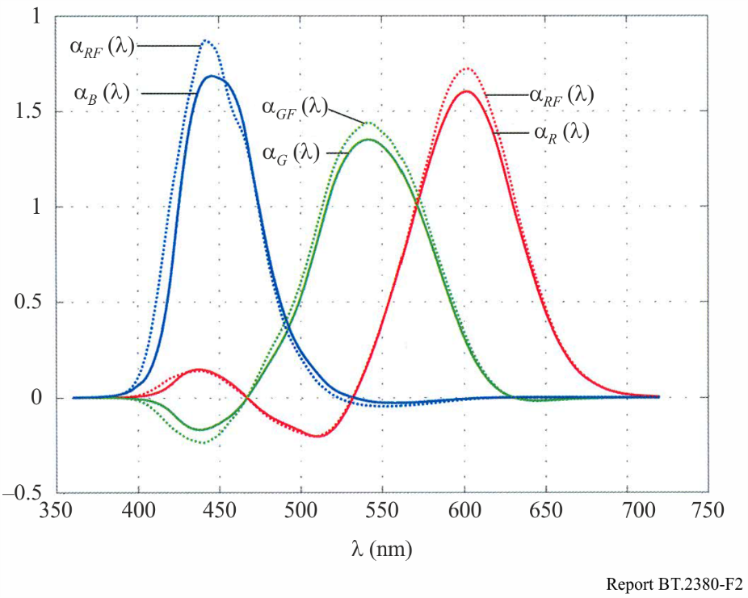

The difference between these characteristics leads to errors introduced by the camera, which applies CIE 1931 colorimetry, with respect to the camera, which applies more perfect colorimetry CIE 2006.

Corresponding calculation results and error estimates for Color Checker colours set [F.2, F.3] and the set of optimal colours (whose parameters – shown in Table F.2 – were defined so that it is compatible with the standard set of colour bars) are shown in Tables F.3 and F.4.

TABLE F.2

Borders (in nanometers) of spectral areas of optimal colours with high and   
low levels of spectral responses

|  |  |  |  |  |  |  |  |
| --- | --- | --- | --- | --- | --- | --- | --- |
| Optimal colours I type | Spectral coefficient transmittance / reflectance | | | Optimal colours II type | Spectral coefficient transmittance / reflectance | | |
| 1 | 0 | 1 | 0 | 1 | 0 |
|  | 360–480 | 481–599 | 600–720 |  | 360–497 | 498–555 | 556–720 |
|  | 360–499 | 500–663 | 664–720 |  | 360–504 | 505–645 | 646–720 |
|  | 360–470 | 471–578 | 579–720 |  | 360–435 | 436–541 | 542–720 |
|  | 360–421 | 422–582 | 583–720 |  | 360–480 | 481–568 | 569–720 |
|  | 360–499 | 500–663 | 664–720 |  | 360–427 | 428–572 | 573–720 |
|  | 360–428 | 429–492 | 493–720 |  |  |  |  |
|  | 360–485 | 486–566 | 567–720 |  |  |  |  |
|  | 360–435 | 436–561 | 562–720 |  | 360–464 | 465–583 | 584–720 |
|  | 360–522 | 523–611 | 612–720 |  | 360–415 | 416–590 | 591–720 |
|  | 360–440 | 441–485 | 486–720 |  |  |  |  |
|  | 360–498 | 499–552 | 553–720 |  |  |  |  |
|  | 360–453 | 454–534 | 535–720 |  | 360–448 | 449–604 | 605–720 |
|  | 360–540 | 541–597 | 598–720 |  | – | 360–611 | 612–720 |
|  | 360–452 | 453–474 | 475–720 |  |  |  |  |
|  | 360–515 | 516–542 | 543–720 |  |  |  |  |

It is indicated in the Tables:

 – chromaticity coordinates and the relative luminance of the scene in the CIE 1931  space;  – tristimulus values of the object image equal to the relative levels of the red, green and blue primaries, changing the  interval in the signal space at the output of an ideal camera, which implements CIE 1931 colorimetry;  – chromaticity coordinates and the relative luminance  CIE 2006 colour space;  – tristimulus values in the signal space at the output of ideal camera, which implements CIE 2006 colorimetry;  – chromaticity coordinates and the relative luminance in the CIE 1931 space of image of the object on the screen of the reproducing device, reproduced by signals of ideal camera, which implements CIE 2006 colorimetry;  – lightness and chromaticity coordinates in CAM02-UCS space of the object image of the on the screen of reproducing device, reproduced by signals of an ideal camera, which implements CIE 1931 colorimetry;  – lightness and chromaticity coordinates in CAM02-UCS space of the object image on the screen of reproducing device, reproduced by signals of an ideal camera which implements CIE 2006 colorimetry;  – Euclidean distance between two points  and  in CAM02-UCS space.

TABLE F.3

Evaluation of colour distortion of Color Checker set due to difference of view on the characteristics of the ideal UHDTV camera in terms of CIE 1931 and CIE 2006 colorimetry

|  |  |  |  |  |  |  |  |  |  |
| --- | --- | --- | --- | --- | --- | --- | --- | --- | --- |
| Parameters | Colour | | | | | | | | |
| 1 | 2 | 3 | 4 | 5 | 6 | 7 | 8 | 9 |
| Dark skin | Light skin | Blue  sky | Foliage | Blue flower | Bluish  green | Orange | Purplish  blue | Moderate red |
| Chromaticity coordinates and relative luminance of the scene object in the CIE 1931  space | | | | | | | | | |
|  | 0.402 | 0.385 | 0.250 | 0.341 | 0.269 | 0.259 | 0.507 | 0.213 | 0.458 |
|  | 0.360 | 0.355 | 0.267 | 0.440 | 0.255 | 0.358 | 0.410 | 0.189 | 0.313 |
|  | 0.110 | 0.389 | 0.198 | 0.141 | 0.280 | 0.446 | 0.266 | 0.127 | 0.208 |
| Tristimulus values of the object image in the signal space at the output of an ideal camera which implements CIE 1931 colorimetry | | | | | | | | | |
|  | 0.205 | 0.610 | 0.128 | 0.159 | 0.361 | 0.215 | 0.571 | 0.093 | 0.506 |
|  | 0.079 | 0.320 | 0.217 | 0.142 | 0.240 | 0.539 | 0.169 | 0.124 | 0.100 |
|  | 0.065 | 0.233 | 0.304 | 0.059 | 0.380 | 0.384 | 0.051 | 0.302 | 0.130 |
| Chromaticity coordinates and the relative luminance of the scene object in the CIE 2006 space | | | | | | | | | |
|  | 0.403 | 0.390 | 0.248 | 0.347 | 0.267 | 0.262 | 0.510 | 0.208 | 0.457 |
|  | 0.360 | 0.359 | 0.269 | 0.439 | 0.259 | 0.362 | 0.410 | 0.196 | 0.317 |
|  | 0.113 | 0.392 | 0.199 | 0.139 | 0.286 | 0.436 | 0.270 | 0.131 | 0.215 |
| Tristimulus values in the signal space at the output of ideal camera which implements CIE 2006 colorimetry | | | | | | | | | |
|  | 0.203 | 0.603 | 0.129 | 0.157 | 0.359 | 0.216 | 0.562 | 0.095 | 0.500 |
|  | 0.079 | 0.323 | 0.216 | 0.142 | 0.240 | 0.548 | 0.169 | 0.123 | 0.099 |
|  | 0.064 | 0.230 | 0.307 | 0.057 | 0.384 | 0.378 | 0.050 | 0.307 | 0.131 |
| Chromaticity coordinates and the relative luminance in the CIE 1931 space of the object image on the screen of the reproducing device, reproduced by signals of ideal camera, which implements CIE 2006 colorimetry | | | | | | | | | |
|  | 0.400 | 0.385 | 0.251 | 0.342 | 0.269 | 0.261 | 0.506 | 0.214 | 0.457 |
|  | 0.360 | 0.359 | 0.264 | 0.446 | 0.252 | 0.364 | 0.414 | 0.185 | 0.312 |
|  | 0.103 | 0.367 | 0.199 | 0.131 | 0.248 | 0.411 | 0.291 | 0.126 | 0.203 |

TABLE F.3 (*continued*)

|  |  |  |  |  |  |  |  |  |  |  |  |  |  |  |
| --- | --- | --- | --- | --- | --- | --- | --- | --- | --- | --- | --- | --- | --- | --- |
| Parameters | | Colour | | | | | | | | | | | | |
| 1 | 2 | | 3 | 4 | | 5 | 6 | | 7 | | 8 | 9 |
| Dark skin | Light skin | | Blue  sky | Foliage | | Blue flower | Bluish  green | | Orange | | Purplish  blue | Moderate red |
| Lightness and chromaticity coordinates in CAM02-UCS space of the object image on the screen of reproducing device, reproduced by signals of an ideal camera, which implements CIE 1931 colorimetry | | | | | | | | | | | | | | |
|  | | 12.55 | 12.49 | | 11.94 | 12.07 | | 12.12 | 11.80 | | 12.83 | | 11.82 | 13.02 |
|  | | –0.11 | –1.60 | | –10.42 | –11.39 | | –7.09 | –14.29 | | 6.16 | | –9.66 | 10.34 |
|  | | –13.78 | –14.20 | | –17.57 | –12.40 | | –18.08 | –14.49 | | –10.25 | | –20.87 | –11.96 |
| Lightness and chromaticity coordinates in CAM02-UCS space of the object image of the on the screen of reproducing device, reproduced by signals of an ideal camera, which implements CIE 2006 colorimetry | | | | | | | | | | | | | | |
|  | | 12.56 | 12.50 | | 11.92 | 12.10 | | 12.09 | 11.81 | | 12.85 | | 11.75 | 12.99 |
|  | | 0.002 | –1.39 | | –10.79 | –10.89 | | –7.69 | –14.21 | | 6.42 | | –11.01 | 9.87 |
|  | | –13.76 | –14.04 | | –17.48 | –12.42 | | –17.93 | –14.38 | | –10.14 | | –20.45 | –12.01 |
| Colour distortion | | | | | | | | | | | | | | |
|  | | 0.12 | 0.26 | | 0.38 | 0.50 | | 0.62 | 0.14 | | 0.28 | | 1.41 | 0.48 |
| Chromaticity coordinates and relative luminance of the scene object in the CIE 1931  space | | | | | | | | | | | | | | |
|  | 0.288 | | | 0.379 | 0.475 | | 0.188 | 0.304 | 0.550 | 0.447 | | 0.365 | | 0.199 |
|  | 0.214 | | | 0.497 | 0.443 | | 0.141 | 0.490 | 0.316 | 0.475 | | 0.240 | | 0.272 |
|  | 0.084 | | | 0.419 | 0.379 | | 0.067 | 0.225 | 0.153 | 0.538 | | 0.231 | | 0.234 |
| Tristimulus values of the object image in the signal space at the output of an ideal camera, which implements CIE 1931 colorimetry | | | | | | | | | | | | | | |
|  | 0.178 | | | 0.362 | 0.648 | | 0.044 | 0.098 | 0.509 | 0.729 | | 0.557 | | 0.061 |
|  | 0.042 | | | 0.470 | 0.305 | | 0.062 | 0.287 | 0.027 | 0.507 | | 0.101 | | 0.292 |
|  | 0.144 | | | 0.093 | 0.067 | | 0.228 | 0.085 | 0.045 | 0.082 | | 0.279 | | 0.324 |
| Chromaticity coordinates and the relative luminance of the scene object in the CIE 2006 space | | | | | | | | | | | | | | |
|  | 0.280 | | | 0.389 | 0.480 | | 0.182 | 0.311 | 0.547 | 0.455 | | 0.360 | | 0.198 |
|  | 0.216 | | | 0.497 | 0.441 | | 0.151 | 0.489 | 0.321 | 0.473 | | 0.245 | | 0.280 |
|  | 0.089 | | | 0.407 | 0.379 | | 0.071 | 0.217 | 0.162 | 0.531 | | 0.243 | | 0.231 |
| Tristimulus values in the signal space at the output of ideal camera which implements CIE 2006 colorimetry | | | | | | | | | | | | | | |
|  | 0.177 | | | 0.358 | 0.638 | | 0.045 | 0.097 | 0.501 | 0.718 | | 0.551 | | 0.064 |
|  | 0.040 | | | 0.475 | 0.306 | | 0.060 | 0.290 | 0.026 | 0.512 | | 0.098 | | 0.297 |
|  | 0.148 | | | 0.085 | 0.064 | | 0.233 | 0.081 | 0.045 | 0.073 | | 0.285 | | 0.323 |

TABLE F.3 (*end*)

|  |  |  |  |  |  |  |  |  |  |  |  |  |  |  |
| --- | --- | --- | --- | --- | --- | --- | --- | --- | --- | --- | --- | --- | --- | --- |
| Parameters | | Colour | | | | | | | | | | | | |
| 1 | 2 | | 3 | 4 | | 5 | 6 | | 7 | | 8 | 9 |
| Dark skin | Light skin | | Blue  sky | Foliage | | Blue flower | Bluish  green | | Orange | | Purplish  blue | Moderate red |
| Chromaticity coordinates and the relative luminance in the CIE 1931 space of the object image on the screen of the reproducing device, reproduced by signals of ideal camera, which implements CIE 2006 colorimetry | | | | | | | | | | | | | | |
|  | 0.285 | | | 0.381 | 0.475 | | 0.190 | 0.305 | 0.548 | 0.448 | | 0.362 | | 0.201 |
|  | 0.205 | | | 0.508 | 0.448 | | 0.137 | 0.500 | 0.315 | 0.483 | | 0.235 | | 0.275 |
|  | 0.072 | | | 0.415 | 0.410 | | 0.070 | 0.221 | 0.122 | 0.553 | | 0.206 | | 0.201 |
| Lightness and chromaticity coordinates in CAM02-UCS space of the object image on the screen of reproducing device, reproduced by signals of an ideal camera, which employs CIE 1931 colorimetry | | | | | | | | | | | | | | |
|  | 12.45 | | | 12.12 | 12.61 | | 11.64 | 11.83 | 13.42 | 12.42 | | 12.88 | | 11.52 |
|  | 0.03 | | | –11.17 | 0.36 | | –9.91 | –15.61 | 17.25 | –4.73 | | 8.09 | | –16.28 |
|  | –19.31 | | | –11.06 | –11.24 | | –23.41 | –11.34 | –8.60 | –11.23 | | –16.10 | | –16.99 |
| Lightness and chromaticity coordinates in CAM02-UCS space of the object image of the on the screen of reproducing device, reproduced by signals of an ideal camera, which employs CIE 2006 colorimetry | | | | | | | | | | | | | | |
|  | 12.37 | | 12.16 | | 12.63 | | 11.52 | 11.85 | 13.383 | 12.45 | | 12.81 | | 11.50 |
|  | –1.51 | | –10.48 | | 1.03 | | –11.94 | –15.16 | 16.602 | –3.88 | | 6.839 | | –16.69 |
|  | –19.41 | | –11.04 | | –11.13 | | –22.65 | –11.34 | –8.68 | –11.19 | | –16.28 | | –16.69 |
| Colour distortion | | | | | | | | | | | | | | |
|  | 1.54 | | 0.68 | | 0.67 | | 2.16 | 0.44 | 0.66 | 0.86 | | 1.27 | | 0.50 |

TABLE F.4

Evaluation of colour distortion of optimal colours set due to difference  
of view on the characteristics of the ideal UHDTV camera in terms of CIE 1931  
and CIE 2006 colorimetry

|  |  |  |  |  |  |  |
| --- | --- | --- | --- | --- | --- | --- |
| Parameters | Colour | | | | | |
| R0.9 | G0.9 | B0.9 | Ye0.9 | C0.9 | M0.9 |
| Chromaticity coordinates and relative luminance of the scene object in the CIE 1931  space | | | | | | |
|  | 0.675 | 0.167 | 0.148 | 0.440 | 0.155 | 0.372 |
|  | 0.305 | 0.747 | 0.059 | 0.540 | 0.327 | 0.170 |
|  | 0.188 | 0.498 | 0.162 | 0.749 | 0.643 | 0.257 |

TABLE F.4 (*continued*)

|  |  |  |  |  |  |  |
| --- | --- | --- | --- | --- | --- | --- |
| Parameters | Colour | | | | | |
| R0.9 | G0.9 | B0.9 | Ye0.9 | C0.9 | M0.9 |
| Tristimulus values of the object image in the signal space at the output of an ideal camera, which implements CIE 1931 colorimetry | | | | | | |
|  | 0.833 | 0.032 | 0.378 | 0.502 | 0.047 | 0.985 |
|  | 0.063 | 0.744 | 0.006 | 0.910 | 0.915 | 0.067 |
|  | 0.234 | 0.039 | 0.965 | 0.013 | 0.552 | 0.754 |
| Chromaticity coordinates and the relative luminance of the scene object in the CIE 2006 space | | | | | | |
|  | 0.661 | 0.180 | 0.139 | 0.452 | 0.154 | 0.364 |
|  | 0.309 | 0.755 | 0.073 | 0.535 | 0.342 | 0.177 |
|  | 0.211 | 0.467 | 0.192 | 0.719 | 0.617 | 0.295 |
| Tristimulus values in the signal space at the output of ideal camera which implements CIE 2006 colorimetry | | | | | | |
|  | 0.8270 | 0.0279 | 0.3720 | 0.5065 | 0.0420 | 0.9822 |
|  | 0.0676 | 0.7449 | 0.0038 | 0.9084 | 0.9303 | 0.0918 |
|  | 0.2517 | 0.2159 | 0.9841 | 0.0015 | 0.5278 | 0.7874 |
| Chromaticity coordinates and the relative luminance in the CIE 1931 space of the object image on the screen of the reproducing device, reproduced by signals of ideal camera, which implements CIE 2006 colorimetry | | | | | | |
|  | 0.667 | 0.171 | 0.150 | 0.442 | 0.157 | 0.368 |
|  | 0.301 | 0.776 | 0.053 | 0.550 | 0.342 | 0.160 |
|  | 0.165 | 0.376 | 0.120 | 0.720 | 0.500 | 0.356 |
| Lightness and chromaticity coordinates in CAM02-UCS space of the object image on the screen of reproducing device, reproduced by signals of an ideal camera, which employs CIE 1931 colorimetry | | | | | | |
|  | 13.99 | 11.18 | 10.37 | 12.26 | 11.14 | 13.49 |
|  | 25.82 | –24.33 | –14.06 | –8.93 | –21.42 | 18.40 |
|  | –5.32 | –8.51 | –29.21 | –10.00 | –14.89 | –16.02 |
| Lightness and chromaticity coordinates in CAM02-UCS space of the object image on the screen of reproducing device, reproduced by signals of an ideal camera, which employs CIE 2006 colorimetry | | | | | | |
|  | 13.98 | 11.19 | 10.40 | 12.25 | 11.16 | 13.56 |
|  | 25.73 | –24.34 | –12.69 | –9.27 | –21.51 | 19.46 |
|  | –5.53 | –8.25 | –30.07 | –9.80 | –14.50 | –16.30 |
| Colour distortion | | | | | | |
|  | 0.14 | 0.20 | 1.61 | 0.36 | 0.35 | 0.91 |

TABLE F.4 (*continued*)

|  |  |  |  |  |  |  |
| --- | --- | --- | --- | --- | --- | --- |
| Parameters | Colour | | | | | |
| R0.75 | G0.75 | B0.75 | Ye0.75 | C0.75 | M0.75 |
| Chromaticity coordinates and relative luminance of the scene object in the CIE 1931  space | | | | | | |
|  | 0.615 | 0.197 | 0.175 | 0.415 | 0.178 | 0.357 |
|  | 0.321 | 0.651 | 0.092 | 0.493 | 0.328 | 0.196 |
|  | 0.242 | 0.664 | 0.278 | 0.913 | 0.704 | 0.335 |
| Tristimulus values of the object image in the signal space at the output of an ideal camera, which implements CIE 1931 colorimetry | | | | | | |
|  | 0.940 | 0.028 | 0.537 | 0.992 | 0.002 | 0.993 |
|  | 0.033 | 0.976 | 0.116 | 0.927 | 0.983 | 0.035 |
|  | 0.331 | 0.141 | 0.982 | 0.433 | 0.611 | 0.856 |
| Chromaticity coordinates and the relative luminance of the scene object in the CIE 2006 space | | | | | | |
|  | 0.586 | 0.207 | 0.166 | 0.416 | 0.177 | 0.351 |
|  | 0.310 | 0.664 | 0.107 | 0.476 | 0.340 | 0.203 |
|  | 0.267 | 0.626 | 0.308 | 0.902 | 0.678 | 0.372 |
| Tristimulus values in the signal space at the output of ideal camera which implements CIE 2006 colorimetry | | | | | | |
|  | 0.935 | 0.025 | 0.533 | 0.991 | 0.002 | 0.990 |
|  | 0.043 | 0.995 | 0.118 | 0.921 | 0.996 | 0.019 |
|  | 0.352 | 0.112 | 0.995 | 0.433 | 0.588 | 0.882 |
| Chromaticity coordinates and the relative luminance in the CIE 1931 space of the object image on the screen of the reproducing device, reproduced by signals of ideal camera, which implements CIE 2006 colorimetry | | | | | | |
|  | 0.589 | 0.198 | 0.176 | 0.409 | 0.180 | 0.354 |
|  | 0.303 | 0.683 | 0.088 | 0.486 | 0.340 | 0.189 |
|  | 0.277 | 0.526 | 0.176 | 0.889 | 0.625 | 0.465 |
| Lightness and chromaticity coordinates in CAM02-UCS space of the object image of the on the screen of reproducing device, reproduced by signals of an ideal camera, which employs CIE 1931 colorimetry | | | | | | |
|  | 13.66 | 11.30 | 4.42 | 11.46 | 8.77 | 8.69 |
|  | 20.84 | –22.82 | –5.24 | –8.16 | –17.65 | 10.57 |
|  | –6.73 | –9.30 | –17.78 | –10.68 | –13.42 | –13.85 |
| Lightness and chromaticity coordinates in CAM02-UCS space of the object image of the on the screen of reproducing device, reproduced by signals of an ideal camera, which employs CIE 2006 colorimetry | | | | | | |
|  | 13.66 | 11.30 | 4.44 | 11.45 | 8.77 | 8.71 |
|  | 20.94 | –22.99 | –4.55 | –8.27 | –17.76 | 11.06 |
|  | –7.49 | –8.97 | –18.07 | –10.85 | –13.13 | –14.00 |
| Colour distortion | | | | | | |
|  | 0.56 | 0.32 | 0.75 | 0.20 | 0.31 | 0.52 |

TABLE F.4 (*continued*)

|  |  |  |  |  |  |  |
| --- | --- | --- | --- | --- | --- | --- |
| Parameters | Colour | | | | | |
| R0.5 | G0.5 | B0.5 | Ye0.5 | C0.5 | M0.5 |
| Chromaticity coordinates and relative luminance of the scene object in the CIE 1931  space | | | | | | |
|  | 0.537 | 0.232 | 0.219 | 0.384 | 0.218 | 0.346 |
|  | 0.333 | 0.527 | 0.156 | 0.444 | 0.333 | 0.236 |
|  | 0.331 | 0.683 | 0.449 | 0.953 | 0.733 | 0.481 |
| Tristimulus values of the object image in the signal space at the output of an ideal camera, which implements CIE 1931 colorimetry | | | | | | |
|  | 0.998 | 0.026 | 0.647 | 0.996 | 0.089 | 0.996 |
|  | 0.069 | 0.973 | 0.326 | 0.972 | 0.986 | 0.244 |
|  | 0.415 | 0.255 | 0.985 | 0.571 | 0.657 | 0.918 |
| Chromaticity coordinates and the relative luminance of the scene object in the CIE 2006 space | | | | | | |
|  | 0.498 | 0.239 | 0.214 | 0.383 | 0.218 | 0.342 |
|  | 0.320 | 0.541 | 0.168 | 0.431 | 0.337 | 0.242 |
|  | 0.356 | 0.648 | 0.472 | 0.943 | 0.709 | 0.511 |
| Tristimulus values in the signal space at the output of ideal camera which implements CIE 2006 colorimetry | | | | | | |
|  | 0.993 | 0.029 | 0.647 | 0.994 | 0.094 | 0.992 |
|  | 0.055 | 0.995 | 0.328 | 0.969 | 0.994 | 0.242 |
|  | 0.438 | 0.224 | 0.992 | 0.570 | 0.639 | 0.935 |
| Chromaticity coordinates and the relative luminance in the CIE 1931 space of the object image on the screen of the reproducing device, reproduced by signals of ideal camera, which implements CIE 2006 colorimetry | | | | | | |
|  | 0.498 | 0.234 | 0.221 | 0.378 | 0.219 | 0.345 |
|  | 0.315 | 0.554 | 0.154 | 0.437 | 0.337 | 0.232 |
|  | 0.435 | 0.605 | 0.304 | 0.922 | 0.719 | 0.604 |
| Lightness and chromaticity coordinates in CAM02-UCS space of the object image on the screen of reproducing device, reproduced by signals of an ideal camera, which employs CIE 1931 colorimetry | | | | | | |
|  | 8.47 | 8.82 | 6.30 | 11.71 | 9.65 | 9.74 |
|  | 11.99 | –17.88 | –3.91 | –8.03 | –15.44 | 5.33 |
|  | –7.27 | –9.61 | –16.99 | –11.97 | –13.90 | –14.94 |
| Lightness and chromaticity coordinates in CAM02-UCS space of the object image on the screen of reproducing device, reproduced by signals of an ideal camera, which employs CIE 2006 colorimetry | | | | | | |
|  | 8.42 | 8.81 | 6.32 | 11.71 | 9.65 | 9.75 |
|  | 10.94 | –18.13 | –3.43 | –8.13 | –15.48 | 5.65 |
|  | –8.38 | –9.25 | –17.06 | –12.15 | –13.79 | –15.02 |
| Colour distortion | | | | | | |
|  | 1.53 | 0.45 | 0.49 | 0.21 | 0.12 | 0.32 |

TABLE F.4 (*continued*)

|  |  |  |  |  |  |  |
| --- | --- | --- | --- | --- | --- | --- |
| Parameters | Colour | | | | | |
| R0.25 | G0.25 | B0.25 | Ye0.25 | C0.25 | M0.25 |
| Chromaticity coordinates and relative luminance of the scene object in the CIE 1931  space | | | | | | |
|  | 0.410 | 0.271 | 0.261 | 0.346 | 0.263 | 0.330 |
|  | 0.338 | 0.420 | 0.235 | 0.384 | 0.333 | 0.278 |
|  | 0.492 | 0.722 | 0.665 | 0.979 | 0.795 | 0.716 |
| Tristimulus values of the object image in the signal space at the output of an ideal camera, which implements CIE 1931 colorimetry | | | | | | |
|  | 0.992 | 0.136 | 0.769 | 0.989 | 0.248 | 0.991 |
|  | 0.297 | 0.979 | 0.595 | 0.994 | 0.989 | 0.587 |
|  | 0.529 | 0.378 | 0.995 | 0.767 | 0.959 | 0.976 |
| Chromaticity coordinates and the relative luminance of the scene object in the CIE 2006 space | | | | | | |
|  | 0.402 | 0.279 | 0.259 | 0.345 | 0.263 | 0.328 |
|  | 0.326 | 0.435 | 0.242 | 0.377 | 0.334 | 0.282 |
|  | 0.509 | 0.693 | 0.678 | 0.973 | 0.782 | 0.733 |
| Tristimulus values in the signal space at the output of ideal camera which implements CIE 2006 colorimetry | | | | | | |
|  | 0.986 | 0.139 | 0.771 | 0.988 | 0.243 | 0.988 |
|  | 0.276 | 0.996 | 0.595 | 0.996 | 0.989 | 0.592 |
|  | 0.554 | 0.351 | 0.998 | 0.766 | 0.959 | 0.982 |
| Chromaticity coordinates and the relative luminance in the CIE 1931 space of the object image on the screen of the reproducing device, reproduced by signals of ideal camera, which implements CIE 2006 colorimetry | | | | | | |
|  | 0.400 | 0.276 | 0.263 | 0.342 | 0.263 | 0.328 |
|  | 0.324 | 0.441 | 0.234 | 0.379 | 0.333 | 0.275 |
|  | 0.633 | 0.717 | 0.531 | 0.956 | 0.851 | 0.770 |
| Lightness and chromaticity coordinates in CAM02-UCS space of the object image on the screen of reproducing device, reproduced by signals of an ideal camera, which employs CIE 1931 colorimetry | | | | | | |
|  | 9.91 | 9.89 | 8.64 | 11.94 | 10.89 | 10.84 |
|  | 2.58 | –14.41 | –5.58 | –8.01 | –12.34 | –0.92 |
|  | –12.24 | –11.89 | –16.15 | –13.65 | –14.69 | –15.71 |
| Lightness and chromaticity coordinates in CAM02-UCS space of the object image on the screen of reproducing device, reproduced by signals of an ideal camera, which employs CIE 2006 colorimetry | | | | | | |
|  | 9.91 | 9.88 | 8.66 | 11.94 | 10.89 | 10.84 |
|  | 2.79 | –14.70 | –5.17 | –7.94 | –12.34 | –0.88 |
| Colour distortion | | | | | | |
|  | 0.43 | 0.53 | 0.41 | 0.21 | 0.00 | 0.11 |
|  | –12.63 | –11.44 | –16.21 | –13.84 | –14.69 | –15.81 |

TABLE F.4 (*end*)

|  |
| --- |
| *) In this table, the notation of colours is: R – red, G – green, B – blue, Ye – yellow, C – cyan, M – magenta. The index in the colours designation characterizes their chroma saturation, defined as the ratio of the length of the straight line segment in the plane of the Maxwell triangle in the signal space, connecting point of evaluated colour with reference white point, to the length of a segment on the same straight line joining the point of its intersection with the boundary of the primary colours triangle. For example, R0,9, G0,9, B0,9 represent red, green and blue with saturation of 0.9. |

From Tables F.3 and F.4 it is seen that differ in luminance and, respectively, relate to different levels of lightness of the image. For Color Checker set primary colour signals do not exceed the limits of the  interval, i.e. they can be transmitted by UHDTV systems. For optimal colours set for certain colours, some primary colour signals exceed the level of the unit, so the luminance normalization is introduced as a result of which the signal levels are limited to the  interval. The colour points of both sets are represented in Figs F.3 and F.4.

Colour coordinates of object image on the screen of a reproducing device in CAM02-UCS space and colour rendering error  are determined for visual perception adaptation luminance of 50 cd/m2, which corresponds to the brightness of the reference white of 250 cd/m2 and an average viewing environment for the screen of the reproducing device. Colour rendering error is, for almost all colours, less than 2 CIE units, i.e. it is at the level of error of colorimetric measuring instruments and less than the threshold of colour discrimination.

FIGURE F.3

Chromaticity points of colours of Color Checker set (left) and of optimal colours set (right)  
as a function of the chromaticity coordinates  of the CIE 1931 colour space

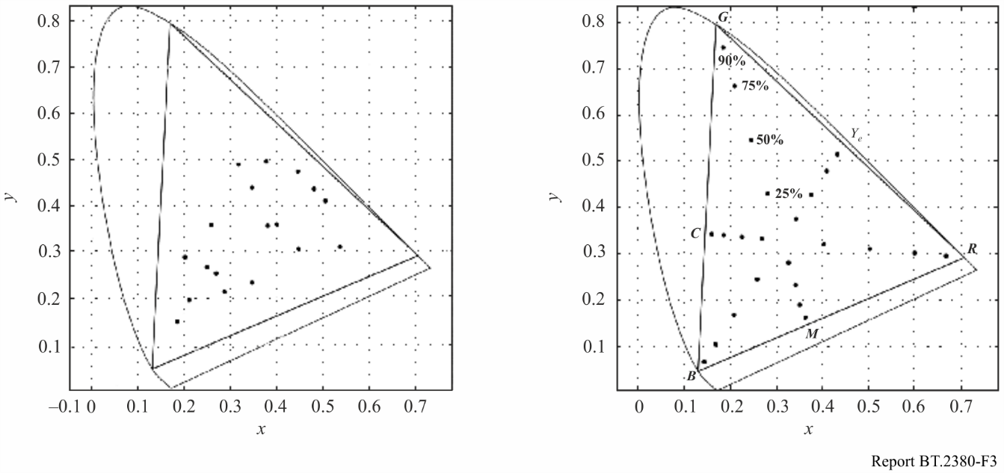

FIGURE F.4

Chromaticity points of colours of Color Checker set (left) and of optimal colours set (right)  
as a function of the chromaticity coordinates  of the CAM02-UCS colour space

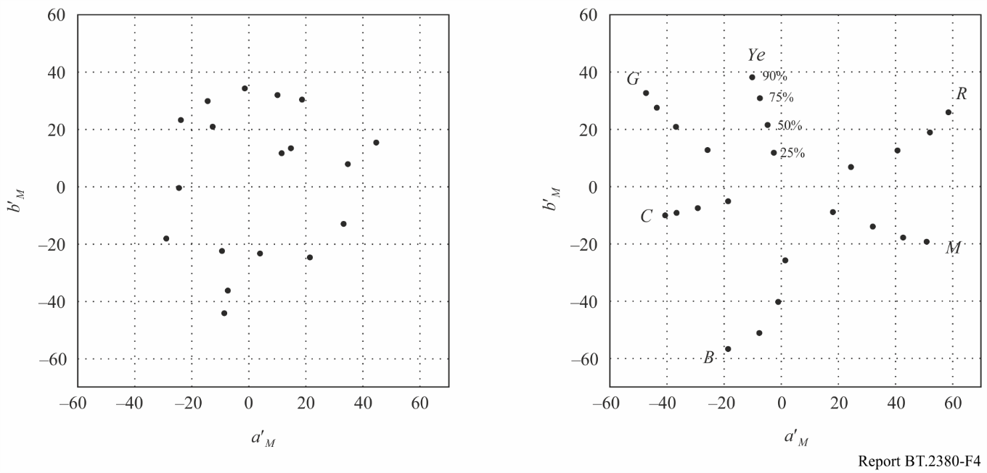

## F.4 Conclusions

Evaluation of colour distortion of ideal camera, which implements CIE 1931 colorimetry, in relation to ideal camera, which implements CIE 2006 colorimetry, is held for two colour sets defined by spectral reflectance characteristics of test objects: (a) Color Checker set, which found use for image quality evaluation for a variety of video applications, particularly for the evaluation of the characteristics of TV cameras, and (b) a set of optimum colours chromaticity points which uniformly fill primary colours  triangle. The evaluation has shown that the colour rendering error do not exceed about 2 CIE units, i.e. its level is below the level of error of colorimetric devices and below the threshold of visibility of colour changes. So, it can be predicted that the transition to the use CIE 2006 colorimetry instead of CIE 1931 colorimetry will not lead to a significant improvement of quality of colour rendition in television and other similar applications.

Bibliography for Annex F

[F.1] ITU. “Annex 3 to Working Party 6C Chairmanʼs Report. Working Document towards Draft New Recommendation ITU-R BT.[EIDRTV] *Parameter Values for the Extended Image Dynamic Range Television System (EIDRTV)*.” Document 6C/431-E (2015). Print.

[F.2] EBU TECH 3355. *Method for the assessment of the colorimetric properties of luminaires. The television lighting consistency index (TLCI-2012)*. FTV-LED. Geneva, April 2013

[F.3] Gofaizen, O., and V. Pilyavskiy. “*Colorimetric characteristics of through light-to-light TV path: calculation spectral sensitivity characteristics of primary color channels of video cameras*.” Digital Technologies 17 (2015). Print.

Annex G  
(relevant to § 7.5)  
Evaluation of colour rendering fidelity of the through  
light-to-light digital television system video path

The main feature of the progress of TV systems and other video applications is the tendency of transition to new levels of image quality and the creation of new systems functionalities. In this context, special interest is for colour rendition fidelity depending on the colorimetric characteristics of the systems as a whole and their components, which determine the colorimetric image quality.

When referring to colorimetric quality, the evaluation should be based on colour fidelity in through light-to-light path [G.1, G.2], as the main colour distortion occurs in the transmitting and receiving sides, namely, they arise due to the possible imperfection of the spectral distribution of radiation source of studio lighting, due to the possible imperfection of the spectral characteristics of the camera, as well as colorimetric inaccuracy, introduced by the reproduction device and uncertainties that may bring digital image processing at the transmitting and receiving sides.

One of the most critical factors includes inadequate spectral sensitivity characteristics of the camera primary channels. This means that when evaluating colour fidelity, it cannot be abstracted from the spectral characteristics of reflection of objects in the scene and to operate only their colour coordinates.

In order to be able to quantitatively judge the colour rendering fidelity of TV cameras, it is needed to be able to compare the characteristics of real cameras with the characteristics of the ideal cameras, the spectral characteristics of primary channels which would provide undistorted colour reproduction, regardless of the spectral distribution of objects.

In this Annex examples of distortion evaluation for Colour Checker set of colours, introduced by optimally tuned “standard” SDTV camera are produced with respect to the ideal camera. As a source approach is taken, which consists in the fact that serial gamma conversion on the transmission side and on the receiving side lead to the reproduction of colours and lightness tones, perceived by observers as the best. Therefore, as a criterion of colour fidelity it seems preferable to evaluate the chromaticity shift with respect to the colours specified for the case of using the ideal camera and use both series of non-linear gamma transformation. Such comparison is given in Table 1, from which it follows that the use of cameras with the characteristics of a “standard” camera with linear matrix [3, Figure 11] provides a practically undistorted colour reproduction.

This conclusion can be extended to HDTV system, considering the proximity of the colour-metric systems, standardized for SDTV and HDTV systems. These data are also consistent with the data of [4] for UHDTV systems.

TABLE G.1

Evaluation of colour distortion for Color Checker set introduced by “standard” camera  
in respect to ideal camera, in which CIE 1931 colorimetry is implemented

|  |  |  |  |  |  |  |  |  |  |
| --- | --- | --- | --- | --- | --- | --- | --- | --- | --- |
| Parameters | Colour | | | | | | | | |
| 1 | 2 | 3 | 4 | 5 | 6 | 7 | 8 | 9 |
| Dark skin | Light skin | Blue  sky | Foliage | Blue flower | Bluish  green | Orange | Purplish  blue | Moderate red |
| Chromaticity coordinates and relative luminance of the transmitted scene object in the CIE 1931 colour space | | | | | | | | | |
|  | 0,410 | 0,389 | 0,265 | 0,369 | 0,314 | 0,285 | 0,483 | 0,244 | 0,446 |
|  | 0,349 | 0,361 | 0,297 | 0,412 | 0,289 | 0,378 | 0,392 | 0,235 | 0,316 |
|  | 0,111 | 0,389 | 0,199 | 0,142 | 0,279 | 0,448 | 0,267 | 0,127 | 0,207 |
| Tristimulus values of the transmitted scene object in the signal space at the output of an ideal camera | | | | | | | | | |
|  | 0,202 | 0,603 | 0,128 | 0,154 | 0,356 | 0,214 | 0,566 | 0,092 | 0,502 |
|  | 0,080 | 0,324 | 0,218 | 0,144 | 0,243 | 0,546 | 0,172 | 0,125 | 0,101 |
|  | 0,062 | 0,221 | 0,287 | 0,057 | 0,358 | 0,362 | 0,049 | 0,285 | 0,125 |
| Tristimulus values of the transmitted scene object image in the image space on the screen of reproducing device, reproduced by signals of an ideal camera | | | | | | | | | |
|  | 0,183 | 0,576 | 0,106 | 0,130 | 0,324 | 0,186 | 0,496 | 0,074 | 0,472 |
|  | 0,081 | 0,292 | 0,190 | 0,121 | 0,213 | 0,517 | 0,391 | 0,104 | 0,082 |
|  | 0,056 | 0,192 | 0,256 | 0,044 | 0,326 | 0,329 | 0,112 | 0,254 | 0,104 |
| Chromaticity coordinates and the relative luminance in the CIE 1931 colour space of the transmitted scene object image on the screen of the reproducing device, reproduced by signals of ideal camera | | | | | | | | | |
|  | 0,419 | 0,396 | 0,262 | 0,373 | 0,314 | 0,283 | 0,496 | 0,238 | 0,461 |
|  | 0,349 | 0,363 | 0,293 | 0,418 | 0,287 | 0,382 | 0,391 | 0,227 | 0,316 |
|  | 0,086 | 0,345 | 0,177 | 0,117 | 0,245 | 0,433 | 0,222 | 0,109 | 0,166 |
| Lightness and chromaticity coordinates in CAM02-UCS space of the object image on the screen of reproducing device, reproduced by signals of an ideal camera | | | | | | | | | |
|  | 3,22 | 3,18 | 4,59 | 4,71 | 5,18 | 7,28 | 5,41 | 3,43 | 3,75 |
|  | 1,24 | –0,52 | –6,80 | –4,72 | –2,62 | –10,61 | 4,37 | –4,97 | 5,52 |
|  | –6,68 | –6,86 | –10,57 | –8,01 | –11,03 | –11,04 | –6,84 | –10,61 | –6,33 |
| Tristimulus values of the transmitted scene object in the signal space at the output of “standard” camera | | | | | | | | | |
|  | 0,183 | 0,608 | 0,113 | 0,109 | 0,242 | 0,165 | 0,658 | 0,052 | 0,545 |
|  | 0,081 | 0,304 | 0,211 | 0,157 | 0,233 | 0,527 | 0,168 | 0,115 | 0,087 |
|  | 0,056 | 0,236 | 0,348 | 0,040 | 0,449 | 0,414 | 0,014 | 0,385 | 0,130 |

TABLE G.1 (*continued*)

|  |  |  |  |  |  |  |  |  |  |  |  |  |  |  |  |  |  |
| --- | --- | --- | --- | --- | --- | --- | --- | --- | --- | --- | --- | --- | --- | --- | --- | --- | --- |
| Parameters | Colour | | | | | | | | | | | | | | | | |
| 1 | | | 2 | | | 3 | | 4 | | 5 | | 6 | | 7 | 8 | 9 |
| Dark skin | | | Light skin | | | Blue  sky | | Foliage | | Blue flower | | Bluish  green | | Orange | Purplish  blue | Moderate red |
| Tristimulus values of the transmitted scene object image in the image space on the screen of reproducing device, reproduced by signals of “standard” camera | | | | | | | | | | | | | | | | | |
|  | 0,157 | | | 0,581 | | | 0,093 | | 0,089 | | 0,213 | | 0,140 | | 0,634 | 0,039 | 0,516 |
|  | 0,064 | | | 0,272 | | | 0,183 | | 0,133 | | 0,204 | | 0,497 | | 0,143 | 0,095 | 0,069 |
|  | 0,043 | | | 0,207 | | | 0,316 | | 0,030 | | 0,418 | | 0,382 | | 0,009 | 0,353 | 0,108 |
| Chromaticity coordinates and the relative luminance in the CIE 1931 colour space of the transmitted scene object image on the screen of the reproducing device, reproduced by signals of “standard” camera | | | | | | | | | | | | | | | | | |
|  | 0,416 | | | 0,395 | | | 0,244 | | 0,356 | | 0,267 | | 0,267 | | 0,532 | 0,202 | 0,471 |
|  | 0,359 | | | 0,352 | | | 0,263 | | 0,461 | | 0,250 | | 0,361 | | 0,402 | 0,181 | 0,307 |
|  | 0,083 | | | 0,333 | | | 0,174 | | 0,116 | | 0,221 | | 0,412 | | 0,238 | 0,102 | 0,167 |
| Lightness and chromaticity coordinates in CAM02-UCS space of the object image on the screen of reproducing device, reproduced by signals of an ideal camera | | | | | | | | | | | | | | | | | |
|  | | | 3,21 | | | 3,19 | | 4,57 | | 4,65 | | 5,09 | | 7,25 | 5,46 | 3,36 | 3,78 |
|  | | | 0,77 | | | –0,08 | | –6,93 | | –7,01 | | –4,58 | | –10,96 | 5,71 | –6,04 | 6,48 |
|  | | | –6,63 | | | –6,96 | | –11,30 | | –7,42 | | –12,14 | | –11,50 | –5,99 | –11,89 | –6,14 |
| Colour distortion | | | | | | | | | | | | | | | | | |
|  | | 0,47 | | | 0,45 | | | 0,74 | | 2,35 | | 2,26 | | 0,58 | 1,59 | 1,67 | 0,98 |
| Chromaticity coordinates and relative luminance of the transmitted scene object in the CIE 1931 colour space | | | | | | | | | | | | | | | | | |
|  | | 0,341 | | | 0,369 | | | 0,450 | | 0,219 | | 0,313 | | 0,550 | 0,423 | 0,391 | 0,245 |
|  | | 0,236 | | | 0,467 | | | 0,421 | | 0,192 | | 0,463 | | 0,317 | 0,449 | 0,264 | 0,324 |
|  | | 0,083 | | | 0,422 | | | 0,380 | | 0,067 | | 0,227 | | 0,152 | 0,541 | 0,229 | 0,235 |
| Tristimulus values of the transmitted scene object in the signal space at the output of an ideal camera | | | | | | | | | | | | | | | | | |
|  | | 0,176 | | | 0,359 | | | 0,643 | | 0,043 | | 0,097 | | 0,503 | 0,723 | 0,550 | 0,061 |
|  | | 0,043 | | | 0,476 | | | 0,309 | | 0,061 | | 0,291 | | 0,027 | 0,514 | 0,102 | 0,294 |
|  | | 0,138 | | | 0,087 | | | 0,064 | | 0,215 | | 0,081 | | 0,043 | 0,077 | 0,264 | 0,305 |
| Tristimulus values of the transmitted scene object image in the image space on the screen of reproducing device, reproduced by signals of an ideal camera | | | | | | | | | | | | | | | | | |
|  | | 0,150 | | | 0,327 | | | 0,617 | | 0,033 | | 0,078 | | 0,472 | 0,702 | 0,522 | 0,047 |
|  | | 0,032 | | | 0,445 | | | 0,277 | | 0,047 | | 0,259 | | 0,019 | 0,483 | 0,083 | 0,264 |
|  | | 0,115 | | | 0,071 | | | 0,050 | | 0,186 | | 0,064 | | 0,032 | 0,061 | 0,234 | 0,274 |

TABLE G.1 (*end*)

|  |  |  |  |  |  |  |  |  |  |  |  |  |  |  |  |  |  |  |  |  |  |  |
| --- | --- | --- | --- | --- | --- | --- | --- | --- | --- | --- | --- | --- | --- | --- | --- | --- | --- | --- | --- | --- | --- | --- |
| Parameters | | Colour | | | | | | | | | | | | | | | | | | | | |
| 1 | | | 2 | | | 3 | | | 4 | | | 5 | | | 6 | | 7 | 8 | 9 | |
| Dark skin | | | Light skin | | | Blue  sky | | | Foliage | | | Blue flower | | | Bluish  green | | Orange | Purplish  blue | Moderate red | |
| Chromaticity coordinates and the relative luminance in the CIE 1931 colour space of the transmitted scene object image on the screen of the reproducing device, reproduced by signals of ideal camera | | | | | | | | | | | | | | | | | | | | | | |
|  | | 0,344 | | | 0,371 | | | 0,459 | | | 0,213 | | | 0,312 | | | 0,566 | | 0,429 | 0,401 | 0,242 | |
|  | | 0,231 | | | 0,476 | | | 0,423 | | | 0,181 | | | 0,473 | | | 0,319 | | 0,453 | 0,261 | 0,324 | |
|  | | 0,063 | | | 0,393 | | | 0,333 | | | 0,055 | | | 0,207 | | | 0,117 | | 0,499 | 0,187 | 0,218 | |
| Lightness and chromaticity coordinates in CAM02-UCS space of the object image on the screen of reproducing device, reproduced by signals of an ideal camera | | | | | | | | | | | | | | | | | | | | | | |
|  | | 2,51 | | | 7,42 | | | 7,19 | | | 2,32 | | | 4,99 | | | 3,89 | | 8,57 | 5,01 | 4,80 | |
|  | | 2,82 | | | –8,53 | | | 0,33 | | | –4,08 | | | –9,64 | | | 9,84 | | –4,04 | 6,26 | –9,42 | |
|  | | –7,55 | | | –9,10 | | | –8,87 | | | –9,75 | | | –7,70 | | | –4,42 | | –9,82 | –9,08 | –10,18 | |
| Tristimulus values of the transmitted scene object in the signal space at the output of “standard” camera | | | | | | | | | | | | | | | | | | | | | | |
|  | 0,106 | | | 0,376 | | | 0,736 | | | 0,011 | | | 0,080 | | | 0,454 | | | 0,817 | 0,484 | 0,011 | |
|  | 0,052 | | | 0,497 | | | 0,320 | | | 0,053 | | | 0,308 | | | 0,027 | | | 0,527 | 0,098 | 0,264 | |
|  | 0,153 | | | 0,010 | | | 0,003 | | | 0,312 | | | 0,047 | | | 0,041 | | | 0,024 | 0,313 | 0,403 | |
| Tristimulus values of the transmitted scene object image in the image space on the screen of reproducing device, reproduced by signals of “standard” camera | | | | | | | | | | | | | | | | | | | | | | |
|  | 0,086 | | | 0,344 | | | 0,716 | | | 0,007 | | | 0,064 | | | 0,422 | | | 0,802 | 0,453 | 0,007 | |
|  | 0,039 | | | 0,466 | | | 0,288 | | | 0,041 | | | 0,277 | | | 0,019 | | | 0,498 | 0,080 | 0,234 | |
|  | 0,129 | | | 0,007 | | | 0,002 | | | 0,280 | | | 0,035 | | | 0,031 | | | 0,017 | 0,282 | 0,372 | |
| Chromaticity coordinates and the relative luminance in the CIE 1931 colour space of the transmitted scene object image on the screen of the reproducing device, reproduced by signals of “standard” camera | | | | | | | | | | | | | | | | | | | | | | |
|  | | | 0,283 | | 0,394 | | | 0,494 | | | 0,174 | | | 0,318 | | | 0,561 | | 0,464 | 0,366 | 0,210 | |
|  | | | 0,217 | | 0,518 | | | 0,444 | | | 0,131 | | | 0,517 | | | 0,319 | | 0,482 | 0,239 | 0,268 | |
|  | | | 0,056 | | 0,407 | | | 0,359 | | | 0,051 | | | 0,214 | | | 0,106 | | 0,525 | 0,174 | 0,196 | |
| Lightness and chromaticity coordinates in CAM02-UCS space of the object image on the screen of reproducing device, reproduced by signals of an ideal camera | | | | | | | | | | | | | | | | | | | | | | |
|  | | | 2,43 | | 7,43 | | | 7,23 | | | 2,23 | | | 4,97 | | | 3,88 | | 8,62 | 4,97 | 4,74 | |
|  | | | –0,50 | | –8,69 | | | 1,61 | | | –5,58 | | | –10,25 | | | 9,65 | | –3,08 | 5,26 | –9,92 | |
|  | | | –8,62 | | –8,35 | | | –8,06 | | | –1,21 | | | –7,13 | | | –4,50 | | –9,09 | –10,14 | –11,43 | |
| Colour distortion | | | | | | | | | | | | | | | | | | | | | | |
|  | | | 1,54 | | | 0,68 | | | 0,67 | | | 2,16 | | | 0,44 | | | 0,66 | 0,86 | 1,27 | | 0,50 |

Bibliography for Annex G

[G.1] Pilyavskiy V.V. *Evaluation of color rendering in high-definition television path with use of color bar signals* / V.V. Pilyavskiy // Proceedings of the higher educational institutions of Russia. Radioelectronics. – No. 3. – 2014. – P. 26-33

[G.2] Gofaizen O.V. Problem questions of TV colorimetry / O.V. Gofaizen, V.V. Pilyavskiy // Digital Technologies, 2014. – No. 16. – P. 104-110

[G.3] TECH 3355. Method for the assessment of the colorimetric properties of luminaires. The television lighting consistency index (TLCI-2012). FTV-LED. Geneva, April 2013

[G.4] ABU Tech Review 257/2014. Kenichiro Masaoka, Takuji Soeno, Yuichi Kusakabe, Takayuki Yamashita, Yukihiro Nishida, Masayuki Sugawara UHDTV System Colorimetry and Technical Development for Its Implementation

[G.5] Gofaizen O.V. “Colorimetric characteristics of through light-to-light TV path: calculation spectral sensitivity characteristics of primary color channels of video cameras / O.V Gofaizen, V.V. Pilyavskiy, S.V. Osetsky // Digital Technologies, 2016. – No. 17. – P. 101-125.