|  |
| --- |
| **Report ITU-R BT.2339-0**  **(11/2014)** |
| **Co-channel sharing and compatibility studies between digital terrestrial television broadcasting andinternational mobile telecommunication in the frequency band 694-790 MHz in the GE06 planning area** |
| **BT Series**  **Broadcasting service (television)** |

Foreword

The role of the Radiocommunication Sector is to ensure the rational, equitable, efficient and economical use of the radio-frequency spectrum by all radiocommunication services, including satellite services, and carry out studies without limit of frequency range on the basis of which Recommendations are adopted.

The regulatory and policy functions of the Radiocommunication Sector are performed by World and Regional Radiocommunication Conferences and Radiocommunication Assemblies supported by Study Groups.

# Policy on Intellectual Property Right (IPR)

ITU-R policy on IPR is described in the Common Patent Policy for ITU-T/ITU-R/ISO/IEC referenced in Annex 1 of Resolution ITU-R 1. Forms to be used for the submission of patent statements and licensing declarations by patent holders are available from <http://www.itu.int/ITU-R/go/patents/en> where the Guidelines for Implementation of the Common Patent Policy for ITU‑T/ITU‑R/ISO/IEC and the ITU-R patent information database can also be found.

|  |  |
| --- | --- |
| Series of ITU-R Reports  (Also available online at <http://www.itu.int/publ/R-REP/en>) | |
| **Series** | Title |
| **BO** | Satellite delivery |
| **BR** | Recording for production, archival and play-out; film for television |
| **BS** | Broadcasting service (sound) |
| **BT** | Broadcasting service (television) |
| **F** | Fixed service |
| **M** | Mobile, radiodetermination, amateur and related satellite services |
| **P** | Radiowave propagation |
| **RA** | Radio astronomy |
| **RS** | Remote sensing systems |
| **S** | Fixed-satellite service |
| **SA** | Space applications and meteorology |
| **SF** | Frequency sharing and coordination between fixed-satellite and fixed service systems |
| **SM** | Spectrum management |

|  |
| --- |
|  |

|  |
| --- |
| ***Note****: This ITU-R Report was approved in English by the Study Group under the procedure detailed in Resolution ITU-R 1.* |

*Electronic Publication*

Geneva, 2015

© ITU 2015

All rights reserved. No part of this publication may be reproduced, by any means whatsoever, without written permission of ITU.

REPORT ITU-R BT.2339-0[1]

Co-channel sharing and compatibility studies between digital terrestrial television broadcasting and international mobile telecommunication  
in the frequency band 694-790 MHz in the GE06 planning area

(2014)

TABLE OF CONTENTS

*Page*

1 Introduction 2

2 Analysis 2

2.1 General assumptions on the broadcasting service 2

3 Summary 20

3.1 Mobile service base stations as an interferer into broadcast reception 20

3.2 Broadcasting as an Interferer into Mobile Service Base Stations 21

Annex A – Co-channel case studies 21

Attachment 1 (to Annex) 35

# 1 Introduction

WRC-12 resolved to allocate the band 694-790 MHz for the mobile, except aeronautical mobile service through Resolution **232 (WRC-12)** and subject to its provisions. Some administrations in GE06 Planning area may continue developing and evolving digital terrestrial television broadcasting in the frequency band 694-790 MHz while neighbouring administration may decide to deploy IMT networks instead of its digital entries in GE06 Plan in this band. This Report describes the co-channel sharing studies and their results in this frequency band.

# 2 Analysis

## 2.1 General assumptions on the broadcasting service

### 2.1.1 GE06 Agreement field strength parameters

The GE06 Agreement specifies (in Appendix 1 to Section I of Annex 4) the coordination trigger field strength of other primary services for the protection of broadcasting from the modifications to the plan.

The values are listed in Table 1 from the GE06 Agreement and shown below.

TABLE 1

GE06 coordination trigger field strength of other primary services for  
the protection of broadcasting from the modifications to the plan

|  |  |  |  |  |
| --- | --- | --- | --- | --- |
| Broadcasting service to be protected | Trigger field strength (dB(μV/m))(1) | | | |
| Band III (174-230 MHz) | Band IV (470-582 MHz) | Band V (582-718 MHz) | Band V (718-862 MHz) |
| DVB‑T | 17 | 21 | 23 | 25 |
| T‑DAB | 27 | – | – | – |
| Analogue TV | 10 | 18 | 20 | 22 |
| (1) The trigger field-strength values are related to the bandwidth of the system to be protected. | | | | |

Dealing with the frequency band 694-790 MHz, the coordination threshold is 23 (lower Band V) or 25 dB(µV/m) (upper Band V). This threshold corresponds to the median interference field strength at the border of a neighbouring country.

For fixed DTTB reception at a point located at the neighbouring country border with a receiving antenna oriented towards the affected country, a field strength at the antenna level of *EdBμV/m* represents an interference power level *IdBm* at the receiver input of:



where:

 is the isotropic antenna gain, including feeder losses:   
7 dBd + 2.15 dB = 9.15 dBi

 is the Antenna directivity discrimination. From Recommendation   
ITU-R BT.419-3 it is 16 dB for 180°

 is the frequency in MHz.

With a median field strength value of 23 dB(µV/m) at 694 MHz the received interference power will be:

*IdBm* = –117.9 dBm (including 16 dB antenna discrimination)

*IdBm* = –101.9 dBm (no antenna discrimination).

With a noise level at the DTTB receiver input of –98.2 dBm (in 7.61 MHz bandwidth and 7 dB of noise figure), the median *I/N*, or *I/N* (50%) corresponding to the triggering field strength of 23 dB(µV/m) at 694 MHz is:

*I*/*N* (50%) = –19.7 dB (including 16 dB antenna discrimination)

*I*/*N* (50%) = –3.7 dB (no antenna discrimination).

With a median field strength value of 25 dB(µV/m) at 790 MHz the received interference power will be:

*IdBm* = –117.0 dBm (including 16 dB antenna discrimination)

*IdBm* = –101.0 dBm (no antenna discrimination).

With a noise level at the DTTB receiver input of –98.2 dBm (in 7.61 MHz bandwidth and 7 dB of noise figure), the median *I/N*, or *I*/*N* (50%) corresponding to the triggering field strength of 23 dB(µV/m) at 790 MHz is:

*I*/*N* (50%) = –18.8 dB (including 16 dB antenna discrimination)

*I*/*N* (50%) = –2.8 dB (no antenna discrimination).

2.2 Co-channel sharing studies

#### 2.2.1 Interference from and to mobile service base-stations

2.2.1.1 Mobile service as an interferer: Interference from mobile service base-stations into broadcasting service reception

#### 2.2.1.1.1 Scenario 1 *I/N*

Section A.1.2.1 of the Annex contains a case study for this Scenario.

#### 2.2.1.1.1.1 Study 1a

#### 2.2.1.1.1.1.1 Description

In order to estimate the cumulative effect of co-channel interference from IMT base-station to digital terrestrial television (DTT) in particular DVB-T receiving system, a single base-station is first evaluated and the required separation distance to meet the field strength threshold value corresponding to the required *I/N* criteria is calculated. Then a network of several IMT base-stations is modelled and the cumulative effect is evaluated. Finally, the new separation distance that would be required to reduce the cumulative effect to the original threshold is calculated.

2.2.1.1.1.1.2 Methods of calculation with formulas

A threshold field strength of 23 dB(V/m) was used in the calculations which equivalents to a *I/N* of –10 dB (95% locations, 16 dB antenna discrimination) at the lower end of the 694-790 MHz band.

**Step 1: Single base-station**

The main base-station parameters used in this study are:

– Frequency: 700 MHz[2]

– Radiated Power: 55 dBm

– Tx Antenna Height: 30 m

The separation distance R required to give the threshold field strength (23 dB(V/m)) from a single base-station at 1% time is then calculated using Recommendation ITU-R P.1546.

It is found that R would be around 61 km (see Fig. 1 below), if the whole path between the base-station and the receiving point A is considered to be land.

Figure 1

Single base station interference scenario (land path only)

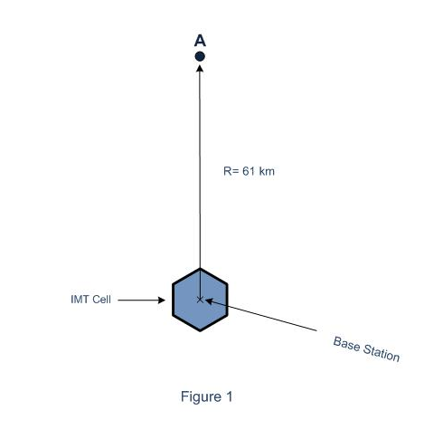

Step 2: Several base-stations

In Step 2, a network consisting of several IMT base-stations is modelled on either side of base-station in Step 1, and also behind it. All base-stations have the same characteristics as that in Step 1. The area in which this network operates is assumed to be urban and therefore a cell range of 1 km is selected. This is within the range specified by ITU-R of (0.5 km – 5 km). The inter-site distance is 1.6 km.

The IMT network used in this study consists of alternately 15 or 16 cells across and 17 cells deep, making a total of 263 cells.

Now the field strength from each base-station in the extended IMT network is calculated at point A, according to the methodology given by ITU-R (i.e. calculated at 2% time).

The field strengths from each base-station in the extended IMT network are summed to give accumulated field strength at A.

The resultant accumulated field strength is found to be 43.4 dB(V/m), i.e. an increase of 20.4 dB compared to the single cell case in Step 1.

Step 3: Derive a new separation distance

Having derived a value for the accumulated field strength, the distance modelled between the IMT network and the DTTB receiving point A can be recalculated such that the accumulated field strength drops to the original threshold.

In the case considered here, that is found to be about 212 km.

2.2.1.1.1.1.3 Results

The results found above are summarised in the Table 2 below.

TABLE 2

Results of study 1a

|  |  |  |  |  |
| --- | --- | --- | --- | --- |
| Interfering field strength threshold @700MHz | Initial separation distance R | Total cumulative field strength | Increase over original threshold | New required separation distance |
| dB(V/m) | km | dB(V/m) | dB | km |
| 23 | 61 | 43.4 | 20.4 | 212 |

2.2.1.1.1.2 Study 1b

2.2.1.1.1.2.1 Description

When assessing the interference from MS networks to broadcasting service (BS) it necessary to evaluate the interference field strength of MS base-stations in the test points at the territory of other country. “Geneva-06” Agreement provides trigger value for consideration of the single assignment of MS base-station to which a threshold value applied at any test point within the territory of   
the country concerned. However, at the time of the “Geneva-06” Agreement development IMT implementation plans currently under consideration were not known. Those plans assume use of the same frequency throughout all country (frequency reuse factor 1).

2.2.1.1.1.2.2 Calculations

2.2.1.1.1.2.2.1 Single base-station

Calculations were performed for a single base-station with typical parameters (see Table. 2) at 700 MHz. The distance at which the interfering base-station field strength decreases to the threshold value of 25 dB(µV/m). This equivalents to an *I/N* of –19 dB (50% locations) and –10 dB (95% locations) at the upper end of the 694-790 MHz band.

###### 2.2.1.1.1.2.2.2 Base stations network

A network of base-stations is created, with typical parameters corresponding to those given in Table 3. The calculation of the increment of the total interference from the network of base-station is performed, and the cumulative field strength is compared with the field strength from a single interferer. For the summation of multiple interfering signals method proposed by ITU-R is used.

After obtaining cumulative field strength values, the distance between the simulated network IMT and DTTB reception point A was recalculated until the cumulative field strength drops to the initial threshold of 25 dB(µV/m).

TABLE 3

Network parameters for MS base-stations

| Parameter | Scale | Value |
| --- | --- | --- |
| e.r.p. without loss and Giso for 10 MHz | dBm | 58.00 |
| Cable loss (Lcable) | dB | 3.00 |
| Antenna factor (Giso) | dBi | 15.00 |
| Polarization discrimination | dB | 3 |
| Antenna height above ground | m | 30.00 |
| Antenna tilt, downside | Degrees | 3 |
| Main beam by 3 dB loss in H plane | Degrees | 65 |
| Main beam by 3 dB loss in V plane | Degrees | Based on Rec. ITU-R F.1336 |
| MS network type |  | Rural |
| Cell radius (*r*IMT) | km | 8 |

2.2.1.1.1.2.3 Results

The results are shown in Table 4. The calculation is performed for base-station antenna height of 30 m.

TABLE 4

Separation distances and the increment of the field strength

|  |  |  |  |  |  |  |
| --- | --- | --- | --- | --- | --- | --- |
| Frequency (MHz) | Trigger field strength (dB(μV/m) | Propagation path | Separation distance for single base station (km) | Total cumulative field strength (dB(μV/m) | Increase over original threshold (dB) | Separation distance for MS network (km) |
| 700 | 25 | Land | 60 | 42,4 | 17,4 | 212 |
| 700 | 25 | warm sea | 704 | 52,8 | 27,8 | >1 000 |

The case study indicating the increment of the cumulative interference from the multiple base-station MS network with respect to a single interferer is given in the case study 1 in the Annex. The results show that the excess of the cumulative interference from MS network over the single interferer can be up to 21 dB which causes a significant increase in the required separation distance when using the same field strength threshold for cumulative interference as for single entry interference. This study shows that when conducting compatibility studies, the cumulative interference of signals from the MS base-stations should be considered.

##### 2.2.1.1.2 Scenario 2 – Degradation of reception location probability

###### 2.2.1.1.2.1 Description

The study assessed the cumulative effect of co-channel interference from a network of IMT base-stations in one country into DTTB reception in a neighbouring country in terms of degradation in location probability at different levels of the DTTB coverage area: at one pixel at the edge and in a ring of pixels at the coverage edge.

The study also assessed co-channel geographical separation between IMT base-stations (single and multiple) and DTTB reception area for a land path and for different network configurations.

###### 2.2.1.1.2.2 Methods of calculation with formulas

This study uses the methodology described in Annex 2 to Report ITU‑R BT.2265. It takes into account the liaison statements received from ITU-R with regard to time percentages of individual base-stations (1.7% instead of 1%), and from ITU-R on generic IMT networks to be used in sharing studies. All technical parameters are in line with the ITU-R agreed parameters.

The base-stations are placed uniformly so that individually the GE06 coordination threshold is not exceeded at the border. A broadcast coverage area is placed on the opposite side of the border, just touching the border (see Fig. 2). Tri-sector cell structure is used (see Fig. 3). The interference probability is calculated, using Monte Carlo simulation, throughout a ring at the broadcast coverage edge, and at the two pixels on the coverage edge, closest to and farthest from, respectively, the base-station network. (see Fig. 3). The cumulative interfering field strength from increasing numbers of base-stations was calculated.

Figure 2

Mobile network starts at the ‘Single Cell Critical Distance’,  
SCCD, from the border

Cell network BSs above this line

Cell network continues

Cell network continues

Cell network continues

Because the pixel is far (at the SCCD) from the main interferer, the additional effect of the other interferers is greater because their distances to the pixel are similar. That is, cumulative effects may play a major role. This means that the individual interference contributions must be reduced in order to keep the ‘total’ interference within the protective limits. That is, the trigger value must also be significantly lower than a single-interferer trigger value.

Representative pixel at country border:  
100 m x 100 m

SCCD

Because SCCD is ‘large’, the relative distances from the pixel to the other BSs are very similar to the SCCD, so the relative interference contributions are also similar.

Broadcast coverage area

Ring 4

Ring 3

Ring 2

Figure 3

Cell structure

**LTE Tx**

**Cell Radius = R**

**Sector Range = R**

**LTE Cell**

**Tri-sector Structure**

**R**

Figure 4

DTTB coverage area, coverage edge, nearest and farthest pixels

Direction to IMT network

DTTB coverage area

DTTB coverage edge

Nearest DTTB coverage edge pixel

Farthest DTTB coverage edge pixel

###### 2.2.1.1.2.3 Degradation in reception location probability

Tables 5 to 9 provide degradation in reception location probability at the considered pixels/areas of the DTTB coverage area for different numbers of interferers. They also provide the SINR exceeded in 95% of the locations in the considered pixels/areas.

## Urban DTTB coverage

TABLE 5

Urban cell network, high power urban DTTB coverage

|  |  |  |  |  |
| --- | --- | --- | --- | --- |
| Number of interferers (IMT 3-sector base-stations) | 1 | 6 | 91 | 378 |
| Degradation of reception location probability for a PR of 21 dB at the DTTB coverage edge | 0.02% | 0.12% | 1.3% | 3.6% |
| SINR exceeded in 95% of the locations in a ring of 100m at the DTTB coverage edge | 21.1 dB | 21.0 dB | 20.4 dB | 19.3 dB |
| Degradation of reception location probability for a PR of 21 dB at the border DTTB coverage pixel | 0.3% | 1.7% | 15.3% | 30.5% |
| SINR exceeded at 95% of coverage at the border DTTB coverage pixel | 20.9 dB | 20.2 dB | 16.6 dB | 13.9 dB |
| Degradation of reception location probability for a PR of 21 dB at the far DTTB coverage edge pixel | 0% | 0.03% | 0.4% | 1.6% |
| SINR exceeded at 95% of coverage at the far DTTB coverage edge pixel | 21.1 dB | 21.1 dB | 20.9 dB | 20.2 dB |
| **1% time aggregated interference (1.7% time individual interference)**  Urban network: e.i.r.p. = 55 dBm, Htx = 30 m, cell range = 1 km, SCCD = 17.2 km  Broadcast coverage: e.r.p. = 23 dBkW, Htx = 300 m, Hrx = 10 m, coverage radius = 39.5 km  Thickness of Broadcast coverage edge: 100 m | | | | |

TABLE 6

Urban cell network, medium power urban DTTB coverage

|  |  |  |  |  |
| --- | --- | --- | --- | --- |
| Number of interferers (IMT 3-sector base-stations) | 1 | 6 | 91 | 378 |
| Degradation of reception location probability for a PR of 21 dB at the DTTB coverage edge | 0.1% | 0.5% | 5.4% | 14.3% |
| SINR exceeded in 95% of the locations in a ring of 100m at the DTTB coverage edge | 21 dB | 20.8 dB | 18.9 dB | 16.5 dB |
| Degradation of reception location probability for a PR of 21 dB at the border DTTB coverage pixel | 0.3% | 1.7% | 15.3% | 30.5% |
| SINR exceeded at 95% of coverage at the border DTTB coverage pixel | 21 dB | 20.9 | 16.6 dB | 13.9 dB |
| Degradation of reception location probability for a PR of 21 dB at the far DTTB coverage edge pixel | 0.1% | 0.7% | 8.7% | 25.3% |
| SINR exceeded at 95% of coverage at the far DTTB coverage edge pixel | 21 dB | 20.7 dB | 18.1 dB | 14.7 dB |
| **1% time aggregated interference (1.7% time individual interference)**  Urban network: e.i.r.p. = 55 dBm, Htx = 30 m, cell range = 1 km, SCCD = 17.2 km  Broadcast coverage: e.r.p. = 7 dBkW, Htx = 150 m, Hrx = 10 m, coverage radius = 12.6 km  Thickness of Broadcast coverage edge: 100 m | | | | |

## **Rural DTTB coverage**

TABLE 7

Urban cell network, high power rural DTTB coverage

|  |  |  |  |  |
| --- | --- | --- | --- | --- |
| Number of interferers (IMT 3-sector base-stations) | 1 | 6 | 91 | 378 |
| Degradation of reception location probability for a PR of 21 dB at the DTTB coverage edge | 0.04% | 0.3% | 3.4% | 10.7% |
| SINR exceeded in 95% of the locations in a ring of 100m at the DTTB coverage edge | 21 dB | 20.9 dB | 19.5 dB | 16.9 dB |
| Degradation of reception location probability for a PR of 21 dB at the border DTTB coverage pixel | 0.3% | 1.9% | 22.2% | 51.5% |
| SINR exceeded at 95% of coverage at the border DTTB coverage pixel | 20.9 dB | 20.2 dB | 15.4% | 10.9 dB |
| Degradation of reception location probability for a PR of 21 dB at the far DTTB coverage edge pixel | 0.03% | 0.2% | 2.6% | 15% |
| SINR exceeded at 95% of coverage at the far DTTB coverage edge pixel | 21 dB | 21 dB | 20 dB | 17.6 dB |
| **1% time aggregated interference (1.7% time individual interference)**  Urban network: e.i.r.p. = 55 dBm, Htx = 30 m, cell range = 1 km, SCCD = 47.1 km  Broadcast coverage: e.r.p. = 23 dBkW, Htx = 300 m, Hrx = 10 m, coverage radius = 70.5 km  Thickness of Broadcast coverage edge: 100 m | | | | |

TABLE 8

Urban cell network, medium power rural DTTB coverage

|  |  |  |  |  |
| --- | --- | --- | --- | --- |
| Number of interferers (IMT 3-sector base-stations) | 1 | 6 | 91 | 378 |
| Degradation of reception location probability for a PR of 21 dB at the DTTB coverage edge | 0.1% | 0.7% | 10.3% | 29.1% |
| SINR exceeded in 95% of the locations in a ring of 100m at the DTTB coverage edge | 21.1 dB | 20.6 dB | 17.5 dB | 13.4 dB |
| Degradation of reception location probability for a PR of 21 dB at the border DTTB coverage pixel | 0.4% | 1.9% | 22.2% | 51.4% |
| SINR exceeded at 95% of coverage at the border DTTB coverage pixel | 20.9 dB | 20.2 dB | 15.4 dB | 10.9 dB |
| Degradation of reception location probability for a PR of 21 dB at the far DTTB coverage edge pixel | 0.2% | 1.5% | 20.2% | 52.4% |
| SINR exceeded at 95% of coverage at the far DTTB coverage edge pixel | 20.9 dB | 20.4 dB | 15.7 dB | 10.8 dB |
| **1% time aggregated interference (1.7% time individual interference)**  Urban network: e.i.r.p. = 55 dBm, Htx = 30 m, cell range = 1 km, SCCD = 47.1 km  Broadcast coverage: e.r.p. = 7 dBkW, Htx = 150 m, Hrx = 10 m, coverage radius = 32.1 km  Thickness of Broadcast coverage edge: 100 m | | | | |

###### 2.2.1.1.2.4 Relationship between reception location probability degradation (Δ*RLP*) and *I/N* criteria

TABLE 9

Reception location probability degradation (ΔRLP) as a function  
of *I/N* (50%) and *I/N* (95%) RLP target = 95%

|  |  |  |  |  |  |
| --- | --- | --- | --- | --- | --- |
| *I*/*N* (50%)[3] | –19 dB | –12.8 dB | –10 dB | –6 dB | 0 dB |
| *I*/*N* (95%)[4] | –10 dB | –3.8 dB | –1 dB | +3 dB | 9 dB |
| Δ*RLP* | 0.23% | 1% | 1.84% | 4.47% | 14.68% |

###### 2.2.1.1.2.3 Separation distances

Tables 10 to 12 provide co-channel separation distances for a land path with single and multiple base-stations, for different network configurations, on the basis of protecting the nearest DTTB coverage edge pixel (with full antenna discrimination).

Table 10

Co-channel separation distances for a land path with single and multiple base-stations for  
urban IMT network (sector range = 1 km) into urban fixed DTT reception (at 20 m), suburban fixed DTT reception (at 10 m), rural fixed DTT reception (at 10 m)  
for different target levels of ΔRLP and corresponding *I/N* protection criteria

|  |  |  |  |  |  |
| --- | --- | --- | --- | --- | --- |
| *I/N* (50%) | –19 dB | –12.8 dB | –10 dB | –6 dB | 0 dB |
| *I/N* (95%) | –10 dB | –3.8 dB | –1 dB | +3 dB | 9 dB |
| DRLP% | 0.23% | 1% | 1.85% | 4.48% | 14.68% |
| Number of base-stations |  |  |  |  |  |
| 1 | 53.50 km | 37.55 km | 32.39 km | 26.15 km | 19.02 km |
| 6 | 81.80 km | 55.04 km | 47.12 km | 37.98 km | 28.27 km |
| 91 | 160.90 km | 111.20 km | 94.32 km | 73.30 km | 52.30 km |
| 378 | 212.60 km | 157.70 km | 135.45 km | 105.15 km | 72.80 km |

TABLE 11

Co-channel separation distances for a land path with single and multiple base-stations for suburban IMT network (sector range = 2 km) into urban fixed DTT reception (at 20 m), suburban fixed DTT reception (at 10 m), rural fixed DTT reception (at 10 m)  
for different target levelsof ΔRLP and corresponding *I/N* protection criteria

|  |  |  |  |  |  |
| --- | --- | --- | --- | --- | --- |
| *I/N* (50%) | –19 dB | –12.8 dB | –10 dB | –6 dB | 0 dB |
| *I/N* (95%) | –10 dB | –3.8 dB | –1 dB | +3 dB | 9 dB |
| DRLP% | 0.23% | 1% | 1.85% | 4.48% | 14.68% |
| Number of base-stations |  |  |  |  |  |
| 1 | 53.5 km | 37.6 km | 32.4 km | 26.2 km | 19.0 km |
| 6 | 81.3 km | 54.3 km | 46.5 km | 37.3 km | 28.6 km |
| 91 | 157.1 km | 107.0 km | 90.0 km | 68.8 km | 47.3 km |
| 378 | 204.3 km | 148.3 km | 125.3 km | 94.3 km | 61.1 km |

TABLE 12

Co-channel separation distances for a land path with single and multiple base-stations for Rural IMT network (sector range = 8 km) into urban fixed DTT reception (at 20 m), suburban fixed DTT reception (at 10 m), rural fixed DTT reception (at 10 m) for different target levels of ΔRLP and corresponding *I/N* protection criteria

|  |  |  |  |  |  |
| --- | --- | --- | --- | --- | --- |
| *I/N* (50%) | –19 dB | –12.8 dB | –10 dB | –6 dB | 0 dB |
| *I/N* (95%) | –10 dB | –3.8 dB | –1 dB | +3 dB | 9 dB |
| DRLP% | 0.23% | 1% | 1.85% | 4.48% | 14.68% |
| Number of base-stations |  |  |  |  |  |
| 1 | 53.5 km | 37.6 km | 32.4 km | 26.2 km | 19.0 km |
| 6 | 76.6 km | 48.9 km | 40.6 km | 31.2 km | 21.4 km |
| 91 | 126.0 km | 74.1 km | 57.7 km | 39.9 km | 24.5 km |
| 378 | 142.8 km | 84.3 km | 63.9 km | 42.3 km | 25.1 km |

Analysis of results

The protection of DTTB from co-channel IMT downlink requires a separation distance to avoid coordination according to GE06. Calculations show that, even without accumulation of interfering field strength, a single IMT base-station will need to be positioned 53 km (for land path) from the DTTB service edge, i.e. from the border of the affected Administration.

Including multiple interfering base-stations would increase the interfering field strength at the DTTB service edge by up to 20 dB. Based on the parameters used in this particular study, the resulting separation distance could be increased up to 200 km when using the same field strength threshold for cumulative interference as for single entry interference (23 dB(µV/m)).

The calculations are made according to Report ITU-R BT.2265 which contains a method to assess the impact of interference from multiple base-station networks on DTTB reception.

###### 2.2.1.1.3 Scenario 3 C/(N+I)

Section A.1.1.2 of the Annex contains a case study for this Scenario.

#### 2.2.1.2 Mobile service as a victim: Interference from broadcasting transmissions into mobile base-stations

###### 2.2.1.2.1 Scenario 1: *I/N*

Section A.1.2.1 of the Annex contains a case study for this scenario.

###### 2.2.1.2.1.1 Study 1

2.2.1.2.1.1.1 Introduction

This section presents results of co-channel interference calculations from existing DVB-T/T2 transmitters and GE06 Plan entries, into IMT uplink receivers. Calculations have been made for a generic case. Also a Case study was made (see § A.1.2.1) including two countries France and Germany using the existing and coordinated DTTB transmitters on UHF channel 50 (706 MHz).

The aim of this study is to assess the feasibility of using the same band for DTTB by one country and the IMT uplink in a neighbouring country.

The criteria used by the MS for the protection of the mobile and base-stations receivers is based on the *I/N* criteria. These criteria are used in this study where only the case of the base-station receiver is considered.

2.2.1.2.1.1.2 Technical characteristics

2.2.1.2.1.1.2.1 DTTB Transmitter data

For the generic study, two reference single broadcast transmitter configurations are considered. They are representative of actual deployments in the case of assignments used in the GE06 planning area.

• High power transmitter

• e.r.p.: 200 kW

• Effective antenna height: 300 m

• Antenna height a.g.l.: 200 m

• Antenna pattern:

• Horizontal: Omnidirectional

• Vertical antenna aperture: based on 24λ aperture with 1° beam tilt

• Medium power

• e.r.p.: 5 kW

• Effective antenna height: 150 m

• Antenna height a.g.l.: 75 m

• Antenna pattern:

• Horizontal: Omnidirectional

• Vertical: based on 16λ aperture with 1.6° beam tilt

2.2.1.2.1.1.2.2 Mobile network data

In Table 13 the calculation of the interference limits for an IMT base station (uplink) is made [1]. This limit is based on *I/N* of –6 dB as protection criteria, which corresponds to a 1 dB desensitization of the uplink receiver at the base-station.

TABLE 13

Calculation of interference threshold for base-station

|  |  |  |  |
| --- | --- | --- | --- |
| Parameter | Value for base Station | Unit | Comment |
| Frequency | 698 | MHz | F |
| Rx Noise figure | 5 | dB | NF |
| Bandwidth | 10 | MHz | BW |
| Temperature | 290 | K | T |
| **Thermal Noise (10 MHz)** | –**99.0** | **dBm** | **PN = 10log(kTB) + NF** |
| *I/N* protection criterion | –6 | dB | *I/N* |
| **Interference power threshold** | –**105.0** | **dBm** | **PI = PN + *I/N*** |
| Downtilt | 3 | ° |  |
| Rx antenna discrimination | 1.19 | dB | Dant (Rec. ITU-R F 1336) |
| Polarization discrimination | 3 | dB | Dpol |
| Rx antenna gain | 15 | dB | Grx |
| Feeder loss | 1 | dB | Dfl |
|  |  |  |  |
| **Field strength interference threshold at Rx antenna height** | **19.3** | **dB(µV/m)** | **Eunwanted = 77.21+PI+20log(F)-Grx+Dant+Dpol+Dfl** |
| Antenna height | 30 | M | Hant |

In Table 14 the field strength thresholds are given, subject to different assumption on *I/N* and different polarization for the broadcast and the mobile IMT network.

TABLE 14

Field strength thresholds

|  |  |  |  |
| --- | --- | --- | --- |
| Threshold | Value dB(V/m) | Rx Antenna height m | Comment |
| Th1 | 19.3 | 30m | *I/N* of –6 dB |
| Th2 | 25.3 | 30m | Relaxed *I/N* from –6 to 0 dB |
| Th3 | 31.1 | 30m | Cross polarization and *I/N* of –6 dB |
| Th4 | 37.1 | 30m | Cross polarization and *I/N* of 0 dB |

2.2.1.2.1.1.3 Analysis

Fig. 5 shows the basic configuration for the assessment of the separation distance between interfering DTTB transmitter and victim IMT base-station receiver (uplink)

Figure 5

Basic configuration for the assessment of separation distance between interfering DTTB transmitter   
and victim IMT base-station receiver (uplink)

Border

IMT base-station receiver

DTTB Transmitter

DTTB Coverage radius

Separation distance

DTTB

IMT

For this generic study, only Recommendation ITU-R P.1546 was used. There is no point in using other methods based on terrain for generic studies.

The separation distances were calculated for all the field strength thresholds calculated in Table 14, which correspond to two different levels of protection and to the possible use of cross polarisation as a mitigation technique (or alternatively the use of full antenna discrimination).

Finally, the prediction was made for three percentages of time, 1%, 5 % and 10% to consider also a range of protection levels in terms of acceptable time percentage for the interference.

The DTTB coverage radius corresponding to the two reference transmitters are:

70.53 km for the high power transmitter (HP)

32.11 km for the medium power transmitter (MP)

TABLE 15

Required separation distances between interfering DTTB transmitter  
and victim IMT base-station receiver (uplink)

|  |  |  |  |  |  |  |
| --- | --- | --- | --- | --- | --- | --- |
| e.r.p. | Antenna height (m) | Target Field Strength (dB(µV/m)) | 1% time | 5% ime | 10% time | Comment |
| 200 kW | 300 | 19.3 | 427 | 355 | 318 | *I/N* of –6 dB |
| 200 kW | 300 | 25.3 | 359 | 290 | 258 | *I/N* of 0 dB |
| 200 kW | 300 | 31.1 | 297 | 235 | 207 | Cross polar and *I/N* of –6dB |
| 200 kW | 300 | 37.1 | 235 | 183 | 159 | Cross polar and *I/N* of 0dB |
|  |  |  |  |  |  |  |
| 5 kW | 150 | 19.3 | 269 | 215 | 192 | *I/N* of –6 dB |
| 5 kW | 150 | 25.3 | 211 | 167 | 148 | *I/N* of 0 dB |
| 5 kW | 150 | 31.1 | 161 | 126 | 110 | Cross polar and *I/N* of –6dB |
| 5 kW | 150 | 37.1 | 117 | 89 | 76 | Cross polar and *I/N* of 0dB |

As can be seen in Table 15, separation distances up to 427 km and 269 km, for HP and MP DTTB transmitters respectively, would be required to protect the IMT base-station receiver (uplink) in 99% time for a target *I/N* of –6 dB and with no additional discrimination by cross polarization of antenna directivity.

The relaxation of the protection level to 90% time, a target *I/N* of 0 dB and mitigation by full antenna polarization and/or antenna discrimination would reduce the separation distances to 159 km for HP and 76 km for MP.

2.2.1.2.1.1.4 Analysis of results

The calculations show that Co-channel sharing between DTTB broadcasting and IMT at UHF will be difficult due to significant interference into the IMT uplink receiver positioned at 30 metres height.

High level protection of the IMT uplink from DTTB co-channel interference would require separation distances of up to 269 km with a medium power DTTB station and up to 427 km with a high power DTTB station. This has also been shown on a case study (see § A.1.2.1) using planned assignments and allotments from the GE06 plan. Interference distances up to 200 km into uplink in neighbouring countries are predicted with the use of certain mitigation techniques and relaxation of the protection requirements.

###### 2.2.1.2.1.2 Study 2: Assessment of mechanisms of GE06 for protection of IMT from modification to GE06 Plan

2.2.1.2.1.2.1 Description

Base stations of MS (generic case, code NB) is protected from the modifications of GE06 Plan based on coordination trigger field strength to be calculated at 20 metres above the ground with use of 10% time and 50% location curves. Since the typical characteristics of IMT base-station differ from the generic mobile base-station considered in GE06 Agreement and typical IMT base-station antenna height is 30 metres, it is necessary to verify whether the mechanisms in GE06 Agreement is still appropriate to protect IMT base-stations form the modification to the GE06 Plan or not.

2.2.1.2.1.2.2 Methods of calculation with formulas

Maximum permissible interference field strength for IMT base-station was found based on *I/N* interference criteria and this value was compared to the equivalent of GE06 coordination field strength at 30 metres height above the ground. Conclusion was drawn out based on this comparison.

**Maximum permissible interference field strength for protection of IMT base-station** from DTTB transmitter is calculated based on *I/N* interference criteria:

$E_{INT}≤E_{N}+\frac{I}{N}+D_{DIR}+D_{POL} (dB(μV/m)$)

where

*EN*: total equivalent noise field strength of IMT base-station Receiver (dB(µV/m))

*I/N*: required interference-to-noise ratio (interference criteria), (dB)

*DDIR*: IMT base-station antenna directivity discrimination (dB)

*DPOL*: IMT base Station antenna polarization discrimination (dB).

**GE06 coordination trigger field strength** for protection of the base-stations of MS (generic case, code NB) is calculated as per paragraph 5.1.2 of Section I of Annex 4 of the GE06 Final Acts:

$$F_{trigger}=-37+\left(F-G_{i}+L_{f}+P_{o}\right)+10\log{B_{i}+20\log{f}}+\frac{I}{N} (dB (μV/m))$$

where

*Bi*: Bandwidth of DVB-T (MHz)

*F*: Centre frequency of interfering station (MHz)

*I/N*: Interference to noise ratio (dB)

  (*F* – *Gi* + *Lf* + *Po*) = –10 dB Typical value for Generic case (code NB, at 790 MHz).

Correction for **increase of interfering field strength** at 30 metres compared to its value calculated at 20 metres height above the ground is done as per the § 9 of Annex 5 of Rec. ITU-R P.1546‑5.

2.2.1.2.1.2.3 Calculations

**Maximum permissible interference field strength for protection of IMT base-station**

TABLE 16

|  |  |  |  |
| --- | --- | --- | --- |
| **Required *I/N*  (interference criteria)** | **Maximum permissible interfering field strength for protection of IMT base-station receiver, dB(µV/m) at 30 m above ground level** | | |
| In city area | In residential area | In rural area |
| *I/N* = –6 dB | 29.59 | 25.65 | 21.52 |
| *I/N* = –10 dB | 25.59 | 21.65 | 17.52 |
| NOTE – To simulate the worst case, IMT base-station’s antenna directivity and polarization (DDIR=0 and DPOL=0) discriminations were not taken into account in calculation of maximum permissible interfering field strength. | | | |

TABLE 17

|  |  |  |  |  |  |
| --- | --- | --- | --- | --- | --- |
|  | **Unit** | **Values** | **Formula** | **Notes** | |
| IMT base-station receiver system noise floor (NR) | dBW | –129.43 | $$N_{R}=10\log_{10}\left(kT_{0}B\right)+F$$ | *k = 1.38E-23 JK–1 T = 290 K B = 9E+6 Hz (Signal bandwidth) F = 5 dB (receiver noise figure)* | |
| Noise equivalent field strength (ENR) | dB(µV/m) | 22.74 | $$E_{NR}=N_{R}-G_{R}+ \\ \log_{10}\left(f\right)+107.2$$ | *GR = 12 dBi (antenna gain incl.3 dB feeder loss) f=706 MHz (reference frequency)* | |
| Environmental equivalent noise field strength (ENE) | dB(µV/m) | 35.36 | $$E_{NE}=c-d\log_{10}\left(f\right)+ \\ G_{R}-2.15+20\log_{10}\left(f\right)+10\log_{10}\left(B\right)-98.9$$ | City | Values of *c* and *d* were taken from Rep. ITU‑R BT.2265 |
| 31.06 | Residential |
| 25.76 | Rural |
| Total equivalent noise field strength (EN) | dB(µV/m) | 35.59 | $$E_{N}=10\log_{10}{\begin{aligned} \\ \left({10}^{\frac{E_{NR}}{10}}+{10}^{\frac{E_{NE}}{10}}\right)\end{aligned}}$$ | City area | |
| 31.65 | Residential area | |
| 27.52 | Rural area | |

NOTE – Values of variables related to IMT Base stations are typical ones. **GE06 coordination trigger field strength**

$$F_{trigger}=-37+\left(F-G_{i}+L_{f}+P_{o}\right)+10\log{B_{i}+20\log{f}}+\frac{I}{N}=13 dB(μV/m)$$

NOTE – In accordance with GE06 Agreement, this trigger field strength (i.e. 13 dB(uV/m)) shall be calculated at 20 m height (Table A.1.3, Appendix 1, Section I, Appendix 4 GE06 Final Acts) for 10% time and 50% location (Para. 5.1.2, Section I, Appendix 4 GE06 Final Acts).

TABLE 18

|  |  |  |  |
| --- | --- | --- | --- |
| **Values** | **Unit** | **Notes** | **References to Annex 4 of GE06 Final Acts** |
| 8 | MHz | Bandwidth of DVB-T (*Bi*) |  |
| 706 | MHz | Centre frequency of interfering station (*f*) |  |
| –6 | dB | Interference to noise ratio (*I/N*) | Para. A.2, Appendix 1, Section I |
| –10 | dB | Typical values for Generic case (code NB, at 790 MHz) $(F-G_{i}+L_{f}+P_{o}$) | Table A.1.4, Appendix 1, Section I |

**Increase of interfering field strength** calculated at 30 m height above ground level compared to 20 m height.

TABLE 19

|  |  |  |  |
| --- | --- | --- | --- |
| **Area of location of IMT base-station** | | | **Notes** |
| **Dense urban area** | Urban area | Rural area | Assumption of representative height of ground cover surrounding the receiver antenna, R2 is 10m for suburban and rural area, 20 m for urban area and 30 m for dense urban area |
| 0.4 | 3.67 | 3.67 dB |

2.2.1.2.1.2.4 Results

Since the maximum permissible interfering field strengths for IMT base-station situated in city, urban or in rural areas are always higher (25.59 dB(µV/m), 21.65 dB(µV/m), 17.52 dB(µV/m)) than the equivalent trigger field strength of 16.67 dB(µV/m) (13 dB uV/m + 3.67 dB), all IMT base‑stations behind the coordination contour would be protected better than *I/N* = –10 dB if GE06 coordination mechanisms are applied for protection of IMT base-stations.

# 3 Summary

## 3.1 Mobile service base stations as an interferer into broadcast reception

The generic study in § 2.2.1.1.1.1 showed that the cumulative effect of interference can exceed 20 dB and that a separation distance of more than 200 km is needed to meet the field strength threshold of 23 dB(µV/m) which equivalents to an I/N of –10 dB (95% locations, 16 dB antenna discrimination) at the lower end of the 694-790 MHz band compared to 61 km for a single base-station of the MS.

The results of another generic study in § 2.2.1.1.1.2 showed that the excess of the cumulative interference from a MS network (from IMT to broadcast) over the single interferer can be up to 21 dB. This causes a corresponding increase of separation distance of up to 274 km on land and up to 1 000 km for land/sea paths (warm), when using the same field strength threshold for cumulative interference as for single entry interference.

The case study in § A.1.1.1 showed that excess of the cumulative interference from MS network over the single interferer can be up to 21 dB (using the receiving antenna).

The generic study in § 2.2.1.1.2 showed that even without accumulation of interfering field strength, a single IMT base-station will need to be positioned 53 km (for land path) from the DTTB service edge, i.e. from the border of the affected Administration in order not to exceed 23 dB(µV/m). This field strength is equivalent to an *I/N* of –10 dB (95% locations, 16 dB antenna discrimination) at the input of the DTTB receiver at the lower end of the 694-790 MHz band. Including multiple interfering base-stations would increase the interfering field strength at the DTTB service edge by up to 20 dB which corresponds to a separation distance of up to 200 km based on the parameters used in this particular study, when using the same field strength threshold for cumulative interference as for single entry interference

The case study in § A.1.1.2 showed that IMT base-stations in one country which are not individually subject to coordination, i.e. meeting the trigger threshold of GE06 (25 dB(µV/m)), will not interfere with the TV receivers in the neighbouring country, even if the cumulative effect of those base-stations is taken into account.

## 3.2 Broadcasting as an Interferer into Mobile Service Base Stations

The generic study in in § 2.2.1.2.1.1 showed that separation distances up to 427 km and 269 km, for high power (HP) and medium power (MP) DTTB transmitters respectively, would be required to protect the IMT base-station receiver (uplink) for 99% time, a target *I/N* of –6 dB and with no additional discrimination by cross polarization or receive antenna directivity. The relaxation of the protection level to 90% time, a target *I/N* of 0 dB and mitigation by full receive antenna polarization and/or discrimination would reduce the separation distances to 159 km for HP and 76 km for MP. The case study in § A.1.2.1 showed that co-channel sharing between DTTB broadcasting transmitters and an IMT uplink receiver positioned at 30 metres height, will require separation distances of the order of 200 km on land paths even with antenna cross polarization and a relaxation of the percentage of time for the interfering signal from 1 to 10%.

The generic study in in § 2.2.1.2.1.2 showed that the maximum permissible interfering field strength threshold for the protection of IMT base-stations from DTTB stations based on an   
*I/N*= –10 dB is higher than the GE-06 trigger field strength threshold of 13 dB(µV/m) (generic case, code NB).

Annex A  
  
Co-channel case studies

# A.1 Case studies

## A.1.1 Mobile service as an interferer: Interference from mobile service base-stations into broadcasting service reception

### A.1.1.1 Scenario 1 *I/N*

#### A.1.1.1.1 Description

When assessing the interference from MS networks to BS it necessary to evaluate the interference field strength of MS base-stations in the test points (tp) at the territory of another country. Russian Federation has assessed the change of the interference field strength taking into account the aggregate interference from base-stations in the MS network compared to the single-interference source for typical implementation of MS in the border areas. The results show that the excess of the cumulative interference from MS network over the single interferer can be up to 21 dB (using the receiving antenna). This study shows that when conducting compatibility studies, cumulative interference of signals from the MS base-stations should be considered.

#### A.1.1.1.2 Methods of calculation with formulas

The calculation of the increment of the cumulative interference field strength from the MS network in relation to a field strength from single interference source carried out in the following order:

1 select country A and country B;

2 create along the borders of countries A and B a uniform network of MS base-stations with typical parameters within the territory of the country A at a distance up to *X* kilometres from the border, so that the first row of the base-station stay close to the border;

3 create test points on the territory of country B on the border of countries A and B, and inland to a distance *Dt* kilometres by step, for example 10 km.

At each test point calculate:

a. the highest interfered field strength (for 1% of the time) from a single base-station at an altitude of 10 meters, but without take into account receiving antenna directivity;

b. the highest interfered field strength (for 1% of the time) from a single base-station at an altitude of 10 meters, taking into account receiving antenna directivity with the orientation of the fixed receiving antenna to the TV station with the strongest signal;

c. cumulative interference field strength from all base-stations in MS network, but without taking into account receiving antenna directivity, using the ITU-R guidance for the 1% of time interfering signals summation;

d. cumulative interference field strength from all base-stations in MS network, taking into account receiving antenna directivity, using the ITU-R guidance for the 1% of time interfering signals summation.

Fig. A.1 shows positions of MS network base-stations (blue dots) on the territory of country A and test points established in the territory of the country B (black dots). Fig. A.2 shows an example of the opposite situation – when MS network located in country B and test points in country A.

Figure A.1

MS network base-station sites (blue circles) within the borders of one country  
and the test points (black circles) on the territory of another country

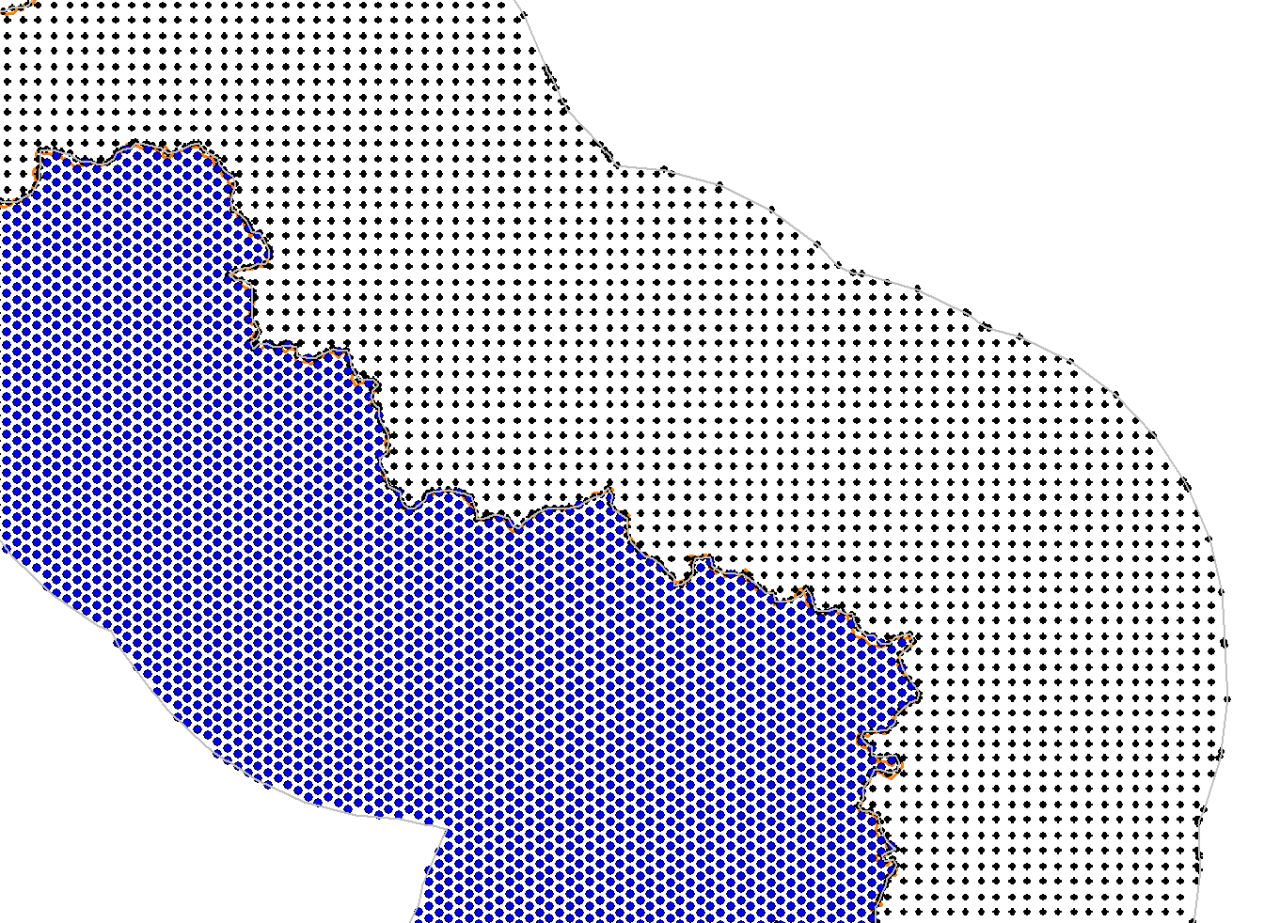

Figure A.2

MS network base-station sites (blue circles) within the borders of second country   
and the test points (black circles) on the territory of first country

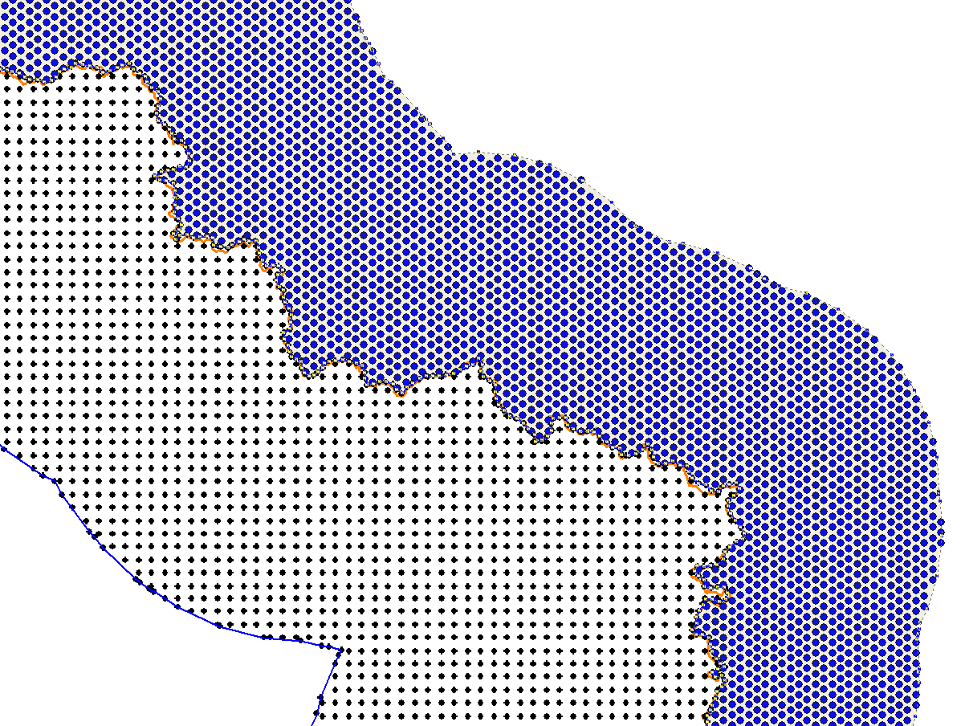

#### A.1.1.1.3 Results

The resulting distribution of the increments of the total strength of the interfering field with respect to the maximum field strength of the interfering signal from one station is shown in Fig. A.3 and A.4 (∆Fs).

Figures below show results for the case of using omnidirectional receiving antenna, and for the case of using the receiving antenna oriented in direction to TV station with the highest level of the desired signal.

Figure A.3

Distribution of cumulative interfering field strength from MS network increments over   
the maximum field strength from a single MS base-station in Fig, A1.1

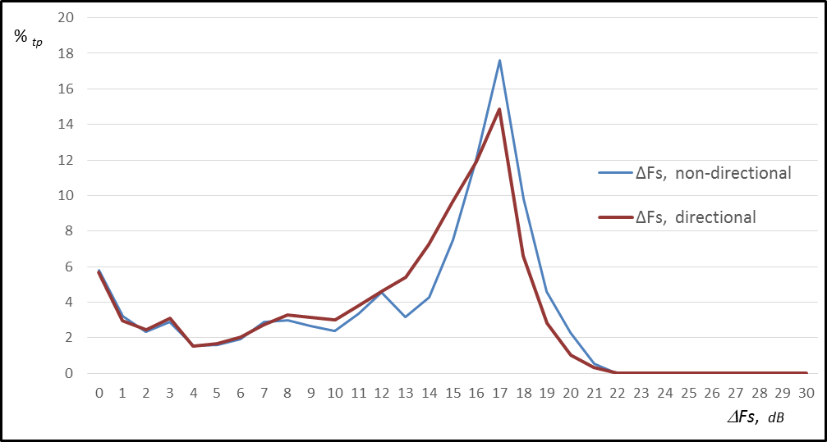

Figure A.4

Distribution of cumulative interfering field strength from MS network increments over   
the maximum field strength from a single MS base-station in Fig. A1.2

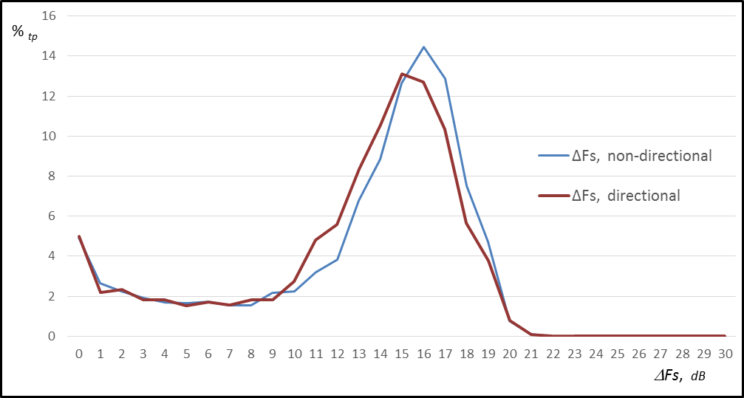

**A.1.1.2 Scenario 2: C/(N+I)**

**A.1.1.2.1 Description**

This section presents a summary of the results of a co-channel sharing study in the UHF band, based on a real mobile network , in order to assess the potential impact of multiple sources of interference in terms of C/N+I at different points at the border between two countries and inside the victim country.

Two areas are studied in this section:

− Area 1: Bordering area between France and Germany.

− Area 2: Bordering area between France and United Kingdom.

Figure A.5

Areas of the study

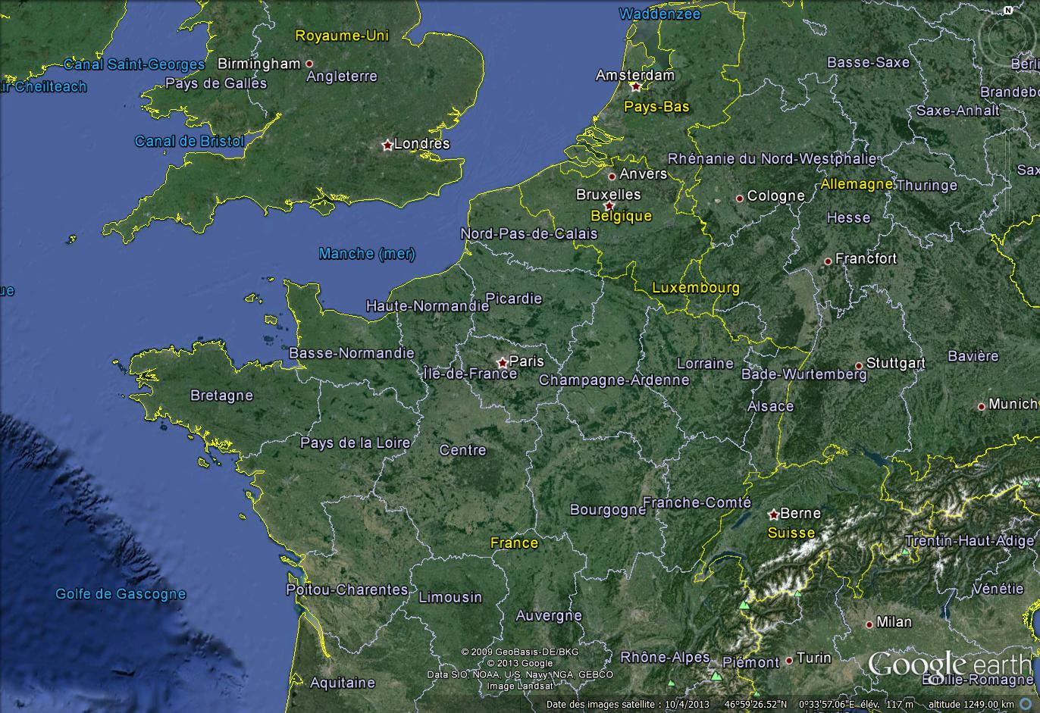

**Area 1**

**Area 2**

Both areas have a different DTT planning strategy as DTT is planned for portable outdoor reception reference planning configuration 2 (RPC2) in Germany and for fixed rooftop reception (RPC1) for United Kingdom.

The coordinated DTT networks, which are currently on air, have been used for both areas[5] and base‑stations of the GSM 900 have been used for MS[6]. In order to simplify the calculations, the base‑stations are considered as omnidirectional with 0° downtilt. As a consequence, the simulated field strength of the IMT network is overestimated. Due to the level of details the level of the DTT field strength is also overestimated.

The methodology of the study consists first, on a large set of test points, on the border or inside the victim country, in computing the DTT wanted field strength from all broadcasting stations. We can consider that the DTT reception antenna is receiving the maximum of all the field strength provide by all the broadcasting stations, taking into account the antenna directivity depending on the RPC. Thus, for each test points, the maximum of the median field strength, Ewanted is determined.

The second step consists in computing the interfering field strength for each test point and from each base-station.

In order to consider only the base-stations not subject to the coordination process under the condition of GE06 Agreement, the base-stations providing an interfering field strength above or equal to 25 dB(µV/m) on, at least, one test point on the border are withdrawn from the simulation

For each test point where Ewanted is above the minimum median DTT field strength, the cumulative median interfering field strength, **IMedCmul**, is computed with all the “non-coordinated” base-stations, using the power summing methodology.

The minimum median DTT field strength are taken from the GE06 Agreement (Table A-3-5-1 of Annex 3.5)

TABLE A.1

RPCs for DVB‑T

|  |  |  |  |  |
| --- | --- | --- | --- | --- |
| RPC | RPC 1 | RPC 2 | RPC 3 | |
| Reference location probability | 95% | 95% | 95% | |
| Reference *C*/*N* (dB) | 21 | 19 | 17 | |
| Reference (*Emed*)*ref* (dB(μV/m)) at *fr* = 200 MHz | 50 | 67 | 76 | |
| Reference (*Emed*)*ref* (dB(μV/m)) at *fr* = 650 MHz | 56 | 78 | 88 | |
| (*Emed*)*ref*: Reference value for minimum median field strength  RPC 1: RPC for fixed reception  RPC 2: RPC for portable outdoor reception or lower coverage quality portable indoor reception or mobile reception  RPC 3: RPC for higher coverage quality for portable indoor reception | | | |

The appropriate frequency correction factor is used to adjust the minimum median DTT field strength.

The calculations were performed at 790 MHz. The coordinated antenna pattern was used for the horizontal plane of the antenna while for the vertical plane an omnidirectional pattern was used.

The calculations were performed at 790 MHz. The coordinated antenna pattern was used for the horizontal plane of the antenna while for the vertical plane an omnidirectional pattern was used.

For the field strength calculations, the propagation model of the Rec. ITU-R P.1546 is used, 50% of time for the DTT and 2% of the time for the IMT network.

Finally, each IMedCumul is compared with Emaxint defined as:

 (1)

Where:

TABLE A.2

Parameters of the study

|  |  |
| --- | --- |
| Emaxint | Maximum median allowable base-station field strength in 8 MHz bandwidth at the wanted receiving antenna (dB(μV/m)) |
| Ewanted | Median wanted BS field strength at the wanted (BS) receiving antenna (dB(μV/m)) |
| σw | Standard deviation (dB) of the normal distribution of the wanted signal level (BS signals). The value of 5.5 dB is used for both cases |
| σi: | Standard deviation (dB) of the normal distribution of the interfering signal (base-station signals). The value of 5.5 dB is used for both cases |
| Q | Correction factor obtained from the complementary cumulative inversed normal function Q(x%), where x% represents the locations where a certain field strength is present; and is equal to 95% |
|  | “Propagation correction factor” (Recommendation ITU-R P.1546) (dB) |
| PR | Appropriate BS protection ratio (dB), the value of 19 dB is used according to Rec. ITU‑R BT.1368 |
| IM | Allowance for inter-service sharing (dB). The value of 0 dB is used |
| Ddir | BS receiver antenna directivity discrimination with respect to base-station signal (dB). For RPC1 the Recommendation ITU-R BT.419 is used and for RPC2, no antenna discrimination is considered |
| Dpol: | BS receiver polarization discrimination with respect to base-station signal (dB). It is assumed that base-station signals are cross polarized. The receiver antenna polarization discrimination is, therefore, assumed to be 3 dB for RPC1 and 0 dB for RPC2 |

An interference situation occurs when the cumulative interference field strength, **IMedCmul**, from the selected set of base-stations is above the maximum median allowable base-station field strength, **Emaxint**.

As a consequence, the following criteria must be kept to avoid interference situation:

**IMedCmul** < **Emaxint**(2)

**A.1.1.2.2 Area 1: Bordering area between France and Germany**

The DTT network used for this case study is illustrated below.

Figure A.6

DTT network

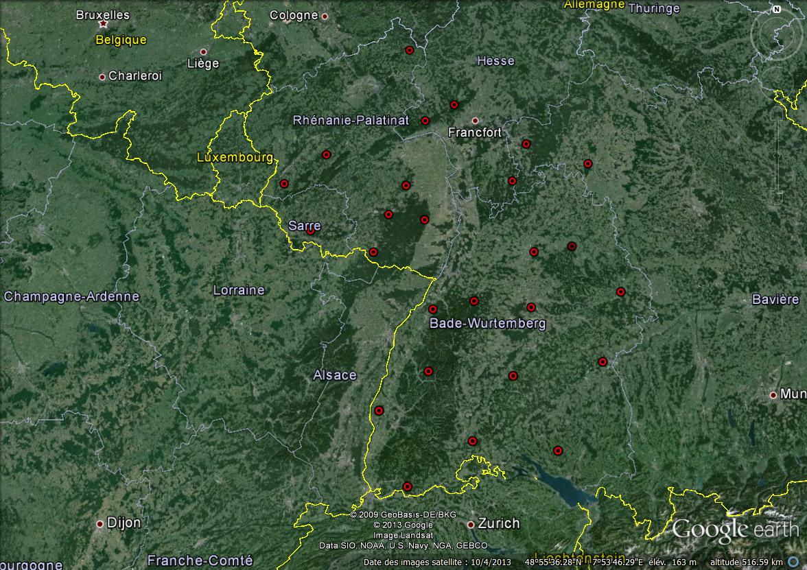

The IMT network is illustrated below. The figure on the left corresponds to all the considered IMT stations and the figure on the right correspond to all the IMT stations not concern by the international coordination, i.e. interfering field strength is below the triggering threshold according to the GE06 Agreement.

Figure A.7

|  |  |
| --- | --- |
|  |  |
| IMT Network (1 384) | Non coordinated IMT Network (519) |

The considered test points are illustrated below.

Figure A.8

|  |  |
| --- | --- |
|  |  |
| Test points at the border (328) | Complementary test points (48) |

The results of the simulations with a 1.5 m receiving antenna height are illustrated below.

Figure A.9

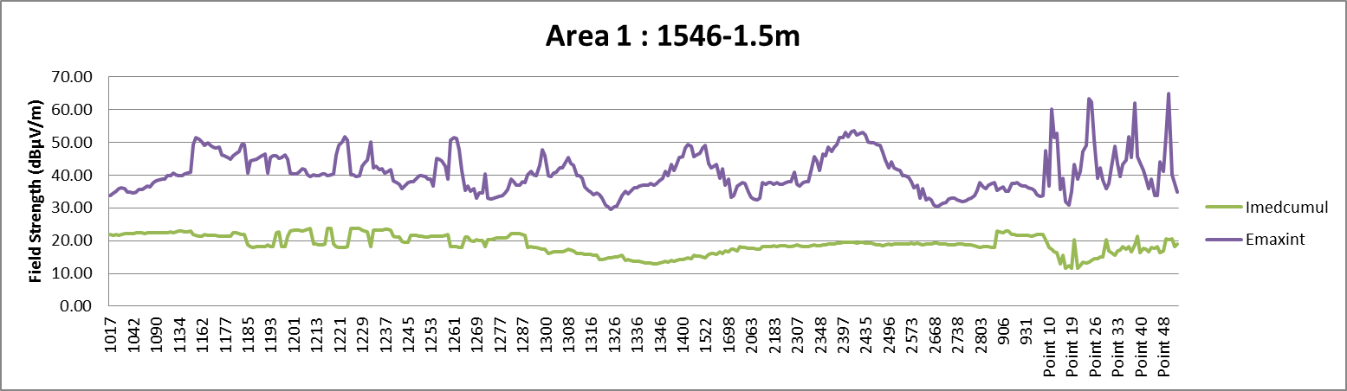

Complementary test points

For all the test points where C/N ≥ PR, the cumulative median interfering field strength is below the maximum median allowable base-station field strength in 8 MHz bandwidth at the wanted receiving antenna. The criterion (2) is always respected.

The results of the simulations with a 10 metres receiving antenna height are illustrated below.

Figure A.10

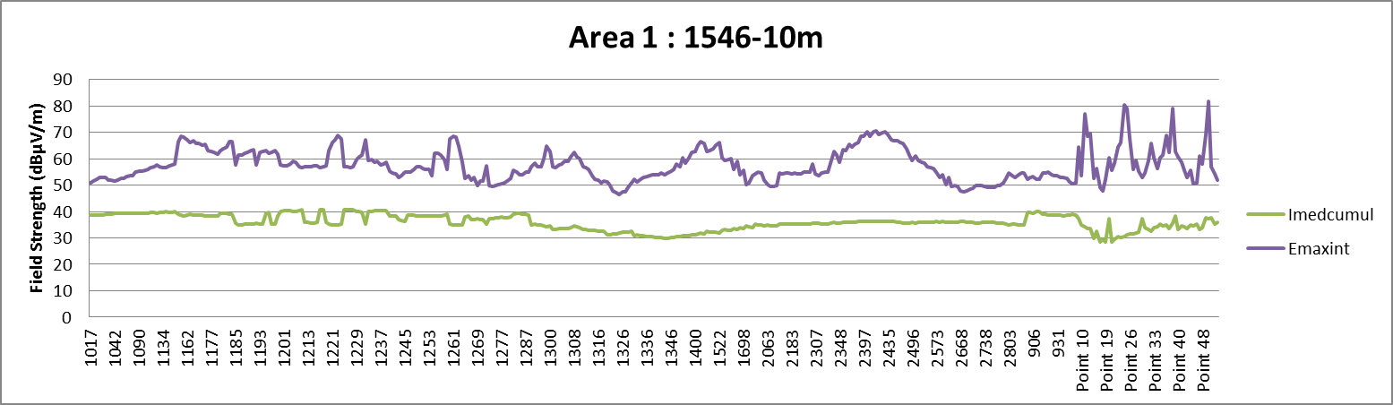

Complementary test points

The same conclusion applies.

**A.1.1.2.3 Area 2: Bordering area between France and United Kingdom**

The DTT network used for this case study is illustrated below.

Figure A.11

DTT network

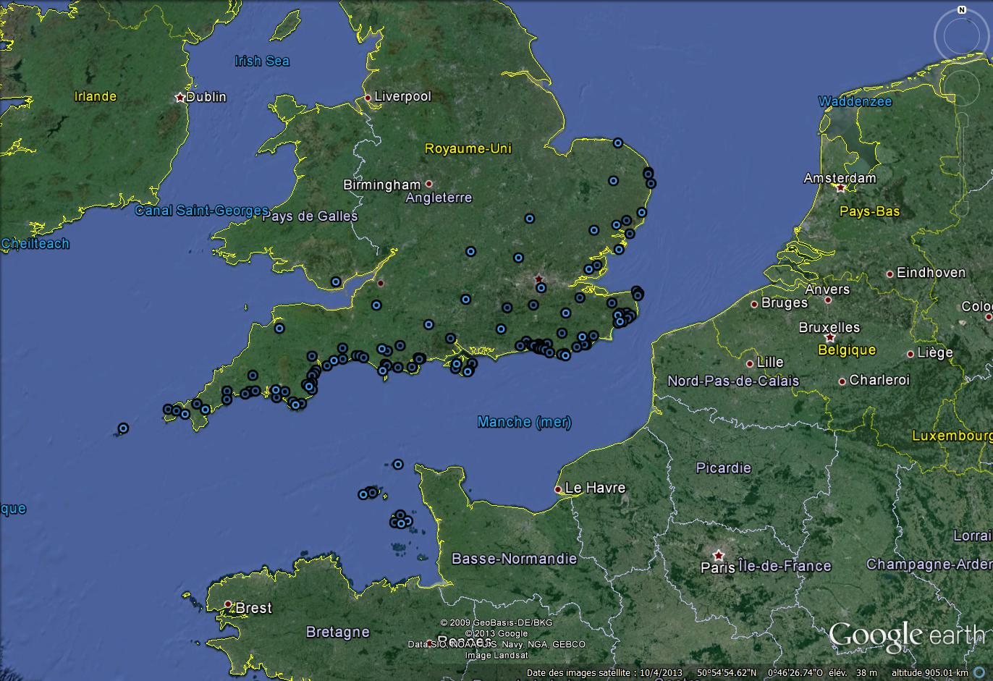

The IMT network is illustrated below. The figure on the left corresponds to all the considered IMT stations and the figure on the right correspond to all the IMT stations not concern by the international coordination, i.e. interfering field strength is below the triggering threshold according to the GE06 Agreement.

Figure A.12

|  |  |
| --- | --- |
|  |  |
| IMT Network (6 811) | Non coordinated IMT Network (5 137) |

The considered test points are illustrated below.

Figure A.13

|  |  |
| --- | --- |
|  |  |
| Test points at the border (84) | Complementary test points (29) |

The results of the simulations with a 10 metres receiving antenna height are illustrated below.

Figure A.14

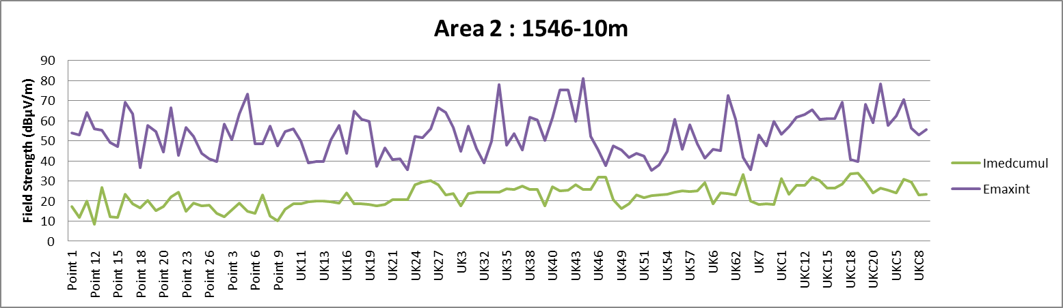

Complementary test points

For all the test points where C/N ≥ PR, the cumulative median interfering field strength is below the maximum median allowable base-station field strength in 8 MHz bandwidth at the wanted receiving antenna. The criterion (2) is always respected.

###### A.1.1.2.3 Conclusions

The purpose of GE06 coordination trigger threshold evaluations is to indicate when it is advisable to have discussions with your neighbours. In this study the stations that would have been subject to coordination have been left out. In normal bilateral situations it would be advisable to discuss the whole of the proposed network with your neighbours. If these discussions do not take place the study above would provide an indication of potential residual interference field strength of the remaining stations omitted from the coordination.

With the parameters and assumptions taken for this study, it is shown that the strict application of GE06 Agreement (including its coordination threshold) adequately protects the reception of the BS. In this case study, those base-stations in one country which are not individually subject to coordination will not interfere with the TV receiving station in the neighbouring country even if the cumulative effect of those base-stations is taken into account.

### A.1.2 Mobile service as a victim: Interference from broadcasting transmissions into mobile base-stations

#### A.1.2.1 Scenario 1 *I/N*

##### A.1.2.1.1 Introduction

This section presents results of co-channel interference calculations from broadcasting transmissions into IMT uplink receivers. Calculations have been made for two countries France and Germany using the existing and coordinated DTTB transmitters on UHF channel 50 (706 MHz).

The aim of this study is to assess the feasibility of using the same band for DTTB by one country and the IMT uplink in a neighbouring country.

The criterion of *I/N* is used for the protection of the MS base-station in this study.

##### A.1.2.1.2 Technical characteristics

###### A.1.2.1.2.1 DTTB Transmitter data

The French DTTB transmitter data is based upon existing coordination data using about 100 transmitters. Highest e.r.p. is about 50 kW. Transmitters with an e.r.p. below 100 W have not been included in the calculation. The German DTTB transmitters are taken directly from the GE06 Plan (DT1 entries), which means that a few transmitters have an e.r.p. of 200 kW.

In both cases, only DTTB transmitters on channel 50 have been included in the calculations.

###### A.1.2.1.2.2 Mobile network data

In Table A.3 the calculation of the interference limits for an IMT base-station (uplink) is made [1]. This limit is based on *I/N* of –6 dB as protection criteria, which corresponds to a 1 dB desensitization of the uplink receiver at the base-station.

TABLE A.3

Calculation of interference threshold for base-station

|  |  |  |  |
| --- | --- | --- | --- |
| Parameter | Value for base Station | Unit | Comment |
| Frequency | 698 | MHz | F |
| Rx Noise figure | 5 | dB | NF |
| Bandwidth | 10 | MHz | BW |
| Temperature | 290 | K | T |
| **Thermal Noise (10 MHz)** | –**99.0** | **dBm** | **PN = 10log(kTB) + NF** |
| *I/N* protection criterion | –6 | dB | *I/N* |
| **Interference power threshold** | –**105.0** | **dBm** | **PI = PN + *I/N*** |
| Downtilt | 3 | ° |  |
| Rx antenna discrimination | 1.19 | dB | Dant (Rec ITU-R F 1336) |
| Polarization discrimination | 3 | dB | Dpol |
| Rx antenna gain | 15 | dBi | Grx |
| Feeder loss | 1 | dB | Dfl |
| **Field strength interference threshold at Rx antenna height** | **19.3** | **dB(µV/m)** | **Eunwanted = 77.21+PI+ 20log(F)–Grx+Dant+Dpol+Dfl** |
| Antenna height | 30 | M | Hant |

In Table A.4 the field strength levels used in the plots are given, subject to different assumption on *I/N* and different polarization for the broadcast and the mobile IMT network.

TABLE A.4

Field strength levels used in the presentations

|  |  |  |  |
| --- | --- | --- | --- |
| Threshold | Value dB(V/m) | Rx Antenna height (m) | Comment |
| Th1 | 19,3 | 30 | *I/N* of –6 dB |
| Th2 | 25,3 | 30 | Relaxed *I/N* from –6 to 0 dB |
| Th3 | 31,1 | 30 | Cross polarization and *I/N* of –6 dB |
| Th4 | 37,1 | 30 | Cross polarization and *I/N* of 0 dB |

###### A.1.2.1.2.3 Field strength prediction and summation

The calculations are made using the Recommendation ITU-R P.1812-2 which takes the terrain into account.

Calculation has been used using the PROGIRA-Plan broadcast planning software using 100 metres resolution clutter and height (topographical) data.

Field strength values are presented for 1% and 10% of time. No aggregation (summation) of field strength has been used. The plots show the highest field strength in each pixel of calculation

###### A.1.2.1.3 Results

The results are presented in the Figures in Attachment 1:

Figures A.15 and A.16: Interference from GE06 Channel 50 DTTB in France using Recommendation ITU-R 1812, for 1% and 10% of time

Figures A.17 and A.18: Interference from GE06 Channel 50 DTTB in Germany using Recommendation ITU-R 1812, for 1% and 10% of time

The interference areas are reduced for “higher” time percentage (e.g. 10% of time) field strength.

It should be kept in mind that no aggregation of field strength has been made in the examples shown here.

It should be noted however that the results would change, in the sense of reducing the interference, when the following measures are applied:

– the antenna height of some base-station may be lower than 30 metres, which would result in reduced levels of DTTB co-channel interference;

– the use of down tilt for the antenna of the base-station would also introduce an attenuation of the DTTB interference received from long distance;

– the acceptable level of *I/N* for the IMT uplink may be higher depending on the extent to which a typical IMT network is noise limited or self-interference limited.

These calculations for this case study show that co-channel sharing between DTTB broadcasting transmitters and IMT uplink receiver positioned at 30 meters height at UHF will require separation distances of the order of 200 km on land paths, even considering cross polarisation or relaxation of the percentage of time for the protection of the uplink.

Possible solution would be to relax the protection of IMT uplink by accepting the existing levels of DTTB emissions as planned in the GE06 agreement and subsequent cross boarder coordination.

###### A.1.2.1.4 References

[1] PTD(13) 023 “WRC-15 agenda item 1.2 co-channel case study. Mobile Service interfered with by Broadcasting Service”, Source: France, Input to CPG-15 PTD, January 2013

Attachment 1  
to Annex A

Figure A.15

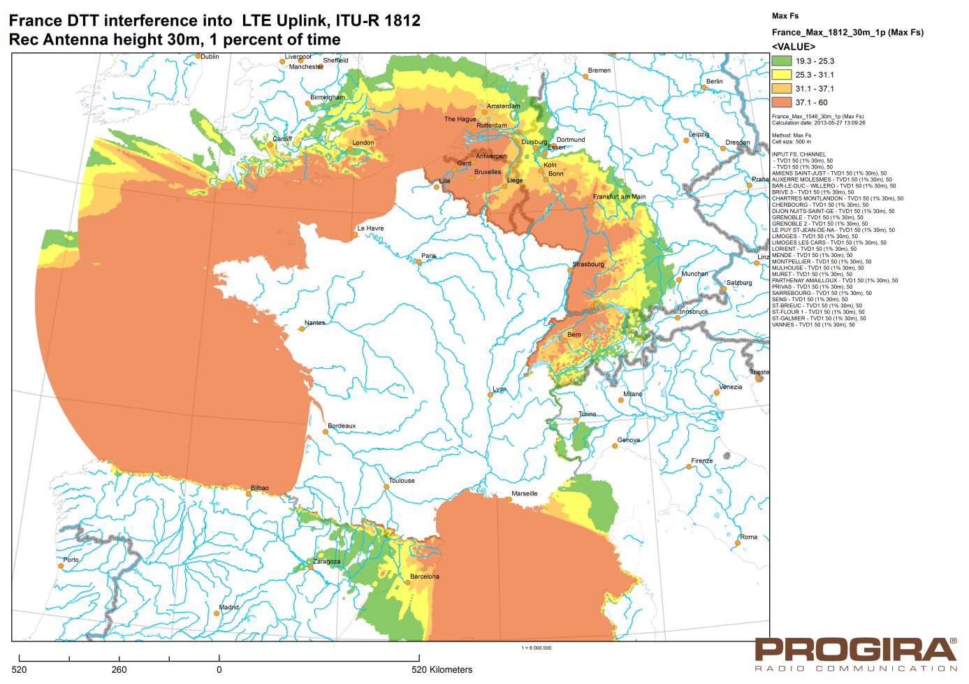

Figure A.16

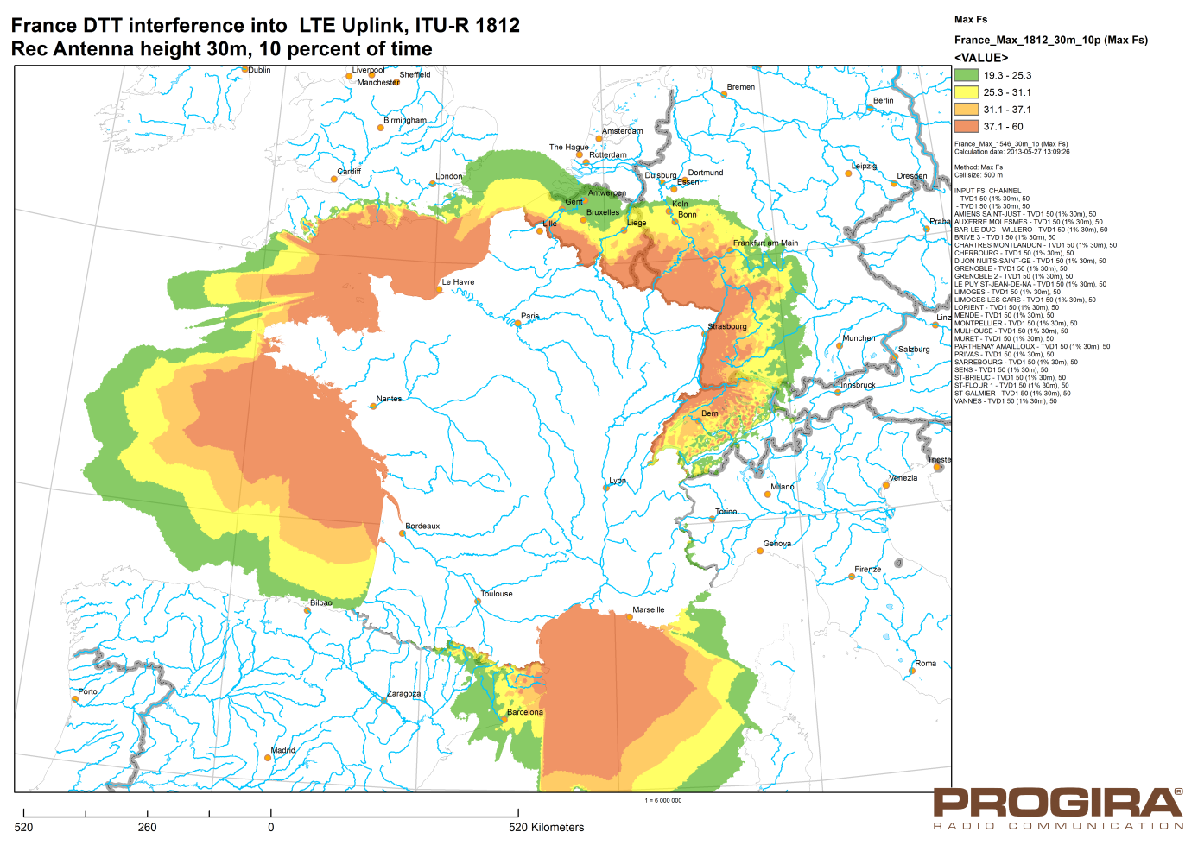

Figure A.17

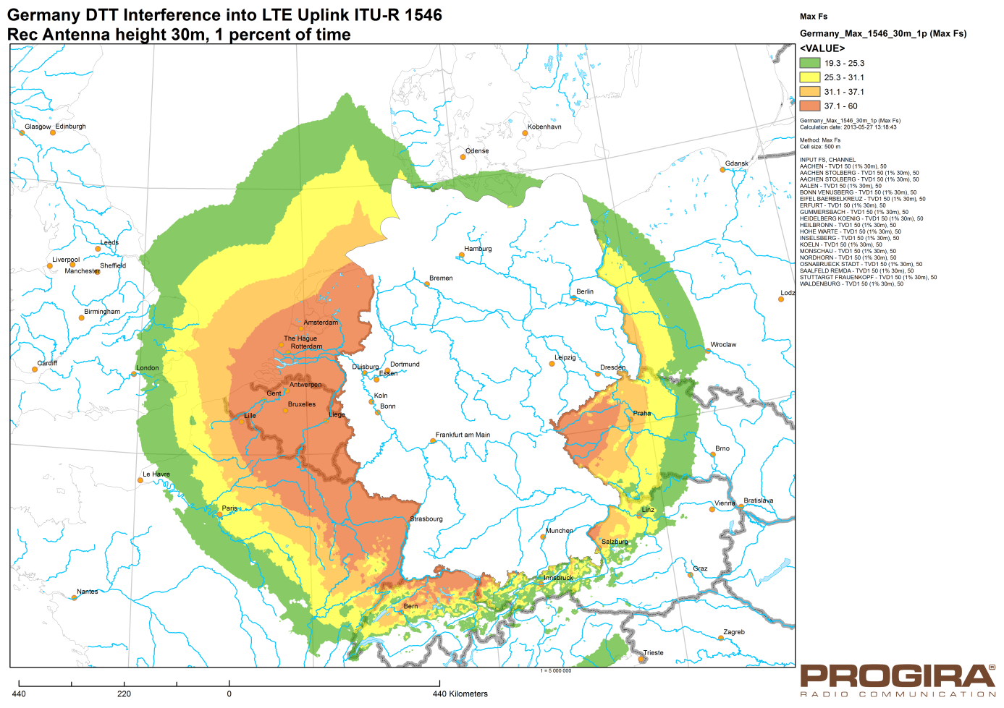

Figure A.18

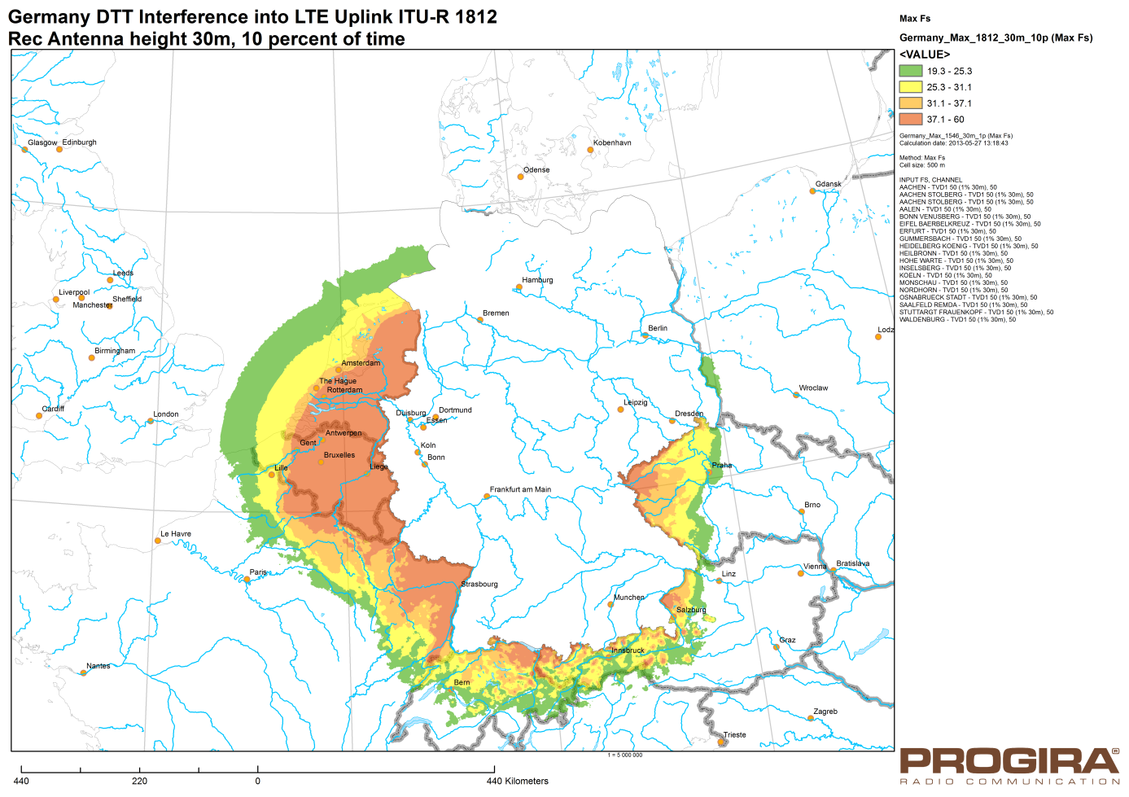

_______________

1. This Report was approved jointly by Radiocommunication Study Groups 5 and 6, and any future revision should also be undertaken jointly.
2. This frequency does not correspond to any specific IMT band plan. Rather, it is selected to be representative of both the 700 MHz band and the 600 MHz band. Results at other frequencies would be much similar and just slightly change.
3. *I/N (50%) is the I/N exceeded in 50% of the location in the considered pixel.*
4. *I/N (95%) is the I/N exceeded in 95% of the location in the considered pixel.*
5. More information at “<http://www.anfr.fr/fr/planification-international/coordination/recherche-daccords/television-et-radio-numerique.html>”.
6. Information at “<http://www.cartoradio.fr/cartoradio/web/>”.