Report ITU-R BT.2302-1
(03/2021)
Spectrum requirements for terrestrial television broadcasting in the UHF frequency band in Region 1 and
the Islamic Republic of Iran

BT Series
Broadcasting service
(television)

Foreword
The role of the Radiocommunication Sector is to ensure the rational, equitable, efficient and economical use of the radio-frequency spectrum by all radiocommunication services, including satellite services, and carry out studies without limit of frequency range on the basis of which Recommendations are adopted.
The regulatory and policy functions of the Radiocommunication Sector are performed by World and Regional Radiocommunication Conferences and Radiocommunication Assemblies supported by Study Groups.

Policy on Intellectual Property Right (IPR)
ITU-R policy on IPR is described in the Common Patent Policy for ITU-T/ITU-R/ISO/IEC referenced in Resolution ITU-R 1. Forms to be used for the submission of patent statements and licensing declarations by patent holders are available from http://www.itu.int/ITU-R/go/patents/en where the Guidelines for Implementation of the Common Patent Policy for ITU-T/ITU-R/ISO/IEC and the ITU-R patent information database can also be found.

Series of ITU-R Reports
(Also available online at http://www.itu.int/publ/R-REP/en)
Series | Title
BO | Satellite delivery
BR | Recording for production, archival and play-out; film for television
BS | Broadcasting service (sound)
BT | Broadcasting service (television)
F | Fixed service
M | Mobile, radiodetermination, amateur and related satellite services
P | Radiowave propagation
RA | Radio astronomy
RS | Remote sensing systems
S | Fixed-satellite service
SA | Space applications and meteorology
SF | Frequency sharing and coordination between fixed-satellite and fixed service systems
SM | Spectrum management

Note: This ITU-R Report was approved in English by the Study Group under the procedure detailed in Resolution ITU-R 1.

Electronic Publication
Geneva, 2021
© ITU 2021
All rights reserved. No part of this publication may be reproduced, by any means whatsoever, without written permission of ITU.

REPORT ITU-R BT.2302-1*
Spectrum requirements for terrestrial television broadcasting in the UHF frequency band in Region 1 and the Islamic Republic of Iran
(2014-2021)
TABLE OF CONTENTS
Page
Policy on Intellectual Property Right (IPR) ii
1 Abstract 2
2 Introduction 3
3 Spectrum requirements questionnaire 5
4 Spectrum allocations for television broadcasting 6
4.1 Number of Multiplexes with Nation-Wide coverage 6
4.2 Number of programmes in one 8 MHz channel 7
5 Capacity improvement techniques 8
6 Spectrum efficiency techniques 10
7 Limitations on efficiency 10
8 Foreseen evolution of broadcasting services: present and future trends 11
8.1 High Definition (HD) and Ultra High Definition (UHD) 11
8.2 Interactive Broadcast Broadband (IBB) 11
8.3 Time shifted services 12
8.4 Local, regional and community services 12
8.5 Pay-TV programme services 12
8.6 5G Broadcast 12
9 Other usages of the 470-694 MHz in addition to DTTB 13
9.1 Use of additional local capacity by SAB/SAP 13
Page
9.2 Use of additional local capacity by White Space applications 14
10 Conclusions 14
Annex 1 – Analysis of responses to Circular Letter 6/LCCE/104 15
A1.1 Responses 16
A1.2 Introduction of digital terrestrial television 17
A1.3 Analogue television switch-off 17
A1.4 Choice of technology 18
A1.5 Proportion of users who receive television by terrestrial broadcasting 19
A1.6 Percentage of population covered by DTTB networks 21
A1.7 Total number of national DTTB multiplexes 22
A1.8 Total number of local or regional DTTB multiplexes 23
A1.9 Number of TV programme services broadcast on DTTB 24
A1.10 Number of operational or planned DTT transmitters 25
A1.11 Other usages of the band 470-694 MHz 25
A1.12 Future services 26
A1.13 Required amount of spectrum for DTT in the future 28
Attachment 1 to Annex 1 – Full Responses received from Administrations to the 2020 Questionnaire 31
A2.1 Existing and planned situation(s) 44
A2.2 Future situation(s), consequences of the new allocation 46
A2.3 Assessment of spectrum requirements for terrestrial TV broadcasting in the frequency band 694-790 MHz for the RCC countries 49

1 Abstract
In preparation for WRC-23, WP 6A has updated its studies on spectrum use and needs of the broadcasting service in the band 470-960 MHz in Region 1 and the Islamic Republic of Iran. The results of these new studies are presented in the new edition of this Report.

2 Introduction
Broadcasting serves an important social function, and consequently many countries have established public service broadcasters as a matter of public policy. The British Broadcasting Corporation (BBC), for example, is established by Royal Charter in the United Kingdom. That Charter states five public purposes:
– To provide impartial news and information to help people understand and engage with the world around them;
– To support learning for people of all ages;
– To show the most creative, highest quality and distinctive output and services;
– To reflect, represent and serve the diverse communities of all of the United Kingdom’s nations and regions and, in doing so, support the creative economy across the United Kingdom; and
– To reflect the United Kingdom, its culture and values to the world.
In other countries, publicly-funded and commercial broadcasters often undertake similar public purposes in exchange for access to spectrum.
Historically, all television delivery was by terrestrial means. The delivery mechanisms in place have evolved in subsequent decades, and have also diverged. In some countries, delivery via cable systems or satellite has come to dominate, while in others terrestrial delivery remains dominant.
In Region 1 and in Iran, the use of the band 470-862 MHz is regulated by the Geneva 2006 Agreement (“GE06”). It recognizes three distinct reception conditions for digital television: fixed, portable outdoor (mobile) and portable indoor. While cable or satellite delivery are suitable for fixed reception, only terrestrial delivery can be used in portable, mobile and fixed reception scenarios. There are also significant differences in different geographical or regional areas because of different penetration of fixed, satellite and terrestrial services.
Further, under Radio Regulations footnote No 5.322, the Broadcasting Service has a primary allocation in the frequency band 862-960 MHz in some countries of the African Broadcasting Area (see Nos 5.10 to 5.13).
There is a global difference in availability of telecommunication services in different geographical areas between highly developed countries and developing countries and inside countries between urban and rural populations.
The urban population is usually provided with broadband fixed connections and, additionally, several alternative information service delivery links such as cable broadcasting or broadband mobile communication are also available. In contrast, rural areas and small towns often have very few additional means to deliver information services.
Rural areas often have generally lower penetration levels of fixed communications infrastructures than urban areas. Thus, to successfully solve the issue of bridging the digital divide, it is necessary to use an approach which is able to combine wide bandwidth and low cost for building and operation of the networks.
Currently, there are several technologies providing delivery of broadband digital content to remote and rural areas. Each technology is mostly suitable for a specific task.
TABLE 1
Specific properties of different radiocommunication technologies
Technology | Advantages | Disadvantages
Wired communication | All types of content and information services, the highest data transmission rate, robustness against interference, bidirectional data transmission | Very high expenses for building and operation of communication links due to specific rural conditions, high requirements to routing nodes and upper level communication channels, impossibility to serve mobile subscribers
Mobile communication | All types of content and information services, possibility to serve mobile subscribers, portable receive equipment, very suitable for on-demand content delivery, bidirectional data transmission | Great demand for radio spectrum, limited radio link bandwidth, degraded communication when user peak load, high expenses for building and operation of infrastructure, high cost of user terminals supporting broadband access
Satellite communication and broadcasting | Low levels of terrestrial infrastructure required (uplink and downlink terminals), very efficient delivery of the same content to the whole country or large region | Small bandwidth per subscriber when delivering individual content, low efficiency of local content transmission, shortage and high cost of satellite channels, expensive and complex installation of subscriber equipment
Terrestrial broadcasting | Low cost of transmission network infrastructure, low cost of receiving devices, very efficient delivery of the same content to medium and small territories | Small bandwidth per subscriber when delivering individual content, limited number of available radio channels, one direction transmission (down link)

In the future, it is anticipated that most households and most users will have alternative ways of communication or content reception using terrestrial mobile communication, fixed-satellite communication, satellite and/or terrestrial broadcasting. Smart user terminals and home multimedia centres will be able to transmit and receive data from different networks, record broadcast data and seamlessly present content from different sources to the user. This will realize the benefits of all the data transmission technologies and environments to obtain the desired information in the most-efficient way.
Broadcasting transmission ensures very cheap subscriber delivery of common information such as entertainment and news, often in high-definition format. Deployed properly, this could offload traffic from mobile networks, reducing their task of transmitting large volume of multimedia downlink traffic.
An attempt to transmit multiple copies of the same programs in high definition via mobile networks would lead to inefficient use of resources (bandwidth and transmitter power for a large number of base stations) in the networks primarily designed to transmit different data packets to different subscribers. Use of a broadcast mode in the mobile network would improve the situation. On the other hand, unicast transmission of individual data packets, with exception of very sparsely populated areas, could be better provided by terrestrial fixed or mobile service.
When considering the future use of the radio spectrum, a lack of spectrum resource for terrestrial broadcasting will lead to an increase of mutual interference between stations, and a more complicated and expensive infrastructure of communication and broadcasting networks will be required to compensate for this increased mutual interference.
A lack of radio spectrum for development of broadcasting service will reduce the opportunities it could offer in future telecommunication markets. The parties mostly affected by such a change would be the end users of telecom services whose choice will ultimately be more limited.
It is important to note that even in countries with high cable or satellite penetration, terrestrial broadcasting continues to operate. In some cases, this is because of government policy; in others, because it is commercially attractive to do so. In many countries, both reasons apply.
To support a competitive and fast development of data transmission technologies and broadband access in rural areas, as well as to continue to support the cultural value of broadcasting services, it will be necessary to make an appropriate amount of frequency resource available for digital terrestrial data/TV broadcasting service.

3 Spectrum requirements questionnaire
In order to inform the content of this Report, and to report on the spectrum use and needs for broadcasting in the UHF band to TG 6/1, WP 6A sent a questionnaire to all Administrations and Sector Members in Region 1 and Iran. The responses to this questionnaire, along with some analysis of those responses, are presented in Annex 1.
A detailed case study in Annex 2 shows the impact that reducing spectrum availability would have in the Russian Federation and in neighbouring countries.

4 Spectrum allocations for television broadcasting
The GE06 Agreement applies to almost all of Region 1, plus the Islamic Republic of Iran. It governs the use of the spectrum for delivery of digital sound and television broadcasting in VHF Band III (174-230 MHz), and UHF Bands IV and V (470-862 MHz). Subsequently, part of Band V (790-862 MHz) was co-allocated to the mobile service at WRC-07, and the band 694-790 MHz was co-allocated to the mobile service at WRC-15. Many countries in Region 1 have now implemented these mobile allocations.
Radio Regulation No 5.296, which applies in many Region 1 countries, makes a secondary allocation in the band 470-694 MHz to applications of the land mobile service intended for applications ancillary to broadcasting and programme-making (SAB/SAP). Further details of the use of this footnote are given in § 9.1.
Many countries have television assignments in all three bands, whereas others use Band III for sound broadcasting only, and rely on the UHF bands for television broadcasting.
Under the GE06 Agreement, Plan entries exist as either allotments or assignments. Whereas the details of how these are implemented are different, they each result in a coverage or “layer”. A layer is a set of frequency channels distributed across the planning areas such that each location of the planning area, where reception is intended, is covered with one multiplex.
The number of RF channels required to give one complete layer depends on aspects such as:
– the size and shape of the intended service areas;
– the network structure applied;
– the target coverage (area/population);
– the intended reception conditions.
In general, it was found that 6-8 RF channels were required for a single layer across most of the planning area. In the parts of Bands IV and V (470-694 MHz), therefore, the 28 RF channels, equivalent to 224 MHz of spectrum, can support around four layers. See § 4.1 below for supporting arguments to this statement.
Similarly, in areas where Band III is used for television broadcasting, it is found to be able to support another one layer.

4.1 Number of Multiplexes with Nation-Wide coverage
Following the decision at WRC-12 to allocate, in Region 1, the 700 MHz band (694-790 MHz) to the Mobile service with identification to IMT, to become effective after confirmation at WRC-15, the countries of Sub-Saharan Africa carried out a re-planning of the band 470-694 MHz. This replanning was supported and coordinated by ITU over an 18-month period of negotiation and coordination between 2011 and 2013 (see § 6.2.1.2 of the DTTB Handbook on network implementation). Similar activity took place in Arab countries over an 11-month period between 2014 and 2015 (see § 6.2.1.3 of the DTTB Handbook on network implementation).
In both activities, the objective in terms of number of multiplexes with nation-wide coverage was set to four.
The average percentage of satisfied requirements reached 97.37% in the Sub-Saharan process and 76.87% in the Arab countries process.
These examples showed that four full-area nation-wide multiplexes were largely reachable with equitable access to spectrum for all countries.
In the European part of Region 1, much careful planning combined with extensive bilateral and multilateral coordination took place to re-plan the band 470-694 MHz in order to release the 700 MHz band. Section 6.2.1.4.1 of the DTTB Handbook provides further information on the process. There was no unique objective in number of multiplexes to plan for every country, but the target was to preserve as far as possible the programme offering that existed in each country before the clearance process. This means that some countries may have accepted a lower number of multiplexes in the sub-700 MHz band if they did not have a large programme offer or preferred to plan for a demanding reception mode, while others may have got a higher number of multiplexes if they have a large programme offer and/or a less demanding reception mode planned. In many countries, five or six nation-wide multiplexes could be obtained in these conditions.
Based on these sub-regional planning processes, four seems to be an achievable target for the number of multiplexes with full-area, nation-wide coverage in the band 470-694 MHz across Region 1, noting that with careful planning and extensive negotiations with neighbours, national administrations have a possibility to coordinate and implement additional regional / local multiplexes or even additional nation-wide multiplexes.
Referring to the results of the questionnaire carried out by ITU-R between February and August 2020, it can be seen (see Fig. 9) that while the mean number of operational or planned national DTTB multiplexes was six and the median was five in the band 470-960 MHz (actually 470-790 MHz which is the effective band used initially for DTTB in most of Region 1 countries).The mean decreases to five and the median to four when the band is limited to 470-694 MHz.
The results of the questionnaire also show that the mean number of additional operational or planned local or regional DTTB multiplexes was five and the median was four in the band 470-960 MHz (actually 470-790 MHz), which decreases to a mean of four and a median of two in the band 470-694 MHz.

4.2 Number of programmes in one 8 MHz channel
Typically, if first generation DVB-T technology is used, each multiplex can deliver a capacity of around 24 Mbit/s for fixed reception. For portable or mobile reception the signal needs to be more robust (i.e. lower code rate and/or lower modulation scheme) and the capacity decreases accordingly.
The number of television programmes that can be carried in each multiplex depends on the total capacity of the multiplex, the type of source coding used for the television programme and the desired quality in which the programme is to be delivered.
Early implementations of DVB-T specified MPEG-2 coding. The bit rate required for delivery of a single standard definition (SD) TV programme is around 4 Mb/s using MPEG-2 coding. Therefore, in France, for example, six SD programmes are delivered in 24.1 Mbit/s. Through the use of statistical multiplexing, gains can be made to allow more services to be carried in the available capacity. In the UK, for example, up to nine SD programmes are carried in the same 24.1 Mbit/s.
The ability to employ statistical multiplexing will depend on how a multiplex is managed and may not be possible for operational reasons.

5 Capacity improvement techniques
Improved video coding systems that can reduce the bitrate required for delivery of television programmes are now available. H.264/MPEG4 coding can reduce bitrate by 30-50% for an SD service compared to MPEG2. Similar improvements are possible for HD services when moving from H.264/MPEG4 to H.265/HEVC coding. Note however that newer video coding schemes are not necessarily compatible with older decoders, so broadcasters are faced with the choice of taking advantage of the improvements available via adoption of newer coding techniques, or protecting reception by audiences who do not possess newer decoders.
At the time of the GE06 Agreement, digital television broadcasting in the GE06 planning area was foreseen to be delivered by DVB-T. Since 2006, the second-generation system DVB-T2 has been developed. This gives improved channel coding resulting in an increase in capacity of between 50% and 100%. The current implementation of a DVB-T2 multiplex in the UK, for instance, has allowed delivery of an additional 67% total capacity while maintaining the same coverage.
The capacity gained from these improvements could be used by broadcasters to deliver some or all of the following to their audiences:
– delivery of additional services;
– delivery of enhanced services (for example, HDTV or UHDTV programmes);
– delivery of interactive content delivery systems (such as IBB);
– greater robustness of the delivery platform to improve reception.
Based on the information provided in Chapter 3 of the DTTB Handbook on network implementation, Table 2 below shows the number of programmes in one 8 MHz channel, depending on the data rate offered by examples of DTTB implementation scenarios.
TABLE 2
Number of programmes in one 8 MHz channel, depending on the data rate offered
by examples of DTTB implementation scenarios
Scenario | 1 | 2 | 3
 | (Example DVB-T, Fixed rooftop reception using an 8 MHz channel and MFN planning – See A4.2.1.1 of Annex 2 to Chapter 4) | (Example DVB-T2, Portable reception using an 8 MHz channel and based on an SFN approach – See A4.2.1.6 of Annex 2 to Chapter 4) | (Example DVB-T2, fixed rooftop reception using an 8 MHz channel and MFN planning – See A4.2.1.1 of Annex 2 to Chapter 4)
Data rate | 24.1 Mbit/s | 26.2 Mbit/s | 40.2 Mbit/s
SDTV 576i  H.264 statmux | 10.9 | 11.9 | 18.2
HDTV 1080p/50 H.264 statmux | 3.1-4.1 | 3.3-4.4 | 5.4-7.3
HDTV 1080p/50 H.265 statmux | 6.5-6.6 | 7.2-7.3 | 11.5-11.7
UHDTV 2160p/50 H.265 statmux | 1-1.5 | 1.1-1.7 | 1.7-2.9

Note regarding the number of programmes per multiplex with UHDTV 2160p/50 HEVC H.265:
As shown in Table 3.4 of the DTT Handbook on network implementation, the required bitrates UHDTV 2160p/50 HEVC H.265 are as follows:
UHDTV H.265 Lower bound | 10.4-14.8 Mbits/s
UHDTV H.265 Upper bound | 22.5 Mbits/s
Referring to the information in Report ITU-R BT.2343 – Collection of field trials of UHDTV over DTT networks, the actual bit rates used in the field trials are closer to the upper bound than to the lower bound shown above. Therefore, for the calculation of number of programmes in Table 2 above, the range between the higher values of bitrates: 14.8 and 22.5 Mbits/s is used.
From Table 2, it can be seen that the capacity of one 8 MHz channel with the legacy DVB-T system for fixed roof top reception or with the second-generation DVB-T2 system for portable reception are quite close (24 to 26 Mbit/s). On the other hand, the capacity for fixed-roof top reception with the second-generation DVB-T2 system is significantly higher. Under specific planning constraints and network implementations, the bitrates could be lower.
Even newer video coding techniques (e.g. H.266/VVC) are now on the horizon. Although these offer the potential of even greater efficiencies, they still suffer the problem of lack of compatibility with existing receivers and decoders and would mean a complete change of all the receivers yet again. Typically, unless consumers receive some concrete incentive to upgrade, market forecasts indicate that even after ten years, there may only be penetration to around 80-90% of households.
The results of the ITU-R questionnaire presented in Annex 1 show that 50 Administrations in Region 1 intend to introduce more programmes on DTTB in their countries.

6 Spectrum efficiency techniques
In addition to the improved channel coding available in DVB-T2, the system also allows for more extensive use of single-frequency networks (SFNs) by virtue of the increased FFT size and consequentially longer guard interval that can be employed. SFNs can, under certain circumstances, allow a layer to be constructed using fewer RF channels. This is not universally true however, and in some cases can result in the same spectrum efficiency as MFNs.
Further spectrum efficiency gains may be achievable by a change from high-power, high-tower infrastructure to medium-power, medium-tower or low-power, low-tower infrastructure. A change to an infrastructure with higher density of transmission sites would provide a more uniform distribution of field-strength. Also the smaller sites and lesser power would result in a shorter distance at which a frequency can be reused for different content. Over a wide area, therefore, the number of frequencies needed to provide a complete layer is reduced, relative to the high-power, high-tower approach. It should also be noted, however, that a complete change of network infrastructure is likely to incur substantial additional cost of investment for the network operator.

7 Limitations on efficiency
While careful design and deployment of SFNs can result in an overall lower number of RF channels required per layer, there are constraints on their use that limit the efficiencies that can be gained. Firstly, political or commercial requirements for national or regionalized programming may not be accommodated within an SFN. This applies, for instance, across national borders, and across regional borders within a single country where broadcasting is regionalized (for example, in Germany where the Federal states mostly have different broadcasting organizations).
Secondly, depending on the choice of guard interval, there is a practical maximum size over which an SFN can operate without self-interference starting to take effect.
DVB-T2 is designed with a larger range of guard intervals, including some of several hundred microseconds. For the case of a dense DTT transmitter network, this could effectively remove the upper limit on SFN size, as signals from transmitters “too far away” would be sufficiently attenuated by path loss to avoid causing interference.
The guard interval represents lost transmission time in the network. Therefore increasing the guard interval leads to a loss in network capacity.
There are additional limitations of spectrum efficiency that apply to both SFNs and MFNs. For example, the presence of sea paths between target areas can enhance propagation and hence increase the distance within which frequency re-use is not possible. In some parts of the world, extreme propagation effects frequently occur which increases frequency re-use distance.
In many cases, spectrum efficiency can be improved by detailed planning and moving away from relying on high-level planning algorithms. This, however, is a complex task requiring technical expertise and often sophisticated computer planning tools.

8 Foreseen evolution of broadcasting services: present and future trends
Various future trends can be identified that could have an impact on future demand for broadcast spectrum, as shown in the sections below. The applicability of these will vary from country to country.

8.1 High Definition (HD) and Ultra High Definition (UHD)
HD is now a widely adopted television standard, utilizing the benefits of digital transmission technology by bringing to the end-user the improvement of picture quality in comparison to the former analogue TV broadcasting systems. It is expected that demand for many services to migrate to HD will continue. It is likely that there may be a transitional period where most HD services require to be also broadcast in a SD version, to ensure they can be received by all viewers. It is important to note improvements in portable display technology that allows the mass market HD displays to be no longer restricted to fixed reception devices.
UHD provides further improvement in image quality which is available on large screen TV receivers. It is expected that the foreseen spread of the ultra-large screens and video-walls, providing the presence effect, will be an important factor in future media delivery. In that case, broadcasting is the most efficient way to deliver the high data rate demanding UHDTV content to a large number of users simultaneously. Report ITU-R BT.2343 - Collection of field trials of UHDTV over DTT networks, gives example of many trials of UHD televisions services over terrestrial networks.
The results of the ITU-R questionnaire presented in Annex 1 show that 59 Administrations in Region 1 intend to introduce enhanced services (e.g. HDTV, UHDTV) on DTTB in their countries.

8.2 Interactive Broadcast Broadband (IBB)
IBB is the technology providing the features of interactive services. This technology can significantly reduce the loading of conventional telecommunication networks, or provide partial compensation for the users who have no access to adequate broadband services, which is very important for remote or rural areas.
Chapter 10 of the DTTB Handbook on network implementation explains that IBB technology is an example of service-layer collaboration between DTTB and non-broadcasting systems, where broadcast content is transmitted over a unidirectional broadcast network and additional (often multimedia) content is received over bi-directional broadband networks. It maximizes the user experience by providing high quality, flexible, interactive and personalized services such as additional information about television programmes (for example, an EPG), or additional services for minorities and people with special needs, etc. One of the main attractions is non-linear broadcasting, i.e. to watch missed programmes (‘catch-up TV’). IBB systems are described in Recommendation ITU-R BT.2075. Typical data rates for IBB services in a DTTB multiplex would be in the range 500 kbits/s to 2 Mbits/s, which will use part of the capacity for TV programmes shown in Table 2. Such services need to be accommodated alongside the programmes, depending on the service requirements.
IBB services can include:
• Service Portal (to access all available services)
• Enhanced Electronic programme Guide (EPG)
• Catch-Up and Video-On-Demand
• Start-Over service (example Start-over TV for catching up on the start of a program already broadcasting)
• Rating/Voting - Get feedback from viewers
• Games
• Social Networks
• E-Commerce
• News, weather, sports.
• Regional and Local TV
• E-Government
• E Learning
• E-Payment
• E-Health
• Games
• Music
• Radio
The results of the ITU-R questionnaire presented in Annex 1 show that 40 Administrations in Region 1 intend to use IBB on DTTB in their countries.

8.3 Time shifted services
With time shifted services, channels are rebroadcast, e.g. one hour later than originally broadcast, are proving very popular with consumers, providing over 20% of viewing for some channels in the UK. Whilst increasingly sophisticated DTR technology might make them less important, they have definitely a role to play for the next few years.

8.4 Local, regional and community services
There is an increasing demand for local, regional and community services. Such services, in comparison to country-wide broadcast networks, typically cover a more limited area, and are attractive to audiences because they are able to select content which is more focused on their region.
The results of the ITU-R questionnaire presented in Annex 1 show that a mean of 46, and a median of 16, local or regional free-to-air programme services are broadcast per country in Region 1.

8.5 Pay-TV programme services
In many countries, Pay-TV programmes are not delivered through telecommunication services due either to not sufficiently developed infrastructure or to a high subscription cost compared to the average income level of the viewers. In the context, several countries in Region 1, especially in Sub-Saharan Africa, developed novel Pay-TV offers with adapted content and cost to their viewers.
The results of the ITU-R questionnaire presented in Annex 1 show that a mean of 70, and a median of 45, pay-TV programme services are broadcast per country in Region 1.

8.6 5G Broadcast
5G Broadcast is a development based on the 3GPP “eMBMS” system designed to optimize delivery to, and compatibility with, mobile handsets. The technology has been used in various trials (see Annex 3 to Report ITU-R M.2373 for some examples). Broadcasting organizations are now considering whether to deploy systems for public use.
5G-Broadcast will need spectrum to be implemented. If the standard were extended to include the sub-700 MHz, and if manufacturers implemented the option in handsets, the band 470-694 MHz could become candidate for future deployment of 5G-Broadcast systems, subject to the demand for DTTB in the band.
In this band, 5G-Broadcast would need to co-exist with DTTB and SAB/SAP which are likely to continue to operate in the band for a long period of time. Co-existence between 5G-Broadcast, DTTB, and SAB/SAP might require specific network design solutions, interference mitigation techniques, regulatory arrangements or additional standardisation efforts (e.g. an 8 MHz channel bandwidth variant of 5G-Broadcast).
The EBU has published a report entitled “5G for the Distribution of Audio-Visual Media content and services” that includes an analysis of the Spectrum aspects and introduction scenarios in various bands including the sub-700 MHz band.
Commercial viability of 5G-Broadcast in the sub-700 MHz spectrum is contingent on the creation of a sufficiently large device and infrastructure ecosystem in this band. This would require that a joint effort be made globally with all stakeholders. Here, the largest potential markets such as China and possibly India may deserve specific attention as they might be early adopters of 5G-Broadcast and would influence the developments in other parts of the world.
The results of the ITU-R questionnaire in Annex 1 show that 32 Administrations in Region 1 intend to allow for additional reception modes (e.g. portable, mobile) on terrestrial broadcasting in their countries. Although this is not directly linked to 5G Broadcast, this latter being designed for reception in portable and mobile devices, it could be considered as a candidate technology to offer this type of reception modes.

9 Other usages of the 470-694 MHz in addition to DTTB

9.1 Use of additional local capacity by SAB/SAP
Most DTTB networks are of MFN type (Multiple Frequency Network) or a mixture of MFN and SFN (Single Frequency Network). The reasons for this are given in § 3.3 of the DTTB Handbook on network implementation. In either of these configurations, not all the spectrum is used in every point of the territory. This permits the use of the available spectrum in a given geographical point by SAB/SAP applications.
In general, the use of UHF interleaved spectrum for SAB/SAP is coordinated through a national mechanism managed by the frequency regulator. The related frequency allocation is secondary or on a non-interference basis, i.e. the SAB/SAP applications are not allowed to interfere with broadcasting or other primary services, nor can they claim protection from interference from the broadcasting service. This has generally proved not to be an issue, as the SAB/SAP equipment is frequency-agile and compatibility is ensured by national coordination procedures and advanced technical SAB/SAP solutions. Indeed, the UHF band under 1 GHz has been for many years the core spectrum for audio SAB/SAP applications because this frequency band provides the characteristics that meet demanding professional applications.
Spectrum requirements for SAB/SAP applications have been increasing, in particular driven by the growing number of live events and broadcast productions and their increasing complexity. Major productions routinely use ten or more UHF TV channels within the 470-694 MHz band to operate over 100 wireless microphones. Likewise, Electronic News Gathering (ENG) heavily uses this band. ENG is a vital element in the comprehensive coverage of a wide range of internationally noteworthy events, including natural disasters. At the same time, several frequency bands historically used by SAB/SAP, including parts of the UHF band, have in recent years been reallocated to mobile communications services which is incompatible in sharing with SAB/SAP. The long-term trend of bourgeoning news and entertainment production, new media and other content creation continues and is accelerating. This has accentuated the need for SAB/SAP applications to retain access to spectrum in the band 470-694 MHz in the longer term and identify additional suitable spectrum to meet future demand.
Further details on the spectrum and other technical requirements for SAB/SAP are found in Reports ITU-R BT.2344, ITU-R BT.2069, ITU-R BT.2338 and Recommendation ITU-R BT.1871.
As shown the results of the ITU-R questionnaire in Annex 1, 48 countries declared using the band 470-862 MHz also for SAP/SAB. See § 11 of Annex 1.

9.2 Use of additional local capacity by White Space applications
For the same reasons as for SAB/SAP, other radiocommunication applications can make use of the locally available spectrum in the band 470-694 MHz. A number of countries in the world have effectively permitted such use. In Africa, according to “Motivation for TV white space: An explorative study on Africa for achieving the rural broadband gap” (2nd Europe – Middle East – North African Regional Conference of the International Telecommunications Society (ITS): "Leveraging Technologies For Growth", Aswan, Egypt, 18th-21st February, 2019), “TVWS solution is affordable and offers reachability to connect and serve the rural and urban communities. For example, In Botswana, 43% of people in rural areas are being covered through TVWS deployment. Ghana (50%), Namibia (55%), South Africa (37%), Tanzania (70%) are also great examples of TVWS deployment [4]. The potential market for rural broadband is quite substantial. It has been shown that emerging TVWS broadband can support data speeds up to 30 to 50 Mbit/s”.
According to the results of the ITU-R questionnaire in Annex 1, only Mozambique and Ghana in Africa and United Kingdom in Europe declared using the band 470-694 MHz also for TV White Space applications, on a secondary basis.
Like SAB/SAP, White Space Applications have a secondary status in terms of frequency usage, i.e. they should not create interferences to other services nor to claim protection. The choice of frequency and transmission characteristics is also made through a form of national coordination, involving the use of geolocation database that contain information about the actual spectrum usage by DTTB and SAB/SAP at the location of the White Space device.
In countries where DTTB is a major distribution platform, the continuous evolution of the DTTB networks, including changes to transmission spectral masks, network architecture, radiated powers, makes it difficult to use the band 470-694 MHz by White Space applications.

10 Conclusions
Digital Terrestrial Television Broadcasting is currently the most widespread technology to serve the needs of linear TV broadcasting, and it drives demand for UHF broadcast spectrum among a majority of administrations.
This Report shows that the 470-694 MHz band can meet most current national needs for Digital Terrestrial Television Broadcasting including complementary technologies such as 5G Broadcast and Integrated Broadcast Broadband (IBB). It offers sufficient capacity to improve quality to HDTV for most programmes and possibly to UHDTV for some programmes. However, the loss of spectrum in this band will limit this opportunity, as well as the opportunity for sharing with other services such as SAB/SAP, Radio Astronomy and White Space Applications.

Annex 1
Analysis of responses to Circular Letter 6/LCCE/104
In February 2020, ITU-R Working Party 6A sent a questionnaire to all Administrations of Member States of the ITU and Radiocommunication Sector Members in Region 1 participating in the work of Radiocommunication Study Group 6.
To assist WP 6A in its understanding of the responses received, the Rapporteur Group on WRC-23 AI 1.5 has undertaken a statistical analysis of the responses. The findings of this analysis are presented in this Annex.
As agreed at the February 2020 meeting of Working Party 6A, responses to the 2020 Questionnaire supplement those received in 2013, and where no new response has been received from an Administration, the 2013 response has been assumed to be still valid.
The following points are particularly noted:
– Section 1 of the analysis shows the number of responses received. A total of 78 responses have been received to 6/LCCE/104 as of 4 September 2020, of which 73 are from Administrations. A further five Administrations responded as of 1 February 2021. Twenty-eight Administrations which have not replied to 6/LCCE/104 submitted responses in 2013.
– A large amount of the population views television received by terrestrial networks (20 countries with between 50% and 75% of the population and 28 countries with more than 75% of the population)
– Most countries have very high DTTB coverage and there are plans to extend it: 58 countries state that DTTB covers more than 75% of population (24 of these have plans to extend the coverage) – 13 countries with less than 75% of coverage have plans to extend it
– DTTB is heavily used for regional/local distribution and for pay-TV programmes
– The band above 694 MHz is still used by 22 countries for DTTB (6 of which plan to migrate to 470-694 MHz), and more than 10000 DTTB transmitters are still operating above 694 MHz
– The 470-694 MHz band is widely used for PMSE/SAP-SAB (49 countries)
– Many countries are still investing in DTTB: 52 countries plan the introduction of more programmes; 62 countries anticipate the introduction of enhanced services; 35 countries foresee additional reception modes; 27 countries foresee/already planned to move to new technology; but also, many countries are not able to comment at this time about future plans
– In Section 13, the analysis shows the amount of spectrum in the band 470-960 MHz that Administrations consider will be required for DTTB in the future. 102 Administrations have expressed a clear view on this question. Of those, 12 expressed a requirement for more than 224 MHz, 83 require exactly 224 MHz and seven Administrations indicate a requirement for less than 224 MHz. A further four responses gave no answer, or were unclear.
– In the Attachment to this Annex, there is a detailed table of all responses received to the 2020 Questionnaire.
In order to avoid the possibility of double-counting, only responses from Administrations are considered in the analysis.

A1.1 Responses
TABLE A1.1
Total number of responses
 | 2020 Responses | 2013 Responses | Total  (see NOTE)
Total Administration responses received | 78 | 89 | 106
Sector Members responses received | 5 | 11 | 11
Total responses received | 83 | 100 | 117

NOTE – Some Administrations/Sector Members responded in 2013 but not in 2020. In this analysis, the most recent response only from each has been considered. The Total column does not therefore equal the sum of 2013 and 2020 responses as some Administrations/Sector Members replied to both questionnaires. In that case, only the 2020 response has been included in the analysis.
Administrations that responded only in 2013: Benin (Republic of); Bulgaria (Republic of); Burkina Faso; Burundi (Republic of); Cameroon (Republic of); Chad (Republic of); Comoros (Union of the); Congo (Republic of the); Democratic Republic of the Congo; Gabonese Republic; Gambia (Republic of the); Iran (Islamic Republic of); Israel (State of); Lebanon; Lesotho (Kingdom of); Libya (State of); Lithuania (Republic of); Mali (Republic of); Mauritania (Islamic Republic of); Niger (Republic of the); Poland (Republic of); Rwanda (Republic of); Sao Tome and Principe (Democratic Republic of); Serbia (Republic of); Seychelles (Republic of); Sierra Leone; Togolese Republic and Uganda (Republic of).
Administrations that responded only in 2020: Albania (Republic of); Botswana (Republic of); Greece; Iceland; Jordan (Hashemite Kingdom of); Kuwait (State of); Liberia (Republic of); Madagascar (Republic of); Mauritius (Republic of); Montenegro; North Macedonia (Republic of); Palestine (State of); Qatar (State of); Romania; Saudi Arabia (Kingdom of); Tajikistan (Republic of) and Tunisia.
Administrations that responded to both questionnaires: Algeria (People's Democratic Republic of); Angola (Republic of); Armenia (Republic of); Austria; Azerbaijan (Republic of); Bahrain (Kingdom of); Belarus (Republic of); Belgium; Cabo Verde (Republic of); Côte d'Ivoire (Republic of); Croatia (Republic of); Cyprus (Republic of); Czech Republic; Denmark; Egypt (Arab Republic of); Estonia (Republic of); Eswatini (Kingdom of); Finland; France; Germany (Federal Republic of); Ghana; Guinea (Republic of); Guinea-Bissau (Republic of); Hungary; Ireland; Italy; Kazakhstan (Republic of); Kenya (Republic of); Kyrgyz Republic; Latvia (Republic of); Luxembourg; Malawi; Malta; Moldova (Republic of); Morocco (Kingdom of); Mozambique (Republic of); Namibia (Republic of); Netherlands (Kingdom of the); Nigeria (Federal Republic of); Norway; Oman (Sultanate of); Portugal; Russian Federation; Senegal (Republic of); Slovak Republic; Slovenia (Republic of); South Africa (Republic of); South Sudan (Republic of); Spain; Sudan (Republic of the); Sweden; Switzerland (Confederation of); Tanzania (United Republic of); Turkey; Ukraine; United Arab Emirates; United Kingdom of Great Britain and Northern Ireland; Uzbekistan (Republic of); Vatican City State; Zambia (Republic of) and Zimbabwe (Republic of).
Figure A1-1
Responding Administrations
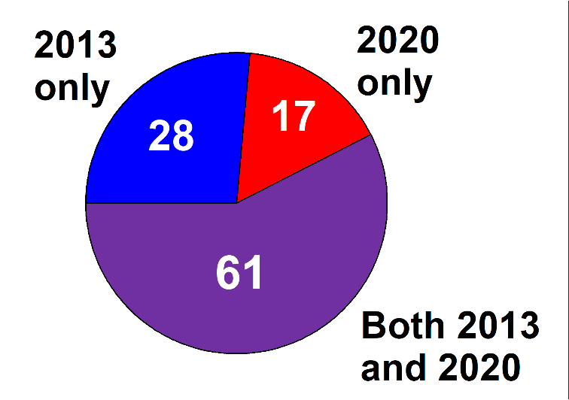

A1.2 Introduction of digital terrestrial television
The date of DTTB introduction is shown in Fig. A1-2.
Figure A1-2
Date of DTTB Introduction
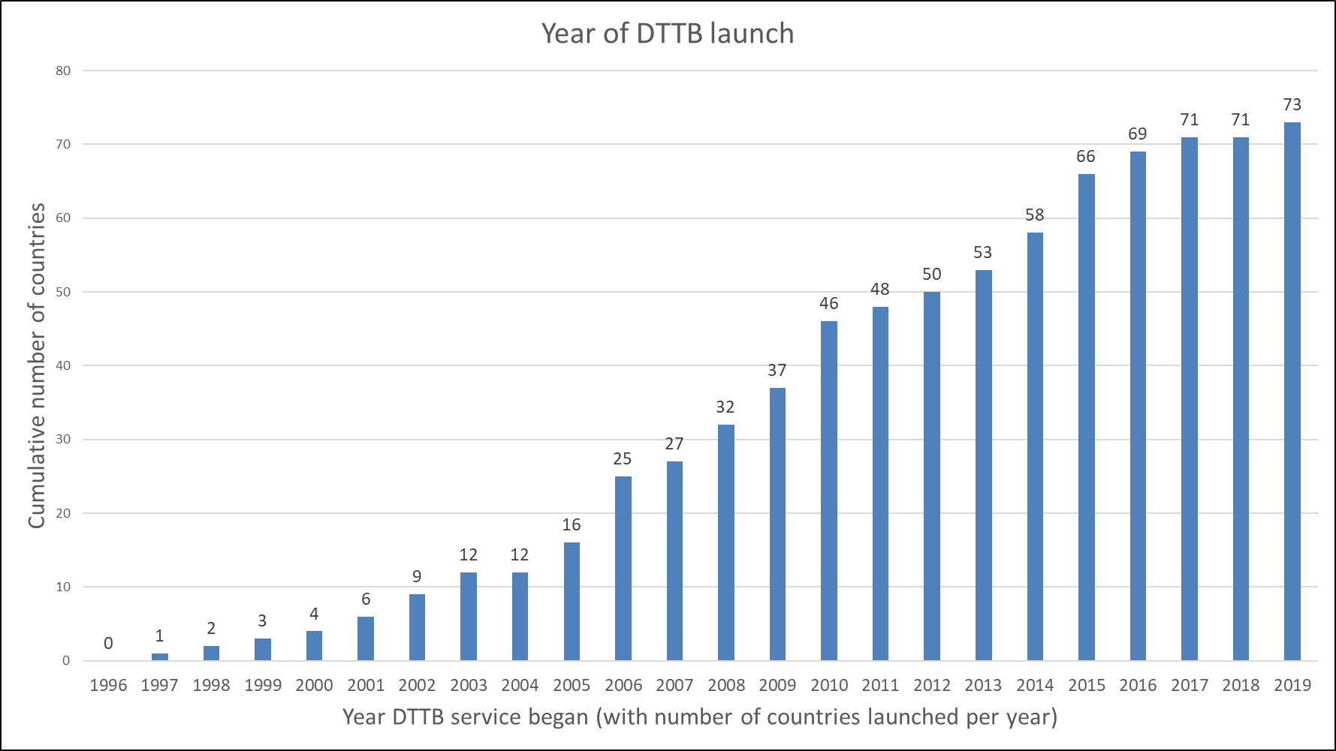

A1.3 Analogue television switch-off
The date of analogue television switch-off (ASO) is shown in Figs A1-3 and A1-4 below.
Figure A1-3
Date of analogue TV switch-off
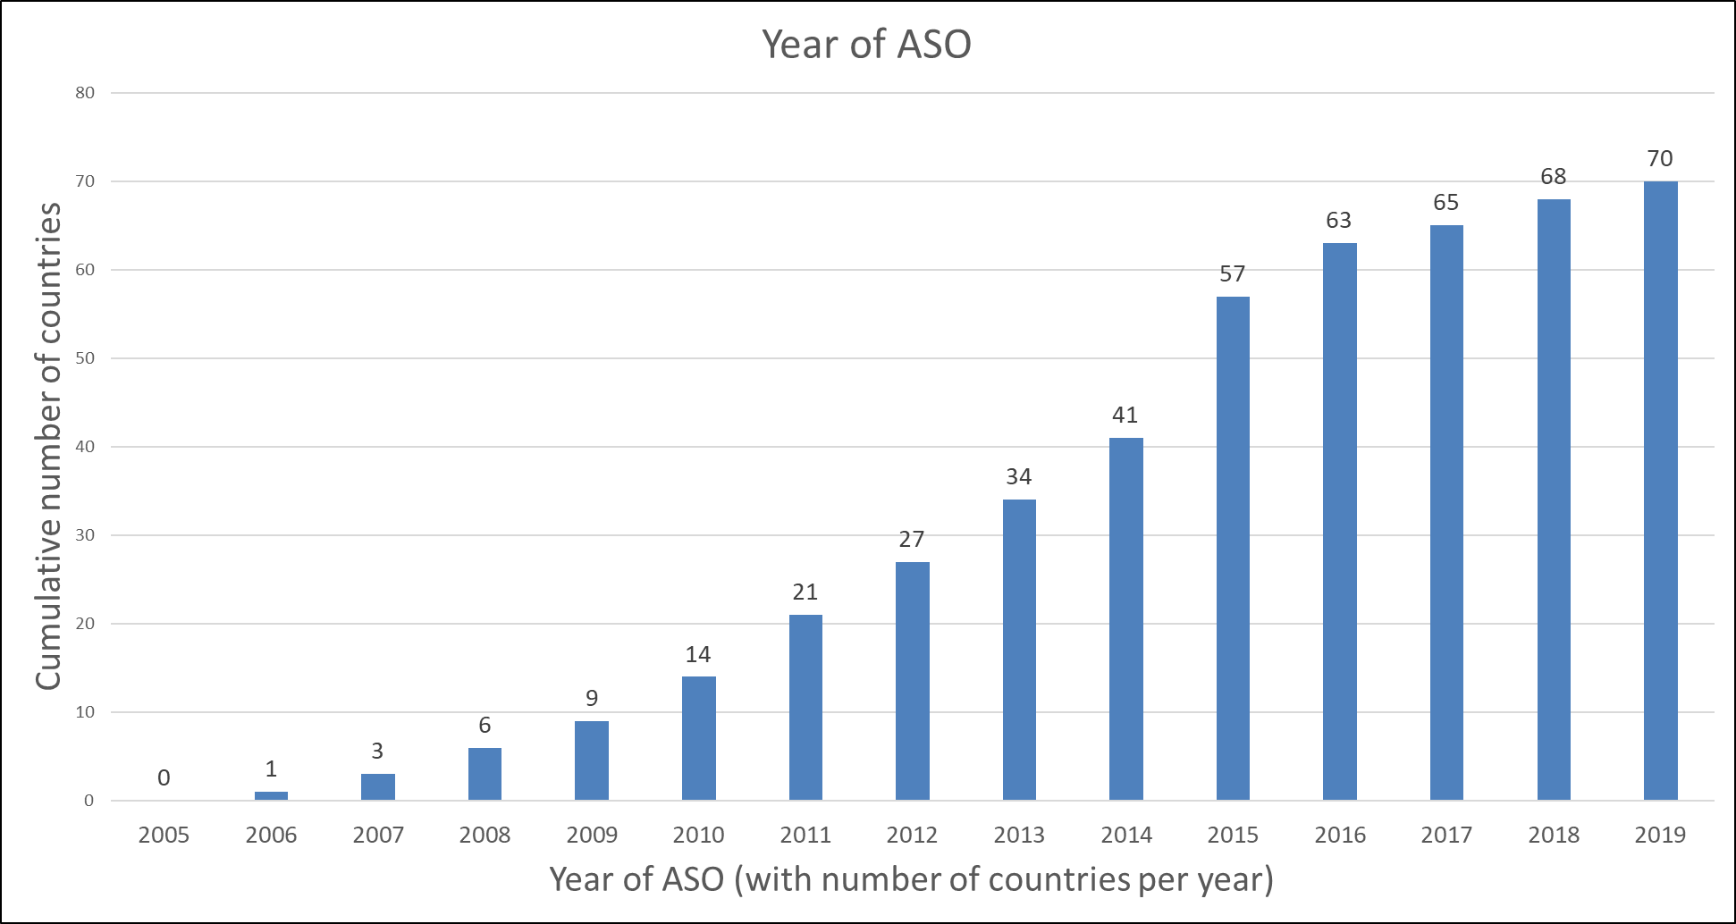
Figure A1-4
Date of ASO
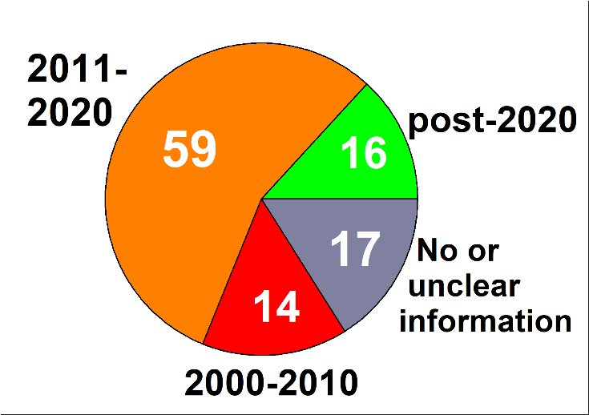

A1.4 Choice of technology
The choice of DTTB technology is shown in Table A1.2 and Fig. A1-5 below.
TABLE A1.2
Choice of DTTB technology
 | DVB-T | DVB-T2 | DVB-T and DVB-T2 | ISDB-T | No or unclear reply
Total Administrations | 19 | 48 | 26 | 2 | 11
Figure A1-5
Choice of the DTTB technology
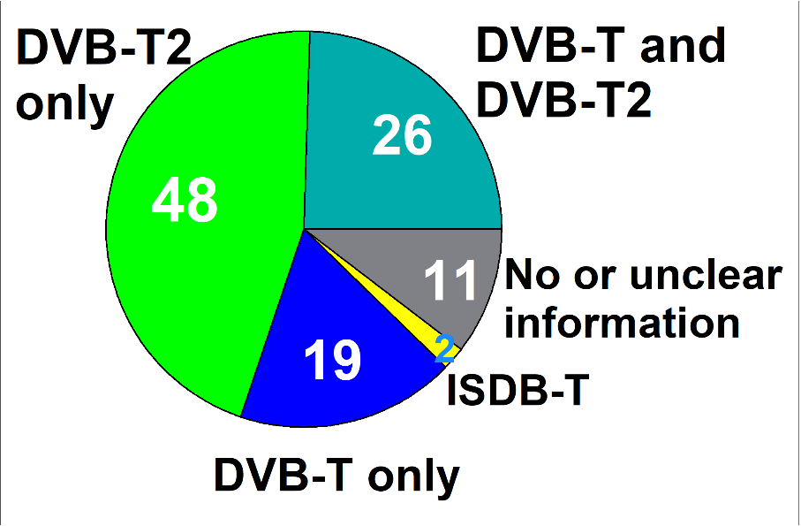

A1.5 Proportion of users who receive television by terrestrial broadcasting
The proportion of users who receive television by terrestrial broadcasting is divided into ranges as shown in Table A1.3 and Figs 6 and 7.
TABLE A1.3
Proportion of users who receive television by terrestrial broadcasting
 | < 25% | ≥ 25%  < 50% | ≥ 50%  < 75% | ≥ 75% | No or unclear reply
Total Administrations | 28 | 15 | 20 | 28 | 15
Figure A1-6
Proportion of users who receive television by terrestrial broadcasting
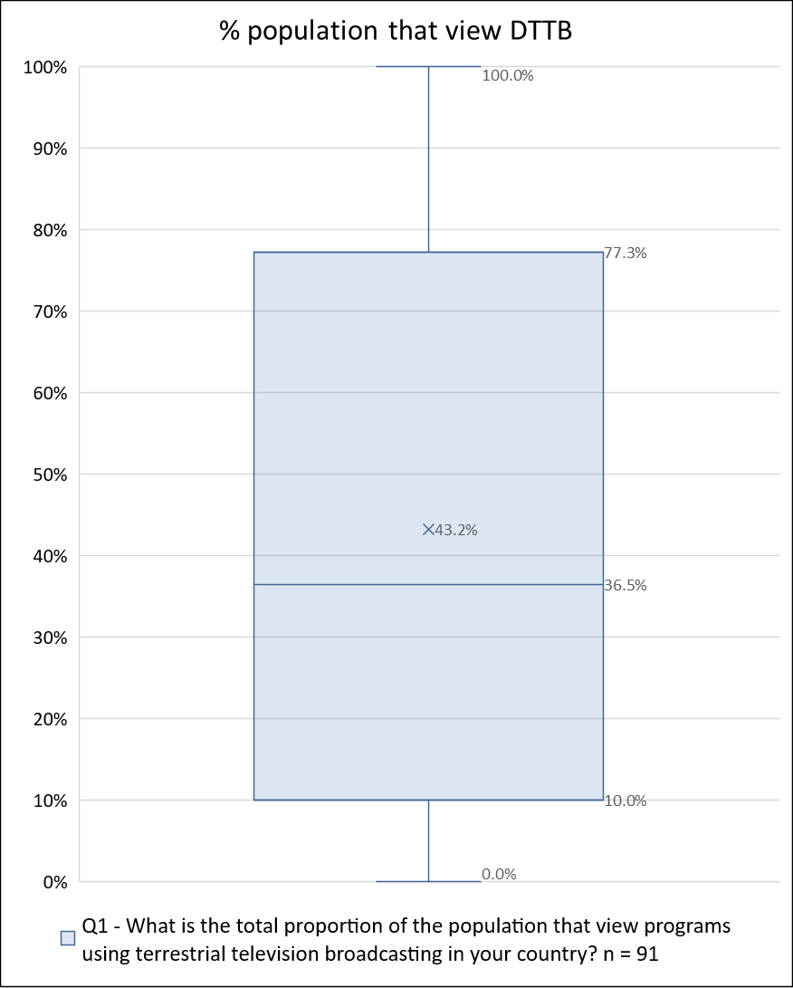
Figure A1-7
Proportion of users who receive television by terrestrial broadcasting
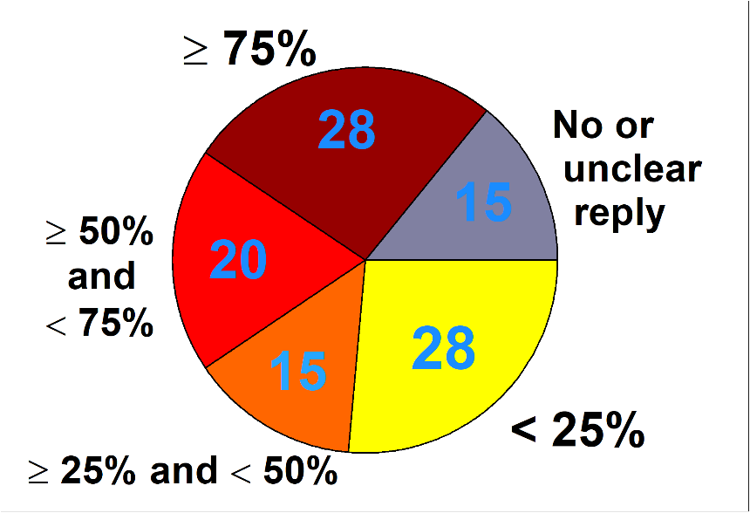

A1.6 Percentage of population covered by DTTB networks
Where available, the percentage of population of a country covered by DTTB networks is shown in Fig. A1-8 below. This Figure also shows the target coverage when there are plans to change the percentage of population covered by DTTB networks.
Figure A1-8
Percentage of population covered by DTTB networks
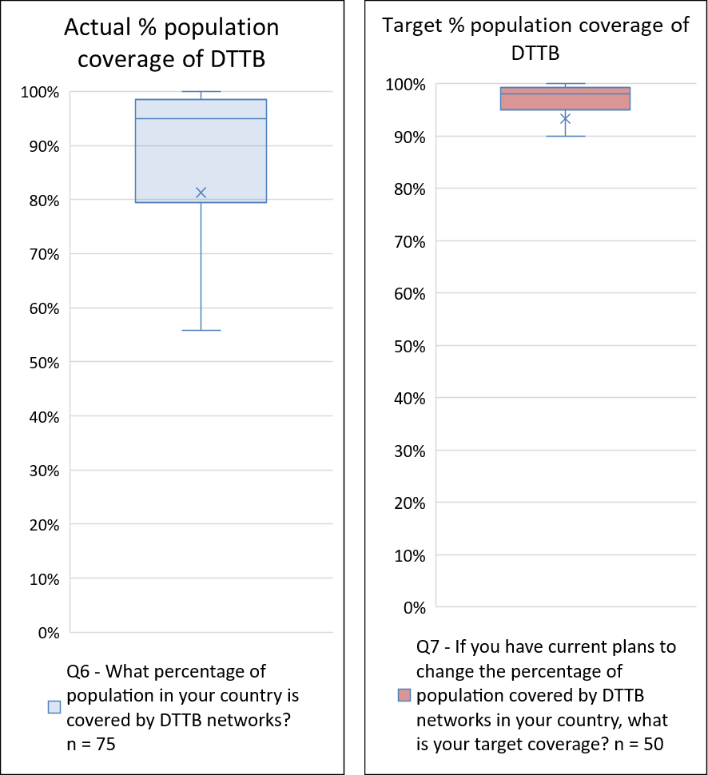

A1.7 Total number of national DTTB multiplexes
The total number of national DTTB multiplexes planned or operational in the bands 470-960 MHz and 470-694 MHz is shown in Fig. A1-9.
Figure A1-9
Total number of planned or operational national DTTB multiplexes
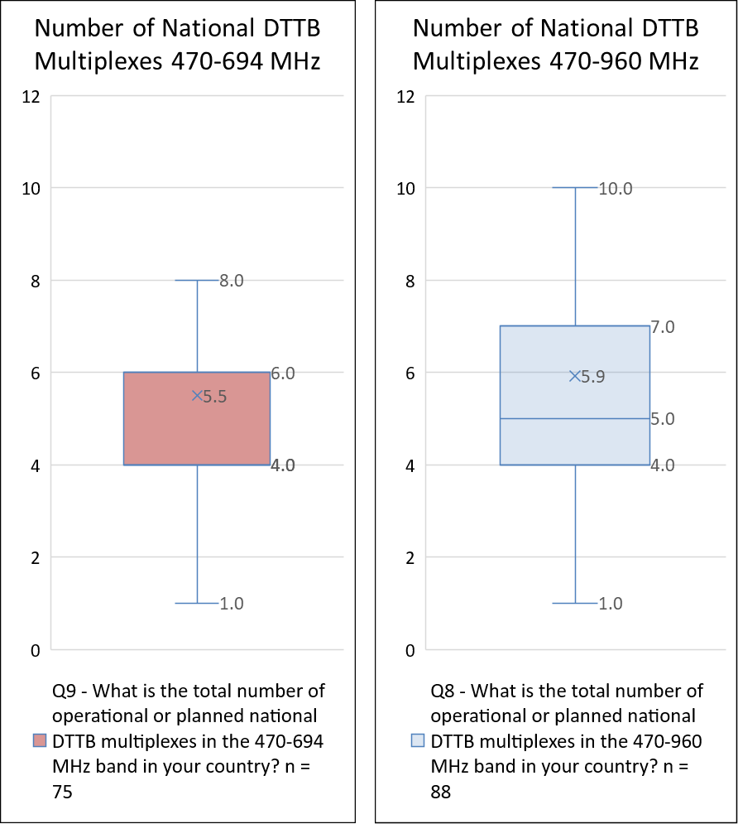

A1.8 Total number of local or regional DTTB multiplexes
The number of local or regional DTTB multiplexes planned or operational in the bands 470-960 MHz and 470-694 MHz is shown in Fig. A1-10.
Figure A1-10
Number of planned or operational local or regional DTTB multiplexes
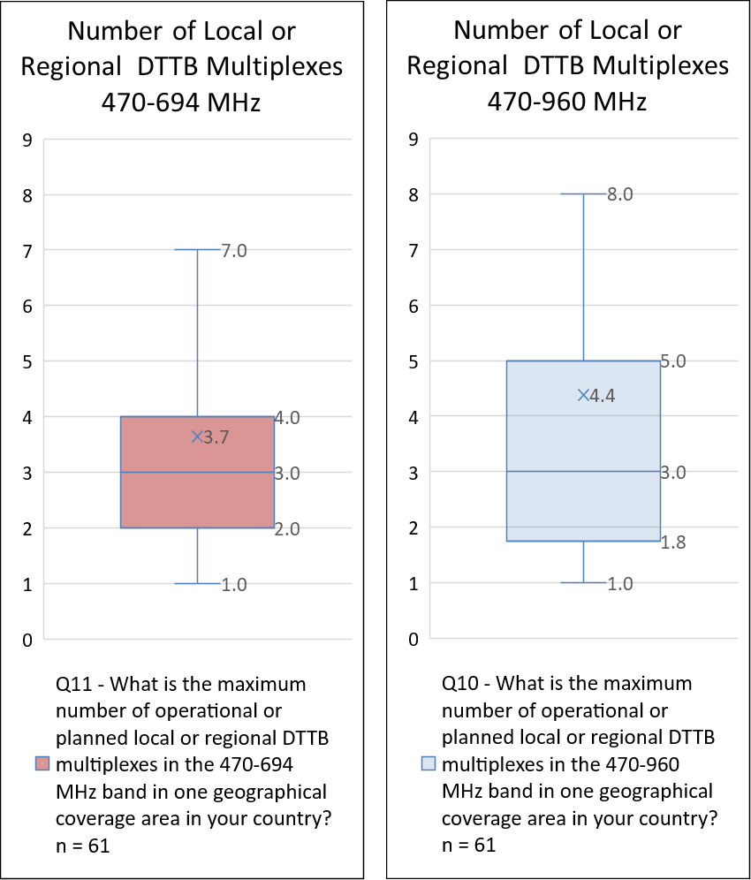

A1.9 Number of TV programme services broadcast on DTTB
The number of free-to-air national, free-to-air local and pay TV programme services broadcast on DTTB is shown in Fig. A1-11.
Figure A1-11
Number of TV programme services free-to-air national, free-to-air local and pay TV
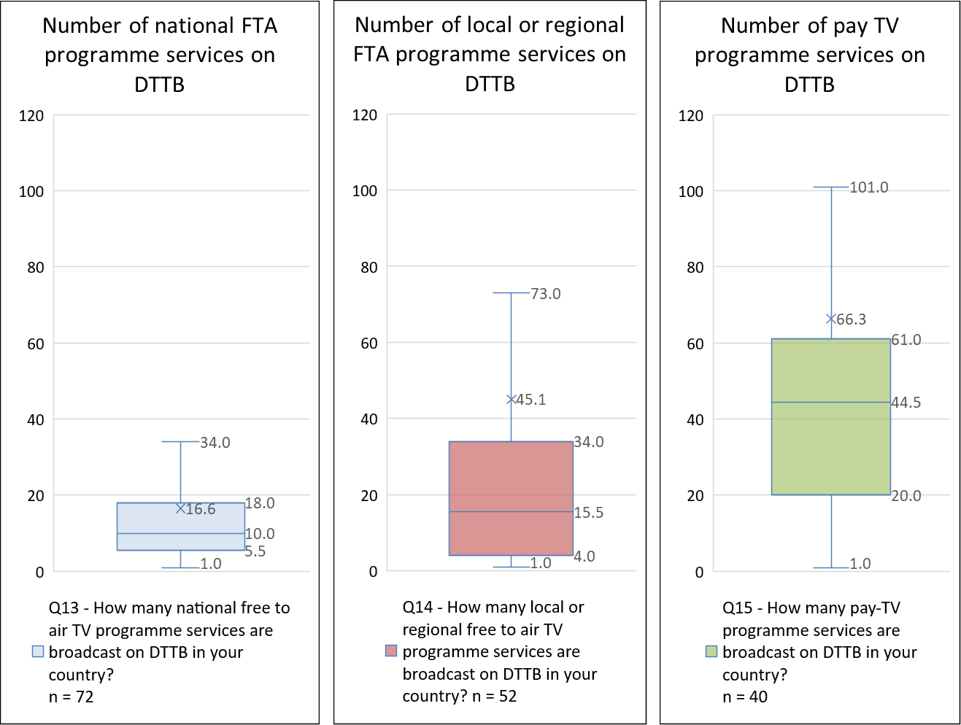

A1.10 Number of operational or planned DTT transmitters
The number of operational or planned DTT transmitters split by frequency band is shown in Table A1.4.
TABLE A1.4
Number of operational or planned DTT transmitters
 | 470-694 MHz | 694-960 MHz
Number of operational or planned DTTB transmitters | 90996 | 10566

A1.11 Other usages of the band 470-694 MHz
The existence of other primary services, secondary services or primary and secondary services is shown in Table A1.5 and Fig. A1-12 below.
TABLE A1.5
Other usages of the band 470-862 MHz
 | Primary | Secondary | Primary and Secondary | No other services | No or unclear information
Total Administrations | 4 | 49 | 8 | 41 | 4
Figure A1-12
Other usages of the band 470-862 MHz
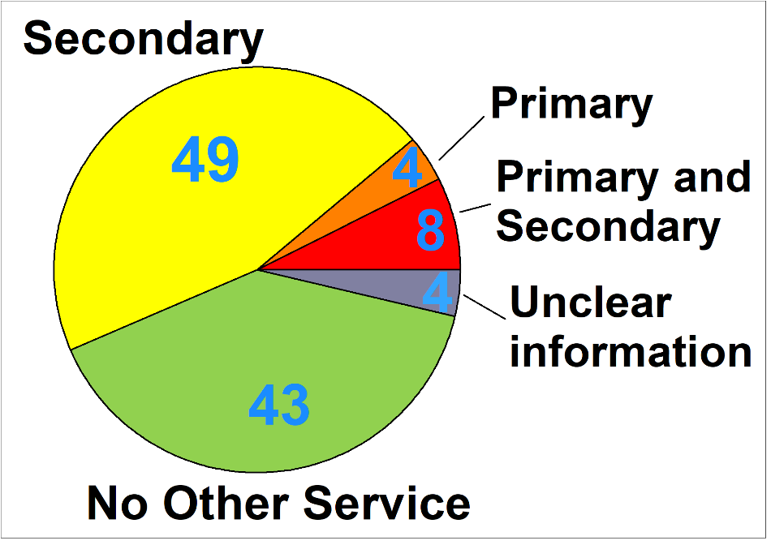

A1.12 Future services
Responses to questions on to the intentions of respondents to introduce more services are shown in Figs A1-13, A1-14, A1-15 and A1-16.
Figure a1-13
Intentions to introduce more programmes on DTTB
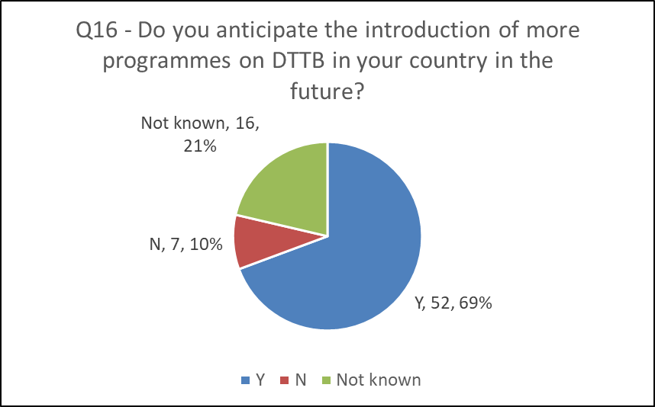
Figure a1-14
Intentions to introduce enhanced services on DTTB
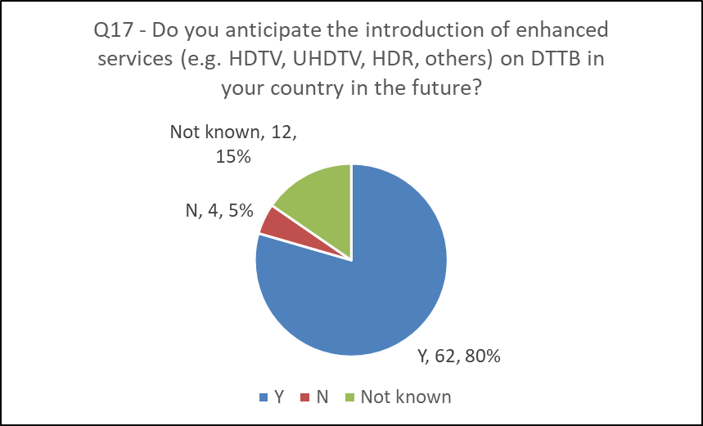
Figure a1-15
Intentions to allow for additional reception modes on terrestrial broadcasting

Figure a1-16
Intentions to use interactive broadcast broadband on DTTB
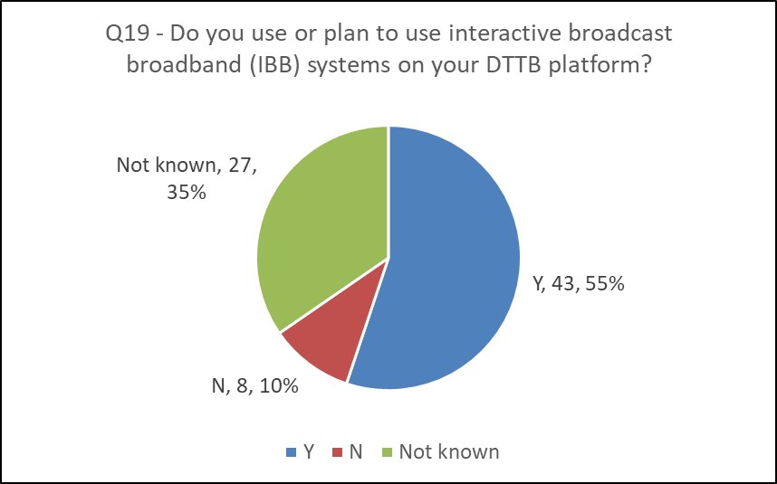

A1.13 Required amount of spectrum for DTT in the future
The required amount of spectrum for DTT in the future is divided into ranges, as shown in Table A1.6 and Fig. A1-17. The figure 224 MHz corresponds to the amount of spectrum in the band 470-694 MHz.
TABLE A1.6
Required amount of spectrum for DTT in the future
 | < 224 MHz | 224 MHz | >224 MHz | Unclear reply
Total Administrations considered | 7 | 83 | 12 | 4
Figure A1-17
Required amount of spectrum for DTT in the future
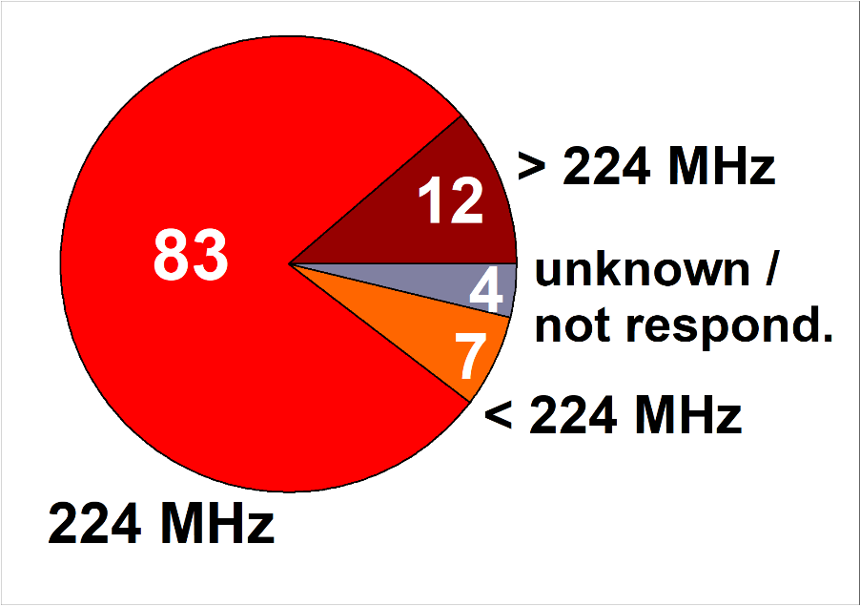
The Administrations requiring less than 224 MHz are: Egypt (Arab Republic of); Finland; Israel (State of); Kuwait (State of); Saudi Arabia (Kingdom of); Slovenia (Republic of) and United Arab Emirates.
The Administrations requiring exactly 224 MHz are: Angola (Republic of); Armenia (Republic of); Austria; Azerbaijan (Republic of); Bahrain (Kingdom of); Belarus (Republic of); Belgium; Benin (Republic of); Burkina Faso; Burundi (Republic of); Cabo Verde (Republic of); Cameroon (Republic of); Chad (Republic of); Comoros (Union of the); Congo (Republic of the); Côte d'Ivoire (Republic of); Cyprus (Republic of); Czech Republic; Democratic Republic of the Congo; Denmark; Estonia (Republic of); Eswatini (Kingdom of); France; Gabonese Republic; Gambia (Republic of the); Germany (Federal Republic of); Ghana; Greece; Guinea-Bissau (Republic of); Hungary; Iceland; Ireland; Italy; Jordan (Hashemite Kingdom of); Kazakhstan (Republic of); Kenya (Republic of); Latvia (Republic of); Lesotho (Kingdom of); Liberia (Republic of); Libya (State of); Luxembourg; Madagascar (Republic of); Malawi; Mali (Republic of); Malta; Mauritania (Islamic Republic of); Mauritius (Republic of); Moldova (Republic of); Montenegro; Morocco (Kingdom of); Mozambique (Republic of); Namibia (Republic of); Netherlands (Kingdom of the); Niger (Republic of the); Nigeria (Federal Republic of); North Macedonia (Republic of); Norway; Oman (Sultanate of); Palestine (State of); Portugal; Qatar (State of); Romania; Rwanda (Republic of); Sao Tome and Principe (Democratic Republic of); Senegal (Republic of); Sierra Leone; Slovak Republic; South Africa (Republic of); South Sudan (Republic of); Sudan (Republic of the); Sweden; Tajikistan (Republic of); Tanzania (United Republic of); Togolese Republic; Tunisia; Turkey; Uganda (Republic of); Ukraine; United Kingdom of Great Britain and Northern Ireland; Uzbekistan (Republic of); Vatican City State; Zambia (Republic of) and Zimbabwe (Republic of).
The Administrations requiring more than 224 MHz are: Albania (Republic of); Algeria (People's Democratic Republic of); Croatia (Republic of); Guinea (Republic of); Iran (Islamic Republic of); Kyrgyz Republic; Lithuania (Republic of); Poland (Republic of); Russian Federation; Serbia (Republic of); Seychelles (Republic of) and Spain.
The Administrations which have not responded or given unclear answer are: Botswana (Republic of); Bulgaria (Republic of); Lebanon and Switzerland (Confederation of).
Explanatory Note on “Box and Whisker” Charts
Box and Whisker charts are used to provide a one glance overview of the responses received by respective question. These charts illustrate the dominant views expressed (the values in the box) whilst also reflecting the outliers in the minimum and maximum values and how far removed these are from the majority view. The Figure below serves as guide to interpreting the Box and Whiskers chart.

NOTE: Some values may not be shown on the Box and Whisker chart in Excel if they fall outside a range calculated by the Excel function. They are considered “outliers”. For this, Excel calculates the interquartile range (IQR) which is defined as the distance between the 75th quantile and the 25th quantile. In the above example, IQR = 7-4 = 3. A data point is considered an outlier by Excel if it exceeds a distance of 1.5 times the IQR below the 25th quantile (4-3*1.5= - 0.5) or 1.5 times the IQR above the 75th quantile (7+3*1.5=11.5).

Attachment 1
to Annex 1
Full Responses received from Administrations to the 2020 Questionnaire
For size reasons, the data is divided into three parts:
1) Answers to questions 1 to 12 – the four next pages
2) Answers to questions 13 to 25 – the six subsequent pages
3) Additional comments provided by some Administrations – the four subsequent pages.

 |  | 1 | 2 | 3 | 4 | 5 | 6 | 7 | 8 | 9 | 10 | 11 | 12
No | Country Name (ITU) | What is the total proportion of the population that view programs using terrestrial television broadcasting in your country?[1] | When did or will DTTB[2] start in your country? | When did or will ASO[3] occur in your country? | What DTTB transmission technology is used in your country (multiple answers are possible)? | Do you anticipate the introduction of a more advanced DTTB transmission technology in your country? | What percentage of population in your country is covered by DTTB networks? | If you have current plans to change the percentage of population covered by DTTB networks in your country, what is your target coverage? | What is the total number of operational or planned national DTTB multiplexes in the 470-960 MHz band in your country? | What is the total number of operational or planned national DTTB multiplexes in the 470-694 MHz band in your country? | What is the maximum number of operational or planned local or regional DTTB multiplexes in the 470-960 MHz band in one geographical coverage area in your country?[4] | What is the maximum number of operational or planned local or regional DTTB multiplexes in the 470-694 MHz band in one geographical coverage area inyour country?⁴ | What is the current frequency range that you use for the operation of DTTB in the 470-960 MHz band in your country?
1 | Albania (Republic of) | 80% | 2016 | 2020 | DVB-T2 | Not known | 90% | 99% | 7 | 2 | 1 | 1 | 470-790 MHz
2 | Algeria (People's Democratic Republic of) | 85% | 2010 | 2015 | DVB-T DVB-T2 | Y | 77.25% | 95% | 8 | 6 | 6 | 6 | 470-862 MHz
3 | Angola (Republic of) | Less than 50%. | We started with the studies in 2009, and in 2018 the tests for the pilot emission of the DTT signal was concluded and is currently operational. | Our Administration Intends and is directing all efforts that ASO occurs not after 2025. | Our Administration officially adopted the Japanese ISDB-T Standard. | Yes. | 27% of the population is covered by the DTTB network. | Our target coverage is 90%. | The planned national DTTB multiplexes in the 470-694 MHz band in our country is 7. | This item has not yet been defined. |  |  | 470-694 MHZ
4 | Armenia (Republic of) | 99.9 | 2014 | 2016 | DVB-T2 | YES | 99.9% | 100 | Republican-1.Yerevan-3 | Republican-1.Yerevan-3 | 4 | 4 | 470-694
5 | Austria | 12% | 2006 | 2011 | DVB-T, DVB-T2 | Y | 98% |  | 4 | 4 | 3 | 3 | 470-694 MHz
6 | Azerbaijan (Republic of) | 70 | 2016 | 2016 | DVB-T,DVB-T2 | YES | 99.7% | 99.9 | 3 | 3 | 14 in Baku and on the AbsheronPeninsula.5 in the regions | 9 in Baku and on the AbsheronPeninsula.5 in the regions | 470-790
7 | Bahrain (Kingdom of) | 30% | 2010 | 2016 | DVB-T; DVB-T2 | Yes | 80% | 97% | 4 | 4 | 4 | 4 | 470-694 MHz
8 | Belarus (Republic of) | 30 | 2015 | 2015 | DVB-T,DVB-T2 | YES | 98.7% | 98.7% | 3 | 4 | 1 | 1 | 470-790
9 | Belgium – Flemish Community | <5% | 2001 | 2008 | DVB-T2 | Y | >98% (rooftop) | >98% | 6 | 6 |  |  | 470-782 MHz
9 | Belgium – French Community | 10% | 2001 | 2010 | DVB-T | Y | 95% | 98% | 6 | 6 | 4 | 4 | 638-766 MHz
9 | Belgium – German Community | 65% | 2001 |  | DVB-T | Y | 77% | 85% | 4 | 4 | 4 | 4 | 478-670 MHz
10 | Botswana (Republic of) | ~65% | 2015 | Started 2017Ongoing | ISDB-T | Not known | ~45% | ~75-80% | Currently 1 operating | Currently 1 operating | Currently 1 | 0 | 470-690 MHz
11 | Cabo Verde (Republic of) | 90% | 2007: DVB-T Private Network2016: DVB-T2 Public Network | January 2021 | DVB-T Private Network DVB-T2 Public Network | Not known | 95% | 98.5% | 7 | 4 | 3 | 3 | 470 – 614 MHz
12 | Costa Rica | 29,2% (percent of households In 2019) | 2010 ISDB-Tb standard was identified 2013 first digital transmission aired | 2019 (Region 1); 2021(Region 2) | ISDB-Tb | No | NA | 100% of all the population initially covered by analog TV | 32 | 32 | Up to 4 per operator; Up to 84 per Region | Up to 4 per operator Up to 84 per Region | 470 MHz -698 MHz
13 | Côte d'Ivoire (Republic of) | 80% | 2015 | 2022 | DVB-T2 | Not known | 60% | 98% | 4 | 4 | 4 | 4 | 470-694 MHz
14 | Croatia (Republic of) | 69% | 2002 | 2010 | DVB-T, DVB-T2 | Y | 98.5% | 99.4% | 8 | 6 | 1 | 1 | 470-790 MHz
15 | Cyprus (Republic of) | 67,7% | 2010 | 2011 | DVB-T | No at the moment | 100% | - | 7 (only 2 multiplexers are within the 694-960MHz range and are expected to terminate their transmission within2020) | 5 | 0 (We don’t have local or regional multiplexers only national) | 0 (We don’t have local or regional multiplexers only national) | 470-710 MHz (the use of the range 694-710 MHz is expected to be terminated within 2020)
16 | Czech Republic | Approx. 70% | 2010 | 2011 | DVB-T, DVB-T2 | Y – conversion DVB-T to DVB‑T2 is ongoing | 98,9% | 99,1% | 7+2 optional | 9 | 19 | - | 470-694 MHz(470-758 MHz temporarily by 2020/11)
17 | Denmark | 12% | 2006 | 2009 | DVB-T2 | Not known | 99% |  | 5 | 5 | 1 | 1 | 470-694 MHz
18 | Egypt (Arab Republic of) | Less than 5% | 2008 | NA | DVB-T, DVB-T2 | Not Known | 90% | 99% | Operational: 2, Planned: 4 | Operational: 2, Planned: 4 | Operational: 1, Planned: 2 | 2 | 470-694 MHz
19 | Estonia (Republic of) | 14% | 2003 | 2010 | DVB-T; DVB-T2 | Yes | 100% | 100% | 8 | 8 | 8 | 0 | 470–694 MHz
20 | Eswatini (Kingdom of) | Not known | 2015 | 2016 | DVB-T2 | Not known | 85% | 95% | 1 | 1 | 1 | 1 | 470-694 MHz
21 | Finland | 50% | 2001 | 2007 | DVB-T DVB-T2 | Not known.5G Broadcasting is being tested. It is not clear whether DTTB definition includes 5G broadcasting or other future mobile based multicast technologies. | 99.96% | 99.96% No change. | 6 | 6 | 3 | 3 | 470-694 MHz
22 | France | 50% (*) | 2005 | 2011 | DVB-T | Y | 95.3% (*) | 95.3% | 6 (*) | 6 (*) | 1 (*) | 1 (*) | 470-694 MHz
23 | Germany (Federal Republic of) | 6% | 2002 | 2008 | DVB-T2 | YES | 96.0% | 96.0% | 6 | 6 | 1 | 1 | 470-694 MHz
24 | Ghana | 80% | 2010 | Not known | DVB-T2 | Not known | 90% | N/A | 25 | 25 | 1 | 1 | 470-694 MHz
25 | Greece | >98% | 2014 | 2014 (19/12/2014) | DVB-T | Migration to DVB-T2 is foreseen but not decided yet | 96.2% | No plan | 167 emission points 167 x 6 layers = 1002 national MUXs | Operational :956 Planned: 5 layers x 167 emission points= 835 national MUXs | Operational: 24 Planned: 24 | Operational :20 Planned: 24 | Currently 470-790 MHz is usedbut there is a plan to migrate to 470-694 MHz
26 | Guinea (Republic of) | 70% | 2008 | Not known | DVB-T2 | Not known | 15.80% | 98% | 4 | 4 | Unknown | 4 | 470-694 MHz
27 | Guinea-Bissau (Republic of) | 50% | Dificile de prévoire la date. Néanmoins on a une station piloteinstallé en 2015. | Indeterminé | Nous planifions utiliser la technologie DVB-T2 | N | 30% | 98% | 4 | 4 | 0 (Compte tenu la petite taille de notre territoire, nous n´avons pas planifié deployer des multiplexes par zones) | 0 | 470-694 MHz
28 | Hungary | 15% | 2008 | 2013 | DVB-T, DVB-T2 | N | 98.9% | 99.3% | 5 | 5 | 2 | 2 | 470-694 MHz
29 | Iceland | Not known | 2005 | 2014 | DVB-T / DVB-T2 | Not known | >99,9% | No plan to change | 2 | 2 | 3 | 3 | 470-662 MHz
30 | Ireland | 42% | 2011 | 2012 | DVB-T | Not decided | 98% | n/a | n/a | 2 operational at May 2019; Total Planned: 6 i.e.3 high quality full coverage and 3 lower priority | n/a | n/a | 470MHz – 694MHz
31 | Italy | 91% | 2003 | 2012 | DVB-T, DVB-T2 | Not known | 99,5% | 99,5% | 20 | 12 | 22 (Currently) | 17 Currently 4 (after 30-06-2022) | 470-790 MHz
32 | Jordan (Hashemite Kingdom of) | 10% | It started the trial broadcast at the end of 2017 and officially at the beginning of2019 | 2014 | DVB/T2 | NOT KNOWN | 70% )TOP ROOF ANTENNA( | There are no current plans to start new stages. | We have no idea about that until this moment. | We have no idea about that until this moment, the only operator in the Kingdom for DTTB is the Jordan radio and television Corporation. | We have no idea about that until this moment. | NOT KNOWN | 470- 694 MHZ
33 | Kazakhstan (Republic of) | - | 2012 | 2022 | DVB-T2 | N | 86.27% | 95.00% | 2 | 2 | 2 | 2 | 470-734
34 | Kenya (Republic of) | 89.3% | 2006 | 2015 | DVB-T2 | Y | 89.3% | 100% | 10 | 10 | 3 | 3 | 470-694 MHz
35 | Kuwait (State of) | 95% of resident area | 2013 | 2017 | DVB-T2 | Planed | 95% | 100% | 3 operational4planed | 3 operational4planed | 3 operational4planed | 3 operational4planed | 470-686
36 | Kyrgyz Republic | 99.70% | 2008 | 2017 | DVB-T2 | Not known | 98% | 98% | 4 | 3-operational 2-planned | 4- operational 2- planned | 5 | 470-778
37 | Latvia (Republic of) | 20% | 2002 | 2010 | DVB-T | N | 99.8% | 99.9% | 6 | 4 | 1 | 1 | 470-790 MHz
38 | Liberia (Republic of) | 10% | 2013 | There was no Analogue Television broadcast in the UHF in Liberia | DVB-T2 | Not known | 5% | 20% | 1 | 3 | 3 | 3 | 470 MHz – 694 MHz
39 | Luxembourg | 5-10% | 2006 | 2011 | DVB-T | Not known | 90% | Currently, there are no plans to change the percentage | 3 | 3 | 0 | 0 | 470 – 638 MHz
40 | Madagascar (Republic of) | 72% | 2010 | pas encore effectuée | DVB-T2 | Not known | 55,75% | les populations dans chef lieux dedistrict | 12 | 4 | 4 | 4 | 470-814 MHz
41 | Malawi | 5% | 2013 | 2019 | DVB-T2 | Not known | 90% | 100% | 2 | 2 | 0 | 2 | 470-694
42 | Malta | <12% of total households | 2005 | 2011 | DVB-T | Not known | 95% (territory coverage) | n/a | Operational (until May 2021): 9 Planned (after May 2021 depending on market demand: 13 | Operational (until May 2021): 6 Planned (after May 2021 depending on market demand: 13 | n/a | n/a | 470-790 MHz (until May 2021) 470-694 MHz (from June 2021)
43 | Mauritius (Republic of) | 100% | 2003 | 2015 | DVB-T | Y | 100% | N/A | 14 operational28 planned | 7 operational28 planned | 7 planned | 3 operational7 planned | 470-790 MHz
44 | Moldova (Republic of) | 61% | 2007 (trials) 2015 (full-scale deployment) | 2020 | DVB-T DVB-T2 | Not known | 97.7% | 99% | 2 (operational) | 2 (operational) | 1 (planned) | 1 | 470-694 MHz
45 | Montenegro | Total proportion of the population that view TV programs using DTTB only is estimated to 6.4% of households | 2014 | 2015 | DVB-T2 | Not known | 98% | An increase of percentage of coverage population is possible by implementation of gap fillers where and when needed in some rural areas, target not prescribed exactly | 2 operational/6 planned national DTTB multiplexes in the band 470-694 MHz, while the band 694-960 MHz is not used for DTTB | 2 operational; 6 planned national DTTB multiplexes | According to the national regulation, at least one DTTB local coverage network has been planned for each municipality, while for some municipalities and capital few local coverage networks are planned. 7 local networks has been operational. The band 694-960 MHz is not used for DTTB | According to the national regulation, at least one DTTB local coverage network has been planned for each municipality, while for some municipalities and capital few local coverage networks are planned. 7 local networks has been operational. | 470-694 MHz
46 | Morocco (Kingdom of) | 100% | 2006 | 2015 | DVB-T, DVB-T2 | Not known | 93% | 95% | 3 operational 10 planned | 3 operational 8 planned | 0 | 0 | 470-694 MHz
47 | Mozambique (Republic of) | 69% | 2010 | 2021 | DVB-T2 | Not Known yet | 79% | 95% | 3 | 3 | 6 | 6 | 470 - 694 MHz
48 | Namibia (Republic of) | 72% | 2012 | 2015 as per ITU deadline | DVB-T2 | N | 72% | 90% | 4 | 4 | 4 | 4 | 470-694 MHz
49 | Netherlands (Kingdom of the) | This is commercial information. It is assumed to be around 3% | 1997 | December 2006 | DVBT2 | Not known | It’s about 99% rooftop and 65% outdoor reception | No | 5 | 5 | 5 | 5 | 470-694 MHz
50 | Nigeria (Federal Republic of) | 78% | 2006 | Not yet, simulcast ongoing | DVB-T2 | Yes | 16.21% | 99% |  | 4 |  | 4 | 470-694 MHz
51 | North Macedonia (Republic of) | DVB-T- 11.1% Cable TV-51.16%Satellite TV-5.38%IPTV-32.45% | 2009 | 2013 | DVB-T, MPEG-4 | Not known | 96% | 96.50% | 7 | 7 | 1 local, 6 national multiplexes | 1 local, 6 national multiplexes | 470-694 MHz
52 | Norway | 12% | 2007 | 2009 | DVB-T | No | 98% | No current plans | Operational 5 Planned 6 | Operational 4 Planned 5 | Operational 5 Planned 6 | Operational 4 Planned 5 | 470-694 MHz
53 | Oman (Sultanate of) | 25% | 2017 | 2015 | DVB-T2 | Y | 80% | 0 |  | 2 | 0 | 0 | 470-600 MHz
54 | Palestine (State of) | 25% | 2021 |  | DVB-T2 | Now known | The plan is to cover 90% | no | 6 | 6 | 4 | 4 | 574- 582 MHz590 -598 MHz
55 | Portugal | 25% | 2009 | 2012 | DVB-T | Not known | 92.45% | ≈94% | 5 | 5 | 1 | 1 | Mainland: 638-646 MHz,670-678 MHz and 750-758 MHz Madeira: 734-742 MHz Azores: 678-702 MHz and 742- 758 MHz We are currently adjusting all frequency bands to the following ones:542-550 MHz566-606 MHz622-694 MHz
56 | Qatar (State of) | 25% | 2017 | 2016 | DVB-T2 | Y | 80% | 0 |  | 2 | 0 | 0 | 470-600 MHz
57 | Romania | 10-13% | 2014 | 2015 | DVB-T2 | Not known | 88% (declared by public broadcaster) | 92% | 7 | 4 | 2 | 2 | 470-694 MHz
58 | Russian Federation | 98.4 | 2006 | 2019 | DVB-T2 | YES | 98.4% | 98.4 | 5 | 2 | 3 | 2 | 470-790
59 | Saudi Arabia (Kingdom of) | 3% | 2006 | 2013 | DVB-T, DVB-T2 | N | 95% | No plans | --- | --- | --- | --- | ARS are considering the frequency band (470-694) MHz for the current use
60 | Senegal (Republic of) | Around 85% | 2015 | Planned for 2021 | DVB-T2 | Not known | Around 92% | 96% | See 8 (no planned multiplex in the band upper than 694 MHz) | 4 (in 25 locations) | The band above 694 MHz is assigned to IMT in Senegal | 4 multiplexes for each of the 14 regions Average 3 regionally | 470 – 694 MHz
61 | Slovak Republic | 15% | 2009 | 2012 | DVB-T / DVB-T2 | Y | > 92% | No | 4 | 4 | NA | NA | 470 – 694 MHz
62 | Slovenia (Republic of) | 15,0% | 2006 | 2010 | DVB-T / DVB-T2 | N | > 90% | > 90% | 2 | 2 | 1 | 1 | 470-500 MHz
63 | South Africa (Republic of) | 88% | Feb 2016 | 2021 | DVB-T2 | Y | 88% total | 95% by June 2021 (end of performance period) | 2 of 7 Multiplexes | 2 of 7 Planned Multiplexes | 7 per Province | 7 per Province | 470-758 MHz
64 | South Sudan (Republic of) | Less than 5% | 2019 | 2020 | DVB-T2 | Not Known | Less than 10 % | 15-50 % | 3 | 12 | 3 | 3 | 470-694 MHz
65 | Spain | 92,4% | 2000 | 2010 | DVB-T | Y (DVB-T2) | >99% | NO | 7 | 7 | 4 | 4 | 470-694 MHz
66 | Sudan (Republic of the) | 25% | no | 2020 | DVB-T2 | Y | 0% | 70 | 10 | 10 | 2 | 2 | 470-694 MHz
67 | Sweden | Circa 20% | 1999 | 2007 | DVB-T DVB-T2 | Not known | MUX 1: 99.8 %MUX 2-6: 98 %MUX 7: 30 % | Not known | 6 | 6 | 5 | 6 | 470-694 MHz
68 | Switzerland (Confederation of) | <1% | 2005 | 2008 | DVB-T, DVB-T2 | Not known | 20% | No plan | 0 | 0 | 2 | 2 | 470-694 MHz
69 | Tajikistan (Republic of) | 90 | 2010 | - | DVB-T2 | YES | 60% | - | 12 | - | 4 | 4 | 470-774
70 | Tanzania (United Republic of) | 75% | 2010 | April 2015 | DVB-T, DVB-T2 | Y | 50.5% | 90% by 2025 | 4 | 4 | 4 | 4 | 470-694 MHz
71 | Tunisia | 80% | 2001 (trial)2009 (operational) | 2016 | DVB-T | Not Known | 99.6% | 99.6% | 4 (planned) | 4 (planned) | 4 | 4 | 470-694 MHz
72 | Turkey | 0,012 | Not finalized yet | Not finalized yet | DVB-T2 | Y |  |  | 5 | 4 | 1 | 1
73 | Ukraine | 31,0% | 2006 (some channels) | started with 31.08.2018 | DVB-T / DVB-T2 | Not known | 95% | 95% | 5 | 5 | 3 | 3 | 470 - 822 MHz  846 - 862 MHz
74 | United Arab Emirates | N/A | 2014 | 2013 | DVB-T2 | Not known | 15% | N/A | 2 | 2 | 2 | 2 | 470-694 MHz
75 | United Kingdom of Great Britain and Northern Ireland | 61.2% | 1998 | 2012 | DVB-T & DVB-T2 | No current plans | 98.5% |  | 7 | 6 | 2 | 2 | 470-750 MHz
76 | Uzbekistan (Republic of) | 100 | 2008 | 2018 | DVB-T2, DVB-T | Not known | 100% | 100 | 4 | 4 | 8 | 8 | 470-694
77 | Vatican City State | 99% | 2009 | 2009 | DVB-T | YES | ~100% | NO | 5 | 4 | 0 (No local/regional) | 0 (No local/regional) | 470 – 790MHz
78 | Zambia (Republic of) | 38.0% | 2015 | 2018 | DVB-T2 | Not known | 38.0% | 85.0% | 0 | 2 | 6 | 6 | 470-694
79 | Zimbabwe (Republic of) | 60% | Nov/2020 | 2021 | DVB-T2 | Not known | 36% | 90% | 4 | 4 | 4 | 4 | 470-694 MHz

 |  | 13 | 14 | 15 | 16 | 17 | 18 | 19 | 20 | 21 | 22 | 23 | 24 | 25
No | Country Name (ITU) | How many national free to air TV programme services[5] are broadcast on DTTB in your country?[6] | How many local or regional free to air TV programme services are broadcast on DTTB in your country?6 | How many pay-TV programme services are broadcast on DTTB in your country?6 | Do you anticipate the introduction of more programmes on DTTB in your country in the future? | Do you anticipate the introduction of enhanced services (e.g. HDTV, UHDTV, HDR, others) on DTTB in your country in the future? | Do you foresee the need to allow for additional reception modes (e.g. portable, mobile) on terrestrial broadcasting in your country in the future? | Do you use or plan to use interactive broadcast broadband (IBB)[7] systems on your DTTB platform? | What is the total number of operational or planned DTTB transmitters in the band 470- 694 MHz?[8] | What is the total number of operational or planned DTTB transmitters in the band above694 MHz?⁷ | What other services (including applications in these services) are in operation in the 470-694 MHz band in your country, and what is their status of allocation? | What is the total amount of spectrum needed in the UHF range in your country for broadcasting service taking into account the need for quality of service and answers to Questions above (in particular Questions 16, 17, 18,19)?⁷ | What is/are the frequency range(s) that you consider necessary to accommodate the needs of the broadcasting service within the band 470-960 MHz in your country?[9] | Date of response to the questionnaire
1 | Albania (Republic of) | 23 | 21 | 79 | Y | Y | Not known | Not known | 228 | 66 |  | 320 MHz | 470-790 MHz | 2020/08
2 | Algeria (People's Democratic Republic of) | 6 | 0 | 0 | Y | Y | Y | Y | 2500 | 0 | PMSE/ Secondary SRNA | 224 MHz | 470-862 MHz | 2020/08
3 | Angola (Republic of) | 3 | 3 | Has not yet been defined | Yes | Yes | Yes | Yes | Angola currently has only one site on the DTTB network. | No DTTB transmitters are planned in band above 694 MHz | There is no other service or application of these services operational in these bands other than Digital Terrestrial Television. | ≥ 224 MHz and < 320 MHz. | 470-694 MHz.
4 | Armenia (Republic of) | 8 | 17 | 0 | Yes | Yes | Not known | Yes | 215 | 0 | No | 224 | 470-694 | 2020/07
5 | Austria | 11 | 37 | 41 | Y | Y | Y | Y | 644 | 0 | PMSE / secondary | 224 MHz | 470-694 MHz | 2020/07
6 | Azerbaijan (Republic of) | 11 | 10 | - | Yes | Yes | Yes | Not known | 179 | 29 | Not used | 224 | 470-694 | 2020/07
7 | Bahrain (Kingdom of) | 6 | 6 | 0 | Yes | Yes | Yes | Not known | 5 | 0 | Mobile service - secondary (PSME) | 224 MHz | 470-694 MHz | 2020/07
8 | Belarus (Republic of) | 9 | 12 | 52 | Yes | No | No | No | 201 | 85 | Radio navigation/Primary | 224 | 470-694 | 2020/06
9 | Belgium – Flemish Community |  |  | 16 | Y | Y | Not known | Not known | 39 |  | PMSE Secondary status | 224 MHz | 470-694 MHz | 2020/08
9 | Belgium – French Community | 4 | 1 | 0 | Not known | Y | Not known | N | 45 | 12 | PMSE Radio-Astronomy | 224 MHz | 470-694 MHz | 2020/08
9 | Belgium – German Community | 4 | 0 | 0 | Not known | Y | Not known | Not known | 24 | 0 | PMSE | 224 MHz | 470-694 MHz | 2020/08
10 | Botswana (Republic of) | 6 | not yet | 0 | Not known | Y | Y | Not known | 44 | Not yet |  | [No response] | [No response]
11 | Cabo Verde (Republic of) | 7 | 0 | 44 | Y | Y | Not known | Plan to use: Y | 53 | 0 | No service | 224 MHz | 470-694 MHz | 2020/08
12 | Costa Rica | 32 | 8 | 0 | Y | Y | Y | Y | 130 | 0 | Terrestrial broadcast | 228 MHz | 470 MHz – 698 MHz | August 13th, 2020
13 | Côte d'Ivoire (Republic of) | 7 | 1 | 50 | Y | Y | Y | Y | 800 | 0 | Broadcasting service only | 224 MHz | 470-694 MHz | 2020/07
14 | Croatia (Republic of) | 11 | 20 | 60 | Y | Y | Y | Y | 417 | 210 | PMSE / Secondary SRD / Secondary | 244 MHz | 470-694 MHz, 738-758 MHz | 2020/08
15 | Cyprus (Republic of) | 15 | 0 (We don’t have local or regional services only national) | 0 | Y | Y | Not Know | Not Know | 244 | 0 | PMSE /secondary Radio astronomy /secondary Radio microphones and ALD /secondary Wind profilers /secondary | 224 MHz | 470-694 MHz
16 | Czech Republic | Approx. 50 | Approx. 40 | None | Y | Y | N | Y | Approx. 400 | 0 | PMSE/SRD category | 224 | 470-694 MHz | 2020/08
17 | Denmark | 4 | 16 | 33 | Not known | Not known | N | Y | 282 | 0 | PMSE/Secondary | 224 MHz | Question unclear. Unable to answer. Is it the current need or the long term need? | 2020/06
18 | Egypt (Arab Republic of) | 18 | 6 | 0 | Y | Y | N | Y | Operational: less than 100, Planned: 1646 | 0 | Fixed / Mobile except aeronautical mobile ,Radio-Astronomy, PMSE (All secondary) | 136 MHz | 470-606MHz | 2020/8
19 | Estonia (Republic of) | 4 | 0 | 36 | Yes | Yes | No | Yes | 200 | 0 | Mobile service - secondary (PSME) (470–786 MHz) | 224 | 470–694 MHz | 2020/08
20 | Eswatini (Kingdom of) | 2 | 2 | 0 | Y | Y | Y | Not known | 18 | 0 | No other service | 56 MHz | 470-694 MHz | 2020/09
21 | Finland | 21 | 9 | 38 | No. Total number of TV programmes is not expected to rise. | Not known yet. HDTV services already in use with DVB-T2. | No Not in DVB-networks, possible need for mobile reception if 5G Broadcasting or similar technologies are taken into use | Yes. HbbTV already In use. | 800 (39 HPHT transmitter sites) | 0 | PMSE / Secondary | Less than 224MHz with various steps and timelines | Within the 470-694MHz frequency range. | 2020/07
22 | France | 27 | 43 (*) | 5 | Not known (*) | Y | Not known | Y | 11146 (*) | 0 | Mobile service - secondary (PMSE);Radio astronomy service – other | 224 MHz (*) | 470-694 MHz (*) | 2020/08
23 | Germany (Federal Republic of) | 15 | 19 | 21 | Not known | YES | Not known | Y | 767 | 0 | PMSE in accordance with 5.296, Wind Profiler Radar in accordance with5.291A,Radio-Astronomy in accordance with 5.306 | 224 MHz | 470-694 MHz | 2020/08
24 | Ghana | 60 | 20 | 600 | Y | Y | Y | Y | 146 | 0 | TV Whitepsace / Secondary | 224 MHz | 470-694 MHz | 2020/05
25 | Greece | 12 | 106 | 0 | Not known | Y, HDTV already introduced | Not known | Not known | Operational: 1037 Redundant: 85 | Operational:230 Planned: 0 | PMSE | 224MHz | 470-694 MHz | 2020/08
26 | Guinea (Republic of) | 0 | 2 | 96 | Y | Y | Y | Y | 14 | 0 | No other services | 224 MHz | 470-694 MHz694-790 MHz | 2020/08
27 | Guinea-Bissau (Republic of) | 1 | 0 | 0 | Y | Y | N | Y | 10 | 0 | None | 224 MHz | 470-694 MHz | 11.03.2020
28 | Hungary | 12 | 32 | 64 | Y | Y | N | Y | 498 | 0 | Land Mobile / Secondary and Radio- Astronomy / Secondary | 224 MHz | 470-694 MHz | 2020/07
29 | Iceland | 2 | 2 | 20 | Y | Y | Not known | y | 322 | 0 | PMSE | 224 MHz | 470-694 MHz | 2020/05
30 | Ireland | 11 | 0 | 0 | Not known | Currently two programme services are in HD (1440x1080i) | Not Known | Y | 134 | 0 | PMSE / Secondary Radio-Astronomy / Primary | 224MHz | 470MHz – 694MHz | 2020/05
31 | Italy | 106 | 411 | 20 | Y | Y | Not known | Y | 14.000-15.000 | Currently 6.000-7.000. After 30-6-2022 0 (zero) | PMSE-SRD / Secondary Radioastronomy / Secondary VLBI Observation/Secondary | 224 MHz | 470-694 MHz | 2020/07
32 | Jordan (Hashemite Kingdom of) | the only operator in the Kingdom for DTTB is the Jordan radio and television Corporation, we transmitting two national free to air TV program | 2 | There are no pay TV | Y | y/ we transmitting 2HD programs | NOT KNOWN | NOT KNOWN | 8 | NOT KNOWN | This band frequency just for DTTB (470- 694 MHZ) | 224 MHZ | 470-694 MHZ | 2020/31
33 | Kazakhstan (Republic of) | 80 | 50 | 0 | Not known | Y | N | N | 849 | 80 | Aeronautical radionavigation servise/ PrimaryRadio navigation/PrimaryFixed/Primary Land mobail servise/ Primary | 224 | 470-694 | août.20
34 | Kenya (Republic of) | 34 | 73 | 127 | Y | Y | Y | Y | 352 | 0 | PMSE/ Secondary TVWS/ Secondary | 224MHz | 470-694MHz | 2020/08
35 | Kuwait (State of) | 30 | 30 | 0 | Y | Y | Y | Y | 7 operationa 20 planned | 0 | no | 128MHz | 470-614 MHz | 2020/06
36 | Kyrgyz Republic | 48 | 15 | 0 | Y | Y | Y | Not known | 88 | 33 | Broadcasting serviseFixed/Primary | 320 | 470-694 | août.20
37 | Latvia (Republic of) | 5 | 1 | 57 | N | Y | N | N | 60 | 14 | PMSE | 224 MHz | 470-694 MHz | 2020/08
38 | Liberia (Republic of) | 4 | 4 | 180 | Y | Not known | Y | Not known | 3 | 0 | NONE | 224 MHz | 470-694 MHz | 2020/08
39 | Luxembourg | 11 | 0 | 0 | Not known | Not known | Not known | Not known | 3 in operation | 0 | Wireless microphones - Ancillary broadcasting radio equipment SAP/SAB | 32 MHz | 470 – 638 MHz | 2020/07
40 | Madagascar (Republic of) | 10 |  | 54 | not known | not known | Y | Not known |  |  | No other services |  | 470-694 MHz | 2020/06
41 | Malawi | 14 | 2 | 2 | Y | Y | Y | Y | 16 | 0 | Non Only DTT | 224 | 470-694 | 2020/08
42 | Malta | 8 | n/a | 58 | Not known | Not known | No | No | 84 | 42 | PMSE (secondary) | 104 MHz | 470-694 MHz | 2020/08
43 | Mauritius (Republic of) | 18 | N/A | 0 | Y | Y | Not known | Not known | 154 | 26 | PMSE / Radio-microphones | 224 MHz | 470-694 MHz | 2020/07
44 | Moldova (Republic of) | 15 | 0 | 0 | Y | Y | Not known | Not known | 53(operational) | 0 | Land mobile/Secondary | 224 MHz | 470-694 MHz | 2020/08
45 | Montenegro | 5 national TV programs have been broadcasted free-to-air: 2 public and 3 commercial programs | 0 regional; in total 8 (3 public and 5 commercial) programs have been broadcasted locally | 31 | Y | Y | Y | Not known | 161 operational DTTB transmitters | 0 | PMSE limited to audio links including radio microphones / Secondary | 224 MHz | 470-694 MHz | 2020/07
46 | Morocco (Kingdom of) | 10 | 1 | 0 | Y | Y | Y | Y | 1200 | 0 | 470-694 MHz is also allocated to the mobile service on a secondary basis terrestrial, for applications auxiliary to broadcasting and program production (foot note 5.296 of Art 5 of RR). | 224 MHz | 470-694 MHz | 2020/07
47 | Mozambique (Republic of) | 17 | 17 | 3 Pay TV operator with over 100 programs each | Y | Y | Y | Y | 250 | 0 | 3 Trails on TV White Space on secondary basis | 224 MHz | 470-694 MHz | sept.20
48 | Namibia (Republic of) | 5 | 0 | 2 | Y (2 more) | Y (2 more) | N | N | 264 | 0 | None | 224 MHz | 470-694 MHz | 2020/08
49 | Netherlands (Kingdom of the) | 3 | 1 per region in total 12 regional TV Programs | Around 27 | N | Not known | N | Not known | Around 50 | 0 | PMSE/ Radio Astronomy | The net amount of spectrum required is 5x8 =40 MHz on any location. To fulfil all the requirements of neighboring countries and required reuse distances 694 – 470 = 224 MHz is required | 470-694 MHz, current license is valid until 2030. | 2020/08
50 | Nigeria (Federal Republic of) | 30 | 30 | 4 | Y | Y | Y | Y | 444 | 0 | PMSE TVWS | 224 MHz | 470-694 MHz | 2020/08
51 | North Macedonia (Republic of) | 5 from private national TV stations (free to air TV programme services) 5 from public broadcaster free to airTV programme services | 18 | 45 | Y | Y | Y | Not known | 123 locations/443 Authorizations for Radio Frequency Utilization | 0 | / | 224 MHz | 470-694 MHz | 2020/05
52 | Norway | 3 | 10 | 30 | N | Y | N | Y | 2378 | 0 | PMSE | 224 MHz | 470-694 MHz | 2020/08
53 | Oman (Sultanate of) | 4 | 0 | 0 | Y | Y | Y | Not known | 100 | 0 | None | 224 MHz | 470-694 MHz | 2020/08
54 | Palestine (State of) | 10 /for the first planned Mux | ------------- | 0 | y | y | y | y | 40 | 0 | Telemetry | 112 MHz | 470-694 MHz | 2020/08
55 | Portugal | 7 | 2 | 0 | Y (2) | Not known | Not known | Not known | 267 currently. 260 in 2021 | We are currently adjusting all transmitters and there will be no transmitter operating above 694 MHz until the end of year. | PMSE /Secondary | 224 MHz | 470-694 MHz | 2020/08
56 | Qatar (State of) | 4 | 0 | 0 | Y | Y | Y | Not known | 100 | 0 | PMSE | 224 MHz | 470-694 MHz | sept.20
57 | Romania | 9 | 1 | 0 | Not known | Not known | Not known | Not known | 230 | 0 | PMSE/Secondary | 224 MHz | 470-694 MHz | 2020/05
58 | Russian Federation | 20 | 150 | 0 | Yes | Yes | Yes | Yes | 8249 | 2150 | Fixed/Primary Space operation/Primary PMSE/Secondary | 376 | 470-790 | 2020/07
59 | Saudi Arabia (Kingdom of) | --- | --- | 0 | Not known | N | N | Not known | Operational 135 | 0 | BROADCASTING/Primary fixed/ Secondary land mobile/Secondary | --- | ARS are considering the frequency band (470-582 )MHz | 2020/08
60 | Senegal (Republic of) | 19 | No regional broadcasting yet | Around 60 | Y | Y | Y | Y | 174 (28 operational) | None (band used for IMT now) | Radio-Astronomy / Primary | 224 MHz | 470 – 694 MHz | 2020/08
61 | Slovak Republic | 8 | NA | 12 | N | Y | N | N | 175 | 0 | PMSE | 470 – 694 MH = 224 MHz | 470 – 694 MHz | 2020/08
62 | Slovenia (Republic of) | 6 | 6 | 6 | N | N | N | Y | 200 | 0 | PMSE / Secondary; Radio-Astronomy / Primary | 30 MHz | 470-500 MHz | 2020/09
63 | South Africa (Republic of) | 8 National on Mux1 | 6 1 | 15 | Y | Y | Y | Y | 283 current 1281 for 7 Mux plan | 183 | SAB/SAP: 470 – 694 MHz (secondary) TVWS: 470 – 694 MHz (secondary) RADIO ASTRONOMY: 606 – 614 MHz | 224MHz | 470-694 MHz | 2020/07
64 | South Sudan (Republic of) | 3 | 20 plus | 1 | Y | Y | Y | Y | 12 | None | PMSE | Not much | 470-694 MHz | 2020/10
65 | Spain | 26 | 750 | 0 | Not known | Y | Y | Y | ~ 24000 - 27000 | 0 | PMSE/Secondary SAB Service Ancillary to Broadcasting/ SAP Service Ancillary to Programme Making. | 239MHz | 470-694 MHz, 738-753 MHz | 2020/08
66 | Sudan (Republic of the) | - | - | - | Y | Y | Now known | Y | 360 | 0 | - | 224 MHz | 470-694 MHz | 2020/08
67 | Sweden | 6 | 4 | 61 | Not known | Not known | Not known | Not known | 1336 | 0 | PMSE Secondary | 224 MHz | 470-694 MHz, until 31st of December 2025, in accordance with the government’s decision. | 2020/08
68 | Switzerland (Confederation of) | 5 | 1 | 0 | Not known | Not known | Not known | Not known | 3 | 0 | PMSE (excluding 606-614 MHz) / Secondary Radio Astronomy (in 606-614 MHz) / Primary UWB / Secondary PMR / Secondary Wind profiler Radars / Secondary | Not known | Not known | 2020/05
69 | Tajikistan (Republic of) | 8 | 10 | 61 | Yes | Yes | Not known | Not known | 78 | 37 | - | - | 470-694 | 2020/07
70 | Tanzania (United Republic of) | 13 | 34 | 101 | Y (The local content pay TV industry is growing exponentially. The local artists have seized this opportunity as their source of revenue) | Y | N | Y | 672 | 0 | PMSE | 224MHz | 470-694 MHz | 2020/08
71 | Tunisia | 13 | 0 | 0 | Y | Y | N | Y | 70 | 0 | PMSE / Secondary | 224 MHz | 470-694 MHz | 2020/06
72 | Turkey |  |  |  |  | Y | Y | Y |  |  | PMSE/Secondary | 224 MHz | 470-694 MHz | 2020/08
73 | Ukraine | 28 | 130 | 0 | Not known | Not known | N | Not known | 936 | 223 | Aeronautical Radio Navigation/Primary  Radio-Astronomy/Secondary | 28 | 130 | 2020/07
74 | United Arab Emirates | None | 5 | None | No | No | No | No | 96 | 68 | PMSE / Secondary | 144 MHz | 470-614 MHz | 2020/08
75 | United Kingdom of Great Britain and Northern Ireland | 113 | 34 | 0 | Not known | Not known | Not known | Y | 3772 | 87 | PMSE (secondary) / White Space Devices (secondary) | 224 MHz | 470-694 MHz | 2020/08
76 | Uzbekistan (Republic of) | 19 | 40 | 45 | Yes | Yes | Yes | No | 466 | 0 | No | 224 | 470-694 | 2020/07
77 | Vatican City State | 13 | 0 (No local/regional) | 0 | Not known | Y | Y | Y | 12 | 3 | PMSE / Secondary | 224 MHz | 470 – 694MHz | 2020/07
78 | Zambia (Republic of) | 5 | 50 | 99 | Yes | Yes | Yes | Yes | 54 | 0 | Fixed service - secondary Frequency range 470-494 | 224 MHz | 470-694 | 2020/08
79 | Zimbabwe (Republic of) | 12 | 0 | 0 | Y | Y | Y | Y | 200 | 0 | Broadband/Secondary Systems Ancillary to Broadcasting/Secondary | 224MHz | 470-694 MHz | 2020/08

No | Country Name | Any additional comments relevant to the answers you have given above (optional)
14 | Croatia (Republic of) | Question 1: Based on Special Eurobarometer 462 DTT figure, D46.1_QB2. Question 4: All DVB-T will be migrated to DVB-T2 till the end of 2020.  Question 5: All DVB-T will be migrated to DVB-T2 till the end of 2020.  Question 20: DVB-T2 only transmitters after 2020 (300 main and 117 reserve transmitters). Question 21: Transmitters will be switched off or tuned to sub 700 MHz band till the end of 2020. Questions 18, 23, 24: Using future broadcasting technology in UHF sub 700 MHz band and 738-758 MHz band.
17 | Denmark | The answer to Question 1 only includes Main TV sets, since accurate numbers are not available for secondary TV sets.
18 | Egypt (Arab Republic of) | Demand in Egypt for terrestrial broadcasting service is low and still decaying due to the following reasons: 1. Satellite broadcasting is widely adopted. 2.Content is easily reachable through internet by PCs, tablets, phones and smart TVs. 3. Analog receivers in households need to be replaced or equipped by set-top box. 4.Installing, directing and maintaining antennas for terrestrial broadcasting is a burden
19 | Estonia (Republic of) | Need of spectrum for broadcasting may decrease in the future depending on development of mobile services.
21 | Finland | - Change of tv-content distribution market and consumer behavior such as transition to non-linear television watching is not included in the questionnaire. It would be good to analyze the impact and pace of changes in the tv-content provision and the consumer behavior as more and more consumers transit from watching linear TV towards non-linear. It is a very important element to consider.  - It is not clear what is meant by DTTB and broadcasting in the questions, i.e. does it cover only the currently used technologies mentioned eg. in question 4 (e.g. DVB-T and T2, …), or also possible future solutions e.g. 5G-based broadcasting or other future mobile multicast technologies.  - Shift from DVB-T to DVB-T2 is ongoing. Switch off of DVB-T will release spectrum, but time schedule is yet unknown and depends on penetration of DVB-T2 receivers. It's too early to define which will be the main technologies for distribution of audio visual media in the future, 5G broadcast or 5G broadband (i.e. unicast or unicast with multicast option) being examples. The uncertainty in timelines of above changes would benefit if flexibility, i.e. a co-primary allocation for mobile service, is introduced for the use of the band 470 - 694 MHz in the Radio Regulation at WRC-2023. Administrations would retain the control over the use of the band taking into account the national needs of broadcasters.
22 | France | Preliminary note: all the data provided above concerns mainland France, and doesn’t represent the situation in the French overseas territories, including the ones in Region 1 – Réunion and Mayotte.  Besides, the answers of the French administration show the status of the spectrum use and spectrum needs for terrestrial television broadcasting in the UHF band, in France, at the date of submission and for the foreseeable future. This status and related answers to this questionnaire may be revised in the light of administrative, regulatory and technical developments.  The administration of France would like to provide these additional comments:  - Q1: The answer corresponds to the population that receives television using DTTB television, including reception through a DTT dedicated cable headend, on the whole household based on declarative. Excluding reception through cable headend, the penetration is 45.9 % of the population. More details are available in the television equipment observatory published by the Conseil supérieur de l’audiovisuel (CSA) – which is the French broadcasting authority – for S2 2019 (https://www.csa.fr/Informer/Collections-du-CSA/Panorama-Toutes-les-etudes-liees-a-l-ecosysteme-audiovisuel/Les-observatoires-de-l-equipement-audiovisuel/L-equipement-audiovisuel-des-foyers-aux-3e-et-4e-trimestres-2019-TV-et-pour-l-annee-2019-radio). In France, the common DTT penetration indicator is calculated over TV equipped households (92.5% of total population); it is evaluated to 54 % at the end of 2019. This study is based on declarative only and doesn’t include all IPTV and Set-Top-Boxes that are connected to a DTTB antenna, as respondents are not necessarily aware that they are using DTTB in those indirect configurations. Based on statistical assumptions, another study estimates the total amount of DTTB users including indirect configurations. It leads to significantly higher results.  - Q6: the French law states that DTTB programme services are provided to the entire population whether by DTT or any other mean and that the DTTB network coverage cannot be less than 95% of the population of mainland France. Nowadays, 95.3 % of the population of mainland France is able to receive the entire DTT offer using the DTT platform. The individual coverage of each multiplex ranges from 95.3 to 97.1% of the population.  - Q8 9 and 20: the French audiovisual sector currently prepares the next evolutions of the DTT platform. A first offer of UHD programmes could be broadcast on one DVB-T2 / HEVC multiplex in a relative short term. On a longer term, this technological evolution could be extended to the entire DTT platform.  To implement the preliminary offer, two main scenarios are currently considered: to roll out a seventh multiplex (with a limited coverage) or to migrate the current DVB-T offer from 6 to 5 national multiplex, in order to reuse one of the current national multiplex. The number of transmitters may increase accordingly.  - Q10 and 11: In France, most of the regional programmes are delivered by different version of a multiplex which deliver national, regional, and for some areas local contents. The rest of the local or regional programmes are delivered by one fully local multiplex. As the multiplex with national and regional/local contents is already take into account in questions 8 and 9, the answer to question 10 and 11 only takes into account the multiplex which only offers regional or local programmes. However, it should be noted that in some areas, different versions of the multiplex with national and regional/local contents overlap up to six times. It means that depending on their antenna orientation, some household can receive the regional programmes from six different geographical area. For some areas, this overlapping is the only way to deliver all regional contents intended for the tv viewers of those areas.  - Q14: in its annual activity report for 2019 (https://www.csa.fr/Informer/Informations-publiques-et-ressources-humaines/Les-rapports-annuels-et-bilans-du-CSA/Le-rapport-annuel-2019-du-CSA), the CSA indicates that 43 regional programme services are authorized to be broadcast in mainland France. This figure doesn’t include regional programmes of the national public service France 3.  - Q16: the introduction of new programmes on DTT will depend on several elements, especially the regulatory framework in which the preliminary offer will be launched, and the stakeholder’s strategy. As the preliminary HD offer, the first UHD programs to be broadcast could be simulcast of existing HD programmes, in this case, they will not be considered as additional programmes.  - Q23 and 24: the current frequency resource (224 MHz) is insufficient to generalize, for example, UHD. Diminishing the available amount of spectrum would impede the provision of increased image and sound qualities, thus resulting in a quality gap between urban areas, where FTTH is available, and the vast majority of rural areas, where DTTB is still the only mean to receive TV programmes.
23 | Germany (Federal Republic of) | Question 4: HEVC standard is used.  Question 5: 5G-Broadcast field trial with high-power high-tower currently in Bavaria.  Question 8-11: The assignment of the layers is ambiguous and values may vary depending on the method of assigning.  Question 16: In Germany regulations on the type and scope of broadcasting services are in the responsibility of the federal states, not in the responsibility of the Federal Network Agency. Question 17: HDTV already implemented.  Question 18: Current networks are planned for portable outdoor. Question 19: HbbTV.  Questions 23, 24: Currently used spectrum, licensed until 2030 (see also comment to Question 16).
28 | Hungary | In question number 1 we do have statistical report only for primarily usage for terrestrial television broadcasting, which is 13%.  15% is an estimation for primarily and secondary usage, derives from the following research of our Authority: Research on the consumers in the electronic communications market. Household survey, 2019.
31 | Italy | Italy will finalize the release of 694-790 MHz band by 30th June 2022
34 | Kenya (Republic of) | The response given to No. 20 above only covers the current operational full power and gap filler DTT transmitters. The planned frequencies are 568.
37 | Latvia (Republic of) | The forecasts are based on the information available at the time of questioner.
41 | Malawi | (15) - One government owned i.e. Malawi Digital Broadcast Network limited and the other one private i.e. GoTV (Multichoice)
42 | Malta | Malta’s population at end 2019 was 507,949. / As at end 2019, the total number of Pay-TV DTTB subscribers was 14,686. / 91.8% of the population have a Pay-TV subscription. It is observed that some other countries having such a high level of pay-TV take-up have announced DTTB switch-off. / As at March 2020, the estimated number of population not having a paid DTTB subscription was around 5,100. (≈1% of population). This figure is 0.2% less when compared to the period March 2019. / Licences granting the right of use of radio frequencies for the provision of commercial (pay-TV) DTTB services will expire in May 2021. The continued provision of this service is dependent on market interest. / Although radio spectrum is assigned on a technology neutral basis, the Malta Communications Authority promotes technologies which utilise the radio spectrum in the most efficient and effective manner.
48 | Namibia (Republic of) | Provided frequency channeling plan for ease of reference
52 | Norway | Q1: 12% covers those with subscription (pay-TV customers). There is an addition of appr 25% who do not subscribe but only uses the free to air programmes.  Q11: The capacity is 22 Mbit/s per multiplex
54 | Palestine (State of) | The answers are built on our near future plans which accordingly DTTB will begin in 2021and also on our national DTTB strategy plan.
62 | Slovenia (Republic of) | We plan to move DTT to 5G mobile platform
63 | South Africa (Republic of) | 1 Tshwane TV, Soweto TV, Bay TV, TBN, Cape Town TV, and IKZN TV  2 Invitation to pre-register for Digital Community Broadcasting Service and Radio Frequency Spectrum License published on 03 August 2020 in Government Gazette No. 43088
65 | Spain | Question 23:  - 239MHz as:  - 224MHz from 470 – 694MHz  - 15MHz from 738 – 753MHz (SDL spectrum on the duplex gap of 700MHz)  Additional remarks:  - L band, 40MHz (1452 – 1492MHz): interesting band to be studied.
70 | Tanzania (United Republic of) | - The local Pay TV programmes are increasing rapidly and become a source of revenue for the local artists.  - The plan is underway for some of the Signal Distributor (SD) to introduce HDTV  □ The plan is underway for some of the Signal Distributor (SD) to introduce HDTV
72 | Turkey | The figures in the replies to questions 23 and 24 are based on the current capabilities of broadcasting and mobile technologies and binding international regulations/frequency coordination requirements but can be reassessed taking into account the developments therein
75 | United Kingdom of Great Britain and Northern Ireland | Q1 - Source: BARB Establishment Survey, Q1 2020.  Q2 - Geographically-phased ASO completed in 2012.  Q6 - Approximately 98.5% of UK households are covered by at least the three ‘public service broadcaster’ multiplexes.  Q7 – No change planned.  Q8 - Three of these national multiplexes contain programme services which vary by region and/or UK nation. One of these multiplexes that is operating above 694 MHz will be switched off in due course as part of the clearance of the 700 MHz band.  Q11 – As per Q10.  Q13 - As of mid-July 2020 (including national and regional programming variations).  Q14 – Specifically-licensed local TV services (‘L-DTPS’ services) only. Does not include national services with regional variations, or programme services targeting individual UK nations.  Q16 - This is a matter for the multiplex operators to determine.  Q17 - A number of HDTV services are already in operation.  Q20/Q21 - These figures refer to operational transmitter assignments only as of 11 August 2020: Ofcom has no detailed knowledge of the broadcasters’ reserve/redundant equipment arrangements. However we do understand that high power DTTB sites have reserve transmitter capabilities.  Q21 - These transmitters will move to frequencies below 694 MHz or be switched off in due course as part of the clearance of the 700 MHz band.  Q22 – During 2019  129,026 individual PMSE assignments in UHF TV spectrum were issued to a total of 2,580 Ofcom-registered entities as licence holders. /
78 | Zambia (Republic of) | kindly note that 95% of Television services in Zambia are provided on the Terrestrial platform
79 | Zimbabwe (Republic of) | The licensing of Digital Terrestrial Television broadcasters is currently in progress and we anticipate the process to be completed by end of 2020.

Annex 2
Case Study 1 – The consequences of the loss of further broadcasting
spectrum for RCC countries

This case study examines the digital broadcasting spectrum requirements of RCC countries, and the consequences of the possible elimination of 694-790 MHz band in addition to the already eliminated 790-862 MHz band from the Geneva-06 Plan. It also contains an example methodology for evaluating spectrum requirements for digital terrestrial broadcasting.

A2.1 Existing and planned situation(s)

A2.1.1 Consequences of possible elimination of 694-790 MHz band in addition to already eliminated 790-862 MHz band from “Geneva-06” Plan for RСС countries
In the case of use of TV broadcasting bands for mobile communications on the basis of the end-to-end channel arrangement, a substantial part of frequency allocations of “Geneva-06” Plan will be lost or cannot be used for TV broadcasting. Tables with total number of in “Geneva-06” Plan in the 470-694, 470-790, 470-862 MHz frequency bands for RCC countries are given below.
TABLE A2.1
Total number of frequency allotments
RCC members | 21-48  TV channels | 21-60  TV channels | 21-69  TV channels | Total reduction  (%)
Azerbaijan | 234 | 317 | 375 | 38
Armenia | 135 | 175 | 204 | 34
Belarus | 133 | 179 | 205 | 35
Georgia | 107 | 140 | 156 | 31
Kazakhstan | 951 | 1371 | 1674 | 43
Kyrgyzstan | 162 | 234 | 269 | 40
Moldova | 33 | 44 | 56 | 41
Russia | 5 347 | 7 629 | 9 226 | 42
Tajikistan | 218 | 315 | 377 | 42
Turkmenistan | 153 | 216 | 268 | 43
Uzbekistan | 424 | 602 | 675 | 37
Ukraine | 354 | 513 | 636 | 44

TABLE A2.2
Average number of radio channels in the band
RCC members | 21-48  TV channels | 21-60  TV channels | 21-69  TV channels | Total reduction  (%)
Azerbaijan | 7,1 | 9,6 | 11,4 | 38
Armenia | 15 | 19,4 | 22,7 | 34
Belarus | 5,3 | 7,1 | 8,2 | 35
Georgia | 10,7 | 14 | 15,6 | 31
Kazakhstan | 5,7 | 8,3 | 10,1 | 44
Kyrgyzstan | 16,2 | 23,4 | 26,9 | 40
Moldova | 1,8 | 2,4 | 3,1 | 42
Russia | 5 | 6,7 | 8 | 38
Tajikistan | 19,8 | 28,6 | 34,3 | 42
Turkmenistan | 3,6 | 5,1 | 6,4 | 44
Uzbekistan | 10,6 | 15 | 16,9 | 37
Ukraine | 4,4 | 6,3 | 7,8 | 44

TABLE A2.3
Minimum number of radio channels in the band
RCC members | 21-48  TV channels | 21-60  TV channels | 21-69  TV channels | Total reduction  (%)
Azerbaijan | 2 | 4 | 5 | 60
Armenia | 4 | 7 | 8 | 50
Belarus | 4 | 6 | 7 | 43
Georgia | 5 | 9 | 11 | 55
Kazakhstan | 2 | 3 | 5 | 60
Kyrgyzstan | 8 | 11 | 12 | 33
Moldova | 0 | 0 | 2 | 100
Russia | 1 | 2 | 5 | 80
Tajikistan | 6 | 10 | 13 | 54
Turkmenistan | 0 | 1 | 4 | 100
Uzbekistan | 4 | 6 | 6 | 33
Ukraine | 2 | 2 | 3 | 33

TABLE A2.4
Maximum number of radio channels in the band
RCC members | 21-48  TV channels | 21-60  TV channels | 21-69  TV channels | Total reduction  (%)
Azerbaijan | 25 | 35 | 40 | 38
Armenia | 25 | 33 | 38 | 34
Belarus | 8 | 9 | 10 | 20
Georgia | 17 | 23 | 25 | 32
Kazakhstan | 12 | 17 | 22 | 45
Kyrgyzstan | 26 | 38 | 45 | 42
Moldova | 5 | 5 | 5 | 0
Russia | 30 | 40 | 49 | 39
Tajikistan | 26 | 38 | 47 | 45
Turkmenistan | 8 | 8 | 9 | 11
Uzbekistan | 26 | 36 | 41 | 37
Ukraine | 8 | 11 | 12 | 33

A2.2 Future situation(s), consequences of the new allocation
Let us consider the consequences of full redistribution of 694-790 MHz frequency band for mobile service (first of possible scenarios of future use). They are divided into short-term and long-term consequences.

A2.2.1 Short-term consequences
1) Necessity to replace operating radio channels and implementing digital broadcasting networks
During the first phase, changes will be required to modify frequency plans for the first and second multiplexes, as well as search for available resource to replace lost frequency channels of the 694-790 MHz band by lower channels.
Additionally, digital stations operated in TV channels 49-60 will be needed to be transferred to other frequency channels. Large frequency shift of radio channel is an expensive and long procedure, requiring the following measures:
a) selection of new radio channel with lower frequency, taking into account the protection of incumbent TV broadcasting systems and other primary services, ensuring coverage area not worse than that of initial channel and considering a change in electromagnetic environment at new frequency (the lower the frequency, the more complex the electromagnetic environment is as a rule). With this, it is necessary to consider that planned frequencies in lower part of the UHF band rather will not be available due to the high occupancy of lower frequency bands;
b) for a single frequency network, it is necessary to find the channel which is to be used by all stations of this network;
c) harmonization of frequency use with radio systems of other primary services and international coordination for non-planned frequencies;
d) obtaining an authorization for frequency use and other authorizing documents;
e) manufacturing and assembly of new elements of transmitting path (antenna and feeder, channel filters, transmitter when there is no capability to tune the channel within necessary band). Recall that the price of the channel filter for high-power stations is comparable to the price of the transmitter;
f) after change of channel frequency for all stations in a single frequency network, it is necessary to synchronize single frequency network to the new channel;
g) measures to inform population.
If there is no available channel in lower part of the band even for few stations of single frequency network, the change of channel will be possible only after analogue stations are switched-off.
Taking into account the above mentioned, successful replacement of frequency channels by the end of transitory period is not guaranteed.
During the second phase a search for frequency resource for new multiplexes will be required. According to preliminary evaluations, in Russia about 10% of allocation areas may have difficulties with the search for available frequencies for the third multiplex. For the next multiplexes this figure will only be increasing. Therefore, evidently, it will be necessary for frequency re-planning to recover frequency resources available for radio broadcasting service as large as for 5-6 multiplexes, and, as a consequence, international harmonization of these changes with border countries.
2) Replacement of radio channels or switching-off of incumbent analogue broadcasting stations
In RCC countries there are a substantial number of analogue broadcasting stations operating in the frequency band above 694 MHz (Russia operates 1 281 analogue broadcasting stations). Due to highly intensive use of the band below 694 MHz (Russia operates here 7 474 analogue TV stations), search for frequencies to replace channel in this part of UHF band could be problematic.
Substantial frequency shift of analogue broadcasting channel will require the same measures as those for channel of a digital station.
Taking into account the above mentioned, successful radio channel replacement of analogue TV station is not guaranteed.
If there is no available channel in the lower part of the band, use of mobile service frequencies will be possible only after analogue station are switched-off. Limiting date for analogue stations switch-off in RCC countries is not defined yet, and “Geneva-06” Agreement does not contain an obligatory requirement to switch off analogue stations in 2015, but only terminates their international protection, if otherwise not agreed to between Administrations. The concept of digital TV implementation, accepted by some of RCC countries, supposes that analogue station switch-off will be possible only after duplicating coverage of the entire service territory by digital broadcasting.
3) Ensuring electromagnetic compatibility between terrestrial TV broadcasting and mobile communications
The experience with implementation of mobile communication systems in the frequency band 790-862 MHz in a number of countries showed problems concerning electromagnetic compatibility with TV broadcasting systems operating at frequencies lower than 790 MHz. The main source of the problems is an overload of broadband amplifiers in antenna system, input stages of air and cable TV receivers due to emissions from base stations and mobile user terminals in the tuning bandwidth when their level is considerably exceeding the level of wanted TV broadcasting signal.
Bench tests showed that frequency offset doesn’t play a role, but interference will affect all TV channels in the UHF band. In addition, cable networks are also affected by interference due to insufficiently high decoupling between cables and consumer equipment.
Around base stations and mobile user terminals so-called “grey zones” are observed where receiving of air TV programs is impossible in UHF band. During ITU-R JTG 5-6 studies when allocation of frequency band 790-862 MHz for mobile service was considered, these issues were described in the JTG 4-5-6-7 Chairman’s Report only by one phrase: that they might be resolved in the future by the improvement of TV receivers. Definitely, the only reliable solution for the overload problem is to install bandpass filter and change algorithm for setting operating point in broadband amplifiers for air and cable broadcasting, as well as for input stages of TV receivers. Thereby, changing up to 95% of user receivers could be required, as well as active receiving antennas located distantly from the TV centre. Otherwise it will not be possible to guarantee reception of digital signal because portable terminal could begin operation somewhere close at any time.
Alternative solution of this issue is a full withdrawal of uplinks (transmissions of user terminals) from the TV broadcasting frequency band, and location of base stations (downlinks) at a distance from location of terrestrial TV broadcasting receivers.
Also there is a difficulty to ensure electromagnetic compatibility between mobile systems and TV broadcasting in the overlapping frequency bands. In this case, mobile networks will be affected by interference as well. If a neighbouring country does not implement mobile services but continues to use TV broadcasting, then a risk of interference arises in border areas, and coordination of mobile systems with such countries out of “Geneva-06” Plan will be extremely complicated due to conservatism of “Geneva-06” provisions with respect to any modifications of the Plan.
Terms and conditions for mobile communication use of the frequency band 694-790 MHz can be considered only after successful solution of its EMC problem with TV broadcasting, otherwise implementation of digital broadcasting can be at risk in addition to difficulties with the implementation of mobile networks. This may depreciate government efforts to create up-to-date national TV broadcasting network and unified information space.
4) Ensuring electromagnetic compatibility between CATV and mobile communication systems
Cable TV (CATV) networks represent a rapidly growing market segment of broadcasting services. Deficiency in terrestrial TV channels and difficulties in installation of satellite receive equipment within urban areas encourage the rapid development of CATV networks. In spite of growing competition from IPTV, broadcasting networks are many times cheaper in deployment and operation, do not require special user equipment and do not suffer from peaks of user traffic resulting in unavailability of interactive services.
Currently most of the population (up to 75-90%) in large cities and towns receives programmes via CATV networks. Cable broadcasting networks are expected to retain high penetration in large cities and towns and will continue to be actively developing in small towns, especially in areas of tenement house construction. As the regulator does not stimulate CATV operators to transfer services to digital technologies, many of them will continue operating in analogue format beyond 2015, as it will keep their subscriber base at the maximum level. Moreover, a necessity to deliver high-definition programmes will force operators to use digital systems (DVB-C, DVB-T/T2) in parallel to analogue broadcasting.
CATV networks use the same frequencies as terrestrial broadcasting to transmit programmes, but the number of programmes per radio channel is considerably more than in the air broadcasting networks. CATV operators are using not only all air bands, but starting to actively use extended cable TV band (below 470 MHz), despite that it is not supported by old-fashioned TV sets. Thus they practically have no possibilities to transfer some programmes from 694-790 MHz and 790-862 MHz bands to other spectrum parts.

A2.3 Assessment of spectrum requirements for terrestrial TV broadcasting in the frequency band 694-790 MHz for the RCC countries
Currently the development of terrestrial TV broadcasting is practically blocked due to lack of unoccupied frequencies in economically developed areas which are commercially interesting for broadcasting. Priority was given to allocation of frequency channels for operation during transition period (for duplication of analogue broadcasting), in order to allow radio spectrum release by transferring federal and regional TV stations with analogue channels to the digital broadcasting system which uses radio spectrum more efficiently. Programmes in the federal multiplexes are transmitted with «standard» quality which is not better and even a bit worse than picture resolution in analogue broadcasting systems. This resulted from the lack of frequency resource (among other reasons) available before analogue stations are switched off.
Frequency resource for further development of terrestrial broadcasting will show up after the start of the analogue stations switch-off. Mass implementation of up-to-date and advanced broadcasting technologies will start with high-definition TV, 3D TV, non-linear TV, multimedia broadcasting, ultra-high-definition TV. Picture size and image quality of TV displays are permanently growing – with the development of light-emitting OLED technology very large screens will be used by 2020, which will make the presence effect. They will require programmes with the appropriate resolution.
On 24 May 2012, the ITU announced a new Recommendation which is a substantial progress in TV broadcasting, as Ultra-High Definition TV (UHDTV) is the absolutely new environment for broadcasting television.
The UHDTV standard is supposed to be implemented after 2025. It will require implementation of new principles of broadcasting arrangement (switchover from multichannel broadcasting to transmission of individual multimedia programmes) which will allow a limited number of UHDTV programmes without additional allotments of great spectrum resource. One or two more additional multiplexes will be required for real-time nation-wide UHDTV coverage. The rest UHDTV programmes will be transmitted as a part of existing multiplexes.
The increase in spectrum requirements (capacity) for digital broadcasting standards is shown in Fig. A2-1.
Figure A2-1
Radio spectrum requirements for different broadcasting standards
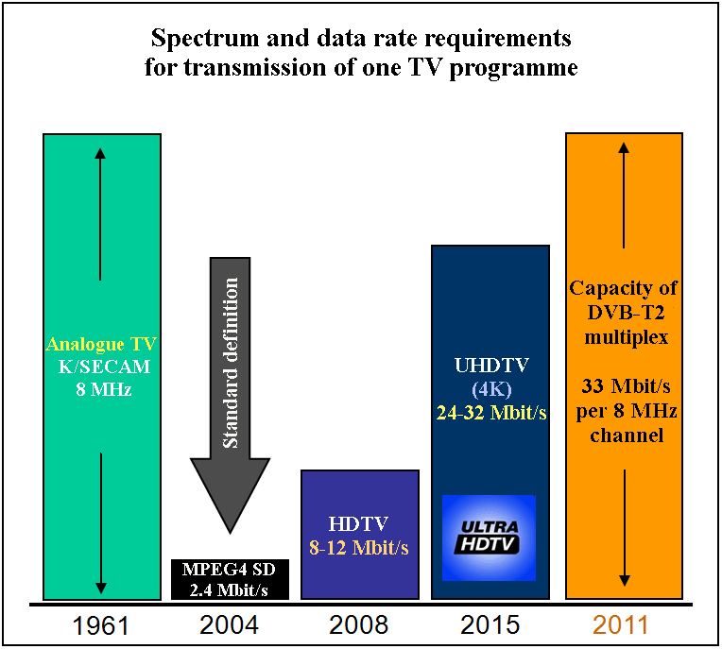
The requirements in frequency bandwidth and bit rate within multiplexed radio channel for existing and future broadcasting technologies are shown in the diagram. The analogue broadcasting systems transmit one programme per radio channel with bandwidth of 8 MHz. Using DVB-T2 system, it is possible to transmit a digital stream at a bit rate of ~33 Mbit/s in the same radio channel. The standard definition programme requires a bit rate of 2.4 Mbit/s, while high definition programme – 8-12 Mbit/s, 3D programme – 10-16 Mbit/s and ultra-high definition programme requires a bit rate 32 Mbit/s or more.
It is evident that a number of radio channels necessary to transmit the same number of programmes will increase during implementation of new technologies, and in the future it will approach the figures of analogue broadcasting with incomparably higher quality of a transmitted image and availability of multimedia services.
Taking into account development of image compression techniques, up to two 4K UHD lower profile programmes (compared to one programme per channel in analogue broadcasting system) will possibly be transmitted as a part of DVB-T2 multiplex stream in the future. Thus considering the requirement to transmit 20 or more programmes, availability of the second digital dividend as a consequence of reduced frequency resource below 790 MHz for TV broadcasting is rather disputable.
National plans for use of the band 470-862 MHz
Preparing a response to the ITU questionnaire concerning future requirements of terrestrial TV broadcasting in the band 694-790 MHz, the RCC Administrations have estimated the minimum number of terrestrial digital broadcasting multiplexes necessary for TV broadcasting development and corresponding frequency resource in this band.
The total frequency resource in the band 694-790 MHz (ignoring constraints from radio systems of other services) is 96 MHz (12 TV channels).
The results of analysis of national frequency plans for use of the band 470-862 MHz obtained on the basis of responses to the ITU questionnaire concerning the radio spectrum requirements for terrestrial broadcasting service are given in Table A2.5.

TABLE A2.5
National plans of the RCC Administrations concerning development of terrestrial broadcasting service and radio spectrum
requirements to develop terrestrial TV broadcasting in the UHF band and in the band 694-794 MHz
Administration | Analogue stations  in the band  694-790 MHz/  in the other part | Existing multiplexes | Spectrum requirements  for existing MUXES  in UHF  (MHz) | Spectrum requirements  for existing MUXES  in the band  694-790 MHz  (MHz) | Planned MUXES | Spectrum requirements  for planned MUXES,  (MHz) | Spectrum requirements  for planned MUXES  in the band  694-790 MHz (MHz)
ARM | 54 / 283 | no | – | – | 4-6 | 304 | 96
AZE | 57 / 176 | 86 | 320 | 96 | 8+ | 320 | 96
BLR | 16 / 123 | 3 | 256 | 32 | 6 | 296 | 72
KAZ | 91 / 1 397 | 2 | 260 | 36 | 4 | 260 | 36
KGZ | 35 / 102 | 4 | 336 | 72 | 4 | 384 | 80
MDA | 40 / 107 | 1 | 48 | 96 | 6 | ** | **
RUS | 1 281 / 7 474 | 2 | 376 | 96 | 5-6* | 280* | 56*
UKR | 378 / 1 584 | 6 | 336 | 96 | 8 | 320 | 96
UZB | 20 / 387 | 1 | 480 | MUXES do not operate in this band | 3 | 288 | MUXES do not planned in this band
* Not taking into account full transition to HDTV, under study.
** Under study.

Example of calculated requirements in frequency resource in the UHF band for broadcasting service are given below.

Example – Assessment of spectrum requirements for the development of terrestrial TV broadcasting during the transition to HDTV
The realistic scenario assumes that the development of terrestrial broadcasting will not be limited to the social segment (commercial transmitting stations will be in operation), all the programmes will be transferred to advanced broadcasting standards and terrestrial broadcasting will also be used for mass non-TV broadband content delivery over the downlink. At the same time it is assumed that the total number of delivered programmes will be significantly lower than in satellite and cable channels, and that the broadband content delivery in the downlink will gradually replace the delivery of common TV programmes and therefore will not require an additional frequency resource.
Calculations of realistic radio spectrum requirements for the development of broadcasting were performed according to the following assumptions:
– 20 federal and regional TV programmes will be sufficient for terrestrial broadcasting during the unlimited period;
– it is believed that standard definition broadcasting is to be replaced by high definition broadcasting with 3D capability;
– it is believed that a coverage of more than 55% of country population by portable broadcasting reception will not be demanded;
– overall transition of broadcasting to UHDTV is not expected. It is assumed that several UHDTV programmes will be enough to meet the demands of population in high-quality terrestrial TV broadcasting for a long period of time.
The calculated estimation is given for average local conditions regarding complexity of electromagnetic compatibility (EMC). The necessity to preserve radio spectrum in the band 694-790 MHz and a part of the spectrum in the band 790-864 MHz for TV broadcasting may be reduced, only under the condition of a successful completion of total broadcasting service replanning in the UHF band for operation under conditions of higher mutual interference. It should be noted that to release a significant amount of frequency resource using replanning is impossible, the release of spectrum takes place as a result of a minor spectrum economy with a simultaneous increase in the cost of transmitting TV broadcasting networks, which can be assumed to have a quadratic dependence from the amount of spectrum released during replanning.
Beyond 2025 the broadcasting service requirements, including broadcasting multimedia programme and data delivery, will be defined by the role which will be dedicated to the terrestrial broadcasting service delivery in the system approach to overcome the digital divide. It should be underlined that the assessed averaged requirements for broadcasting service takes into consideration only the common multi-programme TV broadcasting needs under the condition that broadcasting multimedia programme and data delivery will gradually replace the conventional multi-programme broadcasting and will not require additional frequency spectrum allotment.

Number of multiplexes for digital terrestrial TV after analogue broadcasting switch-off (2015-2025)
 | Number of SD multiplexes  (2015) | Capacity of  a multiplex (Mbit/s) | Bit rate per one SD TV programme (Mbit/s) | Number of SD programmes  in a multiplex  (2015) | Bit rate per one HD/  3D programme (Mbit/s) | Number of HD/  3D programmes  in a multiplex  (2025) | Number of multiplexes (2025)
Federal multiplexes | 2 | 33.2 | 2.9 | 10 | 8 | 4 | 5
Regional/local multiplexes | 1 | 33.2 | 2.9 | 10 | 8 | 4 | 2
Broadcasting for portable reception | 1 | 18.8 | 2.0 | 9 | – | – | 1

Overall radio spectrum requirements for the development of digital terrestrial TV broadcasting in 2015-2025
Country | Number of multiplexes | System and modulation | Reception type⁽¹⁾ | Capacity of a multiplex (Mbit/s) | Assumed percentage of population coverage | Multiplex content | Multiplex generation | Transmitting network type | Average number of radio channels per multiplex | Average required bandwidth  (MHz) | Maximum number of radio channels per multiplex | Maximum required bandwidth (MHz)
RUS | 5 | DVB-T2,  64-QAM | Fixed | 33.2 | 95% | 4 HD H.264 | Federal | Single frequency | 6 | 240 | 8.2 | 328
RUS | 2 | DVB-T2, 64-QAM | Fixed | 33.2 | 95% | 4 HD H.264 | Regional/  local | Multiple frequency | 9 | 144 | 12 | 192
RUS | 1 | DVB-T2,  16-QAM | Portable | 18.8 | 55% | 9 SD H.264 | Local | Single frequency | 3 | 24 | 5 | 40
 |  |  |  |  |  |  | Total spectrum requirements (MHz) |  |  | 408 |  | 560
⁽¹⁾ For example, fixed, portable outdoor/mobile, portable indoor.

Radio spectrum requirements for the development of digital terrestrial TV broadcasting in the band 694-862 MHz (49-69 TV channels)
 | Average assessment, radio channels | Average  assessment  (MHz) | Maximum assessment, radio channels | Maximum assessment  (MHz)
Required | 51 | 408 | 70 | 560
Used in the VHF band (174-230 MHz) | 7 | 56 | 7 | 56
Cannot be used according to the EMC conditions with systems of other primary services (MHz) | 4 | 32 | 5 | 40
Required in the UHF band | 44 | 352 | 63 | 504
Upper limit in the UHF band (MHz) | 48 | 854 | 68 | 1 014
Required in the band above 694 MHz | 20 | 160 | 40 | 320
___________

* The Administrations of Egypt (Arab Republic of), Saudi Arabia (Kingdom of) and United Arab Emirates do not support the approval of this Report. The Report in its current form is containing many errors in the summary provided in this document with conclusions supporting only one view as clarified in detail during the WP 6A and SG 6 meetings. Several modifications proposed to correct many mistakes by membership, supporting the other views, were not considered. For the procedural concerns on approval of this Report and the official rejections by Administrations; see also the details in Annex 2 to the summary record (Doc 6/130 rev)). Therefore, these Administrations do not believe this Report should share a place along with other technical ITU-R Reports.
Applications of the land mobile service for SAB/SAP are also commonly known as “programme making and special events” (PMSE).
The multiplex is a digital data stream that combines several programmes streams into a single stream for transmission over an RF channel.
Handbook on Digital Terrestrial Television Broadcasting networks and systems implementation; https://www.itu.int/pub/R-HDB-63
Statistical multiplexing is the application of dynamic allocation of the available bit rate to the various programmes streams carried in the multiplex, according to the quasi-instantaneous bit-rate need of each stream. This provides a gain in picture quality of each stream.
The number of programmes in one 8 MHz channel is based on the estimated bit rate per programme, as provided in the DTTB Handbook. The values of estimated bit rate per programme (Tables 3.1 to 3.4 of the Handbook) are typical but indicative. There may be differences between these values and what is or will be used in real networks. The actual data-rates used by individual broadcasters will depend on a trade-off between the economics of the available capacity in a multiplex, including the number of programmes to be made available, and the desired picture quality. There will also be differences due to the performance of video codecs at the time of implementation. Furthermore, the additional bit rate for audio and associated data may vary depending on the desired audio quality and the associated data.
http://www.yozzo.com/news-and-information/media-broadcasting/hbbtv-hybrid-broadcast-broadband-tv
See EBU Technical Report 054 https://tech.ebu.ch/publications/tr054
Oliver, M., & Salas, F. (2017). TV White Space as a Feasible Solution to Spread Mobile Broadband. SSRN Electronic Journal. doi:10.2139/ssrn.2944184
In 2013, Working Party 6A conducted a similar survey of Administrations requirements for broadcasting to inform preparations for WRC-15 agenda items 1.1 and 1.2. That questionnaire is available as 6/LCCE/78, and the responses are summarised in Report ITU-R BT.2302-0.
One response was received from an Administration from Region 2. This response is shown in the table in the Attachment, but has not been included in the rest of the statistical analysis in this document.
For information on how to interpret Box charts, see Annex.
Primary services: aeronautical radio-navigation service, fixed, mobile and land-mobile services, RAS (Radio astronomy).
Secondary services: PMSE (Programme Making and Special Events), SRD (Short Range Devices), RAS (Radio astronomy), PMR (Private Mobile Radio), Wind Profile Radars, TV White Space, Land Mobile, VLBI Observation, SAP/SAB (Services Ancillary to Programme-making/Services Ancillary to Broadcasting)
Explanation of charts based on information from wellbeing@school available on-line on 11 February 2021 at https://www.wellbeingatschool.org.nz/information-sheet/understanding-and-interpreting-box-plots and https://www.excel-easy.com/examples/box-whisker-plot.html Further information is available at https://support.microsoft.com/en-us/office/create-a-box-and-whisker-chart-62f4219f-db4b-4754-aca8-4743f6190f0d
In 2013, Working Party 6A conducted a similar survey of Administrations requirements for broadcasting to inform preparations for WRC-15 agenda items 1.1 and 1.2. That questionnaire is available as 6/LCCE/78, and the responses are summarised in Report ITU-R BT.2302-0.
Regional Commonwealth in the field of Communications.
The term “digital dividend” is used to indicate the improved efficiency in the use of the spectrum, consequential to the digital switchover.

