|  |
| --- |
| **Report ITU-R BT.2252**  **(08/2012)** |
| **Objective quality coverage assessment of digital terrestrial television broadcasting signals of Systems A and B** |
| **BT Series**  **Broadcasting service**  **(television)** |

Foreword

The role of the Radiocommunication Sector is to ensure the rational, equitable, efficient and economical use of the radio-frequency spectrum by all radiocommunication services, including satellite services, and carry out studies without limit of frequency range on the basis of which Recommendations are adopted.

The regulatory and policy functions of the Radiocommunication Sector are performed by World and Regional Radiocommunication Conferences and Radiocommunication Assemblies supported by Study Groups.

# Policy on Intellectual Property Right (IPR)

ITU-R policy on IPR is described in the Common Patent Policy for ITU-T/ITU-R/ISO/IEC referenced in Annex 1 of Resolution ITU-R 1. Forms to be used for the submission of patent statements and licensing declarations by patent holders are available from <http://www.itu.int/ITU-R/go/patents/en> where the Guidelines for Implementation of the Common Patent Policy for ITU‑T/ITU‑R/ISO/IEC and the ITU-R patent information database can also be found.

|  |  |
| --- | --- |
| Series of ITU-R Reports  (Also available online at <http://www.itu.int/publ/R-REP/en>) | |
| **Series** | Title |
| **BO** | Satellite delivery |
| **BR** | Recording for production, archival and play-out; film for television |
| **BS** | Broadcasting service (sound) |
| **BT** | Broadcasting service (television) |
| **F** | Fixed service |
| **M** | Mobile, radiodetermination, amateur and related satellite services |
| **P** | Radiowave propagation |
| **RA** | Radio astronomy |
| **RS** | Remote sensing systems |
| **S** | Fixed-satellite service |
| **SA** | Space applications and meteorology |
| **SF** | Frequency sharing and coordination between fixed-satellite and fixed service systems |
| **SM** | Spectrum management |

|  |
| --- |
|  |

|  |
| --- |
| ***Note****: This ITU-R Report was approved in English by the Study Group under the procedure detailed in Resolution ITU-R 1.* |

*Electronic Publication*

Geneva, 2012

© ITU 2012

All rights reserved. No part of this publication may be reproduced, by any means whatsoever, without written permission of ITU.

REPORT ITU-R BT.2252

Objective quality coverage assessment of digital terrestrial  
television broadcasting signals of Systems A and B

(2012)

Introduction

In May 2011, it was decided to establish a Working Party 6A Rapporteur Group to develop a report on objective quality coverage assessment of digital terrestrial television broadcasting signals of System B. It was realized that Recommendation ITU-R BT.1735 covers MFN networks.

A number of countries have developed networks based on an SFN configuration, whereby transmitters are placed far apart. In such networks, the use of the maximum permissible guard interval together with high code rate (i.e. 3/4 or 5/6) results in a very complex impulse response with a lot of reflected rays, both natural and artificial falling on the shoulder, or outside, the guard interval.

The situation is further complicated, due to field-strength variations at the receiving point originated by the farthest transmitters. Such variations impact on the positioning of the window in the receiver, depending on the strategy implemented by manufacturers, and sometimes one or more rays of sufficient energy fall outside the guard interval.

In such conditions it may easily happen that different receiving situations are detected during the day and it is not easy to find a simple algorithm to determine coverage quality. Moreover the relationship between BER measurements taken before and after Viterbi decoding depends on unpredictable factors and an evaluation on BER before Viterbi decoding does not permit it to be known if BER after Viterbi decoding would fall below the threshold or above it. Moreover, since MER and BER measurements are based on different aspects of the phenomenon, no close relationship can be identified between them.

It was concluded there is a need for a new multidimensional evaluation system that supersedes the one specified in Recommendation ITU-R BT.1735 which remains valid for MFN networks.

In October 2011, it was decided to continue with Rapporteur Group on the revision of Recommendation ITU-R BT.1735 with the mandate to put all the relevant material into a draft new Report ITU-R BT.[DTTBACCESS].

The Rapporteur Group met during the first days of April 2012 and decided to add the contribution on System A contained in Document 6A/14 and the contribution received from Ls Telcom.

TABLE OF CONTENTS

Page

Part 1 4

1 Performance characteristics of System A in the terrestrial broadcast mode 4

2 Relationship between objective BER and subjective visual TOV for System A 4

Part 2 6

**Chapter 1 of Part 2** 6

1.1 Service area and local SFN 6

1.2 MUX1 quality coverage (regional SFN multiplex – local area SFN) 7

1.3 Improvements and verification 10

1.4 Other MUX quality coverage (national multiplex – wide area SFN) 15

1.5 Conclusions 17

**Chapter 2 of Part 2** 19

2.1 Introduction 19

2.2 Correlation between field strength, cBER and MER for MFN networks 20

2.2.1 Pearson correlation index interpretation 20

2.2.2 Observations on Italian field measurement 20

2.2.3 Observations on Australian field measurement 26

2.2.4 Conclusions 37

2.3 Determination of the transition point in the DTTB coverage quality scale 37

2.3.1 UHF case 37

2.3.2 VHF case 39

2.4 Example for SFN network 42

2.5 Results for possible correlation between parameters 44

2.6 Review of Figure 1 of Annex 1 of Recommendation ITU-R BT.1735 44

2.7 Deployment method for field survey data analysis 47

2.7.1 Introduction 47

2.7.2 General frame to deploy field survey data 48

2.7.3 Field survey data analysis 48

2.7.4 Plotted data interpretation 51

2.8 CIR considerations on how to deal with contribution falling or can fall outside GI 51

Page

2.8.1 Introduction 51

2.8.2 Considerations 52

2.8.3 Physical constraints 52

2.8.4 Proposition 52

**Chapter 3 of Part 2** 53

3.1 Introduction 53

3.2 Tests 53

3.3 Study of SFN echoes symmetry 54

3.4 MER and BER analysis in a SFN with multiple signals inside GI 56

3.5 MER and BER analysis in a SFN with a contribution outside GI 57

3.6 MER and BER analysis in a SFN with contribution inside and outside GI 60

3.7 Study of the allowable limit value of the combination level-delay outside GI 61

3.8 Verification of the protection ratio 63

3.9 General BER frame 63

3.10 Conclusion 66

Annex 1 67

Annex 2 68

Appendix – Acronyms 69

PART 1

Objective quality coverage assessment of digital terrestrial television broadcasting signals for DTTB System A

# 1 Performance characteristics of System A in the terrestrial broadcast mode

The ATSC terrestrial 8-VSB system, System A, can operate in a signal-to-additive-white-Gaussian-noise (*S*/*N*) environment of 14.9 dB. The 8-VSB segment error probability curve including 4-state trellis decoding and (207,187) Reed-Solomon decoding in Fig. 1 shows a segment error probability of 1.93 × 10–4. This is equivalent to 2.5 segment errors/second, or a bit error rate (BER) of 3 × 10–6 which was established by subjective measurement as the threshold of visibility (TOV) of errors[1]. It should be noted that care must be exercised with subjective TOV measurements since particular receiver designs may achieve somewhat better performance by means of error masking.

Figure 1

Segment error probability versus *S*/*N* for System A using 8-VSB  
with 4 state trellis decoding, RS (207,187)



# 2 Relationship between objective BER and subjective visual TOV for System A

The Advisory Committee on Advanced Television Service (ACATS) of the United States Federal Communications Commission (FCC) in its testing of the ATSC DTTB system, System A, confirmed that objective measurements of BER and subjective measurements of visual TOV would not differ by more than 0.5 dB[2]. For example, Table 1 compares the subjective visual TOV method with the objective BER method for various interference tests and a various wanted signal power levels at the receiver RF input (Strong, –28 dBm; Moderate, –53 dBm; and Weak, –68 dBm). The interference signals included analogue TV (NTSC) on co- and adjacent channels as well as random noise and impulse noise. Furthermore, the ACATS tests confirmed that the “cliff effect” for System A occurs within a range of ±0.5 dB about the threshold. Table 2 shows an example of test results with random noise as the unwanted signal and a strong wanted signal. The interference threshold occurs at a wanted-to-unwanted ratio of 15.19 dB with the transition about the threshold occurring within ±0.5 dB. Therefore, quality assessment for DTTB System A can be measured objectively from signal levels relative to the interference threshold.

TABLE 1

Comparison of subjective visual TOV measurements with objective BER measurements  
for DTTB System A using various types of interference and wanted signal power levels

|  |  |  |  |
| --- | --- | --- | --- |
| Test interference | Wanted power level | Subjective wanted to unwanted ratio (dB) at threshold | Objective wanted to unwanted ratio (dB) at threshold |
| Random noise | Strong | 15.28 | 15.19 |
| Impulse noise | Moderate | 0.38 | 0.40 |
| Co-channel | Weak | 2.05 | 1.81 |
| Lower adjacent | Moderate | –44.37 | –44.46 |
| Lower adjacent | Weak | –47.61 | –47.73 |
| Upper adjacent | Moderate | –44.44 | –44.44 |

TABLE 2

Measurement of BER for a strong (–28 dBm) DTTB signal (System A)  
in the presence of random noise interference about the threshold of reception

|  |  |  |  |  |  |
| --- | --- | --- | --- | --- | --- |
| Deviation from threshold | –0.50 dB | –0.25 dB | Threshold | +0.25 dB | +0.50 dB |
| Wanted to unwanted ratio (dB) | 14.69 | 14.94 | 15.19 | 15.44 | 15.69 |
| BER | 5.74E-04 | 3.55E-05 | 7.32E-07 | 0.00E+00 | 0.00E+00 |
| 5.89E-04 | 3.67E-05 | 8.22E-07 | 0.00E+00 | 0.00E+00 |
| 5.95E-04 | 3.35E-05 | 1.03E-06 | 0.00E+00 | 0.00E+00 |

PART 2

Objective quality coverage assessment of digital terrestrial television broadcasting signals for DTTB System B

Chapter 1 of Part 2

Coverage evaluation of the SFN network in the sites  
of Dongo and Stazzona, Italy  
  
Propagation of a SFN signal in a hilly area

## 1.1 Service area and local SFN

The towns of Dongo and Stazzona are situated on a hill sloping down toward the west bank of Como lake. Those towns are covered by a DVB-T transmitter station located at the top of a 1 100 m mountain on the opposite side of the lake.

Figure 1

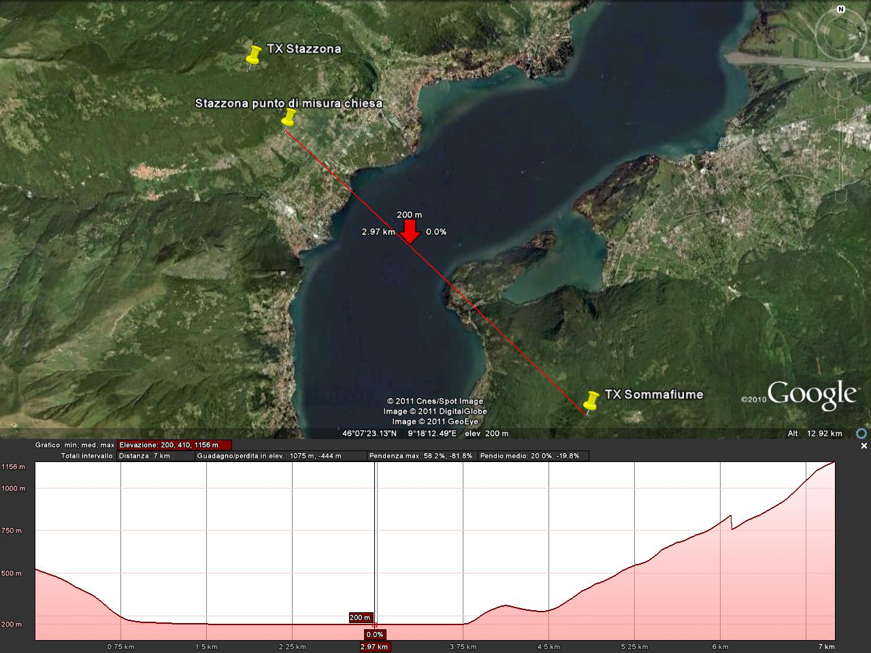

Figure 1 shows the location of two transmitters of the RAI SFN network, the location of one measurement point and the profile between it and the Sommafiume transmitter.

The RAI transmitting site of Sommafiume broadcasts, using SFN techniques, 4 digital multiplexes on channels 23, 30, 26 and 40, named respectively MUX1, MUX2, MUX3, AND MUX4, with the following characteristics:

FTT: 8K

Bandwidth: 8 MHz

Modulation: 64 QAM

GI = 1/4

Code Rate: 2/3 for channels 26, 30, 40 and 5/6 for channel 23

Polarization: H.

The same area receives the same channels broadcasted in SFN by the local transmitter of Stazzona, which is located just at the top of the hill behind the town and it is essentially intended to cover the towns located on the opposite side of the lake.

Almost all the directional receiving antennas of the audience are oriented to the Sommafiume transmitting site, but in the areas where both transmitters are in line of sight, the field strength of the two transmitters is roughly the same.

Moreover, at the measurement test point signals broadcasted by the transmitting sites of Bellagio, Monte Padrio and Poira are also available with a non negligible field strength.

## 1.2 MUX1 quality coverage (regional SFN multiplex – local area SFN)

In spite of the clear line of sight between transmitting and receiving antennas and the short distance between them (around 6 or 7 km), the reception quality proved to be very poor in a wide area and impossible at some points.

Figure 2 shows the time domain/impulse response analysis on channel 23, measured with a professional receiver (the measurement point is shown in Fig. 1).

FIGURE 2

Impulse response at Stazzona receiving point – Channel 23 Sommafiume

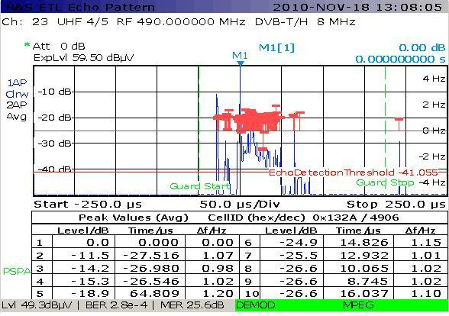

The measurement was made with an antenna mast 10 m high mounted on a vehicle and a log periodic III-IV-V band receiving antenna with an antenna factor of 24 dB on channel 23. The receiving antenna was raised at a fixed height of 10 m during the measurement campaign.

The measured values were:

− Field strength: 49.3 + 24 = 73.3 dBµV/m;

− BER before Viterbi (cBER): 3.5E-3;

− BER after Viterbi (vBER): 2.8E-4;

− MER: 25.6 dB;

− MER pick: 3.7 dB.

Figure 2 shows the following echoes, from left to right, measured with respect to the highest value represented by the Sommafiume transmitter:

− Stazzona −27.5 µs; –11.5 dB;

− nearest echo from Stazzona station at about –14 µs, at a –29 dB level;

− echoes group from Stazzona, due to the reflections from the mountains situated on the other side of the lake, located at about 15 µs, at a –14.8 dB level;

− Bellagio 64.8 µs; –18.9 dB;

− Monte Padrio, placed outside GI, at around 195 µs from Sommafiume, at a relative –30 dB level.

It should be noted that the time difference between the first signal received, Stazzona, and the last one, Monte Padrio, is about 27.5 + 1 295 = 222.5 µs, near to the GI of 224 µs. The exact position of the window depends on the strategy implemented in the receiver. Nevertheless, it can be also chosen from a number of options on measuring instruments. The levels of natural and far artificial echoes received at a given site can vary with time and this can result in a cyclic difference in the position of the window. Consequently, it is possible or impossible to receive the content of the multiplex moment by moment and this happens although the protection ratio for the signal falling outside GI is about 30 dB, which is greater than the 23 dB required by Recommendation ITU‑R BT.1368 for a code rate of 5/6. It is clear that the reception conditions at this site are more complex than those considered when developing Recommendation ITU-R BT.1735.

It is noteworthy that, in the middle part of the window, about 15 µs from the reference signal, a relevant group of echoes has been detected, with a maximum level of –25 dB.

The Stazzona transmitter was briefly shutdown and it was verified that these echoes are related to the transmitter itself. In fact the transmitter signal is reflected back by the side of the opposite mountains directly or through the lake.

The time difference between the direct signal received at Stazzona and the group of its echoes is between 40 and 55 µs and corresponds exactly to the propagation time of the signals reflected back by the side of the opposite mountain directly or through the lake.

In these conditions, the reception was very difficult and the signal could be locked only by manually adjusting the position of the window, choosing at the same time a specific reception option (mobile instead of fast/SFN). This is shown in the bottom line of Fig. 2 where vBER (BER after Viterbi) was 2.8E-4, above the quasi error free threshold (QEF = 2E-4).

The same situation can be found in other towns, such as Dongo, situated near Stazzona, as reported in Fig. 3.

Figure 3

Impulse response at Dongo receiving point – Channel 23 Sommafiume

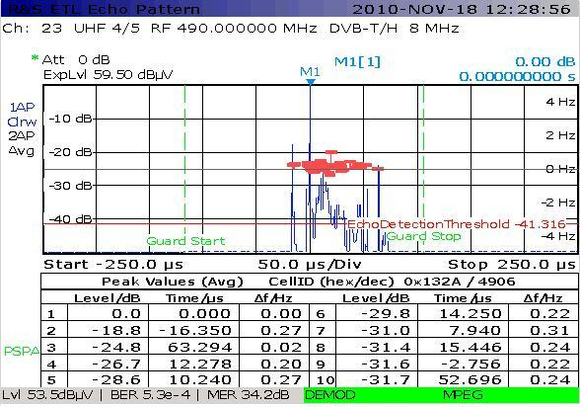

The measurement system was the one previously described for the Stazzona measurement point.

The measured values were:

− Field strength: 53.5 + 24 = 77.5 dBµV/m

− BER before Viterbi (cBER): 4E-4

− BER after Viterbi (vBER): 5.3E-4

− MER: 34.2 dB

− MER pick: 3.7 dB.

Figure 3 shows the following echoes, from left to right, measured with respect to the highest value represented by Sommafiume transmitter:

− Stazzona –16.35 µs: –18 dB;

− echoes group from Stazzona, due to reflections from the mountains situated on the other side of the lake, located at about 12 µs at a –26.7 dB level;

− Poira 52.7 µs: –31.7 dB;

− Bellagio 63.3 µs: –24.8 dB.

The BER measured after Viterbi was 5.3E-4, worse than the BER measured before Viterbi and it again proved to be higher than the QEF threshold, the while the MER value was instead very good – better than 34 dB.

The results agreed with laboratory tests that show that convolution coding does not work with CR = 5/6 in the presence of a group of echoes. The improvement of MER, with respect to the previous measurement point, is related to the disappearing of echoes falling outside the guard interval.

## 1.3 Improvements and verification

Two causes for bad reception were identified: the number of echoes associated to the signal broadcast by Stazzona and the time distance between the first and the last echo (Stazzona and Monte Padrio respectively).

In order to improve reception quality, we acted in two directions: increasing the ratio between the wanted signal and the echoes from other transmitters and reducing the time difference between transmitters.

In particular, the following actions were taken:

− we reduced the power of the Stazzona transmitter by 7 dB (reduction of echoes level);

− we increased the power of the main transmitter (Sommafiume) by 3 dB, thus increasing the *C*/*N* ratio;

− we modified the static delay of the transmitters of Stazzona, Sommafiume, Bellagio and Monte Padrio in order to reduce the time interval between the first and the last transmitter.

Having implemented such modifications, the results shown in Fig. 4 were obtained.

FIGURE 4

Impulse response at Stazzona measurement point, after improvements – Channel 23 Sommafiume

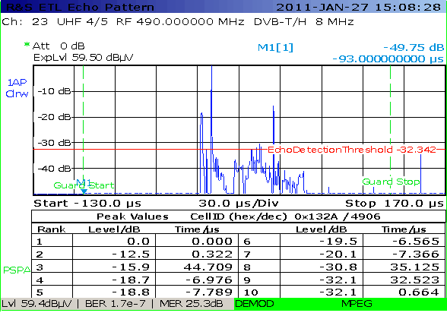

The measurement system was the one described above with the following differences: the antenna mast was raised to 14.5 m and a receiving antenna for Bands IV and V was used, with an antenna factor of 21 dB on channel 23. The measuring receiver was set up for mobile reception and the window positioning was set on manual.

The measured values were:

− Field strength: 59.4 + 21 = 80.4 dBµV/m

− BER before Viterbi (cBER): 8.5E-4

− BER after Viterbi (vBER): 1.7E-7

− MER: 25.3 dB.

Figure 4 shows the following echoes, from left to right, measured with respect to the highest value represented by Sommafiume transmitter:

− Stazzona –7 µs: –18.7 dB;

− short echo from the lake surface at 0.322 µs: –12.5 dB;

− echoes group from Stazzona, due to the reflections from the mountains situated on the other side of the lake, located at about 35 µs at a –30.8 dB level;

− Bellagio at 44.7 µs: –15.9 dB;

− Monte Padrio ~155 µs: –33 dB (not shown in the table).

The measurement results show a slight improvement in the reception condition. This was confirmed by information provided by several users living in the areas.

The field strength was increased, due also to the different height of the receiving antenna, but the main result obtained was an increased *C*/*N* ratio between the main signal and the contributions from natural or artificial reflections.

Nevertheless, it was necessary to again set the measurement equipment on the mobile option and to manually adjust the window position.

The cause was the short echo coming from the lake surface situated at 0.322 µs and 12.5 dB below the main signal.

A theoretical calculation of the difference ∆*d* between direct and reflected rays is expressed by:



where:

*h*1 = 990 m transmitting antenna height on the lake surface (1 180 m a.s.l.);

*h*2 = 340 m receiving antenna height on the lake surface (530 a.s.l.);

*D* ≅ 6 900 m distance between transmitting and receiving points.

In terms of propagation time, such ∆*d* corresponds to97.6/300 = 0.325 µs as shown by the measured impulse response.

Figure 5, taken from the spectrum analyser, shows the typical phase and counter-phase addition of two rays having a fixed short delay and a small amplitude difference, when scanning over a wide frequency band.

FIGURE 5

Spectrum at Stazzona measurement point

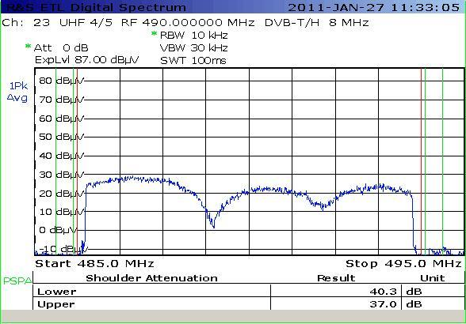

The measurement system was the one described above, with the antenna raised to 12 m.

Figure 5 shows that a substantial part of signal is lost when the reflected ray reaches almost the same level of the direct one.

Since it is almost impossible to avoid the presence of reflected rays in the target area of the Sommafiume transmitter, situations of bad reception are very common especially on the west side of the lake.

The other SFN multiplexes (2, 3 and 4) are affected by the presence of reflected rays in a similar way.

Figure 6 shows the MER of each carrier of MUX2 multiplex, with the receiving antenna pointed to Sommafiume, taken at the Stazzona measurement point.

Figure 6

MER amplitude for MUX2 at Stazzona test point

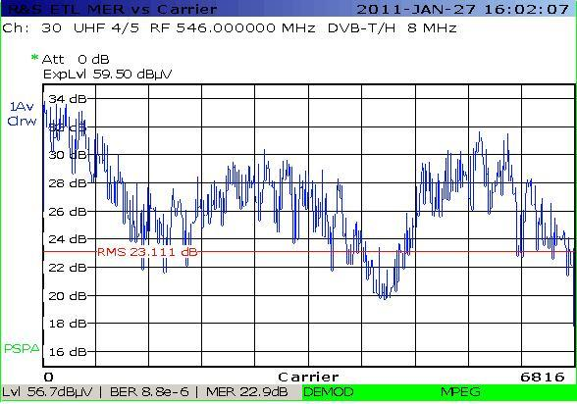

In this case, the antenna was raised to 14 m.

A measurement taken in the Dongo area, nearer to the lake shore, after the modifications described above shows a more evident improvement.

FIGURE 7

Impulse response at Dongo measurement point for MUX1 after improvements

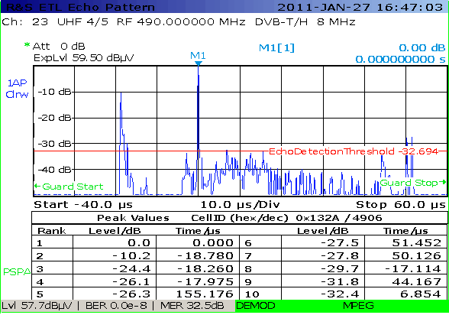

The measurement system was the one described above with the difference that the antenna mast was raised to 12 m and the receiving antenna was an antenna for only Bands IV and V with an antenna factor of 21 dB on channel 23.

The measured values were:

− Field strength: 57.7 + 21 = 78.7 dBµV/m

− BER before Viterbi (cBER): 2.7E-5

− BER after Viterbi (vBER): 0E-8

− MER: 32.5 dB.

The measurement receiver was set for mobile reception and for manual window positioning.

We can notice the following echoes (from left to right):

− Stazzona –18.8 µs: –10 dB;

− Poira a 51 µs: –27.5 dB;

− Bellagio 44.1 µs: –31.8 dB;

− Monte Padrio ~155 µs: –26.3 dB (not shown in the figure).

The echoes, created by the reflection of the Stazzona signal on the side of the opposite mountain, do not exceed the threshold of –32 dB.

In the measurement point of Dongo, the reception quality is quite good and it seems not affected by the ray reflected by the lake. Indeed, it is impossible to determine whether this ray is present, due to its very short delay.

The artificial echoes generated by other SFN transmitters are more than 10 dB below the main signal received from Sommafiume and broadly fall inside the GI. They are far from the threshold of 7 dB below the main signal (this is the threshold at which, according to laboratory tests, receivers could present reception problems with a code rate of 5/6).

## 1.4 Other MUX quality coverage (national multiplex – wide area SFN)

In the same evaluation area of MUX1, other national SFN multiplexes can be also received. Propagation conditions are the same for MUX1, but the adoption of a different code rate (2/3 instead of 5/6) makes for a noticeably better reception condition, although reception remains far from the ideal one.

vBER measurements give values below QEF threshold.

For this multiplex no changes in network configuration, powers and static delays have been tested.

FIGURE 8

Impulse response for MUX4 at Dongo measurement point

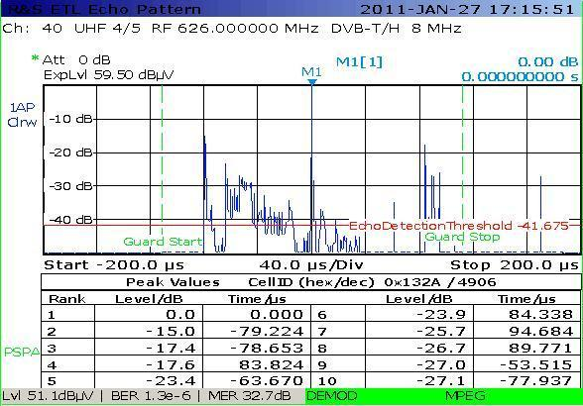

The measurement system was the same described above. The antenna factor for channel 40 was 22 dB.

The measured values were:

− Field strength: 51.1 + 22 = 73.1 dBµV/m

− BER after Viterbi (vBER): 1.3E-6

− MER: 32.7 dB.

The measurement receiver was set up for fast SFN reception and the window positioning was set to automatic.

We can notice the following echoes, from left to right.

− Stazzona –79.2 µs: –15 dB;

− Echoes group from Stazzona, due to the reflections from the mountains situated on the other side of the lake, they are located at about –53 µs at a –27 dB level;

− Bellagio 83.8 µs: –17.6 dB;

− Monte Padrio 94.7 µs: –25.7 dB;

− Chiavenna ~ 170 µs: –27 dB (not shown in the table).

figure 9

Impulse response for MUX2 at Gravedona measurement point

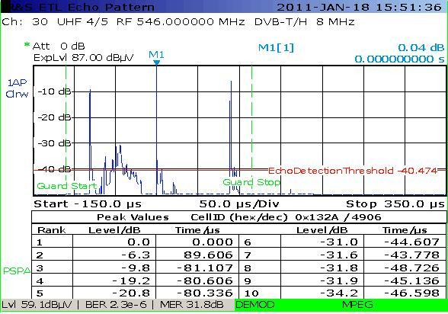

The measurement system was the one described above. The antenna mast was raised up to 12 m. The antenna factor for channel 30 was 22 dB.

The measured values were:

− Field strength: 59.1 + 22 = 81.1 dBµV/m

− BER before Viterbi: 4E-4

− BER after Viterbi (vBER): 2.3E-6

− MER: 31.8 dB

− MER pick: 3.7 dB.

The measurement receiver was set up for fast/SFN reception and the window positioning was set to automatic.

We can notice the following echoes, from left to right:

− Stazzona –81.1 µs: –9.8 dB;

− echoes group from Stazzona, due to the reflections from the mountains situated on the other side of the lake; they are located at about –44 µs at a –31 dB level;

− Bellagio 89.6 µs: –6.3 dB.

## 1.5 Conclusions

An analysis of the measurement results suggests the considerations below.

– Several artificial echoes combined with a large number of natural reflections arising from the sides of the mountains resulted in a time-variable channel. In this situation, the window is continuously moving forward and backward; which results in frequent unlocking. This happens especially when artificial echoes fall near to the slopes of the windows. The situation can be improved by changing the static delay on the transmitters and by reducing the field strength of some transmitters. It is also advisable to adopt a stronger code rate, where possible.

It could be noted that natural echoes often result in a quick variation of the multipath signal level. It has been shown that a noticeable improvement can be obtained by reducing the power of the transmitters that originate echoes groups. In addition, the time variation of the channel suggests the Rayleigh channel model should be adopted instead of the Rice channel model. This would mean to increase the protection ratio in planning by 6 dB for the system variant used in the Italian measurements (see ETSI EN 300 744 V1.6.1 (2009-01), p. 40, Table A.1 for 64 QAM, 5/6: Ricean = 20.4 dB; Rayleigh = 26.2 dB).

A method to describe a transition from a Rice to a Rayleigh channel case and calculate an intermediate *C*/*N*, called effective protection target, EPT, can be found in the Joint ERC/EBU Report on Planning and Introduction of Terrestrial Digital Television in Europe, Izmir, December 1997. The method is described and an example given in Annex 2.

Reception conditions, such as the ones we examined, can be found frequently. In these cases it could be necessary to reduce the static delay between transmitters and to adopt a more effective code rate, because it is impossible to reduce the effect of natural echo groups.

– A strong reflection related to the main transmitter could limit the service area and reduce the quality of coverage. This happens because carriers that add in phase do not improve reception quality, while carriers that add in counter phase could increase the number of errors. There are no simple technical measures that can limit the effect of such natural reflection and the only possible action is to increase the protection through the adoption of a better-performing code rate. Such situation is typically found around lakes and sea coasts.

The following observation can be made concerning measurements and quality coverage methodologies:

– The quality coverage methodologies reported in Recommendation ITU-R BT.1735 have been developed taking into account MFN network and statistic variability of field strength (location variability). The same methodology cannot be effectively applied when the channel impulse response is time-variable. The parameters used in Recommendation ITU‑R BT.1735, cBER and vBER, can exhibit sudden variations in time, when the change in *C*/*I* exceeds the threshold of the adopted system. It should be kept in mind that natural or artificial echoes act as interference both for a specific carrier when they fall inside guard interval and on all the carriers when they fall outside guard interval. Therefore the use of Recommendation ITU-R BT.1735 could prove to be unreliable in local or wide SFN areas where a large number of multipath signals can be detected. We believe that it is necessary to introduce a new methodology and a new parameter based on the shape of impulse response, in order that an evaluation of 95% reliability at a given of the location may be extended to adjacent areas. This would amount to computing a “*location correction margin*” in the same way reported in Annex 1 of Attachment. Unfortunately, there is currently no meter on the market that can compute *C*/*I* in presence of wanted signal.

– Short-delay echoes, below 0.3 µs, cannot be seen on impulse response analysis. In such cases, when unexplained reception problems appear, it is necessary to have recourse to a spectrum analysis to identify the presence of very short echoes.

– In conclusion, it can be said that an MER analysis allows identification of the presence of interferences and out-of-GI echoes; a BER analysis takes into account all echoes and interferences; an impulse response analysis takes into account the time variability of a channel model.

Chapter 2 of Part 2

Correlation between field strength and BER for MFN and SFN systems and transition point in the DTTB coverage quality scale

## 2.1 Introduction

Determine the correlation between field strength and BER for MFN and SFN systems taking into account the most used system variants for DVB-T within administrations

Recommendation ITU-R BT.1735 states:

*The corresponding BER after Viterbi decoding (vBER) is used to determine the threshold of quasi error free (QEF) condition.*

*The intrinsic non-linearity related to Viterbi soft decision, protection levels, temporal and spatial dispersion gives as a result a low correlation between field strength and BER. Existence of a correlation law is yet to be studied.*

Determine the transition point in the DTTB coverage quality scale; the study should identify the transition point between the five scale quality grades as applicable to DTTB

Recommendation ITU-R BT.1735 also states:

*The quality evaluation system for an analogue signal has been based on both field strength and the five quality (Q) grades subjective assessment scale. Q5 grade corresponds to “excellent”, Q1 grade corresponds to “very bad”. The acceptance threshold is fixed to Q3 grade. In a digital environment the situation is quite different and it is important to note the difference between compression quality evaluation methods and broadcasting coverage quality evaluation. For the compression method evaluation, such as MPEG, the five-grade assessment scale has been maintained. For the objective of broadcasting coverage quality evaluation, it would seem more difficult to maintain a method based on the five-grade scale because of rapid transition from a service to a no service condition. Nevertheless it is possible again to maintain a five‑grade scale if at each grade the meaning of distance from the transition point is attributed. Evaluation of the distance from the transition point is very important because the measurement equipment is usually placed before the end user’s reception system, usually composed of an antenna, distribution system and set top box. Interpretation of digital objective quality coverage assessment is not to be confused with interpretation of the analogue quality assessment.*

If evaluation of the distance from the transition point is very important, what studies have been undertaken to confirm the transition points between the five quality grades as applied to DTTB?

While Recommendation ITU-R BT.1735 states:

*Q2 read on the horizontal line of the table means that field strength is lower than the minimum value assigned in the planning procedure. In such cases no protection against interference can be guaranteed. Q2 read in vertical line means that the “cliff effect” appears. In the first case it is possible to move to Q3 by increasing transmitted power or by modification of the antenna pattern. In the second case it is possible to move to Q3 by reducing interference or the level of multipath interference.*

Is there any measurable difference between Q5 to Q4 to Q3? And similarly can a difference in measurable quality between Q2 and Q1 be measured?

## 2.2 Correlation between field strength, cBER and MER for MFN networks

The figure reported in Annex 1 of Recommendation ITU-R BT.1735 was based on thousands of measured values collected until 2004 on MFN networks. The system variant adopted for an UHF band (8 MHz bandwidth channels) was 64 QAM, CR = 2/3 and GI = 1/32, whereas the system variant adopted for the VHF band (7 MHz bandwidth channels) was 64 QAM, CR = 3/4 and GI = 1/32. During that period, in channel interference sources was arising only from analogue to digital.

After that period a system for measurement, acquisition and analysis of the quality of the coverage based on Recommendation ITU-R BT.1735 was developed and used intensively (it is called “Qualric”[3] and should be described in a specific further document).

In order to evaluate a relationship between the measured parameters field strength, cBER and MER, the Pearson correlation index has been utilized.

The pictures presented in this document give a graphical representation of relation between acquired values.

### 2.2.1 Pearson correlation index interpretation

Pearson correlation index ρxy may assume values comprised between –1 and 1.

Current interpretation gives the following indication:

0 < ρxy ≤ 0.3: weak correlation

0.3 < ρxy ≤ 0.7: medium correlation

ρxy > 0.7: strong correlation.

### 2.2.2 Observations on Italian field measurement

#### 2.2.2.1 UHF results

In the following pictures are reported, in pair, the correlation between field strength, cBER and MER based on 1 550 measurement points on whole Italy for MFN networks.

Field strength – cBER correlation is reported in Fig. 10.

Figure 10

Field strength (dBμV/m) vs. cBER



Correlation index between cBER and field strength calculated through Pearson equation is: –**0.23**.

Taking into account current interpretation of correlation index, it can be said that a weak negative correlation exists between BER and field strength. Therefore both values need to be measured and taken into account for quality coverage evaluation.

Field strength – MER correlation is reported in Fig. 11.

Figure 11

MER vs. field strength (dBμV/m)



Correlation index between MER and field strength calculated through Pearson equation is: **0.65**.

Taking into account current interpretation of correlation index, it can be said that more than moderate positive correlation can be found between MER and field strength. Although both parameters need to be measured for a full understanding of reception conditions, MER can acknowledge better than field strength for a simple evaluation.

cBER – MER correlation is reported in Fig. 12.

Figure 12

cBER vs. MER



Correlation index between cBER and MER calculated through Pearson equation is: –**0.38**.

Taking into account current interpretation of correlation index, it can be said that moderate negative correlation exists between cBER and MER. It means that the measurements have been done in Ricean channel. Therefore MER cannot be used instead of BER for quality coverage evaluation.

#### 2.2.2.2 VHF band results

In the following pictures are reported, in pairs, the correlation between field strength, cBER and MER based on 760 measurement points on whole Italy for MFN networks.

Field strength – cBER correlation is reported in Fig. 13.

Figure 13

Field strength vs. cBER



Correlation index between cBER and field strength calculated through Pearson equation is: –**0.4**.

Taking into account current interpretation of correlation index, it can be said that a moderate negative correlation exists between BER and field strength. Beside that both values need to be measured and taken into account for quality coverage evaluation.

Field Strength – MER correlation is reported in Fig. 14.

Figure 14

Field strength vs. MER



Correlation index between MER and Field Strength calculated through Pearson equation is: **0.6**.

Taking into account current interpretation of correlation index, it can be said that more than moderate positive correlation can be found between MER and Field Strength. Although both parameters need to be measured for a full understanding of reception conditions, MER can acknowledge better than Field Strength for a simple evaluation.

cBER – MER correlation is reported in Fig. 15.

Figure 15

cBER vs. MER



Correlation index between cBER and MER calculated through Pearson equation is: –**0.74**.

Taking into account current interpretation of correlation index, it can be said that a quite strong negative correlation exists between BER and MER. It means that all measurements have been done in a pure Gaussian channel (in such case the correlation index is −0.8). Therefore MER can be used instead of BER for quality coverage evaluation.

### 2.2.3 Observations on Australian field measurement

#### 2.2.3.1 VHF Band III

VHF Band III digital signals with modulation parameters 64-QAM, ¾ FEC, 1/16 Guard Interval.

Minimum median field strength under Australian DTTB planning (as per March 2005) in VHF Band III (7 MHz, 8K):

Urban 66 dBuV/m

Suburban 57 dBuV/m

Rural 44 dBuV/m

Sample size: 650 (of which 259 out of 650 has cBER of “0”)

Variant in plots:

a) Sample size 650 with cBER = “0” being replaced with “1e-10”

b) Reduced sample size 391 with cBER = “0” being omitted.

#### 2.2.3.2 UHF Band IV

UHF Band IV digital signals with modulation parameters 64-QAM, ¾ FEC, 1/16 Guard Interval.

Minimum median field strength under Australian DTTB planning (as per March 2005) in UHF Band IV (7 MHz, 8K):

Urban 71 dBuV/m

Suburban 63 dBuV/m

Rural 50 dBuV/m

Sample size: 360 (of which 225 out of 360 has cBER of “0”)

Variant in plots:

a) Sample size 360 with cBER = “0” being replaced with “1e-10”

b) Reduced sample size 135 with cBER = “0” being omitted.

#### 2.2.3.3 UHF Band V

UHF Band V digital signals with modulation parameters 64-QAM, ¾ FEC, 1/16 Guard Interval.

Minimum median field strength under Australian DTTB planning (as per March 2005) in UHF Band V (7 MHz, 8K):

Urban 74 dBuV/m

Suburban 67 dBuV/m

Rural 54 dBuV/m

Sample size: 2 196 (of which 1 479 out of 2 196 has cBER of “0”)

Variant in plots:

a) Sample size 2 196 with cBER = “0” being replaced with “1e-10”

b) Reduced sample size 717 with cBER = “0” being omitted.

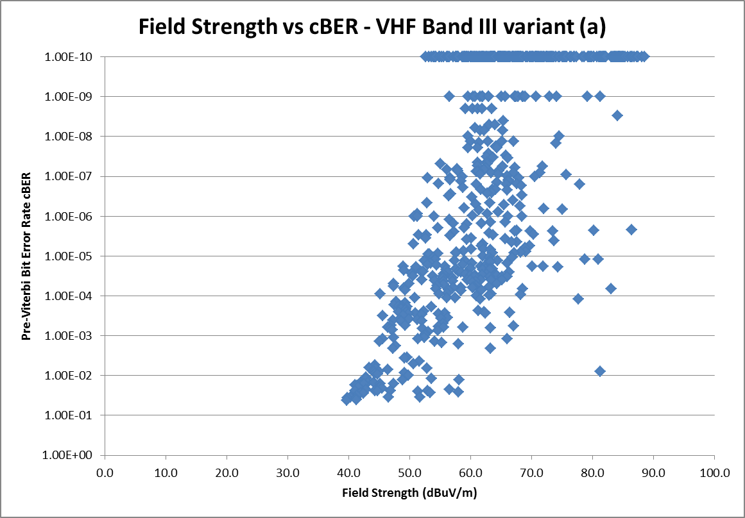

**Pre-Viterbi BER cBER**

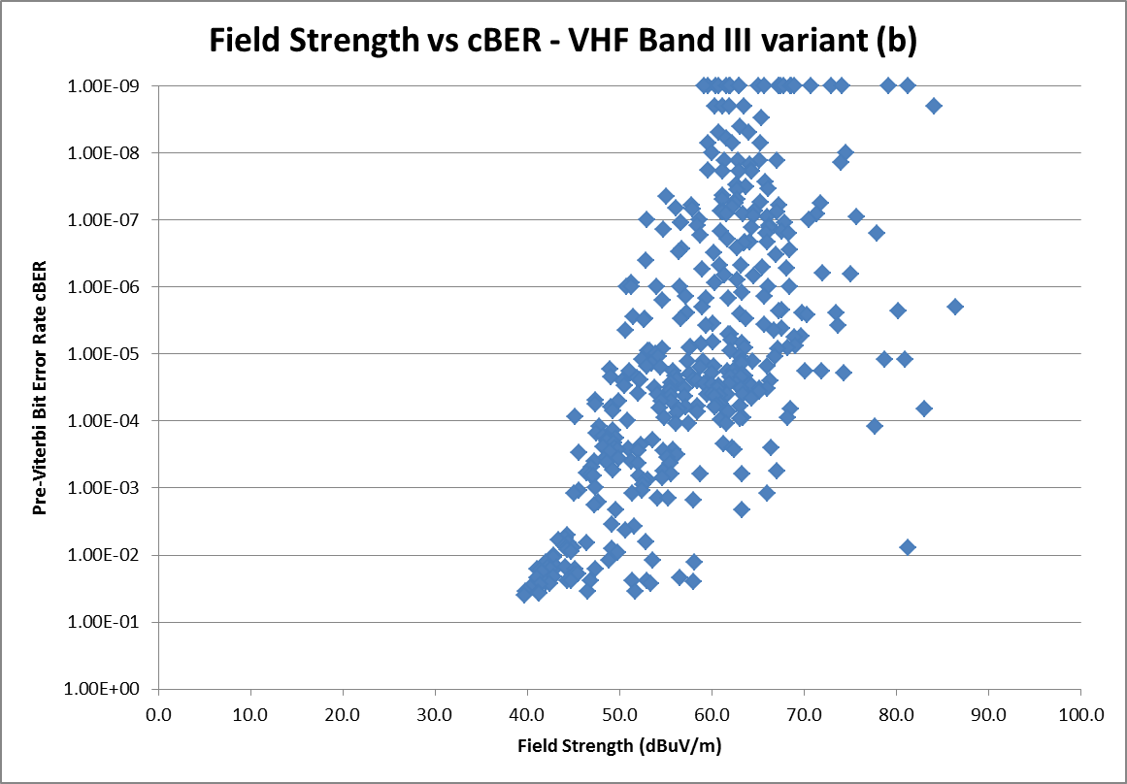

**Pre-Viterbi BER cBER**

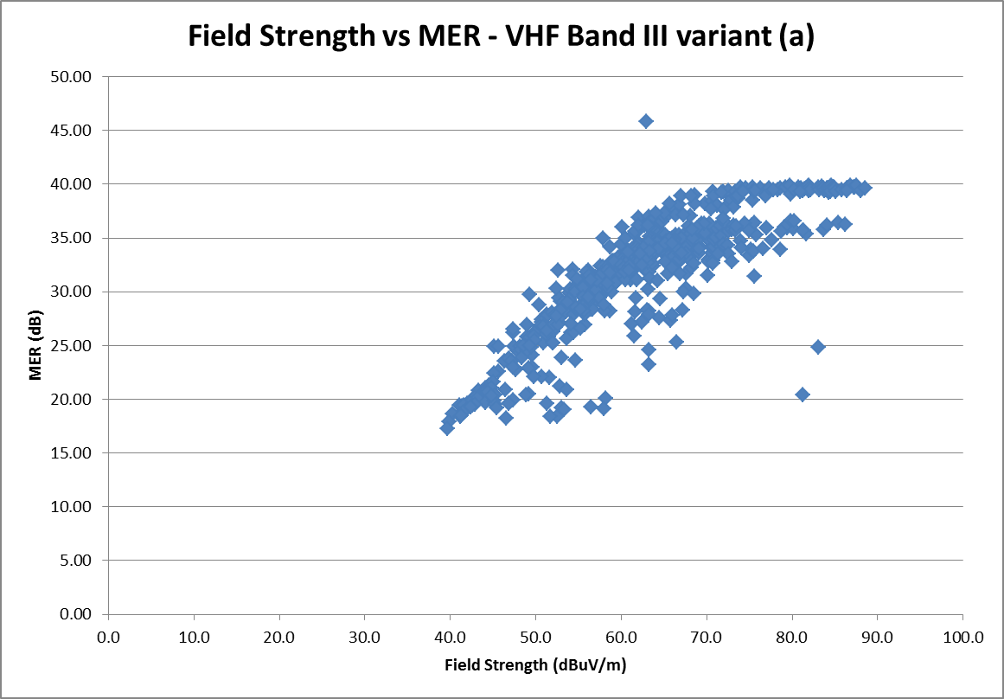

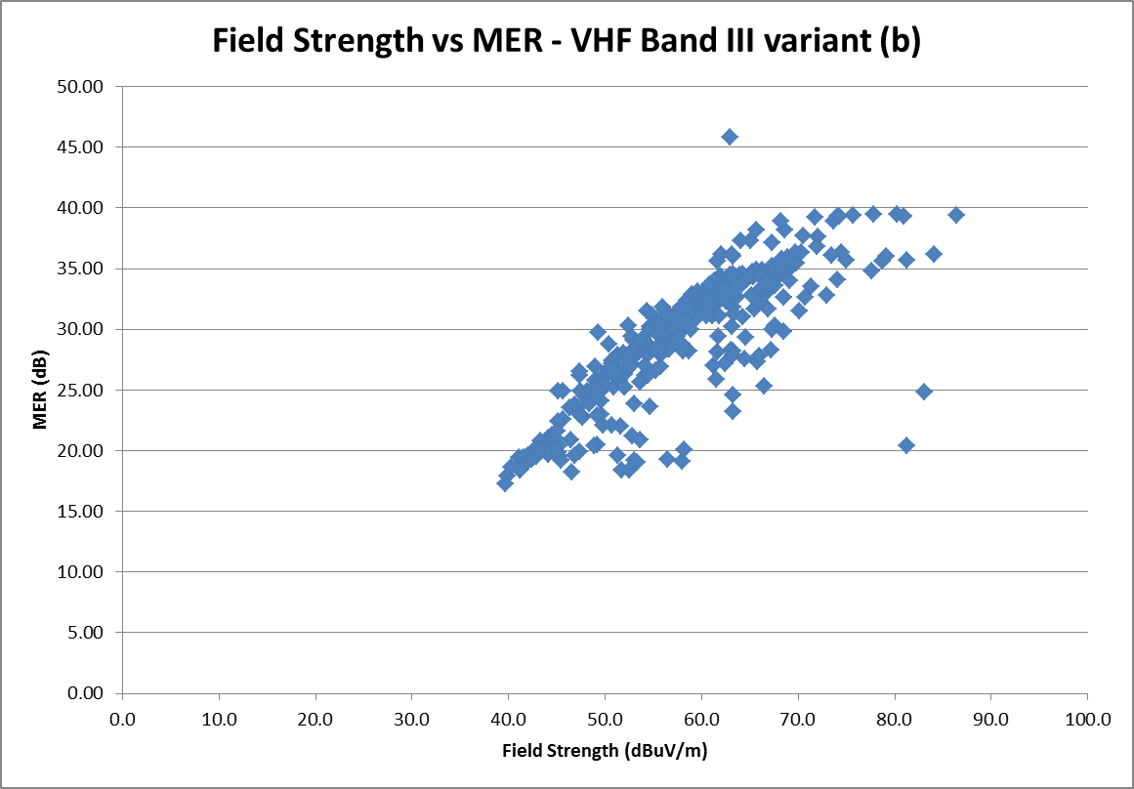

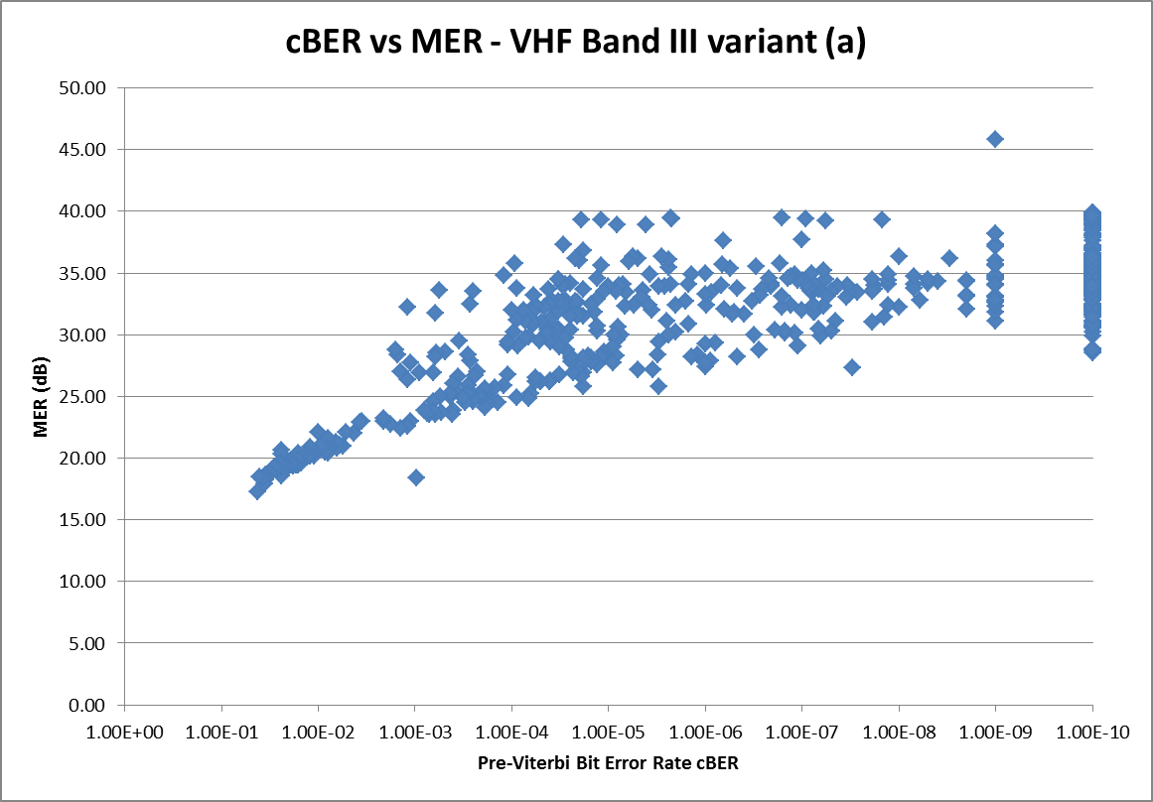

**Pre-Viterbi BER cBER**

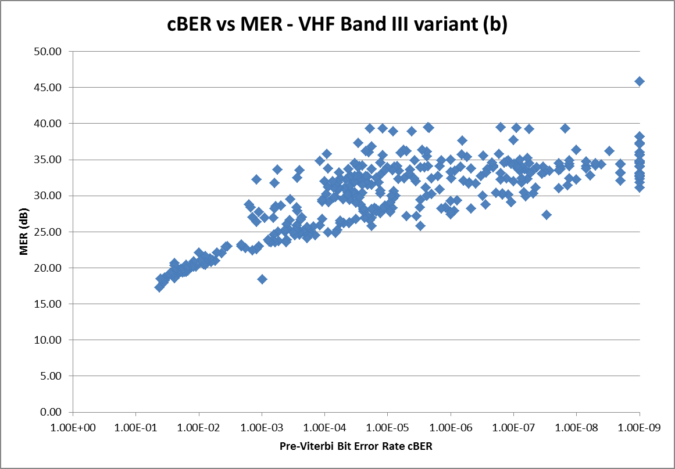

**Pre-Viterbi BER cBER**

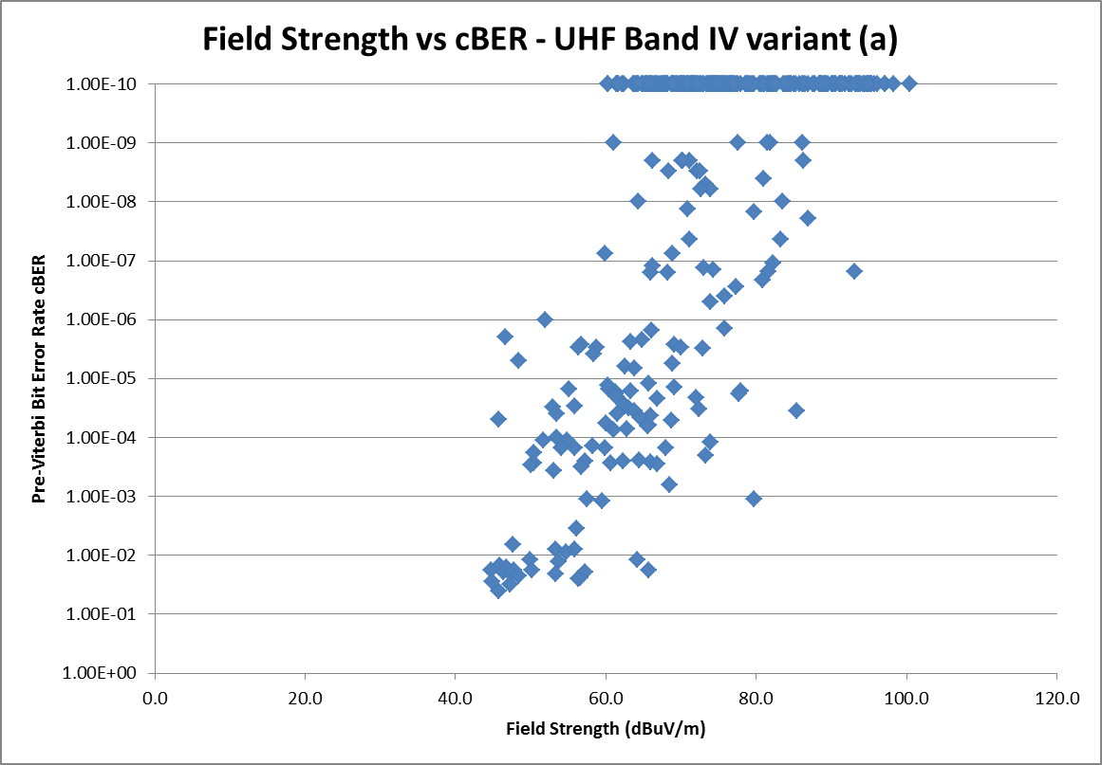

**Pre-Viterbi BER cBER**

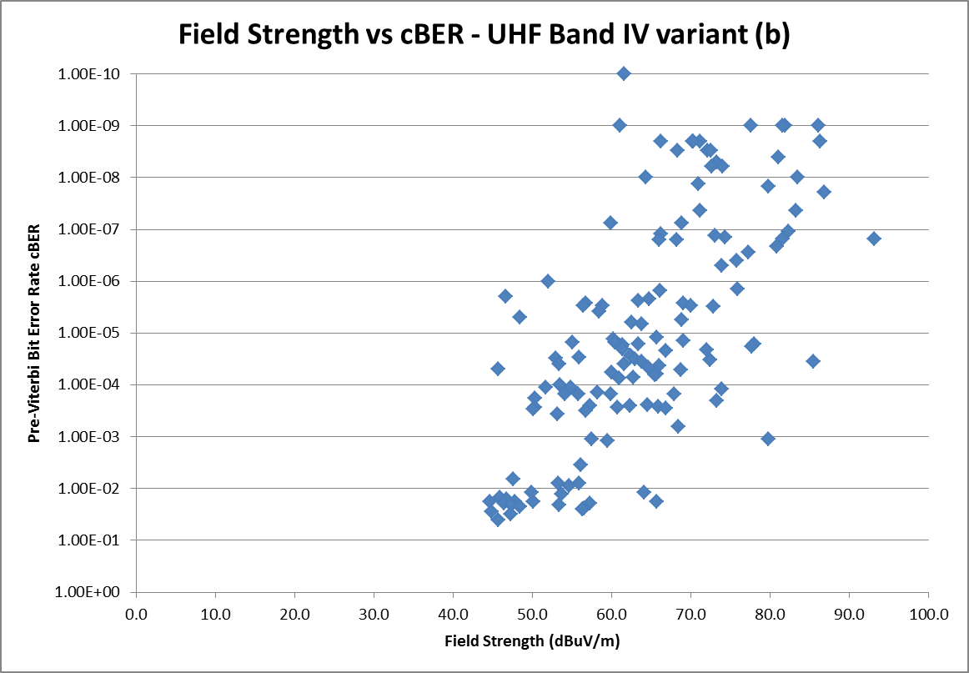

**Pre-Viterbi BER cBER**

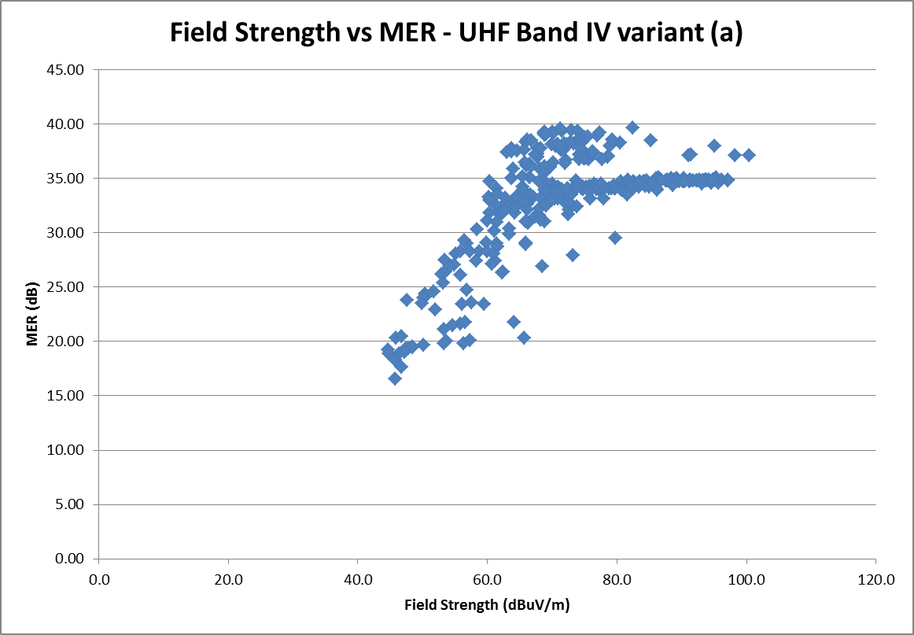

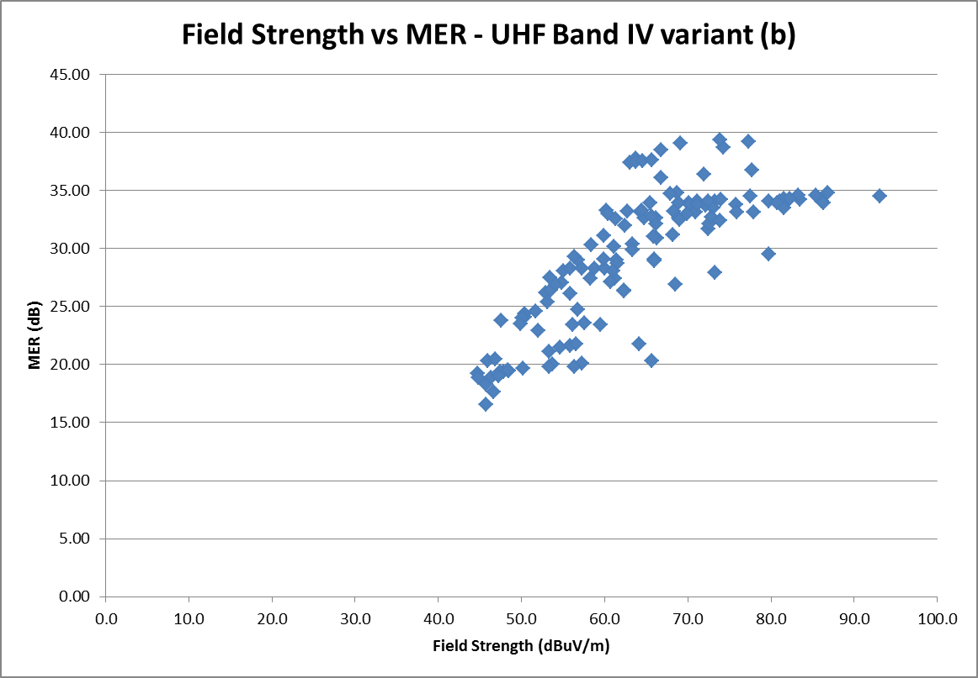

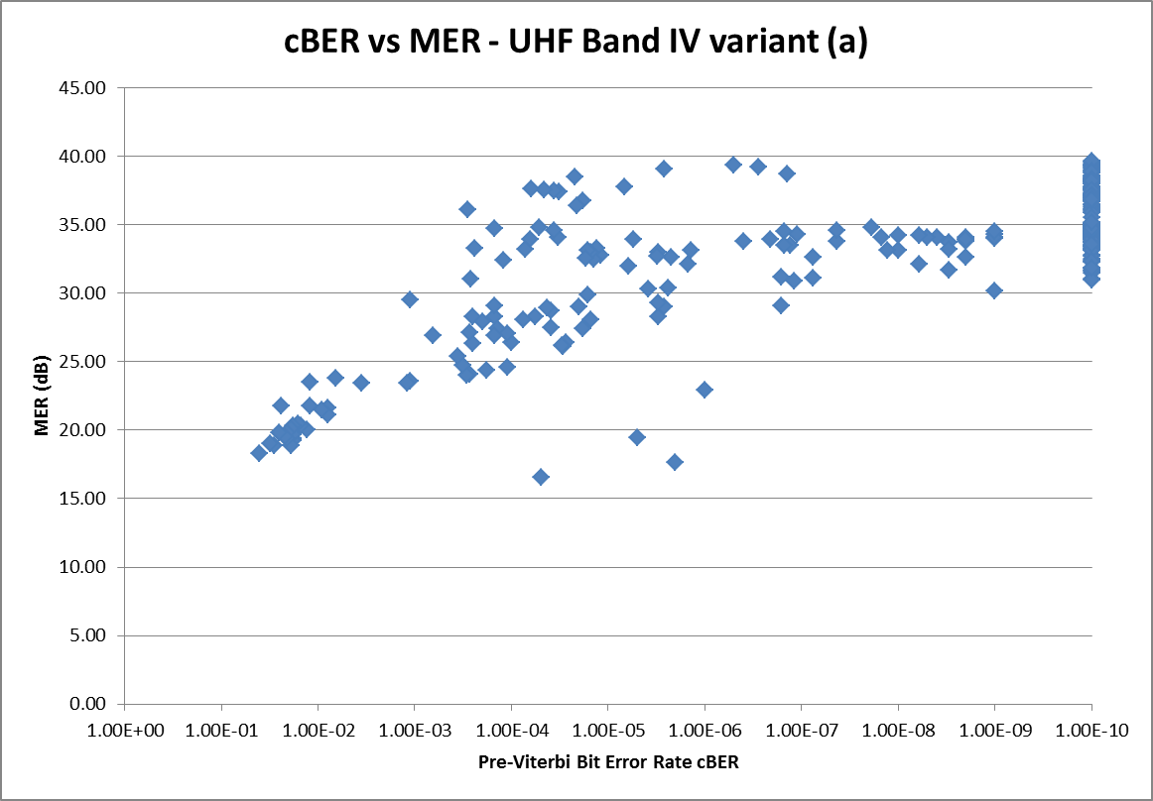

**Pre-Viterbi BER cBER**

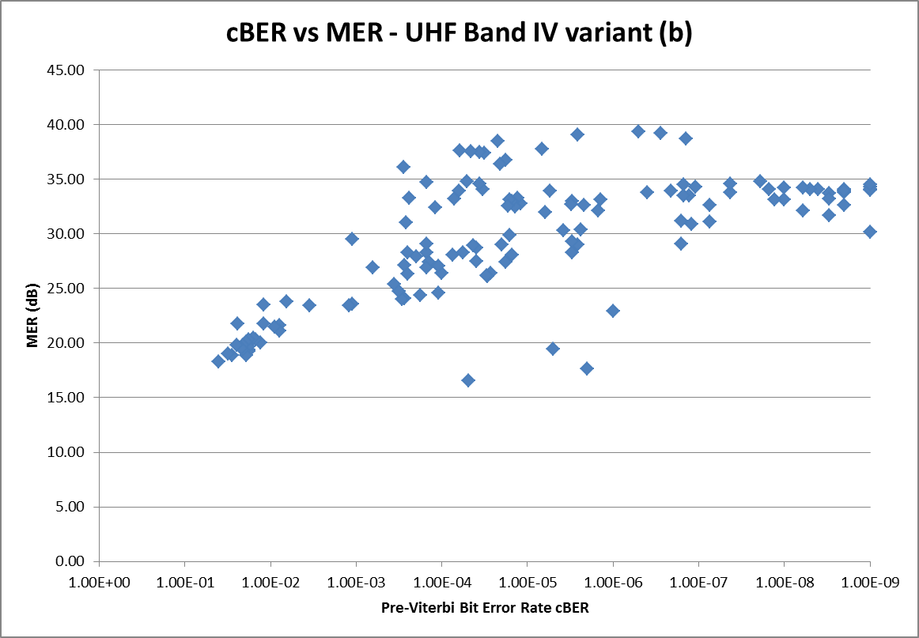

**Pre-Viterbi BER cBER**

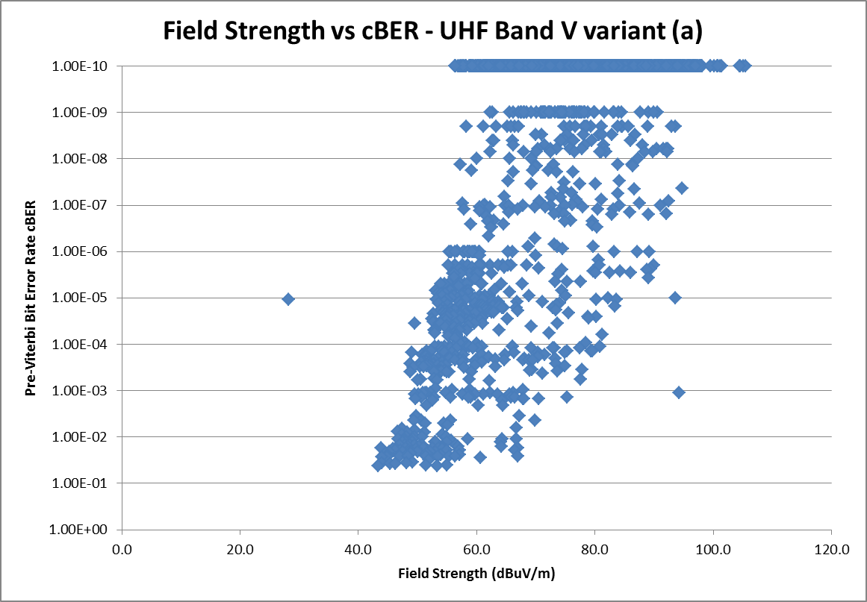

**Pre-Viterbi BER cBER**

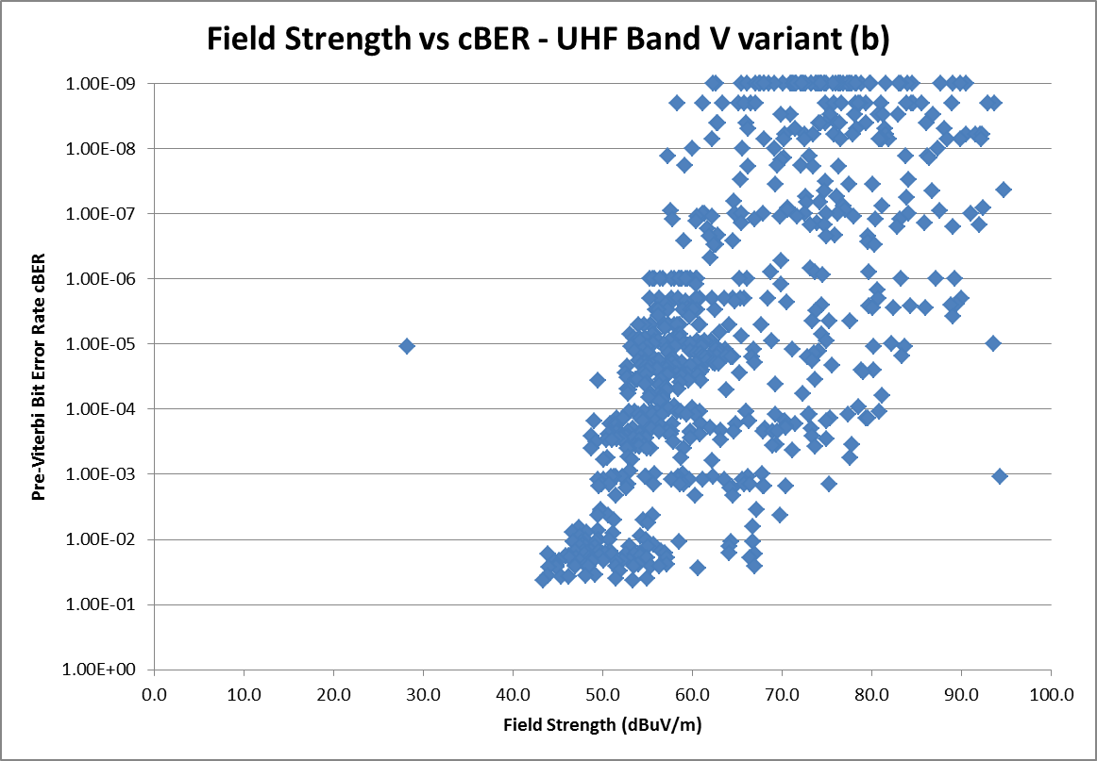

**Pre-Viterbi BER cBER**

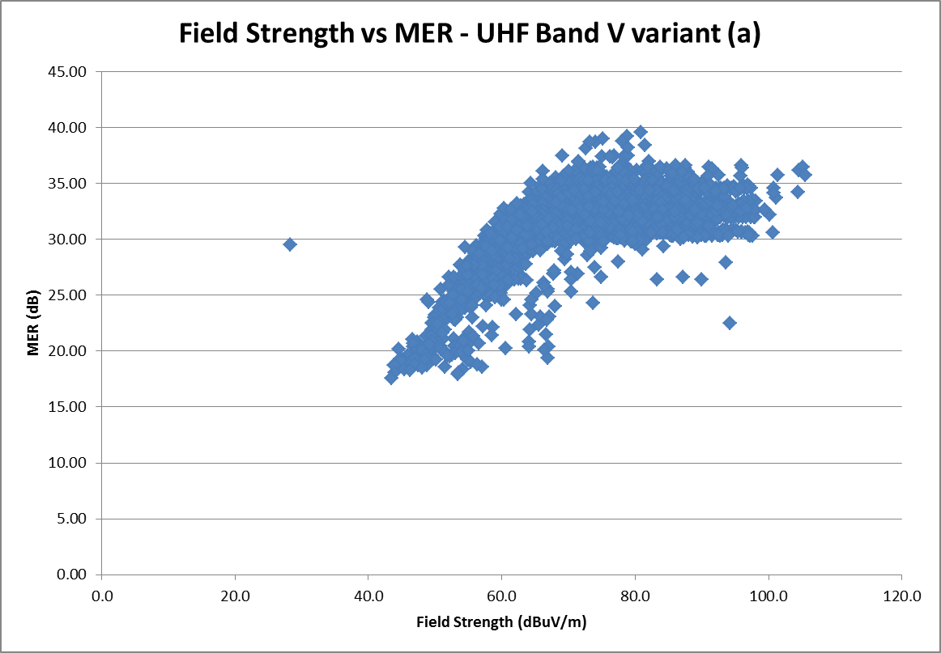

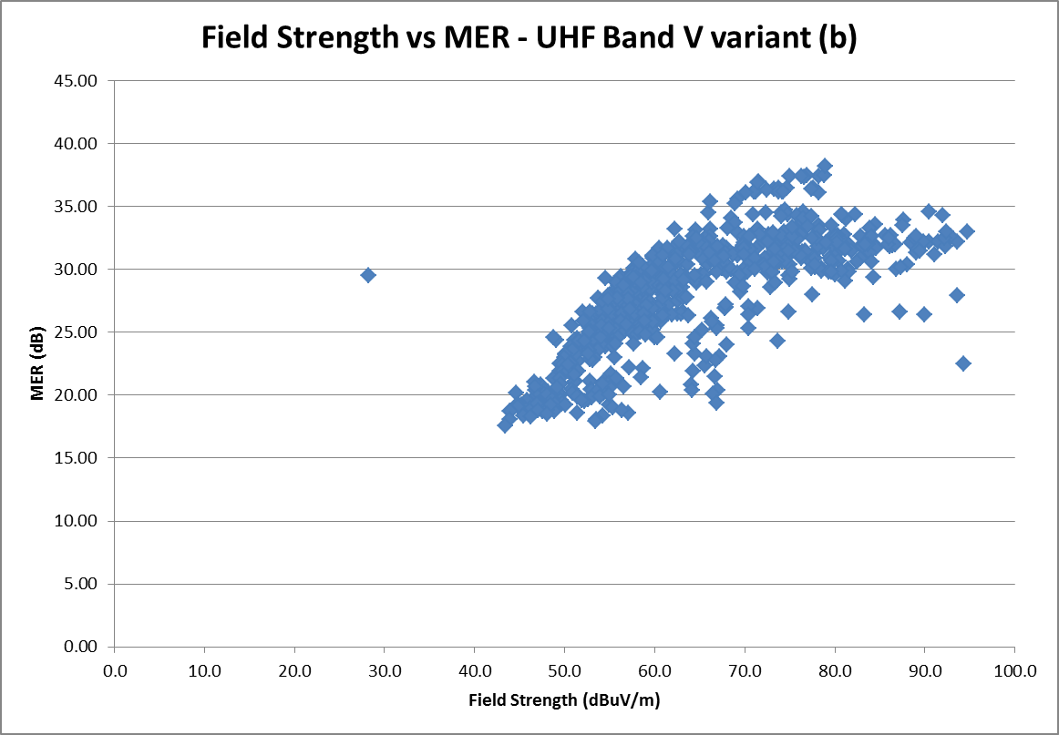

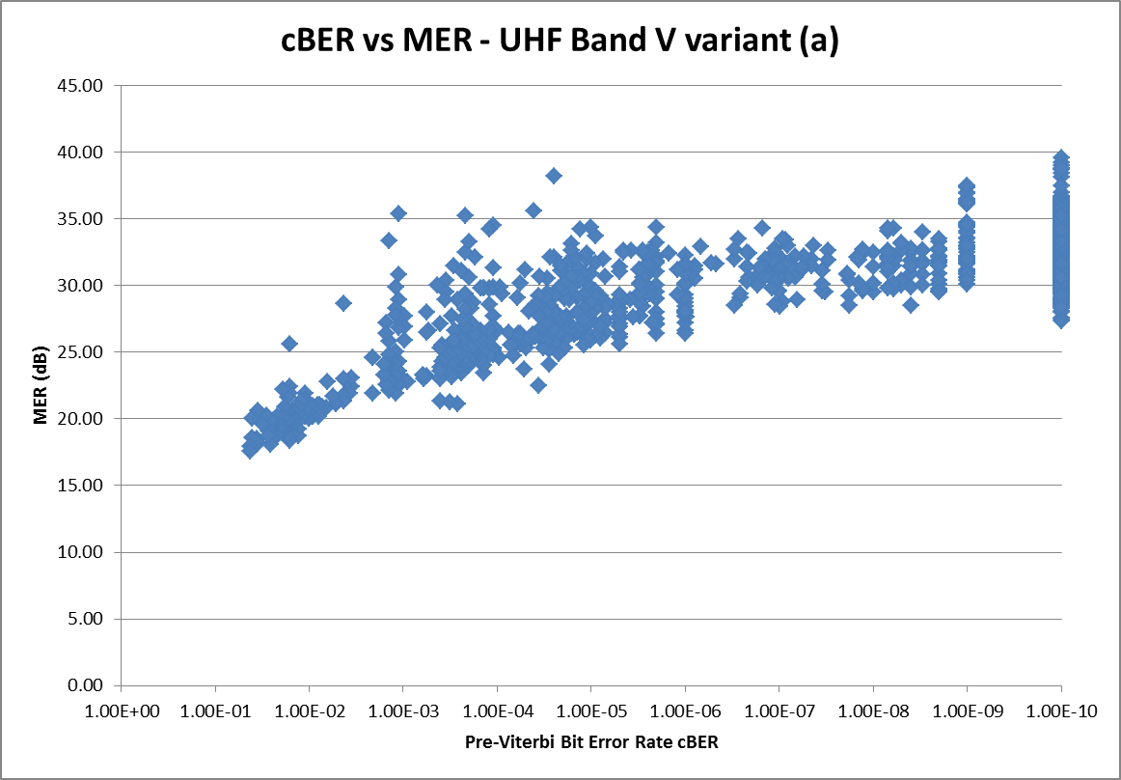

**Pre-Viterbi BER cBER**

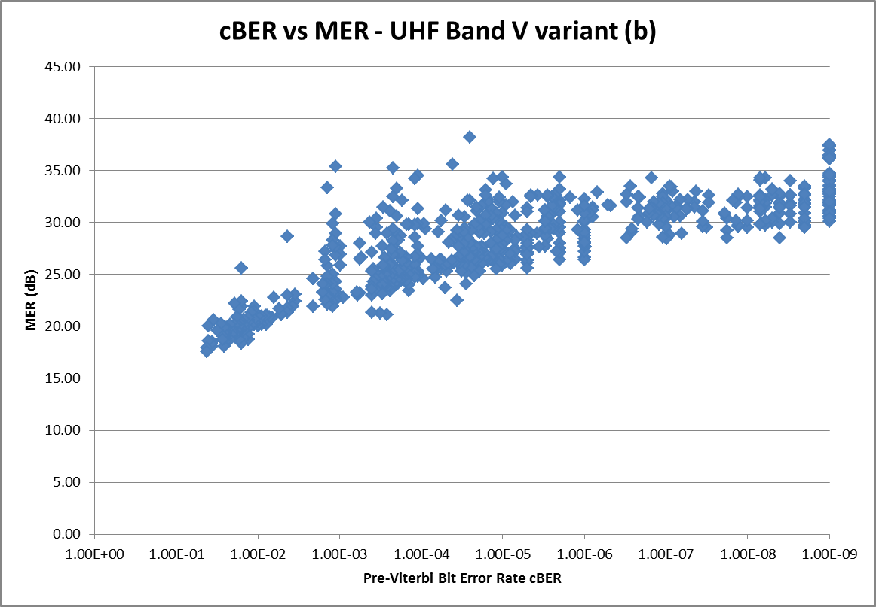

**Pre-Viterbi BER cBER**

### 2.2.4 Conclusions

Measurements analysis on MFN networks shows that at least two parameters have to be taken into account for quality coverage evaluation. In Ricean channels it is better to choose field strength and cBER. In pure Gaussian channels, as it seems in VHF band, only MER could be considered for a simple evaluation.

Recommendation ITU-R BT.1735 suits very well for MFN networks and Ricean receiving conditions. It can also be applied for Gaussian receiving conditions where the MER parameter can only be utilized.

For a deeper analysis on a difference resulted in UHF and VHF bands measurements, it is necessary to take into account the following additional items: polarization, reflection coefficient, measurements height, wavelength, distance between transmitting and receiving points. It is the so‑called vertical stratification effect on which some indication is reported in Report ITU-R P.228-3 at page 345 [Gentile, 1966].

## 2.3 Determination of the transition point in the DTTB coverage quality scale

The study **s**hould identify the transition point between the five scale quality grades as applicable to DTTB.

### 2.3.1 UHF case

#### 2.3.1.1 Transition points on cBER axis

Through consideration based on the same set of measurement values as above for UHF case, it can be seen that more than 85% of the cBER values falls between 4E-2 and 4E-5. It should be remembered that for 64‑QAM modulation and CR = 2/3 in Gaussian channel, 4E-2 before Viterbi decoding corresponds to the QEF value of 2E-4 after Viterbi decoding.

The quasi-linear shape of Fig. 16 in the range 4E-2 and 4E-5 suggests the adoption for a transition point of a linear scale with a spacing step of 10 between each class.

The graphical results are given in Fig. 16.

Figure 16

cBER classification



**Occurrences**

#### 2.3.1.2 Transition points on field strength axis

Figures 17 and 18 show respectively the shape of MER and field strength. Although the correlation index is only moderate with a numerical value of 0.65, both figures have a similar shape. The greater the field strength, the greater the robustness against noise and in band interference. The greater the MER, the lower the noise, in band interference and echoes, artificial and natural, falling outside guard interval. The transition points related to the field strength have been chosen taking into account the planning coverage probability given in DTTB Handbook 2002 edition of 70% and 95%, also adopted into ITU-R Recommendations.

Figure 17

MER distribution



**Occurrences**

Figure 18

Field strength distribution



**Occurrences**

### 2.3.2 VHF case

#### 2.3.2.1 Transition points on cBER axis

Through consideration based on the same set of measurement values as above for VHF case, it can be seen that more than 99% of the cBER values falls between 2E-2 and 2E-5. It should be remembered that for 64‑QAM modulation and CR = 3/4 in Gaussian channel, 2E-2 before Viterbi decoding corresponds to the QEF value of 2E-4 after Viterbi decoding.

The quasi-linear shape of Fig. 19 in the range 2E-2 and 2E-5 suggests, as for the UHF band, the adoption for a transition point of a linear scale with a spacing step of 10 between each class.

Figure 19

cBER classification



**Occurrences**

#### 2.3.2.2 Transition points on field strength axis

Figures 20 and 21 show respectively the shape of MER and field strength. Although the correlation index is only moderate with a numerical value of 0.59, both figures have a similar shape. The greater the field strength, the greater the robustness against noise and in band interference. The greater the MER, the lower the noise, in band interference and echoes, artificial and natural, falling outside guard interval. The transition points related to the field strength have been chosen taking into account the planning coverage probability given in DTTB Handbook 2002 Edition of 70% and 95%, also adopted into ITU-R Recommendations.

Figure 20

MER distribution



**Occurrences**

Figure 21

Field strength distribution



**Occurrences**

## 2.4 Example for SFN network

Figure 22

cBER vs. field strength



Correlation index between cBER and field strength calculated through Pearson equation is: –**0.43**.

Figure 23

Field strength vs. MER



Correlation index between MER and field strength calculated through Pearson equation is: –**0.57**.

Figure 24

cBER vs. MER



Correlation index between cBER and MER calculated through Pearson equation is: –**0.75**.

Figure 25

cBER classification



**Occurrences**

One can see that this is the same shape as the MFN case.

## 2.5 Results for possible correlation between parameters

No general strong correlation between parameters (cBER, vBER, MER, field strength) has appeared for MFN and SFN as well, therefore all parameters have to be measured separately. The specific request contained in the Recommendation for correlation investigation can be deleted.

## 2.6 Review of Figure 1 of Annex 1 of Recommendation ITU-R BT.1735

Annex 1 in Recommendation ITU-R BT.1735 suggests the use of a five-grade scale as reported below.

*For fixed reception, the five-grade scale reported in Table 1 should be used.*

*TABLE 1*

*DTTB coverage quality scale*

|  |  |  |  |  |
| --- | --- | --- | --- | --- |
| *BER*  *Field  strength* | *VBER > 2 × 10–4* | *VBER ≤ 2 × 10–4 and CBER ratio ≤ 10* | *VBER ≤ 2 × 10–4 and CBER ratio between 10 and 100* | *VBER ≤ 2 × 10–4 and CBER ratio > 100* |
| *E < E70* | *Q1* | *Q2* | *Q2* | *Q2* |
| *E70 ≤ E < E95* | *Q2* | *Q3* | *Q3* | *Q4* |
| *≥ E95* | *Q2* | *Q3* | *Q4* | *Q5* |
| *CBER: Channel BER or BER before Viterbi*  *VBER: BER after Viterbi*  *CBER ratio = CBERmin/CBER* | | | | |

*where:*

***E70*** *or* ***E95****[4]represents the minimum median field strength needed for location probability of 70% or 95% (DTTB Handbook, Chapter 5 (edition 2002) and Recommendation ITU-R BT.1368). The* ***E70****or* ***E95****value depends on the adopted configuration.*

*CBERmin is the value presented when VBER is equal to 2 × 10–4 (QEF condition) and it depends on the adopted code rate. CBERmin values for the most used configurations are listed below in Table 2. It should be noted that these values do not change with frequency and modulation scheme. Further studies are required for determination of values for other code rates.*

*TABLE 2*

*Values of CBERmin for different code rates*

|  |  |
| --- | --- |
| *Code rate* | *CBERmin* |
| *2/3* | *4 × 10–2* |
| *3/4* | *2 × 10–2* |

***Table 1 scale interpretation***

*Figure 1*



*Q2 read on the horizontal line of the table means that field strength is lower than the minimum value assigned in the planning procedure. In such cases no protection against interference can be guaranteed. Q2 read in vertical line means that the “cliff effect” appears. In the first case it is possible to move to Q3 by increasing transmitted power or by modification of the antenna pattern. In the second case it is possible to move to Q3 by reducing interference or the level of multipath interference.*

The following questions may arise:

Is there any measurable difference between Q5 to Q4 to Q3? And similarly can a difference in measurable quality between Q2 and Q1 be measured?

It appears that the most significant transition is that between Q3 and Q2 – the “cliff effect” point. Can this “cliff effect” transition be measured as a “margin to failure” based upon constraints to a quasi-*error free signal* or it is incorrectly marked*?*

Revision of Figure 1 of Annex 1 in Recommendation ITU-R BT.1735

According to our experience we propose a new interpretation of Table 1.

Figure 1



where

QEF condition is VBER = 2⋅10–4;

SFP condition is VBER ≈ 4⋅10–3.

Q2 and Q1 of the first row of the table (E < E70) are displayed with a blue line whereas the red line represents Q2 of the rest of the table (E > E70).

Q2 read on the horizontal line of the table means that field strength is lower than the minimum value assigned in the planning procedure. In such cases no protection against interference can be guaranteed and no “cliff effect” appears.

Q2 read in vertical line means that the “cliff effect” appears when SFP condition is reached.

In the first case it is possible to move to Q3 by increasing transmitted power or by modification of the antenna pattern. In the second case it is possible to move to Q3 by reducing interference or the level of multipath interference.

NOTE – The meaning of the axis should be specified better.

## 2.7 Deployment method for field survey data analysis

### 2.7.1 Introduction

An enough quantity of field survey data have been made available by RaiWay and FreeTVAustralia to Rapporteur Group. The data are related to both MFN and SFN networks. Some kind of plots have been produced in order to compare the most relevant parameters acquired that are: field strength, MER, BER before and after Viterbi decoding.

No information have been made available on Impulse Response (IR) conditions.

To understand in deep the meaning of data plotted, a general frame is proposed upon which could be represented the field survey data.

### 2.7.2 General frame to deploy field survey data

In the frame where are plotted cBER vs. vBER (BER before and after Viterbi) four reference curves could be identified: QEF, SFP, Gaussian channel, cBER = vBER. Apart from measurement uncertainty, all measured values coming from field survey are taking place within such curves. Depending where the measured values fall it should be possible to have an idea on receiving conditions and to determine if a more deep analysis based on IR is required.

QEF and SFP curves are based on vBER threshold and therefore are independent of modulation schemes.

The following frame is proposed:



### 2.7.3 Field survey data analysis

UHF band IV signals with modulation parameters 64‑QAM, 2/3 FEC, ¼ guard interval.

|  |  |
| --- | --- |
|  |  |
|  |  |

|  |  |
| --- | --- |
|  |  |
|  |  |

UHF band V signals with modulation parameters 64-QAM, 2/3 FEC, ¼ guard interval.

|  |  |
| --- | --- |
|  |  |
|  |  |

|  |  |
| --- | --- |
|  |  |
|  |  |

### 2.7.4 Plotted data interpretation

It seems that data having field strength just above the planning values falls along the Gaussian curve. It could mean that the dominant effect is due to the noise-like impairments. When field strength is height enough the values are spread between the Gaussian and the cBER = vBER curves. cBER = vBER curve means that, independently of the numerical value of the BER, punctured convolution protection does not work properly. The most critical situation appears when the values fall below QEF curve. For all the other cases, more information has to be acquired in order to understand the real margin to the failure and for which more parameters are needed for this evaluation.

## 2.8 CIR considerations on how to deal with contribution falling or can fall outside GI

### 2.8.1 Introduction

On the basis of the measurement data and their plotted representations available onto reflector, comments have been received on echoes falling outside GI interval and how to deal with them.

It is clear that this issue is the main task that the group has to finalize in order to complete its work.

Herewith are summarized considerations and physical constraints.

### 2.8.2 Considerations

There are some measurement samples with high level of field strength but still with high cBER (i.e. no picture). These seem to be the most complicated part of the work. My question is whether in these samples all the carriers of different transmitters (within SFN) fall within the guard interval or not? If the answer is no, then one way could be to present the samples in two separate groups. One, for all those samples in which all the carriers fall within GI. Second, other samples in which at least one carrier falls outside GI. Then we can treat two groups differently. For the first group we may expect better correlation between field strength and cBER. For the second group we should also consider the term: (*Ctotal*/ (*Itotal* + *N*)) where *Itotal* includes those carriers which fall outside GI (possibly with some sort of weighting).

### 2.8.3 Physical constraints

Usually the CIR is fully derived from the pilots. The maximum measurement range *T_max* in time domain is given by the pilot pattern (every third OFDM carrier is a pilot), and the symbol duration Ts.

*Tmax* = Ts/3

When one or more contributions, having enough energy, of SFN transmitters fall outside *Tmax* in absolute way (maximum distance in time among the first arrived and the last significant echo) ghost echoes would appear due to the limitation in the frequency distance of the carriers carrying pilots.

The *Tmax* values are:

− 298 μs for 8K

− 74 μs for 2K.

Therefore CIR analysis can be carried out if all significant echoes fall within *Tmax* constraints.

Some attempts have been made by measurement receiver manufacturers to override this limitation, but the results do not seem completely satisfactory yet.

### 2.8.4 Proposition

When CIR analysis can be carried out, it is important to verify both if there are echoes falling outside the adopted GI and if failure in window positioning conditions could occur, taking into account receivers strategy implemented by the manufacturers. On the basis of unofficial information received by manufacturer's representative, the strategies reported in EBU Technical Review – July 2003 seem superseded and only one strategy, let not know, seems to be implemented into most recent receivers.

Information coming from CIR analysis should be considered as an input for the SFN Quality Table application.

Chapter 3 of Part 2

The latest studies toward a revision of Recommendation ITU-R BT.1735

## 3.1 Introduction

Thanks to the experience achieved by the constant application of the first version of Recommendation ITU-R BT.1735 for the evaluation of SFN quality coverage, we discovered that, in the presence of many SFN signals, level and BER parameters are not able to indicate border line conditions with a minimum margin with respect to the possibility of losing service. Such situations are critical not only in relation to the fluctuations of the SFN signal received within the guard interval but also in consideration of possible signals that could be out of GI. For this last case, windows position strategy could change in relation to field strength variability for certain percentages of time and some SFN contributions could fall inside or outside reception window or GI. It could also happen that the level of SFN contributions falling outside GI could, for certain percentages of time, increase and approach the protection level and decrease the possibility of having a stable reception. Another case could happen when the SFN signals fall very close to GI edge and, depending on the measuring point, could fall inside or outside, giving location variability on reception. It is important to note that the distance between these points could be sometimes very small.

It is necessary to consider the reduction of noise margin of the received signal due to the rise of noise generated by SFN contributions when they are received with very low levels ratio (<7 dB) and their delays are close to maximum admitted value or very near to the main signal or synchronous to pilots repetition positions. These cases are not correctly evaluated by the first version of Recommendation ITU-R BT.1735.

Case studies of this type can easily occur in mountainous areas or even on lakes and sea shores and in Italy we have already detected situations like these.

Having established the aim of finding new criteria for assessing the coverage quality that can better fit SFN critical conditions, we set up the study in an equipped laboratory where we could create different combinations of SFN networks, even similar to the real ones.

In a first session of tests, we considered the dynamics and the interactions of the common DVBT signal parameters, RF level, MER, BER before and after Viterbi, related to different combinations of SFN signals that may occur in service areas.

As final, studies were addressed to investigate the relationship between BER before and BER after Viterbi in presence of certain critical features of SFN coverage.

We report the results of some preliminary tests and the final investigation that lead to the proposed update of Recommendation ITU-R BT.1735.

## 3.2 Tests

Laboratory settings

Frequency: 490 MHz – 64-QAM – Code rate: ¾ – GI: ¼ – Level: –60 dBm (46.8 dBµV/50 Ω) (for almost all the tests) – cBER; measurement time greater than 30 seconds.

**Remark**: In all graphics, cBER – channel BER or BER before Viterbi – and vBER – BER after Viterbi – marks do not appear when their value is zero.

All the signal levels are referred to highest signal.

Herewith, the terms ray, contribution and echo have the same meaning and are referred to different transmitters signals belonging to the same SFN.

## 3.3 Study of SFN echoes symmetry

First of all, we investigated whether pre- or post-echoes can affect in a different way on the measured parameters.

The tests were made with SFN contributions or echoes falling inside and outside GI. The values obtained in the two instances, if not equal, are completely comparable especially when the SFN contributions fall inside GI. In fact, there are only few occurrences with delays higher/lower than ± 224 µs, where cBER assumes different values.



­

|  |  |  |  |  |
| --- | --- | --- | --- | --- |
| Delay (μs) | MER (dB) | cBER | vBER | Quality |
| –222 | 37.6 | 2.00E-07 | 7.70E-09 | 5 |
| 222 | 37.7 | 2.00E-07 | 4.40E-09 | 5 |
| –100 | 38.5 | 5.10E-09 | 1.20E-09 | 5 |
| 100 | 38.7 | 0.00E+00 | 0.00E+00 | 5 |
| –5 | 40.2 | 2.50E-09 | 3.60E-09 | 5 |
| 5 | 40.2 | 4.90E-09 | 6.60E-09 | 5 |
| –3 | 41.0 | 7.90E-09 | 3.80E-09 | 5 |
| 3 | 41.0 | 2.80E-09 | 2.20E-09 | 5 |
| –1 | 41.8 | 0.00E+00 | 0.00E+00 | 5 |
| 1 | 41.8 | 1.00E-09 | 4.00E-10 | 5 |
| –0.25 | 42.6 | 0.00E+00 | 0.00E+00 | 5 |
| 0.25 | 42.6 | 4.70E-09 | 2.00E-09 | 5 |
| –424 | 26.90 | 2.00E-06 | 0.00E+00 | 5 |
| 424 | 26.90 | 2.00E-06 | 0.00E+00 | 5 |
| –324 | 26.50 | 1.90E-06 | 0.00E+00 | 5 |
| 324 | 26.50 | 2.10E-06 | 0.00E+00 | 5 |
| –274 | 27.37 | 4.60E-05 | 0.00E+00 | 5 |
| 274 | 27.35 | 3.80E-05 | 0.00E+00 | 5 |
| –229 | 34.48 | 8.90E-07 | 0.00E+00 | 5 |
| 229 | 34.48 | 8.60E-09 | 0.00E+00 | 5 |
| –227 | 34.68 | 8.30E-07 | 0.00E+00 | 5 |
| 227 | 34.60 | 3.10E-09 | 0.00E+00 | 5 |
| –225 | 34.43 | 8.90E-07 | 0.00E+00 | 5 |
| 225 | 34.62 | 7.00E-09 | 0.00E+00 | 5 |

## 3.4 MER and BER analysis in a SFN with multiple signals inside GI

Many tests have been made and the results show that there is a relation between the position of the echoes and the quality of signal evaluated according to current Recommendation ITU-R BT.1735 procedure.

Rather than the complexity of the SFN and the consequent amount of rays inside GI, degradation is related especially to echoes delays and levels: the higher the absolute value of delay, the smaller the level difference between the main signal and the echoe's one, worst are BER and MER values.



|  |  |  |  |  |  |
| --- | --- | --- | --- | --- | --- |
| Main signal level 46.8 dBµV | | MER | cBER | vBER | Q |
|  | 2 SFN: 200 μs –3 dB; 210 μs –10 dB | 26.98 | 4.6E-03 | 6.0E-09 | 3 |
|  | 3 SFN: ±100 μs –15 dB; –75 μs –3 dB | 28.18 | 2.5E-03 | 6.0E-09 | 3 |
|  | 3 SFN: 180 μs –3 dB; 200 μs –15 dB; 210 μs –10 dB | 28.58 | 2.1E-03 | 6.3E-08 | 3 |
|  | 4 SFN: –78 μs –3 dB; –88 μs –10 dB; ±100 μs –15 dB | 28.91 | 1.4E-03 | 2.5E-08 | 4 |
|  | 3 SFN: 180 μs –3 dB; 200 μs –15 dB; 190 μs –10 dB | 29.46 | 1.0E-03 | 0.0E+00 | 4 |
|  | 2 SFN: 180 μs –3 dB; 200 μs –15 dB | 29.46 | 7.2E-04 | 0.0E+00 | 4 |
|  | 4 SFN: 180 μs –3 dB; 200 μs –15 dB; 190 μs –10 dB; 210 μs –10 dB | 30.01 | 4.9E-04 | 1.3E-09 | 4 |
|  | 3 SFN: –20 μs –15 dB; 80 μs –5 dB; 180 μs –15 dB | 30.78 | 3.0E-04 | 0.0E+00 | 4 |
|  | 4 SFN: ±100 μs –15 dB; –80 μs –3 dB; –70 μs –10 dB | 29.66 | 2.6E-04 | 0.0E+00 | 4 |
|  | 4 SFN: ±100 μs –15 dB; 80 μs –3 dB; 90 μs –10 dB | 30.22 | 1.3E-04 | 0.0E+00 | 5 |
|  | 3 SFN: ±100 μs –15 dB; –50 μs –3 dB | 32.30 | 1.6E-05 | 0.0E+00 | 5 |
|  | 3 SFN: ±100 μs –15 dB; –50 μs –10 dB | 33.59 | 2.4E-06 | 0.0E+00 | 5 |
|  | 3 SFN: ±100 μs –15 dB; –75 μs –10 dB | 32.76 | 4.0E-07 | 0.0E+00 | 5 |
|  | 3 SFN: ±100 μs –15 dB; –50 μs –30 dB | 33.74 | 1.6E-07 | 0.0E+00 | 5 |

The worst measure is acquired with two rays with this feature: 200 μs –3 dB and 210 μs –10 dB.

During this test, it was also detected that, in certain cases, a greater number of echoes could make the reception better.

As shown in the figure and in the table below, the case with four rays has better BER and MER values than the case with three echoes.



|  |  |  |  |  |
| --- | --- | --- | --- | --- |
| Main signal level 46.8 dBµV | MER | cBER | vBER | Q |
| 2 SFN: 180 μs –3 dB; 200 μs –15 dB | 38.0 | 2.40E-05 | 0.00E+00 | 5 |
| 3 SFN: 180 μs –3 dB; 200 μs –15 dB; **190 µs** –**10 dB** | 37.9 | 2.60E-05 | 0.00E+00 | 5 |
| 4 SFN: 180 μs –3 dB; 200 μs –15 dB; **190 µs** –**10 dB; 210 µs** –**10 dB** | 38.5 | 1.90E-05 | 0.00E+00 | 5 |
| 3 SFN: 180 μs –3 dB; 200 μs –15 dB; **210 µs** –**10 dB** | 36.0 | 1.70E-04 | 5.80E-09 | 5 |

## 3.5 MER and BER analysis in a SFN with a contribution outside GI

The analysis was made on SFN with an echo of variable level – from –20 dB to –3 dB and variable delay – from 225 µs to 290 µs.

It is noticed a degradation of the measured values connected to the increase of delay and level.

It is important to point out that if a ray outside GI has a –3 dB level, the quality does not exceed 3.







A part of the measures of this investigation is listed below.

|  |  |  |  |  |
| --- | --- | --- | --- | --- |
| Delay (μs) | MER (dB) | cBER | vBER | Quality |
| SFN level –3 dB | | | | |
| 225 | 24.71 | 3.80E-03 | 3.90E-08 | 3 |
| 234 | 18.87 | 4.40E-02 | 2.70E-03 | 2 |
| SFN level –15 dB | | | | |
| 225 | 32.96 | 4.90E-06 | 0.00E+00 | 5 |
| 242 | 25.49 | 1.80E-04 | 1.80E-06 | 5 |
| 242.5 | 25.27 | 2.00E-04 | 1.10E-06 | 4 |
| 249 | 22.31 | 1.90E-03 | 6.50E-05 | 4 |
| 250 | 21.78 | 2.60E-03 | 3.40E-05 | 3 |
| 251 | 21.39 | 3.70E-03 | 3.00E-04 | 2 |
| 267 | 17.23 | 6.30E-02 | 7.90E-03 | 2 |
| SFN level –20 dB | | | | |
| 243 | 29.09 | 4.60E-05 | 0.00E+00 | 5 |
| 253 | 24.98 | 1.80E-04 | 8.20E-06 | 5 |
| 254 | 24.46 | 2.40E-04 | 9.70E-07 | 4 |
| 261 | 21.73 | 1.70E-03 | 1.50E-04 | 4 |
| 262 | 21.39 | 2.30E-03 | 1.20E-04 | 3 |
| 277 | 18.52 | 2.70E-02 | 8.80E-05 | 3 |
| 280 | 18.32 | 3.10E-02 | 2.50E-04 | 2 |
| 290 | 18.03 | 3.90E-02 | 8.20E-04 | 2 |

Beside, a detailed study on the behaviour of SFN echo with –15 dB and –20 dB level points out that the vBER has not an increasing monotonic trend.

This fact has an impact on the representative validity of the measure. In other words, two different measurement points within the SFN area which are only a few hundred metres distant from each other could have very different receiving conditions.





## 3.6 MER and BER analysis in a SFN with contribution inside and outside GI

Comparing the previous results with a more complex SFN which have also contributions falling inside GI, we do not notice substantial variations: there is only a little increase of vBER values and a little decrease of MER values.



The SFN with four echoes inside GI has these characteristics: 28 µs –15 dB; 35 µs –15 dB; 150 µs –15 dB; 157 µs –15 dB. The contribution outside GI has –3 dB signal level with respect to the main signal.

|  |  |  |  |  |
| --- | --- | --- | --- | --- |
|  | MER (dB) | cBER | vBER | Quality |
| 225 μs | 24.71 | 3.80E-03 | 3.90E-08 | 3 |
| 225 μs + 4 SFN | 24.00 | 6.40E-03 | 7.20E-08 | 3 |
| 227 μs | 21.82 | 1.40E-02 | 4.30E-06 | 3 |
| 227 μs + 4 SFN | 21.75 | 1.40E-02 | 3.70E-06 | 3 |
| 229 μs | 20.48 | 2.40E-02 | 5.40E-05 | 3 |
| 229 μs + 4 SFN | 20.19 | 2.40E-02 | 5.20E-05 | 3 |
| 234 μs | 18.87 | 4.40E-02 | 2.70E-03 | 2 |
| 234 μs + 4 SFN | 18.47 | 4.40E-02 | 2.30E-03 | 2 |

## 3.7 Study of the allowable limit value of the combination level-delay outside GI

As highlighted by previous studies, the worst results are obtained by contributions falling outside GI. An investigation was performed with the aim to search the limit value of the combination level-delay and the quality shifts.

The trial was carried out with the level of the ray outside GI lower than 3 dB, 7 dB, 11 dB, 15 dB and 20 dB with respect to main signal and increasing the delay.

The analysis points out:

– when the delay is 225 µs, the quality is 3 when the signal level is 3 dB lower than the main one; in the other performed instances the quality is always 5;

– an echo with delay of 234 µs and level –3 dB, the quality is 2. Comparing this with the previous result, we could state that a difference of 9 µs, 2.7 km, could strongly affect on the reception possibility;

– for a SFN contribution with –20 dB level and delay of 267 µs the quality is 3 and when the delay reaches 280 µs, the vBER is higher than the QEF value.





|  |  |  |  |  |  |
| --- | --- | --- | --- | --- | --- |
| Level (dB) | Delay (μs) | MER (dB) | cBER | vBER | Quality |
| –20 | 253 | 24.98 | 1.80E-04 | 8.20E-06 | 5 |
| 254 | 24.46 | 2.40E-04 | 9.70E-07 | 4 |
| 262 | 21.39 | 2.30E-03 | 1.20E-04 | 3 |
| 280 | 18.32 | 3.10E-02 | 2.50E-04 | 2 |
| –15 | 242 | 25.49 | 1.80E-04 | 1.80E-06 | 5 |
| 242.5 | 25.27 | 2.00E-04 | 1.10E-06 | 4 |
| 250 | 21.78 | 2.60E-03 | 3.40E-05 | 3 |
| 251 | 21.39 | 3.70E-03 | 3.00E-04 | 2 |
| –11 | 233 | 25.45 | 1.90E-04 | 0.00E+00 | 5 |
| 234 | 24.98 | 3.20E-04 | 0.00E+00 | 4 |
| 240 | 22.71 | 2.40E-03 | 3.10E-07 | 3 |
| 243 | 21.59 | 5.40E-03 | 2.40E-04 | 2 |
| –7 | 226 | 26.80 | 1.20E-04 | 0.00E+00 | 5 |
| 227 | 25.60 | 4.40E-04 | 0.00E+00 | 4 |
| 230 | 23.11 | 3.00E-03 | 0.00E+00 | 3 |
| 241 | 19.51 | 2.60E-02 | 6.20E-04 | 2 |
| –3 | 230 | 20.02 | 2.80E-02 | 1.40E-04 | 3 |
| 231 | 19.67 | 3.20E-02 | 3.00E-04 | 2 |

## 3.8 Verification of the protection ratio

Finally, a test was implemented in order to verify if the protection ratios defined for the MFN could be extended to SFN.

The trial was made with two different types of SFN interfered by an uncorrelated co-channel DVBT 64‑QAM 8 k signal with increasing level.

In both cases, the main signal level was 47 dBμV, as stated by Recommendation ITU-R BT.1368, and the first SFN has a contribution with 200 µs delay and 15 dB lower level. The second one has two contributions with ±100 µs delay and 15 dB lower level.

The results confirm the validity of the defined MFN protection ratios (Recommendation ITU‑R BT.1368 and ETSI EN-300744) also for the SFN.

|  |  |  |  |  |
| --- | --- | --- | --- | --- |
| Co-channel signal level (dB) | MER (dB) | cBER | vBER | Quality |
| SFN: 200 µs; –15 dB | | | | |
| –28 | 26.13 | 7.80E-06 | 0.00E+00 | 5 |
| **–27** | 25.15 | 3.70E-05 | 0.00E+00 | **5** |
| –26 | 24.11 | 2.00E-04 | 0.00E+00 | 4 |
| –25 | 23.07 | 6.00E-04 | 0.00E+00 | 4 |
| **–24** | 22.22 | 1.70E-03 | 0.00E+00 | **4** |
| –23 | 21.36 | 3.60E-03 | 1.40E-08 | 3 |
| –22 | 20.62 | 6.00E-03 | 1.60E-07 | 3 |
| –21 | 19.69 | 1.30E-02 | 3.90E-06 | 3 |
| **–20** | 19.05 | 2.10E-02 | 3.80E-05 | **3** |
| –19 | 18.47 | 3.10E-02 | 4.60E-04 | 2 |
| SFN: ±100 µs; –15 dB | | | | |
| **–28** | 25.59 | 1.30E-04 | 0.00E+00 | **5** |
| –27 | 24.29 | 5.30E-04 | 0.00E+00 | 4 |
| **–26** | 23.45 | 1.10E-03 | 0.00E+00 | **4** |
| –25 | 22.62 | 2.30E-03 | 0.00E+00 | 3 |
| –24 | 21.71 | 4.60E-03 | 2.40E-08 | 3 |
| –23 | 20.94 | 7.80E-03 | 1.40E-07 | 3 |
| –22 | 20.17 | 1.30E-02 | 2.60E-06 | 3 |
| –21 | 19.39 | 2.20E-02 | 3.90E-05 | 3 |
| **–20** | 18.98 | 2.80E-02 | **2.00E-04** | **3** |
| –19 | 18.39 | 3.80E-02 | 1.40E-03 | 2 |

## 3.9 General BER frame

In order to better understand the circumstances which affect the disposition of field survey data in the “general BER frame” proposed in Annex 15 to Working Party 6A Chairman’s Report, we make use of it with all the measures of the laboratory tests.

In the proposed “general BER frame” are plotted cBER vs. vBER four reference curves: QEF, SFP, Gaussian channel, cBER = vBER.

QEF and SFP curves are based on vBER threshold and therefore are independent of modulation systems.



Gaussian

In particular, the analysis was addressed to discover which kind of situation is behind the points of quality 4 and 5 with high vBER (placed in the circle of the chart): these points are very close to QEF line but, according to Recommendation ITU-R BT.1735, result to have good coverage quality.

Grouping experimental data by the SFN characteristics of having contributions inside or outside GI, we noticed that those points are the ones related to particular tests with rays falling outside GI.

In fact, generally, measures with not null vBER arrange themselves near the Gaussian curve and a point, shifting from quality 5 to quality 2, at first approaches the Gaussian line and then slopes down along it.

Only tests with echoes falling outside GI generate values with cBER higher than 2⋅10–3 and vBER higher than 10–6.



Gaussian

Studying the paths of those quality variations, we detected that their trend is different and it is quite asymptotic to cBER = vBER line.

In the chart below, we try to underline the traces of quality changes.



Gaussian

This trial was made keeping fixed the delay of the contribution of the SFN (delays listed in the top of the figure) and increasing their level. For example, the SFN with a ray with 243 µs delay shifts from quality 4 to quality 2 increasing the level of 4 dB (from 11 dB to 7 dB).

## 3.10 Conclusion

In the light of what we explained in the previous section, for the SFN, we propose a revision of the quality table of Recommendation ITU-R BT.1735 introducing an evaluation which depends also on vBER value.

We suggest to use the curve  with  to evaluate the quality.

Experimentally, we advise these two expressions:

Q4 curve: 

Q5 curve: 

and the quality should be estimated in this manner:

Quality 2: 

Quality 3: 

Quality 4: 

Quality 5: 



Gaussian

Annex 1

Source: EBU doc. BPN 043 “Issues concerning DVB-T and T-DAB in Band III”

Location correction margin

The location correction margin is added to the system protection ratio to give the amount (in dB) by which the wanted signal must exceed the interfering signal in order to provide protection other than 50% of locations. The location correction margin is related to the location correction factor, and in deriving it from the location correction factor, it is assumed that the wanted and interfering signals are both normally distributed, are uncorrelated and have identical aggregate standard deviations.

The resultant standard deviation is calculated as follows





since σ *wanted* = σ *interferer*

Fixed antenna reception (10 m above ground level)

The aggregate standard deviation, σ is 5.5 dB, which makes the resultant standard deviation, σ*res* =  × 5.5 = 7.8 dB.

Portable indoor ground floor reception

The aggregate standard deviation, σ is 6.3 dB, making the resultant standard deviation, σ*res* =  × 6.3 = 8.9 dB.

Calculation of location correction margin

Table A2.2 gives the Band III location correction margin which has to be added to the system protection ratios in Tables A2.3 to A2.6 to determine if the wanted signal is protected at the desired percentage of locations (location probability).



It should be noted that the indicated values are also valid for Bands IV and V (see Recommendation ITU-R BT.1546 Annex 5, § 12, Table 2).

Annex 2

Reference: Joint ERC/EBU Report on Planning and Introduction of Terrestrial Digital Television in Europe, Izmir, December 1997

Effective Protection Target, EPT

Rayleigh statistics is assumed for the propagation channel for portable or mobile reception cases and thus the respective *C*/*N* value is applied in planning. For fixed reception, basically a Ricean channel is assumed. But also in fixed reception, the channel may become less favourable, especially if active echoes – other transmitters of the same SFN – cannot be attenuated substantially by the directional antenna at the receiving point. A smooth transition between the application of the Rice and Rayleigh value to be applied for the *C*/*N* is described by the “effective protection target” (EPT).

In this concept, there is a “channel criticality” parameter, *KA*, defined as the ratio of the power of the main signal compared to the power sum of the artificial echoes. Interpolation between the Rice and the Rayleigh value of *C*/*N* depends on this parameter. If the main signal dominates, the Rice statistics is assumed, while if the ratio is balanced, Rayleigh statistics is assumed.

The calculation of the EPT is given in formula (1)



With:

EPT: effective protection target (dB)

: *C*/*N* for Ricean channel (dB)

: *C*/*N* for Rayleigh channel (dB)

*KA*: channel criticality parameter, the ratio of power of main signal to the power sum of the active echoes (dB).

If *KA* < 0 dB, then *KA* is set to 0 dB.

A possible implementation margin has been neglected here.

Figure A2-1 shows the values of EPT, depending on the channel criticality parameter for the example with and .

Figure A2-1

EPT as a function of channel criticality parameter, *KA*



Appendix  
  
Acronyms

cBER: Channel BER or BER before Viterbi

cBER ratio = *cBERmin*/*cBER*

CIR: Channel impulse response

QEF: Quasi error free

SFP: Subjective failure point

TOV: Threshold of visibility

vBER: BER after Viterbi

1. “Recommended Practice: Guide to the Use of the ATSC Digital Television Standard, including Corrigendum No. 1”, Advanced Television Systems Committee Document A/54A, Washington, DC, 20 December 2006. <http://www.atsc.org/cms/standards/a_54a_with_corr_1.pdf>
2. “*digital* HDTV Grand Alliance System, Record of Test Results”, Advisory Committee on Advance Television Service of the Federal Communications Commission, October 1995.
3. Qualric has resulted practical and useful to support measurement activity and has been utilized in RaiWay call centre and website to indicate to the user the quality of the coverage. Only few complaints were received on its reliability.
4. ***E70*** *or* ***E95*** *may also represent the planning values chosen by administrations.*