Report ITU-R BT.2140-15
(03/2026)
BT Series: Broadcasting service (television)
Transition from analogue to digital terrestrial television broadcasting

Foreword
The role of the Radiocommunication Sector is to ensure the rational, equitable, efficient and economical use of the radio-frequency spectrum by all radiocommunication services, including satellite services, and carry out studies without limit of frequency range on the basis of which Recommendations are adopted.
The regulatory and policy functions of the Radiocommunication Sector are performed by World and Regional Radiocommunication Conferences and Radiocommunication Assemblies supported by Study Groups.

Policy on Intellectual Property Right (IPR)
ITU-R policy on IPR is described in the Common Patent Policy for ITU-T/ITU-R/ISO/IEC referenced in Resolution ITU-R 1. Forms to be used for the submission of patent statements and licensing declarations by patent holders are available from https://www.itu.int/ITU-R/go/patents/en where the Guidelines for Implementation of the Common Patent Policy for ITU-T/ITU-R/ISO/IEC and the ITU-R patent information database can also be found.

Series of ITU-R Reports
(Also available online at https://www.itu.int/publ/R-REP/en)
Series | Title
BO | Satellite delivery
BR | Recording for production, archival and play-out; film for television
BS | Broadcasting service (sound)
BT | Broadcasting service (television)
F | Fixed service
M | Mobile, radiodetermination, amateur and related satellite services
P | Radio-wave propagation
RA | Radio astronomy
RS | Remote sensing systems
S | Fixed-satellite service
SA | Space applications and meteorology
SF | Frequency sharing and coordination between fixed-satellite and fixed service systems
SM | Spectrum management
TF | Time signals and frequency standards emissions

Note: This ITU-R Report was approved in English by the Study Group under the procedure detailed in Resolution ITU-R 1.

Electronic Publication
Geneva, 2026
© ITU 2026
All rights reserved. No part of this publication may be reproduced, by any means whatsoever, without written permission of ITU.

REPORT ITU-R BT.2140-15
Transition from analogue to digital terrestrial television broadcasting
(2008-2009-2010-05/2011-10/2011-2012-2013-2014-02/2015-07/2015-2017-2018-2019-2021-2023-2026)

Introduction
The purpose of this Report is to help the countries that are in the process of migrating from analogue to digital terrestrial television broadcasting. The Report examines the reasons why this is happening and the technologies involved. It provides an overview of digital terrestrial television broadcasting technologies and system migration. The Report outlines the available options for making that transition and the route to be followed.
The Report is divided into two parts:
Part 1 contains general information regarding Digital Terrestrial Television Broadcasting.
Part 2 contains available national case studies.

Acronyms and abbreviations
AAC Advanced audio coding
AM Amplitude modulation
API Application programme interface
ASI Asynchronous serial interface
ASO Analogue switch off
ATM Asynchronous transfer mode
ATSC Advanced television systems committee
ATV Analogue television
BCH Bose–Chaudhuri–Hocquenghem coding
BER Bit error rate
BML Broadcast markup language
CA Conditional access
CAT Computer‑aided techniques
CIR Channel impulse response
COFDM Coded orthogonal frequency division multiplex
DAB/T-DAB Digital audio broadcasting
DCP Digital channel plans
DRM Digital radio mondiale
DTMB Digital television terrestrial multimedia broadcasting, chinese digital television – terrestrial broadcasting standard
DTT Digital terrestrial television
DTTB Digital terrestrial television broadcasting
DTV Digital terrestrial television
DTx Distributed transmission
DVB Digital video broadcasting
DVB-H Digital video broadcasting – handheld
DVB-S Digital video broadcasting – satellite
DVB-T/T2 Digital video broadcasting – terrestrial
EPG Electronic programme guide
ERP Effective radiated power
ETSI European telecommunications standards institute
EWS Emergency warning system
FDM Frequency division multiplex
FEC Forward error correction
FLO Forward link only
FM Frequency modulation
FTA Free-to-air
GPS Global positioning system
GSM Global system for mobile communication
HD High definition
HDTV High definition television
HF High frequency
IBOC In Band On Channel
iDTV Integrated digital television receivers
IEC International Electrotechnical Committee
IFFT Inverse fast Fourier transform
IMT International mobile telecommunications
IP Internet protocol
IPR Intellectual property right
ISDB Integrated services digital broadcasting
ISDB-T Integrated services digital broadcasting – terrestrial
ISDB-Tb ISDB‑T Brazilian variant
ISDB- TSB Integrated services digital broadcasting – terrestrial sound broadcasting
ITU-D International Telecommunication Union – Telecommunication Development Sector
ITU-R International Telecommunication Union – Radiocommunication Sector
ITU-T International Telecommunication Union – Telecommunication Standardization Sector
LAN Local area network
LDPC Low density parity check
LF Low frequency
MER Modulation error ratio
MF Medium frequency
MFN Multi-frequency network
MHP Multimedia home platform
MMDS Multichannel multipoint distribution system
MPEG Moving picture experts group
MTS Multichannel transmission system
MUX Multiplexer
MW Medium wave
NTSC National Television System Committee
OCDE Organisation pour le Commerce et le Développement Economique
OFDM Orthogonal frequency division multiplex
OTT Over-the-top
PAL Phase alternating line
PC Personal computer
PCM Pulse code modulation
PDH Plesiochronous digital hierarchy
PSK Phase shift keying
QAM Quadrature amplitude modulation
QoS Quality of Service
QPSK Quadrature phase shift keying
RA Radiocommunication Assembly of ITU-R
RF Radio frequency
RFP Radio frequency phase
RRC Regional Radiocommunication Conference
SD Standard definition
SDH Synchronous digital hierarchy
SDTV Standard definition television
SECAM Séquentiel couleur à mémoire
SFN Single frequency network
STB Set top box
TDM Time division multiplexing
T-DMB Terrestrial digital multimedia broadcasting
TMCC Transmission and multiplexing configuration control
TPS Transmission Parameter Signalling
TS Transport stream
USB Universal serial bus
VOD Video on demand
VLSI Very large-scale integration
VSB Vestigial sideband
WARC World administrative radiocommunication conference
WRC World radiocommunication conference
WTDC World telecommunication development conference
xDSL x digital subscriber line

Part 1

TABLE OF CONTENTS
Page
Chapter 1 to Part 1 7
1 Introduction 7
1.1 Purpose 7
1.2 General 7
1.3 Why Digital? – Technical considerations 8
1.4 Why digital? – Commercial and regulatory considerations 8
1.5 How digital? – Technical and regulatory considerations 9
1.6 How digital? – Commercial considerations 10
1.7 ITU activities 11
1.8 The work of SG 6 11
Chapter 2 to Part 1 16
2 Overview of broadcasting technologies 16
2.1 Introduction 16
2.2 Digital broadcasting technologies 18
2.3 Digital terrestrial television broadcasting 20
2.4 Evaluation of potential digital terrestrial television broadcasting systems 23
Chapter 3 to Part 1 25
3 Application and implementation of digital broadcasting 25
3.1 Regulatory considerations 25
3.2 Efficient usage of broadcasting spectrum 26
3.3 Requirements of television broadcasting services 26
3.4 Aspects related to the interoperability of systems 27
3.5 Market impact 30
3.6 General strategy and coordination 33
3.7 Components of digital terrestrial television broadcasting equipment 34
3.8 Benefits of digital broadcasting 35
3.9 Broadcasting services for mobile reception 36
3.10 Interference aspects 36
Chapter 4 to Part 1 37
4 Transition issues 37
4.1 Considerations for the digital broadcasting 37
4.2 Spectrum management 38
4.3 Broadcasting planning 39
4.4 Quality of service 41
4.5 Economical aspects of spectrum utilization 41
4.6 Health, safety and other legal considerations 42
4.7 Switchover analogue to digital 42

Part 1

Chapter 1
to Part 1

1 Introduction

1.1 Purpose
Throughout the world, countries are in various stages of switching over from analogue to digital terrestrial television broadcasting (DTTB). The digital systems utilized in different parts of the world are described in Recommendations ITU-R BT.1306 (for first-generation DTTB systems) and ITU‑R BT.1877 (for second-generation DTTB systems).
This Report attempts to provide an overview of the digital switch-over situation worldwide and will be updated regularly.
In 2006, the ITU Regional Radiocommunication Conference (RRC-06) comprising 120 Administrations in Region 1 (except Mongolia) and Iran from Region 3, adopted a treaty Agreement (GE06 Agreement) that includes a frequency Plan for the digital sound and television broadcasting service. The Plan was developed based upon the digital sound T-DAB system and the digital television DVB-T system. This is a long-term Plan which is based on a mask concept and defined protection and interference criteria that would allow for further evolution of this Plan.

1.2 General
The process of migration, or “Switchover” from analogue to digital techniques can take many routes, each with its own advantages and disadvantages in terms of rapidity, the players involved, and the degree of government intervention. Often influenced by the local broadcasting legacy, each country will follow its own switchover path. Switchover implies more than a technical migration as the role of TV and radio in modern societies is economic, social and political. Case studies presented in this Report are intended to demonstrate the existing and planned transition from analogue to digital systems in different countries.
Switchover affects all segments in the broadcasting value-chain: from content production through transmission to reception, all of which require technical upgrading to support digital broadcasts. The serious challenge is to replace or upgrade the huge installed base of analogue receivers. This can be done with integrated digital receivers, or “set-top-boxes” taking care to modify such things as antennas, dishes, cabling, etc. as appropriate.
While market forces and consumer demand will eventually drive the digitalization of broadcasting it is important to remember that the change has been facilitated by technical development. In broadcasting, as in many other industries, changes are brought about as much, if not more, through the emergence and exploitation of new technologies than by a perceived business demand. With this in mind, it is worth first briefly examining the benefits that digitization might offer.

1.3 Why Digital? – Technical considerations
A primary benefit of digitalization is greater control over channel performance. The overall performance of an analogue radiocommunications channel is dictated largely by the characteristics of the channel itself. The scope for exploiting the “trade-offs” implicit in Shannon’s Theorem (Shannon, C. E. [1949] The Mathematical Theory of Information.: University of Illinois Press) is limited. By contrast, the overall performance of digital systems is largely governed by the quality of the conversion processes (analogue to digital and vice versa) provided that the capabilities of the channel are not exceeded. There is much greater scope for exploiting the “Shannon trade-offs”, particularly if error correction techniques are used. In effect the performance of analogue systems tends to deteriorate as the channel performance deteriorates while digital systems remain as defined by the conversion processes until they fail completely. Unfortunately, this means that the subjective effects of channel performance on digital systems can be much more obtrusive when working close to the ultimate channel capacity.
Of seminal importance is the ability of digital systems to compress data into a smaller space with the consequently delay output of the signal. In the broadcasting context this means the use of compression coding techniques which allow relatively high sound and picture quality to be accommodated in a much smaller channel bandwidth. A related benefit is the ability to trade between quality (which is dictated primarily by the degree of compression) and spectral occupancy more or less at will.
The two factors taken together have allowed digital broadcasters to transmit various combinations of high definition (HDTV) and standard definition (SDTV) programs and ancillary data in the same amount of spectrum as one analogue channel while the transmitter power per channel is approximately one fifth of that for an analogue channel. The major selling point for digital TV systems is the ability to offer the viewer and listener more services, greater variety and higher technical quality.
Further to this, digital systems offer additional benefits. Firstly, the relatively easy addition of ancillary data services allows such features as automatic or semi-automatic tuning, multiple camera angles, conditional access and the inclusion of supplementary (or even completely unrelated) data streams. Secondly, digital broadcasting techniques can offer credible “single frequency networks”. This in its turn makes for even more efficient use of available spectrum, potentially opening the door to even more audience choice. Another technical solution related to digital broadcasting technology is the possibility to adopt them for mobile receiving devices.

1.4 Why digital? – Commercial and regulatory considerations
As already stated, the major commercial advantage of digital broadcasting is the ability to offer a greater range and diversity of services and applications. This is attractive from the broadcaster’s perspective since this can be done ultimately without the need for additional spectrum (after transition period) and with lower transmitter power. New commercial opportunities will exist. The more consistent, if not better, subjective quality can be a benefit to both providers and users, as can the ancillary services like automatic re-tuning on a car radio for example.
In an environment where the regulatory authority can charge users for the use of spectrum, the availability of a greater number of channels can generate greater income or allow lower rates to be charged to a wider range of users. Some in the regulatory community might even be keen to force the analogue switch off as soon as possible, commensurate with not causing disquiet among listeners and viewers, in order to release the spectrum for other uses.
There are, however, commercial drawbacks. For any individual broadcaster there is the cost of re-equipping and it is unlikely that this will be offset by increased revenue (advertising or subsidy). Persuading the audience to invest in new receivers, or set top boxes, is of fundamental importance to the venture. This cannot be stressed too highly and to do it, it is necessary either to offer a wider range of high quality programming or threaten to discontinue the analogue service. The latter course can be taken at the behest of the administration or government or by way of a commercial decision by the broadcasters. In some environments, spectral allocations are traded between broadcasters (and new entrants). The availability of more channels in such an environment will, in the short term at least, upset the commercial balance by depressing the value of the existing allocations.

1.5 How digital? – Technical and regulatory considerations
There is little compatibility between digital and analogue broadcast transmission systems. While this can cause some transition problems it is generally advantageous because the digital systems have been optimized against their own technical and financial drivers and are not compromised by having to be compatible with less advanced existing technologies. A primary consideration with the familiar NTSC, PAL and SECAM analogue colour TV systems was their backward compatibility with the existing black and white transmissions.
Any technical transition, or “Switchover”, strategy must work within certain commercial and regulatory imperatives. Commercial considerations are discussed in more detail in the next section but in essence any transition strategy will probably demand the continued availability of analogue versions of existing programme streams until a high proportion of the audience is able to receive the digital services by one delivery means or another (satellite, cable or terrestrial broadcast). Typically, this will mean that digital and analogue versions of the same programmes are broadcast simultaneously during the transition period (i.e. simulcast). Various technical strategies can be and have been deployed to achieve this.
The easiest is to allocate a new band of spectrum to accommodate the new programmes. In the fullness of time, as migration takes place, the old spectrum can be given up. If necessary, and with careful planning and equipment design, it may eventually be possible to transfer the digital services back to the original band. Eureka 147 DAB has been introduced into Europe in this way. The technical characteristics of the system even allow different bands to be used in different countries.
Given the lower demands in both bandwidth and power of digital systems there can be scope for digital transmissions to fit into bands that are already occupied with other services. Typically this will involve a small deterioration in quality (an increase in interference) to the existing analogue services but this could be tolerable because:
− it is potentially small;
− it is temporary – until the digital service becomes the norm;
− it is a key element in facilitating the transition.
The introduction of digital terrestrial television services to UHF bands 4 and 5 in the United Kingdom is an example of this approach. Its effectiveness depends on the existing degree of band congestion.
Where a digital transmission can be made to occupy the same amount of spectrum and have the similar interference impact as an analogue signal it might be possible to simply replace an existing analogue service with a digital one or to use an existing, unused allocation. In most bands there are few unused allocations and so this strategy relies on there being broadcasters which simultaneously transmit the same material on different channels (or even platforms) and are prepared to risk one (the smaller) audience re-tuning to the other frequency. This strategy is currently being used in the AM bands, HF, MF and LF, to mount experimental DRM transmissions. In the HF bands there are possibilities to coordinate channels through the various informal coordinating bodies. There are however, still problems with congestion in the lower frequency HF bands and with the limited availability of suitable transmitting plant.
Another approach that is being pursued, notably in the United States of America with the IBOC systems, fits the digital signal simultaneously into the same channel as the analogue signal. This is only possible where the channelling arrangements allow it and great care needs to be taken to prevent unacceptable levels of co and adjacent channel interference.
If new spectrum is not available and the digital transmissions cannot co-exist with the analogue ones, the switchover might have to take place “overnight”. This will be expensive for all concerned.

1.6 How digital? – Commercial considerations
It seems unlikely that there has been or will be any pressure from the audience to introduce digital services for their own sake. Audience take up is driven much more by the potential benefits:
– the availability of a wider range of services and applications,
− the availability of premium (conditional access – subscription) services and applications such as first run films and sport,
− improved formats such as wide screen, high definition and surround sound,
− improved sound and picture quality,
− programme associated data, metadata or even independent services like web pages,
− easier access – particularly to specialist material, and
− easier selection of programming – e.g. automatic switching between different LF, MF and HF transmitters or electronic programme guides.
These must be traded against the perceived cost of new equipment and possible subscription costs. It is essential therefore that the audience is presented with an attractive package of services and applications at a price that it is prepared to pay. The drivers on the industry are therefore the production of more and increasingly attractive programme content and the deployment of receivers at appropriate prices.
Receiver price is driven by a number of factors, not least the willingness of the broadcaster or regulator to subsidize the cost in order to promote sales and uptake of the service. DVB-S receivers in the UK are “free issued” as part of an interactive subscription package. Any switch over strategy must recognize that, the user community can generally be divided in three in its willingness to invest in new technology. The “early adopters” tend to be enthusiastic about technological development and will invest in new machinery simply in order to have it at an early stage. Such people will typically be prepared to pay a high price for new equipment. In the early stages of product life, the manufacturers rely on this community to offset some of the high development costs of new consumer equipment. The early adopters are followed by the “mainstream”. These users will be much more circumspect about price and will compare the value they put on the new service/application with the cost of making the change before actually buying a new receiver. These people know that they intend to make the change but do so when the cost of the receiver has dropped (as it inevitably will) to the level they are prepared to pay. The third group, the “unwilling” have typically decided that they will never change or they have sufficiently little interest in the subject that they are unaware of the development. These people will only change when they absolutely have to (perhaps because the analogue service is withdrawn) or when the price becomes so low that it is not important and digital has anyway become the standard.
This simplistic model of the market is clearly going to be distorted by factors such as subsidies and the threat of discontinuing the analogue services. The threat of discontinuation is a (market) driver that must be used with extreme caution. Public service broadcasters as well as the advertisers who fund a large part of the broadcasting industry will not be pleased to find themselves “cut off” from an established audience if “switch off” is contemplated before a substantial proportion of it is able to receive the new service. The community of broadcasters will be unwilling to turn any of their services off before the audience drops to the point where the transmission cost is not viable.
One thing can be stated with certainty. Continued technical development and an ever expanding consumer base will mean that the cost of producing receivers will fall. This in turn will push down the purchase price. Continuous development in the integrated technology sector means that systems of ever greater complexity can be accommodated on small silicon chipsets. Receivers with diverse capabilities and single function machines can all use elements of the same chipset, the manufacturing cost of which depends far more on production volumes than on functionality. Stifled development of purely analogue receivers will mean that the time will come when they are more expensive than their much more capable digital brothers. At this point the pressure for switch over will be unstoppable.
While the broadcasters are potentially easier to persuade than the audience when it comes to deploying new equipment, the process is not cost free. If transition is to be achieved within realistic timescales and budgets, every effort must be made to re-use existing analogue plant if at all possible. Thankfully, where services are to be mounted in existing frequency bands, the transmitters and antennas, which at the lower frequencies are usually expensive and difficult to replace, can often be adapted to work with the digital transmissions. Most of the DRM transmissions now currently being broadcast around Europe are carried on analogue transmitters which have been adapted. While these transmitters are not usually optimized for carrying digital transmissions, the design considerations are quite different, this strategy can allow the plant to continue to be used for analogue services as well as digital during the transition period. In addition the cost of producing and transmitting analogue and digital versions of the same programme material at the same time must not be ignored.

1.7 ITU activities
The ITU will continue to play a pivotal role in the regulation of spectrum usage and broadcast technologies.
The three ITU Sectors, each within its own sphere of competence, are responsible for activities and studies relating to broadcasting (see Chapter 2 to Part 1, § 2.1). In particular, Radiocommunication Study Group 6 (SG 6) is mainly involved in this issue. Due to the explosive increase in the convergence of the various media, the introduction of digital technologies and taking into account the approach of SG 6 in studying the broadcasting service as an end-to-end chain, SG 6 is well placed to play an important role in the study of emerging services and applications. These services and applications involve the distribution of multimedia material by new means which include over-the-air distribution to portable and handheld receivers.

1.8 The work of SG 6

1.8.1 Introduction
On the need to study the broadcasting service on an end-to-end basis, the Radiocommunication Assemblies (Istanbul 2000 and Geneva 2007) have already recognized that the broadcasting service must be studied on an end-to-end basis. Indeed, the terms of reference for SG 6 “Broadcasting services” clearly state that “the Study Group, recognizing that radiocommunication broadcasting extends from the production of programmes to their delivery to the general public, studies those aspects related to production and radiocommunication, including the international exchange of programs as well as the overall quality of service”. In effect, broadcasting services are based on a long chain of technical operations that use different technologies and perform different functions, but are closely interrelated, since each operation strongly influences the operations that are located downstream in the chain.
The purpose of these considerations is to provide some further insight in the diversified structure of the broadcasting chain, in order to further clarify the reasons why it is essential to study broadcasting services in a single body. A single body collects all of the diverse expertise needed to cover all the links in the broadcasting chain, keeping in mind that the goal of those studies today, is to issue a set of harmonized ITU-R Recommendations. These Recommendations point the way to achieving the best possible quality of the media (audio, video and data) that broadcasting can provide to the end user (the home listener/viewer) most reliably and with the minimum expenditure of resources (e.g. with an efficient use of the spectrum).

1.8.2 The digital broadcasting chain
Figure 1 shows a very simplified basic block diagram of the digital broadcasting chain. It includes four main conceptual blocks, namely the production block, the delivery block, the reception block and the presentation block.
The production block includes three main conceptual functions, namely: acquisition, postproduction and recording.
Production covers the capture of the various media that form a programme (programme image and the various accompanying sound components) and their transformation from their original state as perceptual stimuli into their representation as digital signals. This block includes the mixing and sequencing of signals from various audio and video sources. It requires, inter alia, expert knowledge of human psychophysical perception to audiovisual stimuli, including knowledge of colorimetry, and of the sampling of audio and video signals.
Recording covers the recording, playback and archiving of audiovisual programs for their subsequent use. It is used when programme material produced in the production block needs to be re-mixed or re-sequenced, or when it needs to be integrated with programme material produced at different times. It also covers programme archiving, which now attracts the keen interest of broadcasters, in view of the possibility to exploit their asset of recorded programs, for re-use on the air, or for sale on the national and international programme market. This study requires in-depth knowledge of the available recording technologies, including knowledge of modern tapeless recording (recording on optical discs, solid-state memories and on computer-type memories) and on the ways to manage the access and exploitation of such programme signals.
Postproduction covers all the technical operations required to put the captured programme signals in their final form as a finished programme. It includes the insertion of component elements in the programme, such as the mixing of music and dialogue, the development of special visual effects such as reframing, matting or colouring, the dubbing of programme sound, the insertion of archive material in studio sequences, the development of elements related to multimedia and interactive applications, etc. This study requires, inter alia, expert knowledge of the type and extent of interaction among the various post-processing treatments of image or sound signals, when they are performed in tandem, one after the other, in view of the risk that, cumulating, they may impair the final quality of the image or sound.
Figure 1
Conceptual block diagram of the broadcasting chain
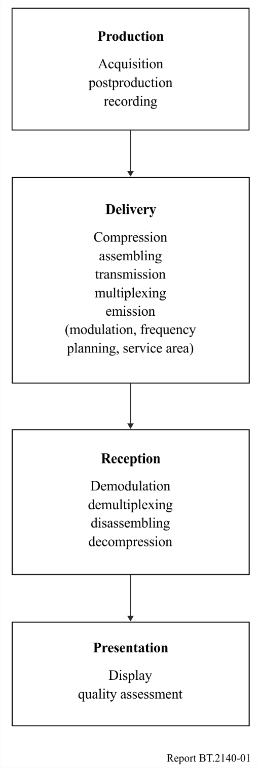
The delivery block includes five main conceptual functions, namely: compression, assembling, distribution, multiplexing and emission.
Compression covers the operations required to reduce the bit rate of each programme component (e.g. video and audio signals), in order that they will require as small a bit rate in the emission channel, as it is strictly necessary to deliver the intended image and sound quality to the end user. This study requires, inter alia, an in-depth knowledge of bit-rate-reduction mechanisms and of their impact on the perceptual quality of programme material.
Assembling merges the various programme components (e.g. video signals, audio signals, signals related to multimedia and interactive applications), in order that they form a properly structured, single serial data stream, that also carries any ancillary information required to manage the programme, such as information on intellectual property rights, conditional access and copy protection. This study, as the one described below, requires a good familiarity with the digital protocols used to smoothly multiplex various digital streams into a single stream, e.g. preserving synchronization of audio and video.
Multiplexing merges various programme streams together, into a single data stream whose bit rate matches the data capacity of the transmission channel used to deliver the programs carried in the multiplexed stream. It also adds the data required to protect those programme signals against errors introduced by the transmission channel. It is at this stage that statistical multiplexing can be best implemented, thus achieving greater exploitation of the bit rate available on the emission channel.
Emission modulates the multiplexed data stream on the channel carrier, in order that it may be broadcast in the foreseen delivery channel. It also studies the frequency plan, the location and design of the emitting antennas and their emitted power. This study requires an excellent grasp of the related spectrum implications, in order to adequately cover the intended service area while complying with the mandated requirements in terms of interference to and from the emissions of other transmitters.
The reception block of the broadcast chain implements functions that are the counterparts of the functions implemented in the delivery block, namely: demodulation, de-multiplexing, disassembling and decompression.
Demodulation operates on the modulated signal received by the receiver at the user premises, recovering the multiplexed bit stream and correcting as far as possible the errors introduced by the transmission channel.
Demultiplexing operates on the multiplexed bit stream, extracting from it the various programme streams that are multiplexed on it.
Disassembling operates on a programme stream selected among those demultiplexed in the previous function, recovering the compressed signals that contain the components of the selected programme (video signal, various audio signals, and data).
Decompression operates on the compressed signals that compose the selected programme, recovering them in their uncompressed form.
The presentation block operates on the decompressed signals, processing them in such a way that the original audio and video programme material may be properly presented on the set (radio or television) at the end-user premises. This study requires matching the characteristics of the devices originally used to capture the programme, to the characteristics of the user’s display. With the current advent of new types of displays, this has become an important challenge.

1.8.3 Outline for the future
Radiocommunication SG 6 grasped the multifaceted nature of broadcasting at an early stage of its activity and has promptly and efficiently addressed this challenge.
SG 6 was mandated to conduct end-to-end studies in the following domains:
− production of programme material (all functions needed to repackage programme material in order that it may also be distributed over the advanced applications such as internet and cellular phones);
− digital signal compression, assembly of programme material and relevant metadata;
− production of television programs for collective viewing in large halls, similar to movie theatres (almost completed);
− distribution of programme material by terrestrial broadcasting and by satellite broadcasting service;
− programme distribution over new, emerging media such as interactive broadcasting and “webcasting”;
− reception of broadcasting service by the end user;
− provide to the end user the best possible quality of picture and sound;
− subjective assessment and objective measurement of perceptual video and audio quality at the end of a chain, even on-line.
Indeed, the broadcasting chain described above applies to both traditional broadcasting and interactive broadcasting, whether it is over the air, by cable television, by fibre optics or via satellite. The identification of appropriate return channels and of the applicable digital protocols to achieve the desired degree of interactivity is being aggressively pursued in cooperation with other Sectors of the ITU.
Nowadays we witness an explosive increase in the convergence of various media in the wake of the pervasive introduction of digital technologies, the success of the approach taken by SG 6 to the study of the broadcasting service as an end-to-end chain, might encourage extending its study to the repackaging of television programme material for distribution by new broadcasting means such as over-the-air distribution of television programme material to fixed, portable and handheld receivers or even for distribution of that material over cabled connections by “web-casting” or “cable-casting”.

Chapter 2
to Part 1

2 Overview of broadcasting technologies

2.1 Introduction
This chapter deals with ITU activities and studies concerning analogue and digital broadcasting systems.
The three ITU Sectors, each within its own sphere of competence, are responsible for activities and studies relating to broadcasting.

2.1.1 ITU-R
Radiocommunication Study Group 1 – Spectrum management
− Recommendation ITU-R SM.1047 – National spectrum management
− Report ITU-R SM.2012 – Economic aspects of spectrum management
− Handbook – National Spectrum Management, 2015
− Handbook – Computer-aided Techniques for Spectrum Management (CAT), 2015
− Handbook – Spectrum Monitoring, 2011.
Radiocommunication Study Group 3 – Radio-wave propagation
− Recommendation ITU-R P.1546 – Method for point-to-area predictions for terrestrial services in the frequency range 30 MHz to 3 000 MHz.
− Recommendation ITU-R P.1812 – A path-specific propagation prediction method for point-to-area terrestrial services in the frequency range 30 MHz to 6 GHz
− ITU-R Handbook – Terrestrial land mobile radiowave propagation in the VHF/UHF bands, 2002.
Radiocommunication Study Group 6 – Broadcasting service
− Handbook – Digital Terrestrial Television Broadcasting networks and systems implementation

2.1.2 ITU-T
SG 15 – Networks, technologies and infrastructures for transport, access and home
ITU-T Study Group 15 covers optical and other transport networks; the related Questions and the associated Recommendations can be found on the webpage of List of Questions and Rapporteurs.
SG 21 (former SG9 and SG16) – Technologies for multimedia, content delivery and cable television
ITU‑T Study Group 21 is responsible for studies relating to multimedia technologies, capabilities, systems, applications and services for existing and future networks, including Internet Protocol (IP)‑based and cable-based networks.
The following Questions and the related Recommendations of SG21 can be found:
Question 6/21 – Visual, audio and signal coding.
Question 13/21 – Multimedia streaming-related systems and services including content delivery, application platforms and end systems.
Question 14/21 – Guidelines for developing countries to implement and deploy digital cable television networks.
Question 21/21 – Transmission and delivery control of television and sound programme signals for contribution, primary distribution and secondary distribution.

2.1.3 ITU-D
Specific collaboration was initiated between ITU-D Study Group 2 and ITU-R Study Group 1 with respect to the implementation of WTDC-98 Resolution 9, entitled “Participation of countries, particularly developing countries, in frequency spectrum management”, leading in the first instance to the adoption of a report in that regard.
The following the ITU-D Questions have been discussed and the pertinent reports can be found on the ITU website:
– in periods 2006-2010 and 2010-2014 Question 11-2/2 – Examination of terrestrial digital sound and television broadcasting technologies and systems, including cost/benefit analyses, interoperability of digital terrestrial systems with existing analogue networks, and methods of migration from analogue terrestrial techniques to digital techniques;
– in period 2014-2018 Question 8/1 – Examination of strategies and methods of migration from analogue to digital terrestrial broadcasting and implementation of new services;
– in period 2018-2021 Question 2/1 – Strategies, policies, regulations and methods of migration and adoption of digital broadcasting and implementation of new services;
– in period 2022-2025 Question 2/1 “Strategies, policies, regulations and methods of migration to and adoption of digital technologies for broadcasting, including to provide new services for various environments” discusses best practices for the transition to digital broadcasting, including television and sound, the use of the released spectrum (digital dividend), and new services and applications in broadcasting.

2.1.4 Regional Radiocommunication Conference
Following the consultations initiated in 2000 regarding the holding of a Regional Radiocommunication Conference (RRC) and planning of the future broadcasting service in the bands 174-230 MHz (VHF bands) and 470-862 MHz (UHF bands), the Plenipotentiary Conference adopted Resolution 117 (Marrakech, 2002) on determination of the planning area for terrestrial television and sound broadcasting in those bands at the Regional Radiocommunication Conference.
At its 2003 session, the Council modified Resolution 1185 to take account of the decisions taken by the Plenipotentiary Conference (Marrakech, 2002) and draw up the agendas of the two sessions of the RRC. In accordance with Council Resolution 1185 (modified, 2003), a report was drawn up in Geneva during RRC-04 (May 2004). It served as the basis for the work of the first session of the RRC, with a view to facilitating the planning exercises prior to the second session and the form in which administrations should submit their requirements. The first session of the conference took place from 10 to 28 May 2004 in Geneva. The second and final session of the Conference took place from 15 May to 16 June 2006 in Geneva. The results are reported in Chapter 4 Part 1, § 4.1.2.

2.1.5 World Radiocommunication Conference
The World Radiocommunication Conference of 2007 (WRC-07) decided to allocate conditionally on a co-primary basis some bands (790/806-862 MHz) to IMT, previously allocated on a primary basis to the broadcasting service (please refer to WRC-07 Final Acts, Article V, Table of Frequency Allocations).
WRC-12 considered further spectrum allocations to the mobile service, including IMT, to facilitate the development of terrestrial mobile broadband applications and allocated the 700 MHz band (694-790 MHz) to the mobile service, co-primary with broadcasting.
WRC-15 allocated a portion (614-698 MHz) or the whole (470-698 MHz) of the UHF band to mobile broadband in a small number of countries in Region 2 and 3.

2.2 Digital broadcasting technologies

2.2.1 Digital fundamentals
There are a number of fundamental technologies which underpin digital broadcasting systems. The more important ones are summarized below.

2.2.1.1 PCM and Sampling
Most digital signal representations and processes are based on pulse code modulation (PCM). PCM was invented in the 1930s and allows an analogue waveform to be represented by a string of numbers known as a bitstream. In its simplest form these numbers are “1”s and “0” (on/off keying) representing binary quantities. The advantage of this over (then) conventional analogue transmission was that, provided the channel quality was sufficient to distinguish a “1” from a “0”, the original signal could be reconstructed to a defined accuracy. Digital systems process signals by manipulating the numbers. With ever more powerful and faster digital number crunching devices coming from the IT industry, the opportunities for advanced signal processing are considerable.
There are two fundamental elements to the PCM process.
First is “Sampling”. The analogue signal is represented by a series of discrete samples. While the analogue signal has to be sampled sufficiently often to allow and accurate version of the original to be re-constructed, there is no benefit in sampling more often than is necessary. The Nyquist-Shannon Sampling Theorem specifies the minimum sampling rate as greater than double the highest frequency component present in the analogue original. Sampling at a lower frequency gives rise to an effect called aliasing, familiar to most people from “western” films where the wheels of the stagecoach appear to go backwards. In this instance the sampling frequency is the frame rate of the camera which is insufficient to resolve the positions of adjacent spokes of the wheel. The effect is used beneficially in stroboscopic examination of fast moving objects.
Second is “Digitization”. Each individual sample has to be converted to a (usually) binary number using an analogue to digital converter. Given sufficient quality and resolution in the converter itself, this can be done to any level of accuracy. The price paid for high accuracy is long binary numbers which, in turn demand high bandwidth if they are to be transmitted in “real time”. The noise performance of the overall system is limited by the resolution of the analogue to digital conversion. Any digital representation of an analogue quantity has an error which is less than or equal to half the least significant bit in the binary number. This noise component is called quantization noise and obviously reduces as the number of bits in the digital sample is increased.

2.2.1.2 Bits, Symbols, QAM and IP
While the digital representation almost invariably uses binary numbers it can be wasteful in a channel capable of carrying analogue signals simply to transmit “1s” and “0s”. The channel capabilities can often be better exploited by using intermediate levels as well. By moving to four levels, “0”, “⅓”, “⅔”, and “1” for example, each level can be made to represent 2 binary bits; “00”, “01”, “10” and “11” respectively. Each discrete level or “symbol” now carries double the amount of information. Depending on the noise in the channel more levels can be resolved allowing each symbol to carry more information. In systems using a carrier or sub-carrier, the phase of the carrier can similarly be varied in discrete steps. This is called phase shift keying (PSK), often qualified as B(inary)PSK for 180° phase shifts and Q(uadrature)PSK for 90°.
Quadrature amplitude modulation (QAM) modulates both the amplitude and phase of the carrier simultaneously. Each symbol is defined by a unique combination of amplitude and phase, chosen to minimize the potential for interference (noise) to confuse any one symbol with others which are in close proximity in terms of amplitude and phase. While any set of symbols can be used, typically 64‑QAM with 64 (2⁶) unique symbols and 16-QAM with 16 (2⁴) are the most common in broadcasting applications; 4-QAM is a variant of QPSK. 64-QAM carries 6 binary bits per symbol and 16-QAM carries 4.
Usually, N-QAM arrangements can be described mathematically. It can be seen that this gives rise to an even spread of N points on a complex plane. This is customarily called a “constellation”.
FIGURE 2
Constellation 16-QAM
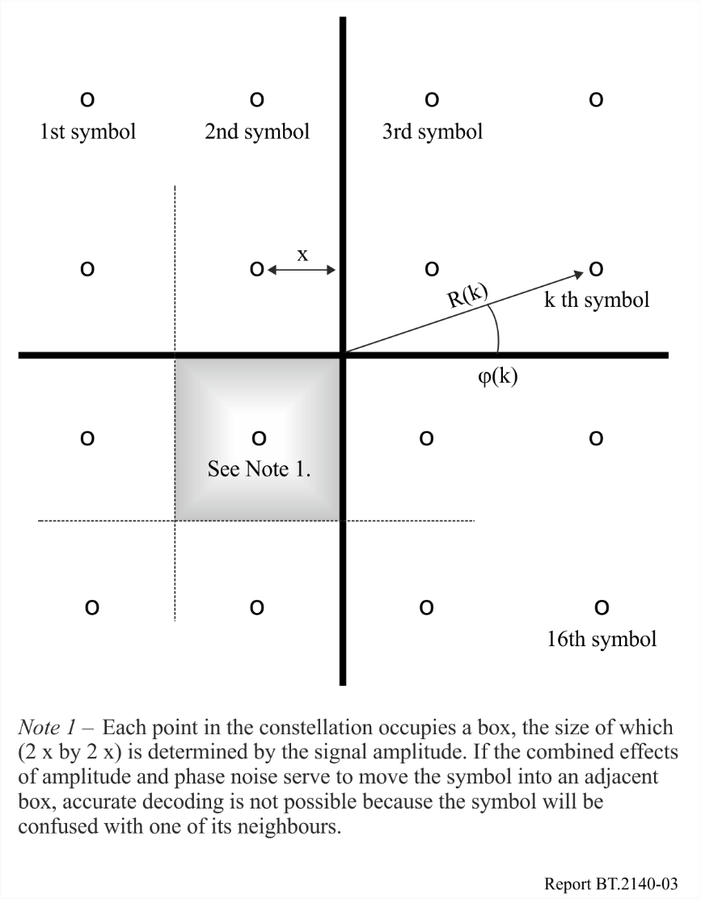

2.2.1.3 Time and frequency division multiplexing
It is often advantageous to transmit more than one bit stream in a given channel. One method, frequency division multiplexing (FDM) puts each bit stream onto a different sub-carrier and adds all of the sub-carriers together ready for transmission. This is a familiar technique and has been used for multiplexing analogue signals for a very long time. It relies on the total channel bandwidth being sufficient to accommodate the sum of the bandwidths of the individual components.
Time division multiplexing (TDM) can only be used with digital systems and places bits (or groups of bits) from one stream in a sequence with bits from other streams. In its simplest form, a bit from stream 1 is followed by a bit from stream 2, then one from stream 3, etc. until it is time to insert a bit from stream 1 again. Clearly, the more complicated the interleaving structure, the more sophisticated will be the timing and date recovery arrangements. Clearly, the throughput rate, in bits per second, of the channel must be greater than or equal to the sum of the bit rates of all the component bit streams.
Time and frequency interleaving and error correcting code are two other important techniques to be considered.

2.2.1.4 Coded orthogonal frequency-division multiplexing
Coded orthogonal frequency-division multiplexing (COFDM) is used extensively in digital terrestrial broadcasting systems. Early experiments with digital broadcasting showed that there could be severe problems with multipath reception in urban areas. A delayed version of the signal could be received that was of comparable magnitude with the direct version and the delay was such that adjacent (or even further separated) symbols would become confused and interfere with each other. The solution was to reduce the effective bit rate and add a buffer interval (the so called “guard interval”) to allow the effect of any reflected contributions to stabilize. Rather than transmit the bitstream at full speed it was divided into a large number of sub-streams (almost the opposite of TDM), each with a much lower bitrate and each modulated onto a different sub-carrier; a clear example of frequency division multiplexing. Since the bitrate on each sub-carrier was relatively small, they could be closely spaced and a large number fitted into the channel bandwidth. In COFDM systems, each carrier actually carries an N-QAM signal with N typically 4, 16 or 64 in broadcasting applications.
Conventionally, each sub-carrier in an FDM scheme is extracted from the multiplex by filtering before it is demodulated. This implies a certain separation, or “guard band”, between the modulated sub-carriers. If the frequencies of the sub-carriers are chosen with care they can be made to be mathematically orthogonal. This means that they can be closer and can even overlap. Orthogonality means that the intrusive effect of an adjacent sub-carrier, when integrated over one whole symbol period, is reduced to almost zero; actually zero (only) if the adjacent sub-carrier is unmodulated. Very simply, there is a whole number of cycles of the adjacent sub-carrier within the symbol length when the wanted sub-carrier has been translated to base band.
Inevitably, any radio transmission channel will be affected by flat or selective fading. Hopefully, the channel bandwidth can be sufficient to minimize the former, but selective fading will occasionally take out one or a group of adjacent channels in the multiplex. Interleaving will mean that any errors in the received signal can be spread so as to have a small impact on a large number of samples rather than a gross effect on a few. Coding, or strictly error correcting coding, is used in COFDM to minimize the impact on the overall received signal of selective fading and the occasional “drop out”.
COFDM brings together most if not all of the techniques covered in earlier sections and gives a modulation scheme which is both efficient and robust.

2.3 Digital terrestrial television broadcasting

2.3.1 Introduction
Digital TV was introduced in 1994 in the United States of America and in 1996 in Europe and Japan, first on satellite and soon after on cable and terrestrial networks, based on the Advanced Television Systems Committee (ATSC), Digital Video Broadcasting (DVB) and Integrated Services Digital Broadcasting (ISDB) specifications.
With the advent of digital television, the public authorities made preparations for the transition from analogue to digital television to be as smooth as possible. The United States scheduled the cessation of analogue television broadcasting in February of 2009. Japan scheduled to cease analogue television broadcasting in July of 2011. Korea planned to make the transition from analogue to digital in December 2012. In Europe the analogue switch-off started in 2006 and was completed in 2020. Brazil ceased analogue television broadcasting progressively, from 2016 to 2019 in all state capitals, metropolitan areas and other areas where the analogue switch-off was required to clear the 700 MHz band, and is scheduled to complete its analogue television switch-off up to 2023 in the rest of the country.
Government authorities studied the policy implications, proposed services, market (potential audience and financial volume), availability of channels for introducing digital television service and, of course, the technical integration of such a service in the existing analogue network.
The first stage in such a migration required that a regulatory framework (law or ordinance) be set up to govern the introduction of digital television, specifying the number of multiplexes authorized (several broadcast channels per multiplex, one multiplex occupying the equivalent of an analogue channel) and the types of service.
The migration from a television service dependent primarily on the application of analogue technologies to one that is based on digital technologies has been evolving over the past thirty years. This television service migration is part of a natural outgrowth of the convergence of the television, telecommunications and computer arts and sciences through the shared use of digital technology.
The input and output signals of television systems, at the camera and at the receiver, respectively, are inherently analogue. Thus, the question “Why digital?” is a natural one.
While signal degradations in the analogue signal are cumulative and the characteristics of the degradations make them difficult to distinguish from the video signal, the ability to regenerate a digital pulse train exactly renders the digital signals theoretically immune to impairments from external sources. Digital bit streams can be interleaved within a single channel. This interleaving process allows for the emission, transmission, storage or processing of ancillary signals along with the video and associated audio. Further, compression techniques based on redundancy reduction can be applied to digitized video and audio services allowing the possibility of transmitting one HDTV service, multiple standard services or combinations of HDTV and SDTV in an existing broadcasting channel.
The arrival of the second and third generation component and composite digital video tape recorders, switchers, animated graphics and special effects machines and agreement on a serial digital signal interface by 1990 have sped up the move to implementation of the all-digital production facility. Digital production and use of digital tape recorders moved the broadcaster’s practice on multi-generation editing from five generations of post-production editing using analogue technology to tens of generations using digital technology. The application of digital techniques has reduced camera set-up time from hours to near-instantaneous. Digital library systems made the location of recorded media transparent to the user. Computer control of the entire process penetrated deeply into the programme generation and distribution facility, bringing with it precise control and function repeatability.
The first use of digital broadcasting technologies has been for distribution between the studio and the transmitting sites either via satellite or terrestrial links.
Consequently the advantages of the digital terrestrial television broadcasting (DTTB) are as follows:
As well as more channels than analogue television, digital television terrestrial (DTT) offers advantages likely to encourage viewers to buy or rent new equipment in order to receive it:
a) Better images and sound − A driving force behind the development of DTT was the ability to transmit high definition television (HDTV) to consumers. HDTV with high quality surround sound is the major focus of all delivery platforms including terrestrial broadcasting, satellite and cable. HDTV is also being delivered on disk using Blu-ray technology.
b) Attractive new programmes − The attraction must be real and sufficient to capture audiences. Three types of channel are likely to arouse viewer’s interest: general channels which either innovate or differentiate themselves from existing ones; more thematic channels, sufficiently encompassing and likely to appeal to a fairly broad target audience; and local or regional channels, which respond to the social, economic, and political concerns of viewers in their immediate geographic environment.
c) Portability − In the absolute, this is the ideal technical solution: by means of an antenna integrated within or connected to the set, television can be received outdoors as well as anywhere in the house, even on a pocket set. In terms of broadcasting infrastructure, however, it will be costly, as the main transmitters will need additional relays in order to provide all viewers in the DTT coverage area with portable reception.
d) Interactivity – The fast growing of the Internet has led to a strong integration between traditional DTT services and IP related applications. Smaller screen devices such as smartphones are often used as “2nd screens”, providing control interfaces and auxiliary services for the TV device. In this context, the development of optimized hybrid broadband broadcast languages allows code developers to easily integrate broadband and broadcast technologies.
The integration of broadband and broadcast networks leads to the development of “2-Way” services, such as quality of service (QoS) measurement, user profiling and video-on-demand services.
e) Mobility − One of the most obvious advantages of terrestrial broadcasting compared with other means of broadcasting is the capability to provide mobile reception for cars, trucks, buses and trains.
The most difficult switchover case is with terrestrial TV due to such factors as lack of spectrum in certain areas, cost of achieving wide coverage, relatively limited network capacity, competing TV offers already in place, and business mistakes.
However, there are significant national differences, notably in relation to market variables like penetration of individual TV networks (terrestrial, cable and satellite) and business models (free-to-air versus pay-TV), but there are also differences between national policies regarding the migration to digital broadcasting. So far, digital TV has mainly grown on the back of satellite pay-TV, with free-to-air still accounting for less than 20% of total digital TV viewing. In turn, pay-TV has been driven by multi-channel and premium programming, together with operator’s subsidies for set-top-boxes.

2.3.2 Description of digital television broadcasting systems
Various digital television systems have been developed for terrestrial broadcasting. The relevant systems are:
– ATSC 1.0/ATSC Mobile DTV/ATSC 3.0 – Advanced Television Systems Committee – (System A/Multimedia System S).
– DTMB/DTMB-A – Digital Terrestrial Multimedia Broadcast / Digital Terrestrial Multimedia Broadcast – Advanced (System D).
– DVB-H – Digital Video Broadcasting Handheld.
– DVB-T/DVB-T2 – Digital Video Broadcasting Terrestrial – (System B).
– ISDB-T – Integrated Services Digital Broadcasting Terrestrial – (System C).
– T-DMB/AT-DMB compatible with DAB.
– ISDB-T_{SB} – Integrated Services Digital Broadcasting-Terrestrial Sound Broadcasting – (Multimedia System F).
– FLO – Forward Link Only (Multimedia System M).
Details of systems may be found in Recommendation ITU-R BT.1306 – Error-correction, data framing, modulation and emission methods for digital terrestrial television broadcasting, in Recommendation ITU-R BT.1833 – Broadcasting of multimedia and data applications for mobile reception by handheld receivers, in Recommendation ITU-R BT.1877 – Error-correction, data framing, modulation and emission methods and selection guidance for second generation digital terrestrial television broadcasting systems and in Report ITU-R BT.2295 – Digital terrestrial broadcasting systems.
For more details see the Handbook on Digital Terrestrial Television Broadcasting Networks and Systems Implementation.
For the key characteristics of digital terrestrial broadcasting systems see Report ITU-R BT.2295.

2.4 Evaluation of potential digital terrestrial television broadcasting systems
In recent times, several digital broadcasting systems have been proposed in different areas of the world.
All of the currently implemented systems are based on the availability of a high efficiency encoding system with the capability to compress the bit rate needed to transmit digital contents to values compatible with the characteristics of the available on-air channels.
For TV broadcasting, the MPEG standard is currently almost globally adopted in its various levels, even though newer and possibly even more efficient encoding standards have been recently proposed.
The different currently available digital transmission systems have been proposed in different times, and the newer ones are supposed to benefit from the analysis of advantages and disadvantages of the previously proposed ones.
In the search for a real “killer application” for digital broadcasting, of the utmost importance is the capability of the digital standard to adapt to possible advanced broadcasting services. Concerning digital TV broadcasting, this includes interactivity, datacasting, portable and mobile reception.

2.4.1 Evaluation of specific digital terrestrial television broadcasting
The available standards for digital terrestrial TV broadcasting can be roughly divided in two groups:
− Single carrier codes (like 8-VSB, used in the ATSC standard ATSC-A/53)
The 8-VSB system is based on coding the digital information to be transmitted using amplitude only (8 levels). The modulated signal is then processed through a Nyquist filter, in order to reduce the transmission bandwidth.
− Multicarrier (various evolutions of COFDM), on which DVB-T – adopted in Europe and in Countries involved in the RCC-06-, ISDB-T – adopted in Japan-, and other codes are based.
The COFDM approach is based on splitting the data between a high number of carriers within the operating channel. The digital information associated to each carrier can then be coded using amplitude and phase (e.g. QPSK, 16-QAM, 64-QAM). Together, the digital data simultaneously transmitted and associated to the different carriers constitute an OFDM symbol.
COFDM-based codes allow the transmission through the physical channel of a multiplex, consisting of several contents that can then be selected and extracted by the receiver.
Moreover, the signal spreading over many carriers distributed over the whole channel width, together with the error-recovery systems introduced to safeguard the data integrity, make it possible to consider COFDM-based systems, like DVB-T, also for the implementation of SFN networks, in which the same frequency is used for the transmission over adjacent coverage areas and the implied fading due to co-channel interference between signals originated by transmitters operating on the same frequency is recovered due to the COFDM system characteristics. SFNs in DVB-T have been rolled out many countries.
The same high immunity to interferences makes COFDM digital broadcasting systems also suitable for mobile reception. Especially suited to this purpose is the recently issued standards for handheld receptions listed under Recommendation ITU-R BT.1833. In this case, special attention has been paid to preserving battery life, error correction mechanism, etc. in order to enhance the system’s robustness.
For more details on the systems, see the Handbook on Digital Terrestrial Television Broadcasting Networks and Systems Implementation.

Chapter 3
to Part 1

3 Application and implementation of digital broadcasting
Traditionally, broadcasting and telecommunications have been treated as separate, vertical markets. Digital convergence, which means the same digital content can be transported over any of those networks, has a potential to create new horizontal markets within each level of the value chain such as content, service provision, network operation and terminals thereby opening up an abundance of new business opportunities. People are able to access any multimedia services from any type of delivery platforms such as fixed, portable and mobile with reasonable costs.
Switchover, i.e. the transition, from analogue to digital broadcasting is a complex process with social and economic implications going well beyond the pure technical migration. Digital broadcasting development is positive as it improves both the range and quality of services, notably thanks to digital compression. This improves both spectrum efficiency and network payloads.
Digital TV switchover should be an inclusive process encompassing various networks, business models and services, including free to-air TV, better picture quality or data and interactive services. Analogue switch-off should only take place when digital broadcasting has achieved almost universal penetration, taking all the above possibilities into account, to minimize social cost. Policy intervention should take place at national level in the first instance, considering market and policy differences between Member States in the area of broadcasting. However, the ITU has also a role to play, in particular in view of the internal market aspects. Possible ITU contributions concern notably: benchmarking, equipment standards, consumer information, facilitating and promoting access to added value services.
The industry is in the process of developing technologies that will make digital convergence a reality. Digital convergence allows content and service providers to deliver their offers through multiple delivery mechanisms. Correspondingly, consumers can access services via various terminals delivering multimedia content and more services via a single terminal. This blurs the borderlines between the traditional broadcasting and electronic communication sectors and consequently has a profound effect in the future of media distribution. Consequently, regulatory provisions must be carefully elaborated to reflect those changes.

3.1 Regulatory considerations
Regulation should allow multimedia service provision through all types of delivery networks, and regulations should ensure that a level playing field exists for all actors in the new horizontal markets and should correct imperfections of the market. To facilitate this process, the existing political and regulatory structures need to be adapted.
It is also important that spectrum policy (which includes and takes into account items such as allocations, assignments, and liberalization) provide access for all contenders in a harmonized, open, transparent and non-discriminatory way, and the means for sufficient and appropriate delivery capacity. In order to facilitate the development of global service and delivery, as well as interoperability and economies of scale in the production of equipment, a globally harmonized spectrum usage should be encouraged, without preventing, at the same time, the flexibility needed for the creation of a competitive and technologically advanced scenario through spectrum management and licensing. In addition, the spectrum usage should also allow for regional differences in the amount of spectrum required for content delivery and for interactive services, since customer demand and interest may differ between regions.
The new regulatory environment should also allow multimedia service provision through all types of delivery networks (broadcasting and mobile). In fact, network usage expands and becomes more flexible when it is not bound to the transmission of certain kinds of content. The expansion of usage will increase the desire to invest in the building of networks, and their technological improvement.

3.2 Efficient usage of broadcasting spectrum
The migration from analogue to digital broadcasting has already commenced in many countries and is expected to continue throughout the world for the next years. The actual duration of parallel analogue and digital broadcasting, i.e. the date when the analogue transmissions will end, will vary from country to country.
There are a number of elements to this transition:
– the switch on of digital TV;
– the switch off of analogue TV;
– how to deal with the reuse of analogue TV spectrum (“refarming”).
This development will bring about significant new capacity for new services, as digital content can be broadcast in a fraction of the radio bandwidth that would be required for the equivalent transmission in analogue mode. Consequently, a much larger offering of digital TV programming is technically feasible while using less of the available radio spectrum. Furthermore, new types of digital services and content can be offered through this digital broadcast spectrum, both during the introduction of the digital technology is introduced but even more so also once analogue broadcasting has ceased – even while significantly increasing the quantity of broadcast TV (video) programming.
The full benefits of the all-digital future will only be realized once analogue switch-off has been completed. The key issue will be to ensure the availability of many different services by many different service providers, as well as to guarantee openness and neutrality, which will pave the road for innovative services, technological innovation and vigorous competition to the benefit of the consumer and the entire economy.

3.3 Requirements of television broadcasting services

3.3.1 Network aspects
The advantage of digital terrestrial broadcasting in terms of portability, mobility, integrated receivers and set-top reception fully justify the maximization of terrestrial coverage. In many countries most households receive analogue broadcasting by terrestrial means. For those households who only want digital free-to-air services there will be a strong expectation of receiving these services by terrestrial means. The existing terrestrial analogue network infrastructure can be fully utilized for this.
The concept of single frequency networks (SFNs) is efficient in saving the spectrum required to offer service to a limited geographical area.
However, for DVB-T, by having both 2K and 8K modes as well as several guard intervals, the system can offer efficient tools for planning SFNs for various purposes including mobile reception. As is widely known in the broadcasting world, by also using gap fillers or repeaters, transmitters can easily enhance reception with full compatibility with respect to future upgrades, and portable and mobile reception possibilities will be better. This means that network extensions and modification for mobile or portable reception can be implemented at reasonable costs.

3.3.2 Receiver aspects
There will likely be four main types of receiver:
1) Fixed digital TV and set-top boxes for fixed reception using either roof-top antennas or fixed indoor antennas.
2) Portable TV or radio sets.
3) Car-installed terminals and mobile hand-held terminals, integrating with 3G/4G/5G cellular functions.
4) Mobile/portable broadband wireless systems.
Types 3 and 4, i.e. hand-held and portable terminals, will be battery operated and must focus on low power consumption. Therefore extra care has to be taken to make the radio environment such that this would be possible, and also user-friendly and convenient from the terminal and RF viewpoints. In particular, as regards TV one of the major concerns with the current environment is the placement of digital channels all over the UHF spectrum so that high-power analogue channels are adjacent to digital ones. This sets up very high linearity requirements from the terminal’s RF components, and thus consumes excessive power. Having a unified part of the spectrum reserved only for portable/mobile digital data broadcasting and broadband wireless would help to ease the situation considerably.

3.4 Aspects related to the interoperability of systems
Regarding more sophisticated functionalities such as Application Programme Interfaces (API), interoperable and open solutions for interactive TV services must be encouraged. The Member States will decide whether it is necessary to mandate certain standards to improve interoperability and freedom of choice for users. Indeed, these two criteria will likely contribute to consumer uptake of digital broadcasting in a market-led switchover scenario, thus minimizing the need for public intervention.
The interoperability of systems is facilitated by the introduction of new technologies and convergence of services.

3.4.1 Digital reception
Ensuring that most users are equipped with digital receivers is the main challenge for switchover and a pre-condition for switch-off. Finding a solution for all receivers in the home, not just the main receiver, just adds to the challenge. The two basic options are digital converters or set-top-boxes connected to analogue receivers, and integrated digital receivers. Moreover, additional reception facilities such as cabling, antennas and dishes are often necessary.
There must be a large range of digital reception solutions to suit various user segments. This means choice of functionality, price and commercial formulas. Equipment cost is not a major barrier to the consumer of pay-TV services since some pay-TV operators subsidize it, having already deployed millions of set-top-boxes. However, pay-TV will not achieve the widespread penetration of digital TV only. Now the main challenge concerns the creation of “horizontal” markets for unsubsidized receivers supporting free-to-air digital TV services, where consumers pay the full cost from day on Co-existence of the two business models is important for wide-spread digital TV market penetration.
Availability of cheap receivers is essential to minimize entry barriers for consumers. Most of them must be equipped before the switch-off can take place. Equipment costs should not be much higher than in analogue and services at least comparable, thus offering a cheap entry point to digital TV. This is the way the market seems to go now. Of course consumers should also have options to buy expensive equipment supporting sophisticated services. Service and equipment diversity also contributes to wide-spread digital TV market penetration.

3.4.2 Encouragement to deployment of digital receivers
Free movement of goods within the internal market requires that national authorities do not impose administrative constraints for commercializing digital broadcasting equipment and compulsory technical requirements.
Some ITU Member States envisage public subsidies for digital equipment through schemes aimed at the whole population or just specific groups. The risk with the first scheme is discouraging purchases, including purchases of more sophisticated equipment than the one subsidized. The risk with the second scheme is trading of devices between subsidized and unsubsidized population groups.
Several other forms of incentives have been considered by some Member States, for instance temporary and digressive reduction of the license fee for homes with digital equipment to encourage fast digital migration, etc. Some Member States allow a reduced rate of VAT on pay-per-view and subscription broadcasting services. The financial implication and parties affected are different, so each option should be carefully analysed and implemented.

3.4.3 Consumer information on digital equipment and switchover
Consumer information is crucial to drive digital equipment sales in a market-led approach to switchover. Consumers should be empowered to plan their own migration rather than being forced and thus deprived by this process. They should be well informed of the timing and consequences of switchover so as to take their own decisions on services and equipment from a wide range of choices. They must be aware of what various devices can offer, what are the prospects of analogue equipment obsolescence and the possibilities for upgrading. Information and labelling should also be available in accessible formats for consumers with disabilities.
Informing consumers is the responsibility of equipment manufacturers, retailers and service providers, who need to co-ordinate their action and send clear messages whilst respecting competition law. Labelling schemes for analogue and digital equipment, with explanatory notices and/ or logos, based on voluntary industry commitment, would be particularly useful. The goal would be to send consumers positive and negative signals about, respectively, digital-compliant and analogue-only receiver equipment. This information should mirror national switchover policies, including indicative national or regional switch-off dates. Especially as an analogue switch-off date approaches in a particular Member State, its consumers should be clearly warned about the risks of equipment obsolescence.
Policy intervention in this area has been proposed in some ITU countries. However, Member States cannot impose de jure or de facto compulsory labelling schemes without prior notification. Notification enables a compatibility assessment of such measures with internal market rules to be undertaken. Where necessary, a certain degree of harmonization could be envisaged so that the approach to labelling would be common whilst tailoring its implementation to local circumstances, such as national switch-off dates. Labelling specifications could be approved by consumer and standardization bodies.

3.4.4 Integrated digital television receivers
The prohibition of selling analogue-only television receivers according to a staggered calendar was approved and is now fully implemented in many countries.
Another potential drawback of compulsory integrated digital receivers would be the extra cost for consumers which, depending on the exact technical requirements, could however be partly offset by economies of scale. The impact would be greater in those countries where digital TV is less developed. Concerns can be also raised as to the technological neutrality of the measure. If only one type of digital tuner were to be mandated, this would presumably favour the dominant analogue TV network, often terrestrial.

3.4.5 Digital connectivity
Currently, digital TV signals are almost always displayed on analogue TV sets connected to a digital set-top-box, which decodes those signals, through the analogue “SCART” socket or connector. That means digital signals are converted into analogue signals before being displayed. This is acceptable for television receivers, based on cathode ray tubes and small screen sizes. However, the quality penalty is more perceptible on big screens using new digital display technologies. Moreover, the lack of systematically implemented and enabled digital connectors prevents the transfer of digital information between digital TV receivers and other digital devices in the home. But digital connectivity raises copyright security concerns, in particular that insufficiently protected digital content could be illegally copied or distributed. The possibilities for implementing digital connectors should be further explored as an incentive to consumer equipment switchover. A number of options exist to interconnect digital TV equipment, fulfilling different requirements but it is still unclear which way the market will go.

3.4.6 Access for users with special needs
Access to digital broadcasting should include citizens with special needs, notably people with disabilities and older persons. Digital broadcasting offers greater possibilities than analogue in this area, and these are supported by digital equipment on the market. Harmonized approaches can reduce costs through economies of scale, thus facilitating the marketing of relevant functionalities.

3.4.7 Removal of obstacles to the reception of digital broadcasting
Infrastructure competition stimulates market development, increasing consumer choice, quality of service and price competition. This may be constrained in some areas by legal, administrative or contractual restrictions on the deployment of infrastructure or reception facilities. Authorities will need to arbitrate between promoting digital broadcasting and the fundamental freedom to receive information and services, therefore facilitating network competition, and other policy objectives on town planning, environmental protection or other areas. With that proviso, national authorities should encourage network competition. By way of example, some Member States have already adopted measures in support of this objective, for instance by requiring the provision of multi-network reception facilities in new apartment blocks, facilitating their installation in existing blocks (for instance by reducing the required threshold of tenants’ votes), or by removing restrictive clauses in property or renting contracts. Coordination between national and local authorities is important since local authorities are often responsible for the practical implementation of this type of measure.

3.4.8 Effects on citizens
In all transition periods there are a lot of actors, but the past has shown the principal actors are the users. The decision of the users is in all cases oriented by market forces that, driven politically by Administrations and Manufacturers with the support of Broadcasters, can promote the opinion for change to oldest analogue systems and buy the new digital equipment. What is very important and urgent is the coordination among the different actors. In fact, if the users are ready to buy new equipment and the manufacturers have produced the equipment, is very important to have a “frequency planning” programme prepared by Administrations and, at the same time, a sufficient number of programmes emitted, with interesting contents attract the attention of users and promote the change.
The users are moving fast towards a mobile 4G/5G lifestyle and future technologies have taught us to use mobile technology in our everyday communication. By receiving mobile broadcasting services in conjunction with 4G/5G as a return channel, consumers will be able to receive a new kind of content service and have increased interactivity. Joint utilization of digital broadcasting and existing and new cellular/cellular-type network technologies will provide consumers with location-independent and personalized services. Additionally, the delivery of digital media content via several distribution channels strengthens the availability of information society services, as they could be provided in various manners, via different network transmission methods. The use of more extensive and diverse communication networks promotes the availability of additional services and the development of content and receivers at affordable prices. This will mean information society services, including public services, can be made more accessible and cheaper than ever for all citizens by combining the usage of different types of distribution communication networks or by offering them via one communication network.
For digital television and radio, the crucial conditions for success require a public that is informed on the facilities and benefits offered by the new digital services, including technical enhancements, additional programmes and services. The public must be aware of the additional service opportunities digital broadcasting and consumer electronics will offer. (For example, initiatives in this direction (i.e. to raise the public’s awareness) are already ongoing in some European countries.) In addition, geographical access to digital services should be maximized and the new services should be accessible on the shortest time-scale.
Open access to public services of the information society should be encouraged, and directly developed whenever possible. This will support and speed up the implementation and success of digital broadcasting and additional datacast services. The lifetime of consumer products is in general expected typically to be from 5 to 10 years, and in some instances more. This requires stable systems, open access and the possibility of upgrading. This can only be assured when there are common, widely adopted standards jointly agreed among market players.

3.5 Market impact

3.5.1 Market complexity; plurality of scenarios and stakeholders
There is no single switchover pattern or formula. Experiences vary according to the local circumstances and from one network to another. Consequently, the general analysis provided here could only be a simplification. The switchover debate tends to focus on terrestrial TV for two reasons: greater difficulties for a market-led digitization than other networks; and higher political stakes and government involvement, mainly because of the pressure to recover spectrum, and a wide-spread perception associating terrestrial with universal free-to-air broadcasting services.
Switchover is a complex and long process involving many variables and affecting more or less directly many parties, namely: users/ consumers, industry and public authorities. Each group can be further subdivided into smaller segments. For instance, users can be categorized according to their attitude towards digital TV: current or potential pay-TV subscribers, assuming that all pay-TV will be digital sooner or later; current or potential free-to-air digital TV viewers, who have bought or are ready to buy a digital receiver; viewers who will be always reluctant to adopt any form of digital TV, pay or free-to-air, for various reasons. The switchover strategies adopted will obviously determine, and be determined by, the respective percentage of each user category. In particular, the extent to which market forces alone can achieve digitization will depend on the number and resilience of consumers reluctant to migrate to digital TV.
Switchover also concerns many industry players, such as content creators, service providers, network operators or equipment manufacturers. Some were already active in the analogue broadcasting market, others look for new business opportunities. Likewise, various departments in national and international administrations are interested in switchover insofar as it affects the achievement of policy objectives.

3.5.2 The case for public intervention
A key question is whether public authorities should intervene to accelerate switchover and/ or otherwise influence the process. That would be justified under two premises: first, the extent to which general interests are at stake; that is, how far there are potential benefits and/ or problems for the society as a whole, rather than just for certain groups or individuals. Secondly, market failure; that is, market forces alone fail to deliver in terms of collective welfare. In other words, market players’ behaviour does not fully internalize switchover costs. Assessing the existence and intensity of both premises is largely a matter of political judgement by the competent authority, which, in the case of broadcasting, tends to be national and/ or regional authorities. In any case, such judgement should not be arbitrary but supported by sound market analysis.
As to general interests, potential benefits from digitization can be oriented towards various policy goals: social, cultural, political, economic, etc. Usually there are trade-offs to make between them. For instance, part of the spectrum released by analogue switch-off could be redistributed in order to transfer this resource to operators who would use it to support different services or “reinvested” in broadcasting to improve and extend the service.
The broadcasting sector is not comparable to any other sector, as it plays a central role in modern democratic societies, notably in the development and transmission of social values. Broadcasting offers a unique combination of features. Its widespread penetration provides almost complete coverage of the population across different broadcasting networks; provision of substantial quantities of news and current affairs together with cultural programming mean that it both influences and reflects public opinion and socio-cultural values. Switchover may affect these general interests. It will be important to ensure the continuing availability of a variety of television services, without discrimination and on the basis of equal opportunities, to all parts of the population. In particular, this is a pre-condition for public service broadcasters to fulfil their special obligations.
The likelihood of market failure is linked to the complexity of the environment where switchover takes place, and the interactions between the main parties involved. All have interests to defend and seek to influence the main variables: introduction or not of digital terrestrial TV, speed of the migration and switch-off timing, convenience and type of public intervention. However, coordinated action from the main stakeholders, rather than confrontation of individual strategies, is likely to lead to the collective optimum: a swift and efficient switch-off, with the minimum negative social and economic implications.
At least in the case of terrestrial television and radio, a series of structural failures hinder market cooperation and slow down switchover, notably (free riding) behaviour, oligopoly situations and “chicken and egg” deadlocks. More specifically, the parties benefiting the most from switchover (equipment manufacturers or potential beneficiaries of released spectrum, including new broadcasters) may be different from those likely to bear the costs (final users or current broadcasters). So the latter have little incentive to internalize the costs and contribute to the switchover. Overcoming this kind of situation would require setting up coordination mechanisms to share benefits and costs between all parties involved, ideally with little or no public intervention. In this regard, public authorities, especially those responsible for competition law, must make careful judgements as to the right balance between market competition and cooperation between relevant parties. Those judgements must be based on clear understanding of both market dynamics and policy goals pursued.

3.5.2.1 Modalities
If the need for public intervention is established, decisions must be taken about its modalities, within a coherent switchover strategy. Any intervention should be transparent and proportionate as to the policy objectives pursued, market obstacles, and implementing details. This would provide certainty for all parties to prepare themselves and would limit the scope for arbitrary or discriminatory measures.
Five principles and guidelines for regulatory action can be established. Regulation should:
− Be based on clearly defined policy objectives.
− Be the minimum necessary to meet those objectives.
− Further enhance legal certainty in a dynamic market.
− Aim to be technologically neutral.
− Be enforced as closely as possible to the activities being regulated.
A key area in national switchover strategies is the approach to digital broadcasting licensing and regulatory obligations attached thereto. This involves policy choices on network competition versus complementarity, number of operators, roll-out calendar and map, etc. Otherwise, there is a variety of possible intervention instruments and measures to encourage switchover, ranging from encouragement measures, like information campaigns, to compulsory ones, like analogue turn-off dates, or mandatory standards for equipment including digital tuners. They can also vary according to the parties targeted (consumers, equipment manufacturers, broadcasters, potential users of released spectrum, others). The impact of the planned measures should be evaluated through prospective economic analysis to ensure that the expected cost and benefits are fairly distributed; public policy should not lead to situations where some parties will be forced to bear most switchover costs whilst others will enjoy the benefits.
Timing is a key element of any intervention on switchover. Premature or late action can be useless and even counterproductive insofar as it introduces market distortion. Timely intervention requires good knowledge of market status and evolution, and therefore regular monitoring and analysis. In principle, an early switch-off is likely to be more controversial, but a more distant date may reduce any beneficial impact. In this connection, three main phases can be identified in TV switchover: the take-up phase driven by pay-TV, where sooner or later operators convert subscribers to digital; the consolidation phase, starting now in the countries where digital TV is the most advanced, where some consumers decide to equip themselves with digital devices to receive free-to-air digital TV; the closure phase, where users still not interested in any type of digital TV are forced to adopt it, with or without public support for the acquisition of a digital receiver.
Public intervention can support digital TV penetration in all three phases but stronger measures should be confined to the closure stage, after industry has made all possible efforts to increase consumer uptake. This requires that authorities ensure a favourable and predictable regulatory environment, and intensify their action when the market cannot deliver further. That may be the case when it is considered that digital broadcasting is not progressing quickly enough to achieve policy targets.

3.5.2.2 Risks
Broadcasting has a stronger tradition of policy intervention than other information and communication sectors like telecommunications, where the impact of liberalization has been greater. This is justified by the political and social relevance of broadcasting content, which calls for the enforcement of minimum quality and pluralism requirements. Policy intervention is even greater in the case of terrestrial broadcasting because of its heavy use of spectrum, a scarce public resource, and the already-cited perception associating terrestrial with universal free-to-air TV services.
However, the contexts surrounding the introduction of analogue and digital broadcasting are very different. When analogue broadcasting was introduced, only the terrestrial option existed; there was no competition and the market was entirely shaped by regulatory intervention. Now, there are various types of networks, high market competition and faster technological change. Under these circumstances, the transition to digital broadcasting represents a big industrial challenge that must be led by the market. Intervention from public authorities to facilitate and supervise the process could be justified insofar as general interests are at stake.
The risks from both public intervention or absence of it must be assessed. Non-intervention can result in market failure and jeopardize general interest goals in the sense explained above. As to the risk from public intervention, it includes policy-driven approaches captured by industrial parties seeking to offset commercial risk, thus reducing competition and pressure to innovate. This could result in perverse effects, like “moral hazard” or market inaction, and ultimately slow the switchover process down. In practice, these parties may exaggerate the advantages from digital broadcasting, mixing private and collective benefits. Then, they might persuade authorities to support them (legally, financially or otherwise) in the name of general interests to gain a competitive edge over rivals. If not transparently justified, this could distort the market.
Moreover, public intervention, or the simple announcement of it, that turns out to be inappropriate for any reason (disproportionate, discriminatory, untimely, etc.) can be counterproductive. It can create additional obstacles to digital broadcasting uptake, by stimulating an appetite for more public intervention than would have been necessary otherwise. For instance, if a government announces too early that digital receivers will be offered to all remaining analogue users shortly before analogue switch-off, there will be little incentive for those users to buy receivers. Also, untimely imposition of technical standards that are immature or require costly implementation may discourage investment. Finally, all intervention by national authorities must be compatible with existing law.

3.5.2.3 Policy orientations
As explained, market forces must drive the switchover process focusing on users. The challenge is to stimulate demand so that it is a service-led process rather than a simple infrastructure change with no perceived added-value for citizens. Consequently, the various consumer segments must be offered packages of services and equipment that are attractive to them; that is, stimulating, user-friendly and affordable. This is primarily a task for market players.
There is however also scope for policy intervention considering the social and industrial general interest at stake, and that some key elements of the process are the responsibility of public authorities. Such intervention must be conducted in the first instance by national and/ or regional authorities, which are the most directly responsible for broadcasting content policy and licensing.

3.6 General strategy and coordination

3.6.1 Transparent strategy and monitoring
As indicated, policy transparency improves certainty for market players (including consumers), encourages coordinated action, and ultimately facilitates the switchover.
At ITU level, comparison of national experiences and regular monitoring would provide useful information on policy and market status. This would help identifying possible actions to develop internal market synergies.

3.6.2 Regulation allowing for business autonomy and cooperation
Developing digital broadcasting markets is a complex process requiring significant investment from many players to: roll-out networks, develop enabling technologies, sell terminals, offer compelling services, and encourage user uptake. Industry must have incentives to invest and autonomy to search for winning formulas. This requires a stable regulatory environment, including licensing terms for service operators with a duration that enables an appropriate return on investment, taking into account the additional costs caused by the transition and with the possibility of licence renewal so as to provide an adequate incentive. Licensing terms should also facilitate provision of sufficient network capacity to support a variety of services.
However, authorities should monitor market evolution, consult with industry, and be ready to review or flexibly interpret conditions relevant to switchover where justified, for example conditions concerning the calendar for roll-out and territorial coverage, technical choices on transmission and terminals, ownership thresholds, price caps, taxes, simulcast extent and timing, or obligations to provide certain programming. Authorities may have trade-offs to make between a faster switchover and other policy objectives, for instance regarding the degree of pluralism, and they need to consider the impact of policy choices on market competition. The challenge is to find the right balance between different policy objectives while respecting legal requirements, in order to maximize collective welfare. For instance, as argued below, coordination and cooperation between different industries is important for switchover. While various public policy objectives can be taken into consideration in this context, competent authorities must ensure maximum transparency regarding such objectives and the necessary means to achieve them. This should go beyond vague references to the goal of digital switchover and/or the Information Society.
Coordinated and synchronized action may be necessary to achieve critical mass. Cooperation between industry players at various levels of the value-chain must be therefore facilitated, especially in the initial market stages, which imply trial and error testing. This can be organized through joint investment and risk sharing schemes for technological research, launch of new equipment and services, and promotion. Authorities may contribute through financing or regulation, as is done in some Member States for both digital TV and radio.
Coordination is particularly relevant in horizontal markets, such as free-to-air broadcasting. Unlike pay broadcasting, no dominant party controls the value-chain and “free-riding” behaviour can result in collective business failure. Sharing responsibility for commercial promotion and consumer after-sale service, notably in face of difficulties with signal reception or receiver equipment, is particularly important.
In the case of digital radio, apart from favourable regulatory frameworks in the Member States, it appears that synchronized implementation across the ITU Member States is important to increase market synergies.

3.6.3 Proportionate and technologically neutral regulation
In terms of political feasibility, switch-off in a given territory can only take place when nearly all households receive digital services. In order to promote the fast and efficient achievement of this objective, all transmission networks should be taken into account (primarily cable, satellite or terrestrial). This approach recognizes that network competition contributes to the roll-out process. This implies a regulatory level playing field. In principle, each network should compete on its own strengths. Any public support for one particular option cannot be excluded but should be justified by well-defined general interests, and implemented in a proportionate way. Otherwise, it would appear discriminatory and could jeopardize investments in other networks. In particular, each individual network should not necessarily enjoy the same position in the digital landscape as in the analogue landscape. The objective should be to achieve a fast and efficient switchover. Efficiency should include preserving the general interest missions of broadcasting, while limiting public expense.
Finally, any public financial support to digital broadcasting needs to be compatible with State aids rules and in line with national laws.

3.7 Components of digital terrestrial television broadcasting equipment

3.7.1 Transmitters
In addition to replacing the existing analogue modulator with a suitable digital modulator in order to convert analogue equipment to digital, the following points have to be considered with the utmost care:
− Capability of the system to operate in “common amplification”, i.e. amplifying the whole signal, and not its separate carriers (e.g. audio and video carriers).
− Linearity of the system, with low intermodulation, that in digital is expressed by the shoulder level.
− Stability and phase noise produced by the reference frequency sources.
− Capability of the system control logic to interface the new components requested to convert the system to digital (i.e. the digital modulator).

3.7.2 Antennas for transmission
VHF and UHF antenna systems in use for TV broadcasting are generally well suited to operate additionally with digital signals on the same channel. In this case, no further critical issues are expected in terms of RF bandwidth, as the channel width is the same as used for analogue broadcasting. Antenna re-tuning could be needed in case the operational channel in digital is different from the one previously used in analogue, or when a new digital channel is added to the existing analogue channels of operation, without replacing any of them. Even though a large number of antenna components feature wideband characteristics, a change of operating frequency within the same frequency band (VHF or UHF IV) implies a need to check the antenna tuning. In many cases, possible incompatibility problems could be solved by tuning the input characteristics, that could be generally obtained using specific tuning devices, and checking the phasing of the feed lines. In other cases, a new antenna design is required to comply with the new operational condition.

3.7.3 Receivers
Old TV analogue receivers can be maintained with the addition of set-top-boxes compliant with the standard used. Consequently the TV transition can be changed progressively.

3.7.3.1 Distribution network
In the case of community reception a new distribution network may be required.

3.7.3.2 Antennas for reception
Modification to the antenna is not normally required. However, in certain cases, depending on the planning criteria applied and service area obtained, a modification may be necessary.

3.8 Benefits of digital broadcasting
The pivotal factors for the success of the technologies are the availability of higher bandwidth, cheaper receivers, frequency spectrum for efficient global usage and interoperability issues with the existing analogue networks.
Before migrating from analogue to digital broadcasting, it is always essential to identify the market. The market and consumers look for usability and quality in technology and services. However, it is proved that both digital radio and TV have a range of benefits compared with their analogue counterparts. They are:
− Better images and sound.
− Attractive new programmes.
− Portability.
− Interactivity.
− New services.
− Lower radiated power of the transmitters.
These factors strengthen the viability of the future digital market.
The relevant problems are related to multiplexing, data bit rate, the video bit rate and the audio bit rate with consequent different choice or usage of algorithms, software and compressions. The above problems may be influenced also by the type of propagation (e.g. ionospheric propagation).

3.9 Broadcasting services for mobile reception
There are multimedia systems for mobile reception by handheld receivers developed within SG 6 as described in Annex 1 of Recommendation ITU-R BT.1833 – Broadcasting of multimedia and data applications for mobile reception by handheld receivers.

3.10 Interference aspects

3.10.1 Interference free reception in the mobile environment
Having experienced the quality of service (QoS) of stationary (analogue) terrestrial broadcasting for many years, future users of mobile broadcasting services will not only demand a higher level of QoS (clearer TV pictures, higher sound quality) but also demand that this is sustained in the mobile environment where multipath-reflections and Doppler-shifts introduce substantial BER in the broadcasted data stream.
Here it is important to note that these systems will not only be used to receive broadcast content in the traditional sense, but also be capable of offering error free downloads of purchased source code and even executable code, which of course has to reach the target clients uncorrupted.
The practical implementation of mitigating such interference is not trivial, but has already found different solutions in some of the new standards/specifications emerging.

3.10.2 Impact of interference in end user environment
The receivers are normally affected by local interference created by manmade noise and/or by other services. The system efficiencies can be improved when the cause of the interference has been mitigated.
The PC, the mobile telephone and/or domestic equipment (electric razor, microwave oven, etc.) are the principal equipment producing greater interference to fix or portable audio and video receivers.
To mitigate this impact each Administration has to consider the possibility to define and apply appropriate protection values.

Chapter 4
to Part 1

4 Transition issues
In general, spectrum, technology, legal requirements and obligations on digital broadcasting services drive the implementation of digital broadcasting.

4.1 Considerations for the digital broadcasting

4.1.1 Technological convergence
With the introduction of digital techniques and technologies in digital broadcasting the difference between digital broadcasting, computing and other telecommunications systems seems to become smaller and smaller. Therefore, technological convergence of these applications becomes possible.
Different technologies offer different opportunities for different types of services, like sound, television, additional data, etc.
As digital services in principle offer both improved quality and/or more programmes in the same frequency bandwidth, the broadcaster has the possibility to offer new attractive services in addition to broadcasting.
On the other hand, technologies in mobile telephony services can offer services similar to broadcasting, with limited quality but for portable reception.

4.1.2 Obligations
In some countries, obligations to transmit certain channels have been traditionally imposed on certain networks. Some broadcasters argue that extension of these obligations to digital networks will help switchover to digital technology as users expect to find the same service they already have in analogue. However, network operators express concerns about the proportion of these measures and the absence of appropriate compensation. In any event, the obligation can be clearly defined.

4.1.3 Copyright
As a general rule, transmission in digital as well as analogue (simulcast) of a copyright protected service results in additional copyright payments even though few or no additional viewers are involved. Such demands may be perceived as a disincentive to provide or extend digital services. Rights holders, including their representatives, should be encouraged to offer appropriate terms for the simultaneous transmission of analogue and digital through the same delivery mechanism where migration is the aim. Future copyright licences should also facilitate modifications or enrichment of services and data to improve accessibility for users with special needs.
Developments in digital broadcasting can also be constrained by the inability of citizens to legally obtain access to TV programmes other than those originating in the country where they reside. Although such access is technically possible, it is, in some instances, not authorized by Rights holders, given the territorial nature of copyright.

4.1.4 Diversity of digital broadcasting services
Digital broadcasting will attract different consumer segments if it is associated with a variety of services not available, or only partially available, in analogue, such as:
− fixed, portable and mobile reception;
− increased audio and picture quality, including wide-screen and high-definition television;
− data and interactive services, notably “Information Society services”;
− increased number of programs transmitted and therefore possibility for higher diversity of programs and possibility also of more regional and local programs.
Such digital service diversity is helpful for extending the appeal of digital TV beyond multi-channel and premium pay services. These have been the predominant digital TV services since the beginning of the market, but are usually not a driver where analogue multi-channel is available. Maximizing digital service diversity will help ensure differentiation from analogue and serve the needs of population segments and markets that are interested in other types of digital television services.
Public authorities can encourage the availability of added value content on TV networks in different ways.
First, ensuring government information is increasingly available. Much of this information is very valuable to citizens and is often cheaply available. It is possible to build on the work done on e-government and ensure the information is formatted to be displayed on TV in accessible formats. Action by Member States can provide critical mass and reduce costs thanks to economies of scale. This implies interoperable and horizontal solutions, as “platform-agnostic” as possible, to facilitate exchanges between administrations.
Secondly, various Member States initiatives in the areas of e-content, e-government, e-learning, e-health, can support public-private partnerships regarding the provision of added value content, government-related or not, on digital broadcasting networks.
Thirdly, service competition can be stimulated through the implementation of National and International regulatory provisions on third party access to electronic communication networks and facilities. Services concerned can include traditional broadcast programming but also interactive services, such as messaging services allowing for interaction between users, thus stimulating uptake through direct network effects.
Finally, wide-screen and high definition formats will stimulate the consumer take-up of digital television.

4.2 Spectrum management
Limited availability of terrestrial broadcasting spectrum is both an important justification and challenge for switchover.
The spectrum situation varies from one region to another. In areas where spectrum is over-crowded simulcasting is more challenging and there is greater pressure on analogue services to be switched off early.
Spectrum management has traditionally been closely controlled by national governments. In addition, a high degree of international coordination of spectrum management takes place within the ITU. These international fora focus on two major issues:
− avoidance of cross-border interference;
− promoting the availability of communication services and equipment on a global and/or regional scale by fostering the harmonization of the frequency bands used for specific purposes.
In spectrum management it is necessary to distinguish “allocation”, “allotment” and “assignment” issues. See respectively Nos. 1.16, 1.17 and 1.18 of the RR.
Allocation refers to the types of services delivered over specific spectrum bands (terrestrial mobile, fixed satellite, radio astronomy or other), on which harmonization decisions are largely agreed at international level. Nevertheless, the distinction between different services may be increasingly challenged by market and technological developments, notably associated with digital convergence, calling for more flexible approaches to spectrum allocation. This issue affects, but actually goes well beyond, the switchover debate. Frequency assignment refers to granting of rights to use specific frequencies to a station.
The actual organization of switchover and the timing of analogue switch-off are important factors. In Region 1 and some countries in Region 3 the provision of services in one country could constrain the use of the same frequency bands in another. This tension between the priorities of different national governments is particularly acute for broadcasting signals because of the long distances they typically travel, due to their high power and their use of low transmitting frequencies (VHF and UHF bands). So switchover progress in these countries, and all its attendant benefits, may be held up by slower migration in neighbour countries.
Technical discussions on coordination issues have been taking place for some years in the ITU. In particular, a two-session ITU Regional Radiocommunication Conference, covering the whole European Broadcasting Area, Africa and contiguous countries, was held place to review the current frequency coordination planning for terrestrial broadcasting (the “1961 Stockholm plan” and Geneva 89 and their subsequent updates), so as to facilitate the digital transition and prepare the post-switch off scenario. The first session was held in 2004 and the second session in 2006. These inter-governmental negotiations have a technical focus and decisions are not necessarily based on shared policy goals, with outcomes which may not be in line with market developments. The selection of coordination mechanisms according to specific technical criteria may also lead to the exclusion of other alternatives, possibly reducing market competition and consumer’s welfare.
In this context, it seems justified to develop policy orientations on spectrum management and switchover to achieve the goals of the internal market, addressing in particular the three aspects mentioned: assignment mechanisms; organization and time scales of the migration. This would help clarify the real stakes of the switchover, in particular who will benefit from it, when and how. That would provide certainty for all those involved, help establish their respective responsibilities.

4.3 Broadcasting planning

4.3.1 General considerations on broadcasting planning
As explained before, there is a general trend for introduction of digital techniques to replace analogue broadcasting. However, because of the very large numbers of broadcasting receivers in use and the long life expected for such receivers, it is clear that a changeover from analogue to digital broadcasting will not take place very rapidly in all countries. Indeed, the changeover can be expected to take many years in most countries. It is therefore necessary to consider very carefully how the changeover can be managed to ensure the end result is successful. It is also necessary to consider very carefully the transition period between an all-analogue situation and an all-digital situation if harmful interference to broadcasting reception is to be avoided.
In the context of transition, it must be stressed that there are two separate phases to be considered. The first phase occurs when digital transmissions are introduced into broadcasting bands, which are already occupied, more or less completely, by analogue transmissions which remain in operation. The second phase occurs when the analogue transmissions are switched off allowing the opportunity to introduce additional digital transmissions. Planning considerations during these two phases are likely to be very different.
The second session of the Regional Radiocommunication Conference (RRC-06) established digital terrestrial broadcasting DVB-T plan for television systems in Band III (VHF), Bands IV and V (UHF), and digital terrestrial sound broadcasting T-DAB plan in Band III (VHF) in Region 1 and certain Countries in Region 3, known as Geneva-06 Plan. This text can be accessed via internet at https://www.itu.int/en/history/Pages/RadioConferencesRegional.aspx?conf=4.129 .

4.3.2 General planning principles
The planning of terrestrial analogue broadcasting services during the Stockholm and Geneva Conferences was based on the concept of an “assignment” defined in No. 1.18 of the RR as:
“Authorization given by an administration for a radio station to use a radio frequency or radio frequency channel under specified conditions.”
In the context of producing a plan using an assignment planning approach, an assignment consists of a (single) transmitter site (specified in terms of longitude and latitude), with given effective radiated power (e.r.p.), effective antenna height, transmitter radiation pattern, etc. These parameters are chosen to ensure acceptable reception (or coverage) of an intended programme in an area associated with, and usually surrounding, the transmitter location. However, the desired coverage of the assignment is not explicitly taken into account during the development of the plan and, in principle, cannot be determined until the plan had been finalized.
As more attention is now being placed on the need for a plan to achieve protection of a known coverage area and as digital techniques offer greater potential for planning approaches, the concept of assignment planning has come under close examination This has evolved into a related but more flexible concept termed “allotment planning”. An allotment is defined in No. 1.17 of the RR as:
“Entry of a designated frequency channel in an agreed plan, adopted by a competent conference, for use by one or more administrations for a terrestrial or space radiocommunication service in one or more identified countries or geographical area and under specified conditions.”
However, in order to avoid difficulties with regard to the competence of administrations in territories other than their own, in the context of planning for terrestrial broadcasting services, this definition can be taken to mean:
“Entry of a designated frequency channel in an agreed plan, adopted by a competent conference, for use by an administration for a terrestrial broadcasting service within its own territory, or geographic areas within its territory, and under specific conditions.”

4.3.3 Coverage of an allotment area
Allotment planning may be used to ensure that the area which is intended to be protected against interference is taken into account during the development of a plan. The coverage of an allotment may be achieved by using:
– A single frequency network (SFN) consisting of a group of transmitters whose precise site locations and other technical characteristics are known at the time when the plan is made because the transmitter infrastructure has already been determined. In this case, the interference potential of the network can be represented by the set of assignments forming the SFN.
– A single transmitter with known characteristics at a pre-determined site. The interference potential is represented by the assignment.
– A single frequency network (SFN) consisting of a group of transmitters whose precise site locations and other technical characteristics have not been determined at the time when the plan is made. In this case, the interference potential of the network must be represented by means of a reference network.
– In the case where a small area is to be covered but where there have been no decisions regarding the choice of transmitter site or other characteristics, the interference potential may be represented by a single transmitter.
See Recommendation ITU-R SM.1050.

4.3.4 Allotment test points
Once the coverage area for an allotment has been decided, its boundary must be explicitly defined by means of test points. These test points will serve several purposes.
First of all, the allotment test points will define the geographical position, shape, and size of the allotment, that is, the “allotment boundary”:
– For this purpose, the test points are to be specified using, where appropriate, an agreed set of national boundaries and coastlines (as contained in the ITU IDWM), in terms of degrees, minutes, and seconds of longitude and latitude.
– An allotment area will be represented by the polygon (or polygons) defined by the specified test points (which will be the vertices of each polygon). Because only a limited number of test points can be usefully treated, the match between the polygon (or polygons) and the desired coverage may not be exact; therefore, the choice of test points must be made carefully to demarcate the allotment area to a sufficient degree of accuracy.
– The test points for a given polygon should be ordered so that, when straight lines are drawn between consecutive points, a closed polygon is formed with no sides intersecting and containing the intended coverage area. This means that the coordinates of the first test point and the last test point in the sequence for the polygon must be identical (i.e. they represent the same physical point) so that the polygon “closes”.
Secondly, for calculations during planning in those cases where the interference potential of the allotment is represented by means of reference networks rather than by actual assignments, the test points will be used for the locations of the source of the interference that is associated with the allotment. In this way the interference potential of the allotment can be assessed.
Thirdly, for calculations during planning, the interference level due to other allotments or assignments will be calculated for the allotment test points. For this reason they should be “reasonably” spaced. This means that they should give a “good” approximation to the intended coverage area, the idea being that any potential interference within the polygon (i.e. the coverage area) will be no more than that occurring at the test points; too large a spacing may not assure this aim. On the other hand, too small a spacing may be “overkill” and only lead to superfluous calculations.

4.4 Quality of service
An important part of assuring the quality of any broadcast transmission comes from monitoring the transmitted signals within the target coverage area. In the case of analogue services, this has generally been accomplished by using a high-quality receiver for signal reception. The signal strength is then read from a calibrated meter, whilst making a subjective assessment of the signal quality. Such an assessment has historically been made by someone in the target area tuning a receiver to the required service and then watching and/or listening to it in real time. More recently, this manual method has been supplemented by using unmanned remotely controlled or scheduled receivers to receive the signals and record the signal strength, together with a sample of the received signal. The move to using a digital transmission system enables the monitoring of reception to be completely automated.

4.5 Economical aspects of spectrum utilization
For more information it is necessary to take into account Report ITU-R SM.2012 – Economic aspects of spectrum management, and ITU-D Resolution 9 (Rev. Kigali, 2022) – Participation of countries, particularly developing countries, in spectrum management.

4.6 Health, safety and other legal considerations
During any transition from Analogue to Digital broadcasting due care must be taken to ensure that transmission systems conform to all prevailing standards and recommendations concerning the limits of electromagnetic radiation hazards in force and the health and safety of staff and the general public.
Recommendation ITU-R BT/BS.1698 contains the precautions to be taken into account.

4.7 Switchover analogue to digital

4.7.1 Simulcast of analogue and digital services

4.7.1.1 Advantages and disadvantages of simulcast
There are several kinds of possible simulcast. In this report we consider only the following:
− Single channel simulcast: a single channel carrying both analogue and digital versions of the same content.
− Multichannel simulcast: The same content is broadcast in analogue and digital in two (possibly adjacent) channels.

4.7.1.2 Advantages and disadvantages of single frequency networks
The main advantage is to use only one RF channel to deliver the same content all over a coverage area. The main weakness is that the content needs to be exactly the same and that local or regional services are not any more possible.

4.7.1.3 Spectrum availability
In some countries where there is congestion in the broadcasting bands the transition could be difficult. Solutions should be found by national administrations.

4.7.2 Possible mechanisms for the implementation of digital broadcasting
The most important parameter in deciding when to change over to digital is the availability of receivers capable of decoding the digital signal. For this reason, a transition period is needed, during which emissions will be transmitted in both analogue and digital techniques.
When the number of digital receivers will exceed say 95% of all receivers or all listeners, the analogue services can be discontinued.
The strategy to introduce the DTTB may be quite different from region to region of the planning area and even from country to country.
In general, when replacing the existing analogue transmission with digital for the same coverage area with the same quality of service, the radiated power will be lower.

4.7.3 Switchover overview
In the field of radio and television (jointly referred to as “broadcasting”), “switchover” refers to the migration process from analogue to digital broadcasting, starting with the introduction of digital and ending with the switch-off of analogue broadcasting. Many routes are possible in terms of the speed and length of the process, the parties involved, and the degree of government intervention.
Each country follows its own switchover path, often influenced by local broadcasting legacy.
Ideally, the final analogue switch-off should take place when digital broadcasting has achieved widespread penetration and very few analogue homes remain. Otherwise, the impact would be socially regressive, if many homes were simply deprived of TV or radio services; or economically damaging, if expensive or distorting public policy measures were implemented to avoid such a negative outcome.
Switchover implies much more than a technical migration. Considering the role of TV and radio in modern societies, that impact is not only economic but also social and political. Switchover affects all segments in the broadcasting value-chain, namely: content production, transmission and reception. All require technical upgrading to support digital broadcasts. The main challenge is on the reception side: to replace or upgrade the huge installed base of analogue receivers. This can be done with integrated digital television or radio receivers, or “set-top-boxes” connected to the analogue TV set. Moreover, connection points (antennas, dishes, cabling) must often also be adapted.
As to the benefits of digital broadcasting, some are associated with the switchover process itself, others would be only achieved at the end, when analogue broadcasts have ceased. All benefits derive from the possibility of processing and compressing digital data, making much more efficient use of network capacity than is the case with analogue signals. This can be exploited in several ways. Firstly, it enables the offering of new or improved broadcasting services: additional programming; programme-related enhancements; better picture and audio quality; data and interactive services. Secondly, it provides increased market competition and innovation, thanks to the potential arrival of new entrants at different levels in the value-chain, for instance new broadcasters or developers of interactive applications.
In addition, switchover implies specific benefits for some categories of market players: reduction of transmission costs; opportunity for increased sales of digital receivers; easier storage and processing of content. In fact, the potential benefits and difficulties vary according to the stakeholders, as well as the local context and networks considered.
In any event, in the short-term, switchover involves significant costs and difficulties associated with the need to: introduce technical upgrades in all segments of the value chain and review spectrum mechanisms and approaches; develop attractive services to drive demand, without which the overall process could be financially and politically unsustainable; and overcome scepticism and even resistance from some industrial players and citizens, who may see risks in changing the status quo in the broadcasting sector.
Currently, the migration to digital broadcasting has been affected by the situation in the information and communications sector, characterized by limited capital availability. This removes part of the pressure to accelerate switchover in order to release spectrum. Moreover, market potential for interactive TV and convergent services is taking time to materialize and consumer willingness to pay for this remains uncertain.

Part 2
Case studies

TABLE OF CONTENTS
Page
1 Australia 49
1.1 Digital terrestrial television broadcasting in Australia 49
1.2 DTTB System Selection 50
1.3 Simulcast of SDTV and HDTV programmes 50
1.4 Use of single frequency networks 50
1.5 Planning parameters and interference threshold limits 51
1.6 Comparison of ITU-R and Australian television planning parameters 51
1.6.1 Digital television minimum median field strengths 51
1.6.2 Digital television protection ratios 52
1.7 Regulatory framework 52
1.8 Digital switchover 52
1.9 Digital dividend 53
1.10 Planning the restack of DTTB to achieve the digital dividend 53
1.10.1 Restack channel planning 54
1.10.2 Television licence area plans 56
1.10.3 Indicative restack channel chart 56
1.10.4 Implementation of the restack 56
2 Brazil 57
2.1 National Policies 57
2.2 Spectrum usage 63
2.3 DTT implementation 65
2.4 New services offered by DTT 66
2.5 Public and State Communication 68
2.5.1 Expansion of the RNCP 68
2.5.2 Brazil Digital Government Programme 68
2.6 Brazilian digital terrestrial television standards 69
3 Bulgaria 69
3.1 Background of country TV broadcasting market 70
3.1.1 TV Programme licences 70
3.1.2 Public/Commercial/Temporary licensed operators 70
3.1.3 Cable/Satellite/Terrestrial delivery 70
3.1.4 Digital terrestrial TV broadcasting 70
3.2 Purpose and mission of the analogue to digital terrestrial TV transition 70
3.3 Impact of the digital terrestrial broadcasting Plan of RRC-06 and GE-06 Agreement 71
3.4 Transition to digital terrestrial TV broadcasting 71
3.4.1 First phase-start of the transition 72
3.4.2 Second phase of the transition 72
3.4.3 Allotment zones 73
3.4.4 HDTV 73
3.4.5 One Year Simulcast Limitation 73
3.4.6 “Must carry” obligation 73
3.4.7 Analogue switch-off 74
3.4.8 Digital dividend 74
4 Canada 74
4.1 National planning strategies and policy considerations 75
4.1.1 Introduction 75
4.2 DTV/HDTV history 76
4.2.1 The early years 76
5 China 88
5.1 Analogue switch-off 89
5.2 National digital terrestrial broadcasting coverage project 89
5.2.1 Project background 89
5.2.2 Process of implementation 90
5.2.3 Progress of implementation 90
5.3 Hong Kong 90
5.3.1 Technical aspects of DTT Implementation 90
5.3.2 Network coverage 91
5.3.3 Receiver specification 92
5.3.4 Take-up rate 92
5.4 Macao 93
6 Dominican Republic 93
7 Germany 94
8 Guinea 95
9 Italy 96
9.1 Spectrum policy 97
9.1.1 Italian Plan for DTT and the “internal digital dividend” 97
9.1.2 The local/private broadcasters phenomenon 97
9.1.3 Migration to DVB-T2 system 97
9.2 Monitoring systems 99
9.2.1 The EVA system 99
9.2.2 “Rete Leggera” 104
10 Japan 112
10.1 History in brief 113
10.2 Situation with frequencies 113
10.3 Transmission antennas 114
10.4 Technical characteristics of ISDB-T 115
10.5 Outline of ISDB-T transmission scheme, related ARIB standards and ITU-R Recommendations 116
10.6 Emergency warnings through broadcasting 117
10.6.1 Automatic activation of handheld receivers by emergency warning system signals (see Recommendations ITU-R BT./BO.1774) 117
10.6.2 Earthquake and tsunami information services via data broadcasting 118
10.6.3 Broadcasting early warnings of earthquakes 119
10.7 Termination of analogue TV broadcasting in Japan 120
10.7.1 Consultation office 120
10.7.2 Support for reception 121
10.7.3 Publicity 121
10.7.4 Notification through analogue TV broadcasting 121
11 Kenya 123
11.1 Kenya’s preparations for digital terrestrial broadcasting 123
11.1.1 National preparations towards the RRC 123
11.1.2 National Preparatory Committee 123
11.1.3 Regional preparations 124
11.1.4 Kenya’s technical bases for digital planning 124
11.1.5 Kenya’s assignments in the Geneva 2006 Plan (GE06) 125
11.2 Post RRC-06 activities regarding digital broadcasting 125
11.3 Establishment of the digital migration taskforce 126
11.3.1 Role of the taskforce 126
11.3.2 Recommendations of the taskforce 126
11.4 Digital Television Committee 128
11.5 Initial roll out of DTT in Kenya 129
11.5.1 Trial DVB-T digital network 129
11.5.2 DVB-H digital broadcasting network (mobile TV) 130
11.6 Migration from analogue to digital terrestrial broadcasting 132
11.6.1 Introduction 132
11.6.2 Restructuring of the DTC 133
11.6.3 Digital infrastructure roll out plan in Kenya 133
11.7 Programmes transport system 137
11.8 Set-top boxes 137
11.8.1 Standardization 137
11.8.2 Tax exemptions for STBs 138
11.8.3 Marketing of STBs 138
11.9 Making migration visible to consumers 138
11.9.1 Digital migration logo/identity 138
11.9.2 Consumer awareness campaign and publicity 139
11.10 Broadcast signal distribution 140
11.10.1 Licensing of first broadcast signal distributor 140
11.10.2 Licensing of second broadcast signal distributor 140
11.10.3 Obligations of the signal distributor 141
11.11 Developments in policy and legislative arena 141
11.11.1 The Kenya Communications (Amendment) Act 141
11.11.2 Public notification 142
11.12 Harmonization at the East Africa Community level 142
12 Mexico 143
13 Paraguay 143
14 Republic of Korea 146
14.1 Digital TV for fixed reception 146
14.2 T-DMB for mobile reception 147
15 Russian Federation 148
16 Tanzania 154
17 Thailand 156
17.1 Technology selection 157
17.2 Frequency band 158
17.3 Licensing and regulatory framework 158
17.4 Network licenses and network deployment plan 160
17.5 Multiplex composition 161
17.6 DVB-T2 parameters and capacity management 163
17.7 Network planning 164
17.7.1 Planning parameters and targets 164
17.7.2 Planning approach 165
17.7.3 Overview of planning results 166
17.8 Other matters 168
18 Trinidad and Tobago 171
19 United States of America 173
20 Venezuela 176
21 OCDE 178
22 European Union 178
23 Rwanda 178
23.1 Implementation roadmap and strategy 178
23.2 Transition progress 179
23.3 Challenges 179
Attachment 1 to Part 2 – Minimum Technical Specifications of Set Top Box (STB) for Digital Terrestrial Television (DTT) in Rwanda 180
Attachment 2 to Part 2 – Digital frequency planning of Rwanda 184
National case studies
This Part presents an overview of the approach and current status of digital terrestrial television broadcasting (DTTB) in several countries.

1 Australia

1.1 Digital terrestrial television broadcasting in Australia
Australia is served by an extensive network of DVB-T digital, terrestrial television broadcasting transmitting sites, covering approximately 600 geographic areas. Digital terrestrial television broadcasting transmitting sites operate in both VHF Band III and UHF Bands IV and V on a 7 MHz raster and predominately operate with the following transmission parameters: 8k carrier mode, 64‑QAM, 2/3 or 3/4 FEC. Digital terrestrial television services commenced in major metropolitan regions on 1 January 2001 and have been progressively deployed in regional and some remote areas.
A feature of the transmitter deployments in Australia is that a very large proportion of the population receives signals from a relatively small number of high power “main station” transmitters that have large coverage areas, typically 100-150 km in diameter. Radiated power levels at main station VHF Band III digital transmitters can be up to 150 kW e.r.p. The radiated power levels at main station UHF Band IV and V transmitters can be up to 895 kW e.r.p. In addition to high power main station services, repeater stations to cover deficient coverage areas are extensively used. They may be implemented using either a multi-frequency network (MFN) or a single frequency network (SFN) approach.
As a consequence of an initially sparse distribution of terrestrial transmitter sites, analogue main station assignments in Australia were generally planned on the basis of noise-limited reception rather than interference limited reception. This meant that the so-called analogue taboo channels (e.g. adjacent channels, image channels and local-oscillator channels) were usually unencumbered by other (out-of-area) TV signals. Most of the population of Australia had access to five free-to-air analogue TV services.
HDTV was a key feature of the introduction of digital terrestrial television in Australia and has been an important driver in the uptake of digital television. The Australian Government committed to ensuring that digital television would be as affordable as possible. Initially broadcasters were required to provide at least a minimum amount of high-definition television programming for those who have HDTV sets, they were also required to provide their broadcasts in SDTV format. Transmission of SDTV format programming not only provided viewers with the ability to access the additional features of digital broadcasting, but it also gave viewers a cheaper conversion path for obtaining digital services.
Australian digital television services commenced in metropolitan regions on 1 January 2001 and were progressively deployed in regional areas and then to some remote areas. The relevant federal government legislation originally stipulated a simulcast period of eight years. During the simulcast period, existing analogue television transmissions continued and an additional digital signal was brought into service. The digital service was required to carry a standard definition (SDTV) digital version of the programmes being provided on the analogue service (more discussion on the regulatory framework for the introduction of digital television services is given in § 1.7).
In December 2007 the Australian Government changed the simulcast period, announcing that 31 December 2013 will be the date by which the last analogue transmissions will be switched off. Subsequently, a timetable was set for the progressive area by area switchover from June 2010 to December 2013.

1.2 DTTB System Selection
The first step in the DTV conversion process was a comparative assessment process that led to the selection of DVB-T as the preferred digital television transmission standard and the determination of system planning parameters such as interference protection ratios and minimum required signal levels.
The availability of this information permitted the conduct of a preliminary study of possible DTV channel allocations. The conclusions of this preliminary study showed that it would be possible to allocate a complete TV channel (7 MHz wide in Australia at both VHF and UHF) to each existing analogue service to permit its conversion to DTV as well as provide additional channels for new digital-only services.
In 1998 legislation that set the framework for the establishment of DTV services was passed by the Australian Parliament. In that legislation the government determined that each broadcaster would be loaned spectrum to provide a digital service that matched the coverage of the analogue service as closely as possible. Further legislation was also enacted to establish the detail of the regulatory regime to apply to the provision of digital television and datacasting.

1.3 Simulcast of SDTV and HDTV programmes
The Australian Government committed to ensuring that digital television would be as affordable as possible. Although broadcasters were required to provide at least a minimum amount of high-definition television programming for those who could afford HDTV sets, they were also required to provide their broadcast in SDTV format. SDTV programming provided viewers with a picture quality that is generally superior to the analogue television service. Two additional SDTV digital-only programme streams were transmitted on national broadcaster networks and three more commercial SDTV programme streams were available from 1 January 2009. The transmission of SDTV format programming not only provided viewers with the ability to access the additional features of digital broadcasting, but also gave viewers a digital conversion path that was cheaper than the alternative approach of purchasing a HDTV set or a HD set top box.
HDTV was a key feature of the introduction of digital terrestrial television in Australia. Broadcasters were required to transmit HDTV programmes for a minimum of 1 040 hours per year. The government did not specify any particular technical parameters for HDTV, and broadcasters have been able to adopt and use the MPEG-2 MP@HL format for transmission (i.e. 576/50p, 720/50p, 1080/50i). However, Australian broadcasters expressed a preference that programme production and exchange should be based on 1080i line formats.
By requiring both SDTV and HDTV programming, viewers were given a choice in digital television products but at the same time allowed broadcasters scope to demonstrate the appeal of HDTV.

1.4 Use of single frequency networks
Digital television services were introduced in Australia, using either a multi-frequency network (MFN) or a single frequency network (SFN) approach. In either case, the digital television service is provided from a network that consists of a high-powered central (or parent) transmitter that may be supported by, or contribute signal to off-air feed, a number of low-powered in-fill or area-extension re-transmitters.
In the MFN case, the re-transmitters operate on a different channel (or channels) from the parent transmitter while, in the SFN case, the re-transmitters either operate on the same channel as the parent transmitter (if not an off air feed); or on another channel in one or more SFN re-transmission networks, which could be off air feed from the parent.
In the latter case, the parent transmitter is operated in the MFN mode, albeit with SFN timing information embedded into the signal for use by the SFN re-transmission network(s). In a few cases more than one parent transmitter, together with their re-transmitters operate as an SFN.

1.5 Planning parameters and interference threshold limits
Australia’s planning for digital television services has taken into account a legislated requirement that “... in SDTV digital mode in that area should achieve the same level of coverage and potential reception quality as is achieved by the transmission of that service in analogue mode in the same area”. Following this approach, Australia’s digital services were typically planned with a maximum e.r.p. of 6 dB less than same band analogue television services.
Planning guidelines in Australia also specified minimum median field strengths (referred to a measurement height of 10 m above local terrain) of 44, 50 and 54 dB(μV/m) for Band III, IV and V digital television services respectively. To minimize the “cliff-effect”, digital television services were planned to achieve the required protection ratio for better than 99% of the time, irrespective of whether the interference is considered to be continuous or tropospheric in nature.

1.6 Comparison of ITU-R and Australian television planning parameters
The following text summarizes differences between Australian television planning parameters, including minimum field strengths and protection ratios and the corresponding Recommendation ITU-R BT.1368 parameters for the protection of DVB-T digital television services.
Australian planning for digital terrestrial television is based on an assumption of fixed reception using outdoor receiving antennas. Therefore, protection ratios relevant to Ricean channels are used where available. The DVB-T mode 64-QAM with 2/3 FEC and a 1/8 guard interval was originally adopted as the basis for digital television planning. Subsequently the guard interval assumed in planning was revised to 1/16 (refer section 4). However, to achieve a higher picture quality for the SD/HD simulcast, most broadcasters have selected 64-QAM with 3/4 FEC and 1/16 guard interval.

1.6.1 Digital television minimum median field strengths
Australian digital television planning is based on provision of minimum median field strength levels in rural environments of 44, 50 and 54 dB(μV/m) in Bands III, IV and V respectively. These values are reasonably close to the values that can be derived from the sample calculation value provided in Table 53 (§ 6) of Annex 2 to Recommendation ITU-R BT.1368-10, once a location correction factor, bandwidth adjustment and interference margin are applied. The Australian values for rural environments are, respectively, 0.3 and 0.1 dB lower, and 1.8 dB higher than values that would be derived from the Recommendation, for Bands III, IV and V, respectively.
The differences are due to: inclusion of a 1 dB higher receiver noise figure allowance in Bands III and V; inclusion of a 1 dB allowance for man-made noise in VHF Band III; different combinations of antenna gain/feeder loss in Bands III and IV; and, use of frequencies at the top rather than the middle of each band as the reference frequency for the calculation.

1.6.2 Digital television protection ratios
Protection ratios for digital-digital co-channel and adjacent channel interference from other television broadcasting services were first defined in July 1999. Only minor changes have been made to those original values. The values used in Australian planning are the same as the 64-QAM, 2/3 FEC values set out for DVB-T interfered with by DVB-T in Tables 15 and 17 of Recommendation ITU‑R BT.1368-10.
The relevant protection ratios are not to be exceeded for more than 1% of the time. That is, the E(50,1) value is used for the interfering field strength.

1.7 Regulatory framework
To facilitate the transition from analogue to digital broadcasting, the Australian Communications and Media Authority (ACMA) was required to prepare digital channel plans (DCPs) that determined the channels to be allotted in each area and assigned to each broadcaster as well as the technical limitations and characteristics of those channels. The ACMA’s objective in preparing the DCPs was to enable a broadcaster to plan its digital transmission coverage to match its analogue coverage. Further, each broadcaster was required to prepare implementation plans relating to the conversion of their services to digital.
To underpin the development of the DCPs, the ACMA developed and promulgated technical planning documents setting out the general and technical assumptions that were to be used for planning the rollout of digital television services.
Digital channel plans were developed in four stages. During the first stage, main station channels for the metropolitan licence areas of Sydney, Melbourne, Brisbane, Adelaide and Perth and some other priority areas were completed. These areas were revisited in the second stage through a variation to the DCP. Variations included planning for additional digital services and digital repeater sites. DCPs for regional areas of Australia were developed during stage three and DCPs for remote areas prepared during stage four.

1.8 Digital switchover
The Australian Government established a Digital Switchover Taskforce to coordinate and oversee the transition to digital from analogue television.
Its objectives are to:
– advise government on policy settings, implementation and issues connected with digital switchover;
– develop and implement a programme framework, including a switchover timetable, to complete the switchover from analogue to digital television transmission in Australia by the end of 2013;
– manage an information and education programme explaining the switchover process to all Australians setting out what they will need to do and how to get further information; and
– convene meetings of an industry advisory group consisting of stakeholders – including broadcasters, retailers, manufacturers, antenna technicians and public and commercial housing agencies, government departments – and coordinate these to utilize their expertise in delivering switchover by the end of 2013.

1.9 Digital dividend
In June 2010, the Australian Government announced that a digital dividend of 126 MHz of 700 MHz band spectrum, comprised of Australian UHF television channels 52 to 69, will be realized. The digital dividend is made possible by the move to digital-only television broadcasting under the digital television switchover programme. The final step to realizing the digital dividend is for a significant number of digital television services to be moved to new channels so that channels 52 to 69 can be cleared and made available for new services such as wireless broadband.
The digital dividend channel changes will take place affecting approximately 450 geographic coverage areas across Australia.

1.10 Planning the restack of DTTB to achieve the digital dividend
The process of clearing digital television services from the digital dividend band (694-820 MHz) is often referred to as the restacking of digital services or ‘restack’. After the restack is complete, all digital television services will operate in the remaining UHF broadcasting spectrum of 520-694 MHz and VHF broadcasting spectrum of 174-230 MHz.
At the outset of the restack planning process, the Australian Government provided a series of Ministerial objectives:
– the requirement to clear the dividend band (694-820 MHz);
– the requirement to complete restack as soon as possible after the final switchover day (with a target of end 2014);
– the number of services to be planned at each location (generally 6 but 9 in licence overlap areas);
– the retention of VHF spectrum for digital radio purposes (14 MHz); and
– specific planning arrangements for metropolitan area main transmission sites (all services to be in VHF).
The requirement to consider viewer and broadcaster costs and viewer disruption resulting from any changes that are not necessary for, or consequential to, the achievement of the policy objectives of the minister’s direction. The restack activity has two major phases of work. The first was the development of revised channel plans and sequencing plans that identify the final channels that digital television services will move to and the order in which the moves will need to occur. The second was the implementation of those channel changes by broadcasters.

1.10.1 Restack channel planning
A Restack Planning Advisory Group (RPAG) was established by the ACMA to consult industry on the restacking of digital television services to clear the digital dividend. The RPAG was an informal group as it was not constituted under any legislative provisions. The RPAG provided a forum for the ACMA and industry to discuss proposals relating to replanning of digital television channels to facilitate the restack as well as restack implementation and timing issues. The RPAG was an important part of the process for the development of formal instruments but it did not replace public consultation on formal instruments. After discussion within the RPAG forum, and a formal public consultation, in May 2011 the ACMA adopted a series of restack objectives and principles. The objectives were:
1) clear the digital dividend band of broadcasting services as soon as practicable;
2) plan for six digital channels at each transmission site;
3) plan for six VHF channels at all metropolitan main station sites;
4) plan such that coverage of all six channels is similar;
5) maintain or improve digital television coverage;
6) simplify viewer reception of terrestrial digital television;
7) establish spectrum planning arrangements that support future needs;
8) retain 14 MHz of spectrum in VHF Band III for possible expansion of digital radio;
9) comply with the legislated framework;
10) consistent with the minister’s direction, the ACMA should wherever possible:
a) minimize viewer costs and disruption;
b) minimize commercial and national broadcaster costs.
The restack planning principles were as follows:
Principle 1: Replan digital television services to use VHF channels 6-12 and UHF channels 28-51.
Principle 2: Create a digital radio sub-band, comprising VHF television channels 9 and 9A, that is clear of digital television in metropolitan and regional licence areas. Where practicable, also avoid planning new services on these channels in remote licence areas.
Principle 3: Plan for six digital channels at each transmission site, except for
i) licence area overlaps where two sets of three commercial services will require channels (a total of nine channels) and;
ii) where broadcasters operate from different sites but cover the same area.
Principle 4: Plan channels so that viewers in metropolitan and regional licence areas can receive all services using a single band antenna (i.e. plan all channels in either the VHF or UHF band). Consider the benefit of single band operation in other areas on a case-by-case basis. The current polarization of the existing transmissions in a particular band at each transmission site is to be maintained.
Principle 5: Plan all six services on channels within defined blocks of channels as follows:
Block A: 6, 7, 8, 10, 11 and 12*
Block B: 28, 29, 30, 31, 32 and 33
Block C: 34, 35, 36, 37, 38 and 39
Block D: 40, 41, 42, 43, 44 and 45
Block E: 46, 47, 48, 49, 50, and 51.
* Channels 9 and 9A may be used for digital TV in some remote areas.
Principle 6: Assign channels within a block as follows.
VHF: Existing VHF services to retain current channels unless they have to move to clear channels 9 and 9A under Principle 2. New or changed channel assignments do not need to follow any particular order, except in all Metropolitan areas where SBS should move to channel 7. Where it is possible without moving existing services, channel 10 should be the unassigned channel to align with the metropolitan area unassigned channel.
UHF: Channel assignments should be made after considering and balancing a number of objectives including:
– avoiding off-air input issues (adjacent channel and N+5)
– avoiding changes to existing services within the block
– using the unassigned channel to remove restack timing constraints and manage band edge interference potential.
If none of the above issues apply, UHF channels should be assigned in the following order: SBS, ABC, Seven (or affiliate), Nine (or affiliate), Ten (or affiliate), Unassigned.
Principle 7: In selecting the channel block for a transmission site:
– Consider the channels used by existing digital services and any information available on the operating frequency range of broadcaster transmission equipment.
– Avoid use of a block outside the likely bandwidth of viewer antennas. In particular, avoid Block B where there is no current or past use of UHF Band IV channels. Where this cannot be avoided, minimize the total population affected.
– Wherever sites utilize UHF channel blocks, attempt to place high power services on lower UHF channel blocks.
Principle 8: Break up wide area single frequency networks (SFNs) known to have associated reception problems and minimize use of new SFNs where possible.
Principle 9: Plan on the basis of broadcasters using the DVB-T standard with transmission parameters of 8k, 64QAM, 2/3 forward error correction (FEC) and 1/16 guard interval.
The co-channel protection ratio used for planning will be: 20 dB
The minimum median field strengths used for planning will be:

Minimum median field strengths for digital television planning (dBµV/m)
 | VHF (Block A)  (174-230 MHz) |  |  | UHF (Blocks B and C)  (526-610 MHz) |  |  | UHF (Blocks D and E)  (610-694 MHz)
 | Rural | Suburban | Urban | Rural | Suburban | Urban | Rural | Suburban | Urban
Minimum median field strength (dBuV/m) | 44 | 57 | 66 | 50 | 63 | 71 | 54 | 67 | 74

Principle 10: Equalize transmissions across all broadcasters as far as practicable through planning on the basis of equal ERP levels, identical antenna patterns, closely sited transmitters and all broadcasters having the same SFN arrangement.
Principle 11: Determine the timing constraints on channel availability and specify a minimum window of six months, where practicable, when both the current digital and the final digital channels are available. When all sites and timing windows are considered together, they should result in the digital dividend channels (52-69) being cleared as soon as practicable, and by the end of 2014 at the latest.
Principle 5 gave effect to a unique characteristic of the Australian planning which was the adoption of the “contiguous channel block model”.
174 230 526 568 610 652 694 MHz

It was considered that aggregating all broadcast services that serve a particular area into one frequency range would equalize reception quality for all services – viewers that could receive one service would be much more likely to be able to receive all services (previously, under “interleaved” planning where services were widely spread across a band or across VHF and UHF Bands, this was sometimes not the case).
It is also noted that under Principle 2 Australian VHF channels 9 and 9A are being left clear for possible digital radio use in metropolitan and regional areas. DAB+ digital radio services commenced in the five major capital cities in July 2009.

1.10.2 Television licence area plans
Following discussions with the industry through the RPAG, the proposed restack channel planning proposals have been codified in draft instruments known as Television Licence Area Plans (TLAPs). These instruments identified the channel allotments each digital television service will need to move to, if it needs to change, and by when the changes need to be made. The draft instruments were made available for a period of formal public comment before being considered for approval by the ACMA.

1.10.3 Indicative restack channel chart
Detailed restack channel planning work commenced in 2011 and continued until late 2012. In the early stages of channel planning, to provide a framework that allowed the detailed channel planning for each licence area to proceed relatively independently, a ‘key sites indicative channel plan’ was developed. It has now been superseded by a more comprehensive Indicative Channel Chart that consolidates in a single spreadsheet the detailed channel planning work that the ACMA has performed for each of the television licence areas.

1.10.4 Implementation of the restack
The Australian Government has committed to:
– relocate commercial and national broadcasters’ digital television services to their new channels by retuning, replacing or otherwise modifying transmission equipment to operate below UHF channel 52 (694 MHz);
– provide a project and implementation manager to manage channel changes nationally; and
– conduct a public education/information campaign about the need to retune receivers.
Generally, digital dividend channel changes will take place once digital television switchover has occurred in an area.
Viewers will not need to purchase new television reception equipment, but will generally need to retune their existing television, set top box or digital recorder to be able to continue viewing free-to‑air services that have undergone a channel change.
The Australian Government expects that the channel changes will be completed by 31 December 2014.
A channel change timetable schedule that advises of nationwide activities and particularly public retune dates to ensure the programme is delivered by 31 December 2014, was published on the website of the Department of Broadband, Communications and the Digital Economy (www.dbcde.gov.au).

2 Brazil

2.1 National Policies
The Brazilian digital television system Project (SBTVD) was established with the purpose of analysing exploration and deployment alternatives that can be fruitful for the advent of digital terrestrial television in Brazil. The government decided that the evolution of analogue television into the digital system should be developed by aiming at real benefits for the society. Among these benefits, it is possible to highlight the promotion of social inclusion, the creation of a widespread remote teaching network, and a gradual transition, compatible with users’ purchasing power. Following that, it was established a formal structure of decision and execution concerning the necessary actions for obtaining the reference model of the DTTB system.
The first phase in the deployment of the DTTB system in Brazil was accomplished in the first half of the year 2005, reaching the following objectives:
– define a reference model;
– propose the digital television standard to be adopted;
– propose the digital television service development model;
– propose timeframe and model for the transition from analogue to digital system.
The second phase carried on the development of technologies and services considered significant to be selected within the reference model. It depended mostly on the definitions in the standard and on the business model chosen in the first phase. In the second phase, among other initiatives, the regulation framework will have to be adapted.
Finally, the third phase encompassed the deployment of technologies and services developed. Brazilian Government has promoted the adoption of a DTTB system that respects the social particularities and conditions, providing the opportunity to develop regional solutions, which are mostly suitable, overcoming the urgency of the decision.
After thorough testing and careful studies, the Brazilian Government adopted on June 2006 the ISDB-T standard for digital television, incorporating technological innovations that are deemed relevant by the Brazilian Government and whose technical specifications should facilitate the following:
– high-definition digital transmission (HDTV) and standard-definition digital transmission (SDTV);
– simultaneous digital transmission for fixed, mobile, and portable reception;
– interactivity.
To make the transition to digital possible, up to December 2006, 1 893 digital channels had been made available by the National Telecommunications Agency (Agência Nacional de Telecomunicações – Anatel). At the end of 2012, Anatel completed its planning phase for digital television channels, guaranteeing the possibility of simulcasting for all primary analogue transmitters up to the date of the analogue switch-off, with the inclusion of approximately 6 200 digital channels. Considering that each analogue channel must have its digital correspondent, more than 12 200 channels, including analogue and digital, are available during the “simulcast” period.
On December 2nd, 2007, the first official implementations of the Brazilian DTTB system began commercial operations in the city of São Paulo and, in the second semester of 2008, there were already 10 commercial broadcasters operating in the city. Although test transmissions were being held since May 2007, the Brazilian government established December 2nd as the official system launch date. Brazilian Authorities consider that keeping the free and open TV model is essential to the DTTB success and to bring its benefits to the entire Brazilian society.
DTTB in Brazil is gradually replacing analogue TV by using VHF (174-216 MHz) and UHF (470‑698 MHz) frequency bands. DTTB stations have similar service areas as analogue stations do. Simulcasting of analogue channels and the digital ones is the approach applied during the transition phase.
Since then, the deployment of DTTB transmissions in Brazil is being successfully implemented. In the beginning of the process, stimulated by the increasing interest in the new technology, many broadcasters have invested earlier than required by law and have started digital transmissions sooner than expected.
Since the beginning of DTTB deployment in Brazil, commercial broadcasters transmit a single programme per 6 MHz channel, with a very high-quality MPEG-4 1080i HD video (> 15 Mbit/s), along with multichannel audio, closed caption and data-casting in the main layer, and a low definition version of it in the one-seg layer for portable/mobile reception. The availability of a free of charge, high quality distribution platform has been a strong stimulus to the development of the Brazilian creative economy, by increasing the audio-visual production quality, which is not only very popular in Brazil, but also has become a relevant Brazilian export product. This high quality has also maintained the free-to-air television as the main distribution platform in Brazil, even facing the competition with Pay TV and with the new OTT audio-visual distribution platforms. Even in newer and bigger 4K displays, this HD content upscaled still looks fairly good.
Public broadcasters, on the other hand, transmit multiple programs per 6 MHz channel, to reduce costs and to allow the introduction of new public TV programme services.
Considering the high diversity of economic distribution and different stages of DTTB implementation in Brazilian territory, it was decided to review the deadline for analogue transmissions, first planned for July 2016.
Hence, in 2013, the Brazilian administration initiated the planning process to accelerate the transition and to properly plan the actions that would have to be undertaken by all stakeholders to shut down the analogue transmissions. The Ministry of Communications, after discussions with ANATEL and experts of the broadcasting sector, established in 2014 a new switch-off plan, starting in 2015 and gradually being implemented until November 2018, instead of a “one shot” method, as planned before.
Furthermore, it was established as condition that at least 93% of the households that access the free-to-air terrestrial TV service should be able to receive the digital signal before the analogue switch-off is allowed in each municipality. It was also established that the broadcasters should provide a mandatory communication campaign about the switch-off in their analogue transmissions (changing the aspect ratio to 16:9 using letterbox, inserting an “Analogue” logo, informative text, informative videos and a countdown), starting one year before the switch-off date. Brazilian broadcasters also engaged in voluntary communication efforts, including advertisements, news programs and social mobilization events.
Finally, ANATEL included a number of obligations for the mobile network operators on the 700 MHz band auction (2014) in order to facilitate the digital switchover and the implementation of the digital dividend, such as:
– distribution of a DTTB readiness kit (STB, antenna and accessories) for low-income families, provision of mass-media campaigns;
– provision of a website and a 24/7 toll-free call-centre to support the affected population in the process;
– execution of household surveys to verify the fulfilment of the analogue switch-off condition;
– repack of TV channels to release the 700 MHz band; and
– mitigation of possible interference from IMT into TV receiving systems.
To operationalise this process, a third-party entity was set by the mobile network operators that won the 700 MHz auction, with its budget reserved from the auction proceeds. A management committee was created, composed by representatives from the government, broadcasters and mobile network operators.
Considering the lessons learned from the implementation of the analogue switch-off in the first cities that underwent through that process, the schedule was further revised, in order to complete the process from 2016 to 2019 in all state capitals, metropolitan areas and other areas where the analogue switch-off is required to clear the 700 MHz band, in the first phase of the process, and up to 2023 in the rest of the country, in a second phase. The reason for this change was to focus the efforts (and the budget) on fewer locations, as it was deemed necessary to expand the DTTB readiness kit distribution and the communication campaigns beyond what was initially expected. The objective was to reach the analogue switch-off condition in time to maintain the 700 MHz band release schedule (to be completed by 2019, after the necessary analogue switch-off and TV channels repacking). As TV channels are not distributed evenly across the different municipalities in Brazil (highly populated municipalities have many TV channels, while lower populated municipalities have just a few of them), in many lower populated municipalities it is possible to maintain the analogue and digital TV simulcasting without using the 700 MHz band.
The deadline of December 2023 for the rest of the country was determined based on a projection of the expected lifespan of existing analogue TVs in Brazilian households (as since 2014 all TVs available in the Brazilian market have an integrated ISDB-T receiver). The population in these areas will not receive set-top-boxes and antennas, and their analogue switch-off is not conditioned to household surveys, as it is expected, based on the previously mentioned projection, that they will naturally and progressively migrate from analogue to digital TV as the currently existing analogue TV sets stop working.
This deadline was further postponed to 2025 due to concerns regarding the number of DTTB channels available in some locations, as well as due to the damaging effects of floods in the southern state of Rio Grande do Sul.
For the first phase of the process, the pilot analogue shutdown took place in Rio Verde, a medium-size city (population of 209 000 people) in the state of Goiás, in March 2016. In November 2016, Brasilia, along with eight surrounding cities, was the first metropolitan area (population of 4 million people) to have the analogue switch-off. The biggest Brazilian metropolitan area, São Paulo (population of 21 million people) completed the analogue switch-off on March 2017. Then, the process continued, switching off other municipality clusters progressively. By the end of 2017, 11 clusters (202 municipalities, 62.5 million people) have completed the analogue switch-off. By the end of 2018, 56 clusters (1 362 municipalities, 127.6 million people) have completed the analogue switch-off. And finally, by January 2019, 62 clusters (1 379 municipalities, 129.6 million people) have completed the analogue switch-off, completing all state capitals, metropolitan areas and other areas where the analogue switch-off was required to clear the 700 MHz band, corresponding to 62.6% of the Brazilian population.
The experiences carried out in the first phase were successful, as the analogue switch-off had no significant impact on the free-to-air terrestrial TV audience. It is particularly important to Brazil, as a vast majority of the population relies on free-to-air television. Other consequences of the digital switchover were: a positive impact in the national industry (STBs, TVs, receiving antennas, Digital TV transmitters, transmission antennas etc.) and a renewed interest on free-to-air terrestrial television by the public.
The second phase of the analogue switch-off comprehends the locations in which only analogue TV operate (2 896 cities), some of them having partially digitized its transmissions, whether another group relies solely on analogue TV. For the latter, a government program has been established for advancing DTTB deployment nationwide and to complete the transition to digital terrestrial television by December 2023, the final deadline for the switch-off.
Two main courses of action were devised in the program, which are to continue the distribution of DTTB readiness kits to low-income families, where deemed necessary; and to digitize stations in analogue-only locations.
The project’s target audience was residents of small municipalities (with less than 50,000 inhabitants) who had an authorized analogue channel with a planned shutdown by 2023 and who did not have any digital channel. This universe totalled 1 650 municipalities and covering around 23 million inhabitants.
For the first course of action, preliminary estimates are that 4.2 million DTTB readiness kits will be distributed (in addition to the 12 million that were distributed in the first phase of the ASO). The second course of action involves acquiring and installing DTTB transmitters for the analogue broadcasters, as well as bearing costs with regulatory demands (mainly taxes and engineering labour).
A standardized transmission assembly, namely the Multichannel Transmission System (MTS), as shown in Fig. 3, will be used as a reference for the deployment of stations in each of the municipalities, which can be modified to meet local conditions. The MTS will allow sharing of common infrastructure between different channels, such as the combiner, transmission line, tower, and antenna, reducing both equipment, deployment, energy, and maintenance costs. A maximum power of 50 W will be provided for each channel.
FIGURE 3
Multichannel Transmission System (MTS) schematic
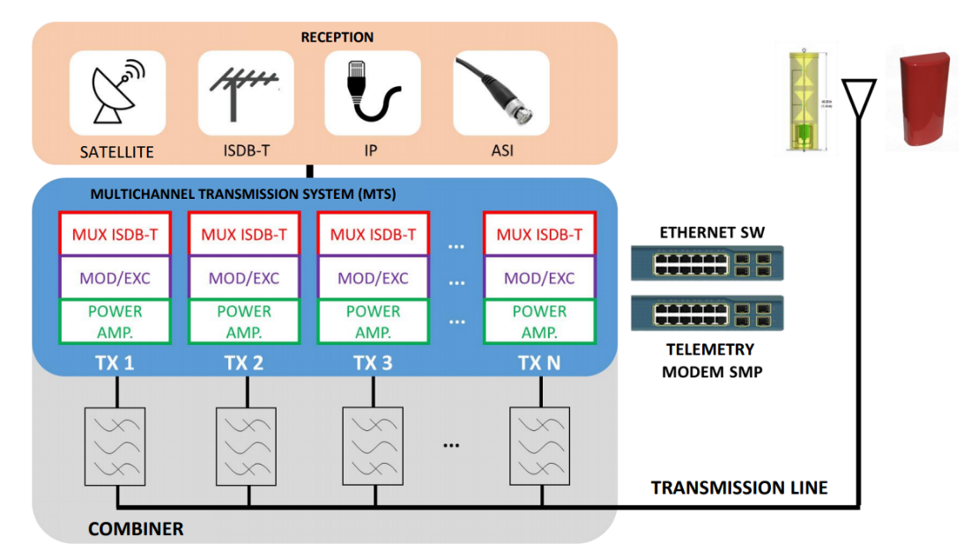
The infrastructure will be maintained under the municipal administration premises and will be operated by local broadcasters. Both municipal administrations and broadcasters will undergo a selection process to fill in requirements established by the program.
As the typical MTS assembly, as shown in Figs 4 and 5, is capable of housing up to 8 broadcasters (8 channels), and most (90%) stations are estimated to house up to 6 broadcasters, at least two slots will be made available for interested broadcasters, in most cases.
FIGURE 4
Multichannel Transmission System (MTS) housing and equipment
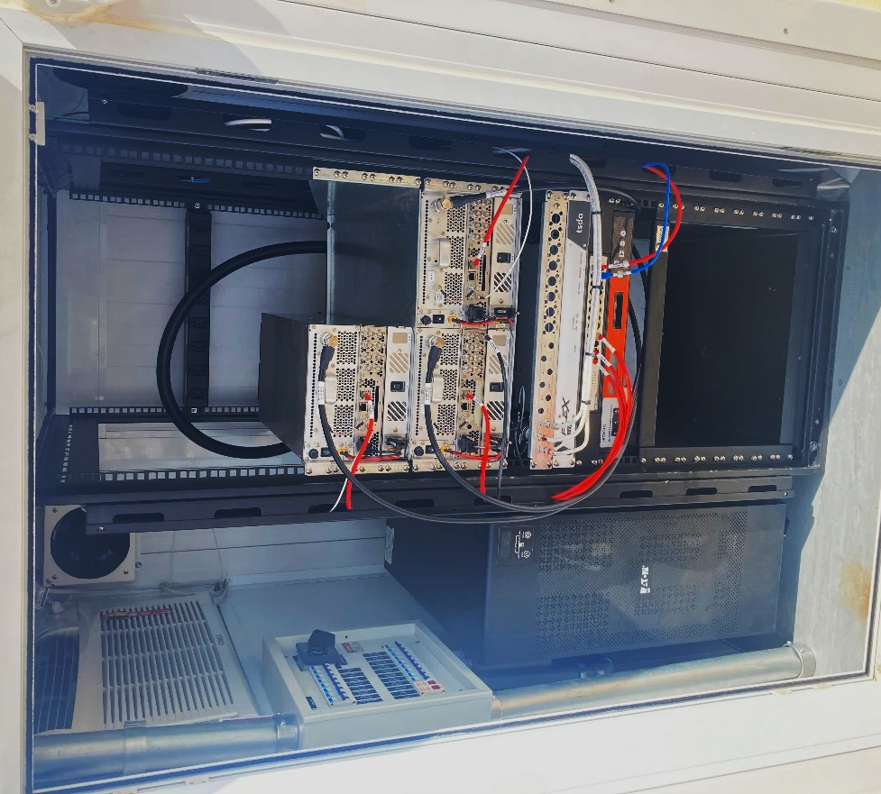
Qualified broadcasters are to deploy necessary equipment at their own expenses. On the other hand, the existing infrastructure (site, housing, tower, antenna, etc.) can be used in a shared basis by incoming broadcasters, greatly reducing total deployment costs. Additionally, municipalities bear electricity costs, reduction operational expenditures.
In addition to these commercial channels eligible for digitalization, the project also established the installation of two government digital channels – for Astral (Brazilian Association of Legislative Televisions and Radios) and a digital channel for EBC (Brazilian Communication Company) in all municipalities qualified for implementation.
Funding for the program is provided by resources from the 700 MHz band auctioning for 4th generation IMT Advanced systems, which resulted in approximately R$ 850 million being reserved as counterpart for the digital dividend. Operationalisation is being done by the aforementioned entity, constituted by the mobile network operators that won the 700 MHz auction.
Extraordinary efforts are being done for the assignment of more than 4 600 new DTTB channels in the Brazilian Digital Television Master Register Plan, preferably in the 470-698 MHz UHF band, as well as for the licensing of more than 7 200 TV broadcasters’ stations to operate digital transmissions.
As a kick-off to the government program, the pilot project was initiated on September 27th, 2021, on Tenente Ananias, a small city in the state of Rio Grande do Norte, with a population of 10 000 inhabitants.
FIGURE 5
Typical MTS assembly deployed in the north-eastern region of Brazil
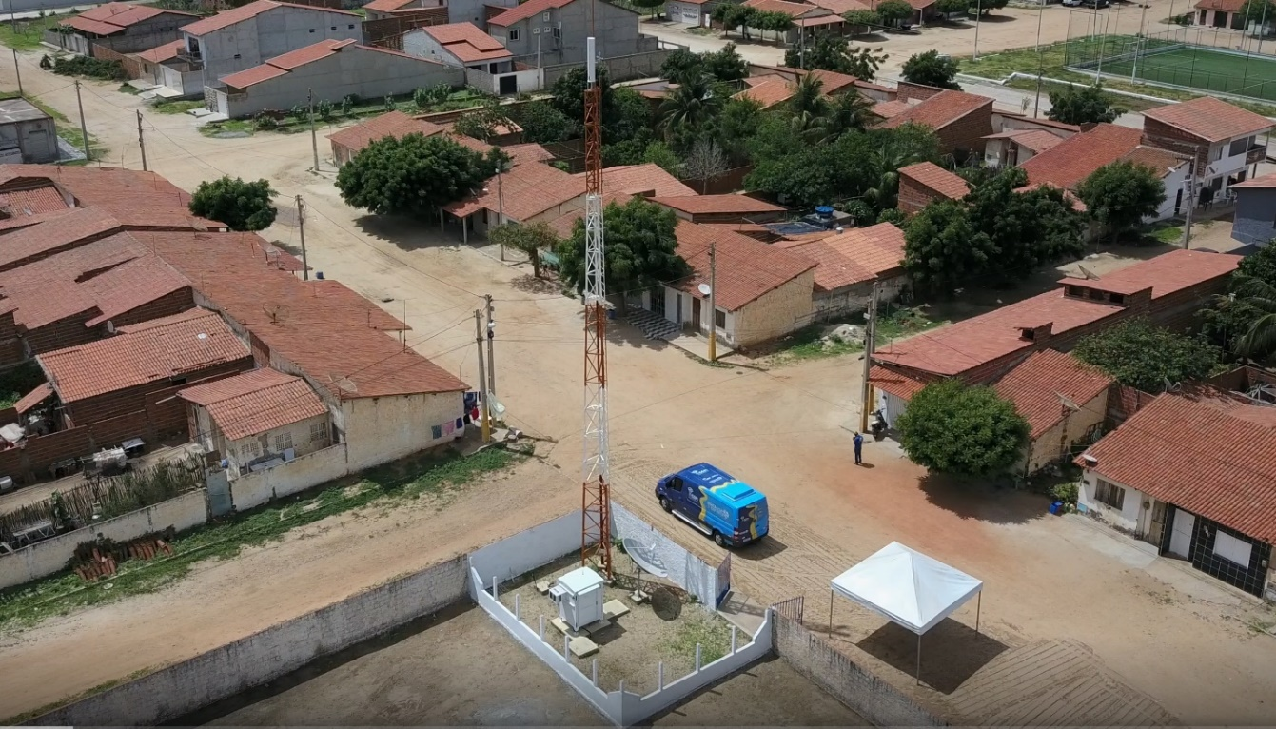
In Brazil, the terrestrial television has provided to the citizens a wide variety of quality programmes, free of charge, fulfilling important objectives of public policy, as the cultural diversity, the national integration and the pluralism of the communication media. Due to its characteristics of providing high quality television programmes to massive audiences and ensuring a free and universal access to the citizens, the terrestrial television will continue playing an essential role as the main mass communication platform in the foreseeable future.

2.2 Spectrum usage
The radio spectrum is an important and highly valuable resource that must be adequately managed to meet the established policies. To achieve this objective, regarding the TV broadcasting service, ANATEL started drawing up a channel assignment plan in Brazil before the adoption of the digital standard, to guarantee simultaneous compliance with the technical requirements of the three digital television systems that were under analysis. This work took into consideration the following directives:
− the digital television channels would use the bands of VHF-H (7 to 13) and, preferably, the UHF band (14 to 59), keeping the service area equivalent to that of the current analogue service;
− during the analogue to digital transition phase, the programming of the stations shall be transmitted simultaneously by the analogue and digital channels. After that phase, analogue transmissions would be interrupted remaining only digital transmissions.
− for each analogue channel considered, a digital channel shall be assigned during the analogue-to-digital transition period, observing the current coverage of the analogue signal;
− for the adequate delivery of digital television service in Brazil without the interruption of analogue signal transmission, in order to facilitate the transition to digital technology, a 6 MHz channel shall be allocated;
− the technical criteria adopted must meet the protection and interference requirements of the three digital television systems, always bearing in mind the worst case, regarding this aspect.
Guided by these principles, ANATEL, which is responsible for drawing up and maintaining the Basic Channel Assignment Plans, published the first Basic Digital Television Channel Assignment Plan (Plano Básico de Distribuição de Canais de Televisão Digital – PBTVD). With 1 893 channels included, the above-mentioned Basic Plan was comprised of a universe of 296 Brazilian localities, including those which at that time had at least one operating broadcasting television generator station and, in addition, those which, although having only television translator stations, had a population of over 100 000 inhabitants.
The adoption of the ISDB-T standard made possible to adjust the PBTVD to the modulation characteristics inherent to the system. In 2006, ANATEL started up this adjustment to that new reality basically excluding the 91 channels envisaged for a possible choice of a system that would not permit the use of single frequency network (SFN), and adjusting the power of the digital channels to match the coverage area of analogue channels, once the drafting of the PBTVD had considered the worst protection and interference case, which led to higher power levels than needed and the alteration of the related installation points to meet co-location requirements.
This task was carried out by region, starting with the regions in Brazil that account for the highest economic output and occupy most of the radioelectric spectrum, without neglecting however the regions of higher demographic density, which shall facilitate the implementation of digital television in Brazil.
At the end of 2012, ANATEL completed its planning phase for digital television channels, guaranteeing the possibility of simulcasting for all primary analogue transmitters up to the date of the analogue switch-off, initially scheduled for June 2016. VHF (174 to 216 MHz) and UHF (470 to 806 MHz) bands were used for this purpose.
In February 2013, the Ministry of Communications established the directives for accelerating access to the Brazilian Digital Terrestrial Television System (SBTVD) and for the expansion of spectrum availability to meet the objectives of the National Broadband Program (PNBL), further instructing ANATEL to look into the possibility of allocating the 700 MHz (698 to 806 MHz) band to broadband mobile services. Later that year, the Brazilian Government published a Decree which established that the analogue blackout would begin in 2015 and end in 2018, according to the schedule outlined by the Ministry of Communications, as mentioned before.
During the same year, once public policies had been defined for the 700 MHz band and for the analogue switch-off, ANATEL began developing studies for refarming television channels for the purposes of releasing channels 52 to 69. In the regions where UHF spectrum was more densely occupied it was necessary to contemplate the analogue switch-off in order to successfully release the band. This was the case of 1096 of the country’s 5 570 municipalities, accounting for approximately 43% of the population. In the remaining municipalities it was possible to restack all analogue and digital channels, and to ensure the release of the 700 MHz band. In summary, it was necessary to change the frequency of approximately 1 000 TV channels. This process was carried out during the switchover phase, and the 700 MHz band was released gradually. Figure 6 details the amount of channels that were considered in the refarming process.
FIGURE 6
Distribution of TV channels in Brazil
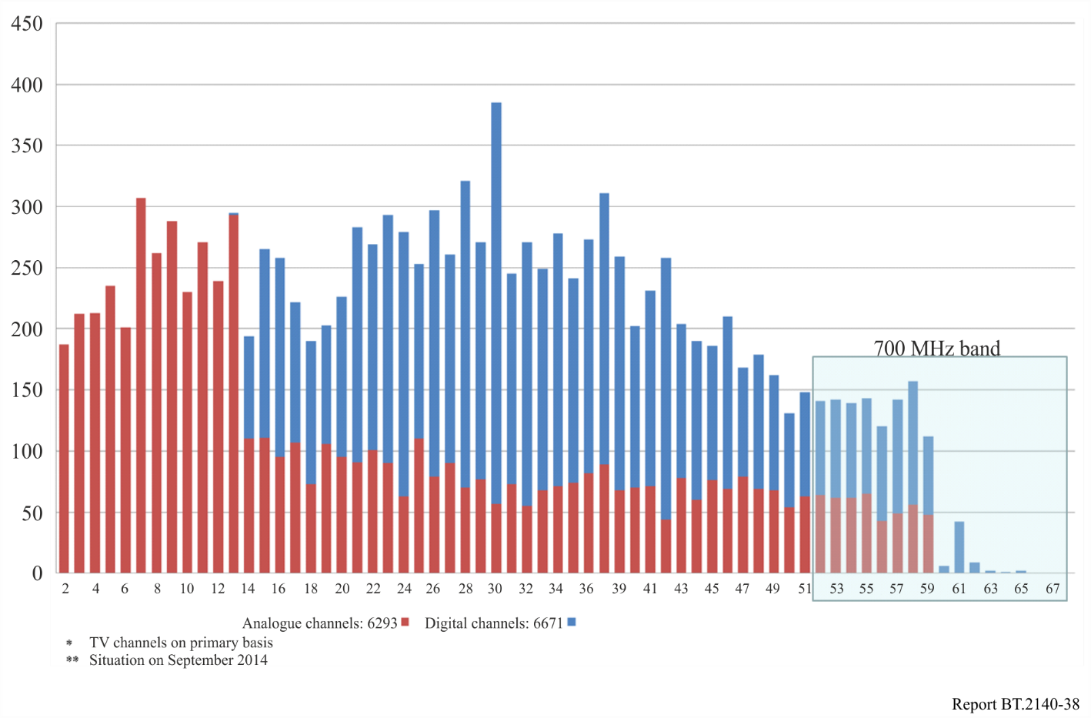
To ensure the implementation of all changes necessary for releasing the 700 MHz band, the Auction for IMT Services, that was carried out by ANATEL in September 2014, included the obligation that winning bidders defrays the migration of TV channels down to band between TV channels 7 to 51. It was established that 36% of the amount collected would be used to reimburse all broadcasters that were operating in 700 MHz band. Four companies won spectrum licenses in the auction, raising about R$ 10 billion Brazilian reais in revenue (about $3,8 billion American dollars).
Furthermore, a specific entity was established by the auction winners to manage the amount raised by the auction for restacking digital TV services. The entity also carried actions to ensure the completion of the switchover to digital TV and apply methodologies to avoid interference between the IMT services and broadcasting services in UHF band.

2.3 DTT implementation
On December 2nd, 2007, the first official implementations of the Brazilian DTT system began commercial operations in the city of São Paulo and, by mid-2008, there were already ten commercial broadcasters operating in this city. Although tests were already being conducted since May 2007, the government chose the December date as the official date of the system launch.
Nowadays, there are several different DTT receivers available in the market, with functionalities and designs aimed to different economic segments and user preferences, and which since mid-2010 also includes interactivity. Among those models, there could be found portable reception devices (1-Seg), including portable TVs, computer USB tuners and cell phones. For fixed reception, consumers could choose between standard definition and high-definition devices, although all broadcasters have been transmitting in high definition (1080i). All interactivity products were branded with the DTVi logo.
Since the beginning of transmissions, market prices for DTT receivers have been falling gradually, as the market moves from the early adopters to the ordinary consumers. That expected movement has been regarded by broadcasters and industry as proof of the successful introduction of DTT.
The receiver industry had already provided many solutions for the high-end DTT market, such as full-HD displays with integrated digital tuners. Brazilian Government provided tax incentives for the production of television set only if LCDs and Plasma with display sizes for at least 42 inches had built in receivers. These incentives exemption have been extended to all display sizes since January 2011.
Not only the availability of products contributed to the system successful deployment but also the existence of the Forum of Brazil’s terrestrial digital TV broadcasting system, formally instated in December 2006. The Forum is a non-profit entity, whose main objectives are to support and foster the development and implementation of the best practices for the success of digital television broadcasting in Brazil. Its membership is composed mainly of participants from the broadcasting, reception and transmission equipment manufacturing, and software industries.
The Forum’s mission is to help and encourage the installation or improvement of the digital sound and image transmission and receiving system in Brazil, promoting standards whose qualities meet the demands of the users.
The purpose of this Forum is to propose voluntary or mandatory technical norms, standards, and regulations for Brazil’s terrestrial digital television broadcasting system, and, in addition, to foster and promote representation, relations, and integration with other national and international institutions.

2.4 New services offered by DTT
The Brazilian digital transmission system provides several capabilities to serve viewers, such as high definition and standard resolution pictures, data delivery, interactive communication, portable and mobile services, with the required technical flexibility to better serve the viewers.
The possibility of signal transmission through a single channel for fixed (HDTV), mobile (SDTV) and portable reception (1-Seg), possible on the ISDB-T system, encourages the relationship between viewers and the content provided. Furthermore, the system enables to increase the signal penetration to meet the needs of a dynamic population, maintaining the broadcasting service features of providing information, education and entertainment, which distinguishes it from other services.
Brazilian DTV broadcasting system enables a limitless variety of new information services, including interactive services. A great deal of interactivity in such applications can be provided simply by downloading substantial information from which viewers can choose. Interactivity can be increased further through the use of a return channel through which viewers can request specific content from the broadcaster. Brazilian system comprises multiple technologies to implement the return channel, including, but not limited to, fixed and mobile networks, broadband connections or even a terrestrial return channel if additional spectrum is available.
New services under deployment in the Brazilian market, including interactive services, represents an important opportunity to promote social inclusion, i.e. to provide education, health care, and other important social services to viewers of all socio-economic segments, including citizens who may never own a personal computer.
There are a wide range of opportunities in the digital transition and in the digital system:
– Signal coverage in all terrain types: provision of better services in their coverage areas, improving the quality of their service to the local population.
– Signal robustness and performance: signal robustness lowers acquisition and operation costs for all broadcasters, allowing resources to be allocated to content production and providing.
– Tolerance to signal interference: ISDB-T offers time interleaving techniques, which provide powerful channel coding for mobile reception in which variations in field are inevitable.
– Audio and video quality in HDTV services: use of MPEG-4 audio and video coding for better quality. Viewers may benefit from enhanced image, sharper sound and exciting new applications.
– Balance between costs and technical performance: MPEG-4 was the most powerful and state-of-the-art audio and video coding standard. Its design provides valuable future proof balance between coding efficiency, implementation complexity and cost, based on the current state of VLSI design technology.
– Deliver of programs and applications to portable devices: Direct service from broadcasters to portable and hand-held devices of audio, video and applications creates new business models and increase audiences, reaching viewers on the move everywhere.
– One channel for all services: All types of services, either HDTV, SDTV or to portable devices (1-Seg) are transmitted using only one channel, rendering a better and more efficient use of the spectrum.
– Flexibility between signal coverage and bandwidth: The system is configurable in such a way that broadcasters may trade bit rate capacity against signal coverage to all services individually, either for stationary, mobile or portable reception.
– Signal coverage and quality of service (QoS): The system ensures a more efficient and cost-effective use of the spectrum when compared to analogue transmissions. All versions of the specification guarantee the use of advances such as SFN (single frequency network), on‑channel repeaters and several other techniques for optimizing coverage and filling shadow areas.
– Flexible business models: Flexibility needed to offer the adequate blend of content that is most appealing to local audiences. HDTV, multiple SDTV services, mobile and portable services, plus a limitless variety of data services can be all harmonized under the same technical and regulatory umbrella.
– Mobile and portable services: The digital television system platform was developed to maximize its unique capacity for offering mobile and portable services, which has been actively developed for portable and mobile applications.
– New services: It renders an alternative to in-house wireless solutions as a means of overcoming the problem of second and third television sets in the home and providing new broadcast entertainment and information services to people on the move.
– Social inclusion and new audiences: ISDB-T is capable of providing increased access to information services to viewers of all socio-economic segments at once. Reaching the poorer segments of society is particularly relevant since in many countries a vast majority of the population relies on free-to-air television as the only means of access to information, government services and entertainment.
The Brazilian digital terrestrial television standards have continuously evolved since their first introduction in 2006. One of the latest relevant updates on its specifications was the introduction of the receiver profile D of its Integrated Broadcast-Broadband system, further detailed in the Report ITU-R BT.2267.
The digital television implementation is no longer a technical challenge in Brazil but rather an opportunity to provide access to digital technology to all socio-economic segments of society. Flexible business models, mobile and portable reception and attractive applications to viewers are key to any digital television platform future viability.

2.5 Public and State Communication
At the federal level, Brazil has two public and state-run television networks. One is the National Public Communication network (“Rede Nacional de Comunicação Pública”) – RNCP, coordinated by the Brazilian Communication Enterprise (“Empresa Brasil de Comunicação” – EBC, an entity linked to the Secretariat of Social Communication of the Presidency of the Republic (SECOM). The EBC is responsible for TV Brasil, the fifth most-watched broadcasting programming by Brazilians. Partners of the EBC in the RNCP, such as public universities and entities linked to state governments, incorporate local content into the programming. Typically, the RNCP TV channels broadcast four streams in multiprogramming: TV Brasil (with local inserts); Canal Gov; Canal Educação; and Canal Saúde, with the latter three consisting solely of national programming. The RNCP also brings together public FM radio stations, which retransmit the programming of Rádio Nacional, under the responsibility of the EBC, with local inserts.
The Rede Legislativa, on the other hand, is coordinated by the House of Representatives. Each TV channel simultaneously broadcasts, in multiprogramming, TV Câmara; TV Senado; a stream from the state Legislative Assembly; and one from the municipal City Council. Rádio Câmara also operates as a network, broadcasting content from the partners of the Legislative Branch.

2.5.1 Expansion of the RNCP
Since October 2023, SECOM and the EBC, in partnership with the Ministry of Communications (MCOM), the National Telecommunications Agency (ANATEL), and dozens of public organisations, have been conducting the largest expansion of the RNCP in its history (the EBC was created in 2007 and the RNCP in 2010). Since that month, the EBC has signed cooperation agreements with over 60 federal, state, and municipal universities and federal institutes of education, interested in operating more than 150 TV stations (based on TV Brasil’s programming, with local content) and FM stations (following the same model, based on Rádio Nacional).
If all the intended stations are installed, this initiative has the potential to double the RNCP’s broadcasters as a whole and triple the network’s radio broadcasters. From October 2023 to June 2025, more than 180 new TV and FM channels were allocated to the EBC, enabling the expansion of the RNCP.
In parallel, regulatory, economic, and bureaucratic issues identified as obstacles to the network’s expansion were addressed. For example, the EBC and the Ministry of Management and Innovation in Public Services (MGI) are currently developing a simplified procurement process for equipment for the new stations.

2.5.2 Brazil Digital Government Programme
Coordinated by the MCOM and monitored by the aforementioned agencies and entities, the Brazil Digital Programme (PBD), established by [Ordinance MCOM No. 13,345 of 27 May 2024] (https://www.in.gov.br/en/web/dou/-/portaria-mcom-n-13.345-de-27-de-maio-de-2024-562413986), is crucial for the installation of the new Digital TV stations of the RNCP and the Legislative Broadcasting Network (“Rede Legislativa”). This initiative is part of the Development Acceleration Programme (PAC), a federal government plan covering development of various sectors of the economy. The PBD’s budget comes from three main sources: PAC funds; remains from the Analogue to Digital TV transition, supervised by ANATEL (approximately R$ 105 million); and parliamentary amendments, allocated to specific municipalities.
The PBD aims to support the expansion of the RNCP and the Rede Legislativa, promoting greater pluralism and diversity in Brazilian broadcasting. In each municipality covered by the PBD, two new Digital TV stations are to be installed: one allocated to the EBC, operated by a partner that may include its own programming, and part of the RNCP; and another allocated to the Chamber of Deputies, featuring streams from the state and municipal legislative branches, and part of the Rede Legislativa.
As of June 2025, there are two groups of municipalities covered under the PBD. The first consists of up to 30 selected locations participating in a pilot project. In addition, in 2024, the MCOM published a notice to select public entities interested in partnering with the programme, with these entities responsible for providing a location for the installation of the two new transmitter stations. In December, the results were published, with eligible entities in 321 municipalities. The unused capacity at these sites may eventually be utilised by other broadcasting stations, sharing the costs.
Subsequently, ANATEL began including the necessary broadcasting channels in the basic plan for the programme. By June 2025, the MCOM had already allocated channels to the EBC and the Chamber of Deputies in 51 of the municipalities covered by the notice. The EAD and a company contracted by the MCOM were conducting technical inspections and drafting the projects for the new stations, some of which are scheduled to be inaugurated in 2025.

2.6 Brazilian digital terrestrial television standards
The technical standards of the Brazilian Digital Terrestrial Television System can be found at http://forumsbtvd.org.br/legislacao-e-normas-tecnicas/normas-tecnicas-da-tv-digital/english/.

3 Bulgaria
With due consideration of the complexity and far reaching consequences of the transition from analogue to digital, relevant Strategic Plan for Introduction of Terrestrial TV Broadcasting (DVB-T) in the Republic of Bulgaria has been elaborated and approved at session of the Council of Ministers of 31 January 2008 (Reference: Protocol No. 5 by decision on Agenda item 24). Its main considerations and key aspects are provided herewith.
Simulcasting between analogue and digital terrestrial TV broadcasting will be applied but not permitted for more than a year duration, except in remote rural areas.
Two phases of transition to digital TV terrestrial broadcasting will enable gradual transition to digital.
Six nation-wide DVB-T and DVB-H MFN/SFN networks-licensed operators must ensure full population coverage in all fifteen allotment zones: first three by December 2012, remaining three by June 2015.
Twenty-seven regional SFN networks must ensure 90-95% population coverage in all fifteen allotment zones: first twelve SFNs by January 2010, remaining fifteen SFNs by December 2012.
License applications for digital terrestrial HDTV broadcasting shall be submitted by December 2011, and licenses may be granted shortly.
Interactive services and applications will be encouraged.
Switch-off of all analogue TV terrestrial transmissions will be completed by December 2012.
Transition to digital terrestrial TV Broadcasting shall be terminated by June 2015 and factual digital dividend be established.

3.1 Background of country TV broadcasting market

3.1.1 TV Programme licences
As of January 2008, a total of 203 TV programmes have been licensed for delivery to the population of this country by cable television, terrestrial broadcasting and via satellite.

3.1.1.1 The terrestrial broadcasting component ensures analogue delivery of the total of seven TV programmes as follows
a) Three nation-wide TV programmes, namely:
– “Channel 1” of the Bulgarian National Television (BNT) with population coverage of 98,3% achieved by 677 high power main transmitters, relay transmitters and low power fill-in transmitting stations in Frequency Bands II, III, IV and V;
– “bTV” with population coverage of 97% achieved by 676 high power main transmitters, relay transmitters and low power fill-in stations in Frequency Bands III, IV and V; and
– “Nova” exceeding 70% population coverage achieved by total of 143 transmitters, with comparatively lesser number of high power main transmitters and with a growing network of relay transmitters and low power fill-in transmitting stations, all operating in Frequency Bands IV and V.
b) In addition, there are four regional TV programmes licensed to be on air in the towns of Blagoevgrad, Plovdiv, Ruse and Varna.

3.1.1.2 Remaining 196 licenses are issued for TV programme delivery via cable or satellite

3.1.2 Public/Commercial/Temporary licensed operators
Seventeen licenses are issued to public broadcasting operators and 169 licenses to commercial broadcasting operators totalling 186 regular licenses. Furthermore, the said regular licenses are supplemented by additional 42 specific licenses (temporary in nature but still in force) for terrestrial analogue broadcasting.

3.1.3 Cable/Satellite/Terrestrial delivery
It is estimated that predominantly around 63% of the country population is served by cable network delivery, 7% of the population by satellite and about 30% of the population receives TV programming via terrestrial broadcasting channels. While every country town is served via cable TV network delivery only about 28% of the villages of this country are served by cable TV. It is expected that cable TV network delivery would reach its saturation limit at 75% of the population coverage.
The country population having access to terrestrial TV broadcasting only is estimated to be within 10 to 11% range.

3.1.4 Digital terrestrial TV broadcasting
Only one digital terrestrial TV broadcasting operator has been licensed to serve the area of Sofia City since 2004.

3.2 Purpose and mission of the analogue to digital terrestrial TV transition
The said Plan for introduction of digital terrestrial broadcasting aims not only at retaining the number of users who, in spite of having access to cable, terrestrial and satellite delivery, have already chosen to use analogue terrestrial delivery, but also has set the target of increasing the number of digital terrestrial delivery users in nearest future. Indeed, the Plan has the objective of creating an enabling competitive environment thus effectively preventing the monopolistic cable and satellite delivery operator’s grasp at the market.
Towards this end, the digital terrestrial broadcasting shall be deployed under certain conditions as follows:
– free of charge delivery to users (not more than one encrypted programme per multiplex be permitted);
– initial number of programmes delivered shall be not less than 15;
– programmes delivered be composed of an attractive-to-viewers blend of national, regional and local origin;
– HDTV programme delivery license applications be allowed by 2011;
– better quality and offer of additional/interactive e-services and applications, in consistency with Directives 2002/21/EC (Framework Directive) and 2002/19/EC (Access Directive) of the European Parliament and the Council of 7 March 2002; and
– mobile outdoor reception predominantly for cars and portable reception inside of buildings expected to be used for the purpose of second and third household receivers.
The said Transition Plan has defined the strategic aspects of:
– population coverage objectives and criteria;
– Multiple Frequency Network (MFN) approach dedicated only to nation-wide coverage, while Single Frequency Network (SFN) approach will be applied explicitly to allotment zones;
– initial build-up of SFN network broadcast coverage of densely populated towns and areas (Island Coverage) within any allotment zone followed by further gradual network extension until the entire allotment zone coverage has been achieved;
– optimization of number of multiplexes within allotment zones;
– granting license or temporary permission to any new analogue terrestrial broadcasting operator applicant will be severely restricted;
– parallel broadcasting of both the analogue and the digital (simulcast) being limited to one year duration upon the expiry of which the concerned analogue broadcasting license/s will be terminated. Thus, the reuse of liberated spectrum of analogue broadcasting is provided for further build-up of digital terrestrial TV broadcasting networks as per the Plan;
– establishing criteria for switch-off of analogue TV broadcasting, but not later than end 2012;
– nation-wide coverage by digital terrestrial broadcasting to be completed in all zones by end 2015;
– factual digital dividend definition; and
– timely supply of Set-Top Boxes (STB) to the population at affordable prices and risks involved.

3.3 Impact of the digital terrestrial broadcasting Plan of RRC-06 and GE-06 Agreement
RRC-06 and GE 06 Agreement guarantee to the Bulgarian Administration to have at its disposal and use at its discretion 10 nation-wide networks for terrestrial digital TV broadcasting, supplemented by 34 regional networks and by 23 networks dedicated to the regions of Sofia and Varna.

3.4 Transition to digital terrestrial TV broadcasting
The said transition will be executed into two phases as follows:

3.4.1 First phase-start of the transition

3.4.1.1 Three nation-wide digital terrestrial TV networks
Three nationwide MFN/SFN networks, all DVB-T, will be licensed to operators for deployment in allotment zones of Burgas, Plovdiv, Ruse, Sofia, Stara Zagora, Varna and Vidin by June 2008.
Licensed operators shall start “Island Coverage” broadcast within said allotment zones as from January 2009 and they must achieve at least 75% population coverage within said allotment zones by December 2012.
Exactly one year later, after the simulcast expiry, new licenses will be granted to operators with obligation to start “Island Coverage” broadcast within allotment zones of Blagoevgrad, Kurdzhali, Pleven, Smolyan and Shumen and they must achieve at least 75% population coverage by December 2011.
Furthermore, relevant licensees must ensure full population coverage inclusively for the above-mentioned twelve allotment zones by December 2012.

3.4.1.2 Twelve regional digital terrestrial TV networks
Twelve regional SFN networks will be licensed to operators within allotment zones of Burgas, Plovdiv, Sofia and Varna (three SFN networks each) by June 2008. Licensees shall start “Island Coverage” broadcast within said allotment zones by January 2009 followed by ensuring of full population coverage for the said four allotment zones by January 2010.

3.4.2 Second phase of the transition

3.4.2.1 Additional three nation-wide digital terrestrial TV networks
Furthermore, three nation-wide MFN/SFN networks, two of them DVB-T plus one DVB-H, will be licensed to operators for deployment in the allotment zones of Burgas, Plovdiv, Ruse, Sofia, Stara Zagora, Varna and Vidin by July 2010.
Licensed operators shall start “Island Coverage” broadcast within said allotment zones as from January 2011 and they must ensure at least 75% population coverage of said allotment zones by December 2013.
Exactly one year later, after the simulcast expiry, new licenses will be granted to operators by July 2011 with obligations to start “Island Coverage” broadcast within the allotment zones of Blagoevgrad, Kurdzhali, Pleven, Smolyan by January 2012, being followed by obligations to ensure at least 75% population coverage by July 2014.
Furthermore, relevant licensees must ensure full population coverage inclusively for the above-mentioned twelve allotment zones by July 2015.

3.4.2.2 Additional fifteen regional digital terrestrial TV networks
Fifteen regional SFN networks will be licensed to operators for deployment in the allotment zones of Blagoevgrad, Burgas, Kardzhali, Pleven, Plovdiv, Ruse, Smolyan, Sofia, Sofia-City, Stara Zagora, Strandzha, Shumen, Varna, Varna-City and Vidin by July 2010.
These licensees will be obliged to start “Island Coverage” broadcast within said allotment zones as from January 2011 and they will be required to ensure 90-95% of population coverage in the above-mentioned allotment areas by December 2012.

3.4.3 Allotment zones
Figure 7 defines the distribution of allotment zones on the map of Bulgaria as per RRC-06.
figure 7
Allotment zones for the Republic of Bulgaria defined by RRC-06
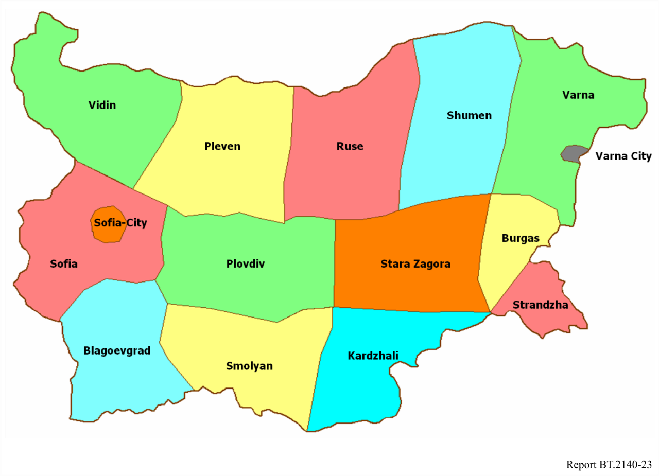

3.4.4 HDTV
Subject to license application(s) for digital terrestrial HDTV broadcasting network/s being submitted latest by December 2011 to competent regulatory authorities, or upon initiative of competent regulatory authority, license/s may be granted to relevant operator/s for deployment and operation of digital High Definition TV terrestrial broadcasting network/s.

3.4.5 One Year Simulcast Limitation
The period of parallel broadcasting of both analogue and digital terrestrial TV broadcasting (simulcast) is limited to one year after the startup of digital terrestrial broadcasting within relevant “Island”. Upon expiry of this one-year period all analogue terrestrial TV broadcasting transmitters within the “Island” territory coverage will be switched-off as a principle, however exceptions may be granted spectrum permitting, in particular for remote rural areas.
Appropriate measures will be taken to ensure adequate spectrum allocation/s in order to guarantee the practical implementation of this key requirement.

3.4.6 “Must carry” obligation
The Electronic Communications Law, May 2007, Article 47(2).1 stipulates that any digital terrestrial broadcasting network, be it radio or television, must carry two Bulgarian programmes. It is within the purview of the Electronic Media Council (EMC), empowered by this Law, to decide on the programme allocation within any network. Furthermore, it is the EMC who decides on the network to broadcast the programme/s of Bulgarian National Television, but within the said limitation of two Bulgarian programmes per network.
Taking into account the existing spectrum constraints, the Second Phase of the Transition Plan (see § 2.4.2) may be implemented only on condition that relevant spectrum indeed be liberated by the already licensed operators for analogue terrestrial digital TV broadcasting with nation-wide coverage networks. In this regard and in order to ensure that the above-mentioned requirement of the Electronic Communications Law will be met, either the said licensed operators must have new licenses granted for nation-wide network coverage of digital terrestrial TV broadcasting during the First Phase of Transition (see § 4.1), or alternatively, in consistency with the decision of the EMC on the network assigned to carry the programme/s of Bulgarian National Television (BNT) a “must carry” obligation be imposed on relevant operator/s, being licensed as First Three Nation-wide digital terrestrial TV Broadcaster during the First Phase of Transition to carry obligatorily the programme/s of Bulgarian National Television.

3.4.7 Analogue switch-off
Switch-off of any analogue TV terrestrial broadcasting transmission in the country will be imposed by December 2012 at the latest.

3.4.8 Digital dividend
The switchover from analogue to digital broadcasting will create new distribution networks and expand the potential for wireless innovation and services. The digital dividend accruing from efficiencies in spectrum usage will allow more channels to be carried with variety of fast data transmission rates and lead to greater convergence of services.
The inherent consistency of data flows over long distances and flexibility offered by digital terrestrial broadcasting will support mobile reception of video, internet and multimedia data, making applications, services and information accessible and usable anywhere and at any time. Along with the introduction of innovations such as Handheld TV Broadcast (DVB-H) and High-Definition Television (HDTV), it will provide greater bandwidth which, in full consistency with “European Parliament resolution Towards an European policy on the radio spectrum” {2006/2212(INI)}, could increase the widespread availability of affordable mobile/wireless broadband, including in rural areas.
Services ancillary to broadcasting (wireless microphones, talk back links), planned on a national basis, could also be extended.
Because of the complex and interleaving reasons, associated inter alia with the said purpose and mission of the introduction of digital TV terrestrial broadcasting in this country, it will be very difficult in the mid-term future to quantify the spectrum which will be available for use of services other than broadcasting. Therefore it is foreseen that the factual quantitative balance of the spectrum liberated will be done not earlier than the complete analogue switch-off at the end of 2012 and not later than end 2015, in full conformity with the decisions taken at the WRC-07.

4 Canada
Canada adopted the ATSC standard in 1997. The first commercial DTT station went on the air in Toronto in early 2003. Currently, there are about 2 dozen DTT stations across the country broadcasting in the major markets such as Toronto, Montreal, Vancouver and Ottawa. About 33% of the population of can receive at least on Canadian DTT station. The Canadian Radio-television and Telecommunications Commission (CRTC) mandated August 31, 2011 as the date to shut-down analogue TV in Canada. As a result, most major television networks are actively planning their transition to digital to meet the CRTC deadline.
Test transmissions are being carried out by the Communications Research Centre (CRC) using distributed transmission networks such as SFN – Single Frequency Network and digital on-channel repeaters (DOCR). The purpose of the tests is to identify the solutions that are needed to overcome coverage difficulties due to terrain and to explore possibilities in the area of pedestrian and mobile reception of DTT services.

4.1 National planning strategies and policy considerations

4.1.1 Introduction
For almost 25 years Canada has carried-out, research, demonstrations, put in place a Task Force, Working Groups, Industry Associations, Regulatory initiatives with minimal government involvement and with a policy firmly based on the marketplace for the transition to digital terrestrial television. Although the core of all this work has focused on terrestrial television transition, there have been some notable diversions along the way including the Advanced Broadcasting Systems of Canada (ABSOC), which dealt with video compression issues for standard digital terrestrial television, cable and satellite.
ABSOC recommended that a digital Task Force look at all the issues surrounding the implementation of Digital Television (DTV) in Canada and the Government set one up in late 1995. It included all industry segments and completed its work in late 1997 with a report presented to the Ministers of Canadian Heritage and Industry Canada.
Following the Task Force report Industry Canada responded by accepting the recommendation to adopt the American Television Systems Committee (ATSC) transmission standard for terrestrial DTV services and made spectrum available to all licensed terrestrial television broadcasters for digital services. The broadcasters, distributors and manufacturers set up an industry association to manage and facilitate the transition realizing another recommendation, Canadian Digital Television (CDTV).
Over the next eight years CDTV working with the industry and the relevant interest groups and government departments, provided a platform for testing the technology, educating both the industry and the consumer, demonstrating HDTV services, and encouraging the production and distribution of HDTV programs and services. Over this period, the Canadian Radio-television and Telecommunications Commission (CRTC) also provided a regulatory framework for terrestrial television broadcasters and pay and specialty services to make the transition to digital High Definition service. The important point to note is that the emphasis of all of these initiatives was not just the introduction of DTV service but that service providing HDTV programmes. The benefit for the citizen/consumer was defined both informally and formally as improved video and audio as characterized by HDTV.
In 1999, the industry defined Canada’s DTV transition strategy as a fast follow by two years of the US roll out of DTV services. This strategy was consistent with the marketplace approach and ensured that the high-end costs associated with early adoption of new technology were avoided for both broadcasters and consumers.
A lot has changed in the broadcast environment since the beginnings of HDTV in the eighties. Broadcasters have lost market share to viewing in both in real terms to pay and specialty services as well as viewers receiving their service directly from the transmitter in favour of distributed cable and satellite. More than 30% of all viewing was from terrestrial transmitters in the eighties where today that figure hovers around 10% or even lower in some markets. Consequently, broadcasters have been reluctant to build digital transmission infrastructure noting that there simply is not a business case to do so. There are currently 12 DTV transmitters on the air concentrated in Toronto, Vancouver and Montreal, even though more than 40 temporary licenses have been granted.
Over this time, progress was made in creating digital HD infrastructure in network operations of the major networks and the production community is just now beginning to embrace HD production. However, for the most part the Canadian terrestrial television broadcast system remains a standard definition one (as do the pay and specialty services) and in many regional centres an analogue throwback.
It is against this background that the CRTC is conducting a television policy review and the Minister of Heritage requested an examination of the impact of new technology on the Canadian Broadcasting System. A lot has changed since the Task Force reported 9 years ago. Internet delivery, Video on Demand, mobile television and consumer empowering personal video recorders and devices have and will have an increasing impact on the traditional broadcast model and in fact on the fundamentals of the Canadian Broadcasting system as Canadians have historically understood it. Decisions made by the CTRC, Government and the interests of the Broadcasting system over the coming 12 months will have a profound impact on the future of broadcasting generally and the roll out of conventional terrestrial broadcast services in particular.
The remainder of the paper will look more closely at the history, present circumstances and future options.

4.2 DTV/HDTV history

4.2.1 The early years
Canadian engagement with digital television is rooted in the industry’s early interest in High Definition Television (HDTV) as far back as 1982. In that year, the Canadian Broadcasting Corporation (CBC) and the Department of Communications and its research centre organized a Colloquium in Ottawa that drew delegates from all over the world to discuss HDTV and how to develop it as a future service. For almost a decade, there were follow up conferences, demonstrations and debate.
It is probably fair to say that the Department of Communications led a lot of Canada’s participation through the eighties and into the nineties. In 1987, a major public demonstration of the Japanese MUSE system of HDTV was done with the cooperation of government, a number of Canadian industry players and the Japanese. It was successful but not practical for terrestrial display in North America because of the amount of bandwidth needed for broadcast, although the Japanese used the MUSE technology from the late eighties through to today via Satellite DTH. At the same time, the CBC produced the first North American High Definition programme series, Chasing Rainbows.
As the eighties drew to a close the Canadian Government was involved in that process testing proponents of five different systems in 1991/92 and then the eventual successful effort in the mid-nineties. Canada worked closely with US industry and agencies in this process. At the same time Canadian industry recognized the need to become involved in the digital initiatives became apparent and in 1990 ABSOC was set up to perform that role.
From 1990 through to 1997 ABSOC played an important role of both informing the industry on digital developments and recommending standards and practices for MPEG-2 compression technologies as it effected production and distribution of standard digital television. Representing a cross section of the broadcast and distribution community with government liaison and support ABSOC brought a practicality and application to the new digital technologies as they developed.
As the initiative matured and accepted a new digital transmission technology capable of delivering High Definition signals within MHz of spectrum or multicast digital delivery of standard television, ABSOC came to realize that Canada needed to focus on what this new technology meant for Canadian viewers and the broadcast industry. They recommended a Task Force to examine the elements required to implement digital television in Canada and the government responded by naming a Task Force in November of 1995.
It is important to understand the environment that Canadian broadcasters enjoyed in the mid-nineties. Although conventional broadcasters faced increasing market fragmentation, they still enjoyed a transmitted market share of their viewers of over 20%. Although pay and specialty services were growing, they had not fragmented the audience share to the degree that would develop and is seen today. The internet as a delivery mechanism, video on demand and other platforms that define today’s multi-platform broadcast world were barely a dream very much on the horizon but in a business sense not a huge blip on anyone’s radar screen. By the end of the nineties, the view of the broadcast world was rapidly disintegrating. What was real was MPEG-2 compression, which made possible digital standard television satellite and cable delivery. Providing for more pay and specialty services with cheaper delivery to Broadcasting Distribution Undertaking (BDU) head ends and production facilities, and the prospect of better-quality pictures and sound with HD services very far down the road.
For the newly announced Digital Task Force these problems were all in the future and it focused on its mandate to recommend the best way to implement digital television for Canada.
Digital Television Task Force
The Task Force was truly representative of all industry interests plus the production and consumer manufacturer’s community. Over ninety people were on the Task Force or committees and many more were consulted throughout the Task Force’s work. It has been noted that Canada does Royal Commissions and Task Forces very well, as they are often vehicles for inaction. However, they also do some remarkable work from time to time and by the time the Task Force reported in late 1997 an industry had been somewhat educated, consulted and had arrived at a consensus; albeit kicking, screaming and probably thinking that many of its recommendations were so far down the road that there was nothing really to worry about.
The seventeen recommendations were rooted in the work of four committees who recommended the substance to the Task Force members. The committees included; technology, production, policy and regulation, and economics, consumer services and products. It is interesting to note as Canada moved to an implementation stage those areas of work continue to provide guidance and direction. While it is not useful to review the entire Task Force report and recommendations, it is useful to recognize that much was achieved and many recommendations were acted on:
The ATSC transmission standard, A/53, was adopted by Canada and a subsequent allotment plan was adopted providing digital spectrum for all licensed analogue conventional broadcasters. Broadcasters were to make the transition to digital transmission while retaining their analogue spectrum for simulcast until the transition was complete. This was important since it provided a secure business basis for broadcasters to begin the transition.
Many of the policy and regulatory recommendations have found their way into CRTC licensing and carriage frameworks. Again, this was to provide stability during the transition for the industry business models, as they were understood at the time.
A period was suggested for the digital transition with an end date that would be a year to 18 months behind the US. While not acted upon in Canada, virtually every other country in the world has either a notional or a firm target date for analogue shutdown. The Canadian transition has lacked clarity and definition in the absence of such an initiative.
Initiatives concerning the production community for training and HDTV content were never acted upon and regrettably this industry sector has lagged behind many in the global community and Canada has a lack of HD production.
The recommendation to set up an industry organization to help manage, facilitate and advise government on the transition was put into place and will be discussed later in this paper.
Some recommendations like that calling for a universal box which would work for terrestrial television and distributed BDU services were not realized and probably too idealistic.
One recommendation calling for universally available terrestrial services is worth noting:
Recommendation Fourteen
Basic terrestrial broadcast television services that are freely and universally available are central to achieving the objectives of the Canadian broadcasting system. This must continue in future digital terrestrial distribution packages.
Freely available broadcast television services are the foundation of the Canadian broadcasting system. This universality of access must be preserved in the emerging digital system.
This was fundamental to the system in 1997 but in today’s environment terrestrial broadcasters are not committed to this principle given the change in how viewers receive their television services. In fact, the costs associated with this recommendation and the lack of any kind of business case will characterize the discussions of future policy hearings. This issue has also characterized the industry reluctance to move ahead with the digital transition in a timely way.
In looking back, the Task Force got many things right as evidenced by the overwhelming number of recommendations implemented. It set the agenda for the transition for terrestrial services and coincidently the pay and specialty services. However, it did not anticipate the rapid change in the broadcast environment; its multi-platform distribution opportunities and the availability of the devices, which would empower consumers with both choice and schedule. Combined with a marketplace approach these factors inhibited a timely transition to digital High definition services.
Implementation 1998 to 2006
Following the Task Force report the broadcasting and distribution industry, along with manufacturers and producers came together to create CDTV, as recommended by the Task Force. In September of 1998 the organization was formally created as a not profit association, with by-laws, a Board of Directors based on industry sectors and a work plan. Relevant Government Departments and the CRTC were welcome to participate and contribute to committee work and observe in Board meetings.
The Board created Working Groups in the technology, policy and regulation, economics and marketing, communication and education and production. This was not very different from the original Task Force committees. These working groups were a part of the association to a greater or lesser extent through the life of the association responding to the approved work plans from the Board and the changing environment
The work of the association was totally funded by the industry with both direct and indirect funding. Industry Canada provided funds to test the frequency allotments at the CDTV test transmitter in Ottawa in 1998/99.
For eight years, CDTV represented the industry in helping manage and facilitate the transition. The early years focused on testing, education, and understanding the standards. As time passed demonstrations, seminars, policy, regulation and business models dominated the agenda. Over the last few years CDTV focused on operational implementation, the creation of HDTV programming, consumer education and awareness, and the impact of new technology including; improved compression technology, IPTV and mobile service. Throughout its mandate, CDTV participated with ATSC committees and on the Board, bringing back to the Canadian broadcasters and relevant government departments and agencies changes and improvements to the ATSC family of digital standards and Canadian input to those discussions.
An industry association that tries for consensus on issues, or at the very least an overwhelming majority is not the easiest of vehicles to manage in an environment of competing interests and agendas. The consensus and goodwill, which characterized the Task Force was not always seen as CDTV grappled with some of the business and regulatory issues where the interests of the principals were seen to be on the line. Yet for all of that the achievements were many over the life of the association and in fact defined the steps of the transition to digital terrestrial television to date.
Test transmitters were set up and operated in Ottawa, Toronto and Montreal. These gave the broadcasters and distribution communities the opportunity to work with the new digital transmission standard, understand its properties, coverage areas and delivery to BDU head ends.
The transmitters were used to test the frequency allotments (funding from Industry Canada), coverage reach, receiver strength and signal strength. This work became increasingly important, as improvements were made to off air receiver reception.
Canada was also called upon by consumer electronics manufacturers and the ATSC to test improvements and additions to the ATSC family of transmission standards.
Demonstrations for both the public and the industry of HDTV programming and delivery on the Canadian broadcasting system.
Seminars and workshops were held to explain to and educate the industry on the full range of the issues surrounding the production and distribution of digital High Definition programmes.
A great deal of time and effort was spent on attempting to develop business models that digital terrestrial television in terms of programme and non-programme related data and multichannel delivery. It was hoped that these models could lead to additional resources to help fund the transition. While the process certainly educated the industry there was not a consensus on the right model or an agreement between the conventional broadcasters and the distributors over revenue sharing of distributed terrestrial data and services.
Costs for the transition were also carefully calculated and included transmission, master controls, editing and production all in high definition. Suggestions for upgrading as equipment became obsolete were made available so that the capital costs of conversion would not be an overnight hit and distort budgets. Again, the identification and process were helpful but no overall industry plan was adopted.
Very early in the transition the Board of Directors of CDTV created the policy of a two-year lag behind the US in Canada’s transition to digital television. This built on a recommendation in the Task Force report that suggested a year to 18 months. Given the Government’s view that Canada’s transition to digital high-definition broadcasting should be driven by the market this two-year lag policy was sensible and virtually adopted by all parties. It was successful in saving the industry and consumers a great deal of the costs associated with the early adoption of new technology.
Education and consumer awareness was a major focus of the transition work. This work involved not only the broadcast and distribution industry but the consumer electronics manufacturers and the retail sector as well. Several editions of pamphlets aimed first at the retailers and then directly at the consumers were prepared and delivered through retail outlets and reprinted in consumer electronic magazines. They explained digital television and all the choices and variables in services, programs and consumer equipment. This work was recognized as an effective tool in education and adopted by other countries as part of their transition work.
From the work done on consumer education it was decided that a web-based information source of information would be a useful tool. CDTV resourced and created a bilingual consumer section open to everyone on its website. Since its creation a couple of years ago hundreds of thousands of Canadians have used it to gather more information about HDTV. In addition, a 15-minute infomercial and several 30 s promos were produced and aired to both provide HD information and push people to the website. Similar efforts will be required in the future, as analogue shutdown becomes a reality in Canada.
The education, training and development of the independent production on HD production were the final major projects taken on by CDTV to aid the transition. Again, a bilingual website was created that contained information and practical experience about, equipment, facilities, production and editing of HD material. Originally conceived as a series of training modules that may be adapted to workshop environments, the website has proven a valuable tool for Canada’s content creators. It is sad to note that additional funding could not be achieved to run workshops in all regions of the country to work with the production and broadcast community to create a better understanding of the challenges associated with HD production and how to meet these practically and efficiently. The production of HD content is still very modest in Canada but this is beginning to change and it should be encouraged.
While the core mission was on terrestrial broadcasting a great deal of time and effort was spent on assisting pay and specialty services to make the transition and supporting their needs for effective policies and regulation, facilities and capacity, and education.
During this period CDTV became the principle source of HD information in Canada for both trade press and general media. In the late nineties and in the early part of the two thousands the interest tended to be more industry related but today the Canadian consumer is engaged and very hungry for relevant information. Importantly, it is not about digital television that engages the consumer but it is High Definition, which is capturing their interest.
It is probably fair to ask if a transition association like CDTV was working so well, why it ceased its work a few months ago. Probably for two basic reasons:
The environment in 1998 was very different than it is today. There was less concentration in the broadcast industry and generally more reliance on associations to represent the industry sectors in designated areas. Emerging platforms and new technologies like IPTV and mobile applications were not a huge market factor in 1998, yet they are increasingly dominating discussions today.
At the core broadcasters, who were to make the transition from analogue to digital transmission platforms, drove CDTV. As markets fragmented and viewing reception for transmitter received services declined, the consensus achieved by the Task Force to transit to digital transmitted services began to break down and eventually eroded the support for an association whose mandate was to see the transition through.
With the above in mind, the industry members felt the association had gone as far as it could and its mandate was complete from their perspective given the new environmental realities. Many elements of this 8-year phase of Canada’s DTV transition were done well and made substantial contributions to the process. Issues of timeliness, a focus on what the Canadian broadcast system should be when the transition is complete, and an end date for analogue needs to be urgently answered before the transition may proceed.
The Present
The Current Players and the Issues
Canadian broadcasters have demonstrated reluctance to build transmission infrastructure and thus there are only transmitters in Toronto, Montreal and Vancouver as noted earlier in this text.
Conventional broadcasters have invested in considerable digital HD equipment in their network centres but very little in regional locations across the country. To date they have depended on cable and satellite delivery of their HD signal to locations across the country. In some cases because of cable and satellite bandwidth constraints and the strict application of the carriage rules, this national coverage is not as good as the broadcasters would like.
There are no French language networks, which are providing digitally transmitted HD or SD services aside from SRC. Most of the transition developments have been within English services. While there have been more than 40 temporary licenses issued there have been relatively few actually act upon. Most of these are English services. With some 12 transmitters on the air and broadcasters reluctant to build out their digital transmission infrastructure the future of conventional terrestrial television, has we have historically understood it, seems to be poised for a change.
Digital HDTV set penetration is projected to be over 3 million by year-end in Canada and most of the sets now coming to market have built in tuners.
Hook ups to HD services from a BDU are still modest in Canada with numbers approaching 600K by year-end in Canada. This figure is expected to dramatically increase over the next few years.
It is difficult to assess IPTV, mobile, and multi-platform delivery and their impact on the terrestrial digital transition. All industry sectors are coping with these challenging issues and they are increasingly becoming central issues in developing future business models. However, it is a difficult to suggest that conventional broadcasters have not made the transition to transmitted digital services because of these emerging technologies. At this stage, they are just too peripheral to the core business. The only apparent reason is the declining viewing to terrestrial services directly from the transmitter and the costs of duplicating the existing analogue system with digital transmitters for a decreasing audience return. In simple terms, there is no business case.
Although this paper focuses on terrestrial television it is important to understand the steps taken by the BDU industry to increase capacity that provides both more choice and HDTV capacity. Cable has worked to upgrade its capacity in recent years and has migrated its customer base to digital delivery with demonstrable success. The end of analogue conventional television would ease the bandwidth crunch that is clearly apparent in a transitional environment. Measures to speed up this process would benefit both the consumer and the industry interests. By necessity, these measures must be part of an agreed overall transition plan with a firm analogue shut off date.
Satellite DTH providers are already all digital but face similar capacity issues in this transitional phase which must be addressed. Likewise, Satellite carriers will face increasing demand and capacity issues as more services move to digital HDTV demanding more bandwidth in a finite satellite universe. Delivery to BDU head end, collection and backhaul in a HD environment puts tremendous pressure on the carrier and cost for the service provider whether conventional or pay and specialty. New compression technology and new Satellites may well be part of the solution for DTH providers and Carriers but a definable end to the digital transition would provide some certainty in the marketplace for all the players.
The above discussion provides some of the background that the recently held Television Review and the Canadian Government Directive concerning the impact of new technology on the future of broadcasting has considered. The reports and decisions, which arrive from it, will be very important to the future digital transition of the industry.
In reviewing the many submissions for consideration in this process, it was clear that most conventional broadcasters do not want to duplicate their entire analogue transmitter structure and many see little or no future in transmitted services at all. The difficulty of these submissions is there seems to be no clear alternative or plan for what a new conventional broadcast system would look like in a non-analogue world.
Virtually every country in the world, which has embarked on a Digital Transition plan for terrestrial services, whether it includes HDTV or not, has a definable plan including scope and timeframe. The Canadian situation has suffered from this lack of definition and this now needs to be addressed.
Action Required
In order to expedite the transition of Digital Television, the regulatory process would have to address the following issues:
A policy decision about the future of terrestrial television.
If transmitted terrestrial services are to remain in the digital world do they mirror the current analogue coverage, a part of that coverage or not at all?
If there are Canadians disenfranchised by a decision to reduce transmitter coverage how do they receive their basic service?
Coincidental with this decision an analogue shut off date needs to be established with definable and measurable milestones.
A plan for informing the public and ensuring that all Canadians can receive a television signal with analogue shut off needs to be established.
The digital benefit for consumers needs to be defined (HDTV and/or enhanced choice) and realized by conventional and pay and specialty broadcasters.
Attention needs to focus on the new technologies; how they can both challenge and enhance the core conventional services in a multi-platform environment.
Capacity needs to be assessed in the distribution system to ensure that all services that need to transit to digital HDTV can do so in a timely cost-efficient manner. There will be a capacity crunch and it cannot be a barrier to transition.
A plan for regional and local participation in the digital transition needs to be addressed, including local HD production and services.
A plan for the creation of Canadian HDTV content in all programme genres to service Canadian HD services that now rely largely on foreign produced HD product.
It is worth repeating that a great deal of good work has been accomplished in the last decade and it is important to see these suggestions in light of that work and building upon it. At the same time, the current transition to digital HDTV is in crisis and needs to be firmly put on track, particularly for conventional terrestrial broadcasters. Canada has gained a lot of first-hand experience and knowledge of other countries and their challenges and triumphs. It is now time to take that experience and knowledge and resolve the future of the Canadian Broadcasting System in the digital HD world.
The Future
Given the changes to the broadcast environment in the last decade, it is difficult if not foolhardy to try to predict the future. None the less there is some givens that can shape our environment over the next few years.
High Definition programming will become the new norm over the coming years throughout most of the developed world.
All the new emerging technologies and platforms will have a business impact that will benefit and challenge the core conventional broadcast business in a multi-platform environment characterized by quality, choice, and consumer empowerment.
Content will need to be created at the highest possible level of quality for shelf life and conversion for multi-platform delivery. The 1080 progressive production standard will be the international HDTV programme exchange standard. HD delivery will be either 720p or 1080 depending on spectrum availability and the nature of the service distributed
The ATSC family of standards evolved to an advanced compression codec which enhances the value of terrestrial television spectrum, this is already happening with the DVB-T standard. Future digital receivers will be capable of receiving both MPEG-2 and MPEG-4 signals (France is currently rolling out these boxes as part of their DTV transition).
A plan for analogue shutdown with a responsible agency or group who may be held accountable by the viewer and citizen will be critical to analogue shut off.
The Canadian Broadcasting System will continue to enjoy a balance of cable and satellite delivery along with the internet, and telecommunications services all providing real time, video on demand, and streaming services to the viewer. Consumer devices will enhance the viewer as programmer but for the foreseeable future conventional television will continue to drive the industry in terms of content and national, regional, and local reflection. Wireless delivery of these services has a role to play within this system.
Conclusion
Canadian distribution and collection of programming via satellite led the world in using this new technology to the benefit of broadcasting. Canada built the longest stereo FM network in the world. And Canada’s television production industry has thrived in the most competitive market in the world producing indigenous product for Canadians, while producing and selling for the rest of the world. Not bad! Canada has done so with the right balance of policy, regulation, incentives, creativity and entrepreneurial skill.
Canada is again at another critical point in its broadcast history. The environment has rapidly changed and yet the issue of valued Canadian services for all Canadians in all parts of the country remains as the constant core issue. Decisions made over the coming year will provide the framework that will define Canadian success in completing the digital transition to HD service for conventional broadcasting and in turn the rest of the system. These are important decisions that require a timely response. Not to respond will leave the current system in disarray and less relevant for both the Canadian viewer and the global community in which it has been a player.
ATSC-DTV distributed transmission network
Introduction
Distributed transmission (DTx) network is a network of transmitters that covers a large service area with a number of synchronized transmitters operating on the same TV channel. DTx offers interesting possibilities for digital TV transmission systems.
As explained in the ATSC Recommended Practice for Design of Synchronized Multiple Transmitter Networks, DTx networks have a number of benefits over the single central transmitter approach, which has so far been the usual way of covering a large service area with analogue TV transmission. These benefits include:
− More uniform and higher average signal levels throughout the coverage area.
− More reliable indoor reception.
− Stronger signals at the edges of the service area without increasing interference to neighbouring stations.
− Less overall effective radiated power (ERP) and/or antenna height resulting in less interference.
DTx networks can also reduce the number of channels used to cover a large service area and can free spectrum for other applications such as interactive TV, multimedia broadcasting, or any other application that may come up in the future.
As a trade-off for these benefits, implementation of a DTx network requires a very careful design when a DTV adjacent channel is operating in the same market area. A more serious limitation on the DTx operation is that in the possible presence of NTSC adjacent channels operating within the same market area. In such cases, implementation would be very challenging if not impossible. This is due to the higher protection ratios required by NTSC, as opposed to DTV, from an adjacent channel DTV. However, such limitation will not exist after the transition period from NTSC to DTV.
Another important issue affecting the design of a DTx network is the ATSC-DTV receiver’s performance with respect to their multipath handling capabilities. Better receivers, capable of handling stronger pre- and post-multipath distortions (pre- and post-echoes) on a wider range of delays, make DTx network design more flexible and simpler. On the other hand, receivers with weaker multipath handling capabilities put more restrictions on the design and implementation of DTx networks.
In addition to providing many guidelines for designing a DTx network and managing its internal and external interference under different conditions, the above-mentioned Recommended Practice proposes three methods (or their combinations) for implementing a DTx network.
DTx methods
The first method is distributed transmitter network, commonly known as single frequency network (SFN), consisting of a central studio that sends baseband signal or video-audio data stream to the SFN transmitters via studio-transmitter-links (STL). STLs can be fibre optics, microwave links, satellite links, etc. The SFNs may be costly to implement and operate. The SFN transmitters in this configuration require subtle (and rather complex) processes for their frequency and time synchronization with each other.
The second method is called distributed translator network in which the transmitters contributing to the SFN, which are some coherent translators all operating on the same channel, translate the frequency of an over-the-air signal received from a main DTV transmitter to a second RF channel. This eliminates the need for a costly Studio to Transmitter Links (STL). On the other hand, frequency and time synchronization for this configuration is quite simpler than the first method. During the translation process to the designated output channel, necessary corrections may also be applied to the signal. In this configuration, however, the main transmitter feeding the coherent translators is operating on another channel and is not part of the SFN. But one may consider this as a sort of frequency diversity in the overlapping coverage area of the main transmitter and the SFN.
The third method consists of digital on-channel repeaters (DOCR) that can differ from each other in the way that they process the signal through the path from their input to their output antennas. The DOCRs contributing to the SFN again pick up their inputs from a main transmitter, eliminating the need for any STL, and transmit on the same channel as they receive. Each DOCR can work on the basis of direct RF operation, conversion to IF or to baseband and up-convert again to the same channel as it receives. In order to form an SFN, however, all the repeater’s outputs should be synchronized with each other and also with the main transmitter feeding them.
With this approach, two limiting factors exist on the operation of the network. First, the main transmitter signal can create advanced multipath (pre-echo) in the overlapping coverage areas between the main transmitter and the repeaters. For creating pre-echo, the repeater’s signal must be dominant in such overlapping areas. This may be problematic to the ATSC legacy receivers that are vulnerable to pre-echoes. Second, depending on the amount of feedback from DOCR transmitting to receiving antenna, there is a power limitation on the repeater’s output.
The Communications Research Centre (CRC) of Canada has already studied, by performing various field tests, different applications of direct RF operation OCRs and their performance under different conditions, and has published the results, . The below study focuses on the second configuration of distributed transmission network, which is “distributed translators”.
Setup and methodology
The distributed transmission network under consideration by the CRC consisted of three coherent translators. The translators received their input signal on channel 67 (788-794 MHz) from a medium power DTV transmitter having a tower height and EHAAT of 209 and 215.4 meters, and located at about 30 km south of Ottawa, Canada. This DTV transmitter covers Ottawa and its surroundings with an average ERP of 30 kW through a horizontally polarized omni-directional antenna system.
The translators converted the received channel 67 to channel 54 (710-716 MHz) through direct RF to RF operation. They were all frequency synchronized and their timing was adjusted to make them transmit with no delay with respect to each other.
The translators were installed on the top of three high-rise buildings in downtown Ottawa. They covered a common rectangular target area of approximately 1.66 by 1.14 km, and their output powers, which were between 15 to 25 W e.r.p. (enough to cover the small rectangular target area), were adjusted to produce equal signal strengths at the centre of the target area. Figure 8 shows the relative locations of the three synchronized translators along with their overlapping target area. Also shown is the direction of transmission of the three translator’s output antennas and their 60° beam width. The main DTV station, which covers the whole Ottawa area including its downtown in which the DTx target area is located, is outside the map in the bottom right direction at a distance of 25 km from the centre of the target area.
Receiving conditions
The receiving conditions for these tests were intentionally selected to make a worst-case scenario for the study. A single target area was selected for all three translators (see Fig. 8). In this way, the translators could create a lot of artificial multipaths (active echoes) in the target area. On the other hand, the downtown canyon, in which such target area was located, made the situation worse by creating additional static and dynamic multipath through reflections of each of the translator’s signal from high-rise buildings and moving vehicles (passive echoes).
Figure 8
Ottawa distributed translator network.
The rectangular target area is 1.6 × 1.14 km
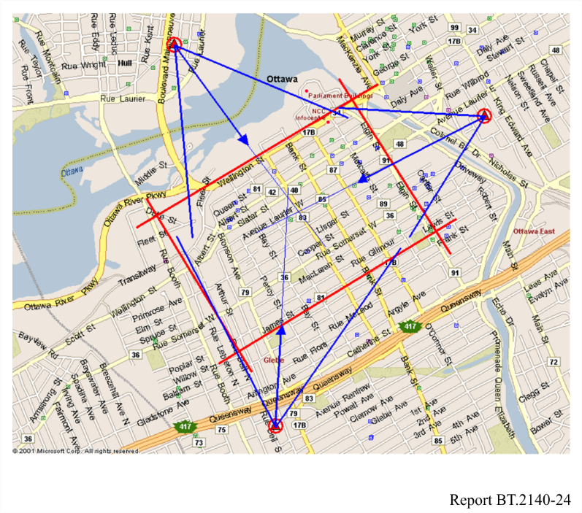
The measurement points were at the corners of the grids of a lattice covering the target area. A total of 59 points, at distances between 100 to 200 m from each other were measured. For the measurements, which were made on the street sidewalks at about 1.5 m above ground level (AGL), two types of antennas were used, an omni-directional antenna and a low gain directional antenna (usually used for indoor reception) with about 5 dB gain and 60° beam width.
Both antennas were made active by connecting them to a low noise amplifier (LNA) of about 1.2 dB noise figure and 20 dB gain, and also a band pass (BP) filter installed on the same stand as the antennas.
Characteristics of the receivers used for the tests
For these tests, two types of receivers were used, a new prototype, and an older generation receiver. The new prototype receiver, as compared with the older generation, was capable of handling pre-and post-echoes with a much wider delay range.
Figure 9 shows the relative attenuation of a single static echo at different delays, at which the receivers are at the threshold of visibility (TOV). As it is seen, the older generation receiver (Receiver G in the figure) could operate with about −5 dB echo in the range of −3 to +40 μs. The new generation receiver (Receiver V in the Figure), on the other hand, could handle pre and post echoes over a wider range. It was capable of handling −10 dB pre- or post-echo with a delay spread of −50 to +50 μs, or −5 dB echo in the range of −25 to +25 μs.
FIGURE 9
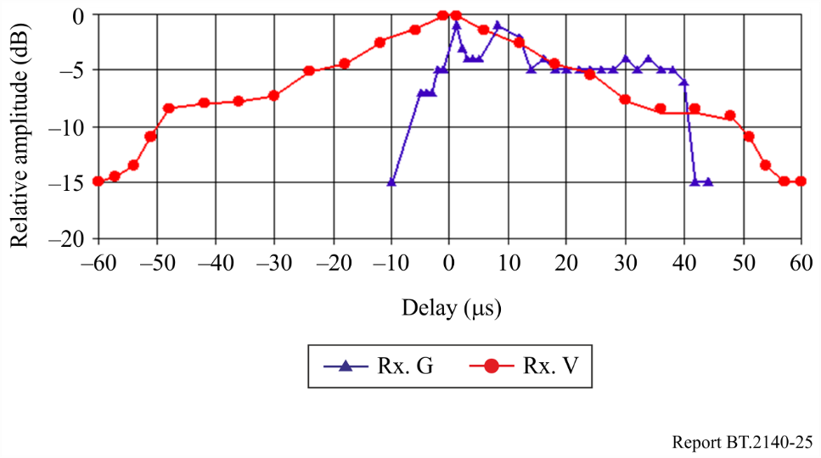
Performance of the two receivers used for the tests
Test results
In the first phase of the tests, the feasibility of implementation of such a network was verified. In the next phase of the study, measurements were performed in 59 points inside the target area. Table 1 shows the percentage of locations in which successful reception was achieved.
TABLE 1
Percentage of reception points with successful reception
 | DTx (CH-54)
 | New Prototype Rx. | Older Generation Rx.
Directional Rx. Ant | 97% | 54%
Omnidirectional Rx. Ant. | 71% | 19%
 | Main Tx (CH-67)
 | New Prototype Rx. | Older Generation Rx.
Directional Rx. Ant | 93% | 36%
Omnidirectional Rx. Ant. | 44% | 10%

Table 1 shows the results for DTx (CH-54) and also for the single distant transmitter (CH-67), using the new prototype and the older generation receivers, and also using directional and omni-directional antennas. As it is seen, the results are somehow better, under all circumstances, with the DTx network as compared to the single transmitter configuration.
Comparison of the results, however, can be made based on the type of the receiver, type of the receiving antenna, or type of coverage. What is quite evident is that under any condition, the reception situation is remarkably improved when the new generation receiver is used instead of the older generation receiver. Another major improvement can also be seen with using directional antenna instead of omni-directional antenna for both DTx and single transmitter. This has probably been due to the attenuation effect of the antenna on signals coming from the directions other than the main signal and acting as multipath.
Another important result that can be highlighted from this table is the fact that the DTx network, as compared to single transmitter configuration, has improved the situation also for the older generation receiver under all conditions (although not significant in all cases). The most significant improvement is when directional receiving-antenna is used. Under this condition, distributed transmission could improve the percentage of points with successful reception from 36% for single transmitter configuration to 54% for DTx network.
Conclusion
For the study in this section, a distributed transmission (DTx) network, consisting of three coherent translators, was used to cover parts of the coverage area of a single transmitter. Two types of receivers and two types of receiving antennas were used and measurements were made in both channels corresponding to the DTx network and the single distant transmitter. The reception conditions were made very tough by choosing overlapping coverage area located in the hostile downtown environment for the DTx network, and also by making the measurements at 1.5 m AGL on the street sidewalks.
The results showed that the DTx network had better reception availability than the single transmitter, especially when omni-directional receiving antenna was used.
The results also showed remarkable improvement in the performance of a new prototype receiver in the SFN environment, as compared to an older generation receiver that was used in the tests. This was because of the major improvement in the multipath handling capabilities of the new prototype receiver, which makes the implementation and operation of ATSC distributed transmission networks possible and reliable.
Another important result was the impact of even small directivity of the receiving antenna on reception. Directional receiving antenna, as compared to the omni-directional one, could provide successful reception for a greater percentage of the measurement points.
The test results also demonstrated reception improvement for the older generation receiver under SFN operation. However, because that receiver was only one generation older than the new prototype one, more tests are required to investigate the performance of the legacy receivers in a distributed transmission environment.

5 China
China started research and development on digital television (DTV) broadcasting systems in 1994.
In 2004, the national special working group for Chinese digital television terrestrial broadcasting standard was established including members from several universities and research institutes. Prototypes, field trials and system demonstrations were conducted by this working group.
On 18 August 2006, the Chinese digital television terrestrial broadcasting standard, GB20600-2006, was officially ratified. The full name of this standard is “Framing structure, channel coding and modulation for digital television terrestrial broadcasting system” and the abbreviation is DTMB, standing for digital television terrestrial multimedia broadcasting.
The signal frame of DTMB system consists of a specially designed pseudo-noise (PN) sequence and an either orthogonal frequency division multiplexing (OFDM) modulated or single-carrier modulated frame body. PN sequence is inserted as the training sequence and guard interval, which could be used by receivers to achieve synchronization, channel estimation and equalization.
The system information is protected by using spread spectrum communication techniques to guarantee the reliability.
There are five different constellations used in DTMB standard, i.e. 64-QAM, 32-QAM, 16-QAM, 4-QAM and 4-QAM-NR (Nordstrom Robinson).
Concatenated code of BCH and LDPC is adopted as forward error correction coding. There are three coding rates in the system, i.e. 0.4, 0.6 and 0.8. The system frame head also has three options (420, 595 and 945). There are two different modulation modes, multi-carrier and single-carrier. The usage of these two carrier modes depends on the IFFT processing parameter, C = 3 780 or C = 1. To improve the performance under impulse interference, time-domain interleaving with two different depth and frequency-domain interleaving are supported.
Through the combinations of different parameters, the DTMB system can provide a bit rate from 4.813 Mbit/s to 32.486 Mbit/s and flexible services can be supported by the DTMB standard. The bandwidth of the DTMB system used in China is 8 MHz. Lab tests and field trials demonstrate that the DTMB standard can also work well for systems with bandwidths of 6 MHz and 7 MHz.
The DTMB standard can support high definition TV, standard definition TV, fixed/mobile, as well as indoor/outdoor reception. The system can also support the infrastructure of single-frequency networks.
On 31 December 2007, the Hong Kong Special Administrative Region of China became the first city to implement commercial DTMB service. In January of 2008, DTMB signals were broadcasted in 8 cities, some of them hosting the 2008 Olympic Games. In late 2008, the Macao Special Administrative Region of China also adopted the DTMB standard. The Chinese Government plans to provide national wide digital terrestrial television signal coverage before analogue TV is switched off.
In 2013, the evolution system of DTMB -Digital Terrestrial Television Multimedia Broadcasting – Advanced (DTMB-A) was introduced to ITU-R WP6A by China. DTMB-A can support high-definition TV, standard-definition TV, and data broadcasting services under indoor/outdoor and fixed/mobile reception conditions with improved spectrum efficiency and better system performance. DTMB-A can be used for the large-area coverage within both multiple and single frequency networks. DTMB-A adopts multi-carrier modulation and advanced forward error correction coding scheme and can therefore provide fast system synchronization, high receiving sensitivity, better performance against multi-path effect, high spectrum efficiency and flexibility for future extension.
DTMB-A is proven to be able to support the system performance request from the broadcasting service providers and has received strong interests from other countries.

5.1 Analogue switch-off
Since June 15,2020, China started to promote switch-off of analogue TV terrestrial broadcasting transmission in the country. By the end of 2021, all analogue TV terrestrial broadcasting transmission was switch-off.

5.2 National digital terrestrial broadcasting coverage project
Since 2015, a nation-wide digital terrestrial broadcasting coverage project for Central Radio and Television programs was launched by the Chinese government to promote the development of national DTT network, the project was organized and implemented by the Chinese radio and TV competent authority named SAPPRFT. So far, DTTB signal has basically covered parts of villages and small towns in rural areas, all counties and big cities, more than 12 sets of SD programs were transmitted on regular basis. The network will be further expanded to serve more than 84% of the populations.

5.2.1 Project background
In “DTT Broadcasting Network Development Plan” published by SAPPRFT in December 2012, the timetable of transition from analogue TV to digital TV was scheduled.
To address the transmitting capacity issue by the analogue technology and to improve the level and quality of radio and TV public service, SAPPRFT launched the nation-wide digital terrestrial broadcasting coverage project for Central Radio and Television programs in December 2014.

5.2.2 Process of implementation
The implementation of this project includes three steps. The first step is to set up the technology solution and the frequency planning plan. The second step is to purchase the transmitting equipment and other affiliated facilities including antennas and feeders. For the last step, the province authorities work out the local implementation plan and carry out them.
Supported by this project, a new SFN structure-based satellite programme distribution networks was introduced to fully utilize the existing infrastructure. This related information was included in Report ITU-R BT.2386-1 ‒ Digital terrestrial broadcasting: Design and implementation of single frequency networks (SFN). Detail of this SFN technology solution is introduced which including DTT SFN structure, characteristics, and key technology based on satellite distribution link.

5.2.3 Progress of implementation
The whole project was divided into two phases: The first one is to install 6 230 DTT transmitters at 3 115 radio and TV transmitting stations (two transmitters at each station). Until now, more than 90% work has been finished; the second phase is to install 4 302 DTT transmitters at 2 151 radio and TV transmitting stations. For phase two, more than 40% works have been completed now.

5.3 Hong Kong
In December 2007, Hong Kong, China officially implemented digital terrestrial television (DTT) service in the UHF band provided by two incumbent domestic free television programme service licensees (free TV broadcasters) who shared a Multiple Frequency Network (MFN) multiplex for digital simulcast of their existing four analogue television programme channels and were respectively assigned a Single Frequency Network (SFN) multiplex to provide new television programme channels. Currently, they are broadcasting a total of 11 digital television programme channels via three digital multiplexers.

5.3.1 Technical aspects of DTT Implementation
Hong Kong, China adopted DTMB for DTT transmission. The specific technical parameters of the DTT transmission adopted by the two free TV broadcasters are summarised below.
TABLE 2
Modulation parameters
Mode |  | Multi-carrier mode with number of carriers (C) = 3 780
Modulation |  | 64-QAM
Frame header |  | PN945
Code rate |  | 0.6
Symbol interleaving |  | Mode 2 i.e. B = 52 and M = 720 symbols
Audio and video parameters
 | Standard Definition |  | High Definition
Profile/Level | ISO/IEC 14496-10  Main profile at level 3.0 |  | ISO/IEC 14496-10  High profile at level 4.0
Full-screen luminance resolution (horizontal × vertical) | 720 × 576 pixels interlaced |  | 1920 × 1080 pixels interlaced
Frame rate | 25 Hz |  | 25 Hz
Aspect ratio | 16:9 |  | 16:9
Chroma subsampling | 4:2:0 |  | 4:2:0
Audio encoding | AC-3 |  | AC-3

5.3.2 Network coverage
The two free TV broadcasters are responsible for the construction of the DTT transmitting network for broadcasting throughout Hong Kong, China. In this regard, they started with one transmitting station to cover 50% population coverage at the end of 2007, and gradually expanded the coverage by adding more transmitting stations by phases in the following years. They established a total of 29 transmitting stations by the end of 2011, with population coverage of 96%. Through optimizing the DTT network, the DTT service currently achieves 99% population coverage, which is on par with that of the analogue television broadcasting network. The improvement in population coverage from 2007 to 2013 is summarised in Table 3.
TABLE 3
Year | Number of DTT transmitting stations | Population coverage
2007 | 1 | 50%
2008 | 7 | 75%
2009 | 12 | 85%
2010 | 20 | 90%
2011 | 29 | 96%
2012 | 29 (beginning of network optimisation) | 98%
2013 | 29 (completion of network optimisation) | 99%

5.3.3 Receiver specification
As Hong Kong, China was among the first batch of cities to launch DTT service based on the DTMB standard, in order to facilitate production of DTT receivers by suppliers, a DTT receiver specification, namely the Technical Specification for DTT Baseline Receiver Requirements (HKCA 1108), was published in June 2007 and a voluntary labelling scheme was introduced in the same year. For those DTT receivers such as standalone set-top boxes or integrated digital television receivers (iDTVs) which are in compliance with the HKCA 1108 and the stated requirements, upon their application, suppliers could affix a prescribed label on the relevant DTT receivers so as to facilitate the general public in making informed choice when purchasing DTT receivers for use in Hong Kong, China. This arrangement was found useful, in particular during the initial launch of the DTT service.

5.3.4 Take-up rate
Currently, about 80% of the households in Hong Kong, China can receive DTT service via set-top boxes, iDTVs or computers. The DTT take-up rates since the launch of DTT service are summarised below.
TABLE 4
Date | DTT take-up rate (percentage of households)
2008 | 32%
2009 | 47%
2010 | 61%
2011 | 69%
2012 | 71%
2013 | 80%

Radio Television Hong Kong (RTHK), a public service broadcaster of Hong Kong, China, has commenced trial DTT service on its own SFN multiplex since January 2014. RTHK is currently broadcasting three high-definition programme channels from seven DTT transmitting stations co-located with those of the two free TV broadcasters. RTHK is planning to expand its DTT coverage by phases in the following years.

5.4 Macao
“Teledifusão de Macau (TDM)” started utilizing digital terrestrial television broadcasting technology since July 2008. TDM adopted the DTMB standard to transmit digital terrestrial television broadcasting signals, and uses the MPEG2 and H.264 video encoding techniques. TDM is currently providing totally 11 digital terrestrial television programs to Macao residents. Please refer to the detailed information:
TABLE 5
The detailed information of digital terrestrial television broadcasting of Macao
 | Technical information | Number of channels
The first single frequency network | The highest transmit rate is 21.658 Mbit/s, using MPEG2 as video encoding | Including 4 SD channels
The second single frequency network | The highest transmit rate is 21.658 Mbit/s, using MPEG2 as video encoding | Including 1 HD channel and  1 SD channel
The third single frequency network | The highest transmit rate is 21.658 Mbit/s, using H.264 as video encoding | Including 5 SD channels

In order to ensure Macao residents to buy suitable set-top boxes to receive the digital terrestrial television channels, DSRT, which is the telecommunication regulator of Macao S.A.R., co-operates with a higher educational institution of Macao, set up the “Digital Terrestrial Television Receiver Testing Center”. The equipment of this centre is provided by DSRT, and the institution which provides the facilities of the centre, and it is in charge of daily operation.
During the first phase of operation, this centre mainly tests the set-top boxes as well as the IDTVs and accepts applications from the manufacturers and suppliers. After testing, the qualified equipment will be listed on the website of DSRT, providing reference information for Macao residents. This centre will also hold meetings and conferences of innovative digital television broadcasting technologies.
Analogue and digital terrestrial television broadcasting currently co-exist in Macao, China. DSRT will continue to review the needs of frequency band usage and listen to the opinions from Macao residents.

6 Dominican Republic
Background
By Decree No. 407-10, dated August 9, 2010, the Dominican Republic officially adopted the digital terrestrial television standard of the North American system, Advanced Television Systems Committee (ATSC). Decree No. 407-10 established that the analogue shutdown would take place in August 2015. Decree No. 295-15 replaced 407-10 and established August 9, 2021, as the date for the analogue shutdown, which was later updated for 2022 by Decree No. 539-20. In 2022, Decree No. 437-2022 was issued, which instructs establishing August 31, 2023, as the new deadline for television broadcasting service concessionaires to proceed with the analogue shutdown and December 31, 2023, as the deadline for the digital switch-on.
DTTB implementation progress
Government decree No. 539-20 orders a series of actions to ensure the availability of the 700 MHz bands (698-806 MHz) to ensure that these frequencies can be put out to public tender in 2021 and implement Digital Terrestrial Television in 2022.
Through Resolution No. 081-2020, dated October 28, 2020, the regulatory body began the public consultation process to adopt the ATSC Digital Television standard (ATSC 3.0), for its implementation in the Dominican Republic. After several meetings with the private sector, it was decided to maintain version 1.0 of the ATSC Digital Terrestrial Television standard (ATSC 1.0).
At the beginning of 2021, through dialogue with the sector, it was possible to obtain the availability of the entire 700 MHz band to proceed with a public tender for the band from Channel 52 to 69 in UHF (698-806 MHz), of the Terrestrial Television service to make way for terrestrial mobile services in accordance with the National Frequency Allocation Plan (PNAF).
On February 4, 2021, the Board of Directors called for a public tender for the award of licenses for the provision of public carrier and final telephone and internet access services using radio frequencies in the 698-806 MHz bands throughout the national territory. This public tender concluded on October 28, 2021, being declared void with respect to the nine (9) blocks of ten (10) MHz each, in the 700 MHz band.
Since the end of 2021, the Board of Directors has been in the process of assigning the final frequency segments and virtual channel numbers to each of the concessionaires in accordance with what was approved in the Digital Terrestrial Television Transition Plan.
After exhausting the public consultation process on November 11, 2021, the Board of Directors approved the Digital Terrestrial Television Broadcasting (DTTB) Transition Plan, through Resolution No. 122-2021, which sets out the conditions and guidelines to be followed by television broadcasting concessionaires. This regulation established the stages of the transition process, the obligations of concessionaires and infrastructure providers, the schedule of activities and the assignment of frequencies to concessionaires. The Board of Directors updated the approval of the DTTB Transition Plan on September 1, 2022 through resolution 083-2022. Establishing the new deadline for the analogue switch-off on August 31, 2023 as the deadline for the television broadcasting service concessionaires to proceed with the analogue switch-off and December 31, 2023 as the deadline for the digital switch-on.
On April 25, 2022, the INDOTEL Board of Directors issued its Resolution No. 042-2022, by which it approved the specifications, appointed the evaluation committee, and called for the international public tender INDOTEL-BID-LPI-001-2022, for the "acquisition and delivery of digital television signal converter boxes to selected homes." The call for tender was published on May 10 and 11, 2022, in national circulation newspapers and on INDOTEL’s website.
By Resolution No. 075-2022, the deadline for submission of offers for the Indotel-BID-LPI-001-2022 International Public Tender for the "acquisition and delivery of digital television signal converter boxes" is extended to August 3, 2022, as well as the same date for the opening of offers for the aforementioned tender. The ceremony for opening the envelopes with the offers was held on August 3, 2022, as stipulated in Resolution No. 075-2022. Currently, the Dominican Republic continues to advance in the measures for the implementation of DTTB.

7 Germany
DTTB was officially launched on 1 November 2002 and, by the end of 2008, all transmissions were completely digital, using the DVB-T standard. The business model is free-to-air broadcasting. The country’s channel planning is based on the framework of the national frequency rights resulting from the ITU-R Geneva Agreement 2006 (GE-06), using predominantly the service concept “portable outdoor” (RPC-2 according to the Geneva Plan plus one or several assignments per city for high-power transmitter). This service concept generally enables indoor reception in the German agglomerations, which makes up one half of the total area, where typically more than twenty digital programmes are available in standard definition (SD) quality. Outside of these agglomerations, DVB‑T can either be received as “portable outdoor” or by using directive antennae. With respect to HDTV, first test transmissions have taken place. Trials are also carried out concerning the transmission of sound radio programmes within a DVB-T multiplex.
There are various types of receivers on the market, ranging from USB dongles for PC and laptops over small portable TV sets for handheld and in-car reception (screen size typically between 5 and 7 inch of diameter) to set-top boxes and stand-alone TV sets for stationary reception (typically with flat-screen displays). In May 2008, the first mobile phones with integrated DVB-T receivers appeared on the market. In addition, car navigation systems are nowadays equipped with DVB-T receivers.
The switch-off started in Berlin-Brandenburg in August 2003. Already by the end of 2003, some six million people were able to receive 26 digital channels in SD quality in the city of Berlin and the federal member state of Brandenburg. This was the first switch-off of terrestrial analogue television worldwide. This success can be ascribed in part to the Government, which decreed that the service was to be totally free of charge, and which provided, only in 2003, free decoders to the poorest households. Under no other circumstances, the purchase of DVB-T receivers was subsidized. By the end of 2007, more than 85% of the German population (68 million people) could already receive digital terrestrial television. More than nine million receivers had been sold by that data. The success of DVB-T in Germany was due to the fact that the reception of a multitude of German-speaking programmes was available to the general public free-of-charge. In 2008, DVB-T is used by 16.8% of the households in Berlin –Brandenburg.
In other metropolitan areas, DVB-T transmissions started in 2004. One key element of the German approach was the implementation of the digital broadcasting service region by region, initially after an announced transition period of as little as six months and later on without any simulcast period. By the end of 2008, the switch-over have been completed definitely (two years earlier than originally planned).
By the end of 2008, some 15 million DVB-T receivers are expected to have been sold since the launch of the service. Nevertheless, for their primary TV service in the households (large flat screen in the living room) approximately 90% of the Germans still rely on cable TV or satellite distribution.
Detailed information could be found at following links:
http://www.alm.de/fileadmin/forschungsprojekte/GSDZ/digitalisierungsbericht2008D.pdf;
and http://www.ueberallfernsehen.de/.

8 Guinea
The advance of satellite broadcasting slows down the process of migration from analogue to digital broadcasting in terrestrial television. However, DTTB launching is under consideration.
Legal and regulatory aspects
It has to be acknowledged that analogue radio and television broadcasting are not very developed in certain African countries, for example the Republic of Guinea, where radio broadcasting was introduced only in 1952, and television in 1977.
The transmission medium initially used was the radio-relay network, constructed in 1977.
Today, this network, operated by the Department of Posts and Telecommunications and digitized to the tune of 85%, does not carry television and radio signals owing to the advance of satellite broadcasting, which is favoured by the Government. However, we are convinced that the rapid development of radio and television broadcasting will of necessity involve digitization through liberalization of the audiovisual sphere.
Legal and regulatory framework for DTT
In the Republic of Guinea, the tools and infrastructures conducive to the rapid opening up of digital radio and television broadcasting are to be found in different sectors, with much of the equipment (radio and television transmitters, studios) being administered by the Ministry of Information, while other equipment (shortwave and medium wave radio transmitters and terrestrial radio-relay transmission facilities) is administered by the Ministry of Posts and Telecommunications. The Government would be better advised, with support from the development partners, to group the various communication media under the same authority, pending the opening of the audiovisual sphere.
Technical aspects
Two alternatives may be envisaged for the migration from analogue broadcasting to DTT:
− close down the analogue system and construct an entirely digital network, or
− deploy a hybrid system (analogue and digital).
The second option would seem to be the most appropriate for developing countries. It involves using the existing analogue network with a certain amount of refitting and the construction of a number of sites. However, the paramount requirement for making the DTT network more operational is a redistribution (replanning) of the frequencies used, this being the task of the regional radiocommunication conference (RRC) over the coming months.
Furthermore, the fact that our States currently use the radio-relay network for their radio and television signals leads us to recommend, for those countries that share a common border, that they jointly replan their frequencies and select the same digital television system, namely DVB-T, which is technically more adaptable than the ATSC(A) and ISDB-T(C) standards. In respect to channel planning and platforms, the DVB-T standard is less costly and more advantageous to developing countries during the transition period. This will allow for more fruitful regional consultation aimed at harmonizing the technical facilities to be used when introducing digital broadcasting equipment.

9 Italy
The switch-off of analogue broadcasting (analogue switch off (ASO)) was completed in July 2012. The adopted standard for digital terrestrial television broadcasting was mainly DVB-T. DVB-T2 and DVB-H were also used (the latter only in an early stage). In the reception availability model, free TV coexisted with pay-per-view services.
Broadcasters have provided a wide range of MHP-based interactive services such as digital teletext, news information, weather forecasts, audience polling and EPG.
The current percentage of digital terrestrial television, DTT, coverage is around 99% of the population and recent surveys indicate that for 92.1% of households DTT is the primary platform. Only 3.1% of household watch television by other means.
With regard to the satellite platform, a free to view satellite service called “Tivù Sat” was launched in July 2009 as result of a joint venture of the main Italian terrestrial broadcasters (Rai, Mediaset, Telecom Italia Media and two associations of local/private broadcasters – Aeranti Corallo and FRT). This platform, available from Eutelsat Hotbird 13°, offers its viewers access to all the free-to-air programmes already available on the DTT platform and a set of additional channels.

9.1 Spectrum policy

9.1.1 Italian Plan for DTT and the “internal digital dividend”
The Italian Plan defined in 2010, identified the channels in the VHF and UHF bands for 25 DTT national networks (21 DVB-T + 4 DVB-H) with a coverage of at least 80% of the national population and an extensive use of SFN techniques.
At the end of 2013, all the DVB-H channels have been changed into DVB-T channels.
In 2015, eight national network operators broadcasted 20 national multiplexes with a population coverage greater than 90%, which for the public service broadcaster reached the 99%.
In 2019 AGCOM, the italian communications regulatory authority, published the latest national plan for the DTT service (subsequently amended in 2020 and 2022), in view of the future adoption of the DVB-T2 standard, which provides for 12 national networks to be operated in SFN and 73 local networks at the most.
Following the Decision (EU) 2017/899 of the European Parliament and of the Council of 17 May 2017 on the use of the 470-790 MHz frequency band in the Union, in June 2022 the Italian broadcasters completed the release of the 700 MHz band.
In Table 6 are summarized details on number of multiplexes in use related to Italian national broadcasters, their technical specifications and percentage of population covered.

9.1.2 The local/private broadcasters phenomenon
It is important to take into account that about 600 local broadcasters were in operation over Italy in the “analogue era”, typically with a service target area of some adjacent provinces/regions. As a result of the Italian digitizing process, each “analogue” local broadcaster became a “digital” network operator having been assigned a multiplex. Before the Switch-Off in some areas there was a preliminary selection (“graduatoria”) of the local regional/subregional operators and formal agreements among them (“intese”), in order to limit the total number of assignments.
At the time of the analogue switch off, in 2012, in Italy remained a lot of multiplexes broadcasted by about 500 different local regional/subregional network operators that produce, as a result, an average occupancy of spectrum equivalent to 18 national Muxes.
With the release of the 700 MHz band, at the most 73 local networks could be deployed.

9.1.3 Migration to DVB-T2 system
In early 2012, the Italian government announced that as of 2015, all DTT receivers must include a tuner with the DVB-T2 standard. This decision is a consequence of, at least, the following two reasons:
– at present, in DVB-T multiplexes there is not enough capacity to introduce new services or improve the technical quality of broadcasting contents (SD towards HD and beyond);
– following the outcome of the last WRCs to reduce the amount of spectrum to broadcasting service in favour of mobile services, new and more efficient modulation and transmission techniques will be necessary to satisfy the enhanced TV services (i.e. DVB-T2/HEVC) on DTT platform.
From 28 August 2024 RAI broadcasts its national multiplex on channel 40 in DVB-T2 standard, with a mixed MPEG4 / HEVC encoding, in accordance with the provisions of the national service contract with the Ministry of Enterprises and Made in Italy. A subsequent roadmap by the same Ministry will define the transition to DVB-T2 of the other multiplexes.

TABLE 6
Details on number of multiplexes in use, their technical specifications and percentage of population covered
Broadcasters | System and modulation | FEC | GI | Content | Total capacity  (Mbit/s) | Channels  used | Percentage population coverage | Notes ⁽¹⁾
RAI | DVB-T, 64-QAM | 2/3 | 1/4 | 3 HD + 1 SD  and 4 HD + 2 SD during regional news | 19.9 | 29 30 37 43 45 | > 99% | Macro region SFN. Public service broadcaster multiplex with one different regional programme for each region.
RAI | DVB-T, 64-QAM | 2/3 | 1/4 | 2 HD + 5 SD + 3 radio + 15 HbbTV | 19.9 | 26 27 | > 95% | Ch 27 used only in Sicily
RAI | DVB-T2, 256-QAM | 3/4 | 1/8 | 9 HD + 1 SD +  9 HbbTV | 37.7 | 40 | > 95% | National SFN
Mediaset | DVB-T, 64-QAM | 5/6 | 1/4 | 14 HD + 4 radio | 24.8 | 46 | > 95% | National SFN
Mediaset | DVB-T, 64-QAM | 5/6 | 1/4 | 11 HD + 2 SD | 24.8 | 36 | > 95% | National SFN
Mediaset | DVB-T, 64-QAM | 3/4 | 1/4 | 15 HD | 22.4 | 38 | > 96% | National SFN
Persidera | DVB-T, 64-QAM | 5/6 | 1/4 | 12 HD + 22 SD +  4 radio | 24.8 | 44 32 31 | > 96% | Ch 44 and 32 are the most widespread. Ch 31 is used in the western part of Sicily
Persidera | DVB-T, 64-QAM | 5/6 | 1/4 | 9 HD + 6 SD +  3 radio | 24.8 | 42 48 | > 96%
Persidera | DVB-T, 64-QAM | 5/6 | 1/4 | 12 HD + 7 SD +  1 radio | 24.8 | 45 47 | > 96% | Ch 45 used in Trentino Alto Adige, Lombardy and in part of Piedmont
Cairo Network | DVB-T, 64-QAM | 3/4 | 1/4 | 8 HD + 24 SD +  12 HbbTV | 22.4 | 25 33 21 35 | > 94% | Ch 25 and 33 are the most widespread. Ch 21 is used only in the southern part of Sardinia. Ch 35 is only used in Sicily
DFREE/Prima TV | DVB-T, 64-QAM | 5/6 | 1/4 | 5 HD + 21 SD +  4 HbbTV | 24.8 | 23 24 | > 95%
⁽¹⁾ All Italian DTT licences will last until 2032 and all multiplexes are intended for fixed reception.

9.2 Monitoring systems
Due to the transition of terrestrial television transmission from analogue to digital, it became necessary to improve and adapt the monitoring systems and the technical procedures, used by Companies to verify the signal quality at every stage of the chain. As known, the past years in Italy, every broadcasting Company owned its broadcasting network: consequently, every broadcasting Company had developed its peculiar monitoring system to evaluate the compliance of signal quality with the standards defined by ITU Recommendations and in the Monitoring Handbook.
For this purpose, Rai Radiotelevisione Italiana, in a collaborative effort by its internal departments, has developed a monitoring system known as “EVA” (signal quality evaluator), which provides results that are considered more than satisfactory.
Moreover Rai Way, a Company of the Rai Group in charge of network planning, design, implementation and management, has developed a family of monitoring systems covering the whole chain from the signal coding to the user antennas: one of these systems is called “Rete Leggera”.
The monitoring networks mentioned above, described in detail in the following sections, are just two of the several different monitoring networks implemented by RAI-Rai Way. The other networks have more specific tasks, e.g. surveillance for operational aims, such as transmitters remote control.

9.2.1 The EVA system
EVA (Signal Quality EVAluator) is a system designed and implemented to ensure a constant monitoring of the technical quality of the Rai offer to the customer. It also provides the General Directorate with a fast and effective communication of technical inefficiency that generates a visible impact on users of services with common platforms, i.e. analogue broadcasting, digital terrestrial and digital satellite broadcasting. The system, which covers the entire production process from the production of the signal to the broadcast distribution to users, guarantees – in accordance with a provision of internal organizational communication – a fast internal communication of disruptions in order to identify:
– failure to deliver and distribute broadcasting services for a duration longer than 5 min, relating to 32 terrestrial Class 1 broadcasting plants and to the Rai satellite broadcasting services;
– failure to deliver and distribute broadcasting services for a duration longer than 10 min, for the 57 Class 2 broadcasting plants;
– disruption of television and radio broadcasts for more than 20 s;
– audio and video anomalies (RF/TV) longer than 1 min;
– transmission of a programme with a delay of more than 1 min, if due to technical reasons;
– transmission of a wrong programme.
The speed of communication ensures notification:
– within two hours after the event (except for Class 2 where the event is notified within 4 o’clock p.m. of the next day);
– for failures that occur between 00.00 and 06.00 a.m. the running part from 6.00 o’clock a.m.
The new system allows RAI’s structures to coordinate the activities of collection, verification and management of anomalies and to identify any required corrective actions. Its actions in real time include:
– inform top management about anomalies perceived by customers;
– monitor the communication process across the right company paths.
In terms of quality management for the continuous improvement, the system allows to perform sophisticated analysis on the collected data to support the identification of strategies to improve technical quality. The important aim is to help the corporate quality department in finding suitable preventive and corrective actions to improve the services offered to the public at large.

9.2.1.1 System architecture
The architecture of the system uses, on one side, the channels of communication officers of the structures involved in the production process and, on the other side, the “virtual user” which are sensors or devices capturing analogue and digital signals in service area. They measure directly on the territory the parameters conventionally used to evaluate the technical quality of broadcasting services: the information received is analysed in real time from the central system for managing communication anomalies operators and also for archiving and statistic purposes.
The system architecture is shown in Fig. 10.
FIGURE 10
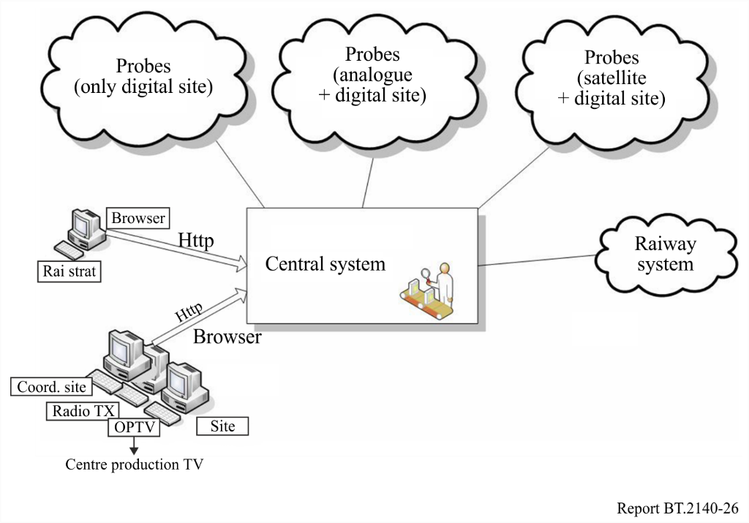
Where “probes” stand for remote devices placed in several Rai’s regional branches and which ensure the technical monitoring of the diffusion network; the graphic symbols represent the Company structures directly involved in the whole production/distribution process up to the customer. The entire workflow has been supplied with warning functionalities as e-mail (Exchange infrastructure) and sms (SMS Gateway infrastructure).
All warnings are collected in a centralized database. The technical collection of measures from remote sensors is carried out by a specific system component called “Dataminer”.
The EVA system afterwards assembles information from remote devices (measures) and from internal/external company structures (communications) in a central architecture as shown in Fig. 11.
FIGURE 11
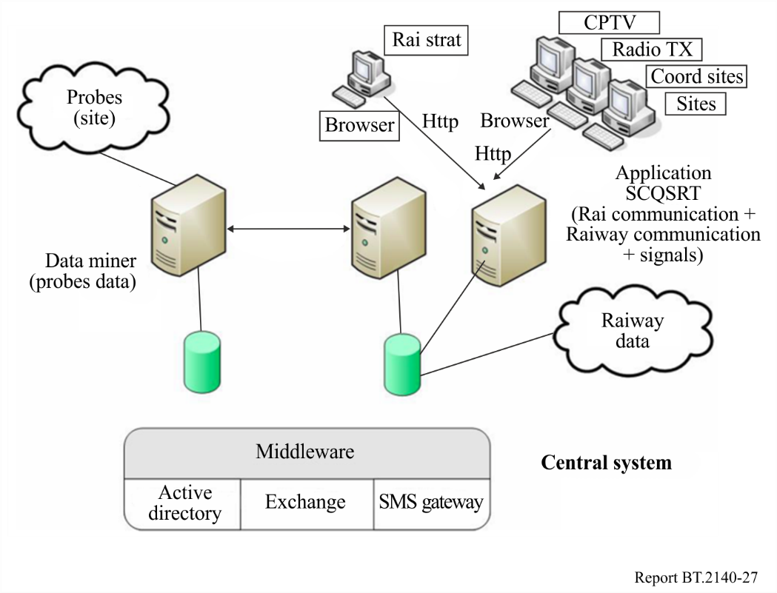

9.2.1.2 The measuring section
A typical remote device (so called “virtual user”) for all digital areas is the following:
FIGURE 12
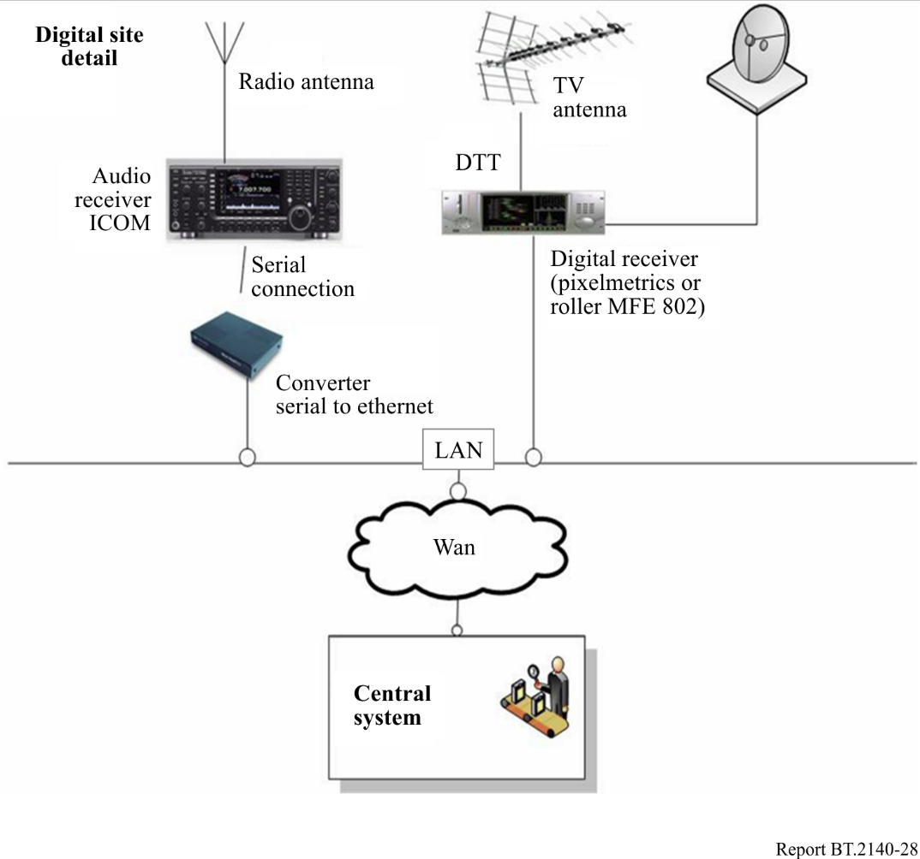
Technical parameters monitored by remote devices are different depending on signals (analogue, digital, radio, satellite, etc.). Typically they are:

Analogue services:
– Signal level.
Digital services:
– Sync loss.
– Continuity error.
– Signal level.
– MER.
– Pre-Viterbi BER.
For digital sensors we are studying the best threshold values for measure to be in line with the customer perceiving expectations.
The transport stream analysis of the DTT signal is possible (at present only for the same remote branches).

9.2.1.3 The communication section
As seen below, EVA also collects structured communication on faults coming from all company sections involved in broadcasting process. Operators can put into system warning messages with different severity. The procedure is a system driven by user friendly forms like this:

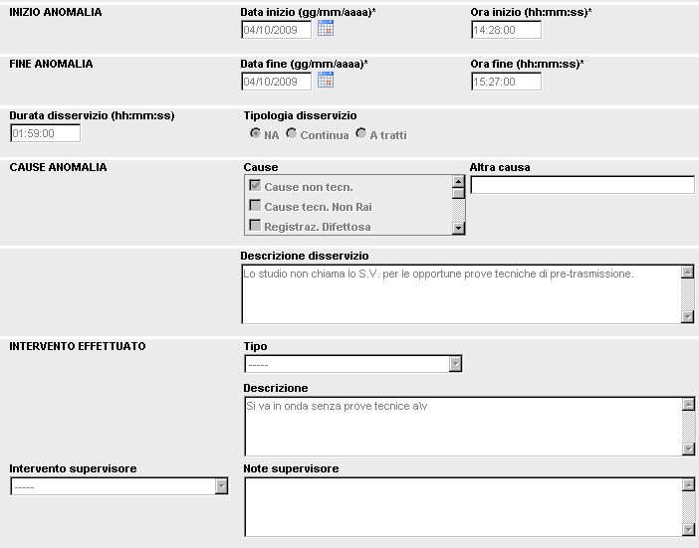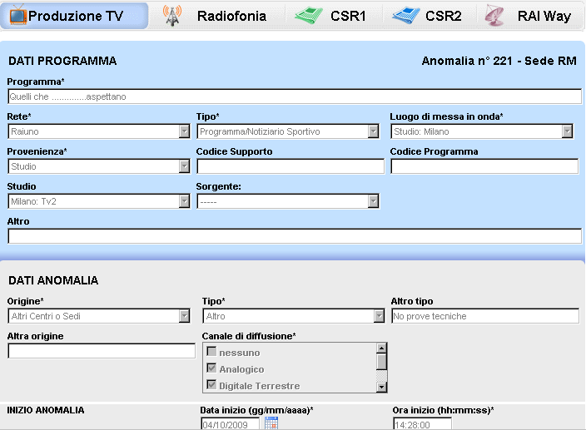
where all requested information contributes to give a complete fault picture without interfering with the normal working process.
The EVA system has a layer WEB based software and is accessed by internal users according to a profiling policy (Operator, Supervisor, Responsible, Area Supervisor, Area Responsible, User monitoring, Supervisor monitoring, Administrator).
At different authorization levels the system allows a set of tools to manage the warning messages from the production/broadcast chain.

Service Impairment Communication
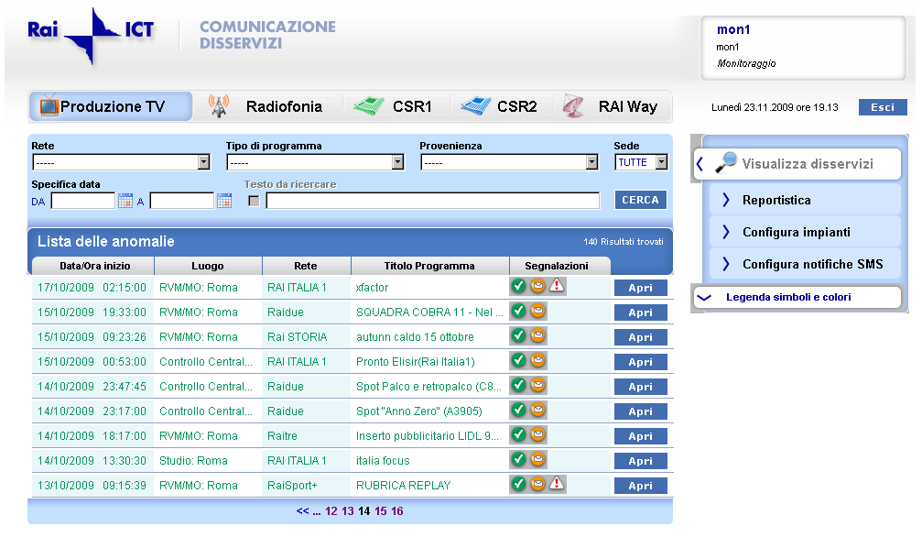

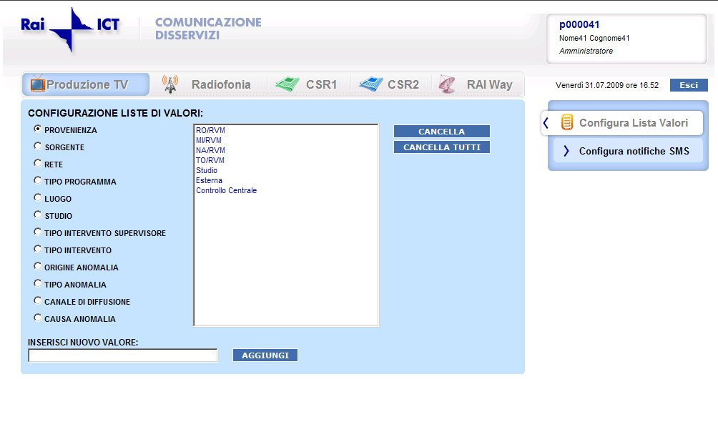

9.2.1.4 The monitor user interface
At the top-level EVA offers a “dashboard” for a complete picture of the technical status of the Rai offer on air, with mask, screen report, interactive forms that manage the “measure” and the “communication” world.
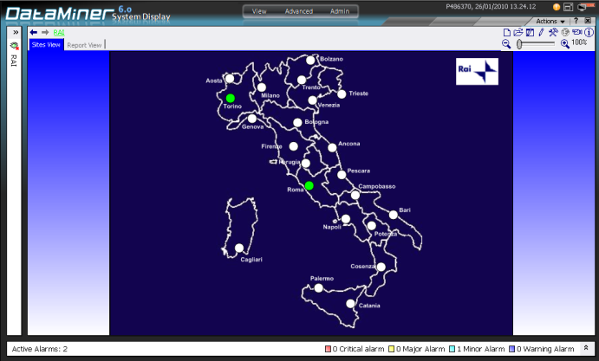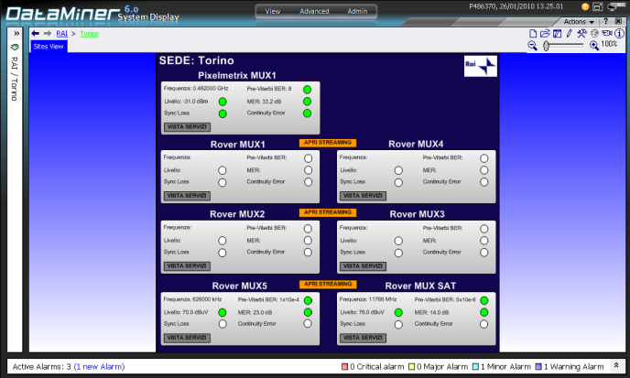
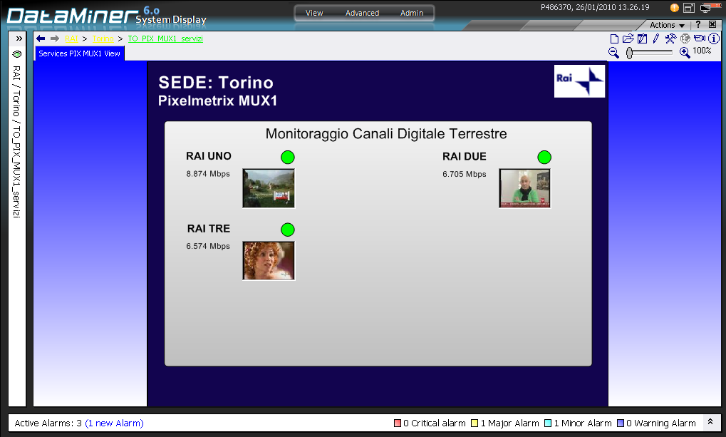

9.2.1.5 Report and analysis section
Some reports and tools allow the administrator to perform analysis on archived data. Others are designed to evaluate the performance of entire TV/Radio broadcasting process and to better show areas which can be improved.

9.2.1.6 Quality certification
The system has a client-server structure and runs on a PC with a common WEB browser.
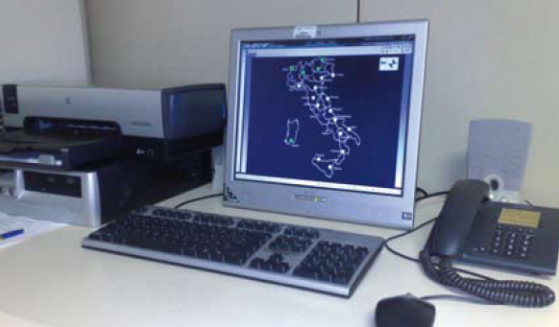
On June, 2010 EVA system obtained the quality certificate of conformity which will evolve according to system improvement.

9.2.2 “Rete Leggera”
“Rete Leggera” has been developed since 1998 inside the Monitoring Centre of Rai as the natural evolution of previous systems and it is based on ITU Monitoring Handbook’s guidelines. Rai Monitoring Station has been part of the international monitoring network since its constitution in 1929.
The idea, on which the new monitoring network is based, was to verify the signal quality in target area in user perspective, using several fixed measurement locations which cover all the Italian Districts (about 100 Districts).
The monitoring network has been subject to several re-engineering processes, following the technical evolution and the new control requirements.
At the moment, the network is deployed on three hierarchical levels: UP (Peripheral Unit), UC (Concentrator Unit), UG (Management Unit), as shown in Fig. 13.
Figure 13
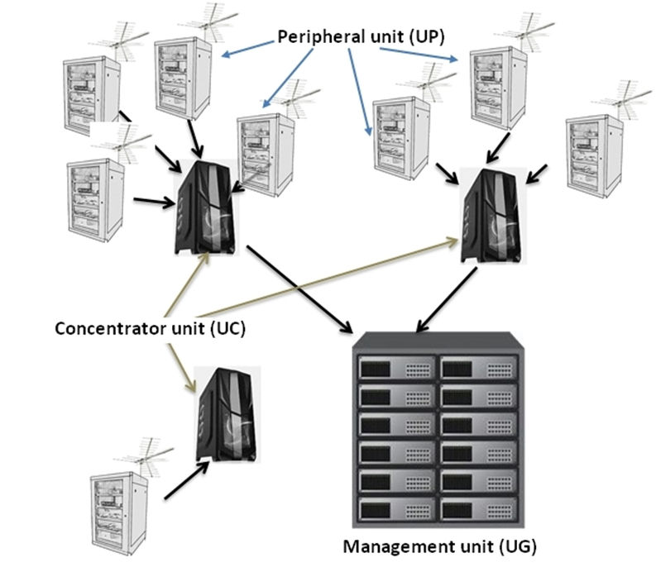
– UP: Collects measurement data in target area. It is composed by a processor, specific receivers, antennas and custom developed software. Collected data are not locally processed but sent directly to its UC.
– UC: Collects and processes data coming from its UP network. Its processor is based on high performance system. It is usually located by Rai premises.
– UG: Is the kernel of the system, where processed data are stored and shown on the Intranet WEB site.

9.2.2.1 DTTB measurements
The control activity is performed only on received signals following customized steps:
– Level 1: field strength measurements.
– Level 2: modulated signal (MER, BER, TPS).
– Level 3: coded-bit stream (ASI analysis and stream recording).
– Level 4: SFN specific analysis (Channel Impulse Response).
The measurements of the first two levels are performed by tuning cyclically the receivers on different channels, selected from a frequency table. Measurements of Level 3 and 4 are performed on demand.
Level 1
Field strength measurements are carried out through a fast cycle compatible with the minimum time permitted by receivers. For this kind of measurements, no signal lock is required. The minimum required signal level at the input of the receiver is 30 dB(μV).
Every measurement is compared with a reference level, which is the expected signal level/field strength, the confidence interval and the threshold under which a warning is generated. Only measurements outside confidence interval are stored in database.
Figure 14
RF charts
(the red line is the measured value; green line is the reference level; the blue dotted line is the threshold)
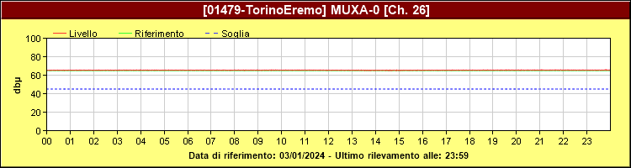
Level 2
Modulated signal measurement requires a signal lock on the channel under investigation. Signal lock needs a minimum time. In case of no lock a warning is generated. After locking procedure, the parameters MER and BER are measured by calculating the mean on ten values. All measured values are stored in a database. Four times a day, TPS check is performed.
Figure 15
MER chart (threshold values are defined by ETSI)
(the red dots are the measured RF value; green dots are the measured MER;
the black dots are the MER reference level and the MER threshold)
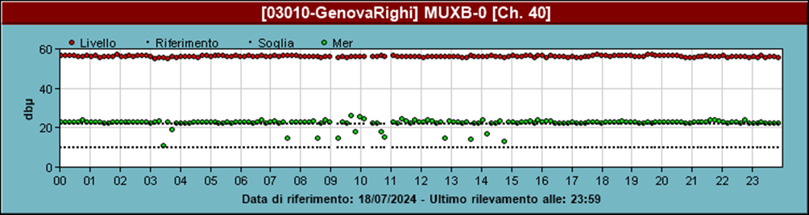
Figure 16
BER chart
(the green dots are the measured cBer; the blue line is the cBer reference level)
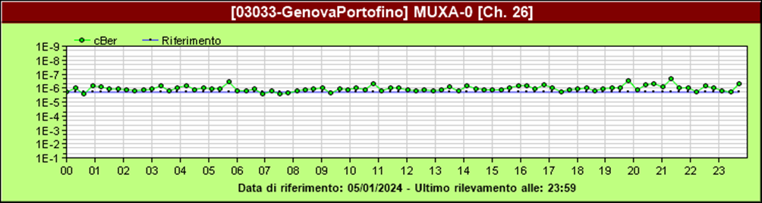
Using signal level, BER and MER value, signal quality is calculated as indicated by Recommendation ITU-R BT.1735 for DVB-T and Report ITU-R BT.2467 for DVB-T2.
Figure 17
Quality chart
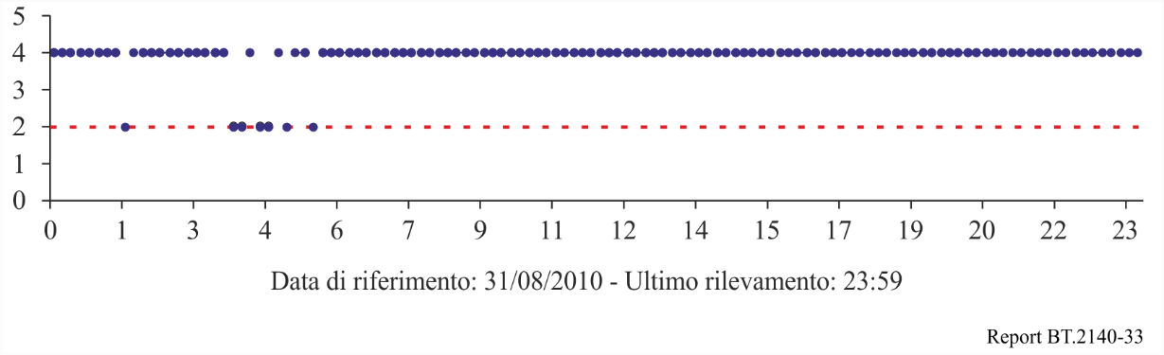
Level 3
At this level, a specific hardware composed by a receiver providing ASI output and a TS analyser is required. Two different kinds of analysis can be performed:
a) cyclical analysis on bit rate and null packet with dwell time of a minute on each multiplex under investigation. ASI stream can be also recorded for more detailed evaluation;
b) long-term analysis on a specific multiplex to check the compliance with ETSI TR 101-290 protocol parameters for MPEG-2-TS monitoring.
In both cases, results are stored in the local database.
Level 4
In Italy, very large SFNs have been deployed and it is important to have the possibility to check the stability of the network. To operate correctly, SFNs require tight control of frequency and time. Failure of the timing in any part of the network or a drift in the frequency of a transmitter can result in significant interference. Moreover, anomalous propagation phenomena could also impact on the reception quality of service.
For these reasons, a specific tool was implemented which is able to analyse the Channel Impulse Response, CIR, every minute and to collect measurements of RF levels, MER, BER of the main transmitter and the levels and delays of the signals of all transmitters received at a specific monitoring place. The measurement data are organized in a daily csv files.
FIGURE 18
CIR analysis
The brown line is the RF level and the green line is the MER and the reference scale is on the right.
For the delays, the RF difference from the main signal is shown and the reference scale is on the left
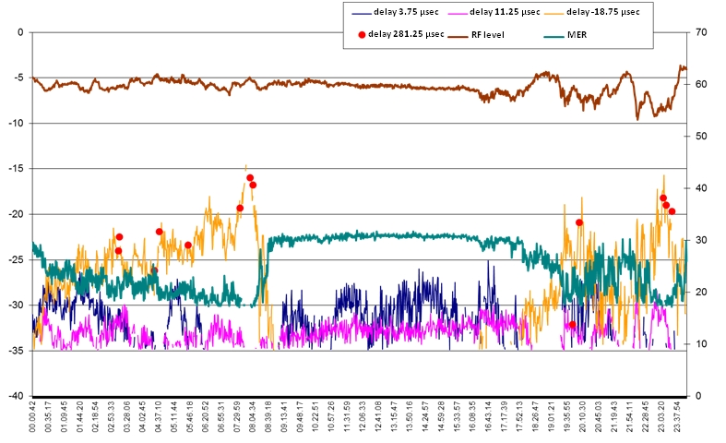
This is an on-demand activity.

9.2.2.2 WEB user interface
All collected data are stored in the central database and processed to produce different types of results which are displayed on an intranet Web site using various kinds of charts.
The global situation of the broadcasting network, in real time, is shown on a general map of Italy.
There, active warnings are displayed by red flags indicating if it is a RF or MER alert.
FIGURE 19
Web panel with real time warnings
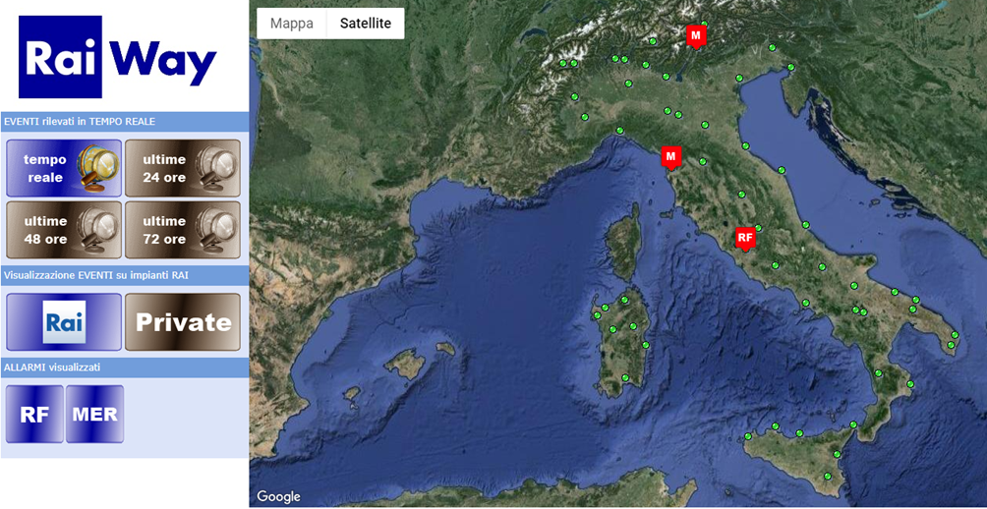
It is also possible to see the events which occurred in the last 24-48-72 h (the represented interval is selectable by the user).
FIGURE 20
Web panel with real warnings occurred in the 24h
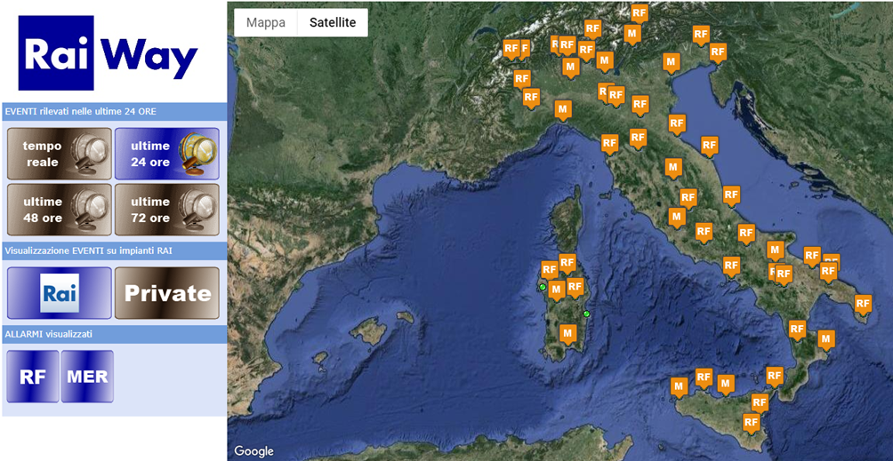
Clicking on the dots, the page of the chosen monitoring site is displayed. It contains the detailed information of all the channels controlled in this point.
Looking into the detail, the main page of a monitoring site shows the collection of RF real time signal level graphs for each controlled channel (see Fig.21).
Figure 21
Monitoring chart
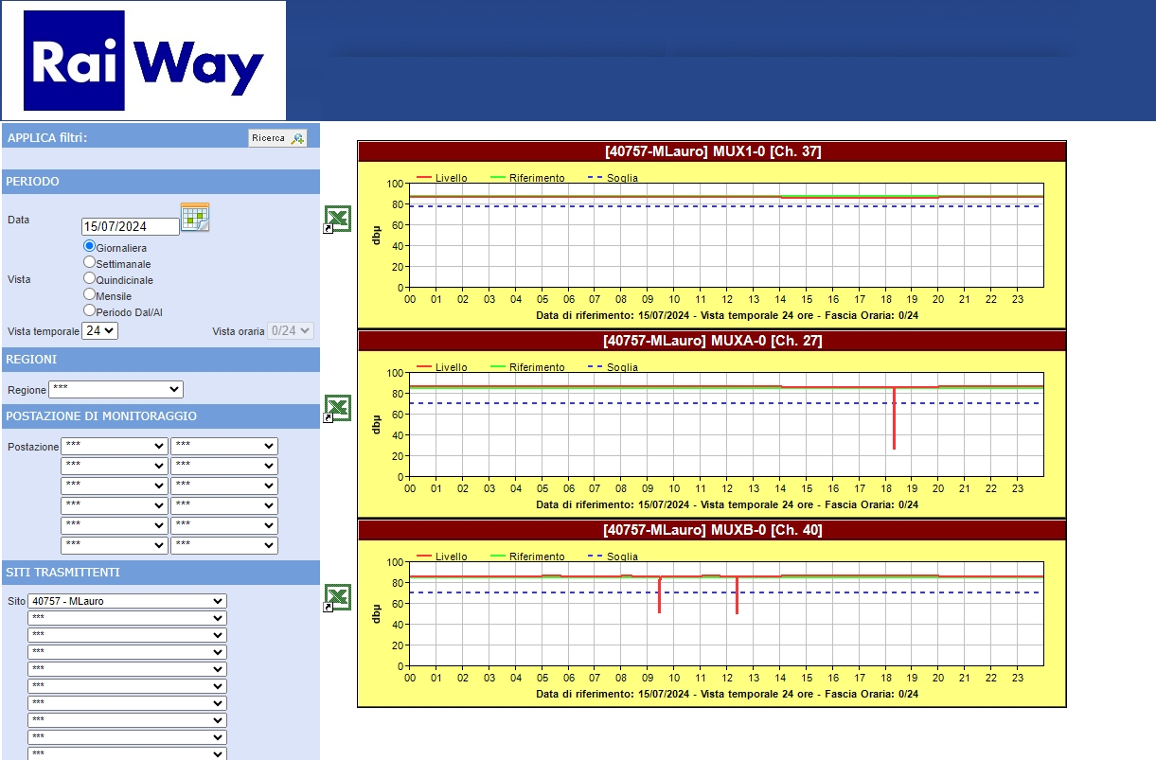
In the charts, it is possible to examine the details of measurements and signal level changes and even detect the details of the occurred interruptions.
In addition, users can display more graphs representing RF, MER, BER and quality measurements selecting monitoring sites, channels, services, data and time, according to their needs.
Figure 22
Monitoring details
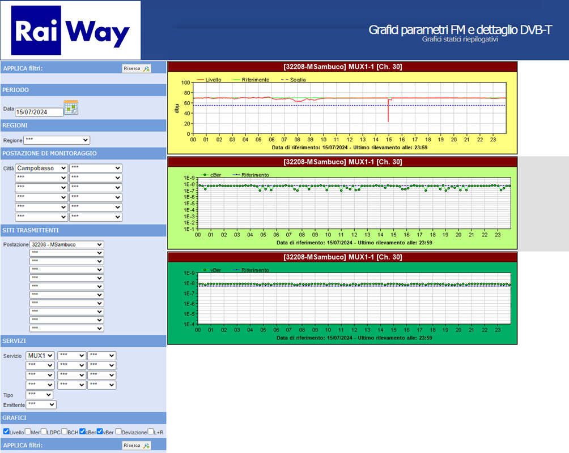
A section has also been developed where recorded ASI streams are available and can be reproduced (see Fig. 23).
Figure 23
Example of possible statistic on recorded data
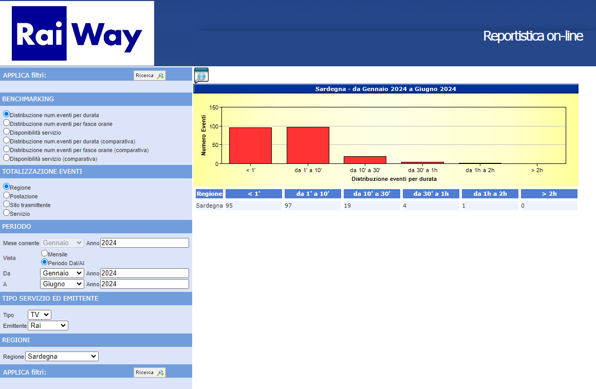
At the moment the web site is under re-engineering with the aim to add new facilities which can better match the new requirements.

10 Japan
Terrestrial TV broadcasting is a fundamental medium in Japan with 52 million households. Terrestrial broadcasters have established many relay stations to provide maximum coverage throughout mountainous regions and the entire archipelago. In fact, there were more than 3,000 transmitter sites for analogue TV broadcasting. Assigning digital channels without migrating analogue channels was not possible due to the heavy use of UHF cannels by analogue relay stations. As a result, many analogue TV channels were forced to shift to other UHF channels before assigning channels for digital TV broadcasting.
From the three major metropolitan areas of Tokyo, Nagoya, and Osaka, service coverage has been expanded nationwide since the start of digital terrestrial TV broadcasting (DTTB) in December 2003. As of December 2007, more than 90% of households were covered. Most of the relay stations were built by 2010 and digital migration was completed in July 2011. The number of households with digital receivers has been increasing on a gradual basis. According to government investigations, the percentage of households with digital receivers was 28% in 2007, 61% in 2009, and 95% in 2010. Over 120 million receivers had been shipped by May 2011.
Receivers for automobiles have been on the market since 2005, and 6.9 million automobile TV receivers had been shipped by May 2011.
The One-Seg service for handheld receivers using the central segment of the ISDB-T signal started in April 2006. Over 106.2 million mobile phones with One-Seg receivers had been shipped by May 2011.

10.1 History in brief
The digital broadcasting system was discussed in Japan by the Telecommunications Technology Council (TTC) of the Ministry of Post and Telecommunications – MPT (current MIC: Ministry of Internal Affairs and Communications) and detailed technical matters were discussed at the Association of Radio Industries and Businesses (ARIB).
Under the concept of integrated services digital broadcasting (ISDB), three kinds of systems, ISDB-S (satellite), ISDB-T (terrestrial) and ISDB-C (cable) were developed in Japan to provide flexibility, expandability, and commonality to the multimedia broadcasting services using the networks.
Based on the results of field trials, the ISDB-T system was found to offer superior reception characteristics and consequently the ISDB-T system was adopted in Japan as the DTTB system and digital terrestrial sound broadcasting (ISDB-T_{SB}) system in 1999.
Figure 24 outlines the time schedule for DTTB in Japan.
FIGURE 24
Schedule for DTTB in Japan
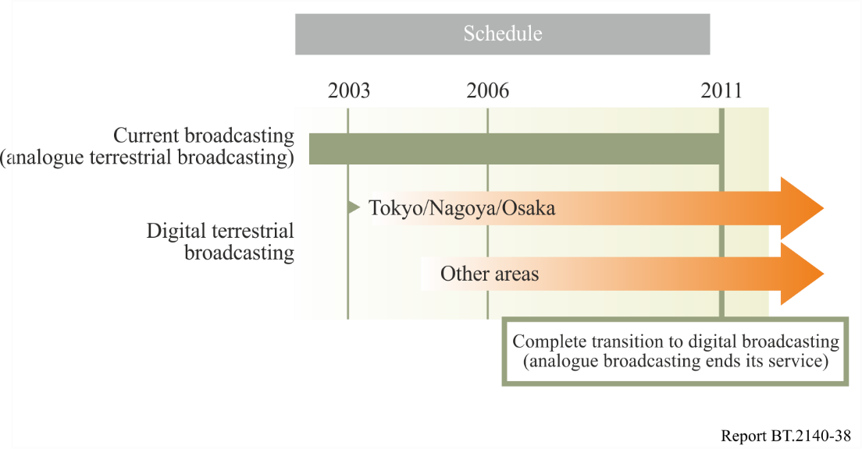
Broadcasters created a road map and constructed transmitting stations according to this plan. DTTB was launched in December 2003 in the Tokyo, Osaka, and Nagoya metropolitan areas. After that, digital terrestrial broadcasting started at the main cities in all other prefectures and 84% of households were covered by the end of 2006. Broadcasters constructed all relay stations and the service areas gradually expanded. Analogue terrestrial TV broadcasting was finally terminated in 2011.

10.2 Situation with frequencies
Analogue terrestrial broadcasting utilizes a multi-frequency network (MFN) with a transmission scheme that uses different transmitting frequencies in service areas. An MFN with many transmitting stations is a means to deliver programs to the national audience without causing harmful interference in service areas. Approximately 15,000 transmitting channels for analogue terrestrial TV broadcasting had been constructed throughout Japan. Consequently, there were not sufficient frequencies available for digital television broadcasting.
The Japanese government is undertaking a huge project to move the numerous analogue TV stations to the upper or lower parts of the spectrum to free up frequencies for digital television use (see Fig. 25).
FIGURE 25
Number of transmitting channels for analogue TV
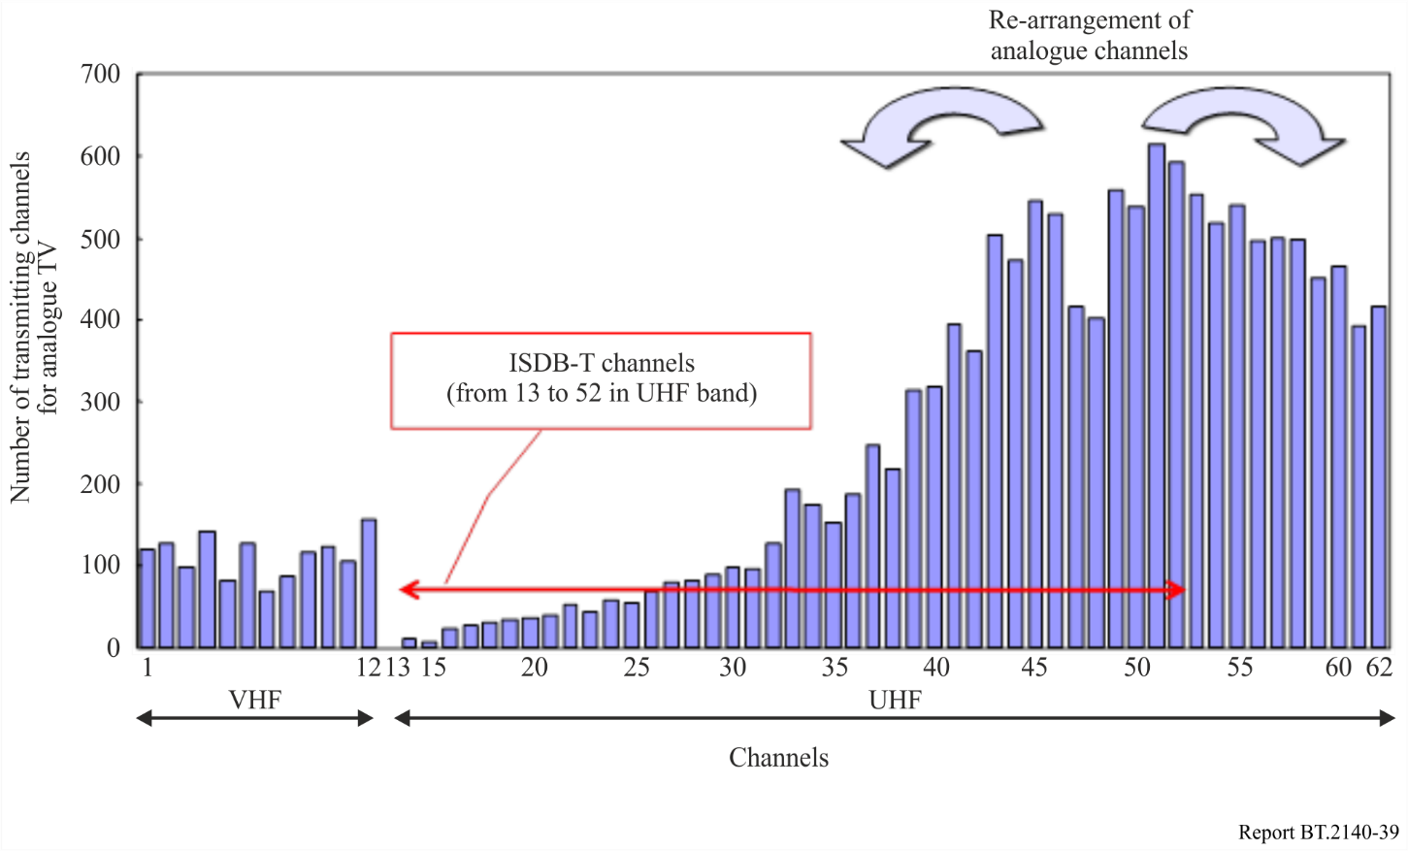

10.3 Transmission antennas
Broadcasters in the Tokyo area have placed new antennas at a height of 250 m on Tokyo Tower. A transmitter room was built under the tower’s large observatory. A new facility with a 246-m steel tower and a broadcasting station has opened in Seto city in the Nagoya area. Broadcasters in the Osaka area have installed antennas on their own towers.
A new transmitting tower called Tokyo Sky Tree that will replace Tokyo Tower is being constructed in the Oshiage area in Tokyo. Its height will be 634 m, which will make it the highest self-standing tower in the world. Because it is twice the height of Tokyo Tower, it will reduce radio wave interference caused by super-high tower buildings in the Tokyo metropolitan area. TV broadcasting services from Tokyo Sky Tree will begin in 2013. An overview of these facilities is illustrated in Fig. 26.
FIGURE 26
Digital transmitting facilities in major cities
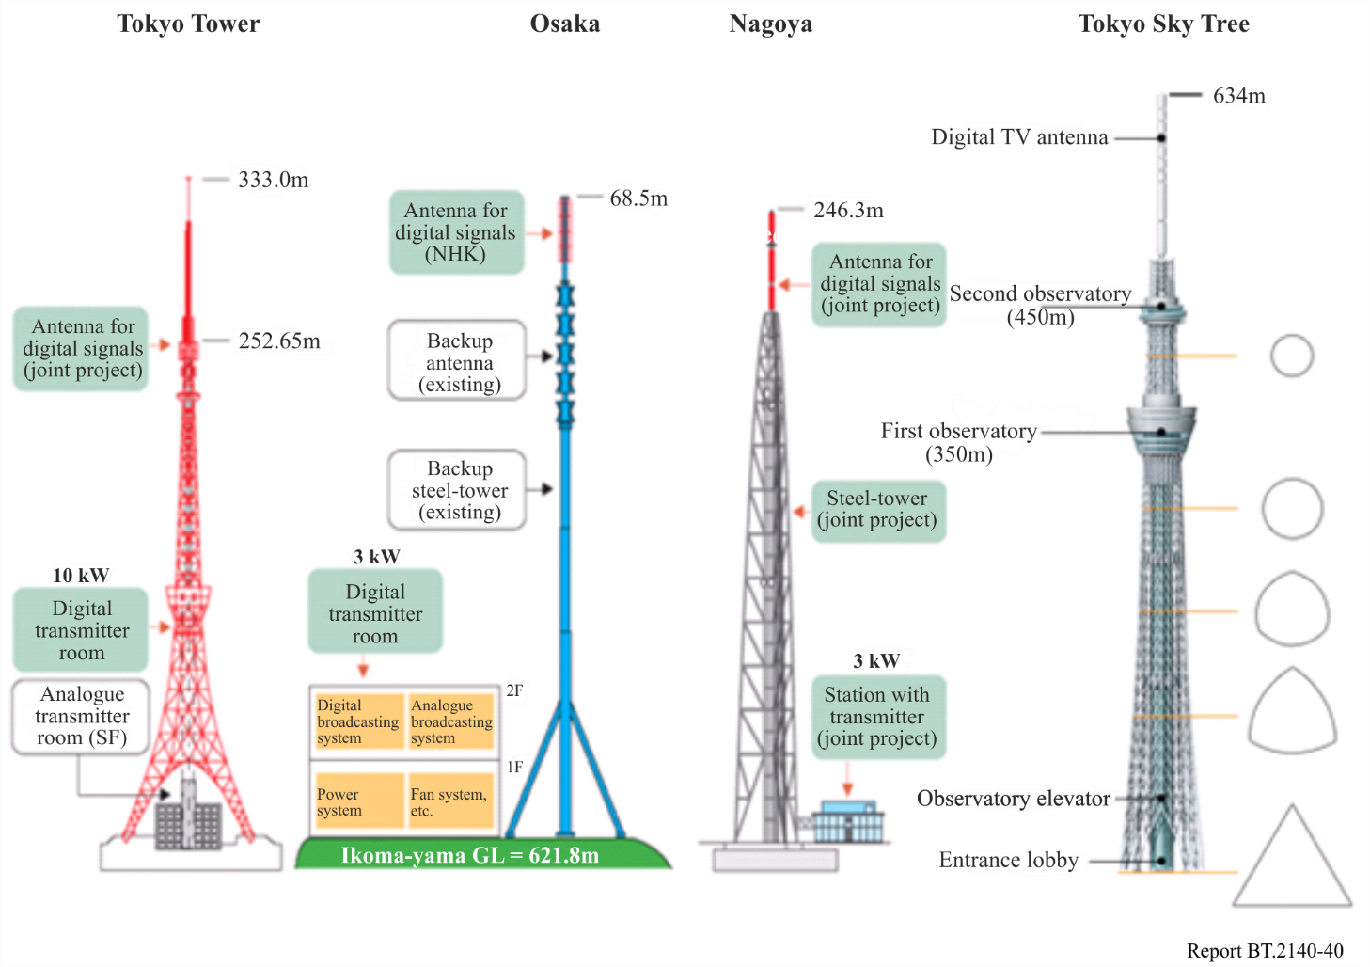

10.4 Technical characteristics of ISDB-T
The system compatibility between digital television and digital sound broadcasting was taken into consideration in ISDB-T. ISDB-T with full segments serves digital terrestrial television broadcasting and ISDB-T_{SB} using one segment, or three segments, serves digital terrestrial sound broadcasting.
ISDB-T is also capable of providing data broadcasting consisting of text, diagrams, still pictures, and video images to handheld devices, in addition to high-resolution pictures and stereo sound. In contrast with digital satellite broadcasting, it is able to feature detailed information on local interests. Furthermore, it has great potential to disseminate information to mobile multimedia terminals, such as car radios and pocket-sized receivers.
The following requirements were considered in developing ISDB-T.
It should:
− be capable of providing a variety of video, sound, and data services;
− be sufficiently robust to any multipath and fading interference encountered during portable or mobile reception;
− have separate receivers dedicated to television, sound, and data, as well as fully integrated receivers;
− be flexible enough to accommodate different service configurations and ensure flexible use of transmission capacity;
− be extendible enough to ensure that future needs can be met;
− accommodate SFN;
− use vacant frequencies effectively; and
− be compatible with existing analogue services and other digital services.
To comply with all the specified requirements, ISDB-T makes use of a series of unique tools such as (1) the orthogonal frequency division multiplex (OFDM) modulation system associated with band segmentation, which gives the system greater flexibility and the possibility of hierarchical transmission, (2) time interleaving, which contributes to achieving the necessary robustness for mobile and portable reception while giving the system powerful robustness against impulsive noise, and (3) transmission and multiplex configuration control (TMCC), which allows dynamic changes in transmission parameters to adjust the system for optimized performance depending on the type of broadcasting (e.g. HDTV and mobile reception).
These unique characteristics enable ISDB-T to provide a wide range of applications.

10.5 Outline of ISDB-T transmission scheme, related ARIB standards and ITU-R Recommendations
TABLE 7
ISDB-T transmission scheme
Item |  |  | Content | ARIB standards | Recommendations ITU-R
Video coding |  |  | MPEG-2 Video (ISO/IEC 13818-2) | STD-B32 | BT.1870
Audio coding |  |  | MPEG-2 AAC (ISO/IEC 13818-7) | STD-B32 | BS.1196
Data broadcasting |  |  | BML (XHTML), ECMA script | STD-B24 | BT.1699
Multiplex |  |  | MPEG-2 systems (ISO/IEC 13818-1) | STD-B10,  STD-B32 | BT.1300, BT.1209
Conditional access |  |  | Multi 2 | STD-B25 | –
Transmission |  |  | ISDB-T transmission | STD-B31 | BT.1306  System C
 | Channel bandwidth |  | 6 MHz, 7 MHz, 8 MHz | STD-B31 | BT.1306  System C
 | Modulation |  | Segmented OFDM (13 segment / ch) | STD-B31 | BT.1306  System C
 | Mode, guard |  | Mode: 1, 2, 3  Guard interval ratio: 1/4, 1/8, 1/16, 1/32 | STD-B31 | BT.1306  System C
 | Carrier modulation |  | QPSK, 16-QAM, 64-QAM, DQPSK | STD-B31 | BT.1306  System C
 | Error correction | Inner | Convolutional code  (Coding rate: 1/2, 2/3, 3/4, 5/6, 7/8) | STD-B31 | BT.1306  System C
 | Error correction | Outer | (204,188) Reed-Solomon code | STD-B31 | BT.1306  System C
 | Interleave |  | Frequency and time interleave  Time interleave: 0 – 0.5 s | STD-B31 | BT.1306  System C
 | Information bit rate  (depends on parameters) |  | 6 MHz: 3.7-23.2 Mbit/s  7 MHz: 4.3-27.1 Mbit/s  8 MHz: 4.9-31.0 Mbit/s | STD-B31 | BT.1306  System C
Receiver |  |  | ISDB-T receiver | STD-B21 | –
Operational guideline |  |  | ISDB-T broadcasting operation | TR-B14 | –

10.6 Emergency warnings through broadcasting
Early warnings of impending massive natural disasters such as earthquakes, tsunami, hurricanes, and volcanic activity are very effective in alerting those who may suffer from their consequences. Emergency warnings through broadcasting effectively inform persons of impending events and provide them with related information that can save their lives and help them protect their properties in the event of disaster. This chapter presents some emergency warning systems using broadcasting.

10.6.1 Automatic activation of handheld receivers by emergency warning system signals (see Recommendations ITU-R BT./BO.1774)
The emergency warning system (EWS) described in Recommendations ITU-R BT./BO.1774 enables public warnings to be made in emergencies due to disasters through analogue radio and/or analogue TV sound channels. Analogue broadcasting quite effectively issues public warnings using this method as it is one of the most widespread of all broadcasting services.
Digital terrestrial broadcasting has an emergency warning mechanism that is similar to that in analogue broadcasting. Broadcasting differs from other communications in that it can simultaneously send information to numerous handheld receivers. The capability to activate handheld receivers to receive emergency information should lead to reduced damage caused by disasters. Handheld receivers would have to be in constant stand-by mode for this to be effective for EWS signals, but if power consumption were too high, it would be difficult to maintain stand-by for prolonged periods.
A stand-by circuit for EWS signals that has low-power-consumption and can maintain stand-by for the EWS signals for digital terrestrial broadcasting has been studied to solve this problem.
Figure 27 shows the activation of a handheld receiver using EWS signals in digital terrestrial broadcasting.
An EWS signal is indicated by bit 26 in the TMCC signals comprising 204 bits in System C of Recommendation ITU-R BT.1306-3. In Mode 3 (No. of carriers: 5 617), there are 52 TMCC carriers in total for 13 segments, or four carriers per segment. The TMCC signals modulated by differential binary phase shift keying (DBPSK) are transmitted at intervals of approximately 0.2 s.
The EWS signals in one or more TMCC carriers are to be continuously monitored by all receivers to remotely activate the receivers. Furthermore, continuous monitoring is to be achieved without substantially shortening the stand-by time of handheld receivers. To reduce power consumption, a dedicated stand-by algorithm is introduced that:
a) only extracts TMCC carriers; and
b) only monitors the EWS signals by limiting time slots.
The function for EWS stand-by with very low power consumption has been tested and verified.
The technique of remote activation that uses EWS signals in TMCC can also be applied to fixed receivers in System C of Recommendation ITU-R BT.1306-3. Many existing TV receivers are able to receive EWS signals. Analogue TV receivers turn on automatically when the TV receiver detects EWS signals even if the switch is off, enabling the viewer to obtain urgent information. However, digital TV receivers can only receive these signals when the switches of TV receivers are turned on at present. Operation when EWS signals are received is essentially established by the product specifications of individual manufacturers.
FIGURE 27
Activation of handheld receiver using EWS signals for digital terrestrial broadcasting
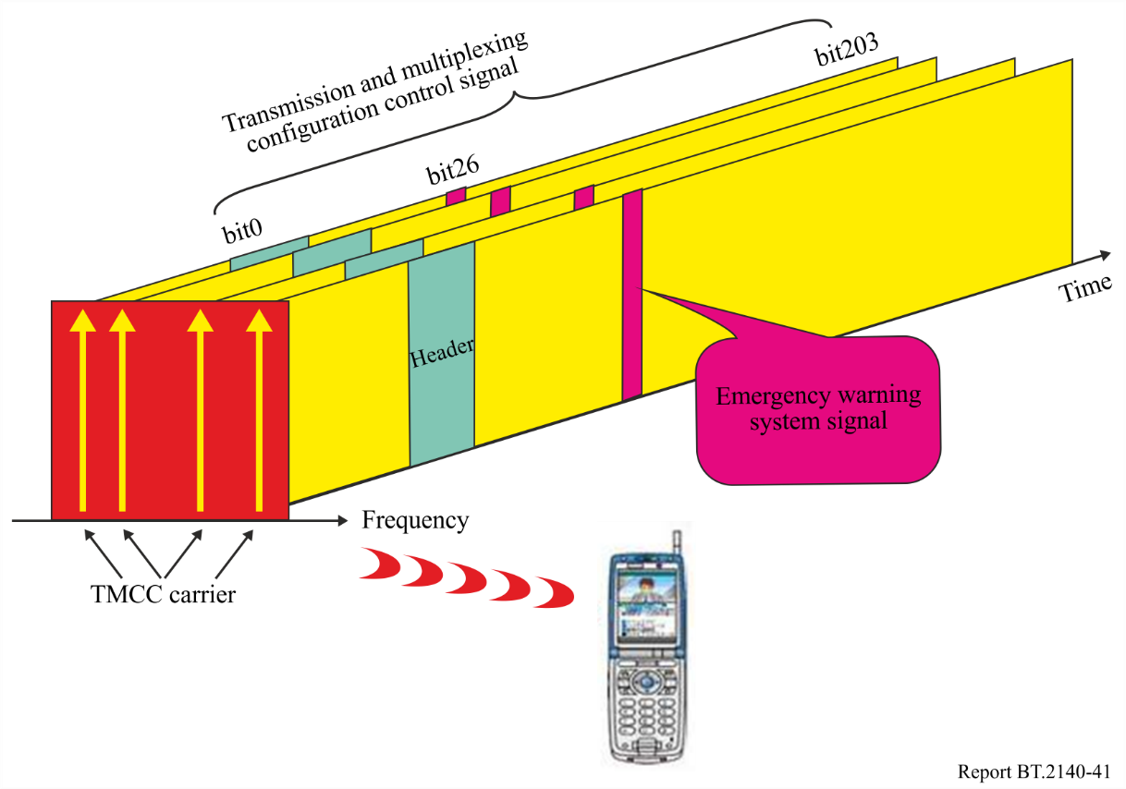

10.6.2 Earthquake and tsunami information services via data broadcasting
Earthquake and tsunami information has been offered via data broadcasts since January 2007, using three delivery media-broadcast satellite (BS) digital broadcasts, terrestrial digital broadcasts, and terrestrial digital broadcasts for mobile receivers (One-Seg). The features of these new “earthquake and tsunami information” services enabled people to obtain information about earthquakes that had just occurred or past earthquakes, and to rapidly learn of impending danger due to tsunamis following earthquakes.
The content of “earthquake and tsunami information” via data broadcasting is based on information obtained from the Japan Meteorological Agency (JMA). The production system for data broadcast content (called the “production system” after this) processes data received from outside the station and automatically produces content in BML format. The content that is automatically generated by the production system is registered with the data broadcast transmission system and then broadcast. Earthquake and tsunami information is also automatically produced.
Data delivered to the broadcaster from the JMA for “earthquake and tsunami information” content are first received by the “earthquake tsunami database system”, which is commonly used by broadcasters for managing earthquake and tsunami information. Data are then transferred to the “earthquake tsunami gateway (GW)”, which is a dedicated system developed for “earthquake and tsunami information” content. The GW converts the data into a broadcast-ready format and sends it to the production system. Thus, content is automatically produced. The system configuration and flow for the “earthquake and tsunami information” service is given below.
FIGURE 28
System configuration and flow for earthquake and tsunami information
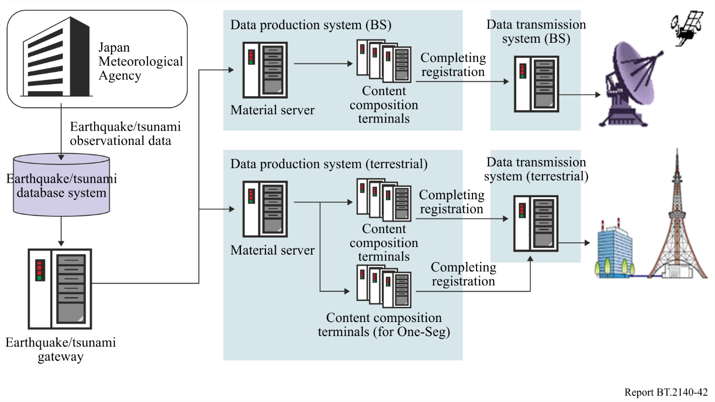
The “earthquake and tsunami information” service essentially consists of six kinds of screens. These are “Earthquake occurrence notification,” “Latest earthquake information,” “Most recent earthquakes,” “Tsunami Warnings/Advisories,” “Tsunami – Related earthquake information,” and “Tsunami monitoring information.” At the bottom of each screen are buttons for moving onto other screens, and viewers can use a remote controller to switch between any of these screens.
Within a month of when earthquake and tsunami information services commenced in January 2007, there were five earthquakes of intensity 3 or higher, and information on these earthquakes was delivered via data broadcasts. On each occasion, the automatic production function that enabled data to be broadcast immediately after they occurred worked effectively to enable earthquake information to be broadcast rapidly. Due to the large volume of information involved in reporting earthquake magnitudes for areas throughout Japan, viewers of regular TV services occasionally fail to see the information relevant to their areas of residence. In contrast, the data broadcasts were found to be extremely useful because they enabled people to use their remote controllers to see relevant information after the broadcasts had been made. The service was very helpful for this reason.

10.6.3 Broadcasting early warnings of earthquakes
The Japan Meteorological Agency has introduced an Earthquake Early Warning system, which can alert people to an impending earthquake when initial small-scale vibrations (primary waves) are detected and an estimated fix on its epicentre and magnitude (scale) is obtained. The system can predict such factors as the amount of time remaining until the earthquake’s main and potentially destructive vibrations (secondary waves) arrive, and its intensity (degree of jolting). The Agency will issue an Earthquake Early Warning in the event an earthquake is likely to have a minimum intensity of 5 on the Japanese scale of intensity which runs from 0 to 7, alerting people that they can expect severe jolting approximately within the next fifty seconds.
The Japan Broadcasting Corporation (NHK) has developed a system for relaying alerts issued by the Meteorological Agency. The system, which commenced operation on 1 October 2007, can relay alerts nationwide via all of NHK’s radio and television channels.
Any Earthquake Early Warning issued by the Meteorological Agency must be conveyed to the public promptly and in a readily intelligible format. The system adopted by NHK for relaying such alerts is characterized by three main features:
1 Alerts are broadcast on all NHK radio and television channels
Any alert is simultaneously broadcast on all twelve NHK radio and television channels.
2 Alerts are fully automated
Speed is essential, which means a fully automated system is in place for relaying an alert the moment it is received from the Meteorological Agency, without any decisions or intervention by NHK staff members.
3 Special chime sounds in event of alert being issued
A distinctive chime sounds and computer graphics (CG) appear on the television screen when an alert is being issued. The CG provide a map and list the names of prefectures that can expect jolting.
The alert is superimposed on all nationwide and local NHK TV broadcasts.
An alert issued from Tokyo will interrupt all nationwide and local broadcasts on NHK radio stations. The warning chime is followed by a synthesized voice announcing the prefectures that can expect seismic jolting.

10.7 Termination of analogue TV broadcasting in Japan
Analogue TV broadcasting was terminated in Japan on 24 July 2011. The government and broadcasters worked hard to effect the migration to digital TV broadcasting.

10.7.1 Consultation office
In March 2003, the Ministry of Internal Affairs and Communications (MIC) opened a call centre to help audiences to migrate to digital broadcasting. In October 2008 MIC, in cooperation with broadcasters, manufacturers, and electricians, also opened 11 support centres, then opened the total of 51 centres finally with at least one in every prefecture, to solve problems in migrating to digital broadcasting. The support centres, which enable audiences to consult with staff for technical advice, have six major activities:
1) consultations and surveys;
2) visits to the elderly to give them advice;
3) consultations at town halls;
4) consultations, surveys, and grants for co-receivers of systems in apartments or fields;
5) consultations and grants for solutions to watching TV in areas with poor reception;
6) free loans of Set-Top Boxes (STBs) and UHF antennas.
FIGURE 29
Support centre activities
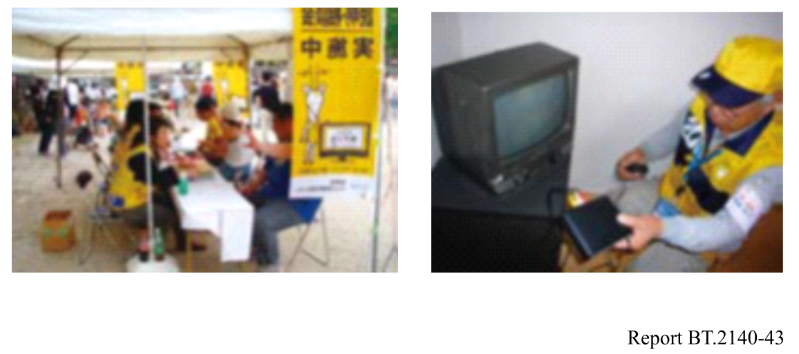

10.7.2 Support for reception
In the border area of analogue broadcasting coverage, where the received signal level is very weak, additional measures were taken, such as newly installing shared receiving facilities or replacing antennas with high-gain antennas.
In addition, MIC has prepared a safety net for receivers. For those with insufficient means, MIC will distribute free STBs and offer broadcasting satellites to cover areas with poor reception as a temporary measure to broadcast terrestrial TV programs. The broadcasting satellite services use a conditional access system to restrict viewers to only that area, and seven programs in the Tokyo metropolitan area are being served.
By standardizing the minimum functional requirements for STBs along with the technology development efforts of manufacturers, digital television and STB prices have steadily become cheaper, contributing to the spread of digital receivers. In addition, the government implemented an incentive programme for consumers to purchase and switch to digital televisions, accelerating digital receiver diffusion.

10.7.3 Publicity
Many campaigns and commercials were developed by using animal mascots or famous entertainers as promotion symbols and popular newsreaders as “promotion ambassadors”. In addition, people of various generations were made familiar with the concept of “digitalization of terrestrial TV broadcasting” through the efforts of distinguished entertainers belonging to their own generation, who were named as “cheerleaders” and participated in a lot of promotional campaigns. Public viewing systems with huge screens were also used to show promotional clips that would appeal to fans at professional baseball and football stadiums and horse racing tracks. These activities helped to create a nationwide understanding of and familiarity with the concept of “digitalization of terrestrial TV broadcasting”.

10.7.4 Notification through analogue TV broadcasting
One of the most effective methods of generating publicity for the analogue-to-digital transition was having broadcasters make changes to analogue TV images in the stages shown in Table 8. These changes made it easy for viewers to distinguish between analogue and digital TV services, and telephone numbers on the screen made it easy for them to contact the call centre.
TABLE 8
Publicity via analogue broadcasting
Stage | Sample picture | Description
1st stage  July 2008 |  | Characters meaning “analogue” were superimposed on the top right of the picture.
2nd stage  July 2010 |  | As an addition to the 1st stage, blanks serving as “letterboxes” were added to the top and bottom of the picture.
3rd stage  October 2010 | 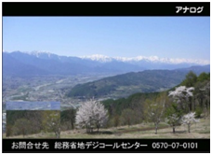 | As an addition to the 2nd stage, short messages to promote the digital transition were superimposed in the letterbox on the bottom of the picture.
4th stage  1 July 2011 | 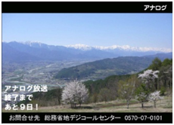 | As an addition to the 3rd stage, a message showing the countdown to the termination of analogue TV was superimposed on the picture.
5th stage  Noon, 24 July 2011 |  | All broadcasters broadcast their final message announcing that analogue broadcasting would terminate when analogue transmitting was terminated.
6th stage  After 24 July 2011 |  | Analogue transmitting was terminated.

11 Kenya

11.1 Kenya’s preparations for digital terrestrial broadcasting

11.1.1 National preparations towards the RRC
Following the Decision by the ITU Council to hold two sessions of a Regional Radiocommunication Conference (RRC) for planning of digital terrestrial broadcasting in the frequency bands 174‑230 MHz and 470-862 MHz in ITU Regions 1 and 3, Kenya took an active part and fully participated in the following forums:
– the work of ITU-R Task Group 6/8 which was tasked by Radiocommunication SG 6 to prepare a Report on the technical bases for the Regional Radiocommunication Conference in 2004 for the planning of digital terrestrial broadcasting services (radio and television) in parts of Regions 1 and 3 in frequency bands 174-230 and 470-862 MHz;
– the first session of the Regional Radiocommunication Conference, held in 2004 (RRC-04), that established the technical basis for the work of the second session of the RRC held in 2006 (RRC-06), including the necessary bases to facilitate planning exercises prior to the second session of the RRC and the form in which the requirements of administrations should be submitted;
– the meetings of the Intersessional Planning Group (IPG), that was responsible for monitoring the intersessional activities with respect to the development of the draft digital plan and supervision of the activities of the planning exercise team (composed of BR assisted by experts nominated by the respective regional groups);
– the meetings of the ITU-R Regulatory and Procedural Group (RPG) specifically established by RRC-04 to study regulatory/procedural matters relating to the relevant parts of the RRC-06 agenda, and the agendas of the short conferences, associated with RRC-06, to revise the Regional Agreements Stockholm, 1961 and Geneva, 1989. The RPG was also responsible for transition issues;
– the second session of the Regional Radiocommunication Conference (RRC-06) that established new agreements and associated frequency plans for terrestrial digital broadcasting in the frequency bands 174 to 230 MHz and 470 to 862 MHz.

11.1.2 National Preparatory Committee
In Kenya, sound and television broadcasting is an activity of great public interest, and therefore, it is necessary that the broadcasting service is provided in an efficient and effective manner in order to benefit the people of Kenya. In this respect, following the conclusion of the ITU RRC-06 Conference, the government established the Digital Broadcasting Taskforce (the taskforce) on 14th March 2007 to provide advice on the development of a national strategy for the switchover of broadcasting systems from analogue to digital broadcasting.
The Taskforce made various recommendations including the need for the government in consultation with the country’s ICT sector regulator Communications Commission of Kenya (CCK) to establish a Digital Television Committee (DTC) to manage the migration process within a specified timetable and develop an appropriate switchover strategy. The taskforce also recommended the simulcast period to end on 30 June 2012 and the analogue switch-off of analogue broadcasting to be effected on 1st July 2012.
Kenya constituted a National Preparatory Committee (NPC) under the leadership of the CCK to study the ITU Reports and prepare appropriate proposals and digital requirements for the first and second sessions of the RRC respectively. NPC were drawn from the following stakeholders in the broadcasting industry:
– Communications Commission of Kenya (CCK).
– National Communications Secretariat.
– Kenya Broadcasting Corporation.
– Media Owners Association.
– Ministry of Tourism and Information (now Information & Communications).
The NPC was responsible for developing national proposals and requirements for the RRC.
The DTC set up in February 2008 focused on three areas namely digital broadcasting standards, signal distribution and consumer issues. “DigitalKenya” is the brand associated with digital migration process in Kenya. In June 2012, consumer awareness campaign under the slogan ‘join the great digital migration’ was unveiled using the print, radio/TV media and roadshows. Minimum requirements for set-top boxes (STB) based on DVB-T2/MPEG-4 video compression standards have already been issued and conditional access feature has been made optional for free to air (FTA). The CCK hosts the DTC secretariat, and also provides budget to meet expenses related to DTC and consumer awareness campaigns.
The CCK authorized the first trial terrestrial DVB-T network in Nairobi on channel 57 and the licensee began operations in April 2006. However, this network is no longer operational. The mobile TV digital network deployed on DVB-H platform was authorized in Nairobi on channel 21 and began operations in October 2007. The DVB-H network is still operational having expanded its coverage to other cities namely Mombasa, Kisumu, Eldoret and Nakuru.

11.1.3 Regional preparations
Kenya took an active role in the Africa information meetings /workshops related to the planning of digital broadcasting. Kenya also held several meetings with its East Africa neighbours in an effort to forge common positions and also coordinate digital requirements.

11.1.4 Kenya’s technical bases for digital planning
The country’s channel planning for digital terrestrial television broadcasting (DTTB) is based on DVB-T and MPEG-4 AVC. Sound broadcasting using T-DAB technology is envisaged in band III (174-230 MHz) while digital TV was planned in bands IV/V (470-806 MHz) but arising from the decision of WRC-12, re-planning is now being carried out covering only channels 21-48 (470-694 MHz).
Table 9 summarizes Kenya’s planning bases for digital terrestrial broadcasting during the RRC-06 Conference.
TABLE 9
Description | RRC-06 Plan value
Frequency bands | 174-230 MHz, 470-806 MHz
Channels | Channels 5-12, channels 21-62
Planned Band III services | Both DVB-T and T-DAB
Planned Band IV/V services | DVB-T
Reception mode | Fixed
Bandwidth | 7 MHz in band III, 8 MHz in band IV/V
Network structure | Multi Frequency Network (MFN)
Reference planning configuration (T-DAB) | RPC5
Reference planning configuration (DVB-T) | RPC1
Planning mode | Assignment planning
Spectrum mask (DVB-T) | Mask 1 (DVB-T Tx operating in non-critical cases)
Spectrum mask (T-DAB) | Mask 1 (T-DAB Tx operating in non-critical cases)

In the planning process, a number of existing analogue TV frequencies in the GE89 Plan were converted to digital while almost all existing sites for analogue TV were retained for the digital plan.

11.1.5 Kenya’s assignments in the Geneva 2006 Plan (GE06)
The GE06 digital broadcasting plan consists of two parts, namely, the 174-230 MHz band and the 470-862 MHz band (comprising T-DAB assignments, T-DAB allotments, DVB-T Plan assignments and DVB-T allotments). At the end of the RRC-06, Kenya obtained a total of 948 frequencies representing a level of over 95% satisfaction of the input requirements at the RRC-06.

11.2 Post RRC-06 activities regarding digital broadcasting
a) Following the conclusion of the Regional Radiocommunication Conference of 2006 that established the Geneva 2006 (GE-06) digital Plan, the Commission prepared a Report of the outcome of the RRC-06 to the Minister of Information and Communications and recommendations on the next course of action.
b) The Commission issued a public notice on the outcome of the RRC-06 with regard to transition from analogue to digital broadcasting and the envisaged discontinuation of assignments of broadcasting frequencies for analogue TV broadcasting on 4 October 2006. The Commission thereafter discontinued the assignment of frequencies for analogue TV broadcasting in order to prepare the country for digital broadcasting.
c) In order to update broadcasters with the developments in digital broadcasting arena as well as the conclusions of the ITU RRC-06 Conference, a consultative broadcaster’s breakfast meeting was jointly organized by CCK and the Ministry in December 2006. The Commission delivered presentations regarding results of the RRC-06, terrestrial digital audio broadcasting (T-DAB) technology, digital video broadcasting-handheld (DVB-H) technology and digital radio mondiale (DRM) technology. In addition, the Commission made similar presentations to the management of a number of local media houses following their requests.
d) The Commission initiated Kenya’s approval process for the Protocol revising certain parts of the Regional Agreement relating to the planning of VHF/UHF television broadcasting in the African Broadcasting Area and neighbouring countries (Geneva, 1989) (Geneva, 2006) and the Final Acts of the Regional Agreement for the Planning of the digital broadcasting service in Parts of Region 1 and in the Islamic Republic of Iran, in the frequency bands 174-230 MHz and 470-862 MHz, Geneva 2006. This was as a result of a request from the ITU.

11.3 Establishment of the digital migration taskforce

11.3.1 Role of the taskforce
In order to prepare Kenya for a smooth transition from analogue to digital broadcasting by the deadline set for 2015, the Government established a taskforce on the migration from analogue to digital broadcasting. The taskforce was launched by the Minister for Information and Communications, on 14 March 2007. It comprised of broadcasting experts and representatives drawn from the following stakeholders:
– Ministry of Information and Communications.
– National Communications Secretariat.
– Communications Commission of Kenya (CCK).
– Media Owners Association.
– Kenya Broadcasting Corporation (KBC).
– Media Council of Kenya.
– Association of Practitioners in Advertising (APA).
The Minister mandated the taskforce to give recommendations that will contribute to the development of a national strategy for the switchover and more specifically to:
– give recommendations to the government on the required policy and regulatory framework to address the introduction of digital broadcasting;
– develop a Kenyan approach for transition to digital broadcasting;
– establish a transition timeframe and a firm programme for analogue switch-off;
– give proposals on how Kenyans can adopt digital broadcasting.
The CCK took a leading role in facilitating and co-coordinating the activities of the taskforce. The Commission successfully organized and conducted a stakeholder’s forum where stakeholders were sensitized and their views received. The consultation process provided vital inputs into task force report in which views of the stakeholders were incorporated and presented to the Ministry of Information and Communications.

11.3.2 Recommendations of the taskforce
The taskforce completed its work in September 2007 and prepared a Report to the Minister in October 2007, giving recommendations on various aspects. These included:

11.3.2.1 Digital broadcasting standards
– The DVB-T standard be adopted for digital television broadcasting in accordance with the decisions taken at RRC-06.
– The introduction of DVB-T standard for television broadcasting service and T-DAB standard for sound broadcasting in Kenya to be facilitated through licensed signal distributor(s).
– High-definition TV may be considered for deployment after the transition period.
– T-DAB standard be adopted as the standard for digital sound broadcasting in frequency band 174-230 MHz in accordance with the decisions taken at RRC-06.
– The platform for the introduction of DVB-H service in Kenya be determined in future depending on market developments.

11.3.2.2 Broadcast signal distribution
– The national public broadcaster, Kenya Broadcasting Corporation shall be required to form a separate company to run the signal distribution services in order to avoid conflict of interests or cross subsidization.
– Interested investors including current broadcasters may be licensed to offer broadcast signal distribution services.
– A broadcast signal distributor will be required to provide signal distribution services as a common carrier to broadcasting licensees upon their request on an equitable, reasonable, non-preferential and non-discriminatory basis.

11.3.2.3 Content issues in digital broadcasting
– The mandate of the Kenya Film Commission should be expanded to include promotion and development of local content for the broadcasting industry.
– The Government should streamline the development and supervision of curriculum used in the media training institutions.

11.3.2.4 Policy and regulatory considerations in the transition to digital broadcasting
– Subject to the timeframe set out in the taskforce Report, existing analogue terrestrial broadcasting service should migrate to digital transmission network based on their own commercial strategy and economic considerations.
– The Government in consultation with CCK should establish a multi-stakeholder Working Group to be known as Digital Migration Board whose role would include among others:
i) manage the migration process within a specified timetable;
ii) develop an appropriate switchover strategy;
iii) identify likely bottlenecks to the uptake of digital broadcast;
iv) make recommendations relating to fiscal measures;
v) develop and implement appropriate consumer awareness strategy;
vi) monitor and evaluate the awareness, take-up and use of the new services, and adjust the campaign accordingly.
– Digital Migration Board in consultation with the CCK to manage the migration process within a specified timetable and develop an appropriate switchover strategy once the government approves the taskforce recommendations.
– At least one broadcast signal distributor be licensed as soon as possible.
– The simulcast period to run up to 30 June 2012 and the proposed analogue switch-off date was set for 1st July 2012.
– The Government was urged to set aside adequate financial resources funds to cater for the digital migration process.
– Kenya should adopt a phased switch-off of analogue services in accordance with a proposed timeframe.
– The Government should ensure availability of set-top boxes (STB) through fiscal measures among others.
– The national standards agency, Kenya Bureau of Standards and the CCK should define the minimum standards for set-top boxes to be used in Kenya.
– Frequencies for digital broadcasting shall be assigned to signal distributor(s) as opposed to the broadcasters.
– One digital programme channel will be made available for the transition of each of the existing analogue television channel.
– The regulator (CCK) will ensure that the license condition obligates licensed signal distributors to provide services to broadcasters promptly upon request.
– CCK to explore providing appropriate regulations and necessary incentives towards implementation of digital broadcasting.
– Upon switch-off of the analogue television broadcasting transmitters, the broadcast frequencies earlier assigned to broadcasters for analogue TV broadcasting shall revert back to CCK.

11.3.2.5 Consumer issues
– Government should institute measures to ensure availability of set-top boxes and digital transmissions countrywide at the time of the switchover date. This will protect the end-user against instant crash of service that leaves them with no option at the end of the migration process.
– The consumers should be given adequate and timely information on the migration implementation timeframe to enable them to prepare for the change.
– The Digital Migration Board will have the responsibility of responding to public concerns even beyond the switchover as all concerns may not be anticipated in time.
– Consumer education should involve broadcasters, retailers and other players in the broadcasting industry in order to yield the expected benefits.
– Government and broadcasters should contribute to consumer education by airing the campaigns regularly.
– Set-top boxes for digital broadcasting should be zero-rated to reduce their cost.
– The implementation strategy must specifically target the vulnerable groups which include people with disabilities, people in marginalized areas and the poor, to ensure they are included in the digital migration process.
– The consumer campaign should contain information on the need to purchase set-top boxes and that consumers will not have to discard their analogue equipment in order to receive digital transmissions.
– The government should put in place policies that discourage dumping of obsolete technologies and equipment.
– A switchover logo or other mechanisms will be developed by the Digital Migration Board. This will give consumers the assurance and confidence while purchasing receivers, antennae, and other equipment necessary to receive over-the-air signals after the switch over.
– Retailers should be required to sell only type approved/accepted set-top boxes or integrated digital television receivers.

11.4 Digital Television Committee
Following the recommendations of the taskforce, the Minister of Information & Communications appointed a 12 persons Digital Television Committee (DTC) in December 2007 to spearhead the implementation/adoption of digital broadcasting in Kenya. The DTC was mandated to develop recommendations for effective implementation of digital broadcasting in Kenya so as to ensure that the country experiences a smooth transition from analogue to digital broadcasting. The DTC was specifically mandated to:
– manage the migration process within a specified timetable;
– develop an appropriate digital switchover strategy;
– recommend measures to be taken to ensure availability of digital set-top boxes and digital transmissions countrywide at the switchover date;
– identify likely bottlenecks to the uptake of digital broadcasting services;
– make recommendations relating to fiscal measures that need to be taken to encourage uptake of digital television services;
– develop and implement appropriate consumer awareness strategy;
– monitor and evaluate the awareness, take up and use of new services, and adjust the campaign strategy accordingly.
The CCK serves as Secretariat to the DTC.
The DTC membership, which was expanded to 20 members in 2009, is drawn from the following organizations:
– Ministry of Information and Communications.
– National Communications Secretariat.
– Communications Commission of Kenya.
– Kenya Broadcasting Corporation.
– Media Owners Association.
The DTC recommended that Kenya adopts MPEG-4 video compression standard on the DVB-T platform for migration to digital broadcasting. The Committee further recommended the following:
– launch of the pilot phase starting in Nairobi for DVB-T signal;
– development of the STB standards;
– waiver of taxes on the STBs;
– the roll out of the DVB-T signal be done in phases;
– marketing of STBs in Kenya;
– enhancement of the awareness campaign.
The DTC is an active committee that frequently holds meetings and that continues to oversee the migration process in Kenya.

11.5 Initial roll out of DTT in Kenya

11.5.1 Trial DVB-T digital network
The first DVB-T broadcasting network was authorized in Kenya on 10 April 2006 on trial basis for an initial period of 6 months. The licensee, MS Lancia Media Ltd, was assigned channel 57 in Nairobi with the transmitter at Limuru site (100 W transmitter, e.r.p. 1 kW) with 10.2 dBi antenna. The transmitter power was later on increased to 250 W (with corresponding e.r.p. of 2.5 kW) in July 2006. The digital transmitter deployed is Screen Service Italia SCA 501UB. The digital platform used was DVB-T, MPEG-2.
The company initially operated its digital broadcasting services under the name Oxygen Television Network Ltd but later on changed to Freeview TV in 2009. The service was initially accessible through subscription with the set-top boxes (decoders) being readily available in the local market. The programmes were downloaded by satellite and transmitted to the DVB-T broadcast transmitter situated on the outskirts of Nairobi using a microwave link.
In 2009, the subscription service became available on free to air basis in Nairobi. The service was however discontinued in 2011 following Kenya’s adoption of DVB-T2 standard. The initial network configuration and technical details are indicated in Table 10.
TABLE 10
Description | Value
Transmitter site | Limuru, Nairobi
Network configuration | Fixed DVB-T
TV channel | 57 (762 MHz)
Carrier power | 250 W
e.r.p. | 2.5 kW
Antenna height | 60 m
Modulation | 64 QAM and QPSK COFDM
FEC code rate | 7/8
Guard interval | 1/32
Carriers/FFT | 8k
Data rate | 38 Mbit/s
Bandwidth | 8 MHz
STL frequency | 7 226 MHz

In 2010, the DTC adopted DVB-T2, MPEG-4 standard and decided that going forward, further rollout of the digital terrestrial infrastructure in Kenya would be on DVB-T2 technology in order for the country to fully benefit from the spectrum efficiency gain and services flexibilities associated with DVB-T2. The DVB-T transmitter was switched off on 31 August 2012, and all terrestrial digital transmissions are on DVB-T2.
On 7th October 2011, the second broadcast signal distribution licence was awarded to Pan Africa Networks Group (K) Co. Ltd following a competitive tendering process. This licensee’s first digital transmitter went on air in Nairobi in June 2012.

11.5.2 DVB-H digital broadcasting network (mobile TV)
In pursuit of the country’s appetite to try out emerging technologies, the Commission licensed MS Digital Mobile Television (Kenya) Ltd to provide mobile TV (DVB-H) service in Nairobi on television channel 21.
The DVB-H broadcasting service, whose brand name is “DSTV Mobile and/or GOTV Mobile” was launched on 23 October 2007 in Nairobi with the first transmitter at Kasarani (carrier power 1 KW) and antenna gain of 10 dBi.
Additional sites operating on SFN mode have since been set up in Nairobi to improve mobile TV coverage especially for indoor reception. These sites include Rahimutula towers and Mombasa Road-steel makers.
Additional frequencies have been assigned to the licensee to expand the service to other parts of the countries. These are Mombasa (channel 30), Kisumu (channel 24), Nakuru (channel 24) and Eldoret (channel 24). The DVB-H signal is on air in all these four sites.
As at September 2012, the DVB-H service had a subscription bouquet of 16 channels as follows:
– KBC channel 1.
– SuperSport Blitz.
– SuperSport 9.
– Events.
– Super Sport 3 A.
– CNN.
– Africa Magic (Family).
– Africa Magic Entertainment.
– Africa Magic Swahili.
– Channel O.
– Disney Junior.
– Sony Max.
– Citizen TV.
– Nation TV (NTV).
– Select Sports.
– National Geographic Wild.
The programmes are downloaded from satellite (DSTV) and fed into the transmitters with the signal being synchronized using GPS. Three of the channels carried in the bouquet are local free to air TV channels.
The DVB-H network configuration and technical details for Nairobi are indicated in Table 11.
TABLE 11
Description | Authorized value
Transmitter sites and TV channel | Nairobi (21), Mombasa (30), Kisumu (24),  Nakuru (24) and Eldoret (24).
Network configuration | DVB-H
Carrier power | 1 kW
ERP | 10 kW
Antenna height | 75 m (Kasarani)
Modulation | QPSK
FEC code rate | 1/2
Guard interval | 1/4
Carriers/FFT | 8k
Data rate | –
Bandwidth | 8 MHz

In Nairobi, the DVB-H network is configured for mini-SFN whereby there are three transmitters in Kasarani, Rahimutulla and Mombasa Road-Steel Makers operating on the same TV channel to improve DVB-H coverage. All the sites have 11 dBi antennas.
The DVB-H service is a subscription service which requires monthly fees. The DVB-H service provider is collaborating with some locally licensed mobile phone service operators with respect to distribution of handsets and subscription management.

11.6 Migration from analogue to digital terrestrial broadcasting

11.6.1 Introduction
The government is responsible for initially funding the migration from analogue to digital broadcasting in Kenya. During the simulcast period that was envisaged to take place between 2009 to 30 June 2012, the national broadcaster KBC was authorized to set up a subsidiary company “SIGNET Co. Ltd” to carry out broadcast signal distribution services. Priority will be given to existing broadcasters to provide their broadcast signal to the signal distributor so that the same can be relayed on the digital platform.
On 9th December 2009, Kenya took a giant step towards setting the pace for migration from analogue to digital broadcasting when H.E the President of the Republic of Kenya launched the pilot digital signal in Nairobi officially paving way for existing analogue TV stations to be broadcast on DVB-T digital platform. One multiplex was activated on UHF channel 26 carrying a total of 16 standard definition TV channels and 4 radio services.
Rollout of digital TV in other parts of the country is expected to be implemented in phases until the entire country is covered. Phase 1 rollout ending by 31st December 2012 targets to cover 12 main towns and is expected to provide digital signal coverage to 70%-80% of the existing analogue coverage areas.
The deadline for analogue switchover was initially set for 1st July 2012 but later revised to 31st December 2012 with the understanding that phased analogue switch-off would be employed. It is expected that at the switch-off date, up to 90-95% of the consumers currently receiving analogue signal shall be capable of receiving the digital signal. This deadline could be further reviewed if the digital migration progress made by then fails to meet the targeted audience.
During the simulcast period expected to run until end of 2012, existing analogue channels shall be accommodated on the signal distributor’s multiplex platform for free. The analogue switch-off date earlier set for 30th June 2012 at which time all analogue transmitters were expected to be switched off, was revised in view of the delayed network roll out. The government has decided to adopt phased switch-off starting with Nairobi whose switch-off date has been provisionally set at 31st December 2012.
Four main challenges are envisaged in the digital migration initiative:
– ensuring DVB-T2 compliant digital set-top boxes are readily available and at affordable prices to the general public;
– financing the roll out of the digital network infrastructure to ensure adequate coverage of the country with digital signal to meet the ambitious analogue switch-off date of 2012 for East Africa Region;
– generating appropriate content that is relevant to the Kenyan consumers to populate the envisaged immense capacity afforded on digital platform;
– the desire to ensure that all consumers, including the rural communities, access the digital TV content against the challenge of poor coverage of rural areas by the national electricity grid and the limitations of alternative solar power.
In June 2012, the Government announced the waiver of import duty (accounting for about 25%) on digital set-top boxes to make them more affordable. This was in line with the decision by the five East African Community (EAC) member states to zero rate import duty on digital broadcast terrestrial receivers.
As at the end of September 2012, the DVB-T2 signal was on air in seven sites namely Nairobi, Mombasa, Kisumu, Eldoret, Nakuru, Webuye and Nyeri carrying both free to air and pay TV channels.

11.6.2 Restructuring of the DTC
The DTC is responsible for overseeing the digital migration process during the simulcast period and the period beyond. In order to fast track the preparations for the launch of the pilot digital signal and facilitate greater efficiency in its mandate going forward, the DTC was restructured into three taskforces to focus in specific areas namely:
– technical taskforce to handle at all technical aspects related to the digital migration process;
– policy and regulatory taskforce to advise on digital migration matters of policy and regulatory nature;
– consumer awareness taskforce for the development of consumer awareness and publicity programme for the digital migration process.
The recommendations of the taskforces are presented to the DTC which deliberates on them before making decisions or giving further directions.
The Commission facilitates the meetings of the DTC and its associated taskforces by providing logistical and technical support services in addition to hosting the Digital Kenya secretariat and meeting the budgetary needs. The secretariat is responsible for responding to all enquiries received from members of public, broadcasters and international organizations regarding digital migration in Kenya.

11.6.3 Digital infrastructure roll out plan in Kenya
The roll out of digital broadcasting infrastructure in Kenya will be the responsibility of the signal distributor and shall be carried out in phases. The national public broadcaster, Kenya Broadcasting Corporation, is establishing a subsidiary company known as SIGNET, to carry out the business of broadcast signal distribution and multiplexing during the simulcast period. SIGNET will initially be funded fully by the government. The government is also in the initial stages of considering a public private partnership arrangement between SIGNET and the private sector investor(s) in order to mobilize the much-needed capital necessary for the massive digital infrastructure roll out. In this regard, the Ministry of Information and Communication has already invited potential investors interested in partnering with SIGNET, through a public expression of interest (EOI) notice, to submit their proposals. If the PPP process succeeds, it will be a big relief to government in terms of funding the rollout of the digital infrastructure.
At switchover, the DTT services broadcast on at least two multiplexes are planned to substantially replicate the current analogue TV reception coverage (estimated to be 60% of population), so that 60% of population should then be able to receive all the free-to-air digital broadcast services over DTT platform using their rooftop aerial and a set-top box. At the same time other services, like audio channels and Pay TV are expected to be brought on board.

11.6.3.1 Pilot phase roll out
The pilot phase involved the implementation of the Nairobi digital terrestrial broadcasting project. The Government released Kshs. 152 million to enable the national broadcaster KBC to tender for construction of the digital broadcasting infrastructure.
During this pilot phase, the installation and commissioning of the following was undertaken:
– the DVB-T Multiplex headend at Broadcasting House in Nairobi;
– DVB-T transmitters and accessories at Limuru;
– microwave STM-1 (1+0) radio to link the Multiplex centre to the Limuru Hill transmitting site.
In the last three months preceding the launch of the digital signal in Nairobi, the Commission facilitated two stakeholder forums between the DTC, the existing TV broadcasters and the print/electronic media houses so as to provide updates on the status of preparations for migration to digital broadcasting.
Such forums continue to be undertaken as they bring the broadcast industry players together to exchange ideas on the future of broadcasting in Kenya reflecting on the impeding digital era and related issues.
There was also a built-up of publicity activities regarding digital broadcasting in the electronic (radio and TV) as well as the print media in order to enhance consumer awareness of the impending digital era in broadcasting. These activities were facilitated by the CCK.
On 9 December 2009, Kenya’s migration to the digital television broadcasting became a reality, following the inauguration of the DVB-T signal in Nairobi by H.E., Hon. Mwai Kibaki, the President of the Republic of Kenya. This launch marked the beginning of the transition from analogue to digital TV broadcasting in Kenya.
A total of 16 channels were accommodated on the digital platform that was activated using TV channel 26 in the pilot phase.
NOTE 1 – The channel positions and composition change frequently due to the pilot nature of the project.
The technical details of the DVB-T transmission network established by KBC during the pilot phase are as follows:
TABLE 12
Description | Implemented value (pilot Phase)
Transmitter site | Limuru, Nairobi
TV channel number | 26
Frequency limits | 514 MHz
Transmitter make and model No. | Thomson Elite 1 000
Transmitter carrier power | 2.5 kW
Geographical coordinates of antenna | –010811, 0363835
Antenna type | IMP
Antenna gain (dBi) | 12.9 dB
Antenna height above ground level | 120 m
No of antenna bays | 6
Radiated (transmitted) power | e.r.p. T. max (kW) 70.48 E. max (kW) 32.6
Transmission system | DVB-T
Transmission modulation | COFDM QAM
Channel bandwidth | 8 MHz
Multiplexer make and model | Thomson NetProcessor 9030 – v3.2
Type of multiplexing | Flexstream statistical multiplexing
TABLE 12 (end)
Description | Implemented value (pilot Phase)
Transmission mode (No. of carriers – 2k or 8k) | 8K
Carrier modulation | 64-QAM
Code rate | 3:4
Bit rate | Variable
Guard interval | 1:16
Network identity | Signet
Stream identity | 1
Capacity used for TV broadcasting | 20 Mbit/s
Capacity used for supplementary services | 0.8 Mbit/s
Max No. of TV channels to be accommodated | 16
Max No. of radio channels to be accommodated | 12
Type of links between Mux centre and TX centre | Microwave/fibre optic
Type of link(s) between broadcasters and Mux | Satellite and fibre optic
Video resolution | 720 × 576 (PAL); 720 × 480 (NTSC)
Type of conditional access system (if any) | Conax CAS-7.4 with chipset pairing

11.6.3.2 Phase 1 roll out

11.6.3.2.1 Scope of Phase 1 roll out
The phase 1 DTT roll out was to commence before end of 2010 covering the following:
– upgrading of the headend at the national operating centres (NOC) to a dual (2) multiplex;
– setting up two headend centres in Mombasa and Kisumu city, each with a single multiplex headend unit;
– putting up and upgrading transmission sites at 12 sites namely:
i) Maragoli hills in Kisumu, Kisii Hill, Webuye Hill and Kapenguria Hill for providing coverage to Nyanza, Western and parts of Northern Rift;
ii) Mazeras and Vuria Hills to provide coverage for the Coast Region and parts of Eastern province;
iii) Nakuru, Loldiani, Eldoret for parts of Central and North Rift districts coverage;
iv) Nyeri and Nyambene to provide coverage for Mt. Kenya Region;
v) Limuru transmitter upgrade to a dual multiplex for coverage in Nairobi and its environs;
– linking of programme signal from the NOC to transmission sites via satellite, fibre optic and microwave links;
– Malindi has an existing digital ready analogue TV transmitter and may be easily activated at the end of the phase 1 roll out.
Subject to availability of sufficient funding, Phase 1 roll anticipated covering 12 major towns of the country covering about 80% -90% of areas currently enjoying analogue TV services.
The DTC also made a decision that other than the Nairobi pilot phase, all deployments of digital infrastructure going forward in phase 1 would be DVB-T2, MPEG-4 transmission standard and video compression format respectively.

11.6.3.2.2 Infrastructure requirements
The basic infrastructure requirements for each site vary from site to site depending on whether it exists or completely new. The basic requirements include land, access road, transmitter building, tower, commercial power supply, diesel generator power backup, DVB-T transmitters, and programme distribution and receive system. Each site’s requirement has been assessed and documented for purposes of developing appropriate budget to facilitate roll out.

11.6.3.2.3 Nationwide frequency identification for migration
It was recognized that each of the sites identified required UHF frequencies to cater for the broadcast content providers. In order to ensure efficient use of spectrum, the CCK took stock of unused UHF TV frequencies earlier assigned to KBC at the different sites in order to determine where there was need to assign new frequencies.
The Commission thereafter identified and reserved UHF broadcast frequencies that shall be used by the Signal distributor to provide multiplex services during the simulcast period.
In addition to the developments at the WRC-12 Conference, the Commission began the process of changing frequencies assigned to the signal distributors that were above channel 48.

11.6.3.2.4 Cost effective deployment of infrastructure
In order to ensure costs associated to deployment of digital infrastructure is minimized, a number of strategies are being explored. These include:
a) entering into lease agreements with Kenya Forest Service for lease of land on sites that fall within forest areas as opposed to purchasing of land;
b) deployment of guyed masts as far as possible in favour of self-supporting masts;
c) negotiate with other existing broadcasters on acquisition of their existing infrastructure (masts, sites, air conditioning, power, etc.) to minimize duplication;
d) the use of prefabricated containerized shelters in favour of constructing buildings;
e) modification of certain existing digital ready analogue TV transmitters for digital broadcasting;
f) negotiation with the ICT Board with respect to the possible use of the National Optical Fibre Backbone for transportation of content to transmitter sites.

11.6.3.3 Phase 2 digital roll out
Phase 2 of the roll out was to involve the implementation of the digital broadcasting infrastructure in the following broadcasting sites:
– Nyahururu.
– Kitui.
– Mbuinzau.
– Garissa.
– Lamu.
– Vuria.
– Kabarnet.
– Migori.
– Marsabit.
– Marala.
– Lodwar.
– Lokichogio.
The timeframe for the implementation of Phase 2 earlier envisaged for the period July 2011-June 2012 but is no longer tenable.

11.6.3.4 Phase 3 digital roll out
Phase 3 is not envisaged to be part of the digital migration plan but will be used to ensure all the remaining parts of the country are covered with digital signal. It is noted that this phase will mainly target those areas that did not in the first place receive even the analogue television signal.
The areas initially identified for Phase 3 implementation of the digital infrastructure include the following:
– Eburu.
– Siaya.
– Madogashe.
– Hola.
– Garsen.
– Mandera.
– Embu.
– Moyale.
– Kajiado.
– Kakuma.
– Laisamis.
– Lokitaung.
The timeframe for the implementation of Phase 3 was earlier envisaged for July 2012-June 2013 but this is no longer tenable.
In view of the delays in rollout, the timings of the various phases is being reviewed.

11.7 Programmes transport system
A digital primary distribution network will be needed to distribute MPEG-4 transport streams from signal distributor’s headends to re-multiplexing sites (regional programme insertion points ) and to associated transmitters. The proposed platforms for transport stream include PDH or SDH networks, ATM, optical fibre or satellite distribution. It is envisaged that a mix of the above transport streams.
The linkage between the signal distributor’s headend and the DVB-T transmission site in Limuru has been deployed using PDH/SDH microwave radio link with an optical fibre backbone as a backup.
Whereas Phases 1 and 2 transport system is expected to be fibre, Phase 3 sites shall be linked to the headend using satellite connectivity due to most of these sites being located in very remote areas where there is hardly any infrastructure.
Optical fibre is also the preferred medium for linking broadcasters studios to the signal distributor’s headend facility.

11.8 Set-top boxes

11.8.1 Standardization
The cost-effective migration strategy for Kenya is through the use of digital set-top boxes (STBs) so as to enable consumers already having analogue TV receiving sets to receive the digital signal without the need to purchase a new digital TV receiver. In this regard, the DTC adopted minimum specifications for set-top boxes that must comply with DVB-T2 transmission and MPEG-4 video compression standards. These minimum specifications have been put in the public domain and the Commission’s website www.cck.go.ke and shall also be available on Digital Kenyan website once launched.
These minimum specifications were further revised in August 2012 making requirement of conditional access feature an optional requirement for set top boxes intended for FTA reception. This development will go a long way in ensuring availability of low-priced compliant set top boxes on the local market.
The CCK is currently liaising with the national standards agency, the Kenya Bureau of Standards (KeBs) which is responsible for developing and gazetting national standards, with the view of gazetting DVB-T2 and MPEG 4 as a national standard for digital terrestrial receivers including
STBs and integrated digital TVs. CCK is a member of KeBs technical committee that is charged with the responsibility of developing the national digital standard.
However, due to recent decision by the DTC regarding rolling out DVB-T2 system following the successful pilot phase, it is expected that the specifications shall be upgraded to comply with DVB-T2 system specifications.

11.8.2 Tax exemptions for STBs
In order to make the cost of set-top boxes as affordable as possible to the masses so as not to become a barrier to consumers receiving digital signal, discussions to consider strategies for providing tax relief on STBs were held between the DTC, the Ministry of Finance and the Ministry of Information and Communications.
In June 2012, the Government announced the waiver of import duty (accounting for about 25%) on digital set-top boxes, thus making them more affordable. This action was in line with the decision by the five East African Community (EAC) member states to zero rate import duty on digital broadcast terrestrial receivers.

11.8.3 Marketing of STBs
In October 2009, the Commission issued a public notice in the local print media and on its website informing prospective vendors the opportunity to supply STBs. This was in line with the recommendations of DTC.
This meant that any retailer/vendor was free to import and supply STBs or idTVs to consumers without the need for a vendor’s license from CCK as long as the digital receiver complied with the minimum specified requirements. This was intended to make set-top boxes readily available in the market and at very competitive prices. However, the supply of STBs is now subject to suppliers being required to be licensed and the set-top boxes/idTVs need to be type approved/accepted in order to ensure protection of consumers and maintenance of quality.
Vendors will be expected to import STBs that fully meet the DVB-T2 system specifications.

11.9 Making migration visible to consumers

11.9.1 Digital migration logo/identity
The DTC unveiled Digital Kenya Logo (shown below) to be identified with all activities related to digital migration in Kenya. The Digital Kenya secretariat is now based at the CCK, who are providing the required logistical and technical support for the migration process. Staff have also been seconded from some DTC member organizations to handle matters related to the secretariat.


11.9.2 Consumer awareness campaign and publicity
The consumer awareness taskforce within the DTC is responsible for spearheading the development of consumer awareness and publicity programme for the digital migration process. The taskforce also reviews the communicant plan from time to time.
Digital Kenya Logo is currently used on all publicity material used to educate and inform the public regarding digital broadcasting.
The DTC developed a communication plan for the consumer education on digital migration with a strategic focus that revolved around the following issues:
– creation of an identity for digital television in Kenya;
– consumer awareness;
– appropriate technologies and technology obsolescence issues;
– consumer protection;
– role of stakeholders and partners in transition;
– people with disabilities and other vulnerable categories of consumers;
– sustainability of the brand identity for digital Kenya.
To enhance consumer education and accessibility to information, a dedicated digital Kenya website www.digitalkenya.co.ke has been designed and is being finalized before being officially launched for public access. The website shall be a home for all information on digital migration in Kenya. Currently, the CCK website provides a portal for digital migration related information.
In addition, setting up of a full-fledged call centre for digital migration is envisaged. The call centre shall be staffed with qualified personnel and equipped with the necessary communication facilities to ensure that consumers have access to appropriate information.
The consumer awareness campaign and publicity are expected to be carried out during the simulcast period. The budget for the consumer awareness campaign is provided for by the CCK while existing electronic media houses have pledged to provide free airtime for promotions related to digital broadcasting.
The DTC in collaboration with a selected advertising agency came up with a concept to be used for production of publicity material for digital migration.
The DTC through the CCK commenced a multifaceted public awareness campaign dubbed
“Join the great digital migration” to raise awareness about the ongoing analogue to digital television transition. The comprehensive consumer education had to be synchronized to digital network roll out and availability of DVB-T2 STBs.
The media campaign began on 8th June 2012 with various platforms being engaged in the campaign:
– Advertisements and public notices in the print press.
– Television and radio commercials.
– Digital screens in supermarkets.
– Outdoor advertising on billboards and street poles.
– Television interviews.
– News stories and analyses.
– Forums with stakeholders including vendors of set top boxes, and broadcasters.
– Awareness promotion in road shows and ASK shows at which fliers are distributed.
– Public interaction with Digital Kenya secretariat on phone and email.
The specific digital migration message in the advertisements emphasizes the importance of the public to buy compliant digital set-top boxes of the DVB-T2 standard from authorized vendors as well as the need for UHF aerial.
The campaign is continually being complemented by public relations activities whose strategic approach is focused on educating the media and explaining new developments in the migration process; engagement of distributors and suppliers of set-top boxes; and other stakeholders including media houses. CCK collaborates closely with the local media having recognized the media as an important vehicle to carry the digital migration message to every corner of the country and its TV viewing population. To this end, the campaign involves the media in every promotion event and is given wide coverage. In addition, a training forum for media personalities was held so that the media is able to read from the same digital migration script.
So far it is estimated that the campaign reached at least 60% of the population of Kenya and the number is bound to rise with the onset of roadshows.

11.10 Broadcast signal distribution

11.10.1 Licensing of first broadcast signal distributor
The broadcasting industry in Kenya is now segmented into two sectors, namely, broadcast signal distribution and content service provision, following the enactment of the Kenya Communications Amendment Act No. 1 of 2009.
Arising from the recommendations of the DTC, KBC by nature of its extensive public owned broadcasting infrastructure was identified as one viable entity to provide signal distribution services. The government decided that only one signal distributor would be licensed during the simulcast period due to scarcity of spectrum currently used for analogue TV broadcasting. This policy decision was reviewed before the end of simulcast that resulted in the entry of a second broadcast signal distributor.
Following the initial rollout of DVB-T pilot signal in December 2009 in Nairobi, KBC (SIGNET) launched the first DVB-T2 transmitter in September 2011 with pay TV service offering.
As at September 2012, the SIGNET had activated three multiplexes and was on air on DVB-T2 signal in Nairobi, Mombasa, Kisumu, and Nakuru carrying over 40 channels comprising both free to air and pay TV.
The DVB-T signal was simulcast with DVB-T2 signal until 31st August 2012 when the DVB-T signal was discontinued thus enabling Kenya to only have DVB-T2 transmissions.

11.10.2 Licensing of second broadcast signal distributor
When Kenya commenced its plans to migrate from analogue to digital broadcasting, it was largely expected that the Government was to fully fund the process. However, the slow pace of progress in digital migration occasioned by lack of adequate budgetary provision for KBC by government to roll out the signal distribution infrastructure prompted the DTC to recommend to the Ministry the need to open up the signal distribution market to competition by licensing additional players ahead of end of simulcast period. This was to be done by licensing two more digital broadcast signal distributors to roll-out the digital network on a nationwide basis through a competitive procurement process by the CCK. The initial period is 15 years renewable for another 10 years.
The tendering process which commenced in February 2011 closed on 31st May 2011 attracting four bidders. M/S Pan-Africa Network Group (Kenya) Co. Ltd (PANG) emerged as the only qualified firm that met the tender requirements.
The CCK awarded a nationwide broadcast signal distribution license to Pan-Africa Network Group (Kenya) Co. Ltd on 7th October 2011. The licence required them to rollout in 12 sites by end of first year.
PANG’s first DVB-T2 transmitter went on air in Nairobi in June 2012 and as at September 2012, they were on air in seven sites namely Nairobi, Mombasa, Kisumu, Nakuru, Nyeri, Eldoret and Webuye. Their digital platform currently has a capacity of three multiples whose combined channel capacity is 81. It hosts one pay TV service provider and FTA broadcast content service providers.

11.10.3 Obligations of the signal distributor
In order to gain access to the broadcasting frequency resource necessary for countrywide roll-out of broadcast services, the signal distributor has to apply for the frequency resource in accordance with the applicable procedures.
The signal distributor shall be expected to adhere to license conditions such as:
– provide services to licensees on an equitable, reasonable, non-preferential and non-discriminatory basis;
– comply with coverage and QoS obligations as the case may be;
– payment of annual license operating fees and frequency fees to the Regulator;
– provide quality delivery of broadcasting services as per contract and SLA between the signal distributor and the broadcasters (content service providers), and make the same available to the Regulator;
– submit quarterly and annual returns in a prescribed format to the Regulator;
– file all tariffs with the regulator before implementing them.

11.11 Developments in policy and legislative arena

11.11.1 The Kenya Communications (Amendment) Act
The Kenya Communications (Amendment) Act No. 1 of 2009 that came into force on 2nd January 2009 expanded mandate of the Communication Commission of Kenya to cover the broadcasting sector to include inter alia Licensing, Content Regulation, and Complaints Handling. The legislation also makes provision for licensing of broadcast signal distributor(s) as well as the migration from analogue to digital broadcasting.
The Kenya Communications (Broadcasting) Regulations, 2009 also has specific clauses that provide for licensing of a signal distributor/multiplex operator and provisions related to the migration from analogue to digital broadcasting. These regulations were gazetted by the Minister in January 2010.
In view of the new Act and the Regulations, specific proposals of revisions of the existing Kenya ICT Policy of 2006 have been proposed to facilitate the envisaged new role of KBC as the sole broadcast signal distributor during the simulcast period.
The CCK has also developed a new framework that will govern the licensing and regulation of broadcasting services in Kenya. However, the implementation of the framework has been put on hold due to an existing court injunction issued by the High Court.

11.11.2 Public notification
Following the coming into force of the Kenya Communications Amendment Act No. 1 of 2009, the Commission issued a public notice in February 2009 to bring to the attention of broadcasters the requirement in the Fifth Schedule of Act, which specifies that the broadcasting permits shall lapse within one year after the commencement of the Act. In this regard, the Commission advised on the requirement of migration of existing broadcasters from the regime of permit authorization issued by the Ministry to CCK licensing framework prior to the lapse of the one-year period.
However, the transitioning of existing broadcasters from old regime to the new licensing regime is temporarily on hold due to a pending court case in the High Court.

11.12 Harmonization at the East Africa Community level
The East Africa Community (EAC) member states comprise of Kenya, Uganda, Tanzania, Rwanda and Burundi. Under the auspices of the East Africa Communications Organisations (EACO), the member states have established a broadcasting technical task force (BTTF) whose terms of reference include harmonizing digital transmission standards and technical standards for set-top boxes in the EAC Region. The task force continues to have its meetings to address the various tasks it has been allocated. Kenya, through the CCK, is an active contributor to the work of the EACO taskforce.
This initiative of having a common standard for set-top boxes is expected to create a sizeable market for set-top boxes in the region that will translate into lower prices.
Kenya is currently actively involved in the work of the East African Communications Organization (EACO) technical task force on migration to digital broadcasting. The objective of the taskforce is to come up with harmonized approaches with respect to various areas related to digital broadcasting. Among the notable areas of harmonization currently under study include:
– adoption of the DVB-T2 standard for digital terrestrial broadcasting;
– development of minimum digital transmission standards and STB specifications for the EACO Region;
– coordination of digital broadcasting assignments;
– analogue switch-off date;
– quality of service parameters for digital platform;
– licensing of subscription broadcasting services;
– digital content management;
– charging principles by signal distributors.
The EACO taskforce on broadcasting is likely to be retained for some time in order to continue studying other issues related to digital broadcasting in order to enhance regional harmonization.
The EAC secretariat has also established a technical committee on broadcasting that considers the status of implementation of roadmap for analogue-to-digital broadcast migration and makes recommendations to the Sectorial Council on Transport, Communications and Meteorology (Council of Ministers) for consideration and approval before individual member states can implement.
Following the decision of WRC-12 allocating frequencies above 694 MHz for mobile services, a re-planning of channels within the band 470-694 MHz is ongoing and a number of coordination meetings are being held amongst EACO member states. This finalization of the coordination process shall culminate in individual member states filing modifications to the GE06 with the ITU way before the 2015 deadline for digital migration.

12 Mexico
In Mexico, the broadcasting sound and television is an activity of public interest, and therefore, it is necessary for these services to be provided under the best technological conditions, in benefit of the population. For this reason in 1999 was established the Consultative Committee of Digital Technologies for Broadcasting (the Committee), in which the industry and the government consensually analyse and evaluate, the development and transition process implemented in other countries. In the year 2000, the Committee established the commitments with such agreements; experimental operations have been conducted with digital technology for radio and television.
In addition, the Committee participated in various meetings of Radiocommunication Study Group 6, which provided the necessary technical information to evaluate the development level of the digital standards analysed at the ITU. Furthermore, the committee conducted meetings with digital TV technology developers to learn the strengths and weaknesses of each of the standards from the source, as well as any situation of concern in the transition process due to equipment availability and cost.
The Committee considered that it had the key elements to recommend the adoption of the digital television terrestrial (DTT) standard and its transition policy; the corresponding agreement was issued on July 2nd, 2004. The Agreement established: the adoption of Standard A/53 on the ATSC; the transition process with legal certainty for all parties involved; the objective conditions for process follow-up to evaluate the development, and the objectives, goals, requirements, conditions and obligations.
Due to the costs that the terrestrial digital television transition policy involves for concessionaries, licensees, producers, advertisers and TV viewers in general, this is a long-term process. For this reason the following elements were taken into account to establish a transition schedule: a flexible and gradual installation process for DTT stations; development periods within this process subject to review, and minimum goals based on population density.
At the April 11, 2006, the regulatory authority for broadcasting sound and television corresponds to the Federal Telecommunication Commission who has given special attention to the supervision and control of the DTT transition. At these date, 35 stations transmitting with digital technologies in 10 principal cities of the country.

13 Paraguay
Background
By Decree No. 4.615/2010, dated June 24, 2010, the Republic of Paraguay officially adopted the ISDB-TB (Japan-Brazil) Digital Terrestrial Television Standard.
The transition from analogue to digital TV has been scheduled with a transition period before the ‘analogue switch-off’.
During the transition period, the analogue signal and the digital signal will be transmitted simultaneously (simulcasting), throughout the national territory.
DTTB implementation progress
First Instance: Works on Regulation and Standards issues
Paraguay participated of the Support Programme “Support for Analog Broadcast to Digital Broadcast in America Region” for the development of the “Analog Television to Digital Terrestrial Television Route Guide” sponsored for the International Telecommunications Union (ITU) and the Latin America Development Bank.
Update of the Television Service Regulations: This update implied the change of the Analogue Switch off methodology, from a single date for the whole country to a Transition Schedule based on Services Zones, and the separation of the Television Service Regulation of this Schedule.
Planning, Assignment and Coordination of channels in the scope of MERCOSUR.
Definition of Co-location Coordinates.
For the purpose of help the population to identify which TV receivers are able to operate with the ISDB-TB, CONATEL implemented a Digital Television Lab, wherever tests to TV receivers are performed, to corroborate that these devices operate with the adopted standard.
Based on the ISDB-T Forum Normatives, CONATEL approved the DTTB Receivers Technical Normative.
Furthermore, a Test Protocol for DTTB Receiving Equipment was approved to verify correct operation with the ISDB-TB standard.
Manufacturers or importers may submit a sample receiver, which is tested using the Protocol for DTTB Receiving Equipment. If the sample receiver approves the tests, it will be registered and will have an identification sticker so that the population can identify it as able to receive the ISDB-TB signal.
Second Instance: Digital Switch On and Analogue Switch Off Schedule and Information campaigns.
Due to Covid 19, the Digital Switch On and Analogue Switch Off Schedule underwent several adjustments and date changes.
Numerous meetings were held with television broadcasters throughout the transition process, in order to achieve coordinate efforts for Digital Switch On and Analogue Switch Off.
In conjunction with broadcasters, information campaigns were carried out for citizens throughout the national territory, focusing mainly on the first area of Digital switch-on and subsequent Analogue switch-off.
The separation of the Television Service Regulation and the Transition Schedule granted flexibility in the dates of Digital Switch On and Analogue Switch Off, stablished according to the results of surveys, totally performed by Privates Broadcasters.
Board Resolution No. 1448/2022 approves the implementation of analogue television signal transmission cuts to prepare the population for the change from the analogue television system to DTT in the Service Zone No. 1 of the transition plan schedule.
Directory Resolution No. 1488/2023 issued by CONATEL is the last current update that contains the established schedule with the dates of digital turn-on and analogue turn-off.
Spectrum Policy
At the beginning or the transition process there were 118 broadcast stations were in operation along the whole country.
The Paraguayan digitizing process, stablished to match Analogue Television coverage with the new DTTB coverage.
In 2011, the first DTTB station Switched On, it was the Public TV Station now Paraguay TV. The first Private TV Broadcaster began its transmission in 2016.
In 2016 and 2021 calls for public tender for DTT were done giving licences for 29 new DTT stations.
Paraguayan Plan for DTT and the “internal digital dividend”
Directory Resolution No. 93/2010 establishes that no further assignments will be made in the 700 MHz frequency band and modifies the PRG-34 National Notes of the Frequency Allocation Plan of the Republic of Paraguay.
Recommendation ITU-R M.1036-4, revised in 2012, contains frequency provisions for the implementation of the terrestrial component of International Mobile Telecommunications (IMT) in the bands identified in the Radio Regulations (RR) for IMT in the bands 698-960 MHz, 1 710-2 025 MHz and 2 110-2 200 MHz, and 2 500-2 690 MHz, posing several possibilities of use.
Directory Resolution No. 1088/2015 modifies the National Frequency Allocation Plan of the Republic of Paraguay and the frequency bands for the use of IMT Systems are determined.
In 2018 the 698-960 MHz band was assigned to three IMT Operators to implement the 4G IMT Technology.
Start of Analogue Switch Off
On December 31/2024, the execution of programme 2 (RD N°1488/2023) began, and the first analogue Switch off has been achieved in the Republic of Paraguay for the Service Zone No. 1.
Subsequently, Digital Switch On and Analogue Switch Off are programmed according to the current Schedule.
Nowadays the CONATEL Board of Directors recently approved to bring forward the date of Analogue Switch Off in the Services Zones No. 2 and No. 3.
TABLE 13
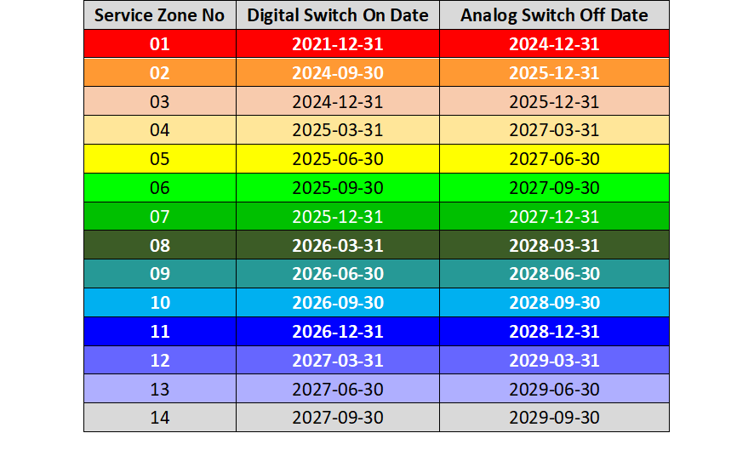
FIGURE 30
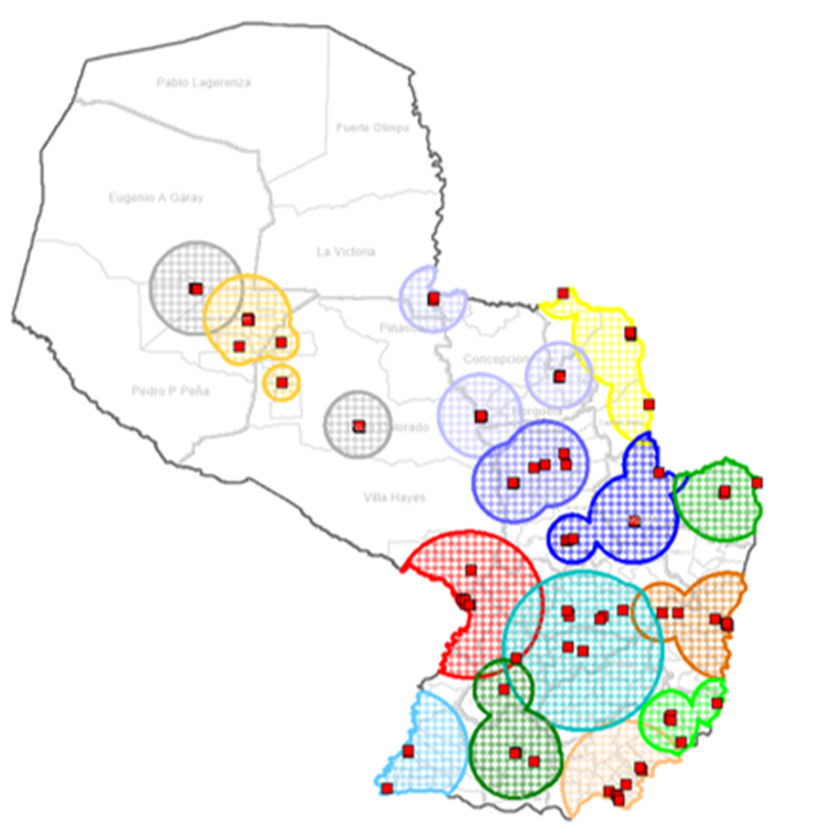

14 Republic of Korea
The Republic of Korea decided digital transition from analogue broadcasting services to provide spectrum efficient and high-quality services. With careful studies and field test, standards to achieve effectively the digital transition of each analogue media were chosen. For fixed reception at home, high quality services on large screen display will be major service models but low or intermediate quality acceptable on small and handheld receivers for mobile reception.
In the Republic of Korea, digital terrestrial television broadcasting was started in 2001, digital satellite broadcasting in 2002, and terrestrial multimedia broadcasting in 2005. Cable TV is also in service of digital programs since 2002.

14.1 Digital TV for fixed reception
Terrestrial television sets may be appropriate receivers to enjoy high-definition video and multi-channel audio with a large screen at home. The Republic of Korea adopted ATSC system in 1997 for digital transition of analogue television broadcasting in the UHF band according to the policy to obtain high-definition quality within 6 MHz raster and conducted field tests in 1999 and 2000.
There are 160 ATSC transmitters currently installed around the country covering about 92% of territory as of 2006. Several principles were given to digital terrestrial television broadcasters to follow government policies on digital transition as follows:
– Simulcast of analogue and digital broadcasting until analogue switchover.
– Requirement of minimum time for HDTV programs (annually increasing).
– Return of frequencies allocated to analogue television stations.
It was not an easy job to find frequencies for digital television stations, because the UHF band from 470-752 MHz is already occupied with analogue television broadcasting. Hence, the band of 752-806 MHz, currently allocated to fixed and mobile services in Korea, was decided to use for broadcasting services during the transition time only, but these bands will be returned after analogue switchover. In order to facilitate frequency assignments, Equalization Digital On-Channel Repeater and Distributed Translator are devised for ATSC system to use same frequencies.
More than 4 million Set-Top-Boxes, about 23% of households, were sold as of 2006. It is expected to increase penetration rates of Set-Top-Boxes, since data broadcasting was started in 2005. Data services provide information on dramas or records of sports games as well as EPG.

14.2 T-DMB for mobile reception
For mobile multimedia broadcasting service, the Republic of Korea developed the video standard, which is fully backward compatible with the T-DAB, and named as Terrestrial Digital Multimedia Broadcasting (T-DMB). The specification of T-DMB was standardized as ETSI TS102 427 and ETSI TS 102 428 and submitted to WP 6M for a new recommendation of mobile multimedia broadcasting by handheld receivers.
T-DMB pilot services were conducted in Band III in Seoul metropolitan area and its vicinity and field test results showed good mobile reception quality. Field test results were submitted to WP 6M meeting held in April 2004 and included in Report ITU-R BT.2049 (see also Doc. 6E/186).
In December 2005, the Republic of Korea launched commercial service of T-DMB in Seoul Metropolitan area and expanded to the nationwide services in March 2007. Each broadcaster provides two video services or one video with three audio services within an ensemble and optionally with data services.
The whole territory was divided into seven regions including Jeju Island for business. One national broadcaster and seventeen regional broadcasters were licensed to serve T-DMB nationwide. It was intended to serve each region with the same frequency and most transmitters are linked with single frequency networks to cover the wanted regional area. Fortunately, Seoul Metropolitan area is assigned two TV channels, 8 and 12, and served by six broadcasters. In order to allocate frequencies to T-DMB stations, frequencies of 44 analogue TVR in the band III were changed after simulation of mutual interference and analysis. The channel assignment plan in the Band III for the services is shown in Fig. 31.
However some transmitters in southern part do not have same frequencies due to pre-occupied frequencies for analogue TV stations and some regions consist of multi frequency networks; Channel 7 and Channel 8 of the south-western region, Channel 7 and Channel 9 of the middle of eastern region, Channel 9 and Channel 12 of south-eastern region and Channel 8 and Channel 12 of Jeju Island. Hand-over technology was implemented on receivers for continued reception of a wanted service, even in other ensembles or different RF channels, while moving into another network.
In order to enjoy T-DMB services even underground, low powered T-DMB gap-fillers, which receive outdoor T-DMB signals and retransmit, were installed at 294 points to cover the whole lines of Metros in Seoul.
A variety of commercial receivers for portable or handheld reception are introduced in the market. Since the launch of T-DMB service in December 2005, 3.14 million receivers are sold in Korea as of 31 January 2007.
Data services such as EPG, TPEG and BWS are in services and interactive services using return channel will be appeared soon with the cooperation of telecommunication operators. These data services are expected to produce pay services for business by providing information on traffic jam, stock and even Internet access.
FIGURE 31
Channel Assignments for T-DMB in Korea
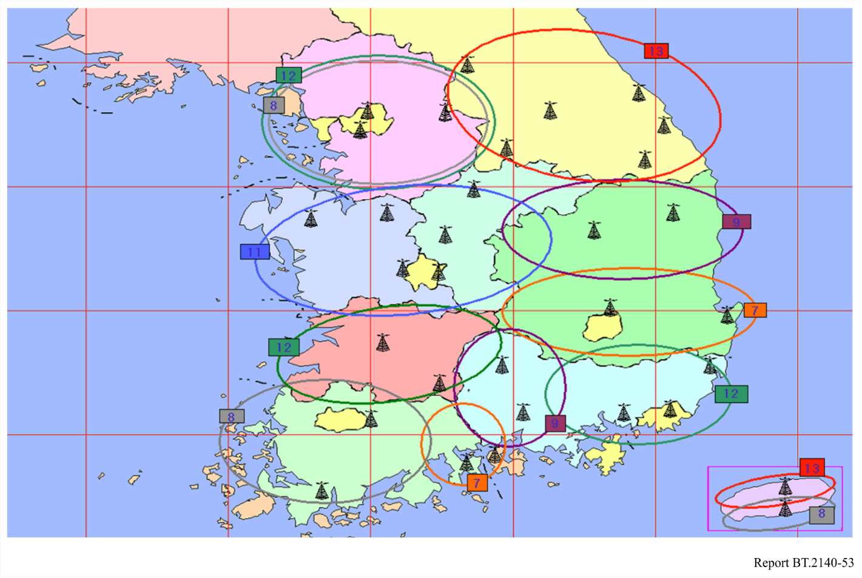

15 Russian Federation
Strategy basics for transition from analogue to digital broadcasting within an individual region (based on the experience of introduction of DVB-T broadcasting in the Primorsky region of Russia)
Transition from analogue to digital TV in the Russian Federation at the first stage assumes the replacement of an analogue signal into digital one with preservation of the existing standard of decomposition of a signal. Such signal can be reproduced not only by colour TV set, but also by black-and-white TV set having a special receiver box.
In Russia before the introduction of digital TV it is required to carry out an experimental broadcasting. In connection to this there were organized experimental broadcasting areas in Moscow – 32, 34 TVch; Saint-Petersburg – 34 TVch; Nizhniy Novgorod – 50 TVch; Vladivostok – 51 TVch; Chelyabinsk – 30 TVch.
The broadcasting is conducted in standard of DVB-T. Now researches of an opportunity of interactive reception on mobile television receivers with the liquid crystal display are conducted, the return channel is planned to realize through GSM network.
For the further introduction of digital TV broadcasting a planning of DVB-T frequency assignments, both in European Broadcasting Area and to the west from longitude 170°E is carried out. Now the majority of planned frequency assignments to DVB-T stations is coordinated with other Administrations, 37 frequency assignments are included in the Plan (Stockholm, 1961), 4 frequency assignments are included in MIFR.
Furthermore 24 frequency assignments to DVB-T stations are coordinated and in the near future will be included in the Plan (Stockholm – 61) and in Lists of existing and planned TV stations for the territories of extended planning area.
MHP-based interactive services are possible, but the penetration of telephone and telecommunication systems –that are not yet at a nationwide extent- is a critical element that shall be taken into deep consideration.
Overall strategy of updating the regional TV and radio transmission network and transition to digital broadcasting in the region
As a rule, the degree of wear of analogue transmitters operated in the region is pretty high. The useful life of many transmitters is already over. Replacement of worn-out analogue transmitters by new analogue equipment appears senseless both from the technological and economic point of view, as in the transition to digital broadcasting it will be necessary to replace such new transmitters again with digital ones, this time long before the end of their useful life. Besides, one cannot see any ways of compensating for such replacement costs as analogue broadcasting in principle cannot support the new information services and products that the population would be prepared to buy and that could generate additional revenue for broadcasting operators. In this connection it seems worthwhile making the transition to digital broadcasting in the region without delay.
It is evident that transition to digital broadcasting should be effected within the framework of current frequency arrangements, that is digital TV programmes should be broadcast in the same frequency bands as analogue broadcasting formerly. This means that overnight transition to digital broadcasting should be accompanied by stopping analogue broadcasting of the same programmes within the coverage area where such transition takes place.
It goes without saying that overnight transition to digital broadcasting is not possible without equipping the population with digital receivers, i.e. subscriber set-top boxes (STBs). Transition to digital broadcasting can only be effected provided that every subscriber has such an STB, so that in the transition process no small group’s interests suffer. A broadcasting operator is not responsible for the provision of STBs to the population. Without going in detail on the organization of such provision one should mention that this problem must be solved through local funding under a comprehensive target programme implemented by the regional administration with the help of private investments. Thus, the financial burden should be distributed between the commercial structures of the region the overwhelming majority of which is interested in new advanced interactive multimedia infocommunication services and products (including e-commerce and e-banking systems) supported by digital broadcasting. Introduction of such systems within a united regional information system (to be described below) may give a powerful impetus to business development in the region with the corresponding growth of commercial structures’ turnover and revenues.
As for providing STBs for digital broadcasting to the population, this should be done according to a uniform schedule approved by the administration and coordinated with the broadcasters in one transmitter broadcasting coverage zone after another. Under the schedule, STBs should be provided to all rather than part of the people residing within one coverage zone, then another and so on. This will ensure the possibility of making a final transition to digital broadcasting in the region successfully. The STBs themselves are multipurpose interactive terminals capable of supporting a wide range of modern interactive information services and products besides broadcasting.
It is clear that transmitters replacing the old worn-out analogue ones should be hybrid, i.e. equally capable of operating both in analogue and digital broadcasting mode. At the first stage such a newly installed transmitter will operate in analogue mode. Later on when the population in the coverage zone is 100% equipped with STBs the transmitter will go over to digital mode with the DVB-T modulator switched on and the driver replaced (it is desirable to have both devices supplied in a complete set with the transmitter). It goes without saying that at the first stage the transmitter will broadcast only those programmes that used to be broadcast for the given coverage zone in analogue mode. Thus the next problem that arises is of most importance for urban areas where several TV programmes can be received within one coverage zone. In each broadcasting zone several analogue programmes broadcast by different transmitters may be received. Digital broadcasting is multiprogramme, i.e. one digital transmitter will broadcast all those programmes that used to be broadcast by several analogue transmitters. Thus, only one “head” analogue transmitter should be chosen out of the group for the coverage zone to be replaced by hybrid equipment. The transmitter should be connected with MPEG-2 signal feeder lines for all the TV programmes broadcast for the given coverage zone. All the signals should be joined together in a multiplexer into an MPEG-2 transport flow and fed into the DVB-T modulator. After this the transmitter may be switched over to the digital broadcasting mode and the analogue broadcasting of other transmitters may be stopped and dismantled.
Five DVB-T transmitters are working at present time and one more will be launched in nearest future. All of them have experimental status and used for investigations of compatibility between DVB-T and analogue (SECAM-K) television broadcasting, but also proposed to be fully-functional DVB-T services.
It is clear that transition to digital broadcasting should entail an increase in the number of programmes provided to the population. As a result, the situation should emerge when the regional programme package (i.e. all the programmes that are currently broadcast to at least part of the population of the region) will be accessible to every TV viewer. Of course, with time the package should be expanded gradually with new commercial programmes (including pay programmes) and with free regional programmes of social and informational importance. To achieve this it is necessary to solve the problem of constructing a full regional network of TV programmes supply and distribution, i.e. when each programme received in the region via satellite channels or produced in the region itself would be supplied to every transmitter (or a group of transmitters) operated in the region. The problem can be best solved on the basis of a fibre-optic line laid in the region and running through its major populated areas. Fibre-optic line branches, i.e. TV programmes supply lines to other populated areas of the region, should be based on the exiting radio relay lines or MMDS systems. Moreover, the radio relay lines must be updated to transmit digital data streams. This can be done through using modems and MUXes ensuring the transmission of digital data streams along the existing radio relay lines at the rate of 51 Mbit/s. The equipment will digitize the radio relay lines and at the same time the UHF equipment installed will remain intact. In many cases MMDS systems can also be used to bring digital broadcasting programmes to home cable networks. Naturally to expand the digital broadcasting programmes package broadcast to the population it is necessary to install some additional digital transmitters. However, it is important that reception of digital broadcasting programme packages from several DVB-T transmitters by outdoor antennas in many cases may be ensured without amending the existing home cable networks.
The regional programme package may be expanded both through increasing the number of programmes made up in the region itself and through receiving more programmes via satellite communication channels.
Stages of comprehensive modernization of the regional TV and radio broadcasting network
Thus with the above approaches the following stages of comprehensive modernization of the regional TV and radio broadcasting network for transition to digital broadcasting can be defined:
– distribution of DVB-T STB to the population. STB manufacture funding may be effected within a target programme of the regional administration funded by regional investors. The STBs should be multifunctional interactive terminals supporting a wide range of modern multimedia services and products along with broadcasting;
– choosing a “head” transmitter out of the operating ones in each broadcasting zone to be replaced by a hybrid unit (with analogue broadcasting at the initial stage) with digital signals of all the programmes broadcast in the area fed to the latter;
– starting digital DVB-T broadcasting of those programmes that used to be analogue from the head transmitter, stopping analogue broadcasting and dismantling all the other transmitters in the broadcasting zone with the process going on in one broadcasting zone after another as these are ready for the change;
– constructing a regional TV programmes supply and distribution network on the basis of fibre-optic lines and digital radio relay lines, MMDS and cable lines used in the “last mile” section;
– as the regional distribution network is expanded bringing the regional TV programme package (i.e. all the programmes coming to the region via satellite channels and all the regional programmes) to each populated area in the region, with further expansion of the range of such programmes, including new regional ones (regional TV, commercial programmes); installing new DVB-T transmitters;
– on the basis of digital TV broadcasting, organizing data transmission (including web and web-type multimedia services) from the very beginning of digital TV broadcasting to provide to the population modern infocommunication services and products, both socially-oriented and commercial;
– introducing interactive products from the very beginning of digital TV broadcasting, primarily web and web-type services on TV broadcasting basis;
– constructing in the region a united interactive information multimedia regional network on the basis of subscriber’s STB with an interactive platform specially designed to take care of the region’s needs and interests and a uniform system of conditional access chosen upon agreement reached between digital broadcasting operators.
Further development of the TV and radio broadcasting transmission network in the region, expansion of the range of services and network functions through interactive servicing and provision of multimedia services.
Transition to digital broadcasting is not the end of TV and radio broadcasting transmission network modernization. It goes without saying that more TV broadcasting programmes will bring more revenue for broadcasting operators. However, the largest source of higher revenues is in the sphere of provision of a wide range of modern infocommunication services and products on the broadcasting basis to corporate and individual users. Technologically this can be achieved through encapsulation of multimedia data streams (including web and web-type services data) into TV broadcasting digital flows. Reception of the above services and their data display on the TV screen will be done with the help of digital TV broadcasting STBs. The same STBs with their software and firmware support return channels organized on telephone lines (on the basis of built-in dial-up modems) or with xDSL facilities or, provided there are home cable lines, HFС (hybrid fibre cable) on the basis of the DOCSIS standard (built-in or external DOCSIS modems connected with the STBs by Ethernet interface).
Modernization of a regional broadcasting network aims at updating the transmission firmware of the TV and radio broadcasting network in a region, expanding the range and list of services provided by the broadcasting operator to the users, increasing revenue for the operator and effecting a phased transformation of such an operator into an information package provider for the region allowing both commercial and social problems to be solved.
Overall description of information and interactive services and products based on digital TV broadcasting. The initial stage of introduction of the services in the region
Enhanced TV and interactive TV are principally new TV broadcasting services that can only be provided on the basis of digital broadcasting. The concept of enhanced TV envisages pay services with a coded signal that requires using smart cards and conditional access systems. Private companies leasing equipment from the operator may provide such services to the population under subscription for pay packages. Moreover, the possibility of free reception of the social programmes package (both national and regional) by the population remains.
Enhanced TV envisages the technology of pseudo-interactive DVB-T services without a return channel. These include various information services and reference materials, such as TV – the press, weather forecasts, ratings and advertisement channels. In transition to digital broadcasting such services may be provided at once in those populated areas of the region where there is a shortage of telephones and where it is yet impossible to organize a return channel for full-scale interactive service.
In the towns of the region with sufficient telephone penetration, interactive systems may be deployed on the basis of a return channel on a telephone line. A return channel can support various e-commerce services, on-line shops as well as rating votes and population polls that are important socially and may be needed by the regional administration. At the same time high-rate access to the Internet on dedicated digital DVB-T channels may be provided. For this a TV viewer will not need a PC as in this case its function will be performed by the STB for digital broadcasting: it will display web pages on the screen after appropriate reformatting and rescaling of text and graphic objects in web pages in a way allowing their display on the screen of a standard definition TV set. The web browser is operated with the help of a cordless keyboard. Connection does not require any additional time, as the Internet channel is permanently available. In fact the service is a factor of new quality of life, as television becomes a powerful information gateway concentrating most advanced information technologies that enable any person regardless of his or her age, education and social status to be a full-scale member of the global information infrastructure without buying a PC, just with the help of a familiar TV set. The digital TV broadcasting STB supports the Internet access and e-mail functions.
At the next stage of deploying a digital TV broadcasting system in the region it becomes possible to extend the interactive services to remote rural areas with insufficient telephone penetration. This becomes possible through using return channel cordless DVB-RCT technology.
Construction of a united interactive multipurpose information system on the basis of digital TV broadcasting in a region
If there are return channels, the following interactive infocommunication services may be provided on the basis of digital TV broadcasting to corporate and individual users:
− access to the Internet without using a PC;
− e-trade;
− e-commerce;
− management of a bank account, including execution of commercial transactions at a distance using a digital signature;
− e-system for ordering municipal services;
− communal utilities payment e-system;
− services base on “video-on-demand” technology;
− cottage industry e-systems;
− e-health;
− e-learning systems;
− virtual CD-ROM;
− web games.
All together the above-listed information services may form a united interactive multipurpose information system implemented on the basis of a single user’s interface (browser) and a uniform interactive platform. Thus, a broadcasting operator may become a provider of the service system to corporate and individual users. It makes sense to shape such systems on a regional basis. For this there should be in the region data formation centres for corresponding information services, including specialized servers and devices for encapsulation of the said services in TV broadcasting signals. Server software represents a multifunctional software package including, in particular, billing modules, modules of interoperation with banking payment systems, advertising management, mediametrics collection and processing of return (interactive) channels data, etc. The user part of the software for such a system (browser) is installed in the digital broadcasting STBs.
Without going into detail concerning the construction and functioning of such a system it is possible to point out its major sources of additional revenues for the operator. These include among others subscription fee charged on the basis of a conditional access system (implemented through STB smart cards). However, it is advertiser’s payments that constitute the most important source of revenue for the operator of an interactive information system. Advertising in interactive information systems radically differs from traditional linear advertising in analogue broadcasting. Its main distinction lies in its target nature (different groups of users get different advertisements) and in the built-in function of measuring the audience (mediametrics). Actually, STBs can support the following functions:
1) Assignment of a consumer index to the subscriber. When a subscriber is switched in the system a questionnaire is displayed on the screen with a number of items referring to the subscriber’s social status, age, sex, revenue, interests in various spheres, goods and services of interest, etc. (such a poll may be repeated in certain periods of time, e.g. annually, to identify the changes, if any). The questionnaire aims at establishing what type of advertising should be supplied to the subscriber. The questionnaire is based on multiple choices. A given consumer index is assigned depending on the choice of answers. The index is forwarded to the operator’s server and further on is used to identify the advertising materials to be supplied to this subscriber.
2) Mediametrics of TV programmes. An STB registers each switch over from one TV channel to another and certainly the viewing time on each channel. Periodically (say, once a day) the obtained viewing data is forwarded to the operator’s server. The function allows calculation of the exact rather than approximate rating of TV programmes.
3) Advertising mediametrics. Each payment for goods and services effected by a subscriber with an STB (supporting the e-payments function) is registered and the information about the type of goods or services bought is transmitted to the operator’s server where the connection between the purchase of the goods and services and their advertising supplied to the subscriber earlier is analysed. This function is necessary to appraise the effectiveness of advertising materials.
It is clear that with these functions the operator of an interactive information system obtains data of vital importance both for TV companies (programme ratings) and advertisers (much higher effectiveness of advertising thanks to its target character, information about the effectiveness of advertising materials). This enhances the attractiveness of the system for the TV companies and advertisers and affects the operator’s revenues accordingly.
Another important source of revenue for the operator is payments by commercial structures selling goods and services within the framework of the e-trade system, as part of the system as a whole. The e-trade system is in great demand for commercial structures as it enables these to increase significantly their sales. A new market is open to the sellers – electronic retail sales with immediate payment for goods and services in non-cash form via e-banking.
TV viewers may choose the goods via the on-line shops system in which they may view video clips of the goods, order these to be delivered to their homes or not and pay for them with the help of their smart card. Foreign practice confirms great success of such projects as in addition to convenience and time saving the customer pays less for the goods than in traditional shops (thanks to lower seller’s overheads and non-cash payments) and due to that fact that e-payment systems in closed digital TV networks are more reliable than those on the Internet.
If the above regional interactive information system based on digital broadcasting is established in a region as a next logical step after overall transition to digital broadcasting in the region, it would also be logical to base the system of subscription fees on a uniform conditional access system. It goes without saying that such a system should have an open (socially oriented) component and a commercial component and subscription fees will be charged only for services provided by the commercial component.

16 Tanzania
Introduction
Tanzania has been addressing the migration from analogue to digital terrestrial broadcasting immediately after the RRC-04. The Tanzania Communications Regulatory Authority (TCRA), the regulator of Communications, Broadcasting and Postal sectors participated in the RRC-06 processes. After RRC-06, two consultation documents were issued followed by workshops, annual conferences and forums aimed at addressing how digital terrestrial broadcasting will be implemented, managed and regulated in Tanzania.
The consultations yielded initial framework on the new broadcasting landscape in Tanzania which is introduction of signal distributors branded Multiplex Operators (MUX). It is proposed of two commercial Multiplex Operators and one Public Service Multiplex Operator under the initial licensing framework.
Important issues addressed, include the way digital television operates and its efficient use of frequency spectrum resource and its associated value-added services.
Furthermore, the Authority has worked out major issues that will guide smooth migration.
Among the measures undertaken by TCRA is the introduction of the Converged Licensing Framework (CLF) with four (4) major licences, 1. Network Facility Licence, 2. Network Service Licence, 3. Content Licence 4. Application Service Licence addresses the complex licensing issues associated with digitization.
To realize smooth migration, TCRA produced two consultation documents on digital broadcasting which were discussed by all stakeholders. National Technical Committee has been formed to handle migration issues and workout the roadmap to full digital broadcasting in Tanzania.
The consultations yielded initial framework on the new broadcasting landscape in Tanzania. The new broadcasting chain landscape is such that, there will be two distinctive features namely, the Content Service Provider and Signal Distributor who will be charged with multiplexing. There will be two commercial Multiplex Operators, and one Public Service Multiplex Operator under the initial licensing framework that will be charged with the responsibility of signal distribution.
Tanzania, a country at the eastern coast of the African continent, spans 1122 Sq. kilometres with a population of 36 million inhabitants. Tanzania falls under ITU Region 1. There are 26 licensed analogue television stations, out of which 4 are national coverage, 5 regional coverage (covering ten administrative district areas) and the rest district administrative coverage.
There are also three (3) licensed digital satellite pay television stations and one digital terrestrial television operator in the City of Dar Es salaam under a pilot DVB-T project. There are 95 analogue television transmitters countrywide.
After the two consultation processes between 2005 and 2007, a final document on “The Transition from Analogue to Digital Terrestrial Broadcasting in Tanzania” addressing the Regulatory and Legal Framework under which Digital Television will be implemented, managed and regulated. The Authority has so far run an awareness campaign among the media stakeholders during the consultation process that has come up with the roadmap for licensing of Multiplex Operators. The Authority has so far achieved the following goals and is set to licence the pilot project in the financial year, 2008/2009 on a phased approach basis.
In the interim period, the Authority has formed the Work Group on Digital Broadcasting (WGDB) with experts from broadcasting, spectrum management, ICT development and legal sector tasked to address the following issues:
− Consider licensing issues of MUX.
− Consider National Plan of Digital Broadcasting and simulcast period.
− Consider Licensing issues of other services like, Mobile TV, IPTV etc.
− Consider and adopt a positional paper on availability of STB.
− Editing of the final document on Digital Broadcasting in Tanzania.
In April 2008, TCRA announced an Expression Of Interest (EOI) for prequalification for interested parties to submit their interest in the provision of digital multiplex services in Tanzania. The response was positive.
The Authority has postponed licensing of new television applicants from 2007 in order to audit the UHF and VHF channels countrywide and plan for digital terrestrial services countrywide during simulcast period. The digital plan status will be ready before the end of this year.
The digital plan will give detail to the WRC-07 decisions, on smooth implementation of digital broadcasting.
The Authority is carrying out an exercise of reviewing the Broadcasting Services Act, 1993, Tanzania Communications Act, 1993 and the Tanzania Communications Regulatory Authority Act, 2003 with a view of incorporating Digital Terrestrial Broadcasting and Multiplex Operator a legal force.
The Authority will embark on public awareness campaign on digital migration and coordinate with neighbouring countries on best ways of efficient utilization of spectrum, interference mitigation and protection of existing analogue services during dual illumination.
Digital Migration Policy in Tanzania
The Tanzanian ICT Policy, 2003 governs the digital migration process in Tanzania.
And the realization of digital dividend prior to WRC-07 by allocating the broadcasting sub-band 825.285-862 MHz (about 37 MHz) for CDMA mobile operators realizing digital dividend earlier.
Tanzania’s position during WRC-07 was very clear. It supported new broadcasting band at 470‑790 MHz to promote mobile phone industry as a catalyst to universal access. The mobile industry penetration in the past few years has dominated the communication market than fixed lines whose roll out has been slowing down.
The Authority is constructively engaging the Government on possibilities of giving out subsidies to importation of set-top-boxes so as to make them available to common people.
TCRA in collaboration with the Government is setting up policies and recommendations on availability of set-top boxes. The idea of fees from the dividend is still raw and under discussion.
Migration from Analogue to Digital broadcasting in Tanzania in Tanzania is policy driven. It has taken TCRA three years to prepare broadcasters for the uptake of digital broadcasting. Worries have been on the fate of the analogue infrastructure investment and “fear” of revocation of frequency channels by incumbents. Worries have even been on consumers on the availability of affordable set-top boxes.
Tanzania has adopted phased migration approach. This will help correct mistakes experienced in initial stages of implementation.
Tanzania will switch off analogue systems by 2015 and the chances of doing it before that time is clear.
Challenges on licensing; There are digital TV products which the Authority is working on the proper framework to cater for the country’s ICT trend.
There have been concerns during the migration process on existing analogue infrastructure.
During consultations, it was agreed that the licensed multiplex operator enters into agreement with analogue broadcasters to use part of their usable infrastructure.
Tanzania is actively participating in all activities pertaining to digital broadcasting in Region 1 of the ITU and the CTO-Digital Broadcasting Forum in Johannesburg every year. This has been instrumental in having common migration strategies and has acted as sensitizing machinery among participating African nations. Even those that have not initiated efforts to migrate from Analogue to Digital broadcasting have been supported to initiate steps towards migration.
Organizations like Communications Regulatory Authorities of Southern Africa (CRASA) and East African Communication Regulatory authorities are engaged in efforts aimed at successful implementation of digital broadcasting.

17 Thailand
In Thailand, the National Broadcasting and Telecommunications Commission (NBTC) is playing an important role in promoting and implementing the transition from analogue to digital terrestrial television.
In 2012, the NBTC started the roadmap of the transition from analogue to digital terrestrial television and selected the DVB-T2 as a national standard for digital terrestrial television. The NBTC also set the target coverage of digital terrestrial television to 95% of the households in Thailand by 2017. The frequency band for digital terrestrial television is on 510-790 MHz with 8 MHz bandwidth. Due to the history of spectrum utilization and assignment in Thailand, the frequency band 470-510 MHz is allocated to Fixed and Mobile Services. The re-farming process will be taken place in the future to release this frequency band to Broadcasting Service.
The roadmap of the transition from analogue to digital terrestrial television in Thailand is divided in four phases, including (Phase 1) DTTB policy development, (Phase 2) Licensing policy and regulation, (Phase 3) Planning and execute auctions and tenders and (Phase 4) DSO communications and supervision.
The NBTC embarked on this journey of implementing DTTB with the following main policy objectives in mind:
1) To provide access to Thailand’s broadcasting spectrum for public and commercial entities as well as citizen, to develop and introduce television services;
2) To reap the benefits of the technological advances that DTTB incorporates, including spectrum efficiency gains and having more television services, as well as new service features;
3) To reform Thailand’s media landscape whereby content diversity is promoted by means of:
a) Opening the market for new market entrants;
b) Having thematic services for defined audiences;
c) Ending the system of concessions.

17.1 Technology selection
In 2012, the national broadcasting and telecommunications commission (NBTC) set a roadmap for the transition from analogue to digital terrestrial television and also selected the DVB-T2 as a national standard for digital terrestrial television. During the technology selection process, the NBTC had compared all digital terrestrial television technologies specified in Recommendations ITU-R BT.1306 and ITU-R BT.1877 and set a scorecard to assess the efficiency and suitability in the context of television industry in Thailand. The key items in the scorecard are as follows:
– innovation and advanced technologies;
– spectrum efficiency;
– sufficient capacity for current and future demands;
– sufficient capacity for public, commercial, and community services;
– capability to provide the service in SD and HD formats;
– economy of scale and price of the Set-top box/iDTV in the market;
– compatibility with the existing analogue television; and
– align with international cooperation and agreement.
After the NBTC had selected the DVB-T2, the policy on technology for digital terrestrial television was established and addressed the following elements:
TABLE 14
Items | Specification/Requirement
DTTB transmission | DVB-T2
Resolution | SD and HD  – SD – Standard Definition (576i)  – HD – High Definition (1080i or 720p)
Video compression | MPEG-4 AVC/H.264  (supports subtitling system)
Audio compression | MPEG-4 HE AACv2  – Stereo is minimum requirement.  – Surround is optional with no specific technology.
Conditional access | No conditional access (free-to-air)
Middleware | To be determined  – broadcasters shall propose to NBTC once a consensus on middleware standard is reached. It shall be an open standard.
Source: Broadcasting Technology and Engineering Bureau (Office of the NBTC)

17.2 Frequency band
The band allocations for broadcasting service in the national spectrum plan and the national Table of frequency allocations deviates from the international band allocation in this Region, as provided in the ITU Radio Regulation. The available spectrum is limited on the lower side of the UHF Band. Channels 21 to 25 (i.e. 470-510 MHz) are allocated to mobile and fixed services, consequently only channels 26 to 60 (i.e. 510-790 MHz) were available for planning the DVB-T2 services. With the limited number of channels, the planning was very challenging during the simulcast period, since it had to take into consideration the existing frequency usage of analogue television. The planning also had to obey some international frequency coordination agreements with neighbouring countries, in particular the agreement with Malaysia. In an area of 100 kilometres from the Malaysia-Thailand common border, only the even number channels could be used.
However, the re-farming process for the frequency band 470-510 MHz is expected in the future in order to release this frequency band to broadcasting service. Therefore, the frequency re-planning process might be necessary.

17.3 Licensing and regulatory framework
The licensing framework for broadcast services and distribution is based on the Broadcast Business Act (2008) and the Act on Organization to Assign Radio Frequency and to Regulate the Broadcasting and Telecommunications Services (2010). The licensing framework is depicted in Fig. 32.
Figure 32
Licensing framework for broadcasting
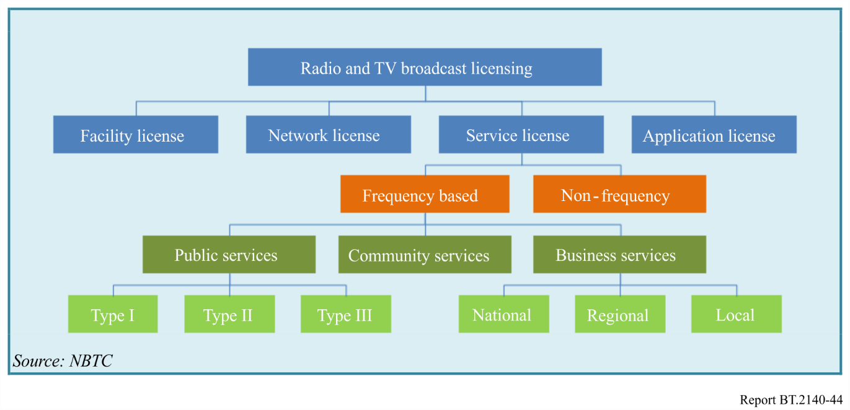
In addition to above mentioned legislation, the NBTC has published several Notifications governing the regulation of broadcast licenses. The roll-out obligation for the DTTB network operators is stated in the NBTC Notification on Additional Criteria and Means for Granting License for Provision for Digital Terrestrial Television Broadcasting Network, B.E. 2556 (2013). This obligation is defined as a minimum coverage requirement (for fixed rooftop reception) as a percentage of households. The percentages per period after the Network license assignment are as follows:
1) 50% within 1 year;
2) 80% within 2 years;
3) 90% within 3 years;
4) 95% within 4 years.
The Network license as included in Fig. 32 includes an operating right. The Service license includes the spectrum rights as well as the right to broadcast television content (i.e. the broadcasting right). The Act on Organization to assign radio frequency of 2010 stipulates that spectrum rights for business/commercial purposes should be auction. Consequently, the DTTB Service licenses have to be auctioned for assigning spectrum rights to commercial broadcasters.
At the end of December 2013, the auction of the service licenses took place. This auction marked the end milestone of Roadmap Phase 3. Interestingly this broadcast auction came one year after the auction of 3G mobile licenses. As both auctions took place in Thailand comparing spectrum value between mobile and broadcasting services becomes easier as social, cultural and demographic differences are not present. Also the key license terms were the same; license duration and coverage obligation (respectively 15 years and 95% population, in both cases). The value per MHz for respectively DTTB and 3G services in Thailand is shown in Fig. 33.
Figure 33
Auction proceeds for broadcasting and mobile in Thailand
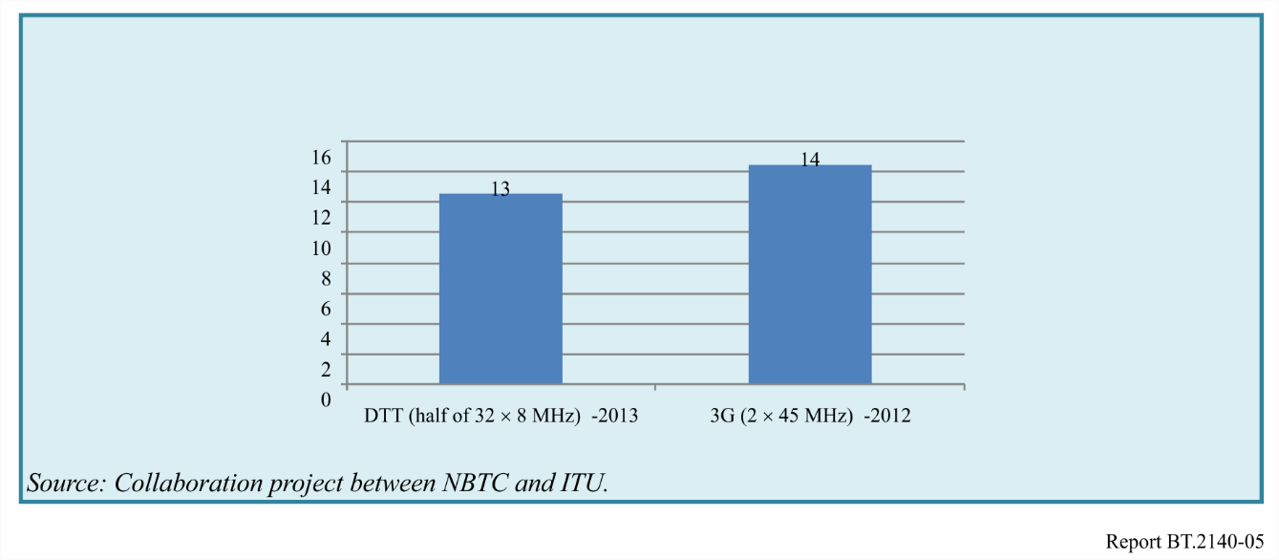
As Fig. 33 shows the price paid per MHz are very close between licenses for broadcasting and mobile services, respectively USD 13m and USD 14m. This is an interesting fact as broadcast spectrum was always deemed to be significantly lower as spectrum for mobile services. A topic heavily debated in the wider discussion of allocating any freed-up spectrum after migrating to DTTB (i.e. the digital dividend).
After this service license assignment to the commercial broadcasters, the broadcasters selected their network operator. Subsequently the network operators embarked on the joined deployment of the first Phase of the DTTB networks. In June 2014 the first Phase of the digital television network (including 11 main DTTB stations) was taken into operations.
In April 2014 the four licensed DTTB network operators launched the FTA digital services. This changed the market structure considerably as 24 new commercial terrestrial services were launched. This new situation is depicted below.
Figure 34
Market structure of Thai Television Broadcasting (after DTTB)
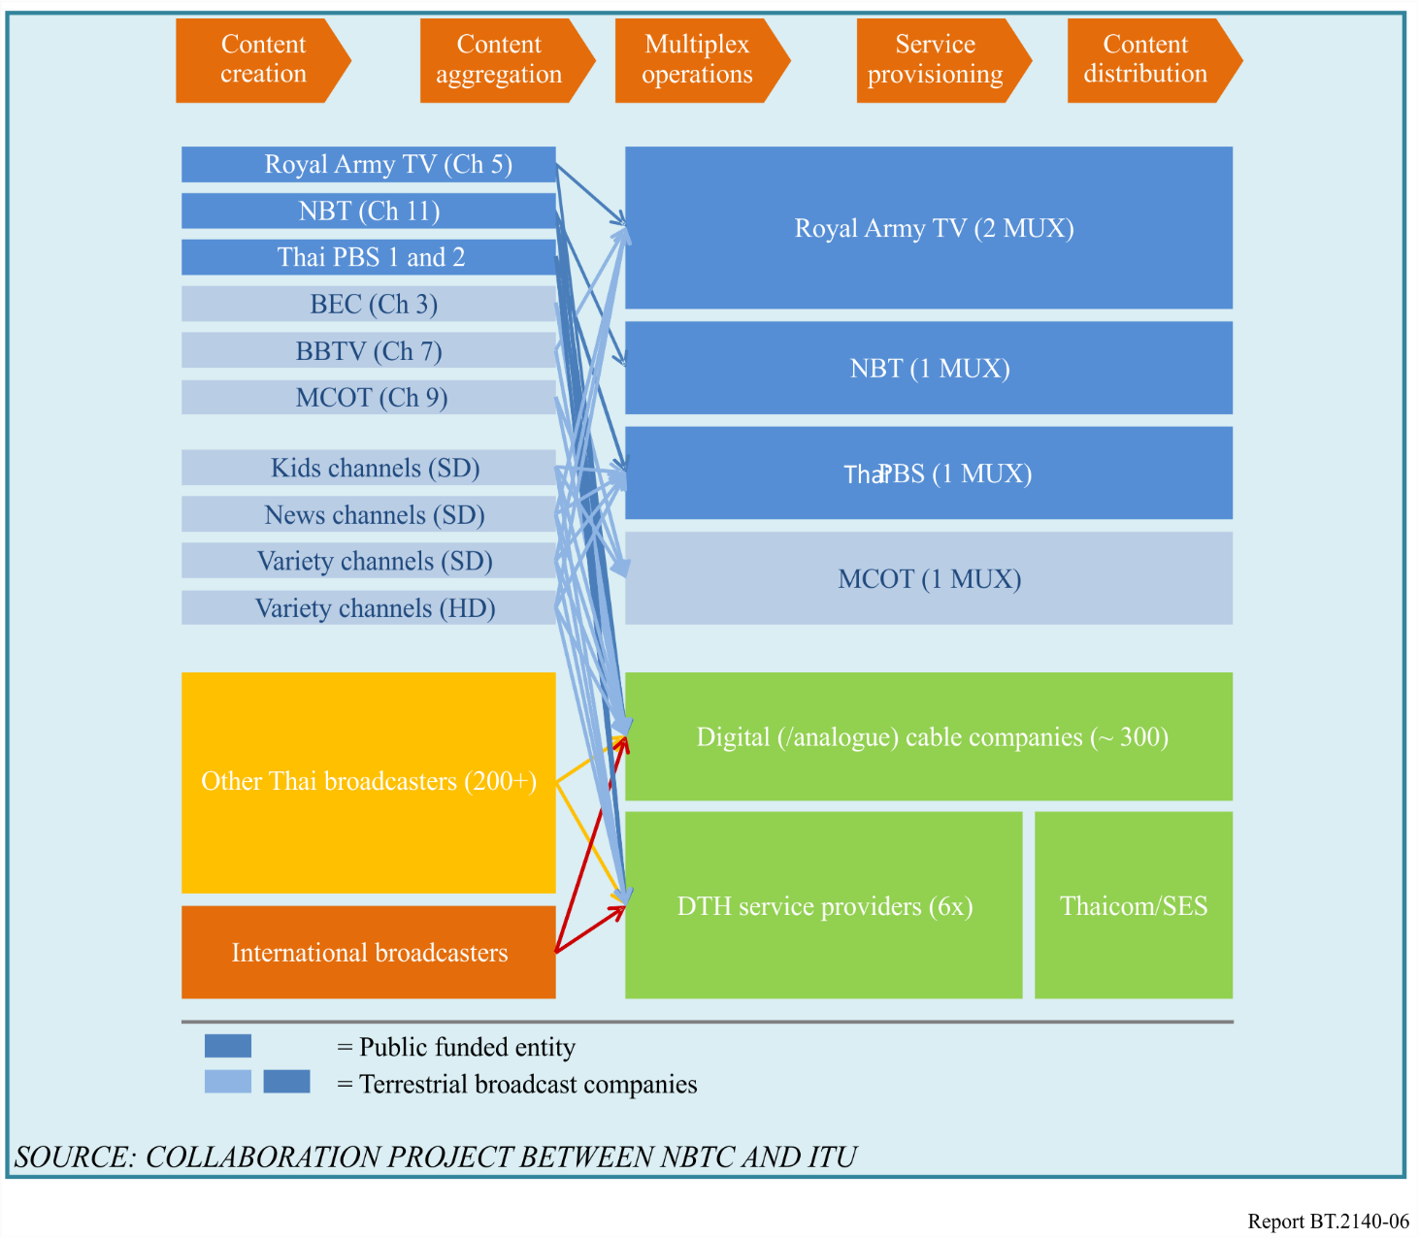

17.4 Network licenses and network deployment plan
In 2013, the NBTC granted five network licenses to four network operators as follows:
– Public relation department (PRD) got one license to operate Multiplex 1 (MUX 1);
– Royal Thai Army Radio and Television got two licenses to operate Multiplex 2 (MUX 2) and Multiplex 5 (MUX 5);
– MCOT got one license to operate Multiplex 3 (MUX 3); and
– Thai PBS got one license to operate Multiplex 4 (MUX 4).
According to the roll-out obligation, the network operators have to achieve the target coverage of 95% households within four years after the license assignment (i.e. 2017). Thus, The NBTC and the network operators set the network deployment schedule in order to reach the target coverage as stated in the roll-out obligation.
TABLE 15
Phase | Timeline  (approximately) | Target Coverage (Households) | Covered by
1 | April 2014 – June 2014 | 50% | 11 main sites
2 | July 2014 – June 2015 | 80% | 39 main sites + 7 additional sites
3 | July 2015 – June 2016 | 90% | 39 main sites + 45 additional sites
4 | July 2016 – June 2017 | 95% | 39 main sites + 132 additional sites

Source: Broadcasting Technology and Engineering Bureau (Office of the NBTC)

17.5 Multiplex composition
For ensuring minimum picture quality levels for HD and SD services the NBTC prescribed several multiplex loading scenarios. These scenarios also served the purpose of balancing the services over the available multiplexes. Two critical input parameters for deciding these multiplex scenarios were:
1) The net effective transport capacity per multiplex, and;
2) The number of HD and SD services in the DTTB service bouquet.
In developing the DTTB policy these two parameters changed over time. Under the supervision of the NBTC, the network operators were carrying out field trials to gain experience with the DVB-T2 technology and for agreeing the system parameters, which in turn determined the effective net transport capacity. At the same time the NBTC organized public hearings to acquire input from the broadcast industry as to determine the optimal number of services. In the latter several factors had to be balanced, including resulting market structure after assigning the DTTB Service licenses as well as DTTB service diversity and minimum content requirements.
A complicating factor was that the Broadcasting Act (BA) required a reservation of at least 20% of the available spectrum for radio and television Community services. Although simple in its formulation the requirement of ‘20% of spectrum’ does not have meaning in real terms if not ‘translated’. One translation option was to define this requirement in terms of available multiplex capacity (i.e. a number of Mbit/s). This is a technical interpretation and does not necessarily reflect a viewer’s or broadcaster’s perspective.
Viewers will first consider the number of Community services they can enjoy (and picture quality secondly). In addition, access to the DTTB platform will be important for Community broadcasters and that is expressed in the number of services, i.e. the number of Service licenses. Hence the NBTC decided to translate the 20% into the number of Community services over the total number of available services which better reflects the intent of the Broadcasting Act.
At the time of this policy making process the NBTC had established the following:
1) System variant: implying a net multiplex capacity of 22 Mbit/s;
2) Number of national services: 24 commercial services (of which 7 HD General, 7 SD General, 7 SD News and 3 SD Kids, 12 PBS services (of which 4/5 HD) and 12 Community services in SD (ultimately the number of Community services was set at 12 in each local area).
In the final stage, the NBTC approved 4 multiplex loading options:
Option 1: 12 SD services (available for the multiplex for community services only)
Option 2: 1 HD and 9 SD services
Option 3: 2 HD and 6 SD services (being used in 4 multiplexes)
Option 4: 3 HD and 3 SD services (being used in 1 multiplex)
In loading the multiplexes near future encoder quality was assumed because the networks would not be deployed at the time of the policy formulation. Figures 35 and 36 illustrate a current status of multiplex composition and multiplex loading in Thailand, respectively. (The nine more public service licenses will be issued in the near future and MUX 6 is reserved for community services, which will be available after ASO.)
Figure 35
Current multiplex composition for six multiplexes
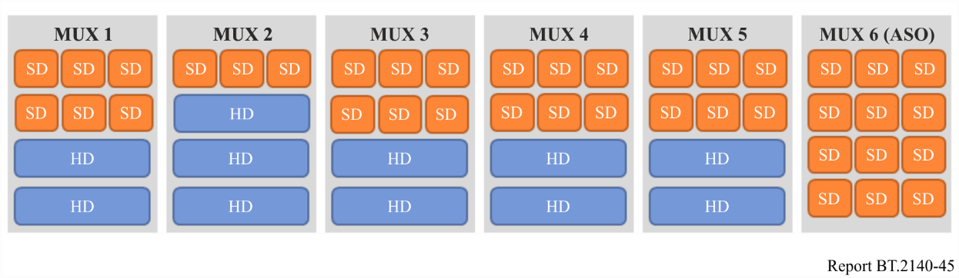
Figure 36
Current multiplex loading for first five multiplexes
(Channel category, channel name, and channel number)
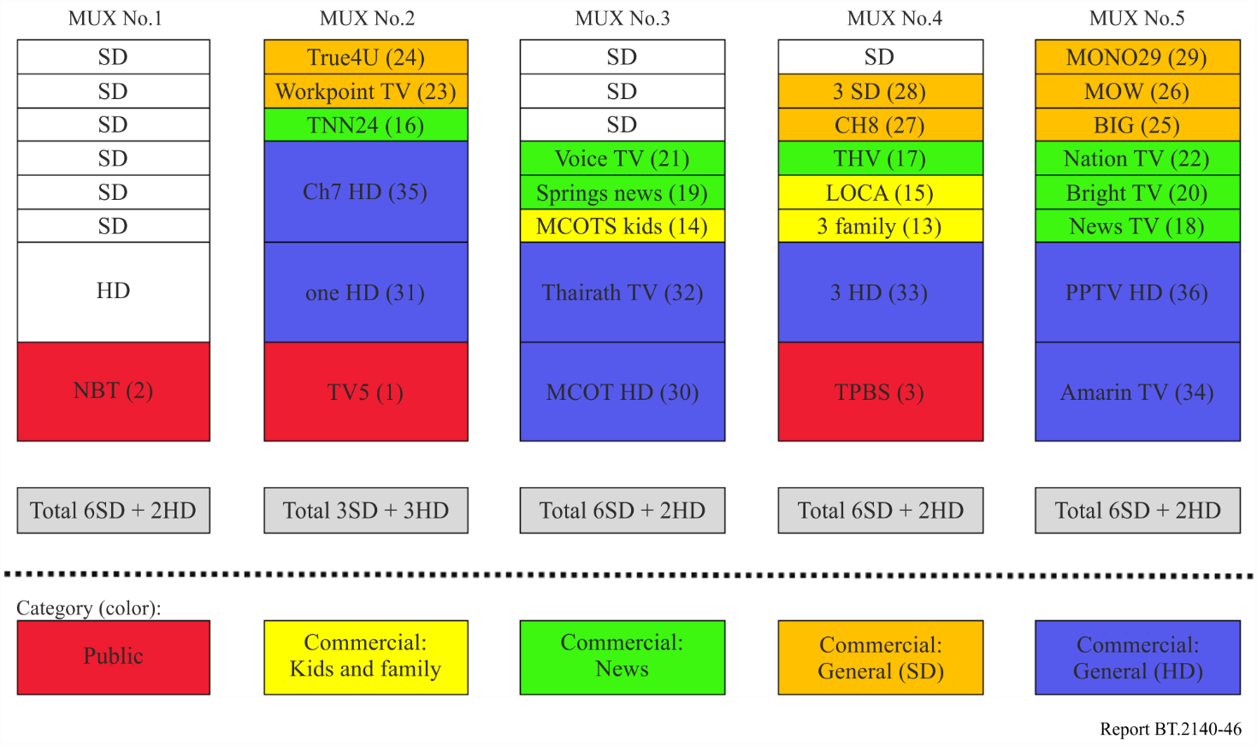

17.6 DVB-T2 parameters and capacity management
Thailand carried out numerous field tests in 2013 to determine and agree the DVB-T2 system parameters (what is basically a trade-off between signal robustness and available transport capacity) between the four network operators. A set of system parameters (i.e. the DVB-T2 system variant) were agreed, defined and stipulated by the NBTC.
TABLE 16
Parameters | Values
FFT size | 16k extended
Guard Interval | 19/128
Modulation | 64-QAM
Code rate | 3/5

The above Table provides the mandatory parameter set. This set reflects a balance between enough transport capacity (for delivering 48 HD/SD services) and also having enough signal robustness to provide indoor coverage (and hence keeping the number of DTTB sites down and consequently the network costs).
The key objective is to have a robust signal and able to provide sufficient capacity for 48 channels with 6 multiplexes per service area. Furthermore, this parameter set has been used during the frequency re-planning process.
In 2014-2015, the NBTC had established a working group to develop a technical guideline for digital terrestrial television. The working group comprised of the representatives from Broadcasting Technology and Engineering Bureau, together with the representatives from the network operators. This guideline covers the important technical issues and more details on the recommended parameter set and multiplex composition. However, the technical guideline is not mandatory and can be revised as appropriate.
In addition to the mandatory parameter set, the technical guideline recommends the network operators to use the recommended parameter set and to manage the multiplex capacity in accordance with the chosen multiplex option as follows:
TABLE 17
DVB-T2 Parameters:  16k ext., GI 19/128, PP2, 64-QAM, CR 3/5,  L1Post:QPSK) Time Interleave Depth = 81.71 ms | Total Bit Rate 21.930 Mbit/s
ITEMS | Option 1 | Option 2 | Option 3 | Option 4
Number of HD Channels | 0 | 1 | 2 | 3
Number of SD Channels | 12 | 9 | 6 | 3
TOTAL CHANNELS | 12 | 10 | 8 | 6
BIT RATE | (kbit/s)
Video Bit Rate (Pool Bit Rate with Statistical Multiplexing)  – SD Bit Rate (min-max) = 0.75-2.5 Mbit/s  – HD Bit Rate (min-max) = 2-7 Mbit/s | 18 400 | 18 700 | 19 000 | 19 000
Audio Bit Rate  (70 kbit/s per one stereo, 2 tracks per channel) | 1 680 | 1 400 | 1 120 | 840
Audio Description  (35 kbit/s per one stereo, 1 track per channel) | 420 | 350 | 280 | 210
Subtitles (100 kbit/s per channel) | 1 200 | 1 000 | 800 | 600
SI (EIT) or EPG | 300 | 300 | 300 | 300
SI (PMT)  (25.75 kbit/s per channel) | 309 | 257.5 | 206 | 154.5
SI (others) = 64 kbit/s | 64 | 64 | 64 | 64
TOTAL PAYLOAD | 22 373 | 22 071.5 | 21 770 | 21 168.5
Reserved for  SSU and others | −443* | −141.5* | 160 | 761.5
* The negative values imply that it is not feasible to provide all supplementary services (i.e. audio description, subtitle, SSU) at the same time.

17.7 Network planning
Network planning or frequency planning is a technical planning process whereby specified planning targets (like population coverage and protection of ATV services) have to be reached with minimal spectrum usage. This detailed planning process was carried out by Broadcasting Technology and Engineering Bureau (Office of the NBTC), with support of ITU. On the basis of the detailed planning results the four network operators could order their transmitter and antenna equipment.
NBTC’s key concern was to facilitate a coordinated network deployment whereby the viewer would receive a unified DTTB service offering. For this reason, and in agreement with the network operators, the NBTC decided to carry out the detailed frequency planning.

17.7.1 Planning parameters and targets
The DTTB networks are deployed in four phases over a period of four years, providing fixed (FX) rooftop coverage for 95% of the Thai households. A major part of the first two phases has been reached. More additional sites are needed for the last two phases to reach the planning target.
Thai PBS operates a nationwide network of UHF transmitters and the applied antenna systems were technically assessed to provide enough capacity to accommodate also the DTTB frequencies. Hence the planning of the 39 main sites had to be based on reusing these UHF transmitter sites.
The following planning targets were defined:
1) FX rooftop coverage for 95% of the Thai households;
2) Regional FX rooftop coverage in 39 regions for providing Community services;
3) Portable Indoor (PI) coverage in target municipalities; and
4) Protection of operational ATV services in the UHF band.
Planning targets 1 to 3 are defined in the regulatory framework, i.e. NBTC Notifications. It should be noted however that the PI target was not clearly defined at the beginning of the planning process. Thus, the first step in the planning was to design the DTTB networks for FX rooftop reception and then calculate what the resulting PI coverage would be. At the time that the FX network would be deployed the policy makers would have reached a conclusion on the PI target and additional PI sites could be planned at a later stage. This approach would also allow the regulator to monitor the uptake of the DTTB services and how well the service providers would do in earning advertising income on the DTTB platform.

17.7.2 Planning approach
The operational ATV networks had to be protected from DTTB interfering these networks (and hence the ATV viewers) and reversely the DTTB network should be made compatible with these ATV networks. Also the network topology should be kept, as much as possible, the same when transitioning from the simulcast period (in which ATV service had to be protected) to the all-digital situation (after television ASO in the UHF band).
The adopted planning approach to cater for this was to first plan for the all-digital situation. For the all-digital situation, the network would be optimized to reach the planning targets and to minimize spectrum usage. This planning scenario was labelled scenario C. For protecting ATV services either some interference on the ATV networks had to be accepted (i.e. acceptable interference) or temporarily frequency had to be applied. The number of frequency changes should be kept to a minimum as this would increase network costs as well as complicate the network deployment. This simulcast scenario was labelled scenario B. The launch scenario (i.e. a subset of the 39 main sites under scenario B) was labelled A.
An overview of this planning approach is provided in Fig. 37.
Figure 37
Applied planning approach
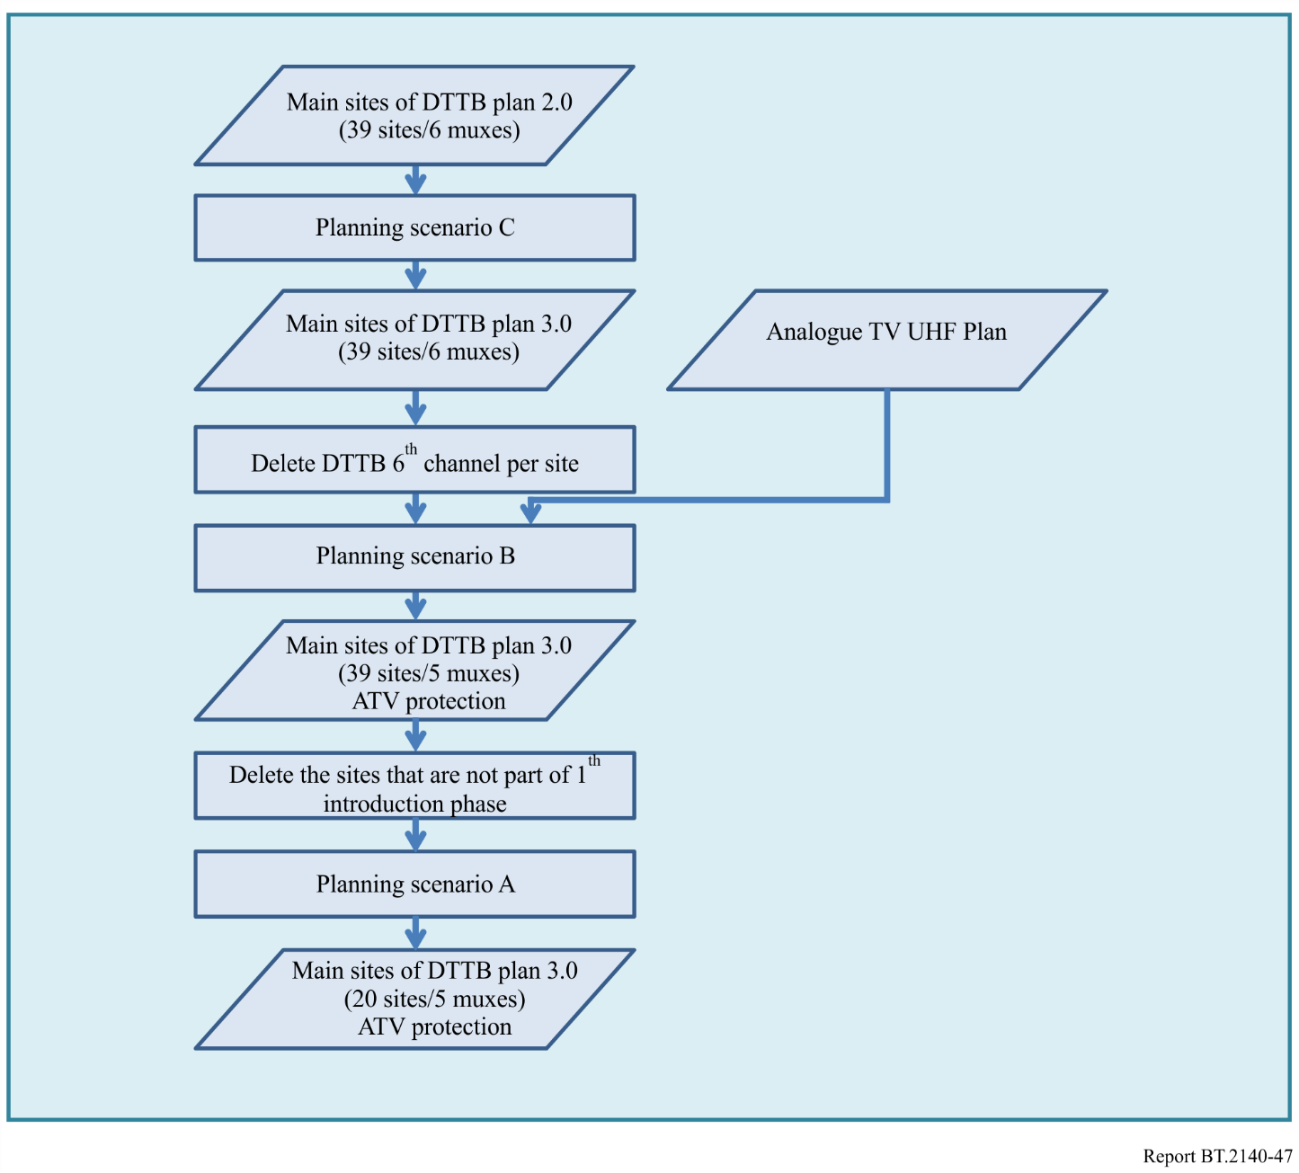

17.7.3 Overview of planning results
In planning the DTTB multiplexes, it was important to consider the difference between the multiplexes. They should be kept to a minimum as to have in each coverage location the same number of multiplexes (i.e. the number of DTTB services). In addition, the four network operators should have the same position in the market of offering distribution services to the broadcasters (i.e. the licensed service providers).
The frequency planning comprises of the two processes:
1) The frequency planning for the 39 main sites (completed in 2014).
2) The frequency planning for the additional sites (completed in 2015).
In the frequency planning process, NBTC and ITU had defined the DTTB sites into four types as follows:
TABLE 18
# | Type of sites | Number of sites | Status
M | Main sites | 39 | Agreed and approved in 2014
A1 | Additional existing sites, most ATV sites | 45 | Site location agreed by the network operators
A2 | Additional existing sites | 38 | Site location agreed by the network operators
A3 | Additional non-existing sites | 49 | Site location proposed by ITU and NBTC in order to reach 95% of the households

The coverage achieved by frequency planning is presented as percentage of the total number of households and as the aggregated coverage areas of the SFNs and sites in MFN mode.
The household coverage resulting from the different types of sites is shown below.
TABLE 19
Type of sites | Number of sites | Household coverage | Difference per type of site
M | 39 | 84.2% | 84.2%
M+A1 | 84 | 90.4% | 6.2%
M+A1+A2 | 122 | 92.8% | 2.4%
M+A1+A2+A3 | 171 | 95.0% | 2.2%

The 39 main sites cover more than 80% of the households. The 45 A1 sites increase the household coverage to about 90%. To reach 95.0% of the households 87 additional sites (38 A2 sites and 49 A3 sites) are needed.
Figure 38 shows the coverage area and the location of the sites.
Figure 38
Coverage area (fixed reception) and DTTB site location in Thailand
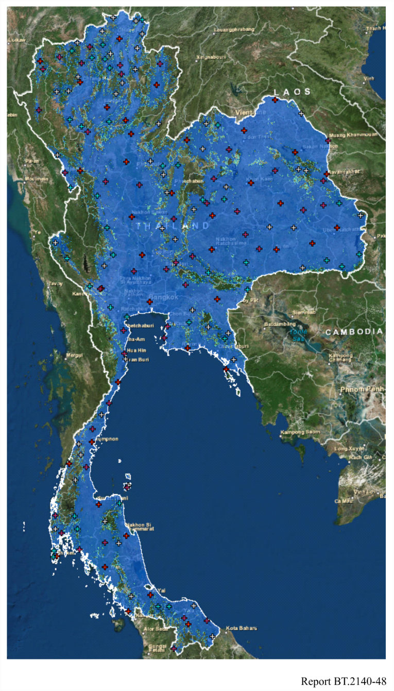
Source: Collaboration project between NBTC and ITU.

17.8 Other matters
Digital TV Logo and Mascot
The NBTC has launched a logo and a mascot named ‘Nong DooDee’ for Digital TV in Thailand. The logo and mascot are shown in Fig. 39.
Figure 39
Logo and mascot for digital TV in Thailand

Digital TV subsidy programme
As part of Thailand’s transition roadmap to digital terrestrial television broadcasting, the NBTC approved and announced the Digital TV Subsidy Programme, which is “cash coupon” distribution. The coupon value is 690 Baht which will be distributed to every household in Thailand. The coupon can be used as a discount when purchasing the digital terrestrial TV receiver i.e. Set-top box, TV with an integrated tuner (iDTV), or Hybrid Set-top box (support both DVB-T2 and DVB-S2). Figure 40 shows the cash coupon.
Figure 40
Digital TV subsidy coupon
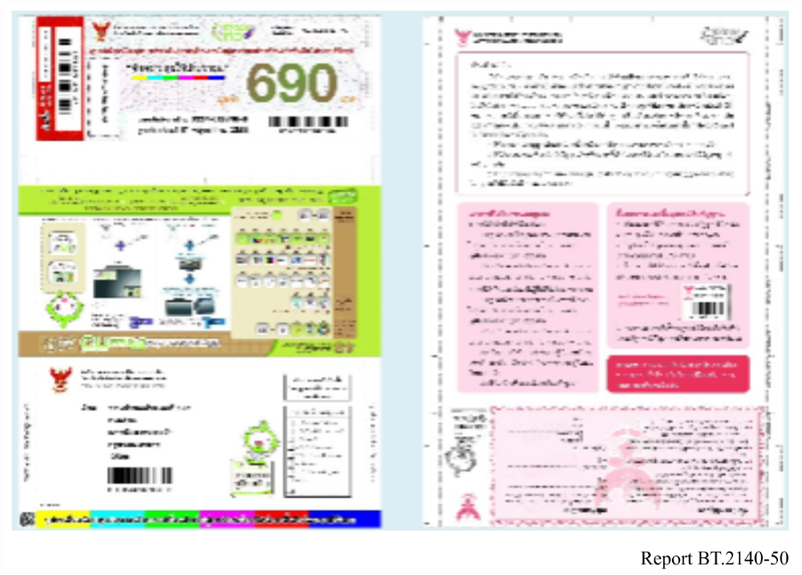
Coverage checking application
Based on the frequency planning and simulation results, the NBTC launched the digital terrestrial television coverage checking application. Figure 41 shows the graphical user interface of one of the web pages of NBTC’s coverage checker. The application was made available for PC, tablet, smartphone in three platforms: (1) Web browser, (2) Android OS, (3) iOS. It shows the common information found on any other typical coverage checker websites, including:
1) A text box to enter the position of the reception location.
2) The location of the nearest or best transmitter site (indicated on the map with a tower symbol).
3) An indication of the signal strength and quality (indicated with a signal strength symbol, typically found on mobile telephone hand-sets).
4) The number of multiplexes available on this transmitter site (and click through pages to the available services on each multiplex).
5) Indication of the antenna direction angle (azimuth angle) towards the nearest or best transmitter site (indicated on the map with a green line).
Figure 41
Graphical user interface of coverage checker
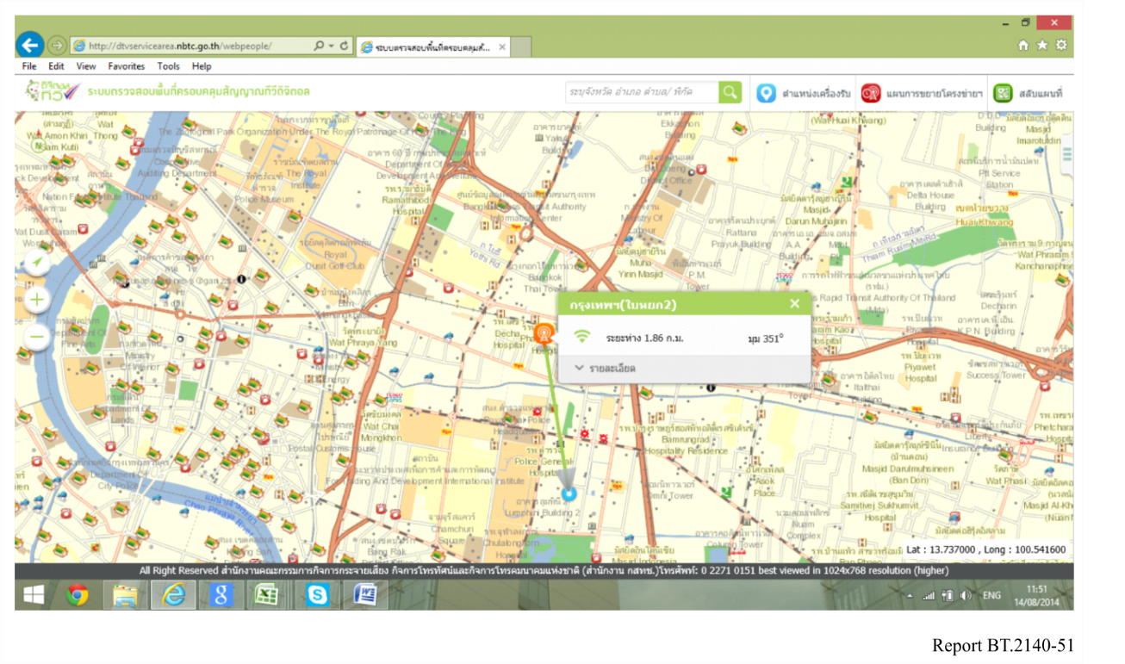
Modern smartphones have GPS, Wi-Fi and compass functionality and these technologies are used to locate the exact position of the smartphone. Location based services, like Google Maps, use this positioning information. Similarly, the coverage checker on the smartphone can be designed as a location-based service.
A smartphone at any reception location can automatically use the positioning information to let the coverage checker software know where the reception location is. In addition, using the compass functionality the smartphone can be directed to the best server transmission site. This is particularly helpful for people having difficulties in reading maps and figuring out the azimuth angle (for directing their receiving antenna). Figure 42 shows the smartphone user interface for this functionality.
Figure 42
Smartphone user interface
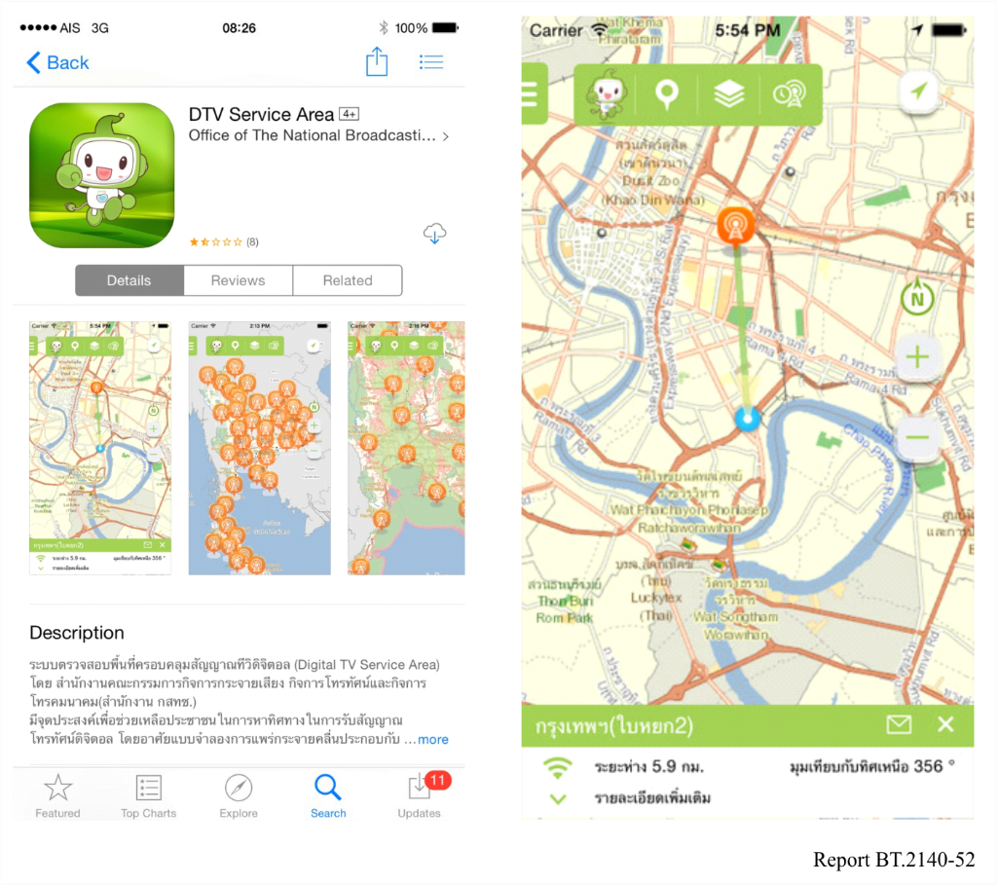

18 Trinidad and Tobago
Introduction
Trinidad and Tobago has been planning the transition to DTT since early 2010. Significant progress was made in 2022 with stakeholders of the free-to-air (FTA) television broadcasting industry, which led to the selection of a DTT standard, the finalization of the signal distribution approach and the creation of an implementation structure. Several other key milestones were also achieved, such as the publication of a DTT Framework and Implementation Plan, the issuance of an RFP for the selection of a shared signal distributor and the deployment of a trial station.
DTT Standard and Signal Distribution Approach
In January 2023, Trinidad and Tobago selected ATSC 3.0 as the national standard for DTT, becoming the fourth country to adopt ATSC 3.0, and the second country after Jamaica to transition from analogue (NTSC) to a second-generation digital standard. The selection of ATSC 3.0 will allow the approximately 100,000 households (26% of households) that view FTA television broadcasting, to enjoy the benefits of digital video services. This step is also expected to support the longevity of the FTA television broadcasting industry.
Following deliberations with the FTA television industry, it was agreed that a flexible approach would be adopted for signal distributions. Broadcasters would be allowed to deploy their own ATSC 3.0 transmission infrastructure or use the service of a signal distributor on a shared infrastructure.
DTT Implementation Schedule
DTT Implementation Structure
The transition to DTT will be achieved in collaboration with the key stakeholders. The implementation is led by a DTT Steering Committee, with oversight of three working groups: the public relations, technical, and finance working groups. The Steering Committee and working groups comprise representatives from the regulator and each of the existing FTA TV broadcasters and the Trinidad and Tobago Publishers and Broadcasting Association. The Figure below illustrates the implementation structure.
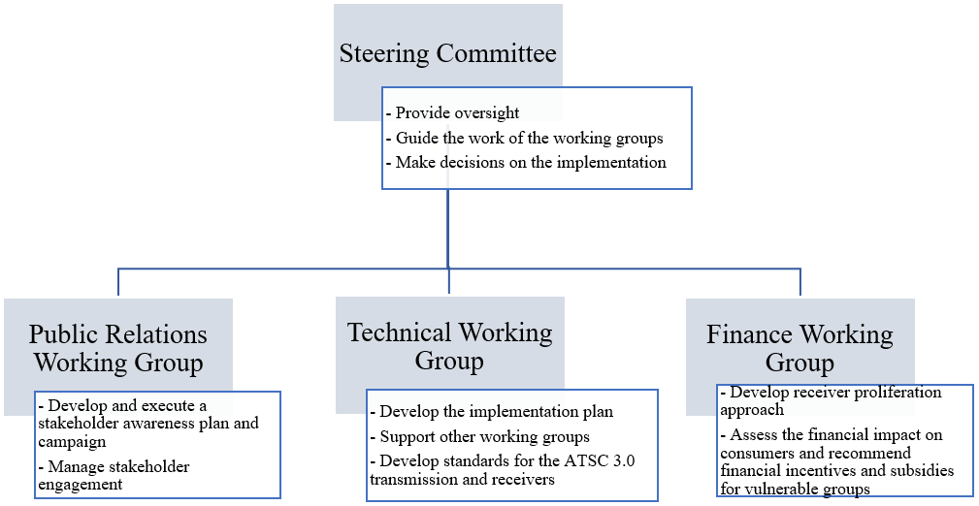
DTT Milestones
Since the selection of the DTT standard and the convening of the Steering Committee and working groups, the following key milestones have been achieved:
1) The DTT Framework has been approved and published after a round of public consultation.
2) The DTT Implementation Plan has been developed by the DTT Technical Working Group and published.
3) An RFP was issued on 3rd January 2024 for the award of the Authorizations of a shared signal distributor, with a deadline for bids of 10th May 2024.
4) Launch of engagement with distributors and retailers of television sets, with two ATSC 3.0 television models (Hisense U75H and Samsung S90) available in the market as of February 2024.
5) The specifications of a set top box (STB) minimal viable product were finalised in conjunction with the ATSC Caribbean Implementation Team 7 (IT-7), which consumers and retailers will use when procuring low-cost STBs.
6) Approval in July 2024 by the Authority of a recommendation for waiver of import duties on STBs and entry-level television models that support ATSC 3.0, and a recommendation to the Government of Trinidad and Tobago to offer subsidies to purchase ATSC 3.0 STBs for vulnerable households that consume free-to-air television.
7) December 2024, launch of the DTT trial/demo station at the studio of CCN TV6 in Port of Spain using a 200W transmitter on channel 24. The launch of the trial station allowed for the training of broadcasters and testing and verification of parameters and transmission specifications for Trinidad and Tobago.
Forthcoming milestones include:
1) Award of authorizations to a selected shared signal distributor, September 2025.
2) Digital switch-on, mid-2026.
3) Phased analogue-switch-off, December 2027.
See the following link for additional information regarding the transition: https://tatt.org.tt/stakeholder/broadcasting/digital-terrestrial-television-dtt/

19 United States of America
Background
The United States of America has moved forward aggressively with the implementation of DTV using the ATSC Digital Television (DTV) Standard, a powerful technology that is transforming the nature of broadcast television service. This new broadcast transmission standard provides broadcasters with many new capabilities to serve the public, such as HDTV and standard resolution pictures, multicasting, data delivery, interactive communication, robust reception modes, and other features. These capabilities provide broadcasters the technical flexibility and options to compete with other digital media such as cable and direct broadcast satellite services. The ATSC DTV standard was developed through a lengthy initial specification process that began in 1987 and its evolution is continuing today, due to the flexibility for extending the digital system to include new capabilities as technology continues to develop. Coincident with the development of the transmission technology, the U.S. Government, through actions by its Federal Communications Commission (FCC) and legislation by the U.S. Congress, has developed public policies under which digital television is being implemented.
The U.S. Government implemented broadcast DTV service as a replacement technology for the existing analogue National Television System Committee (NTSC) technology that has been used for transmission of broadcast television service in the United States of America since the late 1940s. Under this policy approach, all eligible existing television stations were provided a second channel to be used for DTV service during a transition period from the analogue to digital operation. This transition period, which began in 1998, was implemented to facilitate an orderly change to the digital television technology while taking account of consumer investments in analogue television sets. At the end of this transition period, TV stations ceased analogue transmissions so that all broadcast television service would be in the digital format. The FCC also recovered one of each TV station’s two channels at this time. Because operation with the ATSC standard is very spectrum efficient, it is possible for all the existing TV stations to operate in a much smaller amount of spectrum bandwidth, thereby allowing a portion of the existing TV channels 2-69 to be recovered for new uses. The U.S. Government plan was for all DTV stations to operate on channels 2-51 (the DTV core spectrum) after the transition ended and to recover channels 52-69 (698 MHz to 806 MHz) for new uses.
After very careful consideration and review in the FCC’s public rule making processes, the Commission afforded broadcasters great flexibility in the use of their DTT channels. Broadcasters were required at least to match the hours of operation of their existing analogue station. For example, if the analogue station operated 24 h/day, then the digital station would also be required to operate 24 h/day.
Broadcasters were given almost unlimited flexibility in the services that could be offered over their 6 MHz digital channel. They were required to offer one free-to-air video programme service with resolution equivalent to their existing analogue service. Beyond this, they could offer whatever other services they chose on the digital channel.
The FCC did not impose any requirement that broadcasters offer HDTV, and there is no legal requirement for U.S. broadcasters to offer HDTV. However, HDTV was the initial focal point of the U.S. transition to DTT broadcasting, and it has remained the centrepiece application throughout the U.S. deployment.
Pay services were explicitly permitted by the FCC, once a single, free, standard-definition programme had been provided. If broadcasters do use their DTT channel to offer services for which a subscription fee or charge is required in order to receive service, they are required to pay the U.S. government a spectrum use fee in the amount of 5% of gross revenues from any such service.
The basic transition plan followed in the U.S. was to require stations affiliated with the four largest TV networks in the 30 largest cities to implement DTT first, while allowing more time for stations in smaller cities to make the transition. In addition, public TV stations were given an extra year beyond the deadline that applied to commercial stations. The FCC’s initial plan applied to approximately 1 600 commercial and non-commercial (public) stations. Transition planning for low-power TV stations and for translators was deferred for several years, but has now been completed. Low power TV stations generally will be allowed to transition to DTV operation on their existing channels. In addition, if they so desire and a channel is available, low power stations may request a “companion channel” for DTV operation during the transition. The FCC further stated that it would establish a deadline at the end of the transition for low power stations that would be after the end of the transition for full-service stations.
Each station was given a new assignment for its DTT broadcast channel, along with an antenna height, antenna pattern and maximum radiated power level, in an effort to replicate the station’s analogue coverage area. Assignments for all 1,600 stations were made shortly after the FCC formally adopted the ATSC Standard and approximately 18 months before the launch of commercial DTT service.
At the request of the FCC, 28 stations in the ten largest cities volunteered to launch DTT service in November 1998, six months ahead of the deadline established by the FCC. Six months later (May 1999) all stations in the top 10 markets that were affiliated with the four largest broadcast networks were required to provide service, and in another six months (November 1999) this requirement was extended to the affiliates of the four largest networks in all of the 30 largest cities. All commercial broadcasters were required to be on the air by May 2002 and all non-commercial broadcasters by May 2003. Broadcasters who could not meet these deadlines were allowed to apply for a six-month extension and in some cases a second six-month extension under certain circumstances.
The U.S. Congress and the FCC were determined to conclude the transition to DTT broadcasting as rapidly as possible for a variety of reasons, most notably to recapture by means of an auction 108 MHz of invaluable nationwide spectrum to be made available once analogue TV transmissions cease. Broadcasters also wanted to make the conversion as rapidly as possible in order to eliminate the expense of operating two TV stations in parallel.
In early 2006, legislation was enacted by the U.S. Congress requiring all full-power broadcasters to terminate their analogue transmissions by February 17, 2009, and this date was then extended to June 12, 2009, although some low-power NTSC stations remained on the air until July 13, 2021.This legislation included provision of up to US $1.5 billion to subsidize the purchase by television viewers of digital-to-analogue set-top converters that could be used to view DTT signals on existing analogue television receivers.
Each television household would be permitted to apply for up to two $40 coupons that could be used to purchase such converters, with only one coupon allowed per converter. The price of these converters is typically about US $50 (without a coupon).
The FCC adopted regulations that phased in a requirement for inclusion of ATSC receiving capability starting first with the largest TV sets in 2004, and for all sets over 13 inches by July 2007. In November 2005 the FCC amended its rules to advance the date for the completion of the phase-in period to March 1, 2007, and to apply the requirement to all receivers regardless of screen size. Thus, every television set sold in the U.S. must now contain ATSC DTT reception and decoding capabilities. The U.S. Consumer Electronics Association predicted that 34 million ATSC DTT receivers per year would be sold in the U.S. alone by 2007, with a cumulative total of 152 million ATSC receivers by 2009. This is in addition to ATSC HDTV Set-top boxes and digital to analogue converters.
Although it was not required by the government, all DTV receivers available in the United States are capable of decoding all ATSC specified video formats. All-format decoding is essential to permit the introduction of HDTV – later, if not initially.
While there are no government requirements for DTT receiver performance, on a voluntary basis (and upon the recommendation of the FCC) the ATSC has adopted a recommended practice giving performance parameter guidelines for DTT receivers.
Implementation progress
The United States has now completed its DTV transition with many challenges that were faced and overcome in the period since 1997. In recent years the desire of the U.S. Government to recover TV channels 52-69 for new uses gave rise to greater emphasis on completing the transition as rapidly as possible. The FCC took a variety of steps to achieve a rapid conclusion to the transition and to ensure that the benefits and services of DTV broadcasting are available to all Americans.
DTT broadcasting moved ahead at a feverish pace. More than 1,700 DTV stations are on the air in 211 metropolitan areas, reaching 99.99% of U.S. television households with at least one digital signal. More than 90% of households have access to at least five digital signals, and more than 80% have access to at least eight. In the largest U.S. cities, as many as 23 digital stations are on the air.
HDTV programming is widely available, not only via DTT broadcasts, but over cable and satellite systems as well. Most network primetime and sports programming are now produced in HDTV. Local TV stations are beginning to offer their local news in HDTV.
Manufacturers throughout the world have responded to this demand by developing and marketing more than 750 different models of HDTV and other ATSC DTT consumer products, using a wide variety of new display technologies. Competition is frenzied, with prices continuing to fall rapidly and sales skyrocketing. Since late 1998 when the service was launched and by March 31, 2006, more than 30 million units of DTT consumer products worth more than $50 billion were sold in the U.S. alone.
In addition to HDTV, broadcasters in the United States are using DTT to provide innovative packages of new services. Some broadcasters are providing multiple simultaneous programs of SDTV. This is especially important for public broadcasters in achieving their goals to support public education, providing multiple education programs instead of just one programme at one time. Many commercial broadcasters are now offering a main programme in HDTV, plus another SDTV programme such as 24-hour news or weather. Some broadcasters are also pooling their excess capacity to offer basic pay-TV platforms in competition with cable and satellite systems.
Broadcasters are also beginning to offer various data services using the ATSC family of standards, including interactive information services.
With respect to reception by portable hand-held receivers or in fast-moving vehicles, the ATSC Standard was not originally designed to provide this type of reception. Rather, the goal was to deliver the largest possible payload data rate to a service area comparable to that of the preceding analogue transmissions, to ensure that broadcasters could reach the largest possible audience with high-quality HDTV images and associated surround sound.
Now that HDTV is firmly in hand, however, U.S. broadcasters are showing increasing interest in enhanced multimedia services, as well as receiving DTV signals in moving vehicles and by pedestrians with hand-held devices. To that end, broadcasters and consumer electronics companies encouraged the ATSC to develop a Next-Generation DTV standard, and in October 2017, ATSC published the system-level standard A/300 and a family of standards, forming the specification for a second-generation DTTB system, ATSC 3.0. US regulators authorized voluntary deployment of ATSC 3.0 in November 2017, with the rule that broadcasters must continue to simulcast ATSC 1.0 signals for at least 5 years. ATSC 3.0 is fully described in Recommendation ITU-R BT.1877 and Reports ITU-R BT.2295 and BT.2468.
Conclusion
The implementation of digital television service based on the ATSC family of standards moved ahead dramatically in the U.S. (HDTV is firmly entrenched, and replaced analogue colour television at a rapid pace. SDTV multicasting and information services are also important have expanded, as broadcasters learned to take full advantage of the rich possibilities of DTT broadcasting using the ATSC family of standards. A wide variety of new consumer products is available, at rapidly falling prices that make DTT receivers affordable for all socio-economic classes. Continuing improvements in ATSC receivers and further extensions and new additions to the ATSC family of standards are laying the groundwork for additional new services and applications in the future.
The U.S. completed its transition to digital television broadcasting, which permitted the recovery of extremely valuable spectrum supporting new wireless services.

20 Venezuela
Adoption of standards for digital sound and digital television in Venezuela.
Introduction
In order to assist in the selection of Digital Radio and Television systems in Venezuela, the National Commission of Telecommunications (CONATEL) has created a Digital Radio and Television project, supported by constant research. Its ultimate goal is advancing the tasks for the introduction of this service, and thus, making Digital Radio and Television systems in Venezuela a medium-term reality.
Digital Radio and Television project – Development stages
The development of the Digital Radio and Television project involves four (4) stages, as described below:
Stage 1: Feasibility study (technical, economic and legal aspects)
The tasks that comprised the feasibility study – still under development- are the following:
Review of national television and radio stations regarding location, frequency, service quality, technology and regulatory aspects.
Review of digital radio and television technology development, equipment suppliers, costs, comparison and selection of the most suitable technology.
Detailed study of the band frequencies that are to be assigned to analogue and digital radio and television stations, with the purpose of optimizing the use of spectrum.
Study of the required investments, economic impact and investment recuperation involved in the switching from analogical to digital radio and television systems.
Evaluation of foreign experiences regarding this matter, and possible variables for the acceptance of this technology in Venezuela.
Documental analysis of digital radio and television regulations.
Stage 2: Forum and operating tables
During this stage, contacts are made with companies in charge of the development of digital radio and television standards, as well as with equipment suppliers and regulation departments, with the cooperation of domestic radio and television operators.
Stage 3: Trials
Trials help to adopt suitable policies to benefit Venezuela’s technological smooth switch to digital radio and television. This stage will produce both experimental and regulating experiences:
Trials
Switch to the digital system.
Setting of regulation framework.
In general, domestic and foreign investments for the development of new technologies require a regulation framework, which will settle the rules for their evolution and put into practice.
The efficient performance of the above-mentioned functions will be a key aspect to plan legally sustained trials for digital radio and television systems, which can prove trustful and safe for both domestic and foreign investors. Besides, this option will facilitate the study of spectrum shares, not assigned to digital radio and television.
Other important legal aspects relate to the obligation to mention the specific spectrum share to be used by the incumbent. This share can only be used and exploited within the specific cover indicated on a special permission.
Besides, getting a special permission will not grant expectations of rights to incumbents or preferential rights whatsoever in getting of a grant for the use and exploitation of the spectrum share necessary for developing all the activities foreseen by the regulations. Once a special permission has expired, its incumbent will not be able to continue using the spectrum shares assigned, unless they update their permission.
Incumbents with special permission will not obtain any counter-payment from users because of service rendering during trials. Once the trial is over, they should present a detailed report about the activities carried out and the results obtained. At any given moment, CONATEL can inspect or supervise the trials.
For the special permission, the interested incumbents will have to indicate the accurate date for the beginning of trials and the length the trials (up to three months).
If there are justifiable reasons, the beginning of trials can be adjourned unless decided otherwise by CONATEL. The trials can only be adjourned once.
During the deliberation period, CONATEL can require any concerning information from the incumbents, in order to evaluate the application. In this case, CONATEL will notify the titular that they have 10 days to submit their requirements. From the date of the application, CONATEL can interrupt the deliberation period for ten days. Due to the complexity of the matter, this period can be extended up to fifteen continuous days.
Stage 4: Standards adoption
This stage is the milestone for the digital radio and television adoption process. The fitting of the legislation in force to the characteristics of the chosen system will provide strength and trust to the process of putting digital radio and television services into practice in Venezuela.
Specific channel planning is completed and ISDB-T standard was chosen.

21 OCDE
The must part of the OCDE document published in June 2003 with the following title: “The Implications of convergence for regulation of electronic communications” from the Committee for Information, Computer and Communications Policy, is dedicated to the place of broadcasting in electronic communications (Doc. DSTI/ICCP/TISP (2003)5).

22 European Union
Information regarding Digital video broadcasting spectrum issue in Europe (Finland, France, Spain, Sweden, and United Kingdom) can be found in the ITU-D Report regarding Question 11-1/2.

23 Rwanda
In Rwanda, sound and television broadcasting is an activity of great public interest, and therefore, it is necessary that the broadcasting service is provided in an efficient and effective manner in order to benefit the people of Rwanda. In this respect, following the conclusion of the Regional Radiocommunication Conference 2006 (RRC-06), the government of Rwanda established a digital broadcasting steering committee.
The purpose of the steering committee was to develop a national strategy for the switchover of broadcasting systems from analogue to digital broadcasting.

23.1 Implementation roadmap and strategy
In collaboration with the East African Community’s Broadcasting Technical Task Force (BTTF), which is composed of Technical Staff from ICT regulators of East African Community (EAC) member states (Rwanda, Uganda, Tanzania, Burundi and Kenya) dealing with broadcasting issues, the Rwanda steering committee made various recommendations including the need for the government of Rwanda to produce a roadmap of transition from analogue to digital TV Broadcasting within a specified timetable, develop an appropriate switchover strategy and monitor its implementation. The steering committee recommended the simulcast period to end on 31 December 2013 and the switch-off of analogue broadcasting to be effective from 1st January 2014.
The BTTF focuses on developing the Set Top Box (STB) standards, signal distributor licensing framework and monitoring the implementation of the analogue to digital migration roadmap.
The Rwanda Utilities Regulatory Agency (RURA) decided to authorize two signal distributors including the public broadcaster Rwanda Broadcasting Agency; the second signal distributor will be selected through public tender process.
A large public awareness campaign will be launched in course of March 2013. The purpose of that campaign will be to sensitize the general public to migrate from analogue to digital TV broadcasting, to encourage rural population to have at least one TV set per family. Meanwhile the government decided to distribute community TVs and their STBs to a village level within the whole country.
To facilitate commercialization and acquisition of STBs the related minimum technical requirements have already been developed and published on RURA website.
The public Broadcaster Rwanda Broadcasting Agency (RBA) has already installed the necessary DVB-T infrastructure covering almost the same area as the analogue TV.
The country’s channel planning for Digital Terrestrial Television Broadcasting (DTTB) is based on DVB-T2 and MPEG-4 AVC. Sound broadcasting using T-DAB technology is envisaged in Band III (174-230 MHz) while digital TV was planned in Bands IV/V (470-806 MHz). However, following the decision of WRC-2012, re-planning is now being carried out covering only channels 21-48 (470‑694 MHz).
ITU recommended at least four DTT channels at each transmitter site but according to GE06, it was not possible to find those channels at all the selected fourteen main transmitter sites.
A series of DTT frequency coordination meetings organized by EACO (East African Communication Organization) came up with the solution for insufficient frequencies that the government of Rwanda was facing. Now according to the new frequency planning, the minimum four frequencies can be found at all the main fourteen transmitter sites.

23.2 Transition progress
Different actions have been undertaken to ensure the whole country goes digital in harmony and meet the deadline of 30th June 2015 for analogue switch-off:
– signal distributor licensing framework was put in place;
– digital TV infrastructure was rolled out in the whole country;
– DVB-T2 MPEG4 Set Top Box minimum technical requirements were produced and published in order to ensure interoperability;
– DVB-T channel planning was made; now different channels are allocated to the transmitting sites and are ready for assignment to the signal distributors;
– the awareness campaign and the simulcast period are planned to be launched soon;
– the second broadcast signal distribution licence will be awarded soon.
During the simulcast period expected to go until end of 2013, existing analogue channels shall be accommodated on the signal distributor’s multiplex platform for free to air.

23.3 Challenges
– availability of compatible digital STBs at affordable prices to the general public;
– generating appropriate content that is relevant to the Rwandan public to populate the envisaged immense capacity afforded on digital platform;
– lack of electricity in some rural areas.

Attachments: 2

Attachment 1
to Part 2
Minimum Technical Specifications of Set Top Box (STB)
for Digital Terrestrial Television (DTT) in Rwanda
In preparation for migration from analogue to digital television, Rwanda Utilities Regulatory Agency (RURA) like other sister regulators in East African Community (EAC) has adopted DVB-T2 as transmission standards for digital terrestrial television (DTT). Therefore, any rollout of digital broadcasting infrastructure in Rwanda after 2012 shall be in DVB-T2 Standard. Existing broadcasting infrastructure in DVB-T platform are required to be upgraded into DVB-T2.
While awaiting this upgrade, DVB-T and DVB-T2 platforms will run concurrently in Rwanda especially during the entire duration of the simulcast period (migration period).
It is well understood that DVB-T compliant set top box is limited to only receiving DVB-T digital signal and is NOT capable of correctly receiving and displaying digital TV signals transmitted on a DVB-T2 digital platform.
Consequently, in order to receive TV programmes, consumers and vendors of equipment are requested to acquire DVB-T2/MPEG-4 compliant Set Top Boxes or integrated digital TVs (iDTVs) fitted with a DVB-T2 tuner that are capable of receiving and correctly displaying digital TV signals transmitted on both DVB-T and DVB-T2 digital platforms.
In addition to that, STB suppliers are further advised to obtain type approval to import set top boxes from Rwanda Utilities Regulatory Agency as required by the law governing telecommunication.
The minimum DVB-T2/MPEG-4 digital set top box specifications for the Rwandan market are summarized as follows:
TABLE 20
Basic features | Full function standard IR remote control
Basic features | Minimum channels receivable and storable | 200
Basic features | Warranty | 1 year
Basic features | User manual | Use friendly documentation which should be in English or French
System resources | Flash memory | >8 MB
System resources | RAM | >128 MB
RF tuner & DVB-T2 channel | Frequency | – UHF (470-862 MHz)  – Optional, VHF (174-230 MHz)
RF tuner & DVB-T2 channel | Input signal level | 36-85 dBµV
RF tuner & DVB-T2 channel | FEC coding | LDPC Code + BCH Code,  Code rates: 1/2, 3/5, 2/3, 3/4, 4/5, 5/6
RF tuner & DVB-T2 channel | Transmission mode (Fast Fourier Transform, FFT Size) | 1K, 2K, 4K, 8K, 16K, 32K
RF tuner & DVB-T2 channel | C/N range (rice channel) | 3 dB (QPSK 1/2) to 24 dB  (256QAM 5/6)
RF tuner & DVB-T2 channel | Pilot pattern | PP1 to PP8
TABLE 20 (continued)
 | Guard intervals | 1/128, 1/32, 1/16, 19/256,  1/8, 19/128, 1/4
 | Channel raster | 7 MHz (VHF), 8 MHz (UHF)
 | Signal bandwidth | 7.61 MHz (Normal mode), 6.80,  7.77 MHz (Extended mode)  1.54 (optional)  6.66, 1.57 (optional)
 | Service specific robustness | Physical Layer Pipes (PLP)
 | Interleaving | Bit + Cell +Time + Frequency
 | Diversity | SISI, MISO (SIMO, MIMI if diversity receiver)
 | Rotated constellations | Significant robustness gain in channels with severe degradations (multipath, SFN operation, narrow band interference, etc.)
 | Mode of extensions | Future Extension Frame (FEF)
 | Max bit rates (8 MHz) | 50.3 Mbit/s (32Ke, 256QAM, CR=5/6, GI=1/128, PP7)
 | Used bit rates (8 MHz) | Portable SFN: 25.0 Mbit/s, Fixed  SFN: 37.0 Mbit/s,  Fixed MFN: 40.2 Mbit/s
 | C/(N + I) performance in SFNs | EN 300744 compliant
 | GE06 compatible | Signal is under the mask of DVB-T (power level measured in a 4 kHz bandwidth)
Maximum frequency offset | The STB shall be able to receive signals with an offset of up to 125 kHz from the nominal centre frequency
MPEG transmission stream and video and audio decoding | Transmission stream | MPEG-4 ISO/IEC 14496
 | Video decoding | MPEG 4 AVC (ITU-T H.264), (ISO/IEC 14496-10)
 | Aspect ratio (image rate) | 4:3, 16:9
 | Frame frequency | 25 Hz (PAL)
 | Video resolution | 720×576 (PAL)-standard definition, HD 1080,1080i
 | Audio decoding | MPEG/MusiCam Layer  I & II/HE AAC

TABLE 20 (continued)
 | Audio mode | Single track/dual track/stereo
 | Audio sampling rate | 32 kHz, 44.1 kHz, 48 kHz, 96 kHz (optional)
 | Quality reception thresholds | All STBs should have an on-screen visual signal level indicator which would aid in directing the antenna and troubleshooting reception problems
Scanning function (5 min max) | – The STB should include a frequency scanning function to detect the availability of DVB-T signals.  – It should also automatically list the content of the terrestrial bouquet by reading the PSI/SI streams and  – Be capable of programme memory in case of cut off
Software | – EPG: current and next programme information. 24×7 days schedule  – Capable of the Identity control, watch rating and parental lock  – Auto/manual tuning  – 24-hour clock (optional)  – OTA: STB software’s, EPG, CA features must be upgradable over the air (USB Upgrade-optional)  – Support receive mail  – Provides the instant and personalized message prompt  – Display and withdrawal of subtitles  – Support multi-language info
Software for interpretation and handling of the active service information | PSI/SI (programme specific information/service information) |  | NIT, CAT, PAT, PMT, SDT, EIT, TDT, TOT  EN 300 468 and ETSI TR 101 211 compliant
Additional hardware | PVR (optional)
Teletext & teletext subtitle | – It is able to display teletext using the OSD and/or by the insertion of the teletext data in the VBI of the analogue CVBS video output.  – It is able to display teletext subtitling, meeting the requirements for level 1.5 in ETS 300 706, “Enhanced Teletext Specification”.
Interfaces | – RF input connector: IEC 169-2 female, input impedance 75 ohms  – One RCA (CINCH) female connector for video output and two RCA (CINCH) female connectors for stereo sound output  – RF by pass (loop) IEC 169-2 male  – RF input via a PAL-B/G modulator  – SCART interface (optional)  – HDMI interface  – USB port (optional)  – Data port 1 (RS232, 9 pin D – subtype (optional))  – Should include at least one RF cable to connect the unit with its associated analogue television receiver  – For pay TV, at least one CI (Common Interface) slot to allow any type of conditional access module to be plugged into the set top box (EN 50221-1997 V1.2/97)
TABLE 20 (end)
Mechanical interfaces (LED indicators) | Green | Normal operation
 | Flashing green | System boot in progress
 | Flashing red | Software download in progress
 | Controls to be provided on the front panel | Menu, P+, P–, V+, V–
Physical attributes | Power supply | AC 230 ± 10%, 50 Hz
Environmental attributes | Power consumption | Max 15 W
 | Operating temperature | 0~45°C
 | Operating humidity | Up to 90%
 | Over and under voltage protection
 | Overheating protection
Reliability | MTBF  (Mean time between failures) | 80,000 Hrs
 | Standby functionality (sleep mode)
Service acquisition | Typically 500 ms, and a maximum of 750 ms | When required service is carried in the same transport stream as the current service
 | Typically 750 ms and a maximum of 1 000 ms | When the required service is in a different transport stream.

Attachment 2
to Part 2
Digital frequency planning of Rwanda

RWA
Broadcasting Regions | Site | Available channels | RBA (1st Signal Distributor) | 2nd Signal Distributor
KIGALI | Jari | 28 43 47 | 28 43 | 47 29
KIGALI | Rebero | 22 23 26 27 29 | 22 26 | 23 27
KIGALI | Kabuye | 28 38 | channel 38 to be used at Kabuye if requested for
WEST-NORTH | Rubavu | 30 33 41 43 | 30 33 | 41 43
WEST-NORTH | Rubona | 22 25 27 28 | 22 28 | 25 27
WEST-NORTH | Kanama | 39 45 | channel 39 to be used at Kanama if requested for
WEST-CENTER | Karongi | 31 34 36 37 | 34 36 | 31 37
WEST-CENTER | Kibisabo | 42 | to be removed | to be removed
WEST-SOUTH | Gihundwe | 25 26 30 41 | 26 30 | 25 41
WEST-SOUTH | Kinanira | 21 24 35 47 | 24 35 | 21 47
WEST-SOUTH | Nyabitimbo | 40 43 46 | 40 43 | 21 46
Digital frequency planning of Rwanda (end)
RWA
EAST | Gitwe | 21 30 36 | 30 45 | 21 36
EAST | Musaza | 39 42 45 | 30 39 | 36 42
NORTH-WEST | Karisimbi | 24 45
NORTH-WEST | Mugogo | 32 46 | 24 45 | 32 46
NORTH-CENTER | Rushaki | 39 48 42 | 39 48 | 42 44
NORTH-CENTER | Byumba | 25 33 36 44 | 25 33 | 36 44
NORTH-CENTER | Bwesige | 45
NORTH-EAST | Nyarupfubire | 31 34 37 41 | 34 41 | 31 37
SOUTH | Huye | 21 38 40 48 | 40 48 | 21 38
SOUTH | Mushubati | 35 | Free | Free
______________

Article 5.1.3 of GE06 Agreement: “5.1.3 A digital entry in the Plan may also be notified with characteristics different from those appearing in the Plan, for transmissions in the broadcasting service or in other primary terrestrial services operating in conformity with the Radio Regulations, provided that the peak power density in any 4 kHz of the above-mentioned notified assignments shall not exceed the spectral power density in the same 4 kHz of the digital entry in the Plan. Such use shall not claim more protection than that afforded to the above-mentioned digital entry.”
As the number of services and the density of transmitter sites has increased, planning of later services, especially repeater services, has more typically been on an interference limited basis.
In a limited number of cases a parent station may feed several SFNs that may each operate on a different channel.
Refer to the ACMA website, www.acma.gov.au.
Australian planning is based on provision of a service at 80% of locations within 200 m by 200 m areas for rural environments. A 4.5 dB correction factor is applied to convert from a 50% of locations to an 80% locations field strength value.
A 0.5 dB lower noise power applies due to the receiver bandwidth being 6.7 rather than 7.6 MHz.
The minimum field strength calculations also include a 1 dB “interference margin” for the support of co-channel frequency reuse planning.
The original 1999 values were adopted following protection ratio measurements made in 1998 using the “traditional” wanted-to-unwanted protection ratio measurement approach, rather than the C/(I + N) approach that is now included in Recommendation ITU-R BT.1368.
In licence area overlap regions, nine services per site would be planned at existing transmission sites.
Decree No. 4901, of November 2003: http://www.planalto.gov.br/ccivil_03/decreto/2003/D4901compilado.htm.
Decree No. 5820, of June 2006: http://www.planalto.gov.br/ccivil_03/_Ato2004-2006/2006/Decreto/D5820.htm.
In 2009, the UHF band from channels 60 to 69 was also considered for public broadcasting in Brazil.
Portaria No. 14 of February 6th, 2013, available at http://pesquisa.in.gov.br/imprensa/jsp/visualiza/index.jsp?jornal=1&pagina=46&data=07/02/2013.
Decree No. 8,061, available at http://www.planalto.gov.br/ccivil_03/_Ato2011-2014/2013/Decreto/D8061.htm#art1.
Interministerial Ordinance No. 224, October 3rd, 2012, available at http://www.suframa.gov.br/download/legislacao/outros_inst_legais/legi_fed_pi_ppb_224_3out12.pdf.
Advanced Television System Committee (ATSC), Recommended Practice – A/111, “Design of Synchronized Multiple Transmitter Networks”.
Advanced Television System Committee (ATSC), Recommended Practice – A/111, “Design of Synchronized Multiple Transmitter Networks”.
Salehian, K., Guillet, M., Caron, B. and Kennedy, A: On-channel repeater for digital television broadcasting service. IEEE Trans. Broadcast., Vol. 48, 2, p. 97-102.
Salehian, K., Caron, B. and Guillet, M. Using on-channel repeater to improve reception in DTV broadcasting service area. IEEE Trans. Broadcast., Vol. 49, 3, p. 309-313.
The four simulcast programme channels in the MFN multiplex were originally encoded in standard definition format using MPEG-2. Such video coding was subsequently upgraded to H.264 in October 2012. With the adoption of a more efficient H.264 coding in the MFN multiplex, one broadcaster upgraded its two simulcast channels into high-definition format.
The latest version of the specification can be downloaded from http://www.ofca.gov.hk/.
BML is an XML-based data content format as described in Recommendation ITU-R BT.1699, originally developed by the ARIB.
Analogue TV broadcasting will continue until the end of March 2012 in Iwate, Miyagi, and Fukushima prefectures, which were severely damaged by the 2011 Tōhoku earthquake and tsunami.
When comparing auction proceeds between countries the per-MHz price is often corrected for population count.
For carrying the 24 DTTB services it is assessed that 32 frequencies (each 8 MHz wide) will be needed. It should be noted that this number can down when more efficient encoding will be applied over time.

