Report ITU-R BS.2466-0
(07/2019)
Guidelines for the use of the
ITU-R ADM Renderer

BS Series
Broadcasting service (sound)

Foreword
The role of the Radiocommunication Sector is to ensure the rational, equitable, efficient and economical use of the radio-frequency spectrum by all radiocommunication services, including satellite services, and carry out studies without limit of frequency range on the basis of which Recommendations are adopted.
The regulatory and policy functions of the Radiocommunication Sector are performed by World and Regional Radiocommunication Conferences and Radiocommunication Assemblies supported by Study Groups.

Policy on Intellectual Property Right (IPR)
ITU-R policy on IPR is described in the Common Patent Policy for ITU-T/ITU-R/ISO/IEC referenced in Resolution ITU-R 1. Forms to be used for the submission of patent statements and licensing declarations by patent holders are available from http://www.itu.int/ITU-R/go/patents/en where the Guidelines for Implementation of the Common Patent Policy for ITU-T/ITU-R/ISO/IEC and the ITU-R patent information database can also be found.

Series of ITU-R Reports
(Also available online at http://www.itu.int/publ/R-REP/en)
Series | Title
BO | Satellite delivery
BR | Recording for production, archival and play-out; film for television
BS | Broadcasting service (sound)
BT | Broadcasting service (television)
F | Fixed service
M | Mobile, radiodetermination, amateur and related satellite services
P | Radiowave propagation
RA | Radio astronomy
RS | Remote sensing systems
S | Fixed-satellite service
SA | Space applications and meteorology
SF | Frequency sharing and coordination between fixed-satellite and fixed service systems
SM | Spectrum management

Note: This ITU-R Report was approved in English by the Study Group under the procedure detailed in Resolution ITU-R 1.

Electronic Publication
Geneva, 2019
© ITU 2019
All rights reserved. No part of this publication may be reproduced, by any means whatsoever, without written permission of ITU.

REPORT ITU-R BS.2466-0
Guidelines for the use of the ITU-R ADM Renderer
(2019)

1 Overview of ITU-R ADM Renderer

1.1 Introduction
Advanced Sound Systems (AdvSS) technology is a new challenge for the broadcast and broadband industries. Users are strongly encouraged to share their experiences with the ITU-R to help create the most valuable documentation for AdvSS. In particular the experiences of content creators and system developer are very much welcomed.
This Report is intended to provide guidelines for the use of the ITU-R ADM Renderer, which is specified in Recommendation ITU-R BS.2127-0, which is a complementary component of the ITU-R Advanced Sound System, specified in Recommendation ITU-R BS.2051-2 and ADM metadata specified in Recommendation ITU-R BS.2076-1.
The ADM Renderer can be seen as part of the evolution, or an extension, of mixers and down-mixers that are often used today, where the principal of allowing creative control of the listening experience is continued or extended into the environment of Advanced Sound Systems. The ADM Renderer is also a bridge between today’s audio production and the new world of AdvSS.
It is expected that future sound systems used for audio-visual media will include the ITU-R’s AdvSS. This technology is intended to provide an improved sound experience that can be more ‘immersive’ for users, and/or provide additional audio signals to give users a more personalised experience. AdvSS require new signal formats to be used, and they may require a greater number of listening-room loudspeaker positions or specialised sound bars (or possibly if used, binaural headphones) than is needed for existing stereo and 3/2 multichannel sound systems specified in Recommendation ITU-R BS.775. The ADM Renderer and its functionality specified in Recommendation ITU-R BS.2127 is based upon known methods that are currently being deployed in production/delivery and reproduction systems for AdvSS/NGA today.
NOTE – In this Report the term “ADM Renderer” is used to mean the ITU-R ADM Renderer.

1.2 Audio elements and their uses
The ADM Renderer in this case generates the required loudspeaker signals from “audio elements” that are input to it via a delivery platform. These “audio elements” are combinations of a particular sound and the required signalling (‘metadata’) that define how the sound should be reproduced by the receiver. There are three types of audio elements.
1 Channel-based
2 Object-based
3 Scene-based.
Each of these has unique attributes:
– Channel-based – the format essentially used for today’s audio: mono, stereo, and multichannel sound systems, where signals correspond to positions of reproduction loudspeakers, and can be fed directly to them.
– Object-based – where sound ‘objects’ are recorded, and the mixing and panning information is recorded with them, but not executed until the sound is reproduced.
– Scene-based – where sound is recorded in standard directional patterns that can be transformed to any desired reproduction geometry. This is also known in its basic form as ‘Ambisonics’ recording, though a more developed form, Higher Order Ambisonics (HOA), is also used.
The ADM Renderer converts the audio elements to audio signals to feed for loudspeaker configurations or headphones. It may need to address any or all three types of audio elements. The ADM Renderer can be implemented in hardware or software, noting that there may be an impact on the performance and functionality in each case.
The ADM Renderer may avoid the need for multiple version masters for different encoding/transmission systems as well as playback systems. It has the potential to save time, cost, and/or enhance the audience experience, depending on the system configuration.
As content creators and sound engineers adopt advanced sound system technologies, renderers will become a necessary utility in production, post production and for delivery to broadcasters. Versions of the renderer will also be part of domestic receiving equipment.
The basic principles of AdvSS are outlined in Recommendation ITU-R BS 2051-2. The ADM Renderer is specified in Recommendation ITU-R BS.2127-0, which provides a reference interpretation of the ADM metadata specified in Recommendation ITU-R BS.2076-1.

1.3 Renderer implementations
As noted in § 1.2, a renderer could be implemented either as dedicated hardware or as software. The cost, size and wiring would therefore be similar to other audio processing equipment, depending on the design and capabilities of the unit.
Depending on the application, renderers may be simple to use, or they may require more sophisticated control and configuration. Renderers that are very simple to use, or transparent to the user, would be desirable in a broadcast or broadband receiver. Renderers with more sophisticated control and configuration options may be needed to meet a sound engineer’s production requirements, and to arrange the format required to be delivered to the broadcast or broadband system.
The data rate of the audio element metadata is usually a small fraction of the total audio data rate, but an overhead needs to be allowed with streaming or broadcast to accommodate it.
Renderers are necessary in media receivers for consumer use and will be included in appropriate future home entertainment systems. To encourage suppliers to offer equipment with the best listening experience in home entertainment systems, it can be valuable that there is competition for quality/cost in the home systems that different companies provide. Thus the specifications and flexibility of the renderer used in the design of the domestic receiver should be a matter for the manufacturers themselves, provided they can interpret appropriately the audio elements.
Programme makers and those who monitor and check delivery however do need a renderer that can be made available by multiple manufacturers. This will enable uniformity in the delivery of the rendered format, and the experience the user will have with their delivered media content, given that it is delivered in the correct format.
Programme making can be needed in ‘real-time’ or following post production in ‘non-real-time’. Renderers will be needed to cope with both of these circumstances. Currently, a software implementation of the ADM Renderer is available (link to the software given in Recommendation ITU-R BS.2127) which can be used for non-real-time production.
The ADM Renderer specified in Recommendation ITU-R BS.2127-0 can thus be used for programme production, programme monitoring, and where needed for subjective evaluations (given other elements of the methodology are standardised). It may also serve as a guide for renderers in domestic equipment.

1.4 The options and usage for the ADM Renderer
The object sound signals delivered for AdvSS are described using positional metadata which uses either spherical coordinates to indicate the sound’s relative direction from the listener or Cartesian coordinates to indicate the sound’s location in the room. The ADM Renderer can decode and interpret both types of coordinates, and if needed, can convert between them, although such conversion cannot by nature be exact.
This conversion is not invertible, so conversion back and forth should be avoided. The user of the ADM Renderer can make a choice based on how the content was produced, and the likely media user’s environment. The ADM Renderer specification also includes information on an alternative Point Source Panner should it be required.
Having a single standardised production renderer will bring greater consistency to the process of AdvSS content production and delivery to the end user. It should increase production levels, and thus eventually result in lower costs and more widely used AdvSS. The alternative would be for programme makers to buy proprietary equipment which, although satisfactory, may restrict the programme maker into using that kind of equipment.
Using the ADM Renderer, the content provider will know that, if they buy end user equipment that conforms to the ITU-R Recommendation, they will be able to cope with all eventualities for coordinate systems and will be able to experience what the listener will experience with his/her programme. Content makers will be ‘future proofing’ their investment in production equipment, which will, following wider use and volume production, become less expensive.
The interfaces and electrical connections should be straightforward as the ‘input’ is essentially the baseband decoded received signal, audio and metadata. The audio ‘output’ would be wired or wireless connections to the loudspeakers.
The user will have to select the option of Coordinate system, and if available in their equipment, the Point Source Panner. The user will need to input the details of the loudspeaker arrangement in use unless this is done automatically by the equipment. How much of the configuration is automated will depend on how the equipment is designed and implemented, but in principle operation should be relatively simple. Operator training and familiarisation equipment manuals will be needed.
The media production team will need training and practice in content production using AdvSS. It will open up new and exciting media experiences for sound producers, viewers and listeners, and challenge the creativity of content production teams. The media world will need to plan the migration to the new audio environment, coordinating the production of programmes with the availability of suitable reception systems. It may be appropriate, for example, to plan the migration based on major steps in delivery systems, such as combining it with the use of UHDTV.
The ADM Renderer specification was created to serve the media community, and to encourage and accelerate the use of AdvSS. It will serve a need for a standardised system for use in programme production and monitoring and, if needed, quality evaluations. It also will help equipment manufacturers with the design of renderers for consumer equipment.
The reproduction of AdvSS in the home may be expected to use a loudspeaker set up which applies loudspeaker positions from those specified in Recommendation ITU-R BS.2051-2. The loudspeaker positions are input to the renderer to provide the correct inputs and co-ordinates to achieve the programme maker’s / sound engineer’s intent. Specially designed sound bars may function by creating faux loudspeaker positions.
Figure 1
Simplified architecture and user controls overview
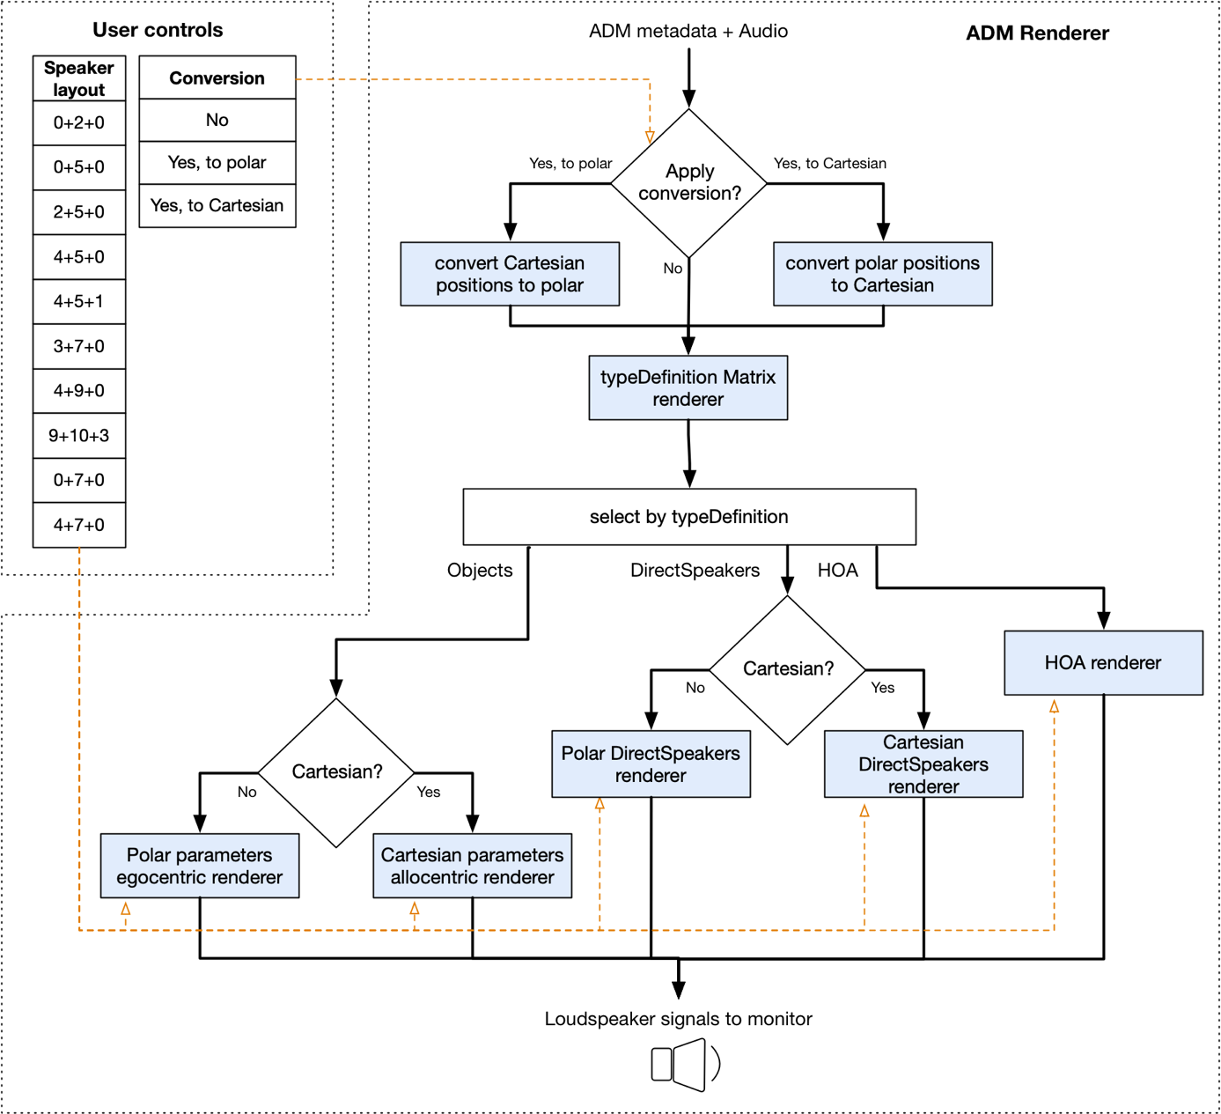
The supported target loudspeaker layouts include 0+2+0, 0+5+0, 2+5+0, 4+5+0, 4+5+1, 3+7+0, 4+9+0, 9+10+3, 0+7+0, and 4+7+0 systems (per Recommendation ITU-R BS.2051-2). The ADM input file may contain audio description for one DirectSpeakers layout, e.g. 4+9+0, while the specified target may be a different layout, e.g. 0+5+0. If the target layout includes fewer loudspeakers than the number of loudspeakers in the DirectSpeakers configuration, the ADM Renderer acts as a down-mixer. However, if the target layout includes more loudspeakers, the audio signal associated with each DirectSpeaker channel will be directed to the nearest target loudspeaker (i.e. no up-mixing of the audio content).
The ADM Renderer supports a number of optional parameters that allow the specification of, among other things, the real loudspeaker positions and screen dimensions of a reproduction setup.
The informative part of the specification of an alternative Point Source Panner provides a reference for an ego-centric renderer that results in certain desirable characteristics under some circumstances. For example, a limited leakage of the back elevated sound sources to the front loudspeakers, and front elevated sources with wider smooth transitions. The placement of these alternative virtual loudspeaker positions and their fold-down coefficients are based on by-ear optimizations and reflect the behaviour of some deployed renderers.

2 How to use the software

2.1 General remarks
The ADM Renderer interprets the ADM metadata and the associated audio signals as prescribed in the Recommendation ITU-R BS.2076-1 and generates the audio PCM waveforms for a specific loudspeaker system/layout or headphones feed. All reproduction systems/layouts specified in the Recommendation BS.2051-2 are supported.
The guidance of how an ADM metadata file should be generated in the first place by considering in particular which of its metadata should be used, how it should be used, and under what circumstances. It is envisaged that the choice and preparation of the ADM metadata, as well as the selection of its attributes/values, will be guided by a verification of how such metadata affects the sound generated by the ITU-R BS.2127-0 ADM Renderer.
Consequently, tools would be expected that allow a content creator to “tune” the ADM metadata based on the output that the ADM Renderer generates. The ADM format provides for a rich set of audio-description features, not all of which may be utilized in every ADM content file. A choice of some metadata, e.g. selection of polar vs. Cartesian coordinates, may be guided by preferences outside the scope of this guide.
Given an ADM/BW64 file, the simplest way to generate the output audio signals is to call the ADM Renderer as follows:
itu_ADM_renderer -s target_system input_ADM_file.wav output_file.w
The ADM Renderer reference implementation renders ADM content from BW64 files according to the specification. It is written in the Python programming language and uses the numpy and scipy libraries for numerical computations.
These attributes make the reference implementation mostly unsuitable for use in situations where real-time or streaming rendering is required, or when the ADM Renderer is to be integrated into another tool.
Although in some circumstances the reference implementation may be used in production, the reference implementation primarily exists to aid in testing and standardization of the ADM Renderer.
In addition to the ‘Python’ reference implementation, other ADM Renderer implementations are being developed (for example an implementation intended for real-time use, written in C++) and are expected to be available soon.

2.2 Implementation of renderers for use in production
When a renderer is required to run in real-time or be embedded within another system, new implementations of the standard will need to be developed to meet these requirements. These should be based on the text of the requirements, using the reference implementation for additional guidance on implementation, and for conformance testing.
Other implementations of the ADM Renderer do not have to use precisely the same methods and structure as the reference implementations. Of course, achieving the desired end result is the most important thing.
Other implementations should be tested against the reference implementation. This can be done by:
– Testing that the output of the reference implementation and the new implementation are the same with the available test files. Note that many test files currently available were produced using systems which only support a small subset of ADM metadata, so will probably not result in full coverage of all cases.
– Testing that individual components of the systems result in the same (or close enough) outputs for the same inputs. For example, given the same position, the point-source panniers of two implementations should produce identical gains.
It is advisable to test both random cases (which are easy to generate and ensure a good level of base coverage), and cases designed to exercise all paths in both implementations (often called unit tests).
Test cases for the reference implementation are available in the test directories of the reference implementation. These test cases may be a good starting point, but if the methods used in the implementation being tested are significantly different, new test cases may need to be devised to test all paths.
In general, developers should take an adversarial approach to testing – tests should be designed to show that the systems are different if possible, rather than to show that they are the same in common cases.

2.3 Interface with non-ADM systems
It should be possible to implement the ADM Renderer in systems like digital audio workstations, which may not support ADM as a native metadata format. Where possible the ADM Renderer should still be used for metadata which might be turned into ADM, but may have to be adapted to work with non-ADM.
metadata formats. Where possible, this adaptation should be standardized to ensure interoperability with other systems.
In particular, the timing model of the ADM is quite different from the time-varying parameter models used in workstations, so more divergence is expected in, for example, gain interpolation than the calculation of gains themselves.
If live rendering is implemented in a product which supports ADM import or export, then the results of live rendering should be the same (or close as given above) in these situations:
– Content is rendered with the AND Renderer reference software and imported then rendered live.
– Content is rendered live then exported and rendered using the ADM Renderer reference software.
This ensures that the system will still be interoperable with others which implement the ADM Renderer exactly.

2.4 Guidelines for subjective evaluations
Quality evaluation in the context of AdvSS is a new and more complex area. The designer or user of the AdvSS system may be interested in evaluating different facets of the reproduced sound. They might include ‘sense of reality’, ‘realism’, distortion, emotional responses, and other attributes.
Evaluations may serve to help design a system or help to make desired choices of parameter values or listening conditions. However, in all cases, the evaluation methodology used must be chosen to minimise unwanted bias, to be accurate, and to be reproduce-able. Test results from different evaluations cannot be fairly compared unless the same methodological conditions are used for all the tests. Achieving this parity of conditions in one of the reasons why the ITU-R ADM Renderer should be used for subjective and objective quality evaluation.
The ADM Renderer should be used for appropriate kinds of quality evaluation where a reference renderer for ADM programme material is required or desired. This includes explicitly the usage of ADM content with subjective evaluation methodologies like Recommendations ITU-R BS.1534, ITU-R BS.1116 and ITU-R BS.1284, when rendering is required. It should be also applied for objective evaluation and measurements when ADM programme material is used.
While the ADM Renderer may serve as a benchmark/reference or an anchor renderer during the perceptual evaluation of other AdvSS systems, it should be noted that the term “reference” does not preclude other renderers to provide more desirable performance characteristics under certain circumstances over the ADM Renderer specified in Recommendation ITU-R BS.2127-0.

Sometimes known as Next Generation Audio, of which AdvSS is one application.
Recommendation ITU-R BS.2051 – Advanced sound system for programme production.
Recommendation ITU-R BS.2127-0, § 1, includes the URL of the reference implementation.

