|  |
| --- |
| **Report ITU-R BS.2213-3**  **(02/2016)** |
| **Impact of audio signal processing and compression techniques on terrestrial FM sound broadcasting emissions at VHF** |
| **BS Series**  **Broadcasting service (sound)** |

Foreword

The role of the Radiocommunication Sector is to ensure the rational, equitable, efficient and economical use of the radio-frequency spectrum by all radiocommunication services, including satellite services, and carry out studies without limit of frequency range on the basis of which Recommendations are adopted.

The regulatory and policy functions of the Radiocommunication Sector are performed by World and Regional Radiocommunication Conferences and Radiocommunication Assemblies supported by Study Groups.

# Policy on Intellectual Property Right (IPR)

ITU-R policy on IPR is described in the Common Patent Policy for ITU-T/ITU-R/ISO/IEC referenced in Annex 1 of Resolution ITU-R 1. Forms to be used for the submission of patent statements and licensing declarations by patent holders are available from <http://www.itu.int/ITU-R/go/patents/en> where the Guidelines for Implementation of the Common Patent Policy for ITU‑T/ITU‑R/ISO/IEC and the ITU-R patent information database can also be found.

|  |  |
| --- | --- |
| Series of ITU-R Reports  (Also available online at <http://www.itu.int/publ/R-REP/en>) | |
| **Series** | Title |
| **BO** | Satellite delivery |
| **BR** | Recording for production, archival and play-out; film for television |
| **BS** | Broadcasting service (sound) |
| **BT** | Broadcasting service (television) |
| **F** | Fixed service |
| **M** | Mobile, radiodetermination, amateur and related satellite services |
| **P** | Radiowave propagation |
| **RA** | Radio astronomy |
| **RS** | Remote sensing systems |
| **S** | Fixed-satellite service |
| **SA** | Space applications and meteorology |
| **SF** | Frequency sharing and coordination between fixed-satellite and fixed service systems |
| **SM** | Spectrum management |

|  |
| --- |
|  |

|  |
| --- |
| ***Note****: This ITU-R Report was approved in English by the Study Group under the procedure detailed in Resolution ITU-R 1.* |

*Electronic Publication*

Geneva, 2016

© ITU 2016

All rights reserved. No part of this publication may be reproduced, by any means whatsoever, without written permission of ITU.

REPORT ITU-R BS.2213-3

Impact of audio signal processing and compression techniques on  
terrestrial FM sound broadcasting emissions at VHF

(2011-2013-2015-2016)

TABLE OF CONTENTS

Page

Annex 1 – Measurement results performed in Hungary on the protection levels against interferers with exceeded MPX power in the FM sound broadcasting 3

1 Measurement setup and measurement methods 3

1.1 Measurement of RF protection curves 5

1.2 Measurement of the reduction of the peak deviation that can compensate the effect of the higher MPX power 6

2 Measurement results 6

2.1 Measurement of RF protection curves 6

2.2 Measurement of the reduction of the peak deviation that can compensate the effect of the higher MPX power of the unwanted transmitter 8

Attachment to Annex 1 – List of instruments 11

Annex 2 – Results of measurements performed in France on the protection levels against interferers with exceeded MPX power in the FM sound broadcasting 12

1 The bench test 12

2 Measurement results 12

2.1 Statistical figure for the measurement analysis 12

2.2 Results 12

3 Conclusion 15

Attachment to Annex 2 – Measurement protocol 16

1 Introduction 16

2 Bench test design 16

2.1 Filtered white noise according to Recommendation ITU-R BS.559-2 16

2.2 Multiplex power (MPX) variations on interfering transmitter 17

2.3 Bench test description 19

2.4 Measuring process 21

Annex 3 – Impact of multiplex power levels higher than 0 dBr on the RF protection ratio of sound broadcasting emissions in VHF band II 23

1 Introduction 23

2 Measurement setup and measurement methods 26

3 Measurement results 27

4 Consequences 30

5 Conclusions 31

Attachment 1 to Annex 3 – Single results of the measurements 33

Attachment 2 to Annex 3 – Spectrum plots of the unwanted signal 38

Introduction

Audio signal processing techniques have developed rapidly in the last few years based on advances in digital signal compression techniques. Applying the compressed audio signal to the FM modulator can increase the modulation power without exceeding the frequency deviation limit given in Recommendation ITU-R BS.412. The processed modulation signal can also result in an increased bandwidth so increasing interference to other VHF FM stations operating on the same or adjacent channels.

Recommendation ITU-R BS.412-9 – Planning standards for terrestrial FM sound broadcasting at VHF, provides the necessary RF protection ratios under the condition that the maximum deviation of the interferer signal is 75 kHz and its multiplex power (MPX) does not exceed 0 dBr. Field measurements show that nowadays a significant number of FM transmitters exceed the 0 dBr limit of the MPX power and have a higher potential to cause interference in the reception of other FM broadcast stations and in other radio services (e.g. air radionavigation). Recommendation ITU‑R BS.412-9 specifies that in these cases the transmitted RF power should be decreased, but does not provide quantitative figures for the necessary reductions. As the FM band is overcrowded and introduction of new digital stations is also considered, it is very important that the FM stations operate in line with the international regulations.

As proposed in Question ITU-R 129/6 measurements were carried out to study:

– What is the impact of audio signal processing and compression techniques on the average power of the complete multiplex signal and the maximum deviation of the emission?

– What techniques are available to ensure that the emission complies with the planning parameters given in Recommendation ITU-R BS.412 when audio signal processing and compression techniques are used?

This Report presents summaries of measurements performed to assess the impact of the MPX power. Annex 1 presents a study carried out in Hungary, Annex 2 presents another study performed in France and Annex 3 provides the results of measurements done in Germany and some comparisons with Annexes 1 and 2. The results of these measurements may help to investigate how it can be ensured that the emission complies with the planning parameters given in Recommendation ITU‑R BS.412 when the 0 dBr MPX power limit is exceeded due to application of audio signal processing and compression techniques.

Annex 1  
  
Measurement results performed in Hungary on the protection levels against interferers with exceeded MPX power in the FM sound broadcasting

Introduction

Recommendation ITU-R BS.412-9 – Planning standards for terrestrial FM sound broadcasting at VHF, provides the necessary RF protection ratios under the condition that the maximum deviation of the interferer signal is 75 kHz and its multiplex power (MPX) does not exceed 0 dBr. Using modern audio processing/compressing techniques which result in an increase of the average power of the complete multiplex signal may lead to an increase in interference to sound broadcasting stations which do not use such techniques. Measurements were carried out in Hungary to investigate how can be ensured that the emission complies with the planning parameters given in Recommendation ITU‑R BS.412 when the 0 dBr MPX power limit is exceeded due to application of audio signal processing and compression techniques.

Using modern audio processing/compressing techniques the 0 dBr MPX power limit can be exceeded while the 75 kHz limit for the maximum deviation is kept. The increased interference potential of the processed/compressed higher MPX power signal can be compensated either by decreasing the transmitted RF power or by reducing the maximum FM deviation of the transmitter. The aim of the measurements was to find quantitative figures for the reduction of the RF power and the peak deviation of the FM broadcast signal exceeding the 0 dBr MPX power limit, which can restore the audio signal-to-noise ratio (*S*/*N*) of the interfered FM broadcast service to the required 50 dB value.

# 1 Measurement setup and measurement methods

The measurements were carried out using the setup shown in Fig. 1 based on Recommendation ITU‑R BS.641 – Determination of radio-frequency protection ratios for frequency-modulated sound broadcasting. The list of the instruments used and the main settings can be found in the Annex.

The signals of the wanted (Generator 6) and the interfering (Generator 7) transmitters were combined and applied to the FM receiver. The output audio signal of the receiver was then measured by an audio analyser.

The wanted signal was a stereo FM broadcast signal modulated by the output of the stereo coder while the stereo coder was driven by internal 500 Hz sinusoidal sources in both (left and right) channels. The level of the modulating signal was adjusted so that the peak FM deviation of the wanted signal was 75 kHz and it remained unchanged during the whole measurement.

The interfering transmitter was modulated by processed/compressed noise plus RDS signal. The input sound signal was a weighted (coloured) noise defined by Recommendation ITU‑R BS.559-2 (see Fig. 1A), which was recorded on a CD. The level of the modulating signal was adjusted so that the peak FM deviation of the unwanted signal was 75 kHz and it was checked by the modulation meter (8). The RF level of the interferer signal could be adjusted by two cascaded step attenuators ((10) and (11)) in 1 dB steps.

figure 1a

Weighted (coloured) noise defined by Recommendation ITU-R BS.559-2



The *S*/*N* ratio was observed at the audio output of the FM receiver (based on the specifications of Recommendation ITU-R BS.468-4 – Measurement of audio-frequency noise voltage level in sound broadcasting). The reference level of the signal was the level of the demodulated 500 Hz wave measured at 75 kHz peak deviation while the unwanted signal (interferer transmitter) was switched off. The level of the noise was measured using quasi-peak detector at the audio output of the FM receiver while the 500 Hz modulation of the wanted transmitter was switched off. Then the *S*/*N* ratio was calculated.

figure 1

Measurement setup (the numbers in bracket refer to the list of equipment in Table 5)



The RF level of the wanted transmitter at the input of the FM receiver was set to 49 dB(µV). It was the lowest RF level where the *S*/*N* ratio at the output of the receiver reached the required 56 dB while the interferer transmitter was switched off.

## 1.1 Measurement of RF protection curves

The measurement procedure of the RF protection curves was as follows. The multiplex power of the interferer signal was set at the sound processor and was checked by the modulation and MPX power meter (8). The interferer transmitter was tuned to the required frequency distance from the wanted transmitter. The audio *S*/*N* ratio was observed at the output of the receiver and the step attenuators were adjusted until the *S*/*N* ratio was set to 50 dB. The actual value of the RF protection ratio was the difference in dB-s between the RF signal levels of the two transmitters. The measurement was repeated with different frequency distances and with different multiplex powers.

## 1.2 Measurement of the reduction of the peak deviation that can compensate the effect of the higher MPX power

The measurement setup was almost the same as in Fig. 1, except that a different type of audio analyser (UPA) was used (for availability reasons). This measurement was completed only for 100 kHz frequency difference between the two transmitters. The RF level of the interferer signal was 33 dB below the wanted signal.

First the peak deviation of the interferer signal was set to 75 kHz in the test mode of the audio processor. The processor keeps this peak value in normal operation mode regardless of the parameters of the input sound signal and the programmed multiplex power. After setting a certain value of the MPX power the signal-to-noise ratio was observed at the audio output of the FM receiver. Then the level of the modulating signal at the output of the audio processor was adjusted until the observed *S*/*N* ratio became 50 dB. This adjustment caused of course a change in the peak deviation of the FM signal as well. The processor was then switched to test mode and the peak deviation was checked by the modulation meter (8).

# 2 Measurement results

## 2.1 Measurement of RF protection curves

The results of the RF protection curve measurements are summarized in Table 1 and Fig. 2.

TABLE 1

RF protection ratios for different multiplex power and   
frequency difference values

|  |  |  |  |  |  |  |  |  |  |
| --- | --- | --- | --- | --- | --- | --- | --- | --- | --- |
| Δ*f* (kHz) | Multiplex power (dBr) | | | | | | | | |
|  | 0 | 0.5 | 1.5 | 2.5 | 3.5 | 4.5 | 5.5 | 6.5 | 7.5 |
| 0 | 42.5 | 43 | 44 | 46 | 47 | 48 | 48 | 49 | 49 |
| 50 | 52 | 52 | 52 | 52 | 51 | 51 | 51 | 50 | 50 |
| 100 | 32.5 | 33 | 35 | 36 | 38 | 39 | 41 | 43 | 44 |
| 150 | 11 | 13 | 16 | 18 | 20 | 23 | 25 | 26 | 27 |
| 200 | −11 | −10 | −7 | −3 | 0 | 2 | 5 | 7 | 8 |
| 250 | −26.5 | −26 | −25 | −23 | −21 | −19 | −16 | −15 | −13 |
| 300 | −28 | −28 | −28 | −28 | −26 | −28 | −28 | −28 | −26 |

figure 2

RF protection ratios for different multiplex power and   
frequency difference values



It can be seen that – in spite of certain expectations – the measured 0 dBr protection curve is not identical with the S1 curve shown in Recommendation ITU-R BS.412-9. The most likely reasons of the difference is that the S1 curve of Recommendation ITU-R BS.412-9:

a) represents an average of the measurements made on a great number of different consumer radio sets while for the present measurements only two different, medium quality radio sets were used; and

b) it was measured with an interferer signal with less than 0 dBr MPX power.

However, the curves clearly indicate the tendency that the higher the MPX power the more protection is needed against it.

From the above results we can also derive curves that show how much reduction of the RF power level of an interferer signal can compensate its increased interfering effect if its MPX power exceeds 0 dBr, keeping the baseband audio *S*/*N* ratio at the required 50 dB. The three curves on Fig. 3 refer to the 0 kHz, 100 kHz and 200 kHz difference between the carrier frequencies of the wanted and the unwanted signal.

TABLE 2

RF power reduction that can compensate the effect of  
the higher MPX power of the unwanted transmitter

|  |  |  |  |  |  |  |  |  |
| --- | --- | --- | --- | --- | --- | --- | --- | --- |
| Δ*f* (kHz) | MPX power (dBr) | | | | | | | |
|  | 0.5 | 1.5 | 2.5 | 3.5 | 4.5 | 5.5 | 6.5 | 7.5 |
| 0 | 0.5 | 1.5 | 3.5 | 4.5 | 5.5 | 5.5 | 6.5 | 6.5 |
| 100 | 0.5 | 2.5 | 3.5 | 5.5 | 6.5 | 8.5 | 10.5 | 11.5 |
| 200 | 1 | 4 | 8 | 11 | 13 | 16 | 18 | 19 |

FIGURE 3

RF power reduction that can compensate the effect of  
the higher MPX power of the unwanted transmitter



## 2.2 Measurement of the reduction of the peak deviation that can compensate the effect of the higher MPX power of the unwanted transmitter

The higher interference potential of a signal exceeding 0 dBr multiplex power can also be compensated by the proportional reduction of the FM deviation. Table 3 and Fig. 4 show the applicable maximum deviations as a function of the original MPX power (before decreasing the peak deviation). The two curves refer to the “on” and “off” state of the RDS signal.

The results of the measurements of the maximum applicable peak deviation are summarized in Table 3 and Fig. 4.

TABLE 3

Peak deviations for different MPX power values

|  |  |  |
| --- | --- | --- |
| Maximum applicable FM deviation (kHz) | | |
| Multiplex power (dBr) | RDS on | RDS off |
| 1 | 71.5 | 69.7 |
| 2 | 61.5 | 63.3 |
| 3 | 56.8 | 56.8 |
| 4 | 51.6 | 50.4 |
| 5 | 48 | 46.9 |
| 6 | 46.3 | 43.9 |
| 7 | 45.1 | 42.2 |

FIGURE 4

Applicable peak deviations that can compensate the effect of  
the higher MPX power of the unwanted transmitter



The measurements were carried out both in the “on” and “off” state of the RDS signal. It was found that this causes only a very slight difference.

The above results can be expressed in the reduction of the peak deviation – relative to the nominal 75 kHz – as well.

TABLE 4

Reduction of the peak deviations that can compensate the effect of  
the higher MPX power of the unwanted transmitter  
(relative to 75 kHz)

|  |  |  |
| --- | --- | --- |
| Reduction of the peak FM deviation (kHz) | | |
| Multiplex power (dBr) | RDS on | RDS off |
| 1 | 3.5 | 5.3 |
| 2 | 13.5 | 11.7 |
| 3 | 18.2 | 18.2 |
| 4 | 23.4 | 24.6 |
| 5 | 27 | 28.1 |
| 6 | 28.7 | 31.1 |
| 7 | 29.9 | 32.8 |

FIGURE 5

Reduction of the peak deviations that can compensate the effect of  
the higher MPX power of the unwanted transmitter  
(relative to 75 kHz)



Conclusion

The laboratory measurements confirmed that FM broadcast signals with higher multiplex power can cause higher degradation in the quality of the interfered FM broadcast signal. This degradation can be compensated by decreasing either the RF level or the peak deviation of the interferer signal. The above described measurements provide quantitative figures for the amount of these reductions.

Attachment   
to Annex 1  
  
List of instruments

TABLE 5

List of instruments

|  |  |  |
| --- | --- | --- |
| No. | Equipment/type | Serial or Reg. No. |
| 1 | CD player (in an industrial PC) | L0064576 |
| 2 | RDS coder |  |
| 3 | Audio processor Orban 5300 FM | 53000135 |
| 4 | Function generator Tektronix AFG 3252 |  |
| 5 | Stereo coder R&S MSC-2 | 890340/017 |
| 6 | Signal generator Marconi 2031 (wanted transm.) | 119848/053 |
| 7 | Signal generator R&S SMR-20 (unwanted transm.) | 11040002.20 |
| 8 | Modulation (and MPX) meter Audemat Aztek FM-MC4 | L0062277 |
| 9 | High power directional coupler C5091 (Werlaton) | 10279 |
| 10 | Step attenuator 8496A 10 dB | 3308A14564 |
| 11 | Step attenuator 8494A 11 dB | 3308A32544 |
| 12 | Resistive power splitter Aeroplex1870A | 8134 |
| 13 | 50/75 Ohm match RAM | 100131 |
| 14 | Radio set Sony S-master CMT-CPZ1 | 122234 |
| 15 | Radio set Denon DN-U100 |  |
| 16 | UPL Audio Analyzer R&S DC…110 kHz | 100091 |
| 17 | UPA Audio Analyzer R&S 10 Hz 100 kHz |  |

Signal and instrument settings

Signal level of the wanted transmitter at the receiver input: 49 dB(µV)

Pilot signal: 9%

FM deviation caused by the RDS signal: 3 kHz

UPL audio analyzer

Low-pass filter: on (15 kHz)

Detector: quasy-peak

Weighting filter: on (weighting characteristics according to Recommendation ITU‑R BS.468-4)

UPA audio analyzer

Low-pass filter: on (22 kHz)

Detector: quasy-peak

Weighting filter: on (weighting characteristics according to Recommendation ITU‑R BS.468-4)

Audemat Aztec FM-MC4 modulation (and MPX) analyzer

Mode of operation: MPX Analysis Mode (In this mode the averaging time is automatically set to 200 ms and the MPX processing mode to “linear”).

Orban 5300 FM audio processor

Applied factory preset: “Extreme”.

Annex 2  
  
Results of measurements performed in France on the protection levels against interferers with exceeded MPX power in the FM sound broadcasting

# 1 The bench test

The French Administration has carried out a bench test using 26 receivers to study the impact of the increase of multiplex power on protection ratios. The results of these measurements carried out in France to quantify the impact of multiplex power over protection ratios (PR) when the limit of 0 dBr is exceeded are included in this Annex, which provides quantitative figures of required protection ratios, according to the values of multiplex power (MPX) used by some broadcasting FM stations.

# 2 Measurement results

## 2.1 Statistical figure for the measurement analysis

The ninth decile statistical figure has been chosen in order to show a representative analysis of the measurement results. It was more representative than the median or the average to describe the statistical behaviour of receivers during the experimentation.

Furthermore, the statistical ninth decile figures represent protection ratios of a theoretical receiver which is less efficient than the 90% of the sample receivers tested.

The PR values taken as reference are given in Recommendation ITU-R BS.412-9 (§ 2.3.2, Table 3: Stereophonic mode and steady interference).

## 2.2 Results

As shown in Fig. 6 below, some receivers (more than 10%) are protection ratio values close to those found in Recommendation ITU-R BS.412-9, where no multiplex power applies to the interfered signal at 100, 200, 300 and 400 kHz of the carrier frequency spacing.

figure 6

RF protection ratios for 0 dBr multiplex power and   
carrier frequency spacing difference values for the 26 receivers tested

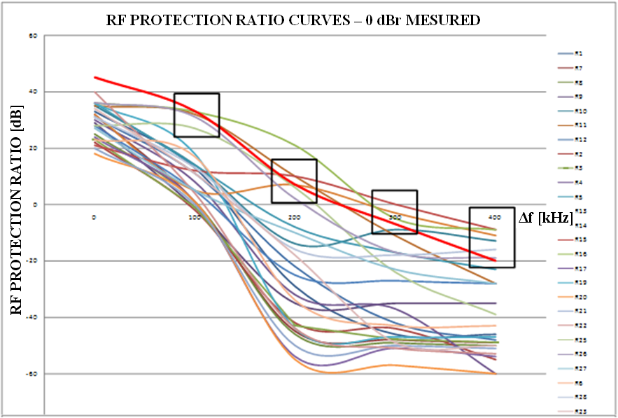

**Δ*f* (kHz)**

**RF protection ratio (dB)**

**RF protection ratio curves – 0 dBr measured**

The bold red curve represents the PR in Recommendation ITU-R BS.412-9.

Figure 6 shows that the protection ratios given in Recommendation ITU‑R BS.412-9 are still relevant even if a lot of receivers have better protection ratios.

Figure 7 below shows several protection ratios measured for different values of multiplex power. As indicated in § 2.1, the following curves represent a theoretical receiver which ensures that 90% of the sample receivers tested will work properly.

figure 7

RF protection ratio curves for several multiplex power values using   
frequency carrier spacing values (by steps of 100 kHz)

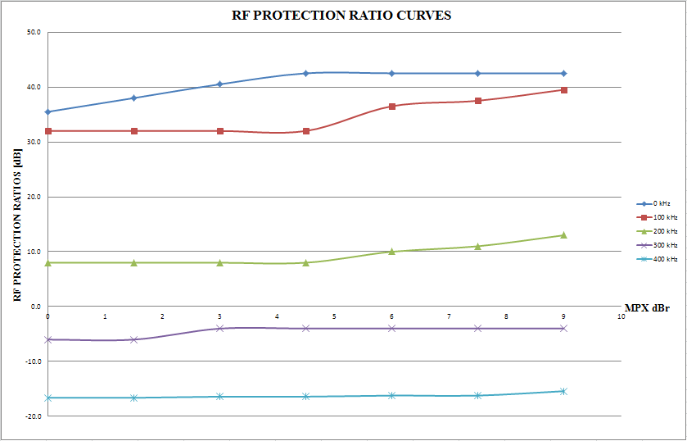

**MPX (dBr)**

**RF protection ratios (dB)**

**RF protection ratio curves**

As shown on Fig. 7, it is important to note that at 300 kHz and 400 kHz of the carrier frequency spacing, the differences between the PR measured at 0 dBr multiplex power and at 9 dBr are very low.

**Thus, only carrier frequency spacing of 0 kHz, 100 kHz and 200 kHz are taken into account for the final results.**

Table 6 shows the value of the PR measured for different values of multiplex power applied to the interfered signal at different carrier frequency spacings: 0, 100 and 200 kHz.

TABLE 6

RF protection ratios for different multiplex power and   
frequency difference values

|  |  |  |  |  |  |
| --- | --- | --- | --- | --- | --- |
| MPX | < 5 dBr | 6 dBr | 7.5 dBr | 9 dBr | Rec. ITU‑R 412-9 |
| **Δ*f*** | RF protection ration measured (dB) | | | | |
| **0 kHz** | 42.5 | 42.5 | 42.5 | 42.5 | **45** |
| **100 kHz** | 32.0 | 36.5 | 37.5 | 39.5 | **33** |
| **200 kHz** | 8.0 | 10.0 | 11.0 | 13.0 | **7** |

According to the measurements made on receivers, for a multiplex power less than 5 dBr, the PR obtained does not exceed: 42.5 dB at 0 kHz of the carrier frequency spacing, 32 dB at 100 kHz and 8 dB at 200 kHz.

But for a multiplex power greater than 5 dBr, the PR measured keeps growing as the multiplex power increases.

Compared to the PR values mentioned in Recommendation ITU-R BS.412-9, the decrease of RF power that can counterbalance the effect of a higher multiplex power of the unwanted transmitter is shown in Table 7.

TABLE 7

Decrease of RF power that can compensate the effect of the higher MPX   
power of the unwanted transmitter

|  |  |  |  |  |  |
| --- | --- | --- | --- | --- | --- |
| MPX | < 5 dBr | 6 dBr | 7.5 dBr | 9 dBr | Rec. ITU-R 412-9 |
| **Δ*f*** | RF protection ration measured (dB) | | | | |
| **0 kHz** | +2.5 | +2.5 | +2.5 | +2.5 | 45 |
| **100 kHz** | +1.0 | –3.5 | –4.5 | –6.5 | 33 |
| **200 kHz** | –1.0 | –3.0 | –4.0 | –6.0 | 7 |

The negative figures represent the necessary decrease of RF power that can compensate the effect of multiplex power to ensure the protection of the wanted signal.

The positive figures show that PR values of Recommendation ITU-R BS.412-9 can be decreased by each value according to the case considered. For example, for a carrier frequency spacing of 0 kHz, the trial has shown the possibility to use 42.5 dB of protection ratio (between a wanted signal which did not use the multiplex power and an unwanted signal which did use the multiplex power) instead of 45 dB as indicated in Recommendation ITU-R BS.412-9.

# 3 Conclusion

The test bench results performed in France in 2012 have confirmed that FM broadcast signals with higher multiplex power are degrading protection ratios and can worsen the quality of the interfered FM broadcast signal. However, by widening the amount of receivers taken into account in the measurements, the figures of the protection ratio obtained in Annex 1 are slightly different.

The main conclusion is that PRs in Recommendation ITU-R BS.412-9 are still relevant for multiplex power that do not exceed 5 dBr for any frequency spacing between the wanted and the unwanted signals. For signals that exceed 5 dBr, it is necessary to reduce the transmitter RF power according to the values shown in Table 7.

Furthermore, the measurements show better performance for receivers put into market after 2010 (35% of the tested receivers). This could be due to a majority of 2010’s FM receivers using digital components. This trend could enable the use of a lower protection ratio in the long term and a possible revision of Recommendation ITU-R BS.412 if a new measurements campaign assessed it.

Attachment  
to Annex 2  
  
Measurement protocol

# 1 Introduction

The bench test is based on Recommendation ITU-R BS.641 used to set protection ratios according to the multiplex power variations and the spacing of carrier frequencies. The bench test involved a representative sample of 26 receivers.

This document explains the methodology and the means used to carry out the bench test.

# 2 Bench test design

This first part explains how to get some technical elements required for the bench test:

1) the coloured noise signal;

2) the equipment that enables the multiplex power variations.

After that, the bench test is set up according to the diagram of measuring given in Recommendation ITU-R BS.641.

The second part describes the bench test configuration, which is adapted in order to match with the modern metrology methods.

## 2.1 Filtered white noise according to Recommendation ITU-R BS.559-2

The multiplex power variations depend on the noise modulating signal given in Recommendation ITU-R BS.559-2. In order to obtain the coloured noise signal spectrum as defined in the recommendation “…*the spectral amplitude distribution of which is fairly close to that of modern dance music*…”, it is necessary to use a filtered white noise signal proceeding from an AF generator signal according to the diagrams below (Figs 8 and 9).

Figure 8

Recommendation ITU-R BS.559-2 Filter diagram



Frequency/Amplitude AF measured

Figure 9

Weighted (coloured) noise defined by Recommendation ITU-R BS.559-2



------- Filter ------- Filtered white noise measured

The coloured noise obtained was recorded in a specific VX222HR audio card from DIGIGRAM.

This file was saved in a PCM (48 kHz – 16 bit) format and can be read by any professional audio card. It just requires a digital or analog audio output.

The device SYSTEM TWO from AUDIO PRECISION was selected to provide a white noise signal. (Set up: Noise – White Pseudo).

## 2.2 Multiplex power (MPX) variations on interfering transmitter

A Principle

The MPX variation is achieved by using a sound processing system often used in the FM sound broadcasting service.

The device selected is an OMNI ONE FM. It consists of a stereo coder, which embeds processing and optimization sound features, used in FM sound broadcasting.

The OMNIA ONE FM can achieve the following functionalities:

1 Filtering at 15 kHz

2 Pre-emphasis of 50 µs

3 Limitation and optimization of level composite output in order to comply with the maximal level fixed at 8.72Vc/c. This condition ensures that the maximum frequency deviation of ±75 kHz would not be exceeded.

The audio processing is based on AF signals dynamic compression techniques. The processing is achieved by a set of cells working in a specific frequency band. Each audio frequency band, cut out beforehand, is handled by a set of functions: dynamic compressor and limiter.

Then, the audio spectrum is reconstructed in order to be injected in the stereo coder. This last function includes a clipper, which eliminates the over-shoot. This handling ensures to keep the MPX in a tension range (8.72 Vc/c) and the maximum frequency deviation less than 75 kHz.

Therefore, the AF signal dynamic range could be reduced according to the device settings. This reduction increases the MPX of the signal.

The RF wanted signal is generated by a FM THOMSON-LGT RAMSES II transmitter. The stereo coder integrated is put into operation.

B Interfering signal line

The bench test interfering signal line consists of the following devices:

– A PUC 2 YELLOWTEC card, which generates a coloured noise as a AES/UER signal

– A set up Mono OMNIA ONE FM

– A FM RVR PTX 100LCD transmitter.

Concerning the measurement in static mode, the following settings are used:

– The control of the maximum deviation is achieved by the FMA of Rohde & Schwarz;

– The spectrum analyser E4402B of HP shows the J0 carrier cancellation;

– The modulating signal MPX is measured with the ADFM02 analyser.

Concerning the measurement in dynamic, following settings are used:

– MPX variations and frequency deviations are analysed with the ADFM02.

This part of the bench test and its measurements modes are shown on Fig. 10.

Figure 10

Diagram of the interfering signal line

Sound card

(Laptop)

OMNIA ONE FM

RVR

Transmitter

Dynamic modulation analyser

ADFM02

RF

MPX

INPUT

FMA

RF spectrum analyser

AF spectrum analyser

AF generator

AES/UER

## 2.3 Bench test description

The bench test is built according to the diagram of measuring apparatus reproduced below:

Figure 11

Diagram of the measuring apparatus



A modern version of this bench test is presented below. It contains, in a macroscopic model, all the elements given in the reference diagram (Recommendation ITU-R BS.641). A correspondence between the diagram given in the recommendation and the new version is shown below (Letters “A” to “U”).

The tested equipment (the receiver) is put in a Faraday cage that shields the receiver from any radio interferences around.

Figure 12

Proposed bench test diagram

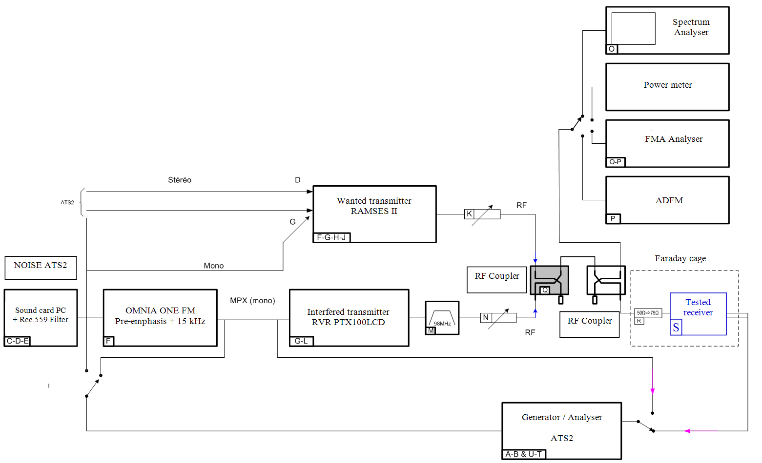

Figure 13

Wanted and interfering transmitters, clipper/Faraday Cage (at left) – measuring devices (At right)

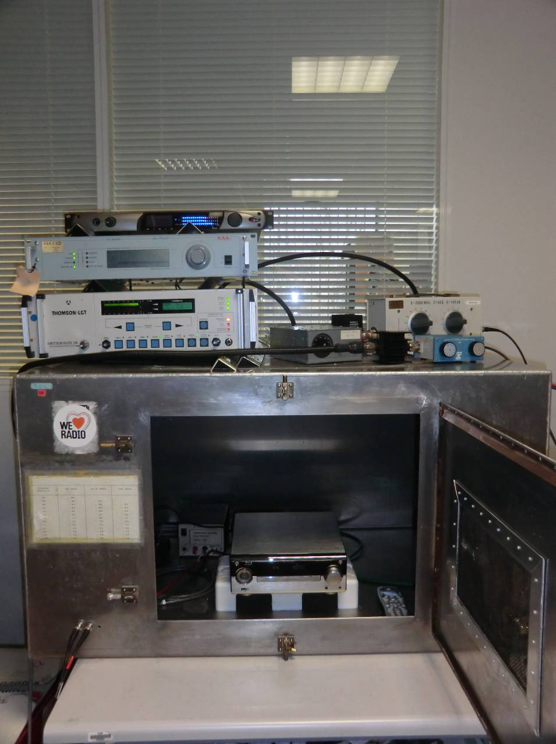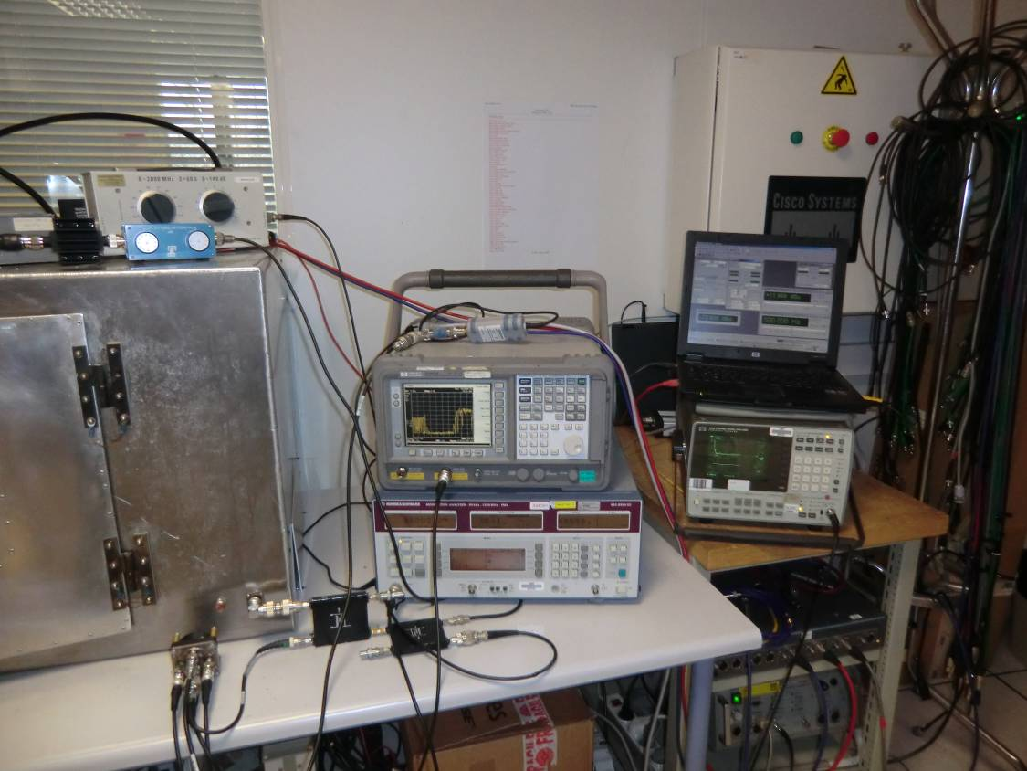

## 2.4 Measuring process

The measurement process used for the bench test follows exactly the methodology described in Recommendation ITU-R BS.641.

The protection ratio is obtained when the following calculation is achieved:

*PR* = (*PU* – *AttU*) – (*PB* – *AttB*)

Where:

*PU* is the RF wanted transmitter power

*AttU* is the RF wanted transmitter attenuation that enables to fix the *S*/*N* at 56 dB, when the interfering transmitter is not activated, as recommended

*PB* is the RF interfering transmitter power

*AttB* is the RF interfering transmitter attenuation that enables to fix the *S*/*N* at 50 dB, when the interfering transmitter is activated.

In order to ease the protection ratio calculation, the power level of wanted and interfering signal is the same.

So the protection ratio is: *PR* = *AttB* – *AttU*.

This measurement process is also described in Fig. 14.

Figure 14

Diagram of the measurement process

Bench test calibration

Tested equipment is set in the Faraday cage

AF gain receiver setting (RF level: 60 dBµV)

**AF level = Max level**

**(@ THD+N<5%) – 10 dB => S**

AF 500 Hz => OFF

**Noise level measurement => B1**

RF wanted attenuator setting:

RF level **= 60 dBµV**

S/B2 = S/B1

Interfering transmitter MPX and frequency deviations check

**White noise filtered for each MPX value**

RF interfering attenuator setting:

**S/B3 = S/B2 – 6 dB**

**Protection ratio for each frequency deviation given**

**PR* = AttB - AttU**

* Interfering and wanted transmitters powers are equal.

**S level**

Q-Peak

Without 15 kHz

Weighting filter

**B1 level**

Q-Peak

With 15 kHz

Weighting filter

**S/B1**

S/B1 ≥ 56 dB ?

RF wanted attenuator setting:

**S/B2 = 56 dB**

YES

Total RF wanted attenuation

**AttU**

NO

Total RF interfering attenuation

**AttB**

Annex 3  
  
Impact of multiplex power levels higher than 0 dBr on the RF protection   
ratio of sound broadcasting emissions in VHF band II

# 1 Introduction

The RF protection ratios given in Recommendation ITU-R BS.412 are valid for MPX power not exceeding 0 dBr and a maximum frequency deviation of ±75 kHz. Annexes 1 and 2 of this Report investigate the impact on a wanted signal from an interfering unwanted FM modulated signal whose MPX power is higher than 0 dBr, i.e. up to 7.5 dBr or 9 dBr respectively:

• Annex 1: Results of measurements performed in Hungary on the protection levels against interferers with exceeded MPX power in the FM sound broadcasting

• Annex 2: Results of measurements performed in France on the protection levels against interferers with exceeded MPX power in the FM sound broadcasting

For 0 kHz, 100 kHz and 200 kHz frequency difference between wanted and unwanted signal, Annex 1 shows an increase of the measured RF protection ratios when increasing MPX power beyond the values given in Recommendation ITU-R BS.412. (In this Annex frequency differences of 50 kHz, 150 kHz and 250 kHz are assumed to be irrelevant in practice, since only 100 kHz steps are used in Band II.)

Annex 2 also shows an increase of the protection ratios with increasing MPX power but far less than Annex 1.

Although it is mentioned that the measurement was executed according to Recommendation ITU‑R BS.641, it seems to be conspicuous that the measured protection ratios for 0 dBr are remarkably low. For example, all measured protection ratios for 0 kHz frequency difference are between 19 dB and 40 dB though experience in Germany is that nearly all receivers show values between about 43 dB and 47 dB with a very low deviation between different receivers. The same applies for the values for 100 kHz frequency difference: the measured values are in a very wide range between –5 dB and 33 dB. Experience in Germany is that the majority of receivers show values around 30 dB with a deviation between different receivers of about 3 or 4 dB, but not much more (when measured in stereo).

For comparison, Fig. 15 shows the data from Annex 1 and measurement results in § 3 of this Annex.

Figure 16 shows the data from Annex 1 compared with the results from Annex 2 and with measurement results in § 3 of this Annex.

Figure 15

Measurement results from Annex 1 compared with measurement results in Germany shown in Fig. 20

Figure 16

Data from Annex 1 compared with measurement results of Annex 2 and measurement results shown in Fig. 21

In effect, Annex 2 weakens the results of Annex 1 by far and led us to make some own check measurements to find out which values are more reliables.

Figure 17

Copy of the results of Fig. 7 of Report ITU-R BS.2213-2 Annex 2 with inserted values given from   
Recommendation ITU-R BS.412 for comparison with Fig. 2 and Fig. 6

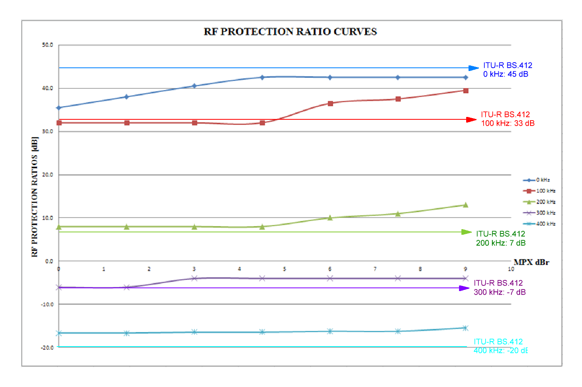

It is noticeable that the measured values for 0 kHz and 100 kHz seem to be too low (see text), while the measured values at 200 kHz, 300 kHz and 400 kHz seem to be too high and are generally above the values from Recommendation ITU-R BS.412.

# 2 Measurement setup and measurement methods

The measurements were carried out based on Recommendation ITU-R BS.641 except for the unwanted signal with multiplex power more than 0 dBr: the transmitter of the unwanted signal was modulated from a CD player with pink noise according to Recommendation ITU-R BS.559. This AF signal was clipped by a limiter (2 anti-parallel diodes). The limiting rate was adjusted by an adjustable attenuator before the clipper. With this method it was possible to generate signals with a multiplex power from 0 dBr to 9 dBr in steps of 1 dB with a maximum deviation not exceeding ±75 kHz, clipped by a depth modelling mode stereo coder (see Fig. 18). Unfortunately it was forgotten to switch off the stereo pilot tone of this stereo coder. So, differing to Recommendation ITU-R BS.641 the unwanted signal included a stereo pilot tone (19 kHz) with ±6.8 kHz frequency deviation, with left channel = right channel like a mono signal. But comparisons with former measurements showed a negligible influence of the stereo pilot tone.

The wanted signal was a stereo signal (19 kHz pilot with ±6.8 kHz deviation) with no further modulation or with additional 500 Hz respectively (±75 kHz sum deviation).

Figure 18 shows the complete measurement arrangement.

Figure 18

Measuring arrangement with signal levels

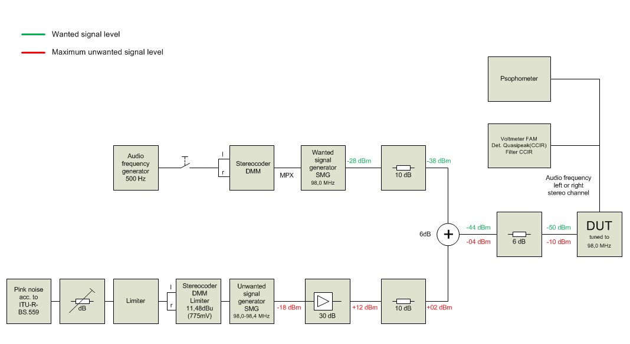

# 3 Measurement results

Table 8 and Fig. 19 show the results of all eight measured receivers. In principle the measurement could have been enlarged to examine further receivers. But after the tendency was clear and very consistent we saw no need to do that at the moment.

It can be seen that there is a very low deviation of the measured protection ratio for 0 kHz frequency difference (43 dB to 47 dB) and also for 100 kHz (25 dB to 32 dB).

In Fig. 19 it can be seen that all receivers meet the values of Recommendation ITU-R BS.412.

It is clear that the average values in Table 8 are not really representative for all receivers of the listeners at home or in cars though that was not the intention of the measurements. Instead it is intended to measure the impact of a more compressed unwanted signal.

TABLE 8

Measured receivers (all in stereo) and the measured protection ratio for an unwanted signal with 0 dBr and ±75 kHz maximum deviation

|  |  |  |  |  |  |
| --- | --- | --- | --- | --- | --- |
| Frequency difference (kHz) | 0 kHz | 100 kHz | 200 kHz | 300 kHz | 400 kHz |
| RX 1 (FM tuner) | 44 dB | 26 dB | –16 dB | –38 dB | –40 dB |
| RX 2 (FM tuner) | 44 dB | 27 dB | –26 dB | –42 dB | –41 dB |
| RX 3 (FM tuner) | 47 dB | 31 dB | –7 dB | –25 dB | –36 dB |
| RX 4 (FM tuner) | 43 dB | 28 dB | –12 dB | –38 dB | –38 dB |
| RX 5 (DAB / FM portable) * | 43 dB | 32 dB | 4 dB | –10 dB | –18 dB |
| RX 6 (car radio) | 44 dB | 30 dB | –26 dB | –51 dB | –53 dB |
| RX 7 (rebroadcasting receiver) | 45 dB | 31 dB | –8 dB | –38 dB | –38 dB |
| RX 8 (monitoring receiver) | 44 dB | 25 dB | –20 dB | –26 dB | –30 dB |
| **Average values:** | **44,3 dB** | **38,8 dB** | –**13,9 dB** | –**33,5 dB** | –**36,8 dB** |

* There was only 47 dB *S*/*N* reached. Therefore we measured the RF protection ratio for 40 dB *S*/*N* and added 10 dB for comparison with the other receivers.

Figure 19

Measured receivers and the measured RF protection ratio for an unwanted signal with 0 dBr   
and maximum frequency deviation of ±75 kHz

* There was only 47 dB *S*/*N* reached. Therefore we measured the RF protection ratio for 40 dB *S*/*N* and added 10 dB for comparison with the other receivers.

Figure 20 shows the results when the MPX power of the unwanted signal is increased from 0 dBr to 9 dBr by steps of 1 dB. It can be seen that the major impact happens at 100 kHz frequency difference. Also the values given by Recommendation ITU-R BS.412 are exceeded by far.

Although at 0 kHz frequency difference there is a lesser impact, the values given by Recommendation ITU-R BS.412 are exceeded anyway.

At 200 kHz frequency difference there is also an impact but all values are still under the values given by ITU-R BS.412, so this influence seems not that critical than at 0 kHz and 100 kHz frequency difference.

At 300 kHz and 400 kHz the influence of the MPX power is very low and in practice negligible.

Figure 20

Average of measured RF protection ratios of eight receivers (see Table 8) in comparison   
with the values given by Recommendation ITU-R BS.412

Figure 21 shows the influence of the MPX power more clearly. It can be seen that at 2 dBr the protection ratio given by Recommendation ITU-R BS.412 are reached (100 kHz) though at 0 kHz frequency difference the value of 45 dB (Recommendation ITU-R BS.412) is still exceeded by 2 dB.

Figure 21

Average of measured RF protection ratios of eight receivers (see Table 8) depending on multiplex power in   
comparison with the values given by Recommendation ITU-R BS.412

# 4 Consequences

Figure 22 shows an example of what would happen if a 100 kHz neighbour transmits with 7 dBr instead of 0 dBr multiplex power. Of course a lot of other parameters have their influence, e.g. ERP of all other transmitters, topography, distances etc.

But it can be seen that there is a certain impact if only one of the 100 kHz neighbour transmitters interferes like having 12 dB more RF power.

Figure 22

Stereo reception (green region) from transmitter Bornberg 90.8 MHz

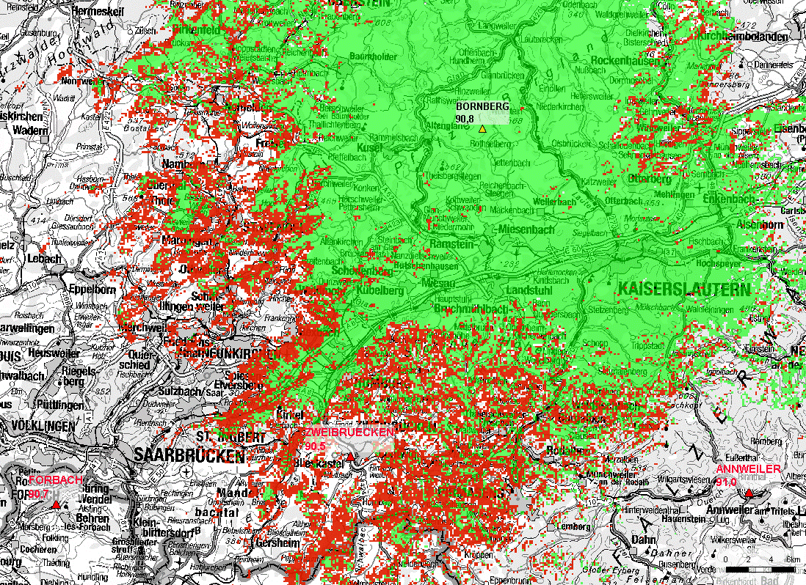

NOTE – All relevant interfering transmitters 0 kHz to ±400 kHz have been considered, protection ratios according to Recommendation ITU-R BS.412, directional receiving antenna according to Recommendation ITU-R BS.599 and 54 dB minimum field strength.

The red colored regions change from not-interfered to interfered when the transmitter Forbach 90.7 MHz changes from 0 dBr to 7 dBr multiplex power. This is considered in higher RF protection ratios which have been changed from 33 dB to 45.1 dB (stereo steady) and from 25 dB to 37.1 dB (stereo tropo), see Table 10.

(Underlay map: ATKIS®, DTK500-V; ©Bundesamt für Kartographie und Geodäsie 2004.)

# 5 Conclusions

A direct comparison of these measurement results with those of Annexes 1 and 2 are presented in Fig. 23. Although it cannot be expected that the values are identical (because of not measuring the same receivers) these measurements and the results from Annex 1 are much more alike than the results from Annex 2.

Figure 23

Comparison of the measured values with the results from Annexes 1 and 2   
and the values given by Recommendation ITU-R BS.412

The measured results are very similar to those from Annex 1, especially for frequency differences of 0 kHz and 100 kHz. From this point of view the results from Annex 1 seem to be reliable and can be used for compatibility calculations.

Table 9 shows these values for 0 kHz frequency difference stereo steady protection ratios and also the necessary derived protection ratios for stereo tropo.

Table 10 shows the same values but for 100 kHz frequency difference.

TABLE 9

Comparison of measurement results and the values given by Recommendation ITU-R BS.412 for 0 kHz frequency difference

|  |  |  |  |  |  |  |  |  |  |  |  |
| --- | --- | --- | --- | --- | --- | --- | --- | --- | --- | --- | --- |
|  | Rec.  ITU-R BS.412 | 0 dBr | 1 dBr | 2 dBr | 3 dBr | 4 dBr | 5 dBr | 6 dBr | 7 dBr | 8 dBr | 9 dBr |
| Stereo **Steady** | **45.0** | **45.0** | **45.8** | **46.9** | **47.8** | **48.6** | **49.4** | **49.9** | **50.0** | **50.5** | **50.5** |
| Stereo **Tropo** | **37.0** | **37.0** | **37.8** | **38.9** | **39.8** | **40.6** | **41.4** | **41.9** | **42.0** | **42.5** | **42.5** |

TABLE 10

Comparison of measurement results and the values given by Recommendation ITU-R BS.412 for 100 kHz frequency difference

|  |  |  |  |  |  |  |  |  |  |  |  |
| --- | --- | --- | --- | --- | --- | --- | --- | --- | --- | --- | --- |
|  | Rec. ITU-R BS.412-9 | 0 dBr | 1 dBr | 2 dBr | 3 dBr | 4 dBr | 5 dBr | 6 dBr | 7 dBr | 8 dBr | 9 dBr |
| Stereo **Steady** | **33.0** | **33.0** | **33.0** | **33.0** | **35.6** | **38.3** | **40.1** | **43.6** | **45.1** | **46.9** | **47.9** |
| Stereo **Tropo** | **25.0** | **25.0** | **25.0** | **25.0** | **27.6** | **30.3** | **32.1** | **35.6** | **37.1** | **38.9** | **39.9** |

Attachment 1 to Annex 3  
  
Single results of the measurements

Note to RX 5: There was only 47 dB *S*/*N* reached. Therefore we measured the RF protection ratio for 40 dB *S*/*N* and added 10 dB for comparison with the other receivers.

Attachment 2 to Annex 3  
  
Spectrum plots of the unwanted signal