 | World Radiocommunication Conference (WRC-23)  Dubai, 20 November - 15 December 2023 |  | 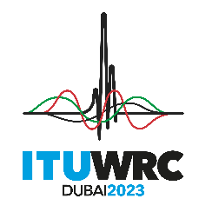
PLENARY MEETING |  | Document 197-E
 |  | 31 October 2023
 |  | Original: English
Ghana
PROPOSALS FOR THE WORK OF THE CONFERENCE
Agenda item 7(B)
7 to consider possible changes, in response to Resolution 86 (Rev. Marrakesh, 2002) of the Plenipotentiary Conference, on advance publication, coordination, notification and recording procedures for frequency assignments pertaining to satellite networks, in accordance with Resolution 86 (Rev.WRC-07), in order to facilitate the rational, efficient and economical use of radio frequencies and any associated orbits, including the geostationary-satellite orbit;
7(B) Topic B - Non-GSO bringing into use post-milestone procedure

NOC GHA/197/1
RESOLUTIONS
Reasons: The first non-GSO systems subject to milestones will reach their 100% milestone as of 1 February 2028, after WRC-27 (see resolves 8c) of Resolution 35 (WRC-19)). Thus, no system will be in a post-milestone situation until after WRC-27. Currently, there is a substantial lack of data necessary to perform an adequate analysis that would determine the threshold values for triggering the post-milestone procedures. This lack of data hampers our ability to make informed decisions and take appropriate actions and it makes sense to wait until that conference to develop post-milestone procedures. Therefore, Ghana recommends that the community wait until WRC-27 to address this issue, after significant experience is gained with the Resolution 35 (WRC-19) milestone process.

_______________

