 | World Radiocommunication Conference (WRC-23)  Dubai, 20 November - 15 December 2023 |  | 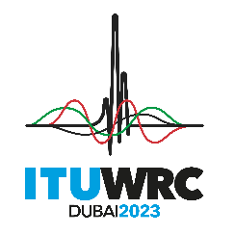
PLENARY MEETING |  | Document 192-E
 |  | 30 October 2023
 |  | Original: English
Mongolia
Proposals for the work of the conference
Agenda item 1.3
1.3 to consider primary allocation of the frequency band 3 600-3 800 MHz to the mobile service in Region 1 and take appropriate regulatory actions, in accordance with Resolution 246 (WRC-19);

ARTICLE 5
Frequency allocations
Section IV – Table of Frequency Allocations
(See No. 2.1)
MOD MNG/192/1
3 600-4 800 MHz
Allocation to services
Region 1 | Region 2 | Region 3
3 600-3 800  FIXED  FIXED-SATELLITE  (space-to-Earth)  MOBILE ADD 5.D13-D | 3 600-3 700  FIXED  FIXED-SATELLITE (space-to-Earth)  MOBILE except aeronautical mobile 5.434  Radiolocation 5.433 | 3 600-3 700  FIXED  FIXED-SATELLITE (space-to-Earth)  MOBILE except aeronautical mobile  Radiolocation  5.435
3 700-4 200
FIXED
FIXED-SATELLITE (space-to-Earth)
MOBILE except aeronautical mobile
3 800-4 200
FIXED
FIXED-SATELLITE
(space-to-Earth)
Mobile

Reasons: The identification of mid-band frequency band for IMT is essential to be able to address digitalization (e.g., sustainable smart cities, industries) and reduce the digital divide in Mongolia.
_______________

