 | World Radiocommunication Conference (WRC-23)  Dubai, 20 November - 15 December 2023 |  | 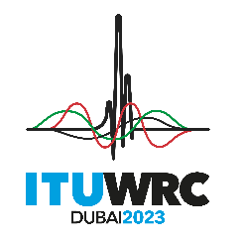
PLENARY MEETING |  | Document 183-E
 |  | 30 October 2023
 |  | Original: English
China (People's Republic of)/Indonesia (Republic of)/Papua New Guinea/Singapore (Republic of)/Tonga (Kingdom of)
PROPOSALS FOR THE WORK OF THE CONFERENCE
Agenda item 10
10 to recommend to the ITU Council items for inclusion in the agenda for the next world radiocommunication conference, and items for the preliminary agenda of future conferences, in accordance with Article 7 of the ITU Convention and Resolution 804 (Rev.WRC-19),
Introduction
China (People's Republic of), Indonesia (Republic of), Papua New Guinea, Singapore (Republic of) and Tonga (Kingdom of) support the inclusion of the following item in the agenda of WRC-27:
Studies on possible revision of sharing conditions for the frequency band 13.75-14 GHz to enable efficient use of the band by uplink fixed-satellite service (FSS) earth stations, including earth stations using smaller antenna sizes.
Proposals
These administrations propose to include this item in the agenda of WRC-27 as follows.

ADD CHN/INS/PNG/SNG/TON/183/1
Draft New Resolution [CHN/INS/PNG/SNG/TON-AI10_WRC-27_AGENDA] (WRC-23)
Agenda for the 2027 World Radiocommunication Conference
The World Radiocommunication Conference (Dubai, 2023),
…
resolves
to recommend to the Council that a WRC be held in 2027 for a maximum period of four weeks, with the following agenda:
1 on the basis of proposals from administrations, taking account of the results of WRC-23 and the Report of the Conference Preparatory Meeting, and with due regard to the requirements of existing and future services in the frequency bands under consideration, to consider the following items and take appropriate action:
…
1.xx to study on possible revision of sharing conditions for the frequency band 13.75-14 GHz to enable efficient use of the band by uplink FSS earth stations, including earth stations using smaller antenna sizes in accordance with draft new Resolution [CHN/INS/PNG/SNG/TON-FSS IN 13.75-14 GHZ] (WRC-23);
...

ADD CHN/INS/PNG/SNG/TON/183/2
Draft New Resolution [CHN/INS/PNG/SNG/TON-
FSS IN 13.75-14 GHZ] (WRC-23)
Studies on possible revision of sharing conditions for the frequency band 13.75-14 GHz to enable efficient use of the band by uplink FSS earth stations, including earth stations using smaller antenna sizes
The World Radiocommunication Conference (Dubai, 2023),
considering
a) that WARC-92 added an allocation to the fixed-satellite service (FSS) (Earth-to-space) in the frequency band 13.75-14 GHz;
b) that WRC-03 modified Nos. 5.502 and 5.503 which, among other things, enabled the use of earth station antennas having minimum diameter limitation of 1.2 m for geostationary (GSO) FSS networks while retaining a minimum antenna diameter of 4.5 m for non-geostationary (non-GSO) FSS systems;
c) that Nos. 5.502 and 5.503 also contain power flux-density, e.i.r.p. and e.i.r.p. density limits to be observed by stations;
d) that there is a great congestion in the GSO arc and there is a need to ensure that orbit and spectrum resources are used efficiently and rationally to facilitate introduction of new satellite networks, in particular those of new satellite operators;
e) that since WRC-03, there has been a significant development of GSO FSS networks where small earth station antennas are seen increasingly used;
f) that there has been a significant increase of non-GSO systems operating in the frequency band 10-15 GHz range for FSS with small diameter earth station antennas and the limitations imposed by Nos. 5.502 and 5.503 may not match with the characteristics of modern non-GSO FSS systems;
g) that there is a lack of uplink bandwidth in the frequency range 13-15 GHz that can be used efficiently, including by small diameter earth station antennas, globally to feed the downlink capacity in the frequency range 10-13 GHz;
h) that this band is shared with the radiolocation service under the conditions set out in No. 5.502;
i) that the space research service has a secondary allocation in this band and the relevant sharing conditions are provided in No. 5.503;
j) that for GSO space stations in the space research service for which information for advance publication has been received by the Bureau prior to 31 January 1992 shall operate on an equal basis with stations in the FSS; after that date, new GSO space stations in the space research service will operate on a secondary basis;
k) that until those GSO space stations in the space research service for which information for advance publication has been received by the Bureau prior to 31 January 1992 cease to operate in this band, the frequency band 13.77-13.78 GHz is shared with the space research service under the conditions set out in No. 5.503;
l) that, in some countries, the band is also allocated to the fixed service and the mobile service (Nos. 5.499 and 5.500) and to the radionavigation service (No. 5.501);
m) that improving operating conditions for earth stations in the frequency band 13.75-14 GHz will help meet the evolving needs for satellite applications and enable efficient and rational use of the frequency bands in 13-15 GHz (Earth-to-space) and 10-13 GHz (space-to-Earth) ranges,
considering further
a) that studies are required to identify possible regulatory changes to meet the growing requirements for spectrum that can be used efficiently by GSO and non-GSO FSS uplink earth stations in the 13-15 GHz range, including by smaller diameter earth station antennas;
b) that in consideration of revising sharing conditions for the 13.75-14 GHz band, there is a need to determine appropriate co-existence conditions between other services sharing the band with their current characteristics and applications and uplink FSS earth stations, in particular noting Nos. 5.502 and 5.503,
resolves to invite ITU-R
to conduct studies, in time for consideration by WRC-27 on possible revisions to the sharing conditions in the frequency band 13.75-14 GHz to facilitate efficient use of the band by uplink GSO and non-GSO FSS earth stations, including use of earth stations with smaller antenna sizes,
invites the 2027 World Radiocommunication Conference
to consider the results of the above studies in resolves to invite ITU-R and take necessary actions, as appropriate.
Reasons: See the following Table that has been prepared using the template given in Annex 2 to Resolution 804 (Rev.WRC-19).

attachment
Template for the submission of proposals for agenda items
Subject: Studies on possible revision of sharing conditions for the frequency band 13.75-14 GHz to enable efficient use of the band by uplink FSS earth stations, including earth stations using smaller antenna sizes
Origin: China (People's Republic of), Indonesia (Republic of), Papua New Guinea, Singapore (Republic of), Tonga (Kingdom of)
Proposal:
To study on possible revision of sharing conditions for the frequency band 13.75-14 GHz to enable efficient use of the band by uplink FSS earth stations, including earth stations using smaller antenna sizes in accordance with draft new Resolution [CHN/INS/PNG/SNG/TON-FSS IN 13.75-14 GHZ] (WRC-23).
Background/reason:

The fixed-satellite service (FSS) has seen a big increase in the number of geostationary (GSO) satellite networks and non-geostationary (non-GSO) satellite systems over the last decades. The use of small diameter FSS earth stations antennas at frequencies around 10-15 GHz has been increasing with the deployment of satellites providing large throughput and broadband connections. Notably is also the large increase over the last decade of non-GSO constellations with large number of satellites offering broadband connections to user terminals with small diameter antennas.

Looking at the portions of Ku-band which is not subject to a space plan in Appendices 30, 30A or 30B of the Radio Regulations (RR), the below figure shows the frequency bands where small user terminals can and cannot be used.

Ku-band for FSS not subject to RR Appendix 30, 30A or 30B

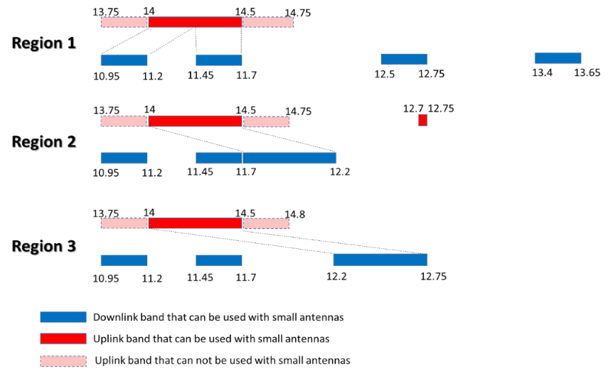

The bandwidths available for use by small diameter FSS earth station antennas in the three ITU-R Regions and the mismatch between up and downlink bandwidth is shown in the below table.
 | Bandwidth (MHz) in the 10-15 GHz range, not subject to RR Appendices 30, 30A or 30B, that can be used by small antennas
 | Downlink | Uplink | Lack of uplink bandwidth to feed downlink bandwidth
Region 1 | 750 (1000) | 500 | 250 (500)
Region 2 | 1000 | 500 | 500
Region 3 | 1050 | 500 | 550

It can be seen that for all three ITU-R Regions, there is a significant mismatch between the uplink and downlink bandwidth in the 10-15 GHz range, not subject to RR Appendices 30, 30A or 30B, that can efficiently be used to provide services by small diameter GSO and non-GSO FSS earth station antennas, e.g. HTS or broadband user terminals and news gathering etc.

The frequency band 13.75-14 GHz was allocated globally by WARC-92 for FSS, but limitations were introduced through RR Nos. 5.502 and 5.503 to enhance compatibilities with other services. These limitations significantly limits the potential for efficient use of the frequency band by FSS earth stations and further enhances the mismatch between uplink and downlink bandwidth. The last review to these footnotes happened 20 years ago at WRC-03, but the efficient use of the 13.75-14 GHz band, including the use of smaller diameter GSO and non-GSO FSS uplink earth station antennas in this frequency band is still not allowed.

For RR No. 5.502, a review on the FSS earth station limitations could reduce the mismatch between the uplink and downlink Ku band, and alleviate the pressure and increasing need for the use of small diameter FSS earth station antenna in the Ku band. Preliminary studies have indicated that the use of small diameter FSS earth station antenna sizes could keep the potential interference into radiolocation and radionavigation services unchanged.

For RR No. 5.503, FSS earth stations need to protect five specific SRS receiving earth stations within eight SRS networks on a global scale. Preliminary studies have also indicated that among the five GSO to non-GSO space-to-space TDRS links, only one ISS link is valid which needs to be protected until year 2030. Consideration of case-by-case site-specific sharing conditions instead of global limitations therefore would be a better approach.
To meet the evolving demands for FSS satellite applications in the 10-15 GHz range, studies on possible revision of sharing conditions for the frequency band 13.75-14 GHz required to enable efficient use of the band by uplink FSS earth stations, including earth stations using smaller antenna sizes.
Radiocommunication services concerned:
The allocated radiocommunication services in the 13.75-14 GHz band, in particular the radiolocation and space research services.
Indication of possible difficulties:
To be identified during the course of studies.
Previous/ongoing studies on the issue:
Studies during WRC-03 study period.
Studies to be carried out by: ITU-R WP 4A as responsible group | with the participation of: ITU-R WP 5B, 7B
ITU-R study groups concerned: ITU-R SG 4, SG 5 and SG 7

ITU resource implications, including financial implications (refer to CV126): Work to be conducted as a part of the regular work of the involved ITU-R working parties. No direct financial implications have been identified to date.
Common regional proposal: No | Multicountry proposal: Yes  Number of countries: 5
Remarks

________________

