 | World Radiocommunication Conference (WRC-23)  Dubai, 20 November - 15 December 2023 |  | 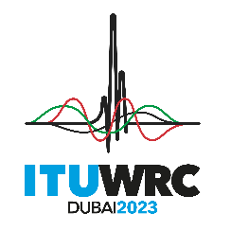
PLENARY MEETING |  | Document 155-E
 |  | 30 October 2023
 |  | Original: English
Viet Nam (Socialist Republic of)
PROPOSALS FOR THE WORK OF THE CONFERENCE
Agenda item 1.10
1.10 to conduct studies on spectrum needs, coexistence with radiocommunication services and regulatory measures for possible new allocations for the aeronautical mobile service for the use of non-safety aeronautical mobile applications, in accordance with Resolution 430 (WRC-19);

NOC VTN/155/1
ARTICLES
Reasons: There is no clear and concrete outcomes from coexistence studies between proposing non-safety aeronautical mobile service (AMS) and existing services. Therefore, NOC is proposed to ensure the protection of primary services in the frequency bands considered (15.4-15.7 GHz and 22-22.21 GHz) and, as appropriate, in adjacent frequency bands.
NOC VTN/155/2
APPENDICES
Reasons: See above reasons.
SUP VTN/155/3
RESOLUTION 430 (WRC-19)
Studies on frequency-related matters, including possible additional allocations, for the possible introduction of new non-safety aeronautical mobile applications
Reasons: It is no longer necessary.
_______________

