|  |  |  |  |
| --- | --- | --- | --- |
|  | **World Radiocommunication Conference (WRC-23) Dubai, 20 November - 15 December 2023** | |  |
|  | |  | |
|  | |  | |
| PLENARY MEETING | | **Addendum 16 to Document 153-E** | |
|  | | **30 October 2023** | |
|  | | **Original: English** | |
|  | | | |
| Korea (Republic of) | | | |
| PROPOSALS FOR THE WORK OF THE CONFERENCE | | | |
|  | | | |
| Agenda item 1.16 | | | |

1.16 to study and develop technical, operational and regulatory measures, as appropriate, to facilitate the use of the frequency bands 17.7-18.6 GHz, 18.8-19.3 GHz and 19.7-20.2 GHz (space-to-Earth) and 27.5-29.1 GHz and 29.5-30 GHz (Earth-to-space) by non-geostationary fixed-satellite service earth stations in motion, while ensuring due protection of existing services in those frequency bands, in accordance with Resolution **173 (WRC‑19)**;

Introduction

WRC‑23 agenda item 1.16 considers the use of the frequency bands 17.7-18.6 GHz, 18.8-19.3 GHz, 19.7-20.2 GHz (space-to-Earth), 27.5-29.1 GHz and 29.5-30 GHz (Earth-to-space) by earth stations in motion communicating with non-geostationary (non-GSO) space stations in the fixed-satellite service (FSS). The studies under this agenda item considered two types of earth stations in motion (ESIMs): aeronautical and maritime only. Studies have been carried out on sharing and compatibility between ESIM and terrestrial as well as space services allocated in the frequency bands above. For this agenda item, two methods have been identified:

Method A

No changes to the Radio Regulations and suppression of Resolution **173 (WRC‑19)**.

Method B

Add a new footnote in RR Article **5** that refers to a new WRC Resolution with technical, operational and regulatory conditions for the operation of non-GSO maritime and aeronautical ESIMs while ensuring protection of allocated services and consequential suppression of Resolution **173 (WRC‑19)**.

The Republic of Korea supports Method A above. It should be noted, however, that Method B can be acceptable if every and all problems, difficulties, inconsistencies, ambiguities and not yet addressed issues as well as those contained in the associated attached Resolution for this agenda item are dully and fully addressed and successfully resolved and agreed by consensus.

In addition, the Republic of Korea provides a study result on the impact of aggregate interference from multiple non-GSO A-ESIMs to terrestrial services with regard to the application of the pfd mask in Resolution **169 (WRC‑19)** as attachment to this contribution.

Proposals

The proposals for WRC‑23 agenda item 1.16 are as shown below and highlighted in yellow.

ADD KOR/153A16/1#1885

draft new RESOLUTION [A116] (WRC‑23)

Use of the frequency bands 17.7-18.6 GHz, 18.8-19.3 GHz and 19.7-20.2 GHz (space-to-Earth) and 27.5-29.1 GHz and 29.5-30 GHz (Earth-to-space) by   
aeronautical and maritime earth stations in motion communicating   
with non-geostationary space stations in the fixed-satellite service

The World Radiocommunication Conference (Dubai, 2023),

considering

*a)* that there is a need for global broadband mobile satellite communications, and that some of this need could be met by allowing earth stations in motion (ESIMs) to communicate with space stations of the non-geostationary-satellite orbit (non-GSO) fixed-satellite service (FSS) operating in the frequency bands 17.7-18.6 GHz, 18.8-19.3 GHz and 19.7-20.2 GHz (space-to-Earth), and 27.5-29.1 GHz and 29.5-30.0 GHz (Earth-to-space);

*b)* that the frequency bands 17.7-18.6 GHz, 18.8-19.3 GHz and 19.7-20.2 GHz (space-to-Earth) and 27.5-29.1 GHz and 29.5-30 GHz (Earth-to-space) are allocated to space services, and the frequency bands 17.7-18.6 GHz, 18.8-19.3 GHz, and 27.5-29.1 GHz are allocated to terrestrial services on a primary basis worldwide; in the countries identified in No. **5.524** of the Radio Regulations, the frequency band 19.7-20.2 GHz is allocated to the fixed and mobile services on a primary basis; and, in the countries identified in No. **5.542** of the Radio Regulations, the frequency band 29.5-30 GHz is allocated to the fixed and mobile services on a secondary basis, and used by a variety of different systems and these existing services and their future development need to be protected, without any additional constraints, from the operation of non-GSO ESIMs;

*c)* that the frequency band 18.6-18.8 GHz is allocated to the Earth exploration-satellite service (EESS) (passive) and space research service (SRS) (passive) and that these services need to be protected from operation of non-GSO ESIMs in the space-to-Earth direction;

*d)* that there is no specific regulatory procedure for the coordination of non-GSO ESIMs relative to terrestrial stations for these services since the frequency bands 17.7-18.6 GHz, 18.8-19.3 GHz and 19.7-20.2 GHz (space-to-Earth) and 27.5-29.1 GHz and 29.5-30 GHz (Earth-to-space) are not allocated for the operation of non-GSO ESIMs;

*e)* that regulatory procedures and interference-management mechanisms, including necessary mitigation measures, are required for the operation of non-GSO ESIMs to protect other space and terrestrial services allocated in the frequency bands mentioned in *considering a)*,

considering further

*a)* that aeronautical and maritime ESIMs operating within the service area of the non-GSO FSS systems with which they communicate may provide service only within the territories under the jurisdiction of multiple administrations;

*b)* that this Resolution does not establish any technical or regulatory provisions for the operation and use of land ESIMs communicating with non-GSO FSS space stations, and any authorization of land ESIMs remains strictly a national matter, taking also into account the need to avoid cross-border interference;

recognizing

*a)* that the administration authorizing non-GSO ESIMs on the territory under its jurisdiction has the right to require that non-GSO ESIMs referred to above only use those assignments associated with non-GSO FSS systems which have been successfully coordinated, notified, brought into use and recorded in the Master International Frequency Register (MIFR) with a favourable finding under Articles **9** and **11**, including Nos. **11.31**, **11.32** or **11.32A**, where applicable;

*b)* that the provisions of No.**22.2** apply to non-GSO FSS satellite systems with which ESIMs operate in the frequency band 17.7-17.8 GHz (space-to-Earth) with respect to GSO FSS and GSO BSS networks;

*c)* that, under the provisions of No. **22.2**, non-GSO ESIMs in the frequency bands 17.8-18.6 GHz and 19.7-20.2 GHz shall not claim protection from GSO FSS and GSO BSS networks operating in accordance with these Regulations, and non-GSO ESIMs in the frequency bands 27.5-28.6 GHz and 29.5-30 GHz shall not cause unacceptable interference to GSO FSS and GSO BSS networks operating in accordance with the Radio Regulations, and No. **5.43A** does not apply in this case;

*d)* that there is no obligation for administration to authorize/license any non-GSO ESIMs to operate within the territory under its jurisdiction;

*e)* that, for the implementation of the relevant parts of *resolves* 1.1.3 below that a non-GSO FSS system operating in the frequency bands 17.8-18.6 GHz and 19.7-20.2 GHz (space-to-Earth) and 27.5-28.6 GHz and 29.5-30 GHz (Earth-to-space) in compliance with the epfd limits referred to in Nos. **22.5C**, **22.5D** and **22.5F** is considered as having fulfilled its obligations under No. **22.2** with respect to any geostationary-satellite network;

*f)* that, with respect to GSO FSS networks, in the frequency bands 18.8-19.3 GHz (space-to-Earth) and 28.6-29.1 GHz (Earth-to-space) Nos. **9.12A** and **9.13** apply, and No. **22.2** does not apply;

*g)* that, for the use of the frequency bands 17.7-18.6 GHz, 18.8-19.3 GHz and 19.7-20.2 GHz (space-to-Earth) and 27.5‑29.1 GHz and 29.5-30 GHz (Earth-to-space) by non-GSO FSS systems, No. **9.12** applies,

recognizing further

*a)* that frequency assignments to non-GSO ESIMs need to be notified to the Radiocommunication Bureau (BR);

*b)* that the notification by different administrations of frequency assignments to be used by the same non-GSO satellite system may create difficulties to identify the responsible administration in case of unacceptable interference;

*c)* that, an administration authorizing the operation of non-GSO ESIMs within the territory under its jurisdiction may modify or withdraw that authorization at any time,

resolves

1 that, for any aeronautical or maritime ESIM communicating with non-GSO FSS space stations in the frequency bands 17.7-18.6 GHz, 18.8-19.3 GHz and 19.7-20.2 GHz (space-to-Earth) and 27.5‑29.1 GHz and 29.5-30 GHz (Earth-to-space), or parts thereof, the following conditions shall apply:

1.1 with respect to space services in the frequency bands 17.7-18.6 GHz, 18.8-19.3 GHz, 19.7-20.2 GHz (space-to-Earth), and 27.5-29.1 GHz and 29.5-30 GHz (Earth-to-space), and in their adjacent bands in the frequency band 18.6-18.8 GHz, non-GSO ESIMs shall comply with the following conditions:

1.1*bis* an administration the territory of which is situated inside the service area of a non-GSO FSS satellite system and has provided explicit authorization to receive the service/to be served by any aeronautical or maritime ESIM has no obligation nor any mandate, whatsoever, to be involved directly or indirectly in detection, identification, reporting, resolution of any interference caused by the operation of the ESIM the operation of which was authorized:

1.1.1 to prevent potential interference with respect to satellite networks or systems of other administrations non-GSO ESIMs characteristics shall remain within the envelope characteristics of typical earth stations associated with the non-GSO FSS system with which these ESIMs communicate;

1.1.1.1 for the implementation of *resolves* 1.1.1 above, the notifying administration for the non-GSO FSS system with which the non-GSO ESIMs communicate shall, in accordance with this Resolution, send to the Bureau Appendix **4** notification information related to the characteristics of the non-GSO ESIMs intended to communicate with that non-GSO FSS system, together with the commitment that the operation shall be in conformity with the Radio Regulations, including this Resolution;

1.1.1.2 upon receipt of the notification information referred to in *resolves* 1.1.1.1 above, the Bureau shall examine it with respect to the provisions referred to in *resolves* 1.1.1 above, including the commitment referred to in *resolves* 1.1.1.1 above, and publish the result of such examination in the International Frequency Information Circular (BR IFIC);

1.1.2 the notifying administration of the non-GSO FSS system with which the ESIMs communicate shall ensure that the operation of ESIMs complies with the coordination agreements for the frequency assignments of the typical earth station of this non-GSO FSS system obtained under the provisions of Article **9** of the Radio Regulations, in particular, into account *recognizing b)*;

1.1.3 notifying administration of the non-GSO FSS system with which the ESIMs communicate shall ensure that non-GSO ESIMs comply with the epfd limits referred to in Nos. **22.5C**, **22.5D** and **22.5F** for the protection of GSO FSS networks operating in the frequency bands 17.8-18.6 GHz, 19.7-20.2 GHz (space-to-Earth), 27.5-28.6 GHz and 29.5-30 GHz (Earth-to-space);

1.1.4 non-GSO ESIMs shall not claim protection from BSS feeder-link earth stations operating in accordance with the Radio Regulations in the frequency band 17.7‑18.4 GHz;

1.1.5 with respect to protection of EESS (passive) operating in the frequency band 18.6-18.8 GHz, any non-GSO FSS systems with an orbital apogee of less than 20 000 km operating in the frequency bands 18.3-18.6 GHz and 18.8-19.1 GHz with which aeronautical and/or maritime ESIMs communicate and for which the complete notification information has been received by the BR after 1 January 2025 shall comply with the provisions indicated in Annex 3 to this Resolution;

1.1.5.1 for the implementation of *resolves*1.1.5 above, the notifying administration for the non-GSO FSS system with which the non-GSO ESIMs communicate shall send to the BR the relevant Appendix **4** notification information including the commitment that the operation shall be in conformity with *resolves*1.1.5;

1.2 with respect to terrestrial services in the frequency bands 17.7‑18.6 GHz, 18.8-19.3 GHz, 19.7-20.2 GHz, 27.5-29.1 GHz and 29.5-30 GHz, non-GSO ESIMs shall comply with the following conditions:

1.2.1 receiving non-GSO ESIMs in the frequency bands 17.7-18.6 GHz and 18.8-19.3 GHz and 19.7-20.2 GHz (see No. **5.524**) shall not claim protection from assignments in the terrestrial services to which those frequency bands are allocated and that operate in accordance with the Radio Regulations;

1.2.2 transmitting non-GSO ESIMs in the frequency band 27.5-29.1 GHz shall not cause unacceptable interference to terrestrial services to which the frequency band is allocated and that operate in accordance with the Radio Regulations, and Annex 1 to this Resolution shall apply;

1.2.2*bis* for the implementation of *resolves* 1.2.2, the following actions need to be pursued:

*a)* the notifying administration of non-GSO ESIMs when submitting Appendix **4** information/data elements shall also send a firm objective, measurable, enforceable and actionable evidence commitment that in case of reported unacceptable interference, it shall immediately cease the interference or reduce it to an acceptable level;

*b)* in the commitment the notifying administration of non-GSO ESIMs shall state that in case of no action taken in regard with obligation referred to in section *a)* above the Bureau shall send a reminder and request that administration to comply with the requirements referred to in the commitment;

*c)* should the interference continue to persist after the expiration of the 30‑day period from the dispatch date of the above-mentioned reminder, the Bureau shall submit the case to the subsequent meeting of the Radio Regulations Board for review and necessary action, as appropriate;

1.2.3 transmitting non-GSO ESIMs in the frequency band 29.5-30.0 GHz shall not adversely affect the operations of terrestrial services to which this frequency band is allocated on secondary basis and that operate in accordance with the Radio Regulations, and limits in Annex 1 to this Resolution shall apply with respect to administrations mentioned in No. **5.542**;

1.2.4 the provisions in this Resolution, including Annex 1, set the conditions for the purpose of protecting terrestrial services from unacceptable interference from non-GSO ESIMs in neighbouring countries in accordance with the provisions included in *resolves* 1.2.2 and 1.2.3 above in the frequency band 27.5-29.1 GHz and in the frequency band 29.5‑30.0 GHz with respect to administrations mentioned in No.**5.542**; however, the requirement not to cause unacceptable interference to, or claim protection from, terrestrial services to which the frequency bands are allocated and operating in accordance with the Radio Regulations remains valid (see *resolves* 6);

1.2.5 the Bureau shall examine, in accordance with the provisions included in *resolves* 1.2.2 and 1.2.3 and with the methodology in Annex 2, the characteristics of aeronautical non‑GSO ESIMs with respect to the conformity with the power flux-density (pfd) limits on the Earth’s surface specified in Part 2 of Annex 1 to this Resolution and publish the results of such examination in the BR IFIC;

1.2.5.1 however, the compliance with the technical conditions in Annex 1, does not release the notifying administration of the A-ESIM and M-ESIM with respect to discharging its responsibility that such earth station shall not cause unacceptable interference and any interrelated receiving part shall not claim protection from the terrestrial stations;

1.3 that, in the case unacceptable interference caused by A‑ESIM and/or M‑ESIM is reported:

1.3.1 only the notifying administration of the non-GSO FSS system with which ESIMs communicate is responsible for resolving the case of unacceptable interference;

1.3.2 the notifying administration of the non-GSO FSS system with which the ESIMs communicate shall immediately take the required action to eliminate or reduce interference to an acceptable level;

1.3.3 the affected administration(s) may assist resolving or provide information that would facilitate resolving the case of unacceptable interference subject to their explicit agreement;

1.3.4 the administration authorizing the operation of A‑ESIM and M‑ESIM on territory under its jurisdiction, subject to its explicit agreement, may provide assistance, including information for the resolution of unacceptable interference;

1.3.5 the administration responsible for the aircraft or vessel on which the ESIM operates shall provide a point of contact to assist identifying the notifying administration of the satellite with which the ESIM communicates;

1.4 that the notifying administration of non-GSO FSS satellite system with which ESIMs communicate shall ensure that:

1.4.1 for the operation of A‑ESIM and M‑ESIM, techniques are employed to maintain adequate antenna pointing accuracy with the associated non-GSO FSS satellite;

1.4.2 all necessary measures shall be taken so that non-GSO ESIMs are subject to permanent monitoring and control by a Network Control and Monitoring Centre (NCMC) in order to comply with the provisions in this Resolution, and are capable of receiving and immediately acting upon inter alia “enable transmission” and “disable transmission” commands from the NCMC (see Annex 4);

1.4.3 measures are taken so that the A‑ESIM and/or M‑ESIM do not transmit on the territory under the jurisdiction of an administration, including its territorial waters and its national airspace, that has not authorized its use;

1.4.4 the notifying administration of the non-GSO FSS system with which ESIMs communicate shall provide a permanent point of contact in the Appendix **4** submission and this shall be published in the relative special section of the BR IFIC for the purpose of tracing any suspected cases of unacceptable interference from A‑ESIMs or M‑ESIMs and for the purpose of immediately responding to the relevant requests;

2 that non-GSO ESIMs shall not be used or relied upon for safety-of-life applications;

3 that the operation of non-GSO ESIMs within the territory, including territorial waters and airspace, under the jurisdiction of any administration shall be carried out only if an authorization or a licence according to No. **18.1** from that administration is obtained;

4 that the notifying administrations of those non-GSO FSS systems with which non-GSO ESIMs in the frequency bands in *considering a)* above are intended to operate shall submit a commitment to the Bureau to immediately act to eliminate or reduce the interference to an acceptable level upon receiving a report of unacceptable interference (see *resolves*5);

5 in case there is more than one administration involved in the notification of frequency assignments of the same non-GSO satellite system with which ESIMs communicate, those administrations shall nominate one administration as the notifying administration responsible to act on their behalf to be responsible to eliminate any unacceptable interference cases and inform the Bureau accordingly;

6 that the application of this Resolution does not provide regulatory status to non-GSO ESIMs different from that derived from the non-GSO FSS satellite system with which they communicate, taking into account the provisions referred to in this Resolution (see *recognizing b)*,

7 that any course of action taken under this Resolution has no impact on the original date of receipt of the frequency assignments of the non-GSO FSS satellite system with which non-GSO ESIMs communicate or on the coordination requirements of that satellite system;

8 the implementation of this Resolution is conditioned on providing a description to the administrations whose authorization is sought of interference management system(s), monitoring facilities (NCMC), dealing with the cessation of transmission over territories which have not authorized (*see resolves*3) the functioning and operation of any ESIM over their territories in order to provide a satisfactory resolution of the problem as referred to in *recognizing further d)* above,

NOTE: Provided the description mentioned above is properly addressed and concluded, *resolves*9 above may be deleted at WRC‑23.

resolves further

1 that ESIMs shall not cause unacceptable interference to nor claim protection from other services as referred to *recognizing c)* and *d)* and in *resolves*1.1.1.1, 1.1.6.1, 1.2.1 and 1.2.4;

2 that the notifying administration for the ESIMs shall send to the BR, when submitting the relevant Appendix **4** data a commitment (as stipulated in *resolves*5) that, upon receiving a report of unacceptable interference, the notifying administration for the non-GSO system with which ESIMs communicate shall remove such interference;

3 that the commitment referred to in *resolves further*2 shall be objective, measurable and enforceable;

4 that, in case of continued unacceptable interference despite of the commitment referred to in *resolves further*2, the assignment causing interference shall be submitted to the Radio Regulation Board for review;

5 that compliance with the provisions contained in Annex 1 does not release the notifying administration of the non-GSO satellite system with which ESIMs communicate of its obligations mentioned in *resolves further*1 above;

6 that frequency assignments to ESIMs shall be notified by the notifying administration of the non-GSO satellite system in the FSS with which ESIMs communicate;

7 that the notifying administration of the satellite system shall ensure that non-GSO ESIMs operate only in the territory under the jurisdiction of administrations from which an authorization has been obtained, taking into account *recognizing further* *c)*;

8 that ESIMs shall be designed and operate so as to cease transmission over the territory of any administration/country from which authorization has not been obtained;

9 that, for the implementation of *resolves further* 1, the notifying administration responsible for the operation of aeronautical and maritime non-GSO ESIMs shall also be responsible for observing and complying with all relevant regulatory and administrative provisions applicable to the operation of the ESIMs as included in this Resolution and those contained in the Radio Regulations;

10 that the authorization to non-GSO ESIM to operate in the territory under the jurisdiction of an administration shall in no way release the notifying administration of the non‑GSO satellite system with which the non-GSO ESIM communicates from the obligation to comply with the provisions included in this Resolution and those contained in the Radio Regulations;

11 that, should an administration authorizing aeronautical and/or maritime non-GSO ESIMs agree to less stringent limits than those contained Annex 1 within the territory under its jurisdiction, such agreement shall not affect other countries that are not party to that agreement,

instructs the Director of the Radiocommunication Bureau

1 to take all necessary actions to facilitate the implementation of this Resolution, together with providing any assistance for the resolution of interference, when required;

2 to report to future world radiocommunication conferences any difficulties or inconsistencies encountered in the implementation of this Resolution, including whether or not the responsibilities relating to the operation of aeronautical and maritime non-GSO ESIMs have been properly addressed;

3 not to examine, under No. **11.31**, the conformity of non-GSO FSS systems with the provisions of *resolves*1.1.5 of this Resolution,

4 to report to future world radiocommunication conferences any difficulties or inconsistencies encountered in the implementation of Recommendation ITU‑R S.1503 for verifying that the non-GSO FSS systems under this Resolution comply with the epfd limits specified in Article **22**;

5 to publish the list of non-GSO satellite systems with which ESIM communicate brought into use with information about its service area and countries authorize such use if any; this information shall be updated regularly,

invites administrations

to take into consideration the relevant recommendations to employ Annex 4 procedures when licensing/authorizing the operation of earth stations in motion in their territories,

instructs the Secretary-General

to bring this Resolution to the attention of the Secretary-General of the International Maritime Organization and of the Secretary General of the International Civil Aviation Organization.

Annex 1 to draft new Resolution [A116] (WRC‑23)

Provisions for maritime and aeronautical non-GSO ESIMs to protect terrestrial services operating in the frequency band 27.5-29.1 GHz and for the frequency band 29.5-30.0 GHz with respect to/on the territories of/in relation to administrations mentioned in No. 5.542 /

The parts below contain provisions to ensure that maritime and aeronautical non-GSO ESIMs do not cause unacceptable interference in neighbouring countries to terrestrial service operations when non‑GSO ESIMs operate in frequencies overlapping with those used by terrestrial services at any time to which the frequency band 27.5-29.1 GHz is allocated and operating in accordance with the Radio Regulations. The provisions below also apply for the operation of the non‑GSO ESIMs in the frequency band 29.5-30 GHz with respect to administrations mentioned in No. **5.542**.

Part 1: Maritime non-GSO ESIMs

1 The notifying administration of the non-GSO FSS satellite system with which maritime ESIMs communicates shall ensure compliance of the maritime ESIMs operating within the frequency bands 27.5-29.1 GHz and 29.5-30 GHz, or parts thereof, with both of the following conditions for the protection of terrestrial services to which the frequency bands are allocated within a coastal State:

1.1 The minimum distance from the low-water mark as officially recognized by the coastal State beyond which maritime ESIMs can operate without the prior agreement of any administration is 70 km. Any transmissions from maritime ESIMs within the minimum distance shall be subject to the prior agreement of the coastal State(s) concerned.

1.2 The maximum maritime ESIMs e.i.r.p. spectral density towards the territory of any coastal State shall be limited to 12.98 dBW in a reference bandwidth of 1 MHz. Transmissions from maritime ESIMs with higher e.i.r.p. spectral density levels towards the territory of any coastal State shall be subject to the prior agreement of the coastal State(s) concerned.

Part 2: Aeronautical non-GSO ESIMs

2 The notifying administration of the non-GSO FSS satellite system with which aeronautical ESIMs communicates shall ensure compliance of the aeronautical ESIMs operating within the frequency bands 27.5-29.1 GHz and 29.5-30 GHz, with all of the following conditions for the protection of the terrestrial services to which the frequency bands are allocated:

2.1 When within line-of-sight of the territory of an administration, and above an altitude of 3 km, the maximum pfd produced at the surface of the Earth on the territory of an administration by emissions from a single aeronautical ESIM shall not exceed:

pfd(θ) = −136.2 (dB(W/(m2 ∙ [1] MHz))) for 0° ≤ θ ≤ 0.01°

pfd(θ) = −132.4 + 1.9 ∙ logθ (dB(W/(m2 ∙ 1 MHz))) for 0.01° < θ ≤ 0.3°

pfd(θ) = −127.7 + 11 ∙ logθ (dB(W/(m2 ∙ 1 MHz))) for 0.3° < θ ≤ 1°

pfd(θ) = −127.7 + 18 ∙ logθ (dB(W/(m2 ∙ 1 MHz))) for 1° < θ ≤ 2°

pfd(θ) = −129.4 + 23.7 ∙ logθ (dB(W/(m2 ∙ 1 MHz))) for 2° < θ ≤ 8°

pfd(θ) = −108 (dB(W/(m2 ∙ 1 MHz))) for 8° < θ ≤ 90.0°

where θ is the angle of arrival of the radio-frequency wave (degrees above the horizon).

2.2 When within line-of-sight of the territory of an administration, and up to an altitude of 3 km, the maximum pfd produced at the surface of the Earth on the territory of an administration by emissions from a single aeronautical ESIM shall not exceed:

pfd(θ) = −136.2 (dB(W/(m2 ∙ 1 MHz))) for 0° ≤ θ ≤ 0.01°

pfd(θ) = −132.4 + 1.9 ∙ logθ (dB(W/(m2 ∙ 1 MHz))) for 0.01° < θ ≤ 0.3°

pfd(θ) = −127.7 + 11 ∙ logθ (dB(W/(m2 ∙ 1 MHz))) for 0.3° < θ ≤ 1°

pfd(θ) = −127.7 + 18 ∙ logθ (dB(W/(m2 ∙ 1 MHz))) for 1° < θ ≤ 12.4°

pfd(θ) = −108 (dB(W/(m2 ∙ 1 MHz))) for 12.4° < θ ≤ 90°

where θ is the angle of arrival of the radio-frequency wave (degrees above the horizon).

2.3 The pfd levels provided in §§ 2.1 and 2.2 above relate to the pfd and angles of arrival that shall be obtained attenuation due to the aircraft fuselage. Unless there is an available ITU‑R Recommendation to calculate attenuation due to the aircraft fuselage in the frequency bands 27.5-29.1 GHz and 29.5-30 GHz, the following figure shall be used for the calculation of attenuation due to the aircraft fuselage in these bands.



Option 2:



2.4 An aeronautical ESIM operating in the frequency bands 27.5-29.1 GHz and 29.5-30 GHz, or portions thereof, within the territory of an administration that has authorized fixed-service and/or mobile-service operation in the same frequency bands shall not transmit in these frequency bands without prior agreement of that administration.

2.5 The maximum power in the out-of-band domain should be attenuated below the maximum output power of the aeronautical ESIM transmitter as described in Recommendation ITU‑R SM.1541.

Annex 2 to draft new Resolution [A116] (WRC‑23)

Methodology with respect to the examination referred to in Scenario 1 *resolves*1.2.5

*NOTE: The methodology needs to be developed based on a new Recommendation ITU‑R [Methodology]. It should be noted that the Recommendation was developed for GSO aeronautical ESIM. The methodology in this Annex must be for non-GSO aeronautical ESIM.*

# 1 Overview

The methodology below is a functional description to conduct examination of A‑ESIM operating with non-GSO satellite systems and their conformity with power flux-density limits specified in Part II of Annex 1 in this Resolution.

# 2 A-ESIM parameters required for the examination

To conduct the relevant examination of A-ESIM and their conformity with respect to the pfd limits, the following parameters are required:

‒ satellite network name;

‒ A-ESIM peak antenna gain;

‒ A-ESIM power density and bandwidth as given in Table 1;

‒ fuselage attenuation mask expressed as a function of the angle below the horizon of the A‑ESIM based on ITU-R reports or recommendations.

# 3 Examination methodology

## 3.1 Introduction

An A-ESIM can operate at different locations defined by latitude, longitude and altitude. This methodology determines the maximum allowable power, *Pj*, for an A-ESIM transmitter communicating with a non-GSO FSS satellite to ensure compliance with the pre-established pfd limits to protect terrestrial services, at all positions, for a defined set of altitude ranges. The methodology derives the *Pj*taking into account the relevant loss and attenuation in the geometry considered.

The methodology then compares the computed *Pj* with the range of notified power for the A-ESIM emission. The minimum and the maximum power values of the emission *Pmin_emission,j* and *Pmin_emission,j* of the A-ESIM are calculated from the data included in the Appendix **4** Notification information of the non-GSO satellite system with which the A-ESIM communicates and from the A‑ESIM characteristics.

A-ESIM are evaluated over a number of predefined altitude ranges in order to establish a number of *Pj*levels.

An examination by the Bureau should apply this methodology for the defined altitude range, to determine whether the A-ESIM operating under a given non-GSO satellite system complies with the pre-established pfd limits to protect terrestrial services.

## 3.2 Parameters and Geometry

Considering a hypothetical GSO FSS network, Table 1 below provides an example of emissions that are included in one Group associated to the “UO” class of earth station transmitting in the 27.5-29.5 GHz band. Tables 2 to 4 provide additional assumptions and Figure 1 illustrates the geometry involved in the examination.

TABLE 1

Example of a group of A-ESIM emissions  
(with reference to relevant Appendix 4 data fields)

|  |  |  |  |  |
| --- | --- | --- | --- | --- |
| Emission n. | C.7.a Designation of emission | *BWemission*MHz | C.8.c.3 Minimum power density  dB(W/Hz) | C.8.a.2/C.8.b.2 Maximum power density  dB(W/Hz) |
| 1 | 6M00G7W-- | 6.0 | −69.7 | −66.0 |
| 2 | 6M00G7W-- | 6.0 | −64.7 | −61.0 |
| 3 | 6M00G7W-- | 6.0 | −59.7 | −56.0 |

TABLE 2

Additional example assumptions

| ID | Parameter | Notation | Value | Unit |
| --- | --- | --- | --- | --- |
| 1 | Frequency assignment | *f* | 29.5 | GHz |
| 2 | Reference bandwidth of pfd mask | *BWRef* | 1.0 | MHz |
| 3 | A-ESIM antenna peak gain | *Gmax* | 37.5 | dBi |
| 4 | A-ESIM antenna gain pattern | – | As per Rec. ITU-R S.580 (see C.10.d.5.a) |  |

TABLE 3

Additional assumptions defined in the methodology

| ID | Parameter | Notation | Value | Unit |
| --- | --- | --- | --- | --- |
| 8 | A-ESIM minimum elevation angle towards GSO satellite | *ε* | 10 | degrees |
| 9 | Atmospheric attenuation | *Latm* | Computed with Rec. ITU‑R P.676 (see NOTE below) | dB |
| 10 | Angle of arrival of the incident wave on the Earth’s surface |  | Specified by the pre-established sets of pfd limits, variable from 0° to 90° | deg |
| 11 | Minimum examination altitude | *Hmin* | 0.01 | km |
| 12 | Maximum examination altitude | *Hmax* | 15.0 | km |
| 13 | Examination altitude spacing[1]1 | *Hstep* | 1.0 | km |
| 14 | Fuselage attenuation | *Lf* | Computed based on ITUR Reports or Recommendations  (see Table 4) | dB |

NOTE: The atmospheric attenuation is computed with Recommendation ITU‑R P.676, with the mean annual global reference atmosphere as defined in Recommendation ITU‑R P.835.

Figure 1

Geometry for the examination of compliance for two different A-ESIM altitudes

TABLE 4

Fuselage attenuation model

|  |  |  |  |
| --- | --- | --- | --- |
|  | dB | for | 0°≤ γ ≤ 10° |
|  | dB | for | 10°< γ ≤ 34° |
|  | dB | for | 34°< γ ≤ 50° |
|  | dB | for | 50°< γ ≤ 90° |

Notes:

• This fuselage attenuation model is based on measurements made at 14.2 GHz (see Fig. 3.6-14 in Report ITU‑R M.2221-0);

•Tables 5A and 5B are taken from Part II of Annex 3 of Resolution **169** **(WRC‑19)**.The reference bandwidth for the sets of pfd limits included in Table 5A and Table 5B are 1 MHz and 14 MHz, respectively.

TABLE 5A

Required conformance pfd mask for altitudes up to 3 km

pfd(δ) = −136.2 (dB(W/(m2 ∙ 1 MHz))) for 0° ≤ δ ≤ 0.01°

pfd(δ) = −132.4 + 1.9 ∙ log δ (dB(W/(m2 ∙ 1 MHz))) for 0.01° < δ ≤ 0.3°

pfd(δ) = −127.7 + 11 ∙ log δ (dB(W/(m2 ∙ 1 MHz))) for 0.3° < δ ≤ 1°

pfd(δ) = −127.7 + 18 ∙ log δ (dB(W/(m2 ∙ 1 MHz))) for 1° < δ ≤ 12.4°

pfd(δ) = −108 (dB(W/(m2 ∙ 1 MHz))) for 12.4° < δ ≤ 90°

TABLE 5B

Required conformance pfd mask for altitudes above 3 km

pfd(δ) = −136.2 (dB(W/(m2 ∙ 1 MHz))) for 0° ≤ δ ≤ 0.01°

pfd(δ) = −132.4 + 1.9 ∙ log δ (dB(W/(m2 ∙ 1 MHz))) for 0.01° < δ ≤ 0.3°

pfd(δ) = −127.7 + 11 ∙ log δ (dB(W/(m2 ∙ 1 MHz))) for 0.3° < δ ≤ 1°

pfd(δ) = −127.7 + 18 ∙ log δ (dB(W/(m2 ∙ 1 MHz))) for 1° < δ ≤ 2°

pfd(δ) = −129.4 + 23.7 ∙ log δ (dB(W/(m2 ∙ 1 MHz))) for 2° < δ ≤ 8°

pfd(δ) = −108 (dB(W/(m2 ∙ 1 MHz))) for 8° < δ ≤ 90.0°

## 3.3 Calculation algorithm

This section includes a step-by-step description of how the examination methodology would be implemented.

**START**

i) For each A-ESIM altitude, it is necessary to generate as many δ*n* angles (angle of arrival of the incident wave) as required in order to test the full compliance with the applicable set of pfd limits. The *N* angles δ*n* must be comprised between 0° and 90° and have a resolution compatible with the granularity of the pre-established pfd limits. Each of the angles δ*n* will correspond to as many *N* points on the ground.

ii) For each altitude *Hj*= *Hmin*, *Hmin*+ *Hstep*, …, *Hmax*:

*a)* Set the altitude of the *A_ESIM* to *Hj*.

*b)* Compute the angles below the horizon γ*j,n* as seen from the A-ESIM for each of the *N* angles δ*n* generated in i) using the following equation:

 (1)

where *Re* is the mean earth radius.

*c)* Compute the distance *Dj,n*, in km, for *n*= *1, …, N* between the A-ESIM and the tested point on the ground:

 (2)

*d)* Compute the fuselage attenuation *Lf j,n* (dB) with *n* = 1,…, *N* applicable to each of the angles γ*j,n* computed in *b)* above.

*e)* Compute the gaseous absorption *Latm_j,n* (dB) with *n*= 1*, …, N* applicable to each of the distances *Dj,n* computed in c) above, using the applicable sections of Recommendation ITU-R P.676.

iii)

*a)* For each altitude *Hj*= *Hmin*, *Hmin*+ *Hstep*, …, *Hmax*, and each angle below the horizon γ*j,n*, compute the maximum emission power in the reference bandwidth *Pj,n*(δ*n*, γ*j,n*) for which the pfd limits are met using the following algorithm:



With *Gtx*(γ*j,n* + ε) being the transmit antenna gain with the off-axis angle from the boresight, consisting of the summation of both angles γ*j,n* and minimum elevation angle ε of 10 degrees as defined in Table 3.

*b)* Compute the minimum *Pj* across all values calculated at the previous step,

*Pj* = Min ()

The output of this step is the maximum power in the reference bandwidth that can be used by the A-ESIM to ensure it complies with the pfd limits in Table 5A or Table 5B, as applicable, with respect to all angles δ*n* at the altitude *Hj*, and the elevation indicated in Table 3. There will be one *Pj* for each of the *Hj* altitudes considered.

The output of step *b)* is summarized in Table 7 below:

TABLE 7

Computed *Pj* values

| *Hj* (Altitude) | *Pj* (Maximum power in the reference bandwidth that can be used at minimum elevation) |
| --- | --- |
| (km) | dB(W/BW) |
| 0.01 | *TBD* |
| 1.0 | *TBD* |
| 2.0 | *TBD* |
| 2.99 | *TBD* |
| 4.0 | *TBD* |
| 5.0 | *TBD* |
| 6.0 | *TBD* |
| 7.0 | *TBD* |
| 8.0 | *TBD* |
| 9.0 | *TBD* |
| 10.0 | *TBD* |
| 11.0 | *TBD* |
| 12.0 | *TBD* |
| 13.0 | *TBD* |
| 14.0 | *TBD* |
| 15.0 | *TBD* |

*c)* For each altitude *Hj*= *Hmin*, *Hmin*+ *Hstep*, …, *Hmax*, and each of the emissions of the groups of emissions under examination, compute the minimum and the maximum power of the emission in the reference bandwidth:





*d)* For each of the emissions of the groups of emissions under examination check if there is at least one altitude *Hj* for which:



The results of this check are illustrated in Table 8 below.

TABLE 8

Example comparison between *Pj* and (*P*min_*emission,j*; *P*max_*emission,j*)

|  |  |  |  |  |  |
| --- | --- | --- | --- | --- | --- |
| Emission n. | C.7.a Designation of emission | *BWemission*MHz | C.8.c.3 Minimum power density  dB(W/Hz) | C.8.a.2/C.8.b.2 Maximum power density  dB(W/Hz) | Lowest altitude *Hj* (km) for which *P*max_*emission,j >Pj>   P*min_*emission,j* |
| 1 | 6M00G7W-- | 6.0 | −69.7 | −66.0 | TBD |
| 2 | 6M00G7W-- | 6.0 | −64.7 | −61.0 | TBD |
| 3 | 6M00G7W-- | 6.0 | −59.7 | −56.0 | TBD |

*e)* Based on the test detailed in iii) *d)* above applied to all emissions of the group under examination, the results of the Bureau’s examination for that group is favourable, after removing emissions that have failed the examination, otherwise it is unfavourable (i.e. all emissions have failed).

iv) The output of this methodology should, at a minimum, include:

* those resulting parameters as contained in Table 7;
* the examination results for each group;
* for those cases when some emissions successfully pass and some do not, the examination results for resulting new group that includes only those emission(s) which successfully passed the examination;

**END**

SUP KOR/153A16/2#1879

RESOLUTION 173 (WRC‑19)

Use of the frequency bands 17.7-18.6 GHz, 18.8-19.3 GHz and 19.7-20.2 GHz (space-to-Earth) and 27.5-29.1 GHz and 29.5-30 GHz (Earth-to-space) by   
earth stations in motion communicating with non-geostationary space stations   
in the fixed-satellite service

ATTACHMENT

Aggregate interference impact of multiple transmitting A-ESIM communicating with non-GSO FSS space stations on terrestrial station

# 1 Introduction

It is fundamental concept for ESIM to ensure the protection of terrestrial services operating in the relevant frequency bands. Under the WRC‑23 agenda item 1.16, it is expected that interference impact of non-GSO A-ESIM on terrestrial stations would be different from that of GSO A-ESIM because the number of non-GSO A-ESIM which make interference to a certain given area on the Earth would be greater than the number of GSO A-ESIM. Nevertheless, the study for the aggregate interference of multiple non-GSO A-ESIM has been rarely conducted and discussed in the ITU‑R due to COVID-19 circumstance. With that situation, a view was expressed that the Pfd mask for GSO A-ESIM in the Resolution **169 (WRC‑19)** is suitable as non-GSO A-ESIM operational condition to protect the terrestrial services.

The one of the differences of the interference scenario between GSO A-ESIM and non-GSO A‑ESIM with respect to the terrestrial services is the number of A-ESIM that can operate simultaneously in the same frequency band respectively. In case of the non-GSO satellite system, the number of non-GSO A-ESIM would be greater than that of GSO A-ESIM because the number of visible space station at a certain area is much greater than that of GSO space station, this would occur the severe interference impact to the terrestrial station.

The Republic of Korea would like to provide the study result on the interference analysis between multiple transmitting non-GSO A-ESIM with the pfd mask in the Resolution **169 (WRC‑19)** and terrestrial stations in order to verify whether the pfd mask in the Resolution **169 (WRC‑19)** is appropriate condition for non-GSO A-ESIM or not.

# 2 Interference scenario and assumptions

In order to consider the use of the pfd mask in the Resolution **169 (WRC‑19)** for non-GSO A‑ESIM, following assumptions are applied to the interference analysis.

For A-ESIM communicating with non-GSO space station;

– Frequency band: 28 GHz

– Each non-GSO A-ESIM shall keep the pfd limit in the Resolution **169 (WRC‑19)**

– Non-GSO A-ESIM is located randomly in the visible area of terrestrial station and altitude range of 0.01 ~ 15 km

– The number of transmitting A-ESIM in the same frequency band: 1, 5, 10, 20, 25.

For receiving terrestrial station;

– The characteristics of terrestrial station are derived from the BS of system B in the Recommendation ITU‑R M.2134

– Down tilt: 10 degrees

– Noise temperature *T*: 290 K

– Protection criteria *I/N* = −6 dB.

For the propagation loss, the free space loss and gaseous attenuation of Recommendation ITU‑R P.676 are used (*T* = 15℃, *P* = 101.3 kPa, *w* = 7.5 g/m3).

The interference scenario is shown in Figure 1 as below.

Figure 1

Interference scenario

For the distribution of multiple non-GSO A-ESIM, as indicated above, each A-ESIM is located within the visible area from the BS with range of altitude 0.01 ~ 15 km randomly and the random distribution of A-ESIM is verified in Figure 2.

Figure 2

Verification for the random distribution of A-ESIM over altitude

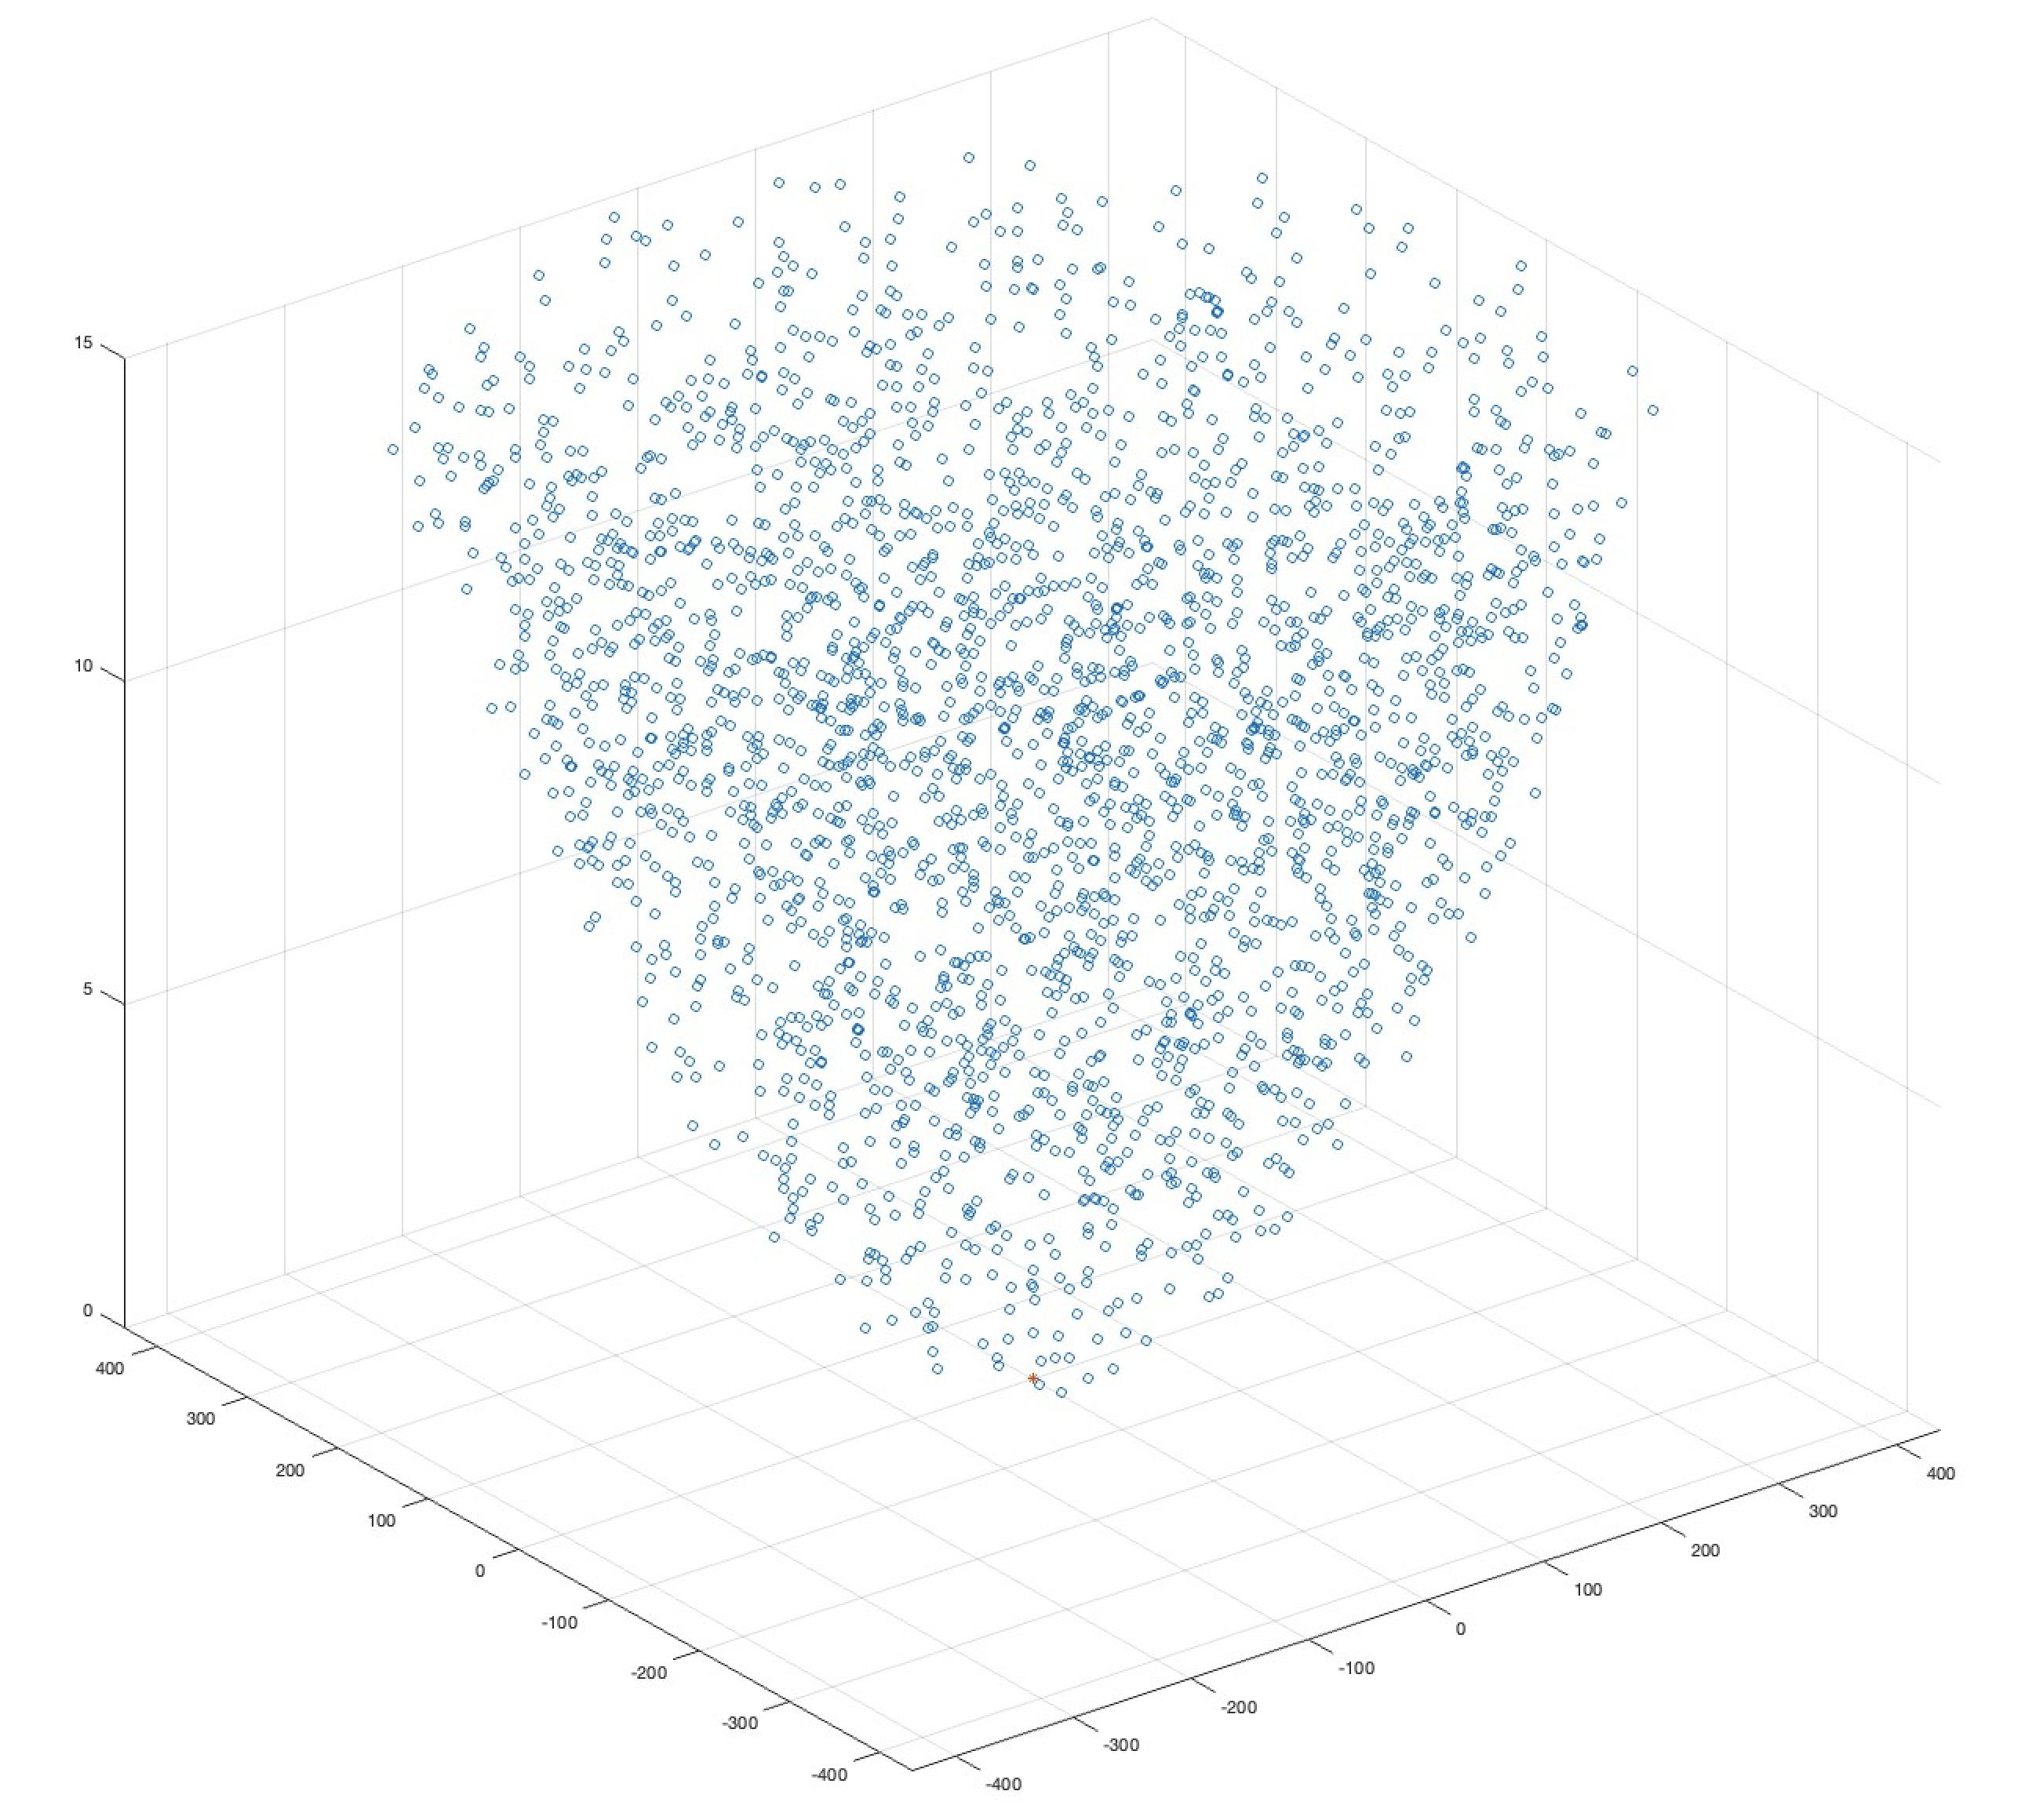

The A-ESIM’s visible distance from BS is derived from equation (1).

*visible distance* (km):  (1)

With regard to the antenna characteristics of the BS as victim station, the system characteristics are shown in Table 1 which is the system B in the Recommendation ITU‑R M.2134.

Table 1

System characteristics of BS

|  |  |  |
| --- | --- | --- |
|  | System B | |
| Characteristics | Base station | Mobile station |
| Frequency range (GHz) | 27.5-29.5 | |
| Receiver bandwidth (MHz) | 100 | |
| Antenna pattern type | Directional | |
| Antenna polarization | Linear | |
| Peak antenna gain (dBi) | 29 | 20 |
| Antenna pattern model | See antenna pattern in § 4.1 below | |
| Antenna height (m) | 10-20 | 1.5 |
| Receiver noise figure (dB) | 6 | 6 |
| Protection criterion (dB) | −6 | |
| Base station antenna downtilt (degrees) | 10 | |
| Body loss (for handheld UE scenario) | N/A | 4 dB |
| Feeder loss for BS | 0 | N/A |

The antenna model geometry and the pattern of the BS is shown in Figure 3.

Figure 3

The antenna characteristics of BS

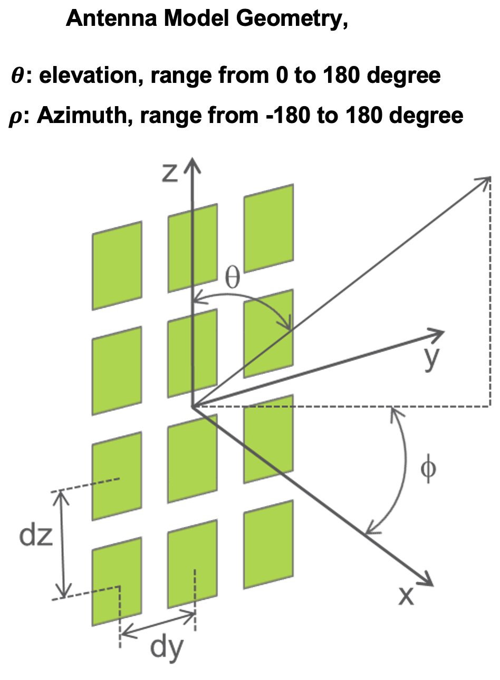

Under the condition that A-ESIM always keep the pfd mask provided in the Resolution **169 (WRC‑19)**, the aggregate interference can be computed in equations (2) and (3).

 (2)

** (3)

*n* (the number of A-ESIM) = 1, 5, 10, 20, 25.

The calculation was performed 10 000 times taking into account the random distribution of A‑ESIM.

# 3 Results

The study result for the aggregate interference impact on the BS is shown in Figure 4.

Figure 4

CCDF of the aggregate interference impact

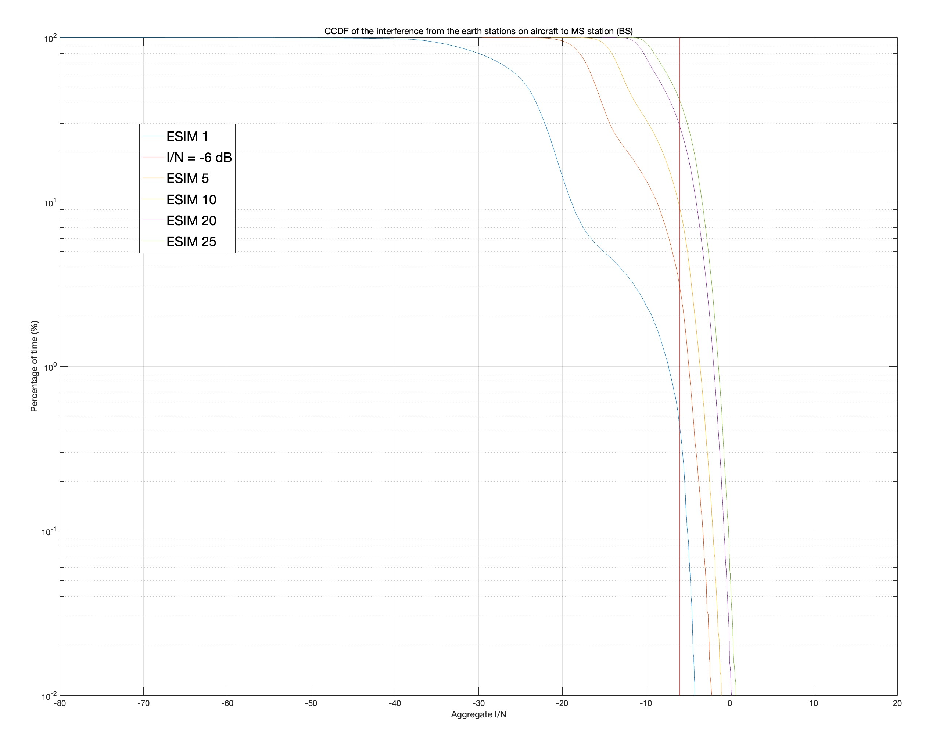

According to Figure 4, as the number of A-ESIM is increased, the aggregate interference (*I/N*) is also increased, therefore, the aggregate interference exceeds the protection criteria *I/N* and the time percentage exceeding the protection criteria *I/N* is shown in Table 2.

Table 2

The time percentage exceeding the protection criteria *I/N*

|  |  |
| --- | --- |
| The number of A-ESIM | Time percentage exceeding the protection criteria *I/N*  (%) |
| 1 | 0.45 |
| 5 | 3 |
| 10 | 9 |
| 20 | 28 |
| 25 | 41 |

It can be seen that the pfd mask for GSO A-ESIM in the Resolution **169 (WRC‑19)** would not be appropriate for multiple the non-GSO A-ESIM using same frequency channel to protect the terrestrial services operated in the same frequency band.

In order to ensure the protection of terrestrial services, additional measure such as condition that the non-GSO satellite system shall not use more than one satellite beam from any of its satellites in the same frequency range in the same or overlapping geographical area at a time should be considered to reduce the number of non-GSO A-ESIM using same frequency band. If this measure is not applicable to specify in the Resolution, the aggregate epfd mask needs to be specified in the Resolution to ensure the protection of terrestrial services.

______________

1. 1 The fourth altitude value (*H4*) computed in accordance with this *Hstep* is adjusted to 2.99 km to facilitate the examination of compliance with the two sets of predefined pfd values indicated in Table 5A and Table 5B.