 | World Radiocommunication Conference (WRC-23)  Dubai, 20 November - 15 December 2023 |  | 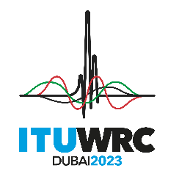
PLENARY MEETING |  | Document 149-E
 |  | 30 October 2023
 |  | Original: English
Thailand
PROPOSALS FOR THE WORK OF THE CONFERENCE
The addenda to this document contain the proposals submitted by this Administration for some WRC-23 agenda items and/or topics, as follows:

Proposal(s) on following  WRC-23 agenda item/topic | Contained in following addendum of Doc. 149
1.7 | Addendum 7
1.10 | Addendum 10
1.11 | Addendum 11
1.12 | Addendum 12
1.17 | Addendum 17
_________

