 | World Radiocommunication Conference (WRC-23)  Dubai, 20 November - 15 December 2023 |  | 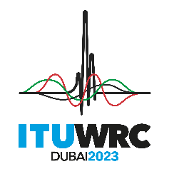
PLENARY MEETING |  | Document 148-E
 |  | 25 October 2023
 |  | Original: English
Iran (Islamic Republic of)
Proposals for the work of the conference
The Administration of the Islamic Republic of Iran is pleased to submit its proposals addressing certain agenda items of the World Radiocommunication Conference 2023 which are contained in addenda to this document. This Administration has also contributed to the development of, and supports, most of the Asia-Pacific Telecommunity Common Proposals (ACPs).
In preparation of the proposals for WRC-23, this Administration has taken into account recent ITU-R studies and Recommendations, the results of CPM23-2, new developments in radiocommunication technology, related service issues, equitable access to spectrum-orbital resources and consequential regulatory changes.
I.R. of Iran looks forward to working with other administrations to achieve the best possible results at the conference.

_____________

