 | World Radiocommunication Conference (WRC-23)  Dubai, 20 November - 15 December 2023 |  | 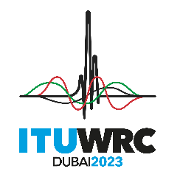
PLENARY MEETING |  | Document 142-E
 |  | 29 October 2023
 |  | Original: English
United States of America
PROPOSALS FOR THE WORK OF THE CONFERENCE
The addenda to this document contain the proposals submitted by this Administration for some WRC-23 agenda items and/or topics, as follows:

Proposal(s) on following  WRC-23 agenda item/topic | Contained in following addendum of Doc. 142
1.4 | Addendum 4
1.14 | Addendum 14
4 | Addendum 21
7(F) | Addendum 22 Addendum 8
8 | Addendum 23
9.1(9.1-a) | Addendum 24 Addendum 1
9.2 (Satellite – Scaling Factor) | Addendum 25 Addendum 1
9.2 (Satellite – SZM and Orbital Decay) | Addendum 25 Addendum 2
9.2 (Terrestrial) | Addendum 25 Addendum 3
10 (PAI 2.2) | Addendum 27 Addendum 1
10 (PAI 2.3) | Addendum 27 Addendum 2
10 (PAI 2.4) | Addendum 27 Addendum 3
10 (PAI 2.5) | Addendum 27 Addendum 4
10 (PAI 2.7) | Addendum 27 Addendum 5
10 (Space Weather) | Addendum 27 Addendum 6
10 (IMT FAI) | Addendum 27 Addendum 7

_____________

