 | World Radiocommunication Conference (WRC-23)  Dubai, 20 November - 15 December 2023 |  | 
PLENARY MEETING |  | Revision 1 to  Document 141-E
 |  | 19 November 2023
 |  | Original: English
Germany (Federal Republic of)/Bulgaria (Republic of)/France/Hungary/Italy/Latvia (Republic of)/Lithuania (Republic of)/Montenegro/Netherlands (Kingdom of the)/Poland (Republic of)/Portugal/Romania/Slovenia (Republic of)
PROPOSALS FOR THE WORK OF THE CONFERENCE
Agenda item 1.8
1.8 to consider, on the basis of ITU-R studies in accordance with Resolution 171 (WRC-19), appropriate regulatory actions, with a view to reviewing and, if necessary, revising Resolution 155 (Rev.WRC-19) and No. 5.484B to accommodate the use of fixed-satellite service networks by control and non-payload communications of unmanned aircraft systems;
Introduction
The signing administrations propose a revision of the Resolution 155 (Rev.WRC-19) considering the progress of the discussion within CEPT and ITU-R Working Party 5B.
Proposals

ARTICLE 5
Frequency allocations
Section IV – Table of Frequency Allocations
(See No. 2.1)
MOD D/BUL/F/HNG/I/LVA/LTU/MNE/HOL/POL/POR/ROU/SVN/141/1
5.484B Resolution 155 (Rev.WRC-23) shall apply. (WRC-23)

MOD D/BUL/F/HNG/I/LVA/LTU/MNE/HOL/POL/POR/ROU/SVN/141/2
Resolution 155 (REV.WRC-23)
Regulatory provisions related to earth stations on board unmanned aircraft which operate with geostationary-satellite networks in the fixed-satellite
service in certain frequency bands not subject to a Plan of Appendices 30,
30A and 30B for the control and non-payload communications of
unmanned aircraft systems in non-segregated airspaces*
The World Radiocommunication Conference (Dubai, 2023),
considering
a) that the operation of unmanned aircraft systems (UAS) requires reliable control and non-payload communication (CNPC) links, as shown in Annex 1 of this Resolution, in particular to relay air traffic control communications and for the remote pilot to control the flight;

b) that UAS CNPC earth stations operating within the service area of the GSO fixed-satellite service (FSS) networks with which they communicate may provide service within more than one country;
c) that for the operation of UAS CNPC earth stations, notification of any frequency assignment under Article 11 of the Radio Regulations can only be made by one single notifying administration;
d) that an administration authorizing the operation of UAS CNPC earth stations within the territory under its jurisdiction may modify or withdraw that authorization at any time,
noting
a) that WRC-15 adopted Resolution 156 (WRC-15) on the use of earth stations in motion communicating with geostationary-satellite orbit (GSO) FSS space stations in the frequency bands 19.7-20.2 GHz and 29.5-30.0 GHz, resolving that these earth stations not be used or relied upon for safety-of-life applications;
b) that Report ITU-R M.2171 provides information on characteristics of UAS and spectrum requirements to support their safe operation in non-segregated airspace,
recognizing

a) that the frequency bands 10.95-11.2 GHz (space-to-Earth), 11.45-11.7 GHz (space-to-Earth) and 11.7-12.2 GHz (space-to-Earth) in Region 2, 12.2-12.5 GHz (space-to-Earth) in Region 3, 12.5-12.75 GHz (space-to-Earth) in Regions 1 and 3 and 19.7-20.2 GHz (space-to-Earth), and in the frequency bands 14-14.47 GHz (Earth-to-space) and 29.5-30.0 GHz (Earth-to-space) are allocated to the FSS on a primary basis;
b) that the frequency bands 10.95-11.2 GHz, 11.45-11.7 GHz and 11.7-12.1 GHz (Region 2), 12.1-12.2 GHz (on the territory of the country listed in No. 5.489), 12.2-12.5 GHz (Region 3), 12.5-12.75 GHz (on the territory of the countries listed in No. 5.494 and in Region 3) considered for FSS downlink are allocated to the fixed and/or mobile except aeronautical mobile service on a primary basis;
c) that the frequency bands 14.0-14.3 GHz (on the territory of countries listed in No. 5.505), 14.25-14.3 GHz (on the territory of countries listed in No. 5.508), 14.3-14.4 GHz (Regions 1 and 3) and 14.4-14.47 GHz considered for FSS uplink are allocated to the fixed and/or mobile except aeronautical mobile service on a primary basis;
d) that the UAS CNPC links support safe operation of UAS;
e) that, since No. 4.10 of the Radio Regulations applicable to the Member States is considered by ICAO to be in support of the safety aspects related to the use of radio-frequency spectrum by aviation, the operation of CNPC under FSS without the application of No. 4.10 is subject to a decision by the State(s)1 responsible for ensuring the safety in the concerned airspace in which the UA is operated;
f) that the State(s) responsible for ensuring the safety in the concerned airspace in which the UA is operated can either require the application of No. 4.10, and therefore the UA operator and the service provider of the CNPC cannot use the FSS in the concerned airspace, or take the responsibility to deactivate it;
g) that the safety-of-life aspects of the use of UAS CNPC related to the oversight of the CNPC service provisions are under the responsibility of the State of the UA operator via the approval of the service level agreement (SLA) between the UA operator and the service provider of the CNPC, named the C2 communication service provider (C2CSP);
h) that the use of the FSS for the CNPC link would not preclude the use of other available allocations to accommodate CNPC links;
i) that, in this Resolution, the regulatory provisions related to the CNPC links under the FSS do not prejudge whether the responsible State(s) is able to ensure safe operation of UAS under the ICAO framework;
j) that the provisions within the Standards and Recommended Practices contained in the International Convention on Civil Aviation for unmanned aircraft systems addresses aviation’s requirements for the safe operation of UAS;
k) that the assessment of the capability of a candidate or an operated FSS link to comply or not with the ICAO SARPs, in particular the required link performance for the safe operation of UAS, is outside the purview of the ITU Radiocommunication Sector (ITU-R);
l) that notifying administrations of GSO FSS networks would not be involved in case the CNPC required performance is impacted by interferences which remains below the thresholds resulting from the regular coordination process under Article 9;
m) that notifying administrations of GSO FSS networks would not be able to provide any interference resolution (e.g. real-time, …) different from the regular complaint process under Article 15;
n) that administrations operating terrestrial stations cannot provide an accurate prediction of the interference that might be present in the airspace being used by UAs everywhere , anytime a UA could fly;
o) that any administrations notifying FSS networks as well as any administrations operating stations in the terrestrial services in the frequency bands identified in resolves 1 have no responsibility for the safety of life for the UA CNPC links operated under the FSS;
p) that the operation of the CNPC under the FSS with a network operated under No. 11.41 may be subject to restrictions due to the provisions of the Convention on International Civil Aviation with regard to No. 11.42;
q) that any change resulting from the satellite coordination process may adversely affect an active service level agreement (SLA) between a CNPC service provider and a UA operator, which may preclude the use of long-term SLAs;
r) that the exchange of information on the status of the coordination of the FSS operator is expected to be required under the SLA by the State overseeing the operation of the UAS,
resolves
1 that frequency assignments to stations of GSO FSS networks operating in the frequency bands 10.95-11.2 GHz (space-to-Earth), 11.45-11.7 GHz (space-to-Earth), 11.7-12.2 GHz (space-to-Earth) in Region 2, 12.2-12.5 GHz (space-to-Earth) in Region 3, 12.5-12.75 GHz (space-to-Earth) in Regions 1 and 3 and 19.7-20.2 GHz (space-to-Earth), and in the frequency bands 14-14.47 GHz (Earth-to-space) and 29.5-30.0 GHz (Earth-to-space), may be used for UAS CNPC links to communicate with earth stations on board UA operating in non-segregated airspace* under the following conditions;
2 that when used for a UAS CNPC link to address resolves 1, the earth station on board the UA is considered as an FSS earth station and therefore operates under an allocation on a primary basis;
3 that frequency assignments to UA CNPC earth stations subject to this Resolution shall be notified under No. 11.2 by the notifying administration of the FSS satellite network with which these typical earth stations communicate;
4 that the notifying administration for the GSO FSS network with which the UAS CNPC earth station communicates shall send to the Radiocommunication Bureau (BR) the relevant Appendix 4 notification information related to the characteristics of the UAS CNPC earth station identified as class of station “UG”;

5 that the notifying administration of the GSO FSS network used for UAS CNPC links shall ensure that the operation of a UAS CNPC earth station within the territory under the jurisdiction of an administration is subject to an explicit authorization under Article 18 from that administration;
6 that with respect to other satellite networks in the frequency bands referred to in resolves 1, the notifying administration of the GSO FSS network with which the UA CNPC earth station communicates shall ensure that its UA CNPC earth stations comply with the following conditions:
6.1 the UA CNPC earth station characteristics shall remain within the envelope of characteristics of the typical earth station(s) of the associated FSS satellite network as notified and published by BR;
6.2 the operation of UA CNPC earth stations shall not cause more interference to and shall not claim more protection than that of the typical earth station(s) of the GSO FSS network in the same area;

6.3 the use of assignments of an FSS satellite network by UA CNPC shall not constrain other satellite networks beyond what is already imposed by the typical earth station(s) of the FSS satellite network used by the UA CNPC earth station during the application of the provisions of Articles 9 and 11;
6.4 the operation of the UA CNPC earth station shall comply with the coordination agreements for the frequency assignments of the typical earth station(s) of the associated GSO FSS network obtained under the relevant provisions of the Radio Regulations;
6.5 the operation of UAS CNPC links shall not have any impact on the relevant existing agreements reached during the FSS satellite coordination process or on the future coordination of FSS networks during the application of the provisions of the Radio Regulations;
7 that, with respect to terrestrial services in the frequency bands referred to in resolves 1, the notifying administration of the GSO FSS network with which the UA CNPC earth station communicates shall ensure that its UA CNPC earth stations comply with the following conditions:
7.1 the use of UAS CNPC links shall not result in additional coordination constraints on terrestrial services under Articles 9 and 11;
7.2 unless otherwise agreed between the administrations concerned, UA CNPC earth stations shall not cause harmful interference to terrestrial services of other administrations by meeting the power flux-density (pfd) masks contained in Annex 2 to this Resolution;
7.3 UA CNPC earth stations receiving in the frequency bands referred to in recognizing c) shall not claim protection from transmitting stations of terrestrial services operating in conformity with the Radio Regulations, No. 5.43A does not apply and there is therefore no change of the regulatory status of UA CNPC earth stations with respect to stations of the terrestrial service;
8 that the use of the frequency bands specified in resolves 1 by the UAS CNPC links shall be in the accordance with the Convention on International Civil Aviation and its annexes that includes standards and recommended practices (SARPs);
9 that earth stations on board UA shall be designed and operated so as to be able to accept the interference caused by terrestrial services operating in conformity with the Radio Regulations in the frequency bands listed in resolves 1 without complaints under Article 15;
10 that earth stations on board UA shall be designed and operated so as to be able to operate with interference caused by other satellite networks resulting from application of Articles 9 and 11;
11 that administrations using FSS frequency assignments in the frequency bands listed in resolves 1 for UA CNPC shall not claim special measures under No. 4.10 to ensure their freedom from harmful interference, taking into account that the State(s) responsible for ensuring the safety in the concerned airspace in which the UA operate may consider that the application of No 4.10 is necessary, therefore UA CNPC cannot use the FSS in the concerned airspace;

12 that, in order to protect the radio astronomy service in the frequency band 14.47-14.5 GHz, administrations operating UAS in accordance with this Resolution in the frequency band 14-14.47 GHz within line-of-sight of radio astronomy stations are urged to take all practicable steps to ensure that the emissions from the UA in the frequency band 14.47-14.5 GHz do not exceed the levels and percentage of data loss given in the most recent versions of Recommendations ITU-R RA.769 and ITU-R RA.1513,

encourages administrations

1 to notify ITU-R of their stations operated under terrestrial services in order to assist the responsible State(s) to assess the level of interference where the UAS plans to operate;
2 to consider the available AMS(R)S and AM(R)S which comply with No. 4.10, as the preferred allocations to be used for UAS CNPC when possible or to consider these allocations as a backup of FSS for UAS CNPC as appropriate,

instructs the Secretary-General
to bring this Resolution to the attention of the Secretary General of ICAO.

Annex 1 to Resolution 155 (rev.WRC-23)
UAS CNPC links
Figure 1
Elements of UAS architecture using the FSS
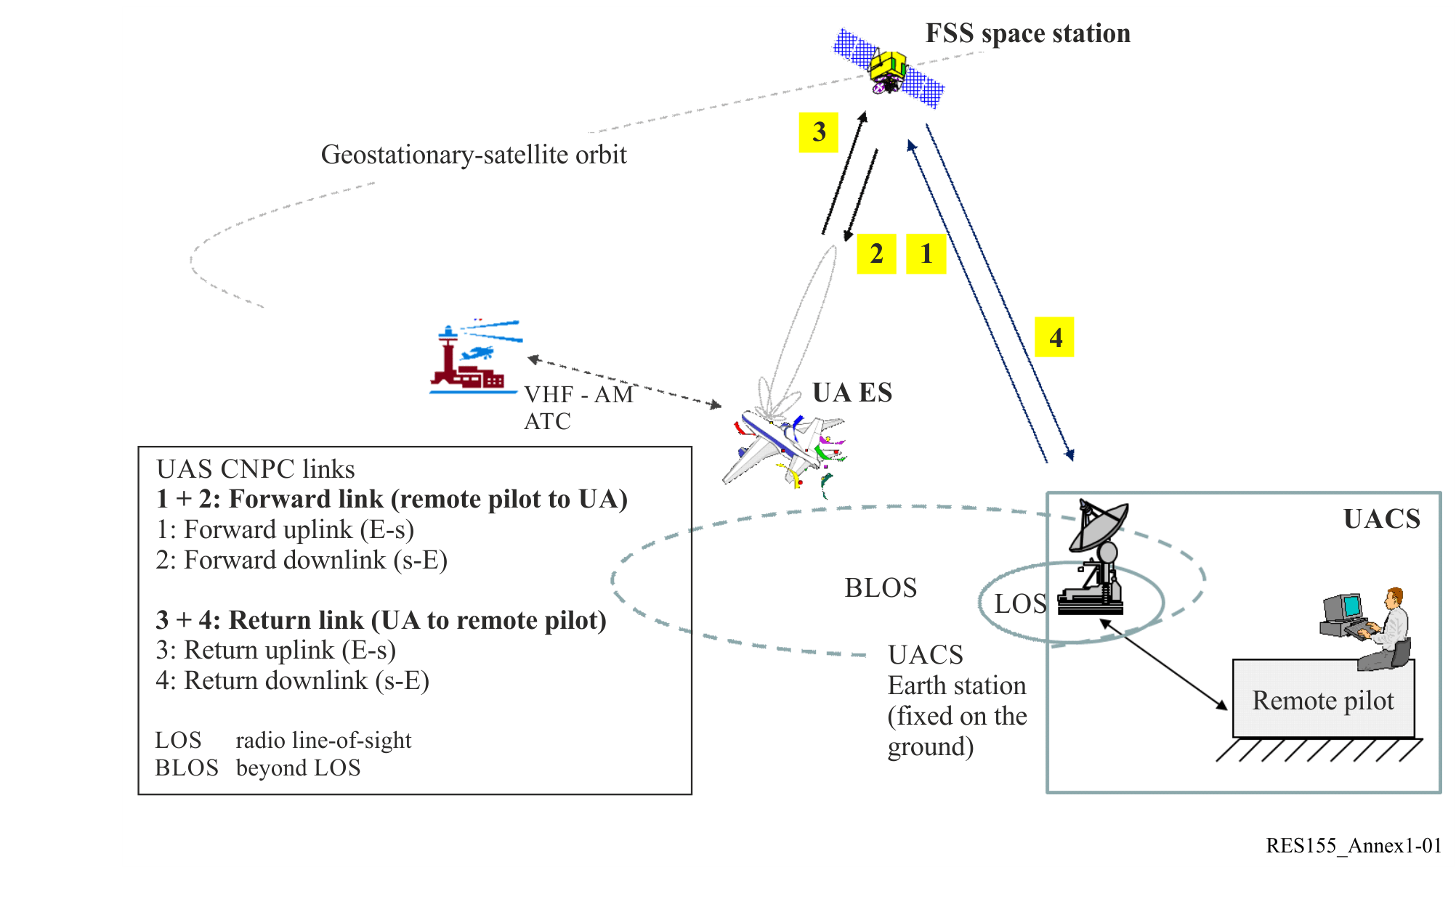
Annex 2 to Resolution 155 (rev.WRC-23)
Protection of the terrestrial service from UAS CNPC emissions

An earth station on board UA in the frequency band 14.0-14.3 GHz shall comply with the pfd limits described below, on the territory of countries listed in No. 5.505:
for 0° ≤ θ ≤ 90°
where θ is the angle of arrival of the radio-frequency wave (degrees above the horizontal).
An earth station on board UA:
– in the frequency band 14.25-14.3 GHz on the territory of countries listed in No. 5.508;
– in the frequency band 14.3-14.4 GHz in Regions 1 and 3;
– in the frequency band 14.4-14.47 GHz worldwide,
shall comply with the pfd limits described below:
for 0° ≤ θ ≤ 90°
where θ is the angle of arrival of the radio-frequency wave (degrees above the horizontal).
NOTE – The aforementioned limits relate to the pfd and angles of arrival that would be obtained under free-space propagation conditions.

SUP D/BUL/F/HNG/I/LVA/LTU/MNE/HOL/POL/POR/ROU/SVN/141/3
RESOLUTION 171 (WRC-19)
Review and possible revision of Resolution 155 (Rev.WRC-19) and
No. 5.484B in the frequency bands to which they apply

______________

* In accordance with the Convention on International Civil Aviation and its annexes that includes standards and recommended practices (SARPs).
1 Defined according to the Convention of the International Civil Aviation Organization (ICAO).
* In accordance with the Convention on International Civil Aviation and its annexes that includes standards and recommended practices (SARPs)..

