 | World Radiocommunication Conference (WRC-23)  Dubai, 20 November - 15 December 2023 |  | 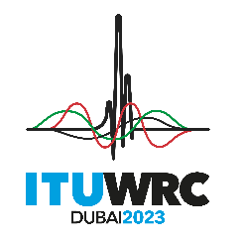
PLENARY MEETING |  | Document 140-E
 |  | 29 October 2023
 |  | Original: English
Ecuador/United States of America/Mexico
PROPOSALS FOR THE WORK OF THE CONFERENCE
Agenda item 9.1(9.1-d)
9 to consider and approve the Report of the Director of the Radiocommunication Bureau, in accordance with Article 7 of the ITU Convention;
9.1 on the activities of the ITU Radiocommunication Sector since WRC-19:
(9.1-d) Protection of EESS (passive) in the frequency band 36-37 GHz from non-GSO FSS space stations

Proposals

NOC EQA/USA/MEX/140/1
ARTICLES

NOC EQA/USA/MEX/140/2
APPENDICES

NOC EQA/USA/MEX/140/3
RESOLUTIONS

NOC EQA/USA/MEX/140/4
RECOMMENDATIONS
Reasons: The co-signatory countries are of the view that regulatory changes to the Radio Regulations are outside the scope of WRC-23 agenda item 9.1. Furthermore, they note that neither studies during the WRC-19 study cycle under WRC-19 agenda item 1.6 nor the updated WRC-23 studies under this topic have demonstrated with certainty that EESS (passive) in frequency band 36-37 GHz requires any additional protection from non-GSO FSS operation in frequency band 37.5-38 GHz. As such, Ecuador, Mexico and the United States support No Change (NOC) to the Radio Regulations for WRC-23 agenda item 9.1, topic d).

______________

