 | World Radiocommunication Conference (WRC-23)  Dubai, 20 November - 15 December 2023 |  | 
PLENARY MEETING |  | Document 129-E
 |  | 29 October 2023
 |  | Original: English
Germany (Federal Republic of)/France/Luxembourg
PROPOSALS FOR THE WORK OF THE CONFERENCE
Agenda item 7(A)
7 to consider possible changes, in response to Resolution 86 (Rev. Marrakesh, 2002) of the Plenipotentiary Conference, on advance publication, coordination, notification and recording procedures for frequency assignments pertaining to satellite networks, in accordance with Resolution 86 (Rev.WRC-07), in order to facilitate the rational, efficient and economical use of radio frequencies and any associated orbits, including the geostationary-satellite orbit;
7(A) Topic A – Tolerances for certain orbital characteristics of non-GSO space stations in the FSS, BSS or MSS

1 Introduction
Taking into consideration the discussions on the definition of orbital tolerances for non-GSO systems during this study cycle, it is necessary to permit some adjustments to the filed orbital parameters with respect to the operational orbital parameters, but at the same time to allow long-term sustainability and equitable access of the non-GSO orbit/spectrum resources. This operational flexibility is mainly required when two systems are filed at the same altitude and the system already deployed is a non-cooperative system. In this context, a non-cooperative system is a system which does not want to accept some constraints on their operational orbital parameters and want to keep the full flexibility to operate their system within the orbital tolerance. To alleviate the problem of the non-sphericity of the Earth, in this contribution the term altitude shall be understood as the distance between the centre of the Earth and the non-GSO satellite.

2 Potential legitimate causes of discrepancy between filed and operational orbital parameters
ITU-R Working Party (WP) 4A and the Conference Preparatory Meeting (CPM) identified potential legitimate causes:
– Orbital parameters optimization: During the seven years coordination period, the definition of targeted market and type of service proposed by the non-GSO system are often adjusted and, as a consequence, the operational orbital parameters could be slightly optimized compared to the orbital parameters contained in the request for coordination (CR/C) publication seven years ago.
– Daily fluctuation: Due to the Earth’s non-homogenous gravity field and oblateness, each non-GSO satellite fluctuates a few kilometres around an average altitude. For a large constellation, this daily fluctuation is mainly linked to the altitude difference between two shells, i.e., if you have shells of your system every 20 km, each satellite of each shell must stay within a maximum range of ±10 km to avoid potential collision between your satellites deployed at different shells, as shown in Figure 1 below. In reality, the altitude range will be lower than ±10 km to provide some additional safety. Based on WP 4A analyses, daily fluctuations of systems deployed in circular orbits and bands subject to Resolution 35 (WRC-19) are of a few kilometres (i.e., less than 20 km).
Figure 1
Daily variation of different satellites in two shells
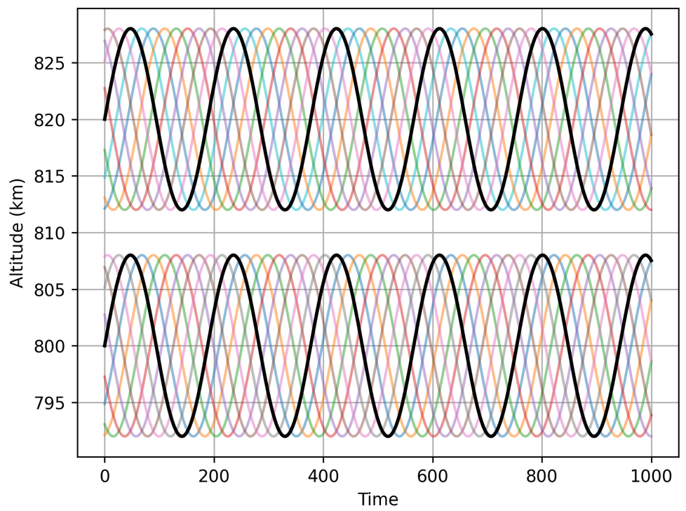

3 Allowable discrepancy to address the orbital parameters optimization
Even if all Regional organizations are not proposing similar orbital tolerance values, the views expressed at the 3rd ITU inter-regional workshop supported allowing a discrepancy between the deployed and filed altitude of between 50 km and 100 km, for filed altitude lower than 2 000 km. Further work is required at the WRC-23 to converge on value(s) but each Regional organization agreed on the necessity to address the orbital parameters optimization.
The main difference between Regional organization proposals is on the regulatory mechanism associated with such allowable discrepancy to address the orbital parameters optimization:
– Some consider that each system could operate during their entire life within ±X km of their notified orbital parameters (current proposal is within the range 50-100 km) without the necessity to update their notified orbital parameters (1-step approach).
– Others consider that each system shall select, at the notification stage, their final orbital parameters within ±X km of their CR/C orbital parameters (current proposal is within the range 50-100 km) and then operate within a reduced range, for daily fluctuations (2-steps approach).

4 1-step approach vs 2-steps approach
To compare the advantages and disadvantages of the two approaches, we propose to use an analogy of driving cars on a motorway.
Assumptions:
– 5-lanes motorway between Point A and Point B
– No speed limits
– A lane is large enough for a car to drive
– The first driver is driving an old Volkswagen Beetle (50 horses power – Max. speed 157 km/h) and he is non-cooperative driver
– The second driver, starting 15 min after the 1st driver, is driving a Ford Mustang (450 horses power – Max. speed 249 km/h)
– The third driver, starting 25 min after the 1st driver, is driving a Bugatti Veyron (1 200 horses power – Max. speed 431 km/h)
– The 3 drivers are at Point A and want to go to Point B through the 5-lanes motorway.
In this analogy, the 5-lanes represent the space range available for the orbital parameters optimization, a lane represents the space range available for the daily fluctuation and the distance between Point A and Point B the validity period of the non-GSO filing
1-step approach
Under this approach each car has the flexibility to drive in any lane at any time. The Beetle being the 1st car in the motorway, the 1st driver can choose any lane at Point A and select another lane later to optimize its journey as shown below in Figure 2. As a non-cooperative driver, he doesn’t like restrictions and wants to keep its full driving flexibility on the entire motorway. Consequently, we have an orange traffic light on each lane as the second and third drivers could not safely use any of the lanes since they do not know which lane will be occupied by the Beetle. It is even worse for the third driver since he has no information on the two other cars ahead of him. To be 100% safe, the Mustang and Bugatti shall use another road to go to Point B and leave the 5-lanes motorway to the only advantage of the Beetle.
Figure 2
1-step approach
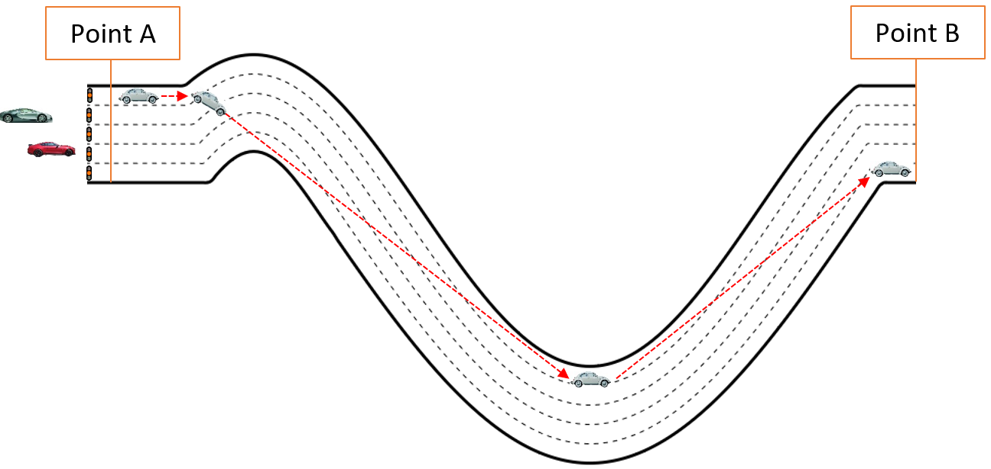
2-steps approach
Under this approach each driver needs to select a lane at Point A and stay on this lane until he reaches the Point B. The Beetle being the 1st car in the motorway, can choose any lane at Point A (i.e., first step) but as soon he makes this selection, he shall stay on this lane (i.e., second step). Even if he is a non-cooperative driver, he shall stay on its initially selected lane until reaching the Point B. As shown in the Figure 3 below, when the Mustang arrives on the motorway, he will find a red traffic light on the lane selected by the Beetle and a green traffic light on the other four lanes. The Mustang will be able to select its own lane over the four lanes available (i.e., first step) and then shall stay on this lane until Point B (i.e., second step). The Beetle has a slight disadvantage of not being able to optimize its journey but in exchange, the 4 other lanes will be totally safe to be used by the Mustang. Later, when the Bugatti arrives, the driver will find 2 lanes with red traffic lights and 3 lanes with green traffic lights; he will be able to select any lane with a green traffic light (i.e., first step) and then shall stay on this lane until Point B (i.e., second step).
Figure 3
2-steps approach
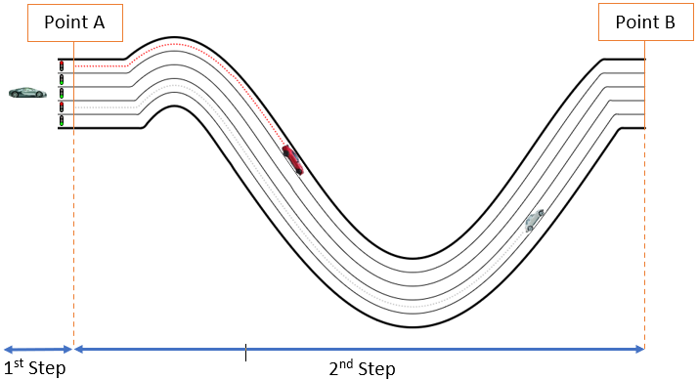
The table below summarizes the pros and cons of each approach.

 | Pros | Cons
1-step approach | – Full flexibility for the Beetle to optimize its journey | – Huge uncertainties for the Mustang and the Bugatti due to the possibility to have a collision with other cars  – The motorway is fully occupied by the Beetle and sharing is not feasible with other cars
2-step approach | – Full flexibility for the Beetle to select its lane at Point A  – No risk of collisions for all three cars  – Full sharing of the motorway | – Slight disadvantage for Beetle for not being able to optimize its journey between Point A and Point B

5 Conclusion
Based on the analogy in section 4, the similar principle applies to non-GSO systems. The 1-step approach is inappropriate since it will not permit a fair and equitable treatment of systems initially filed at a similar altitude. A non-cooperative system will monopolize a large altitude range for its own benefit and will not permit subsequent systems to operate within this altitude range.
The 2-steps approach will permit a better sharing of the altitude range in a safe manner even with non-cooperative systems. This approach will permit a fair and equitable treatment of non-GSO systems initially filed at the same altitude and promote long-term sustainability and rational use of non-GSO orbit/spectrum resources.

______________

